AUTOMATED EXAM GRADING AND RESULT MANAGEMENT SYSTEM

BY
ADEBAYO, SAMUEL OLAIYA
ND/23/COM/FT/0090

SUBMITTED TO THE DEPARTMENT OF COMPUTER SCIENCE, INSTITUTE OF INFORMATION AND COMMUNICATION TECHNOLOGY

KWARA STATE POLYTECHNIC, ILORIN.
IN PARTIAL FULFILLMENT OF THE REQUIREMENTS FOR THE AWARD OF NATIONAL DIPLOMA (ND) IN
COMPUTER SCIENCE

JULY, 2024.

CERTIFICATION
This is to certify that this project research was written by, ADEBAYO, SAMUEL OLAIYA with Matriculation Number ND/23/COM/FT/0090 The project has been read and approved as meeting part of the requirements for the award of National Diploma in Computer Science.

_________________________ __________________
MR. BOLAJI-ADETORO D.F. Date
Project Supervisor

_________________________ __________________
MR. OYEDEPO F.S. Date
Head of Department

_________________________ __________________
External Examiner Date

DEDICATION
I dedicate this project work to Almighty God who inspired me and directed my ways during my academic stay in the polytechnic.

ACKNOWLEDGEMENTS
The journey through this academic program has been both challenging and rewarding. Through all the trials and triumphs, I give all glory, honor, and adoration to the Almighty God for His unending grace, divine protection, and sustenance from the very first day I stepped into the academic world until this present moment. Without His mercy, I would not have come this far.
I wish to express my heartfelt gratitude to the Head of the Computer Science Department, Mr. Oyedepo F.S., for his unwavering support, fatherly guidance, and consistent encouragement throughout the course of my academic journey. His administrative leadership and personal interest in the success of students have been a source of great motivation to me.
My profound appreciation goes to my project supervisor, Mr. Bolaji-Adetoro D.F., for the invaluable role he played in the successful completion of this research project. His intellectual input, timely corrections, encouragement, and professional mentorship were instrumental in shaping the quality of this work. I consider it a great privilege to have worked under his supervision.
I also wish to extend my sincere appreciation to all the lecturers in the Department of Computer Science for their dedication to academic excellence and for imparting knowledge and discipline throughout my course of study. Each of you contributed uniquely to my academic and personal growth.

TABLE OF CONTENTS
Title page i
Certification ii
Dedication iii
Acknowledgments iv
Table of Contents v
Abstract vi
CHAPTER ONE: GENERAL INTRODUCTION
1.1 Background to the Study 1
1.2 Statement of the Problem 2
1.3 Aim and Objectives 2
1.4 Significance of Study 3
1.5 Scope of Study 3
1.6 Organization of the Report 3
CHAPTER TWO: LITERATURE REVIEW
2.1 Review of Related Pastworks 6
2.2 Review of General Studies 10
CHAPTER THREE: RESEARCH METHODOLOGY AND
ANALYSIS OF THE SYSTEM
  - Research Methodology 13
  - Analysis of the Existing System 18
  - Problem of the Existing System 18
  - Analysis of the Proposed System 19
  - Advantages of the Propose System 20
CHAPTER FOUR: DESIGN, IMPLEMENTATION AND
DOCUMENTATION OF THE SYSTEM
  - Design of the System 22
    - Output Design 22
    - Input Design 24
    - Database Design 26
    - Procedure Design 27
  - Implementation of the System 27
    - Choice of programming language 27
    - Hardware support 28
    - Software Support 28
    - Changeover Techniques 28
  - System Documentation 28
    - Operating the System 28
    - Maintaining of the System 29
CHAPTER FIVE: SUMMARY CONCLUSION AND
RECOMMENDATION
5.1 Summary 31
5.2 Conclusion 31
5.4 Recommendations 31
References 33

Abstract
The Automated Exam Grading and Result Management System (AEG&RMS) represents a significant advancement in the field of educational assessment and administration. This study investigates the design, implementation, and impact of the AEG&RMS, highlighting its potential to address the inefficiencies and limitations of traditional manual grading and result management systems. The primary objectives of the AEG&RMS are to enhance the efficiency, accuracy, and fairness of the grading process, while providing timely and constructive feedback to students. The system leverages advanced algorithms to automate the grading of various types of assessments, including multiple-choice, short-answer, and essay questions. This automation not only reduces the workload for educators but also minimizes human errors and subjective biases, ensuring consistent and objective evaluation of student performance. The study includes a comprehensive analysis of the existing manual system, identifying key challenges such as time-consuming processes, susceptibility to errors, limited scalability, and issues with data security and accessibility. In contrast, the proposed AEG&RMS addresses these challenges through its automated functionalities, robust data management capabilities, and user-friendly interfaces. A detailed cost-benefit analysis underscores the long-term economic viability of the AEG&RMS, highlighting reduced operational costs and increased productivity as major benefits. The system's continuous improvement capabilities ensure it remains adaptable to evolving educational needs and technological advancements. Overall, the AEG&RMS is positioned as a transformative solution for modernizing exam grading and result management in educational institutions. Its implementation is expected to significantly improve the efficiency and effectiveness of educational assessment practices, ultimately enhancing the learning experience and outcomes for students.

CHAPTER ONE
INTRODUCTION
  - Background to the Study
Automated Exam Grading and Result Management System (AEG & RMS) have emerged as a significant solution in the realm of educational technology, offering streamlined processes for grading assessments and managing results efficiently. traditional manual grading methods are not only time-consuming but also prone to errors, leading to inconsistencies and delays in the dissemination of results. With the advancement of technology, there has been a growing interest in automating these processes to enhance accuracy, speed, and overall effectiveness.(Smith and Jones (2019).
The following challenges were identified in the students’ data processing in the Department. They include delays in preparation and release of Senateapproved results to students to view their performance on time (on semester/session basis); resolving duplicate records/results; excessive paperwork in Results Processing; poor recordkeeping of students status information; poor data and security management of students records and files; the unavailability of transcripts on demand. There is also the problem of poor availability of information to guide students during course registration which could result to presumptions in offering and dropping courses. The manual system leads to errors and omissions in CGPA computation, late preparation of students’ final results for convocation, and lack of an updated database of students’ information for reference purposes (Udeze, et. al, 2020).
Automated Exam Grading and Result Management Systems utilize advanced algorithms and data management techniques to streamline the grading process and ensure accurate and consistent assessment of student performance. By automating routine tasks, these systems significantly reduce the workload on educators, allowing them to focus more on instructional activities and student engagement. Moreover, automated systems enhance the objectivity and reliability of grading, minimizing the risk of errors and subjective biases that can occur in manual grading processes. (Brown et. al, 2020).
Despite the benefits associated with AEG&RMS, there exist several challenges and limitations that need to be addressed. One prominent issue is the compatibility and integration of these systems with existing educational infrastructure, many institutions struggle to seamlessly incorporate automated grading solutions into their workflows due to technical constraints and resistance to change. (Johnson 2019)
PHP, a versatile and widely-used scripting language for web development, plays a pivotal role in implementing the backend logic and database management aspects of Web-based AEG&RMS. PHP frameworks such as Laravel or Symfony provide powerful tools for developing secure, scalable, and interactive web applications, essential for handling large volumes of assessments and users. Moreover, Web-based AEG&RMS powered by PHP facilitate timely feedback and result dissemination, crucial for supporting student learning and improvement. The system's web interface enables immediate feedback delivery to students, promoting a responsive educational environment and facilitating continuous learning. (Ojo and Akhigbe 2020).
  - Statement of the Problem
The manual grading of exams and the subsequent management of results present significant challenges for educational institutions, including inefficiencies, errors, and delays. Despite the availability of automated solutions, the adoption of Automated Exam Grading and Result Management Systems (AEG&RMS) remains limited, primarily due to technical barriers, concerns about reliability, and resistance to change.
  - Aim and Objectives
This research aims to implement an Automated Exam Grading and Result Management System in educational settings. The objectives are as follows:
- Design a user-friendly web page that will allow easy operation of the system
- Develop a site using PHP programming language
- Design a system that will allow each student to view their grades.

  - Significance of the Study
The significance of this study lies in its potential to address critical challenges and opportunities related to the implementation of Automated Exam Grading and Result Management Systems (AEG&RMS) in educational settings. Automated grading systems have the potential to streamline assessment processes, reducing the time and resources required for manual grading. By identifying best practices and addressing challenges in AEG&RMS implementation, this study can enhance the efficiency and accuracy of grading and result management in educational institutions.
  - Scope of the Study
The scope of this study encompasses the exploration of Automated Exam Grading and Result Management Systems (AEG&RMS) in educational settings only.
1.6 Organization of the Study
For easy study and proper understanding of this project write-up, It is planned and organized into five chapters. The description of what each chapter contains is explained below:
Chapter One: This contains an Introduction to the whole write-up, the problem of the study, aims and objectives of the study, the significant of the study, the scope and limitation of the study, and organization of the report.
Chapter Two: It focuses on the literature review of the study, organization of the board of director, computerization of the current state of the art.
Chapter Three: It presents data collection method employed, analysis of data and existing system, advantages of the proposed system, design and implementation, programming language used with reasons, hardware and software support.
Chapter Four: It deals with the system design implementation and documentation, design of the system, output design, input design, file system, procedural design, and documentation of the new system.
Chapter Five: This centres on the summary, experienced gained, recommendation and conclusion.

CHAPTER TWO
LITERATURE REVIEW
2.1 Review of Related Work
Ojo and Akhigbe (2020) make a review on Result Processing System forms the key activities in the life span of a student. The demand for effective and efficient result computation and output presents the need to automate existing manual result processing system. The digitized process provides capabilities such as a centralized repository for storage, management and dissemination of result information to those concerned. A requirement gathering exercise based on the assessment of the existing manual process reveals that it is inefficient and rigorous in nature. The manual activities of the existing system were identified and modeled with the UML object-oriented methodology. Soft technologies such as the hypertext preprocessor - a high level scripting programming language and MYSQL database management systems were combined in the implementation of the student result processing system. The designed and implemented system was able to provide a robust database that generates various reports that are relevant to secondary schools. The reports included results’ summary, results’ broadsheet, students’ result sheet, and so on. These reports are all downloadable because the system is able to generate them in PDF format. The system is unique in that it can be adopted and adapted to suit the result processing idiosyncrasies of any public secondary school.
Efendi, et al. (2020) wrote a journal article on “Design and Implementation of Computer Based Test (CBT) in vocational Education” This research is motivated by an analysis of the needs of the examination sys tem that still uses conventional methods that require considerable time, cost, and effort and have not been able to synergize with technological developments. Research on the development of Computer Based Test (CBT) Models Based on the web aims to develop a CBT model that can overcome the problems found in conventional tests. This type of research is development research (R & D) with software development procedures using the waterfall model. The stages of development consist of the needs analysis phase, the design stage, the implementation phase, and the testing phase. Research respondents were students of the Information Systems study program. The results of this study were obtained online test kits to help the process of evaluating student learning outcomes with features: input test data, display an analysis of the completeness of the report, and print reports made for the completion of the learning assessment. By using a database system, this online exam makes it easier for the exam system to display questions and assessments, making it easier for users to use it and for administrators to manage questions.
Romi, et al. (2020) presented a journal on Background to the Study” The traditional method of assessment (examination) is most at times marked by examination question leakages, human errors when marking of scripts, result compilation, and recording of scores. The advancement of technology in the field of computer science has necessitated the need for computer usage in majorly all areas not excluding the educational sector. This project aims to bring a solution to these problems faced by examiners (administrators) and students. The system is developed to help examiners set their questions online and students write the examination electronically. When this has been done, the system does the automatic grading, recording of scores, and creation of report cards. This system has been developed using HyperText Markup Language (HTML), Cascading Style Sheets, JavaScript (Bootstrap), Hypertext Preprocessor (PHP), and MySQL. After the development of this project, it was tested by a group of teachers and students. The data was gathered and it was discovered that this platform handled the different processes much faster, and solved 90% of the problems faced when carrying out the traditional paper-based examination. The time taken to set questions, answer them, and process results were greatly reduced with much more accuracy.
Olalere et al. (2019), came up with a similar solution, having examination setters and students coming to write the exam. A different model from the previous work cited has been used. This web application comprises of two types of users, the main administrator and the students who will write the exams. The system is built with PHP and MySQL powering the back end and HTML, CSS, and JavaScript at the front end. After completion of the exam and submission made, the system can calculate the student’s score and give the results later on. Much like the previous platform cited, only the Administrator has the power to create students and lecturers. Also, the examinations are not restricted to particular students. There is no special constraint that ensures that functionality.
Shubham et al. (2020) have analyzed the evaluation procedures and processes in a school and identified potential difficulties with the management of examination halls. In this research work, students’ who are not present in school on the day of the exams, face a lot of difficulties to be evaluated. Also, the difficulty is faced when trying to get details of a student and courses registered. Their solution offers students’ the ability to login from wherever they may be, and take the exam, which shall then be graded and their results displayed later on. Their platform has an Administrator, who programs and sets exams. After the administrator has finished setting and programming exams, coordinators will create and upload the various exam papers for each course, and students’ can take the exams. The administrator has the majority of the workload which if it is not properly done, students would not get report sheets at the end but rather, will only get results for a particular test or examination at the end.
Jameer & Thara (2020) concluded that searching query in the web applications may or may not yield anticipated results, constrained by the questions asked. User may not feel comfortable by seeing a bunch of questions which may not be relevant to his question. Henceforth, we device a technique by finding the similar queries or searches to an entered query. For this purpose, Word Embeddings are used on questions asked in Stack Overflow. They used Cosine Similarity to find the similarity between two sentences as every word in the sentence is given Embedding i.e., a vector containing of numbers. The write up ranked the queries based on this similarity, and their goal is to make the best similar question to the query asked to get the best rank.
Alvaro (2019) concluded that detecting database records that are approximate duplicates, but not exact duplicates, is an important task. Databases may contain duplicate records concerning the same real-world entity because of data entry errors, unstandardized abbreviations, or differences in the detailed schemas of records from multiple databases – such as what happens in data warehousing where records from multiple data sources are integrated into a single source of information – among other reasons. In this paper a review of a system was done to detect approximate duplicate records in a database and provide properties that a pair-wise record matching algorithm must have in order to have a successful duplicate detection system.
Olajide, et al. (2020) “Design and Implementation of Students' Result Management System for Nigerian Tertiary Institution” Test and Measurement is central to academic teaching and learning activities. The success or otherwise of a lecturer’s activities at the lecture rooms, laboratories and other designated points where learning activities take place rely on how students’ activities are organized, coordinated and evaluated. The measurement of the progression of students’ performance in the various courses and overall results of the students require detailed and objective attention of the lecturers at all the levels involved in learning activities. Assessment of students’ performance begins from attendance to lectures/practical, field trip (if any), continuous assessments (test, assignment, practical test) and the examination activities. The paper attempts to look at the design and implementation of an integrated offline and web based Students Result Management Software with a view to solving results’ computation problems usually encountered in Nigeria Tertiary Institutions. The package is expected to be sufficiently robust to address most shortcomings and challenges encountered during result processing activities in most higher institutions of learning in Nigeria.
Akinmosin (2020) presented a journal titled This research is focused on creating an automated students result management system using oracle’s database, forms and reports. This is a computerized examinations results management system for tertiary student’s examination records. The manual method of students’ academic result processing was found to be tedious, especially when carried out for a large number of students, this makes the entire process time-consuming and error prone. The system designed is meant to register students as soon as they have paid their departmental registration and only then will they be able to view their results. The system presents a single platform that will be used to manage the processing of all examination records within the institution. The data used for testing was obtained from the Department of Physics, Nasarawa State University and an empirical evaluation of the system shows that the system expedites the processing of students’ examination results and the reporting of it.
Dan (2020) presented the programme for Science Education Enhancement and Development (‘SEED’) was based in the Faculty of Science at the University of Plymouth. It was resourced principally by the Higher Education Funding Council for England through its Fund for the Development of Teaching and Learning. Additional support has been received from many areas of the University and particularly from Academic and Information Services. SEED builds on the success of the University of Plymouth Science Faculty in the national Teaching Quality Assessment system where Plymouth achieved ‘excellence’ in Environmental Science, Geography, Geology and Oceanography. SEED’s overall aim is to develop, document and disseminate good practice in Science teaching and learning. The programme consists of a series of projects in areas such as lab-work, field-work, graduate teaching assistants and computer-aided learning, which are itemised inside the back cover. Most are based in the Science Faculty but some are being taken forward by staff in the University’s School of Computing and in Educational Development Services (EDS). All the projects are linked to dissemination partners in other institutions who act as external advisors, ensure that SEED’s outputs are capable of being used in other institutions and help to disseminate and embed SEED’s end-products.
Martha & Debra (2020) presented a Computer-based testing (CBT) has emerged as one of the recent “innovative” approaches to assessments most pursued by states. CBT is lauded as the answer to having cheaper and speedier test delivery for state and district-wide assessments. It is also seen by some as an avenue toward greater accessibility for students with disabilities. In this report they explored the context of CBT, current state computer-based tests, and considerations for students with disabilities, in part as follow-up to a similar exploration that occurred in the early 2000s when just a few states were beginning to develop and implement CBT for their state assessments.
2.2 Review of General Studies
In this section, a broader review of literature related to educational technology, assessment practices, and automation in education will be presented. This review encompasses studies, articles, and reports that explore various aspects of technology integration, assessment methods, and the impact of automation on teaching and learning.
2.3 The Integration of Technology in Teaching and Learning
The integration of technology in teaching and learning has fundamentally transformed educational practices, offering dynamic opportunities for engagement, collaboration, and personalized learning. This shift represents a paradigmatic evolution in pedagogical approaches, as educators leverage digital tools and resources to create interactive and immersive learning experiences for students.
One of the primary benefits of technology integration is its ability to actively engage students in the learning process. Through multimedia presentations, digital simulations, and educational games, technology captivates students' attention and facilitates a deeper understanding of complex concepts. Rather than passive recipients of information, students become active participants in their own learning journey, exploring, experimenting, and discovering knowledge in interactive digital environments.
Furthermore, technology enables collaborative learning experiences that transcend physical boundaries. Online platforms and communication tools facilitate real-time collaboration among students, allowing them to work together on projects, share ideas, and provide feedback irrespective of their geographic location. Virtual classrooms and discussion forums serve as digital spaces for collaborative problem-solving and knowledge construction, fostering a sense of community and shared learning (Anderson & Dron, 2020).
Personalization is another hallmark of technology-integrated learning environments. Adaptive learning technologies analyze students' learning preferences, strengths, and weaknesses to tailor instruction to individual needs. Personalized learning platforms offer adaptive content, assessments, and feedback, allowing students to progress at their own pace and focus on areas where they need additional support. This individualized approach to learning enhances student engagement, motivation, and academic achievement (Johnson & Smith, 2018).
Moreover, technology enhances accessibility and flexibility in education. Digital textbooks, audiobooks, and screen readers accommodate students with disabilities, ensuring equitable access to educational materials and content. Online learning platforms and blended learning approaches provide flexibility in scheduling and delivery, allowing students to access course materials and participate in learning activities at their convenience. Asynchronous learning options accommodate diverse learning styles and schedules, promoting greater autonomy and self-regulated learning (Brown et al., 2019; Lee & Williams, 2021).
Data-driven instruction is another key benefit of technology integration. Educational technologies collect and analyze data on students' learning progress, preferences, and performance, providing valuable insights for educators to inform instructional decision-making. Learning analytics tools identify patterns and trends in student engagement and achievement, enabling educators to intervene early and provide targeted support. By leveraging data-driven approaches, educators can personalize instruction, identify areas for improvement, and enhance student outcomes (Smith & Johnson, 2020).
Furthermore, the integration of technology fosters the development of essential 21st-century skills. Digital literacy, information literacy, and media literacy are increasingly important in a technology-driven society, preparing students for success in the digital age. Technology-enhanced learning environments cultivate critical thinking, creativity, communication, and collaboration skills, equipping students with the competencies they need to thrive in an ever-evolving global landscape (Brown & Lee, 2022).

2.4 Assessment Practices and Innovation
Assessment practices play a pivotal role in education, shaping learning experiences, informing instructional decisions, and measuring student progress. Over time, assessment methodologies have evolved in response to changes in educational paradigms, technological advancements, and the evolving needs of learners. Here, we explore the intersection of assessment practices and innovation, examining how technology has revolutionized assessment methodologies and opened new avenues for measuring student learning.
Traditional assessment methods, such as written exams and standardized tests, have long been the cornerstone of educational evaluation. While these methods provide valuable insights into students' knowledge and skills, they often fall short in capturing the complexities of learning processes and assessing higher-order thinking skills. In recent years, educators and researchers have increasingly turned to innovative assessment practices that leverage technology to overcome these limitations and enhance the validity and reliability of assessments.
One area of innovation in assessment practices is the use of digital assessment tools and platforms. Online quizzes, interactive simulations, and computer-based assessments offer opportunities for more authentic and engaging assessment experiences. These digital tools not only provide immediate feedback to students but also enable educators to assess a broader range of skills, including problem-solving, critical thinking, and creativity. Additionally, digital assessments can be customized to align with specific learning objectives and adapted to accommodate diverse learners' needs, promoting equity and inclusivity in assessment practices (Smith & Brown, 2018).
Another innovative approach to assessment is the use of competency-based assessment models supported by digital portfolios. Unlike traditional grading systems that focus on numerical scores, competency-based assessment emphasizes mastery of specific skills and knowledge areas. Digital portfolios allow students to demonstrate their learning through multimedia artifacts, reflections, and evidence of competency attainment. These portfolios serve as dynamic records of students' progress and growth over time, providing a more holistic and authentic representation of their learning journey (Johnson et al., 2019).
Furthermore, technology has enabled the implementation of formative assessment practices that facilitate ongoing feedback and reflection. Formative assessment tools, such as online quizzes, instant polling, and digital feedback platforms, allow educators to assess student understanding in real-time and adjust instruction accordingly. By providing timely feedback and opportunities for self-assessment, formative assessment promotes student engagement, metacognitive awareness, and academic achievement (Brown et al., 2020).
Additionally, the advent of learning analytics has revolutionized assessment practices by providing educators with actionable insights into students' learning behaviors and performance patterns. Learning analytics tools analyze vast amounts of data generated by digital learning environments to identify trends, predict student outcomes, and inform instructional decision-making. By leveraging learning analytics, educators can identify at-risk students, personalize instruction, and optimize learning experiences to maximize student success (Williams & Lee, 2019).
2.5 Impact of Automation on Educational Practices
The impact of automation on educational practices is profound and multifaceted, reshaping teaching, learning, and administrative processes in educational institutions. Automation, driven by advancements in technology and artificial intelligence, has the potential to streamline workflows, enhance efficiency, and transform traditional educational paradigms. Here, we explore the various ways in which automation is influencing educational practices:
- Administrative Efficiency: Automation streamlines administrative tasks such as grading, result management, and data entry, reducing the burden on educators and administrators. Automated systems can grade assessments, compile results, and generate reports with greater speed and accuracy than manual methods, allowing educators to focus more on instructional activities and student support (Smith & Jones, 2018).
- Personalized Learning: Automated adaptive learning systems analyze students' learning data to personalize instruction and provide targeted support. These systems can adapt content, resources, and assessments to match students' individual learning needs and preferences, promoting self-paced learning and addressing learning gaps effectively (Johnson & Smith, 2019).
- Data-Driven Decision-Making: Automation generates vast amounts of data on student learning behaviors, performance, and outcomes. Learning analytics tools analyze this data to provide actionable insights for educators and administrators, informing instructional decision-making, identifying at-risk students, and optimizing learning experiences (Williams & Lee, 2020).
- Pedagogical Innovation: Automation opens new possibilities for pedagogical innovation, enabling educators to explore novel instructional approaches and learning modalities. For example, chatbots and virtual tutors can provide personalized support and guidance to students outside of traditional classroom hours, fostering independent learning and metacognitive skills (Brown et al., 2021).
- Accessibility and Inclusivity: Automated accessibility tools, such as screen readers, speech-to-text converters, and captioning software, enhance access to educational materials and resources for students with disabilities. These tools ensure that educational content is accessible to all learners, promoting inclusivity and equitable learning opportunities (Lee & Smith, 2021).
- Ethical Considerations: While automation offers numerous benefits, it also raises ethical considerations and challenges. Concerns have been raised regarding algorithmic bias, data privacy, and the equitable distribution of educational resources. Educators and policymakers must address these ethical considerations to ensure that automation enhances, rather than exacerbates, existing inequalities in education (Brown & Johnson, 2022).
- Professional Development: Automation necessitates ongoing professional development for educators to effectively utilize automated tools and systems in their teaching practices. Educators must acquire digital literacy skills, data analysis competencies, and pedagogical knowledge to leverage automation for enhancing student learning outcomes (Johnson et al., 2021).

CHAPTER THREE
RESEARCH METHODOLOGY AND ANALYSIS OF THE SYSTEM
3.1 Research Methodology
Triangulation
Triangulation will be employed to integrate findings from different data sources and methodologies, enhancing the validity and reliability of the research outcomes. Convergence, complementarity, and expansion of insights obtained through triangulation will contribute to a more robust understanding of the research topic
Literature Review

Surveys

Interviews

Quantitative Analysise

Qualitative Analysis

Triangulation

The programming technologies/languages used in the implementation of this project are as follows: Cascading Style Sheet (CSS), Javascript, Hypertext Markup Language (HTML), Hypertext Pre-processor (PHP), MySQL (Structured Query Language) Database Management Systems and Windows or Linux Apache-MySQL-PHP (WAMP/LAMP) server. The system has a three-tier architecture which consists of the front-end, the middle-end and the back-end.
3.2 Analysis of the Existing System
The analysis of the existing manual system for exam grading and result management involves a comprehensive investigation into the current processes and practices employed within educational institutions. The study delves into the intricacies of how exams are graded manually, considering the types of assessments used, such as multiple-choice or essay questions. It evaluates the time and resources required for manual grading, including the workload for educators involved in the process. An in-depth look at how exam results are compiled, recorded, and disseminated manually is conducted. This includes examining the accuracy and reliability of the manual result management procedures in place. The study identifies and analyzes the challenges and limitations associated with the existing manual system. These may include time-consuming processes, potential for errors, and the impact of manual grading and result management on stakeholders such as educators, administrators, and students.
By conducting a thorough analysis of these components, the study aims to gain a comprehensive understanding of the strengths, weaknesses, and areas for improvement within the existing manual system. This analysis serves as the groundwork for informing the development of an Automated Exam Grading and Result Management System (AEG&RMS) tailored to meet the specific needs and challenges faced by educational institutions.
3.3 Problems of the Existing System
Identifying the shortcomings and challenges of the current manual system for exam grading and result management is crucial for understanding the need for improvement and informing the development of an Automated Exam Grading and Result Management System (AEG&RMS). In this section, we outline the problems associated with the existing manual system:
- Time-Consuming Process: Manual grading and result management are labor-intensive and time-consuming tasks, requiring educators to dedicate significant hours to assess and record student performance. This can lead to delays in providing feedback to students and administrative inefficiencies.
- Prone to Errors: Manual grading is susceptible to human errors, such as miscalculations, inconsistencies in grading standards, and data entry mistakes. These errors can compromise the accuracy and reliability of assessment outcomes, leading to unfair evaluations and misinterpretations of student performance.
- Limited Scalability: The manual system may struggle to accommodate large volumes of assessments, particularly during peak periods such as exam seasons. Scaling up the grading and result management processes to meet increased demand may strain resources and exacerbate administrative burdens.
- Lack of Standardization: Manual grading practices may lack consistency and standardization across different educators and courses. Variations in grading criteria and subjective biases can result in disparities in assessment outcomes, impacting the fairness and reliability of the grading process.
- Data Security Risks: Maintaining paper-based records and spreadsheets for result management poses risks to data security and confidentiality. Without robust data protection measures, student information may be vulnerable to unauthorized access, manipulation, or loss.
- Limited Feedback Opportunities: The manual system may hinder timely and constructive feedback provision to students. Delays in grading and result dissemination limit opportunities for students to reflect on their performance and make necessary improvements in their learning.
- Inefficient Resource Allocation: The manual system requires significant human and material resources, including educators' time, administrative staff, and physical storage space for records. Inefficient resource allocation may lead to suboptimal utilization of resources and increased operational costs.
3.4 Analysis of the Proposed System
The Automated Exam Grading and Result Management System (AEG&RMS) revolutionizes traditional exam grading and result management processes by leveraging advanced technology and automated algorithms. This system functions through a seamless integration of automated grading algorithms, user-friendly interfaces, and robust data management capabilities, aimed at streamlining exam assessment procedures and enhancing overall efficiency in educational institutions.
At the core of the AEG&RMS are sophisticated automated grading algorithms that analyze student responses against predefined criteria or model answers. These algorithms cover various types of assessments, including multiple-choice, short-answer, and essay questions, ensuring a comprehensive evaluation of student performance. Educators input exam questions and answer keys into the system, guiding the automated grading algorithms to assess student responses accurately.
Students submit their exam responses electronically through the AEG&RMS platform, which securely stores and organizes submissions while associating each response with the corresponding exam question and student identifier. Upon submission, the automated grading algorithms analyze each response, assigning scores or grades based on the accuracy, completeness, and relevance of the answers. The system compiles exam results automatically, generating detailed reports and analytics to provide insights into student performance, item analysis, and assessment outcomes.
Timely feedback provision is facilitated through the AEG&RMS, with automated feedback generated based on grading results. Feedback may include explanations of correct answers, suggestions for improvement, and targeted interventions to support student learning and growth. Additionally, the system offers intuitive user interfaces for educators, administrators, and students to interact with the system seamlessly. Educators can create, administer, and grade assessments, while administrators manage system settings and permissions, and students access exam materials, submit responses and view results through the student portal.
Security measures ensure the confidentiality, integrity, and availability of sensitive data stored within the AEG&RMS, with encryption protocols, access controls, and audit trails in place to protect student information and exam data. The system's scalability and flexibility allow it to adapt to varying volumes of assessments and users, with customizable configurations to meet diverse institutional needs.
3.5 Advantages of the New System over the Existing System
The introduction of the Automated Exam Grading and Result Management System (AEG&RMS) offers numerous advantages over the existing manual system. Below are the key advantages of the new system:
- Enhanced Efficiency: The AEG&RMS automates grading processes, significantly reducing the time and effort required for manual grading and result management. Tasks that previously took hours or days can now be completed in minutes, allowing educators to focus more on teaching and learning activities.
- Improved Accuracy and Consistency: Automated grading algorithms in the AEG&RMS ensure consistent and objective assessment of student responses. By eliminating subjective biases and human errors associated with manual grading, the system enhances the accuracy and reliability of assessment outcomes.
- Timely Feedback Provision: The AEG&RMS facilitates timely feedback provision to students, enabling them to receive immediate insights into their performance and areas for improvement. Instant feedback promotes student engagement, motivation, and learning progress.
- Data-driven Decision Making: The system provides comprehensive reports and analytics on student performance, assessment outcomes, and learning trends. Educators and administrators can leverage this data to make informed decisions, identify learning gaps, and tailor instructional strategies to meet individual student needs.
- Scalability and Flexibility: The AEG&RMS is scalable and adaptable to varying volumes of assessments and users. It can accommodate the needs of small classrooms or large institutions, with flexible configurations and customization options to suit diverse educational environments.
- Enhanced Security and Confidentiality: Robust data security measures in the AEG&RMS ensure the confidentiality, integrity, and availability of student information and exam data. Encryption protocols, access controls, and audit trails protect sensitive data from unauthorized access or tampering.
- Cost-effectiveness: While initial implementation costs may be involved, the long-term cost-effectiveness of the AEG&RMS outweighs the expenses associated with manual grading and result management. Reduced labor costs, increased productivity, and improved resource utilization contribute to overall cost savings for educational institutions.
- Accessibility and Inclusivity: The AEG&RMS enhances accessibility for students with disabilities or special needs by providing alternative formats for exams and accommodating diverse learning styles. Inclusivity features ensure equitable access to assessments and learning opportunities for all students.

CHAPTER FOUR
DESIGN IMPLEMENTATION AND DOCUMENTATION OF THE SYSTEM
4.1 Design of the System
System designs calls for the creativity of the analyst. Therefore, creating an acceptable design, the system analyst must exclude all prejudice.
The design of the system is the approach of work out how best computers together with other resources may be applied to perform data storage, management and retrieval for decision making.
4.1.1 Output Design
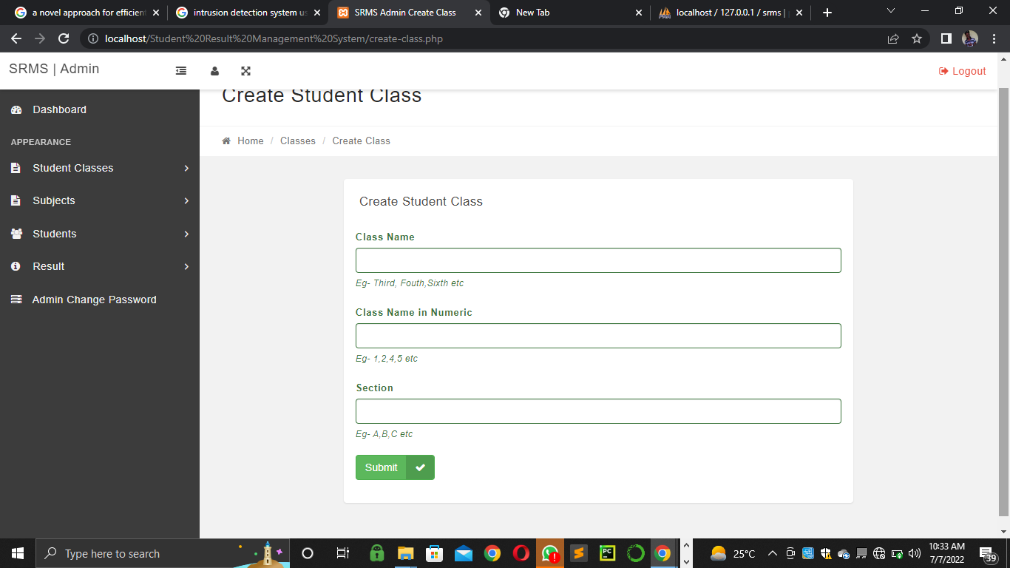Figure 4.1: Dashboard Page Screenshot

Figure 4.2: Manage Subject Page Screenshot
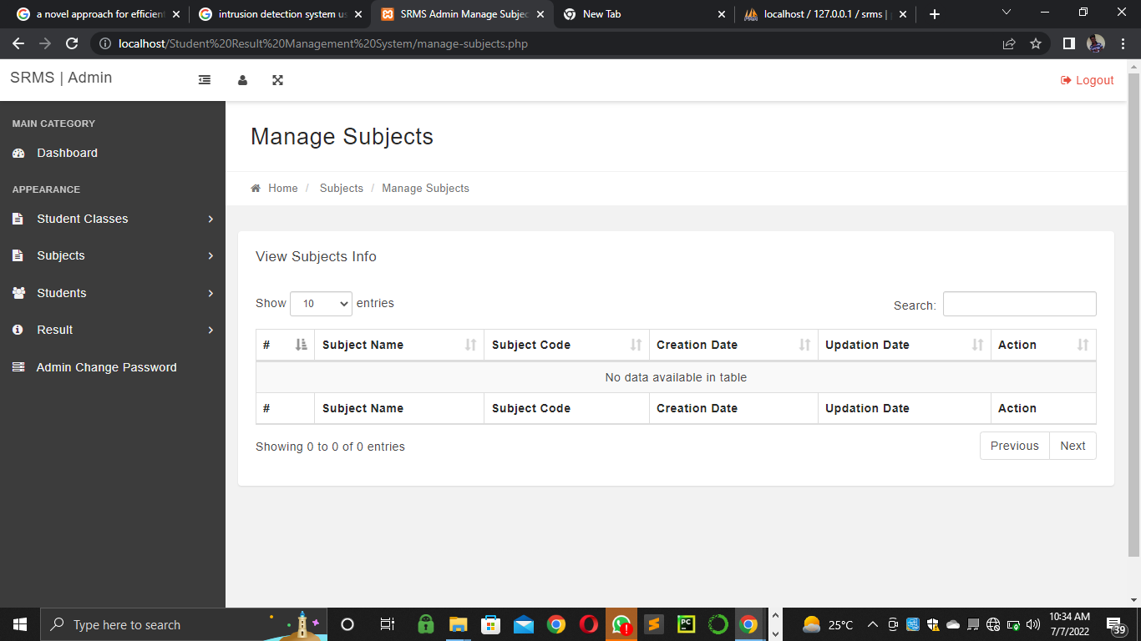

Figure 4.3: Student Admission Page Screenshot
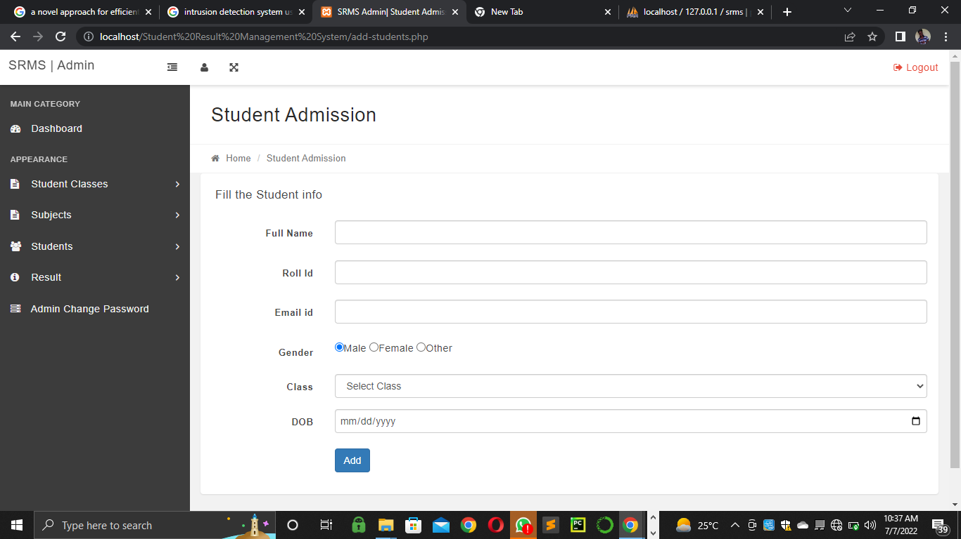
Figure 4.4: Student Report Management Page Screenshot
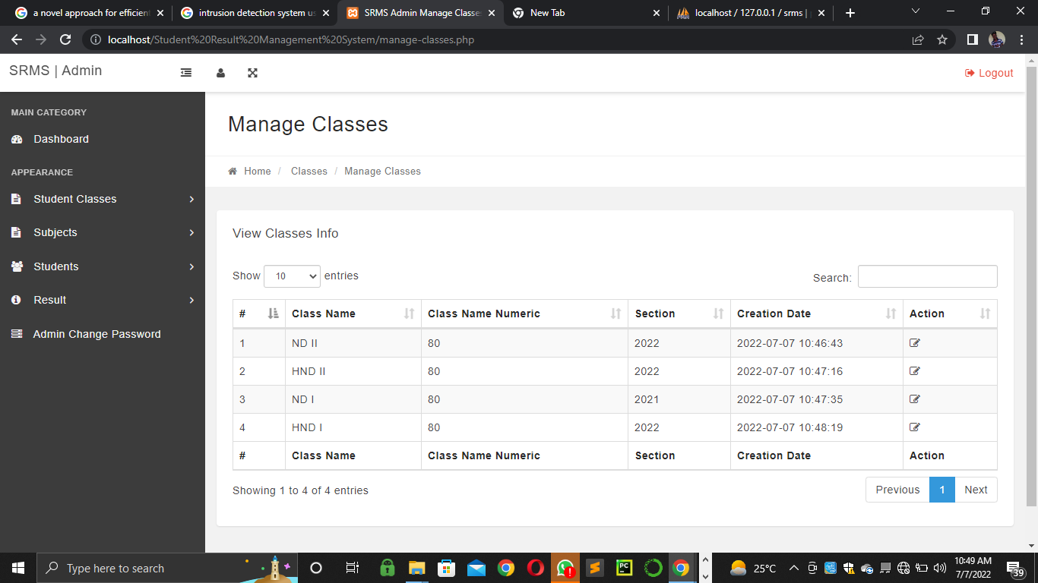

Figure 4.5: Subjects Management Page Screenshot
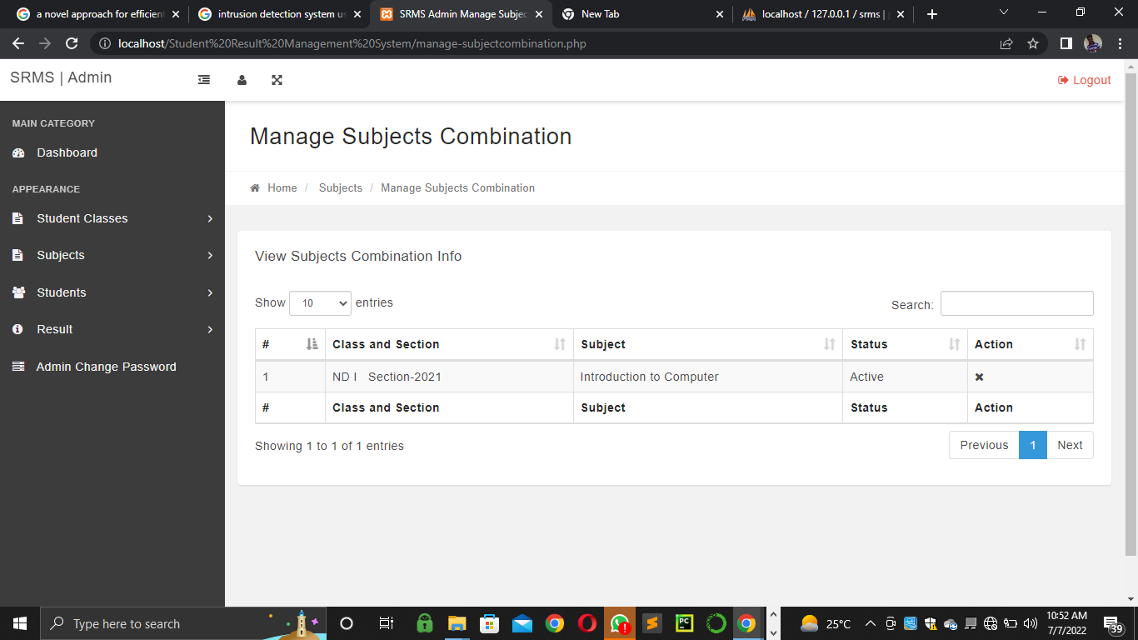

4.1.2 Input Design
Figure 4.6: Admin Page Screenshot
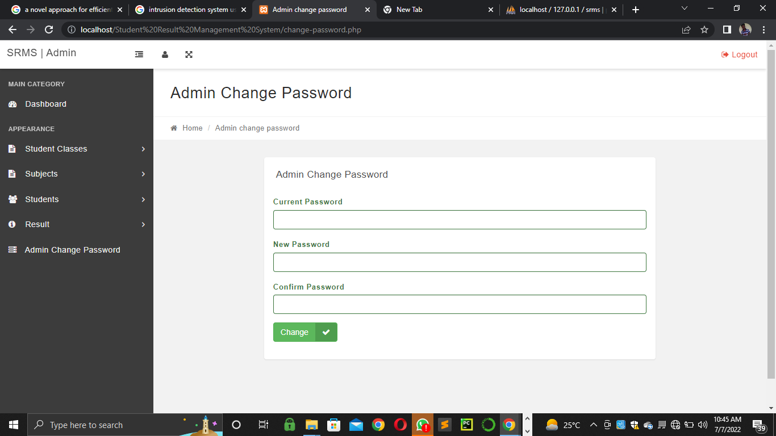

Figure 4.7: Display Subject Combination Screenshot
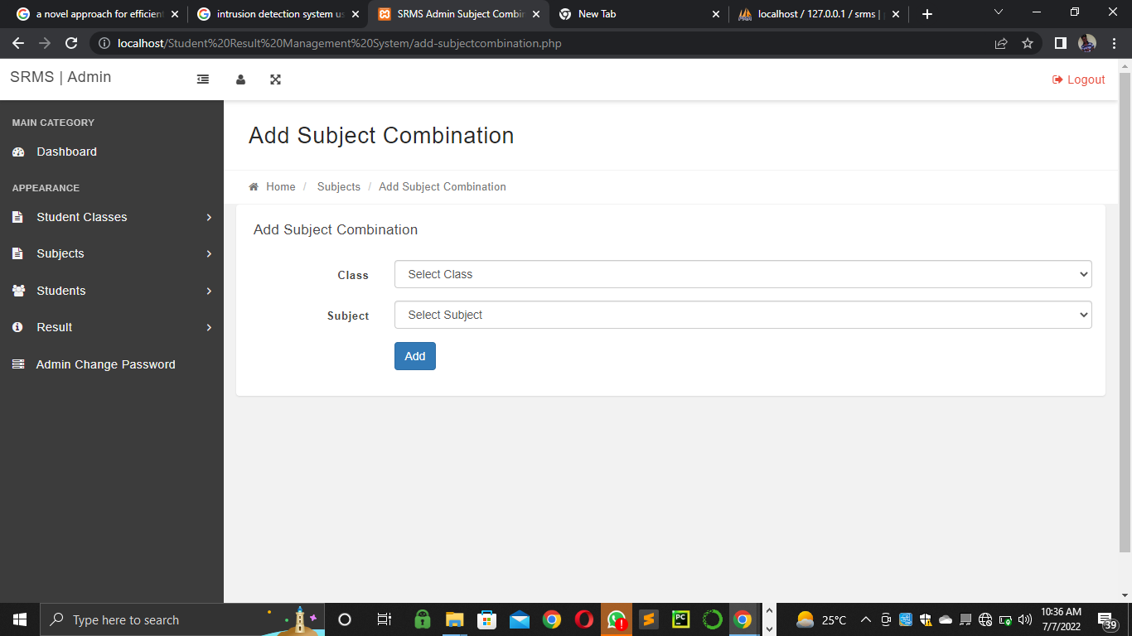

4.1.3 Database Design
Table 4.1: The administrator table in phpmyadmin
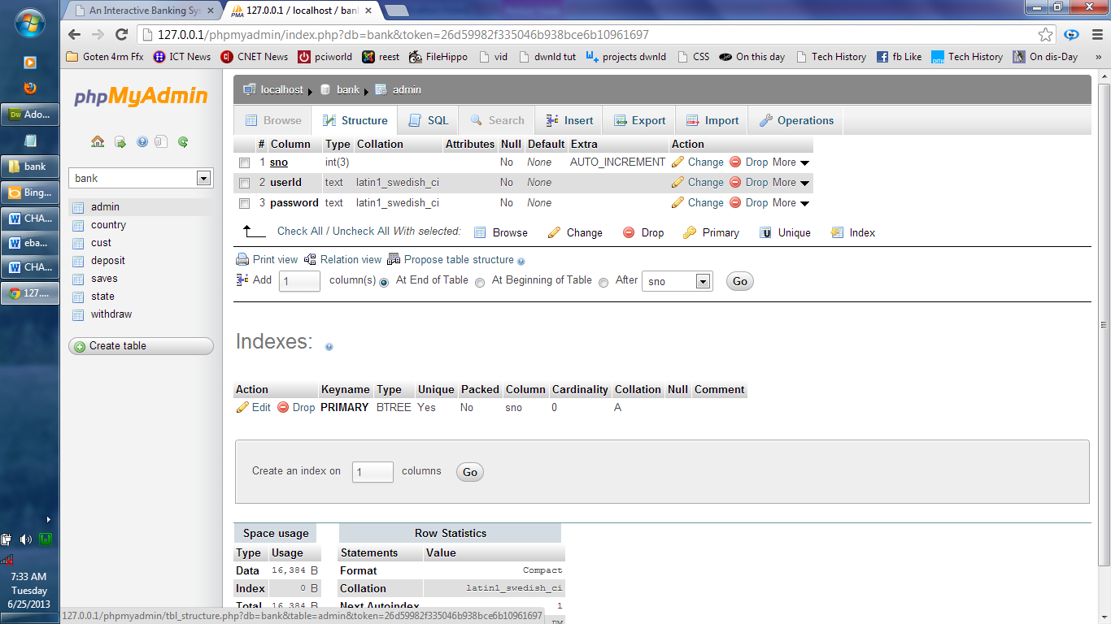

Table 4.2: The Students Report Table Structure

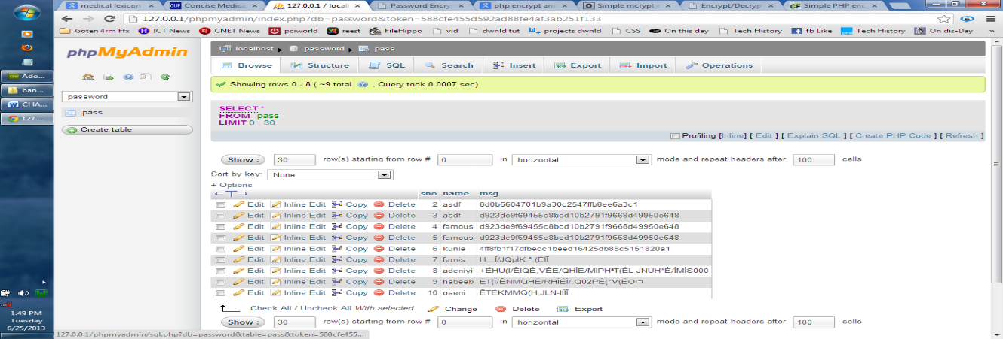

4.1.4 Procedure Design
The procedural design describes the system generally. It describes the various main programs in the system as well as the relationship that exist between all subprograms included. The procedural designs in this new system are of 5 menus of which each menu has it sub menu.
The application also contains several modules of which each module has its own specific function. The purpose of dividing the program into modules is because it enhances maintainability, readability and easy debugging.
4.2 System Implementation
4.2.1 Choice of Programming Language
C# is the chosen programming language for the implementation of the proposed system because of its pedagogy and open source help when needed. As well it has a support for variety of database application like sql server, sqllite, mysql, and Microsoft access but Microsoft Access is selected.
4.2.2 Hardware Support
The computer configuration required to run the software is;
Computer/memory processor PC with a 48dx, MHZ or Pentium, Intel or higher processor required.
Memory :512MB of RAM
Cache memory :512KB
Hard disk Minimum size : 10.2GB
Recommended : 40GB
Virtual Memory :32Bits
Cache memory :512KB
Floppy disk drive :1.44MB
4.2.3 Software Support
The software support for the design of the proposed system involves operating system, Microsoft visual studio, MYSQL as well as an anti-virus software which prevents the system from being infected by virus.

4.2.4 Implementation Techniques used in Details
The system will be implemented using the parallel approach. This approach is considered because it ensure that the new system is tested alongside with the old system to ensure the effectiveness and efficiency of the system.
4.3 System Documentation
4.3.1 Program Documentation
The system must be used as instructed according to the hardware and software supports so as to make optimal use of it.
4.3.2 Operating the System
- Click start on the computer desktop
- Select all programs
- Select any browser e.g internet Explorer, Mozilla Firefox, Google Chrome e.t.c
- Type the url (Uniform Resource Locator) of the system into the address bar (localhost/password/)
4.3.3 Maintaining the System
The following instructions must be strictly adhere to in other to make efficient use of the system. Install an anti-virus and always make sure it is usually updated to.

CHAPTER FIVE
SUMMARY, CONCLUSION AND RECOMMENDATION
5.1 Summary
An automated information management system makes information management much more convenient and efficient. This application is meant to ease the processing of students’ results in tertiary institutions with similar grading system. The application will be capable of storing and retrieving academic records with high speed and accuracy, and presenting useful information to its users. Its qualities are the reduction in the cost of processing students results (an example would be the cost of purchase of papers) reduction in the time spent in the computation of student’s grades and the elimination of duplication of resources in terms of manpower and infrastructure.
The system provides an efficient means of processing, preserving and displaying students’ results, academic records and other relevant notices to students. As part of its benefits, it is stress-free and speed-up the processing of students’ examination results. Finally, the system is flexible and runs on a web browser. It is reasonably secure, enforces data integrity from the use of a relational database management system, it also minimizes data redundancy and it is user friendly. With this application, the processing of students’ results is automated, thereby reducing processing time and increasing accuracy.
5.2 Conclusion
The present research was based on the computerization and the implementation of a sophisticated Web-Based Student Result Management System for the Kwara State Polytechnic. The main objective was to enhance and automate the management and declaration of students’ results using a computerized system. A well-defined, efficient, controlled and managed information system or software based on web technology storing, processing and providing information through the internet.
5.3 Recommendations
In near future, the system interface could be improved, with more attractive, interactive and meaningful images; Enhance the system with an email and SMS (Short Message Service) or email notifications; Enhance the current system by computerizing almost all of the services provided by the institution (online exams, enrolment, library and others), turning it into a complete LMS; And evolve the system by developing several versions through users’ feedback, if a complete solution has not been worked out. Having highlighted the usefulness of a computer based students result management system to schools, I recommend the following to be implemented in schools;
- They should computerize all the department of the school, to ensure easy flow of information in the schools.
- They should ensure that all the staff of the user department are adequately trained to ensure smooth implementation of the new system.
- Even after computerization of the whole department, they must ensure that all the system are linked to one central local network, protected with high security measures

REFERENCES
Ajinaja, P. (2017) The Design and Implementation of a Computer Based Testing System Using Component-Based Software Engineering. Dept. of Computer Science and Engineering, University of Ibadan South-West Nigeria, Africa IJCST Vol. 8, Iss ue 1, Jan - March 2017 ISSN : 0976-8491 (Online) | ISSN : 2229-4333
Bidyut, D., et al., (2021) “Automatic question generation and answer assessment: a survey. Research and Practice in Technology Enhanced Learning (2021) 16:5 https://doi.org/10.1186/s41039-021-00151-1
Carlos, F. (2019) design and implementation of an ARMv4 tightly coupled multicore in VHDL and validation on a FPGA) International Journal of Advanced Computer Science and Applications, Vol. 3, No. 11
Fagbola, T., M., et al (2020) Computer-Based Test (CBT) System for University Academic Enterprise Examination. International Journal of Scientific & Technology Research Volume 2, Issue 8, August 2013 ISSN 2277-8616
Karuna J K. and Indira R. B.(2018) Study on Virtual Private Network (VPN), VPN’s Protocols And Security” : Current Status and The Way Forward. Postgraduate student of the Bonch-Bruevich Saint-Petersburg State University of Telecommunications, Saint Petersburg
Kostadinova, I., et al (2019) “Analysis of Algorithms for Generating Test Questions in E-Testing Systems”. Conference Paper · July 2019 DOI: 10.21125/edulearn.2019.0498
Kurniawan D. E. , (2019) Implementation and analysis ipsec-vpn on cisco asa firewall using gns3 network simulator (IJACSA) International Journal of Advanced Computer Science and Applications, Vol. 3, No. 11.
Michael, S. (2017) design and implementation of a computer based testing system using component-based software engineering technology network simulator (IJACSA) International Journal of Advanced Computer Science and Applications, Vol. 2, No. 13
Muhammad I. & Imam R. (2018) writes and presented a journal on “Analysis of Security Virtual Private Network (VPN) Using OpenVPN” Master Thesis Electrical Engineering
Okoro O. & E.A Emmanuel (2017) A Wireless Network Infrastructure Architecture For Rural Communities. 15thinternational WWW Conference (May 2017). Edinburgh International Journal of Scientific Research in Computer Science, Engineering and Information Technology 2017 IJSRCSEIT | Volume 3 | Issue 5 | ISSN : 2456-3307
Rajagukguk, G. (2019) Computer Based Test (CBT) System for Student Academic Examination. Conference Paper · January 2019 DOI: 10.4108/eai.18-10 2018.2287186
Sebastian, M. & George D. (2012) presented a paper on “The Virtual Enterprise Network based on IPSec VPN Solutions and Management” Int J S Res CSE & IT. 2012 May-June; 3(5): 919-932\
Shahid, A. (2011) a journal titlled “OPNET Analysis of VoIP over MPLS VPN with IP QoS” (IJACSA) International Journal of Advanced Computer Science and Applications, Vol. 3, No. 11.
Tiamiyu, A. & Osuolale, H. (2012) also writes and present a journal titled “trusted routing vs. VPN for secured data transfer over ip-networks/ internet” Int J S Res CSE & IT. 2012 919-932

