DESIGN AND IMPLEMENTATION OF COMPUTERIZED FILE ENCRPTION AND DECRPTION

BY
ABDULAZEEZ QODRI OPEYEMI
ND/23/COM/PT/109

SUBMITTED TO THE DEPARTMENT OF COMPUTER SCIENCE, INSTITUTE OF INFORMATION AND COMMUNICATION TECHNOLOGY,
KWARA STATE POLYTECHNIC, ILORIN

IN PARTIAL FULFILLMENT OF THE REQUIREMENTS FOR THE AWARD OF NATIONAL DIPLOMA (ND) IN
COMPUTER SCIENCE

JUNE, 2025.
CERTIFICATION
This is to certify that this project was carried out by ABDULAZEEZ QODRI OPEYEMI with the Matriculation Number: ND/23/COM/PT/109 in the Department of Computer Science, Institute of Information Communication Technology, Kwara State Polytechnic, Ilorin, Kwara State.

…………………………………. ….………………………
MR. SADIQ, K. A. Date
Project Supervisor

…………………………………. ….………………………
MR. OYEDEPO, F. S. Date
Head of Department

…………………………………. ….………………………
External Examiner Date

DEDICATION
I dedicate this project work to the Almighty God who inspired me and directed my ways during my academic stay in the polytechnic.

ACKNOWLEDGEMENTS
All praise is due to the Almighty God, the Lord of the universe. I praise Him and thank Him for giving me the strength and knowledge to complete my ND program and also for my continued existence on Earth.
I appreciate the utmost effort of my supervisor, Mr. Sadiq, K. A. whose patience, support, and encouragement were the driving force behind the success of this research work. He gave useful corrections, constructive criticisms, comments, recommendations, and advice and always ensures that excellent research is done. My sincere gratitude goes to the Head of the Department, Mr. Oyedepo, F. S., and other members of staff of the Department of Computer Science, Kwara State Polytechnic, Ilorin, for their constant cooperation, constructive criticisms, and encouragement throughout the program.
Special gratitude to my parents, who exhibited immeasurable financial, support, patience, prayers, and understanding during the period in which I was busy tirelessly with my studies, special thanks go to my lovely siblings too.
My sincere appreciation goes to my friends and classmates.

TABLE OF CONTENTS
Title page i
Certification ii
Dedication iii
Acknowledgments iv
Table of Contents v
Abstract vi
CHAPTER ONE: GENERAL INTRODUCTION
1.1 Background to the Study 1
1.2 Statement of the Problem 3
1.3 Aim and Objectives 3
1.4 Significance of the Study 4
1.5 Scope of the Study 4
1.6 Organization of the Report 5
CHAPTER TWO: LITERATURE REVIEW
2.1 Review of Related Works 6
2.2 Review of General Texts 11
CHAPTER THREE: RESEARCH METHODOLOGY AND
ANALYSIS OF THE SYSTEM
  - Research Methodology 14
  - Analysis of the Existing System 16
  - Problem of the Existing System 17
  - Description of the Proposed System 17
  - Advantages of the Propose System 18
CHAPTER FOUR: DESIGN, IMPLEMENTATION AND
DOCUMENTATION OF THE SYSTEM
  - Design of the System 20
    - Output Design 20
    - Input Design 22
    - Database Design 23
    - Procedure Design 24
  - Implementation of the System 24
    - Choice of programming language 25
    - Hardware support 26
    - Software Support 26
4.2.4 Implementation Techniques used in Details 26
  - Program Documentation 27
    - Operating the System 27
    - Maintaining of the System 27
CHAPTER FIVE: SUMMARY CONCLUSION AND
RECOMMENDATION
5.1 Summary 29
5.2 Conclusion 29
5.4 Recommendations 30
References 31

ABSTRACT
In today's digital age, ensuring the confidentiality and integrity of sensitive information during storage and transmission is paramount. The exponential growth of data coupled with sophisticated cyber threats necessitates robust solutions for securing data at rest and in transit. Encryption plays a pivotal role in safeguarding data from unauthorized access, interception, and tampering. This project focuses on the design and implementation of a computerized file encryption and decryption system to provide a secure and user-friendly solution for data protection. The statement of the problem identifies critical challenges within data security and encryption technologies that necessitate the development of an advanced file encryption and decryption system. These challenges include the persistent threat of data breaches and cyber-attacks, which highlight the vulnerability of sensitive information. Existing encryption tools often suffer from usability issues, requiring technical expertise and manual intervention, thereby limiting their accessibility and effectiveness. Furthermore, these tools may not adequately defend against sophisticated cyber threats such as brute-force attacks or cryptanalysis, leaving data exposed to potential compromises. Performance overhead during encryption operations, especially with large files, can impact system efficiency and responsiveness, posing additional hurdles to seamless data protection. Usability concerns, such as complex key management and file handling, further hinder the widespread adoption and effectiveness of encryption technologies among users with varying technical proficiency levels. The software system to handle the task at hand is being developed with a high-level language. The platform selected is the Microsoft .NET Framework 4.5 with the C# language. This platform is developed by Microsoft and has being used in very complex systems which are currently in use today. The .NET Framework is an integral Windows component that supports building and running the next generation of applications and Web services.

CHAPTER ONE
GENERAL INTRODUCTION
  - Background to the Study
In today's digital age, ensuring the confidentiality and integrity of sensitive information during storage and transmission is paramount. The exponential growth of data coupled with sophisticated cyber threats necessitates robust solutions for securing data at rest and in transit. Encryption plays a pivotal role in safeguarding data from unauthorized access, interception, and tampering. This project focuses on the design and implementation of a computerized file encryption and decryption system to provide a secure and user-friendly solution for data protection (Shraddha & Rajesh, 2023).
Encryption is the process of converting plain text or data into an unreadable format (cipher text) using an encryption algorithm and a key. Decryption, on the other hand, reverses this process to convert cipher text back into its original form. This project involves the development of software that can automate these processes seamlessly, allowing users to encrypt and decrypt files with ease. Encryption can be broadly categorized into symmetric-key encryption and asymmetric-key encryption. In symmetric-key encryption, the same key is used for both encryption and decryption. Asymmetric-key encryption employs a pair of keys—a public key and a private key, where the public key is used for encryption and the private key is used for decryption (Francis & Sharad 2020).
The evolution of encryption methods has paralleled advancements in computing and mathematics. Early encryption techniques, such as the Caesar cipher used by Julius Caesar, have evolved into sophisticated algorithms based on complex mathematical principles. With the advent of public-key cryptography pioneered by Diffie and Hellman (1976), encryption techniques have become more versatile and secure, enabling secure online transactions and digital communications (Smith, 2022).
One of the key challenges in contemporary data encryption lies in balancing security with usability. While encryption technologies provide strong protection against unauthorized access, they must also be user-friendly and efficient to encourage widespread adoption (Brown & Green, 2021). Complex encryption processes or cumbersome user interfaces can deter users from implementing secure practices, leaving their data vulnerable to attacks (Jones, 2020). Therefore, the design and implementation of user-friendly encryption tools are crucial for enhancing data security across diverse user populations.
In recent years, encryption technologies have gained significant attention due to privacy concerns and regulatory requirements. Initiatives such as the General Data Protection Regulation (GDPR) in Europe underscore the importance of safeguarding personal data through robust security measures, including encryption (Johnson, 2019). Compliance with such regulations necessitates the implementation of effective encryption strategies within organizations to protect sensitive data and uphold privacy rights (Smith, 2024).
In summary, the background to this study underscores the critical role of encryption and decryption technologies in safeguarding digital information from evolving cyber threats. By exploring the historical evolution, contemporary challenges, and regulatory imperatives of encryption, this research seeks to contribute to the development of innovative and user-friendly solutions for secure data handling and communication.

  - Statement of the Problem
The statement of the problem identifies critical challenges within data security and encryption technologies that necessitate the development of an advanced file encryption and decryption system. These challenges include the persistent threat of data breaches and cyberattacks, which highlight the vulnerability of sensitive information. Existing encryption tools often suffer from usability issues, requiring technical expertise and manual intervention, thereby limiting their accessibility and effectiveness. Furthermore, these tools may not adequately defend against sophisticated cyber threats such as brute-force attacks or cryptanalysis, leaving data exposed to potential compromises. Performance overhead during encryption operations, especially with large files, can impact system efficiency and responsiveness, posing additional hurdles to seamless data protection. Usability concerns, such as complex key management and file handling, further hinder the widespread adoption and effectiveness of encryption technologies among users with varying technical proficiency levels.
  - Aim and Objectives of the Study
The aim of the project is to design and implementation of computerized file encryption and decryption system. The objectives are:
- To create an application that adds more security to data and file using Rijindael algorithm.
- To adapt the algorithm using C# programming language.
- To keep on unauthorized user from gaining access to content of data or file.

  - Significance of the Study
The study on computerized file encryption and decryption holds significant implications for modern information security practices. By developing robust encryption systems, this research aims to bolster data security, protecting sensitive information from cyber threats and unauthorized access. Additionally, understanding encryption technologies is crucial for regulatory compliance, ensuring that organizations adhere to data protection regulations like GDPR and HIPAA. Furthermore, encryption plays a vital role in establishing secure communication channels, especially in sectors where data integrity and confidentiality are paramount. By fostering trust and privacy in digital interactions, encryption technologies contribute to a safer online environment. Moreover, this research drives technological innovation in cybersecurity, addressing current encryption challenges and propelling advancements in data protection. Ultimately, the study not only empowers data owners to make informed decisions about security measures but also enriches academic discourse on encryption methodologies, serving as a valuable resource for students and practitioners in the field of information security.
  - Scope of the Study
The study will involve an in-depth review and analysis of various encryption algorithms, including symmetric and asymmetric techniques like AES and RSA, to understand their applicability and performance characteristics. A key aspect of the study will be designing and coding a software application with an intuitive graphical interface that allows users to encrypt and decrypt files efficiently.

  - Organisation of the Report
This is the overall organizational structure of the work as presented in this project write-up.
Chapter one of this project deals with the introduction to the general work in the project. It also entails the statement of the problem, aims and objectives of this project, the significance of the study, the scope and limitation of the study and organization of the report.
Chapter two deals with the review related journals and books, historical background of of the study, as well as computerization current state of the art.
Chapter three covers the methods used for data collection, description of the current procedure, problems of existing system, description of the proposed system and the basic advantages of the proposed web based application.
Chapter four entails design, implementation and documentation of the system. The design involves the system design, output design form, input design form, database structure and the procedure of the system. The implementation involves the implementation techniques used in details, choice of programming language used and the hardware and software support. The documentation of the system involves the operation of the system and the maintenance of the system.
Chapter five deals with the summary, experience gained, conclusion, recommendation and references.

CHAPTER TWO
LITERATURE REVIEW
2.1 Review of Related Work
The literature review in this chapter aims to explore existing research and studies related to computerized file encryption and decryption. This section will provide a comprehensive review of the relevant work conducted in the field, focusing on key topics such as encryption algorithms, system design, implementation approaches, and security considerations.
Noor & Aymen (2021) opined enhanced AES algorithm based on 14 rounds in securing data and minimizing processing time Computer, Internet technology have grown exponentially, and constant evolution until today. The usage of digital data such as text, images, audio, animation and videos are commonly used in many aspects of daily activity. The continuous increase in the use of digital data transmission over a network and it exposed to the various kinds of attacks, unauthorized access and network hacking. Thus, it is very hard to ensure that the digital data transmission are secure from any attacks and unauthorized access especially for sensitive and important digital data. This has been raised researcher’s concerns on security of the digital data. Digital data security has become one of the most important aspects in communication. Cryptography is one of the most important technology for protecting digital data. As there is need for secure communication, efficient and secure cryptographic processing is needed for desirable platform overall performance. Improvement of any communication platform with secure and complicated cryptographic algorithms incredibly relies on ideas of data safety that is essential within the current technological global. This paper propose a Secured Modified Advanced Encryption Standard Algorithm with decreasing the rounds of Advanced Encryption Standard (AES) to 14 rounds in order to minimize encryption and decryption process time and increasing digital data security as well. The results have been proved that the proposed technique provides higher efficiency in term of encryption and decryption process time compared to other researches while increase security which has been proved by using avalanche effect test (Noor & Aymen, 2021).

Fathurrahmad, (2020) opined development and implementation of the Rijndael Algorithm and base-64 advanced encryption standard (AES) for website data security the security of a website is absolutely analyzed and improvements are made to the web development framework to prevent data leakage, this study analyzes and modifies the Advanced Encryption Standard (AES) algorithm which can later be implemented on a website and tested and compared with the Advanced Encryption Standard (AES) algorithm. will be modified with the model that the researcher plans. The research objectives were, among others, to develop an algorithm that was modified from Base64 and Rijndael. The research stages consisted of a survey, implementation, and comparative analysis of the proposed modified algorithm. The results of research carried out through the encryption and decryption process by integrating the Base64 and AES Rijndael algorithms with the proposed algorithm so that it is known to improve data security better. If it is seen from the level of efficiency that the proposed algorithm can be used as a substitute for the Base64 algorithm. Whereas in the implementation, the proposed algorithm speed has good speed, it can be seen from the encryption process and the description and the resulting bits do not have a significant impact (Fathurrahmad, 2020).
Shraddha & Rajesh, (2023) also opined implementation of AES with time complexity measurement for various input Network Security has a major role in the development of data communication system, where more randomization in the secret keys increases the security as well as the complexity of the cryptography algorithms. In the recent years network security has become an important issue. Cryptography has come up as a solution which plays a vital role in the information security system against various attacks. This security mechanism uses the AES algorithm to scramble data into unreadable text which can only be decrypted with the associated key. The AES algorithm is limited only for text as an input. It also has, the more time complexity. So it suffers from vulnerabilities associated with another type of input and time constraints. So its challenge to implement the AES algorithm for various types of input and require less decryption time. The propose work demonstrate implementation of a 128-bit Advanced Encryption Standard (AES), which consists of both symmetric key encryption and decryption algorithms for input as a text, image and audio. It also gives less time complexity as compared to existing one. At the last stage comparing the time complexity for encryption and decryption process for all three types of input. This paper also demonstrates a side channel attack on the standard software implementation of the AES cryptographic algorithm.
Ezeofor & Ulasi, (2020) opined analysis of network data encryption & decryption techniques in communication systems analysis of network data encryption and decryption techniques used in communication systems. In network communication systems, exchange of information mostly occurs on networked computers, mobile phones and other internet based electronic gadgets. Unsecured data that travels through different networks are open to many types of attack and can be read, altered or forged by anyone who has access to that data. To prevent such an attack, data encryption and decryption technique is employed. In order to visualize the effect and evaluate the performance of the encryption and decryption of each technique used in communication systems, Visual Basic simulation program that encrypt and decrypt data were developed, written and tested. Different data block sizes were captured and plotted against total time response taken during data encryption using Microsoft Excel. The graph result shows the superiority of RSA and AES algorithms over other algorithms in terms of the processing speed and time. DES has worm holes in its security mechanism whereas Blowfish, AES, and RSA do not have any. Further analysis was made based on the graph result obtained on each data encryption techniques.
Suchita & Seema, (2022) opined file encryption, decryption using AES algorithm in android phone nowadays smart gadgets including smart phones and tablets are gaining huge popularity. Comparing with conventional computer, smart phone is easily carried out and provides much computer functionality, such as processing, communication, data storage as well as many computers services such as web browser, video or audio player, video call, GPS, wireless network. However, smart phone have to come long way in terms of security. Encryption is used for security of information in data storage and transmission process. Various encryption algorithms like DES, 3DES, Blowfish, RSA and others are available to secure the data. In DES, key size is too small. In 3DES, key size is increase but the process is slower than other methods. We have used Advanced Encryption Standard algorithm to overcome above problems. AES algorithm is not only for security but also for great speed. It can be implemented on various platforms especially in small devices like mobile phone. Everyday data is shared, transmitted, stored for many purpose like banking, production, research and development. Hence, we need security for information. Encryption can provide security. This application allows user to run this application on android platform to encrypt the file before it is transmitted over the network. It is used for all type of file encryption such as text, docx, pdf and image encryption. AES algorithm is used for encryption and decryption.
Aditya, et al, (2023) also opined securing files using AES algorithm Nowadays information systems play a vital role for organizations and individuals, in which the security is given the high priority. Often, solutions are developed for very similar problems over and over again. In this paper, the files are encrypted and stored in the disk by using a secret key and asking for the same secret key while decrypting. The algorithm used in this system is Advance Encryption Standard (AES). AES-128, AES-192 and AES-256 represents the encryption key sizes (128 bits, 192 bits and 256 bits) and in their number of rounds (10, 12, and 14, respectively) required to open the vault that is wrapped around the data. In this algorithm, encryption is done by interchanging some of the characters with key and data in it. The encrypted files are set to be read only, so that the data in the files cannot be tampered. The main feature of the system is disabling the delete option in the right click menu for the encrypted files. This provides more security for the files on the disk.
Anshu & Ashish, (2022) opined enhancing file security by rijndael algorithm using combination of other new generation security algorithms the one of the famous algorithm is Advanced Encryption Standard (AES) that is used Rijndael Algorithm. The cipher standard algorithms selected, by a Rijndael algorithm because of its high performance of security. In this paper used for file security three different kinds of algorithms i.e. RIJNDAEL, Initialization vector (IV), SHA512 Hashing algorithm these three popular algorithms are used for file encryption and decryption approach. The first is the Rijndael algorithm used for file encryption/decryption it is using a key and Initialization vector (IV), the second Initialization vector algorithm is for encrypting the first portion of data to be encrypted and the third one is SHA512 Hashing algorithm takes a string and transforms it into a fixed size the same or 512 bits of data string. The encryption and decryption operation used to increase the strength of security and high performance provides for file security.
Mahalakshmi & Kuppusamy, (2022) opined a new technique for Image encryption using RIJNDAEL block cipher algorithms visual encryption is most important in transferring image through the communication networks to protect it against reading, alternation of its content, adding false information or deleting part of its content. The block cipher Rijndael algorithm is used to encrypt and decrypt an image with a variable block length, and a variable key length. This paper focused on the quality measurements such as the speed, Encryption Ratio, Correlation Coefficient, Visual Degradation, and Compression Friendliness of the JPEG image encryption with the existing bitmap image encryption. Since, the JPEG files are of compressed format, the compression friendliness is measured here. The result ends with the comparison of performance parameters, based on the type of file formats.
Francis & Sharad, (2020) also opined rijndael algorithm for database encryption on a course management system effectiveness of any software system depends on techniques employed during access, storage, and retrieval. Securing a course management system with the latest security approaches is vital since it can contain information about students and faculty. Encryption is the most efficient way of securing data stored as it ensures that integrity of data is maintained even if an attacker should gain access to the physical data in the database. Encryption can occur at different levels starting from data, disk to the entire device. This paper presents the implementation of Rijndael Algorithm for a database encryption on a Course
Management System, to provide an additional level of security to the information of students, faculty and overall data of the software. We have also provided benefits and drawbacks of various database encryptions based on the amount of data encrypted and the modes of access to keep a balance between efficiency and security. Furthermore, we apply these techniques on a web interface which uses Microsoft technologies to accept users’ login details, goes though encryption process, and stores cipher text in the database (Francis & Sharad, 2022).

2.2 REVIEW OF GENERAL STUDY
The review of general studies in this chapter encompasses a broad exploration of research and literature related to computerized file encryption and decryption. This section aims to provide a comprehensive understanding of the fundamental concepts, methodologies, and applications within the domain of data security and cryptography.
Cryptography is the science of using mathematics to encrypt and decrypt data to keep messages secured by transforming intelligible data form (plaintext) into unintelligible form (ciphertext). The term cryptography has come from the Greek word “kryptós” standing for “hidden” and “gràphin” standing for “writing”. Thus, the proper meaning of cryptography is “hidden writing”. Any cryptosystem consists of plaintext, encryption algorithm, decryption algorithm, Cipher text, and Key. Plaintext is message or data which are in their normal, readable (not encrypted) form. Encryption is the process of converting plaintext to cipher text by using key. Cipher text results from encryption by applying the encryption key on the plaintext. Decryption is the process of retrieving the plaintext back from the cipher text. The Key is used info to control the cryptosystem (cipher system), and it is known by the sender and receiver only (Marwa, Abdelmgeid & Fatma, 2016). While cryptography is very powerful for securing data; the cryptanalysts could success to break the ciphers by analyzing the contents of cipher text to get back the plaintext. Cryptographic systems are generally classified into three independent dimensions:
- Type of Operation on Plaintext: There are two types of operations that are occurred on plaintext to transform plaintext to cipher text. According to the first operation, each element in plaintext (i.e., bit, letter, group of bits or letters) is substituted for one another in the ciphertext. In this type of operation, a one-to-one mapping between the elements such as Caesar cipher. The principle of the second type of operation is that each character in plaintext is transposed with one another based on a mapping dictated by the key. In this type, the plaintext characters stay the same but they are just moved into different positions such as Rail Fence cipher. Most systems, referred to as product systems, involve multiple stages of substitutions and transpositions.
- The Number of Used Keys: If the sender and the receiver use one key to encrypt and decrypt the plaintext, the system is referred to as symmetric, single key, secret key or conventional encryption. Symmetric encryption is fairly straightforward and very fast. If the sender and receiver use different keys, public key and private key, to encrypt and decrypt the plaintext respectively, the system is referred to as asymmetric, two – key, or public key encryption.
- The Way in which The Plain Text is processed: Block cipher operates on fixed-length groups of bits, called blocks, and produces an output block for each input block. A stream cipher operates on each plaintext element continuously, and produces one element at a time, as it goes along. On the other hand, Steganography is considered the art and science of hiding information in other information. The word Steganography is derived from the Greek words “steganos” meaning “impenetrable” and, “grafia” meaning “writing” defining it as “impenetrable writing”. There are two common techniques for image embedding in steganography; spatial domain and transform domain.

CHAPTER THREE
RESEARCH METHODOLOGY AND ANALYSIS
  - Research Methodology
The software system to handle the task at hand is being developed with a high-level language. The platform selected is the Microsoft .NET Framework 4.5 with the C# language. This platform is developed by Microsoft and has being used in very complex systems which are currently in use today. The .NET Framework is an integral Windows component that supports building and running the next generation of applications and Web services. This platform provides a huge base of classes, method, UI objects, data objects and external interactions which makes the implementation of the Rijndael algorithm faster than it could be.
Overall System Dataflow Diagram
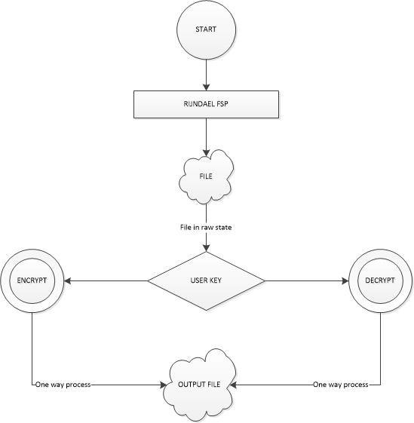
Figure 3.1: The system dataflow diagram
Source: Project design documentation

Algorithms for Each Module
Below are the necessary steps taken to achieve the basic tasks from various modules which demonstrate how the application will work.
Using this application requires you to;
- Enter the application password which will be set on first usage
- The code is entered using buttons instead of the keyboard to avoid key logging spywares
- If code is correct; click on the green button to continue
- Else click the red button to clear and restart process.
3.2 Analysis of the Existing System
The manual system for file encryption and decryption relies on simplistic cryptographic methods and manual processes to secure data. In this system, encryption keys are generated manually and shared securely between parties. Encryption techniques include basic substitution or transposition methods, where each letter of the plaintext is replaced or rearranged according to a predetermined pattern or key. Decryption involves applying the reverse process using the same encryption key to recover the original message. However, manual encryption processes are labor-intensive, susceptible to human error, and impractical for modern security needs due to scalability limitations and inherent vulnerabilities in key management and sharing. While historically significant, manual encryption methods highlight the evolution towards computerized systems that automate encryption processes, employ advanced cryptographic algorithms, and enhance overall security and efficiency in protecting sensitive data.
3.3 Problems of Existing Procedures
The existing manual procedures for file encryption and decryption face several significant challenges and limitations that underscore the need for modern computerized solutions. This section will outline the key problems associated with manual encryption procedures:
- Security Risks: Manual encryption processes often rely on simplistic techniques like basic substitution or transposition, which are vulnerable to cryptanalysis and brute-force attacks.
- Limited Scalability: Manual encryption procedures are not scalable for large volumes of data or complex encryption requirements.
- Usability Challenges: Manual encryption methods require specialized knowledge and training, limiting widespread adoption and usability.
- Key Management Issues: Manual key generation and distribution are prone to human error and lack centralized control, leading to potential security vulnerabilities.
- Lack of Automation: Manual encryption procedures lack automation and rely heavily on manual effort for both encryption and decryption tasks.
- Difficulty in Key Exchange: Secure key exchange between parties in manual encryption systems requires physical or secure communication channels, which can be cumbersome and impractical.
3.4 Description of the Proposed System
The new computerized system for file encryption and decryption offers advanced security and efficiency through automated processes and modern cryptographic techniques. Users can select encryption algorithms such as AES or RSA based on security needs, and the system automatically generates and manages encryption keys securely. Encrypted files are transmitted and stored securely using protocols like HTTPS or SFTP to protect data during transfer and storage. A user-friendly graphical interface simplifies file encryption and decryption tasks, allowing users to select files, input keys, and manage encryption parameters seamlessly. The system prioritizes performance optimization for fast encryption and decryption speeds while minimizing resource usage. Additionally, robust security features include automated key management, secure key transmission, and auditing capabilities to track encryption activities and respond to security incidents promptly. Overall, the system integrates seamlessly with existing infrastructure, providing a comprehensive solution to modern information security challenges.

3.5 Advantages of the Proposed System
The proposed computerized system for file encryption and decryption offers several advantages over existing manual procedures and traditional encryption methods. This section highlights the key benefits of the proposed system:
- Enhanced Security: Advanced Encryption Techniques: The system supports modern encryption algorithms (e.g., AES, RSA) that provide robust security against unauthorized access and cryptographic attacks.
- Secure Transmission and Storage: Encrypted files can be securely transmitted over networks and stored with strong encryption, protecting data confidentiality and integrity.
- Improved Efficiency and Usability: Automated Processes: Automation of encryption and decryption processes eliminates manual effort and reduces the potential for human error, improving efficiency.
- User-Friendly Interface: A graphical user interface (GUI) simplifies the encryption and decryption tasks, making it accessible to non-technical users and enhancing overall usability.
- Scalability and Performance: Optimized Performance: The system is designed for optimized performance, offering fast encryption and decryption speeds while minimizing resource utilization.
- Scalability: Automated processes and efficient encryption techniques enable the system to scale effectively for large volumes of data and complex security requirements.
- Comprehensive Key Management: Centralized Control: The system provides centralized control over key management, ensuring secure key generation, distribution, and revocation.
- Secure Key Exchange: Encryption keys are exchanged securely using encryption techniques, preventing interception during key transmission.
- Auditing and Monitoring: Security Auditing: Auditing and monitoring capabilities track encryption activities, key usage, and security events, enabling administrators to detect and respond to security incidents promptly.

CHAPTER FOUR
IMPLEMENTATION AND DOCUMENTATION OF THE SYSTEM

4.1 DESIGN OF THE SYSTEM
Generally, all efforts are geared toward designing a system program that eliminates all the setbacks of the existing manual method. This new approach is simple, efficient and guaranteed.
The proposed is designed in order to meet the goal and objective of the organization. The design of the system is intended to solve the various problems encountered in transferring of filess
4.1.1 OUTPUT DESIGN
It refers to the report expected to be generated from files in database. The generated reports are lists of view, index page e.t.c.. Below are the snapshot of the output designs.

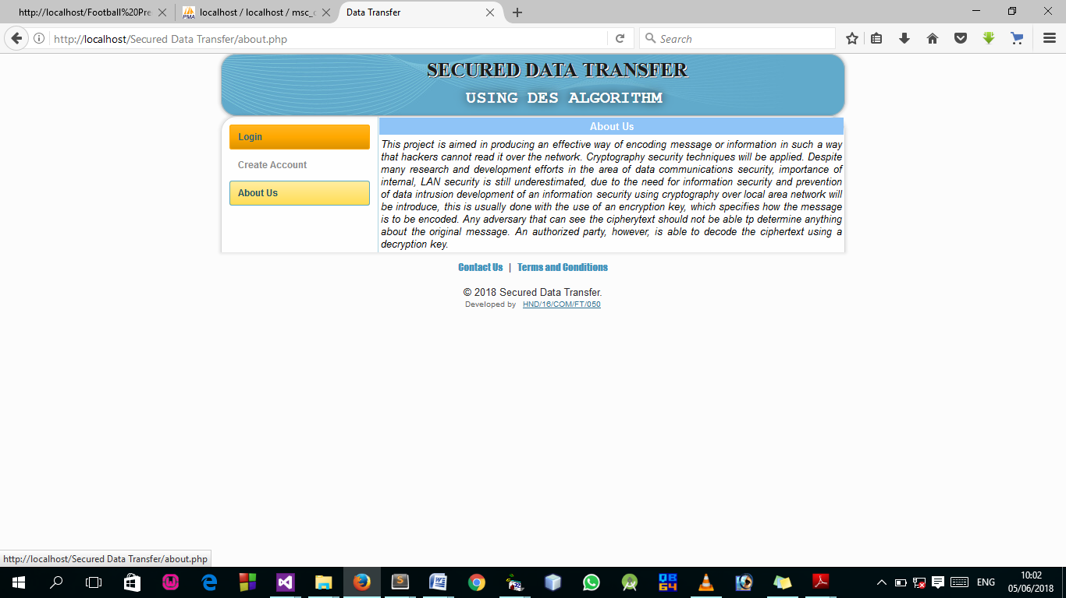
FIGURE 4.1: Index page output design: This is the welcome page

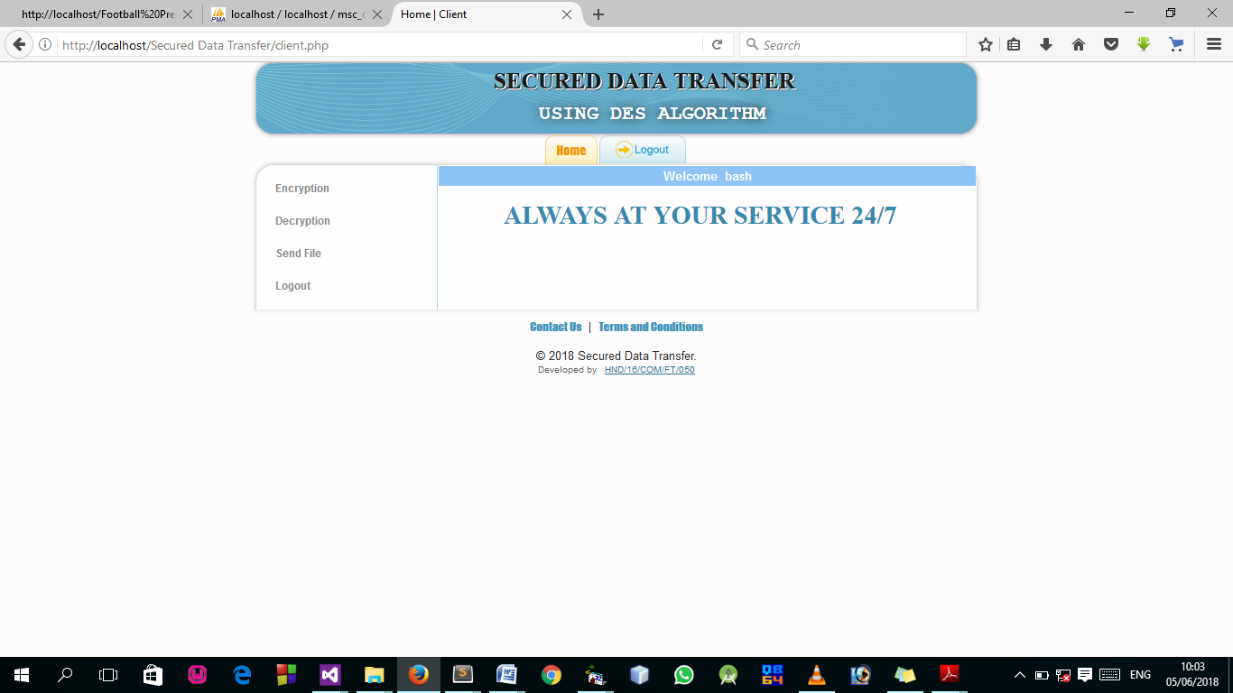
FIGURE 4.2: Dashboard Output Design: This is the page showing Encryption, Decryption, Send file and Logout. A click on any of this will channel the user to another page.
4.1.2 INPUT DESIGN
Design is a way of mapping and arranging part into a whole, which satisfies the objective involved. The input design refers to the type of all data used to feed information into the database via the program and the format and the input used for the system. Below are the snapshots of the input designs

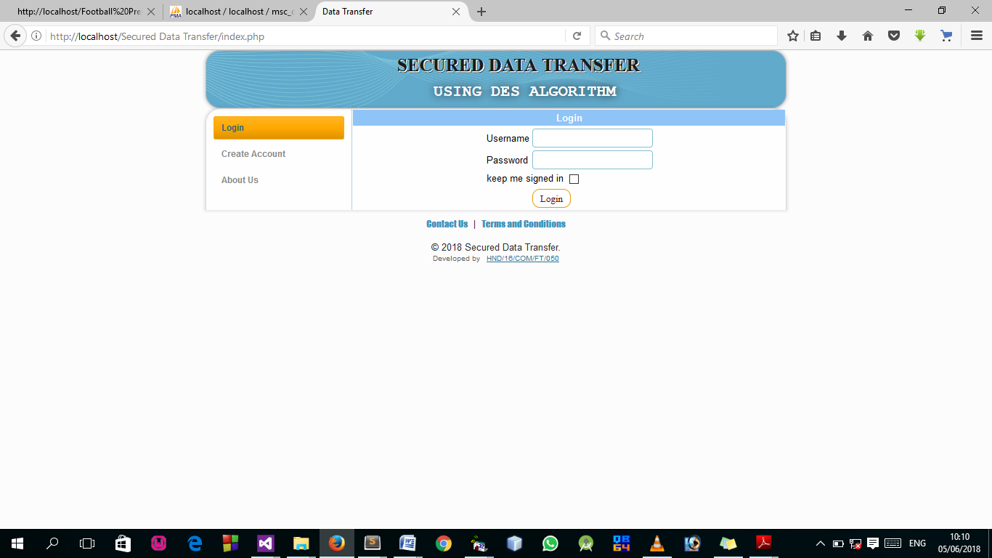
Figure 4.3: Login Page Screenshot: This is the user login page.

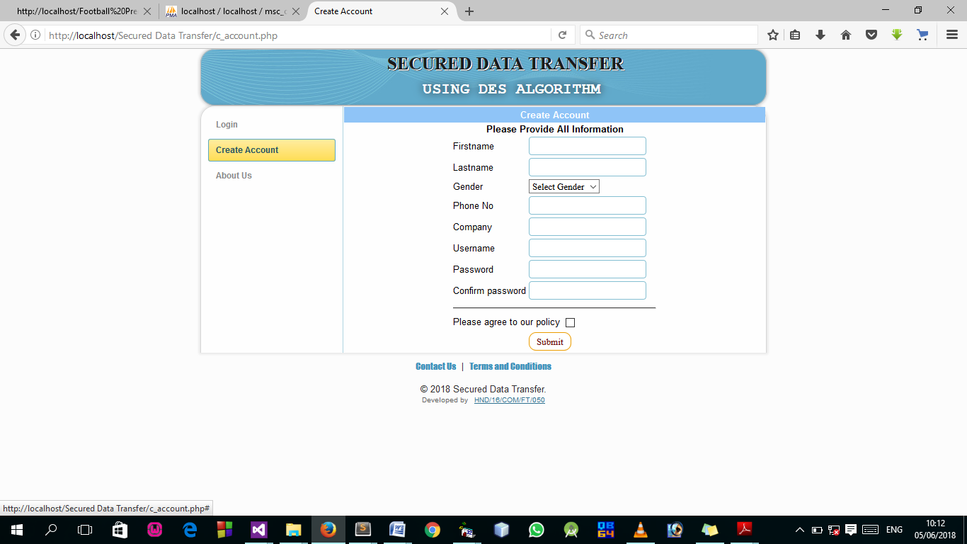
Figure 4.4: Registration Page Screenshot: This is the page for creating account.

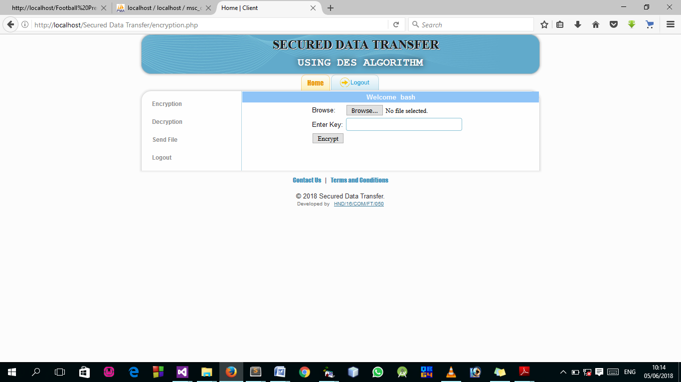
Figure 4.5: Encryption Page Screenshot: This is the page where users input data to Encrypt
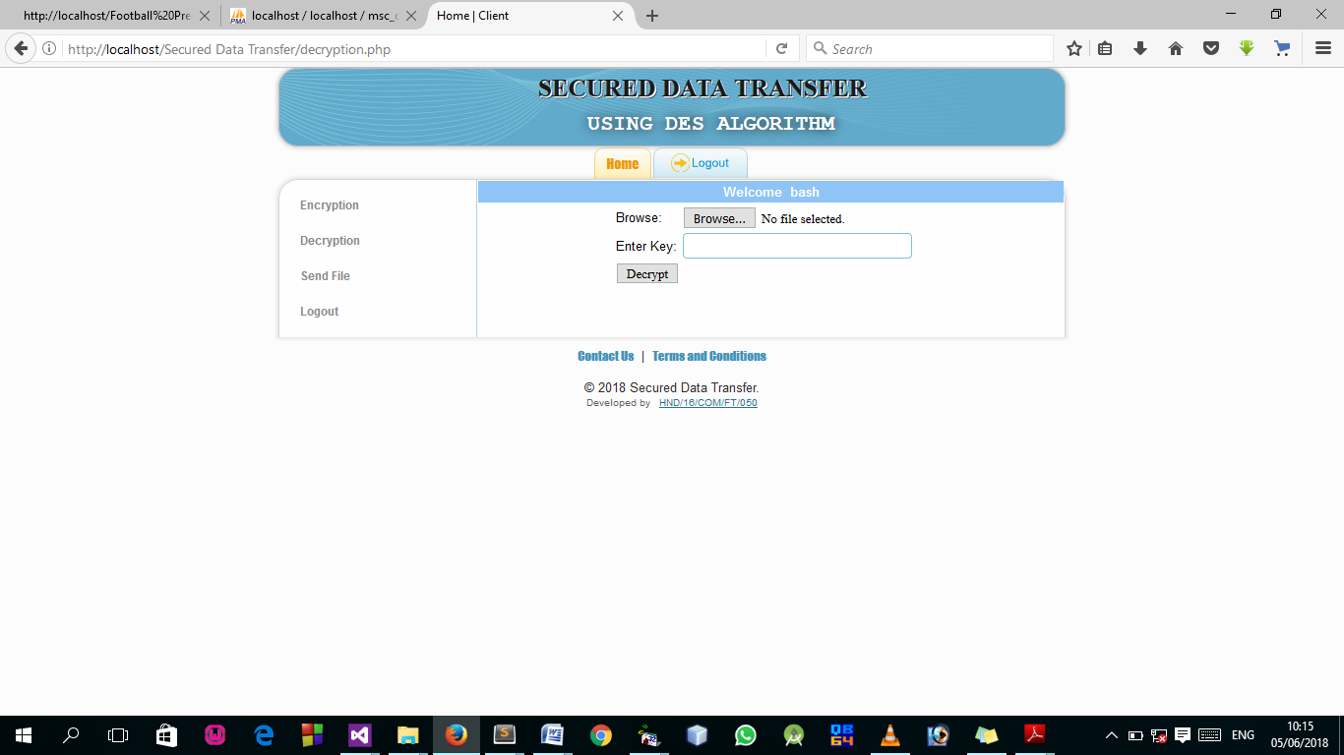
Figure 4.6: Decryption Page Screenshot: This is the page where users input data to Decrypt

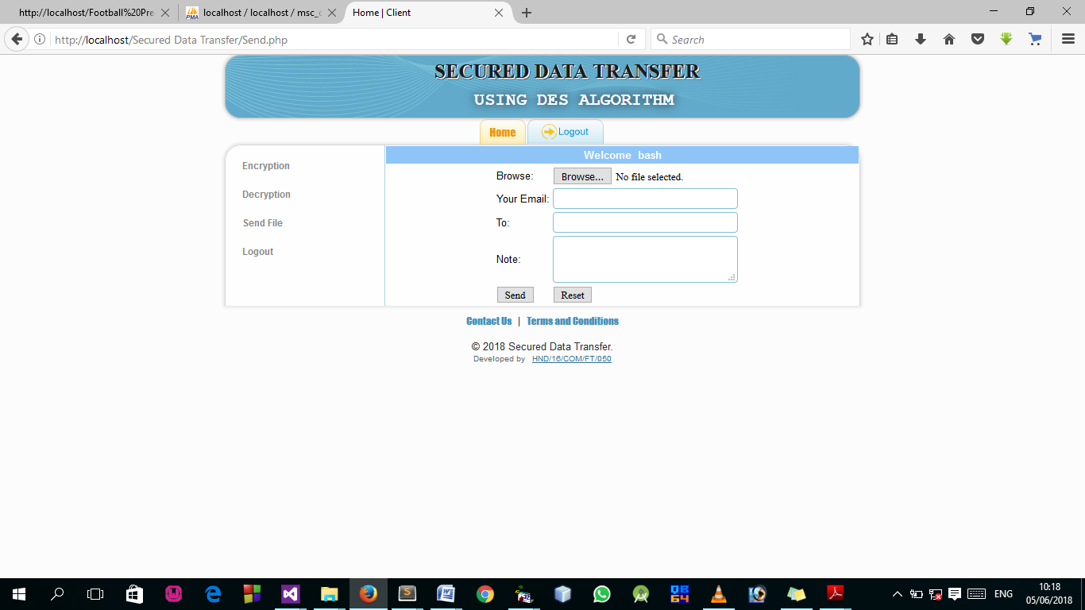
Figure 4.6: Send File Page Screenshot: This is the page where users input their email and specify where to send the file.

4.1.3 DATABASE DSIGN
Database entails the organization and access mode that are implemented in carrying out our specified operations upon the records of the file.
The files used in this system have records that have been organized randomly (random organization) and for this purpose, it will be more appropriate to access the records of the files randomly (random access mode).
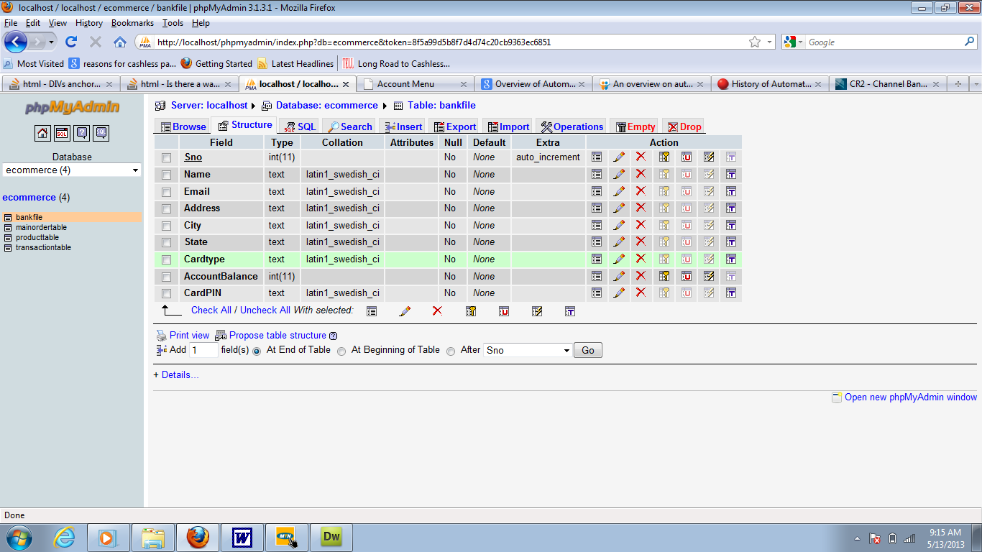
Figure 12: Encryption table structure: This is a database where all information entry or data are displayed are stored.
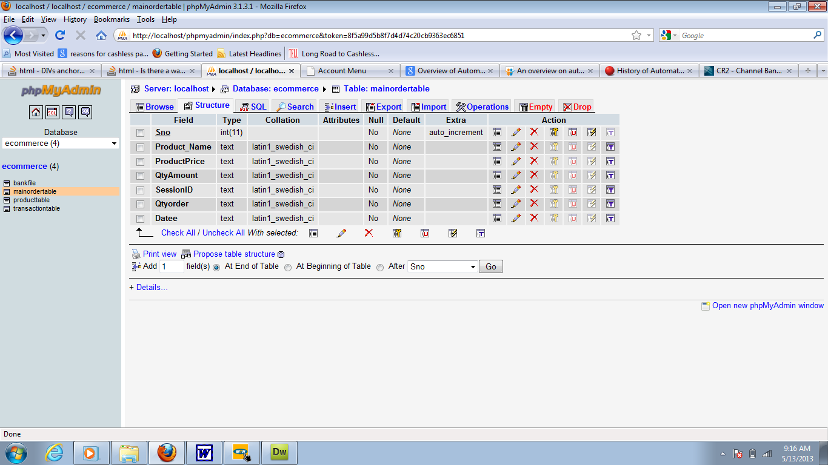

Figure 13: Customer table structure: This is a database where user entry or data are displayed are stored.
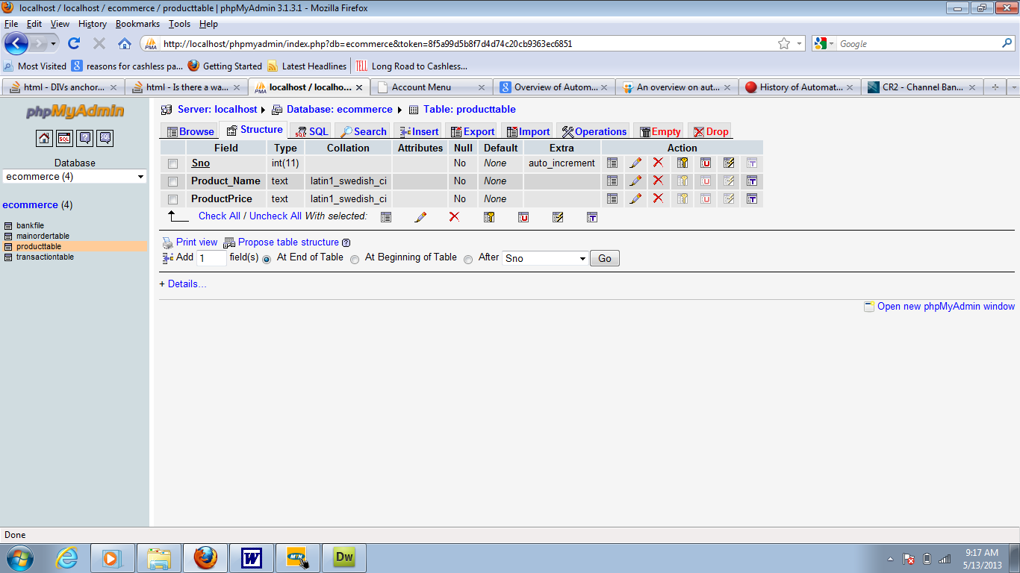
Figure 14: User page: This is a database where the admin entry or data are displayed are stored.

4.1.3 PROCEDURE DESIGN
Procedures are steps which verify the whole process i.e which are everything put together to produce the desired output. This involves the organization of the source document and end with the output result.
Documents are sent to various departments to be filled by the employees and later returned to the personnel department which are analysed to determine which record goes into the computer.
After selecting the necessary data, this serves as input to the computer system.

4.2 IMPLEMENTATION OF THE SYSTEM
It is always good to develop new ideas, to implement them on a computer and eventually to relish the satisfaction of achieving a successful result. The implementation process involves converting the system design into a complete and tested EDP that is fully operational and that can be used by the system users to meet their business needs. During implementation phase, the hardware and the software must be implemented.
Implementation of a system can be explained in six steps:-
1. Review design specification
2. Code, test and document programs
3. Train users
4. Perform system test
5. Convert to new system
6. Evaluate and maintain the new system

4.2.1 CHOICE OF PROGRAMMING LANGUAGE
The application is designed in Adobe CS4 Dreamweaver web development package which involves the use of PHP server-side scripting language, MYSQL for database management and HTML (with other embedded functionalities) for the page design and layout settings. Hence, the program testing simply involves running it directly from a Mozilla Firefox web browser on local host server provided by Apache 2.0 in WampServer 2.0 application.
In preparation for the installation of the new system, the method of changeover is given serious consideration to determine the success of the new system. Suitable changeover technique for this system is pilot changeover. The pilot changeover operates by applying the new system bit-by-bit until it covers the whole of the operations. The result obtained from using the pilot method on a small portion of the operations would be used in determining the suitability of the need system for the rest of the operations. This method is similar to testing small sample of a distribution if the test yields a good result then the whole system because fully operational and the manual/existing system is eliminated.

4.2.2 HARDWARE SUPPORT
The computer configuration required to run the software is;
Computer/memory processor PC with a 48dx, MHZ or Pentium, Intel or higher processor required.
Memory: 2GB of RAM
Cache memory: 512KB
Hard disk Minimum size 500GB
Recommended 200GB
Virtual Memory 32Bits
Cache memory 512KB

4.2.3 SOFTWARE
I. Interface Design Language, windows Notepad for help interface design Hypertext Mark-up Language (HTML)
ii. MY SQL Database Management Software
iii. Programming PHP (Hypertext Pre-processor)
iv. Operating system window 07 professional
v. Graphic software paint shop and choosing these two formats GIF (Graphic Image Format)
vi. Scanner software, Mira scans
- Web browser software MOZILLA

4.3 PROGRAM DOCUMENTATION
4.3.1 OPERATING THE SYSTEM
Step 1: Boot your computer and click on start button on task bar
Step 2: Launch WampServer
Step 3: Create an account for a user
Step 4: Click on Options
4.1 Login a user
4.2 Click on Encrypt (to encrypt a file)
4.3 Click on send file (to browse and send encrypt file)
4.4 Click on Decrypt (to download file)
4.5 Click on Decrypt (to decrypt the file)
Step 5: Logout

4.3.2 MAINTAINING THE SYSTEM
The use of the term maintenance for software is different from other references to maintenance. Unlike the tires on your car, software does not “wear out”. If this is the case, then why does software maintenance account for such a high percentage of the Total Cost of Ownership for software?
The software maintenance definition refers to changes for defect correction, performance improvements, or adaptations to a changed environment (enhancements). According to this definition, if we build software that is defect-free, performs well, and contains user-controlled parameters to adjust processing rules in response to changing requirements then most maintenance would not be necessary.
Why does this happen? There are many reasons but the most common reasons are time constraints and lack of experience. Adding validation logic takes time. So, people make assumptions about the quality of in-bound data. Assumptions are also made about the volume of transactions and the impact on performance and the stability of the automated business processes. Finally, it is common for new software to be developed by younger developers who don’t understand the maintenance impacts of their designs.
The reality is that business requirements change and most of these assumptions are flawed. Transaction volumes increase, changing business processes require new transactions or new validation criteria, and software users will use the software incorrectly. The cost of software maintenance and the total cost of ownership can dramatically be reduced if developers build software that adjusted to changes in transaction volumes; validated all inbound data and provide user-configurable options for decision logic and data validation.

CHAPTER FIVE
CONCLUSION AND RECOMMENDATIONS
5.1 SUMMARY
In this system, I have proposed an efficient data encryption and data decryption algorithm to protect the outsourced sensitive data in cloud computing environment. With data encryption, data owner can utilize the benefits of file splitting to reduce storage and computational overheads. On the other hand, to reduce the burden of data owner, trusted third party is introduced for verification of authorized users to access the data from cloud server. We demonstrate the performance of encryption and decryption algorithms in terms of data privacy, computational efficiency and effectiveness of the cloud storage system. On top of this architecture, we can also demonstrate for dynamic block level operations on encrypted data blocks for insertion, deletion and update, which we consider is our improvement future work.
5.2 CONCLUSION
It is concluded that, Cryptography is one of the first lines of defense against hackers and crackers in today’s world. Web Based File Sharing System is a very reliable means of transferring files which ranges from client to client i.e. user to user without delay in delivery.
Thus, it will stay important for a long time to come as it has for thousands of years since Caesar first invented the Caesar cipher in an era before the birth of Christ. The primary goals of this work were to produce a performance comparison between traditional cryptanalysis methods and genetic algorithm (GA) based methods, and to determine the validity of typical GA-based. Methods in the field of cryptanalysis. The focus was on classical ciphers, including substitution, transposition. The encryption decryption by using this new concept definitely will be and effective and better method for the point of view of information security.

5.3 RECOMMENDATIONS
It is recommended the new system to any organization or enterprises to implement the system to their day to day basis for the effective secured of transfer of data.
And the training staff should be organized for the usage of the new system. This is very essential, especially if the staff do not have electronic data processing and computer operating experience. The training must be supervised by the system designer / programmer and presentation of the new system must be carried out. The old and the new system should be run completely and concurrently using of some input from the old system until the new system proves to be satisfactory by the coordinating committee.

REFERENCES

Adams, R.T. (1991). Information Communication Technology and Nigerian Banking Industry, Journal vol 6, pg 18-32, Mill world Press.
Adelabu, Y.R. (1999). The analysis of Acceptance of Internet banking in Nigeria Banking industry, Macmillan Company limited.
Aganga, F.A. (1991). Movement of Computer System in broader perspective, 2nd edition pg 66-78, MKK Publication limited. Alignment using graphics processing units. BMC Bioinformat. 8, 474 (2007)and matching technique for fingerprint recognition. IEEE Trans. Pattern. Anal. Mach.Authentication (3rd), pp. 205–210 (2001)
Awaju, A.F. (2013). Importance of computerize monitoring system in Nigeria, Journal vo 3, pg 44-56, Macmillan Press limited.
Bill, C.D. (2001). Impact of Computerize Monitoring information System on performance of banking industry, Journal vol 7, pg 66, World press limited. Biometrics, pp. 309–315 (2006) Biometrics, Seoul, Korea, 27–29 August 2007. LNCS, vol. 4642, pp. 134–143 (2007)
Bolle, R. (eds.) Automatic Fingerprint Recognition Systems, pp. 183–205. Springer,
Brown, S.S. (1999). Computer and its Application, a textbook, 3rd ediion, pg 66-78, Macgrawhill Publication limited.
Chikkerur, S., Cartwright, A.N., Govindaraju, V.: K-plet and cbfs: a graph based code. IEEE Trans. Pattern Anal. Mach. Intell. 33(5), 1051–1057 (2011)
Medina-Pérez, M.A., García-Borroto, M., Gutierrez-Rodriguez, A.E., Altamirano-Robles, New York (2004) of fingerprint verification systems. IEEE Trans. Pattern Anal. Mach. Intell. 28, 3–18
Mohammed, L. A. (2011). Use of biometrics to tackle ATM fraud. In Proc. 2010 International Conference on Business and Economics Research (Vol. 1).
Onyesolu, M. O., and Ezeani, I. M. (2012). ATM Security Using Fingerprint Biometric Identifier: An Investigative
Peralta, D., Triguero, I., Sanchez-Reillo, R., Herrera, F., Benitez, J.M.: Fast fingerprint PolyLines. Pattern Recognition 40, 3164–3177 (2007)
Yang, S., Wang, Y.: Fingerprint matching combining the global orientation field Recognition 41(2), 662–671 (2008)Recognition. Springer, London (2009)
Schatz, M., Trapnell, C., Delcher, A., Varshney, A.: High-throughput sequence Semantic analysis algorithm for social tagging data. Inform Sci., May 2014 Support vector machines dynamically ordered with naive Bayes classifiers. Pattern

