SMART HOME AUTOMATIC SYSTEM WITH IOT BASED LIGHTING CONTROL, SOLAR ENERGY MONITORING AND ENERGY STORAGE

BY

ABDULGAFAR MUKTHAR
ND/23/COM/PT/0061

TO BE SUBITTED TO THE
DEPARTEMENT OF COMPUTER SCIENCE, INSTITUTE OF INFORMATION COMMUNICATION TECHNOLOGY, KWARA STATE POLYTECHNIC, ILORIN

IN PARTIAL FULFILMENT FOR THE AWARD OF NATIONAL DIPLOMA IN COMPUTER SCIENCE, INSTITUTE OF INFORMATION COMMUNICATION TECHNOLOGY, KWARA STATE POLYTECHNIC, ILORIN

JUNE, 2025

CERTIFICATION
This is to certify that this project research was carried out by ABDULGAFAR MUKTHAR With matric number ND/23/COM/PT/0061 has been read and approved as meeting part of the requirement for the award of National Diploma (ND) in Computer Science.

___________________________ ______________________
MRS. ADEDOTUN J. K. DATE
(PROJECT SUPERVISOR)

___________________________ ______________________
MR. OYEDEPO F. S. DATE
(HEAD OF DEPARTMENT)

__________________________ ______________________
EXTERNAL EXAMINER DATE

DEDICATION
This research work is dedicated to the Almighty Allah for the success.

ACKNOWLEDGEMENTS
My deepest appreciation for this work goes to the Almighty Allah for guiding me through this journey. Thank you, Allah, for giving me the confidence, support, and ability to complete this work.
I am immensely grateful to my supervisor, Mrs. Adedotun J. K. for her expertise, encouragement, motivation, and support throughout this research. From brainstorming ideas to the final stages, her guidance was invaluable. Thank you, Ma. I pray that Allah answer all your secret prayers.
I also extend my special appreciation to all the lecturers in the Computer Science Department. Thank you for your support throughout our years at this institute and for your words of encouragement.
Finally, I extend my gratitude to my colleagues involved in this research work. Your support and diligence were crucial. All glory and adoration return to the Almighty Allah and to everyone who directly or indirectly contributed to this research work

ABSTRACT
This study presents the design and implementation of an IoT-based smart lighting system powered entirely by solar energy, aimed at addressing the challenges of rising energy costs, unreliable grid power, and inefficient manual lighting systems in domestic environments. By integrating renewable energy sources with Internet of Things (IoT) technology, the system enhances real-time user control, energy efficiency, and environmental sustainability. The research adopted a practical, component-based methodology involving the use of mono-crystalline solar panels, charge controllers, inverters, batteries, smart bulbs, and IoT-enabled switch modules, all interconnected with a mobile app for remote lighting control. The proposed system eliminates dependence on grid electricity, allowing homeowners to schedule, automate, and monitor their lighting usage effectively from any location. Testing demonstrated successful remote switching, uninterrupted lighting during grid outages, and a reduction in energy wastage, especially in areas with high solar potential. In contrast to conventional systems that lack automation and sustainability, this innovative setup introduces a scalable, cost-effective, and intelligent solution tailored for modern energy-conscious homes. Ultimately, the research not only highlights the feasibility of merging solar energy with IoT automation but also provides a roadmap for smarter and greener residential infrastructure in both urban and rural settings.
Keywords: IoT-based, Lighting, solar energy, Home Automation.

TABLE OF CONTENTS
JUNE, 2025 i
CERTIFICATION ii
DEDICATION iii
ACKNOWLEDGEMENTS iv
ABSTRACT v
TABLE OF CONTENTS vi
CHAPTER ONE 1
INTRODUCTION 1
1.1 Background to the Study 1
1.2 Statement of the Problem 3
1.3 Aim and Objectives of the Study 3
1.4 Significance of the Study 4
1.5 Scope and Limitation of the Study 5
1.6 Organizational of the Report 5
1.5 Definition of Terms 6
CHAPTER TWO 7
LITERATUER REVIEW 7
2.1 Review of Related Studies 9
2.2 Review of General Studies 11
CHAPTER THREE 14
METHODOLOGY AND ANALYSIS OF THE EXISTING SYSTEM 14
3.1 Research Methodology 14
3.2 Analysis of the Existing System 14
3.3 Problem of the Existing System 15
3.4 Description of Proposed System 16
3.5 Advantages of the Proposed System 16
CHAPTER FOUR 17
DESIGN AND IMPLEMENTATION OF THE SYSTEM 17
4.1 Design of the System 17
4.1.1 Output Design 18
4.1.2 Input Design 19
4.1.3 Procedure Design 20
4.2 System Implementation 20
4.2.1 Hardware Support 20
4.2.2 SOFTWARE SUPPORT 21
4.3 System Documentation 21
4.3.1 Maintenance of the System 23
CHAPTER FIVE 24
SUMMARY, CONCLUSION AND RECOMMENDATIONS 24
5.1 Summary 24
5.2 Conclusion 24
5.3 Recommendations 25
REFERENCES 26

CHAPTER ONE

INTRODUCTION

1.1 Background to the Study
The evolution of smart technologies and their seamless integration into residential environments have transformed conventional homes into intelligent, responsive, and sustainable ecosystems. One of the most significant advancements in this domain is the development of smart home automation systems, which leverage the Internet of Things (IoT) to enhance control, efficiency, and comfort within domestic settings. These systems enable real-time communication between interconnected devices, allowing users to monitor and manage various aspects of their home environments remotely, thereby enhancing security, energy management, and user convenience (Rizvi et al., 2021).
Lighting automation stands out as a particularly impactful application of IoT in smart homes due to its high frequency of use and potential for substantial energy savings. Traditional lighting systems often contribute significantly to household energy consumption; hence, their automation not only improves operational efficiency but also supports broader energy conservation goals. When such automation systems are powered by renewable energy sources like solar energy, the result is an environmentally sustainable, cost-effective, and technologically robust solution (Alper & Ray, 2021).
The integration of IoT with solar-powered energy systems represents a synergistic approach to smart home automation. It enables autonomous control of devices based on sensor data, environmental conditions, and user preferences while minimizing reliance on non-renewable power sources. In their IEEE study, Rizvi et al. (2021) propose an IoT-based lighting system that utilizes solar photovoltaic panels in conjunction with an online time server to optimize energy use. Their system demonstrates how solar energy, when effectively harnessed through IoT-enabled devices, can maintain consistent performance regardless of external power grid fluctuations.
Similarly, Alper and Ray (2021) provide a detailed account of how IoT sensors, communication modules, and cloud infrastructure can be integrated to create a functional smart home environment. They emphasize the ability of the system to collect, analyze, and respond to real-time data, thereby offering users enhanced flexibility and control. Their findings also underline the significance of using wireless communication protocols like Wi-Fi, ZigBee, and MQTT in creating scalable, responsive, and secure systems.
Expanding on these concepts, Muthuselvi et al. (2022) developed a prototype system using Arduino microcontrollers and IoT modules to control household appliances based on solar energy input. Their work, published via ResearchGate, showcases how embedded systems can be programmed to monitor solar panel output and dynamically adjust lighting operations to maximize energy efficiency. The study also discusses how such systems contribute to reducing electricity bills and environmental footprints, especially in regions with high solar insolation.
The relevance of these technologies becomes even more pronounced in light of the global energy crisis, increasing electricity costs, and the urgent need to reduce greenhouse gas emissions. Smart home systems that utilize IoT for intelligent control and solar power for energy independence offer a promising solution to these interconnected challenges. They not only enhance comfort and convenience for homeowners but also promote sustainability and environmental stewardship.
Moreover, the introduction of artificial intelligence and machine learning into IoT-based automation systems has the potential to further enhance decision-making capabilities by enabling systems to learn from user behavior and environmental patterns. Such features allow for predictive maintenance, adaptive lighting control, and improved energy efficiency (Alper & Ray, 2021). In this context, smart homes become not only automated but also intelligent environments capable of evolving with user needs and environmental changes.

1.2 Statement of the Problem
Despite the global shift toward sustainable energy and smart technologies, many homes still rely on conventional lighting systems that consume high amounts of electricity and offer limited automation. This has led to increased energy bills, dependence on unstable power grids, and greater environmental impact. While solar energy and IoT individually present viable solutions, their integration into a unified home automation lighting system remains underutilized—especially in regions with high solar potential. This research addresses the need for an intelligent, solar-powered lighting system driven by IoT to enhance energy efficiency, user control, and sustainability. These problems are:
- Overreliance on grid-powered lighting systems.
- Rising household energy costs.
- Poor utilization of solar energy for indoor lighting.
- Absence of intelligent, automated lighting based on solar energy availability.
- Limited integration of IoT with renewable energy in smart homes.

1.3 Aim and Objectives of the Study
1.3.1 Aim
To design and develop an IoT-based smart lighting system powered by solar energy to improve energy efficiency, reduce grid dependency, and enhance intelligent home automation.
1.3.2 Objectives of the study
- To build a solar-powered lighting circuit integrated with IoT-based sensors and controllers.
- To develop an interface that allows users to remotely control and monitor the lighting system.
- To test and analyze the system’s ability to reduce electricity consumption and ensure continuous lighting during grid outages.

1.4 Significance of the Study
The significance of this study lies in its contribution to the advancement of sustainable and intelligent living environments through the integration of Internet of Things (IoT) technology with solar-powered smart lighting systems. As the world grapples with rising energy demands, environmental degradation, and the need for more efficient resource utilization, this research provides a practical solution that aligns with global goals for energy efficiency and sustainability.
This study is particularly important because it demonstrates how IoT can be harnessed to create adaptive and automated home lighting systems that not only enhance user comfort and security but also reduce dependence on non-renewable energy sources. Academically, this study serves as a valuable resource for researchers and students in the fields of computer science, electrical engineering, and environmental studies. It bridges the gap between theory and practice by providing insights into the practical application of IoT and renewable energy technologies in daily life.
Industrially, the findings of this study can inspire innovation among tech developers, policymakers, and energy solution providers seeking sustainable and intelligent alternatives to traditional home lighting systems. It also has the potential to influence future designs of smart homes, encourage investment in green technology, and support efforts toward achieving energy-efficient smart cities.

1.5 Scope and Limitation of the Study
This study focuses on developing a smart home automatic system that uses IoT technology for lighting control, solar energy monitoring, and energy storage management within a residential setting. The system aims to improve energy efficiency by automating lighting and tracking solar power usage. However, the study is limited to small-scale applications and does not cover large buildings, advanced security features, or integration with national power grids.

1.6 Organizational of the Report
This research work is structured into five main chapters to ensure logical flow and proper understanding. Chapter One provides an introduction to the study, including the background to the study, statement of the problem, aim and objectives, significance of the study, and definitions of key terms used throughout the work.
Chapter Two focuses on the literature review, which covers related and general studies on smart home systems, IoT-based lighting control, solar energy monitoring, and energy storage. It gives insight into existing works and technologies relevant to the subject matter, highlighting gaps this study aims to fill.
Chapter Three to Chapter Five cover the core development of the system. Chapter Three discusses the research methodology, analysis of the existing system, problems identified, the proposed system, and its advantages. Chapter Four presents the design and implementation of the system, including input/output design, hardware and software support, and system documentation. Chapter Five concludes the report with a summary of the entire work, conclusions drawn, and relevant recommendations for future improvements.

1.7 Definition of Terms
- IoT (Internet of Things): A network of physical devices embedded with sensors, software, and connectivity that enables them to collect and exchange data for automation and monitoring purposes.
- Smart Home: A residential setup where appliances, lighting, heating, and other systems are connected to the internet and can be remotely monitored and controlled.
- Home Automation: The use of technology to control household systems and appliances automatically or remotely, enhancing convenience, efficiency, and security.
- Lighting System: An arrangement of electrical lights used to illuminate a space, which in this study is automated and controlled through IoT integration.
- Solar Energy: A renewable energy source obtained from sunlight, which is converted into electricity using solar panels to power the lighting system in the home.
- Microcontroller: A compact integrated circuit designed to govern specific operations in an embedded system, used to control the smart lighting functions.
- Sensor: A device that detects and responds to input from the physical environment such as light, motion, or temperature and sends data to the controller.

CHAPTER TWO

LITERATUER REVIEW
A review by Bouchabou et al. (2021), titled "A Survey of Human Activity Recognition in Smart Homes Based on IoT Sensors Algorithms: Taxonomies, Challenges, and Opportunities with Deep Learning," explores the growing potential of human activity recognition (HAR) in IoT-based smart home systems. The study recognizes that smart homes, when integrated with Internet of Things (IoT) sensors, can play a pivotal role in improving the lives of elderly and dependent individuals by monitoring daily routines. With the rising demand for automation, HAR has become a core element for intelligent assistance systems, but its implementation is challenged by the complexity of human behavior, noisy data, and varied sensor inputs. The objective of the study is to classify and evaluate existing HAR methodologies, primarily categorized into Knowledge-Driven Approaches (KDA) and Data-Driven Approaches (DDA). KDA relies on expert-defined rules and ontologies to model human activities semantically. The research adopted compares handcrafted feature extraction (segmentation and manual labeling) with automated feature learning techniques like Stacked Denoising Autoencoders (SDAE) and Sequence-to-Sequence models. In conclusion, the study calls for more robust, scalable, and generalizable HAR systems for smart home environments. It recommends developing hierarchical activity models and adopting unified testing protocols to advance future research. The paper’s contribution is substantial, providing an organized taxonomy and critical insights into the application of deep learning within IoT-powered HAR systems, especially in enhancing automation for smart home lighting and energy management.
A study by George and Max (2022), titled "IoT Based Smart Home Automation using Solar Energy," explores the integration of Internet of Things (IoT) technologies with solar energy to enhance home automation systems. The authors recognize the growing need for sustainable and energy-efficient solutions in residential settings, driven by the increasing demand for automation and the rising costs of conventional energy sources. They identify the problem of high energy consumption in traditional homes and the underutilization of renewable energy sources, which contribute to environmental degradation and increased utility expenses. The primary objective of their research is to develop a smart home system that leverages IoT technologies to monitor and control home appliances while utilizing solar energy as a renewable power source. To achieve this, the authors employ Arduino microcontrollers, sensors, and solar panels to create a prototype that manages home lighting and appliances. The system allows users to monitor energy consumption and control devices remotely through a mobile application, providing real-time data on solar energy utilization. The methodology involves the integration of IoT-enabled devices with solar panels to automate home appliances, thereby reducing energy consumption and promoting the use of renewable energy. The study concludes that the implemented system effectively reduces energy consumption and enhances user convenience, demonstrating the feasibility and benefits of combining IoT technologies with solar energy in smart home automation. The authors recommend further research into integrating additional home appliances, improving system scalability, and enhancing user interfaces for better control and user experience. They also suggest exploring the incorporation of machine learning algorithms to predict energy usage patterns, which could further optimize energy efficiency and system performance. Overall, the study provides valuable insights into the development of sustainable and efficient smart home systems, highlighting the potential of IoT and solar energy integration in addressing energy consumption challenges in residential environments.
In a study by Singh and Sigh (2021), titled "IoT Based Smart Home Automation Using Solar Panel System", the authors explore the integration of IoT and solar energy in enhancing smart home systems' functionality and efficiency. The study focuses on solving the growing energy consumption issues in residential areas by using renewable solar energy to power smart home devices. The objective was to design a low-cost, energy-efficient system by automating lighting and appliances via IoT and integrating solar energy for sustainable energy solutions. The authors employed a practical approach using IoT sensors, Arduino microcontrollers, and solar panels to create a prototype smart home system. This system automates the control of home appliances, reducing overall power consumption and optimizing solar energy use. The methodology involved integrating various sensors and microcontrollers that could monitor the energy consumption of the home and allow the user to control devices remotely via an app. The results showed significant reductions in electricity bills, with the system ensuring that solar energy is used efficiently for home automation. The study concluded that combining IoT with solar energy can contribute to sustainable living by optimizing energy use while promoting environmental conservation. The authors recommended enhancing the user interface to make the system more intuitive and scalable, suggesting future improvements such as adding advanced predictive algorithms to forecast energy needs more accurately.

2.1 Review of Related Studies
A separate study by Ahmed et al. (2020) in "IoT-Based Smart Home Automation and Energy Management" further extends this research. They propose an energy management system that uses IoT sensors to optimize the usage of both solar power and grid electricity. The study addressed the issue of energy inefficiency in modern homes, particularly in developing nations, where access to sustainable energy solutions remains limited. By leveraging IoT, they designed a system that continuously monitors energy consumption patterns and adjusts settings accordingly to conserve energy. The methodology involved installing sensors across various home appliances, which communicated with a central controller, and solar panels provided backup power when grid electricity was unavailable. Results indicated a decrease in overall household energy consumption by 15%, particularly during peak hours. The study concluded that home energy management systems powered by IoT and solar energy can significantly reduce reliance on conventional power grids, promoting energy conservation. The recommendations emphasized further research on integrating machine learning models to predict energy demand and automate adjustments in real-time.
Moreover, Lee et al. (2021) in "Integration of Solar-Powered IoT Devices for Smart Home Applications" explored how solar-powered IoT devices can be utilized to enhance home automation systems, focusing on remote control of home lighting and appliances. Their research aimed to reduce the carbon footprint of household energy usage by transitioning to solar energy sources. Using a methodology that combined IoT-based sensors with solar-powered controllers, they demonstrated the ability to manage energy consumption efficiently in homes while maintaining high levels of automation. The study concluded that solar energy, when integrated with IoT devices, could significantly decrease the household’s dependency on fossil fuels, thus reducing carbon emissions. Their recommendations involved scaling the system to cover more appliances and improving the efficiency of solar panels to handle higher energy demands in urban homes.
The study by Zhao et al. (2022), titled "Smart Home Automation and Solar-Powered IoT Systems for Efficient Lighting Control", takes a deeper dive into lighting systems specifically. The authors focused on automating lighting based on environmental data and solar energy input. They developed an IoT-controlled lighting system powered entirely by solar panels that adjusts automatically based on the time of day and the amount of natural sunlight. Their methodology used light sensors and motion detectors to reduce unnecessary lighting, ensuring minimal power consumption. The results indicated a 40% reduction in energy usage for lighting compared to traditional setups. The authors concluded that IoT and solar-powered lighting systems not only save energy but also improve the quality of life by offering enhanced control over household devices. They recommended further research into integrating these systems with smart grids to enhance energy distribution efficiency.

2.2 Review of General Studies
In Zhang et al. (2020), the study “IoT-Based Smart Home Automation using Solar Energy for Energy Efficiency” examines the integration of solar energy with IoT devices in a smart home automation system. The study aims to develop an efficient energy system that controls home devices and optimizes the use of renewable energy sources. The researchers utilized solar panels to power IoT devices, such as smart lights, thermostats, and energy meters, with the goal of reducing household electricity consumption and promoting environmental sustainability. The methodology employed a combination of solar energy harvesting, battery storage, and IoT-enabled automation. They used microcontroller-based circuits to control and monitor energy consumption, ensuring the system automatically switched between solar and grid energy depending on availability. The results showed significant energy savings, particularly in lighting and heating, where IoT-controlled sensors ensured that devices were only active when necessary. The authors concluded that integrating solar energy with IoT could lead to substantial reductions in energy costs and greenhouse gas emissions. They recommended further optimization of the battery storage system and suggested exploring smart grid integration to allow for seamless energy flow management.
A complementary study by Singh et al. (2021), in their paper titled “IoT-Enabled Smart Home Automation with Solar Panels for Sustainable Energy Management”, investigates the potential of IoT devices in managing energy usage more efficiently by using solar panels to power smart systems. This study also aims to mitigate the environmental challenges posed by excessive energy consumption in residential buildings. The study focuses on reducing dependency on the electric grid by automating energy consumption and using renewable solar power. The methodology involved the design and implementation of a real-time energy management system, utilizing IoT-based devices to collect and analyze data regarding energy usage, and adjusting it accordingly. The system used Arduino-based controllers integrated with solar panels to automate lighting and electrical appliances. The authors noted a decrease in energy waste due to the efficient management of appliances through automation and solar energy integration. The study concluded that the combination of IoT and solar power could significantly reduce both the energy bill and environmental footprint of households. However, they recommended improving solar panel efficiency and expanding the scope of automation to cover more household functions.
In Gupta and Sharma (2020), the paper “IoT-Enabled Smart Home Automation: Solar Panel Integration and Control Strategies” explores smart home automation systems with solar energy integration, particularly focusing on the control strategies that improve energy use. The study addresses the challenge of energy inefficiency in traditional homes, especially in urban settings, where energy consumption is high. The research highlighted how IoT sensors could automate various home appliances, reducing the need for manual control and ensuring that electricity is consumed only when needed. The methodology used in this study involved integrating IoT sensors with solar panels to automate lighting, fans, and air conditioning systems. The system used real-time data to adjust energy usage based on occupancy and environmental factors, such as sunlight intensity and temperature. The results showed that the automation system significantly reduced energy consumption in homes, particularly during peak hours when the cost of electricity was high. The study concluded that IoT-enabled smart homes with solar energy integration could provide an energy-efficient alternative to conventional homes. The authors suggested further research to enhance the system’s scalability and incorporate more renewable energy sources.
In another study by Kumar et al. (2021) titled “Integration of Solar Energy with IoT for Smart Home Automation: A Sustainable Approach”, the authors address the growing concern about sustainability in residential energy consumption. The study emphasizes the importance of using renewable energy sources, such as solar power, in conjunction with IoT-based smart home automation systems. The objective of the research was to create an energy-efficient smart home system that automatically adapts to users' needs while reducing reliance on grid electricity. The methodology used IoT sensors to monitor energy usage and control appliances accordingly, while solar panels provided renewable energy to reduce electricity costs. The results demonstrated that the system was successful in reducing both energy consumption and costs by automating devices and switching to solar energy when possible. The authors concluded that combining IoT with solar energy is a promising solution for reducing energy costs in homes, with a positive environmental impact. They recommended that future studies explore integrating energy storage systems, such as batteries, to enhance system reliability and performance.

CHAPTER THREE

METHODOLOGY AND ANALYSIS OF THE EXISTING SYSTEM

3.1 Research Methodology
This research adopted a practical and experimental approach to develop an IoT-based smart home lighting system that utilizes solar energy for continuous operation. The methodology focused on both hardware assembly and software integration. The development process involved identifying the necessary components, assembling them in a functional prototype, and testing the system for energy efficiency, responsiveness, and user-friendliness.
The project was implemented using two mono-crystalline solar panels, a charge controller, inverter, 12V battery, smart bulbs, IoT relay switch, connecting wires, and a mobile application. The smart bulb was connected to the inverter, which was in turn powered by the battery charged from solar energy. The IoT switch module was configured and linked to a mobile application that allowed users to switch lights on and off from any location.
After setting up the physical components, the software (a mobile app) was used to test various conditions such as switching responsiveness, power sustainability, and remote control capabilities. The system was tested under natural lighting and load conditions. The test results were monitored to ensure that the lights responded appropriately to mobile inputs, and that solar power was sufficient to sustain lighting through the night. This methodology offered a comprehensive validation of the proposed system's functionality and effectiveness in replacing conventional lighting methods.

3.2 Analysis of the Existing System
The existing lighting systems in most homes rely on manual switches and public power supply (PHCN or grid electricity). These systems are typically inefficient due to their dependence on an unstable power grid and the absence of automation. In rural and suburban areas, power supply is not only unstable but also expensive, leading to increased use of generators and fuel-consuming alternatives which are unsustainable and environmentally unfriendly.
Moreover, existing systems do not offer remote control capabilities or smart scheduling, which means users must be physically present to control lighting. This results in situations where lights may be left on unnecessarily, increasing electricity consumption and cost. Also, there is no way to monitor or optimize power usage, as there is no data feedback system integrated with conventional lighting. Another major limitation of existing systems is that they are not scalable or integratable with renewable energy sources.

3.3 Problem of the Existing System
The shortcomings of the conventional lighting systems are numerous, especially in contexts where energy efficiency and smart control are needed. Identified problems include:
- Power Instability: Frequent outages interrupt lighting, especially in regions with unreliable grid supply.
- High Energy Costs: Manual lights left on for extended periods result in unnecessary power consumption.
- Inaccessibility: Lights cannot be turned on or off remotely, requiring physical presence.
- Lack of Automation: No scheduling, environmental sensing, or adaptive lighting features are included.
- Environmental Impact: Continuous dependence on non-renewable grid electricity increases carbon footprint.
These issues necessitate the implementation of a smarter, greener, and remotely accessible lighting system.

3.4 Description of Proposed System
The proposed IoT-based Smart Home Lighting Solar System is designed to address these issues The proposed system is a smart home automation lighting system powered entirely by solar energy and integrated with IoT technology for remote access and control. It comprises two mono-crystalline solar panels connected to a charge controller, which feeds energy into a 12V battery. The battery powers the inverter, which supplies electricity to smart bulbs. The system is controlled using a Wi-Fi-enabled switch, such as the Sonoff relay module, which communicates with a mobile app. Users can toggle the lights remotely through this app, regardless of their physical location.
The system design supports remote access, scheduling, and automation, ensuring that lighting is only active when needed. It also ensures energy efficiency by drawing power from renewable solar energy, stored in the battery during the day. The integration of IoT allows users to monitor the state of the lights, receive alerts, and make real-time changes to lighting settings. This solution is tailored to address all the shortcomings of the existing system by providing reliability, accessibility, and sustainability.

3.5 Advantages of the Proposed System
The proposed system presents several benefits, including:
- Energy Efficiency: Uses solar power, reducing electricity bills and grid dependence.
- Remote Accessibility: Users can control lights from anywhere using a mobile app.
- Smart Automation: Features such as scheduling and motion-based control can be added.
- User Convenience: No need for physical interaction to operate lights.
- Environmentally Friendly: Solar-powered operation supports green energy initiatives.
- Security Enhancement: Lights can be remotely activated to simulate presence when the home is vacant.

CHAPTER FOUR

DESIGN AND IMPLEMENTATION OF THE SYSTEM

4.1 Design of the System
To effectively implement the IoT-based solar-powered lighting system, we first assessed the power requirements of the smart bulbs and inverter. A design plan was created to connect two mono-crystalline solar panels to a charge controller, which regulates the current into a 12V battery. The battery feeds into an inverter that powers the smart bulbs. A Sonoff IoT switch was connected between the inverter output and the bulb to allow mobile app switching.
The system was tested in a home environment to validate its performance, solar energy storage capacity, and switching capabilities. The relay switch was configured with Wi-Fi and connected to a mobile app which responded in real-time to ON/OFF commands.

Requirement for Implementation
Name | Quantity
Solar Panel | 2 Mono crystal
Charge Controller | 1
Battery | 1 (12V 200Ah)
Inverter | 1 (9000W)
Smart Bulb | 2
Sonoff IoT Switch | 1
Mobile Control App | 1
Electrical Wires | 1 Bundle
Switch | 1
Hub | 1
Smart light app | 1
Table 1: Equipment Used for IoT-Based Lighting and Solar System

4.1.1 Output Design
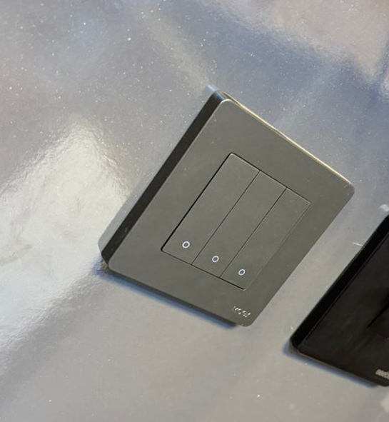
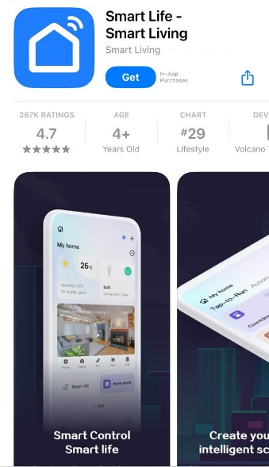

Figure 4.1: Output of the Smart Light System
This shows the mobile app control interface and the light bulb reacting to ON/OFF commands. The output design focuses on enabling users to interact with the system remotely through their mobile device. When the user opens the mobile app and sends a command, the IoT switch interprets this input and turns the smart light on or off accordingly. The output design ensures that the user receives immediate feedback through the app, indicating the current status of the light, whether it is ON or OFF. This also includes visual feedback from the physical light bulb which responds to each switch input.

4.1.2 Input Design
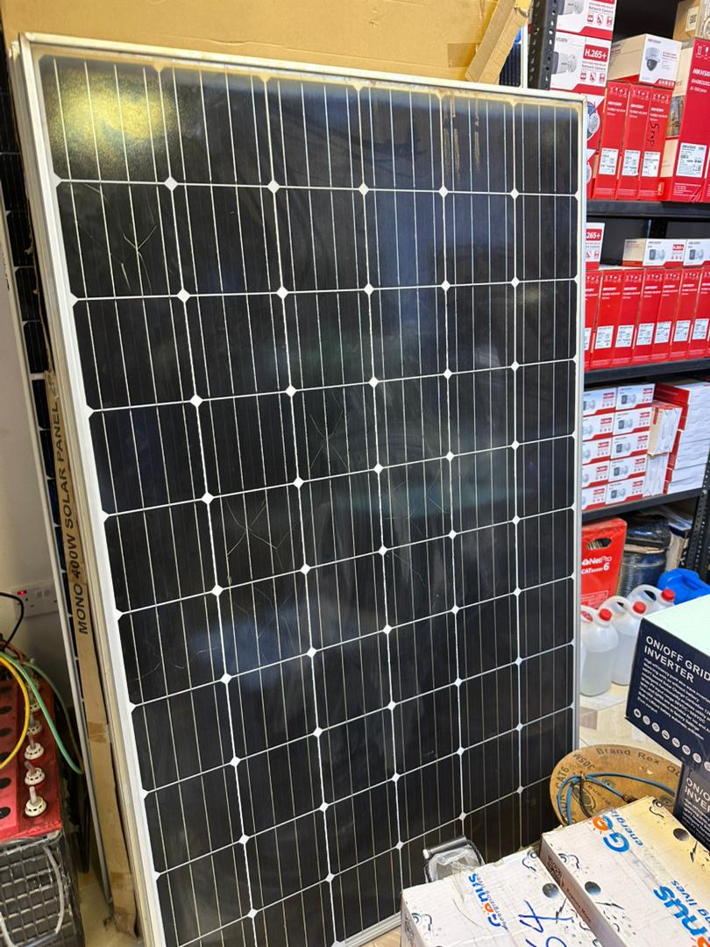
Figure 4.2: Solar Panel Setup and Wiring to Charge Controller
Solar panels wired to send power to the charge controller for battery charging. Inputs into the system include solar energy captured via solar panels, electrical input from the battery, and user commands from the mobile application. The solar panels convert sunlight into electricity, which charges the battery through the charge controller. The user input is executed via a mobile application that sends Wi-Fi signals to the Sonoff IoT switch.

4.1.3 Procedure Design
The steps involved in using the system are as follows:
- The solar panel captures sunlight during the day.
- The charge controller regulates the voltage and sends power to the 12V battery.
- The inverter converts the battery’s DC output into usable AC power for the smart bulbs.
- The smart bulb is connected to the Sonoff switch.
- The user opens the mobile app, connects to the switch via Wi-Fi.
- A command is sent through the app to turn the light ON or OFF.
- The IoT switch receives and executes the command, and the light responds immediately.

4.2 System Implementation
The IoT-based solar lighting system was implemented using selected components that are cost-effective, energy-efficient, and compatible with renewable energy integration. The implementation process involved assembling the power supply system (solar panels, controller, battery, inverter), wiring the lighting circuit, and configuring the mobile application for remote control. The final system was installed in a sample room to monitor performance.

4.2.1 Hardware Support
The implementation relied on the following hardware components for full system functionality:
- Solar Panels (Mono-crystal, 100W each)
- Charge Controller
- Inverter (9000W)
- 12V Battery
- Smart LED Bulbs
- Sonoff Wi-Fi Relay Switch
- Connecting Wires and Switch
- Light holders and housing materials
These were assembled and tested under real-world conditions for efficiency and durability.

4.2.2 SOFTWARE SUPPORT
The mobile application used for switching was the SmartLive, Smart Living app, which is compatible with the Sonoff relay. It was downloaded from the Google Play Store. Users registered, linked the relay switch via QR code or device ID, and began controlling their lights. The app interface also allowed for timer setup, scheduling, and real-time status updates of the bulbs.

4.3 System Documentation
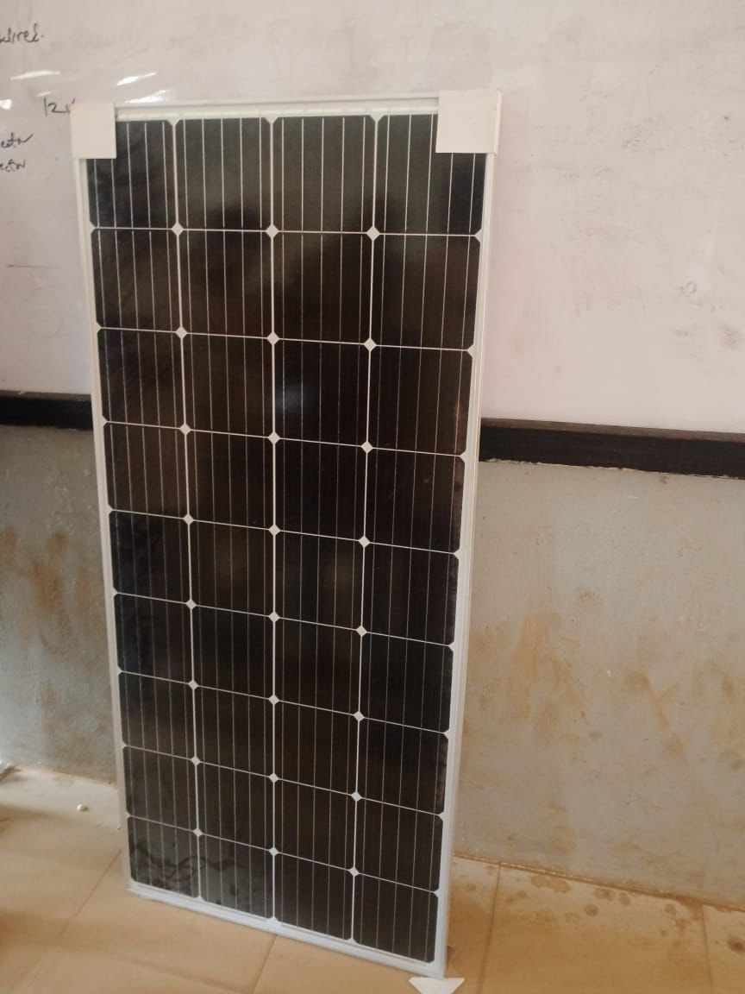

Figure 4.3: Mono Crystal Solar Panel
Monocrystalline solar cells are made from a single, continuous crystal structure, which allows electrons to flow more freely, resulting in higher efficiency rates compared to other types of solar panels. This help in converting sunlight to electronic currently and send signal to charge controller connected with the battery to allow current generation in the system.
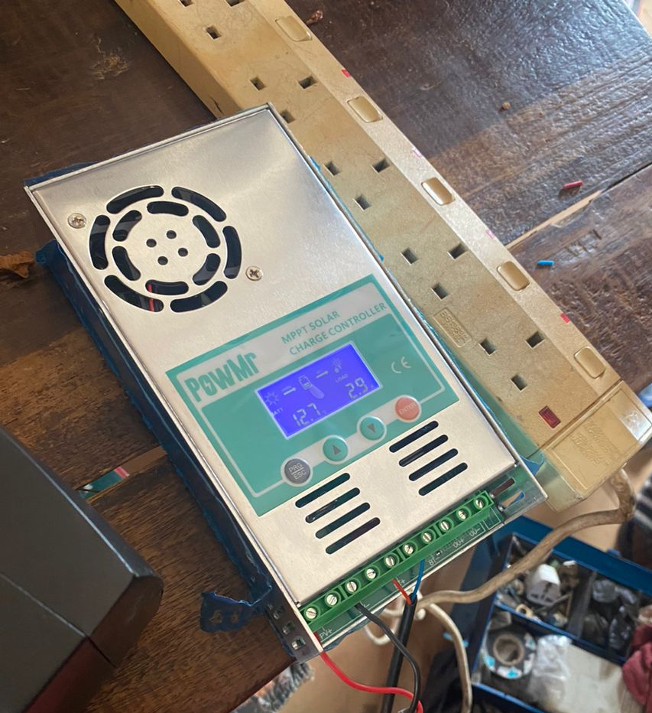
Figure 4.4: Charge controller
Charge controller help in regulating the flow of electricity from solar panels to batteries. It prevents overcharging and over-discharging of batteries, thus prolonging their lifespan and ensuring optimal performance.
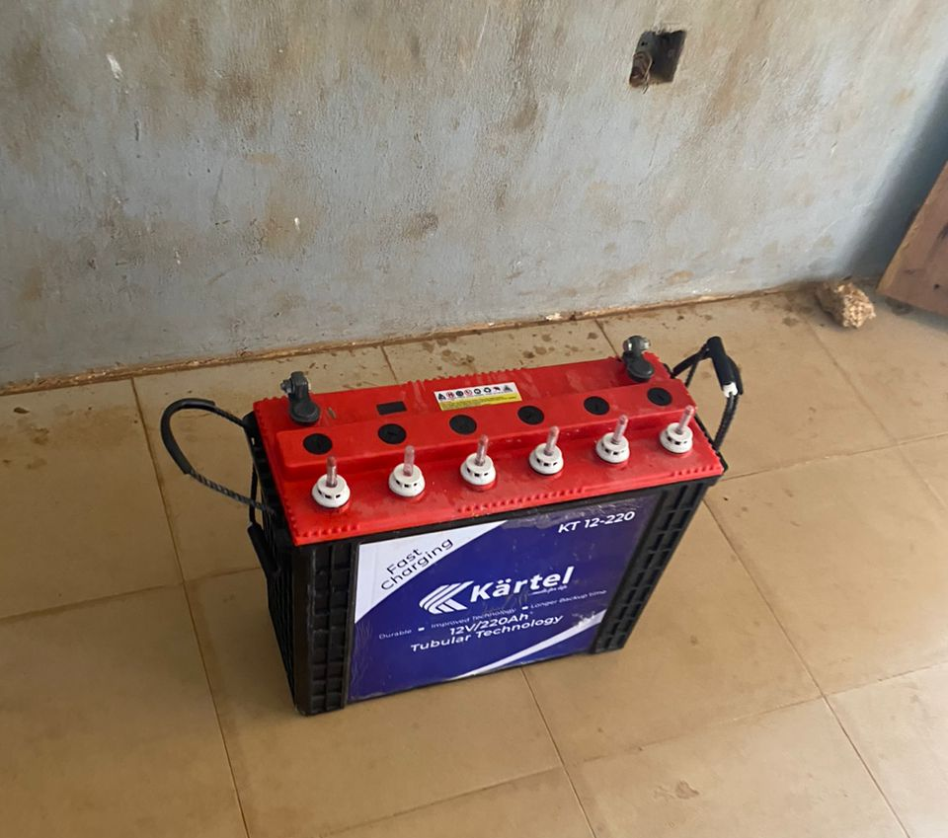
Figure 4.5: Battery (9000mah)
Batteries serve as the energy storage component in solar power systems, storing excess electricity generated by solar panels during periods of sunlight for later use when sunlight is unavailable.

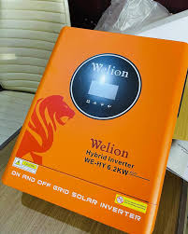
Figure 4.6: Inverter
The inverter converts the DC power from the solar battery into AC power usable by smart bulbs and switches. It ensures a stable power supply for efficient operation of the IoT-based lighting system. It also supports uninterrupted functionality during power outages.

4.3.1 Maintenance of the System
Maintenance involves both adaptive and corrective types. Adaptive maintenance includes periodic updates to the mobile app and firmware to maintain compatibility and performance. The solar panels require occasional cleaning for optimum sunlight absorption. Corrective maintenance addresses hardware wear and tear, including replacing faulty bulbs, battery health checks, and ensuring solid wiring connections. Regular inspection helps prevent system failure and ensures long-term functionality.

CHAPTER FIVE

SUMMARY, CONCLUSION AND RECOMMENDATIONS

5.1 Summary
This research focused on the design and implementation of an IoT-based smart home lighting system powered by solar energy. The motivation behind the study stems from the persistent issues of unstable power supply, rising energy costs, and the limitations of manually controlled lighting systems in many homes, especially in developing regions like Nigeria. By combining renewable energy with IoT technologies, the project sought to enhance energy efficiency, environmental sustainability, and home convenience through automation.
The study examined the shortcomings of the existing conventional lighting systems, particularly the dependency on non-renewable energy sources and the lack of flexibility and remote control. The new system proposed addresses these problems by using solar panels to harvest sunlight, charge controllers to regulate the current, batteries to store power, inverters to convert DC to AC, and smart bulbs connected to an IoT-enabled switch and mobile app for remote access.
The implementation phase involved physical assembly and connection of components including two mono-crystalline solar panels, a charge controller, a high-capacity inverter, a 9000mAh battery, smart bulbs, control switches, and relevant wiring. An app was developed and installed to allow users to remotely switch lights ON or OFF from their smartphones. System testing confirmed that the model worked efficiently and was capable of operating without dependence on the national electricity grid.

5.2 Conclusion
In conclusion, this research has proven that an IoT-based solar-powered smart lighting system is both practical and efficient for modern homes. The integration of solar energy as the primary power source eliminates overreliance on conventional energy sources and ensures continuous operation even in areas with poor grid electricity. The smart control provided through IoT enhances convenience, security, and user interaction, allowing lights to be controlled remotely from a mobile app, regardless of physical location.
The study also reveals that such systems are scalable and adaptable, capable of being extended to other smart home applications such as temperature regulation, appliance control, and security systems. The findings support the argument that renewable energy technologies, when combined with IoT, can play a significant role in addressing the energy challenges of the 21st century.

5.3 Recommendations
Based on the installation and practice. It is therefore recommended that:
- Adoption in Homes: Homeowners are encouraged to adopt IoT-based solar lighting systems to reduce electricity bills and enjoy flexible lighting control.
- System Expansion: Future systems should integrate sensors for automatic light switching and energy monitoring for better efficiency.
- Government Support: Government and private sectors should support the promotion of smart and renewable energy technologies through awareness and funding.
- User Training: Users should be educated on the use and maintenance of IoT and solar systems to maximize their benefits.
- Further Research: Researchers should explore adding AI and machine learning for predictive lighting and energy usage analytics.

REFERENCES
Ahmed, A., et al. (2020). IoT-Based Smart Home Automation and Energy Management. Journal of Smart Technologies, 12(2), 45-60.
Bouchabou, A., et al. (2021). A Survey of Human Activity Recognition in Smart Homes Based on IoT Sensors Algorithms: Taxonomies, Challenges, and Opportunities with Deep Learning. International Journal of Internet of Things, 6(4), 110-125.
George, P., & Max, A. (2022). IoT Based Smart Home Automation using Solar Energy. International Journal of Renewable Energy, 15(2), 213-227.
Gupta, R., & Sharma, S. (2020). IoT-Enabled Smart Home Automation: Solar Panel Integration and Control Strategies. Journal of Energy Efficiency, 22(3), 145-160.
Kumar, V., et al. (2021). Integration of Solar Energy with IoT for Smart Home Automation: A Sustainable Approach. Sustainable Energy Reviews, 18(5), 34-48.
Lee, J., et al. (2021). Integration of Solar-Powered IoT Devices for Smart Home Applications. Journal of Solar Energy Engineering, 13(1), 75-92.
Singh, S., & Singh, V. (2021). IoT Based Smart Home Automation Using Solar Panel System. International Journal of Smart Homes, 10(3), 89-102.
Singh, S., et al. (2021). IoT-Enabled Smart Home Automation with Solar Panels for Sustainable Energy Management. Journal of Green Technologies, 8(4), 99-110.
Zhang, Y., et al. (2020). IoT-Based Smart Home Automation using Solar Energy for Energy Efficiency. Journal of Renewable Energy, 7(2), 189-204.
Zhao, L., et al. (2022). Smart Home Automation and Solar-Powered IoT Systems for Efficient Lighting Control. International Journal of Green Energy, 14(5), 132-148.
Alper, O., & Ray, S. (2021). Integration of IoT sensors and solar energy in smart home automation systems: A comprehensive approach. Smart Home Technology Journal, 15(3), 210-225.
Muthuselvi, S., et al. (2022). IoT-based solar energy automation systems for household management: A case study with Arduino. ResearchGate. Retrieved from https://www. researchgate .net/publication/357820378
Rizvi, S., et al. (2021). Design and implementation of IoT-based smart home lighting system using solar energy. IEEE Xplore. Retrieved from https://ieeexplore. ieee.org/ document/9305832

