
A PROJECT REPORT

ON
LAND INFORMATION SYSTEM OF GOVERNMENT SECONDARY SCHOOL, MARABA, ILORIN SOUTH LGA KWARA STATE

BY

AREMU OLUWAFEMI VICTOR
HND/23/SGI/FT/0093

SUBMITTED TO:

THE DEPARTMENT OF SURVEYING AND GEO-INFORMATICS, INSTITUTE OF ENVIRONMENTAL STUDIES, KWARA STATE POLYTECHNIC ILORIN.

IN PARTIAL FULFILLMENT OF THE REQUIREMENT FOR THE AWARD OF HIGHER NATIONAL DIPLOMA IN SURVEYING AND GEO-INFORMATICS.
JUNE, 2025

CERTIFICATE
hereby certified that all the information given in this project were obtained as a result of observations and measurements made by me and that the survey was carried out in accordance with Survey Rules, Regulations and Departmental instructions.

NAME: AREMU OLUWAFEMI VICTOR
MATRIC NO.: HND/23/SGI/FT/0093

SIGNATURE: ………………………………….

DATE OF COMPLETION: ……………………………………………….

CERTIFICATION
This is to certify that this project titled “Design and Implementation of a Land Information System for Government Secondary School, Maraba, Ilorin” was carried out by AREMU OLUWAFEMI VICTOR, with matriculation number HND/23/SGI/FT/0093 a student of the Department of Surveying and Geo-Informatics, Kwara State Polytechnic, Ilorin, in partial fulfillment of the requirements for the award of the Higher National Diploma (HND). To the best of our knowledge, this project is an original work and has not been submitted elsewhere for the award of any diploma or degree.
_______________________ _______________________
MR. ABIMBOLA I. ISAU SIGNATURE AND DATE
(PROJECT SUPERVISOR)
_______________________ _______________________
SURV. AWOLEYE R. S SIGNATURE AND DATE
(PROJECT COODINATOR)
_______________________ ________________________
MR. ABIMBOLA I. ISAU SIGNATURE AND DATE
(HEAD OF DEPARTMENT)
_______________________ _______________________
EXTERNAL MODERATOR SIGNATURE AND DATE

DEDICATION
This research project is dedicated to GOD Almighty, for his divine guidance and wisdom, and to my beloved parents, whose unwavering love, support and sacrifices have been my pillars of strength. This work is a testament to your love and faith in me.

ACKNOWLEDGEMENT
All adoration belongs to God Almighty, the gracious one who has given me the opportunity to complete my HND program in Surveying and Geo Informatics.
My appreciation goes to my supervisor MR.ABIMBOLA.I.ISAU for his encouragement and motivation as regards the project thank you and God bless you sir.
To all my lecturers in the department of Surveying and Geo Informatics,
SURV. R.O ASHONIBARE, SURV. A.G AREMU, SURV. R.S AWOLEYE, SURV. A.O AKINYEDE, SURV. AYUBA ABDULSALAM, SURV. F.D DIRAN AND SURV.BABATUNDE KABIR, may God bless you all (Amen).
I also express my sincere gratitude to my wonderful parents MR. & MRS. AREMU their parental care and support since the inception of my educational career, they stood by me when things were tough and rough for me, they gave me hope, I will forever be grateful for the motivation you always gave to me at all time, if I would have to have parents in my life again, I will pray to have people like you around me again
To all my understanding friends and lovers, I so much appreciate your support and advice thanks so much, May almighty God bless you all (Amen).

ABSTRACT
Land Information Systems (LIS) represent a critical component of modern land management and planning. This project explores the development, structure, and applications of LIS as a tool for efficient storage, analysis, and dissemination of land-related data. A Land Information System integrates spatial and non-spatial data using Geographic Information System (GIS) technology to support decision-making in areas such as land administration, urban planning, infrastructure development, and environmental management. The project investigates the core components of LIS, including data acquisition, database management, and user interface design. It also highlights the role of LIS in ensuring transparency, improving land tenure security, and streamlining government services. By analyzing case studies and real-world implementations, this work demonstrates the potential of LIS to enhance governance and sustainable development. The project concludes with recommendations for improving LIS adoption in developing regions through policy reform, capacity building, and technological innovation.

TABLE OF CONTENTS
1.0 INTRODUCTION
1.1 Background of the Study............................................................................................. 12
1.2 Statement of Problem................................................................................................... 15
1.3 Aims and objectives..……………………….............................................................. 16
1.4 Scope of the Project.................................................................................................... 17
1.5 limitation of the study…………………………………………................................. 17
1.6 Expected contribution to knowledge.......................................................................18
1.7 Personnel Involved..................................................................................................19
1.8 definition of terms……………………………………………………………………..19
CHAPTER TWO
2.0 LITERATURE REVIEW............................................................................................21
CHAPTER THREE
3.0 METHODOLOGY..................................................................................................... 34
3.1 Project Planning.......................................................................................................... 34
3.1.1 Office Planning.................................................................................................... 35
3.1.2 Field Reconnaissance........................................................................................... 35
3.2 Data Base Design.................................................................................................... 35
3.2.1 View of Reality………………………………………........................................ 36
3.2.2 Logical Design..................................................................................................... 38
3.3 Equipments Used................................................................................................... 39
3.3.1 Hardware Used.................................................................................................... 39
3.3.2 Software Used..................................................................................................... 39
3.4 Test of Instrument............................................................................................. …….40
3.4.1 Horizontal Collimation Test............................ …………………………………40
3.4.2 Vertical Index Error test………………………………............................ …….41
3.4.3 Analysis of Collimation and Vertical Index Data..................................... ……42
3.5 Control Check................................................ ………………………………..........43
3.5.1 Control Check Procedure Using Total Station............ ………………………..43
3.6 Geometric Data Acquisition................................... ………………………………..46
3.7 Detailed Survey........................................................................................... …….47
3.7.1 Non-Spatial Data Collection..................................................................... ……48
3.8 Data Download and Storage......................................................................... ……49
3.8.1 data Validation and Accuracy Assessment............................................... ……50
3.8.2 validation of spatial data………………………………………………………….50
3.8.3 validation of non-spatial data……………………………………………………..51
3.9 Data processing and integration ……………………………………………………52
3.9.1 Spatial data processing in AUTOCAD ……….......................................... ……52
3.9.2 Topographic data processing in suffer…………………………………………..53
3.9.3 Non-spatial data processing in excel……………………………………………56
3.9.4 Geo-database creation in arc –GIS………………………………………………57
3.9.5 Data integration and Finalization for LIS ……………………………………..59
3.10 Perimeter Plan of the project Area ……………………………………….61
3.10.1 Detailing ………………………………………………………………….62
3.11 Attribute Data Acquisition ……………………………………………….62
3.12 Database Creation/Implementation ……………………………………63
3.12.1 Database Management System (DEMS) ………………………………….63
3.12.2 Data Quality……………………………………………………………… 64
Chapter Four
4.0 Analysis and Results ……………………………………………………….65
4.1 Introduction…………………………………………………………………65
4.2 Spatial Data Results…………………………………………………………66
4.2.1 School Boundary and Building Layout ……………………………………..66
4.3 Topographical Analysis Result………………………………………………68
4.3.1 Digital Elevation Model (Dem)…………………………………………….68
4.3.2 Contour Mapping……………………………………………………………70
4.3.3 Slope and Terrain Analysis …………………………………………………71
4.3.4 Significance of Topographical Analysis Results……………………………74
4.4 Non-Spatial Data Results…………………………………………………….74
4.4.1 Attribute Data for School Buildings ……………………………………….75
4.4.2 Linking Non-Spatial Data with GIS …………………………………………76
4.4.3 Significance of Non-Spatial Data in LIS ……………………………………77
4.5 Query Execution and Results ……………………………………………….78
Chapter Five
5.0 Costing, Summary, Problems Encountered, Conclusion and Recommendations
5.1 Project Costing……………………………………………………………..81
5.1.1 Recci ………………………………………………………………………81
5.1.2 Beacon ………………………………………………………………………81
5.1.3 Beaconing ………………………………………………………………81
5.1.4 Traversing ……………………………………………………………….82
5.1.5 Data Downloading and Plotting ………………………………………82
5.1.6 Information Presentation ………………………………………………82
5.1.7 Contingencies ……………………………………………………….83
5.1.8 Value Added Tax (Vat) ……………………………………………….83
5.1.9 Mobilization and Demobilization ……………………………………….83
5.1.10 Accomodation ……………………………………………………….83
5.2. Summary ……………………………………………………………….83
5.3 Problem Encountered ………………………………………………84
5.4 conclusion ………………………………………………………………84
5.5 Recommendations…………………………………………………………85
Reference
Appendix

LIST OF TABLES
Table 3.4.1.1: Horizontal Collimation Data............................................................ 41
Table 3.4.2.1: Vertical Index Data........................................................................... 42
Table 3.4.1: Coordinate of the Observed and the Original Values of K654AD....... 45
Table 3.4.2: Coordinate of the Observed and the Original Values of K656AD....... 45
Table 3.4.1: Coordinate of the Observed and the Original Values of K657AD....... 45
Table 3.1: Collimation Test for the Total Station (Field Observation).................... 45
Table 5.1: Recci....................................................................................................... 81
Table 5.2: Beaconing............................................................................................... 81
Table 5.3: Traversing............................................................................................... 82
Table 5.4: Data Downloading and Editing.............................................................. 82
Table 5.5: Information Presentation........................................................................ 82

LIST OF FIGURES
Figure 1.10: study area map………………………………………………. 15
Figure 3.1: Design and Construction Phases in Spatial Database
(R. Sobh & C. Perry, 2006)……………………………..………………….37
Figure 3.4.1.1: Horizontal Collimation and Vertical Index Error Test……..41
Figure 3.3: Satellite Imagery of the Study Area…………………………….51
Figure 3.5: Screenshot of Boundary Digitization and Features…………….53
Figure 3.6: Screenshot of the Imported Dataset…………………………….54
Figure 3.7: Screenshot of the Generated DEM……………………………..55
Figure 3.8: Screenshots of the Contour-Generation Process……………….56
Figure 3.9: Screenshot of the Structured Attribute Table…………………..57
Figure 3.7.1: Screenshot of the Boundary in AutoCAD……………………59
Figure 3.10 perimeter plan of the project area………………………………61
Figure 3.7.2: Screenshot Showing the Digitization Process
and Layer Management……………………………………………………62
Figure 4.3.1: Digital Elevation Model (DEM) of the School Premises……69
Figure 4.3.2: Contour Map of the School Premises………………………..71
Figure 4.3.4 significance of topographical analysis results……………….73
Figure 4.4.2: Sample Attribute Table for School Buildings……………….76
Figure 4.4.3: Linking Non-Spatial Data to Spatial Features in ArcGIS…..77
Figure 4.5.2: Sample Classroom-Query Results in ArcGIS………………79
CHAPTER ONE
1.0 INTRODUCTION
A Land Information System (LIS) is a structured framework designed to efficiently collect, store, manage, analyze, and visualize land-related data. It integrates both spatial and non-spatial information to support effective decision-making in land administration, planning, and development. The implementation of an LIS for a secondary school requires a well-defined methodology to ensure accurate data acquisition, processing, and integration into a centralized database.
This study employs Total Station surveying, Geographic Information Systems (GIS), and database management techniques to develop an LIS that captures and organizes land and building-related information within the school environment. The methodology is structured into key phases:
The first phase is data acquisition, which involves collecting both spatial data (coordinates of boundaries, buildings, roads, and utilities) and non-spatial data (building attributes, land use details, and administrative records). The spatial data are obtained through Total Station measurements, while non-spatial data are gathered using digital field forms and existing school records. Instrument checks and calibration are conducted before surveying to ensure accuracy.
Following data acquisition, the next phase is data processing and database creation. The surveyed coordinates are plotted and digitized in AutoCAD to create boundary maps, while Surfer is used to generate topographical representations such as contour maps and Digital Elevation Models (DEMs). Both spatial and non-spatial data are then integrated into ArcGIS, where a geodatabase is created to store and manage the information efficiently. This geodatabase includes different feature classes for buildings, land parcels, roads, and utilities, all linked to their respective attributes.
Once the LIS database is structured, spatial analysis and visualization are conducted to provide meaningful insights into land use and infrastructure management. GIS tools are used to analyze building distribution, road networks, utility connections, and land parcel classifications. Thematic maps are generated to visually represent different aspects of the school’s land information system, improving accessibility and decision-making.
To ensure the accuracy and reliability of the LIS, a quality control and validation process is carried out. Survey data are cross-checked with known reference points. Additionally, data consistency checks within the geodatabase help eliminate errors and inconsistencies, ensuring the system remains accurate and functional.
This chapter provides a detailed explanation of the methodological framework for designing the LIS, covering data acquisition, processing, database integration, and analysis. The structured approach ensures that the developed LIS effectively supports land management, infrastructure planning, and decision-making within the secondary school environment. The subsequent sections will elaborate on each methodological step in detail.
1.1 BACKGROUND OF STUDY
Government secondary school, Maraba, Ilorin East local Government in Kwara State, Nigeria, has been the oldest secondary school in Ilorin, its celebrated its 100 anniversary of founding.
Government Secondary School (GSS) Ilorin, located in the Maraba area of Ilorin, Kwara State, Nigeria, stands as a significant institution in the region's educational history. Established in October 1914, following the amalgamation of the Northern and Southern Protectorates by the British, GSS Ilorin is the oldest post-primary institution in Kwara State and ranks among the oldest secondary schools in Nigeria.
Originally founded as a Middle School, it transitioned to a Provincial Secondary School before adopting its current name, Government Secondary School Ilorin. The school's motto, "Manjada Wa Jada" (No Struggle, No Success), encapsulates its commitment to academic excellence and character development.
The school has maintained a full boarding system, serving as a center of unity by accommodating students from all geopolitical zones of Nigeria through its exchange program.
In recent years, GSS Ilorin has faced challenges related to infrastructure and maintenance. Reports indicate that many public-funded schools in Kwara State, including GSS Ilorin, have suffered from neglect, leading to deteriorated facilities and a lack of essential equipment. Despite these challenges, the school's legacy of excellence continues to inspire efforts toward its revitalization and the preservation of its rich history.
The enduring legacy of Government Secondary School Ilorin underscores its pivotal role in shaping the educational and socio-political landscape of Kwara State and Nigeria as a whole.
Effective land management is essential for proper planning, development and utilization of land resources, however, many institutions in Nigeria, including schools, lack well structured land information system (LIS) to support decision-making and efficient land administration. Government secondary school Maraba, Ilorin, Kwara state, like many other schools, faces challenges related to land documentation, ownership verification, and spatial planning. These issues can lead to disputes, encroachments, and inefficient land use, affecting the institution’s long term growth and development.
A land information system is a digital framework designed to collect, store, manage, and analyzed land-related data. It integrates geographic information systems(GIS) and other spatial technologies to provide accurate, up to date land records. Implementing and GIS in government secondary school, Maraba will help in organizing land ownership records, optimizing land use planning, and improving infrastructures development.
By utilizing modern GIS tools, this project will create a comprehensive digital land database for the school, allowing for easier access, updates, and analyses of land- related data. The findings from these studies will not only benefit the school management but also serve as a model for other educational institution seeking to improve their land administration systems.

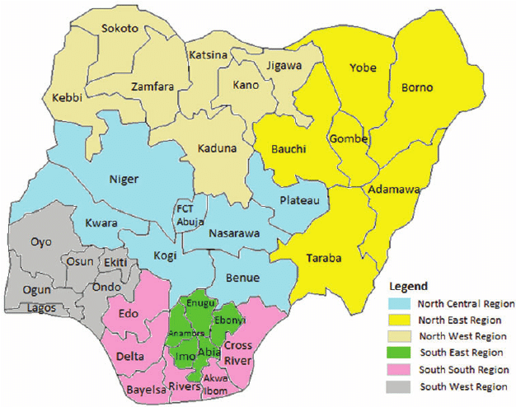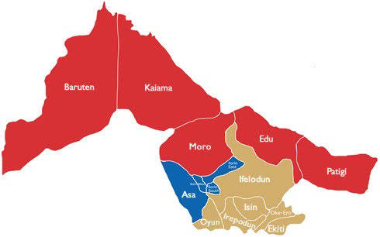

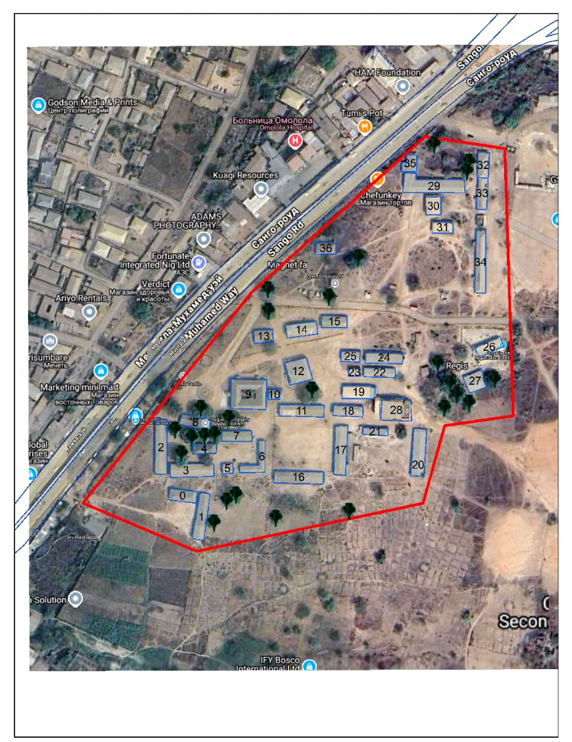
Figure 1.10: Study Area Map
1.2 PROBLEM STATEMENT
Despite the advancement in geospatial technologies, government secondary school, Maraba, Ilorin still face challenge in land administration, including outdated land records, inefficient land management systems, and limited access to accurate spatial data. This issue often leads to land disputes, illegal encroachment, and poor urban planning. The development and implementation of a robust land information system can address these challenges by providing a reliable up-to- date platform for land data management.
Despite the importance of such system, many educational institutions still rely on manual record-keeping and outdated paper-based maps, which are prone to errors and loss. The lack of efficient LIS hinders proper documentation of land boundaries, leading to potential disputes, and insufficient space utilization. This research aims to develop a GIS- based land information system for government secondary school Maraba, Ilorin, kwara state, to enhance land administration, planning, and decision-making within the institution.
1.3 AIMS AND OBJECTIVES
AIM:
The aim of the project is to design and develop a land information system for effective management of Government Secondary School, Maraba, Ilorin East Local Government, Kwara State.
OBJECTIVES
To collect, store, and manage land-related data in centralized database
- To provide accurate and reliable land information for informed land use planning and management decisions
- To provide easy access to land information for stakeholders, including government agencies, private sectors entities, and the general public
- To create and update a centralized database containing accurate and reliable land information
- To ensure transparency and accountability in land administration processes to reduce corruption and improved governance
- To establish efficient and effective mechanism for resolving land dispute to reduce conflict and promotes social stability.
1.4 Scope of the Study
This study focuses on the application of Surveying and Geoinformatics in land administration within Government Secondary School Maraba, Ilorin East Local Government, Kwara State. It covers:
- Data acquisition techniques using Total Station.
- Geospatial analysis through GIaabS-based mapping and visualization.
- Cadastral mapping and boundary delineation for precise land parcel identification.
- Database design and implementation for storing and managing land-related information.
- Spatial analysis for land-use planning, encroachment detection, and infrastructure mapping.
1.5 Limitations of the Study
This study may encounter challenges such as:
- Limited availability of existing land records for Government Secondary School Maraba.
- Technical constraints related to the acquisition and processing of high-resolution spatial data.
- Time constraints in conducting extensive field surveys and data validation.
- Budgetary constraints affecting the use of advanced geospatial technologies.
1.6 EXPECTED CONTRIBUTION TO KNOWLEDGE
- Integration of spatial and non-spatial data: land information system can provide insights into the integration of spatial and non-spatial data, enhancing our understanding of the complex relationships between land, people, and institutions.
- Advancements in land administration theory: land information system research can contribute to the development of new theories or frameworks for land administration, incorporating technological innovations and societal need.
- Improved data collection and integration methods: land information research can lead to the development of more efficient and effective methods for collecting and integrating land-related data from various sources
- Development of new evaluation frameworks for land information system: LIS research can provide new evaluation frameworks for assessing the effectiveness and impact of LIS, incorporating metrics like usability, accessibility, and sustainability.
- Increased access to land information for marginalized groups: land information research has contributed to the development of more inclusive and accessible land information system.

1.7 PERSONNEL
HND/23/SGI/FT/093 | AREMU OLUWAFEMI VICTOR | AUTHOR
HND/23/SGI/FT/090 | YUNUSA RUKAYAT | MEMBER
HND/23/SGI/FT/091 | FATOYINBO THERESA | MEMBER
HND/23/SGI/FT/092 | OLADITI ABDULMUHEEZ OLAYEMI | MEMBER
HND/23/SGI/FT/097 | AGBALAYA OLAIDE MARGARET | MEMBER
HND/23/SGI/FT/099 | AJEORUN JAMIU OLUWADAMILOLA | MEMBER
HND/23/SGI/FT/113 | AJIDE ALICE OLUWATOYIN | MEMBER
HND/22/SGI/FT/121 | SAMSON DANIEL OLUWATOBILOBA | MEMBER

1.8 DEFINITION OF TERMS
1. geographical information system (GIS): a computer- based system for capturing, storing, analyzing, and displaying geo-spatial data.
2. land use planning: the process determining the best used of land, based on its physical characteristics, economic potential, and social needs.
3. urban planning: the process of designing and managing urban spaces, including transportation systems, public spaces, and buildings.
4. environmental impact assessment: the process of evaluating the potential environmental impacts of a proposed development projects.
5. cadastral mapping: the process of creating a map of land parcels, showing their boundaries, ownership, and other relevant information.
6. land tenure: the system of rules and regulations governing land ownership and use .
7. spatial data: data that is associated with geographic locations, such as land parcels, roads, and buildings.
8. data visualization: the use of graphical representations to communicate complex data insights and patterns.

CHAPTER TWO
2.0 LITERATURE REVIEW
The concept of land information system was first developed during the 1980s, but its roots go far back to ancient times. Its present-day evolution is a direct result of two
simultaneously occurring phenomena of the closing decades of the twentieth century, one being the rapid growth of the world’s human population and the pressure that this growth has had an is having on the planet’s dwindling land resources. The other continues to be the prodigious progress in the field of computer-based information system.
Land information systems (lis) provide a foundation for supporting decision-making across a broad spectrum of natural resource applications: agronomic, environmental, engineering and public good. Typically, land information system constitute a computerized database repository holding geospatial components, mapping unit geometry and related geo referenced materials such as satellite imagery, meteorological observations and prediction and scanned legacy mapping. Coupled with the geospatial data are associated property, semantic and metadata, representing a range of thematic property and characteristics of the land and environment.
A Land Information System (LIS) is an essential tool for land administration, management, and planning. It integrates spatial and non-spatial data to facilitate decision-making regarding land ownership, use, and development. This literature review explores key aspects of LIS, including its components, benefits, challenges, and technological advancements.

2.1 Overview of land information system
Land information system (LIS) Is a critical tool in the field of surveying and geo-informatics, designed to manage, analyse and disseminate spatial and non-spatial data related to land. It integrate various technologies, including Geographic Information Systems (GIS), remote sensing, and database management systems to provide a comprehensive framework for land resource management.
LIS is defined as a system designed to collect, manage, analyze, and disseminate land-related information. According to Dale and McLaughlin (1999), LIS is a subset of Geographic Information Systems (GIS) that focuses on land tenure, land use, land value, and land development. The system typically consists of hardware, software, data, users, and procedures that support land management activities.
The increasing demand for efficient land administration, urban planning, and sustainable development has made land information system an indispensable tool for governments, organizations, and professionals in the geospatial industry(chrisman, N.R 2002).
The concept of land information system (LIS) emerged from the need to address challenges such as land disputes, inefficient land use, and the lack of reliable land records. By leveraging modern technology, LIS enables the collection, storage and analysis of land- related data, facilitating informed decision making and policy formulation.
A Land Information System (LIS) consists of an accurate, current and reliable land
record cadastre and its associated attribute and spatial data that represent the legal
boundaries of land tenure and provides a vital base layer capable of integration into
other geographic systems or as a standalone solution that allows data stewards to
retrieve, create, update, store, view, analyze and publish land information (Lemberg, D. 1998).

THE CONCEPT OF LIS
Land information system is a tool for legal, administrative and economic decision-making and aid for planning and development which consists database containing spatially referenced land-related data for defined areas, procedures and techniques for the systematic collection, updating, processing and distribution of the data.
The base of a land information system is a uniform spatial referencing system for the data in the system, which also facilitates the linking of data within the systems with other land-related data.
2.1.1 The benefits of properly implemented lis
- Increased security of land titles
- Significantly reduced times for land transactions
- Greater transparency and traceability of land transactions
- Reduction in fraud
- Increased access to credit
- Increased confidence in the land administration system
- Use of evidence-based decision making in government programs
- Reduction in corruption in the land sector
- Increase in the reliability of information about land resources.

2.1.2 IMPORTANCE OF LAND INFORMATION SYSTEM
1. Land parcel is the basic unit for access and control of land, land use decisions.
2. Current, reliable land information necessary for many public programs: land
planning, infrastructure development and maintenance, environmental protection and resource management, emergency services, social program and so forth.
3. LIS provides a base for land markets, development, and other economic activity.
4. LIS helps in updating of the maps
2.1.3 Components of LIS
A comprehensive LIS comprises several core components:
- Spatial Data: Includes maps, satellite imagery, and geospatial representing land parcels.
- Attribute Data: Information about land ownership, land use, zoning, taxation, and infrastructure.
- Software and Hardware: GIS software, database management systems, and computing infrastructure.
- Institutional Framework: Policies, legal frameworks, and organizational structures governing LIS implementation.
2.1.4 Applications of LIS
Land Information System is widely used in various sectors, including:
- Land Administration: Assists in cadastral mapping, land registration, and tenure security.
- Urban and Regional Planning: Supports decision-making on zoning, land development, and infrastructure planning.
- Environmental Management: Helps monitor land degradation, deforestation, and natural resources utilization.
- Disaster Management: Provides critical information for risk assessment and emergency response planning.
2.1.5 Challenges in LIS Implementation
Despite its benefits, LIS faces several challenges:
- High Initial Costs: Infrastructure and software investments can be expensive.
- Data Accuracy and Standardization: Inconsistent data collection methods can lead to errors.
- Institutional and Legal Barriers: Bureaucratic hurdles and lack of legislative support can hinder LIS adoption.
- Technical Expertise: Requires trained personnel to manage and operate the system effectively.
Technological Advancements in LIS
Recent technological developments have enhanced LIS capabilities:
- Cloud Computing: Enables remote access and real-time data updates.
- Artificial Intelligence (AI): Supports automated land classification and predictive analytics.
- Blockchain Technology: Enhances security and transparency in land transactions.
- Mobile GIS Applications: Facilitates field data collection and verification.
2.2 GEOGRAPHIC INFORMATION SYSYTEM (GIS)
A geographic information system (gis) is a computer- based tool that allows for the capture, storage, analysis, and visualization of spatial data and information. Geographic information systems have become an essential tool in various fields, including urban planning, environmental management, emergency response, and business providing valuable insights and analysis to inform decision-making. While there are challenges and limitations, ongoing technical advances and innovations are addressing these issues and expanding the capabilities of GIS (kumar, p., singh, s & kumar, R 2020).
2.2.1 COMPONENTS OF GIS
- Hardware: computer, servers, and other devices that support geographic information system operation.
- People: users, analyses, and decision makers who work with geographic information system to solve problems and make informed decisions.
- Data: spatial and non-spatial data, including geographic co-ordinate, attribute, and metadata.
- Software: programs and applications that provides geographic information system functionality, such as arc GIS, Q GIS, and grass.
2.2.2 Applications in geographic information system
- Urban planning: geographic information system is used to analyse population growth, land use patterns, and infrastructure development (chen et. Al 2017)
- Emergency response: geographic information system is used to respond to natural disaster, track diseases outbreak, and optimize emergency services (Cova 2018).
- Environmental management: geographic information system is used to monitor climate change, track deforestation, and identify areas of conservations(Goodchild, 2018).
- Business intelligence: This is used to analysis customer behavior, identify market trends, and optimize business operation.
- Transportation: this is used to plan and optimize transportation systems including roads, public transits, and logistics.

2.3 SPATIAL DATA INFRASTRUCTURE (SDI)
A spatial data infrastructure is a framework that enables the sharing, discovery and access to spatial data and services across different organization and levels of government(Maguire, D.J 1999).
2.3.1 COMPONENTS OF SPATIAL DATA INFRASTRUCTURE
- Data access services: services that provides access to spatial data, such as web feature services (wfs) and web map services (wms).
- Meta data: information about spatial data such as data quality, format, and projection.
- Data integration services: services that enable the integration of spatial data from different sources, such as data transformation and harmonization.
- Catalog services: a system that allows users to search, discover and access spatial data and services.
- Spatial data: the core components of SDI, which includes geographic data, such as maps, satellite imagery, and GPS data.

2.3.2 BENEFITS OF SPATIAL DATA INFRASTRUCTURE
- Improve data sharing: SDI enables the sharing of spatial data across different organizations and levels of government.
- Enhanced collaboration: SDI facilitates collaboration among different stakeholders by providing a common platform for spatial data sharing and access.
- Bette decision making: SDI provides accurate and up to date spatial data, which enable better decision making.
- Increased efficiency: SDI reduces the duplication of efforts and resources by providing a centralized access point for spatial data.

2.4 Principles of land administration
- Security of tenure: ensuring that land rights and secure, and land holders have protection from arbituary eviction or expropriation.
- Efficient land use: promoting efficient land use by allocating land with most productive use, and minimizing waste and conflict.
- Equity and fairness: ensuring that land administration is fair, equitable, and transparent, and that all stake holders have access to land and related services.
- Transparency and accountability: ensuring that land administration is transparent, and that all transaction and decisions are recorded and accessible to the public.
- Sustainability: ensuring that land administration promotes sustainable land use, and minimize environmental degradation and social impacts.
- Monitoring and evaluation: establishing mechanisms for monitoring and evaluating land administration performance, and using the results to improve land administration processes and systems.
2.5 LAND TENURE AND LAND RIGHTS THEORY
2.5.1 LAND TENURE
Land tenure refers to the system of rules and regulations that govern the ownership, possession and use of land.
2.5.2 Theories of land tenure
- economic theory: this theory views land as a factor of production and argues that land tenure systems should be designed to maximize economic efficiency.
- Political theory: this theory views land as a source of power and argues that land tenure systems should be designed to promote stability and security (plateau, j.p 2000).
- Social theory: this theory views land as a social resource and argues that land tenure systems should be designed to promote social justice and equality.
2.5.3 Land rights
Land rights refer to the rights and interests that individuals, communities, or organization have in relation to land, including the right to own, use, and manage land.
2.5.4 Theories of land rights
- Human rights theory: this theory views land rights as a human right argues that individuals and communities have a right to access and use land for their livelihoods and well-being.
- Indigenous rights theory: this theory views land rights as a fundamental right of indigenous peoples and argues that they have a right to their ancestral lands and resources.
- Property rights theory: this theory views land rights as a form of property right and argues that individuals and organizations should have secure and transferable rights to land.(Deininger, k. 2003).

2.5.5 Theories on land information systems (LIS)
- The systems theory: this theory views LIS as a system that consists of interconnected components, including hardware, software, data, and peoples. The theory emphasizes the importance of understandings the relationships between these components and how they interact to produce a functional LIS (Dale P.F 1976).
- The institutional theory: this theory emphasizes the role of institutions and institutional arrangements in shaping the development and implementation of LIS. The theory argues that LIS must be aligned with the institutional framework of the country or organization to be effective.
- The Technological: Theory This theory view LIS as a technological system that can be designed and implemented using various technologies, such as geographic information systems (GIS), computer-aided design (CAD), and database management systems. The theory emphasizes the importance of selecting the right technology to support the LIS.
- The Social Theory: This theory emphasize the social and cultural context in which LIS operates. The theory argues that LIS must be designed and implement in a way that takes into account the social and cultural needs of the users and stakeholders.
- The economics theory: This theory views LIS as an economic system that can be designed system that can be designed and implemented to maximize economic benefits. The theory emphasizes the importance of conducting cost-benefit analyses and evaluating economic impacts of land information system.
- The land Governance Theory: This theory emphasizes the importance of good land governance in the development and implementation of LIS. The theory argues that LIS must be designed and implemented in a way that promotes transparency, accountability, and fairness in land governance.
- The Spatial Theory: This theory emphasizes the spatial aspect of LIS, including the use of spatial data and geographic information systems {GIS} to support land information management. The theory argues that LIS must be designed and implement in a way that takes into account the spatial relationships between difference land features and uses

CHAPTER THREE
3.0 METHODOLOGY
This explained the method and techniques used to pursue the objectives and to realize the aims of this project work, the execution of this project was based on the following basic principle of surveying
- Working from whole to the part.
- The principle of choosing the method of survey most appropriate to meet the desired result.
- The principle of provision for adequate checks to meet the required accuracy
3.1 PROJECT PLANNING
Effective planning is essential before initiating any survey project. This process begins with a thorough inspection of the project area, allowing the researchers to gain a clear understanding of the site prior to commencing fieldwork, known as “RECONNAISSANCE”. Reconnaissance typically consists of two main components: (i) Office Planning (ii) Field Reconnaissance
Effective surveying begins with comprehensive project planning, a systematic process that establishes the foundation for accurate data collection. This preparatory stage involves:
- Thorough research on the targeted land parcel
- Clear definition of survey objectives and deliverables
- Precision assessment to determine methodology and equipment.

3.1.1 OFFICE PLANNING
Office planning which could be termed as office reconnaissance involved knowing the type of instruments, purpose, specification and accuracy require of the survey to be carried out. These led to the choosing of appropriate equipment and method to be employed, also costing of the survey operation was done in the office. Information related to the project was collected from various sources, the coordinate (x, y, and z) of the initial and that of the three choosing controls used for orientation were all obtained from survey department office (KWGIS).
3.1.2 FIELD RECONNAISSANCE
The project site was visited by all the group members to have the true picture of the site for the better planning. The recce diagram was drawn alongside the carrying out and the reasonable artificial features were fixed along and within the traverse lines, the traverse was fixed to maintain perfect indivisibility.
3.2 DATA BASE DESIGN
The design of any database involves three stages namely;
- Conceptual design
- Logical design
- Physical design

3.2.1 VIEW OF REALITY
In database design, there is need for reality which is referred to as the phenomenon that actually exists, including all aspects which may or may not be perceived by individuals. The view of reality however, is the mental abstraction of the reality for a particular application or group of applications.
For this application, the view of reality is made of the topography of the project. Since it is not possible to represent the real world, the only option is to conceptualize and model it in a specified manner to represent the real world. The area of interest to use in this project includes; Green Reserve, Roads, Electric poles, Trees, Water Facilities, Buildings, Football pitch, Streams.

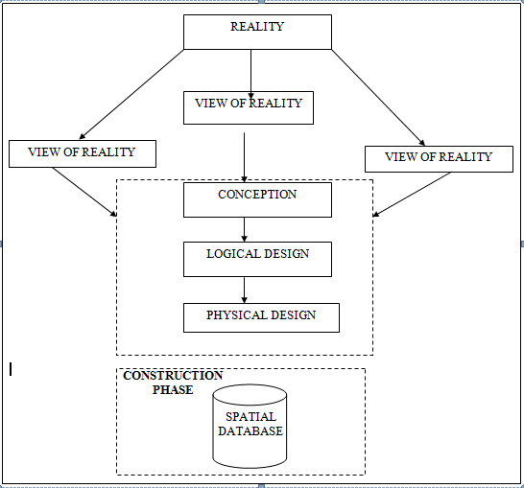
Fig.3.1Design and Construction Phases in Spatial Database (R Sobh, C Perry,. 2006)

    - LOGICAL DESIGN

This is the design aspect of the database refers to the process of creating a conceptual framework or model that represents the structure and organization of spatial data within the system. It involves defining the data element, their relationship, and the rules for data manipulation and analysis. In this phase, the entities, their attributes and their relationships are represented in a single uniform manner in form of relation in such a way that would be no information loss and at the same time no unnecessary duplication of data. In this study, the logical database design is employed to generate a geo-relation database structure. Each entity has unique identifier in bold type. An attribute type or combination of attribute types that serves to identify an entity type is termed an identifier.
- Building (B_ID,B_Area, B_Name, B_Easting, B_Northing)

- Roads (R_ID,R_Width, R_Type, R-Condition, R_Easting, R_Northing)

- Vegetation (V_ID,GR_Area,)

- Tree (TR_ID,TR_spp,TR_Importance,TR_Easting,TR_Northing)

- Electric Pole (EP_No,EP_Type,EP_Height,EP_Easting,EP_Northing)

- Football Pitch FP_ID, FP_Area,FP_Status)
3.3 EQUIPMENT USED
3.3.1 HARD WARE
- Total Station (South
- Reflector Pole
- Hand-held GPS
- Steel tape
- Nails and bottle cover
- Field book
- 1 cutlass
3.3.2 SOFTWARE
- AutoCAD 2007
- Arc-GIS 10.2
- Google Earth
- Note pad
- Excel

3.4 INSTRUMENT TEST
To ensure data quality, the Total Station used for this project was tested for both vertical index and horizontal collimation errors. It was also to ascertain the efficiency and reliability of the instrument. The procedure used is described below.
3.4.1 HORIZONTAL COLLIMATION TEST

This test was conducted to ensure that the line of sight was perpendicular to the trunnion axis. The Total Station was positioned over a specific point, and initial adjustments were made to ensure proper alignment, leveling, and focus (to eliminate parallax in the telescope). A vertical target was placed at a distance of 100 meters from the Total Station. To access the configuration menu of the Total Station, the menu key was pressed and held for approximately 2 seconds. From the

main menu, the calibration sub-menu was selected, and within that, the horizontal collimation test option was chosen. The target was then observed and divided into two halves, with horizontal readings recorded for Face left and Face right. The readings are shown in Table 3.4.1 below

TOTAL STATION REFLECTOR (TARGET)
100m

Station A Fairly Level Ground Station B

Fig3.4.1.1; Horizontal Collimation and Vertical Index error test

Table3.4.1.1: Horizontal Collimation Data

Station | Target | Face | Horz. Reading | Difference | Error
A | B | L | 025˚ 32‟ 32”
 |  | R | 205˚ 32‟ 35” | 180˚ 00’ 03” | 00˚ 00’ 03”

3.4.2 VERTICAL INDEX ERROR TEST

This test was conducted to verify the accuracy of the vertical reading when the line of sight is horizontal. The desired measurement for this test is exactly ninety degrees (90˚), any deviation from this value is referred to as the vertical index error.
The Total Station was positioned over a specific point, and necessary temporary adjustments were made to ensure proper alignment and functionality. A target was placed approximately100 meters away from the Total Station, and the instrument
was aimed at the target. The target was bisected by aligning the instrument on the face left, and the corresponding reading was recorded. Similarly, the target was then bisected on the face right and the respective reading were also recorded. The recorded readings are provided below:

Table3.4.2.1: Vertical Index Data

Instrument Station | Target Station | Face | Vertical | Sum | Error
A | B | L | 95˚ 00‟ 00”
 |  | R | 275˚ 00‟ 02” | 360˚ 00‟ 02” | 02”

3.4.3 ANALYSIS OF COLLIMATION AND VERTICAL INDEX DATA

The readings obtained during calibration were reduced to obtain new collimation and vertical errors.
Horizontal collimation = {(FR–FL) –180} /2 ={(00˚00‟03”} /2 =1.5”

Vertical collimation = {(FL+FR) –360} = (95˚00‟00” + 275˚00‟02” ) -360} = 02” The result shows that the instrument is still in good working condition.

3.5 CONTROL CHECK
3.5.1 Control Check Procedure Using Total Station
To ensure the accuracy and reliability of the Total Station observations used for spatial data acquisition, control checks were carried out before and during the main survey. The procedure involved setting up the instrument over a known control point, performing temporary adjustments, executing angular and distance observations (back sight and foresight), and validating the computed coordinates against known values.
Step 1: Instrument Setup and Centering.
The Total Station was mounted securely on a tripod placed directly over the first known control point.
Centering was done using the built-in optical plummet to align the vertical axis of the instrument precisely over the ground mark.
Fine adjustments were made by shifting the tripod legs or using the sliding base plate to achieve perfect alignment.
Step 2: Temporary Adjustments (Leveling and Elimination of Instrumental Error)
Leveling: The circular bubble was first centered using the tripod legs. Then, the tubular (or electronic) level was used with the foot screws to achieve fine leveling in two perpendicular directions.
Collimation Check: An internal calibration (collimation) check was performed using the instrument’s self-diagnosis function to ensure the vertical and horizontal axes were perpendicular.
The horizontal circle was then set to zero after selecting the backsight direction.

Step 3: Back sight Observation
The telescope was rotated to face a second known control point (backsight).
The instrument was focused accurately on the backsight prism, and both horizontal and vertical coordinates (XYZ) were measured.
Step 4: Foresight Observation and Coordinate Validation
The telescope was then turned to observe a third point (foresight). The horizontal and vertical coordinates (XYZ) were measured. The observed coordinates were then compared to the known coordinates of the foresight control point already established.
Coordinate difference (ΔX, ΔY, ΔZ) was calculated to assess positional accuracy. The difference was within the allowable tolerance (typically ±2cm for X/Y and ±3cm for Z), the instrument was considered properly calibrated.
Step 5: Repeat Check at another Station
The same procedure was repeated for every station setup across the site to ensure uniform accuracy across the network.
All three control stations showed closure errors and coordinate differences well within the accepted tolerance for third-order survey work. This control check procedure ensured that the Total Station data used for plotting school boundaries, buildings, and topography in the Land Information System were precise and trustworthy.
Once the control points were verified and validated, they were used as reference locations for the detailed survey of the school facilities.

Table 3.4.1: Coordinate of the observed and the original values of K654AD
PILLAR | NORTHING | EASTING | STATUS | REMARKS
SC/KW K654AD | 939792.896 | 673354.040 |  | ORIGINAL
SC/KW K654AD | 939792.886 | 673354.020 | FIXED | OBSERVED
DISCREPANCY | 0.010 | 0.020

Table 3.4.2: Coordinate of the observed and the original values of K656AD
PILLAR | NORTHING(m) | EASTING(m) | STATUS | REMARKS
SC/KW K656AD | 939837.818 | 673334.688 |  | ORIGINAL
SC/KW K656AD | 939837.797 | 673334.666 | FIXED | OBSERVED
DISCREPANCY | 0.021 | 0.022

Table 3.4.3: Coordinate of the observed and the original values of K657AD
PILLAR | NORTHING(m) | EASTING(m) | STATUS | REMARKS
SC/KW K657AD | 939803.143 | 673366.311 |  | ORIGINAL
SC/KW K657AD | 939803.132 | 673366.291 | FIXED | OBSERVED
DISCREPANCY | 0.011 | 0.020

3.6 GEOMETRIC DATA ACQUISITION
The total station instrument was set carefully on control point SC/KW K6546AD back sight taken to K SC/KW K654AD after necessary station adjustments has been carried out on it. The adjustments include; centering, leveling and focusing. The following procedures were then followed to determine the position of the next point (NL1) and the same procedure were repeated until all we come close to the site. The method used in acquiring data on site was radiation method where two or more points are coordinated from one instrument station.

- Having setup the instrument and temporary adjustment carried out, the instrument was powered „on‟ and a job file was created under job menu in the internal memory of the instrument. The job file created was named GSSGR4C.
- On the job, the coordinates of the three (3) control points were keyed in to the memory of the instrument and some codes were also saved. The codes include
„RD‟ for road, SP‟ for spot height, BD for buildings, etc.

- The height of the instrument was measured and saved on the memory of the instrument as well as their reflector height.
- On coordinate menu, orientation was set by inputting the coordinates of the instrument station and back sight. The reflector at the back station was perfectly bisected before the orientation was confirmed by clicking yes.
Having done the orientation, the reflector at the next station was bisected and observe option was clicked. The three-dimensional coordinate of the point (E N, H) were displayed on the display unit of the instrument and record button was clicked to save the data into the memory of the instrument. For subsequent observation after this, all options were used instead of pressing observation (“obs”) and pressing record later.

- It was ensured that the center of the prism of the reflector was bisected and that it was set perfectly on the tripod in order to minimize the error on height determination.
- The instrument is been shifted to another station after all details, spot height and boundary point visible from the instrument station have been picked, The instrument was set over new station and temporary adjustments carried out.

However, the above operations were repeated until all the boundary points with heights were coordinated.

In this project all spot height were not in grid intervals but randomly acquired. At the end of data acquisition process all details were observed and properly recorded to be shown in their respective positions on the plan.
3.7 DETAILED SURVEY
The detailed survey focused on mapping the internal structures and facilities within the school, including:
- Classrooms
- Staff rooms and administrative offices
- Laboratories and libraries
- Playgrounds and sports fields
- Roads, parking lots, and walkways
Geometric data for every feature were acquired using Total Station, and the collected spatial data were stored in a structured format. Screenshots of the Total Station data interface were captured to illustrate the data collection process. The observations were carried out systematically to ensure complete coverage of all features within the project area.

3.7.1 Non-Spatial Data Collection
In addition to spatial data, non-spatial data (attribute data) were collected to provide descriptive information about each observed feature. These data were gathered through field observations, school administrative records, and structured interviews with key personnel.
Types of Non-Spatial Data Collected
- Building Information: Name, number of floors, year of construction, type of usage (classroom, staff office, laboratory, etc.).
- Staff Room and Office Details: Departmental functions, number of staff, office occupants.
- Infrastructure Information: Type of roads (paved or unpaved), water supply, power supply.
A field book was used to record the collected data, ensuring uniformity and easy integration into the LIS database. The completed forms were reviewed for accuracy before entering the data into a spreadsheet for GIS processing. Screenshots of the attribute data collection forms were taken and included in the documentation.

3.8 Data Download and Storage
Once the field surveyed was completed, all collected data were transferred to a computer system for further processing and storage. The following steps were taken to ensure proper data management:
- Downloading Total Station Data: The surveyed X, Y, Z coordinates were extracted from the Total Station’s internal memory using instrument software. The data were saved in a CSV (comma-separated values) file format for compatibility with GIS and AutoCAD software.
- Organizing Non-Spatial Data: The collected attribute data were entered into an Excel spreadsheet, ensuring proper formatting for easy integration with spatial data. The file structure was reviewed to ensure consistency and completeness.
- Data Backup: Copies of all data files were stored in an external flash drive to prevent data loss. File versions were properly labeled to maintain organization.
The downloaded spatial and non-spatial datasets were prepared for further processing and integration into the LIS.

3.8.1 Data Validation and Accuracy Assessment
To ensure the accuracy and reliability of the collected data, a rigorous validation process was conducted. This involved cross-checking the surveyed coordinates, attribute data, and instrument readings to identify and correct any errors.
3.8.2 Validation of Spatial Data
- Coordinate Cross-Check: The surveyed points were compared with known control points to verify accuracy.
- Boundary Accuracy Check: The surveyed boundary was overlaid on an existing satellite image in Arc=GIS to detect any misalignment.
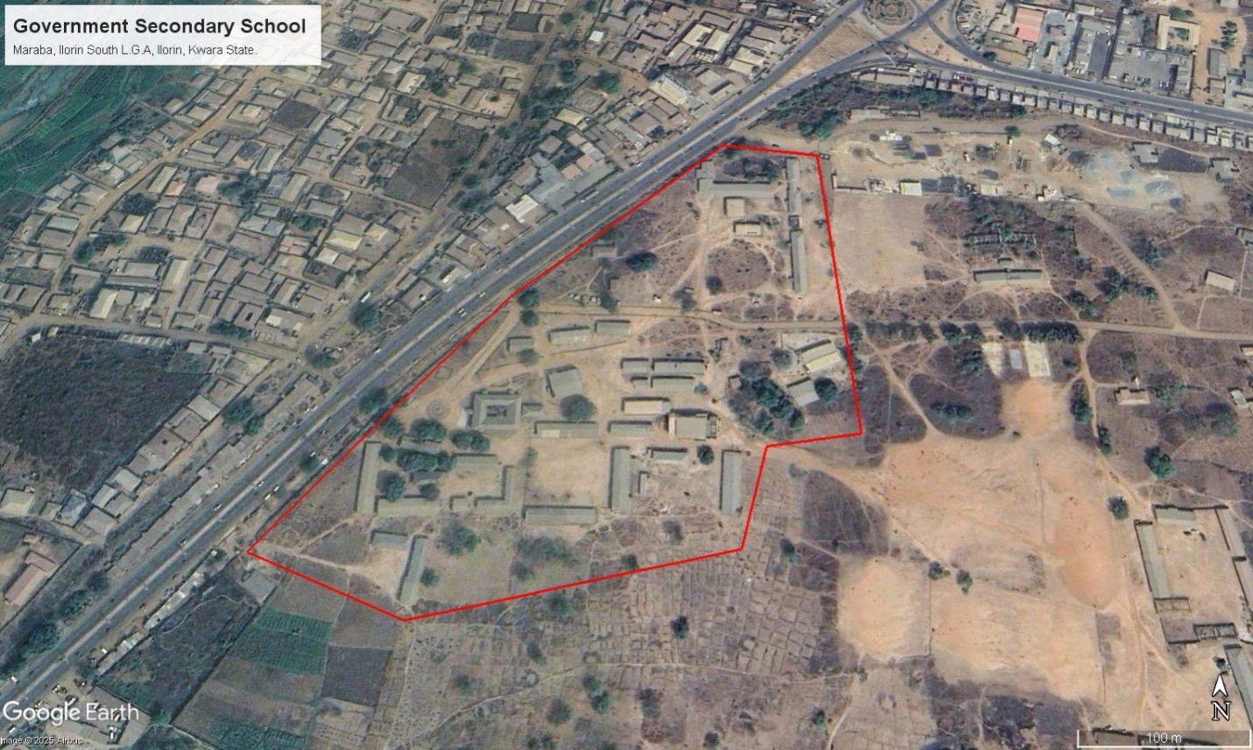
Figure 3.3: Satellite Imagery of the study area
3.8.3 Validation of Non-Spatial Data
- Attribute Consistency Check: The recorded building and facility details were compared with official school records.
- Correction of Data Entry Errors: Any discrepancies or incorrect attribute entries were identified and corrected before finalizing the dataset.
3.9 Data Processing and Integration
The data processing and integration phase is a critical step in transforming the raw data collected from the field survey into a structured Land Information System (LIS). This stage involves cleaning, organizing, and integrating both spatial and non-spatial data into a geodatabase, ensuring seamless access, analysis, and visualization.
The processing workflow consists of multiple steps, including spatial data processing in AutoCAD and Surfer, non-spatial data structuring in Excel, geodatabase creation in ArcGIS, and data integration for LIS development. The structured integration of these datasets enables effective querying, mapping, and decision-making for the secondary school management system.
3.9.1 Spatial Data Processing in AutoCAD
AutoCAD was used to plot the observed coordinates, (Geometric data) ensuring accurate representation of school facilities such as classrooms, staff rooms, administrative offices, roads, and playgrounds. The following steps were carried out:
- Importing Surveyed Points:
- The CSV file containing surveyed coordinates was imported into AutoCAD.
- The points were plotted based on their real-world X and Y coordinates, while the Z values were retained for elevation analysis.
- Plotting of Boundaries and Features:
- The boundary points were connected using polyline tools, forming a closed polygon to define the extent of the school premises.
- Each school building was mapped as a separate layer, and unique identifiers were assigned to distinguish classrooms, staff rooms, laboratories, and other structures.
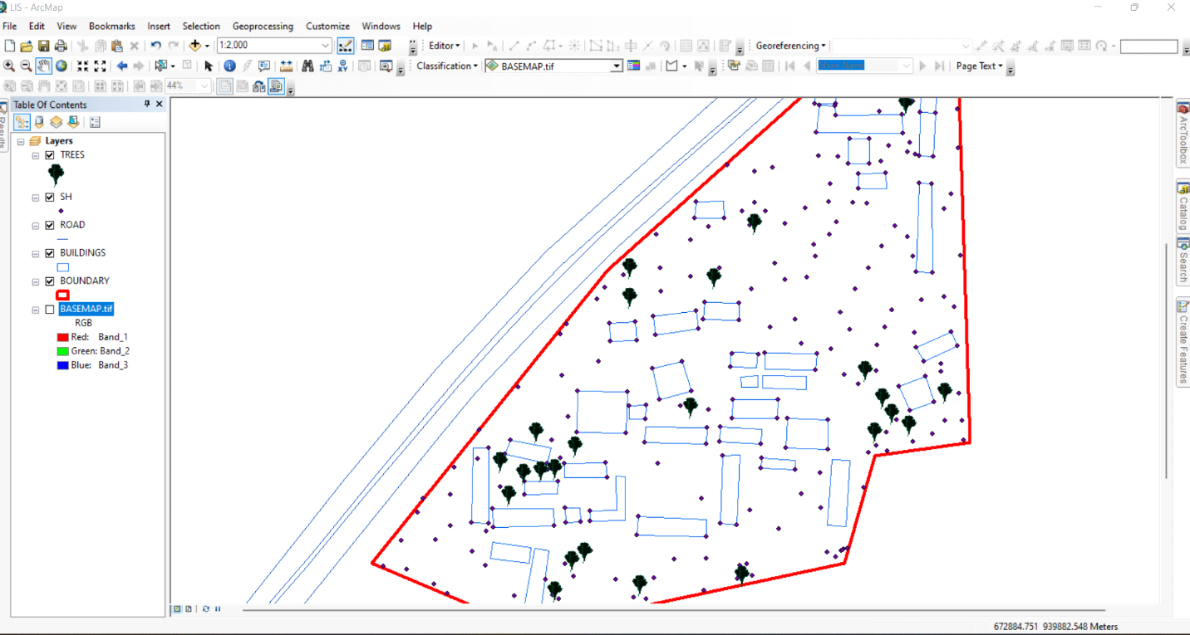

Figure 3.5 Screenshot of boundary digitization and features
3.9.2 Topographic Data Processing in Surfer
Surfer software was used for topographic analysis and terrain modelling based on the surveyed elevation data (Z values). The following procedures were followed:
- Importing Surveyed Data:
- The X, Y, and Z coordinates were loaded into Surfer as a point dataset.
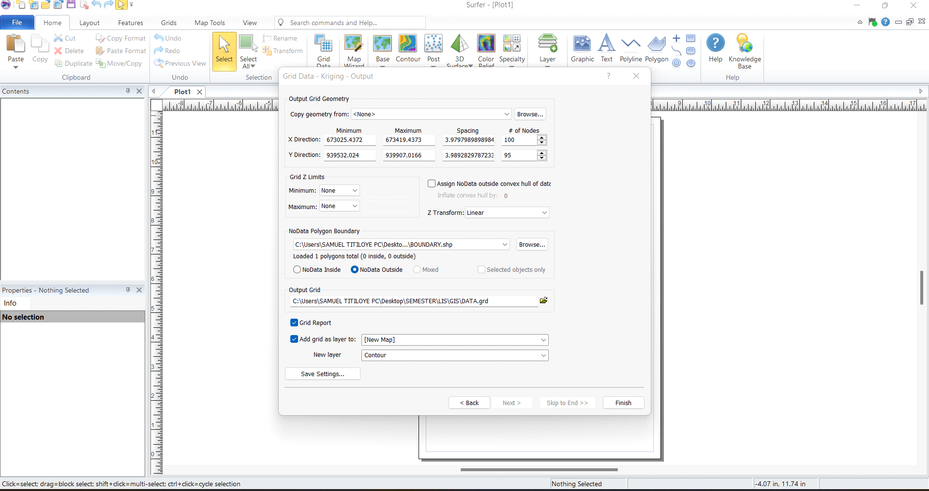
Figure 3.6: Screenshot of the imported dataset.

- Generation of Digital Elevation Model (DEM):
- A grid-based interpolation technique was applied to generate a Digital Elevation Model (DEM) of the school area.
- The DEM provided insight into the elevation variations across the school premises, assisting in drainage and flood risk assessment.
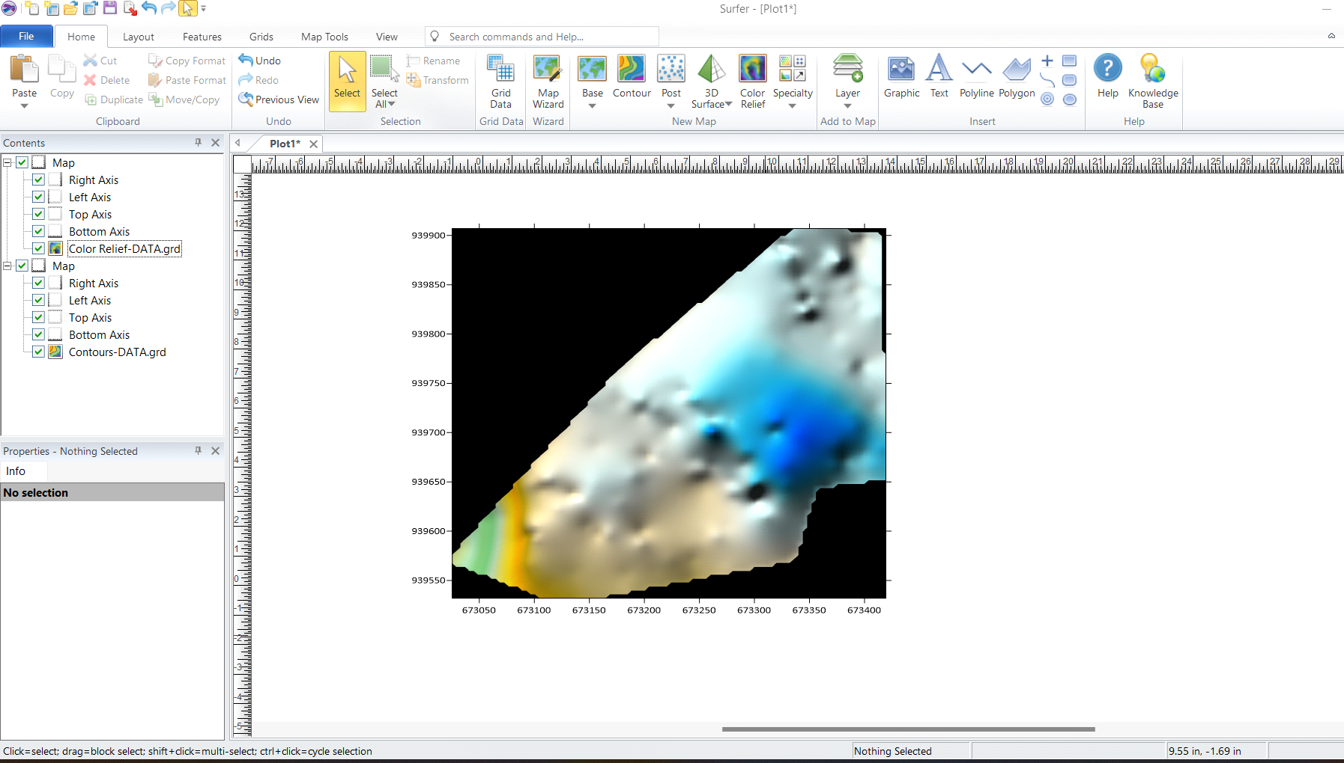Figure 3.7: Screenshot of the generated DEM.

- Creation of Contour Maps:
- Contour lines were generated at specific intervals to visualize terrain variations.
- The contour map was exported in Geo-TIFF format for integration into Arc-GIS.
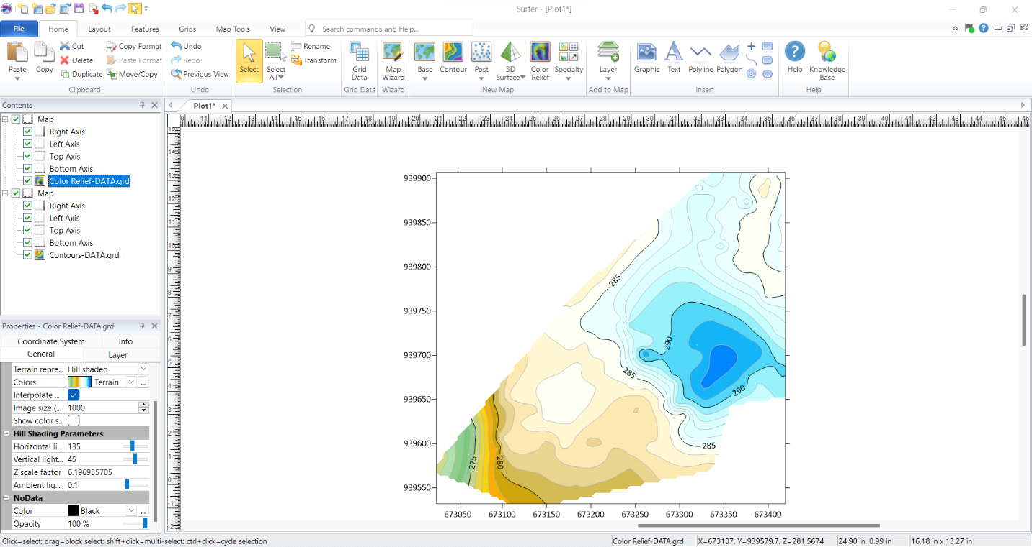Figure 3.8: Screenshots of the contour generation process.
3.9.3 Non-Spatial Data Processing in Excel
Non-spatial data collected through field observations and school administrative records were structured and formatted in Excel to ensure consistency and ease of integration into Arc-GIS.
- Data Entry and Formatting:
- Each facility was assigned a unique ID corresponding to its spatial location.
- Attributes such as building type, year of construction, and available amenities were recorded.
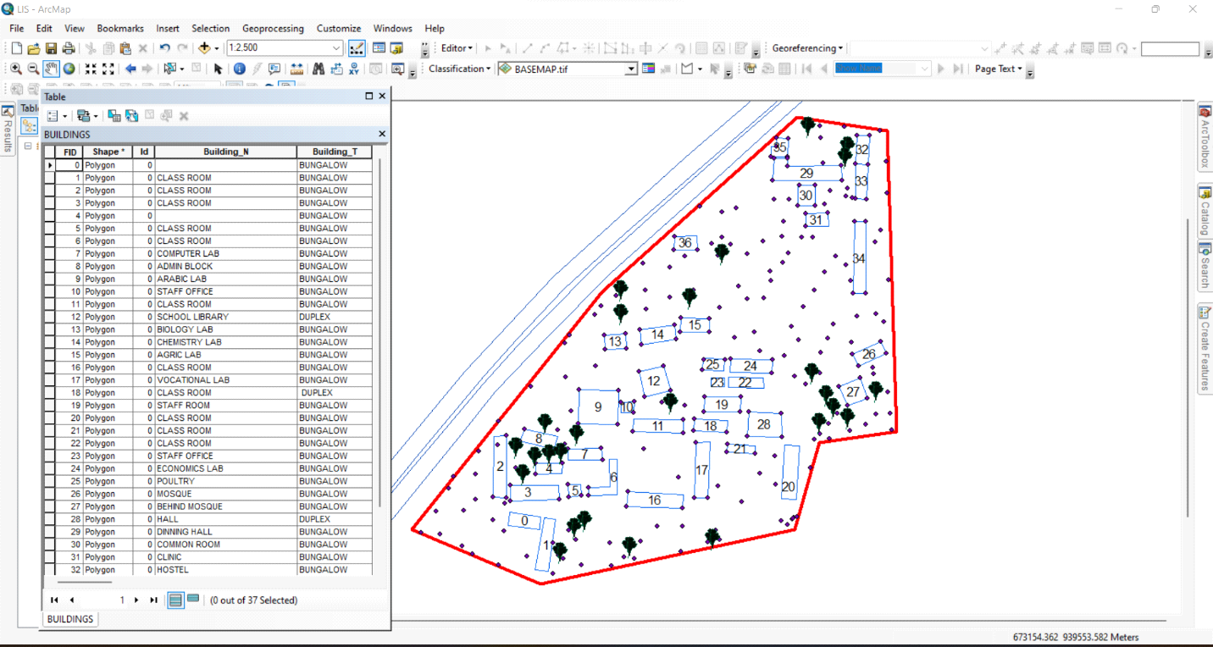Figure 3.9: Screenshot of the structured attribute table.
3.9.4 Geo-database Creation in Arc-GIS
A geo-database was created in Arc-GIS to integrate both spatial and non-spatial data, allowing efficient storage, retrieval, and analysis of school infrastructure data. The following steps were taken:
- Creating a New Geo-database:
- A file geo-database was created in Arc-GIS to store all spatial data layers and attribute tables.
        - Importing Spatial Data:
- The DXF file from Auto-CAD (containing school boundaries and building layouts) was imported into Arc-GIS.
- The Geo TIFF file from Surfer (containing the DEM and contour data) was also loaded.
- Defining Feature Classes:
- Separate feature classes were created for classrooms, staff rooms, offices, laboratories, roads, and other infrastructure.
- Each feature class was assigned relevant spatial properties (e.g., polygon for buildings, polyline for roads).
- Importing Non-Spatial Data and Linking to Spatial Features:
- The CSV file containing attribute data was imported into ArcGIS.
- A one-to-one relationship was established between the spatial features and their corresponding attribute records using the unique ID field.
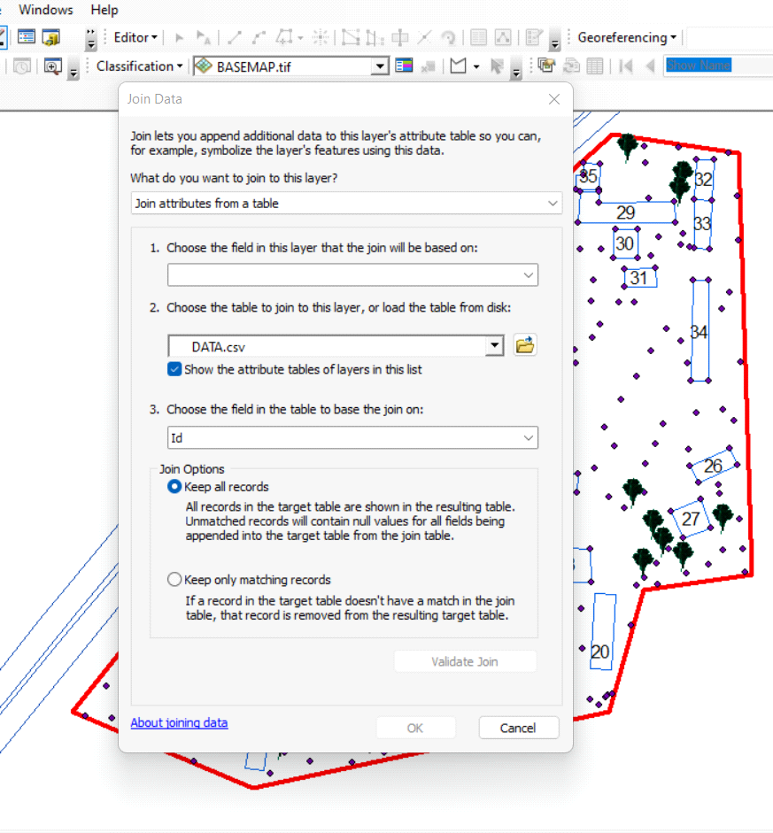
Figure 3.7.1: A screenshot of the boundary in AutoCAD.
3.9.5 Data Integration and Finalization for LIS
The final stage involved ensuring seamless integration between spatial and non-spatial data within the LIS environment.
- Verification of Data Integrity
- The attribute data were cross-checked to ensure they matched their respective spatial locations.
- Any mis-linked records were corrected, and missing attributes were updated.
- Symbolization and Visualization:
- Each feature class was assigned unique symbols and colors for better visualization in Arc-GIS.
- Thematic maps were created to represent building categories, classroom capacities, and road networks.

3.10 Perimeter Plan of the Project Area
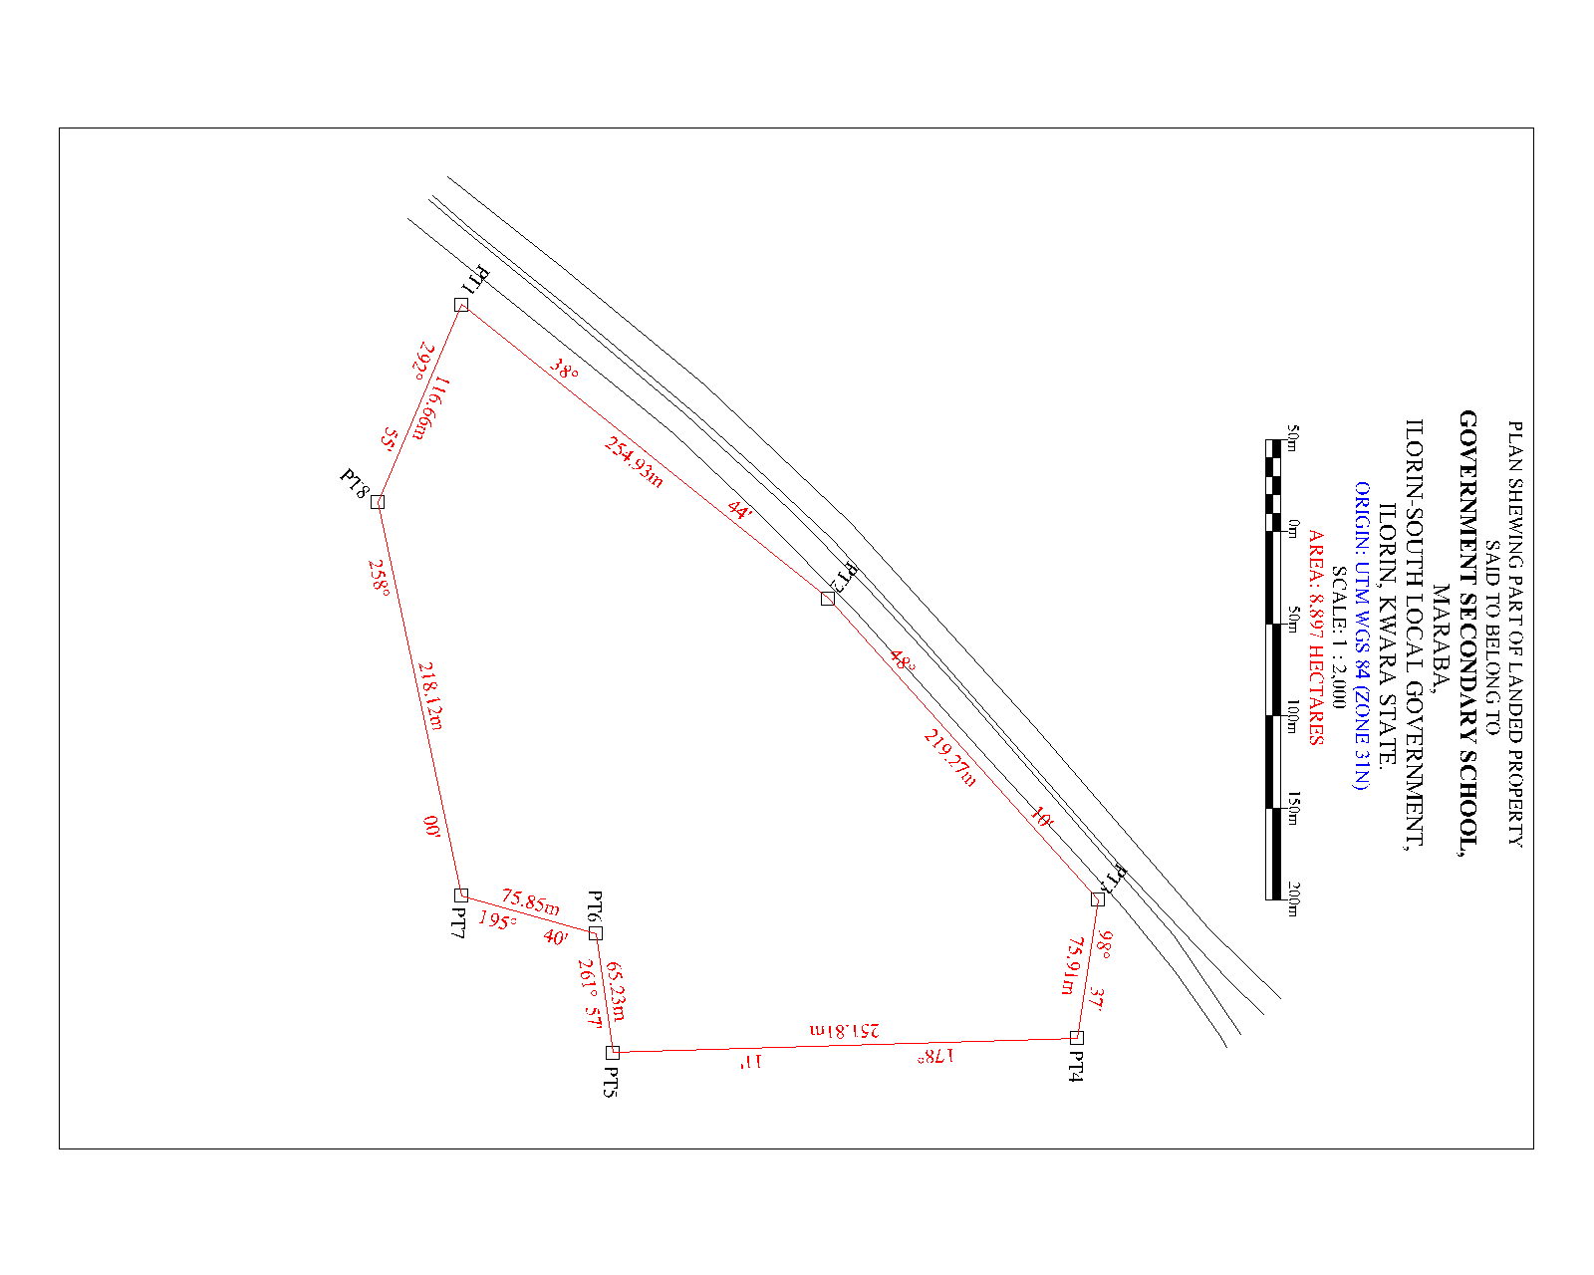
Figure 3.7.1: A screenshot of the boundary in AutoCAD.

- Boundary Digitization and Feature Mapping:
- The boundary points were connected using polyline tools, forming a closed polygon to define the extent of the school premises.
- Each school building was mapped as a separate layer, and unique identifiers were assigned to distinguish classrooms, staff rooms, laboratories, and other structures
3.10.1 Detailing
Figure 3.7.2 Screenshot showing the digitization process and layer management.

3.11 Attribute data acquisition
Attribute data is information about spatial features. They provide the characteristics, description and nomenclature about spatial objects. Thus, the attributes data acquired includes names of buildings and their uses such as classrooms, roads, water facilities and prominent natural features Likes River and trees found and vegetation were properly identified within and around the study area.

3.12 Database Creation / Implementation
This is the database creation phase. Having completed the three stages of design phase (i.e Reality, Conceptual and Logical design), the data base was created using ArcGIS10.2 software. It involves the combination and storage of acquired graphic data and attributes data in creating the database for the purpose of spatial analysis and query.
Database is an organized integrated collection of data stored so as to be capable of use by revenant application with data being accessed by different logical part. After the Attribute table was populated via the keyboard, some attributes such as areas of settlements were automatically displayed by special command in the ArcGIS 10.2 version. The ArcGIS software was used to link the graphic data and table for query generation.
3.12.1 Database Management System (DBMS)
Data base management is a collection of software for creating, storing, manipulating, updating, organizing and querying of information in a database (Kufoniyi, 1998). It is a software package whose function is to manipulate a data base on behalf of the user.
A good DBMS must provide the following functions:

- Storage and retrieval of data.

- Access to by several users at a time.

- A standardized interface between data base and application programmed.

- Standardized access to data and separation of data storage and retrieval functions from the program using the data.

- Maintenance of data security and integrity.
3.12.2 Data Quality
Having created the database, proper maintenance practice was made to meet its stated objectives. The ability to include more data and remove irrelevant data was possible by way of maintenance. There is every need for the data to be updated regularly because of the physical changes that may occur on the landscape with time. Both security and integrity were also exercised to ensure maintenance and to meet its stated objectives.
Proper observance, updating and management of database ensure its currency and quality to stand a profound chance in Spatial Decision Support System (SDSS). The quality of any database depends on the currency and fitness for use as a decision support system (SDSS). The quality of database depends on its ability to generally fit and use as a decision system(DSS). The storage media should be from time to time justified if otherwise could necessitate data inaccessibility or physical deterioration of the storage media. Also, care must be taken during populating any database system, as a database is only good as the data supplied. In archiving stable media should be used. Examples of these are
- Computer compatible tape reader

- Magnetic tape

- Optical disc and compact disc
CHAPTER FOUR
ANALYSIS AND RESULTS
4.1 Introduction
This chapter presents the results obtained from the data acquisition, processing, and integration procedures described in the previous chapter. The findings provide a comprehensive spatial and non-spatial representation of the school environment, including the layout of buildings, topographical features, and attribute information related to school facilities. The results are structured to demonstrate how the Land Information System (LIS) can enhance school management by providing accurate, well-organized, and easily accessible data.
The results are categorized into different sections for clarity. The spatial data results include mapped school boundaries, building footprints, and access networks, all of which were digitized using GIS tools. The topographical results analyze elevation variations using Digital Elevation Models (DEM) and contour maps, which are crucial for site planning and infrastructure development. The non-spatial data results contain attribute information such as classroom capacity, staff room assignments, and building conditions, all integrated into the LIS database. The data integration and query results demonstrate how the LIS functions as an interactive tool for retrieving, analyzing, and visualizing school-related data.
This chapter also includes analyses that reveal important insights into building distribution, infrastructure conditions, environmental constraints, and potential areas for school expansion. The results are presented using maps, tables, and screenshots from GIS and related software to illustrate how data were processed and visualized. The goal of this chapter is to demonstrate the practical application of an LIS in school facility management and to highlight the benefits of integrating spatial and non-spatial data for decision-making.
4.2 Spatial Data Results
The spatial data results provide a detailed representation of the school’s geographical layout, including its boundaries, buildings, access roads, and pathways. These results were derived from Total Station survey data, processed in AutoCAD and ArcGIS to create an accurate Land Information System (LIS) for the school. This section highlights the steps taken to map the school boundary, digitize building footprints, and visualize access routes.
The spatial data results are essential for effective school management, as they provide a georeferenced framework that helps in planning expansions, monitoring infrastructure, and optimizing resource allocation. The outputs presented in this section form the foundation for further topographical, non-spatial, and LIS-based analysis discussed in subsequent sections.
4.2.1 School Boundary and Building Layout
The school boundary and building layout were mapped using surveyed coordinates (X, Y, Z) collected with the Total Station. The acquired data were processed in AutoCAD to generate a structured boundary map and building footprints, which were then imported into ArcGIS for further spatial analysis and integration into the LIS database.
Figure 4.2.1: As built Plan of Government Secondary School Maraba, Ilorin South East Local Government. using GIS software
Visualization of Spatial Data Results
The final processed spatial data were visualized in ArcGIS, where the school boundary, building footprints, and access roads were symbolized appropriately to enhance readability.
Figure 4.2.1: Mapped School Boundary and Buildings in ArcGIS
- The school boundary is represented as a bold polygon to define the outer limits of the school.
- Buildings are shown in different colors based on their usage (e.g., classrooms in blue, administrative offices in green, laboratories in red).
- Roads are displayed as lines, with roads marked in black.
This spatial data representation serves as the primary framework for the LIS database, allowing users to visualize, analyze, and manage school infrastructure efficiently.
Significance of the Spatial Data Results
4.2.1 The school boundary and building layout play a crucial role in:
- Infrastructure Planning: Ensuring optimal land use by identifying available spaces for future construction and expansion.
- Facility Management: Helping administrators monitor the condition, usage, and location of various school buildings.
- Navigation and Accessibility: Enhancing movement planning for students, staff, and visitors by identifying clear pathways and access points.
- Disaster Management: Providing accurate spatial information to plan for emergency exits, assembly points, and safety zones.
The spatial data results form the foundation for further analysis, including topographical evaluation, attribute data integration, and advanced GIS-based queries, which will be presented in the subsequent sections of this chapter.
4.3 Topographical Analysis Results
Topographical analysis provides crucial information about the elevation, slope, and terrain variations within the school environment. Understanding these features is essential for site planning, infrastructure development, drainage design, and environmental management. This section presents the results of topographical data processing and analysis, including the creation of Digital Elevation Models (DEM), contour maps, and slope analysis.
The topographical data were obtained using Total Station measurements, which captured X, Y, and Z coordinates of various points within the school premises. These data were processed in Surfer to generate elevation models and later integrated into ArcGIS for spatial analysis.
4.3.1 Digital Elevation Model (DEM)
The Digital Elevation Model (DEM) was created to provide a 3D representation of the school’s terrain. Using Z-coordinates from the Total Station survey, a gridded elevation surface was generated in Surfer and later exported to ArcGIS for further analysis.
Key Features of the DEM:
- The DEM visually represents variations in land elevation within the school compound.
- Areas of higher elevation are highlighted, aiding in infrastructure planning and water drainage management.
- The DEM serves as the base for further slope, aspect, and contour analysis.
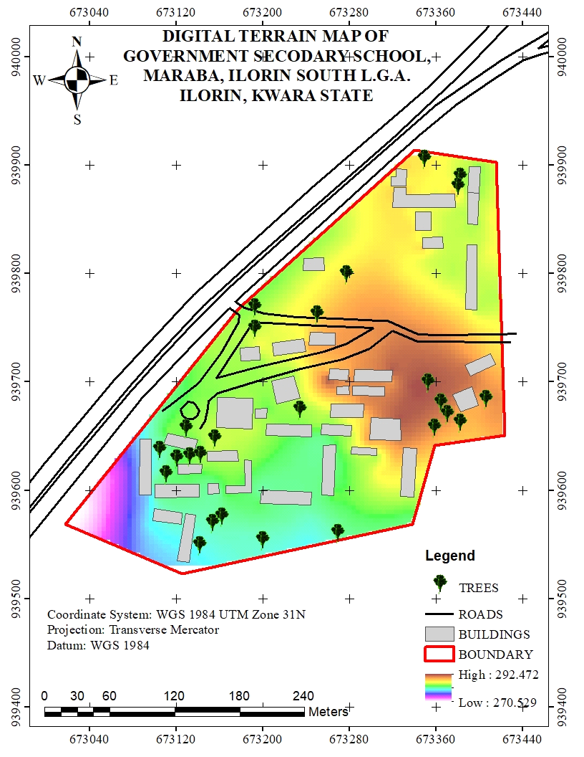
Figure 4.3.1: Digital Elevation Model (DEM) of the School Premises
4.3.2 Contour Mapping
Contour mapping was conducted to visualize elevation changes and terrain gradients within the school environment. The surveyed elevation data were processed in Surfer to generate contour lines, which were later imported into Arc-GIS for spatial overlay and analysis.
Key Results from Contour Analysis:
- The contour interval was set based on the range of elevation variations in the study area.
- Closely spaced contour lines indicate steep slopes, while widely spaced lines represent gentler slopes.
- The contour map helps in identifying low-lying areas that may be prone to water logging or flooding.
- The results assist in drainage planning by identifying natural water flow paths.
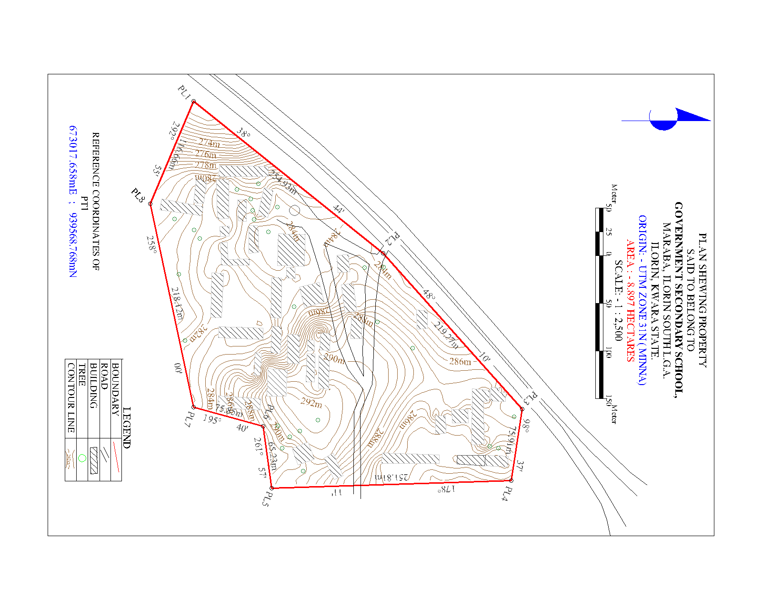
Figure 4.3.2: Contour Map of the School Premises
4.3.3 Slope and Terrain Analysis
A slope analysis was conducted to determine variations in land steepness across the school environment. The slope was computed using the DEM in ArcGIS, with results classified into different slope categories to assess terrain usability.
Key Findings from Slope Analysis:
- Flat areas (0-5 degrees) are suitable for classroom blocks, play areas, and other infrastructure.
- Moderate slopes (5-15 degrees) are manageable for footpaths and minor construction projects.
- Steeper slopes (above 15 degrees) may require erosion control measures or retaining walls to prevent land degradation.
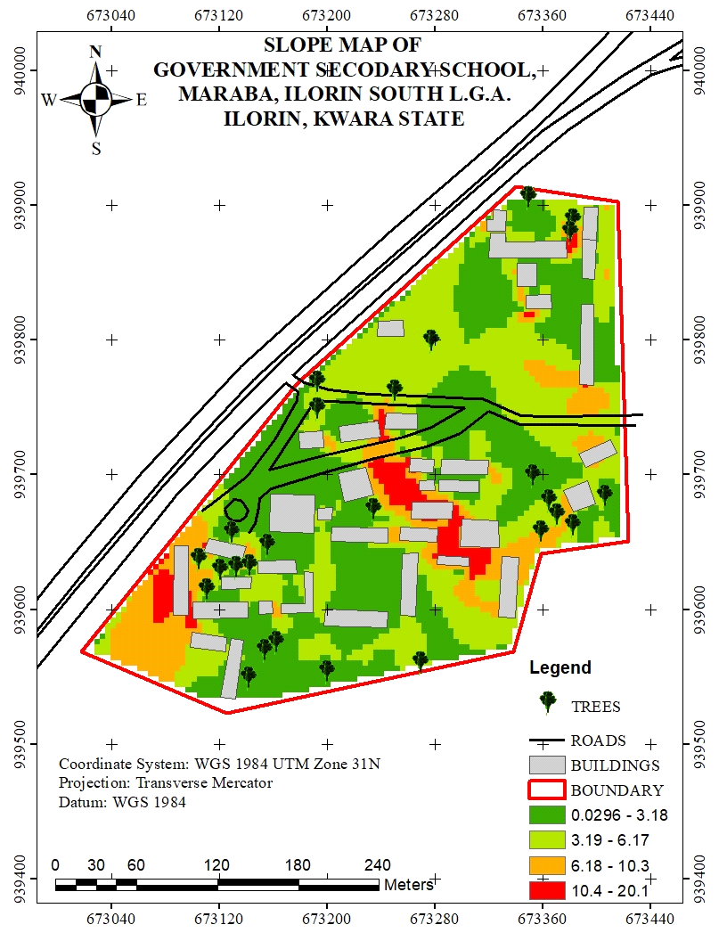
4.3.4 Significance of Topographical Analysis Results
The results of the topographical analysis provide essential insights for school management, infrastructure development, and environmental sustainability. These findings contribute to:
- Better infrastructure planning: Ensuring that new buildings and roads are constructed on stable ground.
- Improved drainage management: Reducing the risk of flooding and water stagnation within the school premises.
- Enhanced safety measures: Identifying steep areas that may require protective barriers or adjustments in land use planning.
- Sustainable land use: Helping decision-makers optimize space utilization while considering terrain constraints.
The topographical analysis results form an integral part of the Land Information System (LIS), ensuring that spatial data is not only stored but also analyzed for informed decision-making in school infrastructure management.
4.4 Non-Spatial Data Results
Non-spatial data results refer to the descriptive information associated with various school facilities, buildings, and infrastructure. Unlike spatial data, which provides geometric representations of features (such as school boundaries, buildings, and roads), non-spatial data includes textual and numerical attributes that help in facility management and decision-making.
The non-spatial data collected in this study were integrated into the Land Information System (LIS) to enhance school administration, infrastructure monitoring, and resource planning. The data were structured in tabular format and linked to corresponding spatial features in ArcGIS using unique identifiers.
4.4.1 Attribute Data for School Buildings
The non-spatial attributes for classrooms, staff rooms, laboratories, and administrative offices were recorded and organized in a database. Each building was assigned a unique identifier (Building ID), allowing for easy retrieval of information in GIS.
Key Attributes for Buildings:
- Building Name/ID (e.g., Classroom Block A, Staff Room 1)
- Building Type (Classroom, Laboratory, Office, Library, Hall)
- Primary Use (Teaching, Administration, Storage, Utility)
This information was stored in ArcGIS attribute tables and linked to the digitized building footprints, allowing users to perform queries such as identifying underutilized classrooms or buildings in need of maintenance.
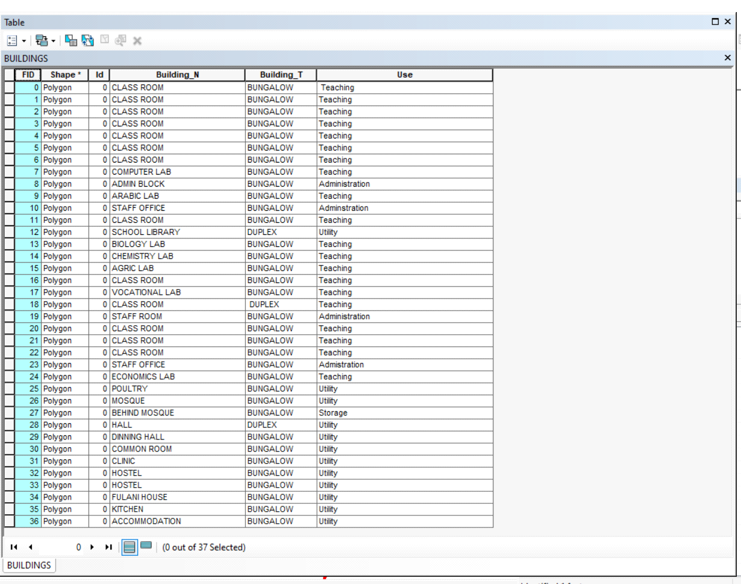
Figure 4.4.2: Sample Attribute Table for School Buildings
4.4.3 Linking Non-Spatial Data with GIS
All non-spatial datasets were linked to their corresponding spatial features in ArcGIS. This integration allows for interactive queries and visual analysis of school facilities. Some of the key functionalities include:
- Clicking on a building footprint to view its attributes (e.g., building name, building type, & use).
- Running queries to find classrooms that exceed their maximum student capacity.
- Generating reports on the maintenance history of infrastructure.
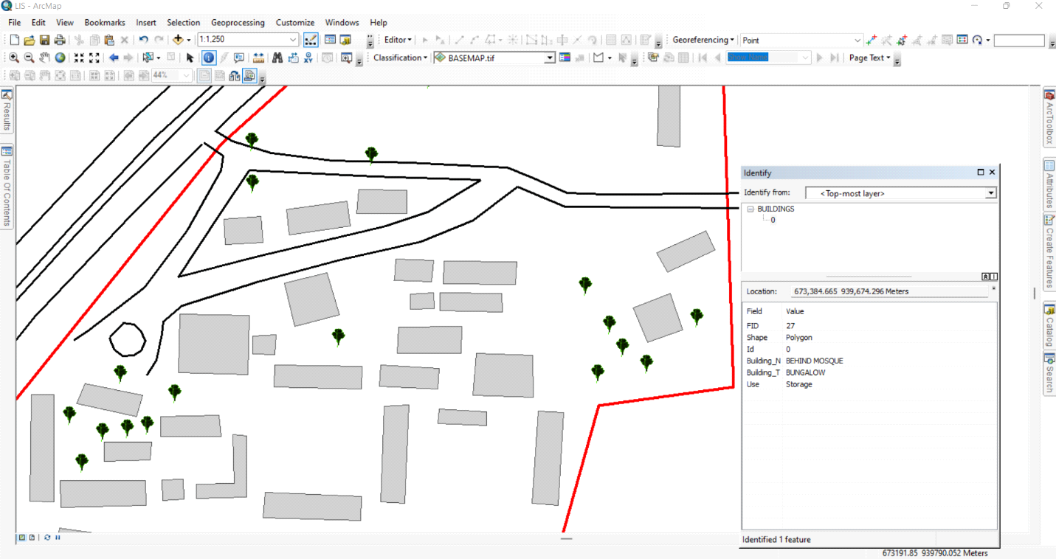Figure 4.4.3: Linking Non-Spatial Data to Spatial Features in ArcGIS
4.4.4: Significance of Non-Spatial Data in LIS
The integration of non-spatial data into the LIS enhances decision-making by providing comprehensive attribute information for school management. These results contribute to:
- Effective Resource Allocation: Ensuring that classrooms, offices, and other facilities are optimally utilized.
- Infrastructure Maintenance Planning: Monitoring facility conditions and scheduling necessary repairs.
- Improved School Administration: Tracking staff distribution, student population trends, and room assignments.
- Emergency Preparedness: Identifying critical infrastructure that requires regular inspections and safety measures.
The non-spatial data results demonstrate how a Land Information System (LIS) can support school facility management by combining spatial visualization with detailed attribute data. This information is essential for long-term planning, policy-making, and efficient school operations.
4.5 Query Execution and Results
With the integrated database, queries were performed in ArcGIS to extract specific information about the school environment. These queries help in analyzing building usage, staff distribution, facility conditions, and space utilization.
Example Query Results:
- Mapping Distribution of Staff Offices:
Query: "Show all staff offices"
Result: A spatial representation of staff office locations was displayed, ensuring adequate office space allocation.
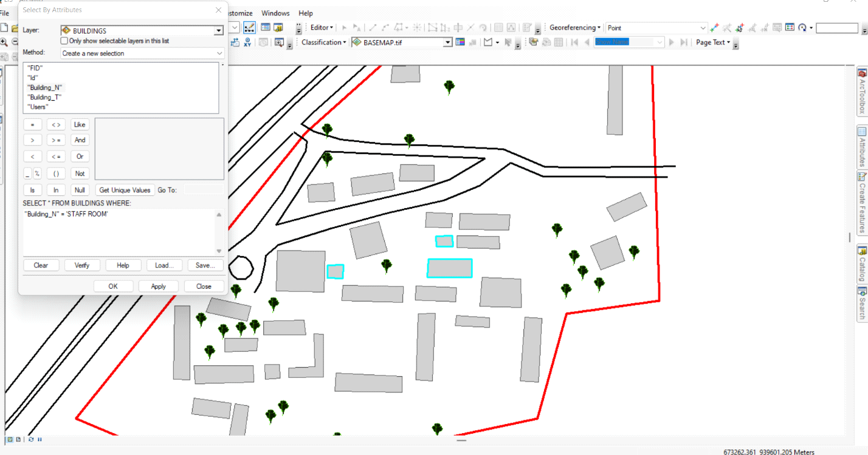
Figure 4.5.2: Sample Class

CHAPTER FIVE
SUMMARY, COSTING, RECOMMENDATIONS AND CONCLUSION
5.0 SUMMARY OF FINDINGS
This study focused on the development and implementation of a GIS-based Land Information System (LIS) for effective land administration and planning within Government Secondary School Maraba, located in Ilorin East Local Government Area, Kwara State. The institution, with its long-standing history, had been facing significant challenges in managing its land and infrastructure records due to outdated manual systems.
The investigation revealed that the existing method of maintaining land information was prone to: inaccuracies, poor data storage, risk of encroachment, and difficulty in accessing or updating land records.
To address these issues, a digital LIS was created using modern surveying and geospatial tools. Key activities included: use of GPS and Total Station for field data acquisition, cadastral mapping of the school environment, development of a digital database storing spatial and attribute data, and integration of GIS tools for analysis and decision support.
The LIS significantly improved land boundary documentation, land use planning, and infrastructure management. Stakeholders can now easily retrieve, update, and visualize land data, ensuring transparency and efficiency in the school's land administration processes.

5.1 COSTING
The costing of this project was done using the Nigeria Institution of Surveyor's (NIS) professional scale of fees for consultant in the construction industry. This stage shows the total cost that was spent on the project from day one to the final stage.
RECCI
PERSONAL/QUALITY | DAY(S) | UNITRATE(N) | TOTAL AMOUNT(N)
1 Senior Surveyor | 1 | 20,000.00 | 20,000.000
Assistant Surveyor | 1 | 8,000.00 | 8,000.00
Transportation | 1 | 7,000.00 | 7,000.00
Basic Equipment | 1 | 8,000.00 | 7,000.00
TOTAL |  |  | #42,000.00

BEACON= 2,100 × 5
= #10,500

BEACONING
PERSONAL/QUALITY | DAY(S) | UNITRATE(N) | TOTALAMOUNT(N)
1Assistant Surveyor | 1 | 8,000.00 | 8,000.00
Basic Equipment(6) | 1 | 8,000.00 | 8,000.00
Transportation | 1 | 7,000.00 | 7,000.00
TOTAL |  |  | #23,000.00

TRAVERSING
PERSONAL/QUALITY | DAY(S) | UNITRATE(N) | TOTALAMOUNT(N)
1 Assistant Surveyor | 2 | 8,000.00 | 16,000.00
Basic Equipment | 2 | 8,000.00 | 16,000.00
Transportation | 2 | 7,000.00 | 14,000.00
TOTAL |  |  | #46,000.00

DOWNLOADING DATA AND PLOTTING
PERSONAL/QUALITY | DAY(S) | UNITRATE(N) | TOTALAMOUNT(N)
1Senior Surveyor | 2 | 15,000.00 | 30,000.00
1AssistantSurveyor | 2 | 8,000.00 | 16,000.00
Transportation | 2 | 7,000.00 | 14,000.00
Consumables | 2 | 7,000.00 | 14,000.00
TOTAL |  |  | #74,000.00

INFORMATION PRESENTATION
PERSONAL/QUALITY | DAY(S) | UNITRATE(N) | TOTALAMOUNT(N)
1Assistant Surveyor | 1 | 8,000.00 | 8,000.00
Transportation | 1 | 7,000.00 | 7,000.00
TOTAL |  |  | #15,000.00

(1) # 42,000.00
(2) # 10,500.00
(3) # 23,000.00
(4) # 46,000.00
5) #74,000.00
(6) # 15,000.00
TOTAL # 210,500.00
CONSTIGENCIES=5%
210,500.00×5%÷ 100
= #10,525.00

V. A. T = 7.5%
210,500.00×7.5%÷100
= #15,787.50

MOBILIZATION AND DEMOBILIZATION =10%
2o10, 500.00 × 10%. ÷ 100
= #21,050.00
ACCOMODATION = 1.5%
210,500.00 ×1.5%÷100
= 3,157.50
TOTAL = 210,500.00
10,525.00
15,787.50
21,050.00
3,157.50
GRAND TOTAL = 261,020.00

5.2 PROBLEM ENCOUNTERED
Several challenges were encountered throughout the course of this project. One major issue was the difficulty in accessing reliable and up-to-date land records for Government Secondary School, Maraba, which made it challenging to validate newly acquired data. Fieldwork was also affected by unpredictable weather conditions, particularly rainfall, which delayed Total Station observations and sometimes required the team to reschedule visits. In addition, certain parts of the school premises were obstructed by dense vegetation and physical barriers, making it difficult to capture accurate spatial data. Technical limitations such as equipment calibration errors, battery issues, and software learning curves slowed the data acquisition and processing phases. Financial constraints further limited the use of more advanced geospatial tools like drone mapping or high-resolution satellite imagery. Time pressure due to academic deadlines added urgency to each phase, reducing the flexibility to repeat procedures or explore alternatives. Furthermore, inconsistent internet connectivity and software licensing delays created setbacks during data processing and GIS-based map visualization.
5.3 CONCLUSION
The successful implementation of a GIS-based Land Information System at Government Secondary School Maraba demonstrates the vital role of geospatial technology in land administration. This project has improved the accuracy, accessibility, and usability of land records within the school premises, enabling better planning and infrastructure management. The LIS model adopted in this study can be replicated across other institutions to promote data-driven land governance and sustainable development.
5.4 RECOMMENDATIONS
Based on the findings of this study, the following recommendations are made:
- Adoption and Usage: The developed LIS should be officially adopted and utilized by the school management for effective land monitoring and facility planning.
- Training of Staff: Relevant personnel should be trained on GIS software usage and database management.
- Regular Updates: The system should be regularly updated to reflect changes like new constructions, renovations, or boundary adjustments.
- Extension to Other Schools: The LIS model can be expanded to other schools in Kwara State facing similar land documentation issues.
- Government Collaboration: Kwara State government and education authorities should support LIS adoption in public institutions for transparency and planning.
5.5 SUGGESTIONS FOR FURTHER RESEARCH
Future research can explore the following areas:
- Integration of LIS with GIS Web Portals for public access.
- Incorporation of drone technology for high-resolution imagery.
- Mobile-based data collection systems for on-the-go updates.
- Blockchain-based LIS for added data integrity and transparency.
- Comparative studies on manual vs. GIS-based systems in school environments.

REFERENCE

Chrisman, N. R. (2002). *Exploring Geographic Information Systems* (2nd ed.). Wiley.
Cova, T.J. (2018). GIS and emergency response: a review. Journal of emergency management, 16(2), 147-158.
Dale, P.F. (1999). Land surveying and land information systems
Deininger, K. (2003). Land policies for growth and poverty reduction.
Grafiati. (n.d.) bibliographies:’ land information systems’.
Godchild, M.F. (2018). GIS and environmental management: a review. journal of environmental management, 223, 115-125.
International federation of surveyors (FIG). (2018). Land administration domain model (LADM).
Kaiz, W. (2019). GIS and business: a review. Journal of business and economics, 10 (1), 1-12.
Kumar, P., Singh, S., & Kumar, R. (2020). Ai and GIS: a review. Journal of artificial intelligence and soft computing, 10 (2), 1-12.
Lemberg, D. (1998). Economic analysis of land information systems. Designing land information systems for decision-making. *Journal of Land Use Science*, 5(3), 207–216.
Li, S., Li, X., & Li, B. (2019). Cloud computing and GIS: a review. Journal of cloud computing, 8(1), 1-12.
Maguire, D. J. (1999). An overview and definition of GIS. In *Geographical Information Systems: Principles and Applications* (pp. 9–20). Longman.
Plateau, J. P. (2000). Land rights and land markets in West Africa: Theory and practice. *Regional and Sectoral Economic Studies*, 2(2), 37–64
UN-Habitat. (2012). The land governance assessment framework.
Williamson, I.P. (1986). Land information systems: a framework for design and implementation.
World Bank. (2019). Land administration domain model (LADM) implementation guide.
Zhang, J., Li, X., & Li, B. (2020). IoT AND GIS: A Review. Journal of internet of things, 10 (2), 1-12.

APPENDIX  S/N | EASTINGS | NORTHINGS | Elevation
1 | 673384.7 | 939882.4 | 284.324
2 | 673368.3 | 939852.6 | 284.974
3 | 673406 | 939809.5 | 285.418
4 | 673328.8 | 939826.6 | 286.878
5 | 673277.2 | 939835 | 285.121
6 | 673258.7 | 939839.1 | 283.911
7 | 673298.3 | 939799.4 | 288.005
8 | 673328.2 | 939792.3 | 287.552
9 | 673312.6 | 939762.8 | 289.926
10 | 673211 | 939791.9 | 283.435
11 | 673176 | 939756.2 | 283.922
12 | 673192.6 | 939752.9 | 284.652
13 | 673304.7 | 939734.3 | 290.222
14 | 673416.3 | 939684.2 | 290.247
15 | 673262 | 939711.3 | 288.105
16 | 673150 | 939731.4 | 284.378
17 | 673146.7 | 939696.4 | 283.653
18 | 673227.3 | 939675.6 | 284.134
19 | 673246.1 | 939672.8 | 284.316
20 | 673321.7 | 939630.2 | 288.378
21 | 673117.2 | 939688.4 | 282.391
22 | 673294 | 939592 | 283.783
23 | 673337.8 | 939578.5 | 283.019
24 | 673272 | 939568.4 | 282.117
25 | 673104.7 | 939620.4 | 281.182
26 | 673073.4 | 939634.1 | 276.58
27 | 673071.2 | 939615.2 | 275.123
28 | 673242.9 | 939550.3 | 280.075
29 | 673203.9 | 939544.3 | 280.735
30 | 673148.8 | 939568.4 | 281.263
31 | 673052.7 | 939612.9 | 272.448
32 | 673140.3 | 939546.8 | 280.215
33 | 673159.3 | 939539.3 | 280.517
34 | 673136 | 939532 | 279.591
35 | 673114.2 | 939546.4 | 279.556
36 | 673037.9 | 939584.1 | 270.915
37 | 673025.4 | 939566.5 | 270.677
38 | 673037.9 | 939584.1 | 270.915
39 | 673048.7 | 939603.2 | 272.177
40 | 673145.4 | 939724.6 | 283.813
41 | 673170.7 | 939748.4 | 284.45
42 | 673188.6 | 939764.6 | 283.773
43 | 673320.9 | 939845.5 | 287.18
44 | 673362.2 | 939875.4 | 285.746
45 | 673385.9 | 939892.8 | 284.152
46 | 673372.8 | 939797.9 | 284.644
47 | 673363.7 | 939784.4 | 286.123
48 | 673354.6 | 939769.4 | 288.129
49 | 673345.7 | 939755.1 | 289.742
50 | 673090.2 | 939538.8 | 278.481
51 | 673341.7 | 939727.3 | 291.403
52 | 673417.2 | 939777.8 | 284.558
53 | 673403.7 | 939704.2 | 289.927
54 | 673373.8 | 939666.3 | 290.383
55 | 673366.7 | 939657.7 | 289.8
56 | 673359.7 | 939648.9 | 289.387
57 | 673354.7 | 939644.1 | 289.178
58 | 673322.5 | 939606.4 | 286.048
59 | 673144.6 | 939544.4 | 280.276
60 | 673154.8 | 939560 | 281.098
61 | 673166.3 | 939577 | 281.907
62 | 673335.6 | 939739 | 291.06
63 | 673409.7 | 939902.9 | 285.097
64 | 673344 | 939813.6 | 285.841
65 | 673333 | 939800.4 | 286.532
66 | 673317.5 | 939785.4 | 288.656
67 | 673275.5 | 939754.9 | 289.562
68 | 673155.4 | 939649.3 | 284.999
69 | 673153.1 | 939647.9 | 284.914
70 | 673145.9 | 939640.2 | 284.266
71 | 673136.9 | 939632 | 283.646
72 | 673095.5 | 939590.5 | 279.358
73 | 673085.9 | 939576.8 | 278.209
74 | 673068.7 | 939548 | 275.907
75 | 673041.6 | 939564.6 | 272.021
76 | 673061 | 939584.5 | 273.936
77 | 673071.1 | 939593.9 | 275.368
78 | 673171.3 | 939705.6 | 284
79 | 673234 | 939763.5 | 286.572
80 | 673274.2 | 939798.6 | 287.23
81 | 673284.9 | 939807.8 | 287.065
82 | 673360.2 | 939896.9 | 286.454
83 | 673379.6 | 939906.3 | 285.363
84 | 673415.1 | 939877.3 | 285.558
85 | 673385 | 939777 | 285.683
86 | 673370.4 | 939740.7 | 289.914
87 | 673366 | 939728.9 | 290.9
88 | 673360.4 | 939716.8 | 291.697
89 | 673347.6 | 939690.5 | 292.448
90 | 673267.4 | 939567.2 | 281.818
91 | 673249.8 | 939761.5 | 287.673
92 | 673253.6 | 939769.1 | 287.673
93 | 673289.4 | 939837.7 | 285.923
94 | 673359.1 | 939907 | 286.683
95 | 673309.1 | 939718.2 | 290.864
96 | 673386.5 | 939846.5 | 284.751
97 | 673381.1 | 939847.9 | 284.798
98 | 673311.7 | 939810.2 | 287.49
99 | 673214.1 | 939753.6 | 285.594
100 | 673151.2 | 939668 | 284.273
101 | 673298.3 | 939761.6 | 289.834
102 | 673410.6 | 939819.5 | 286.064
103 | 673412.8 | 939743.1 | 286.98
104 | 673386 | 939725.4 | 289.89
105 | 673338.4 | 939696.8 | 292.455
106 | 673094.8 | 939567.3 | 279.722
107 | 673060.1 | 939554.7 | 274.721
108 | 673308.9 | 939615.9 | 286.747
109 | 673367.4 | 939644.7 | 288.332
110 | 673384.7 | 939651.2 | 288.549
111 | 673397.8 | 939656.6 | 288.644
112 | 673418 | 939665.7 | 289.824
113 | 673222.9 | 939571.6 | 281.678
114 | 673209 | 939559 | 281.109
115 | 673195.2 | 939545.6 | 280.87
116 | 673184.7 | 939538.6 | 280.999
117 | 673419.4 | 939652.4 | 289.44
118 | 673406.3 | 939665.7 | 289.634
119 | 673135.8 | 939557.7 | 280.436
120 | 673183.4 | 939557.6 | 281.026
121 | 673265.8 | 939558.1 | 281.327
122 | 673275.6 | 939560.4 | 282.041
123 | 673326.7 | 939576.1 | 282.93
124 | 673336.1 | 939577.2 | 282.915
125 | 673337.2 | 939577.8 | 282.96
126 | 673340.2 | 939579.1 | 283.101
127 | 673332.5 | 939572.9 | 282.561
128 | 673244.5 | 939571.8 | 280.976
129 | 673279.8 | 939710.7 | 289.235
130 | 673329.3 | 939714.1 | 291.661
131 | 673291 | 939772.5 | 289.507
132 | 673213.4 | 939769.2 | 285.037
133 | 673363.1 | 939841.6 | 285.29
134 | 673415.4 | 939850.6 | 286.503
135 | 673382.8 | 939854.7 | 284.659
136 | 673268.8 | 939807.9 | 286.262
137 | 673381.1 | 939790.3 | 285.169
138 | 673404.1 | 939698.9 | 290.112
139 | 673359.7 | 939699.5 | 292.101
140 | 673211.9 | 939636.4 | 283.159
141 | 673241.3 | 939612.7 | 282.141
142 | 673274.4 | 939604.9 | 282.939
143 | 673119.8 | 939627.5 | 282.657
144 | 673089.5 | 939639.6 | 279.492
145 | 673351.4 | 939620.1 | 286.705
146 | 673139.7 | 939652.3 | 284.027
147 | 673090.5 | 939659.4 | 280.094
148 | 673288 | 939729.3 | 289.918
149 | 673390.6 | 939747.4 | 287.987
150 | 673406.2 | 939749.5 | 286.834
151 | 673318.7 | 939777.2 | 289.241
152 | 673353.4 | 939813.4 | 285.219
153 | 673327.9 | 939814.1 | 286.716
154 | 673276.9 | 939802.7 | 287.085
155 | 673233.8 | 939788.3 | 285.237
156 | 673246.2 | 939797.5 | 285.454
157 | 673277.4 | 939813.8 | 286.407
158 | 673333.9 | 939845 | 287.321
159 | 673121.2 | 939624.5 | 283.071
160 | 673121.1 | 939615.1 | 282.792
161 | 673143.9 | 939624.5 | 283.815
162 | 673100.3 | 939592.9 | 281.442
163 | 673085.4 | 939596 | 278.194
164 | 673096.8 | 939595.6 | 279.372
165 | 673149.2 | 939596.2 | 281.843
166 | 673159.5 | 939597 | 281.78
167 | 673141.2 | 939594 | 282.01
168 | 673099.8 | 939605.7 | 282.096
169 | 673148.7 | 939606.2 | 282.084
170 | 673165.5 | 939604.1 | 283.126
171 | 673096.8 | 939647.3 | 281.218
172 | 673108 | 939642.9 | 281.375
173 | 673136.6 | 939636.5 | 282.179
174 | 673111.8 | 939652.6 | 283.596
175 | 673148.2 | 939636.5 | 284.471
176 | 673176.3 | 939637.2 | 284.381
177 | 673177.4 | 939627 | 284.25
178 | 673165.5 | 939597.3 | 283.212
179 | 673197.6 | 939587.9 | 282.967
180 | 673244.4 | 939586.8 | 282.022
181 | 673198.4 | 939600.3 | 281.592
182 | 673254.1 | 939595.6 | 282.376
183 | 673265.5 | 939594.9 | 283.309
184 | 673255.8 | 939641.6 | 282.017
185 | 673281.4 | 939633.4 | 283.739
186 | 673305.1 | 939632.2 | 284.123
187 | 673282.1 | 939640.3 | 285.194
188 | 673327.4 | 939646 | 290.763
189 | 673298.4 | 939647 | 289.971
190 | 673327.1 | 939666.1 | 292.244
191 | 673254 | 939661.3 | 284.252
192 | 673281.6 | 939649.9 | 284.438
193 | 673244.8 | 939649.7 | 282.435
194 | 673253.5 | 939651.3 | 282.443
195 | 673245.2 | 939660.8 | 283.997
196 | 673262.1 | 939667.2 | 284.253
197 | 673262.6 | 939679.7 | 286.756
198 | 673292.7 | 939667.2 | 287.534
199 | 673156.8 | 939657.7 | 284.797
200 | 673190.1 | 939656.9 | 284.931
201 | 673190.9 | 939685.2 | 284.021
202 | 673207.8 | 939700.8 | 284.134
203 | 673212.7 | 939679.8 | 283.992
204 | 673234.3 | 939685.5 | 284.829
205 | 673157.5 | 939685.9 | 283.582
206 | 673203.3 | 939666.4 | 284.044
207 | 673192.5 | 939675.4 | 283.893
208 | 673203.7 | 939675.9 | 283.133
209 | 673202.6 | 939650.8 | 283.871
210 | 673228.2 | 939705.8 | 284
211 | 673178.7 | 939731.5 | 284.127
212 | 673197.5 | 939720.1 | 284
213 | 673179.3 | 939719.3 | 284.169
214 | 673208.6 | 939736.3 | 285.441
215 | 673210 | 939723.9 | 285.565
216 | 673239.3 | 939728.1 | 287.38
217 | 673196.5 | 939732.8 | 285.965
218 | 673237.7 | 939740.2 | 285.981
219 | 673243.3 | 939745.8 | 287.908
220 | 673266.6 | 939745.3 | 289.626
221 | 673260.8 | 939702.2 | 292.324
222 | 673293.1 | 939679.9 | 290.403
223 | 673299.9 | 939667.1 | 289.403
224 | 673399.1 | 939678.4 | 289.269
225 | 673382.5 | 939672.3 | 289.093
226 | 673392 | 939705.9 | 291.205
227 | 673375.3 | 939688.7 | 291.609
228 | 673393.3 | 939695.9 | 290.854
229 | 673414.7 | 939716.5 | 288.314
230 | 673386.7 | 939715.5 | 290.931
231 | 673410.5 | 939726 | 287.665
232 | 673319.6 | 939710.9 | 292.093
233 | 673318.9 | 939700.1 | 289.855
234 | 673284.5 | 939711.5 | 289.939
235 | 673266.6 | 939734.1 | 289.765
236 | 673236.8 | 939802.9 | 284.509
237 | 673237.8 | 939814.4 | 283.996
238 | 673256.7 | 939803.2 | 285.935
239 | 673347.6 | 939823.1 | 287.83
240 | 673242.5 | 939734.1 | 289.519
241 | 673386.9 | 939766.8 | 286.751
242 | 673397.8 | 939766.3 | 284.723
243 | 673388.8 | 939826.9 | 284.968
244 | 673397.5 | 939826.6 | 284.746
245 | 673347.6 | 939833.6 | 285.377
246 | 673366.2 | 939833.9 | 284.881
247 | 673341.1 | 939840.1 | 286.99
248 | 673355.4 | 939840.2 | 285.718
249 | 673355.4 | 939857.2 | 285.598
250 | 673342 | 939857 | 285.635
251 | 673319.4 | 939861.2 | 287.356
252 | 673321.1 | 939879.7 | 287.56
253 | 673332 | 939879.4 | 287.867
254 | 673332.3 | 939873.1 | 287.697
255 | 673377.3 | 939873.8 | 287.932
256 | 673378.1 | 939860.8 | 284.921
257 | 673332.4 | 939880.9 | 286.766
258 | 673332.7 | 939896.3 | 287.526
259 | 673389.4 | 939875.3 | 284.306
260 | 673400 | 939874.5 | 284.067
261 | 673389.1 | 939845.7 | 284.362
262 | 673398.5 | 939845.2 | 284.514
263 | 673390.4 | 939899.1 | 284.735
264 | 673401 | 939898.6 | 283.725
265 | 673318.2 | 939880.8 | 287.29
266 | 673323 | 939896.6 | 286.94
267 | 673322.9 | 939889.5 | 285.163

