FACE RECOGNITION SYSTEM FOR STUDENT IDENTITY VERIFICATION
(A CASE STUDY OF KWARA STATE POLYTECHNIC, ILORIN)

BY
ADIO IFEOLUWA EZEKIEL
ND/23/COM/FT/0064

SUBMITTED TO THE DEPARTMENT OF COMPUTER SCIENCE,
INSTITUTE OF INFORMATION AND COMMUNICATION TECHNOLOGY
KWARA STATE POLYTECHNIC, ILORIN.

IN PARTIAL FULFILLMENT OF THE REQUIREMENTS FOR THE AWARD OF NATIONAL DIPLOMA (ND) IN
COMPUTER SCIENCE

JULY, 2025.

CERTIFICATION
This is to certify that this project was carried out by ADIO IFEOLUWA EZEKIEL of Matriculation Number: ND/23/COM/FT/0064 as part of requirement for the award of the National Diploma (ND) in Computer Science.

…………………………………. ….………………………
MR. ABIODUN E.T. Date
Project Supervisor

…………………………………. ….………………………
MR. OYEDEPO F.S Date
Head of Department

…………………………………. ….………………………
External Examiner Date

DEDICATION
I dedicate this project work to Almighty God who inspired me and directed my ways during my academic stay in the polytechnic.

ACKNOWLEDGEMENT
All praise is due to Almighty God the Lord of universe. I praise him and thank him for giving me the strength and knowledge to complete my ND program and also for our continued existence on the earth.
I appreciate the utmost effort of our supervisor, Mr. Abiodun, E.T whose patience, support and encouragement have been the driving force behind the success of this research work. He gave useful corrections, constructive criticisms, comments, recommendations, advice and always ensures that an excellent research is done. My sincere gratitude goes to Head of Department and other members of staff of the Department of Computer Science, Kwara State Polytechnic, Ilorin, for their constant cooperation, constructive criticisms and encouragements throughout the programme.
Special gratitude to my parents, who exhibited immeasurable financial, patience, support, prayers and understanding during the period in which I was busy tirelessly on mystudies, special thanks go to my lovely siblings
My sincere appreciation goes to my friends and classmates.

TABLE OF CONTENTS
Title page i
Certification ii
Dedication iii
Acknowledgements iv
Table of contents v
Abstract vi
CHAPTER ONE: GENERAL INTRODUCTION
1.1 Background to the Study 1
1.2 Statement of the Problem 3
1.3 Aim and Objectives 3
1.4 Significance of the Study 3
1.5 Scope of the Study 3
1.6 Organization of the Report 4
CHAPTER TWO: LITERATURE REVIEW
2.1 Review of Related Works 5
2.2 Review of General Text 9
2.3 Overview of an Examination Monitoring and Verification 10
CHAPTER THREE: RESEARCH METHODOLOGY AND
ANALYSIS OF THE SYSTEM
  - Research Methodology 12
  - Analysis of the Existing System 14
  - Problem of the Existing System 14
  - Analysis of the Proposed System 14
  - Advantage of the Propose System 14

CHAPTER FOUR: DESIGN, IMPLEMENTATION AND
DOCUMENTATION OF THE SYSTEM
  - Design of the System 16
    - Output Design 16
    - Input Design 18
    - Database Design 19
    - Procedure Design 20
  - Implementation of the System 20
    - Choice of programming language 20
    - Hardware support 21
    - Software Support 21
  - System Documentation 21
    - Operating the System 21
    - Maintaining of the System 22
CHAPTER FIVE: SUMMARY CONCLUSION AND
RECOMMENDATION
5.1 Summary 23
5.2 Conclusion 23
5.4 Recommendations 24
References 25

ABSTRACT
All academic institutions have certain criteria for admitting students into examination hall. That is why keeping the accurate record of attendance and fees payments are very important. In almost all institutions in the developing countries, clearance is usually done manually using paper sheets and old file system approach. These paper clearance approaches encourage fraud, impersonation during the examination. As the level of security breaches and transaction fraud increases, the need for highly secured identification and personal verification technology is fast becoming apparent. Biometric recognition techniques have emerged as most promising option for securing valuable information or system based on their physiological and/or behavioural characteristics. Because of the fact that individual’s biological traits cannot be forgotten, forged, misplaced or stolen. The problems associated with face to face malpractice detection in examination hall are enormous, it is time consuming, stressful, requires physical identification and biasness. For these reasons, a secured biometric authentication system introduced to meet with the latest technology in security considering the rate at which examination malpractices is going. The application is designed in C# (CSHARP) programming language with adaptation of fingerprint sensor, which involves the use of MYSQL for database management. Hence, the program testing simply involves running it directly from a C# (CSHARP) compiler on local host server provided by Apache 2.0 inWampServer 2.0 application.

CHAPTER ONE
GENERAL INTRODUCTION
1.1 BACKGROUND TO THE STUDY
All academic institutions have certain criteria for admitting students into examination hall. That is why keeping the accurate record of attendance and fees payments are very important. In almost all institutions in the developing countries, clearance is usually done manually using paper sheets and old file system approach. These paper clearance approaches encourage fraud, impersonation during the examination. As the level of security breaches and transaction fraud increases, the need for highly secured identification and personal verification technology is fast becoming apparent (Paul, Alane and Ari, 2020). Many organizations are trying to identify accurate, safe, and reliable techniques to protect access rights to their existing services or operations. Biometrics is the best answer to these concerns.
Biometric recognition techniques have emerged as most promising option for securing valuable information or system based on their physiological and/or behavioural characteristics. Because of the fact that individual’s biological traits cannot be forgotten, forged, misplaced or stolen (Hambali and Jimoh, 2022). The relevance of biometrics in modern society has been reinforced by the need for large-scale identity management systems whose functionality relies on the accurate determination of an individual’s identity in the context of several different applications. Biometrics offers a secured method of access to sensitive services and obviates the need to carry a token, card or to remember several passwords.
Biometric techniques also reduce the risk of lost, forgotten or copied passwords, stolen tokens or even shoulder attacks, yet despite these obvious benefits, most biometric techniques are not pervasive in everyday life (Salil, Sharath and Anil, 2021). There are some significant reasons for this. The cost of deployment of many techniques is very high; potentially requiring specialist analytical software and machines with the computing power to run it. There is a lack of standardization of many methods, and the wide variance of algorithms results in different performance levels from comparable equipment. Additionally, end users may refuse to use some types of biometric identification due to possible hygiene misunderstandings, cultural differences or ethical issues (Farzad, 2012).
Face recognition is becoming a popular area of research in the field of computer vision. Face recognition is a popular application of biometric. Verification and identification of a human being is essential in many areas like army and surveillance of a suspected person. The goal of a face recognition method is to identify a particular face from a set of faces stored in a database. The automatic face recognition was introduced in 1960. Face recognition is fruitful in various areas like access control, inspection and employee authentication. It can automatically identify a person. But face recognition is not an easy task as face expression changes continuously. In other identification metrics like fingerprints, features are very minute and difficult to identify. But the face recognition can provide more accurate results (W. Klongdee & W. Ieosanurak, 2019).
Face detection and alignment are fundamental to numerous face applications; for example, face recognition and facial expression analysis. Be that as it may, the extensive visual varieties of appearances, for example, impediments, expansive attitude varieties, and extraordinary lightings, force incredible difficulties for these assignments in certifiable applications likewise it was a standout amongst the most essential highlights of human feeling recognition because of a man's inward enthusiastic state, aims, or social correspondence. These days, robotized facial demeanor recognition has a vast assortment of uses, for example, information driven movement, neuro promoting, intuitive diversions, amiable mechanical technology and numerous other human-computer cooperation frameworks.
In Information Technology (IT), biometrics refers to technologies for measuring and analyzing human physiological characteristics such as fingerprints, eye retinas and irises, voice patterns, facial patterns, and hand measurements, especially for authentication purposes. Examples of behavioral measureable characteristics include signature recognition, gait recognition, speaker recognition and typing recognition. Biometrics authentication is by measuring a person's physiological or behavioral features. In the past, the common perception of biometrics was that they were limited to use by government facilities and high security areas. However, biometrics is becoming more prevalent in day-to-day applications. It is a type of verification that can be used for authentication when using computers for a variety of purposes.

1.2 STATEMENT OF THE PROBLEM
The problems associated with face to face malpractice detection in examination hall are enormous, it is time consuming, stressful, requires physical identification and biasness. For these reasons, a secured biometric authentication system introduced to meet with the latest technology in security considering the rate at which examination malpractices is going.

1.3 AIM AND OBJECTIVES OF THE STUDY
The aim and objectives of this project is to design of student verification using facial recognition techniques and the objectives are follows:
- To examine the major biometric technologies of today i.e face biometric authentication.
- To be able to identify every student with a unique identity with the use of OpenCV techniques.
- To relief the supervisor from the stress of checking examination card and confirm if it is the same student that has registered for the course.
- To be able to use the latest technology for security measures.
1.4 SIGNIFICANCE OF THE STUDY
The system uses a facial biometrics this would help ensure that only registered student during registration with their finger prints are allowed into the examination hall. The system would contribute in the area of stopping any activity of corruption in the educational sector among students, and student to teachers. Hard work would be encouraged as every registered student knows he/she is going to write the exam by him or herself. The impersonation which has eating the educational system there by encouraging laziness among students would be eliminated and standard of student educational performance would be increased.

1.5 SCOPE AND LIMITATION OF THE STUDY
The proposed system is an examination monitoring system with security of facial biometric authentication model. It allows for adding of new student details with each person’s faces. It as well has the ability to print an examination card that contains the details of the previously added details of such user.
1.6 ORGANISATION OF THE REPORT
This is the overall organizational structure of the work as presented in this project write-up. Chapter one of this project deals with the introduction to the general work in the project. It also entails the statement of the problem, aims and objectives of this project, the significance of the study, the scope and limitation of the study and organization of the report.
Chapter two focuses on the review related journals and books, historical background of the study, as well as computerization current state of the art.
Chapter three covers the methods used for data collection, description of the current procedure, problems of existing system, description of the proposed system and the basic advantages of the proposed web based application.
Chapter four entails design, implementation and documentation of the system. The design involves the system design, output design form, input design form, database structure and the procedure of the system. The implementation involves the implementation techniques used in details, choice of programming language used and the hardware and software support. The documentation of the system involves the operation of the system and the maintenance of the system.
Chapter five contains with the summary, experience gained, conclusion, recommendation and references.

CHAPTER TWO
LITERATURE REVIEW
2.1 REVIEW OF RELATED WORKS
Kyungnam, et al. (2020) presented a journal titled “Face Recognition using Principle Component Analysis”. The Principal Component Analysis (PCA) is one of the most successful techniques that have been used in image recognition and compression. PCA is a statistical method under the broad title of factor analysis. The purpose of PCA is to reduce the large dimensionality of the data space (observed variables) to the smaller intrinsic dimensionality of feature space (independent variables), which are needed to describe the data economically. This is the case when there is a strong correlation between observed variables.
Fares, et al. (2022) wrote journal on “Face Recognition Machine Vision System Using Eigen faces”. Face Recognition is a common problem in Machine Learning. This technology has already been widely used in our lives. For example, Facebook can automatically tag people’s faces in images, and also some mobile devices use face recognition to protect private security. Face images comes with different background, variant illumination, different facial expression and occlusion. There are a large number of approaches for the face recognition. Different approaches for face recognition have been experimented with speciﬁc databases which consist of single type, format and composition of image. Doing so, these approaches don’t suit with different face databases. One of the basic face recognition techniques is eigenface which is quite simple, efﬁcient, and yields generally good results in controlled circumstances. So, this paper presents an experimental performance comparison of face recognition using Principal Component Analysis (PCA) and Normalized Principal Component Analysis (NPCA). The experiments are carried out on the ORL (ATT) and Indian face database (IFD) which contain variability in expression, pose, and facial details. The results obtained for the two methods have been compared by varying the number of training images. MATLAB is used for implementing algorithms also.
Kanokmon, Chakchai, & Banchar, et al. (2023) writes a journal on “PEM-PCA: A Parallel Expectation-Maximization PCA Face Recognition Architecture”. Principal component analysis or PCA has been traditionally used as one of the feature extraction techniques in face recognition systems yielding high accuracy when requiring a small number of features. However, the covariance matrix and eigen value decomposition stages cause high computational complexity, especially for a large database. Thus, this research presents an alternative approach utilizing an Expectation-Maximization algorithm to reduce the determinant matrix manipulation resulting in the reduction of the stages’ complexity. To improve the computational time, a novel parallel architecture was employed to utilize the benefits of parallelization of matrix computation during feature extraction and classification stages including parallel preprocessing, and their combinations, so-called a Parallel Expectation-Maximization PCA architecture. Comparing to a traditional PCA and its derivatives, the results indicate lower complexity with an insignificant difference in recognition precision leading to high speed face recognition systems, that is, the speed-up over nine and three times over PCA and Parallel PCA.
Shoewu & Ogunsola, et al. (2022) wrote a report on “Design and Implementation of Computer Based Police Investigation System Using Biometric Approach (Lasupolis)”. A software application for handling police investigation system using biometric approach was designed. The software is implemented completely as a php application; manage code in php, JavaScript, Ajax, Css and Html incorporated with MySQL relational database technology. Management of suspect identity, records and automatic intelligent backups and recovery procedure of data is an important problem in police investigation process. Biometric recognition are increasingly been used as irreplaceable part of many identification systems. This paper deals with the design and development of a computer based police investigation system using fingerprint in order to provide high performance with high security to the investigation system, also we use web technology to make the investigation system more practical.
Igwe, Benson & Mercy, (2019) wrote a report on “Implementation of an Algorithm for Face Recognition by Using Principal Component Analysis (Pca) In Matlab”. The human face is a dynamic structure with characteristics that can easilychange with time. Face recognition is applied in many areas such as medical records, online banking, Passports, driver licenses , video surveillances , investigation , biometrics, access control, law enforcement, surveillance system, security systems, identification of criminals, verification of credit cards and so on. Unfortunately, many face features make development of facial recognition systems hard. This problem is solved by the method called Principal Component Analysis (PCA). Face recognition is one of the researches in pattern recognition & computer vision due to its diverse practical applications in the area of biometrics, Information security, access control, law enforcement, smart cards and surveillance system.
Robert, Vanlalhruaia & Chawngsangpuii et al. (2018) writes an article on “Face Recognition Using Pca”. Security and authentication of a person is a crucial part of any industry. There are many techniques used for this purpose. One of them is face recognition. Face is the most common biometric used by humans. It is a complex multidimensional structure and needs good computing techniques for recognition. In this paper we treats face recognition as a two-dimensional recognition problem by converting the colored image into greyscale image. In this paper we have done the face recognition by using principal component analysis (pca). The system consists of a database of a set of facial patterns for each individual. Face images are projected onto a face space that encodes best variation among known face images. The face space is defined by eigenface which are eigenvectors of the set of faces, which may not correspond to general facial features such as eyes, nose, and lips. The eigenface approach uses the pca for recognition of the images. The system performs by projecting pre extracted face image onto a set of face space that represents significant variations among known face images. The characteristic features called ‘eigenfaces’ are extracted from the stored images using which the system is trained for subsequent recognition of new images. Experiment result for 145 face images of 29 persons of varying illumination and posture show 80 percent of successful recognition of test images.
Ajit & Khot, et al (2023) writes a review on “Facial Expression Recognition Using Principal Component Analysis”. Expression detection is useful as a non-invasive method of lie detection and behavior prediction. However, these facial expressions may be difficult to detect to the untrained eye. In this paper we implements facial expression recognition techniques using Principal Component analysis (PCA). Experiments are performed using standard database like Japanese Female Facial Expression (JAFFE) database. The universally accepted six principal emotions to be recognized are: Angry, Happy, Sad, Disgust, Fear and Surprise along with neutral. Euclidean distance based matching Classifier is used.
Ningthoujam & Hemachandran (2024) writes a report on “Face Recognition Using Principal Component Analysis”. Face recognition is one of the most relevant applications of image analysis. It’s an efficient task (true challenge) to build an automated system with equal human ability to face recognized. Face is a complex 3D visual model and developing a computational model for face recognition is a difficult task. The paper presents a methodology for face recognition based on information theory approach of coding and decoding the face image. Proposed methodology is combination of two stages – Feature extraction using principle component analysis and recognition using the feed forward back propagation Neural Network. The proposed method has been tested on Oracle Research Laboratory (ORL) face database containing 400 images (40 classes). A recognition score for the test lot is calculated by considering almost all the variants of feature extraction. The test results gave a recognition rate of 99.50%.
Mong, Chen & Lin, (2019) writes an article on “Face Recognition under Variant Illumination Using PCA and Wavelets”. In this paper, an efficient wavelet subband representation method is proposed for face identification under varying illumination. In our presented method, prior to the traditional principal component analysis (PCA), we use wavelet transform to decompose the image into different frequency subbands, and a low-frequency subband with three secondary high-frequency subbands are used for PCA representations. Our aim is to compensate for the traditional wavelet-based methods by only selecting the most discriminating subband and neglecting the scattered characteristic of discriminating features. The proposed algorithm has been evaluated on the Yale Face Database B. Significant performance gains are attained.
Yundi, Yongli, & Sangaiah (2024) wrote a report on “An Investigation of Face Recognition Characteristics Using PCA and ICA”. This aims to investigate the face recognition characteristics using widely adopted statistical approaches (i.e., Principal Component Analysis (PCA) and Independent Component Analysis (ICA)). This paper focus on Eigen faces approach for implementing the face recognition and detection on the images to compare the performance of PCA and ICA. Moreover, our results are reveals that based on applied condition and performance metric, turning ICA produce better results than PCA. The managerial practices and results of the paper have presented.
Olaniyi, O.M, Omotosho. A, Oluwatosin E.A, Adegoke M.A and Akinmukomi, T. (2012) writes an article on “Students Exeat Monitoring System Using Fingerprint Biometric Authentication and Mobile Short Message Service”. Exeat is a generic term commonly used to describe a period of absence from a centre of learning either for entire day, or parts of a day for appointments, interviews, open days and other fixtures in privately owned academic environment. The current method of monitoring student’s movement is inefficient and brings difficulty to the University Halls management checking student’s exit/entry into the halls of residence as well as impersonation. By using nexus combination of Ubiquitous Mobile Computing Technology through Mobile Short Message Service and biometric fingerprint approach exeat management and monitoring is quick and easy. Result after testing of the designed and simulated system shows that exeat monitoring systems is less prone to forgery as stakeholders are carried along, capable of preventing impersonation among students, and provide absolute electronic compliance to the policy of issuing exeat to students in the University Halls of Residence.
Wielder J.P.M. et. al, (2022) writes a report on “Validation and verification of examination procedures in medical laboratories”. The current discourse on global education notes a shift in focus and the emergence of new challenges since the Dakar Global Education Forum. This warrants new impetus to periodic measurements of progress made in the education sector, including the diverse nature of the Education 2030 agenda that encompasses varying themes such as quality, gender, adult literacy, youth and skills, early childhood care and education, inequality and governance, marginalized populations and armed conflicts. It is important to note in this context that the neweducation 2030 Framework for Action lays emphasis on developing and implementing a focused, evidence‐based and dynamic monitoring and evaluation system for the education sector in order to
adequately meet the demands generated by the new challenges mentioned above.

2.2 REVIEW OF GENERAL TEXT
This paper will provide an account of published work by academic scholars and accredited commentators on the subject of modern biometrics. The intent is to provide the reader with the pros and cons of the knowledge and ideas established on the topic. The material selected for research should reflect the overall goals outlined in the aims and objectives for this project. Those overall goals are primarily intent on evaluating the current state of biometric technologies and their potential. Therefore, with this in mind and taking into account the Ashbourne definition of a modern biometric system, it is possible to discern the more relevant material for appraisal.
Biometrics is a technology that (uniquely) identifies a person based on his physiological or behavioral characteristics. It relies on something that you are to make personal identification and therefore can inherently differentiate between an authorized person and a fraudulent imposter. Although biometrics cannot be used to establish an absolute yes/no personal identification like some of the traditional technologies, it can be used to achieve a positive identification with a very high level of confidence, such as an error rate of 0.001%. Fingerprint technology using biometrics employ certain advantage of eradicating the problem of examination impersonation by allowing the measure of what you are to perform the security activities of student participation in the exams.
2.3 OVERVIEW OF AN EXAMINATION MONITORING AND VERIFICATION
Exams are a critical component of any educational program, and online educational programs are no exception. In any exam, there is a possibility of cheating, and therefore, its detection and prevention are important. Educational credentials must reﬂect actual learning in order to retain their value to society.
Fingerprint-based identification is the oldest biometric system in terms of successful practical This system suggests an investigation system that feature unlimited registration of police suspect which are murder, robbery, cultist, scam, suspect, trespassers, defaulters, criminals and other unlisted suspect can be enlisted into any of this arrays, and the choice of the core programming and database language used in the development of this project is C# and MySQL database, MySQL holds the tables that contains all the information and functioning of this system and these tables are: Admin tables which holds information about the administrator, suspect tables which holds the information about all the suspect in the database, the testing tables holds several crime category that will be available in the system. The Principal Component Analysis (PCA) is one of the most successful techniques that have been used in image recognition and compression. PCA is a statistical method under the broad title of factor analysis. The purpose of PCA is to reduce the large dimensionality of the data space (observed variables) to the smaller intrinsic dimensionality of feature space (independent variables), which are needed to describe the data economically. This is the case when there is a strong correlation between observed variables. The jobs which PCA can do are prediction, redundancy removal, feature extraction, data compression, etc. Because PCA is a classical technique which can do something in the linear domain, applications having linear models are suitable, such as signal processing, image processing, system and control theory, communications, etc.

CHAPTER THREE
RESEARCH METHODOLOGY AND ANALYSIS OF THE EXSTING SYSTEM
3.1 RESEARCH METHODOLOGY
Method of data collection refers to the practices and techniques in research used to gather, process, and manipulate information that can then be used to test ideas and theories about social life. Types of methodologies include interview, textbooks and internet research. The main type of method employed in this system is observation on the ways in which message is been sent and not known may be it delivered or not.
Research methodology has many research dimensions and methods. The scope of research methodology is wider than research method. This is mainly adopted by the researcher in undertaking this research. Methodology is the underlying principles and rules that govern a system method on the other hand it is a systematic procedure for a set of activities. Thus, from these definitions a methodology encompasses the methods used within a study.

FACIAL BIOMETRIC APPROACH
import face_recognition
make a list of all the available images
images = os.listdir('images')
load your image
image_to_be_matched = face_recognition.load_image_file('my_image.jpg')
encoded the loaded image into a feature vector
image_to_be_matched_encoded = face_recognition.face_encodings(
image_to_be_matched)[0]
for image in images:
# load the image
current_image = face_recognition.load_image_file("images/" + image)
# encode the loaded image into a feature vector
current_image_encoded = face_recognition.face_encodings(current_image)[0]
# match your image with the image and check if it matches
result = face_recognition.compare_faces(
[image_to_be_matched_encoded], current_image_encoded)
# check if it was a match
if result[0] == True:
print "Matched: " + image
else:
print "Not matched: " + image
- The application is designed in C# (CSHARP) programming language with adaptation of fingerprint sensor, which involves the use of MYSQL for database management. Hence, the program testing simply involves running it directly from a C# (CSHARP) compiler on local host server provided by Apache 2.0 in WampServer 2.0 application.

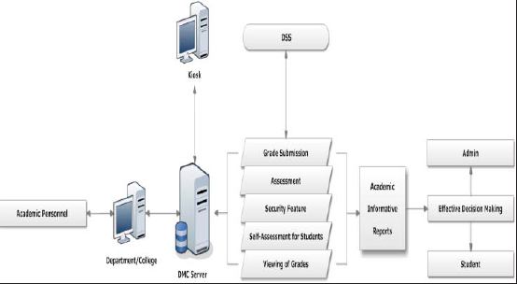
Figure 3.1: Conceptual diagram of the system

3.2 ANALYSIS OF THE EXISTING SYSTEM
The traditional approach is a dedicated manual approach. The manual method of examination monitoring system involves supervisor having to check each student into the exam hall and confirms their examination card if valid to avoid any form of exam malpractice.
  - PROBLEMS OF THE EXISTING SYSTEM
The old system is a very traditional method and involves many difficulties. Now-a-days in this fast world of technology it is very important to complete a work in a speedy manner. In the above mentioned method collecting data takes a long time, discrepancies with the method of examination monitoring system threaten the very principles that make our society democratic and it is not free from biasness. This system has dual work of collecting the data on paper and then feeding it in computer. This also takes a vast amount of manpower into it. There is no proper security measure put in place for examination monitoring.
  - ANALYSIS OF THE PROPOSED SYSTEM
In this work, we aim to develop an examination monitoring and verification using facial technics to detect a wide variety of cheating behaviors during an online exam session. Our proposed online exam process includes two phases, the preparation phase and exam phase. In the preparation phase, the test taker has to authenticate himself before beginning the exam, by using a password and facial authentication. This phase also includes calibration steps to ensure that all sensors are connected and functioning properly. Further, the test taker learns and verbally acknowledges the rules of using the system, such as, no second person is allowed in the same room, the test taker should not leave the room during the exam phase, etc. In the exam phase, the test taker takes the exam, under the continuous “monitoring” of our system for real-time cheating behavior detection.

3.5 ADVANTAGE OF THE NEW SYSTEM OVER THE EXISTING SYSTEM
The advantages of the new system over the existing system are listed below:
- The System is design and developed in such way that it tries to overcome all the prescribe problem.
- The system being a computer-based system will give accurate information regarding the property which helps to view all the students’ information and validation.
- It provide accurate and a very responsive solution to the exam monitoring and verification system using correlation based techniques.

CHAPTER FOUR
DESIGN, IMPLEMENTATION AND DOCUMENTATION OF THE SYSTEM
4.1 DESIGN OF THE SYSTEM
System design and specification is very important in every software development. At this stage, the developer puts every factor into consideration while making this design. In the course of the design, the system has to be designed in a way that there will be a close relationship between the inputs and outputs. Also, the design format must be made in a way that it will be acceptable to the end users.
4.1.1 OUTPUT DESIGN
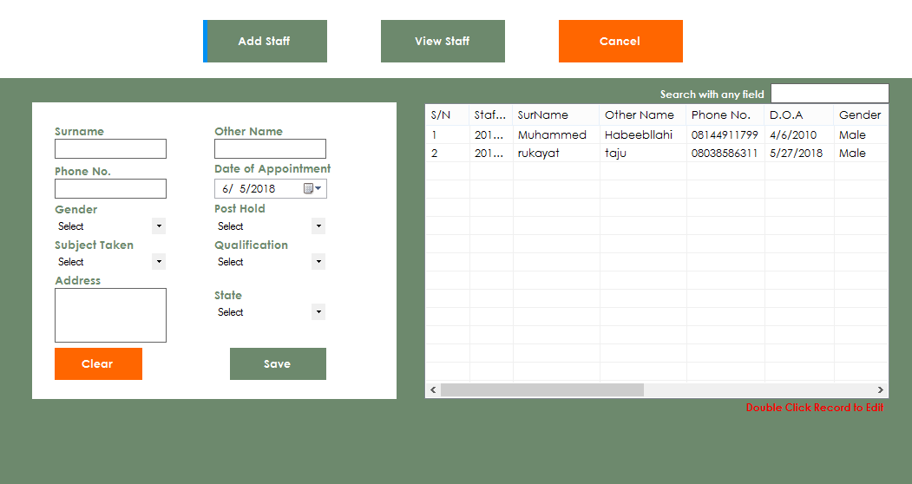

Figure 4.1: Splash Screen: This is the welcome Page


Figure 4.2: Main Menu: This is the menu page where every module directory is displayed.
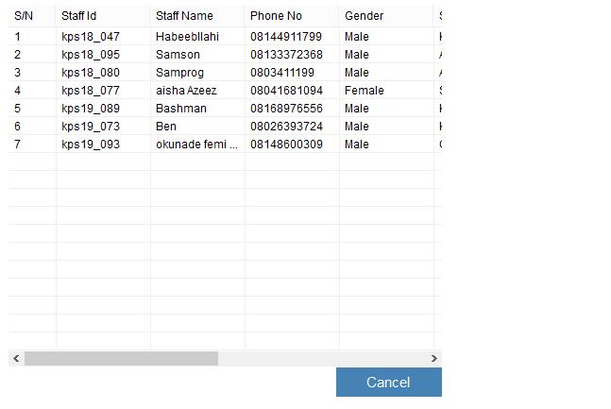
Figure 4.3: Staff Report Page: This is where staff details are displayed

4.1.2 INPUT DESIGN
It is also necessary to denote that data inputted in the computer for processing determines what the output will be. The inputs are use in collecting information the student through the keyboard. Inputs are necessary information needed for processing so as to produce the expected outputs; which are supplied through the keyboard.
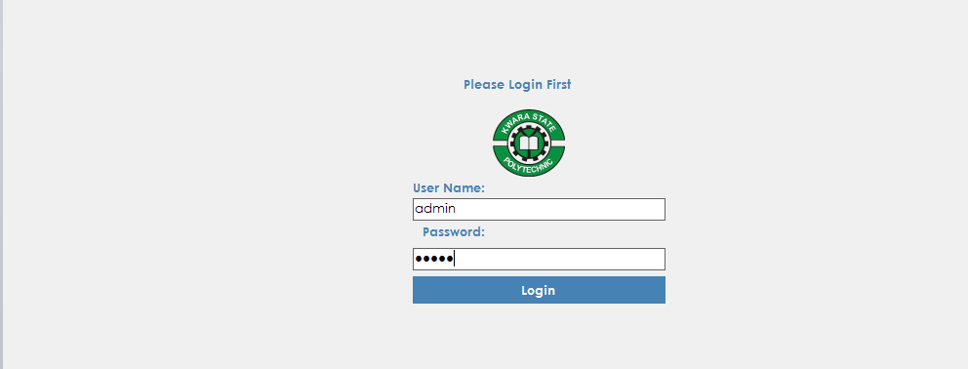
Figure 4.4: Login Page: The login environment for admin
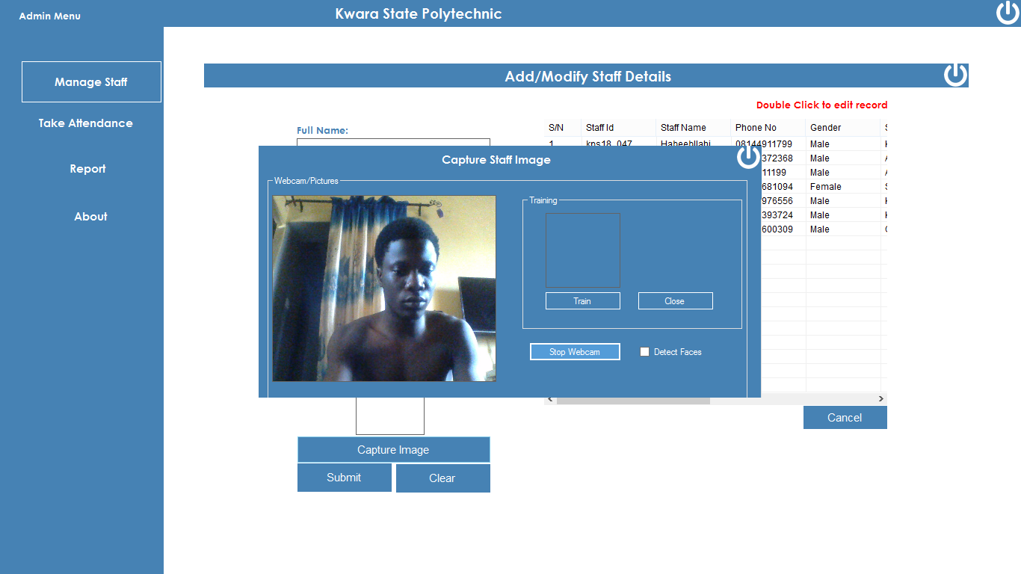
Figure 4.5: Face Authentication Page: This is where Admin Add Staff Fingerprint Details
4.1.3 DATABASE DESIGN
A database table is used for storing information about the files. The database use for this application is mysql database. The files and their respective modes of access as well as information they hold are given below;
Table 4.6: Admin Data table
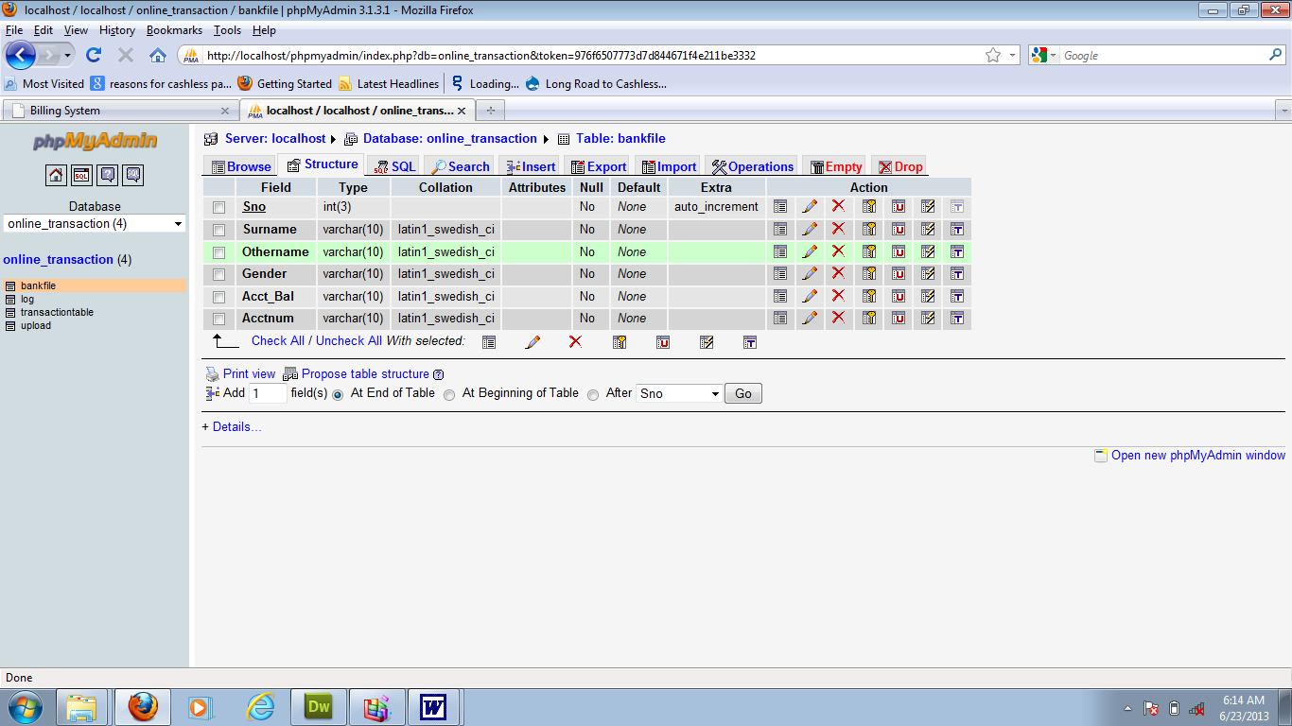

This is admin datatable where data are stored and retrieved
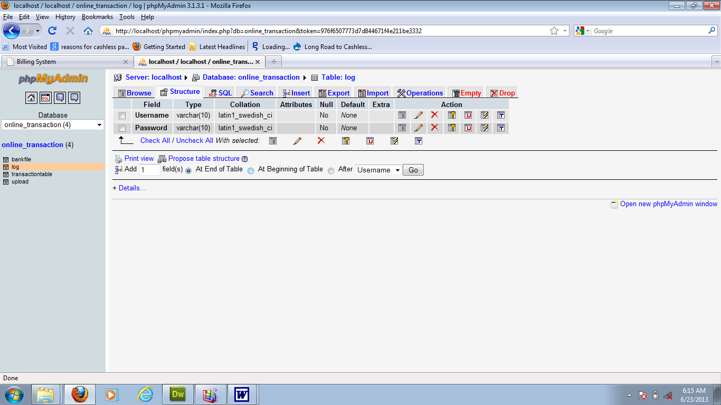
Table 4.2: Staff Details Data table

This is where staff’s data are stored and retrieved
4.1.4 PROCEDURE DESIGN
Procedures are steps which verify the whole process i.e which are everything put together to produce the desired output. This involves the organization of the source document and end with the output result.
Documents are sent to various departments to be filled by the employees and later returned to the personnel departments which are analyzed to determine which record goes into the computer.
After selecting the necessary data, this serves as input to the computer system.
4.2 IMPLEMENTATION OF THE SYSTEM
It is always good to develop new ideas, to implement them on a computer and eventually to relish the satisfaction of achieving a successful result. The implementation process involves converting the system design into a complete and tested EDP that is fully operational and that can be used by the system users to meet their business needs. During implementation phase, the hardware and the software must be implemented.
Implementation of a system can be explained in six steps:-
- Review design specification
- Code, test and document programs
- Train users
- Perform system test
- Convert to new system
- Evaluate and maintain the new system
4.2.1 CHOICE OF PROGRAMMING LANGUAGE
The application is designed using C# as the programming language and MYSQL for database management. Hence, the database testing simply involves running it directly from a Mozilla Firefox web browser on local host server provided by Apache 2.0 in WampServer 2.0 application.
In preparation for the installation of the new system, the method of changeover is given serious consideration to determine the success of the new system. Suitable changeover technique for this system is pilot changeover. The pilot changeover operates by applying the new system bit-by-bit until it covers the whole of the operations. The result obtained from using the pilot method on a small portion of the operations would be used in determining the suitability of the need system for the rest of the operations. This method is similar to testing small sample of a distribution if the test yields a good result then the whole system because fully operational and the manual/existing system is eliminated.
4.2.2 HARDWARE SUPPORT
The computer configuration required to run the software is;
Computer/memory processor PC with a 48dx, MHZ or Pentium, Intel or higher processor required.
Memory: 2GB of RAM
Cache memory: 512KB
Hard disk Minimum size 500GB
Recommended 200GB
Virtual Memory 32Bits
Cache memory 512KB
4.2.3 SOFTWARE
I. Microsoft Visual Studio
ii. MY SQL Database Management Software
iii. Operating system window 07 professional
v. Graphic software paint shop and choosing these two formats GIF (Graphic Image Format)
vi. Scanner software, Mira scans
vii. Web browser software MOZILLA
4.3 PROGRAM DOCUMENTATION
4.3.1 OPERATING THE SYSTEM
Step 1: Boot your computer and click on the C# application to load
Step 2: Enter your username and password
Step 3: Click on Options
3.1 Click on Manage Staff (to manage staff)
3.2 Click on Take Attendance (to take attendance)
3.3 Click on Report (to view report)
3.4 Click on About (to view the about page)
Step 4: Logout
4.3.2 MAINTAINING THE SYSTEM
The use of the term maintenance for software is different from other references to maintenance. Unlike the tires on your car, software does not “wear out”. If this is the case, then why does software maintenance account for such a high percentage of the Total Cost of Ownership for software?
The software maintenance definition refers to changes for defect correction, performance improvements, or adaptations to a changed environment (enhancements). According to this definition, if we build software that is defect-free, performs well, and contains user-controlled parameters to adjust processing rules in response to changing requirements then most maintenance would not be necessary.
Why does this happen? There are many reasons but the most common reasons are time constraints and lack of experience. Adding validation logic takes time. So, people make assumptions about the quality of in-bound data. Assumptions are also made about the volume of transactions and the impact on performance and the stability of the automated business processes. Finally, it is common for new software to be developed by younger developers who don’t understand the maintenance impacts of their designs.
The reality is that business requirements change and most of these assumptions are flawed. Transaction volumes increase, changing business processes require new transactions or new validation criteria, and software users will use the software incorrectly. The cost of software maintenance and the total cost of ownership can dramatically be reduced if developers build software that adjusted to changes in transaction volumes; validated all inbound data and provide user-configurable options for decision logic and data validation.

CHAPTER FIVE
SUMMARY, CONCLUSION AND RECOMMENDATIONS
5.1 SUMMARY
In this project research, a Principal Component Analysis (PCA) matching systems has been described. Principal Component Analysis (PCA) algorithm has really helped in this proposed system. It recognizes faces which have already been trained to the database in a very fast and reliable manner system is divided in two main blocks: the feature extraction block and the matching block. Main problem in feature extraction section is quality of facial image. Low quality areas of fingerprint occurs large number of false minutiae point. Most important in matching stage, is selection of tolerance distances and transformation method. When tolerance values are increasing, then false accept rate is also rising. When transformation of input minutiae set is not precise, then false reject rate value is high. In the proposed layout the design shows the method used for marking the attendees. The camera will take pictures and produce the outline and identify the student's face after which the face to be released is the same as the corresponding database. The task of the proposed system is to capture the face of each student and to store it in the database for their attendance. The face of the student needs to be captured in such a manner that all the feature of the students' face needs to be detected, even the seating and the posture of the student need to be recognized. There is no need for the teacher to manually take attendance in the class because the system records a video and through further processing steps the face is being recognized and the attendance database is updated. The enhanced algorithm gives the same performance results in less time of recognition as 75% of the recognition time of the original algorithm. The experiments are conducted using the face 94 face database and the algorithm is coded using C#.
5.2 CONCLUSION

In this work we aim to optimize the face recognition using PCA algorithm by increasing the number of images in the training set and then reduce the computation time that may occur of this enhanced algorithm. Our enhanced algorithm reduces the participated eigenvectors in the algorithm to reduce the computation time. The enhanced algorithm gives the same performance results in less time of recognition as 75% of the recognition time of the original algorithm. The experiments are conducted using the face 94 face database and the algorithm is coded using C#.
This research methodology is based on exercising the proposed modified PCA algorithm to decide the minimum number of images in the training set for individual that fulfill 100% of recognition, i.e., zero FAR. This experiment aims to neutralize the factor of the number of images in the training set while as this high training set number of images is best exercise our proposed algorithm for computational time. It is also important to decide the best threshold value that fulfill the highest recognition rate, while as we use this value in the original PCA and enhanced one to compare the results.

5.3 RECCOMENDATIONS
It recommend that they repeat the experiment on larger databases in the future and also intent to conduct the same experiment using a different finger database and compare the results with the current experiment to ensure the validity of the enhanced algorithm over different types and sizes of database. Other techniques to enhance the accuracy of the face recognition and decrease the false acceptance rate need to be compared.

REFERENCES
Abhishek , J. (2010) Class Room Attendance System Using Facial Recognition System.The International Journal of Mathematics, Science, Technology and Management. Vol. 2 Issue 3.
Aziza, A. and Survana, N. (2015) An Automatic Attendance System Using Image Processing. The International Journal of Engineering And Science ()IJES Volume 4 Issue 11 PP-01-08.

Igwe, Agu F., Benson, E. and Mercy, E. (2018) wrote an article on “Implementation of an Algorithm for Face Recognition by UsingPrincipal Component Analysis (PCA) In Matlab”. The International Journal of Engineering and Science (IJES) || Volume || 7 || Issue || 6 Ver. III || Pages || PP 06-10 || 2018 || ISSN (e): 2319 – 1813 ISSN (p): 23-19 – 1805

Jayshree, G. and Siddhant, A. (2011) wrote an article on “SOM and PCA Approach for Face Recognition - A Survey”. International Journal of Computer Trends and Technology- March to April Issue-2011

Klongdee, W. and Ieosanurak, W. (2018). “Face classification based on PCA by using the centroid of a triangle”. International Journal of Circuits, Systems and Signal Processing Volume 12, 2018

Kyungnam, K. (2003). “Face Recognition using Principle Component Analysis”. IEEE Conf. on Computer Vision and Pattern Recognition, pp. 586-591, 1991.

Liton, C.P. and Abdulla, A.S. (2012). “Face Recognition Using Principal Component Analysis Method”. International Journal of Advanced Research in Computer Engineering & Technology (IJARCET) Volume 1, Issue 9, November 2012

Mahesh, K.V. (2011) Facial Expression Detection Using Principal Component Analysis. A thesis Submitted In Partial Fulfillment Of The Requirements For The Award Of The Degree Of Masters Of Technology In Telematics And Signal Processing.

Manal, A., Majda, W. and Sahar, B. (2012). “Optimizing Face Recognition using PCA”. International Journal of Artificial Intelligence & Applications (IJAIA), Vol.3, No.2, March 2012

Mangesh, O. (2017) “Attendance Monitoring System Using Face Recognition.” International research Journal of Engineering and Technology (IRJET), Volume: 04 Issue: 05

Nithya, D. (2016). “Automated Class Attendance System based on Face Recognition using PCA Algorithm”. International Journal of Engineering Research & Technology (IJERT)ISSN: 2278-0181 IJERTV4IS120249 www.ijert.org (This work is licensed under a Creative Commons Attribution 4.0 International License.) Vol. 4 Issue 12, December-2015
Pooja, H., Kudale, S., Apurva, K, Jagtap, A. and Balerao, K. (2008) Automatic Attendance Using Face Recognition. International Journal on Recent and Innovation Trends in Compyuting and Communication, Volume: 5 Issue: 12

Reddy, K. S. and Nagabhushan, R. K. (2016). “Design and Implementation of an Algorithm for Face Recognition by using Principal Component Analysis (PCA) in MATLAB”z.Volume 6, Issue 10, October 2016 ISSN: 2277 128X. Research Paper Available online at: www.ijarcsse.com

Rohini, S. (2018). “Face Recognition using Principal Component Analysis”. Face Recognition using Principal Component Analysis: A Survey Proceedings of ARSSS International Conference, 29thApril, 2018, Bengaluru, India. Vol. 12, Issue1, pp. 1-14, 2018.
Samuel, L., Aditya, R.M., Ririn, I.D. and Dion, K. (2010) “Student Attendance System iIn Classroom Using Face Recognition Techniques.” The International Journal Of Engineering And Science (IJES) Volume 5 Issue 9, PP-05-11 ieeexplore.ieee.org/document/7763360/
Shireesha, C. and Raghunadh, M.V. (2013) “Automated Attendance management System Using Face Recognition Algorithm.” (ICCIC), IEEE International Conference, DOI: 10.1109/ICCIC.2013.6724266 Vol. 2 Issue 15

Sultoni, S. and Abdullah A.G. (2018). “Real Time Facial Recognition Using Principal Component Analysis (PCA) And EmguCV”. Jurnal Ilmiah NERO2 3 153-160
Syed Navas, A.S., Dhevi, T.S. and Pratap, M. (2013). Face Recognition Using Principal Component Analysis and Neural Network. International Journal of Computer Networking, Wireless and Mobile Communications (IJCNWMC) Vol. 3, Issue 1.

