DESIGN AND IMPLEMENTATION OF MEDICAL GUIDANCE FOR DRUGS PRESCRIPTION ON TRIVIAL DISEASE
(A CASE STUDY OF UITH)

BY

OJO AYOBAMI ZION
ND/23/COM/FT/0109

SUBMITTED TO THE DEPARTMENT OF COMPUTER SCIENCE,
INSTITUTE OF INFORMATION AND COMMUNICATION TECHNOLOGY
KWARA STATE POLYTECHNIC, ILORIN.

IN PARTIAL FULFILLMENT OF THE REQUIREMENTS FOR THE AWARD OF NATIONAL DIPLOMA (ND) IN
COMPUTER SCIENCE

JULY, 2025.

CERTIFICATION
This is to certify that this project research was carried out by OJO AYOBAMI ZION with Matriculation Number: ND/23/COM/FT/0109, has been read and approved as meeting part of the requirement for the award of National Diploma (ND) in computer science

…………………………………. ….………………………
MR. ABIODUN E.T. Date
Project Supervisor

…………………………………. ….………………………
MR OYEDEPO F.S Date
Head of Department

…………………………………. ….………………………
External Examiner Date

DEDICATION
I dedicate this project work to Almighty God who inspired me and directed my ways during my academic stay in the polytechnic.

ACKNOWLEDGEMENT
All praise is due to Almighty God the Lord of universe. I praise him and thank him for giving me the strength and knowledge to complete my ND programand also for our continued existence on the earth.
I appreciate the utmost effort of our supervisor, Mr. Abiodun, E.T whose patience, support and encouragement have been the driving force behind the success of this research work. He gave useful corrections, constructive criticisms, comments, recommendations, advice and always ensures that an excellent research is done. My sincere gratitude goes to Head of Department and other members of staff of the Department of Computer Science, Kwara State Polytechnic, Ilorin, for their constant cooperation, constructive criticisms and encouragements throughout the programme.
Special gratitude to my parents, who exhibited immeasurable financial, patience, support, prayers and understanding during the period in which I was busy tirelessly on mystudies, special thanks go to my lovely siblings
My sincere appreciation goes to my friends and classmates.

LIST OF FIGURE
Figure 4.1: Admin dashboard: this page show the admin page to different module 15
Figure 4.2: List of loan : this show the list of loan from the database 16
Figure 4.3: Payment: this show the payment of customer. 16
Figure 4.4:login type page: this page show loan type 17
Figure 4.5: new borrower: this is the page that shows where to register new borrower 17
Figure 4.6: new loan: this page is used to add new loan 18

LIST OF TABLE
Table 4.1: Database: this is the database for the loan credibility 19
Table 4.2: borrower : this is use holding borrower details 19
Table 4.3: login: this is the table that hold user authentication 19

TABLE OF CONTENTS
Title page i
Certification ii
Dedication iii
Acknowledgements iv
Table of contents v
Abstract vi
CHAPTER ONE: GENERAL INTRODUCTION
1.1 Background to the Study 1
1.2 Statement of the Problem 2
1.3 Aim and Objectives 2
1.4 Significance of the Study 3
1.5 Scope of the Study 3
1.6 Organization of the Report 3
1.7 Definition of Technical Term 3
CHAPTER TWO: LITERATURE REVIEW
2.1 Review of Related Works 5
2.2 Review of Related Concepts 7
2.2.1 Credit Analysis 8
2.2.2 Credit Presentation and Decisioning 9
2.2.3 Monitoring 10
2.3 Overview of Loan Management 10

CHAPTER THREE: METHODOLOGY AND ANALYSIS OF THE SYSTEM
  - Research Methodology 15
  - Analysis of the Existing System 15
  - Problem of the Existing System 16
  - Analysis of the Proposed System 16
  - Advantage of the Propose System 16
CHAPTER FOUR: DESIGN AND IMPLEMENTATION OF THE SYSTEM
  - Design of the System 18
    - Output Design 18
    - Input Design 20
    - Database Design 21
    - Procedure Design 22
  - Implementation of the System 23
    - Choice of programming language 23
    - Hardware support 24
    - Software Support 24
  - System Documentation 25
    - Operating the System 25
    - Maintaining of the System 25
CHAPTER FIVE: SUMMARY CONCLUSION AND
RECOMMENDATION
5.1 Summary 27
5.2 Conclusion 27
5.4 Recommendations 27
References 29
Appendices
APPRNDIX 1: PROGRAM FLOWCHART 29
APPENDIX 2: NEW LOAN 30
APPENDIX 3: NEW PAYMENT 31
APPENDIX 4: SYSTEM FLOCHART 32
APPENDIX 5: LOAN FLOWCHART 33
APPENDIX 6: SOURCE CODE 34

CHAPTER ONE
INTRODUCTION
  - BACKGROUND OF THE STUDY
Medication prescription is one of the most common and powerful treatment methods used by physicians. For years, hand-written prescription has been a preferred communication method for physicians in decision making concerning medication therapy, and pharmacists in in distributing medications. On the other hand, it has been a valuable instruction on how to use medications for patients. Besides, it is considered as an important activity in the health care process. National health care systems face numerous forces such as demographic changes followed by increasing need for health care services. Hence, people tend to use more medications which have been resulted in rising the number of prescriptions and diversity in medication types. Therefore, society became much more reliant on medication prescribing, distributing, administrating and processing systems. Medication process is an erroneous procedure. Among different types of errors associated with medication process, prescription errors are the most preventable cause of medication errors. Traditional hand written prescription is too slow due to using pen and paper. The paper-based prescription process is inefficient, expensive and resource-intensive. This approach has several other limitations such as high rate of human errors in manipulating data, and documentation errors which are inevitable. However, it is so hard to overcome the limitations of paper prescription that arise due to the growing number of pharmaceutics and complexity of medical care. Most of the limitations of paper prescription could be eliminated or minimized by electronic prescription or e-prescription (Pandey, 2020).
It would be of great necessity to provide a computerized system that will provide complementary medical service, like medical disease diagnosis in places that are difficult to ace and health care facilities where qualified experts are lacking. This develops a system that will aid the diagnosis of common diseases for hospitalized children using machine learningtechniques. Failure to rescue hospitalized patients from complications of discase or treatmentis the source of substantial morbidity and death. Prediction to aid preventative efforts is anotherpromising frontier tor improving outcomes using ML(Podgorelec, et al. 2023).
Therefore, healthcare professionals should ‘recognise that non-adherence is common and that most people are non-adherent sometimes’ (NICE, 2019). This non-adherence can be in intentional (patients do not want to take the medication) or non-intentional (they have practical problems taking the medication). NICE advises that when non-adherence is identified, a plan should be agreed with the patient and a follow-up date arranged for review (NICE, 2019).During a medication review, the GP should be alert to the possibility of intentional and non-intentional non-adherence to treatment plans; it is necessary to employ a patient-centred approach to prescribing in order to fully address these issues. A comprehensive medication review is multifaceted: it may not be possible to achieve a full review of a patient receiving multiple medications in one 10-minute appointment and may be beneficial to make use of a practice pharmacist in the medication review process. A GP should have good working relationships with local community pharmacists; MUR and NMS reviews are two examples of specific medication reviews that may be provided by community pharmacists(Pal Singh, 2020).
It is well known that in Information Technology (IT) driven society, knowledge is one of the most significant assets of any organization. The role of IT in health care is well established. Knowledge Management in Health care offers many challenges in creation, dissemination and preservation of health care knowledge using advanced technologies. Pragmatic use of Database systems, Data Warehousing and Knowledge Management technologies can contribute a lot to decision support systems in health care (Harleen, 2019).
Traditionally, decision making in health care is based on the ground information, lessons learnt in the past resources and funds constraints. However, data mining techniques and knowledge management technology can be applied to create knowledge rich health care environment. A health care organization may implement Knowledge Discovery in databases (KDD) with the help of a skilled employee who has good understanding of health care industry. KDD can be effective at working with large volume of data to determine meaningful pattern and to develop strategic solutions. Health care analyst and policy makers can learn lessons from the use of KDD in other industries and apply KDD to problems of health care industry (Hospitals, Insurance companies, Physicians and Pharmaceutical companies etc.).

  - STATEMENT OF THE PROBLEM
Between a third and a half of all medicinesprescribed for long term conditions are not takenas recommended. If the prescriptions are appropriate,then this may represent a loss to patients,the healthcare system and society.One of the most important issues to consider when reviewing patients’ medications is whether they are taking the medicines as intended which is often termed ‘adherence’.Medical errors are a major public health problem and a leading cause of mortality. During hospitalization, the majority of adverse events are attributed to invasive procedures, hospital- acquired infections, and health products (drugs and medical devices). Improving patient safety by reducing medication errors has therefore become a top priority.
  - AIM AND OBJECTIVES OF THE STUDY
The aim of the research work is develop a machine learning application that will diagnosed and prescribe drug on hospitalized children with the following objective:
- To acquire the data from electronic health record
- Develop a system that analyses the data using php programming language
- Implementation of the developed system.

  - SIGNIFICANCE OF THE STUDY
Medication reviews are an important part of the repeat prescribing’ process: if issues are not addressed during these reviews, inappropriate prescribing may continue for another year. The patient and the GP may approach the concept of a ‘medication review appointment’ from different perspectives: the GP must use good communication skills to ensure that concordance is reached. This will allow the patient to continue toreceive their medicines on repeat prescription for an appropriate amount of time.

  - SCOPE OF THE STUDY
We present an overview of decision trees with the emphasis on a variety of different induction methods available nowadays. Induction algorithms ranging from the traditional heuristic based techniques to the most recent hybrids, such as evolutionary and neural network based approaches, are described. Basic features, advantages and drawbacks of each method are presented, biasing to the medical domain.
1.6 ORGANIZATION OF THE STUDY
For easy study and proper understanding of this project write-up, It is planned and organized into five chapters. The description of what each chapter contains is explained below:
ChapterOne: This contains an Introduction to the whole write-up, the problem of the study, aims and objectives of the study, the significant of the study, the scope and limitation of the study, and organization of the report.
Chapter Two: It focuses on the literature review of the study, organization of the board of director, computerization of the current state of the art.
Chapter Three: It presents data collection method employed, analysis of data and existing system, advantages of the proposed system, design and implementation, programming language used with reasons, hardware and software support.
Chapter Four:It deals with the system design implementation and documentation, design of the system, output design, input design, file system, procedural design, and documentation of the new system.
Chapter Five:This centres the summary, experienced gained, recommendation and conclusion.

CHAPTER TWO
LITERATURE REVIEW
2.1 REVIEW OF RELATED PASTWORK
Vili, et al. (2023) “Decision Trees: An Overview and Their Use in Medicine” In medical decision making (classification, diagnosing, etc.) there are many situations where decision must be made effectively and reliably. Conceptual simple decision making models with the possibility of automatic learning are the most appropriate for performing such tasks. Decision trees are a reliable and effective decision making technique that provide high classification accuracy with a simple representation of gathered knowledge and they have been used in different areas of medical decision making. In the paper we present the basic characteristics of decision trees and the successful alternatives to the traditional induction approach with the emphasis on existing and possible future applications in medicine.
Subhash, et al. (2019) “Data Mining Techniques for Medical Data: A Review” Data mining is an important area of research and is pragmatically used in different domains like finance, clinical research, education, healthcare etc. Further, the scope of data mining have thoroughly been reviewed and surveyed by many researchers pertaining to the domain of healthcare which is an active interdisciplinary area of research. In fact, the task of knowledge extraction from the medical data is a challenging endeavor and it is a complex task. The main motive of this review paper is to give a review of data mining in the purview of healthcare. Moreover, intertwining and interrelation of previous researches have been presented in a novel manner. Furthermore, merits and demerits of frequently used data mining techniques in the domain of health care and medical data have been compared. The use of different data mining tasks in health care is also discussed. An analytical approach regarding the uniqueness of medical data in health care is also presented.
HarleenandWasan, et al. (2019) “Empirical Study on Applications of Data Mining Techniques in Healthcare” The healthcare environment is generally perceived as being ‘information rich’ yet ‘knowledge poor’. There is a wealth of data available within the healthcare systems. However, there is a lack of effective analysis tools to discover hidden relationships and trends in data. Knowledge discovery and data mining have found numerous applications in business and scientific domain. Valuable knowledge can be discovered from application of data mining techniques in healthcare system. In this study, we briefly examine the potential use of classification based data mining techniques such as Rule based, decision tree and Artificial Neural Network to massive volume of healthcare data. In particular we consider a case study using classification techniques on a medical data set of diabetic patients.

World Health Organization (2022) “Methods to analyse medicine utilization and expenditure to support pharmaceutical policy implementation” Many low- and middle-income countries are transitioning their health care systems to enable universal health care coverage. In most instances, the coverage includes support for access to medicines, recognizing that this needs to be at a cost both the individual and the community can afford. Central to health systems providing access to medicines is the need for a formulary that stipulates which medicines are covered under universal health care and under what circumstances they are covered. The World Health Organization (WHO) is supporting efforts to ensure health technology assessment underpins the decision-making process for including medicines on the formulary.This manual includes an overview of the governance structures and human resources required to support routine analysis of medicine utilization and expenditure. The data sources and methods that can be used to undertake the analyses are described, and examples of analyses are given. The final section of the manual includes a list of guidance documents for research on medicine utilization research, and web addresses of agencies that routinely publish reports of medicine utilization and expenditure to inform pharmaceutical policy.

Mahnaz, et al. (2020) “A Theoretical Approach to Electronic Prescription System: Lesson Learned from Literature Review” The tendency to use advanced technology in healthcare and the governmental policies have put forward electronic prescription. Electronic prescription is considered as the main solution to overcome the major drawbacks of the paper-based medication prescription, such as transcription errors. This study aims to provide practical information concerning electronic prescription system to a variety of stakeholders. In this review study, PubMed, ISI Web of Science, Scopus, EMBASE databases, Iranian National Library Of Medicine (INLM) portal, Google Scholar, Google and Yahoo were searched for relevant English publications concerning the problems of paper-based prescription, and concept, features, levels, benefits, stakeholders and standards of electronic prescription system. There are many problems with the paper prescription system which, according to studies have jeopardized patients’ safety and negatively affected the outcomes of medication therapy. All of these problems are remedied through the implementation of e-prescriptions. The sophistication of electronic prescription and integration with EHR will become a reality, if all its stakeholders collaborate in developing fast and secure electronic prescription systems. It is plausible that the required infrastructure should be provided for implementation of the national integrated electronic prescription systems in countries without the system. Given the barriers to the implementation and use, policymakers should consider multiple strategies and offer incentives to encourage e-prescription initiatives. This will result in widespread adoption of the system.

Ajeet, et al. (2021) “Online medical consultation: a review” The Internet has been a steady source of medical data previously; it has just as of late been utilized for online private patient-doctor consultations. As of late, the market has seen a surge in applications providing healthcare services on the go. An online consultation has secured a foothold in the market and individuals are opening up to the likelihood of substituting a visit to a physical facility with an online option. This study reports a review of the literature on online medical consultation from various databases as well as various surveys and reports published. As per published work/reports/surveys, the various factors which led to a sudden surge in the online medical consultation are the convenience, shift in disease patterns, cost-effective, privacy and second opinion.
United Nations Office on Drugs and Crime (2020) “Technical Guidance: Increasing access and availability of controlled medicines” During the last ten years, increased discussions and debates have centered around the barriers to accessing controlled medicines, and the need for governments to overcome those barriers in order to provide access for more than 80% of the world’s population still without access to controlled medicines. While information on barriers is important, it is critical to provide concrete information about actions Member States can take to address the negative health outcomes, such as the enormous burden of untreated pain around the world, associated with inadequate access to controlled medicines. Untreated pain that lasts beyond the expected healing time, or for more than 3 months, becomes the disease itself, with the expected clinical, social, economic, and psychological impacts on the patients and families. Inclusive in this document is the understanding that the medical use of controlled drugs should be based on scientific evidence and the highest acceptable medical standards. However, we acknowledge that this document reflects current ideas and best practices building upon three seminal documents referenced in the introduction. The current research does not provide a strong platform to recommend concrete actions but rather supports practical strategies within a framework of monitoring and evaluation. This document focuses on the critical components essential to create change, move forward, and implement the best medical care available for patients, inclusive of access to essential controlled medicines. These critical components are not stand-alone elements but are rather intended to be systematically inter-linked and part of a comprehensive approach to quality healthcare, including the rational medical use of controlled medicines, for all persons around the world who need them.
Sana, et al. (2022) “Detecting Diseases in Medical Prescriptions Using Data Mining Methods” Misdiagnosis or late diagnosis of diseases is currently at the forefront of medical errors. These errors not only lead to the death or disability of a significant number of patients around the world each year, but also have an indirect impact on the professional life of doctors and the quality of services provided by them. Furthermore, the complaints raised as a result of such errors have always been one of the most important stressors for doctors. Data mining in the medical industry to diagnose and predict diseases has become one of the fields of interest for researchers in recent years. Our aim in this paper is to use data mining methods to find knowledge in a dataset of medical prescriptions. By analyzing the drugs prescribed for each disease, our proposed method aims to predict the category of each disease and the type of disease that the patient suffers from. In general, the results of this research can be used by, for example, the medical staff of a hospital, including the specialists and general practitioners to reduce the misdiagnosis error rate and also have more confidence in the correctness of the disease diagnosis and the prescribed medication. At the same time, the patients can have more trust in the correct diagnosis of their disease and the prescribed drugs. In addition, it can reduce the cost of compensating for medical errors which could, in turn, lead to lowering the expenses of medical insurance companies. Finally, these results can be used as a basis for future research in this field. Our collected dataset includes details such as the name of the disease, the category of the disease, and the names of the drugs prescribed for each patient. To label the cases, a team of doctors has identified each patient’s disease. A number of experiments have been conducted to compare the performance of different data mining techniques for disease prediction, and the results show that the proposed stacking model is more accurate than other data mining techniques such as Na¨ıve Bayes.
UNODC (2020) “Guidance for Community-Based Treatment and Care Services for People Affected by Drug Use and Dependence in Southeast Asia” Drug use disorders are health conditions that can affect any individual, family and community. Yet misperceptions, fears of social and legal consequences, and discrimination all tend to keep people away from the services they need. On the other hand, if they get help, people suffering from drug use disorders can and do manage their condition, recover and lead happy, productive, and full lives. UNODC promotes a health-oriented approach to drug dependence. Together with WHO it has launched a Joint Programme on drug dependence treatment and care which promotes and supports worldwide evidence-based policies, strategies and interventions that are based on a public health and human rights approach, in order to reduce drug use and the health and social burden it causes. The Joint Programme encourages investment in comprehensive and results-oriented programmes for drug dependence treatment and care, particularly community-based interventions. The dominant response in Southeast Asia to drug use and dependence are compulsory centres for drug users, which are not consistent with a number of Principles of Drug Dependence as proposed by UNODC and WHO in 2009. Community-base treatment for drug use disorders, a cost-effective alternative, is not well understood in the region. This Guidance Document outlines community-based treatment as an alternative model to compulsory centres, which results in less restriction of liberty, is more cost-effective, less stigmatizing and offers better prospects for the future of the individual and society. The Guidance Document is aimed at helping practitioners in the health, social work and law enforcement sectors implement community-based Treatment.

2.2 REVIEW ON ELECTRONIC PRESCRIPTION
2.2.1. The Concept of Electronic Prescription
Electronic prescription is a reality far beyond the simply using computers to write and save prescriptions. In fact, electronic prescription (e-prescription) is a broad term that means using the computer devices to enter, modify, review and generate or transmit medication prescriptions that prepare two-way transmissions between the point of care and the dispenser. This form of technology would safely transmit prescription or prescription-related information between stakeholders (prescribers, dispensers, pharmacies, health plans, and health insurers) either directly or through an intermediary (including an electronic prescription network) using electronic media. E-prescription transfers prescriptions from prescribers to pharmacies, refills and renewals requests from pharmacies to providers, prescription benefit and formulary information and fills status notification for prescribers. Therefore, the utilization of electronic systems in prescription can facilitate the communication of a prescription, aid the choice, and supply the medication by decision support and finally provides a robust audit trail for the entire medication process.
There are several main steps in creating and managing prescriptions electronically. Firstly, a user of the system signs in by some sort of authentication to prove his or her identification. In the next step, a clinician identifies a patient within the electronic prescription system and the electronic prescription process begins. These data should be readily available to the clinician prior to entering new prescriptions. Different devices in multiple environments are used in three activities of the electronic prescription process, such as selecting a medication, entering parameters and signing the prescription. Also, clinical decision support is utilized through reviewing alerts and reminders in these activities. Then, the verified prescription was directly or indirectly transferred to pharmacy for dispensing. Prescription Refill and renewal requests are also automated in e-prescription cycle, illustrated in Figure 4. Moreover, prescription claims are transmitted electronically from pharmacy to payers.

CHAPTER THREE
RESEARCH METHODOLOGY AND ANALYSIS OF THE EXISTING SYSTEM
3.1 RESEARCH METHODOLOGY
The cornerstone of any development project is a thorough understanding of the business requirements. Therefore, the first step was to explore and develop a good working knowledge of the problem which in this case is to develop a system which can diagnose and prescribe drug far hospitalized patient accurately to ease children medical treatment which are shared across the different ailment is accomplish this by mimicking human reasoning with computer accuracy.
3.1.1 Steps to diagnoscd using decision tree techniques are as follow:
Step 1 Start
Step 2 Accept patient data
Step 3 Select the data form file
Step 4 preprocess selected data using Arff Converter
Step 5 Classify the data using the algorithms ID3, C4, MLP (using C#)
Step 6 Choose the best node has a class label associated with it
Step 7 Process the result
Step 8 Repeat to check for errors
Step 9 Display result and select possible treatment from the database
Step 10 Stop

3.1.2 ADAPTATION IN INITIAL DECISION TREE TECHNIQUES
For = number of root nodes do
For S-I to number of nodes child do
Split the value of all attribute
End for S
Compute the nodes using Arff Converter
Repeat
End for I
Iterative Dichotomiser 3(ID3)
For = number of root nodes do
For S=I to number of nodes child do
Classify values using ID3,C4 and MLP
Choose the best node has a class label associated with it
End for S
Compute the diagnosis for patient
Display the result of the prediction from the name table and process the possible solution
Repeat
End for I.
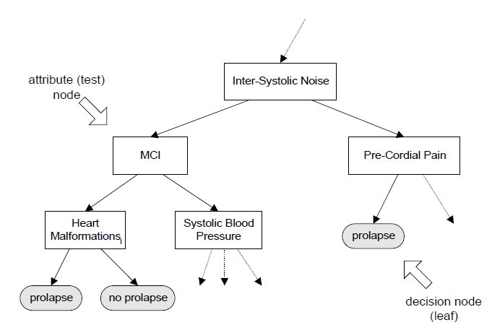
Figure 3.1.An example of a (part of a) decision tree.
The decision tree is very easy to interpret. For example, from the tree shown in figure 1 we can deduce the following two rules:
- If the patient has inter-systolic noise and MCI and heart malformations then she/he has a prolaps, and
- If the patient has inter-systolic noise and MCI and no heart malformations then she/hedoes not have a prolaps.
3.2 ANALYSIS OF THE EXISTING SYSTEM
The existing system medicine needed in the hospital that consists of vast amount of records. These produce large scale of datasets that are complex to manage and thereby need tools and technique to easily process, interpret, forecast and predict future consumption. Due to this, the method of predicting of drug and forecasting stock consumption using Decision tree technique in hospital is not be a surprising issue. Thus, this research investigated the potential applicability of Decision tree technique to predict the Anti-Retroviral drugs consumption for hospital based up on patient’s history datasets.
3.3 PROBLEMS OF THE EXISTING SYSTEM
There are many problems with the paper prescription system which, according to studies have jeopardized patients’ safety and negatively affected the outcomes of medication therapy. All of these problems are remedied through the implementation of e-prescriptions. Examples of prescription problems are mentioned below:
• Errors in drug name, dose, formulation, frequency of dosing, dosing regimen, strength and rout
• Illegibly written prescriptions
• Ambiguous order and incorrect interpretation of the prescription
• Unclear telephone or verbal orders
• Prescriptions issued to the wrong patient
• Missing prescriber or patient data
• Omission of medication, high rate of prescription fraud imposing costs on pharmacies
• Rewriting prescriptions in physicians’ offices and pharmacies
It is sometimes difficult to balance the needs of the prescriber to undertake a medication review against the expectations of the patient to address other issues within a consultation. It may be useful to take a moment to consider the reasons for this mismatch of expectations.
There are no easy solutions to this problem, butthe suggestions in Box 1 might help to ensure that patients recognise the need for medication review, andadequate time is available.
3.4 ANALYSIS OF THE PROPOSED SYSTEM
Selecting medications, printing prescriptions, electronically transmitting prescriptions, delivering clinical knowledge to the prescriber, and controlling all patients’ safety based on the patients’ demographics and medical history to support decision-making and knowledge at point of care, (safety controls include automatic alerts and reminders representing data about ordering correctness, inappropriate dose or route of administration of a drug-drug interactions, drug allergies, drug or diagnostic test contraindications, age-specific warnings, or cautions)
- Providing information on the availability of lower cost medications and medically appropriate treatment alternatives
- Providing information on formulary, co-pay (or coinsurance) and patients’ eligibility received electronically from the patient’s medication plan.
- Facilitating electronically transfer of prescription to the pharmacy by sending messages and using the interoperable standards
- Speeding up the process of renewing medications with ability to send prescription renewal requests electronically and automate the renewal authorization process
- Supporting patients during administration and actively promoting the appropriate medication usage

3.5 ADVANTAGES OF THE NEW SYSTEM OVER THE EXISTING SYSTEM
This will help to ensure effective and safe prescribing that takes account of the views of the patient, costs and the need for further monitoring and reviewthis will help to ensure patient satisfactionand adherence to the management plan.
Implementing electronic prescription system can overcome many problems related to paper prescription process; and offer the following advantages:
- Cost savings and reduced expenses of health care for patients, health care providers, health programs, and health care insurance organizations throughout the prescription processing system.
- Reducing prescription, medication and transcription errors, adverse drug reaction (ADR), prescription fraud and litigation.
- Improving medication therapy outcomes, patient safety, practice, health care efficiency and quality, and public health.
- Providing a safe instrument for electronic access to updated formulary information and patient medication history at the point of care.
- Supporting clinical decision-making for medication therapy in the context of drug-drug interactions, drug-allergy reactions, diagnoses, duplicative treatment and dose calculation based on age, weight, health history, and etc.

CHAPTER FOUR
DESIGN, IMPLEMENTATION AND DOCUMENTATION OF THE SYSTEM
4.1 DESIGN OF THE SYSTEM
System design and specification is very important in every software development. At this stage, the developer puts every factor into consideration while making this design. In the course of the design, the system has to be designed in a way that there will be a close relationship between the inputs and outputs. Also, the design format must be made in a way that it will be acceptable to the end users.
4.1.1 OUTPUT DESIGN
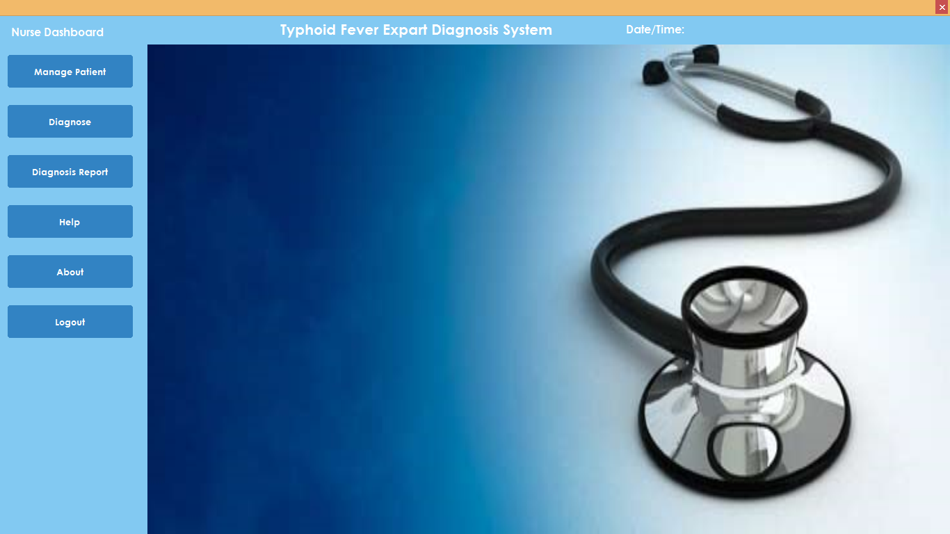
Figure 4.1: Index Page Interface
Show information about the welcome page to tell user about Typhoid Diagnostic system

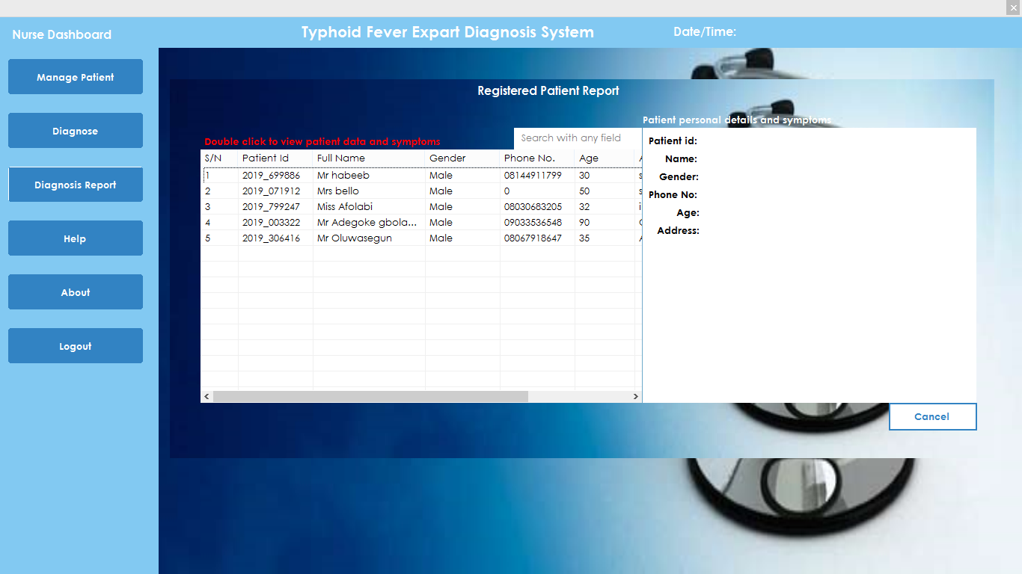
Figure 4.2: Registered Patient Report Module
This is where registered patient report are displayed
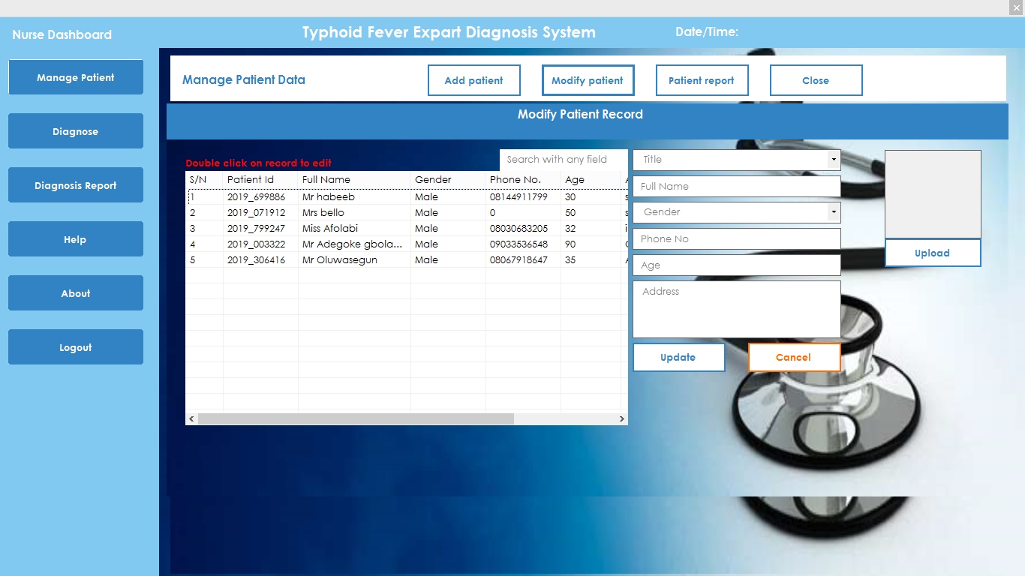
Figure 4.3: Modify Patient Record Module
This is where patient record are modified or update

4.1.2 INPUT DESIGN
It is also necessary to denote that data inputted in the computer for processing determines what the output will be. The inputs are use in collecting information the student through the keyboard. Inputs are necessary information needed for processing so as to produce the expected outputs; which are supplied through the keyboard.
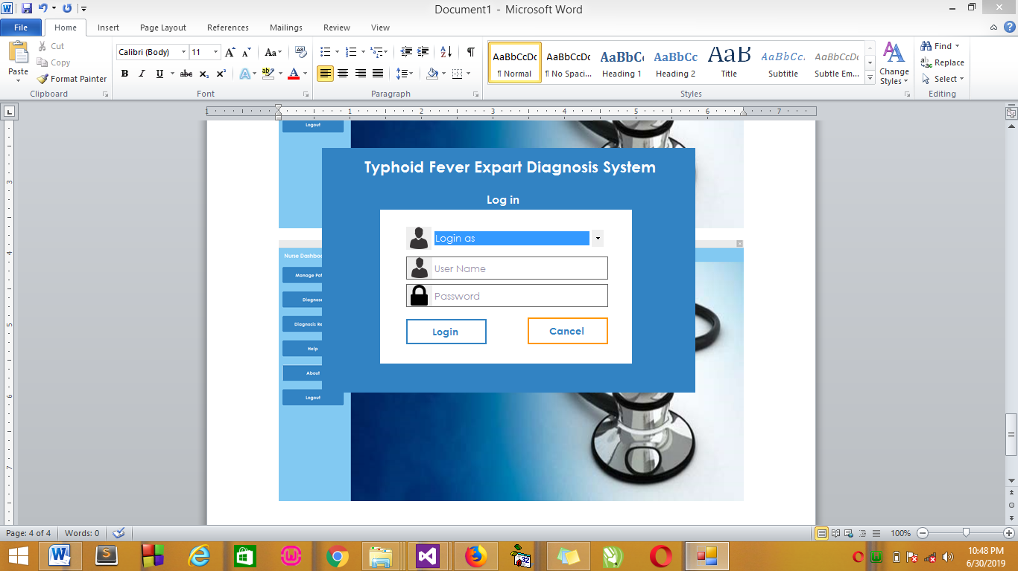
Figure 4.5: Input Interface for Admin login.
The login environment for users

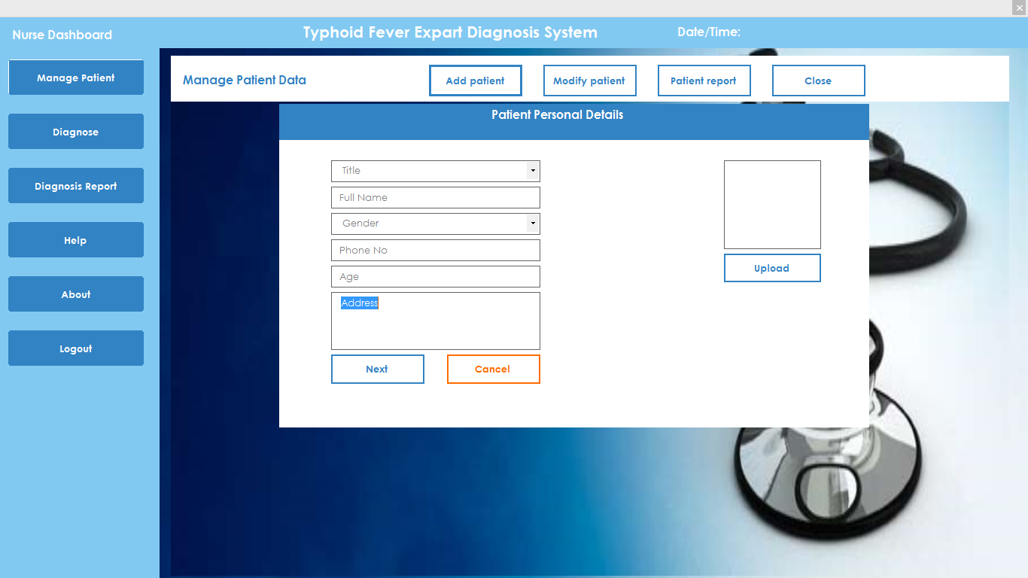
Figure 4.6: Patient Personal Details Page
This is where patient personal details are entered.
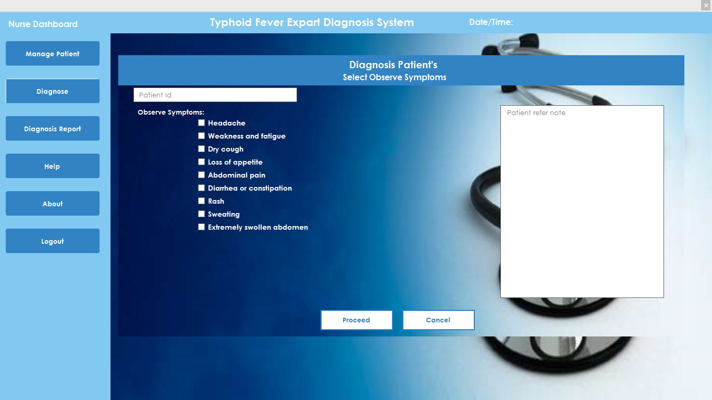
Figure 4.7: Diagnosis Patient Page
This is where the nurse select observe symptoms for patients.
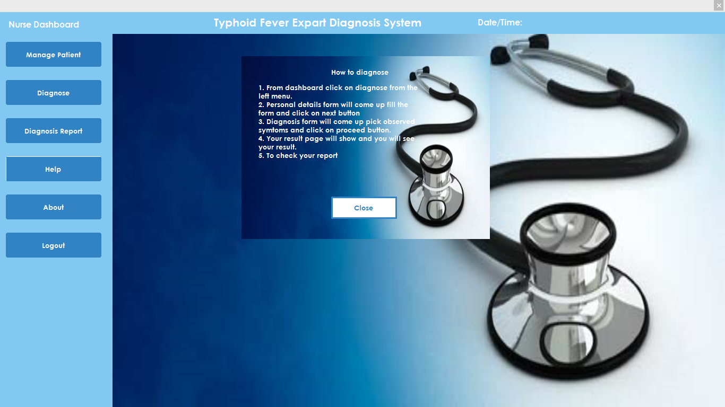
Figure 4.8: Help Module
This is where how to operate the system is displayed.
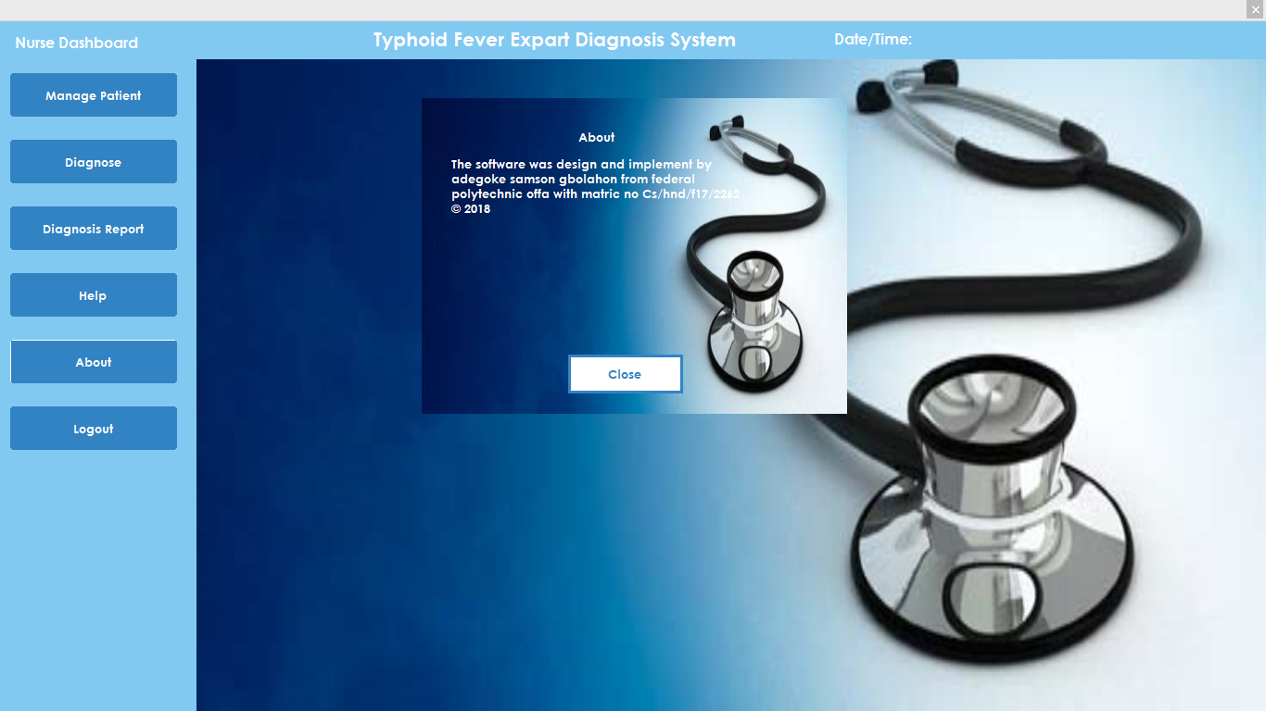
Figure 4.8: About Module
This is where the about page is displayed

Table 4.1: Table showing various symptoms and the sickness prediction
RESULT
Numbers of Patients | Symptoms | Arff Converter Process Time | Sickness Prediction | Prediction Process Time
Patient 1 | Headache, Weakness and fatigue, Abdominal pain | 0.9654455444 | Typhoid | 0.5768
Patient 2 | Rash, Sweating, Dry cough, Diarrhea or constipation | 0.865898899 | Measles | 0.4998
Patient 3 | Headache, Weakness and fatigue, Abdominal pain, Dry cough, Diarrhea or constipation | 1.9867376635 | Typhoid | 0.9876
Patient 4 | Rash, Sweating, Diarrhea or constipation, Extremely swollen abdomen | 0.7654321879 | Measles | 0.3236
Patient 5 | Headache, Weakness and fatigue, Abdominal pain, Dry cough, Diarrhea or constipation, Extremely swollen abdomen | 1.9987654923 | Typhoid | 0.9765

DISCUSSION
The decision tree method is a powerful statistical tool for classification, prediction, interpretation, and data manipulation that has several potential applications in medical research.
A decision tree is a flow-chart-like tree structure, where each internal node is denoted by rectangles, and leaf nodes are denoted by ovals. All internal nodes have two or more child nodes. All internal nodes contain splits, which test the value of an expression of the attributes. Arcs from an internal node to its children are labelled with distinct outcomes of the test. Each leaf node has a class label associated with it. Decision tree are commonly used for gaining information for the purpose of decision -making. Decision tree starts with a root node on which it is for users to take actions. From this node, users split each node recursively according to decision tree learning algorithm. The final result is a decision tree in which each branch represents a possible scenario of decision and its outcome.

4.1.3 DATABASE DESIGN
A database table is used for storing information about the files. The database use for this application is mysql database. The files and their respective modes of access as well as information they hold are given below;

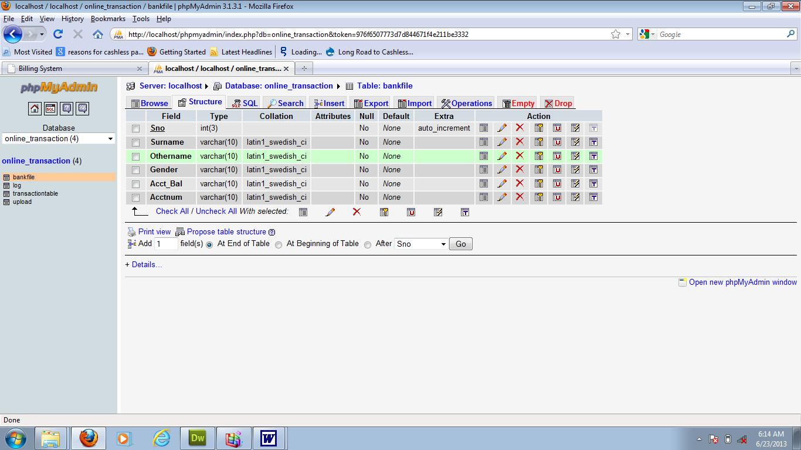

Table 4.1: Users Datatable
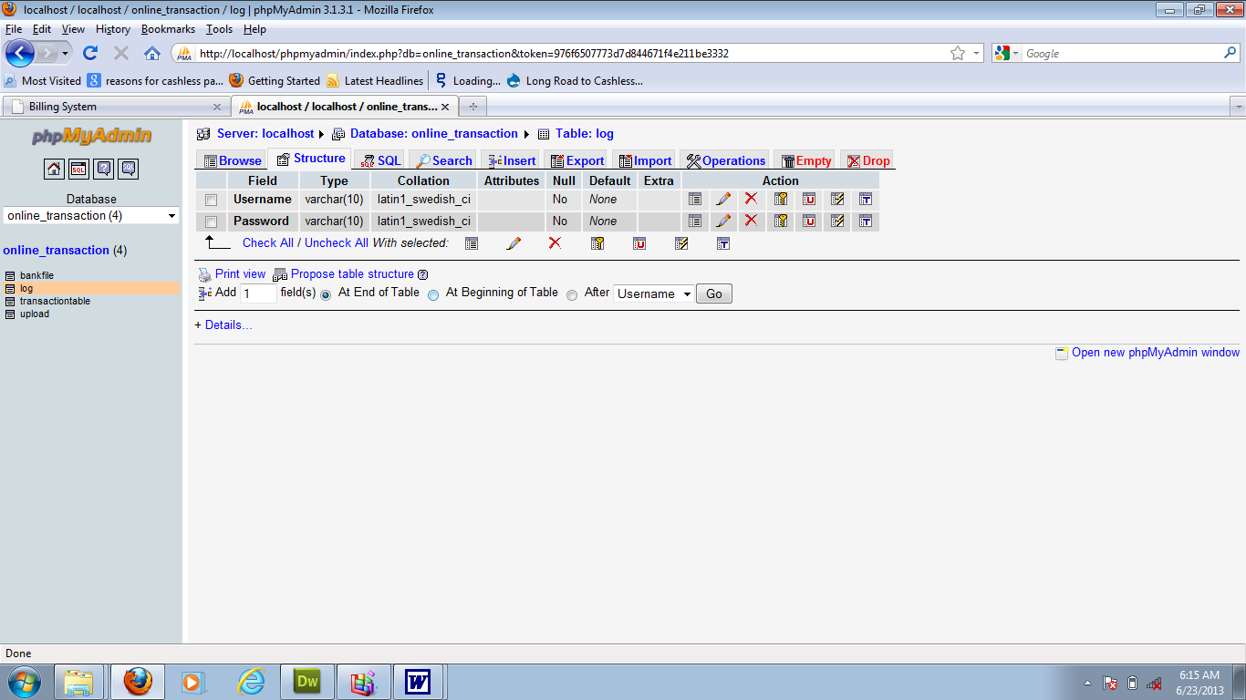
This is usersdatatable where data are stored and retrieved

Table 4.2: Patient Details Datatable
This is where patients data are stored and retrieved
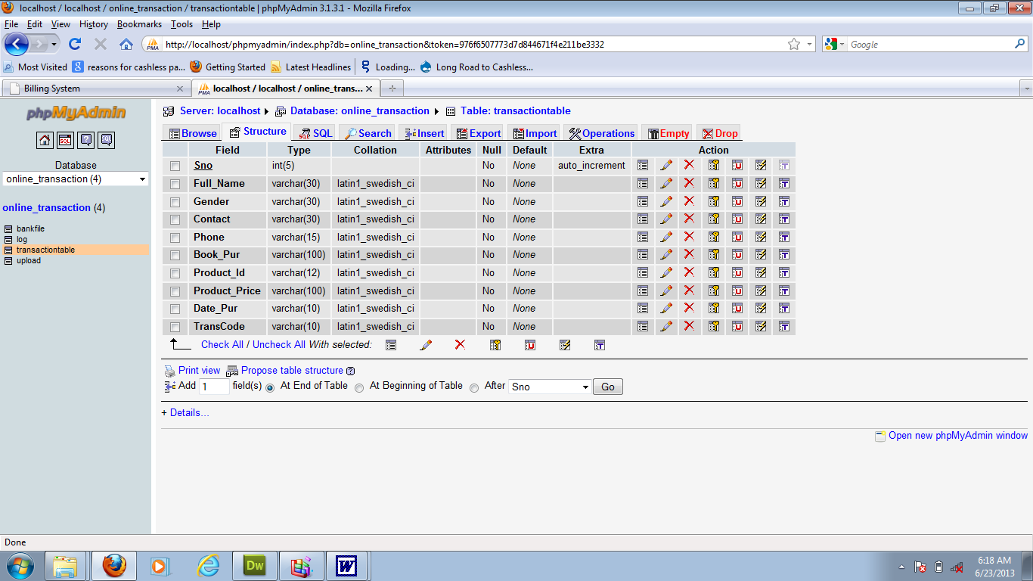

Table 4.3: Diagnosis Datatable
This is where patients selected symptoms are stored and retrieved
4.1.4 PROCEDURE DESIGN
Procedures are steps which verify the whole process i.e which are everything put together to produce the desired output. This involves the organization of the source document and end with the output result.
Documents are sent to various departments to be filled by the employees and later returned to the personnel department which areanalyzed to determine which record goes into the computer.
After selecting the necessary data, this serves as input to the computer system.

4.2 IMPLEMENTATION OF THE SYSTEM
It is always good to develop new ideas, to implement them on a computer and eventually to relish the satisfaction of achieving a successful result. The implementation process involves converting the system design into a complete and tested EDP that is fully operational and that can be used by the system users to meet their business needs. During implementation phase, the hardware and the software must be implemented.

Implementation of a system can be explained in six steps:-
1. Review design specification
2. Code, test and document programs
3. Train users
4. Perform system test
5. Convert to new system
6. Evaluate and maintain the new system

4.2.1 CHOICE OF PROGRAMMING LANGUAGE
The application is designed using C# as the programming language and MYSQL for database management. Hence, the database testing simply involves running it directly from a Mozilla Firefox web browser on local host server provided by Apache 2.0 inWampServer 2.0 application.
In preparation for the installation of the new system, the method of changeover is given serious consideration to determine the success of the new system. Suitable changeover technique for this system is pilot changeover. The pilot changeover operates by applying the new system bit-by-bit until it covers the whole of the operations. The result obtained from using the pilot method on a small portion of the operations would be used in determining the suitability of the need system for the rest of the operations. This method is similar to testing small sample of a distribution if the test yields a good result then the whole system because fully operational and the manual/existing system is eliminated.
4.2.2 HARDWARE SUPPORT
The computer configuration required to run the software is;
Computer/memory processor PC with a 48dx, MHZ or Pentium, Intel or higher processor required.
Memory: 2GB of RAM
Cache memory: 512KB
Hard disk Minimum size 500GB
Recommended 200GB
Virtual Memory 32Bits
Cache memory 512KB
4.2.3 SOFTWARE
I. Microsoft Visual Studio
ii. MY SQL Database Management Software
iii. Operating system window 07 professional
v. Graphic software paint shop and choosing these two formats GIF (Graphic Image Format)
vi. Scanner software, Mira scans
vii. Web browser software MOZILLA

4.3 PROGRAM DOCUMENTATION
4.3.1 OPERATING THE SYSTEM
Step 1: Boot your computer and click on start button on task bar
Step 2: Click on document
Step 3: Locate Visual Studio and click it
Step 4: Locate your application and click it
Step 5: Choose user and enter the password
Step 6: Click on Options
6.1 Click on Manage Patient (to manage patient)
4.3 Click on Diagnose (to diagnose a patient)
4.4 Click on Diagnose Report (to view diagnose report)
4.5 Click on Help (to view the help page)
4.5 Click on About (to view the about page)
Step 5: Logout

4.3.2 MAINTAINING THE SYSTEM
The use of the term maintenance for software is different from other references to maintenance. Unlike the tires on your car, software does not “wear out”. If this is the case, then why does software maintenance account for such a high percentage of the Total Cost of Ownership for software?
The software maintenance definition refers to changes for defect correction, performance improvements, or adaptations to a changed environment (enhancements). According to this definition, if we build software that is defect-free, performs well, and contains user-controlled parameters to adjust processing rules in response to changing requirements then most maintenance would not be necessary.
Why does this happen? There are many reasons but the most common reasons are time constraints and lack of experience. Adding validation logic takes time. So, people make assumptions about the quality of in-bound data. Assumptions are also made about the volume of transactions and the impact on performance and the stability of the automated business processes. Finally, it is common for new software to be developed by younger developers who don’t understand the maintenance impacts of their designs.
The reality is that business requirements change and most of these assumptions are flawed. Transaction volumes increase, changing business processes require new transactions or new validation criteria, and software users will use the software incorrectly. The cost of software maintenance and the total cost of ownership can dramatically be reduced if developers build software that adjusted to changes in transaction volumes; validated all inbound data and provide user-configurable options for decision logic and data validation.

CHAPTER FIVE
SUMMARY, CONCLUSION AND RECOMMENDATION
5.1 SUMMARY
Strengthening the health systems is complex and demanding. Nowadays e-Health has emerged as a fast-growing technology and effective tool to meet day-to-day healthcare needs. In this regard, the pace of using information technology in prescription and dispensing medications to improve the quality, safety, and health care efficiency has been rapidly accelerated in recent years. Through the use of computerized systems, electronic prescription systems provide the potential to dramatically improve the outcome of prescription processes, reduce adverse drug events, and save health care costs. Strengthening and supporting electronic prescription system requires the collaboration between all system stakeholders and the establishment of the underlying healthcare information infrastructure, which leads to better health care for every person of the society. In this way, the integrated electronic prescription system would become a reality. Regarding final approval of many technical standards about the integrity of data transmission as well as verification of security, privacy, and interoperability of many electronic prescription products, it is vital and essential to establish information exchanges with national e-prescription networks. It can improve health care quality, reduce cost and save people’s lives.
5.2 CONCLUSION
Decision trees are a reliable and effective decision making technique which provide high classification accuracy with a simple representation of gathered knowledge. When using decision trees, the decision making process itself can be easily validated by an expert.Because of these reasons decision trees are especially appropriate to support decision making process in medicine.

5.3 RECOMMENDATION
The related studies have highlighted a high frequency of medication error, quantitative and qualitative problems and imperfections in the current prescription system. Moreover, these studies have emphasized on the impact of computerized provider order entry (CPOE) on reducing medication error and improving patient safety, and also the patients' willingness to refill their prescriptions electronically and obtain more information about the administration of medication via information technology. Nowadays, Some great opportunities have been provided on medication prescription in hospital, including the possibility of entering medication request in hospital information systems, designing applications for management of health care settings, Therefore, it is necessary to give a high priority to designing and implementing a national, unified and safe electronic prescription system by Iranian health care system. The study also recommends further work by using different methodology or alternative data mining techniques that can be a basis for comparison. Such will enhance the reliability and validity of the predicted result.

REFERENCES
Patrick Dela Corte Cerna (2016) Prediction of Anti-Retroviral Drug Consumption for HIV Patient in Hospital Pharmacy using Data Mining Technique.I.J. Information Technology and Computer Science, 2016, 2, 52-59 Published Online February 2016 in MECS (http://www.mecs-press.org/) DOI: 10.5815/ijitcs.2016.02.07
Mahnaz, S., Maryam A. &Seyed M., H. (2013) A Theoretical Approach to Electronic Prescription System: Lesson Learned from Literature Review. Article in Iranian Red Crescent Medical Journal · October 2013 DOI: 10.5812/ircmj.8436 · Source: PubMed
WHO (2014).HIV/AIDS Treatment and Care.http://www.who.int/hiv/topics/treatment/en/. Accessed on July 14, 2014.
Gang Zhang,CaixianYe,ChunruWang,XiaominHe,"Data Mining based Software Development Communication Pattern Discovery", IJMECS, vol.2, no.2, pp.25-31, 2010.
FolorunshoOlaiya,Adesesan Barnabas Adeyemo,"Application of Data Mining Techniques in Weather Prediction and Climate Change Studies", IJIEEB, vol.4, no.1, pp.51-59, 2012.
Sandhya Joshi and Hanumanthachar Joshi. 2013. Applications of Data Mining in health and pharmaceutical industry. International Journal of Scientific and Engineering Research, Volume- 4, Issue – 4, April-2013,
Kay D. M., et al. (2021) Predicting Patient Deterioration:A Review of Tools in the Digital Hospital Setting. Journal of medical internet research J Med Internet Res 2021 | vol. 23 | iss. 9 | e28209 | p. 1
Tariq I., A. et al., (2022) “Use of learning approaches to predict clinical deterioration in patients based on various variables: a review of the literature” Article in Artificial Intelligence Review · February 2022 DOI: 10.1007/s10462-021-09982-2
Jacob, N., B. et al. (2020) Early detection of in-patient deterioration: one prediction model does not fit all. medRxiv preprint doi: https://doi.org/10.1101/2020.04.24.20077453.this version posted April 29, 2020.
Amin, N. (2020) Personalized Predictive Models for Identifying Clinical Deterioration using LSTM in Emergency Departments.Creative Commons Attribution Non-Commercial License 4.0 (CC BY-NC 4.0).doi:10.3233/SHTI200713

Henriksen DP, Brabrand M, Lassen AT. Prognosis and risk factors for deterioration in patients admitted to a medical emergency department. PLoS One. 2014;9(4):e94649.
AlNuaimi, Noura, Mohammad M Masud, and Farhan Mohammed (2015) ICU patient deterioration prediction: a data-mining approach, arXiv preprint arXiv :1511.06910
Bonafide CP, Russell Localio A, Song L, Roberts KE, Nadkarni VM, Priestley M, Paine CW, Zander M, Lutts M, Brady PW (2014) Cost-benefit analysis of a medical emergency team in a children’s hospital. Pediatrics 134:235–241

