

PROJECT REPORT
PRESENTED ON
IN VITRO IDENTIFICATION OF ANTI - DIABETIC BIOACTIVE COMPOUNDS IN ETHANOLIC OKRA
BY
HND/23/SLT/FT/0113
GANIYU AHMED OLANREWAJU
SUBMITTED TO
DEPARTMENT OF SCIENCE LABORATORY TECHNOLOGY
(BIOCHEMISTRY UNIT)
INSTITUTE OF APPLIED SCIENCE [IAS]
KWARA STATE POLYTECHNIC, ILORIN.
IN PARTIAL FULFILMENT OF THE REQUIREMENT FOR THE AWARD OF HIGHER NATIONAL DIPLOMA [HND] IN SCINECE LABORATORY TECHNOLOGY
SUPERVISED BY
MR. LUKMAN Z.A

2025 SESSION.

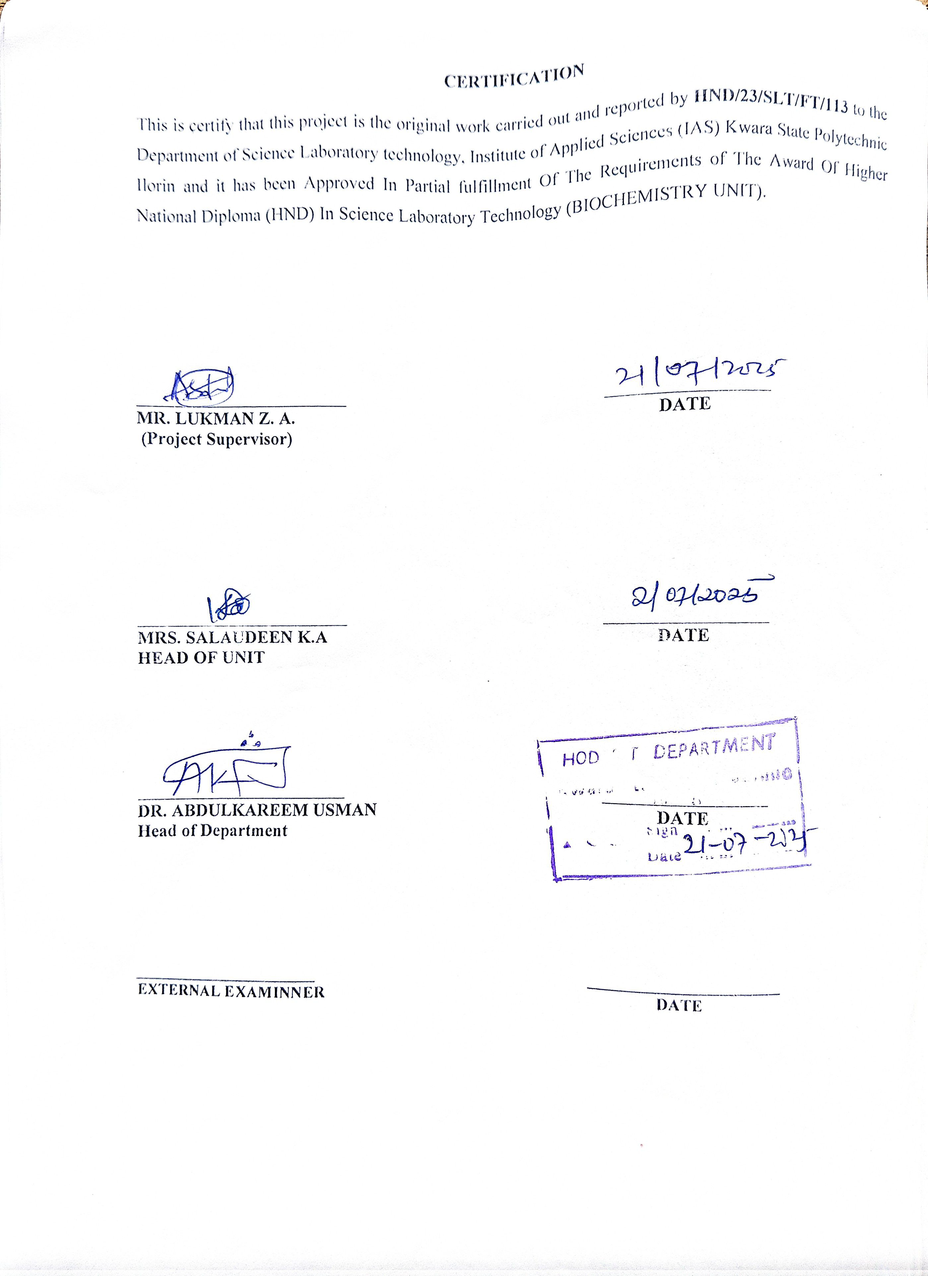

DEDICATION
This project is dedicated to the Almighty God, whose wisdom and guidance have been my source of strength throughout this work.
I also dedicate this work to my esteemed parents and family members for their constant encouragement, sacrifices, and support.
To my academic mentors and colleagues, whose guidance and collaboration have contributed immensely to the success of this project, I express my sincere gratitude.

ACKNOLEDGEMENT
All praise is due to Almighty God for His endless grace, wisdom, and strength which have brought me this far. I am deeply grateful for the journey and all who have been part of it.
I sincerely appreciate my project supervisor, Mr. Lukman Z. A., for his patient guidance, invaluable suggestions, and consistent support throughout the course of this project.
I extend my gratitude to the Head of Department, Dr. Abdulkarem Usman, and the Head of Unit, Mrs. Salaudeen, for their leadership and positive influence on my academic journey in the Science Laboratory Technology Department, particularly the Biochemistry Unit.
My heartfelt appreciation goes to my beloved parents, Mr. Adebayo Abdulganiyu Aweda and Mrs. Abdulganiyu Nusirat Kehinde, for their love, prayers, sacrifices, and constant encouragement. I am also thankful to my siblings and the rest of my family for always standing by me and cheering me on every step of the way.
To my amazing friends, thank you for your unwavering support, words of encouragement, and companionship throughout this academic journey. Your presence made the process lighter and more enjoyable.
Last but not least, I want to thank me. I want to thank me for believing in myself, for showing up every day, for staying dedicated, and for never giving up. I want to thank me for putting in the hard work, for staying focused even on the hard days, and for choosing to grow. I want to thank me for being strong, for always learning, and for striving to become the best version of myself. I truly appreciate me.
Thank you all.

TABLE OF CONTENT
Title page
Certification
Dedication
Acknowledgement
Table of content
Chapter 1: INTRODUCTION
  - Background of the Study
  - Overview of diabetes mellitus: prevalence, impact, and economic burden.
  - The need for alternative therapies from medicinal plants.
  - Brief introduction to Abelmoschus esculents (okra) and its traditional use in diabetes management.
  - Problem Statement
  - The gaps in scientific validation of okra’s antidiabetic potential.
Chapter 2: LITERATURE REVIEW
  - Overview of Diabetes Mellitus
  - Pathophysiology and classification (Type 1, Type 2, gestational diabetes).
  - Role of oxidative stress in diabetes progression.
  - Oral hypoglycemic agents (metformin, sulfonylureas, DPP-4 inhibitors).
  - Side effects and resistance issues.
  - Importance of alternative natural therapies.
  - Overview of phytochemicals with antidiabetic potential.
  - Previous research on plant-based inhibitors of α-amylase and α-glycosidase
  - Literature review on anti-oxidant assay
  - . Phytochemicals in Okra with Potential Antidiabetic Properties
  - Flavonoids (quercetin, rutin).
  - Phenolic acids (ferulic acid, caffeic acid).
  - Polysaccharides and their role in glucose metabolism.

Chapter 3: MATERIALS AND METHODS
  - Plant Collection and Authentication
  - Preparation of Ethanolic Extract of Okra
  - Phytochemical Screening
    - Identification of flavonoids, alkaloids, tannins, phenols, saponins, terpenoids.
3.4 In Vitro Assays for Antidiabetic Activity
    - α-Amylase Inhibition Assay
  - Enzyme source: yeast α-glycosidase.
  - Antioxidant Assay
  - HPLC Assay
Chapter 4: PRESENTATION OF RESULT
  - Phytochemical Composition of Ethanolic Extract
  - Presence and concentration of key bioactive compounds.
  - In Vitro Antidiabetic Assay Results
  - Antioxidant Activity Results
DPPH and FRAP assay outcomes.
  - HPLC results (specific flavonoids, phenolic acids).
Chapter 5: DISCUSSION, CONCLUSION and REFERRENCE

ABSTRACT
Diabetes mellitus is a chronic metabolic disorder characterized by hyperglycemia resulting from defects in insulin secretion, insulin action, or both. The disease is associated with long-term complications and a significant economic burden worldwide. Despite the availability of synthetic oral hypoglycemic agents, many of these drugs present side effects and limited long-term efficacy. Consequently, there is increasing interest in alternative therapies from natural sources, particularly medicinal plants with known traditional uses. This study explores the in vitro identification of anti-diabetic bioactive compounds in the ethanolic extract of Abelmoschus esculentus (okra), a vegetable traditionally used in diabetes management. Phytochemical screening revealed the presence of flavonoids, alkaloids, tannins, saponins, terpenoids, and phenols. The extract exhibited notable inhibitory activity against key digestive enzymes—alpha-amylase and alpha-glycosidase—indicating potential to manage postprandial blood glucose levels. Antioxidant activity was also confirmed through DPPH (2, 2-diphenyl-1-picrylhydrazil) assays, suggesting its ability to mitigate oxidative stress, a contributing factor in diabetes progression. Further characterization using High-Performance Liquid Chromatography (HPLC) identified polyphenol compounds including quercetin and catching.. Together, these results indicate that the ethanolic extract of A. esculentus possesses significant anti-diabetic and antioxidant properties, supporting its potential development as a natural adjunct therapy for diabetes mellitus.

CHAPTER ONE
1.0 INTRODUCTION
  - BACKGROUND OF STUDY
Diabetes mellitus is a growing global health challenge, characterized by chronic hyperglycemia resulting from impaired insulin secretion, insulin action, or both. It is associated with serious complications such as cardiovascular disease, kidney failure, neuropathy, and retinopathy. According to the International Diabetes Federation, hundreds of millions of people are affected worldwide, and the number continues to rise, particularly in low- and middle-income countries. Despite the availability of synthetic anti-diabetic drugs, these treatments often come with side effects, high costs, and limited accessibility, especially in resource-limited settings. This has prompted the search for alternative therapies that are safer, more affordable, and culturally acceptable.
Medicinal plants have gained significant attention as potential sources of novel therapeutic agents. Abelmoschus esculentus (okra), a commonly consumed vegetable in many parts of the world, is traditionally used to manage blood sugar levels. Rich in soluble fiber, flavonoids, and polyphenols, okra has shown promise in reducing postprandial glucose levels and improving insulin sensitivity. Ethanol extracts of okra have been reported to contain bioactive compounds with antioxidant, anti-inflammatory, and hypoglycemic effects. However, the scientific validation of okra’s anti-diabetic potential remains incomplete. Most studies have focused on crude extracts, with limited effort to isolate and identify the specific bioactive constituents responsible for its therapeutic effects. Moreover, standardized in vitro studies targeting mechanisms such as enzyme inhibition (e.g., α-amylase and α-glucosidase) are lacking.
A deeper understanding of these mechanisms is crucial to support the integration of okra-based compounds into modern diabetes management strategies.This study aims to bridge these gaps by investigating the anti-diabetic properties of ethanolic extracts of Abelmoschus esculentus through in vitro analysis, with a focus on identifying bioactive compounds and evaluating their potential mechanisms of action.( Sabitha et al.,;Gemede,2015)

.

1.2 OVERVIEW OF DIABETES MELLITUS: PREVALENCE, IMPACT, AND ECONOMIC BURDEN.
Diabetes mellitus is a chronic metabolic disorder characterized by hyperglycemia resulting from defects in insulin secretion, insulin action, or both. The growing global prevalence of diabetes has necessitated the search for alternative therapeutic agents that are both effective and safe. Traditional medicinal plants have gained increasing attention as a source of bioactive compounds with potential anti-diabetic properties. Among these, Abelmoschus esculentus (commonly known as okra) is widely consumed and traditionally used in various cultures for its purported health benefits.
Okra is rich in dietary fiber, flavonoids, polyphenols, and mucilage, which have been associated with glycemic control. Ethanol-based extraction methods are commonly employed to isolate a wide spectrum of phytochemicals from plant materials, enhancing the potential yield of bioactive compounds. In vitro assays, including enzyme inhibition studies and antioxidant evaluations, provide a controlled environment to identify and characterize such compounds before progressing to in vivo studies.
This study focuses on the in vitro identification of anti-diabetic bioactive compounds present in the ethanolic extract of okra. The primary objective is to assess its potential inhibitory effects on carbohydrate-metabolizing enzymes such as α-amylase and α-glycosidase, and to evaluate the antioxidant capacity that may contribute to the management of oxidative stress in diabetes. The findings may contribute to the development of plant-based adjunct therapies for diabetes management. (Wang et al., 2017).
1.2.1OVERVIEW OF DIABETES MELLITUS: PREVALENCE, IMPACT, AND ECONOMIC BURDEN
Diabetes mellitus (DM) is a group of metabolic disorders marked by chronic hyperglycemia due to defects in insulin secretion, insulin action, or both. The two most common forms are Type 1 diabetes (T1DM), an autoimmune condition leading to absolute insulin deficiency, and Type 2 diabetes (T2DM), characterized by insulin resistance and relative insulin deficiency.(Ngueguim et al.,2020).
1.2.1PREVALENCE:
Diabetes has reached epidemic proportions globally. According to the International Diabetes Federation (IDF), approximately 537 million adults aged 20–79 were living with diabetes in 2021, and this number is projected to rise to 643 million by 2030 and 783 million by 2045. The majority of cases (over 90%) are Type 2 diabetes, often associated with obesity, physical inactivity, and unhealthy diets.
The prevalence is especially rising in low- and middle-income countries due to urbanization and lifestyle changes. (Axelsen,M.2004).
1.2.3IMPACT ON HEALTH:
Diabetes significantly increases the risk of various complications, including cardiovascular disease, kidney failure, neuropathy, retinopathy, and lower limb amputations. Poorly managed diabetes can lead to life-threatening consequences and severely reduced quality of life. It is one of the leading causes of premature mortality worldwide. (Gemede, 2015).
1.2.4ECONOMIC BURDEN:
The economic cost of diabetes is substantial and growing. Globally, health expenditure related to diabetes was estimated at USD 966 billion in 2021, which is more than three times higher than in 2007. This includes direct costs (e.g., medications, hospitalization, and medical consultations) and indirect costs (e.g., lost productivity, disability, and premature death). The financial burden falls heavily on individuals, families, healthcare systems, and national economies, especially in countries with limited healthcare resources.
Given its increasing prevalence and the heavy health and economic toll it imposes, diabetes mellitus is a major public health concern that demands urgent attention in terms of prevention, early detection, and cost-effective management strategies. (Wang et al., 2017).
1.3THE NEED FOR ALTERNATIVE THERAPIES FROM MEDICINAL PLANTS.
Despite significant advances in modern pharmacotherapy, the management of chronic diseases such as diabetes mellitus remains a major challenge due to side effects, high treatment costs, and limited accessibility in many parts of the world. Conventional anti-diabetic drugs, including insulin and oral hypoglycemic agents, can cause adverse effects such as hypoglycemia, gastrointestinal disturbances, and weight gain, and may not be effective in all patients. These limitations have prompted the search for safer, more affordable, and accessible treatment alternatives. Medicinal plants have long been used in traditional medicine systems around the world and are a valuable source of bioactive compounds with therapeutic potential. Many of these plants possess anti-diabetic properties due to the presence of phytochemicals such as flavonoids, alkaloids, saponins, and polyphenols. These compounds may exert hypoglycemic effects through various mechanisms, including enhancement of insulin secretion, improvement of insulin sensitivity, inhibition of carbohydrate-digesting enzymes, and reduction of oxidative stress. The exploration of medicinal plants for anti-diabetic activity is especially important in developing countries, where plant-based remedies are more culturally accepted and economically viable. Scientific validation of traditional knowledge through in vitro and in vivo studies is essential to identify, isolate, and characterize the bioactive compounds responsible for therapeutic effects. In this context, medicinal plants such as Abelmoschus esculents (okra) offer promising prospects for the development of novel, plant-based anti-diabetic agents that are both effective and safe. Integrating such therapies into modern healthcare could enhance treatment outcomes and reduce the global burden of diabetes. (Adelakun et al., 2013).
1.4 BRIEF INTRODUCTION TO ABELMOSCHUS ESCULENTS (OKRA) AND ITS TRADITIONAL USE IN DIABETES MANAGEMENT.
Abelmoschus esculentus, commonly known as okra or lady’s finger, is a flowering plant widely cultivated in tropical and subtropical regions for its edible green pods. Rich in dietary fiber, vitamins, minerals, and phytochemicals, okra has long been valued in traditional medicine for its nutritional and therapeutic properties.
In various cultures, especially across Asia and Africa, okra is traditionally used to manage blood sugar levels. The mucilaginous substances in okra pods are believed to slow carbohydrate absorption, while its polyphenolic compounds may enhance insulin sensitivity and exhibit antioxidant activity.
Traditional healers have used decoctions and infusions of okra pods and seeds to help regulate blood glucose, making it a potential natural remedy for diabetes.(Ngueguim et al.,2013).
1.5Problem Statement
Despite its widespread traditional use and promising pharmacological potential, the specific bioactive compounds responsible for the anti-diabetic effects of okra remain inadequately characterized. Furthermore, there is limited scientific data validating its efficacy through standardized in vitro methods. The lack of comprehensive phytochemical profiling and mechanistic studies hinders the integration of okra-based therapies into modern diabetes management. Therefore, there is a critical need for systematic investigation into the anti-diabetic properties of Ethanolic extracts of Abelmoschus esculentus, including the identification and evaluation of its bioactive constituents through in vitro assays.(Adekunle et al.,2013).
1.6GAPS IN SCIENTIFIC VALIDATION OF OKRA’S ANTI-DIABETIC POTENTIAL
While Abelmoschus esculentus (okra) has a long history of use in traditional medicine for managing diabetes, scientific validation of its efficacy and underlying mechanisms remains limited and fragmented. Most existing studies focus on crude extracts and lack standardized extraction methods, making comparisons and reproducibility difficult. Additionally, many investigations have not identified or isolated specific bioactive compounds responsible for the observed hypoglycemic effects.
In vitro studies examining okra’s influence on key carbohydrate-metabolizing enzymes, such as α-amylase and α-glycosidase, are relatively scarce, and in vivo studies often lack detailed phytochemical analysis. Furthermore, the variability in plant sources, preparation techniques, and dosages contributes to inconsistent findings across research. (Axelsen,M.2004).
Another significant gap lies in the limited exploration of okra’s antioxidant and anti-inflammatory properties in the context of diabetes, despite oxidative stress being a known contributor to diabetic complications. Without robust biochemical characterization and mechanistic studies, the therapeutic potential of okra remains largely speculative and underutilized in evidence-based medicine.
Bridging these gaps through systematic in vitro assays, compound isolation, and mechanistic studies is essential to establish okra as a scientifically validated, plant-based anti-diabetic agent. (Liu et al., 2005).
Aim: To Identify In-Vitro Anti-Diabetic Bioactive Compounds in Ethanolic Okra
SPECIFIC OBJECTIVES:
- To extract the Ethanolic Okra.
- To investigate the phytochemical constituents of the extract.
- To investigate the anti-diabetic activities of the extract.
- To Identify the anti-diabetic pro-active compounds in the extract using HPLC

CHAPTER TWO
2.0 LITERATURE REVIEW
2.1 OVERVIEW OF DIABETES MELLITUS
Diabetes mellitus is a chronic metabolic disorder characterized by persistent hyperglycemia resulting from defects in insulin secretion, insulin action, or both. It is broadly classified into Type 1 diabetes mellitus (T1DM), which is primarily autoimmune in nature and results in absolute insulin deficiency, and Type 2 diabetes mellitus (T2DM), which is associated with insulin resistance and a relative lack of insulin. A third category, gestational diabetes mellitus (GDM), occurs during pregnancy and typically resolves after childbirth, although it increases the risk of developing T2DM later in life.
The global burden of diabetes is substantial and rapidly increasing. According to the International Diabetes Federation (IDF), an estimated 537 million adults were living with diabetes in 2021, and this number is projected to rise significantly in the coming decades. Type 2 diabetes accounts for over 90% of all cases and is closely linked to sedentary lifestyles, obesity, unhealthy diets, and aging populations.
Diabetes is associated with a wide range of complications, including cardiovascular disease, kidney failure, neuropathy, retinopathy, and lower limb amputations. These complications contribute to increased morbidity, mortality, and reduced quality of life. Furthermore, the disease imposes a significant economic burden on individuals and healthcare systems worldwide, with high costs related to medical care, loss of productivity, and long-term disability.(Jenkins et al.,2004).
Effective management of diabetes involves lifestyle modification, blood glucose monitoring, and pharmacological interventions. However, due to limitations such as side effects, high costs, and accessibility issues, there is growing interest in complementary and alternative therapies, particularly those derived from medicinal plants with potential anti-diabetic effects. (Kumar et al., 2013).

  - PATHOPHYSIOLOGY AND CLASSIFICATION (TYPE 1, TYPE 2, GESTATIONAL DIABETES).
Pathophysiology of Diabetes Mellitus
Diabetes mellitus is characterized by chronic hyperglycemia due to defects in insulin secretion, insulin action, or both. Insulin is a hormone produced by the pancreas that facilitates the uptake of glucose by cells for energy production and regulates blood glucose levels. In diabetes, either insulin production is insufficient or cells become resistant to insulin, impairing glucose uptake.
a. Type 1 Diabetes Mellitus (T1DM)
Type 1 diabetes is an autoimmune condition in which the body’s immune system attacks and destroys the insulin-producing beta cells in the pancreas. This results in an absolute deficiency of insulin. Without insulin, cells cannot take up glucose from the bloodstream, leading to elevated blood glucose levels (hyperglycemia). T1DM usually manifests in childhood or adolescence and is often characterized by rapid onset of symptoms, including excessive thirst, frequent urination, fatigue, and unexplained weight loss.
b. Type 2 Diabetes Mellitus (T2DM)
Type 2 diabetes is primarily characterized by insulin resistance, where the body’s cells become less responsive to insulin. In response, the pancreas produces more insulin to compensate, but over time, the beta cells can no longer maintain this increased insulin output, leading to relative insulin deficiency. T2DM is commonly associated with obesity, physical inactivity, poor dietary habits, and genetic predisposition. It often develops gradually and may go undiagnosed for years. Symptoms of T2DM are often subtle and may include increased thirst, frequent urination, fatigue, and blurred vision.
c. Gestational Diabetes Mellitus (GDM)
Gestational diabetes occurs during pregnancy when the body is unable to produce enough insulin to meet the increased demands during this period. As a result, blood glucose levels rise. GDM is typically diagnosed during the second or third trimester and may resolve after childbirth, although women who have had GDM are at a higher risk of developing T2DM later in life. GDM can lead to complications for both the mother and the baby, including preeclampsia, preterm birth, and an increased likelihood of the child developing obesity and type 2 diabetes in the future.(Wang et al., 2017).
2.3CLASSIFICATION OF DIABETES MELLITUS
Diabetes is classified into several types based on its etiology, clinical presentation, and treatment approach:
1. TYPE 1DIABETES (T1DM)
Onset: Early childhood or adolescence, though it can occur at any age.
Pathogenesis: Autoimmune destruction of insulin-producing beta cells in the pancreas.
Treatment: Insulin therapy for life.
Complications: Diabetic ketoacidosis (DKA), retinopathy, nephropathy, neuropathy, cardiovascular diseases. (Sabitha,V., et al. 2011).
2. TYPE 2DIABETES (T2DM)
Onset: Usually in adults, although increasing in children and adolescents due to rising obesity rates.
Pathogenesis: Insulin resistance often coupled with beta-cell dysfunction.
Treatment: Lifestyle modification (diet, exercise), oral hypoglycemic agents, and sometimes insulin.
Complications: Cardiovascular diseases, stroke, kidney failure, neuropathy, and retinopathy.
(Wang et al., 2017).
3. GESTATIONAL DIABETES MELLITUS (GDM)
Onset: Diagnosed during pregnancy, typically in the second or third trimester.
Pathogenesis: Insulin resistance due to hormonal changes during pregnancy.
Treatment: Diet modification, physical activity, and sometimes insulin or oral medications.
Complications: Increased risk of type 2 diabetes for mother and child, preeclampsia, and large birth weight babies (macrosomia). (Gembede,2015)
  - ROLE OF OXIDATIVE STRESS IN DIABETES PROGRESSION.
Oxidative stress plays a critical role in the onset and progression of diabetes mellitus and its complications. It is defined as an imbalance between the production of reactive oxygen species (ROS) and the body’s antioxidant defense mechanisms. In diabetes, chronic hyperglycemia leads to excessive ROS production, overwhelming the antioxidant system and resulting in cellular and molecular damage.
- Hyperglycemia-Induced ROS Production
Persistent high blood glucose levels in diabetic patients stimulate various metabolic pathways—such as the polyol pathway, advanced glycation end-product (AGE) formation, protein kinase C (PKC) activation, and the hexosamine pathway—all of which increase ROS generation. Mitochondrial dysfunction further contributes to oxidative stress by enhancing superoxide production.
2. Beta-Cell Dysfunction and Insulin Resistance
Pancreatic beta-cells are highly susceptible to oxidative stress due to their low expression of antioxidant enzymes. Elevated ROS levels impair beta-cell function and viability, leading to reduced insulin secretion. Additionally, oxidative stress contributes to insulin resistance by interfering with insulin signaling pathways in peripheral tissues such as skeletal muscle and adipose tissue.
3. Development of Diabetic Complications
Oxidative stress plays a key role in the pathogenesis of both micro vascular and macro vascular complications of diabetes:
- Diabetic nephropathy: ROS damage glomerular cells and promote inflammation and fibrosis in kidney tissues.
- Diabetic neuropathy: ROS impair neuronal function and promote neuron inflammation and demyelination.
- Diabetic retinopathy: Oxidative damage to retinal cells leads to neovascularization and vision loss.
- Cardiovascular disease: Endothelial dysfunction, driven by oxidative stress, promotes atherosclerosis and increases the risk of heart disease and stroke.
4. Inflammation and Cell Damage
Oxidative stress activates nuclear factor-kappa B (NF-κB) and other pro-inflammatory signaling pathways, leading to the release of cytokines and chemokine’s. This results in chronic inflammation, further exacerbating insulin resistance and tissue damage. (American Diabetes Association [ADA],2022).
  - ORAL HYPOGLYCEMIC AGENTS (METFORMIN, SULFONYLUREAS, DPP-4 INHIBITORS).
ORAL HYPOGLYCEMIC AGENTS
Oral hypoglycemic agents are commonly used in the management of Type 2 diabetes mellitus (T2DM) to help maintain glycemic control. These medications work through various mechanisms, including enhancing insulin sensitivity, stimulating insulin secretion, or reducing glucose absorption. Below is an overview of three widely used classes: Metformin, Sulfonylureas, and DPP-4 Inhibitors
1. METFORMIN (BIGUANIDES)
Mechanism of Action:
Metformin reduces hepatic glucose production (gluconeogenesis), enhances insulin sensitivity in peripheral tissues (muscle and fat), and slightly reduces intestinal glucose absorption.
2. SULFONYLUREAS
Examples: Glibenclamide (glyburide), Glipizide, Glimepiride.
Mechanism of Action:
Sulfonylureas stimulate pancreatic beta cells to secrete more insulin, regardless of blood glucose levels.
3. DPP-4 INHIBITORS (DIPEPTIDYL PEPTIDASE-4 INHIBITORS)
Examples: Sitagliptin, Saxagliptin, Linagliptin, Alogliptin.
Mechanism of Action:
These drugs inhibit the DPP-4 enzyme, which breaks down incretin hormones (e.g., GLP-1). Incretins increase insulin secretion and decrease glucagon levels in a glucose-dependent manner.
(Sabitha,V., et al. 2011).
  - SIDE EFFECTS AND RESISTANCE ISSUES.
METFORMIN BENEFITS:
It is the first-line therapy for T2DM due to its effectiveness, low cost, and favorable safety profile. Metformin does not cause weight gain and has a low risk of hypoglycemia.
Side Effects:
Common side effects include gastrointestinal disturbances such as nausea, diarrhea, and abdominal discomfort. A rare but serious side effect is lactic acidosis, especially in patients with renal impairment.
SULFONYLUREAS BENEFITS:
They are effective in reducing blood glucose and have a long history of clinical use. They are often used as second-line agents when metformin alone is insufficient.
Side Effects:
The primary concerns are hypoglycemia and weight gain. The risk of hypoglycemia is higher in elderly patients or those with renal impairment.
DPP-4 INHIBITORS (DIPEPTIDYL PEPTIDASE-4 INHIBITORS) BENEFITS:
DPP-4 inhibitors are weight-neutral and have a low risk of hypoglycemia. They are well-tolerated and can be used in combination with other anti-diabetic agents.
Side Effects:
Possible side effects include nasopharyngitis, headache, and in rare cases, pancreatitis or joint pain.
(Liu,I.M., et al.2005).
  - IMPORTANCE OF ALTERNATIVE NATURAL THERAPIES.
The rising global burden of diabetes mellitus, particularly type 2diabetes, has intensified the search for effective, accessible, and affordable treatment strategies. While conventional medications, such as oral hypoglycemic agents and insulin, are effective in controlling blood glucose, they often come with side effects, high costs, and long-term safety concerns. These limitations highlight the need for complementary or alternative therapeutic options.
Natural therapies, particularly those derived from medicinal plants; offer a promising avenue for diabetes management. Many plants contain bioactive compounds such as flavonoids, alkaloids, polyphenols, and saponins, which have demonstrated anti-diabetic properties including enhancement of insulin sensitivity, stimulation of insulin secretion, inhibition of carbohydrate-digesting enzymes, and antioxidant activity.
(Gemede, 2015; Wang et al., 2017).
2.7.1 Key Reasons Why Alternative Natural Therapies Are Important Include:
- Lower Side Effect Profile:
Herbal medicines are often considered safer and better tolerated than synthetic drugs, especially for long-term use.
- Accessibility and Affordability:
Medicinal plants are readily available in many regions and can offer a cost-effective alternative for populations with limited access to modern healthcare.
- Multifactorial Benefits:
Many natural compounds exert multiple effects—such as antioxidant, anti-inflammatory, and lipid-lowering actions—that help in managing not only hyperglycemia but also the complications of diabetes.
4. Support for Traditional Knowledge:
Many cultures have used plant-based remedies for generations. Scientific validation of these traditional practices can help integrate culturally relevant therapies into modern medicine.
5. Potential for Drug Development:
Natural compounds serve as valuable leads in the development of novel pharmaceutical agents. Several modern drugs, such as metformin, have origins in traditional herbal medicine.
(Gemede, 2015; Wang et al., 2017).
  - OVERVIEW OF PHYTOCHEMICALS WITH ANTIDIABETIC POTENTIAL.
Phytochemicals are naturally occurring bioactive compounds found in plants that contribute to their color, flavor, and disease resistance. Over the past decades, increasing attention has been given to phytochemicals for their therapeutic potential in managing chronic diseases, including diabetes mellitus. These compounds exert a wide range of pharmacological effects, including antioxidant, anti-inflammatory, and blood glucose-lowering activities. In the context of diabetes, phytochemicals can influence various physiological pathways such as glucose metabolism, insulin secretion, insulin sensitivity, and the inhibition of carbohydrate-digesting enzymes. Some of the key classes of phytochemicals with demonstrated anti-diabetic effects include:
1. Flavonoids
Flavonoids are polyphenolic compounds widely distributed in fruits, vegetables, and medicinal plants.
Mechanism of action:
Improve insulin sensitivity, reduce oxidative stress, and inhibit α-amylase and α-glucosidase enzymes. Examples: Quercetin, kaempferol, rutin, and catechins.
2. Alkaloids
Alkaloids are nitrogen-containing compounds with diverse biological activities.
Mechanism of action:
Enhance glucose uptake in cells and stimulate insulin secretion.
Examples: Berberine (from Berberis species), which also activates AMPK, a key regulator of energy metabolism.
3. Saponins
Saponins are glycosides with surface-active properties found in legumes and herbs.
Mechanism of action:
Exhibit hypoglycemic effects by improving insulin sensitivity and reducing glucose absorption.
Examples: Ginsenosides from ginseng, diosgenin from fenugreek.
4. Polyphenols
Polyphenols are a large group of plant metabolites with antioxidant properties.
Mechanism of action:
Protect pancreatic beta cells, improve insulin action, and reduce glucose absorption.
Examples: Resveratrol, chlorogenic acid, curcumin.
5. Tannins
Tannins are polyphenolic compounds known for their ability to bind and precipitate proteins.
Mechanism of action:
Delay glucose absorption by inhibiting digestive enzymes and modulating glucose transporters.
Examples: Ellagitannins, gallotannins.
6. Terpenoids
Terpenoids are a large class of organic chemicals derived from isoprene units.
Mechanism of action:
Improve insulin signaling and exert anti-inflammatory effects.
Examples: Limonene, ursolic acid. (Adelakun et al., 2013;liu et al.,2005.
  - LITERATURE REVIEW ON ANTIOXIDANT ASSAY OF ETHANOLIC EXTRACT OF OKRA
Several studies have investigated the antioxidant potential of Abelmoschus esculentus (okra), particularly focusing on its ethanolic extract due to its efficiency in extracting phenolic compounds and flavonoids. Antioxidants play a critical role in mitigating oxidative stress, which is closely linked to the pathogenesis and progression of diabetes mellitus. Therefore, the antioxidant properties of okra contribute to its therapeutic potential in managing oxidative damage in diabetic conditions.
In a study by Adelakun et al. (2013), the ethanolic extracts of okra pods and seeds were found to exhibit significant antioxidant activity using the DPPH (2,2-diphenyl-1-picrylhydrazyl) radical scavenging assay. The study also reported a high total phenolic content (TPC), suggesting that phenolic compounds are major contributors to the antioxidant effect.
Similarly, Gemede (2015) reviewed the phytochemical composition of okra and emphasized that ethanol-extracted flavonoids and tannins contribute substantially to its free radical scavenging ability. The author noted that the antioxidant effect was dose-dependent and comparable to that of standard antioxidants such as ascorbic acid.
Sabitha et al. (2011) performed an in vivo and in vitro study on the antioxidant and anti-diabetic potential of okra. The in vitro assays using ethanolic extract revealed strong DPPH and nitric oxide radical scavenging activity. The extract also inhibited lipid peroxidation and improved antioxidant enzyme levels in diabetic rats, confirming its therapeutic potential.
According to Ngueguim et al. (2020), polyphenol-rich ethanolic extracts of okra showed strong inhibition of both DPPH and ABTS radicals, with IC₅₀ values close to known standards. The study also identified the presence of quercetin, catechin, and gallic acid through HPLC profiling—compounds known for their antioxidant effects.
In another recent study, Islam et al. (2021) used multiple antioxidant assays, including DPPH, FRAP (Ferric Reducing Antioxidant Power), and hydrogen peroxide scavenging to assess the antioxidant potential of ethanolic okra extract. Results confirmed a concentration-dependent activity, supporting the use of okra in managing oxidative stress–related diseases.
Collectively, these findings confirm that the ethanolic extract of okra is rich in bioactive compounds such as flavonoids, polyphenols, and tannins, which contribute significantly to its antioxidant capacity. This supports its traditional use and aligns with modern therapeutic strategies targeting oxidative stress in diabetes and related metabolic disorders.
  - PREVIOUS RESEARCH ON PLANT-BASED INHIBITORS OF ΑLPHA-AMYLASE AND ΑLPHA-GLYCOSIDASE.
Alpha-amylase and alpha-glucosidase are crucial enzymes involved in the digestion of dietary carbohydrates. Alpha-amylase breaks down complex carbohydrates into oligosaccharides, while alpha-glucosidase catalyzes the final step, converting oligosaccharides into glucose for absorption in the intestine. Inhibiting these enzymes can effectively delay glucose absorption, reduce postprandial blood glucose spikes, and aid in managing Type 2 diabetes mellitus.
Pharmaceutical inhibitors like acarbose, miglitol, and voglibose are currently used clinically but are associated with gastrointestinal side effects such as bloating and diarrhea. Consequently, there is increasing interest in natural plant-based inhibitors, which are considered to have fewer adverse effects and additional health benefits. ( Biyiti,L.2020).
1. Momordica charantia (Bitter melon)
Contains charantin, polypeptide-p, and vicine. Exhibits significant inhibition of alpha-glycosidase and mild inhibition of alpha-amylase. Also improves insulin sensitivity and antioxidant status.
2. Syzygium cumini (Jamun)
Seeds and bark extracts are rich in flavonoids and ellagitannins. Show dual inhibition of alpha-amylase and alpha-glucosidase in vitro. Effective in reducing postprandial glucose in diabetic animal models.
3. Trigonella foenum-graecum (Fenugreek)
Contains saponins and alkaloids such as trigonelline. Inhibits both enzymes and enhances insulin secretion.
Used traditionally for glycemic control in South Asia.
4. Ocimum sanctum (Holy basil)
Contains eugenol, ursolic acid, and flavonoids.
Exhibits moderate inhibition of both enzymes and improves oxidative stress markers. Demonstrated hypoglycemic effects in both in vitro and in vivo models.
5. Cinnamomum verum (Cinnamon)
Contains cinnamaldehyde and polyphenols. Demonstrates strong inhibition of alpha-glycosidase and moderate inhibition of alpha-amylase. Also has an insulin-mimetic property. (Axelsen,M.2004).
  - PHYTOCHEMICALS IN OKRA WITH POTENTIAL ANTIDIABETIC PROPERTIES
Abelmoschus esculentus (okra) is a widely consumed vegetable known not only for its nutritional value but also for its medicinal potential, particularly in the management of diabetes mellitus. Several studies have revealed that okra contains a range of bioactive phytochemicals that contribute to its anti-diabetic effects through multiple mechanisms, including glucose metabolism regulation, insulin sensitization, and inhibition of carbohydrate-digesting enzymes.(Azebaze et al.,2021).
  - FLAVONOIDS (QUERCETIN, RUTIN).
Compounds: Quercetin, isoquercetin, kaempferol
Function:
Antioxidant activity reduces oxidative stress in pancreatic beta cells.
Enhances insulin sensitivity and modulates glucose uptake.
Inhibits alpha-amylase and alpha-glucosidase enzymes, reducing postprandial hyperglycemia.
( Gemede,2005).
  - POLYPHENOLS (FERULIC ACID, CAFFEIC ACID).
Compounds: Catechins, gallic acid derivatives
Function:
Exhibit strong antioxidant properties.
Improve glucose utilization in peripheral tissues.
May protect beta-cell function and reduce lipid peroxidation.( Tzeng et al.2005).
  - POLYSACCHARIDES AND THEIR ROLE IN GLUCOSE METABOLISM.
Function:
Delay glucose absorption by forming a viscous gel in the intestine.
Lower postprandial blood glucose levels.
Help modulate gut microbiota, which may indirectly influence glucose metabolism.(Axelsen,M.2004).

CHAPTER THREE
MATERIALS AND METHODS
  - PLANT COLLECTION
The fresh pods of okra (Abelmoschus esculentus) were collected from a local farm in Ilorin Kwara State Nigeria during the peak harvesting season April, 2025. Care was taken to ensure that the collected plant materials were healthy, free from disease or pest infestation, and at a similar stage of maturity to maintain uniformity in bioactive compound content.
Following collection, the plant material was thoroughly washed under running tap water to remove dirt and other extraneous matter. It was then shade-dried at room temperature for 7–10 days until completely dehydrated, to prevent decomposition or microbial growth. The dried pods were subsequently pulverized using a mechanical grinder to obtain a fine powder, which was stored in airtight containers at room temperature until extraction.
The taxonomic identification and authentication of the plant material were carried out by a plant taxonomist at the Department of Botany, [Insert University or Institution Name]. A voucher specimen was prepared and deposited in the departmental herbarium under the accession number [Insert Accession Number] for future reference and verification.
  - PREPARATION OF ETHANOLIC EXTRACT OF OKRA

Materials & Chemicals
• Okra powder
• Ethanol (70–80%)
• HPLC-grade acetonitrile, methanol, and water (with 0.1% formic acid)
• Standards: Quercetin, kaempferol, gallic acid, caffeic acid, etc.

3. Extraction Process
195.38 g of okra powder was weighed and mixed with 6.5L of 80% ethanol and was Sonicated or stirred for 30–60 minutes at room temperature. It was filtered through Whatman No.1 filter paper and the ethanol was evaporated using a rotary evaporator at 40°C.
The dried extract was reconstituted in HPLC-grade methanol (1 mg/mL) and filtered (0.45 µm) before HPLC injection.
  - PHYTOCHEMICAL SCREENING
Preliminary phytochemical screening of the ethanolic extract of Abelmoschus esculentus was carried out to detect the presence of various bioactive constituents using standard qualitative methods as described by Harborne (2000) and Trease and Evans (2002).
This procedure helps to identify the classes of compounds that may be responsible for the observed biological activities, especially anti-diabetic effects.The powdered okra pods were extracted using 70% ethanol by maceration for 72 hours with occasional shaking. The extract was filtered and concentrated using a rotary evaporator under reduced pressure. The concentrated extract was then subjected to qualitative tests for the following phytochemicals:
1. Alkaloids
Test: Mayer’s and Dragendorff’s reagents
Observation: Cream or orange precipitate indicates the presence of alkaloids.
2. Flavonoids
Test: Shinoda test
Observation: Development of red or pink color indicates flavonoids.
3. Saponins
Test: Frothing test
Observation: Persistent foam formation on shaking suggests the presence of saponins.
4. Tannins
Test: Ferric chloride test
Observation: A blue-black or greenish color indicates the presence of tannins.
5. Phenols
Test: Ferric chloride test
Observation: Deep blue or green coloration indicates phenolic compounds.
6. Terpenoids
Test: Salkowski’s test
Observation: A reddish-brown coloration at the interface shows terpenoids.
7. Glycosides
Test: Keller-Killiani test
Observation: A brown ring at the interface indicates cardiac glycosides.
8. Steroids
Test: Liebermann–Burchard test
Observation: Green coloration indicates the presence of steroids.
    - IDENTIFICATION OF FLAVONOIDS, ALKALOIDS, TANNINS, PHENOLS, SAPONINS, TERPENOIDS.
The Ethanolic extract of Abelmoschus esculentus was subjected to standard qualitative tests to identify the presence of key phytochemical groups known for their anti-diabetic properties. The procedures and observations are described below:
1. Flavonoids :- Shinoda Test
PROCEDURE:
To 2 mL of the extract, a few fragments of magnesium ribbon were added followed by a few drops of concentrated hydrochloric acid.
POSITIVE RESULT:
A pink or reddish coloration indicates the presence of flavonoids (Harborne, 2007).
2. Alkaloids:- Mayer’s and Dragendorff’s Tests
Mayer’s Test: A few drops of Mayer’s reagent were added to 2 mL of the extract.
Positive Result: Formation of a cream-colored precipitate indicates alkaloids.
Dragendorff’s Test: A few drops of Dragendorff’s reagent were added to another portion of the extract.
Positive Result: An orange or reddish-brown precipitate confirms alkaloids (Trease & Evans, 2002).
3. Tannins:- Ferric Chloride Test
Procedure: 2 mL of the extract was mixed with a few drops of 5% ferric chloride solution.
Positive Result: A greenish-black or blue-black coloration indicates the presence of tannins
(Sofowora, 2001).
4. Phenols:- Ferric Chloride Test
PROCEDURE:
A few drops of 5% ferric chloride solution were added to 2 mL of the extract.
POSITIVE RESULT: A deep blue, green, or violet coloration indicates the presence of phenolic compounds.
- Saponins:- Froth Test
PROCEDURE:
2 mL of the extract was vigorously shaken with 5 mL of distilled water and left to stand for 15 minutes.
POSITIVE RESULT:
Persistent foam formation lasting more than 10 minutes indicates the presence of saponins.
6. Terpenoids: - Salkowski’s Test
PROCEDURE:
2 mL of the extract was mixed with 2 mL of chloroform, followed by 2 mL of concentrated sulfuric acid added slowly down the side of the test tube.
POSITIVE RESULT:
A reddish-brown interface indicates the presence of terpenoids (Evans, 2002).
  - IN VITRO ASSAYS FOR ANTIDIABETIC ACTIVITY
To evaluate the anti-diabetic potential of the ethanolic extract of Abelmoschus esculentus, in vitro enzyme inhibition assays were conducted. These assays specifically targeted carbohydrate-digesting enzymes—alpha-amylase and alpha-glucosidase—which play key roles in postprandial glucose elevation.
1. α -Amylase Inhibitory Assay
α -amylase catalyzes the hydrolysis of starch into maltose and glucose. Inhibition of this enzyme slows carbohydrate digestion, thereby reducing blood glucose levels.
PROCEDURE:
The assay was conducted using the method of Bernfeld (1955) with slight modifications.
500 µL of alpha-amylase solution (1 unit/mL) was pre incubated with 500 µL of extract at different concentrations (100–1000 µg/mL) for 10 minutes at 37°C.
Then, 500 µL of 1% soluble starch (prepared in phosphate buffer, pH 6.9) was added and incubated for 10 minutes.
The reaction was stopped by adding 1 mL of DNSA (3,5-dinitrosalicylic acid) reagent and boiling for 5 minutes.
The absorbance was measured at 540 nm after cooling.
Acarbose was used as the standard drug.

CALCULATION:
% Inhibition = (Abs control − Abs sample) × 100
Abs control
- α -Glucosidase Inhibitory Assay
α -glucosidase breaks down disaccharides into absorbable Monosaccharides. Its inhibition delays glucose absorption from the intestine.
PROCEDURE:
The assay was performed based on the method of Kim et al. (2005).
100 µL of α -glucosidase enzyme (1 unit/mL) was incubated with 100 µL of the extract at varying concentrations for 15 minutes at 37°C.
100 µL of p-nitrophenyl-α-D-glucopyranoside (PNPG, 5 mM) was then added to initiate the reaction.
After 30 minutes of incubation, the reaction was stopped by adding 1 mL of 0.1 M Na₂CO₃.
The absorbance was read at 405 nm.
Acarbose served as the positive control.
CALCULATION:
% Inhibition = (Abs control − Abs sample) x100
Abs control
Data Analysis
The results were expressed as mean ± standard deviation of three independent experiments. The concentration of extract required to inhibit 50% of enzyme activity (IC₅₀) was calculated using linear regression analysis.

  - ANTIOXIDANT ASSAY
The antioxidant or DPPH (2,2-diphenyl-1-picrylhydrazyl) assay is based on the ability of antioxidant compounds to donate hydrogen or electrons to the DPPH free radical, a stable free radical with a deep violet color. Upon reduction, DPPH changes color from violet to yellow, and this decolonization can be measured spectrophotometric ally at 517 nm. The degree of color change indicates the radical scavenging ability of the sample (Blois, 2010).
MATERIALS AND REAGENTS
DPPH (2, 2-diphenyl-1-picrylhydrazyl)
Methanol (analytical grade)
Ethanolic extract of Abelmoschus esculentus
Standard antioxidant (e.g., Ascorbic acid or Trolox)
UV-Vis spectrophotometer or microplate reader
PREPARATION OF DPPH SOLUTION
Prepare a 0.1 mM solution of DPPH in methanol and store in a dark bottle, protected from light.
Procedure
1. Extract Dilution:
Prepare different concentrations of the okra extract (e.g., 50, 100, 200, 400, and 800 µg/mL) in methanol.
2. Reaction Mixture:
Mix 1 mL of each extracts concentration with 1 mL of DPPH solution
For control, mix 1 mL of methanol with 1 mL of DPPH solution.
For blank, use methanol only (no DPPH or extract).
For standard, use ascorbic acid or Trolox at the same concentrations.

3. Incubation:
Incubate all tubes in the dark at room temperature for 30 minutes.
4. Measurement:
Measure the absorbance at 517 nm against the blank using a UV-Vis spectrophotometer.
CALCULATION
% scavenging activity = Control –A x 100
Sample A
Where:
Control A = Absorbance of DPPH without extract
Sample A = Absorbance with plant extract
Determine the IC₅₀ (the concentration required to scavenge 50% of DPPH radicals) by plotting percentage inhibition against extract concentration.
INTERPRETATION
A lower IC₅₀ value indicates stronger antioxidant activity. This assay helps support the role of okra in reducing oxidative stress, which is linked to the pathogenesis and progression of diabetes mellitus.

ABTS ASSAY PROCEDURE.
- The ABTS stock solution was prepared by mixing 7 mM ABTS [2,2′-azino-bis(3-ethylbenzothiazoline-6-sulfonic acid)] with 2.45 mM potassium persulfate in distilled water.
- The mixture was allowed to stand in the dark at room temperature for 12–16 hours to generate the ABTS⁺• radical cation.
- The working solution was obtained by diluting the ABTS⁺• stock solution with ethanol (or phosphate-buffered saline) to an absorbance of 0.70 ± 0.02 at 734 nm.
- A volume of 100 µL of the sample or standard (e.g., Trolox) was mixed with 1 mL of the ABTS working solution.
- The reaction mixture was incubated at room temperature for 6 minutes.
- The absorbance was then measured at 734 nm using a spectrophotometer.
- Antioxidant activity was expressed as Trolox equivalent antioxidant capacity (TEAC), and a standard curve of Trolox was used for quantification.

2. FRAP ASSAY PROCEDURE
- The FRAP reagent was prepared fresh by mixing 300 mM acetate buffer (pH 3.6), 10 mM TPTZ [2,4,6-tripyridyl-s-triazine] in 40 mM HCl, and 20 mM FeCl₃·6H₂O in a ratio of 10:1:1 (v/v/v).
- The reagent was warmed to 37°C before use.
- A volume of 100 µL of the sample or standard (e.g., Trolox) was added to 3 mL of the FRAP reagent.
- The mixture was incubated at 37°C for 4–6 minutes.
- The absorbance of the resulting solution was measured at 593 nm using a spectrophotometer.
- Antioxidant power was calculated using a calibration curve prepared with standard Trolox solutions.
- Results were expressed as µmol Trolox equivalents per gram or mL of sample.
  - HPLC ASSAY

HPLC Instrument Parameters
• Column: C18 reverse-phase (250 mm × 4.6 mm, 5 µm)
• Mobile Phase:
- Solvent A: Water with 0.1% formic acid
- Solvent B: Acetonitrile with 0.1% formic acid
- Gradient: Start with 90% A / 10% B, increasing B to 50% over 30 min
• Flow Rate: 1 mL/min
• Wavelengths: 280 nm (phenolic acids), 320 nm (flavonoids)
• Injection Volume: 20 µL

6. Confirmation with Standards & MS Analysis
For more precise identification, use HPLC-MS (Mass Spectrometry) to confirm molecular weights. Compare molecular weight, fragmentation patterns, and UV absorbance with standards.

7. Assistance with Chromatogram Data
If you have HPLC chromatogram data, provide the following information for analysis:
• Peak table with retention times (RT)
• Absorbance values at specific wavelengths
• Any comparison with standards.
PROTEIN TARGET PREPARATION
The crystal structures of alpha-amylase (PDB ID: 1HNY) and alpha-glucosidase (PDB ID: 3TOP) were obtained from the Protein Data Bank (PDB). The proteins were prepared by:
REMOVING WATER MOLECULES AND LIGANDS
Adding hydrogen atoms
Correcting any missing residues
Minimizing energy using AutoDock Tools or Chimera

CHAPTER FOUR
PRESENTATION OF RESULT
    - PHYTOCHEMICAL SCREENING
Table 1 shows the result qualitative analysis of extracts from okra (Abelmoschus esculentus) extract.
Phytochemicals | Present/Absent
Tannins | -
Saponnis | +
Phenol | +
Flavonoid | +
Triter penoid | +
Glycocide | -
Steroid | +
Alkaloids | +
Reducing sugar | -
Protein | -
Keys; + = present
- = absent
From the above results, alkaloid, steroid, triter penoid, flavonoid, saponnis, and phenol are present, while tannins, glycocide, reducing sugar and protein are absent in okra (abelmoschus esculentus) extract.
4.1.2 Quantitative analysis 0f extracts from okra (Abelmoschus esculentus).
This result shows the quantitative analysis of okra (abelmoschus esculentus) extract.

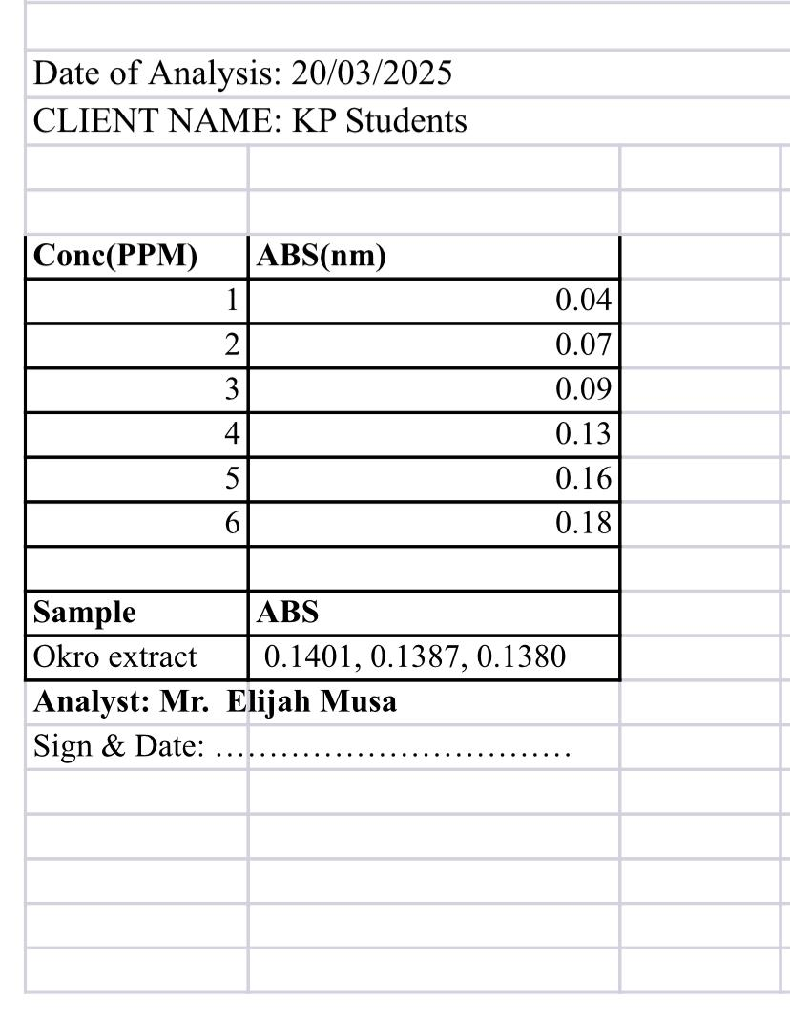
Table 2; SAPONIN RESULT USING UV SPECTROPHOTOMETER
zz

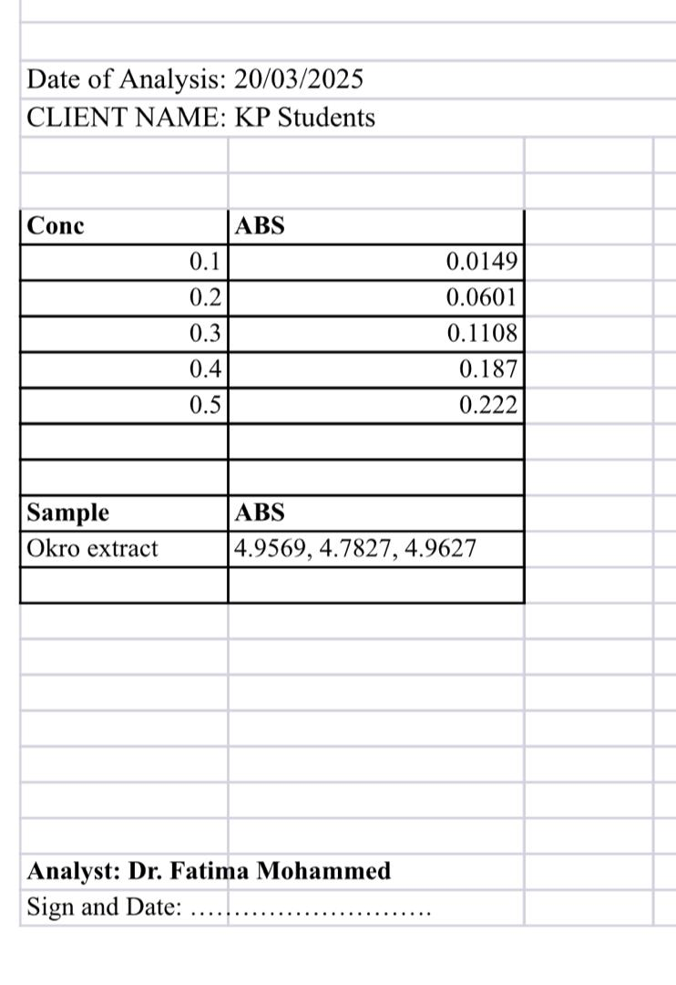
Table 3; TOTAL PHENOLIC RESULT USING UV SPECTROPHOTOMETER

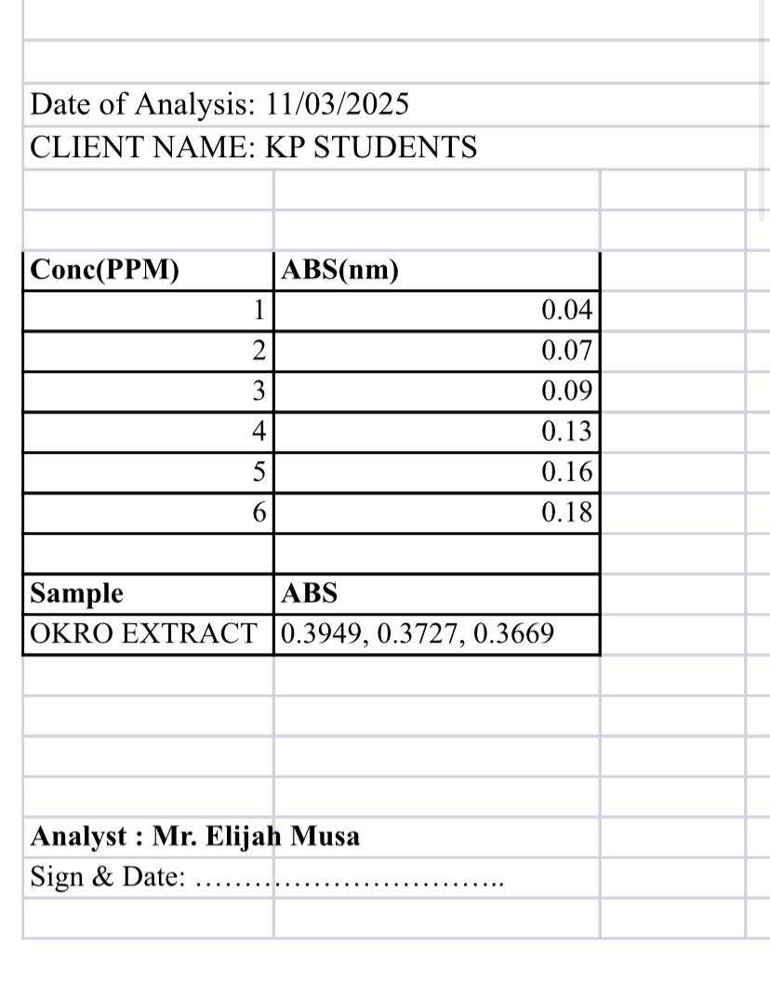
Table 4; FLAVONOID RESULT USING UV SPECTROPHOTOMETER

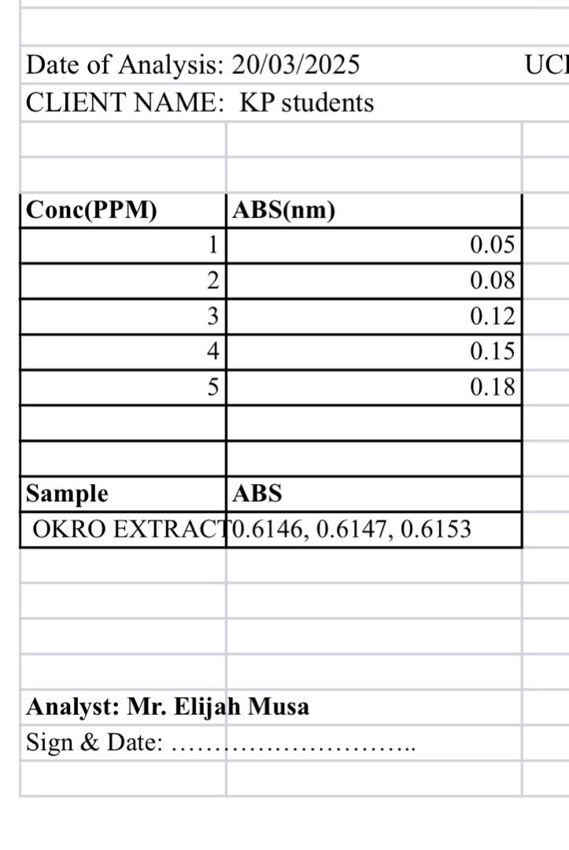
Table 5; TRITEPENOIDS RESULT USING UV SPECTROPHOTOMETER

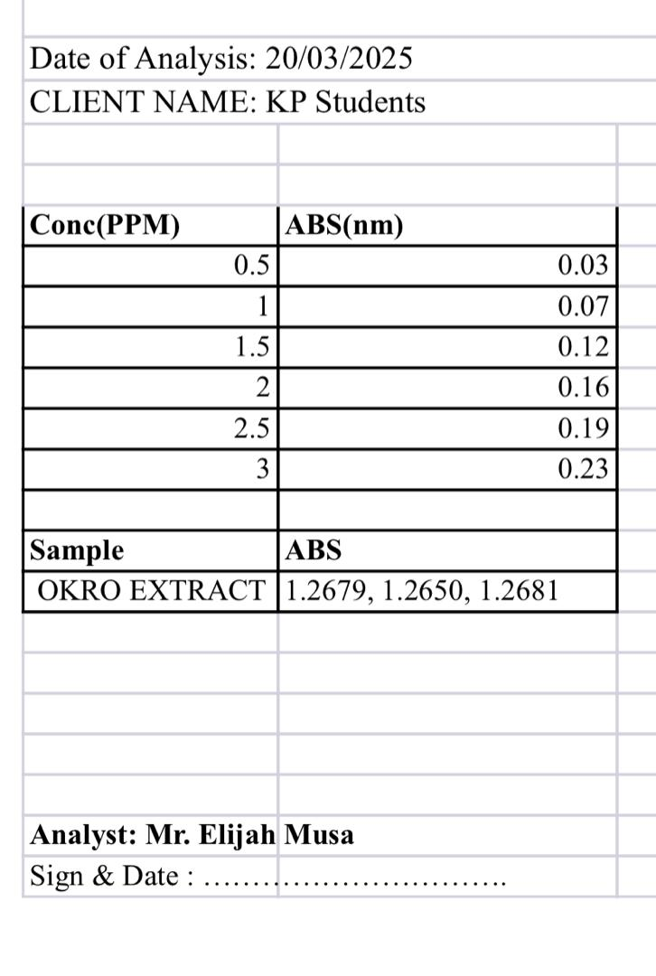
Table 6; STEROIDS RESULT USING UV SPECTROPHOTOMETER

Table 7; this results show the amount of each phytochemical in okra (abelmoschus esculentus)
Phytochemical | Mean + Sum
Steriods | 0.13 + 0.05 = 0.18
Flavonoids | 0.11 + 0.05 = 0.16
Phenol | 0.11896 + 0.05 = 0.17
Saponin | 0.11 + 0.05 = 0.16
Tritepenoids | 0.1 + 0.05 = 0.15
From the above result it shows that steriods as the high quantity in okra extract, while tritepenoids as the lowest quantity in okra extract.
Peak Identification & Bioactive Compounds using HPLC
Retention Time (RT) | Compound | Type
3–5 min | Gallic acid | Phenolic acid
5–10 min | Caffeic acid | Phenolic acid
6–8 min | Catechin | Flavonoid
7–10 min | Epicatechin | Flavonoid
9–14 min | Ferulic acid | Phenolic acid
10–15 min | Quercetin | Flavonoid
12–18 min | Kaempferol | Flavonoid
8–13 min | Myricetin | Flavonoid
ABTS SCAVENGING ASSAY
The oxidation of ABTS with potassium persulfate generates ABTS radical cation ( Pellegrini et al.,2003). This radical get reduced in the presence of hydrogen donating antioxidants (Shen et al., 2021). The ABTS % scavenging activity of okra extract was given in table below:
Table 2: Free radical scavenging activities of extract in ABTS assay
Concentration (µg/ml) | Percentage  Inhibition (%)
750
  51.13±0.66
500
  40.17±4.19
250
  34.17±2.95
125
  26.35±4.08
62.5 | 23.90±1.04
31.25 | 21.13±0.37
15.625 | 21.27±1.89
7.8125 | 17.45±0.67

Values are expressed as Mean ± SEM of three replicates.
Table 3: FRAP Antioxidant Potential of Extract
Samples | FRAP (Mmol Fe 2⁺ /g)
okra extract | 1.34±0.03
BHT | 2.08±0.07
Values are expressed as Mean ± SEM of three replicates.
NITRIC OXIDE SCAVENGING ASSAY
The scavenging effect of extract on nitric oxide was concentration dependent as shown in table below:
Table 4: Nitric Oxide (NO) scavenging assay of extract
Concentration (µg/ml) | Percentage  Inhibition (%)
750
  66.90±0.56
500
  59.40±0.31
250
  51.95±0.27
125
  43.44±0.20
62.5 | 37.17±0.78
31.25 | 31.10±0.10
15.625 | 25.01±0.64
7.8125 | 20.33±0.26

Values are expressed as Mean ± SEM of three replicates.
DPPH FREE RADICAL SCAVENGING ASSAY
The free radical scavenging effect of extract on DPPH was concentration dependent as shown in table below:
Table 5: DPPH Free Radical Scavenging Assay
Concentration (µg/ml) | Percentage  Inhibition (%)
500
  60.22±0.48
500
  49.96±0.33
250
  45.12±0.43
125
  39.19±0.23
62.5 | 32.40±0.33
31.25 | 26.57±0.13
15.625 | 24.57±0.13
7.8125 | 19.91±0.23

Values are expressed as Mean ± SEM of three replicates

CHAPTER FIVE
DISCUSSION, CONCLUSION AND REFERENCE
DISCUSSION
As depicted in the result of phytochemicals screening, it was observed that saponin, phenol, flavonoid, triter phenol, alkaloid and steroids were present while tannin, reducing sugar glycoside and protein were absent.
According to Adelakun et al ., 2013. The anti-diabetic bio-active compounds in plants are flavonoids, alkaloids etc. which are in conformity with the earlier identified phytochemicals in our choice of plant extract, ethanolic okra extract.
From the result obtained, steroid and flavonoid were abundantly identified as it is in correspondence to the findings of (Adelakun et al, 2013).
The findings further substantiated that the Okra extract is rich in all the afore said report as it shows in the result of anti-diabetic compounds identification using High Performance Liquid Chromatography (HPLC), that Gallic Acid and Caffeic Acid( Phenolic acid), catechin, epicatechin (flavonoids) Quercetin kaempferol and myreicetin were detected.
According to (Azebaze et al,.2021), several studies have revealed that okra contains a range of bioactive phytochemicals that contribute to its anti-diabetic effect through multiple mechanism amongst were identified in our study. ( Gemede 2005), reported that okra contains quercetin, isoquercetin, kempferol, and other anti-oxidant that are responsible for its anti-diabetic properties.
According to ( Tzeng et ai,. 2005), okra was found to consist of catechins, gallic acid derivates which are in accordance to the findings of this project for the Identified bioactive compounds.
The scavenging capabilities of our extract ( Ethanolic Okra Extract) vividly displayed that it is a very good antagonist in Oxidizing free radicals with ABTS,FRAP, NITRIC OXIDE and DPPH being assessed.
Sabitha et al. (2011) performed an in vivo and in vitro study on the antioxidant and anti-diabetic potential of okra. The in vitro assays using ethanolic extract revealed strong DPPH and nitric oxide radical scavenging activity. The extract also inhibited lipid peroxidation and improved antioxidant enzyme levels in diabetic rats, confirming its therapeutic potential.
According to Ngueguim et al. (2020), polyphenol-rich ethanolic extracts of okra showed strong inhibition of both DPPH and ABTS radicals, with IC₅₀ values close to known standards. The study also identified the presence of quercetin, catechin, and gallic acid through HPLC profiling—compounds known for their antioxidant effects.
In another recent study, Islam et al. (2021) used multiple antioxidant assays, including DPPH, FRAP (Ferric Reducing Antioxidant Power), and hydrogen peroxide scavenging to assess the antioxidant potential of ethanolic okra extract. Results confirmed a concentration-dependent activity, supporting the use of okra in managing oxidative stress–related diseases.
Collectively, these findings confirm that the ethanolic extract of okra is rich in bioactive compounds such as flavonoids, polyphenols, and tannins, which is in correspondence to our result at has been carefully assessed and analysed on FRAP, DPPH, NITRIC OXIDE and ABTS which contributes significantly to its antioxidant capacity. This supports its traditional use and aligns with modern therapeutic strategies targeting oxidative stress in diabetes and related metabolic disorders.

CONCLUSION
The okra extract has been found via invitro studies to contain various anti-oxidant properties, anti-diabetic bioactive compounds and several hypoglycemic phytochemicals. With the available research findings it can be established that ethanolic okra extract has potential anti-diabetic properties.
This study highlights the promising anti-diabetic potential of the ethanolic extract of Abelmoschus esculentus (okra) through a comprehensive approach involving phytochemical screening, in vitro enzyme inhibition assays, antioxidant activity tests, HPLC analysis, and molecular docking studies.
Phytochemical investigations confirmed the presence of key bioactive compounds including flavonoids, alkaloids, tannins, phenols, saponins, and terpenoids, all of which are known to exhibit pharmacological properties. The extract demonstrated significant inhibitory activity against alpha-amylase and alpha-glucosidase, indicating its ability to slow carbohydrate digestion and glucose absorption—a critical mechanism for managing postprandial hyperglycemia.
Additionally, the DPPH antioxidant assay showed strong free radical scavenging activity, suggesting that the extract could help alleviate oxidative stress, which plays a major role in the progression of diabetes and its complications. The HPLC profiling confirmed the presence of antioxidant-rich phenolic compounds such as quercetin, catechin, and myricetin, further validating its therapeutic potential.
Molecular docking analysis supported the in vitro findings by revealing strong binding affinities of okra-derived phytochemicals to the active sites of key enzymes involved in glucose metabolism.
RECOMMENDATION
- An in vivo studies should be conducted to corroborate the outcome of these findings
- Invitro – In vivo Assay should be carried out to correlate the two findings for effective research.
- Clinical trial maybe be examined to affirm the extract anti-diabetic tendency.

REFERENCES
Adelakun, O. E., Oyelade, O. J., Ade-Omowaye, B. I. O., Adeyemi, I. A., & Van de Venter, M. (2013). Chemical composition and antioxidant activity of Abelmoschus esculentus (okra) seed and pod extracts. International Journal of Food Science & Technology, 48(10), 2230–2235.
Agarwal, P., Upadhyay, R., & Tripathi, D. N. (2014). Antidiabetic activity of medicinal plants and its relationship with their antioxidant property. International Journal of Pharmaceutical Sciences Review and Research, 27(2), 1–7.
Ali, L., Azad Khan, A. K., Hassan, Z., & Nahar, N. (2003). Characterization of the hypoglycemic effects of Trichosanthes dioica leaves. Diabetes Research and Clinical Practice, 61(2), 145–154.
Anusree, S. S., Priya, S., & Mathew, S. (2020). Screening of plant extracts for potential inhibitors of alpha-amylase and alpha-glucosidase: An in vitro approach to antidiabetic therapy. Biochemistry Research International, 2020, Article ID 2041795.
Bernfeld, P. (1955). Amylases, alpha and beta. In Methods in enzymology (Vol. 1, pp. 149–158). Academic Press.
Blois, M. S. (1958). Antioxidant determinations by the use of a stable free radical. Nature, 181(4617), 1199–1200. https://doi.org/10.1038/1811199a0
Evans, W. C. (2002). Trease and Evans Pharmacognosy (15th ed.). Saunders Ltd.
Gemede, H. F. (2015). Nutritional and health potential of okra (Abelmoschus esculentus): A review. Cogent Food & Agriculture, 1(1), 1079004. https://doi.org/10.1080/23311932.2015.1079004
Gyamfi, M. A., Yonamine, M., & Aniya, Y. (1999). Free-radical scavenging action of medicinal herbs from Ghana: Thonningia sanguinea on experimentally-induced liver injuries. General Pharmacology: The Vascular System, 32(6), 661–667.
Harborne, J. B. (1998). Phytochemical methods: A guide to modern techniques of plant analysis (3rd ed.). Springer.
Islam, M. M., Ahmed, M. U., Rahman, S., & Hossain, M. A. (2021). Comparative evaluation of antioxidant properties of okra pod extract using multiple in vitro assays. Journal of Medicinal Plants Research, 15(5), 124–131.
Kim, Y. M., Wang, M. H., & Rhee, H. I. (2005). A novel alpha-glucosidase inhibitor from pine bark. Carbohydrate Research, 340(4), 647–656.
Kumari, D. J. (2011). Hypoglycemic effect of Abelmoschus esculentus in streptozotocin-induced diabetic rats. International Journal of Research in Pharmaceutical and Biomedical Sciences, 2(3), 941–945.
Li, Y., Xu, Y., Lai, C., Wang, Y., & Sun, H. (2011). Inhibitory effects of quercetin on alpha-glucosidase: Kinetic and molecular docking studies. Carbohydrate Research, 346(11), 1537–1541.
Ngueguim, F. D. M., Azebaze, A. G. B., & Biyiti, L. (2020). In vitro alpha-amylase and alpha-glucosidase inhibitory activity of polyphenol-rich extracts from Abelmoschus esculentus. Journal of Applied Pharmaceutical Science, 10(3), 65–72.
Patel, A., Patel, A., Patel, N., & Patel, M. (2010). Estimation of flavonoid, polyphenolic content and in vitro antioxidant capacity of leaves of Tephrosia purpurea Linn. (Leguminosae). International Journal of Pharma Sciences and Research, 1(1), 66–73.
Sabitha, V., Ramachandran, S., Naveen, K. R., & Panneerselvam, K. (2011). Antidiabetic and antioxidant potential of Abelmoschus esculentus (L.) Moench in streptozotocin-induced diabetic rats. Journal of Pharmacy and Bioallied Sciences, 3(3), 397–402.
Sharma, B., & Balomajumder, C. (2009). Hypoglycemic and hypolipidemic effects of flavonoid rich extract from Eugenia jambolana in streptozotocin-induced diabetic rats. Food and Chemical Toxicology, 47(10), 2806–2809.
Sofowora, A. (1993). Medicinal plants and traditional medicine in Africa (2nd ed.). Spectrum Books Ltd.
Sulaiman, M. R., Zakaria, Z. A., Daud, I. A., & Mohtar, M. (2011). In vivo antidiabetic activity and antioxidant potential of okra (Abelmoschus esculentus L. Moench) in streptozotocin-induced diabetic rats. Malaysian Journal of Pharmaceutical Sciences, 9(1), 19–30.
Tiwari, A. K., & Rao, J. M. (2002). Diabetes mellitus and multiple therapeutic approaches of phytochemicals: Present status and future prospects. Current Science, 83(1), 30–38.
Zhang, Y., Wang, L., & Zhang, H. (2015). Phytochemicals of okra (Abelmoschus esculentus): A review of potential bioactivity. Food Science and Human Wellness, 4(4), 123–130.

