
A PROJECT
ON
DIGITAL SURFACE MODELING
(A CASE STUDY OF PART OF KWARA STATE POLYTECHNIC)
BY
TIAMIYU ZAINAB OLAITAN
HND/23/SGI/FT/0556

SUBMMITTED IN PARTIAL FUFILMENT OF THE REQUIREMENTS OF THE AWARD OF HIGHER NATIONAL DIPLOMAL (HND) IN SURVEYING AND GEO-INFORMATICS TO THE DEPARTMENT OF SURVEYING AND GEO-INFOMATICS,
KWARA STATE POLYTECHNIC, ILORIN KWARA STATE.

JUNE, 2025.

CERTIFICATE
I hereby certified that all the information given in this project were obtained as a result of observations and measurements made by me and that the survey was carried out in accordance with Survey Rules, Regulations and Departmental instructions.

NAME: TIAMIYU ZAINAB OLAITAN
MATRICNO.:HND/23/SGI/FT/056

SIGNATURE: ………………………………….

DATE OF COMPLETION: ……………………………………………….

CERTIFICATION
This is to certify that TIAMIYU ZAINAB OLAITAN with matriculation number HND/23/SGI/FT/056 has satisfactorily carried out this project under our instructions and direct supervision.

_______________________ _______________________
MR. ABIMBOLA I. ISAU SIGNATURE AND DATE
(PROJECT SUPERVISOR)
_______________________ _______________________
SURV. AWOLEYE R. S SIGNATURE AND DATE
(PROJECT COODINATOR)
_______________________ ________________________
MR. ABIMBOLA I. ISAU SIGNATURE AND DATE
(HEAD OF DEPARTMENT)
_______________________ _______________________
EXTERNAL MODERATOR SIGNATURE AND DATE

DEDICATION
I dedicate this project to Almighty God, whose guidance, strength, and blessings have been my constant source of inspiration and perseverance.
ACKNOWLEDGEMENTS
All adoration be to God Almighty, the gracious one who has given me the opportunity to complete my HND program in Surveying and Geo Informatics. My appreciation goes to my supervisor MR.ABIMBOLA.I.ISAU for his encouragement and motivation as regards the project thank you and God bless you sir.
To all my lecturers in the department of Surveying and Geo Informatics, Surv.R.O ASONIBARE, SURV.A.GAREMU, SURV.R.S AWOLEYE, SURV.A.O AKINYEDE, SURV.AYUBA ABDULSALAM, SURV.F.D DIRAN AND SURV. BABATUNDE KABIR, may God bless you all (Amen). I also express my sincere gratitude to my wonderful parents MRS. ADEBISI OLUWATOYIN their parental care and supports once the inception of my educational career, they stood by me when things were tough and rough for me, they gave me hope, I will forever be grateful for the motivation you always gave to me at all time, if I would have to have parents in my life again, I will pray to have people like you around me again and to all my brothers and sisters JOSHUA TIMOTHY, MARVELOUS.
To all my understanding friends and lovers, I so much appreciate your support and advice thanks so much, May almighty God bless you all (Amen).

ABSTRACT
The project was carried out to generate a Digital Surface Model for part of Kwara state polytechnic, Moro Local Government Area, Kwara State, Nigeria. The reconnaissance was first carried out, spatial data were acquired directly from the field using Total Station, while non-spatial data were obtained through social survey by means of oral interviews and observations. The data were processed and analyzed using Arc GIS 10.1 software for database design and geospatial analysis, AutoCAD2007 for graphical representation, surfer 10 for generating the contour as well as Digital Terrain Modelling (DTM) and other relevant software. Some queries were generated to enable spatial search on the database created and transform such dataset into information system which will support decision making process, as a result of this we produced Topographic data in softcopy to be accessible for various application. Finally, a comprehensive technical report was written.

TABLE OF CONTENTS
Cover page……………………………………………………………………….i
Certificate………………………………………………………………………..ii
Certification……………………………………………………………………..iii
Dedication……………………………………………………………………….iv
Acknowledgement…………………………………………………………….....v
Abstract………………………………………………………………………….vi
Table of contents ….…………………………………………………………..vii-ix

CHAPTER ONE
- Introduction……………………………………………………. ..1
1..1 Background to the study………………………………..……..….1
1.2 Statement of the problem……………………………...…...……..3
1.3 Aim……………………………………………………………….3
1.4 Objectives ………………………………………………………..4
1.5 Scope of the Project……………………………………………….4
1.6 Pesonnel……………………………………….……………..…....4
1.7 Study Area…………………………………………………………6

CHAPTER TWO
- Literature Review…………………………………………….…..7

CHAPTER THREE

3.0 Methodology……………………………..………………………….17

3.1 Project Planning …………………………..………………………...17

3.2 Equipment Used/ System Selection Software………………………19

3.3 Data Acquisition….…....………………………………………...…22

3.4 Physical Design ......………………………………………………....25

3.5 Database Creation………..…..……………………………………...27

3.6 Data Processing.............…………………………………..………...28
3.7 Database Management…………………..……………………….30

CHAPTER FOUR
4.0 Spatial Analysis And Information Presentation ……………..………31
4.1 Testing of Database…………………………………………………31

4.2 Spatial Query……………………………………………………..…32

4.3 Result Analysis……………………...………………..……………..46
4.4 Application of Project…………………………………….…………47

CHAPTER FIVE
5.0 Costing, Summary, Problem Encountered, Possible Solution,
Recommendation And Conclusion ………………………...……...…49
5.1 Costing……………………………………………..………….……49
5.2 Summary……………………………………………..………….……49
5.3 Problem Encountered and Possible Solution..……………………..….49
5.4 Recommendation……………………………………………………...49
5.5 Conclusion…………………………………………………...………..50
REFERENCES…….……………………………………………….….....…51
APPENDIX DATA……………………………..……….……………….….52

CHAPTER ONE

- INTRODUCTION
1.1 Background to Study

The Earth's surface exhibits a variety of forms, including mountains, foothills, basins, terraces, ditches, cuttings, and embankments, and its elevation varies from place to place. Despite these natural variations, humans have learned to adapt to living on Earth. Different professionals, such as civil engineers, geologists, geomorphologists, and geomatic engineers, interact with the Earth's surface in various ways. While their areas of focus and interests may differ, they share a common goal of accurately describing and representing the Earth's surface.
This desire to represent the Earth's surface has led to the development of digital surface modeling, digital elevation modeling, and digital terrain modeling. Initially, terrain models were physical representations made from materials like clay, sand, and plastic. However, since the 1950s, computers have been introduced into this field, enabling the numerical or digital modeling of the terrain surface, which has evolved into the discipline of digital terrain modeling. Digital terrain modeling is a process used to create accurate models of the land surface. These models have found extensive applications in various disciplines, including mapping, remote sensing, civil engineering, mining engineering, geology, hydrology, land planning, and communications. Consequently, digital terrain modeling has garnered increasing attention as a discipline.
A Digital Terrain Model (DTM) is a description of the relief of a terrain, enabling computer processing and facilitating more efficient and accurate solutions to problems related to the Earth's surface geometry. For example, when designing a road, the computer can determine the optimal road alignment if the terrain's digital representation is available. A DTM can be described as a three-dimensional representation of a terrain surface, consisting of X, Y, Z coordinates stored in digital form. It includes not only heights and elevations but also other geographical elements and natural features, such as rivers and ridge lines.
In practice, the terms DTM, DEM, and DSM are often used interchangeably, although they can sometimes refer to different products. Li (1990) conducted a comparative analysis highlighting some differences between these terms. Elevation refers to the height above a given level, such as sea level or the horizon. Terrain is a broader concept, encompassing a tract of country considered in terms of its natural features, among other aspects. As a result, the term DTM tends to have a wider meaning than DEM and may incorporate specific terrain features, such as rivers, ridge lines, and break lines, into the model. On the other hand, Digital Surface Models (DSMs) measure the height values of the first surface on the ground, including terrain features, buildings, vegetation, power lines, etc., providing a topographic model of the Earth's surface. A digital surface model represents the Earth's surface and includes all objects on it, making it a superset of both DTM and DEM. Therefore, DSMs cannot be discussed without mentioning DEM and DTM, as they are subsets of the broader DSM concept.
Digital Surface Models (DSMs) are often used to model the first reflective or visible surface, while DTMs typically refer to the bare earth without trees, buildings, and other natural or manmade features. DSMs and DTMs are common products derived from various sources, such as (digital) photogrammetric systems, optical satellite imagery through block adjustment, real-time kinematic GPS, topographic maps, total station surveys, and LIDAR mapping, among others. In modern map production, DSMs and DTMs serve as valuable information sources for scene analysis, change detection, GIS database updating, 3D feature extraction and reconstruction, inter-visibility calculations for optimizing telecommunication antenna locations, risk mapping, generating true ortho-images, mission planning and rehearsal, virtual and augmented reality applications, and urban planning. Consequently, research in this field contributes to a better1.2.

1.2 Statement of Problem
Kwara state polytechnic Ilorin is an institution which has been established and functioning, for years, the population is increasing every year and also increasing in the artificial features like buildings, roads, electric poles, trees and many more. It was discovered that there is no up to date digital surface plan/map of the study area, so there is need for digital surface map for future several purpose of the study area which may be used for polytechnic modeling, landscaping and also erosion control in some area.
The demand for Digital Surface Model for various needs and application is on the increase owing to the rapid physical changes and development taking place on different part of the earth surface, hence, there is need for the creation of 3D digital database for the topography. The major problem here is the lack of up-to-date topographic database, therefore demands for topographic information in the area are not met and this occurs due to the following problems.
- The information contained in the available maps are not enough and current for the school’s management use, meaning there is need for an up-to-date Digital Surface Model.
- Due to the new development on the proposed site, the current school map does not contain an up to date details, there by calling for an update.
- Lack of information about the height of the features in the school which is poor deformation studies of the features within the school premises and the study area.

1.3 Aim of the Project

This project is aimed to create an up to date Digital Surface Model of the part of Kwara state polytechnic Ilorin.

1.4 Objective of the Project

- Design and develop a comprehensive database for the study area, integrating spatial and attribute data.
- Conduct a ground survey using Total Station to acquire accurate geometric and attribute data.
- Create a spatial database that captures the study area's features and characteristics.
- Perform spatial analysis to extract insights and patterns from the collected data.
- Develop an effective information presentation and management system to facilitate data-driven decision-making.
1.5 Scope of the Project

- Field reconnaissance
- Office planning
- Boundary establishment
- Data acquisition (Both geometric and attribute)
- Data processing
- Data presentation

1.6 List of the Personnel
The following are the personnel involved in executing the project:
S/N | NAMES | MATRIC/NO | POSITION
1 | TIAMIYU ZAINAB OLAITAN | HND/23/SGI/FT/056 | Writer
2 | ILESANMI ESTHER O. | HND/23/SGI/FT/055 | Member
3 | BABALOLA OLUWATOSIN O. | HND/23/SGI/FT/059 | Member
4 | ADEOYE AYOBAMI L. | HND/23/SGI/FT/063 | Member
5 | SHUAIB OLOHUNTOYIN | HND/23/SGI/FT/064 | Member
6 | OGUNLADE MATHEW K. | HND/23/SGI/FT/065 | Member
7 | AYINLA ABDULWAHAB B. | HND/22/SGI/FT/094 | Member
8 | GANIYU MISTURA D. | HND/22/SGI/FT/111 | Member

1.7 Project Location

The project site is part of Kwara state polytechnic Ilorin fall on geographic coordinate of Latitude: 008 33 25.96; Longitude : 004 37 54.39 to Latitude: 008 33 24.78 ; Longitude: 004 38 05.73, covered total area of 5 hects.

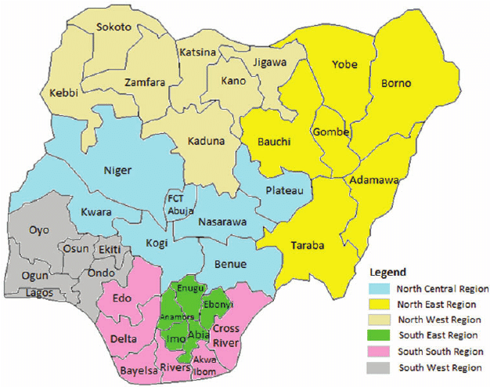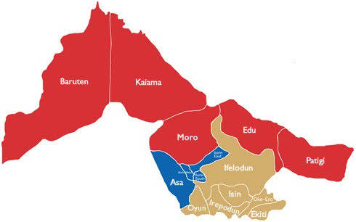
Map of Kwara State
Map of Nigeria

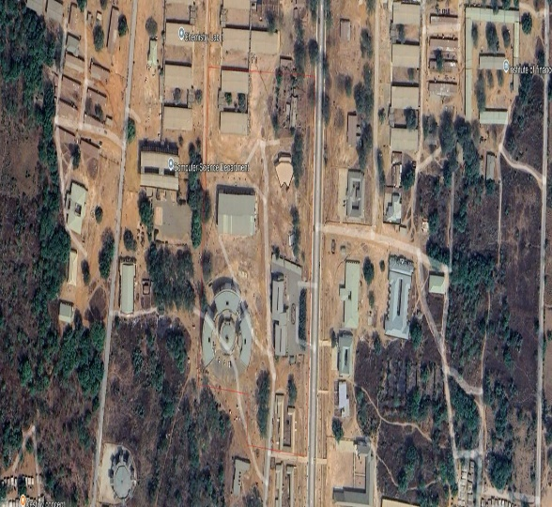
Google Imagery of the Study Area

Figure 1.10: Study Area Map
Imagery of Project Site
Showing the study area
FIG 1.2: Diagram Showing Location of Study Area.

CHARPTER TWO
2.1 LITERATURE REVIEW
Digital Surface Models (DSMs) offer the possibility of extracting the elevations of surface features to leave the ground surface DEM. For many applications in the urban environment this separation of above-surface feature information from ground information canoffer a useful combination of data sets. For example, detailed knowledge of the elevation of the ground surface is essential for predicting good inundation and the potential effects of sea level rise, whilst a detailed model of the man-made objects that would be affected is essential for property owners, planning authorities and insurance companies.
This project discusses several such applications and focuses on how Airborne Laser Scanning devices can provide digital surface models which can be used to separate surface features from the ground for modeling flood inundation from rivers in urban and semi-urban environments. DEMs can be constructed by digitizing existing topographic maps (Gao, 1995, 1997) or by using stereoscopic aerial photographs. With the advance of digital photogrammetry, DSMs can be created using stereo image matching techniques (Smith & Smith, 1996). Many authors (Abanmy, Khamees, Scarpace & Vonderohe, 1995; Jaafar & Priestnall, 1998) have considered the potential for these DSMs to provide the heights of surface features such as buildings. Recently LiDAR (Light Detection And Ranging) has become an established technique for deriving geometric information in three dimensions. The system is seen to offer a relatively quick technique for extracting accurate surface models and thus offers the potential for the creation of DEMs and other mapping products (Kost, Loddenkemper& Petring, 1996; Lohr, 1998). LiDAR is considered to offer several potential benefits for the creation of DSMs:
1. Offers Cost
Effective way of producing DSMs with an accuracy in the order of decimeters (Lohr, 1998), and is less prone than other remote measuring systems to difficulties in measurement due to variations in weather. 2. Offers precise definition of surface features through a very high density of recorded points, allowing the creation of gridded DSMs with cell resolutions of 1±3 m (Lohr, 1998). Automatic DSM generation using digital photogrammetry has problems with feature definition because of surface smoothing and the difficulty of controlling the image-matching algorithms (Smith, 1997; Smith & Waldram, 1996; Smith, Smith, Tragheim& Holt, 1997).
Reliable and accurate three-dimensional models of the urban environment are required by many applications and constructing these models has beenan activeresearch involving a diversity of approaches using remotely sensed data (Gruen, Baltsavias&Henricsson, 1997). A comparison of photogrammetric and Lidar (Baltsavias, 1999) considers these technologies not merely competitive but complementary and suggests that their close integration should be encouraged. Nevertheless, the production of DSM products using LiDAR is a quicker, more automated process and coupled with the high density of point measurements can offer greater definition of urban features, these factors encouraging research into the automated extraction and characterization of surface features.
The degree to which precisely defined surface features need to be extracted and categorized depends upon the application. The reconstruction and visualization of three-dimensional urban models, for example, requires precise definitions of building walls and roofs and much research effort has focused on their automated extraction (Gruen, Kubler &Aqouris, 1995). Typically, utilizing raw laser data or 1-m DSMs, buildings have been identified, removed and replaced with Computer Aided Design (CAD)-generated building objects, often with the aid of existing building outlines or through the use of additional optical information (Haala & Brenner, 1997, 1999). With CAD objects placed on the DEM surface, textures can be mapped onto individual faces of these objects giving the high levels of photorealism necessary for many urban planning visualization exercises. For land use change detection, the incorporation of building heights offers important extra information over and above that offered by optical sensors alone (Preinstall & Glover, 1998). Change detection between map vector outlines and building edges from newer imagery may be possible under certain conditions but processing can be complex. Due to the nature of gradient maps derived from the Lidar data, the identification of building edges becomes possible. Although not sensitive to lighting conditions, as are edges extracted from optical sensors, edge extraction from laser data is complicated by the presence of objects in close proximity to buildings such as parked vehicles and trees. Land use-change detection need not, however, rely upon the recognition of individual surface features. As the capture of laser data becomes more routine and time-series data sets become available, then differencemaps produced by subtracting successive DSMs should prove a successful means of urban change detection without the requirement to recognize features at every stage (Murakami, Nakagawa, Hasegawa, Shibata & Iwanami, 1999).
For certain applications the extraction of discrete geometrically precise objects is less important than the separation of the surface feature layer from the underlying ground elevations. Laser scanning can offer a fast, cost-effective alternative to conventional methods of producing DEMs from digitized contours or stereo plotters. Forflood hazard mapping over large areas ground DEMs derived from contour data are often used, but for more detailed modelling of flood inundation the use of LiDAR derived surface models can be considered. DEMs created from contour data are reliant upon a suitably small contour interval and a large number of surveyed spot heights in order to represent the ground surface faithfully. For floodplain mapping and modelling, laser scanning offers the chance to represent the ground surface at finer resolutions and, therefore, to predict the extent and depth of flood inundation more precisely (Marks & Bates, 2000). Gomes Pereira and Wicherson (1999) consider the potential of LiDAR for supplying topographic data for the management of alluvial zones. A simple simulation of river flooding using a LiDAR DSM where objects impacted by the flooding are clearly seen is shown in Fig. 2. Models of flood inundation can be one-dimensional where cross-sections extend across the floodplain from points along the river channel, each section being assigned a roughness coefficient. Where a one-dimensional model predicts significant floodplain show a two-dimensional model can be used to give more reliable estimates of flood depth and extent. The floodplain is represented as a triangulated surface where each triangle is assigned a roughness coefficient (such as Mannings n) which is typically estimated manually using field or photographic observations (Chow, 1973).
The representation of a more complete and precise coverage of surface roughness coefficients over the flood plain, coupled with a high resolution elevation surface, would offer improved data provision for this modelling process. LiDAR could provide such data if the surface features are removed to leave the ground elevation surface, and in so doing the spatial distribution of surface roughness could be estimated by summarising the texture of the features removed.
2. Rationale
Attempts to separate surface features from the ground elevations work on the assumption that these features are higher than the surrounding surface (Jaafar &Preinstall, 1999; Weidner & Forstner, 1995). If the above-surface features can be identified and removed from the DSM, then the ground elevations for the gaps left by the removed features can be replaced by interpolating between DSM elevation values around the edge of each gap. To identify the above surface features a `reference surface' which is lower than the LiDAR DSM can be subtracted from the DSM, leaving a `residual surface representing the locations of all above-surface features. The areas defined in this residual surface can be used to mask out the equivalent areas in the DSM.
The final stage involves interpolation to fill in the gaps masked out of the DSM, resulting in the ground DEM. This study investigates the above procedure with particular emphasis on the creation of a reference surface using a filtering process to smooth the DSM surface. The sensitivity of the results to varying the filter size used was an important aspect of the study. Further discussion of this technique will be outlined in the Methodology section. Although the isolation of the above-surface features from the ground surface is paramount in this study, the classification of these features based on topographic and spectral character is discussed. The use of an Artificial Neural Network (ANN) to extract features based upon their topographic maps produced by subtracting successive DSMs should prove a successful means of urban change detection without the requirement to recognize features at every stage (Murakami, Nakagawa, Hasegawa, Shibata & Iwanami, 1999). For certain applications the extraction of discrete geometrically precise objects is less important than the separation of the surface feature layer from the underlying ground elevations. Laser scanning can offer a fast, cost-effective alternative to conventional methods of producing DEMs from digitized contours or stereo plotters. One application for which an accurate DEM is important is the modeling of flood inundation from rivers. For flood hazard mapping over large areas ground DEMs derived from contour data are often used, but for more detailed modeling of flood inundation the use of LiDAR derived surface models can be considered. DEMs created from contour data are reliant upon a suitably small contour interval and a large number of surveyed spot heights in order to represent the ground surface faithfully. For floodplain mapping and modeling, laser scanning offers the chance to represent the ground surface at finer resolutions and, therefore, to predict the extent and depth of flood inundation more precisely (Marks & Bates, 2000). Gomes Pereira and Wicherson (1999) consider the potential of LiDAR for supplying topographic data for the management of alluvial zones.
A simple simulation of river flooding using a LiDAR DSM where objects impacted by the are clearly seen is shown in Fig. 2. Models of flood inundation can be one-dimensional where cross-sections extend across the floodplain from points along the river channel, each section being assigned a roughness coefficient. Where a one-dimensional model predicts significant floodplain show a two-dimensional model can be used to give more reliable estimates of flood depth and extent. The floodplain is represented as a triangulated surface where each triangle is assigned a roughness coefficient (such as Mannings n) which is typically estimated manually using field or photographic observations (Chow, 1973). The representation of a more complete and precise coverage of surface roughness coefficients over the flood plain, coupled with a high-resolution elevation surface, would offer improved data provision for this modeling process. LiDAR could provide such data if the surface features are removed to leave the ground elevation surface, and in so doing the spatial distribution of surface roughness could be estimated by summarizing the texture of the features removed.
3. The data
LiDAR is based on sequential laser range measurements from an airborne sensor to points on the ground surface. Knowing the precise position and orientation of the airborne platform, from differential Global Positioning Systems and Inertial Navigation Systems, the laser beam is reflected o the ground surface to enable the three-dimensional positions of the surface points to be determined with decimeter accuracy (Hug, 1997; SoÈhne, Heinze, Hug &KaÈlberer, 1993). It is reported that an accuracy of the order of 0.2 m horizontally (x,y) and 0.1 m vertically (z) can be achieved in the production of DSMs (Lohr, 1998) from LiDAR depending on the system used. The nature of the surface models produced allows surface features to be distinctly defined and, consequently, the identification and extraction of these features both as discrete objects and in terms of roughness coefficients becomes a reality.
In this study, the LiDAR data used are those produced by the Environment Agency and the study area is an area of the Trent floodplain at Newark-on-Trent, Nottinghamshire, UK. The study area consists of an undulating topography that includes man-made objects and natural features such as trees. The spacing of the surveyed points is approximately 2.5 m and the final gridded elevation matrices used for analysis have a spatial resolution of 2 m. The DSMs are referenced to the Ordnance Survey of Great Britain (OSGB36) and the heights are transformed to Ordnance Survey Datum Newlyn (OSDN). In the data-acquisition phase, the swath angle used is ‹19 and the flying height approximately 700 m. The precise large-scale geometry of building objects as represented in the 2-m DSM (as illustrated in Fig. 1) cannot be extracted reliably but the surface texture is sufficiently well defined to allow the filtering procedure described in Section 2 to be implemented. Although the present study uses the surface topography alone, the availability of multi-spectral remotely sensed imagery offers additional potential for discriminating trees from buildings (Haala & Brenner, 1999) and is the focus of ongoing investigations.

4. Methodology
The task is to separate surface features from ground elevations but the specific techniques very much depending upon the requirements of the application. For example, in the case of three-dimensional urban model reconstruction and mapping it may be appropriate to extract and generalize edges from the gradient image in a similar way to image edges in previous studies (Preinstall & Glover, 1998). Generalized edge features can be grouped to form a candidate building object, supported by height information `internal to', and `external to' the building boundary. Techniques such as this rely on high-resolution laser scanning data using either raw point measurements or gridded DSMs with a resolution of around 1 m. For example, Maas and Vosselman (1999) present algorithms to segment individual roof faces of buildings based upon clusters of common aspect values present in the triangulated data set.
The approach taken by the current study does not attempt to extract building geometry but focuses upon extracting the whole surface feature layer with a view to characterizing the features present. Several approaches to `stripping' this surface feature layer have been investigated. The Environment Agency, Bath, UK, have explored the potential of using 33 variance filters to identify areas above a certain threshold limit equivalent to a variance of 2 m (or 66.gradient). These areas are buffered and the resulting mask is used to remove areas of the DSM which are replaced by re-interpolating elevations across the gaps. This study presents a modified approach for isolating surface features. Working on the assumption that man-made objects and natural features stand above the surrounding surface a lower reference surface can be subtracted from the DSM, leaving a residual surface representing all surface features (Jaafar & Priestnall, 1998, 1999; Weidner & Forstner, 1995).
An important issue at this point is the method used to create the reference surface. In the first part of the investigation, the effects of filtering on the LiDAR DSM using a mean filter of varying size are investigated with a view to deriving the most appropriate smoothed `reference' surface. The standard deviations (s) for the derived surfaces are then computed for comparative purposes. The main aim of this filter exercise is to understand the smoothing effects of the DSM in the creation of the reference surface. As would be expected the value for s decreases with respect to the field size used, Choosing an appropriate filter size based upon this effect alone would be difficult. In order to assist the choice of filter size the effect must be understood with respect to the features on the DSM being smoothed. To achieve this an unsupervised classification of the DSM elevation data is carried out. This process of thresholding results in a pre-defined number of clusters, in this case five clusters being assigned to ensure the separation of the three main entities (the terrain surface, buildings and trees). The choice of the number of clusters varies according to the range of elevation values in the DSM and the number of entities to be differentiated. In order to understand the effect of various sizes of mean filters on the smoothing of features on the LiDAR DSM, well-defined regions generated by the unsupervised classification that represent trees, buildings and bare land are randomly identified.
The reference surface' which is lower than the LiDAR DSM could be created using any mean filter with window sizes between 1111 and 2525. In this study the 1111 mean filter is applied to the LiDAR DSM to generate the `reference sur- face'. The `reference surface' is then subtracted from the LiDAR DSM to isolate the above-surface features. As a result of the subtraction, the above-surface features are revealed as scattered regions (Jaafar & Priestnall, 1999) with positive elevation values. However, it should be pointed out that the whole area corresponding to a particular above-surface feature is not necessarily revealed after the subtraction.
Remotely sensed data obtained from satellites and airborne platforms are useful in providing an understanding of the distribution of damage due to natural disasters (Yamazaki 2001). The platforms and sensors of remote sensing should be selected with regards to the coverage and resolution required and the urgency, weather and time conditions. Recently, the digital aerial imaging system has become widely used (Hinz 1999; Leberl and Gruber 2005). The imaging system saves time associated with analog imagery processes and provides more precise and better-quality aerial images. In addition, the exterior orientations of airborne image can be determined by integrating GPS (Global Positioning System) and IMU (Inertial Measurement Unit) observations made during the mapping flight. Hence, it is expected that the digital surface model (DSM) can be constructed with good accuracy using the images captured by the imaging system. Aerial and satellite images are employed to detect collapsed buildings due to an earthquake.
Mitomi et al. (2001) tried to reveal building debris automatically using images captured by a high-definition television camera. Saito et al. (2004) performed visual damage inspection using the post-event IKONOS image, in which individual buildings can be identified, and pre-event other satellite images for the 2001 Gujarat, India earthquake. QuickBird images with the maximum spatial resolution of 0.6 m were also employed to detect collapsed buildings after the 2003 Bam, Iran, earthquake (Yamazaki et al. 2005). The object-based classification technique using digital aerial images was applied to access damaged buildings in the 2007 Niigata Chuetsu-oki earthquake (Suzuki et al. 2010). So far, remotely sensed images might be effective to detect earthquake induced damages. Since we can obtain only the top view of the affected area, some of the damaged buildings are difficult to reveal. Figure 1 shows an example of the aerial image captured after the 2007 Niigata Chuetsu-oki earthquake. A two-story building with the collapsed ground floor was found from the field photo. The building could not be pointed out from the aerial image because no damage was observed on its roof.
The Niigata Chuetsu-oki earthquake occurred on July 16, 2007 with a JMA (Japan Meteorological Agency) magnitude of 6.8 (JMA, 2007). Severe ground shaking was observed near the epicenter and the JMA seismic intensity of 6+ was recorded in Kashiwazaki city, Niigata Prefecture, Japan. The number of collapsed buildings is 1,121 and that of casualties is 14 in the affected area. The digital aerial image was captured for Kashiwazaki city on April 27, 2007, about three months before the earthquake. The digital aerial camera, UltraCamD, was employed to obtain the aerial images. The operated digital airborne imaging system was integrated with in-flight control systems consisting of GPS and inertial measurement units (IMU). The altitude of aircraft during capturing was about 1970 m and the spatial resolution of the aerial images is about 0.17 m. Performing aerial triangulation using the GPS/IMU dataset for the pre-event image with ground control points, the exterior orientations of airborne images can be determined accurately (Smith et al. 2005). The exterior orientations mean the three dimensional position and the three rotational angles of digital camera. The relative orientation of a stereo-pair of digital aerial images was conducted by introducing pass points, which are used as control points to match the two images, to reveal the accuracy of the exterior orientations.
Due to the limitation of the automated method, the shape of buildings could not be extracted so accurately. Hence, the breaklines (Briese 2004), which describe the discontinuities of the elevations in 3D model, were developed from the pre-event DSM. After the elevations were assigned to the both ends of breaklines, the 3D model for buildings were constructed based on the pre-event image.

CHAPTER THREE

3.0 METHODOLOGY

3.1 PROJECT PLANNING

Before beginning any survey assignment, project planning is a crucial requirement. It entails a careful investigation of the topic matter about a certain land region that is being evaluated. This crucial step in the surveying process allows the surveyor to become acquainted with the chosen location before starting work. During the reconnaissance phase, the survey's goals, requirements, and required precision levels are examined because these elements have a big impact on the choice of survey tools and techniques. In the end, this project resulted in the development of a first working diagram. Reconnaissance is divided into two phases: (i) Office Planning and (ii) Field reconnaissance.

3.1.1 FIELD RECONNAISSANCE

As part of this process, a surveyor or student must physically visit the site to gain a thorough understanding of its topography, including any vegetation, accessibility, existing frame work, as well as the social and economic 19 activities that take place there. The optimal approach and tools for improved decision-making must also be chosen. This on-site visit gives the surveyor or student a comprehensive grasp of the entire region and allows them to look at the entire area of the land. To guarantee correct orientation, the locations of all accessible horizontal and vertical controls in the region of the research area will be visited, and their outlooks will be viewed. This exercise makes it easier to create a Recce diagram, which is shown below but is not drawn to scale:

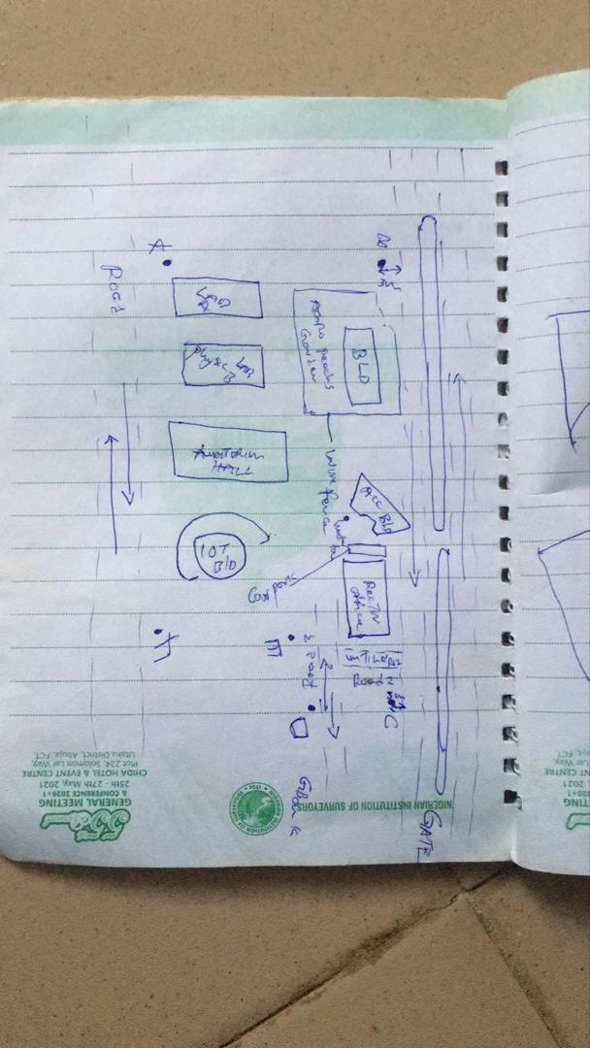

Figure 3.4: RECCI DIAGRAM

3.1.2 OFFICE PLANNING

Gathering crucial project information is the focus of this phase, which is usually done in an office setting. It is the initial phase of planning that comes before the fieldwork itself and entails gathering and analyzing a variety of project-related data. This covers a range of requirements for the project, scheduling, budgeting, and generating the coordinates for the control points under the project control prefix. It includes figuring out the best process, picking the right tools, as well as subscription for the CORS station.

3.2 EQUIPMENT USED/ SYSTEM SELECTION SOFTWARE
The following equipment was used:
- Total station and accessories
- One Tripod
- Two Prism
- One 7.5 meters short tape
- One Plumb bob
- One Cutlass
- Bottle corks and nails
- Writing materials.

3.2.1 HARDWARE USED
Model: HP 15 Note book PC
System Manufacturer: Hewlett-Packard
Rating: 1.0 Windows Experience Index.
Processor: Intel(R) Core(TM) i5-3230M CPU @ 2.60GHz, 2601 Mhz, 2 Core(s), 4 Logical Processor(s)
Installed Memory RAM: 8.00 GB
System Type: x64-based PC.
Product ID: F9F84EA#ABV

3.2.2 SOFTWARE USED
Some of the software used includes:
- AutoCAD 2007
- Notepad
- Microsoft Word 2007
- Microsoft Excel 2007
- Arc GIS 10.5

3.3 DATA ACQUISITION

This involves using different surveying methods and tools to gather data and make observations in the field. To acquire data for this project, Handed GPS and Total station were both used.

3.3.1 PRIMARY DATA SOURCE: This is a type of data source in which data is direct acquired from the field such as data acquired from field survey operations.

3.3.2 SECONDARY DATA SOURCE: This data source are already made data or gotten from research work, which has been acquired for future use. This involves downloading satellite imagery used for the project area and Google map as guide.

3.4 TEST OF INSTRUMENT
Testing of instruments is very crucial when carrying out any survey operation. Having collected the required instruments from the department, the check was carried out on the accuracy and precision of both the Handed GPS and TOTAL STATION to ensure they were in proper working condition before the actual field observation of the project.

3.4.1 TEST FOR TOTAL STATION
The horizontal collimation and vertical index inaccuracies of the instrument were confirmed. Once the device was positioned on a rather flat surface, the required temporary modifications, including focusing, centering, and setting, were made. Configuration information, such as extra parameters and fast settings, was examined and adjusted as necessary. The configuration parameters selected collimation, namely horizontal collimation. Next, to focus on a distant object, the means' option located on the left side of the device was chosen. The instrument was transited, and the right side went through the same procedure. Then, when the 'accept' button was pushed, the table that was displayed showed the old and new values for the vertical index errors and horizontal collimation. Re-press "ok" signified acceptance of the updated values, which were minimal.
Figure 3.5: INSTRUMENT TEST

The diagrammatic representation of the procedure and the readings obtained are shown below

Table 3.4.1 COLLIMATION TEST OF TOTAL STATION
STN | SIGHT | FACE | HCR | REDUCTION | VCR | REDUCTION
A | B | L | 126º 07’ 11.33” |  | 67º 22’40”
 | B | R | 306º 07’ 31.3” | 180º 00’ 20” | 292º 37’ 1” | 359 º 59’ 41”

HORIZONTAL COLLIMATION ERROR = 180°00’20’’ - 180°
=00°00’20’’
=00°00’20’’/2 =00°00’10’’
VERTICAL INDEX ERROR=360° - 359°59’41.6’’
=00°00’18.4’’
=00°00’18’’/2 =00°00’9.2’’
The instrument's satisfactory operation was validated by the acceptance of the updated readings. It appears from this result that any possible issues can be resolved or at least greatly reduced.

3.4.2 REFERENCING AND ORIENTATION OF TOTAL STATION
Tripod Setup:
- Place the tripod over the station point (known or assumed).
- Level the tripod head as much as possible by adjusting the legs.
Mount the Total Station:
- Fix the total station onto the tripod head.
- Ensure it’s securely locked in place.
Centering and Leveling:
- Use the optical plummet or laser plummet to center the instrument exactly over the survey station mark (station point).
- Level the instrument using the foot screws and circular bubble.
- Fine-tune leveling using the electronic level display.

Power On and Instrument Configuration
- Switch on the Total Station.
- Set the correct project, coordinate system, and units.
- Select the appropriate survey mode (e.g., topographic survey or station setup).
Orientation (Station Setup)
Orientation means establishing the direction of the horizontal angle reference (back sight direction).
Orientation by Known Coordinates (Resection or Free Station)
Used when both the instrument station and a back sight point have known coordinates.
- Input the coordinates of the instrument station (or let the instrument compute it later).
- Sight and measure to one or more known reference points (minimum of 2 for better accuracy).
- The Total Station calculates the instrument position and orientation using these known points.

3.3.7 PERIMETER TRAVERSING
The perimeter of the project area was traversed for the purpose of the coordinating the boundary points. HandedGPS (GALAXY G1) was connected to kwara state CORS station for referencing and orientation after which all the boundary points were traversed using HandedGPS from the initial until each successive boundary is occupied.

3.3.8 DETAILING
All features such as roads, buildings, electric poles, street light, trees, etc. were captured by coordinating their edges simultaneously as the perimeter is being measured within the project area. Buildings were measured and identifiers (BD) were used to differentiate them from other features. Roads were also measured and labelled (RD) accordingly. Data captured here were basically in 3Dimension i.e. Easting, Nothings and Elevations (X, Y, and Z) coordinates.

3.3.9 REMOTE ELEVATION MEASUREMENT
All the features such as buildings, electric poles, street light, etc. captured by coordinating their edges from a subsidiary traverse stations created within the project area. Buildings heights were measured and recorded. Electric poles height were also measured and recorded accordingly. So also the same was repeated for the trees. Data captured here were basically in 3Dimension i.e. Easting, Nothings and Elevations + Heights (X, Y and Z + H) coordinates. The following procedures were followed:
- Escape key was pressed then F1 for MENU
- The REM programme was selected.
- Observation was made again and the height of reflector was displayed.
- The telescope was tilted to the top of the object and the height keeps changing until F4 is been pressed to stop.
- The value was recorded.
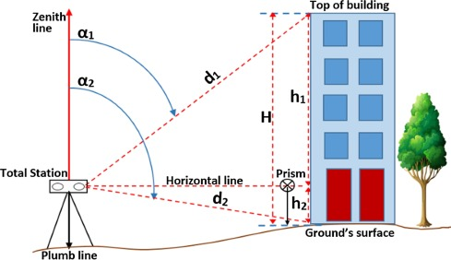
Figure 3.3.9: REM OBSERVATION STRATEGY

3.3.9A SPOT HEIGHTINGS
This was carried out by occupying randomly the subsidiary points within the project area and taking measurements (Easting, Nothings and Heights) along the terrain at approximate intervals to determine the difference in height between points and some areas within the project location. Spot heighten is very important in producing topographical information of the area with the aid of ArcGIS 10.5.

3.4 PHYSICAL DESIGN
At this stage, all geospatial (attribute) data were structured and organized to form a database in a format acceptable by the implementing software and hardware. This was done in a way that, stored information can be accessed and retrieved at any time. Also, for regular updates when the need arise and to allow for analytical functions to be carried out answering generic questions. Also, it provided integrity and security that must be obeyed before such data could be accepted into the records. These virtues are as show in the tables below. ArcGIS 10.5 was used for database creation of the project area.

Table 3.4A TREE TABLE
ATTRIBUTE | DATA TYPE | WIDTH | DECIMAL
T_ ID | String | 5 | -
T_NAME | Float | 20 | -
EASTING | Number | 10 | 3
NORTHING | Number | 10 | 3
T_USE | Float | 10 | -
T_HEGHT | Number | 7 | 3

Table 3.4B ROAD TABLE
ATTRIBUTE | DATA TYPE | WIDTH | DECIMAL
POINT_ID | String | 10 | -
NORTHING | Number | 10 | 3
EASTING | Number | 10 | 3
RD_HEIGHT | Number | 7 | 3
Table 3.4C ELECTRIC POLE TABLE
ATTRIBUTE NAME | DESCRIPTION OF ATTRIBUTE | DATA TYPE | WIDTH | DECIMAL
POINT_ID | Electric pole identifier | Number | 6 | -
NORTHING | Coordinate | Number | 15 | 3
EASTING | Coordinate | Number | 15 | 3
EP_TYPE | Type of Electric pole | Text | 15 | -
EP_HEIGHT | Height of the Electric pole | Number | 5 | 2

Table 3.4D BUILDING TABLE
ATTRIBUTE | DATA TYPE | WIDTH | DECIMAL
P_ID | String | 15 | -
NAME | Text | 15 | -
CONDITION | Text | 15 | -
USE | Text | 15 | -
HEIGHT | Number | 15 | 2
AREA_METERS | Number | 15 | 2

Table 3.4E STREETLIGHT TABLE
ATTRIBUTE NAME | DESCRIPTION OF ATTRIBUTE | DATA TYPE | WIDTH | DECIMAL
POINT_ID | Street light identifier | Number | 6 | -
NORTHING | Coordinate | Number | 15 | 3
EASTING | Coordinate | Number | 15 | 3
SL_HEIGHT | Height of the street light | Number | 5 | 2

3.5 DATABASE CREATION
Database is an organized integrated collection of data stored so as to be capable of use by relevant application with data being accessed by different logical part. This was the construction phase where database was created. After the table has being populated via the keyboard, some attributes such as area, perimeters of parcel were automatically displayed by special command in the ArcGIS 10.5 version.
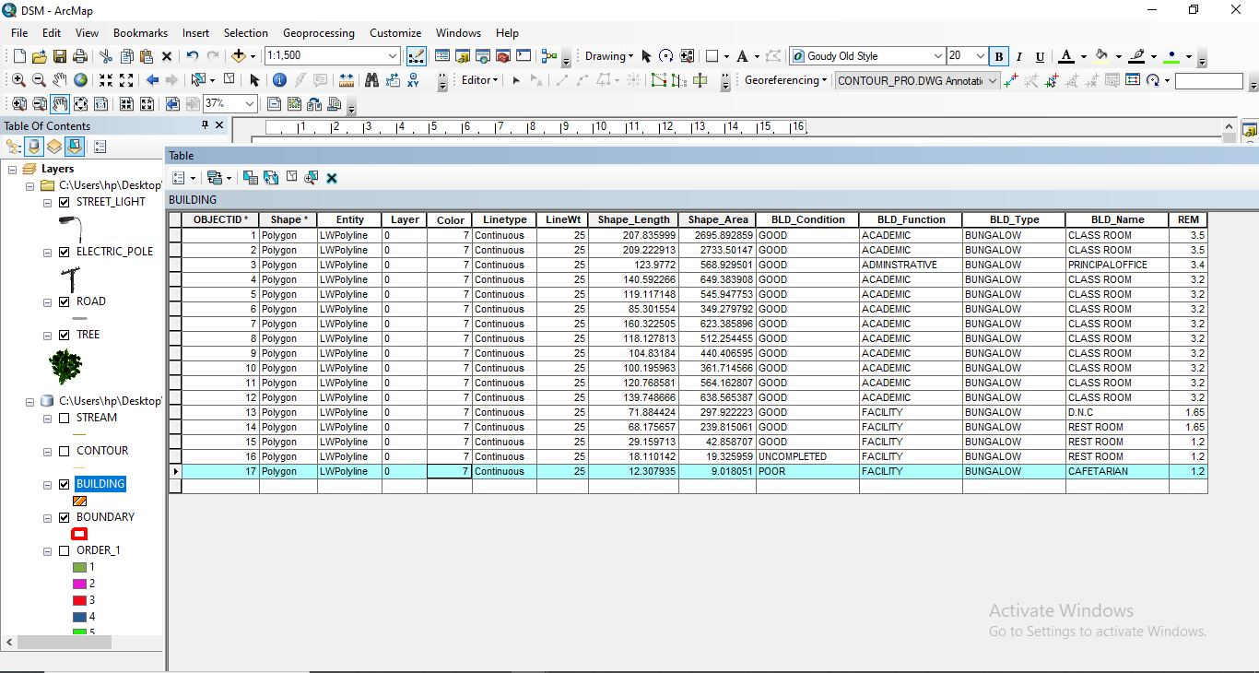
Figure 3.5: ABSTRACTED OF TABLE CREATED

3.5.1 ATTRIBUTE DATA ACQUISITION
The data about the characteristics of features especially man-made features were acquired through oral interview method and online source (Google Earth). Social survey was carried out during which information such as; building name, building use and related data about features were obtained from the students and staffs within the school. All these data formed the attribute aspect of the feature necessary for the database creation.

3.6 DATA PROCESSING

3.6.1 TOTAL STATION DATA DOWNLOADING PROCEDURE
Data downloading is the process of transferring data from the instrument into the computer system connected through the connection cable or wireless such as Bluetooth with the help of software in the computer, the process is as follows as performed on Total station.
- Connection of the two devices (computer and the instrument).
- Go to project working folder created on the instrument.
- Click on export.
- Input the name of file
- Indicate the file extension for the output
- Permit the other device to receive the file.

3.6.2 DRAFTING AND PLOTTING
The script file created containing the refined coordinates was then opened in the AutoCAD environment and the boundary of the project area was plotted using AutoCAD 2007. This was followed by the details, which included buildings, roads, trees, sport facilities and electric poles.
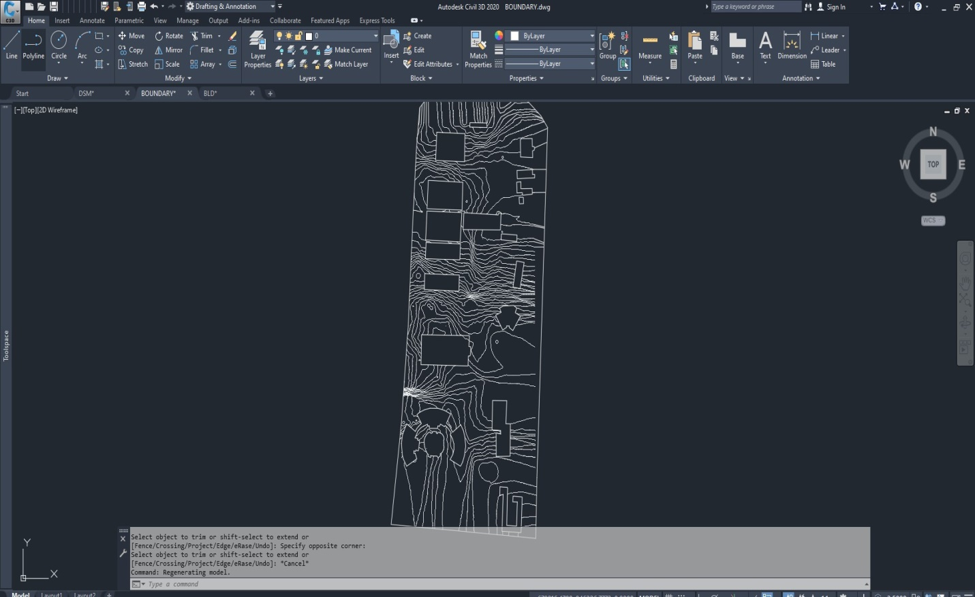
Figure 3.6.2: AUTOCAD PLOTTING.

3.7 DATABASE MANAGEMENT

3.7.1 DATA SECURITY
This is the security measure used the protection of the database security is very important since it is vital for data integrity. The strategic measure used included controlling access to database by use of password.

3.7.2 DATA INTEGRITY
This ensures that data in the database is accurate and that cases of violation of integrity can be detected automatically by the system. Here, care was taken while entering data into the system, such that, accurate data were entered and updating could be done accurately without tampering with existing data. Backups are provided to cater for any loss of data through system failure. Also a member of the project group was appointed for quality assurance and checks therefor do checks the consistency, accuracy and integrity of the input data.

3.8.3 DATABASE MAINTANANCE
Having created the database, proper maintenance practice was made to meet its stated objectives. The ability to include more data and remove irrelevant data can be possible. There is every need for the data to be updated regularly because of the physical changes that tends to occur on the landscape with time, even as a result of development.
Both security and integrity were also exercised to ensure maintenance and to meet its stated objectives.

CHAPTER FOUR

4.0 SPATIAL ANALYSIS AND INFORMATION PRESENTATION

4.1 TESTING OF DATABASE
This is the test carried out to determine whether the relationship between the spatial data of a feature and their attributes is capable of being retrieved. This is necessary to ascertain the quality of data in the database, its reliability to satisfy the demand of the user. The spatial data were arranged logically in an organized manner with respect to their attributes. This was carried out by designing a sample query and running the query to see if the desired result would be achieved. In this project, the database was queried to show different categories of information levels in the project area. Hence the database was confirmed fit for analysis. A sample of the attribute table in the database design can be found on the next page.
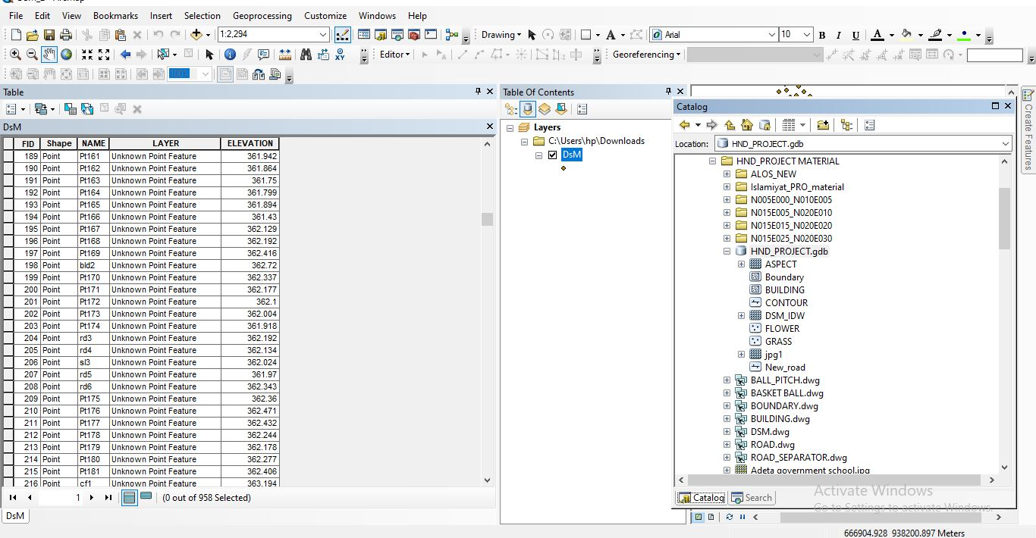
Figure 4.1: SAMPLE OF ATTRIBUTE TABLE

4.2 SPATIAL QUERY
Queries were designed for the purpose of retrieving information from the database. The queries performed in this project gave answers to certain generic questions asked from the database. This was made possible as a result of the implicit link of both the spatial and attributes data. The queries were based on the products from the analysis carried out on the database.

4.2.1 SINGLE CRITERIA QUERY
A single criterion is carried out where one condition is used to design query. This condition is used to retrieve the information from the database.

QUERY ANALYSIS 1 (selection by attribute)
ANALYSIS ONE
Analysis Name: Database extraction
Analysis Type: Single criteria analysis
Syntax: Query analyses showing buildings that are used for Administrative.

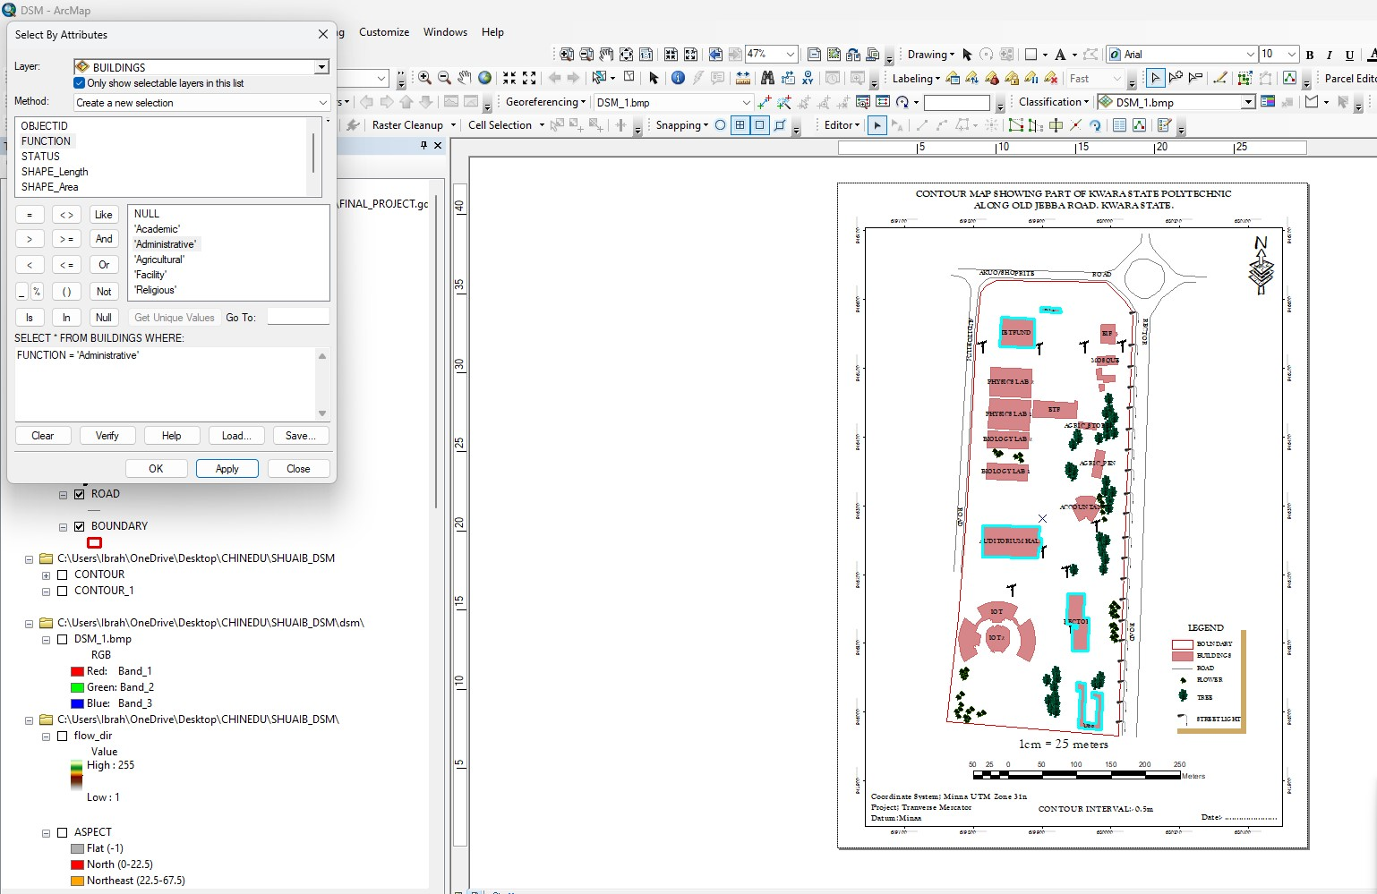
Figure 4.2.1.1 RESULT OF QUERY: (BLD_FUNCTION = “ADMINISTRATIVE”).

Analysis Name: Database extraction
Analysis Type: Single criteria analysis
Syntax: “BLD_ Function” =”Agricultural”
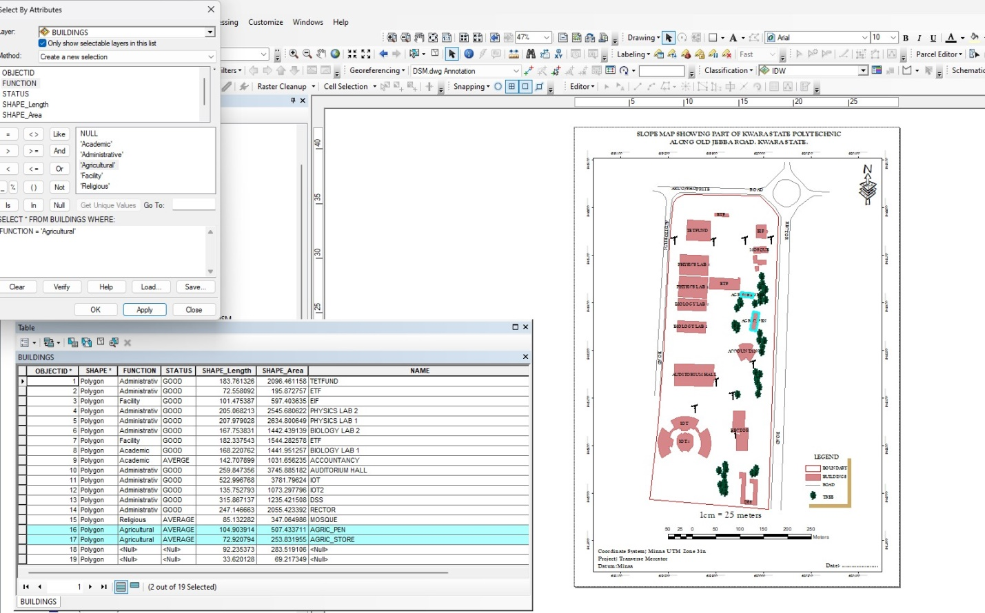
Figure 4.2.1.2: RESULT OF QUERY: (BLD_FUNCTION = “AGRICULTURAL”).
ANALYSIS THREE
Analysis Name: Database extraction
Analysis Type: Single criteria analysis
Syntax: “BLD_ CODITION” =”ACADEMIC”
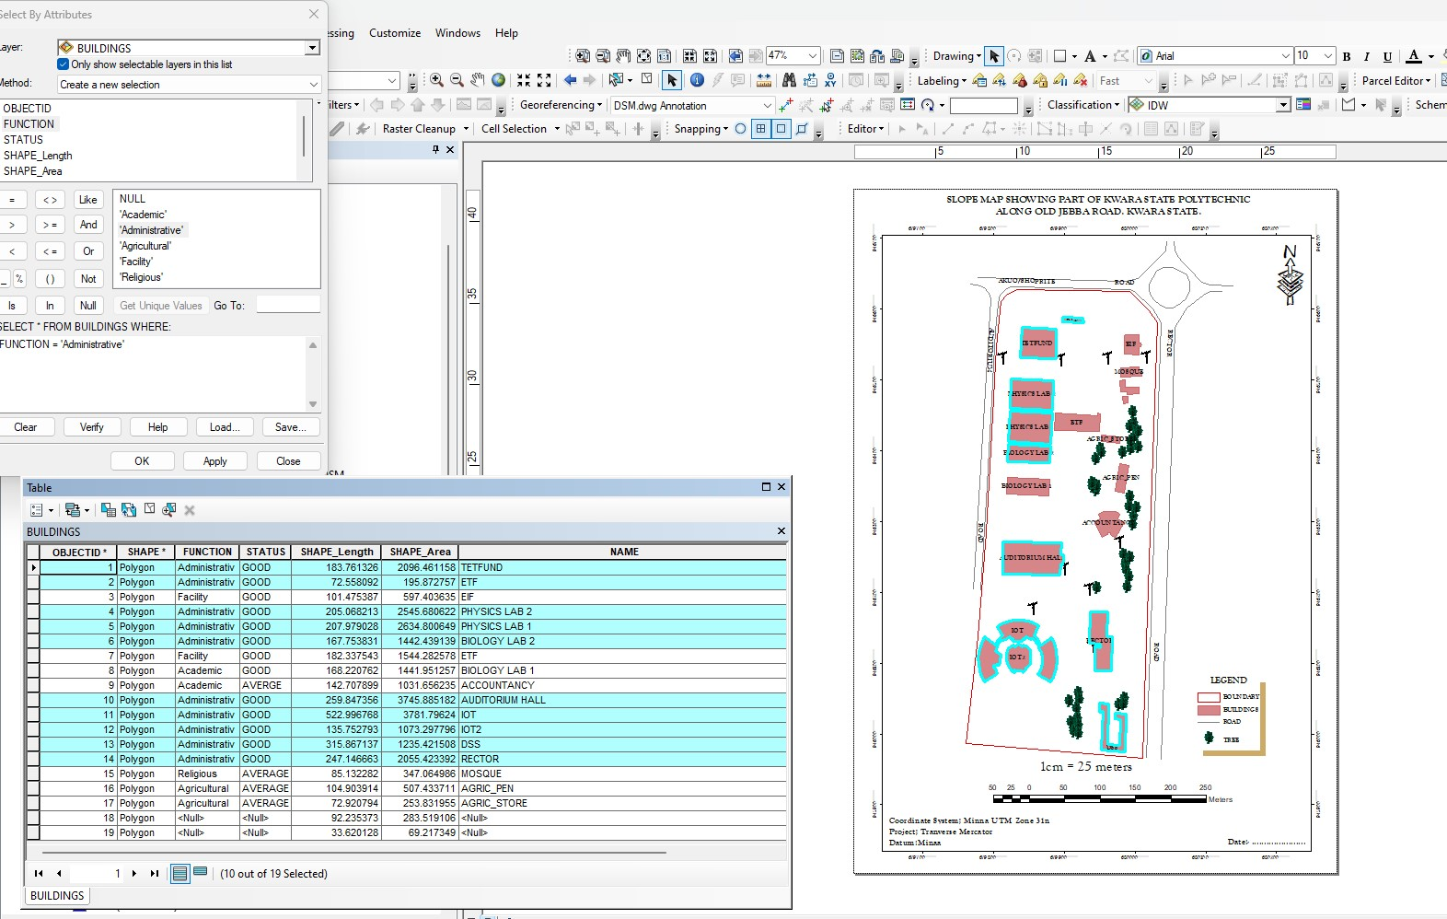
Figure 4.2.1.3: QUERY BLD_FUNCTION"ACADEMIC"

ANALYSIS FOUR
Analysis Name: Database extraction
Analysis Type: Single criteria analysis
Syntax: “TREE_FUNCTION= ORNAMENT”

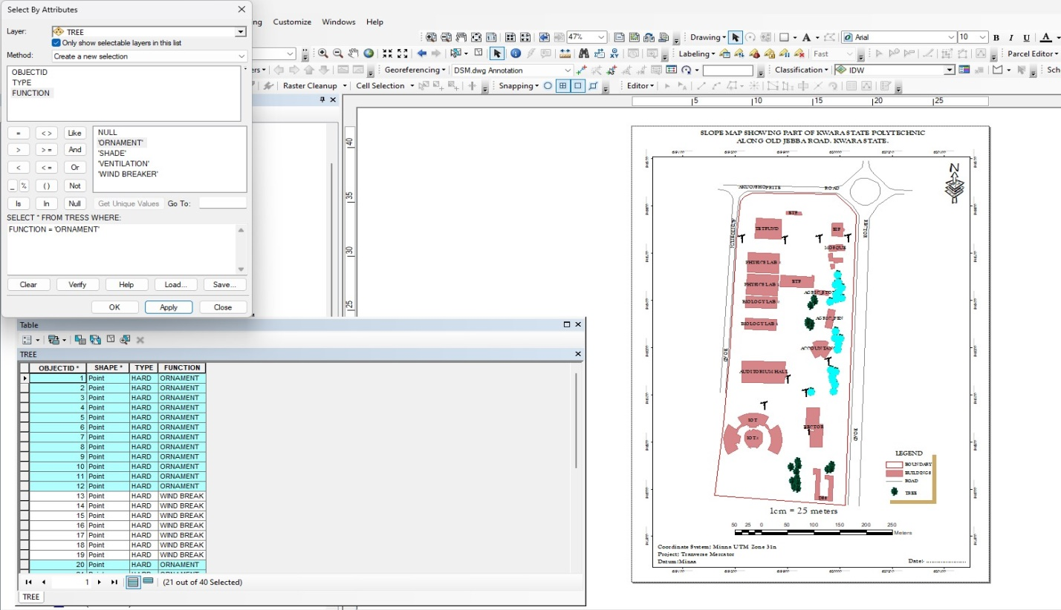
Figure 4.2.1.4: RESULT OF QUERY: (TREE_FUNCTION “ORNAMENT”).

4.2.2 MULTIPLE CRITERIA
This is a situation where two or more conditions are used to design a query. The conditions determine the information that may be requested by the user from the database.
Query for QUERY: TREE_FUNCTION “ORNAMENT” AND TREE_TYPE “HARD”
ANALYSIS FOUR
Analysis Name: Database extraction
Analysis Type: Multiple criteria analysis
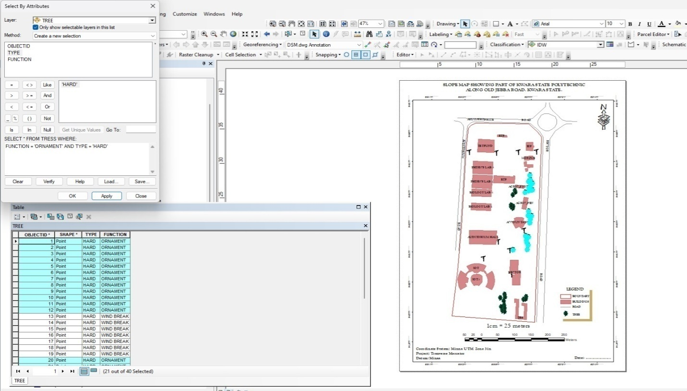
Figure 4.2.2.1 RESULT OF QUERY: TREE_FUNCTION “ORNAMENT” AND TREE_TYPE “HARD”
Query for BLD_FUNCTION =“RELIGIOUS” AND BLD_STATUS= “AVERAGE”
ANALYSIS FOUR
Analysis Name: Database extraction
Analysis Type: Multiple criteria analysis

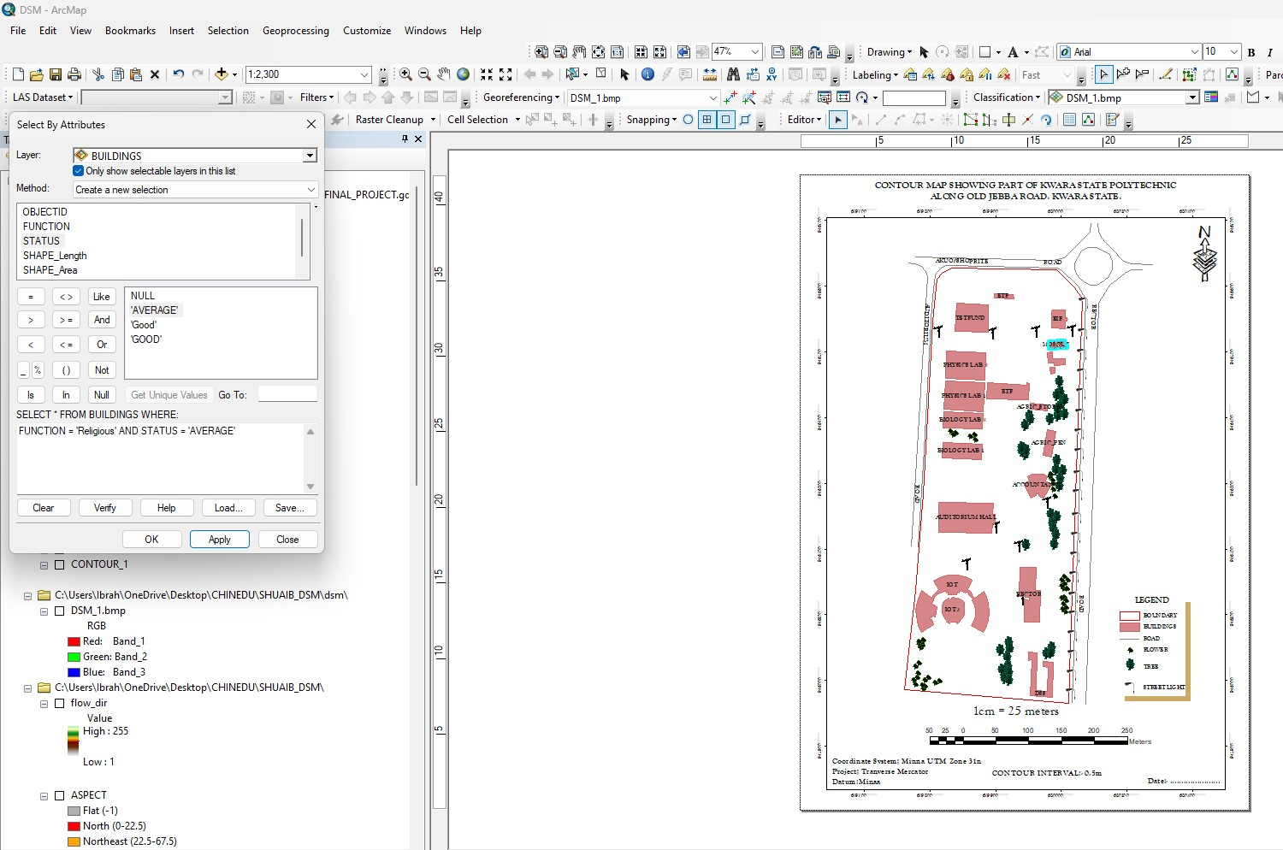
Figure 4.2.2.2 RESULT OF QUERY: BLD_FUNCTION =“RELIGIOUS” AND BLD_STATUS= “AVERAGE”

4.2 SPATIAL ANALIYSIS
This makes Geographic Information System (GIS) a unique analytical tool or technique because of its ability to combine spatial attribute data to produce information relevant for decision making. The basic GIS analysis performed in this project includes overlay and topographic operations. Maps on various themes were overlaid since they were from the same geometric origin.

4.2.1 OVERLAY OPERATION
This overlay operation is the presentation that shows different features within the project area. The outcome of overlay operation could be composite plan if it shows all the existing features, and boundary.

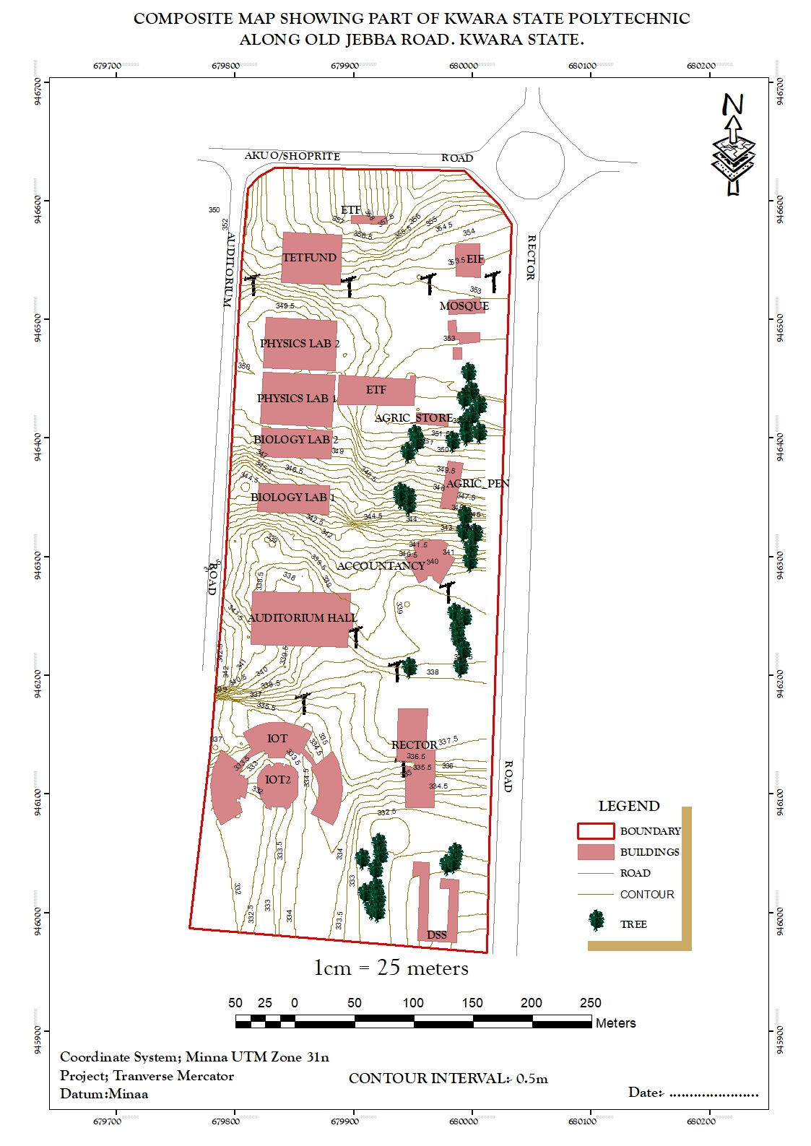
Figure 4.2.1: COMPOSITE MAP OF THE PROJECT AREA.

4.2.2 TOPOGRAPHICAL OPERATIONS
Topographic operations were carried out to determine the surface characteristic of the area which showed the relief of the project. These operations were performed on the Digital Elevation Model (DEM) generated from the use of relevant software, in this case, ArcGIS 10.5 and ArcScene 10.5 was used. The following maps were produced from the topographic operations and analysis:

- TRIANGULATION IRREGULAR NETWORK (TIN): this shows series of triangulated surface automatically generated from ArcGIS 10.5 using 3D analysis tools. This is applicable in finding suitable place for building or any engineering construction
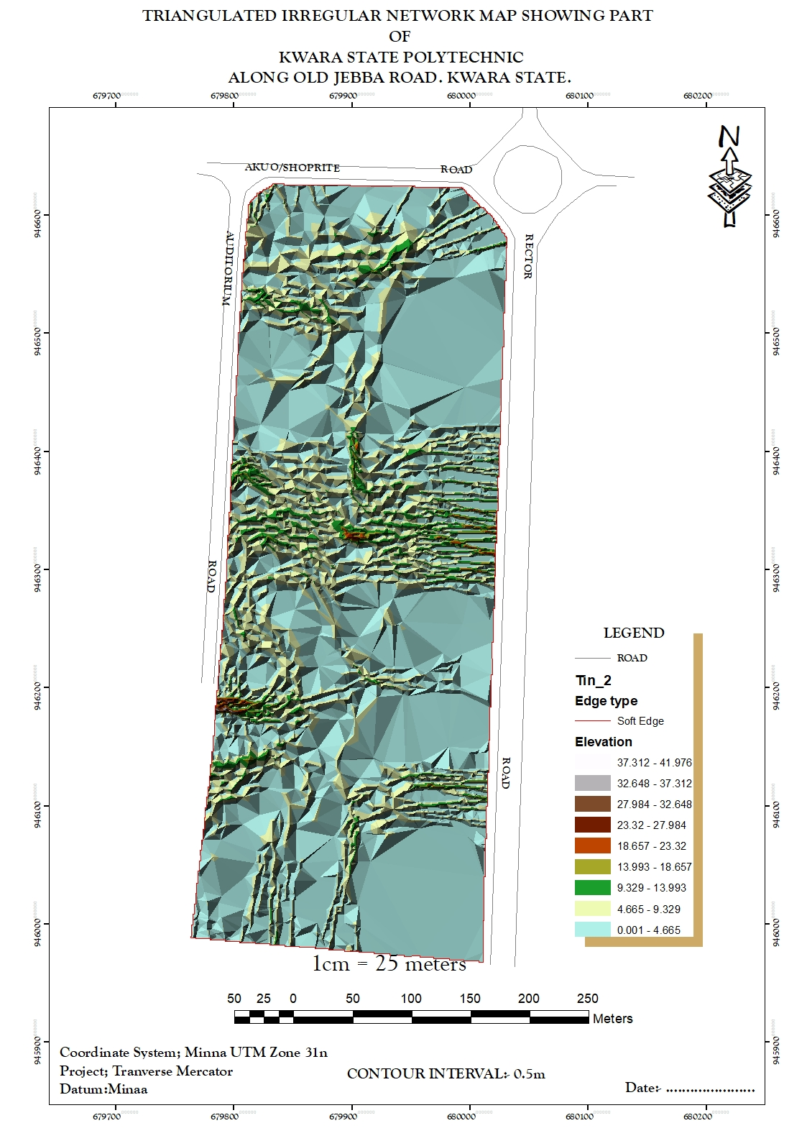
Figure 4.2.2.1: TIN AND DETAILS OVERLAY MAP OF THE PROJECT AREA
- SLOPE MAP: A slope map represents the gradient or steepness of the terrain's surface. It calculates the rate of change in elevation between neighboring pixels or points on a digital elevation model (DEM). Typically, slope is measured in degrees or percentage. Steeper slopes are represented by higher values, while flatter areas have lower values.
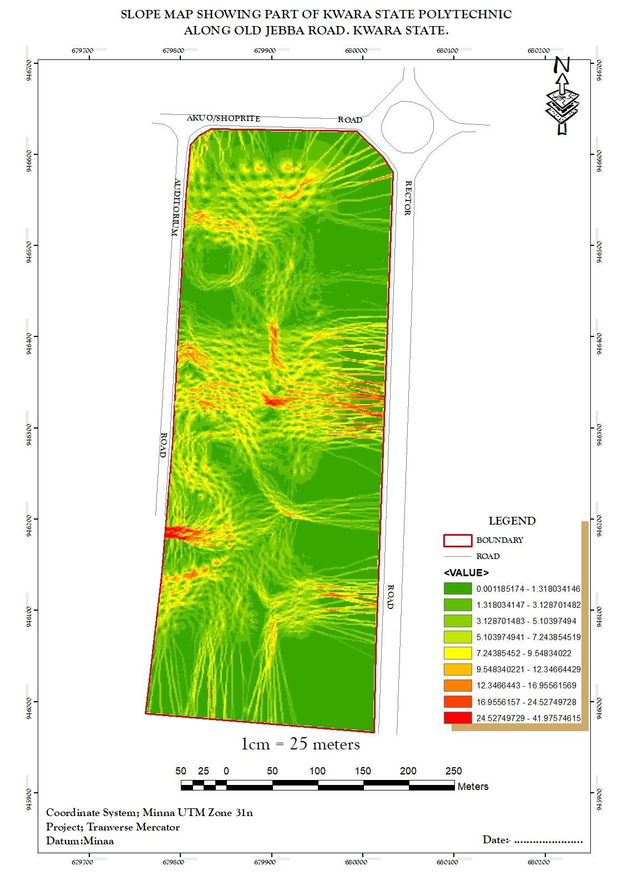
Figure 4.2.2.2: SLOPE MAP OF THE PROJECT AREA

- THE ASPECT MAP:
This shows the direction of the surface faces. It is used to determine how much sun a hill received and the information can be used to put building where they will get enough sun. Also the aspect map shows the suitable place for plane landing i.e. the flat terrain area and also solar illumination which can affect the diversity of life i.e. Vegetation and soil studies; glaciology.

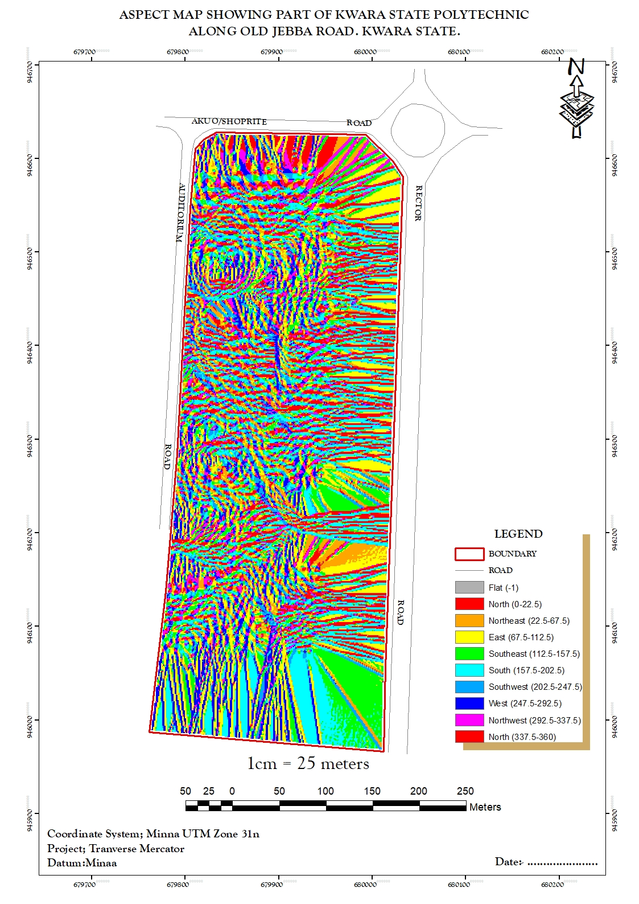
Figure 4.2.2.3: ASPECT MAP OF THE PROJECT AREA.
- THE CONTOUR MAP:
Contour maps display lines connecting points of equal elevation on the terrain surface. These lines, called contour lines, depict the shape and elevation of the land. Contour maps are widely used in topographic mapping and land surveying for visualizing elevation changes and terrain features. This provides a very intuitive view of the landscape. Contour map of the project area can aid in giving information on the highest and the lowest point on the terrain. This is important in road construction and location of other facilities like storage tanks for water distribution.
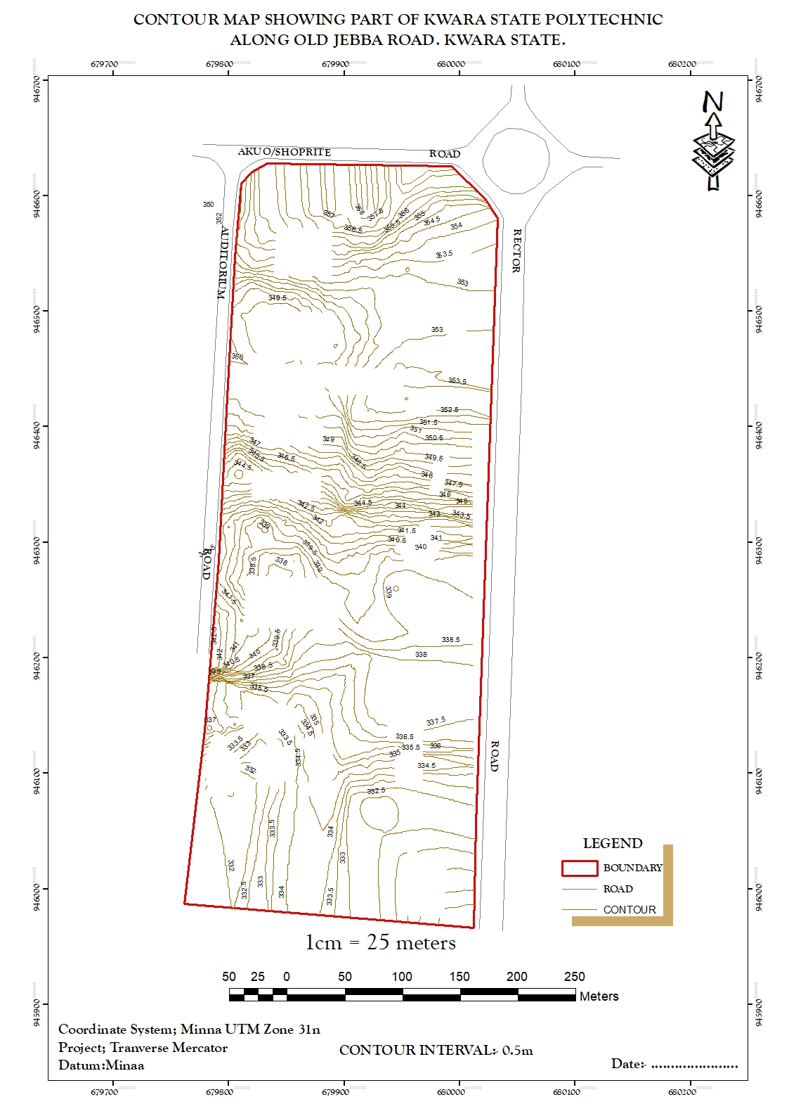
Figure 4.2.2.4: CONTOUR MAP OF THE PROJECT AREA.

- FLOW DIRECTION MAP:
This is used to determine the direction of flow of water within the project area. It also indicates the magnitude and erosive force water passing through an area.
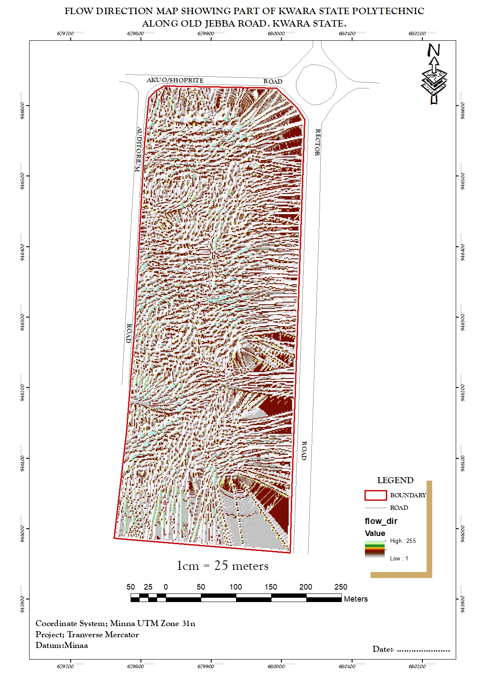
Figure 4.2.2.5 FLOW_DIRECTION MAP OF THE PROJECT AREA
- DIGITAL SURFACE MODEL MAP:
A DSM (Digital Surface Model) map, or Digital Surface Model, represents the elevation of the Earth's surface including all objects on it, such as buildings, vegetation, and other structures. Unlike a DTM (Digital Terrain Model), which only includes the bare-earth surface, a DSM incorporates both natural and man-made features. DSMs are useful for various applications, including urban planning, infrastructure design, and 3D visualization. They are often derived from aerial or satellite imagery, LiDAR data, or photogrammetry techniques. This shows the reality of the terrain of the project area.
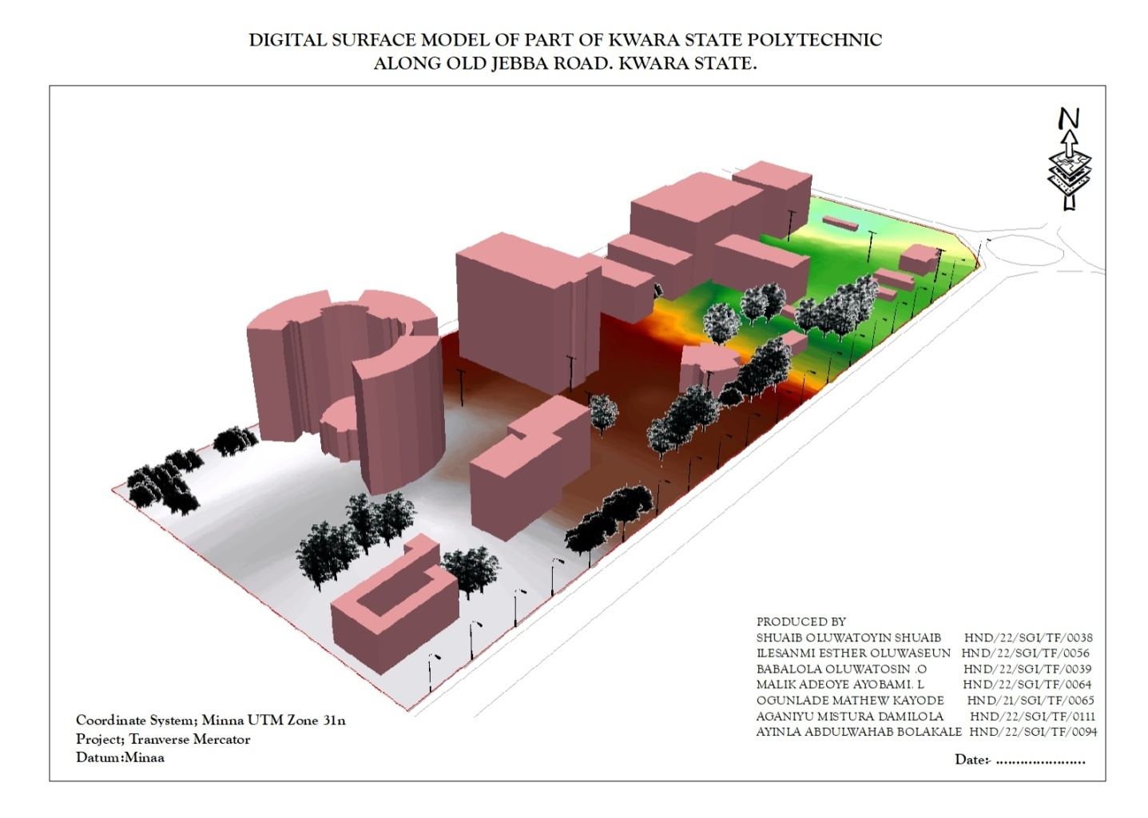
Figure 4.2.2.6: DIGITAL SURFACE MAP OF THE PROJECT AREA

4.3 RESULT ANALYSIS
From the below pie chart, it is inferred that large percentage is serving academic function.The DSM project commenced with the utilization of a Total station referenced to control station within kwara state polytechnic to capture 3D data of the project area. The captured data were then processed using software, employing photogrammetry techniques to generate a high-precision DSM and create a detailed 3D model. Subsequently, ArcGIS and ArcScene software was employed to visualize and analyze the DSM data, facilitating spatial analysis and information presentation both in 2D and 3D respectively.
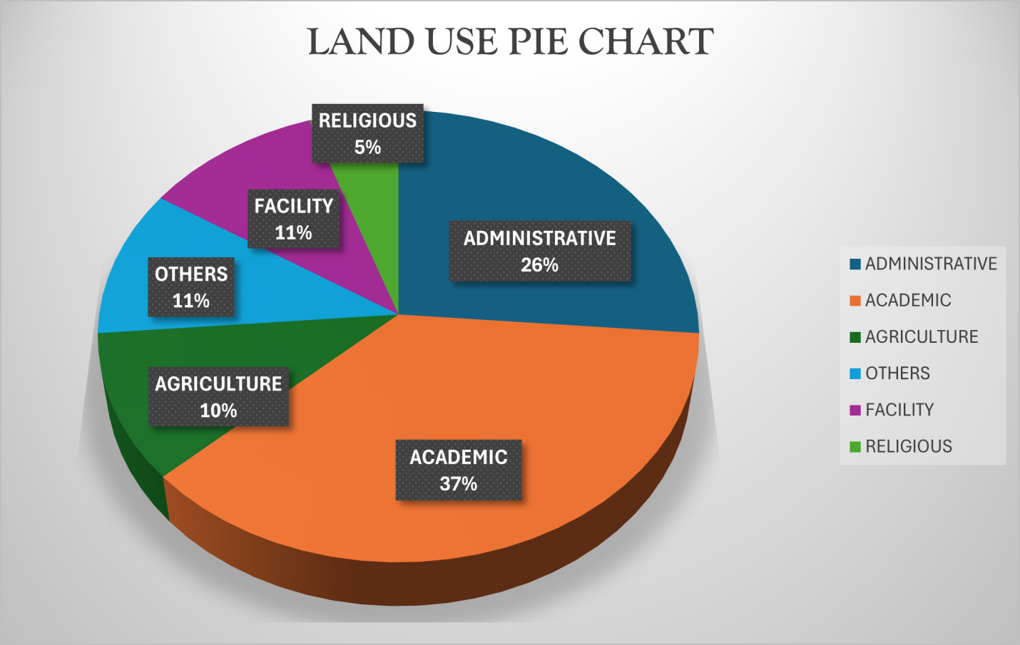
Figure 4.2.2.7: LAND USE PIE CHART

4.4 APPLICATION OF PROJECT
- Generally DSM is applicable in urban development modeling.
- It enhanced visualization and communication of such data not only in maps modeling but also in mobile digital devices for quick navigation and assessment.
- To create a sustainable and favourable living environment.
- Positioning and monitoring of physical features, structures and engineering works on, above or below the surface of the earth to protect properties or investment.
- The feasibility studies through the use of line of sight analysis provide visibility between two points. This is good for network distribution in telecommunication.
- The profile graph is good road construction which will provide the cross section of the topography from which rivers, streams and depression can be shown. Points require bridges, culverts and filling can be known from the profile graph.
- The vector map shows the direction of rivers, streams and depression which helps in road construction.
- The aspect map shows the direction of the surface faces. It is used to determine how much sun a hill received and the information can be used to put building where they will get enough sun also used to find where different crop will do best and also the Converging/diverging flow; soil water properties.
- The aspect map shows the suitable place for plane landing i.e. the flat terrain area and also solar illumination which can affect the diversity of life i.e. Vegetation and soil studies; glaciology.
- The result from the analysis can be help in managing the land resources of the project area. With the DSM, adequate information has been provided for proper decision making on the school land. Proper allocation various land use can now be done without difficulty in the decision making process.
- The slope map which is used to find low- slope for potential construction site and high slope that may be vulnerable to erosion or landslide.
- Also, the slope map shows slope length which is important topographical parameters for soil erosion analysis and traditional soil erosion studied
- Contour map of the project area can aid in giving information on the highest point on the terrain as well as the lowest. This is important in Road construction and location of other facilities like storage tank for water distribution.

CHAPTER FIVE

5.0 PROJECT COSTING, SUMMARY, PROBLEM ENCOUNTERED, POSSIBLE SOLUTION, RECOMMENDATION AND CONCLUSION

5.1 PROJECT COSTING

Table 5.1: Shows the worked out cost of the project
PERSONNEL | RATE/DAY | NO. OF DAYS | UNIT COST(N) | AMOUNT (N)
RECONNAISSANCE
DAYS
Senior Surveyor | 10,000 | 1 | 10,000 | 10,000
Technical Officer | 5,000 | 1 | 40,000 | 40,000
Skilled Labour | 5,000 | 1 | 5,000 | 5,000
Transportation | 20,000 | 1 | 20,000 | 20,000
Basic Equipment  (hand held GPS, Field book e.t.c) | 5,000 | 1 | 5,000 | 5,000
SUB TOTAL |  |  |  | ₦80,000

DETAILING AND SPOT HEIGHTING DAYS
PERSONNEL | RATE/DAY | NO. OF DAYS | UNIT COST(N) | AMOUNT (N)
Senior Surveyor | 10,000 | 4 | 40,000 | 40,000
Technical Officer | 5,000 | 4 | 20,000 × 8 | 160,000
Basic Equipment (Total station, Reflector) | 20,000 | 4 | 80,000 | 80,000
Transportation | 5,000 | 4 | 20,000 | 20,000
SUB TOTAL |  |  |  | ₦300,000

DATA PROCESSING DAYS
PERSONNEL | RATE/DAY | NO. OF DAYS | UNIT COST(N) | AMOUNT (N)
Principal Surveyor | 10,000 | 5 | 50,000 | 50,000
Surveyor | 8,000 | 5 | 40,000 | 40,000
Assistant Technical Officer | 5,000 | 5 | 25,000 | 25,000
Computer Accessories(Printer, Internet, Generator, Fuelling etc | 15,000 | 5 | 75,000 | 75,000
SUB TOTAL |  |  |  | ₦190,000

INFORMATION PRESENTATION
PERSONNEL | RATE/DAY | NO. OF DAYS | UNIT COST(N) | AMOUNT (N)
Senior Surveyor | 10,000 | 1 | 10,000 | 10,000
Technical Officer (CAD) | 8,000 | 1 | 8,000 | 8,000
Standard Set (Computer, Plotter, Generator etc.) | 15,000 | 1 | 15,000 | 15,000
SUB TOTAL |  |  |  | ₦33,000

TECHNICAL REPORT
PERSONNEL | RATE/DAY | NO. OF DAYS | UNIT COST(N) | AMOUNT (N)
Chief Surveyor | 30,000 | 1 | 30,000 | 30,000
Surveyors | 20,000 | 1 | 20,000 × 2 | 40,000
SUB TOTAL |  |  |  | ₦70,000

PROJECT COST SUMMARY

COST BREAKDOWN TABLE
PERSONNEL | AMOUNT (₦)
SUM OF THE PROJECT Base Project Cost | ₦673,000
MOBILIZATION/DEMOBILIZATION (10% of the project) | ₦67,300
CONTINGENCY (5% of the project) | ₦33,650
V.A.T (7.5% of the project) | ₦50,475
ACCOMMODATION (1.5% of the project) | ₦10,095
GRAND TOTAL | ₦838,520

5.2 Summary
The basic aim of the project is to generate a Digital Surface Model and topographic information for part of Kwara state polytechnic. Relevant literatures were reviewed and past researches highlighted. Data was acquired using digital methods of land survey and processing of the data was carried out with the use of relevant software.The data was processed and used to design, create and implement the database used for the analyses in this project, observing all the rules and conventions governing database creation and management. This was successful with the use of software suitable for the applications involved in the processing, analysis and presentation of information (Arc GIS).Presentation of information was done in digital format, in form of maps (hard and soft copies). A report on all the procedures carried out in the course of the project was presented containing all details about the project.
5.3 Problem Encountered and Solution
During this project, we encountered challenges with instrumental errors and data collection. Despite these issues, we were able to generate a DSM with reasonable accuracy. However, I realized the importance of careful field planning, data filtering, and software selection in ensuring the quality of the final product.

5.4 RECOMMENDATIONS
Having considered various stages undergone in this project, I hereby recommend as follows;
- The school authority should acquire survey site vehicle for easy mobility of the student and equipment to and fro from their various project site so as to protect the life of both students and equipment instead of using motor cycle and public cabs.
- The school should at least establish a central spatial database of Kwara poly by making use of the supervised students final project and practical as an input into database.
- There should be mass public enlightenment on the need to have topographic information in digital format since this is easier to review and update.
- .The SIWES/Practical unit of the school should make the control coordinate register available in electronics form for easy retrieval of information
There should be detailed topographic mapping of any portion of the land before any physical development on the said parcel can be embarked on.

5.5 CONCLUSION
Given the ever-changing trends in technology and the need for spatial information in digital format, the acquisition and management of topographic information is a basic necessity. The use of digital equipment and GIS application have become a veritable tool that must be used by all and sundry if the needed high accuracy spatial information system must be provided for spatial decision making. This will in turn aid physical and economic development, hence sustainability of the landscape in question and the environment at large.
Aim of developing a DSM for the study was achieved through the application of GIS to the topographical surveying of the study area by the use of ArcGIS 10.1 software for the product generation and Topographic analysis.
REFERENCES
Adriana, A. and Nicholas, Y. (2002).“Sustainable Urbanization: Bridging the Brown andGreenAgenda”. University College London pp 31-35.
(Charles D. Ghilani& Paul R. Wolf 2008): Elementary surveying An introduction toGeomatics_12th edition
Keeble, Lewis (1969). Principles and Practice of Town and Country Planning,).In Shrapnel Urban Planning http://www.shrapnel.com.au/planning.htm.
Kufoniyi, O. (1998):Database Design and Creation in C.U. Ezeigbo, Principles and Application of Geographic Information System. Pp. 46.
Li, (1994);Maume et al., (2001); Li et al., (2005) Jobin, (2010): Digital terrain modellingprinciples and methodology. Pp. 7 - 9. CRC Press. Boca Raton.
Moore and Foster, (1990): Terrain Modelling in Surveying and Civil Engineering, Computer Aided Design, Vol. 19/4, Pp. 173.
Ndukwe, N.(2001): Digital Technology in Surveying and Mapping, principle, Application and Legislative Issues RhyceKerex Publishers, Enugu pg. 18-21.
Nkeki, F. N. (2013a). Living near high-voltage power lines: GIS-based modeling of the risk in Nigeria’s Beninregion.Applied GIS, 9(1), 1-20.
Office of University Planning (1997).Planning Principles and Premises for Physical Developmenthttp://www.gov.ms/ministries/ppunit.htm.Accessed on the 19th November,2006.
Toutin T. & Gray, L. (2000) - State-of-the-art of elevation extraction from satellite SAR Data. ISPRS Journal of Photogrammetry and Remote Sensing, Vol. 55, No 1, pp. 13-33
Wilson, J.P. and Gallant, J. (Eds.) 2000.Terrain Analysis: Principle and Applications.
John Wiley & Sons, Singapore.

COORDINATE LIST

Detail E N ELEVATION
679549.147 940622.115 349.661
679571.054 940634.161 349.647
679592.961 940646.207 349.647
679614.867 940658.253 357.133
679636.911 940670.039 4330
679659.764 940680.158 349.661
679683.38 940688.339 349.661
679707.585 940674.572 349.647
679731.947 940700.18 349.661
679,756 940705.789 349.661
679780.673 940711.397 349.647
679805.036 947717.006 349.647
679829.399 940722.614 357.133
679853.761 940728.223 349.635
679878.124 940733.831 350.567
679902.468 940739.52 349.731
679926.406 940746.703 350.484
679949.664 940755.852 350.233
679972.079 940766.906 350.012
679993.497 940779.788 349.347
680013.768 940794.407 349.402
680032.752 940810.663 349.661
680050.318 940808.441 349.661
680067.208 940846.873 349.647
680084.097 940865.305 349.647
680100.986 940883.738 357.133
680177.876 940902.17 349.635
680134.765 940920.602 350.567
680151.654 940939.034 349.731
680168.544 940957.467 350.484
680185.433 940975.899 350.233
680202.323 940994.331 350.012
680219.212 941012.764 349.347
680236.101 941031.196 349.402
680252.991 941049.628 349.661
680269.88 941068.06 349.661
680286.77 941086.493 349.647
680303.996 941104.607 349.647
680322.097 941121.847 357.133
680341.038 941138.161 349.635
680360.77 941153.507 350.567
680381.244 941167.848 349.731
680402.41 941181.148 350.484
680424.213 941193.373 350.233
680446.601 941204.494 350.012
680469.485 941214.558 349.347
680492.472 941224.39 349.402
680595.455 941234.233 349.661
680538.44 941244.055 349.661
680561.426 941253.888 349.647
680584.411 941263.72 349.647
680677.396 941273.552 357.133
680630.382 941283.385 349.635
680653.367 941293.271 350.567
680676.352 941303.05 349.731
680699.337 941312.882 350.484
680722.323 941322.547 350.233
680745.308 941342.379 350.012
680768.296 941352.212 349.347
680791.279 941362.044 349.402
680814.264 941371.877 349.661
680837.249 941381.779 349.661
680869.234 941391.542 349.647
680883.22 941401.374 349.647
680906.205 941411.206 357.133
680929.19 941421.039 349.635
680952.175 941430.871 350.567
680975.161 941440.774 349.731
680998.146 941450.334 350.484
681021.216 941459.483 350.233
681044.482 941468.576 350.012
681067.77 941477.669 349.347
681091.057 941486.761 349.402
681114.345 941495.854 356.33
681160.921 941504.947 333.336
681184.209 941514.039 350.561
681207.496 941523.132 350.528
681230.784 941532.225 349.57
681254.072 941541.318 349.314
681277.36 941550.411 336.852
681300.248 941559.503 336.426
681323.935 941568.596 336.839
681347.223 941577.689 336.841
681370.511 941586.782 346.601
681393.799 941595.874 335.186
681417.087 941604.967 346.322
681440.374 941614.06 346.327
681463.662 941623.153 346.33
681486.95 961632.245 335.276
681510.238 941641.338 335.358
681533.526 941650.431 335.304
676356.26 938198.37 335.258
676368.289 938195.409 356.33
636364.319 938192.449 333.336
676368.348 938189.448 350.561
676372.377 938186.528 350.528
676376.407 938183.568 349.57
676380.436 938180.607 349.314
676384.465 938177.647 336.852
676388.495 938174.686 336.426
676392.524 938171.726 336.839
676396.553 938168.765 336.841
676400.583 938165.805 346.601
676404.612 938160.847 335.186
676408.648 938159.892 346.322
676412.698 938156.961 346.327
676416.763 938154.049 346.33
676420.842 938151.158 335.276
676424.936 938148.287 335.358
676429.044 938145.437 335.304
676433.158 938142.596 335.258
676437.272 938139.754 356.33
676441.386 938136.913 333.336
676445.5 938134.071 350.561
676449.615 938131.229 350.528
676453.729 938128.388 349.57
676457.843 938125.546 349.314
676461.957 938122.705 336.852
676466.071 938119.863 336.426
676470.185 938117.022 336.839
676474.299 938114.18 336.841
676478.415 938111.341 346.601
676482.538 938108.541 335.186
676486.49 938105.7 346.322
676490.808 938102.89 346.327
679494.943 938100.08 346.33
676499.079 938097.271 335.276
676503.215 938094.461 335.358
676507.351 938091.651 335.304
676511.487 938088.841 335.258
675515.622 938086.031 356.33
676519.758 938083.222 333.336
676523.894 938080.412 350.561
676528.03 938077.602 350.528
676532.166 938074.792 349.57
676536.302 938071.982 349.314
676540.437 938069.173 336.852
676544.573 938066.363 336.426
676548.709 938063.553 336.839
676552.845 938060.743 336.841
676556.981 938057.934 346.601
676561.117 938055.124 335.186
676565.252 938052.314 346.322
676569.388 938049.504 346.327
676573.524 938046.694 346.33
676577.66 938042.885 335.276
676581.796 938041.075 335.358
676585.932 938038.265 335.304
676590.067 938035.455 335.258
676594.205 938032.647 335.354
676598.354 938029.857 335.526
676602.517 938027.088 346.038
676606.694 938024.34 346.075
676610.884 938021.612 346.127
676615.086 938019.902 335.887
676619.289 938016.194 335.276
676623.492 938013.486 335.358
676627.695 938010.778 335.304
676631.898 938008.069 335.258
676636.101 938005.361 335.354
676640.302 938002.649 335.526
676644.48 937999.903 346.038
676648.63 937997.114 346.075
676652.759 937994.294 346.127
676656.887 937991.472 335.887
676661.014 937988.65 348.773
676665.142 937985.829 349.333
676669.269 937983.006 349.333
676673.397 937980.185 348.33
676677.525 937977.363 335.354
676681.652 937974.541 335.354
676685.78 937971.719 335.526
676689.907 937968.897 346.038
676694.035 937966.075 346.075
676698.162 937963.253 346.127
676702.29 937960.431 335.887
676706.417 937957.609 335.276
676710.545 937951.965 335.358
676714.672 937949.143 335.304
676718.8 937946.321 335.258
676722.927 937943.521 335.354
676727.069 937940.818 335.526
676731.276 937938.221 346.038
676735.548 937935.732 346.075
676739.885 937933.345 346.127
676744.278 937930.981 335.887
676748.684 937928.616 348.773
676753.089 937926.252 349.333
676757.495 937923.888 349.333
676761.901 937921.524 348.33
676766.307 937919.16 335.354
676770.713 937919.16 349.661
676775.118 937916.196 349.661
676779.524 937914.432 349.647
676783.93 937912.068 349.647
676788.336 937909.103 357.133
679950.479 946498.189 349.661
679950.491 946498.191 349.661
679950.504 946498.018 349.647
679950.518 946498.081 349.647
679934.511 946685.294 357.133
679950.555 946498.085 349.635
679767.154 946487.096 350.567
679889.863 946495.087 349.731
679908.552 946495.934 350.484
679922.324 946485.237 350.233
679938.369 946482.334 350.012
YB 679942.726 946447.667 349.347
YB 679951.616 946494.93 349.402
muu 679954.166 946493.685 356.33
zsu 680052.252 946663.441 333.336
Pl 679877.555 946362.24 350.561
kp704cp 679790.101 946612.117 350.528
Rd1 679797.106 946608.52 349.57
Rd1 679798.963 946607.102 349.314
PL1 679951.493 946504.835 336.852
PL2 679778.794 946218.243 336.426
PL3 679773.011 946212.525 336.839
Rd2 679776.97 946218.623 336.841
Rd2 679776.992 946218.657 346.601
Rd2 679874.136 946428.193 335.186
679884.297 946419.018 346.322
679874.159 946428.114 346.327
679935.313 946390.241 346.33
679761.812 946401.236 335.276
IOT 679767.23 946400.507 335.358
IOT 679766.877 946397.766 335.304
IOT 679767.39 946393.899 335.258
IOT 679768.185 946392.132 335.354
IOT 679780.852 946390.63 335.526
Ep 679787.141 946389.368 346.038
Ep 679796.626 946383.742 346.075
IOT 679795.987 946382.484 346.127
IOT 679802.37 946376.284 335.887
IOT 679797.038 946362.095 335.276
IOT 679798.791 946356.995 335.358
IOT 679799.368 946350.984 335.304
IOT 679811.452 946351.109 335.258
IOT 679809.795 946338.021 335.354
IOT 679808.56 946332.144 335.526
IOT 679856.7 946402.607 346.038
IOT 679865.099 946413.267 346.075
AUD 679868.065 946417.833 346.127
AUD 679874.472 946430.042 335.887
AUD 679821.234 946466.003 348.773
AUD 679796.705 946483.775 349.333
RD1 679802.487 946480.038 349.333
RD1 679824.499 946474.962 348.33
STL 679992.15 946412.203 335.354
ACC 679928.325 946404.352 335.526
ACC 679947.108 946413.144 346.038
ACC 679966.022 946430.1 346.075
TREE 679954.869 946416.095 346.127
TREE 679951.942 946418.633 335.887
TREE 679946.089 946403.635 348.773
679955.07 946420.288 349.333
679970.027 946416.214 349.333
679949.719 946391.003 348.33
EP 679953.97 946390.006 335.354
679940.811 946369.187 335.526
679926.79 946376.368 346.038
679917.705 946382.196 346.075
679921.791 946399.618 346.127
679902.133 946412.212 335.887
679886.129 946422.819 348.773
679880.055 946408.541 349.333
679894.626 946399.673 349.333
679908.308 946390.299 348.33
67896.923 946375.722 335.887
679981.384 946376.767 348.773
STL 679878.204 946367.443 349.333
WT 679875.94 946369.131 349.333
WT 679876.93 946371.023 348.33
WT 679879.252 946369.096 335.276
WT 679881.127 946385.816 335.358
679869.276 946393.585 335.304
679903.999 946366.986 335.258
MSQ 679916.947 946363.527 335.354
MSQ 679910.932 946354.601 335.526
MSQ 679900.085 946357.584 346.038
MSQ 679912.022 943330.948 346.075
CARP 679908.229 946326.306 346.127
CARP 679872.245 946368.601 335.887
CARP 679868.541 946364.229 335.276
CARP 679863.66 946350.6 335.358
RECTOR 679879.993 946341.304 335.304
RECTOR 679868.976 946925.282 335.258
RECTOR 679873.052 946312.293 335.354
RECTOR 679866.974 946302.191 335.526
RECTOR 679842.011 946372.685 346.038
RECTOR 679842.007 946372.683 346.075
679844.923 946386.445 346.127
679830.916 946371.166 335.887
679818.994 946358.6 348.773
679805.906 946377.496 349.333
679809.597 946383.496 349.333
679816.535 946393.23 348.33
EP 6798626.452 946405.202 347.586
679808.254 946421.525 335.276
679799.138 946408.163 335.358
679791.397 946395.303 335.304
679773.316 946398.098 335.258
679767.303 946409.27 335.354
679770.338 946414.894 335.526
TREE 679782.687 946419.253 346.038
679795.94 946435.294 346.075
679802.913 946438.451 346.127
679790.889 946448.778 350.752
STL 679790.165 946418.168 349.338
EP 679809.615 946383.514 348.733
EP 679822.886 946353.509 349.029
679828.814 946348.826 349.377
679840.564 946345.286 349.179
EP 679850.537 946338.807 348.3302
679916.014 946412.481 353.37
676917.035 946433.207 353.3308
ACC 679936.018 946460.231 355.228
ACC 679969.032 946503.296 356.711
WIREFENCE 679959.048 946497.993 356.208
679944.204 946506.013 355.33
679930.437 946512.695 350.752
679919.293 946494.447 349.338
679928.906 946485.964 348.733
679939.243 946476.365 349.029
679929.081 946460.821 349.377
679914.112 946468.615 349.179
679904.141 946472.315 348.3302
679887.739 946444.47 353.37
679899.748 946438.196 353.3308
679913.373 946434.103 355.228
679844.744 946322.441 356.711
679835.358 946308.958 356.208
679820.262 946317.617 355.33
679811.268 946322.831 350.752
679792.405 946308.835 349.338
679810.85 946298.029 348.733
679823.981 946295.136 349.029
679808.038 946293.822 349.377
EP 679804.218 943278.115 349.179
679800.779 946273.668 348.3302
TREE 679791.67 946264.05 344.233
TREE 679803.187 946266.737 335.15
RD3 679812.433 946259.653 335.231
RD3 679813.059 946259.106 335.011
AUD 679822.607 946253.774 335.272
AUD 679791.984 946234.386 333.705
RD3 679786.581 946232.487 333.033
RD3 689758.276 946229.73 342.651
EP 679757.229 946231.852 342.609
679776.672 946852.809 344.233
679776.674 946282.812 335.15
PL5 679776.684 946282.8 335.231
PL5 679729.76 946217.895 335.011
IOT 679724.982 946202.784 335.272
IOT 679720.122 946191.069 333.705
IOT 679727.667 946189.137 333.033
IOT 679731.729 946185.142 342.651
IOT 679732.753 946173.222 342.609
IOT 679731.566 946156.504 344.233
IOT 679736.458 946160.546 335.15
IOT 679748.502 946150.008 335.231
IOT 679763.547 946135.015 335.011
IOT 679765.932 946123.941 335.272
IOT 679755.728 946154.631 333.705
IOTCAR 679761.208 946165.795 333.033
IOTCAR 673761.328 946181.224 342.651
IOTCAR 679759.198 946190.102 342.609
IOTCAR 679756.778 946198.261 344.233
IOTCAR 679748.325 946209.728 335.15
IOTCAR 679738.387 946216.575 335.231
IOTCAR 679729.133 946193.58 335.011
IOTCAR 679791.431 946273.704 335.272
PL5 679780.157 946220.381 333.705
PL4 679842.028 946222.811 333.033
AUD 6798280275 946219.97 347.857
RD 6798270872 946217.076 347.829
RD 679701.552 946284.126 350.326
PL6 679711.47 946286.216 350.3303
679726.233 946282.318 350.207
679749.786 946279.757 350.309
679766.964 946277.688 350.763
679778.44 946275.937 350.732
679916.412 946440.847 353.3304
679967.317 946502.488 351.3305
LAB 679953.447 946495.441 352.013
LAB 679932.711 946484.612 347.857
LAB 679918.429 946477.254 347.829
LAB 679896.597 946519.121 350.326
LAB 679894.309 946524.58 350.3303
679887.459 946513.309 350.207
679877.034 946506.23 350.309
679866.745 946499.249 350.763
679877.531 946479.312 350.732
679890.763 946484.201 353.3304
679903.82 946489.798 351.3305
679914.965 946471.205 352.013
679899.523 946464.72 347.857
STREETLIGHT 679888.742 946459.561 347.829
679893.393 946446.288 350.326
679893.348 946446.299 350.3303
679905.506 9464510413 350.207
679920.122 946454.749 350.309
679889.219 946537.761 350.763
679878.716 946559.804 350.732
LAB 697842.259 946566.147 353.3304
LAB 679841.218 946557.973 351.3305
LAB 679841.226 956557.965 352.013
679841.179 946547.3 351.641
679859.662 946543.615 350.33
679863.356 946555.265 350.265
679880.926 946552.61 349.3308
679881.131 946539.771 350.088
679894.893 946550.513 349.313
679929.131 946546.304 348.562
679910.9 946533.748 348.833
679922.266 946531.412 348.533
679923.969 946538.261 347.3301
679925.312 946544.538 348.529
679920.956 946549.028 347.3301
679937.632 946530.579 347.28
679942.359 946540.665 350.33
679961.886 946536.949 350.265
679954.955 946533.448 349.3308
676899.008 946540.596 350.088
679595.563 926077.774 349.313
679584.498 926096.94 348.562
679610.828 926041.662 348.833
679530.083 926071.317 348.533
680136.869 946468.048 347.3301
PL1 680118.501 946563.078 348.529
PL2 680162.982 946533.033 347.3301
680143.539 946535.543 347.28
680135.188 946537.814 350.33
680129.161 946540.4 350.265
680122.031 946540.418 349.3308
680124128 946534.5 350.088
680135.503 946524.907 349.313
680126.966 946526.341 348.562
BLD 680117.808 946509.489 348.833
BLD 680099.807 946519.512 348.533
BLD 680087221 946500.313 347.3301
BLD 680112.801 946482.968 348.529
BLD 680108.689 946476.814 330.611
BLD 680121.514 946477.457 330.533
6801127.184 946485.028 330.153
680130.068 946491.122 330.333
680139.799 946482.89 330.115
680138.212 946490.96 330.633
680144.614 946499.432 331.325
680137.673 946509.715 331.3308
680148.336 946516.23 332.375
680119.823 946500.707 330.782
680107.316 946507.273 330.3308
680090.498 946515.917 330.611
680087.674 946510.725 330.533
680102.204 946503.742 330.153
680118.045 946493.463 330.333
680117.252 946475.535 330.115
680111.624 946463.279 330.633
680103.628 946455.397 331.325
680090.966 946444.463 331.3308
680083.202 946449.399 332.375
680073.893 946456.352 330.782
680079.016 946462.359 330.3308
680083.982 946469.515 330.611
680090.234 946464.677 330.533
680072.27 946470.994 330.153
680065.653 946471.062 330.333
680089.305 946429.839 330.115
680080.898 946436.514 330.633
680074.493 946442.448 331.325
680067.942 946444.048 331.3308
680060.661 946444.139 332.375
680057.18 946437.511 330.782
680053.972 946430.704 330.3308
680060.373 946426.062 330.783
680066.994 946421.446 330.88
680074.955 946416.657 330.03
680080.257 946413.373 330.26
680075.453 946407.571 330.3308
680067.385 496404.576 330.575
680060.997 946409.008 330.313
980055.631 946412.843 330.276
680049.554 946408.475 330.3308
680043.739 956401.831 330.577
680051.182 946398.539 330.72
680057.742 946394.685 330.855
680052.102 946389.309 330.57

680034.027 946378.19 330.378
BLD 680039.434 946385.919 330.379
BLD 680029.451 946392.61 330.33
BLD 680064.95 946449.304 330.116
BLD 680072.991 946462.481 330.178
BLD 680060.274 946470.863 330.3306
BLD 680026.388 946279.188 330.553
CP1 680026388 946279.188 330.553
CP1 687969.31 946303.241 330.035
CP1 679967.787 946291.188 330.722
CP2 679915.507 945264.285 330.035
PT4 679938.317 946279.995 330.722
BLD 679960.805 946294.594 330.429
BLD 679944.446 946328.264 330.3306
BLD 679957.896 946322.486 330.859
679965.619 946311.485 330.622
679970.16 946304.965 330.05
679940.921 946298.082 330.256
679970.341 946298.082 330.731

