TOPOGRAPHICAL INFORMATION SYSTEMS OFF MAIGIDA HOUSING ESTATE, ALONG TAOHEED ROAD ILORIN, KWARA STATE

BY
AKINBOLA BUKOLA DEBORAH
HND/23/SGI/FT/0019

SUBMITTED TO

DEPARTMENT OF SURVEYING AND GEO-INFORMATIC, INSTITUTE OF ENVIRONMENTAL STUDIES (I.E.S), KWARA STATE POLYTECHNIC, ILORIN.

IN PARTIAL FULFILLMENT OF THE REQUIREMENTS FOR THE AWARD OF THE HIGHER NATIONAL DIPLOMA (HND) IN SURVEYING AND GEO-INFORMATIC.

JULY, 2025

DECLARATION
I hereby conclude that I AKINBOLA BUKOLA DEBORAH with matriculation number HND/23/SGI/FT/0019 fully participated on this project and acquired more experience about Topographic information system off Maigida Housing Estate along taheed Road Ilorin, Kwara State,.

NAME OF STUDENT: I AKINBOLA BUKOLA DEBORAH
STUDENT SIGNATURE:__________________________________
DATE:___________________________________________________

CERTIFICATION
I hereby certify that this project was carried out by I AKINBOLA BUKOLA DEBORAH with Matriculation number HND/23/SGI/FT/0019 under my supervision and the report was submitted on _____________________ day of _____________________________ 2025

________________________ _______________________
MR. ABIMBOLA ISAU DATE
Project Supervisor

_________________________ ________________________
SUR. R.O AWOLEYE DATE
Project Coordinator

________________________ _________________________
MR. ABIMBOLA ISAU DATE
Head of Department

________________________ __________________________
External Examiner DATE

DEDICATION
This project is Dedicated to Almighty God, the victory giver and the best of mankind and my beloved parents MR. AKINBOLA (a.k.a Moreke). May God continue to bless him and may he reap the fruit of his labor.

ACKNOLEDGEMENTS
All praise, adoration, doxology and esteem refinement be to God Almighty, the author and finisher of my faith for his protection, provision and guidance throughout my Higher National Diploma (HND) programme at the Kwara state polytechnic may your name be highly praise.
I also appreciate my project Supervisor, MR. ABIMBOLA ISAAU, for guiding me through on my project, which is also my noble H.O.D I say a big thanks to you.
My sincere gratitude also goes to my (H.OD) MR. ABIMBOLA ISAU and other lecturers at the Department of Surveying Geo-informatics (SURV. A.G AREMU, SUR. R.S ASONIBARE, SURV. R.O AWOLEYE, SURV. BANJI, SURV. AYUBA, SURV. DIRAN, SURV. KAZEEM, SUR. KABIRU), for nurturing me in my academic activities. May Almighty Allah continue to bless you all abundantly.
My appreciation goes to my amiable, loving, caring supporting and incomparable father Mr Akinbola (aka Moreke), who is my indefatigable backbones for their support, financially, spiritually and morally, I really appreciate your love for education. I pray God will continue to replenish your pocket and you will live longer to eat the fruits of your labor in Jesus name.
My appreciation also goes to all my adorable, affable, friendly, jovial and outstanding bother and sister in person of bother kunle and aunty fatimot and my colleagues (Ire, Victoria, Abiba and Mercy), I really appreciate you for your cooperation, advice and supports during our HND programme. You all made my stay on the campus a memorable one. I pray God will uphold each and every one of us. In Jesus name (AMEN)
.lastly to my group project I would like to think my teammates,( fatai kikelomo, ogundeji oluwaseun and my other team member) for their hard work and dedication to this project thanks to you all

ABSTRACT
Topographic Information Systems (TIS) are advanced geospatial tools that integrate surveying techniques, cartographic data, and digital mapping technologies to capture, analyze, and manage detailed information about the Earth's surface. In surveying, TIS plays a pivotal role in providing accurate and comprehensive topographical data essential for planning, design, construction, and environmental management. This study explores the application of Topographic Information Systems in modern surveying practice, focusing on how it enhances spatial accuracy, terrain analysis, landform visualization, and data integration. The research examines the use of technologies such as Total Stations, GPS/GNSS, drone photogrammetry, and LiDAR in generating high-resolution topographic maps and digital elevation models (DEMs). The study also evaluates the significance of TIS in various sectors, including civil engineering, urban planning, agriculture, disaster management, and infrastructure development. Through case studies and system analysis, it is shown that TIS facilitates better decision-making, reduces field time, and improves the efficiency and reliability of topographic data collection.

CHAPTER ONE
1.O Introduction ……………………………………………………………………………..1
1.1 Statement Of The Problem,,,,,,,,,,,,,,,,,,,,,,,,,,,,,,,,,,,,,,,,,,,,,,,,,,,,,,,,,,,,,,,,,,,,,,,,,,,,,,,,,,,,,,,,,,,,,,,2

1.2 Aim Of The Study ……………………………………………………………………2

1.3 Objectives Of The Study…………………………………………………………….3
1.4 Scope Of The Project………………………………………………………3
1.6 Personnel Involve…………………………………………………………………………4
1.7 Study Area……………………………………………………………………………..…5
CHAPTER TWO

2.0 Literature review .. ………………………………………………………………………6
2.1 Topographic Survey………………………………………………………………8
2.2 Topographic Information and Geographic Information Systems (GIS)……..10

CHAPTER THREE

  - METHODOLOGY………………………………………………………………….14
  - Database design…………………………………………………………………….14
    - View of Reality,,,,,,,,,,,,,,,,,,,,,,,,,,,,,,,,,,,,,,,,,,,,,,,,,,,,,,,,,,,,,,,,,,,,,,,,,,,,,,,,,,,,,,,,,,,,,,,,,,,,,,,,,,,14
    - Conceptual design…………………………………………………………………..15
    - Logical design………………………………………………………………………16
    - Physical design…………………………………………………………………….17
  - Reconnaissance……………………………………………………………………..18
    - Office planning………………………………………………………………………18
    - Field reconnaissance…………………………………………………………………18
  - Equipment used/ System selection and software ……………………………………19
    - Hardware used……………………………………………………………………….19
    - Software component…………………………………………………………………19
  - Instrument test………………………………………………………………………..21
    - Horizontal collimation test…………………………………………………………21
    - Vertical index error test……………………………………………………………..22
    - Analysis of collimation and vertical index data…………………………………....23
  - Control check………………………………………………………………………..23
  - Monumentation………………………………………………………………………25
  - Data acquisition………………………………………………………………………25
    - Geometric data acquisition…………………………………………………………..26
    - Attributes data acquisition……………………………………………………………27
  - Data Downloading And Processing………………………………………………….28
    - Data Downloading And Editing……………………………………………………..28
    - Data Processing And Data Editing…………………………………………………..28
    - Data Processing Using Autocad 2007……………………………………………….28
    - Dataprocessingusingarcgis10.3………………………………………………………29
    - Database implementation…………………………………………………………….41
    - Database management systems………………………………………………………41

3.9.2 Database Maintenance…………………..……………………………………………43

CHAPTERFOUR

  - Spatial analyses and presentation……………………………………………………44
  - Testing of database…………………………………………………………………44

CHAPTER FIVE
5.0 Costing, Summary, Problems Encountered, Recommendation And Conclusion……………51
5.1 Costing………………………………………………………………………………………51
5.1.1 Recci……………………………………………………………………………………….51
5.1.2 Beacon,…………………………………………………………………………………51
5.1.3 Beaconing…………………………………………………………………………………52
5.1.4 Traversing…………………………………………………………………………………52
5.1.5 Topography………………………………………………………………………………53
5.1.6 Downloading Data And Plotting………………………………………………………….53
5.1.7 Information Presentation…………………………………………………………………54
5.1.8 Constigencies=5%................................................................................................................54
5.1.9 V. A. T = 7.5%....................................................................................................................55
5.1.10 Mobilization And Demobilization =10%...........................................................................55
5.2 Summary………………………………………………………………………………55
5.3 Problem Encountered……………………………………………………………………56
5.4 Recommendations………………………………………………………………………56
5.5 Conclusion………………………………………………………………………………57
References……………………………………………………………………………….58
Appendix…………………………………………………………………………………59

.

CHAPTER ONE
INTRODUCTION
The demand for topographic information for various needs and applications by numerous users is on the increase. From a global point of view, there is no meaningful development embarked upon by an individual, government and agencies without information about the topography of the area to be developed. In recent past, classical and conventional techniques were used to produce topographical maps, whereas the configuration of the terrain can be shown in form of contour lines (Jimoh, 2014). Topography is generally known as the study of earth surface, and its features and shape. It also gives the description of the features (such as surface, shapes, vegetation cover & elevations), depicted in maps. In essence, topography mainly concerned with local details such as vegetative and man-made features including local history and culture. More specifically, topographic surveying involves the gathering information on terrain, three dimensional details of the surface including recognizing the specific landforms. In modern terms, it is the generation of data digitally or electronically. The outcome of topographic survey is the graphic representation of a given land parcel on a map using several techniques such as contour lines, Hypsometric tints and relief shading (i.e. topographic maps). There are varieties of methods used in topographic surveying. For example, direct surveying, remote sensing, aerial and satellite imagery, photogrammetry, radar and sonar. The most appropriate method to be used depends on the scale, size (extent of the area of interest), purpose and complexity of the subject to be study. Also, it depends on the accessibility and the quality of existing survey information (Olaniyi , 2013).
Understanding the topography of the land around and beneath any type of structure is essential when it comes to changing an existing property or even building an entirely new one. Federal School of Surveying, Oyo as an academic institution has undergone rapid development and the existing topographical map covers only the built-up area. So, there is need to produce a complete topographic information system based on the existing topographical data in order to determine the topographic variation of the land surface, to ensure effective socio-economic development and to produce an updated map in digital format thereby displaying the shortcomings of the analogue map. it is also imperative that a comprehensive database be created, which will serve as a source of information for future
1.1 STATEMENT OF PROBLEM
Topographical information system is very essential for areas where any physical developments are to be carried out. Such information like location, size, nature and terrain features of the area required. The existing topographical map showing the position of features of the area (institute of finance and management studies, Kwara State polytechnic Ilorin) failed to meet the user's need in terms of decision making and in development planning.
Therefore, this project will serve as the digital base plan and spatial database that can be used in planning and also in the retrieval of information for the purpose of decision making.
1.3AIM
The aim of this project was to create a Topographical Information System (of both natural and man-made features) Maigida housing estate along Toaheed Road, Ilorin, Kwara State.
1.4 OBJECTIVES
This work is set to be achieved through a number of objectives as follows:
1. Field data Acquisition (Spatial and non-spatial)
2. Overlaying of field data on image and Vectorizing
3. Creation of TIS
4. Spatial and non-spatial analysis
5. Information presentation and Surface modelling (DEM, Slope map, contours etc.)
1.5 SCOPE OF THE PROJECT
Scope of the project is all sorts of activities carried out to accomplish the project task. These include the surveying operations or steps taken to carry out the topographical information system of Maigida housing Estate along Taoheed Road, Ilorin, Kwara state. These are;
1. Reconnaissance
2. Delineation of boundaries
3. Perimeter boundary traversing
4. Astronomical Observation
5. Perimeter Leveling
6. Detailing by tacheometry
7. Spot heightening
8. Mathematical Computations
9. Plan production and
10. Project report writing.
1.6 PERSONNEL INVOLVE
Akinbola Bukola Deborah HND/23/SGI/FT/0019 Writer
Fatai Hafusat kikelomo HND/23/SGI/FT/0024 Member
Ogundeji Oluwaseun Moses HND/23/SGI/FT/0032 Member
Daramola Sarah Tope HND/23/SGI/FT/0028 Member
Bello Damilola HND/23/SGI/FT/0022 Member
Muhammed Ndagi Mahmud HND/23/SGI/FT/0027 Member

1.7 STUDY AREA
Location
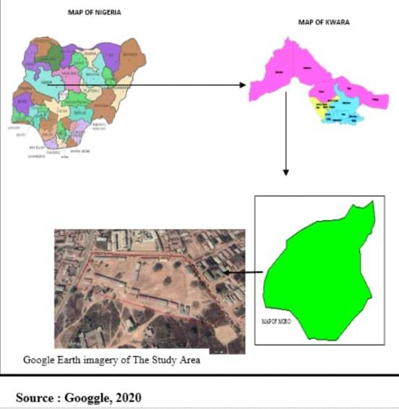
The project site is maigida housing estate along Taoheed Road road, Ilorin Kwara state. It lies approximately within latitude 08⁰ 29m 90s N and longitude 04⁰ 30m 44.69s E. it covers an area of 4.17 hectares.

CHAPTER TWO
2.0 Literature review
2.1 Topographic Survey
Topography is generally known as the study of earth surface, and its features and shape. It also gives the description of the features (such as surface, shapes, vegetation cover & elevations), depicted in maps (Ojiako & Jimoh , 2017). These characteristics are natural and artificial (or man made). Man-made features are highways, bridges, dams, wharfs, buildings, and so forth. A topographic survey is a survey conducted to obtain the data needed for the preparation of a topographic map. This data consists of the horizontal and vertical locations of the features to be shown on the map. Topographic Surveys are surveys made to determine the configuration of the earth’s surface and to locate natural and cultural features on it. Topographic surveys establish the different manmade and the natural features of land. This type of survey can be very beneficial to home owners, industrial owners, or even for properties under construction. Land may include hills, trees, fences, buildings, ravines. A topographical survey will provide exact figures of the size, height and position of different changes that have occurred over the course of time with regard to their presence or that of any manmade structures. A graphic representation of the topography of this area is called a topographic map. A topographic map is simply a drawing that shows the natural and artificial features of an area. Topographic maps with larger scales as well as digital map products are necessary for better planning (Charles & Paul, 2012). This report comprises the few of the activities involved in topographic map compilation such as field data acquisition, processing of field data, analyses of data and presentation of results and elevation models of acquired topographic field data using AutoCAD Civil 3D, Surfer 10 and ArcGIS 10.2.

2.2 Topographic Information and Geographic Information Systems (GIS)
Topographic detailing and Geographic Information Systems (GIS) are a sine-qua-non for the successful creation of any Topographic Information System. A TIS would be best described as an incorporation of human efforts, Information and Communication Technology ICT using computerized tools and relevant software for the collection, storage, analysis, manipulation and retrieval of various kinds of earth related data (natural and artificial). The demand for Geo Information about topographic features of the landscape has been increasing continuously. Its ranges of application are for the planning of power supply, transportation, construction among others. Topographic data are vital for many scientific, technical, and other applications. Even when not used directly in a study, topographic data are often used in preparing visualization tools such as perspective or stereoscopic views of terrain (NOAA, 2017). Topographic information system can be derived from the topographic data with the employment of the analytical capabilities of GIS (Onuigbo, Zita, Gbedu, Pious, & Samaila, 2015). The modern digital techniques for the compilation of topographic maps greatly differ from the conventional processes. Today, the collection of topographical data by modern digital tools is carried with the view of building a complex topographic multi-purpose system. Thus, the focus of topographic surveying has shifted from production of analogue topographic maps printed on paper to the structuring, production, capture and maintenance of an organized and regulated database of digital spatial information (Igor, 2010). The acronym GIS sometimes used for Geographic Information Science is used to refer to the academic discipline that studies Geographic Information Systems and is a large domain within the broader academic discipline of Geoinformatics. Geographic Information System (GIS) evolved as a new technology in surveying. It combines geographic data (location) and attribute data about object feature on the earth‘s surface with cartographic representation in order to perform spatial decision making using spatial analysis (Odo, Idhoko, Oha, Okoro, & Okafor, 2015). GIS is becoming essential to understanding what is happening and what will happen in geographic space. Once we understand, we can prescribe action. This new approach to management— managing geographically—is transforming the way organizations operate. A GIS is a computer-based system that provides the following four sets of capabilities to handle georeferenced data (Otto & Rolf , 2009): i. Data capture and preparation ii. iii. Data management, including storage and maintenance. Data manipulation and analysis Data presentation. a geographic information system (GIS) lets us visualize, question, analyze, and interpret data to understand relationships, patterns, and trends. “GIS is an integrated system of computer hardware, software, and trained personnel linking topographic, demographic, utility, facility, image and other resource data that is geographically referenced.” National Aeronautics and Space Administration (NASA)”
A Topographic Information System (TIS) is a geospatial data management framework designed for the collection, storage, analysis, and dissemination of topographic data—information that describes the Earth's surface and its features. As a subset of Geographic Information Systems (GIS), TIS has become fundamental to applications in cartography, urban planning, environmental monitoring, and infrastructure development.
Evolution and Background
Early topographic mapping was manual and paper-based. With the advancement of GIS technologies in the 1980s and 1990s, national mapping agencies (e.g., USGS, Ordnance Survey, etc.) transitioned from analog to digital topographic data systems.
Goodchild (1992) emphasized the need for structured spatial data infrastructures to support national-scale topographic databases.
Rhind (1999) highlighted the evolution of data standards and the increasing need for interoperability across systems and agencies.
Components and Architecture
Modern TIS integrates:
Digital Elevation Models (DEMs)
Vector data (e.g., contour lines, roads, rivers)
Raster imagery (e.g., satellite/aerial photos)
Attribute databases
Cloud-based systems and WebGIS technologies now allow distributed access and real-time updates.
Applications
Urban and Regional Planning: TIS supports zoning, infrastructure planning, and disaster risk assessment (Batty, 2013). Environmental Management: Used for watershed modeling, erosion prediction, and land use monitoring (Burrough & McDonnell, 1998). Navigation and Defense: TIS provides high-resolution terrain data for military simulations and logistics (De Smith et al., 2020).
Data Sources and Integration
With the proliferation of satellite data (e.g., Landsat, Sentinel), TIS now integrates remote sensing with ground survey data for improved accuracy.
Crowdsourcing and VGI (Volunteered Geographic Information) such as OpenStreetMap enhance and update base topographic datasets. LiDAR and UAV-based Mapping: Offer high-resolution 3D terrain modeling.
Challenges
Data Quality and Standardization: Ensuring consistency across datasets is a major concern (Longley et al., 2015). Interoperability: Systems often face issues integrating heterogeneous data formats and sources. Cost and Access: High-resolution topographic data can be costly or restricted in some countries.
Future Directions
AI and Machine Learning are being applied for feature extraction and terrain classification from remote sensing imagery.
Real-Time Topographic Monitoring via IoT and sensor networks is an emerging field.
Open Data Initiatives are expected to democratize access to high-quality topographic information. Topographic Information Systems are central to modern spatial decision-making. With advancements in data collection, processing power, and AI integration, TIS continues to evolve, playing a key role in sustainable development and environmental resilience.

CHAPTER THREE

  - METHODOLOGY
This stage outlines the methods and procedures used throughout the project, including planning, data collection, data processing, database creation, development of a database management system, and presentation of information. These activities were systematically organized and executed in phases, particularly focusing on database design. The process typically involves a spatially referenced, structured digital database and suitable application software for geospatial analysis. Overall, this section details the techniques and principles applied during the execution of the project.
  - DATABASE DESIGN

The design of any database involves three stages namely ;
i Conceptual design
ii Logical design
iii Physical design

    - VIEW OF REALITY

In database design, it is essential to consider reality, which encompasses all existing phenomena—whether or not they are perceived by individuals. A "view of reality" refers to the mental abstraction or simplified representation of this reality, tailored for a specific application or set of applications. In the context of this project, the view of reality focuses on the topography of the project area. Since it is not feasible to fully replicate the real world, the approach involves conceptualizing and modelling key elements to represent it accurately. The specific features of interest in this project include the Green Reserve, roads, electric poles, trees, water facilities, buildings, a football pitch, and streams.

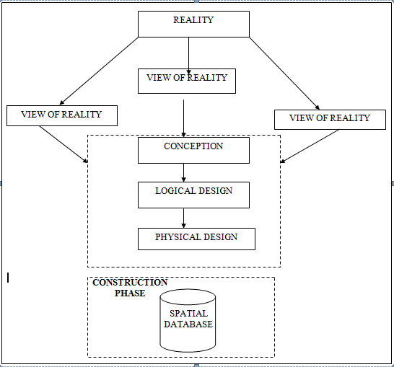

    - CONCEPTUAL DESIGN

Vector data model is the data type adopted for this project, which is represented, by points, lines and polygon. The identified entities are: -
      - Green Reserve (polygon)

      - Roads(line)

      - Electric poles(point)

      - Trees(point)

      - Buildings(polygon)

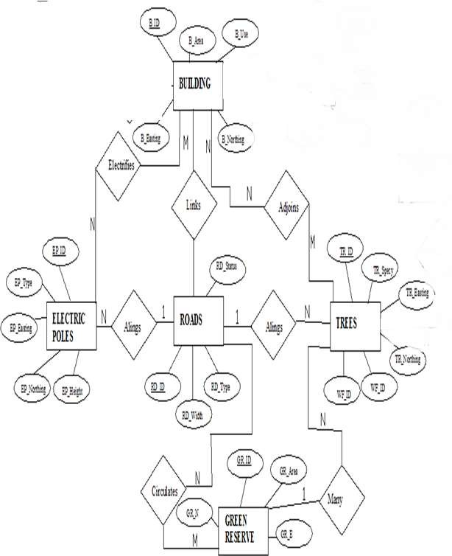
    - LOGICAL DESIGN

The design phase of the database involves developing a conceptual framework that defines the structure and organization of spatial data within the system. This includes identifying data elements, establishing their relationships, and setting rules for data manipulation and analysis. During this phase, entities, their attributes, and their relationships are represented in a consistent and uniform format—typically as relations—ensuring no loss of information and avoiding unnecessary data duplication. In this study, a logical database design approach is used to create a geo-relational database structure. Each entity is assigned a unique identifier, highlighted in bold. An attribute or a combination of attributes used to uniquely distinguish an entity type is referred to as an identifier.
- Building (B_ID,B_Area, B_Name,B_Easting,B_Northing)

- Roads(R_ID,R_Width,R_Type,R-Condition,R_Easting,R_Northing)

- Tree(TR_ID,TR_spp,TR_Importance,TR_Easting,TR_Northing)

- Electric Pole (EP_No,EP_Type,EP_Height,EP_Easting,EP_Northing

    - PHYSICAL DESIGN

Table3.1.4.1.: Building and its attribute

ENTITY |  | DESCRIPTION
B_ID |  | Building Identification
BLD_name |  | Building Name
B_Area |  | Building Area
BLD_COND |  | Building Condition
BLD_COL |  | Building Color
B_Easting | Building Easting
B_Northing | Building Northings

Table3.1.4.2:Road and its attributes

ENTITY | DESCRIPTION
R_ID | Road Identifier
R_Length | Road Length
R_Width | Road Width
R_Type | Road Type
R_Condition | Road Condition

Table3.1.4.3: Trees and its attributes

ENTITY | DESCRIPTION
TR_ID | Tree Identifier
TR_Spp | Tree specy
TR_E | Tree_ Easting
TR_N | Tree Northing

  - RECONNAISSANCE

This is the preparatory stage before the execution of this project; it involves collection of available information about the project area.
The necessary step taken for the successful execution of the project involves two stages, which are: -
- Office Planning

- Field reconnaissance

    - OFFICE PLANNING
This phase involves gathering detailed information about the study area, testing the tools and instruments required for project execution, and outlining the necessary resources. It includes listing the equipment needed, estimating the number of days for each task, defining the procedures for carrying out each activity, and assigning responsibilities to team members based on the supervisor’s guidance and instructions.
    - FIELD RECONNAISSANCE

The field reconnaissance is the first visitation to the project site to get intimated with the environment.
- Boundary points was selected

- The distribution of features was studied

- Controls to be used were located

- Method and type of instrument to be uses was determined

- Subsidiary point for Ground control Points were picked and define using nail and bottle cock
- A diagram of the study area was drawn.
  - EQUIPMENT USED/ SYSTEM SELECTION AND SOFTWARE
    - HARDWARE USED

- Total station

- 1 reflector with a tracking rod.

- 1 Tripod

- One (1) 50m tape

- One (1) umbrella

- 1 cutlass

- Hand held GPS

- Hammer

- Nails and bottle cover

- Field book and writing materials

- 1-NoofPersonalComputerHP655 and its accessories

- 1-NoofHP DeskJetK7100 A3 printer

- 1-NoofHPDeskJet 1110 A4printer

    - SOFTWARE COMPONENT

- Notepad.

- Microsoft Excel.

- AutoCAD 2007

- ArcMAP10.2

- Surfer25

- Microsoft Word.

  - INSTRUMENT TEST
To ensure data quality, the Total Station used for this project was tested for both vertical index and horizontal collimation errors. It was also to ascertain the efficiency and reliability of the instrument. The procedure used is described below.
    - HORIZONTAL COLLIMATION TEST
This test was performed to verify that the line of sight was perpendicular to the trunnion axis. The Total Station was set up over a known point, with initial adjustments made for proper alignment, leveling, and focusing to eliminate parallax. A vertical target was placed 100 meters away from the instrument. To begin the test, the configuration menu was accessed by holding the menu key for about two seconds. From the main menu, the calibration sub-menu was selected, followed by the horizontal collimation test. The target was then observed and bisected, and horizontal readings were taken for both Face Left and Face Right positions. The recorded results are presented in Table 3.4.1 below.

Total Station

REFLECTOR( TARGET)
100m

STATIONA
Fairly Level Ground
STATIONB

Fig 3.4.1.1; Horizontal Collimation and Vertical Index error test.
Table3.4.1.1: Horizontal Collimation Data

Station | Target | Face | Hz Reading | Difference | Error
A | B | L | 38˚42‟32”
 |  | R | 218˚42‟35” | 180˚00‟03” | 03”

    - VERTICAL INDEX ERROR TEST

This test was conducted to verify the accuracy of the vertical reading when the line of sight is horizontal. The desired measurement for this test is exactly ninety degrees (90˚), any deviation
from this value is referred to as the vertical index error.

The Total Station was positioned over a specific point, and necessary temporary adjustments were made to ensure proper alignment and functionality. A target was placed approximately100 meters away from the Total Station, and the instrument was aimed at the target. The target was bisected by aligning the instrument on the face left, and the corresponding reading was recorded. Similarly, the target was then bisected on the face right, and the respective reading was also recorded. The recorded readings are provided below:

Table3.4.2.1: Vertical Index Data

Instrument Station | Target Station | Face | Vertical | Sum | Error
A | B | L | 90˚00‟00”
 |  | R | 270˚00‟02” | 360˚00‟02” | 02”

    - ANALYSIS OF COLLIMATION AND VERTICAL INDEX DATA

The reading obtain during calibration were reduced to obtain new collimation and vertical errors.
Horizontal collimation={(FR–FL)–180}/2={(00˚00‟03”}/2=1.5”

Vertical collimation={(FL+FR)–360}=(90˚00‟00”+270˚00‟02”)-360}=02”Theresult shows that the instrument is still in good working condition.

  - CONTROL CHECK

Three control beacons (PBIL3304, PBIL3306 and NILL) were used. In order to ascertain the in-situ of the control beacons, a check was carried out on them by observing the angle between them and comparing the result obtained with the computed angles from the giving coordinates.
The total station instrument was set on the control beacon PBIL3306. After performing all the necessary temporary adjustment, the reflector was placed on the control beacon PBIL3304 which served as the back station. The horizontal angular reading was taken and recorded while the instrument was on face left. The reflector was then taken to the NILL which serves as the forward station, the horizontal angle reading was then taken and recorded on both face left and face right. The reflector was taken back to the back station, the horizontal angle was then recorded on face right.

Table3.5.1: Table showing the back computation of the control coordinates

From STN | Bearing | Dist(m) | ∆N | ∆E | Northing(m) | Easting(m) | To STN
 |  |  |  |  | 940288.197 | 678281.701 | PBIL3306
PBIL3306 | 245°11'  30’’ | 30.242 | -12.689 | -27.451 | 940275.508 | 678254.250 | PBIL3304
PBIL3304 | 188°19'  41” | 264.560 | -261.774 | -38.320 | 940013.734 | 678215.930 | NILL

Table3..2: Table showing the distance observation result of the control check

FROM | OBSERVED DISTANCE  (m) | COMPUTED DISTANCE  (m) | TO
PBIL3306 | 30.240 | 30.242 | PBIL3304
PBIL3304 | 264.559 | 11.562 | NILL

Table3..3: Table showing the observation result of the control check

STN | SIGHT | FACE | OBSERVEDHZANGLE | REDUCED HZANGLE | MEAN
 | PBIL3306 | L1 | 350°22'43''
PBIL3304 | PBIL3306 | L2 | 105° 11'24'' | 245° 11'19''
 | PBIL3306 | R2 | 285° 14'13'' | 245° 11'26''
 | PBIL3306 | R1 | 170° 25'39'' |  | 245° 11'23''

Difference in angle (observed -computed)=245°11'23''-245°11'19''

=00° 00'04''

Since the allowable accuracy (angular) of third order traverse of one station is 00° 00' 30'' and the result obtained from the control check (00°00'04'') is less than allow able error. Therefore, the controls were angularly intact.

  - MONUMENTATION
The boundary of the designated area was marked using precast concrete beacons, following the clearing of necessary lines of sight. Points where the boundary changed direction were identified, excavated, and beacons were installed, leaving approximately 15 cm of each beacon exposed above ground level. The beacons were placed at intervals determined by the terrain and the nature of the boundary.
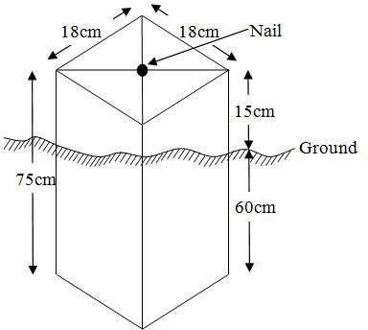

Fig.3.6.1: Pillar Description
  - DATA ACQUISITION

PRIMARY DATA SOURCE

Field observation was the primary source of data for this project. Ground based method was used in acquiring data with the use of Total Station Instrument, which involved the collection of X, Y, Z data through coordinated Ground control Points (GCP) established at conspicuous points within the study area.

SECONDARY DATA SOURCE

An imagery of the area was acquired through Updated Google earth; this was used to ascertain the extent of coverage of the project area.
    - GEOMETRIC DATA ACQUISITION

The Total Station was carefully set up over control pointPBIL3304, with a back sight taken to point PBIL3306 after performing the necessary station adjustments, including cantering, levelling, and focusing. The same procedure was repeated to determine the coordinates of the next point (NL1), and continued progressively until the site was reached. The radiation method was used for data acquisition, where two or more points were coordinated from a single instrument station.
The Following Steps Outline The Procedure:
i. After completing temporary adjustments, the instrument was powered on, and a new job titled GRP2B was created in the internal memory under the job menu.
ii. The coordinates of two control points were input into the instrument's memory, along with predefined feature codes such as "RD" for roads, "SP" for spot heights, and "BD" for buildings.
iii. The height of the instrument and the reflector height were measured and entered into the instrument's memory.
iv. In the coordinate menu, orientation was established by inputting the coordinates of the instrument station and back sight. The reflector at the back sight was accurately bisected before confirming the orientation.
v. Once oriented, the reflector was aimed at the next target (nail), and the "OBS" (observe) function was selected. The three-dimensional coordinates (Easting, Northing, and Height) were displayed and saved by pressing "REC" (record). For subsequent observations, the "ALL" option was used to streamline the process.
vi. It was ensured that the centre of the prism on the reflector was properly aligned and securely mounted on the tripod to minimize height determination errors.
vii. Once all visible details, including spot heights and boundary points, had been observed from the current station, the instrument was relocated to the next control nail, and the temporary adjustments were repeated.
This process was systematically carried out until all boundary points and elevation data were captured. In this project, spot heights were not recorded at regular grid intervals but were instead collected randomly. For each building, three corner points were surveyed. Upon completing the data acquisition phase, all relevant features were accurately recorded and positioned accordingly on the final site plan.
    - ATTRIBUTES DATA ACQUISITION
Attribute data refers to information that describes the characteristics and properties of spatial features. It provides details such as names, classifications, and functions of geographic objects. In this study, the attribute data collected included the names and uses of buildings (e.g., classrooms), as well as information on roads, water facilities, and significant natural features such as rivers, trees, and surrounding vegetation. These attributes were accurately identified and documented within and around the study area.

  - DATA DOWNLOADING AND PROCESSING

    - DATA DOWNLOADING AND EDITING
This stage involves transferring all acquired data, which were automatically stored in the Total Station, to a personal computer. The data download was carried out using a connecting cable and supported by compatible software installed on the computer to facilitate the transfer and management of the data.
    - DATA PROCESSING AND DATA EDITING
The downloaded geometric data were further processed to convert them into usable formats and improve their accuracy. The resulting coordinate data were edited and exported in multiple formats, including .txt, .xls, and .pdf. These files were then imported into ArcGIS 10.3 for additional processing and to perform spatial analysis.
    - DATA PROCESSING USING AUTOCAD 2007
Before using AutoCAD, we processed the coordinate data observed in the field by first transferring it into Notepad, then copying it into AutoCAD. The following steps outline the process for handling the data in AutoCAD:
- Launch AutoCAD on the computer.
- Click "New" from the application menu to start a new drawing.
- Type UNITS in the command line and press Enter.
- Select the desired unit type (e.g., decimal, architectural, engineering).
- In the menu bar, select the "Polyline" tool.
- Copy the data from Notepad and paste it into AutoCAD.
- Type Z (for zoom) and press Enter, then type E (for extents) and press Enter to adjust the view.

    - DATA PROCESSING USING ARC GIS10.3
Arc GIS, AutoCAD was used to plot feature data, saving them separately in different files such as roads, boundary lines, buildings, and trees.
To load and process this data in Arc GIS 10.3, follow these steps:
- Launch Arc Map in Arc GIS 10.3.
- When the dialog box appears, click on "A NEW EMPTY MAP" to start a new project.
- Click on "Tools" in the menu bar, and then select "Extensions." Mark all extensions and click "Close."
- On the left-hand side (LHS), right-click on "Layers" and select "Properties."
- In the "Layer Properties" window, click on the "Coordinate System" tab to set the projection system to "Minna Datum Zone 31N." Then, go to the "General" tab to set the units and click "Apply," followed by "OK."
- On the toolbar, click "Add Data," select all the saved AutoCAD files, and load them into the "Table of Contents" layer section.
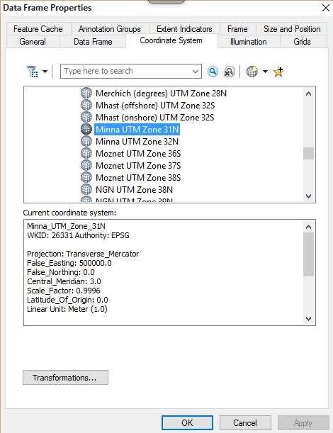
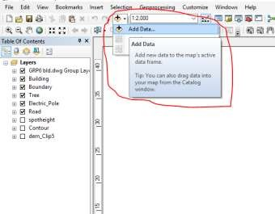

All drawings were exported to a shape file. Once the feature class was created, click on the "Editor" button to start editing, then select "Start Editing" to load the object.

Creating Contours:
- First, create a Digital Elevation Model (DEM) by searching for "INTERPOLATION > NATURAL NEIGHBOR" in the search icon. Select the XYZ data to create the DEM, using the boundary line as the extent.
- To create contours, enable the Spatial Analyst Toolbar by going to Customize > Toolbars > Spatial Analyst, or you can open the search bar by clicking on Windows > Search or using the search icon.

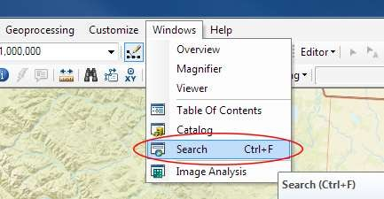

In the search bar type Contour, and select Contour (Spatial Analyst) from the search result slist.
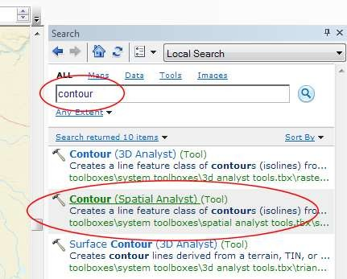

After selecting Contour, a dialog window will appear, prompting you to set the following five parameters:
- Input Raster: Select the DEM file from which you want to generate contours. You can either locate it on your hard drive or choose it from the dropdown menu that shows layers present in the Table of Contents.
- Output Polyline Features: Specify the location where you want to save your output contours.
- Contour Interval: Set the distance between contour lines in meters. A smaller interval results in more contour lines. For example, setting a contour interval of 10 meters will create more frequent contour lines compared to a 50-meter interval.
- Base Contour (Optional): Define the starting point from which the contours will be generated. The default is 0, so with a 25-meter interval, the contours will be generated at 25, 50, 75, 100, and so on. If the base contour is set to 40, the contours will be generated at 65, 90, 115, 140, etc.
- Z Factor (Optional): Adjusts the vertical scale of the data. For example, if your data is in meters and you want to display contours in feet, use a Z-factor of 3.28 (since 1 meter = 3.28 feet).

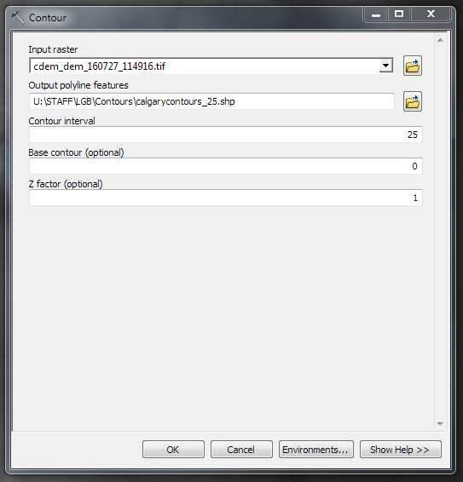

The generated contours will automatically be added to the map.
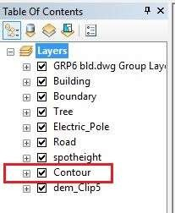
- Input Data: Load the AutoCAD drawing and select the feature type you want to import.
- Click "Add": Click "Next" to proceed, then choose the Target Layer where the feature will be loaded.
- Load Data: Import the data from the feature class that was created in ArcGIS.
- Query the Feature: Click "Next" and select "Only the features that satisfy the query." Then, click on Query Builder to create a query for the feature you want to load, for example: "layer" = 'Boundary'.
- Finish Setup: Click "Next" and then "Finish" to complete the process.
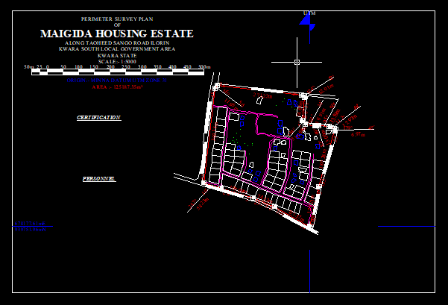
- View the Feature: Right-click on the Boundary layer in the Table of Contents and click Zoom to Layer to display the feature on the map.

Editing, Converting, and Merging Geodatabase
- Removing Features:
  - To remove unnecessary features, right-click on the feature and select Remove.
- Converting Features:
  - If features are not correctly classified (e.g., points, lines, polygons), they need to be converted to the appropriate feature type.
- Converting a Geodatabase Feature Class:
  - For Converting Line Feature Class to Polygon Feature Class:
    - Go to Window on the menu bar and select Arc Toolbox.
    - In Arc Toolbox, select Data Management Tools, then Features, and click on Feature to Polygon.
    - In the Input Features section, select the feature you want to convert. In the Output Feature Class, specify the location (e.g., save in the GRP6C folder), and click OK.
    - After the conversion, remove the feature class from both the Layer Menu and ArcCatalog.
- Merging Feature Classes:
  - To merge multiple feature classes:
    - In Input Datasets, select the features you wish to merge.
    - In Output Datasets, specify where to save the merged file (e.g., in the GRP6C folder), and click OK.
    - After the merge is complete, remove the merged feature class from both the Layer Menu and ArcCatalog.

Table Creation
- Creating Attribute Tables:
  - Attribute tables are essential for performing queries. Ensure that Editing is stopped before adding fields to the table.
- Steps to Add Fields:
  - Right-click on the feature class and select Open Attribute Table.
  - Click on Options and select Add Field.
  - In the Field Name section, give the field a name.
  - In the Type dropdown, select the appropriate type:
    - Short Integer or Long Integer for whole number variables.
    - Double for decimal variables.
    - Text for text variables.
    - Date for date variables.
  - For Text fields, set the Length (e.g., text width), and for Decimal fields, set the Scale (decimal places). Click OK.
- Inputting Data into the Attribute Table:
  - To input data, go to the Editor menu on the menu bar and select Start Editing.
  - Click on Attributes on the menu bar (behind the Target).
  - Select the features in the Data View Display and input the required variables, which may come from social surveys or field data.
  - Once the data is entered, click Save Edits in the Editor menu.
  - To switch between layers, select Stop Editing from the Editor menu.
  - Repeat the steps above to create additional fields and populate the table, then save the edits.

Table3.8.3.1: Building

ENTITY | FIELD ALIAS | DATA TYPE | FIELD SIZE
B_ID | Building Identification | Numeric | -
B_name | Building Name | Text | 14
B_Area | Building Area | Numeric | -
B_E | Building Easting | Numeric | -
B_Northing | Building Northings | Numeric | -

Table3.8.3.2:Road

ENTITY | FIELDALIAS | DATATYPE | FIELDSIZE
R_ID | Road Identifier | Numeric | -
R_Length | Road Length | Numeric | -

R_Width | Road Width | Numeric | -
R_Type | Road Type | Text | 14
R_Condition | Road Condition | Text | 14

Table3.8.3.3:Trees

ENTITY | FIELD ALIAS | DATA TYPE | FIELD SIZE
TR_ID | Tree Identifier | Numeric | -
TR_Spp | Treespecy | Text | 14
TR_E | Tree_ Easting | Numeric | -
TR_N | Tree Northing | Numeric | -

Table3.8.3.4:ElectricPoles

ENTITY | FIELD ALIAS | DATA TYPE | FIELD SIZE
EP_ID | Electric pole Identifier | Numeric | -
EP_Type | Electric pole Type | Text | 14
EP_Height | Electric pole Height | Numeric | -
EP_E | Electric pole Easting | Numeric | -
EP_N | Electric pole Northing | Numeric | -

ADDING SPOT HEIGHTS DATA

- NOTE: STOP EDITING on the EDITOR MENU before adding data field,

- Go to FIELD ON THE MENU BAR, scroll to add Data and then ADDXYZ DATA

- Browse the EXCEL FILE for SPOT HEIGHTS, select EASTING VALUE on X-FIELD and NORTHING VALUE on Y-IELD and ELEVATION

- « Select DATA the EXPORT DATA, locate the folder created and give it name then YES AND OK, remove the previous layer by right clicking on it and select REMOVE.

TIN, ASPECT AND SLOPE CREATION USING ARC MAP

NOTE: Making sure the 3D Analyst Extension is active, select VIEW on MENU bar, then click TOOLBARS and MARK the 3D Analyst EXTENTION Then X, Y Data

TO CREATE TIN

- Click on 3D Analyst arrow, select create TIN and then create TIN from FEATURE.

- On layers mark the SPOT HEIGHT LAYER, select height data on HEIGHT, then ok.
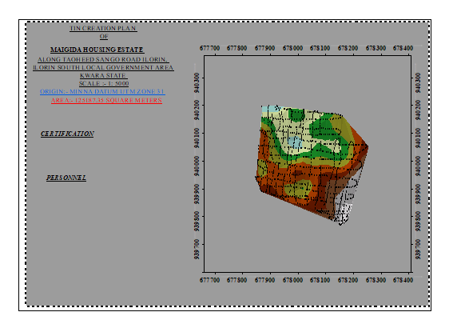

TO CHANGE THE FACE OF THE TIN ACCODING TO ITS ELEVATION

- RIGHT CLICK on the TIN, select PROPERTIES, and click on SYMBOLOGY.

- Then ADD, select FACE ELEVATION WITH COLOR RAMP, click ADD, and then select APPLY and OK.

TO CREATE ASPECT

- Click on 3D analyst arrow, select SPATIAL ANALYST TOOLS, SURFACE and THEN DOUBLE CLICK on ASPECT.
- Browse to where the raster format of all the acquired data created from the surfer was saved to.
- Browse to where you want the OUT PUT RASTER to be saved

- You can change the OUTPUT MEASUREMENT to Degree OR percent

- Click OK [then it displays on the data view screen], then Close.
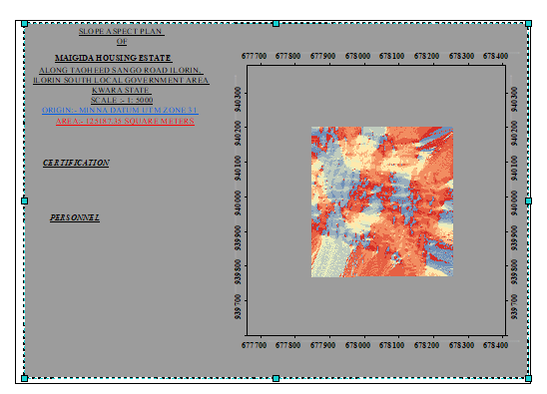

  - DATA BASE IMPLEMENTATION
This phase involves the creation of the database. After completing the three stages of the design process—Reality, Conceptual, and Logical design—the database was established using ArcGIS 10.3 software. This process combines and stores both the acquired graphical data and attribute data, facilitating spatial analysis and queries.
A database is an organized, integrated collection of data stored in a way that allows it to be accessed by relevant applications. The data is structured so it can be retrieved by different logical components. After populating the attribute table through manual input, certain attributes, such as the areas of settlements, were automatically displayed using specific commands in ArcGIS 10.3. The software was then used to link the graphical data with the attribute table, enabling query generation.

    - DATA BASE MANAGEMENT SYSTEMS
Database management refers to a collection of software used for creating, storing, and manipulating, updating, organizing, and querying information within a database (Kufoniyi, 1998). It is a software system designed to manage and manipulate a database on behalf of the user.
A good Database Management System (DBMS) should provide the following essential functions:
a. Storage and Retrieval of Data: Efficient storage and retrieval of data within the database.
b. Concurrent Access: The ability to allow multiple users to access the database simultaneously without compromising data integrity.
c. Standardized Interface: A standardized interface between the database and application programs, enabling seamless integration and communication.
d. Separation of Data Functions: Standardized access to data, with a clear separation of the data storage and retrieval functions from the applications using the data.
e. Data Security and Integrity: Ensuring the security and integrity of the data, protecting it from unauthorized access, corruption, and loss.

3.9.2 Database Maintenance
Once the database is created, it is essential to perform proper maintenance to ensure it meets its intended objectives. Regular maintenance allows for the inclusion of new data and the removal of irrelevant or outdated data. Since physical changes can occur in the landscape over time, it is crucial that the database is updated frequently to reflect these changes.
Both data security and integrity are integral aspects of maintenance, ensuring that the database remains reliable and functional. Proper database management, including regular updates and consistent monitoring, helps to maintain its currency and quality, which is essential for effective use in a Spatial Decision Support System (SDSS). The quality of a database is determined by its timeliness and its fitness for use as part of a decision support system (DSS).
The storage media used for the database must be periodically assessed to prevent potential issues such as data inaccessibility or the physical deterioration of the media. Additionally, careful attention should be paid during data entry, as the integrity of the database is only as good as the quality of the data provided. For archiving purposes, stable and durable storage media should be employed, such as:
- Computer-compatible tape readers
- Magnetic tape
- Optical discs and compact discs

CHAPTERFOUR

  - SPATIALANALYSESANDPRESENTATION

GIS stands out from other information systems due to its spatial analytical capabilities, which include overlay operations, buffering, spatial search, topographic analysis, and neighbourhood and connectivity operations. These features allow GIS to address key generic questions related to location, condition, trends, routing, patterns, and modelling by manipulating and analysing input data. In this project, the primary analyses performed were overlay operations, topographic operations, and spatial search.

  - TESTINGOF DATABASE

This test was conducted to determine whether a relationship exists between the data modeled about entities in the spatial database and to assess its retrieval capabilities. The test involved designing a sample query with specific conditions, which was then executed to verify if the desired results were achieved.

Analysisof Result
The contour with a value greater than or equal to 350 meters indicates areas that are less likely to be prone to flooding within the project area, as shown in Fig. 4.5 (Query 1). This contour represents the elevation of points above 350 meters. The displayed attribute table confirms that the north-eastern part of the institute has the highest elevation. Elevation is a critical factor when assessing the surface or slope of the terrain. Conversely, the southwestern part of the school has the lowest elevation and is highly susceptible to erosion. Buildings constructed in this region must have elevated foundations to protect them from potential damage. The results of this query will help the school management make informed decisions about the terrain characteristics and guide them in choosing the appropriate type of construction for each area of the project site, considering the unique terrain conditions.

SINGLESELECTIONCRITERION

Query1: Shows theretrievingAreawhoseheightisGreaterthan310meters

SELECT* FROM Contour WHERE "CONTOUR">310

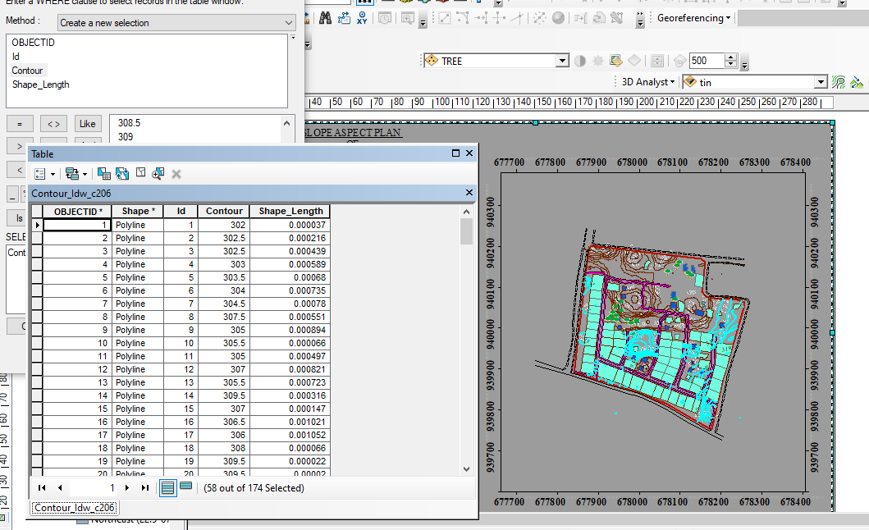

Fig4.1.1:Shows the retrievingAreawhoseheightisgreaterthan310meters

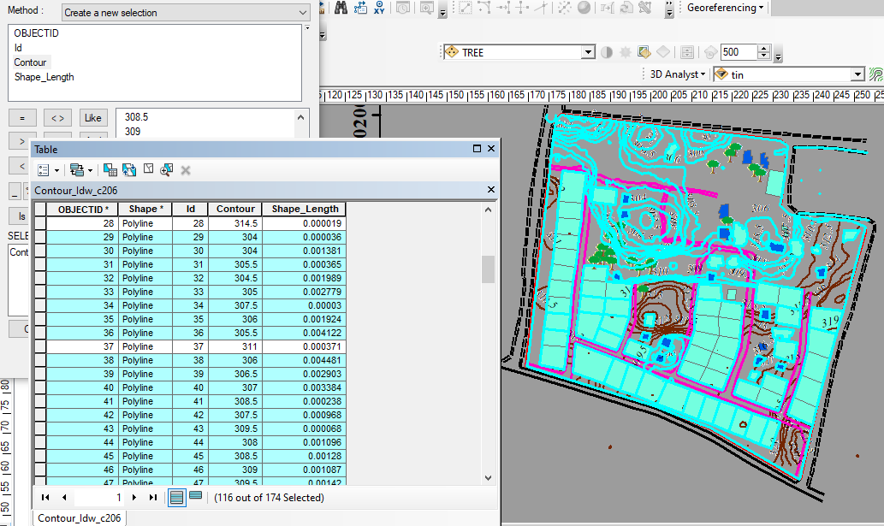

Fig4.1.2: Shows the resultof area whose heightisgreaterthan310 meters

Fig4.1.3:Show the resultof areawhoseheightisgreaterthan310 meters

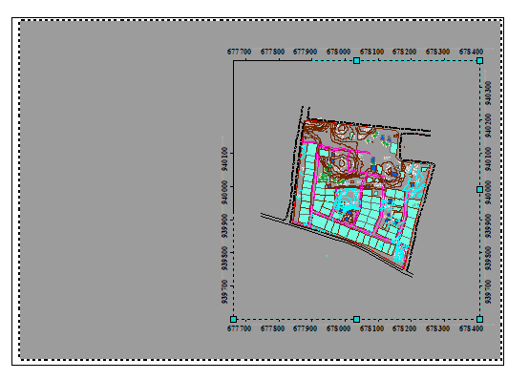

Fig4.1.4Query Shows the resultofBuildingsthat painted in white collorfor(BLD_COLOUR = 'WHITE')

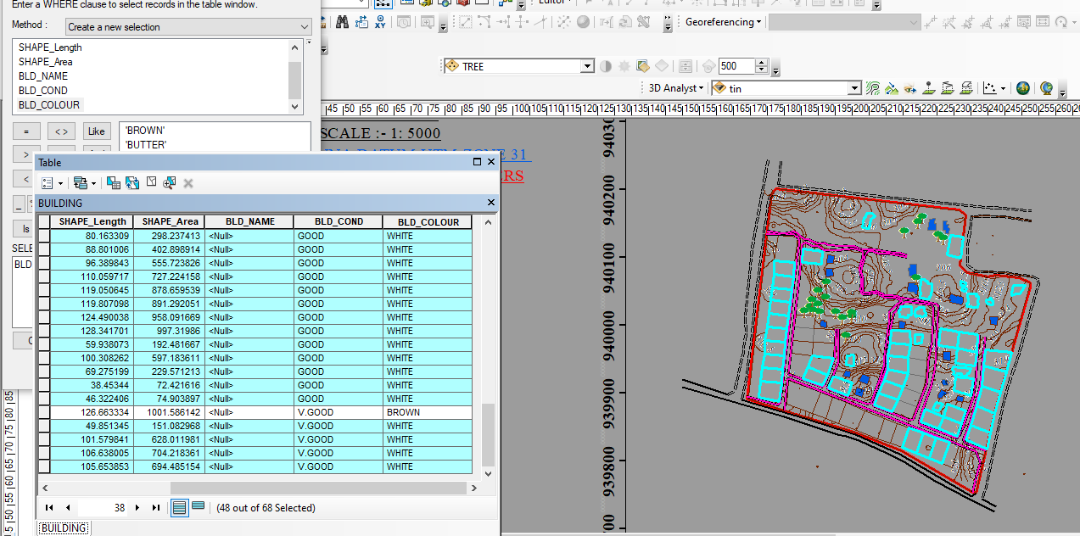

Fig4.1.5QueryShows the resultofBuildingsthat painted in brown color (B_NAME = 'BROWN')

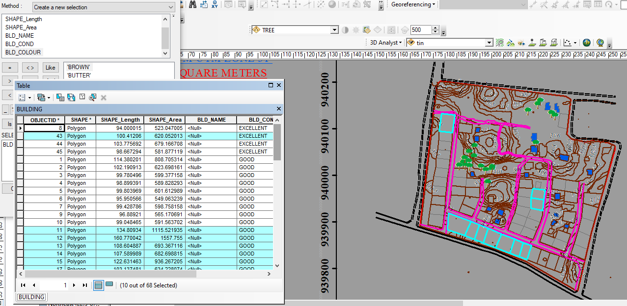

Fig4.1.6QueryShows the result of Buildings that painted in butter color (B_NAME = 'BUTTER')

CHAPTER FIVE
5.0 COSTING, SUMMARY, PROBLEMS ENCOUNTERED, RECOMMENDATION AND CONCLUSION
5.1 COSTING
The costing of this project was done using the Nigeria Institution of Surveyor's (NIS) professional scale of fees for consultant in the construction industry. This stage shows the total cost that was spent on the project from day one to the final stage.
5.1.1 RECCI
PERSONAL/QUALITY | DAY(S) | UNITRATE(N) | TOTAL AMOUNT(N)
Principal surveyor | 1 | 18,000.00 | 18,000.00
Senior Surveyor | 1 | 15,000.00 | 15,000.00
Assistant Surveyor | 1 | 8,000.00 | 8,000.00
Transportation | 1 | 7,000.00 | 7,000.00
Basic Equipment | 2 | 10,000.00 | 20,000.00
TOTAL |  |  | #68,000.00

5.1.2 BEACON= 5,000 × 4
= #20,000
5.1.3 BEACONING
PERSONAL/QUALITY | DAY(S) | UNITRATE(N) | TOTALAMOUNT(N)
1Assistant Surveyor | 2 | 8,000.00 | 16,000.00
Unskilled Labor | 2 | 5,000 | 10,000
Basic Equipment(6) | 1 | 10,000.00 | 10,000.00
Transportation | 1 | 7,000.00 | 7,000.00
TOTAL |  |  | #43,000.00

5.1.4 TRAVERSING
PERSONAL/QUALITY | DAY(S) | UNITRATE(N) | TOTALAMOUNT(N)
Senior Surveyor | 2 | 15,000.00 | 30,000.00
Assistant Surveyor | 2 | 8,000.00 | 16,000.00
Basic Equipment | 2 | 10,000.00 | 20,000.00
Transportation | 2 | 7,000.00 | 7,000.00
TOTAL |  |  | #73,000.00
5.1.5 TOPOGRAPHY
PERSONAL/QUALITY | DAY(S) | UNITRATE(N) | TOTALAMOUNT(N)
Senior Surveyor | 2 | 15,000.00 | 30,000.00
Assistant Surveyor | 2 | 8,000.00 | 16,000.00
Basic Equipment | 2 | 10,000.00 | 20,000.00
Transportation | 2 | 7,000.00 | 14,000.00
TOTAL |  |  | #80,000.00

5.1.6 DOWNLOADING DATA AND PLOTTING
PERSONAL/QUALITY | DAY(S) | UNITRATE(N) | TOTALAMOUNT(N)
Pricipal surveyor | 1 | 18,000.00 | 18,000.00
Senior Surveyor | 2 | 15,000.00 | 30,000.00
AssistantSurveyor | 2 | 8,000.00 | 16,000.00
Transportation | 2 | 7,000.00 | 14,000.00
Computers accessaries | 2 | 15,000.00 | 30,000.00
M I S | 2 | 15,000 | 30,000
TOTAL |  |  | #138,000.00

5.1.7 INFORMATION PRESENTATION
PERSONAL/QUALITY | DAY(S) | UNITRATE(N) | TOTALAMOUNT(N)
Principal surveyor | 1 | 18.000 | 18,000.00
Basic Equipment | 1 | 10,000.00 | 10,000.00
Logistics | 1 | 10,000 | 10,000
Transportation | 1 | 7,000.00 | 7,000.00
TOTAL |  |  | #45,000.00

(1) # 68,000.00
(2) # 20,000.00
(3) # 43,000.00
(4) # 73,000.00
(5)#80,000.00
(6) # 138,000.00
(7) # 45,000.00
TOTAL # 467,000.00
5.1.8 CONSTIGENCIES=5%
467,000.00×5%÷ 100
=#23,350
5.1.9 V. A. T = 7.5%
467,000.00×7.5%÷100
= #35,025
5.1.10 MOBILIZATION AND DEMOBILIZATION =10%
467000 × 10%. ÷ 100
= #46,700
5.1.11 ACCOMODATION = 1.5%
467,000.00 ×1.5%÷100
= 7,005
TOTAL = 467,000.00
23,350
35,025
46,700
7,005
GRAND TOTAL = 579,080
5.2 SUMMARY
A Topography Information System (TIS) is a specialized geographic information system (GIS) designed to collect, store, analyze, and visualize terrain-related data. It integrates topographic maps, elevation models, satellite imagery, and geospatial datasets to support planning, infrastructure development, environmental monitoring, and disaster management. TIS helps stakeholders—such as surveyors, urban planners, engineers, and geologists—make informed decisions based on terrain features like elevation, slope, aspect, and contour.
5.3 PROBLEM ENCOUNTERED
Despite its usefulness, several challenges are commonly faced in implementing and using a Topography Information System:
Data Quality and Accuracy: Inconsistent or outdated elevation and terrain data can lead to errors in analysis and decision-making.
Integration Issues: Difficulty in integrating data from different sources or formats (e.g., LiDAR, satellite, GPS) can limit the system’s effectiveness.
High Costs: Acquisition of high-resolution topographic data and advanced software tools often requires significant investment.
Technical Expertise: A lack of trained personnel to operate and maintain the system can hinder full utilization.
System Scalability: Some systems struggle to handle large volumes of data or provide real-time updates, especially in dynamic environments.
Accessibility: In many regions, especially developing areas, there is limited access to reliable topographic information systems.
5.4 RECOMMENDATIONS
Data Updating and Validation: Regularly update the system with current, high-resolution data using reliable sources like drones, LiDAR, or remote sensing satellites.
Adopt Open Standards: Use interoperable formats and open-source GIS platforms to improve data sharing and integration.
Invest in Training: Provide continuous training for staff on GIS tools, data analysis, and system management.
Cloud-Based Solutions: Transition to cloud infrastructure for better data storage, scalability, and remote accessibility.
Partnerships and Collaboration: Collaborate with government agencies, academic institutions, and private sector for data sharing and technological support.
User-Friendly Interfaces: Design intuitive user interfaces to improve accessibility for non-specialists.
5.5 CONCLUSION
A Topography Information System is a vital tool for terrain analysis and decision-making in numerous fields. While it offers substantial benefits, its effectiveness depends on the quality of data, system usability, and technical capacity of its users. Addressing the identified challenges through targeted investments, partnerships, and technology upgrades will enhance the system’s performance and ensure that stakeholders can leverage accurate terrain data for sustainable development and risk management.

REFERENCES
Agor, R. (1992): Surveying theory and leveling (6th Ed) Similar printer, new Delhi. Pp 3.
Adeoye (1998) development of land information system in Nigeria
Ramsey J.P.W (1976): Land Surveying, (3rd Ed), Mac Donald and Evans Pp. 12,178 and 259.
Bannister, A and Raymond S (1977) Surveying 7th edition, Singapore potman publishing
Haggin, A.L (1970): Elementary Surveying, 3rd edition, Addison Wesley Longman Limited
Marrienwebster’s eleventh edition colligation dictionary
Christopher .jwillis (1977) element of quantity surveying
Wikipedia 2015
www.state.nj.us 2007 (surveying measurements)
surveying2012.blogsport.in

APPENDIX
PT296 | 678034.610 | 940067.109 | 288.552
PT297 | 678051.525 | 940067.109 | 185.681
PT298 | 678068.440 | 940067.109 | 297.702
PT299 | 678085.355 | 940067.109 | 339.568
PT300 | 678102.270 | 940067.109 | 95.652
PT301 | 678119.185 | 940067.109 | 85.153
PT302 | 678136.100 | 940067.109 | 192.204
PT303 | 678153.015 | 940067.109 | 208.123
PT304 | 678169.931 | 940067.109 | 278.798
PT305 | 678186.846 | 940067.109 | 243.119
PT306 | 678203.761 | 940067.109 | 296.789
PT307 | 678220.676 | 940067.109 | 281.625
PT308 | 678237.591 | 940067.109 | 282.376
PT309 | 677865.459 | 940085.154 | 131.641
PT310 | 677882.374 | 940085.154 | 181.302
PT311 | 677899.290 | 940085.154 | 102.162
PT312 | 677916.205 | 940085.154 | 68.618
PT313 | 677933.120 | 940085.154 | 74.314
PT314 | 677950.035 | 940085.154 | 99.768
PT315 | 677966.950 | 940085.154 | 157.085
PT316 | 677983.865 | 940085.154 | 164.301
PT317 | 678000.780 | 940085.154 | 212.636
PT318 | 678017.695 | 940085.154 | 212.145
PT319 | 678034.610 | 940085.154 | 261.402
PT320 | 678051.525 | 940085.154 | 185.167
PT321 | 678068.440 | 940085.154 | 209.625
PT322 | 678085.355 | 940085.154 | 178.661
PT323 | 678102.270 | 940085.154 | 207.028
PT324 | 678119.185 | 940085.154 | 213.521
PT325 | 678136.100 | 940085.154 | 174.566
PT326 | 678153.015 | 940085.154 | 195.951
PT327 | 677865.459 | 940103.199 | 190.069
PT328 | 677882.374 | 940103.199 | 67.865
PT329 | 677899.290 | 940103.199 | 90.745
PT330 | 677916.205 | 940103.199 | 55.045
PT331 | 677933.120 | 940103.199 | 51.381
PT332 | 677950.035 | 940103.199 | 180.395
PT333 | 677966.950 | 940103.199 | 147.717
PT334 | 677983.865 | 940103.199 | 135.039
PT335 | 678000.780 | 940103.199 | 171.308
PT336 | 678017.695 | 940103.199 | 212.308
PT337 | 678034.610 | 940103.199 | 258.797
PT338 | 678051.525 | 940103.199 | 241.847
PT339 | 678068.440 | 940103.199 | 183.679
PT340 | 678085.355 | 940103.199 | 177.607
PT341 | 678102.270 | 940103.199 | 198.430
PT342 | 678119.185 | 940103.199 | 211.586
PT343 | 678136.100 | 940103.199 | 215.438
PT344 | 678153.015 | 940103.199 | 206.246
PT345 | 677882.374 | 940121.244 | 47.971
PT346 | 677899.290 | 940121.244 | 54.162
PT347 | 677916.205 | 940121.244 | 95.419
PT348 | 677933.120 | 940121.244 | 91.436
PT349 | 677950.035 | 940121.244 | 278.431
PT350 | 677966.950 | 940121.244 | 264.827
PT351 | 677983.865 | 940121.244 | 179.812
PT352 | 678000.780 | 940121.244 | 222.810
PT353 | 678017.695 | 940121.244 | 207.351
PT354 | 678034.610 | 940121.244 | 284.207
PT355 | 678051.525 | 940121.244 | 292.422
PT356 | 678068.440 | 940121.244 | 276.493
PT357 | 678085.355 | 940121.244 | 181.216
PT358 | 678102.270 | 940121.244 | 230.653
PT359 | 678119.185 | 940121.244 | 249.254
PT360 | 678136.100 | 940121.244 | 271.772
PT361 | 678153.015 | 940121.244 | 320.173
PT362 | 677882.374 | 940139.289 | 333.123
PT363 | 677899.290 | 940139.289 | 55.251
PT364 | 677916.205 | 940139.289 | 48.110
PT365 | 677933.120 | 940139.289 | 109.353
PT366 | 677950.035 | 940139.289 | 224.489
PT367 | 677966.950 | 940139.289 | 221.813
PT368 | 677983.865 | 940139.289 | 214.569
PT369 | 678000.780 | 940139.289 | 175.177
PT370 | 678017.695 | 940139.289 | 180.301
PT371 | 678034.610 | 940139.289 | 183.244
PT372 | 678051.525 | 940139.289 | 326.351
PT373 | 678068.440 | 940139.289 | 305.327
PT374 | 678085.355 | 940139.289 | 19.655
PT375 | 678102.270 | 940139.289 | 282.533
PT376 | 678119.185 | 940139.289 | 233.611
PT377 | 678136.100 | 940139.289 | 253.374
PT378 | 678153.015 | 940139.289 | 1.193
PT379 | 677882.374 | 940157.334 | 49.846
PT380 | 677899.290 | 940157.334 | 18.110
PT381 | 677916.205 | 940157.334 | 50.891
PT382 | 677933.120 | 940157.334 | 207.829
PT383 | 677950.035 | 940157.334 | 130.080
PT384 | 677966.950 | 940157.334 | 226.732
PT385 | 677983.865 | 940157.334 | 170.815
PT386 | 678000.780 | 940157.334 | 147.876
PT387 | 678017.695 | 940157.334 | 114.015
PT388 | 678034.610 | 940157.334 | 137.138
PT389 | 678051.525 | 940157.334 | 15.443
PT390 | 678068.440 | 940157.334 | 318.436
PT391 | 678085.355 | 940157.334 | 332.768
PT392 | 678102.270 | 940157.334 | 326.663
PT393 | 678119.185 | 940157.334 | 322.009
PT394 | 678136.100 | 940157.334 | 321.076
PT395 | 678153.015 | 940157.334 | 343.335
PT396 | 677882.374 | 940175.379 | 20.482
PT397 | 677899.290 | 940175.379 | 347.355
PT398 | 677916.205 | 940175.379 | 23.413
PT399 | 677933.120 | 940175.379 | 337.876
PT400 | 677950.035 | 940175.379 | 295.959
PT401 | 677966.950 | 940175.379 | 304.409
PT402 | 677983.865 | 940175.379 | 229.221
PT403 | 678000.780 | 940175.379 | 90.484
PT404 | 678017.695 | 940175.379 | 61.952
PT405 | 678034.610 | 940175.379 | 69.365
PT406 | 678051.525 | 940175.379 | 42.232
PT407 | 678068.440 | 940175.379 | 298.995
PT408 | 678085.355 | 940175.379 | 297.031
PT409 | 678102.270 | 940175.379 | 285.812
PT410 | 677882.374 | 940193.424 | 357.454
PT411 | 677899.290 | 940193.424 | 351.067
PT412 | 677916.205 | 940193.424 | 340.130
PT413 | 677933.120 | 940193.424 | 323.310
PT414 | 677950.035 | 940193.424 | 289.041

