
A PROJECT
ON
DIGITAL SURFACE MODELING
(A CASE STUDY OF PART OF KWARA STATE POLYTECHNIC)
BY
ILESANMI ESTHER OLUWASEUN
HND/23/SGI/FT/0055

SUBMMITTED IN PARTIAL FUFILMENT OF THE REQUIREMENTS OF THE AWARD OF HIGHER NATIONAL DIPLOMAL (HND) IN SURVEYING AND GEO-INFORMATICS TO THE DEPARTMENT OF SURVEYING AND GEO-INFOMATICS,
KWARA STATE POLYTECHNIC, ILORIN KWARA STATE.

JUNE, 2025.

CERTIFICATE
I hereby certified that all the information given in this project were obtained as a result of observations and measurements made by me and that the survey was carried out in accordance with Survey Rules, Regulations and Departmental instructions.

NAME: ILESANMI ESTHER OLUWASEUN
MATRICNO.:HND/23/SGI/FT/055

SIGNATURE: ………………………………….

DATE OF COMPLETION: ……………………………………………….

CERTIFICATION
This is to certify that ILESANMI ESTHER OLUWASEUN with matriculation number HND/23/SGI/FT/055 has satisfactorily carried out this project under our instructions and direct supervision.
_______________________ _______________________
MR. ABIMBOLA I. ISAU SIGNATURE AND DATE
(PROJECT SUPERVISOR)
_______________________ _______________________
SURV. AWOLEYE R. S SIGNATURE AND DATE
(PROJECT COODINATOR)
_______________________ ________________________
MR. ABIMBOLA I. ISAU SIGNATURE AND DATE
(HEAD OF DEPARTMENT)
_______________________ _______________________
EXTERNAL MODERATOR SIGNATURE AND DATE

DEDICATION
I dedicate this project to Almighty God, whose guidance, strength, and blessings have been my constant source of inspiration and perseverance.
ACKNOWLEDGEMENTS
All adoration be to God Almighty, the gracious one who has given me the opportunity to complete my HND program in Surveying and Geo Informatics.
My appreciation goes to my supervisor MR.ABIMBOLA.I.ISAU for his encouragement and motivation as regards the project thank you and God bless you sir.
To all my lecturers in the department of Surveying and Geo Informatics,
Surv. R.O ASONIBARE, SURV. A.G AREMU, SURV. R.S AWOLEYE, SURV. A.O AKINYEDE, SURV. AYUBA ABDULSALAM, SURV. F.D DIRAN AND SURV.BABATUNDE KABIR, may God bless you all (Amen).
I also express my sincere gratitude to my wonderful parents MRS. ILESANMI REBECCA their parental care and support since the inception of myeducational career, they stood by me when things were tough and rough for me, they gave me hope, I will forever be grateful for the motivation you always gaves to me at all time, if I would have to have parents in my life again, I will pray to have people like you around me again and to all my brothers and sisters ILESANMI SEYI, ILESANMI MIRACLE.
To all my understanding friends and lovers, I so much appreciate your support and advice thanks so much, May almighty God bless you all (Amen).

ABSTRACT
This project focuses on generating a Digital Surface Model (DSM) for part of Kwara State Polytechnic, located in Moro Local Government Area, Kwara State, Nigeria. To achieve this, a reconnaissance survey was conducted, and spatial data were collected using a Total Station, while non-spatial data were gathered through social surveys, including oral interviews and observations. The collected data were processed and analyzed using various software tools, including ArcGIS 10.1 for geospatial analysis and database design, AutoCAD 2007 for graphical representation, and Surfer 10 for contour generation and Digital Terrain Modeling (DTM). The project resulted in the creation of a comprehensive database that supports spatial search and decision-making processes. The outcome of this project is a topographic dataset in digital format, which can be utilized for various applications. A detailed technical report documenting the project's methodology, findings, and results has also been prepared.

TABLE OF CONTENTS
Cover page……………………………………………………………………….i
Certificate………………………………………………………………………..ii
Certification……………………………………………………………………..iii
Dedication……………………………………………………………………….iv
Acknowledgement…………………………………………………………….....v
Abstract………………………………………………………………………….vi
Table of contents ….…………………………………………………………..vii-ix

CHAPTER ONE
- Introduction……………………………………………………. ..1
1.1 Background to the study………………………………..……..….1
1.2 Statement of the problem……………………………...…...……..2
1.3 Aim……………………………………………………………….2
1.4 Objectives ………………………………………………………..3
1.5 Significance of the Project………………………………………..3
1.6 Scope of the Project……………………………………………….3
1.7 Pesonnel……………………………………….……………..…....4
1.8 Study Area…………………………………………………………5

CHAPTER TWO
- Literature Review…………………………………………….…..6
2.1 Methods for DSM Creation……………...……..…………….….11
2.2 Techniques for DSM Generation ………..….……………………12
2.3 Applications of DSMs ……………………………………………12
2.4 Project Review…………………………………………….....13

CHAPTER THREE

3.0 Methodology……………………………..………………………….14

3.1 Project Planning …………………………..………………………...14

3.2 Equipment Used/ System Selection Software………………………16

3.3 Data Acquisition….…....………………………………………...…19

3.4 Physical Design ......………………………………………………....22

3.5 Database Creation………..…..……………………………………...24

3.6 Data Processing.............…………………………………..………...25
3.7 Database Management…………………..……………………….27

CHAPTER FOUR
4.0 Spatial Analysis And Information Presentation ……………..………28
4.1 Testing of Database…………………………………………………28

4.2 Spatial Query……………………………………………………..…29

4.3 Result Analysis……………………...………………..……………..43
4.4 Application of Project…………………………………….………...44

CHAPTER FIVE
5.0 Costing, Summary, Problem Encountered, Possible Solution,
Recommendation And Conclusion………………………...……...…46
5.1 Costing ……………………………………………..………….……46
5.2 Summary……………………………………………..………….……46
5.3 Problem Encountered ……………………………………………..….46
5.4 Possible Solution………………………..……………………............47
5.5 Recommendation……………………………………………………...47
5.6 Conclusion……..……………………………………………………...47
REFERENCES…….……………………………………………….….....…48
APPENDIX DATA……………………………..……….………………….49

CHAPTER ONE

1.0 INTRODUCTION

1.1 Background to the Study
The surface of the land is an important resource which human activities are continually modifying. Land is the earth's surface, both land and water, plus natural resources in their original state, such as: mineral deposit, wildlife, fish, timber, etc. Particular areas of land can be utilized by humans in diverse ways. These can include residential, institutional, business, industrial, agricultural, forestry, park, and other relatively natural land uses. In order to create a sustainable and favorable living, it is essential to protect our property or investment, in which land surveying helps in the positioning of objects in space and time as well as the positioning and monitoring of physical features, structures and engineering works on, above or below the surface of the earth and the analysis, interpretation and integration of spatial objects and phenomena in GIS, including the visualization and communication of such data in maps, models and mobile digital devices.
A Digital Elevation Model (DEM) is a digital representation of ground surface, topography or terrain. A DEM can be represented as a raster (a grid of squares) or as a triangular irregular network. DEMs are commonly built using remote sensing techniques; however, they may also be built from land surveying. DEMs are used often in geographic information systems, and are the most common basis for digitally-produced relief maps.
A Digital Surface Model (DSM) is a representation of any surface by using three dimensional (3D) coordinates, normally X, Y, Z Cartesian coordinates. The surface might be part of a small object, for example a vase, or it may be a very large object such as the surface of the Earth. When related to the Earth’s surface, these coordinates are often converted into Easting, Northing and Height (E, N and H). A Digital Elevation Model (DEM) specifically relates to elevation and therefore height, and so will be defined as a DSM of the Earth’s surface. It is used generically to define both the ground surface, also called a Digital Terrain Model (DTM), and the ground surface plus the tops of features above the ground surface such as artificial structures and vegetation. The DSM is therefore the first surface that many airborne and spaceborne sensors will interact with. A DTM is normally created by stripping off all above ground surface features from the DSM to reveal a bald-earth Model.
Digital Elevation Model (DEM) represents a very important geospatial data type in the analysis and modelling of different hydrological and ecological phenomenon which are required in preserving our immediate environment. DEMs are typically used to represent terrain relief. DEMs are particularly relevant for many applications such as lake and water volumes estimation, soil erosion volumes calculations, flood estimate, quantification of earth materials to be moved for channels, roads, dams, embankment etc.
There are known methods by which DSMs can be constructed. Such methods include but not limited to digitizing existing topographic maps or by using stereoscopic aerial photographs, with the advance of digital photogrammetry.
Maune (2001) stated that Surface modelling is essential for various applications; orthophoto productions, engineering design, floodplain mapping, telecommunication, etc. all require surface data with different level of detail and accuracy.

1.2 Statement of the Problem
Topographic map of the School Kwara State Polytechnic is not up-to-date and heights of features were not represented. The production of Digital Surface Model will solve the following problems.
- Lack of current maps for the school’s management use.
- Lack of information about the height of details within the school.

1.3 Aim of the Project
The aim of the project is to produce a digital surface model of part of Kwara State Polytechnic, Ilorin Kwara State.

1.4 Objectives of the Study
In achieving the above stated aim, the following operations were carried out:
- Database Design for the study area
- Data Acquisition, using Ground survey method (Total Station)
- Geometric (Locational) Data Acquisition (X, Y, and Z).
- Attribute Data Acquisition (Features description).
- Creation of Database for Spatial entities in the study area.
- Spatial Analysis.
- Information Presentation and Management.

1.5 Significance of the Study
The significance of this project are to, as stated below;
- Easy planning of any meaningful development.
- Provide up-to-date Digital Survey Model for the School.
- Provision of useful spatial analysis of information about any object for viable decision making and deformation studies.
- For map revision purposes i.e. easy retrieval and updating of the database, and
- To get student acquainted with the knowledge needed for future environmental occurrences.

1.6 Scope of the Project
The scope of the project covers the following:
- Review of previous projects, literatures, journals, reports and text books.
- Project Planning.
- Database Design techniques.
- DataAcquisition for perimetertraversing,detailing and spotheighting using automated Survey equipment.
- Data processing, spatial analyses and information presentation.

1.7 Personnel
The following are the personnel involved in executing the project:
S/N | NAMES | MATRIC/NO | POSITION
1 | ILESANMI ESTHER O. | HND/23/SGI/FT/055 | Author
2 | TIAMIYU ZAINAB OLAITAN | HND/23/SGI/FT/056 | Member
3 | BABALOLA OLUWATOSIN O. | HND/23/SGI/FT/059 | Member
4 | ADEOYE AYOBAMI L. | HND/23/SGI/FT/063 | Member
5 | SHUAIB OLOHUNTOYIN | HND/23/SGI/FT/064 | Member
6 | OGUNLADE MATHEW K. | HND/23/SGI/FT/065 | Member
7 | AYINLA ABDULWAHAB B. | HND/22/SGI/FT/094 | Member
8 | GANIYU MISTURA D. | HND/22/SGI/FT/111 | Member

1.8 Location

The project site is part of Kwara state polytechnic Ilorin fall on geographic coordinate of Latitude: 008 33 25.96; Longitude : 004 37 54.39 to Latitude: 008 33 24.78 ; Longitude: 004 38 05.73, covered total area of 5 hects.

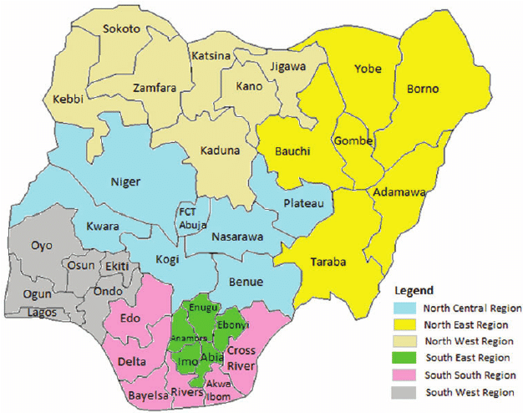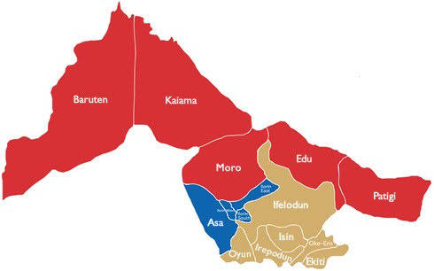
Map of Kwara State
Map of Nigeria

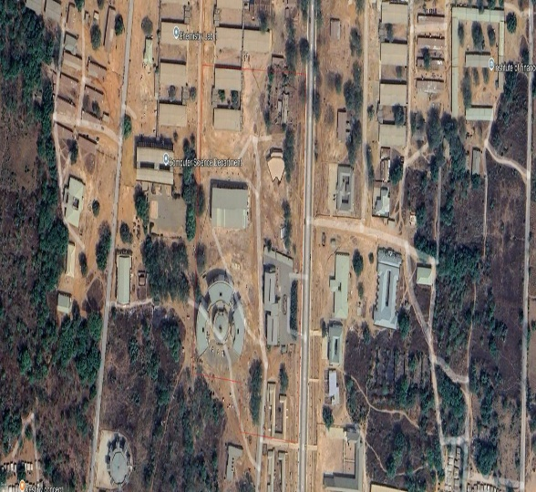
Google Imagery of the Study Area

Figure 1.10: Study Area Map
Imagery of Project Site
Showing the study area
FIG 1.2: Diagram Showing Location of Study Area.

CHAPTER TWO

2.0 LITERATURE REVIEW
A Digital Surface Model (DSM) is a digital representation of the Earth's surface, including natural and man-made features. The creation of a Digital Surface Model (DSM) is a crucial aspect of various fields, including geography, geology, urban planning, and environmental monitoring. A DSM provides a detailed representation of the Earth's surface, allowing for the analysis of terrain characteristics, land use patterns, and environmental features. This chapter reviews the existing literature on DSM creation, focusing on the methods, techniques, and applications of DSMs.
A digital surface model represents the elevation associated with the surface of the earth including topography and all natural or human-made features located on the surface of the earth. There is a variety of DSM source data available for developed areas and the suitability of this available data is depending on the project specifications. In remote regions around the World, were little or no source data is available, the DSM can be produced automatically from stereo satellite scenes, from satellite sensors such as IKONOS, SPOT-5 and Terra-ASTER l;tography at various resolutions, depending on the quality and scale of the aerial photography.
Digital Surface Model stands for the Earth’s surface including all the objects on it, for instance, trees, plants, buildings, and other features elevated above the "Bare Earth”. On the other hand, the Digital Terrain Model represents the bare ground surface without any object. An important fact that has to be taken into account in the DTM generation is the resolution attribute, the higher the resolution capture, more feasible the DTMs generation which depends on the application of complex algorithms. LiDAR is a good example of high-resolution capture, the advantages of using the LiDAR include the high density of sampling, high vertical accuracy, and the opportunity to derive these set of surface models given that some laser scanning systems can already provide at least two versions of the surface: the vegetation canopy (first returns) and ground surface (last returns).
Digital Surface Models (DSMs) offer the possibility of extracting the elevations of surface features to leave the ground surface DEM. For many applications in the urban environment this separation of above-surface feature information from ground information canoffer a useful combination of data sets. For example, detailed knowledge of the elevation of the ground surface is essential for predicting good inundation and the potential effects of sea level rise, whilst a detailed model of the man-made objects that would be affected is essential for property owners, planning authorities and insurance companies. This paper discusses several such applications and focuses on how Airborne Laser Scanning devices can provide digital surface models which can be used to separate surface features from the ground for modeling flood inundation from rivers in urban and semi-urban environments. DEMs can be constructed by digitizing existing topographic maps (Gao, 1995, 1997) or by using stereoscopic aerial photographs. With the advance of digital photogrammetry, DSMs can be created using stereo image matching techniques (Smith & Smith, 1996). Many authors (Abanmy, Khamees, Scarpace & Vonderohe, 1995; Jaafar & Priestnall, 1998) have considered the potential for these DSMs to provide the heights of surface features such as buildings. Recently LiDAR (Light Detection And Ranging) has become an established technique for deriving geometric information in three dimensions. The system is seen to offer a relatively quick technique for extracting accurate surface models and thus offers the potential for the creation of DEMs and other mapping products (Kost, Loddenkemper& Petring, 1996; Lohr, 1998).
Digital Surface Model stands for the Earth’s surface including all the objects on it, for instance, trees, plants, buildings, and other features elevated above the "Bare Earth”. On the other hand, the Digital Terrain Model represents the bare ground surface without any object. An important fact that has to be taken into account in the DTM generation is the resolution attribute, the higher the resolution capture, more feasible the DTMs generation which depends on the application of complex algorithms. LiDAR is a good example of high resolution capture, the advantages of using the LiDAR include the high density of sampling, high vertical accuracy, and the opportunity to derive these set of surface models given that some laser scanning systems can already provide at least two versions of the surface: the vegetation canopy (first returns) and ground surface (last returns).
Digital Surface Models (DSMs) are often used to model the first reflective or visible surface, while DTMs typically refer to the bare earth without trees, buildings, and other natural or manmade features. DSMs and DTMs are common products derived from various sources, such as (digital) photogrammetric systems, optical satellite imagery through block adjustment, real-time kinematic GPS, topographic maps, total station surveys, and LIDAR mapping, among others. In modern map production, DSMs and DTMs serve as valuable information sources for scene analysis, change detection, GIS database updating, 3D feature extraction and reconstruction, inter-visibility calculations for optimizing telecommunication antenna locations, risk mapping, generating true ortho-images, mission planning and rehearsal, virtual and augmented reality applications, and urban planning.This definition implies that the built environment though delicate, but an integral part of the human environment has witnessed unprecedented use and re-use, hence the need for an efficient and rational action towards making it sustainable. Since resources are scarce and are fast diminishing, even as demands on them are on the increase, planning as an intelligent and rational form of decision making becomes inevitable as a means of reducing waste, of producing greatest return from the employment of resources and of ensuring efficiency in the utilization of resources to achieve maximum economic growth and national development.
However, because of the peculiar nature and importance of the built environment, planners around the world have emphasized the need to cater for physical development within the cities and other human settlement using the planning principles and concepts. The essence of this is to achieve a livable settlement described as ‘a welcoming, organized and comprehensible environment, where physical elements is unifying, accessibility within and without facilitate communication and promote interactions and flexibility, involving the design and development of buildings, circulation and service/utility system adapt to the needs of an evolving environment’ (Office of University Planning,1997). Physical development planning which is concerned with the process of ordering the use of land and siting of buildings structures and communications to secure the maximum degree of economy, functionality, convenience, and beauty (Keeble, 1969) has, therefore, come to be accepted as a major area of planning because it encompasses all other facets of human interaction with land, including building engineering, mining or other operations in, on, over or under any land.
The above statement is vividly captured in the UN Agenda 21 and Habitat Agenda summed up in the concept of urban physical sustainability defined as an intervention to enhance the livability of buildings and urban infrastructure for all city dwellers, without damaging or disrupting the urban region environment (Adriana and Nicholas, 2002).
Surveying, which is also interchangeably called geomatics, has been defined as the science, art, and technology of determining the relative positions of points above, on, or beneath the Earth's surface, or of establishing such points. In a more general sense, however, surveying can be regarded as that discipline which encompasses all methods for measuring and collecting information about the physical earth and our environment, processing that information. and disseminating a variety of resulting products to a wide range of clients (Ghilani& Wolf 2008).
Surveying has been important since the beginning of civilization. Its earliest applications were in measuring and marking boundaries of property ownership. Throughout the years its importance has steadily increased with the growing demand for a variety of maps and other spatially related types of information and the expanding need for establishing accurate line and grade to guide construction operations (Ghilani& Wolf 2008).
Topographic surveys are three-dimensional; they employ the techniques of plane surveying and other special techniques to establish both horizontal and vertical control. The relief or configuration of the terrain and the natural or artificial features are located by measurement and depicted on a flat sheet to form a topographic map. Contour lines, connecting points of the same elevation, are used to portray elevations at any one of various intervals measured in meters or feet.
GIS technology has made topographical mapping and geo-visualization more accurate, appealing and a large area can be mapped within a far lesser time frame. It has the power to visualize geographic data by allowing the user to dynamically integrate multiple data sources, unconstrained by format, scale and coordinate system. Also, the capability of GIS technology to visualize and analyze spatial and non-spatial information from diverse sources make it a powerful platform for multilevel decision making, and so greater credit should be given to its geo-visualization capabilities. They enable a large volume of geographic data to be summarized into a map which, without doubt, facilitates fast visual interpretation (Nkeki, 2013a). In this paper, GIS technology is viewed from two dimension–the spatial data gathered with sensor-based space satellite devices used for producing topographic maps such as DEM and those used for manipulating and geo-visualizing the DEM data such as GIS software and algorithms. Geo-visualization (geographic visualization) refers to the technologies and procedures of displaying geographic data for quick visual interpretation. Presently, this method of visualizing geographic dataset is fast replacing the cumbersome paper topographical map. It is capable of visualizing multiple spatial data and presents a friendly interface between the map and the user.
3D city models are digital representations of the Earth’s surface and related objects belonging to urban areas (like cities, factories, buildings etc.). Several disciplines like urban planning, architecture, telecommunication, tourism, environmental protection and many others have an increasing demand for digital 3D city models, in order to use such complex data for planning, analyses, visualization and simulation in different applications. Additionally, the open geospatial viewers (e.g. Google Earth, Virtual Earth, etc.) increase the demand on 3D city models (Remondino et al., 2006). 3D city model and its update require the development of automatic methods for acquisition of Digital Surface Models (DSM) (Toutin and Gray, 2000). Digital photogrammetry, both airborne and spatial, is efficient modern technique for DSM acquisition as a base for 3D city modelling.
A digital surface model represents the elevation associated with the surface of the earth including topography and all natural or human-made features located on the surface of the earth. There is a variety of DSM source data available for developed areas and the suitability of this available data is depending on the project specifications. In remote regions around the World, were little or no source data is available, the DSM can be produced automatically from stereo satellite scenes, from satellite sensors such as IKONOS, SPOT-5 and Terra-ASTER l;tography at various resolutions, depending on the quality and scale of the aerial photography.

2.1 Methods for DSM Creation
Several methods can be employed to create DSMs, including:

- Ground Surveying: Traditional ground surveying methods, such as Total Station and leveling, can be used to collect data for DSM creation. These methods provide accurate measurements of terrain features and are suitable for small-scale projects(Kahmen & Faig, 2012).

- Remote Sensing: Remote sensing technologies, including photogrammetry and LiDAR (Light Detection and Ranging), have become increasingly popular for DSM creation due to their ability to collect data over large areas. LiDAR technology uses laser pulses to measure distances and create detailed 3D models of the terrain(Wehr & Lohr, 1999).

- Interferometric Synthetic Aperture Radar (InSAR): InSAR is a technique that uses radar images to generate DSMs, particularly useful for areas with persistent cloud cover or dense vegetation. InSAR can provide accurate measurements of terrain deformation and is widely used in geological and environmental applications (Hanssen, 2001).

2.2 Techniques for DSM Generation
Various techniques can be applied to generate DSMs from collected data, including:
- Triangulation: Triangulation methods, such as Triangulated Irregular Network (TIN), can be used to create DSMs from irregularly spaced data points. TIN is a popular method for generating DSMs from LiDAR data(Peucker et al., 1978).
- Grid-based Methods: Grid-based methods, such as Inverse Distance Weighting (IDW) and Kriging, can be employed to generate DSMs from regularly spaced data points. IDW is a simple and efficient method, while Kriging is a more complex method that takes into account the spatial autocorrelation of the data(Burrough & McDonnell, 1998).

2.3 Applications of DSMs
DSMs have a wide range of applications, including:
- Urban Planning: DSMs can be used to analyze urban morphology, identify areas of high population density, and plan infrastructure development. DSMs can also be used to simulate the impact of urban development on the environment (Barnsley & Barr, 1997).
- Environmental Monitoring: DSMs can be employed to monitor land use changes, track deforestation, and analyze terrain characteristics. DSMs can also be used to study the impacts of climate change on the environment (Kourgialas& Karatzas, 2017).
- Natural Hazard Assessment: DSMs can be used to assess the risk of natural hazards, such as landslides and floods, by analyzing terrain characteristics and land use patterns. DSMs can also be used to identify areas prone to erosion and sedimentation (Guzzetti et al., 2006).

2.4 Advantages and Limitations of DSMs
DSMs have several advantages, including:
- Detailed Representation: DSMs provide a detailed representation of the Earth's surface, allowing for accurate analysis and decision-making.
- Flexibility: DSMs can be used in various fields and applications, from urban planning to environmental monitoring.
- Cost-Effective: DSMs can be generated using a range of methods, including remote sensing and ground surveying, making them a cost-effective solution for many applications.
However, DSMs also have some limitations, including:
- Data Quality: The quality of the DSM depends on the quality of the input data, which can be affected by various factors, such as sensor accuracy and data resolution.
- Data Complexity: DSMs can be complex and require significant computational resources to process and analyze.
- Interpretation: DSMs require careful interpretation and analysis to extract meaningful information and insights.
2.5 Project Review
In conclusion, DSMs are a powerful tool for understanding the Earth's surface and have a wide range of applications in various fields. The choice of method and technique for DSM creation depends on the specific application and data availability. DSMs provide a detailed representation of the terrain and can be used to analyze terrain characteristics, land use patterns, and environmental features.

CHAPTER THREE

3.0 METHODOLOGY

3.1 PROJECT PLANNING

Before beginning any survey assignment, project planning is a crucial requirement. It entails a careful investigation of the topic matter about a certain land region that is being evaluated. This crucial step in the surveying process allows the surveyor to become acquainted with the chosen location before starting work. During the reconnaissance phase, the survey's goals, requirements, and required precision levels are examined because these elements have a big impact on the choice of survey tools and techniques. In the end, this project resulted in the development of a first working diagram. Reconnaissance is divided into two phases: (i) Office Planning and (ii) Field reconnaissance.

3.1.1 FIELD RECONNAISSANCE

As part of this process, a surveyor or student must physically visit the site to gain a thorough understanding of its topography, including any vegetation, accessibility, existing frame work, as well as the social and economic 19 activities that take place there. The optimal approach and tools for improved decision-making must also be chosen. This on-site visit gives the surveyor or student a comprehensive grasp of the entire region and allows them to look at the entire area of the land. To guarantee correct orientation, the locations of all accessible horizontal and vertical controls in the region of the research area will be visited, and their outlooks will be viewed. This exercise makes it easier to create a Recce diagram, which is shown below but is not drawn to scale:

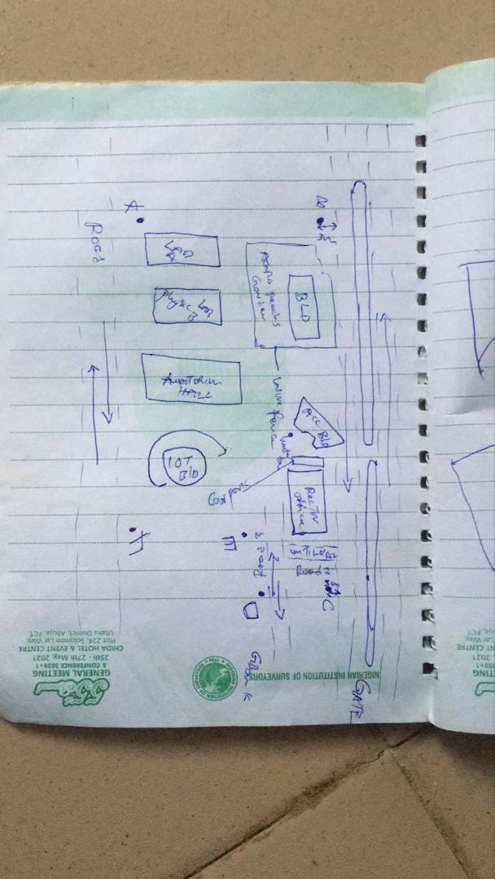

Figure 3.4: RECCI DIAGRAM

3.1.2 OFFICE PLANNING

Gathering crucial project information is the focus of this phase, which is usually done in an office setting. It is the initial phase of planning that comes before the fieldwork itself and entails gathering and analyzing a variety of project-related data. This covers a range of requirements for the project, scheduling, budgeting, and generating the coordinates for the control points under the project control prefix. It includes figuring out the best process, picking the right tools, as well as subscription for the CORS station.

3.2 EQUIPMENT USED/ SYSTEM SELECTION SOFTWARE
The following equipment was used:
- Total station and accessories
- One Tripod
- Two Prism
- One 7.5 meters short tape
- One Plumb bob
- One Cutlass
- Bottle corks and nails
- Writing materials.

3.2.1 HARDWARE USED
Model: HP 15 Note book PC
System Manufacturer: Hewlett-Packard
Rating: 1.0 Windows Experience Index.
Processor: Intel(R) Core(TM) i5-3230M CPU @ 2.60GHz, 2601 Mhz, 2 Core(s), 4 Logical Processor(s)
Installed Memory RAM: 8.00 GB
System Type: x64-based PC.
Product ID: F9F84EA#ABV

3.2.2 SOFTWARE USED
Some of the software used includes:
- AutoCAD 2007
- Notepad
- Microsoft Word 2007
- Microsoft Excel 2007
- Arc GIS 10.5

3.3 DATA ACQUISITION

This involves using different surveying methods and tools to gather data and make observations in the field. To acquire data for this project, Handed GPS and Total station were both used.

3.3.1 PRIMARY DATA SOURCE: This is a type of data source in which data is direct acquired from the field such as data acquired from field survey operations.

3.3.2 SECONDARY DATA SOURCE: This data source are already made data or gotten from research work, which has been acquired for future use. This involves downloading satellite imagery used for the project area and Google map as guide.

3.4 TEST OF INSTRUMENT
Testing of instruments is very crucial when carrying out any survey operation. Having collected the required instruments from the department, the check was carried out on the accuracy and precision of both the Handed GPS and TOTAL STATION to ensure they were in proper working condition before the actual field observation of the project.

3.4.1 TEST FOR TOTAL STATION
The horizontal collimation and vertical index inaccuracies of the instrument were confirmed. Once the device was positioned on a rather flat surface, the required temporary modifications, including focusing, centering, and setting, were made. Configuration information, such as extra parameters and fast settings, was examined and adjusted as necessary. The configuration parameters selected collimation, namely horizontal collimation. Next, to focus on a distant object, the means' option located on the left side of the device was chosen. The instrument was transited, and the right side went through the same procedure. Then, when the 'accept' button was pushed, the table that was displayed showed the old and new values for the vertical index errors and horizontal collimation. Re-press "ok" signified acceptance of the updated values, which were minimal.
Figure 3.5: INSTRUMENT TEST

The diagrammatic representation of the procedure and the readings obtained are shown below

Table 3.4.1 COLLIMATION TEST OF TOTAL STATION
STN | SIGHT | FACE | HCR | REDUCTION | VCR | REDUCTION
A | B | L | 126º 07’ 11.33” |  | 67º 22’40”
 | B | R | 306º 07’ 31.3” | 180º 00’ 20” | 292º 37’ 1” | 359 º 59’ 41”

HORIZONTAL COLLIMATION ERROR = 180°00’20’’ - 180°
=00°00’20’’
=00°00’20’’/2 =00°00’10’’
VERTICAL INDEX ERROR=360° - 359°59’41.6’’
=00°00’18.4’’
=00°00’18’’/2 =00°00’9.2’’
The instrument's satisfactory operation was validated by the acceptance of the updated readings. It appears from this result that any possible issues can be resolved or at least greatly reduced.

3.4.2 REFERENCING AND ORIENTATION OF TOTAL STATION
Tripod Setup:
- Place the tripod over the station point (known or assumed).
- Level the tripod head as much as possible by adjusting the legs.
Mount the Total Station:
- Fix the total station onto the tripod head.
- Ensure it’s securely locked in place.
Centering and Leveling:
- Use the optical plummet or laser plummet to center the instrument exactly over the survey station mark (station point).
- Level the instrument using the foot screws and circular bubble.
- Fine-tune leveling using the electronic level display.

Power On and Instrument Configuration
- Switch on the Total Station.
- Set the correct project, coordinate system, and units.
- Select the appropriate survey mode (e.g., topographic survey or station setup).
Orientation (Station Setup)
Orientation means establishing the direction of the horizontal angle reference (back sight direction).
Orientation by Known Coordinates (Resection or Free Station)
Used when both the instrument station and a back sight point have known coordinates.
- Input the coordinates of the instrument station (or let the instrument compute it later).
- Sight and measure to one or more known reference points (minimum of 2 for better accuracy).
- The Total Station calculates the instrument position and orientation using these known points.

3.3.7 PERIMETER TRAVERSING
The perimeter of the project area was traversed for the purpose of the coordinating the boundary points. HandedGPS (GALAXY G1) was connected to kwara state CORS station for referencing and orientation after which all the boundary points were traversed using HandedGPS from the initial until each successive boundary is occupied.

3.3.8 DETAILING
All features such as roads, buildings, electric poles, street light, trees, etc. were captured by coordinating their edges simultaneously as the perimeter is being measured within the project area. Buildings were measured and identifiers (BD) were used to differentiate them from other features. Roads were also measured and labelled (RD) accordingly. Data captured here were basically in 3Dimension i.e. Easting, Nothings and Elevations (X, Y, and Z) coordinates.

3.3.9 REMOTE ELEVATION MEASUREMENT
All the features such as buildings, electric poles, street light, etc. captured by coordinating their edges from a subsidiary traverse stations created within the project area. Buildings heights were measured and recorded. Electric poles height were also measured and recorded accordingly. So also the same was repeated for the trees. Data captured here were basically in 3Dimension i.e. Easting, Nothings and Elevations + Heights (X, Y and Z + H) coordinates. The following procedures were followed:
- Escape key was pressed then F1 for MENU
- The REM programme was selected.
- Observation was made again and the height of reflector was displayed.
- The telescope was tilted to the top of the object and the height keeps changing until F4 is been pressed to stop.
- The value was recorded.
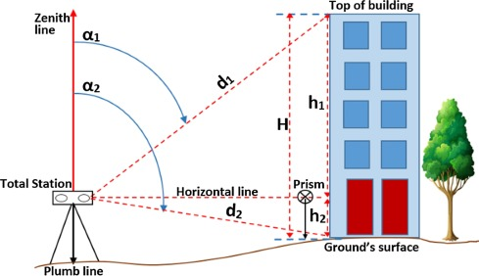
Figure 3.3.9: REM OBSERVATION STRATEGY

3.3.9A SPOT HEIGHTINGS
This was carried out by occupying randomly the subsidiary points within the project area and taking measurements (Easting, Nothings and Heights) along the terrain at approximate intervals to determine the difference in height between points and some areas within the project location. Spot heighten is very important in producing topographical information of the area with the aid of ArcGIS 10.5.

3.4 PHYSICAL DESIGN
At this stage, all geospatial (attribute) data were structured and organized to form a database in a format acceptable by the implementing software and hardware. This was done in a way that, stored information can be accessed and retrieved at any time. Also, for regular updates when the need arise and to allow for analytical functions to be carried out answering generic questions. Also, it provided integrity and security that must be obeyed before such data could be accepted into the records. These virtues are as show in the tables below. ArcGIS 10.5 was used for database creation of the project area.
Table 3.4A TREE TABLE
ATTRIBUTE | DATA TYPE | WIDTH | DECIMAL
T_ ID | String | 5 | -
T_NAME | Float | 20 | -
EASTING | Number | 10 | 3
NORTHING | Number | 10 | 3
T_USE | Float | 10 | -
T_HEGHT | Number | 7 | 3
Table 3.4B ROAD TABLE
ATTRIBUTE | DATA TYPE | WIDTH | DECIMAL
POINT_ID | String | 10 | -
NORTHING | Number | 10 | 3
EASTING | Number | 10 | 3
RD_HEIGHT | Number | 7 | 3
Table 3.4C ELECTRIC POLE TABLE
ATTRIBUTE NAME | DESCRIPTION OF ATTRIBUTE | DATA TYPE | WIDTH | DECIMAL
POINT_ID | Electric pole identifier | Number | 6 | -
NORTHING | Coordinate | Number | 15 | 3
EASTING | Coordinate | Number | 15 | 3
EP_TYPE | Type of Electric pole | Text | 15 | -
EP_HEIGHT | Height of the Electric pole | Number | 5 | 2
Table 3.4D BUILDING TABLE
ATTRIBUTE | DATA TYPE | WIDTH | DECIMAL
P_ID | String | 15 | -
NAME | Text | 15 | -
CONDITION | Text | 15 | -
USE | Text | 15 | -
HEIGHT | Number | 15 | 2
AREA_METERS | Number | 15 | 2

Table 3.4E STREETLIGHT TABLE
ATTRIBUTE NAME | DESCRIPTION OF ATTRIBUTE | DATA TYPE | WIDTH | DECIMAL
POINT_ID | Street light identifier | Number | 6 | -
NORTHING | Coordinate | Number | 15 | 3
EASTING | Coordinate | Number | 15 | 3
SL_HEIGHT | Height of the street light | Number | 5 | 2

3.5 DATABASE CREATION
Database is an organized integrated collection of data stored so as to be capable of use by relevant application with data being accessed by different logical part. This was the construction phase where database was created. After the table has being populated via the keyboard, some attributes such as area, perimeters of parcel were automatically displayed by special command in the ArcGIS 10.5 version.
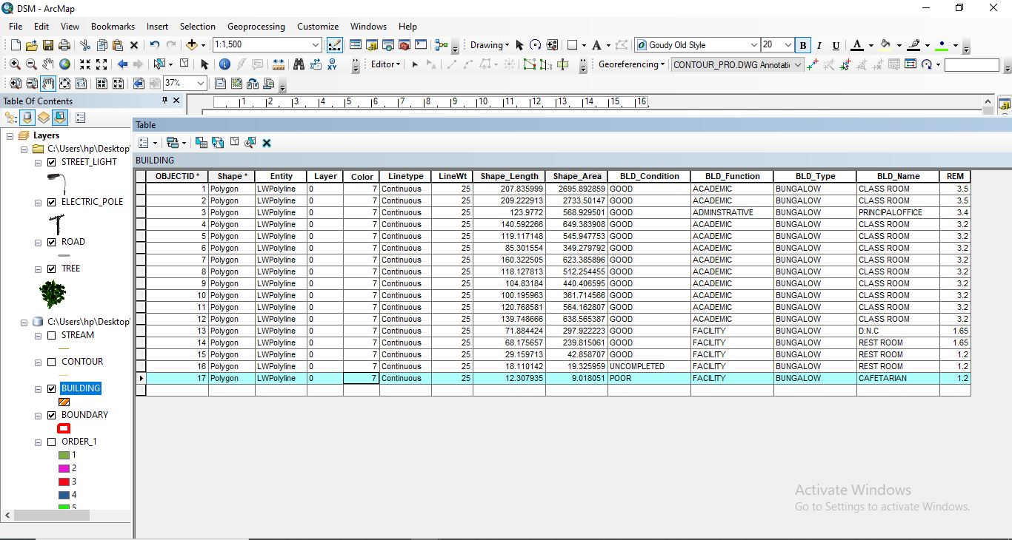
Figure 3.5: ABSTRACTED OF TABLE CREATED

3.5.1 ATTRIBUTE DATA ACQUISITION
The data about the characteristics of features especially man-made features were acquired through oral interview method and online source (Google Earth). Social survey was carried out during which information such as; building name, building use and related data about features were obtained from the students and staffs within the school. All these data formed the attribute aspect of the feature necessary for the database creation.

3.6 DATA PROCESSING

3.6.1 TOTAL STATION DATA DOWNLOADING PROCEDURE
Data downloading is the process of transferring data from the instrument into the computer system connected through the connection cable or wireless such as Bluetooth with the help of software in the computer, the process is as follows as performed on Total station.
- Connection of the two devices (computer and the instrument).
- Go to project working folder created on the instrument.
- Click on export.
- Input the name of file
- Indicate the file extension for the output
- Permit the other device to receive the file.

3.6.2 DRAFTING AND PLOTTING
The script file created containing the refined coordinates was then opened in the AutoCAD environment and the boundary of the project area was plotted using AutoCAD 2007. This was followed by the details, which included buildings, roads, trees, sport facilities and electric poles.
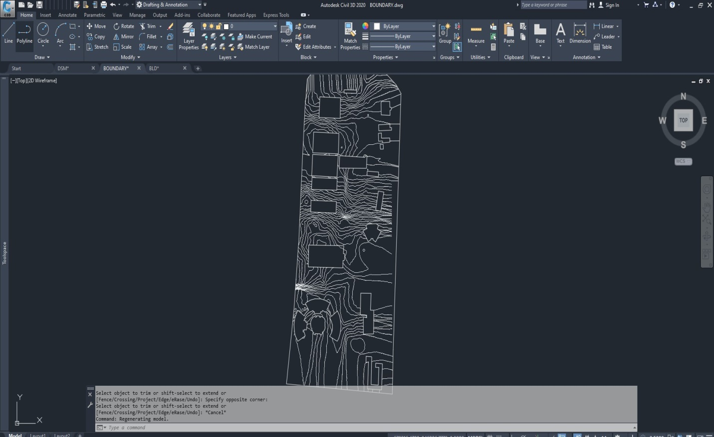
Figure 3.6.2: AUTOCAD PLOTTING.

3.7 DATABASE MANAGEMENT

3.7.1 DATA SECURITY
This is the security measure used the protection of the database security is very important since it is vital for data integrity. The strategic measure used included controlling access to database by use of password.

3.7.2 DATA INTEGRITY
This ensures that data in the database is accurate and that cases of violation of integrity can be detected automatically by the system. Here, care was taken while entering data into the system, such that, accurate data were entered and updating could be done accurately without tampering with existing data. Backups are provided to cater for any loss of data through system failure. Also a member of the project group was appointed for quality assurance and checks therefor do checks the consistency, accuracy and integrity of the input data.

3.8.3 DATABASE MAINTANANCE
Having created the database, proper maintenance practice was made to meet its stated objectives. The ability to include more data and remove irrelevant data can be possible. There is every need for the data to be updated regularly because of the physical changes that tends to occur on the landscape with time, even as a result of development.
Both security and integrity were also exercised to ensure maintenance and to meet its stated objectives.

CHAPTER FOUR

4.0 SPATIAL ANALYSIS AND INFORMATION PRESENTATION

4.1 TESTING OF DATABASE
This is the test carried out to determine whether the relationship between the spatial data of a feature and their attributes is capable of being retrieved. This is necessary to ascertain the quality of data in the database, its reliability to satisfy the demand of the user. The spatial data were arranged logically in an organized manner with respect to their attributes. This was carried out by designing a sample query and running the query to see if the desired result would be achieved. In this project, the database was queried to show different categories of information levels in the project area. Hence the database was confirmed fit for analysis. A sample of the attribute table in the database design can be found on the next page.
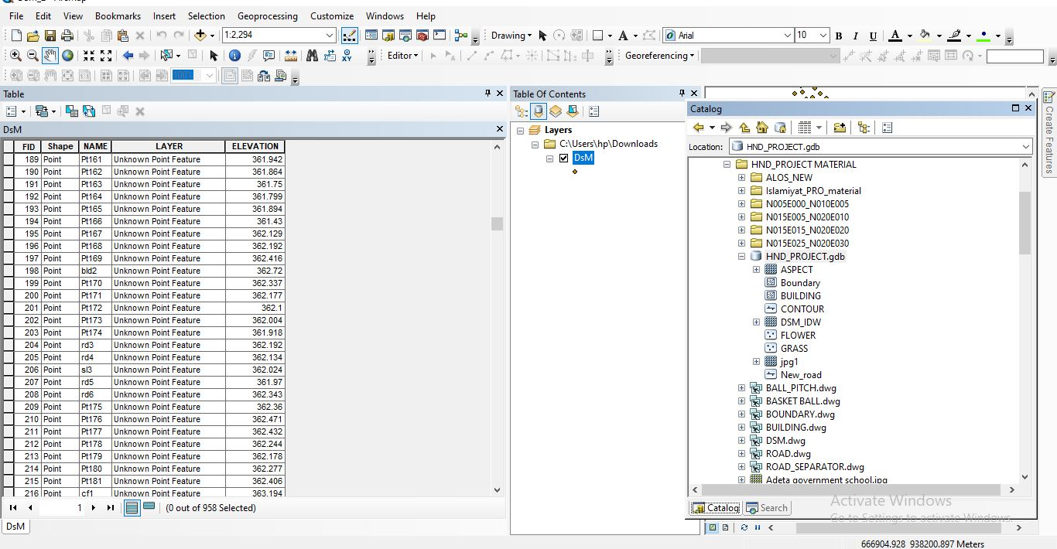
Figure 4.1: SAMPLE OF ATTRIBUTE TABLE

4.2 SPATIAL QUERY
Queries were designed for the purpose of retrieving information from the database. The queries performed in this project gave answers to certain generic questions asked from the database. This was made possible as a result of the implicit link of both the spatial and attributes data. The queries were based on the products from the analysis carried out on the database.

4.2.1 SINGLE CRITERIA QUERY
A single criterion is carried out where one condition is used to design query. This condition is used to retrieve the information from the database.

QUERY ANALYSIS 1 (selection by attribute)
ANALYSIS ONE
Analysis Name: Database extraction
Analysis Type: Single criteria analysis
Syntax: Query analyses showing buildings that are used for Administrative.

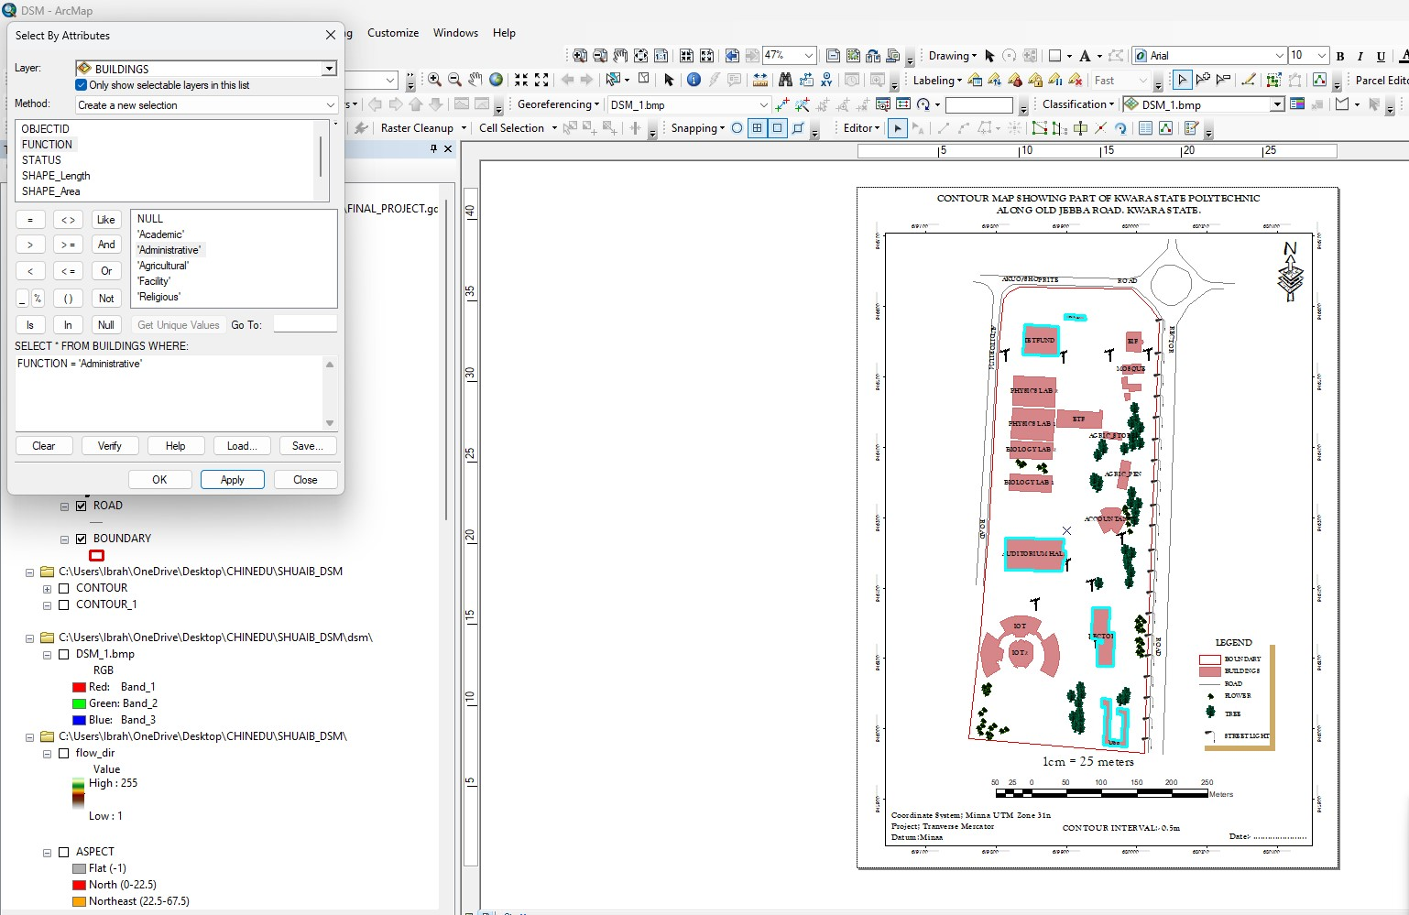
Figure 4.2.1.1 RESULT OF QUERY: (BLD_FUNCTION = “ADMINISTRATIVE”).

Analysis Name: Database extraction
Analysis Type: Single criteria analysis
Syntax: “BLD_ Function” =”Agricultural”
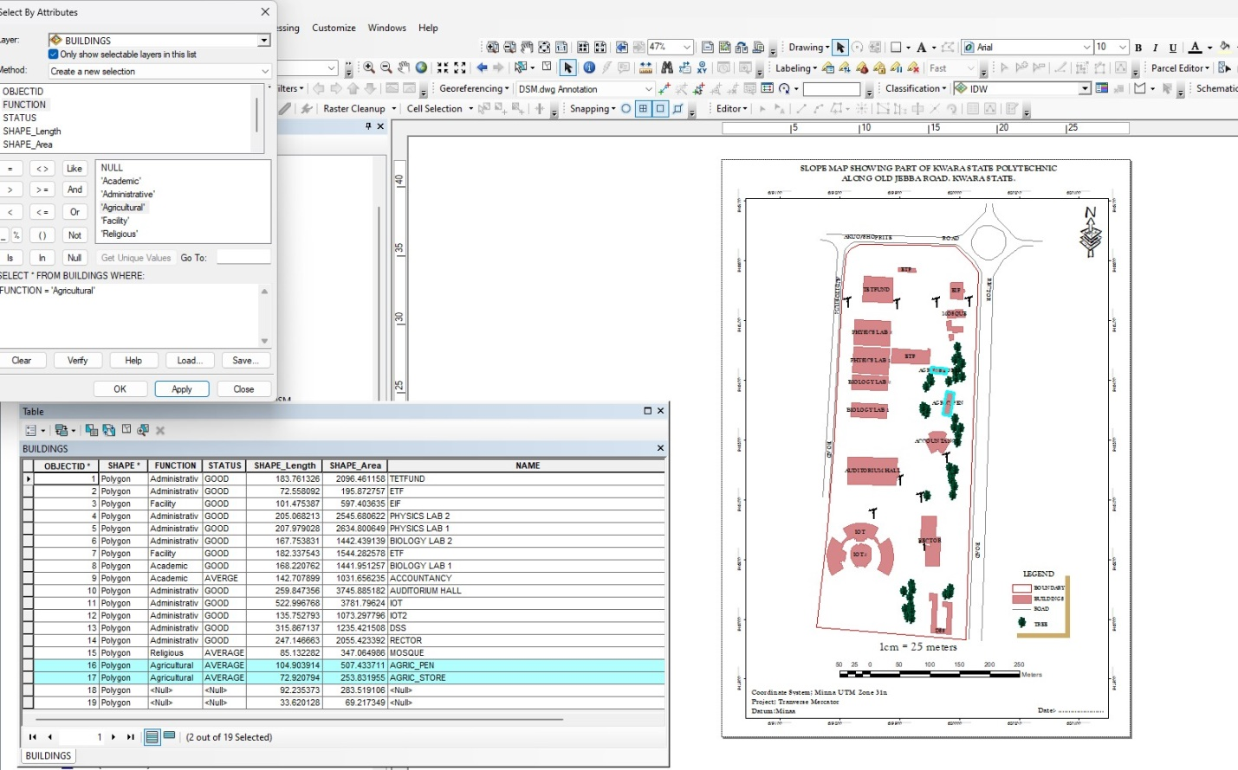
Figure 4.2.1.2: RESULT OF QUERY: (BLD_FUNCTION = “AGRICULTURAL”).
ANALYSIS THREE
Analysis Name: Database extraction
Analysis Type: Single criteria analysis
Syntax: “BLD_ CODITION” =”ACADEMIC”
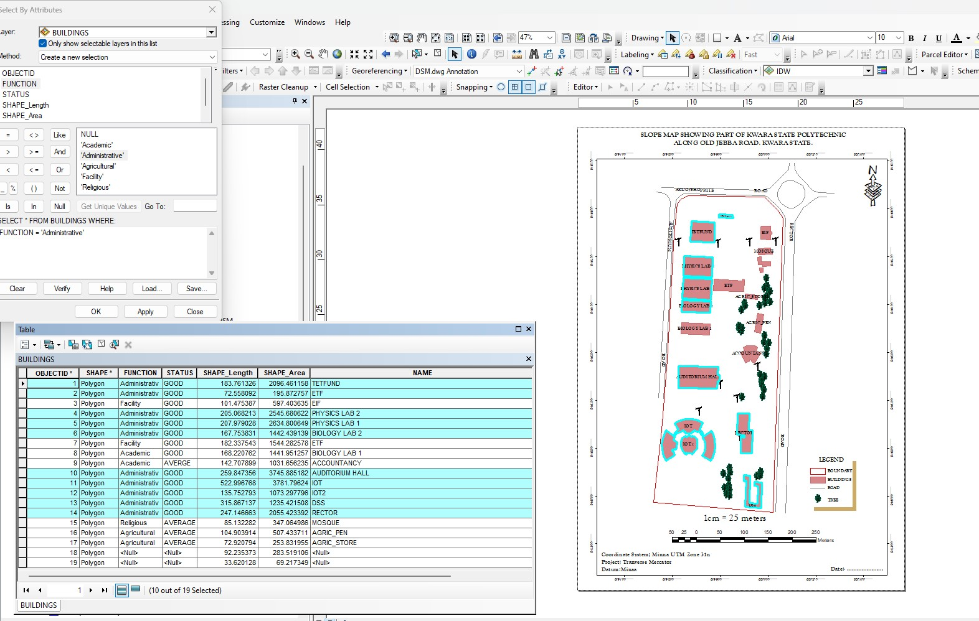
Figure 4.2.1.3: QUERY BLD_FUNCTION"ACADEMIC"

ANALYSIS FOUR
Analysis Name: Database extraction
Analysis Type: Single criteria analysis
Syntax: “TREE_FUNCTION= ORNAMENT”

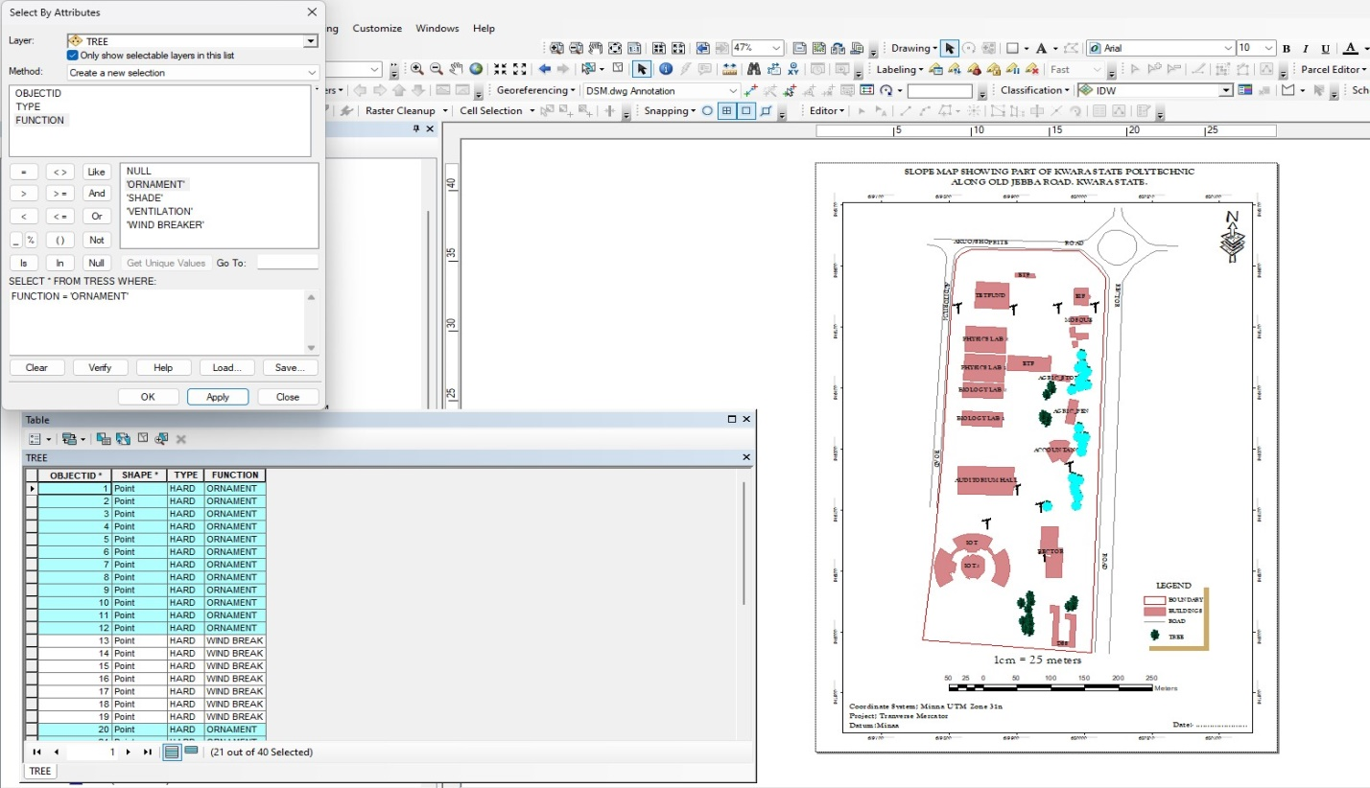
Figure 4.2.1.4: RESULT OF QUERY: (TREE_FUNCTION “ORNAMENT”).

4.2.2 MULTIPLE CRITERIA
This is a situation where two or more conditions are used to design a query. The conditions determine the information that may be requested by the user from the database.
Query for QUERY: TREE_FUNCTION “ORNAMENT” AND TREE_TYPE “HARD”
ANALYSIS FOUR
Analysis Name: Database extraction
Analysis Type: Multiple criteria analysis
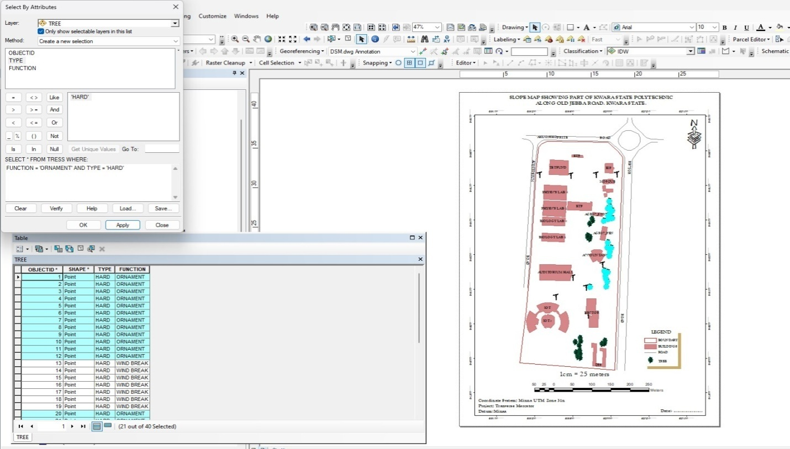
Figure 4.2.2.1 RESULT OF QUERY: TREE_FUNCTION “ORNAMENT” AND TREE_TYPE “HARD”
Query for BLD_FUNCTION =“RELIGIOUS” AND BLD_STATUS= “AVERAGE”
ANALYSIS FOUR
Analysis Name: Database extraction
Analysis Type: Multiple criteria analysis

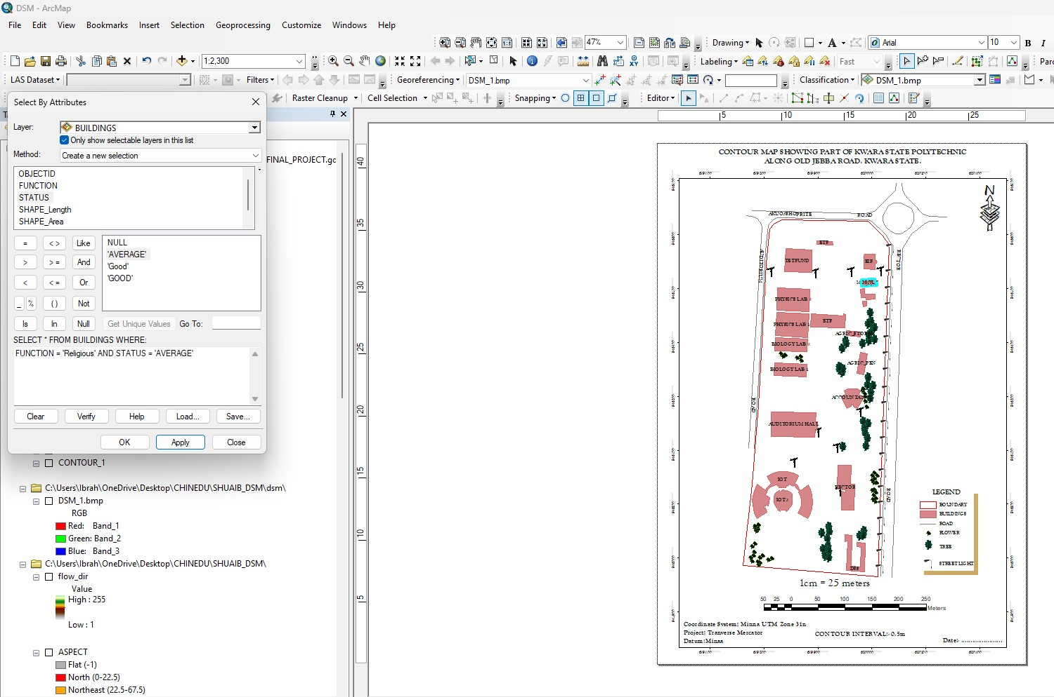
Figure 4.2.2.2 RESULT OF QUERY: BLD_FUNCTION =“RELIGIOUS” AND BLD_STATUS= “AVERAGE”

4.2 SPATIAL ANALIYSIS
This makes Geographic Information System (GIS) a unique analytical tool or technique because of its ability to combine spatial attribute data to produce information relevant for decision making. The basic GIS analysis performed in this project includes overlay and topographic operations. Maps on various themes were overlaid since they were from the same geometric origin.

4.2.1 OVERLAY OPERATION
This overlay operation is the presentation that shows different features within the project area. The outcome of overlay operation could be composite plan if it shows all the existing features, and boundary.

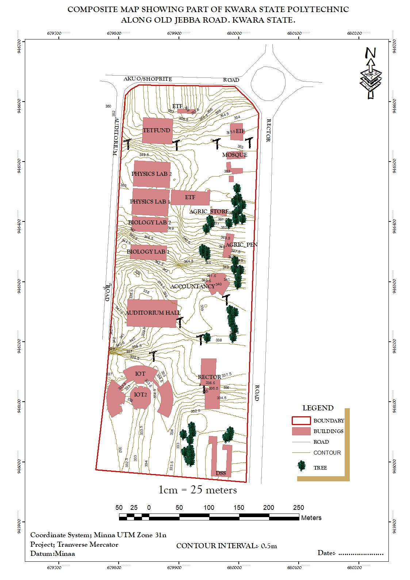
Figure 4.2.1: COMPOSITE MAP OF THE PROJECT AREA.

4.2.2 TOPOGRAPHICAL OPERATIONS
Topographic operations were carried out to determine the surface characteristic of the area which showed the relief of the project. These operations were performed on the Digital Elevation Model (DEM) generated from the use of relevant software, in this case, ArcGIS 10.5 and ArcScene 10.5 was used. The following maps were produced from the topographic operations and analysis:

- TRIANGULATION IRREGULAR NETWORK (TIN): this shows series of triangulated surface automatically generated from ArcGIS 10.5 using 3D analysis tools. This is applicable in finding suitable place for building or any engineering construction
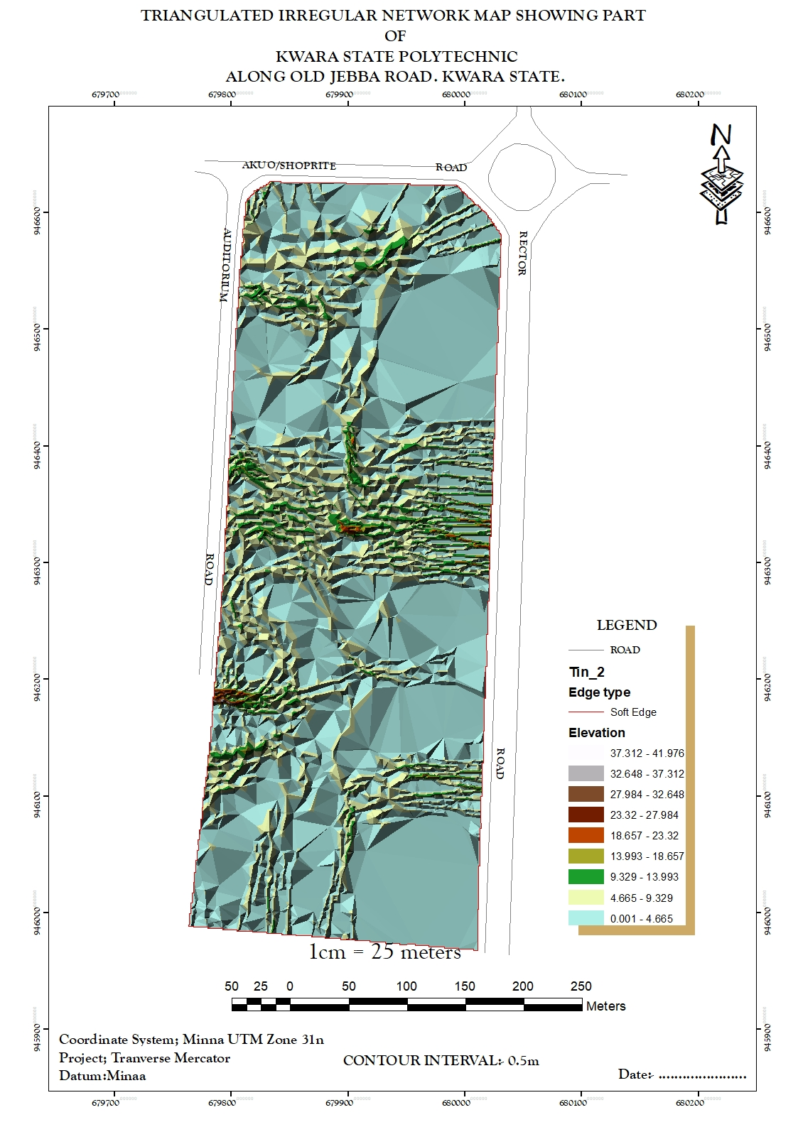
Figure 4.2.2.1: TIN AND DETAILS OVERLAY MAP OF THE PROJECT AREA
- SLOPE MAP: A slope map represents the gradient or steepness of the terrain's surface. It calculates the rate of change in elevation between neighboring pixels or points on a digital elevation model (DEM). Typically, slope is measured in degrees or percentage. Steeper slopes are represented by higher values, while flatter areas have lower values.
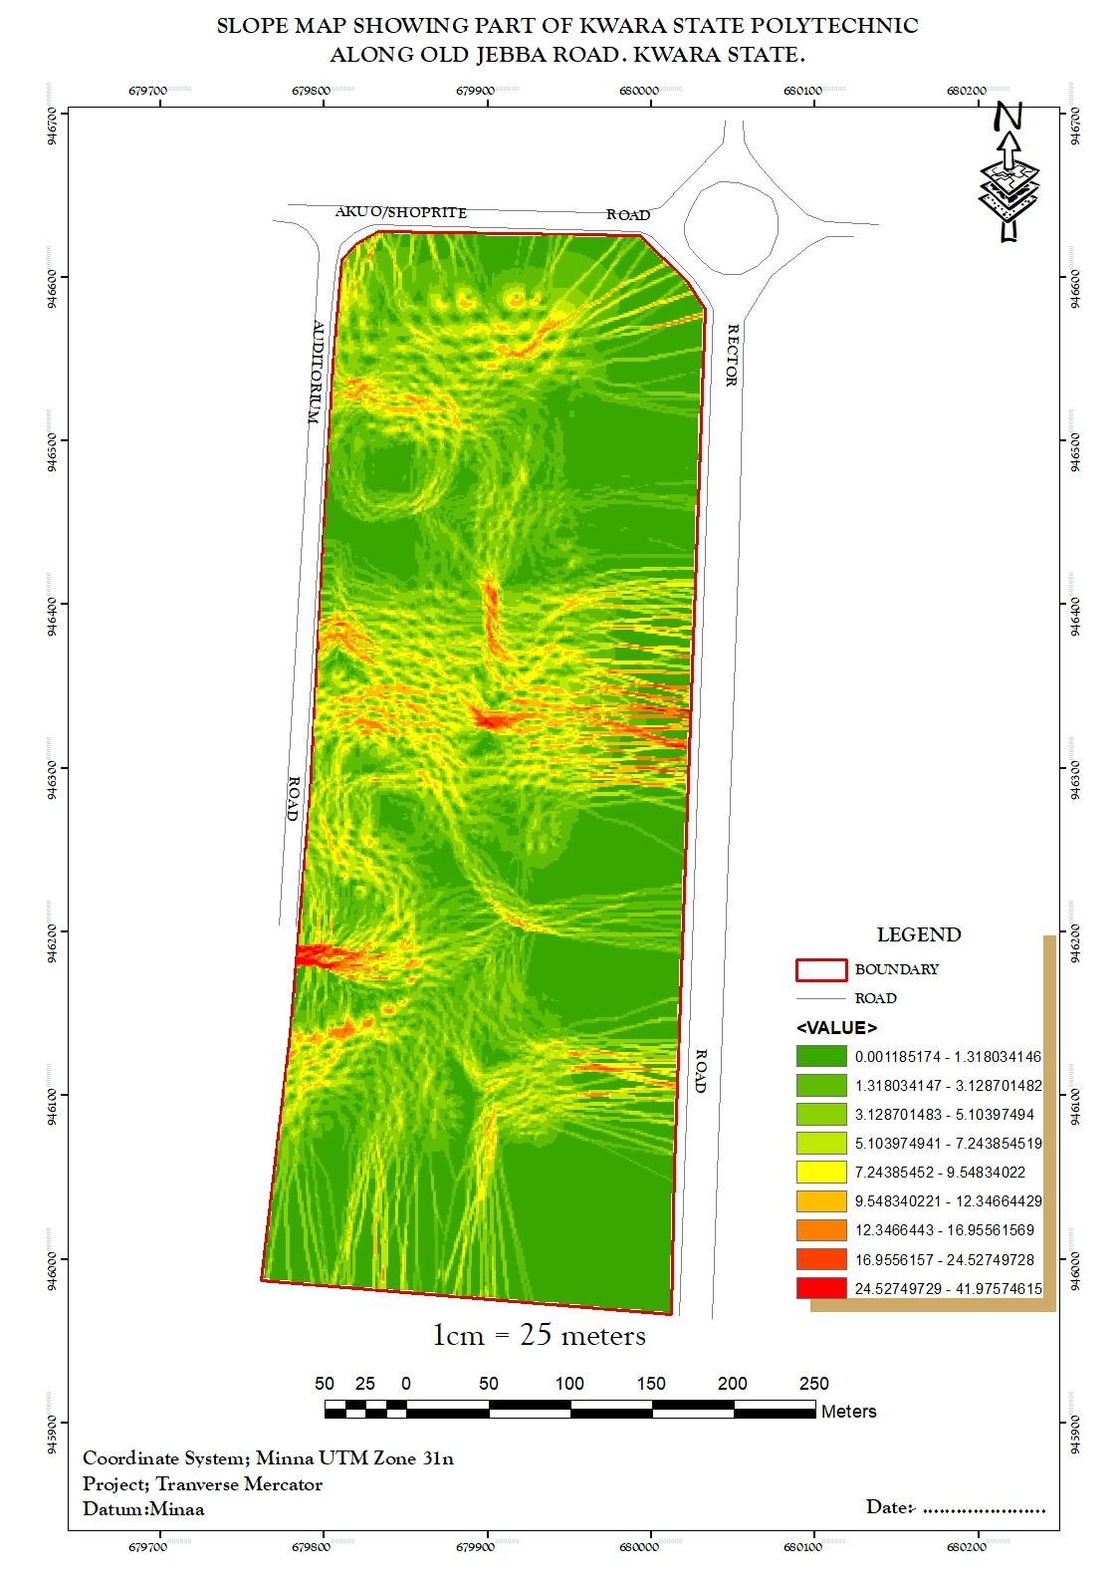
Figure 4.2.2.2: SLOPE MAP OF THE PROJECT AREA

- THE ASPECT MAP:
This shows the direction of the surface faces. It is used to determine how much sun a hill received and the information can be used to put building where they will get enough sun. Also the aspect map shows the suitable place for plane landing i.e. the flat terrain area and also solar illumination which can affect the diversity of life i.e. Vegetation and soil studies; glaciology.

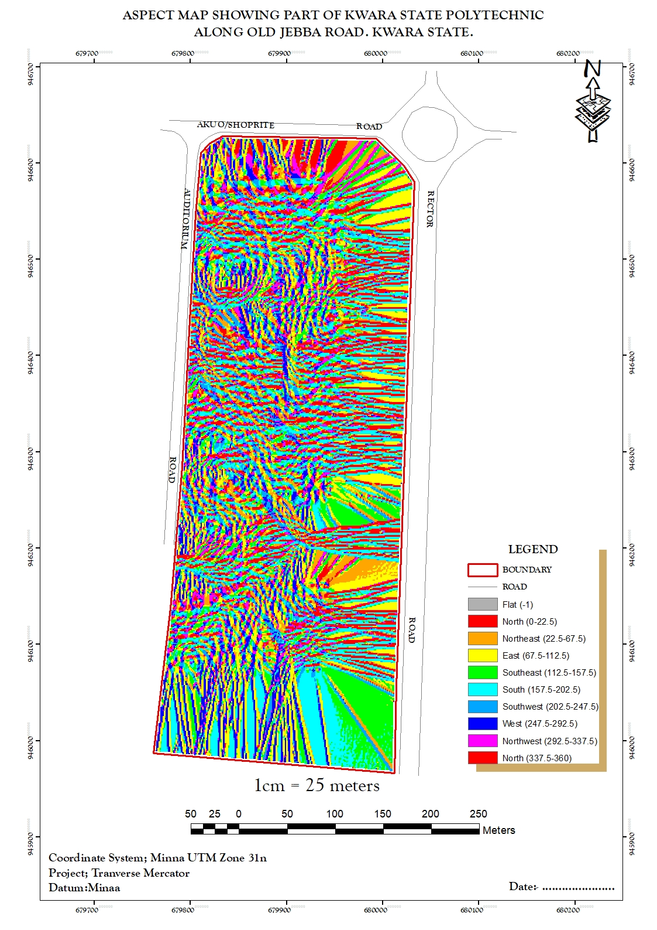
Figure 4.2.2.3: ASPECT MAP OF THE PROJECT AREA.
- THE CONTOUR MAP:
Contour maps display lines connecting points of equal elevation on the terrain surface. These lines, called contour lines, depict the shape and elevation of the land. Contour maps are widely used in topographic mapping and land surveying for visualizing elevation changes and terrain features. This provides a very intuitive view of the landscape. Contour map of the project area can aid in giving information on the highest and the lowest point on the terrain. This is important in road construction and location of other facilities like storage tanks for water distribution.
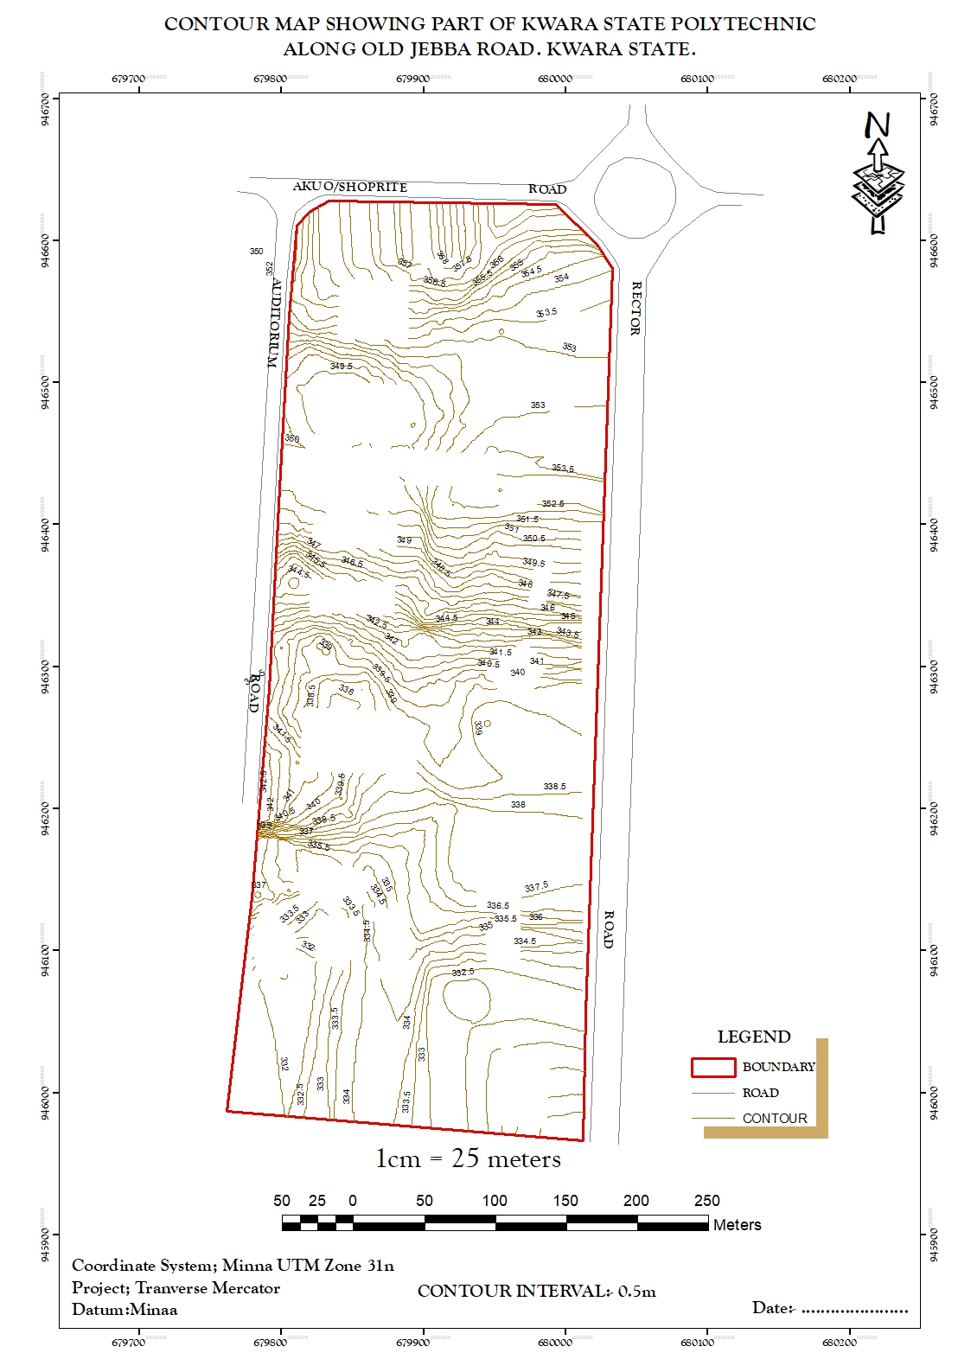
Figure 4.2.2.4: CONTOUR MAP OF THE PROJECT AREA.

- FLOW DIRECTION MAP:
This is used to determine the direction of flow of water within the project area. It also indicates the magnitude and erosive force water passing through an area.
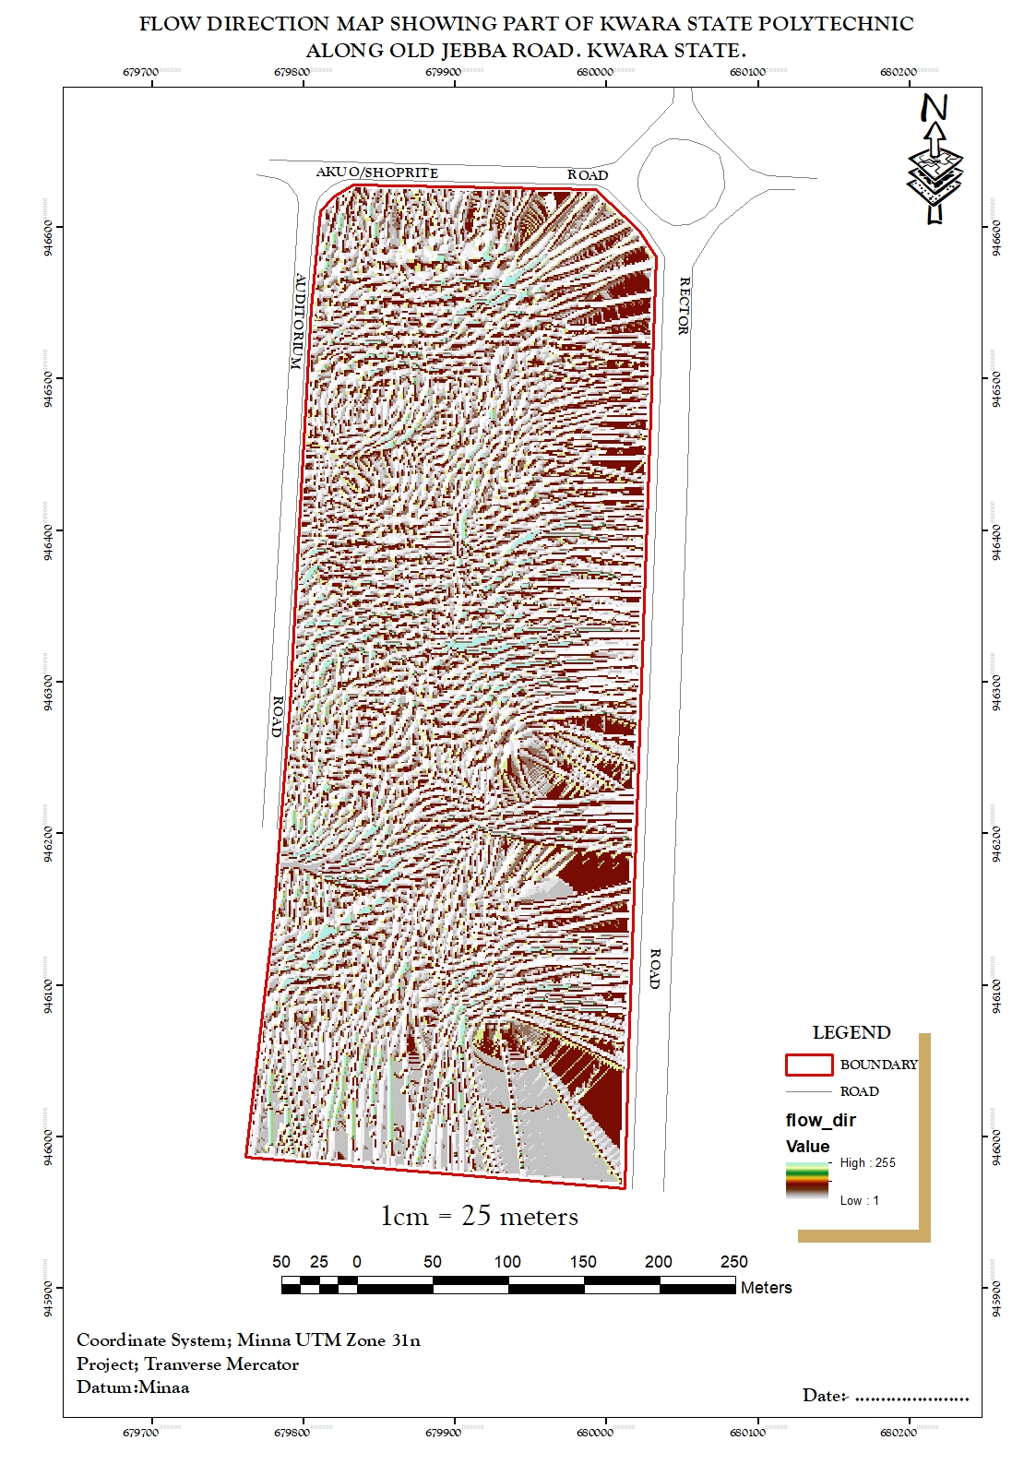
Figure 4.2.2.5 FLOW_DIRECTION MAP OF THE PROJECT AREA
- DIGITAL SURFACE MODEL MAP:
A DSM (Digital Surface Model) map, or Digital Surface Model, represents the elevation of the Earth's surface including all objects on it, such as buildings, vegetation, and other structures. Unlike a DTM (Digital Terrain Model), which only includes the bare-earth surface, a DSM incorporates both natural and man-made features. DSMs are useful for various applications, including urban planning, infrastructure design, and 3D visualization. They are often derived from aerial or satellite imagery, LiDAR data, or photogrammetry techniques. This shows the reality of the terrain of the project area.
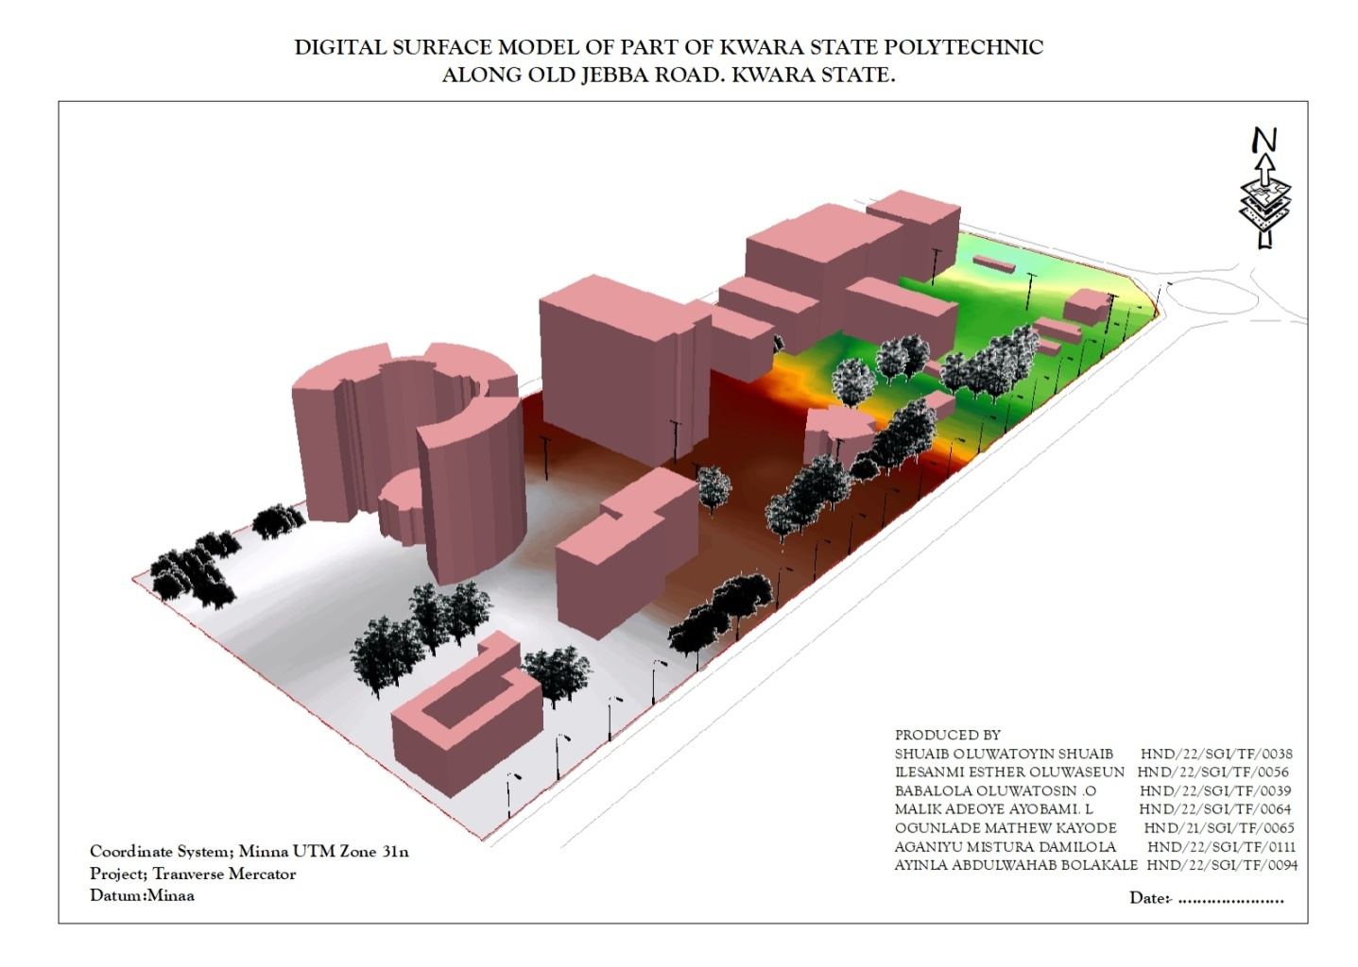
Figure 4.2.2.6: DIGITAL SURFACE MAP OF THE PROJECT AREA

4.3 RESULT ANALYSIS
From the below pie chart, it is inferred that large percentage is serving academic function.The DSM project commenced with the utilization of a Total station referenced to control station within kwara state polytechnic to capture 3D data of the project area. The captured data were then processed using software, employing photogrammetry techniques to generate a high-precision DSM and create a detailed 3D model. Subsequently, ArcGIS and ArcScene software was employed to visualize and analyze the DSM data, facilitating spatial analysis and information presentation both in 2D and 3D respectively.
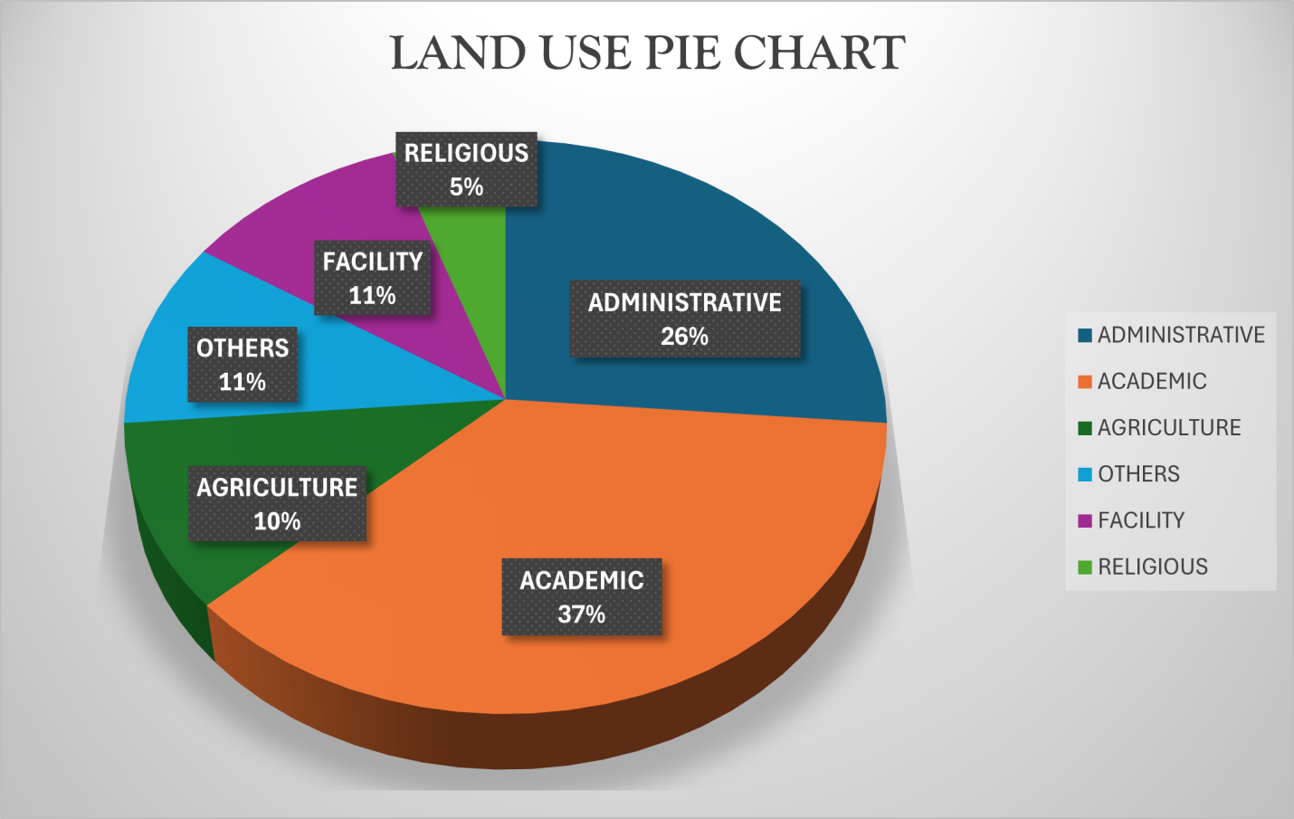
Figure 4.2.2.7: LAND USE PIE CHART

4.4 APPLICATION OF PROJECT
- Generally DSM is applicable in urban development modeling.
- It enhanced visualization and communication of such data not only in maps modeling but also in mobile digital devices for quick navigation and assessment.
- To create a sustainable and favourable living environment.
- Positioning and monitoring of physical features, structures and engineering works on, above or below the surface of the earth to protect properties or investment.
- The feasibility studies through the use of line of sight analysis provide visibility between two points. This is good for network distribution in telecommunication.
- The profile graph is good road construction which will provide the cross section of the topography from which rivers, streams and depression can be shown. Points require bridges, culverts and filling can be known from the profile graph.
- The vector map shows the direction of rivers, streams and depression which helps in road construction.
- The aspect map shows the direction of the surface faces. It is used to determine how much sun a hill received and the information can be used to put building where they will get enough sun also used to find where different crop will do best and also the Converging/diverging flow; soil water properties.
- The aspect map shows the suitable place for plane landing i.e. the flat terrain area and also solar illumination which can affect the diversity of life i.e. Vegetation and soil studies; glaciology.
- The result from the analysis can be help in managing the land resources of the project area. With the DSM, adequate information has been provided for proper decision making on the school land. Proper allocation various land use can now be done without difficulty in the decision making process.
- The slope map which is used to find low- slope for potential construction site and high slope that may be vulnerable to erosion or landslide.
- Also, the slope map shows slope length which is important topographical parameters for soil erosion analysis and traditional soil erosion studied
- Contour map of the project area can aid in giving information on the highest point on the terrain as well as the lowest. This is important in Road construction and location of other facilities like storage tank for water distribution.

CHAPTER FIVE

5.0 PROJECT COSTING, SUMMARY, PROBLEM ENCOUNTERED, POSSIBLE SOLUTION, RECOMMENDATION AND CONCLUSION

5.1 PROJECT COSTING

Table 5.1: Shows the worked out cost of the project
PREPARATION | RATE/DAY | NO. OF DAYS | UNIT COST(N) | AMOUNT (N)
RECONNAISSANCE
DAYS
Senior Surveyor | 10,000 | 1 | 10,000 | 10,000
Technical Officer | 5,000 | 1 | 40,000 | 40,000
Skilled Labour | 5,000 | 1 | 5,000 | 5,000
Transportation | 20,000 | 1 | 20,000 | 20,000
Basic Equipment  (hand held GPS, Field book e.t.c) | 5,000 | 1 | 5,000 | 5,000
SUB TOTAL |  |  |  | ₦80,000

DETAILING AND SPOT HEIGHTING DAYS
ITEM | RATE/DAY | NO. OF DAYS | UNIT COST(N) | AMOUNT (N)
Senior Surveyor | 10,000 | 4 | 40,000 | 40,000
Technical Officer | 5,000 | 4 | 20,000 × 8 | 160,000
Basic Equipment (Total station, Reflector) | 20,000 | 4 | 80,000 | 80,000
Transportation | 5,000 | 4 | 20,000 | 20,000
SUB TOTAL |  |  |  | ₦300,000

DATA PROCESSING DAYS
ITEM | RATE/DAY | NO. OF DAYS | UNIT COST(N) | AMOUNT (N)
Principal Surveyor | 10,000 | 5 | 50,000 | 50,000
Surveyor | 8,000 | 5 | 40,000 | 40,000
Assistant Technical Officer | 5,000 | 5 | 25,000 | 25,000
Computer Accessories(Printer, Internet, Generator, Fuelling etc | 15,000 | 5 | 75,000 | 75,000
SUB TOTAL |  |  |  | ₦190,000

INFORMATION PRESENTATION
ITEM | RATE/DAY | NO. OF DAYS | UNIT COST(N) | AMOUNT (N)
Senior Surveyor | 10,000 | 1 | 10,000 | 10,000
Technical Officer (CAD) | 8,000 | 1 | 8,000 | 8,000
Standard Set (Computer, Plotter, Generator etc.) | 15,000 | 1 | 15,000 | 15,000
SUB TOTAL |  |  |  | ₦33,000

TECHNICAL REPORT
ITEM | RATE/DAY | NO. OF DAYS | UNIT COST(N) | AMOUNT (N)
Chief Surveyor | 30,000 | 1 | 30,000 | 30,000
Surveyors | 20,000 | 1 | 20,000 × 2 | 40,000
SUB TOTAL |  |  |  | ₦70,000

PROJECT COST SUMMARY

COST BREAKDOWN TABLE
ITEM | DESCRIPTION | AMOUNT (₦)
SUM OF THE PROJECT | Base Project Cost | ₦678,000
MOBILIZATION/DEMOBILIZATION | (10% of the project) | ₦67,600
CONTINGENCY | (5% of the project) | ₦33,800
V.A.T | (7.5% of the project) | ₦50,700
ACCOMMODATION | (1.5% of the project) | ₦10,140
GRAND TOTAL | Final Project Cost | ₦838,240

5.2 SUMMARY
To accurately determine the shape, size, and precise location of the site extensive office planning and on-site visitation were conducted. As part of the preparation process, a reconnaissance diagram was produced, providing valuable insights for informed decision-making.
Controls were searched for and checked using a South Total Station instrument, enabling the systematic traversal and observation of various points, including detailed features such as roads. The observed coordinates were diligently recorded in the field book and also saved in the memory of the total station for future reference.
The recorded coordinates were utilized to plot the boundary points and preparation of other necessary plans with accuracy. This information served as the foundation for creating a comprehensive plan and generating a detailed report, both of which were diligently prepared and printed.
5.3 Problem Encountered
- Limited Access to Equipment: Limited access to Total Station equipment and other surveying instruments, which delayed data collection.
- Technical Issues: Technical problems with software and equipment, such as data import errors.
- Data Quality Issues: Ensuring data accuracy and quality, particularly with limited experience in data collection and processing.
- Time Management: Managing time effectively to complete the project within the given timeframe, balancing data collection, processing, and analysis.
- Software Challenges: Difficulty in using DSM software, for us with limited experience in geospatial analysis.
5.4 Possible Solution
Addressing the challenges encountered required careful planning, collaboration with supervisor, seeking assistance from geospatial analysisexperts, and leveraging available resources effectively. By overcoming these challenges, the project was able to carried out successfully and able to gain valuable skills in DMS and geospatial analysis.
5.5 RECOMMENDATION
During the course of carrying out this project a lot of new things were learned which will make me recommend that this type of project should be carry out as practical as well for the student to have a profound knowledge on it. A better learning environment with digital equipment should be available for the students as well.
  - CONCLUSION
In conclusion, all necessary observational procedures and precaution were taken into consideration during the project execution. The field work was carried out in line with fundamental principles of surveying and instructions from the supervisor the aim of the project which was to produce a 3D plan, perimeter and detailed plan, 3D wireframe and Contour plan was perfectly and timely achieved in better accuracies.

REFERENCES
Li, Z., & Chen, J. (2019). Digital surface modeling using LiDAR data. Journal of Surveying Engineering, 145(2), 04019006.
Zhang, L., & Gruen, A. (2019). Automatic DSM generation from aerial images using deep learning. ISPRS Journal of Photogrammetry and Remote Sensing, 151, 119-132.
Barnsley, M. J., & Barr, S. L. (1997). A graph-based structural pattern recognition system for inferring urban land use from fine spatial resolution images. Computers, Environment and Urban Systems, 21(3-4), 209-225.
Burrough, P. A., & McDonnell, R. A. (1998). Principles of geographical information systems. Oxford University Press.
Guzzetti, F., Reichenbach, P., & Ghigi, S. (2006). Rockfall hazard and risk assessment in the Yosemite Valley, California, USA. Natural Hazards and Earth System Sciences, 6(1), 1-16.
Hanssen, R. F. (2001). Radar interferometry: Data interpretation and error analysis. Kluwer Academic Publishers.
Kahmen, H., & Faig, W. (2012). Surveying with construction applications. Springer Science & Business Media.
Kourgialas, N. N., & Karatzas, G. P. (2017). A national scale flood risk assessment using a hybrid approach. Journal of Flood Risk Management, 10(2), 147-158.
Peucker, T. K., Fowler, R. J., Little, J. J., & Mark, D. M. (1978). The triangulated irregular network. Proceedings of the 1978 American Society of Photogrammetry Conference, 516-540.
Wehr, A., & Lohr, U. (1999). Airborne laser scanning—An introduction and overview. ISPRS Journal of Photogrammetry and Remote Sensing, 54(2-3), 68-82.

COORDINATE LIST

Detail E N ELEVATION
679549.147 940622.115 349.661
679571.054 940634.161 349.647
679592.961 940646.207 349.647
679614.867 940658.253 357.133
679636.911 940670.039 4330
679659.764 940680.158 349.661
679683.38 940688.339 349.661
679707.585 940674.572 349.647
679731.947 940700.18 349.661
679,756 940705.789 349.661
679780.673 940711.397 349.647
679805.036 947717.006 349.647
679829.399 940722.614 357.133
679853.761 940728.223 349.635
679878.124 940733.831 350.567
679902.468 940739.52 349.731
679926.406 940746.703 350.484
679949.664 940755.852 350.233
679972.079 940766.906 350.012
679993.497 940779.788 349.347
680013.768 940794.407 349.402
680032.752 940810.663 349.661
680050.318 940808.441 349.661
680067.208 940846.873 349.647
680084.097 940865.305 349.647
680100.986 940883.738 357.133
680177.876 940902.17 349.635
680134.765 940920.602 350.567
680151.654 940939.034 349.731
680168.544 940957.467 350.484
680185.433 940975.899 350.233
680202.323 940994.331 350.012
680219.212 941012.764 349.347
680236.101 941031.196 349.402
680252.991 941049.628 349.661
680269.88 941068.06 349.661
680286.77 941086.493 349.647
680303.996 941104.607 349.647
680322.097 941121.847 357.133
680341.038 941138.161 349.635
680360.77 941153.507 350.567
680381.244 941167.848 349.731
680402.41 941181.148 350.484
680424.213 941193.373 350.233
680446.601 941204.494 350.012
680469.485 941214.558 349.347
680492.472 941224.39 349.402
680595.455 941234.233 349.661
680538.44 941244.055 349.661
680561.426 941253.888 349.647
680584.411 941263.72 349.647
680677.396 941273.552 357.133
680630.382 941283.385 349.635
680653.367 941293.271 350.567
680676.352 941303.05 349.731
680699.337 941312.882 350.484
680722.323 941322.547 350.233
680745.308 941342.379 350.012
680768.296 941352.212 349.347
680791.279 941362.044 349.402
680814.264 941371.877 349.661
680837.249 941381.779 349.661
680869.234 941391.542 349.647
680883.22 941401.374 349.647
680906.205 941411.206 357.133
680929.19 941421.039 349.635
680952.175 941430.871 350.567
680975.161 941440.774 349.731
680998.146 941450.334 350.484
681021.216 941459.483 350.233
681044.482 941468.576 350.012
681067.77 941477.669 349.347
681091.057 941486.761 349.402
681114.345 941495.854 356.33
681160.921 941504.947 333.336
681184.209 941514.039 350.561
681207.496 941523.132 350.528
681230.784 941532.225 349.57
681254.072 941541.318 349.314
681277.36 941550.411 336.852
681300.248 941559.503 336.426
681323.935 941568.596 336.839
681347.223 941577.689 336.841
681370.511 941586.782 346.601
681393.799 941595.874 335.186
681417.087 941604.967 346.322
681440.374 941614.06 346.327
681463.662 941623.153 346.33
681486.95 961632.245 335.276
681510.238 941641.338 335.358
681533.526 941650.431 335.304
676356.26 938198.37 335.258
676368.289 938195.409 356.33
636364.319 938192.449 333.336
676368.348 938189.448 350.561
676372.377 938186.528 350.528
676376.407 938183.568 349.57
676380.436 938180.607 349.314
676384.465 938177.647 336.852
676388.495 938174.686 336.426
676392.524 938171.726 336.839
676396.553 938168.765 336.841
676400.583 938165.805 346.601
676404.612 938160.847 335.186
676408.648 938159.892 346.322
676412.698 938156.961 346.327
676416.763 938154.049 346.33
676420.842 938151.158 335.276
676424.936 938148.287 335.358
676429.044 938145.437 335.304
676433.158 938142.596 335.258
676437.272 938139.754 356.33
676441.386 938136.913 333.336
676445.5 938134.071 350.561
676449.615 938131.229 350.528
676453.729 938128.388 349.57
676457.843 938125.546 349.314
676461.957 938122.705 336.852
676466.071 938119.863 336.426
676470.185 938117.022 336.839
676474.299 938114.18 336.841
676478.415 938111.341 346.601
676482.538 938108.541 335.186
676486.49 938105.7 346.322
676490.808 938102.89 346.327
679494.943 938100.08 346.33
676499.079 938097.271 335.276
676503.215 938094.461 335.358
676507.351 938091.651 335.304
676511.487 938088.841 335.258
675515.622 938086.031 356.33
676519.758 938083.222 333.336
676523.894 938080.412 350.561
676528.03 938077.602 350.528
676532.166 938074.792 349.57
676536.302 938071.982 349.314
676540.437 938069.173 336.852
676544.573 938066.363 336.426
676548.709 938063.553 336.839
676552.845 938060.743 336.841
676556.981 938057.934 346.601
676561.117 938055.124 335.186
676565.252 938052.314 346.322
676569.388 938049.504 346.327
676573.524 938046.694 346.33
676577.66 938042.885 335.276
676581.796 938041.075 335.358
676585.932 938038.265 335.304
676590.067 938035.455 335.258
676594.205 938032.647 335.354
676598.354 938029.857 335.526
676602.517 938027.088 346.038
676606.694 938024.34 346.075
676610.884 938021.612 346.127
676615.086 938019.902 335.887
676619.289 938016.194 335.276
676623.492 938013.486 335.358
676627.695 938010.778 335.304
676631.898 938008.069 335.258
676636.101 938005.361 335.354
676640.302 938002.649 335.526
676644.48 937999.903 346.038
676648.63 937997.114 346.075
676652.759 937994.294 346.127
676656.887 937991.472 335.887
676661.014 937988.65 348.773
676665.142 937985.829 349.333
676669.269 937983.006 349.333
676673.397 937980.185 348.33
676677.525 937977.363 335.354
676681.652 937974.541 335.354
676685.78 937971.719 335.526
676689.907 937968.897 346.038
676694.035 937966.075 346.075
676698.162 937963.253 346.127
676702.29 937960.431 335.887
676706.417 937957.609 335.276
676710.545 937951.965 335.358
676714.672 937949.143 335.304
676718.8 937946.321 335.258
676722.927 937943.521 335.354
676727.069 937940.818 335.526
676731.276 937938.221 346.038
676735.548 937935.732 346.075
676739.885 937933.345 346.127
676744.278 937930.981 335.887
676748.684 937928.616 348.773
676753.089 937926.252 349.333
676757.495 937923.888 349.333
676761.901 937921.524 348.33
676766.307 937919.16 335.354
676770.713 937919.16 349.661
676775.118 937916.196 349.661
676779.524 937914.432 349.647
676783.93 937912.068 349.647
676788.336 937909.103 357.133
679950.479 946498.189 349.661
679950.491 946498.191 349.661
679950.504 946498.018 349.647
679950.518 946498.081 349.647
679934.511 946685.294 357.133
679950.555 946498.085 349.635
679767.154 946487.096 350.567
679889.863 946495.087 349.731
679908.552 946495.934 350.484
679922.324 946485.237 350.233
679938.369 946482.334 350.012
YB 679942.726 946447.667 349.347
YB 679951.616 946494.93 349.402
muu 679954.166 946493.685 356.33
zsu 680052.252 946663.441 333.336
Pl 679877.555 946362.24 350.561
kp704cp 679790.101 946612.117 350.528
Rd1 679797.106 946608.52 349.57
Rd1 679798.963 946607.102 349.314
PL1 679951.493 946504.835 336.852
PL2 679778.794 946218.243 336.426
PL3 679773.011 946212.525 336.839
Rd2 679776.97 946218.623 336.841
Rd2 679776.992 946218.657 346.601
Rd2 679874.136 946428.193 335.186
679884.297 946419.018 346.322
679874.159 946428.114 346.327
679935.313 946390.241 346.33
679761.812 946401.236 335.276
IOT 679767.23 946400.507 335.358
IOT 679766.877 946397.766 335.304
IOT 679767.39 946393.899 335.258
IOT 679768.185 946392.132 335.354
IOT 679780.852 946390.63 335.526
Ep 679787.141 946389.368 346.038
Ep 679796.626 946383.742 346.075
IOT 679795.987 946382.484 346.127
IOT 679802.37 946376.284 335.887
IOT 679797.038 946362.095 335.276
IOT 679798.791 946356.995 335.358
IOT 679799.368 946350.984 335.304
IOT 679811.452 946351.109 335.258
IOT 679809.795 946338.021 335.354
IOT 679808.56 946332.144 335.526
IOT 679856.7 946402.607 346.038
IOT 679865.099 946413.267 346.075
AUD 679868.065 946417.833 346.127
AUD 679874.472 946430.042 335.887
AUD 679821.234 946466.003 348.773
AUD 679796.705 946483.775 349.333
RD1 679802.487 946480.038 349.333
RD1 679824.499 946474.962 348.33
STL 679992.15 946412.203 335.354
ACC 679928.325 946404.352 335.526
ACC 679947.108 946413.144 346.038
ACC 679966.022 946430.1 346.075
TREE 679954.869 946416.095 346.127
TREE 679951.942 946418.633 335.887
TREE 679946.089 946403.635 348.773
679955.07 946420.288 349.333
679970.027 946416.214 349.333
679949.719 946391.003 348.33
EP 679953.97 946390.006 335.354
679940.811 946369.187 335.526
679926.79 946376.368 346.038
679917.705 946382.196 346.075
679921.791 946399.618 346.127
679902.133 946412.212 335.887
679886.129 946422.819 348.773
679880.055 946408.541 349.333
679894.626 946399.673 349.333
679908.308 946390.299 348.33
67896.923 946375.722 335.887
679981.384 946376.767 348.773
STL 679878.204 946367.443 349.333
WT 679875.94 946369.131 349.333
WT 679876.93 946371.023 348.33
WT 679879.252 946369.096 335.276
WT 679881.127 946385.816 335.358
679869.276 946393.585 335.304
679903.999 946366.986 335.258
MSQ 679916.947 946363.527 335.354
MSQ 679910.932 946354.601 335.526
MSQ 679900.085 946357.584 346.038
MSQ 679912.022 943330.948 346.075
CARP 679908.229 946326.306 346.127
CARP 679872.245 946368.601 335.887
CARP 679868.541 946364.229 335.276
CARP 679863.66 946350.6 335.358
RECTOR 679879.993 946341.304 335.304
RECTOR 679868.976 946925.282 335.258
RECTOR 679873.052 946312.293 335.354
RECTOR 679866.974 946302.191 335.526
RECTOR 679842.011 946372.685 346.038
RECTOR 679842.007 946372.683 346.075
679844.923 946386.445 346.127
679830.916 946371.166 335.887
679818.994 946358.6 348.773
679805.906 946377.496 349.333
679809.597 946383.496 349.333
679816.535 946393.23 348.33
EP 6798626.452 946405.202 347.586
679808.254 946421.525 335.276
679799.138 946408.163 335.358
679791.397 946395.303 335.304
679773.316 946398.098 335.258
679767.303 946409.27 335.354
679770.338 946414.894 335.526
TREE 679782.687 946419.253 346.038
679795.94 946435.294 346.075
679802.913 946438.451 346.127
679790.889 946448.778 350.752
STL 679790.165 946418.168 349.338
EP 679809.615 946383.514 348.733
EP 679822.886 946353.509 349.029
679828.814 946348.826 349.377
679840.564 946345.286 349.179
EP 679850.537 946338.807 348.3302
679916.014 946412.481 353.37
676917.035 946433.207 353.3308
ACC 679936.018 946460.231 355.228
ACC 679969.032 946503.296 356.711
WIREFENCE 679959.048 946497.993 356.208
679944.204 946506.013 355.33
679930.437 946512.695 350.752
679919.293 946494.447 349.338
679928.906 946485.964 348.733
679939.243 946476.365 349.029
679929.081 946460.821 349.377
679914.112 946468.615 349.179
679904.141 946472.315 348.3302
679887.739 946444.47 353.37
679899.748 946438.196 353.3308
679913.373 946434.103 355.228
679844.744 946322.441 356.711
679835.358 946308.958 356.208
679820.262 946317.617 355.33
679811.268 946322.831 350.752
679792.405 946308.835 349.338
679810.85 946298.029 348.733
679823.981 946295.136 349.029
679808.038 946293.822 349.377
EP 679804.218 943278.115 349.179
679800.779 946273.668 348.3302
TREE 679791.67 946264.05 344.233
TREE 679803.187 946266.737 335.15
RD3 679812.433 946259.653 335.231
RD3 679813.059 946259.106 335.011
AUD 679822.607 946253.774 335.272
AUD 679791.984 946234.386 333.705
RD3 679786.581 946232.487 333.033
RD3 689758.276 946229.73 342.651
EP 679757.229 946231.852 342.609
679776.672 946852.809 344.233
679776.674 946282.812 335.15
PL5 679776.684 946282.8 335.231
PL5 679729.76 946217.895 335.011
IOT 679724.982 946202.784 335.272
IOT 679720.122 946191.069 333.705
IOT 679727.667 946189.137 333.033
IOT 679731.729 946185.142 342.651
IOT 679732.753 946173.222 342.609
IOT 679731.566 946156.504 344.233
IOT 679736.458 946160.546 335.15
IOT 679748.502 946150.008 335.231
IOT 679763.547 946135.015 335.011
IOT 679765.932 946123.941 335.272
IOT 679755.728 946154.631 333.705
IOTCAR 679761.208 946165.795 333.033
IOTCAR 673761.328 946181.224 342.651
IOTCAR 679759.198 946190.102 342.609
IOTCAR 679756.778 946198.261 344.233
IOTCAR 679748.325 946209.728 335.15
IOTCAR 679738.387 946216.575 335.231
IOTCAR 679729.133 946193.58 335.011
IOTCAR 679791.431 946273.704 335.272
PL5 679780.157 946220.381 333.705
PL4 679842.028 946222.811 333.033
AUD 6798280275 946219.97 347.857
RD 6798270872 946217.076 347.829
RD 679701.552 946284.126 350.326
PL6 679711.47 946286.216 350.3303
679726.233 946282.318 350.207
679749.786 946279.757 350.309
679766.964 946277.688 350.763
679778.44 946275.937 350.732
679916.412 946440.847 353.3304
679967.317 946502.488 351.3305
LAB 679953.447 946495.441 352.013
LAB 679932.711 946484.612 347.857
LAB 679918.429 946477.254 347.829
LAB 679896.597 946519.121 350.326
LAB 679894.309 946524.58 350.3303
679887.459 946513.309 350.207
679877.034 946506.23 350.309
679866.745 946499.249 350.763
679877.531 946479.312 350.732
679890.763 946484.201 353.3304
679903.82 946489.798 351.3305
679914.965 946471.205 352.013
679899.523 946464.72 347.857
STREETLIGHT 679888.742 946459.561 347.829
679893.393 946446.288 350.326
679893.348 946446.299 350.3303
679905.506 9464510413 350.207
679920.122 946454.749 350.309
679889.219 946537.761 350.763
679878.716 946559.804 350.732
LAB 697842.259 946566.147 353.3304
LAB 679841.218 946557.973 351.3305
LAB 679841.226 956557.965 352.013
679841.179 946547.3 351.641
679859.662 946543.615 350.33
679863.356 946555.265 350.265
679880.926 946552.61 349.3308
679881.131 946539.771 350.088
679894.893 946550.513 349.313
679929.131 946546.304 348.562
679910.9 946533.748 348.833
679922.266 946531.412 348.533
679923.969 946538.261 347.3301
679925.312 946544.538 348.529
679920.956 946549.028 347.3301
679937.632 946530.579 347.28
679942.359 946540.665 350.33
679961.886 946536.949 350.265
679954.955 946533.448 349.3308
676899.008 946540.596 350.088
679595.563 926077.774 349.313
679584.498 926096.94 348.562
679610.828 926041.662 348.833
679530.083 926071.317 348.533
680136.869 946468.048 347.3301
PL1 680118.501 946563.078 348.529
PL2 680162.982 946533.033 347.3301
680143.539 946535.543 347.28
680135.188 946537.814 350.33
680129.161 946540.4 350.265
680122.031 946540.418 349.3308
680124128 946534.5 350.088
680135.503 946524.907 349.313
680126.966 946526.341 348.562
BLD 680117.808 946509.489 348.833
BLD 680099.807 946519.512 348.533
BLD 680087221 946500.313 347.3301
BLD 680112.801 946482.968 348.529
BLD 680108.689 946476.814 330.611
BLD 680121.514 946477.457 330.533
6801127.184 946485.028 330.153
680130.068 946491.122 330.333
680139.799 946482.89 330.115
680138.212 946490.96 330.633
680144.614 946499.432 331.325
680137.673 946509.715 331.3308
680148.336 946516.23 332.375
680119.823 946500.707 330.782
680107.316 946507.273 330.3308
680090.498 946515.917 330.611
680087.674 946510.725 330.533
680102.204 946503.742 330.153
680118.045 946493.463 330.333
680117.252 946475.535 330.115
680111.624 946463.279 330.633
680103.628 946455.397 331.325
680090.966 946444.463 331.3308
680083.202 946449.399 332.375
680073.893 946456.352 330.782
680079.016 946462.359 330.3308
680083.982 946469.515 330.611
680090.234 946464.677 330.533
680072.27 946470.994 330.153
680065.653 946471.062 330.333
680089.305 946429.839 330.115
680080.898 946436.514 330.633
680074.493 946442.448 331.325
680067.942 946444.048 331.3308
680060.661 946444.139 332.375
680057.18 946437.511 330.782
680053.972 946430.704 330.3308
680060.373 946426.062 330.783
680066.994 946421.446 330.88
680074.955 946416.657 330.03
680080.257 946413.373 330.26
680075.453 946407.571 330.3308
680067.385 496404.576 330.575
680060.997 946409.008 330.313
980055.631 946412.843 330.276
680049.554 946408.475 330.3308
680043.739 956401.831 330.577
680051.182 946398.539 330.72
680057.742 946394.685 330.855
680052.102 946389.309 330.57

680034.027 946378.19 330.378
BLD 680039.434 946385.919 330.379
BLD 680029.451 946392.61 330.33
BLD 680064.95 946449.304 330.116
BLD 680072.991 946462.481 330.178
BLD 680060.274 946470.863 330.3306
BLD 680026.388 946279.188 330.553
CP1 680026388 946279.188 330.553
CP1 687969.31 946303.241 330.035
CP1 679967.787 946291.188 330.722
CP2 679915.507 945264.285 330.035
PT4 679938.317 946279.995 330.722
BLD 679960.805 946294.594 330.429
BLD 679944.446 946328.264 330.3306
BLD 679957.896 946322.486 330.859
679965.619 946311.485 330.622
679970.16 946304.965 330.05
679940.921 946298.082 330.256
679970.341 946298.082 330.731

