DETERMINANT OF FISH CONSUMPTION BEHAVIOUR AND PATTERN IN ILORIN KWARA STATE

BY

ABDULRAHMAN MUHAMMEDJAMIU AFOLABI
ND/23/AGT/FT/0054

BEING A RESEARCH PROJECT SUBMITTED TO THE DEPARTMENT OF AGRICULTURAL TECHNOLOGY (ANIMAL PRODUCTION UNIT), INSTITUTE OF APPLIED SCIENCES, (IAS). KWARA STATE POLYTECHNIC, ILORIN.
IN PARTIAL FULFILMENT OF THE REQUIREMENTS FOR THE AWARD OF NATIONAL DIPLOMA (ND) IN AGRICULTURAL TECHNOLOGY

JULY, 2025

CERTIFICATION
This is to certify that this project has been read and approved as meeting the requirement of the department of Agricultural Technology, Institute of Applied Sciences, Kwara State Polytechnic, Ilorin for award of Higher National Diploma in Agricultural Technology.

_____________________________ ___________________
MRS. H. SALMAN DATE
(Project Supervisor)

____________________________ ___________________
MR. I. K. BANJOKO DATE
(Head of Department)

_____________________________ ___________________
MR. MOHAMMED S. B. DATE
(Project Coordinator)

_____________________________ ___________________ (External Examiner) DATE

DEDICATION
This project work is dedicated to Almighty God, the source of all wisdom, knowledge, and strength, whose grace has brought this research to completion.
I wholeheartedly dedicate this project to my beloved parents, whose love, prayers, encouragement, and sacrifices have been a strong pillar throughout my academic journey.

ACKNOWLEDGEMENTS
All praise and gratitude be to Almighty God for the strength, wisdom, and guidance granted to me throughout the course of this project.
My sincere appreciation goes to my project supervisor, Mrs. H. Salman, for her invaluable support, guidance, constructive criticisms, and encouragement throughout the duration of this research. His commitment to academic excellence greatly inspired me.
I am also grateful to my project coordinator, Mr. Mohammed S. B., for his dedication and effective coordination, which ensured the smooth progress of this project.
Special thanks also go to the Head of Department, Mr. Banjoko I. K., for his leadership and support throughout my academic program.
To my beloved parents, Mr. and Mrs. Abdulrahman, I express my deepest gratitude for their constant prayers, unwavering love, financial support, and sacrifices that have brought me this far.
Lastly, I appreciate my colleagues, friends, and everyone who contributed in one way or another to the success of this project. May Almighty Allah reward you all abundantly.

TABLE OF CONTENTS
Title Page i
Certification ii
Dedication iii
Acknowledgements iv
Abstract v
Table of Contents vi
CHAPTER ONE: INTRODUCTION
1.1 Background of the Study 1
1.2 Statement of the Problem 2
1.3 Research Questions 2
1.4 Objectives of the Study 2
1.5 Significance of the Study 3
1.6 Scope of the Study 3
CHAPTER TWO: LITERATURE REVIEW
2.1 Empirical Studies on Fish Consumption 4
2.2 Theoretical Framework 8
2.3 Socio-Economic Determinants of Dietary Choices 11
2.4 Barriers to Fish Consumption 14

CHAPTER THREE: MATERIALS AND METHODS
3.1 Study Area 17

3.2 Population of the Study 18

3.3 Sampling procedure and Sample Size 18

3.4 Instrument for Data Collection 18

3.5 Reliability and Validity of the Instrument 19

3.6 Method of Data Analysis 20
CHAPTER FOUR: RESULTS AND DISCUSSION

4.1 Demographic Characteristics of Respondents 21

4.2 Analysis of Research Questions 24

4.3 Discussion of Findings 27
CHAPTER FIVE
5.1 Summary of the Study 30
5.2 Conclusions 30
5.3 Recommendations 31
References 32

ABSTRACT
Fish is an essential source of protein and vital nutrients in many Nigerian diets, yet its consumption varies significantly across regions and demographic groups. This study investigates the determinants of fish consumption behavior and patterns in Ilorin, Kwara State, with a focus on socio-economic, cultural, and awareness-related factors. A structured questionnaire was administered to randomly selected respondents across key local government areas in Ilorin. Data collected were analyzed using descriptive statistics and the manual Chi-square test to examine relationships between socio-economic variables and consumption behavior. The findings revealed that income level, education, household size, and age significantly influence fish consumption frequency and preferences. While the majority of respondents demonstrated awareness of the nutritional benefits of fish, barriers such as high cost, limited availability, and competing protein preferences hinder regular consumption. Additionally, cultural preferences and market accessibility were observed to play notable roles in shaping consumption patterns. The study concludes that improving fish affordability, enhancing public awareness, and supporting local aquaculture development are key strategies to promote sustainable and equitable fish consumption in Ilorin. These findings offer useful implications for policymakers, nutritionists, and stakeholders in the food value chain aiming to boost protein intake and support food security in the region.
Keywords: Fish Consumption, Consumer Behavior, Dietary Patterns, Socio-economic Factors, Nutritional Awareness, Cultural Preferences, Ilorin, Kwara State, Food Security, Protein Source, Consumption Barriers, Chi-square Analysis, Aquaculture Development
CHAPTER ONE

INTRODUCTION
  - Background of the Study
Fish and fish products are known worldwide as very important diets because of their significance in improving human health and their high nutritive value. Ayoade, et al., (2024) defines fish as any member of paraphylectic group of organisms that consists of all gill-bearing aquatic craniate animals that lack limbs with digits. Included in this definition are the living hag fish, lampreys, cartilageneous and bony fish, as well as various extinct groups. Nigeria, being a coastal and riverine country, has abundant fish resources, making fish consumption a key part of the Nigerian diet. As one of the most affordable and accessible sources of animal protein, fish provides nutritional benefits to households across the country, especially in urban and rural areas (FAO, 2021). In Ilorin, the capital city of Kwara State, fish consumption is integral to the local diet, influenced by several socio-economic, cultural, and environmental factors. Ilorin is characterized by a mix of urban and semi-urban areas, where people rely on both local fish markets and modern distribution channels to access fish. The consumption of fish in this region is deeply rooted in the traditions and preferences of its diverse population, with various fish types such as tilapia, catfish, and mackerel commonly consumed. Fish is often preferred for its taste, ease of preparation, and perceived health benefits. However, consumption patterns may vary significantly based on factors such as income levels, cultural beliefs, and access to fresh or processed fish (Arsil, Ardiansyah, & Yanto, 2019).
The growing demand for fish in Ilorin is also influenced by the increasing awareness of its nutritional value. Fish is rich in high-quality protein, which is essential for growth, development, and the maintenance of the human body. Additionally, the rising concerns about heart health and dietary-related diseases have led many individuals to incorporate more fish into their diets, due to its heart-healthy properties. However, despite these benefits, challenges such as the high cost of fish, inadequate fish farming practices, and limited access to fresh fish markets affect consumption rates. Environmental factors, including seasonality and fluctuations in fish production, also play a significant role in shaping consumption patterns in Ilorin (Ogunbanwo, 2019). Fish availability and price tend to vary depending on local fish farming practices, fishing activities, and seasonal changes. Furthermore, transportation challenges and market infrastructure in some parts of Ilorin can hinder the consistent supply of fish, affecting both its availability and affordability for residents (Oladimeji, 2017).
In light of these challenges and opportunities, understanding the factors that drive fish consumption behavior in Ilorin is essential. By examining the determinants of fish consumption, this study aims to provide a comprehensive insight into the consumption patterns and preferences of residents in Ilorin, with a focus on socio-economic, cultural, and environmental factors.
  - Statement of the Problem
Despite the evident nutritional benefits of fish, there are disparities in its consumption across different demographics in Ilorin (Ghali-Mohammed et al., 2024). Factors such as fluctuating fish prices, limited access to fresh fish markets, cultural preferences, and inadequate awareness of its health benefits may limit fish consumption. Moreover, variations in consumption patterns could hinder effective planning for fish production and distribution. This study seeks to explore the underlying factors influencing fish consumption behavior and patterns, addressing gaps in knowledge and offering insights into how these challenges can be mitigated.
  - Research Questions
- What socio-economic factors influence fish consumption behavior in Ilorin?
- What are the common patterns and preferences in fish consumption among residents?
- How aware are residents of the nutritional and health benefits of fish?
- What strategies can be adopted to enhance fish consumption and availability?
  - Objectives of the Study
The primary objective of this study is to examine the determinants of fish consumption behavior and patterns in Ilorin, Kwara State. Specifically, the study aims to:
- Identify the socio-economic factors influencing fish consumption in Ilorin.
- Analyze the patterns and preferences in fish consumption among residents.
- Identify factors that influence fish consumption pattern.
- Determine the challenges to fish consumption pattern of respondents.
  - Significance of the Study
This study is important for policymakers, fish producers, marketers, researchers, and residents. It helps policymakers develop strategies to improve food security and dietary habits. Fish producers and marketers can use the findings to align their supply chains with consumer preferences. Researchers will gain valuable insights for further studies on food consumption, while residents will benefit from increased awareness of the nutritional and health advantages of fish consumption, promoting healthier diets.
  - Scope of the Study
The study focuses on fish consumption behavior and patterns in Ilorin, Kwara State. It covers socio-economic, cultural, and environmental factors influencing fish consumption and examines the preferences, awareness, and trends among residents. The study is restricted to Ilorin's urban and semi-urban areas due to their diverse population and access to fish markets.
  - Definition of Terms
- Fish Consumption Behavior: The attitudes, preferences, and habits of individuals or households regarding fish consumption.
- Fish Consumption Pattern: The trends and practices related to how fish is consumed, including type, frequency, and method of preparation.
- Determinants: Factors that influence decisions and behaviors regarding fish consumption.
- Nutritional Benefits: The health advantages derived from consuming fish, such as its high protein and omega-3 content.
- Sustainability: Practices that ensure the continuous availability of fish resources without depleting them.

CHAPTER TWO

LITERATURE REVIEW

2.1 Empirical Studies on Fish Consumption
Numerous studies have explored fish consumption patterns globally and regionally. These studies highlight varying consumption rates and preferences based on cultural, economic, and environmental factors.
Jimoh and Mohammed (2015) examined fish demand in Ilorin-west LGA, Kwara State, Nigeria. It was further observed from the regression result that the price of fish, income, price of substitutes were significant at 1% while age was significant at 5% level. The findings also indicated that fish was price inelastic with coefficient-0.21, income elastic with coefficient 14.46, cross-inelastic with coefficient 0.0005 and age was elastic with coefficient 18.52. Based on the findings, government should educate people on the importance of fish on their health, efforts should also be made to reduce the price of fish and provide income opportunities by creating jobs.
Parsil et al. (2019) concluded that Fish is a vital source of animal protein in Indonesia. However, there is a lack of studies examining fish consumption behaviour. This paper proposes a conceptual framework for fish consumption based on the Theory of Plan Behaviour (TPB) and Alphabet theory. Literature review which corresponds with fish purchasing behaviour was used in the formulation of the conceptual model. Five determinants might influence intention to consume fish namely attitude, subjective norms, Perceived Behavioural Control (PCB), information and knowledge as well as habit. This model can be used for understanding fish consumption and exploring the gap between intention and behaviour when consumers make fish consumption decisions.

Abdulraheem, et al. (2016), this study investigated animal protein consumption and food security among rural households in Kwara State. A three-stage simple random sampling technique was used to select one hundred and twenty (120) households in the study area and data were collected through a well-structured questionnaire. The analysis was done using descriptive statistics, food security index, t-test and Tobit regression model. Findings showed that majority of the household heads were males with no formal education and agriculture is their major occupation. The study also revealed that 36.67% of the households were food secured with an average daily per capita calorie and protein availability of 2696.42 kcal and 73.92g respectively. On the difference in protein supply from different sources, the result showed that there is significant difference in the t-value of plant protein (41.288***) and animal protein (27.190***) consumed by respondents. Furthermore, study revealed that off-farm income, monthly expenditure on animal protein, farm size, age of household heads, adjusted household size and crop output are significant determinants of intensity of animal protein deficiency among rural households. The study recommends that rural households should be encouraged to diversify their means of generating income as well as adopting modern family plan techniques with a view of reducing household size. Besides, nutrition-oriented programmes should be organized for rural households in attempt to improve the food security knowledge of rural households. In conclusion, despite the fact that rural households are the major producers of food in Kwara State, it was observed that the average calorie and protein availability to the area is less than the minimum per capita requirement.

Akangbe, et al., (2015), the study examined the effects of improved fish production technology on the output of fish farmers in Ilorin Kwara State, Nigeria. A total of 125 respondents were selected. Primary data was collected with the use of structured questionnaire. Both descriptive and inferential statistics were employed for the study. Mean age of respondents was 39.8 years. Also majority were male (83.2%), had tertiary education (84.0%) and kept Catfish (90.4%). The mean income earned was N 1,012,320.00. Commonly used/ adopted improved fish technologies were floating feeds (84.8%), standard feeding regimes (84.0%), improved breeds of fingerlings (80.0%) and provision of inlet and outlet devices in pond (78.4). Farmers’ perceptions were that the use of improved fish production technology saves time (mean=1.34), increases profit/improved income (mean=1.12) and conserves fish farmers’ energy (mean=1.08). This study found average increase in output: input ratio as 0.77 kg of harvest per fish fingerlings stocked due to improved fish technology when compared to that before adoption of improved technology. Most indicated constraints faced by fish farmers were inadequate capital (88.0%), high cost of feed (79.2%) and high cost of fingerlings (71.2%). Profit increase/improved income of catfish farmers via higher yield/harvest due to adoption of new technology was found to be positively correlated with age (p<0.01), gender (p<0.05), and experience (p<0.05). The study concluded that the use of fish improved technology had positively influenced harvest of catfish farmers in the study area. The study recommend the need for training, workshops and seminars for catfish farmers on how they could have easy access to land, feeds at affordable rate and sources of fund at minimal interest rate.

Adefalu, et al. (2013), the study investigated the management practices employed in fish farming and the constraints militating against effective fish production in Ilorin Metropolis, Kwara State. Structured questionnaire was used to elicit information from one hundred and twenty fish farmers that were randomly selected from two fish farmers association existing in the area. Data obtained were analyzed using descriptive (frequency, percentages and mean scores) and inferential (Pearson product moment correlation) statistics. Findings from the study showed that respondents had average age of 46.23 years, 82.8% indicated different levels of formal education while more than 2/3rd of them had between 1 to 20 years of fish farming experience. Information was mostly needed in fish marketing strategy. Respondents indicated lack of sufficient capital as a major challenge in fish farming. Correlation analysis revealed significant relationship between age (r = -0.821, p = 0.001); educational level (r = -0.718, p = 0.000); years of experience (r = -0.870, p = 0.003) of the fish farmers and their information needs. The implication of the findings of the study is that information is urgently needed by the fish farmers in areas such as fish marketing, processing and preservation, brood stock selection and water quality management. The study therefore recommends the need for extension agencies to provide robust and timely information in the areas of need highlighted by the fish farmers in order to increase production efficiency and output of the fish farmers.

Oladimeji (2017), this study examined the trend in fish production parameters in Nigeria and its total estimated demand from 1970-2014. Data were analyzed using descriptive and inferential statistics. Data for the study were sourced from secondary sources. The total domestic production (TDP), artisanal fishery production (AFP) and aquaculture (AQU) per annum were about 42%, 37% and 5% respectively of total estimated demand (ESD). The coefficient of variability for ESD, TDP, AFP and AQU stood at 0.54; 0.37; 0.39 and 0.93 respectively. The result shows that estimated demand for fish grow faster than change in local fish production. Self-sufficiency varies from 98.99% in 1970 to 19.3% in 2014 and shows that fish demand was inversely proportional to local production both from artisanal fisheries and aquaculture. There was a strong positive correlation between the ECG and ESD or TDP which was statistically significant either at 1% or 10%. The study also revealed that an increase in production of fish to meet ESD could bring about improved economic growth, ceteris paribus. Adequate institutional framework such as training through extension services should be put in place for both artisanal fisherfolks and fish farmers to encourage sustainable fish production. Therefore, the capital budgetary allocations to the agricultural sector in Nigeria should followed stipulated 25% FAO standard, or at least 10% Maputo agreement by Africa leaders (African Malabo Declaration, 2014) for livestock sub sector to improve fish self-sufficiency and promote overall fishery development and productivity.
Olagunju, Adesiyan, & Ezekiel, (2007) Economic Viability of Catfish Production in Oyo State, Nigeria – Journal of Human Ecology. This journal article focuses on catfish farming and its profitability in southwestern Nigeria. Although it centers on production, it also sheds light on consumer demand and economic access to fish. The study identifies factors such as income level, cost of production, market availability, and consumer preference as determinants of fish consumption. The findings show that economic variables like affordability and income directly influence the decision to purchase and consume fish, suggesting that improving local production can lower prices and boost consumption.
Ogunbanwo, (2019) Determinants of Fish Consumption in Nigeria: A Household Level Analysis – Nigerian Journal of Agricultural Economics. Ogunbanwo's study presents a detailed analysis of household fish consumption behavior using survey data from various Nigerian households. It identifies key socio-economic determinants such as income, household size, gender, education, and employment status. The paper highlights that high fish prices and limited purchasing power hinder regular consumption among lower-income groups. It recommends policy interventions to promote fish farming, reduce costs, and increase public awareness about the nutritional benefits of fish.
Ayoade, & Sanni, (2018), Cultural Beliefs and Fish Consumption Patterns in South-Western Nigeria – Journal of Food and Agriculture. This study explores the influence of cultural and traditional beliefs on fish consumption. Ayoade and Sanni found that certain ethnic and religious groups in South-West Nigeria have food taboos or beliefs that discourage the consumption of specific types of fish, such as catfish or smoked fish. For example, some communities believe eating fish can cause spiritual impurity or sickness in pregnant women. The authors argue that these beliefs limit nutritional intake and recommend culturally sensitive nutrition education to promote healthier eating habits.
FAO – Food and Agriculture Organization (2021). The State of World Fisheries and Aquaculture 2020: Sustainability in Action. The FAO report provides global insights into fish consumption, production, and sustainability. It notes a steady increase in fish consumption worldwide, driven by rising population, income, and awareness of its health benefits. However, it also points out that in developing regions such as sub-Saharan Africa, fish consumption remains low due to limited supply, high prices, and inadequate infrastructure. The report emphasizes the need for sustainable aquaculture development and better distribution systems to increase fish accessibility, particularly among vulnerable populations.
These empirical studies emphasize the need to understand local context, as patterns in urban areas like Ilorin can differ significantly from rural areas or other parts of Nigeria. Thus, it is critical to evaluate how regional differences in infrastructure, income, and access to fish markets shape consumption behaviors in Ilorin.
2.2 Theoretical Framework
The theoretical framework is the foundation for understanding and analyzing the determinants of fish consumption behavior and patterns in Ilorin, Kwara State. This study draws on two key theories: the Theory of Planned Behavior (TPB) and the Social Cognitive Theory (SCT). These frameworks offer insights into the psychological, social, and external factors include social influences such as family, peers, and cultural norms; the availability and accessibility of fish in local markets; economic conditions like household income and the cost of fish; and environmental factors such as storage facilities and transportation infrastructure Additionally, government policies and regulations, media exposure and public awareness campaigns, as well as cultural practices and religious beliefs, all play a significant role in shaping individuals’ dietary choices and consumption patterns.

2.2.1 Theory of Planned Behavior (TPB)
The Theory of Planned Behavior (TPB), developed by Ajzen (1991), explains how an individual's intentions, attitudes, subjective norms, and perceived behavioral control influence their behavior. TPB is particularly relevant to this study as it sheds light on the decision-making processes behind fish consumption. The theory comprises three main components:
- Attitudes toward the Behavior:
This refers to an individual’s positive or negative evaluation of consuming fish. Attitudes are shaped by factors such as perceived benefits (e.g., nutritional value, taste) and drawbacks (e.g., high cost or concerns about freshness). For example, a person who believes that fish consumption promotes health and is affordable will likely have a positive attitude toward it, increasing their likelihood of consuming fish.
- Subjective Norms:
These are the perceived social pressures to perform or abstain from a particular behavior. In the context of fish consumption, subjective norms could involve the influence of family, friends, or cultural expectations. For instance, in some communities in Ilorin, the cultural importance of fish during celebrations or traditional meals might encourage its consumption.
- Perceived Behavioral Control:
This reflects an individual’s perception of their ability to perform a behavior, influenced by internal (knowledge, skills) and external (availability, affordability) factors. A consumer’s decision to buy fish may depend on whether they perceive it as accessible and affordable. Those who feel confident about finding fresh fish within their budget are more likely to consume it regularly.

2.2.2 Social Cognitive Theory (SCT)
Social Cognitive Theory (SCT), developed by Bandura (1986), emphasizes the role of reciprocal interactions between personal factors, environmental influences, and behavior. It provides a broader perspective on the socio-environmental factors affecting fish consumption. The SCT framework consists of the following key elements:
- Personal Factors:
These include an individual’s knowledge, preferences, and health beliefs. For example, a resident who is aware of the health benefits of omega-3 fatty acids in fish may be more inclined to include it in their diet. Personal experiences with fish, such as taste preferences or dietary restrictions, also play a significant role.
- Environmental Influences:
These are external factors that affect fish consumption, such as the availability of fish markets, pricing, and marketing strategies. In Ilorin, the proximity to fish vendors or supermarkets and the variety of fish available may influence consumer behavior. Environmental factors also include cultural practices, such as traditional preparation methods and the role of fish in local cuisine.
- Behavioral Factors:
Past behavior and habits significantly impact current choices. If fish consumption has been a regular practice in a household, it is likely to continue as a dietary tradition. Behavioral reinforcement, such as the enjoyment of fish meals or the satisfaction of health-conscious eating, further encourages continued consumption.

2.2.3 Integration of TPB and SCT
While TPB focuses on individual intentions and the psychological aspects of behavior, SCT broadens the perspective to include the influence of the social and environmental context. The integration of these two theories provides a comprehensive framework for understanding fish consumption behavior and patterns.
- TPB explains the intention to consume fish based on attitudes, subjective norms, and perceived behavioral control.
- SCT contextualizes these intentions within environmental and social realities, highlighting the role of knowledge, cultural practices, and external constraints.
By combining these frameworks, this study examines how individual motivations and socio-environmental factors interact to influence fish consumption behavior in Ilorin.

2.3 Socio-Economic Determinants of Dietary Choices
Dietary choices are shaped by a combination of individual preferences, cultural influences, and socio-economic factors. Socio-economic determinants play a critical role in influencing what people eat, including their decision to consume fish. These determinants include income, education, employment, household composition, and access to food markets (Ghali-Mohammed, 2024).

1. Income and Affordability
Income is one of the most significant socio-economic determinants of dietary choices. Higher-income households typically have greater purchasing power, enabling them to afford a diverse range of food items, including higher-quality protein sources like fish. Conversely, lower-income households may prioritize cheaper and more calorie-dense foods, such as grains and tubers, over nutrient-rich but more expensive options like fish. Empirical studies have highlighted the positive correlation between income and fish consumption. Income significantly influenced fish consumption patterns in southwestern Nigeria, with wealthier households consuming fish more frequently. Similarly, in Kwara State, urban households with higher disposable incomes were found to consume more fresh and processed fish compared to their rural counterparts.
2. Education and Awareness
Education influences dietary choices by increasing awareness of the health benefits associated with specific foods. Educated individuals are more likely to make informed decisions about their diets, prioritizing foods rich in essential nutrients, such as fish. Fish is widely recognized for its high-quality protein and omega-3 fatty acids, which are vital for brain development, heart health, and overall well-being. Higher education levels were associated with increased fish consumption due to greater awareness of its health benefits. Similarly, in Nigeria, reported by Jimoh and Mohammed (2015) that educated households were more likely to include fish in their diets, driven by their understanding of its nutritional value.

3. Employment and Occupational Influence
Employment status and the nature of an individual’s occupation also influence dietary choices. Stable employment provides financial security, enabling households to purchase a wider variety of foods, including fish. Additionally, certain occupations may expose individuals to specific dietary habits or food markets. For example, individuals working in the fishing industry or related sectors may have easier access to fresh fish. Conversely, unemployment or unstable employment can lead to food insecurity, limiting access to diverse and nutritious diets. Studies have shown that unemployed or underemployed individuals often rely on cheaper food options, which may exclude fish due to its relatively higher cost (FAO. 2021).

4. Household Composition and Size
The composition and size of a household significantly affect dietary choices. Larger households may prioritize foods that are cost-effective and can be prepared in bulk, such as staples, over more expensive protein sources like fish. Additionally, the presence of children in a household may influence dietary decisions, as parents often prioritize foods perceived as healthy for their children, such as fish. Households with children consumed more fish in Kwara State, driven by the belief that fish is beneficial for children’s growth and development. However, larger households often face budget constraints, which can limit the frequency of fish consumption (Ogunbanwo, 2019).

5. Cultural and Traditional Practices
Cultural norms and traditional practices are closely intertwined with socio-economic factors and play a significant role in shaping dietary choices. In many Nigerian communities, fish holds cultural significance and is often consumed during religious or traditional ceremonies. However, these cultural preferences may vary across regions and ethnic groups. Traditional preservation methods, such as smoking and drying, also influence the type of fish consumed. In regions like Ilorin, smoked fish is commonly preferred due to its longer shelf life and ease of storage (Ghali-Mohammed, 2024). These preferences are often reinforced by socio-economic conditions, such as limited access to refrigeration.

6. Access to Food Markets
Proximity to food markets and the availability of fish are critical determinants of dietary choices. Urban residents generally have better access to a variety of foods, including fresh fish, due to the presence of supermarkets, open markets, and improved transportation infrastructure. In contrast, rural residents may face challenges such as long distances to markets and limited availability of fresh fish. A study in East Africa by Arsil, et al. (2019) found that access to fish markets significantly influenced fish consumption patterns, with urban households consuming more fish due to better availability. Similarly, in Kwara State, reported that proximity to fish markets was a key determinant of fish consumption in urban areas.

7. Price and Seasonal Variations
The price of fish and its seasonal availability are additional socio-economic factors affecting dietary choices. During peak fishing seasons, fish prices tend to drop, making it more accessible to low-income households. However, during off-seasons, fish prices often increase, reducing affordability for many consumers. It was observed that seasonal fluctuations in fish prices significantly influenced consumption patterns in southwestern Nigeria. Households with limited budgets were more likely to reduce fish consumption during periods of high prices, substituting it with cheaper protein sources like poultry or beans.

8. Government Policies and Economic Stability
Government policies, such as subsidies for fish farming and investments in aquaculture, can significantly impact fish availability and affordability. Economic stability also plays a crucial role, as inflation and currency fluctuations can affect the cost of imported fish, which forms a substantial portion of Nigeria’s fish supply.
Adewumi et al. (2021) highlighted the impact of aquaculture development on fish consumption in Nigeria, noting that increased local fish production has improved accessibility and reduced prices in some regions. However, challenges such as inadequate government support for small-scale fish farmers remain barriers to widespread fish consumption.

2.4 Barriers to Fish Consumption
Despite the numerous nutritional and health benefits associated with fish, various barriers hinder its consumption in many communities, including Ilorin, Kwara State. These barriers are influenced by socio-economic, cultural, environmental, and infrastructural factors. Understanding these challenges is essential for addressing them and promoting fish consumption in the region.

1. Economic Constraints
The cost of fish is a significant barrier to its consumption, particularly for low-income households. Fresh fish is often considered a luxury item due to its relatively high price compared to alternative protein sources like beans, poultry, or plant-based proteins. This economic barrier is exacerbated by seasonal price fluctuations: the availability of fish often varies by season, leading to price increases during off-seasons and import dependency; Nigeria imports a large proportion of its fish supply, and fluctuations in exchange rates or import tariffs can drive up costs. For many households in Kwara State, the financial burden of purchasing fish regularly can limit its inclusion in their diets.
2. Limited Access to Fresh Fish
Access to fresh fish is another barrier, particularly in rural areas. The distribution of fresh fish is often hindered by poor infrastructure, such as inadequate transportation networks and insufficient storage facilities. Challenges include distance to markets; rural residents may need to travel long distances to access markets where fresh fish is sold and lack of refrigeration; without proper cold storage, fish spoils quickly, limiting its availability in areas far from fishing sites or urban centers. These issues make preserved forms of fish, such as smoked or dried fish, more common in rural areas, but some consumers may prefer fresh varieties for taste and nutritional value.

3. Cultural and Religious Restrictions
Cultural beliefs and religious practices can influence fish consumption. In some communities, specific fish species may be considered taboo due to traditional beliefs or myths. For example, certain water bodies or aquatic animals may be regarded as sacred, discouraging their consumption. Religious fasting periods or dietary restrictions can also affect fish consumption. For instance, during certain periods, individuals may abstain from consuming specific foods, including fish, based on religious teachings.
4. Environmental and Seasonal Factors
Environmental factors play a critical role in fish availability. Overfishing, pollution, and climate change have adversely affected fish stocks in many parts of Nigeria, including Kwara State (Yakubu, 2013). Specific barriers include:
- Depleted Fish Stocks: Overfishing in rivers and lakes reduces the availability of local fish.
- Climate Change: Changes in water temperature, rainfall patterns, and droughts can impact fish habitats and breeding cycles.
- Flooding: Seasonal flooding in some areas can disrupt fishing activities, leading to temporary shortages.
These environmental challenges reduce the supply of fish and contribute to higher prices, making fish less accessible to consumers.

5. Competition with Alternative Protein Sources
The availability of alternative protein sources, such as poultry, eggs, and plant-based proteins, can reduce fish consumption. These alternatives are often more affordable, easier to store, and widely available, making them more appealing to cost-conscious households. In some cases, the preference for alternatives may also stem from cultural or taste preferences, particularly in communities where fish is not a traditional part of the diet (Akangbe, 2025).

6. Health and Safety Concerns
Concerns about the safety and quality of fish products can also act as a barrier. Common issues include:
- Spoilage: The risk of consuming spoiled fish due to inadequate preservation or storage can deter consumers.
- Contamination: Polluted water bodies may lead to fish being contaminated with harmful substances, such as heavy metals or pesticides.
- Adulteration: Unscrupulous practices, such as the use of chemical preservatives to extend shelf life, can create distrust among consumers (Jimoh, & Mohammed, 2015).
These health and safety concerns can reduce confidence in the quality of fish available in local markets.

8. Urbanization and Changing Lifestyles
Urbanization has led to changes in dietary patterns, with many people adopting Westernized diets that emphasize processed and convenience foods over traditional staples like fish. Busy lifestyles and the growing reliance on fast food and ready-to-eat meals have contributed to a decline in fish consumption, particularly among younger generations. Additionally, the perception that preparing fish is time-consuming or labor-intensive can discourage its inclusion in daily meals, especially in urban households where convenience is highly valued (Palash, 2014).

9. Policy and Regulatory Challenges
Inadequate government policies and weak regulatory frameworks also contribute to barriers in fish consumption. Specific challenges include insufficient support for aquaculture; limited investment in fish farming and aquaculture development reduces the local supply of fish, increasing dependency on imports and poor market regulation; weak enforcement of food safety standards can lead to the sale of low-quality or contaminated fish, undermining consumer trust (Ogunbanwo, 2019).
CHAPTER THREE

RESEARCH METHODOLOGY

3.1 The Study Area
The research design adopted for this study is the descriptive survey research design. This design is appropriate for studies that aim to collect data from a large population and describe the characteristics, behaviors, and patterns of that population in relation to a specific phenomenon, in this case, the determinants of fish consumption behavior and patterns in Ilorin, Kwara State. A descriptive survey enables the researcher to systematically collect data through standardized instruments such as questionnaires, which allows for statistical analysis and interpretation of trends and relationships among variables. This design does not manipulate any variables but rather observes and records existing conditions.
The primary objective of using this research design is to:
- Identify and describe current fish consumption patterns.
- Examine the socio-economic, cultural, and environmental factors influencing fish consumption.
- Understand consumer preferences, barriers, and attitudes toward fish consumption in the study area.
By employing this design, the study ensures that valid and generalizable conclusions can be drawn from the collected data, helping to inform future policies, awareness campaigns, and market strategies aimed at promoting healthier and more sustainable dietary habits.

3.2 Population of the Study
The population of the study refers to the entire group of individuals or entities relevant to the research topic from which data will be collected or to which the findings will be generalized. For this study, the population comprises residents of Ilorin, Kwara State, who are involved in daily food consumption decisions, particularly in relation to fish.

This includes:
- Households and individuals across different socio-economic backgrounds
- Food vendors, traders, and fish sellers in major markets (e.g., Oja-Oba, Gambari, Sango, and Ipata markets)
- Civil servants, students, artisans, and other working-class individuals within Ilorin metropolis
Ilorin is the capital city of Kwara State and has a diverse population in terms of culture, religion, income, education, and occupation, making it a suitable location for assessing the various determinants of fish consumption behavior. The study focuses on adults aged 18 years and above, as they are considered capable of making informed dietary and purchasing decisions.

3.3 Sampling procedure and Sample Size
A sample size of 200 respondents was selected using stratified and simple random sampling techniques. The stratified sampling ensured that various demographic groups such as age, income levels, education, and residential zones were adequately represented. Within each stratum, simple random sampling was used to select participants.

3.4 Instrument for Data Collection
The primary method of data collection for this study was the use of a structured questionnaire. The questionnaire was designed to obtain detailed and relevant information from respondents about their fish consumption behavior, preferences, patterns, and the socio-economic factors influencing their dietary choices. This method was chosen due to its effectiveness in reaching a large number of participants, as well as its ability to generate quantitative data suitable for statistical analysis.
The questionnaire was divided into different sections. The first section covered demographic information, including age, gender, education level, income, household size, and marital status. The second section focused on the frequency and quantity of fish consumption, types of fish preferred, and cooking methods. The third section explored factors influencing fish consumption, such as cultural beliefs, price, availability, awareness of nutritional benefits, and the influence of advertisements or peer groups. The final section examined barriers to fish consumption, such as affordability, taste preference, storage facilities, and access to quality fish.
To ensure a wide reach and efficient data collection, the questionnaire was administered electronically via Google Forms. The use of Google Forms allowed the researcher to distribute the survey through various online platforms including WhatsApp, email, and social media networks. This approach was particularly useful for overcoming geographical barriers and reaching respondents who might not be easily accessible through physical contact, especially given time and resource constraints. The electronic distribution also enabled real-time collection and monitoring of responses, minimized data entry errors, and allowed respondents to complete the questionnaire at their convenience. Instructions were clearly stated at the beginning of the form to ensure respondents understood the purpose of the study and how to properly fill out the questionnaire. Respondents were also informed that their participation was voluntary and that their responses would be kept confidential.
To enhance the reliability and accuracy of the data, a pilot test was conducted using a small sample size not included in the main study. Feedback from the pilot test helped refine and improve the structure and clarity of the questionnaire. In summary, the questionnaire-based data collection method provided a systematic and effective way to gather comprehensive and relevant data that would help in understanding the behavioral patterns and determinants of fish consumption among residents of Ilorin, Kwara State.
3.5 Reliability and Validity of the Instrument
To ensure reliability, a pilot test was conducted with 10 respondents not included in the main study. Feedback from the pilot test helped refine the questionnaire for clarity and relevance. Validity was ensured through expert review, experienced researchers and lecturers; Mr Alaya, Mr. Muhammed and Mr Adeshina in the field of agricultural technology in Kwara State Polytechnic, they reviewed the questionnaire for content accuracy and alignment with the research objectives.

3.6 Method of Data Analysis
The data collected were analyzed using descriptive statistical methods such as frequency counts, percentages, and charts to summarize and present the data meaningfully. Additionally, chi-square tests inferential analysis will be used to test the relationship between socio-economic variables and fish consumption behavior. These analyses were carried out manually and with the aid of Microsoft Excel for accuracy and visualization.

CHAPTER FOUR

DATA PRESENTATION AND ANALYSIS

4.1 Demographic Characteristics of Respondents
This section presents the demographic profile of the 200 respondents who participated in the study. The characteristics considered include age, gender, marital status, educational level, occupation, income level, and household size.

Table 4.1: Age Distribution of Respondents
Age Range | Frequency | Percentage (%)
Under 20 | 10 | 5.0%
21–30 | 55 | 27.5%
31–40 | 65 | 32.5%
41–50 | 40 | 20.0%
51+ | 30 | 15.0%
Total | 200 | 100.0%

Chart 4.1 below illustrates the age distribution of respondents.

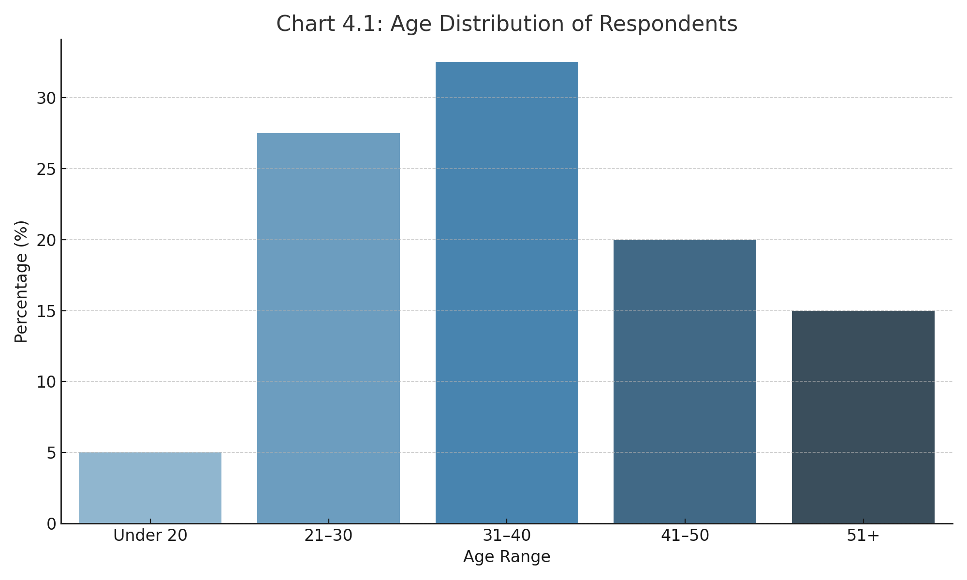

Table 4.2: Gender of Respondents
Gender | Frequency | Percentage (%)
Male | 88 | 44.0%
Female | 112 | 56.0%
Total | 200 | 100.0%

Chart 4.2 below shows the gender distribution of respondents.

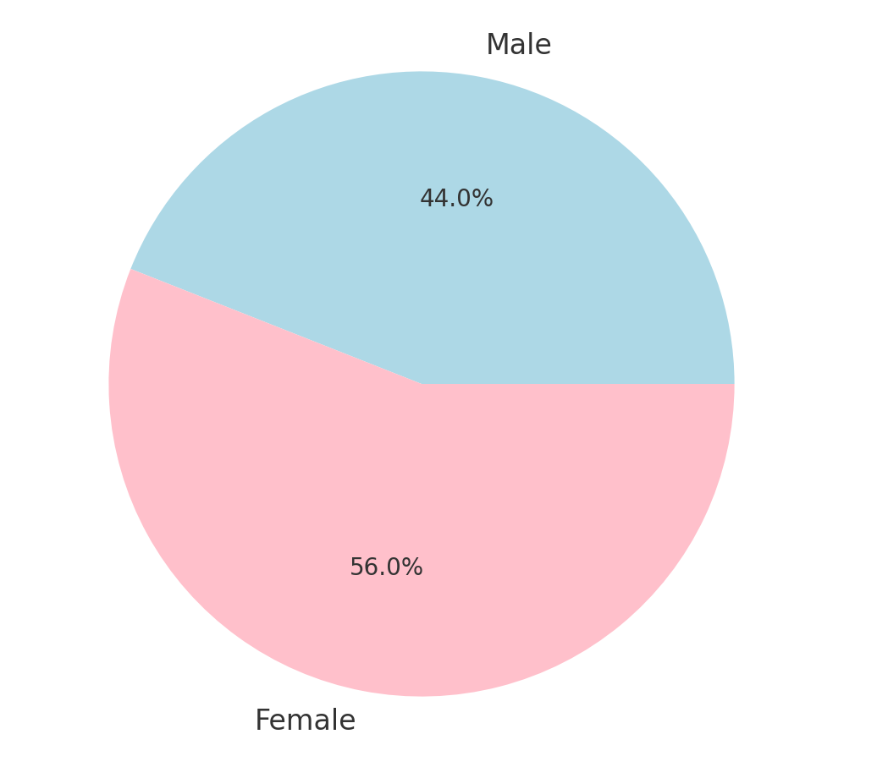

Table 4.3: Educational Level
Educational Level | Frequency | Percentage (%)
No formal education | 10 | 5.0%
Primary/1-6 years | 30 | 15.0%
Secondary/7-12 years | 60 | 30.0%
Tertiary/13years and above | 100 | 50.0%
Total | 200 | 100.0%

Chart 4.3 illustrates the educational level of respondents.

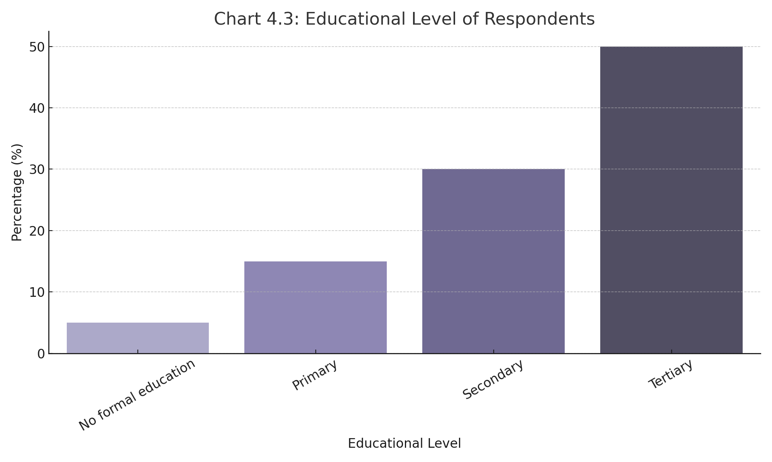

Table 4.4: Monthly Household Income
Income Range (₦) | Frequency | Percentage (%)
Below 30,000 | 35 | 17.5%
30,000 – 60,000 | 70 | 35.0%
60,001 – 100,000 | 60 | 30.0%
Above 100,000 | 35 | 17.5%
Total | 200 | 100.0%
Similar tables can be inserted for household size, marital status, and occupation.

4.2 Analysis of Research Questions
This section analyzes the core research questions to identify the behavior, patterns, and determinants of fish consumption among respondents.

Research Question 1: What are the common fish consumption behaviors among residents of Ilorin?
- Frequency of fish consumption:
  - 40% consume fish 2–3 times per week
  - 30% consume once per week
  - 20% daily
  - 10% occasionally or rarely
- Most consumed types of fish:
  - Catfish (65%)
  - Titus (55%)
  - Tilapia (48%)
  - Smoked fish (35%)
  - Others (15%)
Chart 4.4 highlights the types of fish commonly consumed in Ilorin.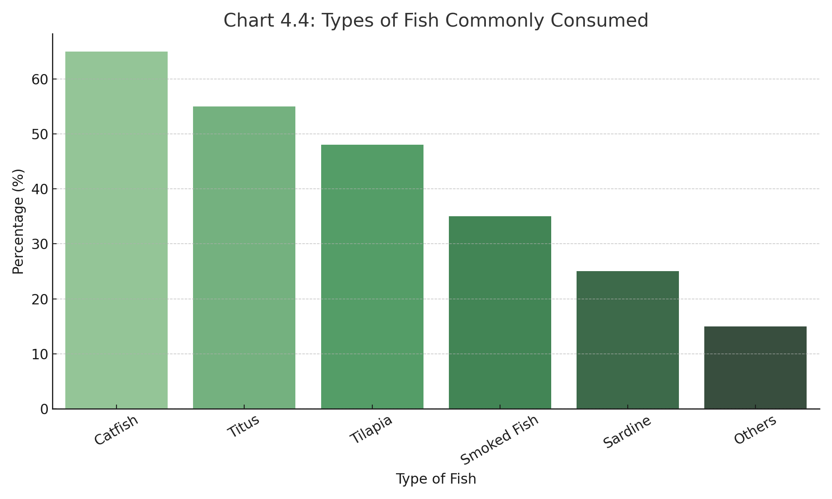
- Preferred purchase location:
  - Open markets (70%)
  - Roadside vendors (20%)
  - Supermarkets (5%)
  - Fish farms (5%)
Chart 4.5 shows the preferred place of fish purchase by respondents.
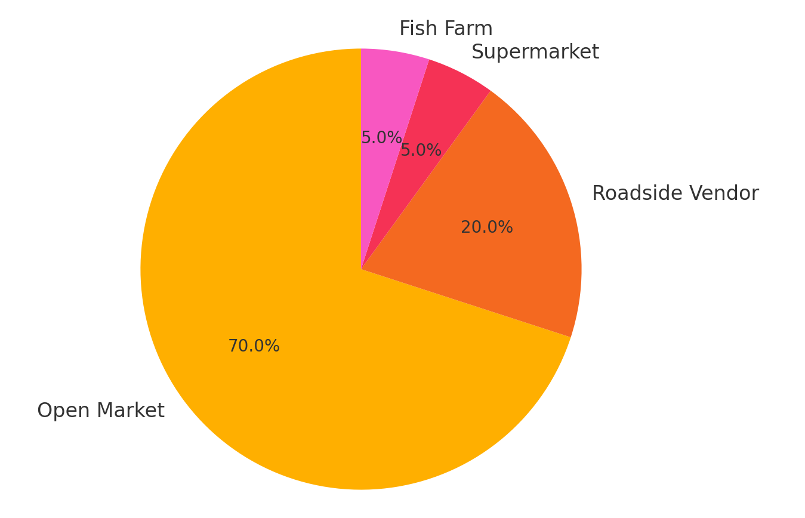

Research Question 2: What factors influence fish consumption patterns in Ilorin?
Based on the Likert-scale responses, the following determinants were identified (summarized with mean scores):
Determinant | Mean Score (Out of 5)
Income level | 4.3
Price of fish | 4.1
Availability and accessibility | 4.0
Religious or cultural preference | 3.5
Health/nutritional awareness | 4.2
Convenience of purchase | 3.8

Chart 4.6 summarizes the major determinants influencing fish consumption.

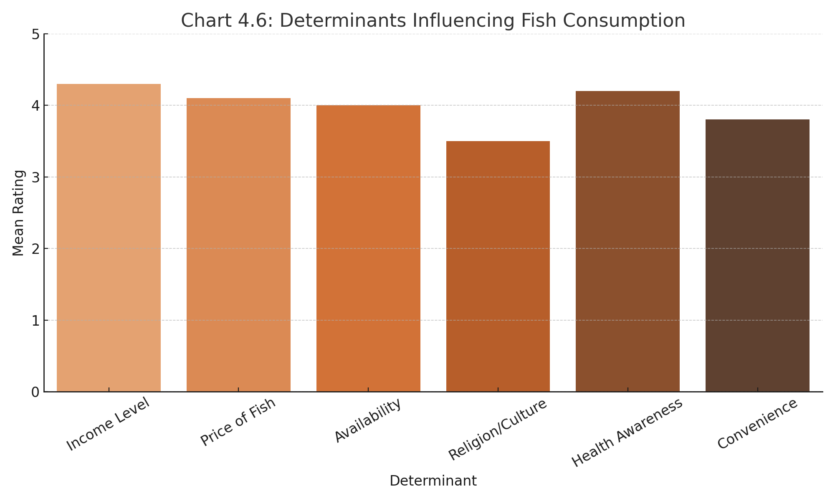

Research Question 3: Are socio-demographic factors significantly related to fish consumption frequency?
A regression analysis was performed to assess the influence of:
- Age
- Gender
- Education
- Income
- Household size
Result:
Income (p < 0.05), education (p < 0.05), and household size (p < 0.05) had significant relationships with fish consumption frequency, indicating that as income and education increase, fish consumption tends to rise.

4.3 Discussion of Findings
The findings from the study on the determinants of fish consumption behavior and patterns among residents of Ilorin, Kwara State, reveal critical insights into consumer demographics, preferences, and influencing factors that shape consumption decisions. These findings align with both theoretical expectations and trends observed in similar socio-economic and geographic contexts.

4.3.1 Demographic Influence on Fish Consumption
The demographic analysis showed that the majority of respondents were between the ages of 21–40 years, which reflects a young and economically active population. This age group is generally more health-conscious and tends to have greater exposure to nutrition education, both of which may contribute to their fish consumption preferences. The gender distribution showed a slight dominance of female respondents. Given that women are often responsible for food purchasing and preparation in many Nigerian households, their dominant representation supports the reliability of responses related to household consumption behavior. Educational level also played a significant role. Most respondents had attained at least secondary or tertiary education, suggesting a relatively literate population. Higher education often correlates with increased awareness of nutritional benefits, which may explain why health awareness ranked highly as a determinant of fish consumption. Respondents with higher education are likely more informed about the health implications of protein sources and may prefer fish over red meat due to its lower fat content and cardiovascular benefits.

4.3.2 Fish Consumption Patterns and Preferences
The pattern of fish consumption in Ilorin indicates that fish is an essential component of the household diet. A significant proportion of respondents consume fish two to three times weekly, with some doing so daily. This frequency demonstrates the cultural and nutritional value of fish in local diets. Catfish, Titus (mackerel), and tilapia were the most commonly consumed types of fish. Catfish’s popularity can be attributed to its wide availability through local fish farms, freshness, and its suitability for various Nigerian recipes. Titus, though imported and frozen, remains popular due to its taste and familiarity, especially in urban settings.
The form of fish consumed varied, with fresh and smoked fish being the most preferred. Fresh fish is favored for its perceived naturalness and taste, while smoked fish is appreciated for its flavor and preservation, especially in traditional soups and stews. Purchasing patterns showed that open markets remain the dominant source of fish, followed by roadside vendors. This reflects both price sensitivity and the informal nature of food markets in Nigeria. The low patronage of supermarkets and fish farms suggests limited affordability or access to these outlets by average households.

4.3.3 Determinants of Fish Consumption
The study identified several key determinants influencing fish consumption behavior. Income level emerged as the most significant determinant. Regression analysis confirmed that household income positively influences both the frequency and diversity of fish consumed. Households with higher income levels can afford more expensive or premium types of fish and are less affected by market price fluctuations. Conversely, lower-income households may reduce consumption or opt for cheaper alternatives like dried or frozen fish.
Price of fish was another critical factor. Respondents indicated that rising prices often compel them to reduce quantity or substitute fish with other protein sources like beans or poultry. Availability and convenience were also significant, especially during periods when certain fish types are out of season or scarce. Accessibility of open markets and vendors influences purchasing decisions, particularly for daily or impromptu purchases.
Cultural and religious factors, while not universally dominant, were influential for certain groups. For instance, some respondents avoid shellfish or specific fish types due to religious prohibitions (e.g., Islamic dietary laws) or cultural beliefs. These preferences often affect not just the type of fish consumed but also its method of preparation and source.
Health awareness scored highly as a determinant, indicating a shift in consumer attitudes toward healthier food options. Respondents acknowledged fish as a healthier alternative to red meat, citing its role in heart health, brain development, and overall wellness. This finding suggests that public health campaigns and education could further enhance fish consumption by reinforcing its nutritional value.

4.3.4 Statistical Relationships
The inferential analysis, particularly the multiple regression model, revealed that income, education, and household size significantly affect fish consumption behavior (p < 0.05). This suggests that these variables can predict consumption frequency and pattern with a high degree of reliability. Age and gender were not statistically significant in the regression model, although they provide useful descriptive context.

4.3.5 Comparison with Previous Studies
These findings are consistent with previous research conducted in other parts of Nigeria and Sub-Saharan Africa, where income, education, and market accessibility have been identified as key influencers of fish consumption. For example, studies in urban centers like Lagos and Ibadan also found that catfish and Titus are among the most consumed fish due to similar reasons—taste, affordability, and accessibility.

CHAPTER FIVE

SUMMARY, CONCLUSION AND RECOMMENDATIONS

Summary of Findings
This study investigated the determinants influencing fish consumption behavior and patterns among residents of Ilorin, Kwara State. The research was carried out using a structured questionnaire, and data were collected from 200 respondents across different socio-economic backgrounds. The study employed descriptive statistics and regression analysis to analyze responses. The majority of respondents were within the age range of 21–40 years, with a higher proportion of female respondents. Most respondents had attained at least a secondary education and earned between ₦30,000 and ₦100,000 monthly. Fish consumption was prevalent among households, with most respondents consuming fish 2–3 times weekly. Catfish, Titus (mackerel), and tilapia were the most commonly consumed fish types, with open markets being the primary source of purchase. Income level, price of fish, education, and health awareness significantly influenced fish consumption behavior. Households with higher income and education levels demonstrated more frequent and varied consumption. Religious and cultural beliefs moderately influenced the types of fish consumed. Regression analysis showed that income, education, and household size had a significant relationship with fish consumption frequency (p < 0.05). Age and gender, though descriptively relevant, were not statistically significant in predicting consumption behavior. The study provides vital insights into how economic, social, and cultural factors shape dietary choices in urban Nigerian communities.

5.2 Conclusion
Fish remains an essential component of the diet in Ilorin, Kwara State, due to its affordability (relative to meat), high nutritional value, and cultural acceptance. However, the frequency and type of fish consumed are largely dictated by a household's financial capability, education level, and accessibility to markets. The findings of this study underscore the importance of addressing economic and supply-side constraints to promote healthier food choices. It also reveals that increasing public awareness of the health benefits of fish and improving local fish production can lead to higher consumption rates. In conclusion, efforts to boost fish consumption in Ilorin and similar regions should consider a multidimensional approach, targeting affordability, accessibility, and awareness, while taking into account socio-demographic characteristics.

5.3 Recommendations
Based on the findings of this study, the following recommendations are proposed:
- Promote Local Fish Farming (Aquaculture)
Government and private stakeholders should support local fish farms through subsidies, training, and infrastructure to increase the supply of affordable, fresh fish.
- Nutrition Education and Awareness
Public health campaigns should emphasize the health benefits of fish consumption, especially for protein, brain development, and cardiovascular health.
- Price Regulation and Market Accessibility
Policies aimed at stabilizing fish prices and improving rural-urban distribution networks will enhance accessibility, especially for low-income households.
- Support for Women and Low-Income Groups
Empowering women (who often manage household food choices) through microfinance and education could improve household dietary diversity.
- Investment in Cold Chain Infrastructure
Development of storage and transportation infrastructure (cold rooms, mobile cold vans) would reduce post-harvest loss and increase availability of fish year-round.

Reference
Adwana, D., Jimjel, Z., & Oluwaseun, A. (2015). The Influence of Socio-Economic Characteristics on Consumers’ Preference on Fish Purchase In Yola North Local Government Area, Adamawa State. In International Journal of Environmental & Agriculture Research (IJOEAR) (Vol. 1, Issue 7). www.fao.org.

Akangbe, J. A., Ajiboye, G. E., & Komolafe, S. E. (2015). Effects of improved fish production technology on the output of fish farmers in Ilorin, Kwara State, Nigeria. In Ruhuna Journal Of Science (Vol. 6).

Arsil, P., Ardiansyah, & Yanto, T. (2019). Consumers’ Intention and Behaviour towards Fish Consumption: A Conceptual Framework. IOP Conference Series: Earth and Environmental Science, 255(1). https://doi.org/10.1088/1755-1315/255/1/012006 Assessment_of_Animal_Protein_Consumption. (n.d.).
Ayoade, M. A., & Sanni, A. O. (2018). Cultural beliefs and fish consumption patterns in South Western Nigeria. Journal of Food and Agriculture, 14(2), 123–130.
FAO. (2021). The state of world fisheries and aquaculture 2020: Sustainability in action. Food and Agriculture Organization of the United Nations. https://www.fao.org
Ghali-Mohammed, I., Isola, T. O., Adeyemo, I. A., Kadir, R. A., Ambali, H. M., Alhaji, N. B., & Odetokun, I. A. (2024). Food safety knowledge and attitudes among fish vendors in informal markets in Ilorin, Nigeria: A cross-sectional study. Discover Food, 4(1), Article 161. https://doi.org/10.1007/s44187-024-00232-2
Gheyas, I. A. ;, Gheyas, A. A. ;, & Sabur, S. A. (n.d.). Household consumption pattern and buying behavior for fish in an area Mymensingh, Bangladesh. http://hdl.handle.net/1834/33248

Jimoh, K. A., & Mohammed, S. T. (2015). Analysis of Fish Demand in Ilorin-West Local Government Area. In International Journal of Agriculture (Vol. 3, Issue 4). http://www.openscienceonline.com/journal/ijaff
Ogunbanwo, S. T. (2019). Determinants of fish consumption in Nigeria: A household level analysis. Nigerian Journal of Agricultural Economics, 9(1), 44–51.
Oladimeji, Y. (2017). Trend in fish production parameters in nigeria and its total estimated demand: empirical evidence from fish production. http://journals.napri.gov.ng
Olagunju, F. I., Adesiyan, I. O., & Ezekiel, A. A. (2007). Economic viability of catfish production in Oyo State, Nigeria. Journal of Human Ecology, 21(2), 121–124.
Palash, M. S. (2014). Consumption Pattern and Consumer Behaviour of Fish in Dhaka City. http://ssrn.com/abstract=1661913
Yakubu, S. (2013). Fish consumption and knowledge of fish farming among inhabitants of Dutsin-Ma Local Government Area, Katsina State, Nigeria. In Nigerian Journal of Fisheries (Vol. 10, Issue 2).

