CHAPTER ONE
- INTRODUCTION TO SOLAR SYSTEM
Solar energy is a clean and in expensive renewable power source that we can harness nearly everywhere in the world. Any point where sunlight hits the surface of the earth is a potential location to generate solar power. Renewable energy technologies generate electricity from infinite resources and since solar energy comes from the sun. Solar energy systems are among the most promising renewable energy technologies, converting sunlight into electricity or heat through various materials and mechanisms. Their global adoption has surged in recent years due to the urgent need to transition away from fossil fuels and mitigate climate change. This review explores the key components of solar systems, materials used in their construction, technological advancements, and associated challenges it represents a limitless source of power (Doe, 2024).
SOLAR POWER
It refers to converting sunlight into electricity using photovoltaic (PV) cells or through the concentration of solar energy to generate electricity. Solar power is a renewable and sustainable energy source that harnesses the vast energy emitted by the sun. The sun's energy is abundantly available worldwide, making solar power an accessible and inexhaustible resource.
Electricity is the principal force that powers modern society. It lights buildings and streets. Runs computers and telephones, drives trains and subways and operates all variety of motors and machines (Zubairu et.al,2015).
It is important to recognize that electricity is not mined or harvested, it must be manufactured. Since it is not easily stored in quantity, it must be manufactured at the time of demand. Electricity is a form of energy, but not an energy source. Different generating plants harness different energy sources to make electrical power. Some of these sources are thermal plants. Kinetic plants, geothermal power and solar photovoltaic.
Since, the demand for electricity in this area of the world is alarming, there is the need for the production or generation of constant electricity, due to the epileptic condition of electricity in the country. This gives rise to the design and construction of a 5KVA hybrid inverter. A hybrid inverter, otherwise known as a hybrid grid-tied inverter or a battery-based inverter, combines two separate components-a solar inverter and a battery inverter-into a single piece of equipment
An inverter is a critical component of any solar energy system: you need it to convert the direct current (DC) electricity generated by your solar panels into alternating current (AC) electricity for your home's appliances. (Smith, 2024).
However, when you pair your solar panel system with a hybrid inverter. a separate battery inverter isn't necessary: it can function as both an inverter for electricity from solar panels and a solar battery.
A solar hybrid inverter's main job is to convert DC power generated from the array into usable AC power. Hybrid inverters go a step further and work with batteries to store excess power as well. This type of system solves issues renewable energy variability and unreliable grid structures. Hybrid inverters are commonly used in the developing world, but they are starting to make their way into daily use in certain areas of the U.S and some part of Africa due to their ability to stabilize energy availability. Hybrid inverters work with batteries to store power which is the aim of this project. Figure 1.1 is a depiction of the basics of solar power generation (Phansopkar, 2020).
1.1 BACKGROUND OF PROJECT
Solar technologies are characterized as either passive or active depending on the way the energy captured converts & distributed. Active solar techniques use photovoltaic panel which was used. Electrical power supply from renewable sources is advantageous as the increasing electrical demand is a scientific contribution to the peak demand on the grid. As individuals and companies generate their power through renewable energy, the stress on the grid is reduced. The solar resource is so massive that it dwarfs every other resource on the planet. The DC electricity from the panels passes through DC distribution network to an inverter, which converts the DC electricity into AC for Single phase operation by using state of the art technology with MOSFET methodology and fed through A/C distribution system linked to the consumer load.
Most of the electrical appliances operate with an AC power supply of 220V and at 50Hz frequency. But in case of power failure, AC power cannot be stored due to repetitive change in polarity of electric current. The batteries can be charged through a solar panel using a charge controller and AC power supply from the utility which makes it hybrid powered.
An inverter is designed and obtainable in order to provide an AC output from a DC source. The AC could be at any required voltage and frequency with the use of appropriate transformers, switching and control circuits. It maintains a continuous supply of electric power to connected equipment or load by supplying power from a separate source, like battery, when utility power is not available. It is inserted between the source of power and the load is protecting. (Seger, B.2016)

1.1.1 PROJECT AND THE SITUATION OF ENERGY IN NIGERIA
Nigeria, the most populous country in Africa, is facing a serious energy crisis despite its vast natural resources. The national electricity grid is outdated and unreliable, supplying less than 5,000 megawatts of power to over 220 million people. This is far below the estimated demand, which exceeds 30,000 megawatts. As a result, millions of Nigerians either lack access to electricity entirely or experience frequent power outages, especially in rural areas.
To cope with the energy shortfall, many households and businesses rely on petrol or diesel generators. While these provide temporary relief, they are expensive to operate and contribute significantly to environmental pollution and carbon emissions. In this context, renewable energy—especially solar power—has become an essential alternative for providing clean, reliable, and affordable electricity.
Nigeria receives high levels of solar radiation, between 4.0 and 7.0 kilowatt-hours per square meter per day, and enjoys over 2,000 hours of sunshine each year. This gives the country enormous potential for solar energy development. Unlike large power plants that require connection to the national grid, solar energy systems can be installed directly in homes, schools, hospitals, and businesses—even in the most remote villages.
Promoting solar energy is also critical for achieving national and international development goals. It aligns with Nigeria’s commitments to reducing greenhouse gas emissions under the Paris Agreement and supports the United Nations Sustainable Development Goal 7: access to affordable, reliable, sustainable, and modern energy for all.
In summary, solar energy offers Nigeria a sustainable way to expand electricity access, reduce dependence on fossil fuels, create jobs, and improve living standards. It is not just an option, but a necessity for the country’s future development. (Franklin, E.2017)

1.2. HISTORY OF SOLAR ENERGY
Solar energy has long supported humanity, with at least two forms, passive solar energy and biomass fuel use. Thus solar energy has been our partner throughout the progress of mankind. The growth of agriculture in the sunny “cradle of civilization” played a critical role in the development of civilization. People have used the sun for drying crops, bricks, etc. since prehistoric times. The first known crop drying installation has been found in France and dates from around 8000 BC. There is evidence from around the world of dryer development in many civilizations and this relatively simple solar technology continues to change lives and economies for the better, even today, in remote locations all over the planet.
The US Department of Energy timeline provides a series of important historical milestones for solar energy. Butti and Perlin describe that his- tory, beginning with ancient classical Greek and Roman over-consumption of biomass and including the passive solar dwelling and city design. In the case of the Roman Empire, the architect Vitruvius recommended different passive solar building designs for different latitudes, outlining principles that are still applied today. Solar access rights for buildings were included in the Justinian Code of law in the sixth century AD. Both ancient Greek and Chinese cultures developed concentrating solar reflectors to generate high temperature ignition for religious, civil and military purposes. “Burning mirrors” have since then been designed and used by many cultures through the centuries. Glazed heat traps in buildings were developed by the Romans and the idea was revived much later in Europe as the conservatory or greenhouse for horticulture of plants outside their natural ranges or out of season.
The commercial availability of the Climax Solar Water Heater at the end of the 19th century in the USA initiated the mass availability of afford- able solar domestic heating of water that has continued to drive the development of flat plate and evacuated tube heaters ever since. The harnessing of the sun for mechanical power began at least as early as the 1st century AD with solar water siphons built in Alexandria. The invention of the first solar steam engine has been attributed to Augustin Mooched in France in 1866. He went on to develop solar cooking ovens and solar thermoelectric generators. The early 20th century saw an explosion of applications for solar engines for water pumping and other remote energy applications in the American west and elsewhere.
Three main forms of concentrator have been developed to generate either high temperatures in solar thermal collectors or high conversion efficiencies in photovoltaic collectors: parabolic troughs that focus light onto a line, parabolic dishes that focus light onto a point and arrays of heliostats focusing onto a central receiver mounted on a tower. Concentrating solar power has been developed significantly since the oil shocks of the 1970s, principally in the US, Spain, Australia, and Israel. “Solar One”, a 10 MW central-receiver demonstration project which opened in the US in 1982, was the first of several large solar concentrators constructed in the modern phase of growth to establish feasibility. It generated steam to drive a turbine for electricity generation. Solar One was expanded and upgraded to Solar Two in 1995, including molten salt thermal energy storage. (Richardson, L. 2019)
There are several good histories documenting the beginnings of photo- voltaic, among them that by Crossly et al. The French scientist Edmond Becquerel discovered the photovoltaic effect in an experimental photoelectric- trochemical setup in 1839 At that time it was not possible to distinguish between chemical and photoelectric effects and the explanation of these experiments was originally in terms of chemistry. It was not until 1914 that Goldmann and Brodsky made a photoelectric interpretation. In the 1870s, William Gryllis Adams and R.E. Day investigated “whether it would be possible to start a current in the selenium merely by the action of light ”. The result was positive, “clearly proving that by the action of light alone we could start and maintain an electrical current in the selenium”. They did not, however, understand the processes at work in their devices, explaining the voltage as being due to extra light-induced crystallization in the material. Charles Fritts foresaw great potential for solar power from selenium photovoltaics. There were at least four American manufacturers of selenium photovoltaic cells by 1949. Copper–cuprous oxide cells were also under investigation since 1917 and there was intense rivalry between groups in Germany and USA through the 1920s, when copper- based cells were commercialized. The photovoltaic effect was found in germanium in 1944 in USA but all of these materials were eclipsed by the success of silicon as a photovoltaic material. Russel Ohl of Bell Laboratories filed patents in 1941 that were granted in 1946 and 1948 for the p–n junction photovoltaic effect in silicon and markets gradually grew for terrestrial and space applications. Silicon underpinned the development of serious and significant application of photovoltaic but cells based on alternative materials, cadmium–telluride, copper–indium–gallium–dieseline and III-V semiconductors (i.e. compounds of elements from Groups III and V of the Periodic Table), have also been developed and commercialized in the late 20th century (Weis, C. 2013)

1.2.1 AREA OF APPLICATIONS OF SOLAR ENERGY
Methods to collect solar energy and convert it to useful forms range from the simple and traditional to modern and highly sophisticated. Outputs include low grade heat, high temperature industrial process heat, hydrogen, synthesis gas, synthetic hydrocarbons and other chemical energy carriers such as ammonia and metals, and intermittent or dispatch able electricity. These technologies are all at different developmental stages and associated cost of energy. We introduce a range of them in this section before they are treated in detail in the following chapters. (Franklin, E. 2013)
1.2.2. ADVANTAGES OF HYBRID SOLAR SYSTEM
Hybrid inverters have many advantages -here are some of the top ones to consider as you're comparing inverter solutions:
Resiliency
A common misconception about solar is that if you install a system. You’ll always have power during outages. In most cases, this is not true: traditional grid-tied solar inverters automatically shut off during power outages for safety purposes, cutting off power generation from your solar panel system.
Monitoring
With a hybrid inverter, all of your solar electricity-whether being sent to the grid. Self-consumed on your property or being stored in your battery-is converted through one component. This allows for "centralized monitoring." which means you can monitor both your solar panel system and battery performance through one platform.
Retrofit battery storage installations
One of the biggest benefits of a hybrid inverter is that it combines the functionality of two separate pieces of equipment into one. This can mean a cashier installation process for your solar installer. Depending on the prices of the individual components and the cost of labor, you may save money by installing a hybrid inverter from the get-go as opposed to paying for both a solar inverter and a battery-specific in crier separately. (Hongtao Xu, 2017)
1.3 TYPES SOLAR POWER SYSTEMS:
There are basically three kinds of solar power systems through which electricity can be generated. These include:

The on-grid solar also known as grid-tie or grid feed solar system consists of the solar panels, the inverter, meter and the power/utility grid. The electrical energy which is obtained through solar cell is direct current. An alternating current is used for powering most of the appliances. The alternating current is obtained through an inverter which flows through the electric meter that feeds electricity into devices.
If the solar system produces more than required energy which is needed, the excess electricity is sent back to the electricity, and can get paid feed in traffic (Fit).

During night or when the solar power system is not a proper condition the electricity can be used from the power grid.

DISADVANTAGE OF ON-GRID SOLAR:
The disadvantage of on-grid solar is that during certain climatic conditions or when there is a problem with the electricity grid, we cannot store the electricity for immediate use which becomes a drawback for this system.
HYBRID SOLAR
Hybrid solar is the amalgamation of on grid and off grid solar power systems. The storage of power through batteries for use at any time, without consuming it from the electricity grid makes this system convenient to use and reduces the electricity cost.
Working of Hybrid solar power system:
During day, the sunlight is converted into electricity. Any excess amount will be stored in the batteries which is similar to off grid system. Incase if there is excess power stored it is fed back into the electricity grid similar to the on grid solar.
When there is neither support of solar energy nor the electricity grid, power can be used from the batteries. Similarly, when there is no sufficient battery backup left and no solar power an uninterrupted flow of electricity can be obtained from the electricity grid and the battery can also be charged.
OFF-GRID SOLAR
In off-grid solar power system also known as stand-alone power system has battery storage instead of the connectivity to the electricity gnd. The off grid solar power minimally uses the electricity that comes from the grid. It consists of solar cell, inverter and a battery bank if required a generator can also be used for backup of power.
Working of off grid solar power system:
The conversion of sun light into electricity is done through the solar cells and this direct current is converted into alternating current using an inverter.
After supplying the electricity to the devices if there is any excess amount of electricity that is left out, it is stored in the batteries which act as a backup when there is no support of solar energy.
But at times when the requirement of electricity is more and there is no sufficient solar power nor there is no adequate power to supply from the battery, it becomes difficult to perform the necessary requirements. This system is more advantageous for people living in remote areas where there is no accessibility to the utility grid.
So, to overcome the disadvantages of the on grid and off grid solar power systems one can inculcate a hybrid solar power system instead of these two power generating techniques. (Phansopkar, 2020).
1.3.2 ADVANTAGES OF SOLAR POWER SYSTEM AND LIMITATION
The more we can capture the benefits of solar energy, the less we will rely on fossil fuels. Adding a solar energy system to your home allows you to tap into these solar energy advantages:
1.3.2.1 LIMITATION OF THE PROJECT
The disadvantages of solar energy are becoming fewer as the industry advances and grows. Creating economies of scale. Technological advances are helping solar go mainstream. Here are how the disadvantages of solar energy and the pros and cons stack up.
The high initial costs of installing panels the most commonly cited solar energy disadvantage, cost, is declining as the industry expands. The initial cost to buy and install the equipment is not cheap. Still, if cost is an issue. Leasing options may reduce the amount of your initial outlay. If you do choose to buy. You will need to live in your home for several years before the system pays for itself. It's a long-term investment better suited to property owners than renters.
Solar energy storage is expensive of the disadvantages of solar energy, the temporary decline in energy production during bad weather has been a major issue. Days with low solar energy, however, are having less of an effect due to advances in battery technology. Old technology for storing solar energy. Like lead acid batteries is being replaced by alternatives. Lithium-ion batteries offer greater power at a lower cost. Nickel-based batteries have an extremely long life. New technologies, like flow batteries, promise scale and durable power storage
Solar doesn't work for every roof type
Not every room will work well with solar panels. Orientation matters. If your roof doesn't face the san, you won't be able to capture enough solar energy. Roofs that angle into the sun tend to work better than flat roof. (Goldmann, 2000)
1.3.3. COMPONENTS OF SOLAR POWER SYSTEM
The main solar components that come with every solar power system or solar panel kit are:
a. Solar panels
b. Inverters
c. Rack (mounting system)
d. Batteries and battery cage.

1.4 COMPONENTS OF HYBRID SOLAR POWER SYSTEM
- Solar Panels
- Charge Controller
- Battery Bank
- Inverter
- Backup Power Source (Generator or Grid)
- System Controller / Energy Management Unit
- Mounting Structure
- Wiring and Electrical Protection Devices (Cables, Breakers, Fuses, etc.)

- Solar Panels: These are installed on the roof or open ground to capture sunlight and convert it into DC electricity.
- Charge Controller: The DC power from the panels flows into the charge controller, which regulates the voltage and current going into the battery bank to prevent overcharging or damage.
- Battery Bank: Stores the excess electricity produced during the day. This stored power can be used at night or during power outages.
- Inverter: Converts the DC electricity from the solar panels or batteries into AC electricity, which is what household appliances use.
- Energy Management System (EMS): This controls how power flows between the solar system, batteries, grid, and backup generator. It decides when to charge batteries, when to use solar, and when to switch to backup power.
- Backup Power Source: When solar power and stored battery power are not enough, the system can switch to a backup source—either the national grid or a generator.
- Mounting Structure: Supports the solar panels, ensuring they are positioned at the right angle for maximum sunlight exposure.
- Wiring and Protection Devices: Cables connect all the components. Safety devices like circuit breakers and fuses protect the system from overloads or faults. (Richardson, L. 2019)
1.5. Working principle of Hybrid solar power system:
During day, the sunlight is converted into electricity. Any excess amount will be stored in the batteries which is similar to off grid system. Incase if there is excess power stored it is fed back into the electricity grid similar to the on grid solar.
When there is neither support of solar energy nor the electricity grid, power can be used from the batteries. Similarly, when there is no sufficient battery backup left and no solar power an uninterrupted flow of electricity can be obtained from the electricity grid and the battery can also be charged.
1.6 Working Principle of Solar Panels
In the previous discussion it has been established that there is abundance of solar energy available to be harvested. A brief discussion of what PV cells is also being covered. It is necessary that we understand how these cells generate electricity so that we can design systems that can be in tandem with these basic concepts. The following discussion will explain how the cells generate electricity.
Principle: Sun is a powerhouse of energy and this energy moves around in the form of electromagnetic radiations. These radiations are of several types such as light, radio waves, etc. depending upon the wavelength of the radiations emitted. A very less percentage of sun's radiations reach the earth's atmosphere in the form of visible light. Solar cells use this visible light to make electrons. Different wavelength of light is used by different solar cells.
Solar cells are made up of semiconductor materials, such as silicon, which is used to produce electricity. The electricity is conducted as a stream of tiny particles called electrons and the stream is called electric current. Two main types of electric currents are; DC (direct current) which the flow of current is in the same direction while in AC (Alternating current) it may reverse the direction of current. A typical solar cell has two layers of silicon, which is n-type at the top and p-type at the bottom. When sunlight strikes the solar cell, the electrons are absorbed by silicon, they flow between n and p-layers to produce electric current and the current leaves the cell through the metal contact. The electricity generated is of AC type. (Johnson, F. 2024).

1.7 SOLAR PV POWER GENERATOR
Solar electricity, also known as Photovoltaic technology, is the process through which sunlight is directly converted to electricity. Solar as a source of electric power has been put to use for decades in rarely mentioned areas like space programs. In the last decade, the advances in solar PV technology has meant the emergence of a stronger electricity power market which has provided viable alternatives in powering both grid and off grid homes. Despite the existence today of various types of Solar electric systems, three components that make up each of these individual systems are at the core of their operating systems; these are namely - the module, inverter and battery (depending on the type). The solar modules convert sunlight into electricity, the inverters convert the same electricity (DC) from the modules into Alternating Current (AC) making it safe for domestic and household use. The batteries store up excess electricity produced by the solar PV system. Other components which are equally important include equipment such as circuit breakers and wirings. With the advance of Solar PV technology, sunlight converting modules are now built into glass roofs, walls, car roof tops.

A process called Net Metering ensures additional electric power produced by the PV system (which is in excess of that being used by the building and stored in the battery), can be fed back into the grid, allowing the customer to pay only for the net electricity consumed - which is the power consumed by the consumer from the grid minus ( - ) the power generated by their solar PV system. With the metering system, consumers are able to realize good value for the electricity produced by their PV systems. Solar PV systems, as will be further expatiated, differ slightly with specific regards to the presence or not of battery storages within the system. Grid connected (On grid) PV systems do not require batteries, save for some in which they are used for backup power in emergency situations. The Off grid and the Hybrid PV systems both have the use of batteries considering their peculiar nature and the alternative power option they are conceptualized and built to provide. The Solar Energy Systems, come in various configurations and is basically a choice between staying completely Off grid or On grid.
The figures below are illustrative of the three common Solar Photovoltaic (PV) power systems.

On-Grid Solar System
Also known as the Grid Tied system, is always connected to the grid as the name (grid tied) suggests. The excess energy that the solar panels produces is fed to the grid. During periods in the day when there is no sunlight, and the domestic load consumption goes up, it draws from the grid's electricity. For the Grid tied system, the use of a battery to store electrical energy is unnecessary as the grid serves as its means of storage - this has its benefits and disadvantages. The On Grid Solar system is relatively cheaper than the Off-grid or Hybrid systems. Its disadvantage lies in the fact that electricity cannot be stored within the system, hence, if the grid is down at anytime, there will be no alternate source of electricity.
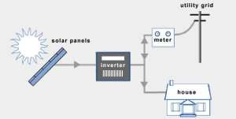
Figure 1.7.1: On-Grid Solar System,
Figure 1.7 further illustrates the lack of battery within the On Grid Solar System, the arrow heads also indicate the working pattern as the sun rays from the solar panel are immediately fed to the inverter as DC, converted to AC and supplied to the house, the excess load of which is sent to the grid, having been measured through the meter.
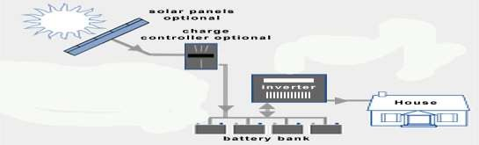
Off-Grid Solar System: The Off grid solar system is also referred to as the Stand Alone Solar System. As the name implies, they are not connected to the grid, the solar panels produce electricity which is stored in the battery banks. Night time, the stored power is used to provide electricity. The Off grid solar system is popularly mostly used in remote areas with little to no grid connection or power supply. It's advantages lies in the feeling of energy self-sufficiency it gives, and the fact that grid failures and power down times won't affect system power supply. Its disadvantage lies in the additional cost that come with battery bank or generator installations, and the increased need for delicate care and maintenance services.
Figure 1.7.2: Off-grid Solar System, [20]

The Off grid Solar System as explained and illustrated above in Figure 3, is stand-alone completely separate and independent of the grid. It comprises the solar panel, a charge controller, inverter and then the house receiving the electricity supply. The solar panel receives the sun rays and sends to the battery for storage, there is an optional charge controller which serves the purpose of limiting the rate at which electric current is added or drawn from the battery. The inverter converts to AC current ready for residential supply and use. (Richardson, L. 2015)
1.8 ENERGY DEMAND AND COMPENSATION IN SOLAR POWER SYSTEM

1. Energy Demand
Energy demand refers to the total amount of electrical power required by a household, business, or facility to operate its appliances, equipment, and systems. This includes:
- Lighting
- Refrigeration and cooling (fans, AC)
- Cooking appliances
- Electronics (TVs, computers, phones)
- Industrial or commercial machinery (in businesses or factories)
The total demand is usually measured in kilowatt-hours (kWh) per day or per month. Energy demand varies by location, time of day, season, and usage patterns.

2. Energy Compensation in a Solar System
Since solar energy is available only during daylight hours, and not always at peak levels due to weather or shading, a solar power system must compensate for demand in various ways:

a. Real-Time Solar Generation
- During sunny periods, the solar panels produce electricity to meet immediate demand.
- If generation is more than demand, the excess is sent to batteries or the grid (if net metering is available).

b. Battery Storage
- At night or during cloudy periods, stored energy from the battery bank is used to compensate for demand when solar panels aren’t generating power.

c. Backup Power (Grid or Generator)
- When both solar and battery power are insufficient (e.g., prolonged rain or high energy usage), the system automatically switches to the grid or a diesel/petrol generator.
- This ensures continuous power supply, maintaining balance between demand and supply. (Smith, 2021)
1.9. THE AIM AND OBJECTIVES OF THE PROJECT
1.9.1. AIM OF SOLAR POWER SYSTEMS: The aim of this project is to provide an uninterrupted power supply to domestic appliances and lighting where there is public mains supply failure and also generates a stable source of power supply in I.O.T. Offices.
1.9.2 OBJECTIVES OF SOLAR POWER SYSTEMS
a. To ensure that there is continuous power supply
b. To reduce reliance on fossil fuels and decrease carbon emission
c. Lowering electricity costs in the long run1
1.10. PROBLEM STATEMENT
If there is one factor that has perpetually maintained the status of Nigeria as a less developed country, it is the electrical sector. To date, many households and industrial businesses even in schools and hospitals cannot be guaranteed 24 hours supply of electricity from the national grid. Rather. Nigeria has continued to rely on electricity generators for their power supply. Fuel marketers are taking a significant portion of households, institutions of learning. And business income to supply and noise pollution has become an integral part of living for many Nigerians with unimaginable consequences to health. So, there is a need to design and construct the solar panel inverter to reduce cost and eliminate noise environmental pollution associated with running the generator.
1.11 SCOPE OF THE PROJECT

The scope of this project is typically based on the specific objectives which are checking the problem of the unstable power supply in the school, purchasing a solar panel and battery, studying the major electronic component to be used in the inverter circuit, coupling the inverter, testing it with the batteries and fully installing

CHAPTER TWO
2.0 LITERATURE REVIEW
2.1 LITERATURE REVIEW ON SOLAR SYSTEMS AND MATERIALS
Solar energy harvesting technologies for PV self-powered applications, This paper gives detail information on solar energy harvesting by PV technology. In housing, health care, transport, sport more demand of electricity which is fulfill by conventional energy source and which make pollution, so we can replace this system by PV system. This paper gives you where we can use this system also gives design of self-powered system, various components of PV system. It gives you maximum power point tracking (MPPT) techniques and power managements systems. This paper gives you analysis of solar radiation, system design for PV applications and hybrid energy system design like hybrid PV – wind system and hybrid PV – wave system. (Daning Hao et.al 2022)
A study of renewable energy and solar panel literature through bibliometric positioning during three decades, This paper gives collected data of renewable energy and solar panel by using bibliometric technique. The research was carried out using bibliometric techniques. Data analysis as well as visualization utilizing VOS Viewer program and the Scopus function for analyzes search results. The study reveals that National University of Singapore and India Studies were the most active affiliated institutions scientists and nation in renewable energy and solar panel literature. In renewable energy and solar panel literature, the Engineering and Energy Procedia were the most areas of study and dissemination sources. (Mochamad Choifin et.al 2021)
Solar energy technology, In this paper focus on solar energy, improvement in the technique of solar energy. This paper gives weakness in solar energy technique and new technique of solar energy harness i.e. solar cell and its material. It discussed about increase in the efficiency of power generation with solar energy (Sumedha R.G. Weliwaththage et.al 2020)
A review paper on solar energy system, This paper gives information of solar energy conversion in to the electrical energy. Many solar cell combination form solar panel which is connected to each other. Solar energy falls on solar panel and converts in to the electrical energy. It gives calculation of finding the size of solar panel, load on battery and inverter and installation of solar thermal system. (Deepak Purohit et.al 2020)
Awareness and use of solar energy as alternative power sources for ICT facilities in Nigerian university libraries and information centers, In this paper get information and use of solar energy as renewable energy source for ICT facilities in Nigerian library and information centers. Survey method was used for the study and questionnaire were designed and in survey found that the people who participated in survey having good knowledge about the solar energy. (Samuel et.al 2019)
Solar energy: potential and future prospects, in this paper advantage and disadvantage of solar energy technologies is discussed also technical problems in a research of alternative energy sources. They disused solar energy technology with respect to potential, capacity, prospects, limitations and future policies. This assists you to understand on how much count on solar energy to meet the upcoming energy demand. There are few drawbacks of solar energy technology but this is the energy source will meet the future demand of energy. (Ehsanul Kabir et.al 2018)
Concentrated solar power in India: current status, challenges and future outlook, In this paper growth of CSP is explained with future challenges. Current status of CSP in India and PTC technology is the most used and mature technology in the world. Also this technology is not getting investor support due to low confidence and low availability of skilled labour. In India most of the components of CSP is imported due to the lack of indigenous manufacturing. CSP plant has initial cost as compare to PV plant. In CSP large energy is rejected in condenser so we can utilize this energy to run the some other processes then efficiency will get increase. (Suhas bannur 2018)
A review of the solar energy situation in Rwanda and Uganda, in this paper authors give information about the solar energy development and future of this energy in Uganda and Rwanda. In these two countries solar energy is playing big role in social development also getting solar energy market from beginning of 80’s. In these two countries development of solar energy getting more support from investors, donors and government lastly will get information of future and challenges of solar energy in these two countries. (Jean Baptiste et.al 2018)
Empirical analysis of factors influencing price of solar modules, in this paper authors give overview of solar module price this price is depend on wage, oil price, exchange rate and interest rate. He also explained price reduction mechanism and R&D expenditure in the solar industry. This paper gives you information about the relationship between oil price and renewable energy and framework of solar module pricing model. (Farhard Taghizadeh-Hesary 2018)

2.1 LITERATURE REVIEW OF HYBRID INVERTERS

1. HYBRIDS SOLAR/ WIND SYSTEM
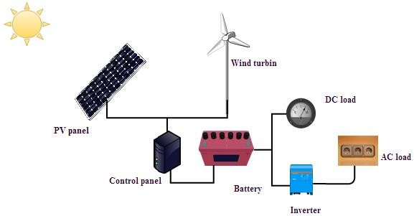
Hybrid solar Photovoltaic/Wind system is a parallel hybrid system that combined the PV array that depends on the abundant solar radiation which is not the same intensity during the same day and wind turbine that depend on the abundant of wind source. Thus, generate power that could meet the load consumption when the solar radiation is available, the hand when the sun goes down the wind turbine could cover power shorting when the wind source, Adopted both of wind and solar energy resources as one system (hybrid) by using both wind energy and solar energy like a combined system to the resolved issue of variability and optimization the production of the system by converting wind and solar energy into electricity that directly storage by batteries to meet the required loads Thus, to build a hybrid system it is very important to study the technical abilities of the local consumers for knowledge of the advances that include this sector. In 2012, a study had conducted to determine the performance and compatibility of the hybrid PV/wind system on the remote area power system (RAPS) around the year. Therefore, data analysis funded that for each hour around the year both wind and solar energy resources one of them completes the other with meet the specific loads without the need for additional batteries for charging compared with converting and storing for separate PV system. Therefore, increasing utilizing hybrid systems like solar and wind systems that considered as promising energy resources that use for residential and industrial applications. Although lowering usable in the rural areas due to the reduction of technical capacity such as break-even distance and low population size. In another hand, hybrid solar/wind systems are a little complicated regarding to their components (non-linear properties) and other variables parameters among both of configurations to reach optimization technique for hybrid solar/wind system with the assistance of computer software which plays an important role to design safe energy systems.

Figure 2.1 PV/ Wind Hybrid System

Both systems that combined use batteries as a back-up option for the stored energy generated in the case of one of the sources (solar radiation or wind) is not sufficiently available. However, in case of the solar hybrid PV/wind that connected by the grid, there is no effect on the stability of the system and in case of off-grid hybrid PV/wind system It is possible to reach stability in the system by increasing the number of batteries, it is necessary at design the hybrid system to specify equipment's with taking in consideration the capacity maintain the reliability of system when meeting the loads with reducing of system capital cost.

2.2. HYBRID SOLAR/GEOTHERMAL SYSTEM
Maximizing the benefit of renewable energy sources which has rapid growth in the recent period, several hybrid systems can be used in different applications areas like hybrid solar/geothermal systems to obtain thermal and electric energy. Hybrid PV/geothermal system has two configurations one of them is building- integrated PV/thermal, the other is earth-air heat exchanger both of them work as a heating and cooling modes adding to the electric energy production to achieve the efficient benefit of solar/geothermal energy as shown in Fig below. According to the thermodynamic performances of hybrid PV/geothermal, the results show improvement by performances of the hybrid system and achieve appropriate thermodynamic with improving the efficiency of the hybrid system. Hybrid solar/geothermal systems have promising features and it is applicable spicily at the regions that have high heat flux with surface radiation which leads to combined solar energy with geothermal is possible.
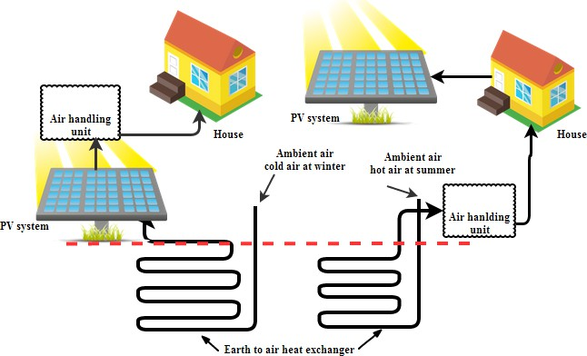

Figure 2.2. Hybrid solar/geothermal systems for heating and cooling mode

Hybrid solar/geothermal systems have proved it is a suited choice to processing the lowering of the capacity factor with the instability of the grid which leads to the fluctuated power supply. Combined solar with geothermal energy will contribute to compensation the lower capacity factor of solar energy by geothermal and improve the configurations of hybrid during heating geothermal fluid that has a low temperature of solar energy. Generally, geothermal energy has a temperature between moderate-low to raising the temperature of geothermal fluids it is important to make the efficiency of geothermal generation is better by combined with solar energy and to solve the instability of solar system by using geothermal fluids that gain high temperature as a storage system which leads to obtained mutually beneficial due to combined with promising renewable energy. The results of many studies show that hybrid solar/geothermal has a great performance comparing with separating systems and the efficiency of the system depended on the improvement of hybrid system components. However, as there are advantages of hybrid solar/geothermal systems there are disadvantages represented by high initial cost adding to the complexity in the components of hybrid systems. One of the suggested solutions to meeting the shorting in energy supply is geothermal energy that represents by stored energy that proposed as a combined concentrated solar array with geothermal depending on stored energy under the earth (water or steam) which effected by high pressure and temperature. In this respect, the productive lifetime of hybrid concentrated solar arrays/geothermal energy will extension and by reheating the fluid during reinjection in the well which leads to increase the thermal energy of concentrated solar collectors thus could use this system as alone grid with providing energy security when the energy consumption be high. (Goldmann, 2019)

2.3 .LITERATURE REVIEW ON SOLAR GENERATORS
Review of Related Literature Ali et al.(2015) presented the design and sizing of stand-alone solar power system which involves designing, selecting and calculating the various component ratings that should be employed during the system implementation. A stand-alone photovoltaic system which would power a medium energy-consumption residence was designed. The major parameters factored into the design were the orientation of the panels, days of autonomy, the best tilt angle for the solar panels and the likes. The system so designed is both robust and efficient. Abdelnaser, Kamaruzzaman, Ruslan & Ali (2016) in their paper showed the feasibility of powering remote desert area using PV power generation system. This is against the backdrop that it is not economically viable to supply the energy need of these remote areas from the conventional grid or from fossil fuel as the cost of the later is enormous. The authors designed a design of a stand-alone PV system to power a greenhouse in remote desert area. The energy model is based on Watt-hour demand. Based on the load estimation found to be 61,894kWh/ day, a stand-alone PV generator of 15.6kW capacity was implemented and tested. Morakinyo, Adu &Atayero (2014) proposed a solar powered street light with automatic switching mechanism. The proposed system would automatically turn on the luminaires at night and turn them off at dawn. At the off time of the system, the battery bank would charge via charge controller; the stored battery energy will deliver power to the luminaries via the inverter and thus the cycle continues. The proposed scheme was implemented and result showed a reliable, energy efficient power source for proper street illumination at night with little human supervision and maintenance. Sayed Salem Basyoni, Sayed Salem Basyoni & Al-Dhlan(2017) designed and implemented a small scale photo voltaic system (PV system) which would provide electric power for a living room, kitchen and bathroom. The load requirement was based on power saving mode rather than the conventional lighting. This option ensured that the overall energy demand on the PV system was minimal as well as the cost. The PV system was tested and it worked efficiently. Units of the Solar Generator This solar generator is made up of two units of 150 W PV panels, two units of 12 V, 40 AH storage battery bank, a charge controller and 1.5 KVA inverter unit. The PV panels draw sunlight energy and convert it to direct current electricity; the dc current charges the storage battery bankvia a charge controller (Nwankwo & Azubogu, 2016). The stored energy in the batteries can either converted into ac sine wave for feeding ac appliances. All the units of the solar generator are housed in a metallic casing equipped with rollers for easy movement from one place to another. To power dc loads, all dc loads are directly connected to the dc rail of the charge controller for 12V dc system. According to (SMA Solar Technology, 2009), apure DC coupled system hasall loads and generators coupled exclusively at the battery voltage level, but the system under consideration is a hybrid system. The battery bank feeds the inverter with dc current which the later converts into 240 V, 50 Hz ac signal using pulse width modulation technique. The ac output of the inverter supplies current to ac appliances as depicted in figure below (Ali et al. 2015)

2.4 LITERATURE REVIEW OF APPLICATION SOLAR POWER SYSTEMS
The integration of solar power systems into energy projects has gained significant momentum over the past few decades, largely due to the growing emphasis on sustainability, renewable energy utilization, and reduction of greenhouse gas emissions. Solar power, derived from harnessing energy from the sun through photovoltaic (PV) panels or solar thermal collectors, has become an essential component of energy infrastructure in both developed and developing countries. Numerous studies have addressed the practical application of solar energy systems in residential, commercial, agricultural, and industrial settings, evaluating their effectiveness, performance metrics, and alignment with international and national project standards.
In residential applications, solar power systems are primarily deployed to supplement grid electricity and reduce dependency on non-renewable energy sources. Several researchers, including Luthander et al. (2015), have discussed the increasing popularity of rooftop PV installations, which conform to standardized installation procedures such as the International Electrotechnical Commission (IEC) standards (e.g., IEC 61730 for PV module safety and IEC 61215 for design qualification). These standards help ensure system reliability, durability, and safety, particularly in urban environments. Furthermore, project guidelines often require feasibility assessments, financial analysis, and regulatory compliance reviews before implementation. Studies show that compliance with these standards not only enhances the performance and lifespan of the systems but also simplifies integration with existing grid systems through net metering and feed-in tariffs. (Luthander et al. 2015),
In the commercial and industrial sectors, solar power systems are typically deployed on a larger scale, necessitating more complex project planning and execution protocols. The literature highlights the importance of standards such as ISO 50001 for energy management, which guides the integration of renewable energy into organizational energy frameworks. Yoon et al. (2016) and Sinha & Chandel (2014) examined case studies where industrial facilities reduced their energy bills and carbon footprints significantly by installing solar PV systems designed according to national electrical codes (e.g., NEC 690 in the U.S.). The authors emphasize the need for adherence to engineering standards related to electrical safety, voltage regulation, and structural integrity when implementing large-scale systems. Commercial solar projects also involve detailed project documentation, including risk assessments, system sizing models, performance simulations, and maintenance planning, all of which must align with engineering and quality management standards such as ISO 9001. (Yoon et al. 2016 and Sinha & Chandel 2014)
Off-grid and rural electrification projects also represent a significant area of application for solar power systems, particularly in developing regions. According to Palit and Chaurey (2011), decentralized solar energy solutions such as Solar Home Systems (SHS) and solar mini-grids are effective in addressing energy poverty. These systems must be designed in accordance with project standards that ensure sustainability, cost-efficiency, and community involvement. Organizations such as the World Bank and the International Renewable Energy Agency (IRENA) have published technical guidelines and performance standards for off-grid solar projects, emphasizing the importance of battery management, system modularity, and end-user training. The success of these projects often depends on detailed community needs assessments, clear maintenance protocols, and the inclusion of monitoring and evaluation components in the project cycle.( Palit and Chaurey 2011)

2.5 LITERATURE REVIEW OF SOLAR POWER SYSTEM BREED
The integration of solar power systems within Building Renewable Energy Efficient Design (BREED) frameworks is a growing area of interest in sustainable construction and energy engineering. BREED emphasizes the combination of architectural efficiency and renewable energy technologies to reduce the environmental impact of buildings. Among the renewable sources, solar energy—especially photovoltaic (PV) and solar thermal systems—has emerged as a cornerstone of BREED applications due to its scalability, availability, and rapidly declining costs. highlights how building-integrated solar technologies, such as photovoltaic panels embedded into façades and rooftops, allow buildings not only to consume less energy but also to produce clean electricity, thereby shifting toward nearly zero-energy or net-positive buildings. (Jelle et al. 2012)
The successful application of solar power in BREED projects is closely linked to adherence to international and regional project standards. These standards ensure that solar technologies are safe, reliable, and compatible with other building systems. For instance, the IEC 61215 standard for PV module performance and IEC 61730 for safety are commonly referenced in BREED-based solar installations. Additionally, building codes such as the International Energy Conservation Code (IECC) and standards like ISO 50001 for energy management help structure energy efficiency practices during both design and operation. According to Peng et al. (2011), compliance with these standards ensures not only the functional integration of solar systems but also enhances long-term building performance and return on investment.
In terms of project planning and design, literature emphasizes the importance of integrated energy modeling and simulation tools. Tools like EnergyPlus, PVsyst, and BIM (Building Information Modeling) are frequently used to simulate building energy behavior and optimize solar system placement and sizing. These simulations help architects and engineers design BREED-compliant buildings that meet both energy targets and regulatory criteria. The use of such tools aligns with green building certifications including LEED, BREEAM, and Green Star, all of which increasingly incorporate renewable energy targets and efficiency standards in their evaluation frameworks. (Hernandez and Kenny 2010),
Furthermore, economic and policy-related project standards are essential in ensuring the viability of solar-powered BREED designs. Literature explores how financial incentives, such as tax credits, net metering, and renewable energy subsidies, can support widespread adoption. In this context, national energy strategies and local urban development plans often integrate BREED principles into broader climate and energy policies, creating a supportive framework for solar adoption. (Zinzi and Agnoli 2012)
In conclusion, the literature affirms that the integration of solar power systems within BREED frameworks is not only technologically feasible but also increasingly necessary in the context of global energy efficiency goals. Compliance with technical, environmental, and economic standards throughout the project lifecycle ensures that BREED projects deliver reliable performance, long-term sustainability, and measurable energy savings. Continued innovation in solar technologies and standardization processes will further enhance the impact of BREED in transforming the built environment.

CHAPTER THREE
3.0 MATERIALS AND METHOD
3.1 MATERIALS FOR SOLAR ENERGY
Fossil fuel storages are lowering now and cost is increases due to continuously increases in demand and low supply. Current Global Energy Scenario says that increasing electricity energy demand due to increasing Population. And fossil fuel is main contributor for pollution and Global warming, and then every country is doing effort to switch over the new renewable energy technology. When solar system concept first comes in market there is huge large cost than conventional energy sources. As a technology developed new material such as nano materials are introduced now they have saving in cost and production is increased. At the different location different season then sunlight is not equal to all places. Then it is placed as per geographical location and solar radiation data. Solar P.V materials and blocks is converted sunlight into electrical energy by photoelectric effect, the efficiency of solar cell is depends on the semiconductor material band gap and structure of PV cell. When the incident of photon energy is greater than band gap energy of semiconductor then the photons absorbed increases the energy of the valence band electrons and causes the jump of electron in to the conduction bond. As temperature increases of PV cells then decreases in band gap and reduced efficiency of panel. (Smith, 2019).
A. Basic Working of Solar Photovoltaic Cell
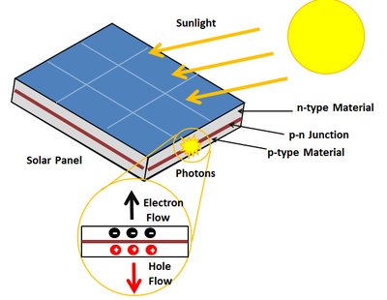
When solar cell is get contact in the solar rays the P-N junction, light photon easily through very thin P type layer the light energy in the form of photons supply enough energy to the junction to create number of electron hole pairs. And energy is transfer to load through connections.
Figure 3.1 Working of solar photovoltaic cell

B. Classifications of Solar PV Materials
The main factors impacts the choice of 90% of the world’s photo voltaic solar cell are smaller variation of silicon purity, cost, space and efficiency. Detailed classification of solar materials.
1) Crystalline Silicon solar Cell: crystalline silicon solar cells are most commonly used in solar panels. Its energy conversion efficiencies are over 25%. There are also two types:
a) Mono-crystalline Silicon Solar Cells (mono-si): It is also called as single crystal silicon cell. Czocharalaski process is used to manufacture the mono crystalline solar cells.
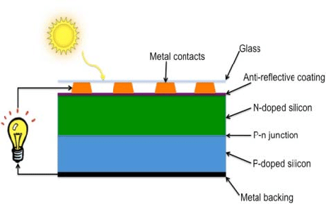
Figure 3.1.1 Crystalline structure
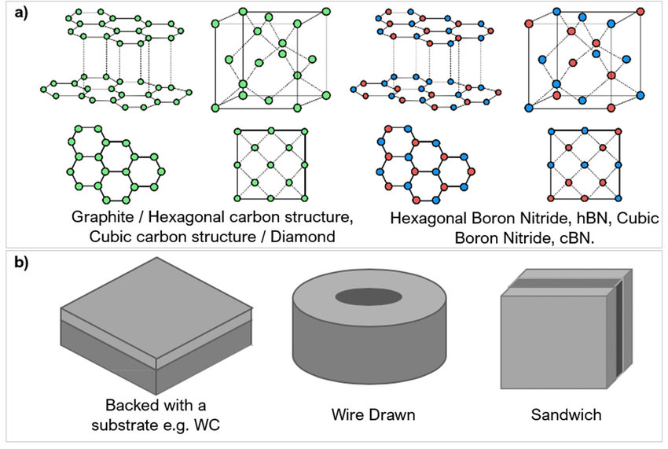
Efficiency of mono si solar cells are 21% now it’s improved to 26.7% due to the development of technology. Mono si cells are more performance giving at worm weather.
b) Polycrystalline Silicon Cell: Polycrystalline silicon is simple and cheaper to manufacture and it is made from raw silicon it is melted and poured into square mound. It is less efficient than mono crystalline. These serials are composition of many crystalline of different size and shapes. It includes ceramic, rock, and ice and its efficiency is 13-16% because of low quality of silicon material used.
Figure 3.1.1 Structure of Polycrystalline material
2) Thin Film Solar Cells (TF): Thin film solar cells also called as second generation solar cell. It made by one or more layers of glass, plastic or metal. film thickness varies from nanometres to tens of micrometers it is cheaper than crystalline based solar cells but more space required and efficiency of thin film solar cell is 21.7% to 23.4%
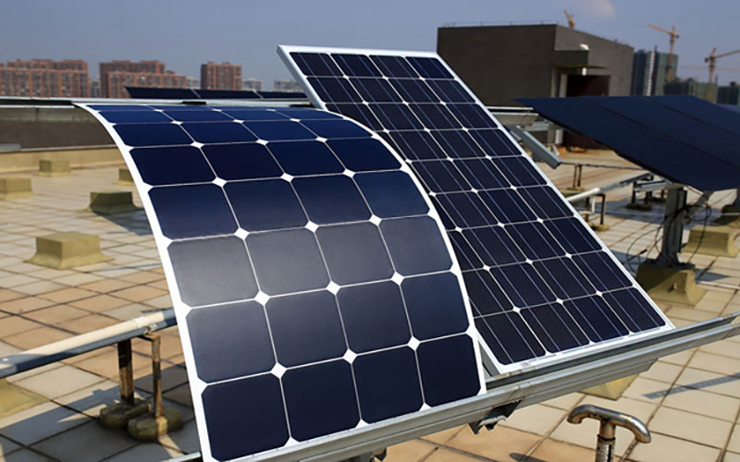
Figure 3.1.2 Thin film
3) Amorphous Silicon (a-si): It is a non crystalline allotropic form of silicon and good developed technology now and it is used in small scale applications especially as the power source for electronic calculators. For last 15 years it is used in electricity
generation, and its efficiency is 8.8 to 10.2%.
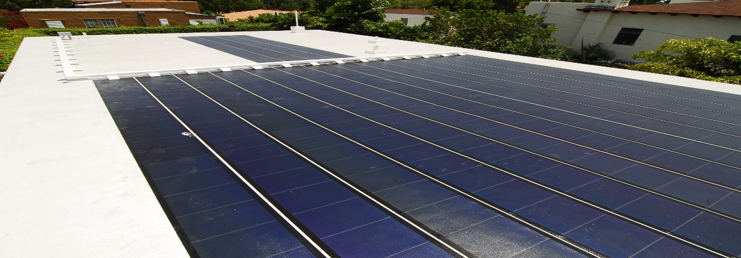
Figure 3.1.3 Application of Amorphous silicon cell
4) Cadmium Telluride solar cell (CdTe): Cadmium telluride PV is the only thin film technology with low cost than conventional solar cells, and it is made up of crystalline silicon. It is used in world’s largest PV stations such as TOPAZ solar farm. And its efficiency is 16.1 to 22.1%.
5) Copper Indium Gallium Selenide Solar cell (CIGS): It is made by deposing a thin layer of copper, indium, gallium and selenium on the electrodes on the front and back for the purpose of collect current. And efficiency is 10-12% now due to modern technology it is improved to 22.8%.
6) Organic Polymer Solar Cells: Recent developments in solar photovoltaic technology polymer material is developed. It is flexible and it includes organic cells also called as plastic solar cells. It is light in weight and also used for windows, walls, roofs. The problem is that is low efficiency, low lifetime compared with other types of solar cells. as it is manufactured high quantity it’s cost is reduced. Its efficiency is only 10% via tandem structure, but in 2018 record breaking efficiency noted is 17.3% via tandom structure.
7) Nano Crystal Solar Cell: The nano crystal are made up of silicon, CdTe, and CIGS materials and it’s efficiency possibility up to 40-60% this is now modern technology in solar cells.
C. Solar PV Material and Efficiency
Sr. No | Material | Efficiency in %
1 | Crystalline | 25
2 | Mono-crystalline | 26.7
3 | Polycrystalline | 13-16
4 | Thin film | 21.7-23.4
5 | Amorphous silicon | 8.8-10.2
6 | Cadmium telluride | 22.2
7 | Copper indium gallium selenide | 22.8
8 | Organic polymer | 10-17.3
9 | Nano crystal solar cell | 40-60
Comparison of material and efficiency
ENVIRONMENTAL IMPACTS
Fossil fuels are increase amount of carbon in to atmosphere and also increases noise, pollution and increases the global worming for this solution is use renewable energy sources, use of solar energy reduced carbon foot print and other harmful emission to environment there is no moving part then less maintenance and no noise during the operation. Use of solar energy for better sustainable green energy for future.
3.1.1. DESCRIPTION OF HYBRID INVERTER COMPONENTS AND LAYOUT
A hybrid solar inverter combines solar, battery, and grid systems to ensure efficient energy management. Below is a detailed description of its components and typical layout.

COMPONENTS OF A HYBRID INVERTER
a. Power Electronics Components
1. MPPT Controller (Maximum Power Point Tracking):
- Optimizes the voltage and current from the solar panels to maximize power output.
- Key component for increasing system efficiency.

2. Inverter Circuit (DC to AC Converter):
- Converts DC power from solar panels or batteries to AC power for home appliances or grid connection.
- Uses IGBTs (Insulated Gate Bipolar Transistors) or MOSFETs for switching.

3. Rectifier Circuit (AC to DC Converter):
- Converts grid power to DC for charging batteries.

4. DC-DC Converter:
- Steps up or steps down the voltage as required for batteries or loads.

Battery Management System (BMS):
- Ensures the safe operation of batteries by monitoring charge/discharge cycles, temperature, and voltage.
- Protects against overcharging, deep discharge, and short circuits.

Microcontroller/Processor Unit:
- Central control system for coordinating the operation of solar input, battery charging, and grid management.
- Executes algorithms for MPPT, load priority, and energy flow.

Filters (LC or LCL):
- Reduces harmonic distortion in the AC output, ensuring clean and stable power supply.

Transformer (Optional):
- Provides galvanic isolation for safety and adjusts voltage levels if needed.

Cooling System:
- Includes heat sinks, temperature sensors, and fans to dissipate heat from power electronics.
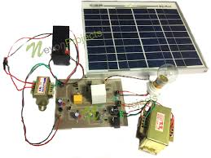
Fig. 3.1.1 Power Electronics Components of solar power system
2. Auxiliary Components
i. Display and User Interface:
- LCD or LED screen for monitoring system parameters (e.g., voltage, current, and load).
ii. Connectivity Modules:
- Wi-Fi, Bluetooth, RS485, and CAN bus modules for remote monitoring and smart home integration.
iii. Protections:
- Fuses: Protect against overcurrent.
- Surge Arresters: Protect against voltage spikes.
- Relay Switches: Ensure safe isolation during faults.
iv. Relay and Contactor Units:
- Manage automatic switching between solar, battery, and grid power.
v. Chassis/Enclosure:
- Provides physical protection and ensures compliance with IP65 or IP67 standards for outdoor installations.

3. Layout of a Hybrid Solar Inverter
Front Panel Layout:
- Display Screen: Positioned centrally for real-time data display.
- LED Indicators: Show operational status (Solar, Battery, Grid, Fault).
- Control Buttons: Power ON/OFF and menu navigation.
Internal Layout:
a. Upper Section:
- Heat Dissipation Area: Heat sinks and cooling fans for temperature management.

b. Middle Section:
- Power Electronics Board: Contains MPPT, inverter circuits, and control modules.
- Filter Modules: Located close to the AC output section to ensure clean power delivery.

c. Lower Section:
- Battery Terminals: Positioned for direct connection to the battery bank.
- Grid Connection Terminals: Located for incoming AC power.

d. Side Panel:
- Communication Ports: RS485, CAN, and USB ports for external connections.

e. Rear Panel:
- Input Terminals:
- DC input terminals for solar panel connection.
- AC input/output terminals for grid and load connections.
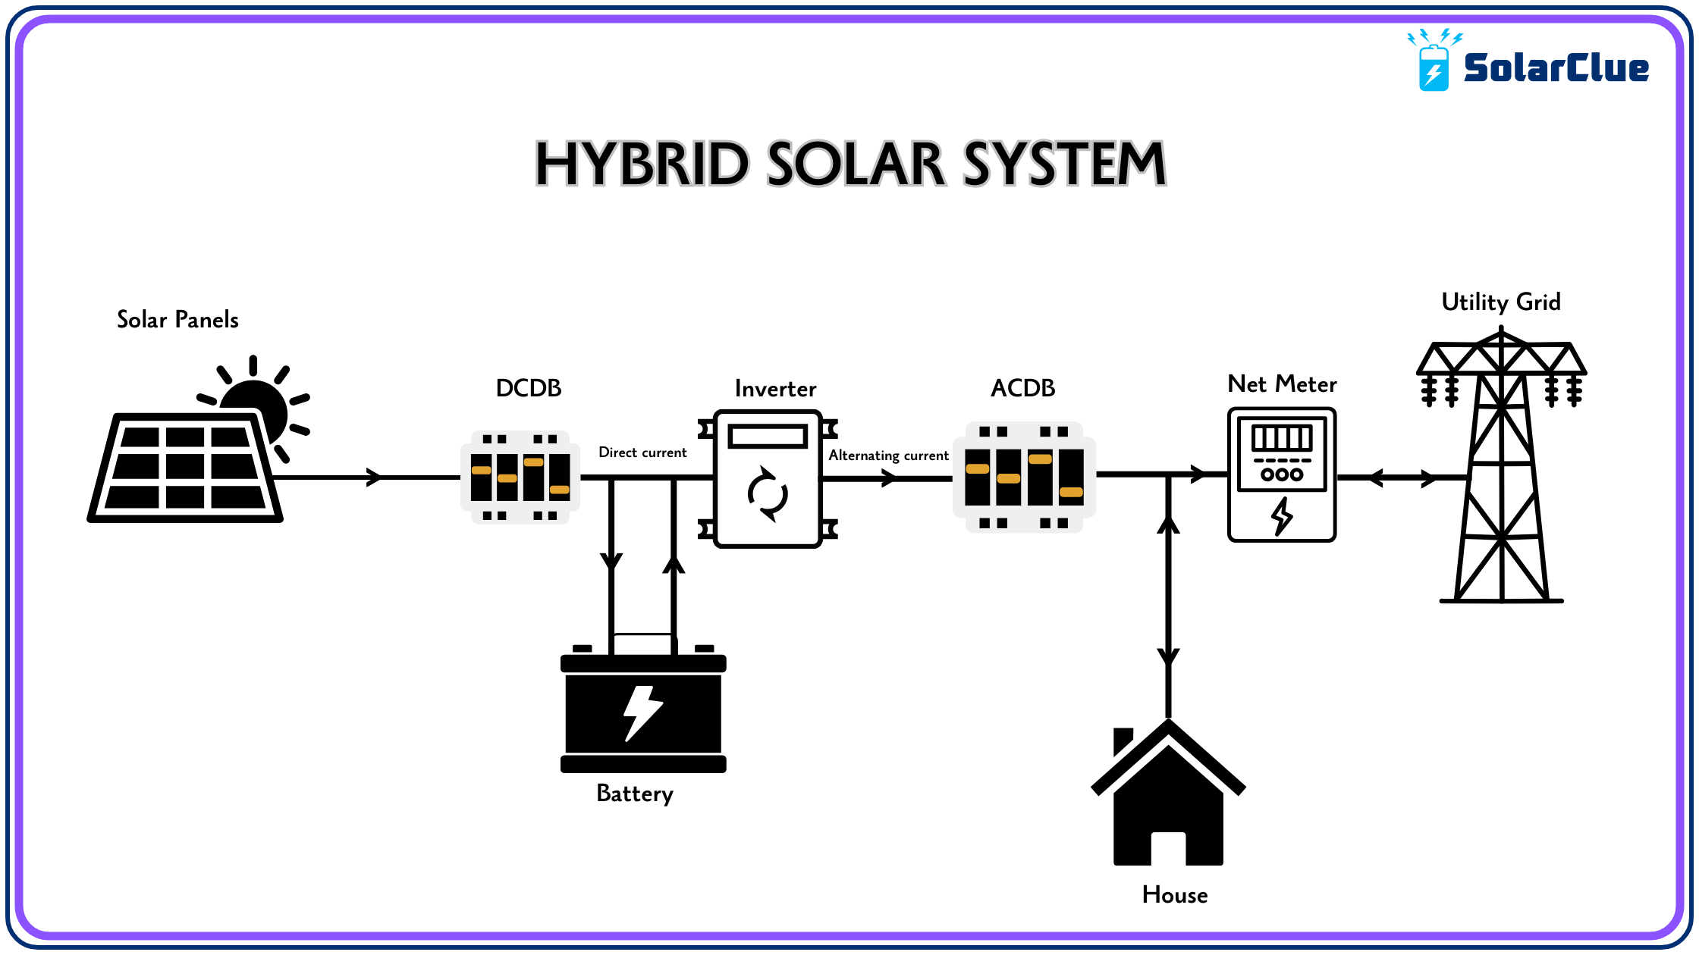
Fig. 3.1.1.3 Layout of a Hybrid Solar Inverter

3.1.2. DESIGN CONSIDERATION FOR CONSTRUCTING SOLAR HYBRID INVERTER
Designing a solar hybrid inverter in accordance with project standards requires a multidisciplinary approach that ensures efficiency, safety, scalability, and regulatory compliance. A solar hybrid inverter must manage multiple power sources—solar photovoltaic (PV), battery storage, and the utility grid—while delivering uninterrupted power to the load. The following considerations, based on standard engineering and project development protocols, guide the design and construction of a reliable solar hybrid inverter system. . (Jelle et al. 2018)

1. System Sizing and Load Analysis
According to standard project planning procedures (e.g., IEEE 1013 and IEC 62509), the initial step involves assessing the total load demand and energy consumption profiles of the intended site. This includes:
- Peak load estimation for sizing the inverter's capacity.
- Daily energy consumption (kWh) to size the battery bank and PV array.
- Load types (resistive, inductive, sensitive electronics) to design for startup surges and power quality.
The inverter should be sized to handle at least 125% of the peak load to ensure resilience and operational stability under varying conditions.

2. PV Array Integration
The inverter must be compatible with the solar array configuration. Project standards (IEC 61215 and IEC 61730) recommend:
- MPPT (Maximum Power Point Tracking) for efficient solar energy harvesting.
- Voltage and current compatibility between PV strings and inverter input ratings.
- Input protection using fuses, surge arresters, and isolation switches as per IEC 60364.

3. Battery Storage Design
Battery integration is a core feature of hybrid inverters. Design must follow standards such as IEEE 1561 and IEC 62619:
- Battery chemistry support (Lead-acid, Lithium-ion, etc.) with Battery Management System (BMS) compatibility.
- Voltage range and capacity planning based on autonomy needs (e.g., 24/48V systems).
- Charge/discharge control via MPPT or PWM charge controllers integrated into the inverter.
- Thermal protection and current limiting to prevent battery degradation and safety hazards.

4. Grid Synchronization and Safety
Hybrid inverters must safely interact with the utility grid. Standards such as IEEE 1547 and IEC 62116 dictate:
- Anti-islanding protection to prevent back-feeding during outages.
- Grid voltage and frequency compliance to synchronize correctly with local utility parameters.
- Net metering and export limiting configurations as required by regulatory authorities.
The inverter must allow flexible priority settings (solar > battery > grid or grid > battery > solar) through programmable logic.

5. Power Conversion Efficiency and Quality
Project efficiency standards (IEC 61683) demand high conversion efficiency (>90%) to minimize energy losses. Key considerations include:
- Use of high-quality semiconductors (IGBTs or MOSFETs).
- Pure sine wave output for sensitive loads.
- Low Total Harmonic Distortion (THD) to ensure compliance with power quality regulations (IEEE 519).

6. Control, Monitoring, and Communication
According to modern project execution standards, smart control and monitoring features are essential:
- Microcontroller/DSP-based logic to manage source switching, battery status, and fault detection.
- LCD/LED display panels for user interface.
- Remote monitoring capability via Wi-Fi, GSM, or IoT systems.
- Data logging for energy performance audits.

7. Safety, Enclosure, and Environmental Protection
The system must comply with safety and environmental standards such as IEC 62109 and IP rating specifications:
- Short-circuit, over-voltage, and over-temperature protections.
- Isolation between AC and DC circuits to avoid electrical hazards.
- IP54 or higher-rated enclosures for dust and water protection.
- Corrosion-resistant material (e.g., anodized aluminum) for outdoor units.

8. Standards and Compliance
To ensure legal and operational integrity, the hybrid inverter must adhere to the following:
- IEC 62109-1/2 – Safety of power converters.
- IEC 62040 – Uninterruptible power systems (for off-grid capability).
- ISO 50001 – Energy management integration.
Power Supply
Transformer
Oscillator
Bulk
Converter
Output
Drivers

Power
Amplifier
Charge
Controller

Fig 3.1.2: Block Diagram of 5KVA Hybrid Inverter System
3.1.3 DESIGN SPECIFICATION OF HYBRID SOLAR INVERTER
The design specification outlines the technical and operational requirements for a hybrid solar inverter. These specifications ensure compatibility, efficiency, and reliability for managing solar, grid, and battery energy sources
1. Electrical Specifications:
a. Input Specifications:
- Solar Input (DC):
- Maximum DC Input Voltage: 550V
- MPPT Voltage Range: 150V–500V
- Maximum Input Current: 20A

- Battery Input (DC):
- Nominal Voltage: 48V
- Voltage Range: 40V–60V
- Maximum Charge/Discharge Current: 50A
- Grid Input (AC):
- Voltage Range: 230V ± 10%
- Frequency: 50Hz/60Hz

b. Output Specifications:
- AC Output:
- Output Voltage: 230V ± 5%
- Output Frequency: 50Hz/60Hz ± 0.5Hz
- Power Output: 5 kW (scalable up to 10 kW for higher models)
- Power Factor: 0.99 (adjustable)

c. Efficiency:
- Maximum Efficiency: ≥ 98%
- European Efficiency: ≥ 97%

2. Functional Specifications:
a. System Capabilities:
1. Grid-Tie Operation: Supports feeding excess solar power back to the grid.

2. Off-Grid Operation: Provides uninterrupted power during grid outages using batteries.

3. Hybrid Mode: Prioritizes solar power, supports batteries, and switches to the grid only when necessary.

b. Battery Management System (BMS):
- Support for Lithium-ion, LiFePO4, and Lead-acid batteries.
- Real-time battery health monitoring.
- Overcharge, over-discharge, and short-circuit protection.
c. Maximum Power Point Tracking (MPPT):
- Dual MPPT for multiple solar panel arrays.
- Efficiency: ≥ 99.5%

d. Inverter Topology:
- Full-bridge or H-bridge with advanced Pulse Width Modulation (PWM) techniques.

e. Overload and Protection:
- Overload Protection: Up to 150% for 60 seconds.
- Surge Protection: Up to 6000V.
- Thermal Protection: Automatic shutdown at >75°C.

3. Mechanical Specifications:
a. Dimensions:
- Compact design: 450mm x 400mm x 150mm

b. Weight:
- Approx. 15-25 kg (depending on model and features)

c. Cooling System:
- Forced air cooling with temperature-controlled fans.

d. Enclosure:
- IP65-rated dustproof and waterproof casing for outdoor installation.

4. User Interface and Communication:
a. Display and Monitoring:
- LCD/TFT touchscreen for real-time status updates (voltage, current, battery state, etc.).
- LED indicators for system status (grid, battery, solar).

b. Connectivity:
- Wi-Fi and Bluetooth for remote monitoring via mobile app.
- RS485/Modbus and CAN bus for integration with smart home systems.

c. Control Features:
- Priority setting: Solar > Battery > Grid or customizable.
- Time-of-use settings for load optimization.

5. Environmental Specifications:
- Operating Temperature: -10°C to 55°C
- Humidity: 0–95% non-condensing
- Altitude: Up to 2000m without derating

6. Standards and Certifications:
- Compliance with IEC 62109 (Safety of power converters).
- Certification: CE, UL 1741, ISO 9001.

7. Expandability and Scalability:
- Parallel operation supported for capacity expansion.
- Compatible with solar systems ranging from 3 kW to 10 kW.
3.2 DESIGN CALCLULATION FOR SOLAR POWER SYSTEM
3.2.1 Formula relating watts, ampere, and volts
$Watts=Volts x Ampere$
$Ampere= \frac{Watts}{Volts}$
$Power=VI$

Taking into consideration 5KVA, the battery amperage 230Ah, and voltage 12V.
When connected in series, 12V + 12V + 12V +12V= 48V
Therefore; Power = 48V x 230Ah = 11,040 Watts

- Calculating for Inverter Battery back-up time
$Backup Time \left(in hours\right)= \frac{\left(Battery Capacity in Ah\right) x Input Voltage (V)}{Total Load (in watts)}$
Taking the inputs for 5KVA into consideration, calculating the total load, like;
- 1 computer set = 150 Watts
- 11 Laptops = 11 x 70 = 770 Watts
- Fans = 19 x 120 = 2280 Watts
- Lighting points = 22 x 5 = 110 watts
- 1000 watts for the four classrooms
So, the total load in this case is 150 + 770 + 2280 + 110 + 1000= 4310 Watts
When six batteries are connected in series, 12V x 4 = 48V
Backup Time (in hours) = $\frac{230 x 48}{4,310}=\frac{11,040}{4,310}=2.56 Hours$

- Solar Panel Calculation
Given Specification for 5KVA:
Imp = 5.98A
Vmp = 54.7V

Series Connection for fourteen solar panels of 320 Watts capacity:
Vmp = 54.7V x 14 = 765.8V
Imp = 5.98A
Power = Vmp x Imp = 765.8V x 5.98A = 4,579.48 Watts

Parallel Connection for fourteen solar panels of 320 Watts capacity:
Vmp = 54.7V
Imp = 5.98A x 14 = 83.72A
Power = Vmp x Imp = 54.7V x 11.96A = 4,579.48 Watts

- Solar Panel to Battery Bank Calculation
$I=\frac{P}{V}$
For 5KVA:
$I=\frac{Total Pv array wattage}{System nominal voltage}=\frac{4,579.48 }{48V}=95.41A$
Given Specifications:
Current: $95.41$A
Voltage: 48V

- Battery Bank to Inverter calculation
For 5KVA:
$I=\frac{Inverter wattage}{System nominal voltage}=\frac{5000W}{48V}=104.17A$
Given Specifications:
Current: 104.17A
Voltage: 48V

- Inverter to AC Load calculation
For 5KVA:
$I=\frac{Inverter wattage}{Distribution Utility AC Voltage}=\frac{5000W}{230VAC}=22.73A$
Given Specifications:
Current: 21.73A
Voltage: 230Vac

    - The Load Calculations
The power rating of all the loads in the offices were properly checked and tabulated before making a choice of the inverter. Thus, the load calculations were based solely on data comparisons from the previous work of literature, there are fifteen lecturer offices in consideration, the HOD’s office which is made up of three rooms, the library, two PG classes and four classrooms. However, the four classrooms were separated with a 1000 watts circuit breaker, so there were no load calculations for it.

Table Energy Audit for the Department of Mechanical Engineering. Appliances’ ratings are shown below;
Appliances’ | Units | Power | Total Power
Computer Set | 1 | 150 watts | 150 watts
Laptops | 11 | 70 watts | 770 watts
Fans | 19 | 120 watts | 2280 watts
Lighting Points | 22 | 5 watts | 110 watts
 |  |  | 3,310 watts

    - SYSTEM PERFORMANCE PARAMETERS
This constitutes the performance parameters of the respective components of the solar panel system for the 5KVA Hybrid Inverter System.

    - Solar Panel Parameters
- Nominal Maximum Power (Pmax): 320W
- Optimum Operating Voltage (Vmp): 54.7V
- Optimum Operating Current (Imp): 5.98A
- Open Circuit Voltage (Voc): 64.9V
- Short Circuit Current (Isc): 6.46A
- Maximum Temperature: 80℃
- Application Class: Class A
- Cell Technology: Monocrystalline
- Standard Test Conditions:
- AM = 1.5
- IRRADIANCE = ${1000W/m}^{2}$
- Temp = 25℃
3.4. ASSEMBLING AND TESTING OF SOLAR HYBRID INVERTER
The solar hybrid inverter is a crucial component in modern solar energy systems, responsible for converting DC power from solar panels and batteries into usable AC power, while intelligently managing grid and storage integration. The assembling and testing process of this inverter must adhere strictly to project standards, ensuring optimal performance, safety, and compliance with international and national regulations.
ASSEMBLING OF SOLAR HYBRID INVERTER
COMPONENT VERIFICATION
All components must be verified for quality, compatibility, and certification before integration. Key components include:

- Solar charge controller (MPPT or PWM)
- DC-DC converter
- DC-AC inverter module
- Battery bank and BMS
- Microcontroller or DSP board
- Input/output terminals
- Cooling system (heat sinks or fans)
- Enclosure (IP54 or higher)

Each part must meet the relevant standards such as IEC 62109-1/2, IEC 62509, and IEEE 1013.

MECHANICAL ASSEMBLY
- Mount components securely within the enclosure using non-conductive mounting brackets.
- Route internal wiring through protective conduits and use cable ties to organize circuits.
- Ensure ventilation pathways are clear and fans or heat sinks are properly aligned for thermal regulation.

ELECTRICAL INTEGRATION
- Connect solar input to MPPT input terminals with proper overcurrent protection (fuses or breakers).
- Interface battery bank with inverter terminals through a Battery Management System (BMS).
- Connect AC output to load and grid via isolators and relays
- Ensure wiring complies with IEC 60364, with correct cable sizing, insulation, and color coding.
- Install surge protection, grounding systems, and safety interlocks per NEC and IEC guidelines.

TESTING OF SOLAR HYBRID INVERTER
Testing must validate the inverter’s functionality, safety, and reliability before commissioning.

PRE-OPERATIONAL CHECKS
- Visual Inspection: Confirm correct component placement, polarity, and cable connections.
- Continuity Test: Use a multimeter to check for open or short circuits in DC and AC paths.
- Insulation Resistance Test: Conduct with a megohmmeter to ensure safety insulation is intact between live and grounded parts.
FUNCTIONAL TESTING
- Testing should follow IEC 61683, IEC 62116, and IEEE 1547 standards:
- Solar Input Test: Apply simulated or real solar input and observe MPPT function under varying irradiance.
- Battery Operation Test: Verify charge/discharge cycles, current limits, and BMS communication.
- Inverter Output Test: Connect AC loads and verify output waveform, voltage regulation, and frequency accuracy.
- Grid Synchronization Test: Ensure the inverter synchronizes with the utility grid and supports export/import functions.

SAFETY AND PROTECTION TESTS
- Overload and Short Circuit Test: Simulate fault conditions to confirm automatic protection response.
- Anti-Islanding Test: Ensure disconnection from the grid during outage to avoid back-feed, as per IEC 62116.
- Thermal Performance Test: Monitor temperature rise under full load operation and evaluate cooling system efficiency.

PERFORMANCE EVALUATION
- Efficiency Test: Measure inverter DC-to-AC conversion efficiency; target >90%.
- Power Quality Test: Check total harmonic distortion (THD), aiming for <5% to protect sensitive loads.
- Data Logging: Monitor real-time values including input/output voltages, currents, battery state, and fault logs.
DOCUMENTATION AND COMMISSIONING
- Compile test results into a commissioning report.
- Issue compliance certificates for standards met (e.g., IEC, IEEE, NEC).
- Affix warning labels, wiring diagrams, and operational instructions on the inverter casing.
- Provide the user manual including maintenance procedures, safety instructions, and warranty terms.

3.4.1 ASSEMBLING OF COMPONET PART
The assembly of component parts in a solar hybrid inverter is a critical phase in the system development process. This stage involves integrating all functional units in accordance with engineering design specifications, safety standards, and quality control requirements. Each component must be assembled in a manner that ensures mechanical stability, electrical reliability, and compliance with international standards such as IEC 62109 (Safety of Power Converters), IEC 60364 (Electrical Installations), and ISO 9001 (Quality Management).
MAJOR COMPONENTS AND ASSEMBLY PROCEDURES
ENCLOSURE AND MOUNTING FRAME
- Use a metallic or polycarbonate enclosure with a minimum rating of IP54 to protect against dust and moisture.
- Drill and mount component holders, standoffs, or DIN rails securely for stable positioning of PCBs, relays, and fuses.
- Ensure adequate space for ventilation and future maintenance.
SOLAR CHARGE CONTROLLER (MPPT MODULE)
- Mount the MPPT controller on a dedicated section of the enclosure using screw terminals or panel mount brackets.
- Connect the solar input terminals using appropriately rated cables, ensuring polarity is correct.\
- Ensure thermal pathways or heat sinks are unobstructed to allow passive or active cooling.

BATTERY BANK INTERFACE
- Use a fuse-protected cable connection from the battery to the inverter’s DC input.
- Incorporate a Battery Management System (BMS) to manage charging parameters, monitor battery health, and provide overcharge and deep-discharge protection.
- Mount the battery connector with lockable terminals to prevent accidental disconnection.

INVERTER MODULE (DC TO AC CONVERTER)
- Position the inverter PCB or power board securely with insulated spacers to prevent short circuits.
- Connect the inverter module to the MPPT output and the AC output terminal block.
- Ensure all semiconductor switches (MOSFETs or IGBTs) are mounted with heat sinks and thermal paste for effective dissipation.

DC-DC CONVERTER (IF SEPARATE FROM MPPT)
- Install a step-up or buck-boost converter module where voltage level shifting is necessary.
- Maintain isolation between low-voltage and high-voltage sections using insulating sheets or acrylic barriers.

MICROCONTROLLER / CONTROL UNIT
- Mount the control board on a separate tray or within an EMI-shielded section of the enclosure.
- Interface it with sensors (voltage, current, and temperature), the BMS, and relay control lines.
- Include a provision for firmware updates through USB or UART programming ports.

PROTECTION AND SAFETY DEVICES
- Install circuit breakers, SPDs (Surge Protection Devices), fuses, and relays as per the single-line diagram.
- Use color-coded wiring (e.g., red for positive DC, black for negative, green/yellow for ground) in accordance with IEC 60446.
- Connect the earth terminal to all metal parts and the inverter ground point.

COOLING SYSTEM
- Mount fans (if active cooling is used) on ventilation grills and connect them to temperature-controlled relays.
- Heat sinks must be installed with tight mechanical fastening and thermal interface materials.
- 2.9 AC Output Terminal Block
- Securely install a terminal block rated for the system’s maximum current and voltage (typically 230V AC, 50/60 Hz).
- Connect the output to load breakers and grid interface circuits if grid-tied.

GENERAL ASSEMBLY GUIDELINES
- Tightening Torque: Use appropriate torque for electrical terminals to prevent overheating.
- Clearance and Cree page: Maintain minimum spacing between high-voltage components (as per IEC 60664).
- Labeling: Label all inputs/outputs, terminals, and fuses using heat-resistant tags.
- Documentation: Update the assembly drawing and wiring layout after each modification.

QUALITY AND SAFETY CHECKS
- Perform a continuity check on all connections before power-on.
- Verify insulation resistance using a meohmmeter.
- Confirm that all moving parts (fans, relays) are properly mounted and unimpeded.
- Ensure that all fasteners are tightened and no loose wires or solder joints exist
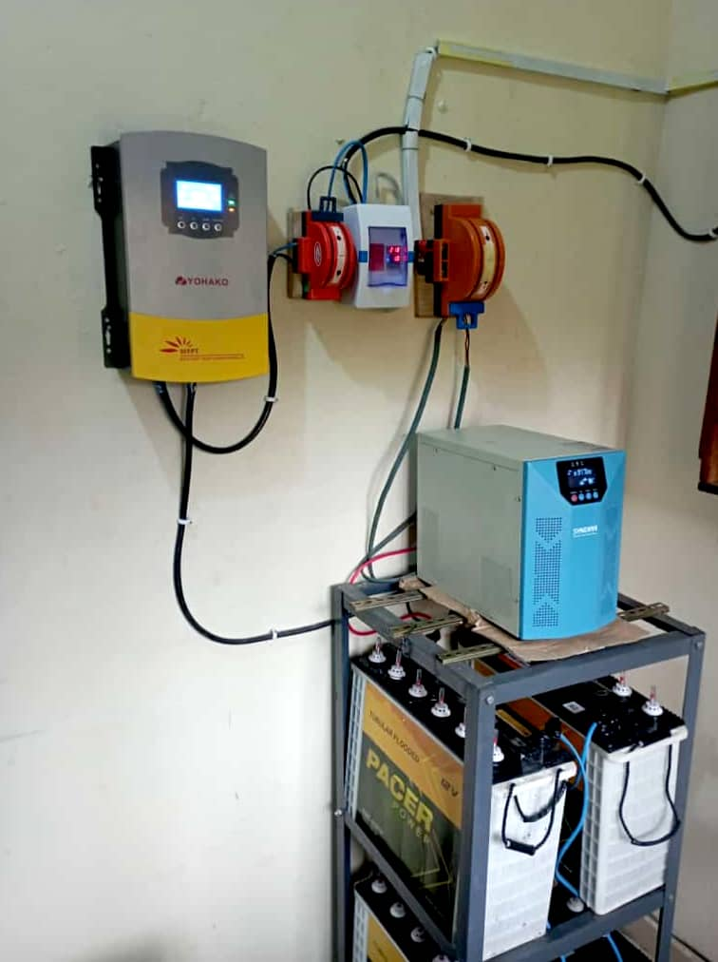
Fig. 3.4: Pictorial View of the 5KVA Hybrid Inverter System

3.5 SYSTEM FLOWCHART

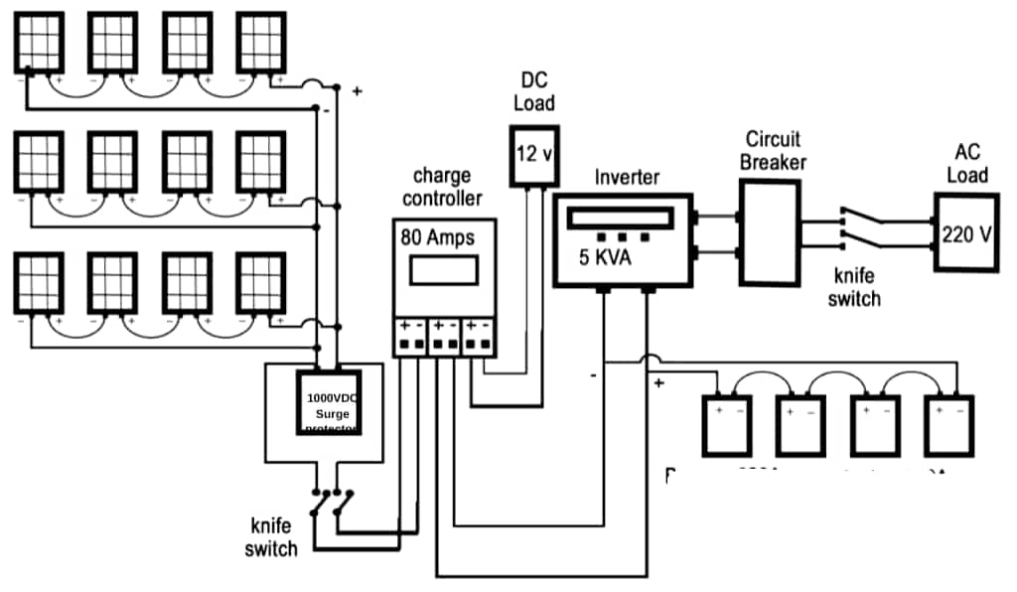

Fig 3.5: Flow chart for 5KVA Inverter System

CHAPTER FOUR
TEST AND RESULTS
  - RESULT TESTS AND DISCUSSION
The following system tests were carried out, which included;
- Solar panel testing
- Inverter testing
- Battery testing
- During loading
- When on no-load

    - Solar Panel Testing
There are two things that needs to be measured in order to ensure the panel is functioning properly.
Manufacturers open circuit voltage: 65.2V
Open circuit voltage: 64.9V
Short circuit current: 6.46A
Manufacturers short circuit current rating: 6.75A
To measure open circuit voltage, the panels should not be under sunlight but care must be taken since the panel will be live when it is placed under sunlight and there is possibility of electric shock. The readings were taken using multimeter. The readings (open circuit voltage and short circuit current) should be compared with the rating of put in place by the manufacturers. The reading also gotten depends on the sun intensity as of the time reading was taking.
    - Charge Controller Testing
A visual inspection testing was conducted to check how the voltage going to the battery was regulated at full charge.
The calculated battery voltage was=13.5V * 4
The total battery voltage=54V
The charge controller voltage displayed was 54V at full charge.
This value 54V was the practical value.
    - Battery Testing
To determine the battery’s capability to hold a charge, one would require the use of a charge controller. However, a physical inspection was carried out to determine the healthy condition of the battery. Things to look out for includes;
- Leaking acid.
- Crystallization on the terminals.
- Physical damage like cracks on the battery.
The battery was connected in series and their respective voltage and current was obtained.
Battery rating =12V\230Ah
Total number of batteries = 4
Series connection:
Voltage = 48volts
Current = 230amps
  - System Design Testing (under no-load):
Here are specifications for the installation:
- 1 x 5KVA inverter system
- 14 x 320 watts solar panel
- 4 x 12V/230AH
- 1 x 60A charge controller
Under no-load the 24V battery was carefully connected to the 5000w inverter and these readings was taken down.
- The voltage was tested and it reads 230V
- The frequency meter reads 50Hz
- The battery voltages read 54.0V

  - System Design Testing (on-load test)
This test was conducted by connecting loads to the inverter individually and adding an additional load to it (increasing the load by 200watts) and also another test was conducted by connecting all the loads incrementally without removing them until the inverter reaches its tripping point.
Table 4.1: Load analysis of the 5KVA hybrid power supply system (AC table)
Load | AC(Voltage) | AC(Current) | AC(Power)
150watts | 235.47volts | 0.61amps | 143.64
300watts | 239.72volts | 1.20amps | 287.66
450watts | 246.89volts | 1.87amps | 461.68
600watts | 253.17volts | 2.49amps | 630.39
750watts | 256.25volts | 3.20amps | 820
900watts | 261.22volts | 3.86amps | 1008.31
1050watts | 269.11volts | 4.52amps | 1229.73
1200watts | 276.03volts | 5.17amps | 1216.38
1350watts | 280.01volts | 5.81amps | 1626.86

Table 4.2: Load analysis of the 5KVA hybrid power supply system (DC table)
Load | DC(Voltage) | DC(Current) | DC(Power)
150watts | 54.04volts | 11.56amps | 624.70
300watts | 57.03volts | 22.11amps | 1260.93
450watts | 58.59 | 44.64amps | 5551.60
600watts | 59.53 | 87.02amps | 5180.30
750watts | 60.21 | 92.38amps | 5562.20
900watts | 60.44 | 96.13amps | 5810.10
1050watts | 61.57 | 98.99amps | 6094.81
1200watts | 62.46 | 105.74amps | 6604.52
1350watts | 62.73 | 106amps | 6,649.38

Table 4.3: Bill of Engineering Measurement and Evaluation (BEME)
S/N | Items | Quantity | Unit price
1 | Opto- Coupler | 4 | 900 | 3,600
2 | Liquid Crystal Display | 1 | 3,900 | 3,900
3 | LCD Flex | 8 | 400 | 3,200
4 | Pic microcontroller | 1 | 5,200 | 5,200
5 | I. C Socket | 4 | 700 | 2,800
6 | Resistor | 90 | 120 | 10,800
7 | Capacitor | 25 | 700 | 17,500
8 | MOSFET | 30 | 1,000 | 30,000
9 | Electromechanical Relay | 4 | 2,500 | 10,000
10 | Set-down transformer | 4 | 2,700 | 10,800
11 | 5kva Set-up Transformer | 1 | 395,000 | 395,000
12 | Voltage Regulator | 3 | 1,000 | 3,000
13 | Heat Zink | 3 | 12,000 | 36,000
14 | Heat Extractor | 1 | 3,600 | 3,600
15 | Diode | 60 | 200 | 12,000
16 | MOSFET Driver | 3 | 1,500 | 4,500
17 | Switch | 1 | 500 | 500
18 | Buzzer | 1 | 1,200 | 1,200
19 | L.E.D | 3 | 200 | 600
20 | Crystal oscillation | 1 | 3,300 | 3,300
21 | LCD Pin socket | 1 | 2,500 | 2,500
22 | Casting fabrication | 1 | 20,000 | 20,000
23 | Workmanship |  | 70,000 | 70,000
24 | Others |  |  | 30,000
 | Total Cost |  |  | 680,000

CHAPTER FIVE
CONCLUSION AND RECOMMENDATION
  - CONCLUSION
Solar photovoltaic (PV) panels convert sunlight to electricity, and PV installers put these systems in place. PV installers use a variety of hand and power tools to install PV panels. They often use drills, wrenches, saws, and screwdrivers to connect panels to frames, wires and support structures. PV installers connect the solar panels to the electric grid, although electricians sometimes perform this duty. However, once the panels are installed, workers check the electrical systems for proper wiring, polarity, and grounding, and they also perform maintenance as needed. Moreover, Solar Power could be generated throughout the year but it works best when the sun is at its maximum. Solar powered system can be optimally used during the dry season when water level in the dams is low for sufficient hydro power generation and there is high availability of solar radiation due to high sunshine hours compared with other season, that are favorable for hydro power generation. Furthermore, given that both the immediate and long-term harmful effects of power generation through burning of fuels and the dangers of nuclear power to reduce the over dependence on hydropower, the abundant of sunlight is the best answer.

  - RECOMMENDATION
Working on this topic as my project work is a good idea and it came at the right time. However, the power analysis, installation of the 5KVA inverter for the department of Mechanical Engineering was successful even though there were certain factors that limited the project. For future works on optimization to the work. It is recommended that the capacity of the battery, solar panel and inverter should also be increased for an optimal performance and greater efficiency. This is due to the fact that an inverter with a higher power rating will simply demand a higher current from the system, also a higher battery rating will increase the duration of the power supply to the load. This will go a long way to boost the overall performance of the system.

References
- Doe, J. (2024). Solar energy systems and their potential for sustainable development. GreenTech Publishing.
- Franklin, E. (2017). Renewable energy solutions for Africa: A path forward. African Energy Review, 12(4), 45–59.
- Phansopkar, P. (2020). Hybrid inverters in modern energy systems: Principles and applications. International Journal of Renewable Energy Research, 8(2), 102–111.
- Seger, B. (2016). Understanding inverters: From design to implementation. Power Systems International.
- Smith, L. (2024). Solar inverters and hybrid systems: New trends and technologies. SolarTech Research Institute.
- Zubairu, A., Hassan, M., & Bello, T. (2015). The role of electricity in modern society: A Nigerian perspective. Journal of Energy and Environment, 7(1), 30–37.
- Franklin, E. (2013). Applications of solar energy: From low-grade heat to synthetic fuels. Journal of Renewable Energy Studies, 6(2), 78–92.
- Richardson, L. (2019). A historical overview of solar energy development. Solar Innovations Quarterly, 11(1), 15–33.
- Weis, C. (2013). The evolution of photovoltaic technology: From selenium to silicon and beyond. Photovoltaic Progress Journal, 9(3), 211–229.
- Hongtao, X. (2017). Integrated solar inverter technologies and battery systems: A performance review. International Journal of Smart Energy Systems, 4(1), 22–34.
- Phansopkar, P. (2020). Hybrid inverters in modern energy systems: Principles and applications. International Journal of Renewable Energy Research, 8(2), 102–111.
- Goldmann, A. (2000). Challenges in rooftop solar energy adoption. Solar Industry Insights, 2(3), 54–60.
- Johnson, F. (2024). Understanding photovoltaic cells and their working principles. Journal of Solar Power and Energy Systems, 15(1), 11–27.
- Richardson, L. (2019). A historical overview of solar energy development. Solar Innovations Quarterly, 11(1), 15–33.
- Richardson, L. (2015). Off-grid solar technologies and their impact on energy self-reliance. Energy Independence Journal, 7(2), 40–53.
- Smith, L. (2021). Energy demand and solar system compensation strategies. Global Solar Energy Review, 9(4), 100–117.
- Bannur, S. (2018). Concentrated solar power in India: Current status, challenges and future outlook. International Journal of Renewable Energy Development, 7(2), 115–124.
- Choifin, M., Fajri, M. N., & Sari, L. K. (2021). A study of renewable energy and solar panel literature through bibliometric positioning during three decades. Renewable Energy and Sustainability Studies, 13(4), 88–97.
- Hao, D., Zhang, W., & Liu, Y. (2022). Solar energy harvesting technologies for PV self-powered applications. Journal of Sustainable Energy Research, 14(1), 32–48.
- Jean Baptiste, I., & Mugisha, E. (2018). A review of the solar energy situation in Rwanda and Uganda. African Journal of Renewable Energy, 9(1), 72–80.
- Kabir, E., Kumar, P., Kumar, S., Adelodun, A. A., & Kim, K. H. (2018). Solar energy: Potential and future prospects. Renewable and Sustainable Energy Reviews, 82, 894–900. https://doi.org/10.1016/j.rser.2017.09.094
- Purohit, D., & Patel, R. (2020). A review paper on solar energy system. International Journal of Scientific and Research Publications, 10(5), 103–109.
- Samuel, S. A., & Igbokwe, O. U. (2019). Awareness and use of solar energy as alternative power sources for ICT facilities in Nigerian university libraries and information centers. Library Philosophy and Practice, Article 2805. https://digitalcommons.unl.edu/libphilprac/2805
- Taghizadeh-Hesary, F. (2018). Empirical analysis of factors influencing price of solar modules. Journal of Cleaner Production, 204, 278–293. https://doi.org/10.1016/j.jclepro.2018.08.278
- Weliwaththage, S. R. G., & Perera, H. M. (2020). Solar energy technology: Advances and material improvements. Solar Energy Materials and Solar Cells, 215, 110–122.
- Ali, M., et al. (2015). Design and sizing of a stand-alone solar power system. [Paper presented].
- Basyoni, S. S., & Al-Dhlan, K. (2017). Implementation of a small-scale photovoltaic system for domestic use. [Journal/Conference].
- Choifin, M., et al. (2021). A study of renewable energy and solar panel literature through bibliometric positioning during three decades. [Journal/Source].
- Daning, H., et al. (2022). Solar energy harvesting technologies for PV self-powered applications. [Journal/Conference].
- Doe, J. (2024). Introduction to solar energy systems. [Book/Report].
- Ehsanul, K., et al. (2018). Solar energy: Potential and future prospects. [Journal/Source].
- Franklin, E. (2013). Applications of solar power systems. [Source].
- Franklin, E. (2017). Solar energy in developing nations: Nigeria's case study. [Journal/Report].
- Goldmann, H. (2000). Solar technology limitations and future prospects. [Book/Conference].
- Goldmann, H. (2019). Hybrid solar/geothermal systems for renewable energy generation. [Journal/Conference].
- Johnson, F. (2024). Working principles of photovoltaic solar panels. [Book/Manual].
- Morakinyo, A., Adu, B., & Atayero, A. (2014). Design of a solar-powered street light with automated control system. [Conference proceedings].
- Nwankwo, E., & Azubogu, A. (2016). Solar generator design and implementation for household use. [Engineering Journal].
- Phansopkar, N. (2020). Basics and applications of hybrid solar systems. [Textbook/Publication].
- Purohit, D., et al. (2020). A review paper on solar energy system. [Conference/Journal].
- Richardson, L. (2015). Off-grid solar energy systems and their configuration. [Technical Report].
- Richardson, L. (2019). Components and configurations of hybrid solar systems. [Energy Systems Journal].
- Samuel, J., et al. (2019). Awareness and use of solar energy for ICT in Nigerian libraries. [Library and Information Science Journal].
- Seger, B. (2016). Design and analysis of inverters in hybrid solar systems. [Journal/Manual].
- Smith, A. (2021). Energy demand and solar system compensation strategies. [Journal/Source].
- Smith, B. (2024). Understanding hybrid inverters and their application. [Textbook/Article].
- Suhas, B. (2018). Concentrated solar power in India: Status and outlook. [Renewable Energy Journal].
- Sumedha, R. G., & Weliwaththage, S. (2020). Solar energy technology: Past, present, and future improvements. [Energy Journal].
- Weis, C. (2013). Historical developments in photovoltaic materials. [Research Paper].
- Luthander, R., Widén, J., Nilsson, D., & Palm, J. (2015). Photovoltaic self-consumption in buildings: A review. Applied Energy, 142, 80–94.

