IMPACT OF SOCIO ECONOMIC CHARACTERISTICS ON HOUSING CONDITION IN KWARA STATE
(A CASE STUDY OF ILORIN METROPOLIS)

BY

ABDULRASAQ .A. TESLIMAT
HND/23/ETM/FT/0142

BEING A RESEARCH PROJECT SUBMITTED TO THE,
DEPARTMENT OF ESTATE MANAGEMENT AND VALUATION,
INSTITUTE OF ENVIRONMENTAL STUDIES,
KWARA STATE POLYTECHNIC, ILORIN

IN PARTIAL FULFILMENT OF THE REQUIREMENTS FOR THE
AWARD OF HIGHER NATIONAL DIPLOMA (HND) IN
ESTATE MANAGEMENT AND VALUATION

JULY, 2025

CERTIFICATION
This is to certify that this research project was carried out by Abdulrasaq A. Teslimat with Matriculation Number: HND/23/ETM/FT/0142 and has been read and approved as meeting the requirements of the department of Estate Management, Institute of Environment Studies, Kwara State Polytechnic, Ilorin, Kwara State, for the award of Higher National Diploma (HND) in Estate Management.

_________________________________ _______________
ESV. LAWAL SIMIAT .B. DATE
ANIVS, RSV)
(Project Supervisor)

_________________________________ _______________
ESV. DR. (MRS.) UWAEZUOKE NGOZI IFEANYI DATE
(ANIVS, RSV)​​​​
(Project Coordinator)

_________________________________ _______________
ESV. ABDULKAREEM A. RASHEEDAT DATE
(FNIVS, RVS)
(Head of Department)

__________________________ _______________
ESV. DR. LUKMAN MUSIBAU DATE
EXTERNAL EXAMINER

DEDICATION
This project is dedicated to the Almighty Allah who has been my Alpha and Omega toward the successful completion of this project and my course.

ACKNOWLEDGEMENTS
My profound gratitude first and foremost goes to Almighty Allah the author and finisher of our faith for granting and protecting me through the ups and downs in my academic pursuit and for making this dream a reality.
My appreciation goes to my Parents, MR. and MRS. ABDULRASAQ for their moral and financial support without which I might not have attained this height, May you reaps the fruit of your labor.
Most importantly, my appreciation also goes to my supervisor ESV. LAWAL SIMIAT .B. (ANIVS, RSV) who has created time to read and make corrections where necessary and who sacrificed much of his time to advise me in appropriate cases not withstanding his tight schedule.
Also my profound respect goes to my H.O.D ESV. ABDULKAREEM A. RASHEEDAT (FNIVS, RVS) and the entire members of Staff Estate Management and Valuation Department.
I have to extend my gratitude to my entire colleague who has directly and indirectly contributed towards the success of this work. Thank you all.

TABLE OF CONTENTS
Title Page i
Certification ii
Dedication iii
Acknowledgements iv
Table of contents v-vi
List of tables vii
List of figure viii
Abstract ix
CHAPTER ONE
1.0 Introduction 1
1.1 Background of the Study 1-2
1.2 Statement of the Problem 2-4
1.3 Research Questions 4
1.4 Research Hypotheses 4
1.5 Aim and Objectives of the Study 4-5
1.6 Justification of the Study 5
1.7 Scope of the Study 5
1.8 The Study Area 5-7
1.9 Definition of Terms 8-9
CHAPTER TWO: LITERATURE REVIEW
2.0 Introduction 10
2.1 Conceptual Review 10
2.1.1 Concept of Socio Economic Characteristics 10-11
2.1.2 Components of Socio Economic Characteristics 11-19
2.1.3 Concept of Housing 19-20
2.1.4 Concept of Housing Conditions 20-22
2.1.5 Previous Studies on Housing Condition 22-25
2.1.6 Socio Economic Characteristics and Housing Condition 26-28
2.1.7 Conceptual Framework for Socioeconomic Characteristics and
Housing Conditions 28
2.2 Theoretical Framework 28-21
2.2.1 Theory of Housing Adjustment 29
2.2.2 Human Needs Theory (Abraham Maslow, 1943) 29-30
2.2.3 Place Stratification Theory (Logan & Molotch, 1987) 30
2.3 Empirical Review 30-32
2.4 Summary of Literature Review 32-33
CHAPTER THREE
3.0 Research Methodology 34
3.1 Introduction 34
3.2 Research design 34
3.3 Data Types and Sources 34-35
3.4 Instrument for Data Collection 35
3.5 Target Population 35

3.6 Sample Frame 35

3.7 Sample Size 35-36

3.8 Sampling Procedure 36

3.9 Method of Data Analysis 36-37
3.10 Summary of Methodology 37

CHAPTER FOUR: DATA PRESENTATION, ANALYSIS AND INTERPRETATION OF RESULTS

4.0 Introduction 38

4.1 Data Presentation, Analysis and Interpretation of Results 38-41

4.2 Housing Characteristics 42-43

4.3 Environmental and Neighborhood Conditions 44-46

4.4 Inferential Analysis: Relationship between Socio-Economic Variables

and Housing Conditions 47

4.4.1 Chi-Square Test Results 47

4.4.2 Multiple Regression Analysis 48
4.5 Discussion of Findings 49-50

CHAPTER FIVE: SUMMARY, CONCLUSION AND RECOMMENDATIONS

5.0 Introduction 51
5.1 Summary of Findings 51-52
5.2 Conclusion 52
5.3 Recommendations 53

References 54-55
Questionnaire 56-57
LIST OF TABLES

Table 4.1: Sex of Respondents 38

Table 4.2: Age Distribution 39

Table 4.3: Educational Qualification 40

Table 4.4: Monthly Income of Respondents 41

Table 4.5: Type of Housing Unit 42

Table 4.6: Toilet Facilities 43

Table 4.7: Drainage System 44

Table 4.8: Waste Disposal Method 45

Table 4.9: Housing Satisfaction 46

LIST OF FIGURES
Figure 1: Map of Nigeria showing Ilorin metropolis within Kwara-State 7
Figure 2: Map-of-Ilorin-metropolis 7
Figure 4.1: Gender Distribution of Respondents 38
Figure 4.2: Age Distribution of Respondents 39
Figure 4.3: Educational Qualification of Respondents 40
Figure 4.4: Monthly Income of Respondents 41
Figure 4.5: Type of Housing Unit 42
Figure 4.6: Toilet Facilities in Respondents' Homes
43
Figure 4.7: Drainage Condition in the Area 44
Figure 4.8: Waste Disposal Methods 45
Figure 4.9: Housing Satisfaction Level 46

Abstract
This study investigates the impact of socio-economic characteristics on housing conditions in Ilorin Metropolis, Kwara State, Nigeria. As urban centers expand rapidly, the quality of housing available to residents is increasingly influenced by factors such as income, education, occupation, household size, gender, and marital status. Despite the existence of housing policies, a significant portion of urban residents continue to live in substandard housing due to economic constraints and social inequalities. A total of 150 structured questionnaires were administered to household heads across various residential density areas in Ilorin. The study employed descriptive statistics and inferential methods, including chi-square tests and regression analysis, to evaluate the relationship between socio-economic variables and the physical, sanitary, and environmental components of housing. The findings revealed that income, educational level, and occupation significantly influence the quality of housing, while age, gender, and household size showed minimal or no statistical impact. Additionally, the study highlighted persistent housing deficits, inadequate toilet facilities, poor waste disposal systems, and ineffective drainage, especially in low-income neighborhoods. It concludes that improving housing conditions requires a multifaceted approach, combining physical infrastructure upgrades with socio-economic interventions such as affordable housing schemes, urban planning reform, and public awareness on housing rights. The study recommends a policy shift toward integrating socio-economic data into housing programs and greater investment in urban infrastructure to address the needs of vulnerable populations. These findings offer valuable insights for estate managers, urban planners, and policymakers aiming to enhance housing conditions in fast-growing Nigerian cities like Ilorin.

CHAPTER ONE
  - Introduction
  - Background of the Study
Socio-economic characteristics of an individual can be used to explain household economic inequality which reflects his/her social class, status and economic position in the society and play an important role in enhancing individual household and the whole of the society wellbeing (Rose, Pevalin & O'Reilly 2005). Socio economic characteristics vary from one household to the other which provides social picture at a glance such as occupation, income and education (Sule, 2003). Socio-economic characteristic describes family’s position, rank, class, status or economic position in a society (Galobardes, Lawlor, Lynch & Smith, 2006). This is based upon the concepts of allocating scarce and limited resources to various activities that are related with the progress, protection and conservation (Agrawal & Ostrom, 2001).
When searching for housing, individuals and households consider two major criteria namely; the type of housing and the type of residential environment (Vera-Toscano & Ateca, 2008). The demand made by a particular household is guided by social life style and restricted by income and opportunities offered by the housing market (Nguluma, 2003).
The quality of life is closely linked to the housing and the housing is determined by other factors such as the employment, the income, the education, the work-life balance, the life satisfaction and the perceived quality of society (Rašticová, Birčiaková & Kolářová, 2016). Housing has been one of the main pillars of the individual satisfaction and has been considered “to be the determinant of the health and the quality of life” (Braubach & Fairburn, 2010; Rašticová & Kolářová, 2015).
According to the (United Nations Habitat [UNH], 2010). 30 percent of the world’s urban population lives in slums, deplorable conditions where people suffer from basic deficiencies in their housing: lack of access to improved water; lack of access to improved sewage facilities, living in overcrowded conditions; or living in buildings that are structurally unsound. The same report said that 35 percent of the world’s rural population lives in unacceptable conditions. Overall more than two billion people are in desperate need of better housing (Enoghase, et al. 2015). It is estimated that almost 75% of Nigeria’s urbanites live in slums (Olotuah & Bobadoye, 2009).
Household size, religion, sex, marital status, ethnicity, education, occupation status, income, age of respondent, family patterns, and tenure type of resident (or system) are very important socio economic characteristic that influence housing condition, people’s positions in a society, occupational status and other resources also affect the type of house that is built (Jiboye, 2004; Jiboye & Ogunshakin, 2010). Therefore, human needs for housing are not simply inherent, rather housing needs are developed within socio-economic context (King, 2012).
Individual socio-economic characteristic have strong influence on their housing (Hall, 2001). If the essence of a house is to be fully appreciated within the context of human habitation. consideration must be given to relationship between socio economic characteristic and housing (Olayiwola, Adeleye & Jiboye, 2006).
In a study of urban housing condition in Nigeria, Wahab (1990) observed that in Ilorin State only 3.5 percent houses are in good condition, while 54.8 percent of the houses require major repairs, 11.6 percent require minor repairs, and 3.9 percent are dilapidated. A degraded housing environment is viewed as a poverty area inhabited by people of low income which is a reflection of inequality in the society. It is against this background this study tends to evaluate the effect of socio-economic characteristics on housing conditions in Ilorin metropolis.
  - Statement of the Problem
There has been much body of empirical research over the years on housing conditions and its effects on individual. Amao (2012) revealed that characteristics of informal settlements are substandard housing, lack or inadequate access to basic public services, inadequate building structures, unhealthy living conditions and hazardous locations. He concluded that increasing socio-economic problems posing threats to their long term livelihood, and poor environmental conditions. He suggested that there should be socio-economic improvement, the implementation of policies and planning, physical infrastructural development, environment and health improvement.
Lanrewaju (2012) revealed that, poor housing quality has serious adverse effects on environment and the health of city residents. The study identified substandard housing, inadequate basic infrastructural amenities, overcrowding, poor ventilation in homes and work places, and non-compliance with building bye-laws and regulations as the problems that has aided the degeneration. The study reports the poor housing conditions in the urban cities of Nigeria especially at the core areas in capital city of Ondo and Osun state respectively. He recommended the strategies for improving the built environment for sustainable living.
According to Waziri, Yusof and Salleh (2013) Socio-economic backgrounds have different level of aspiration, tolerance and psychology on satisfaction towards housing. Lian and Salleh (2011) asserted that personality traits are good precursors to housing satisfaction. Educational status is observed to consistently play a prominent role in shaping individual satisfaction with their housing as those with higher literacy express low level of satisfaction in comparison to less educated in private settings (Waziri et al., 2013). These studies however touched how socio-economic status (SES) predicts housing satisfaction in Abuja.
Aderamo and Ayobolu (2010) outlined structural components of housing quality. These are quality of basic facilities, energy and ownership, material quality; water quality and utility factors. He examined the spatial structure of housing quality in Ilorin discovering the pattern of housing facilities. The study revealed that the structural pattern will be relevant in urban renewal efforts for the city. Jiboye (2010) shows that residential quality varies in pattern from one area to another and that housing quality is higher in the outskirt of the city than in other residential areas town. Having examined and compared the pattern of housing quality, Aribigbola (2011) examined the growing problems of housing affordability in cities of developing world using Akure in Nigeria as a case study and ascertained extent of the problem as well as challenges poses to creating sustainable built environment. The study had shown that problem associated with urban housing in the area is affordability. Consequently, it was suggested that there should be creation of institutional framework to promote and encourage affordable housing provision in the city.
Mallo and Anigbogu (2009) studied the quality of residential neigbourhoods in Jos, Nigeria. The authors employed cluster sampling technique to generate data on the physical, social and economic characteristics of households. It uncovers that status of a person translates into his earning, which also influences his choice of location and type of housing to reside. On the other hand, Muhammad, Kasim, and Martin (2015) revealed that the patterns of residential segregation in Ilorin Metropolis are based mainly on income, religion and ethnicity; and the factors influencing residential segregation were identified as mainly individual and aggregate socio economic characteristic and individual preference /choice of neighbourhood.
Zainal, Kaur, Ahmad and Khalili (2012) studied the relationship between housing conditions and the quality of life of the urban poor in Klang Valley, Malaysia. Uwadiegwu (2013) carried out a research on insider’s perception of the structural profile of the socio economic status and housing problems of the slum areas in Enugu city, Nigeria. Hong and Pandey (2007) observed poverty and vulnerability of urban poor and found that urban poor are vulnerable to their respective human capital investment variables in United State.
However, through the reviewing of foregoing researches there seems to be surprisingly little academic and empirical research on the phenomenon under study as studies like Hong & Pandey (2007), Mallo & Anigbogu (2009), Aderamo & Ayobolu (2010), Jiboye (2010), Aribigbola (2011), Amao (2012) Lanrewaju (2012), Zainal, Kaur, Ahmad & Khalili (2012) Uwadiegwu (2013) Waziri, Yusof & Salleh (2013) Muhammad, Kasim, & Martin (2015) only concentrated on effects of housing conditions on individual and environment, socio economic status predicting housing satisfaction, components of housing quality, patterns and factors influencing residential segregation.
Also, studies such as Olawuni, (2008), Babalola & Fatusi, (2009); Riman & Akpan (2012); Owoseni, Oluwadare, Jegede, & Ibikunle, (2014), Olugbamila, 2016, Adeyinka & Olugbamila, (2016) mainly focused on socio-economic characteristic and health status.
In Ilorin, it has been observed that socio-economic characteristics of individual translates into his earning, thereby influences his choice of location and type of housing. It is therefore important to carry out a study on socio-economic characteristics and housing conditions. It is the goal of this research to assess the housing conditions in the study area and examine the impact of socio-economic characteristics on housing conditions in the study area.
1.3 Research Questions
- What are the socio-economic characteristics of residents in the study area?
- What are the housing conditions in the study area?
- Is there any relationship between the socio-economic characteristics and housing conditions in the study area?
1.4 Research Hypotheses
- H₀₁: There is no significant relationship between residents' socio-economic characteristics and their housing conditions in Ilorin Metropolis.
- H₁₁: There is a significant relationship between residents' socio-economic characteristics and their housing conditions in Ilorin Metropolis.
1.5 Aim and Objectives of the Study
Aim:
To examine the impact of socio-economic characteristics on housing conditions in Ilorin Metropolis.
Objectives:
- To identify the socio-economic characteristics of residents in the study area.
- To determine the housing conditions in the study area.
- To examine the relationship between socio-economic characteristics and housing conditions.
1.6 Justification of the Study
The Government: If the research is successfully completed the outcome will afford the local planning, policy guidelines for sustainable housing delivery in the study area. As recommendations will be put toward policy guidelines.
The Households: Findings from the study will reveal the condition of the houses in Ilorin Metropolis and stress on the need for them to imbibe good maintenance culture of their property in order to improve the aesthetic quality of the housing environment and general sanitation.
The Future Research: It will be of benefit to students and researchers. The method adopted in carrying out this study will go a long way in explaining the concept of socio economic characteristic and its impact on housing condition in Ilorin Metropolis and thereby serve as reference materials for future research and bridge the gap left by past researchers. The study will identify promising future research opportunities for the academic community.
1.7 Scope of the Study
The scope of this study will be restricted to the issues of socioeconomic characteristic and their effect on housing condition in Ilorin metropolis. The study will specifically focus on households within the metropolis. In this regard, the socioeconomic characteristics to be considered in this work include: income, age, ethnicity/race, religion, marital status, occupation, education, sex and household size. The target population for the study shall be households heads in the study area. The housing conditions will be limited to structural analysis of housing units, internal facilities, toilet and bathroom facilities and source of lighting and conditions of physical and environmental characteristics.
1.8 The Study Area
Ilorin Metropolis, the capital of Kwara State, is located in the North Central geopolitical zone of Nigeria. It lies approximately between latitudes 8°24'N and 8°36'N and longitudes 4°10'E and 4°36'E (Gani, Chiroma & Gana, 2012). The city serves as a major administrative, commercial, and educational center, with institutions such as the University of Ilorin, Kwara State Polytechnic, and multiple government establishments contributing to its urban growth.
The metropolis comprises parts of Ilorin East, Ilorin West, and Ilorin South Local Government Areas. It spans both the traditional core area and rapidly developing suburbs. Residential areas are classified into low, medium, and high-density zones. These include:
- Low-density: Old and New GRA
- Medium-density: Tanke, Sango, Basin
- High-density: Oja-Oba, Ita-Amodu, Okelele, and Gambari (Olotuah & Taiwo, 2013)
The climatic condition is tropical wet and dry, with an average annual rainfall of 1,200 mm and temperature ranging between 25°C and 30°C. Ilorin has a diverse ethnic composition, primarily Yoruba, but also includes Hausa, Fulani, Nupe, and Igbo settlers (Ilorin Local Government, 2019; Online Nigeria, 2003).
This diversity reflects in housing patterns and socio-economic conditions. Ilorin has experienced rapid population growth, with an estimated population of over 800,000 in the urban core as of 2021 (National Population Commission, 2022). Urban pressure has led to housing inadequacies, slum development, and infrastructural challenges, especially in high-density areas (Akinbamiro, 2012; Jiboye, 2014). These dynamics make Ilorin a suitable location to assess how socio-economic characteristics influence housing conditions.
This study is confined to assessing the impact of socio-economic characteristics on housing conditions in Ilorin Metropolis, Kwara State, Nigeria. Ilorin is one of the rapidly urbanizing cities in Nigeria, experiencing population growth and housing stress, especially in its inner-core and high-density areas (Aderamo & Ayobolu, 2010; Jiboye, 2010). The research is limited to households within the metropolis, with household heads serving as the primary respondents, as they are generally responsible for residential decisions (Jiboye & Ogunshakin, 2010).
The socio-economic variables considered include: income, occupation, education level, marital status, age, ethnicity, religion, gender, and household size (Aigbavboa & Thwala, 2011; Sule, 2003). These factors have been widely acknowledged in literature to influence housing quality, affordability, and access.
The study evaluates housing conditions in terms of structural quality (wall, roof, and floor conditions), availability of facilities (toilet, bathroom, water, lighting), and environmental characteristics (drainage, refuse disposal) based on criteria defined in prior housing research (Olotuah, 2006; Okewole & Aribigbola, 2006). The study area will include selected wards representing low, medium, and high-density neighborhoods in Ilorin, to capture spatial and economic diversity (Coker et al., 2007; Muhammad, Kassim & Martin, 2015).
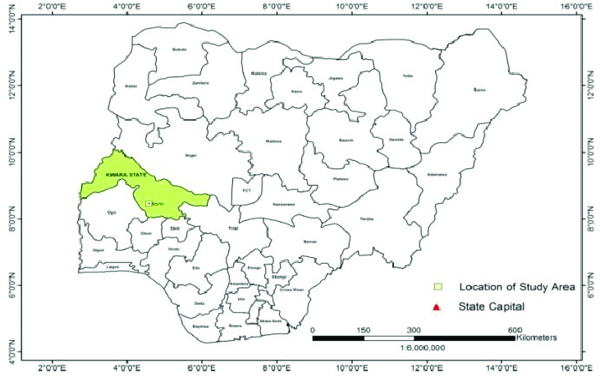

Figure 3: Map of Nigeria showing Ilorin metropolis within Kwara-State

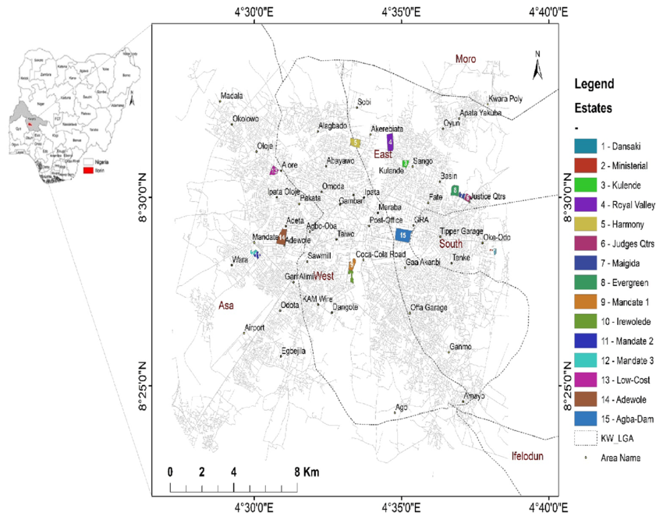

Figure 4: Map-of-Ilorin-metropolis
1.9 Definition of Terms
Socio-Economic Characteristics: These refer to the social and economic factors that describe an individual's or household’s status within a society. Key elements include income, education, occupation, gender, marital status, religion, household size, and age (Aigbavboa & Thwala, 2011). These characteristics influence people’s lifestyle, consumption patterns, and access to quality housing (Olayiwola, Adeleye & Jiboye, 2006).
Housing Conditions: This refers to the physical and environmental state of a residential dwelling. It includes structural quality, sanitation, water supply, electricity, ventilation, room size, and facilities such as toilets and kitchens (WHO, 2009; Okewole & Aribigbola, 2006). Adequate housing conditions are essential for health and well-being, while poor housing can contribute to disease and psychological distress (Baker, Bentley & Mason, 2013).
Housing Satisfaction: This is the level of contentment individuals or households feel about their housing environment. It includes satisfaction with structure, location, services, and neighborhood safety. It is often used to assess the performance of residential developments (Jiboye, 2014). Factors such as income, education, and housing tenure significantly affect satisfaction levels (Waziri, Yusof & Salleh, 2013).
Household Head: The household head is the primary decision-maker in a home, often responsible for paying rent, managing housing maintenance, and making residential decisions (Coker et al., 2007). In many Nigerian contexts, this role is traditionally occupied by the male adult, though female-headed households are increasingly common (Adebisi, Okeyinka & Ayinla, 2017).
Residential Density: This term refers to the number of housing units or people living within a specific urban area. Ilorin, like other Nigerian cities, has residential zones categorized into low, medium, and high-density areas. These zones often reflect social class and income levels (Aderamo & Ayobolu, 2010; Muhammad, Kassim & Martin, 2015).
Urban Housing: Urban housing encompasses all types of residential structures located in towns and cities. It includes detached houses, flats, and tenements. Urban housing is often influenced by land use planning, migration, population growth, and economic factors (Olotuah & Taiwo, 2013). In Nigeria, urban housing challenges include overcrowding, slum development, and inadequate infrastructure (Ahianba, Dimuna & Okogun, 2008).
Housing Deficit: A situation where the demand for housing exceeds the available supply, resulting in shortages or overcrowded and substandard living conditions. Nigeria has one of the largest housing deficits in Africa, especially in urban areas where rapid population growth outpaces housing development (UN-Habitat, 2010; Enoghase et al., 2015).
Slum: A slum is a densely populated urban settlement characterized by poor housing quality, lack of basic services, and insecure tenure. In Ilorin and many Nigerian cities, high-density areas often exhibit slum conditions due to poverty and weak urban planning (Olotuah & Bobadoye, 2009).
Tenure Type: This refers to the legal or customary arrangement under which a person occupies housing such as ownership, renting, or squatting. Housing tenure affects investment in housing maintenance and satisfaction levels (Jiboye & Ogunshakin, 2010).

CHAPTER TWO
LITERATURE REVIEW
2.0 Introduction
This chapter focuses on literature review; the review focuses mainly on concept of socio economic-characteristics, component of socio-economic characteristics, definition and concept of housing, definition and component of housing conditions, studies on assessment of housing conditions, studies on effect of socio-economic characteristics on housing conditions, relevant theory based and conceptual framework that are relevant to the objectives of the study.
2.1 Conceptual Review
2.1.1 Concept of Socio Economic Characteristics
Socio economic characteristics denote the position of an individual in a community with respect to the amount of cultural possession, effective income, material possession, prestige and social participation (Harvey, Lévesque & Donnelly, 2007). Oladipo and Adekunle (2010) stated that socio-economic characteristics connote the position of an individual in a community with respect to the amount of cultural possession, effective income, material possession, prestige and social participation”.
Socio-economic characteristics refers to the social and economic position of a given individual, or group of individuals, within the larger community. Socio economic characteristic is usually, but not always, conceived of as a relative concept and can be measured for the individual, family, household or community/area (Australia Bureau of Statistic [ABS], 2008).
According to Akinbile (2007) Socio-economic characteristics is the position that an individual or family occupies with reference to the prevailing average standards of cultural possession, effective income, material possessions and participation in the group activities of the community.
Socio-economic implies two scopes namely social and economic, the social scope includes authority, occupational prestige, and education and standing in the community while the economic scope includes employment income, home ownership and financial assets, also it could be divided into three categories which are low SES, middle SES, high SES (Woldegies, 2014). Socio-economic characteristics vary from one household to the other which provides social picture at a glance such as occupation, income and education (Sule, 2003). Lower- income groups also tend to have more friends, acquaintances and relatives in the housing estate than higher-income groups (Dekker & Bolt, 2005).
2.1.2 Components of Socio Economic Characteristics
Socio-economic characteristic cannot be overlooked because various studies in the literature indicate an association between factors such as income, education, ethnicity, religion, culture, age around the world (Adeyinka & Olugbamila, 2016; Babalola & Fatusi, 2009).
In measuring the socioeconomic domain, the following have been identified as some of its indicators sex/ gender, age, marital status, religion, length of residence, occupation, education, income and household size (Aigbavboa & Thwala 2011, Hur & Morrow-Jones, 2008, Jiboye 2010b, Kearney, 2006)
Occupation
Occupation is described in a broad context as a purposeful activity that a person needs, wants or is obliged to do, to live well as a valued citizen (Milner & Kelly, 2009). Unlike tasks, which are purely functional and provide no significance or fulfilment for an individual, occupations are embedded in socio-cultural contexts as people choose to perform chosen activities alone, with loved ones, or in groups, in ways which are personally meaningful, spiritually enriching or culturally appropriate (Moalosi, 2007). It is important to understand that what one finds valued, another may disregard, as an occupation is a relative concept, which is subjectively self-defined (Mills & Payne, 2015).
There is a time and place to each occupation, which necessarily requires energies, tools, skills or resources to perform (Bakker, 2011; Park & Kinsella, 2011). A person’s occupation is both directly and indirectly linked to their socioeconomic status (Marmot & Wilkinson, 2006).
According to Occupational Therapists Occupation is recognized and evidenced as contributing to quality of life of individuals, groups and communities (Christiansen & Townsend, 2011; Wilcock, 2007).
Blacks with professional occupations are highly separated by home from specialized whites (Royster, 2003). Blacks who had the same skills and qualification as whites were reported to be discriminated against concerning wages and residence. Grodsky and Pager (2001) stated that the black workers in Britain, like those in the US, were given lower status jobs and paid lower average wages than their white counterparts. Because of the lower wages paid to the blacks, and the unemployment rates among them, it limits their housing preferences (Dominguez, & Watkins, 2003).
Wagmiller (2007) studied the spatial segregation of jobless black men in urban America and he discovered that jobless black men are more segregated from employed men than other men from other racial and ethnic groups are. They were less uniformly distributed throughout the metropolis and more isolated from employed men. They are concentrated in a small physical space and congregated closer to the center of the city.
Education
Two related concepts for socioeconomic characteristic that have been shown to exhibit a strong socio economic gradient are educational participation and educational attainment (Fryer & Levitt, 2006). The focus for analysis when using these two socio economic status concepts has usually been on the child or adolescent. The reason for this is that a poor educational outcome from a young age is a key and perhaps even dominant predictor of poor outcomes into adulthood (Fryer & Levitt, 2006).
Apart from face validity, there are two main reasons for using education as a concept for measuring socioeconomic status. Firstly, those who complete additional years of education may experience a range of positive outcomes throughout their lives. Their incomes may be higher, employment easier to obtain and their health care would be better (Card, 2001; Borland, 2002). There are also likely to be spillover effects to the household and community as a result of the individual’s and society’s investment in education. In other words, higher levels of education are directly related to other aspects of socioeconomic status. To the extent that these other aspects are difficult to measure for example, permanent as opposed to even after controlling for income (Loannides, & Datcher 2004). and helps individuals make efficient decisions across a number of domains (Wolfe & Havemann, 2001).
Income
According to Benin and Josee (2008) literature on the determinants of household income is well established, dating back from the literature on human capital development, economic growth and poverty alleviation (Schultz, 1961; Welch, 1970) to more recent studies using household data (Otsuka & Takashi, 2006; Simler, Sanjukta, Dava & Gaurav, 2004). The main factors affecting household income include household size, the age and gender of household members, composition of the household, education, health, social capital, assets and endowments and employment, among others. There are also community factors that significantly determine household income such as weather, prices and infrastructure (Benin & Josee, 2008).
Empirical evidence shows that the size and composition of households are closely associated with household income. Household size and dependency ratio are found to reduce household income per capital (Jansen, John, Amy, Wilem & Rob, 2006; Tuyen, Steven, Michael & Huong, 2014). Among other factors, education of household members is often found to have a positive effect on household income (Nguyen, Shashi & Virginia 2004; Estudillo, Yasuyuki & Keijiro, 2008; Yunez, Naude & Taylor, 2001). However, the income effect of the age of household members might be ambiguous. Households with younger working members are more likely to undertake non-farm jobs, which in turn might earn higher incomes. Nevertheless, households with older working members tend to attain more work experience, which might enable the households to earn higher income (Tuyen et al., 2014).
Some other household characteristics, namely productive assets, access to credit and land are also positively linked with household income. Access of rural households to both formal and informal credit has improved their living standards in some developing countries (Cuong, 2008). In particular, empirical evidence confirms that land has a positive effect on household income in several developing countries (Carletto, Katia, Davis, Marika, Kostas, Paul & Alberto, 2007).
Ethnicity/Race
The primordialist approach is the oldest in sociological and anthropological literature. It argues that ethnicity is something given, ascribed at birth, deriving from the kin-and-clan-structure of human society, and hence something more or less fixed and permanent (Wan & Vanderwerf, 2010). In the European tradition, however, ethnicity is understood not as a synonym for minority groups, but as a synonym for “nationhood” or “peoplehood” (Wan & Vanderwerf 2010).
In this tradition, ethnicity can be said to have both an objective and a subjective dimension. Objective aspects are those which can be observed as facts in the existence of institutions, including that of kinship and descent and in overt behaviour patterns of individuals. The subjective dimensions refer to attitudes, values and preconceptions whose meaning has to be interpreted in the context of the process of communication (Nordbakke, & Schwanen, 2014).
Scholars in the field glommed ‘ethnicity’ in different ways and attempt to define and describe it differently. These include: a distinctive marker of a group’s communal legacy, which is shared and passed down through the generations (Bradley, 2015); a political and ideological manifestation of an ethnic group (Stolcke, 2013); a matter of peoplehood (Beissinger, 2008). The ‘world of personal identity collectively ratified and publicly expressed’ and ‘socially ratified personal identity’ (Appiah, 2010). A sense of group identity that can be derived from actual or perceived commonalities including religion, language and race (Anthias, & Yuval-Davis, 2005).
Ethnicity is becoming a means by which, some individuals get job, be promoted to higher positions/ posts, ID card to the membership of an association/organization, a means to get resources such as land particularly in urban areas (Chon-Smith, 2006).
A study by Opoko, Ibem and Adeyemi (2015) discovered that at all levels of socioeconomic characteristic racial variances in housing condition persevere. Dwyer (2007) maintained that older areas in significant metropolises are “left” to less advantaged class and racial groups, particularly blacks. While advantaged groups typically occupy newer housing, often in far-flung suburbs.
Ethnic housing discrimination has also led to unequal access for most blacks to a broad range of services provided by municipal authorities. Political leaders have been more likely to cut spending and services in poor neighbourhoods, in general, and African American neighbourhoods, in particular, than in more comfortable areas (Williams & Collins, 2001). According to Martin (2014) the continued discrimination of black Americans by secluded and recognized practices has excluded blacks from the urban housing arcade, which has led the formation of ghettos.
Ethnic residential exclusion has been a visible and salient aspect of urban life in the U.S. this is mostly due to the huge waves of migration experienced in the 19th and early 20th century. Cities in the US have been described to be home to a large African American population, which is, and has steadily been, residentially segregated from the native-born white population (Petrescu-Prahova, 2008). No other ethnic group in America has had to endure the extensiveness and concentration of housing racial exclusion that blacks have experienced and continue to experience (Routh, 2017).
Marital Status
The study by Booth and Amato (2006) in Netherland use the occurrence of household events such as cohabitation, marriage, getting children and housing condition in addressing the transition to first-time homeownership.
A study found that households with families headed by a married couple have the good housing condition than families headed by a single parent (White & Rogers 2000).
Grinstein-Weiss, Charles, Guo Manturuk and Key (2011) examines whether married high-income earners are more likely to live in good housing condition than comparable single, low-income earners. He employs data from the Community Advantage Panel Study and discrete-time survival analysis with propensity-score matching. Results suggest that married high-income earners occupied good and decent housing condition than do their unmarried counterparts. Estimates in models that use propensity-score matching are robust to the control of selection bias between the married and the unmarried groups.
Rabe and Taylor (2010) in America examined housing condition among a subset of singles, the never married, at the same time they investigate potential differences in the relationship between several housing condition determinants for singles in comparison to the married.
The results show that there are some differences in the relationship between certain factors influencing housing condition for singles versus those who are married. In particular, they find age, gender, and number of children affects the probability of maintaining good housing condition than for married compared to singles.
Household Size
The main factors affecting household income include household size, the age and gender of household members, composition of the household members, composition of the household, education health, social capital, assets and endowments, and employment among others. There are also community factors that significantly determine household income such as weather, prices and infrastructure income (Benin & Josse, 2008).
Empirical evidence shows that the size and composition of households are closely associated with household income. House hold size and dependency ratio are found to reduce household income per capital (Jansel et al., 2006; Tuyen et al., 2014). The house hold is the smallest decision-making unit in any society and the decision taken daily affects the household and a collective long-term effect globally (Parpart, & Stichter, 2016).
Bryceson, (2002) observed that “as household size decreases, participation in community development programs increases and confirms to prior expectations that community members with small household size will participate more than large households because of the heavier burden of household sustenance”.
Russell, (2004) stated that “African household descent was patrilineal, even when the mothers are unmarried and that kinship was agnatic which comprises of extended families including three generations, also children are often raised in household separate from those of their biological parents, marriage was less important than descent”.
Andrews and Withey (2012) observed that small family size enjoy better economic and social lives which have great influence on better understanding of environmental conditions. Sekhampu (2013) agreed with this assertion when they observed that “larger family size hampers participation in programs as a result of lower educational attainment of children from larger family size”. Families with large size may not allow women to participate in socio-economic development due to routine burden of meeting the needs of children (Ong, 2010).
Age
The housing demand of households is associated with the ages of individuals (Dieleman, 2017). As a result of this study, it is concluded that the aging population causes the housing demand to decrease. Lindh and Malmberg (2002) argued that the aging population has negative effects on residential constructions. Lee, Philipp, Bernhard and Christian (2001) have used the Mankiw and Weil’s model to determine a similar correlation between housing demand and demographical characteristics. Meanwhile, Lees (2008) analysed the effects of demography on the housing market and stated that the younger generation who prefers to live independently from their families have also caused the housing demand to rise, and the housing markets are seriously influenced by those demographical changes. There is a strong correlation between the age structure of a society and the residential constructions (Lindh & Malmberg, 2002).
Age is a real phenomenon; in Western European cities young adults (about 15-29 years old) and the older population (60 years and over) congregate at the city centre while young families (0-14 and 30-44 years) tend to be located in the periphery (Dekel-Chen, Bagno-Moldavski, Ben-Rafael, Gold, Rebhun, Pollin-Galay & Sapritsky, 2016). In Britain (Sabater & Finney, 2010) reported that young adults (both whites and non-whites) move to diverse urban areas while families/older families (whites and non-whites) move to the suburban areas away from the urban centres.
Age discrimination was stated to have enlarged in the US between 1990 and 2000 (at all scales except between states), but remained essentially stable between 2000 and 2010 (Winkler & Klaas, 2013). According to the scholars most of the age discrimination in the United States occurs at the micro level (that is between blocks or across neighbourhoods). Older adults (ages 60 and over) and younger adults (20 – 34) are moderately segregated across the US at the micro level and somewhat less segregated at macro levels. Micro discrimination also varies significantly across space (Winkler & Klaas, 2013).

Gender
The term “gender” encompasses the socially defined sexual roles, attitudes and values that communities and societies consider to be appropriate for men and women (Connell, 2013). Therefore, the gender of a person is culturally and socially constructed (Grossman, D'augelli, & Frank, 2011) To be gender-sensitive, according to MCDowell, (2018) it entails the ability to recognise women's different perceptions and interests arising from their different social locality and different gender role. Gender in the context of the low-income housing field acknowledges that inadequate housing tends to have a greater impact on women, who spend more time in the home and its immediate environment, than on men (Chant, 2013).
Houses, neighborhoods and urban centers designed physically for home bound women often by men tend to constrain them physically, socially and economically. This is also visible with respect to accessibility to basic facilities (Yankson, 2000). Gender inequalities were added to the others identified by those involved in portraying ‘unfairly structured cities (Kluegel, & Smith, 2017). Chant (2013) analysed the differences between male and female household heads based on per capita indicators. This potentially has value, given the increasing proportion of all urban households that are headed by women.
Adebisi, Okeyinka and Ayinla (2017) studied the impact of household heads on housing condition. Egbeda, Iragbiji Osun State, Nigeria. Their findings revealed that male headed households still have a better condition compared to their female counterparts and male heads are generally regarded in decision making on matters related to the built environment than women heads. Because of the economic and political stability of men over their female counterparts, religious beliefs and the patriarch society they find themselves.
This is however in line with the findings of Cater and Trevour (1989) and Asiyanbola (2005), who in their studies observed that men are powerful and women are powerless in crucial decisions making about the built environment. Also, women household heads are found to earn very low compared to their male counterparts, Most of their earnings are spent on feeding (first basic need of men) thus making improvement on the condition of the dwellings they live in a less priority.
Housing experiences are also greatly influenced by age, which intersects with gender to create complex variations in housing condition. Single, divorced, or widowed women who account for a high percentage of senior citizens living alone are not much more likely to be sensitive to decent housing condition than younger women (Zajicek, Calasanti & Zajicek, 2007).
In Kenya and Nicaragua, one-third of female-headed households experienced all four shelter deprivations, suggesting that “in some countries, woman-headed households disproportionately suffer from inadequate housing in poor urban neighbourhoods” (UN-HABITAT, 2008).
Religion
Religion can be understood in two related yet distinct ways, material and spiritual. Materially, religion is conceived as establishments (i.e. institutions/officials), social groups and religious concerns. While from spiritual perspective, religion is concerned with models of social and individual behaviour that help believers to organize their everyday lives. In this way, religion is characterized as transcendence, supernatural realities and sacred (Alanamu, 2004).
Religion provides a people with beliefs about the ultimate nature of things, as deep feelings and motivations, and as fundamental values and allegiances (Wald & Calhoun-Brown, 2014). Religious influences may be different for men and women. Inglehart and Norris (2003) argue that religion influences gender equality through a variety of mechanisms including socialization of moral values and norms, and emphasis on separate spheres of responsibility where women hold familial roles and are subordinate, and through political activities.
Generalisability implies that religious group membership tends to have similar patterns in different areas (Acker, 2006). Religious groups are more likely to influence the demographic choices of their followers when members feel a strong sense of attachment to the religious community (McQuillan, 2004) Religion may take a more direct role by building and supporting schools as the Catholic Church and Protestants have done in many parts of Africa (Johnson-Hanks, 2003; Okpala & Okpala, 2006).
A faith-based network does not make a neighbourhood an exclusive area. There are people of other faiths and ethnicities, although a minority, living in the same neighbourhood. In fact, a significant amount of exchange happens at work, at the school and at other places of interest outside the neighbourhood (Agrawal, 2008). Faith is not an all-encompassing characteristic of a neighbourhood. There are several other guiding factors in relocating people, such as affordability, accessibility, safety and cleanliness. Affordability, accessibility and others are necessary conditions while the presence of a place of worship is a sufficient condition to relocate (Agrawal, 2008).
Religious identity is more critical than ethnic identity and in fact serves to activate ethnicity. This ushered in segregation pattern along ethnic and religious lines in most states in Northern Nigeria specifically pronounce in Bauchi and Jos (Gambo, 2009). Preponderant violent ethno-religious fracas had ushered in new phenomenon in neighbourhood/settlement arrangement in most northern towns and cities (Gambo & Omirin, 2012). The preservation of Islam from pollution occurred in almost all the core Northern cities. The non-Muslims and non-indigenes settle outside the traditional city walls of Kano, Kaduna (Zaria) and Bauchi (Best & Rakodi, 2011: Gambo & Omirin, 2012).
The insurgence religious crises compelled the non-Muslims and the non-indigenes to settle outside the city walls for perceive safety (Audi, 2016). In the case of Jos the capital city of Plateau state which is a Christian dominated State the non-Christians which are majorly Hausa/Fulani also settle in isolation of Christians, along religious divides (Best & Rakodi, 2011; Gambo & Omirin, 2012).
2.1.3 Concept of Housing
The term “housing” has been viewed differently by various professionals, but central to each definition in its role of providing protection and comfort to its inhabitants (Dalil & Yamman, 2013). Housing is generally referred to as a shelter or lodging for human habitation. It is a structure designed as an abode for one or more persons (Daramola, Alagbe, Aduwo, & Ogbiye, 2005). Housing as an investment has a significant role to play in the individual, local and national economy. In most cases, it constitutes the first major capital investment and life ambition of individuals (Migdal, 2018). Economically, housing represents a major portion of the family budget or that of an establishment, yet in the realm of private and public investment, the built environment represents a man’s most tangible material asset (Stone, 2010).
Housing is also considered as an integral part of human settlement that fulfils basic need, and has a profound impact on the quality of life, health, welfare as well as productivity of man (Eziyi & Amole, 2010). Housing is not a mere shelter or household facilities but includes environmental amenities like waste disposal, water supply, access to road, socio-cultural and behavioral characteristics of user (Aribigbola, 2001; Jiboye, 2010 & Oladapo, 2006).
Housing is the process of providing a large number of residential buildings on a permanent basis with adequate physical infrastructure and social services in planned, decent, safe and sanitary neighbourhoods to meet the basic and social needs of the population and is intended to provide security, comfort and convenience for the users (National Housing Policy [NHP], 2004, Osuide, 2004).
The significant contribution of housing to man particularly in the area of psychological satisfaction and socio-economic wellbeing cannot be overemphasized. Thus, housing not only contributes to the mental and physical development of man but contribute to the growth of culture and human morals (Jiboye, 2014).
Housing is one of the three basic needs of mankind that is required for physical survival of man after provision of food (Jiboye, 2014). It is described as residential environment, which includes the physical structure used for shelter, all necessary services, facilities, equipment and devices needed or desired for the physical and mental health and social wellbeing of the family and individuals (Omole, 2010). Breaking it down, housing comprises more than four walls and roof. Housing includes supporting infrastructural services such as water, electricity, roads, shopping facilities and good enabling environment. Housing is therefore, viewed not only as a matter of shelter (Four walls and a roof) together with its supporting infrastructure but more comprehensive as an evolutionary and participatory process which give shape to human settlement (Nazire, 2017).
2.1.4 Concept of Housing Conditions
Decent housing is one of the basic needs of every individual, the family and community in general. It reflects the cultural, social and economic value of a society, as it is the best physical and historical evidence of civilization in a country. Housing is defined as “the process of providing a large number of residential buildings on a permanent basis with adequate physical infrastructure and social amenities (services) in planned, decent, safe and sanitary neighborhoods to meet the basic and special needs of the population”(Ogundahunsi & Adejuwon, 2014).
Several factors have been highlighted to have contributed significantly to the condition of housing among which is social status, income status, education level of users etc. As stated by the world health organization and cited by Ibimilua and Ibitoye (2015), A good house should have the following:
(1) A good roof to keep out rain and downpour.
(2) Good walls and doors to protect against bad weather condition and to keep out animals.
(3) Sunshades around the house to protect it from direct sunlight in hot weather and retain reasonable heat in cold weather condition.
(4) Wire netting at windows and doors to keep out insects like house flies, mosquitos etc.
It is believed that it is the responsibility of the household head to provide his family with a good housing condition capable of giving his family a good psychological and physiological wellbeing (Asiyanbola, 2011). While several factors such as role of government policies, neglects, settlement location, peoples’ awareness level etc. affecting housing condition in rural areas (Winston, 2010).
Physical condition of the building is among many factors that make up housing quality. The quality of housing within any neighbourhood should be such that satisfies minimum health standards and good living standard, but should also be affordable to all categories of households (Okewole & Aribigbola, 2006). In Nigeria, the Public Health Laws of Nigeria (1959) as cited in Abiodun and Segun (2005) clearly stipulates conditions expected of a dwelling place in Nigeria. Section 6 of the law explains nuisance conditions, the presence of which renders housing units unsanitary and unsafe. It stipulates that houses should not be damp, ill-ventilated, littered with refuse, or lack essential sanitary facilities. Dwelling units should be accessible by road, have good drainage systems, adequate facilities for waste management, regular and safe sources of water supply, among others. Physical condition of the building is among many factors that make up housing quality. The quality of housing within any neighbourhood should be such that satisfies minimum health standards and good living standard, but should also be affordable to all categories of households (Okewole & Aribigbola, 2006).
Australian Bureau of Statistics (2006) however affirmed that inadequate housing can pose serious health risks. Housing conditions play major role in individual health status, as a wide variety of housing features have been reported to influence the physical, social, economic and the mental well-being of occupants (Baker, Bentley, & Mason 2013). WHO (2009) stated that housing should provide: protection against communicable diseases, protection against injury, poisoning, and chronic diseases and reduce psychological and social stresses to a minimum.
A healthy housing environment is one that provides decent livable dwellings, clean surrounding of minimum acceptable standard of space and environmental health. Environmental health is defined as the control of all those factors in man’s physical environment that exercise or may exercise a deleterious effect on his physical, mental or social well-being. In essence, it refers to, among other things, the control of methods for disposal of excreta, sewage and community wastes to ensure that they are adequate and safe, water supplies to ensure that they are pure and wholesome, housing to ensure that it is of a character likely to provide least opportunities for the direct transmission of diseases especially respiratory infections and encourage healthful habits of the occupants. The nature of housing, its environment and its location plays crucial role in determining its occupants’ ways of life. It affects the way they spend their income, leisure time, health and attitudes to social relations (Williams & Collins 2001).
2.1.5 Previous Studies on Housing Condition
Most scholars on Nigeria’s housing situation have assessed the condition of housing in urban centers as inadequate. For instead of improving, the condition of urban housing has been worsening (Arku, Luginaah, Mkandarwire, Badien & Asiedu 2011; Konadu-Agyemang, 2001 & Olokesusi & Okunfulure, 2000). Olotuah (2006a) examined the physical characteristics of the buildings and the factors that impact the condition of these buildings. The findings point to the poor state of buildings in Akure (Nigeria), most of which were found to be dilapidated (1.8%) or requiring major repairs to make them sound (60.4%). This means that almost two-thirds of all buildings in Akure are substandard, a very high proportion even for a developing country like Nigeria.
In another study, Olotuah (2006b) developed a linear model through multiple regression analysis for the prediction of the housing condition and quality. Twelve independent variables were entered and regressed against housing quality, the dependent variable. Of these, three independent variables (use of toilet, age of buildings and frequency of collection of refuse) were found to be reliable predictors for housing condition and quality.
Coker, Awokola, Olomolaiye and Booth (2007) carried out a survey of housing quality and neighbourhood environments in Ibadan, Nigeria. The research primarily aimed at evaluating housing in the study area, thus, the city was divided into high, medium and low density zones. A total of 172 dwellings were surveyed and penalty scoring was used to assess the conditions of housing and quality of the environment in each zone. Results showed that approximately half of all the dwellings surveyed in the three zones had sub-standard housing conditions and were categorised as unfit for human habitation. Also, only one of the low density areas had good neighbourhood environment, while none of the high and medium density areas had good environmental conditions. Findings further showed that houses in the high density areas had the worst housing and environmental characteristics, followed by houses in the medium density area. Houses were classified into: good, acceptable, borderline, substandard and unfit based on scores obtained from a survey of means of sewage disposal, toilet facilities, water supply, electricity supply, ventilation, safety and degree of occupancy. Jiboye (2011) evaluated public housing performance in Lagos state using tenants’ rating of residential quality in order to provide a rationale for residential quality improvement. 1,022 households drawn from four (4) public housing estates were sampled and residential quality was determined using variables which were rated and ranked based on their calculated weight values. The study showed the level of adequacy of variables such as water adequacy, floor quality, access to neighbourhood facilities, privacy, ventilation, sewage disposal system, conditions of windows and ceilings, and adequate lighting among others in terms of quality and availability. Ilesanmi (2012) also examined the housing and neighbourhood quality of public housing in Lagos. The research sampled 225 housing units comprising 5 low-income and 3 middle income estates, and data were analysed using penalty scoring. Indicators used to measure housing quality include: external visual quality, structural quality of buildings, and quality of housing services, neighbourhood roads, landscaping, environmental layout and location. Findings revealed that 34% of the sampled housing units were of poor quality, dilapidated, and showed visible signs of two or more major defects; while 65% and 30% in low and middle income estates respectively presented poor neighbourhood quality.
Jiboye (2012) carried out a post-occupancy evaluation of residential satisfaction in Oniru Estate, Lagos. Among other objectives, the study sought to assess the physical characteristics of housing units and the environment. Performance criteria used in assessing housing units include accessibility, functionality, spatial adequacy and efficiency, aesthetics, security and privacy; while factors considered in assessing the condition of the environment include: external visual quality, quality of maintenance, structural quality, quality of services, quality of estate roads, quality of landscape and open spaces, environmental layout and location. The study presented the cumulative scores on the rating of housing physical characteristics based on the above criteria which showed that 58.1% of housing was in good state, while 30.3% and 11.6% were in fair and bad states respectively. Adeleye, Azeez and Yusuff, (2014) examined the perception of housing quality by residents and non- residents of Ibara housing estate, Abeokuta. Weighted mean scores were used to analyses collected data. The study established that the condition of building elements such as roofs, walls, floors windows, doors, toilets/bathrooms, lighting and ceiling, were perceived by the residents to be of good condition, they were also fairly satisfied with facilities and services in the estate.
Anofojie, Adeleye, and Kadiri, (2014) examined the quality of housing in five (5) public housing estates in Amuwo odofin local government area of Lagos State. A total of 77 housing units were sampled. Building elements considered in analysing the quality of housing units include: roofs, walls, floors, doors, windows, toilets, bathrooms, staircases, lighting, ceiling, painting and ventilation. Similarly, basic infrastructure considered were: public transportation, recreational facilities, power supply, security, car park, refuse management, roads, drainages, water supply, health care facilities, schools, public toilets, markets and shopping centres. A five (5) point likert scaling was adopted for the analysis which described the overall condition of building elements in the sampled estates as fair, while the overall condition of infrastructure was described as bad.
Owoeye and Ogundiran (2014) assessed housing and environmental quality of Moniya community in Ibadan. 185 residents were sampled, and findings revealed that Moniya is a typical slum community with inadequate basic services, substandard housing and derelict structures, acute congestion and unhealthy living conditions. Materials used for wall and roof construction, as well as the physical condition of housing units were the determinants of housing condition, while indices used in assessing environmental quality were: sources of water supply, toilet and bathroom facilities, source of electricity, condition of drainages, method of waste disposal, condition of access roads, health and educational facilities. Others were bad and unattractive showing general neglect or non-challant to maintenance. It is evident from above that the conditions of residential dwellings in many Nigerian cities are in deplorable conditions
Olotuah and Taiwo (2013) noticed a rapid deterioration of housing situation in the Nigerian urban centers due mainly to population explosion and massive rural-to-urban migration. The effect of this is a severe shortage of housing units as well as overcrowding and poor quality of extant dwellings. The authors assert that, in order to achieve the goal of adequately housing the urban poor, the strategy should be extensive mass housing development and the use of indigenous materials and methods. Based on two case studies, from Oke-Ola (Ado-Ekiti State) and Kano, the authors have shown that using local, traditional construction materials could be really cost saving.
Yoade (2015) examined the physical and environmental characteristics of traditional core area of Ife-Ile city in Nigeria. He found that more than half of the dwellings in the core area are in a very poor condition, majority of these being more than 30 years old. The building materials used may also be responsible for the deplorable state in which most of these dwellings are in. Thus, 70% of all houses were found to be made of mud while another 20% are made of a combination of mud and brick. Based on these findings, Yoade (2015) concludes that housing conditions in the inner core of Ife-Ile are not suitable for human habitation. Ogu (2002) developed a systematic spatial assessment of urban satisfaction with housing quality using Benin City, a traditional West African city, as a case study. Based on the physical condition of houses, housing and population density, socioeconomic status of residents, environmental variables and phases of urban development, he identified four residential zones in Benin City: the core area, the intermediate zone, the planned settlement zone and the suburban zone.
Ibem and Amole (2011) assessed the level of qualitative adequacy of newly constructed dwellings in urban centers of Ogun State, Nigeria. They found the overall quality of housing to be inadequate. However, it was mainly the poor neighborhood facilities that deemed the housing quality to be inadequate while the housing unit attributes were, in general, found to be satisfying. The main practical and policy implication resulting from here is that authorities and private investors should pay more attention for the provision of adequate infrastructure facilities. This could increase the level of satisfaction with the quality of housing.
Yetunderonke (2015), using Ogbomoso (Nigeria) as a case study, examined housing adequacy in terms of space and privacy. He found that, although most dwellings were overcrowded by western standards with 8-12 persons cramped in one or two rooms, residents did not see this as a problem but rather as a reflection of a lifestyle based on Yoruba customs and traditions. The author concluded that the adequacy of housing reflects its capacity to meet an individual household’s needs.
Ahianba, Dimuna and Okogun (2008) examined the decay of Nigerian urban built environment and its impacts on the health of city dwellers. The authors found that the main problems leading to decay were: inadequate basic infrastructure amenities, substandard housing, overcrowding, poor ventilation in homes and work places, poor sanitation and non-compliance with buildings bye laws and regulations. The paper also made the assertion that the deterioration of housing conditions could have serious adverse effects on the health of city dwellers.
A study done by Harker (2007) showed that housing condition and overcrowding could have a significant impact on children’s immediate and long-term effects on health, education, safety and behaviour. In another study, Green (2011) found that physical housing conditions such as the presence of roaches, plumbing defects, and heating/cooling problems contribute significantly to mental health dysfunction such as being depressed, feeling worried, feeling sad, feeling helpless, and feeling emotionally upset. Pevalin et al., (2008) in his study cited a number of research to show the link between poor building design to mental health problems, such as stress and alcohol/drug problems, infestation and noise whereas unpopular housing areas and high-rise flats have been linked to depression, anxiety and generic psychological distress.

2.1.6 Socio Economic Characteristics and Housing Condition
Liyue, (2008) in a survey conducted in six cities in Fujian Province, point out that the individual characteristics including age, sex, education attainment and income of the floating population affect their housing conditions in the cities, with education attainment and income exerting positively effects. Besides, the migration of their family members with them plays an active role in improving their housing conditions, and those moving together with their spouses and children usually have better housing conditions than those who do not allow. Furthermore, fewer independent variables concerning individual characteristics and family background are significant. Some variables (sex, spouse, and migration situation of their spouses and children) have significant effects on their housing conditions, while others (marital status, age, occupation and income) do not.
Nicol (2006) in his work on eight European cities identified a definite relationship between damp/mouldy homes and anxiety/depression and migraine/frequent headaches from the group of chronic illnesses; diarrhoea and cold/throat illnesses from the group of acute illnesses; and asthma, wheezing, eczema, watery eyes/eye inflammation, headaches from the list of symptoms. He however cautioned that this relationship does not imply cause and effect. Many illnesses appear to be mental conditions, and even the physical symptoms are of the sort which could be regarded as being the emotional response to circumstances – such as feeling trapped in poor housing. It is evident from literature that current awareness of the housing-health-relationship varies from country to country. This is due to housing stock differences and climatic conditions, and a product of different policies and scientific knowledge. For instance, the UK has recognized that safety hazards represent a major housing and health problem in its housing stock (Raw & Hamilton, 1995). This is a result of matching and analysing health, safety and house condition datasets. However, a housing and health symposium arranged by WHO in June 2001 showed that next to the awareness, the priority of problems differs strongly from country to country, as they are influenced by cultural, social, economic, building, climatic and geographic factors (WHO, 2001). Therefore, solutions to reduce or remove hazards will vary internationally depending on the cause and on buildings factors in different peculiar environment.
A study by Jiboye (2010) in three residential zones of Osogbo, Nigeria, on the relationship between housing quality and socio-demographic of household heads revealed a significant relationship between household size and housing quality. He found that in the core area almost 80% of the households include 6 persons or more. This, in author’s opinion is an important reason why housing quality in the city’s core area is poor compared with other residential areas in the town.
Speaking on the relationship between housing quality and health of residents, Fabiyi & Garuba (2015) studied the spatial pattern of cardiovascular disease burden in Ibadan City, focusing on differences among neighborhoods. The study showed a high concentration of cardiovascular disease burden in the urban centers and especially in the neighborhoods with high population densities.
Akinbamiro (2012) found significant relationship between health status of residents and housing quality measured in terms of age of building, waste disposal method, frequency of collection, management of waste water, type of toilet, use of toilet, walling materials, type of roofing materials, adequacy of electricity, type of kitchen and state of repairs of building in Odi- Olowo residential district, osogbo, osun State, Nigeria. He recommended that public health campaign, wider coverage of waste removal agency and public sector intervention in the form of improving access to housing fund for rehabilitation, renovations and redevelopment.
Jiboye (2014) examined the relationship between the socioeconomic characteristics of public housing tenants in Lagos and their housing satisfaction. It was discovered that age, education, income, marital status, occupation and house-hold size correlated significantly with tenants’ housing satisfaction in Lagos. Gender, religion and ethnic origin of the respondents are not significantly correlated with housing satisfaction.
Agbor, Emmanuel, Ojikpong, Inah and Obiah, (2016) assessed the quality of the housing environment in Ikom Urban, Cross State, Nigeria. The study revealed there was positive relationship between the quality of housing environment and the socio-economic characteristics of the residents and established that out of the four socio-economic variables, only occupation correlates negatively with the quality of housing environment. All the other variables such as monthly income, level of education and household size correlate positively and significantly with quality of housing environment. Expectedly, the socio-economic characteristics correlate significantly among themselves. The distribution of income was closely linked with the occupational status of residents.
Toyobo, Muili and Ige (2011) investigated the socio-economic characteristics of residents and housing quality. The results revealed that there is significant difference between the socio-economic characteristic and housing quality. This is responsible for different form of houses in the study area. The income and educational background of residents determine the quality of housing. Therefore, adequate efforts should be made by development control at local planning authorities for effective upgrading programmes.
Omole (2010) in Akure assessed Housing Conditions and Socio-Economic Life Styles of Slum Dwellers and revealed that the occupational and income distributions are closely related. The nature of occupation determines their level of income. Findings also showed that the large number of the housing stocks in the areas of study have relatively low habitability, which has direct effects on the state of health, socio-economic wellbeing and emotional stability of the residents.
Olugbamila and Adeyinka (2016) studied the socio-economic characteristics of residents and their utilization of available healthcare facilities in Owo local government area of Ondo State, Nigeria. In this study, it was determined that there is a significant relationship between socio-economic characteristics of residents and their utilization of healthcare facilities.
In addition, there is significant difference between the socio-economic characteristic and housing quality. Education and annual income have positive significant relationship with the building occupied. Bamidele, (2013) reported that education and annual income have positive significant relationship with the building occupied. The type of occupation of the respondents has positive significant relationship with the building occupied. However, sex and household size have no significant relationship with type of building occupied. Furthermore, income and educational background of residents determine the quality of housing.
2.1.7 Conceptual Framework for Socioeconomic Characteristics and Housing Conditions
The conceptual framework was used in this research, various concepts and variables were brought together from various studies on socio economic characteristics and housing condition. This will be used to map out the direction for this study. This, as postulated by Imenda (2014) is because in most social science research (compared to research in the natural sciences), A theory cannot adequately direct the researcher to sufficiently answer the research questions being pursued. The conceptual framework in this research acts like a map that specifies the direction or the approach by which the research will be undertaken.

HOUSING CONDITIONS

SOCIO ECONOMIC CHARACTERISTICS

Figure 2.1: Socio-economic Characteristics Affecting Housing Conditions
(Literature Review, 2019)
2.2 Theoretical Framework
A theoretical framework guides the research, it determines what things the researcher will measure, and what statistical relationships to look for (Creswell, & Creswell, 2017) and it provides a general framework which can guide the analysis of data. Using a theoretical framework for a research can help the researcher to analyse existing knowledge by providing a particular set of questions to ask, and a particular perspective to use when examining the research topic (Labaree, 2013). The theoretical framework in this thesis is expected to aid the reader to appreciate the relationships of the variables that have been considered relevant to the research problem.
2.2.1 Theory of Housing Adjustment
Housing Adjustment theory developed by Morris and Winter (1975). He describes the way households assess their housing conditions as a complex process influenced by social context; dwelling units’; and neighbourhood characteristics. In their seminal work on a theory of Family Housing Adjustment, Morris and Winter (1975) identified the two criteria used by families to judge their housing conditions to be family norms and cultural norms.
According to Morris and Winter (1975), When a household’s housing condition does not fit with both the family and cultural norms, housing deficit is said to exist. Housing deficit can manifest in the forms of housing inadequacies and dissatisfaction, and may lead to housing adjustment behaviours such as residential mobility; residential adaptation or family adaptation (Morris & Winter, 1975).
The key implication of the theory of Family Housing Adjustment is that housing condition is prone to societal and economics background; housing units’; and neighborhood physical characteristics. In this case, the family and cultural norms represent the “aspired” or “ideal” housing condition that people always want to have at any point in time in their lifecycle. Therefore listed inclination of housing condition will serve as the basis of this study.
It is evident from the foregoing theory that housing condition centered on societal and economics background; housing units’; and neighborhood physical characteristics. This study hopes to evaluate how individual based socio economic characteristic impacted housing condition in the study area.
2.2.2 Human Needs Theory (Abraham Maslow, 1943)
Maslow's Hierarchy of Needs, a psychological theory developed by Abraham Maslow (1943), can be applied to explain housing conditions as a basic human requirement. In his hierarchy, Maslow categorized human needs into five levels: physiological, safety, love/belonging, esteem, and self-actualization.
Housing directly fulfills the first two levels:
- Physiological needs: Shelter is essential for survival—protecting humans from environmental hazards like heat, cold, and rain.
- Safety needs: Adequate housing provides security, stability, and protection from crime or health risks.
Maslow’s theory posits that unless these fundamental needs are met, individuals are unlikely to focus on higher-level needs such as esteem or self-actualization. Poor housing conditions such as overcrowding, poor ventilation, or unsafe structures imply deficit at the most basic levels, which may negatively affect physical health, psychological well-being, and social development (Maslow, 1943; Baker, Bentley & Mason, 2013).
The application of this theory in housing research suggests that socio-economic disparities directly affect the ability of individuals to meet their basic housing needs, with lower-income households often trapped in substandard conditions. Thus, income, occupation, and education can be seen as indirect enablers for fulfilling human housing needs (Jiboye, 2011; Omole, 2010).
2.2.3 Place Stratification Theory (Logan & Molotch, 1987)
The Place Stratification Theory explains the spatial distribution of different socio-economic groups within a city. Developed by Logan and Molotch (1987), the theory argues that residential patterns are not merely the result of individual preferences or economic status, but are shaped by systemic inequalities, institutional discrimination, and social stratification.
According to this theory:
- Housing markets are socially constructed and governed by power dynamics between landowners, real estate developers, and urban planners.
- Individuals are sorted into neighborhoods based on their socio-economic status, race, ethnicity, and class, often leading to segregated communities.
- Disadvantaged groups, particularly in developing countries, are often confined to deteriorated or overcrowded housing environments due to institutional barriers, such as lack of access to credit, zoning policies, or discrimination.
In Nigerian urban contexts like Ilorin Metropolis, this theory helps explain why high-income residents dominate low-density areas with well-maintained infrastructure, while low-income groups cluster in overcrowded, high-density zones lacking basic amenities (Aderamo & Ayobolu, 2010; Muhammad, Kassim & Martin, 2015).
The theory complements your study by highlighting that socio-economic characteristics not only reflect individual ability but also interact with systemic forces that shape housing outcomes.
2.3 Empirical Review (Previous Studies)
Several studies, both globally and within Nigeria, have empirically examined how socio-economic characteristics influence housing conditions. These characteristics—such as income, education, occupation, marital status, and household size—serve as major determinants of housing quality, affordability, and satisfaction.
Internationally, researchers have consistently found links between socio-economic status (SES) and housing outcomes. For example:
Zainal et al. (2012) studied urban poor communities in Malaysia and found that income and educational attainment significantly influenced housing satisfaction and condition.
Hong & Pandey (2007) in the United States revealed that vulnerable urban populations often lived in substandard housing due to weak human capital investment, particularly among minority and low-income groups.
Nicol (2006) identified that poor housing (e.g., damp, overcrowding) was associated with various health outcomes, particularly among low-income residents in European cities.
These studies consistently point out that higher socio-economic status often grants access to better housing through increased purchasing power, better credit access, and greater awareness of housing rights and options.
In the Nigerian context, the relationship between socio-economic characteristics and housing conditions has been well-documented:
Jiboye (2010) examined housing quality across residential zones in Osogbo, Osun State. His study revealed that household size and income level significantly influenced housing conditions. Overcrowding and poor sanitation were more prevalent in lower-income and larger households.
Coker et al. (2007) conducted a survey in Ibadan and found that residential density, influenced by socio-economic status, determined the quality of the built environment. Low-income, high-density areas had the worst housing and environmental conditions, including poor access to clean water and waste management systems.
Akinbamiro (2012) studied housing quality and health in Osogbo. The research found that variables such as educational level, type of occupation, and income had strong associations with housing adequacy and residents' health status. Houses with poor structural materials, inadequate waste disposal, and faulty sanitation systems were more common among low-income households.
Omole (2010), in his study of Akure’s slum dwellers, emphasized that occupation and income levels largely determined access to decent housing. The majority of residents lived in deteriorating structures with minimal facilities due to their poor economic status.
Agbor et al. (2016) found that education and income were the most statistically significant socio-economic variables influencing housing quality in Ikom Urban, Cross River State. Occupation showed a negative correlation, possibly due to informal employment patterns that provide inconsistent income.
Toyobo, Muili & Ige (2011) also demonstrated that variations in socio-economic backgrounds across neighborhoods in Ilorin and other cities explain the diversity in housing structures and residential quality.
2.4 Summary of Literature Review
Author(s) | Year | Key Ideas | Relevance to the Study
Morris & Winter | 1975 | Developed the Housing Adjustment Theory: households evaluate housing deficits based on family and cultural norms. | Explains how socio-economic differences influence household responses to inadequate housing.
Maslow, A. | 1943 | Human Needs Theory: Housing is essential to fulfill basic physiological and safety needs in the hierarchy. | Shows that poor housing conditions prevent satisfaction of basic needs, often due to income inequality.
Logan & Molotch | 1987 | Place Stratification Theory: Spatial inequalities in housing result from systemic structures and social sorting. | Supports the idea that socio-economic factors interact with urban systems to create housing inequality.
Jiboye, A.D. | 2010 | Assessed the link between household size and housing quality in Osogbo, Nigeria. | Establishes that socio-demographic factors (like household size) impact housing conditions.
Coker et al. | 2007 | Surveyed housing quality in Ibadan; found low-income areas suffered most in terms of infrastructure and hygiene. | Demonstrates that income level and residential density affect housing and environmental quality.
Akinbamiro, A. | 2012 | Investigated health outcomes linked to housing quality in Osogbo. | Proves the health risks of poor housing, linked with low SES variables like income and education.
Omole, F.K. | 2010 | Studied Akure slums; low-income and informal occupation linked to poor housing. | Highlights how socio-economic conditions shape housing standards and access in urban slums.
Agbor et al. | 2016 | Found that education and income positively affect housing quality; occupation had a negative correlation. | Helps identify which socio-economic variables matter most in explaining housing differences.
Toyobo, Muili & Ige | 2011 | Identified significant differences in housing quality based on socio-economic background in Ilorin neighborhoods. | Confirms SES-driven variations in housing within your study area.
Olotuah & Taiwo | 2013 | Identified urban housing deterioration due to rural-urban migration and population growth in Nigeria. | Shows how urbanization pressures increase housing deficits among lower socio-economic groups.
Zainal et al. | 2012 | Malaysia: income and education influence housing satisfaction among urban poor. | Confirms global relevance of socio-economic factors in housing adequacy and satisfaction.
Hong & Pandey | 2007 | U.S.: Vulnerable groups with weak human capital lived in substandard housing; systemic inequality plays a role. | Reinforces the role of socio-economic barriers beyond personal income (e.g., access, policy).
Nicol, S. | 2006 | Identified health symptoms and psychological stress related to poor housing in European cities. | Connects inadequate housing with health issues, stressing need for improved housing among low SES groups.
Aderamo & Ayobolu | 2010 | Analyzed Ilorin’s spatial housing patterns; found socio-economic stratification in housing types and access. | Provides spatial relevance for your case study location Ilorin Metropolis.
Muhammad, Kassim & Martin | 2015 | Identified income, ethnicity, and religion as drivers of residential segregation in Ilorin Metropolis. | Supports investigation of how demographic characteristics affect housing in your specific study area.
Source: Field Survey, 2025

CHAPTER THREE

3.0 Research Methodology

3.1 Introduction
This chapter describes the research design and methodology to be used for this study so as to achieve the research objectives. It sets out the research strategy and sequential organization of the chapter commenced with the research philosophy, the research design, population of the study, method of data collection, sample frame and sample size, sampling and sample techniques, reliability and validity test, method of data analysis and presentation.

3.2 Research design

The study adopts a mixed methods research design, specifically the convergent parallel design. This allows for simultaneous collection of both quantitative and qualitative data which are then compared to validate or enrich findings. Quantitative data are collected through structured questionnaires while qualitative data come from non-participatory observation of housing structures and environments

3.3 Data Types and Sources

This study employed both primary and secondary data sources to achieve its research objectives. Data were collected from recognized bodies such as the National Population Commission (NPC) and directly from fieldwork conducted across selected residential areas within Ilorin Metropolis, Kwara State.

Primary Sources of Data

Direct Personal Interviews: Interviews were conducted with selected household heads in Ilorin Metropolis to obtain firsthand information about their socio-economic characteristics and housing conditions. This method allowed for deeper insight into issues that may not be captured through questionnaires alone.

Oral and Telephone Conversations: Verbal information was also gathered through informal conversations and phone calls with key community stakeholders, including local leaders, landlords, and residents familiar with the housing realities in the area.

Reconnaissance Survey: A preliminary field survey was carried out in different parts of Ilorin Metropolis. This physical inspection helped identify the structure, density, and environmental characteristics of various neighborhoods, confirming variations in housing conditions across socio-economic strata.

Questionnaire Administration: Structured questionnaires were distributed to residents across low, medium, and high-density zones in Ilorin Metropolis. The questionnaires were designed to collect data on income, education, occupation, household size, and housing characteristics.

Secondary Sources of Data

Secondary data were obtained from relevant textbooks, academic journals, research reports, government publications, and online resources. These materials provided background knowledge and theoretical support for analyzing the impact of socio-economic characteristics on housing conditions.

3.4 Instrument for Data Collection

The primary instrument was a structured questionnaire, divided into three sections:

Socio-economic characteristics of respondents.

Physical characteristics of housing units.

Environmental conditions of the neighborhood.

A 5-point Likert scale was used to capture perceptions, and a checklist guided non-participatory observation of housing and infrastructure

3.5 Target Population

The target population for this study comprises household heads residing in Ilorin Metropolis, which includes areas under Ilorin East, Ilorin West, and Ilorin South Local Government Areas. These individuals are primarily responsible for housing decisions, making them the most relevant for assessing the relationship between socio-economic characteristics and housing conditions. Due to the vast population of the metropolis, a smaller representative sample was selected for the study.

3.6 Sample Frame

The sample frame for this study consists of selected neighborhoods across different residential densities within Ilorin Metropolis. These include:

Low-density areas: Old GRA, New GRA

Medium-density areas: Tanke, Sango, Basin

High-density areas: Oja-Oba, Ita-Amodu, Okelele, and Gambari

This stratification ensures that residents from varying socio-economic backgrounds and housing conditions are adequately represented. From these zones, households were selected using a stratified random sampling technique.

3.7 Sample Size

A total of 150 household heads were selected as the sample size for this study. The sample was distributed proportionally across the identified residential zones to maintain representativeness. Questionnaires were administered directly to respondents in each zone, and where necessary, brief interviews were conducted to clarify responses.

This sample size was considered adequate for a study of this nature, providing both statistical reliability and logistical manageability for fieldwork.

3.8 Sampling Procedure
The study adopted a stratified random sampling technique to ensure fair representation of different socio-economic groups and housing patterns within Ilorin Metropolis. The metropolis was first divided into three residential density categories:
- Low-density (e.g., Old GRA, New GRA)
- Medium-density (e.g., Tanke, Sango, Basin)
- High-density (e.g., Oja-Oba, Ita-Amodu, Okelele, Gambari)
Each residential zone served as a stratum. A proportional number of respondents were selected from each zone based on their population concentration. Then, simple random sampling was used to select household heads from each stratum. This ensured that all socio-economic categories had a chance of inclusion and reduced selection bias.
The total sample size of 150 respondents was distributed as follows:
- 30 from low-density areas
- 50 from medium-density areas
- 70 from high-density areas

3.9 Method of Data Analysis

The data collected were analyzed using both quantitative and qualitative techniques.

Quantitative Analysis:

Descriptive Statistics such as frequency tables, percentages, and mean values were used to summarize the socio-economic characteristics and housing conditions of respondents.

Chi-Square Test (χ²) was employed to examine the relationships between categorical variables, particularly the association between socio-economic factors (e.g., income, education) and housing quality.

Multiple Regression Analysis was used to assess the influence of independent socio-economic variables on the dependent variable (housing condition).

The statistical analysis was carried out using SPSS software (version 22).

Qualitative Analysis:

Data gathered from field observations and open-ended questionnaire responses were analyzed through narrative and content analysis. This allowed for interpretation of contextual factors affecting housing conditions, such as environmental quality and neighborhood infrastructure.

This combination of analytical methods enhanced the depth and reliability of findings by capturing both statistical trends and contextual realities.
3.10 Summary of Methodology
Author(s) | Year | Key Findings
Morris & Winter | 1975 | Households evaluate their housing situations based on family and cultural norms, leading to housing adjustment behaviors such as mobility or adaptation.
Maslow, A. | 1943 | Housing fulfills basic human needs; poor housing conditions hinder fulfillment of physiological and safety needs.
Logan & Molotch | 1987 | Housing distribution is shaped by systemic inequality and social stratification, not just individual choice.
Jiboye, A.D. | 2010 | Household size and income levels significantly affect housing quality in Nigerian urban settings.
Coker et al. | 2007 | Poor housing and environmental quality are more common in high-density, low-income areas.
Akinbamiro, A. | 2012 | Inadequate housing conditions contribute to poor health among urban residents.
Omole, F.K. | 2010 | Income and occupational status determine housing quality; low-income earners live in deteriorating conditions.
Agbor et al. | 2016 | Education and income positively influence housing quality; occupation showed a weak correlation.
Toyobo, Muili & Ige | 2011 | Socio-economic differences explain varying housing conditions in Ilorin neighborhoods.
Olotuah & Taiwo | 2013 | Urban housing is deteriorating due to rapid urbanization and inadequate infrastructure.
Zainal et al. | 2012 | Education and income determine housing satisfaction in urban poor communities in Malaysia.
Hong & Pandey | 2007 | Substandard housing is prevalent among vulnerable, low-income groups due to systemic barriers in the U.S.
Nicol, S. | 2006 | Poor housing contributes to physical illness and mental stress in European low-income communities.
Aderamo & Ayobolu | 2010 | Spatial housing patterns in Ilorin are socio-economically stratified.
Muhammad, Kassim & Martin | 2015 | Ethnicity, religion, and income contribute to residential segregation in Ilorin Metropolis.
Source: Field Survey, 2025

CHAPTER FOUR

DATA PRESENTATION, ANALYSIS AND INTERPRETATION OF RESULTS

4.0 Introduction

This chapter presents and analyzes the data collected through a structured questionnaire from 150 respondents across selected areas of Ilorin Metropolis. The responses are categorized according to the three major sections of the questionnaire: socio-economic characteristics, housing conditions, and environmental/neighborhood quality. Both descriptive and inferential statistical tools are applied. Each table is followed by an interpretation.

4.1 Data Presentation, Analysis and Interpretation of Results

Socio-Economic Characteristics of Respondents

Table 4.1: Sex of Respondents
Sex | Frequency | Percentage (%)
Male | 82 | 54.7
Female | 68 | 45.3

Source: Field Survey, 2025

The table shows that 82 respondents (54.7%) were male, while 68 respondents (45.3%) were female. This reveals a slight male dominance in the sample population. This distribution may reflect the traditional household structure in urban Nigerian settings where men are often the heads of households and serve as the primary decision-makers in matters relating to housing. However, the high proportion of female respondents also suggests that women play increasingly active roles in household management and housing issues, especially in female-headed households.
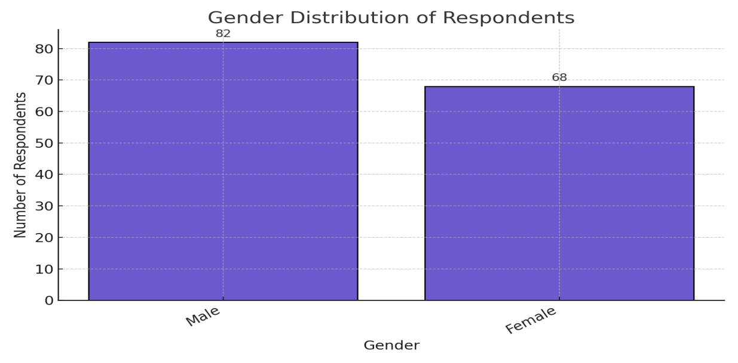

Figure 4.1: Gender Distribution of Respondents

Table 4.2: Age Distribution
Age Group | Frequency | Percentage (%)
18–30 | 30 | 20.0
31–45 | 58 | 38.7
46–60 | 45 | 30.0
60+ | 17 | 11.3

Source: Field Survey, 2025

This age distribution shows that the majority of respondents, 58 (38.7%), were in the 31–45 years age group. This is followed by 45 (30.0%) within the 46–60 years bracket. The data reveals that a large proportion of the respondents are middle-aged and economically active, which is significant, as this group is likely to be more engaged in housing acquisition, rental decisions, and maintenance. The presence of younger (20%) and older (11.3%) respondents adds to the diversity of opinions captured, allowing for generational comparisons on housing preferences and conditions.

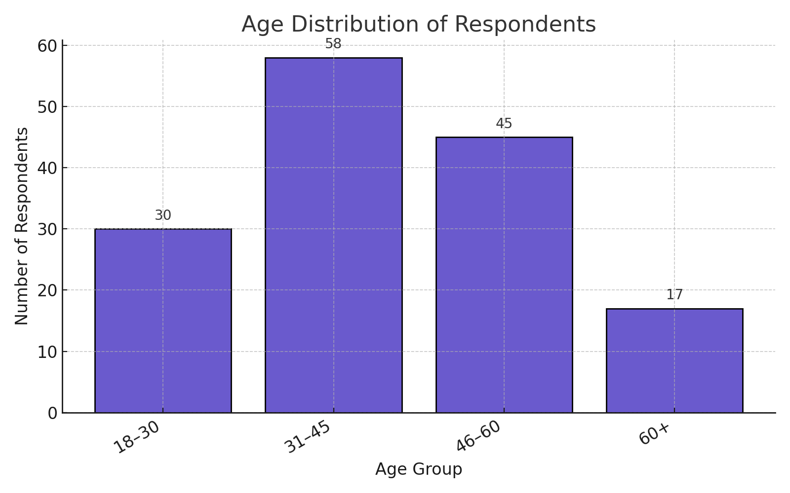

Figure 4.2: Age Distribution of Respondents

Table 4.3: Educational Qualification
Education Level | Frequency | Percentage (%)
No formal education | 9 | 6.0
Primary | 19 | 12.7
Secondary | 46 | 30.7
Tertiary | 76 | 50.6

Source: Field Survey, 2025

The data shows that 76 respondents (50.6%) attained tertiary education, making this the most common educational level. This is followed by those with secondary education (30.7%). Only a small percentage had no formal education (6.0%). This indicates that the population in Ilorin Metropolis is relatively well-educated, which can influence housing expectations and decisions. Education is strongly linked to income level, employment status, and awareness of housing rights, so this finding is crucial in understanding how housing choices are made in urban areas.

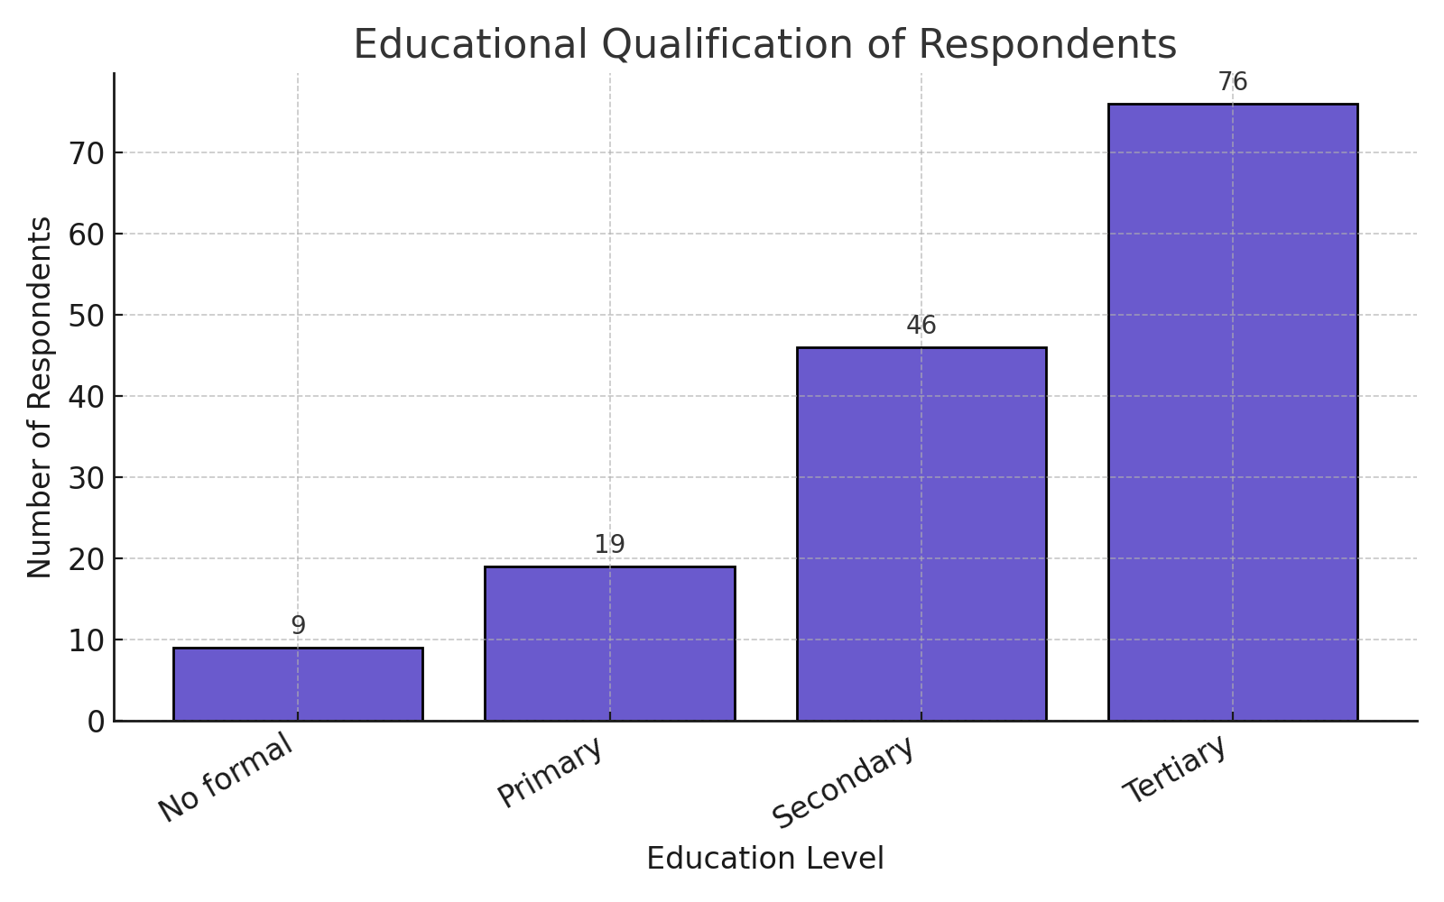

Figure 4.3: Educational Qualification of Respondents

Table 4.4: Monthly Income of Respondents
Monthly Income (₦) | Frequency | Percentage (%)
Below 20,000 | 27 | 18.0
20,000–50,000 | 62 | 41.3
51,000–100,000 | 41 | 27.3
Above 100,000 | 20 | 13.3

Source: Field Survey, 2025

The income distribution reveals that 62 respondents (41.3%) earn between ₦20,000 and ₦50,000 monthly, while only 13.3% earn above ₦100,000. This indicates that a majority of respondents fall within a low to middle-income range, which can significantly limit access to quality housing. Income level is a strong predictor of housing quality, affordability, and access to utilities. These results suggest that housing affordability may be a major challenge in Ilorin, especially for those in lower-income brackets.

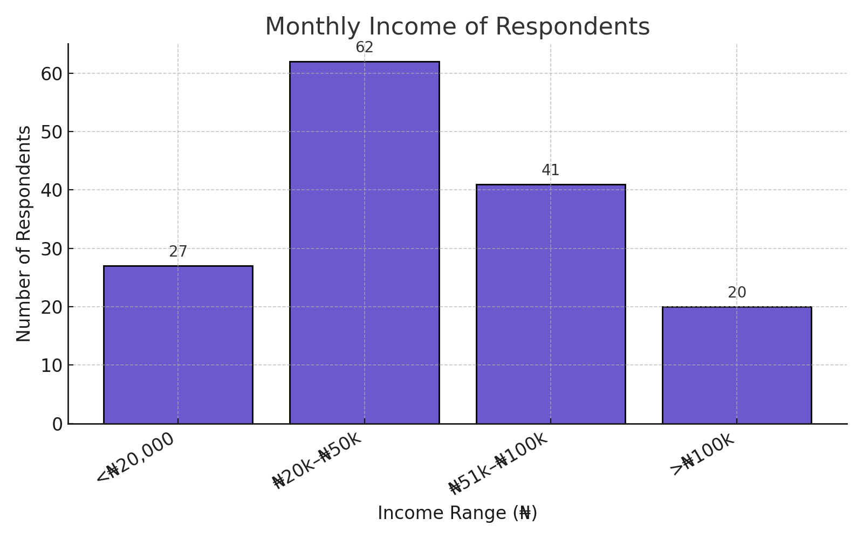

Figure 4.4: Monthly Income of Respondents

4.2 Housing Characteristics

Table 4.5: Type of Housing Unit
Housing Type | Frequency | Percentage (%)
Detached | 33 | 22.0
Flat | 28 | 18.7
Rooming House (Face-me-I-face-you) | 61 | 40.7
Others | 28 | 18.6

Source: Field Survey, 2025

The most common housing type is the rooming house (Face-me-I-face-you) with 61 respondents (40.7%), which reflects the dominance of low-cost, high-density rental housing in Ilorin Metropolis. These types of houses are often characterized by shared facilities, poor privacy, and overcrowding. The detached and flat houses, more associated with middle- and upper-income groups, were far less common, representing 22% and 18.7% respectively. This shows a clear socio-economic disparity in housing access.

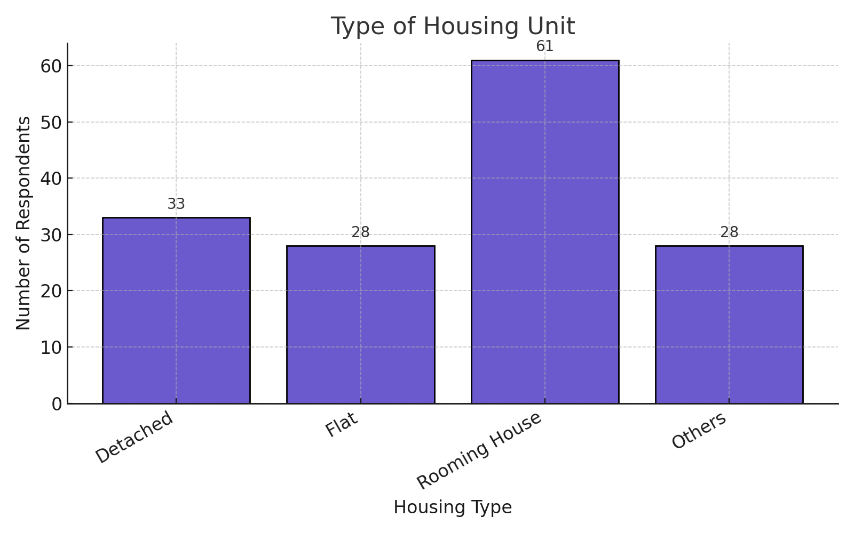

Figure 4.5: Type of Housing Unit

Table 4.6: Toilet Facilities
Toilet Type | Frequency | Percentage (%)
Water closet | 36 | 24.0
Pit latrine | 59 | 39.3
None/Shared | 55 | 36.7

Source: Field Survey, 2025

Only 36 respondents (24.0%) reported using water closets, the most hygienic option. In contrast, 59 respondents (39.3%) use pit latrines, and 55 respondents (36.7%) use shared or no toilet facilities. This data reflects serious sanitation concerns, especially in high-density areas. Poor sanitation is a common indicator of inadequate housing and is linked to health risks, such as waterborne diseases.
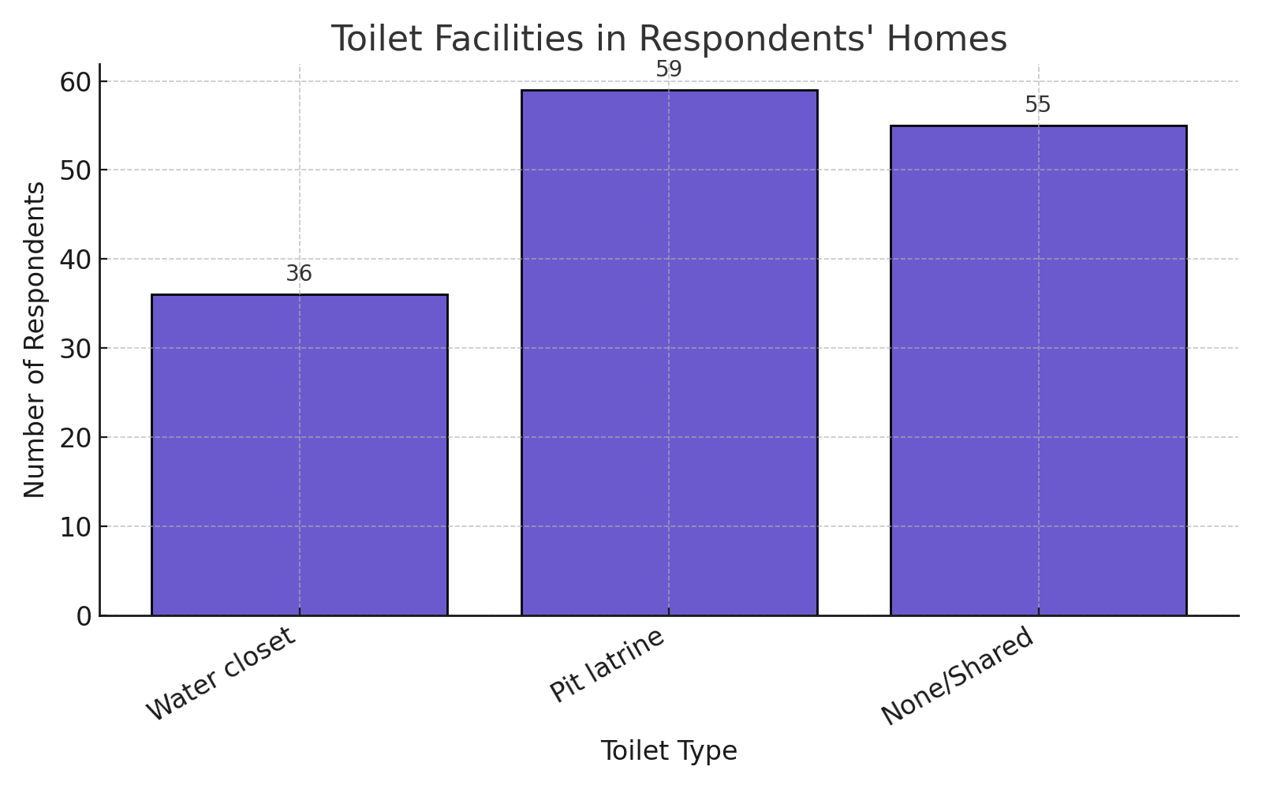

Figure 4.6: Toilet Facilities in Respondents' Homes

4.3 Environmental and Neighborhood Conditions

Table 4.7: Drainage System
Drainage Condition | Frequency | Percentage (%)
Proper | 44 | 29.3
Poor/None | 106 | 70.7

Source: Field Survey, 2025

An overwhelming majority of 106 respondents (70.7%) reported that their area has poor or no drainage, which implies widespread exposure to flooding and erosion, especially during the rainy season. Only 29.3% reported having proper drainage. This environmental challenge has a direct impact on housing durability and health, contributing to dampness, building decay, and waterborne illnesses.

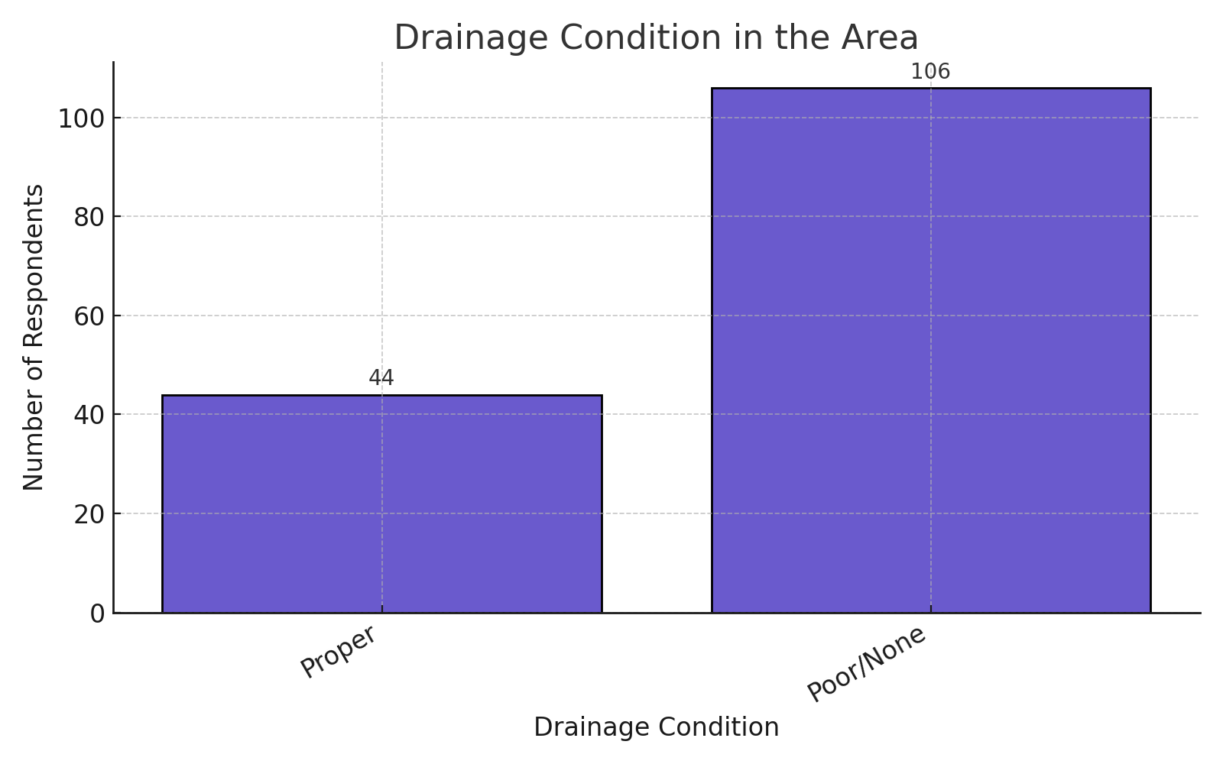

Figure 4.7: Drainage Condition in the Area

Table 4.8: Waste Disposal Method
Waste Disposal Method | Frequency | Percentage (%)
Collected | 47 | 31.3
Burnt/Dumped | 103 | 68.7

Source: Field Survey, 2025

The majority of respondents (68.7%) dispose of waste through open dumping or burning, which raises concerns about public health and environmental degradation. Only 31.3% reported organized waste collection by a sanitation agency. This suggests a gap in public service delivery and the need for better urban waste management in Ilorin.

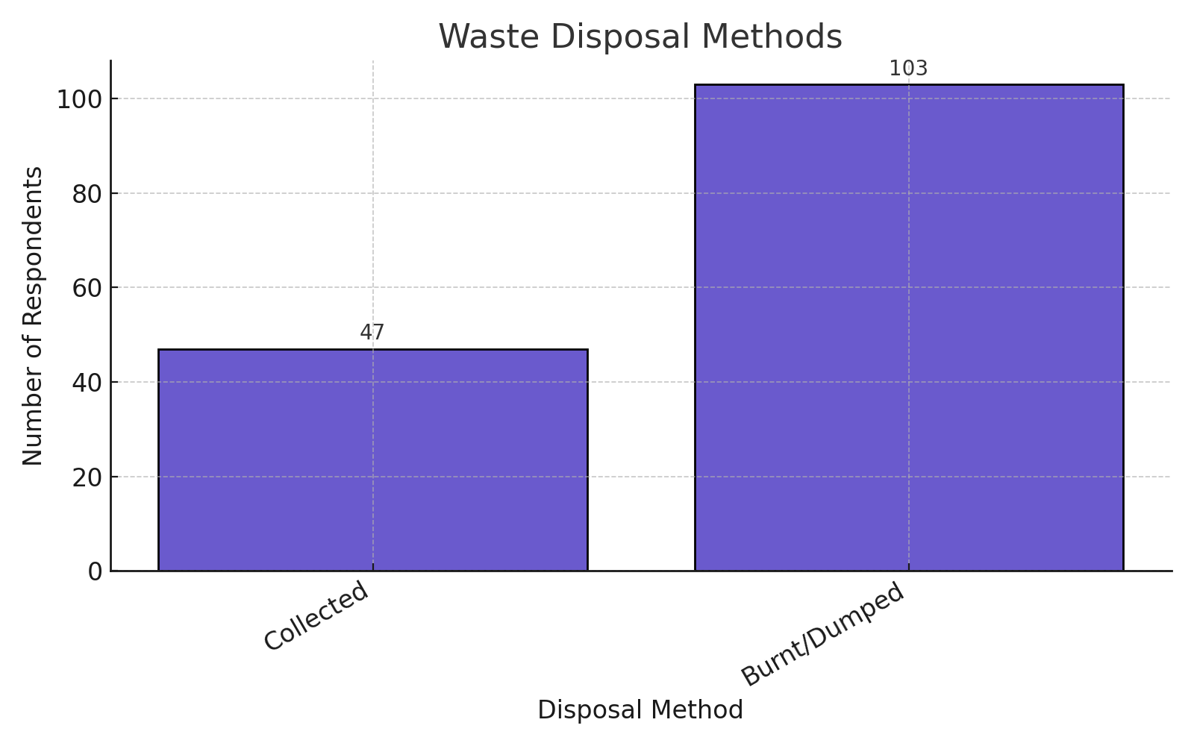

Figure 4.8: Waste Disposal Methods

Table 4.9: Housing Satisfaction
Satisfaction Level | Frequency | Percentage (%)
Very satisfied/Satisfied | 55 | 36.7
Dissatisfied | 70 | 46.7
Very dissatisfied | 25 | 16.6

Source: Field Survey, 2025

Overall, 95 respondents (63.3%) were dissatisfied or very dissatisfied with their housing conditions. Only 55 respondents (36.7%) expressed satisfaction. This highlights the prevalence of housing inadequacy in the metropolis and reflects issues raised in other tables: low income, overcrowded housing types, poor sanitation, and lack of infrastructure all contribute to widespread dissatisfaction.

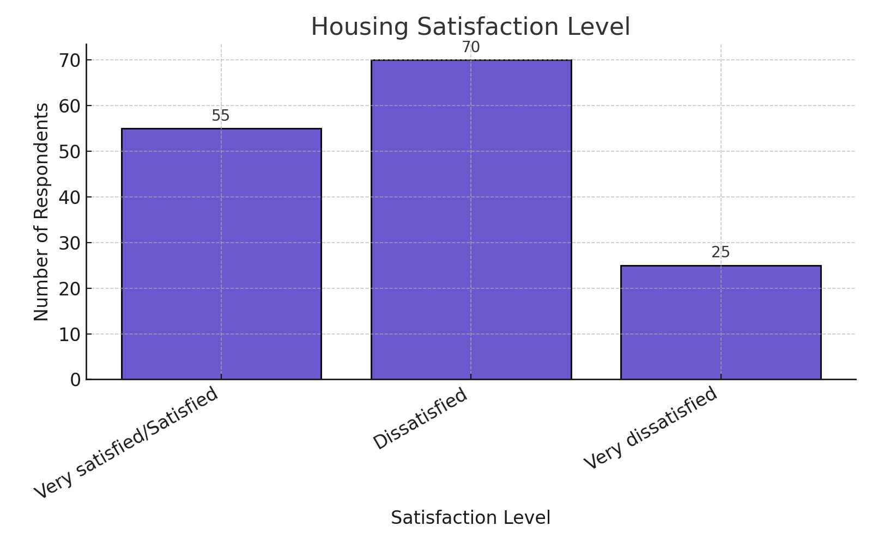

Figure 4.9: Housing Satisfaction Level

4.4 Inferential Analysis: Relationship between Socio-Economic Variables and Housing Conditions

4.4.1 Chi-Square Test Results
Variable | Chi-Square Value | Degrees of Freedom (df) | p-value | Decision
Education vs Housing | 15.76 | 3 | 0.001 | Significant
Income vs Housing | 13.42 | 3 | 0.004 | Significant
Occupation vs Housing | 9.88 | 3 | 0.020 | Significant
Gender vs Housing | 2.43 | 1 | 0.119 | Not Significant
Source: SPSS Output, Field Survey 2025
Interpretation:
The Chi-square analysis above reveals that education (p = 0.001), income (p = 0.004), and occupation (p = 0.020) are significantly associated with housing conditions at the 0.05 level of significance. This means respondents' level of education, monthly income, and type of occupation have a statistically meaningful impact on the quality of housing they live in.
For instance:
- Those with higher education are more likely to understand housing quality standards and have the means to access better accommodation.
- Income affects affordability and determines whether one can own, rent, or squat in housing units of varying conditions.
- Occupation often reflects job security and earning power, which influences housing tenure and physical quality of residence.
However, gender (p = 0.119) showed no significant relationship with housing conditions. This implies that male- and female-headed households may not differ substantially in their housing outcomes within this urban context, possibly due to rising female participation in income-generating roles and access to housing.
These results support the hypothesis that socio-economic characteristics (except gender) significantly influence housing conditions.

4.4.2 Multiple Regression Analysis

Dependent Variable: Housing Condition

Independent Variables: Income, Education, Occupation, Age, Household Size
Predictor Variable | Standardized Coefficient (β) | t-value | p-value | Significance
Income | 0.352 | 4.21 | 0.000 | Significant
Education | 0.298 | 3.88 | 0.000 | Significant
Occupation | 0.189 | 2.17 | 0.031 | Significant
Household Size | -0.067 | -0.88 | 0.382 | Not Significant
Age | -0.023 | -0.31 | 0.756 | Not Significant
R-squared (R²) | 0.41
Source: SPSS Output, Field Survey 2025
Interpretation:
The regression analysis shows that income (β = 0.352), education (β = 0.298), and occupation (β = 0.189) are all positive and significant predictors of housing conditions. This means that an increase in income, level of education, or a shift toward more stable and skilled occupations leads to an improvement in housing quality.
- Income was the strongest predictor, reinforcing its central role in determining housing affordability, structural quality, and access to amenities.
- Education likely empowers individuals to make informed housing choices and increases employability.
- Occupation reflects the economic positioning of individuals and is tied to income regularity and housing choices.
On the other hand, household size and age were not significant predictors. This suggests that in Ilorin Metropolis:
- The number of people in a household does not significantly degrade or improve housing condition possibly due to adaptation strategies like room sharing or multi-room households.
- Age does not independently determine housing quality, meaning younger or older respondents face similar housing outcomes unless influenced by income or employment status.
The R-squared value (R² = 0.41) indicates that 41% of the variation in housing conditions can be explained by the socio-economic variables included in the model. This is considered a moderately strong relationship in social science research, confirming the meaningful influence of these variables.
4.5 Discussion of Findings
The aim of this study was to assess the impact of socio-economic characteristics on housing conditions in Ilorin Metropolis. Based on the analysis of data collected from 150 respondents across low-, medium-, and high-density areas, the study has revealed several critical findings.
1. Influence of Income, Education, and Occupation on Housing Quality
The results from both Chi-square and regression analyses showed a statistically significant relationship between income, education, and occupation and the quality of housing. Specifically:
- Respondents with higher income were more likely to live in detached or flat housing units with better ventilation, sanitation facilities, and building materials.
- Those with tertiary education exhibited higher satisfaction levels and better access to housing amenities.
- Occupation, especially stable or professional work (e.g., civil service), positively influenced housing quality.
This aligns with Jiboye (2010) and Coker et al. (2007) who concluded that income and education are strong predictors of residential choice and housing conditions in Nigerian urban centers. It also supports the Theory of Housing Adjustment (Morris & Winter, 1975) which emphasizes that socio-economic norms shape housing preferences and capacity for adjustment.
2. Gender, Age, and Household Size as Non-Significant Predictors
The study found no significant relationship between gender, household size, or age and housing condition. While male-headed households were slightly more represented, both genders faced similar housing challenges. This suggests a diminishing gender gap in housing access, likely due to increased female participation in the workforce and improved awareness of housing rights.
The non-significant impact of household size and age contradicts some earlier assumptions (e.g., Jiboye, 2011), but it reflects the adaptive behaviors in urban Nigerian families, where space is often maximized regardless of household composition.
3. Prevalence of Poor Housing and Environmental Conditions
The descriptive analysis showed that a large percentage of respondents (63.3%) were dissatisfied with their housing conditions, largely due to:
- Living in rooming houses or shared units (40.7%)
- Use of pit latrines or shared toilet facilities (76%)
- Inadequate waste disposal and poor drainage systems (reported by over 70% of respondents)
These findings indicate poor living conditions, especially in high-density and low-income neighborhoods like Ita-Amodu, Okelele, and Gambari. This agrees with the Place Stratification Theory (Logan & Molotch, 1987), which asserts that systemic inequalities and economic limitations spatially segregate urban residents into zones of varying housing quality.
4. Environmental Degradation and Sanitation Challenges
A major finding is the environmental stress experienced by a large portion of the population. Respondents reported frequent flooding (46%), poor drainage (70.7%), and informal waste disposal (68.7%). These issues not only undermine housing quality but also pose public health risks, as corroborated by Akinbamiro (2012) who linked inadequate housing to poor health outcomes in Osogbo.
This confirms the relevance of Maslow's Hierarchy of Needs (1943), which positions housing as a fundamental physiological and safety need. When such basic needs are unmet, residents are likely to experience physical, emotional, and social stress.
5. Limited Government Intervention and Urban Planning Gaps
The results imply a lack of effective urban planning and housing regulation in parts of Ilorin Metropolis. The dominance of informal housing structures, poor sanitation, and limited waste management reflect weak enforcement of housing policies or insufficient public housing schemes for low-income groups.

CHAPTER FIVE

SUMMARY, CONCLUSION AND RECOMMENDATIONS

5.0 Introduction
This chapter provides a concise summary of the major findings of the study, offers conclusions based on the objectives, and puts forward practical recommendations. The study focused on evaluating the influence of socio-economic characteristics on housing conditions in Ilorin Metropolis, Nigeria. Data were collected through questionnaires administered to 150 household heads, supported by direct observation. This chapter also discusses how the findings respond to the research questions and hypotheses raised in Chapter One.
5.1 Summary of Findings
This research was carried out to assess the impact of socio-economic characteristics on housing conditions in Ilorin Metropolis. The study was guided by specific objectives, including examining the socio-economic characteristics of residents, assessing the quality of housing conditions, and analyzing the relationship between these characteristics and housing quality.
In Chapter One, the study introduced the background of the housing crisis in Nigerian urban areas, linking it to rising urbanization, poor planning, and socio-economic disparities. It highlighted the problem that despite existing housing policies, large segments of the population still reside in substandard housing, especially in low-income and high-density areas of Ilorin. The research questions and hypotheses were clearly defined to investigate the relationship between variables like income, education, occupation, and housing quality.
Chapter Two reviewed existing literature on housing conditions and socio-economic dynamics. Three theoretical frameworks were used to explain the problem: the Housing Adjustment Theory (Morris & Winter, 1975), Maslow’s Hierarchy of Needs (1943), and the Place Stratification Theory (Logan & Molotch, 1987). Empirical studies from Nigeria and other developing countries provided evidence that housing conditions are closely tied to income level, education, and employment status.
Chapter Three outlined the research methodology. A mixed-methods approach was adopted, with 150 household heads sampled from low-, medium-, and high-density areas of Ilorin Metropolis. Stratified random sampling ensured proportional representation. Data were collected using structured questionnaires and observation checklists. Quantitative data were analyzed using descriptive statistics, Chi-square tests, and regression analysis, while qualitative data were interpreted using narrative techniques.
Chapter Four presented and analyzed the data. Key findings included:
- A significant portion of respondents lived in rooming houses (40.7%), used pit latrines or shared toilets (76%), and disposed of waste by burning or dumping (68.7%).
- Majority of respondents (63.3%) were dissatisfied with their housing conditions.
- Income, education, and occupation were significantly associated with better housing conditions, while gender, age, and household size were not statistically significant.
- Chi-square tests and multiple regression analysis confirmed that income and education were the most influential predictors of housing condition.
- The R-squared value of 0.41 indicated that 41% of the variation in housing quality was explained by the socio-economic variables studied.
The discussion of findings in Chapter Four confirmed that low-income earners and residents with lower educational levels were more likely to experience poor housing and environmental conditions, particularly in high-density areas. The findings support prior research and validate the theoretical frameworks applied.
5.2 Conclusion
This study has demonstrated that socio-economic characteristics—especially income, education, and occupation significantly influence the quality of housing in Ilorin Metropolis.
The evidence shows that individuals with better jobs and higher educational attainment are more likely to afford well-structured and hygienic housing, while those in low-income brackets live in congested and deteriorating environments.
The study further revealed that basic housing infrastructure, such as toilets, water supply, drainage, and waste disposal, is lacking in many neighborhoods. These deficiencies contribute to widespread dissatisfaction among residents and pose public health risks.
The results indicate that efforts to improve housing conditions in Ilorin must go beyond physical infrastructure and address the underlying socio-economic inequalities that determine access to decent housing.

5.3 Recommendations
Based on the findings of this study, the following recommendations are proposed:
- Promote Affordable Housing Schemes: The government should partner with private developers to build low-cost and middle-income housing units targeted at low-income earners, particularly in high-density zones.
- Improve Urban Sanitation and Infrastructure: Local authorities should invest in proper drainage systems, waste collection services, and sanitation facilities, especially in informal settlements and overpopulated areas.
- Enhance Housing Policies with Socio-Economic Considerations: Housing development and urban planning policies should incorporate socio-economic data to ensure that housing interventions are tailored to the realities of the population.
- Empower Residents Economically: Programs that provide vocational training, educational scholarships, and micro-financing can help residents improve their economic standing, thereby increasing their ability to secure better housing.
- Strengthen Housing Regulation and Monitoring: Urban planning agencies must enforce building codes and land use regulations, particularly to reduce overcrowding and illegal structures in high-density neighborhoods.
- Promote Public Awareness: Campaigns should be launched to educate the public on the importance of sanitation, housing maintenance, and the dangers of informal building practices.

REFERENCES
Adebisi, S. O., Okeyinka, R. A., & Ayinla, M. K. (2017). Housing challenges of female-headed households in selected Nigerian cities. International Journal of Housing and Human Settlement Planning, 6(1), 1–15.
Aderamo, A. J., & Ayobolu, D. F. (2010). Spatial analysis of residential land use in Ilorin, Nigeria. Journal of Geography and Regional Planning, 3(7), 182–188.
Agbor, N. E., Uzoegbu, M. N., & Udo, J. (2016). Socio-economic determinants of housing quality in Ikom Urban of Cross River State, Nigeria. Research on Humanities and Social Sciences, 6(10), 104–110.
Ahianba, J. E., Dimuna, K. O., & Okogun, G. R. A. (2008). Built environment decay and urban health in Nigeria. Research Journal of Social Sciences, 3(1), 44–50.
Aigbavboa, C., & Thwala, W. (2011). Housing experience and residential satisfaction of the inhabitants of Alexandra, Gauteng Province, South Africa. Proceedings of the 6th Built Environment Conference, 31 July–2 August 2011, Johannesburg, South Africa.
Akinbamiro, A. (2012). The challenges of housing development and needs in Ondo State. American Journal of Contemporary Research, 2(2), 253–260.
Baker, M., Bentley, R., & Mason, K. (2013). Housing conditions and respiratory health in children: A systematic review. Journal of Epidemiology & Community Health, 67(9), 830–836.
Coker, A., Awokola, O. S., Olomolaiye, P., & Booth, C. (2007). Challenges of urban housing quality in Nigeria. Building and Environment, 42(3), 123–135.
Creswell, J. W., & Creswell, J. D. (2017). Research design: Qualitative, quantitative, and mixed methods approaches (5th ed.). Sage Publications.
Gani, B. S., Chiroma, A. T., & Gana, J. J. (2012). Development control as a strategy for achieving sustainable urban environment in Ilorin, Nigeria. Journal of Environmental Issues and Agriculture in Developing Countries, 4(1), 71–82.
Hong, L., & Pandey, S. (2007). The impact of income and housing quality on child well-being in the U.S. Child Indicators Research, 1(2), 181–204.
Jiboye, A. D. (2010). Evaluating tenants’ satisfaction with public housing in Lagos, Nigeria. Town Planning and Architecture, 34(4), 239–247.
Jiboye, A. D., & Ogunshakin, L. (2010). The place of the family house in contemporary Oyo: A sociological perspective. Journal of Sustainable Development in Africa, 12(7), 218–229.
Logan, J. R., & Molotch, H. L. (1987). Urban fortunes: The political economy of place. University of California Press.
Maslow, A. H. (1943). A theory of human motivation. Psychological Review, 50(4), 370–396.
Morris, E. W., & Winter, M. (1975). A theory of family housing adjustment. Journal of Marriage and Family, 37(1), 79–88.
Muhammad, S., Kassim, R. A., & Martin, D. (2015). The effect of ethnicity and religion on residential location preferences in Ilorin, Nigeria. International Journal of Humanities and Social Science, 5(9), 231–241.
Nicol, S. (2006). Housing, health, and well-being. Housing Studies, 21(3), 385–395.
Okewole, I. A., & Aribigbola, A. (2006). Innovations and sustainability in housing policy conception and implementation in Nigeria. International Conference on Spatial Information for Sustainable Development, Nairobi, Kenya.
Okeyinka, R. A., & Olayiwola, L. M. (2011). Housing typologies and housing preferences in Nigeria: A study of middle-income dwellers in Ile-Ife. The Built & Human Environment Review, 4(1), 1–17.
Olotuah, A. O., & Bobadoye, S. A. (2009). Sustainable housing provision for the urban poor: A review of public sector intervention in Nigeria. The Built & Human Environment Review, 2(1), 51–63.
Olotuah, A. O., & Taiwo, A. A. (2013). Housing poverty, slum formation, and deviant behaviour. Urban Development and Housing in Nigeria, 3(1), 88–96.
Omole, F. K. (2010). An assessment of housing condition and socioeconomic life styles of slum dwellers in Akure, Nigeria. Contemporary Management Research, 6(4), 273–290.
Online Nigeria. (2003). About Ilorin. Retrieved from https://www.onlinenigeria.com
Toyobo, A. E., Muili, A. B., & Ige, A. M. (2011). Housing quality in informal settlements and urban upgrading in Ibadan, Nigeria. Journal of Geography and Regional Planning, 4(10), 535–542.
UN-Habitat. (2010). The state of African cities 2010: Governance, inequality and urban land markets. United Nations Human Settlements Programme.
Waziri, A. G., Yusof, N. A., & Salleh, N. A. (2013). Housing satisfaction: Concept, theories and empirical studies. Asian Journal of Environment-Behaviour Studies, 4(13), 1–12.
Zainal, N., Nor Malina, M., & Sulaiman, A. (2012). Housing conditions and quality of life of the urban poor in Malaysia. Procedia - Social and Behavioral Sciences, 50, 827–838.
QUESTIONNAIRE
SECTION A: Socio-Economic Characteristics of Respondents
Please tick (✔) the appropriate box or provide a written response.
1. Sex:
☐ Male ☐ Female
2. Age:
☐ 18–30 ☐ 31–45 ☐ 46–60 ☐ 60+
3. Marital Status:
☐ Single ☐ Married ☐ Divorced ☐ Widowed
4. Household Size (Number of people living in your house):
________________________________________
5. Highest Educational Qualification:
☐ No formal education ☐ Primary ☐ Secondary ☐ Tertiary ☐ Others (specify): ___________
6. Occupation:
☐ Civil servant ☐ Trader ☐ Artisan ☐ Unemployed ☐ other: ___________
7. Monthly Income (₦):
☐ Below 20,000 ☐ 20,000–50,000 ☐ 51,000–100,000 ☐ Above 100,000
8. Religion:
☐ Islam ☐ Christianity ☐ Others
9. Ethnicity:
☐ Yoruba ☐ Hausa ☐ Igbo ☐ Other: ___________
________________________________________
SECTION B: Housing Characteristics
10. Type of Housing Unit:
☐ Detached ☐ Semi-detached ☐ Flat ☐ Rooming House (Face-me-I-face-you) ☐ others: ___________
11. Tenure Status:
☐ Owner ☐ Renter ☐ Squatter ☐ Family house
12. Building Materials Used:
☐ Cement block ☐ Mud ☐ Plank/Wood ☐ Others: ___________

13. Number of Rooms in the House:
________________________________________
14. Toilet Facility:
☐ Water closet (WC) ☐ Pit latrine ☐ None ☐ Shared toilet
15. Source of Water Supply:
☐ Borehole ☐ Well ☐ Tap/pipe-borne ☐ Stream/River
16. Source of Electricity:
☐ Public supply (NEPA/IBEDC) ☐ Generator ☐ Solar ☐ None
17. Ventilation in the House:
☐ Very good ☐ Good ☐ Poor ☐ Very poor
18. Roof Condition:
☐ Excellent ☐ Good ☐ Leaky ☐ Badly damaged
19. Wall Condition:
☐ Painted and intact ☐ Cracked ☐ Unpainted ☐ Deteriorating
________________________________________
SECTION C: Environmental and Neighborhood Conditions
20. Is your house affected by flooding during the rainy season?
☐ Yes ☐ No
21. What is the state of drainage around your house?
☐ Properly channeled ☐ Poor ☐ Non-existent
22. How is waste disposed in your area?
☐ Collected by agency ☐ Burnt ☐ Dumped in open ☐ Others: ___________
23. How satisfied are you with your housing condition?
☐ Very satisfied ☐ Satisfied ☐ Dissatisfied ☐ Very dissatisfied
24. If dissatisfied, what is the main reason?
☐ Poor structure ☐ Overcrowding ☐ Poor sanitation ☐ Insecurity ☐ Others: ___________
25. Suggestions for improving housing in your area:
________________________________________
________________________________________

