
DEPARTMENT OF SCIENCE LABORATORY TECHNOLOGY
HYDRODISTILLATION, PHYTOCHEMICAL PROFILING AND ELUCIDATION OF THE CHEMICAL COMPONENTS IN THYMUS VULGARIS (THYME) LEAVES

By

BABATUNDE WARIS ALABI
HND/23/SLT/FT/0733

BEING A THESIS SUBMITTED TO
THE DEPARTMENT OF SCIENCE LABORATORY TECHNOLOGY (BIOCHEMISTRY UNIT),
INSTITUTE OF APPLIED SCIENCES, KWARA STATE POLYTECHNIC ILORIN, KWARA STATE.
IN PARTIAL FULFILLMENT OF THE REQUIREMENT FOR THE AWARD OF HIGHER NATIONAL DIPLOMA (HND) IN SCIENCE LABORATORY TECHNOLOGY, KWARA STATE POLYTECHNIC ILORIN,
KWARA STATE

SUPERVISED BY: MR. O. E. ADEYEMO

2024/2025 SESSION

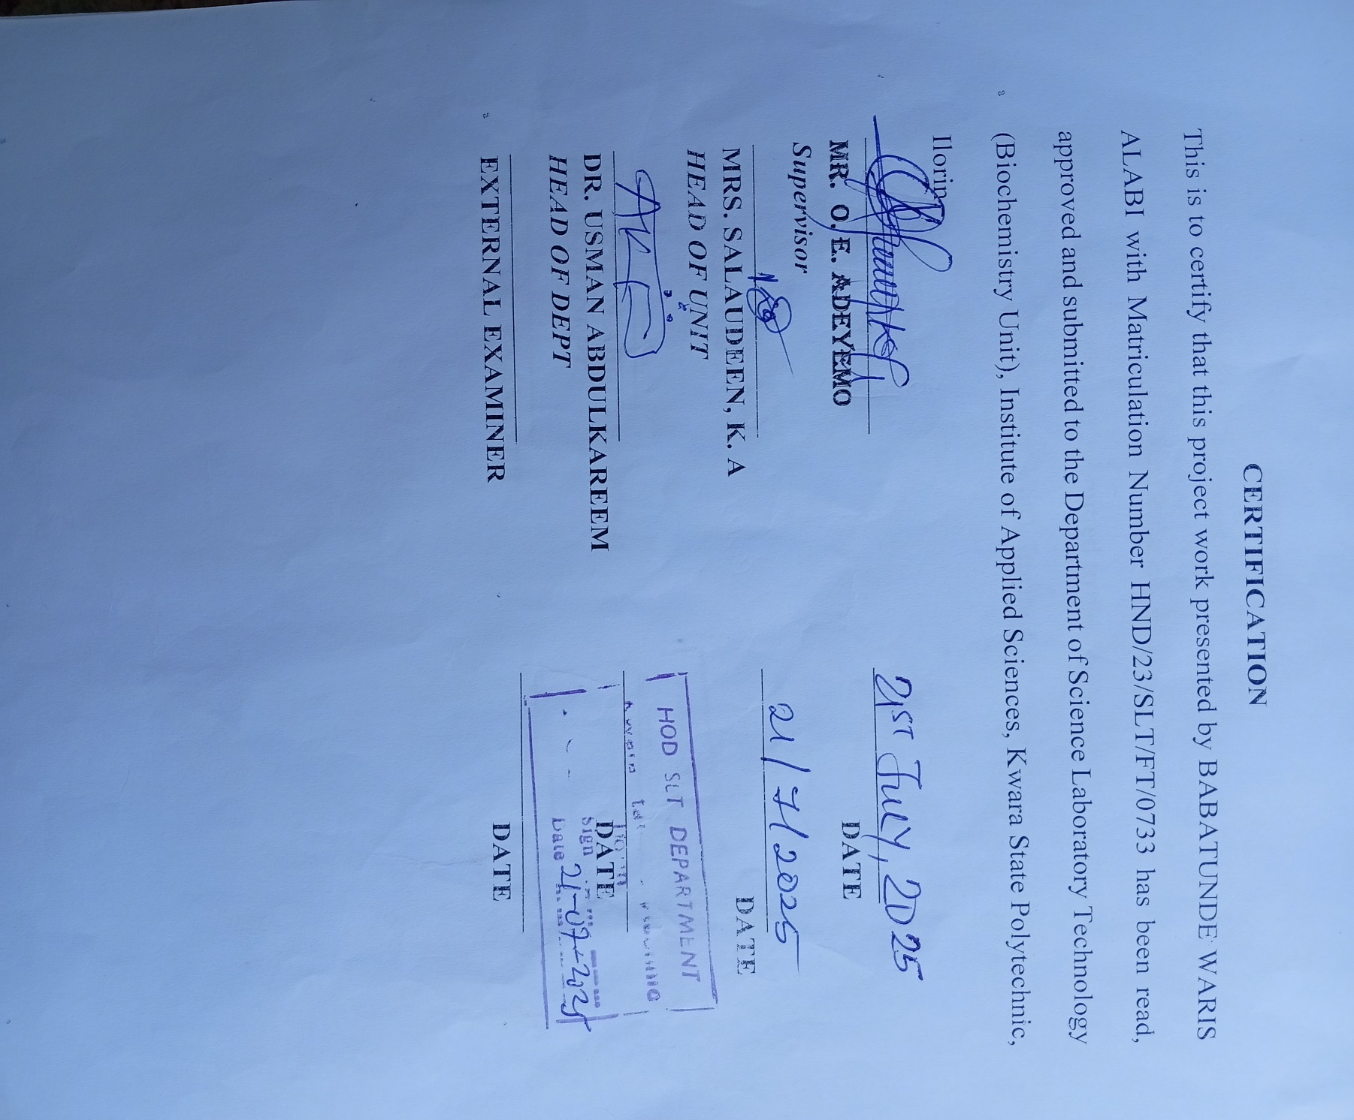
DEDICATION
This project is dedicated to Almighty Allah (S.W.T), the God of mercy and the creatures of the universe. I give him glory for sustaining me up to this moment including my beloved Father, Mother, Brother and sisters.(Mr. & Mrs. Babatunde)
Also I gives thanks to God for making this journey successful and fruitful
ACKNOWLEDGEMENT
First and foremost, I give all glory to the Almighty Allah for the strength, grace, and guidance that has carried me through every moment of this journey. My heartfelt gratitude goes to my HOD DR. USMAN for his support may Almighty Allah provides for his needs.
I will be indepted if I fail to Acknowledge the effort of my supervisor Mr.ADEYEMO ELIJAH for his usual support,caring throughout the writing of my project,I pray may Almighty Allah bless him Abundantly.
To my beloved parents, Mr. and Mrs. Babatunde…words will never be enough to express the depth of my gratitude. Your love, sacrifices, and constant prayers have been the pillars of my life. You’ve given me everything without asking for anything in return. Your belief in me, even when I doubted myself, gave me the courage to keep going. Thank you for being my rock, my light.I hope to make you proud always.
To my Lovely Sisters, Babatunde Roqeebat — your strength, loyalty, and quiet encouragement have meant more to me than you’ll ever know. You’ve been a constant in my life, always showing up, always supporting.Thank you for standing by me, for lifting me when I needed it most, and for being my blood and my friend.
To Fasasi Zainab — you’ve walked with me through the highs and lows, shared in my victories and comforted me in my defeats. Your presence in my life has been nothing short of a blessing. Thank you for the love, the patience, and the unwavering belief in who I am and who I’m becoming. I appreciate you, and I carry your encouragement with me always.
And to my cherished Friend IBRAHIM RASHEED you’ve added color to my world. Thank you for the laughter, the late-night talks, the prayers, and the pure companionship. You’ve been more than friends; you’ve been family. I’m grateful beyond words for the memories we’ve created and the support you’ve given me.
From the depths of my heart, thank you all. I am here because of your love.

Contents
Title page
Certification
Dedication
Acknowledgements
Table of Content
Abstract
CHAPTER ONE
1.0 Introduction
1.1 Problem statement
1.2 Aim and objective of the study
1.3 Justification of the study
1.4 Scope of the story
1.5 Relevance of the study

CHAPTER TWO
2.0 Literature review
2.1 Thymus vulgaris description
2.2 Composition of thyme
2.3 Phytochemical constituents of thymus vulgaris
2.4 Pharmacological of thymus vulgaris
2.4.1 Antioxidant activity
2.4.2 Antibacterial activity
2.4.3 Antifungal activity
2.4.4 Antispasmodic activity
2.4.5 Cytotoxicity activity
2.4.6 Cardiovascular activity
2.4.7 Antimicrobial activity
2.4.8 Anti-inflammatory activity
2.4.9 Anti-viral activity
2.4.10 Thyme as functional food
2.5 Food application
2.6 Public health and Dietary implications of thyme in food
CHAPTER THREE
3.0 Experimental
3.1 Reagents and equipment
3.1.1 Reagents
3.1.2 Apparatus and Equipment
3.2 Collection of samples
3.3 Preparation of samples
3.4 Hydro-distillation of thymus vulgaris
3.5 Solvent extraction of phytochemicals in thymus vulgaris
3.6 Phytochemical screening of extract
3.6.1 Using Biuret test
3.6.2 Using Biuret test
3.6.3 Test for Tannins
3.6.4 Test for Saponin
3.6.5 Test of Triterpenes
3.6.6 Test for flavonoid
3.6.4 Test for Carbohydrate
3.7 GC-MS analysis of the sample
chapter four
4.0 Results and discussion
4.1 Results
4.2 Discussion
4.3 Conclusion
References as footnotes

Abstract
Thymus vulgaris was steam-distilled i.e. hydrodistilled to obtain the volatile components while the non-volatile constituents were extracted with ethanol as solvent. The hydrodistillate was analysed using GC-MS to elucidate the structures of the components while the crude ethanolic extract was screened for the presence of phytochemicals. The results showed that there are 36 volatile components in the hydrodistillate ranging from organic acids to hydrocarbons. The phytochemicals present include steroids, triterpenes, flavonoids and fixed oil. These components identified in both hydrodistillate and crude extract are believed to be responsible for the bioactivities of the plants and facilitated its culinary and medicinal usage.
Keywords: Thymus vulgaris, hydrodistillation, extraction, phytochemicals,

CHAPTER ONE
1.0 INTRODUCTION
(Thyme) is an aromatic small perennial woody plant belonging to the lamiaceae family used for medicinal and spice purpose globally. Thyme grows well under dry and sunny climatic conditions in unshaded areas.
Thymus vulgaris is also called a common thyme this standard cultivar in extensively cultivated in numerous nations, with a particular emphasis on Mediterranean region such as Greece, Italy, and spain³. The UK and other European countries are particularly fond of this variety. Which is distinguished by its silver-edged leaves. ‘Narrow-leaved French’ the name of this variety implies that it is frequently associated with France. It is frequently employed in French cuisine and is characterized by its narrower leaves and strong and fragant fragrance⁴.

1. B. Khosravipour, F. Direkvand-moghadam. “The development of thyme plant as a medicinal herb: A review article”. Advanced Herbal medicine. 2017, 3(2) 47-53
2. E. M. Dauqan, A. Abdullah. “Medicinal and punctional valves of thyme (Thymus Vulgaries L.) herb”. Journal of Applied Biology and Biotechnology 2017, 5(2) 0-2.
3. K. Schwarz, H. Ernst, and W. Ternes. Evaluation of Antixidative constituents from Thyme journal of the science of food and agriculture, 2017, 70(2); 217-223
4. T. Ibrahim. H. Alayan, and Y. A. Mowaqet. “The effect of Thyme leaves extract on corrosion of mild steel in HCl”. Progress in Organic Coatings, 2017, 75,4:
1.1 PROMBLEM STATEMENT
Thyme is a popular herb used in cooking, but it can also be used for medicinal purposes. However, there are some potential problems associated with using thyme. For example, thyme can interact with certain medications, and it may not be safe for pregnant women or people with certain medical conditions.
Additionally, some may be allergic to thyme. It is important to talk to a doctor before using thyme to any medical purpose.
1.2 AIM AND OBJECTIVE OF THE STUDY
Thyme has been used for centuries for medicinal purposes, and some studies suggest that it may have several benefits including: antioxidant properties (thyme contains antioxidants that may help protect cells from damage), anti- inflammatory properties (may help reduce inflammation, which can be beneficial for conditions such as arthritis), anti-microbial properties (have anti-microbial properties that can help fight infections). Others are respiratory benefits (help in relieving symptoms of respiratory conditions such as coughs and colds). The potential risks include allergic reactions (some people may be allergic to thyme), interactions with medications (thyme may interact with certain medications, so it’s important to talk to your doctor before using it). All of these are due to the activities of the various compounds present in thyme.
The study is aimed at extracting these natural compounds in thyme both as volatile and non-volatile components, identifying each class of compounds and elucidating them by means of an instrumental method namely GC-MS analysis.
The specific objectives are:
- To collect samples of thyme leaves by procuring commercially available products
- To extract the volatile components by hydro-distillation methods using Dean-Stark apparatus from a portion of the sample
- To extract another portion of the thyme sample with ethanol for non-volatile components soluble in the solvent.
- To detect and identify the presence of phytochemicals in the crude ethanolic extract using conventional phytochemical screening methods
- To carry out GC-MS analysis (total scan) of the hydro-distillate of thymus vulgaris sample.
- To identify by structural elucidation of the constituents of the hydro-distillate of the thyme sample.
1.3 JUSTIFICATION OF THE STUDY
Thyme has been used for medicinal purpose for centuries, there is limited scientific evidence to support its effectiveness. This study will fill this knowledge gap by investigating the chemical components of thyme so as to account for its potential benefits and risk of using thyme of medicinal purposes. The findings of the study will help inform healthcare professionals and consumers about the safe and effective use of thyme. And possible restrictions on its use due to allergic reactions which may result from its consumption, resulting from the presence of a particular chemical components. The composition may also be indicative of its medicinal properties.
1.4 THE SCOPE OF THE STUDY
This study will focus on the qualitative profiling of the phyto-constituents of thymus vulgaris and the subsequent elucidation of the compounds in the extract to establish it function as a medicinal alongside its use for culinary purpose.
1.5 RELEVANCE OF THE STUDY
The study is relevant because it will provide valuable information about the potential benefits and risks of using thyme for medicinal purposes and further enhance its use in culinary. This information could help to inform nutritionist, dieticians and ‘alternative’ healthcare professionals and consumers about the safe and effective use of thyme. This will boost its consumption and contribution to medicinal applications.

CHAPTER TWO
2.0 LITERATURE REVIEW
Thyme is a medicinal plant use as flavoring substance in food, its products such as powder, extracts and oil, have antioxidant, anti-diabetic, antilipidemic, antitumor and antimicrobial acting attributed to thyme’s active components such as canverciol and thymol in combination with other biological components⁵.

2.1 THYME VULGARIS DSCRIPTION
Thyme (Thyme vulgaris L.) is a main medicinal plant which belongs to the lamiaceae family⁵. Carvarol (5-methy1-1-2-isopropy1 phenol) are the main phenolic components in thymus vulgaris, which form about 2055% of oil extract⁵ many studies demonstrating that thyme volatile oil is among the main essential oils used in cosmetics as antioxidants and preservatives and in food manufacturing⁶. Essential oils of thymus vulgaris is a combination of monoterpenese, the main substances of this oil are phenol isomer carvacrol and its.
5. Y. Masada. Analysis of oil by gass chromatography and mass spectrometry. United States (New York), johan Wiley and sons. (1976).
6. A. Zarzuelo, E Crespo. The medicinal and non-medicinal (2002) The medicinal and non-medicinal uses of thyme, in Thyme: The Genus Thymus. Medicinal and Aromatic Plants -Industrial Profiles, Stahl-Biskup, E. and Saez, F. Eds., Taylor & Francis, New York, NY,USA. Pp. 263–292.
Nature terpenoid thymol, which have antimicrobial, ant oxidative, antibacterial, antitussive, antispasmodic and expectorant actions⁷. Phenolic acid, terpenoids and flavonoids glycosides also present in thymus vulgaris L⁸. In addition, other active biochemical compounds of Thyme species are flavonoids (e.g Thymonin, cirsilineol and 8-methoxy-airsilineol), caffeic acid, triterpenoids, aliphatic aldehydes, long-chain saturated hydrocarbons and “Labiate tannin (rosmarinic acid)
2.2 COMPOSITION OF THYME
Several studies have reported that thyme is a source rich in bioactive compounds. Among the phenolic components of thyme oil are thymol and cavacrol, the latter of which is an isomer of the former. Thymol provides thymol oil with its olfactory peculiarities. Depending on the place of origin and species of thyme, this oil offers percentage of phenolic content that range from 40 to 80 percent of thymol and up to 55 percent of carvacrol¹⁰.
7. M Hoferl et al; Correlation of antimicrobial activities of various essential oil and their main aromatic volatile constituents. J. Essent Oil Res 21:459-463
8. R. Vila.”Flavonoids and further polyphenols in the genus Thymus, in Thyme: The Genus Thymus. Medicinal and Aromatic Plants—Industrial Profiles, E. Stahl-Biskup and F. Saez, Eds., Taylor and Francis, New York, NY, USA. 2002, Pp.75.
9. G. Horváth.” Néhány Thymus taxon fitokémiai jellemzőinek megismerése kromatográfiás, mikrobiológiai és molekuláris módszerekkel. Phd candidate, Pécs. 2005, 1-25.
10. Gema Nieto. “A Review on Applications and Uses of Thymus in the Food Industry”. Plants 2020, 9, 961, 1-29.
Thyme contains monoterpene phenols, including carvacrol (iso-propyl-ortho-cresol; 0.4-20.6%), thymol (2-iso-propulmeta-cresol; CLOHIHOJLO-64%) and p-cymene (9.1-22.2%) and other monoterpenes, such as $∝$- pinene (0.9-6.6%), 1, 8-cinede (0.2-14.2%), Camphor (0-7.3%), linalool (2.2-4.8%) and borneol (0.6-7.5%)¹¹.
Table 2.1: Components in thyme leaves
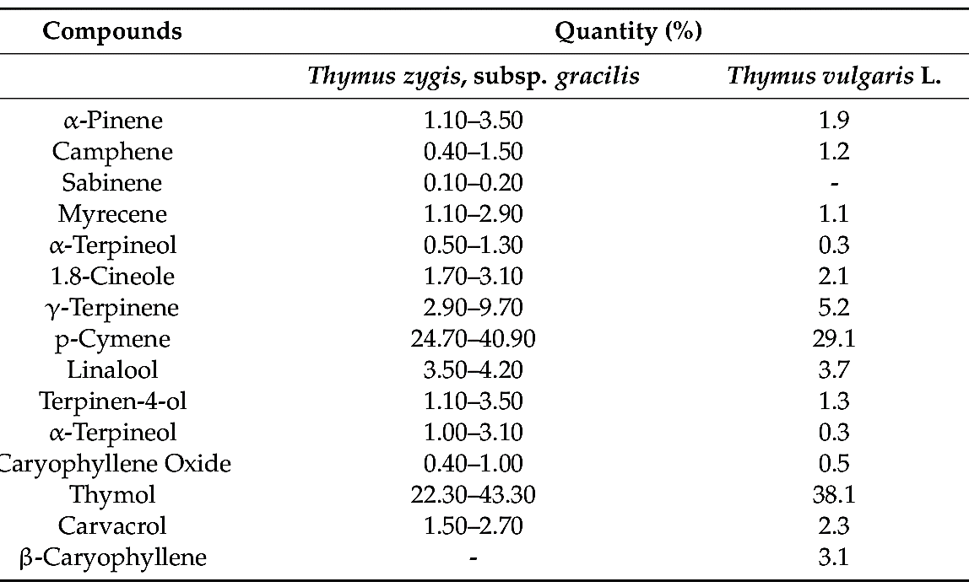
It is important to consider the main factor is that influence the effectiveness of natural extract and essential oils; for examples, the biotic characteristics of the plantis, such as the season and geographical source, have an influence on the concentration and composition of the bioactive compounds¹².
11. S Burt Essential Oils: their antibacterial properties, are potential applications in food are view. Ind J food microbial 2004: 94(3): 223-53
12. M, Sienkiew. The antimicrobial Activity of Thyme Essential oil against multidrug Resistant clinical Bacterial stains. Microbe Drug Resist. 2012,18:137-148.

2.3 PHYTOCHEMICAL CONSTITUENTS OF THYMUS VULGARIS
Numerous dives chemical substances, including as the saponins the tanins, flavonoids, which alkanoids substances, terpenoids that and steroid hormones are found in the vulgaris shrub L. one of the main herbs that yield monoterpene phenolic chemicals was thyme. Carvacrol, which p-cymeme, -pinene, borneal, thymol, and 1, 7-cineole represent a few of their main component.^{11,} . Heidari et al.¹³ Employing Gas Chromatography-Mass spectrometry (GC-MS) to identity the creosol 1-methoxy-3-methyl-phenol, thiophenol (benzene thiol), loliolide, 8-methoxy -7- methylphenol, and quinic acid, as demonstrated within¹³.
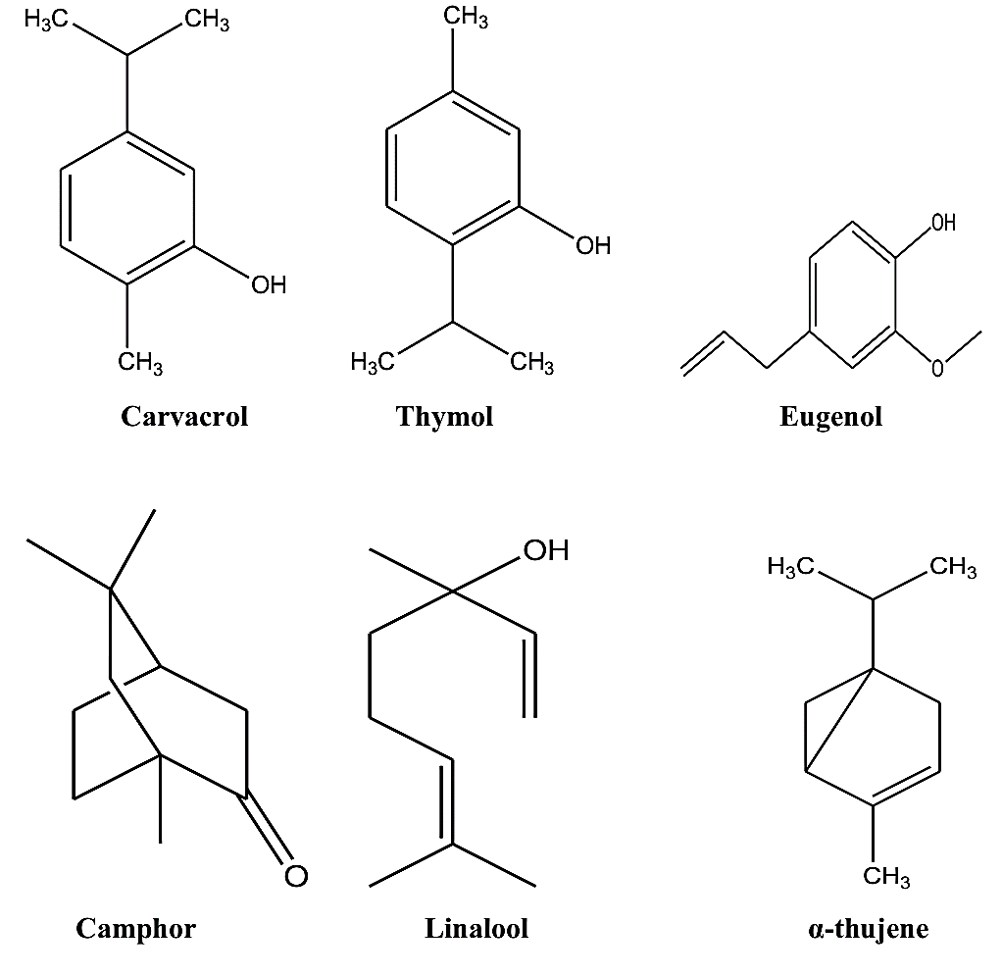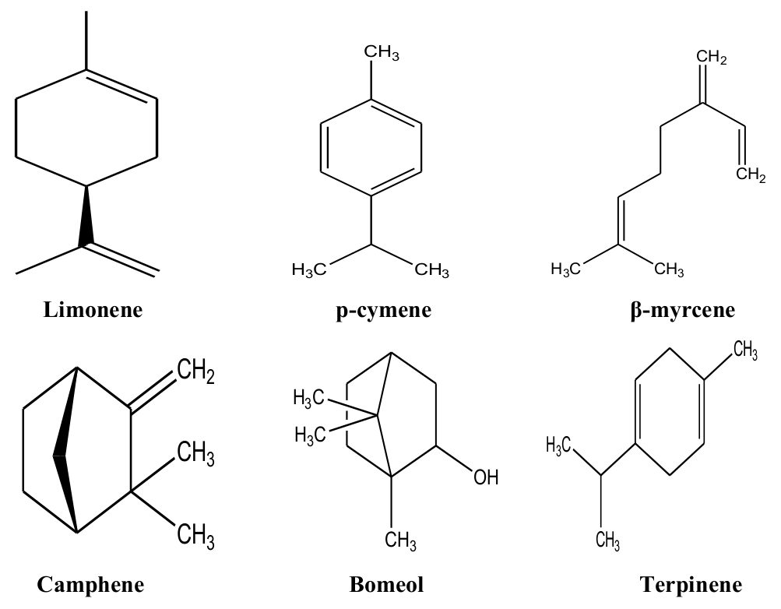
Figure 2.1: Some terpenoidal compounds in thyme

13. Z Heidari Anticancer and anti-oxidant properties of ethanolic leaf extract to Thymus vulgaris and it’s bio-functionalized silver neonparticles 2018;(3):1-4

Thyme has a comparable abundance of flavonoids.
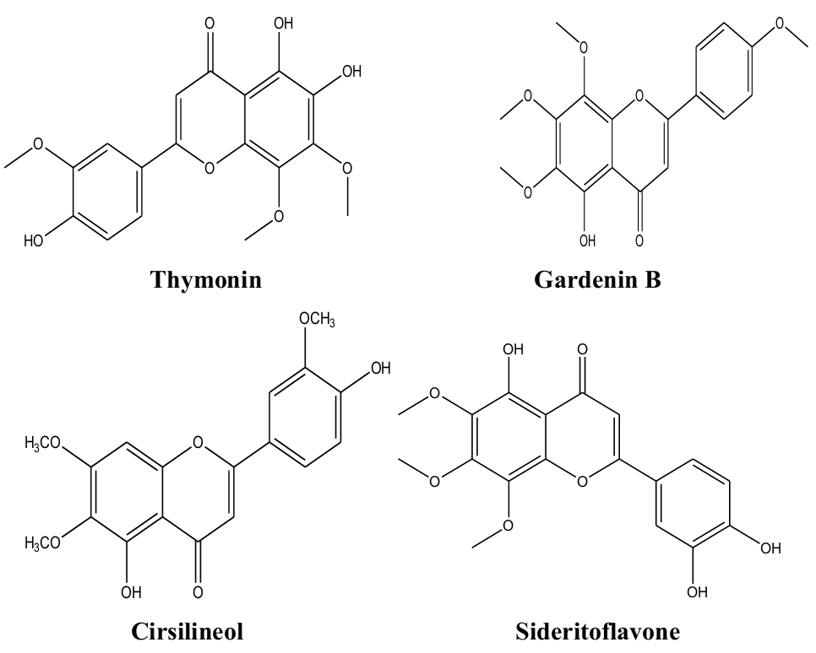
Figure 2.2: Some essential oils in thyme
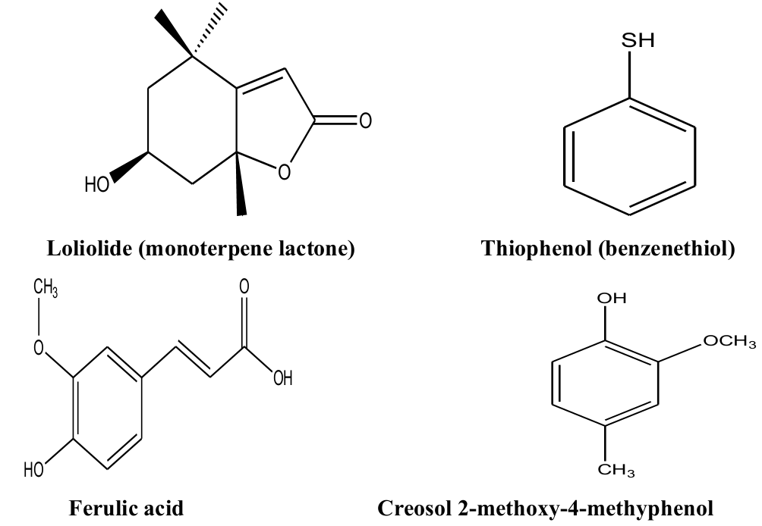
Figure 2.3: Some flavonoids in thyme
Leadenin, 6-hydroxyluteolin, which and methyl flavone including 6-demethylnobiletin, 8-methoxy-crisilineol, cirsimaritin, and 8-methoxy luteolin are the main flavone, Gardenin B, which is the thymonin, sideroto flavone, and xanthomicrol are some more important flavones¹⁴
2.4. PHARMACOLOGICAL ACTIVITIES OF THYMUS VULGARIS
Thymus vulgaris, commonly known as common thyme, is an herb with a long history of medical use. Its pharmacological properties are attributed to the presence of various bioactive compounds.
2.4.1 Antioxidant activity
According to research on liver cells, experimental mice given extracts of thyme or sage showed increased resistance to oxidative stress¹⁹. The result shows that consuming extracts from Thymus Vulgaris and S. officinalis increases the rat liver cells’ ability to withstand oxidative damage and may have liver protective effects¹⁵. The study looked at the quantity and composition of plants extracts, their capacity to stop hydrogen peroxide and 2,3-jimethoxy-1,4 naphlhoquinone- induced damage to DNA, and the concentration of antioxidants that are enzymatic and non-enzymatic in human HepG2 cells, such as peroxidase from glutathione, glutathione, and
14. MH Roby et al: Evaluation of antioxidant activity, total phenols and phenolic compounds in thyme (Thymus Vulgaris L.) sage ( salura officinalis L.), and marjoram (origanum majorana L.) extracts, ind crops prod 2013;43:827-31
15. K Kozic et al: Food Chem.2013;141(3):2198-206
superoxide dioxide dismutase. According to the findings, pretreating the cells with the investigated plant extracts significantly reduced the amount of oxidant-induced damage to the DNA in the cells. The measured DNA-protective effect may be explained by the antioxidant properties of SO and TV as well as the increased GPX activity present in cell that were pretreated with them¹⁶. The sample classified as C-T and T exhibited the least degree for oxidation of lipids and the highest levels of tocopherol, and n-3 fatty acids in their tissues. The two types furthermore showed a substantial drop in drip loss¹⁷.
2.4.2 Antibacterial activity
Thyme essential oils have anti-bacterial properties²³. Evaluated the bacterial activity and resistance of several antibiotics, including parahaemolyticus and fluvialis that were recovered from shrimps. As shown by the findings, the ethanol extract exhibited 20 antibacterial activities in the test and a 23 m zone of inhibition against. Parahaemolyticus and fluvialis. Thymus vulgaris intervened and totally blocked the microbial load in 150 and 60 minutes¹⁸.
16. Dalle Zotte A, Cullere M, Sartori A, Szendrő Z, Kovàcs M, Giaccone V, et al.Meat Sci.2014;98(2):94-103.
17. Cerda A, Martínez ME, Soto C, Poirrier P, Perez-Correa JR, Vergara-Salinas JR, et al. Food Chem. 2013;139(1):138-43.
18. M. A. Eraky, et al. Parasitol Res. 2016:1-9.

2.4.3 Antifungal activity
In chronic experimental toxoplamosis, the potential effectiveness of Thymus Vulgaris ethanolic extract against. Toxoplamosis gondii infection was evaluated. If was revealed that aberrant lesions in the brain and retina were greatly improved. The findings suggest Thymus Vulgaris potential efficiency as a new natural therapeutic and preventative agent for the treatment of chronic toxoplamosis¹⁹.
2.4.4 Anti-plasmodic activity
Investigation by Begrow et al¹⁹ of two different thyme extract arrangements: one with very little concentration of the carvacrol and other with a normal amount of the thymol. We additionally looked at both carvacrol and thymol individually. These comprised functional tests on the ileum including the trachea, two distinct organs, and exvitro clearance of mucociliary tissue (velocity of ciliary transport). Thymol and cabavacrol are effective in smooth muscle tissue such as the riot the trachea despite the kind of activation (Bastt, Kt, or acetylcholine). Utilizing endothelin or Batt as stimulant medications, thyme extract with the thymol concentration less than 40% decreased contractions, suggesting that the thymol is not the primary constituent of interest²⁰. Vulgaris exhibited soothing effects in Kt-depolarized gastrointestinal muscle tissues in the intestinal tract and stomach²¹.
19. F Begrow et al: lmpact of thymol in thyme extracts on their antispasmodic action and ciliary clearance. Planta med 2010;76(4):311-8.
2.4.5 Cytotoxicity activity
Milaidi et al²¹. The essential oils of Thymus Vulgaris and Rosmarinuus officinalis were tested for their in vitro cytotoxicity effects on the A549 human respiratory epithelial cell line. Using the 3-(4,5-Dimethylthiazol-2-yl)-2,5-Diphynyltetrazolium Bromide (MTT) colorimetric test, cytotoxicity was assessed, the A549 cell line we not cytotoxicity to these extracts at any of the tested doses, according to dose dependent tests that showed IC50 valves of 8.50 $±$ 0.01 Ng\ml after 72 hour²². The antibacterial and cytotoxicity properties of petroleum either, chloroform, and hydroalcoholic extracts of thymus leaves that were harvested in oman were investigated by Al-Balushi et al²² the cytotoxicity activity was estimated using a brine shrimp assay.
20. M Micucci et al: Thymus Vulgaris L. essential oil solid formulations Chemical profile and spasmolytic and antimicrobial effects. Bimolecular 2020; 10(6):860
21. H Milaidi et al: Essential oil of Thymus Vulgaris L. and Rosmarinus officinalis L: Gas chromatography-mass spectrometry analysis, cytotoxicity and antioxidant properties and antibacterial activities against foodborne pathogens. Nat sci 2013; 5(1):729-39
22. A. H. Al-Balushi et al: Antibacterial and cytotoxicity activities of Thymus Vulgaris leaves grown in Oman. Int J pharm sci Res 2013; 4(11): 4253
Almost all of the shrimp larvae have been destroyed by petroleum either and chloroform extracts at greater does of 1000 Ng\ml. The two extracts respective lethal concentrations (LC50) were determined to be 85, 2 and 95.8 Ng\ml extremely low cytotoxicity activities were shown by polar components such as hydro alcoholic extract²³.
2.4.6 Cardiovascular activity
Ramchoun et al²³ examined the impact of water-based extract of Thymus Vulgaris on the amount of antioxidants, hypotriglycerides, and high cholesterol level. The FRAP test, the radical-scavenging technique, and the reduction of 2, 2-azobis (2-amidinopropane) hydrochloride-induced reactive RBC hemolysis were implemented to evaluate the antioxidant potential of polyphenol rich solutions. To induce high cholesterol among the rats, an intraperitioneal medication of 200mg per pound of body weight drug Triton WR-1339 was injected. The plasma concentration of overall cholesterol and triglycerides were not significantly altered after a 24hour therapy with a thymus vulgaris extract that contained polyphenols²⁴.

23. M. Ramchown et al: study on antioxidant and hypolipidemic effects of polyphenol-rich extract from Thymus Vulgaris and lavendula multifida. Pharmacogn Res 2009;1(3)
24. M Fournomiti et al: Microb Ecol Health Dis. 2015; 26.

2.4.7 Antimicrobial activity
The study looked as the antibacterial properties essential oils extract from Thyme, sage and oregano seeds grown under various condition. The antibacterial effect of the essential oils extracted from aromatic herbs grown under water compared to those produced without showed significant differnce²⁵.
2.4.9 Anti-inflammatory activity
Vigo et al²⁶ reported that thyme oil decreased independent on dose way, the production of nitrogen oxide in a murine macrophage cell line via endoxin and interferon-gamma. They proposed both their nitrieoxide metabolism and their inhibitory impact on the replication of the gene that encodes an inducible synthase of nitric oxide might be the reason for the reduction it next nitric oxide generation. The key ingredient that has anti-inflammatory effect is thymol²⁷.

25. M Sokovic’ et al: Antifungal activity of the essential oil of Thymus Vulgaris L. and thymol on experimentally induced dernatomycoses. Drug Deu Indu pharm 2008, 34(12): 1388-93.
26. E Vigo et al: in vitro anti-inflammatory effect of Eucalyptus globulus and Thymus Vuldaris: Nitric oxide inhibition in J774A. 1 murine macrophages. J pharm pharmacol 2004; 56(2): 257-63.
27. SE Rezatofighi, A seydabadi, SM Nejad: Evaluating the efficacy of Achillea milesfollum and Thymus Vulgaris extract against Newcastle disease virus in ovo. Jundishapur J microbial 2014; 7(2): e 9016.

2.4.10 Anti-viral activity
Rezatofighi et al.²⁷ evaluated thymus vulgaris extract in OVO adjacent to the Newcastle. Illness virus. The maximal non-toxic concentration was obtained by performing an egg toxicity experiment on embryonated eggs. The extract capacity to lessen the viral potency by more than 56 times was shown by the inhabitation percentage of 10, which was found to be 1.75²⁷.
The effects of water-soluble extract of plants in the Lamiaceae genus that suppress the simplex systems virus (HSV). The thymus vulgaris extract had an inhibitory impact on HSV-1, which is types 2 (HSV-2), or an acyclovir-resistant form of HSV-1, was evaluated by invitro testing on the RG-37 cells utilizing the mechanism of plaque removal test²⁸.
The antiviral effects of hydrosols of Thymus Vulgaris and Nepeta cataria versus a pathogenic virus which harms pork’s reproductive organs and lungs. They discovered a substantial decrease in the park Reproduction and pulmonary Disease Virus (PRRSV) burden via their thymus vulgaris hydrosol. Both pre-entry and post entry phases showed anti-PRRSV action²⁹.
28. Kaewprom K, Chen YH, Lin CF, Chiou MT, Lin CN. Antiviral activity of Thymus vulgaris and Nepeta cataria hydrosols against porcine reproductive and respiratory syndrome virus. Thai J Veterinary Med 2017; 47(1):25.
29. M. Furuhashi et al: Differental regulation of hypoxanthine and xanthine by obesity in a general population .J. Diabetes investing. 2020, 11, 878-887.

2.4.11 Thyme as functional food
The use of herbs and species dates back to 5000 B.C. therefore, they might be considered one of the first functional foods. Experimental evidence supports the health benefits attributes to spices and herbs for example, cardio, protective and anti-atherogenic potential, digestive stimulant action, antidiabetic effects, antilithogenic properties, cancer-preventive potential and anti-inflammatory properties³⁰⁻³².
Although there is not only one definition of functional food, the following definition: A Natural or processed foods that contain known or unknown biologically-active compounds; which in defined, effective non-toxic amounts, provide a clinically proven and documented health benefits for the prevention, management or treatment of chronic disease.
2.5 FOOD APPLICATION
Since ancient times, herbs have been used to improve the look and taste of food; However, herbs and spices can also decrease the use of other unhealthy ingredient, such as synthetic additives (such as glulamate, synthetic antioxidants and antimicrobials) sugar, fat and salt¹⁰.
30. L. Martínez, et al. “Antioxidant and Antimicrobial Activity of Rosemary, Pomegranate and Olive Extracts in Fish Patties”. Antioxidants 2019, 8, 86.
31.M. Asadbegi,et al. “Investigation of thymol effect on learning and memory impairment induced by intrahippocampal injection of amyloid beta peptide in high fat diet- fed rats”. Metab. Brain Dis. 2017, 32, 827–839.
32. A. Serrano, et al. “Anti-Inflammatory and Antioxidant Effects of Regular Consumption of Cooked Ham Enriched with Dietary Phenolics in Diet-Induced Obese Mice. Antioxidants 2020, 9, 639.

The use of thyme in food is limited almost entirely the meat products, where it is used for technological purpose, mainly as an antioxidant and preservative¹⁰.
The features of food (to which thyme is added) can influence the bioactivity of compounds and their preservative properties in foods; such factors include storage condition, composition and the types of microorganisms in food. All these aspects are related to their preservative properties.³³
2.6 PUBLIC HEALTH AND DIETART IMPLICATION CONCERNING THE USE OF THYMES IN FOOD
The European Commission has accepted different EO components as flavoring in food, such as thymol, eugenol, carvacrol, citral, vanillin, limonene, linalool, carvone and cinnamaldehyde, because they do not present a risk to consumer health¹⁰.
In general, recommendations for the intake of food for healthy eating do not yet include suggested amount of spices and herbs. Therefore, the recommended intake of spices and herbs should be considered for incorporation into guides for healthy eating in different countries¹⁰.
33. Rezaei et al: Nanoencapsullation of hydrophobic and low-soluble food bioactive compounds within different Nano carrier’s food Hydrocolloid. 2019, 88,146-162.
Before the application of thyme as a natural extract, several factors must be taken into account, such as nature of the extracts, fruiting stage, mode of extraction, the concentration of active extract component and the possible synergistic effect between thyme and other components¹⁰.

CHAPTER THREE
3.0 EXPERIMENTAL
3.1 REAGENTS AND EQUIPMENT
3.1.1 Reagents
The reagents used were of high analytical grade and include: Absolute ethanol, H₂SO₄, ferric chloride, Fehling’s solution, acetic acid, hydrochloric acid, distilled water, methanol, pyridine, chloroform, acetic anhydride, sodium nitroprussicle (SNP), n-hexane, Lead acetate, Dragendoff’s, Wagner’s, Hagger’s and Mayer’s reagents, as well as sodium hydroxide, methanolic KOH, and cupric acetate.
3.1.2 Apparatus and Equipment
Beakers, weighing balance, measuring cylinder, round bottom flask, water bath, conical flask, spatula, Soxhlet extractor, heating mantle, magnetic stirrer, foils, Multifunctional kitchen blender, Separator funnel, mortar and pestle, test tube, test tube racks, test tube holder, thimble, Uv/Vis spectrophoto- meter, glass rod, Dean-stark apparatus, Dessicator, filter paper and distillation apparatus, GC-MS.
3.2 COLLECTION OF SAMPLES
The thymus vulgaris leaves were procured from the grocery section of a major shopping mall in Ilorin, Kwara State, Nigeria. The product was bought in sealed tamper-proof plastic container.
3.3 PREPARATION OF SAMPLES
The dried leaves were pulverized using a heavy duty nutrition blender (Samsung Model: 2022L). The powdered leaves sample was kept in a plastic container, kept at room temperature away from direct sunlight in the Laboratory till the time of hydrodistillation and solvent extraction and used for the extraction.
3.4 HYDRODISTILLATION OF THYMUS VULGARIS
The hydrodistillation method was used to remove the volatile components in the leaf sample. The extraction was performed. Using a Dean-Stark apparatus operating at atmospheric pressure. After the extraction, it was partitioned with n-hexane in a separator funnel and the Crude essential oil kept in a clean dry amber glass bottle. The collected thymus vulgaris volatile oil was dried with anhydrous Sodium sulfate and stored at 40°C. The volatile component from the hydrodistillation of thymus vulgaris was labelled THD.
3.5 SOLVENT EXTRACTION OF PHYTOCHEMICALS IN THYMUS VULGARIS
50g of dried pulverized leaf sample of thymus vulgaris were weighed into a thimble and carefully placed in the extraction chamber of a 500ml capacity Soxhlet extractor 700ml of absolute ethanol was carefully measured with the 1L flask of the extractor. The sample was exhaustively extracted. The extract solution was subsequently distilled to remove the solvent. The Crude extract was allowed to cool and the weight determined to calculate the yield. The Crude ethanolic extract of thymus vulgaris was eventually labelled as CAEE and kept for further analysis The yield was calculate as follows:
% Extract yield = $\frac{weight of Crude extract }{weight of leaf sample}$ x 100
3.6 PHYTOCHEMICAL PROFILING
3.6.1 Using Biuret test:
1 drop of 2% copper sulphate solution was added to thymus vulgaris extract, then 1mil ethanol is added, follows by potassium hydroxide pellet. Pink colour layers indicate the presence of protein.
3.6.2 Test for fixed oil and fat
A Small quantity of the extract is pressed between two filer papers. Oil Stain on the paper indicating the presence of fixed al.
3.6.3 Test for Tannins
Ferric chloride test: The extract with 10% ferrric Chloride solution gives brownish green colour
3.6.4 Test for Saponin
Coleus amboinicus extract was mixed with 2mL of distilled water in a test tube, the mixture was shaking vigorously and observed for the formation of persistent confirms the and observe foam that presence of saponin.
3.6.5 Test of Triterpenes
3.6.5.1 Saikowski Test Chloroform solution of the extract when shaken with concentration Sulphuric acid, lower layer turns to yellow on standing.
3.6.5.2 Lieberman test: Chloroform solution of the extract with few drop of acetic acid and 1ml concentrated sulphuric and gives deep red at the junction of the 2 layers.
3.6.5.3 Lieberman burchardt Test: Chloroform solution of the extracts were mixed with few drops of acetic anhydride, treated with the reagent Liebermann Burkhardt the appearance of a ring of blue green at the interphase, gives a positive position reaction.
3.6.6 Test for flavonoid
3.6.3.1 Ferric Chloride test: The extracts was mixed with few drops of natural ferric Chloride Solution gives a green colour.
3.6.3.2 Lead Acetate: The Extracts was mixed with few drop of 10% lead acetate give a yellow precipitate
3.6.4 Test for Carbohydrate
3.6.4.1. Benedict’s Reagents. Coleus amboinicus extract was mixed with 2ml of Benedict reagent the mixture was heated on a boiling water bath for 2 minute. A characteristics colour precipitate indicate the presence of sugar
3.6.4.2 Using Fehtling’s Solution. The extract was mixed with equal amount of fehling A and B reagents and gently boiled. A brick Red precipitate appears at the bottom of the test tube indicating the presence of reducing sugar.

3.6 PHYTOCHEMICAL SCREENING OF EXTRACT
The extract was tested for the presence bioactive compounds by using the following standard methods.
3.6.1 Test for alkaloid.
The extract was dilute with ammonia and then extracted with Chloroform solution to this dilute hydrochloric acids was added. The acid was used for Chemical test of alkaloids.
3.6.1.1 Mayer’s test (potassium mercuric lodide) the acid layer with few drops of mayer’s reagent gives a creamy white precipitate
3.6.1.2 Wagner’s test (Sodium of lodide in potassium lodide). The extracts with a few drop of wagner’s reagent gives reddish brown coloured precipitate.
3.6.1.3. Dragendoff’s test (Solution of potassium Bismuth lodide) the extract with a few drop of dragendoff reagent gives a reddish brown precipitate.
3.6.1.4 Hager’s test (solution of lodine in potassium lodide) The acid layer with Hager’s reagent gives yellow precipitate..
3.6.2 Test for Steroid (Salkowski Test): The extract was mixed with 2mil of chloroform and concentrated sulphuric acid was added along the sides of the test tube lower layer turn yellow on of Standing.

3.7 GC-MS ANALYSIS OF THE SAMPLE
The hydrodistillate obtained from the thymus vulgaris was analyzed by GC-MS to elucidate the structures of the components with the aid of GCMSD instrument using AcqMethod scan.

CHAPTER FOUR
4.0 RESULTS AND DISCUSSION
4.1 RESULTS
The results of the phytochemical screening of the ethanol extract of the thymus vulgaris sample is presented in the table 4.1 below.
Table 4.1: Result of Phytochemical screening of thymus vulgaris ethanol extract
Phytochemical | Result
Alkaloids | -
Steroids | +
Tannins | -
Flavonoids | +
Lactones | -
Diterpenes | +
Glycosides | -
Saponin | -
Triterpenes | +
Protein | -
Carbohydrate | -
Fixed oil | +
The results of the GC-MS analysis of the hydrodistillate of thymus vulgaris sample are presented in the following table 4.2.
S/N | STRUCTURES | NAMES
1 | 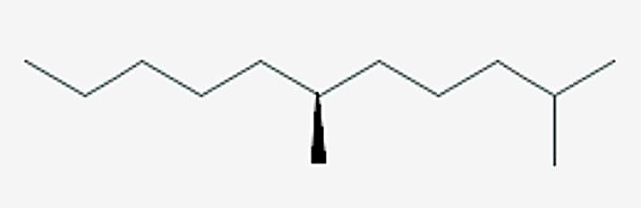 | 2,6-Dimethyl undecane
2 | 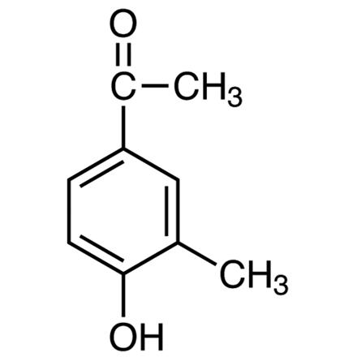 | 4-Hydroxy-3-  Methylacetopheno
3 | 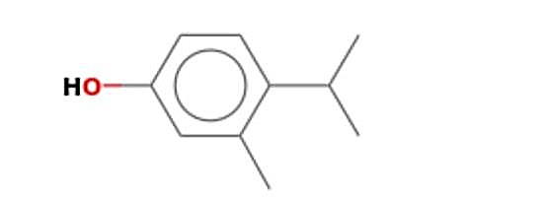 | 3-Methyl-4-Isopropyl phenol
4 | 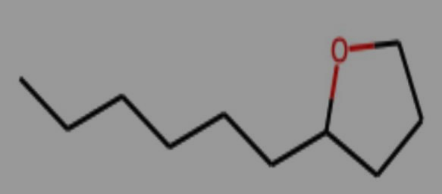 | Tetrahydrofuran, 2-hexyl
5 | 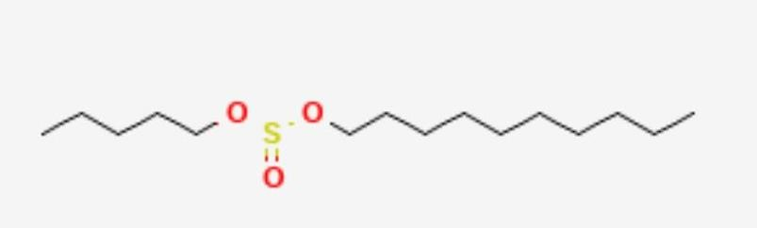 | Sulfurous acid, decyl pentylester
6 | 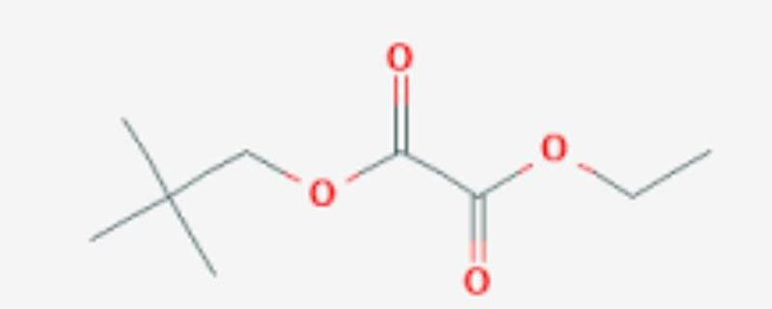 | Oxalic acid, ethyl neopentylester
7 | 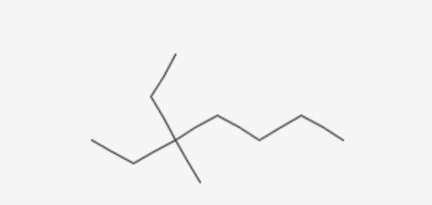 | 3-Ethyl-3-methlheptane
8 | 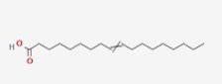 |  | 9-octadecenoic acid
9 | 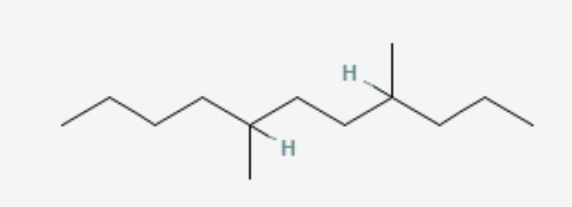 |  | 4,7-Dimethylundecane
10 | 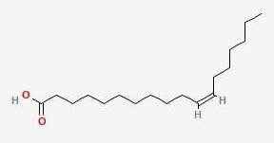 |  | Cis-vaccenic acid
11 | 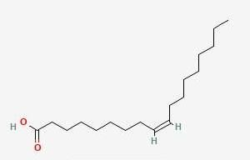 |  | Oleic acid
12 | 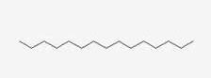 |  | Pentadecane
13 | 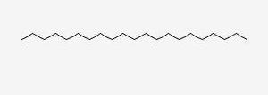 |  | Heneicosane
14 | 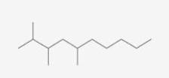 |  | 2,3,5-Trimethyl Decane
15 | 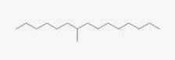 |  |  | 7-methyl Pentadecane
16 | 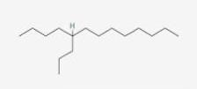 |  |  | 5-propyl Tridecane
17 | 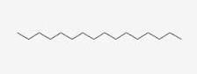 |  |  | Hexadecane
18 | 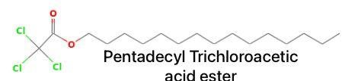 |  |  | Pentadecyl Trichloroacetic acid ester
19 | 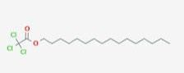 |  |  | Hexadecyl Trichloroacetic acid ester
20 | 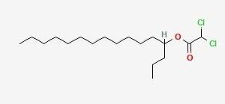 |  |  | Heptadecyl Dichloroacetic acid ester
21 | 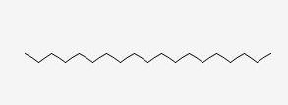 |  |  | 1-Nonadecene
22 | 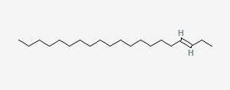 |  |  | 3-Eicosene
23 | 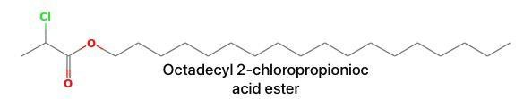 | Octadecyl 2-  chloropropionioc acid ester
24 | 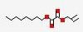 | Allyl octadecyl oxalic acid ester
25 | 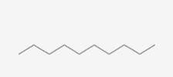 | Decane
26 | 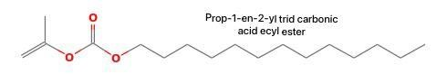 | Prop-1-en-2-yl trid carbonic acid ecyl ester
27 | 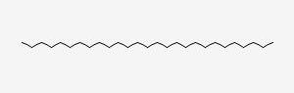 | Heptacosane
28 | 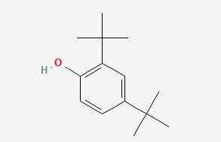 | 2,4-Di-Tert-butylphenol
29 | 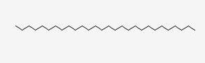 | Octacosane
30 | 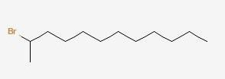 | 2-Bromododecane
31 | 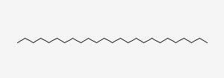 | Pentacosane
32 | 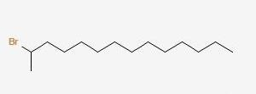 | 2-Bromotetradecane
33 | 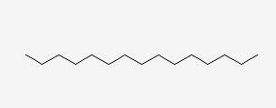 | Pentadecane
34 | 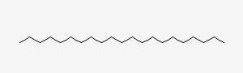 | Heneicosane
35 | 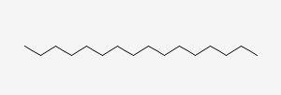 | Hexadecane
36 | 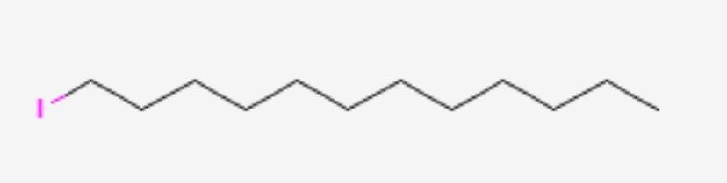 | 1-lodo-Dodene

4.2 DISCUSSION
Table 4.1 above present the classes of phytochemicals present in the crude ethanolic extract of thymus vulgaris. The presence of five (5) phytochemicals were established which include steroids, flavonoids, diterpenes, triterpenes and fixed oil, while alkaloids, tannins, lactones, glycosides, saponins, proteins, and carbohydrates. The phytochemicals present are responsible for the observed medicinal properties of thymus vulgaris.
From the table of the results of GC-MS analysis (Table 4.2) above, there are about thirty-six (36) chemical components in the hydro-distillate of thymus vulgaris. Eleven (11) of these components are acids e.g. oleic acid, Cis-vaccenic acid, 9-octadecenoic acid etc. which are possibly the fatty acids present in the thyme fixed oil. Twelve (12) of these components are hydrocarbons e.g. pentadecane, Hexadecane, 2-Bromotetradecane etc. Six (6) of these components are esters e.g. ethyl neopentyl ester, Allyl octadecyl oxalate etc. Two (2) of these components are aromatic phenols e.g 3-methyl-4-isopropylphenol, 2,4-Di-tert-butylphenol which may impart some form of antiseptic or antimicrobial activity. This explains why thymus vulgaris possesses antimicrobial activity. The remaining five (5) of these components are alkane e.g. 3-Eicosane, Octacosane, Pentacosane etc., and these are generally volatile acting as natural solvent for many of the organic compounds present in thyme.
4.3 CONCLUSION
Thyme is a rich source of chemical compounds, some of which are volatile while others are nonvolatile. These compounds spread across various classes of organic and phytochemicals. These definitely impart the medicinal capabilities and aroma to the plant.
More work should be done to also establish the possible health effects of some of these components, so as to account for its likely toxicity.

