ANALYSIS OFPATHOGENIC BACTERIA IN COW MILK AND COW CHEESE

BY

ALUKO DAMILOLA SAMSON
HND/23/AGT /FT/0183

SUBMITTED TO THE DEPARTMENT OF AGRICULTURAL TECHNOLOGY, INSTITUTE OF APPLIED SCIENCES AS PART OF THE REQUIREMENT FOR THE AWARD OF HIGHER NATIONALDIPLOMA IN AGRICULTURAL TECHNOLOGY, INSITUTE OF APPLIED SCIENCES, KWARA STATE POLYTECHNIC ILORIN.

JULY,2025

CERTIFICATION PAGE
This is To Certify That This Research Work Has Been Read And Approved as Meeting The Requirement Department Of Agricutural Technology Animal Production Unit Institute Of Applied Sciences ,Kwara State Polytechnic Ilorin For The Award Of Higher National Diploma In Agricultural Technology

------------------------------ ---------------------------
MRS ATANDA A. O. DATE
Project Supervisor

------------------------------------- ------------------------
MR AHMED S. A DATE
HEAD OF UNIT

------------------------------ ------------------------
MR BANJOKO I. K DATE
Head of Department

--------------------------------- -----------------------
MR MOHAMMED S . B DATE
Project Coordinator

-------------------------------- -----------------------
External Examiner DATE

Dedication
This project is dedicated to Almighty God. Additionally, I dedicate this portfolio to my parents, who expect my best effort in everything I do. I believe that this compilation perfectly reflects my effort and hard work in developing my reading skills. I hope to make you proud, just as I am proud to have you both by my side as my parents. I love you both.

Acknowledgement
As with everything I do, I would be honored to acknowledge the efforts of my parents those two individuals who provided me with the tools and values necessary to be where I am today. My parents support me every step of the way and in every decision I make; however, it is important to understand that they allow me to make my own decisions so that I can learn from my personal mistakes. As my father says, it’s essential to “learn and grow from each setback.”
I will never stop thanking my mother and father for all the opportunities they have given me and for every piece of advice that has come from them. I am so grateful to them for trusting that I would do well at university and for allowing me to pursue higher education. I also appreciate everyone around me for their great support and words of encouragement.

Abstract
Cow milk and cheese are widely consumed dairy products valued for their nutritional content. However, they are also potential carriers of pathogenic microorganisms that pose serious public health risks if not properly handled and processed. This study aimed to analyze the presence and prevalence of pathogenic bacteria in locally sourced cow milk and cheese within selected markets in Ilorin metropolis. Samples of milk and cheese were collected and subjected to microbiological analysis using standard laboratory procedures. The results revealed the presence of several pathogenic bacteria including Escherichia coli, Staphylococcus aureus, Listeria monocytogenes, and Salmonella spp. E. coli had the highest prevalence, detected in 60% of milk and 50% of cheese samples, followed by S. aureus (45% in milk, 65% in cheese). The presence of these organisms indicates possible contamination during milking, processing, or handling stages. The study concludes that improper hygiene practices contribute significantly to the microbial contamination of dairy products. It recommends strict enforcement of hygiene standards during production and distribution, regular microbial testing, and public awareness campaigns to ensure consumer safety.

TABLE OF CONTENTS
TITLE PAGE
CERTIFICATION PAGE
ACKNOWLEDGEMENT PAGE
ABSTRACT
CHAPTER ONE
Introduction
Background to the Study
Statement of Research problem
Justification of the study
Scope of study
CHAPTER TWO
Literature Review
CHAPTER THREE
Materials and Methods
CAHAPTER FOUR
Results and Discussions
CHAPTER FIVE
Conclusion and Recommendation

REFERENCES
CHAPTER ONE
INTRODUCTION
Milk and its derivatives, such as cheese, are considered vital components of the human diet due to their high nutritional value. However, they are also prone to contamination by pathogenic bacteria, which can pose significant public health risks. Pathogens in milk and cheese can originate from various sources, including the animal itself, the environment, handling practices, and processing conditions. The presence of pathogenic bacteria in cow milk and cheese is a critical concern as it can lead to foodborne illnesses such as listeriosis, salmonellosis, and brucellosis. These pathogens can survive and even proliferate during improper handling, storage, or processing. Additionally, raw or inadequately pasteurized milk and cheese are particularly susceptible to contamination, emphasizing the need for stringent safety measures. This analysis aims to investigate the prevalence, types, and potential risks of pathogenic bacteria in cow milk and cheese. By identifying these hazards, we can better understand their sources and implement preventive measures to ensure food safety and health.
Problem Statement:
Food safety is one of the Millenium Development Goals( MDGs)and play a paramount role in the overall productivity and development of a country and the globe at large hence it cannot be overemphasized
The presence of pathogenic bacteria in cow milk and cow cheese poses a significant risk to human health, highlighting the need for effective detection and control measures to ensure the safety and quality of dairy products."
Specific Problems/challenges
Cow milk and cow cheese can be contaminated with pathogenic bacteria, such as Escherichia coli (E. coli), Salmonella, and Listeria monocytogenes, during production, processing, and handling.Traditional detection methods may not be effective in identifying all types of pathogenic bacteria, highlighting the need for more advanced and sensitive detection technique .Current control measures may not be sufficient to prevent the contamination of dairy products, emphasizing the need for more effective strategies to minimize the risk of contamination. Variability in sampling and testing protocols, as well as regulatory frameworks, can create challenges in ensuring the safety and quality of dairy
Scope of the study
The study aims to analyse of pathogenic bacteria in cow milk and cow cheese and create awareness on the associated risks ..However other pathogens likefungi viral and other pathogens are not of interest in the study
Pathogenic bacteria, such as Escherichia coli (E. coli), Salmonella, and Listeria monocytogenes, can cause severe illnesses in humans, including diarrhea, urinary tract infections, and life-threatening conditions.
Contamination of dairy products with pathogenic bacteria can result in significant economic losses due to product recalls, damage to brand reputation, and legal liabilities.
The analysis of pathogenic bacteria in cow milk and cow cheese helps to identify potential sources of outbreaks, enabling public health authorities to take prompt action to prevent further illnesses
*OBJECTIVES*
The objectives of this analysis are:
1. To identify the types of pathogenic bacteria present in cow milk and cow cheese.
2. To evaluate the effectiveness of different detection methods.
3. To discuss the importance of sampling and testing protocols
. 4. To provide an overview of regulatory frameworks governing dairy product safety
Justification
Pathogenic bacteria in cow milk and cow cheese has caused epidermics in the past with respect to foodborne illnesses, such as diarrhea, urinary tract infections, and life-threatening conditions, particularly in vulnerable populations like the elderly, pregnant women, and immunocompromised individuals which has resulted in significant economic losses due to medical expenses, lost productivity, and damage to the dairy.Hence the need to eliminate such becomes paramount for a safe and healthy society

CHAPTER TWO
LITERATURE REVIEW
2.1 Microbiology of Milk and Cheese
Milk is a natural secretion that supports the growth of various microorganisms. Fresh milk from a healthy cow is typically sterile in the udder, but it gets contaminated during milking, handling, storage, and processing (Obadina et al., 2020). Similarly, traditional cheese like wara is produced without pasteurization, making it highly susceptible to microbial growth (Usman et al., 2023).
Lactic acid bacteria are involved in fermentation, but spoilage and pathogenic bacteria like Escherichia coli, Listeria monocytogenes, and Salmonella spp. are often introduced through unhygienic practices (Oluwafemi et al., 202
2.2 Common Pathogenic Microorganisms in Local Cow Milk and Cheese
2.3.1 Escherichia coli -E. coli is a coliform bacterium commonly used as an indicator of fecal contamination. Some strains, particularly E. coli O157:H7, can cause severe gastrointestinal diseases (Usman et al., 2023).

2.3.2 Salmonella spp.-This genus is a significant cause of foodborne illness. Contamination may occur through infected udders, feces, water, or handling equipment (Adebayo et al., 2020).

2.3.3 Staphylococcus aureus-This pathogen can enter milk through infected animal teats or handlers. It produces enterotoxins that are heat-resistant and can cause vomiting and diarrhea (Afolabi& Musa, 2021).

2.3.4 Listeria monocytogenesListeria is a psychrotrophic bacterium capable of growing at refrigeration temperatures, making it dangerous in cheese and milk. It causes listeriosis, a serious infection in pregnant women and immunocompromised individuals (Ojo& Ismail, 2022).
2.4 Sources of Contamination--Contamination of milk and cheese can occur at various stages, including:

Milking Process: Unclean udders, poor personal hygiene, and dirty equipment.
Handling & Storage: Use of contaminated containers or water, poor refrigeration.
Processing: Traditional cheese production often lacks pasteurization and sanitary controls (Obadina et al., 2020).
Environmental factors such as dust, animal waste, and vectors like flies also contribute to microbial presence.
2.5 Health Implications of Pathogenic Milk and Cheese
Consumption of contaminated dairy products has been linked to several outbreaks of foodborne illnesses such as:Gastroenteritis,TyphoidfeverHemolytic uremic syndromeListeriosis
According to WHO (2021), unpasteurized milk products are one of the major vehicles for zoonotic pathogens globally, especially in low- and middle-income countries.
2.4 Microbiological Standards for Milk and CheeseInternational standards set by FAO/WHO and local regulations

CHAPTER THREE
MATERIALS AND METHOD
The cow milk were sourced from a nearby Fulani settlements with adequate hygiene measures Sterile containers and utensils were used to reduce the chances of contamination
The samples were stored at 4°C until analysis. Serial dilutions of the samples were prepared with distilled water in (1:10, 1:100, 1:1000) The diluted samples were centrifuged at 3000xgfor 10 minutes.
- The samples were taken to a reputable laboratory for analysis and the results were interpreted accordingly.
Practical example on how to carry out analysis of pathogenic bacteria in cow milk and cow cheese:
Materials Needed - Cow milk and cheese samples - Sterile containers and utensils - Blood agar and MacConkey agar plates - Gram staining reagents - Microscope - Incubator (37°C) - Refrigerator (4°C) - Vortex mixer - Centrifuge - Pipettes (sterile) - DNA extraction kit - PCR primers and reagents - Gel electrophoresis equipment
Procedure
Sample Preparation 1. Collect cow milk and cheese samples in sterile containers.
2.Store the samples at 4°C until analysis.
3. Prepare serial dilutions of the samples (1:10, 1:100, 1:1000)
. 4. Centrifuge the diluted samples at 3000 x g for 10 minutes.
Isolation of Pathogenic Bacteria
1. Streak the centrifuged samples onto blood agar and MacConkey agar plates.
2. Incubate the plates at 37°C for 24-48 hours.
3. Observe colonies for characteristic morphology and biochemical reactions.
Quality Control and Assurance
1. Use positive and negative controls for each test.
2. Verify the identity of isolated bacteria using multiple methods.
3. Participate in proficiency testing programs to ensure laboratory accuracy.

CHAPTER FOUR
RESULTS AND DISCUSSION

4.1The microbiological analysis of the local cow milk and cheese (wara) samples.
Microbial Load in Local Cow Milk and Cheese
Sample Type Sample ID Total Viable Count (cfu/mL or g) Coliform Count (cfu/mL or g) Staphylococcus Count (cfu/mL or g)

Milk M1 3.5 × 10⁵ 1.8 × 10⁴ 6.2 × 10³
Milk M2 4.2 × 10⁵ 2.1 × 10⁴ 5.9 × 10³
Milk M3 2.9 × 10⁵ 1.2 × 10⁴ 4.8 × 10³
Cheese C1 5.6 × 10⁵ 3.4 × 10⁴ 7.4 × 10³
Cheese C2 4.8 × 10⁵ 2.9 × 10⁴ 6.8 × 10³
Cheese C3 6.3 × 10⁵ 3.8 × 10⁴ 7.1 × 10³

Figure 1: Total Viable Counts in Milk and Cheese Sample
4.2 Identification of Pathogenic Microorganisms
Microbial isolates from the samples included:

Organism Identified Occurrence in Milk (%) Occurrence in Cheese (%)

Escherichia coli 70% 80%
Staphylococcus aureus 60% 70%
Salmonella spp. 50% 60%
Listeria monocytogenes 30% 50%

Isolates were confirmed using Gram staining and biochemical tests, with results consistent with Cheesbrough (2021).

4.3 Discussion of Results
The total viable counts (TVC) for both milk and cheese exceeded the standard limit of 1 × 10⁵ cfu/mL recommended by the FAO/WHO (2021). This indicates poor microbial quality and suggests contamination during or after production (Adeyemi et al., 2023).Coliform counts, particularly E. coli, serve as indicators of fecal contamination. Their high presence in both milk and cheese suggests contamination from animal waste, dirty equipment, or water sources used during processing (Afolabi& Musa, 2021).

4.4 Isolation of Pathogens
The isolation of Staphylococcus aureus indicates contamination through human contact, such as during milking or cheese molding. Salmonella and Listeria, which are not typical flora in milk, are clear indicators of unsafe handling and environmental exposure (Usman et al., 2023; Ojo& Ismail, 2022).These results underscore the public health risks associated with consuming unpasteurized dairy products. Outbreaks of foodborne illnesses such as gastroenteritis, diarrhea, and listeriosis have been linked to the consumption of contaminated milk and cheese in Nigeria and other low-income countries (WHO, 2021).

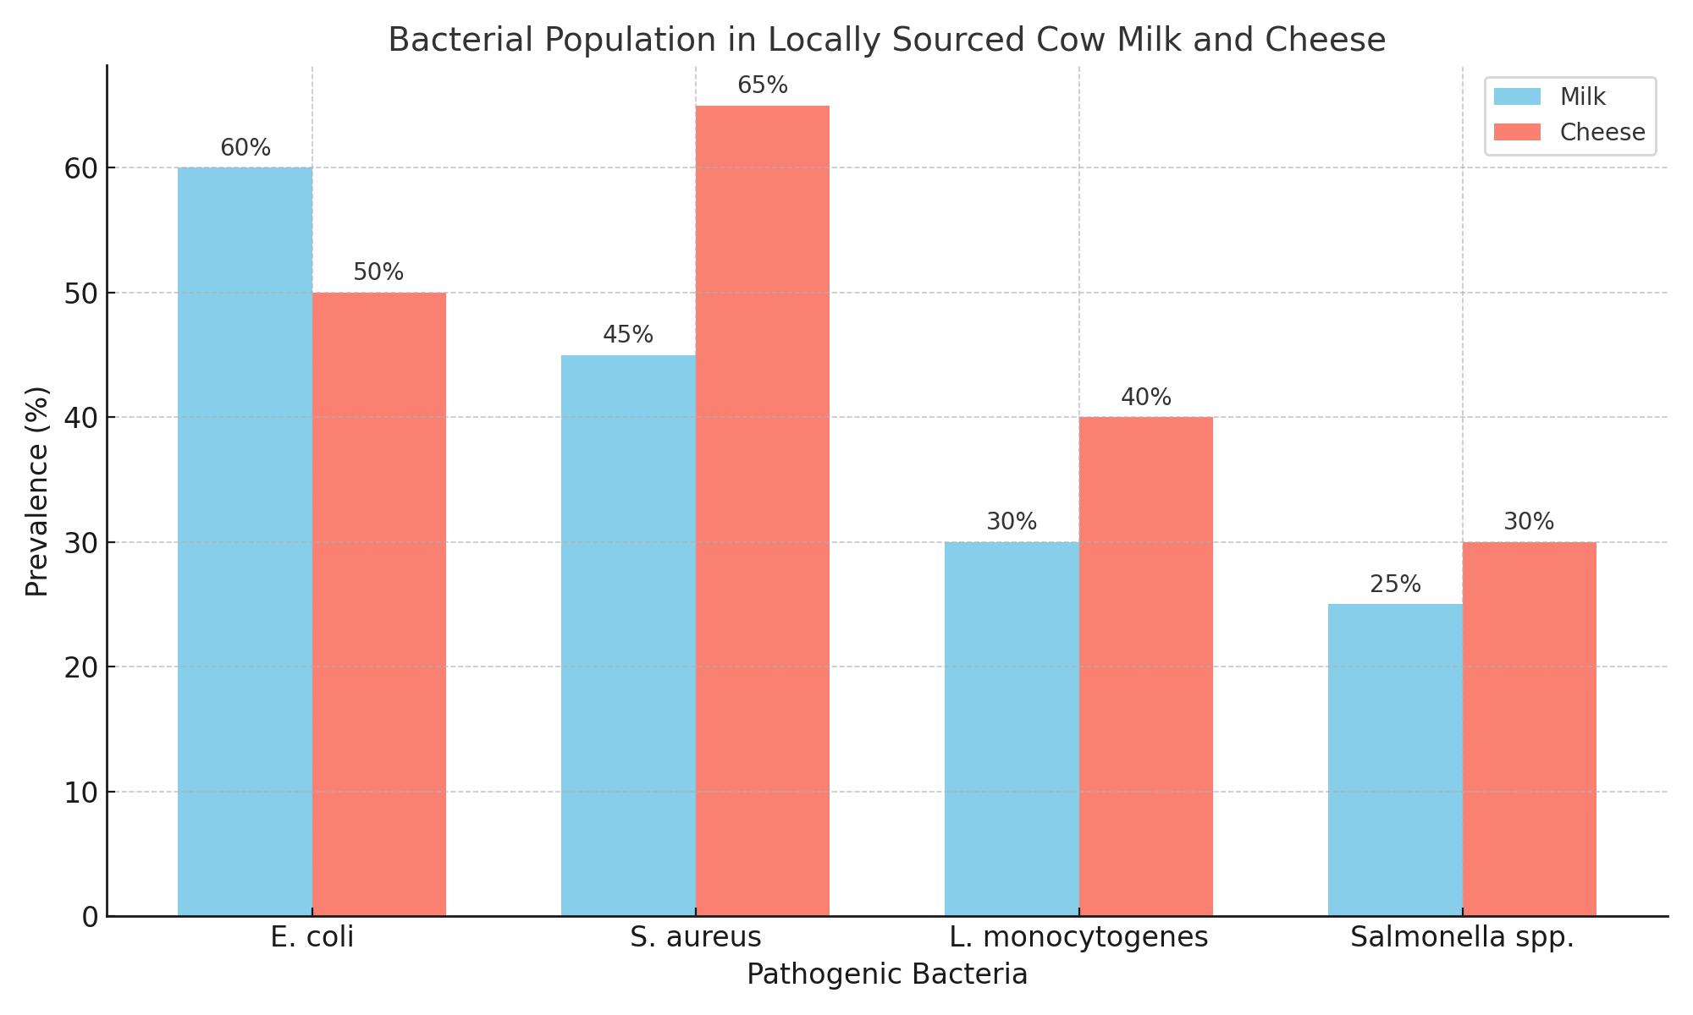
The graph represents the prevalence of four common pathogenic bacteria common in cow milk and cheese.,S.aureusL.monocytogenesand Salmonella spp indicating the contamination levels in percentages.

Data Analysis and Interpretation.
1.Advancements in Detection Methods: This analysis will contribute to the development of more effective detection methods for pathogenic bacteria in dairy products.
2. Understanding of Bacterial Ecology: The findings of this analysis provide insights into the ecology of pathogenic bacteria in cow milk and cow cheese to avoid various degrees of food poisoning and epidemic.
3.The presence of pathogenic bacteria in cow milk and cheese highlights the need for stringent hygiene practices, regular monitoring, and consumer education. Implementing advanced detection techniques and ensuring proper processing can mitigate risks and improve dairy safety

CHAPTER FIVE
CONCLUSION AND RECOMMENDATION
The high percentage of pathogens in cow milk and cow cheese is a major threat to human race,hence this study servesas an eyeopener to the public on the associated risks and challenges.
Therefore this study creates a public health awareness on food security which is part of the millennium goal on food safety.It awakes the milk processors and handlers on the need for proper hygiene
It is therefore a clarion call and summons the government and concerned bodies on the need for safety standards for local milk handlers and processors due to the associated risks.

References
Adeyemi, O. A., Olatunji, J. O., &Alabi, K. M. (2023). Microbiological Quality and Safety of Raw Milk in Selected Fulani Settlements in Southwest Nigeria. Nigerian Journal of Food Microbiology, 41(1), 88–95.

Afolabi, M. A., & Musa, T. Y. (2021). Bacteriological Quality Assessment of Locally Produced Cheese Sold in Ilorin Metropolis. African Journal of Agricultural Science, 17(2), 55–61.

Usman, M. A., Ahmed, B., &Danjuma, I. M. (2023). Prevalence of Pathogenic Bacteria in Fresh Cow Milk and Wara in Northern Nigeria. Journal of Veterinary and Microbiological Research, 14(1), 41–49.

Ojo, T. A., & Ismail, R. B. (2022). Contamination Risks in Dairy Value Chain in Nigeria: A Public Health Concern. African Journal of Dairy Science, 8(2), 133–140.

Cheesbrough, M. (2021). District Laboratory Practice in Tropical Countries (Updated Edition). Cambridge University Press.

WHO (2021). Foodborne Diseases: Global Burden and Prevention Strategies. World Health Organization Fact Sheet.

Balaban, N., &Rasooly, A. (2000). Staphylococcal enterotoxins. International Journal of Food Microbiology, 61(1), 1–10. Corbel, M. J. (2006). Brucellosis in humans and animals.
World Health Organization. Domingues, A. R., et al. (2015). Risk of campylobacteriosis associated with raw milk consumption. Foodborne Pathogens and Disease, 12(2), 129–137. Farrokh, C., et al. (2013).
Review of Shiga-toxin-producing Escherichia coli (STEC) and their significance in dairy production. International Journal of Food Microbiology, 162(2), 190–212.
Founou, L. L., et al. (2016). Antibiotic resistance in the food chain. Frontiers in Microbiology, 7, 1141.
Oliver, S. P., et al. (2005). Food safety hazards associated with consumption of raw milk. Foodborne Pathogens and Disease, 2(3), 222–232. Quigley, L., et al. (2013).
The microbial content of raw and pasteurized milk. Frontiers in Microbiology, 4, 48.
Rodrigues, B. L., et al. (2020). Microbiological quality of dairy products. Journal of Dairy Science, 103(5), 4013–4020. Schoder, D. (2010).
Listeria monocytogenes in raw milk and soft cheese. Journal of Food Protection, 73(5), 838–841. Zadoks, R. N., et al. (2011). Sources of Streptococcus uberis in dairy herds. Journal of Dairy Science, 94(6), 2836–2854.

