PREPARING A PARAFFIN WAX SKIN TREATMENT USING PARABOLIC SOLAR COOKER AS THE HEATING EQUIPMENT AT KWARA STATE POLYTECHNIC,
ILORIN, NIGERIA

BY

ABDULRAHMAN FRIDAOUS GBEMISOLA
ND/23/SLT/PT/0378

A RESEARCH PROJECT SUBMITTED TO DEPARTMENT OF SCIENCE LABORATORY TECHNOLOGY,
INSTITUTE OF APPLIED SCIENCES (IAS), KWARA STATE POLYTECHNIC, ILORIN, NIGERIA
IN PARTIAL FULFILLMENT OF THE REQUIREMENT FOR THE AWARD OF NATIONAL DIPLOMA (ND),
SCIENCE LABORATORY TECHNOLOGY (PHYSICS/ELECTRONICS UNIT).
Supervised By

DR. OLAORE K.O.

JULY, 2025

CERTIFICATION
This is to certify that the project work was successfully carried out by ABDULRAHMAN FRIDAOUS GBEMISOLA with matric no ND/23/SLT/PT/0378 of the Department of Science Laboratory Technology and has been prepared in accordance with the regulation governing the preparation and presentation of Kwara State Polytechnic, Ilorin.

DR. OLAORE K. O DATE
(Project Supervisor)

MR. LUKMAN A. DATE
(Project Coordinator)

DR. USMAN A. DATE
(Head of Department)

EXTERNAL EXAMINER DATE

DEDICATION
This project is dedicated to Almighty Allah, the Alpha and Omega of wisdom, knowledge and understanding. The creator of all living and non-living soul also dedicated to my parent MR. AND MRS. ABDULRAHMAN

ACKNOWLEDGMENTS
First and foremost, I give golden gratitude and adoration to the Almighty Allah the most beneficent and most merciful who alone is the source of wisdom, knowledge for signs and inspiration for making this vision a reality.
I really appreciate and praise you only for your mercy, protection, guidance and salvage over our life from the beginning of academic pregame and actualization of this research despite to those from inception of my childhood to this present moment. I thank you once Again Almighty Allah For the wisdom, knowledge and understanding been offered to me for the completion of this research successfully
My appreciation goes to my lovely parents MR. AND MRS. ABDULRAHMAN for their support in morally, financially and spiritually given to me throughout my Academic May Almighty Allah continue to bless you and live long to reap the fruit of your labour (Amin).
My appreciation also goes to my project supervisor in person of DR. K.O. OLAORE who have been there for me before and during our project work, thanks for being my father during this journey. I sincerely appreciate you sir, my prayer for you is that God should grant you more understanding and success in all your endeavor, and for your children, May God’s favor locate them wherever they go in life.
Our profound gratitude goes to all our amazing and brilliant lecturers as well as the technologist of the Department of Science Laboratory Technology (Physics/Electronics Unit). God bless you all (AMEN).

TABLE OF CONTENTS

TITLE PAGE i
CERTIFICATION ……………………………….ii
DEDICATION ………………………………..iii
ACKNOWLEDGEMENT ……………………………….iv
TABLE OF CONTENTS v
ABSTRACT vii
CHAPTER ONE 1
  - Introduction 1
  - Statement of the Problem 3
  - Aim 4
  - Objectives 4
  - Justification 4
CHAPTER TWO 5
  - Literature Review 5
  - Paraffin Wax 18
  - Mineral Oil 20
  - Solar Radiation 21
  - Solar Irradiance 22
  - Skin Treatment 23
CHAPTER THREE 24
  - Materials And Method 24
  - Material Selection 24
    - Material for Body of the Dish 24
    - Material for Reflecting Surface 25
    - Material for the Absorber/Pot 25
    - Melting Material And Heat Transfer Fluid 26
    - Pyranometer 26
    - Thermocouple 27
    - Weighing Balance 28
  - Method 28
    - Experimental Set Up 28
  - Mathematical Determination 29
    - Determination of Focal Length 29
    - Determination of the Parabolic Aperture Area 29
    - Determination of the Rim Angle 30
    - Determination of Cooking Power Estimation 30
3.3.6 Calculation of Efficiency 31
CHAPTER FOUR 33
  - Results and Discussion 33
  - Result 33
  - Discussion Error! Bookmark not defined.
CHAPTER FIVE 34
  - Conclusion and Recommendation 34
  - Conclusion 34
  - Recommendation 35
References 36
Appendix 39

ABSTRACT
Industrial heating and melting are an indispensable process in the manufacture of various organic products and household cooking. In order to provide a reliable method of heating and melting which is not hazardous to health and environment unlike the conventional sources, an alternative renewable energy was introduced in this project work which could also be used for industrial application. The aim of this project is to use parabolic solar cooking system to harness and focus solar radiation for heating and melting paraffin wax to prepare a solution for skin treatment under Kwara metrological condition and also to measure various temperature parameters. The parabolic solar cooker was used in heating and melting paraffin wax with mineral oil as a lubricant. In the result obtained, the highest solar radiation was 1216.7w/m², the highest ambient temperature was 48.7˚C, the highest fluid temperature was 49.6˚C, the highest temperature of the cover was 59.6˚C, the highest side temperature was 56.4˚C, the highest absorber plate temperature was 94.6˚C and highest temperature of the air gap was 70.4˚C. The parabolic solar cooker was able to melt paraffin wax for 1hour, and the thermal performances in term of average cooking power, standard cooking power and cooker efficiency was evaluated.

CHAPTER ONE

INTRODUCTION
The sun is the ultimate source of energy and its availability allows for various ways to utilize its free energy. One of the major ways in which the energy from the sun (often called solar energy) has been utilized is through solar heating technology (Ahmad, 2001), which is available in different types, from the relatively cheap using low levels of technology, to big, expensive ones that can be used in industrial heating systems (Otte, 2013). A solar cooking system makes use of the energy from the sun to heat and melt several subtances one of which is the paraffin wax (Solar-Cooker-International, 2001).
Solar cooker is a simple device that uses sun’s rays to cook food. The concept of solar cooking was introduced from ancient time. The solar cooker was first built by Swiss naturalist Horace de Saussure (Father of solar cooking) by building a small container in which he cooked fruits using only sunshine and obtained the temperatures of 189.5ºF in 1767. His experiment paved the way for further investigations. Around the world, many scientist and engineers are investigating into the production of modern and highly efficient design of solar cookers and many organizations, renewable energy centers are working towards the distribution and promotion of solar cookers in the areas where it can work effectively. The box type, funnel shaped, panel type, parabolic shaped and vacuum tube technology (advanced type) are mainly five types of solar cooker so far used in this world (Ahmad, 2001).
Concentrating solar power (CSP) is a technology employed to convert solar thermal energy into either electrical power or heat energy (NUFU Network, 2013). There are many forms in which CSP can be used as a heat source, however, the parabolic concentrators have been proven over the years to be the most efficient in terms of heat generation (Reddy & Ranjan, 2003).
They are also considered the fastest in terms of the time it takes to make food when used as a solar cooker (Panwar et al., 2012). Solar cookers, especially the parabolic types, have been identified as a potential solution to some of the challenges facing developing communities, such as overdependence on an insufficient electricity supply that causes load shedding, food insecurity, unemployment, rural-urban migration and other social issues (Bryceson, 1996; Von Braun, 2010).
Heating is one of the essential activities that consume a lot of fossil fuels. Solar cooker is an innovative way of utilizing the solar energy for heating and melting. One of the solar cookers used for cooking in recent times is the parabolic solar cooker which is essentially made of cheap, light weighted and highly reflective glass mirror as reflector. The energy harnessed from the sun using this solar cooker is adequate for house hold cooking (Jayesh et al, 2013).
The parabolic shape of the reflector allows it to concentrate the sun's rays onto a small area, which can reach very high temperatures. This concentrated heat is then used to melt paraffin wax. The heating vessel can be a pot, pan, or any other container that has a good heat conduction and suitable for heating and cooking (Aliyu et al, 2021).
Parabolic solar cookers are often used in areas where there is limited access to electricity or other cooking fuels, such as in rural areas or developing countries.
Parabolic solar cookers are capable of melting wax quickly, often in a matter of minutes, depending on the intensity of the sunlight. They are also easy to use and require no fuel, other than sunlight. Additionally, they can be made from inexpensive and readily available materials (Craig, 2015).
In this present project a parabolic dish solar cooker was designed and constructed whose parabolic dish was made using small pieces of plane mirror for better performance. It also caused more solar radiation to be concentrated into a smaller area for obtaining more heat. The radiation losses were also small because of smaller absorber area.

STATEMENT OF THE PROBLEM
Solar cooking is a realistic solution to the challenges associated with the use of wood and electricity as means of generating heat needed for cooking. More than two billion people worldwide use wood either as a source of fuel to cook or as a source of heat (Wentzel & Pouris, 2007). This scenario is not so different in Africa. Further, Diabaté et al. (2004) claim that a quarter of wood fuel users often face the challenge of fuel shortages (in terms of wood and electricity), yet they live in climatic areas that are ideal for the use of solar cookers. In the quest to obtain the wood used for cooking, many women walk several kilometers and are often exposed to danger, and the continuous reliance on wood as a source of energy has led to deforestation and rural-urban migration in many areas of Africa (Barrios et al., 2006; Diabaté et al., 2004; IFAD, 2009). The use of solar cookers is often limited due to the fact that the sun is not available 24 hours a day. As a result, solar cookers are often either not functional or fully effective on cloudy days or when there is no sunshine. These problems hinder the ease with which solar cookers can compete favourably with other means of cooking. However, these issues are being attended to by on-going research around the world (Craig et al, 2015).

AIM
The aim of this project is to use parabolic solar cooking system to harness and focus solar radiation for heating and melting paraffin wax to prepare a solution for skin treatment.

OBJECTIVES
The objectives of this project are
To measure the effect of the following parameters in the performance of the solar cooker: ambient temperature, absorber temperature, absorber side temperature, absorber cover temperature, solar radiation, wind, angular orientation of the dish, reflective surface.
To converge and focus solar radiation to generate enough heat to melt the wax.
To prepare a skin treatment solution from the experiment

JUSTIFICATION
Parabolic solar cooker can be used to alleviate energy/electricity insufficiency in Nigeria through exploitation of the enormous solar energy available in the country. This would provide an alternative to reduce total dependence on wood, electricity and fossil fuel.

CHAPTER TWO

LITERATURE REVIEW
Noman et al, 2019 developed a simple mathematical model for the performance evaluation of a thermally exposed solar parabolic trough cooker. Their research was carried out under open environmental climate conditions for domestic uses. Their experimental setup consist of a solar cooker made of polished parabolic trough stainless steel having concentration ratio 9.867. In their work, the efficiency analysis depicts that the resulted parabolic trough optical efficiency, theoretical efficiency and the experimental efficiency range between 53-33%, 50-30% and 38 5% respectively.
Furthermore, the maximum water temperature they achieved in their work at the outlet of parabolic trough was 37.2°C and the maximum water temperature they achieved by the trough cooker under stagnated conditions was 53.6ºC. The cooker energy and exergy efficiency was observed in their work and it ranges between 6.5-0.11% and 7.6×10⁻²- 2.1×10⁻²% respectively for direct cooking and their result was stated to be helpful for making domestic useable cooker. Mbodji et al, 2017 presented a dynamic thermodynamic model of a parabolic solar cooking system (PSCS) with heat storage, along with a comparison of their model solution with experimental measurements. Their model uses various thermal resistances to take into account heat transfer between the different parts of their system. The first experimental setup in their work consists of a parabolic concentrator (0.80-m diameter and 0.08-m (depth) and a 1.57-l cylindrical receiver. Their second experimental setup is composed of a parabolic concentrator (1.40-m diameter and 0.16-m depth), the same receiver, and a 6.64-l heat storage. Furthermore, they carried out test in Rabat, Morocco, between April 24 and July 10, 2014, and between May 15 and June 18, 2015. Synthetic oil was used as a transfer fluid and a sensible heat storage in their work. In their conclusion, comparison was made between predicted and measured temperature which shows a good agreement with a relative error of + 4.4%. The effects of important system design and operating parameters was also analyzed in their work. Their result shows that a 50Wm² increase of the daily maximum solar radiation increases their storage temperature by 4ºC and a 5% increase of their receiver reflectance or absorbance improves their maximum storage temperature by 3.6 and 3.9ºC respectively. Furthermore, they optimize the aspect ratio of their receiver to 2 and it gives a maximum storage temperature of 85ºC. They also increase their thermal fluid mass flow rate from 0 to 18kg h-1, their receiver thermal insulation from 0,01 to 0.08m and also increase the maximum storage temperature by 65 and 17ºC.
Asmelash et al, 2014 reported that fuel-wood scarcity is a growing problem that has so far been poorly addressed. They asserted that solar cooking is one possible solution but its acceptance has been limited partially due to low performance and convenience of use of most of the solar cookers that currently are available. The objective of their research was to test the performance of a solar cooker based on concentrating collector and increase its temperature and performance. They constructed parabolic trough cooker (PTC) in a way to allow cooking to be done indoors, in which their cooking sections were placed indoor whiles their collector parts out-door with soya bean oil conveying the energy from the absorber to the cooking stove. They employed ray tracing and standard stagnation tests to show that a 30 mm diameter copper pipe is the optimum size for the absorber. In their work the maximum temperatures they obtained was 191°C at the mid absorber pipe and 119°C at the cooking stove. The efficiency of their system was found to be 6%.
Joyee et al, 2014 reported that the use of renewable energy, particularly solar energy, is increasing day by day to promote its contribution to national economy and solar energy can be used in heating, drying, cooking and also for generating electricity. In their work, the design, construction and performance test of a parabolic dish solar (PDS) cooker was discussed. Their cooker having an aperture diameter of 106 cm and focal length of 54 cm was designed, constructed and the performance was tested and they used plane mirror as a reflecting material in their cooker. In their work, the maximum temperature inside their cooking pot was found to be 97°C as performance test rice and dal were cooked in various amounts at different days and times. Their experiments shows that the temperature inside the cooker varies with the available solar radiation. Their cooker cooked 300 gm rice and 100 gm dal within 40 minutes at an available radiation level of 320 and 390 W/m² respectively. It was reported in their work that an economic analysis of their cooker was performed and it showed a payback of 16 months, which is realistic and very promising.
Claude et al, 2014 stated that the Indian subcontinent is blessed with ample amount of sunlight almost all through the year. They reported that roughly 80% of all seasons are sunny of which 50% is dry and hottest. They explained that there is an urgent need of switching over to a perennial source of energy reserve as a powerful alternative so as to replace all the rapidly depleting fossil fuels. Furthermore, they explained that there is much interest in non conventional energy nowadays so as to tap energy from promising sources such as Solar, Wind and Tidal, of which tapping the heat and infra- red rays from the sun using air and water as appropriate mediums is the most easiest and versatile way of energy capture. They state that in order to tap this abundant energy they require an efficient design of a solar concentrator which heats up the ambient in the quickest pace. They made a cost effective solar concentrator with locally available raw materials which is efficient enough to make water reach steam point and air reach its hottest phase in their work. A thorough dealing with a span of six months observation on the working of the solar cooker is presented in detail in their work.
Ahmed et al, 2015 reported that solar energy is available everywhere for free and Sun’s energy can be directly converted in to electrical energy, mechanical or even direct thermal energy. They reported that the history of solar energy research started in 18th century when solar powered steam engine was designed by a scientist Augaste Mouchount in 1860. In their work, domestic use of solar energy was considered. The detailed structures of solar cookers were studied and its efficiency and economy in production was compared in their work. Parabolic solar cooker SK-14 was considered for their work.
Craig et al, 2017 reported that the continuous increase in global demand and cost of electricity are some of the reasons that solar cooking has received much attention recently and another factor which has also contributed to the acceptance of solar cookers is global campaigns against actions that contribute to climate change. They explained that various types of solar cookers are currently in existence which are box, panel and parabolic cookers. They further explained that some solar cookers only function when the cooking section is placed under direct sunshine, while others have been modified to cook without directly exposing their cooking section to the sun. Also they state that most solar cookers face similar challenges, and these include, exposure of users to sun, inability to function at night or when there is no sunshine, low utilization efficiency and technical complexities. Their report presents an indirect parabolic cooker that eliminates the identified solar cooker challenges. Their cooker uses a parabolic reflector to focus the sun rays to a frustum shaped receiver that was placed at its focus. Their cooker has an insulated cooking/heat storage tank which was separated from the dish and cavity receiver system. In their work, the heat transfer fluid was distributed through the system with the aid of high temperature flexible hoses and several cooking tests including water boiling and pancake baking were done. In their work, an extensive analysis of cooking based on the international testing procedures for solar cookers was also carried out. Their solar cooker had a utilization efficiency of 39%, an overall calculated exergy efficiency of 0.05% and an average characteristic boiling time of approximately 13 minutes/kg. The manufactured solar cooker in their work was used for family cooking.
Adedeji et al, 2020 stated that energy is essential to economic and social development and improved quality of life of human being. They modified, fabricated and evaluated a parabolic solar cooker as a simple device to harness direct sun rays for cooking purposes. Their device was constructed on a steel dish which was completely lined with aluminium foil. They used this reflecting surface to concentrate the rays of the sun at a focus which led to production of high temperature for cooking purposes. They erected and positioned a cooking pot stand near the focus and they tested the equipment for temperature (energy concentration) achieved at the bottom of the cooking pot, and by cooking with it. They found the energy concentration efficiency of the cooker to be 53.41% and the average temperature they achieved was 107.38°C (380.53K) during the time of testing, which was also used to cook beans and groundnuts in comparison to other alternatives such as kerosene stove and firewood. In their work, it took them one hour to cook beans and 18 mins to boil groundnut. On the other hand, it took them 33 mins and 40 mins to cook the same quantity of beans using kerosene stove and firewood respectively while it took them 10 mins and 17 mins to cook groundnuts using kerosene stove and firewood respectively.
Craig, 2015 explained that the reduction in the availability and the ever-increasing prices of fossil fuels, as well as the expensive and insufficient electricity supply, are some of the reasons why the public awareness of the use of alternative cooking methods has increased in recent years. He stated that in most rural areas of Africa, the use of wood is even more preferred for cooking than either fossil fuel or electricity, and this has led to deforestation in many areas. However, the time spent on wood collection by women, who often walk kilometres under scorching hot, sunny conditions, can be utilized better in more productive activities. He further explained that most of those lacking access to convenient cooking methods live in places with good solar resources and where solar cookers would thrive if developed. The study he presented in this report considered a prototype solar cooking system that is relatively cheap and that can be modified to meet these challenges faced in African communities. He design and develop a parabolic solar cooker, which uses a parabolic dish as concentrator and the concentrator used was a television satellite dish of 2 m in diameter, in which the reflecting area was covered with reflective aluminum strips. His dish concentrates radiation from the sun onto a conical cavity receiver placed at its focal point. His system uses heat transfer fluid as its working fluid and a cuboid- shaped storage tank insulated with ceramic wool to enhance the sensible heat storage technique used. A specially modified automotive pump was used to circulate the heat transfer fluid throughout the system in his work, while a cooking head in the form of a flat spiral copper tube put onto the storage tank was used as the cooking section. The cost of manufacturing his system was approximately R9 000, without considering the cost of the tracking system. However, this amount is expected to decrease if the system was massively produced. His solar cooker was tested under winter conditions in South Africa, and each cooking test was done according to international standard procedures for testing solar cooker performance. A utilization efficiency of 47 % was achieved, the exergy efficiency was 0.05 %, while the average characteristic boiling time was around 13.32 min/kg in his work. He stated in his work that the solar cooker can be used indoors, thus eliminating the need for its user to stay in the sun. His reflecting dish was mounted on an automated dual tracking system stand, which eliminated the need for regular adjustment by the user. The cooking section of his system can be modified to be used for other high temperature-based development activities in African communities, such as, industrial baking.
Jacob et al, 2021 explained in their work that despite being able to supply beyond energy required for global use, the sun is still being greatly under-utilized possibly due to the availability of alternative sources of energies which are finite, costly, and far more hazardous. The aim of their research work was to seek better ways of utilizing the luminous flux (luminous energy emitted per second) or power from solar radiation, which is renewable, pollution free and which is freely available to mankind to generate heat or power required for cooking and for related needs of a cooker. Their solar cooker, which is a family size type was designed (with the design specification temperature of 180°C) which was constructed and tested between the periods of 9.00 am and 4.00 pm during sun shine days. The maximum temperature they attained was 140°C. Their parabolic solar cooker has four panel booster reflectors (with rectangular plane mirrors on each booster reflector) each of which is detachable and a mechanical device is provided to constantly tilt the reflectors in the azimuthally direction so as to track the sun. Their reflectors reflect the sun rays which falls incident on it to a focal point which give solar energy of high intensity. In their work, it was explained that a known size pot was positioned with aid of a potholder on the focal point. They reported that the use of the parabolic cooker will help tremendously in the conservation of fossil fuel energy. However, on the sunny and cloudless days, their cooker can work effectively for various cooking purposes at almost the same rate as the conventional stoves. The efficiency of their cooker was determined and recorded. Finally, they explained in their work that the cooker could be more efficient if the entire reflector surfaces of the cooker can be able to radiate heat energy from all its surfaces to the focal point. They concluded that parabolic solar cooker can be used for cooking on sunny days and in areas where electricity availability is questionable in terms of supply.
Sawarn et al, 2021 In their work presented an article which consists of evaluation of the techno-economic feasibility of parabolic solar cooker using energy, exergy and overall thermal efficiency for technological feasibility. In addition, useful energy required for cooking using the solar cooker has also been calculated in their work. The evaluation of economic feasibility capital cost, maintenance costs and payback period has also been calculated in their work. Also in their work, to estimate the annual energy saved and costs of energy saved, cooking power of the parabolic solar cooker and the estimated energy content of LPG cylinder used in BHU hostel was calculated. Their practical experiment on parabolic solar cooker at Centre for Energy and Resources Development, IIT BHU, and face-to-face interview by cooks of Triveni Girls Hostel, BHU, was conducted to collect the required experimental data.
Tibebu and Hailu, 2021 reported that energy demand is increasing due to population increment and industrialization. And to meet this energy demand, technologies that use renewable energy such as solar energy are being developed. They explained that parabolic solar cooker is one of the main solar cookers, which can cook food and boil water at a high temperature within a short period. Their study aimed to design, construct, and evaluate the performance of the constructed parabolic solar cookers. Moreover, their study aimed to compare the constructed cooker with firewood, charcoal, kerosene, and electricity in terms of cooking time and energy cost. Their cooker was constructed using different materials such as old satellite dishes, tyres, steel, and aluminum foil and the aperture diameter, aperture area, receiver diameter, receiver area, depth of the parabola, focal length, rim angle, circumference of the circle, surface area, length of the circumference, and concentration of the cooker were 1.8m, 2.54m², 0.16m, 0.02m², 0.3m, 0.67m, 67.38°, 5.76m,
2.81m², 5.76m, and 123.46, respectively. Their cooker can track the sun from north to south and from east to west and the performance of their cooker was evaluated by calculating the efficiency and power. The output energy, input energy, and average upcoming solar radiation of their constructed parabolic solar cooker were 0.182kW/m², 1.691kW/m², and 0.665kW/m² respectively. The efficiency and power of their cooker were 10.75% and 0.3kW/hr respectively. Their constructed parabolic solar cooker relatively showed better performance in cooking different foods. It was reported in their work that a family, which has five members, was considered to compare the constructed cooker with other fuels in terms of energy cost of cooking and since the parabolic solar cooker does not have any energy cost, it can save the energy cost of cooking foods. Therefore, they concluded that parabolic solar cookers have a great advantage for developing countries including Ethiopia.
Singh et al, 2020 reported that solar energy has prime importance in supply of food and energy to human survival and sustenance. They also stated that cooking is the most common way of utilization of solar energy and the scientific community has developed different models of solar cookers and tested their performance in variable climatic conditions of different parts of the world. In their experimentation, parabolic solar cooker with dish concentrator system with a point focus collector having manual sun tracking was been evaluated for its performance in NEH region of India. The procedure for their experimentation followed measurement of solar insolation, temperature changes in cooker and ambience atmosphere, relative humidity and wind velocity. The parameters in their work were measured at an interval of 30 minutes from 6:00 AM to 6:00 PM each day. Their results suggested that highest pot temperature attained without load was 94.5ºC and with load was 97.08ºC. The efficiency of their solar cooker was found to be 37% for experimental site of Sikkim.
Andrianaivo et al, 2014 stated in their work that the main cause of deforestation in Madagascar is the collection of firewood for cooking. In their research work, it was stated that cooking alternatives that would reduce the use of firewood and charcoal has been undertaken by NGOs. They explained that south Madagascar experiences more than 320 sunny days per year and has close ideal conditions for the use of solar energy. They further explained that currently a variety of solar cooker models are sold at a subsidized price for the poorest household. Their paper work explains the advantages and disadvantages of solar cooking and the challenges they faced to change traditional cooking habits, in order to fight the ongoing deforestation, preserve the environment and fight poverty. To optimize the success of their project, the use of solar cooker has been compared to two alternatives - firewood and charcoal cooking and on the topics of primary energy utilization and CO2 gas emission. The whole life cycle analysis of their alternatives and accompanying devices was examined in their work. Their results shows that parabolic solar cooker is less usable in cloudy or rainy weather. In their work, a reduction of about half the environmental impact was obtained with this technology and some backup heat source was still available to cook meal at these times. They explained in their work that solar cooker, charcoal and firewood can work in a complementary fashion to meet a variety of cooking needs. They concluded that parabolic solar cooker SK14 is a very helpful instrument but less competitive compared to the traditional cooking using wood energy and it can replace firewood and charcoal cooking, reduces deforestation, improves health conditions and creates local job opportunities.
Reddy et al, 2015 reported that solar energy is an inexhaustible source of energy. It was stated in their work that the main aim of their work is performance evaluation of parabolic solar cooker with different reflector and given the prevalent energy crises across the globe, it is always desired to exploit new and renewable energy sources which are readily available at almost negligible cost. The expatiate that solar cookers have come in various forms which are parabolic cookers, panel cookers, box cookers, and funnel cookers; and each of it has its own design and performance peculiarities. In their work, for efficient utilization of solar energy, focusing type parabolic solar cooker was designed and fabricated, having a focal length of 43 cm. Their performance evaluation gave a maximum temperature of 123˚C at an ambient temperature of 30˚C. in their work a black pot which absorbs heat more readily than other materials was used for the performance test. They concluded that by using different reflector (aluminum sheet, Aluminum foil & glass), performance of the solar cooker was found and glass reflector was found efficient for cooking a food items compare to other two reflectors.

Parabolic Solar Cooker
Parabolic solar cooker is a type of solar cooker that uses a parabolic- shaped reflector to direct sunlight to a small area in order to generate heat for melting paraffin wax. They are able to reach high temperatures, 350 °C (662
°F) or higher, which allows them to be used for grilling and frying. Curve or concentrating cookers are solar cookers in which the cooking pot is often placed at the focus of the concentrating device (Schwarzer & Vieira da Silva, 2008). They heat and melt fast at high temperatures, but require frequent adjustment and supervision for safe operation. They are especially useful for outdoor and large-scale institutional heating (Lecuona et al., 2013). When these types of cookers have either a single or double suntracking system attached to them, have a concentration ratio of up to 50, and the temperature in the cooking section often rises to 300 ℃ in a short time and these temperatures are often stable (Muthusivagami et al., 2010). Parabolic solar cookers are very efficient in terms of heat generation, but sensitive to the slightest changes in sun position. For this reason they require constant solar tracking (Pih & Kalogirou, 1997).
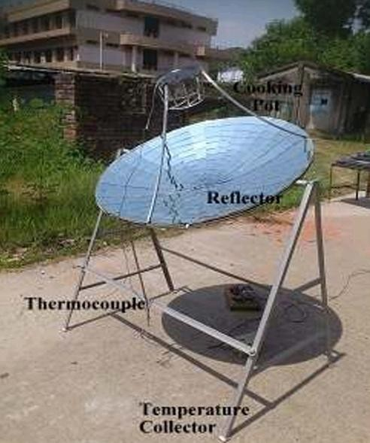

Fig 1.1 Photographic view of Parabolic solar cooker (ICMEE, 2014)

Paraffin Wax
Paraffin waxes are organic phase change materials possessing a great potential to store and release thermal energy. The reversible solid–liquid phase change phenomenon is the under-lying mechanism enabling the paraffin waxes as robust thermal reservoirs based on inherently high latent heat (i.e., ~200–250 J/g). (Raza et al, 2021).
Paraffin waxes are defined as the materials consisting of saturated carbonhydrogen chains integrated with branched, straight and ring-like (aromatics) structures that are relatively complex by nature (Vakhshouri A. R, 2019). This chemical configuration endows the amorphous characteristics and inertness to paraffin waxes, resulting in inactive functional groups where the external chemical reactions become impossible. Therefore, the applications of paraffin waxes ranging from biomedical to thermal storage/release are declared relatively safe and environmental-friendly (Donczoa B, and Guttman A, 2018). Thermal excitation is the phase change process of melting during which thermal energy is absorbed, while thermal de-excitation is the phase change process of solidification during which thermal energy is released. These both processes build up the reversible functionality involving the sensible heat and latent heat storage/release (Gulfam et al, 2021).
Table 1.1 Properties of paraffin wax

Property | Value
Chemical formula | CnH2n+2
Appearance | White solid
Odour | Odourless
Boiling point | > 370 °C (698 °F)
Solubility in water | ~ 1mg/L
Flash point | 200–240 °C (392–464 °F; 473–513 K)

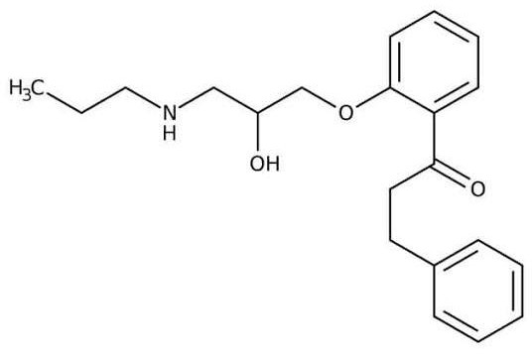

Fig 1.2 Molecular structure of paraffin wax

Mineral Oil
Mineral oil is not a single substance but is composed of a mixture of hydrocarbons isolated from crude petroleum oil (EPA 2007, EFSA 2012, IARC 2012). Mineral oil comprises three main types of compounds: saturated paraffins, napthenes, and aromatics (EFSA 2012, IARC 2012). Saturated paraffins (alkanes) are linear and branched hydrocarbons that include only single bonds throughout their chemical structures (EFSA 2012, Timberlake 2016). Saturated napthenes also include only single bonds within their chemical structures but, unlike paraffins, they also include rings (EFSA 2012). Napthenes may include one or multiple rings and may also include alkyl groups (hydrocarbons) extending from these ringed structures (EFSA 2012). Unlike paraffins and napthenes, aromatics are cyclic hydrocarbons that include carbon-carbon double bonds (EFSA 2012, Timberlake 2016). However, aromatic compounds that are present in mineral oils have double bonds that are limited to the 54 aromatic ring portions of the chemical structure (EFSA 2012). Like napthenes, the aromatic compounds found in mineral oil may include multiple aromatic rings and alkyl groups extending from these ringed structures (EFSA 56 2012).
Table 1.2: Properties of mineral oil

Property | Value
Physical appearance | Clear/pale yellow liquid
Odour | Odourless, odour of lanolin
Molecular weight | 28.2 – 843.6g/mol
Number of carbon atoms | C9 - C60
Melting point | < 0°C
Boiling point | 150 – 894 °C
Flash point | 168.33°C
Specific gravity | 0.79 – 0.94 at 15.6°C
Vapour pressure | < 0.1kPa at 20°C, <1mmHg at 20°C
Solubility | Insoluble in water, soluble in ethanol and  hydrocarbons
Sources: PC 2017a, PC 2017b, SL 2005, EPA 2007, EPA 2009, EFSA 2009, EFSA 2012, Geritrex 2014, APS 2015

Solar Radiation
The sun is the ultimate source of energy and its usefulness to households cannot be overemphasised. The irradiation from the sun is a natural resource that can be harnessed for a breakthrough in any community that maximises it (Craig & Dobson, 2015). Two types of radiation sources are often considered in solar process modelling, namely solar or short-wave radiation, and long-wave radiation. While the former is the radiation whose primary source is the sun and has either direct (beam) or diffuse rays of the sun, the latter is long-wave radiation that represents the radiation that is not directly from the sun, but from a solar receiver/collector or its surrounding matter that has a temperature either in parity to the ambient temperature or close to it (Duffie & Beckman, 2013).
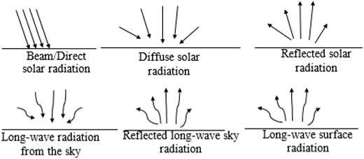

Fig 1.3: Solar energy fluxes showing short/solar and long-wave radiation (Toyosi C, 2015).

Solar Irradiance
Solar irradiance is instantaneous; it is the rate at which a solar receiver receives optical radiation from the sun as a function of its own aperture area (Gueymard, 2012). Solar irradiation, on the other hand, has the same definition but is measured over a longer time, from a day up to yearly data. The harnessing of solar radiation is often easier when the sun path is known. This sun path is defined as the regular change in the position of the sun that occurs either hourly or seasonally. It determines the position of the sun in the sky and is a major factor that dictates the availability of solar radiation (Craig, 2015).

Skin Treatment
Skin treatment is a range of practices that support skin integrity, enhance its appearance, and relieve skin conditions. Practices that enhance appearance include the use of cosmetics, botulinum, exfoliation, fillers, laser resurfacing, microdermabrasion, peels, retinol therapy (Penzer R and Ersser S, 2010), and ultrasonic skin treatment (Rudolfo and Kristina, 2018). Skin care is a routine daily procedure in many settings, such as skin that is either too dry or too moist, and prevention of dermatitis and prevention of skin injuries (Litcherfeld et al, 2015).

CHAPTER THREE

MATERIALS AND METHOD

MATERIAL SELECTION

MATERIAL FOR BODY OF THE DISH
For the material of the body of the dish, Steel was used and it was selected over aluminium because of its strength, cost, durability, and energy effectiveness in use of material. Its smooth contour shape minimizes the sloping error of the reflective mirror material.
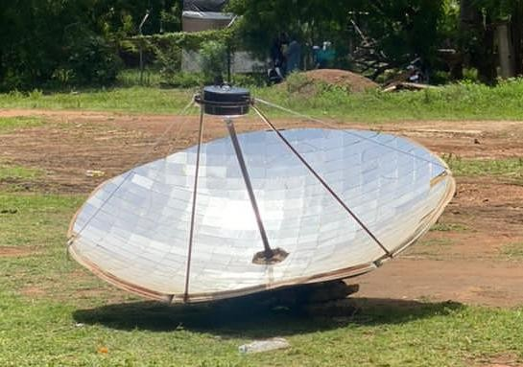

MATERIAL FOR REFLECTING SURFACE
A glass mirror of 3mm thickness was used and it was selected over polished aluminium surface because its reflectivity of 95% is better than that of aluminium (85%).
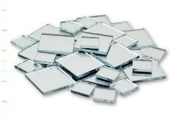

MATERIAL FOR THE ABSORBER/POT
Aluminium was selected as the material for the absorber (cooking pot) because of its cheapness, availability, and specific heat per cubic centimeter. The selection is also due to its corrosion resistance, high strength, and low- density properties. Aluminum is also non-toxic and painted black to ensure higher absorptivity which makes it ideal for heating and melting of paraffin wax.
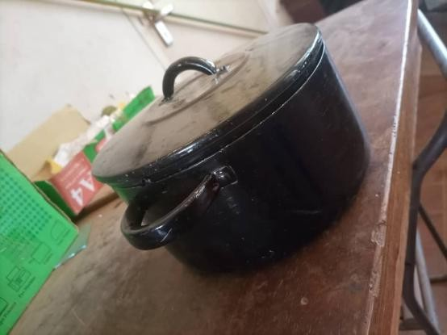

MELTING MATERIAL AND HEAT TRANSFER FLUID
Paraffin wax was selected as the melting material and mineral oil was also selected as the solvent added during melting, because of their applications in cosmetic industry as an effective skin treatment material. Water was selected as the heat transfer fluid because of its stability at high temperatures, low material maintenance and transport costs, safe to use, and is the most commonly used fluid for domestic heating applications.
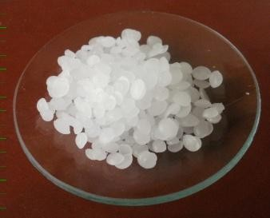
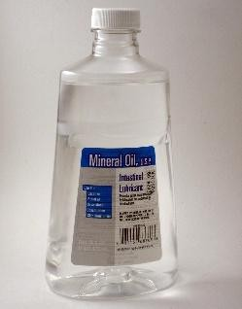

PYRANOMETER
Pyranometer is a device that converts the global solar radiation it receives into an electrical signal that can be measured which are generally used for climatological researches or to monitor the performance of weather stations. The working principle of a pyranometer mainly depends on the difference in temperature measurement between two surfaces like dark and clear

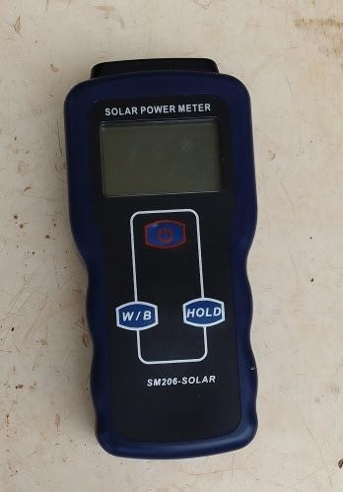

THERMOCOUPLE
A thermocouple is a thermoelectric device used to accurately measure temperatures. It consist of a wire with two leads of dissimilar metals that are joined at one end. Heating the joint produces an electric current which is converted to a temperature reading with a thermocouple monitor.
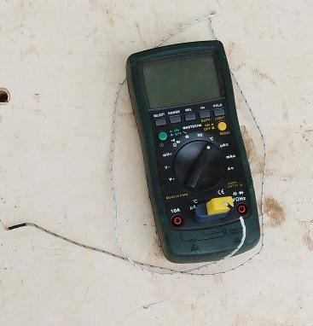

WEIGHING BALANCE
A digital weighing balance is a highly sensitive laboratory instrument which can accurately measure mass in the sub-milligram range to high degree of precision. It has the weighing capacity in the range if 100-500g and a readability of 0.1mg-0.001mg.
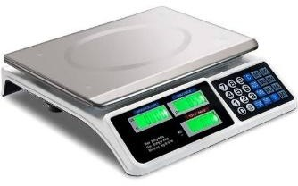

METHOD

EXPERIMENTAL SET UP
The parabolic solar cooker for the experiment was set up behind physics lab B at Kwara State Polytechnic. After the parabolic solar cooker has been setup and the ring and arm been fixed, the sun’s radiation direction was gotten by a compass and the dish was facing the east. Our pot was fixed on the pot hanger and it was adjusted until there was a convergence of solar radiation under the pot. A metallic arm was used as support structure for the reflector and the receiver. The system was adjusted to align with the direction of the sun. Water was poured into the pot and the pot was covered. After the water has reached a considerable temperature of 47.6ºC, the smaller pot containing

the wax was placed inside the bigger pot. This was done in order to maintain a mild temperature suitable to melt the paraffin wax efficiently, as excessive amount of heat could burn the wax. 133ml of mineral oil was added to the wax then the pot was covered. The ambient temperature, temperature of the pot bottom, side of the pot, air gap temperature of the pot and fluid temperature was taken at every 10mins interval until the wax was melted. The molten wax was poured into a container and allowed to cool. Perfume was also added to give the product a sweet smell

MATHEMATICAL DETERMINATION

DETERMINATION OF FOCAL LENGTH
According to Dasin et al 2011, to determine the focal length of a parabolic dish,

Focal distance, 𝐹 = 𝑟2
4ℎ
Diameter of dish is 1.8m and height is 2.6m Where
𝑟 = 𝑑 = ^{1.8}=0.9 h=2.6m
(3.1)

2 2
F= 0.9² 4 ×2.6
F=0.078m

DETERMINATION OF THE PARABOLIC APERTURE AREA
According to Mahendra et al 2020, the parabolic aperture area A is given as,

𝐴 = 𝜋𝐷²
4
𝐴 = 3.142×1.82
4
𝐴 = 2.5𝑚²
(3.2)

DETERMINATION OF THE RIM ANGLE
According to Craig (2015), the rim angle can be calculated as,
𝑡𝑎𝑛𝜃 = 1

(3.3)

𝐷 2ℎ
8ℎ − 𝐷
𝑡𝑎𝑛𝜃 = 1

1.8 2×26
8×2.6 − 1.8
𝜃 = 20°

DETERMINATION OF COOKING POWER ESTIMATION
The cooking power, P, is defined as the rate of useful energy available during heating period. It is measured in watt. According to Samuel et al 2021 it can be calculated as,

P=𝑴𝑾𝑪𝑾 (𝑻𝒇− )
𝒕
(3.4)

where P is interval cooking power (W), 𝑇𝑖 is initial water temperature,𝑇𝑓 is final water temperature,𝑀𝑤 is mass of water (kg), and 𝐶𝑤 is specific heat capacity (4186 J/kg K).
2.5 × 4186(71.2 − 58.3)

𝑃 =
P=225W
600

THE HEAT POWER Q
According to Gundre et al 2012, The heating-power of a solar cooker is calculated as;

𝑄ℎ𝑒𝑎𝑡
= 𝑚𝑤
𝐶𝑤
𝑑𝑇𝑎
𝑑𝑡
(3.5)

𝑄ℎ𝑒𝑎𝑡
= 2.5 × 4186 4.8
600

𝑄ℎ𝑒𝑎𝑡 = 83.72W

CALCULATION OF EFFICIENCY
Based on first law of thermodynamic
Energy input=Energy output + Energy losses
Energy input to the parabolic solar cooker can be calculated as follows: Ei = Ib + A_{sc}
Where;
Ei = Energy Output Ib = Solar Radiation
A_{sc} = Surface area of the solar cooker in m²

But

A_{sc} =

((𝑎2𝐷2+1)) 6𝑎2

Where 𝑎 = 1
4𝑓

𝑎 =
¹ × 0.078
4
𝑎 = 3.2𝑚
Substitute a and other parameters into the equation, A_{sc} becomes; A_{sc} =10.21m²
Therefore,
Ei = Ib + A_{sc}
Ei = 1001 + 10.2
=1011W
𝐸𝑜 = (𝑚𝑤(𝑇𝑤𝑏 − 𝑇𝑤𝑎)⁄𝑡) (3.6)

𝐸𝑜
= 2.5×4186(71.2−58.3)
600

𝐸𝑜 = 225𝑊

EFFICIENCY
ŋ = 𝑬𝒐 = (𝑚𝑤(𝑇𝑤𝑏−𝑇𝑤𝑎)⁄𝑡) × 100 (3.7)

𝑬𝑰
ŋ = 225
1011

× 100
𝐼𝑏+𝐴𝑠𝑐

ŋ = 22.26%

CHAPTER FOUR

RESULTS AND DISCUSSION

RESULT
Some melting test were carried out after the designed and construction of a parabolic cooker. The parameters measured includes: solar radiation, ambient temperature, absorber temperature, side temperature, cover temperature, air gap temperature and water temperature at an interval of 10 minutes for melting of wax. At the end of the experiment, the collected data were analysed and the data gotten from this experiment are shown in the graph below:

CHAPTER FIVE

CONCLUSION AND RECOMMENDATION

CONCLUSION
Parabolic solar cooking is a sustainable and environmentally friendly alternative to traditional heating and melting methods.
Solar technology has made huge advancement technologically and cost-wise, but more research and development work has to be done to make it effective and acceptable compared with fossil fuels. Costs can be reduced by increasing demand for this technology worldwide, as well as through component design and advanced systems. Advancements in the technology and the use of low-cost parabolic solar cooking systems will allow future designs to operate for more hours during the day and partially at the evening hours.
In the near future solar energy will contribute a major share in energy sector. So, proactive utilization of solar power is important. Energy consumption for cooking in developing countries like Nigeria is a major component of the total energy consumption. The parabolic dish solar cooker represents a potential subsidiary way of cooking upon the conventional ways. According to the design the cooker was constructed with the materials which are available in the local market. After construction it was tested with different operating conditions and the cooker can melt 171g of wax within 1 hour at an available radiation level of 1164.5 W/m². So, from the result the efficiency of the parabolic solar cooker was found to be satisfactory. Though its construction and operational cost is low, this type of solar cooker can be promoted in remote and rural areas.

RECOMMENDATION
Based on the evaluation of the experiment conducted and the efficiency derived, Parabolic solar heating method is highly recommended to chemical industries, pharmaceuticals, agro-industries and science laboratories as a very effective alternative to the conventional heating and melting mechanisms. It is also recommended to science and engineering students in Nigeria. Furthermore, we recommend the use of dark protective sun glasses by the users of parabolic solar cooker during heating and melting processes.

REFERENCES
Adedeji, M. A., Umunnakwe, C. K., Adesigbin, A. J., Amoo, M. O. (2020). Modification and Construction of Solar Cooker Using Parabolic Reflector: Engineering and Applied Sciences. Vol. 5, No. 1, 2020, pp. 28-33.
Ahmed. S. A., Prasanna R. S., Murthy, P. L., Bheemarayappa, P. T. (2015). Detail Study of Parabolic Solar cooker: International Research Journal of Engineering and Technology (IRJET) e-ISSN: 2395 -0056 Volume: 02 Issue: 04 - SK-14 p-ISSN: 2395-0072
Andrianaivo, L., Ramasiarinoro J. (2014). Life Cycle Assessment and Environmental Impact Evaluation of the Parabolic Solar Cooker SK14 in Madagascar: Journal of Clean Energy Technologies, Vol. 2, No. 2
Asmelash, H., Bayray1, M., Kimambo C. Z. M., Gebray1, P., and Sebbit, A.
M. (2014). Performance Test of Parabolic Trough Solar Cooker for Indoor Cooking: Momona Ethiopian Journal of Science (MEJS), V6(2)39-54,©CNCS, Mekelle University, ISSN:2220-184X
Claude, A., Balakrishnan, M. and Kumar, D. R. (2012). Engineering, design and fabrication of a solar cooker with parabolic concentrator for heating, drying and cooking purposes: Archives of Applied Science Research, 4 (4):1636-1649
Craig, O. O., & Dobson, R. T. (2015). Stand-alone parabolic solar cookers and rural industrialisation in Southern Africa. In Southern African Solar Energy Conference (SASEC) 2015 (pp. 278–282). Skukuza, South Africa. Retrieved from http://hdl.handle.net/2263/49491

Craig, O. O., Dobson, R., and van Niekerk, W. (2017). A Novel Indirect Parabolic Solar Cooker: Journal of Electrical Engineering v5. pp137- 142
Duffie, J. A., & Beckman, W. A. (2013). Solar engineering of thermal processes, wiley online library, ISBN: 9781118671603
Jacob, A., Timothy, N. C., Adebayo, K. R., Banji, A. A. (2021) Performance Evaluation of Locally Designed and Produced Parabolic Solar Cooker: International Journal of Energy and Environmental Science. Vol. 6, No. 4, 2021, pp. 96-106.
Joyee, E. B. and Rahman, A. N. M. (2014). Design and Construction of a Parabolic Dish Solar Cooker: International Conference on Mechanical, Industrial and Energy Engineering 2014 26-27 December, 2014, Khulna, BANGLADESH
Mbodji, N., Hajji, A., (2017). Performance testing of a parabolic solar concentrator for solar cooking. ASMEJ SolEnergyEng138(4).doi:10.1115/1.4033501
Mirna, B., and Marinovića, S. (2023). Paraffin wax in petroleum industry: A review on formation, experimentation, prevention, and removal techniques vol. 3, pp.82-89
Noman, M., Wasima, A., Alib, M., Jahanzaiba, M., Hussaina, S., Ali, H. M. (2014). An investigation of a solar cooker with parabolic trough concentrator: Case Studies in Thermal Engineering 14 (2019) 100436
Raza, G., Saqib, I. and Farooq, A. (2021). Paraffin Wax-Based Thermal Composites: Paraffin - Thermal Energy Storage Applications Vol. 3, No. 2, 2021, pp. 24-27.
Reddy, R. M., Prasad, T. H., Mallikarjuna, P. (2015). Experimental Investigation of Performance of Parabolic Solar Cooker with Different Reflectors: Journal of Energy, Heat and Mass Transfer 37. 147-160
Sawarn, H., Kumar, P., Singh, R. and Shailendra, K. (2021). Techno- Economic Feasibility Analysis of Parabolic Solar Cooker in Tropical Environment of India: Renew Sustain Energy Rev 81:2703–2713
Singh, M., Kharpude, N. and Narale, P. (2020). Experimental Investigation of Performance of Parabolic Solar Cooker in NEH Region of India: International Journal of Current Microbiology and Applied Sciences ISSN: 2319-7706 Volume 9 Number 6 Page 3322-3326
Tibebu, S., & Hailu, A. (2021). Design, Construction, and Evaluation of the Performance of Dual-Axis Sun Trucker Parabolic Solar Cooker and Comparison of Cooker: Journal of Renewable Energy Volume 2021, Article ID 8944722, 10 pages

APPENDIX
Temp of wax = 26.7°C Initial temp = 47.6°C
Initial ambient temp= 40.4°C

