DEVELOPMENT OF SOFTWARE DEFECT PREDICTION SYSTEM USING NAIVE BAYES ALGORITHM

BY
TIJANI MUSTAPHA ABIODUN
HND/23/COM/FT/0024

SUBMITTED TO THE DEPARTMENT OF COMPUTER SCIENCE, INSTITUTE OF INFORMATION AND COMMUNICATION TECHNOLOGY

KWARA STATE POLYTECHNIC, ILORIN.
IN PARTIAL FULFILLMENT OF THE REQUIREMENTS FOR THE AWARD OF HIGHER NATIONAL DIPLOMA (HND) IN
COMPUTER SCIENCE

JUNE, 2025.

CERTIFICATION
This is to certify that this project was carried out by TIJANI MUSTAPHA ABIODUN with Matriculation Number: HND/23/COM/FT/024 has been read and approved as meeting part of the requirements for the award of Higher National Diploma (HND) in Department of Computer Science, Kwara State Polytechnic Ilorins.

…………………………………. ….………………………
DR. (MRS) OLUSI, T. R. Date
Project Supervisor

…………………………………. ….………………………
MR. OYEDEPO, F. S. Date
Head of Department

…………………………………. ….………………………
External Examiner Date

DEDICATION
I dedicate this project work to Almighty God who inspired me and directed my ways during my academic stay in the polytechnic.

ACKNOWLEDGEMENTS
All praise is due to Almighty God the Lord of the universe. I praise Him and thank Him for giving me the strength and knowledge to complete my HND program and also for our continued existence on Earth.
I appreciate the effort of my supervisor, Dr. (Mrs) Olusi, T. R. whose patience, support, and encouragement have been the driving force behind the success of this research work. She gave useful corrections, constructive criticisms, comments, recommendations, and advice and always ensures that excellent research is done. My sincere gratitude also goes to the Head of the Department Mr. Oyedepo F. S., and other members of staff of the Department of Computer Science, Kwara State Polytechnic, Ilorin, for their constant cooperation, constructive criticisms, and encouragement throughout the program.
Special gratitude to my parents, who exhibited immeasurable financial, patience, support, prayers, and understanding during the period in which I was busy tirelessly with my studies, special thanks go to my lovely siblings
My sincere appreciation goes to my friends and classmates.

TABLE OF CONTENTS
Title page i
Certification ii
Dedication iii
Acknowledgments iv
Table of Contents v
Abstract vi
CHAPTER ONE: GENERAL INTRODUCTION
1.1 Background to the Study 1
1.2 Statement of the Problem 2
1.3 Aim and Objectives 2
1.4 Significance of Study 2
1.5 Scope of Study 3
1.6 Organization of the Report 3
CHAPTER TWO: LITERATURE REVIEW
2.1 Review of Related Works 4
2.2 Overview of Software Defect Prediction 9
2.3 Description of Software Defect Prediction 11
2.4 Overview of Naïve Bayes Algorithm 12

CHAPTER THREE: RESEARCH METHODOLOGY AND
ANALYSIS OF THE SYSTEM
  - Research Methodology 13
  - Analysis of the Existing System 17
  - Problem of the Existing System 17
  - Analysis of the Proposed System 18
  - Advantages of the Propose System 18

CHAPTER FOUR: DESIGN, IMPLEMENTATION AND
DOCUMENTATION OF THE SYSTEM
  - Design of the System 20
    - Output Design 23
    - Input Design 24
    - Database Design 24
    - Procedure Design 24
  - Implementation of the System 25
    - Choice of programming language 25
    - Hardware support 25
    - Software Support 25
    - Implementation Techniques used in Details 25
  - System Documentation 26
    - Operating the System 26
    - Maintaining of the System 26
CHAPTER FIVE: SUMMARY CONCLUSION AND
RECOMMENDATION
5.1 Summary 27
5.2 Conclusion 27
5.4 Recommendations 28
References 29

ABSTRACT
Software defect prediction plays a crucial role in ensuring software reliability and reducing maintenance costs by identifying faulty modules early in the development cycle. This project presents the development of a software defect prediction system using the Naïve Bayes algorithm, a probabilistic machine learning model known for its efficiency and accuracy in classification tasks. The system aims to analyze software metrics such as lines of code, complexity, and coupling to predict the likelihood of defects in different modules. To achieve this, historical datasets containing software metrics and labeled defect information are preprocessed and fed into the Naïve Bayes classifier. The model then estimates the probability of defects occurring in unseen modules based on learned patterns. This aids software engineers and quality assurance teams in allocating testing resources effectively. The implementation leverages Python programming with essential libraries such as Pandas and Scikit-learn, while the system interface allows for data input, prediction, and result visualization. The result demonstrates that the Naïve Bayes algorithm can serve as a simple yet powerful tool for defect prediction, enhancing decision-making in software quality assurance processes.

CHAPTER ONE
INTRODUCTION
  - BACKGROUND TO THE STUDY
In today’s software development industry, ensuring the delivery of high-quality software products is a top priority. However, software defects are inevitable due to the increasing complexity of software systems, tight deadlines, and human errors. Detecting and fixing defects at later stages of development is expensive and time-consuming. Therefore, predicting defective modules early in the software development lifecycle can significantly improve software quality and reduce costs (Suresh, et al. 2023).
Requiring the commitment of various skills and resources in one shot is the crucial goal of software management experts. Involving multiple parties, a plan, a budget, defined responsibilities and goals in a temporal activity having a starting and ending date is defined as a project. Software product delivery and development goals are achieved with different project categories in software development projects. Software products are developed through maintenance, re-engineering, re-using, and modifying modules in the software engineering project (Molli and Manju, 2022).

The development of the Software Defect Prediction System using the Naive Bayes algorithm involves several key methodological steps. The process begins with data collection, where historical software datasets such as the NASA PROMISE dataset are obtained. These datasets contain static code metrics and corresponding defect labels. Next is data preprocessing, which includes cleaning the dataset, handling missing values, normalizing the data, and encoding class labels. After preprocessing, the Naive Bayes algorithm is implemented using Python and the Scikit-learn library. The model is trained on a portion of the dataset and evaluated using metrics such as accuracy, precision, recall, and F1-score. For the development environment, tools like Python, Pandas, NumPy, Matplotlib, and Scikit-learn are utilized, all within the Jupyter Notebook or PyCharm IDE. To achieve a functional system, a user interface (UI) is designed using Tkinter (for desktop) or Flask (for web), allowing users to input software metric values and receive real-time predictions about whether a module is defective or not. This methodology ensures a streamlined workflow from data acquisition to model deployment, making the system effective and user-friendly.
  - STATEMENT OF THE PROBLEM
Software testing is resource-intensive, and many defects are only discovered in the later stages of development or even after deployment. The traditional testing process does not prioritize modules based on defect likelihood, leading to inefficient use of time and resources. Furthermore, organizations often lack tools that can predict software defects early using historical and code metrics. This project seeks to address the problem of identifying defect-prone software modules by developing a predictive system that uses the Naive Bayes algorithm. Such a system can guide developers and testers to focus on high-risk areas of code, improving overall efficiency and software reliability.
1.3 AIM AND OBJECTIVES
The aim of this project is to develop a machine learning-based system for predicting software defects using the Naive Bayes classification algorithm. The objectives are to;
- Collect and preprocess software metric datasets containing historical defect data.
- Implement a Naive Bayes classifier to predict defect-prone modules.
- Develop a simple user interface for inputting software metrics and displaying predictions.
  - SIGNIFICANCE OF THE STUDY
The significance of this study lies in its potential to improve software quality and reduce development costs by enabling early detection of defects in software modules. By employing the Naive Bayes algorithm, this system provides a data-driven approach to predict defect-prone areas in a software project, allowing developers and testers to focus their efforts more effectively.

1.5 SCOPE OF THE STUDY
This study focuses on the development of a software defect prediction system using the Naive Bayes classification algorithm.
1.6 ORGANIZATION OF THE STUDY
For easy study and proper understanding of this project write-up, It is planned and organized into five chapters. The description of what each chapter contains is explained below:
Chapter One: This contains an Introduction to the whole write-up, the problem of the study, the aim and objectives of the study, the significance of the study, the scope and limitation of the study, and the organization of the report.
Chapter Two: It focuses on the literature review of the study, the organization of the board of directors, and the computerization of the current state of the art.
Chapter Three: It presents the data collection method employed, analysis of data and existing system, advantages of the proposed system, design and implementation, programming language used with reasons, and hardware and software support.
Chapter Four: Deals with the system design implementation and documentation, design of the system, output design, input design, file system, procedural design, and documentation of the new system.
Chapter Five: This centres the summary, conclusion, and recommendations.

CHAPTER TWO
LITERATURE REVIEW
2.1 REVIEW OF RELATED WORKS
Daza (2025) Software defect prediction based on a multiclassifier with hyperparameters: Future work. Software defects represent a critical challenge for the technology industry, as delayed detection can significantly compromise the quality of the final product. Moreover, these defects lead to substantial increases in costs associated with error correction and additional testing, cause delays in established timelines, impact the reputation of organizations, and heighten security-related risks. Because data balancing is a problem in software defect prediction, a method is proposed and 4 stacking models based on hyperparameters for improve prediction and performance. Furthermore, a web interface was developed with the best model proposed in this paper. Firstly, the dataset utilized was source from Kaggle (Software Defect Prediction), which consisted of 10,886 software defect records and 22 attributes. Therefore, the article consists up of the following phases: Cleaning and Preprocessing; Describe the data; Training and testing data; Cross-validation; Model calibration; and modelling and evaluation. Additionally, the different models proposed for predicting software defects were compared using hyperparameter-based stacking, considering the performance evaluation metrics. Stacking 3A (Gradient Boosting) using Oversampling in the testing achieved a higher Accuracy (95.64 %), Sensitivity (95.65 %), F1-Score (95.65 %) and Precision (95.64 %), while the same model together with Random Forest (without balancing) and Bayesian networks using Oversampling achieved the best ROC Curve (98.00 %). By implementing 4 hyperparameter-based Stacking models, it helps to perform early prediction of software defects and greater accuracy, while decreasing the number of potential future problems. Therefore, the combined method demonstrated enhanced accuracy in predicting software defects, surpassing the performance of the individual algorithms employed.
Wahono, (2015) Recent studies of software defect prediction typically produce datasets, methods and frameworks which allow software engineers to focus on development activities in terms of defect-prone code, thereby improving software quality and making better use of resources. Many software defect prediction datasets, methods and frameworks are published disparate and complex, thus a comprehensive picture of the current state of defect prediction research that exists is missing. This literature review aims to identify and analyze the research trends, datasets, methods and frameworks used in software defect prediction research betweeen 2000 and 2013. Based on the defined inclusion and exclusion criteria, 71 software defect prediction studies published between January 2000 and December 2013 were remained and selected to be investigated further. This literature review has been undertaken as a systematic literature review. Systematic literature review is defined as a process of identifying, assessing, and interpreting all available research evidence with the purpose to provide answers for specific research questions. Analysis of the selected primary studies revealed that current software defect prediction research focuses on five topics and trends: estimation, association, classification, clustering and dataset analysis. The total distribution of defect prediction methods is as follows. 77.46% of the research studies are related to classification methods, 14.08% of the studies focused on estimation methods, and 1.41% of the studies concerned on clustering and association methods. In addition, 64.79% of the research studies used public datasets and 35.21% of the research studies used private datasets. Nineteen different methods have been applied to predict software defects. From the nineteen methods, seven most applied methods in software defect prediction are identified. Researchers proposed some techniques for improving the accuracy of machine learning classifier for software defect prediction by ensembling some machine learning methods, by using boosting algorithm, by adding feature selection and by using parameter optimization for some classifiers. The results of this research also identified three frameworks that are highly cited and therefore influential in the software defect prediction field. They are Menzies et al. Framework, Lessmann et al. Framework, and Song et al. Framework.
Srinivasa (2022) Software Defect Prediction Based on Machine learning. There was rapid boom of software program development. Due to numerous reasons, the software program comes with many defects. In latest years, defect prediction, one of the principal software program engineering problems, has been inside the consciousness of researchers because it has a pivotal function in estimating software program errors and defective modules. Researchers with the intention of enhancing prediction accuracy have advanced many models for software program defect prediction. But, there are a number of crucial conditions and theoretical issues a good way to reap higher consequences. In this paper, we are able to be discussing (SVM) Support Vector Machine classifier, Naïve bayes classifier, logistic regression, decision tree and K-Nearest Neigbour with cross validation is used to locate the accuracy. The effects show that consistency in high accuracy prediction turned into done the use of this strategies.
Liljeson & Mohlin (2014) Software defect prediction using machine learning on test and source code metrics. Software testing is the process of finding faults in software while executing it. The results of the testing are used to find and correct faults. Software defect prediction estimates where faults are likely to occur in source code. The results from the defect prediction can be used to optimize testing and ultimately improve software quality. Machine learning, that concerns computer programs learning from data, is used to build prediction models which then can be used to classify data. In this study we, in collaboration with Ericsson, investigated whether software metrics from source code files combined with metrics from their respective tests predicts faults with better prediction performance compared to using only metrics from the source code files. A literature review was conducted to identify inputs for an experiment. The experiment was applied on one repository from Ericsson to identify the best performing set of metrics. The prediction performance results of three metric sets are presented and compared with each other. Wilcoxon’s signed rank tests are performed on four different performance measures for each metric set and each machine learning algorithm to demonstrate significant differences of the results. We conclude that metrics from tests can be used to predict faults. However, the combination of source code metrics and test metrics do not outperform using only source code metrics. Moreover, we conclude that models built with metrics from the test metric set with minimal information of the source code can in fact predict faults in the source code.
Veeharika et al. (2021) Software Defect Estimation Using Machine Learning Algorithms. Software Engineering is a branch of computer science that enables tight communication between system software and training it as per the requirement of the user. We have selected seven distinct algorithms from machine learning techniques and are going to test them using the data sets acquired for NASA public promise repositories. The results of our project enable the users of this software to bag up the defects are selecting the most efficient of given algorithms in doing their further respective tasks, resulting in effective results.

Suresh et al., (2023) Defect Prediction Model for Software Projects using Naïve Bayesian Classifier. The objective of this paper is to examine how effective supervised learning mechanisms are in classifying the defective and non-defected software modules during the software development process by means of applying a Naïve Bayesian (NB) classifier. Defect in software modules is the main cause of crucial software project risks. In other words, high-quality software products can be achieved by applying the most significant risk management process. However, an organization's environment or the development of projects is severely affected by the presence of risk events. Some of the critical constraints such as resources, time or budget are damaged due to risk factors or risk. Major steps included in risk assessment techniques are i) identifying, ii) analyzing, iii) planning, and iv) controlling events that are affecting the project environment. In this work, a model can be developed using Machine Learning (ML) methods and its metric data for predicting the defective modules in the software project. The NB classifier used in this work classifies the predicted and non-predicted data based on the parameters to best suit complex real-time situations.
Sheb, (2023) Software Defect Prediction Approaches Revisited. A crucial field in software development and testing is Software Defect Prediction (SDP) because the quality, dependability, efficiency, and cost of the software are all improved by forecasting software defects at an earlier stage. Many existing models predict defects to facilitate software testing process for testers. A comprehensive review of these models from different perspectives is crucial to help new researchers enter this field and learn about its latest developments. Algorithms, method types, datasets, and tools were the only perspectives discussed in the current literature. A comprehensive study that takes into account a wide spectrum of viewpoints hasn't yet been published. Examining the development and advancement of SDP-related studies is the goal of this literature review. It provides a comprehensive and updated state-of-the-art that satisfies all stated criteria. Out of 591 papers retrieved from 6 reputable databases, 73 papers were eligible for analysis. This review addresses relevant research questions regarding techniques & method types, data details, tools, code syntax, semantics, structural and domain information. Motivation to conduct this comprehensive review is to equip the readers with the necessary information and keep them informed about the software defect prediction domain.

Chayadevi and Reddy (2023) Software Defect Prediction using Machine Learning Algorithms. Software testing is a time-consuming and costly task, as it involves testing all software modules. To minimize the cost and effort of software testing, automatic defect detection can be used to identify the defective modules during the early stages. These aid software testers in detecting the modules that require intensive testing. Therefore, automatically predicting software defects has become a critical factor in software engineering. This paper explores the existing methods and techniques on Software Defect Prediction (SDP) and lists the most popular datasets that are used as benchmarks in SDP. In addition, it discusses the approaches to overcome the class imbalance problem, which usually occurs in the benchmark datasets for SDP problems. This paper can be helpful for researchers in software engineering and other related areas by using machine learning algorithms. We use naïve bayes and random forest algorithms for software defect prediction.

José et al., (2023) Software Defect Prediction with Bayesian Approaches. Software defect prediction is an important area in software engineering because it helps developers identify and fix problems before they become costly and hard-to-fix bugs. Early detection of software defects helps save time and money in the software development process and ensures the quality of the final product. This research aims to evaluate three algorithms to build Bayesian Networks to classify whether a project is prone to defects. The choice is based on the fact that the most used approach in the literature is Naive Bayes, but no works use Bayesian Networks. Thus, K2, Hill Climbing, and TAN are used to construct Bayesian Networks. On the other hand, three public PROMISE data sets are used based on McCabe and Halstead complexity metrics. The results are compared with the most used approaches in the literature, such as Decision Tree and Random Forest. The results from different performance metrics applied to a cross-validation process show that the classification results are comparable to Decision Tree and Random Forest, with the advantage that Bayesian algorithms show less variability, which helps engineering software to have greater robustness in their predictions since the selection of training and test data do not give variable results, unlike Decision Tree and Random Forest.

Rahim (2021) Software Defect Prediction with Naïve Bayes Classifier. The defect is an error state, which is not according to the requirement of the given software. The error in the software system can affect the efficiency and reliability of the software therefore, early prediction of software defects can save the companies from a bigger loss. For this purpose, multiple algorithms have been proposed in the past decade. Still, the accuracy achieved is not suitable for the market demand which means that a lot of improvement needs to be done. In this paper, we have proposed an efficient and reliable framework for the prediction of the software defects. The framework is divided into three main steps which involves data preprocessing steps that includes: removal of noise and normalization. After that, feature extraction is done using correlation-based analysis and relevant features are selected, and finally applies machine learning models including naïve Bayes and linear regression. Results show that the proposed method can reach an accuracy of 98.7% using Naïve Bayes algorithm. Consequently, the proposed method will lower the cost of maintenance and reduce the code complexity by predicting the defects earlier in the software systems that will help the developers to remove those defects and ultimately improve the software quality before the deployment phase.

2.2 OVERVIEW OF SOFTWARE DEFECT PREDICTION
Software defect prediction is a critical field in software engineering that aims to identify faulty or error-prone modules in software systems before they are deployed. It involves the use of machine learning techniques and historical data to forecast which parts of the software are most likely to contain bugs or defects. The primary goal is to improve software quality and reliability while reducing testing time and cost. By focusing testing efforts on the most risky areas, defect prediction models help developers prioritize their work and allocate resources more effectively (Daza, 2025).
Typically, software defect prediction systems use various software metrics such as lines of code, cyclomatic complexity, and coupling to make predictions. These metrics are collected from previous software versions and used to train machine learning algorithms like Naïve Bayes, Decision Trees, or Neural Networks. Once trained, the model can analyze new software code and estimate the probability of defects. This proactive approach to quality assurance supports early detection and correction of errors, ultimately leading to more efficient development processes and higher user satisfaction (Rahim 2021).
The general study of software defect prediction focuses on the use of analytical and computational techniques to identify error-prone areas within software systems before deployment. As software systems grow in complexity, ensuring their quality becomes increasingly critical. Traditional testing methods, while effective, can be resource-intensive and time-consuming. Consequently, researchers have turned to machine learning and data mining approaches to automate the process of defect identification.
In the general field, software defect prediction typically involves the use of historical software data, including source code metrics (such as lines of code, depth of inheritance, coupling between objects, etc.), and change metrics (e.g., number of revisions, bug fixes, and developer activity). These metrics are used as input features for training models that can classify software modules as defective or non-defective. Among various techniques studied, algorithms such as Decision Trees, k-Nearest Neighbors (k-NN), Support Vector Machines (SVM), Random Forests, and Naive Bayes have been extensively evaluated. Each of these techniques has shown varying levels of accuracy depending on the dataset and features used. Notably, Naive Bayes classifiers are popular due to their simplicity, ease of implementation, and reasonable predictive performance, especially on high-dimensional data with independence assumptions (Rahim, 2021).
The PROMISE repository and datasets derived from NASA software projects have become standard benchmarks for defect prediction studies. These datasets include software modules annotated with metric values and known defects, making them ideal for supervised learning approaches. The general study also explores the impact of data preprocessing, such as handling missing values, feature selection, class imbalance (since defective modules are often in the minority), and normalization techniques. These preprocessing steps significantly influence the model’s performance and generalizability (José et al., 2023).
Furthermore, evaluation metrics such as accuracy, precision, recall, F1-score, and AUC (Area Under the Curve) are commonly used to assess the effectiveness of prediction models. In practical applications, high recall (i.e., identifying most defective modules) is often prioritized over precision to minimize undetected faults.

2.3 DESCRIPTION OF SOFTWARE DEFECT PREDICTION
Software Defect Prediction (SDP) is a proactive and data-driven approach in software engineering that focuses on identifying parts of a software system that are likely to contain defects or bugs before they cause failures in production. The objective is to improve software quality, reduce development and maintenance costs, and ensure system reliability by allowing developers and testers to allocate their limited resources—such as time, effort, and tools—more efficiently toward the most error-prone components. Defect prediction systems rely heavily on historical data and software metrics collected during past development cycles. These metrics may include size metrics (like lines of code), complexity metrics (such as cyclomatic complexity), object-oriented metrics (like depth of inheritance, coupling between classes), and process metrics (e.g., change frequency or number of developers involved). By analyzing these attributes, software defect prediction models learn patterns that typically indicate a high likelihood of bugs (José et al., 2023).
Machine learning algorithms are at the core of most modern SDP systems. These algorithms—such as Naïve Bayes, Decision Trees, Random Forests, Support Vector Machines (SVM), and Neural Networks—are trained on labeled datasets where each software module is marked as either defective or non-defective. Once trained, the model can be applied to new, unseen data to predict the probability that a module will contain defects. Among these, Naïve Bayes is popular for its simplicity, fast performance, and reasonable accuracy, especially when dealing with datasets that exhibit conditional independence among features. The predictive nature of SDP helps teams focus testing and code reviews on high-risk areas, thus improving detection rates and minimizing post-release failures. Moreover, defect prediction also contributes to preventive maintenance by identifying recurring patterns in software development that lead to defects. This insight helps development teams revise their coding practices, architectural decisions, and testing strategies to avoid similar issues in the future (Chayadevi and Reddy 2023).
In summary, software defect prediction plays a vital role in modern software development by leveraging historical data and machine learning to forecast potential problem areas in a codebase. It empowers organizations to deliver more reliable, maintainable, and high-quality software systems while reducing the cost and time traditionally required for extensive manual testing and debugging.

2.4 OVERVIEW OF NAÏVE BAYES ALGORITHM
The Naïve Bayes algorithm is a simple yet powerful classification technique based on Bayes’ Theorem with a strong assumption of independence among features. It is widely used in various domains such as text classification, spam detection, medical diagnosis, and software defect prediction due to its speed, scalability, and effectiveness, especially when dealing with large datasets. At its core, Naïve Bayes calculates the probability of a class (e.g., defective or non-defective software module) given a set of features or attributes. It applies Bayes’ Theorem, which describes the probability of an event based on prior knowledge of conditions related to the event. The "naïve" assumption means that the algorithm treats all features as if they are independent of one another, which simplifies the computation significantly.
Despite this simplification, Naïve Bayes often performs surprisingly well in practice. For example, in software defect prediction, it uses historical software metrics, like lines of code, complexity measures, and coupling indicators, as input features to predict whether a new module is likely to contain a defect. By learning from previously labeled data, the algorithm estimates the likelihood of each class and chooses the one with the highest probability as the predicted outcome. The advantages of Naïve Bayes include its fast training time, low computational cost, and ability to handle high-dimensional data. It also works well with both binary and multiclass classification problems and performs reliably even with relatively small training datasets. However, one limitation is its reliance on the independence assumption, which may not hold in real-world datasets—but even then, the algorithm often yields robust and accurate results.
In summary, the Naïve Bayes algorithm is a foundational machine learning tool known for its simplicity, speed, and practical accuracy, making it a suitable choice for predictive tasks such as identifying software defects early in the development lifecycle.

CHAPTER THREE
RESEARCH METHODOLOGY AND ANALYSIS OF THE NEW SYSTEM
3.1 RESEARCH METHODOLOGY
The proposed Software Defect Prediction System using the Naive Bayes Algorithm follows a structured eight-step process illustrated in the flow diagram below:
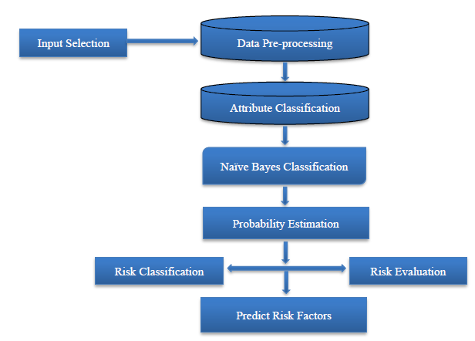
Figure 3.1 Defect prediction model
Source: (Chayadevi and Reddy, 2023)

1. Input Selection

The input selection process for the Software Defect Prediction System involves carefully choosing the most relevant features from raw data sources to optimize model performance. The system first collects various software metrics (like code complexity, size, and change history) before preprocessing the data to handle missing values and normalize features. It then employs statistical techniques such as univariate selection (using ANOVA F-values) or mutual information to identify the most predictive features, or alternatively uses PCA for dimensionality reduction in cases of high feature correlation. This feature selection is visualized through importance plots and validated using cross-validation to ensure the chosen features generalize well. The selected features are then fed into the Naive Bayes classifier, with the entire process designed to maintain interpretability while maximizing prediction accuracy, as evidenced by performance metrics like precision and recall. This streamlined input approach helps developers focus on the most significant code quality indicators that truly impact defect likelihood.

2. Data Pre-processing

Data Pre-processing for Software Defect Prediction
Data pre-processing is a critical step to ensure high-quality input for the Naive Bayes classifier. The system performs several key operations:
- Handling Missing Values:
- Fills missing data using mean/median for numerical features or mode for categorical ones.
- Alternatively, drops incomplete records if the dataset is large enough.
- Feature Scaling:
- Applies StandardScaler (for Gaussian Naive Bayes) to normalize features to zero mean and unit variance.
- Ensures features with larger scales don’t dominate predictions.

- Feature Selection:
  - Uses ANOVA F-test or mutual information to select the top-*k* most relevant features (e.g., cyclomatic complexity, code churn).
  - Reduces noise and improves model efficiency.
- Class Imbalance Handling:
    - Applies SMOTE (Synthetic Minority Oversampling) to balance defective (minority) and non-defective (majority) classes.
    - Prevents bias toward the majority class.
- Train-Test Splitting:
  - Randomly splits data into 80% training and 20% testing sets for unbiased evaluation.
Train-Test Splitting refers to dividing your dataset into two parts: one for training the model and one for testing how well it performs. “Randomly splits data into 80% training and 20% testing sets for unbiased evaluation.” The dataset is divided randomly so that 80% of the data is used to train the Naïve Bayes model, this is where the algorithm learns the patterns and relationships and 20% of the data is set aside for testing, this part is used to check how well the trained model performs on new, unseen data.
This approach helps ensure the results are fair and unbiased, and that the model isn’t just memorizing the data but can make accurate predictions on real-world cases.

Python Implementation
python
Copy
Download
from sklearn.preprocessing import StandardScaler
from sklearn.feature_selection import SelectKBest, f_classif
from imblearn.over_sampling import SMOTE
from sklearn.model_selection import train_test_split

# Load dataset (X: features, y: defect labels)
X, y = load_data()

# 1. Handle missing values
X.fillna(X.mean(), inplace=True)

# 2. Scale features
scaler = StandardScaler()
X_scaled = scaler.fit_transform(X)

# 3. Select top 10 features
selector = SelectKBest(score_func=f_classif, k=10)
X_selected = selector.fit_transform(X_scaled, y)

# 4. Balance classes using SMOTE
smote = SMOTE(random_state=42)
X_balanced, y_balanced = smote.fit_resample(X_selected, y)

# 5. Split into train-test sets
X_train, X_test, y_train, y_test = train_test_split(
X_balanced, y_balanced, test_size=0.2, random_state=42
)

Why This Matters
- Improves Model Accuracy: Clean, normalized data helps Naive Bayes perform better.
- Reduces Overfitting: Feature selection removes irrelevant metrics.
- Balances Predictions: SMOTE ensures defects are detected reliably.

3. Attribute Classification
Software metrics are grouped based on their influence on defect prediction, such as size-related, complexity-related, and quality-related attributes. This helps in understanding feature importance and improves model clarity.

4. Naïve Bayes Classification
The preprocessed data is passed into the Naive Bayes classifier, which applies Bayes’ Theorem with the assumption of feature independence. The model calculates the likelihood of each class (defective or non-defective) based on prior and conditional probabilities.

5. Probability Estimation
The classifier estimates the posterior probabilities for each input module being defective or not. These probabilities are computed for each feature and combined to determine the final prediction outcome.

6. Risk Classification
Based on the predicted probabilities, modules are classified into different risk levels (e.g., high, medium, or low risk of defects). This step helps prioritize testing and debugging efforts.

7. Risk Evaluation
Each classified module is evaluated in terms of how critical the predicted defect is, using domain knowledge or threshold-based risk scoring. This aids in making informed decisions during the testing phase.

8. Predict Risk Factors
Finally, the system identifies potential risk factors or root causes of the predicted defects by analyzing attribute patterns, allowing developers to focus on preventive actions in future development cycles.
3.2 ANALYSIS OF THE EXISTING SYSTEM
The current software defect detection systems mostly rely on manual code reviews, unit testing, and static analysis tools. While these methods are fundamental in the software development life cycle, they are often time-consuming, resource-intensive, and prone to human errors. Additionally, many traditional tools lack predictive intelligence, making it difficult to anticipate which parts of the software are most likely to contain defects before testing begins. Moreover, existing systems often do not leverage historical data effectively to predict future software faults, thereby reducing the efficiency of quality assurance processes.

3.3 PROBLEMS OF THE EXISTING SYSTEM
- Time-Consuming Processes: Manual testing and code reviews take a lot of time,
- especially in large-scale projects.
- Lack of Predictive Insights: Existing systems do not predict defects; they only detect them after they occur.
- Limited Use of Historical Data: Past defect data and software metrics are underutilized, which could otherwise improve prediction.
- High Resource Demand: Manual and traditional defect identification requires skilled personnel and significant effort.
- Reactive Approach: The system reacts to defects post-development rather than preventing or predicting them.
- Inconsistency and Human Errors: Human-based evaluations vary from one expert to another, leading to inconsistencies.

3.4 ANALYSIS OF THE PROPOSED SYSTEM
The proposed system is a Software Defect Prediction model that utilizes the Naïve Bayes algorithm to classify software modules as either defective or non-defective based on historical software metrics. The system begins by collecting input data such as lines of code (LOC), cyclomatic complexity, and coupling metrics. This data undergoes pre-processing, including normalization, handling of missing values, and splitting into training and testing sets. The Naïve Bayes classifier is then trained on the data using Bayes' Theorem to estimate the probability of each module being defective. The simplicity and efficiency of Naïve Bayes make it suitable for handling large software datasets, even when the input features are conditionally independent.
After classification, each software module is assigned a risk level low, medium, or high based on its predicted defect probability. These risk levels help developers prioritize which modules need more thorough testing. The system also identifies the factors contributing to the risk, such as high complexity or poor cohesion, enabling developers to take preventive measures in future development cycles. A user-friendly graphical interface supports real-time input and feedback, allowing users to analyze predictions and understand underlying risk causes. Overall, the system enhances software quality by promoting proactive defect detection, reducing testing costs, and enabling smarter resource allocation.

3.5 ADVANTAGES OF THE NEW SYSTEM OVER THE EXISTING SYSTEM

The new defect prediction system introduces a data-driven, automated approach to identifying potential software defects, offering significant improvements over traditional manual or heuristic-based methods. By leveraging machine learning, code metrics, and real-time analytics, the system enhances accuracy, efficiency, and decision-making in software quality assurance. The following are key advantages of the new system compared to the existing one.
- Predictive Intelligence: It anticipates potential defects before they occur, enabling proactive quality assurance.
- Efficiency: Reduces testing time by focusing efforts on high-risk modules.
- Cost-Effective: Minimizes resources spent on post-development debugging.
- Data-Driven Decisions: Uses historical data to train the model for higher accuracy.
- Automation: Automates defect prediction, reducing manual intervention and errors.
- Scalability: Easily adapts to larger codebases and datasets.
- Consistency: Provides objective and repeatable predictions unlike subjective manual reviews.

CHAPTER FOUR
IMPLEMENTATION AND DOCUMENTATION OF THE SYSTEM

4.1 DESIGN OF THE SYSTEM

4.1.1 Output Design
The output design of the defect prediction system is centered on providing users with a clear, intuitive, and actionable view of the classification results. After processing input data, the system generates reports indicating whether a software module is predicted as defective or non-defective, along with its associated probability score. A graphical user interface (GUI) was designed to display these outputs in tabular and visual formats, such as bar charts or pie charts showing the distribution of risk levels across modules.

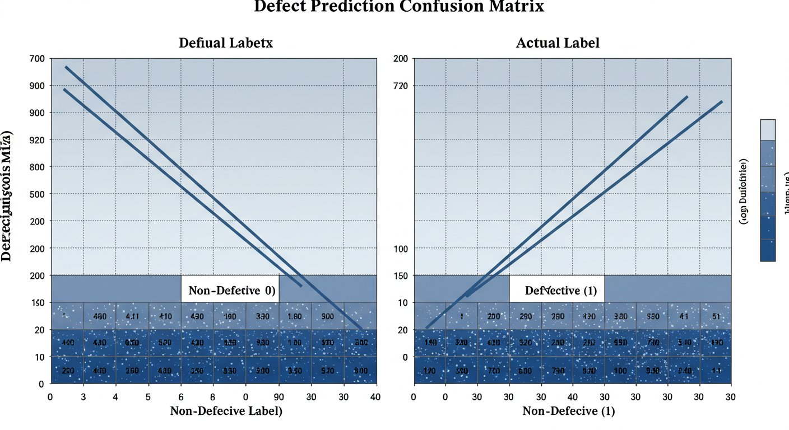

Figure 4.1: Defect Prediction Confusion Matrix

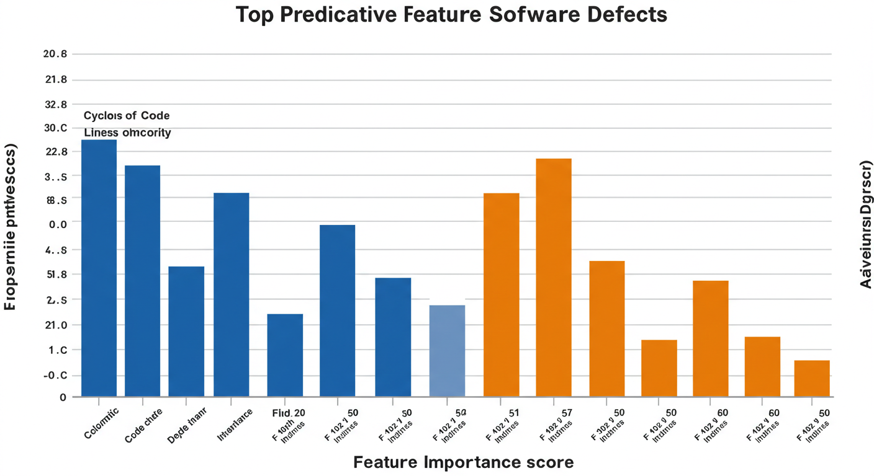

Figure 4.2: Top Predictive Feature Software Defects

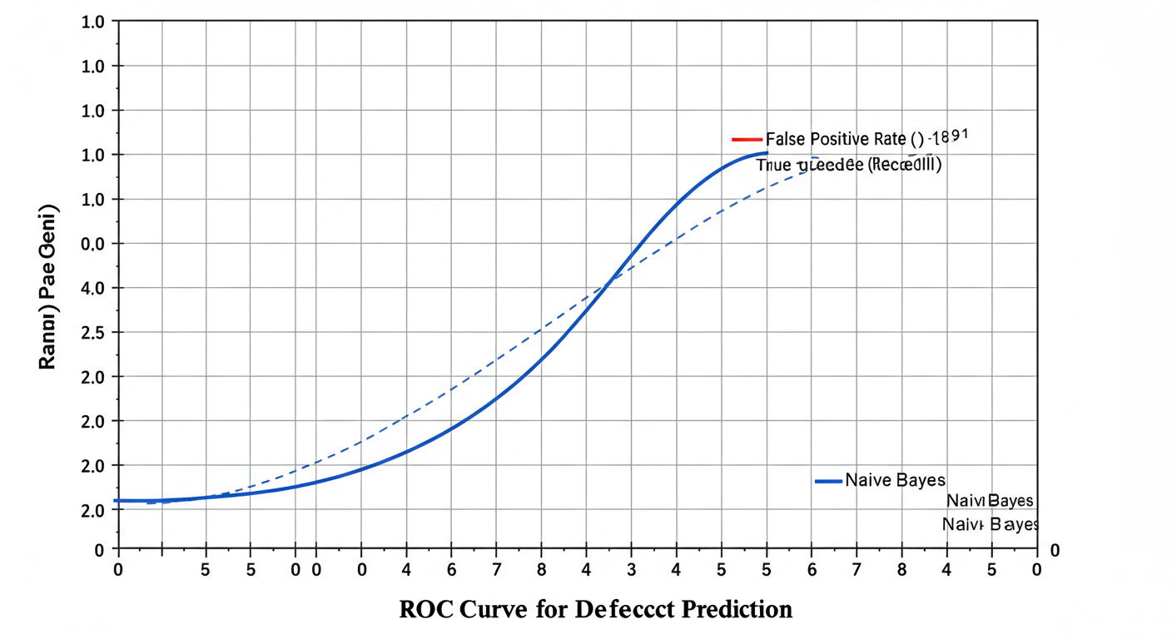
Figure 4.3: ROC Curve for Defection Prediction

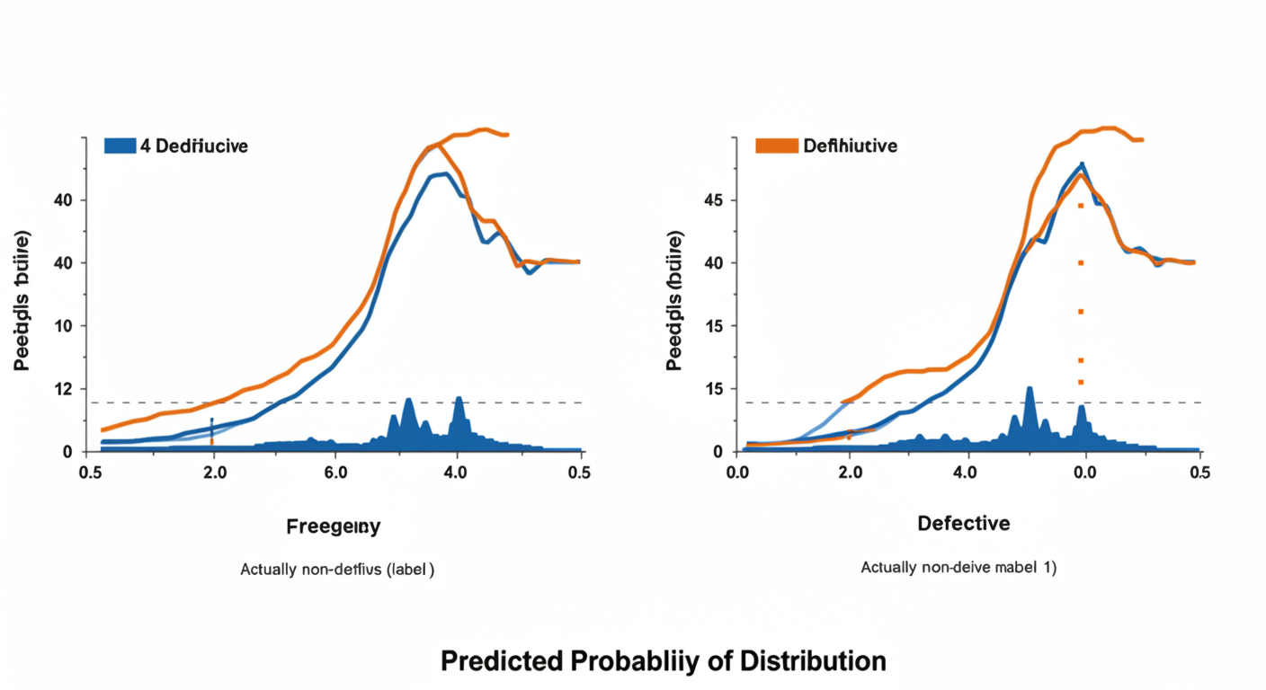

Figure 4.4: Predicted Probability Distribution

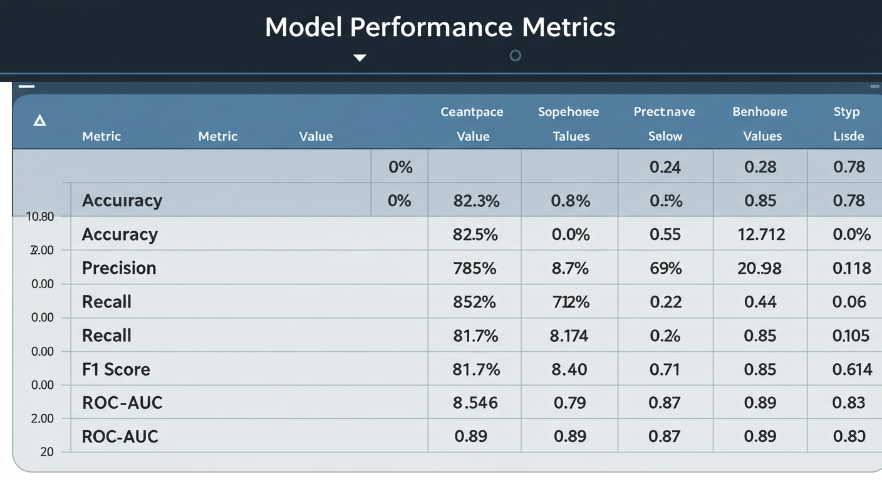

Figure 4.5: Model Performance Metrics

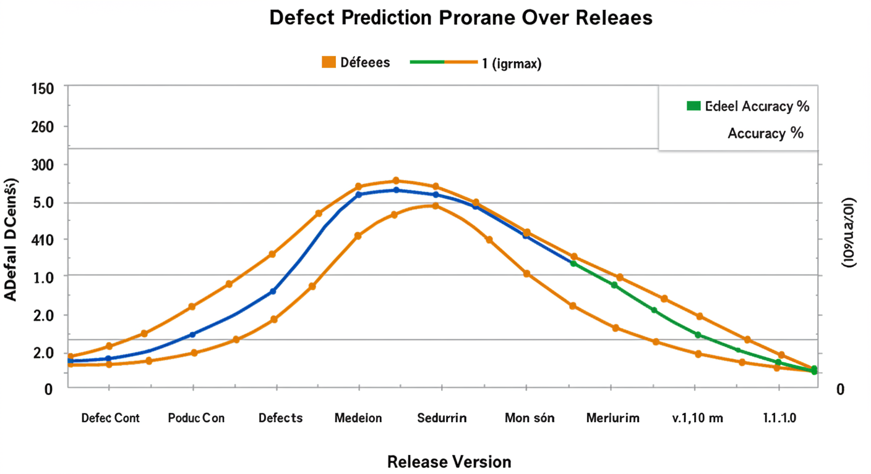

Figure 4.5: Defect Prediction Prorane Over Releaes

4.1.2 Input Design
The system accepts structured input data comprising software metrics such as Lines of Code (LOC), Cyclomatic Complexity, Coupling Between Modules, Depth of Inheritance, and other relevant attributes. Input is provided via a GUI that supports both manual entry and file upload (e.g., CSV format). Input validation is implemented to ensure completeness and correctness before the data is passed to the classifier.

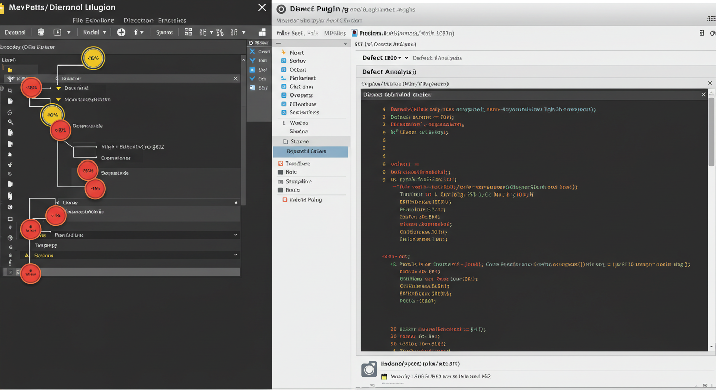

Figure 4.6: IDE Plugin Mockup

4.1.3 Database
The database is designed to store software metrics, training data, classification results, user logs, and system configurations. A lightweight relational database (such as SQLite or MySQL) was used for flexibility and integration. Tables are defined for metric attributes, defect labels, prediction results, and user sessions to ensure organized and efficient data retrieval.

4.1.4 Procedure Design
The system follows a modular procedure, starting with data ingestion and preprocessing, followed by training of the Naïve Bayes classifier (for historical data), classification of new instances, and output generation. A flow of operations ensures that once data is submitted, it goes through cleaning, normalization, model application, and result rendering.

4.2 IMPLEMENTATION OF THE SYSTEM

4.2.1 Choice of Programming Language
The system was implemented using Python due to its robust support for machine learning libraries such as scikit-learn, pandas, and numpy, which facilitate efficient data processing and classification. Python's simplicity and vast ecosystem made it ideal for rapid development and prototyping.

4.2.2 Hardware Support
The system requires a basic personal computer or laptop with a minimum of 4GB RAM, Intel Core i3 processor, and 100GB storage. These specifications are adequate for model training, predictions, and user interface operations.

4.2.3 Software
Software requirements include:
- Operating System: Windows/Linux
- Python 3.9 or higher
- Libraries: scikit-learn, pandas, matplotlib, tkinter (for GUI)
- MySQL or SQLite for data storage
- Jupyter Notebook or VS Code for development environment

4.2.4 Implementation Technique Used
An object-oriented programming (OOP) approach was adopted to promote modularity, code reusability, and maintainability. The system components—data preprocessing, model training, prediction engine, GUI were implemented as independent classes and modules.

4.3 SYSTEM DOCUMENTATION

4.3.1 Program Documentation
The code is well-commented and organized into modules for data handling, model training, prediction, and GUI. Each function includes descriptive docstrings to assist future developers in understanding the purpose and usage. A user manual is also provided to guide users on input preparation, usage, and interpreting results.

4.3.2 Operating the System
To operate the system:
- Launch the application via the provided GUI.
- Upload or manually input software metrics.
- Click the “Predict” button to execute the Naïve Bayes classification.
- View the predicted defect class and risk probability.
- Optionally save or export the results.

4.3.3 System Maintenance
System maintenance includes regular updates to the training dataset, periodic model retraining for improved accuracy, and software patching. Logs are maintained to track system errors, and performance metrics are monitored to ensure continued reliability. Future updates may include support for new metrics or integration with version control tools like Git.

CHAPTER FIVE
SUMMARY, CONCLUSION, AND RECOMMENDATIONS

5.1 SUMMARY
This research focused on the development of a software defect prediction system using the Naïve Bayes algorithm, a probabilistic classifier based on Bayes’ theorem. The aim was to enhance early detection of defects in software modules during development, thus improving software quality and reducing maintenance costs. The study explored relevant literature on software defect prediction techniques and the application of machine learning algorithms in defect classification.
The methodology involved collecting a dataset of software metrics, preprocessing the data to ensure quality, and applying the Naïve Bayes algorithm to classify modules as defective or non-defective. The system was implemented using Python due to its rich libraries for machine learning and GUI development. A user-friendly interface was developed for ease of input, output visualization, and interaction. The final system provides accurate, real-time predictions and supports developers in prioritizing testing and debugging efforts.

5.2 CONCLUSION
The implementation of a defect prediction system using the Naïve Bayes algorithm proves to be an effective and efficient approach to identifying software modules prone to defects. The system leverages historical data and statistical analysis to assist developers in making informed decisions during software development. Its ability to automate the defect detection process enhances productivity, reduces the likelihood of critical software failures, and contributes to overall software reliability.
The Naïve Bayes classifier, despite its assumption of feature independence, demonstrated competitive performance in this study due to its simplicity, fast computation, and robustness with limited data. By integrating this model into the software development lifecycle, organizations can proactively mitigate risks and allocate resources more strategically during testing and quality assurance phases.

5.3 RECOMMENDATIONS
Based on the findings and implementation of this study, the following recommendations are made:
- Integration with Development Tools: The defect prediction system should be integrated with software development environments (e.g., IDEs, CI/CD pipelines) to provide real-time feedback to developers during coding.
- Periodic Model Update: To maintain prediction accuracy, the Naïve Bayes model should be periodically retrained with new datasets reflecting recent software projects and updated development practices.
- Expansion of Dataset and Features: Future improvements can include the use of larger and more diverse datasets, along with additional software metrics that may influence defect prediction.
- Hybrid Model Approach: While Naïve Bayes is effective, combining it with other machine learning techniques (e.g., Random Forest or SVM) may improve classification accuracy.
- User Training and Documentation: Adequate training and user documentation should be provided to ensure that developers and testers understand how to use the system effectively and interpret the results accurately.

REFERENCES
Chayadevi, K., & Reddy, S. (2023). Software Defect Prediction using Machine Learning Algorithms (Vol. 10). www.jetir.org

Daza, A. (2025). Software defect prediction based on a multiclassifier with hyperparameters: Future work. Results in Engineering, 25. https://doi.org/10.1016/j.rineng.2025.104123

Hernández-Molinos, M. J., Sánchez-García, A. J., Barrientos-Martínez, R. E., Pérez-Arriaga, J. C., & Ocharán-Hernández, J. O. (2023). Software Defect Prediction with Bayesian Approaches. Mathematics, 11(11). https://doi.org/10.3390/math11112524

Liljeson, M., & Mohlin, A. (n.d.). Software defect prediction using machine learning on test and source code metrics. www.bth.se

Rahim, A., Hayat, Z., Abbas, M., Rahim, A., & Rahim, M. A. (2021). Software Defect Prediction with Naïve Bayes Classifier. Proceedings of 18th International Bhurban Conference on Applied Sciences and Technologies, IBCAST 2021, 293–297. https://doi.org/10.1109/IBCAST51254.2021.9393250

Reddy, R. V., Kedharnath, N., & Hussain, M. A. (2021). SOFTWARE DEFECT ESTIMATION USING MACHINE LEARNING ALGORITHMS. In International Journal of Creative Research Thoughts (Vol. 9). www.ijcrt.org

Shebl, K., Afify, Y., & Badr, N. (2023). SOFTWARE DEFECT PREDICTION APPROACHES REVISITED. International Journal of Intelligent Computing and Information Sciences, 23(3), 31–58. https://doi.org/10.21608/ijicis.2023.200737.1261

Srinivasa Rao, M. (n.d.). Software Defect Prediction Based on Machine learning. International Journal of Early Childhood Special Education (INT-JECSE), 14, 2022. https://doi.org/10.9756/INTJECSE/V14I5.866
Suresh, K., Velmurugan, K. J., Hemavathi, S., & Kavitha, V. (2023). Defect Prediction Model for Software Projects using Naïve Bayesian Classifier. International Journal of Engineering Trends and Technology, 71(9), 170–177. https://doi.org/10.14445/22315381/IJETT-V71I9P216

Wahono, R. S. (2015). A Systematic Literature Review of Software Defect Prediction: Research Trends, Datasets, Methods and Frameworks. Journal of Software Engineering, 1(1). http://journal.ilmukomputer.org

Admin module flowchart
START

Admin Login

Access Dashboard

Choose Action

Upload Dataset
Prediction module

Logout

Stop

UPLOAD DATASET

START
User Login
Interface

System Preprocess
Data
Submit Login

Display Error
Yes NO

Display: No Error Message
Display: Error message

Exit

PREDICTION MODULE
Start
Display error
Receive Prediction from Model

YES

NO
Stop
Display:
Error
Display:
Error

