
A PROJECT
ON
COMPARATIVE EVALUATION OF ACCURACY AND RELIABILITYOF DIGITAL LEVELLING AND TOTAL
STATION EQUIPMENT TO DETERMINE THE HEIGHT MEASUREMENT
(A CASE STUDY OF PART OF KWARA STATE POLYTECHNIC)
BY
OGUNSUYI BABATUNDE SUNDAY
HND/23/SGI/FT/0118

SUBMITTED TO

DEPARTMENT OF SURVEYING AND GEO-INFORMATIC, INSTITUTE OF ENVIRONMENTAL STUDIES (I.E.S), KWARA STATE POLYTECHNIC, ILORIN.

IN PARTIAL FULFILLMENT OF THE REQUIREMENTS FOR THE AWARD OF THE HIGHER NATIONAL DIPLOMA (HND) IN SURVEYING AND GEO-INFORMATIC.

JULY, 2025.
DECLARATION
I hereby certified that all the information given in this project were obtained as a result of observations and measurements made by me and that the survey was carried out in accordance with Survey Rules, Regulations and Departmental instructions.

NAME: OGUNSUYI BABATUNDE SUNDAY
MATRICNO.:HND/23/SGI/FT/0118

SIGNATURE: ………………………………….

DATE OF COMPLETION: ……………………………………………….

CERTIFICATION
This is to certify that OGUNSUYI BABATUNDE SUNDAY with matriculation number HND/23/SGI/FT/0118 has satisfactorily carried out this project under our instructions and direct supervision.

SURV. A. G. AREMU _______________________
(PROJECT SUPERVISOR) SIGNATURE AND DATE

SURV. AWOLEYE R. S ________________________
(PROJECT COODINATOR) SIGNATURE AND DATE

MR. ABIMBOLA I. ISAU _______________________
(HEAD OF DEPARTMENT) SIGNATURE AND DATE

___________________________ _______________________
EXTERNAL MODERATOR SIGNATURE AND DATE
DEDICATION
This project is dedicated to Almighty God.

ACKNOWLEDGEMENTS
First and foremost, my profound gratitude goes to the Almighty God who saw me through this programme. Human endeavours cannot be a success without the help of Almighty God in heaven who made this project a success from the beginning to the end.
My profound gratitude goes to my wonderful supervisor in person of Surv. A. G. Aremu for his professional advices and supervision on the execution of my project, giving me all the necessary corrections where needed and appropriate. God bless you Sir.
My sincere gratitude also goes to My (H.O.D) MR. ABIMBOLA ISAU and other lecturers at the Department of Surveying Geo-informatics (SUR. A.G AREMU, SUR. R.S ASONIBARE, SUR. R.O AWOLEYE, SUR. BANJI, SUR. AYUBA, SUR. DIRAN, SUR. KAZEEM, SUR. KABIRU ), for nurturing me in my academic activities. May Almighty Allah continue to bless you all abundantly.
I will like to extend my appreciation to my Family, Friends (Afolabi Olaitan, Ayolade Ayorinde, Nadi Adebosola, Bello Mujidat)
To my group members, you are all wonderful, thank you all for your impact in this project execution, May the Lord be with you All. (Amen).

ABSTRACT
Height observations are one of the most fundamental measurement types in surveying and geodetic science-related areas. This project aimed at analyzing and comparing heights of points obtained using total station and digital level instruments. To achieve this aim, a field work was carried out within the Kwara state polytechnic campus. The perimeter of the site area was determined using total station instrument, 20 points were established within the site perimeter as spot heights, total station was used to determine the northing, easting and elevation of the spot heights, likewise digital level instrument was also use to determine the elevation of the spot heights. The data obtained from digital levelling was reduced using the height of the instrument method. The maximum and minimum heights obtained using the digital level instruments are 356.680m and 354.208m respectively, and 356.736m and 354.268m respectively using the total station instrument. The differences between the heights obtained using both instruments were 0.028m and 0.062m respectively. There was no significant difference in the performance of the two instruments in fitting the height of points. Therefore, the Total station and digital level instruments can be used interchangeably for terrain height determination.

TABLE OF CONTENTS
Cover page…………………………………………………………………………………….i
Declaration………..………………………………………………………………….………..ii
Certification…………………………………………………………………………….……..iii
Dedication……………………………………………………………………………….…….iv
Acknowledgement……………………………………………………………………….….....v
Abstract…………………………………………………………………………………….….vi
Table of contents ….……………………………………………………………………….vii-ix
CHAPTER ONE
- Introduction…………………………………………………………..…….………. ….1
1..1 Background to the study………………………………………….……...……….……1
1.2 Statement of the problem……………………………...…...................................……..3
1.3 Aim…………………………………………………………………..……….......…….4
1.4 Objectives …………………………………………………………….………………..4
1.5 Justification …….………………………………………………………...………….4
1.6 Significance of the Project……………………………………………………………..5
1.7 Pesonnel……………………………………….…………………………….……..…...6
1.8 Study Area………………………………………………………….…………………..7
CHAPTER TWO
- Literature Review………………………………………………….……………….…..8
2.1 Digital Leveling Instruments……..…………..…………………….……..……….….11
2.2 Total Station Instrument………..….……………………………………….…………11
2.3 Comparison of Height Measurement Capabilities…………………,..………….……12
2.4 Literature Review on Comparison of Total Station and Levelling Instrument in Height Measurement ……………………………………………………………………….13
2.5 Project Review……………………………………………………………………....15

CHAPTER THREE

Methodology……………………………………….……..………………………….16

3.1 Reconnaissance………………………………………..……………………………...16
3.2 Beaconing……………………………………………………..…………….………..18

3.3 Instrumentation………………………………………………….………………...…19

3.4 Test of Instrument …………………………………………..……………………...21
3.5 Control Check………………..…………………………………...…………………...25
3.6 Data Acquisition …………………………………,……………….………..………...25
3.7 Perimeter, Detailing and Spot Heighting………………………………..………….27

CHAPTER FOUR
- Data Downloading, Processing, Analysis and Discussion……………………………30
4.1 Data Download………………………………………….........................……………30
4.2 Data Editing……………………………………………………………….………..…30
4.3 Data Processing using Autocad 2007……………………………………...………….31
4.4 Results and Discussion……………………………………………………..…………31
4.5 Statistical Analysis……………………………………………………………………36
CHAPTER FIVE
5.0 Costing, Summary, , Recommendation and Conclusion…………………………...…39
5.1 Costing..........................................................................................................................39
5.2 Summary……………………………………………..………………………….……46
5.3 Recommendation …………………………………………………………………….46
5.4 Conclusion……………………………………………………………………............47
REFERENCES…….…………………………………………………………….….…....…48
APPENDIXDATA……………………………..……….…………………..……………….50

CHAPTER ONE
1.0 INTRODUCTION
1.1 Background to the Study
Surveying is a fundamental aspect of engineering and construction projects, ensuring precise measurement of land elevations, distances, and angles. Accurate surveying techniques are essential for infrastructure development, road design, and topographical mapping. Among the most commonly used instruments for precise levelling and elevation measurement are digital levelling instruments and total stations (Ghilani& Wolf, 2017). The comparative evaluation of these two methods in the context of Kwara State Polytechnic is crucial for determining their accuracy and reliability in geospatial data acquisition.
Digital levelling, also known as electronic or automatic levelling, employs highly sensitive digital bar-coded levelling staffs to record precise elevation readings. This method reduces human errors associated with traditional levelling techniques and provides higher precision in elevation determination. The equipment is particularly effective for differential levelling, which is critical in construction, geodetic, and topographical surveys (Uren & Price, 2010). Digital levels are commonly preferred for high-accuracy vertical control networks and engineering surveys due to their ability to minimize reading and interpolation errors.
On the other hand, total station equipment combines an electronic distance measurement (EDM) device with an integrated digital theodolite. This instrument allows surveyors to measure horizontal and vertical angles, distances, and elevations with high precision. Total stations are widely used in cadastral surveys, construction staking, and topographic mapping due to their ability to perform multiple surveying functions simultaneously (Kavanagh & Glennon, 2020). The efficiency of total stations is further enhanced by their capability to store and process data digitally, reducing the need for manual calculations.
Despite their advantages, both digital levelling and total station instruments have limitations that may affect their accuracy and reliability in different field conditions. Digital levels, though highly accurate in elevation determination, are limited in measuring horizontal distances and angles. Conversely, total stations, while excellent for both angle and distance measurement, may be influenced by environmental conditions such as temperature variations, atmospheric refraction, and operator expertise (Luhmann et al., 2014). These factors highlight the need for a comparative analysis of these two instruments in a real-world setting such as Kwara State Polytechnic.
Several studies have examined the accuracy and reliability of surveying instruments in various environments. Research by Al-Omari et al. (2019) demonstrated that digital levelling provided superior accuracy in elevation measurements compared to total stations, particularly in geodetic control surveys. However, in practical construction applications, total stations were found to be more efficient due to their capability to integrate multiple surveying functions. Similarly, Ibraheem et al. (2021) compared digital levelling and total station techniques in an urban area and concluded that the total station was advantageous in terms of speed and efficiency, but digital levels remained superior in vertical precision.
Advances in surveying technology have led to the integration of GNSS (Global Navigation Satellite Systems) with total stations, further improving data acquisition capabilities. However, digital levelling remains a fundamental approach for establishing benchmark elevations, which are critical for engineering projects (Ghilani, 2021). Therefore, understanding the strengths and weaknesses of each method within Kwara State Polytechnic's environment will help optimize surveying practices and decision-making for future developments.
This project will employ experimental data collection and statistical analysis to compare the accuracy and reliability of digital levelling and total station measurements. Key parameters such as measurement discrepancies, environmental influences, and time efficiency will be examined. By analyzing these factors, the research will provide insights into which instrument is best suited for specific surveying tasks in the area.
The comparative evaluation of digital levelling and total stations in Kwara State Polytechnic will contribute to improved surveying methodologies, ensuring accurate geospatial data collection for future infrastructural projects. The findings will also serve as a reference for surveyors, engineers, and researchers interested in adopting the most suitable equipment for different surveying needs. This project aligns with global trends in precision surveying and geospatial technology, reinforcing the importance of choosing the right tools for accurate land measurement and mapping.

1.2 Statement of Problem
Accurate and reliable elevation and distance measurements are crucial in surveying for engineering, construction, and geospatial applications. Digital leveling and total station instruments are widely used for these purposes, but their performance varies based on environmental conditions, terrain characteristics, and specific project requirements. While digital leveling provides superior accuracy in vertical measurements, it is limited in horizontal data collection. Conversely, total stations offer a combination of angular, distance, and elevation measurements but may be affected by atmospheric conditions and operator expertise. The challenge lies in determining which of these two methods is more suitable for different surveying tasks within Kwara State Polytechnic, Kwara State, where ongoing infrastructure development requires precise geospatial data acquisition.
Despite previous research comparing these instruments, there is limited empirical data specific to Kwara State Polytechnic's environment regarding their comparative accuracy and reliability. The need for cost-effective, time-efficient, and precise surveying methods necessitates an in-depth evaluation of these two instruments in real-world applications. This project aims to bridge this knowledge gap by assessing the accuracy, efficiency, and reliability of digital leveling and total station equipment in the project area, providing insights that will aid surveyors, engineers, and policymakers in selecting the most appropriate technology for different surveying needs.

1.3 Aim of the Project
The aim of this project is to compare the accuracy, efficiency, and reliability of digital leveling and total station equipment for height measurement in part of Kwara State Polytechnic.
1.4 Objectives of the Project
- To assess and compare the accuracy of digital leveling and total station measurements in Kwara State Polytechnic.
- To evaluate the efficiency and reliability of both instruments under different environmental and terrain conditions.
- To determine the most suitable instrument for precise geospatial data acquisition in the study area.
1.5 Justification of the Project
Accurate and reliable height measurement is fundamental to infrastructure development, construction, and land management. The choice of surveying equipment significantly influences data precision, project efficiency, and cost-effectiveness. Digital levelling is widely recognized for its superior vertical accuracy, making it indispensable for high-precision height determination in engineering and geodetic surveys (Ghilani& Wolf, 2017). However, it is limited in terms of horizontal measurement capabilities, necessitating the use of other instruments for comprehensive surveying tasks. On the other hand, total stations integrate electronic distance measurement (EDM) with angular observations, allowing surveyors to capture both horizontal and vertical data efficiently. While total stations provide an all-in-one solution, factors such as atmospheric variations, operator experience, and instrument calibration can affect measurement accuracy (Kavanagh & Glennon, 2020).
Previous studies have compared the accuracy of digital levelling and total station equipment, but findings often vary based on environmental conditions, terrain characteristics, and application scope. Research by Al-Omari et al. (2019) found that digital levelling outperformed total stations in elevation accuracy, whereas total stations were more efficient in large-scale mapping and construction staking. However, there is limited research focusing on the specific conditions of Kwara State Polytechnic, where terrain variations, atmospheric influences, and infrastructural needs may impact surveying accuracy.
1.6 Scope of the Project
This study focuses on the comparative evaluation of digital leveling and total station equipment in height measurement. It examines the accuracy, efficiency, and reliability of both instruments in measuring elevationunder different environmental and terrain conditions. The project will involve field data collection, measurement analysis, and statistical evaluation to determine discrepancies and performance variations between the two methods. Key parameters such as precision, ease of use, time efficiency, and external influencing factors will be assessed. The findings will be applicable to surveying, engineering, and construction projects, providing insights for selecting the most suitable equipment for specific geospatial tasks within the study area.

1.7 Personnel
The project was assigned to and was successfully carried by the personnel listed below under the supervision of the project supervisor.
NAME | MATRIC. NO. | POSITION
Ogunsuyi Babatunde Sunday | HND/23/SGI/FT/0118 | Author
Abdul Kareem Ramota Olawumi | HND/23/SGI/FT/0078 | Member
Kazeem Kabirat Damilola | HND/23/SGI/FT/0079 | Member
Adeoti Qudus Adebayo | HND/23/SGI/FT/0080 | Member
Adeleye Sheriffdeen Olawale | HND/23/SGI/FT/0081 | Member
Abdul Qudus Shukurah Temitope | HND/23/SGI/FT/0083 | Member
Ganiyu Akeem Abiodun | HND/23/SGI/FT/0076 | Member
Jimoh Halimah Titilayo | HND/22/SGI/FT/082 | Member

1.8 Study Area
Kwara State Polytechnic is a significant provider of technical and vocational education and is situated in Ilorin, Nigeria. Spread across a wide area, it is roughly located at latitude 8.4791° N and longitude 4.5418° E.The institution's terrain consists of both flat and slightly undulating areas, making it suitable for studying height measurement techniques. With a mix of built-up structures and open spaces, Kwara Polytechnic provides a practical environment for evaluating digital leveling and total station accuracy.
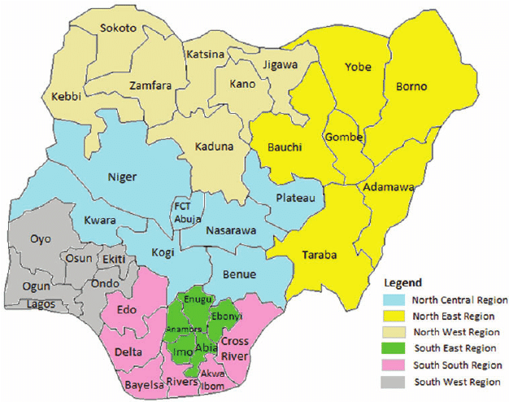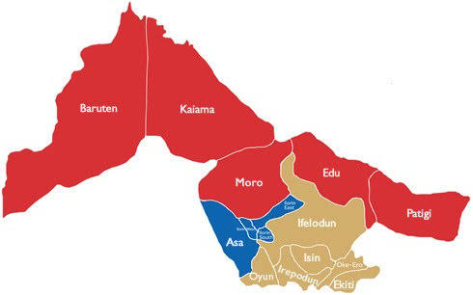
Map of Kwara State
Map of Nigeria

`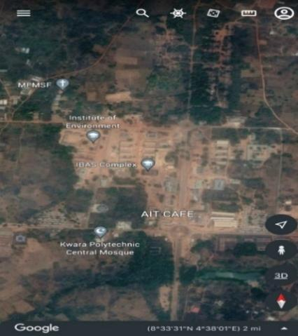 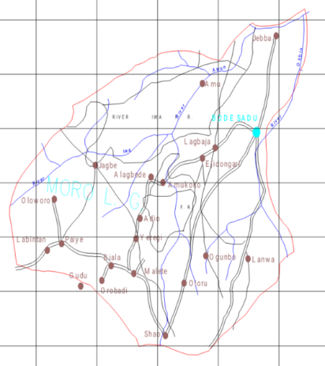
Google Imagery of the Study Area
Map of Moro L.G.A
Figure 1.10: Study Area Map

CHAPTER TWO

2.0 INRODUCTION AND LITERATURE REVIEW
2.1 Introduction
2.1.1 Surveying and Height Measurement
Surveying is a fundamental discipline in geospatial science and engineering, involving the measurement and representation of features on the Earth's surface. One of the most critical aspects of surveying is height measurement, which is essential for construction, topographic mapping, and infrastructure development. The accurate determination of height, or elevation, is necessary for flood risk assessment, land use planning, and engineering projects requiring precise leveling. Geospatial techniques have significantly improved the accuracy and efficiency of height measurement through the use of advanced instruments and technologies (Ghilani& Wolf, 2017).
Height measurement in surveying can be achieved through different methods, including spirit leveling, trigonometric leveling, barometric leveling, Total station and GNSS-based height determination. Traditional techniques such as spirit leveling involve measuring the height difference between two points using a level instrument and a graduated leveling staff. This method is highly accurate and is commonly used for establishing vertical control networks, but it is time-consuming and labor-intensive (Uren & Price, 2010).
Trigonometric leveling is another method used for height measurement, where angles and distances are observed using a total station or theodolite to calculate elevation differences. This method is particularly useful for measuring heights over long distances and rough terrain. However, its accuracy depends on factors such as instrument calibration, atmospheric refraction, and observer experience (Kavanagh & Glennon, 2020).
Digital leveling is an advancement of traditional spirit leveling, where electronic digital levels use bar-coded leveling staffs to automatically record height differences. This method minimizes human error and provides highly accurate elevation data, making it useful for geodetic control surveys and engineering applications (Ghilani, 2021). Compared to conventional leveling, digital leveling is faster and reduces observer fatigue, enhancing productivity in large-scale projects.
Height measurements play a crucial role in civil engineering, particularly in road design, dam construction, and building foundation surveys. Errors in elevation determination can lead to improper drainage systems, unstable structures, and inaccurate volume calculations for earthworks. Hence, surveyors must carefully choose the best height measurement techniques depending on project requirements and environmental conditions (Al-Omari et al., 2019).
2.2 Digital Levelling and is Applications
Digital leveling is a modern surveying technique used to determine height differences with high precision. It utilizes an electronic digital level and a bar-coded leveling staff to automatically capture and record elevation data. Unlike conventional spirit leveling, digital leveling eliminates manual reading errors, enhances measurement speed, and improves data accuracy (Ghilani, 2021). This technology is widely used in geodetic surveys, construction projects, and infrastructure development where precise height determination is crucial.
The principle of digital leveling is based on electronic image processing. When the digital level is aimed at a bar-coded leveling staff, the instrument automatically detects and interprets the code using optical sensors. The encoded height readings are processed digitally, minimizing human error and improving measurement reliability (Kavanagh & Glennon, 2020). This automation makes digital leveling particularly useful in large-scale projects where extensive elevation data is required.
One of the key advantages of digital leveling is its ability to enhance survey accuracy. Traditional optical leveling methods are prone to human-induced errors such as incorrect readings and parallax effects. Digital levels, however, provide precise readings with minimal observer influence. Research shows that digital levels can achieve accuracy levels of ±0.2 mm/km for first-order leveling, making them suitable for high-precision applications (Hofmann-Wellenhof et al., 2008).
Digital leveling is widely used in geodetic surveys to establish vertical control networks. These networks form the basis for various geospatial applications, including mapping, infrastructure development, and environmental monitoring. Engineers also use digital leveling to determine the precise height of benchmarks, ensuring consistency in elevation measurements across different projects (Uren & Price, 2010).
Digital leveling plays a critical role in railway and highway construction, where precise gradient control is necessary. Rail track leveling requires extreme accuracy to prevent structural deformation and ensure passenger safety. Similarly, highway engineers use digital levels to establish longitudinal and cross-sectional profiles, optimizing road slope designs and minimizing surface irregularities (Luhmann et al., 2014).
In hydrology and environmental studies, digital leveling is used to monitor changes in water levels, land subsidence, and coastal erosion. Precise elevation measurements help in assessing flood risk zones, designing drainage systems, and studying the impact of climate change on coastal regions. By integrating digital leveling with remote sensing techniques, researchers can track environmental changes over time with high precision (Shan & Toth, 2018).
Industries such as mining and tunnel construction require highly accurate elevation measurements to ensure safety and structural stability. Digital leveling is used to monitor subsidence in underground mines and to establish reference points in tunnel alignment. Surveyors rely on digital levels to detect vertical deformations in underground structures, preventing potential hazards and ensuring proper engineering adjustments (Ghilani& Wolf, 2017).
Digital leveling is a vital surveying tool that enhances accuracy, efficiency, and reliability in height determination. Its applications span across geodetic control, construction, transportation, hydrology, and industrial surveys. By integrating with advanced geospatial technologies, digital leveling continues to play a crucial role in modern engineering and geospatial analysis. As surveying technology evolves, the adoption of digital leveling will further improve precision in elevation measurement and support the development of sustainable infrastructure.
2.3 Total Station and is Applications
Total stations are widely used in topographic surveys to generate accurate Digital Elevation Models (DEMs) and contour maps. By measuring multiple points within a terrain, surveyors create three-dimensional models that represent land features. In cadastral surveying, total stations are used to define land boundaries for legal documentation and property management (Hofmann-Wellenhof et al., 2008).
In civil engineering and construction, total stations play a crucial role in setting out building foundations, roads, and bridges. Engineers use them to establish precise control points, ensuring structures are aligned as per design specifications. Construction surveyors also rely on total stations to monitor vertical and horizontal deformations in high-rise buildings and infrastructure projects (Shan & Toth, 2018).
Total stations are essential in highway design and construction, where precise curvature, gradient, and elevation profiles must be maintained. Engineers use them to measure and stake out road alignments, cross-sections, and embankments, ensuring smooth and safe roadways. The integration of total station data with GIS software enhances transportation planning and infrastructure management (Luhmann et al., 2014).
In mining and underground tunnel construction, total stations are used to establish accurate underground reference points, ensuring tunnels are aligned correctly. They help monitor subsidence and rock movement, preventing potential hazards. The reflectorless feature in modern total stations allows measurements in hazardous or inaccessible zones, increasing survey safety (Ghilani& Wolf, 2017).
Surveyors use total stations to monitor the stability of bridges, dams, and retaining walls by tracking structural movements over time. High-precision total stations detect millimeter-level displacements, helping engineers assess whether corrective actions are needed. These instruments are crucial for long-term infrastructure safety assessments (Ibraheem et al., 2021).
2.4 Accuracy and Precision in Surveying
Accuracy and precision are essential in surveying, determining the reliability of measurements and the quality of spatial data. Accuracy refers to the closeness of a measurement to its true value, while precision relates to the consistency of repeated measurements. A surveyor may achieve high precision but low accuracy if systematic errors are present. Understanding these concepts is critical for minimizing errors and improving data reliability in engineering, construction, and geospatial applications (Ghilani& Wolf, 2017). The goal is to reduce uncertainties and ensure that surveying data accurately represents real-world conditions.
Several factors influence accuracy and precision in surveying, including instrumental errors, environmental conditions, and observer skills. Instrumental errors arise from equipment imperfections such as optical misalignments in total stations or calibration errors in GNSS receivers. Environmental conditions like temperature changes and atmospheric refraction can distort measurements. Surveyors’ skill levels also impact precision, as improper handling of equipment can lead to inconsistencies (Uren & Price, 2010). By identifying and mitigating these factors, surveyors can enhance the overall quality of their data.
2.5 Surveying Techniques
2.5.1 Level Instrument
Level instruments have long been a cornerstone of surveying techniques, primarily used to determine height differences between points on the Earth’s surface, making them indispensable for establishing elevations in projects like those at Kwara State Polytechnic (Schofield & Breach, 2007). These instruments operate on the principle of creating a horizontal line of sight, allowing surveyors to measure vertical distances relative to a reference datum. In the context of comparing digital levelling and total station equipment, understanding the level instrument’s role provides a baseline for assessing modern advancements in height determination.
The traditional optical level, one of the earliest forms of level instruments, consists of a telescope with crosshairs mounted on a tripod, paired with a levelling rod to read height differences (Uren & Price, 2010). Surveyors use it by setting up the instrument between two points, ensuring it is levelled with a built-in spirit bubble, and then recording rod readings to calculate elevation changes. This technique, known as differential levelling, remains a fundamental skill taught at institutions, forming the basis for more advanced methods.
Digital levelling, a modern evolution of the level instrument, enhances this technique by incorporating electronic sensors and barcode rods, automating the reading process (Anderson & Mikhail, 1998). Unlike optical levels, digital levels display measurements directly, reducing human error and speeding up data collection. For the polytechnic, this advancement makes digital levelling a key focus of study, as its precision in determining orthometric heights supports detailed topographic surveys and infrastructure planning.
The technique of levelling with these instruments involves a systematic process: setting up the level, taking backsight readings to a known elevation, and foresight readings to the point of interest, then computing the height difference (Kavanagh & Mastin, 2013). This method, whether manual or digital, ensures a closed loop of measurements to check for errors, a practice critical for reliability in applications at Kwara State Polytechnic, such as grading roads or designing building foundations.
Level instruments excel in establishing orthometric heights, which measure vertical distance from the geoid along the plumb line, aligning with geodetic surveying principles (Vaníček &Krakiwsky, 1986). Digital levelling, in particular, ties directly into this by providing high-accuracy data that can be referenced to local or national datums. For the polytechnic’s study, this capability positions the level instrument as a benchmark for evaluating total stations, which use a different approach to height determination.
Environmental factors, such as atmospheric refraction and temperature gradients, can affect level instrument accuracy by bending the line of sight (Ghilani& Wolf, 2014). Digital levels mitigate some of these issues with automated corrections, but in Ilorin’s tropical climate, both optical and digital levelling face challenges that the study can assess. This makes the technique’s reliability a key point of comparison with total stations, which rely on trigonometric calculations less sensitive to refraction.
Historically, levelling with instruments like the dumpy level or wye level was labor-intensive, requiring skilled operators to achieve precision (Bomford, 1980). The shift to digital levelling reflects technological progress, reducing training time and enhancing efficiency—advantages that Kwara State Polytechnic can leverage for both educational and practical purposes. This historical perspective highlights why evaluating digital leveling’s accuracy against total stations is relevant to modern surveying education.
The versatility of level instruments extends to their use in establishing control networks, where a series of benchmarks forms a reference for larger surveys (Featherstone & Kuhn, 2006). Digital leveling’s ability to produce consistent height differences makes it ideal for this task at the polytechnic, supporting campus-wide elevation frameworks. In contrast, total stations offer a broader spatial approach, suggesting a complementary rather than competitive role in such networks.
In practical applications, levelling with these instruments underpins tasks like flood risk assessment and site preparation, critical for infrastructure development (Torge & Müller, 2012). Digital levelling’s precision ensures reliable data for these purposes, while its comparison with total stations in the study can reveal trade-offs between speed, accuracy, and cost—factors influencing equipment choice in resource-limited settings like Nigeria.
2.5.2 Total Station
The total station is a highly advanced surveying technique that integrates electronic distance measurement (EDM), angular measurement, and data processing into a single instrument, revolutionizing modern surveying practices (Anderson & Mikhail, 1998). Widely used for determining both horizontal and vertical positions, it is a key tool in the comparative evaluation of accuracy and reliability at Kwara State Polytechnic. Its ability to provide comprehensive spatial data makes it a versatile technique for mapping, construction, and educational purposes in surveying.
A total station operates by combining a theodolite’s angle-measuring capabilities with an EDM to measure distances, allowing surveyors to calculate coordinates and heights trigonometrically (Schofield & Breach, 2007). The instrument emits a laser or infrared beam to a reflector, records the return time, and computes the slope distance, which, paired with vertical and horizontal angles, yields precise 3D positions. At Kwara State Polytechnic, this technique supports tasks like campus layout and topographic surveys, offering a contrast to the elevation-focused digital levelling.
The technique of using a total station involves setting up the instrument over a known point, sighting targets (prisms or reflectorless surfaces), and recording measurements, often stored digitally for real-time analysis (Uren & Price, 2010). This process, known as traversing or resection, establishes control points across a site, making it efficient for large areas. For the polytechnic study, this efficiency is a critical factor in assessing total stations against the more labor-intensive levelling methods.
Total stations determine ellipsoidal heights primarily, derived from their coordinate system, though orthometric heights can be approximated with datum adjustments or geoid models (Hofmann-Wellenhof et al., 2008). This dual capability distinguishes them from level instruments, offering flexibility for geodetic and engineering applications at Kwara State Polytechnic. The study can thus evaluate how well these height outputs align with practical needs like infrastructure design.
Historically, the total station emerged in the late 20th century as electronic technology advanced, replacing separate theodolites and EDM devices with an integrated solution (Bomford, 1980). This evolution reflects a shift toward automation and precision, reducing fieldwork time and operator effort—advantages that Kwara State Polytechnic can leverage for both training and project execution. Its modern relevance makes it a compelling subject for accuracy comparisons with digital levelling.
Environmental conditions, such as atmospheric interference or terrain obstacles, can affect total station measurements, though reflectorless models mitigate some challenges (Ghilani& Wolf, 2014). In Ilorin’s tropical climate, factors like heat haze or vegetation may test the technique’s reliability, providing a real-world context for the polytechnic study. This contrasts with leveling’s sensitivity to refraction, highlighting different strengths and weaknesses.
The total station technique excels in establishing three-dimensional control networks, integrating horizontal and vertical data into a unified framework (Featherstone & Kuhn, 2006). At Kwara State Polytechnic, this capability supports comprehensive campus mapping and ties into geodetic systems when paired with GPS, offering a broader scope than levelling’s vertical focus. The study can assess how this integration enhances overall survey accuracy.
Practically, total stations are used for staking out construction sites, monitoring structural deformations, and creating detailed maps—applications directly relevant to the polytechnic’s infrastructure goals (Kavanagh & Mastin, 2013). Their multifunctionality, however, comes with higher costs and training demands compared to digital levelling, a trade-off the study can explore in terms of reliability and resource efficiency.
In educational settings, the total station technique teaches students advanced surveying skills, from data collection to software integration (Torge & Müller, 2012). Its complexity offers a rich learning opportunity, preparing graduates for industry demands, while the study’s comparison with digital levelling can inform curriculum development by highlighting practical performance differences.
2.3 Review on Comparison of Total Station and Leveling Instrument InHeight Determination
Surveying plays a fundamental role in geospatial science, civil engineering, and construction by providing precise measurements for infrastructure development. Height determination is a critical aspect of surveying, influencing topographic mapping, engineering projects, and geodetic applications (Ghilani& Wolf, 2017). Various surveying techniques, including digital levelling, total station, and Global Navigation Satellite System (GNSS), are commonly employed for height measurement, each offering different levels of accuracy, efficiency, and reliability.
Digital levelling is a widely used method for height determination due to its high precision. It employs a digital level and barcode staff to minimize human errors and enhance measurement accuracy (Uren & Price, 2019). Digital leveling is particularly useful for projects requiring precise vertical control, such as road construction, dam engineering, and bridge foundations (Bannister et al., 2020). However, its efficiency is limited by fieldwork duration and operational constraints in rough terrains.
Total station surveying integrates electronic distance measurement (EDM) with angular observations to determine height differences efficiently. It offers rapid data collection, making it suitable for large-scale surveys (Kavanagh & Glennon, 2020). Although total stations provide relatively high accuracy in both horizontal and vertical positioning, factors such as atmospheric conditions, instrument calibration, and operator skill can influence measurement reliability (Abidin, 2021).
Comparative studies have shown that digital levelling remains the most accurate technique for height determination, particularly for short-range applications (Al-Kasasbeh et al., 2018). However, total station surveys offer a balance between accuracy and efficiency, making them suitable for engineering surveys where speed is essential (Darmawan et al., 2019).
In infrastructure projects, the choice of surveying technique depends on factors such as required accuracy, project scale, and environmental conditions. For example, construction projects requiring sub-millimeter accuracy often rely on digital leveling, whereas topographic mapping and land surveys benefit from the versatility of total stations(Bello et al., 2023). Therefore, surveyors must carefully evaluate the trade-offs between precision, cost, and operational efficiency (Adeoye et al., 2022).
Advancements in surveying technology have led to hybrid approaches combining digital leveling, total station, and GNSS measurements. Integrated techniques enhance accuracy and efficiency by leveraging the strengths of each method (Ezeokonkwo et al., 2021). For instance, combining GNSS for initial positioning and total stations for detailed height measurements improves overall survey accuracy while reducing fieldwork duration (Akanbi et al., 2022).
The increasing use of automation and artificial intelligence in surveying is further improving height determination accuracy. Modern total stations and digital levels feature automated data processing, error correction algorithms, and real-time data integration with GIS platforms (Saleh et al., 2021). These advancements contribute to better decision-making in engineering and geospatial applications.
Recent studies have also explored the impact of environmental conditions on the accuracy of surveying techniques. For instance, temperature fluctuations and atmospheric refraction can affect EDM measurements in total stations, leading to minor deviations in height calculations (Mahmood et al., 2022).
Height determination remains a critical aspect of surveying, with different techniques offering varying degrees of accuracy and efficiency. Digital levelling provides the highest precision, total stations offer a balance between speed and accuracy. Additionally, environmental conditions, cost considerations, and human expertise play vital roles in ensuring the accuracy and reliability of height measurements. A comparative evaluation of these methods helps surveyors select the most suitable technique for their specific needs, ensuring optimal results in geospatial and engineering projects (Bannister et al., 2020).
Research comparing the two instruments also indicates that total stations are better suited for topographic surveys where both height and horizontal positioning are needed simultaneously. Schofield (2001) explains that total stations allow surveyors to capture three-dimensional spatial data in a single setup, whereas levelling instruments require separate processes for horizontal and vertical measurements. This makes total stations more practical for large-scale mapping projects.
Another major factor scholars consider is the ease of data integration with modern surveying technologies. Hofmann-Wellenhof et al. (2008) note that total stations can be integrated with Geographic Information Systems (GIS) and Global Navigation Satellite System (GNSS) data, allowing for seamless geospatial analysis. Levelling instruments, while accurate, are less adaptable to such integrations unless used in conjunction with GNSS receivers.
Comparative studies also reveal differences in the application of these instruments in different terrains. Researchers such as Uren & Price (2010) argue that levelling instruments are best suited for flat or gently sloping terrain, where accurate benchmark elevations can be established. Total stations, on the other hand, perform better in rugged and mountainous areas, where direct levelling may be difficult or impractical.
In terms of cost analysis, various scholars have pointed out that levelling instruments are generally more affordable than total stations. Kavanagh & Bird (2009) mention that traditional levelling instruments have a lower initial cost, making them a cost-effective solution for small projects. However, the time-consuming nature of levelling surveys may offset this cost advantage in large-scale projects, where total stations provide a quicker alternative.
A study by Ghilani& Wolf (2017) compared the reliability of height measurements from both instruments and found that while levelling instruments consistently produced highly accurate results, total stations exhibited minor variations due to EDM-related errors. However, advancements in total station technology, such as improved angular encoders and compensators, have significantly enhanced their accuracy in height determination.
The effect of atmospheric conditions on measurement accuracy has been widely studied. Hofmann-Wellenhof et al. (2008) explain that total stations require careful consideration of temperature, pressure, and humidity adjustments to minimize EDM errors. Levelling instruments, being optically based, are less sensitive to these factors, making them more reliable in extreme weather conditions.

CHAPTER THREE
3.0 METHODOLOGY
Methodology is the systematic theoretical analysis of the methods applied to a field of study, it comprises the theoretical analysis of the body of methods and principles associated with a branch of knowledge. Typically, it encompasses concepts such as paradigm, theoretical model, phases and quantitative or qualitative techniques.
3.1 Reconnaissance
This has to do with framework of survey operation whereby all survey operations are going to base on.
Reconnaissance is also known as (Recce). Reconnaissance is examination of all part of an area accomplished insufficient detail to make generalization about the type and distribution of historical properties that may be present with a given project area. Also, is the process of having the general overview of the area to be surveyed with the view of determining the arrangement of the work such as method to employed, personnel to be involved, instrument to be used, scale at which plan/map is to be drawn. There are two stages of reconnaissance namely: Office and Field reconnaissance.
    - Field Reconnaissance
The first stage in this project was search for existing information in connection with the area in which the project was undertaken. Rough sketch diagram(recce) of the project area was drawn selecting and marking the approximate position of each point. To sum up, the reconnaissance facilitated the planning and execution of the actual survey as its takes into consideration, the possible problems that are likely to be encountered, and how such problems can be overcome or reduced to minimum.
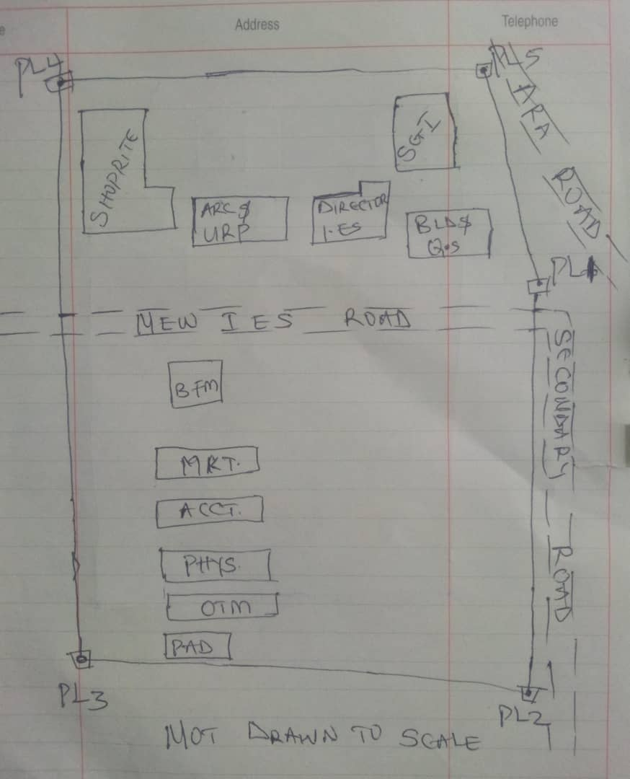

Recce diagram
3.1.2 Office Reconnaissance
Office reconnaissance/data gathering as the name implies is the exploratory survey, scouting or examination, to collect information necessary for the successful execution of the project. It can be simply define as making a preliminary survey before the actual mobilization for the project site. For the purpose of this project, the data search involved retrieving of the coordinate of three (3) existing control.
Pillar No. | Easting(m) | Northing(m) | Height | Location
KWPT 49 | 674341.289 | 937679.115 | 353.682 | Kwara Polytechnic
KWPT 50 | 674555.841 | 937618.402 | 354.903 | Kwara Polytechnic
Table 1: Show coordinates of existing and used control point.
3.1.3 Selection of Station
The boundaries as shown in the recce diagram were laid down by marking points on the ground (station).
The factors considered in selecting these stations include:
- Inter visibility between two points.
- Firmness of the ground at the selected point.
- Working convenience over the station.
- Points located where not disturbed.
3.2 Survey Rod
A survey rod is a physical marker, typically made of metal, used to mark the boundaries of a parcel of land. These markers are used to define the limits of a property and can be used as reference points for future surveys. Rods are durable and can be used in a variety of environments.
3.2.1 Survey rules guiding rod uses:
1. Placement: Rods should be placed at boundary corners or points of change in the boundary.
2. Visibility: Rods should be visible and easily identifiable
3. Durability: Rods should be durable and resistant to weathering.
4. Accuracy: Rods should be placed accurately, following the surveyed boundary.
5. Documentation: the location and description of rods or pegs should be documented in the survey records.

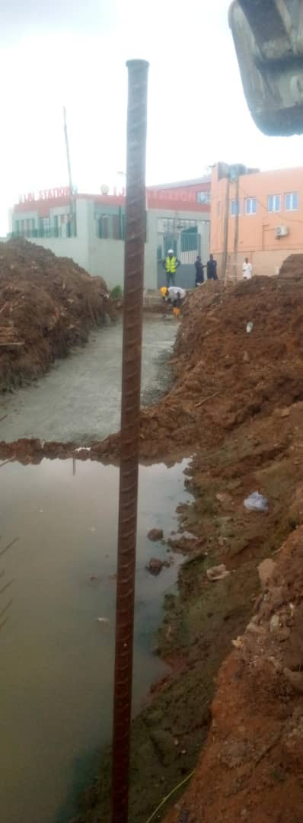

Figure 3.1: Graphical View of Cadastral Survey Rod
3.3 Instrumentation
It refers to the equipment and accessories employed for the successful execution of this project and they are as follows:
Hardware Used
- Stonex R2 Plus Total Station and its accessories
- Leica Digital Level instrument and its accessories
- Handheld GPS
- Hp Core i5 vPro 8th Gen Laptop
- Cutlasses
- Head-pan
- Nail and bottle cover
- 1 Hammer
- 1 Spade
- 1 Hand-trowel
Software Used
- AutoCAD 2007
- Golden Software Surfer 20.0
- Microsoft Office Excel 2013
- Microsoft Office Word 2013
Material Used
- Water
- Cement
Total Station:- It is an electronic or optical instrument used in modern surveying and building construction that used Electronic Distance Measurement (EDM). It is also known as electronic data collection and storage system of which all the data acquired on site is been stored and secured for office reconnaissance.
Digital Leveling:- It is considered one of the most precise methods for height determination. It employs an electronic level instrument and a bar-coded staff to measure vertical distances, reducing human errors common in conventional leveling.
Table 3.2: Equipment Description
S/N | Equipment | Uses
1 | Stonex R2 Plus Total Station | X, Y and Z coordinates of boundaries
2 | Leica Automatic Level | Determination of the reduced level
3 | Handheld GPS | X & Y coordinates of details
4 | Autodesk AutoCAD 2007 | Presentation of the boundaries
5 | Golden Software Surfer 20.0 | Contour and Generation of 3D model
6 | Microsoft Office Excel 2013 | X, Y and Y coordinates editing&program
7 | Microsoft Office Word 2013 | Report writing

3.4 Test of Instrument
For any survey job, testing of the instrument must be done before execution of the job, the instruments used for data acquisition were tested to ascertain whether they are in good working condition.
The following test were carried out,
3.4.1 Total Station
The total station instrument used (Stonex R2 Plus Total Station) underwent a two-phase check. Firstly, the vertical and horizontal angles were verified using pre-established control points within the school campus. Secondly, the electronic distance measurement (EDM) capability was tested for horizontal distances. The instrument passed all tests and was deemed suitable for use.
Below is the procedure for carryout the tests
3.4.1 Total Station
Instrument used in data acquisition was checked for integrity before moving them to site. Apart from check carried-out on Total Station, the following instruments were also checked: Tripod stand legs and their screw were confirmed okay, foot screws, focusing knob, vertical and horizontal knob for slow motion and clamp were all confirmed okay.

3.4.1.1 Horizontal Collimation Test
This error exists when the optical axis of the total station is not exactly perpendicular to the telescope axis. To test for horizontal collimation error, station A was selected and the instrument was set on it and leveled using three foot screws. Then, the telescope was rotated through 360°, but the bubble did not run out of the level tube centre which shows that the line of sight is parallel to the axis of the level tube.
Furthermore, the telescope was pointed to a target on station B in face left, then, pointed back to same target in face right; the difference in horizontal circle readings after averaging the result from both faces of the instrument was 180° except small variation is seconds which is permissible based on the allowable accuracy limit (least Count). The following results were displayed below.
Fairly Level Ground
STATION A
100m
REFLECTOR
(TARGET)
STATION B
Total Station

Fig 3.4.1.1: Horizontal Collimation and Vertical Index error test.
Table 3.4.1.1: Horizontal Collimation Data
Station | Target | Face | Hz Reading | Difference | Error
A | B | L | 38˚42’32”
 |  | R | 218˚42’35” | 180˚00’03” | 03”

3.4.1.2 Vertical Index Error Test
This test was performed to ensure that the vertical reading is exactly ninety degrees (90˚) when the line of sight is horizontal. Any deviation from this figure is known as vertical index error.
The Total Station was set over a point and necessary temporary adjustments were performed. A target set about 100m away from the Total station was sighted and bisected with the instrument on the face left and the reading was recorded. The target was also sighted and bisected on face right and the reading was also recorded. These readings are shown below
Table 3.4.1.2: Vertical Index Data
Instrument Station | Target Station | Face | Vertical | Sum | Error
A | B | L | 90˚00’00”
 |  | R | 270˚00’02” | 360˚00’02” | 02”

3.4.1.3 Analysis of Collimation and Vertical Index Data
The reading obtain during calibration were reduced to obtain new collimation and vertical errors.
Horizontal collimation = {(FR – FL) – 180}/2 = {(00˚00’03”}/2 = 1.5”
Vertical collimation = {(FL + FR) – 360} = (90˚00’00” + 270˚00’02”) - 360} = 02”
The result shows that the instrument is still in good working condition.
3.4.2 Digital Level Instrument
The level instrument employed for the research was Leica Digital level. Two pegs test was carried out on the digital level to check the collimation error of the instrument. The level instrument was set on a specific point A, with initial adjustments made for proper alignment, levelling, and focusing to eliminate parallax, it was now backsight on peg 1 and foresight on peg 2, the instrument was then now moved to another point B, and all the necessary adjustments were made, the peg 2 was bisected as backsight, and the peg 1 as foresight.
Level instrument STAFF (TARGET)

Fairly Level Ground
STATION A PEG 1
Fig3.4.1.1.: Horizontal Collimation error test
Table3.4.2.Horizontal Collimation Data
STATION | Remarks | BS | IS | FS | Diff.
A | Peg 1 | 1.734
A | Peg 2 |  |  | 2.042
 |  |  |  |  | 0.308
B | Peg 2 | 1.578
B | Peg 1 |  |  | 1.262
 |  |  |  |  | 0.316
 | Collimation Error |  |  |  | 0.008
The difference of the two-pegs test from 2 stations (0.008), shows the instrument is in good condition and can be used for the project.
3.5 Control Check
The control points were found along the road in Kwara State Polytechnic. In order to determine their correctness and their true position, one was used as station point KWPT 49 while the point KWPT 50 was used as the back sight. The coordinates obtained were compared with the received data from Department Field Data Records, the difference falls within the allowable accuracy of 3rd order survey job as can be seen in Table 3.3 below:
Table 3.3: Analysis of control check
PILLAR | COORDINATE | EASTING(m) | NORTHING(m) | HEIGHT(m)
KWPT 49 | RECEIVED | 674341.289 | 937679.115 | 353.682
KWPT 49 | OBSERVED | 674341.289 | 937679.115 | 353.682
KWPT 49 | DIFFERENCE | 0.000 | 0.000 | 0.000
PILLAR | COORDINATE | EASTING(m) | NORTHING(m) | HEIGHT(m)
KWPT 50 | RECEIVED | 674555.841 | 937679.115 | 353.682
KWPT 50 | OBSERVED | 674555.853 | 937679.097 | 353.691
KWPT 50 | DIFFERENCE | 0.012 | 0.018 | 0.009
Allowable accuracy |  | 0.600 | 0.600 | 0.600
3.6 Data Acquisition
Data acquisition in land surveying refers to the process of collecting and recording data about the land, its features, and boundaries. This can include:
- Geometric data acquisition
- Attribute data acquisition
3.6.1 Geometric Data Acquisition
Geometric data acquisition involves collecting data that defines the spatial relationships and positions of features on the land. This can include:
- Coordinates: Collecting X, Y, and Z coordinates of points on the land using instruments like total stations, GPS, and levels.
- Distances and angles: Measuring distances and angles between points on the land using instruments like total stations and tape measures.
- Elevations: Determining the height of points on the land above a reference datum using instruments like levels and GPS.
The geometric data of this project was obtained using the total station i.e. combination of electronic theodolite and the Electronic Distance Measurement (for X, Y, Z determination), and Level instrument (for height measurement) Geometric data are positional data, (i.e. they have the X, Y, Z) coordinates which make it easy to locate their actual position of features on the earth surface.
Here is a step-by-step procedure used for Total Station for geometric data acquisition:
Preparation
1. Setup: The Total Station was set over a known control point (KWPT 49).
2. Leveling: Level the instrument to ensure accurate measurements.
3. Orientation: It was done using two know control points KWPT 49(as occupy station) and KWPT 50(as backsight)

Data Collection
1. Target sighting: Sight the target (reflector) at the point to be measured.
2. Measurement: Determination of X, Y, Z of the target.
3. Recording: Record the measured data (coordinates).
4. Repeat: Repeat the process for each point to be measured.
Here's a step-by-step procedure used for Level instrument for data acquisition:
Preparation
1. Setup: The Level instrument was set on a stable surface, ensuring it's level and secure.
2. Leveling: Level the instrument using the built-in leveling mechanism.
3. Focus: The telescope was focused on the target (staff or rod).
Data Collection
1. Backsight: Took a backsight reading on a benchmark (KWPT 49).
2. Foresight: Take foresight readings on points to be measured, ensuring the staff is held plumb.
3. Reading: Record the readings, including the staff readings and points description.
4. Repeat: Repeat the process for each point to be measured.
3.6.2 Attributes Data Acquisition
Attribute data refers to information that describes the characteristics and properties of spatial features. It provides details such as names, classifications, and functions of geographic objects. In this study, the attribute data collected Include the names of buildings (e.g., lecture room of office), as well as information on roads. Handheld GPS was used to acquire attribute data for this project.
Handheld GPS units we used to gather attribute data by:
Collecting positional data: the GPS determines the location (LATITUTDE, Longtitude, and sometimes elevation) of the point where we standing.
Attaching attribute: you can then link attribute information to that location. This could be done by entering the information manually, (e.g. using the keypad on the GPS unit) or by uploading the data to a computer.
Saving the data: the GPS saves the location data along with the attributes, creating a dataset of points with associated information.
3.7 Perimeter, Detailing and Spot Heighting
Perimeter is the total distance covered along the boundary line and an area of land, the total distance covered is 1.214km. It is very important in order to get the exact location of a property. Traversing is a subordinate to perimeter and it may be defined as the process of connecting the series of lines with known bearing and distances (or XYZ).
The Total Station was carefully set up over control point KWPT49, with a back sight taken to point KWPT 50 after performing the necessary station adjustments, including cantering, levelling, and focusing, the KWPT50 (backsight) was measured and the observed coordinates was compared with given one, the difference is not significant and allowable. Then peg1 was established and measured in other to transfer the control to the site. The same procedure was repeated to determine the coordinates of the next point (peg2), and continued progressively until the site was reached. The radiation method was used for data acquisition, where two or more points were coordinated from a single instrument station.
The following steps outline the procedure:
- After completing temporary adjustments, the instrument was powered on, and a new job titled PRJT1 was created in the internal memory under the job menu.
- In the coordinate menu, orientation was established by inputting the coordinates of the instrument station and back sight.
- The height of the instrument and the reflector height were measured and entered into the instrument.
- The reflector at the back sight was accurately bisected before confirming the orientation.
- Once oriented, the reflector was aimed at the next target (nail), and the "OBS" (observe) function was selected. The three-dimensional coordinates (Easting, Northing, and Height) were displayed and saved by pressing "REC" (record). For subsequent observations, the "ALL" option was used to streamline the process.
- It was ensured that the centre of the prism on the reflector was properly aligned and securely mounted on the tripod to minimize height determination errors.
- Once all visible details, including boundary points, spot heights and building, had been observed from the current station, the instrument was relocated to the next control nail, and the temporary adjustments were repeated.
This process was systematically carried out until all boundary points and elevation data were captured. In this project, spot heights were not recorded at regular grid intervals but were instead collected randomly after it has been pegged. For each building, three corner points were surveyed. Upon completing the data acquisition phase, all relevant features were accurately recorded and positioned accordingly on the final site plan.
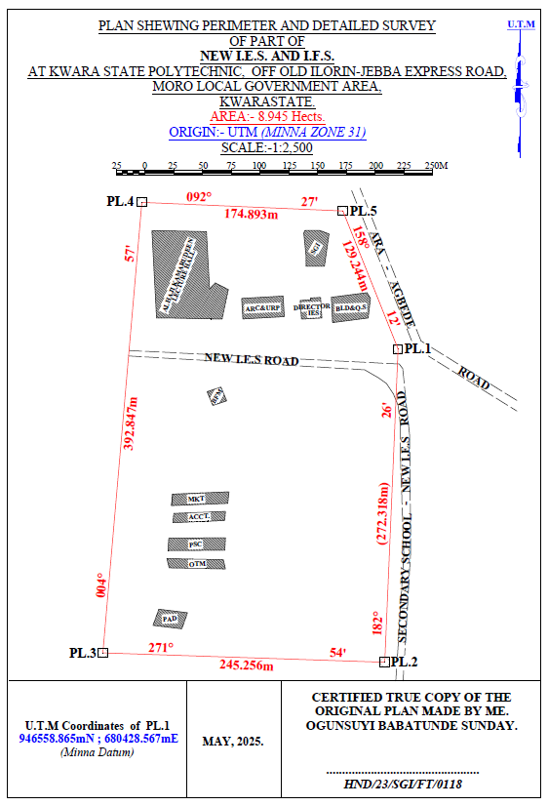
HND/23/SGI/FT/0118
OGUNSUYI BABATUNDE SUNDAY

GANIYU AKEEM ABIODUN
Figure 3.7: Plan showing Perimeter and Detailed Survey.

Area Computation using Cross Multiply Coordinates
E1 N1
E2 N2
E3 N3
E4 N4
E5 N5
E1 N6
680428.567 946558.865
680417.004 946286.792
680171.885 946294.956
680205.833 946686.334
680380.567 946678.865
680428.567 946558.865
∑ - ∑
2
460,787,138,011.03 – 460,786,959,116.36
2
178,894.67
2
Area = 89,447.335 sqft
Area = 8.945 hect.

CHAPTER FOUR
4.0 DATA DOWNLOADING, PROCESSING, ANALYSIS AND DISCUSSION
This chapter provides a detailed overview of the procedures involved in data download, data processing, correction, and data analysis conducted on the acquired data from the site and data presentation.
4.1 Data Download
All the recorded data was stored in the memory of the total station. To download the data, the total station was connected to a computer using a wired cable and downloading software. The software parameters were configured to match those of the instrument. The instrument's menu was accessed, and the memory manager was selected. From there, the "send data" option was chosen, and the file named "PRJT1" was located and downloaded to the computer through the software. The data was saved with a ".txt" file extension on the desktop of the laptop for further processing.
4.2 Data Editing
The downloaded geometric data were further processed to convert them into usable formats and improve their accuracy. The resulting coordinate data were edited using Notepad and Excel software. This file was then imported into AutoCAD2007 for additional processing.

4.3 Data Processing using Autocad 2007
Before using AutoCAD, we processed the coordinate data observed in the field by first transferring it into Notepad, then copying it into AutoCAD. The following steps outline the process for handling the data in AutoCAD:
- Launch AutoCAD on the computer.
- Click "New" from the application menu to start a new drawing.
- Type UNITS in the command line and press Enter.
- Select the desired unit type (e.g., decimal, architectural, engineering).
- In the menu bar, select the "Polyline" tool.
- Copy the data from Notepad and paste it into AutoCAD.
- Type Z (for zoom) and press Enter, then type E (for extents) and press Enter to adjust the view.
4.4 Results and Discussion
Table 4.4: Total station and Digital level Spot height Readings and their differences
REMARKS | EASTING | NORTHING | HEIGHT |  | DIFF.
REMARKS | EASTING | NORTHING | T.S | LEVEL | DIFF.
SH1 | 680272.275 | 946497.781 | 355.749 | 355.715 | 0.034
SH2 | 680267.717 | 946479.907 | 356.403 | 356.362 | 0.041
SH3 | 680273.327 | 946450.469 | 354.811 | 354.772 | 0.039
SH4 | 680287.358 | 946434.349 | 354.268 | 354.208 | 0.060
HSH5 | 680317.873 | 946433.648 | 355.036 | 354.984 | 0.052
SH6 | 680304.544 | 946455.727 | 355.710 | 355.668 | 0.042
SH7 | 680337.867 | 946463.436 | 355.448 | 355.386 | 0.062
SH8 | 680342.774 | 946441.708 | 356.295 | 356.240 | 0.055
SH9 | 680342.774 | 946441.708 | 356.736 | 356.680 | 0.056
SH10 | 680348.740 | 946443.460 | 355.971 | 355.931 | 0.040
SH11 | 680377.262 | 946451.836 | 355.725 | 355.673 | 0.052
SH12 | 680382.060 | 946482.711 | 355.318 | 355.277 | 0.041
SH13 | 680381.009 | 946518.108 | 354.819 | 354.766 | 0.053
SH14 | 680350.494 | 946509.345 | 355.174 | 355.128 | 0.046
SH15 | 680356.104 | 946484.813 | 355.033 | 355.005 | 0.028
SH16 | 680332.603 | 946480.960 | 355.228 | 355.188 | 0.040
SH17 | 680308.051 | 946470.796 | 355.517 | 355.464 | 0.053
SH18 | 680298.581 | 946490.422 | 355.834 | 355.802 | 0.032
SH19 | 680318.222 | 946506.191 | 355.726 | 355.678 | 0.048
SH20 | 680308.753 | 946526.168 | 356.148 | 356.096 | 0.052
Mean |  |  | 355.8163 | 355.7726 | 0.0437
Variance |  |  | 2.5758 | 2.5881 | 0.0123
Standard Deviation |  |  | 1.6049 | 1.6088 | 0.0039

Working Formulas for Mean, Variance and Standard Deviation Calculation
The mean is calculated as:
µ = ∑xi
n
µ= mean
xi = each point height
n = number of points
The variance is calculated as:
ꭤ²=∑(xi - µ)²
n
ꭤ²= variance
xi = each point height
µ= mean
n = number of points
The Standard Deviation is calculated as:
ꭤ = √ꭤ²
ꭤ= standard deviation
ꭤ²= variance
Mean calculation for Total Station Height readings
µ = ∑xi
n
µ=355.749+356.403+354.811+354.268+355.036+355.710+355.448+356.295+356.736+355.971+355.725+355.318+354.819+355.174+355.033+355.228+355.517+355.834+355.726+356.148
20
µ= 7116.326
20
µ=355.8163
Mean calculation for Reduced Level Height readings
µ=355.715+356.362+354.772+354.208+354.984+355.668+355.386+356.240+356.680+355.931+355.673+355.277+354.766+355.128+355.005+355.188+355.464+355.802+355.678+356.096
20
µ= 7115.452
20
µ = 355.7726
Mean calculation for Total Station Height readings - Mean calculation for level height readings 355.8163 – 355.7726 = 0.0437
ꭤ²=∑(xi - µ)²
n
ꭤ²=∑(xi - µ)²
n
0.0673²+0.5867²+1.0053²+1.5483²+0.5327²+0.2521²+0.1582²+0.4126²+0.9284²+0.0992²+0.1104²+0.1327²+1.0217²+0.6184²+0.7834²+0.4926²+0.2581²+0.0164²+0.0428²+0.3317
20
ꭤ²=51.516
20
ꭤ² =2.5758
Variance calculation for Reduced Level Height readings
0.576²+0.5894²+1.006²+1.5686²+0.5285²+0.2375²+0.1382²+0.4103²+0.9126²+0.0821²+0.1013+0.1104²+1.0102²+0.6014²+0.7695²+0.4818²+0.2443²+0.0071²+0.0289²+0.32047
20
ꭤ²=51.762
20
ꭤ² =2.5881
Variance calculation for total station – variance calculation for level height readings 2.5758 – 2.5881 = 0.0123
The Standard Deviation for Total Station Height readings:
ꭤ = √ꭤ²
ꭤ = √2.5758
ꭤ = 1.6049

The Standard Deviation for Reduced Level Height readings:
ꭤ = √2.5881
ꭤ = 1.6088
The standard deviation for total station – standard deviation for level height reading 1.6049 – 1.6088 = 0.0039

The table above shows the station Id, eastings, northings, total station height, digital level reduced level and the difference between the total station height and the digital level reduced level.
The comparison of the two pieces of equipment revealed variations within a specific range. The differences observed between the two pieces of equipment were found to be in the range of 0.028 to 0.062 meters. These differences indicate slight disparities in the measurements obtained from each instrument. Statistical analysis was performed to evaluate the mean, variance, and standard deviations of the observed differences. The mean difference was calculated to be 0.0437, indicating an average deviation between the measurements obtained by the two equipment. The variance, which quantifies the spread of the differences, was found to be 0.0123.
This value suggests that the variations in the measurements obtained by the two pieces of equipment were relatively consistent. The standard deviation, which provides a measure of the dispersion of the data, was determined to be 0.0039. This indicates that the differences between the measurements obtained from the two pieces of equipment had a moderate level of variability.
Overall, the results of the analysis demonstrate that there were slight variations between the measurements obtained from the two pieces of equipment. The mean, variance, and standard deviations provide insights into the magnitude and consistency of these differences, offering valuable information for assessing the accuracy and reliability of the equipment in question.

Figure 1:Bar chart showing heights obtained from the total station and level instrument
Figure 2:Histogram showing the difference in the two instrument’s result
The histogram presented above illustrates the distribution of deviations between the two methods being compared. The deviations are depicted in centimeter, showcasing the level of accuracy achieved by both methods. The histogram highlights that the deviations are tightly clustered and exhibit a consistent pattern.
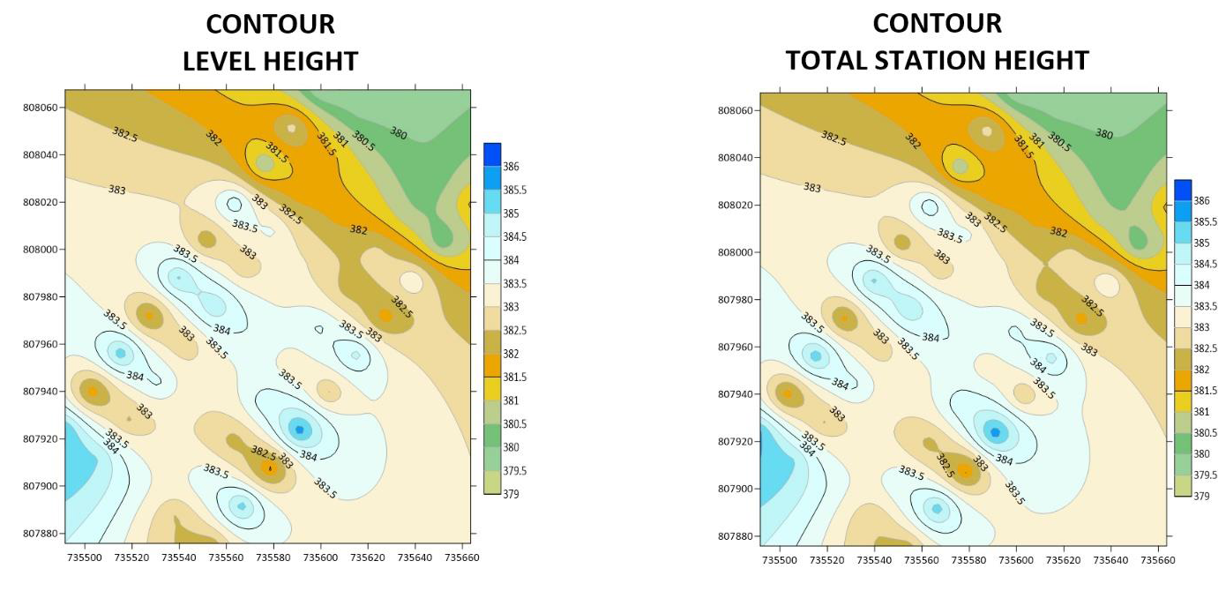Figure 3: Showing the contour map obtained from the two instruments.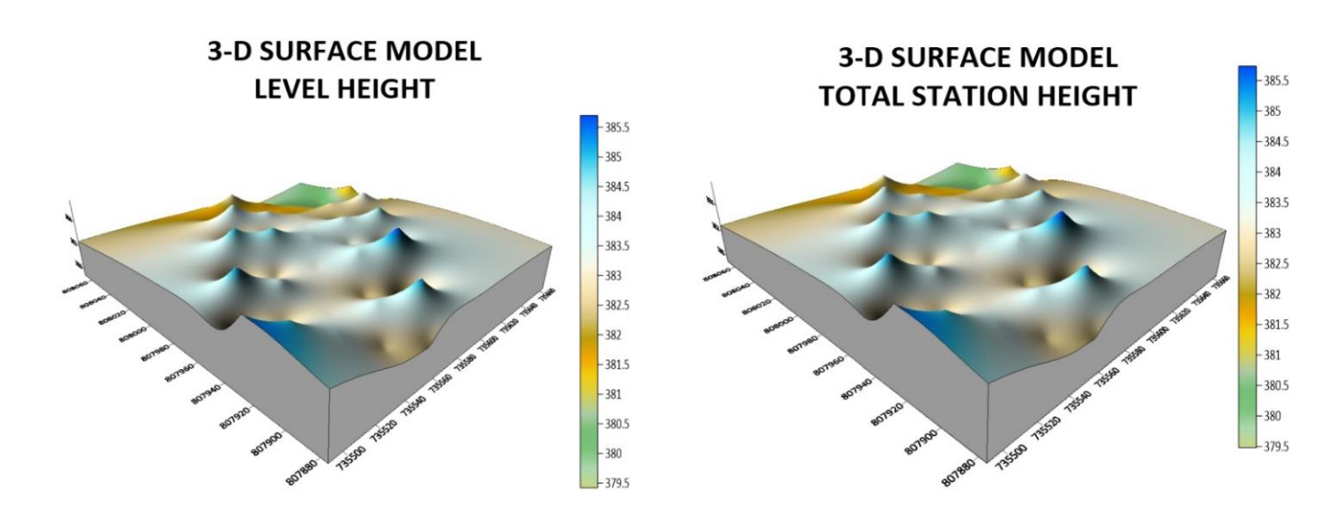Figure 4: Showing the 3D surface map obtained from the two instruments
3-D SURFACE MODEL USING TOTAL STATION
3-D SURFACE MODEL USING AUTO LEVEL
CONTOUR MAP USING TOTAL STATION
CONTOUR MAP USING AUTO LEVEL
The mean of the deviations, calculated to be 0.0437m, provides an indication of the average difference between the measurements obtained from the two methods. This value signifies a small average deviation, suggesting that the two methods generally yield similar results with minimal variation.
The histogram provides a visual representation of the data, allowing for a comprehensive understanding of the distribution of deviations. By examining the histogram, one can observe the concentration of deviations around the mean value, indicating a central tendency in the measurements obtained by the two methods.
The centimeter-level accuracy exhibited by the deviations underscores the precision of the measurement techniques employed. This level of accuracy is crucial, particularly in applications that require high precision, such as engineering, construction, or geospatial analysis. The contour maps presented above exhibit strikingly similar patterns, which serve as a testament to the high degree of precision achieved by the instruments used. The consistent and replicated patterns observed on the maps reinforce the reliability and accuracy of the measurements obtained.
The similarity in the contour patterns indicates that the instruments employed in the surveying process were able to capture the subtle variations in elevation with great precision.
This level of accuracy is crucial in applications such as topographic mapping, land surveying, and engineering, where even minor deviations can have significant implications. By displaying the contours of the surveyed area, the maps provide a visual representation of the landscape's topography and elevation changes.
The congruity in the contour lines across the maps signifies that the instruments effectively captured and recorded the elevation data, resulting in a reliable representation of the terrain
4.5 Statistical Analysis
A statistical investigation was carried out using Paired Two Samples as Means to test whether there is any significant difference in the performance of the two instruments for terrain height determination. The independent sample t-test is a member of the t-test family, which consists of tests that compare mean value(s) of continuous-level (interval or ratio data), normally distributed data (Hinton, 2004). The independent-sample t-test evaluates the difference between the means of two independent or unrelated groups. That is, we evaluate whether the means for the two independent groups are significantly different from each other.
Hypothesis
A hypothesis was set up and tested using an Independent – sample T-Test:
- Null Hypothesis: H0: There is no difference between the terrain height obtained from the total station and digital level instrument.
- Alternative Hypothesis: H1: There is a difference between terrain height obtained from total station and digital levelling instrument.
The null hypothesis is rejected if the calculated t value has a probability sig. (p) greater than the chosen significance level. An Independent sample T-Test was used in testing the hypothesis at a significance level of 0.05. Data analysis Package extension in Excel was activated and used in running the T-Test.
Table 4.5: T-Test: Two-Sample Assuming Unequal Variances
 | Digital Level | Total Station
Mean | 355.77262 | 355.81628
Variance | 2.588092118 | 2.575687471
Observations | 20 | 20
Pearson Correlation | 0.032104369 | 0.031950494
Hypothesized Mean Difference | 0.001605218 | 0.001597525
t Stat | 0.056215684 | 0.056208782
P(T<=t) one-tail | 0.145413689 | 0.144776257
P(T<=t) two-tail | 0.290982737 | 0.289552551
Sum | 7096.631 | 7095.814
Kurtosis | 2.049052417 | 2.0403051292
Skewness | 0.612867732 | 0.5907755549
Median | 354.772 | 354.811
Maximum | 356.680 | 356.736
Minimum | 354.208 | 354.268
Range | 2. 472 | 2.468
The statistical data provided supports our discussion by indicating a high degree of agreement and consistency between the digital level and total station measurements. The mean values are very close, the variances are similar, and the Pearson correlation coefficient indicates a strong linear relationship. The t-test results suggest that any observed difference between the two instruments' means is likely due to random variation rather than a significant discrepancy. After carrying out the project, we observe that digital level is more accurate than total station, although the different can be quite small.

CHAPTER 5
5.0 COSTING, SUMMARY, RECOMMENDATION AND CONCLUSION.
5.1 Cost Estimation of the Project
The project costing was based on number of variables which includes area to be covered, instruments, personnel, transportation and so on. However, another critical factor to be considered is the time duration in which the project was executed. The table below shows the duration the project was accomplished.
Table 5.1: Scheduled and Duration of the Project Execution
Description | Duration (Days)
Reconnaissance | 1
Beaconing / Monumentation | 1
Spot height points establishment | 1
XYZ acquisition of the spot height points (using TS) | 1
Height observation of the spot height points (using level instrument) | 1
Detailing (using handheld GPS) | 1
Data Downloading / Processing | 3
Plotting and Report Writing | 7
Submission of Report and Plan | 5
Total No. of Days Spent for the Project | 21

5.1.1 Project Costing Breakdown

Costing of this project was based on Professional Scale of Fees as approved by Nigerian Institution of Surveyor (NIS) in 2017 using 1996 Federal Government Approved Scale of Fees for Consultants in the Construction Industry. The prevailing inflation rate as at February 2023 was 21.91 % and this was applied to the cost estimate.
Table 5.2: Worked out Calculation for the grand Total Cost
S/N | OPERATION | RATE/DAY | NO OF DAYS | UNIT  COST (#) | AMOUNT (#)
1 | RECONNISSANCE(1 DAY)
 | 4 Technician | 15,189.11 | 1 | 15,189.11 x 4 | 60,756.40
 | 1 Skilled Labour | 9,468.61 | 1 | 9,468.61x 1 | 9,468.61
 | Transportation (Field vehicle + Driver / Mechanic + fuel | 46,027.61 | 1 | 46,027.61 x 1 | 46,027.61
 | Basic equipment (Hand held GPS etc.) | 46,027.61 | 1 | 46,027.61 x 1 | 46,027.61
 | SUB TOTAL |  |  |  | 157,546.00
2 | - BEACONS (5)  (standard Cadastral Beacon) | 5,000 per Beacon |  | 5,000 x 5 | 25,000.00
2 | - BEACONING/  MONUMENTATION (1 day)
2 | 6 Surveyors | 15,189.11 | 1 | 6x 15,189.11x 1 | 91,134.11
2 | 3 Skilled Labour | 9,468.61 | 1 | 3x 9,468.61x 1 | 28,405.83
2 | Transportation (Field vehicle + Driver / Mechanic + fuel) | 46,027.61 | 1 | 46,027.61 x 1 | 46,027.61
2 | Basic tools (Crow bar, Trowel, Shovel etc) | 13,929.00 | 1 | 13,929.00x 1 | 13,929.00
2 | SUBTOTAL |  |  |  | 179,496.55
3 | Spot Height Establishment  ( 1 DAY)
 | 2 surveyors | 15,189.11 | 1 | 2x15,189.11 x 1 | 30,378.22
 | 3 Unskilled Labour | 9,468.61 | 1 | 3 x9,468.61x 1 | 56,811.66
 | Basic Equipment | 46,027.61 | 1 | 46,027.61x1 | 92,055.22
 | Transportation (Field vehicle + Driver / Maintenance + Fuel) | 46,027.61 | 1 | 46,027.61 x 1 | 92,055.22
 | SUBTOTAL |  |  |  | 271,300.32
4 | XYZ ACQUISITION USING (TS)  (1 DAY)
 | 1 Senior Surveyor | 22,783.67 | 1 | 1x 22,783.67 x 2 | 45,567.34
 | 2 Surveyors | 15,189.11 | 1 | 2 x15,189.11 x 2 | 60,756.44
 | 2skilled Labour | 9,468.61 | 1 | 2 x9,468.61x 2 | 37,874.44
 | Basic Equipment | 46,027.61 | 1 | 46,027.61x 2 | 92,055.22
 | Transportation (Field vehicle + Driver / Maintenance + Fuel) | 46,027.61 |  | 46,027.61 x 2 | 92,055.22
 | SUBTOTAL |  |  |  | 328,308.66
5 | HEIGHT OBSERVATIION (LEVEL INSTRUMENT)  (1DAY)
 | 1 Senior Surveyor | 22,783.67 | 1 | 1x 22,783.67 x 2 | 45,567.34
 | 2 surveyors | 15,189.11 | 1 | 2 x15,189.11 x 2 | 60,756.44
 | 2skilled Labour | 9,468.61 | 1 | 2 x9,468.61x 2 | 37,874.44
 | Basic Equipment | 46,027.61 | 1 | 46,027.61x 2 | 92,055.22
 | Transportation (Field vehicle + Driver / Maintenance + Fuel) | 46,027.61 | 1 | 46,027.61 x 2 | 92,055.22
 | SUBTOTAL |  |  |  | 328,308.32
6 | DETAILING  (1 DAY)
 | 2 Surveyors | 15,189.11 | 1 | 2x 15,189.11x 1 | 30,378.22
 | 3 Skilled Labour | 9,468.61 | 1 | 3x 9,468.61x 1 | 28,405.83
 | Transportation (Field vehicle + Driver / Mechanic + fuel) | 46,027.61 | 1 | 46,027.61 x 1 | 46,027.61
 | Basic Equipment | 46,027.61 | 1 | 46,027.61x 1 | 46,027.61
 | SUBTOTAL |  |  |  | 150,839.27
7 | DATA DOWNLOADING  / PROCESSING  (3 DAYS)
 | 1 Senior Surveyor | 22,783.67 | 3 | 22,783.67 x 3 | 68,351.01
 | 2 surveyors | 15,189.11 | 3 | 2x15,189.11 x 3 | 91,134.66
 | Computer Accessories | 49,315.28 | 3 | 49,315.28 x 3 | 147,945.84
 | SUBTOTAL |  |  |  | 307,431.51
8 | PLOTTING AND REPORT WRITTING  (7 DAYS)
 | 1 Senior Surveyor | 22,783.67 | 7 | 1x22783.67 x 7 | 159,485.69
 | 2 surveyors | 15,189.11 | 7 | 2x15,189.11 x 7 | 212,647.54
 | Standard set (computer, plotter etc) | 65,753.70 | 7 | 1x65,753.70 x 7 | 460,275.90
 | SUBTOTAL |  |  |  | 832,409.13
9 | SUBMISSION OF REPORT AND PLAN  (1 DAY)
 | 1 Chief Surveyor | 30,800.00 | 1 | 30,800.00x 1 | 30,800.00
 | 2 surveyors | 15,189.11 | 1 | 2x 15,189.11x 1 | 30,378.22
 | 1 Computer | 46,027.61 | 1 | 46,027.61 x 1 | 46,027.61
 | Consumables | 13,929.00 | 1 | 13,929.00 x 1 | 13,929.00
 | SUBTOTAL |  |  |  | 121,135.41
COST OF TH]E PROJECT = |  |  |  |  | 2,676,775.17 |  |  | 1,379,346.77
ACCOMODATION(15% of the cost of the project) |  |  |  |  | 595,177.22
MOBILIZATION/DEMOBILIZATION (10% of cost of the project) = |  |  |  |  | 396,784.81
CONTINGENCIES (5% of cost of the project) = |  |  |  |  | 198,392.41
VAT (7.5% of the Total cost of the project)= |  |  |  |  | 297,588.61
ACTUAL BILL/ GRAND TOTAL = |  |  |  |  | 4,164,718.22
Hence, the total cost of expenditure used for comparative evaluation of digital levelling and total station equipment for height measurement project was estimated to be Four Million, One Hundred and Sixty Four Thousand, Seven Hundred Eighteen Naira, Twenty Two Kobo only.
5.2 Summary
This project presents a comprehensive comparative evaluation of the accuracy and reliability of digital levelling and total station equipment for determining height measurements. The project reveals that both tools have distinct strengths and limitations, with digital levelling offering high precision and accuracy in precise levelling tasks, and total station equipment providing flexibility and versatility in various surveying applications. The results demonstrate that the choice between these two tools depends on the specific requirements of the project, including the range, precision, and type of measurement. The project's findings have significant implications for surveying professionals, researchers, and engineers, providing a deeper understanding of the capabilities and limitations of digital levelling and total station equipment.
5.3 Recommendation
Based on the findings of this study, it is recommended that surveying professionals and researchers consider the environmental conditions and potential sources of error when selecting and using digital levelling and total station equipment. By understanding the potential sources of error and taking steps to mitigate them, professionals can ensure the accuracy and reliability of height measurements. Additionally, it is recommended that professionals use multiple measurement techniques and equipment to validate results and ensure accuracy.
5.4 Conclusion
In conclusion, this project has provided a comprehensive assessment of the accuracy and reliability of digital levelling and total station equipment for determining height measurements. The results demonstrate that both tools have distinct strengths and limitations, with digital levelling offering high precision and accuracy, and total station equipment providing flexibility and versatility. By understanding these characteristics, surveying professionals can make informed decisions, selecting the most suitable equipment for specific projects. Ultimately, this study contributes to the advancement of surveying practices, enhancing the accuracy and reliability of height measurements and informing the development of more effective surveying methodologies.

REFERENCES
Audu, H.A.P., Tijjani, M.Y. (2017). Comparative Assessment of the Accuracy of the Elevation differences obtained from different Geomatics Techniques and Instruments. Nigerian Journal of Environmental Sciences and Technology Vol 1, No. 1 pp 136 – 145.
Beshr, A.A.A.; Abo Elnaga, I.M. ( 2011). Investigating the Accuracy of Digital Levels and Total Stations for Purposes of Geodetic Engineering. Alex. Eng. J. 50, 399–405.
Featherstone, W. E. (2002). Height systems and vertical datums: A review. Reports on Geodesy, 49(1), 97-107.
Journal of Geomatics: Reliability Analysis of Digital Levelling and Total Station Equipment.
Journal of Surveying Engineering (ASCE): Comparative Study of Digital Levelling and Total Station for Height Measurement.
Lee, J., & Rho, T. (2001). Application to levelling using total station. In New Technology for a New Century International Conference FIG Working Week 2001. Seoul, Korea: FIG Conference Proceedings.
M. Abdullahi and N. A. Yelwa, (2016). Structural Deformation Monitoring Surveys of New Administrative Building of Federal School of Surveying, Oyo – Nigeria, International Journal of Science and Technology, vol. 6, no. 1.
Maembe, w. (2012). Potential application of Total Station Levelling as a Precise Geodetic Levelling. B.Sc. Thesis, Department of Geomatics Ardhi University, Dar es Salaam, Tanzania.
Surveying and Land Information Science: Comparison of Digital Levelling and Total Station for Monitoring Vertical Displacements.

APPENDIX
ID EASTING NORTHING TS HEIGHT LEVEL HEIGHT
PL.1 680428.567 946558.865 356.128
PL.2 680417.004 946286.792 354.746
PL.3 680171.885 946294.956 353.013
PL.4 680205.833 946686.334 357.652
PL.5 680380.567 946678.865 356.849
SH1 680272.275 946497.781 355.749 355.715
SH2 680267.717 946479.907 356.403 356.362
SH3 680273.327 946450.469 354.811 354.772
SH4 680287.358 946434.349 354.268 354.208
SH5 680317.873 946433.648 355.036 354.984
SH6 680304.544 946455.727 355.710 355.668
SH7 680337.867 946463.436 355.448 355.386
SH8 680342.774 946441.708 356.295 356.240
SH9 680342.774 946441.708 356.736 356.680
SH10 680348.740 946443.460 355.971 355.931
SH11 680377.262 946451.836 355.725 355.673
SH12 680382.060 946482.711 355.318 355.277
SH13 680381.009 946518.108 354.819 354.766
SH14 680350.494 946509.345 355.174 355.128
SH15 680356.104 946484.813 355.033 355.005
SH16 680332.603 946480.960 355.228 355.188
SH17 680298.581 946490.422 355.834 355.802
SH18 680318.222 946506.191 355.726 355.678
SH19 680308.753 946526.168 356.148 356.096
SH20 680342.774 946441.708 356.736 356.680

SHOPRITE 680275.567 946584.865 , S.G.I 680364.567 946630.865
SHOPRITE 680229.567 946585.865 , S.G.I 680368.567 946658.865
SHOPRITE 680218.567 946585.865 , S.G.I 680360.567 946661.865
SHOPRITE 680214.567 946661.865 , S.G.I 680347.567 946661.865
SHOPRITE 680262.006 946660.833 , S.G.I 680346.567 946659.865
SHOPRITE 680264.633 946610.907 , S.G.I 680348.567 946639.865
SHOPRITE 680269.493 946616.306 , S.G.I 680348.567 946630.865
SHOPRITE 680281.021 946610.551 , S.G.I 680364.567 946630.865
SHOPRITE 680281.021 946610.551
DRCT. IES 680344.567 946584.865 , BLD&QS 680371.567 946581.865
DRCT. IES 680343.551 946601.098 , BLD&QS 680370.514 946603.802
DRCT. IES 680352.430 946601.591 , BLD&QS 680401.497 946607.815
DRCT. IES 680352.329 946603.210 , BLD&QS 680404.537 946602.905
DRCT. IES 680361.208 946603.703 , BLD&QS 680402.499 946585.830
ARC&URP 680328.567 946604.865 , BFM 680262.567 946521.871
ARC&URP 680292.567 946602.865 , BFM 680267.567 946509.867
ARC&URP 680293.684 946585.013 , BFM 680279.567 946513.862
ARC&URP 680329.684 946587.013 , BFM 680274.567 946525.865
MKT. 680215.442 946426.097 , ACCT.680262.660 946428.209
MKT. 680214.930 946436.134 , ACCT.680218.483 946419.645
MKT. 680263.075 946445.466 , ACCT.680218.891 946411.655
MKT. 680263.587 946435.430 , ACCT.680263.068 946420.219
PHYS. 680266.105 946405.563 , OTM. 680266.988 946386.384
PHYS. 680267.046 946394.755 , OTM. 680218.393 946380.018
PHYS. 680218.331 946387.08 , OTM. 680221.571 946372.409
PHYS. 680217.389 946397.897 , OTM. 680270.166 946378.775
PAD. 680240.402 946321.660
PAD. 680215.235 946320.874
PAD. 680218.077 946335.465
PAD. 680243.244 946336.252

