Examining the Influence of Job Insecurity and Burnout on Employee Performance:
An empirical evidence of GT Bank, Ilorin, Nigeria.

BY

AMODU ALIRU MOHAMMED
HND/23/BAM/FT/0433

SUBMITTED TO

THE DEPARTMENT OF BUSINESS ADMINISTRATION,
INSTITUTE OF FINANCE AND MANAGEMENT STUDIES (IFMS), KWARA STATE POLYTECHINC ILORIN.

IN PARTIAL FULFILMENT OF THE REQUIREMENT OF THE AWARD OF HIGHER NATIONAL DIPLOMA (HND) IN BUSINESS ADMINISTRATION.

MAY, 2025

CERTIFICATION
This is to certify that this project was carried out by AMODU ALIRU MOHAMMED with Matriculation number HND/23/BAM/FT/0433 and had been supervised, read and approved as meeting the requirements for the Award of Higher National Diploma (HND) in Business Administration from the Department of Business Administration, Institute of Finance and Management Studies, Kwara State Polytechnic, Ilorin.

________________________ __________________

MR. S. ISHOLA SANUSI DATE

(Project Supervisor)

_______________________ _________________
MR. ALIYU U.B DATE
(Project Co-Ordinator)

_______________________ _________________
MR. ALAKOSO I.K DATE
(Head of Department (H.O.D))

EXTERNAL EXAMINER DATE

DEDICATION
This project is dedicated to the Almighty God for giving me the privileged and opportunity to write this project successfully and seeing me through all my entire days in school.
ACKNOWLEDGEMENTS
I wish to express my profound gratitude to Almighty God for His infinite mercy, guidance, and strength throughout the course of this project. Without His divine grace, the successful completion of this work would not have been possible.
I am sincerely grateful to my project supervisor, MR. S. ISHOLA SANUSI, for his invaluable guidance, continuous encouragement, constructive criticism, and unwavering support. His professionalism, patience, and deep insight into the subject matter greatly influenced the successful execution of this research.
My appreciation also goes to the entire staff and lecturers of the Department of Business Administration, Institute of Finance, Kwara State Polytechnic, Ilorin, for their dedication and commitment to academic excellence. Their contributions throughout my academic journey laid a solid foundation for the accomplishment of this project.
To my family, I express heartfelt gratitude for your endless love, moral support, and sacrifices throughout my studies. Your encouragement has been a pillar of strength during challenging times.
To my friends and colleagues, thank you for your cooperation, stimulating discussions, and shared experiences that made this journey worthwhile.
Finally, I extend my sincere appreciation to everyone who, in one way or another, contributed to the success of this project. Your efforts, whether great or small, are deeply appreciated.

ABSTRACT
Job insecurity has significantly increased in Nigeria's banking sector over the past decade. Factors such as mergers, downsizing, and the recent economic crisis have heightened employees' concerns about their career prospects. Understanding how job instability affects employee engagement is crucial for banks aiming to thrive in this environment. Negative outcomes include burnout, reduced work dedication, and lower productivity. This research aims to investigate the effects of job insecurity and burnout on the cognitive commitment of employees at Guaranty Trust Bank Plc in Ilorin. It includes behavioral measures to assess how job insecurity influences organizational productivity. The study is descriptive and field-based, surveying 100 employees from a total population of 135 GTBank staff in Ilorin, using simple random sampling. Out of these, 93 completed questionnaires were returned. Data analysis was conducted with SPSS version 25.0.The findings indicate that both job insecurity (β = -0.856) and burnout (β = -0.768) negatively impact employee commitment at a 5% significance level. Additionally, a 1% increase in emotional and physical burnout leads to a 68.4% decrease in employee commitment. The study concludes that job insecurity is moderate among the workforce at GTBank Ilorin. It also reveals a strong relationship between job burnout and employee commitment (β = -0.900, p = 0.00 < 0.05), attributed to employees' limited resources to cope with stress.The study recommends that the bank foster a balanced psychological contract to enhance employee job satisfaction through job security, career growth, skills training, involvement, fairness, equity, and reduced job stress. This approach will promote stronger employee commitment and cultivate a positive working relationship between employees and employer.

TABLE OF CONTENTS

TITLE PAGE I
CERTIFICATION II
DEDICATION III
ACKNOWLEDGMENTS IV
TABLE OF CONTENTS V
ABSTRACT V1
CHAPTER ONE: INTRODUCTION
1.1 Background of the Study 1
1.2 Statement of the Problem 3
1.3 Research Questions 3
1.4 Objectives of the Study 3
1.5 Significance of the study 4
1.6 Scope of the study 4
1.7 Operational definition of terms 5
CHAPTER TWO: REVIEW OF RELATED LITERATURE
2.1 Conceptual Clarification 6
2.2 Theoretical review 12
2.3 Empirical review 15
2.4 Research Gap 17
2.5 Commitment 18
2.6 Process of Employee Commitment 22
2.7 Creating Employee 24
2.8 Main Psychosocial 25

CHAPTER THREE: RESEARCH METHODOLOGY
3.1 Introduction to Methodology 29
3.2 Research Design 29
3.3 Population of the Study 29
3.4 Sample Size and Sampling Techniques 29
3.5 Research Instrument 30
3.6 Validity and Reliability of the instrument 30
3.7 Method of data analysis 31
3.8 Ethical Consideration 31
CHAPTER FOUR: DATA ANALYSIS AND DISCUSSION OF RESULTS
4.1 Introduction 32
4.2 Demographic Profile of the Respondents 33
4.3 Descriptive Analysis of Research Questions 37
4.4 Testing of Hypotheses of the Study 48
4.5 Discussion Findings 54
CHAPTER FIVE: SUMMARY, CONCLUSION AND RECOMMENDATIONS
5.1 Summary of Findings 57
5.2 Conclusion 58
5.3 Recommendation 58
Questionnaire 60
CHAPTER ONE
1.0 INTRODUCTION
1.1 Background to the study
The concept of job insecurity refers to the unpredictability and lack of control over the future viability of one's employment. It is fundamentally based on an individual's perceptions and interpretations of their workplace, which shapes the attitudes and behaviors employees develop, ultimately influencing organizational effectiveness. Job insecurity encompasses the perceived threat of job loss and the associated worries or fears regarding the loss of employment or job features (Hellgren and Sverke, 2003). Research by De Witte, Näswall, and Hellgren (2010) indicates that job insecurity is a widespread phenomenon likely to persist in modern working life.
However, significant unresolved conceptual and theoretical challenges remain in advancing research on this topic. The foundational work by Greenhalgh and Rosenblatt (2000) explored the conceptualization, causes, and effects of job insecurity, marking the beginning of academic interest in this area. Jacobson (2013) described the process of losing and gaining employment as a construct for future studies. The relationship between stress and health has made job insecurity a critical issue, particularly in the industrialized Western world, where significant economic transformations have occurred over the past three decades. Job insecurity is now well-established as having detrimental effects on work-related outcomes, including job satisfaction, organizational commitment, and individual-level factors such as psychological and physical health, as well as a correlation with turnover intentions (Davy, Kinicki & Scheck, 2014). The distinction between cognitive and emotive categories in relation to job insecurity has been emphasized, with Greenhalgh and Rosenblatt (1984) making this distinction intuitive. This differentiation has been further utilized in the works of Ashford et al. (1989) and Borg (1992), influencing subsequent studies on job insecurity. De Witte (2000) developed and validated a measure of cognitive and affective job insecurity using a sample of Belgian employees. According to Lazarus and Folkman's (1984) framework, secondary threat appraisal—where individuals reevaluate a potentially stressful event based on their available resources—may lead to affective job insecurity. Anderson and Pontusson (2007) highlighted that affective insecurity is "driven" by cognitive insecurity, effectively distinguishing between these two elements of job uncertainty. Maslach, Nachreiner, and Schaufeli (2001) later provided a more detailed definition of job burnout, describing it as a "multi-dimensional construct" that includes emotional exhaustion, depersonalization, and diminished personal competence, particularly among those engaged in "people work." Over 25 years since the introduction of the Maslach Burnout Inventory (MBI), burnout is recognized as occurring across various work contexts, although there is less consensus regarding its other components, with fatigue typically acknowledged as a primary contributor. Some scholars argue that distancing from service recipients may be a professional response primarily affecting those in human services. Others have shown that, in addition to fatigue, a significant aspect of burnout is "disengagement from work" (Demerouti, Bakker, Nachreiner, and Schaufeli, 2001). The metaphor of "burning out" suggests that one must first be "burning" (i.e., genuinely enjoying and being dedicated to their work) before experiencing burnout. This implies that when the work environment is excessively demanding and lacking in resources, employees' energy and ability to work may gradually decline, leading to a state of extreme physical, emotional, and mental exhaustion that is difficult to recover from (Schaufeli, 2001). Various factors, including personality traits, demographics, perceived job instability, job burnout, and leadership style, can influence employee performance. Job insecurity can be particularly challenging for individuals, exposing them to prolonged uncertainty. Often, those experiencing job instability respond to these unsatisfactory conditions in ways that also affect the organization (Sverke, 2004). A significant shift in working conditions—from stable to volatile and insecure—can impact employees' health, attitudes, and behaviors toward the organization, ultimately hindering the organization's functioning (Buitendach and Rothmann, 2004).

1.2 Statement of the Problem
One of the compelling goals of this study is to increase employee commitment. These days, as the business environment changes significantly and becomes more dynamic, every firm must work to ensure that their key strategic factor—their employees—is taken into account to the best extent possible. Since it is the employees that carry out the organization's everyday operations, it is important to look after them and protect them from perceived job insecurity and burnout that could affect their ability to remain committed to the company.
As a result, if an employee is not dedicated, there won't be any happiness or productivity in that organization. This study aims to address the issue of job insecurity and job burnout on employee commitment. Therefore, it is necessary to research how job uncertainty and fatigue affect employee commitment.
1.3 Research questions
The following research questions will be explored:
What is the impact of job insecurity (both cognitive and affective) and job burnout on employee commitment?
Is there a relationship between job insecurity and employee work commitment?
Does job burnout affect employee commitment?
Is there a significant overall effect of job insecurity and burnout on organizational productivity?
1.4 Objectives of the Study
The primary aim of this study is to investigate the influence of job insecurity and job burnout on employee commitment among staff at GTBank, Ilorin. The specific objectives are:
To assess the impact of job insecurity (cognitive and affective) and job burnout on employee commitment.
To examine the relationship between job insecurity and employee work commitment.
To analyze the effect of job burnout on employee commitment.
To evaluate the overall significant effect of job insecurity and burnout on organizational productivity.

Research Hypotheses
H1: There is no significant relationship between job insecurity (cognitive and affective) and job burnout on employee commitment.
H2: There is no significant relationship between job insecurity and employee work commitment.
H3: There is no significant effect of job burnout on employee commitment.
H4: There is no significant effect of job insecurity and burnout on organizational productivity.
1.5 Significance of the study
The findings of this study will be valuable for analytical and empirical research, as well as for stakeholders in human resource management. This research focuses on the effects of job insecurity and job burnout on employee commitment. It will enhance our understanding of employees' situations and job roles, providing insights into their working capacity and whether they are experiencing job instability and burnout.
Furthermore, the study will shed light on how job insecurity and burnout may impact employee loyalty to the organization. It will offer management insights into employee commitment levels and factors contributing to job insecurity. Additionally, organizations will be able to identify variables that influence employee commitment.
Overall, this study will benefit business students by equipping them with knowledge that can help them thrive in their desired workplaces—environments that minimize job insecurity and burnout, thereby fostering greater commitment to the organization.
Lastly, this research will contribute to the existing body of knowledge and serve as a valuable resource for future investigations on the topic.
1.6 Scope of the study
The scope of this study is defined by its boundaries. It focuses exclusively on select GTBank branches in Ilorin, Kwara State, Nigeria. The research will examine the effects of perceived job insecurity and job burnout on employees' organizational commitment, as well as how demographic characteristics—such as age, gender, educational attainment, and work experience, marital status, and employment status— impact work outcomes.
1.7 Operational definition of terms
To prevent misunderstandings regarding this research endeavor, the words and definitions below are provided:
Job Insecurity: this symbolizes a person's perceived inability to sustain desired continuity in a profession that is under danger, which is structured into four key aspects.
Employee Commitment: this refers to a person's dedication in light of their awareness of the costs of quitting the organization, which is a conscious psychological state influenced by the external environment (Meyer & Allen, 1991) There are three characteristics of organizational commitment, and they are as follows:
a) Affective Commitment: defined as the emotional attachment to the organization.
b) Normative Commitment: defined as the perceived obligation to remain with the organization.
c) Continuance Commitment: defined as the recognition of the costs associated with leaving the organization.
Job burnout: When organizational conditions are so unbearable and unfair that not even personal variables can counteract their consequences, this happens.
Gender: this is referring to a person's biological sex (usually male or female). It is a sociocultural phenomenon that classifies people into groups like "male" and "female," among others.
Age: this refers to the length of time during which a person has lived or existed. An advanced period of life, it is one of the stage of life; as the age of infancy, youth, adult etc.
Educational status: this refers to the educational attainment or level of education of an individual. It is said to be the highest level of schooling a person has re

CHAPTER TWO
2.0 REVIEW OF RELATED LITERATURE
2.1 Conceptual Clarification
2.1.1 Concept of Job Burnout
The relationship between the provider and the recipient was the fundamental aspect of the job in the caregiving and service professions, when burnout was first studied. Because of the interpersonal nature of the job, burnout has been studied since its inception not just as a personal stress response but also in terms of an individual's relationship interactions at work (Maslach, Schaufeli, &Leiter, 2001). Additionally, this interpersonal context centered attention on the person's feelings as well as the purpose and values that guided their work with the recipients. The early burnout study was shaped by the clinical and social psychology viewpoints of the original papers. The link between the supplier and receiver and the situational setting of service vocations were the main social issues (Maslach, Schaufeli, & Leiter, 2001).
Maslach (2003) identified three dimensions that describe the job burnout syndrome, including: emotional weariness, which reduces one's ability to use their emotional resources to connect with others; Depersonalization is the tendency to have unfavorable emotional and cynical views toward one's service or the object of one's attention, and inefficacy is the propensity to rate oneself poorly, especially in relation to one's work (Polikandrioti, 2009). Maslach (2003) further expects that these three dimensions may change based on the particular working circumstances. For instance, any job or working environment may depend on difficult working relationships with coworkers, which results in emotional tiredness but can also open up new prospects for success.
Working conditions may also be demanding and exhausting, which can induce depersonalization; in addition, the absence of clear objectives may result in inefficacy (Salam-Ari & Bal-na, 2008). Job burnout's primary, innermost, and most significant dimension is emotional weariness (Ozler & Atalay, 2011). Job stress is primarily connected with this dimension. The employee who is working emotionally under a heavy burden strains themselves and is put under emotional pressure by other people. In response to this circumstance, emotional weariness becomes visible (Ungüren, Doan, zmen, & Tekin, 2010). Burnout is primarily caused by a psychological condition that is brought on by the external environment. As a result, an individual may find it difficult to focus at work and may even consider quitting right away. In addition, anger outbursts may damage relationships with coworkers and, more likely, with managers. Burnout is a psychological condition, and this variable surrounds a person when he or she experiences extreme external conditions on the job. It is a common phenomenon, so it stands to reason that a person's lack of interest in their job may become so severe that they lose motivation to join the company or remain committed. Burnout is a developing trait of individual assessments and perceptions, much like job insecurity.
2.1.2 Meaning of Job Insecurity
Job instability is widely regarded as a significant source of workplace stress due to its association with uncertainty (De Witte, 1999). Individuals who perceive themselves as facing job insecurity often experience substantial psychological effects, stemming from fears of losing their livelihood and other valued aspects of their lives (Ashford, Lee & Bobko, 1989).
Consistent with core principles of stress research, the anticipation of a stressful event can be as anxiety-inducing, if not more so, than the event itself (Lazarus & Folkman, 1984). Therefore, job uncertainty can negatively influence employees' attitudes and behaviors, ultimately impacting the overall health of the organization (Hellgren, Sverke & Isakson, 1999; Meyer & Maltin, 2010).
Klandermans, Van Vuuren, and Jacobsen (1991) highlight two key factors that contribute to feelings of work insecurity: the perceived likelihood of job loss and the perceived severity of the consequences associated with that loss. Consequently, any aspect, scenario, or event that affects perceptions of how likely job loss is or the seriousness of its implications can heighten feelings of job insecurity. Personality traits play a crucial role in this context, as job insecurity is defined as a subjective assessment of the likelihood of losing one's job (Kinnunen et al., 2003). Klandermans and Van Vuuren (1999) note that employees in similar situations often experience varying levels of job insecurity. This discrepancy affects employees' attitudes, health, and behaviors, with concerns about job insecurity impacting them more than the actual state of the company.
Research indicates that employees experiencing job instability display different attitudes and behaviors. For instance, Jordan et al. (2002) found that perceived job uncertainty can lead to decreased work performance, while Rosow and Zager (1985) reported similar findings. Conversely, Galup, Saunders, Nelson, and Cervany (1997) observed that some employees increased their work involvement and effort in response to perceived job insecurity.
Given the various roles that work plays in an individual's life, it is not surprising that job instability acts as a stressor. Jahoda (1988) suggests that work provides essential elements such as social interaction, financial security, time organization, and social status; thus, the threat of losing these components is likely to induce significant stress.
Moreover, little is understood about the individual differences in reactions to job instability (Kinnunen, Mauno, & Siltaloppi, 2010), especially when considering coping strategies and living arrangements. Recent studies have begun to explore mediating factors between experiencing job insecurity and its effects, such as perceptions of unfairness (Bernhard-Oettel, De Cuyper, Schreurs, & De Witte, 2011). To enhance our understanding of job insecurity, it is essential to investigate the workplace perceptions that may lead to negative outcomes for employees. Additionally, research into gender differences regarding job insecurity has produced mixed results and raised numerous unresolved questions (Westman, 2000), indicating a need for further investigation in this area.
2.1.3 Models of Job Burnout
The acknowledgment of the need for theoretical models of burnout that would aid in integrating the burnout research was, in fact, a recurring theme across the chapters. Since then, models of burnout have received a lot more attention in terms of their development and testing (e.g., Cordes & Dougherty, 2001).
2.1.3.1: The Conservation of Resource Model
The Conservation of Resources (COR) model, as described by Hobfoll (2001), posits that stress and burnout occur when individuals perceive a threat to valued resources. These resources can include obligations at work, the potential loss of job-related resources (such as layoffs), or insufficient returns on resource investments. For example, an employee may feel threatened if they invest significant time helping a colleague without receiving any reciprocal support in return.
2.1.3.2 The Job Demands—Resource Model
Demerouti, Bakker, Nachreiner, and Schaufeli (2001) expanded on the Conservation of Resources (COR) model to develop the Job Demands-Resources (JD-R) model of burnout. They propose that burnout arises from two categories of work characteristics. Job demands refer to those aspects of work that require effort and are associated with psychological costs, such as burnout.
In contrast, job resources are features of a job that help employees achieve professional goals, alleviate job-related stress, or foster personal development. The authors further suggest that job demands are predictive of emotional exhaustion, while job resources are associated with the depersonalization aspect of burnout, which they frame as disengagement—reflecting a more general withdrawal from one’s job.
2.1.4 Causes or Sources of Job Stress- Job Insecurity and Job Burnout
Arnold, Robertson, and Cooper (1991) identified five key elements that contribute to workplace stress: intrinsic job factors, interpersonal relationships at work, career growth, role in the organization, and organizational structure and climate.
Intrinsic Job Factors. Intrinsic factors related to the job often stem from poor working conditions. This includes the physical layout of the workplace, such as excessive noise, poor lighting, heat, inadequate ventilation, and unpleasant odors, all of which can disrupt an employee's senses and negatively affect their mood and mental state. In a poorly structured office, workers who must frequently interact may face communication challenges, further increasing stress.
Long Working Hours. In a highly competitive business environment, employees are often required to work long hours, which can take a toll on their health and elevate stress levels. Prolonged periods of work with little to no rest or sleep can lead to decreased performance and well-being. Moreover, jobs that involve risk and danger inherently expose employees to heightened stress, as they must remain vigilant and respond quickly to potential threats, leading to physical tension and negative health outcomes.
Technological Changes. The introduction of modern technology has transformed how work is conducted in today’s business landscape. Employees are continually required to adapt to new tools, methods, and workflows. This transition can be a significant source of workplace stress, particularly for those who struggle to manage and adjust to new technologies. For instance, individuals trained on the latest equipment may find it challenging to shift from their previous methods, contributing to increased stress levels.
Work Overload. Work overload occurs when employees are tasked with completing a large volume of work within tight deadlines. This situation often leads to considerable stress as employees feel pressured to meet expectations in a limited timeframe.
Interpersonal Relationships. Working in a professional environment requires frequent interactions and collaboration with others. Difficulties in understanding and communicating with team members can strain relationships and heighten stress levels. Poor workplace relationships can negatively impact an employee’s job satisfaction and overall well-being.
Career Advancement. The modern workforce is increasingly diverse, and the barriers to advancing to higher positions of responsibility have intensified. The desire for career progression generates stress, as new opportunities often demand diverse skills, requiring employees to compete in a challenging job market. Concerns about job insecurity, redundancy, obsolescence, and performance evaluations can further exacerbate stress and pressure on employees.
2.1.5 Relationships between Job Insecurity, Job Burnout and Employee Commitment
Stress becomes a significant issue when individuals recognize that the challenges they face exceed their capacity to cope. This mismatch between demands and resources has led to widespread job stress across various occupations, as organizations increasingly expect high performance from their employees to stay competitive. Consequently, multiple stressors accumulate, complicating and stressing individuals' lives.
Research has consistently shown that job stress adversely affects employee commitment, particularly in relation to job satisfaction. For instance, recent studies (Ahmed & Ramzan, 2013) indicate a negative correlation between job stress and employee performance. Further investigations have identified workload, role conflict, and inadequate compensation as major stressors that diminish employee performance.
In a study on teachers, Jeyarai (2013) found that occupational stress leads to increased absenteeism, a higher likelihood of quitting, and decreased motivation to continue in the teaching profession, highlighting a negative association between stress and job commitment. The relationship between stress and performance is a contentious topic within academic circles. Interestingly, the effects of stress can vary across different organizational settings. Four potential relationships have been proposed:
A negative linear relationship, where productivity declines as stress increases.
A non-negative linear relationship, where productivity rises due to beneficial stress (eustress).
A U-shaped relationship, where moderate stress may initially enhance productivity up to a certain point, after which it declines as distress sets in.
A scenario where there is no relationship between stress and performance. The impact of job stress on performance can be both positive and negative, depending on its intensity. Low stress can hinder job challenges and reduce performance, while moderate stress can enhance performance by motivating employees to meet job demands. Constructive stress (eustress) can inspire employees to overcome obstacles, acting as a catalyst for creativity and productivity.
However, when stress levels become excessive (distress), they can significantly impair an employee's ability to work, leading to poor decision-making and inconsistent behavior. At extreme levels, this can result in complete disengagement from work, potentially leading to absenteeism, resignation, or termination.
According to Maneze (2005), many organizations underestimate job-related stress as a low-risk issue, despite its substantial impact on employee health and performance. The increasing prevalence of job stress has become a serious concern for businesses, as it negatively affects productivity, heightens absenteeism, and contributes to substance abuse among employees. A study by Mead (2000) further emphasized that unmanaged stress can detrimentally impact employee performance, underscoring the negative implications for both individual output and organizational health.
2.2: Theoretical review
2.2.1 The Transactional Stress Theory.
The assessment of this transaction, according to a more recent iteration of this theoretical model, provides a causal pathway that may more accurately describe the nature of the underlying psychological and physiological systems that underlie the overall process and experience of stress (Lazarus et al. 2001).
This means that the person doing the assessing may see any component of the workplace as a stressor. However, a variety of variables, such as a person's personality, the demands of the circumstance, their coping mechanisms, their past experiences, the passage of time, and any current stress states they may be experiencing, can affect how well a person perceives their own demands and capabilities (Prem, 2017). According to a multidisciplinary analysis, most experts agree that a person's perception and assessment of stresses is the sole real factor in determining how they will affect them (Ganster and Rosen 2013). As a result, the transactional theory claims that exposure to certain workplace events and a person's perception of a coping challenge are related to the feeling of workplace stress. Attempts to deal with the underlying issue and modifications in psychological functioning, behavior, and function are typically present in conjunction with this experience (Aspinwall and Taylor 1997, Guppy and Weatherstone 1997). Cox (1993) provided another modified transactional theory to recognize these external and internal components of job stress. This theory accounted for the stressor's sources, how the person perceived them in relation to their capacity for coping, the psychological and physiological changes connected to the recognition of stress, including perceived capacity for coping, the effects of coping, and all overall feedback that takes place throughout this process. However, like with all transactional theories of work-related stress, the appraisal notion has come under fire for being oversimplified and for not always taking into account an individual's past, present, and future as well as their aspirations and identities (Harris, Daniels and Briner 2004). Furthermore, Lazarus emphasized in his later writings that his transactional theories of stress did not take into account the results of coping in particular social circumstances and during interpersonal interactions (Lazarus 2006).
2.2.3: The Conservation of Resources (COR) Model
The model mentioned above all list potential stressors or occupational dangers. However, the stresses of the workplace cannot always be kept apart from the stresses of everyday life. This is illustrated by the Conservation of Resources (COR) Model, an integrated stress model that aims to include a variety of stress theories pertaining to work, life, and family (Hobfoll 2001) . This idea contends that stress arises whenever resources are lost or under danger of being lost. This is due to the fact that people eventually aim to acquire and preserve their resources, which the authors merely define as "things, states, situations, and other things that people value." Some of these stressors may be related to one's possessions, including their house, clothes, self-worth, relationship status, free time, or money. Conflicts between work and relationships in this situation may be stressful because managing both responsibilities successfully consumes time and energy (Hobfoll 2001). Job discontent and anxiety may follow, but other resources, including self-esteem, may mitigate such conflicts and stress (Hobfoll 2002). Such a model would be helpful in the creation of resource-focused interventions that seek to alter the resources of employees and the results that follow (Halbesleben, 2014).
2.2.5: Theories of Employee Commitment
2.2.5.1: One-Side-Bet
Theory Howard Becker's hypothesis from 1960, which identified organizational commitment as the side-bet theory, served as the foundation for primal thinking. This method was one of the first ones to try to investigate a broad conceptual framework concerning employee commitment from the standpoint of the interaction between the individual and the company. The relationship between an employee and an organization, according to Becker's theory, is based on a "contract" of economic exchange behavior. Committed employees are committed because they have made completely or partially hidden investments, or "side bets," by continuing to work for a particular organization. If someone quit, it would be difficult to recover the "side-bet" investments. The phrase "side-bets" describes a person's collection of investments that they appreciate. According to Becker's 1960 theory, keeping membership in the organization becomes more expensive with time, making it harder for an individual to break away from a regular pattern of behavior.
2.2.5.2: Affective-Dependence
Theory Porter developed this Second Theory of Employee Commitment (2004). The emphasis on commitment switched from material benefits to a person's psychological bond with the organization. According to the affective dependence school, commitment is a type of attitude-centered, "economic-contract." Employee retention is influenced by both economic and emotional considerations, with the latter possibly having a greater impact. Porter and his successors therefore defined commitment as "...the proportional strength of an individual's affiliation with and involvement in a specific organization.
2.2.5.3: Theory Adopted
According to the transactional theory, stress is a direct result of a relationship between an individual and their environment. This relationship may tax their resources and endanger their welfare (Lazarus 1986, Lazarus and Folkman 1987). Based on the correlation between job stress and the theory that will be used for this research (job burnout and job insecurity on employee commitment). Porter put forth a second hypothesis of employee commitment (2004). The emphasis on commitment switched from material benefits to a person's psychological bond with the organization. Additionally, the adoption is based on the employees' commitment to the organization.
2.3 Empirical review
Employees in Nigerian banks are experiencing organizational cynicism and job burnout, as noted by Omoankhanlen (2014) from the University of Port Harcourt, Department of Management. Organizations face the interconnected issues of job fatigue and cynicism, prompting this study to explore the relationship between these two factors among bank employees in Nigeria. Utilizing a cross-sectional survey approach—an example of quasi-experimental research—the study surveyed 214 participants selected from a population of 499 bank employees in Port Harcourt, using the Krejcie & Morgan (1970) sample size determination table. The study's research tools were distributed based on Bowley's (1964) population allocation formula. To test the hypotheses, the Spearman rank correlation coefficient was applied. The findings revealed a significant correlation between organizational cynicism and the two aspects of job burnout examined in the study. Among its recommendations, the study suggested that banks should provide employees with regular breaks and time off to mitigate emotional exhaustion, which is closely associated with organizational cynicism, enabling employees to better balance their work and personal lives. In summary, the study effectively examined the link between organizational cynicism and job burnout. Celine (2018) conducted a study on how workplace stress impacts employee performance within a Cameroonian microfinance institution. In today’s competitive business landscape, employee performance is critical to organizational success, yet it is often hindered by significant workplace stress, drawing attention from many companies. Understanding the causes of workplace stress and its effects on employee performance is essential for any organization aiming for success. The study aimed to investigate the effects of workplace stress on employee performance in a microfinance institution. A sample of 80 individuals was selected using simple random and purposive sampling methods, with data gathered through surveys and focus groups. The findings indicated that participants experienced high levels of stress, negatively impacting their performance. Many participants felt pressured by management to increase productivity, while opinions varied on the effectiveness of stress-reduction programs. As microfinance institutions grow, employees face challenging tasks and high expectations. Therefore, the study recommended that management implement stress management programs to create a stress-free work environment that enhances performance and productivity while meeting organizational goals. Reetta (2018) focused on employee commitment, examining the significance of hiring and onboarding processes in fostering commitment. The study explored relevant variables such as recruitment, induction, psychological contracts, engagement, and commitment.
It compared the benefits of strong employee commitment, including improved engagement, against the consequences of weak commitment, such as alienation and high turnover rates. To assess employees' perceptions of how hiring and onboarding affect their commitment levels, a survey was administered to the workforce of a large healthcare organization. The survey questions were developed based on relevant literature and the organization’s hiring and onboarding practices, categorized by their relevance to recruitment or induction. The questionnaire collected both quantitative and qualitative data. Results highlighted the effects of various processes and their components, revealing both positive and negative impacts. Key themes included mentoring, communication, information sharing, and the overall welcome into the new workplace. While the findings indicated that, for most respondents, the two processes did not have a distinctly impactful effect on commitment, the overall influence was predominantly positive, particularly emphasizing the significance of the induction process.
2.4 Research Gap
According to Brubaker (2001) it is suggested that employees attribute their feelings of job insecurity to environmental changes such as government policy, economic conditions including recessions, restructuring, new technology and management's decision making. Feelings of job insecurity are also engendered in survivor employees (Davy, 2007). The organisation investigated in this study consists of survivor employees, who have recently been through a restructuring process and as such, this research is applicable to their situation. In cognizance of the above definitions, the researcher regards job insecurity as a phenomenon in which the individual experiences uncertainty concerning higher employment situation due to various internal and external changes faced by the organisation. This uncertainty acts as a stressor, causing tie worker to experience feelings of powerlessness and a lack of control over their situation. Job insecurity is attributed to the individual's cognitive attributions (belief in losing job) and affective attributions (feelings experienced in losing antiquity in one's job).
The uncertainty of not knowing whether one will be employed or retrenched, prohibits the worker from taking productive action to deal with the situation (as it is yet unknown), therefore increasing the person's lack of control over situation. A need therefore exists, to cope directly with the stressor that is causing the individual to experience the negative effects of job insecurity. Employee commitment is defined by Bishop and Scott (2000) as the relative strength of an individual's identification with and involvement in a particular organisation. That it is the extent to which employees identify with their organisation and managerial goals, show a willingness to invest effort, participate in decision making and internalize organisational values. The person's commitment to the organisation is reflected in three separable psychological states, namely affective attachment, perceived costs (also referred to as continuance commitment) and normative attachment (Allen & Meyer, 1990). In other words, people stay within the organisation because they want to (affective), because they need to (continuance), or because they feel they ought to be committed to the organisation (normative).
2.5: Commitment
2.5.1 Employee commitment
One definition of commitment is "the dedication of personnel, desiring and even continuing to create in order to meet the aims of the organization" (Richards, 2004). Ideally, a committed employee does not require replacement or constant prompting; instead, they serve as a valuable source of innovation and proactive efficiency within the organization. Concepts such as engagement, connection, loyalty, and alignment with organizational values have become increasingly recognized as key components of employee commitment (Mullins, 2010).
Commitment must be reciprocal; employees need to understand the organization's expectations to emotionally and behaviorally respond to them (Mullins, 2010). Therefore, commitment can be viewed as beneficial from both the organization's perspective and the individual employee's perspective. When organizations engage in practices such as outsourcing, downsizing, and streamlining, they may inadvertently signal a reduction in their own commitment to employees, which can create controversy and tension around employee commitment (Mullins, 2010).
Meyer and Allen categorize commitment into three types—affective, normative, and continuance—all of which are connected by the common thread of an individual's relationship with the organization (Meyer, Vandenberghe, and Becker, 2004). Furthermore, an employee's commitment can be directed toward multiple objectives, such as an organization, a team, or management, with some commitments occurring simultaneously (Meyer, Vandenberghe, and Becker, 2004). Research has also indicated a strong correlation between employee commitment and positive early job experiences, underscoring the importance of effective hiring and onboarding processes in fostering commitment (Meyer, Irving, and Allen, 1998).
2.5.1.1 Affective Commitment
The term "affective commitment" describes a worker's emotional connection to, identification with, and involvement in a company. Employees who have a high level of emotional commitment stay on staff with the company because they want to. The antecedents of affective commitment, according to Mowday (1982), typically fall into four categories:
- Personal characteristics, (2) structural characteristics (organizational), (3) job-related characteristics, and (4) work experiences.
Despite several research studies linking demographic factors including age, tenure, gender, and education to commitment, the associations were neither strong nor consistent. This was due to the influence of too many other factors, including employment status, work rewards, and work values. Few research have looked at the connection between organizational traits and commitment.
However, studies have shown that formalizing policies and processes and decentralizing decision-making are connected to affective commitment. A lot of study has been done on the association between work experience variables and affective commitment, in contrast to personal and organizational traits.
Affective commitment has been linked to work experience variables such as equitable reward distribution (Rhodes & Steers, 1981), role clarity and lack of conflict (Glisson & Durick, 1988), supervisor consideration (Glisson & Durick, 1988), fairness of performance-based rewards and job challenge (Meyer & Allen, 1987), opportunity for advancement (O'Reilly & Caldwell, 1980), and involvement in decision-making (O'Reilly & Caldwell, 1980). (Rhodes & Steers, 1981). According to research to date, an employee's decision to stay with an organization is most heavily influenced by their work experiences.

2.5.1.2 Continuance Commitment
A continuance commitment is a recognition of the expenses involved in leaving the organization. The risk of wasting the time and effort invested in learning non-transferable skills, losing desirable benefits such as giving up seniority-based privileges, having to uproot family members, and upsetting personal relationships are some of the potential costs of leaving an organization. A lack of other work prospects will result in continued commitment in addition to the fees associated with quitting the company. Employees who are committed to staying with the company permanently do so out of necessity.
2.5.1.3 Normative commitment
A sense of duty to keep working is reflected in normative commitment. Employees that exhibit a high level of normative commitment believe they should stick with the company. According to Wiener (1982), internalization of normative pressures applied to a person either before entering the organization (family or cultural orientation) or after entry may be the cause of the feeling of obligation to stay with the organization (organisational orientation). However, normative commitment might develop when an organization gives the employee with "advanced benefits" (for example, paying college tuition) or incurs large resources in providing employment (eg head-hunting fees or the costs associated with job training). Employees feel obligated to reciprocate by committing themselves to the organization until the debt is repaid when these investments are recognized (Scholl, 1981).
2.5.2 The benefits of Employee Commitment
Due to the benefits that commitment may have on the working community and productivity through long-term rewards, it is only natural for an organization to strive to instill commitment in its personnel.
Employee commitment, according to Richards (2004), is defined as the dedication and aspirations of the employees toward achieving the goals of the organization and their desire to actively participate rather than remain as simply contributors. Employee dedication can also have an obviously good impact on a company because it reduces the need to hire new replacement workers or more motivated staff, eliminating the costs of hiring replacements as a result of employee churn (Armstrong, 2016). Job satisfaction and organizational dedication have also been demonstrated to have an impact on service quality, with similar satisfaction mirrored in customers, demonstrating the greater quality of service as experienced by devoted employees' customers (McBain, 2005). In terms of organizational gains, Armstrong has proposed that employee commitment can visibly help raise performance and attendance levels while simultaneously resulting in lower staff turnover, whereas Richards has claimed that commitment raises an employee's levels of profitability and results in higher productivity (Armstrong, 2016; Richards, 2004).
As commitment can also have the simultaneous effect of raising an employee’s motivation and job satisfaction, this proves that the benefits of successful commitment are also experienced by the employees (Richards, 2004). Employees that are committed to staying with a company have been proven to be happier and more satisfied, as well as more engaged and self-directed at work, than uncommitted employees (Meyer, Stanley and Parfyonova, 2012). In addition, it has been suggested that higher levels of experienced motivation and control, with a focus on autonomy over one's work, can influence workplace outcomes and job performance in addition to the obvious advantage of mental wellbeing (McBain, 2005).
Successful commitment can therefore also reflect an employee's happiness and satisfaction with their existing employment environment. In terms of the rewards for commitment, these studies not only highlight the significance of employee commitment as a concept to be used by an organization to maximize their benefits while minimizing alienation, staff turnover, and ongoing recruitment, but also the rewards that the workforce itself can receive. An organization that seeks to maximize profits and improve efficiency may view a lack of employee engagement as a serious shortcoming when these positive effects are taken into account.

2.6 Process of Employee Commitment
2.6.1 The Recruitment Process
The processes of recruitment and selection are closely related and both aim to find, assess, choose, and hire a candidate who is most fit for the open position at hand as well as the organization and team as a whole (Foot and Hook, 2011; Hannagan, 2005).
In order to make the hiring process as efficient as possible and produce the best outcomes, an organization approaches it through its human resources strategy and carries it out through proper policies and procedures. (Hannagan, 2005; Foot and Hook, 2011). It is in the organization's best advantage if a candidate is chosen to work for them for a long time and has no immediate plans to leave if they are offering a permanent contract, which is a contract without a specified expiration date. From the start of the hiring process, the organization's goals should be clear so that candidates may decide for themselves if they are the best person for the job in question and whether the company and job in question are the best fit for them (Foot and Hook, 2011; Hannagan, 2005).
2.6.2 The Induction Process
The induction process is designed to welcome new employees and equip them with the knowledge necessary to perform their roles effectively and independently (Armstrong and Taylor, 2014). This process begins as soon as a new hire is selected by the organization (Foot and Hook, 2011). The primary goal of induction is to cultivate a positive attitude toward the organization, thereby reducing the likelihood of employee turnover, while also facilitating a smooth transition into their role and enhancing their early productivity (Armstrong and Taylor, 2014; Wilkinson and Redman, 2013). From the organization's perspective, the induction process is closely linked to performance management. It clearly outlines employee expectations, assesses their progress, and provides constructive feedback (Foot and Hook, 2011). Overall, the aim is to integrate new hires into the team quickly and thoroughly, without compromising performance, while also establishing a strong and enduring relationship between the employee and the organization (Wilkinson and Redman, 2013).
2.6.3 Psychological Contracts
Employee commitment has been determined to be primarily influenced by the form of psychological contracts and individual work ethics (Mullins, 2010). A psychological contract might be described as an agreement between an organization and its employee wherein a condition is established in which the employee's requirements are being addressed to the benefit of both the employees themselves as well as the organization through its investment in human capital (Rousseau, 2003). A further aspect of psychological contracts is reciprocity, and how, in the best-case scenario, such contracts succeed in fostering stability, mental health, and reason (Rousseau, 2003). The nature of the psychological contract that will be made will depend on the beliefs that an employee acquires and maintains about the company prior to employment (Rousseau, 2003).
Additionally, the relationship between a mentor and a protégé can help to mitigate any potential negative consequences of a psychological contract breach because a mentor is probably in a position to defuse some unfavorable behaviors (Haggard, 2011). However, any failure on the part of a mentor to uphold their duties or act to shield a protégé from adverse impacts might alter an employee's perception of the entire organization because such an action can be perceived as breaching the psychological contract (Haggard, 2011; Mullins, 2010). This demonstrates how the existence and character of a psychological contract, which fosters trust between a company and its employees, may be greatly altered during the hiring and induction procedures.
2.6.4 Engagement Employee
Engagement, which influences employees' positive opinions of the company and their proactive pursuit of the company's objectives, is another way to describe commitment (Cook, 2008). An employee's efforts are more effective when they are engaged, or care, about the company (McGrath and Hammontree, 2016). The company's readiness to alter methods as needed to achieve maximum potential may be one of the most important variables in achieving accomplishments in employee engagement (McGrath and Hammontree, 2016). Employee engagement, like employee commitment, is influenced by job challenge, independence over tasks, variation, feedback, environmental fit, opportunity for advancement, and rewards and recognition, according to Armstrong (Armstrong, 2016). This emphasizes the significance of the induction process. Employee engagement may be defined as an employee's interest and enthusiasm for their job, finding happiness in their work, and believing that they have the opportunity to challenge and develop themselves while unleashing their full potential in work they consider significant (Armstrong, 2006). Engagement is most likely to be achieved if the work gives the employee with interest, challenge, variety, autonomy, task identity, and task significance, all of which are likely to become apparent during the induction process (Armstrong, 2006).
2.7 Creating Employee
Commitment Individuals differ in what motivates and influences their emotional and intellectual commitment to an organization (Mullins, 2010). Yet, as Legge regarded an organization's human resource policy in general as a channel for fostering commitment as a way of enabling employees to act in the best interests of the organization, there are ways for an organization to seek to alter the levels of commitment (Armstrong, 2016). Dowling, Festing, and Engle highlight variables that reinforce a company's value systems in order to increase employee engagement, with recruitment and selection methods mentioned as such aspects (Dowling, Festing and Engle, 2013). Furthermore, a link has been shown between organizational commitment and current organizational culture, with data indicating that healthy organizational culture may even be regarded as unavoidable in the face of establishing commitment (Varghese, Das and Jebamalai, 2016). When it comes to person-organization fit, or how well an individual and their working environment will get along, there are several sorts that have been identified between a person, their supervisor or team, and the employing corporation (McBain, 2005). Furthermore, it has been discovered that person-organization fit has a significant impact on organizational commitment (McBain, 2005). Employee outsourcing may result in a work environment where there is less commitment among coworkers and a decreased level of trust in management and job security (Tonks and Nelson, 2008). On the other hand, it has been discovered that choosing candidates who are compatible with the organization's structure, goals, and procedures and integrating them into the philosophies, beliefs, and culture during the selection, training, and induction processes are effective ways of fostering commitment (Tonks and Nelson, 2008). Organizational commitment can result from having faith in the organization's objectives, feeling loyal to it, having financial links to it, and identifying with it (McBain, 2005). Additionally, it has been discovered that an organization's capacity for change and adaptation is correlated with the level of commitment its personnel have to the organization (McBain, 2005).
This fit is crucial because it has an impact on how an individual behaves, feels, and makes decisions in a professional setting (McBain, 2005). According to studies, organizational commitment is significantly influenced by leadership styles and organizational culture, with local and national cultures also possibly having an impact (McBain, 2005). Increased open and accessible communication has been linked to higher levels of commitment and job satisfaction, with the importance of assertive support being highlighted (De Nobile, 2016). As a result, all of these factors that have been identified as having an impact on commitment can be linked to either the recruitment or induction process in general or to either one in particular. Since most factors become relevant during the procedures, the combined impact of the two processes could be considerable.
Due to the fact that early employee commitment has been demonstrated to be influenced by both the recruitment and induction processes, their joint efforts may become increasingly important.

2.8 Main Psychosocial
Stressors at Work Stress is brought on by a poor "person-environment fit", either objectively, subjectively, or both, at work or elsewhere, in combination with hereditary variables, as has already been mentioned. Environmental demands are not matched to individual capability, or environmental opportunities do not meet individual requirements and expectations, similar to a shoe that does not fit properly. A person can be able to do a certain amount of work, but considerably more is needed, or, on the other hand, no job is offered. Another illustration would be when a worker needs to be a part of a social network, to feel a sense of belonging, or to have a purpose in life, but there may be no way for the present environment to provide these demands, and the "fit" becomes poor. The "shoe" and the "foot," the setting as well as individual and group qualities, all play a role in how something fits. The most important situational factors that give rise to “misfit” can be categorized as follows:
Quantitative overload: Too much to do, time pressure and repetitive work-flow.
This is to a great extent the typical feature of mass production technology and routinized office work.
Qualitative under load: Too specific and biased a work description, a lack of variety in the stimuli, a lack of need for creativity or problem-solving, or little possibilities for social connection. Even if there may be occasions when the contrary is true, these positions appear to become increasingly prevalent with sub optimally designed technology and increased computer use in both offices and factories. Role conflicts: Everybody is simultaneously playing multiple roles. Some individuals regard us as their superiors, while others view us as their inferiors. We are young people, parents, friends, spouses, and participants in clubs or labor unions. When expectations from a sick parent or child conflict with those from our numerous roles, for example, or when a supervisor is torn between devotion to superiors and to coworkers and subordinates, conflicts easily emerge and are frequently stressful. Lack of control over one’s own situation: When a worker has no influence, control, or say over decisions that are made regarding what to do, when to do it, and how to do it, such as when it comes to work tempo and working methods. Or when there is ambiguity or no apparent structure present at work. Lack of social support: at home and from your boss or fellow workers. Physical stressors:
Such factors can influence the worker both physically and chemically, for example, direct effects on the brain of organic solvents. Secondary psychosocial effects can also originate from the distress caused by, say, odors, glare, noise, extremes of air temperature or humidity and so on. These effects can also be due to the worker’s awareness, suspicion or fear that he is exposed to life-threatening chemical hazards or to accident risks. Finally, real life conditions at work and outside work usually imply a combination of many exposures. These might become superimposed on each other in an additive or synergistic way. The straw which breaks the camel’s back may therefore be a rather trivial environmental factor, but one that comes on top of a very considerable, pre-existing environmental load. Some of the specific stressors in industry merit special discussion, namely those characteristic of: mass production technology, highly automated work processes and shift work Mass production technology: Over the past century work has become fragmented in many workplaces, changing from a well-defined job activity with a distinct and recognized end-product, into numerous narrow and highly specified subunits which bear little apparent relation to the end-product. The growing size of many factory units has tended to result in a long chain of command between management and the individual workers, accentuating remoteness between the two groups. The worker also becomes remote from the consumer, since rapid elaborations for marketing, distribution and selling interpose many steps between the producer and the consumer. Mass production, moreover, favours the introduction of piece rates. In this regard, it can be assumed that the desire—or necessity—to earn more can, for a time, induce the individual to work harder than is good for the organism and to ignore mental and physical “warnings”, such as a feeling of tiredness, nervous problems and functional disturbances in various organs or organ systems. Another possible effect is that the employee, bent on raising output and earnings, infringes safety regulations thereby increasing the risk of occupational disease and of accidents to oneself and others (e.g., lorry drivers on piece rates). Highly automated work processes: In automated work the repetitive, manual elements are taken over by machines, and the workers are left with mainly supervisory, monitoring and controlling functions. This kind of work is generally rather skilled, not regulated in detail and the worker is free to move about.

Accordingly, the introduction of automation eliminates many of the disadvantages of the mass-production technology. However, this holds true mainly for those stages of automation where the operator is indeed assisted by the computer and maintains some control over its services. If, however, operator skills and knowledge are gradually taken over by the computer—a likely development if decision making is left to economists and technologists—a new impoverishment of work may result, with a re-introduction of monotony, social isolation and lack of control. Monitoring a process usually calls for sustained attention and readiness to act throughout a monotonous term of duty, a requirement that does not match the brain’s need for a reasonably varied flow of stimuli in order to maintain optimal alertness. It is well documented that the ability to detect critical signals declines rapidly even during the first half-hour in a monotonous environment. This may add to the strain inherent in the awareness that temporary inattention and even a slight error could have extensive economic and other disastrous consequences. Other critical aspects of process control are associated with very special demands on mental skill. The operators are concerned with symbols, abstract signals on instrument arrays and are not in touch with the actual product of their work.

CHAPTER THREE
3.0 METHODOLOGY
3.1 Introduction
This chapter explains the research approach that was employed. The research design, study population, sample size and sampling techniques, research tools, instrument validity and reliability, data collecting and analysis methods, and research instruments are all described in this chapter.
3.2 Research Design
For this study, a descriptive survey research design was used. According to Doyle (2002), a descriptive survey entails the formulation of generalizations, universally applicable concepts, or theories as well as a well-defined problem, objectives, and questions. Asking questions about a specific subject to a wide population is a descriptive survey strategy.
3.3 Population of the Study
A target population is a group or entity from which a sample is drawn, while a population is the total set of data that is of interest to a researcher Saunder (2003). The overall population for this study is 135 employees, including all contract, permanent, industrial training, and casual employees of the company.
3.4 Sample and Sampling Techniques
ampling techniques are the methods used to choose the study subjects from which the relevant data for the study were obtained. The workers of Gtbank bank in Ilorin are the study's target population. The sampling strategy used to obtain a good representative sample size is simple random sampling. This strategy indicates that each member of staff has an equal probability of being chosen for research participation. The sample size was estimated using Guilford and Flruchter's (1973) formula for estimating sample size in order to pick the responder use for this study:
N1 + Q² N
Where N= Population size = 135  =100 | 135 = | 135 = | 100.93
Q = alfa = 0.05 | 1+ (0.05)² (135) | 1.3375
3.5 Research Instrument
The process of constructing, testing, and employing measurement equipment such as surveys, tests, questionnaires, and so on for a specific evaluation or research problem is known as instrumentation. The questionnaire is defined as "a broad word that encompasses all data collection strategies in which each responder is asked to answer the same set of questions in a preset order" (Miller, 2015).The only instrument of data collection for this study was the questionnaire method.
The respondents' demographic data was collected in Section A. In this section, the researcher gathered details on the respondents, including their gender, age, marital status, professional background, and year of employment. Section C collected data on how employees perceived change, while Section B collected data on questions about the role of job insecurity and job burnout. a score of five (5) Strongly Agree (SA), Agree (A), Undecided (U), Strongly Disagree (SD), and Disagree on a Likert scale of agreement ( D ).

3.6 Validity and Reliability of the instrument
The degree to which an instrument measures what it is intended to measure and functions as it is intended to function is referred to as validity (Berelson & Steiner, 2007). In order to evaluate an instrument's accuracy, it includes gathering and evaluating data, whereas reliability is a measure of consistency in data measurement.
Finally, the supervisor and additional researcher experts from the department of Industrial Relations and Personnel Management will assess the study's validity and reliability. These individuals' modifications will remove all biases and increase the study's dependability.
3.7 Method of data analysis
For the sake of the study, the data gathered through the questionnaire was gathered and examined. In order to examine the demographic data, simple percentages and frequency counts were used. The four study-generated hypotheses were put to the test using the Pearson Product Moment correlation methods. The four hypotheses were put to the test at 0.5 alpha levels using the Pearson Product Moment Correlation method.
3.8 Ethical Consideration
This study adheres to the established ethical standards for management sciences students and has no potential to harm people. For this investigation, the respondents' privacy was scrupulously safeguarded. The University of Ilorin Ethical Review Committee gave its approval for the study's conduct. Publication of the study's findings in national and international journals will make them available to the general audience.

CHAPTER FOUR
DATA ANALYSIS AND DISCUSSION OF RESULTS
4.1 Introduction
Regardless of the quantity and quality of data acquired for a specific study, no relevant conclusions can be obtained until sufficient and adequate analysis and processing are performed. The analysis tools discussed in chapter three are used appropriately in this section to collect the necessary information required to meet the study's set objectives. The goal was to present the data analysis by answering the study questions, testing the hypotheses, and drawing conclusions from the influence of job insecurity and burnout on employee commitment at Guarantee Trust Bank Ilorin, Kwara State. The discovery was meant to address the study's scientific objectives. A total of 103 questionnaires were distributed, with 93 copies returned after the respondents completed them entirely. It is important to note, however, that there are missing and invalid responses, resulting in a response rate of 90.3% of the overall population. As a result, the analysis is carried out on the 93 examples of returned questionnaires, and it focuses on factors such as work insecurity, job burnout, and employee commitment in relation to how they connect to the stated objectives. Data was collected and reports were created in the form of tables, frequencies, and relative percentage analyses in prose. It begins with the analysis of response rate of returned and its implication in the study as indicated in the excerpt below:
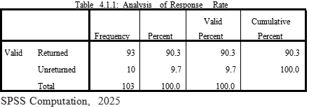
Forgetfulness can lead to unanswered questions, missing information, and insufficient time for compiling surveys, resulting in some responses being marked as "invalid." This situation can lower the overall response rate, and the current study is not exempt from these issues, potentially affecting the generalizability of the findings. Nonetheless, a total of 93 responses were confirmed, yielding a response rate of 90.3%, while 9.7% were not returned.
This response rate is considered robust, surpassing the 70% threshold. As a result, the study is well-equipped to draw meaningful conclusions based on the perspectives of the majority of participants regarding the relationship between job insecurity and organizational commitment in the sampled area
4.2 SECTION A: Demographic Profile of the Respondents
This section details the respondents' demographic information. The section focuses on the respondents' gender, marital status, age, length of service, educational qualification, and job disposition. The statistics are presented in frequency tables and percentages. The initial analysis displays the response rate in a frequency distribution table, as well as the same data in a percentage.
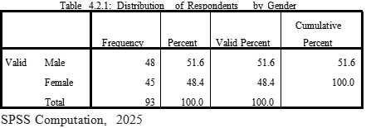
Table 4.2.1 presents a relative frequency distribution and percentage that illustrates the gender distribution of the respondents. It indicates a fairly even balance between males (51.6%) and females (48.4%) at the GTB Ilorin branch. Additionally, the table provides the number of male and female participants in the study. This suggests that the selected bank employs slightly more males than females, indicating that GTB has a lower representation of women (48.4%) compared to men (51.6%).
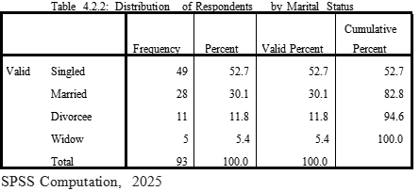
In-depth analysis revealed the marital status profile of the selected bank indicating singled (52.7%) are the majorities participated in the study and they are more than average total population of the selected bank. Married respondents (30.1%) were one-thirds of the total respondents thus greater than one-thirds of the singled counterparts by comparison. Those separated due to one condition or the other are 17.2%. This implies the selected banks have planned to work with singled majorities due to the improved commitment skills that are mostly common among singled majorities because their affinity to family responsibilities is minimal.
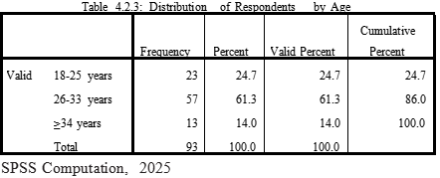
According to Table 4.2.3, there were 24.7% of respondents who were between the ages of 18 and 25 and 61.3% who were between the ages of 26 and 33. As a result, the chart shows that the sampled banks primarily employed people between the ages of 26 and 33. Furthermore, 14% of responders were at least 34 years old. The relative frequency distribution and percentages make it evident that 14% of the respondents were the group of workers with the lowest employment status in the 34+ age range. The fact that this group is the smallest in the survey indicates that the sampled bank didn't employ as many people in this age range.
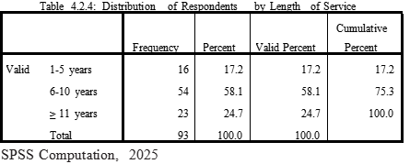
The survey respondents' year of service is shown in Table 4.2.4 above. 17.2% of the 93 employees surveyed had one to five years' worth of experience, 58.1% had six to ten years' worth, and 24.7% had eleven years' worth or more. 82.8% of the workforce was made up of personnel with 6 to 10 years of service and those with more than 11 years. This shows that 17.2% of respondents had less than five years of employment at the chosen bank. Overall, this suggests that 82.8% of the respondents had worked in the GTB Ilorin branch for more than five years.
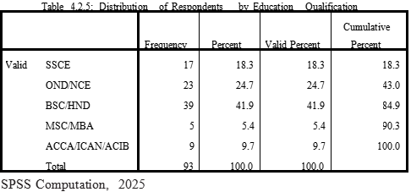
The educational profile indicates 18.3% of respondents the holders of high school certificate, 24.7% of respondents are holders of diploma certificate, 41.9% are degree holders, 5.4% of the respondents are Master degree holders while 9 respondents approximately 10% are holders of other professional certificates like ACCA/ACIB/ICAN. This directly implies that the selected banks have a good record of high numbers of educated staff who have procedural knowledge to run the affair of the banking industry and they were well-informed and enlighten about the study objectives hoping they will provide objective responses that will guide the stated research questions and data for the hypotheses without been bias.
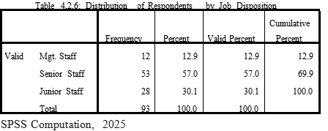
Table 4.2.6 above lists the job titles and responsibilities of the respondents at the sampling banks in the chosen region, where 13% of the respondents had taken on managerial roles. Senior employees made up 57%, whereas junior staff categories made up 30%. It is recommended that the chosen bank employ more senior staff members than junior ones. Given the challenging economic environment and financial difficulties in Nigerian commercial banks, which claim that the rationale for the rising trend of hiring and keeping top staff was to aid in the recapitalization and reform of the banking system (Soludo, 2003)
4.3 Descriptive Analysis of Research Questions
In addition to calculating descriptive measures, descriptive analyses necessitate arranging and summarizing the data using tabulations and frequency distribution. It is particularly helpful since it enables the reader to comprehend the most fundamental features of the data being examined. This section has provided descriptive statistics on employee commitment, job insecurity, and job burnout. Frequency tables and percentage scores are used in this study's presentation of descriptive statistics after data analysis.
SECTION B: ANALYSIS OF DATA PERTAINING TO JOB INSECURITY
This section deals with the results of the questionnaire (Cognitive and Affective) on job insecurity. Table 4.3.1 below shows the percentile summary of the scoring patterns relating to job insecurity. The levels of disagreement were aggregated to show a single category of disagreement and a similar process was conducted for the levels of agreement. The results are presented in table 4.3.1 using summarized percentages for the variables of the sub-statements that constitute each category.
Table 4.3.1: I will be able to keep my present job as long as I wish ( Job
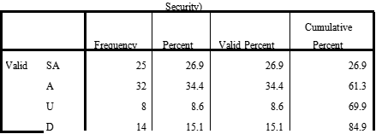

SPSS Computation, 2025
This question was sought to investigate whether employees job security is uphold or not in the sampled banks. 61.3% of respondents agreed they are able to keep their job as long as they wish, 8.6% were neither agree nor disagree while 30.2% of respondent disagree with the statement. This implies that no fewer than two-thirds majority of respondents agreed that their present job are secured in the selected banks in the area.
Table 4.3.2: if my current organization was facing economic problems, my
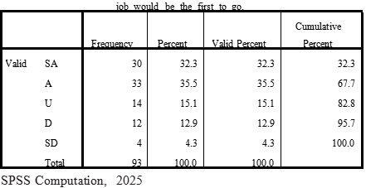
This question was more of Affective than Cognitive by virtue of fact that economic hardship lead to job insecurity. 67.7% of respondents agreed, 15.1% were neither agreed nor disagree while 17.2% disagree with the statement. This directly implies that more than two-thirds majorities concede in the opinion that economic hardship leads to job insecurity in the selected banks.
Table 4.3.3: I am confident that I will be able to work for my organization as long as I wish

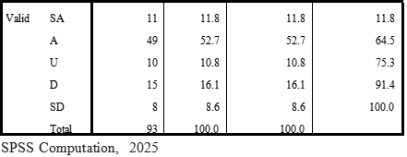
Job confidential is a measure of organizational commitment. 64.5% of respondent agreed they are confident working for the organization as long as they wish. 10.8% of respondents neutrally decided. 24.7% of respondents disagree that job confidence is not a measure of organization commitment. This implies that majority of respondents agreed that job confidence is an element of employee commitment in the selected banks.
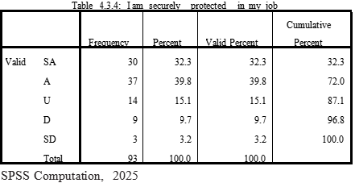
Employees were questioned on whether job security was spelled out in the chosen bank's employment terms and conditions. 72% concurred that the terms and conditions of employment in the sampled institutions securely safeguard them. 12.9% of respondents disagree with the claim, while 15.1% of respondents were unsure. This suggests that the employees of the chosen bank did not have job insecurity as one of their primary traits or characteristics.
B2: ANALYSIS OF DATA PERTAINING TO JOB BURNOUT
Table 4.3.5 I am confident that I could deal efficiently with unexpected,
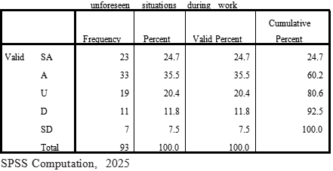
The purpose of this question was to determine whether an employee's condition has not changed after performing some demanding jobs for an extended period of time while being physically and emotionally committed to her area of work. In agreement, 60.2% of respondents said they were bravely dedicated to handle unforeseen circumstances at work. 19.3% of respondents disagree with the statement, while 20.4% of respondents were undecided. This suggests that the working commitment and confidence of the employees in the sampled bank have not been negatively impacted by burnout on a physical or emotional level.
Table 4.3.6: I can solve most problems concerning my work if invested the
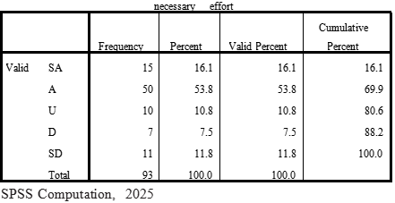
This question complements the one in table 4.3.5 by maybe assessing cognitive and affective tactical problem solving talents bestowed upon employees during long-term task completion without boredom. 69.9% of respondents stated that despite putting in greater effort on assignments, burnout has not caused them to abandon tactical problem solving skills for an extended period of time at work. 10.8% of respondents did not agree or disagree, while 19.3% disagreed with the statement. This means that the employees admitted that burnout had not prevented them from taking a tactical approach to challenges at work. This also demonstrates how dedicated individuals are to their jobs.
Table 4.3.7: if someone opposes me during work, I can find means and
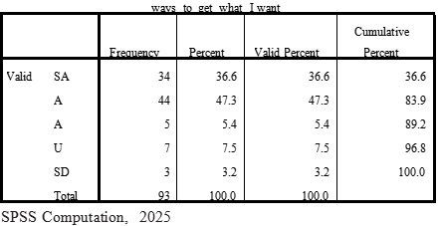
Table 4.3.7 primarily investigates how resourceful the personnel at the sampled bank are even when faced with adversity. 83.9% said they have enough resources to deal with workrelated stress. 5.4% did not agree or disagree. 10.7% of people disagree. This suggests that resourceful people can recover from burnout during work activities of any kind.
Table 4.3.8: No matter what crosses my way during works, I can usually
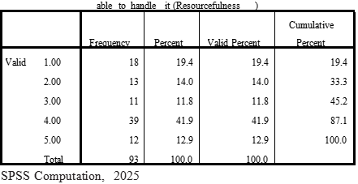
In order to better understand how employees could be unable to complete the challenging duties at hand, this question was put forth. A challenging activity requires little resourcefulness, according to 33.3% of respondents. While 54.8% of respondents agree that resourceful talents are low when challenges arise in the workplace and employee ways of doing things, 11.8% of respondents express no opinion. This blatantly suggests that there are limitations on the amount of work that employees are capable of handling when confronted with challenging assignments due to the risk of resource loss.
B3: Analysis of Data Pertaining to Employee Commitment
This section deals with descriptive analysis regarding perceptions of employee commitment by motivating them monetarily and non-monetarily over the job burnout at GTB Ilorin Branch. The table below show percentile summarized scoring patterns relating to employee’s commitment.
Table 4.3.9 Employees are more committed to their job with regular and
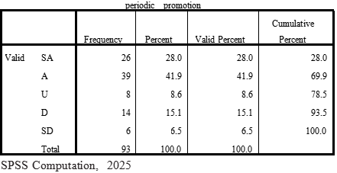
Promotion is a non-monetary means of motivating employees to work and as a means of compensation for job burnout in the workplace. So, the essence of the statement above was to emphasize how promotion interplays between commitment and job burnout. 69.9% of respondents indicate that promotion is two-ways mechanism interplay between employee commitment and job burnout. 8.6% of respondents were neither agree nor disagree while 21.6% of respondents disagree. This simply means that promotion has a fair play interaction between employee commitment and job burnout.
Table 4.3.10: I feel that the company takes advantage of people who are
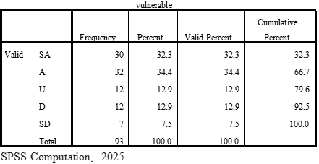
The purpose of this question was to ascertain whether the chosen organization dared to assist the employees in overcoming burnout. The organization is useful to employees who are physically and emotionally unstable while at work, according to 66.7% of respondents. 12.9% of those polled expressed uncertainty about this claim. Of those surveyed, 20.4% are in opposition. This suggests that majorities have given in to the belief that the company supports employees who are physically and emotionally unstable while at work.
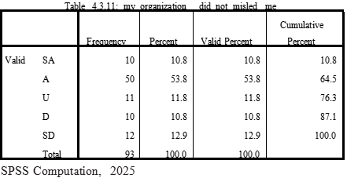
When it comes to providing support to employees, two-thirds of respondents—or 64.5 %— say the business is direct and straightforward. However, 23.7% of respondents disagree, while 11.8% aren't sure. This suggests that the chosen company is not deceiving its staff when they require assistance during a burnout.
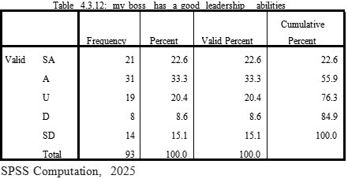
Effective leadership skills increase team commitment and reduce job burnout in the workplace. This viewpoint was shared by 55.9% of respondents. 23.7% of respondents disagree with the claim, while 20.4% of respondents were ambivalent about it. This clearly indicates that the majority of respondents believed that if a leader had strong leadership skills, there will be less burnout.
Table 4.3.13: the organization embark on periodic appraisal of the
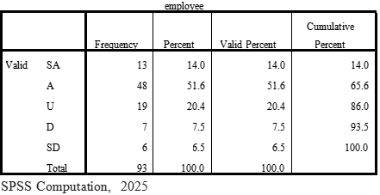
Periodic performance reviews help employees feel less threatened by the prospect of job burnout, which is a sign that the firm should implement regular reviews of employee performance to combat job burnout in the workplace. 65.6% of respondents endorsed this assertion. 14% disagreed, while 20.4% were in the middle. This suggests that timely employee performance reviews lessen the risk of job burnout in the chosen bank.
Table 4.3.14: Friendliness and good rapport between superior and
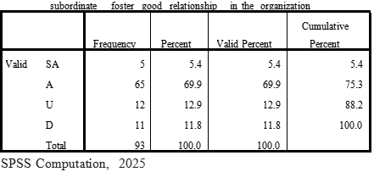
The purpose of table 4.3.14 above was to demonstrate that good relationships promote teamwork while significantly reducing job fatigue, which increases employee commitment. 75.3% of respondents felt that implementing staff engagement, solid relationships, and the capacity to collaborate at work will reduce job turnout. 12.9% of responses were neither agreeing nor disagreeing, while 11.8% disagreed. This suggests that the majority of respondents agreed that friendliness and excellent rapport between superior and subordinate build positive relationships in the workplace.
4.4 Testing of Hypotheses of the Study
H_{O1}: Job insecurity and burnout have no significant impact on employee commitment
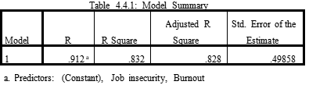
According to the results in model summary table 4.4.1, job insecurity and burnout factors jointly explained 83.2% of the variance in employee commitment, while the remaining 16.8 % could be related to the effect of extraneous variables not accounted for in the model. Other considerations include labor conditions, pay, government policy, and so on. The adjusted Rsquare (0.828), which is so near to R-square (0.832), shows that if the model is sampled from the population rather than the sample, it will account for a trivial 0.4% variation in the outcome. As a result, the model's fitness is satisfactory. R=0.912 is very close to one, indicating that the association between job insecurity/burnout and employee commitment is significant at the 5% level. 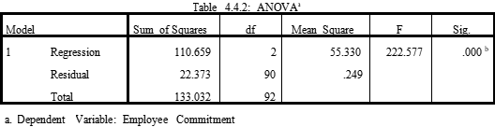
b. Predictors: (Constant), Job insecurity, Burnout
Table 4.4.2 shows the overall diagnostic test of significance (ANOVA) between the joint relationships of Job insecurity, Burnout, and Employee commitment. The significance of the F=55.330>F-table=3.84 at a degree of freedom of (2, 90), i.e. P-value=0.00, is less than 0.05 , according to the ANOVA results for the regression coefficients. This suggests that job uncertainty and burnout have a strong influence on employee commitment. This suggests that at the 5% level, there is a perfect significant link between job instability, burnout, and employee commitment. At 95% confidence, a strong association exists between the joint effects of job instability, burnout, and employee commitment.
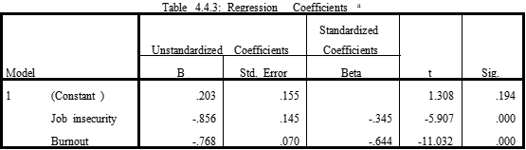
a. Dependent Variable: Employee Commitment
Resulting from regression According to Table 4.4.3, both job instability ( = -0.856) and burnout ( = -0.768) have a detrimental impact on employee commitment. Work insecurity has the least negative impact, which means that a 1% rise in job insecurity causes a 34.5% loss in employee commitment, but job burnout causes a 64.4% decrease in employee commitment. This result shows that both job insecurity and burnout have a considerable impact on employee commitment, despite the fact that the included model summary findings in table 4.4.1 and ANOVA table 4.4.2 failed to indicate the direction of the impact due to statistical power insensitivity. If job insecurity=job burnout=0, then employee commitment will increase by 20.3% and become insignificant at the 5% level, according to the constant of regression. However, due to the nature of the working environment and organizational culture, there is no chance of eliminating job insecurity and burnout at the sampled bank. Because of other characteristics including working conditions, remuneration, and the government policy institute of the sampling bank, it appears that eliminating job instability and burnout cannot be utilized to make conclusions about employee commitment. As a result, the alternative hypothesis—that there is a significant influence of work insecurity and job burnout on employee commitment at a 5% level of significance—is accepted and the null hypothesis is rejected.
H_{O2}: There is no significant relationship between Job insecurity and Employee commitment
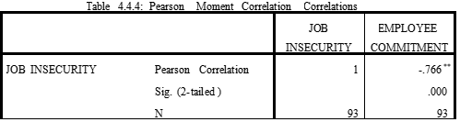
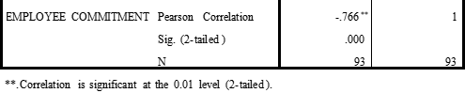
According to table 4.4.4's Pearson Moment Link, there is a bad correlation between job instability and employee commitment (R=-0.766). This implies that there is an inverse relationship between the response variable (employee commitment) and the observed variable (job insecurity), with the implication that a small increase in employee commitment will be decreased by job insecurity while a small decrease in employee commitment will increase it by the same amount at the 5% level of significance. This result is consistent with the response to research question B1, where more than two-thirds of respondents stated that job insecurity will have a strong psychological impact on employee commitment if the organization is experiencing economic hardship because the risk of losing someone's job due to the organization's economic failure places a high value on employee aspects of life and commitment. A perception of employment instability will have a profound psychological impact on individuals impacted because there is a possibility of losing money and other highly valued areas of life, according to Ashford, Lee, and Bobko (1989). The alternative hypothesis, that there is a negative significant association between job instability and employee commitment at a 5% level, is therefore accepted and null hypothesis 2 is rejected.
H₀₃: Job burnout has significant effect on employee commitment
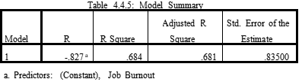
The association relationship (R=-0.827) between job burnout and employee commitment is seen in Table 4.4.5 above. Negative is the correlation coefficient. This indicates that there is an inverse relationship between the dependent variable (employee commitment) and the independent variable (job burnout), with the implication that a slight increase in employee commitment will be decreased by job burnout while a slight decrease in employee commitment will be equal to an increase in employee commitment at the 5% level of significance. This finding is consistent with the response to research question B2 in table 4.3.8, where 54.8% of respondents agreed that resourcefulness is low when difficulties cross employee ways of doing things. This means there is a cap on the amount of work that employees are capable of handling when faced with challenging tasks due to the risk of losing resources, despite their assertions that they are adequately resourced to avoid burnout. The findings corroborated Omoankhanlen's (2014) study, which found a significant association between organizational cynicism in the banking sector and the characteristics of job burnout including emotional exhaustion/stress. The adjusted R2 value of 0.684, also known as the coefficient of multiple determinations, indicates that the change in work burnout in the chosen banks is the only factor that can account for the variation in employee commitment. This indicates that workplace mental and physical fatigue contributes to an increase of 68.4% in employee commitment. Another 31.6% (unexplained) is attributable to outside influences that the model did not take into account. These additional elements could include governmental regulations and other workplace conditions. Therefore, additional research is urgently required to learn more about the other factors (31.6%) that affect employee commitment in the chosen institutions. As a result, alternative hypothesis ( that there is an inverse significance link between job burnout and employee commitment at a 5 % level) is accepted and null hypothesis (that the is no relationship) 2 is rejected.
Table 4.4.6: ANOVAª
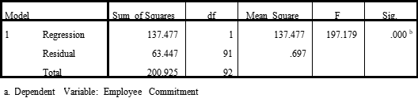
b. Predictors: (Constant), Job Burnout
Analysis of variance (ANOVA) checks if the model significantly outperforms using the mean as a "best guess" in forecasting the outcome. The F-ratio, specifically, measures the improvement in prediction that comes from model fitting (labeled "Regression=137.477" in the table), compared to the model's residual inaccuracy (labeled "Residual=63.447" in the table). Additionally, by dividing the regression sum of squares (Regression=137.477) by the total sum of squares (228.877) in the table, a significant relationship is shown by returning the value of R2=0.684 exactly as in table 4.4.5, and the final model has significantly improved precision ability that the job burnout adequately fits to predict the employee commitment. A significant link between job burnout and employee commitment does, however, exist at the 5% level of significance because the significant value of P (0.000) is less than (0.05).
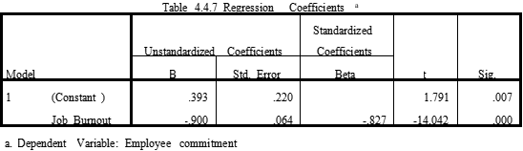
To examine the degree of impact of job burnout on employee commitment, the simple regression equation y=0.393-0.900X is obtained; where y=”employee commitment” and X=”job burnout”. The beta-value (β=-0.900) implies that 90% decrease in employee commitment is caused by 1% increase in job burnout. Peradventure if the job burnout is remove from the model i.e. “Job burnout”=0; there is every possibility for the 39.3% increase in employee commitment (constant=0.393), which is equally significant at 5% level (p=0.00<0.07). This is explained in the transaction theory by Lazarus and Folkman 1987 in the literature which suggests that stress is the direct product of a transaction between an individual and their environment which may tax their resources and thus threaten their wellbeing and organizational commitment. Therefore the null hypothesis 3 is equally rejected and alternate hypothesis is accepted by posited that there is significant impact of job burnout on employee commitment at 5% level.
4.5 Discussion Findings
The primary goal of this study was to examine how employee commitment at the GTB Ilorin Branch is impacted by job instability and burnout. The study's findings support the major purpose and are consistent with the research goals. Table 4.2.1's gender breakdown of the respondents' demographic characteristics shows how many men and women took part in the study. According to the table, the chosen bank employed slightly more men than women, which implied that GTB employed less women (48.4%) than men (51.6%). An in-depth research of the selected bank's marital status profile showed that the majority of study participants (52.7%) were single, making up higher than the average proportion of the bank's overall population. In comparison, married respondents (30.1%), who made up one-third of the total respondents, were more numerous than their single counterparts by a factor of two. 17.2% of separations are the result of one or the other circumstance. Due to the increased commitment skills that are typically seen among singled majorities because of their low affinity for family duties, it is implied that the chosen banks have intended to work with singled majorities. Table 4.2.3's relative frequency distribution and percentages provide unmistakable proof that 14% of the respondents were among the group of workers with the lowest employment levels in the 34+ age range. The fact that this group is the smallest in the survey indicates that the sampled bank didn't employ as many people in this age range. Additionally, 82.8% of the respondents had worked for the sampled institutions for more than 5 years. The chosen banks have a solid track record of having a large number of educated employees with the necessary procedural knowledge to manage the affairs of the banking industry. They were also well-informed and knowledgeable about the goals of the study. It is determined from hypothesis 1 that employee commitment is negatively impacted by both job instability ( = -0.856) and burnout ( = -0.768) at the 5% level. This finding gave a general overview of the issue of job insecurity, which includes economic failure, the potential loss of human resources, and the impact it may have on employee commitment. The regression analysis also shows that, at a 5% level of significance, a decrease in job burnout will increase employee commitment. This indicates that there are limits to the amount of labor that employees can manage when confronted with emotional or physical challenges due to the fear of resource loss, as indicated in table 4.3.8. This result is consistent with a study by Omoankhanlen (2014) that found a significant correlation between organizational cynicism in the banking sector and aspects of job burnout, such as emotional weariness and stressAn inverse relationship between the observed variable (job insecurity) and the response variable (employee commitment), as shown by the Pearson Moment Correlation results in table 4.4.4, implies that, at the 5% level of significance, a slight increase in job insecurity will decrease employee commitment while a decrease in job insecurity will increase it. This result is consistent with the response to research question B1, where more than two-thirds of respondents stated that job insecurity will have a strong psychological impact on employee commitment if the organization is experiencing economic hardship because the risk of losing someone's job due to the organization's economic failure places a high value on employee aspects of life and commitment. A perception of employment instability will have a profound psychological impact on individuals impacted because there is a possibility of losing money and other highly valued areas of life, according to Ashford, Lee, and Bobko (1989).
Therefore the null hypothesis 2 is rejected and alternate hypothesis is accepted by posited that there is significance relationship between job insecurity and employee commitment at 5 % level. While examine the degree of impact of job burnout on employee commitment in hypothesis 3, the simple regression equation y=0.393-0.900X is obtained; where y=”employee commitment” and X=”job burnout”. The beta-value (β=-0.900) implies that 90% decrease in employee commitment is caused by 1% increase in job burnout. Peradventure if the job burnout is remove from the model i.e. “Job burnout”=0; there is every possibility for this decision to yielded 39.3% increase in employee commitment (constant=0.393), which is equally significant at 5% level (p=0.00<0.07). This is explained in the transaction theory by Lazarus and Folkman 1987 in the literature which suggests that stress is the direct product of a transaction between an individual and their environment which may tax their resources and thus threaten their wellbeing and employee commitment. Therefore the null hypothesis 3 is equally rejected and alternate hypothesis is accepted by posited that there is significant impact of job burnout on employee commitment at 5% leve
CHAPTER FIVE
5.0 SUMMARY, CONCLUSION AND RECOMMENDATIONS
5.1 Summary of Findings
The interpretations, comments, and analyses of the research findings were reported in the preceding chapter. The summary, conclusion, and recommendations resulting from the empirical analysis of the findings are highlighted in this chapter, along with suggestions for future research topics. The conclusions of this study, which focuses on job insecurity and burnout in the banking business, are generalized to the bank, the government, and sector policymakers. However, the results might be helpful to academics studying related topics of study. The study adopted a quantitative research design, and a structured closed-ended questionnaire (Annexure B) was used to collect primary data. A survey method was used as the target population was made up of only 138 employees and all data were analyzed using the latest version of the Statistical Package for Social Sciences (SPSS) version 25.0 for Windows. The following are some of the summary of the findings of the study:
Job insecurity and burnout have significant impact on employee commitment at 5% level.
- Job insecurity has an inverse relationship with employee commitment at 5% level of significant
- Job burnout has significant but negative impact on employee commitment Other findings are;
- The sampled bank employed moderately more males than females
- The descriptive analysis revealed that the selected banks have planned to offer more job opportunities to singled majorities due to the improved commitment skills that are mostly common among singles because their affinity to family responsibilities is minimal.
- The bank has a good record of high number of experience workers above minimum of 5 years

5.2 CONCLUSION
The major goal of this study was achieved by the findings, which demonstrated that employee commitment at Guarantee Trust Bank Ilorin Branches is impacted by job instability and burnout. Burnout and job insecurity should not be disregarded because, according to this study at GTB Ilorin, employee dedication is not significantly impacted by dismissal.
However, additional empirical results of this study showed that there was an inverse link between work insecurity and employee commitment at GTB Ilorin, contradicting the conclusions that job insecurity negatively affects employee commitment. The research also revealed a low level of job insecurity among GTB Ilorin employees. Even though most employees admitted they lack the resiliency to deal with challenges or stress at work, job burnout and employee devotion were high among respondents. The conclusion drawn from the study's findings is that management must make sure that employee burnout and severe job insecurity are reduced in the bank in order to create a work environment that fosters employee commitment.
5.3 RECOMMENDATIONS
Based on the findings of this study, the following recommendations are proposed:
- Competitive Compensation: Salaries and benefits should align with market standards. Offering a competitive compensation package is essential for motivating employees to perform at their best.
- Balanced Psychological Contract: The bank should foster a balanced psychological contract by addressing employees' needs for job security, career advancement, skills development, involvement, fairness, and manageable workloads. This approach will promote a positive and ongoing relationship between employees and employers.
- Support from Team Leaders: Management at GTB should ensure that team leaders provide assistance to employees when needed, helping to alleviate the burden of job burnout.
- Encouraging Employee Relationships: Given that a significant number of respondents reported satisfaction with their relationships with coworkers, management should further promote positive interactions among employees and supervisors. This can be achieved through formal and informal activities, such as team-building exercises and social events.
- Additional Support for Job Burnout: The bank should offer additional support mechanisms, such as counseling and career guidance, to help employees cope with job burnout. This can mitigate the negative effects associated with job insecurity and burnout.
- Employee Involvement in Decision-Making: Banks should actively involve employees in decision-making processes and performance evaluations. Management should communicate these decisions regularly during performance appraisals to ensure employees feel secure and informed about their work environment.

QUESTIONNAIRE
Dear Respondent,
I am---------------------- a student of the Department of –Business Administration and Management----------with Matric No: ------------------------------. I am currently conducting a research on a project titled “Examining the Influence of Job Insecurity and Burnout on Employee Performance: An empirical evidence of GTBank, Ilorin, Nigeria using Gtbank in Ilorin as a study area. This will require that you respond to the items of this questionnaire as best as you can.
Please, note that all information provided will be handled with confidentiality and would be used strictly for academic purposes.
Thank you.
Yours faithfully,
SECTION A
DEMOGRAPHIC DATA
Kindly tick (√) the empty boxes as it applies to you
- Gender: Male [ ] Female [ ]
- Marital Status: Single [ ] Married [ ] Divorced [ ] Widowed [ ]
- Age: 18-25 years [ ] 26- 33years [ ] 34years and above [ ]
- Years of Service: 1-5 [ ] 6-10 [ ] 11 and above [ ]
- Highest Educational Qualification: SSCE [ ] OND/NCE [ ] B.SC/HND [ ]
M.Sc/MBA/MPA [ ] OTHERS [ ]
- Job Category: Management Staff [ ] Senior Staff [ ] Junior Staff [ ]
SECTION B
Kindly tick (√) the appropriate boxes for your preferred answers
SA- Strongly Agree, A- Agree, U- Undecided, D- Disagree, SD- Strongly Disagree
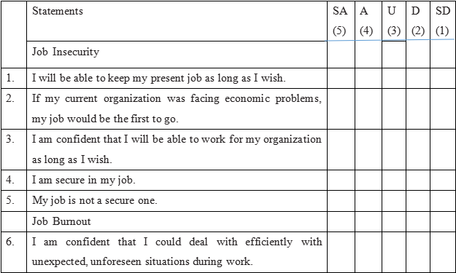

7. | I can solve most problems concerning my work if I invest the necessary effort.
8. | If someone opposes me during my work, I can find means and ways to get what I want.
9. | If I am in trouble during work I can usually think of something to do.
10. | No matter what crosses my way during work, I am usually able to handle it.
 | Employee Commitment
11. | Employees are more committed to their job with regular or periodic promotion.
12. | I feel that my company takes advantage of people who are vulnerable
13. | My organization did not mislead me.
14. | My organization tries to get out of its commitment to satisfy the employees.
15. | My leader has good leadership abilities.
16. | The organization embarks on periodic appraisal of the employees.
17. | The organization motivates employees with better remuneration.
18. | Friendliness and good rapport between superior and subordinate foster good relationship in the organization.

