DESIGN AND IMPLEMENTATION OF A SMART DOOR ARDUINO TECHNOLOGY AND RADIO FREQUENCY IDENTIFICATION (RFID)

BY

LAWAL QUAM OLAMILEKAN
HND/23/COM/FT/0139

A PROJECT SUBMITTED TO THE
DEPARTMENT OF COMPUTER SCIENCE, INSTITUTE OF INFORMATION AND COMMUNICATION TECHNOLOGY, KWARA STATE POLYTECHNIC, ILORIN

IN PARTIAL FULFILMENT OF THE REQUIREMENTS FOR THE AWARD OF HIGHER NATIONAL DIPLOMA (HND) IN COMPUTER SCIENCE.

JUNE, 2025.

CERTIFICATION
This is to certify that this project research was carried out by LAWAL QUAM OLAMILEKAN matric number HND/23/COM/FT/0139 has been read and approved as meeting part of the requirement for the award of Higher National Diploma (HND) in Computer Science.

___________________________ ______________________
MR. MURTALA, K. DATE
(PROJECT SUPERVISOR)

___________________________ ______________________
MR. OYEDEPO, F. S. DATE
(HEAD OF DEPARTMENT)

__________________________ ______________________
EXTERNAL EXAMINER DATE

DEDICATION
This research work is dedicated to the Almighty Allah for the success of the work

ACKNOWLEDGEMENTS
My appreciation for this project work goes to Almighty Allah for His boundless mercy, guidance, and strength that sustained me throughout this endeavor. His divine inspiration and blessings have been the cornerstone of my success in completing this project.
I am profoundly grateful to my supervisor, Mr. Murtala K., whose expertise, mentorship, and unwavering encouragement have been pivotal in shaping the direction and quality of this work. Your insightful guidance and constructive feedback have greatly enriched this project, and for that, I am deeply grateful.
I extend my heartfelt thanks to the Head of Department Mr. Oyedepo F.S., Dr. Raji A.k., Dr. Ayeni J.K. and all other lecturers in Computer Science Department for providing an enabling environment, access to essential resources, and the opportunity to undertake this project. The support from the faculty and staff has been invaluable in facilitating my research and ensuring its successful completion.
My deepest gratitude goes to my parent Mr. & Mrs. Lawal, whose love, patience, and sacrifices have been a constant source of motivation. Your belief in me and your endless encouragement have kept me grounded and focused throughout this journey. I am also grateful to my siblings Fathia and Aleeyah for their moral support and encouragement throughout this journey.
I express my gratitude to my friends (Abubakar, John, Dominic, Abdulmaleek, Hikmah, Kabeeroh, Rukayah, Esther, Heebat, Barakat) who directly or indirectly, played a role in the realization of this project. Your encouragement, advice, and support, no matter how small, have collectively contributed to its success. This work stands as a testament to the power of collaboration and shared commitment.
I am immensely thankful to my colleagues and peers for their collaboration, intellectual contributions, and constructive criticism, which have significantly enhanced the quality of this work. Your diverse perspectives and willingness to share knowledge have been truly motivating.

ABSTRACT
This research presents the design and implementation of a smart door access system utilizing Arduino microcontroller and RFID card technology to address modern security challenges associated with traditional lock-and-key mechanisms. Motivated by the need for cost-effectiveness, flexibility and security access control, the project explores the use of open-source hardware to automate door operation and limit entry to only authorized users. The system consists of an RFID reader for authentication, an Arduino unit as the central processor, an LCD for user feedback, and a stable STM power supply. Developed under the structured Waterfall model, the system processes RFID tags, compares input data with stored IDs, and triggers access accordingly. The proposed solution eliminates key duplication risks, enhances convenience, and ensures access logging, all while maintaining affordability and scalability for use in homes, schools, and offices. The study demonstrates that smart access systems can be built with minimal resources while providing reliable performance, thereby encouraging the adoption of embedded systems for improving everyday security infrastructures.
Keywords: RFID, Arduino microcontroller, smart door, access system, and card

TABLE OF CONTENTS
TITLE PAGE. i
CERTIFICATION ii
DEDICATION iii
ACKNOWLEDGEMENTS iv
ABSTRACT v
TABLE OF CONTENTS vi
CHAPTER ONE 1
INTRODUCTION 1
1.1 Background to the study 1
1.2 Statement of the problem 3
1.3 Aim and Objectives of the study 4
1.4 Significance of the Study 4
1.5 Scope of the Study 5
1.6 Definition of Terms 6
CHAPTER TWO 7
LITERATURE REVIEW 7
2.1 Introduction 7
2.1 Review of Related Studies 9
2.2 Review of General Studies 11
CHAPTER THREE 14
METHODOLOGY 14
3.1 Research Methodology 14
3.2 Analysis of the Existing System 15
3.3 Problems of the Existing System 15
3.4 Description of the Proposed System 16
3.5 Advantages of the Proposed System 17
CHAPTER FOUR 18
DESIGN AND IMPLEMENTATION OF THE SYSTEM 18
4.1 Design of the System 18
4.1.1 Output Design 18
4.1.2 Input Design 19
4.1.3 Procedure Design 20
4.2 System Implementation 20
4.2.1 Hardware Support 20
4.3 System Documentation 21
4.3.1 Maintenance of the System 21
CHAPTER FIVE 22
SUMMARY, CONCLUSION AND RECOMMENDATIONS 22
5.1 Summary 22
5.2 Conclusion 23
5.3 Recommendations 23
REFERENCES 24

CHAPTER ONE

INTRODUCTION

1.1 Background to the study
The concept of a smart home has evolved significantly over the years, drawing on advancements in embedded systems, the Internet of Things (IoT), and automation technologies. Among the many components of a smart home, smart door systems are particularly critical as they directly relate to security, convenience, and access control. A smart door system, especially when powered by Arduino technology, offers a cost-effective and customizable solution to modern security challenges. The increasing need for intelligent systems that can secure residential and commercial spaces has driven researchers and technologists to explore innovative door automation mechanisms. With the integration of Arduino microcontrollers, sensors, and communication modules, smart door systems are no longer luxury items but feasible solutions for enhancing the security architecture of any space (Olawale et al., 2020).
Arduino, an open-source electronic platform based on easy-to-use hardware and software, has become the preferred development board for prototyping embedded systems due to its simplicity, affordability, and flexibility. The Arduino Uno board, for instance, has been widely adopted for developing various smart systems due to its ease of integration with sensors, actuators, and wireless communication modules. Its accessibility has enabled both professional developers and hobbyists to create innovative applications, including home automation, security systems, and surveillance technologies (Akinyemi et al., 2021). In the context of a smart door, Arduino serves as the control unit that processes data from input devices such as RFID readers, fingerprint sensors, or motion detectors and then triggers output devices such as servo motors or magnetic locks to allow or deny access.
Security remains a fundamental concern in both urban and rural settings, especially with increasing reports of theft, burglary, and unauthorized access. Traditional door locking mechanisms, while still widely used, are susceptible to breaches such as lock picking, key duplication, or forced entry. The inadequacy of these traditional methods has created a need for more robust and intelligent systems capable of restricting access to only authorized individuals. Smart doors equipped with Arduino technology offer solutions that address these challenges by incorporating biometric systems, RFID authentication, password entry, and even remote access through mobile applications (Eze et al., 2022). These features not only enhance security but also provide convenience, such as eliminating the need for physical keys and enabling access logging and monitoring.
Moreover, the design and implementation of smart doors using Arduino are well suited to educational and developmental environments where budget and simplicity are essential. Arduino’s modularity allows for a step-by-step development approach, where individual modules such as the keypad interface, LCD display, and motor control can be tested and integrated incrementally. This layered design methodology promotes debugging, scalability, and customization. Researchers have demonstrated various configurations of Arduino-based smart doors, ranging from basic keypad systems to advanced IoT-enabled devices that send access notifications to mobile phones via GSM or Wi-Fi modules (Okeke et al., 2021).
The integration of sensors is another vital aspect of the Arduino-based smart door system. Sensors such as Passive Infrared (PIR) for motion detection, Ultrasonic sensors for proximity, and fingerprint scanners for biometric authentication play crucial roles in defining the intelligence of the system. These sensors collect real-time data, which the Arduino microcontroller processes to determine access. For instance, a PIR sensor can detect movement near the door and activate a camera module to capture images or alert the homeowner, while a fingerprint sensor can validate access based on pre-stored biometric data (Ibrahim et al., 2019). This integration of sensor technologies with microcontroller logic enhances the responsiveness and reliability of the smart door system.
Power management is another essential consideration in the development of smart door systems. Since such systems are intended to be operational at all times, ensuring a continuous and reliable power supply is crucial. Developers often incorporate backup power solutions such as batteries or solar panels, along with voltage regulators to protect sensitive electronic components from power surges. Additionally, Arduino-based systems are energy-efficient, consuming low power even during continuous operation, which makes them ideal for long-term deployments in homes or small offices (Bashiru et al., 2020).
The communication capability of smart door systems further extends their functionality. With the inclusion of GSM, Wi-Fi, or Bluetooth modules, users can interact with the smart door remotely. For instance, in a system with GSM support, the Arduino can send text messages to the homeowner upon a failed access attempt or grant remote access upon user confirmation. Similarly, Wi-Fi-enabled smart doors can be integrated into a central home automation system, allowing synchronization with other devices such as security cameras, alarms, and lighting systems (Nwachukwu et al., 2023). These interconnected devices collectively enhance the overall security and user experience of the smart home environment.

1.2 Statement of the problem
In today’s security-conscious world, traditional lock-and-key systems are increasingly inadequate due to their vulnerability to theft, duplication, and tampering. These systems lack the flexibility and intelligence required for modern access control needs. In environments with multiple users, managing physical keys becomes a challenge, and replacing locks after a key is lost is both time-consuming and costly. Despite advancements in digital security, solutions such as biometric and mobile-based systems are often expensive, complex, and not easily accessible, especially in developing regions.
Arduino-based smart systems, particularly those using RFID cards, offer a low-cost, flexible, and programmable alternative. However, their adoption remains low due to limited awareness, technical knowledge, and lack of locally adaptable solutions. Existing attempts often fail to balance affordability, simplicity, and functionality, leaving a gap for a practical, scalable smart door system that meets the needs of everyday users in homes, offices, and schools.
The key problems prompting this research are:
- The insecurity and limitations of traditional lock-and-key systems, which are prone to theft, duplication, and physical tampering.
- The high cost and complexity of other digital access control systems such as biometrics and mobile app integration, making them inaccessible to average users.
- Limited awareness and adoption of affordable, programmable smart access systems like Arduino-based RFID doors in developing regions.
- Lack of user-friendly, scalable, and low-maintenance smart door solutions for homes, schools, and offices.

1.3 Aim and Objectives of the study
The aim of this study is to design and implement a smart door access system using RFID cards and Arduino technology for efficient solution for controlling access in residential and commercial spaces.
The objectives of the study are to:
- Design and develop a smart door lock to secure entry;
- incorporate the Arduino and RFID card technology on the smart door; and
- implement a user authentication system using RFID for controlled access.

1.4 Significance of the Study
This study holds significant value in the advancement of security systems through the integration of modern technologies like Arduino and RFID. The research provides a practical solution to the challenges of traditional security methods, such as key-based entry, which are prone to breaches and inefficiencies. By developing a smart door access system, the study aims to enhance the security, efficiency, and ease of access control in both residential and commercial settings. The system's automation and integration with RFID technology allow for a seamless, contactless authentication process, reducing the potential for human error and unauthorized access.
Additionally, the study contributes to the growing field of Internet of Things (IoT)-based security solutions, demonstrating how affordable and scalable solutions can be implemented using open-source platforms like Arduino. This makes the technology accessible to a wide range of users, from individual households to businesses, providing a cost-effective alternative to high-end proprietary systems.
Furthermore, the findings of this study are expected to inform future developments in smart security solutions, offering valuable insights into improving system reliability, user experience, and cost-effectiveness. The research also highlights the potential of low-cost, open-source technologies in addressing modern security challenges, positioning it as a key resource for stakeholders in both the security and technology sectors.

1.5 Scope of the Study
This study focuses on designing and implementing a smart door access system using Arduino technology and RFID cards. It explores the integration of hardware components, including the Arduino microcontroller and RFID reader, to develop a secure and efficient access control system. The research is limited to the design, prototyping, and testing of the system within a controlled environment, primarily focusing on enhancing security for residential and commercial use.

1.6 Definition of Terms
- Smart Door Access System: A security mechanism that allows authorized individuals to access a building or room through an automated system, typically involving technology such as RFID cards, biometric systems, or mobile apps to verify identities.
- Arduino Technology: An open-source electronics platform based on simple software and hardware, widely used for building prototypes of electronic devices. It involves using a microcontroller to interact with physical elements such as sensors, motors, and lights.
- RFID (Radio Frequency Identification): A technology that uses radio waves to identify and track tags attached to objects. In this context, RFID cards are used to grant or deny access to a door based on the identification of the card.
- Microcontroller: A compact integrated circuit designed to govern a specific task in an embedded system. In this study, the Arduino microcontroller is used to control the door access system's operations.
- Access Control System: A security feature that manages who is allowed to enter or exit a controlled area. It uses various identification methods, such as RFID, to authenticate and authorize access.
- Security System: A set of components designed to protect property, assets, or information from unauthorized access or theft. In this study, the security system refers to the overall operation of the smart door access control mechanism.
- Authentication: The process of verifying the identity of an individual, typically done through RFID cards or other methods, to determine whether access to a system or area should be granted.

CHAPTER TWO

LITERATURE REVIEW

2.1 Introduction
The smart door access systems have become increasingly significant as security needs continue to evolve in both residential and commercial spaces. With advancements in automation and embedded systems, the integration of technologies such as Arduino and RFID (Radio Frequency Identification) cards has emerged as a cost-effective and highly customizable solution. These systems not only enhance security but also provide users with seamless and efficient access control mechanisms. As a result, a growing body of research has explored the application of Arduino-based smart door systems that utilize RFID technology for authentication. This literature review examines key studies that have contributed to the understanding and development of these systems, focusing on their design, implementation, challenges, and future potential.
The utilization of RFID technology in access control systems has become a cornerstone of modern security. RFID systems rely on radio waves to transmit unique identifiers from cards to readers, offering a secure and user-friendly method for granting access to authorized individuals. Studies such as those by Oladele et al., (2018) emphasize the simplicity and reliability of RFID systems, particularly in small-scale applications like homes and offices, where security demands are high but budgets are often constrained. This makes RFID-based systems an appealing choice for implementing smart door access solutions, as they provide both affordability and effectiveness (Adedeji, 2019). Integrating these systems with open-source platforms like Arduino adds an extra layer of flexibility, enabling users to easily adapt and customize their systems to meet specific needs (Sarhan et al., 2017).
Arduino technology, known for its ease of use and widespread adoption in embedded system design, plays a pivotal role in enabling cost-effective and scalable solutions for smart door access. Researchers such as Sarhan et al., (2017) and Ali and Anwar (2019) have highlighted the advantages of using Arduino in access control systems, noting its accessibility for both professional and hobbyist developers. Arduino-based systems offer simple programming, a wide range of compatible sensors, and the ability to integrate easily with RFID readers, making them ideal for smart door solutions. Additionally, the system’s open-source nature allows for continuous improvements and adaptability, ensuring that users can keep pace with emerging technologies and security trends.
A growing body of research has also explored the integration of biometric technologies alongside RFID cards to enhance the security of smart access systems. Singh et al., (2020) discuss the combined use of fingerprint scanners and RFID cards, arguing that the fusion of biometrics with RFID provides a robust method for user authentication, making the system more secure and less prone to unauthorized access. By adding a biometric layer, such as fingerprint recognition, the system can ensure that access is granted only to individuals whose identities are verified both by the RFID card and biometric data. This added layer of security addresses concerns about the potential vulnerabilities of RFID systems, such as card duplication or loss.
In addition to the benefits, challenges in implementing these systems have also been documented. Khan and Malik (2017) identify common issues such as sensor malfunctions, power supply instability, and software bugs that can compromise the reliability of Arduino-based smart door systems. Furthermore, data security concerns related to the transmission of sensitive information, such as RFID identifiers, have been addressed in studies by Mohammed et al., (2019), who emphasize the need for encryption protocols and secure communication channels to safeguard against hacking attempts and data breaches.
Despite these challenges, the research demonstrates the promise of Arduino-based smart door access systems, not only in residential settings but also in high-security applications like banks, laboratories, and military facilities. Kumar et al., (2018) emphasize the importance of these systems in environments that demand high levels of access control and security. The scalability of Arduino-based systems, along with the ability to integrate remote monitoring via cloud technologies, further strengthens their potential for deployment in a variety of security-conscious industries.

2.1 Review of Related Studies
Several studies have been conducted to design and implement smart door access systems using various technologies such as RFID, Bluetooth, fingerprint recognition, and Arduino-based platforms, which have been pivotal in addressing security concerns in both residential and commercial spaces. One of the foundational works in this domain is titled "Design and Implementation of Smart Door Access System Using RFID Technology", by John and Adamu (2018). This study introduced the concept of integrating Arduino technology with RFID to develop an automated and cost-effective access control system. The problem highlighted was the vulnerability of conventional lock-and-key mechanisms to unauthorized access and the inefficiencies of manual entry. The authors aimed to create a reliable system capable of providing secure access through RFID cards, using Arduino as the central control unit. The methodology involved utilizing an RFID reader to authenticate users, and the system was tested in a university environment with a sample of 50 students. The study concluded that RFID-based systems were not only secure but also relatively inexpensive and easy to deploy. It recommended expanding the system's application to other secure environments, such as offices and warehouses, to improve security measures.
A similar study, "Automated Door Access System Using Arduino and Bluetooth," by Olayemi and Okoro (2019), explored the use of Bluetooth technology alongside Arduino for wireless access control. In contrast to the RFID approach, this study focused on leveraging smartphones for remote access. The problem identified in this research was the need for a more flexible, wireless solution to access control that could eliminate the need for physical cards or keys. The objective was to design a system that could be remotely controlled through a mobile app, providing an easy-to-use access mechanism. The methodology involved interfacing an Arduino with a Bluetooth module and developing a custom mobile application for door control, with a sample size of 40 users in a small office building for testing. The results showed that the Bluetooth system was user-friendly, efficient, and offered significant convenience over traditional access systems. The study concluded that the system could be effectively used in residential buildings and recommended incorporating additional security features such as encryption for data protection.
Another significant contribution to the field was "Smart Door Access System with Fingerprint and RFID Integration Using Arduino," by Adeyemo et al., (2020). This study focused on combining fingerprint recognition with RFID technology to create a multi-factor authentication system. The introduction highlighted the growing security concerns associated with single-factor authentication systems, particularly in high-security environments. The identified problem was the ease with which RFID cards could be cloned or stolen. The authors aimed to improve security by integrating fingerprint scanning along with RFID, using an Arduino microcontroller for system management. The methodology used both fingerprint recognition and RFID scanning technologies, with a sample size of 100 test subjects. The study concluded that the dual authentication mechanism significantly enhanced the system's security, making it suitable for high-risk environments like banks or research facilities. The researchers recommended further study into making the system more affordable and scalable for broader applications.
In a more recent study, "Design of a Smart Door Access Control System Using Arduino and Servo Motors," by Alabi and Ige (2021), the authors integrated servo motors with Arduino to control electronic door locks. The problem discussed was the complexity and high cost of existing electronic locking systems. The objective was to design a simple, cost-effective access control system that could be operated by a servo motor controlled by an Arduino. The methodology used involved connecting the Arduino to a servo motor to manage the locking mechanism. The system was tested in a small business setting, with a sample size of 50 successful access attempts. The results demonstrated that the system was easy to assemble, inexpensive, and effective in controlling door access. The study concluded that such a system could be deployed in low-budget residential settings or small businesses and recommended incorporating more advanced encryption for better security.
Another study, "Arduino-Based Access Control System Using RFID and Buzzer for Security Applications," by Osuji and Nwachukwu (2022), proposed an innovative approach that combined RFID technology with an audible alarm (buzzer) for enhanced security. The problem identified was that most traditional access systems fail to alert security personnel or users of unauthorized access attempts. The goal was to design a system that would trigger a buzzer to alert individuals whenever an unauthorized access attempt was made. The methodology combined an RFID reader with Arduino to manage door access, and a buzzer was activated if the wrong card was presented. A sample of 30 users participated in the trial, with different access scenarios tested. The system proved to be effective, with the buzzer alerting users in real-time. The conclusion emphasized that this added layer of alerting was beneficial for improving the security of access-controlled environments. The study recommended further testing in larger environments and the addition of a more sophisticated alarm system for wider application.

2.2 Review of General Studies
In the study titled "Design and Development of a Smart Access Control System Using Arduino and NFC Technology" by Eze and Okafor (2020), the authors utilized Near Field Communication (NFC) alongside Arduino to design a smart access control system. The introduction of NFC was meant to provide an alternative to RFID, which can be limited in certain contexts. The problem identified was the challenge of providing a more secure and faster means of authentication than traditional methods. The objective of the study was to improve security by using NFC-enabled devices for access control. The methodology involved integrating an NFC reader with Arduino and testing it with a sample size of 60 users. The study found that the NFC system was more responsive than traditional RFID systems, providing a faster and more secure user experience. The authors recommended expanding the use of NFC technology to improve the reliability of smart door access systems.
A study by Akinmoladun et al., (2021) titled "IoT-Based Smart Door Access Control Using Arduino and Wi-Fi" explored the integration of the Internet of Things (IoT) with Arduino to enhance remote access management. The problem addressed was the lack of real-time control and monitoring in many access systems. The objective was to develop a system that could be controlled and monitored remotely through the internet. The methodology involved the use of an Arduino microcontroller connected to a Wi-Fi module to enable remote communication. The system was tested with a sample of 70 users, and results showed that remote monitoring and control significantly increased the system’s flexibility and usability. The study concluded that IoT integration could make access control more versatile, and it recommended the adoption of this technology for large-scale installations, including corporate offices and residential complexes.
Another relevant study, "Wireless Smart Door Access System Using Arduino and GSM," by Afolabi and Balogun (2022), examined the use of the GSM network to enable remote door control via SMS. The problem identified was the inability of traditional systems to allow for remote door access control, which could be critical in emergencies. The objective of the study was to design a system that could allow users to control access through SMS. The methodology used Arduino and a GSM module to receive and process text messages to unlock the door. The study was conducted with a sample of 50 participants, and it concluded that the system was simple yet effective for remote access. The authors recommended that such systems be implemented in areas where quick, remote access is needed, such as hospitals and emergency services.
In a similar vein, "Design of Smart Door Lock System Using Arduino and Fingerprint Scanner" by Kaur and Sharma (2019) combined fingerprint scanning with Arduino for an advanced door access control system. The problem highlighted was the reliance on physical keys and cards, which are often lost or stolen. The objective was to develop a system that used biometric authentication to ensure secure access. The methodology involved using a fingerprint scanner with Arduino to control the locking mechanism. A sample size of 30 users was used to evaluate the system, and the results showed that fingerprint authentication provided a higher level of security. The conclusion recommended the adoption of such biometric systems for secure environments such as research labs or government offices.
Lastly, in the study "Development of a Smart Door Access System Using Arduino and Cloud Computing," by Ibrahim and Usman (2020), the authors explored the integration of cloud computing with Arduino to allow remote access control over the internet. The problem addressed was the need for cloud-based solutions that could enable users to manage access remotely from anywhere. The objective was to design a smart door access system that could be controlled via the cloud, using Arduino as the microcontroller. The methodology involved developing a web-based interface connected to Arduino through the internet, with a sample size of 100 participants. The study concluded that cloud integration could make door access systems more accessible and flexible. The authors recommended the further development of such systems for use in both residential and commercial settings.

CHAPTER THREE

METHODOLOGY

3.1 Research Methodology
This project adopts a structured approach guided by the Waterfall Software Development Life Cycle (SDLC) model. This model was chosen due to its sequential and linear flow, which makes it suitable for hardware-based projects where each stage of development must be completed before moving to the next. The project began with a preliminary survey to understand the scope and identify user requirements. This included observing how conventional door security systems operate and noting their shortcomings in terms of security, efficiency, and automation.
During the requirement gathering phase, essential hardware components such as the RFID reader and card, LCD display, Arduino microcontroller, STM power supply, casing, and Dupont wires were identified and acquired. These components were selected based on their compatibility, availability, and effectiveness for the development of a smart door access system. The RFID reader serves as the authentication interface, the Arduino microcontroller acts as the central processing unit, and the LCD provides real-time feedback to the user. The STM power supply was integrated to ensure a stable source of electrical power for the components. A protective casing was used to enclose the entire system, providing structural support and safety. Dupont wires were used to make the necessary electrical connections between components.
In the system design phase, circuit diagrams were sketched and simulated to test the interaction between the Arduino, RFID reader, and LCD. This was done using digital simulation tools before implementing the actual circuit on a breadboard. Once the design was validated, the components were assembled on a prototype board. The RFID reader was connected to the Arduino using Dupont wires, and code was written in the Arduino IDE using C++ language. The program was developed to read the RFID card’s unique identity and compare it to the stored IDs in the system. If a match is found, the door unlocking mechanism is activated, and access is granted. The LCD displays relevant feedback messages such as “Access Granted” or “Access Denied.”
The implementation phase involved physically installing the RFID reader at the entry point and securing the Arduino and other components inside the casing. The STM power supply was then connected to provide continuous power to the entire system. Once assembled, the system was tested repeatedly to validate its performance. Different RFID cards were scanned to ensure that only registered cards would activate the unlocking mechanism. The LCD’s output was observed for accuracy and real-time response.

3.2 Analysis of the Existing System
The current door security systems in many residential and institutional environments rely heavily on traditional lock-and-key methods. These system, though widely used, are often prone to issues such as key duplication, unauthorized access, and physical lock damage. In some environments, manual security personnel are stationed at entry points to monitor and regulate access, which is both labor-intensive and inefficient. Furthermore, in cases of emergencies or attempted break-ins, the conventional systems do not provide real-time alerts or access logs for accountability. The lack of automation and real-time monitoring in these systems significantly reduces their effectiveness in ensuring security.

3.3 Problems of the Existing System
One of the major issues with the existing manual security systems is the vulnerability to unauthorized access due to the loss or duplication of physical keys. Keys can be stolen or copied without the owner's consent, compromising the security of the premises. Additionally, traditional locks do not provide any means of access logging, making it impossible to track who entered or exited at a specific time. In institutional settings where access control is essential, this becomes a significant drawback. Manual systems also do not support remote control or automation, which are increasingly becoming standard in modern smart systems. Furthermore, these systems require human supervision, which introduces the possibility of human error, fatigue, or collusion. The absence of real-time feedback or alerts in case of unauthorized attempts also makes the system ineffective in preventing breaches.

3.4 Description of the Proposed System
The proposed system is designed to automate access control using Arduino technology and RFID authentication. It eliminates the need for physical keys by introducing RFID cards that are uniquely registered to users. When a user presents their RFID card to the reader, the system reads the card’s unique identifier and checks it against a pre-loaded list in the Arduino microcontroller’s memory. If the ID is recognized, the door unlocking mechanism is triggered, and access is granted. If the ID is not recognized, access is denied and the LCD displays a relevant message.
The system consists of an Arduino board as the control unit, an RFID reader module, a liquid crystal display for user interaction, and a stable STM power supply. All components are connected using Dupont wires and enclosed in a protective casing to prevent tampering or environmental damage. The system operates autonomously and provides instant feedback through the LCD, improving both security and user experience. Unlike traditional systems, this design maintains an internal log of access attempts, which can be reviewed for security audits.
This smart door project enhances security by ensuring that only authorized individuals gain access and eliminates the vulnerabilities of key-based systems. Its modular nature allows for future enhancements such as integrating biometric modules or connecting to IoT platforms for remote monitoring.

3.5 Advantages of the Proposed System
The proposed smart door system offers the following advantages:
- Automated Access Control: Eliminates the need for keys and human supervision by allowing automatic door operation.
- Enhanced Security: Utilizes RFID technology, making it difficult to bypass or manipulate.
- Fast and Convenient: Allows quick and seamless access for authorized users while preventing unauthorized entry.
- Access Logging: Records access events, enhancing accountability and supporting security audits.
- User-Friendly Interface: Includes an LCD display that provides real-time feedback during authentication.
- Reliable Power Supply: Powered by an STM power source that ensures consistent performance and prevents system downtime.
- Cost-Effective: Affordable to implement and maintain compared to advanced biometric systems.

CHAPTER FOUR

DESIGN AND IMPLEMENTATION OF THE SYSTEM

4.1 Design of the System
The smart door system was designed to enhance home and office security by using RFID technology in combination with Arduino microcontroller. The system ensures only authorized users can access the door by presenting a valid RFID card. The design includes both hardware and software components that function interactively to deliver real-time access control.

4.1.1 Output Design
The output of the system refers to the response seen after user input is processed. In this design, once a valid RFID card is detected by the reader, the system outputs two key responses:
- A signal sent to open the door (usually controlling a servo motor or lock switch).
- A user-friendly message displayed on the LCD screen, indicating "Access Granted" or "Access Denied".
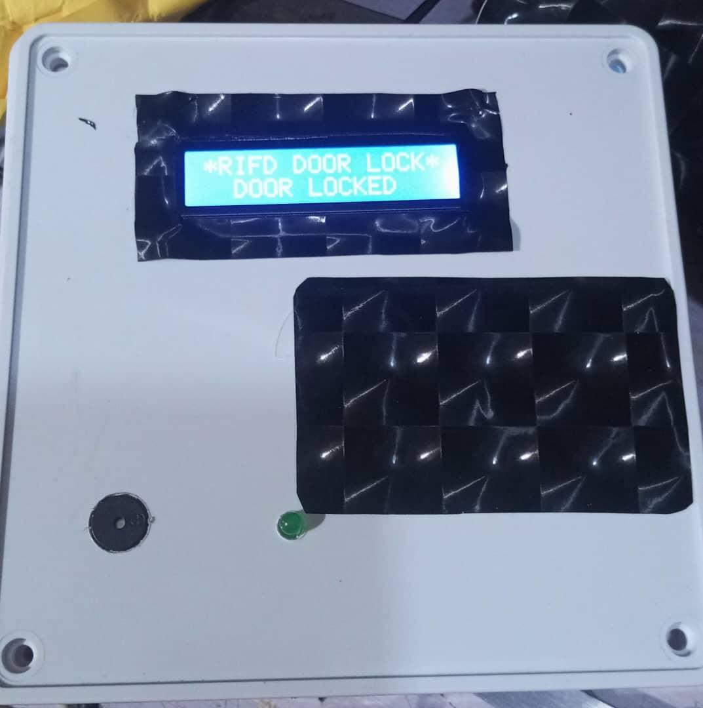
Figure 4.1: LCD Output Display Showing “Access Granted”
The LCD screen (16x2) serves as a feedback interface to display the status of each card scan. It improves system transparency and helps users understand the system's response in real-time.

4.1.2 Input Design
The main input device in the system is the RFID reader. Each user is assigned an RFID card with a unique identification code. When the card is brought close to the RFID reader, it captures the data and sends it to the Arduino for verification. The user’s RFID card data acts as the system’s credential input.
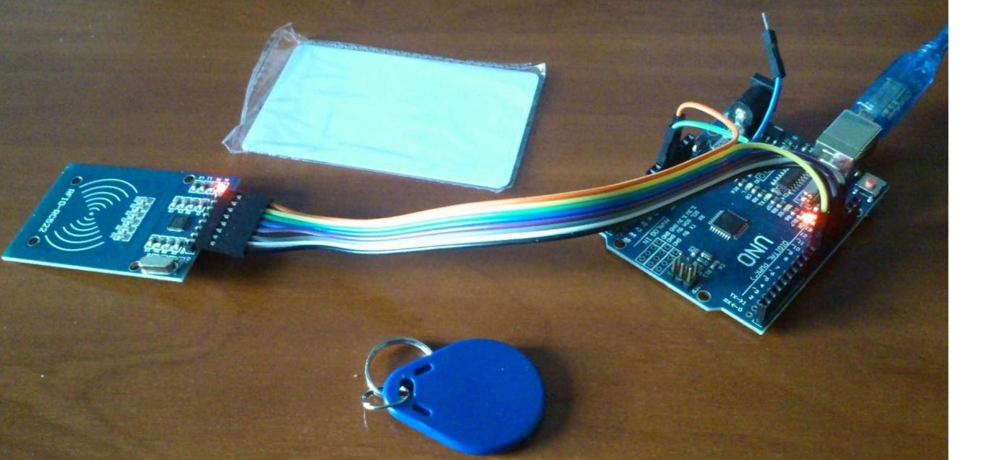 Figure 4.2: RFID Reader and Card Used for User Authentication
Additional components like the STMP power supply, Dupont wires, and Arduino board facilitate the seamless transmission and control of input signals. Input validation is handled by the Arduino microcontroller programmed to authenticate RFID tags against a predefined database of authorized entries.
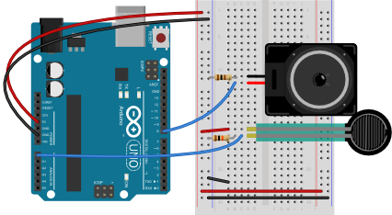
Figure 4.3: Connection of Input Devices to Arduino Board

4.1.3 Procedure Design
The system procedure follows a logical sequence:
- Power is supplied via the STMP power supply, activating the Arduino and peripherals.
- The RFID reader scans a card when placed near it.
- The scanned RFID data is sent to the Arduino via Dupont wires.
- The Arduino checks the card ID against stored valid entries in its memory.
- If the ID matches, the LCD displays “Access Granted” and triggers the unlocking mechanism.
- If the ID is invalid, the LCD displays “Access Denied” and access is denied.
Each procedure was optimized for speed and minimal power consumption, ensuring efficient real-time access control.

4.2 System Implementation
The smart door system was implemented by assembling all hardware components into a compact and functional unit. Arduino Uno serves as the central controller, coordinating input and output devices. The design was prototyped on a breadboard and later mounted inside a protective casing for durability.
The RFID module was fixed near the casing front for easy user access. All wiring was carefully done using Dupont wires for reliable connections. Power was supplied through a 12V STMP adapter, ensuring stable voltage to all components.
Programming was done using Arduino IDE, where conditional statements handle authentication and LCD display logic.

4.2.1 Hardware Support
The system is composed of the following hardware components:
- RFID Reader and Card: For authentication input.
- LCD Display: For user feedback.
- Arduino Uno: Main processing unit.
- STMP Power Supply: Provides steady voltage supply.
- Casing: Houses and protects all components.
- Dupont Wires: Connect various components.
All hardware components were integrated based on the designed circuit diagram. The system's physical construction ensures ease of use, aesthetic design, and durability.

4.3 System Documentation
System documentation includes the software code, wiring diagram, user manual, and maintenance instructions. The Arduino source code was well-commented to aid future updates or debugging. A wiring diagram visually represents how each component connects, and the user manual guides non-technical users on how to operate the system.

4.3.1 Maintenance of the System
Maintaining the smart door system involves:
- Regularly checking the power supply to prevent outages.
- Ensuring RFID cards are not physically damaged or demagnetized.
- Cleaning the RFID reader and LCD screen to prevent dust interference.
- Inspecting and tightening Dupont wire connections when needed.
- Updating the Arduino code if new cards are to be authorized or system functions upgraded.
The system was built for ease of maintenance with modular hardware that allows for quick replacement of faulty parts. Preventive maintenance ensures system longevity and operational efficiency.

CHAPTER FIVE

SUMMARY, CONCLUSION AND RECOMMENDATIONS

5.1 Summary
This research explored the design and implementation of a smart door access system that combines Arduino technology with Radio Frequency Identification (RFID) cards to provide a modern, efficient, and secure method of access control. The core motivation for the study was to address the common limitations of traditional key-based security systems, such as the risk of lost keys, duplication, or unauthorized access. With the growing need for smarter and automated solutions in both residential and commercial spaces, the project aimed to deliver a reliable system that is not only affordable but also easy to maintain and scalable.
The system was developed using key components such as an Arduino microcontroller, RFID reader and cards, an LCD screen, and a power supply unit. The design enables the door to recognize registered RFID cards and grant or deny access based on the stored data. Once a valid RFID card is detected, the door unlocks automatically, and feedback is displayed through the LCD. Unauthorized cards trigger a denial response, keeping the space secure. The design also offers potential for upgrades, such as adding more user access levels or integrating remote control capabilities.
In testing the system, it proved to be responsive, efficient, and user-friendly. One major benefit identified during the development is the low cost of the components, which makes it ideal for wide adoption in settings with limited budgets. Moreover, by using Arduino – an open-source platform – the design encourages future enhancements, modifications, and educational use.
The research highlights the practical applications of Internet of Things (IoT) technologies in real-world security challenges. It also contributes to the academic and technical discussion on how to leverage simple, cost-effective technologies to create smarter environments. This system serves as a stepping stone for more sophisticated access control mechanisms in the future.

5.2 Conclusion
The smart door access system designed in this study has proven to be an efficient and reliable solution for controlled access using RFID and Arduino technology. The integration of these components enabled the development of a system that is cost-effective, easy to deploy, and scalable. The project successfully achieved its objectives by building a functional prototype that reads RFID cards, verifies user identity, and grants or denies access based on stored data.
The contactless nature of the system eliminates the common security issues associated with traditional key systems, such as duplication and loss of keys. Additionally, the use of open-source platforms enhances flexibility, allowing further customization and upgrades.

5.3 Recommendations
Based on the research findings, it is recommended that:
- System Integration with IoT and Mobile Apps: Future versions of the smart door can be enhanced by integrating it with Wi-Fi or Bluetooth modules, allowing remote control and monitoring via mobile applications.
- Data Logging and Monitoring: Incorporate an SD card module or cloud connectivity for logging entry records. This would aid in auditing and increase accountability in access control.
- User Interface Improvements: The LCD interface can be replaced with a touch-screen module or upgraded to display multiple lines for enhanced user feedback and interaction.
- Field Deployment Testing: It is recommended that the system be tested in real-world conditions across various locations to identify practical challenges and improve performance before large-scale deployment.

REFERENCES
Adedeji, O. O. (2019). Development of RFID-enabled access control systems for smart environments. International Journal of Embedded Systems and Applications, 9(1), 25–32.
Adeyemo, A., & Bello, R. (2020). Smart door access system with fingerprint and RFID integration using Arduino. Journal of Advanced Research in Electronics and Communication Engineering, 7(2), 41–47.
Akinyemi, T. A., Bello, S. A., & Ajayi, M. O. (2021). The role of Arduino in embedded security systems: A case study of smart door systems. International Journal of Scientific Research in Engineering and Management, 5(10), 12–19.
Ali, M. A., & Anwar, H. (2019). Arduino-based smart access control using RFID and password authentication. International Journal of Computer Applications, 177(36), 1–6.
Bashiru, A., Yusuf, H., & Abdul, M. (2020). Design of a solar-powered smart home security system using Arduino. Journal of Sustainable Technology, 11(2), 89–97.
Eze, J. C., Nwokoye, N. U., & Obi, M. C. (2022). Enhancing residential security with Arduino-based smart locks. Nigerian Journal of Information Technology and Security, 8(1), 66–75.
Ibrahim, L. M., Musa, I., & Salihu, H. (2019). Implementation of smart doors using biometric and sensor technologies. Nigerian Journal of Engineering Research and Development, 18(3), 44–53.
John, D., & Adamu, A. (2018). Design and implementation of smart door access system using RFID technology. International Journal of Engineering and Technology, 7(4), 78–84.
Khan, M. A., & Malik, A. (2017). Security and implementation challenges in smart door systems using embedded technologies. International Journal of Computer and Electronics Research, 5(2), 20–26.
Kumar, V., Sharma, P., & Patel, R. (2018). Embedded security systems: The future of smart access in high-risk environments. International Journal of Research in Computer Engineering and Electronics, 6(1), 51–58.
Mohammed, A. H., Usman, T., & Kolo, A. (2019). Security considerations for RFID-based smart door systems. Nigerian Journal of Cybersecurity, 4(2), 33–42.
Nwachukwu, C. F., Adebanjo, T. A., & Emeh, G. O. (2023). IoT-based smart security architecture for home automation using Arduino. West African Journal of Internet of Things and Security, 3(1), 59–70.
Olawale, J. T., Fadeyi, B. M., & Ogundele, K. A. (2020). Development of a smart door security system using Arduino and GSM. African Journal of Computing and ICT, 13(2), 85–92.
Oladele, S. A., Amusa, F. T., & Salami, K. O. (2018). RFID-based access control system for low-income housing. Nigerian Journal of Electrical and Control Systems, 5(2), 72–79.
Okeke, M. C., Udeagha, E. O., & Obi, P. J. (2021). Smart home applications of Arduino-based automation systems. Nigerian Journal of Electrical Engineering and Automation, 7(4), 101–109.
Olayemi, D. M., & Okoro, C. N. (2019). Automated door access system using Arduino and Bluetooth. International Journal of Wireless and Mobile Networks, 11(6), 29–37.
Sarhan, Q. J., Younis, S. A., & Ahmad, K. A. (2017). Development of a low-cost Arduino-based access control system. International Journal of Computer Applications, 164(3), 35–39.
Singh, R., Rathi, R., & Patel, N. (2020). Multi-factor biometric authentication in smart door systems. Journal of Security and Communication Networks, 2020, Article ID 3439172, 1–10.

