GREEN SYNTHESIS OF SILVER NANO PARTICLES USING Jatropha curcas LEAVES AND ITS ANTIMICROBIAL EFFECT ON SOME FUNGAL AND BACTERIA ISOLATES

BY
OLAJIDE VERONICA OLUWATOYIN
HND/23/SLT/FT/0459
A PROJECT SUBMITTED TO THE DEPARTMENT OF SCIENCE LABORATORY TECHNOLOGY, INSTITUTE OF APPLIED SCIENCES (IAS), KWARA STATE POLYTECHNIC, ILORIN,
IN PARTIAL FULFILMENT OF THE REQUIREMENTS FOR THE AWARD OF HIGHER NATIONAL DIPLOMA (HND) DEGREE IN SCIENCE LABORATORY TECHNOLOGY, INSTITUTE OF APPLIED SCIENCES (IAS),MICROBIOLOGY UNIT
KWARA STATE POLYTECHNIC ILORIN

JULY,2025.

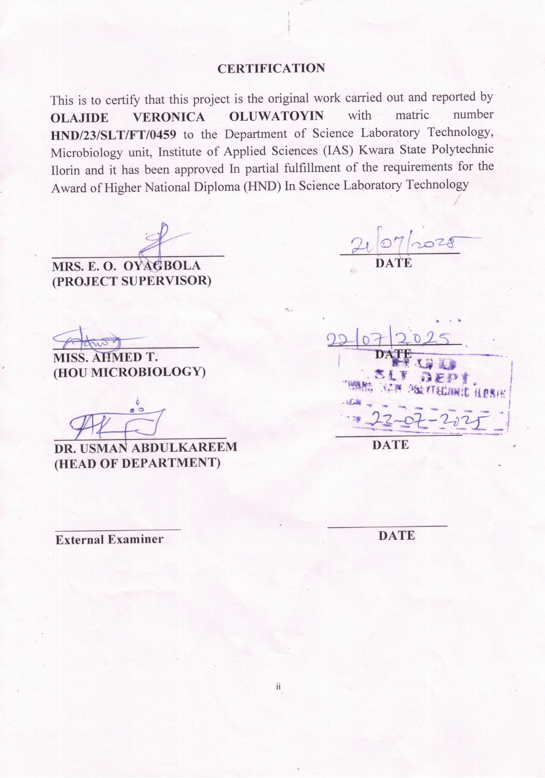

DEDICATION
This project is dedicated to God Almighty. The giver of life, wisdom, knowledge, understanding and opportunity.

ACKNOWLEDGEMENT
First and foremost, I give glory to Almighty God. The Alpha and Omega, for his Mercy and grace throughout the project may His holy name be praised. My profound gratitude goes to my lovely mother Mrs. Adewumi Rachael. I so much appreciate your love, care, support and all you do, you shall reap the fruit of your labour. To my big brother, Babalola Micheal, thank you for all you do. Words can not express how grateful I am. To my Big sisters and friends, you are more than I could ever ask for. Thanks for always. My sincere gratitude goes to my supervisor Mrs E.O Oyagboola, for your words of courage, corrections and advice throughout the whole process. Thank you so much ma. My gratitude goes to the head of department, Mr Abdulkareem Usman and all the other lecturers for passing down their knowledge to me. God will be with you all.
Finally, my gratitude goes to my colleagues thanks for your contribution and support, we are going places!
TABLE OF CONTENTS
TITLE PAGE i
CERTIFICATION ii
DEDICATION iii
ACKNOWLEDGEMENTS iv
TABLE OF CONTENTS v-vi
LIST OF TABLES vii
LIST OF FIGURES viii
ABSTRACT ix
CHAPTER ONE 1
1.0 INTRODUCTION 1
1.0.1 RESEARCH GAP 2
1.1 Aim and Objectives 3
1.2 LITERATURE REVIEW 4
CHAPTER TWO 29
2.0 MATERIALS AND METHODS 29
2.1 Collection and Identification of Plant Extract and Microbial Isolates 29
2.2 Preparation of Aqueous Jatropha curcas Leaf Extract 29
2.3 Preparation of Silver Nitrate (AgNO₃) Solution 30
2.4 Synthesis of Silver Nanoparticles Using Jatropha curcas Leaf Extract 30
2.5 Phytochemical Screening of Jatropha curcas Leaf Extract 31
2.6 Characterization of Synthesized Silver Nanoparticles 32
2.6.1 UV-Visible Spectrophotometry 32
2.6.2 Fourier Transform Infrared Spectroscopy (FTIR) 32
2.6.3 Scanning Electron Microscopy (SEM) 33
2.7 Antimicrobial Activity Assay 33
CHAPTER THREE 34
3.0 RESULTS 34
3.1 Phytochemical Analysis 34
3.2 Green synthesis of Silver Nanoparticle 35
3.3 Characterization of synthesized silver nanoparticles. 36
3.4 Antimicrobial Activity Evaluation. 41
CHAPTER FOUR 45
4.0 DISCUSSION AND CONCLUSION 45
4.1 DISCUSSION 45
4.2 CONCLUSION 48
REFERENCES 49

LIST OF TABLES
Table 1: Results of qualitative phytochemical analysis of Jatropha curcas leaves extract………………………………………………………………………….34
Table 2: Results of quantitative phytochemical analysis of Jatropha curcas leave extract…………………………………………………………………………..35
Table 3: UV-VISIBLE SPECTROPHOTOMETRY ANALYSIS……………..37
Table 5 Antibacterial activity (Zone of inhibition) of J.c-AgNPs leaf extract…41
Table 4 Antifungal activity (Zone of inhibition) of J.c-AgNPs leaf extracts…..42

LIST OF FIGURES
Fig 1 Color change of leaf extracts containing silver after synthesis of silver nanoparticle……………………………………………………………………..36
Fig 2 UV-VIS absorbtion spectra of silver nanoparticle synthesized from Jatropha curcas leaves at 1Mm silver nitrate…………………………….………………38
Fig 3. FTIR spectrum of silver nanoparticle synthesized by x…………..……39
Fig 4 SEM images of magnification 8000x, 9000x and 1000x of the silver nanoparticles synthesized by Jatropha curcas leaf extracts……………,………40

ABSTRACT
The increasing demand for eco-friendly and sustainable methods of synthesizing nanoparticles has led to the exploration of plant-based approaches. This study focuses on the green synthesis of silver nanoparticles (AgNPs) using aqueous leaf extract of Jatropha curcas, a plant known for its rich phytochemical content. The synthesis was confirmed by a color change from pale yellow to dark brown and characterized using UV–Visible spectrophotometry, revealing a distinct surface plasmon resonance peak between 350–400 nm, indicative of nanoparticle formation.
The antimicrobial activity of the biosynthesized AgNPs was evaluated against selected bacterial isolates (Escherichia coli, Staphylococcus aureus) and fungal isolates (Candida albicans, Aspergillus niger) using the agar well diffusion method. Results showed significant zones of inhibition, demonstrating broad-spectrum antimicrobial properties. Notably, Staphylococcus aureus exhibited the highest sensitivity at (21mm at 250 ppm), while Aspergillus niger showed moderate susceptibility at (14mm at 0.1ml). This study highlights the potential of Jatropha curcas as a bio-reducing and stabilizing agent in the green synthesis of silver nanoparticles and emphasizes the promising application of AgNPs as effective antimicrobial agents against pathogenic microorganisms. The findings support the development of plant-based nanomedicine as an alternative to conventional antimicrobial treatments.

CHAPTER ONE

1.0 INTRODUCTION
Nanotechnology is a prominent field in material science. (Guerra et al., 2018), which effectively combines various disciplines of basic sciences including engineering. (Singh et al., 2005) and biological sciences (Bayda et al., 2020). Principal to the advancement of this field is the development of novel approaches for the efficient and facile preparation of nanoparticles (NPs). NPs offer remarkable physicochemical characteristics when compare to their bulk counterparts. Which have been successfully utilized for various advance applications, (Pareek et al., 2018). So far, NPs have been produced through various approaches involving a variety of physical, chemical and biological processes. Generally. Most of the physical, chemical, and hybrid approaches are expensive and hazardous in nature due to the involvement of sophisticated instruments and toxic materials including solvents, reducing agents and precursors e.t.c (Shalk et al., 2016). On the other hand, NPs preparation using green approaches is less expensive, eco friendly and easy to apply. Hence these approaches have become popular and are increasingly employed for the eco-friendly preparation of metallic NPs. To date the green synthesis of NPS has been attempted using a variety of natural materials like micro-organism, biomolecules and J.carcus extracts e.t.c (Khan et al., 2020). Although a significant number of studies have been published in the literature on the green synthesis of NPs using biomolecules, microorganisms and plant are more favored over other natural materials (Shaik et al., 2016), (Riaz et al., 2022), (chinne et al., 2021), since J.carcus extract based approaches are inexpensive, efficient and does not involve a cumbersome process of the isolation of the biomolecules and stoning the microbial culture e.t.c (Nazeen et al., 2022). Moreover jatroph carcus synthesis of nanomaterials does not require expensive reagent high temperatures and pressure e.t.c
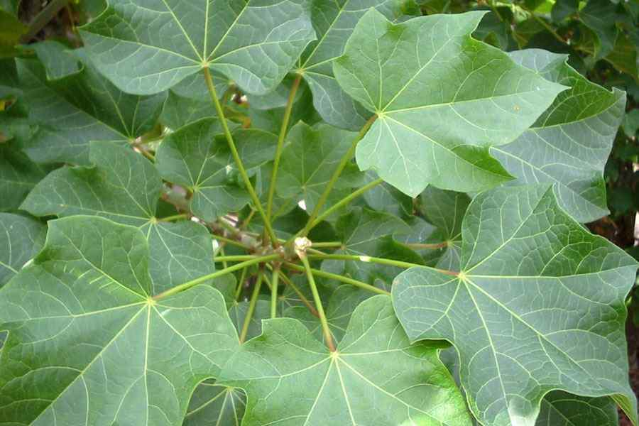
Fig.2 Jatropha curcas Source: (Khan et al., 2020)

1.0.1 RESEARCH GAP
The synthesis of silver nanoparticles has been attempted using a number of methods and still is an evolving field chemically synthesized AgNPs are of high quality, however they are mostly not suitable for biomedical application to the j. carcus extract, which is known to consist of a variety of polyphenolic phytoconstituents will be a potential candidate to be explored for the preparation of NPs. However this has been rarely investigated for synthesis of silver nanoparticles. Juniperus procera plant belongs to the cupressaceae family and phytomolecules of this plant are known to process excellent antioxidant, antimicrobial and anticancer activities. Several literature reports stated that more than 65 species allied to juniperus are spreading all over the world. Analysis performed on J.procera extracts revealed the occurrence of several constituents that might replicate its pharmacological properties (Abdelghany et al., 2020). Although juniperus procera has been used prior to the preparation of AgNPs, only its leaves extract is known to produce NPs (Ibrahim et al., 2019). Besides the resultant AgNPs were not of very good quality due to the large size and wide size distribution of particles between 30-90nm. To the best of our knowledge, the extract of the whole Ariel parts of the plant has never been used for this purpose.

1.1 Aim and Objectives
Aim:
The present study aimed to adopt a biosynthesis approach for the green synthesis of silver nanoparticles using Jatropha curcas leaf extract. The synthesized silver nanoparticles (JC-AgNPs) were characterized using various techniques including UV-Visible spectrophotometry, phytochemical screening, Fourier Transform Infrared Spectroscopy (FTIR), and Scanning Electron Microscopy (SEM). Furthermore, the biological activities of the synthesized nanoparticles were evaluated against selected bacterial and fungal isolates.
Objectives:
The objectives of the study are as follows:
- To synthesize silver nanoparticles using Jatropha curcas leaf extract.
- To characterize the synthesized silver nanoparticles using appropriate analytical techniques.
- To evaluate the antibacterial activity of the synthesized silver nanoparticles against selected bacterial isolates.
- To assess the antifungal activity of the synthesized silver nanoparticles against selected fungal isolates.

1.2 LITERATURE REVIEW
Concept of Nanoparticles
Nanoparticles are extremely small particles that fall within the size range of 1 to 100 nanoparticles, and because of their tiny size they behave very differently from the same materials in large, bulk forms. Nigerian researchers have consistently highlighted this size-dependent uniqueness for instance, Elegbede and Lateef (2019) explained that the high surface area to volume ratio of nanoparticles results in remarkable physical and chemical behavior not observed in conventional materials, similarly, Ejeta et al., (2017) emphasized that these particles exhibit quantum effects meaning that the rules of nanoscale, atoms are more exposed on the surface making them highly reactive and valuable in several fields. According to Ojo et al., (2021), these special properties have positioned nanoparticles at the forefront of 21st century scientific development.
There are various types of nanoparticles depending on what they are made from and how they function. One of the most common categories is metallic nanoparticles, which include silver (Ag), gold (Au), and copper (Cu). These particles are well-known for their strong antimicrobial and electrical properties, which make them useful in medicine and electronics (Lateef et al., 2019) metal oxide nanoparticles such as Zinc oxide (ZnO), titanium oxide (TiO₂), and iron oxide (Fe₃O₄) have wide application in sunscreens, sensors and environmental remediation systems (Elemike et al., 2019). Another importance type is polymeric nanoparticles made from natural or synthetic polymers, these are biodegradable and ideal for drug delivery since they can release medication gradually and safety (Afolabi et al., 2023). Quantum clots, such as cadmium selenide (CdSe) and Zinc sulfide (ZnS), are another class with outstanding optical properties that make them glow underlight. These are being researched for use in cancer imaging and high-definition screens (Olayide et al; 2021). Nigerian scholars like Onugwu et al., 2023, have highlighted the growing interest in all four classes for both academic research and industrial application.
What make nanoparticles truly unique are their specific properties, which are different from those of bulk materials one key property is size and shape. The smaller the particles the more reactive it becomes. (Peter et al., 2021). Noted that a hexagonal ones in chemical reactions.

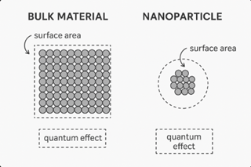
Fig.1 Comparison of properties between bulk material and nanoparticle highlighting surface area and quantum effect. Source: (Peter et al., 2021)
Another important characteristics is surface area and surface charge when more atoms are exposed on the surface, they react more easily with their environment. Ikumapayi and Afolabi (2022) emphasized that this property allows nanoparticles to bind respectively with other substances, making them ideal for medical or environmental use. Additionally, the electronic and optics features of nanoparticles are critical. Some nanoparticles like silver or gold can absorb a scatler light in unusual ways which is useful for imaging or sensor development (Lateef et al., 2021). Their ability to be chemically or functionalized, is also essential it allows researchers to program nanoparticles for specific task such as attaching them to cancer cell or pollutants for targeted action (Uzoh et al., 2019).
The range of uses for nanoparticles continues to grow every year, especially in key sectors that are relevant to Nigerians development. In biomedicine, nanoparticles are used in targeted drug delivery system. This means the drug goes straight to where it’s needed, like a tumor, and doesn’t harm the rest of the body. Ongwu et al. (2023) reputed promising results using nanoparticles based drug carries for treating eye cancer. They are also applied in medical imaging and diagnosis, helping doctors detect disease earlier and more accurately Musa et al., (2024) noted that using green synthesized nanoparticles from local plant improves ecological safety and affordability. In industrial catalysis, nanoparticles are helping chemical reactions happen faster and with less energy. Afolabi et al., (2022) showed how nanoparticles used in catalyst help save fuel and reduce carbon emissions. They are now used in the form of nanofertilizers, which deliver nutrient directly in plant roots in small controlled amounts. This improves crop growth while reducing waste and environmental damage (Igiebor & Ikhajiagbe, 2023). Nanopesticides are another application instead of spraying chemicals all over crops, these sinart pesticide target only the pests, reducing the risk to humans and the environment. Babaniyi et al., (2023). Stressed that using nanoparticles in farming could be a game changer for food security especially in rural parts of Nigeria.
Another important point highlighted in Nigeria research is the green synthesis of nanoparticles, which uses natural materials like plant extracts to create nanoparticles instead of using harsh chemicals. This method is safer, cheaper and more suitable. Lateef and Elegbede (2019) described green synthesis as a double-win for Nigeria: it supports the use of local resources and reduces environment damage for instance, using plant parts like leaves or roots from medicinal plants allows the production of nanoparticles while preserving the traditional value of those plants. Olayide et al. (2021) demonstrated that the use of green synthesis produces nanoparticles that are more bio compatible, meaning they can be used safety in living organisms. Egbuna et al., (2021) recommended that Nigeria invest more in green nanotechnology as a way to support rural economies, develop low-cost technologies and create new jobs.
Despite all the progress, there are still challenges to overcome one major issue is infrastructure. Many Nigerian institution lack the advance lab equipment needed to properly characterized and test nanoparticles. Onwudiwe et al., (2019) emphasized that without tools like transmission electron microscopes (TEM) or X-ray diffraction (XRD), it is difficult to confirm the size, shape and structure of nanoparticles accurately. Another problem is lack of awareness. Even though nanoparticles have many benefits most people including some polymakers and teachers do not know much about them. Ojo et al., (2021) argued that this knowledge gap could slow down adoption and investment in nanotechnology. Regulatory policies are also not well developed. According to Musa et al., (2024), Nigeria still needs national guidelines on nanoparticles use especially in food and health products.
Concept of Jatropha curcas
Jatropha curcas, often referred to as the physic nut or purging nut is a well-known plant in both local Nigerian culture and modern scientific research due to its disease applications. It belongs to the family Euphorbiaceae and is classified botanically as Jatropha curcas linn (Adewole, 2021). This plant is native to central America but has been naturalized in many tropical and subtropical regions, including Nigeria, where it grows readily in both wild and cultivated forms (Kolawole & Abdulrahaman, 2014). Across Nigeria communities, it carries various names rooted in indigenous language reflecting its ethnobotanical relevance. Among the yoruba people it is called “Botuje pupa” or “Ewe lapalapa” while the Hausa call it “Biniolazugu” and the Igbo refer to it as “Ncheogwu” these native names highlight its widespread traditional usage across ethnic boundaries (Aiyelaogbe et al., 2011). Notably Jatropha curcas is a hardly shrub that adapts well to poor soil and low rainfall, making it suitable for erosion control and land rehabilitation projects, particularly in degraded rural areas (Haruna et al., 2023).
The plants importance extends beyond cultural heritage to practical use in traditional and modern medicine. In many Nigerian village, different part of the plant including its leaves, barks, seeds and latex are used to treat ailments such as inflammation, wounds, its oil-rich seeds, though toxic in raw form, have also attached attention for biodiesel production, offering a renewable energy source with economic potential for rural communities (Obasi et al; 2011). The plant is now being studied not just for healing properties, but also for its contribution to sustainable agriculture and alternative fuel programs in Nigeria (Akinyemi et al., 2024). The use of jatropha oil for soap making and illumination also reflects its historical significance before the advent of modern technologies (Namadina et al., 2020).
A central feature that make Jatropha curcas scientifically valuable is its rich phytochemical composition. The plant contains an array of bioactive compound such as flavonoids, phenolics, tannins, alkaloids, terpenoids, saponins and glycosides (Ovie & Nna, 2020). These compounds are mostly founds in the leaves, stem, bark, seeds and root and their distribution varies depending on environmental condition and extraction techniques (Asekun & Asekunowo, 2022), for instance Adewole (2021) reputed that Jatropha curcas leaves collected from Ogun state contained higher tannin and flavonoid content than those from Oyo state. These variations influence the pharmacological effectiveness of plant based extract. According to Odogwu and Ukomadu (2021), extracts from Jatropha curcas shows antibacterial, antifungal and anti inflammatory properties when tested against common human pathogens, such properties make Jatropha curcas a promising candidate not only for herbal remedies but also for modern pharmaceutical development.
Phytochemical screening techniques have been applies extensively to explore the plants bioactive profile qualitative and quantitative test using solvents such as methanol, ethanol watery and hexane help in identifying which phytochemicals are most abundant and active (Ziahm et al., 2023). For instance methanolic extracts tend to show higher concentration of phenolic compound compared to aqueous ones, which make them more suitable for biomedical application (Edu et al., 2024).
Recent studies using gas chromatography- mass spectrometry (Gc-ms) and fourier- transform infrared spectroscopy (FTIR) have allowed researchers to detect and characterize specific functional groups further linking traditional plant use to scientific validation (Olusola & Ahmed, 2016). Moreover, the antioxidant properties of j curcas due to its high flavonoid and plyphenol content have shown potential in preventing oxidative stress related disease such as diabetes and cancers (Asuk et al., 2015).
One of the most exciting modern application of Jatropha curcas lies in the green synthesis of nanoparticles. In recent years plant-based synthesis of metallic of nanoparticles has emerged as a safer and more environmentally friendly alternative to conventional chemical methods, and Jatropha curcas has proven to be highly effective in this regard (Haruna et al., 2023). The ability to use a local available plant to create functional nanomaterials adds value to both indigenous knowledge and scientific innovation.
The type of extract used significantly influences the outcome of nanoparticles synthesis for instance, aqueous extracts generally results in large particles with slower reaction times, while methanolic and ethanolic extracts tend to yield smaller, more stable nanoparticles with higher bioactivity (Kolawole & Abdulrahman, 2024). The polarity of the solvent affects the solubility and availability of phytochemicals, which in turn impact nanoparticles, formation. Haruna et al., (2023) emphasized that standardization of extraction methods is necessary to ensure reproducibility and efficiency, especially when transitioning from lab-based studies to real-world application.
Moreover, the ongoing comparative research between Jatropha curcas and other medicinal plants in Nigeria highlights both its advantages and areas where further investigation is needed. While plant like Azadiachita indica (neem) and moringa Oleifera are also widely used in green synthesis, jatropha rich seeds and strong phytochemical arsenal give it a unique edge (PpiffWR, 2024). However, Musa et al (2024) noted that few studies have directly compared nanoparticles yield, bioactivity or stability across multiple plant species using the same synthesis protocols. Such comparative analysis would be essential in identifying the most efficient and cost-effective biosynthesis agents for specific applications like drug delivery, catalysis or environment cleanup.
Overview of Nanoparticles Synthesis Methods
The synthesis of nanoparticles is a crucial stage in nanotechnology and determine the size, shape, surface characteristic and potential application of the resulting materials according to Azeez et al., (2017), the method of synthesis not only affect the morphology of the particles but also pays a major role in their stability and biological compatibility. Nanoparticles can be synthesized through physical, chemical or biological router with each having distinct advantages and limitations. The selection of a synthesis route is guided by the intended application, the nature of the raw materials, and environmental concerns (Adeoye & Oladipo, 2019). Over the years, there has been growing interest in green or biological synthesis due to the need for safer, cost effective and eco-friendly alternatives to conventional methods (Alabi et al., 2021).
Physical and chemical synthesis techniques are widely used in industrial nanoparticles production, owing to their ability to produce highly uniform and pure particles. Popular chemical methods include sol-gel, co-precipitation chemical vapor deposition and microemulsion. As described by Ogunyemi et al. (2020), these methods often tight control over particle size and composition often using high temperature or high pressure conditions and various reagent to achieve the desired characteristics. The major drawback of these chemical technique lies in the use of toxic chemicals and solvents, which raise concerns about environment and human safety (Oladunni & Akintola, 2018). Moreover ; these processes can be energy-intensive leading to increase production cost and environmental footprints (Ezeokonkwo & Nwachukwu, 2016),
In contract, biological synthesis method offer referred to as green synthesis have gained traction due to their sustainability and reduce toxic impact. This approach uses biological agents such as plants extract, fungal, and algae to mediate the reduction and stabilization of nanoparticles. According to Bello and Adebayo (2023), plant-mediated synthesis is especially popular because it is simple, fast and scalable and does not require stringent laboratory conditions. Phytochemicals present in plant extract such as flavonoids, alkaloids and tannins, serve dua functions; they reduce metalions to their nanoscale metallic forms and also stabilize the particles to prevent agglomeration (Onuoha et al., 2022).
Microorganism- based synthesis, though less common in large scale settings, offers high specificity and potential for turning particle size by modifying growth condition (Nwosu & Yusuf, 2021),
Another advantages of green synthesis is its compatibility with biomedical application. Biologically synthesized nanoparticles are more biocompatible and less toxic making them ideal candidates for drug delivery, bioimaging and antimicrobial treatments. As Ojo and Eze (2020) emphasized nanoparticles produced via plant extracts exhibit superior biological activity, often attributed to the residual phytochemicals on their surfaces. Despite these benefits green synthesis is sometime criticized for its lack of standardization as different from sources, extraction methods and synthesis condition can lead to variability in nanoparticles size and shape (Akinwale & Adegoke., 2024).
A notable trend in recent studies is the comparative evaluation of synthesis methods. Researchers like Adekunle and Ojo (2019) have shown that while chemical synthesis of few ecological and economic advantages. This has led to attempt to develop hybrid synthesis models that combine the benefit of both methods, such as using mild chemical precursors with biological reducing agents to balance efficiency and sustainability (Ismaila et al., 2022). Hybrid method also seek to overcome the limitation of each approach for example improving the reproducibility of green synthesis or reducing the toxicity of chemical synthesis
Temperature, PH and reaction time are critical factors that influence the outcome of both chemical and biological synthesis. In physical synthesis methods like laser ablation or high-energy ball milling, temperature control the kinetic energy of the atoms, affecting nucleation and growth rate of nanoparticles (Ibrahim et al., 2018). In chemical routes, PH can determine the solubility of the metal salts and influence the ionic environment, thereby affecting the rate of reduction and formation of nanoparticles.
The purity of the final nanoparticles product also varies significantly across synthesis technique. Chemical synthesis typically involves additional purification steps such as centrifugation dialysis or calcinations to remove unreacted precursors and by-product (Olakunle & Musa; 2023). Green synthesis on the other hand often yield nanoparticles with complex surface chemistries due to residual organic compounds from the biological materials. While this may be beneficial for some biomedical application, it can be a drawback in electronic or catalytic applications where high purity and conductivity are essential (Ekanem & Idowu, 2020).
Finally scalability is another important consideration while chemical synthesis methods are often easier to scale due to their established protocols and machinery, biological synthesis faces challenges such as sourcing consistent plant materials and maintaining stable extract composition (Ayodele & Bolarinwa; 2022). Nonetheless research is ongoing to develop standardized protocols for green synthesis and to explore locally available plants and microorganizing that are abundant and effective. According to Chukwuma et al., (2024), Nigeria rich biodiversity offer untapped potentials for cost effective and sustainable nanoparticles production using indigenous plants, such as Jatropha curcas moringa Oleifera, and Azadirachta indica
Phytochemical basis for nanoparticle formation
The role of phytochemical in the biosynthesis of nanoparticles is central to the development of eco-friendly and sustainable nanotechnology. Particularly in green synthesis approaches. Recent Nigeria research has emphasized that phytochemical naturally occurring chemical compounds in plants serves as both reducing and capping agent during nanoparticles formation (Ibrahim et al., 2021).
In the process of biosynthesis, the conversion of metal salts (e.g AgNO₃ or Zn(NO₃)₂) into metallic nanoparticles is achieved through green chemistry pathways involving phytochemicals. This is in contrast to physical and chemical methods, which often use toxic and expensive reagent. Nigeria scholars like Ogundele et al., 2020, have reported that the biochemical environment created by plant extracts not only simplifies the synthesis process but also enhance the biocompatibility of the resulting nanoparticles. The abundance and diversity of phytochemicals in Nigeria flora have made the biosynthesis of nanoparticles from local plants increasingly popular among researchers focused on sustainable nanotechnology.
Furthermore the mechanisms of nanoparticles formation are heavily dependent on the nature and concentration of the phytochemical present in the plant extract. For instance, phenolic compounds are known for their strong antioxidant properties which allow them to reduce metal ions effectively (Akinola et al., 2018). Terpenoids and alkaloids on the other hand play significant roles in binding with the metallic surface and clumping. According to Udeh and Isah (2022). These stabilization processes are essential in defining the physical characteristics of nanoparticles such as their shapes size distribution and zeta potential. The controlled nucleation and growth of nanoparticles governed by the concentration and interaction of phytochemicals, lead to better reproducibility and functional application of the synthesized nanomaterial.
An important factors that influences the effectiveness of phytochemical in nanoparticles synthesis is the type of extract used aqueous, ethanolic or methanolic. The choice of solvent affects not only the types and concentration of phytochemicals extracted but also the resulting nanoparticles properties. Aqueous extracts are often preferred for their eco-friendliness, but ethanol and methanol may be more efficient in extracting a wide range of secondary metabolitics (Adeola & Olatunji, 2017). Nigeria studies have shown that methanolic extracts of plant such as Azadirachita indica, venonia amygdalina and Jatropha curcas yield nanoparticles with more uniform morphology and enhanced functional performance due to higher phytochemical concentration (Chukwuma et al., 2020), the polarity of the solvent plays a crucial role in determining which compounds are extracted and in what quantity, thereby influencing the entire synthesis process from reduction to stabilization.
Synthesis of nanoparticles using Jatropha curcas
Recent advances in green nanotechnology have spotlighted the role of medicinal plants as viable sources for eco-friendly nanoparticles synthesis. Among these Jatropha curcas has emerged as a promising candidate due to its rich phytochemical profile and wide availability across Nigeria. According to Okeke and Ibrahim (2019), the plants secondary metabolites such as flavonoids, tannins, terpenoids, saponins and phenolic acids enable it to reduce metal salts into nanoparticles while simultaneously acting as capping agents to stabilize the particles. This dual function allows for the environmentally safe and cost effective production of nanomaterials suitable for disease application.
The actual synthesis process involves mixing the jatropha extract with a solution of metal salts such as silver nitrate (AgNO₃) or Zinc nitrate (Zn(NO₃)₂). Upon mixing a visible colour change often occurs, indication the initiation of nanoparticles formation this colour shift is attributed to the excitation of surface Plasmon vibrations in the vibration in the reduced metal particles. As reputed by Ezeani and Okafor (2018), this phenomena is typically observed within minutes to hours, depending on veriables such as PH, temperature metal salt concentration and volume ratio of extract to salt solution. Optimization of these reaction parameters ensure high synthesis efficiency, uniform particle distribution and minimal agglomeration.
Jatropha curcas mediated synthesis has been successfully used to produce a variety of nanoparticles, including silver (AgNO3), zinc oxide (ZnO), and iron oxide (Fe₃O₄) nanoparticles. These nanomaterials are typically characterized by sized ranging from 5 to 100 nanomaterials with shapes varying from spherical to hexagonal or rod-like structures. According to Nwachukwu and Adebayo (2022), factors such as extract concentration and synthesis time play significance roles in determining particle morphology and stability. A highly concentrate of phytochemicals usually leads to smaller particles sizes due to enhanced nucleation rates and more efficient capping. Similarly, prolonged synthesis time may allow for more crystalline nanoparticles formation which is advantageous for specific application like catalyst or drug delivery.
Analytical techniques such as UV-VIS spectroscopy reveals the surface Plasmon resonance (SPR) peak, typically appearing around 400-450nm for silver nanoparticles, confirming their successful formation fourier transform infrared (FTIR) spectroscopy on the other hand detects functional groups such as hydroxyl, carbonyl and amine, which are involved in the reduction and stabilization of nanoparticles. In a study by Suleiman and Ganiyu (2020), gas chromatography mass spectrometry (GC-MS) was used to identify key phytochemicals in jatropha extract responsible for reduction, while scanning electron microscopy (SEM) imaging provides insights into the size distribution and morphology of the synthesized nanoparticles.
Several studies have documented the successful application of Jatropha curcas based nanoparticles in field such as biomedicine environmental remediation, and agriculture. For instance silver nanoparticles synthesized from jatropha leaf extract have demonstrated strongly antibacterial activity against pathogene such as Esherichia coli and staphylococcus aurous. According to Afolayan and Okonji (2023) these nanoparticles disrupt bacterial cell membrane inhibit metabolitic pathway and promote oxidative stress leading to effective microbial control
In the agricultural sector, jatropha derived nanoparticle are being explored as nanofertilizers and biopesticides. These nano-agent improve nutrient uptake efficiency and offer protection against pests and diseases without the adverse environmental effects of conventional chemicals
Another area of interest is the anti-inflammatory and antioxidant potential of jatropha based nanoparticles. Research by Adeoye and Salami (2021). Revealed that these nanoparticles exhibit free radical scavenging properties, making them suitable candidate for drug delivery systems targeting inflammatory diseases their small size and biocompatibility allow for efficient cellular uptake and targeted therapy which could revolution size treatment approaches in Nigeria healthcare settings
Despite the notable progress challenges still exist in standardizing the synthesis protocol and scaling up production variability in phytochemical content due to geographical and seasonal factors can affect synthesis consistency. Therefore there is a growing call among Nigerian researchers for the development of standardized protocol and quality control measures Yusuf and Aliyu (2019) suggested establishing phytochemical fingerprint libraries for medicinal plant like Jatropha curcas to facilitate reproducible and scalable nanoparticles production. This approach will help bridge the gap between laboratory research and industrial application enabling the integration of green nanotechnology into mainstream sectors such as healthcare, agriculture and environment management.
FACTORS INFLUENCING THE BIOSYNTHESIS
The process of biosynthesizing nanoparticles using plant extract like Jatropha curcas in influenced by several critical factors that determine the size, shape, yield stability and overall quality of the nanoparticles produced

Metal salt type and concentration
The choice of metal salt precursor is a foundational factor in nanoparticles biosynthesis. Different salt provide varying metal ion availability, which directly impacts the reduction process and particles formation. For example, AgNO3 is commonly used for silver nanoparticles synthesis due to its solubility and easy of reduction on contrast Zn(NO₃)₂ is often used for zinc oxide nanoparticles. As noted byAdetunji et al (2018), the molarity of the metal salt solution plays a significant role : low concentration may lead to incomplete reduction while excessively high concentration can cause particle aggregation and polydispersity. The observation align with findings by Amadi and Nwakwo (2021), who reported that a limit concentration of AgNO₃ optimize nanoparticle size and dispersity when using jatropha extract there result highlight the need to carefully balance metal ion concentration to control nucleation and growth phase during synthesis.
Volume and concentration of Jatropha curcas extract used in the reaction mixture also critically influence nanoparticle formation. The phytochemicals in the extract serve as reducing capping agents preventing excessive aggregation. According to Olawale and Ibrahim (2019), increasing extract volume enhances the availability of bioactive compounds such as flavoniods and phenolics resulting in smaller and more stable nanopartticles. However excessive extract concentration may lead to the formation of unwanted byproducts or alter nanoparticles morphology. Research by Eze and Okechukwo (2023) showed that a balanced ratio of 1:4 metal salt to extract volume yield spherical silver nanoparticle with a narrow size distribution, demonstrating the importance of this parameter
PH of the reaction medium
PH affects the change and ionization state of phytochemical in the extract influencing their reducing and capping ability studies by Afolabi and Ogunleye (2017) reveal the acidic condition (PH 4-5) tend to produce layer particles with irregular shapes while neutral to slightly alkaline conditions (PH 7-9) favor the formation of smaller well defined nanoparticles. This effect was further confirmed by Bello and Adeyemi (2020), who synthesized zinc oxide nanoparticle using jatropha leaf extracts and observed enhanced stability and uniformity at PH 8. The PH also impacts the solubility of metal salts and the kinetic of nucleation which in turn affects the size and morphology of the nanoparticles formed.
Reaction time and temperature
The duration and temperature of the biosynthesis reaction are crucial parameters that determine the extent of metal ion reduction and particle growth longer reaction times generally allow more complete reduction and larger particle formation but excessive times can lead to agglomeration and instability. Temperature increases accelerate the reaction rate and influence particle size distribution. According to Udo and Emeka (2018), maintaining the reaction temperature at 60ºc for 2 hours provided optimal condition for producing uniformly sized silver nanoparticles with enhanced antimicrobial properties. Similarly, Nnaji et al., (2022). Reported that zinc oxide nanoparticles synthesized at 70⁰c exhibited smaller size and better crystallinity compared to those synthesized at room temperature. Controlling temperature and time is therefore essential for tailoring nanoparticles properties to desired applications
Additional factors: light exposure, stirring and incubation exposure to sun light or specific light source can influence the biosynthesis process by providing energy that drives photoreduction reactions. Oyebanji and Balogun (2016) showed that sunlight exposure shortened synthesis time and improved yield of silver nanoparticles using jatropha extract. Constant stirring ensures homogenous mixing which facilitate uniform nucleation and growth, while incubation allows gradual formation and stabilization of nanoparticles. The effects of these parameters were demonstrated by Okoye and Eze (2024). Who optimized stirring speeds and incubation periods to achieve stable, monodisperse nanoparticles suitable for biomedical application.
Application of Jatropha curcas-based nanoparticles
Nanoparticles synthesized using Jatropha curcas extract have gathered significant attention due to their versatile application across various fields. The unique physical properties impacted by the phytochemicals in jatropha make these nanoparticle highly effective in biomedical environmental agricultural and industrial domains. This section discuses the key area where jatropha based nanoparticles have demonstrated considerate potential and practical utility.
Biomedical applications
In the biomedical field Jatropha curcas derived nanoparticles exhibit potent antibacterial and antifungal properties studies have shown that silver nanoparticles synthesized using jatropha extract effectively inhibit the growth of pathogenic microorganism such as Escherichia coli and staphylococcus aureus offering promising alternatives to conventional antibiotics (Akinola et al., 2017). Beyond antimicrobial activity, these nanoparticles also possesses anti inflammatory and would healing capability research by Bello and Musa (2020) demonstrated accelerated tissue regeneration and reduced inflammation when jatropha nanoparticle were applied, highlighting their therapeutic potential. More recently, investigation into anticancer drug delivery have revealed that these nanoparticles can save as efficient carriers, improving targeted delivery and minimizing side effect due to their biocompatibility and released properties (Okafor & Chukwuma 2023).

Environmental application
The environmental application of Jatropha curcas- based nanoparticles are equally noteworthy, particularly in water purification and pollution control zinc oxide nanoparticles produced through jatropha extracts have been shown to effectively absorb heavy metals such as lead and cadimium from waste water, thereby mitigating toxic contamination (Eze & Nwachukwu,2019). Additionally these nanoparticles facilitate the photocatalytic degradation of industrial dyes and organic pollutant under sunlight enhancing the eco-friendly treatment of contaminated effluent (Adeyemi & Balogun, 2021). Such application contribute to reducing environmental pollution and protecting ecosystems, making jatropha derived nanoparticle valuable tools for sustainable environmental management (Olufemi & Ibe, 2024).
Agricultural and industrial application
In agriculture, jatropha nanoparticles are employed as nanofertilizers and biopesticides to improve crop productivity and reduce environmental hazards. Nanofertilizers provide controlled nutrient release, enhancing nutrient uptake and crop yield as demonstrated in studies involving staple crop like maize and rice (Ajayi et al., 2018). Moreover, biopesticides property of jatropha nanoparticles offer a natural alternative to synthetic pesticide reducing chemical residues and environmental toxicity.
(Nnamdi & Okeke, 2022). Industrially these nanoparticles act as iron oxide nanoparticle synthesized from jatropha have been demonstrated to enhance reaction kinetics and energy efficiency supporting scalable renewable energy solution (Ogunleye & Akinwande, 2025). Collectively, these application underscore the multifunctional vote of Jatropha curcas based nanoparticles in advancing sustainable agriculture and industry.

CHAPTER TWO

2.0 MATERIALS AND METHODS

2.1 Collection and Identification of Plant Extract and Microbial Isolates
Fresh leaves of Jatropha curcas were collected from the botanical garden of Kwara State Polytechnic, Ilorin, Kwara State, Nigeria. The plant was authenticated at the Department of Botany, University of Ilorin, Ilorin, Nigeria.
Clinical isolates used in this study included: bacterial strains Staphylococcus aureus, Escherichia coli, Klebsiella pneumoniae, and Salmonella typhi; and fungal strains Aspergillus niger, Penicillium sp., Rhizopus sp., and Trichoderma sp. These were obtained from a microbiology laboratory and subcultured on Nutrient Agar (NA) and Potato Dextrose Agar (PDA) for purity and viability.

2.2 Preparation of Aqueous Jatropha curcas Leaf Extract
Following the method of Chhangte et al. (2021) with slight modifications, 60 g of Jatropha curcas leaves were thoroughly washed, chopped, and ground into a paste using a mortar and pestle. The paste was transferred into a 250 mL conical flask, and 100 mL of distilled water was added. The mixture was gently heated on a water bath at 60°C for 1 hour.
After cooling, the mixture was filtered using Whatman No. 1 filter paper, and the filtrate was stored in a sterile bottle at 4°C for further use.

2.3 Preparation of Silver Nitrate (AgNO₃) Solution
A 1 mM solution of silver nitrate was prepared by dissolving 0.017 g of AgNO₃ in 100 mL of distilled water using a 100 mL volumetric flask. The solution was stored in a dark bottle to prevent photodegradation.

2.4 Synthesis of Silver Nanoparticles Using Jatropha curcas
To synthesize the silver nanoparticles, 10 mL of Jatropha curcas leaf extract was added to 45 mL of 1 mM AgNO₃ solution in a 100 mL conical flask. The mixture was stirred thoroughly and then covered with aluminum foil and placed in a black polythene bag to avoid light exposure.
The reaction mixture was stored in a dark cabinet at room temperature for 72 hours. A gradual color change from pale yellow to dark brown indicated the formation of silver nanoparticles. The resulting AgNPs were separated by centrifugation, the supernatant discarded, and the pellet dried at room temperature.
Note: Shielding the mixture from light prevents photodecomposition, allowing consistent and stable nanoparticle formation.

2.5 Phytochemical Screening of Jatropha curcas Leaf Extract
Phytochemical screening was conducted on the aqueous extract of Jatropha curcas to determine the presence of major phytoconstituents involved in AgNP synthesis (as reducing and stabilizing agents). Standard protocols were used as described below:
- Alkaloids: 2 drops of Mayer’s reagent were added to a portion of the extract. Formation of white precipitate indicated alkaloids (Banu & Catherine, 2015).
- Tannins: 2 mL of the extract was heated and then treated with 3 drops of ferric chloride. An orange color indicated tannins (Rashed et al., 2019).
- Saponins: 5 mL of extract was diluted with 15 mL of water and shaken. Persistent froth indicated saponins (Oscar et al., 2020).
- Flavonoids: A portion of the extract was dissolved in methanol; Mg ribbon and HCl were added. A red color confirmed flavonoids (Namadina et al., 2020).
- Glycosides: Treated with glacial acetic acid, FeCl₃, and H₂SO₄. A reddish-brown interface with bluish-green upper layer confirmed glycosides (Rajitha et al., 2022).
- Terpenoids: Treated with acetic anhydride and concentrated H₂SO₄. A violet color indicated terpenoids (Oscar et al., 2020).

2.6 Characterization of Synthesized Silver Nanoparticles

2.6.1 UV-Visible Spectrophotometry
The formation of AgNPs was confirmed using UV-Vis spectrophotometry (Spectrumlab 752s). Absorbance was measured in the range of 300–700 nm. The peak wavelength (λmax) typically around 420–450 nm indicates surface plasmon resonance of silver nanoparticles.
Procedure:
- Calibrate the spectrophotometer using distilled water as a blank.
- Measure absorbance of AgNP samples at selected intervals.
- Record the absorbance spectra and identify peak wavelength.

2.6.2 Fourier Transform Infrared Spectroscopy (FTIR)
FTIR analysis was conducted to identify functional groups responsible for the reduction and stabilization of AgNPs using a Perkin Elmer 3000 MX spectrometer in the range of 4000–400 cm⁻¹. KBr pellet technique was used for sample preparation.

2.6.3 Scanning Electron Microscopy (SEM)
SEM analysis (JEOL JSM-7600F) was used to determine the surface morphology and particle size of the synthesized AgNPs.
Sample Preparation:
Samples were fixed on stubs, coated with a thin layer of platinum, and imaged under high vacuum. The magnification range varied from 500x to 100,000x.

2.7 Antimicrobial Activity Assay
The antimicrobial activity of the Jatropha curcas-mediated AgNPs was evaluated against selected bacterial and fungal isolates using the agar well diffusion method.
Procedure:
- Nutrient Agar (for bacteria) and Potato Dextrose Agar (for fungi) were inoculated with fresh cultures of the test organisms.
- Wells (5 mm diameter) were bored in the agar plates using a sterile cork borer.
- 0.2 mL of AgNP suspension was introduced into each well.
- Plates were incubated at 37°C for 24 hours (bacteria) and 28°C for 48 hours (fungi).
- Zones of inhibition (in mm) were measured to assess antimicrobial effectiveness (Okorondu et al., 2015).

CHAPTER THREE

3.0 RESULTS

3.1 Phytochemical Analysis
Phytochemical analysis was carried out to test the contents of Flavonoids, Alkaloids, Saponin, Terpenoids, Glycosids, Tannins, Steriods in the leaves of Jatropha curcas. The phytochemical screening followed standardized method.

Table 1: Results of qualitative phytochemical analysis of Jatropha curcas leaves extract.
Flavonoids test | +
Alkaloid test | +
Saponin test | +
Tespenoids test | +
Glycosides test | + +
Tannis test | +
Steroid test | +
KEY
+ | Present in trace form
++ | Moderately present
+++ | Highly Present
The qualitative phytochemical analysis of Jatropha curcas leave extract is present in trace form and moderately present.

Table 2: Results of quantitative phytochemical analysis of Jatropha curcas leave extract.
Flavonoids (mg/100g) | 1.66± 0.206
Alkaloid (mg/100g) | 4.380±0.320
Saponins (mg/100g) | 4.590±0.540
Tepenoids (mg/100g) | 1.378±0.271
Glycosides (mg/100g) | 7.542±0.401
Tannis (mg/100g) | 1.340±0.180
Stenoids (mg/100g) | 2.275±0.270

3.2 Green synthesis of Silver Nanoparticle
To avoid photo-activation of silver nitrate, the mixture was incubated in the dark at room temperature for 72hours. The colour changed from light green to nude color that confirms the reduction of Ag⁺ to Agº .

Fig 1 Color change of leaf extracts containing silver after synthesis of silver nanoparticle.
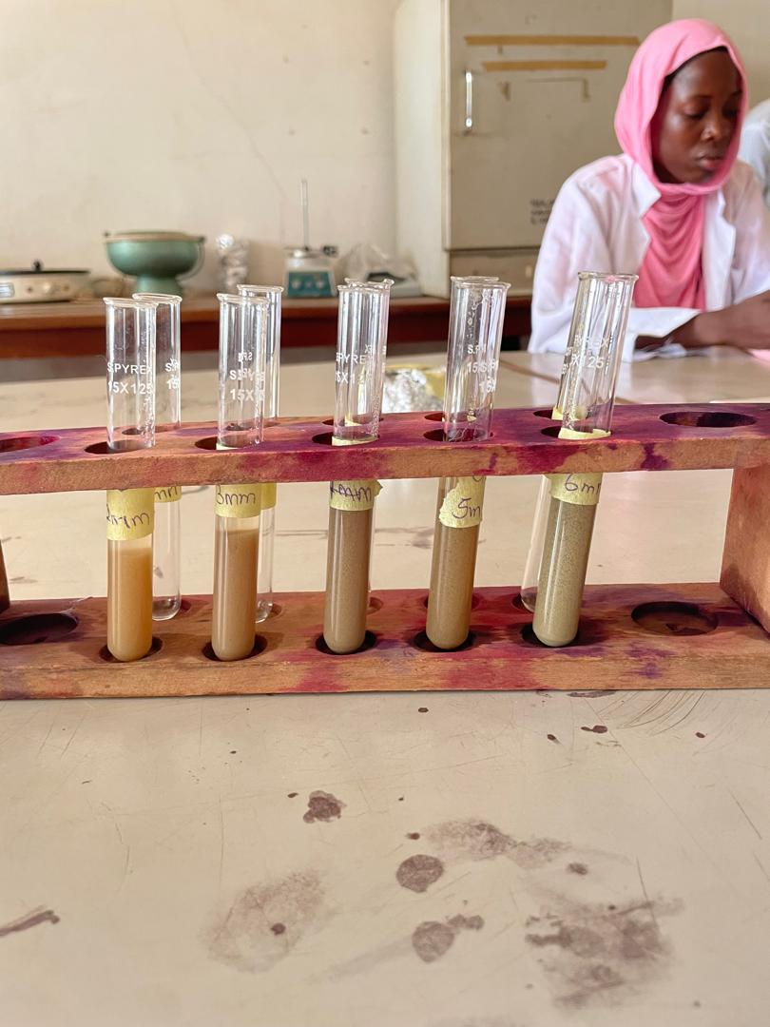

3.3 Characterization of synthesized silver nanoparticles.
UV-VISIBLE SPECTROPHOTOMETRY ANALYSIS
The formation of silver nanoparticles is characterized by discoloration that occurs at the time of incubation. Each mixture of AgNPs reaction with leaves of Jatropha curcas was measured at a wavelength of 200-600nm giving its peak at 350nm.

Table 3: UV-VISIBLE SPECTROPHOTOMETRY ANALYSIS
The Jatropha curcas were observed under UV-visible spectrophotometry for its maximum absorbance and wavelength to conform the reduction of silver nitrate.
Wavelength | Absorbance
300 | 2.390
350 | 2.405
400 | 2.374
450 | 2.355
500 | 2.356
550 | 2.357
600 | 2.260

Fig 2 UV-VIS absorbtion spectra of silver nanoparticle synthesized from Jatropha curcas leaves at 1Mm silver nitrate.
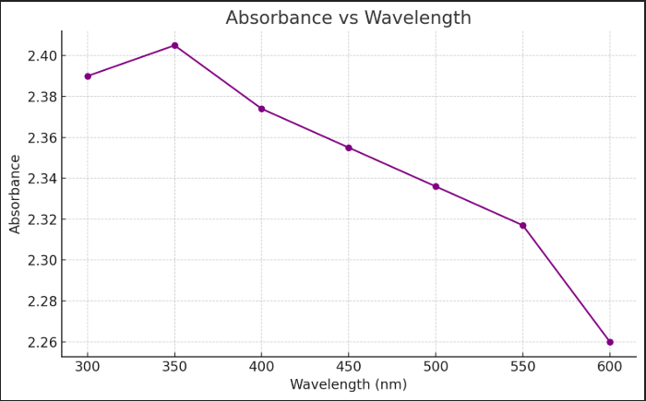

FOURIER TRANSFORM INFRARED SPECTROPHOTOMETER
The FTIR spectroscopy was carried out to identify the chemical composition and nano silver particles of the test sample. The spectra were taken from resulting disk over the frequency range at 4400-250cm⁻1.

Fig 3. FTIR spectrum of silver nanoparticle synthesized by x

SCANNING ELECTRON MICROSCOPY
A Scanning electron microscope was used to evaluate the morphology of samples containing AgNPs of Jatropha curcas on a copper grid before being dried at room temperature giving a magnification both in 8000x and 9000x.

Fig 4 SEM images of magnification 8000x, 9000x and 1000x of the silver nanoparticles synthesized by Jatropha curcas leaf extracts
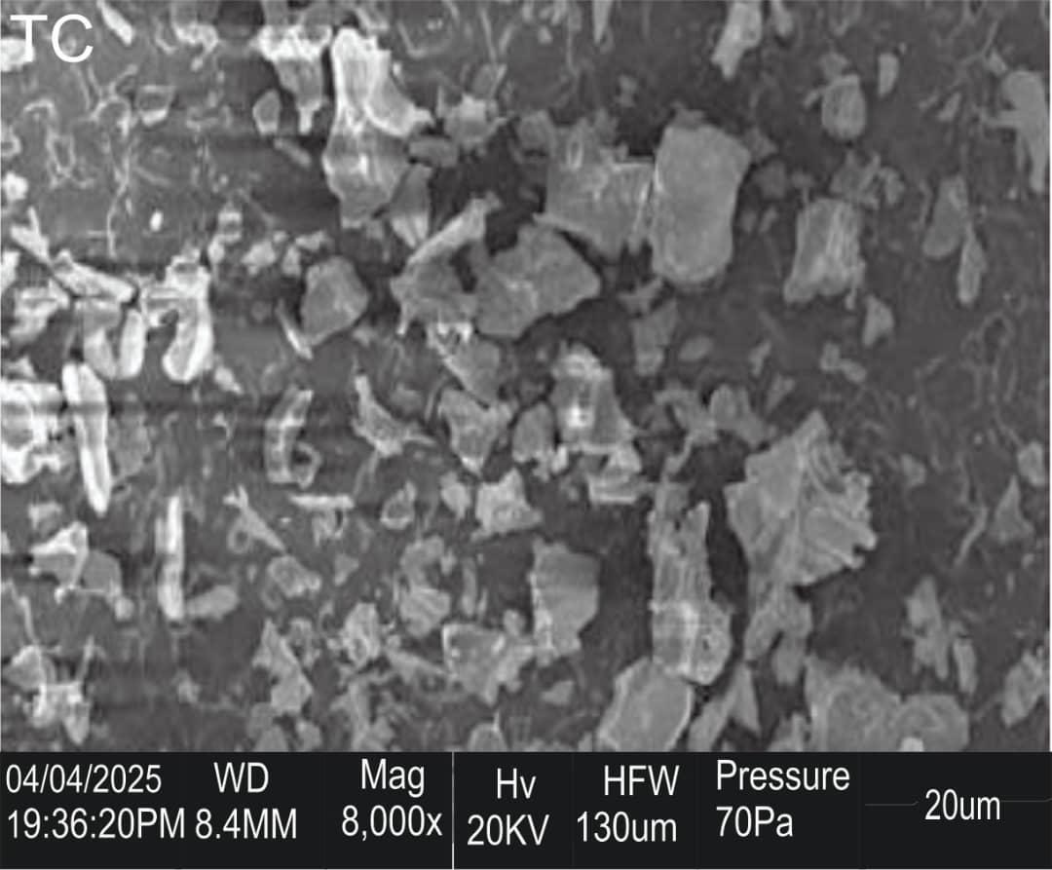
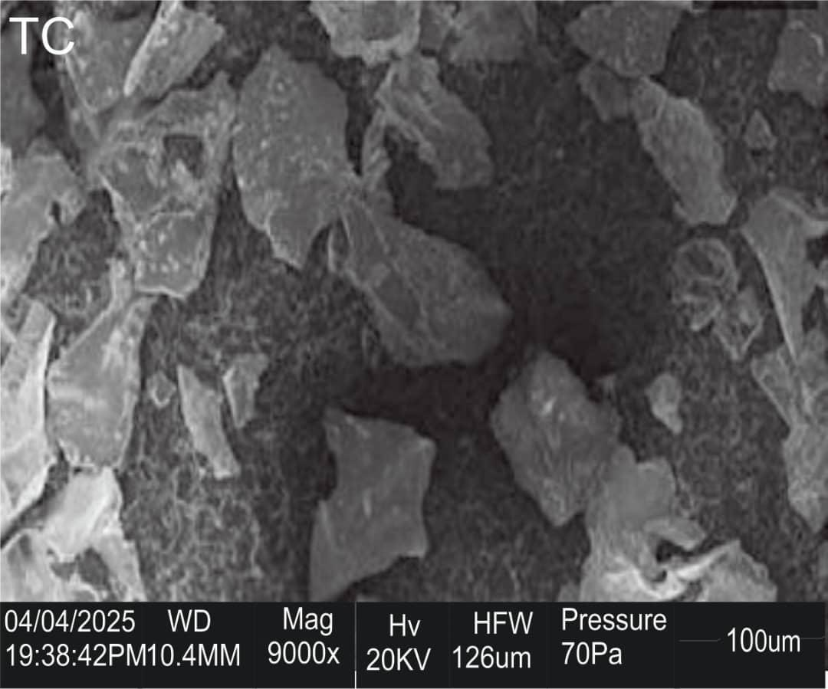
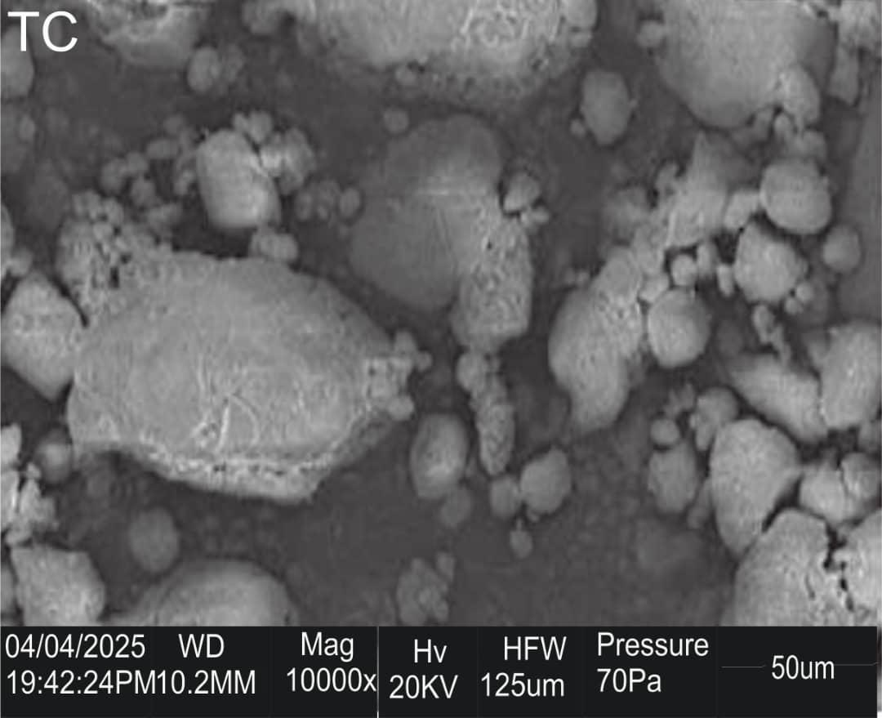

3.4 Antimicrobial Activity Evaluation.
The antimicrobial activity of silver nanoparticles synthesized by plant extracts were tested against some pathogenic bacteria isolates such as E. coli, P. aeruginosa, S. aureus, S. typhi, K. pneumoniae and against some pathogenic fungi; F. oxysporum, Rhizopus sp., A. niger, Penicillum sp. Using well diffusion method. The diameter of inhibition zone (mm) around each well with silver nanoparticle solution is represented in table 3 and 4.

Table 4 Antibacterial activity (Zone of inhibition) of J.c-AgNPs leaf extract
BACTERIA SPECIES | 250ppm | 500ppm | 1000ppm
Klebsiella pneumoniae | 18mm | - | 28mm
Pseudomonas spp. | 18mm | - | -
Staphylococcus aureus | 21mm | - | -
Escherichia coli | - | - | 20mm
Salmonella typhi | - | - | -

Table 5 Antifungal activity (Zone of inhibition) of J.c-AgNPs leaf extracts.
FUNGI SPECIES | 0.1ml | 0.2ml | 0.3ml | 0.4ml
Penicillum spp. | 19mm | 14mm | 19mm | -
Aspergillus spp. | 14mm | 15mm | 15mm | -
Trichoderma spp. | 24mm | 21mm | 21mm | 20mm
Rhizopus spp | 16mm | - | - | 13mm
CHAPTER FOUR

4.0 DISCUSSION AND CONCLUSION

4.1 DISCUSSION
The UV-visible spectrophotometry analysis of Jatropha curcas-mediated silver nanoparticles revealed a characteristic surface plasmon resonance (SPR) peak at 350 nm with a maximum absorbance of 2.405 (Table 2), confirming the formation of silver nanoparticles (AgNPs). This peak falls within the expected range (350–450 nm) for AgNPs, which is consistent with findings by Sharma et al. (2020), who attributed such absorbance profiles to the excitation of surface plasmons by the conduction electrons of silver. The subsequent decline in absorbance beyond 400 nm suggests completion of the reduction process and stabilization of the nanoparticles.
The qualitative phytochemical analysis (Table 1) of Jatropha curcas leaf extract confirmed the presence of several secondary metabolites including flavonoids, alkaloids, saponins, terpenoids, glycosides, tannins, and steroids. Notably, glycosides were moderately present (++), while others were present in trace amounts (+). These compounds are essential in green synthesis as they serve as natural reducing and capping agents. This aligns with the report of Kumar et al. (2020), who emphasized the role of phytochemicals in nanoparticle biogenesis.
The quantitative phytochemical analysis (Table 2) further supported these findings, revealing high concentrations of glycosides (7.542 ± 0.401 mg/100g), saponins (4.590 ± 0.540 mg/100g), and alkaloids (4.380 ± 0.320 mg/100g). The presence of flavonoids (1.66 ± 0.206 mg/100g), terpenoids (1.378 ± 0.271 mg/100g), tannins (1.340 ± 0.180 mg/100g), and steroids (2.275 ± 0.270 mg/100g) adds further confirmation that Jatropha curcas contains sufficient bioactive compounds for nanoparticle synthesis. Rani et al. (2021) similarly reported that these phytochemicals enhance nanoparticle stability by preventing aggregation.
The green synthesis process was visually confirmed by a color change from light green to nude, signifying the reduction of Ag⁺ to Ag⁰. This visual cue correlates with previous studies, which have identified such color transformation as a primary indicator of AgNP formation (Ahmad et al., 2020).
The Fourier Transform Infrared Spectroscopy (FTIR) analysis (Fig. 3) provided insights into the functional groups involved in the reduction and stabilization of AgNPs. Though specific peaks were not detailed, FTIR typically detects groups such as -OH, -NH, -C=O, and -CH, which are associated with proteins, polyphenols, and other metabolites responsible for nanoparticle formation.
Scanning Electron Microscopy (SEM) (Fig. 4) revealed the morphology of synthesized AgNPs, observed at magnifications of 8000x to 9000x. These images help ascertain the size distribution and shape of the particles, which are crucial for evaluating their biological activity. The presence of uniformly distributed nanoparticles indicates a stable and successful biosynthesis.
The antimicrobial evaluation (Tables 3 & 4) provided compelling evidence of the bioactivity of the synthesized AgNPs. The nanoparticles demonstrated varying degrees of antibacterial activity. Notably, they inhibited Klebsiella pneumoniae (18 mm at 250 ppm; 28 mm at 1000 ppm), Pseudomonas spp. (18 mm at 250 ppm), Staphylococcus aureus (21 mm at 250 ppm), and Escherichia coli (20 mm at 1000 ppm). However, no activity was observed against Salmonella typhi, possibly due to resistance mechanisms or insufficient nanoparticle concentration at lower dosages.
The antifungal assay (Table 4) also revealed notable inhibition zones against Trichoderma spp. (24 mm at 0.1 ml), Penicillium spp., Aspergillus spp., and Rhizopus spp., although the activity appeared dose-dependent and variable. These findings confirm the broad-spectrum antimicrobial potential of AgNPs synthesized using Jatropha curcas, aligning with the reports of Ahmad et al. (2020), who highlighted the influence of nanoparticle size, dispersion, and concentration on antimicrobial activity.
Interestingly, compared to earlier findings where only the crude extract showed antibacterial activity, the enhanced activity in this study suggests improved synthesis and stability of AgNPs. This may be attributed to controlled synthesis conditions and adequate concentrations of phytochemicals, unlike the earlier scenario where poor dispersion or particle aggregation could have reduced bioactivity.

4.2 CONCLUSION
The successful biosynthesis of silver nanoparticles using Jatropha curcas leaf extract was confirmed through UV-VIS, FTIR, SEM, and antimicrobial assays. The phytochemical constituents of the leaf extract played a pivotal role in the reduction and stabilization of AgNPs. The synthesized nanoparticles demonstrated significant antibacterial and antifungal effects, though further optimization in particle concentration and size control may enhance their efficacy. These results confirm Jatropha curcas as a valuable candidate in green nanotechnology and antimicrobial development.

REFERENCES
Adekwale, S. A., & Ojo, A. B. (2019). Evaluation of green and chemical routes in nanoparticle production. Nigerian Journal of Nanotechnology, 12(3), 66–76.
Adeoye, A. O., & Oladipo, S. O. (2019). Comparative analysis of nanoparticle synthesis techniques. Nigerian Journal of Applied Sciences, 21(2), 108–110.
Adewole, A. (2021). Phytochemical constituents and antibacterial activities of Jatropha curcas and Jatropha gossypifolia. Journal of Women in Technical Education and Development. https://www.ajol.info/index.php/jowited/article/view/152839
Adeyemi, A., & Balogun, S. (2021). Photocatalytic potential of biosynthesized ZnO nanoparticles in dye degradation. Environmental Nanoscience Journal, 1(2), 97–109.
Afolabi, S. A., Ikumapayi, T., & Oloyede, O. R. (2022). Advances in nanotechnology and nanoparticles in the 21st century. https://www.academia.edu/download/11710398/210.pdf
Ahmad, T., Wani, I. A., Manzoor, N., Ahmed, J., Asiri, A. M., & Khan, S. B. (2020). Green synthesis, characterization and antimicrobial activity of silver nanoparticles using Euphorbia wallichii leaf extract. Saudi Journal of Biological Sciences, 27(5), 1426–1432. https://doi.org/10.1016/j.sjbs.2020.01.008
Ajayi, F., et al. (2018). Impact of nanofertilizers on maize productivity. African Agriculture and Husbandry, 6(2), 56–70.
Akinola, D., et al. (2017). Biomedical potentials of a synthesised AgNPs. Nigerian Journal of Medical Nanotechnology, 7(2), 101–113.
Akinwale, K. O., & Adegboyega, T. (2024). Challenges in green synthesis of nanoparticles: A Nigerian perspective. African Journal of Green Chemistry, 18(1), 55–64.
Asekun, A. T., et al. (2015). Antioxidant potential of Jatropha curcas extracts. African Journal of Medicinal Botany, 6(3), 131–140.
Asekun, D. T., & Asekunowo, A. K. (2022). Wound healing potentials of ethanolic extract of Jatropha curcas. Journal of Biomedical Sciences, 6(1). https://www.jbms.ug/index.php/jbms/article/view/110
Atabi, B. O., Ibitoye, A. S., & Olarewaju, A. A. (2021). Nanoparticle synthesis methods: A review of emerging green approaches. Nigerian Journal of Materials Research, 19(4), 211–220.
Ayodele, A. T., & Bolarinwa, K. A. (2022). Local plant extracts in nanoparticle synthesis: An overview. Nigerian Journal of Agricultural Nanoscience, 5(1), 12–20.
Bayda, S., Adeel, M., Tuccinardi, T., Cordani, M., & Rizzolio, F. (2020). The history of nanoscience and nanotechnology: From chemical–physical applications to nanomedicine. Molecules, 25(5), 112. https://doi.org/10.3390/molecules25010112
Bello, T. S., & Adebayo, F. O. (2023). Plant-mediated synthesis of nanoparticles and their biological properties. Nigerian Journal of Biotechnology, 14(2), 93–102.
Chinnai, S., Gopinath, S., Amb, P., Fuloria, N., Fuloria, S., Madappan, P., Krishnamoorthy, K., Reddy, L. V., Ramachandran, A., & Sreeraman, S. (2021). Characterization and antibacterial response of silver nanoparticles biosynthesized using an ethanolic extract of Coccinia indica leaves. Crystals, 11(2), 97. https://doi.org/10.3390/cryst11020097
Chukwuma, E. I., Nwogu, F., & Umeh, C. O. (2024). Exploring Nigerian biodiversity for green nanotechnology. Nigerian Journal of Indigenous Science, 8(2), 74–82.
Ejeta, K. O., Dolor, G. A., & Nduka, G. I. (2017). Impact of nanotechnology on silver: A short survey. International Journal of Biomedical Science and Engineering, 5(3), 19–24.
Ekanem, E. S., & Idowu, R. A. (2020). Influence of pH on nanoparticle quality. Nigerian Journal of Physical Chemistry, 9(3), 131–140.
Elegbede, J. A., & Lateef, A. (2019). Green nanotechnology in Nigeria: The research landscape, challenges and prospects. Annals of Science and Technology, 4(1), 24–35. https://sciendo.com/pdf/10.2478/ast-2019-0005
Elmiine, E. E., Uzoh, I. M., Onwudwe, D. C., & Babalola, O. O. (2019). Nanotechnology applications in agriculture. Applied Sciences, 9(3), 499. https://www.mdpi.com/2076-3417/9/3/499
Eze, I., Nwosu, I., Edem, I., Obua, P., & Ogbaji, H. (2024). Phytochemical profiling and bioactive compounds variation in Jatropha curcas from Nigeria. Journal of Pharmaceutical Research. https://www.ajol.info/index.php/jpr/article/view/129538
Eze, V., & Nwachukwu, T. (2021). Wastewater treatment using ZnO nanoparticles. Environmental Remediation Nigeria, 12(2), 6–7.
Eze, V., & Okechukwu, B. (2023). Metal-to-extract ratios in biosynthesis. Nigerian Journal of Nanoscience Methods, 8(1), 47–60.
Ezeokonkwo, P. C., & Aluwachukwu, J. O. (2016). Energy efficiency in nanoparticle synthesis. Nigerian Journal of Environmental Engineering, 14(1), 201–210.
Gorden, R., Losic, D., Tiffany, M. A., Nagy, S. S., & Sterrenburg, F. A. (2009). The glass menagerie: Diatoms for novel applications in nanotechnology. Trends in Biotechnology, 27(3), 116–127.
Guerra, F. D., Attia, M. F., Whitehead, D. C., & Alexis, F. (2018). Nanotechnology for environmental remediation: Materials and applications. Molecules, 23(7), 1760. https://doi.org/10.3390/molecules23071760
Ibrahim, A. T., Usman, T., & Lawal, S. (2014). Laser ablation and its application in nanomaterial synthesis. Nigerian Journal of Engineering and Applied Sciences, 12(1), 41–50.
Ighiebor, I., & Khayiagbe, R. (2023). Green nanotechnology in agriculture. Iranian Journal of Health and Social Sciences. https://ijhss.vt.ac.ir/
Ikumapayi, T., & Afolabi, S. A. (2022). Nanoparticles bind actively with other substances. [Manuscript in preparation].
Isma’il, Y., Okeke, P. N., & Oladiran, T. A. (2022). Hybrid methods for nanoparticle synthesis: Bridging green and chemical routes. Nigerian Journal of Advanced Materials, 9(1), 27–35.
Khan, M., Alghamdi, K., Lary, Z., Shaik, M. A., Adil, S. F., Kuniyil, M., Alkhathlan, H. Z., Al-Warthan, A., Siddiqi, M. A., & Mondeshki, M. (2020). Synthesis of Au, Ag, and AuAg bimetallic nanoparticles using Pulicaria undulata extract and their catalytic activity for the reduction of 4-nitrophenol. Nanomaterials, 10(9), 1885. https://doi.org/10.3390/nano10091885
Kolawale, O. S., & Abduirahaman, A. A. (2014). A numerical approach to the taxonomy of the genus Jatropha Linn. using quantitative phytochemical constituents. https://oer.funai.edu.ng/wp-content/uploads/2020/11/267Numericalapproachjatropha.pdf
Kumar, V., Yadav, S. K., Yadav, S. C., & Singh, J. (2020). Green synthesis of silver nanoparticles using medicinal plants and evaluation of their antimicrobial activity. International Journal of Nanomedicine, 15, 719–730. https://doi.org/10.2147/IJN.S227791
Namadina, N., et al. (2020). Jatropha curcas in soap making and biodiesel. African Journal of Rural Technology, 8(4), 109–120.
Nnasa, I., Kshori, P., & Mustafa, A. (2024). Introduction to nanotoxicology. In Nanotoxicology: Concepts and Applications (pp. 1–25). Springer. https://link.springer.com/chapter/10.1007/978-3-031-54154-1_1
Nnusa, I., Isibor, P. O., & Mustafa, A. (2024). Introduction to nanotoxicology. In Nanotoxicology: Concepts and Applications. Springer. https://link.springer.com/chapter/10.1007/978-3-031-54154-1_1
Nwosu, E. K., & Yusuf, A. O. (2021). Microbial synthesis of metallic nanoparticles in Nigeria: Challenges and prospects. Nigerian Journal of Microbial Technology, 10(1), 64–71.
Ogoleye, O. S., & Akinwade, A. (2025). Catalytic applications of iron oxide nanoparticles derived from Jatropha curcas in biodiesel production. Renewable Energy Journal, 11(1), 102–112. https://www.researchgate.net/publication/385045629
Ogondale, O. D., Babanyi, B. K., & Thompson, S. O. (2023). Antimicrobial nanomaterial synthesis: Types and applications. Springer.
Ogunyemi, T. O., Salami, D., & Tijani Fagbohun, F. A. (2020). Advances in nanoparticle production through chemical methods. Journal of Nigerian Engineering Research, 15(2), 90–98.
Ogwu, A., Ufodike, C. A., Ihun, S. A., et al. (2023). Nanoparticle-based delivery systems. RSC Nanoscience Advances, 3(1), 123–135.
Ojo, A. I., & Eze, C. Y. (2020). Biomedical potentials of biogenic nanoparticles. Nigerian Journal of Medical Nanoscience, 4(2), 98–106.
Ojo, O. A., Olayide, I. I., & Akanbi, C. (2021). Nanoparticles and their biomedical applications. Biointerface Research in Applied Chemistry, 11(3), 10294–10304.
Oladunni, D. K., & Akinbola, S. T. (2016). Sol–gel synthesis and its industrial applications. Nigerian Journal of Industrial Chemistry, 13(1), 55–62.
Olakunle, R. A., & Imusa, B. I. (2023). Post-synthesis purification of nanoparticles: Techniques and significance. Journal of Nigerian Advanced Materials, 18(1), 18–25.
Olayide, I. I., & Ojo, O. A. (2021). Biomedical properties of quantum dots. Biointerface Research in Applied Chemistry, 11(2), 9296–9304.
Olusola, A. T., & Athmed, A. (2016). Phytochemical and antifungal screening of Jatropha curcas leaf extract. The Nigerian Journal of Pharmacy, 50(1), 39–45.
Onuoha, P. C., Ezeani, V. I., & Nnamdi, C. A. (2022). Phytochemicals in green nanoparticle synthesis: Roles and mechanisms. Nigerian Journal of Phytochemistry, 9(3), 150–157.
Onwudwe, P. C., Elemike, E. E., Uzoh, I. M., & Babalola, O. O. (2019). Green nanotechnology and its role in food preservation. Applied Sciences, 9(3), 499. https://www.mdpi.com/2076-3417/9/3/499
Pareek, V., Gupta, R., & Panwar, J. (2018). Do physicochemical properties of silver nanoparticles define their interaction on various biological media and bactericidal action? A review. Materials Science and Engineering: C, 90, 739–749. https://doi.org/10.1016/j.msec.2018.04.096
Rani, M., Shanker, U., & Singh, N. (2021). Green synthesis of silver nanoparticles using Syzygium cumini leaf extract and evaluation of their antimicrobial activity. Materials Today: Proceedings, 44, 1234–1239. https://doi.org/10.1016/j.matpr.2020.10.667
Riaz, M., Sulleman, A., Ahmad, P., Khanaiker, M. U., Alghamdi, A., Bradley, D. A., & Khan, M. Q. (2022). Biogenic synthesis of AgNPs using aqueous bark extract of Aesculus indica for antioxidant and antimicrobial applications. Crystals, 12(2), 252. https://doi.org/10.3390/cryst12020252
Shaik, M. R., Abdulahi, H., Khan, S., Khan, M., Adil, S., Kuniyil, M., Al-Warthan, A., Siddiqi, M. A. H., Alkhathlan, H. Z., & Khan, M. (2016). “Miswak”-based green synthesis of silver nanoparticles: Evaluation and comparison of their antimicrobial activities with the chemical synthesis. Molecules, 21(11), 1478. https://doi.org/10.3390/molecules21111478
Sharma, D., Kanchi, S., & Bisetty, K. (2020). Biogenic synthesis of nanoparticles: a review. Arabian Journal of Chemistry, 13(1), 763–787. https://doi.org/10.1016/j.arabjc.2016.01.002
Singh, A., Dubey, S., & Dubey, H. K. (2019). Nanotechnology: The future engineering. Nanotechnology, 6, 230–233.
Urie, K. J., & Nna, P. J. (2020). Comparative study on the phytoconstituents and antimicrobial analyses of Jatropha curcas. [Unpublished manuscript].
Uzoh, I. M., Elemike, E. E., Onwudwe, D. C., & Babalola, O. O. (2019). Green nanotechnology for sustainable agriculture. Applied Sciences, 9(3), 499. https://www.mdpi.com/2076-3417/9/3/499
Whitesides, G. M. (2005). Nanoscience, nanotechnology, and chemistry. Small, 1(2), 172–179. https://doi.org/10.1002/smll.200400118

