
DEPARTMENT OF QUANTITY SURVEYING.
ESTIMATING AND BUDGETING FOR THE PROPOSED MEDIUM SCALE BUILDING.
(A CASE OF STUDY OF AN ESTIMATE AND BUDGET FOR A PROPOSED RESIDENTIAL DEVELOPMENT FOR AHMED ABUBAKAR YUNUS, LOCATED AT 5, AKEEM A. ADEYEMI STREET, SOUTH LINK ROAD, ASA DAM, ILORIN KWARA STATE)
BY
USMAN MUSA ODLND23QTS0014
TSADO MOHAMMED ODLND23QTS0015
ABDULKAREEM SHEFIU OLALEKAN ND/23/QTS/FT/0001

SUBMITTED TO
THE DEPARTMENT OF QUANTITY SURVEYING
INSTITUTE OF ENVIRONMENTAL STUDIES (IES)
KWARA STATE POLYTECHNIC ILORIN, KWARA STATE
IN
PARTIAL FULFILMENT OF THE REQUIREMENT FOR THE AWARD OF NATIONAL DIPLOMA (ND) IN DEPARTMENT OF QUANTITY SURVEYING.

JULY, 2025.

CERTIFICATION
This is to certify that USMAN MUSA, TSADO MOHAMMED AND ABDULKAREEM SHEFIU OLALEKAN. Have successfully completed the practical project work in partial fulfillment and requirement for award NATIONAL DIPLOMA In Quantity surveying department, institute of environmental studies, kwara state polytechnic Ilorin.

____________________________ _______________________
Q.S OMAR AISHAT MUAZU DATE
(Project Supervisor)

____________________________ _______________________
Q.S. SIDIQ LATEEF DATE
(Head of Department)

____________________________ _______________________
External Examiner DATE

DEDICATION
This project is dedicated to Almighty God, the custodian of knowledge and citadel of wisdom and who sustain us fill the stage of the course. We owe our thanks to Almighty God always and those who have crossed our part and has imparted positively into our knowledge, May Almighty God Bless you all. (Amen).

ACKNOWLDGEMENT
Our profound gratitude first goes to God Almighty for giving us the privilege to complete this study and our project against all odds.
Thanks to our entire well wishers for been there when most needed. Worthy of mention is also to the effort of our project supervisor Q.S OMAR AISHAT MUAZU for his devotion to our general well being and academics.
Big thanks to our Head of Department [H.O.D] Q.S. SIDIQ LATEEF, and also our lecturers who contribute to our success in one way or the other in Quantity Surveying Department.
May Almighty God bless you all. [Amen]

ABSTARCT
The main reason for this study is for estimating and budgeting Unpriced Bill of Quantity for a Proposed Residential Development For Ahmed Abubakar Yunus, Located At 5, Akeem A. Adeyemi Street, South Link Road, Asa Dam, Ilorin Kwara State. The following has been discussed under the mentioned chapter in this project work with a view of finding solution to it. Chapter one contain the background Information and the aim and objectives of the project work. Chapter two contains Site Report, the essence of preliminary items required. Chapter three deals with the Project Methodology that is taking off process and abstracting process. Chapter four contains the project Substructure and Super structure work, Abstracting and Bill of Quantities of the project. Chapter five is all about Summary, Recommendation and Conclusion of the whole project work and for further studies.

TABLE OF CONTENT

Title page i
Certification ii
Dedication iii
Acknowledgement iv
Abstract v
Table of content vi
CHAPTER ONE
- Background information
1.1 Description of works
1.2 Aim
1.2.1 Objectives
1.3.1 Scope and limitation
1.3.2 Limitation
1.4 Definition of terms

CHAPTER TWO

2.0 Title
2.1 Site Description
2.2 Location
2.2.1 Accessibility
2.2.2 Nature of the land
2.2.3 Availability and proximity of resources

CAHPTER THREE

3.0 Taking off
3.1 Method of taking off
3.1.0 Selection of taking off
3.1.1 Abstracting
3.2 Bill of quantities
3.3 Requirement for accuracy

CHAPTER FOUR

4.0 Sub-structure
4.1 Super-structure
4.2 Abstracting
4.3 Bill of quantity

CHAPTER FIVE

5.1 Summary
5.2 Conclusion
5.3 Recommendation
References

CHAPTER ONE
1.0 INTRODUCTION
BACKGROUND INFORMATION
This project is based on An Estimate and Budget for a Proposed Residential Development For Ahmed Abubakar Yunus, Located At 5, Akeem A. Adeyemi Street, South Link Road, Asa Dam, Ilorin Kwara State
In construction industry, cost is considered as one of the important element for constructing a project. Cost in construction includes the initial capital cost, and also the subsequent operation cost and maintenance cost. Generally, running a construction project will involve a lot of budget. Furthermore, the increasing rate of inflation by years, will affect the price of raw material, transportation, fuel, machinery, manpower and others will be a bothers for the clients such as developer to invest money for a project . Hence, to overcome this problems and alternative material or a new system will be the best option.
Construction Industry Development Board Malaysia (CIDBM) proposes cost saving method which are the Industrialized Building System (IBS) where the building component or the building system are pre-fabricated and then install on site. Moreover, it is proven not only reducing the cost but also reducing the construction time.
Furtherance to the information by Construction Industry Development Board (CIDB). There are five types of Industrialized Building System (IBS) that were introduced for the construction industry to practice which are pre-cast concrete framing; Panel and board system, steel formwork system, steel framing system, pre-fabricated timber framing system system and finally the block work system. This report will focus on all sections of building works i.e Block work, roof etc block made from cement laterized.
The usage of interlocking blocks as the construction materials has been proven to provide a lot of benefits. By implementing the element laterized interlocking block for buildings will greatly reduce the wastage, volume of building materials, reducing unskilled workers, provide better quality control, promote a safer and more organized site; and last but not least will greatly reduce the construction cost and time.
1.1 DESCRIPTION OF WORK
The building project comprises of the Estimate and Budget for a Proposed Residential Development For Ahmed Abubakar Yunus, Located At 5, Akeem A. Adeyemi Street, South Link Road, Asa Dam, Ilorin Kwara State

The building has a rectangular shape with the land area of about 38.1m in length and 14.30m width.
The construction is found on the plain in-situ concrete foundation with over site concrete floor which is a reinforced concrete slab (150mm thick). The walls are 225mm thick hollow sandcrete block.
The roofing used is long span aluminum roofing sheet, windows are aluminum frame sliding and of different sizes, doors are: iron steel and hard wood panels with different sizes fixed to manufacturer's details.
The wall are rendered and painted with emulsion internally and textured and paint externally. Floor finishing is vitrified sand and cement screeded bed.
Service conducted are mechanical and electrical installation as well as fire fighting and alarm system .
1.2 AIM
The aim of this project is to Estimate and Budget for a Proposed Residential Development For Ahmed Abubakar Yunus, Located At 5, Akeem A. Adeyemi Street, South Link Road, Asa Dam, Ilorin Kwara State
1.2.0 Title:
An Estimate and Budget for a Proposed Residential Development For Ahmed Abubakar Yunus, Located At 5, Akeem A. Adeyemi Street, South Link Road, Asa Dam, Ilorin Kwara State

1.2.1 OBJECTIVES :
1. To determine the effect of site location and construction on the cost of building project.
2. To understand the process involved in preparation of Bill of quantities (BOQ)
3. To understand the process of site investigation and project report.
1.3 Scope and Limitations :
1.3.0 Scope
The scope of this project is to prepare a bill of Quantity (BOQ) for the Proposed Residential Development For Ahmed Abubakar Yunus, Located At 5, Akeem A. Adeyemi Street, South Link Road, Asa Dam, Ilorin Kwara State

1.3.1 Limitations
1. Inability to conduct proper site investigation
2. Insufficient design information
3. Pricing (market survey) was not carried out to determine actual price of measured items.
1.4 Definition of Terms
1. Prime cost sum: This is a sum provided for work or service to be executed by nominated sub – contractor or for materials or goods to be obtained from a nominated supplier. The term includes specialists work carried out by a person apart from the main contractor (Invory Seelay).
2. Contingency Sum: it is the sum allocated to unforeseen expenses. It is expended only with the consent of the Architect or Supervisory engineer.
3. Provisional cost sum: This is the sum allocated to work that is subjected to change or that cannot be accurately measured. The sum will later be adjusted according to the extent and true value of work.

4. Estimating: This can be defined as the technical process of predicting cost of construction. It can also be further explained as a process by which cost of Item is carried out.
5. Preliminaries Item: These are items meant for the smooth execution of project but are not related to a particular trade section in BOQ.
6. Tender: It is an offer to execute a given project at a certain amount of money and specified period of time.
7. Plant: This are tools. Machines and equipment needed for the smooth execution of the project.
8. Project: This is a process of work organized carefully and designed e.g building or Civil engineering work.

CHAPTER TWO
SITE REPORT
2.0 Title
An Estimate and Budget for a Proposed Residential Development For Ahmed Abubakar Yunus, Located At 5, Akeem A. Adeyemi Street, South Link Road, Asa Dam, Ilorin Kwara State

2.1 Site Description
The proposed residential building has a total length of 29,000mm and 6000mm width which appear to be in rectangular shape.
The site is located at 5, Akeem A. Adeyemi Street, South Link Road, Asa Dam, Ilorin Kwara State. The site has small and big trees and bushes which needs to be cleared away from site.

2.2 Location
The site is located within Oke Bola Irona Quarters, Ado Ekiti, Ado local Government area, Ekiti State.
2.2.1 Accessibility
There are untarred roads leading to the site from the main road in the area. So there is no problem delivery of materials to site and the labour are expected to resume work as early as possible.
2.2.2 Nature of land
The proposed site of the building is a virgin land with a flat surface. This will minimize the construction cost of the foundation because of the balanced surface when compare to that of the study area which increases the constructional cost.

2.2.3 Availability and proximity of Resources
Availability of construction resources simply means the extent of convenience at which the resources can be found in the market and the selling price. While proximity means the closeness of the materials resources of the proposed site.
The construction resources include the following:
Plant
All necessary plant needed for the proposed projects are readily available in Ilorin. Such plant include: concrete mixer, Bulldozer, Electric generator, Compacting machine e.t.c all mentioned plant can be hired in area’s not far to the site.
Materials
The whole material necessary for smooth execution of this project are all available at Ilorin, but costly to some materials price in some area of the country this project all are available at Ilorin, but costly to some materials price in some area of the country.
However, all the material needed for smooth execution of this proposed project is remote to the site.
Labour
The human effort is necessary and needed on the proposed project, all can be found at near by village and area’s and need to be transported on a daily basis from their homes to the site within a short distance.
Tender of preliminaries required
To an extent preliminaries items have a great effect on construction project. Such preliminaries items are explained below.
Scaffolding
There should be a provision for scaffolding because the project requires roofing works, there will be the need for rendering and painting at the higher level of the building.
Setting out
This is the transfer of information on the building drawing to the ground with high degree of accuracy. In setting out, site clearance is necessary by cutting down of trees and edges of top soil excavation before making the provisions of setting out instruments. such as: profile pegs, measuring tapes, builder square e.t.c before the commencement of site operation.
Temporary Road
This is done temporarily to provide easy access to the site during work.
Temporary Fence
Temporary fence should be done to cover and protect the materials on site from vandalism.
First aid box
This is very important in any construction site due to some injuries that may occur on site which might be minor or major injuries before being taken to the hospital.
Site Supervision
This is the contractor’s agent on the site who supervises the whole of the project. He/She also co- ordinates the works of sub-contractors and receives instructions from architect on
Setting out of the works
This contractor will set out the position of the building on the site before commencement of any actual work to the satisfaction of the Architect.
Temporary Latrine
Welfare facility of this type must be provided on the site by the contractor to satisfaction of the architect.

Temporary store
The contractor will construct a lockable store for storage of material on site. such as storage facilities must be protected from damage by weather.
Site Meeting
The contractor is expected make all necessary arrangement for meeting to be held on the site and those attending must be made reasonably comfortable.

CHAPTER THREE
PROJECT METHODOLOGY
3.0 TAKING OFF PROCESS
This implies reading of dimension from drawings setting them down in a specific order on specific paper know as dimension paper and inserting an appropriate description. It also refers to the process of identifying elements of construction works that can be measured and priced.
This is necessary to produce bill of quantities and requires that the design is complete and a specification has been prepared.
Analysis of drawing and specification allow the cost consultant (usually a Quantity Surveyor) to prepare a taking off list, which lists all of the individual elements that comprises the works. These elements can be measured in number, length, area, volume, item then collected and structured to produce an unprice bill of quantity(BOQ). This process is sometimes referred to as “working up”
The traditional dimension sheet is divided vertically in to two identical haves each comprising a set of four columns in effort, the ruling on the right half of the sheet may be considered to be a continuation of these on the left side of the sheets.
A | B | C | D | A | B | C | D

Column A: are the timesing columns. These column are used to enter multipliers where
there is more than one of the particular items being measured.
3 | 1.20  1.20

Column B: They are the dimension columns, these columns are used to record the dimensions in meters. Each linear dimensions is underlined.
 |  | 3.45  7.59 |  | Length  Width |  | Area

 |  | 3.45  7.59  0.75 |  | Length  Width  Volume  Depth

 | 2 |  | Number

NOTE: The order of entering dimension is strictly:
1. Length
2. Width
3. Height/Depth
 | Item |  | Allow for bringing to site and removing from site all plants required for this work section

Column c: Are the squaring column: the resulting area and volumes inserted in the timesing and dimension columns are subsequently calculated and entered into the squaring column opposite their respective dimension.

2 | 7.55  0.90  0.10 | 1.36 | Squaring
Column D: The description column. There are many ways of inserting description on the dimension sheet but the most acceptable however, is description which commence in the same level with it’s first dimension.
The example below show the dimension and description should be arranged in dimension sheet.
4 | 3.45  0.68  0.45 | 7.90 | Hardcore filling ton make up level under floor average thickness not exceeding 250mm.

Waste calculation
This is an imaginary column occupying the right hand side of the description columns . in which the taker-off inserts any preliminary calculation (waste) which may be necessary In order to arrive at the dimensions.
All preliminary calculation must be shown in waste, they need to be set down accurately and carefully so that they can be checked.
They should be written either above or below the description to avoid confusion.
Waste: calculate is necessary for each dimension except in the following situations:
  - When a scaled or figured dimensions, can be transferred direct from the drawing to the dimension column.
  - When the dimension has been derived from a previous waste calculations.
  - When a dimension has been inserted from a previous dimension.
  - In all other instance the preliminary calculation, should be shown on waste.
Waste calculation should be done in millimeters (mm) or in three places of decimal. Final figures are then rounded off to the nearest 10mm before being transferred to the dimension column.

3.1 METHOD OF TAKING-OFF
1. Nill: is a method of cancelling wrong entries during taking-off process.
Nill may be done in three (3) ways i.e on waste calculation, on framed description and on figured
dimensions.
2. Bracketing: it is used to determine one item of measurement from another
3. Adding on: This is the method of connecting two or more description related to a common dimension.

3.1.0 SELECTION OF TAKING OFF
The taking off dimension is usually divided into section under the main sub division of
- Sub – Structure
- Super – Structure
- Finishes
- Service
- External works
The section found in a normal building would generally comprises the following:
- Sub – Structure

- Site Clearance
- Top Soil Excavation
- Disposal of top soil
- Trench Excavation
- Pit Excavation
- Leveling and Compacting
- Anti- termite treatment
- Earth work support
- Hardcore filling
- Back filling
- Over site concrete
- Block work
- Finishes to sub structure

- Super – Structure 2. Frame
3. Upper floors
4. Roof
5. Stairs
6. External walls
7. Windows and Doors
8. Internal walls and partitions
9. Internal doors
c) Finishes 10. Walls finishes
11. Ceiling finishes
12. Sanitary appliance

D) Services 13. Disposal installation
14. Waste installation
15. Heating installation
16. Electrical installation
17. Gas installation
18. Lift installation
19. Communication installation
20. Builder’s work in condition
With service
E) External work 21. Site work
22. Drainage
3.1.1 ABSTRACTING PROCESS
After the squaring process, the next process is abstracting. This is in a special rule sheet. The sheet are ruled with series of vertical line that are spaced about 250mm apart and usually on A4 in width. each abstract sheet is headed with the job reference, sheet number and work section and possibly the sub-structure of the work to which the abstract dimension refer, the sheet may e divided into work section or element.
Abstracting id process where various items are stored out into their respective trades as they are entered on the abstract paper.
Description are usually spaced over two columns. The dimension are entered in the left column while any deductions are entered on the right hand column.
The order of abstracting is to commence with cubic items, followed by superficial (square), linear and finally enumerated items. Also labour items should proceed labour and materials. Smaller items proceeding larger ones and cheaper items proceeding more expensive items.
3.2 BILL OF QUANTITIES (BOQ)

Bill of quantities is a documents which set out the quantities and description of the items of labour, materials and plant require to erect and complete a building or other works in a systematic manner.
The measured items are grouped in appropriate sections and each section starts with a number of preamble clauses.
CONTENTS OF THE BILL OF QUANTITIES (BOQ)
The principal use of the bill of quantities is to obtain competitive tenders and for this purpose B.O.Q should be prepared to recognized method of measurement to standardize the bills. Bill of quantities prepared in accordance with a standard method of measurement, fully described and accurate respect the work to be executed and this provides a uniform basis for competitive tendering.
During the construction of the project, the client and the contractor use the bill as the basis for financial management.
Bill of Quantity may consist some all of the following:
Bill Nr. 1. Preliminary
Bill Nr. 2. Preamble
Bill Nr. 3. Measured work
- CARCASS
- Foundation (substructure)
- Frame (column & beam)
- External & internal walls
- Partitions
- Floors
- Roofs
B. Finishing
- External & internal finishing (walls, floor and ceiling)
- Windows
- Doors including opening without joinery
- Fixtures & sundries
- stairs & lifts
- Plumbing & engineering service
C. EXTERNAL WORKS
- Drainage
- Roads, paths, site layout, out buildings etc.
D. Sport items: These are items that are alteration and repair items of a building :
Bill Nr. 4. Provisional quantities
Bill Nr. 5. Prime cost & provisional sum
Bill Nr. 6. General summary
3.3 PURPOSE OF A BILL OF QUANTITIES
1. It serves as a schedule on which all variation in the work may be valued.
2. To provide detailed list of every service to be performed.
3. To supply each tenders with information which will estimate them to tender on a uniform basis.
4. To describe in addition to any description in the specification of the quantity of the work and the method of carrying it out.
5. It can be use for further cost investigation and cost planning information.
6. Prevent disputes as to what is and what is not included in the contract prices and the value of any work or labour which has been omitted
PRODUCTION OF BILL OF QUANTITIES
These are several techniques of preparing bill of quantities (BOQ)
TRADITIONAL BILL METHOD: It is set down in the sequence following the out of the building and engineering standard method of measurement [BESMM]. This system provides “the taking off” with a logical system of measurement designed to prevent accurate and efficient taking off.
The work is measured in series of groups, each representing a particular section of building without regard to the order in which items will finally appearing the bill. As the sequence of measurement is not related to the order of the bill the “working up” process must involved the preparation of an abstract to collect and arrange the items in the order necessary for writing the defect bill. This system is mostly used in the examination.

It comprises of the following:
1. Taking – off usually group system
2. Working – up: Squaring, abstracting, totaling, rounding off & billing.
OPERATIONAL BILL METHOD: It is tendering document for estimating costs prepared by architects that describes a construction project in terms of the operations (which include labour and plant) needed to build it. This form of document contracts with that bills of quantities in which such tendering and estimation is limited to the materials in the completed work operation bills have the advantages of enhancing communication between design and production, enabling realistic tender pricing and making the preparation of critical – path analysis easy for the contractor.
ACTIVITIES BILL METHOD: The activity bill was a development of operational form but without the separation of labour and materials. It was sub- divided into section based on activities or operation derived from a network analysis. The work was measured in accordance with the standard method of measurement although on site and off site activities were usually separated and specialist equipment and component of and the work of nominated specialist could be grouped in spate bills (Seelay and winifield 2005).
ELEMENT BILL METHOD: Here the work is billed in trade order not in sequence of the building and engineering standard method of measurement [BESMM] but under heading that from a breakdown of the building into the main element of the structural wall, floor and roof. Although these provide a more useful control document during the construction operation, it makes the tendering procedure more complicated (T.C onouah)
ANNOTATED BILL: It is possible for the bill of quantities to give the contract fill details of the quantities, types and quantity of materials and labour and for an accurate and complete set drawing to show him precisely where and how the work is to be executed. (Seelay and winifield 2005).
CUT AND SHUFFLE BILL METHOD: This is a faster method than the traditional method. The civil engineer or surveyor take – off quantities into specially designed sheet in duplicate where the original sheet is perforated into strips which can be separated from the book and collected together to form group of items.
DIVISION OF BILL PREPARATION: The traditional method of preparation of bill of quantities can be broken down into two main processes.
TAKING OFF: Seelay 1988 defined “taking- off” as the process in which dimension are scaled read from drawings and entered in a recognized form in a special ruled paper called dimension paper.
WORKING UP: This process can be divided into two stages as follow:
SQAURING: This comprises squaring the dimension and transferring the resultant lengths, area and volumes to the abstract.
ABSTRACTING: The squared dimension are arranged in convenient order for billing and reduced to the recognized units of measure.
Other process include:
EDITING: The editor must check and make adjustment in the abstract, prior to printing as the draft bill is written direct from the abstract.
WRITING THE BILL: This process involve the listing in full the various items of work, making up the complete project with the quantities involved in a suitable order, under work section or elemental heading.
REQUIREMENT FOR ACCURACY:
1. Whatever the method adopted for bill preparation, the requirement for accuracy is the same for example.
2. Work shall be measured not as fixed in position overlaps. (General Rule 4.1)
3. Dimension used in calculating quantities shall be taken to the nearest 10mm (i.e 5mm and less than 5mm shall be disregarded). (General Rule 4.2). All dimension shall be record to two decimal places and waste calculation are to three decimal places.
4. Quantities measured in tones shall be given to two decimal places. (General Rule 4.3).
5. Other quantities shall be given in the nearest whole except that any quantity less than ten shall be given as to the nearest first decimal. (General Rule 4.4).
6. Void or openings, which are wholly within the boundaries of measured area and voids or openings wholly at the boundaries of measured piers, column and similar member, shall always be the subject of deduction, irrespective of size (General Rule 4.5)
7. Items can be measured within a range of stated limits. Average or an interpolation of level may be required for the measurement of execution. Due to problem with reprographics and the inherent inaccuracy of the process, scaling drawing should be avoided whenever possible. However, where dimension are stated on drawing there is no excuse for measurement bring anything other than correct.

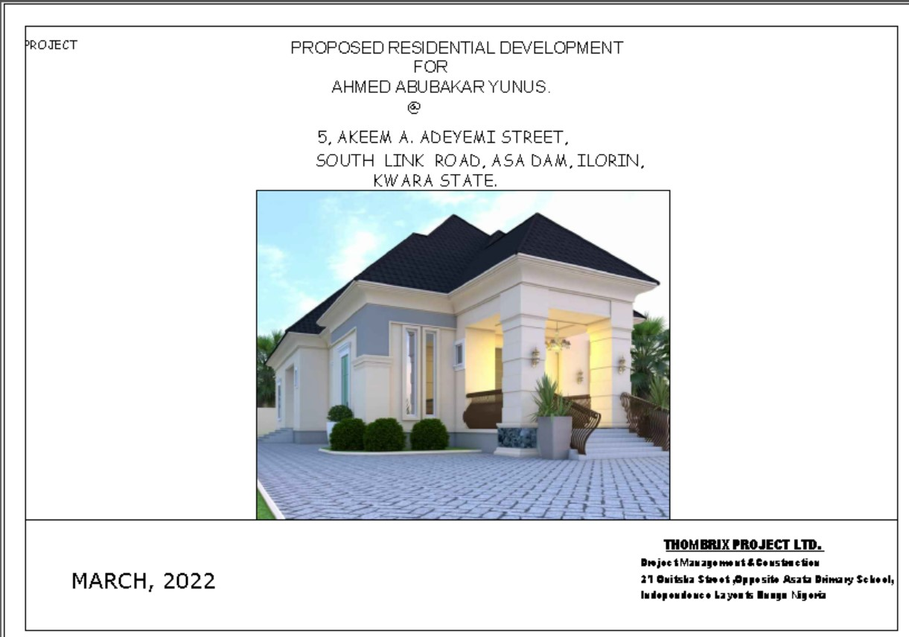

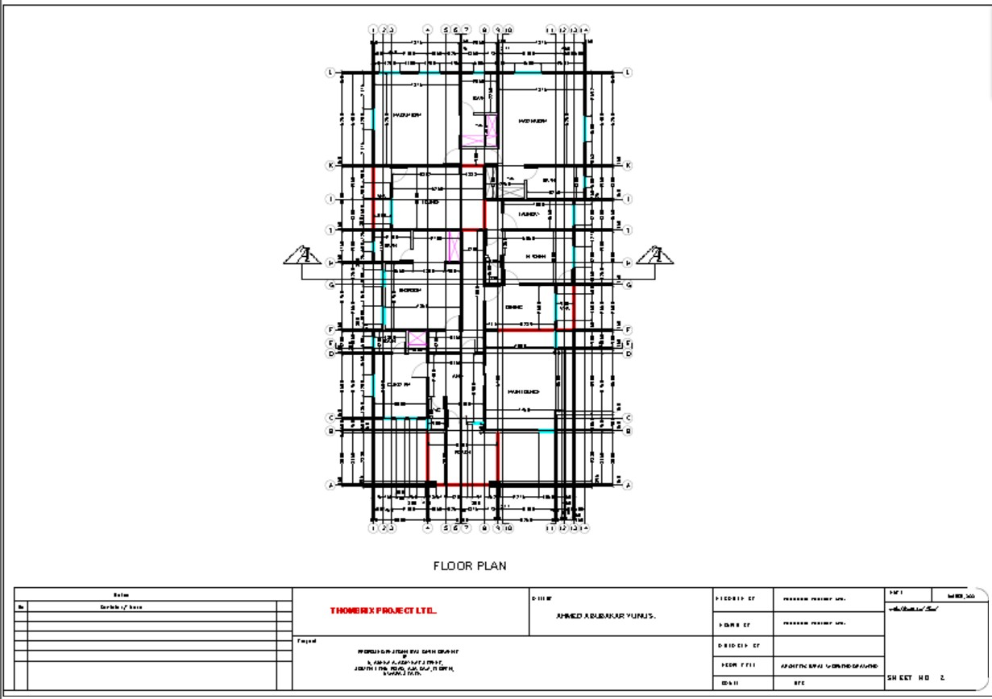

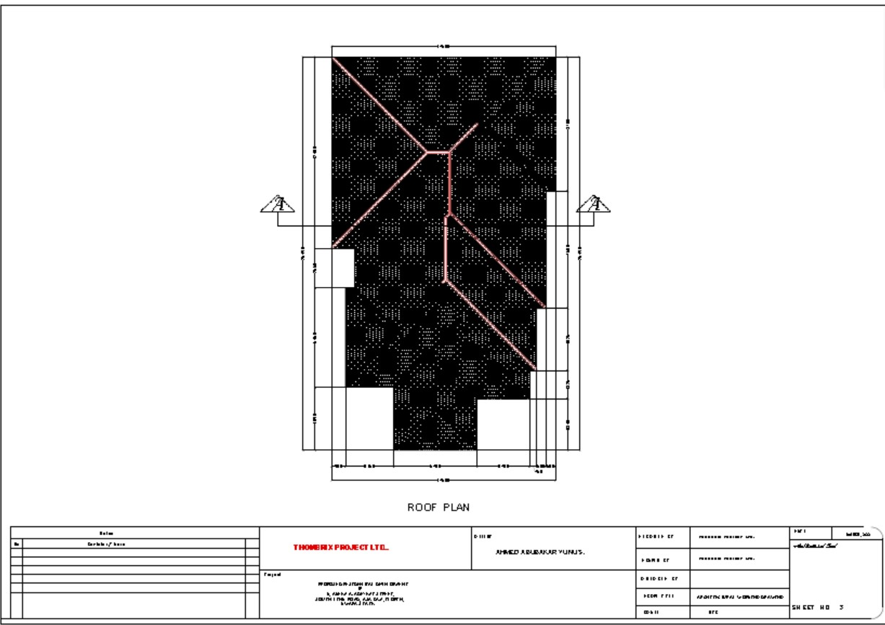

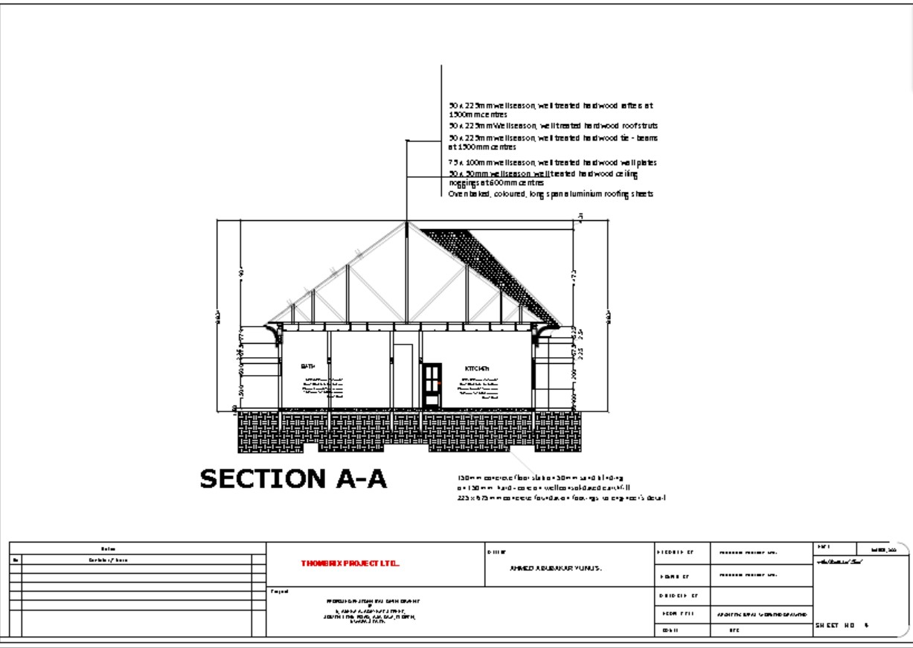

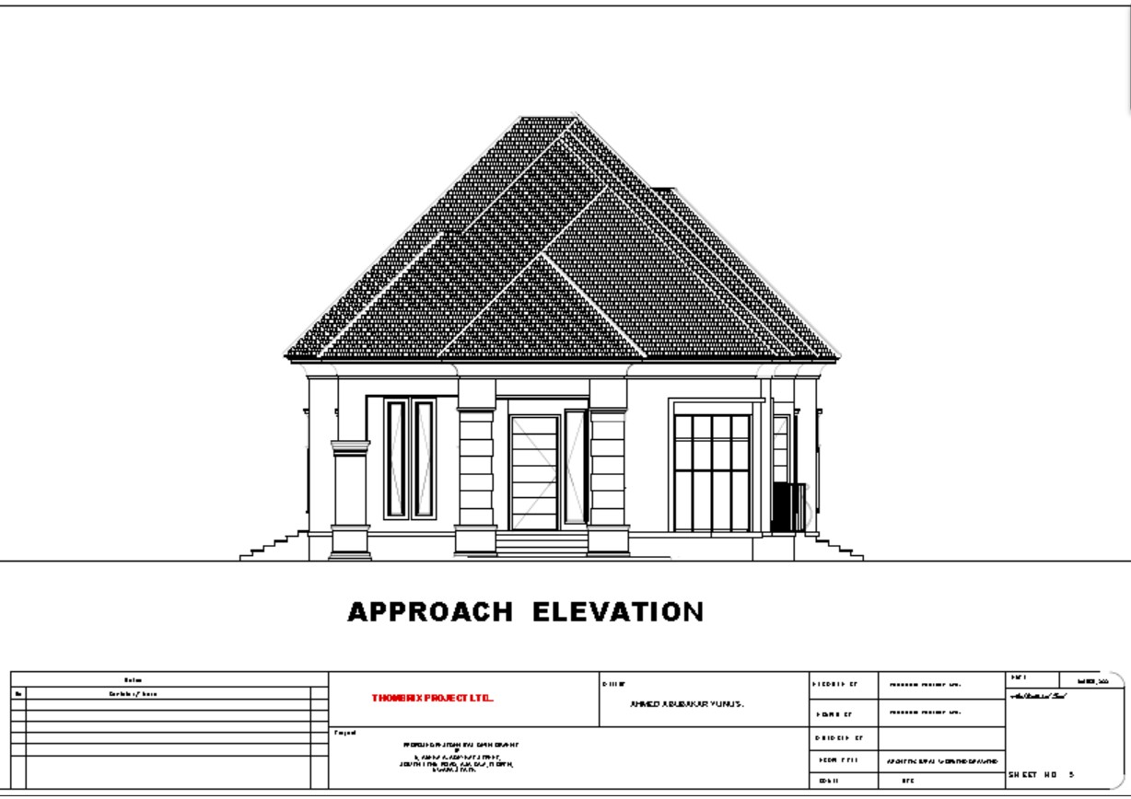

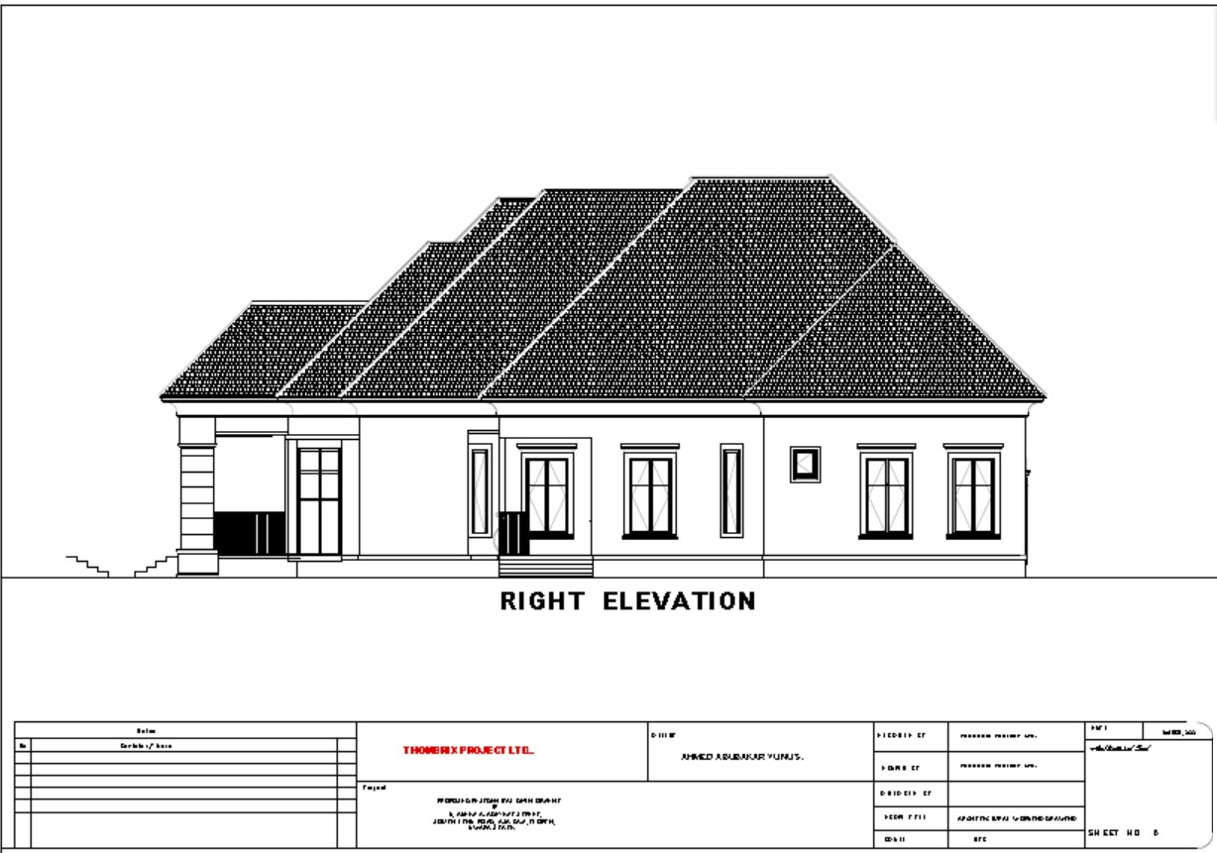

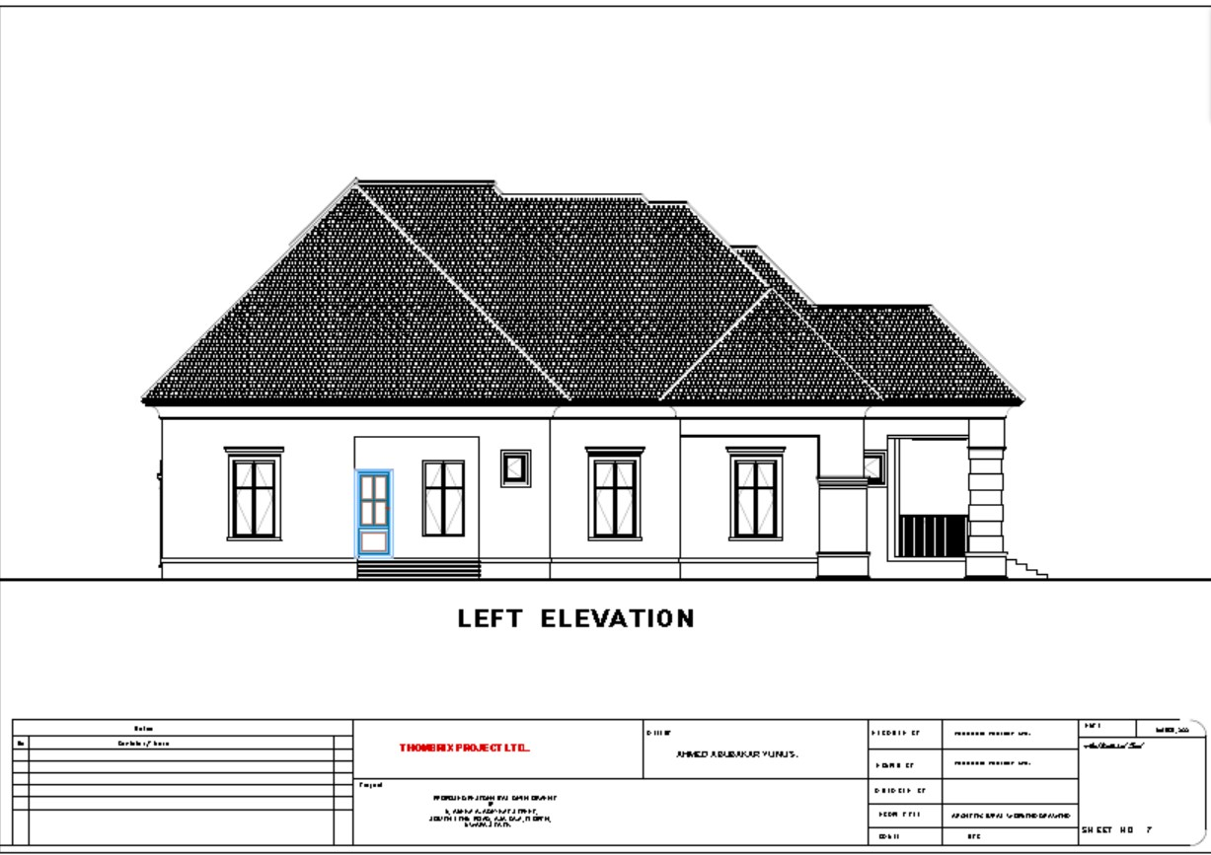

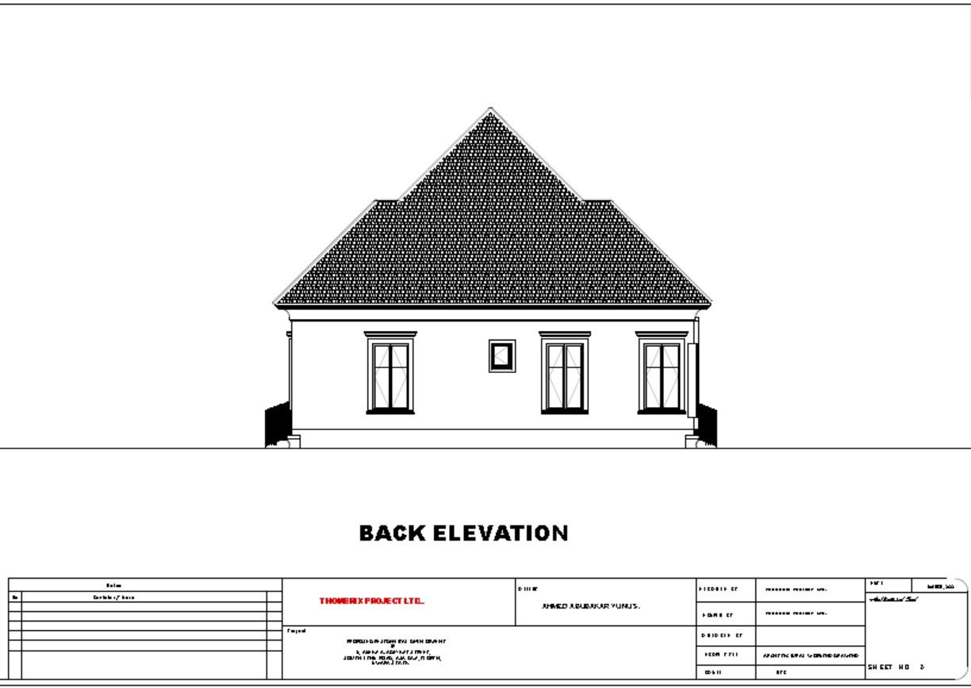

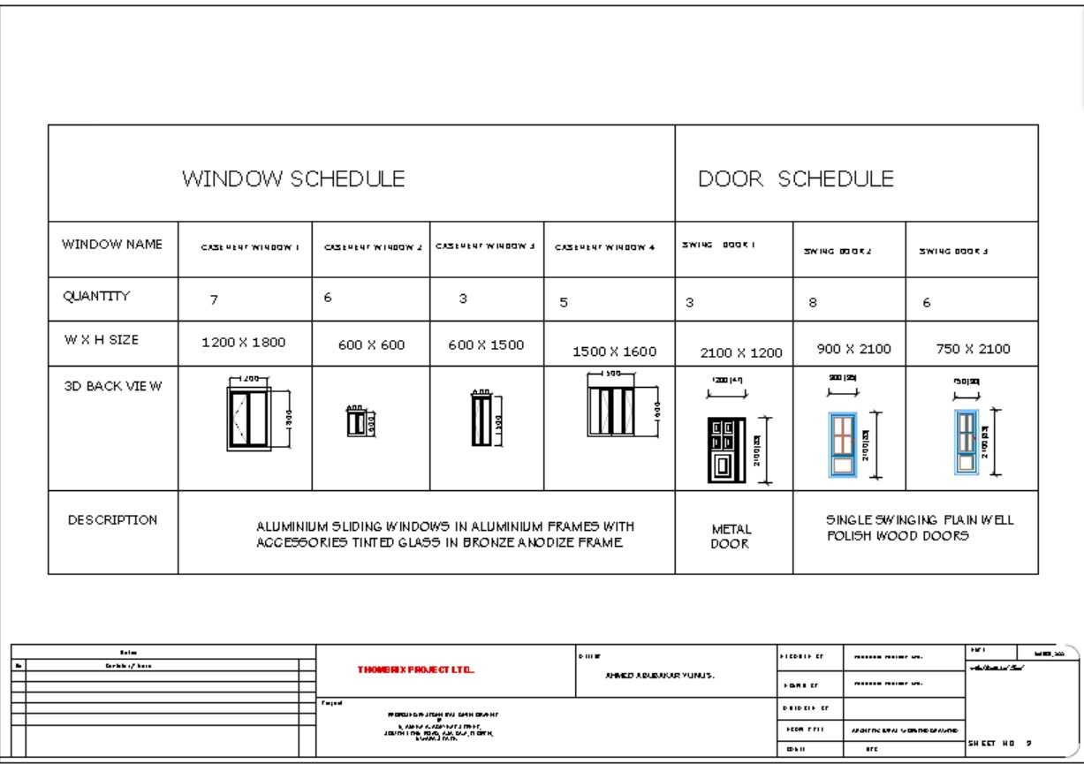

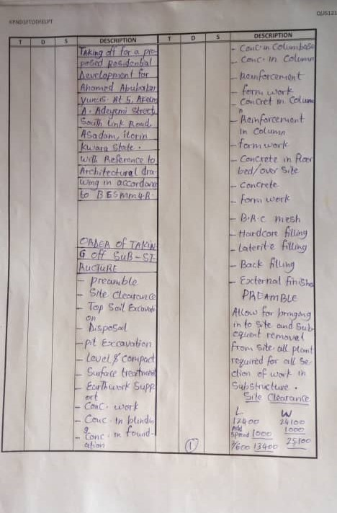
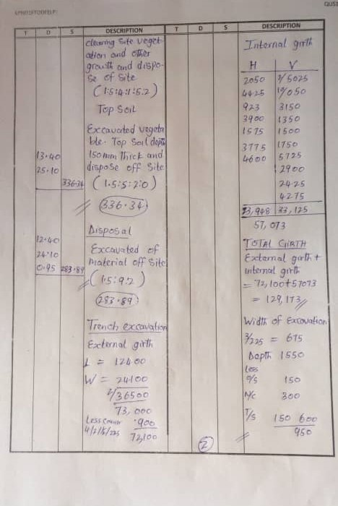
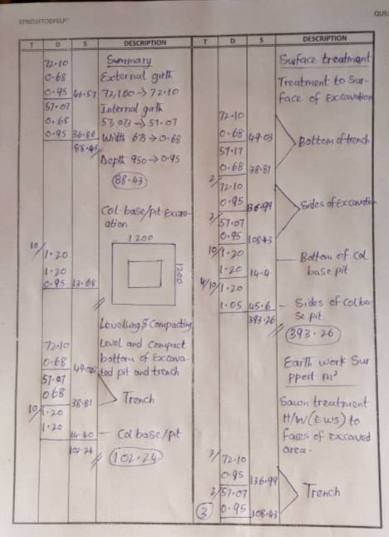

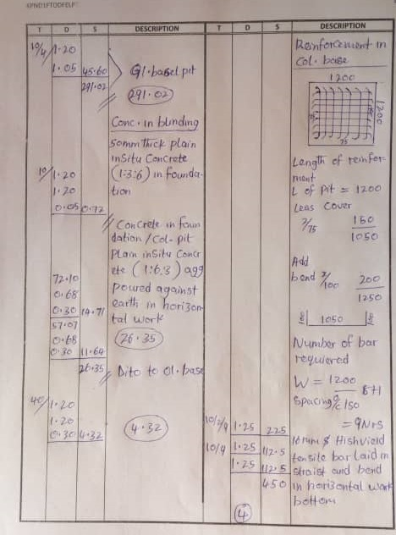

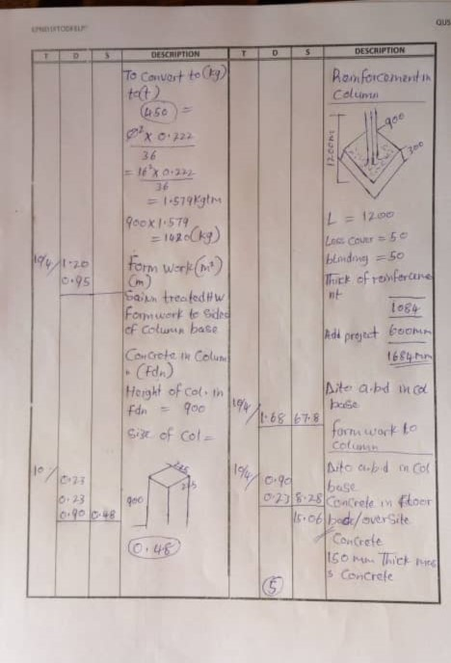

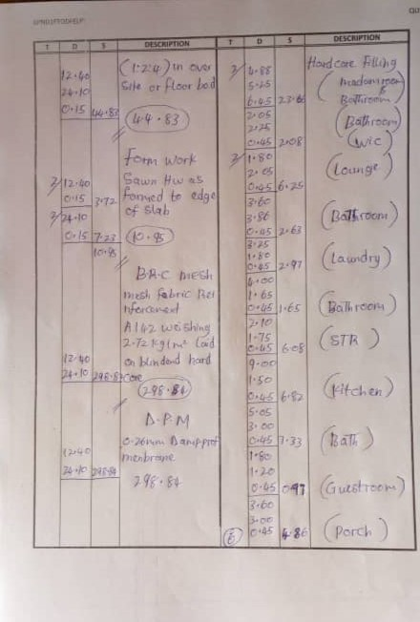

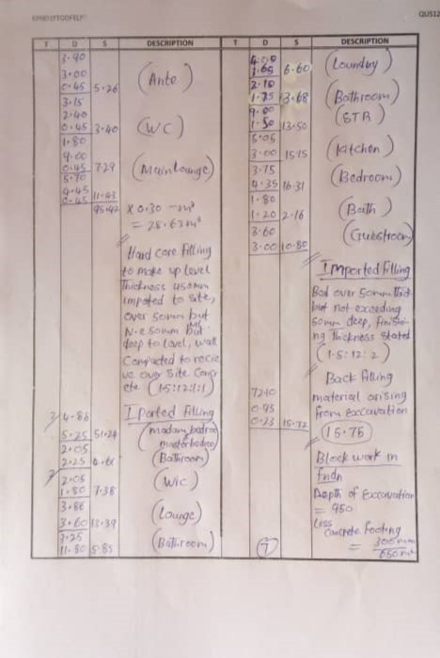

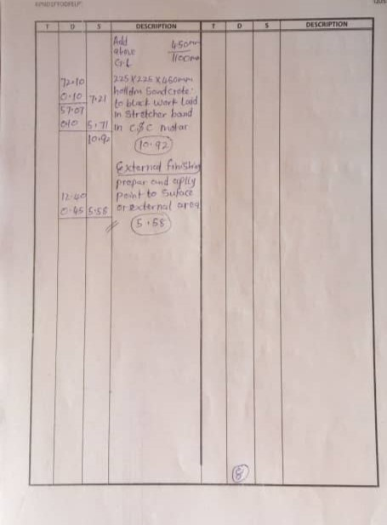

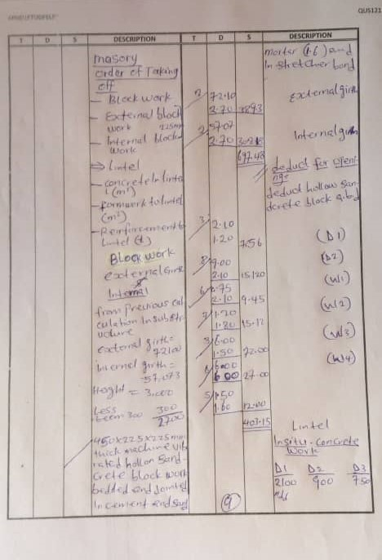
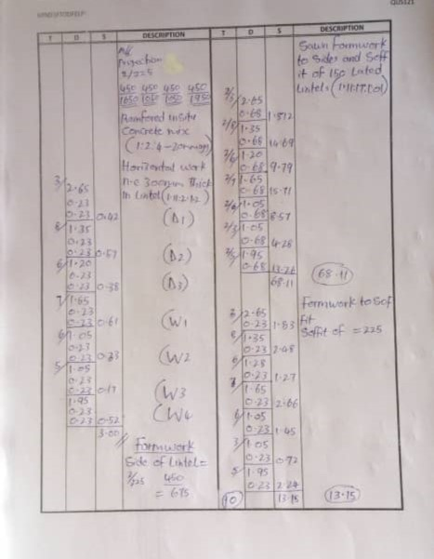

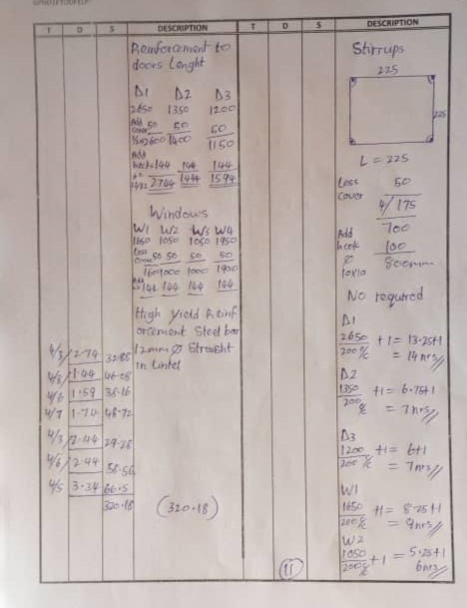

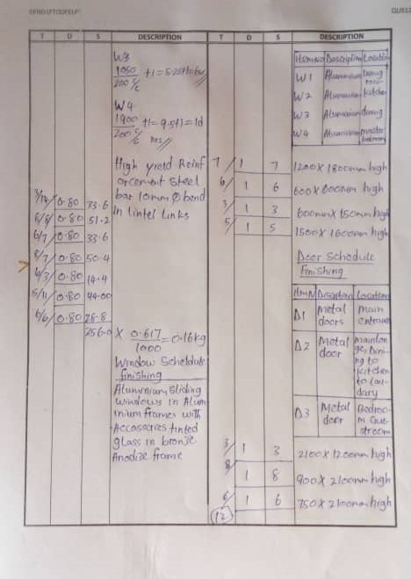

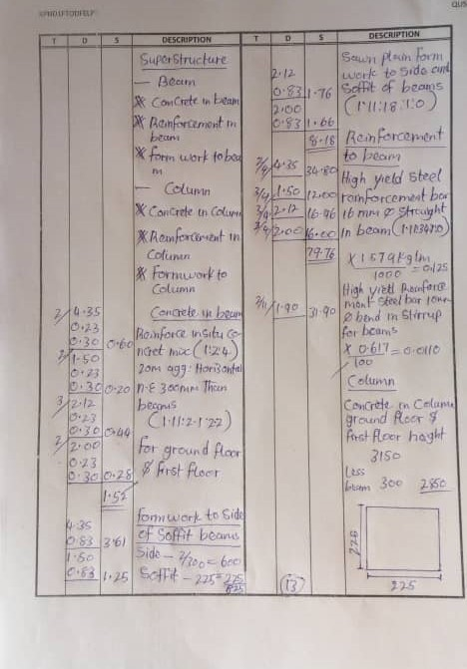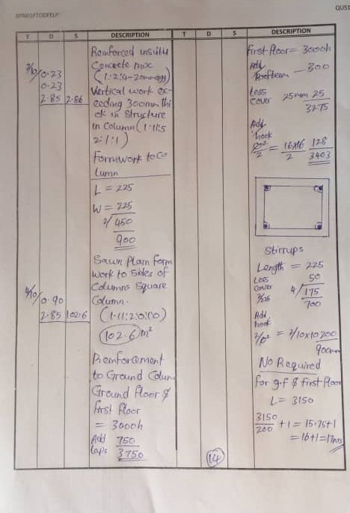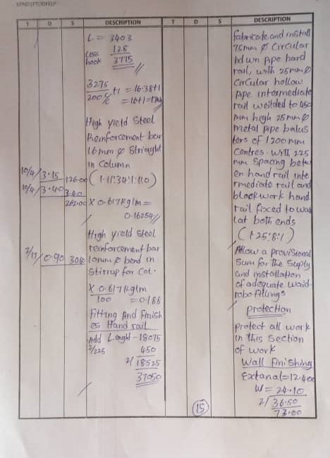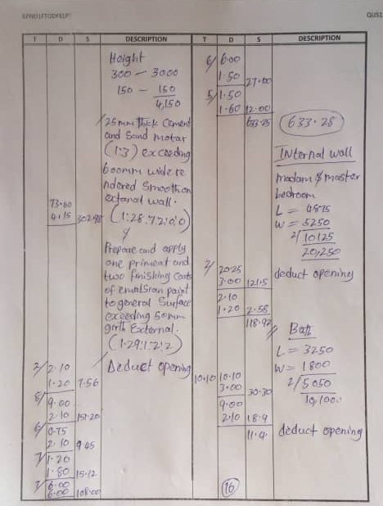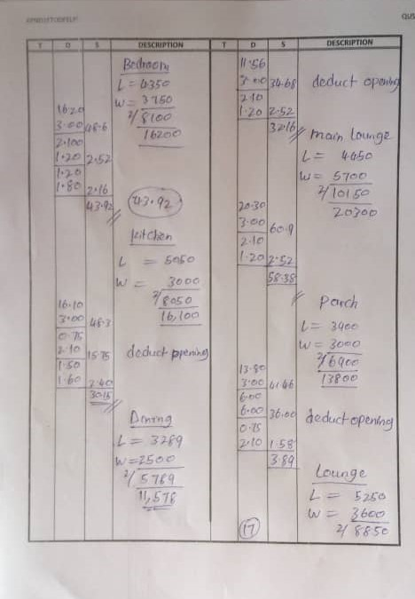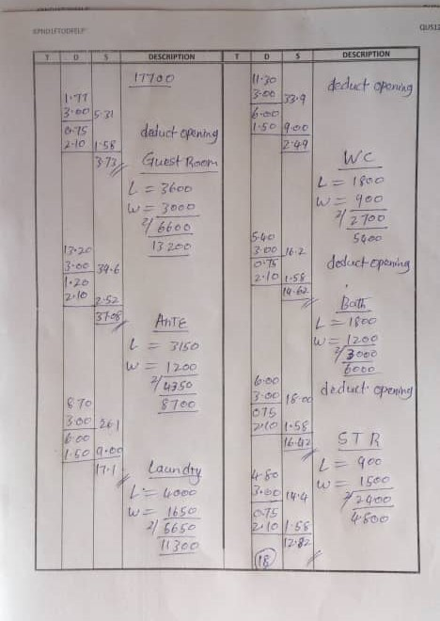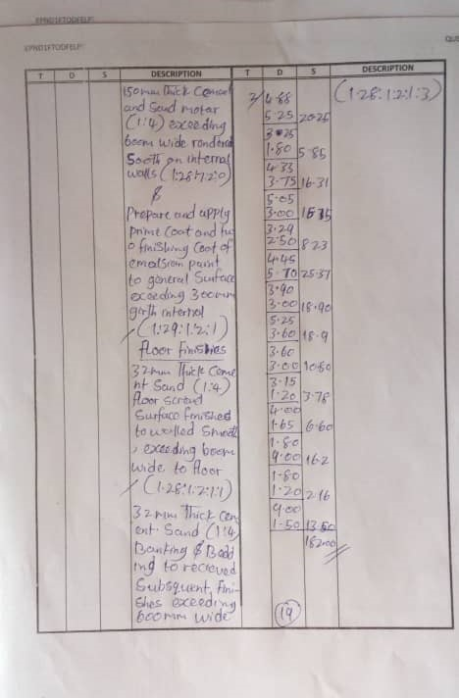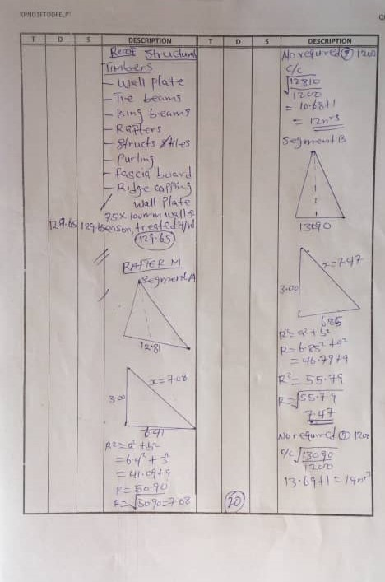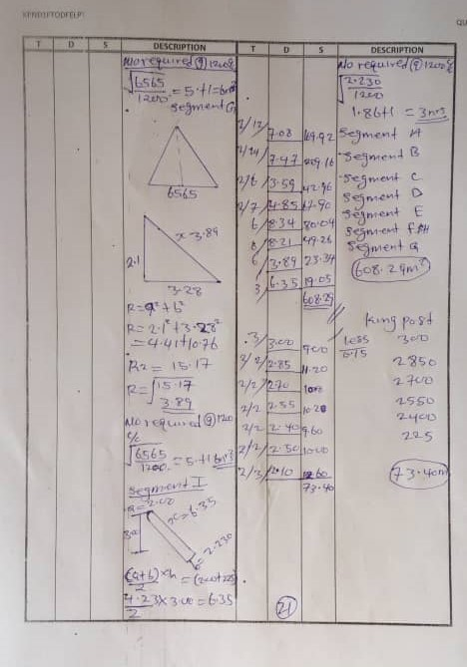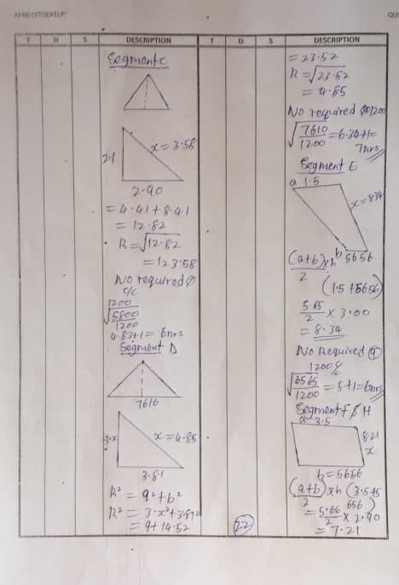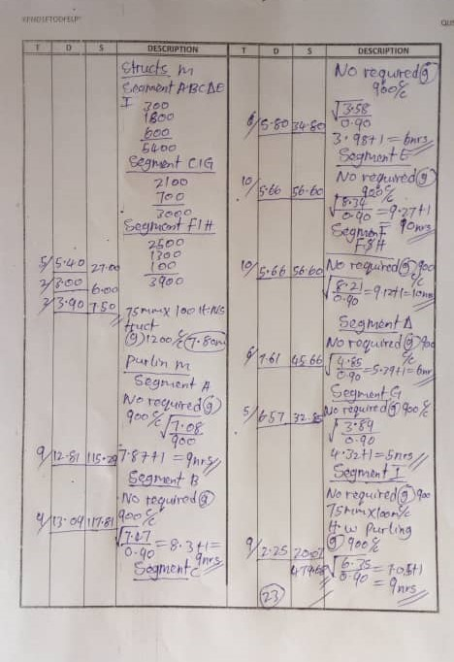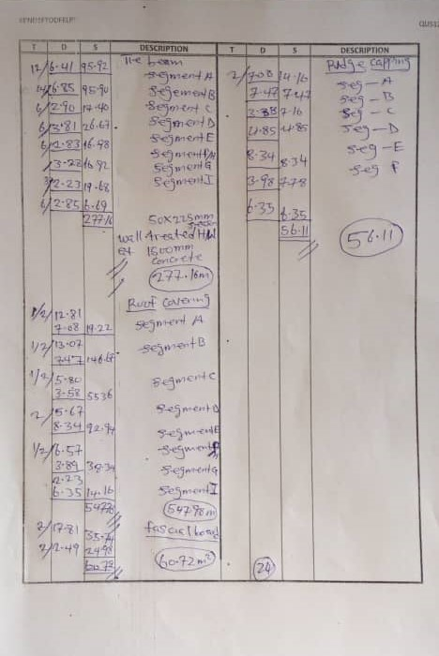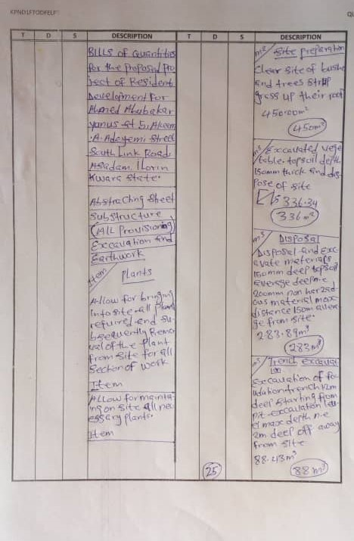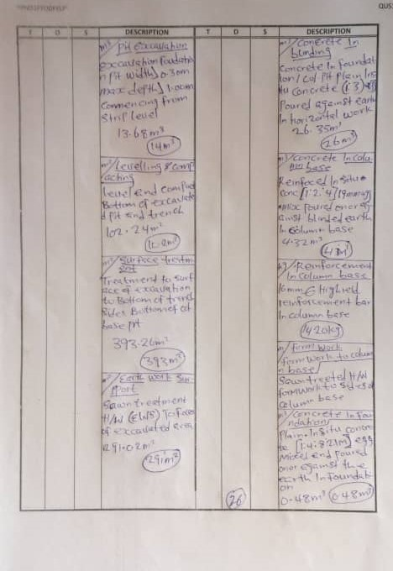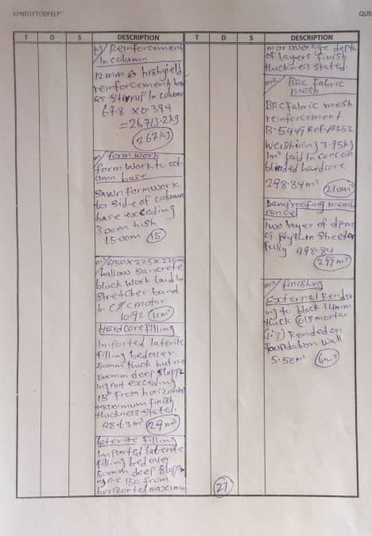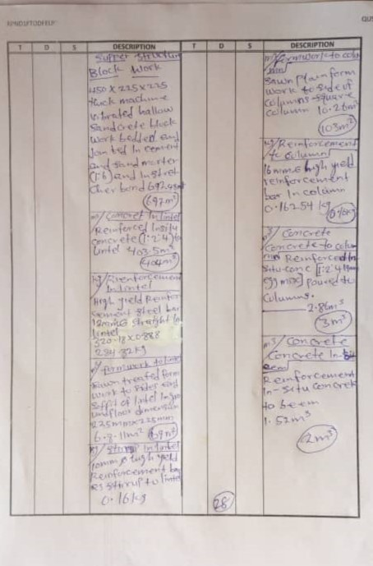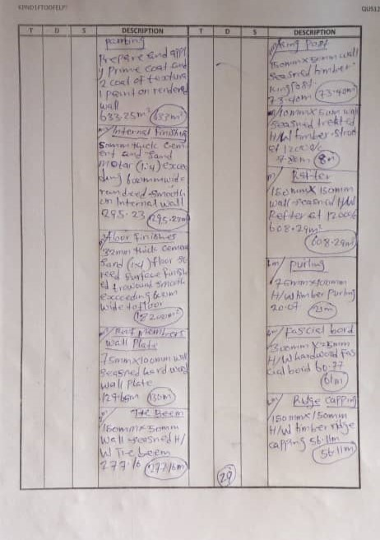

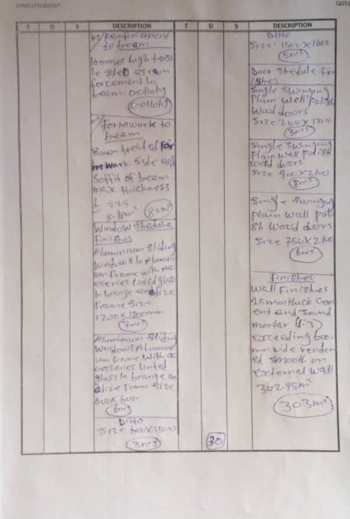

ABSTRACTING FOR THE PROPOSED RESIDENTIAL DEVELOPMENT FOR AHMED ABUBAKAR YUNUS, LOCATED AT 5, AKEEM A. ADEYEMI STREET, SOUTH LINK ROAD, ASA DAM, ILORIN KWARA STATE
SUBSTRUCTURAL WORK  SITE CLEARANCE  Clearance of site vegeptation and other growths including trees, bushes, shrubs, undergrowth e.t.c  264m²  TOP SOIL EXCAVATION  Excavating topsoil to reduce level depth 150mm commencing from natural ground level.  190m²  TOP SOIL DISPOSAL  Disposal of surplus excavated material off site 1m away.  29m³  TRENCH EXCAVATION  Excavate trench in strip foundation, width > 0.30m, maximum depth ≤ 2.00m to receive foundation footing.  61m³  EARTHWORK SUPPORT  Earthwork support to sides of trench maximum depth ≤ 2.00m and distance between opposing faces ≤ 2.00m.  49m³  HARDCORE FILLING  Filling to make up levels broken stone obtained from off-site selected hardcore materials. Areas of 300mm thick  113m²  Laterite filling  Compacted laterite filling 150mm layer thick spread in 150mm layer well and consolidated to cross the access finishes.  209m³  BAKFILLING  Filling to excavate all depth >0.25 arising from excavation  81m²  PIT EXCATION  Excavation foundation pit width <0.3m Max >1.0m commencing from strip level  51m³  CONCRETE IN COLUMN BASE  Reinforced insitu concrete mix 1:2:4 - 19mm agg. Pit base 300mm thick filled with formwork and well poured  12m³  CONCRETE IN COLUMN  Reinforced insitu concrete mix agg. 1:2:4 - 19mm agg. In column 225mm thick filled into formwork and well poured .  1m³  BLINDING  Blinding to faces of hardcore with sharp sand average thicknessn.e 0.05m obtained off-site. Areas of 300mm thick  36m³  OVERSITE CONCRETE  Reinforcedin-situ concrete (1:2:4-19mm aggregate mix) poured on damp proof membrane laid on top of blinded hardcore surface.  26m³ |  | LEVELLING & COMPACTING  Level and compact the bottom of excavated trenches well rammed manually ready to receive concrete footing.  82m²  SURFACE TREATMENT  Prepare and Apply any approved anti-termite solution by the architect to the faces and bottom of excavation.  305m²  CONCRETE IN FOUNDATION  Plain In-situ concrete 1:3:6-20mm aggregate mix poured against the blinded concrete  7m³  BLOCKWORK IN FOUNDATION  225 x 225 x 450mm hollow sandcrete vertical block wall laid in stretcher bond course with cement and sand (1:3) mortar  97m²  DAMP PROOF MEMBRANE  Laid any selected approved polythene damp proof membrane material on top of blinded hardcore surfaces.  174m²  FABRIC MESH  100$×$100mm mesh fabric reinforcement (ref. A98 weighing 150kg/m²) lay in ground slab with 300mm minimum end and side lap.  173m²  REINFORCEMENT IN PIT BASE  High yield tensile 12mm and reinforced bar to column base  279kg  FORMWORK TO THE EDGES OF SLAB  Sawn treated formwork to the edges of slab to provide smooth finishes not exceeding 225mm  70m  ETERNAL RENDERING TOBLOCKWORK  14mm thick cement and sand mortar 1:5 rendered to foundation wall.  97m²  PAINTING  Apply coat of texture paint as rendered wall.  97m²  FORMWORK TO THE COLUMN  Sawn treated formwork to the sides of column  19m²  PROTECTION  Allow for protection of all work contained in this section  Item
SUPERSTRUCTURAL WORKS  CONCRETE IN COLUMN  Reinforced insitu concrete 1:2:4-19mm agg. In column 225mm thick into formwork and well packed  6m³  CONCRETE IN BEAM  Reinforced insitu concrete mix 1:2:4-19mm agg. In beam running on external girth of the building  7m³  REINFORCEMENT IN COLUMN  16mm high yield reinforcement in column  780kg  REINFORCEMENT IN BEAM  16mm high yield reinforcement in beam  483kg |  | STIRRUP IN COLUMN  10mm high yield reinforcement bar as stirrup and link in column  310kg  STIRRUP IN BEAM  10mm high yield reinforcement bar as stirrup and link in beam  251kg  FORMWORK TO COLUMN  Sawn treated soft wood formwork to column Max depth 600mm high ground floor slab  99m²  FORMWORK TO BEAM  Sawn treated hard wood formwork to sides and support to beam  92m²
CONCRETE IN LINTEL  Reinforced insitu concrete 1:2:4-19mm agg. In lintel 225mm filled into finishes and packed  2m³  REINFORCEMENT IN LINTEL  12mm high tensile reinforcement in numerical sizes straight and bent in lintel.  125kg  STIRRUP IN LINTEL  10mm high yield steel reinforcement as stirrup and link in lintel.  133kg  FORMWORK IN LINTEL  Sawn treated formwork to the sides and soffit of the lintel for doors and windows.  22m² |  | BLOCKWORK IN GROUND FLOOR  Hollow sandcrete block laid in stretcher bond joint with cement and sand  27m²  BLOCKWORK IN UPPER FLOOR  Hollow sandcrete 450×225×225 block laid in stretcher bong joint with cement and sand (1:4)  235m²
SLAB  24m³  Concrete in slab  Reinforced concrete 1:2:4 mix- 20 mm agg. In slab.  REINFORCEMENT IN SLAB  Reinforced 12mm high yield steel in concrete slab.  363kg  FORMWORK TO THE EDGES OF SLAB  Sawn treated formwork to the edges of slab  16m²  FORMWORK TO THE SOFFIT OF SLAB  Sawn treated formwork to the soffit of slab.  16m² |  | Wall finishings(ground floor)  Internal walls  Plastering and paint of the internal wall.  259m²  EXTERNAL WALLS  Plastering and paint of external wall.  88m²  WALL FINISHINGS (upper floor)  INTERNAL WALLS  16mm thick cement and sand rendered to other part of wall exceeding 300mm thick and prepare and apply 2 coat of emulsion paint.  284m²
DOORS AND WINDOW SCHEDULE  Door 1  Well designed iron steel door fixed to manufacturer's details.  2800mm×3000mm  2nr  DOOR 2  Well designed iron steel door fixed to maufacturer's details.  1200mm×2100mm  1nr  DOOR 3  Well designed hardwood panel door fixed to manufacturer's details.  900mm×2100mm  3nr |  | DOOR 4  Well designed hardwood panel door fixed to manufacturer's details.  750mm×2100mm  4nr  WINDOW 1  Aluminium sliding window fixed to manufacturer's details.  2800mm×3000mm  2nr  WINDOW 2  Aluminium sliding window fixed to manufacturer's details.  600mm×600mm  5nr
Roof WORKS  WALL PLATE  100mm×50mm hard wood wall plate  69m  TIE BEAM  75mm×150mm hardwood tie beam  144m  RAFTER  75mm×150mm hard wood timber rafters  4m  STRUCT  75mm×100mm hardwood timber struct  25m  KING POST  100mm×50mm sawn treated hard wood king post  73m |  | PURLINS  50mm×75mm hard wood timber purlins  46m  FASCIAL BOARD  25mm×30mm hardwood fascial board  76m  NOGGINGS  50mm×50mm hardwood timber noghings  453m  ROOF COVERING  0.7m long span aluminium roofing sheet to manufacturer fixing details  255m  RIDGE CAP  300mm girth ridge cap  29m

REF | DESCRIPTION | QTY | UNIT | RATE | AMOUNT
 |  |  |  | N | N
 | ELEMENT Nr 1.
 | SUBSTRUCTURE
 | Site Clearance
1.5.4.1.0 | Clear site of bushes, shrubs, hedges and cart away | 264 | m²
 | from site
 | 1.5: Excavation and Earthwork
1.5.10.2.2.1 | Excavate oversite to remove vegetable soil average | 190 | m²
 | 150mm deep and wheel, spread and level on site as
 | directed
1.5.6.2.1.1 | Excavate trench for foundation starting from stripped | 61 | m³
 | level not exceeding 1.50m deep
1.5.6.2.1.1 | Excavate pit for column bases starting from stripped | 51 | m³
 | level not exceeding 1.50m deep
1.5.9.2.1.0 | Dispose surplus excavated materials from site | 29 | m³
1.5.9.2.1.0 | Backfill selected excavated material around the | 81 | m³
 | foundation
1.5.12.2.1.1 | 300mm approved laterite filling well rammed and | 209 | m³
 | consolidated in layers not exceeding 150mm thick
1.5.12.2.1.1 | Level and conpact bottom of excavation | 82 | M
1.5.12.2.1.1 | 300mm thick hardcore filling rammed and compacted | 419 | m³
1.5.16 | "Dieldrex 20" or other equal and approved | 305 | m²
 | anti-termite treatment to surface of excavation
 | sawn marine board for the excavation earthwork support | 146 | m²
 | Concrete work
 | Plain concrete
 | Plain concrete grade 15 in
1.11.2.1.1 | 50mm blinding under bases | 36 | m³
 | Vibrated concrete grade 20 in
1.11.2.1.1 | Foundation | 7 | m³
 | Carried to Collection
 | DESCRIPTION | QTY | UNIT | RATE | AMOUNT
 |  |  |  | N | N
 | SUBSTRUCTURE cont'd
 | Reinforced in-situ concrete
 | Vibrated concrete grade 15 in
1.11.2.1.2 | Column bases | 12 | m³
1.11.2.1.2.1 | Columns | 1 | m³
1.11.2.1.2.1 | concrete oversite | 26 | m³
 | Reinforcement
 | High yield deformed bars to BS4449 in column bases
 | and columns
1.11.34.1.1/2 | 16mm diameter bars | 1007 | kg
 | 12mm diameter bars |  | kg
1.11.34.1.1/2 | 10mm diameter bars use as stirrup | 279 | kg
 | BRC steel fabric reinforcement to BS4483 ref
 | A142 weighing 150kg/m2 laid and lapped in
 | accordance with manufacturer's instructions in
1.11.37.1.1/2 | Bed | 173 | m²
 | Sawn formwork to:
1.11.20.1 | Sides of column bases | 41 | m²
1.11.20.1 | Sides of columns | 20 | m²
1.11.20.1 | Edge of floor slab | 70 | m²
 | Carried to Collection
 | DESCRIPTION | QTY | UNIT | RATE | AMOUNT
 |  |  |  | N | N
 | SUBSTRUCTURE cont'd
 | Block Work
 | Hollow sandcrete blockwork filled solid with vibrated
 | concrete grade 20 and jointed in cement mortar
1.14.1.2.1 | 230mm wall | 97 | m²
 | Damp Proof Membrane
1.5.16 | 1200mm gauge polythene damp proof membrane laid on fillings | 174 | m²
 | at welted joints, laid on blinded hardcore
1.27.7.1.1 | Apply for oat of texture paint to rendered wall | 97 | m2
1.27.7.1.1 | External Rendering to Block work | 97 | m2
 | Carried to Collection
 | COLLECTION
 | PAGE 2/1
 | PAGE 2/2
 | PAGE 2/3
 | SUBSTRUCTURE
 | Carried to Summary
 | DESCRIPTION | QTY | UNIT | RATE | AMOUNT
 |  |  |  | N | N
 | ELEMENT Nr 2.
 | FRAME
 | SUPERSTRUCTURE
 | CONCRETE WORK
 | Reinforced in-situ Concrete 1:2:4-19mm
 | aggregate filled into formwork and well packed
 | around reinforcement (both measured)
1.11.2.1.2 | Columns | 6 | m³
1.11.2.1.2 | Beams | 7 | m³
1.11.2.1.2 | Suspended slab | 24 | m³
1.11.2.1.2 | Lintels | 2 | m³
 | FORMWORK
 | Sawn formwork to:
1.11.20.1 | Sides of Columns | 99 | m²
1.11.18.1 | Sides and soffits of beams | 92 | m²
1.11.17.1 | Sides and soffit of lintels | 22 | m²
1.11.15.1 | Soffits of slab | 16 | m²
1.11.14 | Edges of slabs | 16 | M
 | REINFORCEMENT
1.11.34.1.1/2 | High tensile deformed bars to B.S 4449 in
 | COLUMNS
1.11.34.1.1/2 | 16mm diameter bar | 780 | kg
 | 12mm diameter bar
 | 10mm diameter bar
 | Carried to Collection
 | DESCRIPTION | QTY | UNIT | RATE | AMOUNT
 |  |  |  | N | N
 | FRAME cont'd
 | BEAMS
1.11.34.1.1/2 | 16mm diameter bar | 483 | kg
 | 10mm diameter bar
 | SUSPENDED SLAB
1.11.34.1.1/2 | 12mm diameter bar | 363 | kg
 | 10mm diameter bar
 | LINTELS
 | 12mm diameter bar | 125 | kg
 | 10mm diameter bar
 | STIRRUP
1.11.34.1.1/2 | High yield stead reinforcement used as stirrup in:
 | Columns | 310 | kg
 | Beams | 251 | kg
 | Lintels | 133 | kg
 | Carried to Collection
 | COLLECTION
 | PAGE 5/4
 | PAGE 5/5
 | FRAME
 | Carried to summary
 | DESCRIPTION | QTY | UNIT | RATE | AMOUNT
 |  |  |  | N | N
 | ELEMENT Nr 3.
 | ROOF
 | ROOF COVERING
 | 0.7mm thick longspan aluminium
 | roofing sheets fixed to hardwood purlins
 | (measured seperately) in accordance with
 | specification (measured net- No allowance made for
 | laps)
 | Roofing fixed to manufacturer details | 255 | M
 | HARDWOOD ROOF TRUSS
 | 50mmx100mm wall plate | 69 | M
 | 75mmx150mm rafters | 4 | M
 | 75mmx150mm tie beam | 144 | M
 | 50x75mm purlins | 46 | M
 | 75mmx100mm struct | 25 | M
 | 50x50mm noggins | 453 | M
 | 100mm×50mm kingpost | 73 | M
 | 25mm×30mm fascial board | 76 | M
 | Ridge cap 300mm girth | 29 | M
 | cladding verge and eave angle | 70 | M
 | ROOFING
 | Carried to summary
 | DESCRIPTION | QTY | UNIT | RATE | AMOUNT
 | ELEMENT NR. 4
 | BLOCKWORK
 | Hollow sandcrete 450×225×225mm block laid in stretcher bond
 | joint with cement and sand in:
1.14.1.2 | Ground floor | 27 | m²
1.14.1.2 | Upper floor | 235 | m²
 | DESCRIPTION | QTY | UNIT | RATE | AMOUNT
 |  |  |  | N | N
 | ELEMENT Nr 5.
 | FINISHINGS
 | WALL FINISHINGS
 | INTERNAL AND EXTERNAL
1.28.7.2 | Hollow sandcrete block work in cement and sand
 | 230mm wall internally | 259 | m²
 | External walls | 88 | M²
 | Hollow sandcrete block work in cement and sand
 | mortar (1:3) for upper floor
 | 230mm wall internally | 284 | m²
 | External walls | 200 | m²
 | FLOOR FINISHING
 | 50mm thick vitrified floor with cement and sand screeded bed (1:3) on:
 | Ground floor | 154 | m²
 | upper floor | 12 | m²
 | CEILING FINISHINGS
1.30. | 200mm wide high quality AMOULAR P.V.C ceiling sheet.
 | Ceilings fixing | 154 | m²
 | FINISHINGS
 | Carried to summary
 | DESCRIPTION | QTY | UNIT | RATE | AMOUNT
 |  |  |  | N | N
 | ELEMENT Nr 6.
 | WINDOWS
1.23.1.1.1.1 | Aluminum sliding windows fixed to manufacturer's details.
 | Ditto size 2800x3000mm | 2 | nr
 | Ditto size 600x600mm | 5 | nr
 | BURGLARY PROOF
 | Ditto size 2800x3000mm | 2 | nr
 | Ditto size 600x600mm high | 5 | nr
 | WINDOWS
 | Carried to summary
 | DESCRIPTION | QTY | UNIT | RATE | AMOUNT
 |  |  |  | N | N
 | ELEMENT Nr 7.
 | DOORS
 | Iron steel doors
1.24.2.1.0.1 | Purpose made iron steel door complete with frame
 | ironmongery and all other acceessories including
 | cutting and pinning or building in lugs to block work
 | or concrete work and pointing all around with approved
 | Mastic
 | Size 2800x30000mm | 2 | nr
 | Size 1200mm×2100mm | 1 | nr
 | Purpose made designed hardwood panel door complete with
 | frame ironmongery and all other acceessories including
 | cutting and pinning or building in lugs to block work
 | or concrete work and pointing all around with approved
 | Mastic
 | Ditto size 900x2100mm | 3 | nr
 | Ditto size 750x2100mm | 4 | nr
 | DOORS
 | Carried to summary
 | DESCRIPTION | QTY | UNIT | RATE | AMOUNT
 |  |  |  | N | N
 | GENERAL SUMMARY
 | SUBSTRUCTURE |  |  |  | -
 | FRAME |  |  |  | -
 | ROOF |  |  |  | -
 | BLOCKWORK
 | INTERNAL AND EXTERNAL WALLS |  |  |  | -
 | WINDOWS |  |  |  | -
 | DOORS |  |  |  | -
 | ADD
 | PRELIMINARES ITEM (INCLUDING
 | SCAFOLDING AND SETTING OUT)
 | CONTIGENCY
 | TOTAL ESTIMATED COST OF PROJECT

CHAPTER FIVE
5.1 SUMMARY
This research was carried out to Estimate and Budget for a Proposed Residential Development For Ahmed Abubakar Yunus, Located At 5, Akeem A. Adeyemi Street, South Link Road, Asa Dam, Ilorin Kwara State
It is also designed to show the process of taking off, abstracting and method of preparing Bill of Quantities.
5.2 CONCLUSION
In conclusion, we observed that estimating for medium scale building project is very important.
- It gives an itemized list of the component parts of the building with a full description and quantity of each part.
- It serve as a guideline for the contractor.
- It provides a basis for a valuation of variable which often occur during the progress of the work.
- It enables all contractors tendering for a contract to price on exactly the same information with a minimum of effort.
5.3 RECOMMENDATION
From the analysis of the data in chapter four of this project, the following recommendations were been made:
- The Quantity Surveyor should provide an estimate during the preliminary stage of the project in order to forecast its likely cost.
- It is important not to under estimate, proper estimating procedures should be used and the layout of the estimate should be clear and logical.

REFERECNES
Building and Engineering Standard and Method of Measurements. (BESMM4)
Ivor H. Seeley, (1997): Building Quantities 3rd Edition Macmillan Press Ltd.
Onovah T.C (1997): Building Measurement.

