ROBOTIC FIRE FIGHTER USING ARDUINO UNO TECHNOLOGY

BY
NAME
HND/23/COM/FT/

A Project Submitted to the Department of Computer Science, Institute of Information and Communication Technology, Kwara State Polytechnic, Ilorin

In Partial Fulfillment of the Requirements for the Award of Higher National Diploma (HND) in Computer Science

July, 2025
CERTIFICATION
This is to certify that this project was carried out by Name with Matric Number HND/23/COM/FT/ as part of the requirements for the award of Higher National Diploma (HND) in Computer Science.

………………………………. ……………………………….
Dr. (Mrs.) Dada, O. M. Date
(Project Supervisor)

………………………………. ……………………………….
Mr. Oyedepo, F. S. Date
(Head of Department)

………………………………. ……………………………….
External Examiner Date

DEDICATION
This project is dedicated to the creator of the earth and universe, the Almighty God. It is also dedicated to my parents for their moral and financial support.

ACKNOWLEDGEMENT
All praise is due to the Almighty God the Lord of the universe. I praise Him and thank Him for giving me the strength and knowledge to complete my HND programme and also for my continue existence on the earth.
I appreciate the utmost effort of my supervisor, Dr. (Mrs.) Dada, O. M., whose patience support and encouragement have been the driving force behind the success of this research work. She gave useful corrections, constructive criticisms, comments, recommendations, advice and always ensures that an excellent research is done. My sincere gratitude goes to the Head of the Department and other members of staff of the Department of Computer Science, Kwara State Polytechnic, Ilorin, for their constant cooperation, constructive criticisms and encouragements throughout the programme.
Special gratitude to my parents who exhibited immeasurable financial, patience, support, prayers and understanding during the periods in which I was busy tirelessly in my studies. Special thanks go to all my lovely siblings.
My sincere appreciation goes to my friends and classmates.

TABLE OF CONTENTS
Title Page i
Certification ii
Dedication iii
Acknowledgements iv
Abstract v
Table of Contents vi
CHAPTER ONE: GENERAL INTRODUCTION
  - Background to the Study 1
  - Statement of the Problem 3
  - Aim and Objectives of the Study 3
  - Significance of the Study 4
  - Scope of the Study 4
  - Organization of the Report 5
CHAPTER TWO: LITERATURE REVIEW
2.1 Review of Related Works 6
2.2 Review of Related Concepts 10
2.2.1 Overview of Arduino Uno Technology 10
2.2.2 Fire Detection Sensors 10
2.2.3 Robotic Mobility 12
2.2.4 Overview of Autonomous Systems 12
2.2.5 Robotic Fire Fighter using Arduino Uno 14
CHAPTER THREE: RESEARCH METHODOLOGY AND ANALYSIS OF THE EXISTING SYSTEM
  - Research Methodology 15
  - Analysis of the Existing System 15
  - Problems of the Existing System 16
  - Description of the Proposed System 16
  - Advantages of the proposed system 17
CHAPTER FOUR: DESIGN, IMPLEMENTATION AND DOCUMENTATION OF THE SYSTEM
  - Design of the System 18
    - Output Design 18
    - Input Design 22
4.1.3 Procedure Design 24
  - Implementation of the System 24
    - Choice of Programming Language 24
    - Hardware Support 25
    - Software Support 25
  - Documentation of the System 26
    - Program Documentation 26
    - Maintaining the System 27
CHAPTER FIVE: SUMMARY, CONCLUSION AND RECOMMENDATION
  - Summary 27
  - Conclusion 27
  - Recommendation 28
References
Appendices

ABSTRACT
The increasing occurrences of fire-related disasters necessitate advanced technologies for efficient firefighting operations. In this context, the development of fire-fighting robots emerges as a promising solution. This project outline the design, functionality, and potential applications of a cutting-edge fire-fighting robot. The fire-fighting robot is equipped with a robust mechanical structure designed to withstand high temperatures and navigate through challenging terrains. It integrates state-of-the-art sensors, including thermal imaging cameras and gas detectors, enabling real-time monitoring of the fire environment. These sensors provide crucial data for decision-making algorithms implemented in the robot's control system. The control system incorporates artificial intelligence algorithms for autonomous navigation, fire detection, and suppression. Machine learning techniques enable the robot to analyze environmental data and identify the presence and spread of fire with high accuracy. Upon detection, the robot autonomously devises an optimal path towards the fire source while avoiding obstacles.

CHAPTER ONE
GENERAL INTRODUCTION
  - BACKGROUND TO THE STUDY
One of the most important parameters in fire disaster is life, that is lives lost in saving someone else life. It is sometimes impossible for fire-fighters personnel to access the site of a fire because of explosive materials, smoke, and high temperatures. A fast response to detect the fire can avoid many disastrous things. Fire incidents are a critical challenge, often causing significant property damage and loss of life. Traditional firefighting methods expose personnel to high-risk situations. Automation and robotics offer a promising alternative by reducing human intervention in dangerous scenarios (Jain et al., 2024).
Robotic technology has advanced significantly, finding applications in industrial automation, healthcare, and disaster management. Fire-fighting robots have gained attention for their ability to navigate dangerous environments and respond swiftly to emergencies. As technology is constantly developed, robot uses in real life situations have hiked and human interaction is made less. The high potential for a robot to imitate human’s action has led to the extent that it is able to protect a human’s life from fatal accident such as in fire. Undoubtly, fire accident is a common risk in a daily life and its impact may lead to permanent injury or death (Wasu et al., 2022).
Chirunadh et al., (2023) claimed that the evolution of robotic fire-fighting systems has been influenced by advances in sensor technology and machine learning algorithms. These technologies enable robots to detect fire sources with greater precision and adapt their responses to dynamic environments. Despite these advancements, affordability and accessibility remain barriers to widespread adoption, particularly in developing countries. Arduino Uno, an open-source microcontroller platform, provides a flexible and affordable means of developing such robotic systems.
The integration of robotics in firefighting aligns with global efforts to enhance disaster response mechanisms. Governments and organizations have increasingly recognized the potential of robotics to mitigate risks and reduce casualties in fire emergencies. This trend underscores the importance of continuous research and innovation in this field. Another critical aspect is the collaboration between academia and industry in advancing robotic fire-fighting technologies. Joint efforts have led to the creation of more sophisticated prototypes and systems, showcasing the potential for real-world applications. By leveraging these partnerships, the development of cost-effective solutions can be accelerated, further bridging the gap between research and implementation (Jagruti1 et al., 2024).
Kumar et al., (2024) asserted that upon fire detection, Robot employs its motorized wheels or tracks for mobility, allowing it to navigate through challenging terrains and obstacles, ensuring timely response to fire incidents that might be hard to reach by human firefighters. The integration of Arduino-compatible actuators and servos will further enhance its agility, enabling it to maneuver effectively and access fire-affected areas swiftly. The intelligence of robot is derived from its programming, where Arduino Uno processes sensor data, makes real-time decisions, and executes appropriate actions. Through the integration of wireless communication modules like Wi-Fi or Bluetooth, robot can transmit critical information, such as fire location and status updates, to a remote-control station or a central monitoring system.
The goal of this project is to design a robotic fire fighter. The heart of the Fire Fighting robot is the Arduino Uno microcontroller, which serves as the brain, orchestrating its functions. Equipped with an array of sensors such as temperature, smoke, and infrared detectors, the robot can accurately identify the presence and intensity of fires within its operational environment.
  - STATEMENT OF THE PROBLEM
Fire disaster is one of the dangerous problems that can lead to heavy loss both financially and by taking lives. Sometime it becomes difficult for fighters to access the site of a fire because of explosive materials, smoke, and high temperatures. Such situations risk the lives of fire fighters too. In such environments, fire-fighting robots can be useful. This Fire Extinguishing Robot is based on IOT Technology. In Fire fighting Robot, the researchers intend to build a system that could extinguish a small flame by sensing and moving to the location itself. Sometime delay in the arrival of fire fighters leads to numerous consequences. The Fire fighting robot continuously monitors the environment and extinguishes it without delay.
  - AIM AND OBJECTIVES OF THE STUDY
The aim of this project is to design and implement a robotic fire fighter using Arduino Uno technology. The objectives are to:
- Design a moveable robotic
- Core the robot using Ardruino; and
- Implementation will done by extinguishing a real fire
- design and build an autonomous Robotic Fire Fighter powered by a rechargeable battery.

  - SIGNIFICANCE OF THE STUDY
This project contributes to the field of disaster management by introducing an innovative, affordable, and efficient fire-fighting solution. It minimizes risks to human life, reduces response time, and offers potential applications in industrial, residential, and forest fire scenarios. The research also highlights the versatility of Arduino technology in solving real-world problems.
  - SCOPE OF THE STUDY
This project focuses on the design, development, and testing of a prototype robotic fire fighter. It covers the integration of sensors for fire detection, motorized systems for mobility, and mechanisms for extinguishing fires. The scope is limited to small-scale fire scenarios suitable for laboratory and simulated environments.
1.6 ORGANIZATION OF THE REPORT
The project write-up is organized into five distinct chapters. Chapter one covers general introduction, which contains introduction to the project topic, statement of the problem, aim and objectives of the study, significance of the study, scope of the study and organization of the report. Chapter two covers the literature review, which contains review of related past works, overview of artificial intelligence, description robotic system and other related concepts. Chapter three explains the project methodology which includes analysis of existing system, problems of the existing system, the description of the proposed system and advantages of proposed system. Chapter four explains the design, implementation and documentation of the system which contain system designed output design, input design, database design, procedure design, implementation of the system hardware and software support and documentation of the new system installation procedure, operating the system and system maintenance. Lastly, chapter five explains the summary of the research, recommendations, and conclusion.

1.7 Definition of the technical terms

Rechargeable Battery Charger Module (TP4056): A circuit used to safely recharge lithium-ion batteries, managing the charging voltage and current.

Actuator: A component, such as a motor or pump, that converts electrical signals into mechanical movement.

Buck Converter: A type of voltage regulator that steps down the voltage from a higher input to a lower output efficiently.

Autonomous Navigation: The robot’s ability to move and make decisions on its own without manual control, using sensors and programmed logic.

Chassis: The structural framework of the robot, supporting all components like motors, sensors, and the extinguishing system.

DC Motor: A motor powered by direct current (DC) electricity, used to drive the wheels of the robot for movement.

Water Pump:A small DC pump used to spray water to extinguish a fire. It is powered by the battery and controlled via a relay.

CHAPTER TWO
LITERATURE REVIEW
2.1 REVIEW OF RELATED LITERATURE
Jain et al., (2024) designed a fire fighting robotic system for fire disaster control. The paper outlined the design, functionality, and potential applications of a cutting-edge fire-fighting robot. The fire-fighting robot was equipped with a robust mechanical structure designed to withstand high temperatures and navigate through challenging terrains. It integrates state-of-the-art sensors, including thermal imaging cameras and gas detectors, enabling real-time monitoring of the fire environment. These sensors provide crucial data for decision-making algorithms implemented in the robot's control system. The control system incorporates artificial intelligence algorithms for autonomous navigation, fire detection, and suppression. Machine learning techniques enable the robot to analyze environmental data and identify the presence and spread of fire with high accuracy. Upon detection, the robot autonomously devises an optimal path towards the fire source while avoiding obstacles.
Chirunadh et al., (2023) implemented an arduino based firefighting robot. The aim of the system was to developed a fire-fighting robot. The firefighting robot uses arduino, Fire sensors, and so on. When the Robot detects a fire, it gives a message to the arduino. Then arduino sends the signal to the motor driver and thus water is sprayed in the direction of the fire. It assists firefighters in extinguishing the fire. And it performed its operation where firefighters can’t reach. This will save the risk of fire fighters' life and avoid any further damage.
Wasu et al., (2022) worked on a wireless arduino controlled fire fighter robot designed for residential area. The fire fighter robot was developed with the aim to save lives of fire fighters who risk their lives, entering dangerous environments. The paper presented the development of the fire fighter robot, which is suitable to extinguish fire in closed areas and residential areas. The robot’s movement can be manually controlled using Flysky grand touring (GT2) Controller from outside of the affected area. The robot is in the form of a robust and compact vehicle which allows it to move front, back, left and right in small areas with a steady speed. The robot has a 12V water pressure pump capable of shooting water up to 3 to 5 litres per minute which allows it to control large amounts of fire. The robot also provides live streaming and GPS location tracking services during the movement of the robot. This live recording can be viewed in PC or in the user's mobile phone.
Udhyami et al., (2024) proposed a firefighting robot using Arduino. The paper introduced a novel firefighting robot designed with Arduino to enhance fire detection and extinguishment in hazardous environments. Utilizing two flame sensors, a water dispenser, and Bluetooth control, the robot autonomously navigates obstacles while scanning for fires. It can move in multiple directions and stops when encountering barriers, resuming once cleared. The robot’s microcontroller processes data to detect flames, activate extinguishing mechanisms, and provide notifications. The system aims to improve safety for engineers in industrial settings by swiftly addressing fire incidents, ultimately minimizing property damage and protecting lives in dangerous situations.
Kumar et al., (2024) designed an arduino fire fighting robot. The project is enhanced to control fire through a robotic vehicle. With the advancement in the field of Robotics, human intervention is becoming less every day and robots are used widely for purpose of safety. In our day-to-day life fire accidents are very common and sometimes it becomes very difficult for fireman to save human life. In such case firefighting robot comes in picture. The project aims in giving a technical solution to the mentioned problem. A robot is a mechanical design that is capable of carrying out a complex series of actions automatically, especially one programmable by a computer. The flame sensor detects the fire and gives the further signal to the extinguisher units to trigger the pump and spray the water. The whole system is programmed using an Arduino UNO board (ATmega328P microcontroller) which forms the brain of the system.
Ali (2022) developed an Arduino fire-fighting robot. The project aims in giving a technical solution to the mentioned problem. A robot is a mechanical design that is capable of carrying out a complex series of actions automatically, especially one programmable by a computer. A fire extinguisher robot is a DTMF tone-controlled robot that has a small fire extinguisher unit added on to it. This mobile robot is controlled using a mobile phone through DTMF tones for its movement and reaching the fire, the flame sensor detects the fire and gives the further signal to the extinguisher units to trigger the pump and spray the water. The whole system is programmed using an Arduino UNO board (ATmega328P microcontroller) which forms the brain of the system.
Jagruti et al., (2024) implemented an arduino based fire fighting robot. The project introduced an Arduino Uno-based Fire Fighting robot, a pioneering technological advancement in firefighting. The heart of this robot is the Arduino Uno microcontroller, which orchestrates its functions, integrating advanced hardware and software components. Equipped with an array of sensors and actuators, the robot can accurately detect fires, navigate challenging terrains, and access fire-affected areas swiftly. The intelligence of the robot stems from its programming capabilities, where the Arduino Uno processes sensor data, makes real-time decisions, and executes appropriate actions. It incorporates wireless communication modules for transmitting critical information to remote control stations, enhancing its adaptability in diverse fire scenarios. The compatibility of Arduino Uno with various programming languages and open-source libraries allows for the development of complex algorithms, contributing to the robot's versatility. The innovative Fire Fighting robot represents a groundbreaking fusion of robotics and firefighting technology, with the potential to revolutionize fire emergency responses. As technology continues to evolve, the application of Arduino-based solutions in critical sectors, such as firefighting, underscores remarkable strides towards enhancing human safety and disaster management.

2.2 REVIEW OF RELATED CONCEPTS
2.2.1 Overview of Arduino Uno Technology
The Arduino Uno is an open-source microcontroller board based on the ATmega328P microcontroller. It features a simple and accessible design, making it an excellent choice for beginners and hobbyists. The board includes 14 digital input/output pins, 6 of which can be used as Pulse Width Modulation (PWM) outputs, and 6 analog inputs. Additionally, it has a USB connection, a power jack, and a reset button. The Arduino Uno supports programming in the Arduino Integrated Development Environment (IDE), which uses a simplified version of C++ for coding. Its flexibility and wide community support make it an ideal platform for DIY projects and prototyping (Wasu et al., 2022).
The Arduino Uno can be used in a variety of applications, including robotics, environmental monitoring, and home automation. One of its most significant features is its compatibility with numerous sensors and shields, which expand its capabilities. Shields, which are plug-and-play expansion boards, enable the Uno to interface with components like motor drivers, wireless communication modules, and GPS units. Furthermore, its ability to interface with external hardware, combined with a rich library ecosystem, simplifies the development of complex projects.
The robust support for the Arduino Uno is not limited to hardware but extends to its software ecosystem and documentation. Online resources, forums, and tutorials provide an extensive knowledge base for troubleshooting and learning. The Uno's popularity ensures that users have access to a wide range of code examples and design ideas. This widespread adoption makes it a foundational tool for learning embedded systems and developing innovative technological solutions (Udhyami et al., 2024).
2.2.2 Fire Detection Sensors
Fire detection sensors are critical components in fire safety systems, designed to identify the presence of fire or smoke in an environment. Common types of fire detection sensors include smoke detectors, heat detectors, and flame detectors. Smoke detectors rely on photoelectric or ionization technology to sense particles produced by combustion. Heat detectors are designed to respond to a rise in temperature or fixed high-temperature thresholds, while flame detectors use infrared (IR) or ultraviolet (UV) light sensors to detect the flame's radiation.
Modern fire detection sensors often integrate multiple technologies to improve accuracy and reduce false alarms. For instance, some detectors combine smoke and heat detection to ensure fire identification in various conditions. Advanced models are equipped with connectivity options for integration with smart systems, enabling real-time alerts through mobile devices and remote monitoring. This connectivity is especially valuable in large buildings, industrial facilities, or outdoor environments where early detection is critical for minimizing damage and ensuring safety.
Fire detection sensors play a vital role in automation and smart home systems. When paired with microcontrollers like the Arduino Uno, these sensors can form part of a larger fire prevention and response system. For example, an Arduino-based setup can trigger alarms, activate sprinklers, or send notifications to designated contacts when a fire is detected. By integrating fire detection sensors with IoT platforms, users can create scalable, efficient systems for safeguarding property and lives (Jagruti et al., 2024).
2.2.3 Robotic Mobility
Robotic mobility refers to the ability of robots to move effectively and adaptively in various environments. Mobility solutions can range from simple wheeled robots to complex legged or aerial robots. The type of mobility employed depends on the robot's intended application. Wheeled robots are efficient for flat surfaces and controlled environments, while legged robots, such as quadrupeds or bipeds, excel in rough or uneven terrains. For aerial navigation, drones use propellers for vertical and horizontal movement, making them suitable for surveillance and search-and-rescue missions (Jain et al., 2024).
The development of robotic mobility involves the integration of multiple components, including motors, actuators, sensors, and control algorithms. Sensors like encoders, gyroscopes, and LIDAR systems enable robots to perceive their surroundings and make informed decisions. Algorithms for path planning, obstacle avoidance, and terrain analysis ensure that the robot moves efficiently while avoiding hazards. These systems often rely on real-time feedback and adjustments to maintain stability and precision during operation.
Robotic mobility has seen widespread application in fields such as logistics, agriculture, healthcare, and exploration. With platforms like the Arduino Uno, developers can create cost-effective robotic systems that demonstrate mobility capabilities. For instance, Arduino-based robots can use motor drivers and distance sensors to navigate autonomously or respond to remote commands. By leveraging open-source tools and modular components, robotic mobility continues to advance, enabling more sophisticated and versatile machines (Chirunadh et al., 2023).

Top of Form

2.2.4 Overview of Autonomous Systems
Autonomous systems are intelligent machines capable of performing tasks without human intervention. These systems use a combination of sensors, actuators, and software to perceive their environment, make decisions, and execute actions. The core technologies behind autonomous systems include machine learning, robotics, and sensor integration. Their applications range from self-driving cars and drones to industrial automation and healthcare devices.
A key feature of autonomous systems is their ability to adapt to dynamic environments. Sensors like cameras, LIDAR, ultrasonic detectors, and GPS provide data about the surroundings, which is processed by onboard computers or cloud-based systems. Algorithms for decision-making and control allow these systems to predict outcomes, optimize performance, and respond to changes in real time. For example, an autonomous vehicle can navigate traffic, recognize pedestrians, and adjust its route based on road conditions.
Arduino Uno serves as an accessible platform for prototyping autonomous systems. Developers can use Arduino to control motors, integrate sensors, and program behaviors for small-scale autonomous robots. This enables experimentation with core concepts like pathfinding, obstacle avoidance, and environmental mapping. By providing a hands-on introduction to the principles of autonomy, Arduino-based projects inspire innovation and prepare developers for working on advanced, large-scale systems (Ali, 2022).
2.2.5 Robotic Firefighter Using Arduino Uno
A robotic firefighter is a specialized robot designed to detect and extinguish fires in hazardous environments, reducing risks to human responders. These robots are equipped with sensors to detect smoke, flames, and heat, as well as mechanisms like water sprayers or fire-extinguishing agents for combating fires. Their ability to operate in extreme conditions makes them invaluable for firefighting missions in industrial plants, forests, or confined spaces.
Using Arduino Uno, developers can create cost-effective robotic firefighters capable of performing basic fire detection and suppression tasks. Sensors like flame detectors, gas sensors, and temperature sensors can be integrated with the Arduino to identify fire conditions. Additionally, motor drivers can control the robot's movement, enabling it to navigate autonomously toward the fire source. Actuators connected to the Arduino can then activate extinguishing mechanisms, such as water pumps or CO2 canisters, to put out the fire.
Arduino-based robotic firefighters can also be enhanced with wireless communication modules to send alerts or stream real-time data to remote operators. This allows for remote monitoring and control, ensuring safety during high-risk missions. By combining robotics, sensor technology, and programming, the Arduino Uno provides an accessible platform for developing robotic firefighting solutions that can save lives and protect property in emergency scenarios (Kumar et al., 2024).

CHAPTER THREE
RESEARCH METHODOLOGY AND ANALYSIS OF THE EXISTING SYSTEM
3.1 RESEARCH METHODOLOGY
The theme of this project is to automatically sense the environmental fire and extinguish it without human intervention. The methodology is divided into three parts. The first part is on the design structure, followed by hardware description and the finally on the programming design. All these three parts were assembled together and experiments were then performed to build a system that can extinguish the fire.
3.1.1 Design Structure
In this section, the prototype of robotic system is presented, in which it consists of IR flame sensors, servo motors, water pump, motor driver, mini breadboard, rubber wheels, processor, and communication module for exchanging data between the fire-fighting robot and Arduino software. The methodology involves designing and assembling a fire-fighting robot powered by an Arduino Uno, selecting and integrating components such as sensors, motors, and a water pump, programming the microcontroller for fire detection and navigation, testing the system in controlled conditions, and optimizing performance for deployment, the robot starts to extinguish the fire with the help of servo motors and submersible water pump.

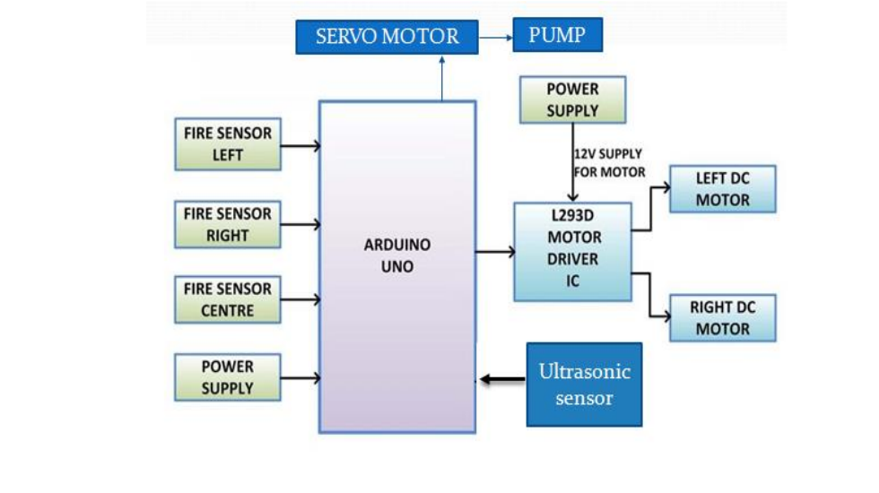
Figure 3.1: Overview of the Proposed System Source Ali, (2022)
3.1.2 Hardware Requirements: Arduino Uno, GSM Module, Flame Sensor, L298NMotor Driver Relay Module, Servo Motor, Mini water pump, 4-wheel BO motor and 18650 Battery
3.1.3 Software Requirements: Arduino IDE
3.1.4 Implementation of Objective
Chassis Assembly: the physical structure of the robot was built using the chassis, wheels, and motors.
Motor and Wheel Connection: the DC motors was connected to the motor driver and then to the Arduino.
Sensor Connections: the fire detection sensor and ultrasonic sensor was connected to the Arduino.
Water Pump and Nozzle Setup: the water pump was connected to the Arduino and the nozzles was set up to spray water effectively.
Programming: Arduino code was written to control the motors, read sensor data, and make decisions based on the input.
Fire Detection Logic: a logic was implemented in the code to detect fire using the fire sensor.
Obstacle Avoidance Logic: data from the ultrasonic sensor was used to avoid obstacles.
Firefighting Logic: If fire is detected, the water pump will be activated and direct the robot towards the fire.
3.2 ANALYSIS OF THE EXISTING SYSTEM
Manual firefighting methods rely heavily on human involvement, which often results in delayed responses to fire incidents and places lives at significant risk. In many cases, the effectiveness of firefighting efforts is hindered by the limited reach and speed of human operators, especially in environments with high temperatures, dense smoke, or structural instability. These challenges underscore the critical need for innovative solutions that can address these limitations effectively.
Existing robotic fire-fighting systems, while promising, tend to be prohibitively expensive and lack the adaptability required for diverse and dynamic environments. Many systems are designed for specific applications and cannot accommodate varying fire scenarios, such as residential fires, industrial blazes, or forest fires. These deficiencies highlight a gap in the market for cost-effective and versatile robotic systems that can be widely adopted. firefighting methods rely on human effort, often leading to delayed responses and increased risk. Existing robotic solutions are often expensive and lack adaptability to diverse environments. These limitations necessitate the development of an affordable, efficient, and autonomous system.
3.3 PROBLEMS OF THE EXISTING SYSTEM
Existing fire-fighting robotic systems primarily rely on human power and limited AI integration, restricting their efficiency and adaptability. Studies have highlighted the need for systems that can operate autonomously and adapt to a dynamic environments. Problems of the existing system are:
- High risk to human firefighters.
- Delays in detecting and responding to fires.
- Limited availability of cost-effective robotic solutions.
- Challenges in adapting to diverse fire scenarios.
3.4 DESCRIPTION OF THE PROPOSED SYSTEM
The proposed robotic fire-fighting system is designed to operate autonomously in fire-prone environments, utilizing Arduino Uno as the central microcontroller. The system is equipped with flame and smoke sensors to accurately detect fire sources, ensuring timely intervention. Motorized wheels enable seamless mobility, allowing the robot to navigate complex terrains while responding to fire emergencies. The fire-extinguishing mechanism comprises a water pump and nozzle system capable of suppressing small-scale fires effectively. Also, the system incorporates a robust control algorithm that processes sensor data to make autonomous decisions, such as moving toward the fire and activating the extinguishing mechanism. The use of Arduino Uno ensures cost-efficiency and ease of implementation, making this system accessible for deployment in residential, industrial, and experimental settings. The proposed system consists of:
- Arduino Uno Microcontroller: To control sensors, motors, and the extinguishing mechanism.
- Sensors: Flame and smoke detectors for fire detection.
- Mobility Unit: Motorized wheels for navigation.
- Fire-Extinguishing Mechanism: A pump and nozzle system for water spraying.
- Control Algorithm: Autonomous decision-making based on sensor inputs.
3.5 ADVANTAGES OF THE PROPOSED SYSTEM
Advantages of the proposed system are:
- Reduces risk to human life.
- Ensures faster response times.
- Provides a cost-effective solution.
- Adaptable to various fire scenarios.
- Enhances safety in hazardous environments.

CHAPTER FOUR
DESIGN, IMPLEMENTATION AND DOCUMENTATION OF THE SYSTEM
4.1 DESIGN OF THE SYSTEM
The design of the robotic fire fighter using Arduino Uno integrates sensors, Arduino microcontroller, and wheels to detect flames and fire. It features relay module and GSM module for real-time monitoring, a microcontroller for processing data and executing control algorithms, and sensors, for detecting flames. The system is housed in a protective enclosure and includes a battery, servo motors, and water pump for seamless operation and human interaction.
4.1.1 OUTPUT DESIGN
The output design of the robotic Arduino Uno development board issued to control this firefighting robotic system, which is made up of Sensors. A gas sensor (MQ2) for sensing hazardous smoke, a temperature sensor (LM35) for more precise temperature measurement, and a fire flame sensor (IR) for detecting and sensing the approaching fire are all mounted on a servo-motor for obstacle detection and free path navigation. In addition, for extinguishing the flames, it also makes use of a water tank and a spray gun mechanism. Things taken into consideration in determining the output are represented below:
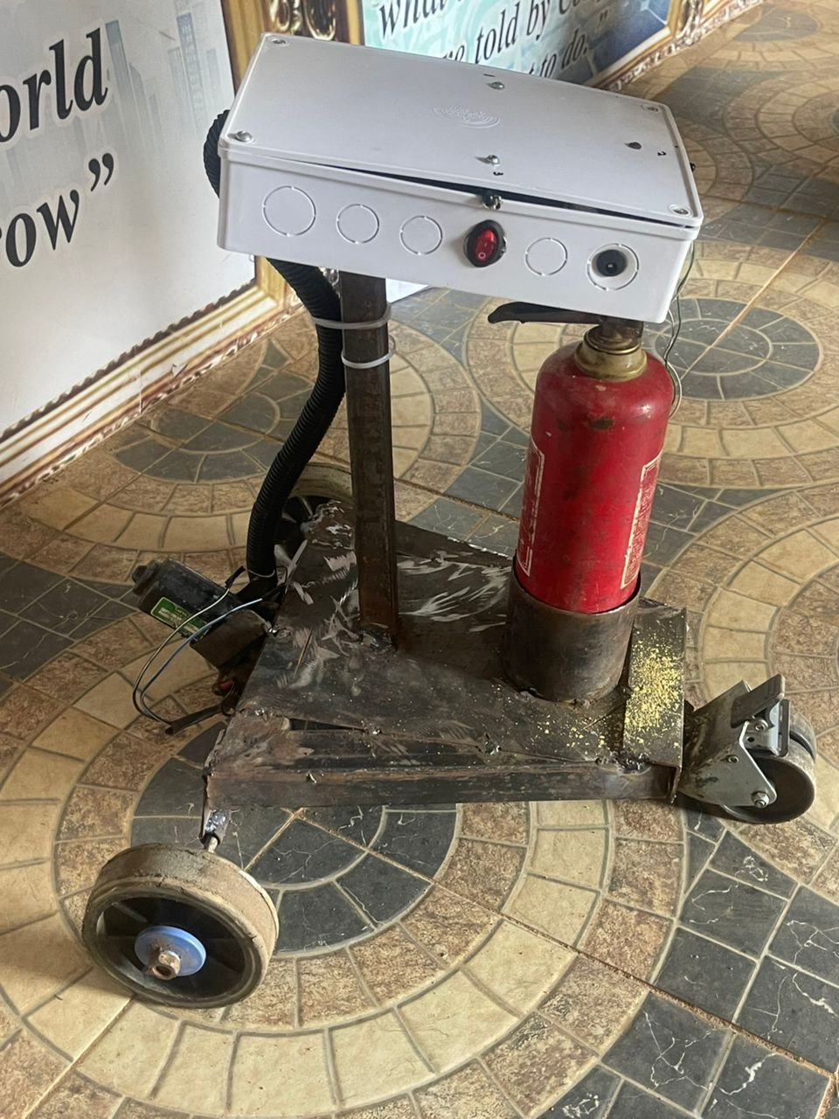
Figure 4.1: The Robotic Fire Fighting System
The picture above is the automatic robotic fore fighter. If any sensor of the robot find the flame anywhere it will start moving toward the flame and with the help of the water nozzle of the fire-fighting robot using Arduino will start watering the particular area.
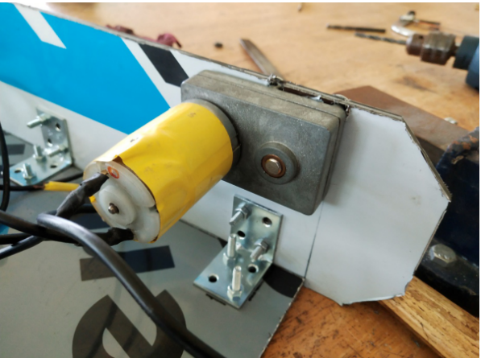
Figure 4.2: Installed Motor on Chassis and Enclosure
An enclosure is a protective casing designed to house electronic components, such as sensors, microcontrollers, and actuators, within a system. The picture above shows a motor installed on chassis of the designed system.
4.1.2 INPUT DESIGN
In this section, the input design of the robotic fire fighter using Arduino Uno system is presented in which it consists of IR flame sensors, servo motors, submersible water pump, motor driver, mini breadboard, BO motors, rubber wheels, processor, and communication module for exchanging data between the fire-fighting robot and Arduino software. Below are the inputs of the developed system.
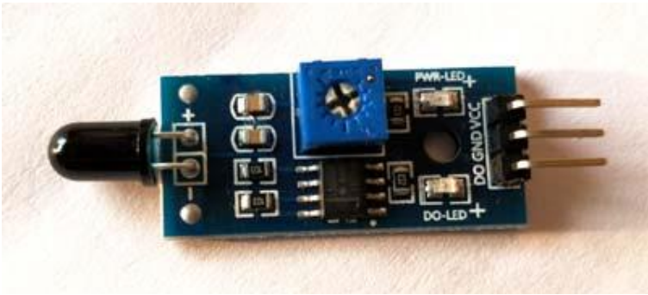
Figure 4.3: Fire Sensor Module
As you can see this sensor have an IR Receiver (Photodiode) which is used to detect the fire. How is this possible? When fire burns it emits a small amount of Infra-red light, this light will be received by the IR receiver on the sensor module. Then the researchers uses an Op-Amp to check for change in voltage across the IR Receiver, so that if a fire is detected the output pin (DO) will give 0V(LOW) and if the is no fire the output pin will be 5V(HIGH). So, the researchers place three such sensors in three directions of the robot to sense on which direction the fire is burning. 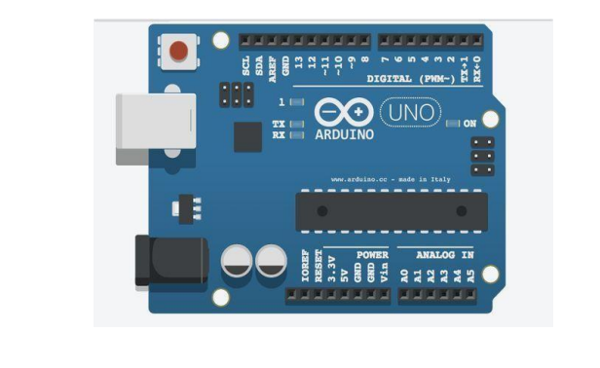
Figure 4.4: Arduino Uno Microcontroller based development Board
A Microcontroller is a compact device with a processor, storage and configurable input/output devices on a single integrated circuit. The researchers used the Arduino UNO board, which combines a microcontroller with all of the extras needed to quickly create and debug projects. The ATmega3288based UNO is a microcontroller board.
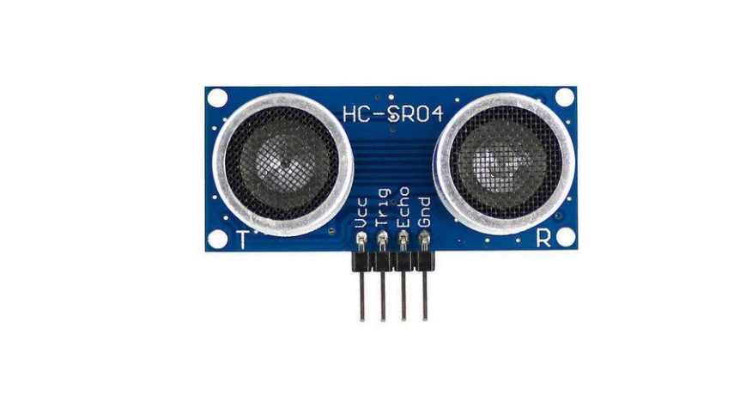
Figure 4.5: Ultrasonic Sensor
The Transducer's sonic waves would be absorbed by an object and returned to the transducer. The time it takes for the ultrasonic sensor to transition from emitting to receiving sound waves is proportional to the distance between the object and the sensor. Ultrasonic Sensor Hard surfaces are the strongest reflectors of sonic waves, and may be solids, granules, liquids, or powder. The distance can be calculated precisely and without touch using an ultrasonic sensor. It could be anywhere from 2cm to 3m long.
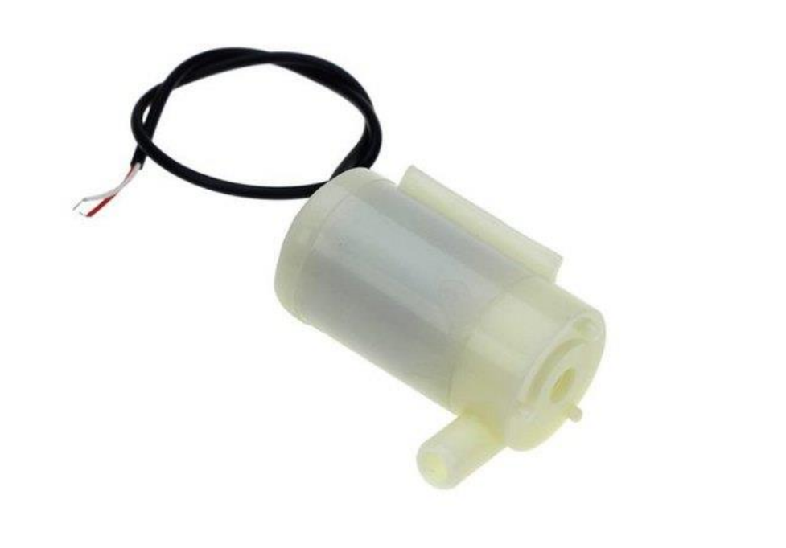
Figure 4.6: Submersible Water Pump
Figure 4.6 above shows the submersible water pump. Submersible Water Pump is ideal for making automatic watering system using Arduino. The water pump is an important part of the robot as it will pump water to extinguish the fire.
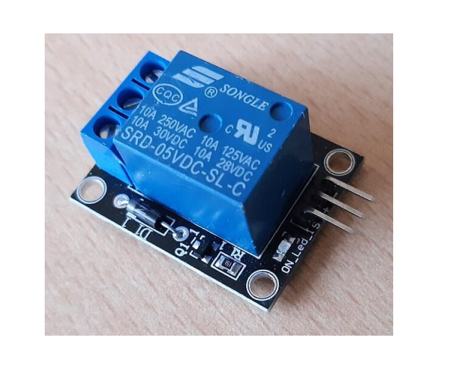
Figure 4.7: Relay
A relay is a switch that is powered by electricity as shown in Figure 4.7. A magnetic field is generated by coil of the relay is which the current flows through, which attracts a lever and changes the switch contacts. There are two switch places on their lay, both of which are double throw switches. There is no electrical connection between the two circuits within the relay. Only magnetic and mechanical connections exist. Relays are incredibly basic instruments.
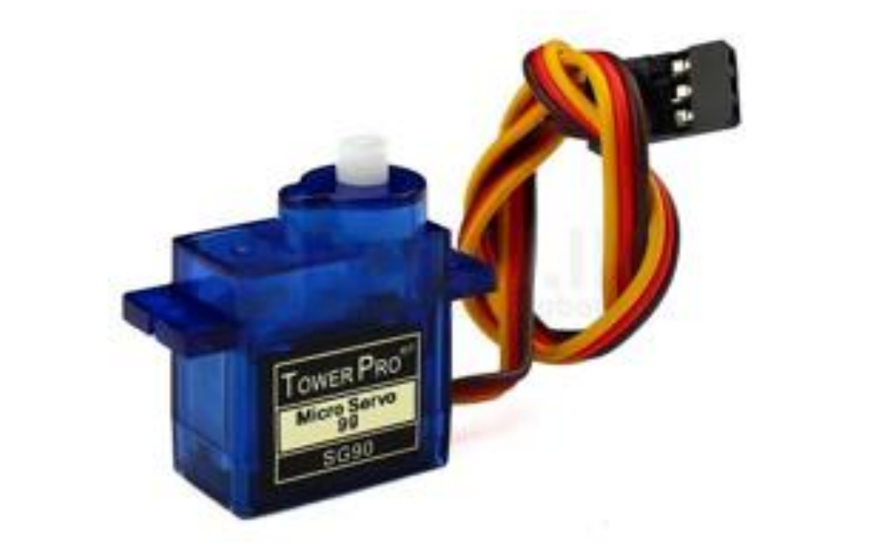
Figure 4.8: Servo Motors
This above diagram shows the Servo Motors. Servo Motors are electronic devices that are mainly used for providing specific velocity and acceleration.
4.1.3 PROCEDURE DESIGN
In the context of automation and control systems, servo motors are essential components responsible for physically adjusting or controlling the movement of mechanisms, systems, or processes. They receive signals from a control system or microcontroller and translate these signals into physical action, such as opening or closing a valve, moving a robotic arm, or adjusting the position of a damper.
4.2 IMPLEMENTATION OF THE SYSTEM
The implementation of the system involves assembling the hardware components, developing and integrating software for control algorithms, calibrating sensors, connecting servo motors, and thoroughly testing the system to ensure it meets the desired specifications for efficient and reliable fire fighting system.
4.2.1 CHOICE OF PROGRAMMING LANGUAGE
The choice of programming language for the system depends on the microcontroller used. For Arduino, C++ is chosen; for Raspberry Pi, Python is preferred; and for ESP32, both C++ and MicroPython are suitable. These languages are selected for their compatibility with hardware, ease of use, and availability of necessary libraries.
4.2.2 HARDWARE REQUIREMENT
- Microcontroller: Arduino Uno
- Sensors: IR Sensor, Flame Sensor
- GSM Module
- 4-wheel: Rubber Tire
- Power Supply: 18650 Battery
- Enclosure: Protective casing for the control unit and other electronics
- Additional Components: Water pump, Wires, connectors, relays, and other necessary electronic components for interfacing sensors and actuators
4.2.3 SOFTWARE REQUIREMENT
- Integrated Development Environment (IDE):
  - Arduino IDE for Arduino
  - Thonny or other Python IDE for Raspberry Pi
- Programming Languages:
  - C++ for Arduino
  - Python for Raspberry Pi
- Libraries:
  - Sensor libraries (e.g., Adafruit DHT, OneWire for temperature sensors)
  - Display libraries (e.g., LiquidCrystal for LCDs)
  - Control libraries for handling actuators
- Communication Protocols:
  - MQTT for remote control and monitoring, if needed
  - HTTP/HTTPS for web-based interfaces
- Operating System:
  - For Raspberry Pi, a Linux-based OS like Raspbian
4.3 DOCUMENTATION OF THE SYSTEM
4.3.1 Program Documentation
The program documentation for the robotic fire fighting system provides a comprehensive guide to understanding, configuring, and utilizing the software developed for the Arduino Uno. It includes setup instructions for the development environment, details on hardware configuration, an overview of the software structure, explanations of functionality, definitions of configuration parameters, usage instructions, and troubleshooting guidance. This documentation serves as a valuable resource for developers and users, ensuring smooth implementation, operation, and maintenance of the robotic fire fighting system.
4.3.2 MAINTAINING OF THE SYSTEM
Maintaining the robotic fire fighting system involves regular checks, updates, and occasional troubleshooting to ensure its continued functionality and efficiency. This entails inspecting hardware components for wear or damage, updating software to the latest versions, monitoring sensor data for irregularities, and conducting scheduled calibrations and battery replacements as needed. Troubleshooting efforts include diagnostic checks, component replacements, and meticulous documentation of maintenance activities to facilitate seamless operation and timely interventions.

CHAPTER FIVE
SUMMARY, CONCLUSION AND RECOMMENDATIONS
5.1 SUMMARY
This project explores the potential of robotic technology to revolutionize firefighting, leveraging the Arduino Uno platform for cost-effective and efficient solutions. By integrating sensor technology and autonomous mobility, the system addresses the challenges posed by manual firefighting methods, including delayed response times and risks to human safety. The findings demonstrate the feasibility of deploying robotic systems in controlled fire scenarios, laying the groundwork for future enhancements.
The proposed system showcases significant advancements in disaster management by minimizing human involvement and enhancing operational efficiency. Its adaptable design makes it suitable for various applications, from residential to industrial settings. The research highlights the need for continued innovation, collaboration, and real-world testing to refine and expand the capabilities of robotic fire-fighting technologies. This study presents the development of a robotic fire fighter using Arduino Uno technology. The system integrates fire detection, mobility, and extinguishing capabilities to address the limitations of traditional firefighting methods. Testing in simulated environments highlights its potential to revolutionize disaster management.
5.2 CONCLUSION
The robotic fire fighter demonstrates the feasibility of using Arduino Uno technology for autonomous fire response. By reducing human risk and improving efficiency, the system represents a significant step forward in firefighting technology. The integration of sensors and autonomous mobility highlights the potential of robotic systems to operate effectively in hazardous environments. The prototype’s success in simulated conditions showcases its capability to detect and extinguish fires promptly, thereby minimizing property damage and saving lives.
This project also emphasizes the importance of leveraging affordable and open-source technologies like Arduino Uno for addressing critical challenges in disaster management. This approach ensures accessibility and scalability, paving the way for widespread adoption in both developed and developing regions. The robotic fire fighter demonstrates the feasibility of using Arduino Uno technology for autonomous fire response. By reducing human risk and improving efficiency, the system represents a significant step forward in firefighting technology.
  - RECOMMENDATIONS
Based on the findings of this research, the following were recommended:
- Future research should focus on scaling the system for larger fire scenarios.
- Integration of advanced sensors for improved detection accuracy.
- Development of AI-based navigation for complex environments.
- Exploration of alternative extinguishing methods, such as foam or gas systems.

REFERENCES
Ali, Y. M. (2022). Arduino Fire Fighting Robot. International Journal on Engineering Applications (I.R.E.A.). Vol. 11, Issue: 5. Pp. 2281-2282. https://doi.org/10.15866/irea.v11i5.24007 346 Alaa
Arduino. Retrieved on Feb, 20, 2024 From: http://electronicsforu.com/electronics-projects/hardware-diy/arduino-ir-firefighter robot
Chirunadh, K. Goud, G. V., Tejaswini, G. & Rao, B. R. (2023). Arduino Based Fire Fighting Robot, International Research Journal of Modernization in Engineering Technology and Science. Vol. 5, Issue: 6. Pp. 89-91. DOI: https://www.doi.org/10.56726/IRJMETS42309
Jagruti, D., Priyanka, Z., Dhanashree, W., Pratiksha, S. & Tathe, S. G. (2024). Arduino Based Fire Fighting Robot, IJIRMPS. Vol. 12, Issue: 1. Pp 90-94.
Jain, C. P., Agarwal, D., Lalawat, H., Pareek, J., Shrimali, D. & Kaithwas, D. (2024). Design of Fire Fighting Robotic System for Fire Disaster Control. International Journal of Technical Research & Science. Vol. 1, Issue: 2. Pp. 2-3. https://doi.org/10.30780/
Kanwar, M. & Agilandeeswari, L. (2018). IOT Based Fire Fighting Robot, International Conference on Reliability Infocom Technologies and Optimization (Trends and Future Directions) (ICRITO). Pp. 718- 723.
Kumar, N. Mounika, P., Ramani, D. Saketh, M. & Sujith, M. (2024). Arduino Fire Fighting Robot. International Journal of Progressive Research in Engineering Management and Science (IJPREMS). Vol. 4, Issue: 4. Pp. 34-35. doi: 10.1109/ECAI58194.2023.10193962.
Nagesh, M. S., Deepika, T. V., Stafford, M. & Shivakumar, M. (2021). Fire Extinguishing Robot, International Journal of Advanced Research in Computer and Communication Engineering, Vol. 5, Issue:12. Pp. 121-123. https://doi.org/ 10.3390/drones7120694
Udhyami, M.B., Naidu, M. Y., & Sibi, J. (2024). Firefighting Robot Using Arduino, International Journal of Progressive Research in Engineering Management and Science (IJPREMS). Vol. 4, Issue: 12. Pp. 46-47.
Ugochukwu, N. A., Goyal, S. B., Rajawat, A. S., Verma, C. & Illés, Z. (2024). Enhancing Logistics with the Internet of Things: A Secured and Efficient Distribution and Storage Model Utilizing Blockchain Innovations and Interplanetary File System, in IEEE Access. Vol. 12. Pp. 4139-4152. doi: 10.1109/ACCESS.2023.3339754
Wasu, L., Kamaruzaman, N. Mohd-Yassin, Z. & Ganeson, S. (2022). Wireless Arduino Controlled Fire Fighter Robot Designed for Residential Area. Malaysian Journal of Science and Advanced Technology. Taichung, Taiwan.
Wu, F., Ge, G., Shang, M., Zhao, G,. Wang, H.,. & Guo, G. (2021). Design and Development of Intelligent Fire-fighting Robot Based on STM32, In Journal of Physics: Conference Series. Vol. 17, Issue: 6. Pp. 167-168.

