AN IMPROVED MACHINE LEARNING FOR WEATHER FORECASTING PACKAGE

BY

ABDULRASAQ AHMAD
HND/23/COM/FT/0193
SUBMITTED TO THE DEPARTMENT OF COMPUTER SCIENCE, INSTITUTE OF INFORMATION AND COMMUNICATION TECHNOLOGY

KWARA STATE POLYTECHNIC, ILORIN
IN PARTIAL FULFILLMENT OF THE REQUIREMENTS FOR THE AWARD OF HIGHER NATIONAL DIPLOMA (HND) IN
COMPUTER SCIENCE

JULY, 2025.

CERTIFICATION
This is to certify that this project was carried out ABDULRASAQ AHMAD of Matriculation Number: HND/23/COM/FT/0193 in the Department of Computer Science, Institute of Information Communication Technology, Kwara State Polytechnic, Ilorin, Kwara State.

…………………………………. ….………………………
MR ABIODUN, E.T. Date
Project Supervisor

…………………………………. ….………………………
MR OYEDEPO, F.S. Date
Head of Department

…………………………………. ….………………………
External Examiner Date

ABSTRACT
The activities of many primary sectors depend on the weather for production, e.g. farming. The climate is changing at a drastic rate nowadays, which makes the old weather prediction methods less effective and more hectic. To overcome these difficulties, the improved and reliable weather prediction methods are required. These predictions affect a nation's economy and the lives of people. To develop a weather forecasting system that can be used in remote areas is the main motivation of this work. The data analytics and machine learning algorithms, such as random forest classification, are used to predict weather conditions. In this research project, a low-cost and portable solution for weather prediction is devised.

TABLE OF CONTENTS
Title page i
Certification ii
Dedication iii
Acknowledgements iv
Table of contents v
List of Tables vi
List of Figures vii
Abstract viii
CHAPTER ONE: GENERAL INTRODUCTION
1.1 Background to the Study 1
1.2 Statement of the Problem 2
1.3 Aim and Objectives 3
1.4 Significance of the Study 3
1.5 Scope of the Study 3
1.6 Organization of the Report 4
CHAPTER TWO: LITERATURE REVIEW
2.1 Review of Related Works5
2.2 Review of General Texts 11
CHAPTER THREE: RESEARCH METHODOLOGY AND ANALYSIS OF THE SYSTEM
  - Research Methodology 12
  - Analysis of the Existing System 13
  - Problems of the Existing System 13
  - Analysis of the Proposed System 14
  - Advantages of the Propose System 15
CHAPTER FOUR: DESIGN, IMPLEMENTATION AND DOCUMENTATION OF THE SYSTEM
  - Design of the System16
    - Output Design 16
    - Input Design 18
    - Database Design 20
    - Procedure Design 21
  - Implementation of the System 22
    - Choice of programming language 23
    - Hardware support 24
    - Software Support 24
  - System Documentation 24
    - Operating the System 25
    - Maintaining of the System 25
CHAPTER FIVE: SUMMARY CONCLUSION AND RECOMMENDATION
5.1 Summary 26
5.2 Conclusion 26
5.4 Recommendations 26
References 27
APPENDICES
Algorithm (if any)

CHAPTER ONE
GENERAL INTRODUCTION
  - BACKGROUND TO THE STUDY
An automated weather station is an instrument that measures and records meteorological parameters using sensors without intervention of humans. The measured parameters can be stored in a built-in data logger or can be transmitted to a remote location via a communication link. If the data is stored in a data logger, recorded data must be physically downloaded to a computer at a later time for further processing. Therefore, the communication system is an essential element in an automated weather station. Today, automated weather stations are available as commercial products with variety of facilities and options (Susmitha and Sowmyabala, 2019).
Weather forecasting plays a crucial role in various sectors such as agriculture, transportation, disaster management, and tourism (Smith et al., 2018). Accurate weather predictions enable individuals and organizations to make informed decisions, mitigate risks, and plan activities effectively. With the advancement of technology, traditional methods of weather forecasting have been enhanced through the integration of various data sources and computational models (Jiang et al., 2020). This has led to the development of sophisticated weather forecasting systems capable of providing detailed and timely information about atmospheric conditions.
In recent years, the demand for reliable weather forecasting systems has grown significantly due to the increasing frequency and severity of extreme weather events attributed to climate change (IPCC, 2021). These events pose significant challenges to society, impacting agriculture, infrastructure, and public safety. Therefore, there is a pressing need to develop robust weather forecasting systems that can accurately predict such events and provide early warnings to mitigate their adverse effects.
The design and implementation of a weather forecasting system involve several components, including data collection, preprocessing, model development, validation, and dissemination of forecast information (Zhang et al., 2019). Each of these components plays a crucial role in ensuring the accuracy and reliability of the forecast output. Furthermore, advancements in machine learning and artificial intelligence have enabled the development of more sophisticated forecasting models capable of capturing complex atmospheric processes (Hassim et al., 2020).
This paper presents the design and implementation of a weather forecasting system aimed at improving the accuracy and timeliness of weather predictions. The system integrates various data sources, including satellite imagery, ground-based sensors, and numerical weather prediction models, to generate forecasts for specific regions with high spatial and temporal resolution. By employing advanced machine learning algorithms and computational techniques, the system aims to provide users with reliable forecasts tailored to their specific needs and applications.

1.2 STATEMENT OF THE PROBLEM
Despite advancements in weather forecasting technology, several challenges persist in accurately predicting weather phenomena, especially at the local and regional scales. One of the primary challenges is the inherent complexity of the Earth's atmosphere, which involves intricate interactions between various meteorological variables such as temperature, humidity, pressure, and wind speed. Additionally, the availability and quality of observational data can vary significantly depending on the geographical location and infrastructure capabilities, leading to uncertainties in the initial conditions for forecasting models.
Another significant issue is the limited understanding of certain atmospheric processes and phenomena, such as convective storms, tropical cyclones, and atmospheric blocking patterns. These phenomena are characterized by nonlinear dynamics and can exhibit sudden changes in intensity and behavior, making them challenging to forecast accurately. Moreover, the increasing influence of climate change on weather patterns further complicates the forecasting process, as it introduces additional sources of uncertainty and variability.

1.3 AIM AND OBJECTIVES
The aim of this study is to design and implement a weather forecasting system that improves the accuracy and timeliness of weather predictions at the local and regional scales. To achieve this aim, the following objectives are defined:
- To integrate various data sources, including satellite imagery, ground-based sensors, and numerical weather prediction models, into a unified forecasting framework.
- To develop advanced machine learning algorithms capable of capturing complex atmospheric processes and phenomena.
- To disseminate forecast information to end-users through user-friendly interfaces and communication channels.

1.4 SIGNIFICANCE OF THE STUDY
The project focuses specifically on the efficient and effective application design and use of qualitative (also called subjectiveor judgmental) forecasting techniques to predict and analyses the future climate over a reasonable period of time. Implementing qualitative forecasting techniques, the application is used for either supplementing or replacing mathematical models that processes the data and information for the.
Produce intelligent climate forecasts, more quickly, more effectively and with none of the tedious manual processes associated with using spreadsheets for the forecasting of demand.
Rapid implementation: the application can be implemented very quickly. Data can be sourced from any ODBC/OLEDB data source or from flat files.
Forecast revenue and profit as well as quantities: The computer based forecaster allows forecasts to be made not just for volume, but also for selling prices, cost of goods etc.
Versatile software tool: Empower your forecasters to productively forecast, plan and re-plan weather, prepare budgets, monitor, review and report, all within a single, easy to use system.

1.5 SCOPE OF THE STUDY
The scope of this research is to show how computer system could be purchased in parts, assembled and installed with required software to match a given configuration for the use in the laboratory. This work will cover the assembly of a personal computer. The order I used to assemble a PC can be changed depending on the circumstance of your build. The process of assembling your own PC is actually very simple in contrast to most people expectations. Compared to researching part selection, actual assembly is a much simpler task.

1.6 ORGANISATION OF THE REPORT
For easy study and proper understanding of this project write-up, it is planned and organized into five chapters. The description of what each chapter contains is explained below:
Chapter One: This contains an Introduction to the whole write-up, the problem of the study, aim and objectives of the study, the significance of the study, the scope and limitation of the study, and organization of the report.
Chapter Two: It focuses on the literature review of the study, history of Pentium 4 computer, review of Pentium 4 microarchitecture and review of processor cores.
Chapter Three: It presents the Methodology, things to consider before assembling a computer, tools and equipment used for assembling computer, preparation for assembling,
assembling method, other connections
Chapter Four: It deals with the system design, implementation and documentation, design of the system, output design, input design, file system, procedural design, and documentation of the new system.
Chapter Five: This centers on the summary, experienced gained, recommendation and conclusion.

CHAPTER TWO
LITERATURE REVIEW
2.1 REVIEW OF RELATED WORKS
Sebastian (2018) opined that predicting weather forecast uncertainty with machine learning Weather forecasts are inherently uncertain. Therefore, for many applications forecasts are only considered valuable if an uncertainty estimate can be assigned to them. Currently, the best method to provide a confident estimate for individual forecasts is to produce an ensemble of numerical weather simulations, which is computationally very expensive. Here, we assess whether machine learning techniques can provide an alternative approach to predict the uncertainty of a weather forecast given the large-scale atmospheric state at initialisation. We propose a method based on deep learning with artificial convolutional neural networks that is trained on past weather forecasts. Given a new weather situation, it assigns a scalar value of confidence to medium range forecasts initialised from said atmospheric state, indicating whether the predictability is higher or lower than usual for the time of the year. While our method has a lower skill than ensemble weather forecast models in predicting forecast uncertainty, it is computationally very efficient and outperforms a range of alternative methods that do not involve performing numerical forecasts. This shows that it is possible to use machine learning in order to estimate future forecast uncertainty from past forecasts. The main constraint in the performance of our method seems to be the number of past forecasts available for training the machine learning algorithm.

Sebastian (2020) also opined that artificial intelligence in weather and climate predictionWeather and climate prediction is dominated by high dimensionality, interactions on many different spatial and temporal scales and chaotic dynamics. This makes many problems in the field quite complex ones, and also state-of-the-art numerical models are - despite their immense computational costs - not sufficient for many applications. Therefore, it is appealing to use emerging new technologies such as artificial intelligence to tackle these problems. We show that it is possible to use deep neural networks to emulate the full dynamics of a strongly simplified general circulation model, providing both good forecasts of the model state several days ahead as well as stable long-term climate timeseries. This method partly also works on more complex and realistic models, but only for forecasting the model's weather several days ahead, not for creating climate runs. It is sufficient to use 50-100 years of data for training the networks. The same neural network method can be combined with singular value decomposition from numerical ensemble weather forecasting in order to generate probabilistic ensemble forecasts with the neural networks. On a more fundamental level, we show that in a simple dynamical systems setting there seem to be limitations in the ability of feed-forward neural networks to generalize to new regions of the system. This is caused by different parts of the network learning to model different parts of the system. Contradictory, for another simple dynamical system this is shown not to be an issue, raising doubts on the usefulness of results from simple models in the context of more complex ones. Additionally, we show that neural networks are, to some extent, able to “learn” the influence of slowly changing external forcings on the dynamics of the system, but only given broad enough forcing regimes. Finally, we present a method to complement operational weather forecasts. Given the initial fields and the error of past weather forecasts, a neural network is used to predict the uncertainty in new forecasts, given only the initial field of the new forecast.

According to Shashank (2020) Weather Project application is a web-based application where you will be able to access all reports related to weather forecasts for any locations. Its location detected by your browser setting and server configuration will automatically identify the location and be able to present its weather information such as temperature, wind direction, rainfall, humidity etc. To change location you will have to select the options provided below to get its details. Its new avatar and feed burner will also allow its users to receive weather reports directly from their mail, where they have not been able to access this particular domain even if the server is down.

William(2017) submits that machine learning techniques for weather forecasting Machine learning models were developed in order to forecast weather variables such as solar radiation, temperature, and wind speed for one to 24 hours in advance. Weather predictions and ground truth weather observations were sourced from the National Oceanic and Atmospheric Administration (NOAA) and the Georgia Automated Environmental Monitoring Network (GAEMN) for five cities in Georgia. Results indicate that incorporating weather forecasts becomes increasingly more important for accurate solar radiation prediction at longer prediction windows, and also that post processing of NOAA's weather forecasts can drastically improve accuracy beyond usage of the raw forecasts alone.

Jaroslavet al (2019) reviewed a weather forecast model accuracy analysis and ECMWF enhancement proposal by neural network a neural network approach for weather forecast improvement. Predicted parameters, such as air temperature or precipitation, play a crucial role not only in the transportation sector but they also influence people’s everyday activities. Numerical weather models require real measured data for the correct forecast run. This data is obtained from automatic weather stations by intelligent sensors. Sensor data collection and its processing is a necessity for finding the optimal weather conditions estimation. The European Centre for Medium-Range Weather Forecasts (ECMWF) model serves as the main base for medium-range predictions among the European countries. This model is capable of providing forecast up to 10 days with horizontal resolution of 9 km. Although ECMWF is currently the global weather system with the highest horizontal resolution, this resolution is still two times worse than the one offered by limited area (regional) numeric models (e.g., ALADIN that is used in many European and north African countries). They use global forecasting model and sensor-based weather monitoring network as the input parameters (global atmospheric situation at regional model geographic boundaries, description of atmospheric condition in numerical form), and because the analysed area is much smaller (typically one country), computing power allows them to use even higher resolution for key meteorological parameters prediction. However, the forecast data obtained from regional models are available only for a specific country, and end-users cannot find them all in one place. Furthermore, not all members provide open access to these data. Since the ECMWF model is commercial, several web services over it free of charge. Additionally, because this model delivers forecast prediction for the whole of Europe (and for the whole world, too), this attitude is more user-friendly and attractive for potential customers. Therefore, the proposed novel hybrid method based on machine learning is capable of increasing ECMWF forecast outputs accuracy to the same level as limited area models provide, and it can deliver a more accurate forecast in real-time.

Gokilavaniet al (2020) opined that sales forecasting using prediction analytics algorithm is planned for providing a complete analysis of sales forecasting. Sales forecasting is an important aspect of different companies engaged in retailing, logistics, manufacturing, marketing and wholesaling. It allows companies to efficiently allocate resources, to estimate achievable sales revenue and to plan a better strategy for future growth of the company. In this project, prediction of sales of a product from an outlet is performed via a two-level approach that produces better predictive performance compared to any of the popular single model predictive learning algorithms. The approach is performed on Departmental store. The proposed approach was organized into six stages, first is data collection, which includes collecting data and dataset, second is hypothesis definition, which used to analyse the problems, third is data exploration which used to explore the uniqueness of the data, fourth is data cleaning, which is used to detect and correct the inaccurate dataset, fifth is data modelling, which is used to predict the data using machine learning techniques, sixth is feature engineering, which is used to import the data from machine learning algorithm.

Scott (2017) reviewed Sales Forecasting Sales forecasting involves predicting the amount people will purchase, given the product features and the conditions of the sale. Sales forecasts help investors make decision about investments in new ventures. They are vital to be efficient operation of the firm and can aid managers on such decisions as the size of a plant to build, the amount of amount of inventory to carry, the number of worker, to hire the amount of advertising to place, the proper price to charge, and the salaries to pay sale people.

Bohdan (2018) writes on Machine-Learning Models for Sales Time Series Forecasting using machine-learning models for sales predictive analytics. The main goal of this paper is to consider main approaches and case studies of using machine learning for sales forecasting. The effect of machine-learning generalization has been considered. This effect can be used to make sales predictions when there is a small amount of historical data for specific sales time series in the case when a new product or store is launched. A stacking approach for building regression ensemble of single models has been studied. The results show that using stacking techniques, we can improve the performance of predictive models for sales time series forecasting.

Trapero, Kourentzes and Fildes (2014) wrote on the identification of sales forecasting models in the presence of promotions shorter product life cycles and aggressive marketing, among other factors, have increased the complexity of sales forecasting. Forecasts are often produced using a Forecasting Support System that integrates univariate statistical forecasting with managerial judgment. Forecasting sales under promotional activity is one of the main reasons to use expert judgment. Alternatively, one can replace expert adjustments by regression models whose exogenous inputs are promotion features (price, display, etc.). However, these regression models may have large dimensionality as well as multicollinearity issues. We propose a novel promotional model that overcomes these limitations. It combines Principal Component Analysis to reduce the dimensionality of the problem and automatically identifies the demand dynamics. For items with limited history, the proposed model is capable of providing promotional forecasts by selectively pooling information across established products. The performance of the model is compared against forecasts provided by experts and statistical benchmarks, on weekly data; outperforming both substantially.

2.2 REVIEW OF GENERAL TEXTS
Forecasting involves methods that device primarily from judgmental sources versus those from statistical source, judgment and statistical procedure are often used together, and since 1985 much research has examined the integration of statistical and Judgmental (Armstrong, 2001). Going down the figure, there is an increasing amount of integrated between judgment and statistical procedures. A brief description of the methods is provided here. Makreidakis and Wheelwright (2013) provide details on how to apply many of these methods.
A person's role may be a dominant factor in some situations, such as predicting how someone would behave in a job related situation. Role-playing is useful for making forecasts of the behavior of individuals whoarc interacting with others, and especially in situations involving conflict.
Another way to make forecasts is to ask experts to predict how others will believe in given situations. The accuracy of expert forecasts can be improved through the use of structured methods, such as the Delphi procedure. Delphi is an iterate survey procedure in which experts provide forecast for a problem, receive anonymous feedback on the forecast made by other experts, and then make another forecast, for a survey of the evidence on the accuracy of Delphi versus unstructured judgment, Rowe and Wright (2010). One principle is that experts" forecasts should generally be independent of one another. Focus groups always this principle. As a result, they should not be used forecasting.
Intentions can be explained by relating the "predictions" to various factors that describe the situation. By asking consumers to state their intentions to purchase for a variety of different situation, it is possible to infer how the factors relate to intended sales. This is often done by regressing their intentions against the factors, a procedure known as "conjoint analysis". As with conjoint analysis, one can develop a model of the expert. This approach, judgmental bootstrapping, converts subjective judgments into objective procedures. Experts are asked to make a series of predictions. For example, they could make forecasts for the next year's sales in geographical regions. This process is then converted to a set of rules regressing the forecasts against the information used by the forecaster. Once developed, judgmental models offer a low-cast procedure for making forecasts. They almost always provide an improvement in accuracy in comparison to judgmental forecasts, although these improvements are typically modest Armstrong, (2010).
Extrapolation methods use only historical data on the series of interest. The most popular and cost effective of these methods are based on exponential smoothing, which implements the use of principle that the more recent data are weighted more heavily. Another principle for extrapolation is to use long time series when developing a forecasting model. Yet, focus forecasting, one of the most widely-used time-series methods in business firms, does not do this. As a result, it forecasts are inaccurate Gardner and Andersen (2015).
Still another principle for extrapolation is to reliable data. The existence of retail scanner data means that reliable data can be obtained for existing products. Scanner data are detailed, accurate timely and inexpensive. As a result the accuracy of the forecasts should improve, especially because of the reduction in the error of assessing the current status. Not knowing where you are starting form has often been a major source of error in predicting where you will wind up. Scanner data are also expected to provide early identification of trends.
Empirical studies have led to the conclusion that relatively simple extrapolation methods perform as well as more method. For example, the boc-jerkins procedure, one of the more complex approaches, has produced no measurable gains in forecast accuracy relation to simpler procedures Makridakis et al. (2015); Armstrong (2010). Although distressing to statisticians this finding should be welcome to managers.
Quantitative extrapolation methods make no use of management knowledge of the series. They assume that the causal forces that have affected a historical series will continue over the forecast horizon. The later assumption is sometimes false. When the casual forces are contrary to the trend in the historical series, forecast errors tend to be large Armstrong, (2001). While such problems may occur only in a small minority of cases in sales forecasting, their effect can be disastrous. One useful guideline is that trends should be extrapolating only when coincide with managements" prior expectations.

Judgmental extrapolations are preferable to quantitative extrapolations when there have been large recent changes in the sale level and where there is relevant knowledge about the item to be forecast. Quantitative extrapolations have an advantages over judgment method when the large Armstrong (2010).more important than these small gains in accuracy, however, is that the quantitative methods are often less expensive. When one has thousands of forecasts to make every month, the use of judgment is seldom cost effective.
Experts can identify analogous situations. Extrapolation of results from this situation can be used to predict for the situation that is interest. For example, to assess the loss in sales when the patent protection for a drug is removed, one might examine the results for previous drugs, indecently the first year loss is substantial.
Rule-based forecasting integrates judgmental knowledge about the domain. Rule-based forecasting is a type of expert system that is limited to statistical time series. Its primary advantages are that it incorporates the manger's knowledge in an inexpensive way. Expert opinion, conjoin analysis, bootstrapping and econometric models can aid in the development of expert systems.
Despite an immense amount of research effort, there is little evidence that multivariate time-series provide any benefits to forecasting. As a result, these methods are not discussed here.
Econometric models, the use of data to estimate the parameters of a given various constraints. Which is nearly always in management problem, one can draw upon prior research to determine the direction, functional form, and magnitude or relationship, and in addition, they can integrate expert opinion, such as the forma judgmental bootstrapping model. Estimated of relationships can then updated by suing time-series or cross-sectional data. Here again, reliable data are needed. Scanner data can provide data from low cost field experiments where key features such as advertising or price are varied to assess how they affect sale. The outcomes of such experiments can contribute to the estimation of relationship. Econometric models can also use inputs form conjoint models, Econometric models allow for extensive integration of judgmental planning and decision making. They can incorporate the effects of marketing mix variables as well as variables representing key aspects market and the environment. Econometric methods are appropriate when one need to forecast what will happen using different assumption about the environment or different strategies. Econometric methods arc most useful when;

1. Strong causal relationships with sales are expected;
2. These casual relationship can be estimated;
3. Large changes are expected to occur in the casual variables over the forecast horizon; and
4. These changes in the casual variables can be forecast or controlled, especially with respect to their direction.
If any of these conditions does not hold (which is typical for short-range sales forecasts) then econometric methods should not be expected to improve accuracy.

CHAPTER THREE
RESEARCH METHODOLOGY AND ANALYSIS OF THE SYSTEM
3.1 RESEARCH METHODOLOGY
In this research work, since the predicted results are continuous numerical values, the temperature in us, it use the regression method to find that Random Forest Regression (RFR) is a superior regressor, as it incorporates many decision trees while making a decision. In addition, it suggest comparing several other state-of-the-art ML strategies with the RFR process. Restoration strategies included Ridge Regression (Ridge), Support Vector (SVR), Multi-layer Perceptron (MLPR), and Extra-Tree Regression (ETR). After receiving raw data from 'underground', it make sure that each line (record) in the database contains records of all ten cities for a period of time. It eliminate any feature with empty or invalid data while creating a database. Also, it convert separate elements in the database, such as wind direction and position, into dummy / indicator variables using a process called 'One Hot Encoding'. If the number of training phase values and test sets are not the same, the conversion reflects the number of different features of these sets. That’s why it need to make this transition before the division of training and database testing.
3.2 ANALYSIS OF THE EXISTING SYSTEM
When trying to deal with sales forecasting management it is important that the fundamentals of weather is fully understood. A separation of several aspects to weather forecasting can be made and by that, one gets a clear picture of what weather purposes and uses, methods for how a forecast can be produced, what indicators affects the forecast and, perhaps most importantly, what impacts errors in forecasts have. With this separation, several aspects between the user and the producer perspective are highlighted and easier to deal with.
3.3 PROBLEMS OF THE EXISTING SYSTEM
- They tend to show the data in fixed views due to the fixed rows and columns structure of spreadsheet programs.
- Brower based forecasting systems overcome the maintenance problems but tend to be inflexible, lacking functionality, and do not provide the variety of instant graphical views that a specialized PC based system makes possible. In addition, it is hard to give these systems the degree of user-friendliness which sales and marketing users generally prefer.

3.4 DESCRIPTION OF THE PROPOSED SYSTEM
Before making a sales forecast, it is useful to have statistics on competition, economic trends, and past data. If you are forecasting a new service, you may have to utilize recent weather, data for similar enterprises.Forecasting helps to provide speed and accuracy and offers data needed to make necessary adjustments that will benefit the season. Many large corporations maintain forecasts updated on a quarterly or even monthly basis that have been revised to account for environmental factors as well as the changing business climate.
System Analysis is a term used to describe the process of collecting and analyzing facts about the functioning of an existing environment so that an integrated operating system can be developed and used if it is found to be feasible. System analysis can be considered as the most recent and perhaps the most complete method of solving computer problems. It helps to understand and compare the performance implications of a sub-program.
System analysis also involves the design of the system, which is a function that involves the creation of an integrated system based on facts revealed during the analysis.
System analysis is a process based on observation process, tasks and complex problems. So specifically, the system is as follows in terms of importance:
1. It provides a way to better understand complex structures.
2. It is a trading tool between the operating requirements of the sub-system and is compatible with the sub-system.
3. It helps to understand and compare the performance implications of a sub-program.
4. It helps to identify processes and mechanisms for building systems where sub-systems may have seemingly contradictory purposes.
Lastly, it helps to put each plan under the expected plan and context so that the entire program achieves its goals with the resources available. It therefore builds synergy between plan and objectives.

3.5 ADVANTAGES OF THE PROPOSED SYSTEM
Forecasting software can help here, by providing the forecasters with a productive and flexible environment in which to analyze and manipulate their forecasts. The advantages of the computer based sales forecasting system are:
1. Create precise, forward-looking projections: Take demand planning to the next level-integration with the new Demand Planner module provides access to
powerful tools to complete statistical forecasting and interactive simulation scenarios.
2. Leverage historical information for more accurate forecasts: Empower managers to review prior years' sales and quickly revise projections based on their knowledge of the weather and the market, and to create new stiles forecasts from the old as new events arise that affect the demand for production resources.
3. Diminish the impact of unforeseen events: Maintain an unlimited number of forecasts, making it easy for both sales and manufacturing managers to gauge the impact of a variety economic or environmental force on production, and anticipate and prepare for possible scenarios ahead of time.
4. Aggregate demand from multiple sources.
5. Effectively collaborate between operations.

CHAPTER FOUR
DESIGN, IMPLEMENTATION AND DOCUMENTATION OF THE SYSTEM
4.1 DESIGN OF THE SYSTEM
The proposed system is designed in modules with each modules working together to perform the Design and Implementation of an Academic Information System in order to enhance the performance of the existing system as earlier discussed in chapter three.
The ability to analyze and give focus to the system is explained in the following formats which are output design, input design, database design and procedure design.
    - OUTPUT DESIGN
The outputs to be extracted from the proposed system are as shown below

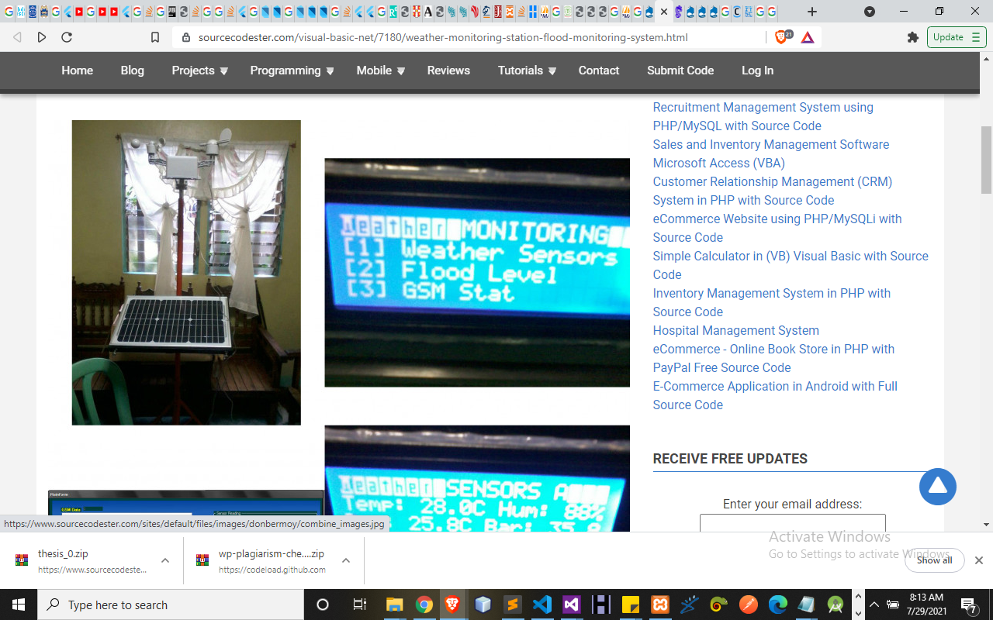
Figure 4.1: Weather monitoring module
Figure 4.2: Panel Session.

    - INPUT DESIGN
The input to be extracted from the proposed system areas shown below

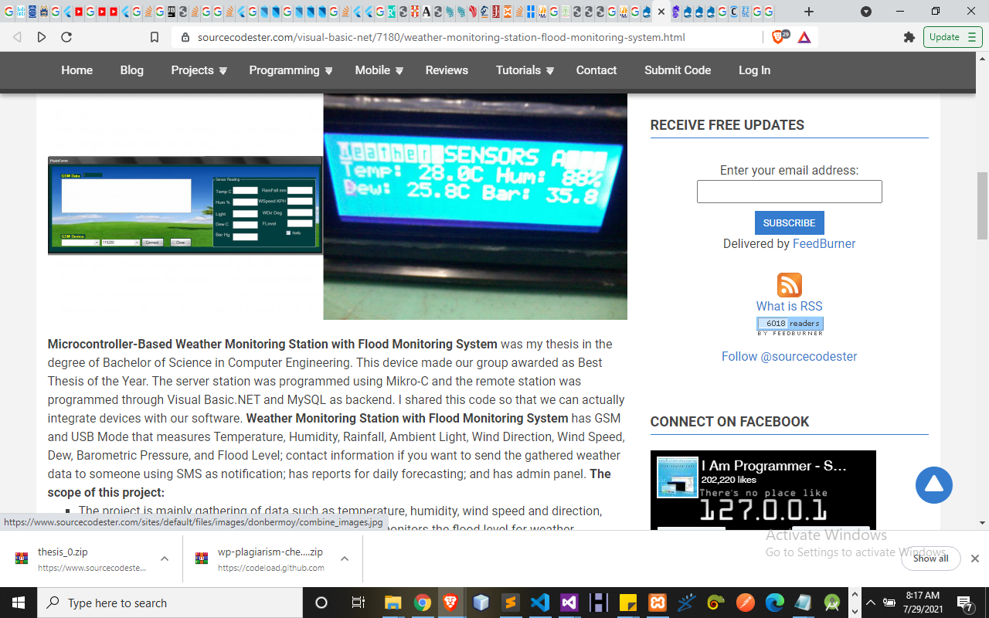
Figure 4.3: Add Dataset Modules
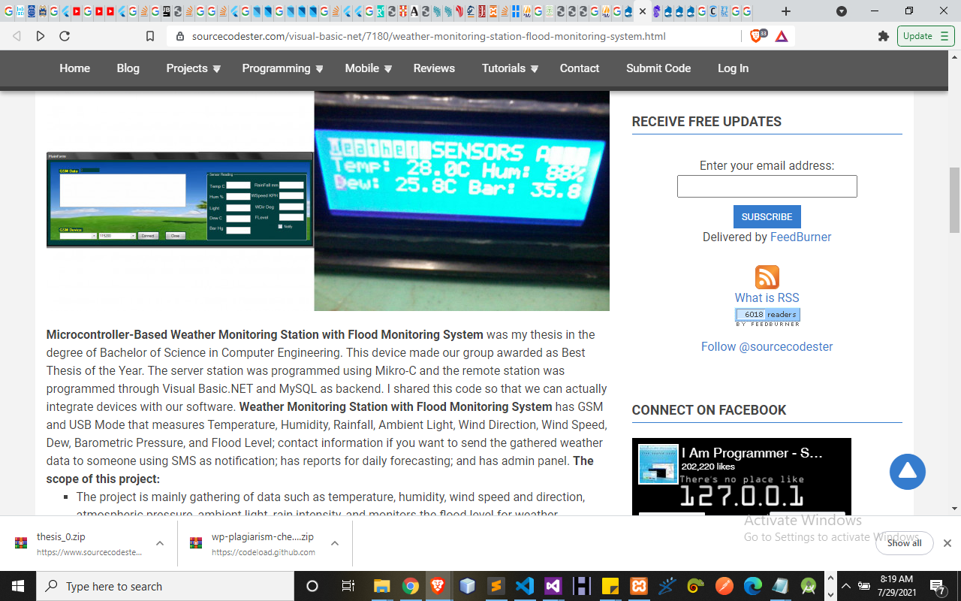
Figure 4.4: Sensors Module
    - DATABASE DESIGN
This refers to the back end of the proposed system. The following steps is employed in the development of the database.
- Click on start button and locate Ampp.
- Open any browser and type http://localhost/phpmyadmin
- Type the name of the database i.e Pharmacy and click on create new
- In few seconds the database is created.
- To create table is the next action.
- On a create table menu type the name of the table and click on ok.

Table 4.1: Weather Details Table
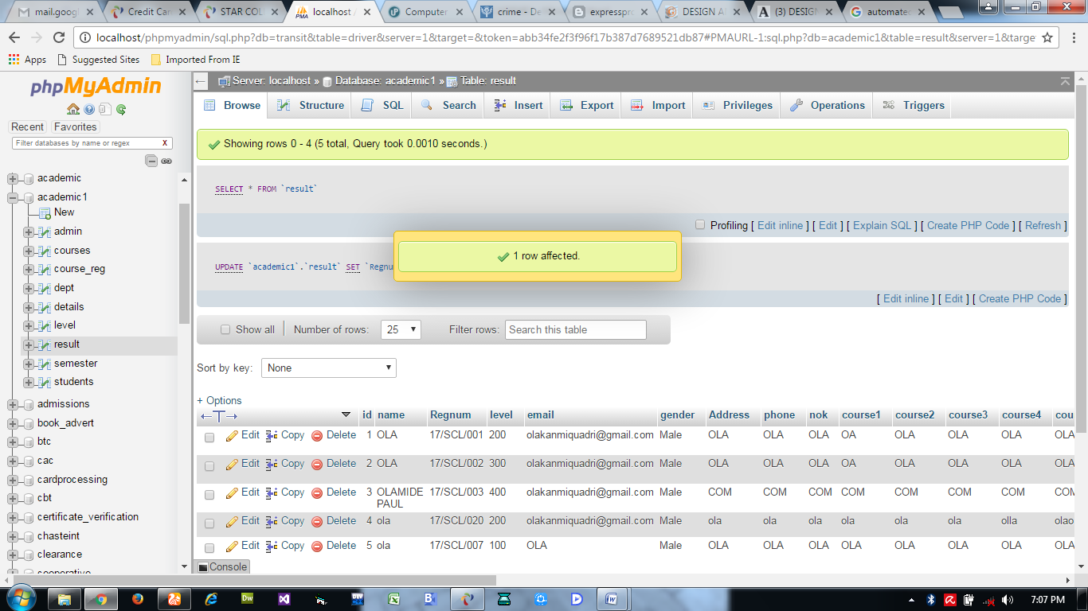

Table 4.2: Users database table
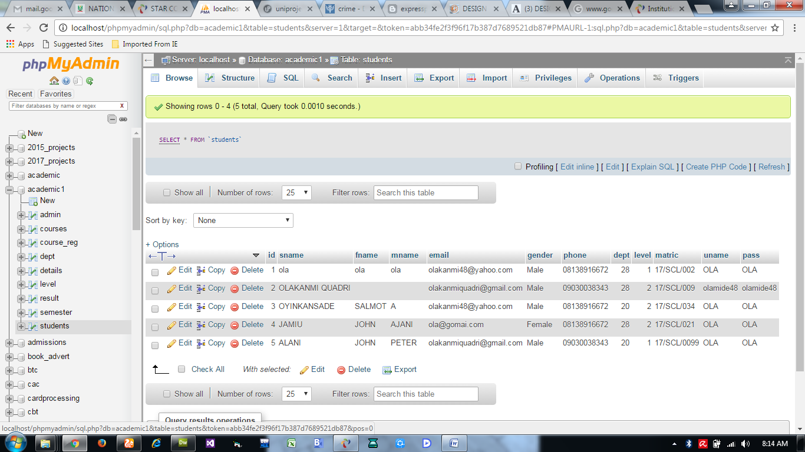

    - PROCEDURE DESIGN
This refers to the step by step method of using the proposed system. The proposed system comprises of Home, Login, Add Record, View Cart, View Mode, Reports, Log out while the administrator is able to add available position as well as its modification.
- On the address bar of any browser type http://localhost/Pharmacy/admin/
- You are prompted to supply the username and password this verifies that you are authorized user and has the privilege to add Product.
- If the username and password supplied are correct as that of the voter you are prompted with the home page with the list of add available position.
- The website has two environments the general user and the administrator environment.
e) User you are to type http://localhost/Pharmacy/login.php on the address bar.
  - IMPLEMENTATION OF THE SYSTEM
    - CHOICE OF PROGRAMMING LANGUAGE
The reason for choosing PHP is that it is among the language of the web and as well it is an open source language in which help is readily available when needed and its level of pedagogy. And also the mysql data base was chosen because of its data integrity and high secured back end. Cascading Style Sheet was used to style the layout of the website while the javascript was used as the server side script in the development of the system
    - HARDWARE SUPPORT
CPU : PENTIUM IV
PROCESSOR SPEED : 2 GHz
COPROCESSOR : BUILT IN
TOTAL RAM : 1GB or Higher
HARD DISK : 80 GB
KEYBOARD : 105 KEYS
MOUSE : LOGITECH MOUSE
DISPLAY : SGVA COLOR
    - SOFTWARE SUPPORT
The proposed system makes use of macromedia fireworks for graphics work on the images and background used in the system, macromedia Dream weaver (a text editor) while MY SQL is used as the database.
    - CHANGEOVER TECHNIQUES
The implementation technique to be use in the system is parallels, a system that support the current system along-side with the proposed system. This means that for user to adopt the proposed system a paper and pen method that is currently in used will still be in existence so that a failure in the proposed system will not lead to total loss of vital information.

  - DOCUMENTATION OF THE SYSTEM
    - PROGRAM DOCUMENTATION
In order for the proposed system to be used on any computer system it takes the following ways
- Boot the system
- Copy the folder to www inside Wamp folder of the drive C: after Wamp server is installed onto the system.
- Open any browser on the system (Microsoft internet Explorer, Mozilla Fire fox, Netscape Navigator, Opera, Flock, Safari e.t.c)
- Type http://localhost/Pharmacy/admin/on the address bar and press the return key/ enter key.

4.3.2 SYSTEM MAINTAINANCE
The system is flexible enough to entertain any future amendment which might be required when the need arise. The system requires regular update which necessitates the function of an administrator for regular information that is needed in the system. The system is also design in such a way that it will be convenient for any other programmers or system analyst that might want to work on the maintenance of the system if the need arises by documenting each and every part of the modules that made of the system.

CHAPTER FIVE
SUMMARY, CONCLUSION AND RECOMMENDATION
5.1 SUMMARY
In the first place, weather forecasts are frequently used for all the purposes suggested above. This leads to conflicts between optimism and pessimism and potentially introduces 'political' influences into the process. Examples are the different role of the profit forecast (probably conservative) and the sales plan (probably optimistic), or where marketing expenditure is loosely linked to the sales revenue of products (and therefore leads to defensive forecasting to protect planned marketing spends).
There are also conflicts in terms of which units should be forecasted - orders-based for production forecasting or invoice-based for financial forecasting.
The important point is to have a clear vision of who the primary customer or customers of the forecasts are. Select the appropriate level of detail and time horizon accordingly and accept that secondary customers of the forecast will probably have to accept sub-optimal forecasts. In many situations it is helpful for both Marketing and Sales to generate sales forecasts. Sales are often more likely to possess the detailed short term knowledge whilst Marketing need to 'own' the forecasts as a result of their role as brand profit 'custodians', and possibly have a clearer knowledge of longer term influences. It is vital here that each area is clear about the role and purpose of the forecasts they produce, and that forecast publication schedules optimise the currency of the data used as inputs, and given as outputs, by each forecaster.
5.2 CONCLUSION
Weather forecasting is a large and important field because it allows businesses to more accurately manage their inventory levels. The goal of our project was to apply the techniques of regression and ANN to predict future sales without using historical sales as the primary predictors. Instead of historical sales alone, we also used various economic indicators as the input variables of the artificial neural networks.
5.3 RECOMMENDATION
Future research in this topic could aim to automate the process of choosing relevant economic indicators used as inputs into the neural network. Since economic indicators are determined by comparing information about the level of fit of different models until a satisfactory level of fit is achieved, it might be worthwhile to create a computer program that executes all of the comparisons until the statistical measures reach a pre-established threshold. Such a technique would enable us to accomplish the determination of economic indicators in a more efficient manner.

/.

REFERENCES
Sebastian (2020) “Artificial intelligence in weather and climate prediction” ©Sebastian Scher, Stockholm University 2020 ISBN print 978-91-7911-128-1 ISBN PDF 978-91 7911-129-8 Printed in Sweden by Universitetsservice US-AB, Stockholm 2020
Jinlei et al., (2021) “Support Vector Machine Weather Prediction Technology Based on the Improved Quantum Optimization Algorithm”HindawiComputational Intelligence and Neuroscience Volume 2021, Article ID 6653659, 13 pa
Sebastian (2018) “Predicting Weather Forecast Uncertainty with Machine Learning” Article in Quarterly Journal of the Royal Meteorological Society · October 2018 DOI: 10.1002/qj.3410
X. Zhao, J. Liu, D. Yu, and J. Chang, “One-day-ahead probabilistic wind speed forecast based on optimized numerical weather prediction data,” Energy Conversion and Management, vol. 164, pp. 560–569, 2018.
X. Zhang, “A solar time based analog ensemble method for regional solar power forecasting,” IEEE Transactions onSustainable Energy, vol. 10, pp. 268–279, 2018.
S. Ghimire, R. C. Deo, N. J. Downs, and N. Raj, “Global solar radiation prediction by ann integrated with europeancentrefor medium range weather forecast fields in solar rich cities of queensland Australia,” Journal of Cleaner Production, vol. 216, pp. 288 310, 2019.
H. Sanikhani, R. C. Deo, P. Samui et al., “urvey of different data-intelligent modeling strategies for forecasting air temperature using geographic information as model predictors,”Computers and Electronics in Agriculture, vol. 152, pp. 242–260, 2018.
K. Khosravi, P. Daggupati, M. T. Alami et al., “Meteorological data mining and hybrid data intelligence models for reference evaporation simulation: a case study in Iraq,” Computers andElectronics in Agriculture, vol. 167, Article ID 105041, 2019.
H. Tao, S. O. Sulaiman, Z. M. Yaseen, H. Asadi, S. G. Meshram, and M. A. Ghorbani, “What is the potential of integrating phase space reconstruction withsvm-ffadataintelligence model? application of rainfall forecasting over regional scale,” Water Resources Management, vol. 32, no. 12, pp. 3935–3959, 2018.
S. Alessandrini, L. DelleMonache, S. Sperati, and G. Cervone, “An analog ensemble for short-term probabilistic solar power forecast,” Applied Energy, vol. 157, pp. 95–110, 2015.
M. A. Zaytar and C. El Amrani, “Sequence to sequence weather forecasting with long short term memory recurrent neural networks,” International Journal of Computer Applications, vol. 143, pp. 7–11, 2016.
Z. Yaseen, I. Ebtehaj, S. Kim et al., “Novel hybrid data-intelligence model for forecasting monthly rainfall with uncertainty analysis,” Water, vol. 11, no. 3, p. 502, 2019.
D. Wang, Y. Liang, D. Xu, X. Feng, and R. Guan, “A contentbasedrecommender system for computer science publications,”Knowledge-Based Systems, vol. 157, pp. 1–9, 2018.
C. Chen, “An improved image segmentation method based on maximum fuzzy entropy and quantum genetic algorithm,” in Proceedings of the 2018 5th International Conference on Systemsand Informatics (ICSAI), Nanjing, China, September 2018.
W. He and Y. Shi, “Multiobjective construction optimization model based on quantum genetic algorithm,” Advances inCivil Engineering, vol. 2019, Article ID 5153082, 8 pages, 2019.
Z. Guofeng and A. Hamdulla, “Adaptive morphological contrast enhancement based on quantum genetic algorithm for point target detection,” Mobile Networks and Applications, pp. 1–11, 2020.
G. Wang, G. Hu, W. Zhang, and Y. Wu, “A prediction method of soybean moisture content in the process of soy sauce brewing production using quantum revolving gate of quantum evolution algorithm back propagation,” MS&E, vol. 382, Article ID 32001, 2018.

Appendix 1: Start Menu

Predict
Stop
Main Menu
Login
Start
Weather Report
Supplier
Customer

Logout
Weather

Appendix 2: Login
Yes
Stop
Main Menu
Close Database
Is Field Correct In Database ?
Is any field empty ?
Input Username, Password
Open Database
Start

Yes

No

No

Appendix 3: Main Menu
Start
Open Database
Select option
Weather
Is it option Weather?
No
Is it option Predict?
Predict
No
Is it option Customer?
Customer
Yes
No
Is it option Supplier?
Supplier
Yes
No
Is it option Sales Report?
Sales Report
Yes
Is it Option Logout?
Logout
Yes
End Select
No

Return
Close Database

Appendix 4: Weather
Start

Open Database

Select Location

Add all Prediction Selected

Proceed to Payment

Stop
Close Database
Save to Database

Appendix 5: Product
No
Yes
Return
Close Database
Save to Database
Add Product
Is any Field Empty?
Enter Product Detail
Open Database
Start

Appendix 6: Customer
Enter Customer Detail
Close Database
Save to Database
Is any Field Empty?
Add Customer
Open Database
Start
Yes
No
Return

Appendix 8: Supplier
Close Database
Save to Database
Is any Field Empty?
Enter Supplier Detail
Add Supplier
Open Database
Start
Yes
No
Return

Appendix 8:Sales Report
Yes
No
Return
Close Database
Save to Database
Is there any Sales Report?
Search for Sales Report
Open Database
Start

Appendix 9: LOGOUT
End
Close Database
Main Menu
No
Yes
Are You Sure You want to Logout?
Select Logout Option
Open Database
Start

Appendix 10: Source Code
Private Sub Form_Load()
Dim Ctrl As Control
For Each Ctrl InMe.Controls
If TypeOf Ctrl Is OptionButton Then
Ctrl.Value = False
End If
Next
optsokoto.Value = False
optniger.Value = False
End Sub

Private Sub mnunigeria_Click()
frmwhole.Show
End Sub

Private Sub mnunorthcentral_Click()
frmnorthcentral.Show
End Sub

Private Sub mnunortheast_Click()
frmnortheast.Show
End Sub

Private Sub mnunorthwest_Click()
frmnorthwest.Show
End Sub

Private Sub mnusoutheast_Click()
frmsoutheast.Show
End Sub

Private Sub mnusouthsouth_Click()
frmsouthsouth.Show
End Sub

Private Sub mnusouthwest_Click()
frmsouthwest.Show
End Sub

Private Sub optabia_Click()
MsgBox "Distance Between Abuja and Abia State is 498Km"
End Sub

Private Sub optadamawa_Click()
MsgBox "Distance Between Abuja and Adamawa State is 445Km"
End Sub

Private Sub optakwaibom_Click()
MsgBox "Distance Between Abuja and AkwaIbom State is 828Km"
End Sub

Private Sub optanambra_Click()
MsgBox "Distance Between Abuja and Anambra State is 440Km"
End Sub

Private Sub optbauchi_Click()
MsgBox "Distance Between Abuja and Bauchi State is 445Km"
End Sub

Private Sub optbayelsa_Click()
MsgBox "Distance Between Abuja and Bayelsa State is 445Km"
End Sub

Private Sub optbenue_Click()
MsgBox "Distance Between Abuja and Benue State is 323Km"
End Sub

Private Sub optcalabar_Click()
MsgBox "Distance Between Abuja and Cross River State is 857Km"
End Sub

Private Sub optebonyi_Click()
MsgBox "Distance Between Abuja and Ebonyi State is 445Km"
End Sub

Private Sub optedo_Click()
MsgBox "Distance Between Abuja and Edo State is 450Km"
End Sub

Private Sub optekiti_Click()
MsgBox "Distance Between Abuja and Ekiti State is 445Km"
End Sub

Private Sub optenugu_Click()
MsgBox "Distance Between Abuja and Enugu State is 595Km"
End Sub

Private Sub optgombe_Click()
MsgBox "Distance Between Abuja and Gombe State is 445Km"
End Sub

Private Sub optjigawa_Click()
MsgBox "Distance Between Abuja and Jigawa State is 512Km"
End Sub

Private Sub optkaduna_Click()
MsgBox "Distance Between Abuja and Kaduna State is 180Km"
End Sub

Private Sub optkano_Click()
MsgBox "Distance Between Abuja and Kano State is 442Km"
End Sub

Private Sub optkatsina_Click()
MsgBox "Distance Between Abuja and Katsina State is 533Km"
End Sub

Private Sub optkebbi_Click()
MsgBox "Distance Between Abuja and Kebbi State is 573Km"
End Sub

Private Sub optkogi_Click()
MsgBox "Distance Between Abuja and Kogi State is 138Km"
End Sub

Private Sub optkwara_Click()
MsgBox "Distance Between Abuja and Kwara State is 500Km"
End Sub

Private Sub optlagos_Click()
MsgBox "Distance Between Abuja and Lagos State is 879Km"
End Sub

Private Sub optmaiduguri_Click()
MsgBox "Distance Between Abuja and Borno State is 908Km"
End Sub

Private Sub optnassarawa_Click()
MsgBox "Distance Between Abuja and Nassarawa State is 445Km"
End Sub

Private Sub optniger_Click()
MsgBox "Distance Between Abuja and Niger State is 117Km"
End Sub

Private Sub optogun_Click()
MsgBox "Distance Between Abuja and Ogun State is 740Km"
End Sub

Private Sub optosun_Click()
MsgBox "Distance Between Abuja and Osun State is 428Km"
End Sub

Private Sub optowerri_Click()
MsgBox "Distance Between Abuja and Imo State is 733Km"
End Sub

Private Sub optoyo_Click()
MsgBox "Distance Between Abuja and Oyo State is 659Km"
End Sub

Private Sub optplateau_Click()
MsgBox "Distance Between Abuja and Plateau State is 313Km"
End Sub

Private Sub optrivers_Click()
MsgBox "Distance Between Abuja and Rivers State is 830Km"
End Sub

Private Sub optsokoto_Click()
MsgBox "Distance Between Abuja and Sokoto State is 793Km Select Other State"
End Sub

Private Sub opttaraba_Click()
MsgBox "Distance Between Abuja and Taraba State is 691Km"
End Sub

Private Sub optyobe_Click()
MsgBox "Distance Between Abuja and Yobe State is 757Km"
End Sub

Private Sub optzamfara_Click()
MsgBox "Distance Between Abuja and Zamfara State is 445Km"
End Sub
Public rec As ADODB.Recordset
Public con As ADODB.Connection
Public response As Double
Public ready As Double

Public Sub DBconnect()
Set con = New ADODB.Connection
With con
.ConnectionString = "Provider=Microsoft.Jet.OLEDB.4.0;Data Source=" &App.Path& "\traffic.mdb" 'Connection string
.CursorLocation = adUseClient 'Cursor location
.ConnectionTimeout = 60 'Seconds to wait for a connection
.CommandTimeout = 60 'Seconds to wait for a command
.Open
End With
Set rec = New ADODB.Recordset
End Sub

Private Sub Form_Load()
Dim Ctrl As Control
For Each Ctrl InMe.Controls
If TypeOf Ctrl Is OptionButton Then
Ctrl.Value = False
End If
Next
optsokoto.Value = False
optniger.Value = False
End Sub

Private Sub mnunigeria_Click()
frmwhole.Show
End Sub

Private Sub mnunorthcentral_Click()
frmnorthcentral.Show
End Sub

Private Sub mnunortheast_Click()
frmnortheast.Show
End Sub

Private Sub mnunorthwest_Click()
frmnorthwest.Show
End Sub

Private Sub mnusoutheast_Click()
frmsoutheast.Show
End Sub

Private Sub mnusouthsouth_Click()
frmsouthsouth.Show
End Sub

