WEB BASED PROCESSING OF STUDENT RESULT IN TERTIARY INSTTUTION
(A CASE STUDY OF KWARA STATE POLYTECHNIC)

ODUNLAMI OPEYEMI BOLAJI
HND/23/COM/FT/0001

A PROJECT SUBMITTED TO:
DEPARTMENT OF COMPUTER SCIENCE,
INSTITUTE OF INFORMATION AND COMMUNICATION TECHNOLOGY (IICT),
KWARA STATE POLYTECHNIC, ILORIN.

IN PARTIAL FULFILLMENT OF THE REQUIREMENTS FOR THE AWARD OF HIGHER NATIONAL DIPLOMA (HND) IN COMPUTER SCIENCE.

JULY, 2025

CERTIFICATION
This is to certify that this project work is carried out and it has been read and approved as meeting the requirements for the award of Higher National Diploma in the Department of Compute Science, Institute of Information and Communication Technology (IICT), Kwara State Polytechnic Ilorin, Kwara State.

__________________________ __________________
MR ABIODUN E.T DATE
PROJECT SUPERVISOR

MR. F.S OYEDEPO DATE
HEAD OF DEPARTMENT

EXTERNAL EXAMINER DATE

DEDICATION
This project is dedicated to the Almighty Allah for his mercies of counting me among living being and makes me witness the end of this program. I also dedicate this report to my parent MR AND MRS ODUNLAMI For their support financially, morally, you are the best.

ACKNOWLEDGEMENT
All Glory, Honor and Adoration belong to God who is the source of Grace, Mercy, Protection, Wisdom, Knowledge Foresight and Guidance for the opportunity giving unto me throughout my years in Kwara State Polytechnic. Indeed GOD has been my backbone.
I am indebted to my able Supervisor MR ABIODUN E.T for all the implacable analysis, corrections and modification towards the attainment of the success of my project, my profound gratitude goes to the head of department Mr Oyedepo F.S, the institute director Dr Raji.A.K, project coordinator Dr Mrs Dada .O.M and all the lecturer at the department of computer science.

LIST OF FIGURES
Figure 4.1: Describes the output of the home page 13
Figure 4.2: Student Result Page 14
Figure 4.3: Result Print Page 14
Figure 4.4: Course Upload Page 15
Figure 4.5: Admin Page 16
Figure 4.6: Check Result Page 16
Figure 4.7: Input Result Page 17

LIST OF TABLES
Table 4.1: Departmental Result Processing Table 18
Table 4.2: Student Details Table 19

TABLE OF CONTENTS
TITLE PAGE I
CERTIFICATION PAGE II
DEDICATION III
ACKNOWLEDGEMENT IV
LIST OF FIGURES V
TABLE OF CONTENT VI
ABSTRACT VIII

CHAPTER ONE: GENERAL INTRODUCTION

1.1 BACKGROUND OF STUDY 1
1.2 STATEMENT OF PROBLEM 2
1.3 AIM AND OBJECTIVES OF THE STUDY 3
1.4 SIGNIFICANCE OF THE PROJECT 3
1.5 SCOPE OF THE STUDY 3
1.6 ORGANIZATION OF THE REPORT 4

CHAPTER TWO: LITERATURE REVIEW
2.1 REVIEW OF RELATED PAST WORK 5
2.2 REVIEW OF GENERAL TEXT . 7
2.2.1 DIFFERENCE BETWEEN MANUAL AND ONLINE SYSTEM 7
2.2.2 CONCEPT OF ONLINE SYETEM 7
2.2.3 ELECTRONIC ASSESSMENT 7
2.3 RANDOMIZED ALGORITHM 8

CHAPTER THREE: METHODOLOGY AND ANALYSIS OF THE EXISTING SYSTEM
3.1 RESEARCH METHODOLOGY 9
3.2 ANALYSIS OF DATA AND THE EXISTING SYSTEM 9
3.3 PROBLEMS IN THE EXISTING SYSTEM 10
3.4 DESCRIPTION OF THE PROPOSED SYSTEM 10
3.5 ADVANTAGES OF THE PROPOSED SYSTEM 11

CHAPTER FOUR: DESIGN AND IMPLEMENTATION OF THE SYSTEM

4.1 DESIGN OF THE SYSTEM 13
4.1.1 OUTPUT DESIGN 13
4.1.2 INPUT DESIGN 15
4.1.3 DATABASE DESIGN 17
4.1.4 PROCEDURE DESIGN 19
4.2 IMPLEMENTATION OF THE SYSTEM 19
4.2.1 CHOICE OF PROGRAMMING LANGUAGE 20
4.2.2 HARDWARE SUPPORT 20
4.2.4 CHANGE OVER TECHNIQUES 20
4.3 SYSTEM DOCUMENTATION 20
4.3.1 DOCUMENTATION OF THE PROGRAM 21
4.3.2 MAINTAINING THE SYSTEM 22

CHAPTER FIVE: CONCLUSION AND RECOMMENDATION
5.1 SUMMARY OF FIGURES 23
5.2 CONCLUSION 23
5.2 RECOMMENDATION 23
REFERENCE 25
APPENDIXES
Appendix 1: Admin flowchart 26
Appendix 2: View Certificate Verification 27
Appendix 3: Check Particular Certificate 28
Appendix 4: Upload Certificate 29
Appendix 5: Certificate Issued 30
Appendix 6: Source code 31

ABSTARCT
Planning and monitoring one’s budget will help one’s identify wasteful expenditures, adapt quickly as your financial situation changes, and achieve one’s financial goals. When you actually see the breakdown of your expenses, you may be surprised by what you find; this process is essential to fully grasping how things can add up. Creating a budget will decrease your stress levels because, with a budget, there are no surprises. Unexpected car problems or medical bills? That dream vacation your best friends are planning? With a budget, you don’t have to panic or wonder if you have the money you already know. This sense of financial clarity is important not only in college, but throughout life.
The effectiveness of a budgeting system is judged by its success in moving the organization towards its vision; a vision that usually requires financial stability and strategic change. A ministry is not a business. More precisely, a not-for-profit ministry is significantly different from a for-profit business. A ministry has no owners but it is a public trust. Without owners, it has no one to pay dividends to, and no one for whom it must maximize its profits. A business has a single overriding goal: the maximization of return for the owners. A ministry has a multiplicity of goals which include serving its community.

CHAPTER ONE

GENERAL INTRODUCTION
  - BACKGROUND TO THE STUDY
An academic record is a certified statement detailing a student's complete result record at the institution level. It includes details of all programs/courses in which the student has had an effective enrolment and the marks/grades achieved in the courses. An automated computational result system is protected by security measures such as passwords, encryption, and firewalls, and thus can be accessed by authorized users through the intranet. Secure intranets are now the fastest-growing segment of the internet because they are less expensive to build and manage than private networks based on proprietary protocols. Internets appeared in the mid 1990s and were perceived as the answer to the need for the integration of existing information systems into organizations. Despite the fact that there has been extensive research regarding implementation, development processes, policies, standardization vs. creativity and so forth, the potentiality of intranets has not been fully exploited. Intranets offer many advantages in the form of working networks that support and enables empowered employees to participate in the development of the organization, to enable the measurement of essential functions and to monitor industries conditions and find suitable functions that support doing work. Mohini, B. and Amar J.S (2021)
Ukem, E.O and Onoyom Ita,E (2021) Many schools have their own system to manage students profile and result processing. Common practice is by recording the student result in a record book. Students’ result is obtained from the result sheet written by the student when they are done with their examination. This practice has some weaknesses such as the longer time to search the student result, the possibility of misplacement of record book and vulnerability of student record to be accessed by unauthorized person. In some schools, several assessments are prepared to evaluate student performance. Types of assessments that are common to all schools are assignments, monthly test, and end of semester exams. At the end of each assignment, test and examination, the class lecturer records student’s marks and grades in the record book or in basic computer software such as Microsoft Excel for lecturer with knowledge and access to computer. After that, the lecturer needs to determine the course unit or and grade the student based on their performances. However, it takes time to do these tasks because they need to formulate their own calculation for student grades. These tasks will be much easier if all calculations for student grades can be automatically done when the lecturers enter assignments, test and exams marks. Students result is the criteria for the measurement of the student’s capability in terms of academic performance in the school. It is used to measure a student’s capability in each course offered by the student, because the student result is very important to the student, there is need to avoid common mistakes made during the result processing, this can easily be achieved by an automated result processing system, The system is an effective, efficient and error free results processing system designed and implemented for tertiary institution for proper running of the schools results processing. Therefore, the researcher developed an automated result processing system (ARPSystem) in order to manage student grading and assessments. This system will help school administration (HOD and exam coordinator).
Ofeogbu, F. A (2022) An academic record is a certified statement detailing a student's complete result record at the junior secondary school level. It includes details of all subjects in which the student has had an effective enrolment and the marks/grades achieved in the subject. An automated computational result system is protected by security measures such as passwords, encryption, and firewalls, and thus can be accessed by authorized users through the intranet. Secure intranets are now the fastest-growing segment of the internet because they are less expensive to build and manage than private networks based on proprietary protocols. Internets appeared in the mid 1990s and were perceived as the answer to the need for the integration of existing information systems into organizations. Despite the fact that there has been extensive research regarding implementation, development processes, policies, standardization vs. creativity and so forth, the potentiality of intranets has not been fully exploited. Intranets offer many advantages in the form of working networks that support and enables empowered employees to participate in the development of the organization, to enable the measurement of essential functions and to monitor industries conditions and find suitable functions that support doing work.
  - STATEMENT OF THE PROBLEM
- It is time wasting
- Poor record keeping
- Accuracy is not guaranteed
- Modification of result is one of the primary difficulty
1.3 AIM AND OBJECTIVES OF THE STUDY
The main aim of this project is to develop a system that will adequately manage student’s result computation, and the objectives of this project are as follows:
- Providing academics the ability to manage and communicate more effectively with students’ data;
- Helping academics spend less time on processing students data;
- To provide student's result;
- Need for efficient, effective and adequate management of students academic records;
- Need for adequate protection and security of vital information;
- Providing academics the ability to manage and communicate more effectively with students data;
- Helping academics spend less time on processing students data.
- Need for easy and past means of information dissemination within the department.
  - SIGNIFICANCE OF THE STUDY
This write-up aims at presenting a clear and simple indefatigable method of generating student’s result. It is also aimed at keeping student result in a database which will make it more secured or safe for future purposes. The proposed system will enable student result to be collected/generated in a simplified format compared to the manual approach which takes a lot of time to get, takes a lot of processing and consume lots of money. With this new system, it will ease the modification of students’ results such as insertion, updating (addition), deletion, and editing of the student results in the database.
  - SCOPE OF THE STUDY
This project work is limited to the basic operation of result record generation system. It is an internet based system which can be used by anyone once it is hosted online (server) so as to be used by everyone. It can also be used if not hosted online, i.e., it can be used on a localhost server. This localhost server that will be used is known as wamp server. The implementation of this project as brought improvement to the educational section example, the ability to manage and communicate with student data and information.
If there were any error which will be rendered it is easily done on system but if it was to be done on paper this lead to wastage of paper and ink and at times it will be so difficult to update when the manual method is been used. It can be used on both the server side and in the client side. If it is hosted online, it will work efficiently and if not, it can work on the client (localhost) server too.

1.6 ORGANIZATION OF THE REPORT
This report is organized as stated below. Chapter one discusses the general introduction and overview of the whole project. It also discusses the statement of the problem, aim and objectives of the proposed system, significance of the study, scope and limitations of the project, organization of the report and the definition of technical result solution package terms used.
Chapter two deals with the literature review, it reviews related topic to the project, discussion of related aspect of the project topic relative to computer technology.
Chapter three deals with analysis of the existing system which includes the data collection method employed, the description of the existing system and its problems and the description of the proposed system and possible advantages it will provide the will solve problems encountered in the existing manual system.
While chapter four deals with the design, implementation and the description of the proposed system. It covers description of the output design, input design, database design and procedure design. The implementation techniques used, the programming language used in developing the new system and system requirements for running the system. And also talks about the program documentation as well user documentation.
Lastly, chapter five presents a brief summary of the work done, experience gained and problems encountered in the course of the project, conclusion and recommendation. Other appendices included after the references used are; algorithm, system flowchart, program flowchart, program source listing and generated computer output.

CHAPTER TWO
LITERATURE REVIEW
2.1 REVIEW OF PAST WORK
Mike, K. (2022) Many school have their own system to manage students profile and assessments. Common practice is by recording the student information in a record book. Students information is obtained from the registration from completed by the parents when they registered their children for the first time. This practice has some weakness such as longer time to search the student profile, the possibility f misplacement of record book and vulnerability of student record to be accessed by unauthorized person
James, P. (2023) The importance of result record generating system is to ease the generation of students’ result in higher institutions. Its impact in the educational sector in recent years cannot be over-emphasized. The importance of result generating system will enable permanent academic record which usually means all courses taken, all grades received all honors received and degrees conferred to a student. Student result generating system is to aid students and other users in educational sectors to easily process the student record. It impact in the educational sector in the recent years cannot be over-emphasized. Today, more than ever before, people are becoming aware of the significant impact that of computational result generating system advent in their life. The system is primarily used to generate results for all years and semesters in addition to completion or conferral (graduation) details of students. A computer has been seen as the super-intelligent human because it can do the work of a human being within nanoseconds and at the same time can store information for a very long period of time, this has led to the design of the proposed system. It will serve as the store for schools, students and the school staffs. Research has been carried-out and proved that an average human is bound to forget anything he or she has read.
James, K. (2019) talked about secondary school result processing. Many schools have their own system to manage students profile and assessments. Common practice is by recording the student information in a record book. Students’ information is obtained from the registration form completed by the parents when they registered their children for the first time. This practice has some weaknesses such as the longer time to search the student profile, the possibility of misplacement of record book and vulnerability of student record to be accessed by unauthorized person. In Nasarawa state public secondary schools, several assessments are prepared to evaluate student performance. Types of assessments that are common to all the secondary schools are assignments, monthly test, and end of term exams. At the end of each assignment, test and examination, the class teacher records student’s marks and grades in the record book or in basic computer software such as Microsoft Excel for teachers with knowledge and access to computer. After that, the class teacher needs to determine student’s position (ranking) in class based on their performances
Smith, G. (2022) However, it takes time to do these tasks because they need to formulate their own calculation for class position (ranking). These tasks will be much easier if all calculations for class position (ranking) can be automatically done when the teacher enter assignments, test and exams marks. Students result is the criteria for the measurement of the student’s capability in terms of academic performance in the school. It is used to measure a student’s capability in each subject offered by the student, because the student result is very important to the student and his/her parents, there is need to avoid common mistakes made during the result processing, this can easily be achieved by an automated result processing system, The system is an effective, efficient and error free results processing system designed and implemented schools in River state for proper running of the schools results processing. Therefore, the researcher developed an automated result processing system (ARPSystem) in order to manage student information and assessments. This system will help school administration (principal and clerk) to manage student profile and class teacher to manage students’ assessments. The importance of result record generating system is to ease the generation of students’ result in junior secondary school. Its impact in the educational sector in recent years cannot be over-emphasized.
The importance of result generating system will enable permanent academic record which usually means all courses taken. Student result generating system is to aid students and other users in educational sectors to easily process the student record. It impact in the educational sector in the recent years cannot be over-emphasized. Today, more than ever before, people are becoming aware of the significant impact that of computational result generating system advent in their life. The system is primarily used to generate results for all years or session and terms in addition to completion or conferral (graduation) details of students. A computer has been seen as the super-intelligent human because it can do the work of a human being within nanoseconds and at the same time can store information for a very long period of time, this has led to the design of the proposed system. It will serve as the store for schools, students and the school staffs. Research has been carried-out and proved that an average human is bound to forget anything he or she has read.

2.2 REVIEW OF GENERAL WORK
2.2.1 DIFFERENCE BETWEEN MANUAL AND ONLINE SYSTEM
A manual system can be accessed by one user at a time while the online system can be accessed by multiple users at time. A manual system will take a lot time to be processed while an online system will be executed within short period of time. Accuracy in online system is efficient than that of a manual system of transcript generating system.

2.2.2 CONCEPT OF ONLINE SYSTEM
The computerized system is a system which is used with a browser and is hosted online. A system is a complex whole; a set of things working together as a mechanism or interconnected network. So, an online system allows multiple users to use the system at a time and ensure efficiency of the system. It is a system controlled or connected to a computer.

2.2.3 ELECTRONIC ASSESMENT
Electronic assessment, also known as e-assessment, online assessment, computer assisted/mediated assessment and computer-based assessment, is the use of information technology in various forms of assessment such as educational assessment, health assessment, psychiatric assessment, and psychological assessment. This may utilize an online computer connected to a network. This definition embraces a wide range of student activity ranging from the use of a word processor to on-screen testing. Specific types of e-assessment include multiple choice, online/electronic submission, computerized adaptive testing and computerized classification testing. Different types of online assessments contain elements of one or more of the following components, depending on the assessment's purpose: formative, diagnostic, or summative. Instant and detailed feedback may (or may not) be enabled.
In education assessment, large-scale examining bodies find the journey from traditional paper-based exam assessment to fully electronic assessment a long one. Practical considerations such as having the necessary IT hardware to enable large numbers of student to sit an electronic examination at the same time, as well as the need to ensure a stringent level of security (for example, see: Academic Dishonesty) are among the concerns that need to resolved to accomplish this transition. e-marking is one way that many exam assessment and awarding bodies, such as Cambridge International Examinations, are utilizing innovations in technology to expedite the marking of examinations (see: Electronic Marking). In some cases, e-marking can be combined with electronic examinations, whilst in other cases students will still handwrite their exams with papers scanned in securely and uploaded into an e-marking system.

2.4 RANDOMIZED ALGORITHM
A randomized algorithm is an algorithm that employs a degree of randomness as part of its logic. The algorithm typically uses uniformly random bits as an auxiliary input to guide its behavior, in the hope of achieving good performance in the "average case" over all possible choices of random bits. Formally, the algorithm's performance will be a random variable determined by the random bits; thus either the running time, or the output (or both) are random variables. One has to distinguish between algorithms that use the random input so that they always terminate with the correct answer, but where the expected running time is finite (Las Vegas algorithms, example of which is Quicksort), and algorithms which have a chance of producing an incorrect result (Monte Carlo algorithms, example of which is Monte Carlo algorithm for MFAS) or fail to produce a result either by signaling a failure or failing to terminate. In the second case, random performance and random output, the term "algorithm" for a procedure is somewhat questionable. In the case of random output, it is no longer formally effective. However, in some cases, probabilistic algorithms are the only practical means of solving a problem. In common practice, randomized algorithms are approximated using a pseudorandom number generator in place of a true source of random bits; such an implementation may deviate from the expected theoretical behavior

CHAPTER THREE
3.0 METHODOLOGY AND ANALYSIS OF THE EXISTING SYSTEM
3.1 RESEARCH METHODOLOGY

The materials used in this project work are collected from the internet, textbooks and from personal interviews. This technique was used so that non-verbal information could be used. Generally speaking, methodology, unlike method (which systematically details a given procedure or process), does not describe specific methods despite the attention given to the nature and kind of processes to be followed in a given procedure or in attaining an objective. When proper to study of methodology, such processes constitute a construction generic framework; thus they may be broken down in sub- processes, combined, or their sequence change. Research Methodology refers to a back philosophy of research. As an example of methodology in theoretical work, the development of paradigms satisfies most or all of the criteria for methodology. A Paradigm, like an algorithm, is a constructive framework, meaning that the so-called construction is a logical, rather than a physical, array of connected or intercalated elements.

Therefore, we can say that its make use of PARALLEL APPROACH. Ends, the proposed systems are only customized on the existing one basically to overcome the problem of only making use of internet connection to disseminate information and valuable advert to the entire society. More so the proposed system is to instills confidence in both organizations or institutions and the general public.
To publish information for global distribution, one needs a university-understood language, a kind of publishing mother tongue that all computers may potentially understand. The publishing language used by the World Wide Web is
The system will be developed using as macromedia Dreamweaver and fireworks. The scripting languages to be used are html, css, javascript and php. The database management system to be used is phpMyAdmin

  - ANALYSIS OF DATA AND THE EXISTING SYSTEM
The existing system takes a lot of time to be used. For a student to get his/her result he/she will have to wait for the department to calculate the GP before he or she could know his/her stand in academic performance.
This has been like this for several years because of the manual procedure that is being used.
With the existing system will take a lot of time to be processed. It sometimes takes up to some days to be processed. This system is slow, error prone and cumbersome.
  - PROBLEMS OF THE EXISTING SYSTEM
There are lots of problems attached to the previous system which the problems are discussed below:
- TIME WASTAGE
Time to wait for the GP to be result solution package collated. And moreso we are in advance world now, which we don’t need to wait for several months for our result to be computed.
- LOSS OF DATA
With the manual approach, hardcopy can get damaged or lost. A result of transferring data from one location to the other may result in the loss of data. The present approach (system) is prone to theft. It can be easily being stolen. Fire outbreak can also affect it.
- ERROR PRONE: The existing system is likely or liable to suffer from, do, or experience error because of the way it is created and used.
- MODIFICATION: in the present system takes a lot of time to edit. With the new system, it will only require the administrator of the system to search for a student matriculation number and the school then the student results will be easily edited. A lot of weeks or even months can be spent in accumulating a student transcript in the present system.
- TEDIOUS: It is tedious because it is too long, slow, dull and takes so much routine to be gotten.

  - DESCRIPTION OF THE PROPOSED SYSTEM
This system is designed using the web technologies such as Macromedia Dreamweaver, macromedia fireworks, macromedia flash, Hypertext Mark-up Language (html), Cascading Style Sheet (css), Javascript, PHP Hypertext Processor (php), Ajax.
Design and implementation of student computational result is design to run on the world wide web through WAMP server (localhost) with the use of server side scripting language (php) and also structure query language (mysql) for construction and maintenance of the database. Also microdream weaver is used along with fireworks, for the animation known as flash.
  - ADVANTAGE OF THE PROPOSED SYSTEM
The proposed system has several advantages over the present system. The advantages will make the operation of the system to be performed in a simplified way compared to the present system. There are lots of merits attached to this system and they are as follows:
- EFFICIENCY
The same set of result will be given when the same set of word is supplied. The speed of processing a student transcript will be fast, use lesser system resources.
- IMMEDIATE RESPONSE
It provides a form of an immediate response. With the computer system, it is designed to response almost immediately to question or task. With the present approach, a student computational result might not be ready in one month but the use of a computer base system, it will be produce with an immediate effect.

- FACILITATES EASY LEARNING
There is an improvement or enhancement in learning while using the proposed system.
- NO LOST OF DATA
The present system consists of lots of paper and this can easily get lost. But with the proposed system, the data are saved and can be retrieved anytime it is needed.
- EASE OF USAGE
It is easy to use than the present system because all that is required in the proposed system is to supply the needed information into the system and the student transcript will be generated.
- ACCURACY
One of the advantages of the proposed system is it flexibility and sresult solution packageability as well as the access it provides to accurate information.
- STORAGE CAPABILITY
The computerize system have a very large storage capacity, very large computer installations are capable of storing billions of data which could be accessed by manual users at a time compare to the manual approach, which is tedious.
- FLEXIBILITY
The program is very flexible and will ease all modifications for example, many terms may be required in large stage. This can easily be inserted.

CHAPTER FOUR
DESIGN, IMPLEMENTATION AND DOCUMENTATIONOF THE SYSTEM
4.1 Design of the PROPOSED system
Design is the development of any application software which are design to solve individual application problems. Design is a creative process of applying various techniques and principles for the purpose of defining a process or a system. The system design is use to structures the architectural requirements to develop a system or product which has undergone the best possible design stage of tuning design to its efficiency, best performance and accuracy levels of interactive design.

4.1.1 OUTPUT DESIGN
Output design is a design developed to meets the system design requirements of the end user, and presents the information clearly to determine how the information is to be displaced for immediate need. This refers to the results generated from the system. The results include the home page design view and the result display that is picked according to a specific matric number. The output of the proposed system are as shown below
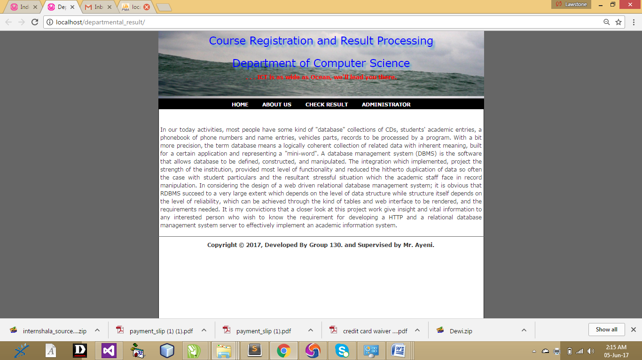
Figure 4.1: Describes the output design of the Home Page

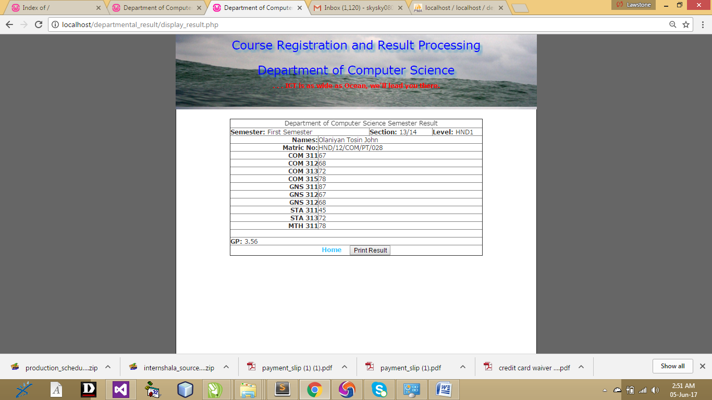
Figure 4.2: Student result: This is a student result computed

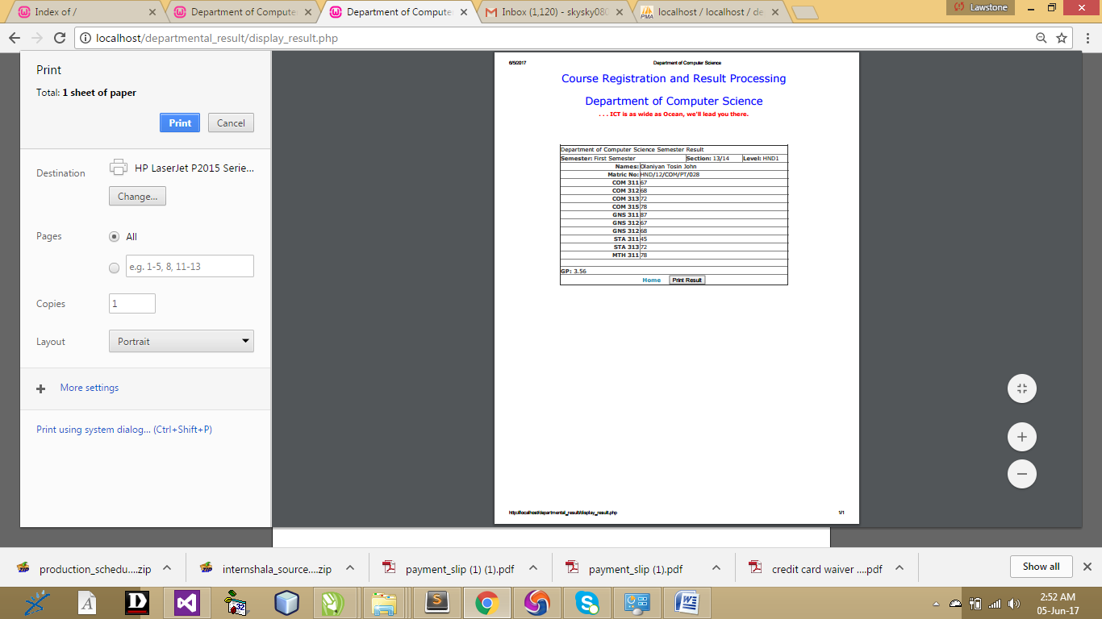
Figure 4.3: Result Print: This is where to print a student computed

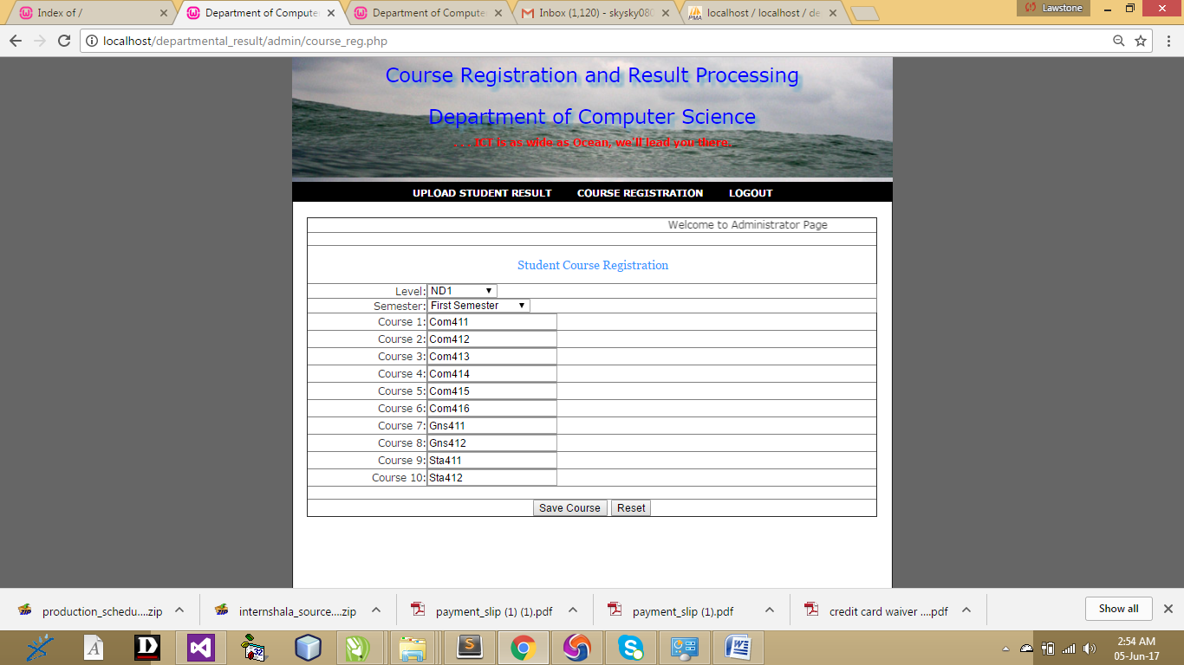
Figure 4.4: Course upload: This is where to upload different departmental course
4.1.2 INPUT DESIGN
This refers to the inputs required to make the website functioning as intended. The inputs to the system include course registration, admin login, result upload as well as checking of result by supplying the neccesory information. The input to the proposed system are as shown below
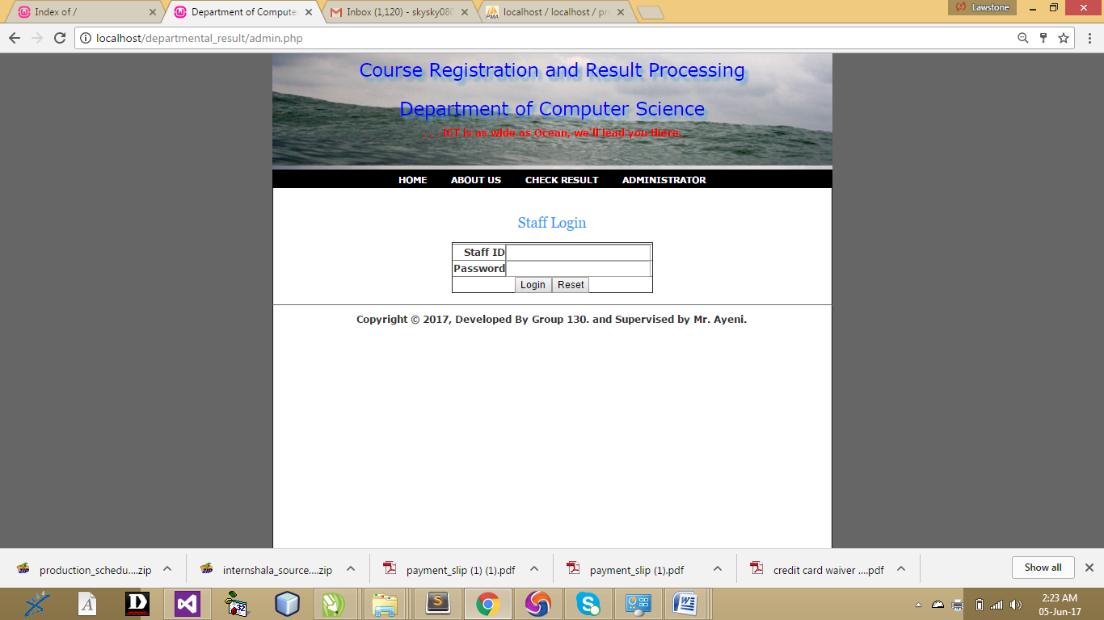
Figure 4.5: Admin Page: This is the that the admin will login
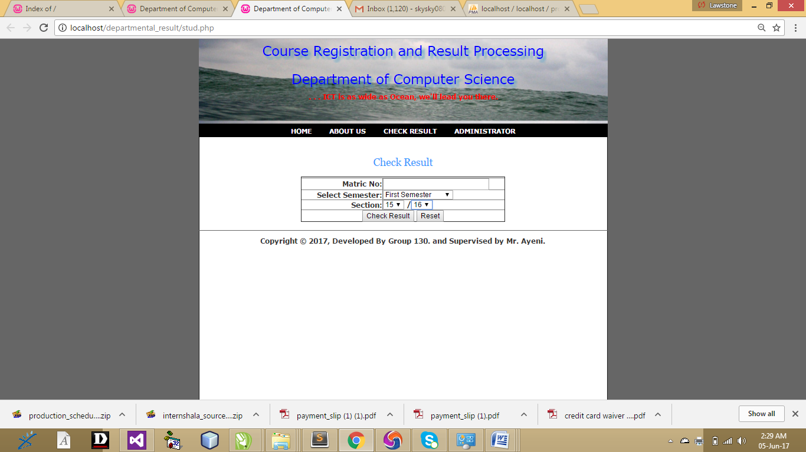
Figure 4.6: Check result: This is the page student will use to check their result
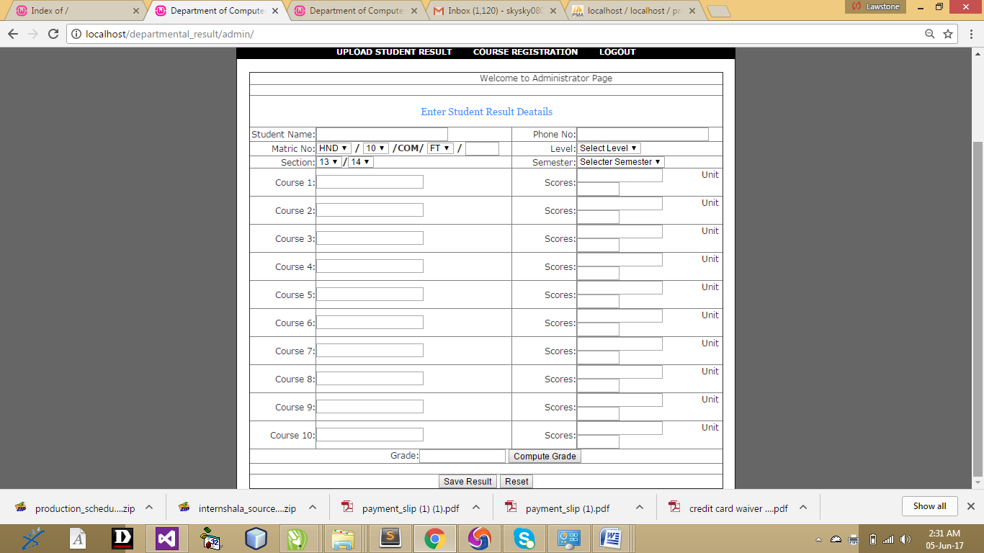
Figure 4.7: Input Result: This is the place where the admin will input student result
4.1.4 DATABASE DESIGN
A Database Design is an organized mechanism that has the capability of storing information through which a user can retrieve stored information in an effective and efficient manner. The data is the purpose of any database and must be protected. The Database Design is a two level process. In the first step, user requirements are gathered together and a database is designed which will meet these requirements as clearly as possible. This step is called Information Level Design and it is taken independent of any individual DBMS.
In the second step, this Information level design is transferred into a design for the specific DBMS that will be used to implement the system in question. This step is called Physical Level Design, concerned with the characteristics of the specific DBMS that will be used. A Database Design runs parallel with the system design. The organization of the data in the database is aimed to achieve the following two major objectives.
- Data Integrity
- Data independence
- Normalization is the process of decomposing the attributes in an application, which results in a set of tables with very simple structure. The purpose of normalization is to make tables as simple as possible. Normalization is carried out in this system for the following reasons.
  - To structure the data so that there is no repetition of data, this helps in saving.
  - To permit simple retrieval of data in response to query and report request.
  - To simplify the maintenance of the data through updates, insertions, deletions.
  - To reduce the need to restructure or reorganize data which new application requirements arise.
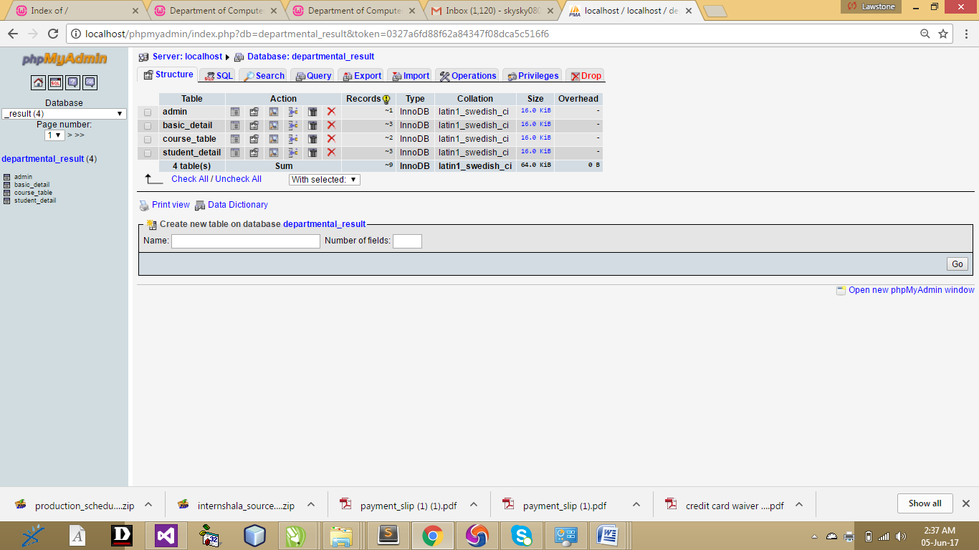
Figure 4.9: Database: This is the database for this departmental result processing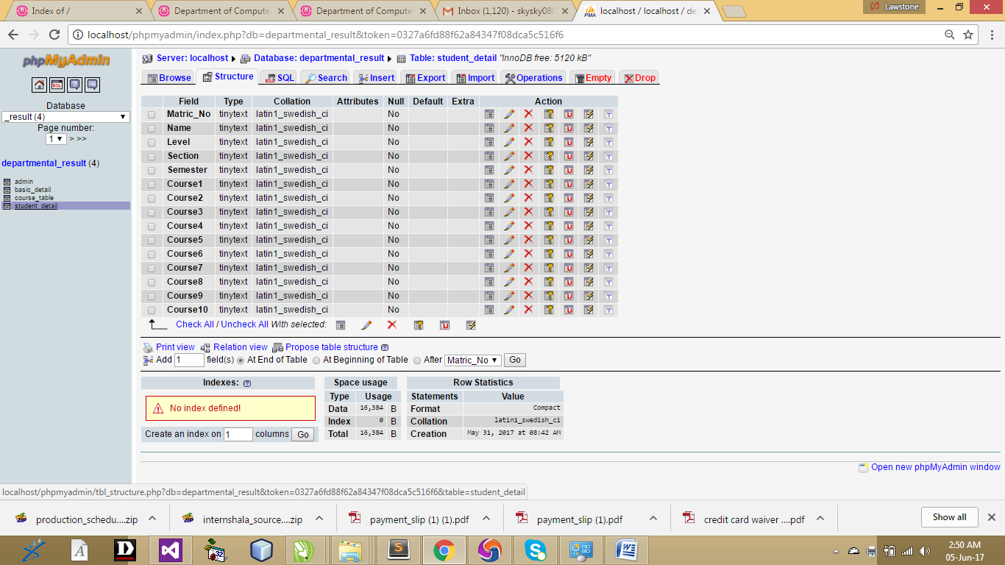
Figure 4.10: Student: This is the table where student details enters.

4.1.4 PROCEDURE DESIGN
This refers to the ways in which the proposed system will be used and the steps are as follows:
- Click start on the computer desktop
- Select all programs
- Select any browser e.g Morzilla Firefox , internet Explorer , Google Chrome e.t.c
- Type the url (Uniform Resource Locator) of the system into the address bar (localhost/departmental_result/index.php)

4.2 IMPLEMENTATION OF THE SYSTEM
The design system depends on the capabilities and power of the computer on which the application system is installed. However, selecting a choice of application support (Hardware and Software) depends much on:
- How readily the user is to interfere with the computer
- Cost and benefits
- Managements support for changes
Hence, choosing the appropriate hardware and software will enhance the performance of the system. A most important requirement on which the running of the program basically depends on is the provision of internet facility. So any system that must run this program must be internet ready.

4.2.1 CHOICE OF PROGRAMMING LANGUAGE
The programming language used in the proposed system is php. PHP meaning (PHP Hypertext Preprocessor) is a server-side programming language. It is an open source server-side scripting language that has taken web-based development to a new level of sophistication. The PHP scripting engine is well optimized for the response times needed on web applications, it can even be part of the web server itself improving the throughput even more. If it were only a matter of improving the speed of the scripts, then PHP will be one of many solutions. But there is more to the PHP equation than that. There is the simplicity and robustness of the language and the scripting engine. There is the connectivity to an ever increasing number of database servers, the shorter development cycles and the ease (encouraged by the syntaxes and constructs) of creating modular and reusable components.

4.2.2 HARDWARE SUPPORT
The hardware requirements for the support of the online inventory application are as follows:
- An enhanced keyboard and mouse
- Minimum of PIII computer and internet enabled
- A processor speed of 500MHz
- RAM size is 18mb
- hard disk size is 100mb
- UPS
- VGA or SVGA colored monitor to be able to achieve the effective user friendliness of the program
- A printer for hard copy record production

4.2.3 CHANGE OVER TECHNIQUES
Phased: The new system is tried out on a small scale to see if it works. For example a supermarket might introduce a new stock control system at just its Bury branch. At the other branches the old system remains in use. When the supermarket is happy the new system works the old system will be gradually replaced at its other stores with the new system. Any problems that occur would only affect the store(s) that the new system was being tried at.

4.2.4 STUDENT DOCUMENTATION
The software required are basically any web browser (internet explorer, Firefox and the likes), WampServer and a network service, be it wired or wireless.
- A network operating system windows NT from Microsoft, Novell Netware.
- A DBM either PhpMyAdmin
- MySQL as the query language to query the database.
- Wambserver

4.3.1 DOCUMENTATION OF THE PROGRAM
It has to do with the installation and usage of the new system.
After the program has been well tested with input that the output has already been known, the next is to install the software in to the computer system for use.
The process of installing are been stated below
- Insert the CD into the system through the CD-ROM after the computer is switch on
- Locate the CD drive directory in my computer and click it to open
- After open, locate setup.exe, and then click to install the program by following the necessary step in installing the program.
- Ensure full installing of the software for effective operation of the system.
After the program has been fully install. The next thing is to locate the package install to put it into operation, to locate the package for expiration purpose the following step are to be taking
v. Click on start menu from task bar. Then select all program
From the display sub option, select by locating the software installed named temperament/ personality check to load the software.

4.3.2 OPERATING SYSTEM
- HOME
- ABOUT
- ADD STUDENT
- ADMIN
- STUDENT LOGIN
- ALLOCATE

4.3.3 MAINTAINING THE SYSTEM
This refers to the changes that have to be, made to complete systems after having been delivered. This project takes care of two types of maintenance these are:
- Adaptive maintenance and
- Perfective maintenance
Adaptive Maintenance: This refers to the type of maintenance which will be done to the system to make it adjust to any changes occurring to it. An example of adaptive maintenance is the yearly updating of the customers database to change account code in database.
Corrective Maintenance: This is a type of maintenance which takes care of some parts of the system which have been omitted in the initial design. The need for this arises as the system is being put into use over a period of time.

CHAPTER FIVE
SUMMARY, CONCLUSION, AND RECOMMENDATION
5.1 SUMMARY
This research work focuses on the use of computer system with reference to course registration, result processing in the polytechnic system. The work covers the manual system of opertions as regards the problems identified, stating the aims of the new system, stating the various specifications and then implementing the programs. The work was successufully developed using visual basic, a user- friendly programming language, and the package was tested and improved upon which yields an automated course registration, examination processing and transcript processing system. The project work cannot be said to be perfect, but however, its benefits cannot be overemphasized. It has led to the improvement in the speed of processing operation, efficiency, accuracy and improved storage of data.

5.2 RECOMMENDATIONS
Based on the achieved objective of this project and the experiences gained during its designed and implementation, I wish to make the following recommendations for future improvement. Students should be exposed to serious practical exercise during the course of their studies. In this regard, the students of Computer Science & Information Technology should be made to write at least a working program with veritable results before graduating. This could be accomplished by providing more computers qualified lecturers in the department. Tertiary institutions should computerize their result processing system for greater efficiency, neatness, and reliability. This will go a long way to save the student all the trouble they go through trying to get their results in one form or the other. Finally, the students’ project should be closely supervised and monitored to achieve more success.

5.3 CONCLUSION
Realizing a project of this nature is very exciting. However, the students encounter a lot a problem which I believe if looked into, will go a long way toward reducing the tension associated with the design implementation and construction of the project. In spite of the constraints encountered during the implementation of this project, the aim of my project is well accomplished. Moreover, an attempt to accomplish this project has taken care of the delay between examination and result processing with minimum mistakes. This has also forced me to learn, practically, what is involved in the design and implementation or computerization of project (existing or non-existing). Finally, I wish to commend the university system and indeed the department of computer science for this project inclusion as a course that must be taken by graduating students it is a step in the right direction to withstand the future challenges in computing in companies, industries, institutions and the world at large.

REFERENCES
Borde, D., (2012) de, “Two-Factor Authentication,” (2010). Available at http://www.insight.co.uk/files/whitepapers/authentication %20(White%20paper).pdf.
Blandford (2014), “result development”
Brainard J. (2012) “Fourth-Factor Authentication: Somebody You Know,” ACM CCS, 168-78. 2012.
Clarke, N. (2012). “Authentication of users on institutes – A survey of attitudes and practices.” Computers & Security, 24(7), 519-527.
Jae-Jung K. (2011).“A Method of Risk Assessment for Multi-Factor Authentication.”Journal of Information Processing Systems, Vol.7, No.1, March.
Judith (2011) Certificate verification system, 178, Communications of the ACM, 48(4).
Kevin S. (2013). “An Examination of Information Security in institution Architectures”
Lange D. (2009). “Programming and Deploying Mobile Agents with Aglets” Addison-Wesley, USA, ISBN:020132582.
Manoj S., (2010).”Security Overlay For Verification”, Thesis, North Carolina State University.
Maamu, K. (2013) Examination Verification Association, 2014 “certificate verification Overview”, January.
Rajnish, T., (2011). “The Certificate Verification Prospects: A Strategic Analysis of Opportunities in institutions.” Hamburg University Press.
Riivari J., (2009). “Mobile banking: A powerful new verification and CRM tool for institutions all over Europe.” Journal of institution , 10(1), 11-20.
Schneier B., (2012) “Two-Factor Authentication: Too Little, Too Late,” in Inside Risks 178, Communications of the ACM, 48(4), April 2012.
Steve L. (2014), “Authentication of users on institutes”
Thomas W. (2012).“The Secure Remote Password Protocol” in Proceedings of the 2012 Distributed System Symposium, pages 97-111, San Diego, CA, March.

APPENDIX 1: ADMIN FLOWCHART

start
Open database
Select option
Is option upload certificate ?
Is option certificate issue?

Is option change password?

Is option logout?

Close database
stop
Log out
Change password
Certificate issue
Upload certificate
N o
N o
N o
N o
Yes
Yes
Yes
Yes

APPENDIX 2: VIEW CERTIFICATE VERIFICATION
Start
Open database
Query database
Display certificate based on institute

Is option view certificate?
Display student certificate details

Close database
Return
Yes
No
More ?
NO
YES

start
Open database
Select option
Is option certificate?
Is view certificate?
Certificate
View certificate
Yes
Yes
No
No
Close database
Return

APPENDIX 3: CHECK PARTICULAR CERTIFICATE
Close database
Return
More ?
Yes
No
Start
Open database
Is certificate number exist?
Display certificate

Yes
No
Input certificate number
Record not found

Query database

APPENDIX 4: UPLOAD CERTIFICATE
Start
Open database
Is option upload?
Display certificate uploaded successfully

Close database
Return
Yes
No
Input certificate number
Empty field

Save to database
Input other details

APPENDIX 5: CERTIFICATE ISSUED
start
Open database
Query database
Display issue certificate
Close database
Return
More ?
Yes
No

SOURCE CODE

<?php
include("header.php");
?>
<body>

<div id="tooplate_wrapper">

<div id="tooplate_header">
<div id="site_title"><h1><a href="#">Certificate Verification System</a></h1></div>
<div id="tooplate_menu">
<ul>
<li><a href="#" class="current">Home</a></li>
<li><a href="verification.php">Verification</a></li>
<li><a href="blog.php">About US</a></li>
<li><a href="contact.php">Contact</a></li>
</ul>
</div> <!-- end of tooplate_menu -->
</div> <!-- end of forever header -->

<div id="tooplate_middle">
<img src="images/cer.jpg" alt="image" height="100%" width="100%" />
</div> <!-- end of middle -->

<div id="tooplate_content"><span class="content_top"></span>
<h2>Certificate Verification System!</h2>
<div class="image_wrapper image_fl"><span></span>
<img src="images/cert.jpg" alt="image" />
</div>
<p align="justify">The most important thing of having the system is to maintain an accurate and precise validation of pre-student and post-student certificate, so the developed system can be used to trace the institution that issued certificate including the candidate that owns the certificate.
With the verification portal, employers can easily detect the studentship of a particular candidate in the institution without facing stress and employers can view those records easily through this system without embarking on a journey for the verification.</p>
<div class="cleaner h40"></div>
<div class="box_w220" />
<h4><span>Our Mission</span></h4>
<p>The main aim of this project work is to develop a good web interface for certificate verification to make information available on the status of such certificates and endorsements to other parties and companies that request for the certificates produced by an institution.</p>
</div>
<div class="box_w220">
<img src="images/cert2.jpg" alt="image" height="100%" width="100%" />
</div>
<div class="box_w220 rmb">
<h4><span>Our Vision</span></h4>
<p><ul>
<li>Able to track fake resumes and certificates.</li>
<li>To make certificate request easier and faster.</li>
<li>To reduce cost of transportation when organization want to embark on the certificate verification.</li>
<li>To make student information available for authenticity.</li>
<li>To eradicate fake certificate used by the pre-students and post-students.</li>
</ul>
</p>
</div>

<div class="cleaner"></div>
</div> <!-- end of content -->

<?php
include("footer.php");
?>
</div> <!-- end of wrapper -->

</body>
</html>
BLOG
<?php
include("header.php");
?>
<body>

<div id="tooplate_wrapper">

<div id="tooplate_header">
<div id="site_title"><h1><a href="#">The Block</a></h1></div>
<div id="tooplate_menu">
<ul>
<li><a href="index.php">Home</a></li>
<li><a href="verification.php">Verification</a></li>
<li><a href="blog.php" class="current">About US</a></li>
<li><a href="contact.php">Contact</a></li>
</ul>
</div> <!-- end of tooplate_menu -->
</div> <!-- end of forever header -->

<div id="tooplate_middle_sub">
<img src="images/cer.jpg" alt="image" height="100%" width="100%" />
</div> <!-- end of middle -->

<div id="tooplate_content"><span class="content_top"></span>
<div class="post_box">
<div class="comment"><a href="#">Hi!</a></div>
<h2>User</h2>

<p style="line-height: 1.3em;">I develop a Certificate Verification System that will be used to solve the following problems; Fake certificates are been used in many organizations to acquire job this days when the owner of the certificate knows there is no way the firm can verify the certificate, and sometimes when there is a way to confirm the certificate, it is somehow stressful and cost expensive for the organization to embark on the authenticity.</p>
<div class="cleaner"></div>
</div>

<div class="cleaner"></div>
</div> <!-- end of content -->

<?php
include("footer.php");
?>

</div> <!-- end of wrapper -->

</body>
</html>

COMPUTER OUTPUT
Figure 4.1: Describes the output design of the Home Page

Figure 4.2: Student result: This is a student result computed
Figure 4.3: Result Print: This is where to print a student computed

Figure 4.4: Course upload: This is where to upload different departmental course
Figure 4.5: Admin Page: This is the that the admin will login
Figure 4.6: Check result: This is the page student will use to check their result
Figure 4.7: Input Result: This is the place where the admin will input student result
Figure 4.9: Database: This is the database for this departmental result processing
Figure 4.10: Student: This is the table where student details enters.

