DEVELOPMENT OF VOICE BASED ASSISTANT USING GOOGLE DIAFLOW AND MACHINE LANGUAGE

By:
ADEWALE ADEMOYO
HND/23/COM/FT/0238

A Project Submitted to the Department of Computer Science, Institute of Information and Communication Technology, Kwara State Polytechnic, Ilorin, Nigeria
In Partial Fulfillment of the Requirements for the Award of Higher Higher National Diploma [HND] in Computer Science
July, 2025
CERTIFICATION
This is to certify that this project was carried out by ADEWALE, Ademoyo with matriculation number HND/23/COM/FT/0238, has part of the requirements for the award of Higher National Diploma (HND) in Computer Science.

_______________________ __________________
Mr. Sadiq K.A Date
(Project Supervisor)

_______________________ __________________
Mr Oyedepo F.S. Date
(Head of Department)
_________________________ __________________
External Examiner Date
DEDICATION
This project is dedicated to the creator of the earth and universe, the Almighty God. It is also dedicated to my parents for their moral and financial support.

ACKNOWLEDGEMENT
All praise due to Almighty God the Lord of the Universe. I praise Him and thank Him for giving me the strength and knowledge to complete my HND programme and also for me continue existence on the earth.
I appreciate the utmost effort of my supervisor, Mr. Sadiq whose patience support and encourages have been the driving force behind the success of this research work. He gave useful corrections, constructive criticisms, comments, recommendations, advice and always ensures that an excellent research is done. My sincere gratitude goes to Head of the Department and other members of staff of the Department of Computer Science, Kwara State Polytechnic, Ilorin, for their constant cooperation, constructive criticisms and encouragements throughout the programme.
Special gratitude to my parents who exhibited immeasurable financial, patience, support, prayers and understanding during the periods in which I was busy tirelessly in my studies. Special thanks go to all my lovely siblings.
My sincere appreciation goes to my friends and classmates.

TABLE OF CONTENTS
Title Page
Certification
Dedication
Acknowledgements
Abstract
Table of Contents
CHAPTER ONE: GENERAL INTRODUCTION
  - Background to the Study 1-2
  - Statement of the Problem 2-3
  - Aim and Objectives of the Study 3
  - Significance of the Study 4
  - Scope of the Study 4
  - Organization of the Report 4-5
CHAPTER TWO: LITERATURE REVIEW
2.1 Review of Related Works 6-7
2.2 Review of General Concepts 7-8
2.2.1 Decision Support System 8
2.2.2 RFM model 8-9
2.2.3 Churn prediction modeling 9
2.2.4 Generation of Optimal Internet Plans 10
CHAPTER THREE: RESEARCH METHODOLOGY AND ANALYSIS OF THE EXISTING SYSTEM
  - Research Methodology 11-13
  - Analysis of the Existing System 13
  - Problems of the Existing System 13-14
  - Description of the Proposed System 14
  - Advantages of the proposed system 14
CHAPTER FOUR: DESIGN, IMPLEMENTATION AND DOCUMENTATION OF THE SYSTEM
  - Design of the System 15
    - Output Design 15-17
    - Input Design 17-21
    - Database Design 22
    - Procedure Design 23
  - System Implementation 23
    - Choice of Programming Language 23
    - Hardware Support 23
    - Software Support 24
  - System Documentation 24
    - Program Documentation 24
    - Maintaining System 24

CHAPTER FIVE: SUMMARY, CONCLUSION AND RECOMMENDATION
  - Summary 25
  - Conclusion 25-26
  - Recommendation 26
References
Flowchart

ABSTRACT
The development of voice-based assistants using technologies like Google Dialogflow and machine learning has gained significant attention in recent years. These assistants provide users with the ability to interact with software applications using natural language commands and queries, enhancing user experience and productivity. This project aims to develop a voice-based assistant using Google Dialogflow and machine learning, implemented in Python. The system utilizes the Dialogflow API for intent recognition and response generation, along with the Speech-to-Text API for converting voice input into text. The assistant can understand user queries, perform tasks, and provide contextually relevant responses.

Chapter One
General Introduction
1.1 Background to the Study
In this new age of technology and innovation, the use of artificial intelligence and machine learning has made our life much easier. These technologies have proved to be beneficial to the society in various fields such as education, industries, e-commerce, etc; and one of the most prominent is communication. Right from the 1960s, when IBM introduced the first digital speech recognition tool, i.e. IBM Shoebox, the idea of having a conversation with a computer seemed quite futuristic. An Intelligent Virtual Assistant is a digital life assistant made to contribute maximum convenience to the user. It is a highly developed software with a powerful speech recognition system which focuses on the processing of audio signal into the system, converting it to text and perform the required task (Tulshan etal., 2019).
Most of the Virtual Assistants work basically on voice as communication. It focuses on processing of audio signal into the system, converting them to text and performing the required task. In general, speech processing consists the following: A Speech-To-Text Module that converts speech signals to text, A Parser that extracts the semantic context, A Dialog Manager that determines system response through machine learning algorithms, An Answer Generator that provides the system response in text and A Speech Synthesizer that converts text to the speech signal (Khan etal., 2019).
When developed by a normal user, he/she may experience many issues, in terms of accuracy in recognition, robustness in performing operations, etc. and at times may not be able to understand the issues faced. Therefore, in this paper, we have tried to give an overview which will help user understand the methodologies and steps involved in the making of a Virtual Personal Assistant. We have taken into consideration the different methodologies, results and limitations published by different researchers (Tulshan etal., 2019).
In today's technology-driven world, voice-based assistants have become increasingly popular, offering users a hands-free and intuitive way to interact with digital systems. These assistants, powered by advancements in natural language processing (NLP) and machine learning, have the ability to understand and respond to user commands and queries, making them a valuable tool for various applications (Liu etal., 2020) .
Google Dialogflow, a powerful conversational AI platform, provides the foundation for building interactive and contextually-aware conversational interfaces. By leveraging machine learning algorithms, the assistant will continuously learn and improve its understanding and response capabilities over time. The voice-based assistant will enable users to interact with the system through natural language commands and queries, eliminating the need for manual input and enhancing user convenience. The assistant will be capable of performing tasks, answering questions, providing recommendations, and executing actions based on user requests (Nassif, etal., 2019).
The development process will involve several key steps. Firstly, a dataset will be collected and annotated to train the machine learning models, enabling the assistant to recognize and understand user input accurately. The training data will include a variety of user queries, commands, and potential responses. Machine learning techniques, such as deep learning algorithms, will be employed to train the models on this data (Vineel, 2020).
Google Dialogflow will be integrated into the system to handle the natural language understanding and generate appropriate responses based on the user's intent. Dialogflow provides tools and APIs that enable developers to build robust conversational interfaces and handle complex conversations (Liu etal., 2020).
The outcome of this project will be an intelligent and interactive voice-based assistant that can understand user input, process it through natural language understanding, and generate contextually relevant responses. The assistant will provide users with a convenient and efficient way to interact with digital systems, improving user experience and productivity (Jurafsky, 2020).
1.2 Statement of the Problem
The problem at hand is the need for the development of a voice-based assistant using Google Dialogflow and machine learning. Existing voice assistants face challenges in accurately understanding user input, maintaining contextual awareness, and providing meaningful responses. Additionally, the collection and annotation of a diverse dataset for machine learning training pose a time-consuming task. Integrating Google Dialogflow into the system requires understanding its features and APIs effectively. To enhance user experience and interactivity, the voice-based assistant should allow users to interact through natural language commands, perform tasks, answer questions, and offer relevant recommendations. Addressing these challenges is crucial for the successful development of an intelligent voice-based assistant that meets user expectations.
1.3 Aim and objectives of the Study
The aim of this study is to develop a voice-based assistant using Google Dialogflow and machine learning techniques to improve the user experience and interactivity in interacting with digital systems. To achieve this aim, the study will focus on the following objectives:
- Develop a robust natural language understanding system: Train machine learning models using a diverse dataset to accurately understand and interpret user input, including queries, commands, and contextual information.
- Implement context awareness: Enable the voice-based assistant to maintain conversational context and provide contextually relevant responses based on user interactions and previous queries.
- Integrate Google Dialogflow: Utilize the features and APIs of Google Dialogflow to enhance natural language processing capabilities, enabling more accurate intent recognition and response generation.
- Design an intuitive user interface: Create a user-friendly interface for users to interact with the voice-based assistant, allowing them to perform tasks, ask questions, and receive relevant recommendations using natural language commands.
1.4 Significance of the Study
By developing a voice-based assistant with robust natural language understanding and context awareness, users can have a more seamless and intuitive interaction with digital systems, reducing the need for manual input and enhancing overall user experience. The voice-based assistant can perform tasks, answer queries, and provide recommendations, thereby increasing user efficiency and productivity. Users can rely on the assistant for various activities, such as setting reminders, retrieving information, and executing actions, resulting in time savings and improved task completion.The study contributes to the field of natural language processing by exploring the integration of Google Dialogflow and machine learning techniques to enhance the accuracy and contextual understanding of voice-based assistants.
1.5 Scope of the Study
The scope of this study includes the development of a voice-based assistant using Google Dialogflow and machine learning techniques. The focus is on building a system that can understand and respond to user queries, commands, and requests through natural language processing and voice recognition.
1.6 ORGANIZATION OF THE REPORT
This is the overall organizational structure of the work as presented in this project. This project is segmented into five distinct chapters. Chapter one is all about the introduction, statement of problem, aim and objectives, significance of the study, scope of the study, definition of terms, as well as the organization of the report. The second chapter deals with the literature review and other related articles. The third chapter talks about the research methodology that entails introduction, system analysis, and system design. The fourth chapter deals with the design of the system which entails the output, database and procedure design of the system, the implementation comprises of the hardware and support while the documentation comprise of how to use the system and the system maintenance. The last chapter deals with the summary of the experience gained, conclusion and recommendation.

CHAPTER TWO
REVIEW OF RELATED LITERATURE
2.1 LITERATURE REVIEW
The Speech Recognition Model is one of the most important part of a Virtual Assistant. Considering the various Neural Networks that are required for building up of a speech recognition system, it was necessary to survey the models that provided the insight by determining the accuracy and other factors of each Model. It was observed that High Accuracy and less Validation Accuracy was achieved for Convolutional Neural Network (CNN) model as compared to Basic Neural Network. Thus, proving that CNN is a better choice for speech recognition systems (Mohit, 2020).
Considering the Limitations for the Model, other parameters such as Word Error rate, throughput of the system was not taken into consideration. Various Machine Learning Algorithms are used for speech recognition. It was found that on application of Auto- WEKA on various algorithms, determined Random Forest as the best algorithm which is useful for learning the dataset based on the training set. However in this survey, Speech samples consisting of noise was not tested for determining the scalability and robustness of the models (Mokgonyane etal., 2019).
In the Survey of scaling speech recognition using CNN, following metrics were taken into consideration:
- throughput,
- (ii) Real-Time Factor(RTF) and latency, and
- (iii) Word Error Rate (WER)
for the overall framework, helped in achieving an efficient model. But due to the increase in the number of the layers the implementation of the same was difficult (Liu etal., 2020).
Other Algorithms such as the Long Short-Term Memory (LSTM) is very powerful in speech recognition and Hybrid model of Hidden Markov Model (HMM) and Gaussian Mixture Models (GMM) can give excellent results[5]. In various Projects of developing a Virtual Assistant it was observed that the platform failed to support various other languages of the countries including China, Japan, India, etc.
The survey paper provided with detailed study on the Recurrent Neural Networks (RNNs) that can be used for Speech Recognition System but with more research to be carried out on the same. However, the survey focused more on the Supervised Learning Models and less importance was given to the Unsupervised Learning Models.
A Survey included the detailed comparison of the Personal Voice-Based Assistants available in the market namely, Google Assistant, Cortana, Alexa and Siri. It concluded that Google assistant gave good results in VR and HFI by achieving 60% accuracy. Siri achieved 44% accuracy in VR and HFI. Cortana was observed with decrease in accuracy close to 30%. Other results included that Alexa wasn’t suitable with simple questions whereas Cortana was poor in basic voice recognition[7]. The illustration to use AI-enabled content analysis has been discussed in one of the survey paper. The system can examine text of leadership speeches, content related to a specific organization. However, Only one type of content was analysed with limited samples and a Pre-defined Coding Scheme was used for the Project (Linda etal, 2020).
2.2. Review of Related Concepts
2.2.1 Google Dialogflow: Benefits and Limitations
The main benefit of Dialogflow is its connection with Google. The Machine Learning Algorithms inbuilt within the platform helps in understanding natural language that is the user’s expression with the help of agents. Each Agent contains Intents which is matched with the user’s expression and action is performed as a response to the query. It not only provides answers to customers but also enables agents to carry out small talks with the users. The Platform also provides pre-built templates that developers can use as foundations for their project.
2.2.2 Feature Comparison between IBM Watson and Google Dialogflow
i. Machine Learning:
Both IBM Watson and Google Dialogflow provides user with this feature to analyse the data. It includes the NLP and NLU Algorithms that are required for understanding natural language of the user’s expression as input to the system. The Text Input is sent to the NLP Module where it is converted into structured data. The Speech input is handled using other Speech-To-Text Algorithms provided by the platforms for further processing.
ii. Chatbots:
Platforms ensure to provide chatbots for interaction of the user with the system. All the QuestionAnswer based queries by the user are handled here. These Chatbots are designed for providing interaction with the user just like humans, thus providing natural experience to the users using it.
2.3 Application
Voice-based assistants have found applications in various domains and industries. Some notable applications of voice-based assistants include:
- Personal Assistance: Voice-based assistants, such as Siri, Google Assistant, and Amazon Alexa, serve as personal assistants to users. They can perform tasks like setting reminders, sending messages, making phone calls, playing music, and providing information on various topics.
- Smart Homes: Voice-based assistants are integrated into smart home systems, allowing users to control various devices using voice commands. Users can control lights, thermostats, security systems, and home entertainment systems without needing to physically interact with the devices.
- Customer Service and Support: Voice-based assistants are used in customer service applications to provide automated support and answer frequently asked questions. They can handle customer queries, guide users through troubleshooting processes, and assist in placing orders or making reservations.
- Healthcare: Voice-based assistants are employed in healthcare applications to assist patients and healthcare professionals. They can provide medication reminders, answer medical queries, schedule appointments, and offer guidance on healthy living.
- Automotive: Voice-based assistants are integrated into cars to provide hands-free operation and enhance driver safety. They can control navigation systems, play music, make phone calls, and provide real-time information such as traffic updates and weather conditions.
- Language Translation: Voice-based assistants can assist with language translation, allowing users to communicate in different languages by translating their speech in real-time. This application is particularly useful for travelers or in multilingual settings.
- Accessibility: Voice-based assistants play a vital role in enhancing accessibility for individuals with disabilities. They enable users with visual impairments or motor disabilities to interact with devices and access information through voice commands.
- Business Applications: Voice-based assistants are used in business settings to streamline operations and improve productivity. They can schedule meetings, provide sales data, manage inventory, and perform other administrative tasks through voice commands.

CHAPTER THREE
METHODOLOGY AND ANALYSIS OF THE SYSTEM
3.1 RESAERCH METHODOLOGY
Python being an Open Source UI Software Development Platform is used for developing attractive UI for the Application. Various packages and graphics library provided by the Platform allow faster operations of the Application. It promises to give a stunning look to the Application Interface, irrespective of the operating platform. It enables the developer to create Cross-Platform Applications with ease.
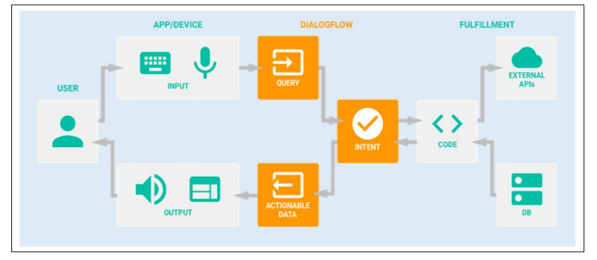
Figure 3.1: Architecture of the Voice Assistant
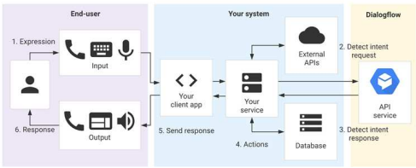
Figure 3.2: User interaction with API
For interacting with the Dialogflow API Service, a code must be written for direct interaction.
3.2 ANALYSIS OF THE EXISTING SYSTEM
The existing systems for voice-based assistants, such as Google Assistant, Amazon Alexa, Apple Siri, and Microsoft Cortana, rely heavily on speech recognition, natural language processing, and machine learning to provide automated responses and perform various tasks. While these systems have significantly advanced in recent years, they still face critical challenges and limitations that restrict their overall effectiveness. The recognition of regional accents and dialects continues to be a challenge. Many systems are optimized for widely spoken languages and standard pronunciations, which can alienate users with non-standard accents or linguistic patterns. Additionally, these systems are heavily dependent on constant internet connectivity, which limits their usability in low-connectivity environments or offline scenarios.
3.3 PROBLEMS OF THE EXISTING SYSTEM
The current voice-based assistant systems, while innovative and widely adopted, face several significant challenges that limit their functionality and user experience. These problems include limitations in accuracy, personalization, scalability, and privacy, which prevent them from meeting the diverse needs of all users effectively.
One of the primary problems is the lack of personalization. Many existing systems fail to adapt to individual users’ preferences or histories, resulting in generic responses that do not cater to specific needs. This lack of dynamic learning makes the interactions less engaging and effective. Additionally, maintaining conversational context remains a persistent issue. Most systems can process standalone queries efficiently but struggle to sustain context across multi-turn conversations, which disrupts the flow of interactions and diminishes user satisfaction. Another significant problem is the limited ability to recognize and process diverse accents, dialects, and linguistic variations. Despite advancements in speech recognition technology, many systems perform poorly with non-standard accents or regional dialects, alienating a segment of users and reducing accessibility. Furthermore, these systems rely heavily on constant internet connectivity to function. This dependence limits their usability in environments with poor connectivity or when offline functionality is required. Privacy concerns also emerge as a major drawback. Users often question how their data is collected, stored, and used, with many existing systems lacking transparency in their data handling practices. This erodes trust and discourages adoption.
3.4 DESCRIPTION OF THE PROPOSED SYSTEM
The proposed system is an advanced voice-based assistant that leverages Google Dialogflow for natural language understanding and integrates with machine learning to address the limitations of existing systems. It is designed to deliver personalized, context-aware, and scalable interactions while ensuring robust privacy and accessibility.
This system introduces dynamic learning capabilities, allowing it to adapt to individual user preferences over time. By integrating advanced machine learning algorithms, the assistant can offer personalized responses and anticipate user needs based on past interactions. Unlike traditional systems, the proposed solution ensures a seamless flow of conversation by maintaining context across multi-turn interactions, creating a more natural and engaging user experience.
3.5 ADVANTAGES OF THE PROPOSED SYSTEM
The proposed voice-based assistant introduces several advantages over existing systems, making it a more robust and user-friendly solution. These advantages are as follows:
- improved accuracy,
- personalization,
- privacy,
- scalability,
- and flexibility, ensuring it meets diverse user needs effectively.

CHAPTER FOUR
DESIGN, IMPLEMENTATION AND DOCUMENTATION OF THE SYSTEM
4.1 DESIGN OF THE SYSTEM
This is the computation of the particulars of a new system and the determination of what the new system would be and the function it is to perform. This may involve changing from one system to another or modifying the existing system operation.
The most challenging phase of the system life cycle is the change from manual operation to a faster and more accurate one; system design stage covers the technical specifications that will be employed in the implementation of the new system in order to modify the previous system. Some factors are put in consideration. These factors include input design, output design, the database and procedure designs and other documentation.
4.1.1 OUTPUT DESIGN
This incorporates the objectives of solving the existing system problems and challenges. The outputs extracted from the system are displayed in the screenshot images below:

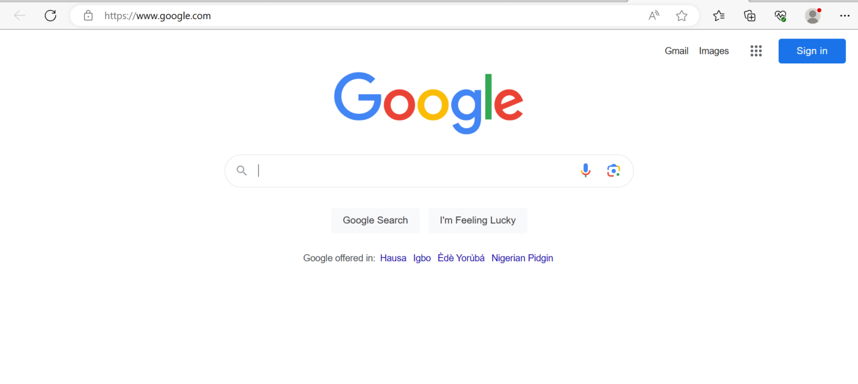
Figure 4.1: Open Google with voice command
This is a page display where users put commands.

4.1.2 INPUT DESIGN
The input to run this software is obtained from the admin. The administrator is expected to register staff and customers. He can achieve this by typing via the keyboard. The input required from the admin is the details of customers. It can serve as the various input layouts from the various modules first from the collection of data and module then from the assessment module and input from admin respectively.
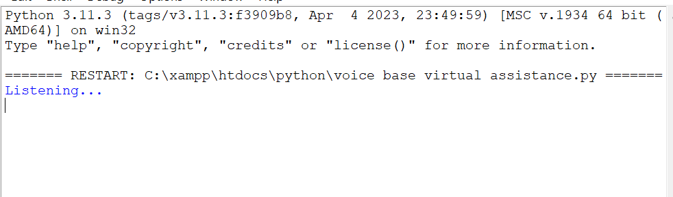
Figure 4.2: login Interface
This page is where the admin can login to the system, an option to display or not to display password is available on the page.
re customers’ records were saved.
4.1.4 PROCEDURE DESIGN
These are the steps involved in unifying the whole process to produce the desired output. It involves computer procedures which start from the original input lessons to the output result file. This allows the processing of user information and result to be possible. Menu is provided to aid user in the processing of the output file.
4.2 IMPLEMENTATION OF THE SYSTEM
This entails the choice of the programming language employed to implement the system which should-be decision support system for Telecommunication Company. The system is designed for the use of the admin which should serve as an assistant. It is also expected to be used in conjunction with the user.
4.2.1 CHOICE OF PROGRAMMING LANGUAGE
The Application was developed in Microsoft Visual Studio (.Net), an integrated development environment (IDE). The Application IDE is chosen following the fact that extracted information needs to be presented in an enhanced pictorial/graphical format and easy communication with the database for program flexibility in windows platform.
4.2.2 HARDWARE REQUIREMENTS
i. 250 Hz minimum with CD ROM drive etc.
ii. Hard disk of capacity 10GB Minimum
iii. 126-512 megabyte of RAM
iv. An Uninterrupted power supply (UPS)
v. A voltage stabilizer
vi. A power generating set and so on.
4.2.3 SOFTWARE REQUIREMENTS
I. Window Operated system such Windows7
ii. Microsoft Visual C#.Net
4.3. PROGRAM DOCUMENTATION
The program is packaged for use in any system. After developing the system, there is a facility provided in Visual Studio suite called “Package and Deployment Wizard” that is used in Microsoft Visual C# .Net app packaging and deployment.
This software is packaged into an installable setup that can be run from any system.
4.3.1 MAINTAINING THE SYSTEM
The system maintenance refers to making modification to an already existing application/program without necessarily re-writing everything from start. Program maintenance of a program includes modification of the program to meet-up with certain requirements of the users. In this course, additional features can be added, errors corrected, ambiguous interfaces redesigned to eliminate confusions and unnecessary features removed.
Maintaining this program can be done in Microsoft Visual C# environment. Any future modification can be by re-running the program source code in a Visual studio making necessary changes and updates and recompile the application into an upgrade version of the existing version of the mini word processing application. Further versions of this program can be named following their year of release or it can be given a different version number.

CHAPTER FIVE
SUMMARY, CONCLUSION AND RECOMMENDATIONS
5.1 SUMMARY
The implementation of a voice-based assistant using C# and the Google Cloud libraries for Dialogflow and Speech-to-Text involves setting up the necessary authentication and API credentials, integrating with Dialogflow for intent recognition and response generation, and using Speech-to-Text for transcribing user voice input. The voice assistant processes the transcribed text, sends it to Dialogflow for intent recognition, and generates an appropriate response based on the recognized intent. The implementation includes capturing voice input, handling user interactions, and displaying the assistant's responses through a user interface. Through testing, refinement, and user feedback, the voice-based assistant can be further improved and iterated upon to enhance its functionality and user experience.
5.2 Conclusion
The development of a voice-based assistant using Python and the Google Cloud libraries for Dialogflow and Speech-to-Text offers a robust and flexible solution for natural language interaction with users. By leveraging the power of Dialogflow for intent recognition and response generation, combined with the Speech-to-Text functionality for converting voice input into text, the voice assistant can effectively understand user queries, perform tasks, and provide contextually relevant responses.
Python, with its simplicity and extensive libraries, allows developers to easily implement the voice-based assistant. The Google Cloud libraries provide a convenient way to interact with Dialogflow and Speech-to-Text APIs, enabling seamless integration into the assistant's functionality.
The use of machine learning techniques and natural language processing enhances the assistant's ability to accurately interpret user intents and extract key information from their queries. This enables more natural and conversational interactions, improving the overall user experience.
Python's versatility allows developers to extend the voice assistant's functionality and integrate it with other systems or applications easily. It provides ample opportunities to create voice-enabled applications across various domains, including personal assistance, home automation, customer support, healthcare, automotive, and more.
5.3 Recommendation
Based on the development of a voice-based assistant using Python and the Google Cloud libraries for Dialogflow and Speech-to-Text, here are some recommendations:
- Dataset: Ensure that the training dataset for intent recognition is diverse and representative of different user queries and intents. Include a wide range of examples to improve the assistant's accuracy and understanding of user inputs.
- Model Optimization: Continuously fine-tune and optimize the machine learning models used for intent recognition and speech-to-text conversion. Experiment with different architectures, hyperparameters, and training techniques to improve the assistant's performance.
- Error Handling: Implement robust error handling mechanisms to gracefully handle situations where the voice input cannot be transcribed or the intent cannot be recognized. Provide appropriate error messages or fallback responses to guide users and maintain a smooth user experience.
- Contextual Understanding: Enhance the assistant's ability to maintain context during conversations by utilizing Dialogflow's context management capabilities. Ensure that the assistant can recognize and retain relevant information from previous user interactions to provide more accurate and personalized responses.
- Integration with Other Services: Explore integration with other services or APIs to enhance the assistant's functionality. For example, integrate with external data sources or APIs to provide real-time information, such as weather updates, news, or third-party services.
- Continuous Testing and Feedback: Regularly test the voice-based assistant with real users or user representatives to gather feedback and identify areas for improvement. Consider implementing a feedback mechanism within the assistant to collect user feedback and address any issues or suggestions for enhancement.
- Privacy and Security: Pay attention to privacy and security considerations, especially when dealing with sensitive user data or voice recordings. Ensure compliance with relevant data protection regulations and implement secure data handling practices.
- Documentation and Maintenance: Document the implementation details, including the system architecture, setup instructions, and usage guidelines, to facilitate maintenance and future development. Maintain the project by keeping up with updates to the Google Cloud libraries and addressing any potential issues or vulnerabilities.

References
Jurafsky, D., & Martin, J. H. (2020). Speech and Language Processing (3rd ed.). Pearson.
Liu, Y., Liu, W., Ma, Q., & Awadallah, A. (2020). Deep Learning for NLP and Speech Recognition. In Handbook of Neural Activity Measurement (pp. 213-247). Elsevier. doi: 10.1016/B978-0-12-815479-0.00012-2
Khan, M. A., Tripathi, A., Dixit, M. and Dixit, M. (2019) "Correlative Analysis and Impact of Intelligent Virtual Assistants on Machine Learning," 11th International Conference on Computational Intelligence and Communication Networks (CICN), Honolulu, HI, USA, 2019, pp. 133-139, doi: 10.1109/CICN.2019.8902424.
Tulshan, A.S., Dhage S.N. (2019) Survey on Virtual Assistant: Google Assistant, Siri, Cortana, Alexa. In: Thampi S., Marques O., Krishnan S., Li KC., Ciuonzo D., Kolekar M. (eds) Advances in Signal Processing and Intelligent Recognition Systems. SIRS 2018. Communications in Computer and Information Science, vol 968. Springer, Singapore.
Nassif, I., Shahin, I., Attili, M. Azzeh, B. and Shaalan, K. (2019) "Speech Recognition Using Deep Neural Networks: A Systematic Review," in IEEE Access, vol. 7, pp. 19143-19165.
Vineel, P. (2020) Scaling up Online Speech Recognition Systems using ConvNets”,

