SMART SOLAR BASED CBT EXAMINATION MONITORING SYSTEM

BY
ABAYOMI, THOMAS AYOBAMI
HND/23/COM/FT/0085

SUBMITTED TO THE DEPARTMENT OF COMPUTER SCIENCE, INSTITUTE OF INFORMATION AND COMMUNICATION TECHNOLOGY, KWARA STATE POLYTECHNIC, ILORIN

IN PARTIAL FULFILLMENT OF THE REQUIREMENTS FOR THE AWARD OF HIGHER NATIONAL DIPLOMA (HND) IN
COMPUTER SCIENCE

MAY, 2025.

CERTIFICATION
This is to certify that this project was carried out by ABAYOMI, THOMAS AYOBAMI with the matriculation number: HND/23/COM/FT/0085 in the Department of Computer Science, Institute of Information and Communication Technology, Kwara State Polytechnic, Ilorin, Kwara State.

…………………………………. ….………………………
DR. AGBOOLA, O. M. Date
Project Supervisor

…………………………………. ….………………………
MR. OYEDEPO, F. S. Date
Head of Department

…………………………………. ….………………………
External Examiner Date

DEDICATION
I dedicate this project work to the Almighty God, who inspired me and directed my ways during my academic stay in the polytechnic.

ACKNOWLEDGEMENTS
All praise is due to the Almighty God, the Lord of the universe. I praise Him and thank Him for giving me the strength and knowledge to complete my HND program and also for my continued existence on earth.
I appreciate the utmost effort of my supervisor, DR. AGBOOLA, O. M. whose patience, support, and encouragement were the driving force behind the success of this research work. He gave useful corrections, constructive criticisms, comments, recommendations, and advice and always ensured that excellent research was done. My sincere gratitude also goes to the Head of Department, MR. OYEDEPO, F. S., and other members of staff of the Department of Computer Science, Kwara State Polytechnic, Ilorin for their constant cooperation, constructive criticisms, and encouragement throughout the program.
Special gratitude to my parents, MR. and MRS ABAYOMI who exhibited immeasurable financial, support patience,, prayers, and understanding during the period in which I was busy tirelessly with my studies, special thanks go to my lovely siblings. I can not, but to appreciate this set of people OLUWASEGUN, IFETAYO, and ADEJOKE. I'm grateful for the love, support, and prayers throughout my academics journey. Your presence meant a lot to me. To my SENATE VILLA FAMILY, thank you for your contributions to my success.
Special thanks to my babe OLAYINKA JOY OLUWASEYI for your care and support. I'm thankful to everyone who played a role in my journey.
My sincere appreciation goes to my friends and classmates, I love you all.

TABLE OF CONTENTS
Title page i
Certification ii
Dedication iii
Acknowledgments iv
Table of Contents v
Abstract vi
CHAPTER ONE: GENERAL INTRODUCTION
1.1 Background to the Study 1
1.2 Statement of the Problem 2
1.3 Aim and Objectives 3
1.4 Significance of the Study 3
1.5 Scope of the Study 3
1.6 Organization of the Report 4
1.7 Definition of Terms 4
CHAPTER TWO: LITERATURE REVIEW
2.1 Review of Related Pastworks 6
2.2 Review of General Studies 12
CHAPTER THREE: RESEARCH METHODOLOGY AND
ANALYSIS OF THE SYSTEM
  - Research Methodology 15
  - Analysis of the Existing System 17
  - Problem of the Existing System 18
  - Analysis of the Proposed System 18
  - Advantages of the Proposed System 19

CHAPTER FOUR: DESIGN, IMPLEMENTATION AND
DOCUMENTATION OF THE SYSTEM
  - Design of the System 20
    - Output Design 28
    - Input Design 29
    - Procedure Design 30
  - Implementation of the System 30
    - Hardware Support 30
    - Software Support 30
    - Implementation Techniques 30
  - System Documentation 31
    - Operating the System 31
    - Maintaining the System 33
CHAPTER FIVE: SUMMARY CONCLUSION AND
RECOMMENDATIONS
5.1 Summary 34
5.2 Conclusion 34
5.4 Recommendations 35
References 36

ABSTRACT
This study explores the implementation of a solar-powered CCTV surveillance system designed to monitor examinations in educational institutions, aiming to enhance security and uphold examination integrity. Traditional manual invigilation methods often fail to prevent malpractice effectively, compromising the reliability of assessments. By integrating solar energy with advanced surveillance technology. This research presents a sustainable, reliable, and efficient solution for continuous monitoring during exams. The proposed system comprises key components such as solar panels, batteries, inverters, and high-definition CCTV cameras, ensuring uninterrupted operation even during power outages. The research methodology covers detailed design, installation, configuration, and maintenance processes, emphasizing user-friendliness and operational efficiency. An analysis of existing invigilation systems identified significant vulnerabilities that the new system addresses. The findings indicate that the solar-powered CCTV system significantly reduces examination malpractice by providing consistent, high-quality surveillance. Utilizing solar power not only cuts operational costs but also aligns with sustainability goals. The system’s intuitive interface and robust maintenance protocols facilitate its adoption and long-term use in educational settings. In conclusion, the solar-powered CCTV examination monitoring system offers substantial improvements over traditional invigilation methods. It ensures a secure and fair examination environment, supports environmental sustainability, and is straightforward to manage, making it an ideal solution for educational institutions. The study advocates for broader implementation of such systems, supported by regular maintenance, staff training, and ongoing research to enhance their effectiveness.
Keywords: Examination monitoring, Examination malpractice prevention, Solar-powered CCTV and Surveillance technology.

CHAPTER ONE

INTRODUCTION
  - BACKGROUND TO THE STUDY

Automation of Traditional Exam Invigilation Using CCTV. An examination is a formal assessment or evaluation of a person’s knowledge, skills or abilities in a particular subject or field. It actually a test or a series of tests designed to measure a person’s understanding, proficiency, or competence in a specific area. There are two types of examination system followed in most countries such as online examination system and offline or paper based traditional examination system. An online examination system is a web based platform that enables the creation, administration and evaluation of exams and assessments over the internet. It provides a secure, efficient, and convenient way to conduct exams, quizzes and assessments for educational institutions, organizations and businesses. Examples are proctored exams, automated grading, and artificial intelligence-based, virtual whiteboard (Marimuthu, 2019).
An offline examination system is a traditional, non-web-based method of conducting exams and assessments, where students physically attend a designated location, such as a classroom, or examination hall, to take a paper-based or computer-based exam without internet connectivity. Examples are paper-based exams, Computer-based exams (without internet), Optical Mark Recognition (OMR), sheet, Bar code reader sheets. Traditional room based examination system has been increasingly popular in many educational institutions such as universities, colleges, and school among others. For their students regular assessment from early nineteenth century. Besides, this type of examination system is the default assessment method for selection during recruitment of numerous organizations (Sunita, 2018).
Examination invigilation refers to the supervision and monitoring of students during an examination or test to ensure the integrity and security of the assessment process. This research work is aim to automating the traditional of exam invigilation through the use if Bio-Metric and CCTV Camera with the objective of developing a framework for traditional pen and paper based examination system where number of invigilators will substantially to reduced and malpractices by the student during exam will be abolished (Adenike 2018).
Inaccurate authentication of examinees before sitting for the exam as well as massive malpractices during exam in mainly two areas iof traditional exam invigilation system where examinees try to breach the system, currently, students require providing their ID CARD and/or admit card to enter the exam hall which is highly insecure in this technological world as anyone can forge those documents and enter the exam hall as a legitimate examinee. Before making any question on existing exam invigilation system a number of literatures have been reviewed (Karitha, 2022).
An automated exam invigilation system using CCTV has been proposed in order to resolve shortcoming of traditional room based exam invigilation system. The proposed model has been implemented using microcontroller, DC Motor , PLX-DAQ,CCTV, speakers and ultrasensitive microphones. In this world, electricity is also added to the most basic needs in everyone's life. The graph of energy consumption is getting increased day by day whereas the energy resources are diminishing in parallel. In order to balance the scarcity for electricity and various sources are used to generate electricity (Emmanuel, 2018).
Methodology used in this research paper is installation of CCTV cameras, Network infrastructure, student Authentication and verification real time monitoring and analysis. In conclusion, the automation of traditional exam invigilation using CCTV and biometric technologies offers a robust and efficient solution for ensuring the integrity and security of examinations. By leveraging these technologies, educational institutions can reduce the risk of cheating, improve the accuracy of invigilation, and enhance the overall student experience. With the following recommendation conduct a feasibility study, Develop a pilot program and establish clear policies and procedures.
The aim of this research is to use smart solar system for monitoring and control of Examination and curb examination malpractice in Computer Science Laboratory Kwara State Polytechnic. In conclusion the integration of renewable energies into the electricity distribution network has become a necessity and consequently in the search for new and effective solutions.
1.2 STATEMENT OF THE PROBLEM
Traditional examination monitoring methods face limitations in ensuring fairness and preventing malpractice. Human invigilators may not be able to monitor all candidates simultaneously, and manual review of recorded footage can be time-consuming and ineffective. Moreover, technological advancements have enabled sophisticated cheating methods that may go undetected without comprehensive monitoring solutions. Traditional power sources, such as grid electricity or generators, are susceptible to interruptions and fluctuations, posing a significant challenge during examinations in computer department.
  - AIM AND OBJECTIVES
The aim of this research work is to design and implement Solar Based CBT Examination Monitoring system with the following objectives.
- Installation of solar panel surveillance cameras and inverter for the monitoring of the CBT examination center.
- Connecting the installed panel with the batteries
1.3 SCOPE OF THE STUDY
The scope of this research study is focused on the Computer Science Laboratory at Kwara State Polytechnic, Ilorin, with a specific emphasis on the impact of inadequate electricity supply to the school community.
1.4 SIGNIFICANCE OF THE STUDY
Real time monitoring: This technology allows for continuous monitoring of solar panel performance, enabling quick identification of issues and minimizing down time, which is crucial for maximizing energy production and enhancing energy efficiency: By optimizing the tracking of solar panels, the system can significantly increase energy capture, leading to more efficiency use of solar resources.
1.6 ORGANIZATION OF THE REPORT
This study is organized into (5) five chapters and each focuses on different section which contribute to the study
Chapter one contains the general introduction which include the background to the study,aim and objectives, scope of the study, significance 0f the study, definition of terms and organization of the report
Chapter two present the literature review, historical background and project similar to the study. The intention of this chapter is to review the past research works which were conducted by other researchers. All relevant journals, conference papers, text and books taken from this research will be discussed in deatails
Chapter three, deals with reseach methodology and analysis of the existing systerm
Chapter four, implementation Output/result of the study.
Chapter five which is the last chapter of this project, gives summary, conclusion and recommendations.
1.5 DEFINITION OF TERMS
- CBT: Computer based test refers to the administration of test or assessments using a computer rather than traditional paper and pencil method
- Monitoring: Refers to the continous observatsion and assessment of a system, process or activity to ensure that it is functioning as intended
- System: Is a set of interconnected components or elements that work together to achieve a specific purpose or function
- Smart: Refers to the ability to think, learn and adapt effectively
- Solar: Refers to anything related to the sun. It's is commonly used in the context of solar energy which is the energy hardnessed from the sunlight
- Inverter: Is an eletrical device that convert direct current into alternating current.

CHAPTER TWO
2.0 LITERATURE REVIEW
According to, Sunita (2018) Solar panel monitoring and energy prediction for smart solar system,this research solar energy system as an alternative source of energy known as Renewable energy, it supports a limitless source of energy, monitoring and prediction of photo­­-voltaic energy generation help to reduce the energy loss and empower to utilize more energy. The aim of this research is to use smart solar for CBT examination monitoring system both in the campus and it's surroundings. It's objectives is to develop a smart solar system for a plant, it is essential to get accurate PV power forecasting results for efficiency energy management the messy nature of ecological condition and the surprising weather circumstances makes accurate solar power prediction enormously difficult. The statement of the proposed system is to monitor solar power prediction for future energy generation. In conclusion, solar energy is sustainable hence the utilization of this smart solar system is reliable and adequate ans cost efficient, the proposed smart solar system comprises both monitoring and prediction using internet of things (IOT).
According to Marimuthu (2019), smart solar automation monitored and controlled using IOT. In this world , electricity is also added to the most basic need's in everyone's life. The graph of energy consumption is getting increased day by day whereas the energy resources are diminishing in parallel. In order to balance the scarcity for electricity and various sources are used to generate electricity. The aim of this research is to use smart solar system for monitoring and remote control of domestic equipment based on IOT from an android using the ESPP 8266 possibly. In conclusion the integration of renewable energies into the electricity distribution network has become a necessity and consequently in the search for new and effective solutions. In this project, an IOT based panel remote monitoring system.
According to, .(Visconti palo) (2016) Solar powered wireless monitoring system of environment conditions yearly this paper describes the design and realization of a smart electronic system, based on a wireless sensor network for wide-are monitoring of availability level and rapid changes in the presence of the monitored system. The aim of this research is to use an integrated circuit LTC3105 used for the battery charger, which is an efficiency step up DCCDC converter that can operate with input voltage as low 22MV. The objectives of this research is the uses of ESP8266 module can be programmed to wake up a specified condition that is detected. In conclusion, the use of designed sensor node, the user, in this way, the users group will monitor in real time for changes of content and the detected environmental parameters in order to predict solar monitoring system.
According to, Karitha (2022). A smart solar PV monitoring system using IOT, introduces that renewable energy are proven to be reliable and accepted as best alternative , he said power generation is a major factor in many developing countries. Due to the improvement of the industrial and commercial sector energy demand reaches it's peak. The aim of this research is to help the society to decrease greenhouse gas emission and ozone layer depletion for future. The objective of this research is to make data acquisition model for solar PV module is proposed using LAB VIEW to determine the performances of different solar PV ratings. In conclusion, An IOT based virtual solar energy monitoring system is developed using a low. Cost smart micro controller cloud-based application
According to, Adenike (2018). Enable smart solar energy management system foe enhancing smart and power quality and reliability. IOT is a device which enables the connecting of most physical items over the internet to exchange data for remote monitoring system. The aim of this research is to use IOT to enable airport,IOT enable mobile devices, Edge IOT devices, Internet of things, data center e.t.c. The objectives of this research is to design and develop a hardware phototype of an IOT based smart solar energy managenent system to improve smart grid. In conclusion, an internet of things (IOT) enable smart solar energy monitoring system to enhance the future smart grid's power quality with high levels of solar energy.
According to, Ajetunmobi Emmanuel (2018) solar energy power system. Solar energy is poroduced by sun and wind energy is produced by moving of the winds. The heat caused by sun drives the wind. The movement of winds is then captured by wind turbines. Both wind and sun cause water to evaporate. The water vapour then turns into rain or snow and flows down to sea or oceans through or streams. Hydro electric power stations capture the kinetic en .ergy of mechanical energy built. The aim and objectives of this research to use thermal, nuclear to interchangeably monitor information system the limitation of this suited for energy. Intensive uses such as heating. In conclusion, there should a pill around system components that immediately shutdown the system immediately after the solar have been off.
According to Adekunle (2018) solar power monitoring and prediction system. To develop a smart solar plant system, it is essential to get accurate PV power forecasting results for energy management. A surprising weather circumstances makes an accurate solar power prediction enormously difficult, prediction of solar power is straight forwardly connected to the weather predictions. The aim and objectives of this research is to develop a smart solar system that use temperature and humidity for it working purpose. The problem stated for the proposed system is to monitor solar panels and predict the future energy. The scope of this research is to develop a real timesss solar panel monitoring system for more energy utilization and to develop a prediction model for solar energy management. In conclusion, solar energy is trustworthy and sustainable hence the utilization of this smart solar system is reliable adequate and efficient
According to Adegorite Lukman (2014). solar powered wireless monitoring system of environmental condition. This paper is design and realization of a smart electronic system based on a wireless sensor network. For wide are monitoring soil. In order to guarantee it, depend on various types of application, the aim and objectives of this research is to use availability of high cost of power performance so that the working of smart solar system will be long. The method of that the author implemented in this research is the use of descriptive survey which describes the direct and indirect ones. In conclusion, thanks to the use of designed sensor node, the user through tablet/smartphones, sharing the detected environment data relative to the monitored area which use the same app
According to Maleek uche (2016). A smart solar PV monitoring system using IOT the primary target of PV monitoring system is to offer cost-effective solution ,which incessantly displays remote energy yields and it's performance either on computer or through smart phones. The aim and objectives of this research is to use photovotaic and renewable energy to design a system for CBT monitoring system. The proposed system of this research is tested with a solar model of 125- watts to monitor string voltage,string current,temperature and irradiance. In conclusion, An IOT based virtual solar energy monitoring system is developed using a low cost smart controller. The monitored parameter show the optimized result that matches approximately with the use electrical ratings of solar module tested under standard test conditionsss
According to Praven Kumar (2020). Smart solar automation monitored and controlled using IOT. Data logger and monitoring system are very crucial for the efficient,robust and smooth operation of PV solar energy system. Frequent power cut is very common, for that it is primary to use the renewable energy and monitoring in secondarily. The rapid growth in solar monitoring system is very wide. A critical drop is cost over the earlier decades and specialized change in their productively. The aim and objectives of this research is to design an electronic system for the measurement and control of the physical parameters like temperature. In conclusion, the integration of renewable energies into the electricity network has become a necessity and consequently the search for new and effective solution for remote monitoring and control is require in parameter of solar panel.

CHAPTER THREE
RESEARCH METHODOLOGY AND ANALYSIS OF THE NEW SYSTEM
3.1 Research Methodology
This methodology outlines a structured approach for designing, implementing, and evaluating a solar-powered CCTV system for examination monitoring.
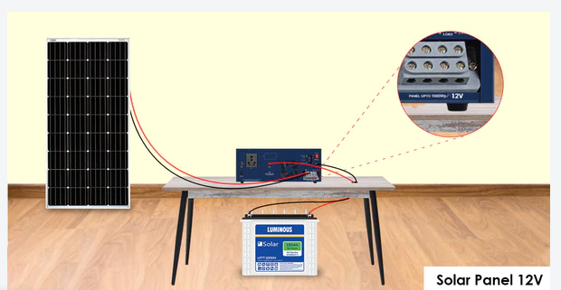

Figure 3.1: Architectural design of the solar-powered CCTV system for exam monitoring.
Camera
Power Box
DVR/NVR

Figure 3.2: CCTV System

Planning and Needs Assessment:
- Evaluate Needs: Assess the security requirements of your specific location. How many cameras are needed? What features are crucial (night vision, weatherproofing)?
- System Design: Based on your assessment, sketch a basic layout of the system. This includes camera placements, cable routing, and the location of the solar panels and recording equipment.
- Cost Analysis: Research the cost of pre-built solar CCTV kits or individual components. Factor in installation costs if you plan to hire a professional.
Selecting Solar-Powered CCTV Components:
- Solar Panels: Choose solar panels with enough wattage to power the entire system, considering location and sunlight hours.
- CCTV Cameras: Select weatherproof cameras with appropriate resolution (e.g., 720p, 1080p) and night vision capabilities if needed. Opt for wireless cameras for easier installation.
- Recording Equipment: A Digital Video Recorder (DVR) or Network Video Recorder (NVR) is needed to store recorded footage. Choose one with sufficient storage capacity based on recording duration and camera count.
- Cabling and Accessories: Select appropriate cables (coaxial for traditional CCTV or ethernet for IP cameras) and connectors for connecting cameras to the recording equipment. You might also need mounting brackets and weatherproofing enclosures for the cameras.
Installation:
- Camera and Panel Mounting: Install camera brackets in strategic locations, ensuring proper coverage and adherence to privacy considerations. Mount the solar panels in a location with maximum sun exposure.
- Cable Routing: Route the cables from the cameras to the recording equipment, ensuring they are protected from weather and potential damage.
- System Configuration: Connect all components, configure the recording settings (resolution, frame rate), and set up remote access if desired.
- Testing and Integration: Thoroughly test the entire system, verifying video recording functionality, remote monitoring capabilities (if applicable), and proper solar power generation under various weather conditions.
3.2 Analysis of the Existing System
Manual examination invigilation relies on human proctors to supervise students during exams. In the lead up to the exam, proctors familiarize themselves with the rules and potentially receive training to identify cheating. They also prepare the exam hall, including assigning seating arrangements to minimize opportunities for copying. During the exam, proctors distribute materials, verify student IDs, and monitor student behavior to ensure they follow the rules. This includes checking for unauthorized materials, communication, or copying attempts. Proctors manage the exam time, announcing the start, end, and any remaining time throughout the exam period. Finally, they collect completed exams and materials from students once the exam is finished.
While this traditional method has been around for a long time, it has limitations. Proctors can get tired and miss things, and it can be expensive and challenging to staff large exam halls with enough proctors. Additionally, the vigilance and effectiveness of proctors can vary, and they might not be able to see everything happening in the exam hall at all times. These limitations are why some institutions are exploring alternative methods like solar-powered CCTV for invigilation.

3.3 Problems of the Existing System
Manual examination invigilation, while a long-standing practice, presents several limitations that can hinder effective exam security. Here are four key problems associated with the traditional system:
- Inconsistency: Human proctors are susceptible to fatigue and lapses in focus. Their ability to detect cheating attempts can vary depending on experience and vigilance. This inconsistency can lead to unfair advantages for some students and undermines the overall fairness of the exams.
- Scalability: Large examination halls often require a significant number of proctors to adequately monitor student activity. This can be a logistical challenge and a significant expense. The cost of hiring and training enough proctors can be substantial, especially for large-scale exams.
- Limited Coverage: Traditional invigilation methods typically involve proctors physically walking around the exam hall. This might not provide a comprehensive view of the entire space at all times. Students seated in blind spots or those employing more subtle cheating techniques might escape detection.
- Fatigue: Proctors are human and can become fatigued over extended exam periods. This fatigue can lead to decreased vigilance and an increased likelihood of missing potential cheating attempts.
3.4 Analysis of the Proposed System
The proposed solution to the limitations of manual invigilation is a solar-powered CCTV system. This system would consist of cameras strategically placed around the exam hall, drawing power from solar panels. The CCTV system could record continuously, be triggered by motion detection, or allow for live monitoring. This approach has several potential benefits. First, the constant presence of cameras might deter cheating and create a more secure testing environment. Second, any suspicious activity would be captured on video, providing objective evidence for review. Furthermore, a single CCTV system could cover a large area, potentially reducing the need for a significant number of proctors. This translates to potential cost savings in the long run. Additionally, recordings can be stored and reviewed later if needed to investigate cheating or disruptions. Finally, the use of solar power makes this system environmentally friendly.
The next chapter will likely explore the implementation of this system in more detail, including how it would be integrated with existing exam procedures and any potential drawbacks or limitations to consider.
3.5 Advantages of the New System over the Existing System
Solar-powered CCTV offers several advantages over traditional manual invigilation methods for examination monitoring. Here are five key benefits:
- Enhanced Security and Reduced Cheating: The constant presence of cameras can act as a strong deterrent against cheating attempts. Students are less likely to engage in misconduct if they know they are being monitored electronically. This can lead to a more secure and fair examination environment for everyone.
- Objectivity and Improved Evidence Collection: Unlike human proctors who might miss or misinterpret events, CCTV recordings provide objective evidence of any irregularities during the exam. This can be crucial for investigating suspected cheating incidents and ensuring fair disciplinary actions.
- Scalability and Cost-Effectiveness: A single strategically placed CCTV system can effectively cover a large examination hall, potentially replacing the need for multiple human proctors. This can lead to significant cost savings in the long run, especially for large-scale exams.
- Reduced Human Error and Fatigue: Manual invigilation is susceptible to human limitations like fatigue and lapses in focus. CCTV systems operate continuously and tirelessly, eliminating the risk of errors or decreased vigilance due to tiredness.
- Improved Recordkeeping and Review: Recordings from the CCTV system can be stored securely and reviewed later if needed. This allows for a more thorough investigation of potential cheating or disruptions that might be missed during the live exam. Additionally, recordings can be used for training purposes to help proctors identify future cheating attempts.

CHAPTER FOUR
DESIGN AND IMPLEMENTATION OF THE SYSTEM
4.1 OUTPUT
Figure 4.1: Camera 1
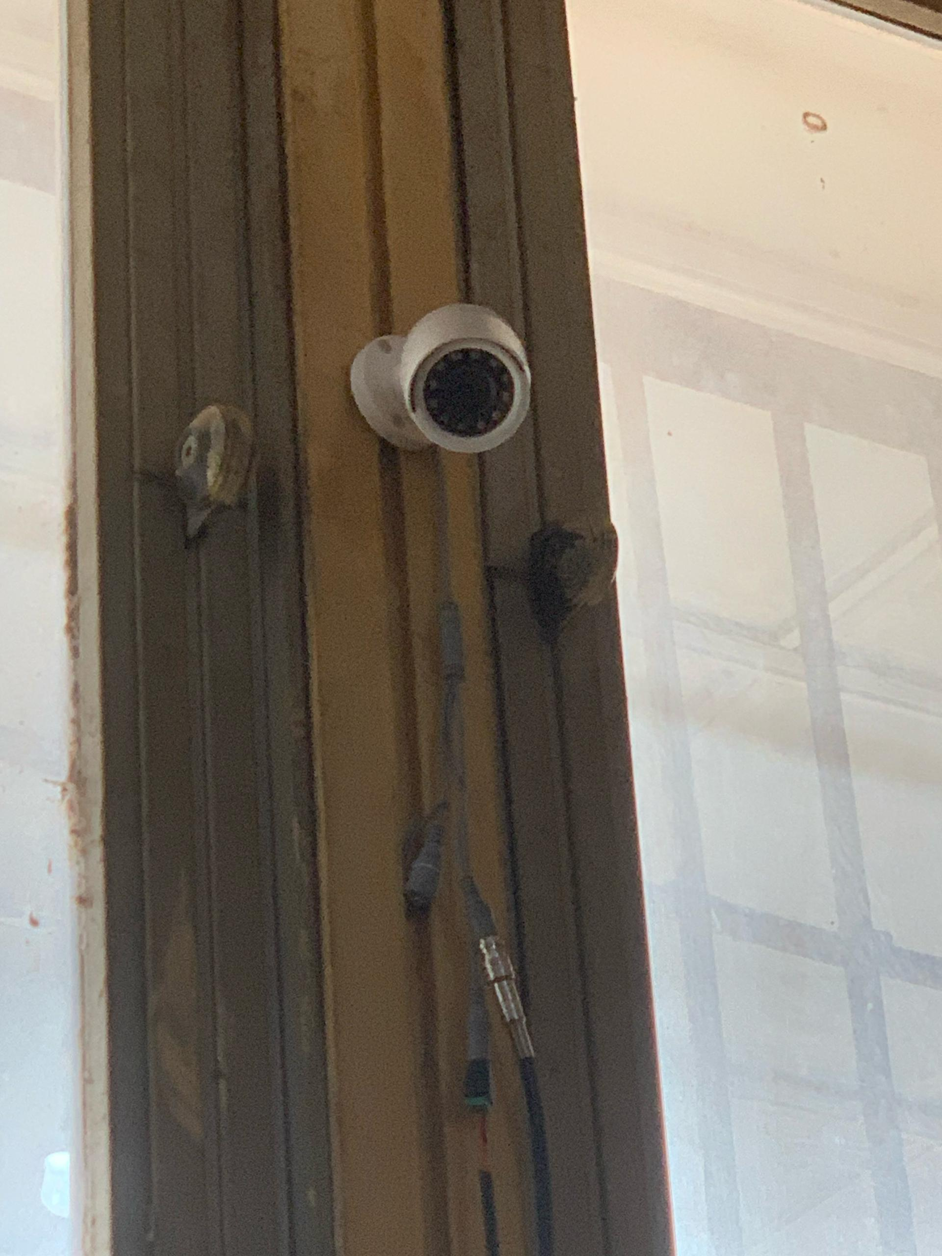
This camera was installed at the Computer Science Practical Room, Kwara State Polytechnic, Ilorin.
Figure 4.2: HDMI
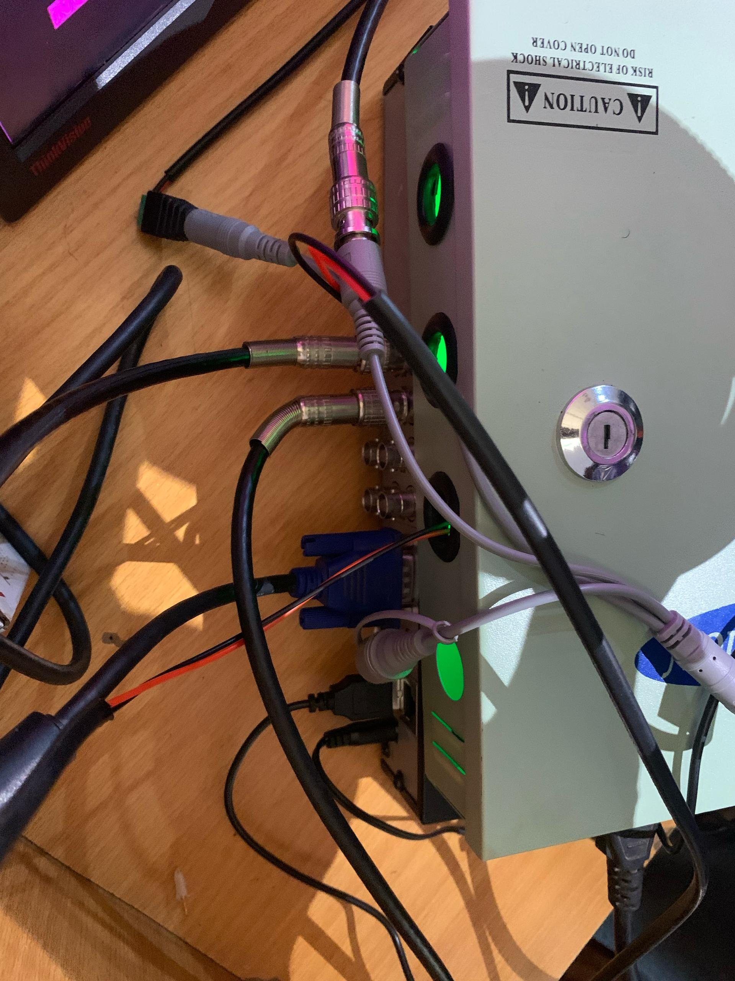
These are the cable used to connect the camera before output can be showned
Figure 4.3: Solar Panel
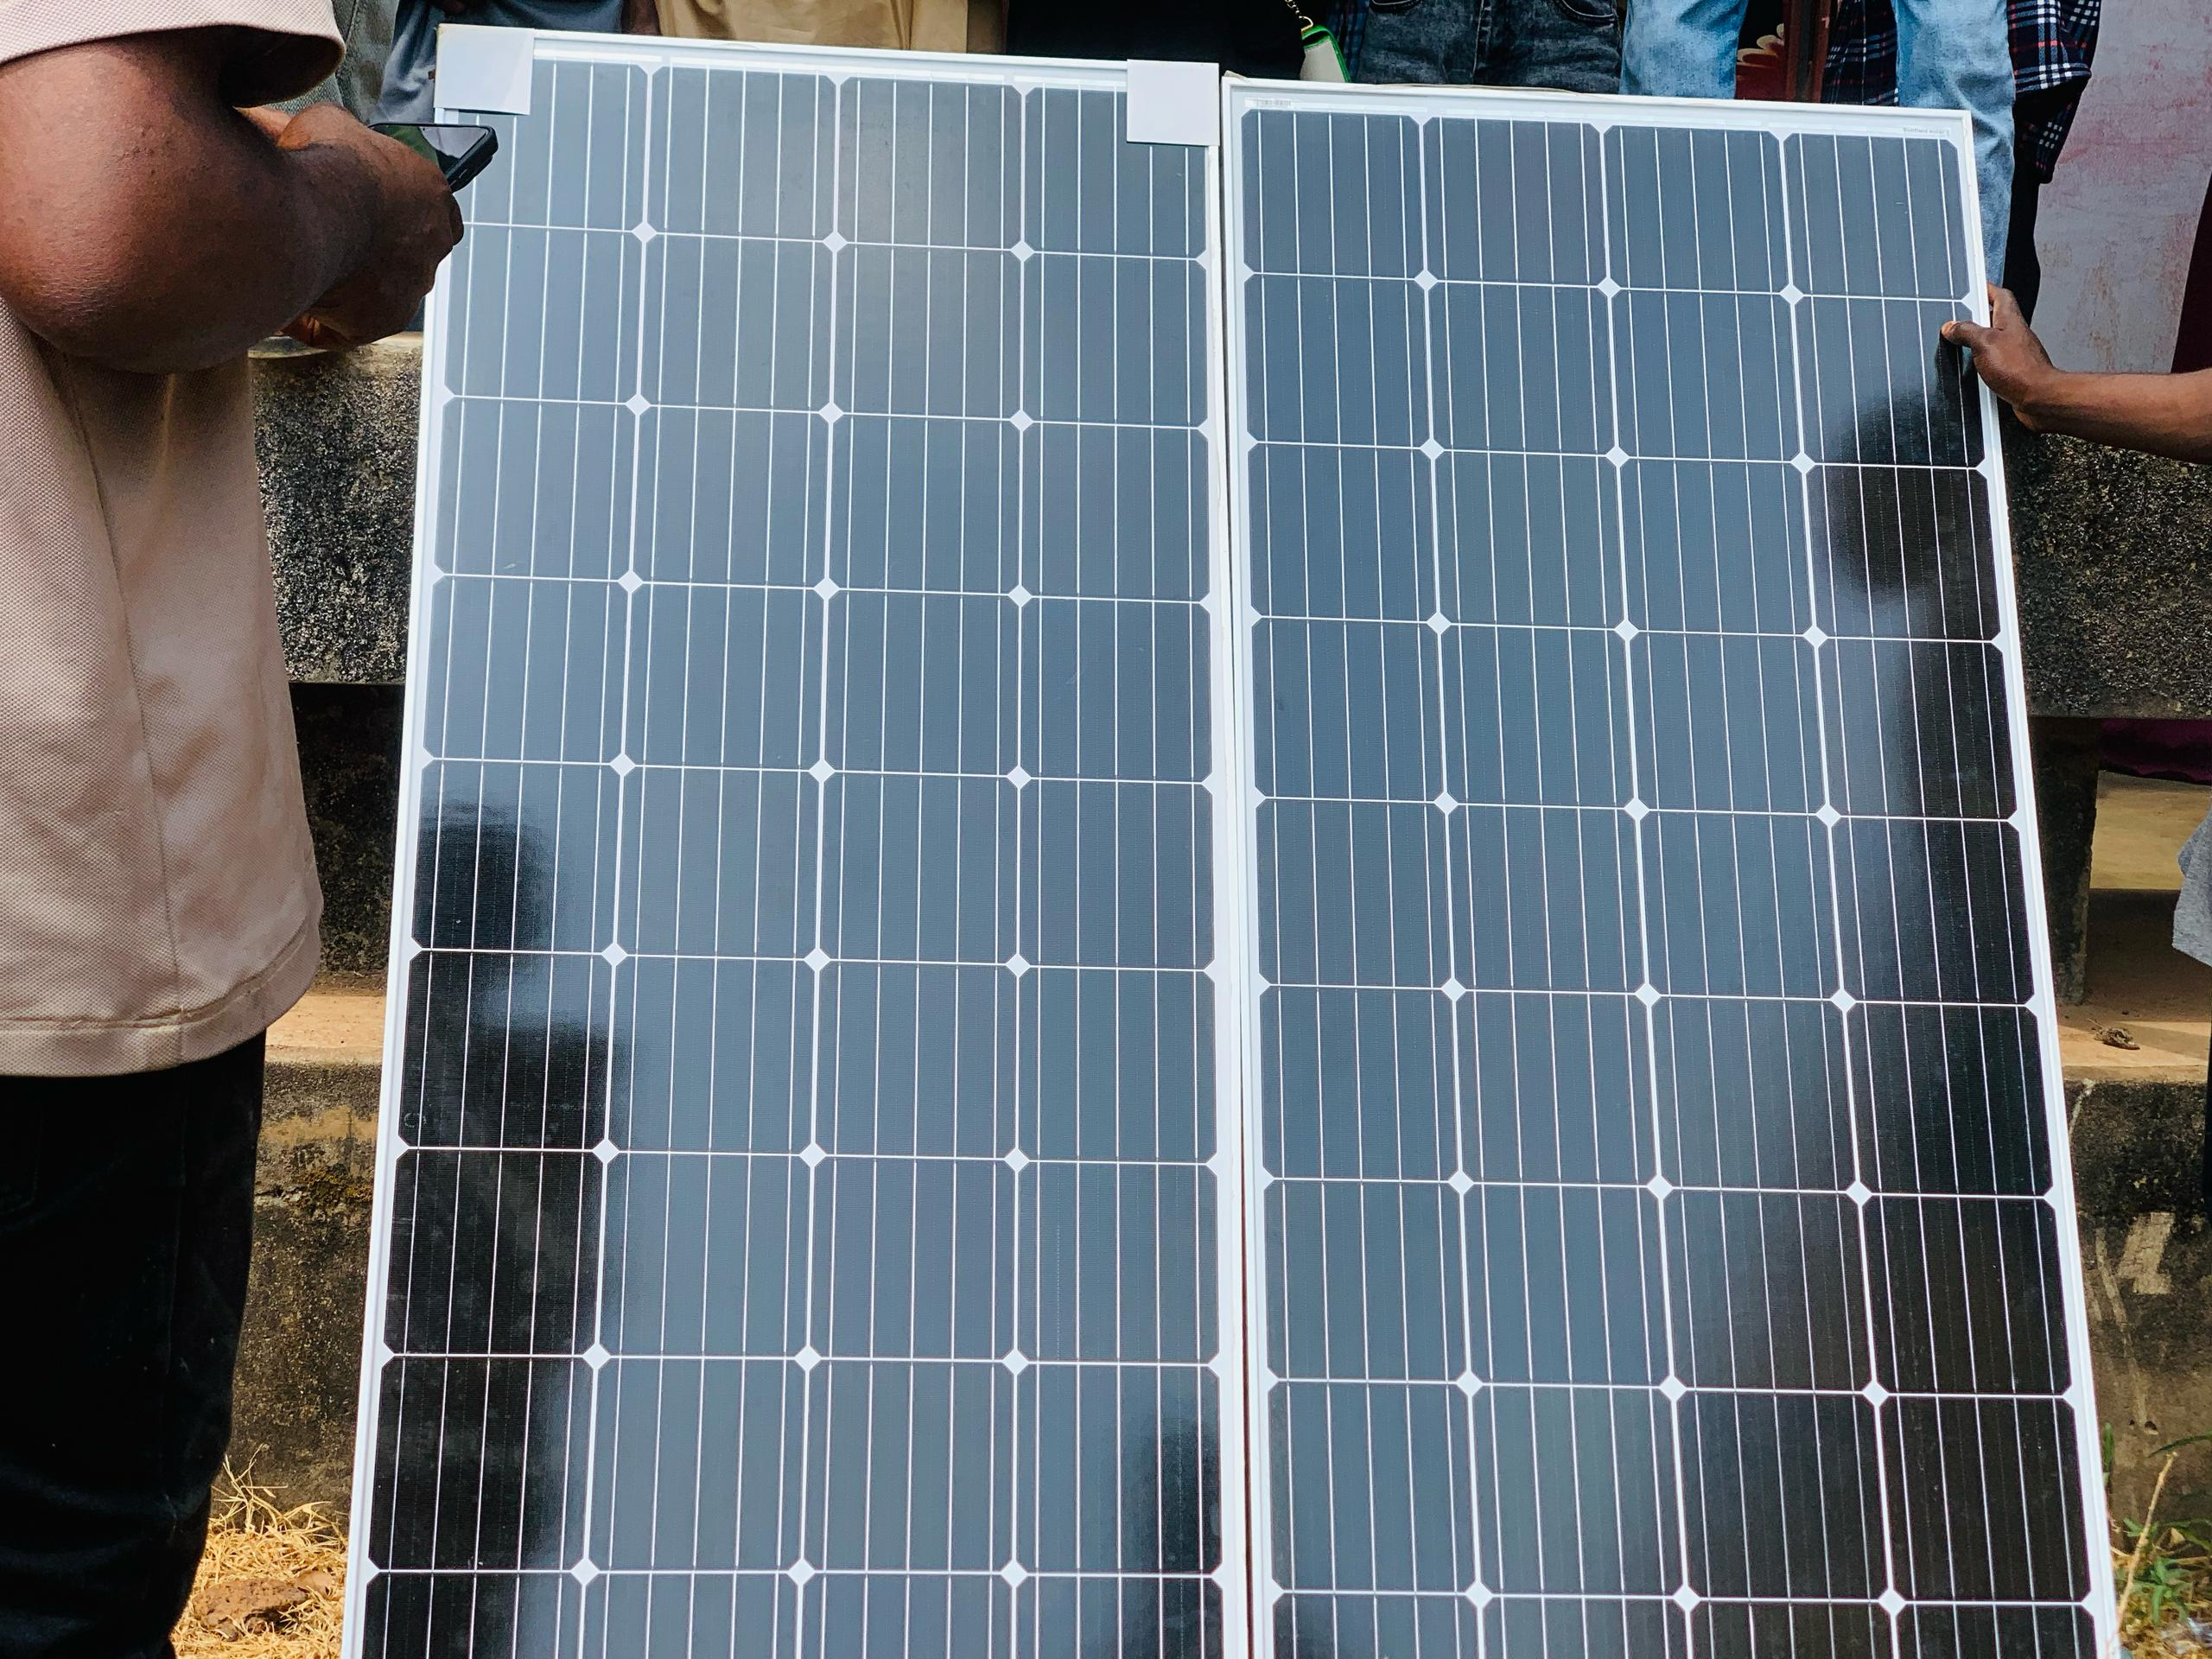
A solar panel is a device that converts sunlight into electricity using a process called the photovoltaic effect.
Figure 4.4 Battery
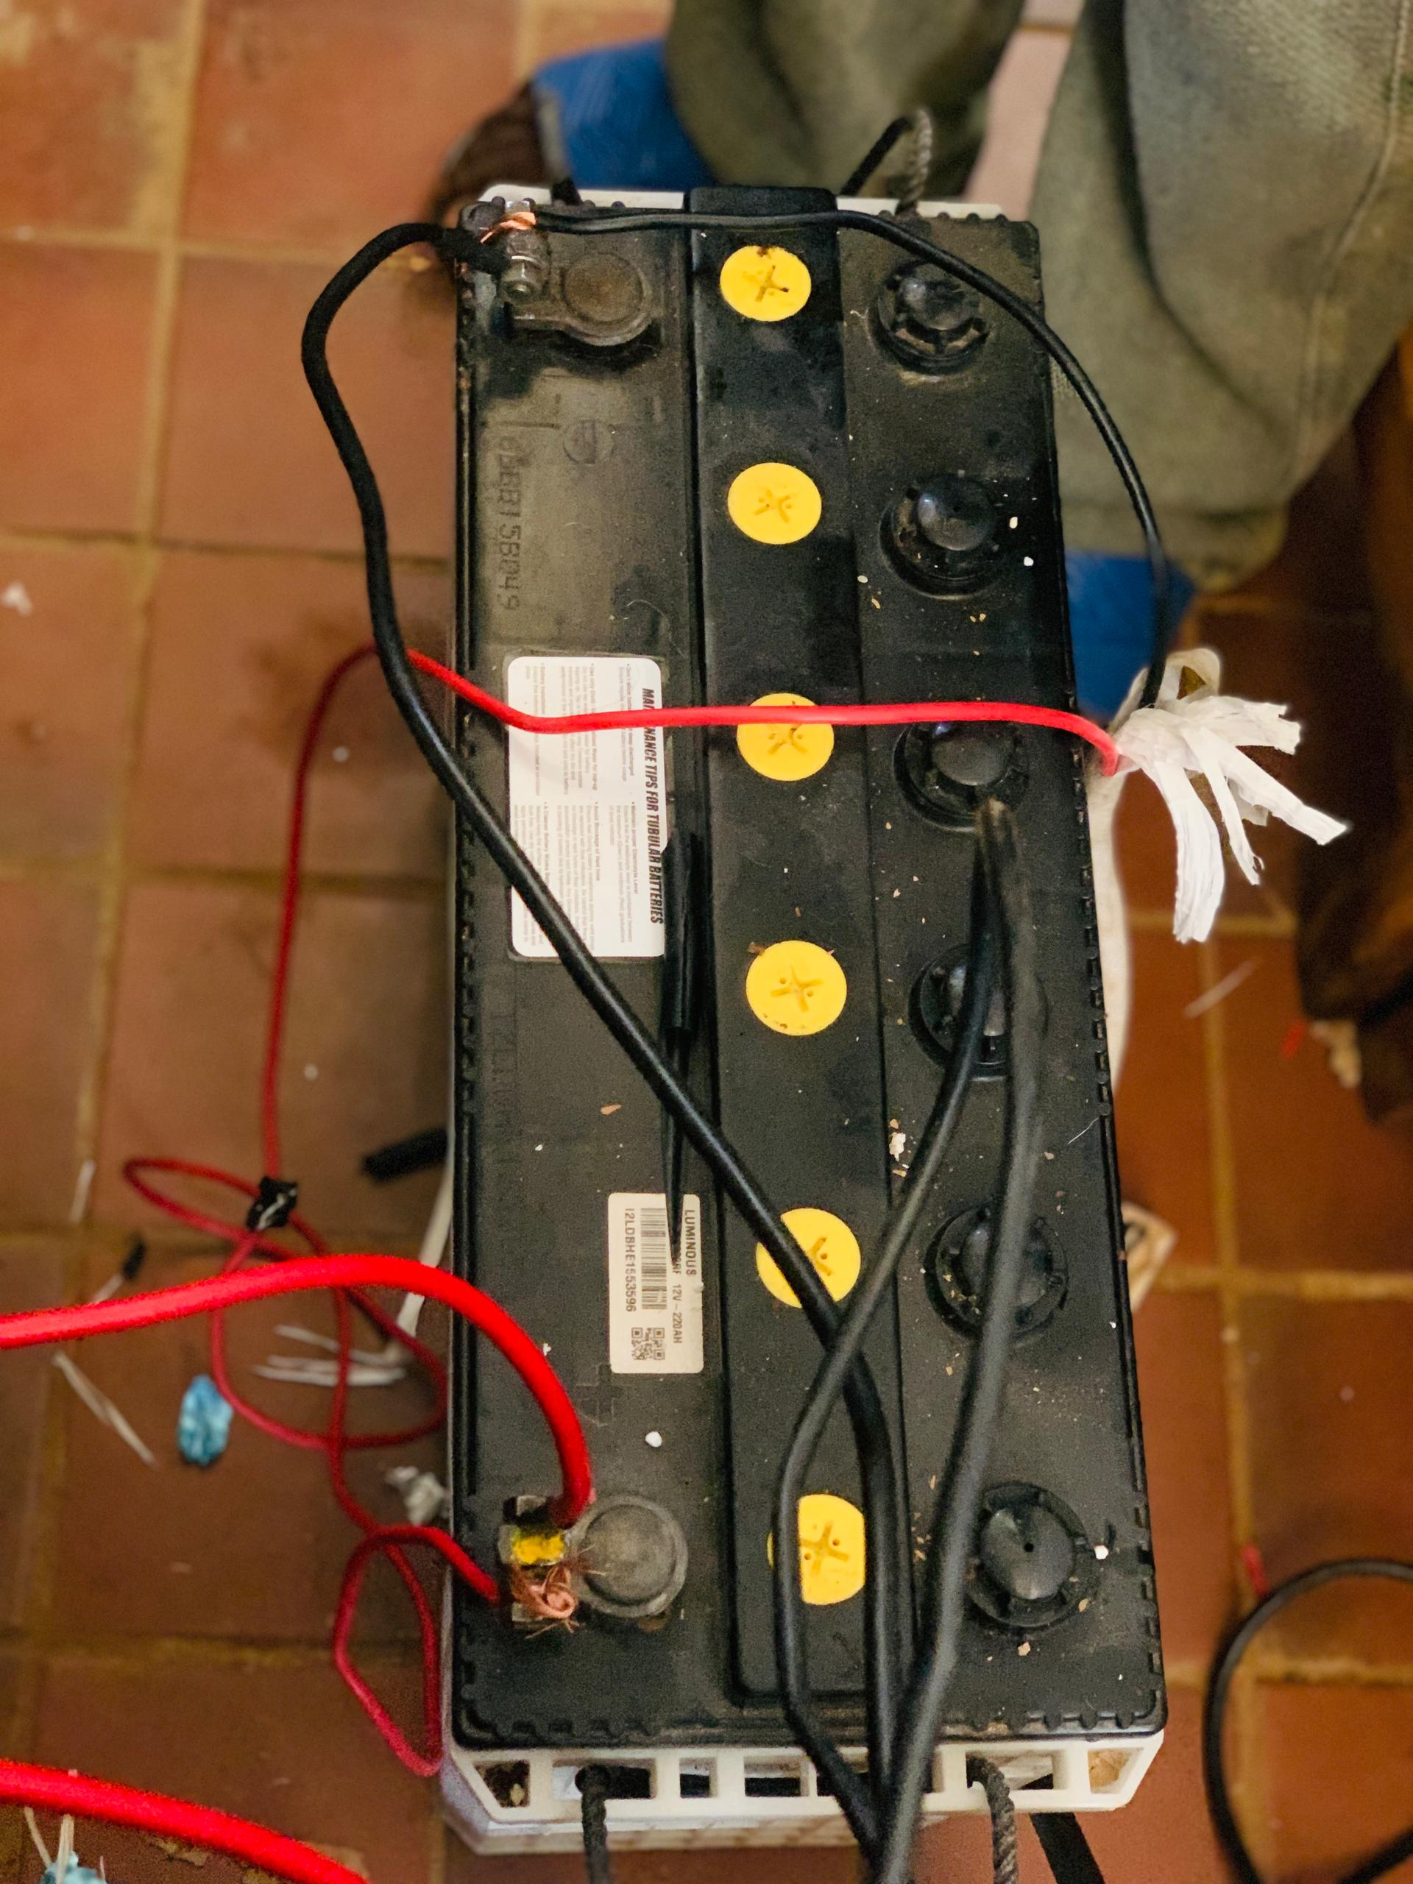
A battery is a device that stores electrical energy for later use.

Figure 4.5: Desktop
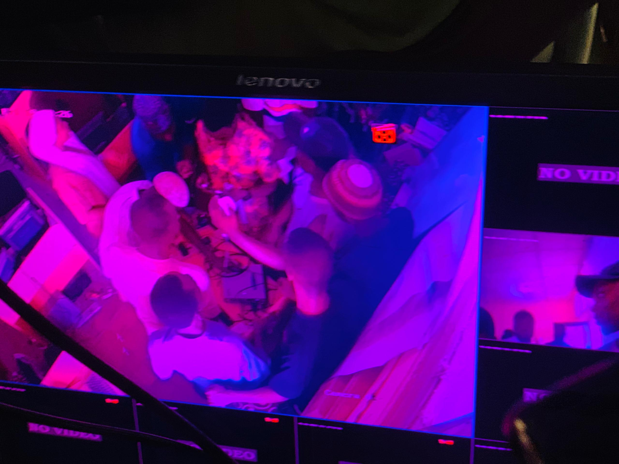
This is an output of the first camera installed
Fig 4.6: Camera Two
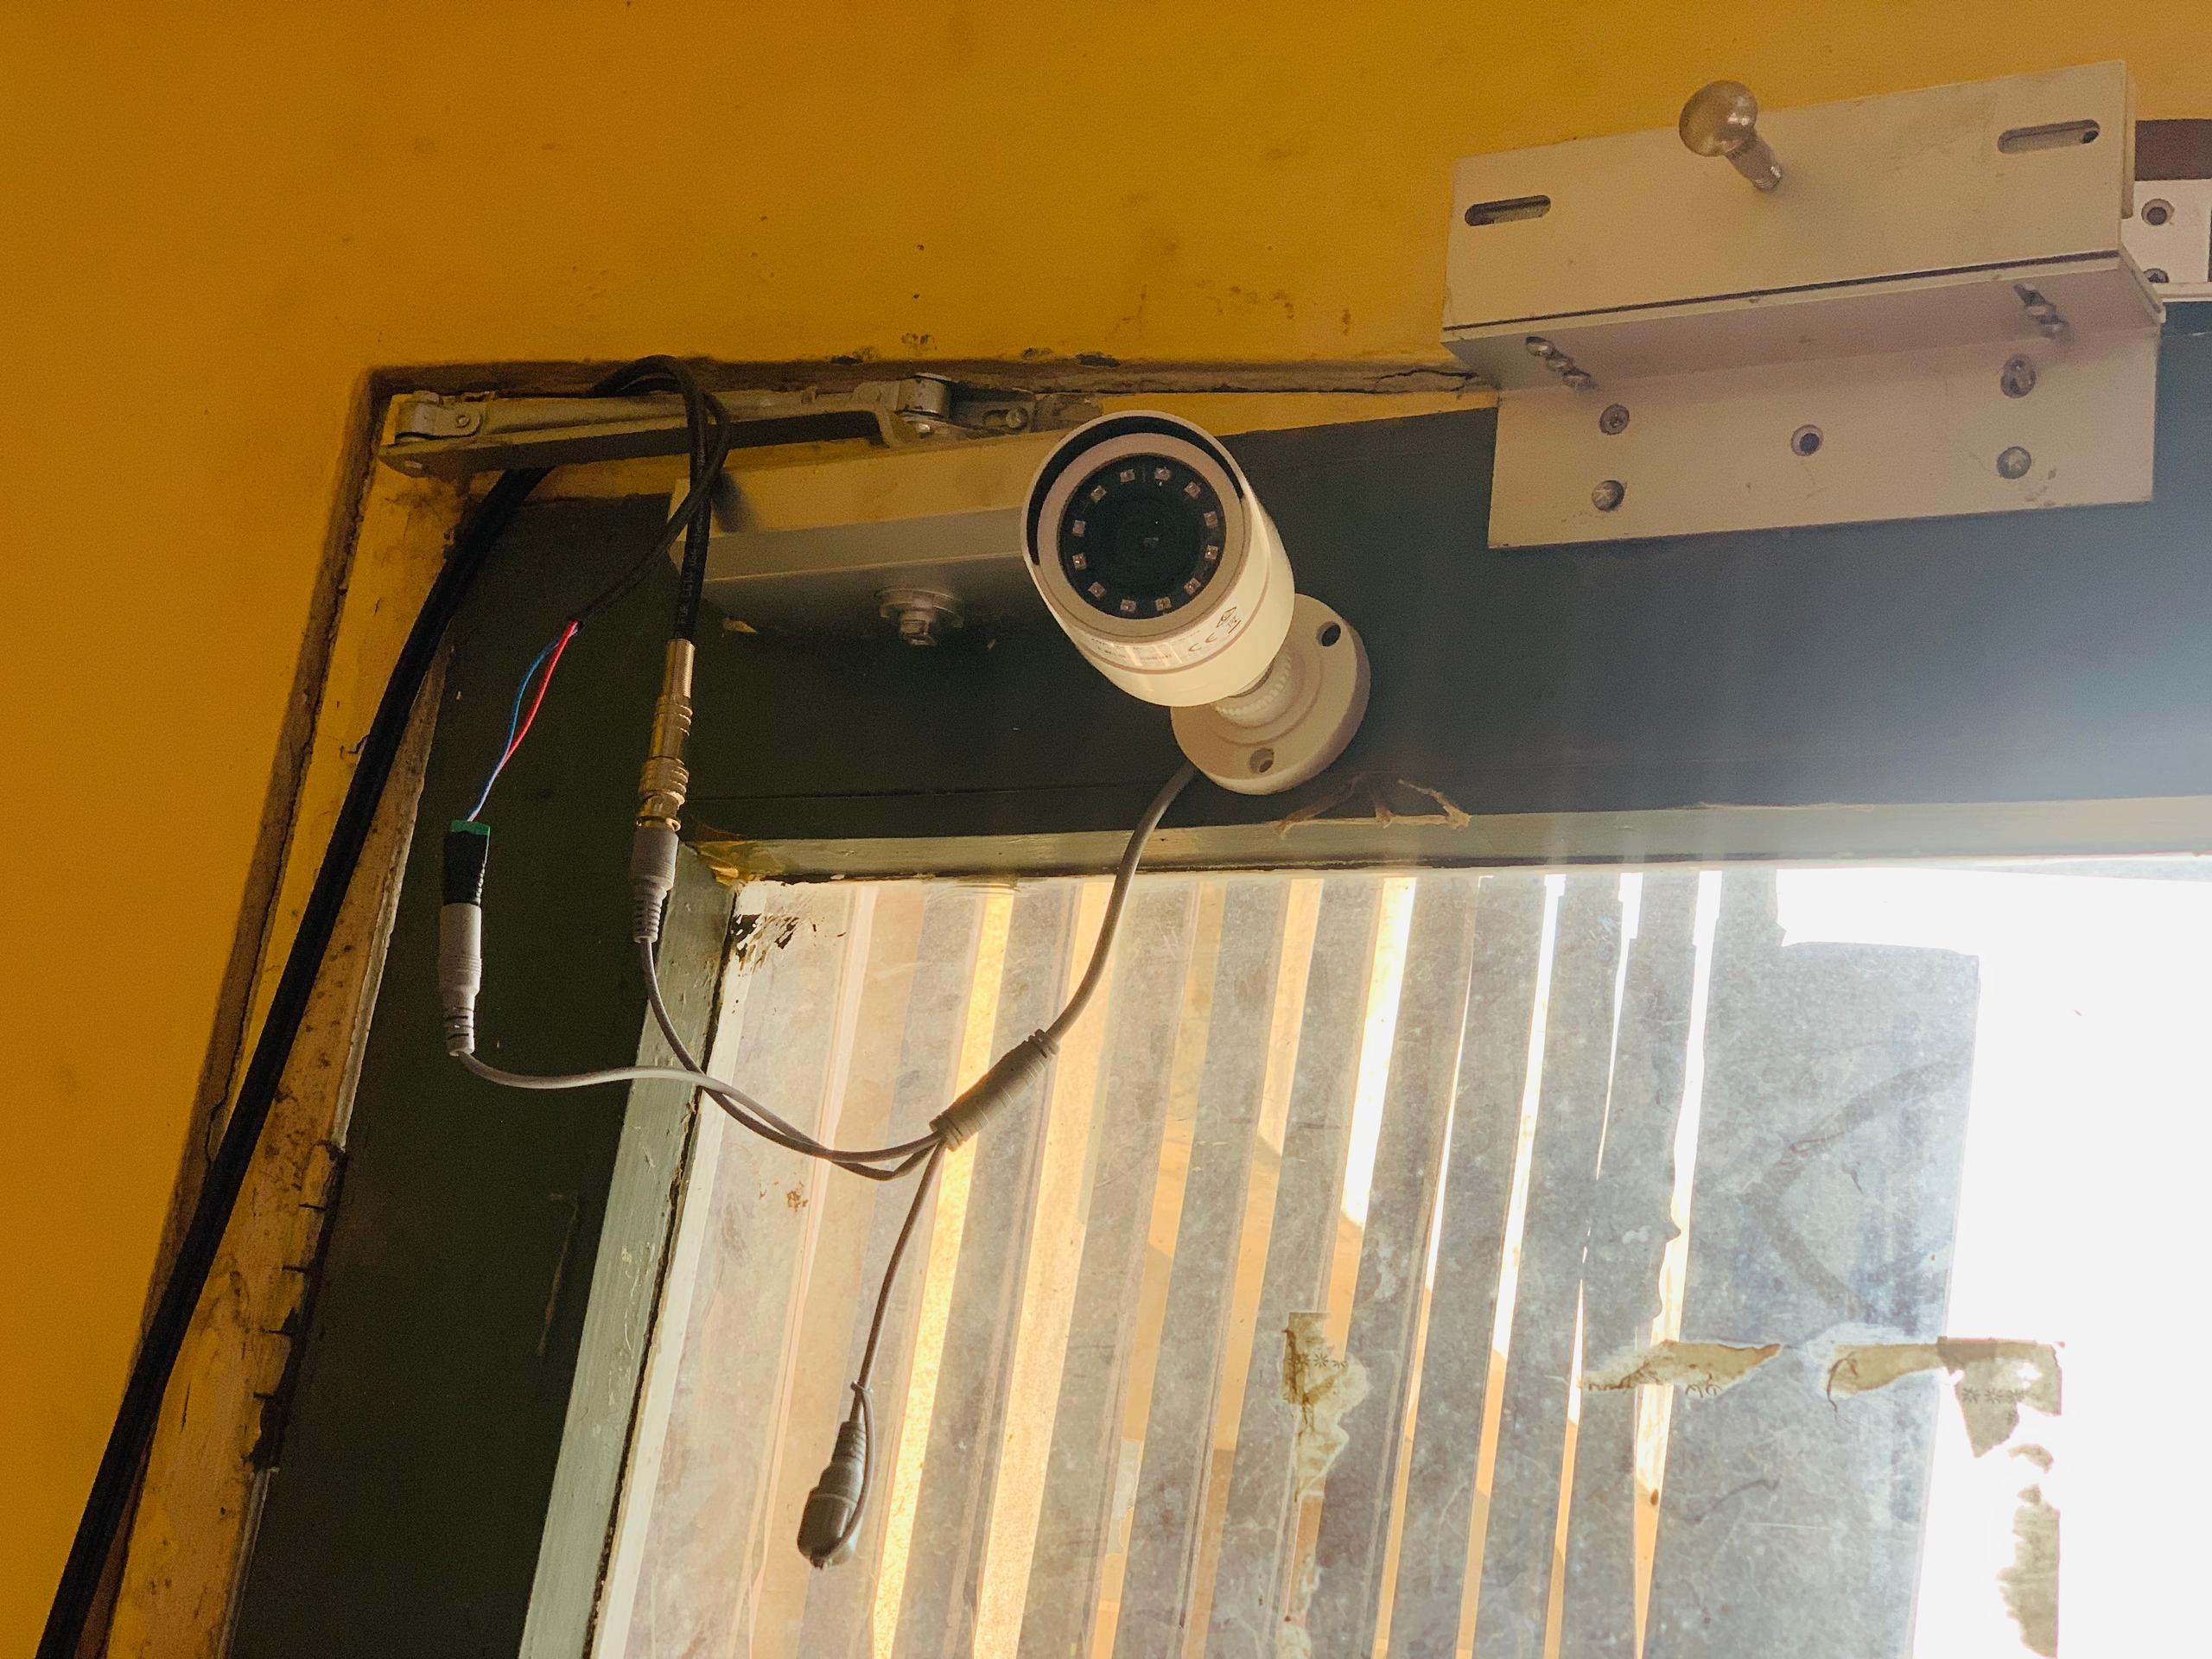
This is second camera inside the practical room

Figure 4.7: Extension Box
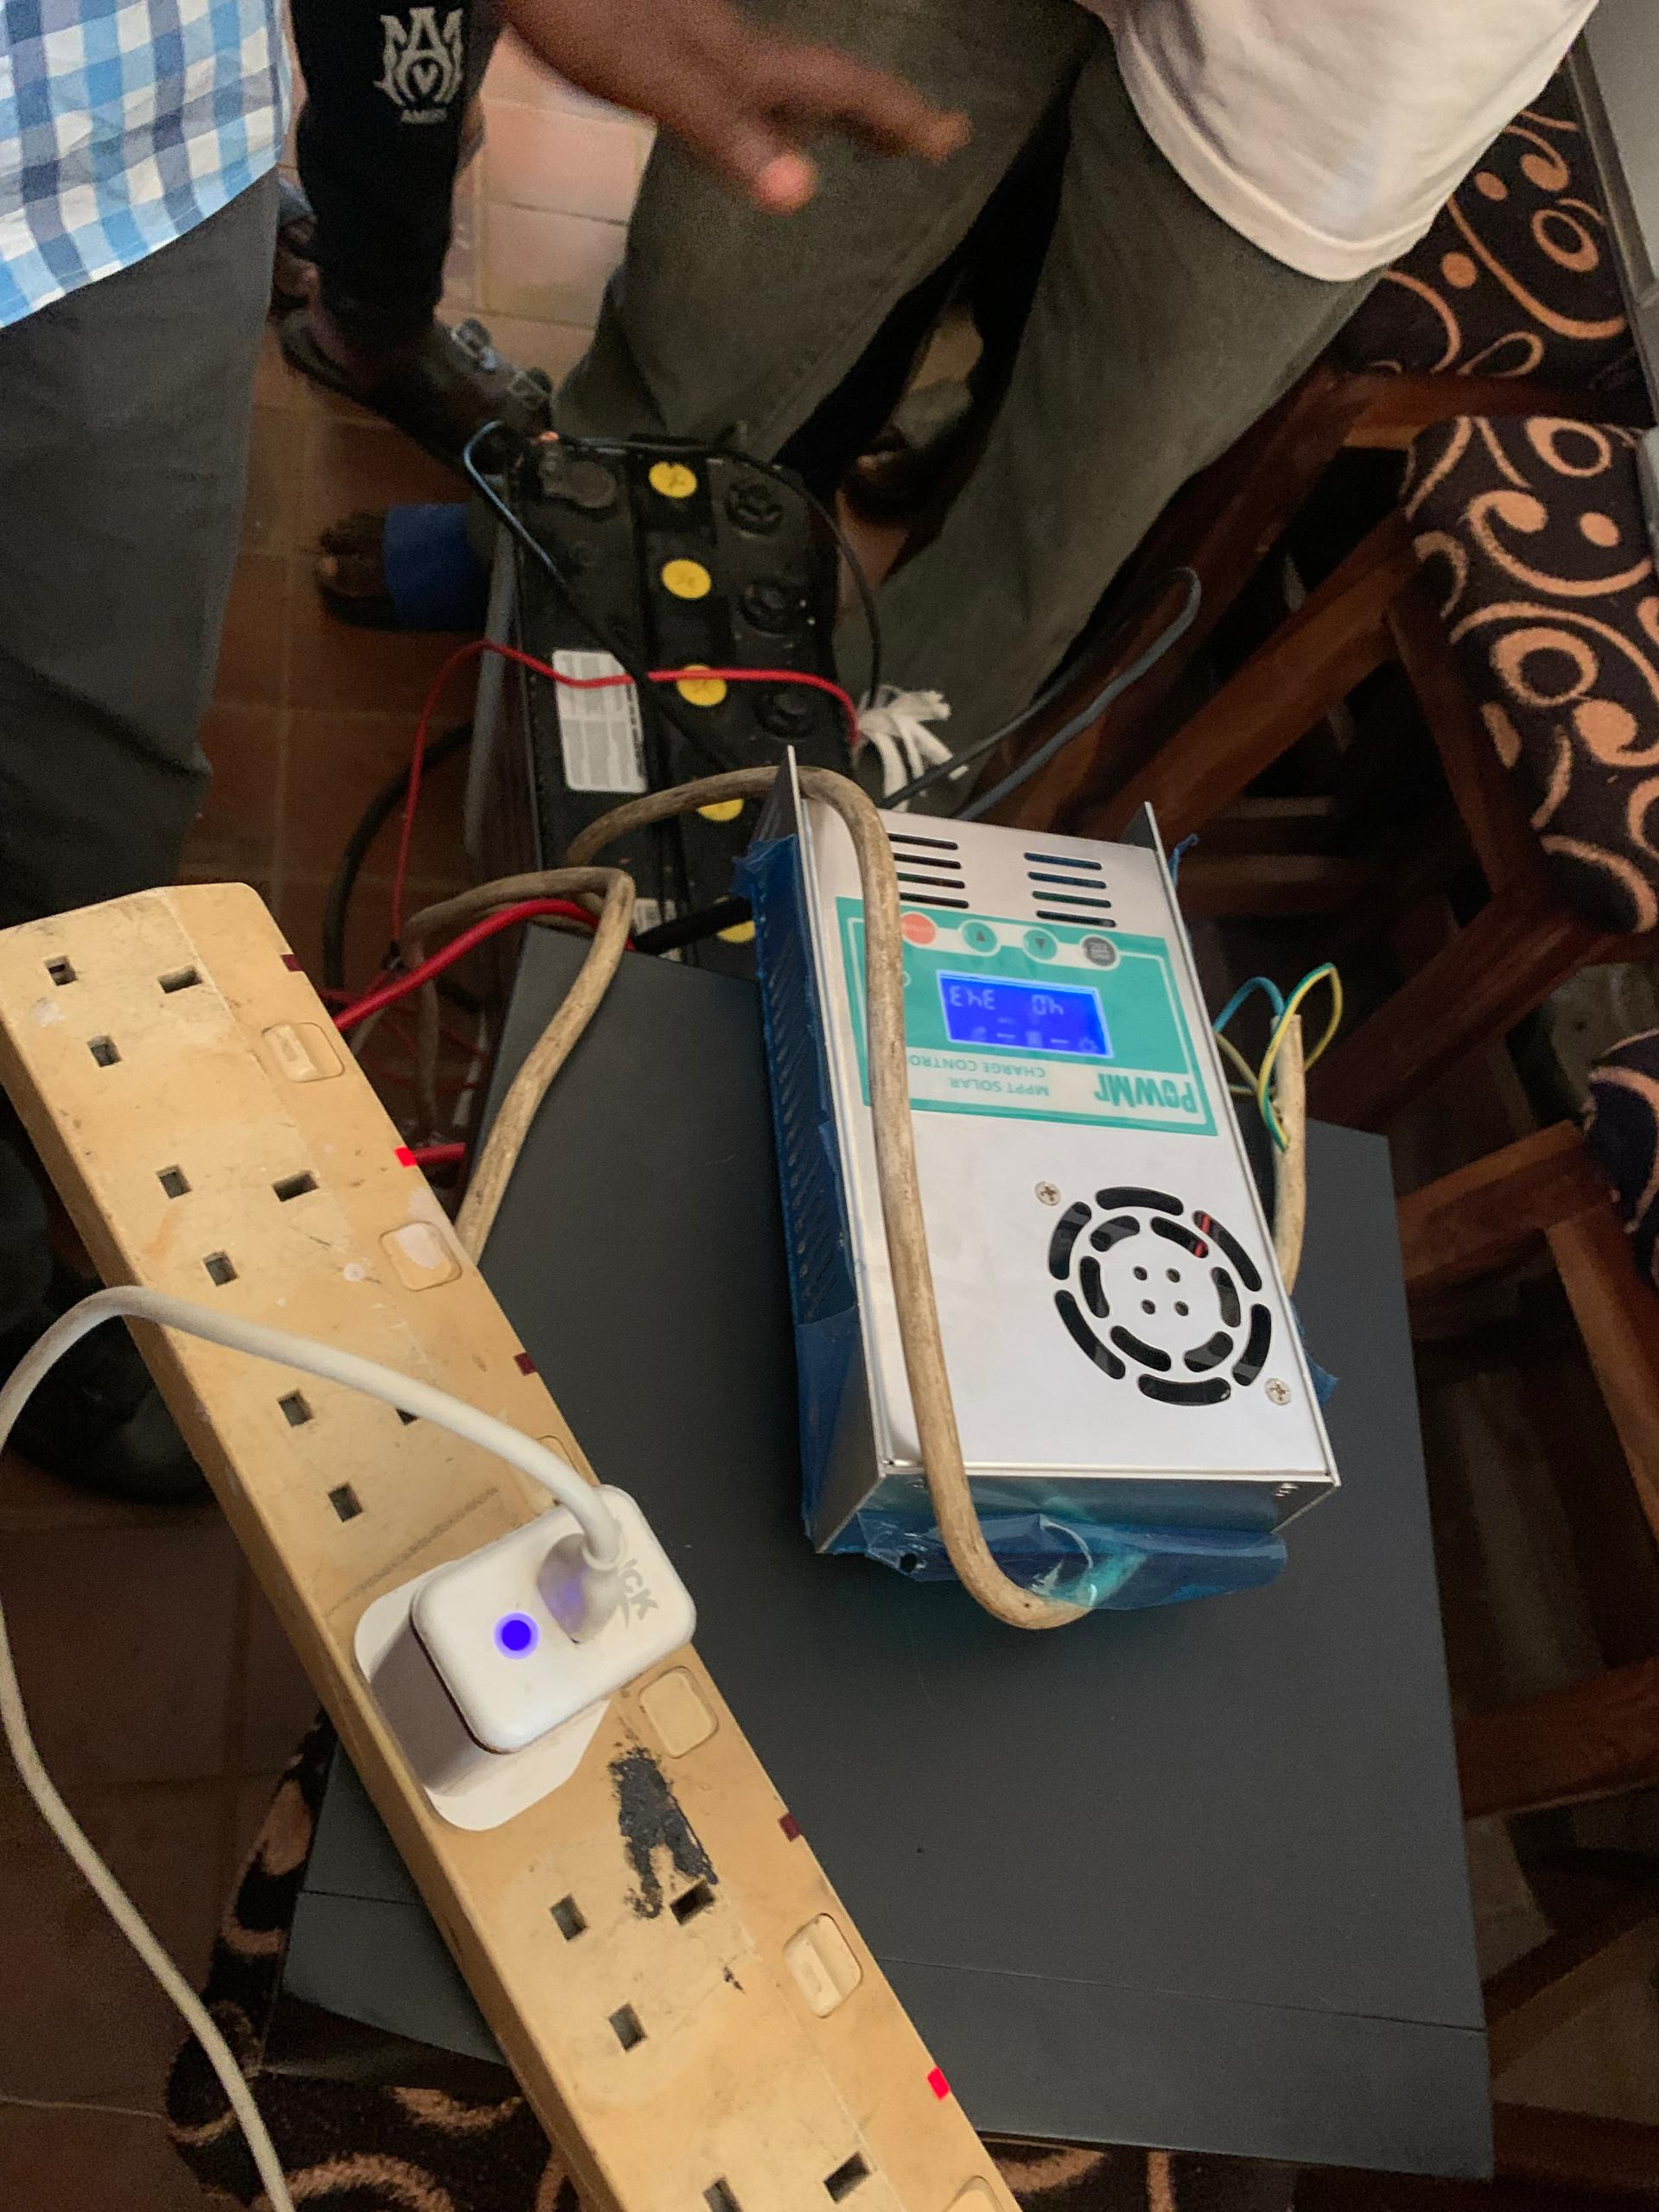
This is the extension box where the power was connected from
Figure 4.9 Charge Controller
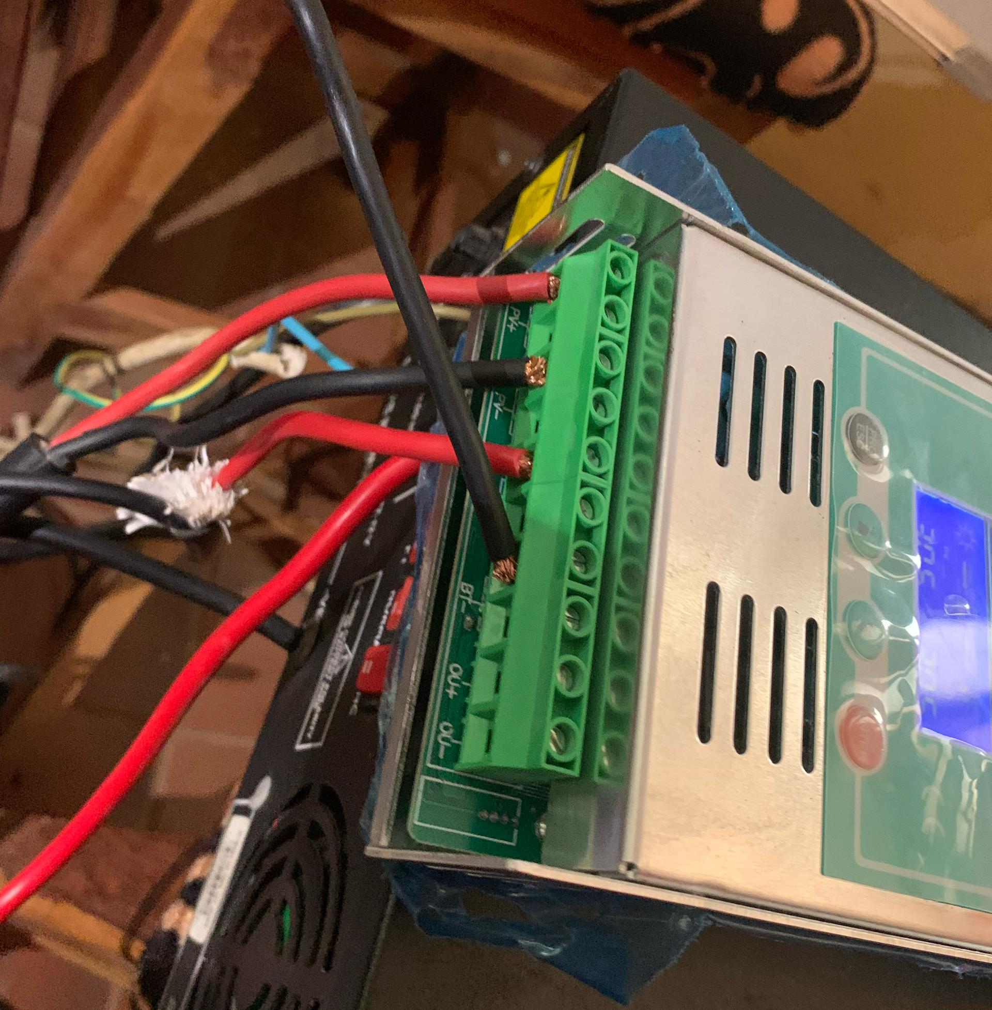
A charge controller (or solar charge regulator) is a critical component in a solar power system. It regulates the voltage and current coming from the solar panels going into the battery,
Figure 4.10: Desktop
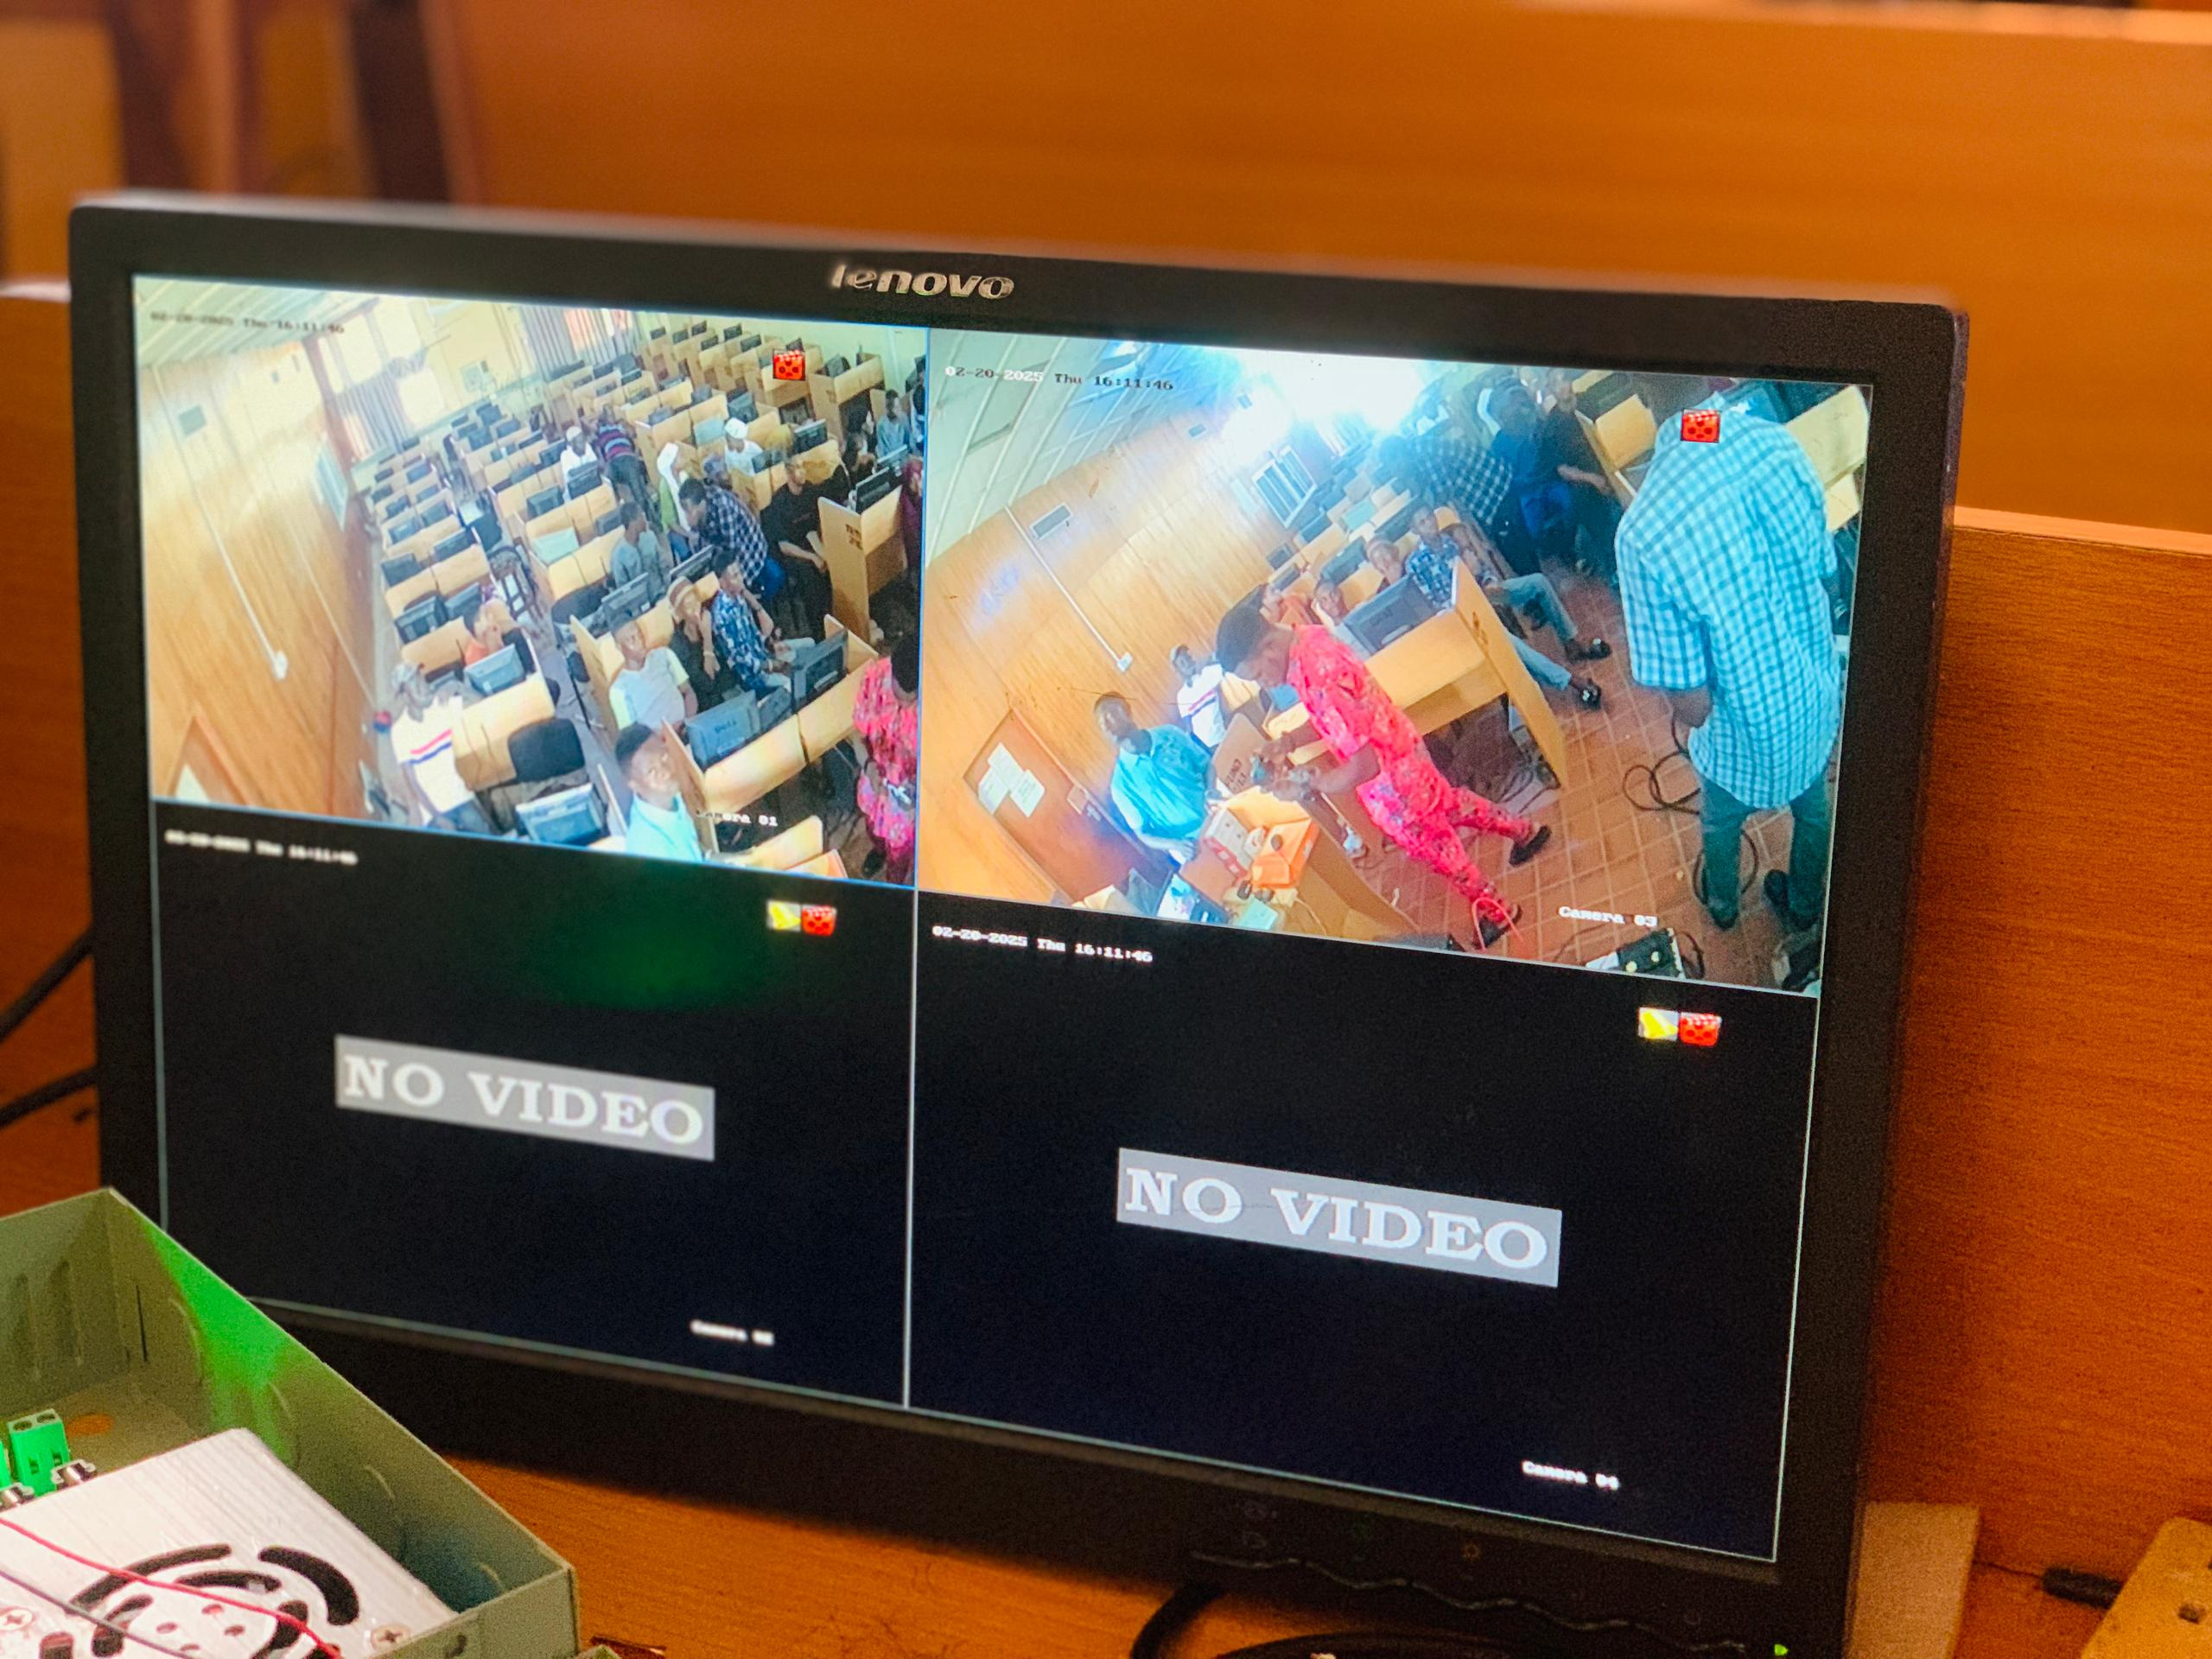
This is the output of the second installed camera.

CHAPTER FIVE
SUMMARY, CONCLUSION, AND RECOMMENDATIONS
5.1 Summary
This research examined the development and application of a solar-powered CCTV system for monitoring examinations in educational institutions, aiming to enhance security and uphold examination integrity. Traditional manual invigilation methods often fail to adequately prevent malpractice, resulting in unreliable assessments. The study proposed a sustainable and effective solution by integrating solar energy with advanced surveillance technology for continuous monitoring.
The system's design featured essential components such as solar panels, batteries, inverters, and high-definition CCTV cameras. The methodology outlined the installation, configuration, and maintenance processes, focusing on ease of use and operational efficiency. An analysis of current systems identified significant vulnerabilities that the new system seeks to address. The findings showed that the solar-powered CCTV system effectively reduces examination malpractice by providing consistent, high-quality surveillance. Additionally, utilizing solar power cuts operational costs and supports sustainability goals. The user-friendly interface and robust maintenance protocols make the system suitable for long-term use in educational institutions.

5.2 Conclusion
The solar-powered CCTV examination monitoring system represents a significant improvement in securing examination processes. By merging renewable energy with advanced surveillance technology, the system offers a dependable and sustainable alternative to traditional invigilation methods. The study concluded that the system effectively deters and detects examination malpractice, ensuring fair and credible assessments. The use of solar power reduces operational costs and supports environmental sustainability. The system guarantees continuous monitoring, even during power outages, enhancing the reliability of the examination process. Moreover, the user-friendly design ensures easy operation and maintenance, making it accessible to institutions without extensive technical resources.

5.4 Recommendations
To fully leverage the benefits of the solar-powered CCTV examination monitoring system, the following recommendations are made:
- Wider Adoption by Educational Institutions: Educational institutions should consider adopting solar-powered CCTV systems to improve examination security and integrity. Develop policies to support the integration of such systems into examination processes.
- Training and Capacity Building: Provide training programs for staff to ensure they can operate and maintain the system effectively.
- Regular Maintenance and Upgrades: Implement a regular maintenance schedule to keep components like solar panels, batteries, and cameras in optimal condition. Periodically review and upgrade the system to incorporate new technologies and address emerging challenges.
- Research and Development: Encourage ongoing research to evaluate the system's impact on examination integrity and gather feedback for continuous improvement. Explore advancements in artificial intelligence and data analytics to enhance the system's capabilities in detecting and responding to anomalies.
- Community and Stakeholder Engagement: Engage with students, faculty, and other stakeholders to raise awareness about the system's benefits and promote a culture of academic integrity. Foster collaborations with technology providers, policymakers, and educational bodies to support the widespread adoption and enhancement of the system.

References
Hoque, J., Ahmed, M. R., Uddin, M. J., Mostafa, M., & Faisal, A. (2020). Automation of Traditional Exam Invigilation using CCTV and Bio-Metric. In IJACSA) International Journal of Advanced Computer Science and Applications (Vol. 11, Issue 6). www.ijacsa.thesai.org

Ignacio, A., & Soria, C. D. (2021). A Study on the Implementation of a Monitoring System to Solar-Powered Houses. International Journal of Multidisciplinary: Applied Business and Education Research, 2(10), 902–908. https://doi.org/10.11594/ijmaber.02.10.06

Kavitha, V., & Malathi, V. (2019). A Smart Solar PV Monitoring System Using IoT. 19–33. https://doi.org/10.5121/csit.2019.91502

Ko, C. C., & Cheng, C. D. (2004). Secure Internet examination system based on video monitoring. Internet Research, 14(1), 48–61. https://doi.org/10.1108/10662240410516318

Kumar S, P., KumarU, S., & SelvanM, T. (n.d.). SMART SOLAR AUTOMATION MONITORED AND CONTROLLED USING IOT Keyword (Vol. 7). www.ijariie.com

Ray MCA Student, A., & Bhopen Singh Assistant Professor, O. (2024). Green Energy for Smart Security Cabin Using Solar Panel. In IUN Research Journal Peer-Reviewed Open Access Journal (Vol. 1, Issue 1).

Shahed, M. T., Haque, M. M., Akter, S., Mian, S., & Shil, R. C. (2023). IoT-Enabled Smart Solar Energy Management System for Enhancing Smart Grid Power Quality and Reliability. SN Computer Science, 4(6). https://doi.org/10.1007/s42979-023-02298-8

Shirbhate, I. M., & Barve, S. S. (2019). Solar panel monitoring and energy prediction for smart solar system. International Journal of Advances in Applied Sciences, 8(2), 136 142. https://doi.org/10.11591/ijaas.v8.i2.pp136-142

Suleiman, A., & Nachandiya, N. (2018). Computer Based Testing (CBT) System for GST Exams in Adamawa State University, Mubi. Asian Journal of Research in Computer Science, 1–11. https://doi.org/10.9734/ajrcos/2018/v2i124776

