LAND INFORMATION SYSTEM OF SENIOR SECONDARY SCHOOL MARABA, ILORIN KWARA STATE

By

HND/22/SGI/FT/121 HND/23/SGI/FT/0090 HND/23/SGI/FT/0091 HND/23/SGI/FT/0092 HND/23/SGI/FT/0093 HND/23/SGI/FT/0097 HND/23/SGI/FT/0099 HND/23/SGI/FT/0113

A Project Submitted to the Department of Survey and Geo-Informatics Institute of Environmental Studies, Kwara State Polytechnic, Ilorin

In Partial Fulfillment of the Requirements for the Award of Higher National Diploma (HND) in Survey and Geo-Informatics

July, 2025

CERTIFICATION

This is to certify that this project research was carried out by HND/23/SGI/FT/0090,

HND/23/SGI/FT/0091, HND/23/SGI/FT/0092, HND/23/SGI/FT/0093, HND/22/SGI/FT/121, HND/23/SGI/FT/0097, HND/23/SGI/FT/0099,
HND/23/SGI/FT/0113 has been read and approved as meeting part of the requirements for the award of Higher National Diploma (HND) in Survey and Geo-Informatics

Surv. Abimbola I. Isau
Project Supervisor
Date

Surv. Abimbola I. Isau
Head of Department
Date

External Examiner Date

DEDICATION
This project is dedicated to the creator of the earth and the universe, the Almighty God. It is also dedicated to our parents.

ACKNOWLEDGEMENT
All glory and gratitude go to Almighty God for granting us the strength, wisdom, and good health throughout the course of this project.
We wish to express our sincere appreciation to our esteemed supervisors, whose guidance, support, and encouragement have been instrumental to the successful completion of this work.
Our profound gratitude goes to Surv. Abimbola I. Isau for the invaluable insights, mentorship, and unwavering support rendered at every stage of this project. Your dedication and guidance truly inspired us.
We are equally grateful to Surv. Ayuba Abdulsalam, Surv. R.S Awoleye, Surv. Asonibare R.O, Surv. A.G Aremu, Surv. B.F Diran, Surv. Kazeem, and Surv. Kabir. Each of you, in your unique way, contributed immensely to our academic journey and the success of this research. Your constructive feedback, encouragement, and shared expertise helped shape our understanding and the quality of this work.
We are indeed privileged to have learned under such a committed and knowledgeable team of professionals. Thank you all for your patience, support, and belief in our abilities.
Special gratitude goes to our parents who exhibited immeasurable financial support, patience, support, prayers and understanding during the periods in which we were busy tirelessly working on our studies. Special thanks go to all our lovely siblings.
Our sincere appreciation goes to our friends and classmates.

TABLE OF CONTENTS

Title Page i
Certification ii
Dedication iii
Acknowledgements iv
Abstract v
Table of Contents vi

CHAPTER ONE: GENERAL INTRODUCTION

  - Background to the Study
  - Statement of the Problem
  - Aim and Objectives of the Study
  - Scope of the Study
  - Significance of the Study
  - Study Area
CHAPTER TWO: LITERATURE REVIEW

  - Review of Related Works

  - Concept of Land Information System (LIS)
  - Evolution of Land Information Systems

  - Components and Architecture of LIS

  - Application of LIS in Institutional Management
  - GIS Techniques in Building and Topographical Mapping

  - Previous Studies on LIS Development in Schools and Institutions

CHAPTER THREE: RESEARCH METHODOLOGY AND ANALYSIS

  - Methodology
  - Project Planning
    - Office Planning
    - Field Reconnaissance
  - Data Base Design
3.2.31 Logical design
  - Equipment Used
    - Hard Ware
    - Software
  - Instrument Test
    - Horizontal Collimation Test
    - Vertical Index Error Test
    - Analysis of Collimation and Vertical Index Data
  - Control Check
  - Control Check Procedure Using Total Station
  - Geometric Data Acquisition
    - Perimeter Plan of the Project Area
    - Detailing
    - Attribute Data Acquisition
  - Data Creation/Implementation
    - Database Management System (DBMS)
    - Data Quality

CHAPTER FOUR: DESIGN, IMPLEMENTATION AND DOCUMENTATION OF THE SYSTEM
  - Introduction
  - Spatial Data results
    - School Boundary and Building Layout
  - Topographical Analysis Results
    - Digital Elevation Model (DEM)
    - Contour Mapping
    - Slope and Terrain Analysis
    - Significance of Topographical Analysis Results
  - Non-Spatial Data Results
    - Significance of Non-Spatial Data in LIS
  - Query Execution and Results
CHAPTER FIVE: COSTING, SUMMARY, PROBLEMS ENCOUNTERED, CONCLUSION AND RECOMMENDATION
  - COSTING
  - Conclusion
  - Recommendation References

ABSTRACT
Traditionally, land records and physical assets within many public schools are managed manually, leading to challenges such as data loss, inaccuracy, and lack of transparency. This study addresses these issues by developing a Geographic Information System (GIS)-based platform tailored to the specific needs of the school. The system integrates key land information such as boundaries, land use, building layout, and utility networks into a centralized database. Using tools such as GPS for spatial data collection, and software like QGIS or ArcGIS for data analysis and mapping, the system allows for real-time updates, easy accessibility, and improved decision-making. Data were collected through site visits, interviews, and review of existing documents. The implementation of this Land Information System is expected to assist school management, government authorities, and relevant stakeholders in making informed decisions regarding land planning, development, maintenance, and dispute resolution. The result is a more transparent, accurate, and efficient method of land administration that serves as a model for other educational institutions within the region.
Keywords: Land Information System (LIS), Geographic Information System (GIS), spatial data, land management, Junior Secondary School, Maraba, digital mapping, land records, school infrastructure, land administration

CHAPTER ONE INTRODUCTION

Background of the Study

Land is a finite and invaluable resource, especially within educational environments where efficient space utilization is essential for the delivery of quality education. In the context of secondary schools, effective land management ensures that essential infrastructure such as classrooms, administrative blocks, staff quarters, sports fields, and laboratories are adequately planned, documented, and maintained. However, traditional approaches to land and asset management in Nigerian schools are typically manual, involving paper records and informal layouts that are difficult to update or scale as institutions expand.
With the increasing student population and infrastructural demand, secondary schools such as Government Day Secondary School in Maraba, Ilorin, face the pressing need to transition from conventional land management systems to more intelligent, data-driven approaches. This is where the adoption of Land Information Systems (LIS) becomes vital. LIS provides an integrated platform for capturing, storing, analyzing, and displaying geographically referenced data related to land parcels, buildings, and other assets. It ensures that decision-makers have access to accurate, real-time information for development planning, space optimization, and resource allocation.
The use of Geographic Information Systems (GIS) as the backbone of LIS facilitates spatial and nonspatial data integration, enabling comprehensive analysis and visualization of a school's infrastructure and land use. Implementing such a system within Government Day Secondary School, Maraba, will help in digitalizing the school's land assets, identifying encroachments, assisting in infrastructure planning, and ultimately supporting informed decision-making.
This study will apply modern surveying tools and GIS software to capture both the physical layout and descriptive characteristics of the school facilities. By integrating these datasets into a functional LIS,

the project will serve as a prototype for smart land management in public secondary schools across Nigeria.

Statement of the Problem

In many public secondary schools in Nigeria, including Government Day Secondary School, Maraba, the management of land and physical infrastructure remains rudimentary. Records of land boundaries, building dimensions, and facility usage are often non-existent, outdated, or maintained in informal formats. This lack of accurate and comprehensive spatial data hampers effective planning, leads to inefficient space usage, and leaves room for land encroachment or unauthorized construction.
The absence of a centralized system for integrating spatial and non-spatial data makes it difficult to retrieve, update, or analyze facility-related information. School administrators and government education planners require tools that enable them to visualize current layouts, assess land utilization, and make informed decisions for renovations, expansions, or maintenance.
This project work addresses these challenges by introducing a digital Land Information System (LIS) framework specifically designed for secondary school environments, with Government Day Secondary School, Maraba serving as the study location.

Aim and Objectives of the Study

    - Aim

The aim of this project is to Land Information System (LIS) for Government Day Secondary School, Maraba, Ilorin South LGA, Kwara State, to support effective spatial data management, infrastructure planning, and decision-making.

Objectives:

      - To conduct depth acquisition

      - To collect descriptive (non-spatial) data on buildings and facilities within the school.

      - To develop a geodatabase that integrates both spatial and non-spatial data.

      - To perform spatial analysis and queries for facility management and planning.

      - To demonstrate the functionality of the LIS for land management and planning use cases.

Scope of the Study

This study is limited to the development of a Land Information System (LIS) for Government Day Secondary School, Maraba. The scope covers:
- Acquisition of spatial data (X, Y, Z coordinates) for the school boundary and building footprints using Total Station.
- Collection of non-spatial data such as building usage, capacity, condition, and facilities.

- Processing and integration of both data types into a functional LIS using GIS tools.

- Visualization of the school’s spatial layout including road networks, building classifications, and open spaces.
- Basic spatial analysis and querying to demonstrate the LIS applications for administrative use.

This study does not include financial or legal documentation of land ownership, nor does it involve long-term system deployment.

Significance of the Study

The development of a Land Information System for Government Day Secondary School, Maraba, is significant for several reasons:
- For the School Administration: It provides a digital tool for managing land and infrastructure, aiding in future planning, facility maintenance, and resource allocation.
- For Educational Planners: It offers a model for assessing land utilization, identifying needs for infrastructure expansion, and ensuring optimal land use.
- For Researchers and Developers: It contributes to the growing body of knowledge on GIS applications in the educational sector and supports future enhancements of LIS for other institutions.

- For Government Agencies: It assists in land auditing, monitoring of encroachments, and data driven budgeting for public schools.
- For Sustainability: It promotes efficient land management practices and supports data-based decisions, which are crucial for sustainable educational infrastructure development.

Study Area

Government Day Secondary School, Maraba, is located in Ilorin South Local Government Area of Kwara State, Nigeria. The school serves as a public secondary institution providing basic and senior secondary education to students in the Maraba area and its environs. Maraba is a semi-urban area within Ilorin metropolis, characterized by moderate development, expanding residential zones, and increasing demand for educational facilities.
The choice of this school as a case study is influenced by its central location, increasing student population, and visible infrastructural expansion. The geographical coordinates of the school were

established during the field survey using Total Station, and its spatial features were mapped and analyzed using GIS techniques.
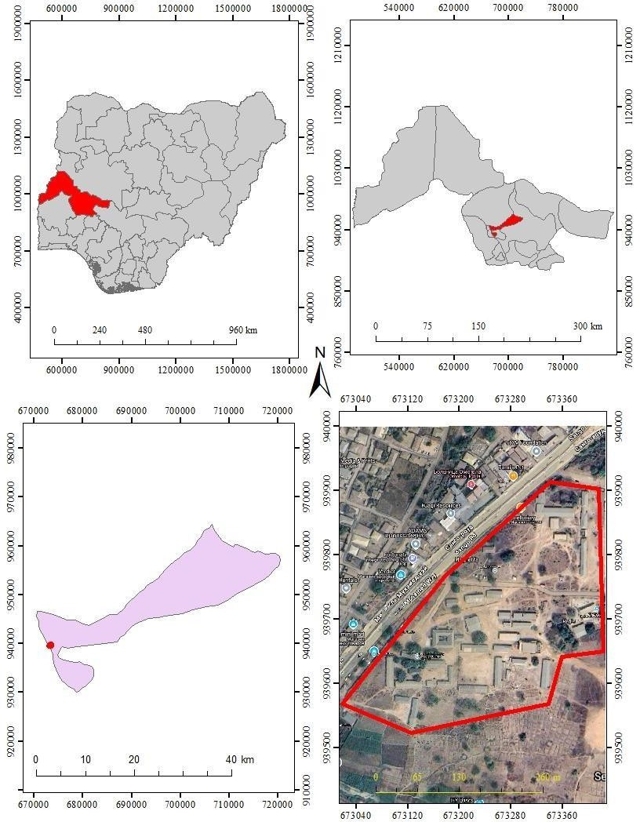

Figure 1.1: Study area Map

CHAPTER TWO

LITERATURE REVIEW

Introduction

The integration of Land Information Systems (LIS) into educational facilities management has become an increasingly important aspect of effective land and resource management. As schools grow in complexity and size, the ability to effectively manage land, buildings, and infrastructure through a centralized database has proven to be crucial for maintaining operational efficiency. With the rise of GIS (Geographic Information Systems) and modern data technologies, educational institutions are now exploring the potential of LIS to streamline administrative processes, enhance spatial planning, and optimize the management of physical assets such as classrooms, staff rooms, and utility systems. This chapter presents an in-depth review of literature focusing on the development and applications of LIS, particularly in secondary schools, with an emphasis on recent advancements in the field. It discusses the evolution of LIS, its components, integration with GIS and BIM (Building Information Modeling), and its impact on institutional management and planning.

Concept of Land Information System (LIS)

A Land Information System (LIS) is essentially a computer-based tool that allows the management of land-related information such as boundaries, property ownership, land use, and other relevant spatial data. It is designed to store, analyze, and retrieve spatial and non-spatial data. LIS integrates geographic information with attribute data to support decision-making in land administration and resource management. According to Williamson et al. (2010), an LIS consists of a spatial database for storing geographically referenced data, a set of applications for processing and analyzing this data, and a user interface for interacting with the system.

In educational contexts, LIS serves as an effective tool for managing school properties, including the mapping of building footprints, managing land tenure, and supporting future development and expansion plans. LIS can also provide real-time data on land use patterns, supporting more sustainable urban development by aiding in the planning of new educational facilities. The system helps school administrators in making informed decisions regarding land acquisition, school expansion, resource management, and infrastructure development (Osei-Tutu, 2011).

Evolution of Land Information Systems

The evolution of Land Information Systems has been a gradual process, shaped by advancements in technology and the increasing complexity of land management. Initially, land records were manually maintained in paper-based systems, which were prone to errors and inefficiencies. However, with the rise of GIS in the late 20th century, the manual recording of land data became obsolete. GIS technology enabled land-related data to be digitized, analyzed, and stored in databases, drastically improving data accessibility and the speed at which spatial analyses could be performed.
The evolution of LIS continued through the integration of more advanced tools, such as GPS (Global Positioning Systems) and Total Stations, which enabled the precise collection of geospatial data. More recently, the incorporation of blockchain technology into LIS has introduced new opportunities for enhancing the transparency and security of land records (Shahariar et al., 2023). Blockchain's decentralized nature ensures that land ownership records are tamper-proof, reducing fraudulent activities that are often associated with land transactions.
As the demands for urban development grow, there is a movement toward developing more comprehensive LIS solutions that are capable of integrating real-time data from IoT devices, sensors, and environmental monitoring systems. These modern systems provide a detailed, dynamic view of land use, infrastructure conditions, and environmental factors, which helps to improve the overall management of land and property (Mylonas et al., 2019).

Components and Architecture of LIS

The structure and design of an LIS are based on several key components that work together to provide comprehensive land management capabilities. These components include spatial data, attribute data, hardware, software, and procedures for data processing and management.
    - Spatial Data: This refers to data that is geographically referenced, such as maps, aerial imagery, land parcels, and building footprints. GIS tools such as ArcGIS and QGIS are used to process, analyze, and visualize spatial data.
    - Attribute Data: These are descriptive data linked to spatial data. For example, a land parcel may be linked to information about ownership, land use, zoning, and building details.
    - Hardware and Software: Hardware components, such as GPS receivers, Total Stations, and drones, are used to collect spatial data. Software like AutoCAD, ArcGIS, and Surfer are essential for data processing, visualization, and analysis. These tools provide the interface through which users can interact with the system.
    - Procedures and Personnel: Data collection and analysis within LIS follow standardized procedures to ensure accuracy and consistency. These procedures typically involve field data collection using surveying equipment, followed by data integration into the LIS database. Skilled personnel, including surveyors, GIS analysts, and data managers, are necessary for the effective operation of an LIS (FIG, 1995).
The architecture of LIS often follows a client-server model, where a central server hosts the system's database, and multiple users can access and interact with the system remotely. Integration with other systems, such as financial management tools or facility maintenance software, can improve operational efficiency.

Application of LIS in Institutional Management

LIS has numerous applications within institutional management, particularly in educational institutions like schools. One of the primary applications is in the efficient management of school infrastructure, such as classrooms, staff rooms, and laboratories. Schools can use LIS to map the physical layout of their buildings, monitor the condition of facilities, and plan for future expansion. The system also provides an efficient way of tracking land tenure, school ownership, and any ongoing or planned land acquisitions.
In many African countries, such as Nigeria, the lack of reliable land data has led to challenges in urban planning, particularly for public institutions (Osei-Tutu, 2011). In this context, LIS can play a vital role in helping schools avoid land disputes, enhance security, and streamline decision-making regarding infrastructure development.
Moreover, the integration of LIS with smart technologies such as Internet of Things (IoT) sensors has provided the ability to monitor real-time conditions of infrastructure and utilities. For instance, sensors can monitor energy usage, water consumption, and even the air quality within school buildings. This data can then be used to inform sustainable practices and energy-saving measures (Mylonas et al., 2019).

GIS Techniques in Building and Topographical Mapping

GIS plays a central role in the process of mapping and analyzing school infrastructure, including building layouts, topography, and other relevant environmental features. GIS allows the precise mapping of physical assets such as classrooms, staff rooms, and parking lots, and it supports the visualization of spatial relationships between different buildings within the school compound.
Topographical analysis is another critical function of GIS in school management. By analyzing terrain data, GIS can identify areas prone to flooding, soil erosion, or other environmental risks. Surfer, a powerful tool for terrain modeling, allows users to create Digital Elevation Models (DEMs) that provide
a three-dimensional view of the school's physical landscape (Burrough & McDonnell, 1998).

When integrated with Building Information Modeling (BIM), GIS further enhances the management of building structures. BIM allows for detailed representation of physical and functional characteristics of school buildings, such as classrooms and administrative offices. This integration allows for better coordination between facility management and GIS data, ensuring that all aspects of the school infrastructure are considered during planning and maintenance activities (Becerik-Gerber et al., 2012).

Previous Studies on LIS Development in Schools and Institutions

Several studies have demonstrated the potential benefits of using LIS for school infrastructure and facility management. For example, Olaleye et al. (2012) developed an LIS for the Obafemi Awolowo University campus, which facilitated better management of property, space allocation, and infrastructure. This LIS allowed the university to track land and facilities effectively, reducing the risks of land disputes and providing the data necessary for planning further campus development.
Aina (2017) applied GIS to map educational facilities in Lagos State, Nigeria, showing how spatial information could be used for effective planning and maintenance. The results highlighted the potential of GIS in improving school infrastructure management, leading to more informed decision-making and better resource allocation.
In Ghana, the development of the Ghana Enterprise Land Information System (GELIS) has proven to be an important tool in managing land records across the country. This system has helped improve land administration and reduced the instances of land disputes, enabling better planning for infrastructure and public services (Ansah et al., 2024).

Challenges in Implementing LIS in Institutional Environments

Despite the significant benefits, the implementation of LIS in educational institutions faces several challenges. One of the most significant obstacles is the high initial cost of hardware, software, and data

collection. In many African countries, including Nigeria, schools often struggle to secure the necessary funding for these technologies (Williamson et al., 2010).
Another challenge is the lack of technical expertise required to manage and maintain LIS systems. The complexity of GIS, combined with a shortage of trained personnel in schools, can hinder the effective use of these systems. Furthermore, resistance to technological change among staff and management can delay or even prevent the successful implementation of LIS (Shahariar et al., 2023).
Data inconsistency and the lack of reliable data sources also present significant challenges. Many institutions may not have accurate and up-to-date data on their land and facilities, making it difficult to integrate such data into an LIS. However, with proper training and investment in technology, these challenges can be mitigated, and the benefits of LIS can be fully realized.

CHAPTER THREE

RESEARCH METHODOLOGY AND ANALYSIS

Methodology
This explained the method and techniques used to pursue the objectives and to realize the aims of this project work, the execution of this project was based on the following basic principle of surveying
- Working from whole to the part.

- The principle of choosing the method of survey most appropriate to meet the desired result.
- The principle of provision for adequate checks to meet the required accuracy

  - PROJECT PLANNING

Effective planning is essential before initiating any survey project. This process begins with a thorough inspection of the project area, allowing the researchers to gain a clear
understanding of the site prior to commencing fieldwork, known as “RECONNAISSANCE”. Reconnaissance typically consists of two main components: (i) Office Planning (ii) Field Reconnaissance
Effective surveying begins with comprehensive project planning, a systematic process that establishes the foundation for accurate data collection. This preparatory stage involves:
Thorough research on the targeted land parcel

Clear definition of survey objectives and deliverables
Precision assessment to determine methodology and equipment.

Office Planning

Office planning which could be termed as office reconnaissance involved knowing the type of instruments, purpose, specification and accuracy require of the survey to be carried out. These led to the choosing of appropriate equipment and method to be employed, also costing of the survey operation was done in the office. Information related to the project was collected from various sources, the coordinate (x, y, and z) of the initial and that of the three choosing controls used for orientation were all obtained from survey department office (KWGIS).

Field Reconnaissance

The project site was visited by all the group members to have the true picture of the site for the better planning. The recce diagram was drawn alongside the carrying out and the reasonable artificial features were fixed along and within the traverse lines, the traverse was fixed to maintain perfect indivisibility.

Data Base Design
The design of any database involves three stages namely;

- Conceptual design

- Logical design

- Physical design

    - View of Reality

In database design, there is need for reality which is referred to as the phenomenon that actually exists, including all aspects which may or may not be perceived by individuals. The view of reality however, is the mental abstraction of the reality for a particular application or group of applications.
For this application, the view of reality is made of the topography of the project. Since it is not possible to represent the real world, the only option is to conceptualize and model it in a specified manner to

represent the real world. The area of interest to use in this project includes; Green Reserve, Roads, Electric poles, Trees, Water Facilities, Buildings, Football pitch, Streams.

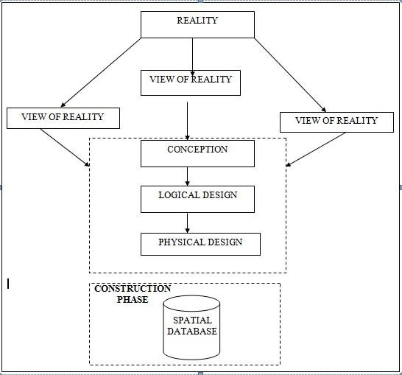

Figure.3.1 Design and Construction Phases in Spatial Database (R Sobh, C Perry,. 200)

19

Logical Design

This is the design aspect of the database refers to the process of creating a conceptual framework or model that represents the structure and organization of spatial data within the system. It involves defining the data element, their relationship, and the rules for data manipulation and analysis. In this phase, the entities, their attributes and their relationships are represented in a single uniform manner in form of relation in such a way that would be no information loss and at the same time no unnecessary duplication of data. In this study, the logical database design is employed to generate a geo-relation database structure. Each entity has unique identifier in bold type. An attribute type or combination of attribute types that serves to identify an entity type is termed an identifier.
- Building (B_ID,B_Area, B_Name, B_Easting, B_Northing)

- Roads (R_ID,R_Width, R_Type, R-Condition, R_Easting, R_Northing)

- Vegetation (V_ID,GR_Area,)

- Tree (TR_ID,TR_spp,TR_Importance,TR_Easting,TR_Northing)

- Electric Pole (EP_No,EP_Type,EP_Height,EP_Easting,EP_Northing)

- Football Pitch FP_ID, FP_Area,FP_Status)

Equipment Used

    - Hard Ware
      - Total Station (South)
      - Reflector Pole
      - Hand-held GPS
      - Steel tape
      - Nails and bottle cover
      - Field book
      - 1 cutlass

    - Software
      - AutoCAD 2007
      - Arc-GIS 10.7
      - Google Earth
      - Note pad
      - Excel

Instrument Test
To ensure data quality, the Total Station used for this project was tested for both vertical index and horizontal collimation errors. It was also to ascertain the efficiency and reliability of the instrument. The procedure used is described below.
    - Horizontal Collimation Test

This test was conducted to ensure that the line of sight was perpendicular to the trunnion axis. The Total Station was positioned over a specific point, and initial adjustments were made to ensure proper alignment, leveling, and focus (to eliminate parallax in the telescope). A vertical target was placed at a distance of 100 meters from the Total Station. To access the configuration menu of the Total Station, the menu key was pressed and held for approximately 2 seconds. From the

main menu, the calibration sub-menu was selected, and within that, the horizontal collimation test option was chosen. The target was then observed and divided into two halves, with horizontal readings recorded for Face left and Face right. The readings are shown in Table 3.4.1 below.
Total Station Reflector (Target)

100m

Station A Fairly Level Ground Station B Figure 3.2; Horizontal Collimation and Vertical Index error test

Table3.1: Horizontal Collimation Data

Station | Target | Face | Horz. Reading | Difference | Error
A | B | L | 025˚ 32‟ 32”
 |  | R | 205˚ 32‟ 35” | 180˚ 00’ 03” | 00˚ 00’ 03”

    - Vertical Index Error Test

This test was conducted to verify the accuracy of the vertical reading when the line of sight is horizontal. The desired measurement for this test is exactly ninety degrees (90˚), any deviation from this value is referred to as the vertical index error.
The Total Station was positioned over a specific point, and necessary temporary adjustments were made to ensure proper alignment and functionality. A target was placed approximately100 meters away from the Total Station, and the instrument was aimed at the target. The target was bisected by aligning the instrument on the face left, and the corresponding reading was recorded. Similarly, the target was then bisected on the face right and the respective reading were also recorded. The recorded readings are provided below:
Table3.2. Vertical Index Data

Instrument Station | Target Station | Face | Vertical | Sum | Error
A | B | L | 95˚ 00‟ 00”
 |  | R | 275˚ 00‟ 02” | 360˚ 00‟ 02” | 02”

    - Analysis of Collimation and Vertical Index Data

The readings obtained during calibration were reduced to obtain new collimation and vertical errors.
Horizontal collimation = {(FR–FL) –180} /2 = {(00˚00‟03”} /2 =1.5”

Vertical collimation = {(FL+FR) –360} = (95˚00‟00” + 275˚00‟02”) -360} = 02” The result shows that the instrument is still in good working condition.

Control Check
    - Control Check Procedure Using Total Station

To ensure the accuracy and reliability of the Total Station observations used for spatial data acquisition, control checks were carried out before and during the main survey. The procedure involved setting up the instrument over a known control point, performing temporary adjustments, executing angular and distance observations (back sight and foresight), and validating the computed coordinates against known values.
Step 1: Instrument Setup and Centering.

The Total Station was mounted securely on a tripod placed directly over the first known control point.
Centering was done using the built-in optical plummet to align the vertical axis of the instrument precisely over the ground mark.
Fine adjustments were made by shifting the tripod legs or using the sliding base plate to achieve perfect alignment.
Step 2: Temporary Adjustments (Leveling and Elimination of Instrumental Error)

Leveling: The circular bubble was first centered using the tripod legs. Then, the tubular (or electronic) level was used with the foot screws to achieve fine leveling in two perpendicular directions.

Collimation Check: An internal calibration (collimation) check was performed using the instrument’s self-diagnosis function to ensure the vertical and horizontal axes were perpendicular.
The horizontal circle was then set to zero after selecting the backsight direction.
Step 3: Back sight Observation

The telescope was rotated to face a second known control point (backsight).

The instrument was focused accurately on the backsight prism, and both horizontal and vertical coordinates (XYZ) were measured.
Step 4: Foresight Observation and Coordinate Validation

The telescope was then turned to observe a third point (foresight). The horizontal and vertical coordinates (XYZ) were measured. The observed coordinates were then compared to the known coordinates of the foresight control point already established.
Coordinate difference (ΔX, ΔY, ΔZ) was calculated to assess positional accuracy. The difference was within the allowable tolerance (typically ±2cm for X/Y and ±3cm for Z), the instrument was considered properly calibrated.
Step 5: Repeat Check at another Station

The same procedure was repeated for every station setup across the site to ensure uniform accuracy across the network.
All three control stations showed closure errors and coordinate differences well within the accepted tolerance for third-order survey work. This control check procedure ensured that the Total Station data used for plotting school boundaries, buildings, and topography in the Land Information System were precise and trustworthy.
Once the control points were verified and validated, they were used as reference locations for the detailed survey of the school facilities.

Table 3.3: Coordinate of the observed and the original values of K654AD
PILLAR | NORTHING | EASTING | STATUS | REMARKS
SC/KW K654AD | 939792.896 | 673354.040 |  | ORIGINAL
SC/KW K654AD | 939792.886 | 673354.020 | FIXED | OBSERVED
DISCREPANCY | 0.010 | 0.020

Table 3.4: Coordinate of the observed and the original values of K656AD
PILLAR | NORTHING(m) | EASTING(m) | STATUS | REMARKS
SC/KW K656AD | 939837.818 | 673334.688 |  | ORIGINAL
SC/KW K656AD | 939837.797 | 673334.666 | FIXED | OBSERVED
DISCREPANCY | 0.021 | 0.022

Table 3.5: Coordinate of the observed and the original values of K657AD
PILLAR | NORTHING(m) | EASTING(m) | STATUS | REMARKS
SC/KW K657AD | 939803.143 | 673366.311 |  | ORIGINAL
SC/KW K657AD | 939803.132 | 673366.291 | FIXED | OBSERVED
DISCREPANCY | 0.011 | 0.020

Geometric Data Acquisition

The total station instrument was set carefully on control point SC/KW K6546AD back sight taken to K SC/KW K654AD after necessary station adjustments has been carried out on it. The adjustments include; centering, leveling and focusing. The following procedures were then followed to determine the position of the next point (NL1) and the

same procedure were repeated until all we come close to the site. The method used in acquiring data on site was radiation method where two or more points are coordinated from one instrument station.

- Having setup, the instrument and temporary adjustment carried out, the instrument was powered „on‟ and a job file was created under job menu in the internal memory of the instrument. The job file created was named GSSGR4C.
- On the job, the coordinates of the three (3) control points were keyed in to the memory of the instrument and some codes were also saved. The codes include
„RD‟ for road, SP‟ for spot height, BD for buildings, etc.

- The height of the instrument was measured and saved on the memory of the instrument as well as their reflector height.
- On coordinate menu, orientation was set by inputting the coordinates of the instrument station and back sight. The reflector at the back station was perfectly bisected before the orientation was confirmed by clicking yes.
Having done the orientation, the reflector at the next station was bisected and observe option was clicked. The three-dimensional coordinate of the point (E N, H) were displayed on the display unit of the instrument and record button was clicked to save the data into the memory of the instrument. For subsequent observation after this, all options were used instead of pressing observation (“obs”) and pressing record later.

- It was ensured that the center of the prism of the reflector was bisected and that it was set perfectly on the tripod in order to minimize the error on height determination.
- The instrument is been shifted to another station after all details, spot height and boundary point visible from the instrument station have been picked, The instrument was set over new station and temporary adjustments carried out.

However, the above operations were repeated until all the boundary points with heights were coordinated.
In this project all spot height were not in grid intervals but randomly acquired. At the end of data acquisition process all details were observed and properly recorded to be shown in their respective positions on the plan.

Detailed Survey:

The detailed survey focused on mapping the internal structures and facilities within the school, including:
  - Classrooms

  - Staff rooms and administrative offices
  - Laboratories and libraries

  - Playgrounds and sports fields

  - Roads, parking lots, and walkways

Geometric data for every feature were acquired using Total Station, and the collected spatial data were stored in a structured format. Screenshots of the Total Station data interface were captured to illustrate the data collection process. The observations were carried out systematically to ensure complete coverage of all features within the project area.

Non-Spatial Data Collection

In addition to spatial data, non-spatial data (attribute data) were collected to provide descriptive information about each observed feature. These data were gathered through field observations, school administrative records, and structured interviews with key personnel.
Types of Non-Spatial Data Collected

  - Building Information: Name, number of floors, year of construction, type of usage

(classroom, staff office, laboratory, etc.).

  - Staff Room and Office Details: Departmental functions, number of staff, office occupants.
  - Infrastructure Information: Type of roads (paved or unpaved), water supply, power supply.
A field book was used to record the collected data, ensuring uniformity and easy integration into the LIS database. The completed forms were reviewed for accuracy before entering the data into a spreadsheet for GIS processing. Screenshots of the attribute data collection forms were taken and included in the documentation.
3.3.4 Data Download and Storage

Once the field surveyed was completed, all collected data were transferred to a computer system for further processing and storage. The following steps were taken to ensure proper data management:
- Downloading Total Station Data: The surveyed X, Y, Z coordinates were extracted from the Total Station’s internal memory using instrument software. The data were saved in a CSV (comma-separated values) file format for compatibility with GIS and
AutoCAD software.

- Organizing Non-Spatial Data: The collected attribute data were entered into an Excel spreadsheet, ensuring proper formatting for easy integration with spatial data. The file structure was reviewed to ensure consistency and completeness.
- Data Backup: Copies of all data files were stored in an external flash drive to prevent data loss. File versions were properly labelled to maintain organization.

The downloaded spatial and non-spatial datasets were prepared for further processing and integration into the LIS.
3.3.5 Data Validation and Accuracy Assessment

To ensure the accuracy and reliability of the collected data, a rigorous validation process was conducted. This involved cross-checking the surveyed coordinates, attribute data, and instrument readings to identify and correct any errors.
Validation of Spatial Data

- Coordinate Cross-Check: The surveyed points were compared with known control points to verify accuracy.
- Boundary Accuracy Check: The surveyed boundary was overlaid on an existing satellite image in Arc=GIS to detect any misalignment.

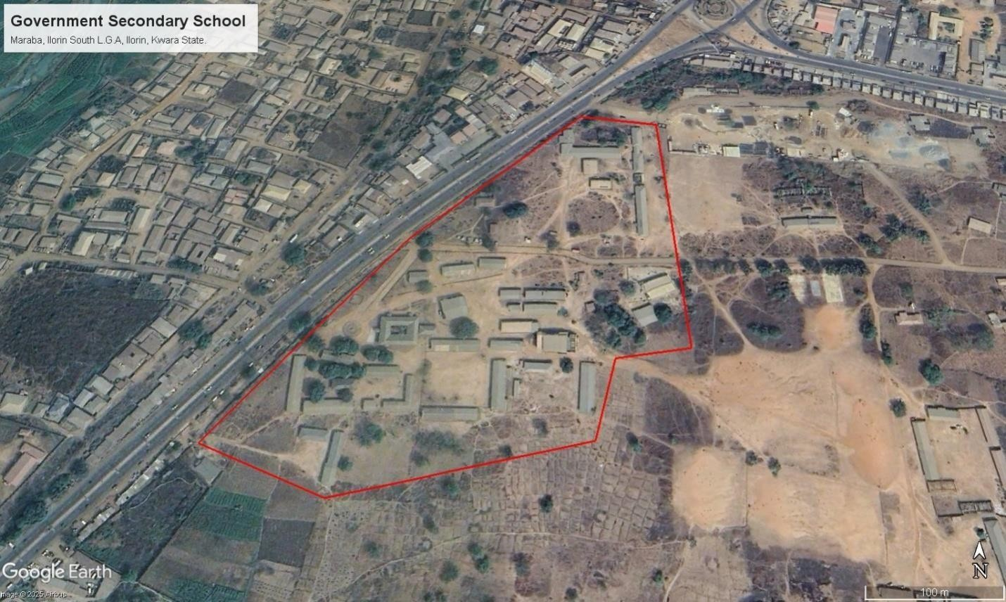

Figure 3.3: Satellite Imagery of the study area Validation of Non-Spatial Data
- Attribute Consistency Check: The recorded building and facility details were compared with official school records.
- Correction of Data Entry Errors: Any discrepancies or incorrect attribute entries were identified and corrected before finalizing the dataset.

  - Data Processing and Integration

The data processing and integration phase is a critical step in transforming the raw data collected from the field survey into a structured Land Information System (LIS). This stage involves cleaning, organizing, and integrating both spatial and non-spatial data into a geodatabase, ensuring seamless access, analysis, and visualization.

The processing workflow consists of multiple steps, including spatial data processing in AutoCAD and Surfer, non-spatial data structuring in Excel, geodatabase creation in ArcGIS, and data integration for LIS development. The structured integration of these datasets enables effective querying, mapping, and decision-making for the secondary school management system.
    - Spatial Data Processing in AutoCAD

AutoCAD was used to plot the observed coordinates, (Geometric data) ensuring accurate representation of school facilities such as classrooms, staff rooms, administrative offices, roads, and playgrounds. The following steps were carried out:
      - Importing Surveyed Points:

        - The CSV file containing surveyed coordinates was imported into AutoCAD.

        - The points were plotted based on their real-world X and Y coordinates, while the Z values were retained for elevation analysis.

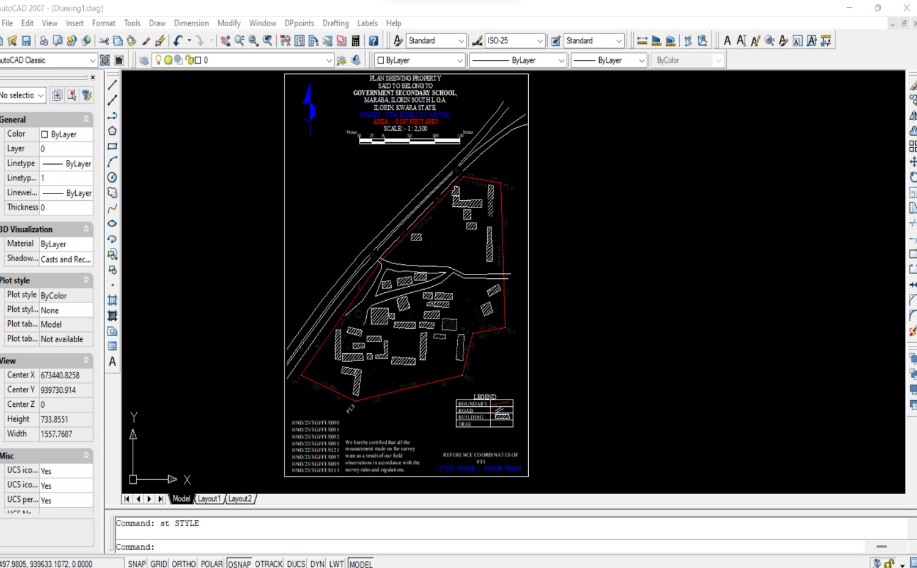
Figure 3.4: A screenshot of the boundary in AutoCAD.

      - Plotting of Boundaries and Features:

        - The boundary points were connected using polyline tools, forming a closed polygon to define the extent of the school premises.
        - Each school building was mapped as a separate layer, and unique identifiers were assigned to distinguish classrooms, staff rooms, laboratories, and other structures.

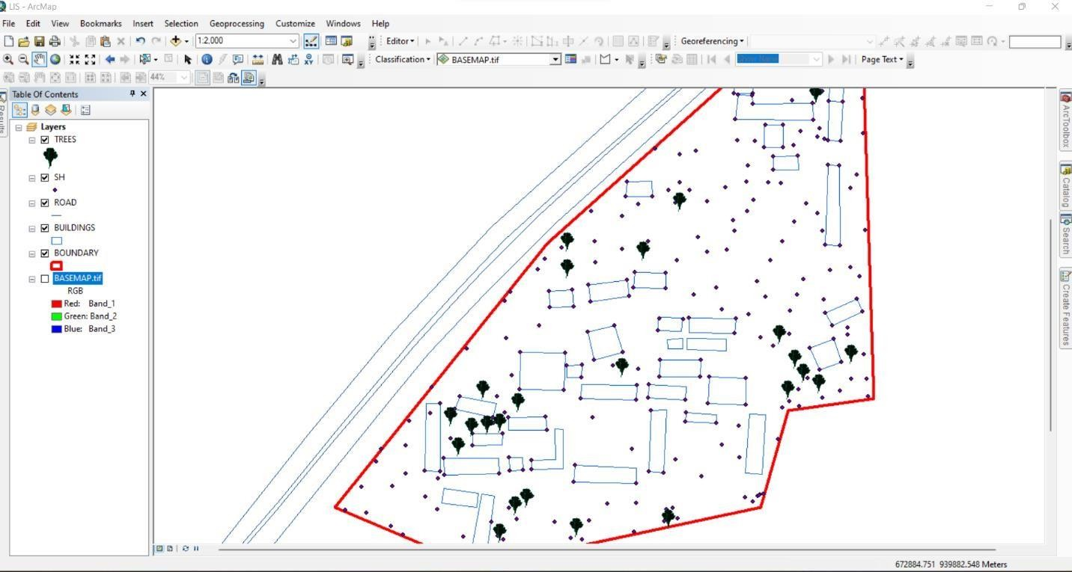

Figure 3.5 Screenshot of boundary digitization and features

    - Topographic Data Processing in Surfer

Surfer software was used for topographic analysis and terrain modelling based on the surveyed elevation data (Z values). The following procedures were followed:
      - Importing Surveyed Data:

        - The X, Y, and Z coordinates were loaded into Surfer as a point dataset.

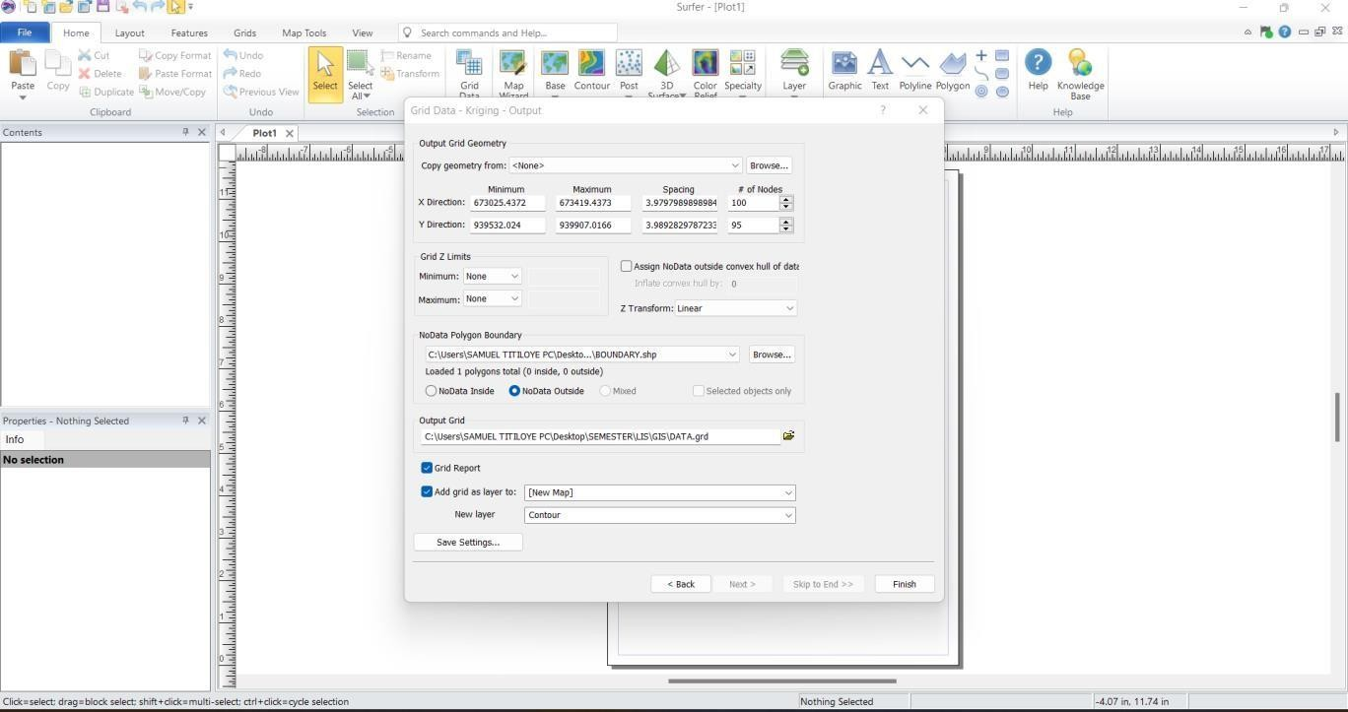

Figure 3.6: Screenshot of the imported dataset.

      - Generation of Digital Elevation Model (DEM):

        - A grid-based interpolation technique was applied to generate a Digital Elevation Model (DEM) of the school area.
        - The DEM provided insight into the elevation variations across the school premises, assisting in drainage and flood risk assessment.

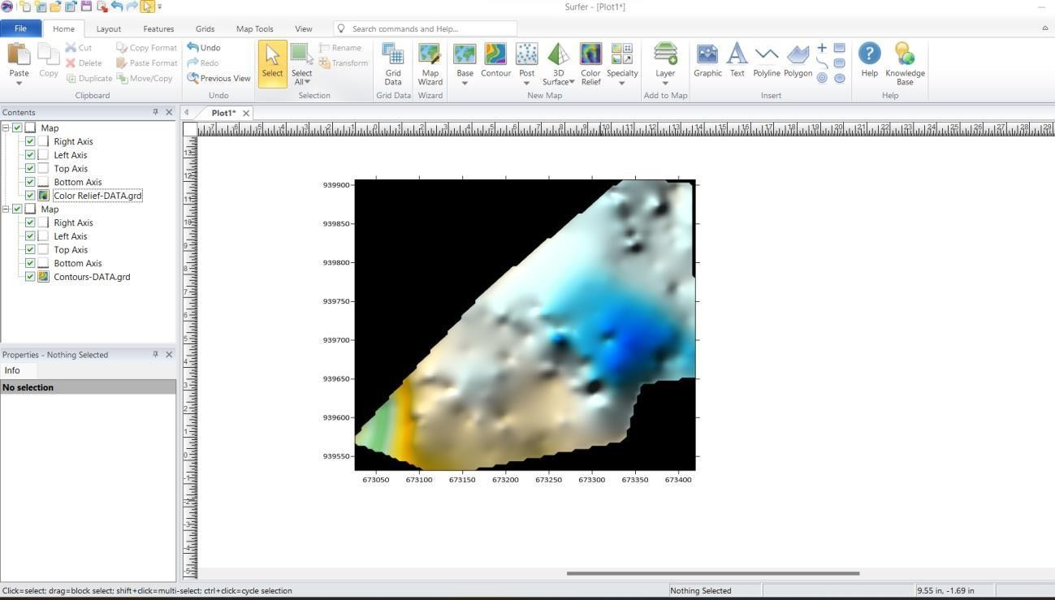

Figure 3.7: Screenshot of the generated DEM.

      - Creation of Contour Maps:

        - Contour lines were generated at specific intervals to visualize terrain variations.

        - The contour map was exported in Geo-TIFF format for integration into Arc- GIS.

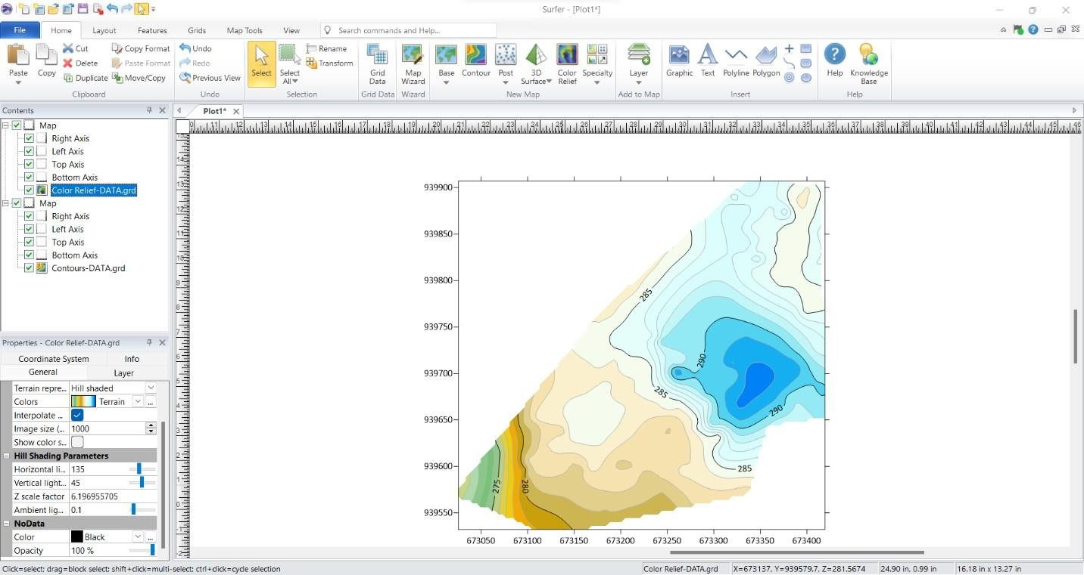

Figure 3.8: Screenshots of the contour generation process.

    - Non-Spatial Data Processing in Excel

Non-spatial data collected through field observations and school administrative records were structured and formatted in Excel to ensure consistency and ease of integration into Arc-GIS.
      - Data Entry and Formatting:

        - Each facility was assigned a unique ID corresponding to its spatial location.

        - Attributes such as building type, year of construction, and available amenities were recorded.

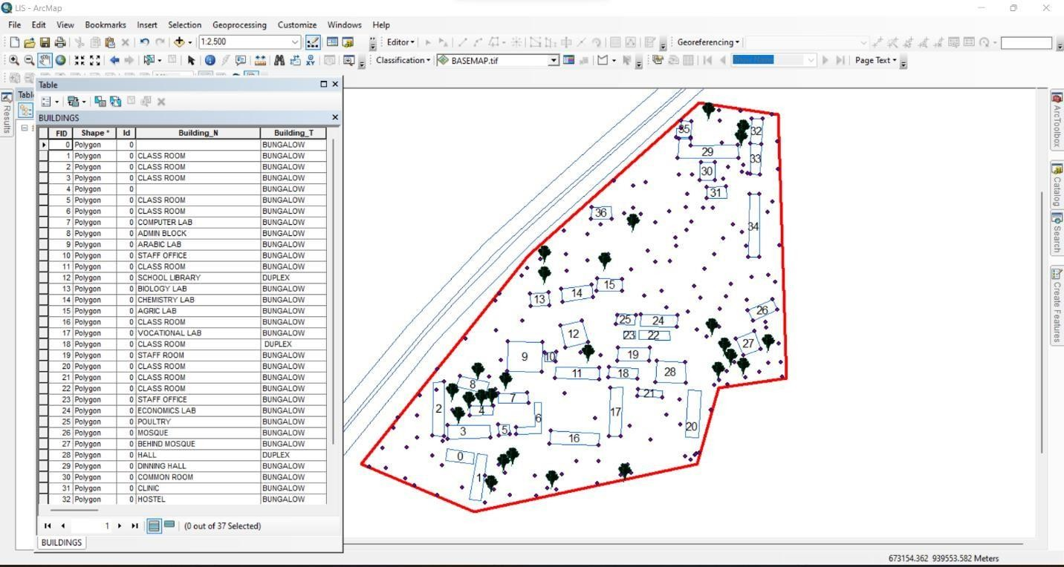

Figure 3.9: Screenshot of the structured attribute table.

    - Geo-database Creation in Arc-GIS

A geo-database was created in Arc-GIS to integrate both spatial and non-spatial data, allowing efficient storage, retrieval, and analysis of school infrastructure data. The following steps were taken:
      - Creating a New Geo-database:

        - A file geo-database was created in Arc-GIS to store all spatial data layers and attribute tables.
      - Importing Spatial Data:

        - The DXF file from Auto-CAD (containing school boundaries and building layouts) was imported into Arc-GIS.
        - The Geo TIFF file from Surfer (containing the DEM and contour data) was also loaded.

      - Defining Feature Classes:

        - Separate feature classes were created for classrooms, staff rooms, offices, laboratories, roads, and other infrastructure.
        - Each feature class was assigned relevant spatial properties (e.g., polygon for buildings, polyline for roads).
      - Importing Non-Spatial Data and Linking to Spatial Features:

        - The CSV file containing attribute data was imported into ArcGIS.

        - A one-to-one relationship was established between the spatial features and their corresponding attribute records using the unique ID field.

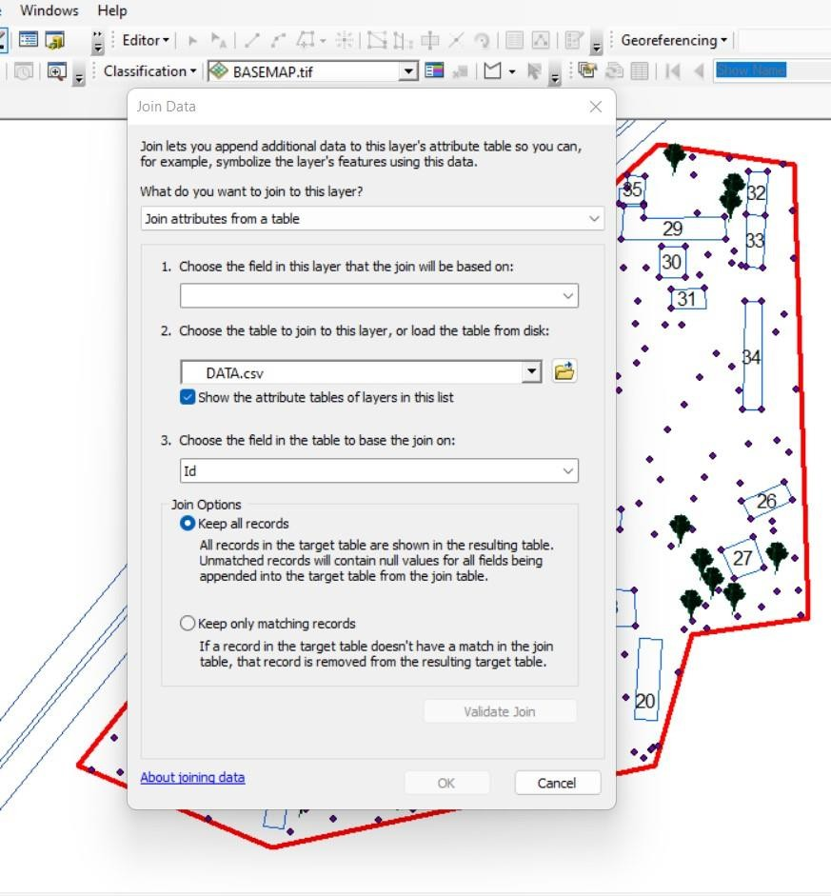

Figure 3.11: Screenshot of the data join process.

    - Data Integration and Finalization for LIS

The final stage involved ensuring seamless integration between spatial and non-spatial data within the LIS environment.
      - Verification of Data Integrity
        - The attribute data were cross-checked to ensure they matched their respective spatial locations.

        - Any mis-linked records were corrected, and missing attributes were updated.
      - Symbolization and Visualization:

        - Each feature class was assigned unique symbols and colors for better visualization in Arc-GIS.
        - Thematic maps were created to represent building categories, classroom capacities, and road networks.

Perimeter Plan of the Project Area
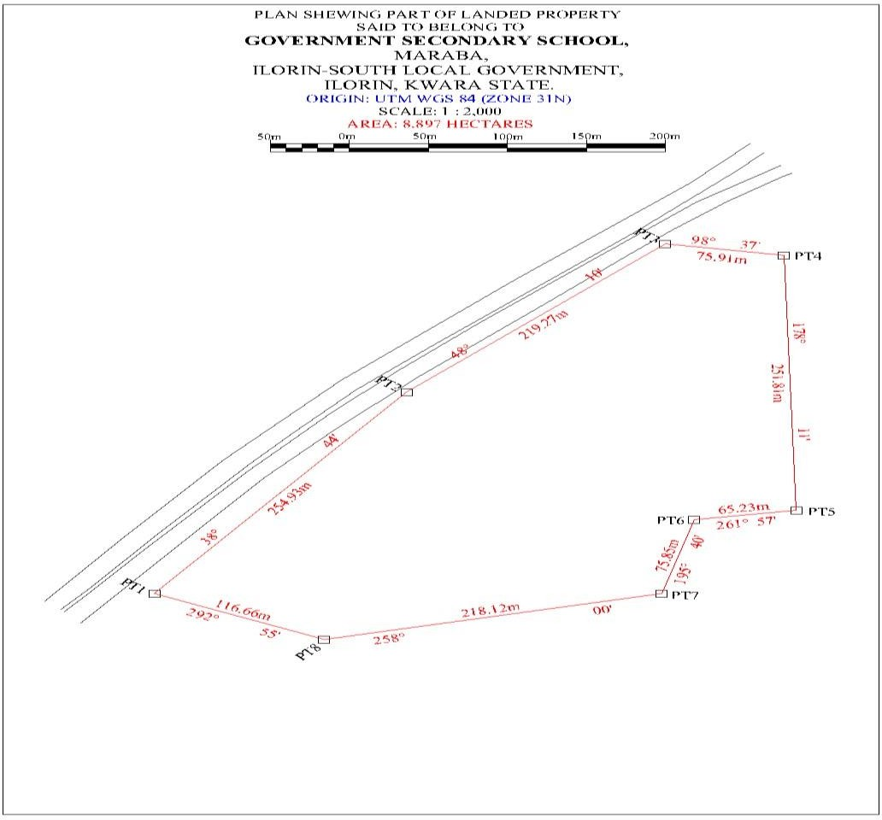

Figure 3.7.1: A screenshot of the boundary in AutoCAD.

      - Boundary Digitization and Feature Mapping:

        - The boundary points were connected using polyline tools, forming a closed polygon to define the extent of the school premises.
        - Each school building was mapped as a separate layer, and unique identifiers were assigned to distinguish classrooms, staff rooms, laboratories, and other structures

Detailing
Figure 3.7.2 Screenshot showing the digitization process and layer management.

3.7.2 Topographic Data Processing in Surfer

Surfer software was used for topographic analysis and terrain modelling based on the surveyed elevation data (Z values). The following procedures were followed:
      - Importing Surveyed Data:

        - The X, Y, and Z coordinates were loaded into Surfer as a point dataset.

Attribute data acquisition

Attribute data is information about spatial features. They provide the characteristics, description and nomenclature about spatial objects. Thus, the attributes data acquired includes names of buildings and their uses such as classrooms, roads, water facilities and prominent natural features Likes River and trees found and vegetation were properly identified within and around the study area.

Database Creation / Implementation

This is the database creation phase. Having completed the three stages of design phase (i.e Reality, Conceptual and Logical design), the data base was created using ArcGIS10.2 software. It involves the combination and storage of acquired graphic data and attributes data in creating the database for the purpose of spatial analysis and query.
Database is an organized integrated collection of data stored so as to be capable of use by revenant application with data being accessed by different logical part. After the Attribute table was populated via the keyboard, some attributes such as areas of settlements were automatically displayed by special command in the ArcGIS 10.2 version. The ArcGIS software was used to link the graphic data and table for query generation.

Database Management System (DBMS)

Data base management is a collection of software for creating, storing, manipulating, updating, organizing and querying of information in a database (Kufoniyi, 1998). It is a software package whose function is to manipulate a data base on behalf of the user.
A good DBMS must provide the following functions:

      - Storage and retrieval of data.

      - Access to by several users at a time.

      - A standardized interface between data base and application programmed.

      - Standardized access to data and separation of data storage and retrieval functions from the program using the data.

      - Maintenance of data security and integrity.

Data Quality
Having created the database, proper maintenance practice was made to meet its stated objectives. The ability to include more data and remove irrelevant data was possible by way of maintenance. There is every need for the data to be updated regularly because of the physical changes that may occur on the landscape with time. Both security and integrity were also exercised to ensure maintenance and to meet its stated objectives.
Proper observance, updating and management of database ensure its currency and quality to stand a profound chance in Spatial Decision Support System (SDSS). The quality of any database depends on the currency and fitness for use as a decision support system (SDSS). The quality of database depends on its ability to generally fit and use as a decision system (DSS). The storage media should be from time to time justified if otherwise could necessitate data inaccessibility or physical deterioration of the storage media. Also, care must be taken during populating any database system, as a database is only good as the data supplied. In archiving stable media should be used. Examples of these are
- Computer compatible tape reader

- Magnetic tape

- Optical disc and compact disc.

CHAPTER FOUR

ANALYSIS AND RESULTS

Introduction

This chapter presents the results obtained from the data acquisition, processing, and integration procedures described in the previous chapter. The findings provide a comprehensive spatial and non-spatial representation of the school environment, including the layout of buildings, topographical features, and attribute information related to school facilities. The results are structured to demonstrate how the Land Information System (LIS) can enhance school management by providing accurate, well-organized, and easily accessible data.
The results are categorized into different sections for clarity. The spatial data results include mapped school boundaries, building footprints, and access networks, all of which were digitized using GIS tools. The topographical results analyze elevation variations using Digital Elevation Models (DEM) and contour maps, which are crucial for site planning and infrastructure development. The non-spatial data results contain attribute information such as classroom capacity, staff room assignments, and building conditions, all integrated into the LIS database. The data integration and query results demonstrate how the LIS functions as an interactive tool for retrieving, analyzing, and visualizing school-related data.
This chapter also includes analyses that reveal important insights into building distribution, infrastructure conditions, environmental constraints, and potential areas for school expansion. The results are presented using maps, tables, and screenshots from GIS and related software to illustrate how data were processed and visualized. The goal of this chapter is to demonstrate the practical

application of an LIS in school facility management and to highlight the benefits of integrating spatial and nonspatial data for decision-making.

Spatial Data Results
The spatial data results provide a detailed representation of the school’s geographical layout, including its boundaries, buildings, access roads, and pathways. These results were derived from Total Station survey data, processed in AutoCAD and ArcGIS to create an accurate Land Information System (LIS) for the school. This section highlights the steps taken to map the school boundary, digitize building footprints, and visualize access routes.
The spatial data results are essential for effective school management, as they provide a georeferenced framework that helps in planning expansions, monitoring infrastructure, and optimizing resource allocation. The outputs presented in this section form the foundation for further topographical, non-spatial, and LIS-based analysis discussed in subsequent sections.
    - School Boundary and Building Layout

The school boundary and building layout were mapped using surveyed coordinates

(X, Y, Z) collected with the Total Station. The acquired data were processed in AutoCAD to generate a structured boundary map and building footprints, which were then imported into ArcGIS for further spatial analysis and integration into the LIS database.
Figure 4.2.1: As built Plan of Government Secondary School Maraba, Ilorin South East Local Government. using GIS software
Visualization of Spatial Data Results

The final processed spatial data were visualized in ArcGIS, where the school boundary, building footprints, and access roads were symbolized appropriately to enhance readability.

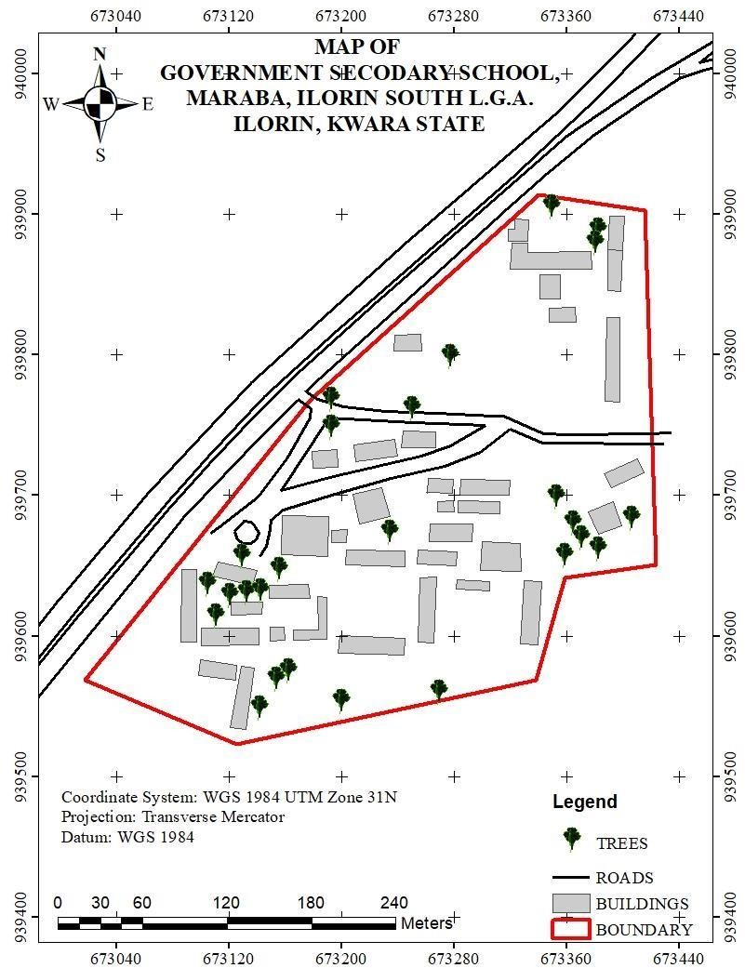

Figure 4.1: Mapped School Boundary and Buildings in ArcGIS

- The school boundary is represented as a bold polygon to define the outer limits of the school.

- Buildings are shown in different colors based on their usage (e.g., classrooms in blue, administrative offices in green, laboratories in red).
- Roads are displayed as lines, with roads marked in black.

This spatial data representation serves as the primary framework for the LIS database, allowing users to visualize, analyze, and manage school infrastructure efficiently.
Significance of the Spatial Data Results

The school boundary and building layout play a crucial role in:

- Infrastructure Planning: Ensuring optimal land use by identifying available spaces for future construction and expansion.
- Facility Management: Helping administrators monitor the condition, usage, and location of various school buildings.
- Navigation and Accessibility: Enhancing movement planning for students, staff, and visitors by identifying clear pathways and access points.
- Disaster Management: Providing accurate spatial information to plan for emergency exits, assembly points, and safety zones.
The spatial data results form the foundation for further analysis, including topographical evaluation, attribute data integration, and advanced GIS-based queries, which will be presented in the subsequent sections of this chapter.

Topographical Analysis Results
Topographical analysis provides crucial information about the elevation, slope, and terrain variations within the school environment. Understanding these features is essential for site planning, infrastructure development, drainage design, and environmental management. This section presents the results of topographical data processing and analysis, including the creation of Digital Elevation Models (DEM), contour maps, and slope analysis.
The topographical data were obtained using Total Station measurements, which captured X, Y, and Z coordinates of various points within the school premises. These data were processed in Surfer to generate elevation models and later integrated into ArcGIS for spatial analysis.

Digital Elevation Model (DEM)

The Digital Elevation Model (DEM) was created to provide a 3D representation of the school’s terrain. Using Z-coordinates from the Total Station survey, a gridded elevation surface was generated in Surfer and later exported to ArcGIS for further analysis.

Key Features of the DEM:

      - The DEM visually represents variations in land elevation within the school compound.

      - Areas of higher elevation are highlighted, aiding in infrastructure planning and water drainage management.
      - The DEM serves as the base for further slope, aspect, and contour analysis.

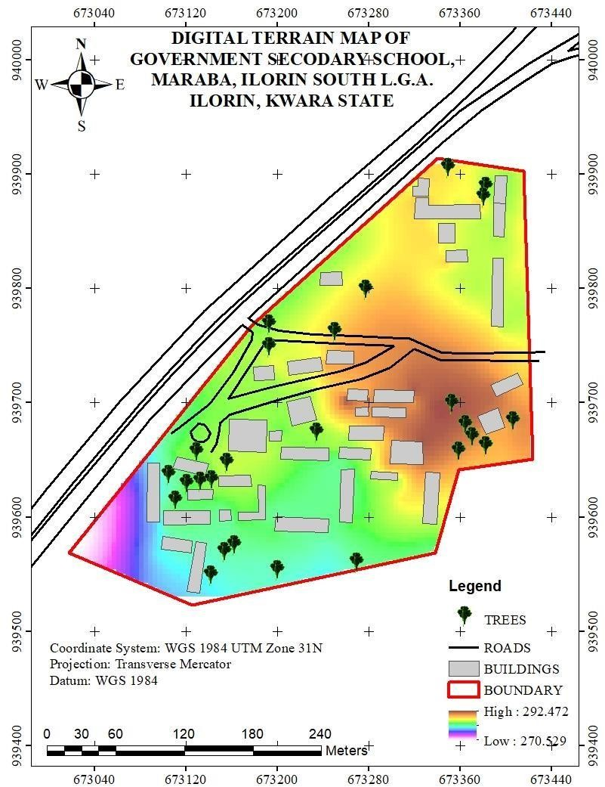
Figure 4.2: Digital Elevation Model (DEM) of the School Premises

Contour Mapping

Contour mapping was conducted to visualize elevation changes and terrain gradients within the school environment. The surveyed elevation data were processed in Surfer to generate contour lines, which were later imported into Arc-GIS for spatial overlay and analysis.

Key Results from Contour Analysis:

      - The contour interval was set based on the range of elevation variations in the study area.

      - Closely spaced contour lines indicate steep slopes, while widely spaced lines represent gentler slopes.
      - The contour map helps in identifying low-lying areas that may be prone to water logging or flooding.
      - The results assist in drainage planning by identifying natural water flow paths.

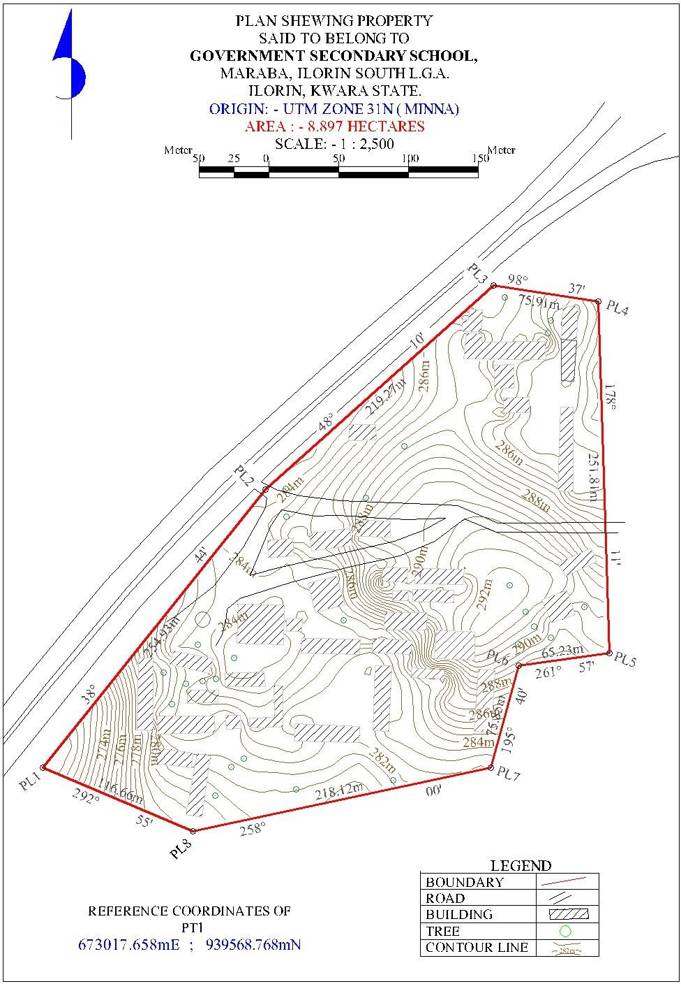

Figure 4.3: Contour Map of the School Premises

Slope and Terrain Analysis

A slope analysis was conducted to determine variations in land steepness across the school environment. The slope was computed using the DEM in ArcGIS, with results classified into different slope categories to assess terrain usability.
Key Findings from Slope Analysis:

      - Flat areas (0-5 degrees) are suitable for classroom blocks, play areas, and other infrastructure.

      - Moderate slopes (5-15 degrees) are manageable for footpaths and minor construction projects.

      - Steeper slopes (above 15 degrees) may require erosion control measures or retaining walls to prevent land degradation.

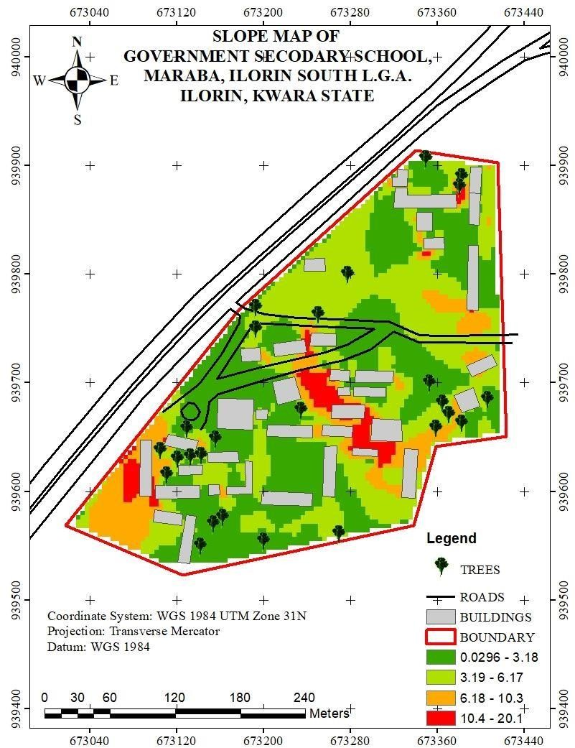
Figure 4.4: Slope Analysis Map of the School Premises

Significance of Topographical Analysis Results

The results of the topographical analysis provide essential insights for school management, infrastructure development, and environmental sustainability. These findings contribute to:
      - Better infrastructure planning: Ensuring that new buildings and roads are constructed on stable ground.
      - Improved drainage management: Reducing the risk of flooding and water stagnation within the school premises.
      - Enhanced safety measures: Identifying steep areas that may require protective barriers or adjustments in land use planning.
      - Sustainable land use: Helping decision-makers optimize space utilization while considering terrain constraints.
The topographical analysis results form an integral part of the Land Information System (LIS), ensuring that spatial data is not only stored but also analyzed for informed decision-making in school infrastructure management.

Non-Spatial Data Results

Non-spatial data results refer to the descriptive information associated with various school facilities, buildings, and infrastructure. Unlike spatial data, which provides geometric representations of features (such as school boundaries, buildings, and roads), non-spatial data includes textual and numerical attributes that help in facility management and decision-making.
The non-spatial data collected in this study were integrated into the Land Information System (LIS) to enhance school administration, infrastructure monitoring, and resource planning. The data were

structured in tabular format and linked to corresponding spatial features in ArcGIS using unique identifiers.
    - Attribute Data for School Buildings

The non-spatial attributes for classrooms, staff rooms, laboratories, and administrative offices were recorded and organized in a database. Each building was assigned a unique identifier (Building ID), allowing for easy retrieval of information in GIS.
Key Attributes for Buildings:

      - Building Name/ID (e.g., Classroom Block A, Staff Room 1)

      - Building Type (Classroom, Laboratory, Office, Library, Hall)

      - Primary Use (Teaching, Administration, Storage, Utility)

This information was stored in ArcGIS attribute tables and linked to the digitized building footprints, allowing users to perform queries such as identifying underutilized classrooms or buildings in need of maintenance.

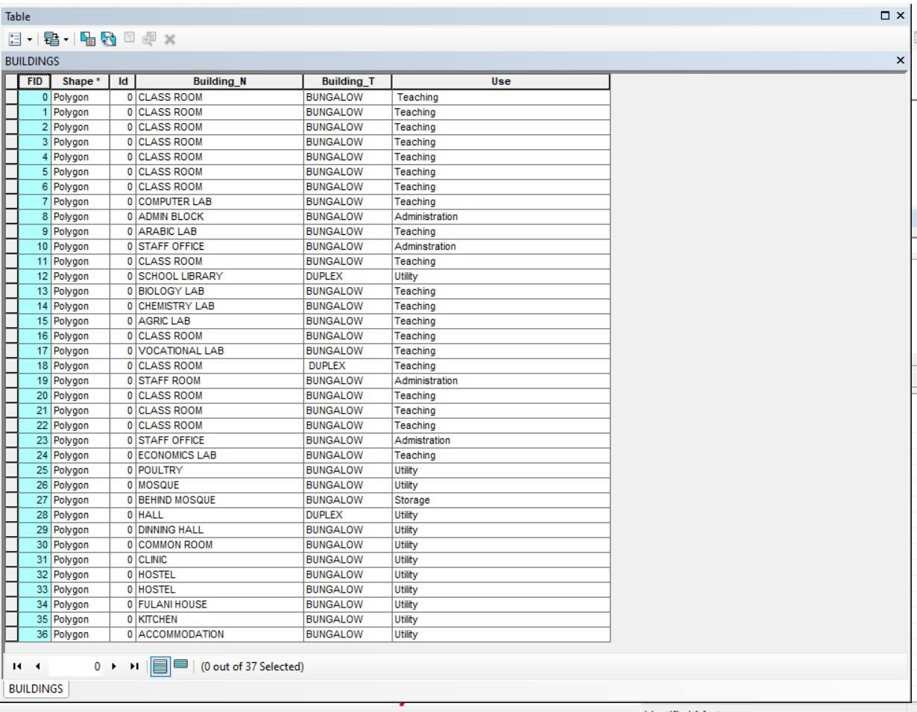

Figure 4.5: Sample Attribute Table for School Buildings

4.4.3 Linking Non-Spatial Data with GIS

All non-spatial datasets were linked to their corresponding spatial features in ArcGIS. This integration allows for interactive queries and visual analysis of school facilities. Some of the key functionalities include:
- Clicking on a building footprint to view its attributes (e.g., building name, building type, & use).
- Running queries to find classrooms that exceed their maximum student capacity.
- Generating reports on the maintenance history of infrastructure.

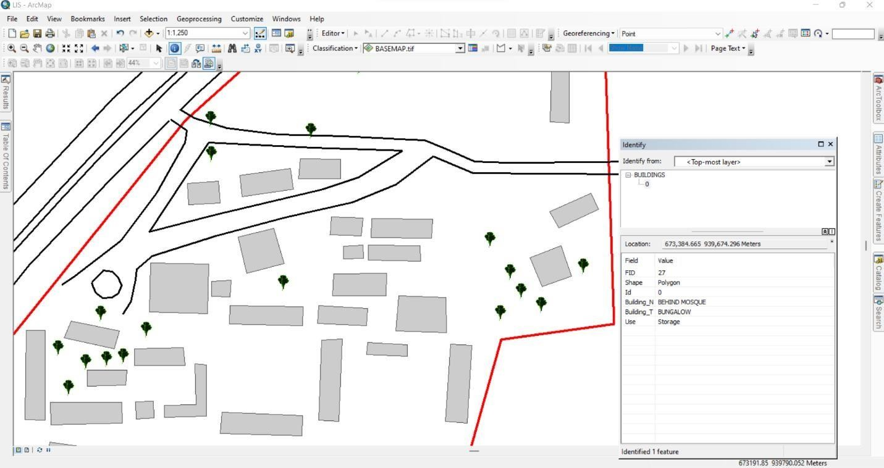

Figure 4.6: Linking Non-Spatial Data to Spatial Features in ArcGIS

4.4.4: Significance of Non-Spatial Data in LIS
The integration of non-spatial data into the LIS enhances decision-making by providing comprehensive attribute information for school management. These results contribute to:
- Effective Resource Allocation: Ensuring that classrooms, offices, and other facilities are optimally utilized.
- Infrastructure Maintenance Planning: Monitoring facility conditions and scheduling necessary repairs.
- Improved School Administration: Tracking staff distribution, student population trends, and room assignments.
- Emergency Preparedness: Identifying critical infrastructure that requires regular inspections and safety measures.
The non-spatial data results demonstrate how a Land Information System (LIS) can support school facility management by combining spatial visualization with detailed attribute data. This information is essential for long-term planning, policy-making, and efficient school operations.

Query Execution and Results
With the integrated database, queries were performed in ArcGIS to extract specific information about the school environment. These queries help in analyzing building usage, staff distribution, facility conditions, and space utilization.

Example Query Results:

- Mapping Distribution of Staff Offices: Query: "Show all staff offices"
Result: A spatial representation of staff office locations was displayed, ensuring adequate office space allocation.
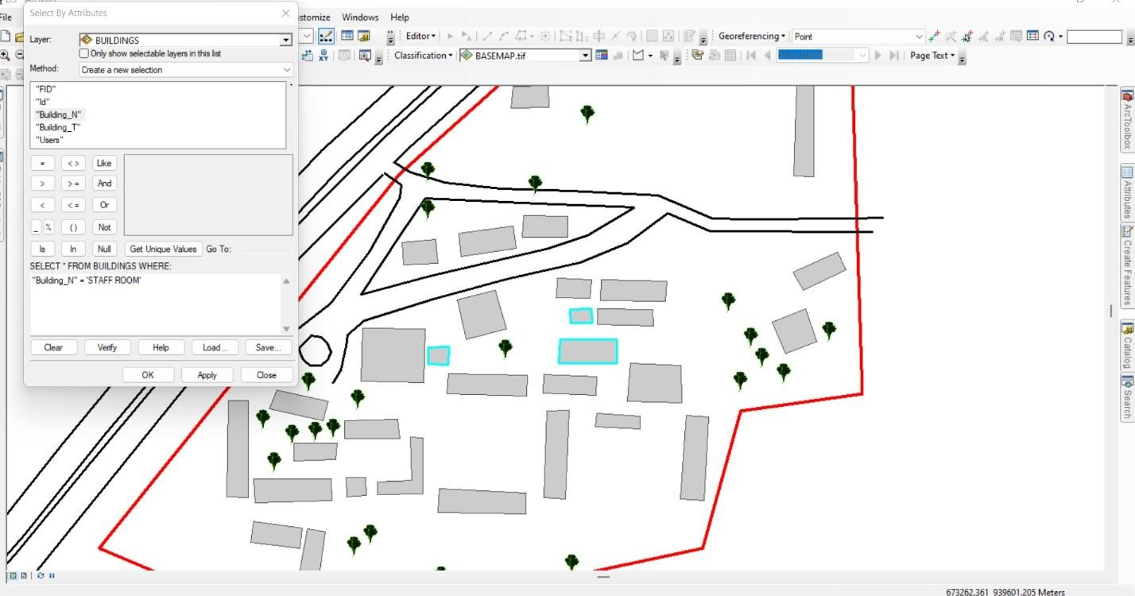

Figure 4.7: Sample Staff room Query Results in Arc-GIS
- Mapping Distribution of Class rooms:

Query: "Show all Class rooms"

Result: A spatial representation of class room locations was displayed, ensuring adequate office space allocation.
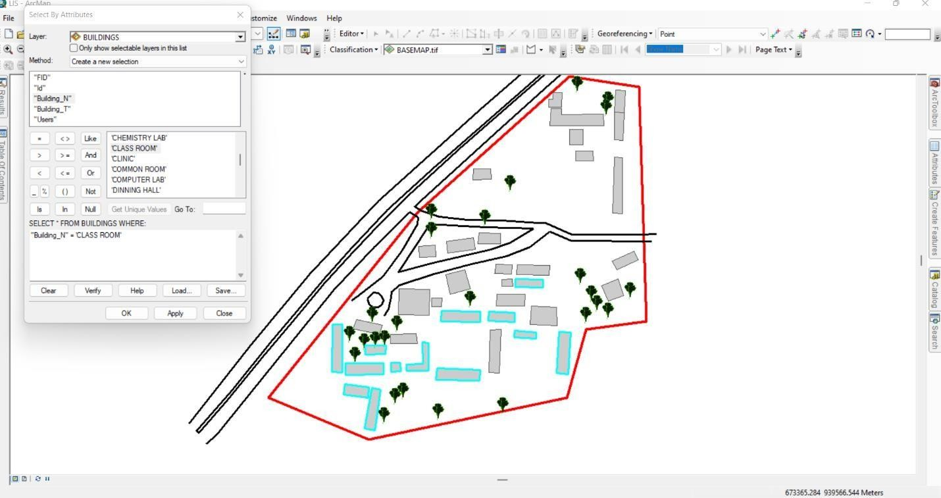

Figure 4.8: Sample Class room Query Results in ArcGIS

CHAPTER FIVE

SUMMARY, CONCLUSION, AND RECOMMENDATION

Summary

This study focused on the development of a Land Information System (LIS) for a secondary school, integrating spatial and non-spatial data to improve infrastructure management and decisionmaking. The research employed Total Station for data acquisition, AutoCAD for spatial data processing, Surfer for topographical analysis, and ArcGIS for data integration and query- based analysis. These tools were used to collect, analyze, and interpret information on the school’s physical structures, terrain characteristics, and facility attributes.
The results of the study provided valuable insights into the spatial organization of school infrastructure, land use efficiency, and facility conditions. The school boundary and building footprints were successfully mapped, distinguishing various structures such as classrooms, staff rooms, laboratories, and administrative offices. The topographical analysis revealed areas prone to waterlogging due to low elevation, highlighting the need for better drainage solutions.
The study demonstrated how a LIS framework can support facility management, enhance accessibility planning, and optimize resource distribution. The integration of these datasets into a spatial database provided a structured and efficient system for managing school infrastructure, ensuring better decision-making and long-term planning.

Conclusion

The study successfully developed a Land Information System (LIS) tailored for secondary school management, demonstrating the importance of GIS-based analysis in educational infrastructure

planning. The integration of spatial and non-spatial datasets allowed for a comprehensive understanding of the school’s facilities, land use patterns, and terrain variations. The findings confirmed that GIS is a powerful tool for managing school environments, enabling authorities to make informed decisions on infrastructure development and maintenance planning.
One of the key conclusions drawn from the study is that spatial analysis can identify infrastructure challenges, such as classroom congestion, poor accessibility, and drainage issues, which might otherwise go unnoticed. The topographical analysis helped assess elevation variations, revealing areas requiring drainage improvements. Furthermore, the integration of non-spatial data with GIS facilitated efficient facility tracking, maintenance scheduling, and infrastructure optimization.
Query-based spatial analysis provided critical insights into facility allocation and emergency response planning. By analyzing building conditions, accessibility networks, and spatial distributions, decision-makers can develop strategic plans for sustainable school management. The results of this research demonstrate that GIS-based LIS is a valuable tool that can be adopted by educational institutions for improving facility management, enhancing infrastructure planning, and ensuring effective land use utilization.

Recommendations

Based on the findings and conclusions of this research, several recommendations are proposed to improve school infrastructure and enhance the application of Land Information Systems (LIS) in facility management.
In terms of facility maintenance and planning, the study recommends the adoption of a preventive maintenance strategy using GIS for real-time monitoring of building conditions and infrastructure deterioration. A structured maintenance plan should be developed based on the LIS database,

prioritizing buildings that require urgent repairs. Additionally, the use of GIS-based tracking will help optimize resource allocation, ensuring that maintenance efforts are distributed effectively across the school premises.
To further enhance LIS adoption, the school should consider expanding the database to include real-time data collection tools such as IoT sensors, drones, or mobile GIS applications for continuous monitoring of school infrastructure. Future research should also focus on integrating advanced spatial models and automation techniques to improve decision-making and infrastructure management.
By implementing these recommendations, the school will not only enhance infrastructure planning and management but also ensure sustainable facility development and optimal resource utilization. The findings of this research emphasize the importance of GIS-based LIS in school management, serving as a model for improving infrastructure planning in other educational institutions.
COSTING
The costing of this project was done using the Nigeria Institution of Surveyor's (NIS) professional scale of fees for consultant in the construction industry. This stage shows the total cost that was spent on the project from day one to the final stage.
RECCI
PERSONAL/QUALITY | DAY(S) | UNITRATE(N) | TOTAL AMOUNT(N)
1 Senior Surveyor | 1 | 20,000.00 | 20,000.000
Assistant Surveyor | 1 | 8,000.00 | 8,000.00
Transportation | 1 | 7,000.00 | 7,000.00
Basic Equipment | 1 | 8,000.00 | 7,000.00
TOTAL |  |  | #42,000.00

BEACON= 2,100 × 5
= #10,500

BEACONING
PERSONAL/QUALITY | DAY(S) | UNITRATE(N) | TOTALAMOUNT(N)
1Assistant Surveyor | 1 | 8,000.00 | 8,000.00
Basic Equipment (6) | 1 | 8,000.00 | 8,000.00
Transportation | 1 | 7,000.00 | 7,000.00
TOTAL |  |  | #23,000.00

TRAVERSING
PERSONAL/QUALITY | DAY(S) | UNITRATE(N) | TOTALAMOUNT(N)
1 Assistant Surveyor | 2 | 8,000.00 | 16,000.00
Basic Equipment | 2 | 8,000.00 | 16,000.00
Transportation | 2 | 7,000.00 | 14,000.00
TOTAL |  |  | #46,000.00

DOWNLOADING DATA AND PLOTTING
PERSONAL/QUALITY | DAY(S) | UNITRATE(N) | TOTALAMOUNT(N)
1Senior Surveyor | 2 | 15,000.00 | 30,000.00
1AssistantSurveyor | 2 | 8,000.00 | 16,000.00
Transportation | 2 | 7,000.00 | 14,000.00
Consumables | 2 | 7,000.00 | 14,000.00
TOTAL |  |  | #74,000.00

INFORMATION PRESENTATION
PERSONAL/QUALITY | DAY(S) | UNITRATE(N) | TOTALAMOUNT(N)
1Assistant Surveyor | 1 | 8,000.00 | 8,000.00
Transportation | 1 | 7,000.00 | 7,000.00
TOTAL |  |  | #15,000.00

(1) # 42,000.00
(2) # 10,500.00
(3) # 23,000.00
(4) # 46,000.00
5) #74,000.00
(6) # 15,000.00
TOTAL # 210,500.00 CONSTIGENCIES=5% 210,500.00×5%÷ 100
= #10,525.00

V. A. T = 7.5%
210,500.00×7.5%÷100
= #15,787.50

MOBILIZATION AND DEMOBILIZATION =10%
2o10, 500.00 × 10%. ÷ 100
= #21,050.00
ACCOMODATION = 1.5%
210,500.00 ×1.5%÷100
= 3,157.50
TOTAL = 210,500.00

10,525.00
15,787.50
21,050.00
3,157.50
GRAND TOTAL = 261,020.00

References

Ansah, M., Osei, P., & Frempong, D. (2024). Ghana Enterprise Land Information System (GELIS) and its contribution to land administration. Land Use Policy, 91, 104357.
Aina, O. (2017). Application of Geographic Information System (GIS) for educational facility mapping in Lagos State, Nigeria. Journal of Geography and Urban Planning, 36(2), 67-83.
Becerik-Gerber, B., Lin, M., & Kamat, V. (2012). Building information modeling for the new millennium: A comprehensive review. Journal of Construction Engineering and Management, 138(2), 1-18.
Burrough, P. A., & McDonnell, R. A. (1998). Principles of Geographical Information Systems. Oxford University Press.
Dale, P. F., & McLaughlin, J. D. (1999). Land Administration. Oxford University Press.

FIG (International Federation of Surveyors). (1995). Land Administration Guidelines. United Nations.

Mylonas, P., Papadopoulou, M., & Spyridonos, S. (2019). IoT-enabled monitoring of energy consumption in buildings for energy efficiency improvement. International Journal of Energy Research, 43(10), 4056-4074.
Osei-Tutu, E. (2011). The role of land information systems in effective land management: A case study in Ghana. Journal of Spatial Planning, 12(1), 47-59.
Shahariar, M., Usman, F., & Jamil, A. (2023). Blockchain-based land records management system: Challenges and opportunities. Land Use Policy, 118, 106214.
Williamson, I. P., Enemark, S., & Wallace, J. (2010). Land Administration Systems. Springer.

APPENDIX

EASTINGS | NORTHINGS | Elevation
673384.7 | 939882.4 | 284.324
673368.3 | 939852.6 | 284.974
673406 | 939809.5 | 285.418
673328.8 | 939826.6 | 286.878
673277.2 | 939835 | 285.121
673258.7 | 939839.1 | 283.911
673298.3 | 939799.4 | 288.005
673328.2 | 939792.3 | 287.552
673312.6 | 939762.8 | 289.926
673211 | 939791.9 | 283.435
673176 | 939756.2 | 283.922
673192.6 | 939752.9 | 284.652

673304.7 | 939734.3 | 290.222
673416.3 | 939684.2 | 290.247
673262 | 939711.3 | 288.105
673150 | 939731.4 | 284.378
673146.7 | 939696.4 | 283.653
673227.3 | 939675.6 | 284.134
673246.1 | 939672.8 | 284.316
673321.7 | 939630.2 | 288.378
673117.2 | 939688.4 | 282.391
673294 | 939592 | 283.783
673337.8 | 939578.5 | 283.019
673272 | 939568.4 | 282.117
673104.7 | 939620.4 | 281.182
673073.4 | 939634.1 | 276.58
673071.2 | 939615.2 | 275.123
673242.9 | 939550.3 | 280.075
673203.9 | 939544.3 | 280.735

673148.8 | 939568.4 | 281.263
673052.7 | 939612.9 | 272.448
673140.3 | 939546.8 | 280.215
673159.3 | 939539.3 | 280.517
673136 | 939532 | 279.591
673114.2 | 939546.4 | 279.556
673037.9 | 939584.1 | 270.915
673025.4 | 939566.5 | 270.677
673037.9 | 939584.1 | 270.915
673048.7 | 939603.2 | 272.177
673145.4 | 939724.6 | 283.813
673170.7 | 939748.4 | 284.45
673188.6 | 939764.6 | 283.773
673320.9 | 939845.5 | 287.18
673362.2 | 939875.4 | 285.746
673385.9 | 939892.8 | 284.152
673372.8 | 939797.9 | 284.644
673363.7 | 939784.4 | 286.123
673354.6 | 939769.4 | 288.129
673345.7 | 939755.1 | 289.742
673090.2 | 939538.8 | 278.481
673341.7 | 939727.3 | 291.403
673417.2 | 939777.8 | 284.558
673403.7 | 939704.2 | 289.927
673373.8 | 939666.3 | 290.383
673366.7 | 939657.7 | 289.8

673359.7 | 939648.9 | 289.387
673354.7 | 939644.1 | 289.178
673322.5 | 939606.4 | 286.048
673144.6 | 939544.4 | 280.276
673154.8 | 939560 | 281.098
673166.3 | 939577 | 281.907

673335.6 | 939739 | 291.06
673409.7 | 939902.9 | 285.097
673344 | 939813.6 | 285.841
673333 | 939800.4 | 286.532
673317.5 | 939785.4 | 288.656
673275.5 | 939754.9 | 289.562
673155.4 | 939649.3 | 284.999
673153.1 | 939647.9 | 284.914
673145.9 | 939640.2 | 284.266
673136.9 | 939632 | 283.646
673095.5 | 939590.5 | 279.358
673085.9 | 939576.8 | 278.209
673068.7 | 939548 | 275.907
673041.6 | 939564.6 | 272.021
673061 | 939584.5 | 273.936
673071.1 | 939593.9 | 275.368
673171.3 | 939705.6 | 284
673234 | 939763.5 | 286.572
673274.2 | 939798.6 | 287.23
673284.9 | 939807.8 | 287.065
673360.2 | 939896.9 | 286.454
673379.6 | 939906.3 | 285.363
673415.1 | 939877.3 | 285.558
673385 | 939777 | 285.683
673370.4 | 939740.7 | 289.914
673366 | 939728.9 | 290.9
673360.4 | 939716.8 | 291.697
673347.6 | 939690.5 | 292.448
673267.4 | 939567.2 | 281.818
673249.8 | 939761.5 | 287.673
673253.6 | 939769.1 | 287.673
673289.4 | 939837.7 | 285.923
673359.1 | 939907 | 286.683

673309.1 | 939718.2 | 290.864
673386.5 | 939846.5 | 284.751
673381.1 | 939847.9 | 284.798
673311.7 | 939810.2 | 287.49

673214.1 | 939753.6 | 285.594
673151.2 | 939668 | 284.273
673298.3 | 939761.6 | 289.834
673410.6 | 939819.5 | 286.064
673412.8 | 939743.1 | 286.98
673386 | 939725.4 | 289.89
673338.4 | 939696.8 | 292.455
673094.8 | 939567.3 | 279.722
673060.1 | 939554.7 | 274.721
673308.9 | 939615.9 | 286.747
673367.4 | 939644.7 | 288.332
673384.7 | 939651.2 | 288.549
673397.8 | 939656.6 | 288.644
673418 | 939665.7 | 289.824
673222.9 | 939571.6 | 281.678
673209 | 939559 | 281.109
673195.2 | 939545.6 | 280.87
673184.7 | 939538.6 | 280.999
673419.4 | 939652.4 | 289.44
673406.3 | 939665.7 | 289.634
673135.8 | 939557.7 | 280.436
673183.4 | 939557.6 | 281.026
673265.8 | 939558.1 | 281.327
673275.6 | 939560.4 | 282.041
673326.7 | 939576.1 | 282.93
673336.1 | 939577.2 | 282.915
673337.2 | 939577.8 | 282.96
673340.2 | 939579.1 | 283.101

673332.5 | 939572.9 | 282.561
673244.5 | 939571.8 | 280.976
673279.8 | 939710.7 | 289.235
673329.3 | 939714.1 | 291.661
673291 | 939772.5 | 289.507
673213.4 | 939769.2 | 285.037
673363.1 | 939841.6 | 285.29
673415.4 | 939850.6 | 286.503
673382.8 | 939854.7 | 284.659
673268.8 | 939807.9 | 286.262
673381.1 | 939790.3 | 285.169
673404.1 | 939698.9 | 290.112
673359.7 | 939699.5 | 292.101
673211.9 | 939636.4 | 283.159
673241.3 | 939612.7 | 282.141

673274.4 | 939604.9 | 282.939
673119.8 | 939627.5 | 282.657
673089.5 | 939639.6 | 279.492
673351.4 | 939620.1 | 286.705
673139.7 | 939652.3 | 284.027
673090.5 | 939659.4 | 280.094
673288 | 939729.3 | 289.918
673390.6 | 939747.4 | 287.987
673406.2 | 939749.5 | 286.834
673318.7 | 939777.2 | 289.241
673353.4 | 939813.4 | 285.219
673327.9 | 939814.1 | 286.716
673276.9 | 939802.7 | 287.085
673233.8 | 939788.3 | 285.237
673246.2 | 939797.5 | 285.454
673277.4 | 939813.8 | 286.407
673333.9 | 939845 | 287.321

673121.2 | 939624.5 | 283.071
673121.1 | 939615.1 | 282.792
673143.9 | 939624.5 | 283.815
673100.3 | 939592.9 | 281.442
673085.4 | 939596 | 278.194
673096.8 | 939595.6 | 279.372
673149.2 | 939596.2 | 281.843
673159.5 | 939597 | 281.78
673141.2 | 939594 | 282.01
673099.8 | 939605.7 | 282.096
673148.7 | 939606.2 | 282.084
673165.5 | 939604.1 | 283.126
673096.8 | 939647.3 | 281.218
673108 | 939642.9 | 281.375
673136.6 | 939636.5 | 282.179
673111.8 | 939652.6 | 283.596
673148.2 | 939636.5 | 284.471
673176.3 | 939637.2 | 284.381
673177.4 | 939627 | 284.25
673165.5 | 939597.3 | 283.212
673197.6 | 939587.9 | 282.967
673244.4 | 939586.8 | 282.022
673198.4 | 939600.3 | 281.592
673254.1 | 939595.6 | 282.376
673265.5 | 939594.9 | 283.309
673255.8 | 939641.6 | 282.017

673281.4 | 939633.4 | 283.739
673305.1 | 939632.2 | 284.123
673282.1 | 939640.3 | 285.194
673327.4 | 939646 | 290.763
673298.4 | 939647 | 289.971
673327.1 | 939666.1 | 292.244

673254 | 939661.3 | 284.252
673281.6 | 939649.9 | 284.438
673244.8 | 939649.7 | 282.435
673253.5 | 939651.3 | 282.443
673245.2 | 939660.8 | 283.997
673262.1 | 939667.2 | 284.253
673262.6 | 939679.7 | 286.756
673292.7 | 939667.2 | 287.534
673156.8 | 939657.7 | 284.797
673190.1 | 939656.9 | 284.931
673190.9 | 939685.2 | 284.021
673207.8 | 939700.8 | 284.134
673212.7 | 939679.8 | 283.992
673234.3 | 939685.5 | 284.829
673157.5 | 939685.9 | 283.582
673203.3 | 939666.4 | 284.044
673192.5 | 939675.4 | 283.893
673203.7 | 939675.9 | 283.133
673202.6 | 939650.8 | 283.871
673228.2 | 939705.8 | 284
673178.7 | 939731.5 | 284.127
673197.5 | 939720.1 | 284
673179.3 | 939719.3 | 284.169
673208.6 | 939736.3 | 285.441
673210 | 939723.9 | 285.565
673239.3 | 939728.1 | 287.38
673196.5 | 939732.8 | 285.965
673237.7 | 939740.2 | 285.981
673243.3 | 939745.8 | 287.908
673266.6 | 939745.3 | 289.626
673260.8 | 939702.2 | 292.324
673293.1 | 939679.9 | 290.403
673299.9 | 939667.1 | 289.403

673399.1 | 939678.4 | 289.269
673382.5 | 939672.3 | 289.093
673392 | 939705.9 | 291.205
673375.3 | 939688.7 | 291.609
673393.3 | 939695.9 | 290.854
673414.7 | 939716.5 | 288.314
673386.7 | 939715.5 | 290.931
673410.5 | 939726 | 287.665
673319.6 | 939710.9 | 292.093
673318.9 | 939700.1 | 289.855
673284.5 | 939711.5 | 289.939
673266.6 | 939734.1 | 289.765
673236.8 | 939802.9 | 284.509
673237.8 | 939814.4 | 283.996
673256.7 | 939803.2 | 285.935
673347.6 | 939823.1 | 287.83
673242.5 | 939734.1 | 289.519
673386.9 | 939766.8 | 286.751
673397.8 | 939766.3 | 284.723
673388.8 | 939826.9 | 284.968
673397.5 | 939826.6 | 284.746
673347.6 | 939833.6 | 285.377
673366.2 | 939833.9 | 284.881
673341.1 | 939840.1 | 286.99
673355.4 | 939840.2 | 285.718
673355.4 | 939857.2 | 285.598
673342 | 939857 | 285.635
673319.4 | 939861.2 | 287.356
673321.1 | 939879.7 | 287.56
673332 | 939879.4 | 287.867
673332.3 | 939873.1 | 287.697
673377.3 | 939873.8 | 287.932
673378.1 | 939860.8 | 284.921

673332.4 | 939880.9 | 286.766
673332.7 | 939896.3 | 287.526
673389.4 | 939875.3 | 284.306
673400 | 939874.5 | 284.067
673389.1 | 939845.7 | 284.362
673398.5 | 939845.2 | 284.514
673390.4 | 939899.1 | 284.735
673401 | 939898.6 | 283.725
673318.2 | 939880.8 | 287.29
673323 | 939896.6 | 286.94
673322.9 | 939889.5 | 285.163

