A PROJECT REPORT
ON
LAND INFORMATION SYSTEM OF GOVERNMENT
SECONDARY SCHOOL MARABA, ILORIN EAST LOCAL
GOVERNMENT AREA, ILORIN, KWARA STATE.

PRESENT BY:
YUNUSA RUKAYAT
HND/23/SGI/FT/0090

SUBMITTED TO:
THE DEPARTMENT OF SURVEYING AND GEOINFORMATICS

INSTITUTE OF ENVIRONMENTAL STUDIES
KWARA STATE POLYTECHNIC P.M.B 1340
ILORIN, KWARA STATE.

IN PARTIAL FULFILLMENT OF THE REQUIREMENT FOR
THE AWARD OF HIGHER NATIONAL DIPLOMA IN SURVEYING
AND GEO-INFORMATICS

SUPERVISOR:
MR ABIMBOLA IBRAHIM ISAU

JUNE, 2025

DECLARATION
I hereby certify that all the information given in this project was obtain as result of field observation and measurement made by me and that the survey was carried out in accordance with survey rules and regulation and department instructions.

NAME: YUNUSA RUKAYAT

MATRIC NO: HND/23/SGI/FT/0090

DATE:

SIGNATURE:

CERTIFICATION
This is to certify that this project report was prepared and submitted by YUNUSA RUKAYAT of Matric No: HND/23/SGI/FT/0090 to the Department of Surveying and Geo-Informatics, Institute of Environmental Studies Kwara State Polytechnic Ilorin, as a result of field observation and measurement using appropriate instrument and equipment to carry out the task.

---------------------------------------- --------------------------
SURV. ABIMBOLA IBRAHIM ISAU DATE
Project Supervisor

---------------------------------------- --------------------------
SURV. ABIMBOLA IBRAHIM ISAU DATE
Head of Department

---------------------------------------- --------------------------
SURV. R. S AWOLEYE DATE
Project Coordinator

DEDICATION
This project is dedicated to Almighty Allah and to my loving parents whose continuous effort, support and encouragement made it possible for me to participate in this project.

ACKNOWLEDGEMENT
I am grateful to almighty Allah for the successful completion of this program and for making this course a success in my life. To everyone around me come rain, come sunshine, I say thank you a million times. Also I appreciate my Parents Mr. and Mrs. Mahmud Yunus for their support in the course to pursue surveying and Geo- Informatics to this level, word can’t be enough to appreciate you.
To my beloved brothers and sisters Mr. Abdulhakeem, Miss Barakah, Miss Khadijah Yusuf, Mustophah and Abdulsobur, I say thank you.
My gratitude goes to my project supervisor Surv. Abimbola Ibrahim Isau for the knowledge been impact to me during the program may almighty Allah be with you and your family allahumo Aameen. I will noy relent to Appreciate the effort of all the staffs in the department in person of Surv. Abimbola Ibrahim Isau (HOD), Surv. Babatunde Kabir, Surv. R. O. Asonibare, Surv. R.S. Awoleye, Surv. Ayuba Abdulsalam, Surv. Bello Felix and humble Surv. A.G. Aremu may almighty Allah enrich you all(Amin).
So also to mention is the care, love and support received from colleagues in the class especially my project group members, and the rest. I pray that God will bless you all and all others who have contributed immensely to the successful completion of this course.
Finally,my profound gratitude goes to my amazing and supporting friends, Kazeem Kabira, Abdulqudus Shukurah, Abdulganiyu Mustopha and Salaudeen Haleema I say a big thank you and God bless you all.

ABSTRACT

The need for information, which is the best necessity for carrying out any planning, development and management activity, can hardly be over emphasized, with regard to the developing nations with inadequate resources, the heed for having a reliable information base is even more important. The absence of the proper land records in the real market is another difficulty being faced by many developing countries. The reason may be unclear delimitation of individual or group right, insecure ownership etc. the necessity for a functioning land market opens the not only other means of ensuring that land is available for dwelling and other urban needs. In this way, the development and implementation of countries wise digital cadastral information system is an area that needs urgent attention. It is felt that there is a need to at least initiate efforts towards achieving this formidable task in an organized manner. As land is one of the most fundamental of resources, with the above background, this highlights all the information on land such as roads, buildings, street lights, electric poles, drainage the topology configuration of government secondary school Maraba, Ilorin, Ilorin west local Government Area of Kwara State. All plans were produced at the scale of 1: 2,500 in accordance to the survey rules and regulation.

TABLE OF CONTENTS
TITLE PAGE i
DECLARATION ii
CERTIFICATION iii
DEDICATION iv
ACKNOWLEDGEMENTS v
ABSTRACT vi
TABLE OF CONTENTS vii
CHAPTER ONE
- INTRODUCTION 1
1.1 BACKGROUND OF STUDY 1
1.2 STATEMENT OF PROBLEM 4
1.3 AIM OF THE PROJECT 5
1.4 OBJECTIVE OF THE PROJECT 5
1.5 SCOPE OF THE PROJECT 6
1.6 PROJECT SPECIFICATION 6
1.7 STUDY AREA 6
1.8 PERSONNEL INVOLVED 9
CHAPTER TWO
2.0 LITERATURE 10
CHAPTER THREE
3.0 METHODOLOGY 14
3.1 PROJECT PLANNING 14
3.1.1 OFFICE PLANNING 14
3.1.2 FIELD RECONNAISSANCE 14
3.2 DATA BASE DESIGN 16
3.2.1 VIEW OF RE4ALITY
3.2.2 LOGICAL DESIGN
3.3 HARDWARE AND SOFTWARE USED 16
3.3.1 HARDWARE USED 16
3.3.2 SOFTWARE USED 16
3.4 TEST OF INSTRUMENT 16
3.4.1 HORIZONTAL COLLIMINATION TEST
3.4.2 VERTICAL INDEX ERRORBTEST
3.4.3 ANALYSIS OF COLLIMINATION AND VERTICAL INDEX DATA
3.5 CONTROL CHECK 17
3.5.1 CONTROL CHECK PROCEDURE USING TOTAL STATION
3.6 GEOMETRIC DATA ACQUISITION 18
3.6.1 DETAILED SURVEY 18
3.6.2 NON SPATIAL DATA COLLECTION 19
3.6.3 ATTRIBUTE/SOCIAL SURVEY 20
3.8 DATABASE CREATION 20
3.8.1 DATABASE MANAGEMENT SYSTEM (DBMS) 21
3.8.2 DATA QUALITY 21
3.8.3 DATA INTEGRITY 22
3.8.4 DATA SECURITY 22
3.9 DATA PROCESSING 23
3.9.1 DRAFTING AND PLOTTING 23
3.9.2 DATABASE CREATION PROCEDURE 23
CHAPTER FOUR
4.1 INTRODUCTION 25
4.2 SPATIAL DATA RESULT 26
4.2.1 SCHOOL BOUNDARY AND BUILDING LAYOUT 26
4.3 TOPOGRAPHICAL ANALYSIS RESULTS 29
4.3.1 DIGITAL ELEVATION MODEL (DEM) 29
4.3.2 CONTOUR MAPPING 31
4.3.3 SLOPE AND TERRAIN ANALYSIS 32
4.3.4 SIGNIFICANCE OF TOPOGRAPHICAL ANALYSIS RESULT 35
4.4 NON-SPATIAL DATA RESULTS 35
4.4.1 ATTRIBUTE DATA FOR SCHOOL BUILDINGS 36
4.4.2 LINKING NON-SPATIAL DATA WITH GIS 37
4.4.3 SIGNIFICANCE OF NON-SPATIAL DATA IN LIS 38
4.5 QUERY EXECUTION AND RESULT 39
CHAPTER FIVE
5.0 COST ESTIMATION, SUMMARY AND CONCLUSION 41
5.1 COST ESTIMATION 41
5.2 SUMMARY 45
5.3 CONCLUSION 46
5.4 RECOMMENDATION 46
REFERENCE 47
APPENDIX 49

LIST OF TABLES
Table 3.1:- Collimation test for the Total Station (Field Observation) 17
Table 5.1 Recci 41
Table 5.2 Beaconing 42
Table 5.3 Traversing 42
Table 5.4 Data Downloading and Editing 43
Table 5.5: Information Presentation 44

LIST OF FIGURES
Fig 1: 1 Study Area location 8
Fig. 3.2.2.1: shows Recce diagram of the study area (not drawn to scale) 15
Figure 4.1: Mapped School Boundary and Buildings in ArcGIS 27
Figure 4.2: Digital Elevation Model (DEM) of the School Premises 30
Figure 4.3: Contour Map of the School Premises 32
Figure 4.4: Slope Analysis Map of the School Premises 34
Figure 4.5: Sample Attribute Table for School Buildings 37
Figure 4.6: Linking Non-Spatial Data to Spatial Features in ArcGIS 38
Figure 4.7: Sample Staff room Query Results in ArcGIS 39
Figure 4.8: Sample Class room Query Results in ArcGIS 40

CHAPTER ONE
INTRODUCTION
1.1 BACKGROUND TO THE STUDY
Land is one of the most valuable natural resource endowed to mankind. According to (Pindiga &Orisakwe, 2013), land form the basis for all forms of human activity; thus, it served as a basis for living, working and shelter. It is an important asset that determines a country’s wealth. The economic development of a country depends upon the availability of land and its usage. Land is considered to be fixed and scarce in nature. Thus it is essential to survey and manage effectively and efficiently for the use and good of mankind. It is apparent, therefore, any information concerning land is valuable key to financial investments, commerce, industry and agriculture (Musa et al., 2016). Land is depicted to include land of any tenure, tenements, hereditaments, corporal, or incorporeal, an undivided share in land, houses, other buildings and anything attached or permanently fastened to earth but does not include minerals (Yusuf Y. D 2009). One unfortunate consequence of this growth has been the deterioration of the urban environment and the resulting reduction in the quality of life in cities. Today Land as a valuable asset is owned and controlled by individuals, public and private sectors. Thus land becomes a necessity of life,these needs warrant the transformation into a myriad of uses and land becomes a scarce commodity. This of course, is due to the rapid population growth of man on earth and his desires to explore land in myriad of ways (Usman & Sc, 2013). The consequence of this growth affect environmental quality (Williamson, I. P 1994), result in an illegal transactions, conflicts, partitions, grabbing and snatching etc. An Ideal land administration provide easy access to land for development, increase efficiency in land use for management, promote social equity, revenue generation, conservation of environmental quality and promote security of tenure
(Usman & Sc, 2013).This means that Digital land information is essential for land administration (Musa et al., 2016).
Land Information System(LIS) which focuses on how to acquire, manage, retrieve, analyse, display and record information regarding land. It is a tool for Cadastral and land use mapping. LIS provide a current, accurate and reliable land records and its attributes as well as spatial data that represent the legal boundaries of land and also provides a foundation or base layer for assimilation into other geographic system. It will allow stewards to retrieve, create, update, store, view, analyse and publish land information. According to (Musa et al., 2016),Digital Cadastral system can facilitate effective and efficient land market as well as land-use administration so as to promote economic development, social cohesion and sustainable development. According to (Obayomi Abiola Benjamin) A computerised LIS will help address issues such as multiple allocations of the same plot of land to more than one applicant, rampant cases of land records forgeries, theft of files and illegal smuggling of forged land documents into the land registry; unauthorized persons within the land management system allocating lands contrary to the provisions of the constitution and the Land Use Act.
A Land Information Management System (LIMS) is essentially a computerized tool for legal, administrative and economic decision making for land use planning and development. It consists of a structured database with spatial referenced land related attributes and spatial data for a defined area as well as procedures and techniques for systematic collection, processing, updating and distribution of the data to aid in solving land management problems (Pindiga, 2012). Currently, the world has more or less become a global village and information on a particular phenomenon at one part of the globe may be required by someone at another part, at any point in time. The need for land information computerization and land titling procedure automation is more crucial now than ever before. A functional land information management system should not only ensure that all data relating to land are consistent, correct and up-to-date but should also avail different users their required information without necessarily engaging in generation of new datasets. This entails the availability of land information to government, industry, business, academia and citizens to meet their needs through easy and simple access solutions (Akingbade, 2005). In many countries, improvements to the existing land administration systems are driven by developments in technology. Land and property datasets grow larger in volume as population expands. Consequently, the need for a reliable means of storage and easy retrieval of land information in support of development becomes critical and ever more urgent. Both the administrators and users of land information need accurate and up-to-date data (Dale & McLaughlin, 1999). Additionally, information technology is dynamic; new ideas and inventions are released almost on a daily basis and this should equally reflect in the land information management system. In 2007, Anambra State Government of Nigeria developed and started the use of the Land Information Management System (commonly referred to as ALIMS) hoping to reduce corruption, delays in title registration and enhanced internal revenue generation from state land management. However, challenges of the state land management are still prevalent despite the system which has remained the same. Similar stories are obtained in different states of the federation. A scale up of the existing system may reasonably solve our problem. A holistic land information management system that captures the needs of all relevant stakeholders is expedient.
Land information system (LIS) is a set of software and hardware-based databases that enable the entry, processing, storage, and retrieval of land records (Rakhmonov & Abdurak himova, 2021). LIS enhances land record In recent times, the traditional land administration services have extended from cadastral activities in land tenure and land information management to sharing information among other land-related agencies (Agunbiade & Kolawole, 2016; Enemark, 2009; I. B. Karikari, 2006). This has made land information systems (LIS) imperative for efficient and effective land administration. A land information management and efficient access to information and reduces the bureaucracies in land administration processes (Meijer, 2009). Countries that have successfully implemented LIS for land administration continue to realise the benefits. For instance, experience from developed countries like the Netherlands has demonstrated the usefulness of LIS in making geographic data accessible to all, promoting transparency, and facilitating individual choices about real estate (Kadaster International, n.d.). Unlike in developed countries, implementing LIS in developing countries is challenging (Berisso & de Vries, 2010; Correia et al., 2021). In countries where such information systems are in place, they remain latent; hence, essential decisions are made based on limited information (Karikari et al., 2003). For example, after efficiently implementing LIS in Rwanda, the bureaucratic nature of the registration system discouraged landowners from registering their properties, thereby making their LIS lack up-to-date records for decision making (Biraro, 2014). Similarly, Kenya’s LIS lacks up-to-date records because of informal registration, which is not documented (Siriba & Dalyot, 2017). Other challenges may result from inadequate land data, poor data quality, and the government’s unwillingness to invest in LIS (Yaw Adiaba, 2014). In the scope of innovation in information technology such as LIS, Davis (1989) argued that the system’s adoption and usage are crucial factors in achieving the overall success of implementation. One must utilise LIS to achieve the expected outcome; however, this is often not the case in many developing countries. Liberia, for instance, has failed to integrate their LIS into their land administration function (Zeng & Cleon, 2018)
1.2 STATEMENT OF PROBLEM
Land administration and management in Government Secondary School Maraba continues to form critical inefficiencies, lack of coordination, and outdated systems in the study area. These problems underscore a deeper need, the urgent implementation of a digital solution that can integrate spatial data, and land use details into a unified platform.
Therefore, this project seeks to address these challenges by designing and implementing a Land Information System that is intelligent, accessible, and tailored to support effective land administration and sustainable development in Government Secondary School Maraba.
1.3 AIM OF THE PROJECT
The primary aim of this project is to design and implement a functional Land Information System (LIS) that enhances the efficiency, accuracy, and transparency of land management processes within Government Secondary School Maraba, Ilorin East Local Government, Ilorin Kwara State. The system will serve as a digital platform for organizing, storing, retrieving, and managing land-related data, with the ultimate goal of supporting effective decision-making, reducing land disputes, improving access to land records, and promoting sustainable land administration at the institutional level.
1.4 OBJECTIVE OF THE PROJECT
The specific objectives of this project are
- Design a user-friendly Land Information System capable of managing land and usage data in a centralized digital format.
- Geometric and attribute data acquisition
- Implement core features of the system including data entry, spatial mapping, search and retrieval functions, and secure access control.
- Integrate Geographic Information System (GIS) tools to visualize and enable location-based analysis and decision-making.
- Evaluate the performance of the developed system in terms of accuracy, usability, responsiveness, and reliability.
- To produce plans as graphical representation

1.5 SCOPES OF THE PROJECT
The scopes of this project covers the following major phases and activities:
- Reconnaissance Survey: Preliminary field inspection to understand the area of study, identify existing features and determine control points needed for mapping.
- Office Planning: Preparation of necessary materials, equipment checks, defining the workflow, and gathering existing maps or records for the project area.
- Data Acquisition: Collection of spatial and non-spatial data through total station.
- System Design and Implementation: Development of a functional Land Information System to address land management and decision making.
- Documentation and Reporting: Compilation of project activities, methodologies, system features, and outcomes into a final technical report.
1.6 PROJECT SPECIFICATION
This project is aimed at building a Land Information System (LIS) to support effective land management. The system will combine both spatial (map-related) and non-spatial (text-based) information to help users register, retrieve, and visualize land records
1.7 STUDY AREA
Government Secondary School (GSS) Ilorin, located in Maraba area of Ilorin, Kwara State, Nigeria, stands as a significant institution in the region’s educational history. Established in October 1914, following the amalgamation of Northern and Southern Protectorates by the British, GSS Ilorin is the oldest post-primary institution in Kwara State and ranks among the oldest secondary schools in Nigeria.
The school has maintained a full boarding system, serving as a center of unity by accommodating students from all geopolitical zones of Nigeria through its exchange program.
In recent years, GSS Ilorin has faced challenges related to infrastructure and maintenance. Report indicate that many public-funded school in Kwara State, including GSS Ilorin, have suffered from neglect, leading to deteriorated facilities and a lack of essential equipment. Despite these challenges, the school’s legacy of excellence continues to inspire efforts toward its revitalization and the preservation of its rich history.
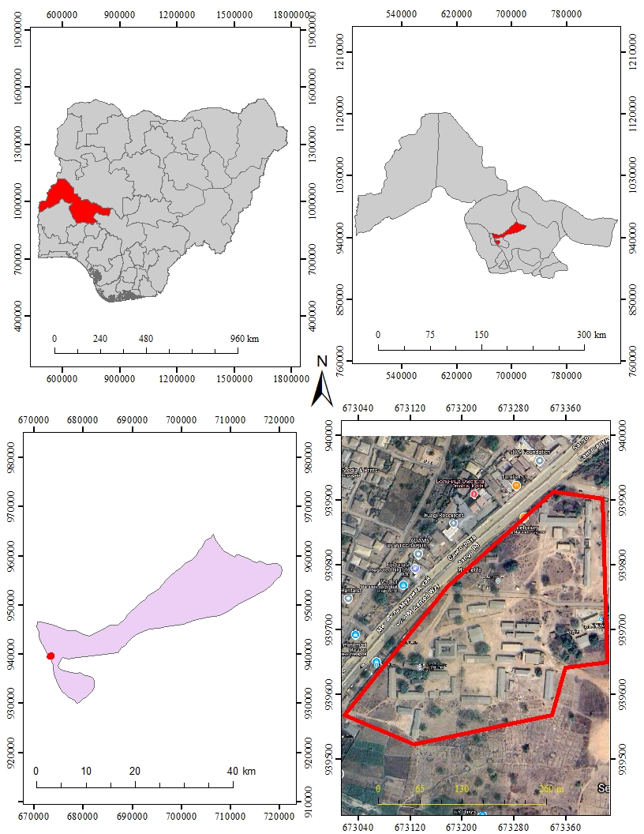
Source: Goggle Earth, 2025, April
Fig 1: 1 Study Area location

1.7 PERSONNEL INVOLVED
NAME MATRIC NUMBER
YUNUSA RUAYAT HND/23/SGI/FT/0090 (AUTHOR)
OLADITI ABDULMUHEEZ OLAYEMI HND/23/SGI/FT/0092
AREMU OLUWAFEMI VICTOR HND/23/SGI/FT/0093
FATOYINBO THERESA HND/23/SGI/FT/0091
AGBALAYA OLAIDE MARGARET HND/23/SGI/FT/0097
AJEORUN JAMIU OLUWADAMILOLA HND/23/SGI/FT/0099
AJIDE ALICE OLUWATOYIN HND/23/SGI/FT/0113
SAMSON DANIEL OLUWATOBILOBA HND/22/SGI/FT/0121

CHAPTER TWO
- INTRODUCTION
A Land Information System (LIS) is a tool for legal, administrative, and economic decision making and an aid for planning and development. It consists of spatially referenced land related data for a defined area and procedures and techniques for the systematic collection, updating, processing, and distribution of the data. This chapter presents a review of literature on LIS, exploring its conceptual framework, components, development, applications, benefits, challenges, and recent advancements. Various scholarly contributions have been examined to provide a comprehensive understanding of the subject.
Concept of Land Information System (LIS) The concept of LIS has evolved over the years from basic land record-keeping to a sophisticated digital and geospatial system. According to Dale and McLaughlin (1988), a Land Information System is defined as “a system for acquiring, processing, storing and distributing information about land.” LIS integrates data on land ownership, land use, land value, and land development to support land administration and management.
Williamson et al. (2010) emphasized that LIS is a subset of a broader Geographic Information System (GIS), specifically focused on land-related data. It provides tools and functionalities for spatial analysis, cadastral mapping, and land registry. Recent definitions by Enemark (2018) highlight LIS as a foundational element in land administration systems that support sustainable development, good governance, and poverty alleviation.
Historical Development of Land Information Systems The development of LIS can be traced to the early 1960s and 70s when governments began to recognize the limitations of paper-based land records. In Canada and Australia, pioneering efforts in automating land records laid the groundwork for modern LIS (Dale & McLaughlin, 1988). In the 1980s and 1990s, technological advancements in GIS, remote sensing, and database management systems contributed significantly to the evolution of LIS (Maguire et al., 1991). The shift from analogue to digital systems led to increased efficiency, accuracy, and accessibility of land information. By the 2000s, international organizations such as the World Bank and UN-Habitat began promoting LIS as part of land reform and sustainable development programs in developing countries (Deininger et al., 2008).
Components of a Land Information System According to Onsrud (1991), the main components of LIS include:
• Spatial Data Infrastructure (SDI): Base maps, cadastral maps, and land parcels. • Attribute Data: Ownership details, land use, land value, zoning, etc.
• Database Management System (DBMS): Manages the storage, retrieval, and manipulation of spatial and attribute data.
• User Interface and Tools: Applications for query, analysis, editing, and reporting.
• Hardware and Software: Computers, GPS, servers, GIS software like ArcGIS, QGIS. Rajabifard et al. (2002) further added institutional and legal frameworks as critical components to ensure effective LIS implementation, particularly in developing countries
Applications of Land Information Systems
Land Information Systems are used in various domains. Some of the key applications include:
• Cadastral Mapping and Land Registration: LIS aids in maintaining accurate and upto-date cadastral data (Williamson et al., 2010).
• Urban Planning and Development Control: LIS supports land use planning, zoning enforcement, and urban infrastructure management (Zevenbergen et al., 2013).
• Taxation and Valuation: Accurate land value data improves property taxation and revenue generation (Deininger et al., 2008).
• Environmental Management: LIS helps in monitoring land degradation, deforestation, and land cover changes (Longley et al., 2005).
• Disaster Management: Used for risk assessment, hazard mapping, and post-disaster recovery (van Westen et al., 2002). 2.6 Benefits of Land Information Systems Several scholars have documented the benefits of LIS, including:
• Improved Land Governance: LIS fosters transparency, reduces land disputes, and enhances tenure security (Enemark et al., 2005).
• Efficient Public Administration: Automation of land records reduces processing time and improves service delivery (Dale & McLaughlin, 1999).
• Economic Development: Facilitates investment by providing reliable land data to stakeholders (Zevenbergen et al., 2013).
• Data Integration and Sharing: Enhances collaboration between government agencies through a unified land database (Williamson et al., 2010). 2.7 Challenges in Implementing Land Information Systems Despite its advantages, LIS implementation faces several challenges:
• High Initial Cost: Development of LIS requires significant financial investment in infrastructure and capacity building (Onsrud, 1991).
• Technical Expertise: Lack of skilled personnel to manage and maintain the system is common in developing countries (Rajabifard et al., 2002).
• Data Inaccuracy and Incompleteness: Poor data quality undermines system reliability and trust (Maguire et al., 1991).
• Institutional Barriers: Resistance to change, poor inter-agency collaboration, and weak legal frameworks hinder LIS success (Enemark, 2018).
Emerging Trends and Future Directions Recent developments in digital technology have introduced new dimensions to LIS: Cloud-Based LIS: Offers scalability, real-time data access, and cost-effectiveness (Saitta et al., 2020). Integration with Internet of Things (IoT): Enhances real-time data collection on land use and environmental factors (Zhou et al., 2021). Mobile GIS: Field data collection and citizen participation through mobile apps are improving data accuracy (Konecny, 2020). Blockchain for Land Registration: Provides secure, immutable records and reduces fraud (Lemmen et al., 2019). AI and Machine Learning: For automated land use classification, predictive modeling, and decision support (Li et al., 2022). 2.9 The Nigerian Context of Land Information System In Nigeria, efforts to digitize land information began in the late 2000s. States like Lagos, Kaduna, and Kwara have initiated various forms of LIS projects (Akingbade et al., 2012). The Kwara State Geographic Information System (KWAGIS) is an example aimed at modernizing land records and improving revenue. However, LIS adoption in Nigeria still faces challenges such as poor funding, inadequate policy support, limited public awareness, and technical skill gaps (Ajayi & Olayanju, 2019.

CHAPTER THREE

3.0 METHODOLOGY
This explained the method and techniques used to pursue the objectives and to realize the aims of this project work, the execution of this project was based on the following basic principle of surveying
- Working from whole to the part.
- The principle of choosing the method of survey most appropriate to meet the desired result.
- The principle of provision for adequate checks to meet the required accuracy
3.1 PROJECT PLANNING
Effective planning is essential before initiating any survey project. This process begins with a thorough inspection of the project area, allowing the researchers to gain a clear understanding of the site prior to commencing fieldwork, known as “RECONNAISSANCE”. Reconnaissance typically consists of two main components: (i) Office Planning (ii) Field Reconnaissance
Effective surveying begins with comprehensive project planning, a systematic process that establishes the foundation for accurate data collection. This preparatory stage involves:
- Thorough research on the targeted land parcel
- Clear definition of survey objectives and deliverables
- Precision assessment to determine methodology and equipment.
3.1.1 OFFICE PLANNING
Office planning which could be termed as office reconnaissance involved knowing the type of instruments, purpose, specification and accuracy require of the survey to be carried out. These led to the choosing of appropriate equipment and method to be employed, also costing of the survey operation was done in the office. Information related to the project was collected from various sources, the coordinate (x, y, and z) of the initial and that of the three choosing controls used for orientation were all obtained from survey department office (KWGIS).
3.1.2 FIELD RECONNAISSANCE
The project site was visited by all the group members to have the true picture of the site for the better planning. The recce diagram was drawn alongside the carrying out and the reasonable artificial features were fixed along and within the traverse lines, the traverse was fixed to maintain perfect indivisibility.
3.2 DATA BASE DESIGN
The design of any database involves three stages namely;
- Conceptual design
- Logical design
- Physical design
VIEWOF REALITY
In database design, there is need for reality which is referred to as the phenomenon that actually exists, including all aspects which may or may not be perceived by individuals. The view of reality however, is the mental abstraction of the reality for a particular application or group of applications.
For this application, the view of reality is made of the topography of the project. Since it is not possible to represent the real world, the only option is to conceptualize and model it in a specified manner to represent the real world. The area of interest to use in this project includes; Green Reserve, Roads, Electric poles, Trees, Water Facilities, Buildings, Football pitch, Streams.

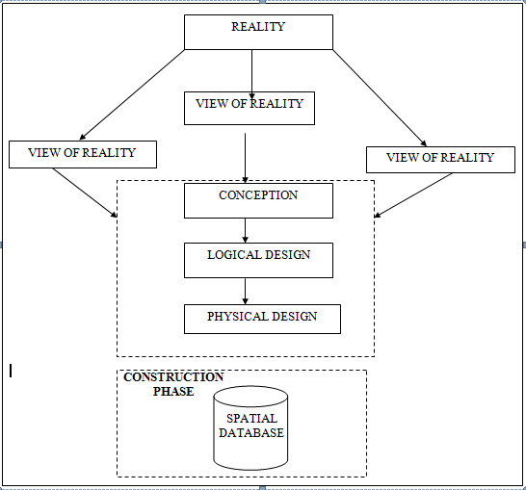

Fig.3.1Design and Construction Phases in Spatial Database (R Sobh, C Perry,. 2006)
    - LOGICALDESIGN

This is the design aspect of the database refers to the process of creating a conceptual framework or model that represents the structure and organization of spatial data within the system. It involves defining the data element, their relationship, and the rules for data manipulation and analysis. In this phase, the entities, their attributes and their relationships are represented in a single uniform manner in form of relation in such a way that would be no information loss and at the same time no unnecessary duplication of data. In this study, the logical database design is employed to generate a geo-relation database structure. Each entity has unique identifier in bold type. An attribute type or combination of attribute types that serves to identify an entity type is termed an identifier.
- Building (B_ID,B_Area, B_Name, B_Easting, B_Northing)

- Roads (R_ID,R_Width, R_Type, R-Condition, R_Easting, R_Northing)

- Vegetation (V_ID,GR_Area,)

- Tree (TR_ID,TR_spp,TR_Importance,TR_Easting,TR_Northing)

- Electric Pole (EP_No,EP_Type,EP_Height,EP_Easting,EP_Northing)

- Football Pitch FP_ID, FP_Area,FP_Status)

3.3 EQUIPMENT USED
3.3.1 HARD WARE
- Total Station (South
- Reflector Pole
- Hand-held GPS
- Steel tape
- Nails and bottle cover
- Field book
- 1 cutlass

3.3.2 SOFTWARE
- AutoCAD 2007
- Arc-GIS 10.2
- Google Earth
- Note pad
- Excel

3.4 INSTRUMENT TEST
To ensure data quality, the Total Station used for this project was tested for both vertical index and horizontal collimation errors. It was also to ascertain the efficiency and reliability of the instrument. The procedure used is described below.

1 HORIZONTAL COLLIMATION TEST

This test was conducted to ensure that the line of sight was perpendicular to the trunnion axis. The Total Station was positioned over a specific point, and initial adjustments were made to ensure proper alignment, leveling, and focus (to eliminate parallax in the telescope). A vertical target was placed at a distance of 100 meters from the Total Station. To access the configuration menu of the Total Station, the menu key was pressed and held for approximately 2 seconds. From the

main menu, the calibration sub-menu was selected, and within that, the horizontal collimation test option was chosen. The target was then observed and divided into two halves, with horizontal readings recorded for Face left and Face right. The readings are shown in Table 3.4.1 below.

Total Station Reflector (Target)
100m

Station A Fairly Level Ground Station B

Fig3.4.1.1; Horizontal Collimation and Vertical Index error test

Table3.4.1.1: Horizontal Collimation Data

Station | Target | Face | Horz. Reading | Difference | Error
A | B | L | 025˚ 32‟ 32”
 |  | R | 205˚ 32‟ 35” | 180˚ 00’ 03” | 00˚ 00’ 03”

VERTICAL INDEX ERROR TEST

This test was conducted to verify the accuracy of the vertical reading when the line of sight is horizontal. The desired measurement for this test is exactly ninety degrees (90˚), any deviation from this value is referred to as the vertical index error.
The Total Station was positioned over a specific point, and necessary temporary adjustments were made to ensure proper alignment and functionality. A target was placed approximately100 meters away from the Total Station, and the instrument
was aimed at the target. The target was bisected by aligning the instrument on the face left, and the corresponding reading was recorded. Similarly, the target was then bisected on the face right and the respective reading were also recorded. The recorded readings are provided below:

Table3.4.2.1: Vertical Index Data

Instrument Station | Target Station | Face | Vertical | Sum | Error
A | B | L | 95˚ 00‟ 00”
 |  | R | 275˚ 00‟ 02” | 360˚ 00‟ 02” | 02”

3.4.3 ANALYSIS OF COLLIMATION AND VERTICAL INDEX DATA

The readings obtained during calibration were reduced to obtain new collimation and vertical errors.
Horizontal collimation = {(FR–FL) –180} /2 ={(00˚00‟03”} /2 =1.5”

Vertical collimation = {(FL+FR) –360} = (95˚00‟00” + 275˚00‟02” ) -360} = 02” The result shows that the instrument is still in good working condition.

3.5 CONTROL CHECK
3.5.1 Control Check Procedure Using Total Station
To ensure the accuracy and reliability of the Total Station observations used for spatial data acquisition, control checks were carried out before and during the main survey. The procedure involved setting up the instrument over a known control point, performing temporary adjustments, executing angular and distance observations (back sight and foresight), and validating the computed coordinates against known values.
Step 1: Instrument Setup and Centering.
The Total Station was mounted securely on a tripod placed directly over the first known control point.
Centering was done using the built-in optical plummet to align the vertical axis of the instrument precisely over the ground mark.
Fine adjustments were made by shifting the tripod legs or using the sliding base plate to achieve perfect alignment.
Step 2: Temporary Adjustments (Leveling and Elimination of Instrumental Error)
Leveling: The circular bubble was first centered using the tripod legs. Then, the tubular (or electronic) level was used with the foot screws to achieve fine leveling in two perpendicular directions.
Collimation Check: An internal calibration (collimation) check was performed using the instrument’s self-diagnosis function to ensure the vertical and horizontal axes were perpendicular.
The horizontal circle was then set to zero after selecting the backsight direction.

Step 3: Back sight Observation
The telescope was rotated to face a second known control point (backsight).
The instrument was focused accurately on the backsight prism, and both horizontal and vertical coordinates (XYZ) were measured.
Step 4: Foresight Observation and Coordinate Validation
The telescope was then turned to observe a third point (foresight). The horizontal and vertical coordinates (XYZ) were measured. The observed coordinates were then compared to the known coordinates of the foresight control point already established.
Coordinate difference (ΔX, ΔY, ΔZ) was calculated to assess positional accuracy. The difference was within the allowable tolerance (typically ±2cm for X/Y and ±3cm for Z), the instrument was considered properly calibrated.
Step 5: Repeat Check at another Station
The same procedure was repeated for every station setup across the site to ensure uniform accuracy across the network.
All three control stations showed closure errors and coordinate differences well within the accepted tolerance for third-order survey work. This control check procedure ensured that the Total Station data used for plotting school boundaries, buildings, and topography in the Land Information System were precise and trustworthy.
Once the control points were verified and validated, they were used as reference locations for the detailed survey of the school facilities.
Table 3.4.1: Coordinate of the observed and the original values of K654AD
PILLAR | NORTHING | EASTING | STATUS | REMARKS
SC/KW K654AD | 939792.896 | 673354.040 |  | ORIGINAL
SC/KW K654AD | 939792.886 | 673354.020 | FIXED | OBSERVED
DISCREPANCY | 0.010 | 0.020

Table 3.4.2: Coordinate of the observed and the original values of K656AD
PILLAR | NORTHING(m) | EASTING(m) | STATUS | REMARKS
SC/KW K656AD | 939837.818 | 673334.688 |  | ORIGINAL
SC/KW K656AD | 939837.797 | 673334.666 | FIXED | OBSERVED
DISCREPANCY | 0.021 | 0.022

Table 3.4.3: Coordinate of the observed and the original values of K657AD
PILLAR | NORTHING(m) | EASTING(m) | STATUS | REMARKS
SC/KW K657AD | 939803.143 | 673366.311 |  | ORIGINAL
SC/KW K657AD | 939803.132 | 673366.291 | FIXED | OBSERVED
DISCREPANCY | 0.011 | 0.020

3.7 GEOMETRIC DATA ACQUISITION

The total station instrument was set carefully on control point SC/KW K6546AD back sight taken to K SC/KW K654AD after necessary station adjustments has been carried out on it. The adjustments include; centering, leveling and focusing. The following procedures were then followed to determine the position of the next point (NL1) and the same procedure were repeated until all we come close to the site. The method used in acquiring data on site was radiation method where two or more points are coordinated from one instrument station.

- Having setup the instrument and temporary adjustment carried out, the instrument was powered „on‟ and a job file was created under job menu in the internal memory of the instrument. The job file created was named GSSGR4C.
- On the job, the coordinates of the three (3) control points were keyed in to the memory of the instrument and some codes were also saved. The codes include
„RD‟ for road, SP‟ for spot height, BD for buildings, etc.

- The height of the instrument was measured and saved on the memory of the instrument as well as their reflector height.
- On coordinate menu, orientation was set by inputting the coordinates of the instrument station and back sight. The reflector at the back station was perfectly bisected before the orientation was confirmed by clicking yes.
Having done the orientation, the reflector at the next station was bisected and observe option was clicked. The three-dimensional coordinate of the point (E N, H) were displayed on the display unit of the instrument and record button was clicked to save the data into the memory of the instrument. For subsequent observation after this, all options were used instead of pressing observation (“obs”) and pressing record later.

- It was ensured that the center of the prism of the reflector was bisected and that it was set perfectly on the tripod in order to minimize the error on height determination.
- The instrument is been shifted to another station after all details, spot height and boundary point visible from the instrument station have been picked, The instrument was set over new station and temporary adjustments carried out.

However, the above operations were repeated until all the boundary points with heights were coordinated.

In this project all spot height were not in grid intervals but randomly acquired. At the end of data acquisition process all details were observed and properly recorded to be shown in their respective positions on the plan.

Detailed Survey:
The detailed survey focused on mapping the internal structures and facilities within the school, including:
- Classrooms
- Staff rooms and administrative offices
- Laboratories and libraries
- Playgrounds and sports fields
- Roads, parking lots, and walkways
Geometric data for every feature were acquired using Total Station, and the collected spatial data were stored in a structured format. Screenshots of the Total Station data interface were captured to illustrate the data collection process. The observations were carried out systematically to ensure complete coverage of all features within the project area.

Non-Spatial Data Collection
In addition to spatial data, non-spatial data (attribute data) were collected to provide descriptive information about each observed feature. These data were gathered through field observations, school administrative records, and structured interviews with key personnel.

Types of Non-Spatial Data Collected
- Building Information: Name, number of floors, year of construction, type of usage (classroom, staff office, laboratory, etc.).
- Staff Room and Office Details: Departmental functions, number of staff, office occupants.
- Infrastructure Information: Type of roads (paved or unpaved), water supply, power supply.
A field book was used to record the collected data, ensuring uniformity and easy integration into the LIS database. The completed forms were reviewed for accuracy before entering the data into a spreadsheet for GIS processing. Screenshots of the attribute data collection forms were taken and included in the documentation.

3.3.4 Data Download and Storage
Once the field surveyed was completed, all collected data were transferred to a computer system for further processing and storage. The following steps were taken to ensure proper data management:
- Downloading Total Station Data: The surveyed X, Y, Z coordinates were extracted from the Total Station’s internal memory using instrument software. The data were saved in a CSV (comma-separated values) file format for compatibility with GIS and AutoCAD software.
- Organizing Non-Spatial Data: The collected attribute data were entered into an Excel spreadsheet, ensuring proper formatting for easy integration with spatial data. The file structure was reviewed to ensure consistency and completeness.
- Data Backup: Copies of all data files were stored in an external flash drive to prevent data loss. File versions were properly labelled to maintain organization.
The downloaded spatial and non-spatial datasets were prepared for further processing and integration into the LIS.
3.3.5 Data Validation and Accuracy Assessment
To ensure the accuracy and reliability of the collected data, a rigorous validation process was conducted. This involved cross-checking the surveyed coordinates, attribute data, and instrument readings to identify and correct any errors.
Validation of Spatial Data
- Coordinate Cross-Check: The surveyed points were compared with known control points to verify accuracy.
- Boundary Accuracy Check: The surveyed boundary was overlaid on an existing satellite image in Arc=GIS to detect any misalignment.
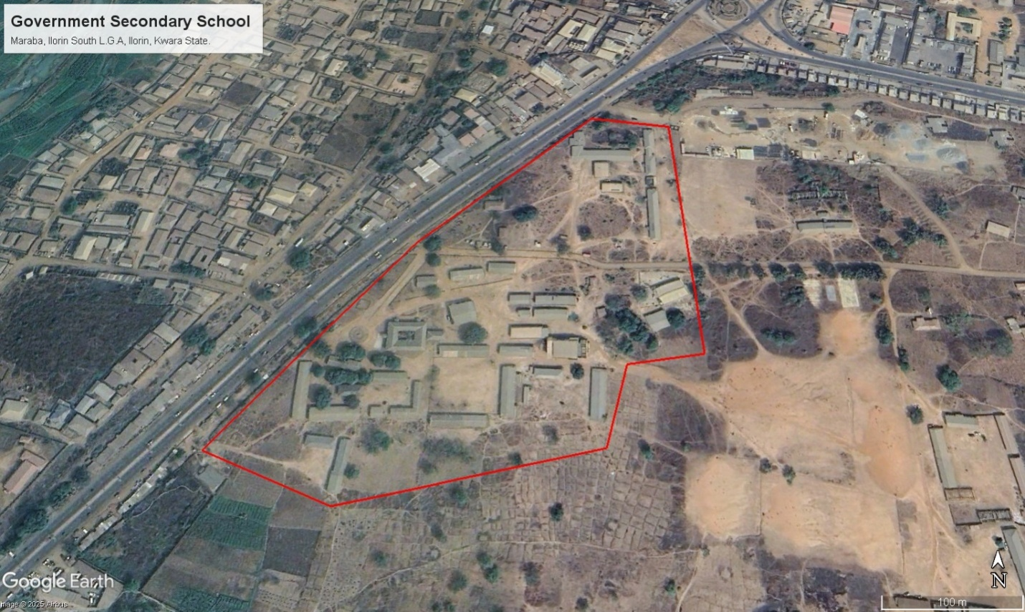
Figure 3.3: Satellite Imagery of the study area
Validation of Non-Spatial Data
- Attribute Consistency Check: The recorded building and facility details were compared with official school records.
- Correction of Data Entry Errors: Any discrepancies or incorrect attribute entries were identified and corrected before finalizing the dataset.

3.4 Data Processing and Integration
The data processing and integration phase is a critical step in transforming the raw data collected from the field survey into a structured Land Information System (LIS). This stage involves cleaning, organizing, and integrating both spatial and non-spatial data into a geodatabase, ensuring seamless access, analysis, and visualization.
The processing workflow consists of multiple steps, including spatial data processing in AutoCAD and Surfer, non-spatial data structuring in Excel, geodatabase creation in ArcGIS, and data integration for LIS development. The structured integration of these datasets enables effective querying, mapping, and decision-making for the secondary school management system.
3.4.1 Spatial Data Processing in AutoCAD
AutoCAD was used to plot the observed coordinates, (Geometric data) ensuring accurate representation of school facilities such as classrooms, staff rooms, administrative offices, roads, and playgrounds. The following steps were carried out:
- Importing Surveyed Points:
  - The CSV file containing surveyed coordinates was imported into AutoCAD.
  - The points were plotted based on their real-world X and Y coordinates, while the Z values were retained for elevation analysis.

- Plotting of Boundaries and Features:
  - The boundary points were connected using polyline tools, forming a closed polygon to define the extent of the school premises.
  - Each school building was mapped as a separate layer, and unique identifiers were assigned to distinguish classrooms, staff rooms, laboratories, and other structures.
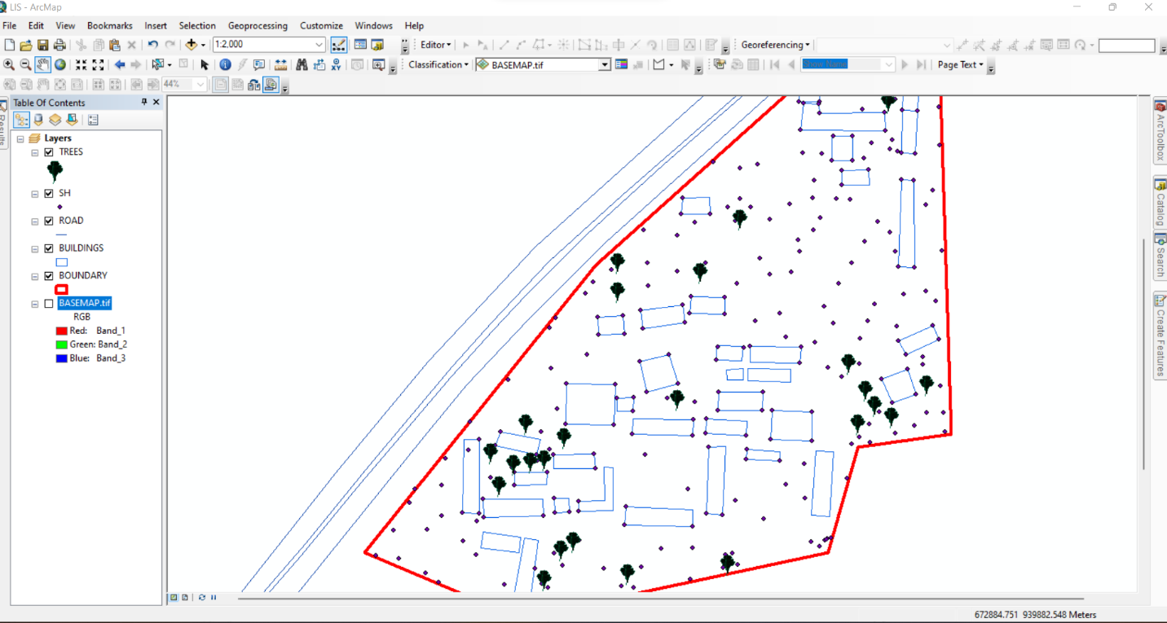
Figure 3.5 Screenshot of boundary digitization and features
3.4.2 Topographic Data Processing in Surfer
Surfer software was used for topographic analysis and terrain modelling based on the surveyed elevation data (Z values). The following procedures were followed:
- Importing Surveyed Data:
  - The X, Y, and Z coordinates were loaded into Surfer as a point dataset.
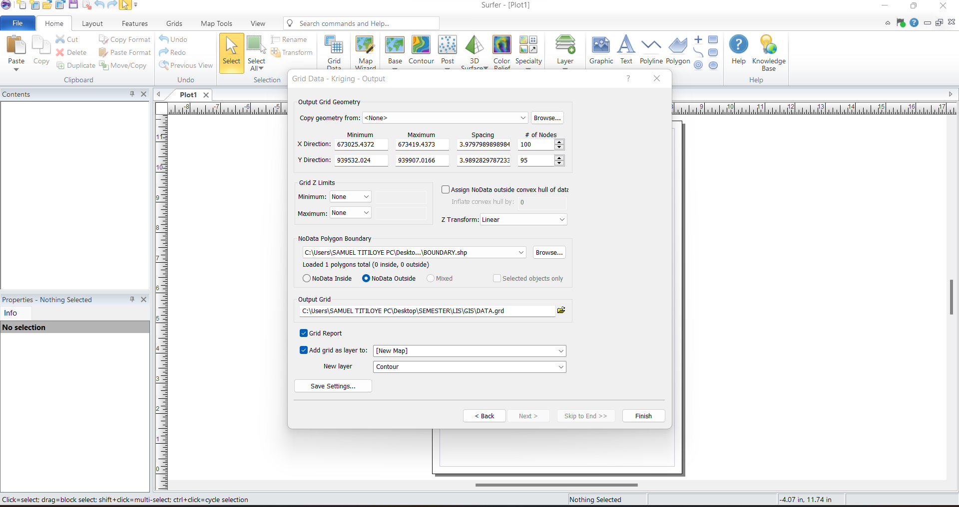
Figure 3.6: Screenshot of the imported dataset.
- Generation of Digital Elevation Model (DEM):
  - A grid-based interpolation technique was applied to generate a Digital Elevation Model (DEM) of the school area.
  - The DEM provided insight into the elevation variations across the school premises, assisting in drainage and flood risk assessment.
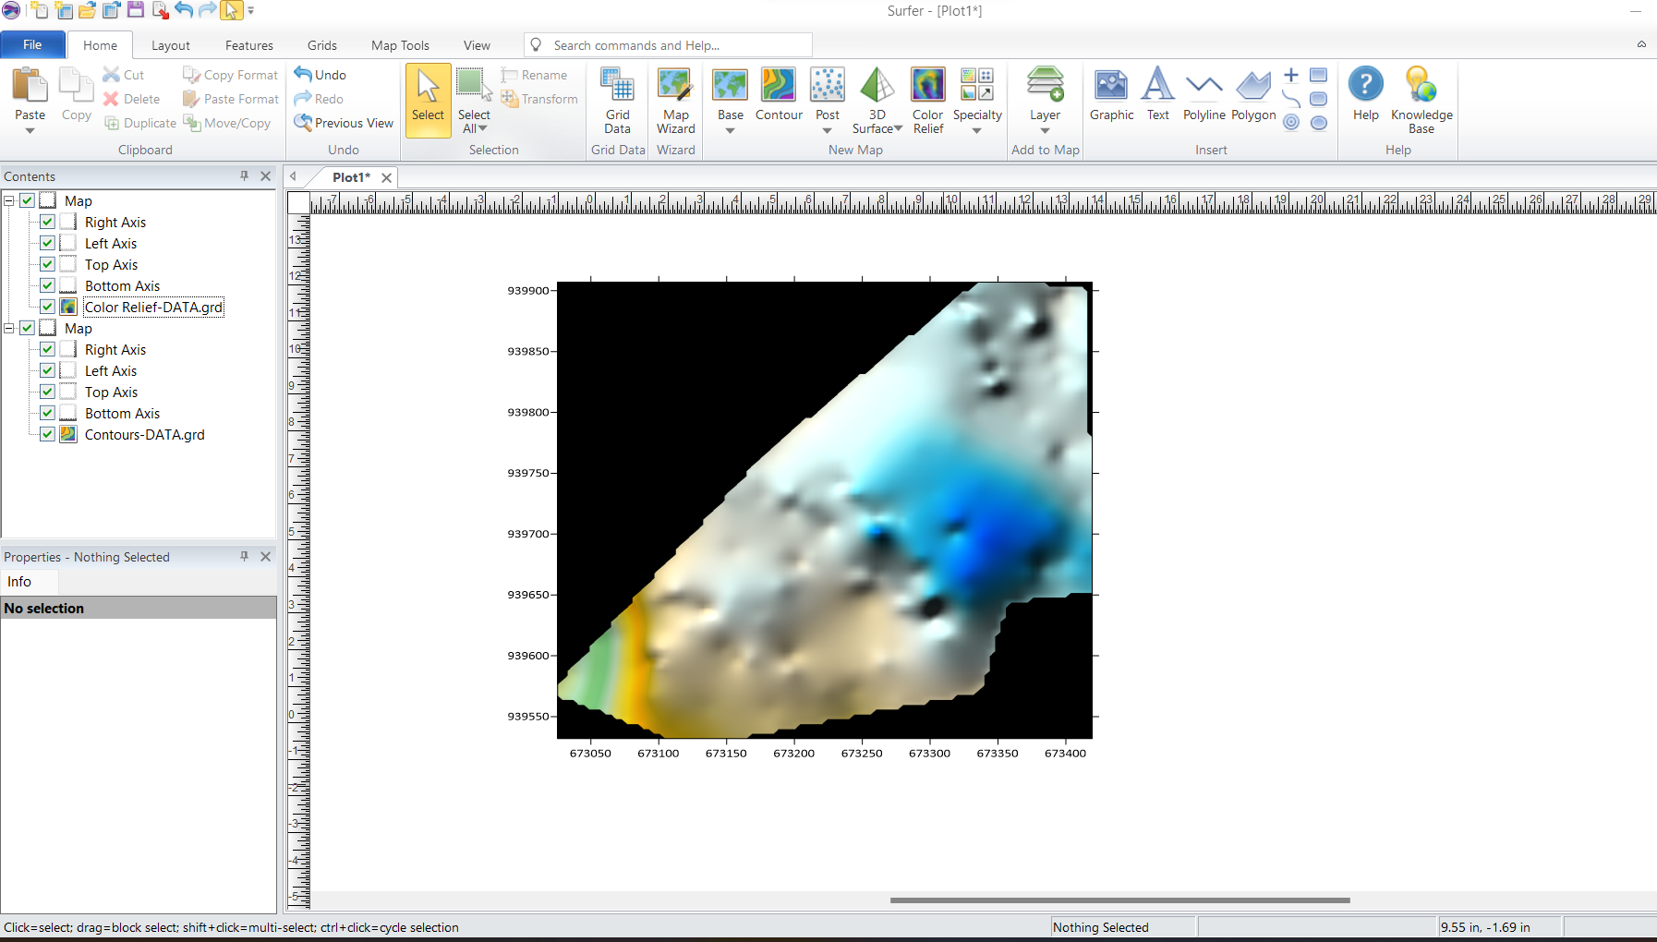Figure 3.7: Screenshot of the generated DEM.
- Creation of Contour Maps:
  - Contour lines were generated at specific intervals to visualize terrain variations.
  - The contour map was exported in Geo-TIFF format for integration into Arc-GIS.
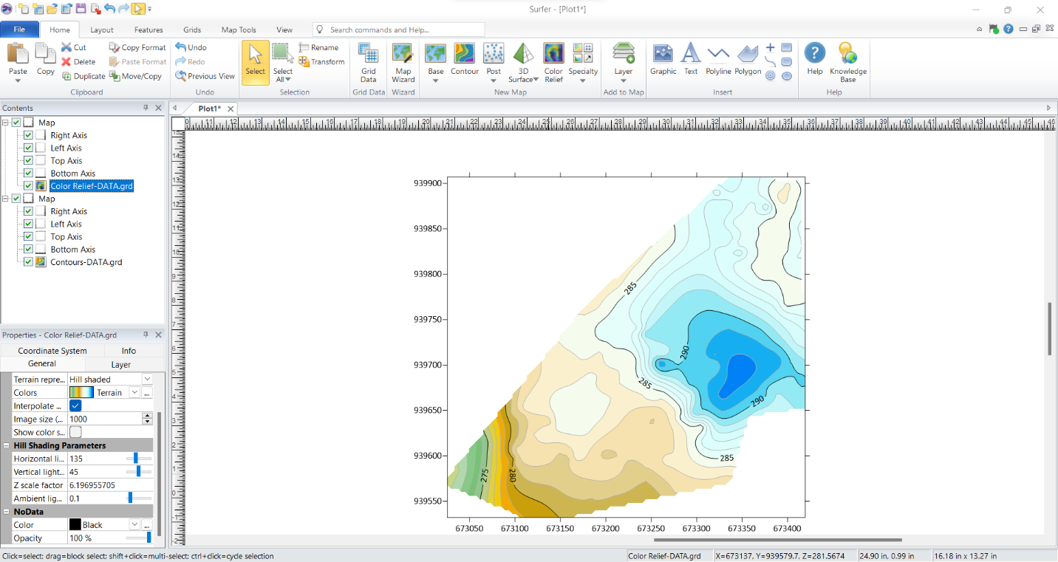Figure 3.8: Screenshots of the contour generation process.
3.4.3 Non-Spatial Data Processing in Excel
Non-spatial data collected through field observations and school administrative records were structured and formatted in Excel to ensure consistency and ease of integration into Arc-GIS.
- Data Entry and Formatting:
  - Each facility was assigned a unique ID corresponding to its spatial location.
  - Attributes such as building type, year of construction, and available amenities were recorded.
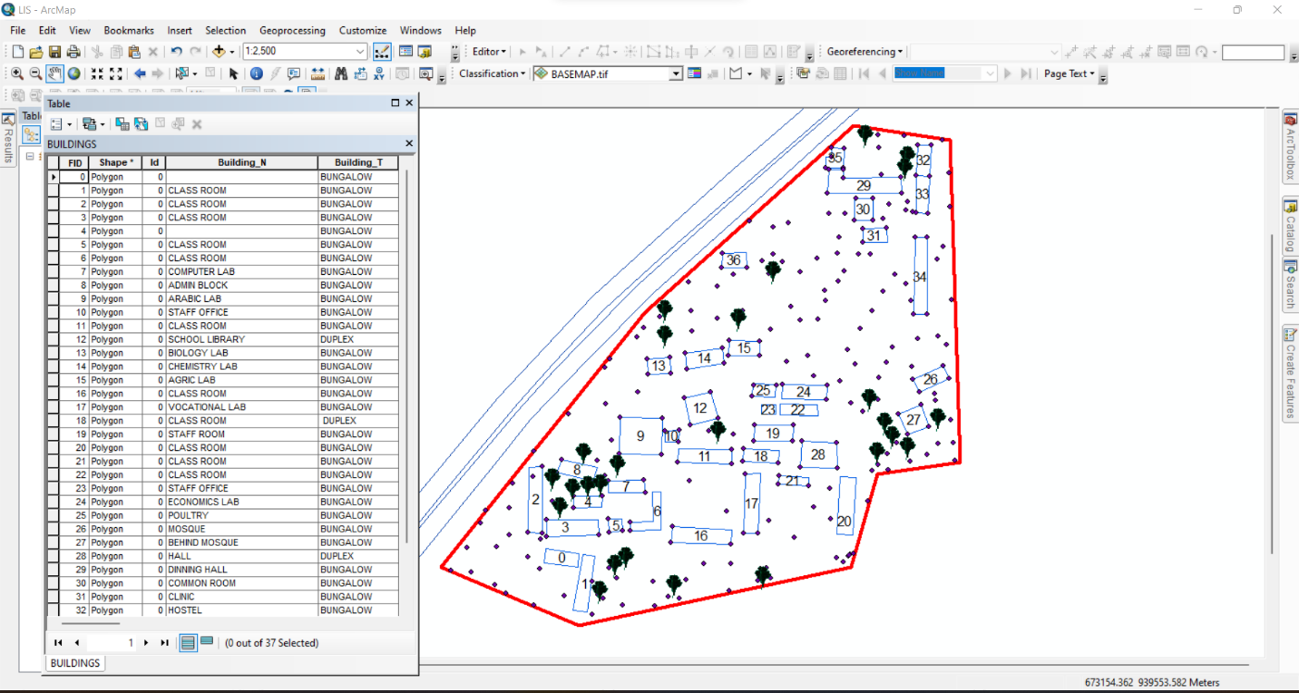Figure 3.9: Screenshot of the structured attribute table.
3.4.4 Geo-database Creation in Arc-GIS
A geo-database was created in Arc-GIS to integrate both spatial and non-spatial data, allowing efficient storage, retrieval, and analysis of school infrastructure data. The following steps were taken:
- Creating a New Geo-database:
  - A file geo-database was created in Arc-GIS to store all spatial data layers and attribute tables.
- Importing Spatial Data:
  - The DXF file from Auto-CAD (containing school boundaries and building layouts) was imported into Arc-GIS.
  - The Geo TIFF file from Surfer (containing the DEM and contour data) was also loaded.
- Defining Feature Classes:
  - Separate feature classes were created for classrooms, staff rooms, offices, laboratories, roads, and other infrastructure.
  - Each feature class was assigned relevant spatial properties (e.g., polygon for buildings, polyline for roads).
- Importing Non-Spatial Data and Linking to Spatial Features:
  - The CSV file containing attribute data was imported into ArcGIS.
  - A one-to-one relationship was established between the spatial features and their corresponding attribute records using the unique ID field.
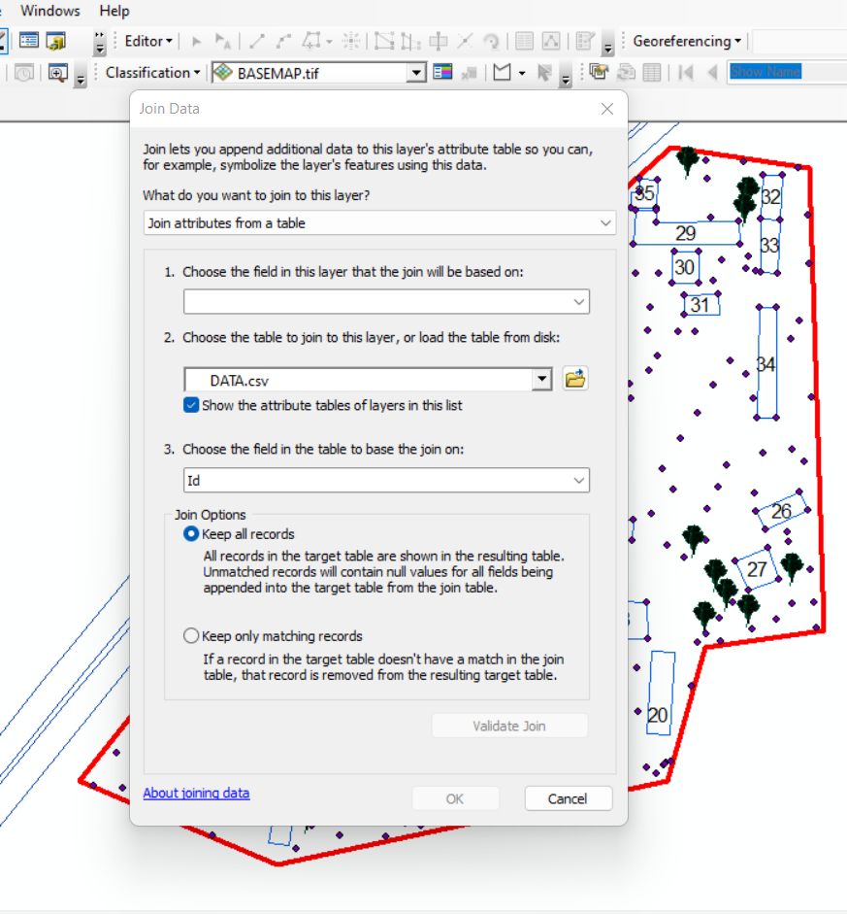
Figure 3.11: Screenshot of the data join process.
3.4.5 Data Integration and Finalization for LIS
The final stage involved ensuring seamless integration between spatial and non-spatial data within the LIS environment.
- Verification of Data Integrity
  - The attribute data were cross-checked to ensure they matched their respective spatial locations.
  - Any mis-linked records were corrected, and missing attributes were updated.
- Symbolization and Visualization:
  - Each feature class was assigned unique symbols and colors for better visualization in Arc-GIS.
  - Thematic maps were created to represent building categories, classroom capacities, and road networks.

3.7.1 Perimeter Plan of the Project Area
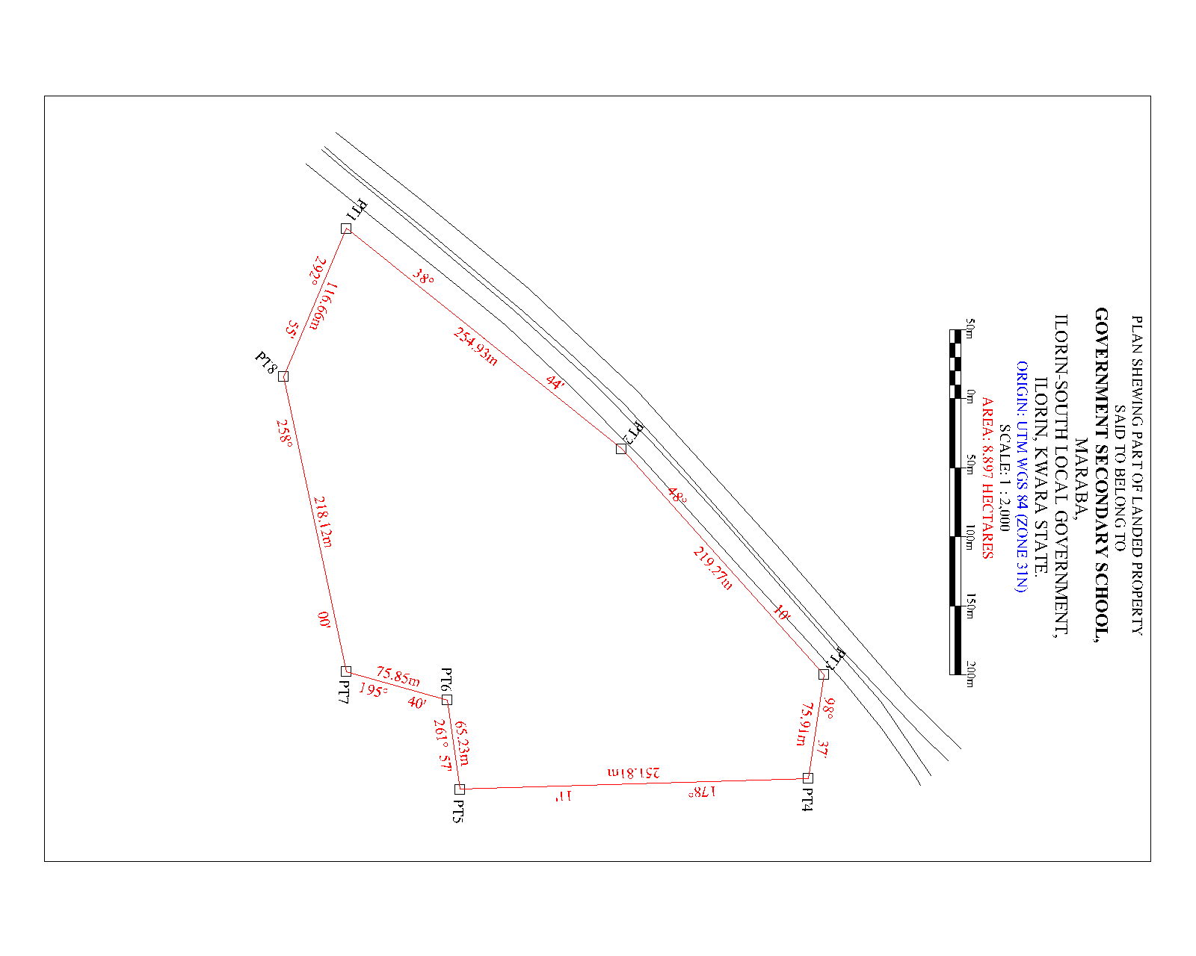
Figure 3.7.1: A screenshot of the boundary in AutoCAD.
- Boundary Digitization and Feature Mapping:
  - The boundary points were connected using polyline tools, forming a closed polygon to define the extent of the school premises.
  - Each school building was mapped as a separate layer, and unique identifiers were assigned to distinguish classrooms, staff rooms, laboratories, and other structures

3.7.2 Detailing
Figure 3.7.2 Screenshot showing the digitization process and layer management.
3.7.2 Topographic Data Processing in Surfer
Surfer software was used for topographic analysis and terrain modelling based on the surveyed elevation data (Z values). The following procedures were followed:
- Importing Surveyed Data:
  - The X, Y, and Z coordinates were loaded into Surfer as a point dataset.

3.7.3 Attribute data acquisition
Attribute data is information about spatial features. They provide the characteristics, description and nomenclature about spatial objects. Thus, the attributes data acquired includes names of buildings and their uses such as classrooms, roads, water facilities and prominent natural features Likes River and trees found and vegetation were properly identified within and around the study area.

3.8 Database Creation / Implementation
This is the database creation phase. Having completed the three stages of design phase (i.e Reality, Conceptual and Logical design), the data base was created using ArcGIS10.2 software. It involves the combination and storage of acquired graphic data and attributes data in creating the database for the purpose of spatial analysis and query.
Database is an organized integrated collection of data stored so as to be capable of use by revenant application with data being accessed by different logical part. After the Attribute table was populated via the keyboard, some attributes such as areas of settlements were automatically displayed by special command in the ArcGIS 10.2 version. The ArcGIS software was used to link the graphic data and table for query generation.

3.8.1 Database Management System (DBMS)
Data base management is a collection of software for creating, storing, manipulating, updating, organizing and querying of information in a database (Kufoniyi, 1998). It is a software package whose function is to manipulate a data base on behalf of the user.
A good DBMS must provide the following functions:

      - Storage and retrieval of data.

      - Access to by several users at a time.

      - A standardized interface between data base and application programmed.

      - Standardized access to data and separation of data storage and retrieval functions from the program using the data.

      - Maintenance of data security and integrity.

3.8.2 Data Quality
Having created the database, proper maintenance practice was made to meet its stated objectives. The ability to include more data and remove irrelevant data was possible by way of maintenance. There is every need for the data to be updated regularly because of the physical changes that may occur on the landscape with time. Both security and integrity were also exercised to ensure maintenance and to meet its stated objectives.
Proper observance, updating and management of database ensure its currency and quality to stand a profound chance in Spatial Decision Support System (SDSS). The quality of any database depends on the currency and fitness for use as a decision support system (SDSS). The quality of database depends on its ability to generally fit and use as a decision system(DSS). The storage media should be from time to time justified if otherwise could necessitate data inaccessibility or physical deterioration of the storage media. Also, care must be taken during populating any database system, as a database is only good as the data supplied. In archiving stable media should be used. Examples of these are
- Computer compatible tape reader

- Magnetic tape

- Optical disc and compact disc.

CHAPTER FOUR

ANALYSIS AND RESULTS

4.1 Introduction
This chapter presents the results obtained from the data acquisition, processing, and integration procedures described in the previous chapter. The findings provide a comprehensive spatial and non-spatial representation of the school environment, including the layout of buildings, topographical features, and attribute information related to school facilities. The results are structured to demonstrate how the Land Information System (LIS) can enhance school management by providing accurate, well-organized, and easily accessible data.
The results are categorized into different sections for clarity. The spatial data results include mapped school boundaries, building footprints, and access networks, all of which were digitized using GIS tools. The topographical results analyze elevation variations using Digital Elevation Models (DEM) and contour maps, which are crucial for site planning and infrastructure development. The non-spatial data results contain attribute information such as classroom capacity, staff room assignments, and building conditions, all integrated into the LIS database. The data integration and query results demonstrate how the LIS functions as an interactive tool for retrieving, analyzing, and visualizing school-related data.
This chapter also includes analyses that reveal important insights into building distribution, infrastructure conditions, environmental constraints, and potential areas for school expansion. The results are presented using maps, tables, and screenshots from GIS and related software to illustrate how data were processed and visualized. The goal of this chapter is to demonstrate the practical application of an LIS in school facility management and to highlight the benefits of integrating spatial and non-spatial data for decision-making.

4.2 Spatial Data Results
The spatial data results provide a detailed representation of the school’s geographical layout, including its boundaries, buildings, access roads, and pathways. These results were derived from Total Station survey data, processed in AutoCAD and ArcGIS to create an accurate Land Information System (LIS) for the school. This section highlights the steps taken to map the school boundary, digitize building footprints, and visualize access routes.
The spatial data results are essential for effective school management, as they provide a georeferenced framework that helps in planning expansions, monitoring infrastructure, and optimizing resource allocation. The outputs presented in this section form the foundation for further topographical, non-spatial, and LIS-based analysis discussed in subsequent sections.
4.2.1 School Boundary and Building Layout
The school boundary and building layout were mapped using surveyed coordinates (X, Y, Z) collected with the Total Station. The acquired data were processed in AutoCAD to generate a structured boundary map and building footprints, which were then imported into ArcGIS for further spatial analysis and integration into the LIS database.
Figure 4.2.1: As built Plan of Government Secondary School Maraba, Ilorin South East Local Government. using GIS software
Visualization of Spatial Data Results
The final processed spatial data were visualized in ArcGIS, where the school boundary, building footprints, and access roads were symbolized appropriately to enhance readability.
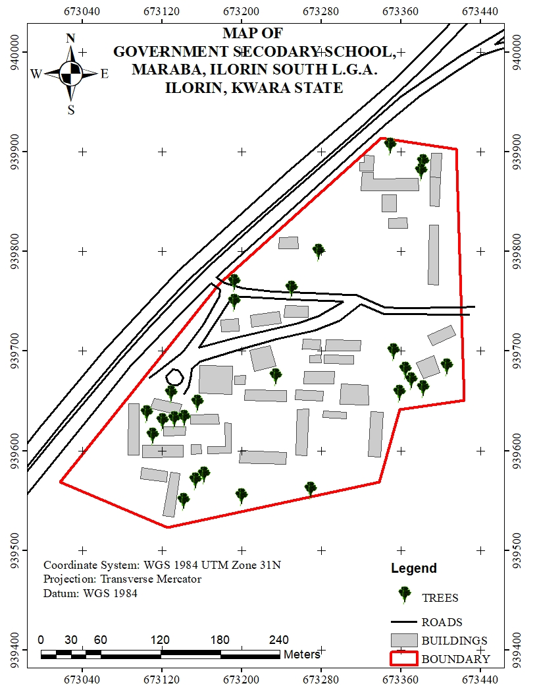
Figure 4.2.1: Mapped School Boundary and Buildings in ArcGIS
- The school boundary is represented as a bold polygon to define the outer limits of the school.
- Buildings are shown in different colors based on their usage (e.g., classrooms in blue, administrative offices in green, laboratories in red).
- Roads are displayed as lines, with roads marked in black.
This spatial data representation serves as the primary framework for the LIS database, allowing users to visualize, analyze, and manage school infrastructure efficiently.
Significance of the Spatial Data Results
The school boundary and building layout play a crucial role in:
- Infrastructure Planning: Ensuring optimal land use by identifying available spaces for future construction and expansion.
- Facility Management: Helping administrators monitor the condition, usage, and location of various school buildings.
- Navigation and Accessibility: Enhancing movement planning for students, staff, and visitors by identifying clear pathways and access points.
- Disaster Management: Providing accurate spatial information to plan for emergency exits, assembly points, and safety zones.
The spatial data results form the foundation for further analysis, including topographical evaluation, attribute data integration, and advanced GIS-based queries, which will be presented in the subsequent sections of this chapter.

4.3 Topographical Analysis Results
Topographical analysis provides crucial information about the elevation, slope, and terrain variations within the school environment. Understanding these features is essential for site planning, infrastructure development, drainage design, and environmental management. This section presents the results of topographical data processing and analysis, including the creation of Digital Elevation Models (DEM), contour maps, and slope analysis.
The topographical data were obtained using Total Station measurements, which captured X, Y, and Z coordinates of various points within the school premises. These data were processed in Surfer to generate elevation models and later integrated into ArcGIS for spatial analysis.
4.3.1 Digital Elevation Model (DEM)
The Digital Elevation Model (DEM) was created to provide a 3D representation of the school’s terrain. Using Z-coordinates from the Total Station survey, a gridded elevation surface was generated in Surfer and later exported to ArcGIS for further analysis.
Key Features of the DEM:
- The DEM visually represents variations in land elevation within the school compound.
- Areas of higher elevation are highlighted, aiding in infrastructure planning and water drainage management.
- The DEM serves as the base for further slope, aspect, and contour analysis.
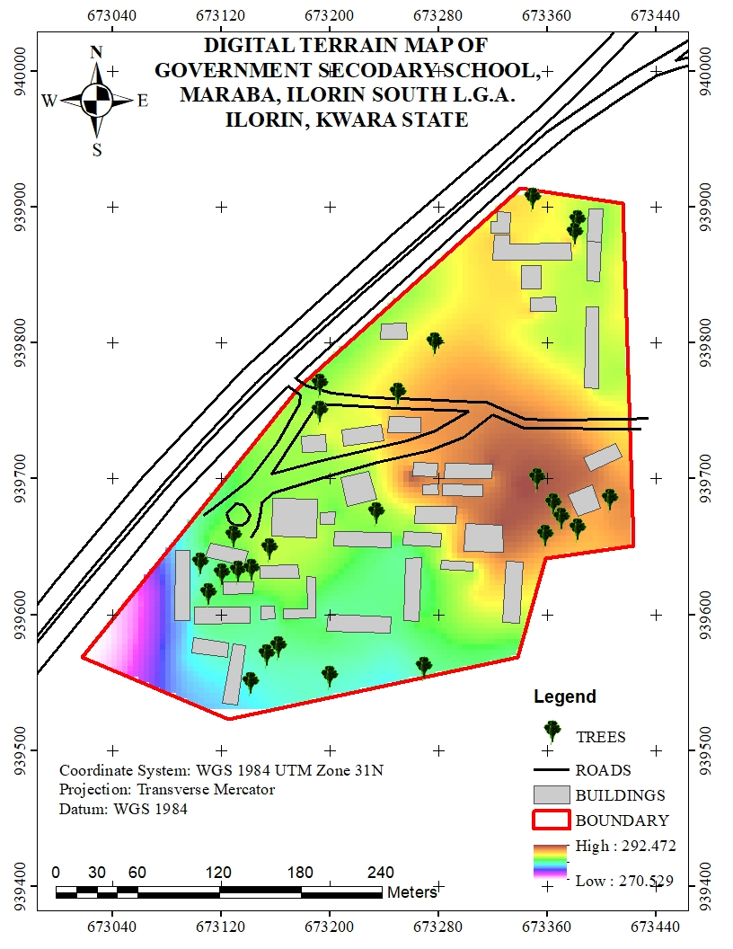
Figure 4.3.1: Digital Elevation Model (DEM) of the School Premises
4.3.2 Contour Mapping
Contour mapping was conducted to visualize elevation changes and terrain gradients within the school environment. The surveyed elevation data were processed in Surfer to generate contour lines, which were later imported into Arc-GIS for spatial overlay and analysis.
Key Results from Contour Analysis:
- The contour interval was set based on the range of elevation variations in the study area.
- Closely spaced contour lines indicate steep slopes, while widely spaced lines represent gentler slopes.
- The contour map helps in identifying low-lying areas that may be prone to water logging or flooding.
- The results assist in drainage planning by identifying natural water flow paths.
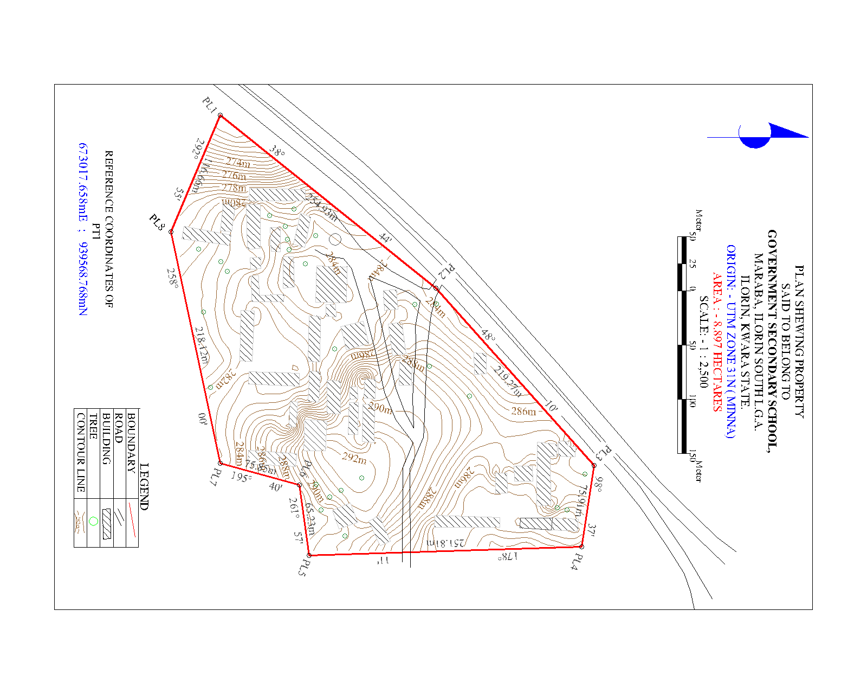
Figure 4.3.2: Contour Map of the School Premises
4.3.3 Slope and Terrain Analysis
A slope analysis was conducted to determine variations in land steepness across the school environment. The slope was computed using the DEM in ArcGIS, with results classified into different slope categories to assess terrain usability.
Key Findings from Slope Analysis:
- Flat areas (0-5 degrees) are suitable for classroom blocks, play areas, and other infrastructure.
- Moderate slopes (5-15 degrees) are manageable for footpaths and minor construction projects.
- Steeper slopes (above 15 degrees) may require erosion control measures or retaining walls to prevent land degradation.
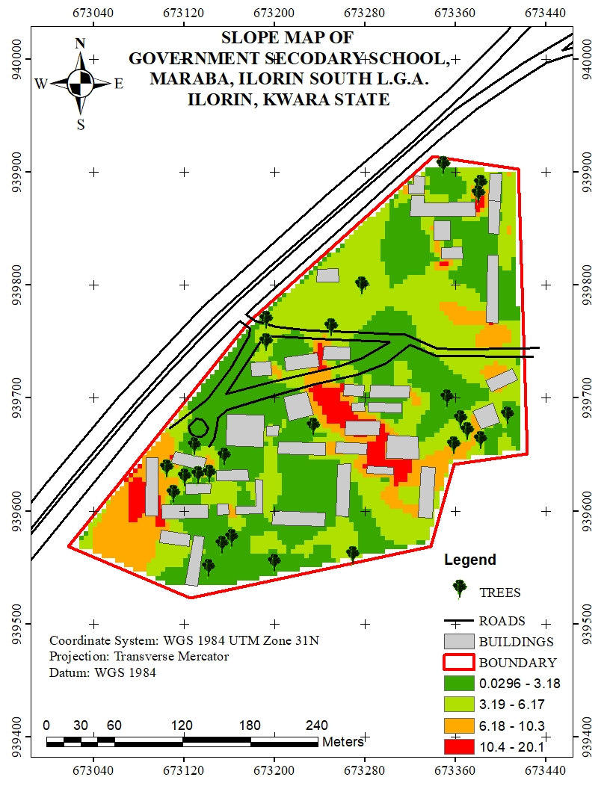
Figure 4.3.3: Slope Analysis Map of the School Premises
4.3.4 Significance of Topographical Analysis Results
The results of the topographical analysis provide essential insights for school management, infrastructure development, and environmental sustainability. These findings contribute to:
- Better infrastructure planning: Ensuring that new buildings and roads are constructed on stable ground.
- Improved drainage management: Reducing the risk of flooding and water stagnation within the school premises.
- Enhanced safety measures: Identifying steep areas that may require protective barriers or adjustments in land use planning.
- Sustainable land use: Helping decision-makers optimize space utilization while considering terrain constraints.
The topographical analysis results form an integral part of the Land Information System (LIS), ensuring that spatial data is not only stored but also analyzed for informed decision-making in school infrastructure management.
4.4 Non-Spatial Data Results
Non-spatial data results refer to the descriptive information associated with various school facilities, buildings, and infrastructure. Unlike spatial data, which provides geometric representations of features (such as school boundaries, buildings, and roads), non-spatial data includes textual and numerical attributes that help in facility management and decision-making.
The non-spatial data collected in this study were integrated into the Land Information System (LIS) to enhance school administration, infrastructure monitoring, and resource planning. The data were structured in tabular format and linked to corresponding spatial features in ArcGIS using unique identifiers.
4.4.1 Attribute Data for School Buildings
The non-spatial attributes for classrooms, staff rooms, laboratories, and administrative offices were recorded and organized in a database. Each building was assigned a unique identifier (Building ID), allowing for easy retrieval of information in GIS.
Key Attributes for Buildings:
- Building Name/ID (e.g., Classroom Block A, Staff Room 1)
- Building Type (Classroom, Laboratory, Office, Library, Hall)
- Primary Use (Teaching, Administration, Storage, Utility)
This information was stored in ArcGIS attribute tables and linked to the digitized building footprints, allowing users to perform queries such as identifying underutilized classrooms or buildings in need of maintenance.
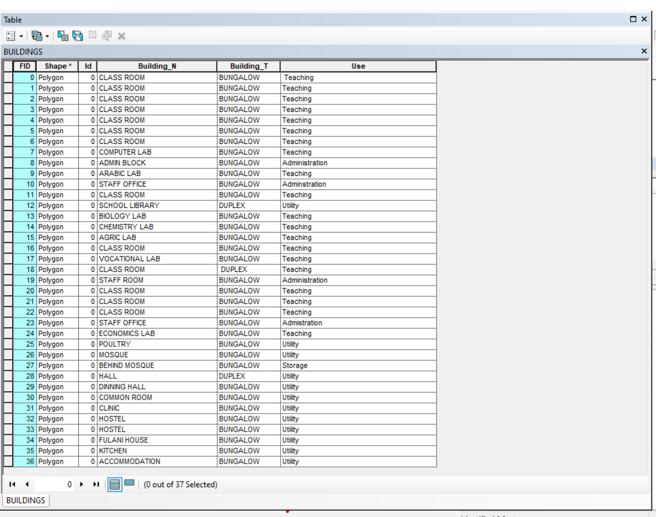
Figure 4.4.2: Sample Attribute Table for School Buildings

4.4.3 Linking Non-Spatial Data with GIS
All non-spatial datasets were linked to their corresponding spatial features in ArcGIS. This integration allows for interactive queries and visual analysis of school facilities. Some of the key functionalities include:
- Clicking on a building footprint to view its attributes (e.g., building name, building type, & use).
- Running queries to find classrooms that exceed their maximum student capacity.
- Generating reports on the maintenance history of infrastructure.
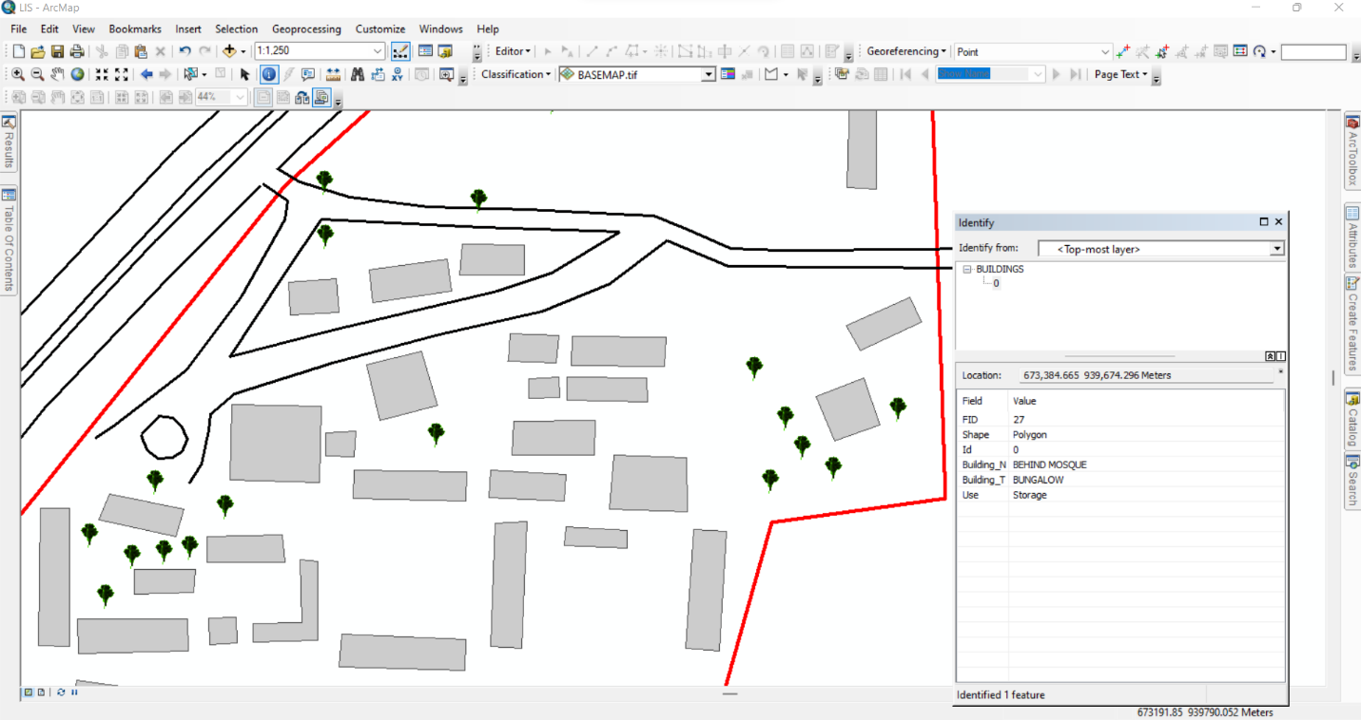Figure 4.4.3: Linking Non-Spatial Data to Spatial Features in ArcGIS
4.4.4: Significance of Non-Spatial Data in LIS
The integration of non-spatial data into the LIS enhances decision-making by providing comprehensive attribute information for school management. These results contribute to:
- Effective Resource Allocation: Ensuring that classrooms, offices, and other facilities are optimally utilized.
- Infrastructure Maintenance Planning: Monitoring facility conditions and scheduling necessary repairs.
- Improved School Administration: Tracking staff distribution, student population trends, and room assignments.
- Emergency Preparedness: Identifying critical infrastructure that requires regular inspections and safety measures.
The non-spatial data results demonstrate how a Land Information System (LIS) can support school facility management by combining spatial visualization with detailed attribute data. This information is essential for long-term planning, policy-making, and efficient school operations.

4.5 Query Execution and Results
With the integrated database, queries were performed in ArcGIS to extract specific information about the school environment. These queries help in analyzing building usage, staff distribution, facility conditions, and space utilization.
Example Query Results:
- Mapping Distribution of Staff Offices:
Query: "Show all staff offices"
Result: A spatial representation of staff office locations was displayed, ensuring adequate office space allocation.
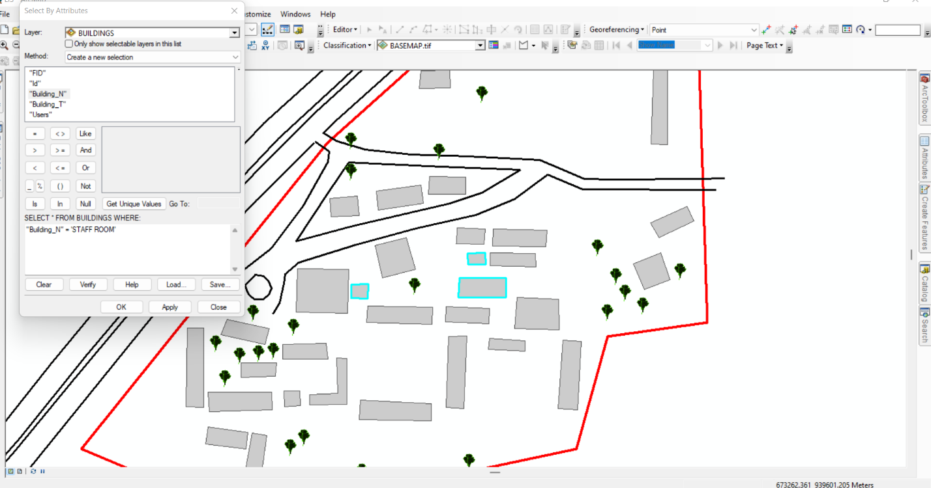
Figure 4.5.1: Sample Staff room Query Results in Arc-GIS
- Mapping Distribution of Class rooms:
Query: "Show all Class rooms"
Result: A spatial representation of class room locations was displayed, ensuring adequate office space allocation.
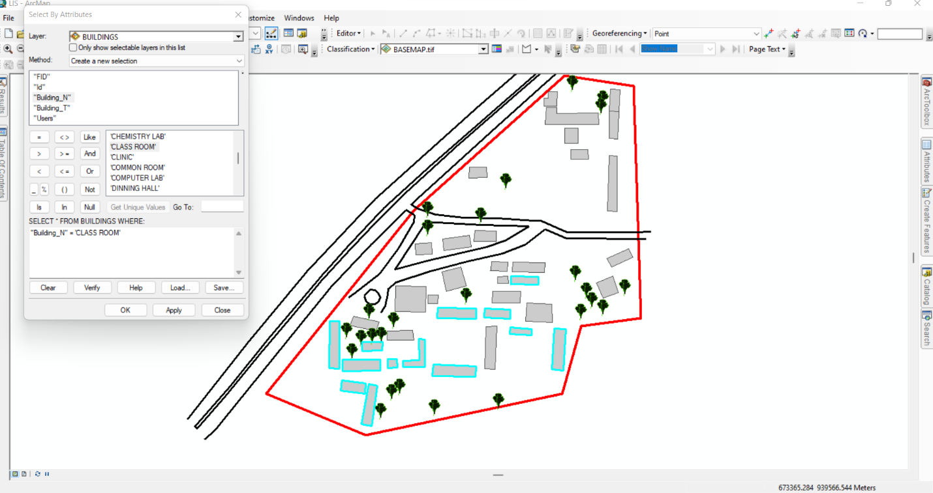
Figure 4.5.2: Sample Class room Query Results in ArcGIS

CHAPTER FIVE
5.0 COST, SUMMARY AND CONCLUSION
5.1 COSTING
The costing of this project was done using the Nigeria Institution of Surveyor's (NIS) professional scale of fees for consultant in the construction industry. This stage shows the total cost that was spent on the project from day one to the final stage.
RECCI
PERSONAL/QUALITY | DAY(S) | UNITRATE(N) | TOTAL AMOUNT(N)
1 Senior Surveyor | 1 | 20,000.00 | 20,000.000
Assistant Surveyor | 1 | 8,000.00 | 8,000.00
Transportation | 1 | 7,000.00 | 7,000.00
Basic Equipment | 1 | 8,000.00 | 7,000.00
TOTAL |  |  | #42,000.00

BEACON= 2,100 × 5
= #10,500

BEACONING
PERSONAL/QUALITY | DAY(S) | UNITRATE(N) | TOTALAMOUNT(N)
1Assistant Surveyor | 1 | 8,000.00 | 8,000.00
Basic Equipment(6) | 1 | 8,000.00 | 8,000.00
Transportation | 1 | 7,000.00 | 7,000.00
TOTAL |  |  | #23,000.00

TRAVERSING
PERSONAL/QUALITY | DAY(S) | UNITRATE(N) | TOTALAMOUNT(N)
1 Assistant Surveyor | 2 | 8,000.00 | 16,000.00
Basic Equipment | 2 | 8,000.00 | 16,000.00
Transportation | 2 | 7,000.00 | 14,000.00
TOTAL |  |  | #46,000.00

DOWNLOADING DATA AND PLOTTING
PERSONAL/QUALITY | DAY(S) | UNITRATE(N) | TOTALAMOUNT(N)
1Senior Surveyor | 2 | 15,000.00 | 30,000.00
1AssistantSurveyor | 2 | 8,000.00 | 16,000.00
Transportation | 2 | 7,000.00 | 14,000.00
Consumables | 2 | 7,000.00 | 14,000.00
TOTAL |  |  | #74,000.00

INFORMATION PRESENTATION
PERSONAL/QUALITY | DAY(S) | UNITRATE(N) | TOTALAMOUNT(N)
1Assistant Surveyor | 1 | 8,000.00 | 8,000.00
Transportation | 1 | 7,000.00 | 7,000.00
TOTAL |  |  | #15,000.00

(1) # 42,000.00
(2) # 10,500.00
(3) # 23,000.00
(4) # 46,000.00
5) #74,000.00
(6) # 15,000.00
TOTAL # 210,500.00
CONSTIGENCIES=5%
210,500.00×5%÷ 100
= #10,525.00

V. A. T = 7.5%
210,500.00×7.5%÷100
= #15,787.50

MOBILIZATION AND DEMOBILIZATION =10%
2o10, 500.00 × 10%. ÷ 100
= #21,050.00
ACCOMODATION = 1.5%
210,500.00 ×1.5%÷100
= 3,157.50
TOTAL = 210,500.00
10,525.00
15,787.50
21,050.00
3,157.50
GRAND TOTAL = 261,020.00

5.2 SUMMARY
The aim and purpose of this project was to carry out a land information system of Government Secondary School, Maraba. The project started with reconnaissance which involve office planning and field planning which involve preliminary visit to the site, instrument selection and test for our instrument to be in good working order, the field operation include carryout third order perimeter traverse, perimeter levelling and Total station was used to determine the spot height and detailing.
The raw data obtained from the field work were deduce and properly adjusted to obtain the final numeric value for the position and direction of point within the project area. The processed data were used for the production of a digital plan using a suitable scale in order to appreciate the work done.

5.3 CONCLUSION
This project has really enhanced my knowledge in survey especially in Land Information System (LIS) within any given area and a good background on surveying operation.
The Land Information System plan of Government Secondary School Maraba, Ilorin west local government area of kwara state was finally produced showing old and new elected structure. This would help the school management team to make better decision in planning vacant land.
5.4 RECOMMENDATION
Having participated in this project and the experience I had acquired during the course of this project, I hereby recommend the following.
- Application of computer programming should be fully implemented as to make the student carryout the data processing exercise more efficiently and faster.
- Software like AutoCAD, Surfer, ArcGIS, and QGIS should be introduce as to ease the problem of data processing analysis and presentation.
- Owing to the project executed proper inventory could be created which could be referenced to by any individual or the govern,ent for planning.
- Department for consultation service should be opened in SIWES and practical units so that the project being carried out by the student could be utilized by both the private sector and the government.

REFERENCE
Akingbade, A. (2005): Improvement of availability of land registration and cadastral information Ondo State, Nigeria: In department of urban and regional planning and geo-information management, international institute for geo-science and earth observation (ITC.),137.Enschede:ITC.
Agunbiade,M.E.,& Kolawole, A.M.(2016). A review of Nigeria land use act and sustainable land administration.journal of environmental science and Resource Management, 8(2),23-31.
Correia, R.,et al. (2021).Land administration and cadastral system. An integrated perspective on spatial data infrastructures. Land use policy 101,104 105.
Dale, P.,& McLaughlin, J. (1999). Land administration. Oxford, Oxford University Press: U Obayomi Abiola Benjamin: The Need for Computerization of Land Information Systems in Nigeria
Deininger,K., Selod,H., & Burns, T.(2008). The land Governance Assessment Framework: identifying and Monitoring Good Practice in the land sector.World Bank policy Research Working paper 54.
Enemark, S.(2009). Land Administation Systems for Sustainable Development.proceedings of the World Bank Annual Conference on land policy and Administration, Washington D.C
Longley P. A.,Goodchild, M. F., Maguire, D. J.,& Rhind,D. W.(2005). Geographic Information System and Science(2nd ed.) wiley.
Musa, B., Umaru, W., Polytechnic, F., & State, K. (2016). Developing a Cadastral Information System for Proper Land Administration in Tudun Salmanu Area of Bauchi Metropolis , Bauchi State , Nigeria. 10(1), 76–86.
Onsurd, H. J. (1991) Geographic and land Information System: Application, Standard and the law. University of Maine, Department of Spatial Information Science and Engineering.
Onemark, M.(2018) The role of spatial data infrastructure in modern land administration. FIG Congress, Istabul, Turkey.
Pindiga &Orisakwe, 2013. (2013). Development of a Land Information System of Tumpure Residential and Commercial Layout in Akko Local Government Area of Gombe State.
Rajabifard, A., Williamson, I., Holland P.,& Johnson, G. (2002). From Local to Global SDI initiatives: A pyramid approach. Proceedings of GSDI-6 Conference, Budapest, Hungary.
Usman, B., & Sc, M. (2013). Cadastral Information System for Title Management in Nigeria . Cadastral Information System for Title Management in Nigeria .December.
Williamson, I. P. (n.d.). The Role of Land and Geographic Information Systems In Economic and Environmental Management. [7] Yusuf Y. D (2009). Property Law Practice in Nigeria. Nigeria: Jos University Press Limited.
Siriba, D. N., & Dalyot, S. (2017). Adoption of Volunteered Geographic Information into the Formal Land Administration System in Kenya. Land Use Policy, 63, 279–287.
Yusuf Y.D (2009).Cadastre and land administration in Nigeria: Issues and prospects.FIG Working Week 2009,Eilat Isreal.
Zeng, Z., & Cleon, C. B. (2018). Factors Affecting the Adoption of a Land Information System: An Empirical Analysis in Liberia. Land Use Policy, 73, 353–362. https://doi.org/10.1016/j.landusepol.2017.12.034.
Zevenbergen j., Augustinus C., Antonio D., & Bennett R.(2013). Proper land Administration: principles for recording the land rights of the underrepresented. Land use policy 31, 595-604.
-

APPENDIX
 | EASTINGS | NORTHINGS | ELEVATION
PT1 | 673384.7215 | 939882.4456 | 284.324
PT2 | 673368.3346 | 939852.5804 | 284.974
PT3 | 673405.9883 | 939809.5429 | 285.418
PT4 | 673328.7865 | 939826.643 | 286.878
PT5 | 673277.1787 | 939834.9943 | 285.121
PT6 | 673258.6622 | 939839.0555 | 283.911
PT7 | 673298.2823 | 939799.4299 | 288.005
PT8 | 673328.172 | 939792.2934 | 287.552
PT9 | 673312.6354 | 939762.8023 | 289.926
PT0 | 673210.9532 | 939791.8953 | 283.435
PT11 | 673176.0265 | 939756.1512 | 283.922
PT12 | 673192.603 | 939752.8734 | 284.652
PT13 | 673304.6739 | 939734.3437 | 290.222
PT14 | 673416.2718 | 939684.1855 | 290.247
PT15 | 673262.0306 | 939711.3252 | 288.105
PT16 | 673149.9921 | 939731.4451 | 284.378
PT17 | 673146.6577 | 939696.4113 | 283.653
PT18 | 673227.3225 | 939675.5951 | 284.134
PT19 | 673246.0674 | 939672.8165 | 284.316
PT20 | 673321.673 | 939630.1681 | 288.378
PT21 | 673117.1536 | 939688.396 | 282.391
PT22 | 673294.0261 | 939591.9552 | 283.783
PT23 | 673337.8286 | 939578.4527 | 283.019
PT24 | 673271.9858 | 939568.4352 | 282.117
PT25 | 673104.7472 | 939620.371 | 281.182
PT26 | 673073.4392 | 939634.0653 | 276.58
PT27 | 673071.2371 | 939615.2187 | 275.123
PT28 | 673242.9053 | 939550.3469 | 280.075
PT29 | 673203.9413 | 939544.2854 | 280.735
PT30 | 673148.8427 | 939568.436 | 281.263
PT31 | 673052.708 | 939612.8861 | 272.448
PT32 | 673140.3028 | 939546.8119 | 280.215
PT33 | 673159.3407 | 939539.2528 | 280.517
PT34 | 673135.9737 | 939532.024 | 279.591
PT35 | 673114.231 | 939546.4438 | 279.556
PT36 | 673037.8605 | 939584.0792 | 270.915
PT37 | 673025.4372 | 939566.4692 | 270.677
PT38 | 673037.8605 | 939584.0792 | 270.915
PT39 | 673048.7103 | 939603.1658 | 272.177
PT40 | 673145.4432 | 939724.5862 | 283.813
PT41 | 673170.6938 | 939748.3946 | 284.45
PT42 | 673188.627 | 939764.5666 | 283.773
PT43 | 673320.9003 | 939845.4578 | 287.18
PT44 | 673362.1948 | 939875.4125 | 285.746
PT45 | 673385.9494 | 939892.7828 | 284.152
PT46 | 673372.8074 | 939797.935 | 284.644
PT47 | 673363.6725 | 939784.3633 | 286.123
PT48 | 673354.6165 | 939769.3984 | 288.129
PT49 | 673345.6938 | 939755.1428 | 289.742
PT50 | 673090.2289 | 939538.8492 | 278.481
PT51 | 673341.702 | 939727.2912 | 291.403
PT52 | 673417.181 | 939777.7687 | 284.558
PT53 | 673403.693 | 939704.2105 | 289.927
PT54 | 673373.8018 | 939666.3041 | 290.383
PT55 | 673366.7365 | 939657.6599 | 289.8
PT56 | 673359.693 | 939648.863 | 289.387
PT57 | 673354.665 | 939644.1429 | 289.178
PT58 | 673322.5007 | 939606.3774 | 286.048
PT59 | 673144.5627 | 939544.431 | 280.276
PT60 | 673154.7819 | 939560.0081 | 281.098
PT61 | 673166.3101 | 939576.9963 | 281.907
PT62 | 673335.5904 | 939738.9727 | 291.06
PT63 | 673409.6768 | 939902.881 | 285.097
PT64 | 673343.9989 | 939813.6289 | 285.841
PT65 | 673332.9823 | 939800.4245 | 286.532
PT66 | 673317.4768 | 939785.3667 | 288.656
PT67 | 673275.4552 | 939754.9254 | 289.562
PT68 | 673155.4283 | 939649.2573 | 284.999
PT69 | 673153.0985 | 939647.8698 | 284.914
PT70 | 673145.872 | 939640.2191 | 284.266
PT71 | 673136.9341 | 939632.0235 | 283.646
PT72 | 673095.4975 | 939590.4612 | 279.358
PT73 | 673085.8895 | 939576.7588 | 278.209
PT74 | 673068.6625 | 939547.998 | 275.907
PT75 | 673041.5594 | 939564.6487 | 272.021
PT76 | 673061.0455 | 939584.5291 | 273.936
PT77 | 673071.1215 | 939593.8976 | 275.368
PT78 | 673171.3443 | 939705.5928 | 284
PT79 | 673234.0205 | 939763.4674 | 286.572
PT80 | 673274.2492 | 939798.5538 | 287.23
PT81 | 673284.8663 | 939807.7859 | 287.065
PT82 | 673360.1973 | 939896.9251 | 286.454
PT83 | 673379.5924 | 939906.2515 | 285.363
PT84 | 673415.0684 | 939877.3203 | 285.558
PT85 | 673384.9695 | 939776.993 | 285.683
PT86 | 673370.35 | 939740.6932 | 289.914
PT87 | 673365.9627 | 939728.855 | 290.9
PT88 | 673360.3944 | 939716.777 | 291.697
PT89 | 673347.5661 | 939690.5155 | 292.448
PT90 | 673267.3527 | 939567.245 | 281.818
PT91 | 673249.8414 | 939761.4528 | 287.673
PT92 | 673253.5943 | 939769.0759 | 287.673
PT93 | 673289.4358 | 939837.6854 | 285.923
PT94 | 673359.1224 | 939907.0166 | 286.683
PT95 | 673309.0537 | 939718.1688 | 290.864
PT96 | 673386.4728 | 939846.5499 | 284.751
PT97 | 673381.1222 | 939847.9086 | 284.798
PT98 | 673311.7239 | 939810.1819 | 287.49
PT99 | 673214.1183 | 939753.5767 | 285.594
PT100 | 673151.1501 | 939668.0286 | 284.273
PT101 | 673298.2596 | 939761.629 | 289.834
PT102 | 673410.6168 | 939819.4782 | 286.064
PT103 | 673412.8398 | 939743.0719 | 286.98
PT104 | 673386.0424 | 939725.4241 | 289.89
PT105 | 673338.3902 | 939696.8038 | 292.455
PT106 | 673094.8002 | 939567.3012 | 279.722
PT107 | 673060.0972 | 939554.7259 | 274.721
PT108 | 673308.9272 | 939615.9023 | 286.747
PT109 | 673367.422 | 939644.724 | 288.332
PT110 | 673384.691 | 939651.1906 | 288.549
PT111 | 673397.7855 | 939656.608 | 288.644
PT112 | 673418.0052 | 939665.7253 | 289.824
PT113 | 673222.9371 | 939571.6333 | 281.678
PT114 | 673208.9905 | 939558.954 | 281.109
PT115 | 673195.205 | 939545.5706 | 280.87
PT116 | 673184.7054 | 939538.5535 | 280.999
PT117 | 673419.4373 | 939652.4321 | 289.44
PT118 | 673406.323 | 939665.6577 | 289.634
PT119 | 673135.7762 | 939557.6619 | 280.436
PT120 | 673183.4375 | 939557.5805 | 281.026
PL121 | 673265.7897 | 939558.0713 | 281.327
PT122 | 673275.585 | 939560.4378 | 282.041
PT123 | 673326.709 | 939576.0595 | 282.93
PT124 | 673336.051 | 939577.2225 | 282.915
PT125 | 673337.2307 | 939577.8349 | 282.96
PT126 | 673340.1753 | 939579.0557 | 283.101
PT127 | 673332.4629 | 939572.9081 | 282.561
PT128 | 673244.5043 | 939571.7683 | 280.976
PT129 | 673279.8337 | 939710.7086 | 289.235
PT130 | 673329.327 | 939714.1065 | 291.661
PT131 | 673291.0307 | 939772.5217 | 289.507
PT132 | 673213.3844 | 939769.2161 | 285.037
PT133 | 673363.0785 | 939841.574 | 285.29
PT134 | 673415.3765 | 939850.5814 | 286.503
PT135 | 673382.7967 | 939854.74 | 284.659
PT136 | 673268.7507 | 939807.9178 | 286.262
PT137 | 673381.0649 | 939790.3494 | 285.169
PT138 | 673404.0828 | 939698.8956 | 290.112
PT139 | 673359.7209 | 939699.5474 | 292.101
PT140 | 673211.8851 | 939636.4391 | 283.159
PT141 | 673241.3311 | 939612.7449 | 282.141
PT142 | 673274.3892 | 939604.8506 | 282.939
PT143 | 673119.7542 | 939627.4855 | 282.657
PT144 | 673089.4511 | 939639.6237 | 279.492
PT145 | 673351.4368 | 939620.0598 | 286.705
PT146 | 673139.7017 | 939652.3184 | 284.027
PT147 | 673090.4839 | 939659.3809 | 280.094
PT148 | 673287.9755 | 939729.3201 | 289.918
PT149 | 673390.6326 | 939747.4299 | 287.987
PT150 | 673406.2127 | 939749.4954 | 286.834
PT151 | 673318.698 | 939777.2251 | 289.241
PT152 | 673353.3829 | 939813.4117 | 285.219
PT153 | 673327.8948 | 939814.0516 | 286.716
PT154 | 673276.8713 | 939802.7248 | 287.085
PT155 | 673233.785 | 939788.3116 | 285.237
PT156 | 673246.1943 | 939797.5355 | 285.454
PT157 | 673277.4142 | 939813.7851 | 286.407
PT158 | 673333.8765 | 939845.0464 | 287.321
PT159 | 673121.233 | 939624.4639 | 283.071
PT160 | 673121.0743 | 939615.0976 | 282.792
PT161 | 673143.9343 | 939624.4639 | 283.815
PT162 | 673100.278 | 939592.8726 | 281.442
PT163 | 673085.3555 | 939596.0476 | 278.194
PT164 | 673096.7855 | 939595.5713 | 279.372
PT165 | 673149.1731 | 939596.2063 | 281.843
PT166 | 673159.4919 | 939597.0001 | 281.78
PT167 | 673141.2356 | 939593.9838 | 282.01
PT168 | 673099.8017 | 939605.7314 | 282.096
PT169 | 673148.6968 | 939606.2076 | 282.084
PT170 | 673165.5244 | 939604.1439 | 283.126
PT171 | 673096.7855 | 939647.3239 | 281.218
PT172 | 673107.9774 | 939642.8657 | 281.375
PT173 | 673136.5524 | 939636.5157 | 282.179
PT174 | 673111.7874 | 939652.6024 | 283.596
PT175 | 673148.1941 | 939636.5157 | 284.471
PT176 | 673176.3458 | 939637.1507 | 284.381
PT177 | 673177.4042 | 939626.9907 | 284.25
PT178 | 673165.5244 | 939597.3176 | 283.212
PT179 | 673197.5935 | 939587.8543 | 282.967
PT180 | 673244.4249 | 939586.796 | 282.022
PT181 | 673198.3873 | 939600.2898 | 281.592
PT182 | 673254.0557 | 939595.5802 | 282.376
PT183 | 673265.4857 | 939594.9452 | 283.309
PT184 | 673255.802 | 939641.6178 | 282.017
PT185 | 673281.4313 | 939633.4209 | 283.739
PT186 | 673305.1116 | 939632.2303 | 284.123
PT187 | 673282.0928 | 939640.3001 | 285.194
PT188 | 673327.3865 | 939645.9658 | 290.763
PT189 | 673298.4353 | 939646.9641 | 289.971
PT190 | 673327.1219 | 939666.0741 | 292.244
PT191 | 673254.0028 | 939661.2816 | 284.252
PT192 | 673281.6254 | 939649.8516 | 284.438
PT193 | 673244.8482 | 939649.7184 | 282.435
PT194 | 673253.5265 | 939651.2804 | 282.443
PT195 | 673245.1657 | 939660.831 | 283.997
PT196 | 673262.0991 | 939667.1554 | 284.253
PT197 | 673262.5753 | 939679.6967 | 286.756
PT198 | 673292.7379 | 939667.1554 | 287.534
PT199 | 673156.8328 | 939657.7089 | 284.797
PT200 | 673190.0645 | 939656.8622 | 284.931
PT201 | 673190.9112 | 939685.2256 | 284.021
PT202 | 673207.8461 | 939700.8096 | 284.134
PT203 | 673212.6572 | 939679.8325 | 283.992
PT204 | 673234.3045 | 939685.4637 | 284.829
PT205 | 673157.4678 | 939685.8606 | 283.582
PT206 | 673203.2556 | 939666.3872 | 284.044
PT207 | 673192.4606 | 939675.436 | 283.893
PT208 | 673203.7319 | 939675.9122 | 283.133
PT209 | 673202.6206 | 939650.8297 | 283.871
PT210 | 673228.2191 | 939705.8367 | 284
PT211 | 673178.7419 | 939731.5013 | 284.127
PT212 | 673197.5274 | 939720.1242 | 284
PT213 | 673179.2711 | 939719.3304 | 284.169
PT214 | 673208.6399 | 939736.2638 | 285.441
PT215 | 673210.0113 | 939723.8857 | 285.565
PT216 | 673239.3316 | 939728.0617 | 287.38
PT217 | 673196.469 | 939732.8242 | 285.965
PT218 | 673237.7441 | 939740.2326 | 285.981
PT219 | 673243.3004 | 939745.7888 | 287.908
PT220 | 673266.6455 | 939745.3188 | 289.626
PT221 | 673260.7952 | 939702.1712 | 292.324
PT222 | 673293.0554 | 939679.8554 | 290.403
PT223 | 673299.8697 | 939667.1325 | 289.403
PT224 | 673399.1328 | 939678.4214 | 289.269
PT225 | 673382.464 | 939672.3359 | 289.093
PT226 | 673391.989 | 939705.9381 | 291.205
PT227 | 673375.3202 | 939688.7401 | 291.609
PT228 | 673393.3119 | 939695.8839 | 290.854
PT229 | 673414.7432 | 939716.5214 | 288.314
PT230 | 673386.6973 | 939715.4631 | 290.931
PT231 | 673410.5099 | 939726.0465 | 287.665
PT232 | 673319.6306 | 939710.8646 | 292.093
PT233 | 673318.8744 | 939700.0749 | 289.855
PT234 | 673284.4939 | 939711.4996 | 289.939
PT235 | 673266.6058 | 939734.0519 | 289.765
PT236 | 673236.7533 | 939802.9493 | 284.509
PT237 | 673237.8116 | 939814.3793 | 283.996
PT238 | 673256.65 | 939803.161 | 285.935
PT239 | 673347.6196 | 939823.0727 | 287.83
PT240 | 673242.5066 | 939734.1471 | 289.519
PT241 | 673386.9377 | 939766.8486 | 286.751
PT242 | 673397.7856 | 939766.3194 | 284.723
PT243 | 673388.7898 | 939826.9091 | 284.968
PT244 | 673397.521 | 939826.6446 | 284.746
PT245 | 673347.6073 | 939833.5502 | 285.377
PT246 | 673366.1811 | 939833.8677 | 284.881
PT247 | 673341.0985 | 939840.059 | 286.99
PT248 | 673355.386 | 939840.2338 | 285.718
PT249 | 673355.386 | 939857.204 | 285.598
PT250 | 673341.973 | 939856.9723 | 285.635
PT251 | 673319.4093 | 939861.2091 | 287.356
PT252 | 673321.0629 | 939879.73 | 287.56
PT253 | 673331.977 | 939879.3993 | 287.867
PT254 | 673332.3077 | 939873.1154 | 287.697
PT255 | 673377.287 | 939873.7769 | 287.932
PT256 | 673378.0787 | 939860.846 | 284.921
PT257 | 673332.3752 | 939880.9239 | 286.766
PT258 | 673332.6927 | 939896.3227 | 287.526
PT259 | 673389.3851 | 939875.3015 | 284.306
PT260 | 673399.9684 | 939874.5078 | 284.067
PT261 | 673389.1205 | 939845.6681 | 284.362
PT262 | 673398.45 | 939845.1514 | 284.514
PT263 | 673390.4434 | 939899.1141 | 284.735
PT264 | 673401.0268 | 939898.5849 | 283.725
PT265 | 673318.167 | 939880.8446 | 287.29
PT266 | 673323.0089 | 939896.6402 | 286.94
PT267 | 673322.8502 | 939889.4965 | 285.163

