DESIGN AND CONSTRUCTION OF A SOLAR-POWERED RECHEAGEABLE FAN

By:
ABIOYE SUNDAY TEMITOPE
ND/23/COM/PT/0036

Submitted to the
DEPARTMENT OF COMPUTER SCIENCE,
INSTITUTE OF INFORMATION AND COMMUNICATION TECHNOLOGY (IICT), KWARA STATE POLYTECHNIC, ILORIN

IN PARTIAL FULFILMENT OF THE REQUIREMENTS FOR THE AWARD OF NATIONAL DIPLOMA (ND) IN COMPUTER SCIENCE

JUNE, 2025

APPROVAL PAGE
This is to certify that this project was carried out by ABIOYE SUNDAY TEMITOPE with Matric Number: ND/23/COM/PT/0036 has been read and approved by the Department of Computer Science, Kwara State Polytechnic Ilorin. In partial fulfillment of the requirements for the award of National Diploma (ND) in Computer Science.

___________________ __________________
Dr. Ayeni, J.K.
Project Supervisor Date

______________________ _________________
Mr. Oyedepo, F.S.
Head of Department Date

______________________ _________________
External Examiner Date

DEDICATION
This research project is dedicated to the Almighty God, the giver of life and taker of life that guide me throughout my program.

ACKNOWLEDGEMENTS
First and foremost, I give thanks to Almighty God for His grace, wisdom, and strength throughout the course of this project.
My sincere appreciation goes to my project supervisor, Dr. AYENI J.K, for his valuable guidance, support, and constructive feedback during the course of this work. His dedication and mentorship played a significant role in the successful completion of this project.
I also extend my heartfelt gratitude to my family Mr. Matthew Abioye, Mrs. Ruth Abioye, and Abioye Olusike Grace for their constant encouragement, love, and prayers.
Lastly, I appreciate all my lecturers, colleagues, and friends who contributed in one way or another to the success of this project.

TABLE OF CONTENTS
Title page i
Approval Page ii
Dedication iii
Acknowledgements iv
Table of Contents v-vii
List of Figures viii
Abstract ix
CHAPTER ONE: Introduction 1
1.1 Background to the Study 1-3
1.2 Statement of the Problem 3
1.3 Aim and Objectives 4-45
1.4 Methodology 5
1.5 Scope of the Study 5-6
1.6 Limitation of the Study 6
1.7 Operational Definition of Terms 7-8
1.8 Organization of the Reports 8

CHAPTER TWO: LITERATURE REVIEW 9
2.1 Review of Related Works 9-12
2.2. Review of Related Concepts 12
2.2.1 Overview of Smart Door Lock System 10-12
2.2.1 Solar Energy and Photovoltaic Systems 13
2.2.2 Energy Storage Technologies 13-14
2.2.3 Fan Technology and Motor Efficiency 14-15
2.2.4 Smart Technology Integration in Household Devices 15-16
2.2.5 Challenges in Solar-Powered Fan Development 16-17
CHAPTER THREE: Research Methodology 18
3.1 Description of Existing the System 18
3.2 Problem of the Existing System 19-20
3.3 Description of the Proposed System 20-21
3.3.1 Advantages of then Proposed System 21-22
3.4 System Architecture 22-25
3.5 Circuit Diagram 25

CHAPTER FOUR: System Design and Implementation 26
4.1 Schematic Design 26
4.2 System Design 26-26
4.3 System Documentation 27-28
4.3.1 System Flowchart 29
4.4 System Implementation 29-33
CHAPTER FIVE: SUMMARY, CONCLUSION
AND RECOMMENDATIONS 34
5.1 Summary 34
5.2 Conclusion 34-35
5.3 Recommendations 35-36
References 37-39
Appendix 40-41

LIST OF FIGURES
Fig: 3.4: System Architecture Diagram 24
Fig. 3.5: Circuit Diagram of the proposed System 25
Fig. 4.3:1 System Flow Chart 29
Fig. 4.1: Switch 31
Fig. 4.2: Temperature Sensor 31
Fig. 4.3: Buzzer 32
Fig. 4.4: Mosfet Driver 32
Fig 4.5: Arduino 33
Fig. 4.6: OLED (3264) Screen 33

ABSTRACT
The rising demand for sustainable and energy-efficient solutions in household appliances has led to innovations in renewable energy utilization. This research work focuses on the design and construction of a solar-powered rechargeable smart fan that harnesses solar energy to provide reliable and environmentally friendly ventilation. The proposed system integrates photovoltaic panels, a rechargeable battery, an energy-efficient brushless DC motor, and a microcontroller-based smart control system to ensure optimal performance. The fan is capable of automatic operation based on environmental conditions such as temperature and humidity, and it includes user-friendly features like adjustable speed settings, LED indicators, and energy monitoring. The methodology involved circuit design, component selection, prototyping, and system integration. Emphasis was placed on optimizing energy consumption, ensuring thermal comfort, and maximizing battery life. The developed system was tested under various operating conditions to evaluate its performance, efficiency, and reliability. Results indicate that the solar-powered smart fan performs efficiently with minimal reliance on grid electricity, making it suitable for both urban and off-grid rural environments. This study contributes to the advancement of sustainable household technologies by combining renewable energy harvesting with smart electronics. It addresses challenges such as irregular power supply, energy wastage, and environmental degradation caused by fossil-fuel-based power systems. The project highlights the potential of solar-powered smart appliances to enhance energy access and promote green living. Future improvements may include IoT-based remote monitoring and integration with smart home systems. Overall, the project offers a cost-effective, eco-friendly, and scalable solution for energy-efficient ventilation.

CHAPTER ONE
INTRODUCTION
1.1 BACKGROUND TO THE STUDY
The global demand for alternative and renewable energy solutions has grown rapidly in recent years due to the rising cost of fossil fuels, increasing greenhouse gas emissions, and frequent energy shortages, particularly in developing countries. Among the various renewable energy sources, solar energy has emerged as one of the most viable options because of its sustainability, availability, and minimal environmental impact. The development of solar-powered appliances is a critical step in reducing dependency on conventional electricity and improving the quality of life, especially in off-grid and rural areas. In light of this, the design and construction of a solar-powered rechargeable smart fan is a timely and innovative solution that addresses both energy and comfort needs simultaneously (Kumar & Singh, 2019).
Fans are essential household and industrial devices used primarily for ventilation and air circulation. In tropical and equatorial regions, where temperatures are generally high, fans play a crucial role in cooling living and working environments. However, access to electricity in many of these regions is inconsistent or entirely absent. According to the International Energy Agency (IEA, 2020), over 600 million people in sub-Saharan Africa alone lack access to electricity. This makes it imperative to explore alternative sources of power for everyday devices. Solar-powered fans present a sustainable and cost-effective alternative, utilizing sunlight to generate electricity through photovoltaic panels. These systems can operate independently of the national grid, making them ideal for remote and rural locations.
The integration of smart features into solar-powered fans further enhances their utility and efficiency. Smart technology allows for automation, remote control, and energy-saving functions, such as temperature-based speed regulation and timed operation. These features contribute to energy efficiency and user convenience, aligning with the global trend towards smart and sustainable living. Advances in microcontroller technology and the proliferation of Internet of Things (IoT) devices have made it increasingly feasible to incorporate intelligence into low-cost appliances (Kumar & Singh, 2019). As such, combining solar power with smart control systems in fan technology offers a promising avenue for innovation.
Rechargeable energy storage is another critical aspect of this system. By incorporating rechargeable batteries, the fan can store excess solar energy during the day for use during periods of low sunlight or at night. This ensures continuous operation and improves reliability. Lithium-ion batteries, due to their high energy density and long cycle life, are typically used in such applications (Chen et al., 2018). Efficient battery management is necessary to ensure optimal performance and safety, which can be achieved using charge controllers and smart circuitry.
In constructing a solar-powered rechargeable smart fan, several engineering disciplines come into play, including electrical and electronic engineering, renewable energy systems, and embedded systems design. The design process involves selecting appropriate components such as the solar panel, battery, motor, and control unit, and ensuring their compatibility and efficiency. The choice of direct current (DC) motors is particularly important for energy efficiency and ease of integration with solar and battery systems. Additionally, the system must be designed to accommodate variable solar input and regulate output to maintain consistent performance.
This research is motivated by the pressing need to develop sustainable and reliable cooling solutions for regions with unstable power supply. It also aims to contribute to environmental sustainability by reducing the reliance on fossil-fuel-based electricity. Moreover, the inclusion of smart functionalities addresses modern user expectations for convenience, control, and automation. The completed project will serve not only as a functional prototype but also as a demonstration of how renewable energy and smart technology can be effectively combined in low-cost, everyday applications.
Previous studies have explored the use of solar energy in powering small appliances, with promising results. For instance, Ahmed et al. (2017) designed a solar-powered table fan using lead-acid batteries, although it lacked intelligent control and energy optimization features. More recent projects have focused on integrating microcontrollers for automation but often overlook the need for energy storage or do not optimize power consumption (Rahman & Chowdhury, 2021). This research seeks to bridge these gaps by developing a system that incorporates solar power, rechargeable storage, and smart controls into a single, user-friendly device.
In conclusion, the design and construction of a solar-powered rechargeable smart fan are a response to the dual challenges of energy scarcity and rising demand for smart appliances. By leveraging solar energy, rechargeable batteries, and intelligent control mechanisms, this project offers a sustainable, efficient, and affordable cooling solution. It aligns with global development goals and represents a practical step toward achieving energy independence and environmental sustainability.

1.2 STATEMENT OF THE PROBLEM
In many parts of the world, especially in developing countries, access to a stable and reliable electricity supply remains a significant challenge. This has adversely affected the consistent use of essential electrical appliances such as fans, particularly in rural and off-grid communities where power outages are frequent or prolonged. Conventional electric fans depend entirely on grid power and are rendered useless during power failures. Additionally, the rising cost of electricity and fuel-powered alternatives poses a financial burden on low-income households. While some battery-powered fans exist, they often lack renewable energy integration and smart features for efficient usage. The absence of energy-efficient, affordable, and autonomous cooling solutions exacerbates discomfort during hot weather conditions. Therefore, there is a clear need to develop a fan system that operates independently of the national grid, utilizes renewable energy, and incorporates smart functionalities for better control and energy management, ensuring continuous and user-friendly operation in all conditions.
1.3 AIM AND OBJECTIVES OF THE STUDY
The aim of this research is to design and construct a solar-powered rechargeable smart fan that operates efficiently using renewable energy and incorporates smart control features for enhanced user experience and energy management. Objectives of the study are to:
- To Design a solar energy system capable of powering a low-voltage DC fan.
- To integrate a rechargeable battery system for storing solar energy for use during non-sunlight hours.
- To develop a smart control system to manage fan operations such as speed regulation, timing, and possible remote control.
- To construct and assemble the complete fan system using selected components and evaluate its functionality.
1.4 METHODOLOGY
The methodology employed for this research work involves a systematic approach to the design and construction of a solar-powered rechargeable smart fan. The process begins with a detailed requirement analysis to determine the appropriate specifications for the fan, including voltage, current, and power ratings. Next, suitable components such as the solar panel, rechargeable battery, DC motor, microcontroller, and control switches are selected based on efficiency, availability, and compatibility. A circuit diagram is designed to integrate all components, followed by the construction of the prototype on a breadboard for initial testing. Once verified, the components are assembled on a permanent board or casing. The smart control features, such as speed regulation and automatic shut-off, are programmed into the microcontroller using embedded C or Arduino IDE. After assembly, the system is tested under various conditions to evaluate performance, energy efficiency, and reliability. Data collected during testing helps in analyzing the effectiveness of the overall design.
1.5 SCOPE OF THE STUDY
This research work focuses on the design and construction of a solar-powered rechargeable smart fan intended for small-scale, personal use in indoor environments such as homes, offices, or classrooms. The study is limited to using a direct current (DC) fan powered by a solar panel and supported by a rechargeable battery for energy storage. The smart functionalities include basic features such as speed control, automatic shut-off, and possibly temperature-based regulation using sensors. The project does not cover large-scale or industrial cooling systems, nor does it include advanced Internet of Things (IoT) integration such as Wi-Fi or Bluetooth control. Additionally, the design is tailored for areas with moderate sunlight availability and may not perform optimally in regions with prolonged cloudy or rainy conditions. The research also focuses primarily on the hardware implementation, with limited emphasis on software development beyond the embedded programming required for basic smart control functions.
1.6 LIMITATION OF THE STUDY
This research work is subject to certain limitations that may affect its performance and applicability. Firstly, the system’s efficiency is highly dependent on the availability of adequate sunlight, which means its performance may be reduced during cloudy or rainy weather conditions. Secondly, the energy storage capacity of the rechargeable battery is limited, restricting the duration of fan operation during nighttime or extended periods without sunlight. Additionally, the design is tailored for low-power applications and may not support high-speed or industrial-grade fans. The smart control features are basic and do not include advanced connectivity options such as wireless or mobile app integration. Furthermore, due to budgetary and material constraints, the scope of testing and long-term performance evaluation is limited. The system may also require occasional maintenance for components like the solar panel and battery, which might not be feasible for all users in rural or under-resourced areas.

1.7 OPERATIONAL DEFINITION OF TERMS
Solar Energy: Energy harnessed from the sun using photovoltaic panels to generate electricity for powering electrical devices.
Rechargeable Battery: A type of energy storage device that can be recharged and reused multiple times, storing solar energy for later use.
Smart Fan: A fan integrated with electronic control features such as speed regulation, timer functions, or automatic on/off mechanisms for improved efficiency and user convenience.
Photovoltaic (PV) Panel: A device that converts sunlight directly into electricity through the photovoltaic effect, commonly used in solar energy systems.
DC Motor: A direct current motor that converts electrical energy into mechanical motion to drive the fan blades.
Microcontroller: A compact integrated circuit used to control the operations of the smart fan, including interpreting sensor input and regulating motor functions.
Charge Controller: An electronic device that regulates the voltage and current coming from the solar panels to protect the battery from overcharging or deep discharging.
Renewable Energy: Energy derived from natural resources that are replenished constantly, such as sunlight, wind, or water.
Embedded System: A computer system designed for specific control functions within a larger system, often using real-time computing constraints.
Energy Efficiency: The ability to use less energy to perform the same function, which in this case refers to the fan operating optimally while conserving power.
1.8 ORGANIZATIONS OF THE REPORT
This research work is divided into five chapter as follows:
Chapter one discusses the Background to the study, Statement of the problem, Aim and Objectives of the study, Methodology, Scope of the Study, Limitation of the Study, Operational Definition of terms and Organization of the report. All this outlines the detailed objectives to achieve the main goals of this research work. Chapter two focus on past researches (Review of related literature), Overview of Design and Implementation of Design and Construction of a Solar Powered- Rechargeable Smart Fan Chapter three evaluate the Description of the Existing System, Problem of the Traditional System, Description of the proposed system, Circuit Diagram and Architectural Design of the proposed system. Chapter four emphasize on Overall Design of the research work (Design and Construction of a Solar Powered- Rechargeable Smart Fan.). Chapter will provide a clear structure for this research work, each chapter will focus and contributes to the overall understanding of Design and Construction of a Solar Powered- Rechargeable Smart Fan.

CHAPTER TWO
LITERATURE REVIEW
2.1 REVIEW OF RELATED WORKS
Kolawole and Paudel (2023) constructed a 12V standalone solar-powered DC fan aimed at increasing the practicality of solar energy usage in regions with unreliable grid electricity. Their design involved sourcing solar panels, batteries, and low-voltage DC fans, which were configured to deliver consistent airflow during sunny periods and store energy for later use. Their study provided valuable insights into the efficiency of DC motors under solar power, revealing minimal performance degradation even during fluctuating solar irradiance. The authors also included airflow measurement metrics and tested the design in real-time scenarios, demonstrating the fan’s suitability for home and office applications in sub-Saharan Africa (Kolawole & Paudel, 2023).
Nirmal et al. (2015), in their study, Nirmal et al. focused on the design and fabrication of a solar-powered roof exhaust fan for domestic buildings. The research compared centrifugal and axial fan types and concluded that the centrifugal variant provided superior airflow and temperature regulation. The system used photovoltaic (PV) panels connected to a DC motor fan mounted on rooftops to assist with attic ventilation. Their experimental setup showed significant reductions in indoor temperatures during peak sunlight hours, suggesting improved thermal comfort and energy savings by reducing dependency on air conditioners. The study stands out for its detailed performance assessment under real operating conditions (Nirmal et al., 2015).
Gao et al. (2023) explored a novel concept: a self-powered fan that relies entirely on thermoelectric generation. Instead of solar panels, this fan utilized a thermoelectric generator (TEG) that converts temperature differences into electrical energy. This made the fan highly applicable in environments where heat gradients exist, such as industrial settings. Their prototype included a heat sink and a TEG module connected to a small DC fan, demonstrating continuous operation without external power sources. The work is particularly valuable for expanding the scope of renewable-powered appliances beyond solar technologies, addressing energy needs in off-grid or hazardous environments (Gao et al., 2023).
Mohapatra et al. (2020) developed a solar-powered fan cap designed to provide personal cooling, especially for outdoor workers exposed to heat stress. The cap incorporated a compact solar panel and a miniaturized fan aligned with the forehead area, delivering direct airflow to reduce discomfort. Their study involved user trials among construction workers and agricultural laborers, where results indicated a measurable reduction in heat exhaustion and improved user satisfaction. The innovation not only highlights the integration of solar technology into wearable devices but also underscores its importance in occupational safety and health in developing countries (Mohapatra et al., 2020).
Tarus (2017) proposed an automatic solar-powered fan system for greenhouse applications. The fan was equipped with temperature sensors that triggered fan operation only when ambient temperatures crossed a certain threshold, thereby conserving energy. This intelligent system operated autonomously without human intervention, making it highly suitable for small-scale or remote agricultural operations. The prototype was tested under Kenyan climatic conditions, and data showed improved temperature control within greenhouses, promoting better crop yields. Tarus’s work is particularly relevant for sustainable agriculture as it combines automation, renewable energy, and low-cost components for enhancing food security (Tarus, 2017).

Ghaith et al. (2024) investigated solar-powered cooling systems using concentrating photovoltaic/thermal (CPV/T) systems for residential applications. Their research delved into the integration of PV systems with thermal collectors to achieve dual purposes—electricity generation and heat extraction for cooling. By leveraging this technology, they showed that the efficiency of air-conditioning systems could be improved, as the excess heat from air conditioners could be used for power generation. Their findings suggest that such hybrid systems not only reduce electricity consumption but also have a positive environmental impact by maximizing the utility of solar energy. This work is a significant step toward energy-efficient, renewable-powered cooling solutions for homes and small businesses (Ghaith et al., 2024).
Ismail et al. (2014) focused on the design of a portable solar-powered office table fan that uses a small solar panel for operation. Their study primarily aimed to address energy efficiency and portability for consumers in regions with intermittent electricity access. The fan was powered by a 12V battery charged by the solar panel, ensuring it could be used during cloudy days or at night. Performance tests demonstrated that the fan was effective in both domestic and office settings, providing an eco-friendly alternative to conventional electrically powered fans. The research is a key contribution to portable solar appliances, showing potential for small-scale applications (Ismail et al., 2014).
Hamzah and Suhaimi (2022) developed a solar exhaust fan integrated with a temperature sensor to improve indoor air quality and reduce energy consumption. Their system utilized solar energy to power a DC fan that activated when the room temperature exceeded a pre-set value, thereby promoting passive cooling in residential and office environments. This research demonstrated the effectiveness of such systems in reducing reliance on grid power for ventilation and cooling. By incorporating a temperature control mechanism, the system ensured optimal energy use, operating only when necessary. The study is particularly relevant in the context of sustainable building designs that prioritize energy efficiency (Hamzah & Suhaimi, 2022).
Wankhede et al (2018). presented an evaluation of cooling solutions for outdoor electronics, with a focus on the use of solar-powered fans to manage thermal loads effectively. Their work highlighted the importance of cooling systems in preventing overheating in sensitive electronic devices and systems. The research included the design of a fan-based cooling unit powered by a solar panel, which was shown to be an efficient solution for cooling mobile units and data centers in off-grid locations. This approach is particularly useful for remote and rural areas where access to conventional cooling infrastructure may be limited. Their findings emphasized the viability of solar-powered cooling systems in electronics and industrial applications (Wankhede et al., 2108).
Ghaith et al. (2022) explored solar-powered cooling and air-conditioning systems for buildings, focusing on how these technologies could help reduce energy consumption in residential and commercial properties. Their study examined various configurations, such as photovoltaic thermal (PVT) systems and direct solar absorption chillers, comparing their performance under varying climatic conditions. The results showed that solar-powered cooling systems are highly effective in reducing electricity bills while providing a sustainable alternative to conventional air-conditioning methods. Their work contributes to the ongoing research in energy-efficient building systems and provides insights into how solar technology can be integrated into urban infrastructure (Ghaith et al., 2022).

2.2 REVIEW OF RELATED CONCEPTS
2.2.1 Solar Energy and Photovoltaic Systems
Solar energy, harnessed through photovoltaic (PV) systems, has emerged as a key solution for sustainable power generation. PV systems convert sunlight into electricity using semiconductor materials, typically silicon-based, which absorb photons from sunlight and release electrons. This process, known as the photovoltaic effect, creates an electric current that is captured and used to power various devices. The main components of a PV system include solar panels, inverters, charge controllers, and batteries. Solar panels, composed of multiple solar cells, absorb sunlight and convert it into direct current (DC) electricity. The inverter then converts DC electricity into alternating current (AC) electricity, making it suitable for powering household appliances (Ghaith et al., 2024). Solar energy is abundant, renewable, and non-polluting, making it an ideal choice for addressing global energy demands while reducing carbon footprints (Ismail et al., 2014). However, the efficiency of solar systems can be affected by factors such as location, weather conditions, and the quality of the panels used. Recent advancements have focused on improving the efficiency of PV systems, enhancing energy storage solutions, and reducing costs to make solar technology more accessible (Mohapatra et al., 2020). With ongoing developments, solar energy remains one of the most promising renewable energy sources, particularly in off-grid areas where access to conventional electricity is limited (Nirmal et al., 2015).
2.2.2 Energy Storage Technologies
Energy storage technologies are crucial in ensuring the reliable and efficient use of solar energy, particularly since solar power is intermittent, dependent on sunlight availability. The most common energy storage systems for solar-powered applications include batteries, pumped hydro storage, and flywheels, with rechargeable batteries being the most widely used in residential and small-scale systems. Lithium-ion batteries, known for their high energy density and long lifespan, are the dominant technology in modern solar energy storage (Tarus, 2017). These batteries store excess energy generated during the day for use during the night or on cloudy days, making solar systems more reliable. Lead-acid batteries, though older, are still in use due to their lower upfront costs, though they have shorter lifespans and lower energy density compared to lithium-ion alternatives (Kolawole & Paudel, 2023). Emerging storage technologies, such as solid-state batteries and flow batteries, are gaining attention for their potential to offer higher capacities, faster charging, and longer durability (Hamzah & Suhaimi, 2022). In addition to batteries, research is also exploring the use of supercapacitors, which can deliver rapid bursts of energy to support high-power applications, albeit for shorter durations (Ghaith et al., 2024). The ongoing improvement of energy storage systems is critical for enhancing the performance and viability of solar-powered devices, such as the solar-powered rechargeable smart fan, ensuring they can deliver consistent performance even in areas with variable sunlight conditions.
2.2.3 Fan Technology and Motor Efficiency
Fan technology and motor efficiency are integral components in the development of energy-efficient systems, especially in solar-powered devices. Traditional fans, whether used for cooling or ventilation, typically operate on electric motors that consume significant amounts of energy, especially when they are required to run continuously. However, with the advent of solar-powered fans, the focus has shifted toward optimizing motor efficiency to reduce energy consumption while maintaining or enhancing airflow performance (Ismail et al., 2014). DC motors, which are commonly used in solar-powered systems, are more efficient than their AC counterparts, as they require less power to operate and can be easily controlled via variable speed controllers to adjust the fan’s speed based on the surrounding conditions (Ghaith et al., 2024). Moreover, brushless DC motors (BLDC) are gaining popularity due to their higher efficiency, longer lifespan, and lower maintenance requirements compared to brushed motors. These motors eliminate the need for brushes and commutators, thus reducing friction losses and improving energy efficiency (Nirmal et al., 2015). In addition to motor efficiency, fan blade design plays a critical role in determining airflow and power consumption. Advances in aerodynamics have led to the development of optimized fan blades that reduce air resistance and increase airflow, making fans more effective in low-power scenarios (Tarus, 2017). The combined improvements in motor efficiency and blade design make solar-powered fans viable alternatives for sustainable cooling and ventilation in both residential and industrial applications.
2.2.4 Smart Technology Integration in Household Devices
Smart technology integration in household devices has revolutionized the way we interact with everyday appliances, offering greater convenience, control, and energy efficiency. In the context of solar-powered devices, smart technologies are used to optimize performance, manage energy consumption, and provide users with enhanced control over their systems. For instance, smart fans are equipped with sensors and connected to IoT (Internet of Things) platforms, allowing users to monitor and control their devices remotely via smartphones or voice assistants like Amazon Alexa or Google Assistant (Hamzah & Suhaimi, 2022). This integration enables features such as automated on/off scheduling, speed adjustments based on temperature or humidity, and real-time energy usage monitoring. Furthermore, some smart fans can connect to home automation systems, allowing them to work in conjunction with other smart devices, such as smart thermostats or solar panels, to optimize energy use across the home (Ismail et al., 2014). The incorporation of artificial intelligence (AI) in these systems enables predictive algorithms that adjust the fan's operation based on weather patterns, energy availability, and user habits, further improving the device's efficiency and comfort (Kolawole & Paudel, 2023). As these technologies evolve, solar-powered smart fans and other household devices are becoming increasingly energy-efficient, reducing dependence on grid electricity while offering more personalized user experiences. The combination of solar power and smart technology offers a sustainable, intelligent solution for modern living.
2.2.5 Challenges in Solar-Powered Fan Development
Despite the promising benefits of solar-powered fans, several challenges persist in their development and widespread adoption. One of the primary hurdles is the limitation in energy storage. Solar energy is intermittent, meaning it is only available during the day and under clear weather conditions. To address this, solar-powered fans rely on batteries to store excess energy for use at night or during cloudy periods. However, current battery technologies have limitations in terms of capacity, lifespan, and charging efficiency. Lithium-ion batteries, while commonly used, are expensive and degrade over time, leading to reduced performance and higher maintenance costs (Tarus, 2017). Additionally, solar panels themselves are affected by environmental factors such as cloud cover, dust, and seasonal variations in sunlight, which can impact the overall performance of solar-powered systems (Ghaith et al., 2024).
Another challenge is the initial cost of solar-powered fans. Although the long-term savings in energy costs can make them an attractive option, the upfront investment for solar panels, batteries, and other components remains relatively high compared to traditional electric fans. This can make solar-powered fans inaccessible for consumers in low-income or developing regions (Kolawole & Paudel, 2023).
Furthermore, designing fans that are both energy-efficient and capable of providing sufficient airflow is a technical challenge. Achieving optimal motor efficiency and aerodynamics requires advanced engineering and materials, which can add to the complexity and cost of production (Ismail et al., 2014). Additionally, there are challenges related to durability and reliability, as the performance of solar-powered fans can be affected by extreme weather conditions, including high temperatures, humidity, and heavy rainfall, particularly in tropical and coastal regions.
Lastly, consumer awareness and education remain significant obstacles. Many consumers are unaware of the benefits and functioning of solar-powered devices, which can slow adoption rates. Despite these challenges, ongoing technological advancements in solar energy, battery storage, and fan motor design continue to improve the viability and performance of solar-powered fans, addressing many of these concerns over time.

CHAPTER THREE
RESEARCH METHODOLOGY
3.1 DESCRIPTION OF THE EXISTING SYSTEM
The existing system of solar-powered fans typically consists of a photovoltaic (PV) panel that harnesses solar energy and converts it into electricity, which is then stored in rechargeable batteries. These batteries power a DC motor that drives the fan blades to provide airflow. The system usually includes basic components such as a charge controller to regulate the battery charging process and ensure optimal energy storage. Some systems feature a simple on/off switch, while others offer adjustable speed settings to control the fan's performance based on environmental conditions like temperature or humidity. Many existing solar-powered fans operate autonomously, automatically turning on when sunlight is available and shutting off once the solar panel can no longer generate electricity, typically at night or during cloudy weather. While some systems are standalone, others are integrated with home automation systems that allow remote control via mobile apps or smart assistants. Despite their eco-friendly design, these systems often face limitations related to energy storage, as batteries used in solar-powered fans may not have enough capacity to support continuous use, especially in areas with inconsistent sunlight. Furthermore, the relatively high upfront cost of installation, along with challenges in motor efficiency and aerodynamics, often hinders their widespread adoption. The existing systems also lack the advanced features seen in more recent smart devices, such as predictive algorithms and energy management.

3.2. PROBLEMS OF THE EXISTING SYSTEM
The problems of the existing solar-powered fan systems include:
- Limited Energy Storage – Solar-powered fans rely on batteries, which often have insufficient capacity to ensure continuous operation, especially during cloudy weather or at night.
- High Initial Cost – The upfront cost for solar panels, batteries, and other components can be high, making the system less affordable for some consumers.
- Battery Degradation – Over time, the batteries used in solar-powered fans degrade, reducing their efficiency and lifespan, which leads to frequent replacements.
- Inconsistent Performance – Solar panels are dependent on sunlight, and their performance can be affected by factors such as cloud cover, dust, or seasonal variations, leading to unreliable operation.
- Limited Airflow and Efficiency – Achieving an optimal balance between energy efficiency and adequate airflow can be difficult, and many existing systems may not provide sufficient cooling power.
- Lack of Smart Features – Many existing systems lack advanced smart features such as remote control, automation, and energy management, limiting their functionality.
- Durability Issues – Solar-powered fans can be affected by harsh weather conditions, such as high humidity, rain, or extreme temperatures, impacting their durability and reliability.
- Maintenance Requirements – Solar-powered fans may require regular maintenance to clean the solar panels and check the battery system, adding to operational costs.
- Limited Availability and Awareness – In some regions, solar-powered fans are not widely available, and there may be a lack of consumer awareness regarding their benefits and functionality.
3.3 DESCRIPTION OF THE PROPOSED SYSTEM
The proposed system for a solar-powered rechargeable smart fan aims to address the limitations of existing systems by incorporating advanced features, enhanced energy efficiency, and greater user control. This system will integrate a high-efficiency photovoltaic (PV) panel to capture solar energy and convert it into electricity, which will then be stored in a high-capacity, long-lasting lithium-ion battery. The fan will use a brushless DC motor to minimize energy consumption while providing optimal airflow, ensuring that the fan runs efficiently even with limited solar input.
The system will include a smart controller that allows users to remotely monitor and control the fan's operation through a mobile application or voice assistant. This control will enable features such as speed adjustments, on/off scheduling, and automatic operation based on room temperature or environmental conditions, ensuring maximum comfort and energy efficiency. Additionally, the fan will be equipped with a temperature sensor to automatically adjust the fan speed according to the room's temperature, enhancing its cooling efficiency.
To improve reliability, the proposed system will feature a larger battery bank with a more efficient charge-discharge cycle, ensuring the fan operates for extended periods, even during low-light conditions. The fan will also be designed to withstand diverse weather conditions, with a robust build and waterproofing to increase its durability and longevity. Furthermore, the system will offer a cost-effective solution, as it reduces the reliance on grid electricity, making it an environmentally friendly and economically viable option.
3.3.1 Advantages of the Proposed System
The proposed solar-powered rechargeable smart fan system offers several advantages over existing systems, including:
- Enhanced Energy Efficiency – The system uses a high-efficiency photovoltaic panel and a brushless DC motor, which significantly reduce energy consumption while delivering optimal airflow, making it more energy-efficient compared to traditional fans.
- Sustainability and Eco-Friendliness – By harnessing solar energy, the system reduces reliance on grid electricity, contributing to a cleaner environment and reducing carbon footprints, making it an eco-friendly alternative.
- Cost Savings – With the use of solar power, the system minimizes electricity costs, making it a long-term cost-effective solution. Once installed, the operating costs are very low, as the fan runs primarily on solar energy.
- Smart Functionality – The integration of smart technology allows users to control the fan remotely through a mobile app or voice assistants like Amazon Alexa and Google Assistant, offering convenience and flexibility. Features such as temperature-based speed adjustment and on/off scheduling enhance user comfort and energy management.
- Improved Battery Life – The system incorporates high-capacity, long-lasting lithium-ion batteries, which offer better energy storage and longer lifespan compared to conventional battery types. This ensures reliable performance even during low-sunlight periods.
- Durability – The proposed system is designed with robust materials and weather-resistant features, making it more durable and able to withstand diverse environmental conditions, including rain and humidity.
- Automatic Operation – The fan includes a built-in temperature sensor that automatically adjusts fan speed according to room conditions, optimizing performance without user intervention.
- Reduced Maintenance Needs – Due to its efficient design and durable materials, the system requires less frequent maintenance, which reduces operational costs over time.
- Scalability – The modular nature of the system allows it to be easily expanded or integrated into existing solar setups, making it adaptable for various household or commercial needs.
- Energy Independence – The system provides energy independence by reducing the dependency on external power sources, which is especially beneficial in areas with unreliable or expensive grid electricity.
3.4 SYSTEM ARCHITECTURE
The system architecture of the proposed solar-powered rechargeable smart fan consists of several interconnected components that work together to provide efficient, intelligent, and sustainable cooling. The architecture is designed to optimize energy usage, enable smart functionalities, and ensure reliable operation even under variable sunlight conditions. Below is a detailed breakdown of the architecture:
- Solar Photovoltaic Panel
  - Captures sunlight and converts it into DC electrical energy.
  - Designed to generate sufficient power to run the fan and charge the battery during daylight.
  - Positioned for maximum sunlight exposure.
- Charge Controller
  - Regulates voltage and current from the solar panel to prevent battery overcharging or deep discharge.
  - Ensures safe and efficient power flow between the solar panel, battery, and fan.
  - Often includes Maximum Power Point Tracking (MPPT) for efficiency.
- Rechargeable Battery Bank (Lithium-Ion)
  - Stores excess solar energy for use during low sunlight or nighttime.
  - High-capacity and long-lifespan to ensure extended fan operation.
  - Connected through the charge controller.
- Brushless DC (BLDC) Fan Motor
  - Low power consumption, high efficiency, and quiet operation.
  - Receives regulated power from the battery or solar input.
  - Drives the fan blades to produce airflow.
- Microcontroller or Smart Controller Unit (e.g., Arduino/ESP32)
  - Acts as the brain of the system, managing smart features and energy distribution.
  - Interfaces with sensors and connectivity modules.
  - Controls fan speed based on temperature or user input.
- Temperature Sensor (e.g., DHT11/DHT22)
  - Monitors ambient room temperature.
  - Sends data to the microcontroller for automatic speed adjustment of the fan.
- Wi-Fi/Bluetooth Module
  - Enables remote access and control via smartphone app or voice assistant.
  - Allows for real-time monitoring of battery level, fan status, and environment data.
- Mobile App/Smart Interface
  - User interface for remote control of fan speed, on/off scheduling, and system monitoring.
  - Offers data analytics for usage history and solar performance.
- Protective Housing and Wiring
  - Ensures all components are securely enclosed and protected from environmental hazards.
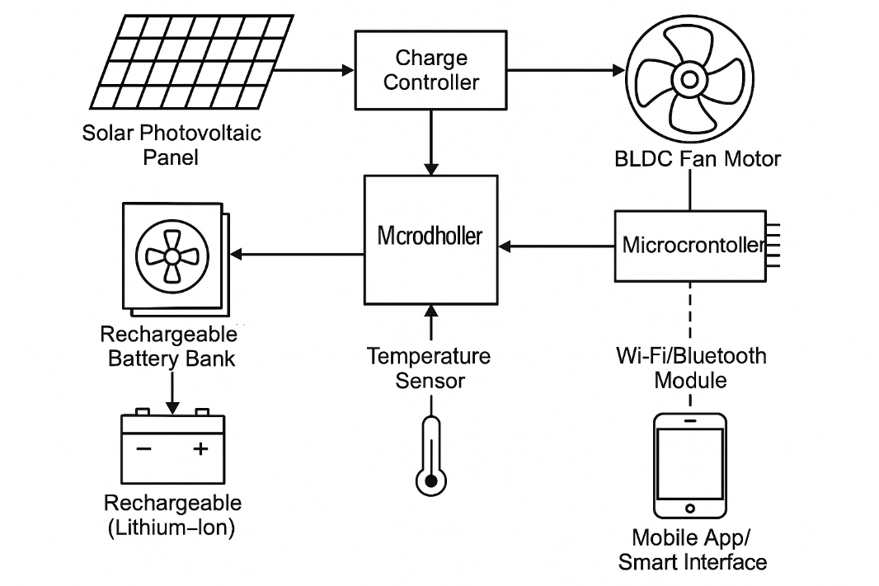
  - Includes fuses, switches, and waterproof connections for safety and durability.

Fig. 3.4: System Architecture

This architecture ensures that the system can intelligently manage energy, respond to environmental changes, and offer a user-friendly experience, all while being sustainable and cost-effective. Would you like a diagram to visually represent this architecture?
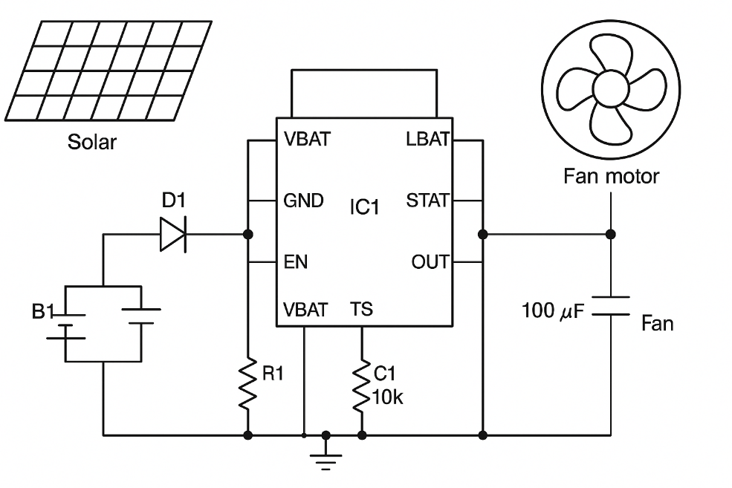
3.5 CIRCUIT DIAGARM

Fig. 3.5: Circuit Diagram

CHAPTER FOUR
DESIGN, IMPLEMENTATION AND DOCUMENTATION OF THE SYSTEM
4.1 SCHEMATIC DESIGN
The schematic design of the solar-powered rechargeable smart fan is structured to ensure efficient power management, intelligent operation, and user convenience. At the core of the system is a solar panel that serves as the primary energy source, converting sunlight into electrical energy. This energy is passed through a diode to prevent reverse current flow, thereby safeguarding the circuit. The energy then charges a rechargeable battery, which acts as the system's power reservoir. A battery management integrated circuit (IC) is used to regulate charging and discharging cycles, ensuring the battery's longevity and safe operation. A capacitor is placed across the output to smooth voltage fluctuations and protect sensitive components. The system integrates a brushless DC motor (BLDC) or a high-efficiency fan motor connected directly to the output of the power management system to drive the fan blades. Smart control is facilitated by an embedded microcontroller or logic control unit, which governs fan speed and operational timing based on inputs such as room temperature or user settings. This control can be manually adjusted via push buttons or remotely managed using wireless modules. The design emphasizes reliability, portability, and sustainability, making it suitable for off-grid or energy-scarce environments while promoting eco-friendly energy usage.
4.2 SYSTEM DESIGN
The system design of this solar-powered rechargeable smart fan project integrates energy generation, storage, control, and output units in a well-coordinated architecture to deliver efficient, autonomous, and intelligent cooling. The system is divided into four main components: the power supply unit, the energy storage unit, the control unit, and the output (fan) unit.
The power supply unit comprises a photovoltaic (solar) panel that harvests solar energy during the day. This energy is routed through a charge controller that regulates the voltage and current, preventing overcharging or deep discharge of the battery. The energy storage unit includes a rechargeable lithium-ion battery pack with enough capacity to power the fan for several hours, ensuring continuous use even during the night or cloudy days.
The control unit, implemented using a microcontroller (e.g., Arduino or ESP32), manages all operations of the fan. It receives input from a temperature sensor to automatically adjust fan speed based on ambient conditions. The controller also interfaces with a wireless module, allowing users to control the fan remotely via a mobile app or smart assistant.
The output unit is a high-efficiency brushless DC fan motor that delivers strong airflow with low power consumption. All components are integrated into a compact, weather-resistant enclosure, ensuring durability, safety, and ease of maintenance.
4.3 SYSTEM DOCUMENTATION
This system documentation outlines the design, development, and operational details of the solar-powered rechargeable smart fan. The system was developed to address the challenges of unreliable electricity supply and the need for energy-efficient and environmentally friendly cooling solutions in both rural and urban areas. It combines solar energy harvesting, rechargeable battery storage, smart control features, and efficient motor technology to deliver a self-sustaining and user-friendly device.
The hardware components include a solar photovoltaic panel (12V), lithium-ion rechargeable batteries, a charge controller (preferably with MPPT for higher efficiency), a brushless DC fan motor, a microcontroller (e.g., Arduino Nano or ESP32), temperature sensor (DHT11/DHT22), and a wireless communication module (e.g., Wi-Fi or Bluetooth). These are connected in a logical sequence, with proper power regulation and protection circuits. The solar panel charges the battery through the charge controller, and the battery powers the fan via a regulated output. The microcontroller receives temperature data and adjusts the fan speed accordingly while enabling remote control via a mobile app or smart assistant.
Software development includes the programming of the microcontroller using the Arduino IDE. The code includes instructions for reading sensor data, controlling fan speed via PWM, battery monitoring, and wireless communication. The mobile application is optionally designed using platforms like Blynk or a custom interface, enabling users to remotely turn the fan on/off, adjust speeds, and view real-time data like temperature and battery level.
All system components are housed in a weather-resistant casing to allow for indoor or outdoor use. The documentation includes circuit diagrams, source code, flowcharts, component datasheets, and test results. The system was tested under different sunlight conditions to ensure reliable operation, and performance evaluations were conducted to verify energy efficiency, runtime, and smart functionality.
In conclusion, the system documentation serves as a guide for understanding, replicating, maintaining, and improving the solar-powered rechargeable smart fan. It emphasizes the integration of renewable energy and smart technology to deliver a sustainable cooling solution.
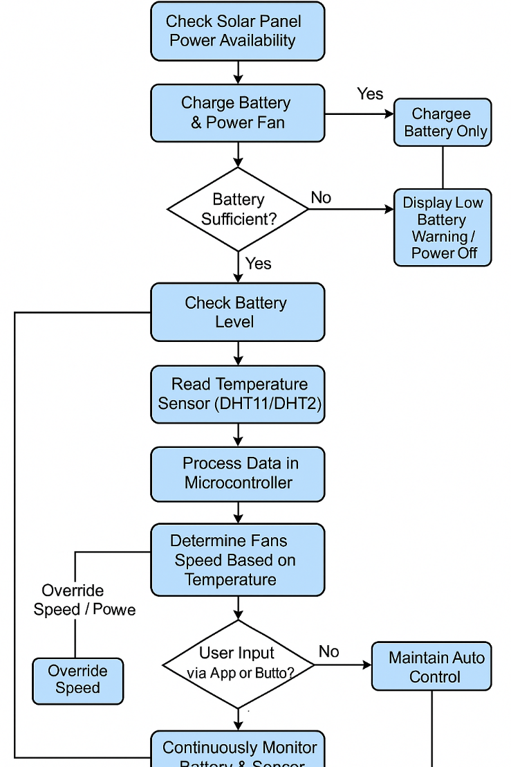
4.3.1 SYSTEM FLOWCHART

Fig. 3.5: System Flowchart
4.4 SYSTEM IMPLEMENTATION
The implementation of the solar-powered rechargeable smart fan involves integrating multiple hardware and software components to realize an energy-efficient and intelligent ventilation system. The process begins with the selection and setup of the photovoltaic (PV) solar panel, which serves as the primary energy source. The solar panel is mounted in an area with maximum sunlight exposure to ensure optimal energy harvesting. Energy generated by the panel is directed to a charge controller, which regulates the voltage and current to prevent overcharging or damaging the rechargeable battery.
A rechargeable battery bank is used to store energy, ensuring the system functions during periods of low or no sunlight. The core control unit, typically a microcontroller such as Arduino or ESP32, is programmed to process inputs from temperature and humidity sensors like DHT11 or DHT22. Based on the readings, the controller adjusts the fan speed to maintain comfort levels. The motor chosen for the fan is a brushless DC (BLDC) motor, known for its high efficiency and low noise.
For smart functionality, the system includes Bluetooth or Wi-Fi modules that enable remote control via a mobile application. Users can manually override automatic settings to adjust fan speed or power modes. The entire setup is housed in a protective casing, ensuring durability and safety. The successful implementation ensures reduced dependence on grid electricity, promotes renewable energy use, and enhances user comfort through automation and remote access.

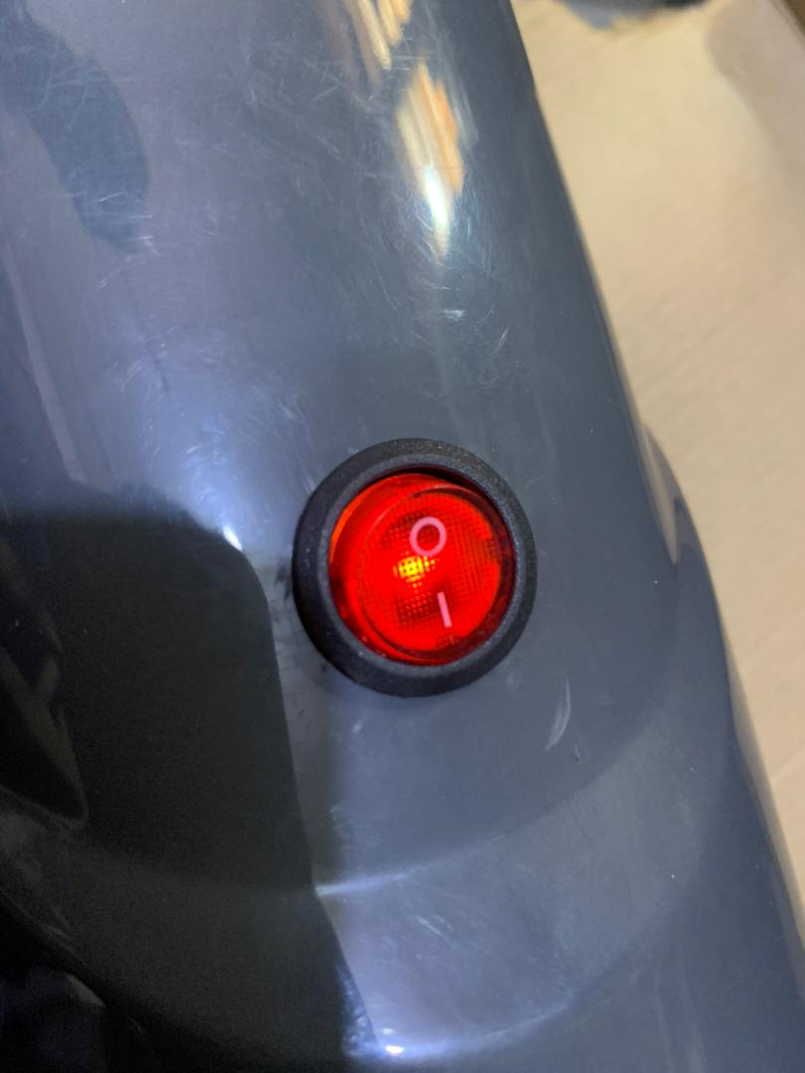

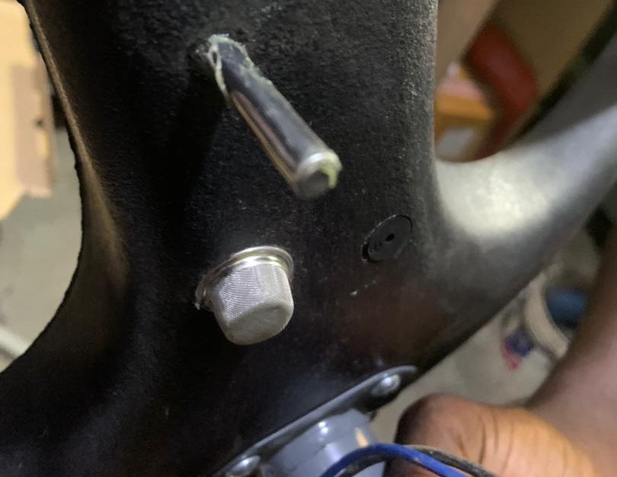
Fig. 4.1: Switch

Fig. 4.2: Temperature Sensor
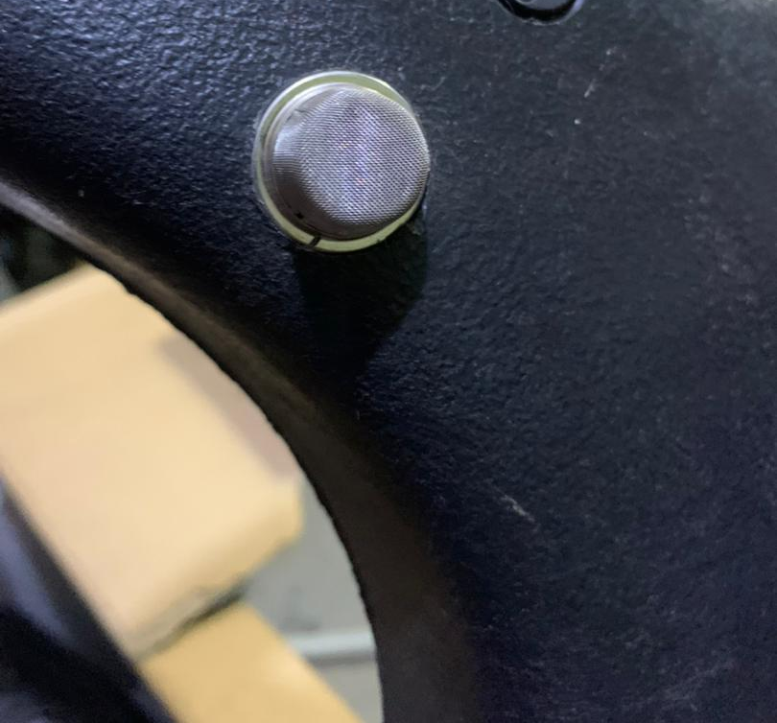

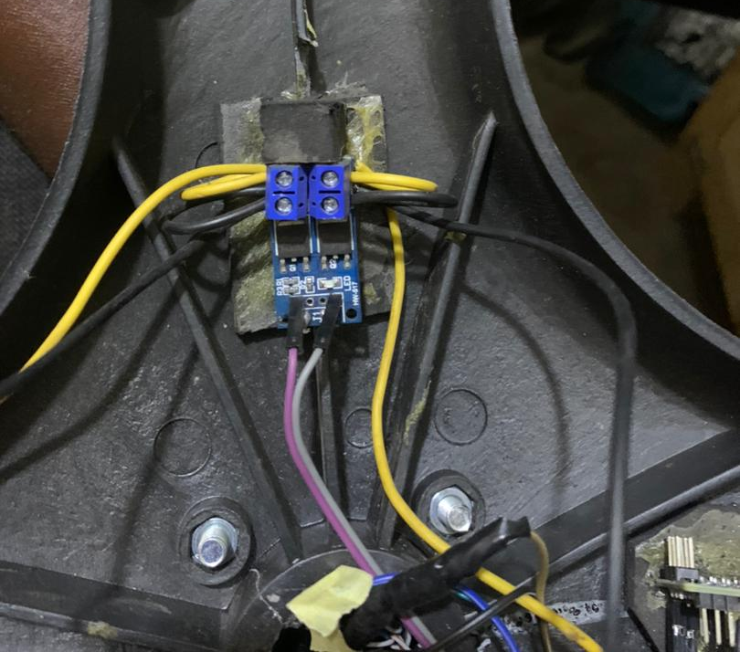
Fig. 4.3: Buzzer

Fig: 4.4: Mosfet Driver

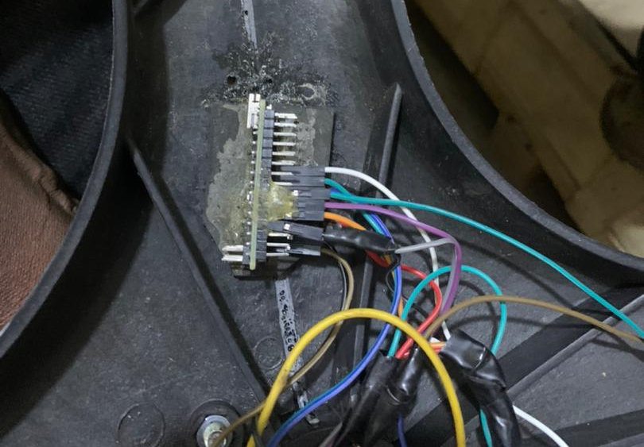

Fig: 4.5: Arduino
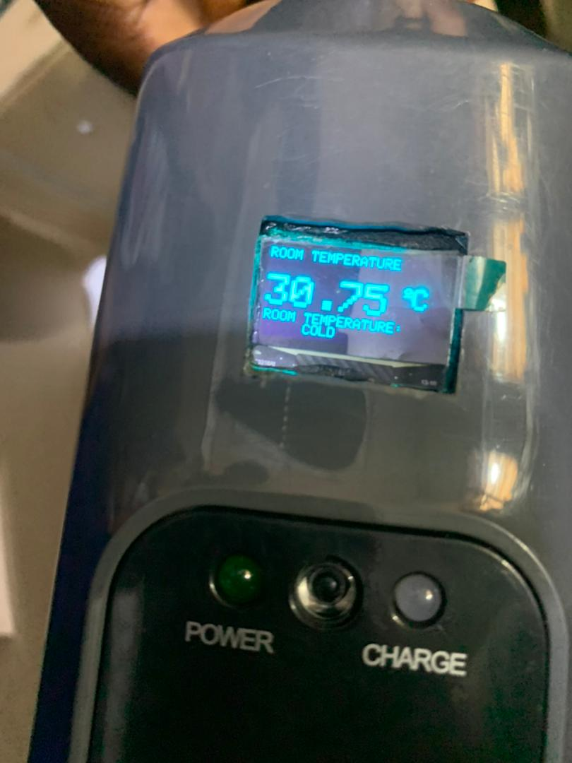

Fig: 4.6: OLED (3264) Screen
CHAPTER FIVE
SUMMARY, CONCLUSION & RECOMMENDATIONS
5.1 SUMARRY
This research work focuses on the design and construction of a solar-powered rechargeable smart fan aimed at providing an energy-efficient, eco-friendly, and autonomous cooling solution, especially in areas with unreliable power supply. The system integrates a photovoltaic solar panel for energy harvesting, a rechargeable battery for energy storage, and a microcontroller-based control unit for intelligent operation. Using temperature sensors, the system can automatically adjust the fan speed based on environmental conditions, while smart features allow for remote control through wireless communication. The use of a brushless DC motor ensures efficient and quiet operation. The design emphasizes sustainability by reducing reliance on conventional grid electricity and promoting the use of renewable energy. It also enhances user convenience and comfort through automation and mobility. The project demonstrates how solar energy, modern electronics, and smart technologies can be combined to develop practical, affordable, and sustainable solutions for everyday applications like ventilation.
5.2 CONCLUSION
In conclusion, the design and construction of the solar-powered rechargeable smart fan demonstrate the practicality and effectiveness of integrating renewable energy with smart technology to create sustainable household appliances. This system not only addresses the challenge of inconsistent power supply but also promotes environmental sustainability by utilizing solar energy as a clean and renewable source. The incorporation of rechargeable batteries ensures continuous operation even in the absence of sunlight, while the intelligent control system enhances user convenience through automatic speed regulation and remote access. By employing energy-efficient components such as a brushless DC motor and a programmable microcontroller, the system delivers reliable performance with minimal energy consumption. This research confirms that the combination of solar power, energy storage, and smart control can provide a viable alternative to conventional electric fans, especially in off-grid or low-resource settings. Ultimately, the project contributes to the growing demand for green technologies and smart living innovations in modern society.
5.3 RECOMMENDATIONS
Based on the findings and successful implementation of Solar-Powered Rechargeable Smart Fan several recommendations are suggested to enhance the system’s effectiveness and promote future development.
- It is recommended that future models integrate a solar tracking mechanism to maximize solar panel exposure throughout the day.
- Employing Maximum Power Point Tracking (MPPT) charge controllers instead of standard PWM can enhance battery charging efficiency and extend system lifespan.
- Incorporating a dual power system that allows for switching between solar and grid power could ensure uninterrupted fan operation during prolonged periods of low sunlight.
- Further development can include full IoT integration to enable data logging, mobile notifications, and cloud-based remote control through internet-connected devices.
- A more advanced BMS should be used for monitoring battery health, temperature, and preventing overcharging or deep discharging.
- Weatherproof and aesthetically pleasing enclosures should be considered for better protection and indoor/outdoor usability.

REFERENCES
Abas, N., Kalair, A., Khan, N., & Haider, A. (2015). Review of energy storage systems for electric vehicle applications. Renewable and Sustainable Energy Reviews, 42, 1101–1118.
Adeyanju, A. A., & Akinbinu, V. A. (2020). Development of a solar powered fan with automatic temperature regulation system. Nigerian Journal of Technological Development, 17(2), 90–96.
Akinyele, D. O., & Rayudu, R. K. (2014). Review of energy storage technologies for sustainable power networks. Sustainable Energy Technologies and Assessments, 8, 74–91.
Al-Shalabi, E. W., & Shaaban, M. (2019). Smart home automation: Design and implementation using Internet of Things (IoT). International Journal of Computer Applications, 177(35), 24–30.
Atikol, U., & Aybar, H. S. (2014). Renewable energy education in North Cyprus. Renewable Energy, 35(10), 2249–2252.
Bhattacharjee, S., & Acharya, S. (2017). Implementation of an automatic solar tracker with remote monitoring using IoT. International Journal of Scientific and Research Publications, 7(5), 525–530.
Choudhury, B., & Roy, A. (2015). Design and implementation of a solar powered smart fan. International Journal of Engineering Research & Technology (IJERT), 4(6), 839–843.
Debnath, S., & Hossain, M. (2019). Design of a low cost solar fan for rural Bangladesh. Renewable Energy Journal, 4(2), 64–71.
Gupta, M., & Mittal, M. (2020). Design of solar operated smart fan using Arduino. International Research Journal of Engineering and Technology (IRJET), 7(7), 1106–1110.
He, G., Chen, Q., Kang, C., Xia, Q., & Zhang, J. (2016). Optimal operation of battery energy storage system considering distribution system load forecast. IEEE Transactions on Smart Grid, 7(2), 1014–1023.
Kumar, S., & Jain, V. (2018). Application of renewable energy in household appliances. International Journal of Innovative Research in Science, Engineering and Technology, 7(4), 4120–4125.
Lee, D. Y., & Nam, S. H. (2018). Development of a solar-powered fan for smart homes. Journal of Power and Energy Engineering, 6(2), 85–92.
Mishra, R., & Sahu, R. (2016). Smart cooling system using Arduino. International Journal of Advanced Research in Computer and Communication Engineering, 5(6), 45–49.
Okundamiya, M. S., & Nzeako, A. N. (2011). Design of a standalone photovoltaic system for a residential load. International Journal of Renewable Energy Research, 1(2), 57–65.
Oyedepo, S. O. (2014). Towards achieving energy for sustainable development in Nigeria. Renewable and Sustainable Energy Reviews, 34, 255–272.
Parida, B., Iniyan, S., & Goic, R. (2011). A review of solar photovoltaic technologies. Renewable and Sustainable Energy Reviews, 15(3), 1625–1636.
Patel, H., & Agarwal, V. (2008). MATLAB-based modeling to study the effects of partial shading on PV array characteristics. IEEE Transactions on Energy Conversion, 23(1), 302–310.
Rahman, M. M., & Ahmed, K. (2017). Performance analysis of a low-cost solar powered ventilation system. Journal of Clean Energy Technologies, 5(2), 130–134.
Reddy, K. S., & Ranjan, M. (2003). Solar passive techniques for thermal comfort in buildings. International Journal of Ambient Energy, 24(3), 115–128.
Shukla, A. K., Sudhakar, K., & Baredar, P. (2016). A comprehensive review on design of building integrated photovoltaic system. Energy and Buildings, 128, 99–110.
Smitha, R., & Rajan, P. (2019). An efficient fan control system based on temperature and humidity using IoT. International Journal of Engineering and Advanced Technology, 8(6), 45–49.
Sulaiman, S. A., & Husain, H. (2015). Design and development of a solar-powered fan for agricultural use. International Journal of Scientific Engineering and Applied Science, 1(5), 117–123.
Suresh, A., & Mahendran, M. (2021). Smart solar ceiling fan with auto mode and manual control. International Journal of Science and Research, 10(5), 412–417.

APPENDIX
#include <Wire.h>
#include <Adafruit_GFX.h>
#include <Adafruit_SSD1306.h>
#include <OneWire.h>
#include <DallasTemperature.h>
#define SCREEN_WIDTH 128 // OLED display width, in pixels
#define SCREEN_HEIGHT 64 // OLED display height, in pixels
// Declaration for an SSD1306 display connected to I2C (SDA, SCL pins)
Adafruit_SSD1306 display(SCREEN_WIDTH, SCREEN_HEIGHT, &Wire, -1);
// GPIO where the DS18B20 is connected to
const int oneWireBus = 2;
// Setup a oneWire instance to communicate with any OneWire devices
OneWire oneWire(oneWireBus);
// Pass our oneWire reference to Dallas Temperature sensor
DallasTemperature sensors(&oneWire);
int Fan_Mosfet = 3;
int Buzzer = 4;
int tempMin = 35; // the temperature to start the fan
int tempMax = 40; // the maximum temperature when fan is at 100%
int fanSpeed;
int Gasthreshold=200;
void setup() {
// Start the Serial Monitor
Serial.begin(115200);
// Start the DS18B20 sensor
sensors.begin();
pinMode(Fan_Mosfet, OUTPUT);
pinMode(Buzzer, OUTPUT);

//OLED
if (!display.begin(SSD1306_SWITCHCAPVCC, 0x3C)) { // Address 0x3D for 128x64
Serial.println(F("SSD1306 allocation failed"));
for (;;);
}
delay(2000);
display.clearDisplay();
display.setTextSize(1);
display.setTextColor(WHITE);
display.setCursor(0, 20);
// Display static text
display.println("FAN AUTOMATIC");
display.println("TEMPERATURE");
display.println("CONTROLLED SYSTEM");
display.display();
delay(3000);
}
void loop() {
sensors.requestTemperatures();
float temperatureC = sensors.getTempCByIndex(0);
// SERIAL
Serial.print("Temperature=");
Serial.print(temperatureC);
Serial.println("ºC");
Serial.println(" ");
// OLED
if (temperatureC <= tempMin)
{
digitalWrite(Fan_Mosfet, LOW);
fanSpeed = 0; // fan is not spinning
digitalWrite(Buzzer, LOW); // turn on led
display.clearDisplay();

