LAND INFORMATION SYSTEM
OF
GOVERNMENT SECONDARY SCHOOL MARABA, ILORIN EAST LOCAL GOVERNMENT, ILORIN KWARA STATE

BY

AGBALAYA OLAIDE MARGARET
HND/23/SGI/FT/0097
SUBMITTED TO THE DEPARTMENT OF SURVEYING AND GEO-INFORMATICS
INSTITUTE OF ENVIRONMENTAL STUDIES (IES) KWARA STATE POLYTECHNIC ILORIN
IN PARTIAL FUILFILMENT OF THE REQUIREMENT FOR THE AWARD OF
HIGHER NATIONAL DIPLOMA (HND) IN SURVEYING AND GEO-INFORMATICS

JULY, 2025.

CERTIFICATE

I hereby certify that this project is as a result of the field work in which I took active part and that the survey work was carried out in accordance with survey laws and department instruction.

____________________ ____________________
AGBALAYA OLAIDE MARGARET DATE
HND/23/SGI/FT/0097

CERTIFICATION
This is to certify that I, AGBALAYA OLAIDE MARGARET with Matric. NO: HND/23/SGI/FT/0097. A student of Kwara State Polytechnic, Department of surveying and Geo-informatics that the practical field work on which this report was based and truly carried out in accordance with survey rules and regulations and with departmental instruction.

________________________ ________________________
SURV. ABIMBOLA I.S DATE
(Project Supervisor)

________________________ ________________________
SURV. R.S AWOLEYE DATE
(Project Coordinator)

________________________ ________________________
SURV. ABIMBOLA I.S DATE
(Head of Department)

________________________ ________________________
DATE
(External Examiner)

DEDICATION

This project is wholeheartedly dedicated to God Almighty, whose grace and guidance saw me through every stage of this academic journey.
To my wonderful parents, Mr. and Mrs. Job Agbalaya, thank you for your unwavering love, support, and prayers.
And finally, to myself, for staying strong, focused, and determined despite all odds. I love the woman you are becoming, Noblewoman.

ACKNOWLEDGEMENT
First and foremost, I give all glory and honor to God Almighty, whose unfailing grace, wisdom, and strength sustained me throughout this project and my academic journey. Without His guidance, this work would not have been possible.
I am deeply grateful to my project supervisor, Surv. Abimbola, for his invaluable guidance, patience, and expert advice. His constructive criticisms and encouragement motivated me to improve and complete this study with excellence and to all my departmental lecturer, Surv Ayuba Abdulsalam, Surv. R.S, Awoleye, Surv. Asonibare R.O, Surv. A.G Aremu, Surv. B.F Diran, Surv. Williams Kazeem, Surv. Akinyede A.O, and Surv. Kabiar Babatunde I am grateful for your impact in my life.
My heartfelt appreciation goes to my beloved parents, Mr. and Mrs. Job Agbalaya, whose unwavering love, prayers, and sacrifices have been the foundation of my success. Your constant support inspired me to push through challenges and remain focused.
To my junior sisters, Joy and Eniola, thank you for your love, encouragement, and understanding during times when I needed peace and quiet to concentrate. Your presence brought joy and motivation into my life.
I am sincerely thankful to my dear friend, Owoeye Emmanuel, who stood by me throughout my Higher National Diploma academic session. Your assistance, advice, and encouragement were invaluable in overcoming difficult moments.
Special thanks also go to my school friends, Odeniyi Boluwatife and Adams Fatimo, for their consistent support and encouragement, as well as to my project team whose teamwork and dedication greatly contributed to the success of this work.
I also appreciate my fellowship, ECWA Student Ministry, and my co-executive members for the spiritual support, fellowship, and prayers. Your encouragement created a positive environment that enriched my academic and personal growth.
Lastly, I appreciate everyone who contributed directly or indirectly to this project. Your support, prayers, and encouragement have been a vital part of this achievement.

To all of you, I say thank you from the depths of my heart.
TABLE OF CONTENTS
Tittle Page
Certificate
Certification
Dedication
Acknowledgement
Table of Content
List of Figures
List of Tables
Abstract
Chapter One
1.0 Introduction
1.1 Background of Study
1.2 Statement of the Problem
1.3 Aim of the Study
1.4 Objective of the Study
1.5 Scopes of the Project
1.6 Project Specification
1.7 Personnel Involved
1.8 Study Area
Chapter Two
2.0. Literature Review
Chapter Three9
3.0 Methodology
3.1 Project Planning
3.1.1 Office Planning
3.1.2 Field Reconnaissance
3.2 Data Base Design
3.2.1 View of Reality
3.2.2 Logical Design
3.3 Equipment Used
3.3.1 Hardware Used
3.3.2 Software Used
3.4 Instrument Test
3.4.1 Horizontal Collimation Test
3.4.2 Vertical Index Error Test
3.4.3 Analysis of Collimation and Vertical Index Data
3.5 Control Check
3.5.1 Control Check Procedure Using Total Station
3.6 Geometric Data Acquisition
3.7 Detailed Survey
3.7.1 Non-Spatial Data Collection
3.7.2 Types of Non-Spatial Data Collected
3.8 Data Download and Storage
3.8.1 Data Validation and Accuracy Assessment
3.8.2 Validation of Spatial Data
3.8.3 Validation of Non-Spatial Data
3.9 Data Processing and Integration
3.9.1 Spatial Data Processing in AutoCAD
3.9.2 Topographic Data Processing in Suffer
3.9.4 Non-Spatial Data Processing in Excel
3.9.5 Geo-database Creation in Arc-GIS
3.9.6 Data integration and Finalization for LIS
3.10 Boundary Digitization and Feature Mapping
3.10.1 Detailing
3.11 Topographic Data Processing
3.12. Attribute Data Acquisition
3.13 Data Creation/Implementation
3.13.1 Database Management System (DEMS)
3.13.2 Data Quality
Chapter Four
4.0 Analysis and Results
4.1 Introduction
4.2 Spatial Data Results
4.2.1 School Boundary and Building Layout
4.2.2 Significance of the Spatial Data Results
4.3 Topographical Analysis Result
4.3.1 Digital Elevation Model (Dem)
4.3.2 Contour Mapping
4.3.3 Slope and Terrain Analysis
4.3.4 Significance of Topographical Analysis Results
4.4 Non-Spatial Data Results
4.4.1 Attribute Data for School Buildings
4.4.2 Linking Non-Spatial Data with GIS
4.4.3 Significance of Non-Spatial Data in LIS
4.5 Query Execution and Results
Chapter Five
5.0 Costing, Summary, Problems Encountered, Conclusion and Recommendations
5.1 Project Costing
5.1.1 Recci
5.1.2 Beacon
5.1.3 Beaconing
5.1.4 Traversing
5.1.5 Data Downloading and Plotting
5.1.6 Information Presentation
5.1.7 Contingencies
5.1.8 Value Added Tax (Vat)
5.1.9 Mobilization and Demobilization
5.1.10 Accommodation
5.2. Summary
5.3 Problem Encountered
5.4 Recommendations
5.5 Conclusion
Reference
Appendix
LIST OF FIGURES
Fig. 1.1 Diagram of study area
Fig 3.1 Design and construction phase in spatial database
Fig. 3.4.1 Horizontal collimation & vertical index error test
Fig. 3.8.3 Satellite imagery of the study area
Fig. 3.9.1 Screenshot of boundary digitization and features
Fig.3.9.2.1 Screenshot of the imported dataset
Fig. 3.9.2.2 Screenshot of the generated DEM
Fig. 3.9.2.3 Screenshot of the contour generation process
Fig. 3.9.4 Screenshot of the structured attribute table
Fig. 3.9.5 Screenshot of the data join process
Fig. 10.1 Screenshot showing the digitization process and layer management
Fig. 4.2.1 Mapped school boundary and buildings in ArcGIS
Fig. 4.3.1 Digital elevation model (DEM) of the school premises
Fig. 4.3.2 Contour map of the school premises
Fig. 4.3.3 Slope analysis map of the school premises
Fig. 4.4.1 Sample attribute table for school buildings
Fig. 4.4.2 Linking non spatial data to spatial features in ArcGIS
Fig. 4.5.1 Sample of staff room query results in ArcGIS
Fig. 4.5.2 Sample of class room query results in ArcGIS
LIST OF TABLES
Table 1.7 Personnel involved
Table 3.4.1 Horizontal collimation data
Table 3.4.2 Vertical index data
Table 3.5.1.1 Coordinate of the observed and the original values K654AD
Table 3.5.1.2 Coordinate of the observed and the original values K656AD
Table 3.5.1.3 Coordinate of the observed and the original values K657AD
Table 5.1.1 Costing for Recci
Table 5.1.2 Costing for Beaconing
Table 5.1.3 Costing for Traversing
Table 5.1.4 Downloading Data and Plotting
Table 5.1.5 Information presentation

ABSTRACT
Land remains one of the most fundamental resources that support the existence and development of human society. The effective management of this vital resource is often hindered by poor documentation, disorganized storage of records, inaccessibility of data, and outdated systems of administration. In Nigeria, where population growth and urban expansion exert pressure on land, the need for an accurate, transparent, and efficient system for land information management is more urgent than ever. This project was undertaken to design and implement a functional Land Information System (LIS) for effective land management of Government Secondary School, Maraba, located in Ilorin-East Local Government Area of Kwara State. The project aims to develop a digital platform that enhances the efficiency, accuracy, and transparency of land administration within the study area. The scope of the work includes the acquisition of both geometric and attribute data using a Total Station, field reconnaissance, control establishment, perimeter and detail surveying, attribute/social data collection, database development, spatial data processing, and presentation using GIS software. The LIS was designed to serve as a centralized system where land data can be stored, retrieved, analyzed, and updated with ease. The methodology involved preliminary office planning, extensive fieldwork, geometric data acquisition through Total Station, and attribute data collection. The data was processed, cleaned, and integrated into a geospatial database developed using standard GIS techniques. Special emphasis was placed on data accuracy, consistency, security, and user accessibility. The system also considered data quality control, system integrity, and functionality across different land-use types. The implementation of the Land Information System revealed that land-related decisions can be made faster and more accurately when data is properly managed in a structured digital system. The LIS offers significant potential to support educational institutions in record-keeping, planning, infrastructural development, and resolving boundary-related issues. Moreover, this project demonstrates the application of modern surveying instruments and GIS in solving real-life land management challenges. In conclusion, the successful development of this Land Information System illustrates the role of technology in transforming land administration practices in Nigeria. The system serves not only as a model for similar public school environments but also highlights the capacity of trained geo-informatics professionals to bridge the gap between data acquisition and meaningful application in land governance.

CHAPTER ONE

1.0 INTRODUCTION
1.1 BACKGROUND OF THE STUDY
In recent decades, the importance of spatial data in decision-making processes has grown significantly, and with it, the need for efficient systems that manage and analyze land-related information. Land Information System (LIS) has emerged as a specialized form of Geographic Information System (GIS) designed specifically to store, retrieve, manage, and analyze data associated with land. LIS provides a digital platform that integrates spatial and attribute data to support various aspects of land monitoring, planning, and management.
LIS plays a vital role in ensuring that land data is organized, accurate, accessible, and up-to-date. It assists in tracking land use patterns, supporting infrastructure development, guiding sustainable land utilization, and improving the quality of spatial information available to professionals and institutions. The need for LIS has become more prominent with increasing urbanization, climate change concerns, and the rising demand for efficient land data handling in public and private sectors.
Unlike broader GIS platforms, LIS is tailored to handle detailed land-related spatial datasets such as coordinates, terrain attributes, land zoning, and environmental overlays. It promotes intelligent analysis and visualization of land dynamics, ensuring that data can support technical operations, research, and policy implementation. The introduction of LIS into land-related projects significantly reduces redundancy, enhances data sharing, and supports integrated land planning approaches.
The use of Total Station, Global Navigation Satellite System (GNSS), and remote sensing technologies has made the collection of accurate land data more efficient, feeding into LIS databases in real time or near real time. These tools enable the system to maintain high precision in both data acquisition and output generation. Through proper implementation, LIS helps engineers, surveyors, planners, and environmental analysts to interact with spatial data in meaningful ways.
This project focuses on the design and development of a Land Information System for efficient spatial data integration, retrieval, and analysis. It explores how LIS tools can be implemented to enhance land-related spatial data accuracy, accessibility, and application in solving real-world spatial problems.
Land Information System (LIS) is a computer-assisted tool that captures, stores, processes, and presents data linked to land features in a spatial format. It provides a systematic means of managing geographically referenced land data in a digital environment. With the increasing need for precise and up-to-date land-related information, LIS has become essential in facilitating efficient land data handling and ensuring that decision-makers have access to reliable spatial records. Unlike traditional methods of storing land data manually, LIS provides a dynamic environment for integrating satellite imagery, maps, survey data, and attribute information into a single system for easy access and analysis.
In the context of modern land development and resource management, LIS plays a vital role in mapping terrain, analyzing spatial patterns, and supporting environmental and infrastructural decisions. The system enables professionals in fields such as surveying, engineering, and environmental science to understand land characteristics in a way that paper-based systems cannot offer. By linking descriptive data to physical locations, LIS enhances the accuracy and speed of land-related investigations. It serves as a practical tool for tasks like route selection, land suitability analysis, and terrain evaluation, especially when multiple layers of land data need to be compared or modeled.
Over time, the application of LIS has expanded due to advancements in technology such as remote sensing, global positioning systems (GPS), and geographic information systems (GIS), all of which contribute to the improved accuracy and functionality of LIS platforms. These tools allow for real-time data integration and interactive mapping, thereby increasing the reliability of outputs used for technical and administrative purposes. The importance of LIS is further seen in how it supports institutional efforts in land resource management by offering timely, consistent, and scalable data solutions.
The demand for spatial data has grown, and LIS addresses this by providing a central platform where geospatial data can be collected, processed, and utilized effectively. Its use enhances data sharing among professionals and ensures that land-related information is not only preserved digitally but also analyzed for future planning. The role of LIS in improving transparency, supporting technical evaluation, and streamlining spatial operations makes it a central tool in land-focused disciplines. The background and relevance of LIS therefore lie in its ability to simplify complex land data interactions and improve the quality of decisions made regarding land use and spatial development.
The reliability of land-based data is crucial in land-related professions, and LIS addresses the challenge of fragmented and outdated land records by offering a centralized, digital solution. In areas where physical records are vulnerable to loss, duplication, or manipulation, LIS introduces a level of accuracy and permanence that improves both administrative efficiency and technical precision. With LIS, spatial and non-spatial land data can be updated consistently, making it easier to maintain current information across institutions and among stakeholders who require access to land-related datasets.
Furthermore, the integration capacity of LIS allows various sources of data such as satellite images, survey results, and land attributes to be combined into a meaningful system. This supports professionals in making informed decisions and also improves communication between departments or agencies involved in land monitoring and evaluation. LIS enables interactive visualization, where maps can be layered with multiple datasets, providing deeper insight into land features, usage patterns, and environmental changes. This is especially useful in contexts where spatial precision and historical land change detection are required.
LIS also supports the documentation of changes over time, helping professionals analyze trends in land development, vegetation cover, infrastructure growth, and spatial relationships. This historical view, which is easily accessible through LIS, is critical for ensuring that future land decisions are informed by past patterns. Additionally, LIS offers customization options for different project goals, such as analyzing flood-prone zones, monitoring land degradation, or evaluating terrain conditions all without introducing administrative or legal concepts that are often linked to cadastral systems.
With improvements in digital storage and processing, LIS systems are now more capable of handling large volumes of spatial data without compromising performance. This has increased their adoption in academic research, environmental assessments, and technological innovations. The system’s ability to handle both vector and raster data ensures that detailed maps, images, and measurements can coexist and be used effectively in land evaluation. These capabilities also make LIS a valuable teaching and research tool in geospatial studies, where clarity, accuracy, and accessibility are critical for student and expert use.
In essence, the application of LIS continues to redefine how land data is approached. It fosters a culture of precision, enhances collaboration among land professionals, and ensures that land-related processes are more transparent, accountable, and effective. The strength of LIS lies in its adaptability to various spatial problems while maintaining its identity as a tool purely focused on technical and analytical aspects of land information not on ownership, taxation, or governance. It provides a technical backbone for land-related activities without delving into administrative components, making it the preferred system in many land and spatial data operations.
Land Information System (LIS) continues to expand in capacity and relevance as geospatial technologies advance. It serves as a structured framework that not only stores but also organizes, manipulates, analyzes, and retrieves land-related data with spatial precision. The evolution of LIS has moved from basic digital mapping to a more dynamic integration of geo-informatics, enabling users to visualize, model, and interpret spatial phenomena across diverse terrains. In research and practice, LIS supports topological modeling and spatial querying, which are essential in the evaluation of land surface changes, slope analysis, and mapping land accessibility.
One major strength of LIS is its application in land suitability analysis. With datasets including soil type, slope, elevation, and proximity to infrastructure, LIS can run multilayer analysis to determine areas best fit for a specific purpose such as agriculture, settlement development, or ecological preservation. This makes it a strategic tool for professionals who depend on evidence based criteria to guide physical planning, agricultural expansion, and conservation efforts. The analytical tools available in LIS reduce human error and offer repeatable results, making the system trustworthy in technical processes that demand high accuracy.
Moreover, LIS supports visualization through 2D and 3D mapping techniques, which increases understanding of spatial relationships and assists in land use classification. Users can overlay different land characteristics to assess the impact of environmental or man-made changes, simulate different development scenarios, and visualize trends over time. These features make LIS useful not only in static mapping but also in predictive analysis, offering foresight in land development strategies and environmental monitoring.
In academic institutions, LIS is instrumental in teaching spatial reasoning and real-world applications of geospatial concepts. Through practical exercises in data collection, digitization, spatial analysis, and cartographic presentation, students and researchers gain hands-on experience in how land-related data is organized and used for informed decisions. Institutions often employ LIS software for research purposes that involve terrain mapping, hydrological analysis, vegetation studies, and slope modeling all without needing to engage with ownership details or administrative boundaries.
Importantly, the strength of LIS lies in its data accuracy and its ability to update and store high-resolution information in real time. Whether sourced from satellite imagery, drone surveys, or total station data, information stored in LIS can be processed and retrieved efficiently. The capability to handle multi-format spatial data, along with its ability to export outputs into various forms (maps, charts, tables), increases its versatility. The LIS platform ensures that the information is not only stored securely but also readily available for technical assessments and spatial reporting.
Land Information System also plays a significant role in environmental monitoring and land degradation assessment. Through the integration of remotely sensed data and spatial datasets, LIS enables researchers to detect patterns of erosion, deforestation, flooding vulnerability, and land cover changes. Such spatially-aware insights provide a basis for sustainable land management. The ability to compare archived spatial data with recent acquisitions supports time-series analysis, helping to identify trends and long-term impacts on the land. In this way, LIS offers not just a static database but a dynamic system that supports land sustainability efforts through informed observation and documentation.
Technological advancements have further elevated the capacity of LIS. Integration with GPS, satellite imagery, UAVs (Unmanned Aerial Vehicles), and GIS software has enriched data acquisition and improved accuracy in spatial representation. Cloud-based platforms now allow real-time collaboration, data sharing, and remote access to LIS tools, which enhances productivity among professionals working on diverse land-based projects. Additionally, open-source LIS software like QGIS, ILWIS, and GVSIG have made it easier for institutions and individuals with limited resources to participate in spatial data analysis without compromising on quality or technical functionality.
Furthermore, LIS is increasingly being recognized as a central component in Smart City frameworks. The spatial intelligence derived from LIS contributes to the planning and monitoring of public infrastructure, green spaces, utility services, and mobility patterns. By visualizing the spatial dimension of land use and development, LIS provides a platform where decisions can be guided by real-time data. It allows for interactive dashboards, mobile-based field data updates, and synchronized mapping interfaces all of which contribute to more responsive and integrated land-related decisions.
As digital literacy grows, LIS is becoming more accessible to a wider range of users, including students, researchers, and professionals across different disciplines. The user-friendly nature of modern LIS platforms, coupled with the growing availability of spatial data, has reduced technical barriers and improved participation in land-based studies. Training on LIS now forms a crucial part of geo-informatics education, equipping users with the skills needed to collect, analyze, and interpret spatial data efficiently.
The application of LIS in academia and research has also opened new frontiers for scientific inquiry into spatial patterns, socio-environmental relationships, and land-related behavior over time. It aids scholars in analyzing geospatial variables, understanding human interaction with land, and modeling predictive outcomes for various land-related scenarios. The flexibility of LIS allows researchers to customize their spatial queries, simulate different land-use possibilities, and visualize the impacts of policy decisions on land resources. These capabilities have made LIS an indispensable resource in postgraduate research and professional field studies, particularly within geography, geo-informatics, environmental science, and urban analysis.
Another important development in the evolution of LIS is its integration with artificial intelligence and machine learning algorithms. These innovations allow for advanced predictive modeling and pattern recognition within spatial datasets. For example, land change detection, land-use classification, and anomaly spotting in large datasets can be efficiently managed through AI-integrated LIS platforms. These systems not only reduce the time needed to analyze large volumes of spatial data but also increase the reliability of such analyses. Consequently, this integration has elevated the relevance of LIS in addressing complex land-related challenges.
The increasing adoption of LIS at institutional levels ranging from universities and research institutes to private mapping companies demonstrates its growing utility across sectors. Many of these institutions now maintain internal LIS databases for asset management, campus planning, research mapping, and resource allocation. This trend has also encouraged curriculum updates in higher education, where students are trained with real-world LIS projects and industry-based case studies, ensuring they are well-prepared for land and spatial-data-related careers.
Moreover, LIS provides the spatial framework necessary for understanding the implications of global issues such as land scarcity, agricultural efficiency, food security, and ecological stability. It enables the spatial correlation of land characteristics with environmental and economic variables, allowing policymakers and researchers to draw informed conclusions from data-driven visualizations. These insights help foster more responsible land stewardship, particularly in regions where land remains a primary asset for livelihood and survival.
The development of Land Information Systems (LIS) has transformed the way land data is managed and utilized. LIS integrates spatial and attribute data to provide a comprehensive digital framework for recording, analyzing, and sharing land-related information. Through the use of geographic data models and database management, LIS enhances the accuracy and accessibility of land data, enabling effective monitoring and management of land resources. By facilitating data collection, storage, and retrieval processes, LIS supports a wide range of applications such as environmental monitoring, resource mapping, and spatial analysis.
Advancements in LIS technologies, including the incorporation of remote sensing, GPS, and digital mapping tools, have enabled the continuous updating and validation of spatial data, ensuring its reliability for various stakeholders. The system’s ability to handle large volumes of geospatial data allows for efficient data manipulation and visualization, empowering users to make informed decisions regarding land use and management without involving administrative or ownership functions.
Furthermore, the integration of LIS with emerging technologies such as cloud computing and mobile platforms has expanded its reach, allowing real-time access to land data from multiple locations. This connectivity fosters better coordination in data sharing and supports the timely response to changes in land conditions, which is vital for sustainable management.
1.2 STATEMENT OF THE PROBLEM
Land administration and management in Government Secondary School Maraba continues to form critical inefficiencies, lack of coordination, and outdated systems in the study area. These problems underscore a deeper need, the urgent implementation of a digital solution that can integrate spatial data, and land use details into a unified platform.
Therefore, this project seeks to address these challenges by designing and implementing a Land Information System that is intelligent, accessible, and tailored to support effective land administration and sustainable development in Government Secondary School Maraba.
1.3 AIM OF THE STUDY
The primary aim of this study is to design and implement a functional Land Information System (LIS) that enhances the efficiency, accuracy, and transparency of land management processes within Government Secondary School Maraba, Ilorin East Local Government, Ilorin Kwara State. The system will serve as a digital platform for organizing, storing, retrieving, and managing land-related data, with the ultimate goal of supporting effective decision-making, reducing land disputes, improving access to land records, and promoting sustainable land administration at the institutional level.
1.4 OBJECTIVE OF THE STUDY
The specific objectives of this study are
- Design a user-friendly Land Information System capable of managing land and usage data in a centralized digital format.
- Geometric and attribute data acquisition
- Implement core features of the system including data entry, spatial mapping, search and retrieval functions, and secure access control.
- Integrate Geographic Information System (GIS) tools to visualize and enable location-based analysis and decision-making.
- Evaluate the performance of the developed system in terms of accuracy, usability, responsiveness, and reliability.
- To produce plans as graphical representation
1.5 SCOPE OF THE PROJECT
The scope of this project covers the following major phases and activities:
- Reconnaissance Survey: Preliminary field inspection to understand the area of study, identify existing features and determine control points needed for mapping.
- Office Planning: Preparation of necessary materials, equipment checks, defining the workflow, and gathering existing maps or records for the project area.
- Data Acquisition: Collection of spatial and non-spatial data through total station.
- System Design and Implementation: Development of a functional Land Information System to address land management and decision making.
- Documentation and Reporting: Compilation of project activities, methodologies, system features, and outcomes into a final technical report.
1.6 PROJECT SPECIFICATION
This project is aimed at building a Land Information System (LIS) to support effective land management. The system will combine both spatial (map-related) and non-spatial (text-based) information to help users register, retrieve, and visualize land records
1.7 PERSONNEL INVOLVED
For easy and proper execution of survey field work eight personnel were engaged, the Matric number of the survey team were listed below:
S/N | MATRIC NO
1 | HND/23/SGI/FT/0097 | AUTHOR
2 | HND/23/SGI/0090
3 | HND/23/SGI/FT/0091
4 | HND/23/SGI/FT/0092
5 | HND/23/SGI/FT/0093
6 | HND/23/SGI/FT/0099
7 | HND/23/SGI/FT/0113
8 | HND/23/SGI/FT/0121

1.8 STUDY AREA
The study area for this project is Government Secondary School Maraba, Ilorin East Local Government, Ilorin Kwara State. This location was selected due to its institutional land use and the need for proper spatial and attribute data management within its premises. Like many educational institutions in growing urban areas, the college faces challenges in managing its land records, development activities, and property boundaries.
The proposed land information system is aimed at capturing, storing, and managing spatial and non-spatial land data specific to the college’s property. With this system in place, the administration will benefit from efficient land monitoring, easier decision-making on land allocation and development, and improved record-keeping.
The map below presents the spatial extent and layout of Government Secondary School Maraba, Ilorin East Local Government, Ilorin Kwara State and its immediate surroundings.

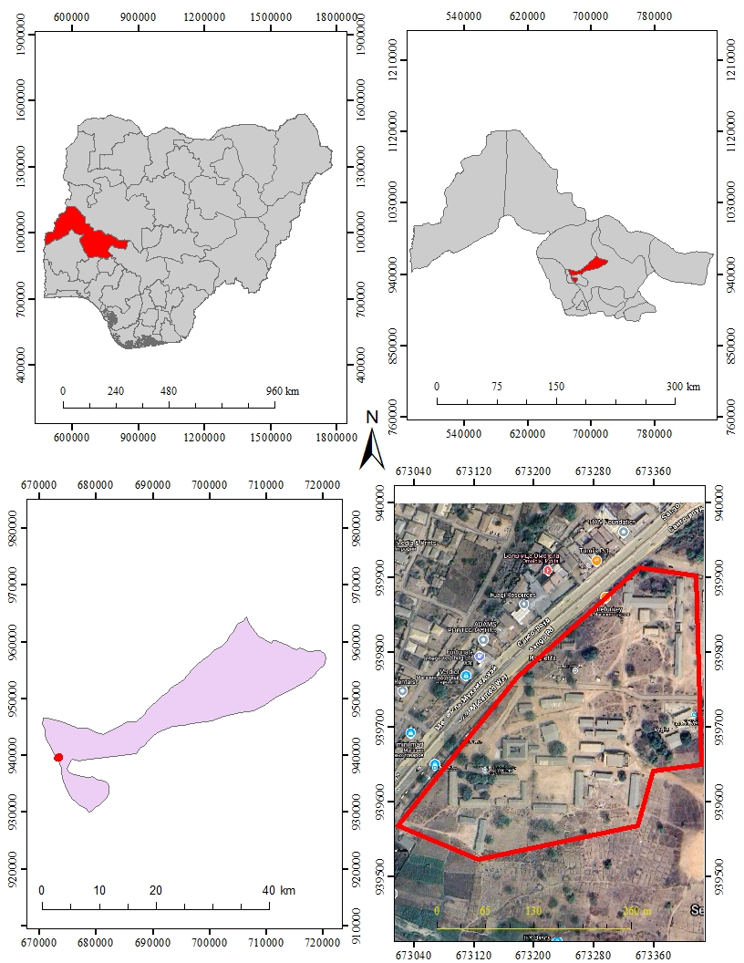
LOCATION MAP OF THE STUDY AREA

SATELLITE OF THE STUDY AREA

MAP OF KWARA STATE

MAP OF NIGERIA

CHAPTER TWO
2.0 LITERATURE REVIEW
Applications of Land Information System (LIS)
Land Information System (LIS) has evolved into a central tool in spatial data management, offering applications that transcend traditional boundaries. At its core, LIS integrates location-based data with attribute information to support land-related decisions that are spatially dependent (Longley et al., 2011).
One of the major areas where LIS finds application is in land-use planning and policy formulation. Government agencies use LIS to map out current land uses and simulate future development scenarios. By analyzing population growth, transportation networks, and environmental factors, LIS provides a spatial framework that supports policy development and strategic land planning (Maguire et al., 2005). It enables planners to make informed decisions that align with environmental sustainability and urban development goals.
In infrastructure development, LIS provides data necessary for identifying optimal locations for public facilities such as schools, hospitals, and water networks. According to Rajabifard and Williamson (2001), LIS allows engineers and planners to consider multiple variables, including topography, soil conditions, and existing infrastructure, to support cost-effective and sustainable development.
Environmental monitoring is another field where LIS has become indispensable. Through the integration of satellite imagery, remote sensing data, and geospatial analysis, LIS helps track changes in vegetation cover, surface water, and erosion patterns. These capabilities make LIS a vital resource for natural resource management and disaster risk reduction (Williamson et al., 2010).
Moreover, LIS enhances public service delivery by increasing transparency and accountability in land management. Citizens can access relevant land data such as zoning information, land-use maps, and environmental reports through online portals powered by LIS platforms. This promotes participatory governance and reduces corruption in land-related matters (Steudler et al., 2004).
Private sectors also benefit significantly from LIS. Real estate companies use LIS to analyze land value trends, accessibility, and property development potential. In agriculture, LIS supports precision farming by identifying soil variability and crop suitability through spatial data overlays (Abdullahi et al., 2017). These data-driven insights improve productivity and land efficiency.
LIS has also made its way into education and research. Universities and institutions use LIS for spatial modeling, simulations, and teaching geospatial science. With the increasing demand for spatial awareness in decision-making, LIS has become a cornerstone in training future professionals in land, environmental, and urban studies (Longley et al., 2011).
Land Information System Components and Data Structure
A Land Information System (LIS) is built on a robust foundation of technical components designed to support spatial and non-spatial data integration. At its core, LIS operates on the fusion of geographic information systems (GIS) and a database management system (DBMS), enabling the capture, storage, analysis, and visualization of land-related data for decision-making (Williamson et al., 2010).
The primary components of LIS include:
Spatial Data Infrastructure (SDI): This includes maps, satellite images, orthophotos, and spatial layers that show land use, topography, and infrastructure networks. Although LIS can incorporate elevation and layout data, it does so for planning and analysis purposes, distinct from cadastral parcel references (Rajabifard et al., 2002).
Attribute Database: This stores descriptive information linked to spatial features. For example, LIS can store data on land use type (e.g., residential, industrial), zoning regulations, and environmental constraints, without referring to ownership or tenure (Frank & Timpf, 1994).
User Interface and Analytical Tools: LIS platforms include tools for querying, buffering, spatial analysis, overlay functions, and modeling scenarios such as flood risk, land degradation, or transportation route optimization (Longley et al., 2005).
LIS relies heavily on data quality and standardization. According to UNECE (1996), accurate spatial referencing and metadata documentation ensure interoperability and consistency across datasets. These characteristics make LIS valuable for urban planners, environmental analysts, and policymakers who rely on reliable, up-to-date land information for effective resource management and development planning.
The data structure in LIS is hierarchical, integrating spatial data layers (vector and raster formats) with tabular databases. Through relational databases, multiple tables (e.g., land use types, planning zones, and environmental hazards) are connected using unique identifiers, allowing for complex analysis without compromising data integrity (Burrough & McDonnell, 1998).
A well-structured LIS also supports the integration of real-time data sources, such as GPS data streams or sensor networks, enabling dynamic monitoring of changes in land conditions or urban growth. This capability is vital in smart city applications, disaster risk reduction, and infrastructure planning.
LIS in Environmental Monitoring and Land Management
Land Information Systems (LIS) play a central role in environmental monitoring and land management, offering the technical capacity to collect, manage, and analyze vast spatial datasets relevant to ecological integrity and sustainability. LIS assists in tracking land cover changes, deforestation, soil erosion, and the impact of human activities on natural landscapes (Goodchild, 2007).
Using tools embedded in LIS, environmental agencies can analyze satellite imagery and aerial photographs over time to detect changes in vegetation, water bodies, and land degradation patterns. For example, multi-temporal analysis tools within LIS can reveal trends in land use conversion from forested to urbanize zones a critical input in climate change modeling and biodiversity conservation planning (Tomlinson, 2007).
LIS also supports the integration of geospatial and non-spatial data, allowing stakeholders to assess how various land-related factors such as slope, drainage, and soil type interact with development policies. Through predictive modeling and suitability analysis, LIS helps in decision-making processes for allocating protected zones, establishing buffer regions, and enforcing regulations that prevent environmental degradation (Maguire et al., 2005).
The strength of LIS in environmental applications lies in its ability to:
Monitor land-use patterns dynamically.
Support spatial planning that prioritizes ecological balance.
Enable early warning systems for disaster-prone areas.
Aid restoration and reclamation efforts in degraded regions.
Technological Advancement in Land Information Systems
The evolution of Land Information Systems (LIS) is closely tied to advancements in geospatial technologies. Originally rooted in basic mapping systems, LIS has expanded with the integration of Geographic Information Systems (GIS), remote sensing, mobile mapping, and web-based platforms to become a dynamic tool for spatial data management and analysis (Longley et al., 2015).
Modern LIS platforms now support multi-layered spatial databases that can be queried, visualized, and analyzed in real-time. These systems are essential for institutions involved in research, infrastructure planning, resource distribution, and sustainable land usage—without requiring parcel-level land rights data (Konecny, 2003).
Cloud computing has further enhanced the functionality of LIS by providing scalable storage and processing capabilities. Cloud-based LIS allow for distributed access, collaborative analysis, and faster updates across diverse land-related datasets (Maguire & Longley, 2005). Mobile integration enables field data collection and synchronization with central LIS servers, improving the timeliness and accuracy of data management.
Artificial intelligence (AI) and machine learning have begun to play a role in predictive analytics within LIS. For example, LIS can use historical satellite imagery and terrain models to anticipate erosion patterns or flood risks in unregulated areas (Chen et al., 2021).
This continuous integration of technology positions LIS as a core digital infrastructure for non-administrative land monitoring, environmental assessment, and educational purposes completely independent of ownership, registration, or legal boundaries.
LIS in Environmental Monitoring and Climate Applications
Land Information Systems (LIS) are increasingly used as analytical tools in environmental science and climate-related studies. They enable the integration of spatial data layers such as vegetation cover, elevation, hydrology, and land surface temperature to monitor, assess, and predict environmental patterns over time (Campbell & Wynne, 2011).
One major application of LIS in this domain is the detection of land degradation, deforestation, and desertification. By overlaying satellite imagery from different years, researchers can quantify the extent and rate of environmental changes. This time-series analysis helps in planning interventions to manage land sustainability, especially in ecologically sensitive zones (Jensen, 2007).
LIS is also instrumental in watershed management and flood-risk analysis. Through digital elevation models (DEMs) and hydrological data integration, LIS platforms can simulate water flow paths, drainage patterns, and potential flood zones. These simulations aid disaster preparedness and mitigation planning (Melesse et al., 2009).
Moreover, climate researchers utilize LIS to model changes in land surface albedo, evapotranspiration rates, and carbon emissions from land-use transitions. These data-driven outputs feed into larger global climate models and help local authorities or NGOs formulate better ecological policies (Giri, 2012).
The effectiveness of LIS in this sector depends heavily on accurate data acquisition, standardized metadata, and cross-platform interoperability attributes that have improved drastically with the adoption of open-source GIS platforms and remote sensing data archives.
Advances in Data Acquisition and Processing for LIS
The reliability of a Land Information System is largely dependent on the quality of spatial and non-spatial data it contains. Advances in data acquisition technologies such as satellite imagery, aerial photogrammetry, and LiDAR have significantly enhanced the precision and accuracy of LIS databases (Herold et al., 2008).
Modern LIS platforms incorporate high-resolution satellite data and drone-based imagery to update spatial datasets more frequently and with greater detail. These improvements support applications such as terrain modeling, infrastructure mapping, and spatial simulations. The integration of multi-source data requires robust data processing algorithms to ensure consistency, reduce redundancy, and correct spatial distortions (Goodchild & Li, 2012).
Additionally, the rise of open-source GIS tools has allowed for easier manipulation and visualization of spatial data within LIS environments. Software platforms like QGIS and GRASS GIS support dynamic modeling and enable users to perform complex geospatial analyses that were once limited to proprietary systems (Neteler et al., 2012).
Moreover, geo-referencing and geocoding techniques have become more automated, improving the alignment of LIS data layers and reducing errors in positional accuracy. These enhancements have expanded LIS usage in both academic and industrial research where spatial data integrity is critical.
Technological Integration in Land Information Systems
The evolution of Land Information Systems (LIS) has been significantly influenced by the integration of emerging technologies such as cloud computing, artificial intelligence (AI), mobile GIS, and web-based platforms. These innovations have transformed LIS from static databases into dynamic, interactive systems capable of real-time analysis, decision-making, and user engagement (Maguire et al., 2011).
Cloud-based LIS platforms offer scalable storage, distributed processing, and seamless data sharing among multiple users and institutions. This transition from desktop-based systems to cloud-hosted environments has made LIS more accessible and collaborative, especially for large-scale land monitoring projects (Sui et al., 2013).
AI and machine learning algorithms are increasingly used within LIS to automate tasks such as feature extraction from satellite images, change detection in land surfaces, and spatial pattern recognition. These tools improve data interpretation and speed up processing workflows, reducing human error and operational delays (Zhang et al., 2020).
Mobile enabled LIS applications allow for on-field data collection using GPS-enabled devices. These mobile tools ensure that updates to the LIS database can be made in real-time, enhancing responsiveness and data accuracy in fast-changing environments.
Lastly, web-based LIS portals facilitate public access to land-related spatial data through interactive maps and dashboards. This accessibility improves transparency and empowers communities, researchers, and decision-makers to engage directly with spatial information.
CHAPTER THREE

3.0 METHODOLOGY
This explained the method and techniques used to pursue the objectives and to realize the aims of this project work, the execution of this project was based on the following basic principle of surveying
- Working from whole to the part.
- The principle of choosing the method of survey most appropriate to meet the desired result.
- The principle of provision for adequate checks to meet the required accuracy
3.1 PROJECT PLANNING
Effective planning is essential before initiating any survey project. This process begins with a thorough inspection of the project area, allowing the researchers to gain a clear understanding of the site prior to commencing fieldwork, known as “RECONNAISSANCE”. Reconnaissance typically consists of two main components: (i) Office Planning (ii) Field Reconnaissance
Effective surveying begins with comprehensive project planning, a systematic process that establishes the foundation for accurate data collection. This preparatory stage involves:
- Thorough research on the targeted land parcel
- Clear definition of survey objectives and deliverables
- Precision assessment to determine methodology and equipment.
3.1.1 OFFICE PLANNING
Office planning which could be termed as office reconnaissance involved knowing the type of instruments, purpose, specification and accuracy require of the survey to be carried out. These led to the choosing of appropriate equipment and method to be employed, also costing of the survey operation was done in the office. Information related to the project was collected from various sources, the coordinate (x, y, and z) of the initial and that of the three choosing controls used for orientation were all obtained from survey department office (KWGIS).
3.1.2 FIELD RECONNAISSANCE
The project site was visited by all the group members to have the true picture of the site for the better planning. The recce diagram was drawn alongside the carrying out and the reasonable artificial features were fixed along and within the traverse lines, the traverse was fixed to maintain perfect indivisibility.
3.2 DATA BASE DESIGN
The design of any database involves three stages namely;
- Conceptual design
- Logical design
- Physical design
3.2.1 VIEWOF REALITY
In database design, there is need for reality which is referred to as the phenomenon that actually exists, including all aspects which may or may not be perceived by individuals. The view of reality however, is the mental abstraction of the reality for a particular application or group of applications.
For this application, the view of reality is made of the topography of the project. Since it is not possible to represent the real world, the only option is to conceptualize and model it in a specified manner to represent the real world. The area of interest to use in this project includes; Green Reserve, Roads, Electric poles, Trees, Water Facilities, Buildings, Football pitch, Streams.

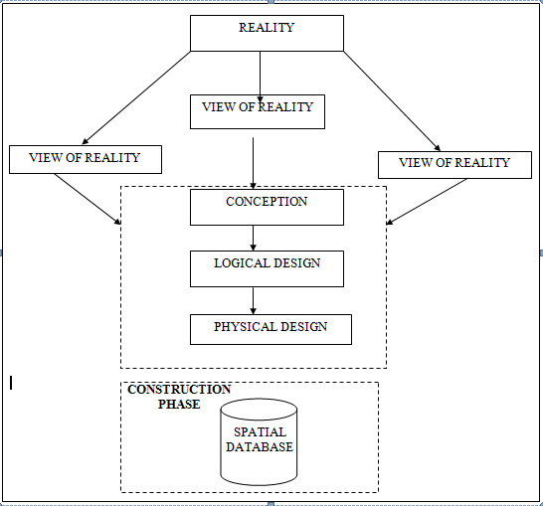

Fig. 3.1 Design and Construction Phases in Spatial Database (R Sobh, C Perry,. 2006)

3.2.2 LOGICAL DESIGN
This is the design aspect of the database refers to the process of creating a conceptual framework or model that represents the structure and organization of spatial data within the system. It involves defining the data element, their relationship, and the rules for data manipulation and analysis. In this phase, the entities, their attributes and their relationships are represented in a single uniform manner in form of relation in such a way that would be no information loss and at the same time no unnecessary duplication of data. In this study, the logical database design is employed to generate a geo-relation database structure. Each entity has unique identifier in bold type. An attribute type or combination of attribute types that serves to identify an entity type is termed an identifier.
- Building (B_ID,B_Area, B_Name, B_Easting, B_Northing)
- Roads (R_ID,R_Width, R_Type, R-Condition, R_Easting, R_Northing)
- Vegetation (V_ID,GR_Area,)
- Tree (TR_ID,TR_spp,TR_Importance,TR_Easting,TR_Northing)
- Electric Pole (EP_No,EP_Type,EP_Height,EP_Easting,EP_Northing)
- Football Pitch FP_ID, FP_Area,FP_Status)
3.3 EQUIPMENT USED
3.3.1 HARDWARE USED
- Total Station (South
- Reflector Pole
- Hand-held GPS
- Steel tape
- Nails and bottle cover
- Field book
- 1 cutlass

3.3.2 SOFTWARE
- AutoCAD 2007
- Arc-GIS 10.2
- Google Earth
- Note pad
- Excel
3.4 INSTRUMENTTEST

To ensure data quality, the Total Station used for this project was tested for both vertical index and horizontal collimation errors. It was also to ascertain the efficiency and reliability of the instrument. The procedure used is described below.

3.4.1 HORIZONTALCOLLIMATIONTEST
This test was conducted to ensure that the line of sight was perpendicular to the trunnion axis. The Total Station was positioned over a specific point, and initial adjustments were made to ensure proper alignment, leveling, and focus (to eliminate parallax in the telescope). A vertical target was placed at a distance of 100 meters from the Total Station. To access the configuration menu of the Total Station, the menu key was pressed and held for approximately 2 seconds. From the main menu, the calibration sub-menu was selected, and within that, the horizontal collimation test option was chosen. The target was then observed and divided into two halves, with horizontal readings recorded for Face left and Face right. The readings are shown in Table 3.4.1 below.
Total Station Reflector (Target)
100m

Station A Fairly Level Ground Station B

Fig 3.4.1; Horizontal Collimation and Vertical Index error test
Table 3.4.1: Horizontal Collimation Data
Station | Target | Face | Horz. Reading | Difference | Error
A | B | L | 025˚ 32‟ 32”
 |  | R | 205˚ 32‟ 35” | 180˚ 00’ 03” | 00˚ 00’ 03”

3.4.2 VERTICAL INDEX ERROR TEST
This test was conducted to verify the accuracy of the vertical reading when the line of sight is horizontal. The desired measurement for this test is exactly ninety degrees (90˚), any deviation from this value is referred to as the vertical index error.
The Total Station was positioned over a specific point, and necessary temporary adjustments were made to ensure proper alignment and functionality. A target was placed approximately100 meters away from the Total Station, and the instrument was aimed at the target. The target was bisected by aligning the instrument on the face left, and the corresponding reading was recorded. Similarly, the target was then bisected on the face right and the respective reading were also recorded. The recorded readings are provided below:
Table 3.4.2 Vertical Index Data
Instrument Station | Target Station | Face | Vertical | Sum | Error
A | B | L | 95˚ 00‟ 00”
 |  | R | 275˚ 00‟ 02” | 360˚ 00‟ 02” | 02”

3.4.3 ANALYSIS OF COLLIMATION AND VERTICAL INDEX DATA
The readings obtained during calibration were reduced to obtain new collimation and vertical errors.
Horizontal collimation = {(FR–FL) –180} /2 ={(00˚00‟03”} /2 =1.5”
Vertical collimation = {(FL+FR) –360} = (95˚00‟00” + 275˚00‟02”) -360} = 02” The result shows that the instrument is still in good working condition.
3.5 CONTROL CHECK
3.5.1 Control Check Procedure Using Total Station
To ensure the accuracy and reliability of the Total Station observations used for spatial data acquisition, control checks were carried out before and during the main survey. The procedure involved setting up the instrument over a known control point, performing temporary adjustments, executing angular and distance observations (back sight and foresight), and validating the computed coordinates against known values.
Step 1: Instrument Setup and Centering.
The Total Station was mounted securely on a tripod placed directly over the first known control point.
Centering was done using the built-in optical plummet to align the vertical axis of the instrument precisely over the ground mark.
Fine adjustments were made by shifting the tripod legs or using the sliding base plate to achieve perfect alignment.
Step 2: Temporary Adjustments (Leveling and Elimination of Instrumental Error)
Leveling: The circular bubble was first centered using the tripod legs. Then, the tubular (or electronic) level was used with the foot screws to achieve fine leveling in two perpendicular directions.
Collimation Check: An internal calibration (collimation) check was performed using the instrument’s self-diagnosis function to ensure the vertical and horizontal axes were perpendicular.
The horizontal circle was then set to zero after selecting the back sight direction.

Step 3: Back sight Observation
The telescope was rotated to face a second known control point (back sight).
The instrument was focused accurately on the back sight prism, and both horizontal and vertical coordinates (XYZ) were measured.
Step 4: Foresight Observation and Coordinate Validation
The telescope was then turned to observe a third point (foresight). The horizontal and vertical coordinates (XYZ) were measured. The observed coordinates were then compared to the known coordinates of the foresight control point already established.
Coordinate difference (ΔX, ΔY, ΔZ) was calculated to assess positional accuracy. The difference was within the allowable tolerance (typically ±2cm for X/Y and ±3cm for Z), the instrument was considered properly calibrated.
Step 5: Repeat Check at another Station
The same procedure was repeated for every station setup across the site to ensure uniform accuracy across the network.
All three control stations showed closure errors and coordinate differences well within the accepted tolerance for third-order survey work. This control check procedure ensured that the Total Station data used for plotting school boundaries, buildings, and topography in the Land Information System were precise and trustworthy.
Once the control points were verified and validated, they were used as reference locations for the detailed survey of the school facilities.
Table 3.5.1.1: Coordinate of the observed and the original values of K654AD
PILLAR | NORTHING | EASTING | STATUS | REMARKS
SC/KW K654AD | 939792.896 | 673354.040 |  | ORIGINAL
SC/KW K654AD | 939792.886 | 673354.020 | FIXED | OBSERVED
DISCREPANCY | 0.010 | 0.020

Table 3.5.1.2: Coordinate of the observed and the original values of K656AD
PILLAR | NORTHING(m) | EASTING(m) | STATUS | REMARKS
SC/KW K656AD | 939837.818 | 673334.688 |  | ORIGINAL
SC/KW K656AD | 939837.797 | 673334.666 | FIXED | OBSERVED
DISCREPANCY | 0.021 | 0.022

Table 3.5.1.3: Coordinate of the observed and the original values of K657AD
PILLAR | NORTHING(m) | EASTING(m) | STATUS | REMARKS
SC/KW K657AD | 939803.143 | 673366.311 |  | ORIGINAL
SC/KW K657AD | 939803.132 | 673366.291 | FIXED | OBSERVED
DISCREPANCY | 0.011 | 0.020

3.6 GEOMETRIC DATA ACQUISITION
The total station instrument was set carefully on control point SC/KW K6546AD back sight taken to K SC/KW K654AD after necessary station adjustments has been carried out on it. The adjustments include; centering, leveling and focusing. The following procedures were then followed to determine the position of the next point (NL1) and the same procedure were repeated until all we come close to the site. The method used in acquiring data on site was radiation method where two or more points are coordinated from one instrument station.
- Having setup the instrument and temporary adjustment carried out, the instrument was powered „on‟ and a job file was created under job menu in the internal memory of the instrument. The job file created was named GSSGR4C.
- On the job, the coordinates of the three (3) control points were keyed in to the memory of the instrument and some codes were also saved. The codes include
„RD‟ for road, SP‟ for spot height, BD for buildings, etc.
- The height of the instrument was measured and saved on the memory of the instrument as well as their reflector height.
- On coordinate menu, orientation was set by inputting the coordinates of the instrument station and back sight. The reflector at the back station was perfectly bisected before the orientation was confirmed by clicking yes.
Having done the orientation, the reflector at the next station was bisected and observe option was clicked. The three-dimensional coordinate of the point (E N, H) were displayed on the display unit of the instrument and record button was clicked to save the data into the memory of the instrument. For subsequent observation after this, all options were used instead of pressing observation (“obs”) and pressing record later.
- It was ensured that the center of the prism of the reflector was bisected and that it was set perfectly on the tripod in order to minimize the error on height determination.
- The instrument is been shifted to another station after all details, spot height and boundary point visible from the instrument station have been picked, The instrument was set over new station and temporary adjustments carried out.
However, the above operations were repeated until all the boundary points with heights were coordinated.
In this project all spot height were not in grid intervals but randomly acquired. At the end of data acquisition process all details were observed and properly recorded to be shown in their respective positions on the plan.

3.7 Detailed Survey:
The detailed survey focused on mapping the internal structures and facilities within the school, including:
- Classrooms
- Staff rooms and administrative offices
- Laboratories and libraries
- Playgrounds and sports fields
- Roads, parking lots, and walkways
Geometric data for every feature were acquired using Total Station, and the collected spatial data were stored in a structured format. Screenshots of the Total Station data interface were captured to illustrate the data collection process. The observations were carried out systematically to ensure complete coverage of all features within the project area.
3.7.1 Non-Spatial Data Collection
In addition to spatial data, non-spatial data (attribute data) were collected to provide descriptive information about each observed feature. These data were gathered through field observations, school administrative records, and structured interviews with key personnel.
3.7.2 Types of Non-Spatial Data Collected
- Building Information: Name, number of floors, year of construction, type of usage (classroom, staff office, laboratory, etc.).
- Staff Room and Office Details: Departmental functions, number of staff, office occupants.
- Infrastructure Information: Type of roads (paved or unpaved), water supply, power supply.
A field book was used to record the collected data, ensuring uniformity and easy integration into the LIS database. The completed forms were reviewed for accuracy before entering the data into a spreadsheet for GIS processing. Screenshots of the attribute data collection forms were taken and included in the documentation.
3.8 Data Download and Storage
Once the field surveyed was completed, all collected data were transferred to a computer system for further processing and storage. The following steps were taken to ensure proper data management:
- Downloading Total Station Data: The surveyed X, Y, Z coordinates were extracted from the Total Station’s internal memory using instrument software. The data were saved in a CSV (comma-separated values) file format for compatibility with GIS and AutoCAD software.
- Organizing Non-Spatial Data: The collected attribute data were entered into an Excel spreadsheet, ensuring proper formatting for easy integration with spatial data. The file structure was reviewed to ensure consistency and completeness.
- Data Backup: Copies of all data files were stored in an external flash drive to prevent data loss. File versions were properly labelled to maintain organization.
The downloaded spatial and non-spatial datasets were prepared for further processing and integration into the LIS.
3.8.1 Data Validation and Accuracy Assessment
To ensure the accuracy and reliability of the collected data, a rigorous validation process was conducted. This involved cross-checking the surveyed coordinates, attribute data, and instrument readings to identify and correct any errors.
3.8.2 Validation of Spatial Data
- Coordinate Cross-Check: The surveyed points were compared with known control points to verify accuracy.
- Boundary Accuracy Check: The surveyed boundary was overlaid on an existing satellite image in ArcGIS to detect any misalignment.
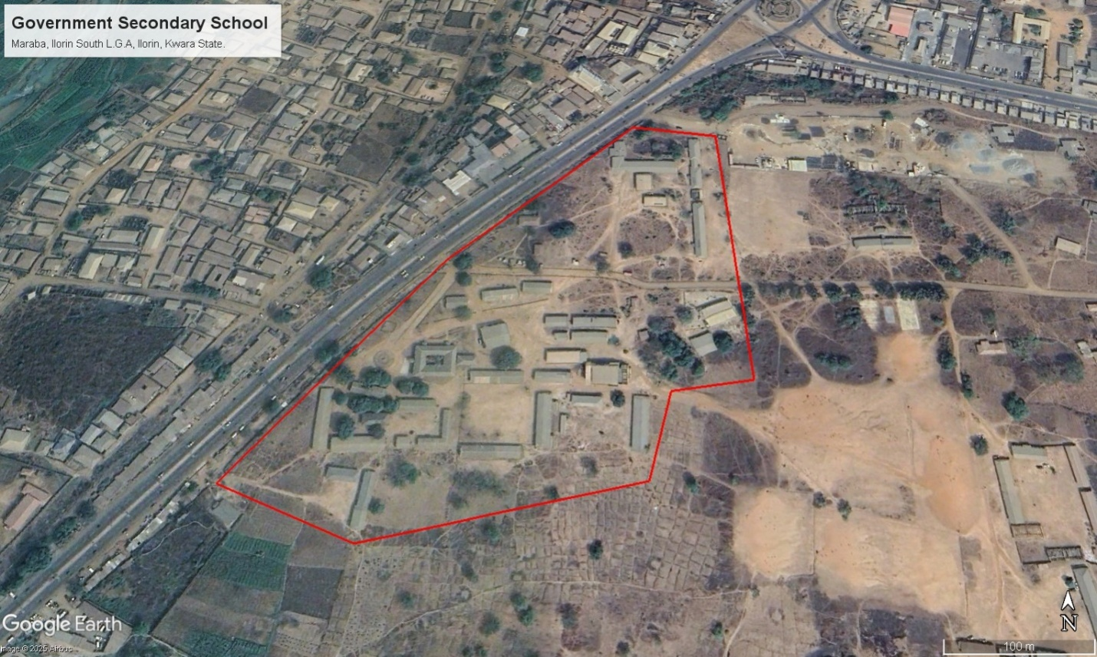
Figure 3.8.2: Satellite Imagery of the study area
3.8.3 Validation of Non-Spatial Data
- Attribute Consistency Check: The recorded building and facility details were compared with official school records.
- Correction of Data Entry Errors: Any discrepancies or incorrect attribute entries were identified and corrected before finalizing the dataset.
3.9 Data Processing and Integration
The data processing and integration phase is a critical step in transforming the raw data collected from the field survey into a structured Land Information System (LIS). This stage involves cleaning, organizing, and integrating both spatial and non-spatial data into a geo-database, ensuring seamless access, analysis, and visualization.
The processing workflow consists of multiple steps, including spatial data processing in AutoCAD and Surfer, non-spatial data structuring in Excel, geo-database creation in ArcGIS, and data integration for LIS development. The structured integration of these datasets enables effective querying, mapping, and decision-making for the secondary school management system.
3.9.1 Spatial Data Processing in AutoCAD
AutoCAD was used to plot the observed coordinates, (Geometric data) ensuring accurate representation of school facilities such as classrooms, staff rooms, administrative offices, roads, and playgrounds. The following steps were carried out:
- Importing Surveyed Points:
  - The CSV file containing surveyed coordinates was imported into AutoCAD.
  - The points were plotted based on their real-world X and Y coordinates, while the Z values were retained for elevation analysis.
- Plotting of Boundaries and Features:
  - The boundary points were connected using polyline tools, forming a closed polygon to define the extent of the school premises.
  - Each school building was mapped as a separate layer, and unique identifiers were assigned to distinguish classrooms, staff rooms, laboratories, and other structures.
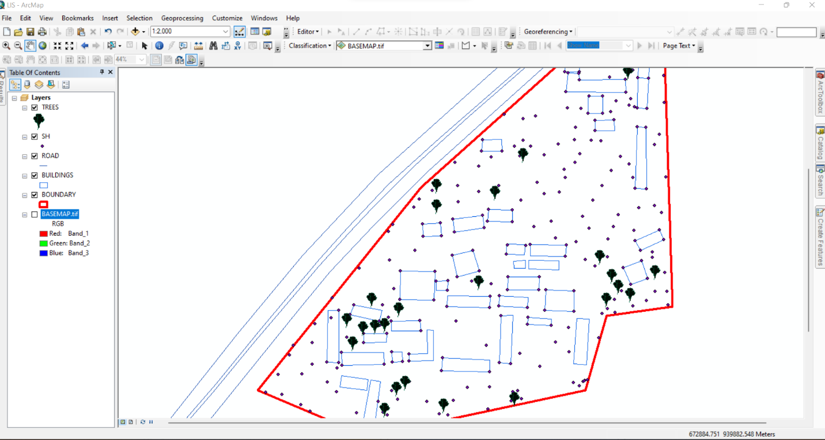
Figure 3.9.1 Screenshot of boundary digitization and features
3.9.2 Topographic Data Processing in Surfer
Surfer software was used for topographic analysis and terrain modelling based on the surveyed elevation data (Z values). The following procedures were followed:
- Importing Surveyed Data:
  - The X, Y, and Z coordinates were loaded into Surfer as a point dataset.
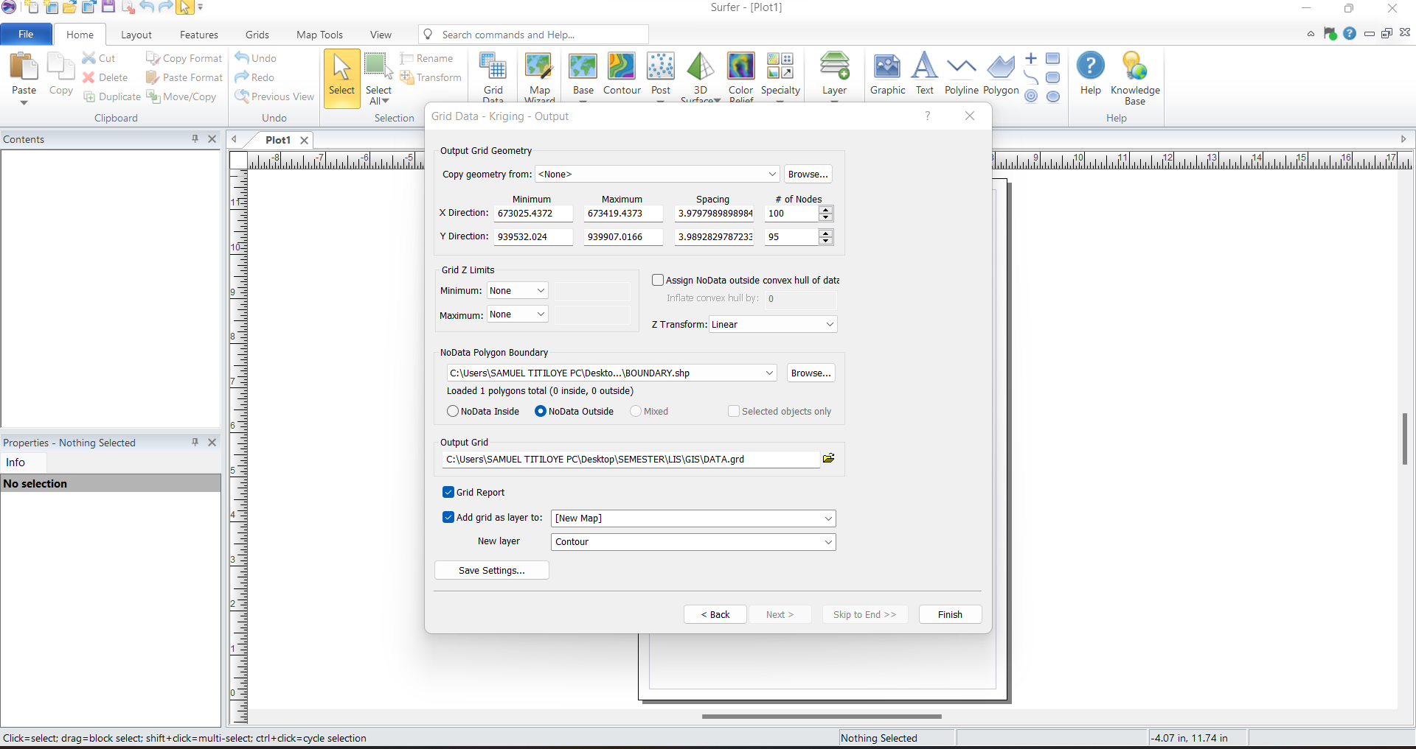
Figure 3.9.2.1: Screenshot of the imported dataset.
- Generation of Digital Elevation Model (DEM):
  - A grid-based interpolation technique was applied to generate a Digital Elevation Model (DEM) of the school area.
  - The DEM provided insight into the elevation variations across the school premises, assisting in drainage and flood risk assessment.
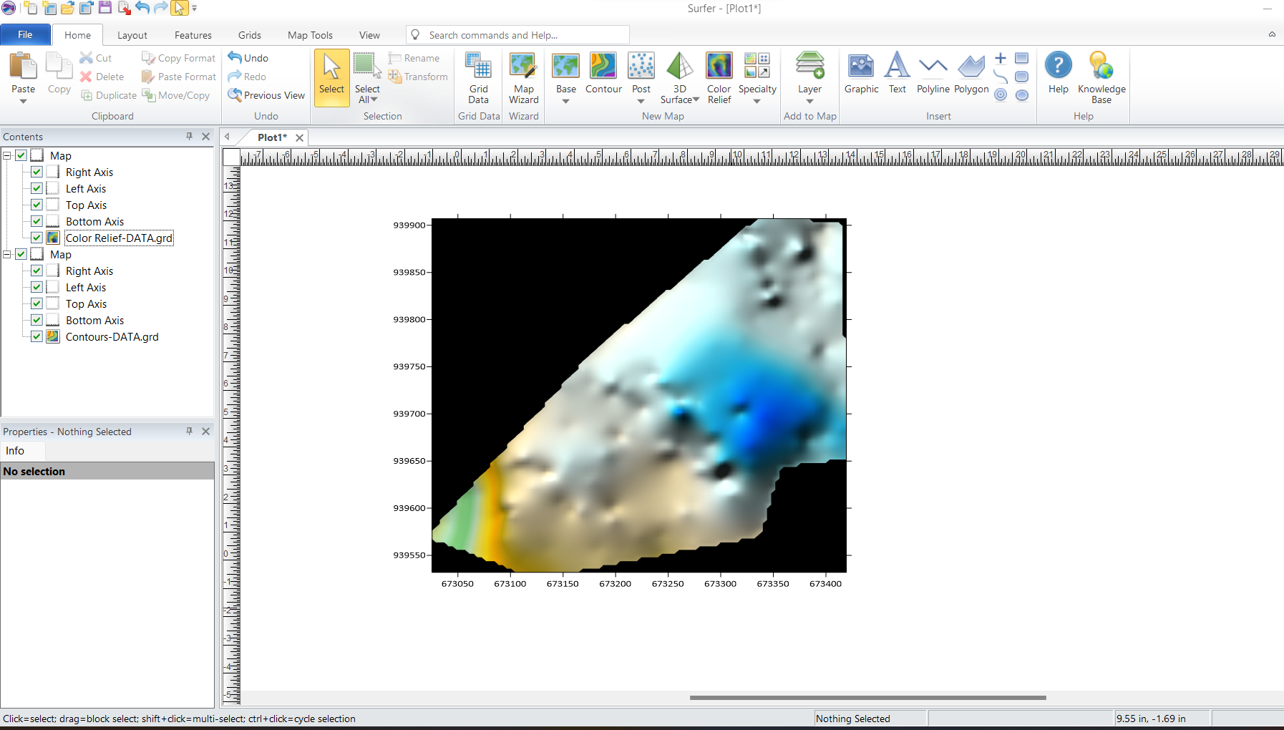
Figure 3.9.2.2: Screenshot of the generated DEM.
- Creation of Contour Maps:
  - Contour lines were generated at specific intervals to visualize terrain variations.
  - The contour map was exported in Geo-TIFF format for integration into Arc-GIS.
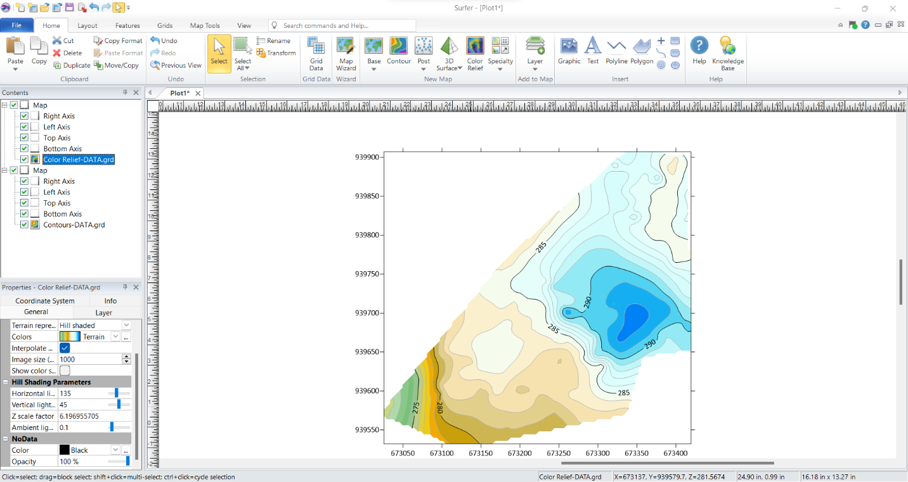
Figure 3.9.2.3: Screenshots of the contour generation process.
3.9.4 Non-Spatial Data Processing in Excel
Non-spatial data collected through field observations and school administrative records were structured and formatted in Excel to ensure consistency and ease of integration into Arc-GIS.
- Data Entry and Formatting:
  - Each facility was assigned a unique ID corresponding to its spatial location.
  - Attributes such as building type, year of construction, and available amenities were recorded.
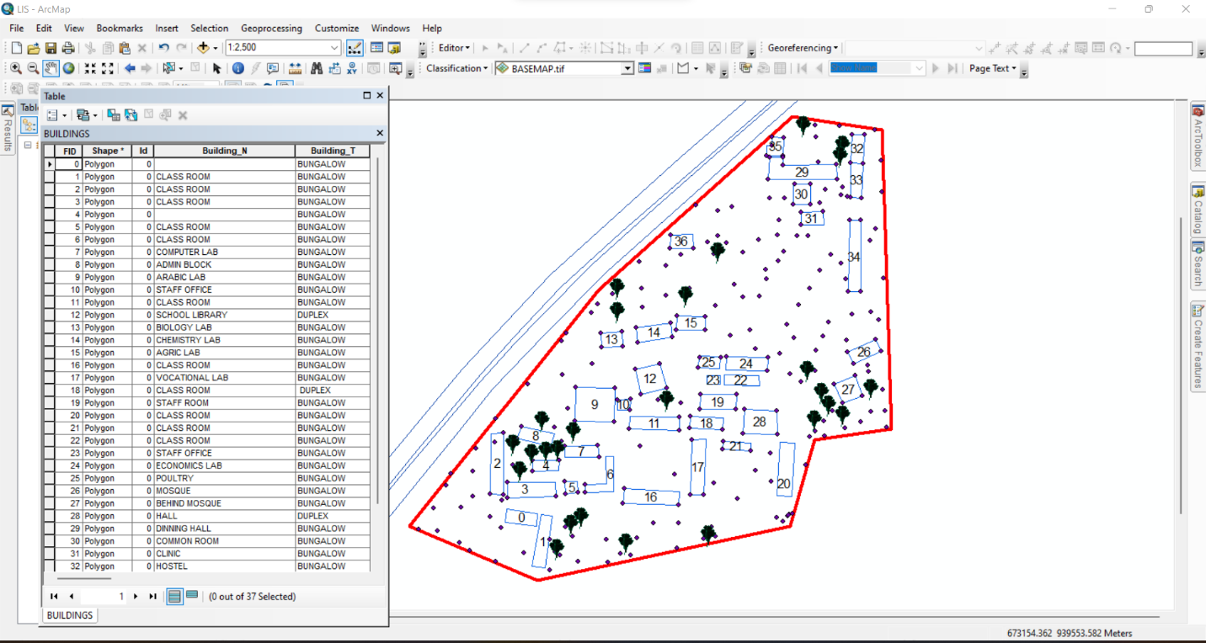
Figure 3.9.4: Screenshot of the structured attribute table.
3.9.5 Geo-database Creation in Arc-GIS
A geo-database was created in Arc-GIS to integrate both spatial and non-spatial data, allowing efficient storage, retrieval, and analysis of school infrastructure data. The following steps were taken:
- Creating a New Geo-database:
  - A file geo-database was created in Arc-GIS to store all spatial data layers and attribute tables.
- Importing Spatial Data:
  - The DXF file from Auto-CAD (containing school boundaries and building layouts) was imported into Arc-GIS.
  - The Geo TIFF file from Surfer (containing the DEM and contour data) was also loaded.
- Defining Feature Classes:
  - Separate feature classes were created for classrooms, staff rooms, offices, laboratories, roads, and other infrastructure.
  - Each feature class was assigned relevant spatial properties (e.g., polygon for buildings, polyline for roads).
- Importing Non-Spatial Data and Linking to Spatial Features:
  - The CSV file containing attribute data was imported into ArcGIS.
  - A one-to-one relationship was established between the spatial features and their corresponding attribute records using the unique ID field.
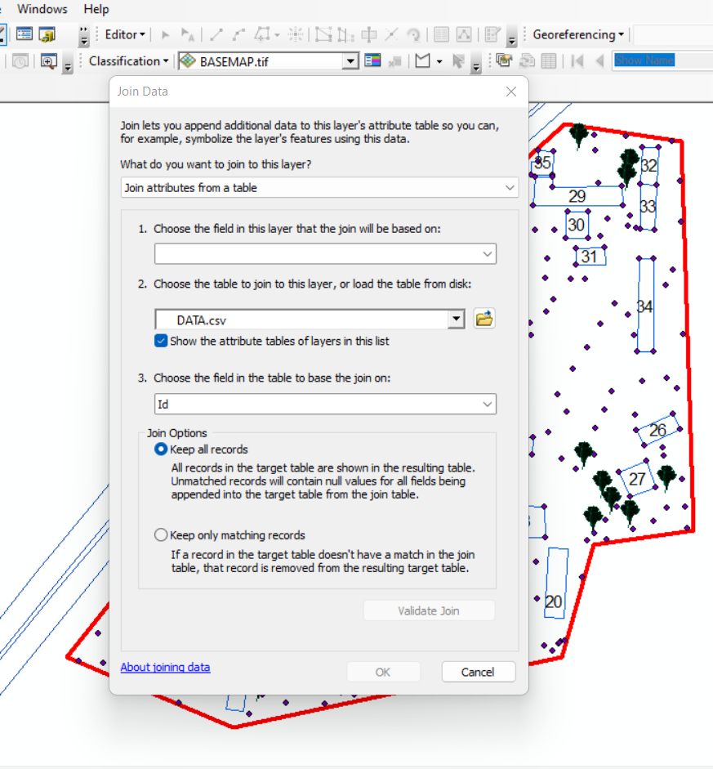
Figure 3.9.5: Screenshot of the data join process
3.9.6 Data Integration and Finalization for LIS
The final stage involved ensuring seamless integration between spatial and non-spatial data within the LIS environment.
- Verification of Data Integrity
  - The attribute data were cross-checked to ensure they matched their respective spatial locations.
  - Any mis-linked records were corrected, and missing attributes were updated.

- Symbolization and Visualization:
  - Each feature class was assigned unique symbols and colors for better visualization in Arc-GIS.
  - Thematic maps were created to represent building categories, classroom capacities, and road networks.
3.10 Boundary Digitization and Feature Mapping
  - The boundary points were connected using polyline tools, forming a closed polygon to define the extent of the school premises.
  - Each school building was mapped as a separate layer, and unique identifiers were assigned to distinguish classrooms, staff rooms, laboratories, and other structures
3.10.1 Detailing
Figure 3.10.1 Screenshot showing the digitization process and layer management.
3.11 Topographic Data Processing in Surfer
Surfer software was used for topographic analysis and terrain modelling based on the surveyed elevation data (Z values). The following procedures were followed:
- Importing Surveyed Data:
  - The X, Y, and Z coordinates were loaded into Surfer as a point dataset.
3.12 Attribute Data Acquisition
Attribute data is information about spatial features. They provide the characteristics, description and nomenclature about spatial objects. Thus, the attributes data acquired includes names of buildings and their uses such as classrooms, roads, water facilities and prominent natural features Likes River and trees found and vegetation were properly identified within and around the study area.
3.13 Data Creation/Implementation
This is the database creation phase. Having completed the three stages of design phase (i.e Reality, Conceptual and Logical design), the data base was created using ArcGIS10.2 software. It involves the combination and storage of acquired graphic data and attributes data in creating the database for the purpose of spatial analysis and query.
Database is an organized integrated collection of data stored so as to be capable of use by revenant application with data being accessed by different logical part. After the Attribute table was populated via the keyboard, some attributes such as areas of settlements were automatically displayed by special command in the ArcGIS 10.2 version. The ArcGIS software was used to link the graphic data and table for query generation.
3.13.1 Database Management System (DBMS)
Data base management is a collection of software for creating, storing, manipulating, updating, organizing and querying of information in a database (Kufoniyi, 1998). It is a software package whose function is to manipulate a data base on behalf of the user.
A good DBMS must provide the following functions:
      - Storage and retrieval of data.
      - Access to by several users at a time.
      - A standardized interface between data base and application programmed.
      - Standardized access to data and separation of data storage and retrieval functions from the program using the data.
      - Maintenance of data security and integrity.
3.13.2 Data Quality
Having created the database, proper maintenance practice was made to meet its stated objectives. The ability to include more data and remove irrelevant data was possible by way of maintenance. There is every need for the data to be updated regularly because of the physical changes that may occur on the landscape with time. Both security and integrity were also exercised to ensure maintenance and to meet its stated objectives.
Proper observance, updating and management of database ensure its currency and quality to stand a profound chance in Spatial Decision Support System (SDSS). The quality of any database depends on the currency and fitness for use as a decision support system (SDSS). The quality of database depends on its ability to generally fit and use as a decision system (DSS). The storage media should be from time to time justified if otherwise could necessitate data inaccessibility or physical deterioration of the storage media. Also, care must be taken during populating any database system, as a database is only good as the data supplied. In archiving stable media should be used. Examples of these are
- Computer compatible tape reader
- Magnetic tape
- Optical disc and compact disc.

CHAPTER FOUR
4.0 Analysis and Results

4.1 Introduction
This chapter presents the results obtained from the data acquisition, processing, and integration procedures described in the previous chapter. The findings provide a comprehensive spatial and non-spatial representation of the school environment, including the layout of buildings, topographical features, and attribute information related to school facilities. The results are structured to demonstrate how the Land Information System (LIS) can enhance school management by providing accurate, well-organized, and easily accessible data.
The results are categorized into different sections for clarity. The spatial data results include mapped school boundaries, building footprints, and access networks, all of which were digitized using GIS tools. The topographical results analyze elevation variations using Digital Elevation Models (DEM) and contour maps, which are crucial for site planning and infrastructure development. The non-spatial data results contain attribute information such as classroom capacity, staff room assignments, and building conditions, all integrated into the LIS database. The data integration and query results demonstrate how the LIS functions as an interactive tool for retrieving, analyzing, and visualizing school-related data.
This chapter also includes analyses that reveal important insights into building distribution, infrastructure conditions, environmental constraints, and potential areas for school expansion. The results are presented using maps, tables, and screenshots from GIS and related software to illustrate how data were processed and visualized. The goal of this chapter is to demonstrate the practical application of an LIS in school facility management and to highlight the benefits of integrating spatial and non-spatial data for decision-making.

4.2 Spatial Data Results
The spatial data results provide a detailed representation of the school’s geographical layout, including its boundaries, buildings, access roads, and pathways. These results were derived from Total Station survey data, processed in AutoCAD and ArcGIS to create an accurate Land Information System (LIS) for the school. This section highlights the steps taken to map the school boundary, digitize building footprints, and visualize access routes.
The spatial data results are essential for effective school management, as they provide a geo-referenced framework that helps in planning expansions, monitoring infrastructure, and optimizing resource allocation. The outputs presented in this section form the foundation for further topographical, non-spatial, and LIS-based analysis discussed in subsequent sections.
4.2.1 School Boundary and Building Layout
The school boundary and building layout were mapped using surveyed coordinates (X, Y, Z) collected with the Total Station. The acquired data were processed in AutoCAD to generate a structured boundary map and building footprints, which were then imported into ArcGIS for further spatial analysis and integration into the LIS database.
Figure 4.2.1: As built Plan of Government Secondary School Maraba, Ilorin South East Local Government. Using GIS software
Visualization of Spatial Data Results
The final processed spatial data were visualized in ArcGIS, where the school boundary, building footprints, and access roads were symbolized appropriately to enhance readability.
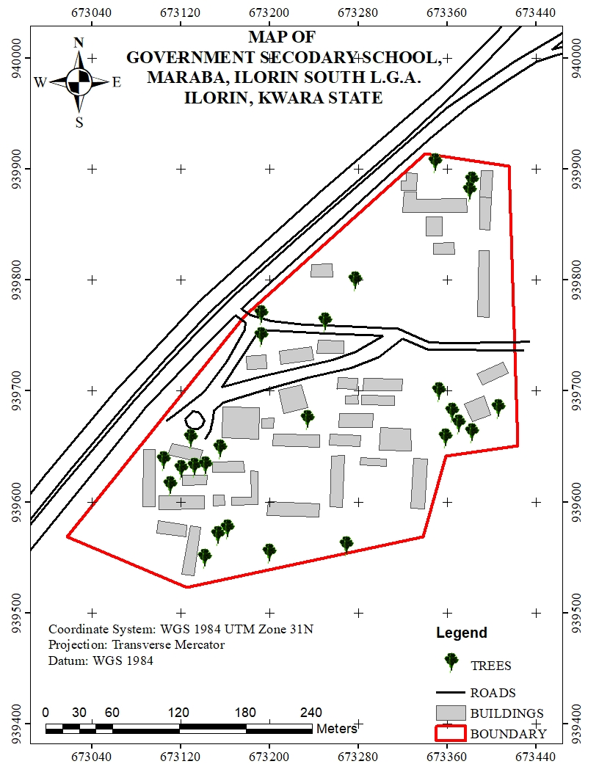
Figure 4.2.1: Mapped School Boundary and Buildings in ArcGIS
- The school boundary is represented as a bold polygon to define the outer limits of the school.
- Buildings are shown in different colors based on their usage (e.g., classrooms in blue, administrative offices in green, laboratories in red).
- Roads are displayed as lines, with roads marked in black.
This spatial data representation serves as the primary framework for the LIS database, allowing users to visualize, analyze, and manage school infrastructure efficiently.

4.2.2 Significance of the Spatial Data Results
The school boundary and building layout play a crucial role in:
- Infrastructure Planning: Ensuring optimal land use by identifying available spaces for future construction and expansion.
- Facility Management: Helping administrators monitor the condition, usage, and location of various school buildings.
- Navigation and Accessibility: Enhancing movement planning for students, staff, and visitors by identifying clear pathways and access points.
- Disaster Management: Providing accurate spatial information to plan for emergency exits, assembly points, and safety zones.
The spatial data results form the foundation for further analysis, including topographical evaluation, attribute data integration, and advanced GIS-based queries, which will be presented in the subsequent sections of this chapter.
4.3 Topographical Analysis Results
Topographical analysis provides crucial information about the elevation, slope, and terrain variations within the school environment. Understanding these features is essential for site planning, infrastructure development, drainage design, and environmental management. This section presents the results of topographical data processing and analysis, including the creation of Digital Elevation Models (DEM), contour maps, and slope analysis.
The topographical data were obtained using Total Station measurements, which captured X, Y, and Z coordinates of various points within the school premises. These data were processed in Surfer to generate elevation models and later integrated into ArcGIS for spatial analysis.

4.3.1 Digital Elevation Model (DEM)
The Digital Elevation Model (DEM) was created to provide a 3D representation of the school’s terrain. Using Z-coordinates from the Total Station survey, a gridded elevation surface was generated in Surfer and later exported to ArcGIS for further analysis.
Key Features of the DEM:
- The DEM visually represents variations in land elevation within the school compound.
- Areas of higher elevation are highlighted, aiding in infrastructure planning and water drainage management.
- The DEM serves as the base for further slope, aspect, and contour analysis.
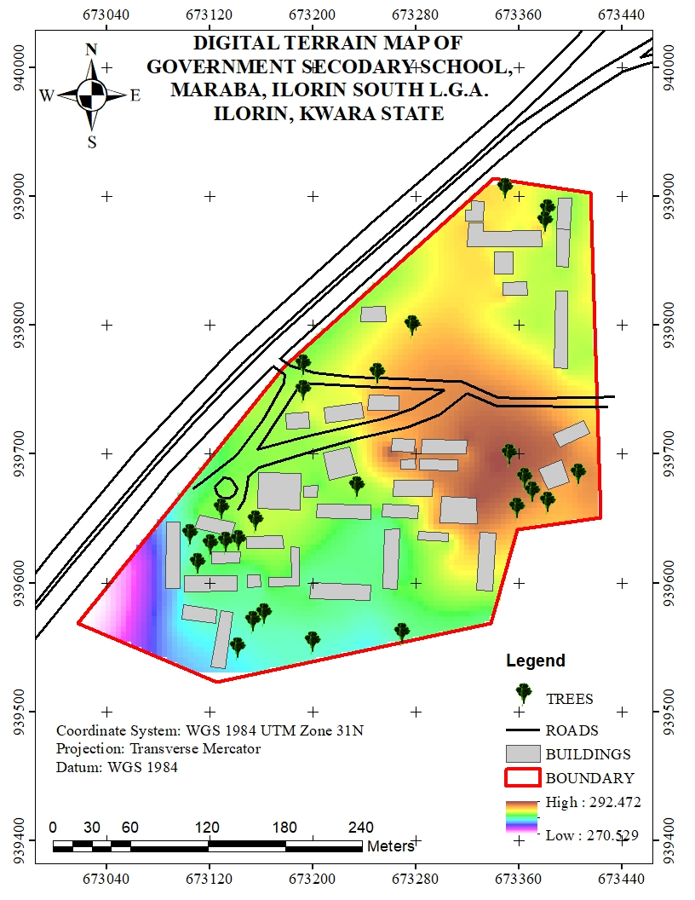
Figure 4.3.1: Digital Elevation Model (DEM) of the School Premises

4.3.2 Contour Mapping
Contour mapping was conducted to visualize elevation changes and terrain gradients within the school environment. The surveyed elevation data were processed in Surfer to generate contour lines, which were later imported into Arc-GIS for spatial overlay and analysis.
Key Results from Contour Analysis:
- The contour interval was set based on the range of elevation variations in the study area.
- Closely spaced contour lines indicate steep slopes, while widely spaced lines represent gentler slopes.
- The contour map helps in identifying low-lying areas that may be prone to water logging or flooding.
- The results assist in drainage planning by identifying natural water flow paths.
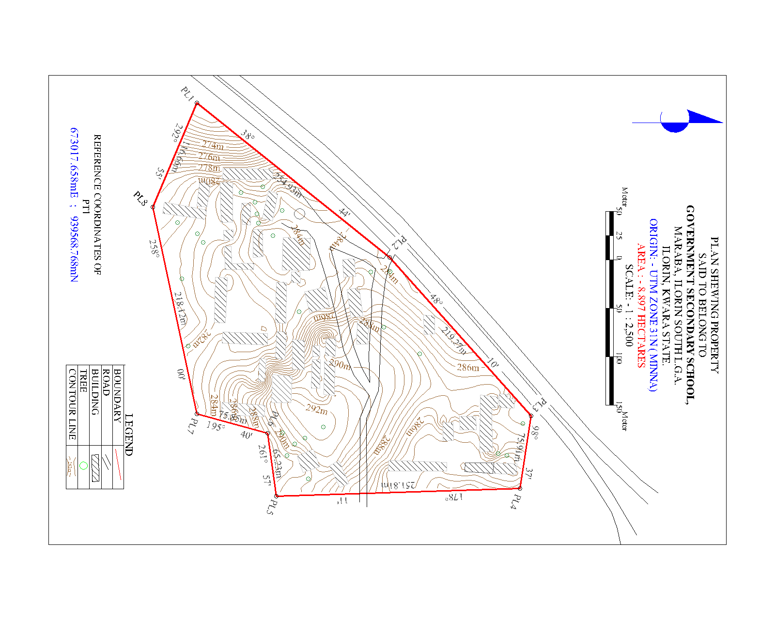
Figure 4.3.2: Contour Map of the School Premises
4.3.3 Slope and Terrain Analysis
A slope analysis was conducted to determine variations in land steepness across the school environment. The slope was computed using the DEM in ArcGIS, with results classified into different slope categories to assess terrain usability.
Key Findings from Slope Analysis:
- Flat areas (0-5 degrees) are suitable for classroom blocks, play areas, and other infrastructure.
- Moderate slopes (5-15 degrees) are manageable for footpaths and minor construction projects.
- Steeper slopes (above 15 degrees) may require erosion control measures or retaining walls to prevent land degradation.
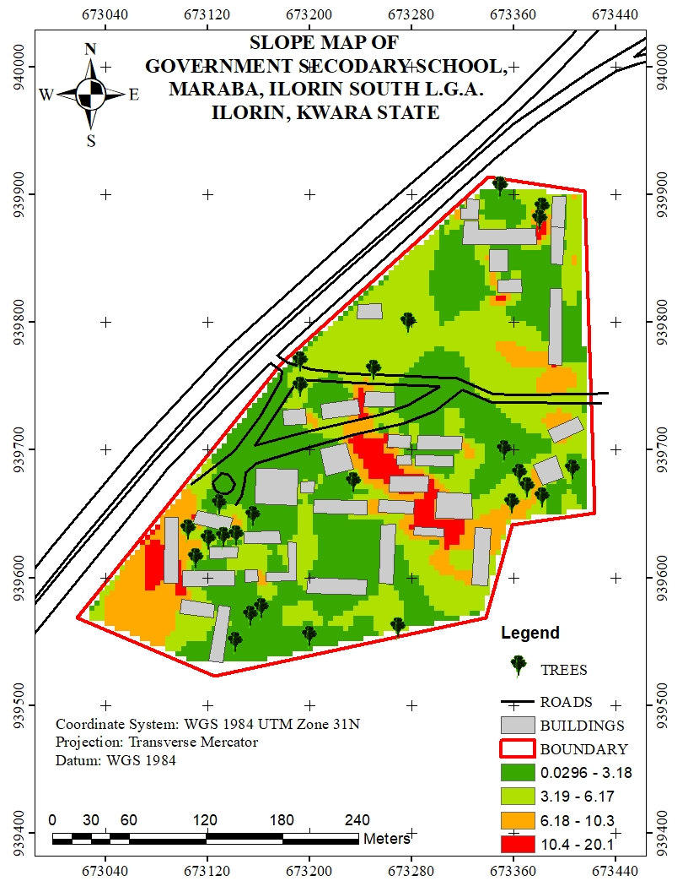
Figure 4.3.3: Slope Analysis Map of the School Premises

4.3.4 Significance of Topographical Analysis Results
The results of the topographical analysis provide essential insights for school management, infrastructure development, and environmental sustainability. These findings contribute to:
- Better infrastructure planning: Ensuring that new buildings and roads are constructed on stable ground.
- Improved drainage management: Reducing the risk of flooding and water stagnation within the school premises.
- Enhanced safety measures: Identifying steep areas that may require protective barriers or adjustments in land use planning.
- Sustainable land use: Helping decision-makers optimize space utilization while considering terrain constraints.
The topographical analysis results form an integral part of the Land Information System (LIS), ensuring that spatial data is not only stored but also analyzed for informed decision-making in school infrastructure management.
4.4 Non-Spatial Data Results
Non-spatial data results refer to the descriptive information associated with various school facilities, buildings, and infrastructure. Unlike spatial data, which provides geometric representations of features (such as school boundaries, buildings, and roads), non-spatial data includes textual and numerical attributes that help in facility management and decision-making.
The non-spatial data collected in this study were integrated into the Land Information System (LIS) to enhance school administration, infrastructure monitoring, and resource planning. The data were structured in tabular format and linked to corresponding spatial features in ArcGIS using unique identifiers.
4.4.1 Attribute Data for School Buildings
The non-spatial attributes for classrooms, staff rooms, laboratories, and administrative offices were recorded and organized in a database. Each building was assigned a unique identifier (Building ID), allowing for easy retrieval of information in GIS.
Key Attributes for Buildings:
- Building Name/ID (e.g., Classroom Block A, Staff Room 1)
- Building Type (Classroom, Laboratory, Office, Library, Hall)
- Primary Use (Teaching, Administration, Storage, Utility)
This information was stored in ArcGIS attribute tables and linked to the digitized building footprints, allowing users to perform queries such as identifying underutilized classrooms or buildings in need of maintenance.
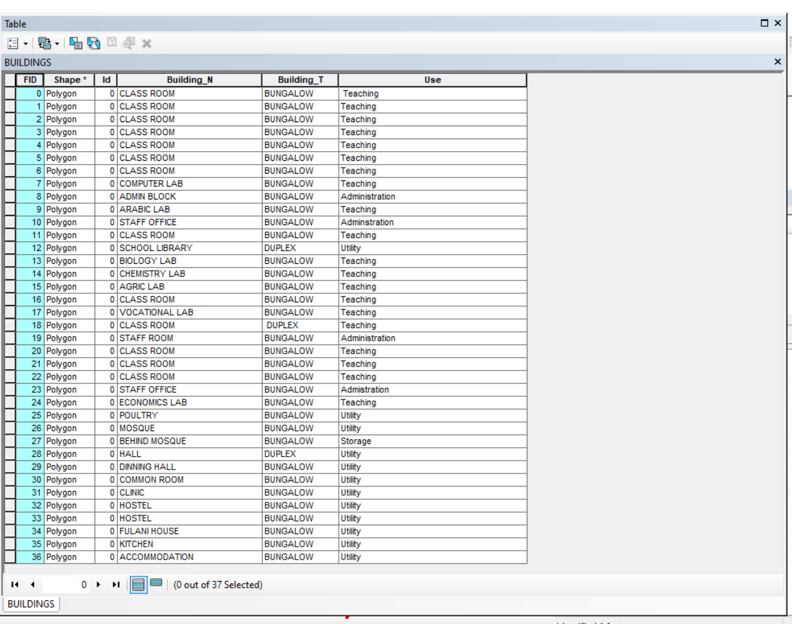
Figure 4.4.1: Sample Attribute Table for School Buildings

4.4.2 Linking Non-Spatial Data with GIS
All non-spatial datasets were linked to their corresponding spatial features in ArcGIS. This integration allows for interactive queries and visual analysis of school facilities. Some of the key functionalities include:
- Clicking on a building footprint to view its attributes (e.g., building name, building type, & use).
- Running queries to find classrooms that exceed their maximum student capacity.
- Generating reports on the maintenance history of infrastructure.
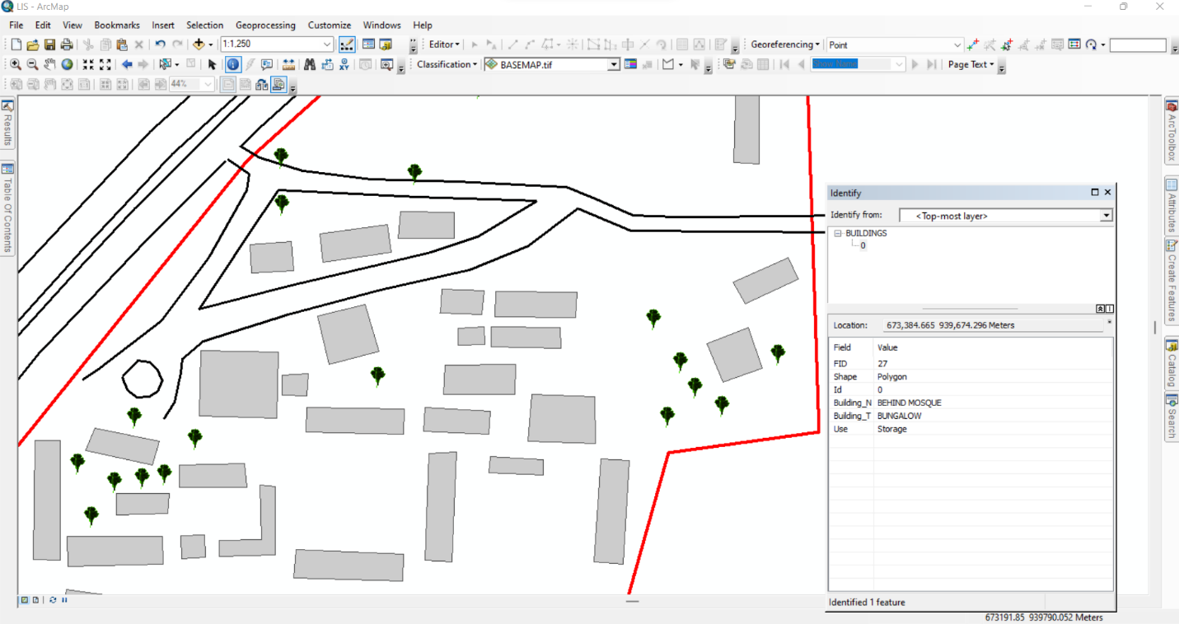
Figure 4.4.2: Linking Non-Spatial Data to Spatial Features in ArcGIS
4.4.4: Significance of Non-Spatial Data in LIS
The integration of non-spatial data into the LIS enhances decision-making by providing comprehensive attribute information for school management. These results contribute to:
- Effective Resource Allocation: Ensuring that classrooms, offices, and other facilities are optimally utilized.
- Infrastructure Maintenance Planning: Monitoring facility conditions and scheduling necessary repairs.
- Improved School Administration: Tracking staff distribution, student population trends, and room assignments.
- Emergency Preparedness: Identifying critical infrastructure that requires regular inspections and safety measures.
The non-spatial data results demonstrate how a Land Information System (LIS) can support school facility management by combining spatial visualization with detailed attribute data. This information is essential for long-term planning, policy-making, and efficient school operations.

4.5 Query Execution and Results
With the integrated database, queries were performed in ArcGIS to extract specific information about the school environment. These queries help in analyzing building usage, staff distribution, facility conditions, and space utilization.
Example Query Results:
- Mapping Distribution of Offices:
Query: "Show all staff offices"
Result: A spatial representation of staff office locations was displayed, ensuring adequate office space allocation.
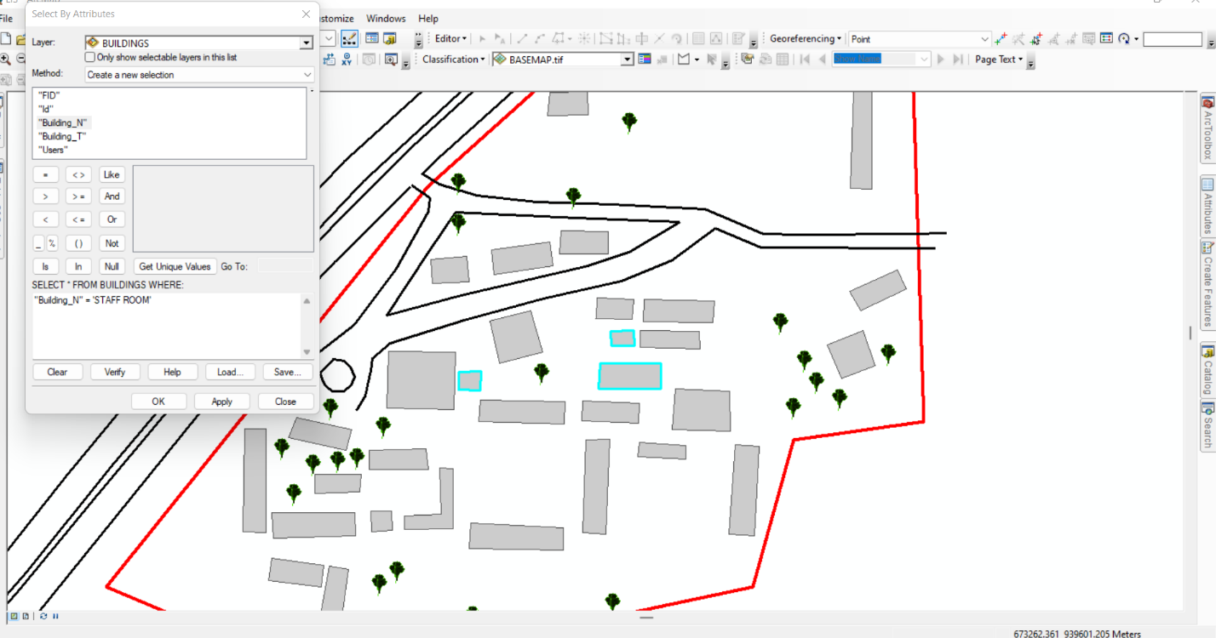
Figure 4.5.1: Sample Staff room Query Results in Arc-GIS
- Mapping Distribution of Classrooms:
Query: "Show all Classrooms"
Result: A spatial representation of class room locations was displayed, ensuring adequate office space allocation.
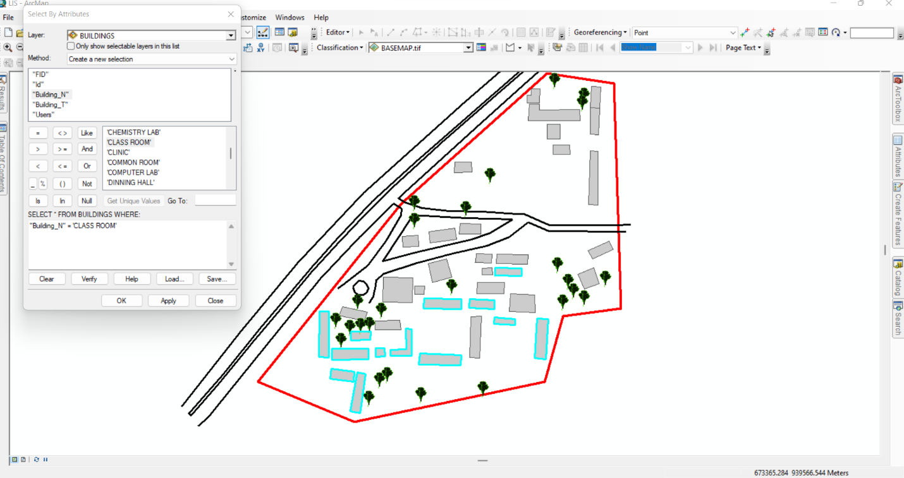
Figure 4.5.2: Sample Class room Query Results in ArcGIS

CHAPTER FIVE
5.0 COSTING, SUMMARY, PROBLEMS ENCOUNTERED, CONCLUSION AND RECOMMENDATION
5.1 COSTING
The costing of this project was done using the Nigeria Institution of Surveyor's (NIS) professional scale of fees for consultant in the construction industry. This stage shows the total cost that was spent on the project from day one to the final stage.
5.1.1 RECCI
PERSONAL/QUALITY | DAY(S) | UNITRATE(N) | TOTAL AMOUNT(N)
1 Senior Surveyor | 1 | 20,000.00 | 20,000.000
Assistant Surveyor | 1 | 8,000.00 | 8,000.00
Transportation | 1 | 7,000.00 | 7,000.00
Basic Equipment | 1 | 8,000.00 | 7,000.00
TOTAL |  |  | #42,000.00

5.1.2 BEACON= 2,100 × 5
= #10,500

5.1.3 BEACONING
PERSONAL/QUALITY | DAY(S) | UNITRATE(N) | TOTALAMOUNT(N)
1Assistant Surveyor | 1 | 8,000.00 | 8,000.00
Basic Equipment(6) | 1 | 8,000.00 | 8,000.00
Transportation | 1 | 7,000.00 | 7,000.00
TOTAL |  |  | #23,000.00

5.1.4 TRAVERSING
PERSONAL/QUALITY | DAY(S) | UNITRATE(N) | TOTALAMOUNT(N)
1 Assistant Surveyor | 2 | 8,000.00 | 16,000.00
Basic Equipment | 2 | 8,000.00 | 16,000.00
Transportation | 2 | 7,000.00 | 14,000.00
TOTAL |  |  | #46,000.00

5.1.5 DOWNLOADING DATA AND PLOTTING
PERSONAL/QUALITY | DAY(S) | UNITRATE(N) | TOTALAMOUNT(N)
1Senior Surveyor | 2 | 15,000.00 | 30,000.00
1AssistantSurveyor | 2 | 8,000.00 | 16,000.00
Transportation | 2 | 7,000.00 | 14,000.00
Consumables | 2 | 7,000.00 | 14,000.00
TOTAL |  |  | #74,000.00

5.1.6 INFORMATION PRESENTATION
PERSONAL/QUALITY | DAY(S) | UNITRATE(N) | TOTALAMOUNT(N)
1Assistant Surveyor | 1 | 8,000.00 | 8,000.00
Transportation | 1 | 7,000.00 | 7,000.00
TOTAL |  |  | #15,000.00

(1) # 42,000.00
(2) # 10,500.00
(3) # 23,000.00
(4) # 46,000.00
5) #74,000.00
(6) # 15,000.00
TOTAL # 210,500.00
5.1.7 CONSTIGENCIES=5%
210,500.00×5%÷ 100
= #10,525.00
5.1.8 V. A. T = 7.5%
210,500.00×7.5%÷100
= #15,787.50
5.1.9 MOBILIZATION AND DEMOBILIZATION =10%
210, 500.00 × 10%. ÷ 100
= #21,050.00
5.1.10 ACCOMODATION = 1.5%
210,500.00 ×1.5%÷100
= 3,157.50
TOTAL = 210,500.00
10,525.00
15,787.50
21,050.00
3,157.50
GRAND TOTAL = 261,020.00
5.2 SUMMARY
This project focused on the development and implement of a Land Information System (LIS) for Government Secondary School, Maraba. Through systematic data acquisition, processing, and management, both spatial and attribute datasets were integrated to create a functional digital representation of the school’s land features. The fieldwork involved the use of GPS for coordinate collection, attribute surveys for non-spatial data, and the application of GIS tools for mapping, analysis, and database creation.
The workflow included ground surveying, attribute data collection, spatial data processing, database design, drafting, plotting, and secure data storage all aligned with LIS best practices. The final output includes geo-referenced maps, attribute tables, and a structured LIS database capable of supporting land administration, planning, infrastructure monitoring, and decision-making.
This summary encapsulates the steps taken and tools used to digitize and manage land-related information in a way that is accessible, accurate, and sustainable for future use.
5.3 PROBLEMS ENCOUNTERED
During the execution of this Land Information System (LIS) project at Government Secondary School, Maraba, several challenges were encountered. These affected various stages of data acquisition, processing, and system development:
- Difficulty Locating Known Control Points
Since the project involved the use of a Total Station, it was necessary to connect the survey work to an existing known control point. However, no control point was found within the school compound. A thorough search had to be conducted outside the school premises before a known control was eventually located across the area. This caused delays in beginning the actual observations.
- Access Restrictions Within the School
Certain parts of the school environment were fenced off and inaccessible due to construction, limiting the ability to take comprehensive measurements across the entire property at once.
- Equipment Setup and Observation Constraints
The Total Station required clear lines of sight for accurate observations. Trees, buildings, and other physical obstructions in some areas created challenges in setting up the instrument and getting accurate readings.

- Attribute Data Challenges
Some attribute information collected from staff was incomplete or unclear. This necessitated additional visits and follow-up clarifications before accurate data could be entered into the LIS database.
- Logistical and Connectivity Issues
Moving equipment between the school and the known control point required time and coordination. Also, slow or unstable internet connectivity posed problems during the integration of base maps and reference layers in the GIS stage.
Despite these challenges, the project was successfully completed, and the final LIS products were generated with the required accuracy and detail through persistent efforts and professional field handling.
5.4 RECOMMENDATION
Based on the execution and outcomes of the Land Information System (LIS) project at Government Secondary School, Maraba, the following recommendations are proposed to improve future projects and enhance the sustainability of land data management:
- Establishment of Permanent Control Points
To avoid the difficulty of searching for existing controls outside the area of interest, permanent and clearly marked control points should be installed within or near the school premises. This will save time and ensure easy access for future surveys or updates.
- Capacity Building and Training
School administrators and relevant government stakeholders should be trained on the importance and use of LIS. This will help them understand how to retrieve, interpret, and update spatial and attribute data for informed decision-making.
- Regular Data Updates
Land use and infrastructure developments are dynamic. It is recommended that the spatial and attribute database be updated periodically to reflect changes and maintain accuracy over time.
Integration with Broader Government Land Systems
The data from this project can be linked with larger municipal or state LIS platforms to support wider planning, documentation, and monitoring efforts.
- Digital Backup and Security
Adequate backup systems should be maintained both locally and in the cloud to safeguard against data loss. Also, implementing access controls and data encryption will help protect sensitive land-related information.
- Use of Complementary Survey Tools
While the Total Station provided precise data, future projects could benefit from integrating other technologies like GPS receivers, drones, or mobile GIS devices to increase field efficiency and data richness.
By implementing these recommendations, future land information projects in academic or institutional settings will be more efficient, reliable, and beneficial for long-term land management and development planning.
5.5 CONCLUSION
The development of a Land Information System (LIS) for Government Secondary School, Maraba, has successfully demonstrated the practical integration of modern surveying techniques, GIS technologies, and data management processes. From the establishment of control using a Total Station to the collection of spatial and attribute data, each stage was carefully executed to ensure accuracy, consistency, and usability.
Despite the challenges encountered including the search for a known control point outside the school premises, accessibility limitations, and weather-related delays the project team was able to produce reliable spatial data and well-structured attribute information. These were effectively processed, analyzed, and presented in forms suitable for decision-making, planning, and future land management activities.
The final outputs, including digital maps, attribute records, and organized spatial databases, provide a solid foundation for improved land administration within the school premises. This project not only reflects the significance of LIS in local land management but also highlights the relevance of technical skills and field experience in producing accurate, valuable geospatial information.
Overall, the LIS project reinforces the importance of integrating field survey data with digital technologies in building systems that support transparency, accessibility, and efficient land governance.

REFERENCE
Goodchild, M. F. (2007). Citizens as sensors: The world of volunteered geography. GeoJournal, 69(4), 211–221.
Longley, P. A., Goodchild, M. F., Maguire, D. J., & Rhind, D. W. (2015). Geographic Information Science and Systems (4th ed.). Wiley.
Maguire, D. J., Goodchild, M. F., & Rhind, D. W. (2011). Geographic Information Systems and Science. Wiley.
Rajabifard, A., Williamson, I. P., Kalantari, M., & Binns, A. (2006). Spatially enabling government through SDI implementation. GSDI Association.
Sui, D., Goodchild, M. F., & Elwood, S. (2013). Crowdsourcing geographic knowledge: Volunteered geographic information (VGI) in theory and practice. Springer.
Tomlinson, R. (2007). Thinking about GIS: Geographic Information System planning for managers (3rd ed.). ESRI Press.
Williamson, I., Enemark, S., Wallace, J., & Rajabifard, A. (2010). Land Administration for Sustainable Development. ESRI Press.
Zhang, C., Li, W., & Travis, D. (2020). Machine learning applications for land use/land cover mapping and change detection. GIScience & Remote Sensing, 57(1), 1–20.

APPENDIX
S/N | EASTINGS | NORTHINGS | Elevation
1 | 673384.7 | 939882.4 | 284.324
2 | 673368.3 | 939852.6 | 284.974
3 | 673406 | 939809.5 | 285.418
4 | 673328.8 | 939826.6 | 286.878
5 | 673277.2 | 939835 | 285.121
6 | 673258.7 | 939839.1 | 283.911
7 | 673298.3 | 939799.4 | 288.005
8 | 673328.2 | 939792.3 | 287.552
9 | 673312.6 | 939762.8 | 289.926
10 | 673211 | 939791.9 | 283.435
11 | 673176 | 939756.2 | 283.922
12 | 673192.6 | 939752.9 | 284.652
13 | 673304.7 | 939734.3 | 290.222
14 | 673416.3 | 939684.2 | 290.247
15 | 673262 | 939711.3 | 288.105
16 | 673150 | 939731.4 | 284.378
17 | 673146.7 | 939696.4 | 283.653
18 | 673227.3 | 939675.6 | 284.134
19 | 673246.1 | 939672.8 | 284.316
20 | 673321.7 | 939630.2 | 288.378
21 | 673117.2 | 939688.4 | 282.391
22 | 673294 | 939592 | 283.783
23 | 673337.8 | 939578.5 | 283.019
24 | 673272 | 939568.4 | 282.117
25 | 673104.7 | 939620.4 | 281.182
26 | 673073.4 | 939634.1 | 276.58
27 | 673071.2 | 939615.2 | 275.123
28 | 673242.9 | 939550.3 | 280.075
29 | 673203.9 | 939544.3 | 280.735
30 | 673148.8 | 939568.4 | 281.263
31 | 673052.7 | 939612.9 | 272.448
32 | 673140.3 | 939546.8 | 280.215
33 | 673159.3 | 939539.3 | 280.517
34 | 673136 | 939532 | 279.591
35 | 673114.2 | 939546.4 | 279.556
36 | 673037.9 | 939584.1 | 270.915
37 | 673025.4 | 939566.5 | 270.677
38 | 673037.9 | 939584.1 | 270.915
39 | 673048.7 | 939603.2 | 272.177
40 | 673145.4 | 939724.6 | 283.813
41 | 673170.7 | 939748.4 | 284.45
42 | 673188.6 | 939764.6 | 283.773
43 | 673320.9 | 939845.5 | 287.18
44 | 673362.2 | 939875.4 | 285.746
45 | 673385.9 | 939892.8 | 284.152
46 | 673372.8 | 939797.9 | 284.644
47 | 673363.7 | 939784.4 | 286.123
48 | 673354.6 | 939769.4 | 288.129
49 | 673345.7 | 939755.1 | 289.742
50 | 673090.2 | 939538.8 | 278.481
51 | 673341.7 | 939727.3 | 291.403
52 | 673417.2 | 939777.8 | 284.558
53 | 673403.7 | 939704.2 | 289.927
54 | 673373.8 | 939666.3 | 290.383
55 | 673366.7 | 939657.7 | 289.8
56 | 673359.7 | 939648.9 | 289.387
57 | 673354.7 | 939644.1 | 289.178
58 | 673322.5 | 939606.4 | 286.048
59 | 673144.6 | 939544.4 | 280.276
60 | 673154.8 | 939560 | 281.098
61 | 673166.3 | 939577 | 281.907
62 | 673335.6 | 939739 | 291.06
63 | 673409.7 | 939902.9 | 285.097
64 | 673344 | 939813.6 | 285.841
65 | 673333 | 939800.4 | 286.532
66 | 673317.5 | 939785.4 | 288.656
67 | 673275.5 | 939754.9 | 289.562
68 | 673155.4 | 939649.3 | 284.999
69 | 673153.1 | 939647.9 | 284.914
70 | 673145.9 | 939640.2 | 284.266
71 | 673136.9 | 939632 | 283.646
72 | 673095.5 | 939590.5 | 279.358
73 | 673085.9 | 939576.8 | 278.209
74 | 673068.7 | 939548 | 275.907
75 | 673041.6 | 939564.6 | 272.021
76 | 673061 | 939584.5 | 273.936
77 | 673071.1 | 939593.9 | 275.368
78 | 673171.3 | 939705.6 | 284
79 | 673234 | 939763.5 | 286.572
80 | 673274.2 | 939798.6 | 287.23
81 | 673284.9 | 939807.8 | 287.065
82 | 673360.2 | 939896.9 | 286.454
83 | 673379.6 | 939906.3 | 285.363
84 | 673415.1 | 939877.3 | 285.558
85 | 673385 | 939777 | 285.683
86 | 673370.4 | 939740.7 | 289.914
87 | 673366 | 939728.9 | 290.9
88 | 673360.4 | 939716.8 | 291.697
89 | 673347.6 | 939690.5 | 292.448
90 | 673267.4 | 939567.2 | 281.818
91 | 673249.8 | 939761.5 | 287.673
92 | 673253.6 | 939769.1 | 287.673
93 | 673289.4 | 939837.7 | 285.923
94 | 673359.1 | 939907 | 286.683
95 | 673309.1 | 939718.2 | 290.864
96 | 673386.5 | 939846.5 | 284.751
97 | 673381.1 | 939847.9 | 284.798
98 | 673311.7 | 939810.2 | 287.49
99 | 673214.1 | 939753.6 | 285.594
100 | 673151.2 | 939668 | 284.273
101 | 673298.3 | 939761.6 | 289.834
102 | 673410.6 | 939819.5 | 286.064
103 | 673412.8 | 939743.1 | 286.98
104 | 673386 | 939725.4 | 289.89
105 | 673338.4 | 939696.8 | 292.455
106 | 673094.8 | 939567.3 | 279.722
107 | 673060.1 | 939554.7 | 274.721
108 | 673308.9 | 939615.9 | 286.747
109 | 673367.4 | 939644.7 | 288.332
110 | 673384.7 | 939651.2 | 288.549
111 | 673397.8 | 939656.6 | 288.644
112 | 673418 | 939665.7 | 289.824
113 | 673222.9 | 939571.6 | 281.678
114 | 673209 | 939559 | 281.109
115 | 673195.2 | 939545.6 | 280.87
116 | 673184.7 | 939538.6 | 280.999
117 | 673419.4 | 939652.4 | 289.44
118 | 673406.3 | 939665.7 | 289.634
119 | 673135.8 | 939557.7 | 280.436
120 | 673183.4 | 939557.6 | 281.026
121 | 673265.8 | 939558.1 | 281.327
122 | 673275.6 | 939560.4 | 282.041
123 | 673326.7 | 939576.1 | 282.93
124 | 673336.1 | 939577.2 | 282.915
125 | 673337.2 | 939577.8 | 282.96
126 | 673340.2 | 939579.1 | 283.101
127 | 673332.5 | 939572.9 | 282.561
128 | 673244.5 | 939571.8 | 280.976
129 | 673279.8 | 939710.7 | 289.235
130 | 673329.3 | 939714.1 | 291.661
131 | 673291 | 939772.5 | 289.507
132 | 673213.4 | 939769.2 | 285.037
133 | 673363.1 | 939841.6 | 285.29
134 | 673415.4 | 939850.6 | 286.503
135 | 673382.8 | 939854.7 | 284.659
136 | 673268.8 | 939807.9 | 286.262
137 | 673381.1 | 939790.3 | 285.169
138 | 673404.1 | 939698.9 | 290.112
139 | 673359.7 | 939699.5 | 292.101
140 | 673211.9 | 939636.4 | 283.159
141 | 673241.3 | 939612.7 | 282.141
142 | 673274.4 | 939604.9 | 282.939
143 | 673119.8 | 939627.5 | 282.657
144 | 673089.5 | 939639.6 | 279.492
145 | 673351.4 | 939620.1 | 286.705
146 | 673139.7 | 939652.3 | 284.027
147 | 673090.5 | 939659.4 | 280.094
148 | 673288 | 939729.3 | 289.918
149 | 673390.6 | 939747.4 | 287.987
150 | 673406.2 | 939749.5 | 286.834
151 | 673318.7 | 939777.2 | 289.241
152 | 673353.4 | 939813.4 | 285.219
153 | 673327.9 | 939814.1 | 286.716
154 | 673276.9 | 939802.7 | 287.085
155 | 673233.8 | 939788.3 | 285.237
156 | 673246.2 | 939797.5 | 285.454
157 | 673277.4 | 939813.8 | 286.407
158 | 673333.9 | 939845 | 287.321
159 | 673121.2 | 939624.5 | 283.071
160 | 673121.1 | 939615.1 | 282.792
161 | 673143.9 | 939624.5 | 283.815
162 | 673100.3 | 939592.9 | 281.442
163 | 673085.4 | 939596 | 278.194
164 | 673096.8 | 939595.6 | 279.372
165 | 673149.2 | 939596.2 | 281.843
166 | 673159.5 | 939597 | 281.78
167 | 673141.2 | 939594 | 282.01
168 | 673099.8 | 939605.7 | 282.096
169 | 673148.7 | 939606.2 | 282.084
170 | 673165.5 | 939604.1 | 283.126
171 | 673096.8 | 939647.3 | 281.218
172 | 673108 | 939642.9 | 281.375
173 | 673136.6 | 939636.5 | 282.179
174 | 673111.8 | 939652.6 | 283.596
175 | 673148.2 | 939636.5 | 284.471
176 | 673176.3 | 939637.2 | 284.381
177 | 673177.4 | 939627 | 284.25
178 | 673165.5 | 939597.3 | 283.212
179 | 673197.6 | 939587.9 | 282.967
180 | 673244.4 | 939586.8 | 282.022
181 | 673198.4 | 939600.3 | 281.592
182 | 673254.1 | 939595.6 | 282.376
183 | 673265.5 | 939594.9 | 283.309
184 | 673255.8 | 939641.6 | 282.017
185 | 673281.4 | 939633.4 | 283.739
186 | 673305.1 | 939632.2 | 284.123
187 | 673282.1 | 939640.3 | 285.194
188 | 673327.4 | 939646 | 290.763
189 | 673298.4 | 939647 | 289.971
190 | 673327.1 | 939666.1 | 292.244
191 | 673254 | 939661.3 | 284.252
192 | 673281.6 | 939649.9 | 284.438
193 | 673244.8 | 939649.7 | 282.435
194 | 673253.5 | 939651.3 | 282.443
195 | 673245.2 | 939660.8 | 283.997
196 | 673262.1 | 939667.2 | 284.253
197 | 673262.6 | 939679.7 | 286.756
198 | 673292.7 | 939667.2 | 287.534
199 | 673156.8 | 939657.7 | 284.797
200 | 673190.1 | 939656.9 | 284.931
201 | 673190.9 | 939685.2 | 284.021
202 | 673207.8 | 939700.8 | 284.134
203 | 673212.7 | 939679.8 | 283.992
204 | 673234.3 | 939685.5 | 284.829
205 | 673157.5 | 939685.9 | 283.582
206 | 673203.3 | 939666.4 | 284.044
207 | 673192.5 | 939675.4 | 283.893
208 | 673203.7 | 939675.9 | 283.133
209 | 673202.6 | 939650.8 | 283.871
210 | 673228.2 | 939705.8 | 284
211 | 673178.7 | 939731.5 | 284.127
212 | 673197.5 | 939720.1 | 284
213 | 673179.3 | 939719.3 | 284.169
214 | 673208.6 | 939736.3 | 285.441
215 | 673210 | 939723.9 | 285.565
216 | 673239.3 | 939728.1 | 287.38
217 | 673196.5 | 939732.8 | 285.965
218 | 673237.7 | 939740.2 | 285.981
219 | 673243.3 | 939745.8 | 287.908
220 | 673266.6 | 939745.3 | 289.626
221 | 673260.8 | 939702.2 | 292.324
222 | 673293.1 | 939679.9 | 290.403
223 | 673299.9 | 939667.1 | 289.403
224 | 673399.1 | 939678.4 | 289.269
225 | 673382.5 | 939672.3 | 289.093
226 | 673392 | 939705.9 | 291.205
227 | 673375.3 | 939688.7 | 291.609
228 | 673393.3 | 939695.9 | 290.854
229 | 673414.7 | 939716.5 | 288.314
230 | 673386.7 | 939715.5 | 290.931
231 | 673410.5 | 939726 | 287.665
232 | 673319.6 | 939710.9 | 292.093
233 | 673318.9 | 939700.1 | 289.855
234 | 673284.5 | 939711.5 | 289.939
235 | 673266.6 | 939734.1 | 289.765
236 | 673236.8 | 939802.9 | 284.509
237 | 673237.8 | 939814.4 | 283.996
238 | 673256.7 | 939803.2 | 285.935
239 | 673347.6 | 939823.1 | 287.83
240 | 673242.5 | 939734.1 | 289.519
241 | 673386.9 | 939766.8 | 286.751
242 | 673397.8 | 939766.3 | 284.723
243 | 673388.8 | 939826.9 | 284.968
244 | 673397.5 | 939826.6 | 284.746
245 | 673347.6 | 939833.6 | 285.377
246 | 673366.2 | 939833.9 | 284.881
247 | 673341.1 | 939840.1 | 286.99
248 | 673355.4 | 939840.2 | 285.718
249 | 673355.4 | 939857.2 | 285.598
250 | 673342 | 939857 | 285.635
251 | 673319.4 | 939861.2 | 287.356
252 | 673321.1 | 939879.7 | 287.56
253 | 673332 | 939879.4 | 287.867
254 | 673332.3 | 939873.1 | 287.697
255 | 673377.3 | 939873.8 | 287.932
256 | 673378.1 | 939860.8 | 284.921
257 | 673332.4 | 939880.9 | 286.766
258 | 673332.7 | 939896.3 | 287.526
259 | 673389.4 | 939875.3 | 284.306
260 | 673400 | 939874.5 | 284.067
261 | 673389.1 | 939845.7 | 284.362
262 | 673398.5 | 939845.2 | 284.514
263 | 673390.4 | 939899.1 | 284.735
264 | 673401 | 939898.6 | 283.725
265 | 673318.2 | 939880.8 | 287.29
266 | 673323 | 939896.6 | 286.94
267 | 673322.9 | 939889.5 | 285.163

