FABRICATION AND MODIFICATION OF A MOBILE BOOKSHELF CABINET

BY:
ADEOSI SURAJUDEEN OLASUNKANMIH
ND/23/WEC/FT/0035

A PROJECT REPORT SUBMITTED TO THE DEPARTMENT OF WELDING AND FABRICATION ENGINEERING, INSTITUTE OF TECHNOLOGY, KWARA STATE POLYTECHNIC, ILORIN

IN PARTIAL FULFILMENT OF THE REQUIREMENTS FOR THE AWARD OF NATIONAL DIPLOMA (ND) IN WELDING AND FABRICATION ENGINEERING

PROJECT SUPERVISOR:
ENGR. ABIODUN OYEYEMI ROTIMI
JULY, 2025
CERTIFICATION
This is to certify that this project report titled Fabrication and Modification of a Mobile Bookshelf Cabinet was prepared by ADEOSI SURAJUDEEN OLASUNKANMIH, with Matric Number: ND/23/WEC/FT/0035 meets the requirements of Welding and Fabrication Engineering Departments for the award of National Diploma (ND)

_______________________ __________________
ENGR. ABIODUN O. R DATE
Project Supervisor

_______________________ __________________
Engr. SALAHUDEEN M. A DATE
Head of Department

_______________________ __________________
External Examiner DATE

DEDICATION
This project is dedicated to Almighty God, the Omniscience, the Omnipotent, the owner of knowledge who made this success in my academic pursuit to be achievable.

ACKNOWLEDGMENT
All praises, honor, glory to Almighty GOD for giving us the abundance of everything and for giving us the opportunity to write this project report. Our special appreciation also goes to our parents for their moral and financial support right from day one and up to date.
My thanks also goes to my Project Supervisor, in person of Engr. Abiodun Oyeyemi for his frequent and consistent guidance during the course of this project.
We cannot drop our pen without expressing our gratitude to H.O.D of the Department Engr. SALAHUDEEN M. A, and all Lecturers and Staff of the Department of Welding and Fabrication Engineering for their moral encouragement and useful suggestion during the course of our project work and academic pursue generally.
Finally, we express our appreciation to all our school mates. Thanks to you all.
May God reward you all abundantly (Amen).

ABSTRACT
A Mobile Bookshelf is so useful when it comes to keeping files and documents, in addition it gives a perfect protection to the books and also gives a decorative stylish appearance for the users. The Modification made in it allows the cabinet to be moved from one position to another with ease and the drawers are now fitted with roller for easy pulling and pushing during usage. The materials are locally sourced and could be maintained as at when due.

TABLE OF CONTENT
Title Page........................................................................................................................................ i
Certification................................................................................................................................... ii
Dedication ..................................................................................................................................... iii
Acknowledgement ……………………………………………………………………................ iv
Abstract........................................................................................................................................... v
List of Tables……………………………………………………………………………..…….. vi
List of Figures………………………………………………………………………………..… vii
Table of Contents ........................................................................................................................ viii
CHAPTER ONE
1.0 Introduction ……………………….………………………………………………………… 1
1.1 Background of the Study ......................................................................................................... 1
1.2 Aims of the Project .................................................................................................................. 2
1.3 Objectives of the Study ............................................................................................................ 2
1.4 Justification of the Project …...……………………………………………………………… 3
1.5 Purpose of the Project .............................................................................................................. 3
1.6 Limitation of the project …………………………………………………………………….. 4
CHAPTER TWO
2.1 History of Mobile Metal Bookshelf Cabinet ……………………..…………………………. 6
2.2 Hole ……………………………………………………………………………..................... 7
2.3 Basket …………………………………………………………………………....................... 7
2.4 Box ……………………………………………………………………………....................... 8
2.5 Cane …………………………………………………………………………......................... 8
2.6 Wood …………………………………………………………………………....................... 9
2.7 Metal ........................................................................................................................................ 9
2.7.1 Materials ……………………………………………………………………………….… 10
2.7.2 Designs …………………………………………………………………………………... 10
2.7.3 Designing of the Cabinet ………………………………………………………………… 11
2.8 Types of bookshelf cabinet.…………………………………………….………………….. 12
2.8.1 Barrister bookshelf cabinet……………………………………………………………….. 12
2.8.2 Modular Bookcase cabinet……………………………………………………………….. 12
2.8.3 Folding bookshelf cabinet………………………………………………………………... 13
2.8.4 Revolving and Corner Bookshelf cabinet………………………………...……………… 13
2.8.5 Display Bookshelf cabinet……………………………………………………………….. 13
2.8.6 Shelf bookcase cabinet…………………………………………………………………… 13
2.8.7 Mobile bookcase cabinet…………………………………………………………………. 14
2.8.8 Uses of bookshelf cabinet………………………………………………………………… 14
CHAPTER THREE
3.0 Research Methodology…………….……………………………………………………….. 15
3.1 Cutting and shaping of the metal………………………………………………………….... 15
3.1.1 Preparing of the metal……………………………………………………………………. 15
3.1.2 Cutting of the metal………………………………………………………………………. 15
3.1.3 Shaping of the metal……………………………………………………………………… 16
3.1.4 Finishing of the metal…………………………………………………………………….. 16
3.2 Fabrication processing……………………………………………………………………… 16
3.3 Cutting the metal sheet and tubes…………………………………………………………... 17
3.4 Welding the frame together………………………………………………………………… 18
3.5 Cutting and welding of the shelves and doors…………………………………………….. 18
3.6 Installing the casters, Hinges and Locks………………………………………………….. 18
3.7 Finishing the process of cabinets………………………………………………………….. 18
CHAPTER FOUR
4.0 Results and Discussion…………………………………………………………………….. 19
4.1 Volume of frame…………………………………………………………………………… 19
4.2 Total weight of front and back frame………………………………………………………. 20
4.3 Fabrication details and bills engineering measurement and evaluation……………………. 27
4.4 Properties of selected materials…………………………………………………………….. 27
4.5 list of tool used……………………………………………………………………………... 28
4.6 Fabrication details………………………………………………………………………….. 29
4.7 Construction procedures……………………………………………………………………. 30
4.8 Painting operations…………………………………………………………………………. 30
4.8.1 Safety requirements………………………………………………………………………. 31
4.8.2 Precaution taken………………………………………………………………………….. 31
4.9 Bill of engineering materials and evaluation………………………………………………. 31
CHAPTER FIVE
5.0 Conclusion and Recommendation…………………………………………………………. 34
5.1 Conclusion…………………………………………………………………………………. 34
5.2 Recommendation…………………………………………………………………………… 34
References……………………………………………………………………………………… 35

TABLES
Table 4.1…………………………………….………………………………………………….. 30
Table 4.2…………………………………………………….………………………………….. 32

FIGURES
Figure 2.1………………………………………………………………….…………………… 11
Figure 2.2……………………………………………………………….……………………… 11
Figure 2.3…………………………………………………………………………….………… 11
Figure 2.4…………………………………………………………………………………….… 11

CHAPTER ONE
INTRODUCTION
1.1 Background of the Study
A mobile bookshelf cabinet is a flat length of wood, metal or other rigid material which is used at homes, business stores, offices, libraries, religious house to hold item of value, keep and secure files and document for future record.
The bookshelf cabinet is mobile in nature and has the ability to be moved with ease from one point to another in spite of the content in the shelf.
All over the world today, files and document keeping cannot be overemphasized. It has found acceptable place within the market economy in commercial enterprises such as offices, schools and institutions.
On the other hand, a file is a folder for holding loose papers together and for easy reference.
Numerous files are being kept in a cabinet and in a Mobile bookshelf cabinet, it could be in the following forms
- Moving metal cupboard
- Moving file cabinet
- Moving metal lockers

Mobile Bookshelves Cabinet
A bookshelf is a piece of furniture or metal neatly constructed used to store books. A bookshelf could also be regarded as a bookcase; it consists of at least a unit of two or more shelves which may be used to contain books, printed materials or files.
Bookshelves sometimes have doors that protect the books from air pollution or other visible contaminants. A bookshelf usually stands on some other piece of furniture or metals such as desk or chest. Larger books are more likely to be kept in horizontal files and very large books flat on wide shelves. A modification made on bookshelf cabinet makes it to be mobile and could be pushed or relocated to another point or place in the house, office or in school.
Four tyres are being firmly placed or fixed under the bookshelves and this allows the bookshelf cabinet to move with ease in its located places.
1.2 Aim of the Project
The aim of the project is to fabricate a mobile bookshelf cabinet to be used at homes, offices, schools, churches or mosques.
1.3 Objectives of the Project
The following are the objectives of this project work
- To help store important files or books
- To protect the files and for easy access to the users
- To modify the existing bookshelf cabinet by improvising four tyres to enhance better placement at ease
- To give a decorative stylish appearance with the modification involved (fixing of tyres underneath the shelf cabinet.
- To have flexibility on the bookshelf cabinet by creating a design that gives strength and stability.
1.4 Justification of the Study
The purpose of the project is to fabricate a mobile bookshelf cabinet which is used to store books, files, document, printed or non-printed materials with files.
The ease with which all these important document that are being stored in bookshelf cabinet is of greater significance and the introduction of tyres to the cabinet underneath became so important and resourceful to ease the pulling or pushing the cabinet to the deserved place where the contents would be useful.
1.5 Purpose of the Project
The purpose of the project are as follows;
(i) To provide the security and safety of files and documents.
(ii) To design a cabinet which will be effective and maintenance free.
(iii) To design a cabinet that is of low cost.
(iv) To improve on the existing design with maximum security value and being mobile

1.6 Limitation of the Project
During the fabrication of a mobile bookshelf cabinet, apart from the modification made by employing the use of the four tyres underneath the cabinet, the use of sliding rollers supposed to be used for the drawls as well in other to ease the opening and closening of the cabinet drawals but the non- availability of such rollers around the school premises made it difficult to use the expected sliding rollers but all effort were made to smoothen the edges of the drawals in other to reduce frictional effect to the nearest minimal.
A mobile metal cabinet is a versatile storage solution that can be used in a variety of settings, such as workshops, garages, and offices. The cabinet is designed to be easily moved around, thanks to the use of casters, and it is made of durable metal materials, such as steel or aluminum. Fabricating a mobile metal cabinet involves several steps, such as designing the cabinet, procuring the materials, and fabricating the components. The fabrication process involves cutting and welding metal sheets and tubes, installing casters, hinges, and locks, and finishing the cabinet with paint or other coatings.
Mobile metal cabinets come in a variety of sizes and styles, from small tool cabinets to large storage cabinets. They can be customized to meet the specific needs of the user, such as adding shelves, drawers, or dividers. The mobility of the cabinet allows it to be easily moved from one location to another, making it a convenient storage solution for those who need to move their tools or supplies around frequently.
Fabricating a mobile metal cabinet requires a combination of technical skills, such as welding and metalworking, as well as design and planning skills. The cabinet must be designed to meet the specific needs of the user, such as the size and weight of the items to be stored, as well as the available space. The materials used in the fabrication process must be of high quality and durable, in order to ensure the longevity and safety of the cabinet.
In this project, we will explore the fabrication process of a mobile metal cabinet, from design to finishing, and provide tips and best practices for each step of the processes.

CHAPTER TWO
LITERATURE REVIEW
2.1 History of Mobile Metal Bookshelf Cabinet
In the olden days, books were written by hands and were not produced in large quantities. They were kept in small boxes or chests which the owners (usually the wealthy and clergy) carried with them. As manuscript volume accumulated in religious houses and in homes of the wealthy. They were stored in shelves and in the cupboards. These cupboards are direct predecessor of the modern day bookshelves/ bookcases.
It was until the invention of printing that greatly reduced the cost of books, thereby allowing many people to have direct access to own books.
Early bookshelves were usually of oak, which was believed to be the most appropriate wood material for elegant shelving.
But due to advancement in science and technology, if was noticed that to take a bookshelf cabinet from place to another place is so stressful due to the load in the bookshelf cabinet, a new designed bookshelf cabinet later came up with the installation of four tyres to ease the moving of the cabinet from one place to the other regardless of the heavy weight of the shelf. In the great public libraries of the twelfth century, the bookshelves are often made of iron as in the british museum where the shelves are covered with cowhide or steel as seen in the library of the congress in Washington D.C or of states as seen in Fitznithan library Cambridge.

2.2 Hole
Hole was the first method of file keeping. This dated back to the dark ages as soon as the advent of civilization which started in Egypt say in the 15th century.
During those days, it was a known fact that 95% of the world population were illiterates. The 5% acclaimed literate used the scrolls for writing down of information. They dugged a hole in the then muddy wall and inserted the scroll only to bring it out when the occasion demanded.
Looking at this primitive way of file keeping, you wonder what happen to the file if the roof of the house is leaking, rodents attacking the scroll or even termite. Since the hole was not moveable, the basket method was introduced.
2.3 Basket
The basket method came in only when the scroll was edged out due to the advent of paper production. The basket stole the show for some time because everyone can afford to get it, since the raw material for its production was locally sourced.
Though, the basket was better of than the hole because it is moveable but it was still not a safer means for file keeping as rodents can eat up the information on the file thereby there was a need for a better option.
2.4 Box
In other to secure the file, a box method was invented. The box was either made of wood or tin. The box method was a little bit better than the previous ones earlier mentioned in the sense that it has cover to safe guard the files inside. This method was in existence till the early seventy’s (70s) when it was discovered that the box rusted faster and as a result spoilt the documents inside since it was not coated before using for construction.
The disadvantages include that it could easily be stole (since it was not big in size), frequent damage to files due to rusting and limited space or capacity for more files.
2.5 Cane
The cane method solved the problem of capacity as it was handly made to the size of a normal cabinet or shelve. It came with multiple compactments to accommodate as many files/ ducument as possible. Its further advantage was that it is free from moisture due to wet floor, from children’s reach as a result of it height but despite all these, it was not still better off as the files were not safe due to the fact that the different compactment does not have a lock. As the day approaches new things began to unfold leading to the construction of a wooding file cabinet which can be locked.
2.6 Wood
The wooden method if not of recent was the most used method due to the fact that, it secures the files, gives more space, aesthetically, adds beauty to homes, offices where they are kept.
Wooden cabinet life span is determined by the type of wood used for its construction. Here different types of wood exist ranging from cadar, mahogany to obeche. But despite any type used if the wood is not seasoned, it is still not going to last long. Therefore wood seasoning is simply the process of treating wood in order for its life span to be extended.
Wooden cabinet at times are heavy while some are light depending on the type of wood, used for its construction.
Nevertheless, wooden cabinet is still en-vogue and as such does not in any way, limit new inventions which metal method of constructing file cabinet belongs
2.7 Metal
In the late 20th century, wooden cabinet began to fade away, in other words lost its acceptance globally as wrought iron construction besieged the market economy and since then, it has been taken the lead. Take for instance, 90% of the furniture used in most fast food and confectionery outlets in our environment are mainly wrought iron works. Therefore, metal file cabinet has gained global acceptance and as such, it has come to stay, not only in this century but probably up to the next century. Its features guarantees the prediction as it more spacious, which can accommodate files in its thousands, secondly, safe guard and secures its contents with the aid of a key and lock.
2.7.1 Materials:
The materials required for this project include mild steel sheets, square tubes, angle bars, casters, hinges, locks, and other hardware. The thickness of the metal sheets and tubes will depend on the size and weight of the cabinet, and the casters will be chosen based on the load capacity and mobility requirements.
2.7.2 Design:
The design of the mobile metal cabinet is based on the user's specifications, such as the dimensions, number of shelves, and door configuration. The cabinet is designed to be modular, so that it can be easily assembled and disassembled for transport or storage. The frame of the cabinet will be made of square tubes, and the shelves and doors are made of mild steel sheets. The casters will be attached to the bottom of the frame, and the hinges and locks is installed on the doors.
2.7.3 Designing the Cabinet
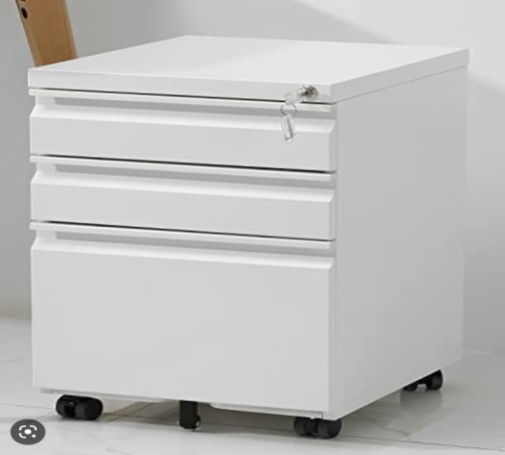
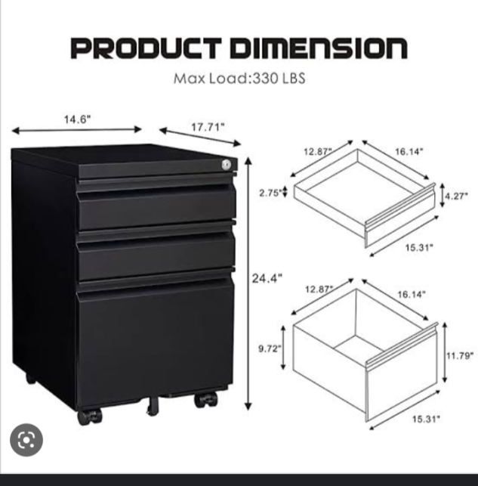
Designing a mobile metal cabinet is a critical step in the fabrication process, as it determines the size, shape, and functionality of the cabinet. The design process involves several steps, such as measuring the available space, determining the items to be stored, and selecting the materials and components.

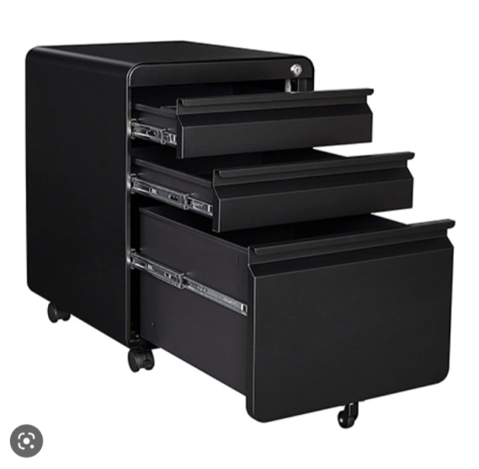
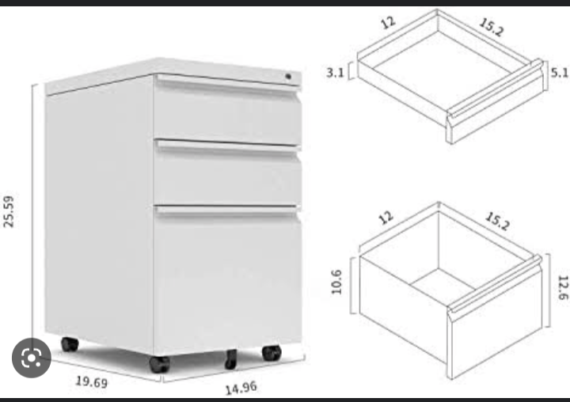
Figure 2.1 Figure 2.2

Figure 2.3 Figure 2.4
2.8 Types of Bookshelves Cabinet
There are many types and styles of bookshelves available today and many different plans to build bookcase.
They are also in different material such wood, metal, glass and plastic.
Some bookshelves are made for heavy books with glass fruit to protect the book from dust. Bookshelves cabinets are made for large areas and small area, they can be built in, free standing and foldable. There are many different types of bookshelves that are homes to book and decorative items.
2.8.1 Barrister Bookshelves Cabinet
Barrister bookshelves cabinet originated were designed for barristers use. Barristers have many law books which was a problem if they have to move to new chambers. In original bookshelves, there are several glass fruited separate shelf unit that may be stacked to form a cabinet. When a barrister change chambers, each shelf could be moved separately within removing its contents.
2.8.2 Modular Bookcase Cabinet
Modular bookcases are versatile and can be used individually or in groups. They can be stacked horizontally or vertically which can be used to create a traditionally looking bookshelf. This types of bookshelf cabinet can be free-standing unit or framed piece to hang on the wall. Modular bookshelves cabinet can be cube unit that slide or snap together in a very creative way to display decorative items or books.
2.8.3 Folding Bookshelf Cabinet
Folding bookcases are shelving unit that fold up. They take up with space and don’t need to be disassembled when moving it to a new place. When you need to move, just pack up the book and fold up the bookcase cabinet.
2.8.4 Revolving and Corner Bookshelf Cabinet
Revolving bookcases are sleek, space-saving and are eye catching in homes or any public place. They can be placed in unused areas in a room to display books and treasure in an attractive way.
2.8.5 Display Bookshelf Cabinet
Another bookshelf is the display bookshelf cabinet that has dowels or strip of wood edge to display books facing forward. The size of book collecting, the amount of space available and the budgeted amount of books will determine the type of bookshelf that will be chosen for book collection.
2.8.6 Shelf Bookcase Cabinet
Shelf bookcase are the most used type of bookshelf. They can be opened-backed or closed-backed. The shelves can be adjustable or non-adjustable shelves. The shelf bookcase cabinet can be free-standing or built into the wall. These bookcases can be 2 shelves or up to 6 shelves or more. The bookcase can be used alone or placed with other unit to create a large bookcase system.

2.8.7 Mobile Bookshelf Cabinet
Mobile bookshelf cabinet is the modern bookshelf usually made of metal that has four tyres for easy movement from one place or point to the other regardless of the weight of the cabinet and the content therein.
2.8.8 Uses of a Bookshelf Cabinet
A bookshelf is used to store books and other valuable items such as jewelries and diskette and electronic devices depending on the available number of shelves. It is also used as part of a home or office decoration due to its stylish design, color, sizes and material.
A bookshelf cabinet can also be used for displaying books, magazines and other items in a store or library.

CHAPTER THREE
3.0 RESEARCH METHODOLOGY
3.1 Cutting and Shaping of the Metal
Once the design plan for a mobile metal cabinet has been created, the next step in the fabrication process is cutting and shaping of the metal. This step involves using various tools and techniques to cut and shape the metal into the desired size and shape for the cabinet.
3.1.1 Preparing the Metal
Before cutting and shaping the metal, it is important to prepare it for the fabrication process. This includes cleaning the metal in other to remove any dirt or debris, marking the metal with the design plan measurements, and selecting the appropriate tools and equipment for the job.
3.1.2 Cutting of the Metal
The first step in cutting and shaping the metal is to cut it to the appropriate size and shape for the cabinet. This involves using a variety of tools, such as a saw, plasma cutter, or laser cutter, to cut the metal according to the design plan measurements. It is important to use the appropriate safety equipment, such as gloves and eye protection, when cutting the metal to prevent injury.

3.1.3 Shaping of the Metal
Once the metal has been cut to the appropriate size and shape, the next step is to shape it into the desired form for the cabinet. This involves using various tools and techniques, such as bending, rolling, or welding, to shape the metal into the desired form. It is important to use the appropriate safety equipment and techniques when shaping the metal to prevent injury and ensure the quality of the final product.
3.1.4 Finishing of the Metal
After the metal has been cut and shaped, the final step is to finish it to ensure the durability and longevity of the cabinet. This involves using various techniques, such as sanding, grinding, or painting, to smoothen the edges, remove any rough spots, and protect the metal from rust or corrosion. It is important to use high-quality finishing materials and techniques to ensure the durability and longevity of the final product.
3.2 Fabrication Process
With the design finalized and the materials procured, it is time to start the fabrication process. The fabrication process involved several steps, such as cutting the metal sheets and tubes to size, welding the frame together, cutting and welding the shelves and doors, and installing the casters, hinges, and locks.

3.3 Cutting the Metal Sheets and Tubes
The first step in the fabrication process was to cut the metal sheets and tubes to size. The metal sheets were cut to the dimensions of the shelves and doors, while the metal tubes were cut to the dimensions of the frame. The metal sheets and tubes were cut using a metal cutting saw, which allowed for precise cuts and clean edges.
3.4 Welding the Frame Together
Once the metal tubes were cut to size, the next step was to weld the frame together. The frame was designed to be modular, so that it could be easily assembled and disassembled for transport or storage. The frame was welded together using a MIG welder, which allowed for strong and clean welds.
3.5 Cutting and Welding of the Shelves and Doors
With the frame welded together, the next step was to cut and weld the shelves and doors. The shelves and doors were cut to size using a metal cutting saw, and then welded to the frame using a MIG welder. The shelves and doors were designed to be easily adjustable, so that they could be customized to the user's needs.
3.6 Installing the Casters, Hinges, and Locks
The final step in the fabrication process was to install the casters, hinges, and locks. The casters were chosen based on the load capacity and mobility requirements, and were installed on the bottom of the frame. The hinges and locks were installed on the doors, allowing them to be easily opened and closed.
3.7 Finishing process for cabinet
With the fabrication process complete, the final step was to finish the cabinet. The metal components were cleaned and prepped for painting, and then painted with a rust-resistant paint. The paint was allowed to dry, and then the cabinet was ready for use.

CHAPTER FOUR
4.0 RESULT AND DISCUSSION
4.1 Volume of Frame
Volume of the frame = length X breath X height
= 0.140 X 0.0381 X 0.381
= 0.0002 m³
Mass of frame = density X volume of frame
Density of mild steel = 7860 kg/m³
Density of mild steel = 7860 kg/m³
Mass of frame = 7860 X 0.0002
= 1. 572 kg
Weight of the frame = mass (m) X acceleration due to gravity (g) = 10 N/ kg
The value of acceleration due to gravity = (g)
(g) = 10N/kg
weight of frame = 1.572 X 10
= 15.72 N

4.2 Total Weight of Front and Back Frame
Total weight = 2 ( 15.72 )
= 31.44
Volume of the Button Frame
volume = area X thickness
thickness pipe $+$ thickness of sheet = 0.0294m
Area of frame = 0.0294m
= 0.104 X 0.02
= 0.00208 m²
Volume of frame =0.00208 m² X 0.0294
= 0.00006115 m³
Mass of button frame = density X volume of frame
= 7860 X 0.00006115
= 0.481 kg
Weight of button frame = MF X g
= 0.481 X 10
= 4.81
Volume of the Sheet Unit A
The self unit A is in form of trapezium
Area of trapezium = ^{½} ( a$+$b ) h
= ^{½} (0.025 $+$ 0.035) X 0.03
= 0.0009m²
Volume of the shelf unit A = area X thickness
= 0.0009 X 0.0294
= 0.0002646m³
Mass of shelf unit A = density X volume
= 7860 X 0.00002646
= 0.208 kg
Weight of Self Unit A
A = 0.208 x 10
= 2.08N

Total Weight of Self Unit A
= 4 (2.08)
= 8.32N
Volume of Unit B
Volume = area X thickness
Area of trapezium = ^{½} ( a $+$ b) h
= ^{½} ( 0.024 $+$ 0.035 ) X 0.03
= 0.000885 m²
Volume = 0.000885 X 0.0294
= 0.0000260 m³
Mass of unit B = density X volume
= 7860 X 0.0000260
= 0.205kg
Weight of unit B = M_{b} X g
= 0.205 X 10
= 2.05 N
Total Weight of Shelf Unit B
= 3(2.05)
= 6.2 N
Volume of Shelf Unit C
Volume = area X thickness
Area of trapezium =^{½} (0.02 $+$ 0.035)
= 0.000825 m²
Volume unit C = 0.000825 X 0.0294
= 0.0000243 m³
Mass of unit C = density X volume of unit C
= 7860 X 0.0000243
= 0.1960 kg
Weight of unit C = Mc X g
= 0.1906 X 10
= 1.906N

Total Weight of Shelf Unit C
= 3 ( 1.906)
= 5.72 N
Volume of Study Unit D
Volume = area X thickness
Area of trapezium = ^{½} ( 0.0015 + 0.035) X 0.03
= 0.00075 m²
Volume of unit D = 0.00075 X 0.0294
= 0.00002205 m³
Mass of unit D = density X volume of unit D
= 7860 X 0.00002205
= 0.17 kg
Weight of unit D = M₀ X g
= 0.17 X 10
= 1.7 N

Total Weight of Shelf Unit D
= 3( 1.7)
= 5.2 N
Volume of Shelf Unit D
Volume = area X thickness
The shelf unit E is in form of a square
Area of a square = 0.03 X 0.03
= 0.0009m²
Volume of unit E = 0.0009 X 0.0294
= 0.0000265m²
Mass of unit E = density X volume of unit E
= 7860 X 0.0000265
= 0.21 X 10
= 2.1 N

Total Weight of Shelf Unit E = 3(2.1)
= 6.3 N
Volume of the Legs
= 0.025 X 0.0381 X 0.0381
= 0.0000363 m³
Mass of the legs = density X volume
= 7860 X 0.0000363
= 0.285kg
Weight of the legs = M_{L}X g
= 0.285 X 10
= 2.85 N
Total of the four legs = 4(2.85)
= 11.4N
Total Weight of the Whole Book Shelf
= 31.44 N + 4.81 N + 8.32 N+ 6.2 N + 5.7 N + 5.2 N + 6.3 N + 11.4 N
Total = 79.37N

4.3 Fabrication Details and Bill of Engineering Measurement and Evaluation
Consideration of material for construction of project in the field of engineering is one of the major task of an engineer.
Factors to be considered in achieving this;
- Job description and component part design
- Availability of material
- Condition of use/ properties of materials
- Fabrication requirement
- Economic requirement
- Service of life
4.4 Properties of Selected Material
Mechanical properties: these are the properties of the material that are being displayed when force is applied to the material such as strength properties: this is the property to consider knowing the extent at which a material will sustain weight of load
Ductility Properties: this is the properties of material to plastically strain with fracture.
Brittleness Property: this is the tendency of material to fracture without physical plastic deformation when subjected to applied force.
Thermal Conductivity: this is the ability of the material to conduct heat
Electrical Conductivity: this is the ability of the material to conduct electricity
Corrosion Resistance: this is the ability of the material to resist deterioration due to chemical electrochemical reaction when it comes in contact with water
Aesthetic Property: this is the property of material to give it an attractive look in the shape, pattern, colour, or surface texture.
4.5 List of Tool Used
Before the completion of the project, work was carried out mostly in the fabrication workshop and painting, the major tools are:
Steel Rule: this is used to measure the actual requirement dimension of the material
Clamps: this was used to hold firmly the material during cutting process
Punch: this was used to locate the center to be drilled on the milld steel pipe
Hacksaw: this is used to cut the material into the required shape. It consist of a frame and cutting blade.
Welding Shield: this is used to protect against metal chips and every other flying particles from getting into eyes. Most importantly, it is used to protect against rays of light during welding.
Electric arc Welding Machine: this was use to weld different join together.
Electric: grade 12 electrodes are used for all the welding process. It is attached to the tong for the welding process to provide required flame
Tong: this is used to hold thee electrode and supplies the needed current for welding
Filler Wires: these were used along with welding tong to fill the void while welding.
4.6 Fabrication Details
The table below shows the step taken for the construction of the bookshelf.
Operation | Workdone | Tool/ machine used
Development | Drawing of component parts of the book shelf on a drawing board | Drawing sheet, drawing set and drawing board
Measurement process | Marking out the dimension on the metals | Engineering sheet rule pencil
Cutting process | Cutting out the material areas | Hand saw, chisel, hammer
Bending process | Bending of mild steel and plate to specific shape of the self | Bending machine anvil, hammer
Welding shape | Welding the cut out plates, steel bars to get it formed | Arc welding machine, grade 12- electrode, goggle, chipping hammer
Drilling process | Drill of steel bars where necessary to fix the barrel hinge and pins | Drilling machine (5mm drill bit) center punch hammer.
Grinding operation | Grinding is performed to achieve a smooth surface especially the areas that were joined together | Grinding machine, hand file, hammer
Table 4.1
4.7 Construction Procedures
4.8 Painting Operation
This process is considered after all the component part of the shelf have been constructed and fitted together. The surface was first cleared with sand paper and wire brush to remove rust and burns. The paint on the bookshelf prevent metal part form corrosion and prolong the life span of the shelf.
4.8.1 Safety Requirement
- The uses of eye goggle/shield
- The use of apron
- The uses of rubber hand gloves
- The use of rubber boots
- The use of nose grif/cover
4.8.2 Precautions Taken
i. Adequate precaution taken during cutting process
ii. the use of correct electrode gauge for welding
- In setting of appropriate and correct voltage of welding machine

4.9 Bill of Engineering Material and Evaluation
S/N | Material | Quantity | Price N
1 | 3 X ½ “ pipe | 2 Length
2 | 1^{n} pipe | 4 Length
3 | Sheet pipe | 2 Sheet
4 | Hingle | 2 Piece
5 | 100 K | 1 piece
6 | Handle | 1 piece
7 | Electrode | 10 dozen
8 | Paint | 1 gallon
9 | Painter
10 | Transport
Total
Table 4.2

CHAPTER FIVE
5.0 CONCLUSION AND RECOMMENDATION
5.1 CONCLUSION
Science and technology are the major drives for economy development of any researchable nation.
The engineers in the country should rise to the occasion and consider this as a challenge, if they actually want the country to improve technologically.
The Fabrication of the Mobile cabinet is one of the significant project to economic growth and it is expected to bring in better income for the fabricator and also to cater for the needs of the populace.
5.2 RECOMMMENDATION
In the design and construction of any project, the student should engage themselves through research before embarking in the project work.
Consultation of various books in the library are essential books needed for correct and successful project.
The school should provide more books for research on science and technology.

REFERENCES
Carrither John, 1996, Tools for Fabrication, Vol, 5 pg.25 Description of metal bookshelf, [www.google.com/discriptionofmetalshelf.wikipedia.com] date accessed 8/6/2023
Fabrication Tools, [http://www.overstock.com] date accessed 17/07/2023
Geneval (1981), Gudie to tools and equipment for labour based road construction;. First edition, vol. 200, pg.150, Hutchinsion and c., London.
John, Carrither and Rodrizeez, (1896), Tools for Agriculture; vol. 25, pg.50
Metal bookshelf, [http://www.wikipedia.com/metalbookshelf.com] date access 18/07/2023
Metal bookshelf, [www.google.com/metalbookshelf/Wikipedia.com25/6/2014] date accessed 25/06/2023.
Rodrizeez Halan, 1985, Metal Fabrication, vol.25 pg.106
Topic: Bookshelf, [www.google.com/wikipedia] date accessed 24/07/2023

