

A PROJECT REPORT
ON
FACILITIES MANAGEMENT OF PART OF KWARA STATE POLYTECHNIC ILORIN, MORO LOCAL GOVERNMENT AREA, KWARA STATE USING GIS APPROACH

BY
DAUDA AISHAT ADEBUKOLA
HND/23/SGI/FT/0015

SUBMMITED TO:
THE DEPARTMENT OF SURVEYING AND GEO-INFORMATICS, INSTITUTE OF ENVIRONMENTAL STUDIES, KWARA STATE POLYTECHNIC ILORIN.

IN PARTIAL FULFILLMENT OF THE REQUIREMENT FOR THE AWARD OF HIGHER NATIONAL DIPLOMA IN SURVEYING AND GEO-INFORMATICS.

JUNE, 2025

CERTIFICATE
I hereby certified that the information given in this project was obtained as a result of the observation and measurement made by me and that the survey was carried out in accordance with survey laws, regulations and departmental instructions

_________________________________
DAUDA AISHAT ADEBUKOLA
Matric. No: HND/23/SGI/FT/0015

CERTIFICATION
This is to certify that this project was carried out by DAUDA AISHAT ADEBUKOLA with Matric No.: HND/23/SGI/FT/0015 under my instruction and supervision for the award of Higher National Diploma in Surveying and Geo-informatics, Kwara State Polytechnic, Ilorin, Kwara State Nigeria. I hereby declared that she has conducted herself with due diligence and honesty on the said duties.

………………………………… ………………………………
SURV. R.S. AWOLEYE DATE
(Project Supervisor)

………………………………. …………………………
SURV. R.S. AWOLEYE DATE
(Project Coordinator)

……………………………… ………………………………
A.I ISAU DATE
Head of Department (H.O.D)
Surveying & Geo-informatics

……………………………….. ……………………………..
EXTERNAL EXAMINER DATE

DEDICATION
This project is dedicated to Almighty ALLAH, the author and the finisher of everything who gave me the grace and privilege to attain this stage in my education pursuit.

ACKWOLEDGEMENT
I give thanks and glory to my Creator for the privilege bestowed on me that resulted in the accomplishment of this project work and also a big thanks to the management of Kwara State Polytechnic for the privilege and opportunity given to me to study in their great institution.
My sincere gratitude goes to my Head of Department (HOD); A.I ISAU and my Supervisor; SURV. R.S. AWOLEYE for their support towards the success of this project, I really appreciate you sir.
To all the lecturers in the department of Surveying and Geo-informatics; Abimbola I. Isau, Surv. A. Ayuba, Surv. R.S. Awoleye, Surv. A.G. Aremu, Surv. B.F Diran, Surv. Wlliams Kazeem, Surv. Kabir Babatunde, Surv. R.O. Asonibare who has imparted their knowledge in me in one area or the other during my year of study, I am grateful for the effort and support. May Almighty ALLAH bless you all (Amiin).
I'm deeply grateful to my parents; MR & MRS DAUDA for their unconditional love, support, and wisdom. Their encouragement and sacrifices have been the driving force behind my endeavors. Thank you, Mom and Dad, for being my pillars of strength and inspiration. I dedicate this project to you, with love and appreciation.
Special thanks to my brother and sister for your unwavering love, care, and dedication that has shaped me into the person I am today. Your selfless love and your influence and values have guided me throughout this project, and I'm forever grateful for your presence in my life.
I would like to extend my heartfelt thanks to my beloved family members and friends who have supported me throughout this project.
May Almighty ALLAH bless you all (Amiin).

ABSTRACT
This study addresses this imperative by proposing and demonstrating the application of a Geographic Information System (GIS) approach to facilities management (FM) within a defined section of Kwara State Polytechnic, Ilorin, situated in Moro Local Government Area, Kwara State, Nigeria. Traditional paper-based or fragmented digital records often prove inadequate for managing spatially distributed assets, leading to inefficiencies in maintenance scheduling, space utilization tracking, emergency response planning, and long-term strategic development. This research establishes a comprehensive geospatial database as the foundational element for modern FM. Utilizing high-resolution satellite imagery, Global Positioning System (GPS) surveys for ground-truthing and precise asset location, and extensive attribute data collection, the study creates detailed digital maps and inventories of campus facilities. Key infrastructure components captured include academic buildings (lecture halls, laboratories, libraries, offices), administrative blocks, student hostels, utility networks (water supply lines, electrical distribution, drainage systems), roads, walkways, parking lots, green spaces, and other significant assets within the study area. The implementation for the selected section of KWARAPOLY Ilorin demonstrates significant potential benefits: dramatically improved accessibility and accuracy of facility data, enhanced decision-making speed and quality for administrative staff and planners, optimized use of physical space leading to potential cost savings, streamlined maintenance workflows, and strengthened institutional capacity for sustainable campus development. This study serves as a practical model for transitioning from inefficient, traditional FM methods to a dynamic, data-driven GIS-based system. The findings strongly advocate for the institution-wide adoption of GIS as a transformative tool for managing Kwara State Polytechnic's infrastructure portfolio, recommending future integration with Building Information Modeling (BIM), development of web-based portals for broader access, and establishing protocols for continuous data updating to ensure the system's long-term value and sustainability. This approach is readily transferable to similar tertiary institutions across Nigeria facing comparable facilities management challenges.
TABLE OF CONTENTS
Pages
Title Page i
Certification ii
Dedication iii
Acknowledgment iv
Table of contents v
List of Figures ix
Abstract x
CHAPTER ONE
General Introduction
1.1 Background to the Study 1
1.2 Aim of the Project 3
1.3 Objectives of the Project 3
1.4 Scope of Project 3
1.5 Significances of the Project 3
1.6 Personnel 4
1.7 Study Area 5
CHAPTER TWO
Literature review
2.0 Literature Review 6
2.1 Concept of Facilities Management 8
2.1.1 Basic Concepts of Geographic Information Systems (GIS) and their elaboration
11
2.2 Geographic Information System (GIS) 13
2.2.1 Spatial Data Infrastructure for Facilities 16
2.2.2 GIS for Facility Management 18
2.2.3 GIS Applications for Facility Management 18
2.3 Integration of GIS in Facilities Management 19
2.3.1 Benefits of Combining GIS with Facilities Management 20
2.3.2 Examples of GIS Platforms/Tools Used in Facilities Management 21
2.3.3 Role of GIS in centralizing facility data 21
2.3.4 Space and Asset Management using Geographic Information System 22
2.4 Challenges and Limitations in GIS-Based Facilities Management 24
CHAPTER THREE
Research Methodology
3.0 Methodology 27
3.1 Reconnaissance 27
3.1.1 Office Planning 28
3.1.2 Field Reconnaissance 28
3.2 Boundary Selection and Monumentation 29
3.3 Equipment Selection 30
3.3.1 Hardware 31
3.3.2 Software Used 31
3.4 Test of Instrument 31
3.4.1 South (NTS-350R) Total Station Test 31
3.4.2 Plate Level Test 31
3.4.3 Horizontal Collimation Test 32
3.4.4 Vertical Index Error Test 32
3.4.5 Analysis of Collimation and Vertical Index Data 33
3.5 Data Acquisition 34
3.5.1 Observation Procedure 34
3.5.2 In-situ Check of Survey Control Used 35
3.5.3 Perimeter Survey 37
3.5.4 Observation Procedure 37
3.5.5 Detailing Survey 38
3.5.6 Procedures of Operating South (NTS-350R) Total Station 39

CHAPTER FOUR
Data Processing and Result Analysis
4.1 Data Processing 41
4.1.1 Data Downloading 41
4.2 Computation of Survey Data 42
4.3 Processing in ArcMap 10.3 43
4.4 Preparation of 3D Map using ArcScene 51
4.5 Plan Production 52
4.5.1 Digital Map 53
4.6 Result Analysis 54
4.7 Queries Analysis 54
4.7.1 Single Criteria Query 54
4.8 Application of Results 62
CHAPTER FIVE
Summary, Problem Encountered, Conclusion and Recommendations
5.1 Costing 63
5.2 Summary 66
5.3 Problem Encountered 66
5.4 Conclusion 67
5.5 Recommendations 68
References
Appendix
LIST OF TABLES
Pages
Table 1.1: Table showing the name and role of the Personnel 4
Table 3.1: Horizontal and Vertical Collimation Test Reading 33
Table 3.2: Comparison of Old and New Values 34
Table 3.3: Result of the computed survey control check from given coordinate 36
Table 3.4: Result of the computed survey control check from given coordinate 36
Table 5.1: Planning 63
Table 5.2: Data Capture 63
Table 5.3: Data Download 64
Table 5.4: Data Processing 64
Table 5.5: Data Presentation 64
Table 5.6: Report Writing 65
Table 5.7: Summary 65

LIST OF FIGURES
Pages
Fig. 1.1: Maps Showing the Study Area 5
Fig. 3.1: Recce Diagram 29
Fig. 3.2: Pre- cast property beacon 30
Fig. 3.3: Instrument set-up for horizontal collimation test and vertical index test 33
Fig. 3.4: Shows the computed check angle and check distance as obtained from the control pillars. 36
Fig. 3.5 Show the observation process of using total station 38
Fig 4.1: Setting of units on ArcMap 44
Fig 4.2: Adding of data 46
Fig 4.3: New dataset creation 49
Fig 4.4: Digitizing on ArcMap 50
Fig 4.5: Facility Management map 53
Fig. 4.6: Single criteria query 55

CHAPTER ONE
INTRODUCTION
1.1 BACKGROUND TO THE STUDY
Facility Management is a management concept that primarily evolved from Property Management out of the necessity to cut organizational costs well as to adding value to the overall chain of operational process. Facility Management focuses on harnessing the physical, spatial, environmental, human and financial resources in the ‘post-occupancy’ state of buildings. It is also concerned with its ‘pre-occupancy’ state. Facility Management has been defined as multidisciplinary approach to ensuring functionality of the built environment by integrating people, place, process and technology (IFMA).
Over the years, facility management has changed from individuals maintaining a small number of buildings to managers currently in charge of a sizable portfolio of facilities. In addition to overseeing capital projects, facility performance, space concerns, customer service, and amenities, today's managers are also heavily involved in and in charge of real estate transactions and efforts at strategic planning (Philip McLaughlin, Cadcorp 2009).
Facility management is a daily balancing act of purchasing, maintenance, and tracking assets – all while adhering to a stringent budget. It can make the job overwhelming and exhausting. Utilizing online calendars, tracking systems, robust inventory systems, and other tool sets can all help day-to-day operations of facility management go smoothly. Arguably one of the most powerful tools that can be implemented is a well-designed Geographic Information System (GIS).
Geographic information system (GIS) is a technology that has many uses and advantages in many fields. One of the potential fields of utilization is Facility Management. GIS can be used by facility managers for space management, visualization and planning, and emergency and disaster planning and response, as well as many other applications (Schürle, D. Fritsch 1998).
GIS can be very helpful for facility managers in order to forecast for their future space, plan for yearly maintenance, response efficiently during emergencies and manage their facilities in an efficient manner (Stuart Rich & Kevin H. Davis 2010).
Given the importance of facilities and their place in society, a revolution in facilities management is occurring. Geographic information systems (GIS) are designed specifically for the management and analysis of spatial relationships, and offer many benefits to the facilities management community.
In the past, GIS was commonly used to help measure the impact of a facility on a natural ecosystem. Today, GIS is increasingly being used to plan, manage and operate the man-made ecosystem – the facility. Facilities managers are finding GIS tools, which have been used successfully for many years in fields such as environmental analysis and landscape planning, support a broad range of applications inside and outside of buildings, such as operations planning, emergency management, Americans with Disabilities Act (ADA) compliance, safety and security planning, space utilization and optimization, and more.
GIS can be used throughout the life cycle of a facility – from site selection, design and construction to use, maintenance and adaptation, and ultimately through closing, repurposing and reclamation. The challenge is to manage each step of the process in a way that maximizes the benefits of the facility to society while minimizing short- and long-term impacts on the natural environment. As an integrative platform for management and analysis of all spatial things, I believe, as the authors of this white paper have eloquently stated, GIS “is the only technology that has the ability to scale across any expanse, from the individual asset within a building to a virtually global context.”
Geographic information systems (GIS) are one technology that has many practical uses for facility managers. A GIS is a system that allows one to view, understand, question, interpret and visualize data in many ways that reveal relationships, patterns and trends in the form of maps, globes, reports and charts. A GIS can be used by facility managers for space management, visualization and planning, and emergency and disaster planning and response, as well as many other applications.
Modern GIS is an integrated system of computer software and data and information about the location and geography of things and phenomena and the relationships between them. GIS is used to interact with, manage and display geographic information.
GIS was first computerized in the 1960s (GIS.net 2010) as an effort to automate the landscape planning process of separating design influences, such as hydrography, vegetation, soils and ownership boundaries, into different layers. The approach before computerization was to draw each of the layers to scale on a separate page of acetate and then physically recombine them by stacking the pages in order to visualize different aspects of a proposed design. In the ensuing decades, GIS has matured into an enterprise-class technology platform that allows users to model the spatial relationships between and among many important aspects of our complex world.
1.2 AIM OF THE PROJECT
The aim of this project is to use GIS approach for better and efficient facility management of Part of Kwara State Polytechnic, Ilorin, Moro Local Government Area, Kwara State.
1.3 OBJECTIVES OF THE PROJECT
- To improve spatial data management
- To enhance decision-making processes
- To optimizing resource allocation
- To increase operational efficiency
- To facilitate communication and collaboration among stakeholders.
1.4 SCOPE OF PROJECT
The scope of this project involved the;
- Illustrating the potential usage of GIS applications in facility management.
- Explorer case study and examples to support the study and to prove the efficiency of the integration between GIS & facility management.
1.5 SIGNIFICANCES OF THE PROJECT
- To help minimize the risk by accurately locating utility system.
- Provide support for all FM projects, and accessibility to accurate and up-to-date documentation and info.
- Enables deep analysis of location data helping to explain patterns, relationships, and situations to help make smarter more efficient and effective decisions.
1.6 PERSONNEL
The students listed below were the members of this group who participated in the execution of the project.
S/N | NAME | MATRIC NO.
1. | DAUDA AISHAT ADEBUKOLA | HND/23/SGI/FT/0015
2. | SALAWU KEHINDE NAOMI | HND/23/SGI/FT/0016
3. | ONI ISAAC AYODELE | HND/23/SGI/FT/0025
4. | ABIDOYE AZEEZ OPEYEMI | HND/23/SGI/FT/0023
5. | AKINSOLA VICTORIA OLUWABUNMI | HND/23/SGI/FT/0017
6. | SOLIU FATAI OLUSINA | HND/23/SGI/FT/0020
7. | IBRAHIM IREWUMI FATIMAT | HND/23/SGI/FT/0018
Table 1.1: Table showing the Name and Matric No. of the personnel

1.7 STUDY AREA
The project is located inside Kwara State Polytechnic, Moro Local Government, Ilorin Kwara State.
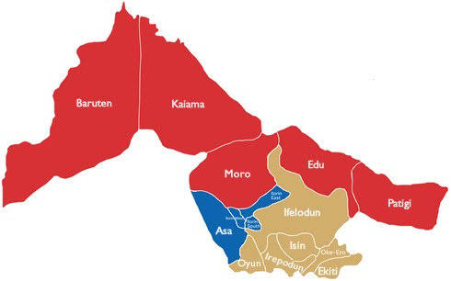
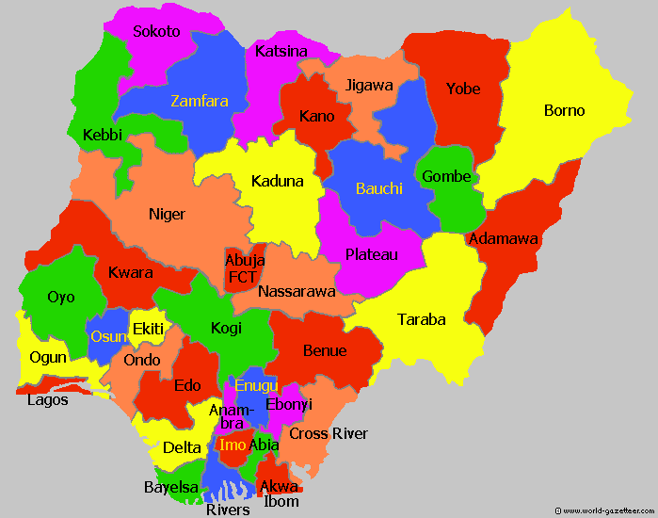
MAP OF KWARA STATE
MAP OF NIGERIA

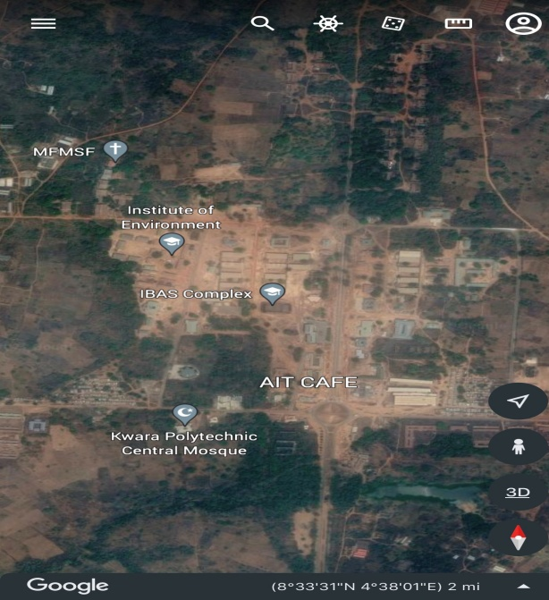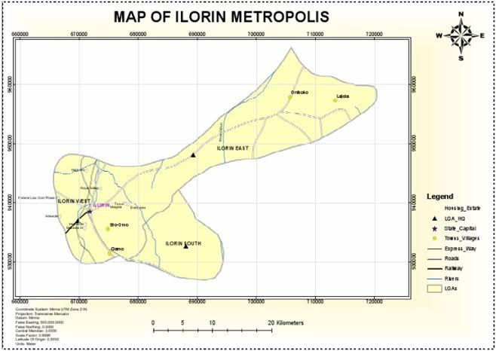
GOOGLE IMAGERY 0F THE STUDY AREA
MAP OF ILORIN METROPOLIS
Fig1.1: Map Showing Study Area

CHAPTER TWO
2.0 LITERATURE REVIEW
According to the International Facility Management Association (IFMA), Facility management is defined as a profession that encompasses multiple disciplines to ensure functionality of the built environment by integrating people, place, process and technology.
In another word, the facility manager rule involved the coordination and integration of workplace, occupants and work processes that ensures the continuity of the operation in a way that the facility will perform as designed and planned for it (Weller R., 1997).
The Facility Management sector acts as an umbrella, horizontally oriented market. It currently represents about 5% of global GDP. Because of its increasing relevance to the core business, it more and more takes the lead when developing a 'new world of work' and 'new ways of working'. As a result the need for convergence with Human Resources, Real Estate and Information Technology has increased dramatically. Also, the Facility Management sector has started taking its social responsibility, has become a strong driver of economy and proofed its role as integrator of people, place and processes. As a result Facility Management has become the leading business service able to integrate the tangible assets of real estate and facilities with the intangible assets of facility services.
The discipline of facility management and the role of facility managers in particular are evolving to the extent that many managers have to operate at two levels: strategic-tactical and operational. In the former case, clients, customers and end-users need to be informed about the potential impact of their decisions on the provision of space, services, cost and business risk. In the latter, it is the role of a facility manager to ensure corporate and regulatory compliance plus the proper operation of all aspects of a building to create an optimal, safe and cost effective environment for the occupants to function.
The facility manager should have two sorts of skills and knowledge areas in order to have a comprehensive background that qualifies him for successful facility management:
Hard skills: such as electrical distribution, civil, plumbing, operation, maintenance and spatial planning.
Soft skills: such as managerial skills, negotiations, time management, team building, problem solving and financial awareness.
According to Philip McLaughlin, Cadcorp (2009), there are several types of facility management services that can be provided to organizations to help them manage their facilities effectively and efficiently. These services may include:
1. Hard Facilities Management (Hard FM)
The management and upkeep of tangible building components, such as finishes, structures, and equipment, are included in hard management services. Hard FM involves overseeing all of the elements that make up a company's or infrastructure's physical structure, including its equipment, systems, processes, people, and technology.
The hard facility management is designed with an exceptional strategy, a particular strategy, and a customised strategy management to match the exceptional needs of every customer and cover the whole spectrum of physical management services.
The whole range of physical management services are covered by the hard FM, which is tailored with a special strategy, customised, and personalised strategy management to match the distinctive needs of each client, including-
- Heating
- Lighting/electrical
- Plumbing
- Fire safety systems
- Air conditioning
- Mechanical
2. Soft Facilities Management (Soft FM)
Soft services are activities and offerings that you can customise. They frequently aren't necessary and can be handled in a variety of different ways. The use and beneficiaries of soft services, however, are what matter most. Soft services can improve the working environment in ways that are advantageous to both people and the work they accomplish when properly implemented.
Soft services aren't built into the structure but are used by and directly benefit employees. They are not necessary; rather, they are intended to enhance the comfort, enjoyment, or security of the workplace. Several instances include:
- Building security
- Landscaping
- Cleaning
- Catering
- Office decorating
- Office moves
2.1 CONCEPT OF FACILITIES MANAGEMENT
The concept of Facilities Management has evolved significantly over time, with definitions reflecting changing emphases. Early perspectives often centered on the physical workplace and support services.
Jacques Thenardier (1983), in one of the earliest formal definitions, described it broadly as "the discipline of planning, designing, constructing and managing space - in every type of building - in an increasingly complex and fragmented industry" (cited in Alexander, 1996, p. 5), highlighting its foundational role in the built environment. Moving towards a more integrated view.
Keith Alexander (1996) defined FM as "the process by which an organisation delivers and sustains support services in a quality environment to meet strategic objectives" (Alexander, 1996, p. 10), explicitly linking facilities support to the organisation's core strategy. This strategic alignment was further emphasized by Peter Barrett (2000), who proposed FM as "the integration of multi-disciplinary activities within the built environment and the management of their impact upon people and the workplace" (Barrett & Baldry, 2003, p. 3), underlining the multidisciplinary nature and human-centric focus of the field.
Brian Atkin (2009) offered a comprehensive perspective, defining FM as "an integrated approach to operating, maintaining, improving and adapting the buildings and infrastructure of an organisation in order to create an environment that strongly supports the primary objectives of that organisation" (Atkin & Brooks, 2009, p. 5), stressing the continuous lifecycle management of assets to support core business functions.
Peter Nutt (2004) viewed FM as "the provision of the support services required for the effective operation of the organisation" (Nutt, 2004, p. 188), framing it fundamentally as an enabling service function.
Keith Roper (2017) expanded the scope further, defining FM as "an organisational function which integrates people, place and process within the built environment with the purpose of improving the quality of life of people and the productivity of the core business" (Roper & Payant, 2017, p. 5), explicitly adding the improvement of quality of life and productivity as core outcomes.
This reflects the modern understanding of FM moving beyond mere cost efficiency towards enhancing user experience and delivering value. The most recent perspectives, like that implied by IFMA (International Facility Management Association), consolidate these elements, positioning FM as "a profession that encompasses multiple disciplines to ensure functionality, comfort, safety and efficiency of the built environment by integrating people, place, process and technology" (IFMA, 2023), highlighting its holistic, technology-enabled approach to optimizing the workplace environment for organisational success.
Becker defined FM as "the coordination of the physical workplace with the people and work of the organization; it integrates the principles of business administration, architecture, and the behavioral and engineering sciences" (Becker, 1990, p. 5). This definition significantly broadened the scope beyond buildings and services to explicitly include the dynamic interplay between the work environment, organizational processes, and human behavior, positioning the workplace itself as a strategic resource influencing productivity and well-being.
Expanding on the service dimension hinted at by Nutt (2004), Tayyab Maqsood (2012) articulated a definition emphasizing FM's role in value creation and core business enablement, describing it as "the practice of coordinating the physical workplace with the people and work of the organisation; it integrates the principles of business administration, architecture, and the behavioural and engineering sciences to ensure functionality of the built environment by integrating people, place, process and technology" (Maqsood et al., 2012, p. 2), reinforcing the multidisciplinary integration for functional outcomes.
David Cotts (2010), aligning with the strategic asset management view, defined FM as "an organizational function which manages people, places, and processes within the built environment to improve the quality of life of people and the productivity of the core business" (Cotts, Roper, & Payant, 2010, p. 4). This definition explicitly links FM outcomes directly to both human experience ("quality of life") and organizational effectiveness ("productivity of the core business"). Reflecting the growing importance of environmental and social governance.
Michel Theriault (2015) emphasized FM's role in sustainability and resilience, defining it as "the profession that encompasses multiple disciplines to ensure functionality of the built environment by integrating people, place, process, technology and environment; with the aim of improving the quality of life, sustainability, resilience and supporting the primary objectives of the organisation" (Theriault, 2015). This incorporates environmental stewardship and organizational resilience as core FM objectives. Similarly, the British Institute of Facilities Management (BIFM, now IWFM) framed FM as "the integration of processes within an organisation to maintain and develop the agreed services which support and improve the effectiveness of its primary activities" (BIFM, 2013), focusing on agreed service levels and effectiveness enhancement.
Eric Teicholz (2013) highlighted the technological transformation, describing FM as "the practice of coordinating the physical workplace with the people and work of the organization, integrating the principles of business administration, architecture, behavioral and engineering sciences, and information technology" (Teicholz, IFMA Foundation, 2013, p. 1), underscoring IT's critical role in modern FM delivery.
Denise Turner (2020) further evolved the concept towards user experience and adaptability, defining FM as "the strategic orchestration of people, place, process and technology to create frictionless, adaptive, and experiential environments that empower the workforce, foster wellbeing, and drive organisational performance" (Turner, 2020), introducing concepts like "frictionless," "adaptive," and "experiential" environments, directly tying FM to employee empowerment and wellbeing as performance drivers.
These additional definitions illustrate the expanding scope of FM, moving from a focus on physical assets and basic services to a strategic, multidisciplinary function deeply concerned with integrating people, place, process, technology, and sustainability to enhance human experience, enable core activities, and deliver tangible value across the entire organizational ecosystem.

2.2.1 BASIC CONCEPTS OF GEOGRAPHIC INFORMATION SYSTEMS (GIS) AND THEIR ELABORATION
Geographic Information Systems (GIS) are built on foundational concepts that enable the capture, analysis, and visualization of spatial data. Below is an elaboration of these core principles, supported by academic references:

1. Spatial Data
Spatial data refers to information tied to specific geographic locations on Earth’s surface, represented by coordinates (latitude/longitude) or addresses. It exists in two primary forms:
- Vector Data: Represents discrete features as points (e.g., trees), lines (e.g., rivers), or polygons (e.g., administrative boundaries). Vector models excel in precision and are ideal for mapping infrastructure or property parcels (Longley et al., 2015).
- Raster Data: Comprises pixels or grid cells, each assigned a value (e.g., elevation, temperature, or satellite imagery). Raster models are used for continuous phenomena like climate patterns or land cover analysis (Chang, 2021). For example, urban planners might combine vector data (roads) with raster data (population density grids) to optimize public transport routes (Tomlinson, 2013).

2. Layers and Georeferencing
GIS organizes spatial data into layers, akin to stacked transparencies, each representing a specific theme (e.g., soil type, vegetation, or zoning laws). Layers can be analyzed individually or combined to reveal spatial relationships. Georeferencing ensures these layers align accurately with real-world coordinates. For instance, a historical map scanned into GIS must be georeferenced by matching its control points (e.g., landmarks) to modern coordinates to enable accurate overlay with current data (USGS, 2023).

3. Coordinate Systems and Projections
To represent the Earth’s curved surface on a flat map, GIS uses coordinate systems (e.g., WGS84 for global data) and map projections (e.g., Mercator for navigation). Each projection introduces distortions in shape, area, or distance, necessitating careful selection based on the analysis purpose. For example, the Equal Area projection preserves landmass proportions for ecological studies, while the UTM system minimizes distortion for regional mapping (Longley et al., 2015).

4. Spatial Analysis
Spatial analysis is the heart of GIS, involving techniques to extract meaning from geographic data:
- Overlay Analysis: Combines layers to identify intersections (e.g., flood zones overlapping with residential areas).
- Buffering: Creates zones around features (e.g., 1 km around a hospital to assess service coverage).
- Network Analysis: Models connectivity (e.g., shortest ambulance routes in a city).
During the COVID-19 pandemic, spatial analysis helped track infection clusters and allocate medical resources efficiently (WHO, 2020).

5. Attribute Data
Non-spatial information linked to geographic features is called attribute data. For example, a city park (polygon) may have attributes like name, size, and visitor count. GIS allows querying and visualizing attributes spatially, such as mapping parks with the highest footfall to prioritize maintenance (Chang, 2021).

6. Topology
Topology defines the spatial relationships between features (e.g., adjacency, connectivity, or containment). It ensures data integrity; for instance, ensuring a county boundary does not overlap a lake polygon. Topological rules are critical for network analysis (e.g., ensuring roads connect correctly for traffic modeling) (Longley et al., 2015).

7. Metadata
Metadata describes the source, accuracy, and purpose of spatial data. It is essential for data credibility and usability. For example, metadata for satellite imagery might include resolution (e.g., 30m/pixel), acquisition date, and sensor type, helping researchers assess its suitability for deforestation studies (Tomlinson, 2013).

8. GIS Workflow
A typical GIS workflow involves:
- Data Collection: Using GPS, remote sensing, or surveys.
- Data Input: Digitizing maps or importing datasets.
- Data Management: Organizing layers in geodatabases.
- Analysis: Applying spatial tools to answer questions.
- Visualization: Creating maps, charts, or 3D models.
- Decision-Making: Sharing insights with stakeholders. For instance, disaster response teams use this workflow to map earthquake damage and prioritize rescue operations (USGS, 2023).
These concepts form the backbone of GIS, enabling its application across fields like environmental science, public health, and urban planning. By integrating spatial and attribute data, leveraging coordinate systems, and applying analytical techniques, GIS transforms raw geographic information into actionable knowledge. As noted by Goodchild (2007), GIS is not just a tool but a "science of spatial relationships," continually evolving with advancements in AI, IoT, and big data to address global challenges.
2.2 GEOGRAPHIC INFORMATION SYSTEM (GIS)
Geographic Information Systems (GIS) represent a transformative technology that integrates spatial data with analytical tools to visualize, interpret, and understand patterns and relationships within geographic contexts. At its core, GIS is a framework for gathering, managing, analyzing, and presenting data linked to locations on Earth’s surface. This system combines hardware, software, geographic data, and human expertise to answer complex questions about spatial relationships, enabling decision-makers across disciplines—from urban planning to environmental science—to derive actionable insights (Longley et al., 2015).
GIS operates on the principle that nearly 80% of all data has a geographic component, such as addresses, coordinates, or regional boundaries (Tomlinson, 2013). By layering diverse datasets—such as satellite imagery, demographic statistics, land use records, or climate models—onto digital maps, GIS transforms abstract information into visual narratives. For example, urban planners might overlay transportation networks with population density maps to identify underserved areas for public transit expansion, while ecologists could map deforestation rates against wildlife habitats to prioritize conservation efforts (USGS, 2023).
Geographical Information System (GIS) - System of computer hardware, software, and procedures designed to support the capture, management, manipulation, analysis, modeling, and display of spatially referenced data for solving complex planning and management problems. GIS is a computer-based system used to capture, store, edit, analyze, display, and plot geographically referenced data. GIS was pioneered in the 1960s by the Canadian forestry mapping initiative and continued to develop as Canadian, U.S., and other government and university researchers sought to represent the earth’s geography using a computer database, display it on a computer terminal, and plot it on paper. They also developed computer programs to quickly search and analyze this data. The typical GIS is founded on several basic concepts.
First, the real-world features on the earth’s surface are related to a map grid coordinate system and recorded in the computer. The computer stores the grid coordinates of these features to show where they are, and the attributes of these map features to show what they are. Second, map features can be displayed or plotted in any combination and at virtually any map scale, making computerized mapping data far more flexible to use than traditional paper maps. Third, the GIS can analyze the “spatial” (locational) relationships among map features.
The capability of GIS technology to process both spatial and attribute data offers the opportunity of using GIS in locational analysis. GIS facilitates effective decision-making by planners in planning. GIS goes beyond the limits of paper maps in manipulating and analyzing spatial data. The advantages of GIS in data documentation and processing include (Al-Ramadan & Aina 2004):
- Quick updating of information
- Automated cartography
- Integration of information by linking spatial and attribute data
- Spatial analysis
- Production of maps at different scales and
- Visualization.
For years, facility managers have been using GIS at the landscape level to manage a number of the assets in their facility portfolio. Some of the earliest applications of GIS in facility management were related to pavement management at airports, municipal water and wastewater infrastructure, and electric utility distribution. For example, facility managers of the US Air Force have developed a standardized set of GIS layers to support the management of Air Force bases.
Today, it is becoming possible with GIS to think about and analyze the spatial aspects of every component of facility management workflows to decrease cost and increase productivity. None of the enterprise applications used within the arena of facility management have advanced spatial analytic capabilities to support business processes that span geographic areas or provide complex scenario modeling that includes multidimensional visualization including 3D (space), 4D (time) and 5D (money).
Geographic information system (GIS) technology manages infrastructure both outside and inside buildings to provide full operational awareness. Use it to optimize existing space, move staff efficiently and map asset conditions. Throughout the facility life cycle,
GIS supports you in your mission, from site selection to space planning and maintenance, lease management and usage, safety issues, and continuity planning.
GIS gives organizations a look at their facilities across all scales using the same data and software, allowing them to analyze dependencies, decrease costs, makes better decisions, and improves performance management. GIS is a robust information system that supports a diverse set of analytic capabilities, workflows, and applications.
GIS is a platform that supports the integration of information from all of these spatial, temporal and informational dimensions. Examples of such integrations include:
• Combining cost data with the visualization of space and occupancy across the campus
• Analyzing routing barriers for disabled persons for use during evacuation planning and emergency action planning
• Conducting visualization of energy consumption data at the room level while simultaneously managing maintenance workflows for mechanical, electrical and plumbing systems for a nationwide facility infrastructure
• Managing security concerns both inside and outside buildings, across regions and continents, simultaneously (4D) and contiguously (3D)
2.2.1 SPATIAL DATA INFRASTRUCTURE FOR FACILITIES
As GIS is becoming more widely used inside buildings, facility managers are applying the insights gained from spatial data infrastructures to the spaces inside buildings. There are framework levels inside the building, just as there are framework levels at the landscape level, such as roads and parcels. A few examples of framework layers inside a building include floor levels, walls, windows, doors and the spaces that are defined by architectural structures.
Once the core architectural elements of the building have been established in the GIS, it is possible for many other layers to be derived from this foundation. Some of the layers that can be derived from basic floor plans include:
• Space use and type definitions
• Lease areas
• Security zones
• Management zones
• Asset locations
• Evacuation collection areas
• Navigable routes
Once this basic data has been added to the GIS, it is possible to provide geospatial support to a wide variety of information systems and business processes for the facility management community:
• Grouping multibuilding and multisite work orders by location to reduce transportation and logistics costs
• Visualizing energy consumption data at the room, building and/or enterprise level over time
• Analyzing space use, space availability and space optimization across campus or regional extents
• Conducting building condition assessments, fire safety inspections and asset inventories using handheld, location-aware (GPS-enabled) devices. These devices provide rapid data capture and precise location of issues, items and assets, supporting visualization, analysis and reporting.
• Analyzing and visualizing lease performance metrics across the portfolio, regardless of geographic extent
• Analyzing, route mapping and reporting of Americans with Disabilities Act (ADA) compliance and/or ADA facility and fixture availability across the campus or portfolio
• Visualizing the impact of proposed building projects on the campus environment
• Conducting line of sight analysis for special events
• Modeling the impact of proposed use changes on the supporting utility infrastructure
• Visualizing proposed space planning scenarios
In order to provide best practices guidance and support for facility managers interested in establishing facility GIS capabilities, an independent committee made up of software vendors, government users, higher education facility managers and facility managers from various levels of government formed the Building Information Spatial Data Model (BISDM) committee in 2007. This committee has published several versions of the Building Information Spatial Data Model and continues to enhance and extend the model and its tools, making them available to the community.
Modern GIS is an integrated system of computer software and data and information about the location and geography of things and phenomena and the relationships between them. GIS is used to interact with, manage and display geographic information. GIS was first computerized in the 1960s as an effort to automate the landscape planning process of separating design influences, such as hydrography, vegetation, soils and ownership boundaries, into different layers. The approach before computerization was to draw each of the layers to scale on a separate page of acetate and then physically recombine them by stacking the pages in order to visualize different aspects of a proposed design. In the ensuing decades, GIS has matured into an enterprise-class technology platform that allows users to model the spatial relationships between and among many important aspects of our complex world.
2.2.2 GIS FOR FACILITY MANAGEMENT
GIS integrates with the top facilities management (FM) software and consulting firms, making it easier than ever to extend the life of your FM data.
GIS can be used throughout the life cycle of a facility from deciding where to build to space planning (Esri 2010).
GIS helps you to:
- Streamline asset information collection, dissemination, maintenance, and use.
- Facilitate better planning and analysis.
- Allow efficient sharing of information in and out of the field, providing a comprehensive view of operations.
2.2.3 GIS APPLICATIONS FOR FACILITY MANAGEMENT
Compliance
Meeting compliance codes ensures that a building or asset is safe and operates as intended. Building compliance can span from energy efficiency, safety, and zoning to issues dealing with conformity to laws such as the Americans with Disabilities Act (ADA) of 1990. Buildings and assets are inherently spatial; they are located somewhere on the earth.
GIS can be used to efficiently collect and store information based on their location, providing a means for query, analysis, and reporting when necessary.
Asset Management and Maintenance
GIS helps organizations gain efficiencies even in the face of finite resources and the need to hold down costs. Operations and maintenance staff can deploy enterprise and mobile workforce applications that provide timely information to the field for faster, more accurate work order processing.
Lease and Property Management
Revenue can be increased and operations and maintenance costs reduced when GIS helps manage space. Real estate and property managers can see and make queries about space including its availability, size, and special constraints for the most cost-effective use.
Space Usage
GIS helps facilities managers organize and spatially visualize space and how it can best be used. Operational costs can be decreased by more efficiently using space including managing the moves of personnel and assets as well as the storage of materials.
Disaster and Business Continuity Planning
Viewing buildings and the locations of assets along with emergency information, such as weather patterns and disaster zones, can give organizations the information they need to make decisions quickly. GIS provides a holistic understanding of facility status and performance and brings together departments, business systems, and data sources for a comprehensive view into and throughout organizations.
Green Buildings
Increase a facility’s sustainability by using GIS to help reduce energy and water use, find better waste disposal, and decrease a building’s carbon footprint. By managing information both inside and outside buildings down to the asset level, a difference can be made in the environmental impact of development.
2.3 INTEGRATION OF GIS IN FACILITIES MANAGEMENT
The integration of Geographic Information Systems (GIS) into Facilities Management (FM) has revolutionized how organizations manage physical assets, optimize space, and streamline operations. By merging spatial data with traditional FM workflows, GIS provides a geospatial lens to visualize, analyze, and manage facilities holistically. This synergy enhances decision-making, improves resource allocation, and fosters sustainability across built environments.

2.3.1 BENEFITS OF COMBINING GIS WITH FM
- Enhanced Spatial Awareness: GIS enables FM teams to map all assets—buildings, equipment, utilities—within their geographic context. For instance, a university campus can visualize HVAC systems, electrical grids, and foot traffic patterns to prioritize maintenance and reduce energy waste (Roper & Payant, 2014). This spatial clarity helps identify inefficiencies, such as underutilized spaces or overlapping service routes.
- Improved Asset Tracking and Maintenance: By georeferencing assets (e.g., fire extinguishers, HVAC units), FM teams can track their condition, lifespan, and maintenance history. Predictive analytics in GIS platforms forecast equipment failures, enabling proactive repairs and minimizing downtime (ISO, 2017). For example, a hospital using GIS can map MRI machines and schedule maintenance based on usage data and spatial proximity to technicians.
- Optimized Space Utilization: GIS tools analyze occupancy trends and space allocation. Heatmaps of office usage can inform hybrid workplace strategies, while 3D models of facilities help redesign layouts for collaboration or compliance with social distancing mandates (IFMA, n.d.). Retail chains use GIS to evaluate store locations based on demographic data and competitor proximity.
- Risk Mitigation and Emergency Planning: GIS integrates real-time data (e.g., weather forecasts, flood zones) to model risks and plan evacuations. During disasters, FM teams use GIS to map emergency exits, fire hydrants, and safe zones, ensuring compliance with safety regulations (BSI, 2011). For example, factories in earthquake-prone regions use GIS to reinforce infrastructure based on seismic hazard maps.
- Sustainability and Energy Management: GIS identifies energy consumption patterns by overlaying utility data with building footprints. Solar potential maps guide renewable energy installations, while carbon footprint analyses align facilities with net-zero goals (RICS, 2020).

2.3.2 EXAMPLES OF GIS PLATFORMS/TOOLS USED IN FM
- ArcGIS (Esri): The industry-leading platform for spatial analytics, ArcGIS integrates with FM software like IBM TRIRIGA to map assets, monitor IoT sensors, and optimize space. For example, the City of Los Angeles uses ArcGIS to manage 500+ municipal buildings, tracking energy use and maintenance schedules across geographic districts (Esri, 2023).
- QGIS: An open-source alternative, QGIS offers cost-effective solutions for small organizations. Schools and NGOs use QGIS to map facility conditions, such as water access points in rural clinics or classroom layouts for ADA compliance.
- FM:Systems: This CAFM (Computer-Aided FM) software embeds GIS capabilities to centralize asset data. Its “Space Analytics” module visualizes occupancy rates and lease agreements on interactive maps, aiding corporate real estate decisions (FM:Systems, 2022).
- AutoCAD Map 3D: Combines CAD design with GIS data, enabling engineers to overlay utility networks (e.g., plumbing, electrical) onto building blueprints for clash detection and lifecycle management.

2.3.3 ROLE OF GIS IN CENTRALIZING FACILITY DATA
GIS acts as a centralized geospatial database, consolidating disparate datasets into a single, visual interface. For example:
- Asset Integration: Combines CAD drawings, IoT sensor data, and maintenance logs into layered maps. A university campus might overlay Wi-Fi coverage maps with classroom schedules to identify connectivity gaps during peak hours.
- Interdepartmental Collaboration: GIS bridges silos between FM, HR, and IT. HR can map employee locations to allocate desks in hybrid workplaces, while IT uses the same platform to plan network expansions (Goodchild, 2007).
- Historical and Real-Time Data Fusion: Utilities like water pipelines are mapped alongside historical repair records and real-time pressure sensors, enabling predictive maintenance. The Port of Rotterdam uses GIS to monitor cargo terminal operations, integrating ship arrival data with crane availability maps (RICS, 2020).
By centralizing data, GIS eliminates redundancies and provides a “single source of truth” for stakeholders. For instance, during the COVID-19 pandemic, organizations used GIS dashboards to track sanitization schedules, ventilation upgrades, and employee vaccination rates across global offices (WHO, 2020).
2.3.4 SPACE AND ASSET MANAGEMENT USING GEOGRAPHIC INFORMATION SYSTEMS (GIS)
The integration of Geographic Information Systems (GIS) into space and asset management has redefined how organizations visualize, monitor, and optimize their built environments. By leveraging spatial data, GIS bridges the gap between physical infrastructure and operational efficiency, enabling precise management of interior spaces, real-time asset tracking, and data-driven space utilization strategies. Below is an elaborative exploration of these applications, supported by industry examples and academic references:

1. Mapping Interior Spaces and Building Layouts
GIS transforms static floor plans into dynamic, interactive spatial databases that reflect the real-time status of interior environments. Advanced tools like ArcGIS Indoors or AutoCAD Map 3D enable FM teams to digitize building layouts, annotating rooms, corridors, utilities, and safety features (e.g., fire exits, HVAC ducts) with georeferenced precision. For example, hospitals use GIS to map surgical suites, patient wards, and equipment storage areas, ensuring compliance with infection control protocols by visualizing airflow patterns and sanitation zones (RICS, 2020).
- 3D Modeling and BIM Integration: GIS integrates with Building Information Modeling (BIM) to create 3D representations of facilities. This allows stakeholders to “walk through” virtual buildings, identifying design flaws or space conflicts before construction. For instance, the University of Cambridge uses GIS-BIM integration to plan laboratory renovations, ensuring electrical systems align with research equipment needs (Esri, 2023).
- Wayfinding and Accessibility: GIS-powered mobile apps, such as MappedIn, provide turn-by-turn indoor navigation for visitors in complex spaces like airports or corporate campuses. These tools also highlight ADA-compliant routes, enhancing inclusivity (IFMA, n.d.).

2. Tracking Physical Assets in Real-Time
GIS enables real-time asset tracking by combining IoT sensors, RFID tags, and GPS data with spatial platforms. Each asset—whether a laptop, medical device, or HVAC unit—is geotagged and linked to a digital twin in the GIS database.
- IoT and Sensor Integration: Sensors embedded in assets transmit location, temperature, or usage data to GIS dashboards. For example, a warehouse using ArcGIS Tracking Analyst monitors forklift movements to optimize logistics and prevent collisions (Esri, 2023).
- Predictive Maintenance: GIS analyzes spatial and temporal data to predict asset failures. A university might track the condition of projectors across lecture halls, scheduling replacements based on usage hotspots mapped in QGIS (Roper & Payant, 2014).
- Emergency Response: During crises, GIS pinpoints the location of critical assets like defibrillators or fire extinguishers. The Port of Los Angeles uses GIS to track cargo-handling equipment, reducing downtime during emergencies (BSI, 2011).

3. Planning and Optimizing Space Usage
GIS empowers organizations to maximize space efficiency by analyzing occupancy patterns, forecasting future needs, and simulating layout changes.
- Space Utilization Analytics: Tools like FM:Systems’ Space Analytics generate heatmaps of desk occupancy, meeting room usage, or foot traffic. For example, a corporate office post-COVID-19 uses GIS to identify underutilized floors and reconfigure them into collaborative hubs or quiet zones (IFMA, n.d.).
- Scenario Modeling: GIS simulates “what-if” scenarios, such as expanding a manufacturing floor or relocating departments. A retail chain might model customer flow in stores using GIS to optimize shelf placement and checkout lanes (Tomlinson, 2013).
Hybrid Work Strategies: With the rise of remote work, GIS helps organizations implement hot-desking by mapping employee preferences and peak office hours. Sensors detect desk availability in real time, updating GIS dashboards for employees to reserve spaces via apps like OfficeSpace Software (RICS, 2020).

2.4 CHALLENGES AND LIMITATIONS IN GIS-BASED FACILITIES MANAGEMENT
While Geographic Information Systems (GIS) offer transformative potential for Facilities Management (FM), their implementation is often hindered by technical, organizational, and human-centric challenges. These limitations range from data quality issues to resistance to technological change, requiring strategic solutions to unlock GIS’s full value. Below is an in-depth exploration of key challenges, supported by industry examples and academic insights:

1. Data Accuracy and Availability
GIS relies on precise, up-to-date spatial and attribute data to generate reliable insights. However, many organizations struggle with incomplete, outdated, or inconsistent datasets. For instance, legacy building blueprints may lack georeferenced coordinates, leading to misaligned maps, while IoT sensors providing real-time asset data might suffer from calibration errors. A hospital attempting to map emergency evacuation routes using outdated floor plans could inadvertently block critical pathways, jeopardizing safety protocols (BSI, 2011).
- Cost of Data Acquisition: High-resolution satellite imagery, LiDAR scans, or drone surveys required for accurate 3D modeling are often prohibitively expensive for small organizations. A municipal government managing public schools might lack funds to digitize decades-old paper records, delaying GIS integration (Tomlinson, 2013).
- Data Maintenance: Spatial data decays over time as facilities undergo renovations or asset locations shift. Without continuous updates, GIS models become obsolete. For example, a university expanding its campus must regularly update its GIS database to reflect new constructions, a process requiring dedicated personnel and software (Roper & Payant, 2014).

2. Integration with Legacy Systems
Many FM teams operate aging Computer-Aided Facility Management (CAFM) or Enterprise Asset Management (EAM) systems that lack compatibility with modern GIS platforms. Retrofitting these systems to support spatial data often demands costly middleware or custom APIs.
- Interoperability Issues: Legacy systems may use proprietary data formats (e.g., .dwg files in AutoCAD) that cannot be directly imported into GIS software like ArcGIS or QGIS. A manufacturing plant using an older CMMS (Computerized Maintenance Management System) might need manual data entry to align equipment logs with GIS maps, increasing error risks (IFMA, n.d.).
- Siloed Data: Departments like HR, IT, and FM often maintain separate databases, creating fragmented views of facility operations. For example, a corporate office’s space utilization data might reside in Excel sheets, while asset locations are tracked in a standalone CAFM tool, complicating holistic GIS analysis (RICS, 2020).

3. Skillset and Training Requirements
GIS demands specialized expertise in spatial analysis, data science, and software management—skills often absent in traditional FM teams.
- Technical Proficiency: Tools like ArcGIS Pro or QGIS require training in geodatabase design, SQL queries, and spatial statistics. A facilities manager accustomed to spreadsheet-based workflows may struggle to interpret heatmaps or perform buffer analyses (Chang, 2021).
- Resistance to Change: Staff accustomed to manual processes may resist adopting GIS due to perceived complexity. For instance, a school district’s custodial team might reject a GIS-based work order system, preferring paper checklists (Roper & Payant, 2014).
- Ongoing Training Needs: GIS software evolves rapidly, with updates introducing new features (e.g., AI-driven analytics in Esri’s ArcGIS Analytics for IoT). Organizations must invest in continuous training to keep teams updated, a challenge highlighted during the COVID-19 pandemic when FM teams rushed to adopt GIS for social distancing planning (WHO, 2020).

Case Studies Highlighting Challenges
- Data Accuracy in Healthcare: A 2020 study revealed that 40% of U.S. hospitals had incomplete utility maps, delaying COVID-19 testing lab setups due to inaccurate electrical load data (Esri, 2023).
- Legacy System Integration in Manufacturing: An automotive plant in Germany spent 18 months integrating SAP EAM with ArcGIS, facing downtime and $2M in unexpected costs (FM:Systems, 2022).
- Skills Gap in Municipal FM: A survey by IFMA found that 60% of public sector FM teams lacked GIS-trained staff, leading to reliance on external consultants for flood risk mapping (IFMA, n.d.).

Strategies to Overcome Challenges
- Data Governance Frameworks: Establish protocols for data collection, validation, and updates. For example, the Port of Rotterdam uses automated drones to refresh GIS maps quarterly (RICS, 2020).
- Middleware Solutions: Tools like FME (Feature Manipulation Engine) bridge gaps between legacy systems and GIS platforms, enabling seamless data translation.
- Upskilling Programs: Partnerships with GIS certification bodies (e.g., GISP) or online courses (e.g., Esri Academy) can build in-house expertise.
Phased Implementation: Pilot GIS in low-stakes areas (e.g., parking management) before scaling to critical operations.

CHAPTER THREE
3.0 METHODOLOGY
This are the methods and procedure employed in executing the project both in office and on the field. The method adopted for this project was based on the principle of surveying which was working from whole to part, aimed at acquiring reliable and accurate data needed for the computation and presentation of information in form of a plan.
The procedure adopted in carrying out the project followed a pattern in which one step leads to another. For easy execution and for the aim and objectives of the project to be realized, it was planned as under listed;
i. Reconnaissance survey.
iii. Data acquisition.
iii. Data downloading and processing.
iv. Data analysis.
v. Information presentation.
3.1. RECONNAISSANCE
This is a very important aspect of surveying that involves planning and preliminary inspection of the area before the commencement of the actual data acquisition of the project site, this was done for the purpose of planning on how to execute the project, fixing stations, locating controls, etc. Its importance prior to the actual survey operation, it cannot be underestimated as it enables the Surveyor to have a clear view of the project area so as to give the best method to carry out the task. The two phases of reconnaissance are;
i. Office planning
ii. Field reconnaissance

3.1.1. OFFICE PLANNING
This involved the office work carried out before the actual field work. This aspect involved the compilation and study of the available information about the project site as this helped in yielding result within the expected accuracy. It comprises of the following;
i. Understanding the purpose of the survey from the project instruction.
ii. Obtaining the specification for the accuracy required leading to the choice of a suitable scale.
iii. Deciding the method to be employed for the measurements.
iv. The kind of instruments to be used in executing the project.
3.1.2. FIELD RECONNAISSANCE
The field reconnaissance was done after the office planning. It involved a visitation to the project site by all the group members to have a pre-requisite knowledge of how it looks like and how the field operations would be carried out. At the end of the visit, a sketch diagram known as “recce diagram” showing the physical appearance of the project site was drawn. To sum it up, the reconnaissance facilitated the planning and execution of the actual survey as it was taking into consideration, the possible problems that are likely to be encountered, how such problems can be overcome or reduced to the barest minimum.
The diagram below shows the drawn recce diagram.
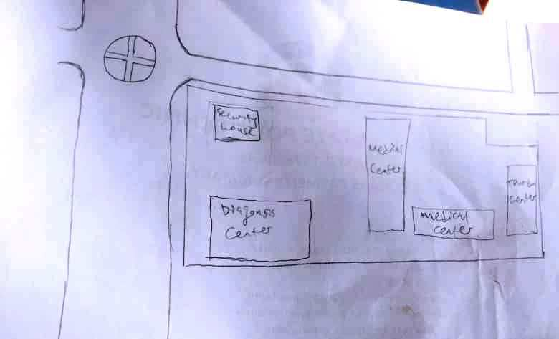

Fig. 3.1. Recce Diagram (NOT DRAWN TO SCALE)
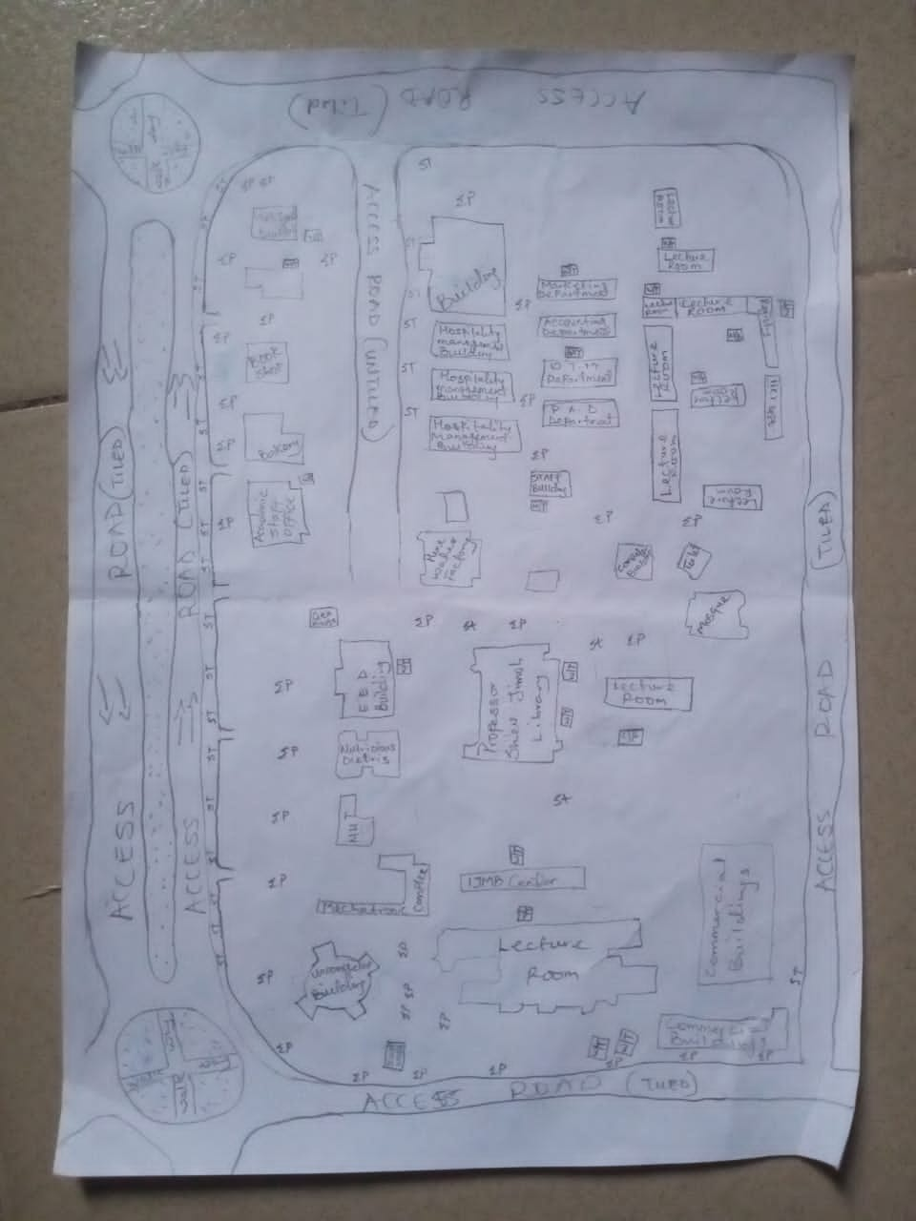

3.2. BOUNDARY SELECTION AND MONUMENTATION
Pre-cast property beacons made of 18cm x 18cm x 75cm were used for the demarcation of the project site. In compliance with the specification for cadastral Survey as specified in CAP 194 of law of the Federation of Nigeria, the Beacons were made of concrete mixture of ratio 3:2:1 (3 parts of sand to 2 parts of granite to 1 part of cement) with water, so as to ensure that the pillars were strong. The beacons protruded 15cm above ground level, while the remaining part was inserted and fixed firmly into an undercut hole. An iron rod (80cm in lengths and 10mm in diameter) protruding at the centre of the beacon represents the centre of the station mark.
A total number of Nine (9) beacons were emplaced and prefixed with identification mark “PIL” where “PIL” represent property beacon, Pillar. The beacons were capped and numbered from Pil.1 to Pil.9 as obtained from the department of surveying, Kwara State Polytechnic, Ilorin and they were numbered in a clockwise direction with stencil.
Fig. 3.2: Pre- cast property beacon
Ground level
18cm
18cm
Beneath Ground level
75cm long
60cm
80cm Iron rod
Above Ground level
15cm

01
PIL

18cm
18cm

3.3 EQUIPMENT SELECTION
The various equipment used for the acquiring of data and successful completion of this project were selected and was grouped in to two categories. They are;

3.3.1 HARDWARE Numbers
i. Total Station (South NTS-350R) with its accessories. 1 No.
ii. Tripod stand 1 No.
iii. Tracking Rod / Reflector 2 No.
v. Tape of 30m 1 No.
vi Cutlass 2 No.
vii Handed GPS (Garmin 72SC) 1 No.
viii Total Station Batteries 2 No.
ix. Laptop computer 1 No.
x HP DeskJet 1 No.
3.3.2. SOFTWARE USED
The software used for the project includes;
- ArcMap 10.3.
- Microsoft Excel
- Microsoft word
- NotePad
3.4 TEST OF INSTRUMENT
3.4.1 SOUTH (NTS-350R) TOTAL STATION TEST
Various tests were conducted on the South (NTS-350R) Total Station used, to ascertain its working condition prior to the commencement of the project execution. These tests are as follows:
3.4.2 PLATE LEVEL TEST
This test was to verify that the vertical axis of the instrument used was truly vertical when the plate level was at the centre of its run.

PROCEDURE: The Total Station (South NTS-350R) was set up firmly on a point arbitrarily. The plate bubble tube was turned parallel to two foot screws and leveled with two foot screws; the tube was then turned through 90º, now over the third foot – screw and level accordingly using the third foot screw. It was then returned to its former position and accurately leveled with the pair of the two initial foot – screws. To complete the test, the instrument was rotated through 180º and 360º and the bubble was still at the centre of its run, hence the plate bubble was in order.
3.4.3 HORIZONTAL COLLIMATION TEST
The aim of this test was to make sure that the line of sight is truly perpendicular to the trunion axis.
PROCEDURE: The Total Station instrument was set up on a point and all necessary temporary adjustments performed. The instrument was switched on, collimation program was selected from the menu and consequently the horizontal collimation test was chosen. This test was done by bisecting a well defined vertical target about 100m away and taking the horizontal readings on Face Left and Face Right. From the analysis of the results, the Total Station was in good adjustment.
3.4.4 VERTICAL INDEX ERROR TEST
This adjustment ensures that the vertical circle reading is exactly 90º when the line of sight is horizontal. Any deviation from this figure is termed vertical index error.
PROCEDURE: The instrument was set over a station point and all necessary temporary adjustments (centering, levelling and focusing) were performed. The vertical index error test was carried out by sighting a target at a distance of about 120m on Face Left. The Vertical Circle reading was recorded and the target was sighted and bisected again on Face Right and the vertical circle reading was recorded.

Fig. 3.3: Instrument set-up for horizontal collimation test and vertical index test
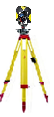
Total
Station
Reflector
Fairly Leveled Ground
Approximately 120m
Station B
Station A
Line of Sight

3.4.5 ANALYSIS OF COLLIMATION AND VERTICAL INDEX DATA
The readings obtained during the calibration were reduced to obtain the new horizontal collimation and vertical index errors. The results of the calibration data acquired for the total station used for this project are shown in the table below;
Table 3.1: Horizontal and Vertical Collimation Test Reading
Inst Stn. | Sight (Reflector) | Face | Hor.Circle Reading | Ver. Circle Reading
 | B | L | 87º 35’ 10’’ | 88º 26’ 15’’
A | B | R | 267º 35’ 12’’ | 271º 33’ 46’’
 |  |  | Diff= 180º 00’ 02’’ | Sum= 360º 00’ 01’
Horizontal Collimation = [(FR – FL) - 180º]/2
= [(180º 00’ 02’ - 180º 00’ 00’’) /2]
= 00º 00’ 02’’/2
= 00° 00’ 01’’
Vertical Collimation = [(FR – FL) - 360º]/2
= [(360º 00’ 01’’ - 360º 00’ 00’’)/2]
= 00º 00’ 01’’/2
= 00° 00’ 01’’
Table 3.2: Comparison of Old and New Values.
HORIZONTAL COLLIMATION | OLD | NEW
HORIZONTAL COLLIMATION | + 00º 00’ 02’’ | +00º 00’ 01’’
VERTICAL INDEX | +00º 00’ 00’’ | + 00’ 00’ 01’’

With the result obtained, it is evident that the instrument is in good working condition. Therefore, the new readings were adopted for the instruments Horizontal Collimation Error and Vertical Index Error respectively.
3.5 DATA ACQUISITION
3.5.1 OBSERVATION PROCEDURE
Geometric data was acquired using South (NTS-350R) Total Station. Total Station is an integrated system combining Electronic Theodolite and Electromagnetic distance measuring device. It is an instrument with inbuilt software for selected programs, which made it possible to compute data. The system also includes storing unit which serves as the survey field book.
This task was achieved through the following procedures;
- The instrument South (NTS-350R) was set up on a known station (KWPT733) and the bubble was centred and levelled.
- The instrument was switched on and menu button was pressed to display the programs on the total station.
- Data collect menu on the total station was selected to key in necessary information needed for commencement of the job. In the appeared dialogue box is Occp. Stn., Backsight and Fss. / SS
- The information of the known station (KWPT734)was keyed into the Total Station under the Data Collect sub-menu (Occp. Stn.) by opening a new file and naming the job. The station parameter N,E,H and height of instrument was entered in its appropriate space.
- The second option was selected, which is the Backsight, a submenu under the Data Collect. Here the information of the target position N,E,H and height of reflector was keyed into the Total Station. After this was achieved, Measure button was pressed for orientation and to compute the bearing, distance and N,E,H of the target position. The result was compared with the given coordinates, when the difference between the given and the observed was seen to be minimal, a centimetre difference, OK button was pressed.
- After the orientation. FS / SS menu was selected, which is a submenu under Data Collect and ALL button which captures and stores data automatically was pressed and observation to both natural and man-made features within the perimeter were fixed. A subsidiary traverse was run close to the interested feature and the above step was repeated at every point created until all the features were covered.
3.5.2 IN-SITU CHECK OF SURVEY CONTROL USED
The position of the control pillars used was checked before any other observation can be carried on. The check was done on control pillars (KWPT.733, KWPT.734 and KWPT.735). I set-up the Total Station instrument, centred and levelled it on KWPT.733 and the values control were keyed into the Total Station. The target position KWPT.734 was sighted and tracked and the result (Bearing, Distance, N, E, and H) was displayed as and checked finally recorded. The reflector was then positioned on KWPT.735 and was sighted and tracked and the results were also recorded and compared with given value of the pillar.
The result of the observed coordinates of pillar KWPT.733 was compared with the given coordinates. By specification the deviation in the distance and angle must not exceed 0.30m and 30’’ respectively. The summary of the computation between the given coordinates and observed is shown in the table below.
Fig. 3.4: Shows the computed check angle and check distance as obtained from the control pillars.
External angle
184⁰ 15’ 57’’

112ᴼ 50’ 07”
245.841m
KWPT733
288ᴼ 34’39”
143.780m
KWPT734
KWPT735

Table 3.3: Result of the computed survey control check from given coordinate.
FROM  STN | BEARING | DIST. (m) | DN | DE | NORTHING  (m) | EASTING  (m) | TO  STN
 |  |  |  |  | 946553.567 | 680054.213 | KWPT733
KWPT733 | 182ᴼ 32’08” | 182.734 | -182.555 | -8.084 | 946371.012 | 680046.129 | KWPT734
KWPT734 | 182ᴼ 05’27” | 493.386 | -493.058 | -18.001 | 945877.954 | 680028.128 | KWPT735
Source: Author, 2025.
The result was used to obtain the inclusive angle between KWPT733, KWPT734 and KWPT735 by finding the difference between the bearings of two lines.
KWPT734 KWPT733 => 002⁰ 32’ 08’’
KWPT734 KWPT735 => 182ᴼ 05’27”
Therefore (182ᴼ 05’27” - 002⁰ 32’ 08’’)
Check angle 179⁰ 33’ 19’’
Table 3.4: Result of the computed survey control check from given coordinate.
FROM  STN | BEARING | DIST. (m) | DN | DE | NORTHING  (m) | EASTING  (m) | TO  STN
 |  |  |  |  | 946553.567 | 680054.213 | KWPT733
KWPT733 | 182ᴼ 32’14” | 182.728 | -182.555 | -8.089 | 946371.012 | 680046.129 | KWPT734
KWPT734 | 182ᴼ 05’26” | 493.390 | -493.058 | -17.998 | 945877.954 | 680028.128 | KWPT735
Source: Author, 2025.

The result was used to obtain the inclusive angle between KWPT733, KWPT734 and KWPT735 by finding the difference between the bearings of two lines.
KWPT734 KWPT733 => 002⁰ 32’ 14’’
KWPT734 KWPT735 => 182ᴼ 05’26”
Therefore (182ᴼ 05’26” - 002⁰ 32’ 14’’)
Check angle 179⁰ 33’ 12’’
The difference between the Observed checked angle and the computed check angle
= (179⁰ 33’ 19’’- 179⁰ 33’ 12’’) = 00⁰ 00’ 07’’

3.5.3 PERIMETER SURVEY
A perimeter survey covering the entire area was ran using the three Survey control pillars found to in-situ and the area covered by the survey was 26.808 Hectares.
3.5.4 OBSERVATION PROCEDURE
The Total Station was setup on kwpt734 and all the necessary temporary adjustment were done like centering, levelling and parallax removal. Then instrument was switched on and the parameters of the instrument station (Station I.D, Height of instrument and the N,E,H coordinate) were keyed in. The reference control point kwpt733 was then bisected and the parameters (back station I.D, Height of reflector over the target station, and the N,E,H coordinate) were also keyed in. After this process, the measured button was pressed and orientation is set. Foresight was made to kwpt735, which was my forward station and the reflector was bisected and tracked to measure the N,E,H value of the point, all the obtained coordinates N,E,H were checked and found correct before proceed to next measurement. The instrument was then moved to kwpt735 as my new instrument station values were keyed in and back sight to kwpt734 was used as my reference station. The same process was repeated from one boundary station to the next pillar from kwpt735 to Pil.1. In this manner, the traverse was ran through the boundary beacons and finally closed back on Kwpt734. A closed loop traverse was carried out and all field data were later downloaded and processed. The data was later downloaded as show on the appendix table.
3.5.5 DETAILING SURVEY
Comprehensive details Survey of all natural and man-made features along the survey line were carried out. Ray method with the total station was used for the detailing. Subsidiary points were established around the project area to allow features that cannot be pick from the boundary points be picked easily. The X, Y and Z coordinates, angles (vertical and horizontal) and distance to the point to be detailed were measured.

Fig. 3.5 Show the observation process of using total station.
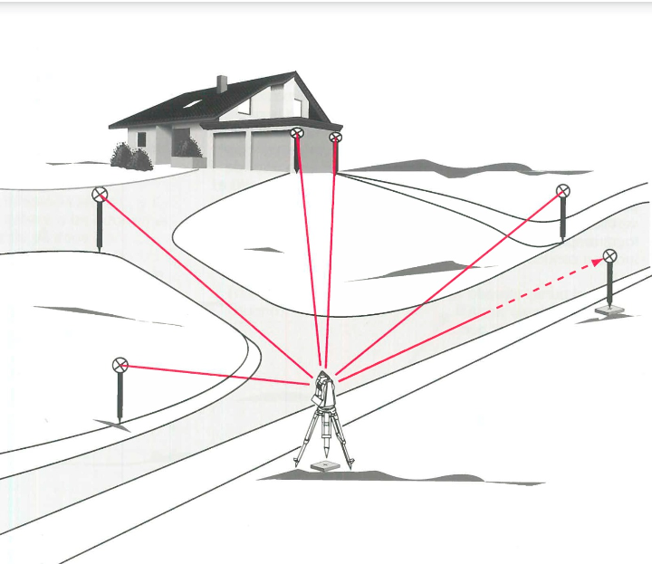

3.5.6 PROCEDURES OF OPERATING SOUTH (NTS-350R) TOTAL STATION
The following steps were taken when operating South (NTS-350R) Total Station.
- The tripod was set-up on the occupied station and the shoes of the tripod legs were adequately marched down to ensure that it grips the ground firmly.
- The Total Station was mounted on the tripod and clamped adequately and the necessary adjustment was carried out to achieve centering and levelling of the instrument, the foot screws were used.
- The instrument was then switched on and MENU button was pressed to display list of all programs resident on the Total Station.
- DATA COLLECT was selected by pressing 1 on the key pad. Then the MEAS. & COORD. File dialogue box appears prompted me to name the job, I created the job by the name KWARAPOLY. [F3] was pressed to change the Numeric button to Alpha so as to key in my desired file name, and when this was done; [F4] was pressed to accept.
- After achieving step 4, the DATA COLLECT dialogue box appear with the following sub-menu (Occp. Pt., Backsight and Fs/ss). Then I pressed on the key pad and to lunch OCCP. PT. on the name FEDPOFFA_TOPO. dialogue box. Here all the parameters (Occp. Pt. ID, P code, Inst. Ht, N, E, N) for occupy station was keyed into the Total station and [F3] button (REC.) was pressed and then [F4] button (YES) to accept these parameters in the occupy point environment. i.e. Occupy point, Pt-I.D, Pcode, Instrument Height H.I. Values.
- The DATA COLLECT dialogue box re-appears when step 5 was completed and 2 was pressed on the keypad to activate BACKSIGHT sub-menu. In the appeared dialogue box, all the parameters (BKP. PT. ID, P code, R. Ht. And N, E, H) for backsight station was keyed in and [F3] (MEAS) button was pressed for orientation by sighting at the target station and bisecting it. By doing this, the orientation is set and the Total Station is ready for the coordination of new points. i.e
- 489spt,679717.405,946223.476,318.638
- 490confe,679724.363,946216.6,318.346
- 491spt,679712.324,946222.709,318.634
- 492spt,679700.275,946222.701,318.734
- 493conf,679695.032,946217.477,318.649
- After achieving step 6, the DATA COLLECT dialogue box reappears again and 3 was pressed on the keypad to lunch the FS/SS dialogue box. F4 (ALL) button was then pressed to make observations to points of interest. As soon as this [F4] button was pressed, the Total Station automatically measures, records and stores the data into the internal memory of the instrument. This setting is peculiar to Kolida (KTS-462) Total Station. Where
F.S means Fore sight
Meas mean Measure
N mean Northing Coordinate
E mean Easting Coordinate
H mean Height of Station

CHAPTER FOUR
4.0. DATA PROCESSING AND RESULT ANALYSIS
4.1. DATA PROCESSING
All the data acquired from the field are required to be processed. It is this processing that makes the acquired data meaningful. The processed data is then used for map production.
After downloading the data into the computer system, the data is converted from document to excel form and save as .csv format (facility management.csv). Then the ArcMap was launched and the necessary parameters are set up, after setting the parameters the saved data file was imported.
4.1.1 DATA DOWNLOADING
The acquired data were downloaded from the memory of the instrument via the Data Transfer Port into the computer. The collected data were downloaded using South Data Transfer Software. The explanation below shows the procedures involved during the downloading from the Total Station to the computer:
* The South (NTS 350R) Total Station was connected to computer before switching “ON” the computer and total station.
* The computer was switched “ON” and allowed to complete the booting operation.
* The Total Station was switched “ON”
* On the Total Station “MENU” key was pressed to open the program page
* F3 key was pressed to select “Memory Manager”.
* In the memory manager sub-menu, F1 key was pressed on the third page to select “Data Transfer”
* In the data transfer dialogue box, F1 key was pressed to select NTS -300 transfer mode. Then F3 key was pressed to select “COMM. PARAMETERS” where “BAUD RATE, PROTOCOL AND PARITY” was set to have the same setting parameters on the computer and on the Total Station to allow good communication between the Total Station and the Computer.
* Escape (ESC) key was pressed to go back to the previous menu (DATA TRANSFER) and F1 key was pressed to select the “SEND DATA”.
* In the appeared dialogue box F1 key was pressed to select the measured data option and the file name “KAM” which is to be downloaded was selected and F4 key was pressed to accept the file to be downloaded.
* On the computer system, in the NTS Total Station software environment, “COMM” menu was clicked on the menu bar and downloads 300 data option was selected on the pull down menu.
* On clicking the download 300 data on the pull down menu, a small dialogue box appear given an instruction to press enter (F4 key) on the Total Station and the (Enter) key on the computer. Once this was done sequentially, the data automatically start to download.
* After downloading the data, Transfer menu was selected on the menu bar and “CASS survey data 300” was selected and clicked to Transfer the data from Chinese Language to English Language for better interpretation and understanding.
4.2 COMPUTATION OF SURVEY DATA
Total Station Instruments, with their microprocessors, can perform a variety of computations, depending on how they are programmed. South (NTS -350R) Total Station is capable of assisting an operator, step by step, through several different types of basic surveying operations.
In addition to providing guidance to the operator, microprocessors of South (NTS -350R) Total Station can perform many different types of computations automatically and some standard computations include:
1) Averaging of multiple angles and distances observations;
2) Correcting electronically observed distances for prism constants, atmospheric pressure, and temperature;
3) Making curvature and refraction corrections to elevations determined by trigonometric leveling;
4) Reducing slope distances to their horizontal and vertical components;
5) Calculating point elevations from the vertical distance components (supplemented with keyboard input of instrument and reflector heights);
6) Making corrections to observed horizontal and vertical angles for various instrumental errors; and
7) Computing coordinates of surveyed points from horizontal angle and horizontal distance components (supplemented with keyboard input of coordinates for the occupied station, and a reference azimuth). Furthermore, the microprocessors of total station perform traverse computations and simultaneously calculate and store station coordinates and elevation.
4.3 PROCESSING IN ARCMAP 10.3
After acquiring the data from the field, it is then processed using the arcmap 10.3 software to produce a digital map of the project area. The following are the steps involved;
- Unit settings: - this is the setting up of the primary units for the drawing. In ArcMap 10.3 the following steps described below are the procedure to set up the primary unit.
STEPS
* Double click on the ArcMap10.3 icon on the desktop (allow the software to lunch).
* Then click on cancel button (to open new fresh ArcMap10.3).
* Right click on the ArcMap10.3 window and select Data Frame Properties, then the Data.
* Frame Properties dialog box appear.
* Then select Coordinates System from the list and go to Projected Coordinate Systems and select UTM.
* On the drop down select Africa and the drop down to select Minna Zone 31(as the Datum Reference).
* Then click Apply and then select ok (the dialog box disappears).
Note: the scale box under the processing Menu will be on.
Fig 4.1: Setting of units on ArcMap
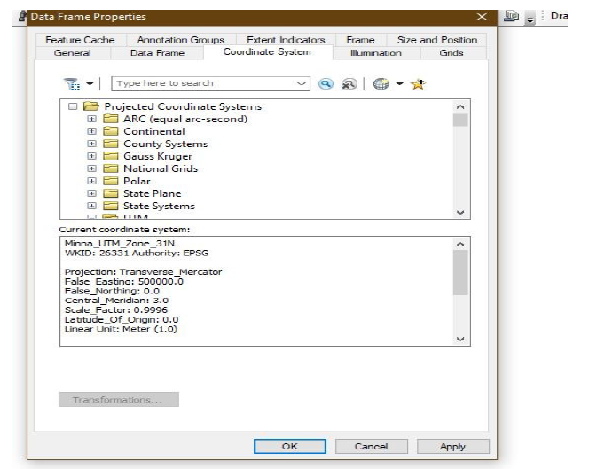

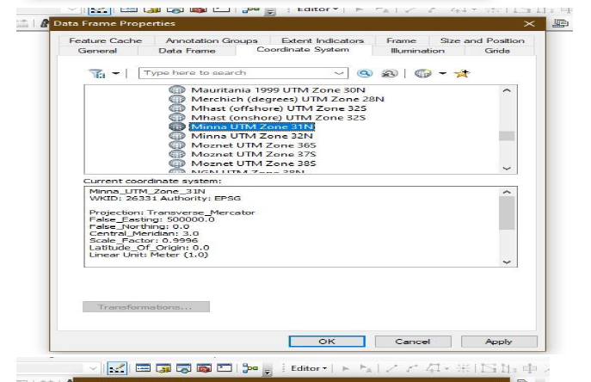

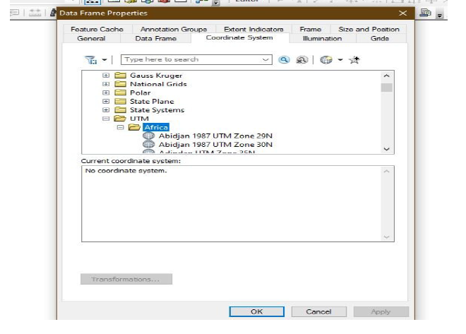

✓ Adding data: - after setting up the primary units, then the data can be added to the
ArcMap10.3, at this stage there two options of data to be add to the ArcMap10.3 i.e. Vector data or Raster data. The practical comprises of Vector data procedures is as follows.
Adding Vector data.

STEPS
* Select File from the Menu, the go to Add data and the drop down show the following:
* elect Add XY data (then Add XY data Dialog box appear).
* Then click on the Folder icon to navigate to the store files.
* After navigate to the folder where the data was stored, select the required folders saved with name (facility management), and
* Click on add data and it will go back to the add XY data.
* Then select the necessary field to the data e.g. column of easting for X and column of northing for Y and column of Z field for Height.
* Then click ok and the point will display on the window.
* Go to table of content on the left corner of the window and right click on the layer of the point key.
* Then select label feature and the names of the features will be labeled according to how the data was saved during capturing.
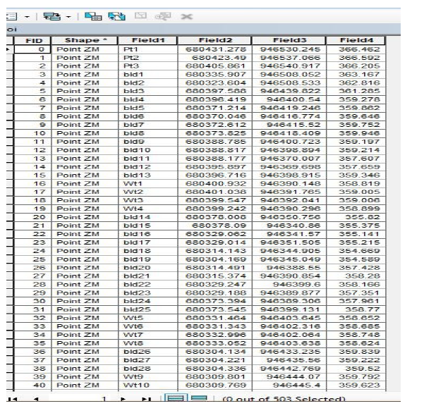
Fig 4.2: Adding of data

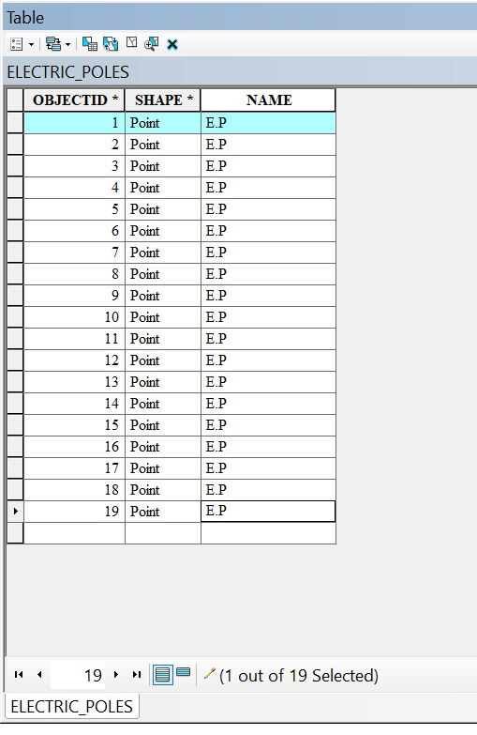
Electric poles

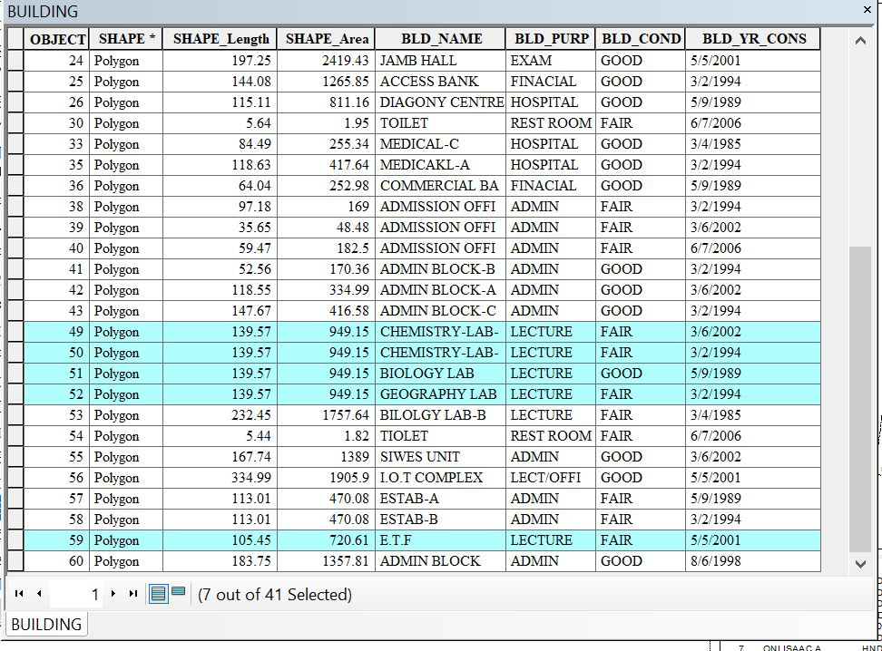
Building

✓ Layer creation or data base creation
STEPS
* Go to catalog on the right corner of the window.
* Navigate to the folder and right click on the folder.
* Then select new and click on file geo-database.
* Then right click on the file geo-database and select new then click on the new feature to create a new dataset.
* Type the name of the dataset and click next to select the unit as done during the primary unit setting, then click next twice and click finish.
* Then the new feature dataset will appear under the file geodatabase.
* Finally, right click on the new feature dataset and select new then select the feature class.
* The new feature class box appears (type in the layer name e.g. Road and copy it into the Alias box.
* Then select the feature type, e.g. line for road, polygon for building and point for electric poles.
* Then click next twice and click finish.
* Then the layer created will appear on the table of content.
* The same processes are repeated to create another layer.
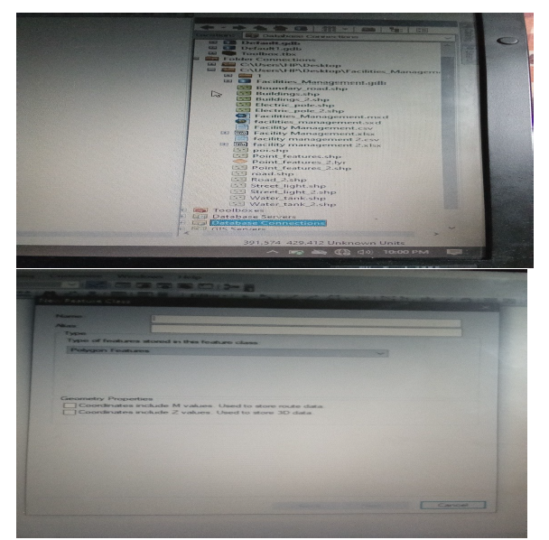
Fig 4.3: New dataset creation

✓ Digitizing: - the digitizing process is involved the tracing out the necessary features, as captured on the field to form the map feature.
STEPS
* Go to Editor, then click on starting editing.
* Then a create feature box appear, then select on the feature to digitize e.g. road, building, e.t.c.
* Then click on the window and trace out the feature outlines and double click when get to the end of the entity.
* Repeat the process above for all the features to be digitize and all will be saved in the data base table.
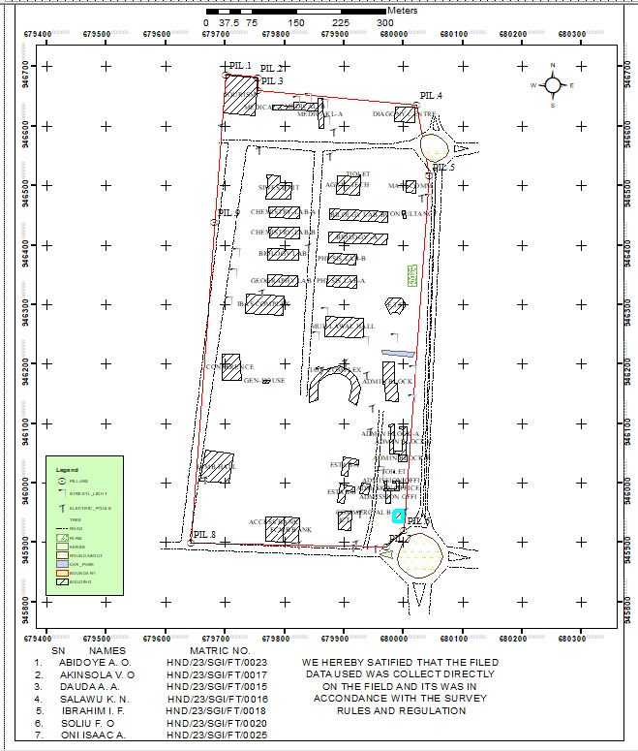
Fig 4.4. Digitizing on ArcMap

✓ Database Creation: - this is the process of populating the database.
STEPS
* Left click on the TOC on the layer to populate the table and then click on the open attribute table.
* The table appears.
* Then go to add field and the add field box appear.
* Set up the necessary information.
* And click ok, then the new field will be added to the table.

4.4 PREPARATION OF 3D MAP USING ARCSCENE
The 3D image was done on ArcScene using the created DEM, the created DEM was added to ArcScene and extruded with the heights gotten on the field. Extrusion incorporates the height of these features in their representation to give them 3D look and were made to float on DEM to have a true land representation. The created DEM was also added to ArcScene, the height of the buildings gotten from the field were added to the already created height field in the attribute table of each of the facility shape file in ArcMap. ArcScene was launched and all the shape files were added, from the table of content each shape file was right clicked on to access the property dialog box, from the property dialog box the shape files were extruded to give them 3D look and were made to float on the DEM to have a full 3D visualization.
* Open the ArcScene software and set necessary parameters.
* Go to arc tool box, click on spatial analytic tools.
* Then click on interpolation and then click IDW (Inverted Distance Way).
* Then it is going to generate 3D dimension value and set Z value point and press ok.
Note: - The IDW can be used to create contour and slope. But we are dealing with slope.
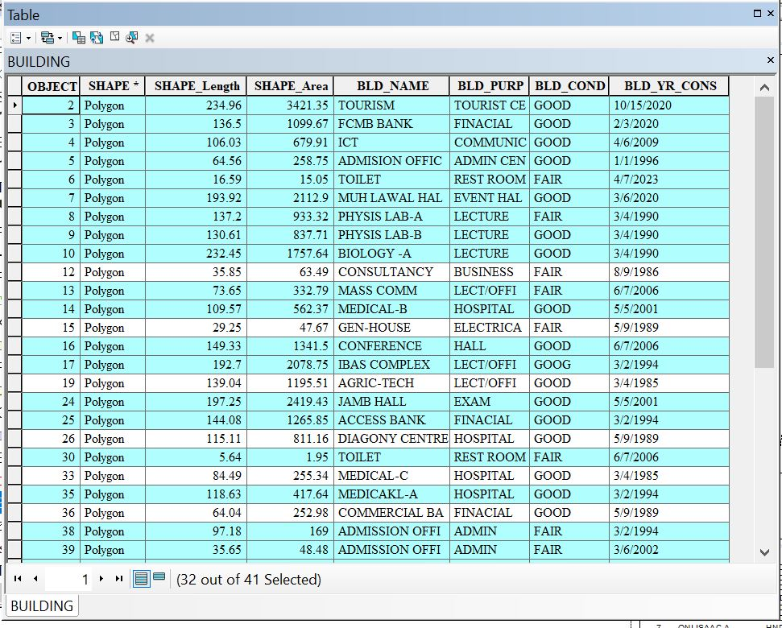

To creates slope, click on surface from interpolation and press slope and input raster(IDW) and press ok. The same procedure for contour also.
To set parameters for necessary facilities needed,
a. Select (IDW).
b. Go to source, click on property and press the base height.
c. Then click floating on a custom surface and press extrusion.
d. Click apply then ok.
4.5 PLAN PRODUCTION
The ultimate aim of the project is to produce a digital map (Facilities management plan) of the part of kwara state polytechnic. After processing the acquired data using the appropriate software, a digital map of the project area was produced. Thus, the aim of the project was achieved.
4.5.1 DIGITAL MAP
A digital map is the representation of cartographic features in a form that allows the value of their attributes to be stored, manipulated, and out-put by a computer system. A digital map is a data base or file that becomes a map when a GIS produces a hardcopy or screen display output.
Finally, a hardcopy of the digital map of the project area was printed.
Fig 4.5: Facility Management map
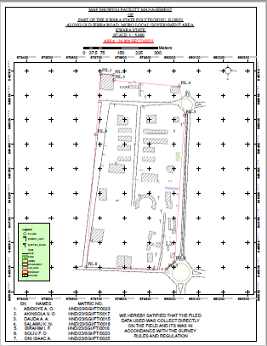

4.6 RESULT ANALYSIS
The facility management project commenced with the usage of a South (NTS – 350R) to capture the data of the project area. The captured data were then processed using software (ArcMap 10.3, ArcScene), employing photogrammetry technique to generate a high precision DSM and create a detailed 3D model.
ARCGIS software was employed to visualize and analyze the DSM data, facilitating spatial analysis and information Presentation.
The following maps were produced and their usefulness was stated,
4.7 QUERIES ANALYSIS
Queries analysis in GIS involve extracting information from spatial datasets by posing specific questions and then analyzing the data to gain insights or make decisions.
Queries involves selecting features based on attributes or spatial relationship, while analysis may include tasks like spatial overlay, proximity analysis, spatial statistics or modeling.
4.7.1 SINGLE CRITERIA QUERY
A single criterion is carried out where one condition is used to design query. The condition is used to gather information from the database.
QUERY ANALYSIS (selection by attribute)
Query question: “To query for the building that construction year is less than or equal to 1990.”
Analysis Name: Database extraction
Analysis Type: Single criteria analysis
Syntax: “BLD_YR_CONS>=1990.

Fig. 4.6: Single criteria query
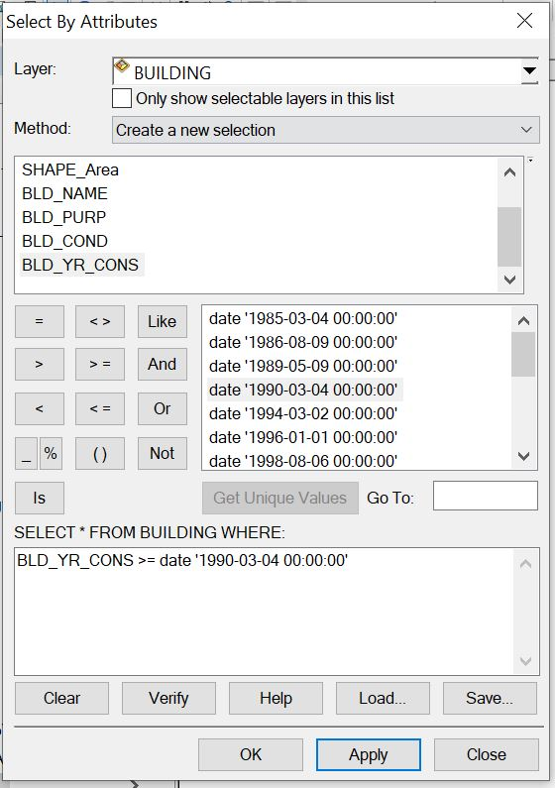

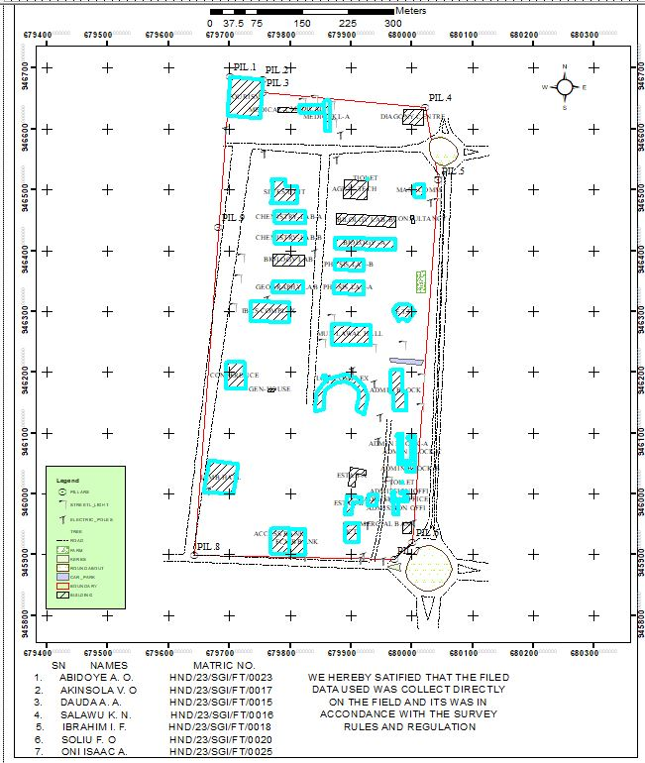
Answer to query 1.

Query question: “To query for the building that has an area less than 470.08 meters square and their purpose is used for financial
Analysis Name: Database extraction
Analysis Type: Double criterion analysis
Syntax: “SHAPE_AREA<470.08AND BLD_PURP”.
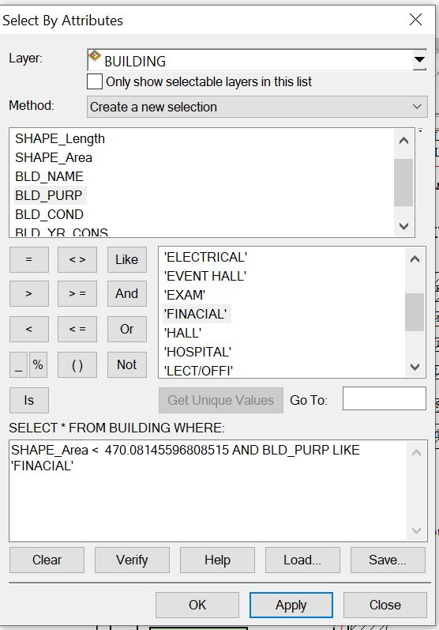

Answer to the query II.

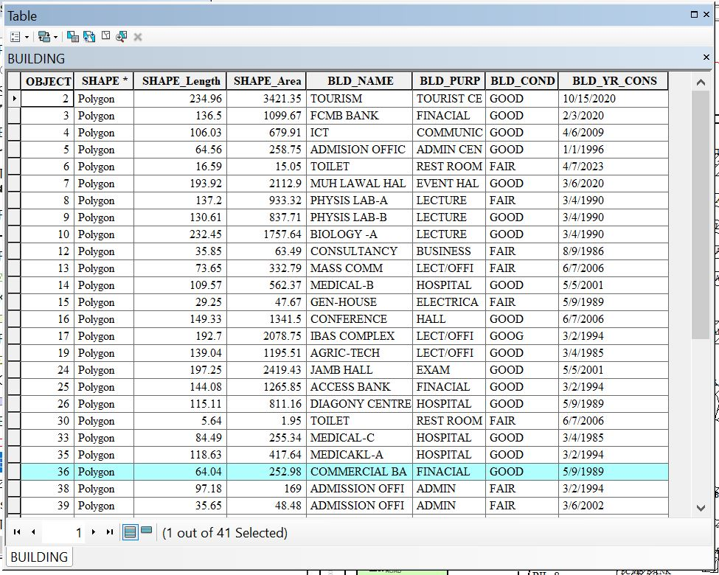
- Query question 3: “To query for the building purpose and that the area less than or equal to 192.69 meters square
- Analysis Name: Database extraction
- Analysis Type: Double criterion analysis
- Syntax: “BLD_PURP LIKE LECTURE AND SHAPE_LENGHT <= 192.69”.
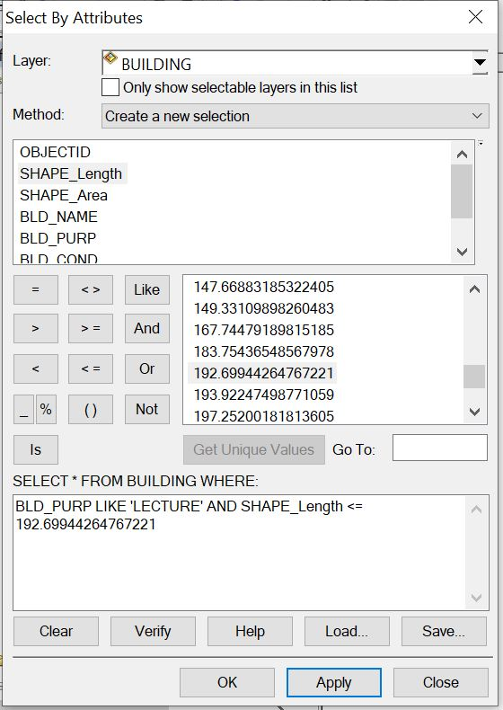

Answer to the query 3.
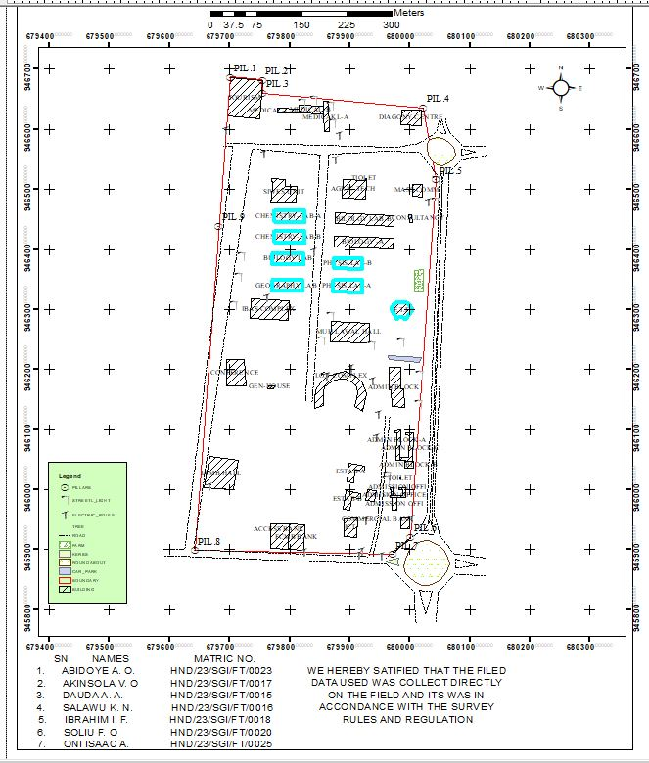
4.8. APPLICATION OF RESULTS
The result obtained can be applied to the following;
* Ensuring efficient use of resources.
* Maximizing occupant comfort and safety.
* Managing maintenance schedules.
* Optimizing space utilization.
* It's essentially a roadmap for maintaining and enhancing the functionality of a building or facility.

CHAPTER FIVE
COST ESTIMATION, SUMMARY, PROBLEM ENCOUNTERED, RECOMMENDATION AND CONCLUSION
5.1 COSTING
Table 5.1: PLANNING
S/N | PERSONNEL | UNIT | PRICE | DAYS | REMARK
1. | Principal Surveyor | 1 | #30,000 | 2 | #60,000
2. | Assistant Surveyor | 1 | #12,000 | 2 | #24,000
3. | Transport | 1 | #3,000 | 2 | #6,000
4. | Basic Equipment | 1 | #15,000 | 2 | #30,000
5. | Logistics | 1 | #10,000 | 2 | #20,000
 | Total | 1 |  |  | #140,000

Table 5.2: DATA CAPTURE
S/N | PERSONNEL | UNIT | PRICE | DAYS | REMARK
1. | Principal Surveyor | 1 | #30,000 | 5 | #150,000
2. | Assistant Surveyor | 1 | #12,000 | 5 | #60,000
3. | Chainman | 7 | #3,000 | 5 | #105,000
4. | Transport | 1 | #3,000 | 5 | #15,000
5. | Basic Equipment | 1 | #15,000 | 5 | #75,000
6. | Logistics | 1 | #10,000 | 5 | #50,000
 | Total |  |  |  | #455,000

Table 5.3: DATA DOWNLOAD
S/N | PERSONAL | UNIT | PRICE | DAYS | REMARK
1. | Principal Surveyor | 1 | #30,000 | 1 | #30,000
2. | Transport | 1 | #3,000 | 1 | #3,000
3. | Basic Equipment | 1 | #15,000 | 1 | #15,000
4. | Logistics | 1 | #10,000 | 1 | #10,000
 | Total |  |  |  | #58,000

Table 5.4: DATA PROCESSING
S/N | PERSONNEL | UNIT | PRICE | DAYS | REMARK
1. | Principal Surveyor | 1 | #30,000 | 8 | #240,000
2. | Assistant Surveyor | 1 | #12,000 | 8 | #96,000
3. | Transport | 1 | #3,000 | 8 | #24,000
4. | Basic Equipment | 1 | #15,000 | 8 | #120,000
5. | Logistics | 1 | #10,000 | 8 | #80,000
 | Total |  |  |  | #560,000

Table 5.5: DATA PRESENTATION
S/N | PERSONNEL | UNIT | PRICE | DAYS | REMARK
1. | Principal Surveyor | 1 | #30,000 | 1 | #30,000
2. | Assistant Surveyor | 1 | #12,000 | 1 | #12,000
3. | Transport | 1 | #3,000 | 1 | #3,000
4. | Basic Equipment | 1 | #15,000 | 1 | #15,000
5. | Logistics | 1 | #10,000 | 1 | #10,000
 | Total |  |  |  | #70,000

Table 5.6: REPORT WRITING
S/N | PERSONNEL | UNIT | PRICE | DAYS | REMARK
1. | Principal Surveyor | 1 | #30,000 | 10 | #300,000
2. | Transport | 1 | #3,000 | 10 | #30,000
3. | Basic Equipment | 1 | #15,000 | 10 | #150,000
4. | Logistics | 1 | #10,000 | 10 | #100,000
 | Total |  |  |  | #580,000

Table 5.7: SUMMARY
1. | Planning | #140,000
2. | Data Capture | #455,000
3. | Data Download | #58,000
4. | Data Processing | #560,000
5. | Data Presentation | #70,000
6. | Report Writing | #580,000
 | Total | #1,863,000
* Mobilization and demobilization 10%
1,863,000 * 10 ÷ 100 = #186,300
* V.A.T. 2.5%
1,863,000 * 2.5 ÷ 100 = #46,575
Total Cost
#1,863,000 + #186,300 + #46,575
= #2,095,875.

5.2 SUMMARY
This study focuses on implementing Geographic Information Systems (GIS) for enhanced facilities management within a designated section of Kwara State Polytechnic, Ilorin, situated in Moro Local Government Area of Kwara State. Recognizing the challenges of manual tracking and maintenance inefficiencies in educational infrastructures, the research adopts GIS technology to systematically capture, store, analyze, and visualize spatial and attribute data related to campus buildings, utilities, roads, green spaces, and other critical assets. By integrating geospatial databases with facility-specific information—such as construction dates, maintenance histories, occupancy rates, and asset conditions—the approach enables precise digital mapping and real-time monitoring of the polytechnic’s physical resources. This GIS framework facilitates optimized space allocation, proactive maintenance scheduling, efficient resource deployment, and data-driven decision-making for campus planners and administrators. Applied to the selected area of Kwara State Polytechnic, the methodology demonstrates significant potential for reducing operational costs, extending asset lifespans, improving emergency response planning, and supporting sustainable campus development through accurate, accessible geospatial intelligence tailored to the institution’s unique environmental and administrative context within Moro LGA.
5.3 PROBLEM ENCOUNTERED
The following were the problems encountered during the execution of this project.
- The project was financially expensive, energetic and time consuming.
- On the day of carrying out the practical, there was a delay in getting the instrument that resulted in getting to the site lately.
- Throughout the practical, we worked under the sun reason that we got to the site lately.

5.4 CONCLUSION
The study focuses on the Facilities Management using GIS Approach of Part of Kwara State Polytechnic, Ilorin, Moro Local Government Area, Kwara State.
In conclusion, the application of Geographic Information Systems (GIS) to facilities management within the designated area of Kwara State Polytechnic, Ilorin, Moro Local Government Area, Kwara State, demonstrates a transformative and highly effective approach to managing complex campus infrastructure. This study successfully established that integrating geospatial technology enables the creation of a centralized, dynamic repository for critical facility data—spanning buildings, utilities, roads, green spaces, and other assets—linking precise spatial locations with detailed attribute information such as condition, maintenance history, usage, and resource allocation. The GIS framework provides unparalleled capabilities for visualization, spatial analysis, and real-time monitoring, fundamentally shifting facility management from reactive, paper-based processes to proactive, data-driven decision-making. By facilitating optimized space utilization, predictive maintenance scheduling, efficient resource deployment, and enhanced emergency response planning, the GIS approach significantly improves operational efficiency, reduces long-term costs, and extends the lifecycle of the polytechnic's physical assets. Furthermore, the system offers invaluable support for strategic campus development planning and sustainability initiatives. While initial implementation requires investment in data collection, software, and training, the long-term benefits for Kwara State Polytechnic—including improved administrative oversight, better service delivery, and a more resilient, well-maintained learning environment within its unique Moro LGA context—firmly establish GIS as an indispensable tool for modern, efficient, and sustainable educational facilities management. This project underscores the feasibility and substantial value of adopting geospatial intelligence for institutional asset management in similar resource-constrained settings.

5.5 RECOMMENDATIONS
- Establish a Centralized Geo-Database should develop a comprehensive, cloud-based GIS database integrating all spatial and non-spatial facility data (buildings, utilities, roads, green spaces, furniture, equipment).
- Implement a Dedicated GIS-FM Platform should procure or develop a user-friendly GIS software platform (e.g., ArcGIS Online, QGIS with plugins) tailored for FM tasks (work orders, asset tracking, space management).
- Develop Standard GIS Data Collection Protocols should create clear guidelines for collecting spatial data (e.g., GPS accuracy standards, attribute fields for different asset types).

REFERENCES
Abdulraheem, M. O., Olayemi, F. F., & Opaluwa, L. O. (2021). Land Use/Land Cover Change Detection and Urban Sprawl Analysis in Ilorin Metropolis, Kwara State, Nigeria Using Remote Sensing and GIS Techniques. Journal of Geography, Environment and Earth Science International, 25(5), 1-16.
Adeboye, B. S., & Alagbe, O. A. (2018). Challenges of Facilities Management in Public Universities in Southwestern Nigeria. Journal of Facilities Management, 16(3), 262-276.
Adejumo, A. V., & Ogunmakinde, O. E. (2019). Facilities Management Practices and Service Delivery in Public Polytechnics in South-West, Nigeria. Journal of Contemporary Management Research, 13(1), 1-20.
Adenuga, O. A., Iyiola, K., & Ogunleye, M. B. (2017). Application of Geographic Information System (GIS) for Facilities Management in Tertiary Institutions: A Case Study of Federal University of Technology, Akure. Journal of Facilities Management, 15(2), 168-183.
El-Mekawy, M., Östman, A., & Shahzad, K. (2012). Integrating Building Information Models and Geographic Information Systems for Facility Management: A Review. Advanced Engineering Informatics, 26(4), 670-679.
Ibem, E. O., & Aduwo, E. B. (2013). Assessment of Facilities Management Practices in Public Buildings in Southwest Nigeria. Property Management, 31(1), 45-70.
Kaya, S., & Erden, M. S. (2018). A GIS-Based Facility Management Framework for Universities: A Case Study of Istanbul Technical University. Journal of Facilities Management, 16(4), 414-435.
Olanrewaju, A. A., & Anifowose, T. J. (2015). Evaluation of Facilities Management Services in Tertiary Institutions in Lagos State, Nigeria. Journal of Facilities Management, 13(3), 282-301.
Oluwadare, O. J., & Ogunleye, M. B. (2020). Spatial Database Development for Facilities Management in Tertiary Institutions Using GIS: A Case Study of Federal Polytechnic, Ado-Ekiti, Nigeria. Geoinformatics FCE CTU, 17(1), 1-15.
Teo, E. A. L., & Lin, K. Y. (2011). Application of Geographic Information Systems (GIS) in Facilities Management. Facilities, 29(3/4), 120-132.
APPENDIX
bld1,680001.553,945920.709,305.03
2bld,679998.724,945935.038,305.427
3bld,679999.37,945952.393,305.747
4bld,679985.139,945953.611,305.899
5Ep,680002.449,945953.267,305.904
6bld,679969.713,945966.376,306.162
7bld,679978.467,945966.005,306.203
8str,679962.742,945980.018,306.873
9str,679963.074,945982.566,306.968
10str,679964.353,945982.451,306.955
11bld,679966.006,945987.485,307.213
12tree,679967.245,945904.712,304.414
13bnd2,679970.974,945892.196,303.848
14Ep,679951.406,945891.426,303.848
15tree,679946.62,945896.648,304.023
16DR,679940.237,945887.579,302.966
17DR,679939.218,945887.348,302.645
18Rd,679931.045,945888.016,303.114
19DR,679929.541,945887.406,302.639
20DR,679928.99,945887.693,302.628
21Ep,679919.632,945898.553,304.019
22Ep,679914.223,945892.929,303.664
23bank,679911.575,945920.464,304.7
24bank,679889.953,945921.531,304.753
25Ep,679915.076,945919.52,304.599
26tree,679931.218,945947.97,305.577
27Ep,679926.29,945949.63,305.493
28gtb,679915.953,945952.093,305.385
29bld,679900.379,945966.825,306.214
30bld,679888.661,945968.32,306.514
31bld,679917.742,945986.294,306.808
32bld,679918.61,945994.023,307.217
33bld,679892.925,945998.188,309.093
34tree,679927.623,946001.143,307.61
35mosq,679928.788,946000.146,307.496
36mosq,679926.197,945982.778,306.943
37mosq,679943.303,945998.462,307.366
38tree,679939.646,946005.798,307.642
39tree,679938.425,945999.848,307.45
40sl,679957.398,945996.07,307.502
41sl,679959.991,946015.805,308.185
42sl,679961.136,946023.735,308.413
43bld,679971.797,946037.722,308.565
44bld,679982.727,946039.467,308.674
45bld,679983.532,946015.505,308.485
46str,679984.655,946017.96,308.269
47str,679984.73,946019.205,308.241
48str,679983.214,946019.476,308.336
49spt,679988.212,946022.841,308.542
50spt,679992.515,946017.403,308.476
51spt,679987.166,946010.653,308.193
52spt,679987.891,946003.31,308.362
53spt,679983.968,946027.112,308.665
54spt,679987.104,946035.048,308.644
55bld,679990.722,946036.027,308.705
56bld,679992.34,946002.873,308.571
57bld,680006.482,946035.908,308.558
58bld,680002.833,946047.922,309.255
59bld,679976.883,946049.044,309.107
60sl,679968.892,946079.409,310.226
61sl,679968.826,946072.011,310.099
62spt,679970.913,946074.442,310.147
63spt,679973.054,946069.097,309.974
64spt,679968.906,946062.177,309.556
65spt,679975.594,946058.773,309.775
66spt,679965.543,946052.38,309.434
67spt,679971.841,946048.431,309.181
68spt,679972.043,946086.812,310.615
69spt,679967.188,946090.828,310.681
70spt,679964.664,946098.415,311.171
71spt,679957.51,946097.69,311.003
72bld,679974.621,946099.158,311.079
73tree,679999.806,946104.888,311.397
74tree,680010.315,946112.512,311.854
75tree,680011.129,946117.7,311.931
76tree,680011.712,946123.067,312.152
77spt,680010.009,946129.671,312.375
78spt,680002.863,946125.025,312.208
79spt,679999.388,946115.06,311.689
80spt,679996.786,946110.187,311.491
81spt,679992.748,946104.278,311.317
82spt,679988.481,946109.369,311.415
83spt,679986.602,946116.996,311.622
84spt,679986.322,946125.052,311.734
85spt,679980.628,946130.727,312.337
86sl,679982.536,946130.339,312.35
87tree,679974.682,946131.68,312.215
88spt,679972.411,946114.815,311.439
89tree,679953.554,946110.003,311.382
90tree,679953.104,946105.441,311.056
91tree,679950.595,946093.033,310.555
92Ep,679943.533,946087.757,310.126
93spt,679943.575,946076.168,309.424
94spt,679934.174,946078.961,309.626
95spt,679920.822,946073.274,309.835
96spt,679915.118,946068.241,310.027
97spt,679908.301,946060.959,310.158
98spt,679909.131,946051.957,309.678
99bld,679899.243,946043.445,309.387
100str,679896.051,946043.006,309.31
101str,679895.49,946040.816,309.26
102str,679893.879,946041.01,309.22
103bld,679894.41,946014.383,308.269
104spt,679890.712,946019.163,308.4
105spt,679895.133,946023.257,308.791
106spt,679896.372,946031.022,308.777
107spt,679888.733,946036.616,309.284
108spt,679892.145,946049.028,309.57
109spt,679898.83,946064.598,310.391
110spt,679896.11,946075.478,310.822
111spt,679899.352,946085.679,311.27
112spt,679900.45,946095.169,311.583
113spt,679889.678,946100.794,311.319
114spt,679879.884,946100.892,311.081
115spt,679875.602,946110.656,311.435
116spt,679860.786,946122.723,311.712
117str,679855.831,946126.252,311.908
118str,679853.412,946125.261,311.866
119str,679851.166,946129.422,312.287
120iotbld,679850.27,946130.672,312.546
121spt,679841.314,946135.195,312.355
122spt,679835.787,946144.524,312.647
123spt,679841.647,946151.983,313.49
124spt,679837.819,946164.575,313.736
125iotbld,679850.445,946177.42,313.803
126iotbld,679862.438,946189.159,314.463
127Ep,679861.389,946190.354,314.38
128genhouse,679858.56,946193.401,314.353
129genhouse,679853.433,946191.354,314.288
130genhouse,679852.175,946193.779,314.345
131spt,679847.82,946190.812,314.204
132tree,679841.606,946187.357,314.446
133spt,679844.792,946183.229,314.106
134spt,679850.527,946189.321,314.319
135spt,679851.064,946199.602,314.568
136spt,679855.333,946207.683,315.227
137tree,679853.54,946210.88,315.612
138spt,679879.319,946199.405,314.666
139spt,679891.519,946197.994,314.864
140Ep,679901.842,946203.883,314.81
141spt,679906.197,946211.283,315.013
142spt,679918.358,946215.481,315.733
143spt,679914.716,946201.78,314.945
144bld,679909.053,946189.322,314.736
145spt,679915.093,946183.095,314.709
146bld,679920.914,946177.103,314.765
147spt,679931.914,946179.877,315.059
148Ep,679936.655,946183.366,315.413
149spt,679939.43,946174.292,314.662
150iot bld,679928.413,946159.401,314.111
151iot bld,679921.013,946130.8,312.808
152spt,679938.628,946129.621,311.581
153Ep,679947.624,946126.676,311.676
154recbld,679969.467,946138.179,312.658
155recbld,679988.307,946136.553,313.33
156spt,680003.893,946140.158,312.992
157sl,680013.476,946142.779,313.247
158spt,680025.065,946145.5,313.202
159tree,680019.078,946151.97,313.464
160tree,680019.278,946156.925,313.322
161tree,680013.13,946162.19,313.762
162spt,680010.315,946170.357,314.334
163spt,680005.425,946192.509,314.898
164sl,680015.327,946192.955,315.007
165spt,680008.594,946202.369,315.172
166spt,679994.076,946204.672,315.339
167recbld,679984.189,946204.478,315.442
168spt,679978.443,946208.804,315.661
169park,679963.226,946223.944,316.333
170park,679964.43,946217.62,316.111
171recbld,679965.631,946205.542,315.672
172recbld,679964.989,946203.903,315.587
173str,679987.609,946220.723,316.05
174str,679987.4,946219.44,315.978
175str,679986.085,946220.984,316.003
176park,680015.108,946212.547,315.512
177tree,680018.861,946219.613,315.808
178spt,680014.758,946225.428,315.898
179tree,680006.385,946231.69,316.557
180spt,679999.351,946228.385,316.251
181spt,679987.348,946239.564,316.827
182sl,679984.519,946245.583,317.412
183spt,679971.822,946245.145,317.291
184spt,679960.457,946244.878,317.405
185spt,679948.429,946244.273,317.266
186sl,679935.524,946242.081,317.515
187HALL,679932.222,946244.134,317.601
188flw,679922.809,946241.583,317.165
189flw,679934.083,946241.146,317.366
190flw,679928.585,946241.375,317.343
191flw,679875.609,946243.447,316.237
192flw,679872.196,946243.686,316.26
193HALL,679868,946246.945,316.38
194spt,679863.1,946248.494,316.311
195spt,679862.028,946258.078,316.687
196sl,679852.432,946249.983,316.747
197spt,679850.85,946256.565,317.056
198spt,679846.943,946278.828,318.518
199spt,679854.526,946289.235,318.359
200sl,679867.033,946289.549,317.91
201HALL,679868.738,946279.925,317.789
202spt,679875.736,946286.279,317.778
203flw,679876.301,946290.444,317.899
204flw,679885.508,946289.456,317.913
205flw,679895.579,946289.105,317.971
206spt,679897.502,946286.067,317.98
207flw,679905.651,946288.569,318.113
208flw,679915.684,946288.166,318.223
209spt,679924.355,946288.183,318.401
210spt,679930.064,946294.245,318.596
211spt,679925.662,946304.69,318.877
212spt,679923.011,946317.638,319.168
213sl,679921.98,946322.967,319.781
214phy labB,679921.417,946328.408,319.794
215spt,679907.945,946324.134,319.139
216spt,679894.785,946323.517,319.075
217spt,679891.188,946313.417,318.748
218spt,679880.275,946316.353,318.837
219phy labB,679871.385,946330.846,319.702
220sl,679865.6,946330.835,320.257
221spt,679854.205,946333.648,320.415
222spt,679851.82,946346.503,320.943
223spt,679863.95,946357.107,320.773
224spt,679861.734,946371.907,321.531
225spt,679854.29,946388.65,322.545
226spt,679871.439,946348.487,320.843
227labB,679871.543,946348.617,320.786
228labB,679868.321,946362.215,320.778
229labA,679869.717,946368.262,321.46
230labA,679872.292,946369.447,321.375
231labA,679873.225,946386.362,321.477
232spt,679877.107,946391.721,321.835
233Ep,679877.207,946395.018,322.157
234spt,679888.942,946395.505,322.218
235sl,679897.92,946395.377,322.146
236spt,679908.405,946393.793,322.034
237Ep,679916.355,946392.766,322.051
238labA,679920.821,946385.067,321.317
239spt,679930.212,946384.164,321.562
240spt,679931.977,946378.503,321.441
241spt,679940.614,946374.718,321.435
242spt,679930.728,946359.746,320.828
243spt,679940.326,946348.681,320.555
244spt,679949.13,946340.51,320.505
245spt,679933.365,946327.57,319.537
246sl,679922.323,946323.282,319.617
247spt,679946.381,946312.41,319.53
248spt,679961.735,946307.531,319.868
249bld,679967.872,946302.28,320.124
250bld,679977.75,946283.855,319.443
251bld,679993.018,946283.593,319.27
252bld,680004.329,946300.539,320.369
253bld,679998.345,946309.339,321.432
254tree,680010.161,946301.343,320.357
255tree,680011.17,946307.794,320.944
256tree,680009.009,946293.252,319.737
257spt,680015.59,946297.693,319.74
258spt,680015.574,946289.681,319.16
259Ep,680022.041,946285.189,319.244
260spt,680022.367,946297.7,320.001
261spt,680020.231,946314.929,322.069
262farm,680021.584,946330.48,322.24
263farm,680022.711,946366.014,322.821
264spt,680027,946360.883,322.324
265spt,680031.595,946350.845,321.481
266spt,680024.335,946344.812,321.828
267spt,680031.067,946331.416,320.716
268spt,680028.347,946323.488,319.878
269spt,679977.281,946388.974,323.011
270labC,679972.044,946401.172,323.314
271labC,679973.272,946419.088,323.233
272labD,679973.871,946433.423,324.022
273labD,679974.748,946456.641,324.966
274spt,679980.711,946456.634,325.093
275spt,679988.131,946449.638,325.106
276spt,679996.524,946452.748,325.135
277spt,679997.235,946440.418,324.772
278spt,679989.428,946434.214,324.237
279tree,679980.064,946429.48,324.194
280masscom,679998.842,946444.882,325.33
281masscom,679998.304,946457.975,325.499
282masscom,680003.72,946445.049,325.531
283spt,680013.136,946456.603,326.05
284spt,680018.707,946450.098,325.732
285tree,680023.094,946448.891,325.958
286spt,680022.83,946462.642,326.321
287masscom,680019.616,946463.454,326.582
288spt,680026.965,946465.006,326.318
289spt,680035.748,946460.119,326.238
290tree,680040.409,946451.978,325.533
291spt,680040.567,946462.387,325.748
292spt,680035.476,946469.089,326.414
293sl,680042.413,946480.408,326.592
294Ep,680029.941,946480.736,326.896
295,680019.483,946471.675,326.482
296,679999.146,946471.334,325.945
297spt,679998.007,946481.651,326.093
298mask,679997.217,946490.219,326.913
299masscom,680003.856,946488.335,326.839
300spt,680012.837,946484.376,326.657
301masscom,680019.78,946487.755,326.977
302spt,680027.827,946490.813,327.234
303spt,680038.345,946495.925,327.444
304spt,680032.6,946507.278,327.747
305masscom,680020.028,946508.713,327.869
306spt,680034.704,946514.238,328.098
307sl,680043.577,946516.198,328.225
308spt,680040.037,946527.784,328.685
309Rd,680040.641,946530.175,328.466
310Rd,680049.621,946529.962,328.464
311Rd,680056.905,946529.803,328.469
312Rd,680066.174,946529.973,328.493
313Rd,680053.986,946539.521,328.665
314Rd,680076.521,946559.448,329.637
315Rd,680085.77,946561.146,329.847
316Rd,680085.395,946555.48,329.582
317Rd,680086.484,946549.999,329.342
318Rd,680085.656,946567.188,330.158
319Rd,680086.534,946572.799,330.393
320Rd,680054.639,946584.625,330.726
321Rd,680054.653,946593.432,331.035
322Rd,680061.27,946593.253,331.125
323Rd,680066.437,946595.111,331.226
324Rd,680050.053,946594.909,331.106
325Rd,680045.444,946596.765,331.157
326spt,680039.314,946597.149,331.337
327spt,680029.489,946601.468,331.371
328spt,680029.315,946607.711,331.316
329spt,680020.265,946607.672,331.059
330diag,680018.165,946606.693,331.033
331diag,680019.206,946631.691,331.924
332bnd,680022.153,946636.213,332.084
333diag,679986.934,946632.21,331.734
334str,679985.026,946628.196,331.654
335str,679984.992,946626.379,331.629
336str,679982.885,946628.303,331.694
337diag,679984.852,946607.814,330.549
338spt,679982.58,946605.019,330.415
339spt,679973.666,946603.998,330.397
340tree,679974.176,946601.549,330.353
341tree,679973.397,946589.542,330.078
342spt,679972.963,946584.72,329.732
343spt,679963.879,946586.222,329.788
344spt,679956.87,946595.672,330.023
345spt,679946.013,946601.875,330.038
346spt,679930.75,946619.622,330.885
347tree,679928.45,946620.919,331.284
348spt,679914.1,946611.046,329.64
349spt,679898.087,946597.825,329.061
350spt,679882.187,946591.781,329.079
351Ep,679875.747,946590.333,329.26
352tree,679868.701,946594.905,329.836
353med,679865.249,946596.022,329.607
354spt,679866.317,946613.264,330.764
355sl,679870.104,946611.749,330.448
356tree,679869.002,946620.45,330.338
357sl,679867.365,946640.719,331.482
358med,679863.455,946647.28,331.563
359sl,679838.988,946649.763,331.865
360sl,679820.621,946645.326,331.859
361med,679814.12,946640.925,331.792
362str,679807.614,946638.115,331.85
363med,679814.689,946627.061,331.338
364spt,679817.665,946616.079,330.645
365tree,679828.122,946614.044,330.841
366spt,679838.385,946613.781,330.356
367spt,679844.583,946621.483,330.737
368med,679855.856,946625.727,330.825
369med,679787.222,946631.296,331.769
370med,679779.997,946635.003,332.057
371spt,679780.163,946627.553,331.861
372spt,679770.268,946631.912,331.989
373spt,679762.184,946637.866,332.338
374bnd,679755.017,946660.031,333.075
375tourism,679754.057,946681.55,333.794
376bnd,679753.911,946682.645,333.981
377tourism,679750.219,946617.823,331.961
378spt,679748.369,946609.748,331.671
379spt,679726.428,946604.74,331.752
380spt,679711.234,946605.009,332.005
381tourism,679695.999,946619.976,332.841
382tourism,679701.524,946687.047,335.035
383bnd,679700.667,946687.499,335.004
384Ep,679692.385,946600.43,332.309
385bnd,679692.343,946579.706,331.427
386DR,679692.364,946578.639,331.36
387Rd,679703.943,946571.196,331.086
388Rd,679740.373,946576.544,330.725
389Rd,679738.515,946566.698,330.366
390DR,679737.454,946566.239,330.273
391Rd,679753.241,946565.427,330.238
392DR,679753.961,946565.058,330.165
393bnd,679759.686,946576.959,330.508
394DR,679759.724,946577.133,330.501
395DR,679759.861,946575.944,330.488
396Ep,679757.002,946560.945,330.053
397spt,679762.26,946554.368,329.652
398spt,679773.919,946545.447,329.265
399spt,679783.794,946545.283,329.106
400tree,679797.339,946532.097,328.547
401tree,679805.074,946530.922,328.508
402spt,679817.284,946535.3,328.231
403spt,679833.269,946524.568,327.689
404spt,679851.315,946542.722,327.869
405Rd,679850.677,946557.627,328.313
406Rd,679864.795,946556.813,328.179
407DR,679865.273,946555.801,328.113
408Ep,679875.386,946550.603,327.754
409spt,679888.512,946543.863,327.896
410spt,679891.642,946533.864,327.368
411spt,679888.834,946517.123,326.999
412masscom,679889.05,946517.058,326.937
413spt,679899.912,946522.355,327.064
414spt,679915.491,946519.935,326.838
415spt,679926.835,946515.582,326.717
416str,679926.944,946517.327,326.867
417str,679927.02,946518.465,326.937
418str,679925.635,946518.897,326.872
419masscom,679925.66,946484.247,325.628
420Ep,679922.207,946477.535,325.07
421spt,679912.947,946469.803,324.723
422spt,679898.424,946477.188,325.108
423phyD,679876.904,946460.337,324.493
424phyD,679875.601,946442.7,324.511
425phyD,679874.442,946422.755,323.12
426phyC,679874.342,946422.841,323.074
427phyC,679874.329,946404.951,323.035
428siwes,679811.118,946489.542,327.46
429siwes,679811.301,946504.852,327.813
430siwes,679794.779,946508.074,327.399
431siwes,679792.125,946517.124,328.323
432siwes,679778.86,946518.031,328.422
433spt,679757.972,946500.52,327.88
434spt,679747.861,946485.376,327.359
435spt,679765.4,946468.931,326.499
436lab,679773.686,946464.84,326.309
437spt,679786.077,946474.385,326.467
438spt,679800.348,946477.709,326.478
439spt,679808.88,946465.732,325.953
440lab,679825.205,946464.11,325.626
441spt,679832.263,946454.383,325.097
442tree,679841.479,946443.802,324.979
443spt,679836.611,946433.405,324.791
444spt,679840.71,946421.725,324.204
445sl,679843.568,946419.033,324.092
446str,679837.827,946407.144,323.659
447Ep,679839.873,946397.401,323.141
448spt,679833.502,946389.207,322.777
449spt,679839.897,946379.734,322.265
450spt,679828.421,946364.884,321.999
451spt,679836.122,946345.598,321.188
452lab,679821.687,946330.154,320.689
453spt,679819.882,946320.826,320.08
454spt,679812.306,946311.131,319.839
455ibas bld,679798.422,946314.969,320.305
456spt,679807.785,946295.85,319.677
457spt,679804.041,946284.353,319.198
458ibas,679796.616,946282.4,319.371
459spt,679780.583,946276.183,318.238
460spt,679772.829,946267.091,317.887
461spt,679755.961,946265.67,318.231
462spt,679749.541,946274.529,318.485
463spt,679734.099,946281.723,319.138
464spt,679733.006,946285.714,319.612
465spt,679723.714,946289.567,320.765
466sl,679706.427,946308.804,321.843
467spt,679719.407,946320.134,321.847
468ibas,679734.738,946318.282,321.374
469spt,679744.3,946332.602,321.916
470spt,679762.173,946330.736,321.611
471Ep,679762.223,946321.77,321.652
472str,679778.259,946321.119,321.018
473str,679780.514,946321.239,320.941
474str,679780.375,946319.129,321.025
475spt,679786.529,946328.307,320.588
476spt,679789.767,946319.323,320.675
477spt,679760.324,946343.063,321.974
478spt,679762.895,946357.967,322.449
479spt,679756.169,946379.483,323.445
480spt,679744.338,946388.777,324.37
481spt,679724.84,946387.462,324.48
482sl,679719.34,946389.328,324.635
483spt,679718.355,946368.399,323.298
484sl,679714.089,946355.145,323.126
485tree,679714.976,946332.789,322.782
486spt,679701.659,946277.468,320.652
487spt,679710.039,946259.778,319.527
488spt,679712.659,946245.359,319.17
489spt,679717.405,946223.476,318.638
490confe,679724.363,946216.6,318.346
491spt,679712.324,946222.709,318.634
492spt,679700.275,946222.701,318.734
493conf,679695.032,946217.477,318.649
494spt,679691.685,946207.163,318.352
495spt,679694.233,946192.327,317.707
496spt,679687.173,946179.679,317.446
497sl,679684.133,946171.226,317.288
498conf,679695.404,946173.152,317.111
499spt,679705.372,946164.723,316.326
500spt,679739.323,946169.855,315.974
501str,679761.513,946167.475,315.439
502str,679761.565,946165.877,315.361
503str,679763.633,946165.947,315.37
504toilet,679763.724,946168.653,315.318
505toilet,679764.159,946173.539,315.623
506toilet,679773.717,946173.249,315.333
507jamb,679667.644,946055.692,312.325
508jamb,679713.683,946049.057,311.138
509jamb,679657.435,946003.657,309.503
510str,679659.401,945994.96,309.083
511str,679673.217,945988.752,308.963
512str,679686.344,945995.935,309.356
513Ep,679665.236,946007.4,309.855
514bnd,679641.989,945898.537,304.249
515DR,679641.058,945898.56,304.298
516acbank,679767.196,945902.127,304.054
517acbank,679768.429,945942.749,304.927
518acbank,679797.233,945900.11,303.306
519fcmb,679823.157,945899.068,302.299
520Ep,679823.612,945897.795,302.293
521fcmb,679825.385,945940.806,303.377
522fcmb,679799.229,945942.602,304.032
523Rd,679960.583,945881.56,303.427
524Rd,679960.955,945885.462,303.397
525Rd,679960.597,945879.86,303.415
526Rd,679960.273,945876.384,303.311
527Rd,679980.368,945879.049,303.967
528Rd,679990.803,945880,303.78
529Rd,680065.766,945877.053,303.758
530Rd,680075.93,945877.731,304.157
531Rd,680073.689,945860.416,303.749
532Rd,680077.007,945858.284,303.83
533Rd,680074.737,945892.084,304.534
534Rd,680077.752,945894.679,304.644
535Rd,680048.003,945926.195,305.26
536Rd,680040.838,945925.336,305.266
537Rd,680031.644,945925.362,305.355
538Rd,680029.91,945915.743,304.974
539Rd,680019.595,945926.285,305.348
540Rd,680013.997,945929.263,305.319
541Rd,680019.203,945841.305,302.768
542Rd,680022.998,945831.059,302.63
543Rd,680015.023,945831.861,302.547
544Rd,680008.185,945829.006,302.226
545Rd,680037.147,945830.531,302.596
546Rd,680046.548,945829.766,302.324

