

A PROJECT REPORT
ON
FACILITIES MANAGEMENT OF PART OF KWARA STATE POLYTECHNIC ILORIN, MORO LOCAL GOVERNMENT AREA, KWARA STATE USING GIS APPROACH

BY
SALAWU KEHINDE NAOMI
HND/23/SGI/FT/0016

SUBMMITED TO:
THE DEPARTMENT OF SURVEYING AND GEO-INFORMATICS, INSTITUTE OF ENVIRONMENTAL STUDIES, KWARA STATE POLYTECHNIC ILORIN.

IN PARTIAL FULFILLMENT OF THE REQUIREMENT FOR THE AWARD OF HIGHER NATIONAL DIPLOMA IN SURVEYING AND GEO-INFORMATICS.

JUNE, 2025

CERTIFICATE
I hereby certified that the information given in this project was obtained as a result of the observation and measurement made by me and that the survey was carried out in accordance with survey laws, regulations and departmental instructions

_________________________________
SALAWU KEHINDE NAOMI
Matric. No: HND/23/SGI/FT/0016

CERTIFICATION
This is to certify that this project was carried out by SALAWU KEHINDE NAOMI with Matric No.: HND/23/SGI/FT/0016 under my instruction and supervision for the award of Higher National Diploma in Surveying and Geo-informatics, Kwara State Polytechnic, Ilorin, Kwara State Nigeria. I hereby declared that she has conducted herself with due diligence and honesty on the said duties.

………………………………… ………………………………
SURV. R.S. AWOLEYE DATE
(Project Supervisor)

………………………………. …………………………
SURV. R.S. AWOLEYE DATE
(Project Coordinator)

……………………………… ………………………………
A.I ISAU DATE
Head of Department (H.O.D)
Surveying & Geo-informatics

……………………………….. ……………………………..
EXTERNAL EXAMINER DATE

DEDICATION
This project is dedicated to Almighty GOD, the author and the finisher of everything who gave me the grace and privilege to attain this stage in my education pursuit.

ACKWOLEDGEMENT
I give thanks and glory to my Creator for the privilege bestowed on me that resulted in the accomplishment of this project work and also a big thanks to the management of Kwara State Polytechnic for the privilege and opportunity given to me to study in their great institution.
My sincere gratitude goes to my Head of Department (HOD); A.I ISAU and my Supervisor; SURV. R.S. AWOLEYE for their support towards the success of this project, I really appreciate you sir.
To all the lecturers in the department of Surveying and Geo-informatics; Abimbola I. Isau, Surv. A. Ayuba, Surv. R.S. Awoleye, Surv. A.G. Aremu, Surv. B.F Diran, Surv. Wlliams Kazeem, Surv. Kabir Babatunde, Surv. R.O. Asonibare who has imparted their knowledge in me in one area or the other during my year of study, I am grateful for the effort and support. May Almighty GOD bless you all (Amen).
I'm deeply grateful to my parents; MR & MRS SALAWU for their unconditional love, support, and wisdom. Their encouragement and sacrifices have been the driving force behind my endeavors. Thank you, Mom and Dad, for being my pillars of strength and inspiration. I dedicate this project to you, with love and appreciation.
Special thanks to my brother and sister for your unwavering love, care, and dedication that has shaped me into the person I am today. Your selfless love and your influence and values have guided me throughout this project, and I'm forever grateful for your presence in my life.
I would like to extend my heartfelt thanks to my beloved family members and friends who have supported me throughout this project.
May Almighty GOD bless you all (Amen).

ABSTRACT
This study addresses this imperative by proposing and demonstrating the application of a Geographic Information System (GIS) approach to facilities management (FM) within a defined section of Kwara State Polytechnic, Ilorin, situated in Moro Local Government Area, Kwara State, Nigeria. Traditional paper-based or fragmented digital records often prove inadequate for managing spatially distributed assets, leading to inefficiencies in maintenance scheduling, space utilization tracking, emergency response planning, and long-term strategic development. This research establishes a comprehensive geospatial database as the foundational element for modern FM. Utilizing high-resolution satellite imagery, Global Positioning System (GPS) surveys for ground-truthing and precise asset location, and extensive attribute data collection, the study creates detailed digital maps and inventories of campus facilities. Key infrastructure components captured include academic buildings (lecture halls, laboratories, libraries, offices), administrative blocks, student hostels, utility networks (water supply lines, electrical distribution, drainage systems), roads, walkways, parking lots, green spaces, and other significant assets within the study area. The implementation for the selected section of KWARAPOLY Ilorin demonstrates significant potential benefits: dramatically improved accessibility and accuracy of facility data, enhanced decision-making speed and quality for administrative staff and planners, optimized use of physical space leading to potential cost savings, streamlined maintenance workflows, and strengthened institutional capacity for sustainable campus development. This study serves as a practical model for transitioning from inefficient, traditional FM methods to a dynamic, data-driven GIS-based system. The findings strongly advocate for the institution-wide adoption of GIS as a transformative tool for managing Kwara State Polytechnic's infrastructure portfolio, recommending future integration with Building Information Modeling (BIM), development of web-based portals for broader access, and establishing protocols for continuous data updating to ensure the system's long-term value and sustainability. This approach is readily transferable to similar tertiary institutions across Nigeria facing comparable facilities management challenges.
TABLE OF CONTENTS
Pages
Title Page i
Certification ii
Dedication iii
Acknowledgment iv
Table of contents v
List of Figures ix
Abstract x
CHAPTER ONE
General Introduction
1.1 Background to the Study 1
1.2 Statement of the Problem 3
1.3 Aim 3
1.4 Objectives 3
1.5 Scope of the Project 4
1.6 Specification of Facilities Management (FM) 4
1.7 Personnel 5
1.8 Project Location 6
CHAPTER TWO
Literature review
2.1 Literature Review 7
2.2 An Overview of Facilities Management 10
2.2.1 Functions of Facilities Management Unit 11
2.2.2 Organizational Structure 15
2.3 Challenges and Limitations 26
CHAPTER THREE
Research Methodology
3.0 Methodology 27
3.1 Reconnaissance 27
3.1.1 Office Planning 28
3.1.2 Field Reconnaissance 28
3.2 Boundary Selection and Monumentation 29
3.3 Equipment Selection 30
3.3.1 Hardware 31
3.3.2 Software Used 31
3.4 Test of Instrument 31
3.4.1 South (NTS-350R) Total Station Test 31
3.4.2 Plate Level Test 31
3.4.3 Horizontal Collimation Test 32
3.4.4 Vertical Index Error Test 32
3.4.5 Analysis of Collimation and Vertical Index Data 33
3.5 Data Acquisition 34
3.5.1 Observation Procedure 34
3.5.2 In-situ Check of Survey Control Used 35
3.5.3 Perimeter Survey 37
3.5.4 Observation Procedure 37
3.5.5 Detailing Survey 38
3.5.6 Procedures of Operating South (NTS-350R) Total Station 39
CHAPTER FOUR
Data Processing and Result Analysis
4.1 Data Processing 41
4.1.1 Data Downloading 41
4.2 Computation of Survey Data 42
4.3 Processing in ArcMap 10.3 43
4.4 Preparation of 3D Map using ArcScene 51
4.5 Plan Production 52
4.5.1 Digital Map 53
4.6 Result Analysis 54
4.7 Queries Analysis 54
4.7.1 Single Criteria Query 54
4.8 Application of Results 62
CHAPTER FIVE
Summary, Problem Encountered, Conclusion and Recommendations
5.1 Costing 63
5.2 Summary 66
5.3 Problem Encountered 66
5.4 Conclusion 67
5.5 Recommendations 68
References
Appendix
LIST OF TABLES
Pages
Table 1.1: Table showing the name and role of the Personnel 4
Table 3.1: Horizontal and Vertical Collimation Test Reading 33
Table 3.2: Comparison of Old and New Values 34
Table 3.3: Result of the computed survey control check from given coordinate 36
Table 3.4: Result of the computed survey control check from given coordinate 36
Table 5.1: Planning 63
Table 5.2: Data Capture 63
Table 5.3: Data Download 64
Table 5.4: Data Processing 64
Table 5.5: Data Presentation 64
Table 5.6: Report Writing 65
Table 5.7: Summary 65

LIST OF FIGURES
Pages
Fig. 1.1: Maps Showing the Study Area 5
Fig. 3.1: Recce Diagram 29
Fig. 3.2: Pre- cast property beacon 30
Fig. 3.3: Instrument set-up for horizontal collimation test and vertical index test 33
Fig. 3.4: Shows the computed check angle and check distance as obtained from the control pillars. 36
Fig. 3.5 Show the observation process of using total station 38
Fig 4.1: Setting of units on ArcMap 44
Fig 4.2: Adding of data 46
Fig 4.3: New dataset creation 49
Fig 4.4: Digitizing on ArcMap 50
Fig 4.5: Facility Management map 53
Fig. 4.6: Single criteria query 55

CHAPTER ONE

INTRODUCTION

1.1 BACKGROUND OF THE STUDY
Organizations, like homeowners, have been caring for their buildings, furnishings, equipment and grounds for years. This is probably true of all types of facilities, such as college and university campuses, industrial and manufacturing plants, research and computer facilities, stadia and auditoria, prisons, military camps, hotels and, of course, offices. This caring for includes selecting and obtaining, maintaining and repairing, furnishing and renovating facilities and their parts, and ensuring that needed functions, such as safety and security, lighting and heating, and the like, are provided. Many of those with responsibility for organizations' facilities are now being called facilities or facility managers.1 Nevertheless, the expressions - treated here as synonyms - are used in three different senses, from a very general one to a very specific one.
The most general use refers to those who are responsible for any organization's facilities. It also is used more specifically to describe those who, more often than not, have responsibility for organizations' office space and, depending on the organization, their manufacturing, laboratory, warehouse and other types of facilities as well. The Facility management had emerged as the key element in the today business world as a support service to the core business. In the final decade of the last millennium the facility management had develop more that ever evolutionary (Reeves, 1999). Present world the facility management is proved its necessity of properly managing elaborate and expensive support facilities (Kincaid, 1994). The Facility management had become a key factor that support for the core business of any organization in other terms as it comes every aspect of the organization under the purview of facility management. Facilities management as defined by the Facilities Engineering and Management Handbook "is a term of broad application used by those who, with proper preparation and training, are occupied with solving the problems of a wide range of disciplines.” Considering this definition, it would be almost impossible for one person to have all the knowledge necessary to maintain his/her building(s). Additionally, the constant changes in the technologies associated with a building’s infrastructure make it difficult to keep all services in-house, making one of the jobs of a facility manager that of a contract manager as well.
Here are some definitions taken from various websites: All services required for the management of buildings and real estate to maintain and increase their value. The means of providing maintenance support, project management and user management during the building life cycle. The integration of multidisciplinary activities within the built environment and the management of their impact upon people and the workplace. All of these definitions are correct; essentially Facility Management or Facilities Management as it is commonly called in Europe is quite implying the management of buildings and services. This sounds suspiciously close to Property Management (PM) and of course so it should as FM developed from PM and the two are fundamentally linked. However, FM has a much wider definition than traditional PM services. The International Facility Management Association (IFMA), the World's leading FM professional body, defines FM as, ‘A profession that encompasses multiple disciplines to ensure functionality of the built environment by integrating people, place, process and technology. That sounds a bit long winded but it accurately identifies the management of multi-disciplines through people, process and technology.
Facility or facilities management (FM) is a profession dedicated to supporting people. It ensures the functionality, comfort, safety, sustainability and efficiency of the built environment - the buildings we live and work in and their surrounding infrastructure.

1.2 STATEMENT OF THE PROBLEM

Poor school facility conditions negatively impact staff and students’ learning achievements This makes school facilities maintenance very important because it ensures safe conditions for facility users, be the learners, educators, staff, parents or guests, and is also concerned with creating a physical setting that is appropriate and adequate for learning. While school maintenance programme is viewed as an activity carried out in order to prolong the life expectancy of school buildings, its furniture and equipment for normal use (Bastidas, 1998), it appears in Ghana most school facilities lack maintenance. Despite the significance of facilities maintenance to teaching and learning, basic schools do not pay much attention to facilities maintenance. A review of school facilities maintenance literature

1.3 AIM

The aim of the project is to map out facilities within our project location as well as analysis for proper maintenance and usage.

OBJECTIVES
In order to actualize the above mentioned aims, the following objectives were done.
- RECONNAISSANCE
- DATA ACQUISITION
- DATA PROCESSING
- INFORMATION PRESENTATION
  - SCOPE OF THE STUDY
- Establishing the perimeter using traverse.
- Measurement of relative position of method of converting raster image to vector format of the detail within the study area.
- Preparation of an overlay plan which facilitated the comparison.
- To explore the power of computer application software especially in the plan production.
- Data analysis

1.6 SPECIFICATION OF FACILITIES MANAGEMENT (FM)

The findings of this study may provide data for top administrators at the Kwara State Polytechnic and Education Service to support and pay attention to the quality of facility’s condition as a factor that might influence teaching and learning. The results of the study may justify the need for government to upgrading existing schools that are below standard, weak and outdated and institute a program of improving school facilities for all new schools. Furthermore, the study may provide data on school facilities maintenance activities for basic schools. The findings may highlight the need for basic schools to know the plans to guide school facilities maintenance, sources of financing maintenance activities as well as factors hindering school facilities maintenance activities.

The study may also serve as a relevant source of academic reference and further research into school facilities maintenance.
1.7 PERSONNEL
The students listed below were the members of this group who participated in the execution of the project.
Table 1.1: Table showing the Name and Role of the Personnel
S/N | NAME | ROLE
1. | SALAWU KEHINDE NAOMI | HND/23/SGI/FT/0016
2. | ONI ISAAC AYODELE | HND/23/SGI/FT/0025
3. | ABIDOYE AZEEZ OPEYEMI | HND/23/SGI/FT/0023
4. | DAUDA AISHAT ADEBUKOLA | HND/23/SGI/FT/0015
5. | AKINSOLA VICTORIA OLUWABUNMI | HND/23/SGI/FT/0017
6. | SOLIU FATAI OLUSINA | HND/23/SGI/FT/0020
7. | IBRAHIM IREWUMI FATIMAT | HND/23/SGI/FT/0018

1.8 PROJECT LOCATION
The study area for this project is situated on Part of Kwara State Polytechnic, Ilorin, Moro Local Government Area of Kwara State. The geographic location of the study area lies between 08⁰ 33’14’’N+ latitude and 04⁰38’08’’E+ longitude and the total area covered was about 12.300 hectares
Fig. 1.1: Maps showing the study Area.
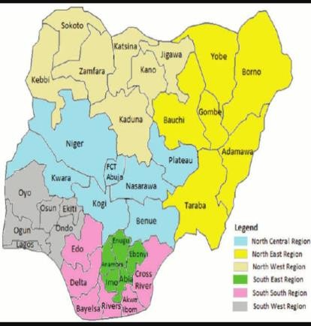
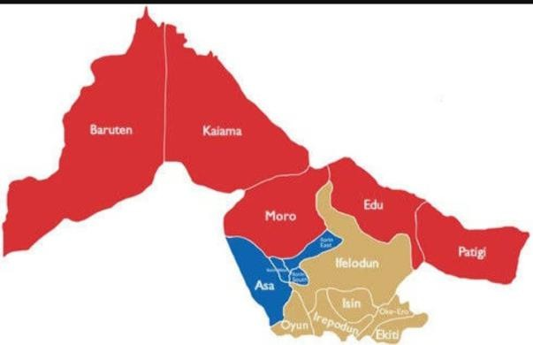
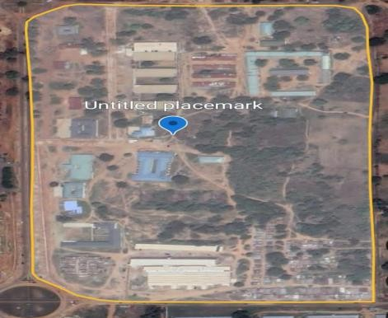
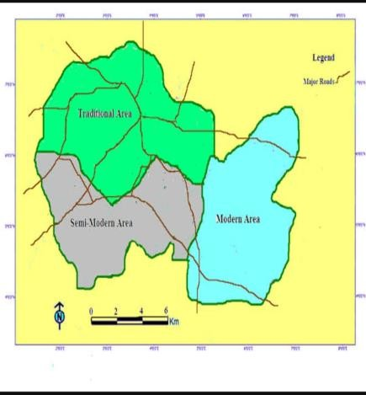

CHAPTER TWO

2.1 LITERATURE REVIEW

Facilities Management as an emerging profession in the built environment is receiving due attention in research endeavour. Though the practice of Facilities Management is widely embraced in the developed countries, it is still in its infancy in many developing countries. There are numerous works on Facilities Management as a profession, the organizational structure operational systems, and other related subjects. There are broad based discussions on Facilities Management operations in the industrial sector, hospitality, health and higher education institutions. In the industrial, hospitality and to a lesser extent in the health sectors operating from multi-sites, the performance of Facilities Management Unit has immediate (positive or negative) effects on the particular site and eventually the product(s) of the respective industry as a whole. By contrast, the performance of the Facilities Management Unit in the education industry does not have immediate effects; but its poor performance gradually erodes the credibility of the educational institution over a long period of time if not checked. In the same sense, the development, operation and maintenance of the required support facilities that enable the institution to execute its core functions and achieve its goals require sustained commitment from the Facilities Management Unit, the academics and the administrators of the institution. Therefore, the focus of this section will be on literature that has direct bearing on Facilities Management practice in institutions of higher education and in particular assessing the performance of Facilities Management units in the achievement of the core functions of teaching and research. Grimshaw (1999) quoting Donald (1994) says that: “…FM holds the ring between an organization, its employees and its physical space” (Grimshaw, 1999:2). This ring is what Carder (1997) refers to as “the interface between an organization’s core business and its physical working environment” (Carder, 1997: 84), and the facilities manager, he referred to as “interface manager” (Carder, 1995 in Carder 1997: 84). The burden of the facilities manager is to develop, operate and maintain standard and functional infrastructure and technology in an environment conducive for the employee to carry out his function in line with the organization’s objective. The dynamics of the workplace interface are to be fully explored, there is need for indepth research, strategic planning, responding to the changes in the workplace, taking culture and setting into consideration, and facilities managers need to be proactive (Grimshaw, 1999). The strength of research is that it “must provide tools which help facilities managers to deal with diversity and uncertainty…” (Grimshaw, 1999) peculiar to the respective industry to which the research is targeted. The facilities manager, as a manager of change, needs to form a close and cordial relationship with the main actors in the workplace, develop a feedback mechanism as a means of measuring how effective his support service is in enhancing performance in the core functions of the organization. In practice, the structure and functions of a typical Facilities Management Unit reflect the organization it serves. There is yet no consensus on what could be regarded as the ideal organizational structure or delimitation of the functions performed by a typical Facilities Management Unit. Instead most authors agree that the structure and function of Facilities Management Units are dictated by the type of the organization, the relationship between core and support function, methods of execution of development, operation and maintenance services as well as the Facilities Management Unit’s recognition by senior management. Customers‟ satisfaction is central in the assessment of the Facilities Management Units performance of its support services and the review of the relevant literature suggested several tools for these assessments. The synthesis of the literature consulted, especially those works that have direct information on the operations of Facilities Management Unit in the higher education institution, and the gap observed in the literature is provided in section 2.6. This is followed by a discussion on the focus of the present research. Most of the literature cited is fairly generalized, so information about Facilities Management Units in a number of universities was obtained from their respective websites, and therefore has not been subjected to analysis or peer review.

Facilities Management (FM) has evolved into a critical discipline that ensures the functionality, safety, and sustainability of built environments by integrating people, processes, and technology. Traditionally, FM has focused on maintaining physical assets, optimizing space utilization, and enhancing operational efficiency through manual workflows and fragmented systems. However, the growing complexity of infrastructure, coupled with increasing demands for cost-effectiveness and data-driven decision-making, has necessitated the adoption of advanced technological solutions. Among these, Geographic Information Systems (GIS) have emerged as a transformative tool, offering spatial intelligence to reimagine how facilities are managed. GIS, renowned for its capacity to capture, analyze, and visualize geospatial data, provides a framework to contextualize facility-related information within a geographic or spatial dimension. This integration enables stakeholders to map assets, monitor real-time conditions, and model scenarios that align with organizational goals, such as energy efficiency, risk mitigation, and user-centric design. By bridging the gap between physical infrastructure and digital analytics, GIS empowers facility managers to transition from reactive maintenance to proactive strategies, fostering resilience in dynamic environments.

The application of GIS in FM spans diverse domains, including space optimization, asset lifecycle management, and emergency response planning. For instance, spatial analysis can identify underutilized areas within a facility, enabling data-driven space allocation decisions, while georeferenced asset databases streamline maintenance schedules by correlating equipment locations with performance metrics. Furthermore, GIS enhances cross-departmental collaboration by consolidating disparate datasets—such as building layouts, utility networks, and environmental conditions—into a unified visual platform, improving transparency and communication. This approach is particularly valuable in large-scale or distributed facilities, such as university campuses, healthcare complexes, or corporate portfolios, where geographic dispersion complicates centralized oversight. Beyond operational efficiency, GIS also supports sustainability initiatives by mapping energy consumption patterns, tracking carbon footprints, and simulating the impact of green infrastructure projects. Despite its potential, the integration of GIS into FM is not without challenges, including data interoperability issues, the need for technical expertise, and organizational resistance to technological change. Nonetheless, the convergence of GIS with emerging technologies like the Internet of Things (IoT), Building Information Modeling (BIM), and artificial intelligence (AI) promises to further revolutionize FM, positioning it as a cornerstone of smart urban development and sustainable infrastructure. This literature review explores the theoretical foundations, practical applications, and future trajectories of GIS-driven FM, underscoring its role in shaping agile, adaptive, and intelligent built environments.

2.2 AN OVERVIEW OF FACILITIES MANAGEMENT

Facilities Management as an emerging profession has been described in several ways. Efforts are still been made to construct a boundary for the activities or functions executed through profession of Facilities Management. Reference will be made to some of the definitions commonly referred to in literature. Atkin and Brooks (2000) see Facilities Management as: An integrated approach to operating, maintaining, improving and adapting the building and infrastructure of an organization in order to create an environment that strongly supports the primary objectives of that organization (Atkin and Brooks, 2000:1). The definition of the American Library of Congress provides that: Facility management… is the development, co- ordination and control of the non-core specialist services necessary for an organization to successfully achieve its principal objectives (American Library of Congress, 1989; in Mole, 1993; in Barrett, 1993: 23).The International Facility Management Association, the parent body of the profession defines it thus: Facility management is a profession that encompasses multiple disciplines to ensure functionality of the built environment by integrating people, place, process and technology (www.ifma.org/what_is_fm/index.cfm).Furthermore, Then (1999) opined that: “Facilities management‟ (FM) has been described as a hybrid management discipline that combines people, property and process management expertise to provide vital services in support of the organization (Then, 1999: 462).These definitions reveal that Facility Management performs several sub-functions: its main function is to manage the facilities that support the accomplishment of the core function of the organization it is meant to serve. A further analysis of these definitions suggests that Facilities Management provides a supporting management function to the core business of an organization; concentrates on the area of interface between physical workplace and people (Then and Akhlaghi, 1993; Carder, 1997). The boundary defining the function of Facility Management is still fluid.

2.2.1 FUNCTIONS OF FACILITIES MANAGEMENT UNIT.

The functions performed by a typical Facilities Management Unit vary, depending on the size, objectives and core activities of the organization it serves. These functions could be as complex as strategic planning to as menial as cleaning services and a range of activities in between. Price (2003) constructs the boundary thus; the facility management (FM) industry can basically be divided into three categories: facility managers, specialist consultants and service providers. Facility managers are responsible for particular facilities either for one organization or on behalf of a number of organizations and function largely at a strategic level. Specialist consultants provide targeted expertise in areas as diverse as architectural, structural, fit-out, services and landscape design, cost management, project management, environmental assessment, due diligence, energy planning and dispute resolution, and function largely at a tactical level. Service providers include cleaning contractors, insurers, furniture suppliers, security, construction, catering, fleet management and a range of other support services, and function largely at an operational level (Price, 2003; in Best et al, 2003:49). The above description of the functions of the facility management could be further expanded into four major divisions with multiple sub- divisions to suit the particular needs of the respective organization. The four generic structures and their sub-functions suggested by Barrett and Baldry (2003) are itemized below:
a. Facility Planning
      - Strategic space planning
      - Set corporate planning standards and guidelines
      - Identify user needs
      - Monitor space use
      - Define performance measure
      - Real estate and building construction
      - New building design and construction management
      - Acquisition and disposal of sites and buildings
      - Negotiation and management of leases
      - Advice on property investment
      - Control of capital budget
      - Building Operation and Maintenance
      - Run and maintain plant
      - Maintain building fabric
      - Energy management Security
      - Monitor performance, supervise cleaning and decoration; waste management and recycling
      - General/office service Provide and manage support services Office purchasing (stationery and equipment)
      - Non-building contract service (catering, travel, etc)
      - Housekeeping standards Health and safety (Barrett and Baldry, 2003: 48)
The list above is not exhaustive: it shows that the Facilities Management Unit performs different functions to support the core objectives of the particular organization. The development, operation and maintenance of infrastructure and technology are critical support services to the core functions of „teaching and research‟ in higher education institutions. These form the major preoccupation of the Facilities Management Unit in any institution of higher education. They could perform these functions at strategic, tactical and operational levels simultaneously through in-house, or combinations of in-house and outsourced service providers.
Facilities Management (FM) units play a pivotal role in ensuring the seamless operation, sustainability, and strategic alignment of physical assets with organizational objectives. At its core, FM encompasses a multidisciplinary array of functions aimed at optimizing the built environment to support human activities, enhance productivity, and mitigate operational risks. One primary function is maintenance management, which involves the systematic upkeep of infrastructure, equipment, and utilities to prolong asset lifespans and minimize downtime. According to Atkin and Brooks (2015), proactive maintenance strategies, such as Computerized Maintenance Management Systems (CMMS), enable FM units to prioritize tasks, allocate resources efficiently, and reduce lifecycle costs. Equally critical is space management, which focuses on the strategic allocation and utilization of physical spaces to align with evolving organizational needs. FM units employ space audits, occupancy sensors, and space utilization software to balance flexibility and efficiency, ensuring that spatial configurations support collaborative workflows while minimizing underused areas (Alexander, 1996). Furthermore, FM units are tasked with health and safety compliance, ensuring adherence to regulatory standards such as OSHA, ISO 45001, or local building codes. This involves conducting risk assessments, implementing emergency response protocols, and fostering a safety-conscious culture through training programs (Hinks and McNay, 1999).
A growing emphasis on sustainability has expanded the FM mandate to include energy and environmental management. FM units integrate green practices such as energy audits, waste reduction programs, and renewable energy installations to meet carbon neutrality goals. Elmualim et al. (2012) highlight how FM-driven initiatives, such as smart lighting systems or HVAC optimization, significantly reduce energy consumption while enhancing occupant comfort. Additionally, technology integration has become a cornerstone of modern FM functions. The adoption of IoT sensors, Building Information Modeling (BIM), and GIS platforms enables real-time monitoring of asset performance, predictive maintenance, and data-driven decision-making (Kincaid, 2000). For instance, GIS facilitates spatial analysis of facility layouts, optimizing workflows and emergency evacuation routes by visualizing georeferenced data (Teicholz, 2013).
FM units also play a strategic role in financial management, overseeing budgeting, cost forecasting, and value engineering to ensure fiscal accountability. Cotts and Lee (1992) emphasize that FM professionals must balance capital expenditures with operational costs, leveraging life-cycle cost analysis (LCCA) to justify investments in sustainable technologies or infrastructure upgrades.
Another key function is stakeholder engagement, where FM units act as intermediaries between occupants, management, and external service providers. By conducting post-occupancy evaluations (POEs) or user satisfaction surveys, FM teams gather feedback to refine service delivery and align facilities with user expectations (Preiser, 2001). In crisis scenarios, such as natural disasters or pandemics, FM units are central to business continuity planning, ensuring rapid recovery through resilient infrastructure design and disaster preparedness frameworks (Hilliard and Tweed, 2013).
Lastly, FM units contribute to strategic asset management, aligning long-term facility plans with organizational growth. This involves portfolio optimization, asset disposal strategies, and adaptive reuse of spaces to accommodate changing demands (Then, 1999). By synthesizing these functions, FM units transcend their traditional operational role, emerging as strategic partners in driving organizational agility, sustainability, and resilience. Their ability to harmonize technical, financial, and human-centric priorities underscores their indispensability in fostering environments that are not only functional but also adaptive to future challenges (Barrett and Baldry, 2003).
2.2.2 ORGANIZATIONAL STRUCTURE
Barrett and Baldry (2003) discuss in detail the evolution, structure and practice of Facilities Management under different settings, in the book “Facilities Management: Towards Best Practice”. In Chapter 1: Current Good Practice in Facilities Management, it is found that Facilities Management can be structured in any one of five categories or models, namely:

Office manager: In this model, the Facilities Management function is not a full time assignment but undertaken by someone as part of their general duties. The person charged with this responsibility may not be technically literate or actively involved in the core function of the organization, but could undertake this additional responsibility. The facilities functions, mainly repairs, are executed through external service providers as the need arises. This model is suitable for a small organization.

Single site: This model depicts organizations in one location but large enough to create a separate unit responsible for the management of its physical assets. The organization may use a combination of in-house and contracted services in the execution of the Facilities Management functions. A manufacturing plant, independent school and independent retail outlet, are good examples.

Localised site: This model is suitable for organizations that have facilities in different locations but operate central management control of their core functions from one site headquarters. This model is suitable for universities or other educational institutions with multi- campuses, banks, hospitality industry, etc. This model encourages partial decentralization of operations that allows a certain level of decision to be made at each site level, with major policy taking place at the central management level.

Multiple sites: This model, similar to the localized site, is suitable for large organizations that operate across widely separated geographic locations, but perform identical functions in each site. Each site accommodates a functional Facilities Management Office, while the activities are coordinated at strategic levels for effective management. Generally, health service institutions, military barracks, parks and historic sites are good examples. The model operates a structured coordination from national through to local levels.

International: This model is similar to the previous, except that it operates across different countries. Allowance should be made to accommodate possible difference between the countries involved in terms of language and legislation. (Barrett and Baldry, 2003: 4-7). The organizational structures discussed above are dynamic, reflecting the growth pattern of the organization.

A typical Facilities Management Unit starts from either the Office Manager or the Single Site model and expands to other models. The Single Site structure aptly describes the structure of Facilities Management Units in the formative years of any institution of higher education. Many universities, including the University of the Witwatersrand, commenced operation from a temporary site before moving to their permanent site, which is usually in one location with progressive development. Through the process of expansion, merger and acquisition, many universities operate from multiple sites and by extension adopt the Localised Site structure. The last two structures may not be generally applicable to the university system, although there are examples of universities that operate internationally (e.g. Monash University of Australia).

Theoretical Review School facilities designers have recently increased efforts in the elimination of environmental problems such as noise, glare, mould, poor ventilation and temperature extremes (Rydeen, 2003). Rydeen notes that architects who design healthy schools that address the aforementioned concerns decrease distractions and allow students and staff to focus on the learning process. Buildings must not only be designed to be healthy. District directorate must also maintain their facilities in an effective manner in order to provide a healthy learning environment (Kennedy, 2003b). For example, poorly maintained roofs may leak allowing moisture to enter the building and increase the growth conditions for mould. The presence of mould could cause respiratory problems for students and teachers or even lead to the closure of the classroom or entire building (Kennedy, 2003). The maintenance of school facilities falls within the key duties of the school head teachers, teachers and students (Lunenburg, 2010). From Lunenburg’s view of facilities maintenance, head teachers need to embrace this responsibility as they gain greater control and are held more accountable. Lunenburg further stressed that ageing and deteriorating school facilities often create barriers that impede effective teaching and learning. This has resulted in escalating school infrastructure costs. Though school facility conditions will deteriorate due to normal wear and tear and also functional and technical obsolescence, the degradation would be faster without adequate investment in facility maintenance (Bello & Loftness, 2010). This is lost facility service life.

According to National Research Council (1998), once this service life is lost due to deferred maintenance, the loss is irreversible, the performance of pupils is sub-optimised, and capital renewal becomes necessary to restore the facility to a minimum level of acceptable performance. Considering the negative impacts associated with inadequate facility maintenance and deferred maintenance, it is important to ensure allocations slated for maintenance actually serve that purpose despite other priorities (Bello & Loftness, 2010). Even a single deferral may prove to have as far-reaching and as numerous adverse effects as those earlier discussed. Accordingly, the damage due to facility maintenance deferral very likely exceeds these initial benefits.

This study reviewed plant value and condition assessment theories of facilities Condition Assessment Theory Deficiencies in facilities need to be assessed and then generate an estimate of the total cost to renovate and repair to an acceptable or adequate condition. This theory may also calculate future maintenance needs by assessing the remaining service life of a facility and its systems (Bello & Loftness, 2010). The methodologies in this category include the Army Installation Status Report (ISR) methodology, Beach, Carson and Keating’s model, the BUILDER model, the IMPACT model, the NASA BMAR model and, the University of Virginia model (Lunenburg, 2010). In addition to utilising condition assessments to identify facility deficiencies, some of the methodologies utilise other models such as the PRV model along with cost factors to determine maintenance, renewal and repair investment needs. Facility condition assessment is an analysis of the condition of a facility in terms of age, design, construction methods, and materials. The industry professionals who perform the assessment are typically architects and engineers, and skilled-trade technicians (Wikipedia, 2019). These professional’s opinions as to the conditions observed are part of the assessment. According to Wikipedia, building diagnostics go beyond facilities condition assessment to determine solutions to the problems found and predict outcomes of the solutions. This analysis can be done by walk-through inspection, mathematical modelling or a combination of both. But the most accurate way of determining the condition requires walk-through to collect baseline data. A very common metric used in determining this stage is the Facility Condition Index (FCI) as expressed in the equation bellows. The school facilities condition assessment of different states and counties set different FCI scores for determining the school facilities that should be replaced and not renovated (Wikipedia, 2019).

Tolk (2007) and Hirai, Krause and Munson (2004) meanwhile expressed an FCI greater than 10 per cent to indicate a facility in poor condition. Using these scales mean a substantial percentage of school facilities are in poor condition and are therefore subject to possible negative effects on student achievement, student attendance, teacher performance, occupant health and safety, teacher retention and recruitment. Though school facility conditions will deteriorate due to normal wear and tear and also functional and technical obsolescence, the degradation would be faster without adequate investment in facility maintenance. This is lost facility service life.

According to NRC (1998), once this service life is lost due to deferred maintenance, the loss is irreversible, performance is sub-optimised, and capital renewal becomes necessary to restore the facility to a minimum level of acceptable performance. Plant Value Theory The idea of head teachers embracing the responsibility of maintaining school facilities places value on the school plant is given further support considering plant value theory of facilities maintenance which determines the need for facility maintenance as a percentage of the facility value. This theory emphasises the current cost of replacing a facility with one of similar capacity and function (Barco, 1994). This accounts for the type, size and location of the facility being considered. The theory has two main methodologies include the Plant Replacement Value (PVR) and Current Plant Value (CPV) models which utilise different approaches to determine facility value (Bello & Loftness, 2010). The theory also gives an indication that it’s more effective when used on a facility by facility basis and not on an inventory of facilities. Replacement cost is the cost of replacing the functionality and capacity of a facility. As such, the full function of each facility must be considered separately. The PRV model is the most widely used methodology for determining annual facility maintenance budgets. CPV is the original cost of a facility time $-$ adjusted to the current year (Barco, 1994). This should also include the time-adjusted values of additions and demolitions. CPV theory indirectly accounts for facility age. The CPV theory is effective when used on an inventory of facilities (Lunenburg, 2010). The model is also widely used for determining annual facility maintenance budgets. Conceptual Review School Facilities School facilities are the material resources provided for staff and students to optimise their productivity in the teaching and learning process (Castaldi, as cited in Lawanson, Anike & Tari, 2011). The chalkboard, for example, facilitates the imparting of information on the learner. School facilities also include school building e.g. classrooms, assembly halls, laboratories, workshops, libraries etc.

Lawanson et al. further stressed that they also include teaching aids, chairs, tables, devices such as modern educational hardware and software in the form of magnetic tapes, films, and transparent stripes. School facilities are all the things that are needed for the effective teaching-learning process to take place. They are designed to enhance the process of teaching. The absence of school facilities implies the non-existence of any set up that may be referred to like a school. The realisation that the transfer of knowledge does not only take place in the four walls of the classroom from the teacher to the students but rather that learning takes place through discovery, exploration, interaction with the internal and external environment has necessitated the creative and innovative development of teaching and learning facilities that reflect these changes.

Asiabaka (2008) defined school facilities as all types of buildings for academic and non-academic activities, equipment for academic and non-academic activities, areas for sports and games, landscape, farms and gardens including trees, roads and paths. Others include furniture and toilet facilities, lighting, acoustics, storage facilities and parking lot, security, transportation, ICT, cleaning materials, food services, and special facilities for the physically challenged persons. In collaboration, Ajayi (2007) and Yusof (2007) maintained that school facilities comprise the machinery which in turn includes machines and tools used in the workshop, in addition to duplicating machines. They also pointed out that the school site, which is the landscape on which the school’s permanent and non-permanent structures are built, are part of the school plant. They also included buildings, equipment, furniture, vehicles of various types, electrical fittings, books, water supply infrastructure, and accessories like playgrounds, lawns, parks and farm, as part of school plant. The writers are lending her opinion by saying that school plant is all-embracing in the fact that it comprises every single item starting from the gate of the school to the walls covering the school compound. This should be drawn into the ears of the school children who did not know that the school ground and everything in it belongs to them and they should take good care of them. School facilities are material resources that enhance teaching and learning thereby making the process meaningful and purposeful.

According to Adeboyeje (2000) and Emetarom (2004), school facilities are the physical and spatial enablers of teaching and learning which will increase the production of results. School facilities serve as pillars of support for effective teaching and learning.

Akinsolu (2004) asserted that the educational curriculum cannot be sound and well operated with poor and badly managed school facilities. He further indicated that school facilities can be defined as the entire materials which school administrators, teachers and students harness, allocate and utilise for the smooth and efficient management of any educational institution, for the main objective of bringing about effective and purposeful teaching and learning experience. If good quality and standard of school depend largely on the provision, adequacy, management and utilisation of educational materials, the responsible bodies in each level must play their role in each function and practices.

Castaldi, as cited in Peretemode (2001), concludes that school facilities are those things of education which enables a skillful teacher to achieve a level of instructional effectiveness that far exceeds what is possible when they are not provided. The successful implementation of any educational programme depends mostly on the quality of available school facilities that are to be provided for such a programme. This is supported by the view of Adaralegbe as cited in Abraham (2003) who posits that “the type of atmosphere required for effective learning is that consisting of better school buildings, more and better teaching facilities” (p.105). Also, Adesina, as cited in Abraham (2003), posits that the quality of education that our children get bears direct relevance to the availability or the lack of physical facilities and overall atmosphere where the learning takes place. Also, in the words of Castaldi, as cited in Lawanson et al. (2011) indicated that “excellent school facilities and dedicated teachers are basic ingredients of good educational programme” (p. 4). The desire for educational attainment is on the high side, the consumers of education, therefore, expect the attainment of standard and quality education that will give them a sense of belonging, fulfillment and satisfaction. Availability of School Facilities Schools can only be what people want them to be if only proper steps are taken in the provision of all that will make teaching and learning effective (Lawanson et al., 2011). To Lawanson and his colleagues, learning cannot take place where facilities are not provided. Therefore, the provision of facilities such as building, equipment etc. is of utmost importance. It is important to note that students and indeed their teachers need a conducive environment to be able to teach and learn adequately and effectively (Lawanson et al., 2011). The school facilities, therefore, must meet the needs of the school community. Each building in the school should be ceiled to reduce the intensity of heat. They must also be constructed with a design that makes for cross ventilation. Good sanitary facilities (W.C. System) must be provided. Classrooms must not be over-crowded and must be spacious enough for free movement (Jacobson et al., as cited in Abraham, 2003). The school farm is another important ground of the school; it is an integral part of the school facilities. It is a part of the school compound which many people tend to ignore (Lawanson et al., 2011). Other important facilities are a standard and well-equipped library and laboratory, games facilities, equipment etc. Our school can only be what we want them to be only if proper steps are taken to plan the buildings, the grounds and in fact the general layout of schools.

Types of School Facilities

Instructional facilities: These are facilities that are specifically meant for direct teaching and learning (Lawanson et al., 2011; Ifeakor, 2000). It includes classrooms, classroom seats, laboratories, libraries, experimental equipment, chalkboard, audio-visual learning equipment, zoological gardens and experimental agricultural farms. To Lawanson et al., these facilities bear directly on the teaching-learning process and are therefore considered of prime priority among other school facilities.

Recreational facilities: These are spaces, lawns, fields, pitches and equipment for sports, games and general recreation (Lawanson et al., 2011). They further highlighted that, games and sports apart from developing specific skills also develop a good learning socio-psychological as well as the mental environment through relaxation. According to Lawanson et al., the importance and level of resources committed to the development and provision of recreational facilities must not exceed their values in facilitating the overall goal of the educational institution.

Residential facilities: These include hostels and hostel facilities, refectory and refectory facilities, staff quarters and other associated facilities meant to provide residential convenience for staff and students (Lawanson et al., 2011).

General-purpose facilities: These are facilities that can easily be converted to uses other than those for which they are being used (Lawanson et al., 2011). Lawanson et al. indicated that such facilities in most cases are made of space facilities. There are basically two types of open space facilities namely: the developed and the undeveloped spaces. Developed Open Space are spaces used as sporting pitches, fields, lawn, school farms, access roads, parking lots and so on. In the view of Lawanson and his colleagues, their uses can easily be modified as occasion demands. The Undeveloped Open Spaces are all the land area within the legal authority of the institution which is yet to be developed into specific uses.

School Facilities Maintenance practice basically considers the necessary actions taken to prolong the life span of a particular resource. It does not only conserve a particular resource but also reduce maintenance cost in the long run and also prolong the safety condition of an asset. Maintenance is the ultimate form of sustainable practice. According to GNA (2008), the main goal for building or renovating schools is to promote child education at a safe studying environment. An aspect of school management that is generally overlooked is facilities maintenance.

Asiabaka (2008), maintained that school facilities maintenance plays a pivotal role in the actualisation of educational goals and objectives by satisfying the physical and emotional needs of the staff and students. According to her, physical needs are met through the provision of safe structures, adequate sanitary facilities, a balanced visual and thermal environment, sufficient shelter space for work and play; while emotional needs are met by creating pleasant surroundings, friendly atmosphere and an inspiring environment. Supporting the need for effective management of facilities in schools, Fenker (2004) stated that it involves a planned process to ensure that the buildings and other technical systems support the proper discharge of operations and services within the school organisation.

Achoru (2015) maintained that facilities maintenance is concerned with the process by which organisations ensure that their buildings, systems and services support core operations while contributing to the achievement of their strategic objectives under stable business conditions. It focuses on matching limited resources to user needs with a view of securing higher quality, lower risks and value for money. Achoru further explained that it specifically deals with space design, construction, allocation, strategy, property asset management, maintenance and post-occupancy evaluation of premises, inventory management, value management and life- cycle costing, computerisation and office automation, management of support services. As facility managers, the principal objective is to manage the existing facilities effectively in a cost- effective manner and also ensure the smooth running of the business. It has been established that effective maintenance management of facilities requires adequate planning, foresight, monitoring and budgeting.
2.3 CHALLENGES AND LIMITATIONS
Despite its numerous advantages, the application of GIS in Facilities Management is not without limitations and challenges. One of the primary obstacles is the high initial cost of GIS implementation, including software, hardware, and training requirements, which can be a barrier, especially for smaller organizations. Additionally, the integration of GIS with existing Facility Management Information Systems (FMIS) or Building Information Modeling (BIM) platforms often involves complex technical processes and interoperability issues. Data accuracy and availability also pose significant concerns, as FM relies heavily on detailed and up-to-date spatial data, which may be lacking or outdated in many facilities. The process of data collection itself—particularly for indoor spaces and legacy buildings—can be labor-intensive and time-consuming. Moreover, there is often a lack of skilled personnel proficient in both GIS technology and FM operations, leading to underutilization of the system’s full capabilities. Organizational resistance to adopting new technologies and changing established workflows further impedes successful GIS integration. Finally, issues related to data privacy and security must be addressed, particularly when sensitive infrastructure and operational information is being mapped and managed digitally. These challenges highlight the need for strategic planning, cross-disciplinary collaboration, and ongoing investment to ensure the effective use of GIS in Facilities Management.
While Geographic Information Systems (GIS) offer transformative capabilities in Facilities Management (FM), their adoption and implementation present a range of limitations and challenges. One of the foremost barriers is the significant initial investment required for GIS technology, which includes not only the cost of specialized software and hardware but also the expenses associated with staff training and system customization. This financial burden can deter organizations with limited budgets from fully adopting GIS. Furthermore, data integration challenges frequently arise, especially when attempting to synchronize GIS with legacy systems such as Computer-Aided Facilities Management (CAFM), Computerized Maintenance Management Systems (CMMS), or Building Information Modeling (BIM) platforms. Disparities in data formats, standards, and system architectures can complicate integration and limit the interoperability needed for seamless facility operations.
Another critical issue is the availability and accuracy of spatial data. Effective GIS applications require detailed, up-to-date spatial and attribute data—something that is often lacking, particularly in older buildings where documentation is minimal or outdated. The process of digitizing floor plans, mapping utilities, and collecting accurate data on assets and systems is labor-intensive, time-consuming, and prone to human error. This challenge is compounded by the complexity of indoor environments, where GPS signals may not be effective, and traditional GIS tools may struggle to represent vertical spaces and interior layouts accurately.
A further limitation is the shortage of skilled personnel who possess both technical GIS expertise and domain-specific knowledge of FM practices. This skills gap can lead to inefficient system use, underutilization of GIS capabilities, and a reliance on external consultants, increasing operational costs. Organizational culture also plays a role, as resistance to change and the inertia of established workflows can slow down the adoption of GIS technology. Stakeholders may be hesitant to transition to digital platforms without clear evidence of return on investment or may lack the vision to see the strategic benefits of spatial data in decision-making.
Moreover, data security and privacy concerns must be considered, particularly when GIS is used to map sensitive infrastructure such as security systems, electrical grids, and emergency evacuation routes. Unauthorized access or breaches could pose safety risks, especially in critical facilities such as hospitals, airports, and government buildings. Finally, there are ongoing maintenance and scalability issues; GIS databases require continuous updates to remain relevant, and scaling the system across large or multi-site facilities can be logistically and financially demanding. These challenges highlight the need for a carefully planned GIS implementation strategy that includes stakeholder engagement, phased integration, and investment in training and data governance.

CHAPTER THREE
3.0 METHODOLOGY
This are the methods and procedure employed in executing the project both in office and on the field. The method adopted for this project was based on the principle of surveying which was working from whole to part, aimed at acquiring reliable and accurate data needed for the computation and presentation of information in form of a plan.
The procedure adopted in carrying out the project followed a pattern in which one step leads to another. For easy execution and for the aim and objectives of the project to be realized, it was planned as under listed;
i. Reconnaissance survey.
iii. Data acquisition.
iii. Data downloading and processing.
iv. Data analysis.
v. Information presentation.
3.1. RECONNAISSANCE
This is a very important aspect of surveying that involves planning and preliminary inspection of the area before the commencement of the actual data acquisition of the project site, this was done for the purpose of planning on how to execute the project, fixing stations, locating controls, etc. Its importance prior to the actual survey operation, it cannot be underestimated as it enables the Surveyor to have a clear view of the project area so as to give the best method to carry out the task. The two phases of reconnaissance are;
i. Office planning
ii. Field reconnaissance

3.1.1. OFFICE PLANNING
This involved the office work carried out before the actual field work. This aspect involved the compilation and study of the available information about the project site as this helped in yielding result within the expected accuracy. It comprises of the following;
i. Understanding the purpose of the survey from the project instruction.
ii. Obtaining the specification for the accuracy required leading to the choice of a suitable scale.
iii. Deciding the method to be employed for the measurements.
iv. The kind of instruments to be used in executing the project.
3.1.2. FIELD RECONNAISSANCE
The field reconnaissance was done after the office planning. It involved a visitation to the project site by all the group members to have a pre-requisite knowledge of how it looks like and how the field operations would be carried out. At the end of the visit, a sketch diagram known as “recce diagram” showing the physical appearance of the project site was drawn. To sum it up, the reconnaissance facilitated the planning and execution of the actual survey as it was taking into consideration, the possible problems that are likely to be encountered, how such problems can be overcome or reduced to the barest minimum.
The diagram below shows the drawn recce diagram.
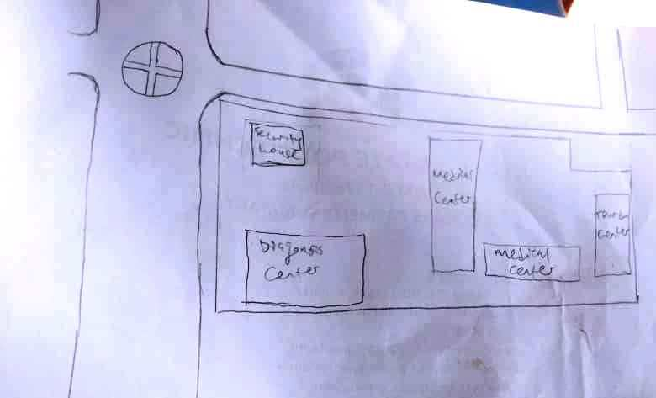

Fig. 3.1. Recce Diagram (NOT DRAWN TO SCALE)
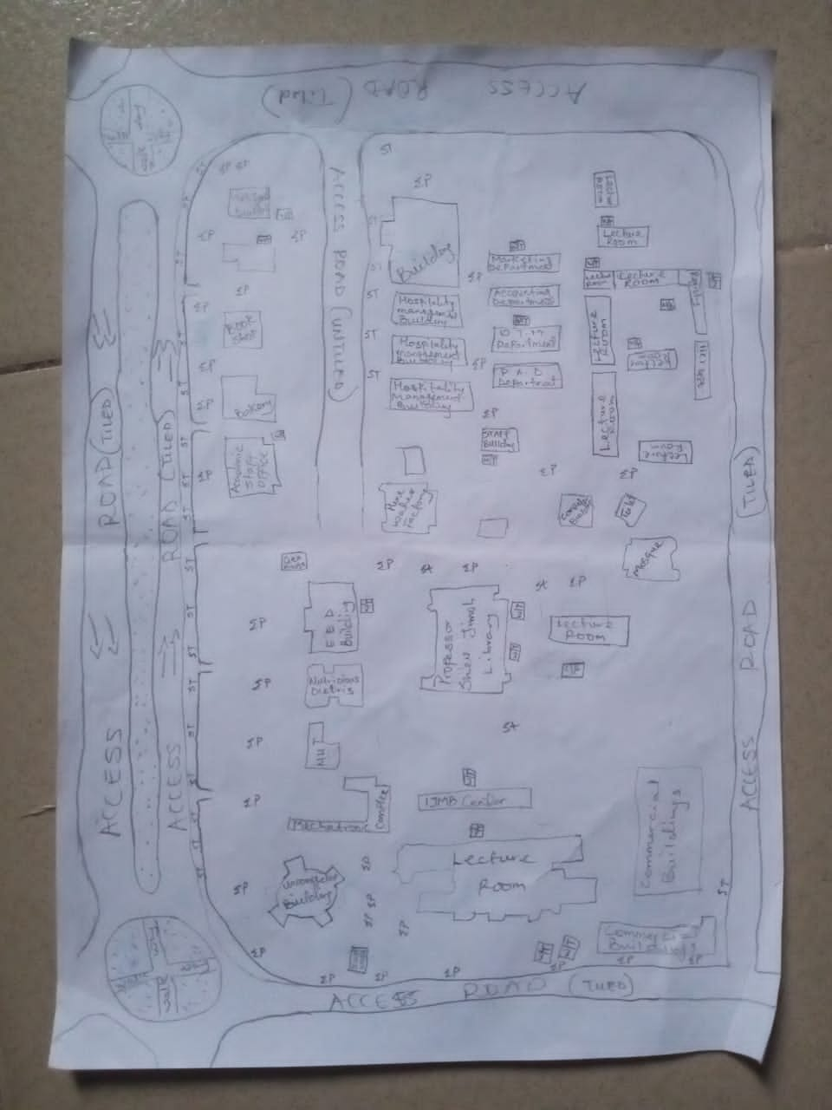

3.2. BOUNDARY SELECTION AND MONUMENTATION
Pre-cast property beacons made of 18cm x 18cm x 75cm were used for the demarcation of the project site. In compliance with the specification for cadastral Survey as specified in CAP 194 of law of the Federation of Nigeria, the Beacons were made of concrete mixture of ratio 3:2:1 (3 parts of sand to 2 parts of granite to 1 part of cement) with water, so as to ensure that the pillars were strong. The beacons protruded 15cm above ground level, while the remaining part was inserted and fixed firmly into an undercut hole. An iron rod (80cm in lengths and 10mm in diameter) protruding at the centre of the beacon represents the centre of the station mark.
A total number of Nine (9) beacons were emplaced and prefixed with identification mark “PIL” where “PIL” represent property beacon, Pillar. The beacons were capped and numbered from Pil.1 to Pil.9 as obtained from the department of surveying, Kwara State Polytechnic, Ilorin and they were numbered in a clockwise direction with stencil.
Fig. 3.2: Pre- cast property beacon
Ground level
18cm
18cm
Beneath Ground level
75cm long
60cm
80cm Iron rod
Above Ground level
15cm

01
PIL

18cm
18cm

3.3 EQUIPMENT SELECTION
The various equipment used for the acquiring of data and successful completion of this project were selected and was grouped in to two categories. They are;

3.3.1 HARDWARE Numbers
i. Total Station (South NTS-350R) with its accessories. 1 No.
ii. Tripod stand 1 No.
iii. Tracking Rod / Reflector 2 No.
v. Tape of 30m 1 No.
vi Cutlass 2 No.
vii Handed GPS (Garmin 72SC) 1 No.
viii Total Station Batteries 2 No.
ix. Laptop computer 1 No.
x HP DeskJet 1 No.
3.3.2. SOFTWARE USED
The software used for the project includes;
- ArcMap 10.3.
- Microsoft Excel
- Microsoft word
- NotePad
3.4 TEST OF INSTRUMENT
3.4.1 SOUTH (NTS-350R) TOTAL STATION TEST
Various tests were conducted on the South (NTS-350R) Total Station used, to ascertain its working condition prior to the commencement of the project execution. These tests are as follows:
3.4.2 PLATE LEVEL TEST
This test was to verify that the vertical axis of the instrument used was truly vertical when the plate level was at the centre of its run.

PROCEDURE: The Total Station (South NTS-350R) was set up firmly on a point arbitrarily. The plate bubble tube was turned parallel to two foot screws and leveled with two foot screws; the tube was then turned through 90º, now over the third foot – screw and level accordingly using the third foot screw. It was then returned to its former position and accurately leveled with the pair of the two initial foot – screws. To complete the test, the instrument was rotated through 180º and 360º and the bubble was still at the centre of its run, hence the plate bubble was in order.
3.4.3 HORIZONTAL COLLIMATION TEST
The aim of this test was to make sure that the line of sight is truly perpendicular to the trunion axis.
PROCEDURE: The Total Station instrument was set up on a point and all necessary temporary adjustments performed. The instrument was switched on, collimation program was selected from the menu and consequently the horizontal collimation test was chosen. This test was done by bisecting a well defined vertical target about 100m away and taking the horizontal readings on Face Left and Face Right. From the analysis of the results, the Total Station was in good adjustment.
3.4.4 VERTICAL INDEX ERROR TEST
This adjustment ensures that the vertical circle reading is exactly 90º when the line of sight is horizontal. Any deviation from this figure is termed vertical index error.
PROCEDURE: The instrument was set over a station point and all necessary temporary adjustments (centering, levelling and focusing) were performed. The vertical index error test was carried out by sighting a target at a distance of about 120m on Face Left. The Vertical Circle reading was recorded and the target was sighted and bisected again on Face Right and the vertical circle reading was recorded.

Fig. 3.3: Instrument set-up for horizontal collimation test and vertical index test
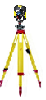
Total
Station
Reflector
Fairly Leveled Ground
Approximately 120m
Station B
Station A
Line of Sight

3.4.5 ANALYSIS OF COLLIMATION AND VERTICAL INDEX DATA
The readings obtained during the calibration were reduced to obtain the new horizontal collimation and vertical index errors. The results of the calibration data acquired for the total station used for this project are shown in the table below;
Table 3.1: Horizontal and Vertical Collimation Test Reading
Inst Stn. | Sight (Reflector) | Face | Hor.Circle Reading | Ver. Circle Reading
 | B | L | 87º 35’ 10’’ | 88º 26’ 15’’
A | B | R | 267º 35’ 12’’ | 271º 33’ 46’’
 |  |  | Diff= 180º 00’ 02’’ | Sum= 360º 00’ 01’
Horizontal Collimation = [(FR – FL) - 180º]/2
= [(180º 00’ 02’ - 180º 00’ 00’’) /2]
= 00º 00’ 02’’/2
= 00° 00’ 01’’
Vertical Collimation = [(FR – FL) - 360º]/2
= [(360º 00’ 01’’ - 360º 00’ 00’’)/2]
= 00º 00’ 01’’/2
= 00° 00’ 01’’
Table 3.2: Comparison of Old and New Values.
HORIZONTAL COLLIMATION | OLD | NEW
HORIZONTAL COLLIMATION | + 00º 00’ 02’’ | +00º 00’ 01’’
VERTICAL INDEX | +00º 00’ 00’’ | + 00’ 00’ 01’’

With the result obtained, it is evident that the instrument is in good working condition. Therefore, the new readings were adopted for the instruments Horizontal Collimation Error and Vertical Index Error respectively.
3.5 DATA ACQUISITION
3.5.1 OBSERVATION PROCEDURE
Geometric data was acquired using South (NTS-350R) Total Station. Total Station is an integrated system combining Electronic Theodolite and Electromagnetic distance measuring device. It is an instrument with inbuilt software for selected programs, which made it possible to compute data. The system also includes storing unit which serves as the survey field book.
This task was achieved through the following procedures;
- The instrument South (NTS-350R) was set up on a known station (KWPT733) and the bubble was centred and levelled.
- The instrument was switched on and menu button was pressed to display the programs on the total station.
- Data collect menu on the total station was selected to key in necessary information needed for commencement of the job. In the appeared dialogue box is Occp. Stn., Backsight and Fss. / SS
- The information of the known station (KWPT734)was keyed into the Total Station under the Data Collect sub-menu (Occp. Stn.) by opening a new file and naming the job. The station parameter N,E,H and height of instrument was entered in its appropriate space.
- The second option was selected, which is the Backsight, a submenu under the Data Collect. Here the information of the target position N,E,H and height of reflector was keyed into the Total Station. After this was achieved, Measure button was pressed for orientation and to compute the bearing, distance and N,E,H of the target position. The result was compared with the given coordinates, when the difference between the given and the observed was seen to be minimal, a centimetre difference, OK button was pressed.
- After the orientation. FS / SS menu was selected, which is a submenu under Data Collect and ALL button which captures and stores data automatically was pressed and observation to both natural and man-made features within the perimeter were fixed. A subsidiary traverse was run close to the interested feature and the above step was repeated at every point created until all the features were covered.
3.5.2 IN-SITU CHECK OF SURVEY CONTROL USED
The position of the control pillars used was checked before any other observation can be carried on. The check was done on control pillars (KWPT.733, KWPT.734 and KWPT.735). I set-up the Total Station instrument, centred and levelled it on KWPT.733 and the values control were keyed into the Total Station. The target position KWPT.734 was sighted and tracked and the result (Bearing, Distance, N, E, and H) was displayed as and checked finally recorded. The reflector was then positioned on KWPT.735 and was sighted and tracked and the results were also recorded and compared with given value of the pillar.
The result of the observed coordinates of pillar KWPT.733 was compared with the given coordinates. By specification the deviation in the distance and angle must not exceed 0.30m and 30’’ respectively. The summary of the computation between the given coordinates and observed is shown in the table below.
Fig. 3.4: Shows the computed check angle and check distance as obtained from the control pillars.
External angle
184⁰ 15’ 57’’

112ᴼ 50’ 07”
245.841m
KWPT733
288ᴼ 34’39”
143.780m
KWPT734
KWPT735

Table 3.3: Result of the computed survey control check from given coordinate.
FROM  STN | BEARING | DIST. (m) | DN | DE | NORTHING  (m) | EASTING  (m) | TO  STN
 |  |  |  |  | 946553.567 | 680054.213 | KWPT733
KWPT733 | 182ᴼ 32’08” | 182.734 | -182.555 | -8.084 | 946371.012 | 680046.129 | KWPT734
KWPT734 | 182ᴼ 05’27” | 493.386 | -493.058 | -18.001 | 945877.954 | 680028.128 | KWPT735
Source: Author, 2025.
The result was used to obtain the inclusive angle between KWPT733, KWPT734 and KWPT735 by finding the difference between the bearings of two lines.
KWPT734 KWPT733 => 002⁰ 32’ 08’’
KWPT734 KWPT735 => 182ᴼ 05’27”
Therefore (182ᴼ 05’27” - 002⁰ 32’ 08’’)
Check angle 179⁰ 33’ 19’’
Table 3.4: Result of the computed survey control check from given coordinate.
FROM  STN | BEARING | DIST. (m) | DN | DE | NORTHING  (m) | EASTING  (m) | TO  STN
 |  |  |  |  | 946553.567 | 680054.213 | KWPT733
KWPT733 | 182ᴼ 32’14” | 182.728 | -182.555 | -8.089 | 946371.012 | 680046.129 | KWPT734
KWPT734 | 182ᴼ 05’26” | 493.390 | -493.058 | -17.998 | 945877.954 | 680028.128 | KWPT735
Source: Author, 2025.
The result was used to obtain the inclusive angle between KWPT733, KWPT734 and KWPT735 by finding the difference between the bearings of two lines.
KWPT734 KWPT733 => 002⁰ 32’ 14’’
KWPT734 KWPT735 => 182ᴼ 05’26”
Therefore (182ᴼ 05’26” - 002⁰ 32’ 14’’)
Check angle 179⁰ 33’ 12’’
The difference between the Observed checked angle and the computed check angle
= (179⁰ 33’ 19’’- 179⁰ 33’ 12’’) = 00⁰ 00’ 07’’

3.5.3 PERIMETER SURVEY
A perimeter survey covering the entire area was ran using the three Survey control pillars found to in-situ and the area covered by the survey was 26.808 Hectares.
3.5.4 OBSERVATION PROCEDURE
The Total Station was setup on kwpt734 and all the necessary temporary adjustment were done like centering, levelling and parallax removal. Then instrument was switched on and the parameters of the instrument station (Station I.D, Height of instrument and the N,E,H coordinate) were keyed in. The reference control point kwpt733 was then bisected and the parameters (back station I.D, Height of reflector over the target station, and the N,E,H coordinate) were also keyed in. After this process, the measured button was pressed and orientation is set. Foresight was made to kwpt735, which was my forward station and the reflector was bisected and tracked to measure the N,E,H value of the point, all the obtained coordinates N,E,H were checked and found correct before proceed to next measurement. The instrument was then moved to kwpt735 as my new instrument station values were keyed in and back sight to kwpt734 was used as my reference station. The same process was repeated from one boundary station to the next pillar from kwpt735 to Pil.1. In this manner, the traverse was ran through the boundary beacons and finally closed back on Kwpt734. A closed loop traverse was carried out and all field data were later downloaded and processed. The data was later downloaded as show on the appendix table.
3.5.5 DETAILING SURVEY
Comprehensive details Survey of all natural and man-made features along the survey line were carried out. Ray method with the total station was used for the detailing. Subsidiary points were established around the project area to allow features that cannot be pick from the boundary points be picked easily. The X, Y and Z coordinates, angles (vertical and horizontal) and distance to the point to be detailed were measured.

Fig. 3.5 Show the observation process of using total station.
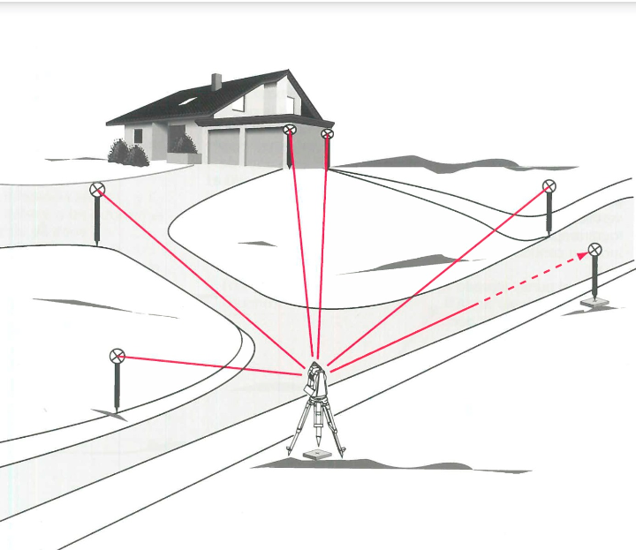

3.5.6 PROCEDURES OF OPERATING SOUTH (NTS-350R) TOTAL STATION
The following steps were taken when operating South (NTS-350R) Total Station.
- The tripod was set-up on the occupied station and the shoes of the tripod legs were adequately marched down to ensure that it grips the ground firmly.
- The Total Station was mounted on the tripod and clamped adequately and the necessary adjustment was carried out to achieve centering and levelling of the instrument, the foot screws were used.
- The instrument was then switched on and MENU button was pressed to display list of all programs resident on the Total Station.
- DATA COLLECT was selected by pressing 1 on the key pad. Then the MEAS. & COORD. File dialogue box appears prompted me to name the job, I created the job by the name KWARAPOLY. [F3] was pressed to change the Numeric button to Alpha so as to key in my desired file name, and when this was done; [F4] was pressed to accept.
- After achieving step 4, the DATA COLLECT dialogue box appear with the following sub-menu (Occp. Pt., Backsight and Fs/ss). Then I pressed on the key pad and to lunch OCCP. PT. on the name FEDPOFFA_TOPO. dialogue box. Here all the parameters (Occp. Pt. ID, P code, Inst. Ht, N, E, N) for occupy station was keyed into the Total station and [F3] button (REC.) was pressed and then [F4] button (YES) to accept these parameters in the occupy point environment. i.e. Occupy point, Pt-I.D, Pcode, Instrument Height H.I. Values.
- The DATA COLLECT dialogue box re-appears when step 5 was completed and 2 was pressed on the keypad to activate BACKSIGHT sub-menu. In the appeared dialogue box, all the parameters (BKP. PT. ID, P code, R. Ht. And N, E, H) for backsight station was keyed in and [F3] (MEAS) button was pressed for orientation by sighting at the target station and bisecting it. By doing this, the orientation is set and the Total Station is ready for the coordination of new points. i.e
- 489spt,679717.405,946223.476,318.638
- 490confe,679724.363,946216.6,318.346
- 491spt,679712.324,946222.709,318.634
- 492spt,679700.275,946222.701,318.734
- 493conf,679695.032,946217.477,318.649
- After achieving step 6, the DATA COLLECT dialogue box reappears again and 3 was pressed on the keypad to lunch the FS/SS dialogue box. F4 (ALL) button was then pressed to make observations to points of interest. As soon as this [F4] button was pressed, the Total Station automatically measures, records and stores the data into the internal memory of the instrument. This setting is peculiar to Kolida (KTS-462) Total Station. Where
F.S means Fore sight
Meas mean Measure
N mean Northing Coordinate
E mean Easting Coordinate
H mean Height of Station

CHAPTER FOUR
4.0. DATA PROCESSING AND RESULT ANALYSIS
4.1. DATA PROCESSING
All the data acquired from the field are required to be processed. It is this processing that makes the acquired data meaningful. The processed data is then used for map production.
After downloading the data into the computer system, the data is converted from document to excel form and save as .csv format (facility management.csv). Then the ArcMap was launched and the necessary parameters are set up, after setting the parameters the saved data file was imported.
4.1.1 DATA DOWNLOADING
The acquired data were downloaded from the memory of the instrument via the Data Transfer Port into the computer. The collected data were downloaded using South Data Transfer Software. The explanation below shows the procedures involved during the downloading from the Total Station to the computer:
* The South (NTS 350R) Total Station was connected to computer before switching “ON” the computer and total station.
* The computer was switched “ON” and allowed to complete the booting operation.
* The Total Station was switched “ON”
* On the Total Station “MENU” key was pressed to open the program page
* F3 key was pressed to select “Memory Manager”.
* In the memory manager sub-menu, F1 key was pressed on the third page to select “Data Transfer”
* In the data transfer dialogue box, F1 key was pressed to select NTS -300 transfer mode. Then F3 key was pressed to select “COMM. PARAMETERS” where “BAUD RATE, PROTOCOL AND PARITY” was set to have the same setting parameters on the computer and on the Total Station to allow good communication between the Total Station and the Computer.
* Escape (ESC) key was pressed to go back to the previous menu (DATA TRANSFER) and F1 key was pressed to select the “SEND DATA”.
* In the appeared dialogue box F1 key was pressed to select the measured data option and the file name “KAM” which is to be downloaded was selected and F4 key was pressed to accept the file to be downloaded.
* On the computer system, in the NTS Total Station software environment, “COMM” menu was clicked on the menu bar and downloads 300 data option was selected on the pull down menu.
* On clicking the download 300 data on the pull down menu, a small dialogue box appear given an instruction to press enter (F4 key) on the Total Station and the (Enter) key on the computer. Once this was done sequentially, the data automatically start to download.
* After downloading the data, Transfer menu was selected on the menu bar and “CASS survey data 300” was selected and clicked to Transfer the data from Chinese Language to English Language for better interpretation and understanding.
4.2 COMPUTATION OF SURVEY DATA
Total Station Instruments, with their microprocessors, can perform a variety of computations, depending on how they are programmed. South (NTS -350R) Total Station is capable of assisting an operator, step by step, through several different types of basic surveying operations.
In addition to providing guidance to the operator, microprocessors of South (NTS -350R) Total Station can perform many different types of computations automatically and some standard computations include:
1) Averaging of multiple angles and distances observations;
2) Correcting electronically observed distances for prism constants, atmospheric pressure, and temperature;
3) Making curvature and refraction corrections to elevations determined by trigonometric leveling;
4) Reducing slope distances to their horizontal and vertical components;
5) Calculating point elevations from the vertical distance components (supplemented with keyboard input of instrument and reflector heights);
6) Making corrections to observed horizontal and vertical angles for various instrumental errors; and
7) Computing coordinates of surveyed points from horizontal angle and horizontal distance components (supplemented with keyboard input of coordinates for the occupied station, and a reference azimuth). Furthermore, the microprocessors of total station perform traverse computations and simultaneously calculate and store station coordinates and elevation.
4.3 PROCESSING IN ARCMAP 10.3
After acquiring the data from the field, it is then processed using the arcmap 10.3 software to produce a digital map of the project area. The following are the steps involved;
- Unit settings: - this is the setting up of the primary units for the drawing. In ArcMap 10.3 the following steps described below are the procedure to set up the primary unit.
STEPS
* Double click on the ArcMap10.3 icon on the desktop (allow the software to lunch).
* Then click on cancel button (to open new fresh ArcMap10.3).
* Right click on the ArcMap10.3 window and select Data Frame Properties, then the Data.
* Frame Properties dialog box appear.
* Then select Coordinates System from the list and go to Projected Coordinate Systems and select UTM.
* On the drop down select Africa and the drop down to select Minna Zone 31(as the Datum Reference).
* Then click Apply and then select ok (the dialog box disappears).
Note: the scale box under the processing Menu will be on.
Fig 4.1: Setting of units on ArcMap
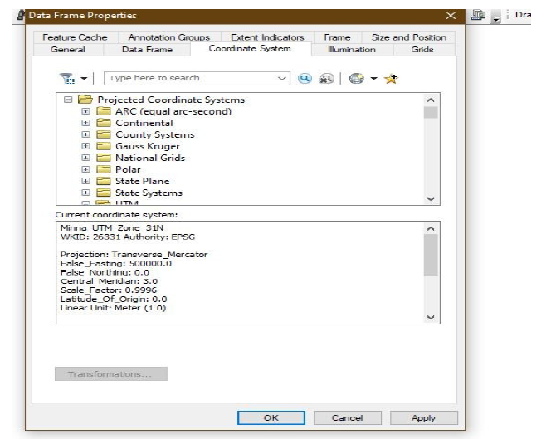

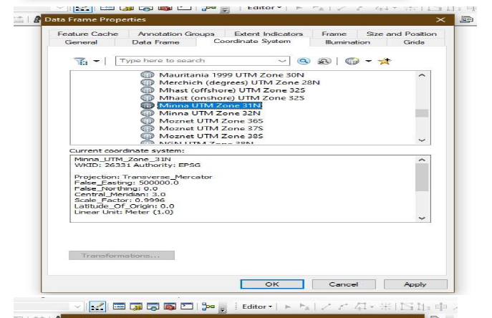

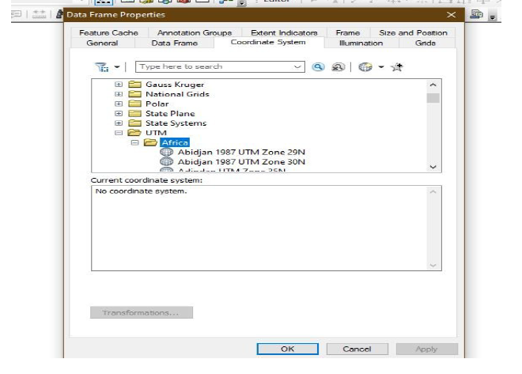

✓ Adding data: - after setting up the primary units, then the data can be added to the
ArcMap10.3, at this stage there two options of data to be add to the ArcMap10.3 i.e. Vector data or Raster data. The practical comprises of Vector data procedures is as follows.
Adding Vector data.

STEPS
* Select File from the Menu, the go to Add data and the drop down show the following:
* elect Add XY data (then Add XY data Dialog box appear).
* Then click on the Folder icon to navigate to the store files.
* After navigate to the folder where the data was stored, select the required folders saved with name (facility management), and
* Click on add data and it will go back to the add XY data.
* Then select the necessary field to the data e.g. column of easting for X and column of northing for Y and column of Z field for Height.
* Then click ok and the point will display on the window.
* Go to table of content on the left corner of the window and right click on the layer of the point key.
* Then select label feature and the names of the features will be labeled according to how the data was saved during capturing.
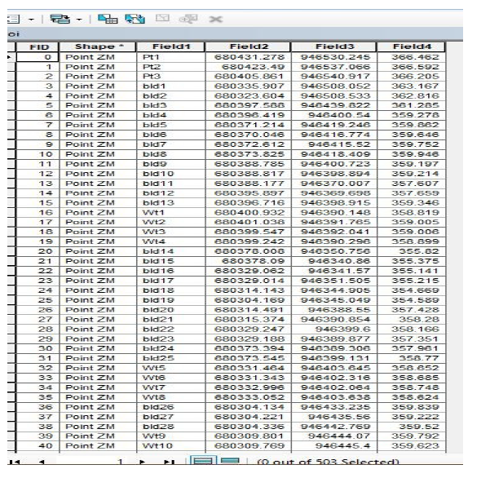
Fig 4.2: Adding of data

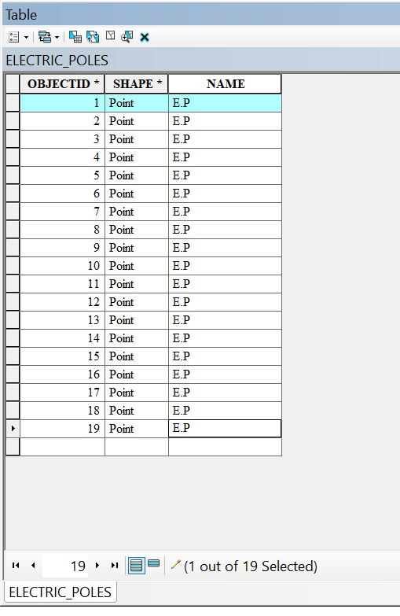
Electric poles

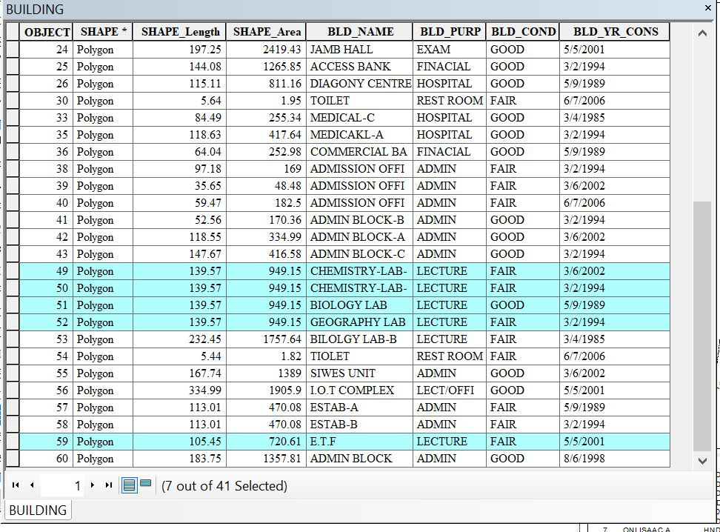
Building

✓ Layer creation or data base creation
STEPS
* Go to catalog on the right corner of the window.
* Navigate to the folder and right click on the folder.
* Then select new and click on file geo-database.
* Then right click on the file geo-database and select new then click on the new feature to create a new dataset.
* Type the name of the dataset and click next to select the unit as done during the primary unit setting, then click next twice and click finish.
* Then the new feature dataset will appear under the file geodatabase.
* Finally, right click on the new feature dataset and select new then select the feature class.
* The new feature class box appears (type in the layer name e.g. Road and copy it into the Alias box.
* Then select the feature type, e.g. line for road, polygon for building and point for electric poles.
* Then click next twice and click finish.
* Then the layer created will appear on the table of content.
* The same processes are repeated to create another layer.
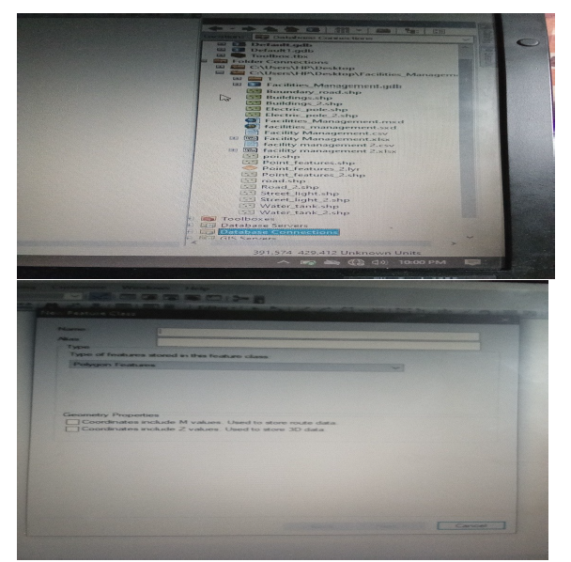
Fig 4.3: New dataset creation

✓ Digitizing: - the digitizing process is involved the tracing out the necessary features, as captured on the field to form the map feature.
STEPS
* Go to Editor, then click on starting editing.
* Then a create feature box appear, then select on the feature to digitize e.g. road, building, e.t.c.
* Then click on the window and trace out the feature outlines and double click when get to the end of the entity.
* Repeat the process above for all the features to be digitize and all will be saved in the data base table.
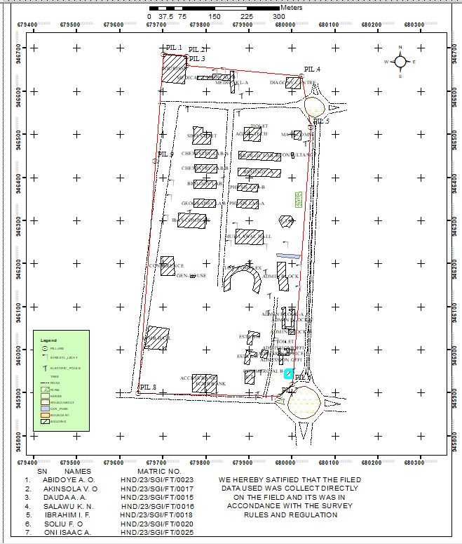
Fig 4.4. Digitizing on ArcMap

✓ Database Creation: - this is the process of populating the database.
STEPS
* Left click on the TOC on the layer to populate the table and then click on the open attribute table.
* The table appears.
* Then go to add field and the add field box appear.
* Set up the necessary information.
* And click ok, then the new field will be added to the table.

4.4 PREPARATION OF 3D MAP USING ARCSCENE
The 3D image was done on ArcScene using the created DEM, the created DEM was added to ArcScene and extruded with the heights gotten on the field. Extrusion incorporates the height of these features in their representation to give them 3D look and were made to float on DEM to have a true land representation. The created DEM was also added to ArcScene, the height of the buildings gotten from the field were added to the already created height field in the attribute table of each of the facility shape file in ArcMap. ArcScene was launched and all the shape files were added, from the table of content each shape file was right clicked on to access the property dialog box, from the property dialog box the shape files were extruded to give them 3D look and were made to float on the DEM to have a full 3D visualization.
* Open the ArcScene software and set necessary parameters.
* Go to arc tool box, click on spatial analytic tools.
* Then click on interpolation and then click IDW (Inverted Distance Way).
* Then it is going to generate 3D dimension value and set Z value point and press ok.
Note: - The IDW can be used to create contour and slope. But we are dealing with slope.
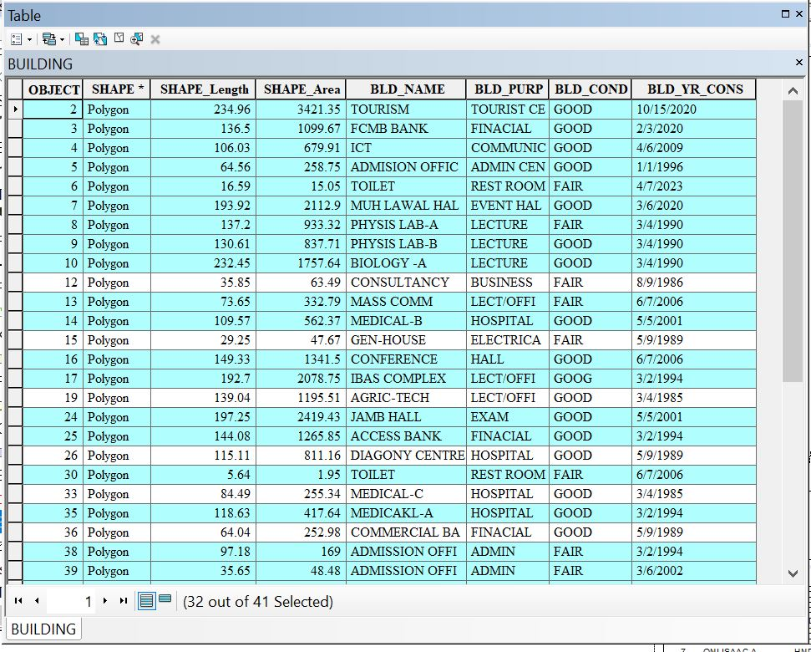

To creates slope, click on surface from interpolation and press slope and input raster(IDW) and press ok. The same procedure for contour also.
To set parameters for necessary facilities needed,
a. Select (IDW).
b. Go to source, click on property and press the base height.
c. Then click floating on a custom surface and press extrusion.
d. Click apply then ok.
4.5 PLAN PRODUCTION
The ultimate aim of the project is to produce a digital map (Facilities management plan) of the part of kwara state polytechnic. After processing the acquired data using the appropriate software, a digital map of the project area was produced. Thus, the aim of the project was achieved.
4.5.1 DIGITAL MAP
A digital map is the representation of cartographic features in a form that allows the value of their attributes to be stored, manipulated, and out-put by a computer system. A digital map is a data base or file that becomes a map when a GIS produces a hardcopy or screen display output.
Finally, a hardcopy of the digital map of the project area was printed.
Fig 4.5: Facility Management map
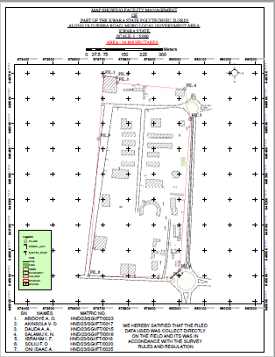

4.6 RESULT ANALYSIS
The facility management project commenced with the usage of a South (NTS – 350R) to capture the data of the project area. The captured data were then processed using software (ArcMap 10.3, ArcScene), employing photogrammetry technique to generate a high precision DSM and create a detailed 3D model.
ARCGIS software was employed to visualize and analyze the DSM data, facilitating spatial analysis and information Presentation.
The following maps were produced and their usefulness was stated,
4.7 QUERIES ANALYSIS
Queries analysis in GIS involve extracting information from spatial datasets by posing specific questions and then analyzing the data to gain insights or make decisions.
Queries involves selecting features based on attributes or spatial relationship, while analysis may include tasks like spatial overlay, proximity analysis, spatial statistics or modeling.
4.7.1 SINGLE CRITERIA QUERY
A single criterion is carried out where one condition is used to design query. The condition is used to gather information from the database.
QUERY ANALYSIS (selection by attribute)
Query question: “To query for the building that construction year is less than or equal to 1990.”
Analysis Name: Database extraction
Analysis Type: Single criteria analysis
Syntax: “BLD_YR_CONS>=1990.

Fig. 4.6: Single criteria query
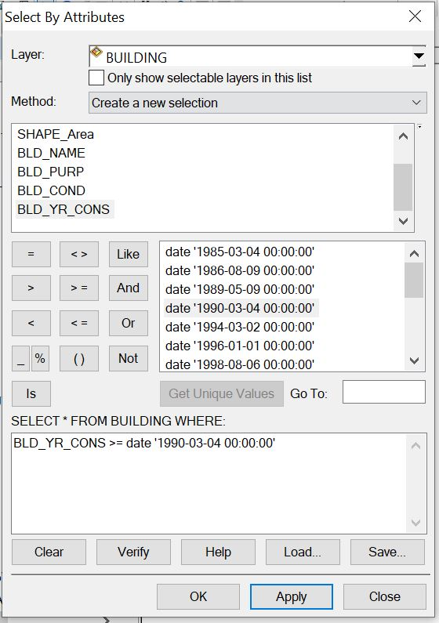

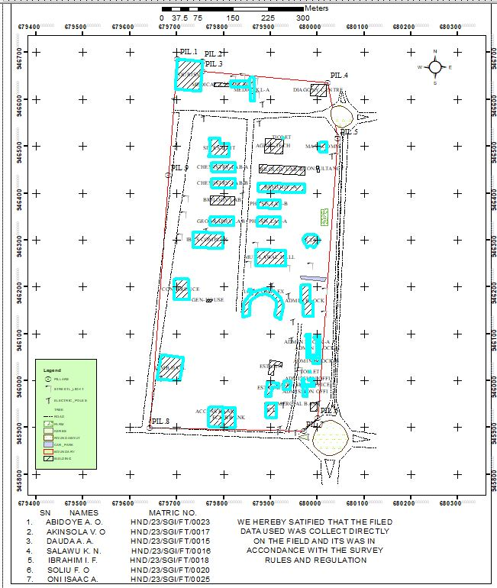
Answer to query 1.

Query question: “To query for the building that has an area less than 470.08 meters square and their purpose is used for financial
Analysis Name: Database extraction
Analysis Type: Double criterion analysis
Syntax: “SHAPE_AREA<470.08AND BLD_PURP”.
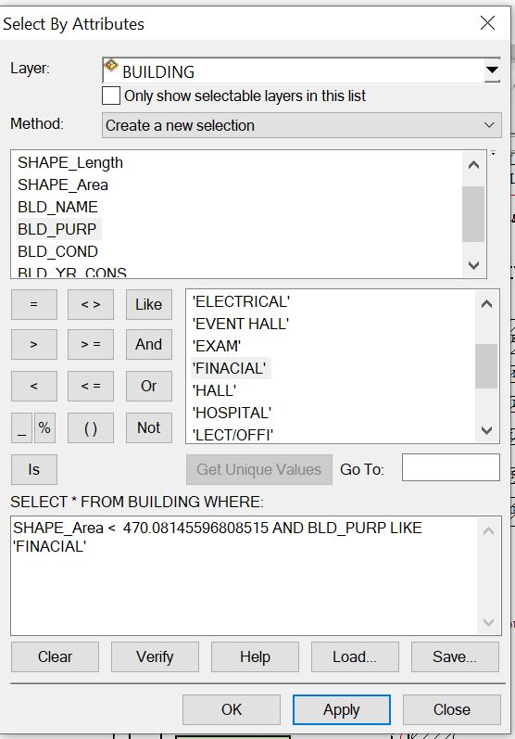

Answer to the query II.

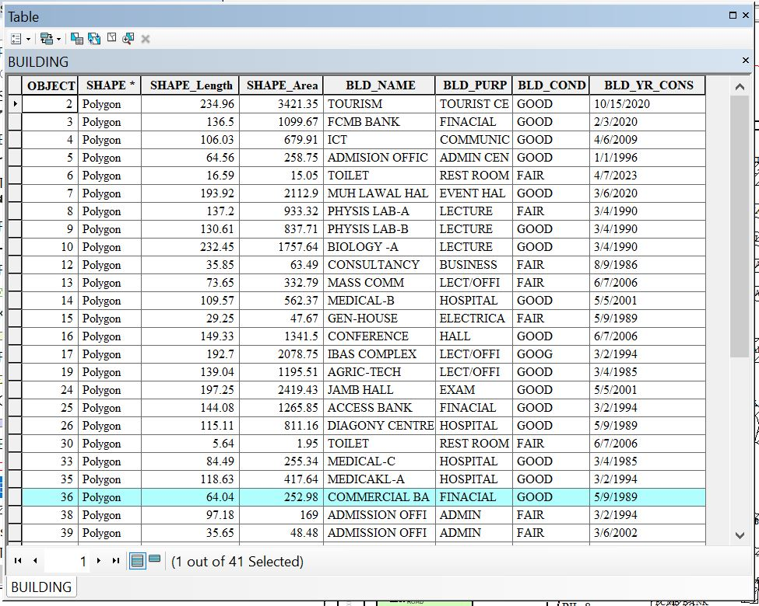
- Query question 3: “To query for the building purpose and that the area less than or equal to 192.69 meters square
- Analysis Name: Database extraction
- Analysis Type: Double criterion analysis
- Syntax: “BLD_PURP LIKE LECTURE AND SHAPE_LENGHT <= 192.69”.
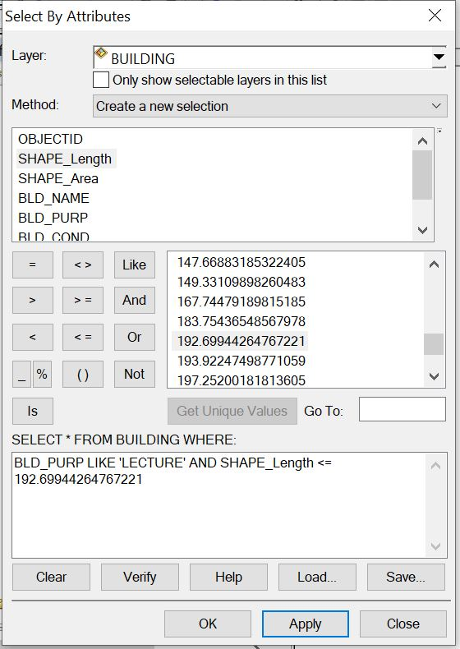

Answer to the query 3.
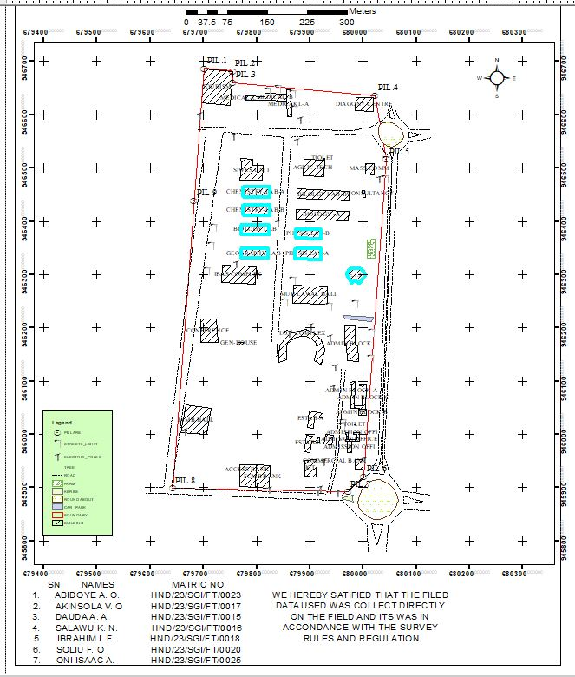
4.8. APPLICATION OF RESULTS
The result obtained can be applied to the following;
* Ensuring efficient use of resources.
* Maximizing occupant comfort and safety.
* Managing maintenance schedules.
* Optimizing space utilization.
* It's essentially a roadmap for maintaining and enhancing the functionality of a building or facility.

CHAPTER FIVE
COST ESTIMATION, SUMMARY, PROBLEM ENCOUNTERED, RECOMMENDATION AND CONCLUSION
5.1 COSTING
Table 5.1: PLANNING
S/N | PERSONNEL | UNIT | PRICE | DAYS | REMARK
1. | Principal Surveyor | 1 | #30,000 | 2 | #60,000
2. | Assistant Surveyor | 1 | #12,000 | 2 | #24,000
3. | Transport | 1 | #3,000 | 2 | #6,000
4. | Basic Equipment | 1 | #15,000 | 2 | #30,000
5. | Logistics | 1 | #10,000 | 2 | #20,000
 | Total | 1 |  |  | #140,000

Table 5.2: DATA CAPTURE
S/N | PERSONNEL | UNIT | PRICE | DAYS | REMARK
1. | Principal Surveyor | 1 | #30,000 | 5 | #150,000
2. | Assistant Surveyor | 1 | #12,000 | 5 | #60,000
3. | Chainman | 7 | #3,000 | 5 | #105,000
4. | Transport | 1 | #3,000 | 5 | #15,000
5. | Basic Equipment | 1 | #15,000 | 5 | #75,000
6. | Logistics | 1 | #10,000 | 5 | #50,000
 | Total |  |  |  | #455,000

Table 5.3: DATA DOWNLOAD
S/N | PERSONAL | UNIT | PRICE | DAYS | REMARK
1. | Principal Surveyor | 1 | #30,000 | 1 | #30,000
2. | Transport | 1 | #3,000 | 1 | #3,000
3. | Basic Equipment | 1 | #15,000 | 1 | #15,000
4. | Logistics | 1 | #10,000 | 1 | #10,000
 | Total |  |  |  | #58,000

Table 5.4: DATA PROCESSING
S/N | PERSONNEL | UNIT | PRICE | DAYS | REMARK
1. | Principal Surveyor | 1 | #30,000 | 8 | #240,000
2. | Assistant Surveyor | 1 | #12,000 | 8 | #96,000
3. | Transport | 1 | #3,000 | 8 | #24,000
4. | Basic Equipment | 1 | #15,000 | 8 | #120,000
5. | Logistics | 1 | #10,000 | 8 | #80,000
 | Total |  |  |  | #560,000

Table 5.5: DATA PRESENTATION
S/N | PERSONNEL | UNIT | PRICE | DAYS | REMARK
1. | Principal Surveyor | 1 | #30,000 | 1 | #30,000
2. | Assistant Surveyor | 1 | #12,000 | 1 | #12,000
3. | Transport | 1 | #3,000 | 1 | #3,000
4. | Basic Equipment | 1 | #15,000 | 1 | #15,000
5. | Logistics | 1 | #10,000 | 1 | #10,000
 | Total |  |  |  | #70,000

Table 5.6: REPORT WRITING
S/N | PERSONNEL | UNIT | PRICE | DAYS | REMARK
1. | Principal Surveyor | 1 | #30,000 | 10 | #300,000
2. | Transport | 1 | #3,000 | 10 | #30,000
3. | Basic Equipment | 1 | #15,000 | 10 | #150,000
4. | Logistics | 1 | #10,000 | 10 | #100,000
 | Total |  |  |  | #580,000

Table 5.7: SUMMARY
1. | Planning | #140,000
2. | Data Capture | #455,000
3. | Data Download | #58,000
4. | Data Processing | #560,000
5. | Data Presentation | #70,000
6. | Report Writing | #580,000
 | Total | #1,863,000
* Mobilization and demobilization 10%
1,863,000 * 10 ÷ 100 = #186,300
* V.A.T. 2.5%
1,863,000 * 2.5 ÷ 100 = #46,575
Total Cost
#1,863,000 + #186,300 + #46,575
= #2,095,875.

5.2 SUMMARY
This study focuses on implementing Geographic Information Systems (GIS) for enhanced facilities management within a designated section of Kwara State Polytechnic, Ilorin, situated in Moro Local Government Area of Kwara State. Recognizing the challenges of manual tracking and maintenance inefficiencies in educational infrastructures, the research adopts GIS technology to systematically capture, store, analyze, and visualize spatial and attribute data related to campus buildings, utilities, roads, green spaces, and other critical assets. By integrating geospatial databases with facility-specific information—such as construction dates, maintenance histories, occupancy rates, and asset conditions—the approach enables precise digital mapping and real-time monitoring of the polytechnic’s physical resources. This GIS framework facilitates optimized space allocation, proactive maintenance scheduling, efficient resource deployment, and data-driven decision-making for campus planners and administrators. Applied to the selected area of Kwara State Polytechnic, the methodology demonstrates significant potential for reducing operational costs, extending asset lifespans, improving emergency response planning, and supporting sustainable campus development through accurate, accessible geospatial intelligence tailored to the institution’s unique environmental and administrative context within Moro LGA.
5.3 PROBLEM ENCOUNTERED
The following were the problems encountered during the execution of this project.
- The project was financially expensive, energetic and time consuming.
- On the day of carrying out the practical, there was a delay in getting the instrument that resulted in getting to the site lately.
- Throughout the practical, we worked under the sun reason that we got to the site lately.

5.4 CONCLUSION
The study focuses on the Facilities Management using GIS Approach of Part of Kwara State Polytechnic, Ilorin, Moro Local Government Area, Kwara State.
In conclusion, the application of Geographic Information Systems (GIS) to facilities management within the designated area of Kwara State Polytechnic, Ilorin, Moro Local Government Area, Kwara State, demonstrates a transformative and highly effective approach to managing complex campus infrastructure. This study successfully established that integrating geospatial technology enables the creation of a centralized, dynamic repository for critical facility data—spanning buildings, utilities, roads, green spaces, and other assets—linking precise spatial locations with detailed attribute information such as condition, maintenance history, usage, and resource allocation. The GIS framework provides unparalleled capabilities for visualization, spatial analysis, and real-time monitoring, fundamentally shifting facility management from reactive, paper-based processes to proactive, data-driven decision-making. By facilitating optimized space utilization, predictive maintenance scheduling, efficient resource deployment, and enhanced emergency response planning, the GIS approach significantly improves operational efficiency, reduces long-term costs, and extends the lifecycle of the polytechnic's physical assets. Furthermore, the system offers invaluable support for strategic campus development planning and sustainability initiatives. While initial implementation requires investment in data collection, software, and training, the long-term benefits for Kwara State Polytechnic—including improved administrative oversight, better service delivery, and a more resilient, well-maintained learning environment within its unique Moro LGA context—firmly establish GIS as an indispensable tool for modern, efficient, and sustainable educational facilities management. This project underscores the feasibility and substantial value of adopting geospatial intelligence for institutional asset management in similar resource-constrained settings.

5.5 RECOMMENDATIONS
- Establish a Centralized Geo-Database should develop a comprehensive, cloud-based GIS database integrating all spatial and non-spatial facility data (buildings, utilities, roads, green spaces, furniture, equipment).
- Implement a Dedicated GIS-FM Platform should procure or develop a user-friendly GIS software platform (e.g., ArcGIS Online, QGIS with plugins) tailored for FM tasks (work orders, asset tracking, space management).
- Develop Standard GIS Data Collection Protocols should Create clear guidelines for collecting spatial data (e.g., GPS accuracy standards, attribute fields for different asset types).

REFERENCES
Abdulraheem, M. O., Olayemi, F. F., & Opaluwa, L. O. (2021). Land Use/Land Cover Change Detection and Urban Sprawl Analysis in Ilorin Metropolis, Kwara State, Nigeria Using Remote Sensing and GIS Techniques. Journal of Geography, Environment and Earth Science International, 25(5), 1-16.
Adeboye, B. S., & Alagbe, O. A. (2018). Challenges of Facilities Management in Public Universities in Southwestern Nigeria. Journal of Facilities Management, 16(3), 262-276.
Adejumo, A. V., & Ogunmakinde, O. E. (2019). Facilities Management Practices and Service Delivery in Public Polytechnics in South-West, Nigeria. Journal of Contemporary Management Research, 13(1), 1-20.
Adenuga, O. A., Iyiola, K., & Ogunleye, M. B. (2017). Application of Geographic Information System (GIS) for Facilities Management in Tertiary Institutions: A Case Study of Federal University of Technology, Akure. Journal of Facilities Management, 15(2), 168-183.
El-Mekawy, M., Östman, A., & Shahzad, K. (2012). Integrating Building Information Models and Geographic Information Systems for Facility Management: A Review. Advanced Engineering Informatics, 26(4), 670-679.
Ibem, E. O., & Aduwo, E. B. (2013). Assessment of Facilities Management Practices in Public Buildings in Southwest Nigeria. Property Management, 31(1), 45-70.
Kaya, S., & Erden, M. S. (2018). A GIS-Based Facility Management Framework for Universities: A Case Study of Istanbul Technical University. Journal of Facilities Management, 16(4), 414-435.
Olanrewaju, A. A., & Anifowose, T. J. (2015). Evaluation of Facilities Management Services in Tertiary Institutions in Lagos State, Nigeria. Journal of Facilities Management, 13(3), 282-301.
Oluwadare, O. J., & Ogunleye, M. B. (2020). Spatial Database Development for Facilities Management in Tertiary Institutions Using GIS: A Case Study of Federal Polytechnic, Ado-Ekiti, Nigeria. Geoinformatics FCE CTU, 17(1), 1-15.
Teo, E. A. L., & Lin, K. Y. (2011). Application of Geographic Information Systems (GIS) in Facilities Management. Facilities, 29(3/4), 120-132.

APPENDIX
bld1,680001.553,945920.709,305.03
2bld,679998.724,945935.038,305.427
3bld,679999.37,945952.393,305.747
4bld,679985.139,945953.611,305.899
5Ep,680002.449,945953.267,305.904
6bld,679969.713,945966.376,306.162
7bld,679978.467,945966.005,306.203
8str,679962.742,945980.018,306.873
9str,679963.074,945982.566,306.968
10str,679964.353,945982.451,306.955
11bld,679966.006,945987.485,307.213
12tree,679967.245,945904.712,304.414
13bnd2,679970.974,945892.196,303.848
14Ep,679951.406,945891.426,303.848
15tree,679946.62,945896.648,304.023
16DR,679940.237,945887.579,302.966
17DR,679939.218,945887.348,302.645
18Rd,679931.045,945888.016,303.114
19DR,679929.541,945887.406,302.639
20DR,679928.99,945887.693,302.628
21Ep,679919.632,945898.553,304.019
22Ep,679914.223,945892.929,303.664
23bank,679911.575,945920.464,304.7
24bank,679889.953,945921.531,304.753
25Ep,679915.076,945919.52,304.599
26tree,679931.218,945947.97,305.577
27Ep,679926.29,945949.63,305.493
28gtb,679915.953,945952.093,305.385
29bld,679900.379,945966.825,306.214
30bld,679888.661,945968.32,306.514
31bld,679917.742,945986.294,306.808
32bld,679918.61,945994.023,307.217
33bld,679892.925,945998.188,309.093
34tree,679927.623,946001.143,307.61
35mosq,679928.788,946000.146,307.496
36mosq,679926.197,945982.778,306.943
37mosq,679943.303,945998.462,307.366
38tree,679939.646,946005.798,307.642
39tree,679938.425,945999.848,307.45
40sl,679957.398,945996.07,307.502
41sl,679959.991,946015.805,308.185
42sl,679961.136,946023.735,308.413
43bld,679971.797,946037.722,308.565
44bld,679982.727,946039.467,308.674
45bld,679983.532,946015.505,308.485
46str,679984.655,946017.96,308.269
47str,679984.73,946019.205,308.241
48str,679983.214,946019.476,308.336
49spt,679988.212,946022.841,308.542
50spt,679992.515,946017.403,308.476
51spt,679987.166,946010.653,308.193
52spt,679987.891,946003.31,308.362
53spt,679983.968,946027.112,308.665
54spt,679987.104,946035.048,308.644
55bld,679990.722,946036.027,308.705
56bld,679992.34,946002.873,308.571
57bld,680006.482,946035.908,308.558
58bld,680002.833,946047.922,309.255
59bld,679976.883,946049.044,309.107
60sl,679968.892,946079.409,310.226
61sl,679968.826,946072.011,310.099
62spt,679970.913,946074.442,310.147
63spt,679973.054,946069.097,309.974
64spt,679968.906,946062.177,309.556
65spt,679975.594,946058.773,309.775
66spt,679965.543,946052.38,309.434
67spt,679971.841,946048.431,309.181
68spt,679972.043,946086.812,310.615
69spt,679967.188,946090.828,310.681
70spt,679964.664,946098.415,311.171
71spt,679957.51,946097.69,311.003
72bld,679974.621,946099.158,311.079
73tree,679999.806,946104.888,311.397
74tree,680010.315,946112.512,311.854
75tree,680011.129,946117.7,311.931
76tree,680011.712,946123.067,312.152
77spt,680010.009,946129.671,312.375
78spt,680002.863,946125.025,312.208
79spt,679999.388,946115.06,311.689
80spt,679996.786,946110.187,311.491
81spt,679992.748,946104.278,311.317
82spt,679988.481,946109.369,311.415
83spt,679986.602,946116.996,311.622
84spt,679986.322,946125.052,311.734
85spt,679980.628,946130.727,312.337
86sl,679982.536,946130.339,312.35
87tree,679974.682,946131.68,312.215
88spt,679972.411,946114.815,311.439
89tree,679953.554,946110.003,311.382
90tree,679953.104,946105.441,311.056
91tree,679950.595,946093.033,310.555
92Ep,679943.533,946087.757,310.126
93spt,679943.575,946076.168,309.424
94spt,679934.174,946078.961,309.626
95spt,679920.822,946073.274,309.835
96spt,679915.118,946068.241,310.027
97spt,679908.301,946060.959,310.158
98spt,679909.131,946051.957,309.678
99bld,679899.243,946043.445,309.387
100str,679896.051,946043.006,309.31
101str,679895.49,946040.816,309.26
102str,679893.879,946041.01,309.22
103bld,679894.41,946014.383,308.269
104spt,679890.712,946019.163,308.4
105spt,679895.133,946023.257,308.791
106spt,679896.372,946031.022,308.777
107spt,679888.733,946036.616,309.284
108spt,679892.145,946049.028,309.57
109spt,679898.83,946064.598,310.391
110spt,679896.11,946075.478,310.822
111spt,679899.352,946085.679,311.27
112spt,679900.45,946095.169,311.583
113spt,679889.678,946100.794,311.319
114spt,679879.884,946100.892,311.081
115spt,679875.602,946110.656,311.435
116spt,679860.786,946122.723,311.712
117str,679855.831,946126.252,311.908
118str,679853.412,946125.261,311.866
119str,679851.166,946129.422,312.287
120iotbld,679850.27,946130.672,312.546
121spt,679841.314,946135.195,312.355
122spt,679835.787,946144.524,312.647
123spt,679841.647,946151.983,313.49
124spt,679837.819,946164.575,313.736
125iotbld,679850.445,946177.42,313.803
126iotbld,679862.438,946189.159,314.463
127Ep,679861.389,946190.354,314.38
128genhouse,679858.56,946193.401,314.353
129genhouse,679853.433,946191.354,314.288
130genhouse,679852.175,946193.779,314.345
131spt,679847.82,946190.812,314.204
132tree,679841.606,946187.357,314.446
133spt,679844.792,946183.229,314.106
134spt,679850.527,946189.321,314.319
135spt,679851.064,946199.602,314.568
136spt,679855.333,946207.683,315.227
137tree,679853.54,946210.88,315.612
138spt,679879.319,946199.405,314.666
139spt,679891.519,946197.994,314.864
140Ep,679901.842,946203.883,314.81
141spt,679906.197,946211.283,315.013
142spt,679918.358,946215.481,315.733
143spt,679914.716,946201.78,314.945
144bld,679909.053,946189.322,314.736
145spt,679915.093,946183.095,314.709
146bld,679920.914,946177.103,314.765
147spt,679931.914,946179.877,315.059
148Ep,679936.655,946183.366,315.413
149spt,679939.43,946174.292,314.662
150iot bld,679928.413,946159.401,314.111
151iot bld,679921.013,946130.8,312.808
152spt,679938.628,946129.621,311.581
153Ep,679947.624,946126.676,311.676
154recbld,679969.467,946138.179,312.658
155recbld,679988.307,946136.553,313.33
156spt,680003.893,946140.158,312.992
157sl,680013.476,946142.779,313.247
158spt,680025.065,946145.5,313.202
159tree,680019.078,946151.97,313.464
160tree,680019.278,946156.925,313.322
161tree,680013.13,946162.19,313.762
162spt,680010.315,946170.357,314.334
163spt,680005.425,946192.509,314.898
164sl,680015.327,946192.955,315.007
165spt,680008.594,946202.369,315.172
166spt,679994.076,946204.672,315.339
167recbld,679984.189,946204.478,315.442
168spt,679978.443,946208.804,315.661
169park,679963.226,946223.944,316.333
170park,679964.43,946217.62,316.111
171recbld,679965.631,946205.542,315.672
172recbld,679964.989,946203.903,315.587
173str,679987.609,946220.723,316.05
174str,679987.4,946219.44,315.978
175str,679986.085,946220.984,316.003
176park,680015.108,946212.547,315.512
177tree,680018.861,946219.613,315.808
178spt,680014.758,946225.428,315.898
179tree,680006.385,946231.69,316.557
180spt,679999.351,946228.385,316.251
181spt,679987.348,946239.564,316.827
182sl,679984.519,946245.583,317.412
183spt,679971.822,946245.145,317.291
184spt,679960.457,946244.878,317.405
185spt,679948.429,946244.273,317.266
186sl,679935.524,946242.081,317.515
187HALL,679932.222,946244.134,317.601
188flw,679922.809,946241.583,317.165
189flw,679934.083,946241.146,317.366
190flw,679928.585,946241.375,317.343
191flw,679875.609,946243.447,316.237
192flw,679872.196,946243.686,316.26
193HALL,679868,946246.945,316.38
194spt,679863.1,946248.494,316.311
195spt,679862.028,946258.078,316.687
196sl,679852.432,946249.983,316.747
197spt,679850.85,946256.565,317.056
198spt,679846.943,946278.828,318.518
199spt,679854.526,946289.235,318.359
200sl,679867.033,946289.549,317.91
201HALL,679868.738,946279.925,317.789
202spt,679875.736,946286.279,317.778
203flw,679876.301,946290.444,317.899
204flw,679885.508,946289.456,317.913
205flw,679895.579,946289.105,317.971
206spt,679897.502,946286.067,317.98
207flw,679905.651,946288.569,318.113
208flw,679915.684,946288.166,318.223
209spt,679924.355,946288.183,318.401
210spt,679930.064,946294.245,318.596
211spt,679925.662,946304.69,318.877
212spt,679923.011,946317.638,319.168
213sl,679921.98,946322.967,319.781
214phy labB,679921.417,946328.408,319.794
215spt,679907.945,946324.134,319.139
216spt,679894.785,946323.517,319.075
217spt,679891.188,946313.417,318.748
218spt,679880.275,946316.353,318.837
219phy labB,679871.385,946330.846,319.702
220sl,679865.6,946330.835,320.257
221spt,679854.205,946333.648,320.415
222spt,679851.82,946346.503,320.943
223spt,679863.95,946357.107,320.773
224spt,679861.734,946371.907,321.531
225spt,679854.29,946388.65,322.545
226spt,679871.439,946348.487,320.843
227labB,679871.543,946348.617,320.786
228labB,679868.321,946362.215,320.778
229labA,679869.717,946368.262,321.46
230labA,679872.292,946369.447,321.375
231labA,679873.225,946386.362,321.477
232spt,679877.107,946391.721,321.835
233Ep,679877.207,946395.018,322.157
234spt,679888.942,946395.505,322.218
235sl,679897.92,946395.377,322.146
236spt,679908.405,946393.793,322.034
237Ep,679916.355,946392.766,322.051
238labA,679920.821,946385.067,321.317
239spt,679930.212,946384.164,321.562
240spt,679931.977,946378.503,321.441
241spt,679940.614,946374.718,321.435
242spt,679930.728,946359.746,320.828
243spt,679940.326,946348.681,320.555
244spt,679949.13,946340.51,320.505
245spt,679933.365,946327.57,319.537
246sl,679922.323,946323.282,319.617
247spt,679946.381,946312.41,319.53
248spt,679961.735,946307.531,319.868
249bld,679967.872,946302.28,320.124
250bld,679977.75,946283.855,319.443
251bld,679993.018,946283.593,319.27
252bld,680004.329,946300.539,320.369
253bld,679998.345,946309.339,321.432
254tree,680010.161,946301.343,320.357
255tree,680011.17,946307.794,320.944
256tree,680009.009,946293.252,319.737
257spt,680015.59,946297.693,319.74
258spt,680015.574,946289.681,319.16
259Ep,680022.041,946285.189,319.244
260spt,680022.367,946297.7,320.001
261spt,680020.231,946314.929,322.069
262farm,680021.584,946330.48,322.24
263farm,680022.711,946366.014,322.821
264spt,680027,946360.883,322.324
265spt,680031.595,946350.845,321.481
266spt,680024.335,946344.812,321.828
267spt,680031.067,946331.416,320.716
268spt,680028.347,946323.488,319.878
269spt,679977.281,946388.974,323.011
270labC,679972.044,946401.172,323.314
271labC,679973.272,946419.088,323.233
272labD,679973.871,946433.423,324.022
273labD,679974.748,946456.641,324.966
274spt,679980.711,946456.634,325.093
275spt,679988.131,946449.638,325.106
276spt,679996.524,946452.748,325.135
277spt,679997.235,946440.418,324.772
278spt,679989.428,946434.214,324.237
279tree,679980.064,946429.48,324.194
280masscom,679998.842,946444.882,325.33
281masscom,679998.304,946457.975,325.499
282masscom,680003.72,946445.049,325.531
283spt,680013.136,946456.603,326.05
284spt,680018.707,946450.098,325.732
285tree,680023.094,946448.891,325.958
286spt,680022.83,946462.642,326.321
287masscom,680019.616,946463.454,326.582
288spt,680026.965,946465.006,326.318
289spt,680035.748,946460.119,326.238
290tree,680040.409,946451.978,325.533
291spt,680040.567,946462.387,325.748
292spt,680035.476,946469.089,326.414
293sl,680042.413,946480.408,326.592
294Ep,680029.941,946480.736,326.896
295,680019.483,946471.675,326.482
296,679999.146,946471.334,325.945
297spt,679998.007,946481.651,326.093
298mask,679997.217,946490.219,326.913
299masscom,680003.856,946488.335,326.839
300spt,680012.837,946484.376,326.657
301masscom,680019.78,946487.755,326.977
302spt,680027.827,946490.813,327.234
303spt,680038.345,946495.925,327.444
304spt,680032.6,946507.278,327.747
305masscom,680020.028,946508.713,327.869
306spt,680034.704,946514.238,328.098
307sl,680043.577,946516.198,328.225
308spt,680040.037,946527.784,328.685
309Rd,680040.641,946530.175,328.466
310Rd,680049.621,946529.962,328.464
311Rd,680056.905,946529.803,328.469
312Rd,680066.174,946529.973,328.493
313Rd,680053.986,946539.521,328.665
314Rd,680076.521,946559.448,329.637
315Rd,680085.77,946561.146,329.847
316Rd,680085.395,946555.48,329.582
317Rd,680086.484,946549.999,329.342
318Rd,680085.656,946567.188,330.158
319Rd,680086.534,946572.799,330.393
320Rd,680054.639,946584.625,330.726
321Rd,680054.653,946593.432,331.035
322Rd,680061.27,946593.253,331.125
323Rd,680066.437,946595.111,331.226
324Rd,680050.053,946594.909,331.106
325Rd,680045.444,946596.765,331.157
326spt,680039.314,946597.149,331.337
327spt,680029.489,946601.468,331.371
328spt,680029.315,946607.711,331.316
329spt,680020.265,946607.672,331.059
330diag,680018.165,946606.693,331.033
331diag,680019.206,946631.691,331.924
332bnd,680022.153,946636.213,332.084
333diag,679986.934,946632.21,331.734
334str,679985.026,946628.196,331.654
335str,679984.992,946626.379,331.629
336str,679982.885,946628.303,331.694
337diag,679984.852,946607.814,330.549
338spt,679982.58,946605.019,330.415
339spt,679973.666,946603.998,330.397
340tree,679974.176,946601.549,330.353
341tree,679973.397,946589.542,330.078
342spt,679972.963,946584.72,329.732
343spt,679963.879,946586.222,329.788
344spt,679956.87,946595.672,330.023
345spt,679946.013,946601.875,330.038
346spt,679930.75,946619.622,330.885
347tree,679928.45,946620.919,331.284
348spt,679914.1,946611.046,329.64
349spt,679898.087,946597.825,329.061
350spt,679882.187,946591.781,329.079
351Ep,679875.747,946590.333,329.26
352tree,679868.701,946594.905,329.836
353med,679865.249,946596.022,329.607
354spt,679866.317,946613.264,330.764
355sl,679870.104,946611.749,330.448
356tree,679869.002,946620.45,330.338
357sl,679867.365,946640.719,331.482
358med,679863.455,946647.28,331.563
359sl,679838.988,946649.763,331.865
360sl,679820.621,946645.326,331.859
361med,679814.12,946640.925,331.792
362str,679807.614,946638.115,331.85
363med,679814.689,946627.061,331.338
364spt,679817.665,946616.079,330.645
365tree,679828.122,946614.044,330.841
366spt,679838.385,946613.781,330.356
367spt,679844.583,946621.483,330.737
368med,679855.856,946625.727,330.825
369med,679787.222,946631.296,331.769
370med,679779.997,946635.003,332.057
371spt,679780.163,946627.553,331.861
372spt,679770.268,946631.912,331.989
373spt,679762.184,946637.866,332.338
374bnd,679755.017,946660.031,333.075
375tourism,679754.057,946681.55,333.794
376bnd,679753.911,946682.645,333.981
377tourism,679750.219,946617.823,331.961
378spt,679748.369,946609.748,331.671
379spt,679726.428,946604.74,331.752
380spt,679711.234,946605.009,332.005
381tourism,679695.999,946619.976,332.841
382tourism,679701.524,946687.047,335.035
383bnd,679700.667,946687.499,335.004
384Ep,679692.385,946600.43,332.309
385bnd,679692.343,946579.706,331.427
386DR,679692.364,946578.639,331.36
387Rd,679703.943,946571.196,331.086
388Rd,679740.373,946576.544,330.725
389Rd,679738.515,946566.698,330.366
390DR,679737.454,946566.239,330.273
391Rd,679753.241,946565.427,330.238
392DR,679753.961,946565.058,330.165
393bnd,679759.686,946576.959,330.508
394DR,679759.724,946577.133,330.501
395DR,679759.861,946575.944,330.488
396Ep,679757.002,946560.945,330.053
397spt,679762.26,946554.368,329.652
398spt,679773.919,946545.447,329.265
399spt,679783.794,946545.283,329.106
400tree,679797.339,946532.097,328.547
401tree,679805.074,946530.922,328.508
402spt,679817.284,946535.3,328.231
403spt,679833.269,946524.568,327.689
404spt,679851.315,946542.722,327.869
405Rd,679850.677,946557.627,328.313
406Rd,679864.795,946556.813,328.179
407DR,679865.273,946555.801,328.113
408Ep,679875.386,946550.603,327.754
409spt,679888.512,946543.863,327.896
410spt,679891.642,946533.864,327.368
411spt,679888.834,946517.123,326.999
412masscom,679889.05,946517.058,326.937
413spt,679899.912,946522.355,327.064
414spt,679915.491,946519.935,326.838
415spt,679926.835,946515.582,326.717
416str,679926.944,946517.327,326.867
417str,679927.02,946518.465,326.937
418str,679925.635,946518.897,326.872
419masscom,679925.66,946484.247,325.628
420Ep,679922.207,946477.535,325.07
421spt,679912.947,946469.803,324.723
422spt,679898.424,946477.188,325.108
423phyD,679876.904,946460.337,324.493
424phyD,679875.601,946442.7,324.511
425phyD,679874.442,946422.755,323.12
426phyC,679874.342,946422.841,323.074
427phyC,679874.329,946404.951,323.035
428siwes,679811.118,946489.542,327.46
429siwes,679811.301,946504.852,327.813
430siwes,679794.779,946508.074,327.399
431siwes,679792.125,946517.124,328.323
432siwes,679778.86,946518.031,328.422
433spt,679757.972,946500.52,327.88
434spt,679747.861,946485.376,327.359
435spt,679765.4,946468.931,326.499
436lab,679773.686,946464.84,326.309
437spt,679786.077,946474.385,326.467
438spt,679800.348,946477.709,326.478
439spt,679808.88,946465.732,325.953
440lab,679825.205,946464.11,325.626
441spt,679832.263,946454.383,325.097
442tree,679841.479,946443.802,324.979
443spt,679836.611,946433.405,324.791
444spt,679840.71,946421.725,324.204
445sl,679843.568,946419.033,324.092
446str,679837.827,946407.144,323.659
447Ep,679839.873,946397.401,323.141
448spt,679833.502,946389.207,322.777
449spt,679839.897,946379.734,322.265
450spt,679828.421,946364.884,321.999
451spt,679836.122,946345.598,321.188
452lab,679821.687,946330.154,320.689
453spt,679819.882,946320.826,320.08
454spt,679812.306,946311.131,319.839
455ibas bld,679798.422,946314.969,320.305
456spt,679807.785,946295.85,319.677
457spt,679804.041,946284.353,319.198
458ibas,679796.616,946282.4,319.371
459spt,679780.583,946276.183,318.238
460spt,679772.829,946267.091,317.887
461spt,679755.961,946265.67,318.231
462spt,679749.541,946274.529,318.485
463spt,679734.099,946281.723,319.138
464spt,679733.006,946285.714,319.612
465spt,679723.714,946289.567,320.765
466sl,679706.427,946308.804,321.843
467spt,679719.407,946320.134,321.847
468ibas,679734.738,946318.282,321.374
469spt,679744.3,946332.602,321.916
470spt,679762.173,946330.736,321.611
471Ep,679762.223,946321.77,321.652
472str,679778.259,946321.119,321.018
473str,679780.514,946321.239,320.941
474str,679780.375,946319.129,321.025
475spt,679786.529,946328.307,320.588
476spt,679789.767,946319.323,320.675
477spt,679760.324,946343.063,321.974
478spt,679762.895,946357.967,322.449
479spt,679756.169,946379.483,323.445
480spt,679744.338,946388.777,324.37
481spt,679724.84,946387.462,324.48
482sl,679719.34,946389.328,324.635
483spt,679718.355,946368.399,323.298
484sl,679714.089,946355.145,323.126
485tree,679714.976,946332.789,322.782
486spt,679701.659,946277.468,320.652
487spt,679710.039,946259.778,319.527
488spt,679712.659,946245.359,319.17
489spt,679717.405,946223.476,318.638
490confe,679724.363,946216.6,318.346
491spt,679712.324,946222.709,318.634
492spt,679700.275,946222.701,318.734
493conf,679695.032,946217.477,318.649
494spt,679691.685,946207.163,318.352
495spt,679694.233,946192.327,317.707
496spt,679687.173,946179.679,317.446
497sl,679684.133,946171.226,317.288
498conf,679695.404,946173.152,317.111
499spt,679705.372,946164.723,316.326
500spt,679739.323,946169.855,315.974
501str,679761.513,946167.475,315.439
502str,679761.565,946165.877,315.361
503str,679763.633,946165.947,315.37
504toilet,679763.724,946168.653,315.318
505toilet,679764.159,946173.539,315.623
506toilet,679773.717,946173.249,315.333
507jamb,679667.644,946055.692,312.325
508jamb,679713.683,946049.057,311.138
509jamb,679657.435,946003.657,309.503
510str,679659.401,945994.96,309.083
511str,679673.217,945988.752,308.963
512str,679686.344,945995.935,309.356
513Ep,679665.236,946007.4,309.855
514bnd,679641.989,945898.537,304.249
515DR,679641.058,945898.56,304.298
516acbank,679767.196,945902.127,304.054
517acbank,679768.429,945942.749,304.927
518acbank,679797.233,945900.11,303.306
519fcmb,679823.157,945899.068,302.299
520Ep,679823.612,945897.795,302.293
521fcmb,679825.385,945940.806,303.377
522fcmb,679799.229,945942.602,304.032
523Rd,679960.583,945881.56,303.427
524Rd,679960.955,945885.462,303.397
525Rd,679960.597,945879.86,303.415
526Rd,679960.273,945876.384,303.311
527Rd,679980.368,945879.049,303.967
528Rd,679990.803,945880,303.78
529Rd,680065.766,945877.053,303.758
530Rd,680075.93,945877.731,304.157
531Rd,680073.689,945860.416,303.749
532Rd,680077.007,945858.284,303.83
533Rd,680074.737,945892.084,304.534
534Rd,680077.752,945894.679,304.644
535Rd,680048.003,945926.195,305.26
536Rd,680040.838,945925.336,305.266
537Rd,680031.644,945925.362,305.355
538Rd,680029.91,945915.743,304.974
539Rd,680019.595,945926.285,305.348
540Rd,680013.997,945929.263,305.319
541Rd,680019.203,945841.305,302.768
542Rd,680022.998,945831.059,302.63
543Rd,680015.023,945831.861,302.547
544Rd,680008.185,945829.006,302.226
545Rd,680037.147,945830.531,302.596
546Rd,680046.548,945829.766,302.324

