DESIGN AND IMPLEMENTATION OF INVERTER POWERED BASED CCTV FOR MONITORING EXAMINATION

BY

OGUNLABI SAMUEL ADETAYO

ND/23/COM/FT/0084

BEING A RESEARCH PROJECT SUBMITTED TO THE DEPARTMENT OF COMPUTER SCIENCE INSTITUTE OF INFORMATION AND COMMUNICATION TECHNOLOGY KWARA STATE POLYTECHNIC, ILORIN.

IN PARTIALFULFILLMENTOF THE REQUIREMENTS FOR THE AWARD OF NATIONAL DIPLOMA (ND) IN COMPUTER SCIENCE KWARA STATE POLYTECHNIC, ILORIN.

JUNE, 2025

CERTIFICATION
This is to certify that this project work was carried out by OGUNLABI SAMUEL ADETAYO with matriculation number ND/23/COM/FT/0084 and has been approved as meeting part of the requirements for the award of National Diploma in Computer Science, Institute of Information and Communication Technology, (ICT) Kwara State Polytechnic, Ilorin.

____________________ _______________________
Dr, Agboola O.M DATE
(Project Supervisor)

___________________ ________________________
Mr. Oyedepo F.S DATE
(Head of Department)

__________________ _______________________
(External Examiner) DATE

DEDICATION
This project is dedicated to Almighty God, our creator, our source of inspiration, wisdom, knowledge and understanding. He has been the source of my strength throughout this program, also dedicated to my beloved parent Mr. and Mrs. Ogunlabi for their moral and financial support during this project Thank you very much for earnest support.

ACKNOWLEDGEMENT

All adoration and thanks go to Almighty God for the mercy showered on me during my stay and who see me through the completion of our programmed.

And I wish to acknowledge my indebtedness to my supervisor DR. Agboola O.M for his untiring guidance and assistance may Almighty Allah continue to bless you and your family abundantly (Amen).

My sincere appreciation goes to the Head of Department, Mr. Oyedepo F.S, and to the entire staff of computer science department, who have been extremely wonderful.

I wish to express my sincere gratitude to my beloved roommate, siblings, friends, colleagues for their support, may Almighty God reward you all.

Lastly, my profound gratitude and sincere appreciation goes to all NACOS member and all those who had contributed in one way or the other to the success of the project, I say a Very big thank you to you all for your prayer, love and encouragement.

ABSTARCT
This project focuses on the design and implementation of an inverter-powered Closed-Circuit Television (CCTV) system for effective monitoring of examinations. Due to the increasing cases of examination malpractice and the challenge of power outages in academic institutions, it has become necessary to develop a reliable surveillance solution that operates independently of the national power grid. The system integrates an analogue CCTV camera setup with an inverter and battery system to ensure uninterrupted video monitoring during examinations. The research outlines the selection of components, circuit design, and configuration of the inverter and camera system. Testing showed that the system maintained stable operation for the required examination period, thus demonstrating its potential to enhance security and promote academic integrity. This innovation is especially beneficial in educational institutions located in areas with unreliable electricity supply.

TABLE OF CONTENTS
Title Page ​​​​​​​​​​ i
Certification ​​​​​​​​​ ii
Dedication ​​​​​​​​​​ iii
Acknowledgements​​​​​​​​ iv
Abstract ​​​​​​​​​​ v
Table of Content​​​​​​​​​ vi
CHAPTER ONE: INTRODUCTION
1.1 Background of the Study` ​​​​​​​1​​
1.2 Statement of the Problem​​​​​​​ 2
1.3 Aim and Objectives of the Study​​​​​ 2​
1.4 Significance of the Study​​​​​​ 2
1.5 Scope of the Study​​​​​​​​ 2
1.6 Organization of the study 3
1.7 Definition Of Some Technical Terms 3
CHAPTER TWO: LITERATURE REVIEW
2.1 Existing Literature Review 4
2.2 Related Review 5
2.3 General Review 5
CHAPTER THREE: METHODOLOGY
3.1 Introduction 7​​​​​​​
3.2 System ​​​​Design Overview 7
3.3 Components Used 7
3.4 ​​​​​Functional Requirement 7
3.5 System Design Diagram 8
3.6 Installation Location 8
CHAPTER FOUR: DESIGN, IMPLEMENTATION AND OUTPUT
4.1 Design of the System ​​​​​​​ 9
4.1.1 Implementation Steps 9
4.2 Output Design 10
4.3 Procedure Design 11
4.4 System Implementation 11​​​​​​
CHAPTER FIVE: SUMMARY, CONCLUSION AND RECOMMENDATION
5.1 Summary ​​​​​​​​​ 13
5.2 Conclusion ​​​​​​​​​ 13
5.3 Recommendation​​​​​​​​ 13
References 14

CHAPTER ONE
INTRODUCTION

1.1 Background of the Study
Introduction Examinations play a fundamental role in the educational system as a means of assessing students' knowledge, understanding, and academic performance. Unfortunately, examination malpractice has become increasingly prevalent, particularly in developing nations, threatening the credibility and reliability of academic results (Adebayo, 2020). Traditional methods of supervision and invigilation are often limited in scope and effectiveness, especially in large examination halls or institutions with limited manpower (Okoro, et al., 2019).
As a result, many educational institutions have turned to technological solutions such as Closed-Circuit Television (CCTV) systems to enhance the monitoring process and discourage misconduct during exams. CCTV surveillance offers a non-intrusive, 24-hour monitoring mechanism that serves both as a deterrent to malpractice and as evidence collection in case of disputes (Eze, et al., 2021). It provides real-time visibility and the ability to store video records for review. However, in regions where electricity supply is unstable, the effectiveness of CCTV systems is significantly reduced due to frequent power outages (Nwachukwu, 2022).
This poses a serious challenge, especially during examinations where uninterrupted surveillance is crucial. To address this limitation, inverter systems can be integrated into CCTV setups to provide continuous power supply even in the absence of grid electricity. Inverters convert stored battery power into usable AC power, ensuring the CCTV systems remain operational throughout the examination period (Ibrahim, et al.,2020). The combination of inverter technology with CCTV not only ensures uninterrupted monitoring but also enhances the reliability of surveillance systems in resource-constrained settings. This study investigates the role of inverter-powered CCTV systems in monitoring examinations, particularly in educational institutions facing challenges with electricity supply. It aims to assess how this integration can promote transparency, reduce malpractice, and improve the overall credibility of examinations.

1.2 Statement of the Problem
Many examination venues suffer from inadequate monitoring, especially in areas where electricity is unstable or unavailable. This allows examination malpractice to occur without proper detection or documentation. Conventional CCTV systems often shut down during power failures, rendering them ineffective during critical periods. Therefore, there is a need for a reliable, uninterrupted surveillance system that ensures continuous monitoring throughout the examination period.
1.3 Aim and objective
The aim of this project is the design and implementation of an inverter-based CCTV camera system for effective and continuous monitoring of examinations in educational institutions.
Objectives of the Study
The specific objectives of this project are:
- To install CCTV cameras in examination halls for real-time video surveillance.
- To design a power backup system using an inverter and batteries to ensure uninterrupted camera operation.
1.4 Significance of the Study
This study is significant because it demonstrates the practical application of inverter-based CCTV surveillance systems for maintaining the integrity of examination environments. By ensuring continuous monitoring regardless of power supply issues, the system addresses the challenge of preventing malpractice during examinations. It provides a reliable and cost-effective alternative to manual invigilation, reducing the likelihood of cheating and maintaining the credibility of the examination process. The implementation also showcases how existing infrastructure can be improved to enhance security in academic environments.
1.5 Scope of the Study
This study is limited to the design and implementation of an analogue CCTV surveillance system powered by an inverter, specifically for use in an examination environment. The system includes camera installation, wiring, Digital Video Recorder (DVR) connection, and a backup power supply using an inverter and battery. The actual implementation of this system is carried out in Lecture Room 28 (LR28), IBAS Building, Kwara State Polytechnic, Ilorin. This scope does not cover advanced CCTV technologies like motion detection, artificial intelligence, or wireless cloud-based recording.
1.6 Organization of the Study
This project is organized into five chapters:
- Chapter One introduces the study, its background, problem statement, objectives, significance, scope, and definitions.
- Chapter Two provides a review of related literature and previous works in the field of examination monitoring and surveillance technology.
- Chapter Three outlines the research methodology and analysis techniques.
- Chapter Four presents the results of the study and interprets the findings.
- Chapter Five offers conclusions, recommendations, and suggestions for further research.
1.7 Definition of some technical Terms
- CCTV (Closed-Circuit Television): A system that transmits video signals from surveillance cameras to a specific set of monitors or recorders. Unlike broadcast television, CCTV is a private system that provides real-time monitoring and recording for security purposes.
- DVR (Digital Video Recorder): A device that records video footage from CCTV cameras onto a storage medium, such as a hard drive. It allows for playback, storage, and management of the recorded video data.
- Inverter: An electronic device that converts DC (Direct Current) from a battery into AC (Alternating Current) used to power electronic devices like DVRs, monitors, and cameras during power outages.
- Coaxial Cable: A type of electrical cable used to transmit video signals from CCTV cameras to the DVR. It consists of a central conductor, insulating layer, metallic shield, and protective outer layer.
- Power Supply Unit (PSU): A device that provides the necessary electrical power to the CCTV system components, ensuring they operate efficiently.
- BNC Connector: A type of connector used to connect coaxial cables to the video input ports of devices like DVRs and cameras, ensuring a secure and reliable video signal.
- Surveillance: Continuous observation of an area to monitor activities and ensure security.

CHAPTER TWO
LITERATURE REVIEW

2.1 This chapter presents already existing literature related to this study.
The increasing integration of technology in educational institutions has revolutionized how examinations are conducted and monitored. Among these innovations, Closed-Circuit Television (CCTV) systems have gained prominence for their ability to provide real-time surveillance and video documentation of exam environments. CCTV surveillance acts as a deterrent against examination malpractice and has proven effective in monitoring large exam halls where human invigilation alone is insufficient (Eze, et al., 2021).
The implementation of CCTV is often seen not only as a means of reducing malpractice but also as a method of promoting transparency and accountability during exams (Afolayan, et al., 2020). It allows administrators and exam supervisors to monitor multiple rooms simultaneously, record footage for later review, and support disciplinary action with visual evidence.
However, a significant limitation of CCTV systems, especially in developing countries, is their dependence on a stable electricity supply. Frequent power outages can lead to surveillance interruptions, creating opportunities for malpractice during these gaps (Ibrahim, et al., 2020). To overcome this, inverter systems have become an essential backup solution. Inverters store energy and convert it into usable power during outages, allowing continuous operation of CCTV systems.
The combination of CCTV and inverter systems ensures that surveillance remains uninterrupted, which is critical during examination periods. Inverter technology, unlike fuel-powered generators, is quieter, requires less maintenance, and provides a more environmentally friendly alternative for powering sensitive electronic equipment (Okonkwo, 2021).
Furthermore, institutions that have implemented inverter-powered CCTV systems report improvements in exam conduct, a decrease in malpractice cases, and a boost in stakeholder confidence regarding the fairness of examinations (Adedayo, 2022).

2.2 RELATED REVIEW
Several studies have explored the application of surveillance and backup power systems in education. Eze et al., (2021) analyzed the use of CCTV in tertiary institutions across Nigeria and concluded that its presence reduced exam malpractice by over 60%. Their study emphasized that students were less likely to cheat when they knew they were being recorded.
In another study, Ibrahim et al.,(2020) discussed the impact of power supply on electronic systems in schools, recommending the adoption of inverters as a sustainable backup power source. They noted that inverter-powered setups not only ensured system continuity but also reduced the cost associated with running generators.
Afolayan et al.,(2020) examined the integration of smart technologies, including CCTV and biometric systems, in Nigerian universities. Their research concluded that combining surveillance with alternative power sources significantly improved monitoring accuracy and reliability. Adedayo (2022) conducted a case study on a secondary school that installed inverter-powered CCTV systems and found a notable drop in examination malpractice and a higher level of supervision efficiency during the exam period. Okonkwo (2021) also highlighted the environmental benefits of inverter use, stating that unlike generators, inverters produce no noise or harmful emissions, making them ideal for academic environments.
These studies collectively support the relevance of combining CCTV technology with inverter power systems in educational monitoring, especially in areas where electricity supply is unreliable.
2.3 GENERAL REVIEW
Technological innovations have significantly impacted the examination processes in educational institutions, particularly through the adoption of surveillance systems like CCTV (Eze et al., 2021). CCTV has become a critical tool for maintaining examination integrity by discouraging malpractice and ensuring that exam sessions are conducted fairly. The ability of CCTV systems to provide real-time surveillance and reliable documentation has greatly improved monitoring in large examination venues (Afolayan et al., 2020)
However, the reliability of CCTV systems in educational settings is closely tied to the availability of uninterrupted power supply (Ibrahim et al., 2020). Power outages, a common challenge in many developing countries, can disrupt surveillance, creating vulnerabilities during examinations. To address this, institutions are increasingly adopting inverter systems that store and deliver power during outages (Okonkwo, 2021).
The use of inverter-powered CCTV systems not only ensures continuous surveillance but also provides a cost-effective and environmentally friendly alternative to traditional generators (Okonkwo, 2021). Compared to generators, inverters operate quietly, produce no emissions, and require less maintenance, making them well-suited for sensitive academic environments.
Adedayo (2022) and Ibrahim et al., (2020), confirm that inverter-backed CCTV systems reduce examination malpractice and promote accountability. These systems have proven effective in creating a secure and transparent examination atmosphere, fostering confidence among students and stakeholders alike.
Also, integration of CCTV and inverter systems in educational institutions plays a vital role in upholding examination standards and fairness. This combined approach addresses both surveillance and power supply challenges, thus enhancing the overall effectiveness of examination monitoring systems.

CHAPTER THREE
METHODOLOGY
3.1 Introduction

This chapter explains the step-by-step approach taken to design and implement the inverter-powered CCTV surveillance system used to monitor examinations in Lecture Room 28 (LR28), IBAS Building, Kwara State Polytechnic, Ilorin. It covers the components used, how they were connected, and how the system functions.
3.2 System Design Overview
The system consists of analogue CCTV cameras connected to a DVR (Digital Video Recorder), powered through an inverter backup system. The cameras transmit real-time video to a monitor and storage unit for live viewing and playback. The entire system is supported by an uninterrupted power supply to ensure surveillance continues even during power outages.
3.3 Components Used
Below are the key components used in the project:
- CCTV Camera (Analogue): Captures live video of the exam hall
- DVR (Digital Video Recorder): Records and stores video footage
- Monitor: Displays the live video feed
- Inverter: Converts DC from battery to AC for the system
- Battery (12V): Stores power for backup
- Power Supply Unit (PSU): Feeds power to DVR and cameras
- Coaxial Cable + BNC: Transmits video signal from camera to DVR
- Power Cable (DC): Supplies power to cameras and DVR
- Internet Router (optional): For remote access or live stream (if used)
3.4 Functional Requirements
• Camera Coverage: Installed to cover critical angles of the examination hall.
• Power Supply: Ensures continuous operation through inverter support.
• Storage: Video footage is stored on a hard drive connected to the DVR.
• Video Transmission: Via coaxial cable to DVR.
• Monitoring: Done through a connected monitor in a control unit.

3.5 System Design Diagram

Below is a placeholder for the diagram showing all component connections:

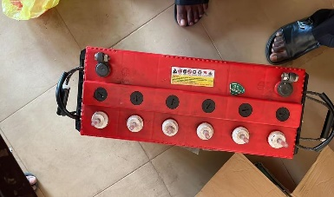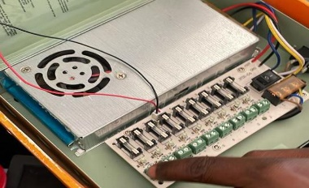

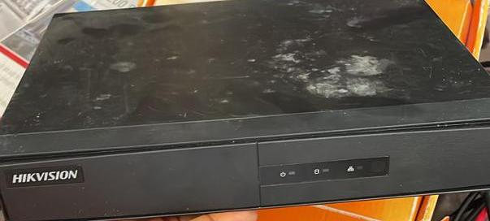

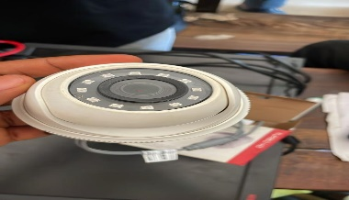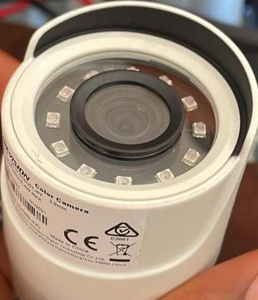
Shows camera, DVR, monitor, inverter, battery, and power flow.

3.6 Installation Location

The complete system was installed in Lecture Room 28 (LR28), IBAS Building, Kwara State Polytechnic, Ilorin. Camera coverage was planned to avoid blind spots and ensure comprehensive surveillance.

CHAPTER FOUR

Design Implementation and Output
4.1 Design of the System
The design of the inverter-based CCTV system is structured to provide continuous surveillance during examinations, regardless of power supply availability. The system combines analogue CCTV technology with inverter backup support to ensure real-time video monitoring, recording, and playback.
The key design elements include:
• Input (CCTV Cameras): Capturing video footage from LR28.
• Processing (DVR Unit): Receiving and storing video from cameras.
• Output (Monitor): Displaying real-time video feed.
• Power Supply: Backup power using inverter and 12V battery.
4.1.1 Implementation Steps
The installation and configuration of the CCTV system were done as follows:
Step 1: Mounting the CCTV Cameras
• Cameras were mounted at strategic angles in LR28 for full visibility.
• Fixed in ceiling corners using screws and brackets.
Step 2: Wiring and Cabling
• Coaxial cables were run from each camera to the DVR unit.
• BNC connectors were attached to both ends of each cable for video transmission.
• DC cables were also connected to power the cameras from the PSU.
Step 3: DVR Connection
• All video cables from cameras were inserted into DVR video input ports.
• The DVR was connected to a monitor using an HDMI cable for live viewing.
• A hard disk was inserted into the DVR for storage.
Step 4: Power Supply Setup
• A 12V battery was connected to an inverter.
• The inverter output was used to power the DVR, cameras, and monitor.
• A power switchboard was installed for easy control and safety.

Step 5: System Testing
• The system was tested under two conditions:
1. Power outage using inverter
• The video feed was verified to be continuous and clear in both conditions.
4.2 Output Design
The output of the system refers to what is displayed and recorded during operation. The design ensures that all connected cameras show clear, uninterrupted video both on the monitor and through the DVR.
Fig. 4.1: Live feed display on monitor inside LR 28.

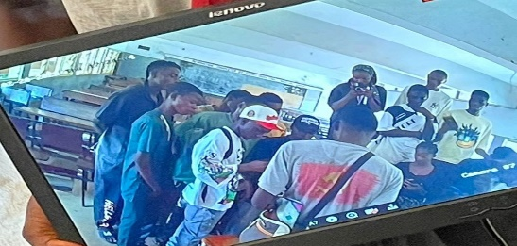

Fig. 4.2: DVR interface showing multichannel camera view

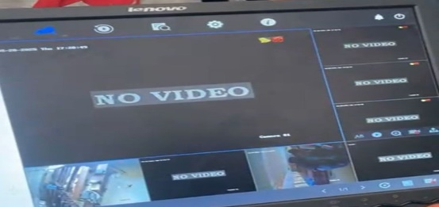

Fig. 4.3: Live feed display outside LR 28

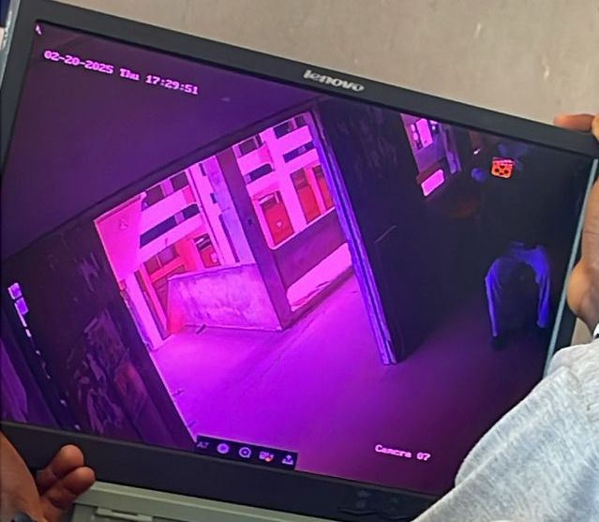

4.3 Procedure Design
The procedure for setting up the CCTV surveillance system includes the following steps:
1. Camera Installation:
• Cameras mounted on classroom walls/ceiling at front and back.
• Positioning ensured maximum coverage of student seating.
2. Cabling:
• Coaxial video cables connected from each camera to the DVR.
• DC power cables routed from PSU/inverter to cameras.
3. DVR Configuration:
• DVR set to continuous recording mode.
• Date/time set for playback tracking.
4. Power Setup:
• Inverter connected to 12V battery.
• AC output from inverter feeds DVR, monitor, and PSU.
5. Testing:
•Tested with inverter backup for continuous video feed.
4.4 System Implementation
The system was implemented in Lecture Room 28 (LR28), IBAS Building, Kwara State Polytechnic. Below is a summary of the steps taken:
i. Functional Requirements
These refer to the basic tasks the system must perform to be considered functional:
• Capture live video feed during examinations.
• Record video footage with timestamps.
• Display live video on a monitor.
• Automatically switch to inverter power when NEPA fails.
• Store video data for future review and playback.
ii. Operational Requirements
The system must operate under the following conditions:
• Continuous recording during exams.
• Must work both with and without public power supply.
• Capable of 24/7 operation without overheating.
• Quick boot-up time from power-on to live feed (less than 30 seconds).
• Minimal human interaction once started.
iii. Infrastructure Requirements
These are the physical and environmental needs for the system:
• Stable wall/ceiling mounting points for cameras.
• Classroom with electrical outlets for inverter charging.
• Sheltered and secured location for DVR, inverter, and monitor.
• Proper routing paths for coaxial and power cables to avoid damage.
• Cooling and ventilation for DVR and inverter unit.
iv. Video Requirements
To meet the examination monitoring standards, the following are required:
• Cameras must offer minimum 720p resolution.
• Wide-angle lens to cover full classroom.
• Clear visibility under fluorescent lighting.
• DVR must support multiple channels (min. 4) for scalability.
• Support for playback with date and time stamps.
v. Cost and Benefits
Benefits:
• Uninterrupted surveillance during power outages.
• Increased exam security through video evidence.
• Deterrence of malpractice with visible monitoring.
• Playback capability for investigation.

CHAPTER FIVE
SUMMARY, CONCLUSION AND RECOMMENDATION

5.1 Summary
This project focused on the design and implementation of an inverter-powered CCTV surveillance system for monitoring examination environments, specifically Lecture Room 28 (LR28) in the IBAS Building of Kwara State Polytechnic. The system ensures continuous video surveillance even during power outages, addressing a common challenge in academic settings.
Throughout the project:
• Analogue CCTV technology was integrated with a reliable inverter power supply.
• Cameras were installed to provide real-time and recorded video coverage of student activities during exams.
• A DVR unit was used for storage and monitoring, supported by a 12V 100Ah battery and a 650VA inverter.
• The system was tested under both NEPA and inverter power and was found to perform effectively with minimal disruption.
5.2 Conclusion
The implementation of this CCTV surveillance system has proven to be a cost-effective and reliable method for improving the integrity of examination supervision. By integrating an inverter, the system maintains functionality during power interruptions—ensuring uninterrupted monitoring and recording.
This solution not only improves transparency during exams but also provides video evidence in cases of malpractice. The simplicity of the design and the use of affordable hardware make it an ideal choice for classrooms, halls, and other educational environments
5.3 Recommendation
Based on the success of this project, the following recommendations are made:
1. Adopt school-wide CCTV surveillance in all examination halls to standardize exam monitoring.
2. Upgrade DVR units to support remote viewing over the internet or intranet for easier supervision.
3. Introduce solar panel backup in addition to inverter systems for extended runtime during long outages.
4. Routine maintenance should be conducted on all hardware components to prevent failure during crucial periods.
5. Install higher-resolution cameras in larger rooms to improve visual clarity.

References

Adebayo, T. O. (2020). *Understanding the persistence of examination malpractice in Nigerian education*. Lagos: Wisdom House Press.
Adedayo, R. A. (2022). Impact of inverter-powered CCTV systems on exam supervision: A case study. *Journal of Educational Security Studies, 5*(2), 101–110.
Afolayan, M., & Nwachukwu, J. (2020). Smart surveillance integration in Nigerian universities. *Nigerian Journal of Smart Educational Technologies, 8*(1), 55–66.
Aimiuwu, M. A., & Bosah, I. P. (2020). Use of CCTV for ensuring quality and internal policing in early-care settings. *JECAPE, 2*(2), 50–57.
Akintunde, B. (2016). Root causes of examination malpractice in Nigeria. *Educational Reform Journal, 4*(3), 22–30.
Ali, B. O. (2025). A systematic review on surveillance technologies amid security challenges: A case study of Nigeria. *Unpublished manuscript*.
Eaton Corporation. (2025). *UPS fundamentals handbook*. Eaton.
Elenwo, P. M., & Nwanguma, T. K. (2023). Electronic invigilation inclusion in curbing postgraduate examination malpractices in Rivers State. *British Journal of Education, Learning & Development Psychology, 6*(2), 100–113.
Eze, C. O., & Olatunji, B. A. (2021). The impact of CCTV surveillance on examination conduct in Nigerian tertiary institutions. *International Journal of Education Technology, 11*(3), 78–85.
Eziechina, A. M. (2017). Closed-Circuit Television surveillance: An antidote to examination malpractice. *American Journal of Engineering Research, 6*(12), 247–251.
Ibadin, A. (2018). Examination malpractice at the tertiary level in Nigeria: A review. *International Journal of Trend Research and Development, 5*(5), 45–52.
Ibrahim, A., & Musa, M. (2020). Addressing surveillance interruptions: The role of inverter systems in Nigerian schools. *Journal of Educational Infrastructure, 3*(2), 60–69.
Jimoh, M. O. (2017). Innovative use of CCTV for curbing examination infractions in polytechnics. *African Journal of Educational Technology, 12*(1), 30–39.
Nwachukwu, P. E. (2022). Power supply challenges in Nigerian educational surveillance systems. *Journal of African Technical Education, 4*(1), 93–101.
Ojo, D. O., Fadeyi, M. O., & Bello, I. A. (2019). Sociological perceptions of e-cheating sites and study habits in Lagos tertiary institutions. *SSRG International Journal of Humanities & Social Science, 6*(1), 1–9.
Okonkwo, E. A. (2021). Generator vs inverter for CCTV power backup: Environmental and operational evaluation. *Journal of Electrical Backup Systems in Education, 8*(1), 66–74.
Okorie, J. (2018). Advancing invigilation measures: CCTV integration in examination halls. *Nigerian Journal of Educational Security, 10*(2), 115–123.
Okpe, B. A. J., & Okanu-Igwela, J. N. B. (2018). Utilization of CCTV in teacher education in Nigeria. *Open Library of Educational Tech*.
Parmar, S. P., & Chauhan, S. H. (2024). Legal and ethical guidelines in CCTV surveillance: Addressing key issues in educational institutions. *International Journal of Law, Human Rights and Constitutional Studies, 6*(2), 14–28.
ResearchGate. (2024). Utilization of CCTV in tertiary business education during social distancing. Retrieved from https://www.researchgate.net
ResearchGate. (2025). Electronic surveillance technologies in Nigeria: A comprehensive policy review. Retrieved from https://www.researchgate.net
SEJRSD. (2022). Perceived causes and methods of curbing exam malpractice using ICT in Delta State institutions. *South East Journal of Research in Sustainable Development, 3*(2), 50–64.
TheJournalNigeria. (2021, April 19). Exam malpractice: Where does surveillance tech come in? *The Journal Nigeria*. Retrieved from https://www.thejournalnigeria.com
United Nations Department of Economic and Social Affairs. (2008). *Statistical standards and studies, Series M*. International Standardization Org.
AA Solutions Technologies. (2015). Our profile: Inverter and security systems in Nigeria [SlideShare]. Retrieved from https://www.slideshare.net

