CHAPTER ONE
1.0 INTRODUCTION
Proper financing is all important to successful Property Investment and development. Various from of findings on varying terms from diverse Investing agencies are available to the property market. The principal field where Various form of Investment finance art employed Is that of development where every loan has to be specially tailored for an Individual scheme and the Particular stages within the scheme since property development in particular involve huge capital expenditure, finance is therefore an essential Input, the nature of which is to provide capital to enable the enterprise operate commercially. In spite of the Importance of development finance in property development, There Is dearth of Information on the amount of funding that takes place. By whom, or the method used. though this is not unexpected given the general characteristics of development funding. Housing Provision has become a paramount cornerstone of the Polices of various government both at federal and State levels since independence in Nigeria. Property has continued to play a significant role in man’s evolution. It is not a coincidence that food, shelter and clothing believed to be the three essentials that sustain mankind, also have some linkage to land. food grows out of land while shelter is affixed to it, and man’s clothing is made largely from what grows out of land. Indeed, whether in ancient times or today’s modern system, land constitutes a significant index for man’s wealth, and as economic activities have assumed more sophistication over time, land has continued to play a central role in their development. There is hardly any business venture that does not require to be supported by some form of real estate: from the small business that requires real estate as offices from where its business can be organized, to the major venture that needs it for its factory.
Consequently, through some very robust and well thought out land policies comprehensively address challenges that are encounter in the real estate sector. This is not exactly the situation here in Nigeria and the result is that there is amy riad of problems in the real estate sector (Adewale, 2000). In the course of this study, the researcher will provide an overview of residential investments in Nigeria and its associated problems.
The consequences of the rapid rate of urbanization are most Visible in the rapid deterioration of urban housing resulting in urban housing, Poverty especially as there is no Proportionate increase in the number of housing stock. For most Nigerians the earning capacity is generally low and makes it practically impossible for the average Nigerian to save toward owning a house. In addition the dwindling economic fortunes in Nigeria which dims the capacity of Individuals to own a house. The economic boom Periods of the 1970s also contributed to the housing Problem in Nigeria.

1.1 BACKGROUND OF THE STUDY
Property has continued to play a significant role in man’s evolution. It is not a coincidence that food, shelter and clothing believe to be the essentials that sustain mankind also had some linkage to land. Food grows out of land. Indeed, whether In ancient times or today’s modern System, land Constitutes a Significant Index for man's wealth and as economic activities have assumed more Sophistication over time, land has continued to play a central role in there development (Lewis 1994). There is hardly any business venture that does not require to be supported by some form of property.
Property Investment Is Intrinsically connected to the economic development and well being of any nation, thereby necessitating Some Intervention by Prudent governments. Such Interventions Vary In degrees, depending on the nation. In Nigeria, individual could rarely lay claim to any part of it as owners and therefore could not alenate it without the consent of the head. Since real estate and property development in particular involve huge capital expenditure, finance is therefore an essential input, the nature of which is to provide capital to enable the enterprise operate commercially (Dawson, 2020). The cost and availability of finance for property development can influence the viability of such project. It is necessary to examine the nature of property investment in Nigeria with a view of finding solutions to the associated problems. Residential property investment is intrinsically connected to the economic development and well being of any nation, thereby necessitating some intervention by prudent governments. Such interventions vary in degrees, depending on the nation. In Nigeria, individual could rarely lay claim to any part of it as owner and therefore could not alienate it without the consent of the head.

1.2 STATEMENT OF THE PROBLEM
In recent times, research on real estate/ property investment had been on the front burner has it is the major source of housing for man. In the hierarchy of man's needs housing has been ranked second as a result of this, housing provision has become
A paramount cornerstone of the policies of various governments both at federal and state
Levels Since independence in Nigeria. The consequences of the rapid rate of urbanization are most visible in the rapid deterioration of Urban housing resulting in urban housing Poverty especially as there no Proportionate Increase In the number of housing stocks.
During the period of economic boom in the 1970s in Nigeria, there was surplus capital, the economic climate then was favorable for the development of real estate and the prospect of gain was over blown and so were the rate of development. Due to the recent drop in the prices of crude oil world wide and corruption, government has not been able to invest in real estate. Overpopulation and urbanization has led to massive increase in property development.
Financial houses readily obliged developers’ loans, as they perceived minimum risks.
Since real estate development requires huge capital outlay, there is always the need for real estate developer to source for fund. However, this study will examine the scope of real estate in Nigeria and its associated challenges with a view of making useful suggestions on the way forward for real estate in Nigeria.

1.3 AIM AND OBJECTIVES OF THE STUDY.
AIM
The aim of the Project Is to identify the problem associated with residential property Investment in Nigeria, with the goal of Providing actionable Solutions to Improve the Investment climate.
OBJECTIVES
- To identify the various property Investment In the study area.
- To identify Various Source of finance for property Investment in Nigeria
- To identify the role of government policies and regulation on Property Investment and how they can be Improved.
1.4 RESEARCH QUESTION
- What type of Property Investments are present in the Study area?
- What are the Various Source Of finance available for Property Investment in Nigeria?
- What is the Impact of government policies and regulations on property investment in Nigeria?
1.5 SIGNIFICANCE OF THE STUDY
The following are the significance of the study
  - The findings from this study will Educate the general public on the benefit of property Investment and its associate problems Which will form the basis for guidance in decision making.

  - This research will also serve as a resources base to other scholars and researchers interested in carrying Out further research In this field subsequently, If applied will go to an extent to provide new explanation to the topic.

1.6 SCOPE /LIMITATION OF THE STUDY
This study is on residential property Investment and its associated Problems In Nigeria and will cover the extent of Property Investment In Nigeria looking at the factors that has facilitated or hindered It. It will also cover the Problems with property Investment in Nigeria

1.7 DEFINITION OF TERMS
INVESTMENT: According to Royal Institution Of Chartered Suveyors (Rics)(2022), Investment Is the acquisition of Property to generate rental Income and Potential Capital appreciation
PROPERTY: According to (Johnson (2023), property refers to any tangible assets that can be owned, Which Includes land, building, and other Structure that hold economic value.
PROPERTY INVESTMENT: According to (Sarah 2023) property investment involves purchasing property to generate rental income and benefit from capital appreciation over time to generate rental Income and benefits from Capital appreciation Over time.
CAPITAL APPRECIATION: According to (micheal 2022) Capital Appreciation refers to the rise In the market Value of a property, which occur due to various factors Such as market demand, location and improvement made to the Property.
RISK MANAGEMENT: According to (Patrica 2021) Risk management Involves Understanding potential threat to property investment and implementing measures to reduce their Impact on financial return.
RENT: According to the International valuation standards council ( IVSC),(2020), Rent is the payment made by a tenant to the landlord for the use of property or land
CHAPTER TWO
2.0 LITERATURE REVIEW
According to (Dawson, 2020), property investment is the process or buying and managing property with the aim of generating income and achieving long term capital growth

TYPES OF PROPERTY INVESTMENT
RESIDENTAL PROPERTY INVESTMENT: This includes single family homes, apartments and Condominiums. Investors can rent out this property to tenants for steady income.
COMMERCIAL PROPERTY INVESTMENT: These are properties use for business Purposes Such as office buildng, rental space and warehouses. Commercial properties Often have larger lease term, Providing stable Cash flow.
INDUSTRIAL PROPERTY INVESTMENT: These are Properties Used for manufacturing / Production and distribution. This includes factories and logistic facilities.

2.0.1 IMPORTANCE OF PROPERTY INVESTMENT
Property investment contributes
Significantly to economic development by:
- Creating employment opportunities in construction, real estate, and property management.
- Serving as a hedge against inflation due to its tendency to appreciate over time.
- Generating steady cash flow through rental income.
- Contributing to infrastructure development and urban renewal.

2.0.2 FACTORS INFLUENCING PROPERTY INVESTMENT
- Several factors influence decisions in property investment:
- Economic Conditions: Inflation, interest rates, and economic stability.
- Government Policies: Regulations, taxes, and land use policies.
- Location: Proximity to amenities, transportation, and job opportunities.
- Market Trends: Demand and supply dynamics in the real estate market.
2.1 PROBLEMS OF RESIDENTIAL PROPERTY INVESTMENT IN NIGERIA
Property Investment in Nigeria presents Several problems:
- Land title and Ownership Disputes: land title and Ownership disputes In Nigeria are among the mayor Legal Challenges that Property Investors face, these are disputes Often arise due to the lack Of formal documentation, Conflicting Claims Or fraudulent activities (Oluwaseun &Olayemi,2020)

- Economic Instability: Economic instability remains a Critical Issue In Nigeria, with Significant Implications for Property Investment. Investors are often faced worth Unpredictable shifts In Inflation, exchange rates, Interest rates, and Overall economic growth, which Can adversely affect the key aspect of economic Instability and its Impact On Property Investment In Nigeria(Adeleke & Alabi, 2022)

- Security Concerns: Security Concerns are a Significant deterrent to property Investment In Nigeria. The persistent threats Of crimes like robbery, kidnapping and civil unrest in Certain regions have had a profound effect on Investor Confidence, property values and the Overall real estate market. (Adeyemi, 2020)

- Infrastructure deficiencies: Infrastructural deficiencies are a major Impediment to property Investment in Nigeria, Despite Significant Urban growth and an expanding real estate market, poor Infrastructure, Including inadequate road networks, Unreliable power Supply, and lack Of basic utilities can affect the Property sector (Umar, 2021).

- Poor Property management: Poor property management One of the major Impediment to property Investment in Nigeria. Inadequate management Practices can lead to a range of issues, Including poor maintenance, low rental yield, high vacancy rates, and declining Property Values. (Adeleke &Alabi, 2022)

2.2 RENT AN INCOME GENERATED FROM PROPERTY INVESTMENT
RENT: Is the Payment made by a tenant to a Property owner for the use of land or Property. In Nigeria, the rental market plays a crucial role in real estate Sector with residential, Commercial and industrial Properties generating Significant Income for Investors (Adeleke & Alabi, 2022)
2.3 KEY ASPECTS OF RENT IN NIGERIA
- Rental agreements and Payment Structures: Rental agreement Often requires tenants to make advance payment, typically ranging from six months to One year.
- Rent as a Source Of income for Investors: Depending On the type and location of the property, Investors can generate steady Stream of revenue through rent ( Ajayi & Olowookere, 2019)
- Rent and property law: Properties with higher rental yield are typically Seen as more Valuable.
2.4 TYPES OF RENT
i) Ground Rent: Ground rent refers to a fixed Payment made by the tenant {leaseholder) to the landowner (freeholder for the use of land, typically associated with leasehold agreement.
ii) Premium Rent: Premum rent refers to a type of rental agrenent where terent Pay an additional amount on top regular rent Often as Part Of agreement for occupying a highly desirable property (Eze& Alabi, 2020)
iii) Net rent: Rent paid by the tenant after deducting Certain expenses Such as utilities, taxes and Insurance.( Eze $ Alabi, 2020)
iv) Market Rent: Rent that a property Can achieve in the open market based on the demand and supply for rental properties In a Specific locations ( Oluwaseun &Adebola,2023)
vi) Economic Rent: The Maximum Anount a terent Is willing to pay for a property, based on its value and market Conditions:

2.5 RESIDENTIAL PROPERTY INVESTMENT
Residential property Investment refers to the process of Purchasing, Owning and managing residential properties for the Purpose of generating Income through rental yield Or Capital appreciation. The residential Property market Is One Of the most Popular form of property Investment, with Significant returns generated from both rental income and property value Increases over time.
Key characteristics of Residential Property Investment in Nigeria: High demand For affordable housing, Rental yields, and Capital appreciation. (Adeleke &Alabi,2022)

2.5.1 TYPES OF RESIDENTIAL PROPERTY INVESTMENT: The following are residential Property Investment.
- Bungalow
- Tenement building semi detached or duplex
- Maisonette
- Cottages
- Cabins.

- BUNGALOW: Is a Single - Story home, usually with a low roof and a front Porch.
- TENEMENT: Is a residential building that has multiple apartments or units, usually for different families or individuals.
- SEMI-DETACHED OR DUPLEX: Is a residential building that has two separate living units, usually side by side or one on top Of the other.
- MAISONETTE: Is a residential building that is two-storey apartments that has Separate entrances.
- COTTAGES: Is a Small, Usually one or two-storey buildings that Is located in rural areas or Country side.
- CABIN: IS a Small, Simple houses that is Usually located in rural areas or natural areas, like forest or by river side.
2.6 FINANCE
In Order to keep an estate operation at maximum Profitability, It is necessary to ensure that whatever Capital may be required for Improvement and development is available when needed of course, the Property owner do not always have sufficient and When they have, they do not always wish to have the trouble and risk that property entails
2. 6.1 SOURCES OF FINANCE
One of the traditional ways of Securing finance is by bearing. The essence of the building lease Is that the leases Provides the capital and accept the risk of development providing a fixed return to the landlord with the prospect of distant reversion.
Other Sources Of finance are opened to Property owner and the One he select will depend upon the amount Of Capital required
The main Sources are:
- Internal funds: These are the Property own resources either saved from Income or accrued from capital transaction such as taking of premiums.
- Consociate Capital: This is Similar to Internal finance In the sense that the funds are In the Same ownership. It is most usual in respect of agricultural property where owner invest capital.
- Short term funds (Bank and trade Craft): Temporary finance way Is Often Needed In Propety management to Cover expenses Pending the receipt of income
- Long term funds (loans and share Capital) Permanent finance for Property Investment may be required for acquisition as well as development.

2.7 SUMMARY OF LITERATURE REVIEW
S/N | AUTHOR/STUDY | METHODOLOGY | OBJECTIVE OF STUDY | MAJOR FINDING.
1. | Oluwaseun & Adebola, (2021) | Quantitative and quantitative approach | To identify the key determinants of market rent in Nigeria | Rent control and regulations
2. | Eze & Alabi, (2020) | Descriptive and analytical research | To explore the demand and supply dynamic in Nigerian rental market | Influence of government policies.
3. | Ajayi & olowoobere, (2019) | Quantitative approach | To examine the impact of land dispute on property investment in Nigeria. | Impact of land dispute on property investment
4. | Dawson, (2020) | Quantitative analysis | To provide a strategic framework on real estate investment | Strategic approach on real estate investment
5. | Umar S.H. (2021) | Quantitative approach | Investing the impact of infrastructure on property values | Explore the relationship between infrastructure development and property investment
6. | Adeleke & Alabi, (2020) | Quantitative approach | Investment the impact of inflation on property price in Nigeria. | Explores the relationship between inflation and property investment
7. | Oluwasuen & Olayemi, (2020) | Quantitative research design | Problem affecting land ownership and real estate investment in Nigeria | Explores the relationship between inflation and property investment

CHARTER THREE
3.0 RESEARCH METHODOLOGY
3. 1 INTRODUCTION
This Chapter examines the research design, the target population, Sample frame, Sampling size, Sampling techniques. I also addresses the Strategy of Investigation of Issues relating to the Study In Order to attain the Stated Objectives.
3.2 RESEARCH DESIGN
This research design outlines how the study will be Conducted. for these Research, a descriptive research design will be employed Descriptive research is Ideal for understanding and documenting the problem associated with Property Investment In my study area, my Study area Is Osogbo, Osun state:
The research will Combine both qualitative and quantitative Methods ensuring a holistic View of the Issues.
3.3 TARGET POPULATION
The target Population refers to the group of people or entities that the research Is Intended to study, two groups were identified for Investigation, these are tenant & buyers and Estate Surveyor And Valuers in Osogbo, Osun state.
3.4 SAMPLE FRAME
The sample frame refers to the list or data base from which the sample will be Selected there are more than 20 houses and more than 15 estate Surveyor and values firms in Osogbo , Osun State.
3.5 SAMPLE SIZE
Sample Size is the number Of Individual that are Selected for Investigation In a research
Study, sample size determination is an Important aspect to examine , due to difficulty In studying the whole population, the Sample size Is 30-50 respondents.
3.6 SAMPLING TECHNIQUES
Most statically data could be obtained by Sampling rather than by examing the whole population, the best course of action is a sample, if such a sample is adequate, conclusion can be drain from it and generated it for the whole Population In the area.
Sampling techniques to be used:
Stratified random Sampling: This techniques will be used for property Investors and proper real estate agent.
Purposive sampling: This will be used to Select government officials and tenants Or buyers to have direct experience with residential Property Investment In Oshogbo
Convenience Sampling: This will be used for real estate agents and Investors who are easily accessible through real estate association or local Property Offices.
3.7 SOURCES OF DATA
There are two sources Of data Collection which Includes
- Primary source of data
- Secondary Source of data
3. 7.1 PRIMARY SOURCE OF DATA
These are regarded as fresh data being collected by the Investigators themselves or by someone on their behalf for the purpose of solving an immediate problems
Example of Primary Source Of data are:
- Personal Interview and
- Questionnaire
Personal interview: A personal interview is a method of data collection where one person (the interviewer) asks questions directly to another person (the interviewee) in a face-to-face, phone, or video call setting. It is typically used in qualitative research, job recruitment, and investigative contexts.
Questionnaire: A questionnaire is a research instrument consisting of a series of questions or prompts used to gather information from respondents. It is often used in quantitative research but can also be adapted for qualitative purposes.
3.7.2 SECONDARY SOURCE OF DATA
These are data Collected and earlier used In A Study by Someone, they are data already In existence. Source of data Used in these study include Journals, textbooks , and Publications of related literature to the study
3.8 METHOD OF GATHERING DATA
The analysis is base on the Questionnaire that were retrieved , these are Instrument used to generate gather Information that Could be relevant to the research word.
Example of these are: Questionnaire and Oral interview
3. 8:1 QUESTIONNAIRE
This is the act of designing questions to gather Information Of data to make research word a successful one. The Questionnaire was then distributed to the resident (Landlord and tenants) these questionnaire Were designed to examine the Problem Of residential property Investment.
3.8.2 ORAL INTERVIEW
Oral Interview were used as supplementary to the questionnaire, It is a way of making further Investigation and make avenue for researcher for follow up answers given by respondents. This method Involves when you directly speak to ask a questions, rather than Written responses, Its a face-to-face or virtual conversation where the Interviewer ask questions, and the Interviewee responds Verbally
3.9 METHOD OF DATA ANALYSIS
Data were administered through physical distribution and method of questionnaire, In Person interviews, and field visit, questionnaire were delivered to respondents during scheduled Visit, While Interview and survey were Conducted on site to ensure accuracy and Completeness.
3.10 SUMMARY OF DATA ANALYSIS TECHNIQUES
S/N | OBJECTIVE OF THE STUDY | DATA REQUREMENT | RESEARCH DESIGN | METHOD OF DATA MEASUREMENT | METHOD OF DATA ANALYSIS
1. | To elevate the profile for property investors | Property price, Nigeria economic, growth rate rule governing land ownership | Quantitative survey | Normal and ordinal scale | Frequency distribution Chi-square test
2 | To elevate risks associated with property investment | Expert opinions market data | Quantitative survey | Normal and ordinal scale | Frequency distribution Chi-square test
3. | To determine relationship between location and property value | Property locations data and market value | Quantitative survey | Normal and ordinal scale | Frequency distribution Chi-square test.

CHAPTER FOUR
4.0 DATA PRESENTATION, ANALYSIS AND INTERPRETATION
This chapter is devoted to the presentation, analysis and interpretation of the data gathered in the course of this study. The data are based on the number of copies of the questionnaire completed and returned by the respondents. The data are presented in tables and the analysis is done using t-Test. The chi-square test was used in the validation of the hypothesis.
4.1 Data Presentation and Analysis
The data presented below were gathered during field work:
Bio data of respondents

4.1.1 Table 1 gender of respondents
 | Response | Frequency | Percent | Valid Percent | Cumulative Percent
 | Male | 30 | 60.0 | 60.0 | 60.0
 | Female | 20 | 40.0 | 40.0 | 100.0
 | Total | 50 | 100.0 | 100.0
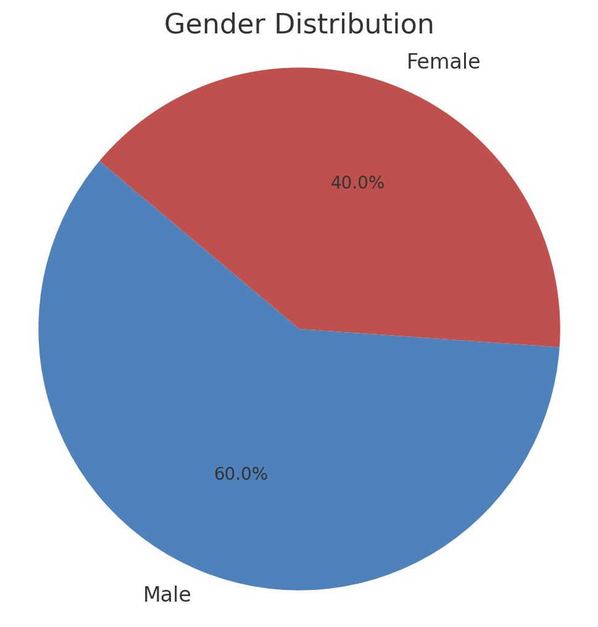
Source: Field Survey, 2025.

Table1 above shows the gender distribution of the respondents used for this study.

Out of the total number of 50 respondents, 30respondents which represent 60.0percent of the population are male.
20 which represent 40.0 percent of the population are female.

4.1.2 Table 2 age range of respondents
Response |  | Frequency | Percent | Valid Percent | Cumulative Percent
 | 10-15 years | 5 | 10.0 | 10.0 | 10.0
 | 16-20 years | 5 | 10.0 | 10.0 | 20.0
 | 21-30 years | 10 | 20.0 | 20.0 | 40.0
 | 31-40 years | 15 | 30.0 | 30.0 | 70.0
 | 41-50 years | 13 | 26.0 | 26.0 | 96.0
 | above 50 years | 2 | 4.0 | 4.0 | 100.0
 | Total | 50 | 100.0 | 100.0
Source: Field Survey, 2025.
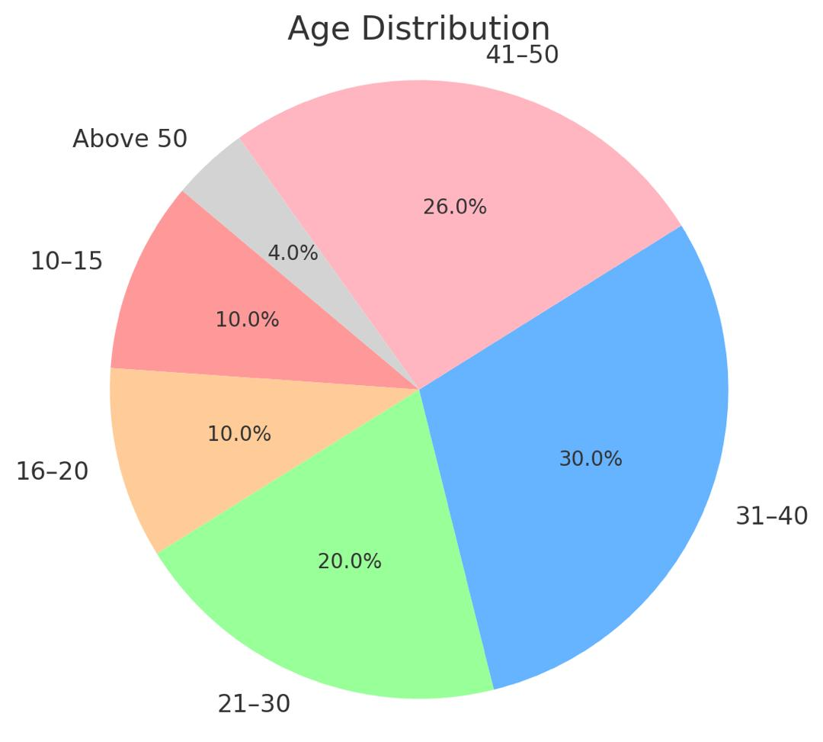

Table 2 above shows the age grade of the respondents used for this study.

5 respondents which represent 10.0percent of the population are between 10-15years.
5respondents which represent 10.0percent of the population are between 16-20years.
10respondents which represent 20.0percent of the population are between 21-30years
15respondents which represent 30.0percent of the population are between 31-40years.
13respondents which represent 26.0percent of the population are between 41-50years.
2respondents which represent 4.0percent of the population are above 50 years.
4.1.3 Table 3 educational background of respondents
 | Response | Frequency | Percent | Valid Percent | Cumulative Percent
Valid | WASSCE/SSCE | 5 | 10.0 | 10.0 | 10.0
Valid | OND/NCE/HND/BSC | 32 | 64.0 | 64.0 | 74.0
Valid | MSC/PGD/PHD | 10 | 20.0 | 20.0 | 94.0
Valid | OTHERS | 3 | 6.0 | 6.0 | 100.0
Valid | Total | 50 | 100.0 | 100.0
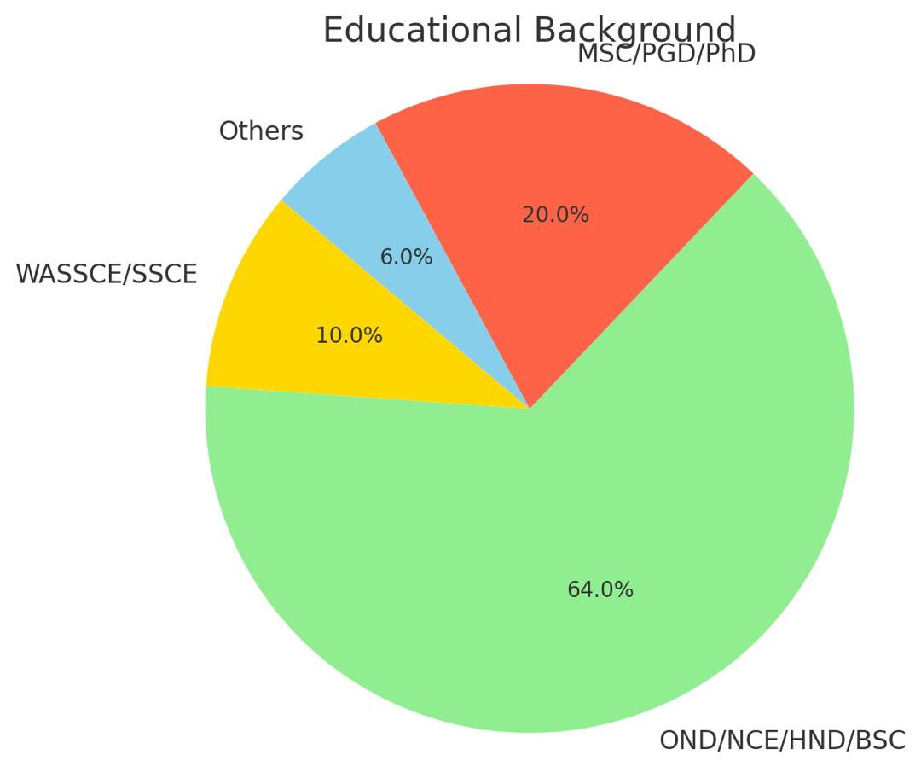
Source: Field Survey, 2025.

Table 3 above shows the educational background of the respondents used for this study.

5 respondents which represent 10.0 percent of the population are WASSCE/SSCE holders.
There were no WASSCE/NECO/GCE holders.
32 which represent 64.0 percent of the population are OND/NCE/HND/BSC holders.
10 which represent 20.0 percent of the population are MSC/PGD/PHD holders
3 which represent 6 percent of the population had other type of certificate.

4.1.4 Table 4 Marital Status of Respondents
Response |  | Frequency | Percent | Valid Percent | Cumulative Percent
 | Single | 20 | 40.0 | 40.0 | 40.0
 | married | 26 | 52.0 | 52.0 | 92.0
 | divorced | 3 | 6.0 | 6.0 | 98.0
 | widowed | 1 | 2.0 | 2.0 | 100.0
 | Total | 50 | 100.0 | 100.0
Source: Field Survey, 2025.
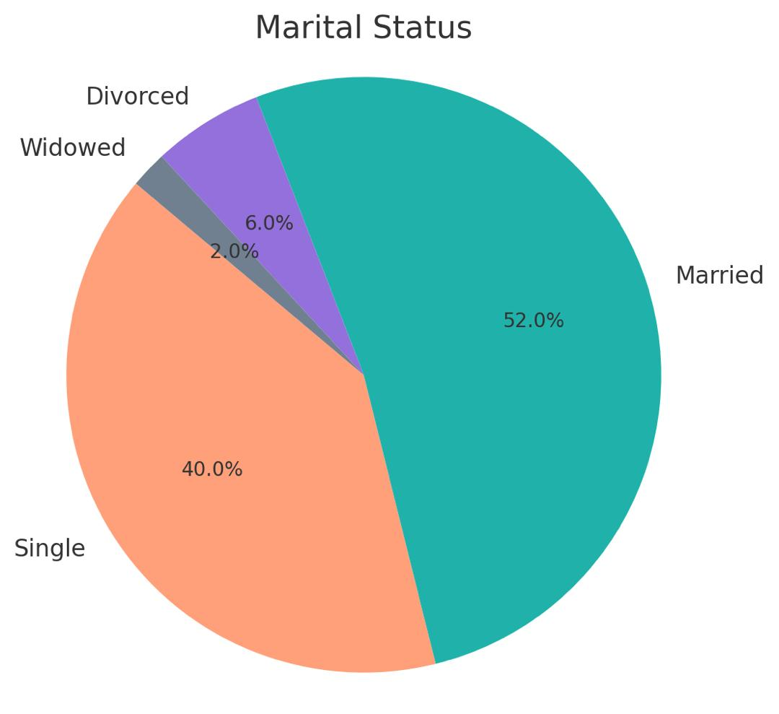

Table 4 above shows the marital status of the respondents used for this study.

20 respondents which represent 40 percent of the population are single.
26 respondents which represent 52.0percent of the population are married.
3 respondents which represent 6.0percent of the population are divorced.
3 respondents which represent 6.0percent of the population are divorced.
1 respondent which represent 2.0percent of the population is widowed.

TABLES BASED ON RESEARCH QUESTIONS
4.1.5 Table 5 RESIDENTIAL PROPERTY INVESTMENT IS VERY LUCRATIVE IN NIGERIA
 | Response | Frequency | Percent | Valid Percent | Cumulative Percent
 | strongly agree | 21 | 42.0 | 42.0 | 42.0
 | agree | 10 | 20.0 | 20.0 | 62.0
 | strongly disagree | 19 | 38.0 | 38.0 | 100.0
 | Total | 50 | 100.0 | 100.0
Source: Field Survey, 2025.

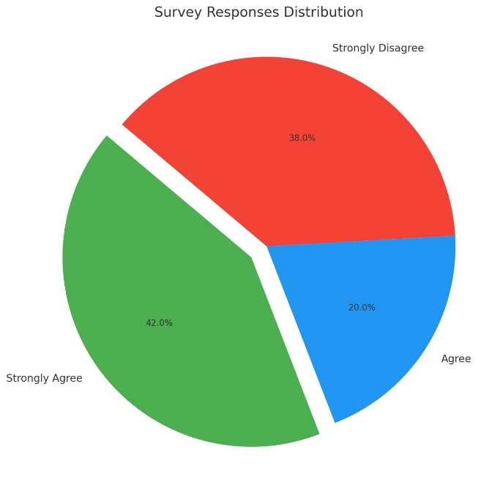

Table 5 above shows the responses of respondents that residential property investments is very lucrative in Nigeria.
21 respondents representing 42.0percent strongly agreed that residential property investments is very lucrative in Nigeria.10 respondents representing 20.0percent agreed that residential property investments is very lucrative in Nigeria while the remaining 19 respondents representing 38.0percent strongly disagreed that residential property investments is very lucrative in Nigeria.

4.1.6 Table 6 THERE ARE PROBLEM TO RESIDENTIAL PROPERTY INVESTMENT IN NIGERIA
 | Response | Frequency | Percent | Valid Percent | Cumulative Percent
 | strongly agree | 25 | 50.0 | 50.0 | 50.0
 | Agree | 6 | 12.0 | 12.0 | 62.0
 | undecided | 9 | 18.0 | 18.0 | 80.0
 | disagree | 5 | 10.0 | 10.0 | 90.0
 | strongly disagree | 5 | 10.0 | 10.0 | 100.0
 | Total | 50 | 100.0 | 100.0
Source: Field Survey, 2025.
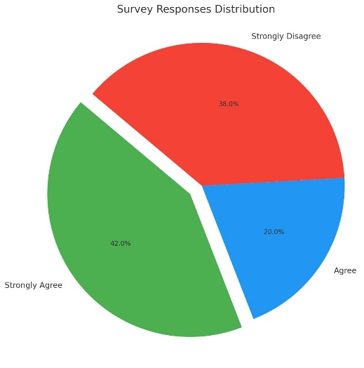

Table 6 above shows the responses of respondents that there are problem to residential property investments in Nigeria.
21 respondents representing 42.0percent strongly agreed that there are problems to residential property investments in Nigeria.6 respondents representing 12.0percent agreed that there are challenges to residential property investments in Nigeria.9 respondents representing 18.0percent were undecided.5 respondents representing 10.0percent disagreed that there are challenges to residential property investments in Nigeria while the remaining 5 respondents representing 10.0percent strongly disagreed that there are problem to residential property investments in Nigeria.
4.1.7 Table 7 RESIDENTIAL PROPERTY INVESTMENTS IS RISKY IN NIGERIA
Response |  | Frequency | Percent | Valid Percent | Cumulative Percent
 | strongly agree | 19 | 38.0 | 38.0 | 38.0
 | Agree | 24 | 48.0 | 48.0 | 86.0
 | undecided | 2 | 4.0 | 4.0 | 90.0
 | disagree | 5 | 10.0 | 10.0 | 100.0
 | Total | 50 | 100.0 | 100.0
Source: Field Survey, 2025.
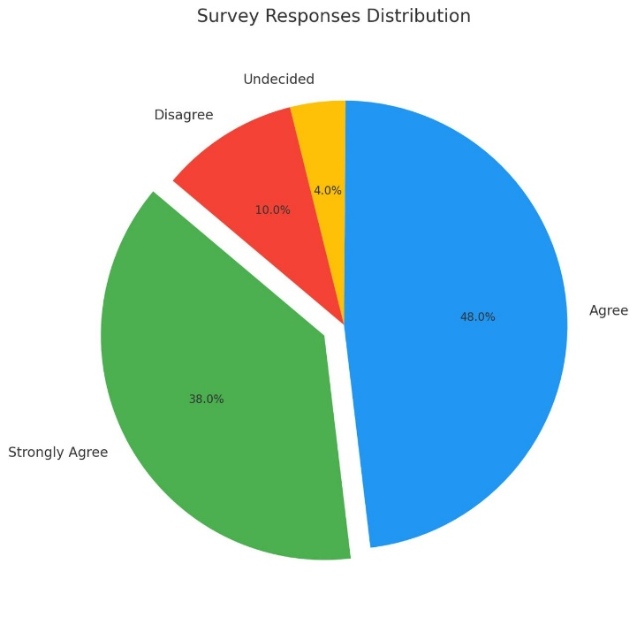

Table 7 above shows the responses of respondents that residential property investment is risky in Nigeria.
19 respondents representing 38.0percent strongly agreed that residential property investment is risky in Nigeria.24 respondents representing 48.0percent agreed that residential property investments is risky in Nigeria.2 respondents representing 4.0percent were undecided while the remaining 5 respondents representing 10.0percent disagreed that residential property investments is risky in Nigeria.
4.1.8 Table 8 RESIDENTIAL PROPERTY INVESTMENT CAN BE MADE MORE ATTRACTIVE TO INVESTORS
Response |  | Frequency | Percent | Valid Percent | Cumulative Percent
 | Strongly agree | 35 | 70.0 | 70.0 | 70.0
 | Agree | 10 | 20.0 | 20.0 | 90.0
 | undecided | 3 | 6.0 | 6.0 | 96.0
 | disagree | 2 | 4.0 | 4.0 | 100.0
 | Total | 50 | 100.0 | 100.0
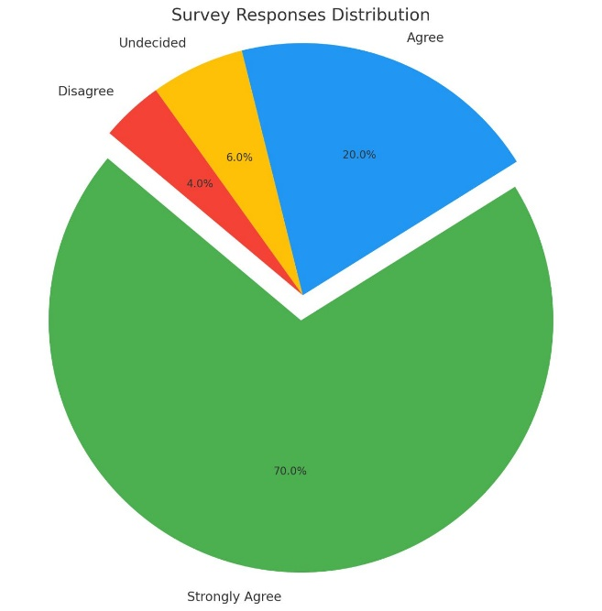
Source: Field Survey, 2025.

Table 8 above shows the responses of respondents that residential property investments can be made more attractive to investors.
35 respondents representing 70.0percent strongly agreed that residential property investments can be made more attractive to investors.10 respondents representing 20.0percent agreed that real estate investment can be made more attractive to investors.3 respondents representing 6.0percent were undecided while the remaining 2 respondents representing 4.0percent disagreed that residential property investments can be made more attractive to investors.

CHAPTER FIVE
5.0 INTRODUCTION
This chapter deals with the summary of findings, conclusion and recommendation to address the identified problems in residential property investment in Nigeria
5.1 SUMMARY OF FINDINGS
This research work revealed the following findings=
- Residential property investment in Nigeria is faced with several problems ranging from land acquisition difficulties to financial constraints.
- The process of obtaining land titles and certificate of occupant is slow expensive, and often fraught with corruption and uncertainty.
- That access to mortgage facilities and long-term housing finance remains limited, with high interest rates discouraging many potential investors.
- That the poor state of infrastructure such as bad roads , electuary, supply, poor drainage system and lace of water affect the value and demand of residential property.
- That there is limited availability of accurate property market data malign investment planning and valuation more difficult.
- The government policies and regulation, such as land use act and bureaucratic building approval processes, create bottlenecks for investors.
- Poor maintenance culture and lace of awareness among tenants also contribute to the decline in property value over time.
- Security concerns, especially in urban areas reduce investor confidence and increase the cost of maintenance in residential property,
5.2 CONCLUSION
This project dissertation has assessed the major problems associated with residential property in Nigeria, A case study of Osogbo, osun state Nigeria.
It was discovered that although there is a high demand for housing due to rapid urbanization and population growth, many problems prevents the smooth flow of investment in to the sector.
From the findings it is clear that both public and private sector stakeholders need to work together to overcome these problems. Factors such as poor infrastructure, legal and regulatory hurdles, financial limitations and market in efficiency are hindering the growth and profitability of residential property investment. However, the situation can de improved if appropriate reforms are made. The suggestions in the next section, if properly implemented, could help improve the property investment climate in Nigeria and encourage more participation in residential property development.
  - RECOMMENDATION
Based on the finding of this research work the following recommendations are proposes.
- Land Administration Processes: should be reformed to make land registration and total acquisition more transparent and efficient
- Infrastructure Development: such as roads, power supply and drainage system should be reviewed and amended to make investors friendly.
- Security measures: should be improved in residential areas to protect property and reduce the cost of risk for investors.
- The Government and Private sectors: should collaborate to establish public-private partnerships (ppps)aimed at proving affordable housing and improving the overall investment climate.
- Awareness and Education: should be provided for both tenants and landlords on the importance of property maintenance and preservation o f property value.
- Digital Technology: should be adopted in land registration, property listing and real estate data management to enhance transparency and access to reliable market information.
- Property Investors: should be encouraged to conduct feasibility studies and seek professional advice before committing to avoid losses and ensure profitable investment.

REFERENCES
Adekunle, A., & Alabi, M. (2022). Real Estate Investment Challenges in Nigeria. Journal of African Urban Studies, 14(2), 89–104.
Adeyemi, O. (2020). The Security Risks of Property Investment in Nigeria. Nigerian Journal of Real Estate and Property Management, 8(1), 55–68.
Adeleke, M., & Alabi, M. (2022). Urban Housing Crisis and Investment Risk in Nigeria: A Case of Lagos and Osun States. International Journal of Housing Policy, 11(3), 120–139.
Ajayi, K., & Olowookere, F. (2019). The Role of Rental Income in Property Investment Viability in Nigeria. African Real Estate Review, 7(2), 34–47.
Adewale, T. (2000). Land Policy and Real Estate Development in Nigeria: Issues and Challenges. Nigerian Journal of Housing and Urban Development, 5(1), 17–30.
Dawson, R. (2020). Modern Approaches to Property Investment. London: Real Asset Publications.
Eze, J., & Alabi, M. (2020). Types and Trends of Rent in Nigerian Urban Areas. Journal of Property Law and Management, 6(2), 77–92.
International Valuation Standards Council (IVSC). (2020). International Valuation Standards. Retrieved from www.ivsc.org
Johnson, T. (2023). Understanding Property Assets and Economic Value. Property Economics Review, 9(4), 112–127.
Lewis, J. (2023). Land and Economic Evolution: Historical Insights. Oxford: Land Use Press.
Michael, S. (2022). Capital Appreciation in Emerging Real Estate Markets: Nigeria’s Case Study. Property Value Journal, 12(1), 30–42.
Oluwaseun, A., & Olayemi, T. (2020). Legal Challenges in Land Ownership and Property Investment in Nigeria. Nigerian Journal of Property Law, 10(3), 143–159.
Oluwaseun, A., & Adebola, B. (2023). Market Rent Dynamics and Economic Valuation in Nigeria. Urban Property Journal, 11(2), 90–102.
Patricia, L. (2021). Risk Management Strategies in Real Estate Investment. Global Journal of Risk and Finance, 18(2), 65–78.
Ratliff, R. (2023). The Economics of Property Development. New York: Urban Investment Publishers.
Royal Institution of Chartered Surveyors (RICS). (2022). Glossary of Property Investment Terms. Retrieved from www.rics.org
Sarah, H. (2023). Fundamentals of Property Investment. Real Estate Insight, 10(3), 50–65.

QUESTIONNAIRE
INSTRUCTION: Please endeavor to complete the questionnaire by ticking the correct answer(s) from the options or supply the information required where necessary.
SECTION A: personal information/Data
- Gender
- Male
- Female
- Age range
- 10-15
- 16-20
- 21-30
- 41-50
- Above 50
- Educational qualification
- WASSCE/GCE/NECO
- OND/HND/BSC/NCE
- MSC/PGD/PHD
- Others
- Marital status
- Single
- Married
- Divorced
- Widow
SECTION B: Questions on the problem associated with residential property investment in Nigeria
- Residential property investment is very lucrative in Nigeria.
- Strongly agreed
- Agreed
- undecided
- disagreed
- strongly disagreed
- There are problem to residential property investment in Nigeria.
- Strongly agreed
- Agreed
- undecided
- disagreed
- strongly disagreed

- Residential property investment is risky in Nigeria.
- Strongly agreed
- Agreed
- undecided
- disagreed
- strongly disagreed
- Briefly identify the solution to the problems of residential property investment in Nigeria.
_ _ _ _ _ _ _ _ _ _ _ _ _ _ _ _ _ _ _ _ _ _ _ _ _ _ _ _ _ _ _ _ _ _ _ _ _ _ _ _ _ _ _ _
_ _ _ _ _ _ _ _ _ ___ __ _ _ _ _ _ _ _ _ _ _ _ _ _ _ _ _ __ _ _ _ _ _ _ _ _ _ _ _ _ _
_ _ _ _ _ _ _ _ __ _ _ _ _ _ _ _ _ _ _ _ _ _ _ _ _ _ _ _ _ _ _ _ _ _ _ _ _ _ _ _ _ _ _
- Residential property investment can be made more attractive to investors.
- Strongly agreed
- Agreed
- undecided
- disagreed
- strongly disagreed

