CADASTRAL LAYOUT SURVEY OF PART OF DE-GOLDEN SISTER RESIDENTIAL LAYOUT
AT ALUFA AGUNBIADE VILLAGE, SENTU COMMUNITY, OFF OKE-OSE - LAJIKI ROAD, ILORIN EAST LOCAL GOVERNMENT AREA, KWARA STATE, NIGERIA.

PRESENTED BY

SULYMAN MUINAT BUKOLA
ND/23/SGI/FT/0008

SUBMITTED TO THE DEPARTMENT OF SURVEYING AND GEOINFORMATICS, KWARA STATE POLYTECHNIC, ILORIN, KWARA STATE.

IN PARTIAL FULFILMENT OF THE REQUIREMENTS FOR THE
AWARD OF NATIONAL DIPLOMA IN SURVEYING AND GEOINFORMATICS.

JUNE, 2025.

CERTIFICATE
I hereby certify that all the information given in this project was obtain as a result of the observation and measurements, carried out by me in accordance with survey rules, regulation and departmental instructions.

--------------------------- ---------------------------
SULYMAN MUINAT BUKOLA DATE AND SIGNATURE
ND/23/SGI/FT/0008

CERTIFICATION
This is to certify that SULYMAN MUINAT BUKOLA Matric no: ND/23/SGI/FT/0008 has satisfactorily carried out his project under my instructions and direct supervision. I hereby declare that he has conducted himself with diligence, honesty and sobriety on the project.

………………………….. ……..……………………………
Surv. I. I. Abimbola Sign and Date
(Project Supervisor)
.................................... .......................................
Surv. Babatunde kabir Date and Sign
(Project Supervisor)

....................................... ........................................
Surv. R. S. Awoleye Sign and Date
Project Coordinator

………………………….. ……………………………………
Surv. I. I. Abimbola Sign and Date
Head of the Department

………………………….. ……………………………………
External Examiner Sign and Date

DEDICATION
I dedicate this project report to the most beloved creator, the Almighty Allah.

ACKNOWLEDEMENT
I appreciate the God almighty for the knowledge, endurance, safety, and courage He bestowed upon me throughout my NATIONAL DIPLOMA PROGRAM (ND). My profound gratitude also goes to my mom (my support system) and my siblings (Especially IFEOLUWA )for their unwavering supports in terms of prayers and providing for me.
I am immensely thankful to my project supervisor, Surv.Babatude Kabir, for his professional guidance, scholarly advice, and consistent encouragement, which were instrumental to the successful execution of this work.
I also acknowledge the educative and moral support of my lecturers. My gratitude also goes to my partner (Favor) for His unceasing support and words of encouragements.
My heart also melts at the care and support of my friends and course mate most especially, Oreoluwa and Blessing.
Finally, I would like to appreciate the entire department of Surveying & Geo-Informatics lecturers. HOD Surv. I.I Abimbola, Surv. Banji, Surv. Babatunde Kabir Surv. Felix Diran, Surv. Kazeem, Mr.Benard, Surv. R.S Awoleye and others for making studying so easy for me thanks all.

ABSTRACT
This project is the layout survey of the property of De-golden sisters at Sentu village, off Oke-ose to Lajiki road, Ilorin East Local Government Area, Kwara State. The components of the project include: Perimeter survey, setting out of points, beaconing of demarcated points, and coordination of 56 plots of land and production of layout plan at a suitable scale. The survey was tied to three existing control within the vicinity and the survey data was computed and AutoCAD Software was used for plotting of the final layout plan. Kolida (Model: SET 02) Total Station with its accessories were used for the setting out and final survey exercises. A total number of 80 points were monumented and surveyed. The total area covered is 2.7383 hectares. The average area of the plots is within 960Sqm. Being a third order job, an accuracy of 1:20,000 was achieved.

TABLE OF CONTENTS
- Title page
- Certificate
- Certification
- Dedication
- Acknowledgement
- Abstract
- Table of contents
Pages
CHAPTER ONE
1.0. INTRODUCTION 1-2
1.1. STATEMENTS OF PROBLEM 3
1.2. AIMS OF THE PROJECT 3
1.3. OBJECTIVES OF THE PROJECT 4
1.4. SCOPE OF THE PROJECT 4
1.5. SPECIFICATION OF THE PROJECT 4-5
1.6. PROJECT LOCATION 6
1.7. PROJECT LOCATION 7

CHAPTER TWO
2.0. LITERATURE REVIEW 8-11

CHAPTER THREE
3.0 PROJECT PLANNING 12
3.1 RECONNAISANCE 12
3.2 FIELD RECONNAISANCE (RECCE) 12
3.3 OFFICE PLANNING 12
3.4 INSTRUMENT TEST 13
3.5 TEST OF TOTAL STATION COLLIMINATION TEST 13
3.5.1 PROCEDURE FOR COLLIMINATION AND VERTICAL INDEX ADJUSTMENT 14
3.5.2 IN-SITU CHECK OF CONTROLS USED 15
3.6 SCHEDULE OF FIELD WORK 16
3.7 DATA ACQUISITION 16
3.8 SETTING OUT OF POINT 17
3.9 MONUMENTATION 18
3.10 TRAVERSING 19

CHAPTER FOUR
4.0 DATA DOWNLOADING AND PROCESSING 20
4.1 DATA PROCESSING & ANALYSIS 20
4.2 PLOTIND AND PLAN PRODUCTION 21
4.3 PROJECT STATISTICS 21
4.4 COMPUTATIONS 21-22
4.5 DISCUSSION OF RESULT 23
4.5.1 PERIMETER SURVEY PLAN 24
4.5.2 DISGN PLAN 25
4.5.3 LAYOUT PLAN 26

CHAPTER FIVE
5.0 SUMMARY, CONCLUSION, PROBLEMS ENCOUNTERED AND RECOMMENDATION 27
5.1 SUMMARY 27
5.2 CONCLUSION 27
5.3 PROBLEMS ENCOUNTERED 28
5.4 RECOMMENDATION 28
REFERENCE 29
RAW DATA 30-31

CHAPTER ONE
1.0. INTRODUCTION
A cadastral layout survey is a type of survey that determines the boundaries, layout, and parcel identification of land areas. It is an essential component of land administration, property registration, and urban planning. Cadastral layout surveys provide accurate and reliable data on land parcels, which is crucial for resolving boundary disputes, facilitating property transactions, and supporting economic development. Cadastral layout surveys play a crucial role in land management, urban planning, and property ownership. These surveys involve the precise measurement and mapping of land parcels to establish boundaries, ownership, and land use. The information derived from cadastral surveys is essential for legal documentation, taxation, land development, and environmental management.
The term “cadastral” refers to a comprehensive land information system that encompasses details related to land tenure, land-use patterns, and the rights and obligations of landowners. Typically, these surveys form the foundation for creating and updating cadastral maps, which are vital for governmental and administrative purposes. Cadastral layout surveys require advanced surveying techniques and equipment, such as Global Positioning System (GPS) technology, electronic theodolites, and Geographic Information Systems (GIS). Surveyors must have a profound understanding of legal regulations, surveying principles, and techniques to ensure accuracy and compliance with local land laws. These surveys are particularly important in rapidly urbanizing areas, where land use is constantly changing. They support effective land administration by providing accurate data for zoning, property taxes, and infrastructure development. Moreover, they help in resolving land disputes, ensuring fair land transactions, and promoting sustainable land management practices.
cadastral layout survey is a vital process that lays the groundwork for effective land governance, ensuring that land use aligns with legal, environmental, and societal objectives. The significance of these surveys is underscored by their impact on economic development, community planning, and the protection of land rights. The importance of cadastral layout surveys cannot be overstated, as they not only dictate land ownership and boundaries but also have far-reaching implications for socio-economic development and environmental stewardship. The role of cadastral surveys has become even more pronounced with the ongoing global challenges of urbanization, climate change, and population growth. Here, we delve deeper into various facets that outline the critical nature of these surveys.
Cadastral layout surveys are indispensable in today’s complex landscape of land management. They are foundational to property rights, urban planning, economic development, and environmental protection. The integration of advanced technology and adherence to legal standards ensures their relevance and accuracy. As society continues to grapple with challenges such as urbanization, environmental degradation, and resource management, the significance of cadastral surveys will undoubtedly grow, reinforcing their role as pillars of sustainable development and effective governance. In essence, they represent not only land lines but also the intersection of legal rights, economic opportunity, and environmental responsibility..
cadastral surveys have roots that trace back to ancient civilizations, where they were used for resource allocation, taxation, and legal ownership of land. The Romans, for example, developed extensive land surveying techniques to organize and manage their empire’s territories. Over time, various cultures have refined and adapted these practices, leading to the modern cadastral systems we see today. cadastral layout surveys are integral to effective land management and property rights administration. As nations face increasing pressures from urbanization, environmental challenges, and disputes over land ownership, the role of cadastral surveys will remain vital for fostering sustainable development, promoting economic stability, and ensuring social equity. The continued evolution of surveying technologies and practices will likely enhance the effectiveness and applicability of cadastral surveys in addressing contemporary land management challenges.
1.1 STATEMENT OF PROBLEM
Inaccurate or incomplete data can lead to boundary disputes, property ownership conflicts and difficulties in land transactions. In many cases, the lack of reliable cadastral information can hinder economic development, leading to social unrest and create challenges for land administration authorities. Therefore, conducting a thorough cadastral survey is essential to gather accurate data and mitigate these risks land dispute among the land owner and other unrest issue in a smart community. This call for the layout of landed property said to belong to the De-Golden sister at Sentu Village.

1.2 AIM OF THE PROJECT
The aim of this project is to carry out Cadastral Layout Survey of plots of land belongs to De-Golden Sister at Sentu Village to accurate delineate the plots and produced a reliable data on land parcels within the designated area, This data will serve as a foundation for land administration, property registration, and urban planning.
1.3 OBJECTIVES OF THE PROJECT
The objectives of this project are:
- To determine the boundaries and ownership of land parcel within the designated area (perimeter plan).
- To provide accurate data on property values and land use (computation sheet).
- To produce area computation sheet.
- To produce standard layout plan
  - SCOPES OF THE PROJECT
- Planning
- Reconnaissance
- Monumentation
- Perimeter Travers
- Layout Design
- Setting-out and Traversing
- Data Processing
- Information Presentation

1.5 PROJECT SPECIFICATIONS
Project is based on the procedures used to execute a project in terms of how the measurements are taken. Specifications mean the requirements necessary to be met when carrying out the survey job of any order (cadastral layout survey). The following specifications are followed:
- Establishment​ of ​traverse​ points​ with​ property​ beacons ( monumentations ).
- Traverse commenced on three existing control points and closed on the same set of controls to check if the traverse is precise and accurate. The accuracy of the control points was found undisturbed before using them for orientation.
- The ​sub-division ​of ​the project ​area​ was ​done ​with ​the dimension of 15.25m x 30.50m for each plots and turning right angle.
- The residential plots should be regular and standard plots 50ft by 100ft.
- Property beacons should be emplaced at all plots.
- Each plot must have access road.
- The accuracy of the job should be third order. (less than1:3,000).
- There mustn't be cross or plus junction without a roundabout within the layout.
- Avoid sharp turning.

1.6 PROJECT LOCATION
The project site is situated in Alufa Agunbiade village area, Sentu community, off Oke-Ose - Lakiji Road, Ilorin East L.G.A, Kwara State which has an area of 2.747 hectares and it fall on geographical coordinate of 8°30'59.96"N ; 4°41'11.16"E to 8°31'9.67"N ; 4°41'10.73"E. The figure below shows the maps of the study area.
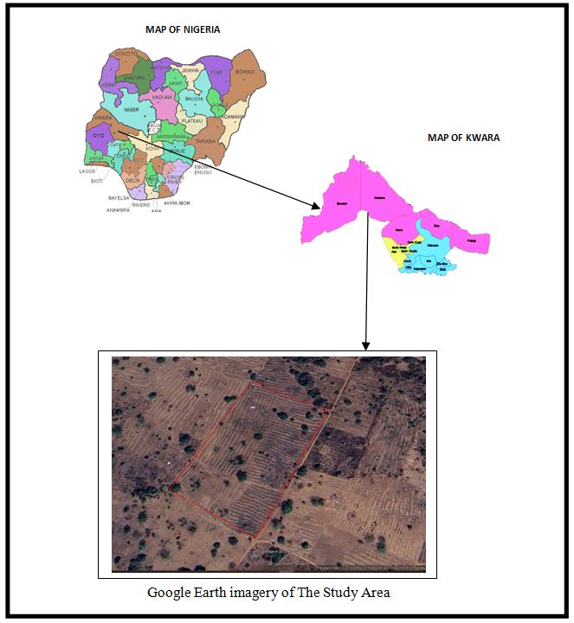

1.7 PERSONNEL MEMBERS OF THE GROUP
The following students contributed greatly to the success of the field practical and they are;
S/N | Name | Matric No | Roles
1. | Idris Abdullahi Umar | ND/23/SGI/FT/0003 | Author
2. | Oloyede Favour Eniola | ND/23/SGI/FT/0001 | Member
3. | Afolayan Joshua O. | ND/23/SGI/FT/0002 | Member
4. | Ajide Racheal Oluwasewun | ND/23/SGI/FT/0004 | Member
5. | Kareem Abass Adebayo | ND/23/SGI/FT/0005 | Member
6. | Sulyman Muinat Bukola | ND/23/SGI/FT/0008 | Member
7. | Olafimihan Racheal Olamide | ND/23/SGI/FT/0009 | Member
8. | Babatomi Favour | ND/23/SGI/FT/0011 | Member
9. | Haroon Abdulmutolib Opeyemi | ND/22/SGI/FT/0018 | Member

CHAPER TWO
2.0 LITERATURE REVIEW
Cadastral layout surveys are foundational to land administration, providing the necessary framework for managing land resources, legal ownership, and spatial data required for urban planning and development. This literature review synthesizes key themes and findings from various scholarly articles, reports, and research related to cadastral surveys, highlighting technological advancements, legal frameworks, social implications, and emerging trends.
The evolution of cadastral systems can be traced to ancient civilizations that recognized the necessity of land management. As documented by authors like Blaschke (2010), historical cadastral systems were often tied to taxation and governance, integrating land ownership records with administrative functions. Over time, modern legislation and standardized practices emerged, formalizing how surveys are conducted. Significant studies, such as those by Williamson et al. (2010), provide insights into the evolution of land administration systems globally and the shifts in methodologies over the decades.
Recent advancements in technology have dramatically transformed cadastral surveying practices. The integration of Geographic Information Systems (GIS), Global Positioning System (GPS) technology, and remote sensing techniques, such as aerial photogrammetry and LiDAR, have enhanced the accuracy and efficiency of surveys. Research by Horrell (2015) emphasizes the impact of digital technologies on cadastral mapping, highlighting their ability to provide multidimensional views of spatial data. Furthermore, Gupta et al. (2018) discuss the benefits of drone technology in achieving rapid and precise land assessments, which are especially relevant in dynamic urban environments.
The legal basis for cadastral surveys varies significantly across jurisdictions and is crucial for the enforcement of land rights. Studies by de Vries (2017) outline the need for clear legal frameworks to ensure the integrity and registration of property boundaries. Many countries are reforming their land administration systems to enhance efficiency and reduce disputes. A comparative analysis by Gefen et al. (2019) demonstrates how different countries implement cadastral systems within their respective legal contexts, indicating the importance of tailor-made solutions that cater to local socio-economic conditions.
Accurate cadastral surveys have profound socio-economic effects. According to Quashigah (2020), these surveys promote equitable resource allocation, influence investment decisions, and support local economic development. The ability to accurately define property rights fosters a stable environment for investment, as demonstrated in research by Lokken (2018). Additionally, community engagement in cadastral processes has been shown to enhance transparency and build trust between authorities and citizens, as evidenced by case studies in developing countries (Chirisa et al., 2010
The connection between cadastral surveys and environmental management is increasingly acknowledged in the literature. Cadastral data helps identify areas for conservation, land-use planning, and sustainable development. Research by Veldhuis et al. (2021) explores how cadastral information can support environmental governance by facilitating land suitability assessments and enhancing resilience to climate change. The inclusion of environmental data in cadastral systems promotes informed decision-making processes that consider ecological impact.
Despite the advancements, several challenges persist in the field of cadastral surveys. Issues such as data accuracy, accessibility, and the adaptation of existing legal frameworks to incorporate emerging technologies remain significant hurdles. Additionally, the literature highlights the need for capacity building in human resources to manage increasingly complex surveying methodologies. Future research, as suggested by authors like Zevenbergen (2019), should focus on integrating participatory approaches to involve communities more actively and on developing adaptable systems that respond to changing socio-economic and environmental landscapes.
According to Jones (2019), the introduction of the metes-and-bounds system and later, the rectangular survey system in the United States, laid the groundwork for modern cadastral surveys, which now rely heavily on precise measurements and advanced surveying techniques.
A cadastral survey is fundamentally defined as a systematic process of mapping land parcels and their boundaries, often resulting in a cadastral map that provides essential information for land ownership, taxation, and development. According to Smith (2020), the primary goal of cadastral surveys is to establish clear and definitive property boundaries to prevent disputes and ensure transparent land transactions. The information generated by these surveys is indispensable for government authorities, property owners, and prospective buyers as it lays the groundwork for legal documentation and land use planning.
In contemporary practice, the use of remote sensing technologies, such as LiDAR and aerial photogrammetry, has enhanced the efficiency and accuracy of surveying processes. LiDAR, for instance, allows surveyors to collect high-density elevation data over large areas rapidly, which is especially beneficial in complex terrains where traditional survey methods may be impractical (Green et al., 2022). The methodologies employed in cadastral layout surveys typically involve a combination of fieldwork, data collection, and processing. Traditional methods primarily include the use of total stations, theodolites, and GPS technology to accurately measure distances and angles between points. Recent advancements have integrated digital tools such as Geographic Information Systems (GIS) for data analysis and visualization (Brown, 2021). These tools enable surveyors to create detailed maps that not only represent legal boundaries but also incorporate geographical features, zoning information, and land use classifications.
In contemporary practice, the use of remote sensing technologies, such as LiDAR and aerial photogrammetry, has enhanced the efficiency and accuracy of surveying processes. LiDAR, for instance, allows surveyors to collect high-density elevation data over large areas rapidly, which is especially beneficial in complex terrains where traditional survey methods may be impractical (Green et al., 2022).
Zandbergen (2020) highlights the role of cadastral surveys in formalizing land tenure systems, which is crucial for economic development, particularly in developing nations where land disputes can hinder investment. Additionally, effective cadastral systems contribute to sustainable land management by providing essential data for urban planning and environmental conservation (Miller, 2023).
The literature on cadastral layout surveys highlights the multifaceted nature of land administration, encompassing historical, technological, legal, social, and environmental dimensions. The ongoing evolution of these surveys, driven by technological advancements and changing societal needs, underscores their critical importance in achieving effective land governance and sustainable development. Future research and practice should continue to explore innovative approaches, enhance accessibility of cadastral data, and foster community engagement, ensuring that cadastral systems remain relevant in the face of global challenges.

CHAPTER THREE
3.0 PROJECT PLANING
This is the preliminary stages of the project were the schedule and all other logistic will be decided and this planning is done in office in two was below.
3.1 RECONNAISSANCE
Reconnaissance is a very important aspect of any project work in surveying field; it generally consists of two methods.
1. Field reconnaissance
2. Office planning.
3.2 FIELD RECONNAISSANCE (RECCE)
In the process of obtaining field reconnaissance, the site was visited, drawing of the Recce diagram was carried out in order to decide on how best to do the job of the approved layout, the map covering the project site which was prepared by Ministry of Lands and Survey as a guide. The existing control points were located and the values were collected from the survey that did the part of the control to be use lather checking will be done for the in-situ.
3.3 OFFICE PLANNING
The relevant maps in the department were checked in order to get information’s about the site. The coordinates of the nearby control points were also obtained from the Ministry of lands and survey Department. These are the information of the controls within the project site.
Table 2.1 Coordinates of Controls
Pillar No | Northing(m) | Easting(m)
SC/KW B10991R | 941701.318 | 685715.747
SC/KW B10992R | 941756.109 | 685609.382
SC/KW B10993R | 941788.423 | 685544.026
Source: Private Practicing Surveyor
3.4 INSTRUMENT TEST
The Total Station was found to be in good working condition after checking for Collimation error, the Circular plate bubble and Plate level.

3.5 TEST OF TOTAL STATION COLLIMINATION TEST
The following test was carried out to test the workability of the equipment before the data capturing process. The tests are of two types which are
- Temporary Adjustment
- Permanent Adjustment
The temporary adjustments are the ones that are carried out on every station before observation. They are;
- Centering of instrument
- Removal of parallax
The permanent adjustments carried out are
1. Collimation adjustment
2. Vertical Index adjustment
2.5.1 PROCEDURE FOR COLLIMATION AND VERTICAL INDEX ADJUSTMENT
The instrument was set up on station SC/KW B10991R and all necessary temporary adjustments were performed. A target was set up at SC/KW B10991R to the line of site. It was aimed at and bisected. The instrument was switch on and program which is on-board of the instrument was switch to the collimation program. Then, horizontal collimation and vertical index were in sequence recorded and stored in the memory of the instrument. The telescope was transited and the same target bisected. Both the new vertical index and collimation were recorded and stored accordingly. It was transited to the same target with both horizontal and vertical readings recorded to check the instrument’s accuracy. The readings obtained are as follows:
Table 2.2 Test of Total Station
 | Old Reading | New Reading
Horizontal collimation error | +00⁰00’ 14” | +00⁰00’ 09”
Vertical index | +00⁰00’ 20” | +00⁰00’ 04”
 |  | +00⁰00’ 09”
Source: Author 2024
From the above reading, it is shown that the new value have higher precision than the previous. Therefore, the new value is set in the instrument for corrections applicable on any of the two axes.
3.5. IN-SITU CHECK OF CONTROLS USED
The following pillars SC/KW B10991R, SC/KW B10992R and SC/KW B10993R were among the ones found on the ground and checks were carried out on them to determine their true position and reliability.
Checks carried out on these pillars show that:
Observed Included angle = 180° 21’ 12’’
Computed Included angle = 180° 21’ 18’’
Difference: 00° 00’06’’
Observed distance: = 120.305m (SC/KW B10992R - SC/KW B10991R)
Computed distance: = 120.315m (SC/KW B10992R - SC/KW B10993R)
Difference: = 0.010m
Remarks: The difference in both the angular and distance observations was within acceptable limit; hence the Pillars were in-situ.

SC/KW B10993R
SC/KW B10992R
$180°$ 21’12”
SC/KW B10991R

Fig 2.1 In-situ check for control

3.6 SCHEDULE OF FIELD WORK
Having completed the reconnaissance, the schedule of field work was designed as follows:
- Perimeter traverse
- Setting out of boundary beacons
- Layout design
- Pillar Numbering
- Traversing
- Report writing
3.7 DATA ACQUISITION
Layout is the sub-division of parcel of land into blocks and subsequently plots. The surveying process of defining the positions of various beacons that make up a layout on the ground by a surveyor using approved layout design made by the town planner is known as setting out. In the execution of this project the principle of “working from whole to parts” was adhered to as the perimeter beacons that formed the framework for the setting out of the blocks and the blocks formed the framework for the setting out of the plots.
The traditional or classical methods of surveying were decided upon for the execution of this project. The methods are:
- Setting out of the entire perimeter.
- Traverse method for acquisition of the entire perimeter.
- Stake out method for block by block and plot by plot setting out.
- Traverse method and interpolation for acquisition of the entire block and plot data.

3.8 SETTING OUT OF POINTS
Sokkia green label (Model: SET 02) Total Station was set up on SC/KW B10992R and oriented to SC/KW B10991R and coordinates of the stations were keyed into the instrument. Total station computed the bearing between the two stations for orientation. Then coordinates of points to be set out were entered into the total station and the setting out program of the instrument was used to get the angle to turn in order to face the direction of the point after orientation, the instrument was rotated until horizontal angle read 0°00’00”, reflector was held along the direction and distance between the instrument and the reflector was measured.
The instrument displayed the remaining distance as either positive or negative. Positive distance means that the reflector should move away from the instrument by that amount while negative distance means that the reflector should move towards the instrument. When the horizontal angle read 0°00’ 00” and measured distance displayed 0.000m this marked the exact position to be set out. The point was pegged and point number was written with permanent marker. All other points were set out in similar manner. Observations were carried out on the set out points and stored in the instrument memory. Also, the measurements made were found out to be permissible since the incurred error is within allowable. The principle of working from whole to part was observed while setting out the points as the boundary of the layout and some selected points within the boundary of the layout were first observed to server as subsidiary points (minor control points). Subsequent points were set-out from them.

3.9 MONUMENTATION
All the points set out were beaconed with a property beacon in compliance with cadastral survey regulations. The property Beacons were of dimension 18cm x 18cm x 75cm and made of concrete mixture of ratio 3:2:1in (3 parts of sand to 2 part of gravels and 1 part of cement) respectively. These beacons were emplaced in such a way that 15cm of its total length was above the ground surface while the remaining length was buried under the ground.
The boundary pillars were numbered accordingly as they were in the working diagram and where they fell during their setting out. However, the pillars were prefixed with identification mark SCKW. Because SURCON private numbers were obtained from the Office of State Surveyor General
SC/KW
B2134R
10cm
65cm
Ground level
18cm
18cm
18cm
B
R

2134

Fig 2.3 Description of pillar used showing portions above and below the ground
3.10 TRAVERSING
Total station was set up on SC/KW B10992R, switched on and all temporary adjustments were carried out. Then, “Job” was set in the instrument, height of instrument and reflectors were measured with steel tape and stored in the instrument’s memory, and coordinates of the control stations were recalled from the instruments’ memory SC/KW B10991R, was bisected for orientation, and Total station was instructed to compute the bearing between the two stations which was confirmed with a prismatic compass. One of the reflectors was taken to pillar SC/KW B10993R, the reflector’s cross hair was bisected with that of the telescope eye piece of the total station and “All” key was pressed so as to measure and record observation in the memory of the instrument. The instrument was switched off and moved to SC/KW B10993R, and the above stated processes were carried out to coordinate the entire boundary points in X, Y, Z. The above process was repeated for other blocks shown on the plan including subsidiary traverses.

CHAPTER FOUR
4.0 DATA DOWNLOADING AND PROCESSING
The coordinates of the observed boundary were downloaded into the computer and were compiled in Microsoft excel for further processing. A script file of boundary points of individual plot was prepared in note pad using Polyline command. These script file was run in AutoCAD and the area information of each plots as well the bearing and distances of each consecutive lines were obtained.
4.1 DATA PROCESSING & ANALYSIS
The acquired field data was downloaded to the computer in the office. This was done using a NTS software. The following procedure was followed:
- Connecting the SET and host computer, using communication cable.
- Selecting “JOB” in Memory Mode.
- Selecting “comms” output to display the JOB list.
- Pressing OK.
- Selecting the output formation
- At the end of the downloading, the data was displaced in the following format, Point No., Easting and Northing.
The data was then copied to other software such as Microsoft Excel for further processing. Here, the data was arranged and stored as formatted Text (space delimited), ready for plotting. The observed data were reduced and corrected, Master Survey programmer software was used to process the data.

4.2 PLOTTING AND PLAN PRODUCTION
Auto-CAD2007 software was used for plotting all the set out pillars. The plotting procedure was as follows,
- Launch Auto-CAD 2007.
- Select Format on the menu tool bar and set all necessary units such as meter, Decimal places, Directions etc.
- Select tool from the menu bar and highlight run script.
- Open the saved formatted Text from Microsoft Excel.
- Zoom extents, by pressing Z enter and E enter.
All the coordinated points are plotted and displayed on the screen and with the help of the Recce diagram; all the boundary points were joined for individual plots to produce the boundary lines and the existing features such as Roads.
The final Layout plan was plotted at scale of 1: 2,500
4.3 PROJECT STATISTICS
- Total Number of residential plots 56 plots
- Total number of boundary beacons 4
- Coordinate Properties UTM

4.4 COMPUTATIONS
The backward and area computation were done to the coordinates of the boundary pillar as show in the tables below;

Tab: 4.1: the table shows the back computation of the perimeter survey
Station form | Bearing | Distance (m) | ∆N | ∆E | Northing (m) | Easting (m) | To Station
 |  |  |  |  | 942244.886 | 684890.452 | SC/KW  J5920BK
SC/KW  J5920BK | 117° 13' 45’’ | 126.709 | -57.976 | 112.668 | 942186.910 | 685003.119 | SC/KW  J7719BK
SC/KW  J7719BK | 206° 44' 54" | 222.330 | -198.539 | -100.065 | 941988.371 | 684903.055 | SC/KW  B10990R
SC/KW  B10990R | 297° 14' 20" | 119.643 | 54.761 | -106.375 | 942043.132 | 684796.679 | SC/KW  B10991R
SC/KW  B10991R | 024° 55' 42" | 222.481 | 201.754 | 93.772 | 942244.886 | 684890.452 | SC/KW  J5920BK

Tab: 4.2: the area computation by double latitude and single departure.
∆E | ∆N | PRODUCT
112.668 | X -57.976 | = -6532.039968
112.668
225.336
-100.065
125.271 | X -198.539 | = -24871.179069
-100.065
25.206
-106.375
-81.169 | X 54.761 | = -4444.895609
-106.375
-187.544
93.772
-93.772 | X 201.754 | = -18918.876088
93.772
0.000
= -6532.039968 -24871.179069 -4444.895609 -18918.876088
= -54766.990734\2 =27,383.495m²\10000 =2.7383 Hectares
4.5 DISCUSSION OF THE RESULT
The following were the results obtained at the end of the project exercise, they are:
- Perimeter Survey plan.
- Design plan
- Layout plan

4.5.1 PERIMETER SURVEY PLAN
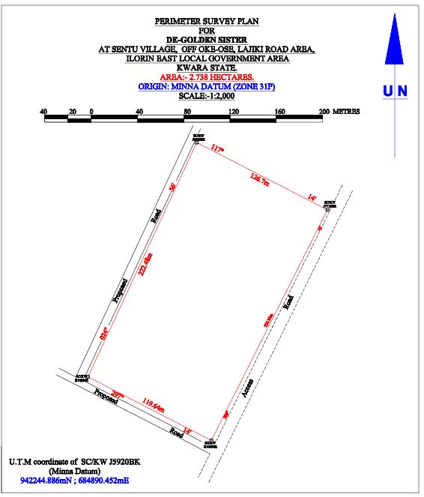

4.5.2 DESIGN PLAN
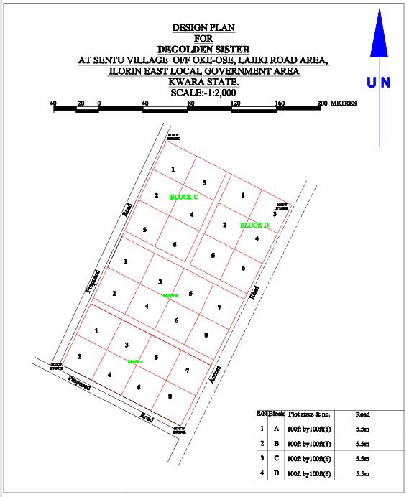

4.5.3 LAYOUT PLAN
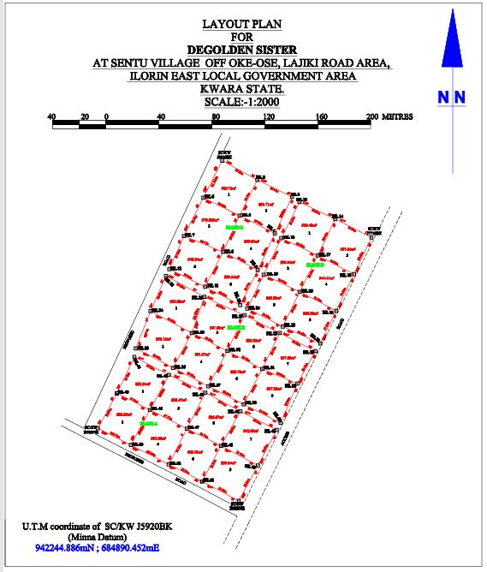

CHAPTER FIVE
5.0 SUMMARY, CONCLUSION PROBLEMS ENCOUNTERED AND RECOMMENDATION.
5.1 SUMMARY
The project area covered a total area 2.738 hectares with total number of 4 pillars used for the Perimeter Survey. Whereas the total number of beacons used for the layout was 54, making a total number of 54 pillars emplaced. The total numbers of plots are 28 at 100ft x 100ft. The project cut across the following; reconnaissance, monumentation and traversing and settingout. Kolida Total Station was used for the geometric data acquisition and its software was used in downloading and transforming the acquired data.
The final adjusted coordinates were used for the production of Perimeter Survey plan and the Layout Survey plan using AutoCAD 2007. The final plan was drawn at a scale of 1:2,000
5.2 CONCLUSION
In every aspect of the project, the results obtained were all within the limits of permissible accuracies. The principle of whole to path was adhering to and all the observations and measurements that were made in total conformity with survey rules and regulations. The final plan was presented to them in hard and soft copies. The hard copy was plotted on A3 paper size.
However, based on the results obtained in the project, it is obvious that the aim of the project has been achieved. Conclusively, I hereby submit the Final Layout Survey Plan of De-Golden sister cooperative Land, which was successfully carried out.

5.3 PROBLEMS ENCOUNTERED
The only problem encountered was from the youths from the area who demanding some money for public relation. This was later settled by the Family representatives.
5.4 RECOMMENDATION
We hereby urge the department to exposed the students to more practical works in and outside the school. This project work show most of us the setting methods and exposed us to the uses of the survey instruments.

RAW DATA
PL | 685715.372 | 941701.43 | 378.762
RD | 685712.862 | 941697.33 | 378.756
PL2 | 685687.678 | 941716.11 | 379.535
PL3 | 685662.456 | 941729.037 | 380.403
B10992R | 685609.007 | 941756.221 | 381.96
PL5 | 685623.378 | 941782.638 | 382.269
PL6 | 685676.16 | 941755.88 | 380.721
PL7 | 685701.779 | 941742.941 | 379.918
PL8 | 685729.781 | 941728.182 | 379.197
PL9 | 685716.533 | 941769.016 | 380.451
PL10 | 685744.061 | 941754.972 | 379.637
PL11 | 685746.929 | 941760.165 | 379.651
PL12 | 685718.942 | 941774.294 | 380.431
PL13 | 685690.1 | 941783.065 | 381.239
PL14 | 685692.255 | 941787.928 | 381.343
PL15 | 685662.604 | 941796.453 | 381.709
PL16 | 685665.695 | 941801.784 | 382.098
G7065KP | 685636.516 | 941809.908 | 382.586
PL18 | 685648.743 | 941844.451 | 383.092
PL19 | 685679.925 | 941828.131 | 382.466
PL20 | 685706.604 | 941814.556 | 381.644
PL21 | 685732.978 | 941800.893 | 380.756
PL22 | 685759.615 | 941789.914 | 380.405
I7720BK | 685776.835 | 941820.074 | 380.555
PL24 | 685759.721 | 941821.191 | 380.853
PL25 | 685748.544 | 941832.933 | 381.25
PL26 | 685746.205 | 941828.009 | 381.176
PL27 | 685719.623 | 941841.467 | 381.902
PL28 | 685721.682 | 941846.436 | 381.831
PL29 | 685716.38 | 941849.007 | 382.014
PL30 | 685702.871 | 941848.943 | 382.391
PL31 | 685686.689 | 941856.609 | 382.611
PL32 | 685689.859 | 941862.847 | 382.662
J5924BK | 685662.878 | 941876.172 | 383.422
PL34 | 685660.297 | 941871.011 | 383.473
J5920BK | 685702.779 | 941957.975 | 383.13
PL36 | 685729.38 | 941943.477 | 382.642
PL37 | 685755.528 | 941930.597 | 382.315
PL38 | 685761.105 | 941926.821 | 381.93
PL39 | 685788.187 | 941913.917 | 381.554
PL40 | 685815.447 | 941899.999 | 381.103
PL41 | 685802.232 | 941872.409 | 380.764
PL42 | 685774.836 | 941886.5 | 381.446
PL43 | 685747.487 | 941899.504 | 381.831
PL44 | 685742.594 | 941903.187 | 382.27
PL45 | 685715.892 | 941916.485 | 382.829
PL46 | 685788.895 | 941844.863 | 380.654
PL47 | 685761.351 | 941859.132 | 381.119
PL48 | 685734.181 | 941872.012 | 381.875
PL49 | 685729.669 | 941875.413 | 382.035
PL50 | 685703.469 | 941889.197 | 382.652
PL51 | 685702.677 | 941887.507 | 382.665
PL52 | 685669.388 | 941903.005 | 383.426

