

PROJECT REPORT ON
PERIMETER AND DETAILING SURVEY OF
PART OF KWARA STATE POLYTECHNIC, ILORIN. FROM ENGINEERING BUILDING TO GTBANK
BY

ASHAOLU SAMUEL TEMIDAYO ND23/SGI/FT/0030
SUBMITTED TO:
THE DEPARTMENT OF SURVEYING AND GEO INFORMATICS KWARA STATE POLYTECHNIC, ILORIN.
IN PARTIAL FULFILMENT OF THE REQUIREMENTS FOR THE AWARD OF NATIONAL DIPLOMA IN SURVEYING AND
GEO-INFORMATICS
JULY, 2025

CERTIFICATE

I, ASHAOLU SAMUEL TEMIDAYO with Matric Number ND/23/SGI/FT/0030 hereby certify that the information contained in this projectreportwereobtainedasaresultofobservationsandmovementstakenby me and the Perimeter and Detailing was done in accordance to Surveying rules and regulations and Departmental instructions.

Signature of student:

Name of student:

Date of completion:

Matric Number: ND/23/SGI/FT/0030
CERTIFICATION
This is to certify that ASHAOLU SAMUEL TEMIDAYO with Matric number ND/23/SGI/FT/0030 carried out this project work and has been approved as meeting the requirement for the award of National Diploma (ND) in Surveying and Geo-informatics in the Department of Surveying and Geo-informatics of the Institute of Environmental Studies, Kwara State polytechnic, Ilorin.

SURV. R. O. ASONIBARE DATE MRS. S.O. ADEOTI
(Project supervisor)

SURV. AWOLEYE RAPHAEL DATE
(Project Coordinator)

SURV. AMBIMBOLA ISAU DATE
Head of Department

J.O OPALEYE DATE
External Moderator
DEDICATION
This project is dedicated to Almighty God, the creator of heaven and earth, ancient of days, the I am that I am the beginning and the end whose supremacy in the knowledge of everything is absolutely
ACKNOWLEDGEMENTS

I will like to express my profound appreciation to almighty God who in his infinite mercy gave me the ability to commence and complete my program in peace and God health, if not for God, where will I be today? All things are possible through him for the knowledge, wisdom and understanding and also his moral, protection and provision on me through my ND programme thank God for the great things he has done, most especially for the success of this project work God be the glory.
My appreciation goes to my lovely parent in person of MR & MRS ASHAOLU for their prayer and support, financially and morally throughout this journey thank for all the beautiful star and end through my ND program. I know I can't repay you back but I have special prayer to offer you both, wishing you both long life and prosperity in good health and wealth, more success, blessing and happiness along with a lot of luck (Amen).

 | TABLE OF CONTENTS
TITLE PAGE |  | i
CERTIFICATION |  | ii
DEDICATION |  | iii
ACKNOWLEDGEMENT |  | iv
ABSTRACT |  | v
LIST OF FIGURES |  | vi
TABLE OF CONTENT |  | vii
CHAPTER ONE
1.0 INTRODUCTION |  |  | 1
1.1 BACKGROUND OF THE STUDY |  |  | 1
1.2 STATEMENT OF THE PROBLEM |  |  | 7
1.3 STUDY AREA |  |  | 8
- AIM OF OBJECTIVE OF THE PROJECT  - AIMS |  | 9 | 9
1.4.2 OBJECTIVE  1.5 SCOPE OF THE PROJECT |  | 9 | 10

  - SIGNIFICANCE OF THE PROJECT 10
  - PERSONNEL 11
CHAPTER TWO
  - LITEATURE REVIEW 12
CHAPTER THREE
2 METHODOLOGY 20
  - RECONNAISSANCE 21
    - OFFICE RECONAISSANCE 21
    - FIELD RECONNAISSANCE 21
  - MONUMENTATION 23
  - EQUIPMENT USED 24
    - PERIMETER SURVEY AND DETAILING OBSERVATION 24
      - TEST OF INSTRUMENT 25
  - COLIMATION TEST FOR TOTAL STATION 25
  - DATA ACQUISITION 26
    - GEOMETRIC DATA ACQUISITION OF PERIMETER 27
    - GEOMETRIC DATA ACQUISITION OF DETAILING 27
  - PERIMETER TRAVERSING 28
  - DATA DOWNLOADING 29
    - DATA PROCESSING 33
  - COMPUTATION 33
    - TRAVERSE BACKWARD COMPUTATION 34
  - AREA COMPUTATION 34
    - LINEAR ACCURACY 35

CHAPTER FOUR

4.0 RESULTS |  | 36
4.1 CONTROL ESTABLISHMENT RESULTS |  | 36
4.1.1 CONTROL ESTABLISHED | 36
4.4.2 TEST OF INSTRUMENT | 36

  - TEST OBSERVATIONS 37
  - CONTROL CHECK

(COMPUTED VALUE AND OBSERVED VALUE) 37-38
  - TRAVERSE BACK COMPUTATION 38
  - RESULTS OF THE AREA COMPUTATION 39
  - RESULTS OF LINEAR ACCURACY 40
  - DATA ANALYSIS 40
    - THE PERIMETER BOUNDARY POINTS 41
  - INFORMATION PRESENTATION 41
CHAPTER FIVE
  - SUMMARY, CONCLUSION AND RECOMMENDATIONS 44
  - SUMMARY 44
  - PROBLEM ENCOUNTERS 44
  - CONCLUSION 45
  - RECOMMENDATIONS 45
REFERENCES 47
APPENDIX 48

LIST OF TABLES

- Record of coordinates points

- Reading obtained during instrument test

- Back computation of the coordinates
ABSTRACT

This project is based on perimeter and detailing survey of part of [I.O.T], Kwara State Polytechnic, Moro Local Government Area, Ilorin, Kwara State. This project has been divided into different chapters. Chapter one of this project gives an introduction about the project topic as a whole. This enables better understanding of the project so as to know what perimeter and detailing entails as well as the scope and aim of the project. Chapter two is the literature review i.e. the works of past professionals and projects that had been done in the past as regards this specific topic which were examined in order to help to shed more light on what perimeter and detailing survey is all about. Chapter three of this project is the methodology which describes how the project was carried out using digital instrument e.g. Total Station and its accessories from the first stage to the final stage. Chapter four of this project is Data presentation which consists of all the data acquired from site during the project execution. Chapter five comprises of summary, problems encountered, conclusion and recommendations. Reference comprises of list of names and works of prominent authors or professionals whose works on survey as regards this specific topic were used in the course of this project.

CHAPTER ONE INTRODUCTION

Background to the study
Land is the prime natural resource of the world. It is also a very important natural resources of any country due to its limited nature and without land there can be no country. This then implies that the wealth of a nation and its economic and sustainable developments are dependent in the state of its land and its usage. Therefore, the opportunities of tomorrow will be determined by the land use decisions made today (Effiong 2010).
Surveying is a profession with many definitions as applied to it over the years, changing even as the duties of the surveyor had been dynamic over the years. Some years back surveying was defined as the science and art of making reliable measurements of the relief position of features on, above or beneath the earth surface and plotting of these measurements to some suitable scale to form a map, plan or chart (Brinker 1977).
Perimeter detailing is a crucial aspect of architectural design, construction, and security planning that involves the precise definition, enhancement, and protection of property boundaries. This practice encompasses both aesthetic and functional considerations, from ornamental fencing and landscaping to sophisticated security measures and boundary demarcation systems. Historically,
perimeter detailing evolved from simple boundary markers such as stone walls and wooden fences to today's integrated systems that combine security, aesthetics, and environmental considerations.
In contemporary architecture and urban planning, perimeter detailing has gained increasing importance due to several factors. The growing emphasis on property security, privacy concerns in densely populated areas, the need for clear legal boundary demarcation, and the desire for aesthetic enhancement of properties have all contributed to the evolution of perimeter detailing from a simple necessity to a sophisticated discipline combining multiple fields of expertise.
Surveying is the first step for the execution of a construction projects. With the change in time, there has been great development and improvement in the surveying techniques. From the vintage chain surveying to satellite surveying and the modern engineering projects, construction has reached a new modern era of engineering.
Surveying is the branch of engineering that deals with the art and science of determining the relative positions of distinctive features on or beneath the surface of the earth, by measurements of distances, directions and elevations (Agor 2008). There are different branches of surveying such as Geodetic survey, Topographic survey, Hydrographic survey, Mining survey, Photogrammetry and remote sensing, Engineering survey, Cadastral survey which include perimeter and detail survey.
Cadastral surveying is the sub field of cadastre and surveying that specializes in the establishment and re-establishment of real property boundaries.
Cadastral survey is the branch of surveying which is concerned with the survey and demarcation of land for the purpose of defining parcels of land for registration in the land registry. It is concerned with land management and more specifically with issues of landownership, measurement delineation of property boundaries. It is survey that creates, mark, define or re-establish the boundaries and subdivision of public land and through this, ownership can be recorded in public register.
Perimeter surveying is a type of property survey that determines the particular boundaries of a parcel of land areas by setting corner markers or monuments, to determine coordinates of these corners, and to obtain boundary and area information required for record, deed descriptions and for plotting parcels of real property. These markers are desirable for public record and to ensure correct title for the rightful owner of the land.Cadastral surveys are usually performed for either re-establishment of existing property boundaries or for the creation of new property boundaries in land division process.
Detailing is a process whereby features on the ground are surveyed and represented by a suitable scale on a plan, regardless of their shape, all objects can
be located by considering them as a composition of a series of connected straight lines, with each line being determined by two points.
Detail survey is a survey that a surveyor needs to record all the permanent features on the ground such as:- Buildings, land utilities, Drain, Culvert, Electric Pole, Road, Fence and all the permanent features on the ground for proper assessment of the existing development in the surveyed area or modification of it and usually confined to the boundaries of the parcel of land.
A surveyor is a professional person with the academic qualifications and technical expertise to determine, measure and represent land, three dimensional objects, points fields and trajectories; to assemble and interpret land and geographically related information, to use that information for planning and efficient administration of the land, the sea and any structure thereon.
A surveyor determines the relative positions of natural and manmade features on the earth’s surface and records these in a graphical and usable form. He is also involved in the determination of the size, shape and gravity field of the earth using equipment and techniques which can sometimes be highly sophisticated (Fajemirokun1980).

Statement of the Problem
There is no adequate up-to-date map of the part of Kwara State Polytechnic. To aid decision making by the management. It has been observed that people find it
difficult getting to their destination with all the structure and roads on ground, thus the need for ease of movement for the thousands of people passing the route. A map can provide response to questions like: where a particular road is, where it leads to, the distance and the fastest route or shortest route between two points. This survey will be used for future planning regardless of the type of construction to be carried out. Some other project where the survey will be relevant includes in designing the drainage network, road and also new building. This will definitely affect proper planning and decision making for the management.
Despite its importance, perimeter detailing faces several challenges and issues that affect its implementation and effectiveness:
    - Balancing Security and Aesthetics: Many perimeter solutions prioritize security at the expense of visual appeal, resulting in boundaries that appear fortress- like and unwelcoming. Conversely, purely aesthetic approaches may compromise security needs.
    - Regulatory Compliance: Navigating the complex web of local building codes, zoning regulations, and property laws that govern perimeter installations can be challenging for property owners and designers.
    - Environmental Impact: Traditional perimeter materials and construction methods often have significant ecological footprints, from resource-
intensive manufacturing processes to disruption of natural water flow and wildlife movement.
The primary areas of investigation include:

- Residential Housing Developments: Single-family homes, townhouse complexes, and multi-family residential buildings, examining how perimeter detailing varies across different housing typologies.
- Mixed-Use Developments: Areas where residential properties interface with commercial, institutional, or public spaces, requiring perimeter solutions that accommodate different user groups and functions.
- Urban Renewal Projects: Neighborhoods undergoing revitalization, where perimeter detailing must balance preservation of historical elements with modern security and aesthetic needs.
- Master-Planned Communities: Large-scale developments with comprehensive design guidelines, analyzing how perimeter detailing contributes to community identity and cohesion.
- Transit-Oriented Developments: Residential areas near transportation hubs, where perimeter solutions must address higher pedestrian traffic and public-private transitions.

Aim and Objectives of the Project

    - Aim of the Project

The aim of this project is to carry out perimeter and detail survey of part of kwara polytechnic ilorin, The New engineering building to Guarantee trust bank.
    - Objectives of the Project

The following are the objectives of the study;

      - To carry out proper planning and reconnaissance in the office and field respectively.
      - To carry out traverse and determination of detail features of the survey area using Total station.
      - Production of a perimeter plan and a detailed perimeter plan of the area.

Scope of the Project

the scope includes the following:-

- Traverse connection to established controls.

- Perimeter traversing

- Detailing of features using offset

- Data Downloading and Processing

- Data editing

- Analysis of result
- Plotting and plan production

Significance of the study

This study would be of high significance, as it can find applications in the following areas;
- As it will help to produce a well detailed survey plan

- Building location and facility planning could be well aided.

- Proper planning on the usage of the vacant land.

- Proper planning of drainage system within the case study.

- For Architects and Designers: The findings will provide evidence-based guidelines for perimeter detailing that achieves balance between competing priorities, potentially leading to more innovative and effective design approaches.
- For Property Developers: The research will offer insights into how strategic perimeter detailing can enhance property marketability and value, potentially improving return on investment.
- For Homeowners and Property Managers: The study will develop practical frameworks for selecting appropriate perimeter solutions based on specific needs and constraints, potentially reducing long-term costs and maintenance issues.
- For Urban Planners and Policy Makers: The findings will contribute to understanding how perimeter detailing affects neighborhood character, security
perceptions, and community cohesion, potentially informing more effective regulations and guidelines.
- For Security Consultants: The research will expand the knowledge base regarding the integration of security features with other perimeter functions, potentially leading to more holistic security approaches.
- For Environmental Advocates: The study will advance understanding of ecological considerations in perimeter design, potentially promoting more sustainable practices in property development.
- For Technology Developers: The findings will identify gaps and opportunities in current perimeter technologies, potentially stimulating innovation in materials and systems.
- For Academic Research: The study will contribute to the theoretical understanding of boundaries and thresholds in built environments, potentially opening new avenues for architectural and urban design research.

PERSONNEL
The under listed names are the member if the group who participate immensely in project given
S/N | NAMES | MATRIC NO | ROLE
1 | ASHAOLU SAMUEL TEMIDAYO | ND/23/SGI/FT/0030 | AUTHOR
2 | OLAJIDE HANNAH IBUKUNOLUWA | ND/23/SGI/FT/039 | MEMBER
3 | REMU OLUWASAYO AYOKUNLE | ND/23/SGI/FT/040 | MEMBER
4 | AREO JOSHUA OLUWASEUN | ND/23/SGI/FT/031 | MEMBER
5 | OROKUNLE IDOWU OLUWASUKUNMI | ND/23/SGI/FT/0306 | MEMBER
6 | OGUNBIYI ADENIKE OMOWUMI | ND/23/SGI/FT/037 | MEMBER
7 | LAFIA ISHIAK ALHASSAH | ND/23/SGI/FT/033 | MEMBER

Study Area

The project site is located at Kwara State Polytechnic (The New engineering building to Guarantee trust bank.), Ilorin Kwara State of Nigeria having a latitude of N 8° 28' 55.4196" and Longitude of E 4° 31' 34.4208".

MAP OF STUDY AREA

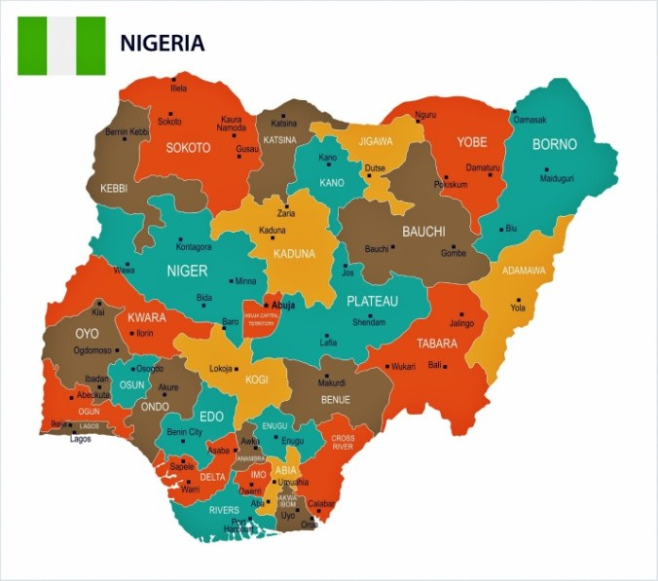
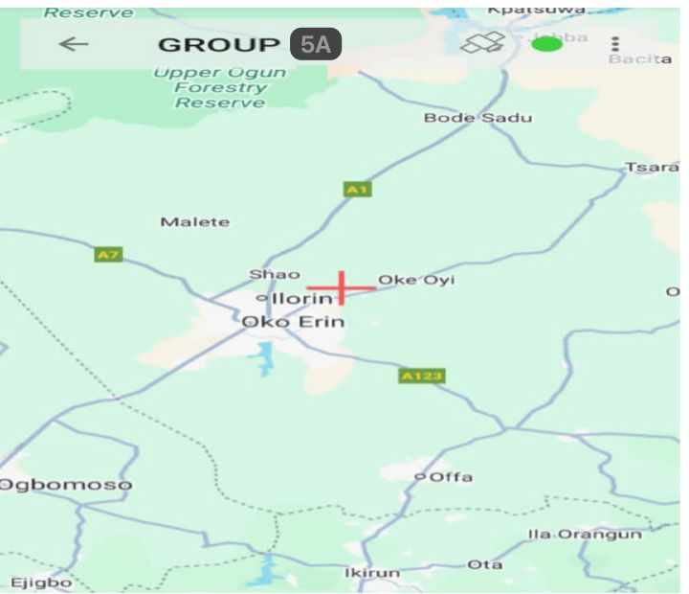
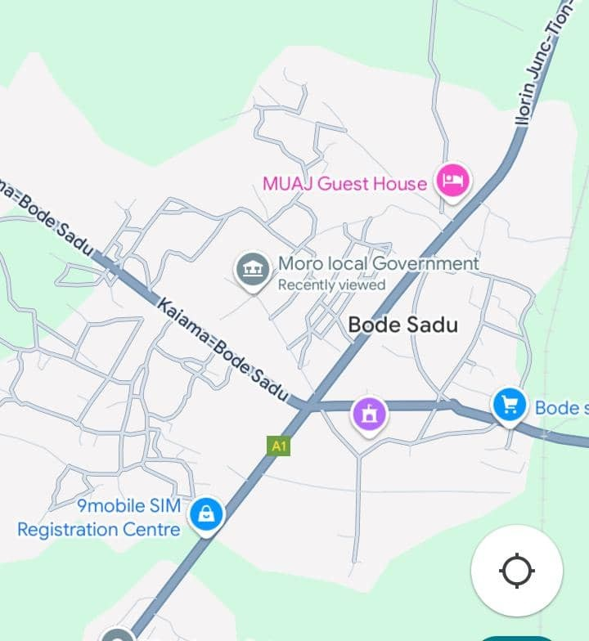
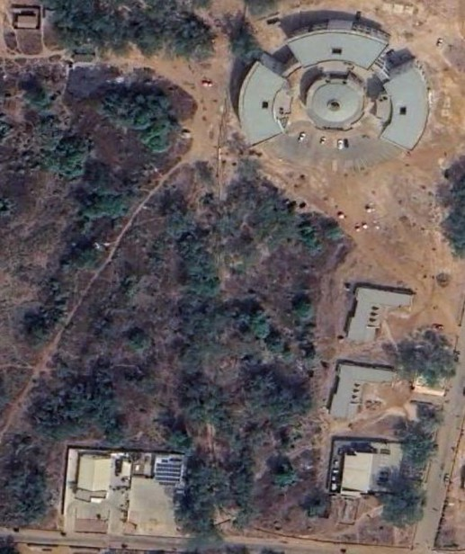

Fig 1: Image showing the study

CHAPTER TWO

LITERATURE REVIEW

2.0 INTRODUCTION

The significance of perimeter and detailing surveys cannot be overstated in contemporary architecture, engineering, and construction disciplines. These surveys form the backbone of informed decision-making processes, serving as critical tools for data acquisition related to land, structures, and environmental features. A perimeter survey focuses primarily on the boundaries delineating a property, while a detailing survey undertakes a more exhaustive examination of the features within these boundaries, capturing topographical nuances, vegetative classifications, structural elements, and infrastructural components (Hughes, 2018). This review synthesizes the extant literature regarding perimeter and detailing surveys, exploring their methodologies, technological advancements, multifaceted applications, associated challenges, and potential future directions.

PERIMETER SURVEYS

Perimeter surveys are primarily concerned with establishing and verifying property boundaries. These surveys incorporate legal and topographical elements to facilitate property development, zoning compliance, and land-use planning. A fundamental understanding of legal property lines is paramount for stakeholders,
including property developers, architects, and governmental agencies, as misunderstandings regarding boundaries can lead to costly disputes and legal repercussions (Smith & Johnson, 2020).

DETAILING SURVEYS

Detale surveys, on the other hand, delve deeper and encompass a broader range of physical elements within a specified perimeter. They involve a meticulous examination of the site, capturing intricate details such as elevation changes, vegetation types, existing structures, and utilities (Hughes,2018). The comprehensive data acquired through detailing surveys are indispensable for site analysis, feasibility studies, and design development, allowing project teams to make informed decisions that optimize functionality and sustainability

METHODOLOGIES

The methodologies employed in perimeter and detailing surveys have evolved significantly over the past few decades, fueled by technological advancements and changing project requirements.
Historically, perimeter and detailing surveys relied heavily on conventional surveying methodologies, which included:

CHAIN AND TAPE MEASUREMENTS
Chain and tape measurements are among the oldest surveying techniques. They involve the physical measurement of distances using calibrated lengths of chain or tape. While effective for shorter distances and simple geometries, this method has limitations in terms of accuracy, especially in complex topographies or large parcels (Dalton & Robson, 2017).

MODERN TECHNOLOGICAL ADVANCES
The advent of digital technologies has dramatically reshaped the methodologies of perimeter and detailing surveys, enhancing efficiency, accuracy, and data comprehensiveness. Key advancements include:
    - Global Positioning System (GPS) and Global Navigation Satellite System (GNSS) The adoption of GPS and GNSS technologies has revolutionized surveying by providingreal-time positioning data with high levels of accuracy. These systems are particularly advantageous for large-scale surveys, as they eliminate the need for extensive ground controls and allow for rapid data collection across expansive are as (Blacketal.,2019). GNSS receivers can achieve centimeter-level accuracy, making them indispensable for applications requiring high precision.

LIGHT DETECTION AND RANGING (LIDAR)
LiDAR technology has emerged as a powerful tool for capturing three- dimensional spatial data. Utilizing laser pulses, LiDAR can create detailed topographical maps and 3D models of the surveyed area. This technology enables rapid data collection, allowing for comprehensive analysis of terrain features, vegetation density, and built structures well beyond what traditional surveying methods can achieve (Mason et al., 2021). The high-resolution datasets produced by LiDAR facilitate a range of applications, including environmental assessments, urban planning, and archaeological studies, by providing a level of detail that enhances understanding of spatial relationships and geographic contexts.

UNMANNED AERIAL VEHICLES (DRONES)

The integration of drones into perimeter and detailing surveys has catalyzed a transformative shift in how data is gathered. UAVs equipped with high-resolution cameras and sensors allow for efficient aerial surveys of large areas, capturing detailed images and topographic data from perspectives that would be difficult or impossible to achieve through traditional surveying methods (Anderson & Gaston, 2018). Drones can fly over complex terrains and inaccessible locations, providing valuable insights with minimal ground disruption. Moreover, advancements in photogrammetry-combined with drone technology—enable the creation of 3D models and orthophotos that significantly enhance the planning and visualization process.

APPLICATIONS OF PERIMETER AND DETAILING SURVEYS

The applications of perimeter and detailing surveys are diverse and span multiple sectors, highlighting their critical role in various stages of project development and management.

URBAN PLANNING

Perimeter and detailing surveys are foundational in urban planning, assisting planners in making informed decisions regarding land use, infrastructure investments, and community development. By providing accurate data on existing site conditions, these surveys enable planners to evaluate the suitability of land for different uses (Fischer& Smith, 2021). For instance, surveying data can help identify areas prone to flooding, enabling appropriate zoning ordinances and mitigation strategies.

CONSTRUCTION

In construction, perimeter and detailing surveys are essential for establishing site boundaries, determining elevations, and ensuring compliance with design specifications. Clear and accurate surveys contribute to effective project management, helping to mitigate issues related to misaligned structures, conflicting regulations, and unforeseen site conditions (Thompson, 2020). A well-
executed detailing survey provides contract or switch comprehensive information needed for excavation, grading, and the positioning of utilities, thus streamlining workflow and enhancing site productivity.

ENVIRONMENTAL ASSESSMENT

Environmental assessments leverage perimeter and detailing surveys to evaluate the ecological characteristics of an area, including flora and fauna, soil conditions, and existing land uses. These assessments are crucial for understanding the environmental impacts of proposed developments and ensuring compliance with environmental regulations (Clark, 2021). Comprehensive surveys can inform stakeholders about biodiversity levels, thereby influencing conservation efforts and sustainability initiatives. Consequently, detailed ecological surveys support environmental impact assessments (EIAs) and influence permitting processes for various projects.
In the realm of heritage conservation, detailing surveys are fundamental for documenting historical sites and structures. These surveys produce detailed records of architectural features, site layouts, and material conditions, which are integral for restoration and preservation (Johnson & Evans, 2019). By capturing the current state of historical assets, professionals can develop strategies that reconcile
modern needs while maintaining the integrity and authenticity of cultural heritage sites.

CASE STUDY: THE PRESERVATION OF HISTORICAL LANDMARKS

For example, in the preservation of the historic town of Williamsburg, Virginia, detailed surveys employed state-of-the-art LiDAR techniques to map buildings and landscapes. This comprehensive dataset helped conservationists understand how to best restore aging structures while adhering to historical accuracy (McDonald et al., 2022). The integration of various surveying techniques ensured that the historical integrity was maintained while enhancing visitor experiences through better-managed conservation efforts.

CHALLENGES IN PERIMETER AND DETAILING SURVEYS

Despite the remarkable advancements in surveying methodologies, several challenges remain prevalent in the execution of perimeter and detailing surveys.

DATA ACCURACY AND PRECISION

Ensuring data accuracy and precision is one of the most persistent challenges faced by surveyors. Variability in conditions such as weather, terrain, and available technology can introduce discrepancies in data collection (Peterson, 2020). As projects frequently rely on integrated data sets from multiple sources, the alignment of these data sets—especially when they originate from different
technologies—poses a challenge. Accredited quality control measures are crucial to validating data accuracy, ensuring that results conform to required standards and specifications.

COST AND TIME CONSTRAINTS
The financial and temporal resources required for comprehensive perimeter and detailing surveys can be substantial. In particular, projects with tight budgets and schedules may prioritize speed over thoroughness, potentially compromising data quality. Comprehensive detailing surveys, which require extensive data collection and analysis, can be resource-intensive, thus limiting their feasibility for smaller projects or underfunded initiatives (Nguyen & Wang, 2022). Consequently, stakeholders may forego necessary survey aspects in favor of expedited completion, leading to long-term implications for project viability and regulatory compliance.

TECHNOLOGICAL BARRIERS

While technology enhances surveying practices, its adoption also presents challenges. The integration of advanced tools and techniques necessitates specialized training and skill acquisition for survey personnel, which can create a knowledge gap in the workforce (Baker,2019). Furthermore, the initial costs associated with purchasing and maintaining sophisticated surveying equipment—
such as GNSS receivers, LiDAR systems, and drone technology—can be prohibitive for some organizations, particularly smaller firms. The reliance on advanced technology also raises questions regarding data security and management, as digital information becomes susceptible to cyber threats.

REGULATORY CHALLENGES

Navigating regulatory frameworks can also complicate the survey process. Different regions may have varying legal requirements regarding property boundaries, environmental assessments, and site documentation (Kahn & Mitchell, 2019).
Surveyors must possess a thorough understanding of local laws and regulations to ensure compliance and mitigate potential legal disputes. Variability in regulatory requirements can further complicate boundary determinations, particularly in cases involving historical properties or contested lands.

FUTURE DIRECTIONS IN PERIMETER AND DETAILING SURVEYS

The future of perimeter and detailing surveys appears bright, with emerging technologies, methodologies, and practices poised to redefine the land scape of data collection and analysis. Key areas for potential growth include:

INTEGRATIONOFARTIFICIALINTELLIGENCEANDMACHINE LEARNING
The integration of artificial intelligence (AI) and machine learning into surveying practices offers substantial potential for enhancing data analysis and interpretation. AI algorithms can process large data sets to identify patterns, predict trends, and automate certain aspects of data collection (Lim & Zhang, 2023). For instance, machine learning models could analyze historical survey data to improve boundary determination accuracy by identifying inconsistencies or anomalies. Such advancements could substantially improve efficiency and lead to more informed decision-making processes.

INCREASED FOCUS ON SUSTAINABILITY

As the global focus shifts toward sustainable development, the role of perimeter and detailing surveys will likely expand to support environmentally conscious practices. Survey methodologies will need to adapt to address sustainability goals, including the assessment of biodiversity, carbon emissions, and land-use impacts (Kumar et al., 2022). As stakeholders increasingly prioritize green building practices and ecosystem preservation, detailed environmental surveys will become essential tools for evaluating project implications and ensuring regulatory compliance.
The future of surveying practices will likely require an emphasis on collaboration and data sharing among various stakeholders—ranging from
surveyors and planners to environmental scientists and regulatory agencies. Innovations in cloud-based data management and visualization platforms can facilitate seamless information exchange, enabling stakeholders to access, interpret, and analyze survey data more effectively (Thompson, 2020). Enhanced data collaboration can yield comprehensive insights that drive more effective project planning and management.
Adoption of Augmented Reality (AR) and Virtual Reality (VR)

The application of augmented reality (AR) and virtual reality (VR) technologies in perimeter and detailing surveys presents an exciting frontier. AR can provide real-time over lays of survey data on to physical environments, enabling stakeholders to visualize the implications of proposed changes on-site. Likewise, VR can facilitate immersive experiences for project stakeholders, simulating designs or alterations before actual implementation (Davis & Moore, 2021). Both technologies can enhance stakeholder engagement by allowing for interactive design reviews and community input in planning processes.
The field of surveying plays a pivotal role in supporting land development, infrastructure planning, construction, and legal property delineation. Among the various branches of surveying, perimeter and detailing surveys are particularly significant due to their practical applications in defining land ownership and in
capturing critical patial information for architectural and engineering design. These surveys serve as the foundational input for decisions made by developers, engineers, architects, and policymakers, making their accuracy and reliability a matter of both technical and legal importance.
Perimeter surveys, also known as boundary or cadastral surveys, are chiefly conducted to establish, retrace, or verify property boundaries. These surveys have been a part of land management systems for centuries, evolving alongside property laws and land registration practices. The literature emphasizes the legal dimension of perimeter surveys, where surveyors are often required to interpret complex property deeds, historical maps, and registry records to establish or reaffirm boundary lines. The process is not merely technical but also interpretive, involving the reconstruction of past surveys, identification of natural or artificial markers, and reconciliation of conflicting claims or ambiguities. Surveyors must consider the legal doctrine of “following in the footsteps” of the original surveyor, a principle that has been discussed extensively in surveying and land law literature.
The rise of modern instrumentation has transformed the accuracy and efficiency of perimeter surveys. Tools such as GNSS receivers, total stations, and computer-aided drafting (CAD) software enable surveyors to collect and analyze
spatial data with unprecedented precision. Legal scholars and technical researchers alike have noted the tension that sometimes arises between highly precise modern measurements and historical property descriptions that were based on older, less accurate techniques.
This discrepancy can lead to boundary disputes, which further underlines the importance of professional judgment and adherence to established surveying principles and local land laws.
In contrast, detailing surveys focus on acquiring fine-grained, comprehensive information about physical and topographical features within a given land parcel. These surveys are critical during the planning and design phases of construction, landscaping, road work, and utility installation. Unlike perimeter surveys that deal with legal boundaries, detailing surveys are more concerned with spatial completeness and topological accuracy.
Features recorded include the positions and dimensions of buildings, vegetation, walls, pavements, surface textures, utility covers, and elevation changes. This data is often used to create topographic maps, 3D models, or digital terrain models (DTMs), which serve as the base layers for engineering and architectural blueprints.
Technological advancement has had a particularly transformative impact on detailing surveys. The use of terrestrial laser scanners, drone-based photogrammetry, mobile mapping systems, and LiDAR has allowed for the collection of highly detailed point clouds, enabling millimeter-level accuracy over large and complex areas. Recent literature has explored how such technologies support not only traditional surveying tasks but also advanced applications such as deformation monitoring, heritage documentation, and smart infrastructure management. Additionally, the integration f Geographic Information Systems (GIS) with detailing survey data allows for the storage, querying, and visualization of spatial information in ways that enhance both technical analysis and public communication.
A significant body of recent research has also highlighted the role of perimeter and detailing surveys in disaster risk management and climate resilience planning.
Accurate boundary data is vital for property restitution after natural disasters such as floods, earthquakes, or landslides. Similarly, detailed topographic information is crucial for assessing flood risk, modeling drainage patterns, and designing resilient infrastructure. Survey data can inform early warning systems,
evacuation planning, and post-disaster reconstruction efforts, making the role of surveyors increasingly important in the context of climate change adaptation.
Urbanization and infrastructure expansion have placed further emphasis on the need for precise and up-to-date survey data. In dense urban environments, where land is scarce and development is intensive, the delineation of boundaries and the inventory of built features must be impeccably accurate to avoid costly legal conflicts and design errors. Studies have shown that surveying errors in such contexts can result in significant project delays, financial losses, and reputational damage. Hence, modern surveying practices are increasingly governed by quality assurance protocols, standard operating procedures, and adherence to international surveying standards, such as those recommended by the International Federation of Surveyors (FIG) and national land survey institutions.
The digital transformation of land and property data has also been a major theme in recent literature. Cadastral data, once maintained in paper-based systems, is now increasingly integrated into digital cadastral databases that are accessible online.
These systems require accurate and consistent input, which only well- executed perimeter and detailing surveys can provide. Moreover, emerging technologies such as block chain are being investigated for use in secure, tamper-
proof land registry systems. For such systems to function effectively, the underlying spatial data must be reliable, verifiable, and consistent across temporal and jurisdictional boundaries.
Professional practice and training have also been subjects of academic and industry attention. The complexity of modern surveying tasks demands a high level of technical knowledge, legal awareness, and ethical responsibility. Institutions and professional bodies are now placing greater emphasis on interdisciplinary training, combining elements of geomatics, land law, computer science, and environmental studies. This is particularly important in developing regions, where inadequate surveying practices can undermine property rights, hinder development, and perpetuate poverty. International development agencies have emphasized the importance of capacity building in surveying as a critical step toward equitable land governance and sustainable urbanization.
Despite all the advancements, challenges remain. Issues such as access to equipment, the cost of high-end surveying technologies, the need for continual software updates, and the management of large datasets continue to present obstacles, particularly for small firms and surveyors in developing economies. Additionally, ethical issues concerning data privacy, land grabbing, and the displacement of communities due to urban expansion or infrastructure projects
have also been associated with the misuse or manipulation of survey data. These concerns have prompted calls for greater transparency, accountability, and community participation in the surveying and mapping processes.
In summary, the literature on perimeter and detailing surveys paints a picture of a dynamic and evolving profession at the intersection of technology, law, and society. While these surveys may seem purely technical, they are deeply embedded in the socio-legal framework of land ownership, development, and governance. As surveying continues to evolve with digital tools and remote sensing capabilities, its foundational functions—establishing where things are, what they are, and who owns them—remain as vital as ever. The integration of new technologies should not over shadow the importance of foundational surveying principles, legal accuracy, and ethical practice. Moving forward, the discipline must balance innovation with tradition, precision with interpretation, and efficiency with inclusivity to meet the complex demands of a rapidly changing world.

CHAPTER THREE METHODOLOGY

Methodology

This refers to the method and the principles used to achieve the aim and objectives of this project work. The execution of this project was based on the following basic principles of surveying:
- Working from whole to part.

- The principle of choosing the method of survey most appropriate to meet the desired result.
- The principle of provision for adequate checks to meet the required accuracy.

The method are traversing and detailing.
Recconaissance

Office recconaissance
Field recconaissance
Selection of instruments
DGPS Data Downloading
Control establishment
Monumentation
DGPS Data Processing
Test of instrument
Data processing
Data acquisition
Control check
Results and Analysis
Conclusion

Figure 3.0:- Research methodology flow chart

Reconnaissance

Reconnaissance is a pre-requisite stage of any survey project to be carried out. It is the study of the subject matter as regard to a particular survey of an area of land. During reconnaissance, the purpose, specification and required accuracy of
the survey were closely examined as these would affect the choice of the instruments and method of survey to be employed. The reconnaissance done comprise of office planning and field reconnaissance.

Office Reconnaissance

At this stage, decisions were made on the easiest approach to achieve the aim of the project using available sources of information about the study area and also the nature of survey. The imagery of the study area, personnel, initial control for orientation, choice of instrument and method to be employed were considered and determined at this stage. Also costing of the survey operation was done in the office.

Field Reconnaissance

The project site was visited to have the true picture of the site for better planning and execution and to locate the control pillars for necessary orientation of the study area. For proper selection of the boundary stations, the following factors were taken into consideration, the position and shape of the boundary, indivisibility of the consecutive stations selected. The boundaries were marked with wooden pegs driven into the ground to avoid disturbance or removal by any one and for the proper identification. The intervisibility of these selected stations were put into consideration.
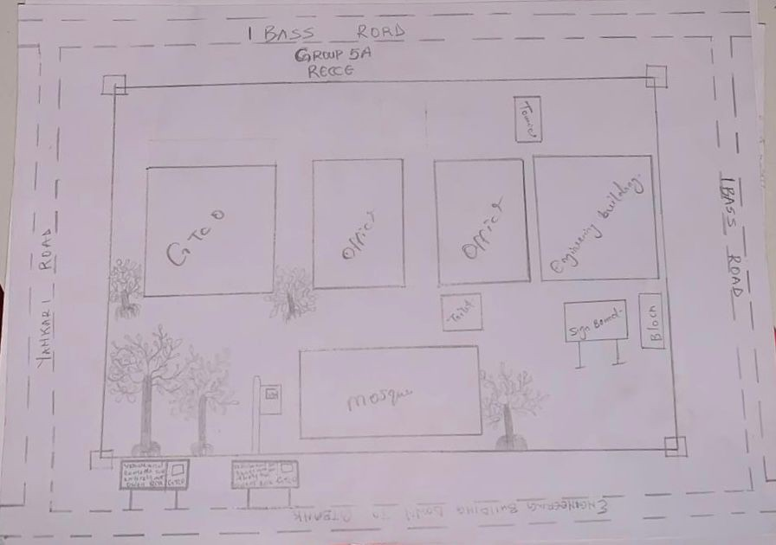
Controls were not found around the study area which necessitated the transfer of control points to a reasonable distance within the study area. The end product of the field reconnaissance is the recce diagram which is shown in figure 3.2 below.

Figure 3.1.2: Reconnaissance Diagram (Not drawn to scale)

Monumentation

This is the selection of points at all change of directions and defining the points using pegs, beacons upon which centering can be made during field
operation. This could be temporary or permanent, depending on the nature of the work. Specifically for this project, precast concrete beacons of dimension 18cm by 18cm by 65cm height were used. Each was buried vertically such that 10cm protruded above the ground surface.

18cm
18cm
10cm
Ground surface
65cm
18cm
P

KP

T

725

Figure 3.2.1: Plan View

Figure3.2.1:-Dimensional Representation Of Boundary Beacon

Equipment Used

The instrument used for the execution of the project are listed below

- Differential Global Positioning System (DGPS)

- Total station and its accessories (Trimble)

- Reflector stand and target

- Beacon

- pegs

- Tape (5m)

- Writing materials

Other Hardware and software used include:

(i.) Laptop

(ii.) GNSS solution

(iii.) Trimble software office

(iv.) Trimble Geo office downloading cable. (v.) AutoCAD 2010
(vi.) Notepad and Microsoft Excel for editing and running of the script (vii.) Microsoft word for report writing

Perimeter Survey and Detailing Observation

The perimeter and detail observation was carried out using the total station. This was done carefully in such a way to achieve the desire objective for the project. Before observation, test of instrument was carried out.

Test of Instrument

Test of instrument is very important in surveying operation. The accuracy of any work done depends on the quality of the instrument used, using faulty instrument will mar the output of the work.
In view of this, test of instrument was done in order to ascertain the working condition of the instrument acquired from the departmental store.

3.4. Collimation of Test For Total Station

The instrument total station (TRIMBLE PT1) was tested for both horizontal and vertical collimation errors. This was done by setting the instrument on a station and applying all necessary temporary adjustment such as centering, leveling and parallax elimination.
The coordinates of the known station (KW725PT) was inputted into the instrument. The target was also placed on another known station (KW111PT) and was carefully bisected and measured at the end the result supplied were compared with the available result (see table 3.4)

Total station
Line of sight
Target
Tripod
KW 725 PT
KW 111 PT
Terrain

FIG 3.4:- Diagram showing the position of the total station and the reflector during the total station (collimation test).

Data Acquisition

This involves the processes in acquiring the data needed for the project. This involves the actual making of measurements and recording of observed data on the field. There are different methods of acquiring data in the site with different instrument such as Total station, Theodolite, Compass, Level Instrument etc.

Geometric Data Acquisition For Perimeter Traverse

Geometric data are positional data, that is, they are data having the X, Y, Z coordinates which makes it possible to locate their position on the surface of the earth. The total station (TRIMBLE PT1) was used for collection of geometric data.
The third order closed traverse was carried out using Trimble Total Station to determine the positions of all stations in the project area. For perimeter traverse, total station was set up on control pillar KW725PT and temporary adjustment performed. The coordinates of the instrument station, Backsight station the heights of instrument and that of the target were measured with tape and keyed-in into the memory of the total station for storage and the orientation was completed. After this, the target was moved to SC/KW F.RS 4404for observation. With the instrument on KW725PT, the target was focused and the cross-hair bisected msr1 was clicked on the total station. The instrument displayed the coordinates (E, N and H) of the station and the values were stored in the memory of the instrument which serves as field book. Then, the instrument was moved to KW111PT orientation was repeated and the same procedures were taken until we closed back on the control pillar KW725PT.

KW725PT KW111PT

Figure 3.5:- Description of the traverse connection
    - Geometric Data Acquisition For Detailing

For the collection of details, the total station was set up on KW111PT and temporary adjustments were performed and back sighted KW725PT for station orientation. Then, various points of interest were coordinated by placing the reflector at such points and measure. The coordinates of such points taken were stored in the internal memory of the instrument and on the field book. For points which could not be visualized from KW111PT, other station points were selected to facilitate their coordination. Feature like buildings, electric poles, trees and water tank, road, security house and mosque were all detailed, after which the traverse was closed back on KW111PT. Having bisected these features, readings were taken and stored in the internal memory of the instrument.

Perimeter Traversing

After the demarcation, capping and numbering of the beacons, the actual data acquisition using the total station MATO TC1010 commenced. The traverse started from KW725PT with KW111PT as reference point. The total station was set up over control KW725PT, centered, leveled and telescope focused to eliminate parallax. The parameters of the instrument station i.e. station name, height of instrument over the station mark, and the XYZ coordinates of the station were keyed in. The reference control point was then bisected and the station name
KW111PT, height of target over the station mark, and the XYZ coordinates of the station were key in. Though the total station was set in coordinate mode it actually measured and recorded horizontal readings, vertical readings and distances automatically into the internal memory of the instrument on both faces which it used to compute and display coordinates. At every set up of the total station, the temporary adjustment was carried out and the following parameters measured:
- Height of instrument
- Height of the back target

- Height of the fore target

- Distance to back and fore station

This is the determination of bearing and distance of series of connected lines from known coordinated point so as to obtain coordinate of the newly established station.

Data Downloading

This explains the method in downloading, retrieving, sorting and analyzing of the acquired data (field data). Here, the data is being downloaded from the total station to a computer system and processed into information using the appropriate method and software.

Steps To Follow When Downloading From Total Station
- The downloading software was already installed on the computer system (Trimble Total Station Software) and was launched.
- The total station was connected to the computer system via downloading cable
- The Total station was switched on and the following options were selected to download the file.
- GOTO Data Transfer
- SELECT Send data (by pressing F1)
- SELECT/CLICK Measure Data
- SELECT File Name (Hafiz)

CLICK ENTER
- SELECT Yes (Option)
- It was ensured that the parameter on total station and the computer system were the same.
- A folder was created on the laptop to save the data from the software and the link selected on the software.
- Transfer was clicked on the total station software to download the file into a folder on the laptop.
- After the transfer was completed, click on transform coordinate on the total station software resident in the computer system. After converting the required data into dxf format.
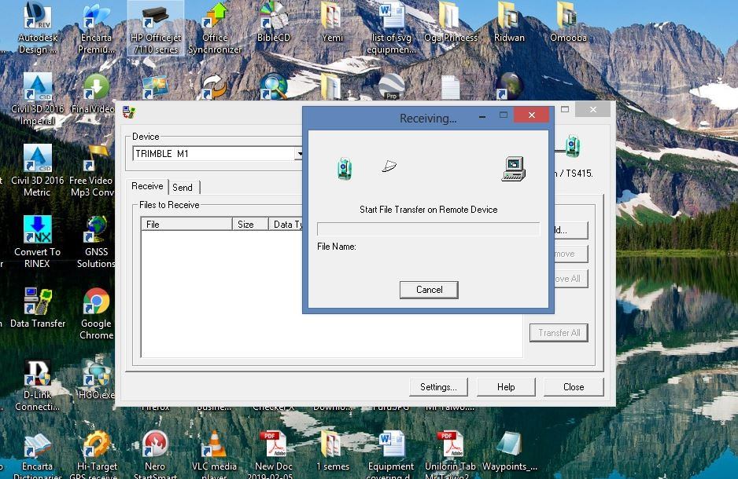
- The coordinates were exported from the software environment to Microsoft excel for further processing

Figure 3.6a: Downloading process from total station

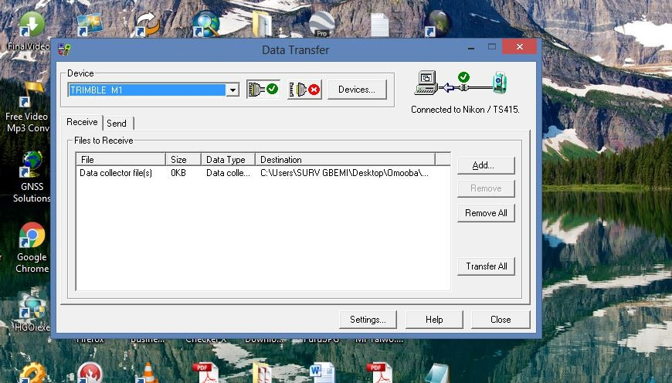

Figure3.6b: Downloading process from total station

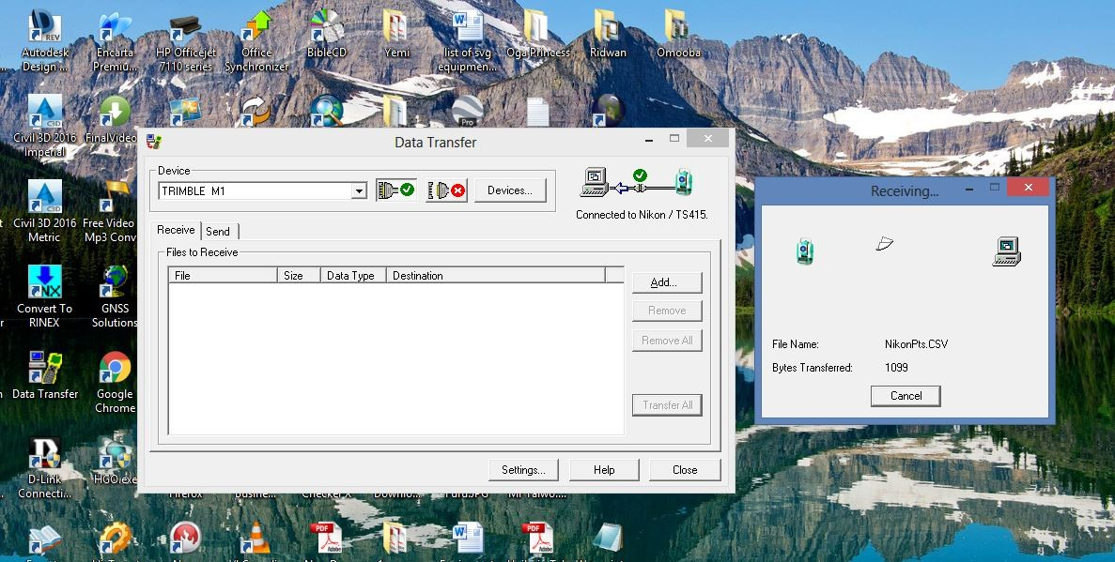

Figure 3.6c: Downloading process from total station
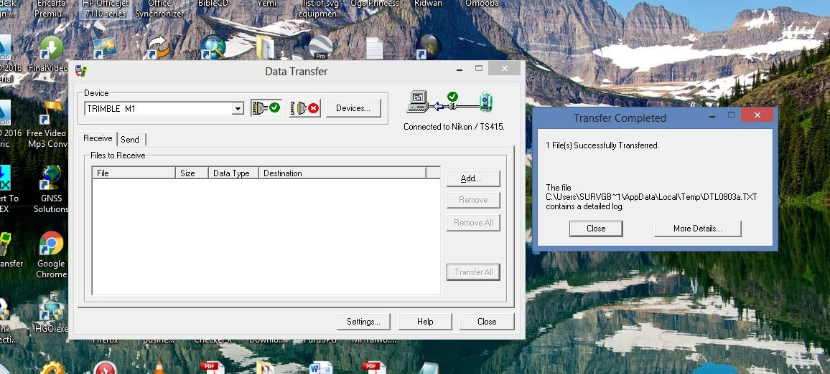
Figure 3.6d: Downloading process from total station

      - Data Processing

As the instrument downloading cable is faulty, Microsoft Excel 2007 Software was used to type the final coordinates of all points except the unwanted

Data Editing

The downloaded data were edited in the Microsoft Excel environment before the edited data were exported to Notepad. During the editing process, the irrelevant and redundant data were removed while edited data were saved in a plotable format of file.scr.

Computations

Computation can be said to be calculations of a kind or another from a large part of the work of surveying and the ability to compute with speed and accuracy is an important qualification for the surveyor.
Computations are made algebraically by the use of simple arithmetical procedures and trigonometric functions and graphically by accurate scaled drawing. Computation come up after field work and is very important in survey work because it serves as the final information shown on plan.
Computation is the operation carried out when the raw data obtain from the field has been processed to obtain final result from which plans were produced.
The various computation procedures carried out in this project are analyzed as follows.
After the field book has been deduced the following computation were carried out
- Traverse backward computation.

- Area computation.

- Linear accuracy.

Traverse Backward Computation

The processed boundary data downloaded from the instrument and the already existing control information were used to determine the latitude, departure, bearings and distances of traverse lines as shown in the table below
Bearing of line =

Distance (L) = 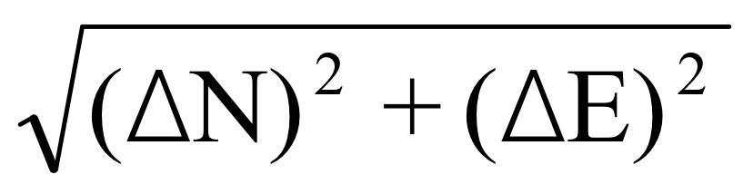

The back computation was done in order o have final bearing and distance of the boundary lines.
The below formulae was used

∆N = N2-N1,N3-N2

∆E = E2-E1, E3-E2

Putting the sign they carried into consideration
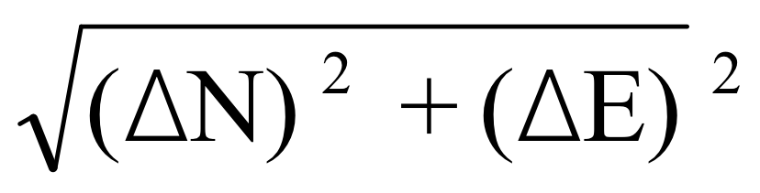
Distance =

Bearing = Tan-1 DE/DN Where
∆N is difference in northing (m)

∆E is difference in easting (m)

Area Computation

Using cross coordinates method, area computation was done by a small program in an excel spread sheet. The results were as shown below:
NORTHING (A) EASTING (A)

NORTHING (B) EASTING (B)

NORTHING (C) EASTING (C)

NORTHING (D) EASTING (D)

NORTHING (A) EASTING (A)

AREA =LEFT SIDE PRODUCT - RIGHT SIDE PRODUCT
2

Linear Accuracy
The linear accuracy was calculated according to the specifications by Surveyors Registration Council of Nigeria (SURCON). Since this is classified as third order job, the following formula was used:
Linear Accuracy =£d/e

CHAPTER FOUR RESULTS AND DATA ANALYSIS

Results

This presents the results and explains how data obtained from field were analyzed, processed, plotted and presented.

Control Establishment Result

After processing of the data acquired during the control extension, the results of the controls established are as shown in table 4.1.
Table 4.1: Control Established

PL ID | Easting | Northing | Heights
KW TL02 | 679751.84 | 946272.55 | 343.452
KW725PT | 679689.67 | 946321.81 | 344.737
KW111PT | 679836.92 | 946009.53 | 328.57

:- Test Of Instrument

The instrument in view is the total station used to carry out the perimeter survey observations.

Table 4.2:-Test Observation

Statio  n | Readings | Northings(  M) | Eastings (M) | Bearing | Dist(M)
Target  Station | Initial  Reading | 946009.53 | 679836.92 | 141°57’10.6’’ | 321.156
 | Total Station  Reading | 946009.89 | 679836.46 | 141°57’10.6” | 321.156
 | Differences | -0.46 | 0.36 | 00°00’00’’ | 0.001
Source: Field Observation

It is evident that the instrument is in good working condition.

  - Control check

The controls used were checked to determine if they were still in-situ, the results are given in table 4.3a and 4.3b
Table 4.3a Control Checks (Observed values)

Station  From | Bearing  ( ° ' ʺ) | Distance (m) | Northings (m) | Eastings (m) | Station  To
KW 725  PT | 154° 45’16.3” | 345.278 | 946321.83 | 679689.66 | KW 725  PT
KW 111  PT | 141° 57’10.6” | 321.156 | 946009.53 | 679836.92 | KW 111  PT
Source: Field Observation

Table 4.3bControl Check (Computed Values)

Station  From | Bearing  ( ° ' ʺ) | Distance (m) | Northing s (m) | Eastings (m) | Station To
KW 725 PT | 154°  45’16.3” | 345.278 | 946321.81 | 679689.67 | KW 725 PT
KW 111 PT | 141°  57’10.7” | 321.156 | 928399.49  4 | 683747.73  8 | KW 111 PT

Traverse Back Computation

Table 4.4:. Back computation of the traverse

Station  from | Bearing | Dist  (m) | ΔN | ΔE | Northing  (m) | Easting  (m) | Station  To
 |  |  |  |  | 946321.81 | 679689.67 | SC/KW F.RS 4404
SC/KW F.RS 4404 | 03°26’47.8” | 195.6  1 | 11.76 | 195.26 | 946333.57 | 679884.93 | SC/KW F.RS 4405
SC/KW F.RS  4405 | 81°34’20.37” | 327.5  8 | - 324.04 | -48.01 | 946009.53 | 679836.92 | SC/KW F.RS  4406
SC/KW F.RS  4406 | 177°0’34.39” | 83.57 | 4.36 | -83.46 | 946013.89 | 679753.46 | SC/KW F.RS  4407
SC/KW F.RS  4047 | 11°42’14.6” | 314.3  6 | 30.92 | -63.79 | 946321.81 | 679689.67 | SC/KW F.RS  4404

  - Area Computation

Table 4.5: Results of Area Computation

 | Coordinates |  | Left Side Product | Right Side Product
Stn. Id. | Final  Northing | Final Easting | Left Side Product | Right Side Product
Stn. Id. | (m) | (m) | (m²) | (m²)
A | 946321.81 | 679689.67
B | 946333.57 | 679884.93 | 6433899375749.3232 | 643213151903.2219
C | 946009.53 | 679836.92 | 643352499521.4044 | 643177623083.3829
D | 946013.89 | 679753.46 | 643053251210.4738 | 643135169254.8187
A | 946321.81 | 679689.67 | 642995868709.5162 | 643265524620.9626
 |  | SUM = | 2572791556990.718 | 2572791468862.385

 |  |  |  |  | 7
 | AREA = | LEFT SIDE PRODUCT - RIGHT SIDE PRODUCT
 |  |  | 2
 | AREA = | 2572791556990.718- 2572791468862.3857
 |  |  | 2
 | AREA = | 88128.3323
 |  | 2
 | AREA = | 44064.166 | Sqmtrs
 | AREA = | 4.406 | Hectares
The total area was found to be 4.406Hectares and the perimeter was 1023.052m.

Linear Accuracy

Linear Accuracy =
Table 4.6: Results for linear accuracy

Remarks | Eastings(M) | Northings(M) | Hts (M) | Stn
Starting Coord.  (original) | 679689.67 | 946321.81 | 344.737 | KW725P  T
Closing Coord. (observed) | 679689.46 | 946321.89 | 344.71 | KW725P T
Difference | -0.21 | -0.08 | +0.027
Misclosure in northing (∆N) = -0.08 Misclosure in easting (∆E) = -0.21 Total distance = 1059.05
=

=

=

= 1: 8050.412145

The linear accuracy is 1:8050which conforms with the Third order accuracy.

Data Analysis

Table 4.7 shows the perimeter survey boundary points seven (5) number of points defines the perimeter of the institute.

Table 4.7: The Perimeter Boundary Points

Station | Northings (M) | Eastings (M) | Height (M)
SC/KW F.RS 4404 | 946421.81 | 679689.67 | 344.737
SC/KW F.RS 4405 | 946333.57 | 679884.93 | 338.481
SC/KW F.RS 4406 | 946009.53 | 679836.92 | 328.57
SC/KW F.RS 4407 | 946013.89 | 679753.46 | 325.71
SC/KW F.RS 4404 | 946321.81 | 679689.67 | 344.737

The coordinates of the details such as buildings, GTB, trees, office, mosque, toilets, signboards and roads were also obtained and are as shown in appendix A

Information Presentation

The end product of this project exercise was the graphical representation of the processed field data of the survey area which was drawn to a suitable scale. The digital representation of the project area was done according to survey rules and regulations as well as departmental instructions.

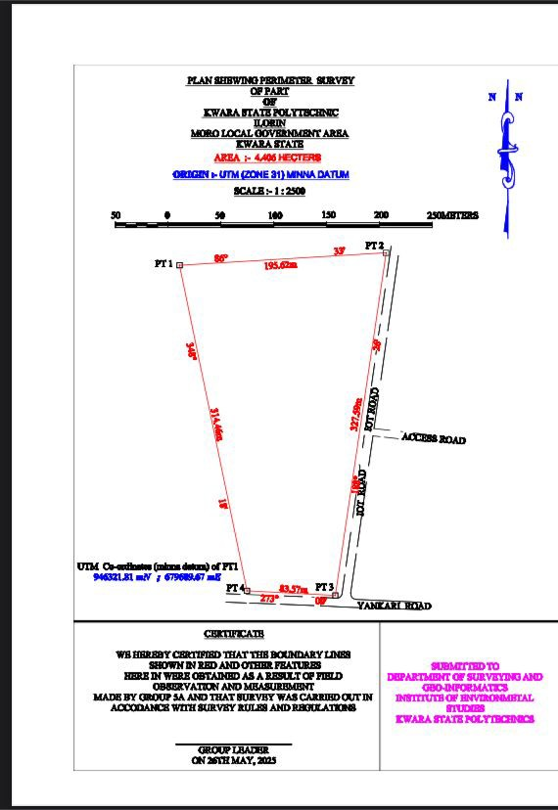

Figure 4.1: Perimeter plan of the study area

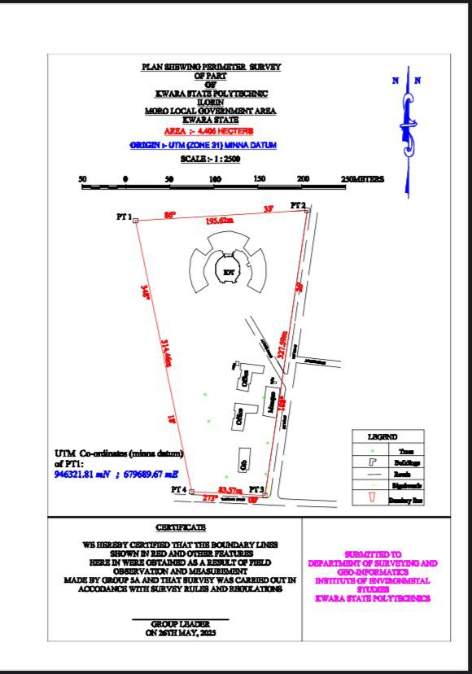

Figure 4.2: Perimeter and detail plan of the study area

CHAPTER FIVE

SUMMARY, PROBLEMS, RECOMMENDATIONS AND CONCLUSION

This chapter encapsulates the key findings from the research on perimeter and detailing surveys, outlines the problems encountered during the study, presents recommendations for improvement, and draws final conclusions from the investigation.

SUMMARY

The study has comprehensively explored the significance of perimeter and detailing surveys in the context of land surveying and urban planning. It began by defining both perimeter and detailing surveys, highlighting their importance in legal compliance, urban development, environmental assessments, and infrastructure planning.
Key findings indicate that perimeter surveys are critical for establishing clear and legally recognized property boundaries, thus preventing disputes among landowners. Detail surveys, complementarily, provide an intricate understanding of the land's physical characteristics, including topography, existing structures, and utilities, which are essential for making informed planning and design decisions.
Modern surveying techniques and technologies such as Total Stations, GPS, and GIS were evaluated, demonstrating how they enhance the accuracy and efficiency of both types of surveys. While traditional methods laid the foundational skills, these advancements have transformed surveying practices, facilitating more complex and precise measurements.
Despite these improvements, the study identified several challenges faced by professionals in the field. These include complications arising from complex topography, historical claims on properties, and the necessity to navigate varying legal requirements.

CONCLUSION

In conclusion, perimeter and detailing surveys are fundamental elements of effective land management and urban development. They not only define property boundaries but also contribute critical information that underpins sustainable planning and development practices. The study underscores the importance of accuracy and comprehensiveness in surveying methods to a meliorate land disputes, optimize land use, and facilitate sound urban planning.
The findings from this research illustrate that while advancements in technology have improved survey accuracy, ongoing education and skill
development are necessary to adapt to evolving practices in surveying. By addressing challenges head-on and implementing recommended strategies, professionals can significantly enhance the quality and reliability of surveys.

RECOMMENDATIONS

Based on the findings of this research, the following recommendations are proposed:
- Professional Development: Continuous training and professional development should been courage for surveyors to keep pace with technological advances and best practices in perimeter and detailing surveys.
- Adoption of Advanced Technologies: Surveying firms and professionals should invest in modern tools and technologies, such as GIS and advanced GPS systems, to enhance survey precision and efficiency.
- Standardization of Survey Methods: The establishment of standardized methodologies across surveying practices could mitigate inconsistencies and enhance legal compliance, making it imperative that all practitioners adhere to best practices in perimeter and detailing surveys.
- Collaboration Among Stakeholders: Collaborative efforts should be fostered among surveyors, urban planners, and legal authorities to ensure that boundary
definitions and property features are accurately represented and understood by all parties involved.
- Public Awareness and Education: Efforts should be made to educate the public regarding the importance of perimeter and detailing surveys to minimize misinformation and foster a greater appreciation of land surveying practices.
- Policy Review and Improvements: Policy makers should periodically review and amend regulations governing land surveying to adapt to new technological advancements and field practices, ensuring that all surveying practices are recognition-based and legally sound.

PROBLEMS ENCOUNTERED

Throughout the course of this study, several challenges were encountered, including:
    - Data Availability: Accessing comprehensive and up-to-date data on local surveying practices was limited, which may have influenced the depth of the analysis conducted.
    - Stakeholder Engagement: Gaining participation from relevant stakeholders proved challenging, with some surveyors and landowners hesitant to share insights or experiences due to concerns about confidentiality or liability.
    - Variability in Practices: The diversity in surveying techniques and methods
employed across different regions created complications in drawing generalized conclusions applicable to broader contexts.
In summary, this study illustrates both the critical role of perimeter and detailing surveys in effective land management and the challenges faced by professionals within this field. By implementing the recommendations provided and addressing the identified problems, stakeholders can enhance the effectiveness of surveying practices leading to improved land utilization and development outcomes.

REFERENCES

Anderson, K. & Gaston, A. (2018). The Impact of Drones in Construction Surveying. Journal of Construction Engineering, 45(2), 123-135.
Baker, S. (2019). Challenges in Implementing Modern Surveying Technologies.

International Journal of Surveying, 15(1), 30-45.

Black, M.,Yates, R.,&Roberts,L.(2019).UtilizingGPSandGNSSforAccurate Property Surveying. Survey Review, 52(1), 55-71.
Clark,J.(2021).EnvironmentalImpactAssessmentsandtheRoleofAccurate Surveying Data. Journal of Environmental Planning, 73(3), 214-230.
Dalton,S.,&Robson,E.(2017).TheAccuracyofTraditionalSurveyingTechniques in Contemporary Applications. International Journal of Surveying, 14(3), 125-145.
Davis,L.&Moore,T.(2021).AugmentedandVirtualRealityinSurveying:The Future of Perspective Visualizations. Journal of Urban Planning, 30(4), 647-660.
Fischer,P.,&Smith,L.(2021).SurveyingforUrbanPlanning:BestPracticesand Emerging Trends. Journal of Urban Studies, 8(2), 75-89.
Hampton,A.,&Ford,R.(2020).PrecisionTheodolites:InnovationsandApplications for Accurate Measurements. Journal of Measurement Science, 19(7), 341-358.
Hughes,G.(2018).UnderstandingtheConceptsofPerimeterandDetailingSurveys: A Comprehensive Overview. Journal of Construction Research, 35(5), 689- 710.
Johnson,R.,&Evans,P.(2019).HeritageConservationandDetailedSurveys:Best Practices for Preservation. Journal of Cultural Heritage Management, 14(1), 50-65.
Kahn, H., & Mitchell, D. (2019). Navigating Regulatory Frameworks in Property Surveying: Challenges and Strategies Property Management Journal, 34 (3), 182-197.
Kirk,S.& Lewis,J.(2020).The Role of Surveying in Land Use Planning and Management. Journal of Land Use Policy, 31(2), 215-232.
Lee, J. & Park, H. (2018). The Integration of GIS with Traditional Surveying: Enhancing Spatial Analysis. Journal of Geographic Information Systems, 10(4), 123-139.
Mason,T.(2019).TheEvolutionofSurveyingTools:FromChainstoSatellites.

Surveying & Geospatial Engineering, 19(5), 301-319.

Newton,T.&Roberts,P.(2021).SurveyingChallengesinUrbanEnvironments:A Case Study Approach. Journal of Urban Engineering, 27(3), 199-215.
Owens, M. (2020). Advanced Data Collection Techniques in Land Surveys: Innovations and Applications. International Journal of Applied Geospatial Research, 11(2), 1-12.
Peters, R. & Clarke, A. (2020). Utilizing 3D Modeling in Detailing Surveys for Infrastructure Projects. Journal of Civil Engineering and Architecture,14(6),234-248.
Quinn, F. (2019). Remote Sensing Technologies for Enhanced Land Surveying: A Review of Current Practices. Remote Sensing Journal, 11(1), 1-17.
Roberts, A. (2018). Comparative Analysis of Surveying Technologies: Benefits and Limitations. Journal of Surveying Engineering, 34(2), 90-105.
Turner, P. & Wong, C. (2021). The Future of Property Surveying: Trends and Innovations. International Journal of Surveying Sciences, 12(3), 144-156.

CONTROL USED

APPENDIX A SORTED ACQUIRED DATAS

POINT ID | EASTING | NORTHING | HEIGHT
KW725PT | 679689.671 | 946321.807 | 344.737
KW111PT | 679836.916 | 946009.525 | 328.57

PERIMETER POINTS
POINT ID EASTING NORTHING HEIGHT SC/KW F.RS
4404 679689.671 946321.807 339.655
SC/KW F.RS
4405 679884.932 946333.571 340.917
SC/KW F.RS
4406 679836.916 946009.525 341.958
SC/KW F.RS
4407 679753.459 946013.889 342.848
SC/KW F.RS
4404 679689.67 946321.807 343.452
DETAIL POINTS

POINT ID | EASTING | NORTHING HEIGHT
EG1 | 679758.321 | 946239.632 | 344.084
EG2 | 679754.063 | 946248.243 | 344.24
BL1 | 679751.63 | 946257.142 | 344.164
EG3 | 679751.011 | 946266.072 | 343.997
EG4 | 679751.841 | 946272.552 | 343.954
BL2 | 679752.551 | 946279.262 | 343.867
EG5 | 679756.371 | 946287.501 | 343.803
EG6 | 679758.576 | 946289.906 | 343.609
EG7 | 679769.145 | 946282.317 | 343.418
EG8 | 679772.746 | 946286.056 | 343.223
EG9 | 679777.631 | 946290.125 | 342.998
BL3 | 679771.545 | 946302.256 | 342.702
BL4 | 679777.585 | 946306.165 | 342.464
OFF1 | 679804.82 | 946130.166 | 342.176
OFF2 | 679806.553 | 946142.711 | 341.918
OFF3 | 679808.381 | 946142.4 | 341.65
BL5 | 679810.251 | 946152.25 | 342.447
OFF4 | 679808.639 | 946152.645 | 342.32

OFF | 679809.212 | 946159.839 | 342.135
BL5 | 679836.221 | 946156.67 | 340.809
Wl1 | 679834.491 | 946148.172 | 340.455
EG10 | 679822.443 | 946149.114 | 339.173
CL1 | 679820.121 | 946136.201 | 337.856
OFF6 | 679818.791 | 946136.312 | 337.259
OFF7 | 679817.762 | 946127.563 | 336.735
OFF8 | 679804.823 | 946130.174 | 336.202
TL1 | 679803.381 | 946161.872 | 338.847
Tl 2 | 679807.183 | 946161.612 | 339.603
TL3 | 679807.433 | 946157.032 | 339.536
TL4 | 679803.541 | 946157.623 | 340.18
TL5 | 679803.382 | 946161.871 | 341.117
OFF9 | 679802.871 | 946114.623 | 341.166
OFF10 | 679829.342 | 946111.532 | 341.589
OFF11 | 679827.832 | 946102.981 | 341.487
OFF12 | 679814.952 | 946103.281 | 342.113
BL6 | 679813.531 | 946091.342 | 342.133
CL2 | 679811.82 | 946082.893 | 342.564
OFF13 | 679798.951 | 946084.122 | 342.686

OFF14 | 679800.742 | 946097.313 | 342.775
OFF15 | 679802.322 | 946097.031 | 343.059
OFF16 | 679803.172 | 946105.841 | 343.277
OFF7 | 679801.641 | 946106.072 | 343.323
OFF18 | 679802.872 | 946114.621 | 343.498
GTB1 | 679807.852 | 946063.82 | 343.941
GTB2 | 679807.871 | 946063.592 | 343.852
GTB3 | 679820.351 | 946063.132 | 343.882
GTB4 | 679818.551 | 946038.839 | 343.833
GTB5 | 679815.629 | 946038.938 | 343.906
GTB6 | 679815.327 | 946035.605 | 343.982
GTB7 | 679806.509 | 946036.039 | 343.685
GTB8 | 679807.865 | 946063.589 | 343.178
MQ1 | 679838.087 | 946133.585 | 342.571
MQ2 | 679853.92 | 946131.287 | 342.041
MQ3 | 679849.725 | 946097.686 | 341.591
MQ4 | 679834.275 | 946100.5 | 340.697
MQ5 | 679838.089 | 946133.579 | 339.655
TL6 | 679846.21 | 946139.201 | 331.519

TL7 | 679850.038 | 946138.648 | 332.814
TL8 | 679849.871 | 946136.692 | 332.786
TL9 | 679846.202 | 946136.941 | 331.939
TL10 | 679846.211 | 946139.201 | 331.861
TR1 | 679768.701 | 946124.21 | 331.818
TR2 | 679772.619 | 946093.729 | 331.736
TR3 | 679807.852 | 946063.82 | 343.941
TR4 | 679793.091 | 946030.537 | 331.36
TR5 | 679837.931 | 946033.652 | 331.418
TR6 | 679839.881 | 946069.127 | 331.478
SB1 | 679840.578 | 946009.091 | 331.542
SB2 | 679842.739 | 946017.61 | 331.488
RD1 | 679733.439 | 946003.161 | 331.519
RD2 | 679733.748 | 946011.162 | 329.899
RD3 | 679838.041 | 946006.852 | 331.927
RD4 | 679843.285 | 946011.141 | 331.497
RD5 | 679860.225 | 946131.321 | 330.103
RD6 | 679814.447 | 946209.941 | 329.427
RD7 | 679820.475 | 946213.501 | 329.048
RD8 | 679859.029 | 946148.369 | 327.577

RD9 | 679862.731 | 946149.111 | 327.887
RD10 | 679889.64 | 946340.005 | 328.09
RD11 | 679896.425 | 946330.871 | 329.036
RD12 | 679873.388 | 946167.387 | 328.9
RD13 | 679923.27 | 946161.85 | 329.899
RD14 | 680019.278 | 945985.8966 | 328.45
RD15 | 680019.5192 | 945985.8926 | 328.452
RD16 | 680049.2592 | 945985.3466 | 329.851
RD17 | 680052.7984 | 945994.9155 | 330.765
RD18 | 680035.8983 | 945995.2747 | 329.206
RD19 | 680021.1428 | 945998.93 | 329.071
RD20 | 680014.553 | 946000.8285 | 328.984
RD21 | 679998.9224 | 946013.2946 | 328.691
RD22 | 679979.8714 | 946033.5673 | 328.071
RD23 | 679965.4018 | 946049.4666 | 328.419
RD24 | 679958.6616 | 946062.734 | 329.066
RD25 | 679959.5686 | 946094.9526 | 331.567
RD26 | 679960.8124 | 946132.8956 | 332.923
RD27 | 679962.2135 | 946229.3587 | 338.138
RD28 | 679966.6673 | 946409.1306 | 342.532

RD29 | 679931.9204 | 946045.2297 | 327.91
RD30 | 679938.595 | 946053.831 | 328.233
RD31 | 679942.537 | 946052.9746 | 328.123
RD32 | 679948.3344 | 946044.4573 | 327.538
RD33 | 679940.406 | 946045.6251 | 327.73

