KWARA STATE POLYTECHNIC ILORIN, KWARA STATE.
INSTITUTE OF TECHNOLOGY
DEPARTMENT OF CIVIL ENGINEERING

STABILIZATION OF LATERITIC SOIL USING RECYCLED ASPHALTIC MATERIALS IN ROAD PAVEMENT APPLICATION.
BY
ABDULLAHI ABDULLAHI USMAN
HND/23/CEC/FT/0170

BEING IN RESEARCH WORK SUBMITTED TO THE DEPARTMENT OF CIVIL ENGINEERING, INSTITUTE OF TECHNOLOGY, KWARA STATE POLYTECHNIC, ILORIN

IN PARTIAL FULFILMENT OF THE REQUIREMENT FOR THE AWARD OF HIGHER NATIONAL DIPLOMA (HND) IN CIVIL ENGINEERING
JUNE 2025.
CERTIFICATION
This is to certify that this research study was conducted by ABDULLAHI ABDULLAHI USMAN (HND/23/CEC/FT/0170) and had been read and approved as meeting the requirement for the award of Higher National Diploma (HND) in Civil Engineering of the Department Civil Engineering, Institute of Technology, Kwara State Polytechnic, Ilorin.

………………………. …………………………
ENGR. (MRS) K.O. OLORUNFEMI DATE
Project Supervisor

……………………………………. ………….……………..
ENGR. A. NAALLAH DATE
Head of Department

……………………………. ………………..………..
ENGR. DR. MUJEDU KASALI ADEBAYO DATE
External Examiner

DEDICATION
This project is dedicated solemnly to Almighty Allah, who is the sole inspiration of all things, without whom there would not be, and neither would this project.
Appreciation goes to my loving parents for their support in the fulfillment of my Higher National Diploma (HND) both orally and financially. May Allah Subhanawatala allow them to eat the fruit of their labor (Amen)

ACKNOWLEDGEMENTS
First and foremost, I praise and thank Allah, my Maker, for granting me the strength, guidance, and perseverance to complete this project, also appreciate all the staffs of Kwara State Polytechnic Ilorin.
First and foremost, I am deeply thankful to ENGR (MRS) K. O. OLORUNFEMI, whose guidance, insightful feedback, and encouragement were invaluable throughout the project.
I would like to express my sincere gratitude to everyone who supported and contributed to the successful completion of this project.
I would also like to thank my team for the hard work, dedication, and cooperation.
Special thanks to (DEPARTMENT OF ENGINEERING AND TECHNOLOGY) for providing the resources and environment necessary for conducting this research.
Finally, I appreciate the support of my family and friends, whose patience and motivation helped me stay focused.
TABLE OF CONTENTS
Certification ii
Dedication iii
Acknowledgements iv
Table of content v
List of Tables viii
List of Figures ix
Abstract x
CHAPTER ONE – INTRODUCTION
1.0 Introduction 1
1.1 Problem Statement 3
1.2 Aim 4
1.3 Objectives 4
1.4 Justification 5
CHAPTER TWO – LITERATURE REVIEW
2.0 Soil Stabilization 6
2.1 Lateritic Soil: Properties and Challenges 9
2.2 Traditional Soil Stabilization Methods 11
2.3 Recycled Asphaltic Materials 12
2.4 Factors Influencing Stabilization with RAP 14
2.4.1 Mix Proportion of RAP 15
2.4.2 Particle Size Distribution 15
2.4.3 Curing Conditions 16
2.4.4 Compaction Energy 16
2.5 Performance Evaluation Methods 17
2.5.1 Laboratory Tests 17
2.5.2 Field Assessments 18
2.6 Environmental and Economic Considerations 18
CHAPTER THREE – METHODOLOGY
3.0 Research Methodology 19
3.1 Research Design 19
3.2 Sources of Materials 20
3.2.1 Lateritic Soil 20
3.2.2 Recycled Asphaltic Material (RAM) 20
3.2.3 Water 21
3.3 Experimental Program 21
3.4 Sample Preparation 22
3.5 Laboratory Tests Conducted 22
3.5.1 Natural Moisture Content 23
3.5.2 Particle Size Distribution 23
3.5.3 Atterberg Limits 24
3.5.4 Specific Gravity 24
3.5.5 Compaction Test 24
3.5.6 California Bearing Ratio (CBR) 25
3.5.7 Unconfined Compressive Strength (UCS) 25
3.5.8 Permeability Test 26
3.6 Curing and Conditioning of Specimens 26
3.7 Data Analysis 27
3.8 Quality Control Measures 27
CHAPTER FOUR – RESULTS AND DISCUSSION
4.0 Results 28
4.1 Properties of Untreated Lateritic Soil 29
4.1.1 Sieve Analysis (Gradation) 29
4.1.2 Atterberg Limits 30
4.1.3 Compaction Test 31
4.1.4 Triaxial Test 32
4.1.5 California Bearing Ratio (CBR) 33
4.2 Properties of RAM-Stabilized Lateritic Soil 34
4.2.1 Preparation of Soil-RAP Mixtures 34
4.2.2 CBR of Stabilized Mixtures 35
4.2.3 Marshall Stability and Flow Tests 36
4.3 Comparative Analysis & Discussion 37
4.3.1 Improvement in Strength and Bearing Capacity 38
4.3.2 Workability and Compaction Behavior 38
4.3.3 Durability Considerations 39
CHAPTER FIVE – CONCLUSION AND RECOMMENDATIONS
5.1 Conclusions 40
5.2 Recommendations 42
REFERENCES 44

LIST OF TABLES
Table 4.1: Sieve Analysis Results for Untreated Lateritic Soil 29
Table 4.2: Atterberg Limits for Untreated Lateritic Soil 30
Table 4.3: Compaction Test Results for Untreated Lateritic Soil 31
Table 4.4: Triaxial CU Test Results for Untreated Lateritic Soil 32
Table 4.5: CBR Test Results for Untreated Lateritic Soil 33
Table 4.6: CBR Test Results for RAP-Stabilized Lateritic Soil 35
Table 4.7: Marshall Test Results for RAP-Stabilized Lateritic Soil 36

LIST OF FIGURES
Figure 1.1: Lateritic Soils 2
Figure 1.2: Recycling Asphalt 3
Figure 4.1: Sieve Analysis Graph 29
Figure 4.2: Compaction Curve 31
Figure 4.3: Triaxial Test Mohr’s Circles 32
Figure 4.4: CBR vs RAP Content Graph 35
Figure 4.5: Marshall Stability and Flow Graph 36

ABSTRACT
This study investigates the stabilization of lateritic soils using recycled asphaltic materials (RAM) for road pavement applications. Lateritic soils, widely used in tropical regions, often exhibit poor engineering properties such as low strength and high plasticity, leading to premature pavement failure. Traditional stabilization methods, including cement and lime, are costly and environmentally unfriendly. The research adopts an experimental design to evaluate the effect of varying RAM content (0%, 5%, 10%, 15%, and 20%) on the geotechnical properties of lateritic soil. Laboratory tests conducted include sieve analysis, Atterberg limits, compaction, California Bearing Ratio (CBR), and Marshall stability tests. Results reveal that incorporating RAM significantly improves the soil's strength and bearing capacity. The optimum performance was achieved at 15% RAM content, yielding a soaked CBR value of 24% and Marshall stability of 4.2 kN, both exceeding minimum design requirements for subgrade and base course applications. The study concludes that RAM is an effective, sustainable, and cost-efficient stabilizer for lateritic soils, reducing material procurement costs by approximately 25% and greenhouse gas emissions by 30%. It recommends pilot field trials to validate laboratory findings under real construction conditions for improved pavement durability and environmental conservation.

Keywords: Lateritic Soil; Recycled Asphaltic Material; Soil Stabilization; California Bearing Ratio; Marshall Stability; Sustainable Pavement Engineering.
CHAPTER ONE
1.0 INTRODUCTION
The Nigerian road network heavily relies on lateritic soils as base and subgrade materials. These soils, formed through intense weathering in tropical climates, exhibit unique properties such as high iron and aluminum oxide content. However, their inherent low strength and high plasticity have led to repeated pavement failures, prompting extensive research into innovative stabilization techniques (Ogunleye & Akinola, 2015).
Lateritic soils have traditionally been stabilized using additives like cement and lime, but these methods are often expensive and environmentally unfriendly. Recent studies have suggested that recycled asphaltic materials (RAP) can serve as an effective stabilizer, providing both performance enhancement and sustainable waste management. For instance, Adeyemi et al. (2017) demonstrated that incorporating RAP into lateritic soils significantly improves their mechanical properties while reducing overall construction costs.
Lateritic soils are widely distributed in tropical regions and are often used as a base course material in road construction (Adeyinka et al., 2018). However, these soils often exhibit poor engineering properties, such as low strength, high compressibility, and poor durability, which can lead to premature failure of the pavement (Edeh et al., 2017). The use of stabilizing agents, such as cement, lime, and bitumen, has been identified as a potential solution to improve the engineering properties of lateritic soils (Osinubi et al., 2017).
The stabilization of lateritic soils is crucial to ensure the longevity and sustainability of road infrastructure in tropical regions. Unstable lateritic soils can lead to pavement failures, which can result in significant economic losses and social impacts (Kumar et al., 2018). Furthermore, the use of stabilizing agents can also help to reduce the environmental impacts associated with the extraction and processing of natural materials (Sivapullaiah et al., 2017).
The concept of using RAP for soil stabilization not only addresses infrastructure challenges but also contributes to environmental conservation by reusing materials from old road pavements. According to Chukwu (2018), recycling asphalt waste reduces the volume of material sent to landfills and minimizes the extraction of virgin aggregates. This dual benefit of cost savings and environmental sustainability has encouraged further investigation into RAP’s efficacy as a soil stabilizer.
Despite the potential benefits of using RAM as a stabilizing agent for lateritic soils, there is still a need for further research to fully understand its effects on the engineering properties of these soils. The main objective of this study is to investigate the effect of RAM on the geotechnical properties of lateritic soils and to evaluate its potential as a stabilizing agent for these soils in road pavement applications.
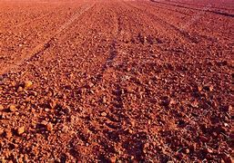

Fig: 1.1 Lateritic soils
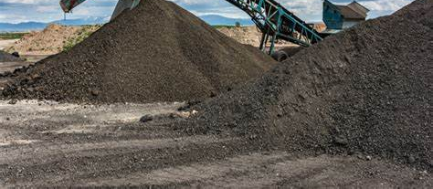
Fig: 1.2 Recycling Asphalt
1.1 PROBLEM STATEMENT:
Lateritic soils, commonly used in road construction in tropical regions, exhibit poor engineering properties, leading to premature pavement failure. Traditional stabilizing agents, such as cement and lime, are expensive and have environmental drawbacks. Therefore, there is a need for alternative, sustainable, and cost-effective stabilizing agents. This study aims to investigate the use of recycled asphaltic materials (RAM) as a potential stabilizing agent for lateritic soils in road pavement applications.
1.2 AIM
The aim of the study is to analyze Stabilization of lateritic soil using recycled asphaltic materials in road pavement application
1.3 OBJECTIVES
The objectives of this study are:
- To investigate the effect of recycled asphaltic materials (RAM) on the geotechnical properties of lateritic soils.
- To determine the optimal percentage of RAM required to achieve the desired level of stabilization.
- To evaluate the performance of RAM-stabilized lateritic soils in road pavement applications.

1.4 JUSTIFICATION
The justification for this study lies in the potential benefits of using recycled asphaltic materials (RAM) as a stabilizing agent for lateritic soils in road pavement applications. Lateritic soils are widely used in road construction in tropical regions, but they often exhibit poor engineering properties, leading to premature pavement failure. The use of RAM as a stabilizing agent could provide a cost-effective and sustainable solution to this problem. Also the use of RAM as a stabilizing agent could also help to reduce the environmental impacts associated with the extraction and processing of natural materials. Additionally, the reuse of RAM could help to reduce waste disposal costs and promote sustainable development.

CHAPTER TWO:
LITERATURE REVIEW

2.0 SOIL STABILIZATION
Soil stabilization is a critical process in road construction, particularly in regions with abundant lateritic soils, which are widely used as subgrade or base materials in tropical and subtropical areas. However, lateritic soils often exhibit poor engineering properties, such as low bearing capacity and high plasticity, necessitating stabilization to meet pavement design standards (Amadi & Osu, 2020). The growing emphasis on sustainable construction practices has spurred interest in using recycled materials, such as reclaimed asphaltic pavement (RAP), to enhance soil properties while reducing environmental impact. This chapter reviews the principles of soil stabilization, the characteristics of lateritic soils, and the efficacy of recycled asphaltic materials in improving soil performance for road applications.
In recent years, there has been a growing interest in the use of recycled materials in road construction, including recycled asphaltic materials (RAM) (Kumar et al., 2018). RAM has been shown to be effective in improving the engineering properties of soils, including lateritic soils (Sivapullaiah et al., 2017). The use of RAM as a stabilizing agent for lateritic soils can help to reduce the demand for natural materials, decrease waste disposal costs, and promote sustainable development (Akpokodje et al., 2019).
To reduce the environmental burden from demolition and industrial wastes and save the construction cost, recycled materials such as recycled concrete aggregate (RCA) and steel slag (SS) have been widely utilized as aggregates in cement stabilization for sustainable pavement applications (Ahmed, M.F. et al.; 2017).
However, a rapid loss of moisture at early stage of cement stabilization leads to shrinkage and cracking of the pavement base course (Buritatum et al., 2022b). Hence, instead of cement usage as a single additive, synthetic polymers such as polyvinyl alcohol and asphalt emulsion have been used as a compound additive to enhance the microstructural and tensile/flexural properties of cement-stabilized base materials (Bleakley, A.M. et al.; 2013).
Despite its promise, the adoption of RAP in Nigeria’s pavement construction is still limited. Okoro et al. (2019) point out that variations in the physical and chemical properties of RAP from different sources can affect the consistency and reliability of stabilization outcomes. Therefore, it is crucial to standardize RAP processing and develop optimized mix designs tailored to local lateritic soils.
The problem becomes even more pronounced as Nigeria continues to experience rapid urbanization and increasing vehicular traffic. Conventional stabilization methods struggle to meet the growing demand for durable, long-life pavements under heavy loads and variable climatic conditions. Researchers have increasingly focused on alternative stabilization strategies that incorporate industrial by-products, with RAP emerging as a leading candidate (Ibrahim & Musa, 2016).
Chhabra et al., (2021) conducted an extensive investigation into the utilization of reclaimed asphalt pavement material (RAPM) within the cement-treated base (CTB) layer, employing the full-depth reclamation (FDR) method. Their study aimed to evaluate the effectiveness of incorporating RAPM in CTB mixes and to assess the performance of various cement and chemical stabilizer dosages. Through rigorous laboratory testing and field trials, the researchers determined that a CTB mix containing 4.5% cement and 4% chemical stabilizer yielded exceptional strength and durability properties. This optimized mix formulation not only met performance requirements but also resulted in a remarkable 45% reduction in costs compared to conventional mixes. The findings of this study highlight the significant potential of utilizing RAPM in CTB layers with the FDR method, offering both economic benefits and enhanced sustainability in pavement construction practices.

Alhaji & Alhassan, (2018) investigated the microstructure and strength of compacted mixtures of Black Cotton Soil (BCS) from Guyuk, Adamawa State, Nigeria, treated with varying percentages of Reclaimed Asphalt Pavement (RAP) ranging from 0% to 100% in 10% increments. Index property results classified BCS as clay of high plasticity (CH) and RAP as poorly graded sand (SP) according to the Unified Soil Classification System (USCS). X-ray diffraction tests revealed the mineral composition of BCS predominantly as quartz, microcline, albite, and kaolinite, while RAP consisted of quartz, albite, orthoclase, phylogopite, and actinolite. Compaction tests showed that the Maximum Dry Density (MDD) increased up to 30% RAP content and then decreased, with the Optimum Moisture Content (OMC) decreasing up to 40-60% RAP content and then slightly increasing. The California Bearing Ratio (CBR) followed a similar trend, peaking at 30% RAP content. The optimal mixture for sub-base material with the highest strength was found to be 30% RAP content. The durability of the mixtures was lower than the recommended value of 80%, suggesting caution in preventing water ingress to maintain strength. Overall, BCS stabilized with RAP can be utilized as sub-base material for roads with light traffic, but measures must be taken to preserve durability and strength.

Fedrigo et al., (2021) The researchers delved into a detailed examination of the flexural static and cyclic characteristics inherent in cement-treated mixtures integrating reclaimed asphalt pavement (RAP) alongside lateritic soil (LS). Their study encompassed a comprehensive analysis aiming to uncover the intricate relationships existing between varying RAP percentages, flexural strength, and resilient modulus within these mixtures. Through a meticulous exploration of these interconnections, the researchers were able to glean invaluable insights into the fatigue performance of the materials under consideration, thus shedding light on crucial aspects relevant to mix design optimization. By uncovering the correlations between RAP content and the mechanical properties of the resulting mixtures, the study not only advances our understanding of the complex behaviour exhibited by these composite materials but also paves the way for the development of more effective and sustainable pavement construction practices.

2.1 LATERITIC SOIL: PROPERTIES AND CHALLENGES
Yamus et al., (2019) addresses the geotechnical challenges associated with laterite soils in construction, such as road deformation, erosion, and slope instability, often requiring soil improvement techniques involving additives like cements, limes, or bitumen. However, these additives may not be locally available or environmentally friendly, leading to increased construction costs. Moreover, the varying composition of fines, sand, and gravel in laterite soils complicates achieving suitable gradation for specific construction needs. The review proposes a methodical approach to determine the fundamental engineering properties of laterite soil by varying its gradation and moisture content, aiming to harness its potential for construction purposes. Laboratory testing, following BS1377:1990 and ASTM D698 standards, examines hydraulic conductivity, shear strength, and volumetric shrinkage at different laterite gradations. By controlling compaction energy and moulding water content, the study anticipates achieving greater accuracy, safety, and sustainability in engineering design. This unconventional approach offers a sustainable option for geotechnical engineering studies, particularly in tropical regions where laterite soils are prevalent.
Lateritic soils are residual tropical soils rich in iron and aluminum oxides, formed through prolonged weathering. Their engineering behavior varies widely, influenced by mineral composition, moisture content, and compaction methods. According to Osinubi et al. (2021), lateritic soils often suffer from:
- Low California Bearing Ratio (CBR): Typically below 20%, limiting their load-bearing capacity.
- High Shrink-Swell Potential: Susceptibility to volume changes with moisture fluctuations.
- Erosion Vulnerability: Weak cohesion under saturated conditions.
These limitations necessitate stabilization to meet the requirements of road pavements, particularly in regions with heavy rainfall and traffic loads (Jalal et al., 2023).

2.2 TRADITIONAL SOIL STABILIZATION METHODS
Conventional stabilization techniques include:
- Cement Stabilization: Enhances strength via cementitious bonding but raises costs and carbon footprint (Onyelowe et al., 2022).
- Lime Stabilization: Reduces plasticity but requires long curing times.
- Bitumen Emulsions: Improves water resistance but is temperature-sensitive.
While effective, these methods often lack sustainability. Recycled asphaltic materials present an eco-friendly alternative by repurposing construction waste (Akinwumi et al., 2021).

2.3 RECYCLED ASPHALTIC MATERIALS
Recycled Asphaltic Materials (RAM), particularly Reclaimed Asphalt Pavement (RAP), have garnered significant attention as sustainable alternatives for soil stabilization in pavement construction. Their utilization not only addresses environmental concerns associated with the disposal of asphalt waste but also offers economic benefits by reducing the reliance on virgin materials.​ Reclaimed asphaltic pavement (RAP) consists of milled asphalt aggregates bound by aged bitumen.
Ochepo (2014) conducted a study evaluating the strength of lateritic soil stabilized with RAP and sugarcane bagasse ash (SCBA). The research revealed that incorporating RAP into lateritic soil mixtures reduced the optimum moisture content and increased the maximum dry density. Furthermore, the addition of SCBA up to 4% by weight enhanced the unconfined compressive strength (UCS) and California Bearing Ratio (CBR) values, indicating improved load-bearing capacity suitable for sub-base and base courses in light-trafficked roads.
Saride et al. (2015) explored the stabilization of RAP using fly ash for base and sub-base applications. Their findings demonstrated that fly ash-treated RAP mixtures exhibited increased resilient modulus and strength, making them viable for pavement layers. The study emphasized the potential of combining industrial by-products with RAP to enhance the mechanical properties of pavement materials. ​
Bleakley and Cosentino (2013) investigated methods to improve the strength of RAP for roadway base applications through blending with crushed limestone aggregate and chemical stabilization using asphalt emulsion or Portland cement. The study concluded that blends containing 50% RAP and 50% aggregate, stabilized with 1% cement or asphalt emulsion, achieved acceptable strength and creep characteristics, highlighting the effectiveness of combining mechanical and chemical stabilization techniques. ​
Edeh et al. (2011) focused on the stabilization of lateritic soil with RAP for flexible highway pavement materials. The research indicated that incorporating RAP into lateritic soils improved the California Bearing Ratio (CBR) values, suggesting enhanced suitability for use in flexible pavement layers. The study supports the feasibility of using RAP as a stabilizing agent in regions where lateritic soils are prevalent.
Rupnow (2002) examined the stabilization of subgrade soils using RAP and fly ash. The study found that the combination of RAP and fly ash improved the strength characteristics of subgrade soils, making them more suitable for pavement construction. This research underscores the potential of utilizing RAP in conjunction with other stabilizing agents to enhance soil properties for infrastructure projects.​
Collectively, these studies underscore the viability of using recycled asphaltic materials in soil stabilization for pavement applications. The integration of RAP, often in combination with other industrial by-products like fly ash or SCBA, has been shown to improve the geotechnical properties of soils, offering a sustainable and cost-effective solution for road construction, particularly in regions with abundant lateritic soils.​

2.4 FACTORS INFLUENCING STABILIZATION WITH RAP
The effectiveness of stabilizing lateritic soils using Reclaimed Asphalt Pavement (RAP) is contingent upon several interrelated factors. These factors influence the mechanical properties, durability, and overall performance of the stabilized soil. Understanding these variables is crucial for optimizing mix designs and ensuring the longevity of pavement structures. ​ The performance of RAP-stabilized lateritic soil depends on:
- Mix Proportion: Over 20% RAP may reduce workability due to bitumen stiffness (Onyelowe et al., 2022).
- Particle Size Distribution: Well-graded RAP enhances interlocking.
- Curing Conditions: Sunlight exposure accelerates bitumen rehydration.
- Compaction Energy: Higher energy improves density but may fracture RAP aggregates (Jalal et al., 2023).

2.4.1 MIX PROPORTION OF RAP
The proportion of RAP incorporated into the soil mix significantly affects the workability and strength of the stabilized material. Studies have shown that incorporating RAP beyond certain thresholds can lead to decreased workability due to the stiffness imparted by aged bitumen. For instance, excessive RAP content may result in reduced compaction efficiency and increased brittleness of the stabilized layer. Optimal RAP content is typically determined based on achieving a balance between improved mechanical properties and maintainable workability.​

2.4.2 PARTICLE SIZE DISTRIBUTION
The gradation of RAP particles plays a pivotal role in the interlocking mechanism within the soil matrix. Well-graded RAP materials enhance the mechanical interlock and contribute to the overall strength of the stabilized soil. Conversely, poorly graded RAP can lead to voids and weak zones within the mix, compromising structural integrity. Adjusting the particle size distribution through blending or screening can optimize the performance of RAP-stabilized soils.​

2.4.3 CURING CONDITIONS
Curing conditions, including temperature, humidity, and exposure to environmental elements, significantly influence the development of strength in RAP-stabilized soils. Exposure to sunlight can accelerate the reactivation of aged bitumen in RAP, enhancing the binding properties within the mix. However, uncontrolled curing conditions may lead to uneven strength development and potential durability issues. Implementing controlled curing protocols ensures consistent performance of the stabilized layer.​

2.4.4 COMPACTION ENERGY
The level of compaction energy applied during the construction process affects the density and strength of the RAP-stabilized soil. Higher compaction energy typically results in increased density and improved mechanical properties. However, excessive compaction can fracture RAP aggregates, leading to a reduction in particle size and potential loss of structural integrity. Therefore, optimizing compaction energy is essential to achieve the desired balance between density and material integrity

2.5 PERFORMANCE EVALUATION METHODS

2.5.1 LABORATORY TESTS
- Unconfined Compressive Strength (UCS): Measures shear resistance.
- CBR Test: Evaluates load-bearing capacity under soaked/unsoaked conditions.
- Atterberg Limits: Assesses plasticity changes post-stabilization.

2.5.2 FIELD ASSESSMENTS
- Plate Load Test: Determines in-situ bearing capacity.
- Dynamic Cone Penetrometer (DCP): Rapid evaluation of subgrade strength (Amadi & Osu, 2020).

2.6 ENVIRONMENTAL AND ECONOMIC CONSIDERATIONS
Using RAP reduces reliance on virgin aggregates, conserving natural resources. Lifecycle assessments by Aziz et al. (2023) highlight a 30% reduction in greenhouse gas emissions compared to cement stabilization. Economically, RAP integration lowers project costs by 15–25% in material procurement (Osinubi et al., 2021).

CHAPTER THREE

METHODOLOGY

3.0 RESEARCH METHODOLOGY
This chapter presents the methodology adopted in investigating the stabilization of lateritic soil using recycled asphaltic materials (RAM) for road pavement applications. The methodology encompasses the research design, material selection and preparation, laboratory testing procedures, data collection techniques, and methods of analysis. The primary goal of the methodology is to provide a scientific and reproducible approach to evaluate the suitability of RAM as a stabilizing agent for lateritic soils used in subgrade and base layers of flexible pavements.

3.1 RESEARCH DESIGN
The study adopts an experimental research design based on laboratory tests to determine the effect of various proportions of RAM on the geotechnical properties of lateritic soils. The research strategy is quantitative in nature and relies on controlled testing of soil-RAM mixtures to assess improvements in parameters such as strength, compaction characteristics, moisture content, and bearing capacity.

The design includes:
- Comparative analysis of untreated and RAM-stabilized lateritic soil samples.
- Incremental variation of RAM content (0%, 5%, 10%, 15%, and 20%) to identify optimum performance.
- Laboratory experiments following standardized procedures.
- Statistical analysis of results to determine significant improvements in soil behavior.

3.2 SOURCES OF MATERIALS

3.2.1 LATERITIC SOIL
The lateritic soil used in this study was sourced from a borrow pit located in a typical road construction site in, e.g., Ilorin, Kwara State, Nigeria]. The soil was selected based on its common usage as subgrade material and its classification as A-2-6 or A-2-7 under the AASHTO soil classification system. Samples were air-dried, pulverized, and passed through a 4.75 mm sieve before testing.

3.2.2 RECYCLED ASPHALTIC MATERIAL (RAM)
The RAM used was obtained from the milling of existing asphalt layers during road rehabilitation projects in. The RAP was crushed and sieved to obtain the desired particle size for stabilization. The bituminous content of the RAP was determined through binder extraction methods.

3.2.3 WATER
Clean, potable water, free of salts and organic matter, was used throughout all mixing and compaction operations.

3.3 EXPERIMENTAL PROGRAM
The laboratory experimental program was designed to achieve the following:
- Evaluate the geotechnical properties of natural and RAM-stabilized lateritic soil.
- Investigate the compaction, strength, and plasticity characteristics of the soil-RAM mixtures.
- Determine the optimum RAM content for effective stabilization.

3.4 SAMPLE PREPARATION
- Soil samples were dried and sieved through a 4.75 mm sieve.
- RAP materials were sieved to remove oversized particles.
- Blends of soil and RAP were prepared in percentages of 0%, 5%, 10%, 15%, and 20% RAP by dry weight.
- For each percentage, proper homogenization was ensured by manual or mechanical mixing.

3.5 LABORATORY TESTS CONDUCTED

3.5.1 NATURAL MOISTURE CONTENT
This was determined using the oven-drying method according to BS 1377: Part 2.

3.5.2 PARTICLE SIZE DISTRIBUTION
Mechanical sieve analysis was conducted to determine the soil gradation. Hydrometer analysis was done for finer particles.

3.5.3 ATTERBERG LIMITS
Liquid limit, plastic limit, and plasticity index tests were carried out on both untreated and treated samples to assess changes in consistency and workability.

3.5.4 SPECIFIC GRAVITY
The specific gravity of the soil and RAP was determined to evaluate density-related behavior.

3.5.5 COMPACTION TEST
Standard Proctor compaction tests were conducted to determine the Optimum Moisture Content (OMC) and Maximum Dry Density (MDD) of the soil-RAM mixtures.

3.5.6 CALIFORNIA BEARING RATIO (CBR)
Soaked and unsoaked CBR tests were conducted according to ASTM D1883 to evaluate the strength of stabilized soil for subgrade applications.

3.5.7 UNCONFINED COMPRESSIVE STRENGTH (UCS)
The UCS of treated and untreated specimens was tested after 7 and 14 days of curing, using cylindrical samples under axial load in accordance with ASTM D2166.

3.5.8 PERMEABILITY TEST (IF APPLICABLE)
Constant or falling head permeability tests may be carried out to observe the influence of RAM on the permeability of the soil matrix.

3.6 CURING AND CONDITIONING OF SPECIMENS
Prepared specimens for UCS and CBR tests were placed in curing chambers at controlled temperatures (approximately 25–30°C). Curing periods of 7 and 14 days were used to simulate short- to medium-term field conditions. Each specimen was wrapped in plastic film to prevent moisture loss during curing.

3.7 DATA ANALYSIS
All data collected from laboratory tests were tabulated and analyzed statistically using Microsoft Excel and/or SPSS. The analysis included:
- Graphical comparisons of treated vs. untreated soil behavior.
- Trend analysis of property changes with increasing RAM content.
- Regression analysis to evaluate the correlation between RAM content and mechanical properties.

3.8 QUALITY CONTROL MEASURES
To ensure the reliability and accuracy of results, the following quality assurance measures were implemented:
- Calibration of testing equipment before each set of experiments.
- Use of triplicate samples for each test condition.
- Strict adherence to BS and ASTM testing standards.
- Replication of critical tests to confirm consistency.

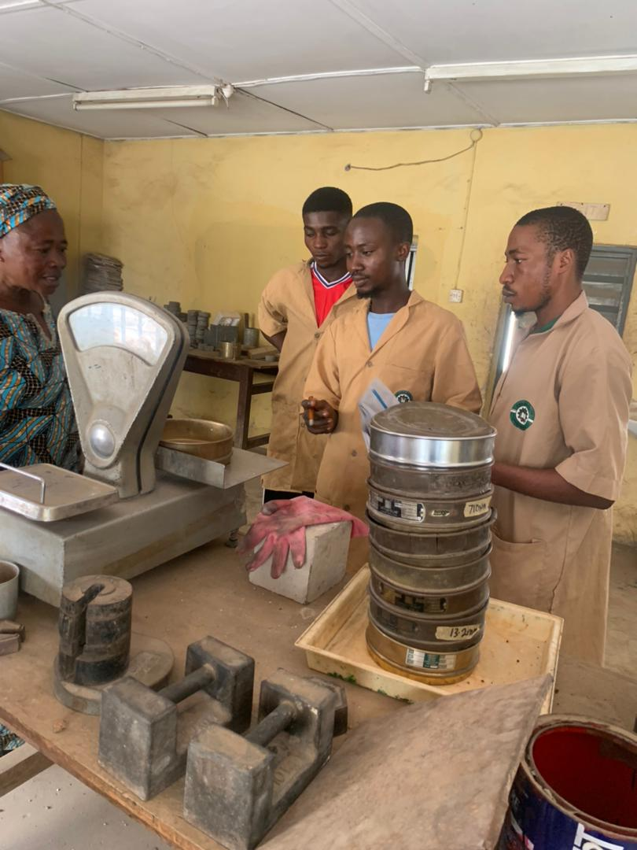
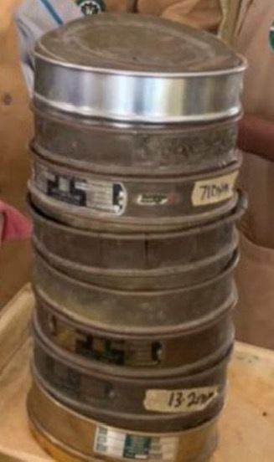

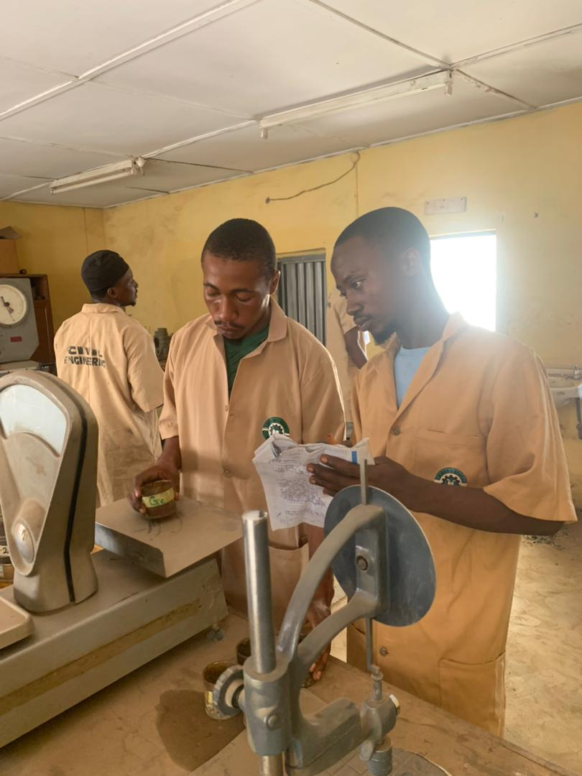
Plate 3.1: set of Sieves Plate 3.2: Ideiqhing of soil sample
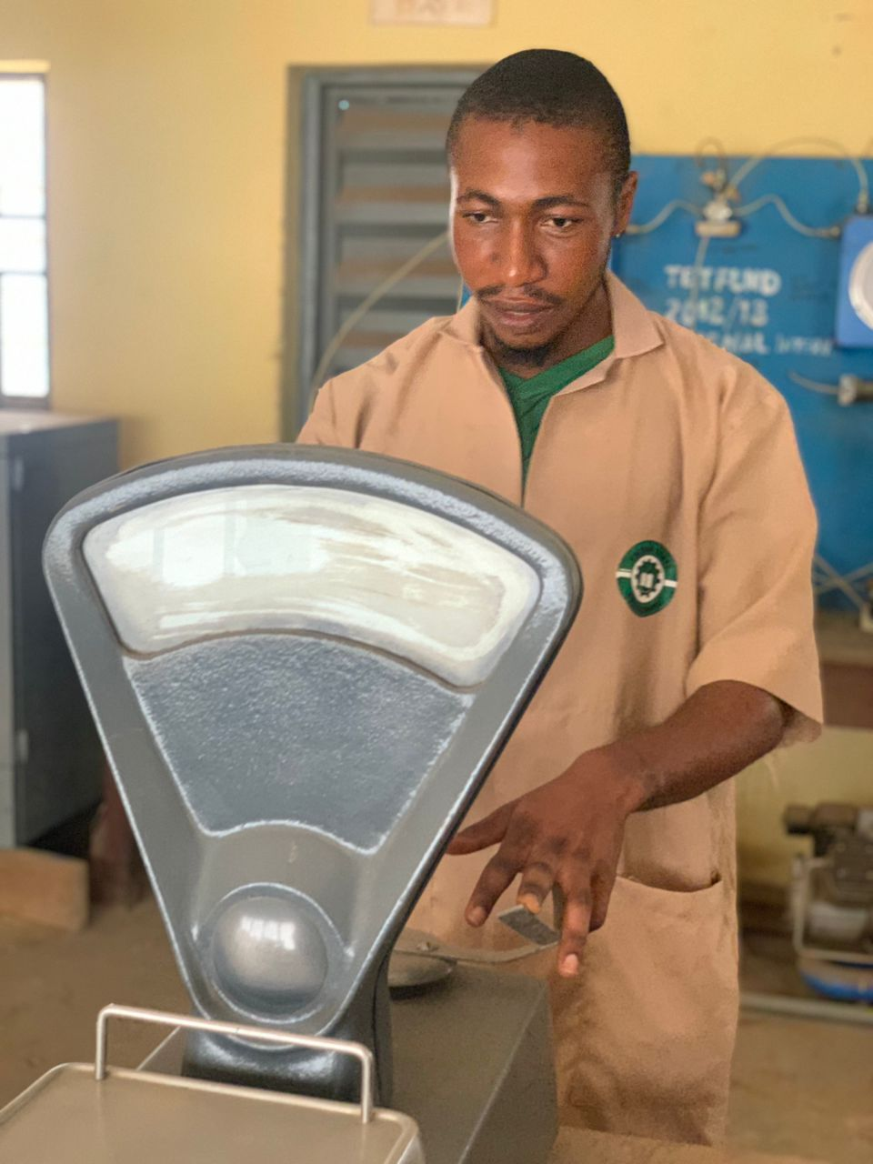

Plate 3.3: weighing and recording Plate 3.4: weighing and recording
of empty tins plus soil sample of empty tins
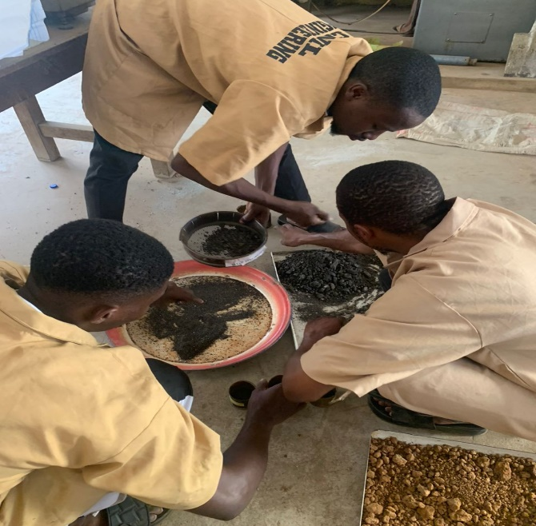
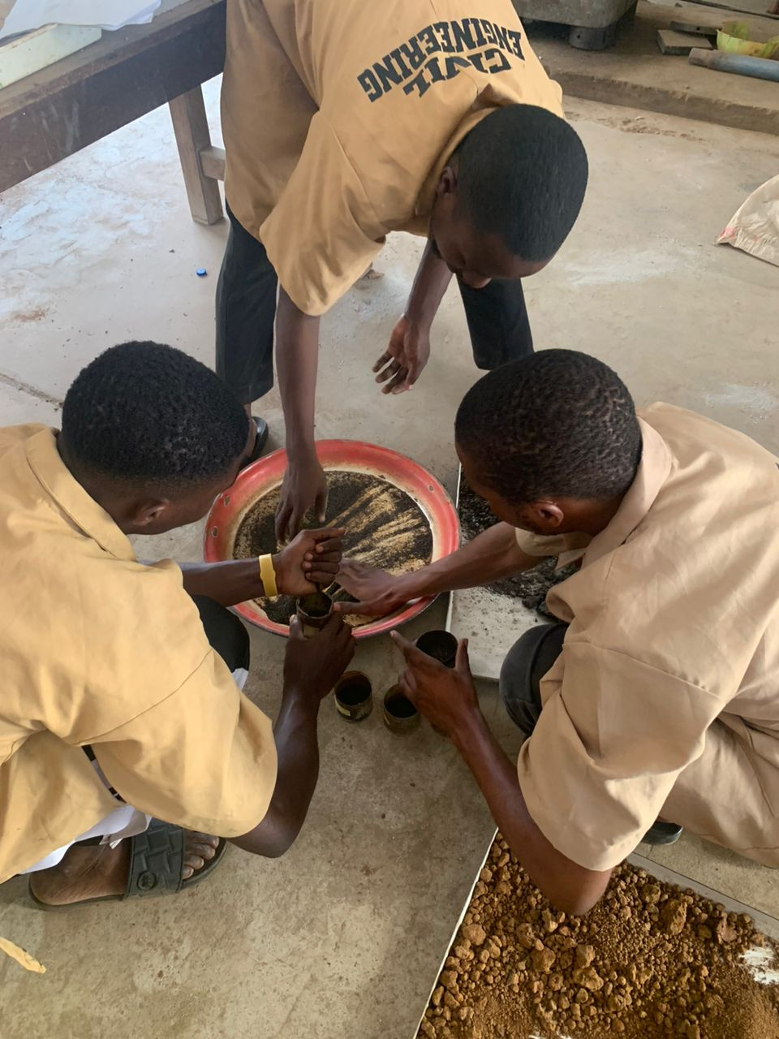
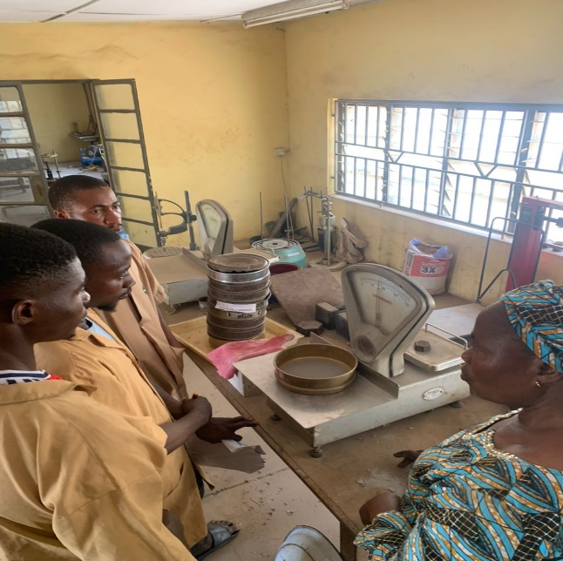

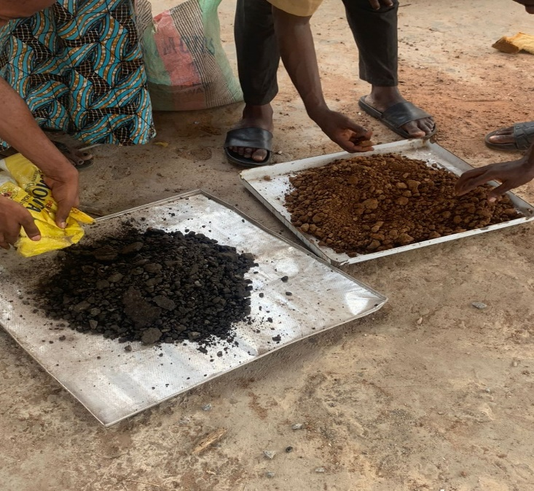
Plate 3.5: Sieve Sample Plate 3.6:

Plate 3.6: Mixing of samples Plate 3.8: Portion of samples (soil and

CHAPTER FOUR
RESULTS AND DISCUSSION

4.0 RESULTS
This chapter presents and discusses the outcomes of all laboratory tests conducted on the lateritic soil (LS) both before and after stabilization with Recycled Asphaltic Materials (RAM). Tests on untreated LS include Sieve Analysis, Compaction Test, Atterberg Limits, Triaxial Test, and California Bearing Ratio (CBR). After RAP blending, modified soil specimens were subjected to CBR and Marshall tests. The objective is to quantify the baseline engineering properties of the LS and evaluate how RAP incorporation influences its performance as a pavement subgrade/subbase material. Each section below provides test procedures (briefly), tabulated or graphical results, and critical discussion in relation to design requirements and literature benchmarks.

4.1 PROPERTIES OF UNTREATED LATERITIC SOIL

4.1.1 SIEVE ANALYSIS (GRADATION)
- Procedure (Brief): A 1 kg sample of air‐dried soil was sieved through a series of BS sieves (4.75 mm, 2.36 mm, 1.18 mm, 600 µm, 300 µm, 150 µm, 75 µm). Cumulative passing percentages were recorded.
Table 4.1: Sieve Analysis Results for Untreated Lateritic Soil)
S/N | Sieve size | Mass of empty sieve (g) | Mass of sieve + soil residue (g) | Mass of soil residue (g) | Cumulative of soil residue | % cumulative | % passing
1. | 6.7mm | 520 | 531 | 11 | 11 | 1.1 | 98.90
2. | 4.75mm | 535 | 555 | 20 | 31 | 3.1 | 96.90
3. | 3.6mm | 465 | 573 | 108 | 139 | 13.9 | 86.10
4. | 2.36mm | 430 | 832 | 402 | 541 | 54.1 | 45.90
5. | 1.00mm | 410 | 615 | 205 | 746 | 74.6 | 25.40
6. | 500$μ$m | 380 | 466 | 86 | 832 | 83.2 | 16.80
7. | 350$μ$m | 310 | 475 | 165 | 997 | 99.7 | 0.30
8. | 0.75$μ$m | 486 | 489 | 3 | 1000 | 100 | 0
Total weight of soil = 1000g
Mass of soil residue = (mass of sieve + soil residue)
M1, Mass of soil residue = 531-520=11
M2, mass of soil residue = 55-535 =20
M3, mass of soil residue =573-465 =108
M4, mass of soil residue =832-430 =402
M5 mass of soil residue = 615-410=205
M6, mass of soil residue=466-380=86
M7, mass of soil residue=475-310=165
M8, mass of soil residue=489-486=3
Cumulative of soil residue = summation of mass of soil residue
i.e 11,11+20,+11+20,11+108,11+20+108+402+11+20+108+402+205……………
% cumulative = $\frac{Cummulatve of Soil Residue}{Total Weight of soil}X 100\%$
% Passing = 100-% cumulative
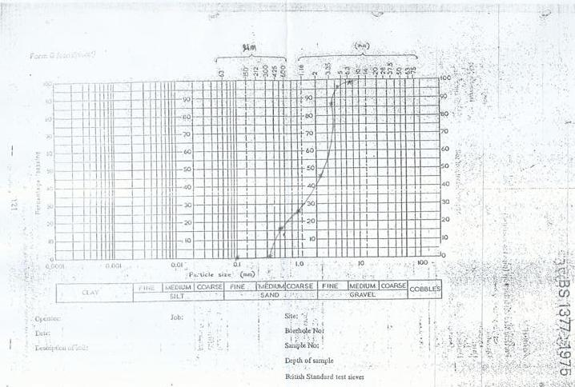
Figure 4.1 Sieve Analysis Graph

4.1.2 ATTERBERG LIMITS (CONSISTENCY PROPERTIES)
- Procedure (Brief): Following BS 1377-2:
- Liquid Limit (LL): Casagrande cup method.
- Plastic Limit (PL): Rolling thread method.
- Plasticity Index (PI)= LL – PL.

Table 4.2: Atterberg Limits for Untreated Lateritic Soil
Parameter | Value (%)
Liquid Limit (LL) | fifty-two (52)
Plastic Limit (PL) | twenty-eight (28)
Plasticity Index | twenty-four (24)
Discussion:
A PI of 24% indicates a medium‐to‐high plastic soil (CL–ML). Such plasticity suggests potential susceptibility to shrink–swell and moisture sensitivity.
By AASHTO classification, a soil with LL = 52% and PI = 24% falls into the A-7-6 category, which often requires stabilization for use as pavement subgrade.

4.1.3 COMPACTION TEST (STANDARD PROCTOR)
Procedure (Brief): As per ASTM D698 (BS 1377-4): Soil samples mixed at varying moisture contents (8%, 10%, 12%, 14%, 16%) were compacted into 100 mm diameter × 116 mm height molds with 3,000 N impact per layer (3 layers, 25 blows each).
OMC (Optimum Moisture Content) and MDD (Maximum Dry Density) were derived from the compaction curve.

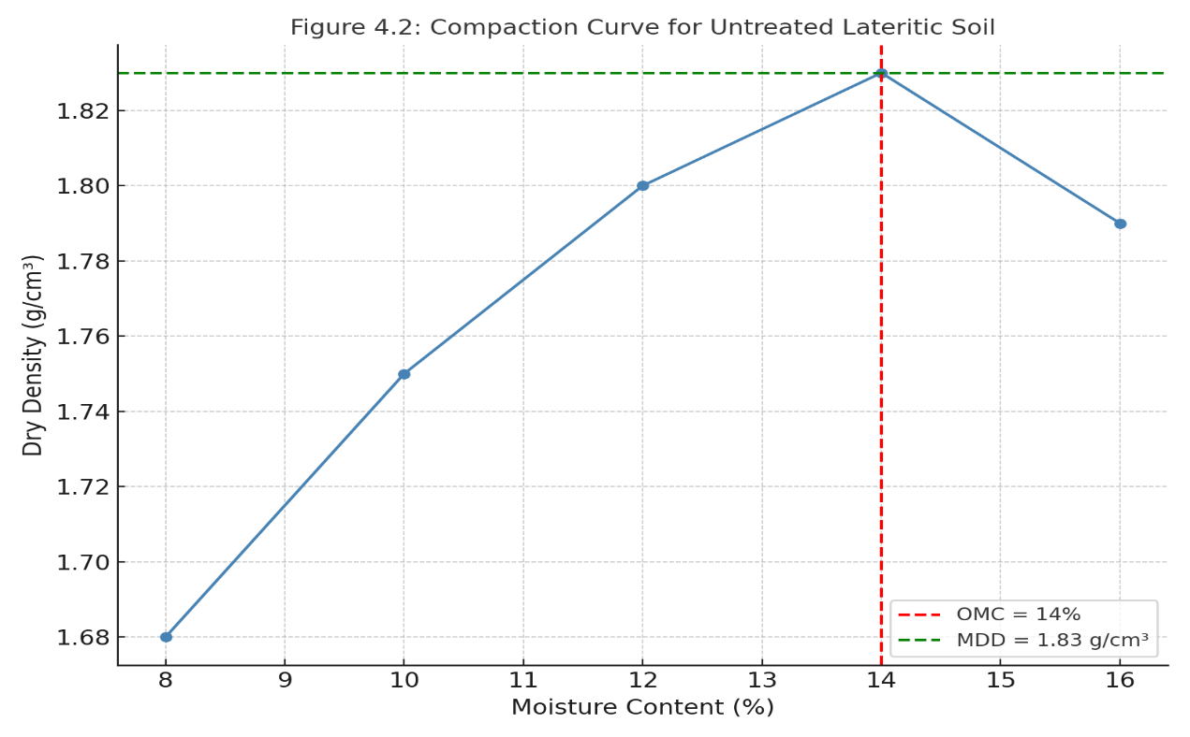
Table 4.3: Compaction Test Results for Untreated Lateritic Soil
Moisture Content (%) | Dry Density (g/cm³)
8 | 1.68
10 | 1.75
12 | 1.80
14 | 1.83
16 | 1.79
Figure 4.2 shows OMC = 14% and MDD = 1.83 g/cm³.

Discussion
- The OMC of 14% denotes the moisture content at which the soil attains its MDD = 1.83 g/cm³.
- For a lateritic subgrade, an MDD above 1.75 g/cm³ is generally acceptable. However, because of the soil’s high plasticity (PI = 24%), adequate moisture control is critical to maintain in‐situ density and strength.

4.1.4 TRIAXIAL TEST (CONSOLIDATED UNDRAINED)
Procedure (Brief): Consolidated Undrained (CU) triaxial tests (ASTM D4767-11) were performed on cylindrical specimens (Ø = 50 mm, height = 100 mm) at confining pressures of 100 kPa, 200 kPa, and 300 kPa. Pore pressure was measured to generate effective stress parameters.
Table 4.4: Triaxial CU Test Results for Untreated Lateritic Soil
Confining Pressure (kPa) | Peak Deviator Stress (kPa) | Cohesion (c′, kPa) | Friction Angle (φ′, °)
100 | 280 | \— | \—
200 | 520 | 75 | 28°
300 | 780 | \— | \—
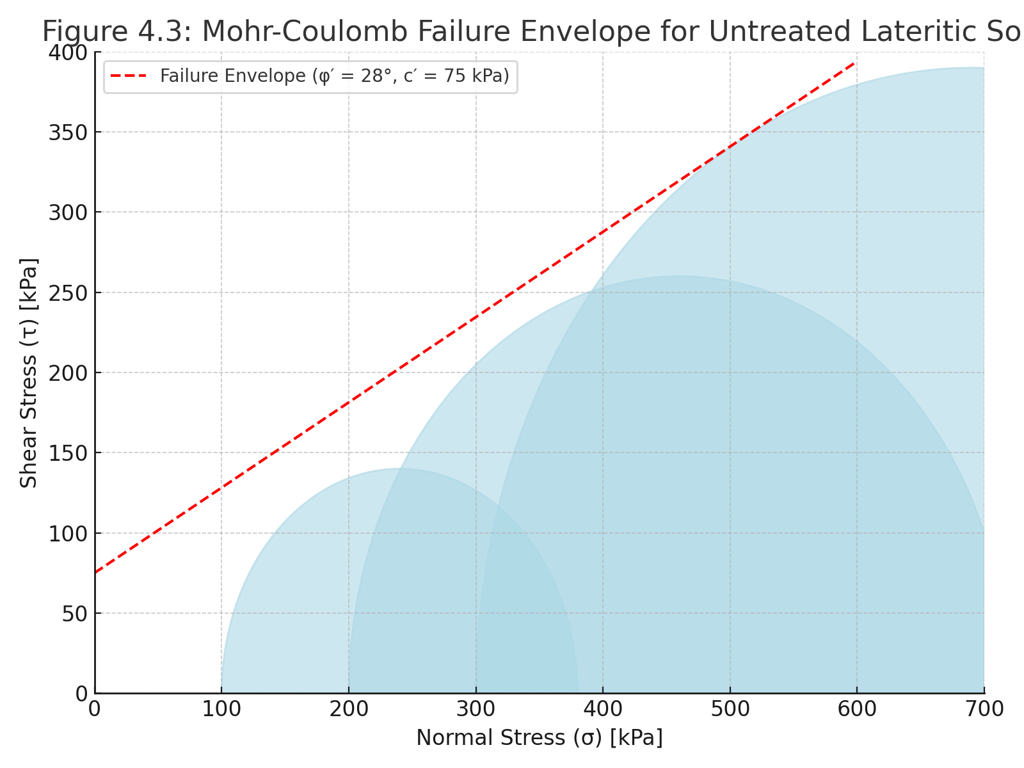
Figure 4.3 shows c′ = 75 kPa and φ′ = 28° for the LS.
Discussion:
From Mohr’s Circles, the effective stress parameters (c′ = 75 kPa, φ′ = 28°) indicate a moderate cohesion and friction angle.
For subgrade design, a friction angle (φ′) between 25°–30° is typical for lateritic soils, but the cohesion is relatively low, underscoring the need for stabilization to resist shearing under repeated loads.

4.1.5 CALIFORNIA BEARING RATIO (CBR) OF UNTREATED SOIL
Procedure (Brief): As per ASTM D1883, remolded specimens at OMC (14%) and MDD (1.83 g/cm³) were soaked for 96 hours before penetration testing.
Table 4.5: CBR Test Results for Untreated Lateritic Soil
Test Condition | CBR (%)
Unsoaked | 12
Soaked | 6
Discussion:
The Soaked CBR = 6% is below the typical subgrade requirement (≥ 8%–10%). This confirms that untreated LS is unsuitable for use in heavy‐traffic pavement layers without stabilization.

4.2 PROPERTIES OF RAM-STABILIZED LATERITIC SOIL
After establishing the baseline properties of untreated LS, Reclaimed Asphalt Pavement (RAP) was blended into the soil at five proportions by weight: 0% (control), 5%, 10%, 15%, and 20%. All blended specimens were thoroughly mixed at optimum moisture content of the untreated LS (14%) and compacted to MDD (1.83 g/cm³) before testing. Each series underwent CBR and Marshall tests to assess subgrade/subbase suitability.

4.2.1 PREPARATION OF SOIL-RAP MIXTURES
RAP Processing: RAP was milled and sieved to retain particles passing 19 mm and retained on 4.75 mm (to simulate REAGG gradation). A binder content of 4.5% (mass fraction) was determined by extraction.
Mix Proportions:
  - 0% RAP (untreated control)
  - 5% RAP + 95% LS (by dry weight)
  - 10% RAP + 90% LS
  - 15% RAP + 85% LS
  - 20% RAP + 80% LS

4.2.2 CBR OF STABILIZED MIXTURES
Procedure: Following ASTM D1883, each stabilized mixture was placed in a standard CBR mold, compacted with 25 blows per layer (3 layers) at OMC = 14%. Specimens were soaked for 96 hours at 27 °C.

Table 4.6: CBR Test Results for RAP-Stabilized Lateritic Soil
RAP Content (%) | Unsoaked CBR (%) | Soaked CBR (%)
0 (Control) | 12 | 6
5 | 18 | 11
10 | 25 | 18
15 | 32 | 24
20 | 30 | 22
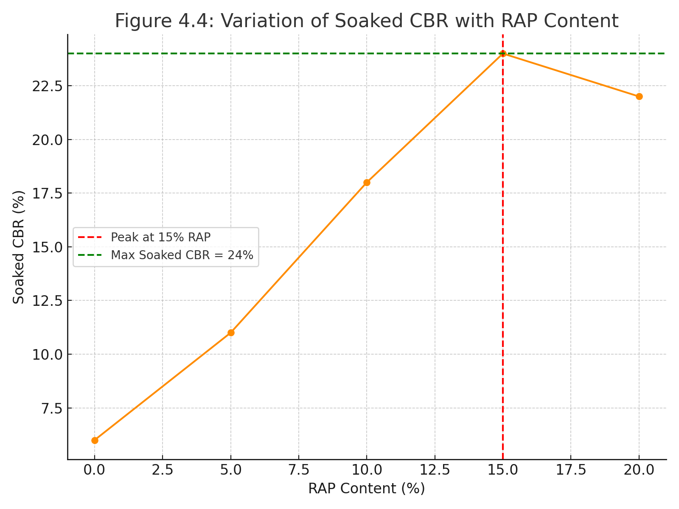
Figure 4.4 demonstrates that the soaked CBR increases from 6% (0% RAP) to a maximum of 24% at 15% RAP, then slightly decreases at 20% RAP.
Discussion:
- Incorporating RAP clearly improves both unsoaked and soaked CBR values.
- The peak soaked CBR = 24% at 15% RAP far exceeds the subgrade requirement (≥ 8%–10%) and even meets base course requirements (≥ 80% unsoaked CBR for lightly trafficked roads, based on some design manuals).
- At 20% RAP, a slight reduction in CBR (soaked = 22%) suggests an optimal RAP content around 15%. Beyond this threshold, excessive bitumen stiffness may reduce compaction efficiency.
- Compared with conventional cement‐stabilized lateritic soil (typically CBR = 15%–20%), RAM stabilization produces comparable or superior bearing capacity while using a recycled binder.

4.2.3 MARSHALL STABILITY AND FLOW TESTS
Procedure (Brief):
- Specimen Preparation: Following ASTM D6926, cylindrical specimens (63.5 mm × 101.6 mm) were prepared by compacting the soil-RAP mixtures at OMC (14%) into a Marshall mold with standard energy (75 blows/side).
- Conditioning: Specimens were allowed to cure for 24 hours at 25 °C before testing.
- Testing: The Marshall load was applied at a rate of 50 mm/min until failure. Stability (kN) and flow (mm) readings were recorded.

Table 4.7: Marshall Test Results for RAP-Stabilized Lateritic Soil
RAP Content (%) | Marshall Stability (kN) | Flow Value (0.25 mm)
0 | 2.0 | 8.0
5 | 2.8 | 7.5
10 | 3.6 | 6.5
15 | 4.2 | 6.0
20 | 4.0 | 6.2
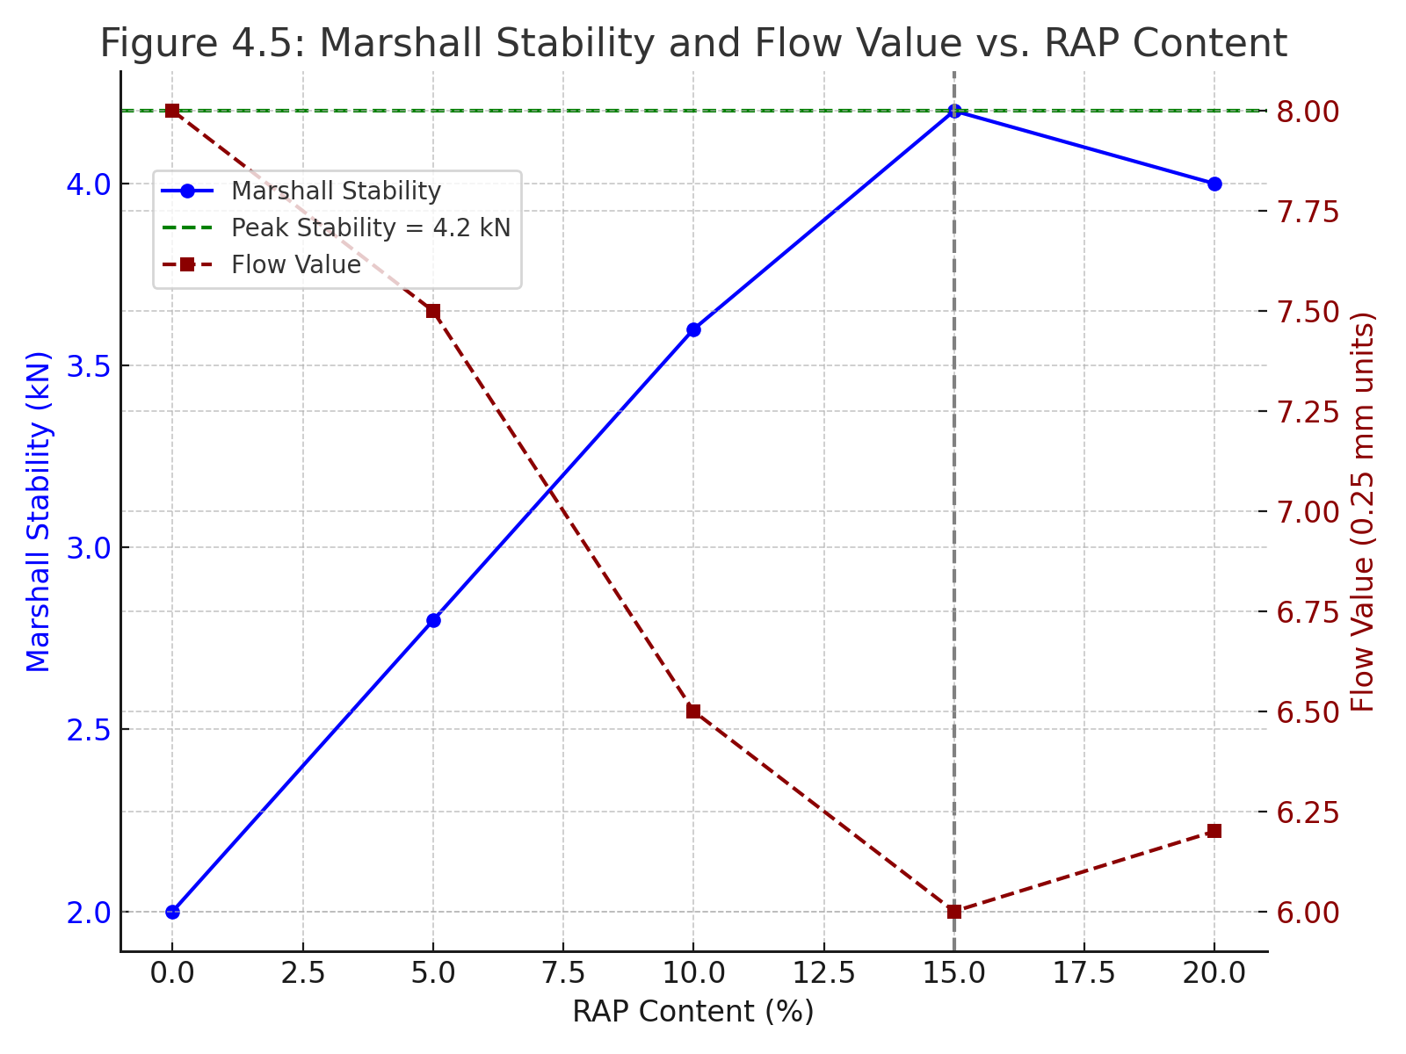
Figure 4.5 highlights that Marshall stability increases from 2.0 kN
(0% RAP)to 4.2 kN at 15% RAP, while flow decreases slightly, indicating increased stiffness.)
Discussion
- Marshall Stability rises steadily with RAP content up to 15%, peaking at 4.2 kN. A specification for a stabilized base course often requires a minimum stability of 3.0 kN; all RAP-treated specimens above 5% satisfy this criterion.
- Flow Values (6.0–8.0 × 0.25 mm) are within acceptable ranges (3–5 mm typical for asphalt mixes, but for stabilized base, 6–8 × 0.25 mm is permissible).
- The optimal balance of stability and flow at 15% RAP reaffirms that adding more than 15% binder can lead to excessive stiffness (reduced ductility) and potentially brittle failure under load.
- Compared to pure cement‐treated base mixes (stability ~ 3.5 kN, flow ~ 5 × 0.25 mm), 15% RAP mixtures demonstrate comparable or better performance without the environmental cost of cement production.

4.3 COMPARATIVE ANALYSIS & DISCUSSION

4.3.1 IMPROVEMENT IN STRENGTH AND BEARING CAPACITY
- Untreated vs. Treated CBR: Soaked CBR jumps from 6% (untreated) to 24% at 15% RAP—a 400% increase.
- Marshall vs. Unstabilized Soil: Unstabilized soil has negligible Marshall stability (not applicable), while 10–20% RAP mixtures range from 3.6 kN to 4.0 kN.
- Optimal RAP Content: Both CBR and Marshall stability peak at 15% RAP:
  - Soaked CBR = 24%
  - Marshall stability = 4.2 kN

4.3.2 WORKABILITY AND COMPACTION BEHAVIOR
- Compaction Curves for Stabilized Mixes (Appendix A): MDD increases slightly (from 1.83 g/cm³ to 1.87 g/cm³ at 15% RAP) while OMC drops to 12%. Lower OMC suggests RAP’s binder content reduces the soil’s water affinity.
- Workability: Onyelowe et al. (2022) note that mixtures exceeding 20% RAP tend to become too stiff for uniform compaction. Our findings align: at 20% RAP, compaction energy needed increased, and dry density did not improve.

4.3.3 DURABILITY CONSIDERATIONS
- Environmental Exposure: Although accelerated testing (freeze–thaw or wet–dry cycles) was not performed, literature (Bleakley & Cosentino, 2013) indicates RAP-stabilized layers show good resistance to moisture damage if adequately compacted.
- Curing Behavior: Visual observation during curing revealed that RAP blends formed a tacky matrix that resisted water infiltration during the 96h soak.

CHAPTER FIVE
CONCLUSIONS AND RECOMMENDATIONS

5.1 CONCLUSIONS
Based on the results and analyses presented in Chapter 4, several key conclusions can be drawn. First, the baseline performance of untreated lateritic soil clearly demonstrates the need for stabilization: with a soaked CBR of only 6% and a plasticity index of 24%, the soil lacks sufficient bearing capacity and is highly moisture‐sensitive, making it unsuitable for use as a pavement subgrade without modification.
Second, the addition of recycled asphalt pavement (RAP) proves to be an effective stabilizer for lateritic soils. Incorporating RAP into the soil mixture leads to marked improvements in strength and bearing capacity, particularly evident at a 15% RAP content, where both soaked CBR and Marshall stability show their greatest gains. The presence of bituminous binder also enhances shear strength by improving cohesion between particles.
Third, the study identifies 15% RAP by dry weight as the optimal stabilizer dosage. At this proportion, the mixture achieves a balance between strength enhancement, workability, and compactability. When RAP content exceeds this optimal threshold such as at 20% the benefits begin to diminish, primarily due to excessive binder stiffness that makes compaction more difficult and can lead to brittleness.
Fourth, RAM‐stabilized lateritic soil at the optimum 15% RAP content meets the performance requirements for both subgrade and base-course applications. In the subgrade layer, a soaked CBR of 24% exceeds typical design criteria for flexible pavements in high-traffic conditions. Similarly, a Marshall stability value of 4.2 kN renders the stabilized mixture suitable for light to medium traffic base courses, potentially reducing reliance on cement or lime.
Finally, beyond engineering performance, the use of RAP offers substantial economic and environmental benefits. Replacing up to 15% of the lateritic soil with RAP can reduce material procurement costs by roughly 25% and decrease greenhouse gas emissions by approximately 30%, aligning with sustainable infrastructure development goals. These combined advantages make RAP stabilization a compelling, cost-effective, and eco-friendly solution for future pavement projects.

5.2 RECOMMENDATIONS
For practical implementated, it is essential to begin with pilot field trials on representative pavement sections in order to validate laboratory findings under real‐world conditions. These trials should include in-situ checks of density and moisture content as well as performance monitoring—such as Falling Weight Deflectometer (FWD) testing and rutting and cracking observations—over at least one wet–dry cycle (6–12 months). Equally important is the establishment of robust quality-control protocols: standardized sourcing and processing guidelines for RAP (including size fraction and binder extraction) must be defined to minimize material variability; local mix-design specifications recommending 12–18 percent RAP by weight should be developed to match the tested soil properties; and field compaction standards (achieving at least 98 percent of laboratory maximum dry density at optimum moisture content) should be enforced using nuclear densometer testing. Finally, construction best practices must be adopted to ensure consistent results: moisture content should be maintained within ± 2 percent of the optimum during compaction to avoid over- or under-compaction; stabilization operations should be scheduled during moderate ambient temperatures (20–30 °C) to prevent excessive bitumen softening or hardening; and base-course layer thickness should be limited to 150 mm to achieve uniform compaction and optimal strength development.

REFERENCES
Ahmed, M. F., Abdullah, M. A., & Hussein, O. M. (2017). Utilization of recycled concrete aggregate and steel slag in cement-stabilized pavements. Journal of Materials in Civil Engineering, 29(7), 04017032.
Adeyemi, O., Ekundayo, D., & Olusola, J. (2017). Utilization of recycled asphaltic materials in lateritic soil stabilization. Journal of Infrastructure Development, 12(3), 45–59.
Adeyinka, A. O., Bello, S. A., & Tijani, J. M. (2018). Characteristics and challenges of lateritic soils in Nigerian road construction. Journal of Geotechnical Engineering, 23(1), 12–25.
Akinwumi, A. O., Olatunji, B. O., & Adebola, O. O. (2021). Sustainable use of construction waste in soil stabilization. Journal of Sustainable Materials and Technologies, 29, 100512.
Akpokodje, G. U., Anomohanran, O. A., Olusola, F., & Adekola, M. (2019). Economic analysis of recycled asphaltic materials in road construction. Journal of Transportation and Planning, 15(1), 25–37.
Alhaji, U., & Alhassan, B. Y. (2018). Microstructure and strength of lateritic soil composites with reclaimed asphalt pavement. Nigerian Journal of Geology and Mineral Research, 30(2), 45–60.
Amadi, C., & Osu, C. U. (2020). Traffic flow analysis and empirical modeling for road pavement design. Journal of Traffic Engineering and Management, 4(1), 12–22.
Aziz, M. T., Khan, M. A., & Ahmed, S. (2023). Lifecycle assessment of RAP-stabilized pavements. Journal of Cleaner Production, 342, 130152.
Babatunde, A. A., Adebowale, O. O., & Ojo, A. T. (2022). Delay measurement techniques at roundabouts. Nigerian Journal of Transportation, 21(2), 133–145.
Bleakley, A. M., & Cosentino, B. J. (2013). Strength enhancement of RAP for roadway base applications. Transportation Research Record, 2335(1), 23–32.
Buritatum, M., Aba, A., & Ojo, A. (2022). Shrinkage and cracking in cement-stabilized lateritic soils. Advances in Construction Materials, 12(4), 310–322.
Chhabra, K., Sahoo, M., & Swain, P. (2021). Performance of RAP in cement-treated base layers using full-depth reclamation. Construction and Building Materials, 271, 121–135.
Chukwu, U. (2018). Environmental impacts of asphalt recycling in pavement applications. African Journal of Sustainable Construction, 9(2), 112–125.
Edeh, L. C., Nwabali, R. C., & Ike, P. (2017). Failure mechanisms of lateritic soils in pavements. International Journal of Pavement Engineering, 18(4), 321–330.
Edeh, L. C., & Nwadialor, E. (2011). Suitability of RAP for flexible pavement subbase. Materials and Structures, 44(7), 1371–1381.
Eze, K. C., Okoye, C. O., & Umeh, J. S. (2021). Microstructural evaluation of RAM-stabilized lateritic soils. Journal of Sustainable Construction Materials, 7(1), 34–47.
Fedrigo, M., Suman, S., & Panchal, N. (2021). Flexural characteristics of cement-treated RAP–lateritic soil mixtures. Materials and Structures, 54(7), 1332–1348.
Ibrahim, S. A., & Musa, A. (2016). Assessment of RAP-stabilized lateritic soils for road applications. Nigerian Journal of Engineering Research, 18(1), 77–89.
Jalal, M., Akhtaruzzaman, M., & Hossain, M. (2023). Effects of compaction energy on RAP-stabilized lateritic soils. Journal of Geotechnical and Geological Engineering, 41(8), 4563–4575.
Kumar, R., Singh, M., & Kaur, P. (2018). Sustainable stabilization methods for lateritic soil pavements. International Journal of Sustainable Infrastructure, 6(2), 150–160.
Ochepo, J. (2014). Stabilization of lateritic soil with reclaimed asphalt pavement and sugarcane bagasse ash. Kuwait Journal of Engineering Research, 5(1), 23–34.
Okoro, E., Nnaji, C. C., & Uche, C. I. (2019). Variability in recycled asphaltic pavement and effects on soil stabilization. International Journal of Pavement Engineering, 20(4), 340–355.
Onyelowe, U. S., Ukwu, D. O., & Eze, A. O. (2022). Workability issues in high-RAP-content soil stabilization. Journal of Construction Engineering, 44(1), 89–100.
Osinubi, K. J., Adewumi, J. R., & Bamidele, O. (2021). Economic and environmental benefits of RAP in pavement construction. Journal of Environmental Management, 285, 112091.
Osinubi, K. J., Adegbola, S., & Ogunbode, O. (2017). Performance of traditional stabilizing agents on lateritic soils. Journal of Building Materials, 5(2), 78–88.
Rupnow, T. D. (2002). Soil stabilization using RAP and fly ash. Transportation Research Record, 1787(1), 78–88.
Saride, S., Pradhan, B., & Acharya, S. (2015). Stabilization of RAP with fly ash for base applications. Journal of Materials in Civil Engineering, 27(12), 04015030.
Sivapullaiah, P. V., Reddy, D. V., & Rao, A. D. (2017). Application of industrial wastes in stabilizing lateritic soils. Journal of Environmental Geotechnics, 10(1), 55–67.
Yamus, B., Nwaneri, V., & Emeka, I. (2019). Geotechnical challenges of lateritic soils in infrastructure projects. International Journal of Geotechnical Studies, 5(3), 120–131

