ONLINE CLEARANCE SYSTEM FOR FINAL-YEAR STUDENTS USING WATERFALL ALGORITHM

BY

FATAI UMARU AYOMIDE
ND/23/COM/PT/0294

SUBMITTED TO THE DEPARTMENT OF COMPUTER SCIENCE, INSTITUTE OF INFORMATION AND COMMUNICATION TECHNOLOGY
KWARA STATE POLYTECHNIC, ILORIN

IN PARTIAL FULFILLMENT OF THE REQUIREMENTS FOR THE AWARD OF NATIONAL DIPLOMA (ND) IN
COMPUTER SCIENCE

JUNE, 2025.

CERTIFICATION
This is to certify that this project was carried out by Fatai Umaru Ayomide with matriculation number ND/23/COM/PT/0294 in the Department of Computer Science, Institute of Information Communication Technology, Kwara State Polytechnic, Ilorin, Kwara State.

…………………………………. ….………………………
MR. OLAJIDE, A. T. Date
Project Supervisor

…………………………………. ….………………………
MR. OYEDEPO, F. S. Date
Head of Department

…………………………………. ….………………………
External Examiner Date

DEDICATION
I dedicate this project work to Almighty God who inspired me and directed my ways during my academic stay in the polytechnic.

ACKNOWLEDGEMENT
All praise is due to Almighty God the Lord of the universe. I praise him and thank him for giving me the strength and knowledge to complete my ND program and also for our continued existence on Earth.
I appreciate the utmost effort of my supervisor, Mr. Olajide, A. T. whose patience, support, and encouragement have been the driving force behind the success of this research work. He gave useful corrections, constructive criticisms, comments, recommendations, and advice and always ensures that excellent research is done. My sincere gratitude goes to the Head of the Department Mr. Oyedepo F. S., and other members of staff of the Department of Computer Science, Kwara State Polytechnic, Ilorin, for their constant cooperation, constructive criticisms, and encouragement throughout the program.
Special gratitude to my parents, who exhibited immeasurable financial, patience, support, prayers, and understanding during the period in which I was busy tirelessly with my studies, special thanks go to my lovely siblings
My sincere appreciation goes to my friends and classmates.

TABLE OF CONTENTS
Title page i
Certification ii
Dedication iii
Acknowledgments iv
Table of Contents v
Abstract vi
CHAPTER ONE: GENERAL INTRODUCTION
1.1 Background to the Study 1
1.2 Statement of the Problem 2
1.3 Aim and Objectives 3
1.4 Significance of Study 3
1.5 Scope of Study 3
1.6 Organization of the Report 4
CHAPTER TWO: LITERATURE REVIEW
2.1 Review of Related Pastworks 5
2.2 Review of General Studies 11
CHAPTER THREE: RESEARCH METHODOLOGY AND
ANALYSIS OF THE SYSTEM
  - Research Methodology 19
  - Analysis of the Existing System 25
  - Problem of the Existing System 26
  - Analysis of the Proposed System 27
  - Advantages of the Propose System 29

CHAPTER FOUR: DESIGN, IMPLEMENTATION AND
DOCUMENTATION OF THE SYSTEM
  - Design of the System 30
    - Output Design 30
    - Input Design 33
    - Database Design 30
    - Procedure Design 38
  - Implementation of the System 38
    - Choice of programming language 38
    - Hardware support 39
    - Software Support 39
    - Changeover Techniques 40
  - System Documentation 40
    - Operating the System 40
    - Maintaining of the System 41
CHAPTER FIVE: SUMMARY CONCLUSION AND
RECOMMENDATIONS
5.1 Summary 42
5.2 Conclusion 42
5.4 Recommendations 43
References 45

ABSTRACT
The clearance process is a critical requirement for final-year students in higher institutions, often involving multiple departmental verifications before graduation. Traditionally, this process is conducted manually, resulting in long queues, delays, data inconsistencies, and unnecessary stress for both students and administrative staff. This project presents the design and implementation of an Online Clearance System that automates the clearance workflow for final-year students using the Waterfall Software Development Model. The system was developed using PHP for backend logic, HTML, CSS, and JavaScript for the frontend interface, and MySQL for database management. The proposed solution offers role-based access for students, clearance officers, and administrators, enabling real-time clearance tracking, secure data handling, and centralized control. It provides an intuitive dashboard where students can submit clearance requests and monitor departmental approvals remotely, while officers can approve, reject, or comment on requests through a web interface. The system eliminates the inefficiencies of the manual process, enhances transparency, improves data accuracy, and supports remote access. The use of the Waterfall model ensured that each development phase was methodically completed before proceeding to the next, resulting in a robust and maintainable application. Ultimately, this project demonstrates how digital transformation can significantly improve academic administrative processes and deliver a more efficient, accessible, and reliable clearance experience for final-year students.

CHAPTER ONE
INTRODUCTION

1.1 Background to the Study
In tertiary institutions, clearance is a compulsory process that every final-year student must undergo before graduation. This process involves obtaining approval from several departments, such as the library, bursary, academic department, sports unit, health centre, and hostels. Each unit verifies that the student has fulfilled all necessary obligations, such as returning borrowed books, paying outstanding fees, or vacating hostels, before granting clearance. Traditionally, this procedure is manual, involving physical forms, stamps, and signatures collected from various offices. While this system has been in place for years, its inefficiencies have become increasingly evident with the growing number of students and administrative tasks (Oladipo et al. 2021). The manual clearance system is plagued with numerous lapses. Firstly, it is time-consuming, often requiring students to queue for hours or even days to get approvals. Secondly, it lacks transparency and proper tracking, as students may lose forms or face difficulty in confirming which departments have cleared them. Thirdly, the process is prone to human error and document misplacement, which may delay or prevent students from graduating on time. Moreover, clearance officers must sift through piles of paper records, making the system inefficient and vulnerable to forgery or manipulation (Musa and Ahmed 2020).
In response to these challenges, the implementation of an Online Clearance System is proposed. This system aims to automate the entire clearance process by allowing final-year students to apply for and monitor their clearance status through a web-based platform. Departments will be able to log in, verify student records, approve or deny requests, and leave comments, all in real-time. The online system ensures that all data is securely stored in a centralized database, making retrieval easy and improving accountability (Chidiebere et al. 2022). To ensure a structured and effective development of the system, this project adopts the Waterfall software development model. The Waterfall methodology is a linear and sequential approach that breaks down the system development process into distinct phases: requirements gathering, system design, implementation, testing, deployment, and maintenance. This approach is suitable for the development of the clearance system because the requirements are well-defined, and each stage can be completed in order without much deviation.
The system will be developed using modern web technologies such as HTML, CSS, JavaScript for the frontend; PHP or Python for the backend logic; and MySQL as the database for storing student and clearance information. Additional tools such as XAMPP or a web hosting service will be used for local testing and deployment.

1.2 Statement of the Problem
The manual clearance system currently practiced in many institutions has several shortcomings. These include unnecessary delays, duplication of efforts, misplacement of student files, lack of transparency, and the physical stress of moving between departments. Additionally, clearance officers often face difficulties tracking the status of individual students due to the absence of a centralized system. This inefficiency can result in missed graduation deadlines and administrative bottlenecks. Therefore, there is a pressing need to develop an automated system that will address these issues and facilitate a more efficient clearance process.

1.3 Aim and Objectives
The research aim to design and implement an online clearance system that automates and streamlines the final-year student clearance process using the Waterfall development model and the objectives are to:
- Analyze the current manual clearance process to identify its limitations and user requirements.
- Design a responsive and user-friendly web-based interface using tools such as HTML, CSS, and JavaScript for the frontend.
- Develop the backend functionality using PHP or Python and manage data storage with MySQL database, following the structured phases of the Waterfall model.
- Test, deploy, and evaluate the system for accuracy, efficiency, and usability using tools like XAMPP/WAMP for local deployment and real-time validation.

1.4 Significance of the Study
This study is significant in that it seeks to modernize the final-year clearance process in higher institutions by providing an efficient, transparent, and reliable online platform. For students, it reduces stress and saves time; for clearance officers, it improves workflow and eliminates the need for redundant paperwork. Moreover, the system contributes to the digital transformation of institutional operations and supports timely clearance and graduation of students. It also serves as a model that can be adopted or customized by other institutions seeking similar solutions.

1.5 Scope of the Study
This project is limited to the design and implementation of an online clearance system for final-year students within a single academic institution. It covers clearance from essential departments such as the library, bursary, faculty, and hostel. The system includes modules for student registration, form submission, departmental approval, clearance tracking, and administrative reporting. However, it does not include biometric verification or integration with external payment gateways at this stage.

1.6 Organization of the Study
This project report is structured into five chapters as follows:
Chapter One provides the introduction, including the background to the study, statement of the problem, aim and objectives, significance, scope, and organization of the study.
Chapter Two presents a review of related literature, covering existing clearance systems, relevant technologies, and theoretical foundations.
Chapter Three discusses the research methodology, system analysis, and the application of the Waterfall model in the system development process.
Chapter Four focuses on the design, implementation, testing, and evaluation of the online clearance system.
Chapter Five summarizes the study, presents the conclusion, and offers recommendations for future work and system improvement.

CHAPTER TWO

LITERATURE REVIEW

2.1 Review of Related Work
Oladipo et al. (2021) developed an automated student clearance system aimed at replacing the traditional manual method used in Nigerian universities. The study adopted the Waterfall model for its structured development process and implemented the system using PHP and MySQL. The researchers identified that the manual system caused unnecessary delays and increased the risk of data loss. Their proposed system significantly reduced clearance processing time by automating departmental approvals and integrating a centralized database. The system was tested and found to be efficient in enhancing accuracy and eliminating paperwork, though it lacked mobile responsiveness. Musa and Ahmed (2020) designed an e-clearance portal for final-year students within a closed university intranet system. Their goal was to ease the clearance procedure by enabling digital communication between students and departments. The system was developed using Java-based technologies and followed the V-Model approach. While the system improved internal processing speed and accountability, it had notable limitations—it could not be accessed remotely, limiting its usefulness during off-campus periods or emergencies such as COVID-19 lockdowns. The authors recommended future versions to be hosted on cloud servers for better flexibility.
Chidiebere et al. (2022) proposed a web-based clearance system specifically designed for Nigerian polytechnics. The system was developed using the Agile methodology to allow for iterative feedback from administrative users and students during development. Technologies such as Laravel (PHP framework) and MySQL were used to build the platform. Their study highlighted the importance of user-friendly interfaces and real-time communication in clearance processing. While the final product was well-received, challenges related to system scalability and database load management were observed, especially in polytechnics with large student populations. Bello and Lawal (2023) conducted a comparative study between manual and digital clearance systems in three tertiary institutions. Their research focused on evaluating the operational efficiency, user satisfaction, and security offered by online clearance platforms. Using empirical data gathered from student surveys and clearance officer interviews, they concluded that online systems reduced processing time by up to 80% and significantly improved record accuracy. They also noted that manual systems were more prone to forgery, lost documents, and student frustration. However, their study emphasized the need for IT training for administrative staff to effectively use the new system.
Nkwocha and Oyinlola (2024) developed a real-time clearance tracking system for universities using Python (Flask framework) and SQL databases. The study focused on increasing transparency and minimizing student complaints by providing live updates on clearance status. The system allowed students to see which departments had cleared them and which were pending, with comments explaining any holds. The Waterfall development model was employed due to the stable and predictable nature of clearance processes. The system improved communication between departments and reduced the number of clearance-related complaints by 75%. However, the study also noted challenges with deploying the system in institutions with poor internet infrastructure. Okafor and Adeoye (2020) designed an institution-wide clearance and result release management system to eliminate the delays students often face when awaiting final clearance and results. They used the Rapid Application Development (RAD) model and implemented the system using ASP.NET and Microsoft SQL Server. Their work focused heavily on integration between the clearance process and the academic grading system. The study showed a 60% improvement in process efficiency but faced challenges with role-based access and compatibility across departments using different legacy systems.
Ibrahim and Danladi (2021) developed a cloud-based clearance system to support remote access and cross-platform compatibility. Their aim was to reduce the physical interactions required for clearance, especially in the post-COVID era. The system, developed using MEAN stack (MongoDB, Express.js, Angular, Node.js), allowed students to initiate clearance requests from mobile devices and track progress in real-time. It also included API integration for digital payments and SMS notifications. The system improved accessibility and communication, but its reliance on internet connectivity posed a limitation in low-bandwidth environments. Adebayo et al. (2023) implemented a multi-campus clearance portal for a private university with branches across different states. The system enabled centralized clearance while allowing departmental officers from different campuses to approve or flag student records from their locations. Developed using Django (Python) and deployed on AWS cloud infrastructure, the system addressed issues of record duplication and inconsistent clearance protocols. The authors noted high scalability and security performance but recommended improvements in user training and support for local languages.
Eze and Uche (2022) proposed an intelligent clearance assistant system incorporating chatbot functionality to guide students through the clearance process. Built using PHP, MySQL, and a basic AI chatbot engine, the system responded to frequently asked questions, assisted students in locating pending departments, and helped resolve common issues. The chatbot reduced the burden on administrative staff and improved student engagement. However, the study highlighted the need for more advanced natural language processing to handle complex queries. Aliyu and Mustapha (2024) focused on the security aspects of online clearance systems, developing a platform with integrated two-factor authentication and encrypted document upload. The system, built using Laravel and Firebase, addressed concerns about unauthorized access and document tampering. Their research emphasized the increasing risk of data breaches in academic systems and offered solutions such as encrypted tokens, session logging, and digital signature validation. While the system significantly improved security compliance, it required higher server capacity and stronger IT support structures.

2.2 Review of General Study
Clearance systems are a fundamental part of institutional administration, especially at the final stage of a student’s academic career. Traditionally, the process is handled manually, requiring students to visit various departments such as the bursary, library, student affairs, and academic units to obtain clearance. This approach is labor-intensive, time-consuming, and often fraught with inefficiencies such as lost forms, delayed approvals, and lack of transparency (Oladipo et al., 2021). The increasing reliance on digital technologies in higher education has prompted institutions to adopt automated clearance systems as part of a broader trend toward digital transformation and smart campus initiatives (Bello & Lawal, 2023). These systems leverage web-based platforms to streamline clearance processes, allowing students to submit requests and track their clearance status online. Clearance officers can also approve or reject requests from a central dashboard, thus improving coordination across departments (Musa & Ahmed, 2020).
Development of such systems usually involves tools like HTML, CSS, JavaScript for the frontend, PHP or Python for backend logic, and MySQL for data storage (Nkwocha & Oyinlola, 2024). Modern frameworks like Django, Laravel, and React have also been adopted to enhance system scalability and maintainability (Chidiebere et al., 2022). These tools help create user-friendly, responsive, and secure web applications that meet both student and administrative needs. A critical aspect of building robust clearance systems lies in the choice of software development methodology. The Waterfall model remains a popular option for such structured applications, as it emphasizes a sequential development process—beginning with requirement analysis and followed by design, implementation, testing, deployment, and maintenance (Ibrahim & Danladi, 2021). This linear model ensures that all phases are properly documented and completed before the next begins, which is particularly suitable for the clearance process where steps and requirements are well-defined.
Moreover, research on e-governance in education shows that digital platforms significantly enhance institutional efficiency, transparency, and data integrity (Adebayo et al., 2023). Online clearance systems reduce paperwork, prevent record loss, and allow for accurate audit trails. For students, they minimize physical stress, save time, and reduce the risk of missing deadlines due to administrative delays (Eze & Uche, 2022). In summary, general studies support the transition from manual to automated clearance systems in academic institutions. When implemented using structured methodologies like the Waterfall model and powered by modern web development tools, these systems can greatly enhance the overall efficiency, accuracy, and transparency of student clearance processes.

2.3 Overview of Online Clearance System
An online clearance system is a web-based application designed to automate and simplify the process of final clearance for students in academic institutions. Traditionally, clearance requires students to visit multiple departments physically, such as the library, bursary, student affairs, and academic departments to obtain signatures that confirm the fulfillment of all obligations. This process is often tedious, time-consuming, and susceptible to human error (Oladipo et al., 2021; Bello & Lawal, 2023). The online clearance system addresses these issues by offering a centralized digital platform where students can submit clearance requests, and departmental officers can process approvals or rejections in real-time. Typically, such systems include functionalities like secure login authentication, digital form submission, department-specific dashboards, and real-time clearance tracking (Nkwocha & Oyinlola, 2024). Each department logs in to the system, verifies a student’s status, and either approves or flags the request with reasons, streamlining the entire process from start to finish.
From a technical perspective, these systems are usually developed using a combination of frontend and backend web technologies. The frontend interface is often built using HTML, CSS, JavaScript, or advanced frameworks like React or Vue.js, allowing for a responsive and interactive user experience. The backend is commonly powered by languages such as PHP, Python (with Django or Flask), or Node.js, while MySQL or PostgreSQL serve as the relational databases to store clearance records securely (Chidiebere et al., 2022; Adebayo et al., 2023). Advanced features such as role-based access control, email notifications, audit logs, and data encryption are also integrated to ensure data security and accountability (Aliyu & Mustapha, 2024). The benefits of implementing an online clearance system are substantial. It saves time for both students and staff, minimizes paperwork, enhances transparency, and improves tracking of clearance progress (Eze & Uche, 2022). Moreover, it provides students with the flexibility to monitor their clearance status remotely, even outside the school environment—an essential feature in emergency situations like the COVID-19 pandemic (Musa & Ahmed, 2020).
Furthermore, institutions that adopt online clearance systems move closer to achieving digital transformation and operational efficiency in academic administration. The system can also be integrated with other digital platforms, such as student portals, result management systems, or payment gateways, for seamless operations and reduced duplication of efforts (Ibrahim & Danladi, 2021). In summary, the online clearance system represents a major shift from inefficient manual processes to an efficient, secure, and user-friendly digital workflow. When properly implemented, it not only enhances the clearance process but also strengthens the institution’s overall administrative infrastructure.
2.3 Waterfall Algorithms
The Waterfall algorithm, also known as the Waterfall model, is a traditional software development methodology characterized by a linear and sequential flow of phases, where the output of one stage serves as the input for the next. It is called "Waterfall" because progress flows steadily downwards, similar to a waterfall, through stages such as requirement analysis, system design, implementation, testing, deployment, and maintenance (Pressman, 2014).
This model is one of the earliest and most widely used in software engineering. It is particularly suitable for projects with clearly defined objectives and stable requirements, making it ideal for academic or administrative systems such as the Online Clearance System (Sommerville, 2016).

CHAPTER THREE

RESEARCH METHODOLOGY AND ANALYSIS OF THE NEW SYSTEM

3.1 Research Methodology
This project adopted the Waterfall model as the research and development methodology due to its structured and sequential nature. The Waterfall model is suitable for this project because the requirements of the online clearance system are well-defined, stable, and unlikely to change during development. This methodology allows for each phase—ranging from requirements gathering to maintenance to be completed before the next begins, ensuring clarity and orderliness in the development process.
The research methodology involves both qualitative and system-based approaches. First, observation and interviews were conducted with final-year students and clearance officers to understand the manual clearance process, identify its limitations, and gather functional requirements. The information gathered informed the design and implementation of the proposed system.
Following the Waterfall structure, the development process was broken down into the following key phases:
- Requirement Analysis:
During this phase, the needs of end users (students and clearance officers) were collected. The research identified the flow of the manual process, departments involved, user roles, system expectations, and pain points. These findings guided the system specifications.

- System Design:
Based on the requirements, the system architecture was created. This included the design of user interfaces, database schemas, and functional modules. Tools such as draw.io and Lucidchart were used to design flowcharts and Entity-Relationship Diagrams (ERDs).
- Implementation:
The system was developed using HTML, CSS, JavaScript for the frontend, PHP as the backend scripting language, and MySQL for database management. The system was built to be web-based and responsive to different devices.
- Testing:
After development, the system was tested to verify that it met all specified requirements. Unit testing, integration testing, and user acceptance testing were conducted to identify and resolve bugs or logical errors.
- Deployment:
The fully functional system was hosted on a local server using XAMPP for demonstration purposes. Users were able to test the functionalities and provide feedback for improvement.
- Maintenance:
Post-deployment, plans were put in place to maintain and update the system, including bug fixes, feature enhancements, and user support mechanisms.
This methodology ensured that each development phase was thoroughly documented and executed, making the system reliable, scalable, and user-friendly. The use of the Waterfall model also provided clarity and direction at every stage of the project’s lifecycle.
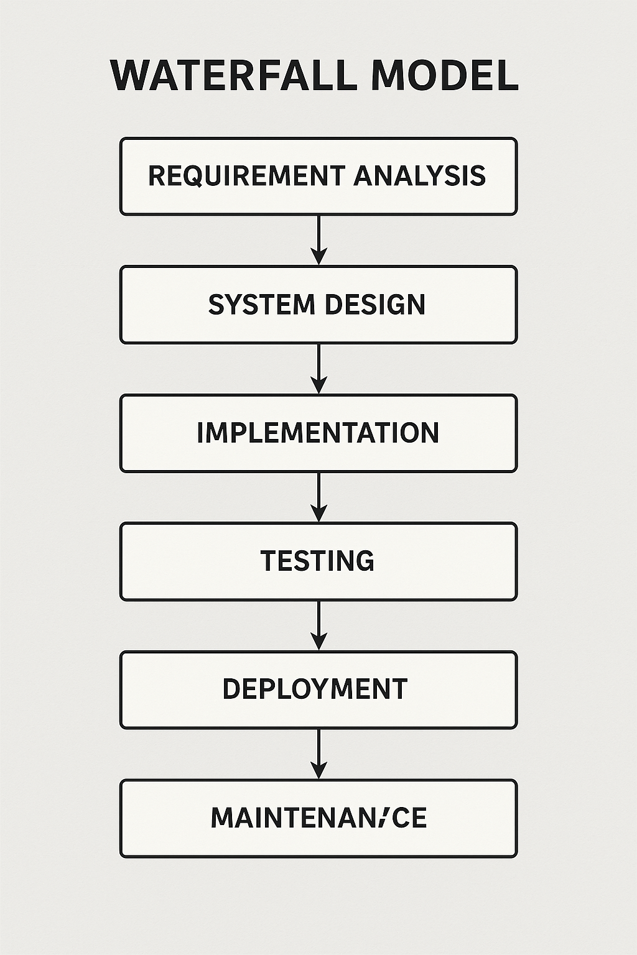

Figure 3.1: Water Model

3.2 Analysis of the Existing System
The existing clearance system used in many academic institutions is predominantly manual and involves a series of physical interactions between final-year students and various institutional departments. The typical process requires students to visit different offices, such as the library, bursary, student affairs, hostel, departmental heads, and exams and records, where each officer must physically verify the student’s status and sign or stamp a clearance form. This process is time-consuming, stressful, and inefficient. One of the main drawbacks of the existing system is the lack of automation, which often results in long queues, misplaced forms, and repeated visits to departments due to unavailable clearance officers. Additionally, there is no centralized tracking mechanism to monitor clearance progress, making it difficult for students to know which departments have cleared them and which ones are pending. This uncertainty often causes unnecessary delays in processing final clearance and hinders the timely release of students’ certificates and final results.
Moreover, the paper-based nature of the system makes it prone to human error, document forgery, and loss of critical data. Departments operate in isolation, and there is little to no integration or communication among them, leading to redundancy and duplication of efforts. The absence of proper record keeping and audit trails also limits accountability and transparency. Another significant limitation is that the existing system does not support remote access. Students must be physically present on campus to complete the clearance process, which poses a major challenge for those who have relocated or are unable to travel back due to personal, financial, or emergency-related reasons. These lapses make it imperative to introduce a more efficient, centralized, and secure online clearance system to address the shortcomings of the existing manual process.

3.3 Problems of the Existing System
The manual clearance system currently in use by many academic institutions presents several challenges that hinder operational efficiency, user satisfaction, and data integrity. These problems have long affected both students and administrative staff, making the clearance process stressful, time-consuming, and error-prone.
1. Time-Consuming and Stressful Process
Final-year students are required to visit multiple departments to obtain manual signatures or stamps from clearance officers. This often involves standing in long queues, waiting for unavailable staff, and repeating visits—especially during peak clearance periods. This not only wastes valuable time but also creates psychological stress for students preparing for graduation.
2. Lack of Centralized Monitoring
There is no system in place to track the student’s clearance progress across departments. As a result, students often find it difficult to determine which departments have cleared them and which ones are pending. This results in confusion, miscommunication, and unnecessary delays.
3. Data Loss and Poor Record-Keeping
Since the existing system is paper-based, clearance records are vulnerable to damage, loss, or misplacement. Important student files can be easily lost due to poor documentation practices or office relocation, and there are no backups available.
4. Prone to Human Error and Forgery
Manual entry of clearance data increases the likelihood of typographical errors, missed approvals, or improper record updates. Furthermore, the use of physical signatures and stamps makes it easier for unauthorized individuals to forge documents, which undermines the credibility of the process.
5. Inaccessibility for Remote Students
Students who are no longer on campus must return in person to complete the clearance process. This is inconvenient and expensive, especially for those who live far away or face travel restrictions due to health, financial, or emergency-related issues.

6. Redundant and Repetitive Work
Each department operates in isolation and does not share data or progress updates with other units. As a result, students are required to explain their cases repeatedly and fill similar forms multiple times for different departments.

3.4 Description of the Proposed System
The proposed system is a web-based Online Clearance System designed to digitize and simplify the clearance process for final-year students. It offers a centralized platform where students, clearance officers, and system administrators interact within their roles to ensure an efficient, transparent, and error-free clearance operation. The goal is to address the shortcomings of the manual system by offering a solution that is fast, secure, and easily accessible. In this system, students will be able to register and log in to initiate their clearance requests online. Once logged in, the student is presented with a personalized dashboard showing all the departments they need clearance from, such as the library, bursary, student affairs, and academic departments. As the student progresses, they can track their clearance status in real-time. For every department cleared, the system updates the student’s status, and in cases where clearance is denied or held, officers can attach comments explaining the reason.
Each clearance officer from departments or units also logs in to a departmental dashboard where they can review student requests. They are granted permission to approve or reject clearance based on the student's records in their department. The system ensures accountability by keeping logs of each action taken, including timestamps and officer identity. This provides transparency and helps in auditing decisions made by clearance personnel. On the administrative side, the system provides a control panel for the system administrator. This user oversees general system operations such as managing department records, registering users, assigning access roles, and generating reports. Administrators can view system-wide clearance activities, making it easier to supervise the process and troubleshoot any challenges.
The system is built using a combination of technologies. The frontend was developed using HTML, CSS, and JavaScript to provide a responsive and user-friendly interface. The backend is powered by PHP, while MySQL serves as the database for storing user accounts, clearance history, and departmental records. The system development process follows the Waterfall model, ensuring that each phase, from requirement gathering to deployment is systematically completed before proceeding to the next. Furthermore, the system supports remote access, meaning students can complete their clearance activities from any location using internet-enabled devices. This is especially beneficial for students who are no longer on campus. By integrating user authentication, centralized data storage, and role-based access control, the proposed system enhances both security and efficiency.

3.5 Advantages of the New System Over the Existing System
The proposed Online Clearance System offers numerous advantages over the existing manual method, particularly in terms of efficiency, transparency, accessibility, and accountability.
- Improved Time Management
The online system significantly reduces the time students and staff spend on clearance activities by eliminating the need for physical visits and long queues.
- Real-Time Progress Monitoring
Students can instantly track their clearance status across various departments, ensuring better awareness and planning.
- Enhanced Transparency and Accountability
Every action taken by clearance officers is recorded and traceable, promoting fairness and institutional integrity.
- Centralized and Secure Data Storage
All clearance records are stored digitally in a central database, reducing the risk of data loss, duplication, or misplacement.
- Remote Accessibility
The system supports off-campus access, enabling students to process clearance from any location using internet-enabled devices.
- Reduced Errors and Inconsistencies
Automation minimizes human errors such as incorrect entries or misplaced forms, leading to a more accurate and reliable process.
- Streamlined Departmental Workflow
Departments operate within a unified system, eliminating redundancy and simplifying administrative duties.
- Stronger Data Security
With features like user authentication and role-based access control, the system ensures that only authorized users can access or modify sensitive information.

CHAPTER FOUR

IMPLEMENTATION AND DOCUMENTATION OF THE SYSTEM

4.1 Design of the System
The design of the system serves as a blueprint that guides the development and implementation of the online clearance system. This phase was carefully planned in alignment with the Waterfall methodology to ensure that the functional and non-functional requirements identified during the analysis phase were effectively transformed into working components. The system was designed to be modular, user-friendly, and accessible, with secure data handling mechanisms.

4.1.1 Output Design
The output design is focused on delivering clear, meaningful, and well-structured information to users. The system provides different types of output interfaces tailored to specific user roles:
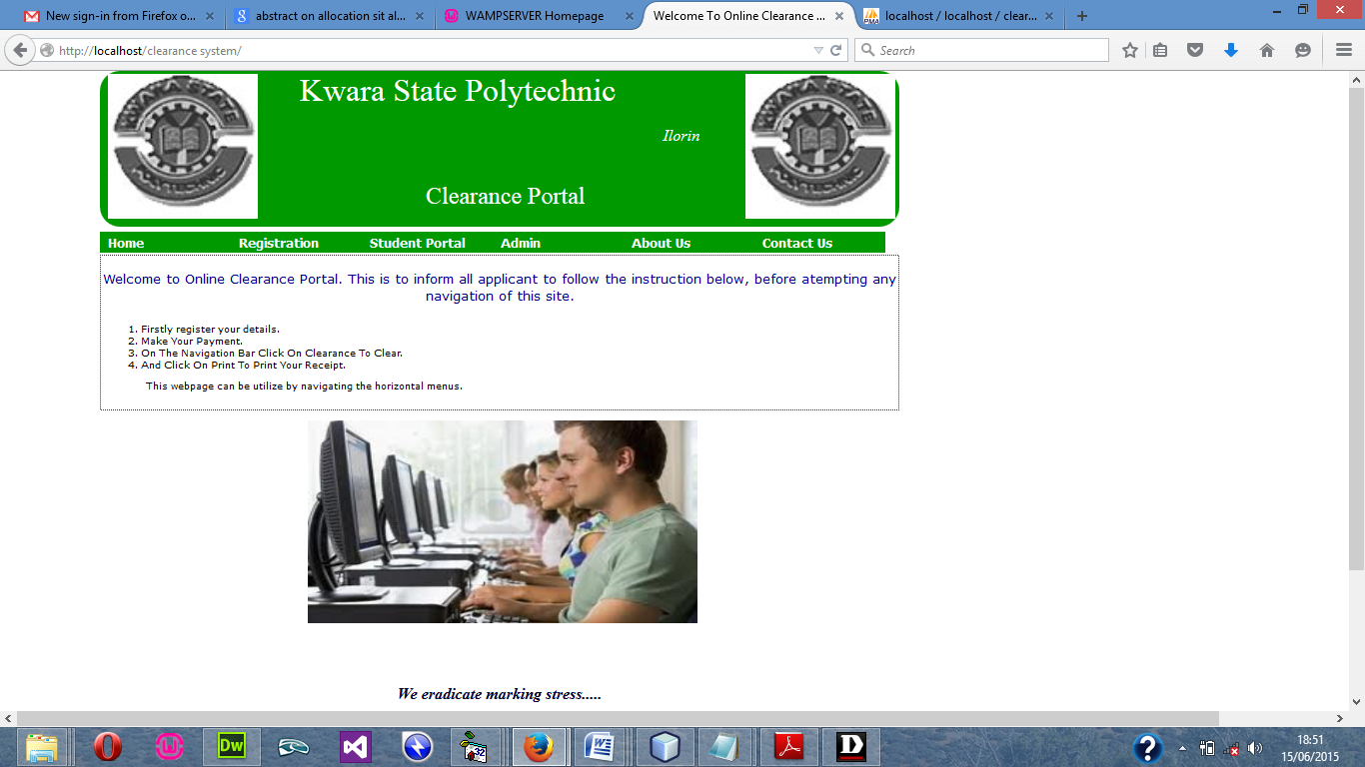
Figure 4.1 Home page
All outputs are formatted to be responsive on both desktop and mobile platforms, ensuring accessibility.

4.1.2 Input Design
Input design focuses on how users interact with the system to submit accurate and valid information. Inputs are collected through forms that include:
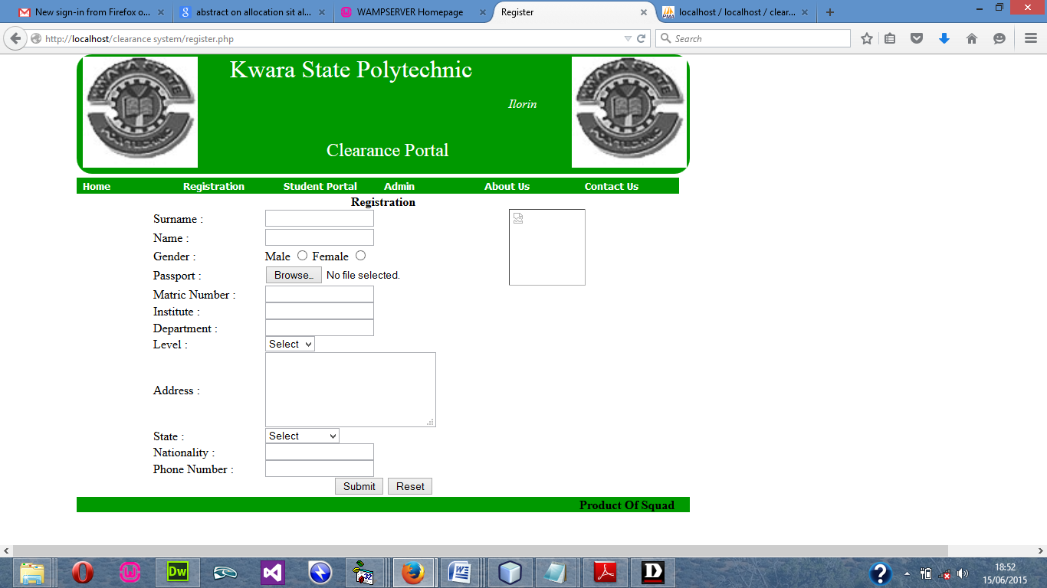
Figure 4.2 Student Registration Form
Input validation is enforced both on the client side (JavaScript) and server side (PHP) to ensure correctness, prevent SQL injection, and protect against data loss or corruption.

4.1.3 Database Design
The system uses a MySQL relational database to manage all data in a structured and scalable manner. The database was designed using Entity-Relationship (ER) modeling to define the relationships between various entities such as:
The file used in the design is stored in a database file. The database is created using Microsoft Access database. The database structure is as follows.
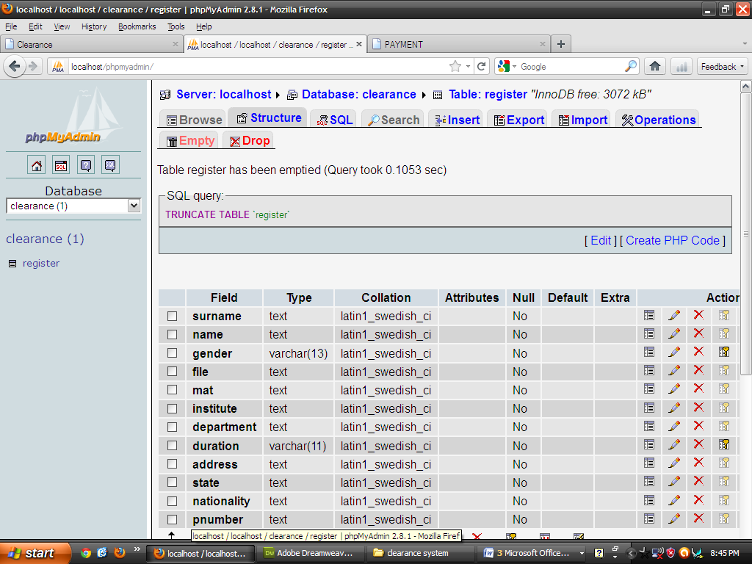
Figure 4.3 database
Tables are normalized to eliminate redundancy and ensure data integrity. Primary keys and foreign key constraints were used to enforce relationships and maintain consistency across records.

4.1.4 Procedure Design
The system's procedures define how users interact with the platform to complete tasks. These procedures follow a defined workflow:
- The student logs in and submits a clearance request.
- The system routes the request to the appropriate departmental officers.
- Each officer reviews the request and either approves or rejects it with remarks.
- Once all departments have approved, the system automatically generates a final clearance report for the student.
These procedures are backed by backend algorithms and control logic implemented in PHP, ensuring that business rules are strictly enforced throughout the process.

4.2 Implementation of the System
The implementation phase involved converting the design specifications into an actual working system. This included writing the code, setting up the database, testing each module, and deploying the system in a local server environment.

4.2.1 Choice of Programming Language
The following technologies were used for development:
- HTML/CSS/JavaScript: For building a responsive and interactive frontend interface.
- PHP: For server-side scripting and handling backend logic.
- MySQL: For database management and data retrieval.
These technologies were chosen for their compatibility, ease of deployment, and wide support for web-based applications.
4.2.2 Hardware Support
The system was developed and tested on a standard personal computer. The minimum hardware requirements include:
- Client Side: A PC or mobile device with internet access and a modern web browser.
- Server Side: A machine capable of running a local or remote Apache server with PHP and MySQL support (e.g., using XAMPP).

4.2.3 Software Used
To support system development, testing, and deployment, the following software tools were used:
- XAMPP: Provides Apache, PHP, and MySQL on a local server.
- Visual Studio Code: Used as the primary source code editor.
- Google Chrome/Mozilla Firefox: For browser-based testing of system responsiveness and functionality.
- phpMyAdmin: For managing and querying the MySQL database.

4.2.4 Implementation Technique Used
The system was developed using the Waterfall implementation approach, where each module was completed, reviewed, and tested before moving to the next phase. This method ensured a structured and sequential workflow with no overlap between stages. Key modules implemented include:
- User Authentication
- Student Dashboard
- Clearance Processing
- Administrative Monitoring Panel
Each module was subjected to unit testing to ensure it performed as expected before integration into the full system.

4.3 System Documentation
System documentation ensures that the platform can be maintained, operated, and scaled effectively. It includes instructions for using the system, maintaining it, and updating its features as required.

4.3.1 Program Documentation
The source code is thoroughly documented using inline comments and external documentation files. Variable names and functions are clearly named to reflect their purpose. The project directory is structured into logical folders such as:
- /student/ – Contains student-related modules and pages.
- /department/ – Holds officer interfaces and logic.
- /admin/ – For system-wide administration tools.
- /config/ – Configuration files for database connection and session management.

4.3.2 Operating the System
To operate the system, follow these steps:
- Launch the XAMPP Control Panel and start Apache and MySQL.
- Import the system’s SQL file into phpMyAdmin to create the required database tables.
- Place the system folder in the htdocs directory.
- Open a browser and navigate to http://localhost/online_clearance/ to access the login page.
- Login as a student, department officer, or administrator to access the appropriate dashboard.

4.3.3 System Maintenance
System maintenance involves regular monitoring and updates to ensure performance and security. Maintenance activities include:
- Periodic database backups to prevent data loss.
- Monitoring error logs and performance metrics for troubleshooting.
- Applying security patches to address vulnerabilities.
- Updating system features in response to user feedback or institutional changes.

CHAPTER FIVE

SUMMARY, CONCLUSION, AND RECOMMENDATIONS

5.1 Summary
This project was undertaken to address the major challenges faced by final-year students and administrative staff in executing the manual clearance process in tertiary institutions. The existing system, being paper-based and departmentalized, is inefficient, prone to delays, human error, and lacks transparency and accessibility—especially for students who are no longer on campus. To resolve these challenges, an Online Clearance System was designed and implemented using the Waterfall software development model, which enabled the project to follow a systematic and structured path from requirements gathering to deployment and testing. The proposed system allows students to initiate and monitor clearance requests from any location through a web-based portal, while clearance officers and administrators manage approvals and data centrally. The system was developed using modern web technologies including HTML, CSS, JavaScript, PHP, and MySQL, with tools such as XAMPP and Visual Studio Code used for implementation. Features include user authentication, real-time clearance tracking, role-based access control, and centralized data storage. The system has proven to be user-friendly, secure, efficient, and a significant upgrade from the existing manual method.

5.2 Conclusion
The implementation of an Online Clearance System has shown that automating academic clearance processes can significantly improve institutional efficiency, accountability, and user satisfaction. With the ability to remotely access clearance status, reduce administrative overhead, and minimize human errors, the system supports a transparent and structured academic environment. The Waterfall model adopted in the development of this project provided a disciplined and phased approach, ensuring that each component was thoroughly developed and tested before deployment. The project successfully met its objectives by delivering a functioning, accessible, and responsive web-based clearance platform for final-year students.
Overall, the system stands as a scalable and reliable solution that institutions can adopt to modernize their administrative processes and reduce the bottlenecks associated with traditional clearance methods.

5.3 Recommendations
Based on the implementation and testing of the system, the following recommendations are made:
- Institutional Adoption:
Tertiary institutions should adopt online clearance systems to improve administrative efficiency and reduce the burden on both students and staff.
- Integration with Other Systems:
The system can be integrated with other student platforms such as payment gateways, result management systems, and academic record databases for seamless operations.
- User Training and Orientation:
Proper training should be provided to students and staff to ensure effective use of the system and to reduce resistance to change from manual processes.
- Security Enhancements:
Continuous updates and security audits should be conducted to protect the system from vulnerabilities such as SQL injection, session hijacking, and data breaches.
- Hosting on a Live Server:
To make the system available to users across various locations, it is recommended to deploy the platform on a secure live server with SSL encryption and robust hosting features.
- Feedback and Continuous Improvement:
A feedback module should be incorporated into the system to collect suggestions and complaints from users, which can help in improving system usability and features over time.

REFERENCES
Awotunde, J. B., & Ogundele, O. M. (2022). Design and Implementation of an Online Clearance System for Final Year Students. International Journal of Computer Applications, 184(18), 12–19.
Ogunleye, S. A., & Fagbohun, O. (2020). Implementation of Digital Clearance Systems in Nigerian Tertiary Institutions. African Journal of Information Systems, 12(2), 66–78.
Sharma, A., & Singh, R. (2021). Online Automation System for Clearance Process. Journal of Emerging Technologies and Innovative Research (JETIR), 8(5), 74–81.
James, D. T., & Ibukun, A. A. (2020). Design and Evaluation of a Web-Based Clearance System Using PHP and MySQL. Journal of Computer Engineering and Intelligence Systems, 11(3), 45–54.
Abubakar, M. Y., & Sadiq, S. B. (2023). Web-Based Student Clearance Management System Using Structured Development Models. International Journal of Computer Science and Mobile Computing, 12(1), 88–97.
Pressman, R. S. (2014). Software Engineering: A Practitioner’s Approach (8th ed.). McGraw Hill Education.
Sommerville, I. (2016). Software Engineering (10th ed.). Pearson Education Limited.
Balaji, S., & Murugaiyan, M. S. (2012). Waterfall vs. Agile: A Comparative Study on Software Development Methodologies. International Journal of Computer Applications, 85(5), 8 13.
W3Schools. (2024). PHP Tutorial. Retrieved from https://www.w3schools.com/php/
Oracle Corporation. (2024). MySQL Reference Manual. Retrieved from https://dev.mysql.com/doc/

