DESIGN AND CONSTRUCTION OF SIX INTERPHASE EXTENSION BOX WITH DIGITAL DISPLAY AND UNINTERRUPTIBLE UNIVERSAL SERIAL BUS PORT.

BY

LUKMAN ABDULQUDRI AYOBAMI
ND/23/MCT/FT/0042

A PROJECT REPORT SUBMITTED TO THE DEPARTMENT OF MECHATRONICS ENGINNERING, INSTITUTE OF TECHNOLOGY

IN PARTIAL FULFILMENT OF THE REQUIREMENTS FOR THE AWARD OF NATIONAL DOIPLOMA IN MECHATRONIC ENGINEERING TECHNOLOGY ILORIN, NIGERIA

JULY, 2025
CERTIFICATION
The undersigned certify that this project report prepared by Lukman Abdulqudri Ayobami, ND/23/MCT/FT/0042 Entitle: Design and construction of six interphase extention box with digital display and uninterruptible universal serial bus port meets the requirement of the Department of Mechatronics Engineering for the award National Diploma [ND] in Mechatronics Engineering, Kwara State Polytechnic, Ilorin.

__________________ ________________
ENGR. Jimoh Abdulraheem DATE
Project Supervisor

_________________ __________________
ENGR. RAJI Idowu Adebayo DATE
Head of Department

_________________ __________________
EXTERNAL EXAMINER DATE
Name & Signature

DECLARATION
I hereby declare that this research project title Design and construction of six interphase extention box with digital display and uninterruptible universal serial bus port is my work and has not been submitted by any other person for any degree or qualification at any higher institution, I also declare that the information provided therein is mine and those that are not mine are properly acknowledged.

______________________ _______________________
Student Name Signature and Date

DEDICATION
I also dedicate to my Parents Mr. and Mrs. Lukman for their moral and financial support towards the completion of this program, I pray may u live long to eat the fruits of your labor Inshallah.

ACKNOWLEDGEMENT
All praise and adoration belong to Almighty Allah, the most high, the ever first and infinite last, the most supreme, the ever living and the giver of life. I thank Him for His immeasurable love, care, blessings, joy, and protection on me from the beginning of my life. To Him is the glory forever.
I appreciate my supervisor ENGR. JIMOH ABDULRAHEEM for his support and his guidance toward this success of this project. May the peace of Almighty God be upon you and your family all the time. I also tender my sincere appreciation to the head of department (H.O.D) in person of ENGR. RAJI IDOWU ADEBAYO. God’s mercy will always be with you (Amen). I must not forget all the staff and lecturers of the Mechatronic Engineering Technology Department of Kwara State Polytechnic for their understanding and professional teaching in their various lectures in class. May the Almighty continue to strengthen you.
I also wish to acknowledge the great support of my parents, Mr. & Mrs. Lukman who have been my constant source of love support and inspiration throughout my academic journey. Your unwavering encouragement and belief in my abilities have been invaluable and I am grateful for the sacrifice you have made to help me to pursue my dreams. May you live long to eat the fruits of your labour.
To my family, siblings, thank you for being a part of my academic journey and for helping me to achieve my goals. God bless you all.
I cannot forget my project members, for their collaboration and dedication to our shared objectives, am truly grateful for the collective efforts and contributions that made this project possible. Thank you all for your support!

CHAPTER ONE
1.0 INTRODUCTION
Extension box is a multiple electrical sockets connected in parallel to each other and encased in a shockproof box. Extension sockets are built in an extension box, which makes use of electricity in our homes, offices and various other places convenient. When electricity gets to our homes, our electrical devices and appliances make use of it by plugging into a mains supply normally rated 220-240v, 50Hz. A single socket usually has one, two or three plug outlets, which has the advantage of being able to plug in two or three devices at a time. However, when you have a socket with only one outlet and you need to connect about four different devices at a time, we make use of an extension sockets box.
Universal Serial Bus (USB) was originally developed and introduced in 1996 as a way of setting up communication between a computer and peripheral devices by replacing many varieties of serial and parallel ports.
USB connectors have become the standard connection method for devices such as keyboards, game pads & joysticks, scanners, digital cameras, printers and external hard drives.
Although designed for personal computers USB has become commonplace on other devices such as mobile phones, tablets, video game consoles, AC power adaptors, memory sticks and mobile internet access dongles.
1.2 AIM
The aim of this project is to design and construct an extension box with an uninterruptible serial bus (USB) port.
1.3 OBJECTIVES OF THE STUDY
- To design a long an extension box circuit.
- To design an uninterruptible serial bus circuit.
- To aid student’s knowledge on electronic experiments.
- To aid student’s knowledge on the performance of electronic components.
1.4 SCOPE OF THE STUDY
The study of this project will cover the qualitative and quantitative analysis that is involved in the design and construction of an extension box with uninterruptible serial bus (USB) port.
1.5 PROBLEM STATEMENT
The need to save money and time with an allowance in the usage and powering of multiple devices even when the main socket outlet is far away from a user and in the case of power outage, there is need to design and construct an extension box with uninterruptible serial bus.
CHAPTER TWO
2.1 LITERATURE REVIEW
This chapter explains the literature review of the previous project work on electrical extension box, its relevance and the detailed explanation of each of the major components that is used to achieve the results.
2.3 COMPONENTS USED FOR THE PROJECT
For this project to be complete, there is a need to know the components used in the design. In electronics, the power system is designed in such a way that the equipment always has power so that it can function effectively. These components include:
- Resistor
- Transistor
- Transformer
- Switch
- Fuse
- Liquid crystal display (LCD)
- 13A sockets
- Rectifier
- Capacitor
2.3.1 CAPACITORS
Capacitor is a passive component that consists of two conducting surfaces separated by a layer of an insulating medium called di-electric. They are usually used to store electric charges.
2.3.2 CERAMIC CAPACITORS
Ceramic capacitor are the common types of capacitors used in most of the electrical instruments, as they are more reliable and cheaper manufacture.
These capacitors consist of ceramic or porcelain discs and are said to exist in a non-polarized from which is used in various types of industries. Ceramic material is known to be an excellent dielectric because of its poor conductivity and an efficient of the electrostatic fields.
2.3.3 ELECTROLYTIC CAPACITOR
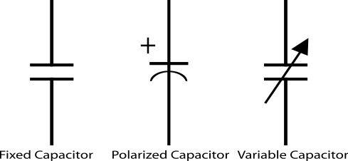
An electrolytic capacitor is a type of capacitor that uses an electrolyte to achieve a larger capacitance than capacitor other capacitor types. An electrolyte is a liquid or gel containing a high concentration. Almost all-electrolytic capacitor are polarized, which means that the voltage on the positive terminal must always be greater than the voltage on the negative terminal.

Fig.2.1 symbols of a capacitor
2.3.4 REGULATORS
A LM79805 regulator is a three terminal positive regulator with 5V fixed output voltage. The fixed regulator provides a local regulation, internal current limiting, thermal shut-down control, and safe area protection. Atypical diagram of a Regulator is shown in Fig. 2.3.
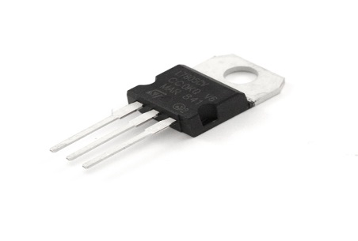
Fig. 2.2 A Regulator
2.3.5 RESISTORS
Resistors are passive elements used to oppose the flow of electricity in a circuit. The resistance of a resistor is measured in ohms. They are used to limit the current in the circuit and as a potential divider to achieve a specific value of voltage across a terminal. Resistors are either fixed or variable. A typical symbol of a resistor is shown in Fig. 2.3

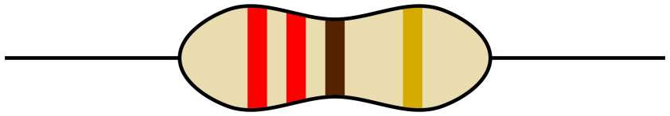
Fig. 2.3 Resistor

2.3.7 CRYSTAL OSCILLATOR
A crystal oscillator is an electronic circuit that uses the mechanical resonance vibrating crystal of piezoelectric material to create an electric signal with a precise frequency. This is often used to stabilize frequencies for radio transmitters and receivers. A typical diagram of crystal oscillator is shown in Fig. 2.4
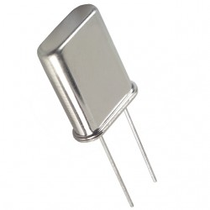
Fig. 2.4 Crystal Oscillator

2.3.8 TRANSFORMER
A current is a passive component that transfers electrical energy from one electrical circuit to another circuit, or multiple circuit. A varying current in any one coil of the transformer produces a varying magnetic flux in the transformer’s core, which induces a varying electromotive force across any other coils wound around the same core.
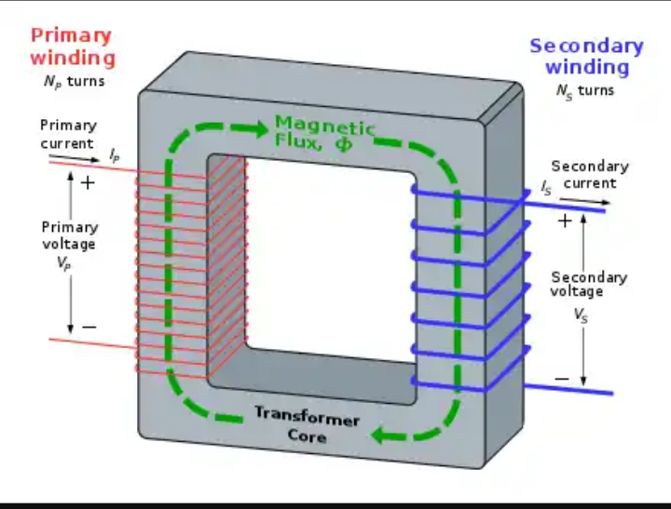
Fig. 2.5 Transformer winding

2.3.9 SWITCH
This electrical component can disconnect or connect the conducting path in an electrical circuit interrupting the electric current or diverting it from one conductor to another. The most common type of switch is an electromechanically device consisting of one or more sets of movable electrical contacts connected t external circuits, when a pair of contacts is touching current can pass between them, while when the contacts are separated, no current flow.
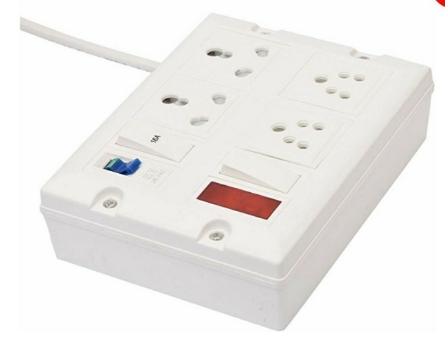
Fig.2.6 A typical switched socket

2.3.10 FUSE
This is an electrical safety device that operates to provide overcurrent protection of an electrical circuit. Its essential component is a metal wire or strip that melts when too much current flows through it, thereby stopping or interrupting the current.

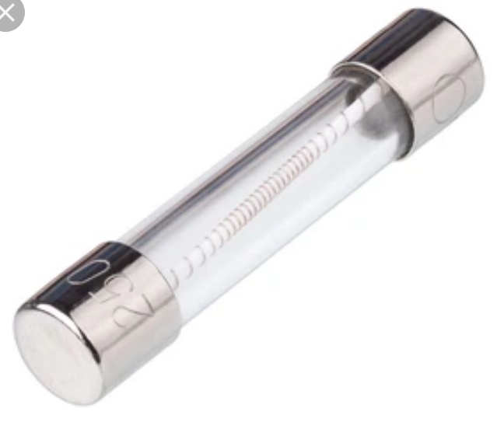
Fig.2.7 A fuse

2.3.11 LIQUID CRYSTAL DISPLAY
This is a flat panel display or electronically modulate optical device that uses the light – modulating properties of a liquid crystals combined with polarizers. Liquid crystals do not emit light directly, instead using a backlight or reflector to produce images in colour or monochrome.
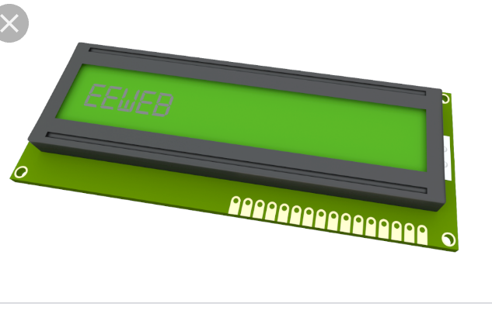
Fig.2.8 Liquid crystal display

2.3.12 13A SOCKET
This is a three (3) outlet with a (live, Neutral and Earth), it accommodates different electrical devices and aid their connections to the electricity before they can function properly. It helps in the connection of appliances rated between 700W and 3000W e.g dishwasher, micro wave, kettle, toaster machine, Iron e.t.c
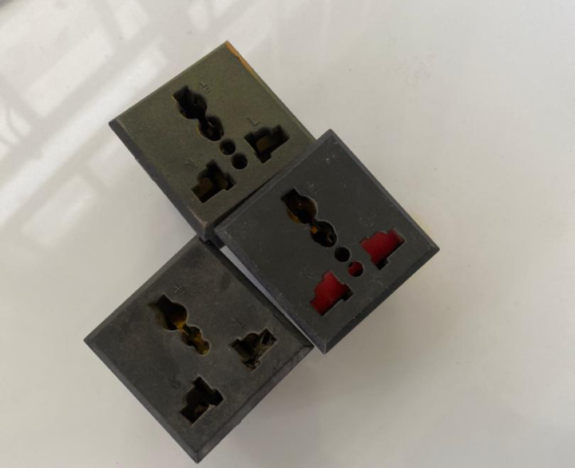
Fig.2.9 A typical 13A sockets

2.3.13 UNIVERSAL SERIAL BUS (PORT)
USB connectors have become the standard connection method for devices such as keyboards, game pads & joysticks, scanners, digital cameras, printers and external hard drives.
Although designed for personal computers USB has become commonplace on other devices such as mobile phones, tablets, video game consoles, AC power adaptors, memory sticks and mobile internet access dongles
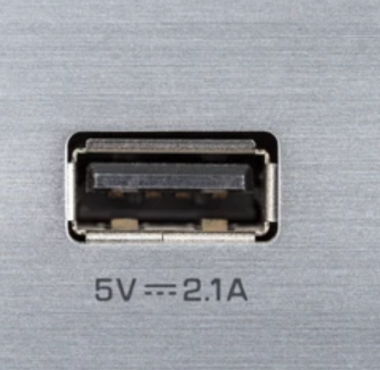
Fig.2.10 USB port

2.3.14 LITHIUM BATTERY
A lithium battery or a Li-ion battery is a type of rechargeable battery composed of cells in which lithium ions move from the negative electrode through an electrolyte to the positive electrode during discharge and when charging. The figure below shows a lithium battery
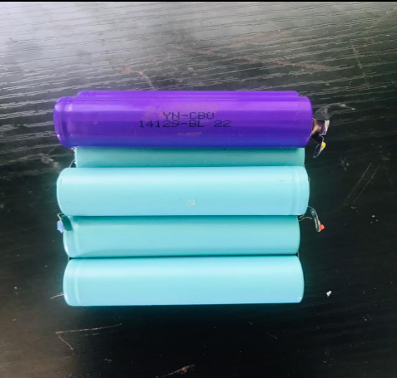
Fig.2.11 A lithium battery

2.3.15 RELAY
A relay is an electrically operated or electromechanical switch composed of an electromagnet, an armature, a spring and a set of electrical constants. The electromagnetic switch is operated by a small electrical current that turns a larger current on or off by either releasing or retracting the armature constant, thereby cutting or completing the circuit.
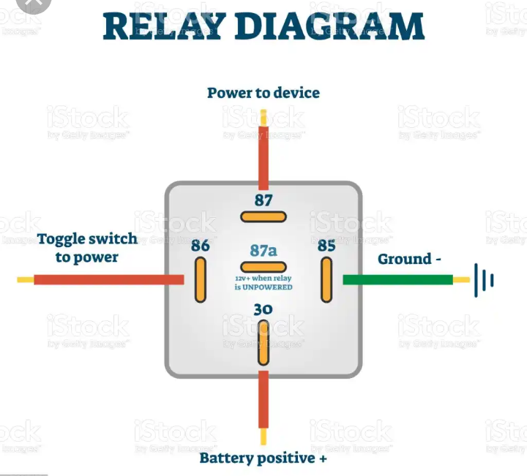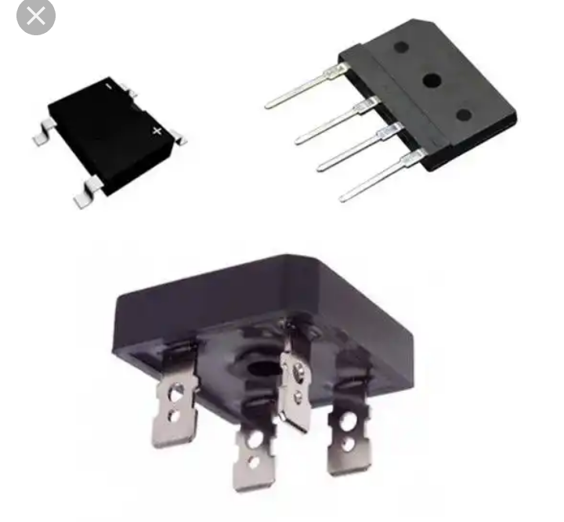
Fig.2.12 Relay

2.3.16 TRANSISTOR
Transistor are active component of integrated circuits, or ‘microchips,’ which often contain billions of these minuscule devices etched into their shiny surfaces. Deeply embedded in almost everything electronic, transistors have become the nerve cells of the information Age.
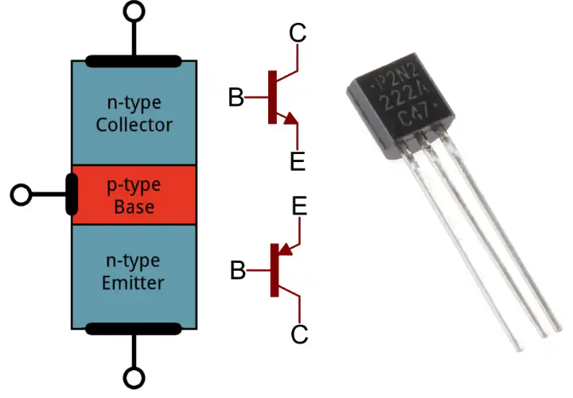 Fig.2.13 Transistor
    - RECTIFIER
A rectifier is a device that converts an oscillating two-directional alternating current (AC) into a single-directional direct current (DC). AC power is available at low cost. DC power is more expensive to produce. Therefore, a method of changing ac to dc is needed as an inexpensive dc source. AC power can be converted to DC power using rectifiers When ac power is converted to dc power using rectifiers, dc output contains un wanted alternating current components known as ripple. Many rectifier applications need that the ripple do not exceed a specified value. If the ripple exceeds the specified value, different unwanted effects appear in the system. Some of the unwanted effects are stray heating and audible noise. The ripple can be reduced using an output filter.

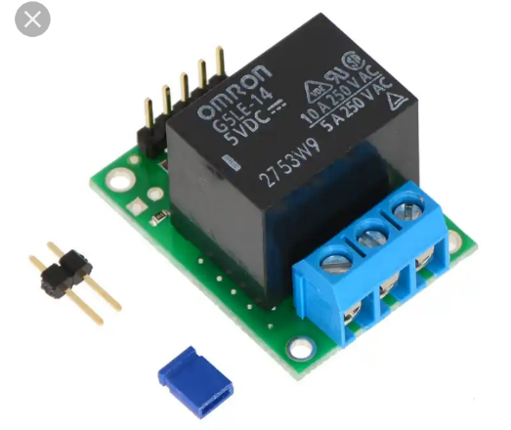Fig.2.15 Rectifier

CHAPTER THREE
DESIGN METHODOLOGY
3.0 INTRODUCTION
This chapter entails the design and calculations involved in the implementation of an extension socket with an uninterruptible universal serial bus port.
3.1 THE BLOCK DIAGRAM OF THE PROJECT
Rectifier
220
VAC
Switches/fuse
13A Electrical
Sockets
12V Step-down
Transformer
Batteries
Regulator
Micro
Controller
Universal Serial Bus port
USB

Fig. 3.1 Block diagram of the project
STAGES OF THE PROJECT
- An electrical voltage is fed from an alternating current circuit, a fuse is connected to prevent the excess flow of electric current
- The source energizes the six phases of the 13A sockets and a stepdown transformer receive its input from the input of the 13A socket
- The power from the step down transformer is rectified to change the state of the Alternating current (AC) to a Direct current (DC) to charge up the inbuilt battery (Lithium) which will store charges to be able to serve the universal serial bus ports when there is power outage
- The Micro-controller controls other electronic components in the circuit
- A regulator is connected to maintain a voltage level required from the battery to power the circuit as well as the micro-controller that requires 5V

3.2 MODE OF CONSTRUCTING THE PROJECT
The first thing is to create holes on the Adaptable box for the creation of an interface for the six phase 13A sockets and two for the USB ports, mapping out accurately and neatly aligned which fits the setting of an extension box. This is followed by measurement and cutting of cable length to be used for the extension box (The cable with thickness of 3.5mm in diameter is peeled by the use of pliers so as to bring out the cores to connect to the socket core. The cores are: the red cable (live), the black cable (neutral), yellow cable (earth) and each socket has its own independent switch. The designed circuit for the working operation of the USB port is arrange systematically with other components into the adaptable box. The box is screwed and readily available for use.
3.3 CALCULATION/ CONNECTION USED FOR THE DESIGN
3.2.1 Parallel Wiring Connection
The parallel connection entails connecting components of a circuit in parallel so that when a component is removed from the others, the circuit continues to work. In other words, both end of each cable are connected directly. Also, same voltage passes through the parallel connection and the current flowing through circuit is the sum of all the current flowing through the components.

V= V1=V2=V3₋₋₋₋₋₋₋₋₋₋₋₋Vn .1

The equivalent resistance of parallel connection is given as:
1/R_{T} = 1/R₁ + 1/R₂ ₋₋₋₋₋₋₋₋₋₋ 1/R_{n} .2

3.2.2 Series Wiring Connection
Cables are connected in series when they are connected end to end. The series connection involves connecting components of a circuit such that when a component is removed, others stop working. This is because same current flows through the series connection and the voltage is the sum of all the voltage drops across the components.

I_{T}= I₁ = I₁ = I₃ ₋₋₋₋₋₋₋₋₋₋₋₋I_{n} .5
The equivalent resistance of series connection is given as:
R_{T}= R₁ = R₁ = R₃ ₋₋₋₋₋₋₋₋₋₋₋₋R_{n} .6

3.4 CIRCUIT DIAGRAM OF THE PROJECT
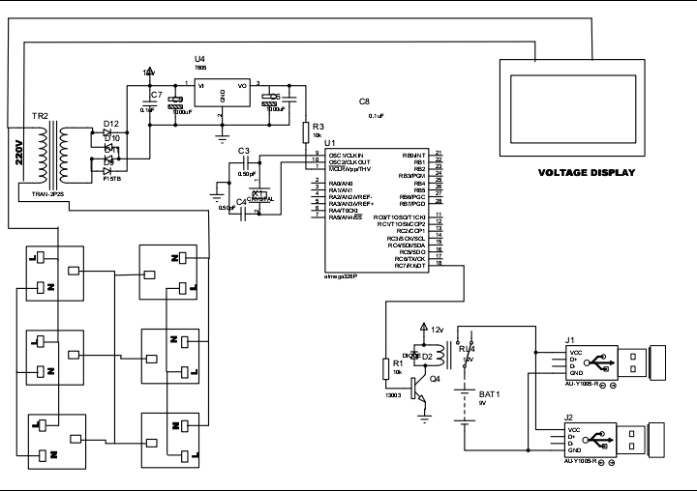
Fig. 3.2 Circuit diagram of the project

CHAPTER FOUR
4.0 TESTING, RESULT, PROBLEMS ENCOUNTERED AND SOLUTION
4.1 TESTING OF THE COMPONENTS
Before the construction of the Extension socket, test was carried out on each of component that was used for the design of the USB unit. These tests are needed to be carried out in order to know the condition, whether the component is in good condition. Tests was carried out on the following components;
- Capacitor
- Transistor
- Transformer
- Integrated circuit
4.1.1 CAPACITOR TESTING
We tested the capacitor in both charging and discharging ways, a connection was done from the two legs of the capacitor to the power supply in orther to store charge and later short circuited in order to be discharged. There was an electrical spark noticed during the short circuit test which affirmed the good condition of the capacitor

4.1.2 TRANSISTOR TESTING
The transistor has three terminals namely; the base, the emitter and the collector. A test was carried out to distinguish the three terminals.
4.1.3 TRANSFORMER TEST
A load and continuity test was carried out on the stepdown transformer to affirm its state before it was used.
4.1.4 TESTING OF THE INTEGRATED CIRCUIT
A continuity test was carried out on the integrated circuit. The state of the IC was known on the multimeter.
4.2 FINAL PROJECT TESTING
The testing of the device was done in stages; the arrangement of the electronic components is mounted on the vero board before it was transferred to the printed circuit board (PCB) for soldering and coupling.
The tests performed on the device includes;
- Charging fully the lithium battery through the step down transformer to ensure that a 12V is passed the USB circuit.
- Performance of continuity tests on various components on the printed circuit board to detect any form of short circuiting
- Switching on the device and testing the effectiveness of the USB port.
4.3 RESULT
An extension socket with an uninterruptible USB port was adopted and constructed with the help of the locally available integrated circuits. The performance evaluation of the design and construction was based on how efficient the USB works when there is power outage, the lithium battery has high quality cells, about 4000 to 5000 cycles can be delivered at 1C and 80% Depth of discharge (DoD).
4.4 PROBLEM ENCOUNTERED
The problems encountered during the design and construction of this project work discuss in two fashions. Firstly, the problem encountered due to unavailability of electrical components in the local market and secondly, the technical problem.
- UNAVAILABILITY OF COMPONENTS
Local components are known to be the second best when it comes to functionality, these components will fairly perform the role assigned for in the designed circuit. Thus, most of the components used were gotten far away South and East.

- TECHNICAL PERSONNEL
In the course of the design work, some technical shortcomings were lacking. This may lead to temporary stoppage in the design layout, pending the outcome of a possible solution.
4.4 SOLUTION PROFFERED
The solutions proffered are necessary so as get the project work completed within the stated period. Itemize next are the solution proffered to the problems encountered.
4.4.1 COMPONENTS ADAPTION
In the case of unavailability of some components part, component’s adaption was done. Components adaptation is the process of combining two or more components together to perform the function of an unavailable component. Likewise, some components were sort for from Lagos and other neighboring states.
4.5 FINAL CONSTRUCTION STAGE
The final project work is able to perform the function it is design and constructed for; the device is able to charge multiple devices at the same time, the USB ports works when there is power as well as during a power outage. Hence, the project works perfectly with the concept of a converter.

4.5.1 SOLDERING/COUPLING STAGES
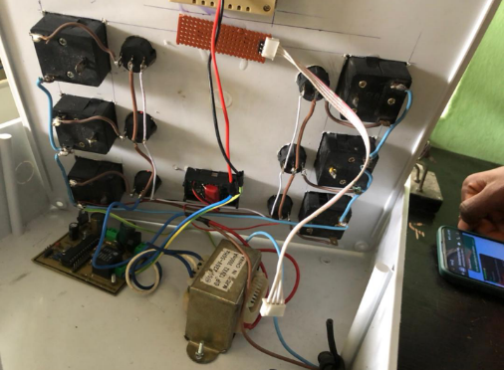
Fig.4.1. placing of the soldered project components

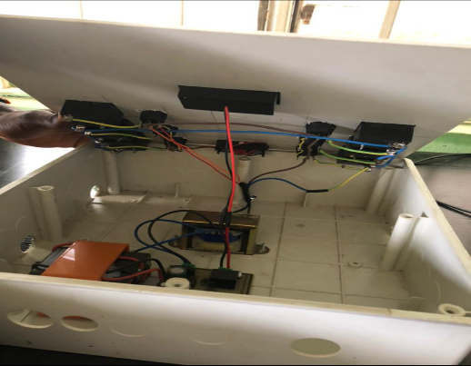
Fig. 4.2. Closing of the arranged soldered component of the project in the casing
4.5.2 FINAL INTERFACE OF THE PROJECT
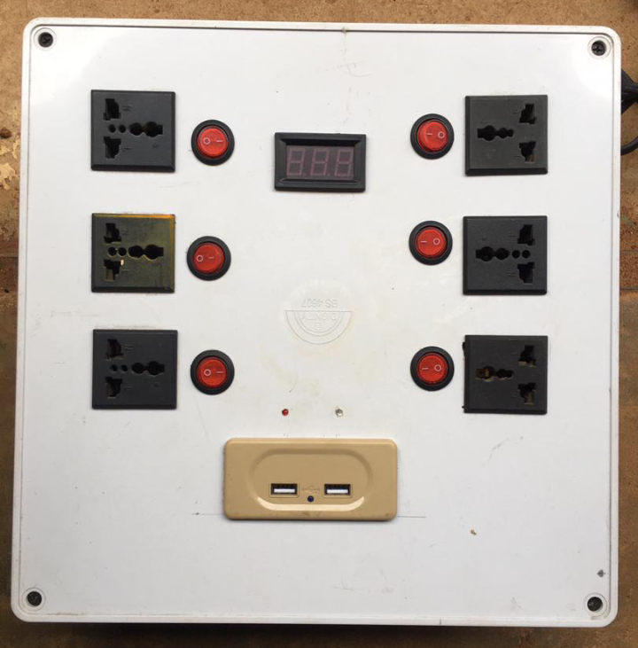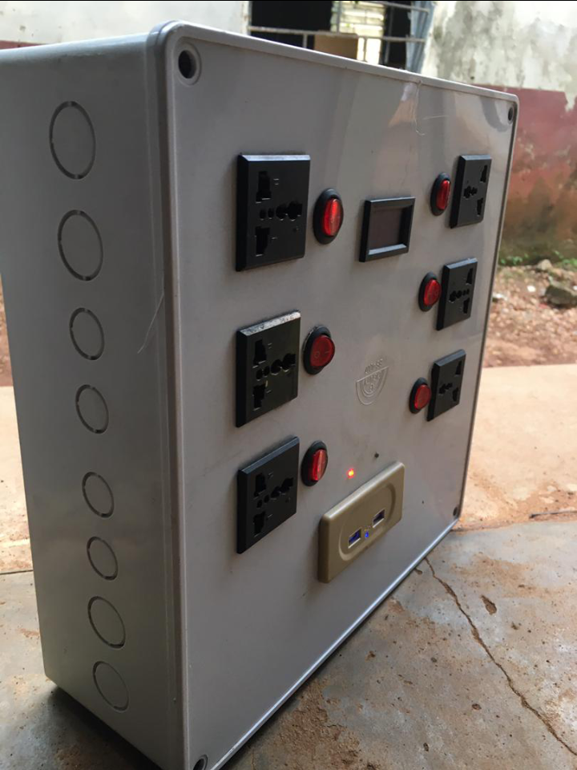
Fig4.3 final project interface

CHAPTER FIVE
5.1 CONCLUSION
The design and construction of an extension socket with an uninterruptible power supply has been achieved. The design successfully made use of electrical components available in our local market to carry out the designed. In addition, it is worth mentioning that the project will perfectly satisfy what it was constructed for; charging of multiple devices at the same time.
5.2 RECOMMENDATION
The implementation, construction and deployment of this project work have successfully achieved the aim and objectives initially set out through extensive tests and troubleshooting. The project work is solely base on acquiring the integrated circuit present in the acquired circuit. The IC’s can be order from outside the country in earnest, considering the fact that project work is within some gazette period for completion.
Also, encouragement should be given to engineering students to do more of this project work in the nearest future as it is well marketable in any sphere.

REFERENCES
[1] C.L. Strong Simon and Schuster, “The Scientific American Book of Projects for the Amateur Scientist” 1960. Pages 377-398
[2] Alistair E. Richie, Seth H. Washburn D. Van Nostrand, “The Design of Switching Circuits William Keister” 1951.
[3] Hao wang (1957), A variant to turing ‘s Theory of computing machine, JACM (Journal of the Association for computing machinery) 4, (June 23-25) 1954, pp 63
[4] Marvin Minsky , “ Recursive Unsolvability of post‘s problem ‘Tag’ and other Topics in theory of Turing machine”1960 pp. 437-455
[5] Calvin elgot and Abraham Robinson (1964) “Random Access stored program machines, an approach to programming languages, Vol. 11, No 4, (October, 1964) pp. 365-399
[6] Bishop, C. M. “Pattern recognition and machine learning”Royal Statistical Soc. Series B (Methodological) 48(3):259-302., 2006. 1st edition, Springer New York, 738 pages.
[7] Cheriyadat, A., Bright, E., Potere, D., Bhaduri, B., 2007., “Mapping of settlements in high resolution satellite imagery using high performance computing”. GeoJournal 69(1/2):119-129.

APPENDIX
BILL OF ENGINEERING MEASUREMENT AND EVALUATION (BEME)
S/N | LIST OF ITEM | DESCRIPTION | QTY | PRICE | AMOUNT
1. | LITHIUM BATTERY | 12V/3AH | 1 | 4000 | 4000.00
2. | LED | 5AH | 2 | 400 | 800.00
3. | SOCKETS | 13A | 6 | 500 | 3000
4. | TRANSFORMER | 12V | 1 | 3000 | 3000
5. | POWER CABLE | 2.5MM² | 1 | 1000 | 1000
6. | USB | PORTS | 2 | 1500 | 3000
4 | SWITCHES | LED | 6 | 150 | 900
3. | RESISTOR | 4.7K | 3 | 5 | 15.00
4. | RESISTOR | 100K | 1 | 5 | 5.00
5. | CAPACITOR | 0.1µF | 3 | 30 | 90.00
6. | CAPACITOR | 1000µF | 2 | 30 | 60.00
7. | SEVEN SEGMENT DECODER | CD4033 AND CD4027 | 4 | 300 | 1200
8. | FUSE | 3A | 1 | 200 | 200
8. | MICRO-CONTROLLER | ATMEGA328 | 1 | 3000 | 3000
9. | ULTRASONIC SENSOR | HC-SRO4 | 1 | 2000 | 2000
10. | CONNECTOR | 8 PINS | 2 | 300 | 600
11. | CONNECTOR SOCKET | 8 PINS | 4 | 50 | 200
12. | PLASTIC CASING |  |  | 1 | 3000
13. | CRYSTAL OSCILLATOR | 4 PIN | 2 | 100 | 200
14. | BOLTS AND NUTS |  | 6 | 40 | 240
15. | PRINTED CIRCUIT BOARD + DESIGN |  | 1 | 3500 | 3500
16. | COVER OF PCB |  | 1 | 200 | 200
17. | DRILLING BIT |  | 1 | 150 | 150
18. | SOLDERING IRON |  | 1 | 350 | 350
19. | MISCELLANEOUS |  |  | 3000 | 3000
20 | Soldering led |  | 1 | 300 | 300
 |  |  |  | TOTAL | 34,010

