

PERIMETER AND DETAILING SURVEY OF OLD INSTITUTE OF ENVIRONMENTAL STUDIES (IES) AND VILLAGE, KWARA STATE POLYTECHNIC ILORIN ALONG OLD JEBBA ROAD,MORO LOCAL GOVERNMENT AREA, KWARA STATE
BY
OYENIYI MASHOOD AKINOLA
ND/23/SGI/FT 0019
A PROJECT WORK SUBMITTED TO THE DEPARTMENT OF SURVEYING AND GEO-INFORMATICS, INSTITUTE OF ENVIRONMENTAL STUDIES, KWARA STATE POLYTECHNIC, ILORIN

IN PARTIAL FULFILLMENT OF THE REQUIREMENT FOR THE AWARD OF NATIONAL DIPLOMA IN SURVEYING AND GEO-INFORMATICS

SEPTEMBER, 2025
CERTIFICATE
I hereby certified that all - work ad information contained in this project report were obtained as a result of the observation and measurement carried out I the field and that the survey was executed in accordance with the survey rules, supervisor and departmental instruction.

…………………………. ……………………….
OYENIYI MASHOOD AKINOLA DATE ND/23/SGI/FT/019

CERTIFICATION
This is to certify that I OYENIYI MASHOOD AKINOLA with matric no; ND/23/SGI/FT/019 a student of Surveying & Geo-Informatics Department has actually carried out the field work in connection with this project and it was carried out in accordance with survey rules and regulations and department instructions.

……………………………… ….………………
SURV. ABDULSALAM A. DATE
PROJECT SUPERVISOR

…………………………….... ….………………
SURV. AWOLEYE R.S DATE
PROJECT COORDINATOR

………………………………. ….………………
SURV. ABIMBOLA ISAAU DATE
HEAD OF DEPARTMENT

………………………………. ….………………
SURV J.O OPALEYE
EXTERNAL SUPERVISOR DATE

DEDICATION
I dedicate this project to Almighty Allah who gives me the grace to execute this programme successfully.
ACKNOWLEDGEMENT
All glory, honour, praise and adoration goes to Almighty Allah (SWT), The creator of the universe, the author and finisher of my faith, under whose protection I have been since I was born even from the beginning of my life.
My profound gratitude goes to my loving, caring, humble and beloved parent MR and MRS OYENIYI pray may God spare your life to reap the fruits of your labour. Also to my amazing family generaly for their support and others may Allah be with you all.
My heartfelt gratitude goes to the entire friends and family palmer,Mubarak,agba survey,emmanuel,Alfa jamiu for the financial,group support and moral support toward the completion of my programme.
I wish to appreciate my wonderful group member despite that the misunderstanding we had between ourselves, we later work as a team in order to acquire our aims and objective.
I also give thanks to my project supervisors in the person of Surv. Abdulsalam Ayuba And Suvr. Benard Oguntayo for their strictly and through supervision. I will like to thank all lecturers of this noble department starting from H.O.D Surv. Abimbola isau, Surv. A. Ayuba, Mr. Bello Felix Diran, Surv. Williams Kzeem, Surv. A.O. Akinyede, and also the Director of IES
Surv. A.G. Aremu and other supportive staff of the department of Surveying and Geo-informatics, Kwara State Polytechnic, Ilorin.
Finally, I appreciate the effort of all my colleagues in the department of surveying and Geo-information (2023/2024) and those who help me in one way or the other that I cannot be mentioning one by one.

ABSTRACT
The abstract of this project is based on various activities carried out and the instrument used during this project. This project is based on perimeter and detailing survey which was carried out at old institute of environmental studies(IES)and village of part of kwara state polytechnic. This project comprises of five chapters which are; the introduction with background of study, statement of problem, aims and objectives, scope, equipment used personnel and study area, the literature review which involves a full discussion on perimeter and detailing, surveying. The main survey operation of this project commenced from reconnaissance to the actual field observation, the data processing and information presentation analysis of the result obtained, summary problem(s) encountered, and concluding part of the report.

TABLE OF CONTENTS
Title page i
Certification ii
Dedication iii
Acknowledgement iv
Abstract v
Table of content vi
CHAPTER ONE
INTRODUCTION 1
  - Statement of the problem 4
  - Aims of the project 4
  - Objective of the project 4
  - Scope of the project 4
  - Study Area 5
  - Personnel Involved 5
CHAPTER TWO 7
LITERATURE REVIEW 7
CHAPTER THREE 12
3.0 Methodology 12
3.1 Reconnaissance. 14
3.2 Instrument Test 14
3.3 Monumentation 19
3.4 Perimeter Traversing 20
3.5 Detail survey 22
CHAPTER FOUR
4.0 Data processing 24
4.1 Result Analysis 24
4.2 Back computation 24
4.3 Compute for the Area using Double latitude and departure 25
4.4 Graphic plotting 27
CHAPTER FIVE
5.1 Summary 27
5.2 Recommendation 27
5.3 Problem Encountered 28
5.4 Conclusion 28
References 29
APPENDIX 30
CHAPTER ONE
1.0 INTRODUCTION
According to (Wikipedia the free encyclopedia 1986) surveying is the technique and source of accurate determining the terrestrial of three dimensional positions of points, the distances and angels between them.
These points are usually on the surfaces of the earth, and they are often used to establish land map and boundaries for ownership or government purpose.
While the American Congress on Surveying and Mapping (ACSM) define surveying as the science and art the of making all essential measurements to determine the relevance position of points, physical and cultural details, above, on, or beneath the earth surface and depict them in a visible forms, or to establish the positions of points or details.
Plane surveying: This is the surveying aspect that deals with an area of limited extent of country land and it’s assumed that the earth surface is plane. Hence, earth’s curvature is not put into consideration.
Surveying consists of different operations and techniques but the following basic principles provide unity and disciplines to the subject.
- Working from whole to parts.
- Choosing the best method of surveying most appropriate to the desired result.
- Provision of adequate checks to all survey operations
- WORKING FROM WHOLE TO PART:-This means that for any particular survey operations, whether it is for an entire country or an area of small extent, it must be connected to the main frame works of higher accuracy that could be made once the frames work has been establishes.
- CHOOSING THE METHOD OF SURVEYING: - this is adopted in order to meet the desired and required accuracy which the more refined techniques and instrument employed, the greater the accuracy that will be obtained.
- PROVISION OF ADEQUATE CHECK: - this is an important aspect of surveying exercise as it will show the possibility of detecting error and how it will be handle. Therefore, survey as well as estate survey involves stages such as planning, data acquisition processing, and information presentation.
Survey can be divided into two main types.
  - The plane surveying.
  - The geodetic surveying.
Plane surveying: - This is referred to as surveying dealing
Kwara State polytechnic Ilorin.OLD INSTITUTE OF ENVIRONMENTAL STUDIES (IES) AND VILLAGE, was designed for lectures room only, while is the largest within the area. With this fact there will be need for perimeter and details base map of the area to know the position of each building and the area covered for security purposes, decision making and future development. For the fact above OLD INSTITUTE OF ENVIRONMENTAL STUDIES (IES) AND VILLAGE, KWARA STATE POLYTECHNIC ILORIN ALONG OLD JEBBA ROAD,MORO LOCAL GOVERNMENT AREA, KWARA STATE
mostly established boundaries so as to be useful for future purpose the detailing will help to have the view of artificial feature of the particular area.
Perimeter and detailing survey which is the subject of the study goes in line with boundary demarcation and facilities inventory take.
Perimeter and detailing survey is a type of land survey that defines the boundaries of a particular parcel of land or real estate property. This survey maps a ship using a minimum width of 15feet.Tis requires surveying the entire perimeter of the said real estate to determine the exact average and geometry of the property and identify any easement that may be present within the land. Also, perimeter survey is used to identify the location of old boundaries documentation and survey pins or they used to set up new ones. A perimeter survey does not identify the features and improvement that exist within a property such garages, sheds, dwelling, surface utilities, road way pool and visible bodies of water, only features that fall within the 15foot width around the boundary perimeter will be depicted. Also perimeter survey resolve conflicts on maps and deeds description and shows structures such as fences, hedges, yards and walls.
Perimeters surveys are cadastral. The measurements were taken and plotted in order to produce a register able cadastral instrument. Detail survey is the survey of the positions of permanent natural features within the area.
  - STATEMENT OF PROBLEM
The reason for carrying out this project operation is due to the irregular or changing boundary line between the project area and the surrounding institution, in order to help the school authority plan for future expansion and development of the project area, the need for a more current and valid perimeter and detailing is suggested.
  - AIM OF THE PROJECT
The aim of this project is to produce a current and comprehensive perimeter and detail plan of OLD INSTITUTE OF ENVIRONMENTAL STUDIES (IES) AND VILLAGE, KWARA STATE POLYTECHNIC ILORIN ALONG OLD JEBBA ROAD,MORO LOCAL GOVERNMENT AREA, KWARA STATE
1.3 OBJECTIVES OF THE PROJECT
1) Reconnaissance (office and field).
2) Selection and marking stations of the selection traverse stations.
3) Angular observation.
4) Linear observation.
5) Field book reduction.
6) Forward computation.
7) Back computation.
8) Area computation.
9) Plan production.
10) Report writing.
1.4 SCOPES OF THE PROJECT
1. Reconnaissance [office and field]
2. Total station traverse
3. Detailing by total station.
4. Computation
5. Plan production (analog and digital)
6. Report writing

1.5 STUDY AREA
The project site is part of Kwara State Polytechnic, Ilorin specifically,OLD INSTITUTE OF ENVIRONMENTAL STUDIES (IES) AND VILLAGE, KWARA STATE POLYTECHNIC

Map of Study Area
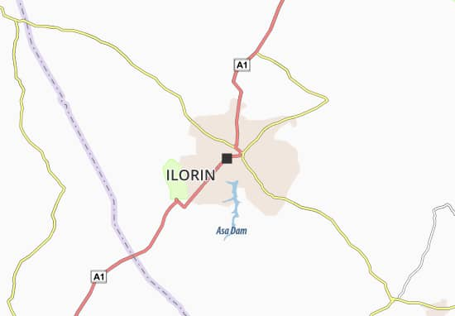
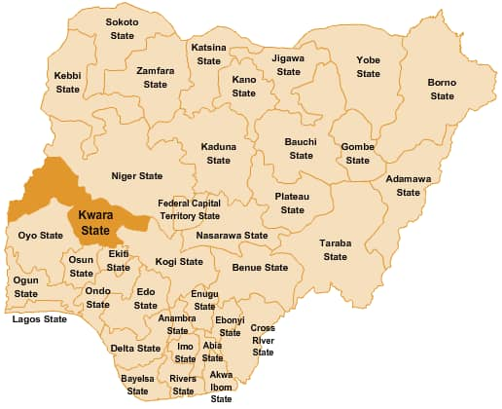

MORO
STUDY AREA

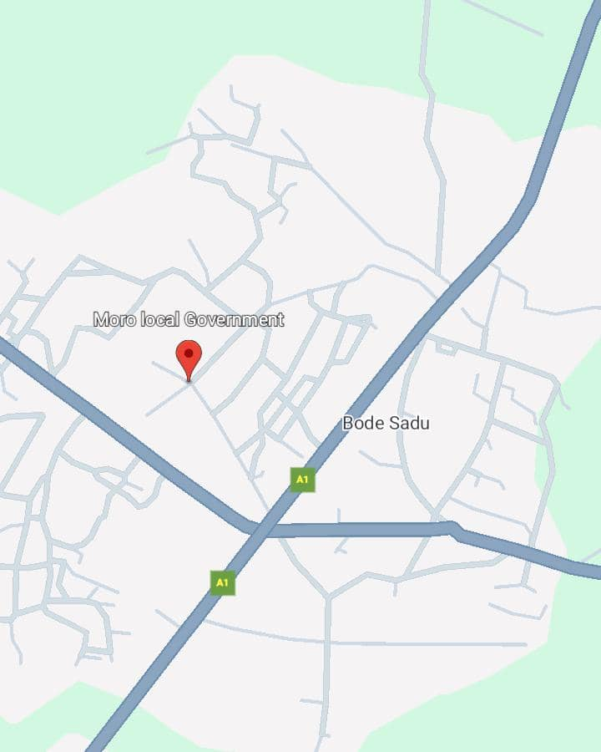
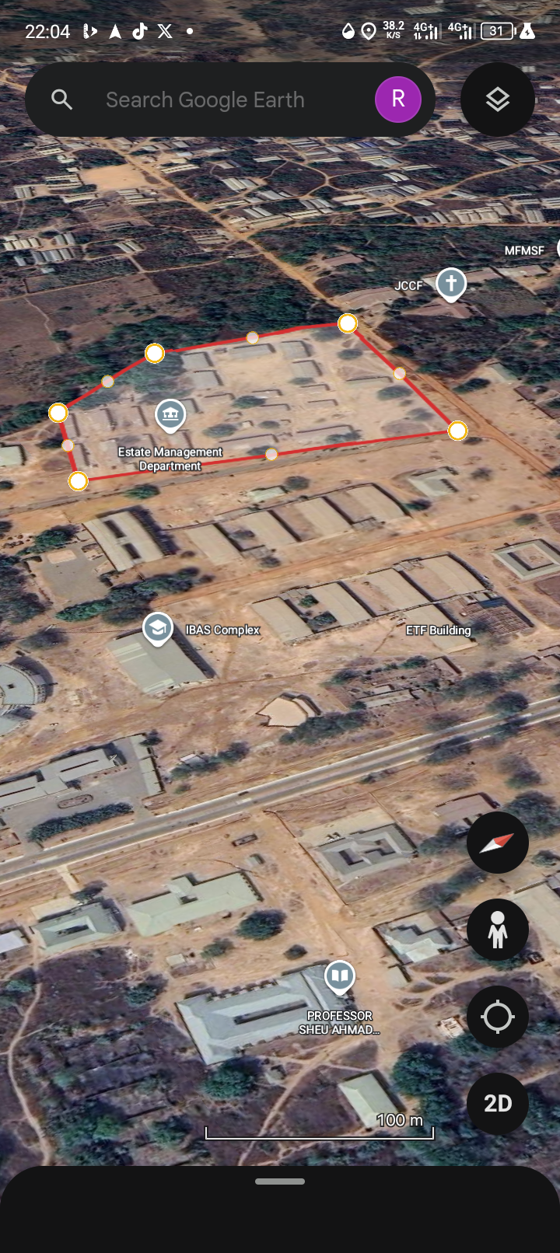

1.6 PERSONNEL INVOLVED
For easy and proper execution of this project, nine (9) members were engaged in the operations. The observer, chairman, pole men and booker. The roles were interchanged among the members in the group for the benefit for everyone to participate in all the operations.
The below table shows the names and Matric numbers of the group members.

S/N | NAME | MATRIC NO | REMARK
1 | OYENIYI MASHOOD AKINOLA | ND/23/SGI/FT/019 | AUTHOR
2 | FAGBOHUN ISAAC OLAMIDE | ND/23/SGI/FT/014 | MEMBER
3 | SHEU ROKIBAT AYOKA | ND/23/SGI/FT/020 | MEMBER
4 | OJO SEERAH ADESOLA | ND/23/SGI/FT/021 | MEMBER
5 | MUSA OLADIMEJI ZULU | ND/23/SGI/FT/017 | MEMBER
6 | NINIOLA OMOWUMI MUTIYAT | ND/23/SGI/FT/024 | MEMBER
7 | AWOYEMI MARIAM DEBORAH | ND/23/SGI/FT/025 | MEMBER
8 | RAHEEM ROKIBAT ANIKE | ND/23/SGI/FT/026 | MEMBER
9 | ISHOLA ABDULROSHEED OLAYINKA | ND/22/SGI/FT/28 | MEMBER

CHAPTER TWO
2.0 LITERATUREV REVIEW
Perimeter surveying may be described as the type of surveys made purposely for producing plan showing property boundaries or plan on which area necessary for the assessment of property or land taxes may be computed. It also referred to as legal surveying because such surveyor forms the basis of a statutory registration of ownership and other right land. (dashes, 1987).
Surveying began in Babylon and Egypt in the form of field measurement the great pyramid which are my stem hitherto could not have been built without the knowledge of surveying principal in spite of complicating views about its physics construction the Egyptians use stone to mark boundaries of by perm land along Nile valley as temporary beacons even through the beacons use to be washed away later. This led to the proper and solid demarcation of boundaries permeate beacons.
Perimeter can be defined as boarder or outer boundary of two dimensional figure can also refers to a trip or boundary usually protecting a military position.
A perimeter is also path that surround a two dimensional shape the word come from a Greek word “peri” means around and “meter” means form may be use either for the path or its length.
Perimeter surveyor in reality include means other assumption and calculation use of this approach they have to analyses calculation and measure a wide range of factors which includes but not limits to :-
i boundary monumentation
ii. Boundary enrollment
iii. unresolved complicit wilt existing property deeds and map.
iv. lines occupation pence’s, walls, hedgix, yards and natural
boundary of perimeter surveyor the perimeter or whole property rath er than say a sub-division which night subdivide one or two house, plots from 50 to 10 across property.
This here by involve surveying the entire perimeter of the property to determine the exact geometry and a crease where the legal access to the property is form any easement that might to be registered over the property benefitting adjoining property.
A perimeter or boundary surveyor is normally carried out on a property that is still define as per the cadastral registration create a surveyor plan that define the boundary. This beneficial because.
- If determine your boundaries more accurately
- Determines the a crease accurately
- Boundary marks are placed at all turning on the property
- Legal surveyor plan is drawn and anthem located by the chief surveyor where registered at the land registry
Some techniques and tools are used in perimeter surveyor that include both conveweharal and modern techniques however most up the surveyor paper to use conjectural surveying tools and techniques that includes bearing and distances or compass and tape although they are considered primitive tools, they still remain an important asset to a land surveyor. Although tape are some minor adjustment and improvement in the compass and tape they still follow the age old concept and techniques. In addition to them, surveyor will use G.P.S techniques in a perimeter.
Also, much of the information of the Survey is portrayed graphically by the construction of maps, profiles, cross sections and diagrams.
The equipment available and methods application for measurement and calculation have changed tremendously in the past decade. Aerial photogrammetric, satellite observations, remote sensing, inertial surveying, and electronic distance measurement and laser techniques are examples of modern system utilized to collect data reliable in the surveying process.
With the development of these data acquisition and processing systems, the duties of the Surveyors have expanded beyond the traditional task of the field work of taking measurements and office work of computing and digital drawing.
The essential operations carried out on the field in order to achieve a well planned perimeter and detail survey these were reconnaissance, traversing, tachometry, detailing.
Traversing: - This is the act of establishing traverse station in a series and making the necessary measurement (Brinker and Wolf 1977). It is also used to determine the position of point on the earth surface.
Traversing; is an orderly sequence of determining the heights and direction of lines between points on the earth surface and to determine the co-ordinate of the position of points (Allan et al 2018).
Bomfard (1984) stated that traversing involves the measuring of angle and distances in sequence over a series of established points to the ground.
Raymond (1986) define traverse as the succession of straight lines connecting a succession established points along the routes of a survey
Perimeter survey; is defined as the type of survey which maps a strip along the boundaries.
Detailing: - This is an act of fixing details such as building, road, electric pole etc.
Detailing ;this can also be define as the manmade and natural features on the ground within the project site which are determined and obtained by the method of total station and are finally represented with a suitable scale on plan.
Detailing: can be said to be the process of fixing both naturals and artificial features to the corresponding traverse line or control are fixed and represented to scale on the plan.
Total station: - This is the combination of digital theodolite and electro-magnetic distances measurement (E.D.M) which are used to measure both vertical and horizontal angle and their distance electronically in survey operation.
This surveying has two similar bits opposite function:
- The determination of existing relative horizontal and vertical position, such as that used for the process of mapping and
- The establishment of marks to control construction or to indicate land boundaries further analyzed that surveying has been on essential element in the development of man’s environment for so many centuries that its importance is often forgotten. It is an imperative requirement in the planning and execution of nearly every form of constructions. Surveying was essential at the door of history and some of the significant scientific discoveries could never have been implemented were it not for the contribution of surveying. So believed that its principle modern uses are in the field of transportation, building appointment of land and communication inside which man can do without development is to be mention in man’s environment.

CHAPTER THREE
- METHODOLOGY
Methodology is a system or principle used is solving problem, with specific component such as task, method technique and tools.
This is also the techniques used to achieve the aims and objectives of this project work, the execution of this project was based on the following basic principles of surveying.
- Working from whole to part.
- The principle of choosing the method of survey most appropriate to meet the desire result.
- The principle of provision of adequate check to meet the require accuracy.
- RECONNAISSANCE
Reconnaissance which is the first stage and vital aspect of any survey work
Carried out is as well the preliminary stage of this project.
This also is the initial operation or preliminary investigation undertaken by the surveyor in order to have a thorough overview of the site before the commencement of the actual survey ,it can also be abbreviated as “recci’’ as the project was concerned the reconnaissance was carried out in two ways.
- Field reconnaissance
- Office reconnaissance

    - Field or Site Reconnaissance
This involves the actual [physical] visit to the site and was carried out before the actual operation. This project site was visited by the group in order to have a prior knowledge as well as true picture of the site and to ascertain the information collected during the office planning. The boundaries were marked with wooden peg driven into the ground to avoid disturbance or removal, taking into consideration the following factors.
- Inter-visibility of the selected traverse station.
- Safety of the selected station for future reference.
- Accessibility of the stations.

    - Office Reconnaissance
This involves knowing the type of instrument, purpose and accuracy required for the survey to be carried out. Information related to the given project was collected from various sources such as project supervisor. The specification/ instructions and coordinates of the control stations were collected from the department of surveying and geo-informatics Kwara State Polytechnic.
TABLE 1 Co-ordinates of control used.
STATION | NORTHINGS (M) | EASTINGS (M)
KWPT2001 | 946677.273 | 679647.447
SC/KW/FRS/4404 | 946699.489 | 679449.408
3.2 INSTRUMENT TEST
HORIZONTAL COLLIMATION TEST
The aim of this test was to be sure that the line of sight is perpendicular to the trunion axis.
Procedure:
The Total Station instrument was set over a point and all necessary temporary adjustments (centering, leveling and focusing) performed. Then the configuration menu of the total station was accessed by pressing down the menu key for about two seconds and the calibration sub-menu and consequently the horizontal collimation test was chosen. This test was done by sighting and bisecting a well-defined vertical target about 100m away and taking the horizontal readings on face left and face right. From the analysis of the results, the total station was in good adjustment.
VERTICAL INDEX ERROR TEST
This adjustment ensures that the vertical circle reading is exactly 90° when the line of sight is horizontal. Any deviation from this figure is termed vertical index error.
Procedure:
The instrument was set over a point and necessary temporary adjustments (centering, leveling and focusing) performed. The vertical index error test was carried out by sighting a target at a distance of about 120m on face left. The vertical circle reading was recorded and on face right the target was sighted and bisected again and the vertical circle reading recorded.

3.2.1 IN-SITU CHECK FOR CONTROL
In-situ checks observations (angular and linear) were executed for the purpose of verifying the integrity of the existing controls. The following observational schedules were executed:
The instrument was set on KWPT2001 and angular observations were made to targets on SC/KW/FRS/4404 .as back station.

FC3184S

The results of the observations as shown below confirm that the controls were still in their original positions and therefore suitable for use.
TABLE 2 IN-SITU CHECK DATA ANALYSIS (control pillars).
STATION | COORDINATE (m) | KNOWN VALUES (m) | MEASURED VALUES  (m) | DIFFERENCE  (m)
KW3001PT | NORTHING  EASTING | 946677.273  679647.447 | 946677.273  679647.447 | 0  0
SC/KW/FRS/4404 | NORTHING  EASTIN | 94699.489  679449.408 | 94699.489  679449.408 | -0.005m  +0.004m

.
KWPT2001
.
SCKWFRS4404

FIGURE 3.2.1 Diagram Showing Control Used

3.2.2 DATA ACQUISITION
This involves the processes in acquiring the data needed for the project. This involves the actual making of measurements and recording of observed data on the field. There are different methods of acquiring data in the site with different instrument such as Total station, Theodolite, Compass, Level Instrument etc.
3.2.3 Geometric Data Acquisition.
These are positional data, that is, they are data having the [x, y, and z] coordinates which is possible to locate their position on the surface of the earth.
3.2.4 Attribute Data Acquisition.
These data are acquired by social survey, these are data used for defining the purpose of features located on the earth surface.
3.2.5 EQUIPMENT USED/SYSTEM SELECTION AND SOFTWARE
This comprises of two components, namely: the hardware components and software components.
HARDWARE COMPONENT: These are the physical equipment used for the execution of the project and they are:
- Total station (MATO)and its accessories
- Steel tape
- Nails and bottle corks
- Field book and pen
- Personal computer
- peg

SOFTWARE USED FOR DATA PROCESSING
- AutoCAD 2017 for plotting the boundary and detailing
- Note Pad, and Microsoft Excel (for Script preparation, editing and restructuring of data and report writing).

3.2.6 SETTING OUT OF PERIMETER BOUNDARY
Based on the office planning and field reconnaissance conducted, the instrument was first set on Control Pillar KWPT2001being the closest control and all temporary adjustment performed. The coordinate of the control point KWPT2001 was key into the instrument SC/KW/FRS/4404 was sighted as back sight.
The coordinates of the station KWPT2001 was key-in the instrument via the keyboard. The instrument then computed the bearing between the two stations for orientation. Then coordinates of points to be set out were entered into the total station and the setting out program of the instrument was used to get the angle to turn in order to face the direction of the point after orientation, the instrument was rotated until horizontal angle read 0° 00’ 00”, reflector was held along the direction and distance between the instrument and the reflector was measured. The instrument displayed the remaining of the point to be fixed distance as either positive or negative. Positive distance means that the reflector should move away from the instrument by that amount while negative distance means that the reflector should move towards the

instrument. When the horizontal angle read 0°00’ 00” and measured distance displayed 0.000m this marked the exact position to be set out.
3.3 MONUMENTATION
The beacons measuring 18cm by 18cm by 75 cm were molded in-situ with a mixture of 1:2:3 of cement, sand and gravel respectively. A 12mm diameter Iron rod defines the center of the beacon was placed. The perimeter boundary line was cleared to ensure inter-visibility between the beacons. The numbering of the beacons was carried out after molding in a clockwise pattern with an arrow pointing to the succeeding station. Also, numbering as carried out accordingly as they were in the Title Deed Plan (TDP).However, the beacons were prefixed with identification mark KP220 where KP represents Kwara State Polytechnic.

KP
P T

KWPT2001

FIGURE 3.2.2: PLAN VIEW

18cm
●
8cm Above ground level

12 mm iron rod

76cm

68cm
Beneath ground level

FIGURE 3.3: PROPERTY BEACON

3.4 PERIMETER TRAVERSING
After the demarcation, capping and numbering of the beacons, the actual data acquisition using the total station SOKKIA 501T

commenced. The traverse started from KWPT2001 with KW/SC/FRS/4404 as reference point. The total station was set up over control KWPT2001, centered, leveled and telescope focused to eliminate parallax. The parameters of the instrument station i.e. station name, height of instrument over the station mark, and the XYZ coordinates of the station were keyed in. The reference control point was then bisected and the station name KW/SC/FRS4404, height of target over the station mark, and the XYZ coordinates of the station were key in. Though the total station was set in coordinate mode it actually measured and recorded horizontal readings, vertical readings and distances automatically into the internal memory of the instrument on both faces which it used to compute and display coordinates. At every set up of the total station, the temporary adjustment was carried out and the following parameters measured:
- Height of instrument
- Height of the back target
- Height of the fore target
- Distance to back and fore station
This is the determination of bearing and distance of series of connected lines from known coordinated point so as to obtain coordinate of the newly established station.
This include the following with formula
- Linear measurement : the difference between the coordinates were first derived using (∆E=E2-E1, E3-E2) etc. and the distance of end traverse leg was obtained using the formula: distance =√(∆E)^2 +(∆N)^2
- Angular measurement: to calculated the bearing after the difference in coordinates has been derived, the formula is Bearing=Tan-1 ∆E/∆N.
3.4.1. TABLE 3 Coordinates of the boundary
The coordinates are as follows
S/n | Easting | Northing
1 | 679582.728 | 946429.840
2 | 679448.029 | 946465.672
3 | 679434.376 | 946560.036
4 | 679449.408 | 946699.489
5 | 679647.447 | 946677.273

3.5 DETAIL SURVEY
Detailing of all features (both natural and man-made) within the site was made by shooting ray to fixing with the instrument.
The instrument was set up on station KWPT2001,switched on and adjustments were carried out. Then, “Job” and “Station Name” were set in the instrument so as to recall the coordinates of the boundary point from the instrument’s memory. Also, heights of instrument above the instrument station

and heights of reflectors were measured with steel tape and stored in the instrument’s memory. A reflector placed on beacon SC/KW/FRS/4404was bisected for orientation. The Total station was instructed to compute the bearing between the two stations after input of the orientation station name KWPT2001, One of the site assistant placed a reflector at the edge of a building , the reflector’s cross hair was bisected with that of the telescope of the total station and “DIST” key was pressed for measurement, display and recording. Then the width of the scream was measured with a 50meter steel tape. The same procedure was adopted in detailing the express way by setting on a boundary beacoKWPT2001 and orienting SC/KW/FRS/4404 in this case, all the edges of the carriage way and some buildings were picked.

CHAPTER FOUR
4.0 DATA PROCESSING
As the instrument downloading cable is faulty, Microsoft Excel 2007 Software was used to type the final coordinates of all points except the unwanted part of the data like the temporary controls which were later transported to Note pad and AutoCAD software 2007.
4.1 RESULT ANALYSIS
The data was analyzed and found to meet with the departmental standards and this is the main traverse result extracted from field, then it was arranged accordingly as the observation was held in the field. The results are as follows.
4.2 Table 4: Back Computation
DE DN
From station | Observerd Bearing | Horizontal Distance | - | + | Sum | - | + | Sum | Easting | Northing | To station
 |  |  |  |  |  |  |  |  | 679582.728 | 946429.840 | A
A | 284°45’00’’ | 139.380 |  | 134.699 | 134 | 35.832 |  | 35 | 679448.029 | 946465.672 | B
B | 351°16’46’’ | 95.450 |  | 13.653 | 147 | 94.364 |  | 129 | 679434.376 | 946560.036 | C
C | 06°09°00’’ | 140.260 | 15.032 |  | 162 | 139.453 |  | 268 | 679449.408 | 946699.489 | D
D | 96°24’00’’ | 199.280 | 198.309 |  | 360 |  | 22.216 | 290 | 679647.447 | 946677.273 | E
E | 194°39’00’’ | 255.760 |  | 64.719 | 424 |  | 247.433 | 537 | 679602.388 | 946429.840 | F

4.3 Table 5: COMPUTE FOR TOTAL AREA USING DOUBLE LATITUDE AND DEPARTURE
∆E | ∆N | Easting | Northing
+51.652 | +35.832 | 679582.782 | 946429.840
$$-$$114.829 | -94.364 | 679448.029 | 946465.672
$$-$$13.501 | -139.453 | 679434.376 | 946560.036
-198.039 | +22.216 | 679449.408 | 946699.489
+45.058 | +247.433 | 679647.447 | 946677.273

Source: Writer, 2025

+134.699
+134.699 × -35.832 = -4826.535

+269.398
+013.653
+283.051
+013.653 × -94.364= ̵ 1288.352
+296.704
- 015.032
+281.672
-015.032 × ̵ 139.453= +2096.257
+266.640
-198.039
+068.601
-198.039 × +22.216 = ̵ 4399.634
-129.438
+ 064.719
-064.719
+ 0.64.719 × +247.433 = +16013.616
0.00

SUM OF POSITIVE (+) - SUM OF NEGATIVE (-) 18109.873 - 10514.521
= 7595.352 2
AREA = 4.265 square meters

4.4 GRAPHIC PLOTTING
Fig 4.0 Perimeter Plan
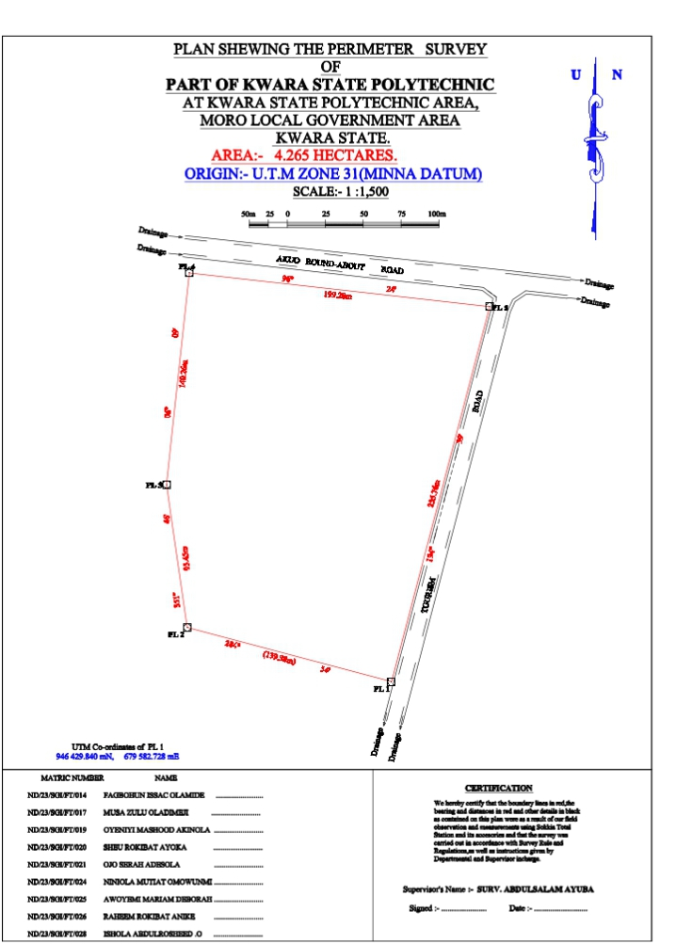

Fig 4.1 Details Plan

This simply refers to the graphically representation i.e. plotting of plan. It was plotted using AutoCAD and other software in a computer system and a suitable scale was used to for the hard copy format. Presented information include boundary details and beg, conventional sign and symbol were also used in the plan.
The digital plan was produced using AutoCAD software and these are procedures followed.
- Switch on the computer and allow it to boost
- Select notepad, from notepad, a script file for the coordinate p-line easting, northing was structured.
- File was saved with extension. SCR
- AutoCAD was launched.
- Format was clicked and set the unit then press “OK”
- Press “Tool” and select Run script to pick your saved file then press escape and press zoom, extent and the image was displayed.
- The boundary line was changed to Red and necessary editing was done.

CHAPTER FIVE
5.0 SUMMARY, CONCLUSION AND RECOMMENDATION
5.1 SUMMARY
The project perimeter and details survey was carried out at the , OLD INSTITUTE OF ENVIRONMENTAL STUDIES (IES) AND VILLAGE, KWARA STATE POLYTECHNIC , KWARA STATE.,
The reconnaissance survey was properly carried out office and field, this was done for proper planning of the operation by locating initial controls that is within the project site for proper orientation, the instrument to be used, and selection of traverse station in which the indivisibility of the selected stations were put into consideration and finally, drawing of sketched diagram of the area to be surveyed.
Finally, report was written on how the entire project was executed.
5.2 PROBLEMS ENCOUNTER
The delay in getting adequate instruments contributed in the delay of completing the field work.
5.3 CONCLUSION
This project work has broaden my knowledge and understanding of what perimeter and detailing survey is all about and in general, when cadastral survey entails. Though, it was my first practical experience of a real life work situation but with the guidance of my supervisor ad adhering the survey rules and regulations and departmental instruments, I was able to take part in the achievement of the objectives of this project.

5.4 RECOMMENDATION
Due to the experience gained during the course of executing this project.
- I hereby recommend that this kind of project work should be a continuous one in order to boost the students knowledge of the profession within and outside this great citadel of learning.
- After achieving our aim of project, the plan production can be used for further construction on girls hostel
- It can be used as a source of information and reference purpose

REFERENCES
Oliver J.G Clending (1978) Principles of Surveying Working Ham Berkshire, England ppl.
Uren J and Price W.F (1994) Engineering survey, Richard and Day Limited Bungayi Suffork pp.8
Igbokwe (1999) Digital mapping-a big stride vol-12 no 1 Magazine of Nigeria institution of Surveying Students University of Nigeria chapter.

APPENDIX
ID EASTING NORTHING
PL1 679582.728. 946429.840
PL2 679448.029. 946465.672
PL3 679434.376. 946560.036
PL4 679449.408. 946699.489
PL5 679647.447. 946677.273
BLD1 679549.274. 946642.233
BLD1 679541.227 946644.456
BLD1 679549.407. 946673.891
BLD1 679557.454. 946671.668
BLD2 679606.155. 946611.461
BLD2 679615.524. 946608.893
BLD2 679605.691. 946573.081
BLD2 679596.322. 946575.649
BLD3 679564.348. 946602.906
BLD3 679557.622. 946604.990
BLD3 679563.626. 946623.263
BLD3 679570.352. 946621.179
BLD4 679541.131. 946609.275
BLD4 679533.505. 946611.284
BLD4 679538.580. 946629.766

BLD4 679546.206. 946627.757
BLD5 679498.379. 946640.771
BLD5 679523.756. 946633.877
BLD5 679520.271. 946620.744
BLD5 679494.894. 946627.638
BLD6 679463.996. 946650.142
BLD6 679489.373. 946643.248
BLD6 679485.888. 946630.115
BLD6 679460.511. 946637.009
BLD7 679457.544. 946625.842
BLD7 679472.023. 946621.924
BLD7 679465.087 946596.289
BLD7 679450.608. 946600.207
BLD8 679529.818. 946596.942
BLD8 679537.413. 946594.907
BLD8 679531.409. 946576.634
BLD8 679523.814. 946578.669
BLD9 679554.668. 946590.470
BLD9 679561.394. 946588.386
BLD9 679555.390. 946570.113
BLD9 679548.664. 946572.197
BLD10 679592.068 946560.674
BLD10 679599.873. 946559.664

BLD10 679593.075. 946538.68
BLD10 679585.270. 946539.689
BLD11 679519.000. 946565.197
BLD11 679528.569. 946563.532
BLD11 679525.179. 946544.786
BLD11 679515.610. 946546.451
BLD12 679478.939 946569.537
BLD12 679504.880. 946562.819
BLD12 679501.237. 946549.083
BLD12 679475.296. 946555.801
BLD13 679444.388. 946578.416
BLD13 679470.160. 946571.719
BLD13 679465.756. 946554.842
BLD13 679439.984. 946561.539
BLD14 679510.302. 946527.118
BLD14 679514.054. 946537.943
BLD14 679534.343. 946533.641
BLD14 679531.147. 946521.705
BLD14 679521.697. 946523.093
BLD14 679522.114. 946524.897
BLD15 679509.302. 946524.064
BLD15 679541.890. 946519.170

BLD15 679539.930 946509.505
BLD15 679506.975 . 946515.133
BLD16 679553.651. 946516.785
BLD16 679586.238. 946511.89
BLD16 679584.278. 946502.226
BLD16 679551.323. 946507.854

BLD17 679504.954. 946503.304
BLD17 679537.91. 946497.676
BLD17 679536.226. 946487.819
BLD17 679503.271. 946493.447
BLD18 679549.303. 946496.025
BLD18 679582.258. 946490.397
BLD18 679580.575. 946480.54
BLD18 679547.619. 946486.168
BLD19 679545.936. 946476.31
BLD19 679578.89. 946470.682
BLD19 679577.208. 946460.825
BLD19 679544.253. 946466.453
BLD20 679501.588. 946483.590
BLD20 679534.543. 946477.961
BLD20 679532.859. 946468.104
BLD20 679499.904. 946473.732
BLD21 679498.221. 946463.875
BLD21 679531.17 946458.24
BLD21 679529.493. 946448.390
BLD21 679496.537. 946454.018
BLD22 679542.569. 946456.596
BLD22 679575.524. 946450.968
BLD22 679573.841. 946441.111
BLD22 679540.886. 946446.739
MSQ. 679496.29. 946502.143
MSQ. 679496.168. 946499.145
MSQ. 679477.014. 946499.605
MSQ. 679477.641. 946514.971
MSQ. 679496.779. 946514.133
MSQ. 679496.657. 946511.135
MSQ. 679499.882. 946506.709
TOI1. 679447.828. 946594.614
TOI1. 679452.651. 946593.297
TOI1. 679450.521. 946585.496
TOI1. 679445.698. 946586.813
TOI2. 679593.53. 946572.708
TOI2. 679598.359. 946571.391
TOI2. 679596.229. 946563.590

TOI2. 679591.406. 946564.907
E.P. 679492.26. 946690.694
E.P. 679562.54. 946684.428
E.P. 679610.758. 946683.743
E.P. 679445.846. 946617.55
E.P. 679483.807. 946478.219
E.P. 679549.084. 946628.813
RD. 679445.277. 946712.177
RD. 679643.316. 946689.961
RD. 679652.008. 946683.482
RD. 679579.403. 946403.808
RD. 679698.787. 946684.724
RD. 679671.309. 946687.806
RD. 679662.698. 946681.966
RD. 679659.235. 946674.342
RD. 679588.01. 946402.041
RD. 679446.392. 946722.115
RD. 679700.67. 946694.575

