

PROJECT REPORT

ON

IMPLEMENTATION OF RELATIONAL DATABASE SYSTEM FOR CADSTRAL INFORMATION PRODUCTION

(A CASE STUDY OF PART OF IREWOLEDE ESTATE, ALONG NEW YIDI ROAD, ILORIN WEST LOCAL GOVERNMENT, KWARA STATE.)

BY:
YUNUS ZAINAB TITILAYO HND/23/SGI/FT/0049

BEING A RESEARCH PROJECT SUBMITTED TO THE DEPARTMENT OF SURVEYING AND GEO-INFORMATICS INSTITUTE OF ENVIRONMENTAL STUDIES

IN PARTIAL FUFILMENT OF THE REQUIRMENT FOR THE AWARD OF HIGHER NATIONAL DIPLOMA (HND) IN SURVEYING AND GEO-INFORMATICS

JUNE 2025

CERTIFICATE

I hereby certify that all the information contained in this project report was obtained as a result of the observations and measurements made by me on the field and that the survey was executed in accordance with survey rules, regulations and departmental instructions.

………………..………………………. YUNUS ZAINAB TITILAYO
DATE ………………………………

CERTIFICATION
This is to certify that YUNUS ZAINAB TITILAYO with Matric No HND/23/SGI/FT/0049 has satisfactorily carried out the survey duties contained in this project report under my instructions and direct supervision.
I hereby declare that he has conducted himself with the due diligence, honesty and sobriety on the said duties.

…. …………………………………… DATE: ………………………… SURV. AWOLEYE . R.S
(SUPERVISOR)

…. …………………………………… DATE: ………………………… MR. ISAU IBRAHIM ABIMBOLA
(H.O.D)

…. …………………………………… DATE: ………………………… SURV. AWOLEYE. R.S
(PROJECT COORDINATOR)

………………………………………. DATE: ………………………… EXTERNAL SUPERVISOR

DEDICATION

I dedicate this project to God Almighty, for His grace, wisdom, and strength throughout this journey.
To my parents, for their endless support, love, and encouragement.
And to everyone who believed in me even when I doubted myself this is for you.

ACKNOWLEDGEMENTS

All glory, praise and adoration be to the author and the finisher of my faith, the ancient of days and Almighty Allah I return all praise, my appreciation goes to my supervisor SURV. AWOLEYE.
R.S for his enormous contribution and supervision and making sure that the project is successful.

My greetings also goes to the head of department in person of MR. ISAU IBRAHIM ABIMBOLA.
My special greetings and thanks to the staff of the department of surveying and Geo- informatics that stand with me SURV. AREMU. A.G, SURV. AYUBA. A, SURV.BELLO DIRAN, SURV. AKINYEDE. A.O, SURV.KABIR. B , SURV.KAZEEM. W
Also my sincere appreciation goes to my Aunt (MRS HABEEB) for her support both spiritual, physically, financially and word of encouragement towards the success of my academic pursuit. Ashabi mi I say a big jazakumullahu khairan.
Appreciation goes to my grand parents (ALHAJI&ALHAJA SANNI) my sincere appreciation goes to (MRS IBRAHIM) and all (ISHOLA’S FAMILY).
My special greetings to (SAN) for her care, support both financially and emotionally may you live long to eat the fruit of your labor.
My profound attitude goes to my sisters and friends Islamiyat Ajoke, Aminat, Halimah, Tolu, Imam Zuglool and all I can’t mention Thank you all.

YUNUS ZAINAB TITILAYO JUNE 2025

ABSTRACT
Analogue Cadastre consists of paper maps and land register which have difficulties during development and updating. The study was aimed at creating a digital Cadastral Information System (CIS) A CASE STUDY OF PART OF IREWOLEDE ESTATE, ALONG NEW YIDI ROAD, ILORIN
WEST LOCAL GOVERNMENT, KWARA STATE The spatial and non spatial data used are local coordinates of the land parcels and entity information obtained from Office of the Surveyor General, Yola. The local coordinates were transformed to Universal Traverse Mercator (UTM) coordinate system using EXCEL spreadsheet and were used in plotting the digital Map in ArcGIS 10.1. The database design was done in phases which include the conceptual design, the logical design, the physical design, and the implementation of the database system. The attribute data were linked with the spatial data to build the digital CIS and some queries were performed to test the efficacy of the database. The study has established the capability of CIS in handling of spatial and non spatial data. It is recommended that the digital CIS be adopted for proper record keeping and updating.

TABLE OF CONTENTS
Title Page I
Certificate II
Certification III
Dedication IV
Acknowledgement ……………………………………………………. V
Abstract ………………………………………………………………. VI
Table of Contents …………………………………………………….. VII
List of Tables …………………………………………………………. VIII
List of Figures………………………………………………………… IX
Appendixes ………………………………………………………… X

CHAPTER ONE
  - INTRODUCTION 1
  - BACKGROUND TO THE STUDY 2
  - STATEMENT OF PROBLEM 11
  - AIM AND OBJECTIVES OF THE PROJECT 11
    - AIM 11
    - OBJECTIVES 12
  - SCOPE OF THE PROJECT 12
  - PERSONNEL 13
  - STUDY AREA 13
CHAPTER TWO
- LITERATURE REVIEW 14
CHAPTER THREE
- METHODOLOGY 35
  - DATABASE DESIGN 35
    - VIEW OF REALITY 36
    - CONCEPTUAL DESIGN 36
    - LOGICAL DESIGN 37
  - DATA SOURCE 37
  - DATA ACQUISITION 37
    - RECONNAISSANCE 38
      - OFFICE PLANNING 38
      - FIELDRECONNAISSANCE 38
    - SYSTEM SELECTION 39
    - CONTROL POINTS CHECK 40
    - PROCESS OF CHECKING CONTROL POINT 40
  - GEOMETRIC DATA ACQUISITION 40
    - TRAVERSING WITH TOTAL STATION 40
    - DETAILING 41
      - ATTRIBUTE DATA ACQUISITION 41
  - PLOTTING/SCRIPT RUNNING 42
    - ADDING AND GEO-REFERENCING OF DOWNLOADED IMAGERIES 42
    - DIGITIZING OF THE EXISTING MAP 42
  - ATTRIBUTE DATA 43
  - GROUND TRUTHING 43
  - CHANGES DETECTION 43
  - MAP UPDATING 44
  - OVERLAY OPERATION 45
  - PHYSICAL DESIGN 25
    - DATABASE IMPLEMENTATION 46
    - DATA MANAGEMENT SYSTEM 46
    - DATA SECURITY 46
    - DATA INTEGRITY 47
    - DATABASE MAINTAINANCE 47
CHAPTER FOUR
- SPATIAL ANALYSIS AND INFORMATION PRESENTATION 48
  - SPATIAL ANALYSIS 49
  - QUERY AND PRESENTATION OF ANALYSIS 50
    - QUERIES 51
    - PRESENTATION OF ANALYSIS 52
  - CRITERION QUERY 52
    - SINGLE CRITERION QUERY 52
    - THE MULTIPLE CRITERIA QUERY 53
    - ANALYSIS ONE (SINGLE CRITERIA QUERY) 53
    - ANALYSIS TWO (SINGLE CRITERIA QUERY) 54
    - ANALYSIS THREE (MULTIPLE CRITERIA QUERY) 54
  - TESTING OF DATABASE 54
    - WHY DO WE TEST A DATABASE 55
    - DATA INTEGRITY 55
    - HOW TO TEST (DATABASE TESTING PROCESS) 56
  - APPLICATION PROJECT 56
CHAPTER FIVE
  - COSTING, PROBLEMS ENCOUNTERED, RECOMMENDATIONS AND CONCLUSION 57
- COSTING 57
  - SUMMARY 58
  - PROBLEMS ENCOUNTERED 60
  - RECOMMENDATIONS 61
  - CONCLUSION 61

REFERENCES

APPENDIXES

Appendix I: Boundary of the Perimeter Survey

Appendix II: Coordinates of all Features that existed within the project area

LIST OF TABLES

Table 3.1:- Showing the Easting, Northing and Height coordinates of the control points……

Table 3.2:- Collimation test for the Total Station (Field Observation)……….. Table 3.3:- In-situ Check………………………………………………………..
Table 3.4: - Control Points of the entire Boundary Pillars……………………………..

Table 3.5:- Primary datasets for implementation of relational database of Irewolede Estate, Ilorin

………………………….. Table 5.1:- Costing of the project.

LIST OF FIGURES

Fig. 1: The Study Area

Figure.2: Flowchart and procedure for the study

Figure.3 Designs and Construction Phase of Spatial Database
Figure.4 Entity Relationship diagram of building data base information system Figure.5: Node Entity and its Attribute
Figure.6: Arc Entity and its Attributes Figure .7: Building Entity and its Attributes
Figure .8: Creation of Building Entity and its Attributes

Figure .9: Showing the satellite imagery of the study area acquired Figure .10: Recce diagram (not drawn to scale)
Figure .11: Georeferencing menu tool indicating the Add contol points and view link table Figure .12: dialog window for coordinates of corresponding X and Y on the ground Figure .13: dialog window for a click made on “update geo-referencing”
Figure .14: Accessing the Editor Tool Figure .15: Editor Tool menu
Figure .16: Create Feature dialog box

Figure .17: (Satellite imagery, January 15, 2011)

Figure .18: Digitized existing map of the study area (January 15, 2011) Figure .19: Updated map of the study area (July 15, 2021)
Figure .20: survey plan plotted from field data

Figure .21: overlaid survey plan plotted from field data on Satellite imagery

Figure 22: Attribute table (relational database) for the buildings within the study area created using ArcGIS
Figure 23: Showing results for buildings that are completed within the study area Figure 24: Query of Building that is allocated to female occupants in the layout Figure 25: Query of buildings that are bungalow with cream and ash colour

CHAPTER ONE

INTRODUCTION
Implementing a Relational Database System for Cadastral Information Production Efficient and reliable management of cadastral information is crucial for land
administration, urban planning, property taxation, and overall socio-economic development. Traditional methods of managing cadastral data, often involving paper- based records and disparate systems, are prone to inefficiencies, errors, data redundancy, and difficulties in information retrieval and sharing. These limitations hinder effective land governance and can impede sustainable development.
To overcome these challenges, the implementation of a relational database system for cadastral information production offers a robust and modern solution. A relational database provides a structured and organized approach to storing, managing, and accessing land-related data, ensuring data integrity, consistency, and efficient retrieval.
This initiative focuses on establishing a centralized and integrated system that leverages the power of relational database technology to streamline the entire cadastral information production lifecycle. This includes processes such as land surveying, parcel identification, ownership registration, boundary demarcation, and the generation of cadastral maps and reports.
By adopting a relational database system, we aim to achieve significant improvements in:
    - Data Accuracy and Integrity: Ensuring reliable and consistent cadastral information through defined data structures, validation rules, and reduced data redundancy.
    - Data Accessibility and Sharing: Facilitating easy and secure access to cadastral information for authorized users across different departments and agencies.
    - Operational Efficiency: Automating data management tasks, streamlining workflows, and reducing the time and resources required for information production and retrieval.

    - Improved Decision-Making: Providing accurate and up-to-date cadastral information to support informed land-use planning, infrastructure development, and dispute resolution.
    - Enhanced Transparency and Accountability: Establishing a clear and auditable system for managing land records, promoting transparency in land administration.
    - Scalability and Flexibility: Creating a system that can adapt to future growth in cadastral data and evolving information needs.
This document outlines the rationale, objectives, key components, and expected benefits of implementing a relational database system for cadastral information production. It underscores the critical role this system will play in modernizing land administration practices and fostering sustainable development within [mention the specific region or context, e.g., Shaki, Oyo, Nigeria]. By embracing this technological advancement, we can unlock the full potential of cadastral information for the benefit of individuals, organizations, and the nation as a whole.

BACKGROUND TO THE STUDY
The management of cadastral information in Shaki, Oyo, Nigeria, like many other regions in developing countries, has historically faced significant challenges rooted in traditional, often manual, record-keeping practices. These methods typically involve paper-based registers, hand-drawn maps, and fragmented data storage across various government agencies. This approach has led to a number of critical issues that hinder efficient land administration and sustainable development within the local context.
    - Existing Challenges with Traditional Cadastral Information Management in Shaki:
Data Fragmentation and Siloing: Cadastral information related to land ownership, boundaries, and property attributes is often dispersed across different departments (e.g., land registry, survey department, local government offices). This lack of integration makes it difficult to obtain a comprehensive and unified view of land parcels.
- Data Inaccuracy and Inconsistency: Manual data entry and the absence of standardized formats contribute to errors, inconsistencies, and discrepancies in cadastral records. This can lead to land disputes, boundary conflicts, and unreliable information for planning and decision-making.
- Inefficient Information Retrieval and Sharing: Locating and accessing cadastral information through paper-based systems is time-consuming and labor-intensive.

Sharing information between different agencies or with the public is often cumbersome and inefficient, hindering inter-agency collaboration and transparency.
- Data Redundancy: The lack of a centralized system often results in the duplication of cadastral information across different records and departments, leading to wasted resources and potential inconsistencies.
- Security and Preservation Risks: Physical records are vulnerable to damage, loss, and unauthorized alteration. Inadequate storage facilities and lack of proper archiving procedures pose a significant risk to the long-term preservation of vital cadastral information.
- Limited Analytical Capabilities: Traditional systems offer limited capabilities for data analysis, spatial querying, and the generation of comprehensive reports needed for effective land-use planning, infrastructure development, and revenue generation.
- Challenges in Scalability and Updates: As the population grows and land development increases in Shaki, manual systems struggle to cope with the increasing volume of cadastral data and the need for frequent updates and modifications.

The Need for Modernization:
Recognizing these limitations, there is a growing awareness within the Oyo State government and specifically in Shaki of the urgent need to modernize the cadastral information management system. An efficient and reliable cadastral system is fundamental for:
- Securing Property Rights: Providing clear and legally recognized land titles, fostering investment and economic growth.
- Facilitating Land Transactions: Streamlining the process of buying, selling, and transferring land, reducing transaction costs and time.
- Supporting Urban and Rural Planning: Providing accurate spatial data for informed land-use planning, infrastructure development, and environmental management.
- Improving Revenue Collection: Enabling accurate property valuation and taxation, boosting local government revenue.
- Resolving Land Disputes: Providing reliable evidence for resolving boundary conflicts and ownership claims.

- Promoting Good Governance: Enhancing transparency and accountability in land administration.

1 1.3 The Proposed Solution: A Relational Database System:
The implementation of a relational database system for cadastral information production in Shaki offers a promising solution to address the aforementioned challenges. A well-designed relational database can provide a structured, organized, and integrated platform for managing all aspects of cadastral data. This technology offers the potential to:
- Centralize Data Storage: Consolidating all cadastral information into a single, accessible database.
- Enforce Data Integrity: Implementing data validation rules and relationships to ensure accuracy and consistency.
- Facilitate Efficient Data Retrieval and Querying: Enabling quick and easy access to specific cadastral information.
- Support Spatial Data Management: Integrating geographic information system (GIS) capabilities for managing and visualizing spatial data related to land parcels.
- Enhance Data Security and Backup: Implementing security measures and data backup procedures to protect valuable cadastral information.
- Enable Data Analysis and Reporting: Providing tools for generating reports and conducting spatial analysis for informed decision-making.
- Improve Scalability and Flexibility: Allowing the system to adapt to future growth and evolving needs.
Therefore, this study is motivated by the pressing need to transition from inefficient traditional methods to a modern, technology-driven approach for managing cadastral information in Shaki, Oyo, Nigeria. The implementation of a relational database system is envisioned as a critical step towards improving land administration, fostering economic development, and promoting sustainable land management practices within the region.
    - Problem Statement: Inefficiencies and Limitations of the Existing Cadastral Information Management System in Shaki, Oyo, Nigeria

Despite its crucial role in land administration and socio-economic development, the current system for managing cadastral information in Shaki, Oyo, Nigeria, suffers from significant inefficiencies and limitations stemming primarily from its reliance on manual and fragmented processes. These shortcomings directly impede effective land governance, hinder economic activities, and create challenges for sustainable development within the local context.

Specific Problems Arising from the Existing System:
- Prolonged Cadastral Processes: The manual nature of surveying, registration, and record-keeping leads to lengthy processing times for land transactions, title registration, and obtaining cadastral maps. This delays development projects, discourages investment, and increases transaction costs for citizens.
- Increased Risk of Land Disputes: Inaccurate and inconsistent boundary records, coupled with difficulties in accessing historical information, contribute to a higher incidence of land disputes. Resolving these disputes through the current system is often protracted and resource-intensive.
- Limited Transparency and Accountability: The lack of a centralized and easily accessible system makes it difficult for citizens and stakeholders to access information about land ownership and boundaries, potentially fostering opacity and hindering accountability in land administration processes.
- Challenges in Land-Use Planning and Management: The difficulty in obtaining accurate and up-to-date spatial data on land parcels hinders effective land-use planning, infrastructure development, and environmental management initiatives. Planners lack the comprehensive information needed for informed decision-making.
- Revenue Leakage: Inaccurate property records and inefficient valuation processes can lead to underassessment and leakage in property tax collection, impacting the local government's revenue generation capacity.
- Difficulties in Data Integration and Interoperability: The lack of a standardized digital platform makes it challenging to integrate cadastral information with other relevant datasets held by different government agencies (e.g., infrastructure, utilities, environmental data). This lack of interoperability limits the potential for holistic planning and analysis.
- Vulnerability to Data Loss and Damage: Physical records are susceptible to fire, floods, pests, and general deterioration, posing a significant risk to the long-term

preservation of critical cadastral information. The absence of robust backup and disaster recovery mechanisms further exacerbates this vulnerability.
- Strain on Human Resources: Managing a manual system requires significant manpower for tasks such as data entry, record retrieval, and map handling. This can be inefficient and divert human resources from more strategic tasks.
- Inability to Support Modern Technologies: The current system lacks the infrastructure to effectively integrate with modern technologies such as Geographic Information Systems (GIS), remote sensing, and online portals, limiting the potential for advanced spatial analysis, visualization, and service delivery.

The Need for a Paradigm Shift:
These persistent problems underscore the urgent need for a paradigm shift in how cadastral information is managed in Shaki. The limitations of the existing system are not merely administrative inconveniences; they have tangible negative impacts on economic growth, social stability, and sustainable development within the region.
Therefore, the implementation of a relational database system is not just a technological upgrade; it represents a strategic imperative to overcome these deep- rooted challenges and establish a modern, efficient, transparent, and reliable foundation for cadastral information production and management in Shaki, Oyo, Nigeria. This transition is crucial for unlocking the full potential of land resources and fostering a more prosperous and equitable future for the community.

Justification for Implementing a Relational Database System for Cadastral Information Production in Shaki, Oyo, Nigeria
The decision to advocate for and study the implementation of a relational database system for cadastral information production in Shaki, Oyo, Nigeria, is firmly grounded in a compelling set of justifications. These justifications highlight the significant benefits that such a system can bring to various aspects of land administration, governance, and socio-economic development within the local context.

Key Reasons for Implementing a Relational Database System:
- Addressing Critical Inefficiencies: As outlined in the problem statement, the current manual system is riddled with inefficiencies that hinder the smooth functioning of land administration processes. A relational database system offers the potential to automate

tasks, streamline workflows, and significantly reduce processing times for crucial cadastral activities.
- Improving Data Quality and Reliability: The structured nature of a relational database, coupled with built-in data validation rules and integrity constraints, will significantly enhance the accuracy and consistency of cadastral information. This reduction in errors will minimize land disputes and provide a more reliable foundation for decision-making.
- Enhancing Accessibility and Information Sharing: A centralized digital database will facilitate easy and secure access to cadastral information for authorized users across different government agencies, departments, and potentially even the public (with appropriate access controls). This improved information sharing will foster better inter-agency collaboration and transparency.
- Strengthening Land Tenure Security: Accurate and readily available cadastral records are fundamental for establishing and securing property rights. A relational database system will contribute to a more transparent and reliable land registration process, reducing ambiguity and strengthening tenure security for landowners.
- Supporting Effective Land-Use Planning and Management: Access to comprehensive and spatially referenced cadastral data within a relational database will empower urban and rural planners with the information they need to make informed decisions regarding land allocation, infrastructure development, and environmental protection. GIS integration will further enhance spatial analysis capabilities.
- Boosting Revenue Generation: Accurate property records and efficient valuation processes facilitated by a relational database system will lead to more effective property tax assessment and collection, thereby increasing the local government's revenue base.
- Reducing Land Disputes and Litigation: Reliable boundary information and transparent ownership records will help prevent land disputes from arising in the first place. When disputes do occur, the availability of accurate historical data within the database will facilitate faster and more equitable resolution.
- Improving Transparency and Accountability in Land Administration: A well- managed digital system with audit trails will enhance transparency in land transactions and administrative processes, making it easier to track land ownership changes and hold relevant authorities accountable.

- Facilitating Integration with Other Systems: A relational database can be designed to integrate with other government information systems (e.g., tax records, utility management, infrastructure planning), creating a more holistic and interconnected data ecosystem for improved governance.
- Ensuring Long-Term Data Preservation and Security: Digital storage within a well- maintained database environment offers superior data preservation capabilities compared to physical records. Robust security measures and backup protocols can be implemented to protect valuable cadastral information from loss, damage, and unauthorized access.
- Enabling the Adoption of Modern Technologies: A relational database provides the necessary foundation for leveraging advanced technologies such as GIS, remote sensing, online portals, and mobile applications to further enhance cadastral information production, dissemination, and service delivery.
- Contributing to Sustainable Development: By improving land administration, securing property rights, and providing accurate spatial data for planning, a relational database system will contribute to more sustainable and equitable land management practices in Shaki.
In conclusion, the implementation of a relational database system for cadastral information production in Shaki, Oyo, Nigeria, is not merely a technological upgrade but a strategic investment that promises to address critical challenges, unlock significant benefits, and lay the foundation for a more efficient, transparent, and sustainable land administration framework. The potential positive impacts on governance, economic development, and social well-being within the region make this initiative a compelling and necessary step forward

Research Questions and Objectives
This study aims to investigate the implementation of a relational database system for cadastral information production in Shaki, Oyo, Nigeria. To effectively guide this investigation, the following research questions have been formulated:

Research Questions:
- What are the key challenges and limitations of the existing cadastral information management system in Shaki, Oyo, Nigeria?
- What are the essential requirements and features of a relational database system suitable for cadastral information production in the context of Shaki?

- What are the potential benefits and challenges associated with the implementation of a relational database system for cadastral information production in Shaki?
- What are the critical factors for the successful design, development, and deployment of such a system in the local context?
- What are the potential impacts of implementing a relational database system on the efficiency, accuracy, transparency, and accessibility of cadastral information in Shaki?
- What are the perceptions and readiness of stakeholders (e.g., land administrators, surveyors, citizens) towards the adoption of a relational database system for cadastral information management in Shaki?
- What are the potential costs and resource implications associated with the implementation and maintenance of a relational database system for cadastral information production in Shaki?
To address these research questions comprehensively, the following objectives have been established:

Research Objectives:
- To identify and analyze the shortcomings and inefficiencies of the current cadastral information management practices in Shaki, Oyo, Nigeria.
- To determine the functional and non-functional requirements for a relational database system tailored to the specific needs of cadastral information production in Shaki.
- To evaluate the potential advantages and disadvantages of implementing a relational database system for managing cadastral data in the local context.
- To identify and analyze the critical success factors for the planning, design, development, and deployment of a relational database system for cadastral information in Shaki.

- To assess the potential impact of the implemented system on key aspects of cadastral information management, including efficiency, accuracy, transparency, and accessibility.
- To examine the awareness, attitudes, and preparedness of relevant stakeholders towards the adoption and utilization of a relational database system for cadastral information in Shaki.
- To estimate the potential costs associated with the implementation, training, and ongoing maintenance of a relational database system for cadastral information production in Shaki.
These research questions and objectives provide a clear framework for this study, ensuring a focused and systematic investigation into the implementation of a relational database system for cadastral information production in Shaki, Oyo, Nigeria. The findings from this research will contribute valuable insights for policymakers, land administrators, and other stakeholders involved in modernizing land administration practices within the region.

STATEMENT OF PROBLEM

Due to the management of cadastral information is a critical component of land administration systems, as it involves the accurate recording, updating, and retrieval of land ownership, boundaries, transactions, and land rights. Over the years, traditional methods of managing this data primarily paper-based records and outdated database systems have proven to be inefficient, error-prone, and incapable of handling the growing complexity and volume of land data. The implementation (RDBS) will help eliminate these problems.

AIM AND OBJECTIVES OF THE PROJECT

AIM

The aim of implementing a relational database system for cadastral information production is to develop an efficient, accurate, and scalable

framework for managing and analyzing land-related data. This system seeks to enhance the integrity, accessibility, and usability of cadastral information, thereby supporting effective land administration, urban planning, and decision-making processes while ensuring compliance with legal and technical standards.

OBJECTIVES

Base on significance of this project the objective includes;

- Project planning: which include office planning and field reconnaissance
- Monumentation: (At least 5 hectares of land according to higher national diploma)
- Data acquisition (geometric data with total station, social survey through oral interview for the purpose of query and building name, colors and some of vital documents on land
- Data processing: this includes downloading and processing of data using appropriate software (GIS SOFTWARE)
- Information presentation: It involved plotting of survey data both soft copy and hard copy showing correct location of a points

SCOPE OF THE PROJECT

- Project planning

- Monumentation

- Data downloading and data processing

- Program and Query

- Report writing

PERSONNEL

NAME MATRIC NO
REMARKS

YUNUS ZAINAB TITILAYO HND/23/SGI/FT/0049 AUTHOR
JAMIU MUFTAU OPEYEMI HND/23/SGI/FT/0058 MEMBER
IDRIS HALIMAT ALATA HND/23/SGI/FT/0050 MEMBER
OLAREWAJU TOLULOPE O. HND/23/SGI/FT/0053 MEMBER
ADEBAYO UTHMAN DOLAPO HND/23/SGI/FT/0061 MEMBER
AINA SAMUEL AYOMIDE HND/23/SGI/FT/0062 MEMBER
ELIJAH TOYIN DEBORAH HND/23/SGI FT/0121 MEMBER
ODENIRAN KAYODE TAIWO HND/22/SGI/FT/086 MEMBER

STUDY AREA

The study area for the project is situated on part of Irewolede Estate Along New Yidi Road Ilorin, Ilorin west Local Government Area, Kwara State. The project lies between longitude 8°27'29.94"N 4°33'56.74"E and latitude 8°27'49.59"N 4°33'21.36" E Respectively
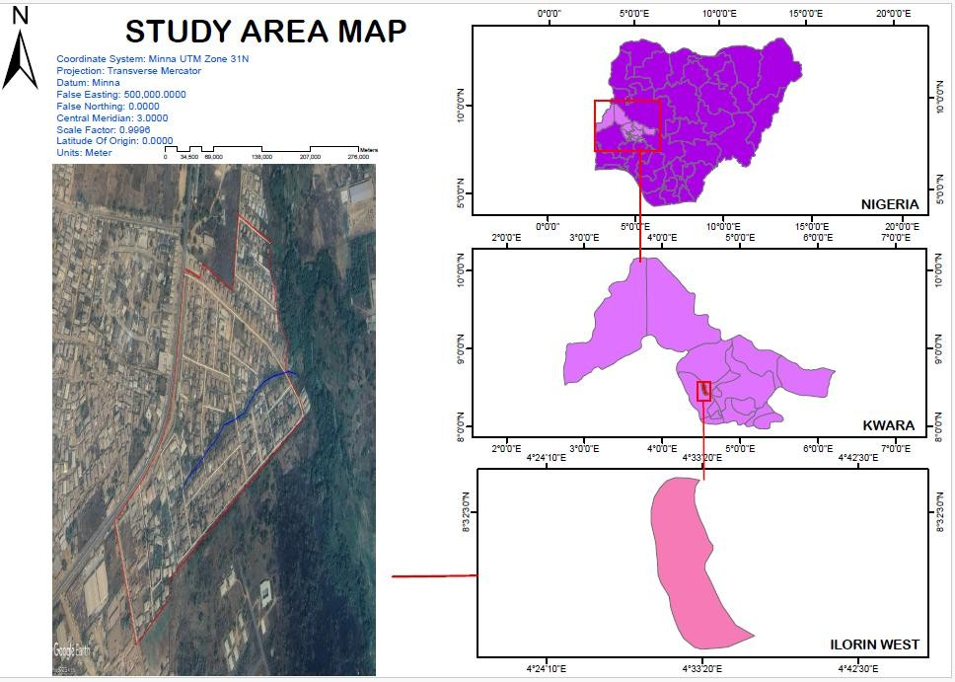

CHAPTER TWO

LITERATURE REVIEW
This literature review explores existing research and scholarly works relevant to the implementation of relational database systems for cadastral information production. It examines the theoretical underpinnings of relational database technology, best practices in cadastral system modernization, challenges and benefits of implementing such systems in various contexts (including developing countries), and the importance of stakeholder engagement and technological considerations.

Foundations of Relational Database Systems:
At its core, a relational database system (RDBMS) provides a structured way to organize, manage, and access data based on the relational model proposed by E.F. Codd (1970). This model organizes data into tables with rows (records) and columns (attributes), establishing relationships between tables to minimize redundancy and ensure data integrity (Date, 2004). Key concepts include data normalization, structured query language (SQL) for data manipulation, and transaction management for data consistency (Silberschatz, Korth, & Sudarshan, 2010). The inherent structure and querying capabilities of RDBMS make them well-suited for managing complex datasets like cadastral information, which involves numerous interconnected attributes and spatial elements.

Modernizing Cadastral Systems:
The need to modernize traditional, often paper-based, cadastral systems has been widely recognized (UN-Habitat, 2007). Studies highlight the inefficiencies, inaccuracies, and limitations of manual systems, emphasizing the potential of information and communication technologies (ICTs) to revolutionize land administration (Enemark,

McLaren, & Siriba, 2014). The transition to digital cadastral systems, often leveraging RDBMS, is seen as a crucial step towards improving efficiency, transparency, and security of land records (Williamson, Enemark, Wallace, & Rajabifard, 2010).

Benefits of Implementing RDBMS in Cadastre:
Numerous studies have documented the benefits of implementing RDBMS for cadastral information management:
- Improved Data Accuracy and Integrity: Digital systems with validation rules and relational integrity constraints significantly reduce data entry errors and inconsistencies (FIG, 1999).
- Enhanced Data Accessibility and Retrieval: RDBMS facilitate efficient querying and retrieval of cadastral information, enabling faster service delivery and informed decision-making (Kaufmann & Steudler, 1998). Web-based interfaces built on RDBMS can further enhance accessibility for authorized users (Mansberger, 2007).
- Increased Operational Efficiency: Automation of data management tasks, such as data entry, updates, and report generation, leads to significant time and cost savings (Grant, 2001).
- Support for Spatial Data Integration: Modern RDBMS often include spatial extensions or are integrated with Geographic Information Systems (GIS), allowing for the seamless management and analysis of both attribute and spatial cadastral data (Zeilhofer & Sester, 2004). This integration is crucial for generating cadastral maps and conducting spatial queries.
- Improved Transparency and Accountability: Digital records with audit trails enhance transparency in land administration processes, making it easier to track changes and ensure accountability (McLaren & Shanahan, 2004).
- Enhanced Security and Data Preservation: Digital databases offer better security options through access controls and encryption, and

facilitate data backup and disaster recovery, ensuring the long-term preservation of vital land records (Dale & McLaughlin, 1999).

Challenges of Implementing RDBMS in Developing Countries:
While the benefits are significant, the implementation of RDBMS for cadastral systems in developing countries like Nigeria can face unique challenges:
- Inadequate Infrastructure: Limited access to reliable electricity, internet connectivity, and suitable hardware can hinder the deployment and operation of digital systems (Kalantari, Binns, &рите, 2008).
- Lack of Technical Expertise: A shortage of skilled professionals in database administration, GIS, and system maintenance can pose a significant obstacle (Bennett, Williamson, & Wallace, 2001).
- Data Conversion and Backlog: Converting existing paper-based records to a digital format can be a time-consuming and resource- intensive process, especially when dealing with large data backlogs and inconsistencies (FIG, 2004).
- Institutional and Legal Frameworks: Outdated land laws and weak institutional capacity can impede the effective implementation and utilization of modern cadastral systems (UN-Habitat, 2019).
- Stakeholder Resistance: Resistance to change from staff accustomed to manual processes and a lack of awareness among stakeholders about the benefits of a digital system can create implementation challenges (Wallace, Williamson, & Bennett, 1999).
- Financial Constraints: The initial investment costs for hardware, software, training, and data conversion can be substantial, posing a challenge for resource-constrained governments (Enemark, 2005).

Critical Success Factors for Implementation:
Research highlights several critical success factors for the successful implementation of RDBMS for cadastral systems:

- Strong Political Will and Leadership: Commitment from government at all levels is essential for providing the necessary resources and support (Burns, 2000).
- Comprehensive Needs Assessment and System Design: A thorough understanding of user requirements and a well-designed system architecture are crucial for developing a system that meets the specific needs of the local context (Dale, 2001).
- Stakeholder Engagement and Participation: Involving all relevant stakeholders (e.g., land administrators, surveyors, legal professionals, citizens) in the planning and implementation process is vital for ensuring buy-in and addressing concerns (Rajabifard, Williamson, & Holland, 2005).
- Capacity Building and Training: Investing in training programs for staff to develop the necessary technical skills is essential for the long- term sustainability of the system (Bennett, 2002).
- Phased Implementation and Pilot Projects: A gradual, phased approach with pilot projects allows for testing and refinement of the system before full-scale deployment (Williamson, 2001).
- Robust Legal and Institutional Framework: Updating land laws and strengthening institutional capacity are crucial for supporting the effective operation of a digital cadastral system (UN-ECE, 1996).
VI. Public Awareness and Education: Raising public awareness about the benefits of the new system can encourage adoption and build trust (Barry, 2002).

Contextual Relevance to Shaki, Oyo, Nigeria:
The challenges faced by many developing countries in modernizing their cadastral systems are likely to be relevant to the situation in Shaki, Oyo, Nigeria. Issues such as inadequate infrastructure, limited technical expertise, and the need for data conversion will need to be carefully considered during the implementation process. Understanding the specific institutional and legal frameworks governing land administration in Oyo State and engaging local stakeholders will be crucial for the success of any proposed RDBMS implementation.

Conclusion:
The literature overwhelmingly supports the adoption of relational database systems as a powerful tool for modernizing cadastral information production and management. While the benefits are well- documented, the implementation process, particularly in developing countries like Nigeria, presents unique challenges that need to be addressed strategically. Success hinges on careful planning, strong leadership, stakeholder engagement, capacity building, and a context- specific approach that considers the local infrastructure, legal framework, and socio-economic realities. This study will build upon this existing body of knowledge by specifically investigating the feasibility, requirements, and potential impacts of implementing a relational database system for cadastral information production within the specific context of Shaki, Oyo, Nigeria.

Cadastral System Modernization in Developing Countries:
- The literature provides numerous case studies and analyses of cadastral system modernization efforts in developing countries. These studies often highlight common challenges such as:
- Data Incompleteness and Inaccuracies: Existing cadastral records in developing nations are frequently incomplete, outdated, and contain significant errors, posing a major hurdle for digitization (Barry, 2001; Dale & McLaughlin, 1999).
- Resource Constraints: Limited financial and human resources often constrain the scope and pace of modernization projects (Enemark, 2005).
- Technological Divide: The digital divide and limited access to reliable technology and infrastructure in many developing regions necessitate careful consideration of appropriate technological solutions (Kalantari et al., 2008).
- Land Tenure Complexity: Diverse and often informal land tenure systems prevalent in developing countries require flexible and adaptable cadastral solutions (UN-Habitat, 2007).

- Governance and Corruption: Weak governance structures and corruption can undermine the integrity and effectiveness of cadastral systems, regardless of the technology employed (Transparency International, 2018).
- These studies offer valuable lessons learned and best practices for navigating these challenges, emphasizing the need for context-specific solutions and a phased implementation approach.

The Role of Relational Databases in Land Administration:
The literature strongly advocates for the use of RDBMS in land administration due to their inherent advantages in data management:
- Data Integration: RDBMS facilitate the integration of diverse cadastral data, including textual (ownership details, property attributes), spatial (parcel boundaries, survey data), and multimedia (scanned documents, images) information (Zeilhofer & Sester, 2004).
- Data Integrity and Consistency: The relational model enforces data integrity through primary and foreign keys, ensuring consistency across different data tables and reducing redundancy (Date, 2004).
- Querying and Reporting Capabilities: SQL provides powerful tools for querying and retrieving specific cadastral information, as well as generating customized reports for various purposes (Silberschatz et al., 2010).
- Scalability and Performance: Well-designed RDBMS can handle large volumes of data and support efficient data retrieval, crucial for managing growing cadastral datasets (Elmasri & Navathe, 2017).
- Research in this area often focuses on database design principles tailored to cadastral data models, including the integration of spatial data types and functionalities.

Integrating GIS with Cadastral Database Systems:

The convergence of cadastral information with Geographic Information Systems (GIS) is a significant theme in the literature. GIS provides powerful tools for spatial data management, visualization, and analysis, enhancing the utility of cadastral data for planning, management, and decision-making (Longley, Goodchild, Maguire, & Rhind, 2015). Studies explore different approaches to integrating RDBMS with GIS platforms, including:
Spatial Extensions in RDBMS: Modern RDBMS often offer spatial extensions (e.g., PostGIS, Oracle Spatial) that allow for the storage and querying of spatial data directly within the database (Ormsby & Napoleon, 2019).
Loose Coupling through Data Exchange: Cadastral attribute data can be managed in an RDBMS and linked to spatial data stored in a separate GIS through unique identifiers (Peng & Tsou, 2003).
Tight Integration within GIS Platforms: Some GIS software packages offer integrated database management capabilities, allowing for seamless handling of both attribute and spatial data.
The literature emphasizes the benefits of this integration for tasks such as cadastral mapping, spatial analysis of land ownership patterns, and linking cadastral information with other spatial datasets (e.g., infrastructure, environmental data).

Stakeholder Engagement in Cadastral System Development:
The importance of actively involving all relevant stakeholders in the design and implementation of new cadastral systems is consistently highlighted in the literature (Wallace et al., 1999; Rajabifard et al., 2005). This includes:
- Government Agencies: Land registries, survey departments, planning authorities, local governments.
- Land Professionals: Surveyors, lawyers, real estate agents.
- Citizens and Communities: Landowners, traditional authorities, community leaders.

- Civil Society Organizations: Advocacy groups, non-governmental organizations.
Engaging stakeholders through consultations, workshops, and participatory design processes can help ensure that the system meets the needs of all users, address potential concerns, and foster a sense of ownership, ultimately increasing the likelihood of successful adoption and sustainability.

Capacity Building and Training for Digital Cadastral Systems:
The literature underscores the critical role of capacity building and training in ensuring the effective use and long-term sustainability of digital cadastral systems (Bennett, 2002). This includes training for:
- System Administrators: Database management, system maintenance, security protocols.
- Data Entry and Management Staff: Data capture, quality control, data updating.
- End-Users: System navigation, data querying, report generation.
- Technical Support Personnel: Troubleshooting, system upgrades, user support.
Effective training programs should be tailored to the specific needs of different user groups and should incorporate ongoing support and professional development opportunities.
Relevance to Shaki, Oyo, Nigeria:
The themes discussed above are highly relevant to the proposed implementation of a relational database system in Shaki, Oyo, Nigeria. Understanding the specific challenges related to data quality, infrastructure limitations, and land tenure complexities in the local context is crucial. Leveraging the benefits of RDBMS and GIS integration can significantly improve cadastral information management. Furthermore, actively engaging local stakeholders and investing in capacity building will be essential for the successful adoption and sustainability of the new system in Shaki.

This deeper exploration of the literature provides a stronger foundation for understanding the complexities and opportunities associated with implementing a relational database system for cadastral information production, particularly within the context of a developing region like Shaki, Oyo, Nigeria. The subsequent sections of this study can now build upon these insights to propose a contextually appropriate and effective implementation strategy.

Legal and Institutional Frameworks for Cadastral Systems in Nigeria:
A crucial area of the literature to examine is the existing legal and institutional framework governing land administration and cadastral systems in Nigeria, and specifically within Oyo State. This includes:
Land Use Act (1978): This fundamental legislation has significant implications for land ownership, management, and the role of the government in land administration. Literature analyzing its impact on cadastral development and the challenges it presents for modernization is essential (Uchendu, 1979; Okoye, 2009).
State-Specific Land Laws and Regulations: Oyo State may have specific laws and regulations related to land registration, surveying practices, and the establishment of cadastral records. Research into these sub-national legal frameworks is necessary to understand the existing legal landscape.
Institutional Capacity: Studies on the capacity of land-related institutions in Nigeria, including staffing, infrastructure, and technological capabilities, will provide insights into the existing environment for implementing a digital cadastral system (Aribigbola, 2008).
Inter-Agency Coordination: Literature on the coordination (or lack thereof) between different government agencies involved in land administration (e.g., land registry, survey department, urban planning) will highlight potential challenges and the need for improved collaboration through a centralized database system (Yahya, 2003).
Traditional Land Tenure Systems: Research on the prevalence and characteristics of customary land tenure systems in Oyo State,

particularly in areas like Shaki, is vital. Understanding how a formal, database-driven cadastral system can accommodate or interact with these traditional systems is crucial for ensuring inclusivity and avoiding conflicts (Olukoju, 2000).
Analyzing the legal and institutional context will help identify potential barriers and opportunities for implementing a modern cadastral system in Shaki. It will also inform the design of a system that is legally sound and aligned with existing administrative structures.

Technological Considerations and Infrastructure in Developing Regions:
The literature on ICT adoption in developing countries provides valuable insights into the practical challenges of implementing a digital cadastral system in a context like Shaki:
- Infrastructure Limitations: Studies on the availability and reliability of electricity, internet connectivity, and mobile network coverage in rural and semi-urban areas of Nigeria are crucial for determining appropriate technological choices (Adesina & Soyemi, 2011).
- Hardware and Software Selection: Research on cost-effective and robust hardware and software solutions suitable for the local environment, considering factors like climate, power fluctuations, and the availability of technical support, is important (Heeks, 2002).
- Data Security and Backup Strategies: Literature on data security best practices in resource-constrained environments and strategies for reliable data backup and disaster recovery is essential to ensure the long-term integrity and availability of cadastral information (Best & Wade, 2000).
- Open Source vs. Proprietary Solutions: The literature comparing the advantages and disadvantages of open-source and proprietary database and GIS software in developing country contexts can inform decisions about the most sustainable and cost-effective options (Wheeler, 2007).
- Mobile and Cloud-Based Technologies: Emerging literature on the potential of mobile technologies for data capture and dissemination, and

cloud-based solutions for data storage and access in areas with limited infrastructure, may offer innovative approaches for Shaki ( ফোস্সা, 2016).
- Addressing these technological considerations is vital for ensuring the feasibility and sustainability of the proposed relational database system.

Socio-Economic Impacts of Cadastral System Improvements:
The literature also explores the broader socio-economic impacts of improving cadastral systems, particularly in developing countries:
- Economic Growth and Investment: Secure land tenure and efficient land markets, facilitated by a reliable cadastral system, can stimulate investment, economic activity, and poverty reduction (De Soto, 2000).
- Land Dispute Resolution: Accurate and accessible cadastral information can play a crucial role in preventing and resolving land disputes, contributing to social stability and reducing the burden on the judicial system (Payne, Durand-Lasserve, & Rakodi, 2009).
- Improved Governance and Transparency: Modern cadastral systems can enhance transparency in land administration, reduce corruption, and improve public trust in government institutions (World Bank, 2019).
- Empowerment of Marginalized Groups: Clear and secure land rights, facilitated by an inclusive cadastral system, can empower vulnerable groups, including women and indigenous communities (Palmer, White, &ван Gelder, 2001).
Understanding these potential socio-economic benefits provides a strong rationale for investing in cadastral system modernization in Shaki.

Change Management and Organizational Adoption:
The successful implementation of a relational database system for cadastral information production will necessitate significant changes in existing workflows, organizational structures, and the skills required of

personnel. The literature on change management provides valuable frameworks and insights for navigating this transition:
Resistance to Change: Studies highlight the common reasons for resistance to technological change within organizations, including fear of job displacement, lack of understanding of the new system, and perceived increased workload (Lewin, 1947; Kotter, 1996). Strategies for addressing this resistance, such as clear communication, stakeholder involvement, and demonstrating the benefits of the new system, are crucial.
Organizational Culture: The existing organizational culture within land administration agencies in Shaki will influence the adoption of new technologies. Literature on assessing organizational readiness for change and fostering a culture of innovation and continuous learning is relevant (Schein, 2010).
Training and Capacity Building Strategies: Effective training programs that go beyond basic system usage and focus on developing a deep understanding of the underlying principles and benefits are essential. Literature on adult learning principles and best practices in technical training can inform the design of appropriate training initiatives (Knowles, Holton III, & Swanson, 2015).
Workflow Redesign and Business Process Re-engineering: Implementing a relational database system offers an opportunity to re- engineer existing cadastral workflows for greater efficiency. Literature on business process re-engineering methodologies can provide guidance on how to optimize processes and integrate the new technology effectively (Hammer & Champy, 1993).
Leadership and Change Agents: Strong leadership and the identification of change agents within the relevant organizations are critical for championing the new system and driving its adoption (Bass, 1990). Literature on leadership styles and their impact on organizational change is pertinent.
Understanding and addressing the human and organizational aspects of change management will be crucial for ensuring the smooth and successful implementation of the relational database system in Shaki.

Data Migration and Conversion Strategies:
A significant practical challenge in implementing a new digital cadastral system is the migration and conversion of existing paper-based or legacy digital data into the new relational database. The literature on data migration offers insights into best practices:
- Data Cleansing and Standardization: Existing cadastral records in Shaki may contain inconsistencies, errors, and non-standard formats. Literature on data quality management and data cleansing techniques is essential for ensuring the accuracy and integrity of the migrated data (Rahm & Do, 2000).
- Data Conversion Tools and Techniques: Various tools and techniques can be employed for data conversion, ranging from manual data entry to automated scanning and optical character recognition (OCR). The literature comparing the effectiveness and cost-efficiency of different approaches is relevant (Castelli, року, & Vercellis, 2001).
- Data Validation and Verification: Robust data validation and verification procedures are necessary to ensure the accuracy of the converted data. Literature on data quality assurance methodologies is important (Kimball & Ross, 2016).
- Phased Data Migration: A phased approach to data migration, focusing on critical datasets first, can help to mitigate risks and allow for iterative refinement of the conversion process (Inmon, Strauss, & Neushloss, 2008).
Developing a well-planned and executed data migration strategy is critical for building a reliable and accurate digital cadastral database in Shaki.

Sustainability and Long-Term Maintenance:
The long-term success of the implemented relational database system depends on its sustainability and ongoing maintenance. The literature on ICT sustainability in developing countries offers relevant considerations:

Technical Support and Local Capacity: Ensuring the availability of local technical expertise for system maintenance, troubleshooting, and upgrades is crucial for long-term sustainability (Braa & Sørensen, 2006).
Financial Sustainability: Developing a sustainable funding model for ongoing system maintenance, software upgrades, and staff training is essential (Foster & Heeks, 2013).
Data Governance and Security: Establishing clear data governance policies and implementing robust security measures are vital for protecting the integrity and confidentiality of cadastral information over time (Weber, 2003).
System Upgradability and Scalability: The system should be designed to be upgradable and scalable to accommodate future growth in data volume and evolving technological advancements (Tanenbaum & Van Steen, 2007).
Considering these sustainability factors from the outset will help ensure the long-term viability and effectiveness of the relational database system in Shaki.
By exploring these additional dimensions within the literature, this study can gain a more holistic understanding of the complexities involved in implementing a relational database system for cadastral information production in a specific developing country context like Shaki, Oyo, Nigeria. This comprehensive review will provide a strong foundation for developing practical and contextually relevant recommendations.

Foundational Concepts of RDBMS in Cadastral Systems
Relational database systems have long been the backbone of data-centric applications. According to Date (2003), the relational model provides a theoretically sound and practically robust framework for managing structured data. In the context of cadastral systems, the use of RDBMS supports normalization, data integrity constraints, and query optimization, which are essential for managing complex relationships between parcels, ownership, boundaries, and legal documents.

Design and Modeling Approaches
Effective implementation of RDBMS in CIS begins with data modeling. Williamson and Ting (2001) emphasized the importance of modeling cadastral objects—such as land parcels, property rights, and ownership records—using Entity-Relationship (ER) or Unified Modeling Language (UML) diagrams before translating them into relational schemas. The LADM (Land Administration Domain Model), standardized as ISO 19152, also provides a structured approach to model legal, administrative, and spatial units in relational formats.

Integration with Spatial Data
One limitation of traditional RDBMS is their lack of native support for spatial data types. However, modern RDBMS (e.g., PostgreSQL/PostGIS, Oracle Spatial) incorporate spatial extensions that allow the storage and querying of geometric data. According to Zevenbergen et al. (2013), integrating spatial and attribute data in a single RDBMS environment enhances system performance and supports spatial queries critical for land analysis, boundary disputes, and urban planning.

2.21. Case Studies and Implementations
Numerous implementations globally have adopted RDBMS for cadastral systems. In Ghana, the Land Administration Project adopted an RDBMS- driven CIS to unify dispersed land records (Arko-Adjei, 2011). Similarly, Turkey’s TAKBIS (Cadastral Information System) integrated spatial and legal data using Oracle Spatial to manage millions of parcels (Çete & Yomralioglu, 2009). These systems demonstrated improvements in data accessibility, user query response time, and institutional coordination.

Challenges in Implementation
Despite its advantages, implementing RDBMS in CIS faces several challenges, including data migration from legacy systems, lack of standardization, and the complexity of integrating spatial and non-spatial datasets. Van Oosterom et al. (2006) highlight that cadastral data often exist in inconsistent formats and require significant cleaning and harmonization before migration to a relational schema.

Future Directions
Emerging technologies such as NoSQL databases and cloud-based architectures present alternatives to traditional RDBMS. However, the relational model remains prevalent due to its maturity, standardization, and strong support for transactional consistency. Future research may focus on hybrid systems that combine relational and spatial-temporal capabilities for dynamic land administration systems.

Introduction to Cadastral Information Systems and RDBMS
Cadastral Information Systems are vital tools for land governance, facilitating efficient management of land rights, tenure, valuation, and land use. These systems rely heavily on accurate and accessible data. The implementation of Relational Database Management Systems (RDBMS) in CIS provides a structured method for storing and managing the vast and complex datasets involved in land administration.

RDBMS technologies, first developed in the 1970s by E. F. Codd, have since evolved to include powerful features such as ACID (Atomicity, Consistency, Isolation, Durability) compliance, SQL querying, and indexing—all essential for cadastral operations that require data precision and reliability.

Conceptual and Logical Data Modeling
Successful CIS implementation begins with rigorous data modeling. Conceptual models, often built using UML or ER diagrams, capture the
domain-specific entities and their relationships. In the cadastral domain, these typically include parcels, rights, holders, and spatial features.
Lemmen et al. (2015) argue that the Land Administration Domain Model (LADM) has significantly advanced cadastral system design by offering a global standard (ISO 19152) that defines a common vocabulary and logical structure. This standard can be implemented directly into relational schemas, allowing for cross-country interoperability and integration.

The transition from conceptual to logical models in RDBMS involves mapping entities and relationships into tables, primary and foreign keys, and normalization to reduce redundancy. Tools such as ERwin, Oracle Designer, and open-source platforms like pgModeler are often used in this phase.

Spatial Data Management in RDBMS
One of the major extensions in implementing RDBMS for CIS is the incorporation of **spatial data**—representing parcels, boundaries, and topological relationships. Traditionally, spatial data were handled separately using Geographic Information Systems (GIS). However, with the evolution of spatial extensions in RDBMS, such as:
PostGIS for PostgreSQL Oracle Spatia
Microsoft SQL Server with Spatial Types

...relational databases can now manage both attribute and spatial data in a unified environment. This integration allows for spatial queries, e.g., finding overlapping parcels or identifying parcels within a buffer zone, directly within SQL.
As Zlatanova and Stoter (2006) suggest, the tight coupling of spatial and alphanumeric data greatly enhances query performance, data consistency, and system simplicity, especially in web-based CIS.

Data Integrity and Security
RDBMS inherently supports data integrity constraints such as unique keys, referential integrity, and check constraints—crucial in a domain where legal ownership and boundaries must be unambiguously maintained.
Furthermore, modern RDBMS provide role-based access control (RBAC) and transaction logging. In a multi-agency cadastral environment (e.g., involving surveyors, municipal planners, and land registrars), access control mechanisms ensure that only authorized users can update or view specific datasets.

System Architecture and Implementation Strategies**

In practical implementations, CIS using RDBMS often follow **three- tier architecture
Database Layer: Implemented in systems like PostgreSQL, MySQL, or Oracle.
Application Layer: Middle-tier services written in Java, .NET, or PHP frameworks.
Presentation Layer: Web-based interfaces (e.g., OpenLayers, Leaflet, QGIS Server) for interaction.

Case Study: Lithuania’s Real Property Cadastre and Register implemented a centralized RDBMS with distributed access points. Their system reduced transaction times for property registration and improved data accuracy (UNECE, 2005).

Challenges in RDBMS Implementation for CIS
Despite the benefits, several challenges persist:
Legacy Data Migration: Many countries still use paper maps or fragmented digital systems. Migrating this data to a structured RDBMS environment involves data cleaning, validation, and standardization.
Semantic Heterogeneity: Differences in terminologies and data definitions across institutions hinder integration.
Training and Capacity Building: Skilled human resources are necessary to manage and maintain the systems.
System Scalability and Performance: Particularly in high-parcel-volume countries, the relational schema must be optimized to handle millions of records without degradation in performance.
Tuladhar (2004) emphasized that successful implementation requires not just technological tools but also institutional readiness, legal frameworks, and user adoption strategies.

Future Trends and Research Directions
While RDBMS remains the dominant model, emerging trends include:
Integration with NoSQL databases for handling unstructured or semi- structured data.
Cloud-based cadastral systems, enabling remote access and scalability.
Blockchain for land transaction transparency, though still in experimental stages.
3D Cadastral Systems, which require spatial extensions capable of handling volumetric data (e.g., ownership of underground parking or above-ground condos).
Van Oosterom (2018) highlights the increasing demand for 3D and 4D (temporal) cadastral capabilities, necessitating more complex spatial data models and efficient indexing methods within RDBMS

Institutional and Policy Frameworks Affecting RDBMS-based CIS
The success of any relational database-backed cadastral system is not solely dependent on technical design—it is equally a product of supportive **institutional, legal, and policy environments**. Countries with clearly defined land tenure policies, legislative backing for digital cadastre, and inter-agency cooperation tend to report more successful implementations.
For example, Bennett et al. (2012) emphasize the importance of flexible land administration systems that can evolve with changing societal and technological contexts. The integration of an RDBMS within such systems must be aligned with existing land laws, data custodianship responsibilities, and dispute resolution frameworks.

Furthermore, public-private partnerships (PPP) have emerged as a model for financing and implementing modern CIS. Private sector expertise in RDBMS development can expedite system rollout, provided there is strong public oversight and regulatory compliance.

Comparative Country Experiences
Netherlands (Kadaster)
The Dutch cadastre uses a highly integrated RDBMS-based system, which supports both legal and spatial data. The system follows the LADM model and supports advanced features like automated registration updates and real-time transaction monitoring. **Van der Molen (2006)** notes that the use of RDBMS enables seamless linkage between land parcel databases and the notary registration system.
Philippines (LAMS-Phil)
The Land Administration and Management System of the Philippines utilizes a MySQL-based RDBMS, integrated with GIS modules and document scanning tools. This system faced initial challenges with data
inconsistencies and overlapping claims but benefited from improved data retrieval speeds and better service delivery (Deininger et al., 2008).
Uganda
Uganda implemented a National Land Information System (NLIS) built on an Oracle RDBMS, enabling digitization of land titles and transaction histories. The system includes decentralized offices that access a central RDBMS via secure VPNs, improving public access and reducing corruption (World Bank, 2015).

Data Standardization and Interoperability

RDBMS implementation in CIS must follow data standards to ensure interoperability between systems, both within and across borders. The Land Administration Domain Model (LADM) facilitates standardization of cadastral data structures, enabling consistent data exchange between different software platforms.

Additionally, OGC (Open Geospatial Consortium) standards such as Simple Features Specification for SQL and WMS/WFS protocols allow spatial RDBMS systems to communicate with GIS clients.
Rajabifard and Williamson (2001) argue that standardization reduces duplication, ensures data integrity, and enables future integration with e- government and taxation systems.

Technical Strategies in RDBMS Implementation
- Normalization and Schema Design
Most implementations begin with **3NF (Third Normal Form)** to avoid redundancy and ensure consistency. However, in read-heavy systems such as CIS, denormalization may be selectively applied for performance gains in report generation and dashboard queries.
- Indexing and Query Optimization
Spatial and attribute indexes (e.g., B-trees, GiST, R-tree) are crucial for ensuring fast retrieval in systems with millions of records. **PostGIS**, for instance, supports spatial indexing using GiST for polygon intersections and proximity queries.
- Versioning and Temporal Data
Land data is dynamic, requiring temporal versioning to track changes in ownership, parcel boundaries, and land use. RDBMS such as Oracle and PostgreSQL allow implementation of temporal tables and triggers to support transaction histories and rollback mechanisms.
- Replication and Backup

National-scale CIS must support database replication, disaster recovery, and high availability. Master-slave replication is common for read optimization, while full backups ensure recovery in case of data corruption or system failure.

Integration with E-Government Systems
Modern CIS are increasingly integrated with e-Government portals, enabling:
Online title searches e-Deed registration
Tax assessment linkages Public access to maps
This integration requires secure APIs and often middleware platforms that translate relational database outputs into web services. XML/JSON- based data exchang is commonly used, and RESTful APIs interact with relational systems for real-time updates.

Human Capacity and Change Management
Implementing RDBMS in CIS is not just a technical endeavor—it requires a change in organizational culture, retraining of staff, and clear communication with users. Many failed systems were technically sound but lacked user adoption due to insufficient training and support.
Kaufmann and Steudler (1998) stressed that sustainable cadastral reform must include capacity-building programs, especially in developing countries where digital literacy may be low.

Sustainability and Maintenance
After implementation, RDBMS-based CIS require continuous maintenance, including:
Schema updates for legal reforms Security patches
Software version upgrades Data audits
Open-source systems like PostgreSQL/PostGIS offer cost advantages and community support, but they also demand in-house technical capacity. Commercial RDBMS (e.g., Oracle Spatial) provide robust support but can be costly for long-term licensing and upgrades.
Conclusion
The implementation of RDBMS in Cadastral Information Systems has greatly enhanced the efficiency, accuracy, and accessibility of land data. While challenges remain in terms of spatial integration, legacy system migration, and evolving user needs, ongoing innovations in spatial databases, standard models like LADM, and increased government digitization initiatives continue to push the boundaries of what CIS can achieve. A well-implemented RDBMS-based CIS not only serves legal and administrative purposes but also supports economic development, environmental planning, and social equity.

CHAPTER THREE

  - METHODOLOGY

Methodology comprises of the method and procedure employed in executing the project both in office and on the field. The method adopted for this project was based on the principle of surveying which was working from whole to part, aimed at acquiring reliable and accurate data needed for the computation and presentation of information in form of a plan.
This chapter describes the systematic procedures and methods adopted in the design and implementation of a Relational Database System (RDBS) for the Cadastral Information System (CIS) of Irewolede Estate. The methodology highlights the research design, data collection methods, system analysis, database design, software tools used, and implementation techniques.

TESTS OF DIFFERENTIAL GPS

The two GPS receivers (Tersus Differential GNSS) were tested to ascertain its working capability on two known established points. The reference receiver (base) and rover receiver were setup using the RTK (Real Time Kinematics) mode with boosts from external radio to increase the communication linkup and range between the two receivers. The interface was access using S1 controller to set the parameter. The data

acquired was downloaded using beam methods (Bluetooth) of the windows mobile platform in text format (.txt)
However, the result displayed the following on the controller: Status (P): Fixed
Horizontal Root Mean Square (H): 0.014
Vertical Root Mean Square (V): 0.021
Satellite Number (S): 10+4 Communication Mode (Channel): 4
Time (T) 11:05:38

CONTROL CHECK
Control check was carried out on the beacons PT 02 and PT 03 in order to ensure whether they were still maintaining their original positions. The reference receiver (base receiver) was set on PT 01 while the rover receiver was set on PT 02 and PT 03 respectively. The following are the result obtained

Table 3.3.1: Coordinate of the observed and the original values of PT 02

PILLAR | NORTHING | EASTING | STATUS | REMARKS
PT 02 | 935768.084 | 670900.867 |  | ORIGINAL

PT 02 | 935768.099 | 670900.847 | FIXED | OBESRVED
DISREPANCY | 0.015 | 0.020
Table 3.3.2: Coordinate of the observed and the original values of PT 03

PILLAR | NORTHING(  m) | EASTING(  m) | STATU S | REMARKS
SC/KW E4583R | 935791.554 | 670975.362 |  | ORIGINAL
SC/KW E4583R | 935791.575 | 670975.384 | FIXED | OBESRVED
DISREPANCY | 0.021 | 0.022
The result shows that the control pillars were in Situ and in good condition for the survey operation. In the case of the instrument, it can be concluded to be in good working condition.

DATA SOURCE
Control coordinate were given from existing map, which is considered as secondary data. This was plotted using AutoCAD. The main source of data used is primary source.

GEOMETRIC DATA ACQUISITION
This involve the acquisition of both northing and easting value of features that are present on the project site. During the data acquisition, Real Time Kinematic method was employed coordinates of boundary points, as well as details and notable features along the perimeter using total station. Boundary pillars are established and accurately measured. These points serve as reference markers and are essential for maintaining consistency and accuracy throughout the survey. Additionally, these coordinates serve as valuable information for future reference, analysis, or planning purposes. They can also be used to assess potential impacts on the survey area and aid in making informed decisions during the project's development or construction phases.

ATTRIBUTE/ SOCIAL SURVEY
This aspect of data acquisition entails the collection of other data which geometric in nature. Such data were directly related to the features to which geometric data was acquired. They included building names, the purpose of which the building is used for. etc.
To collect attribute data, survey was employed. This involves oral interviews, reading information from sign posts, wall signs, virtual observation, etc.

DATABASE CREATION/IMPLEMENT
For efficient and effective management of data in the computer environment, data item are usually arranged and stored in a database or databank. The content of this database could be in form of a text, number, polygon or graphics. The creation of this database involved the combination and storage of the acquired graphical and attributes data obtained in former designed GIS database of a generic structure for the purpose in spatial analysis and queries on project site
In the creation of a land information system data mode, a widely used technique called layering was employed. The features that are present within the project site have been classified into different layers in the AutoCAD software independently. The polyline entities were joined using the polyline tool while appropriate symbols were used for the point entities. These layers were then exported to ArcGIS environment where shape files were created using attributes fields as conceptualized in the schema. These attribute table were then populated accordingly with attributes values for each particular entity as observed in the field and from the social survey template (attached as appendix)
The personal Geodatabase was then created finally in Arc Catalog environment. Where other tables that are non-geometric where created while the already created shape files where imported. Relationship between these tables were also established and the tables were later populated in the Arc Map environment. The following are some of the tables created

DATABASE MANAGEMENT SYSTEM (DBMS)
According to Dale and McLaughlin (1998), database management system was defined as a computer program to control the storage, retrieval and modification of data in the database. DBMS comprises of set of programmers which are used to maintain and manipulate the data orderly and acts as the central control over all the interactions. It manages that data using alphanumeric data with limited capabilities of performing spatial queries
A DBMS must allow the definition of data and their attributes and relationships as well as providing security and on interface between the end users and their application and the data themselves it reduces redundancy. Therefore, Arc GIS 10.2 version was used to create, manipulate, maintain and access the database easily.

DATA QUALITY

Some forms of quality control and quality assurance were incorporated in the project at every phase. These include conformity with data templates, data competences and data accuracy. Conformity with data templates in this premises refers to the degree to which the captured data conformed with the designed templates, while data competence was understood as the degree to which the available data in the report and for which there are specific templates have been extracted.

DATA INTEGRITY
The data captured as exactly downloaded into the system then exported to AutoCAD via notepad and eventually into Arc GIS. The process involves ensuring that the data in the database were accurate and setting of certain constraint to prevent inconsistency in the database.

DATA SECURITY

Security is of great concern to land administration because of the legal implication of cadastral records. Security of the records is of almost importance to all concerned. These includes:
      - Physical and system security
      - Physical security: The use of burgling proof, fire-fighting equipment- controlled access, proper records of the moment of personal and our of the office circuit break
      - System Security: Uninterrupted power supply (UPS) will be used to control voltage, use of passwords and backups
In view of the foregoing, locking mechanism was adopted to protect the data in the database from unconscious deletion. Password was used to prevent unauthorized user from breaking into the database and a backup was created for the whole project on the rentable DVD.
Having succeeded in analysis the methodology employed in the execution of this project to arrive at the successful completion. it is
equally necessary to examine the processes undertaken to ascertain the reliability and effectiveness of the created land information system

CHAPTER FOUR

  - DATA PROCESSING AND PRESENTATION

SPATIAL ANALYSIS

Spatial analysis is a specialized function that distinguish GIS from other information systems. It entails the examination of spatial and attributes characteristics of geographic features that are within the database to establish relationships from which spatial problems can be tackled. In this project work, spatial analyses were performed to select, combine and intersect existing geospatial data-sets in order to generate new information suitable for answering specific spatially-related questions.
The results from these analyses can be shown in a number of ways depending on the required output format. Where attribute information about map features is required, they can be presented as tables containing such valves as are needed from the query analysis. They can also be presented as maps with legend information showing the queried features and their topological relationships with other features shown on the map.
For this project AutoCAD 2007 was used to carry out the plotting of all the parcels. The drawing was exported to ArcGIS 10.3 where all other operations were carried out.

SPATIAL QUERY

Searching of data components using certain criteria of retrieving them from the database is known as spatial query. The information retrieved is used to support decision making. The Cadastral Information System (CIS) plays its role when a relational database is linked to graphics in real time.
A good Cadastral Information System (CIS) allows the user to select records or attributes in the database and to view the result on coverage displayed which can be printed on a hardcopy.

QUERY DESIGN
A query design is a precise definition of what is to be selected from the database. For example, the following queries designs were used in this project:
- Query by P Status=Developed, P use=commercial

- Query by P use = Residential
- Query by P use = Residenial, P area = 1345.624sqm and Owners name = Mr Qudus

TESTING OF DATABASE
This is the test carried out to determine whether the relationship between the geometric data about the objects and their attributes is capable of being retrieved. This was done by designing a simple query and running the query to see if the desired result is

achieved. The query ran, hence the database was confirmed fit for analysis.

EXISTING PARCELS AND BLOCKS
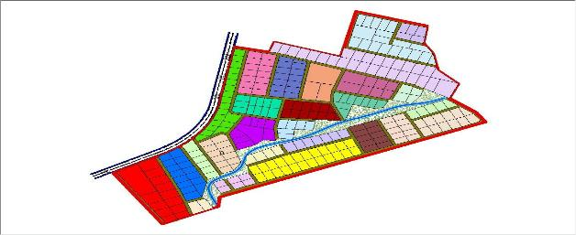

Fig 4.5.1:- the exported cadastral plan of the study area showing the

blocks within the area
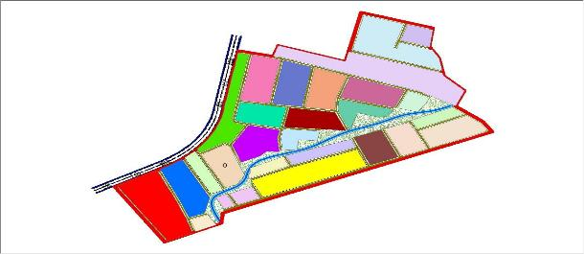

Fig 4.5.2:- the exported cadastral plan of the study area showing the all the parcels within the area.

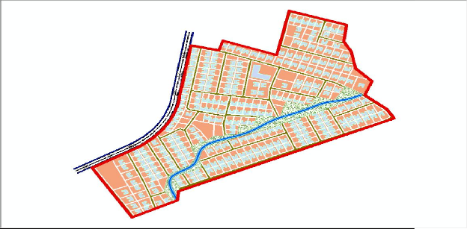

Fig 4.5.3:- the cadastral plan of the study area showing the boundary,

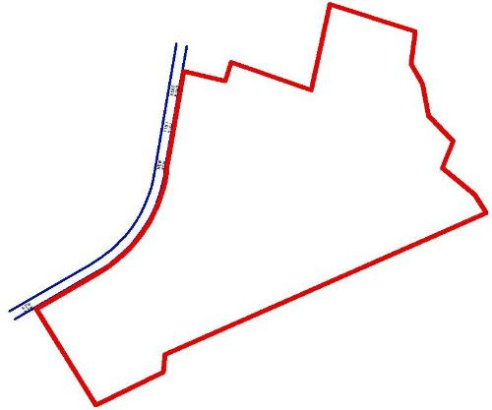

SPATIAL QUERY
Queries were designed for the purpose of retrieving information from the database. The queries performed in this project gave answers to certain generic questions asked from the database. This was made possible as a result of the implicit link of both the spatial and attributes data. The queries were based on the products from the analysis carried out on the database.

Single Criterion Query
A single criterion is carried out where one condition is used to design query. This condition is used to retrieve the information from the database.

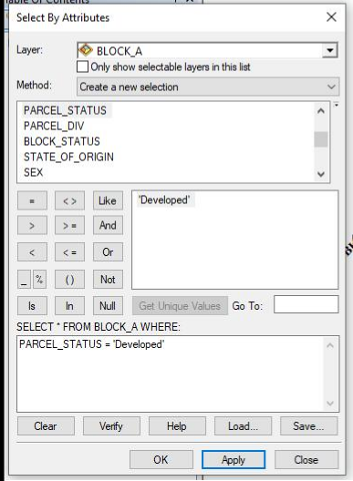

Fig 4.6.1.1:- Query for Parcel status for developed Purposes in the Study Area
SYNTAX; ([Parcel_status]) =’developed’)

    - Query by Parcel Status (Developed)
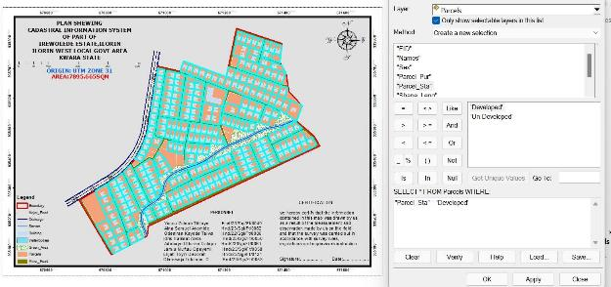
Fig 4.6.2.1: Result of Query for Parcel Used for Residential Area in block A in the study area
SYNTAX; ([Parcel_status]) =’developed’)
    - Discussion of Result

Figure 4.6.2.1 Shows parcels that are meant for developed purposes. It consists of the syntax model or the query builder box, attribute table as well as the map of the selected plot in light green color. The result shows that 8 parcels out of the 20 parcels are meant for commercial purposes.

    - Query by Parcel Status (commercial)
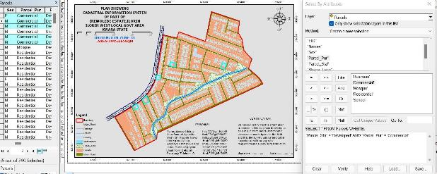

Fig 4.6.4.1: Result of Query for Parcels that are commercial purpose in the study area.
SYNTAX; ([Parcel status]) =’commercial’)

DISCUSSION OF RESULT

Figure 4.6.4.1 shows parcels that already have some type of commercial on it. It consists of the syntax model or the query builder box, attribute table as well as the map of the selected plot in light green color. The result shows that 5 parcels out of the 290 parcels have been developed. This information, however will help in informing the necessary quarters the level of development within the layout.

MULTIPLE CRITERIA QUERY
The database created is then used for implementing several selection queries in determination of user-defined requirements such as parcels whose occupiers are actual owners, occupier’s citizenship, occupier’s occupation, number of residents in each flat, selection of unoccupied flats and other such security.

Query By Parcel Use And Parcel Status (Parcels meant for school, residential, commercial purposes that are “Developed”
Query was carried out in two stages, parcels meant for residential purposes were first queried by means of the parcel use field. In this case parcel use was selection criteria. The shape file data of the query was exported as a layer and named accordingly. Next, the attribute table of the query result was queried by means of parcels meant for residential purposes that are yet to be developed i.e. Developed Parcels using the “Developed” selection criteria. This gives result for the parcels meant for residential purposes that are developed this also will help inform on the level of development within the layout.

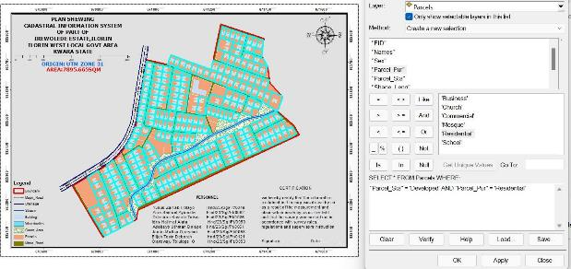

Fig 4.8.1.1: Screen print showing parcel use and parcel status in the layout.
SYNTAX; PARCEL_USE = 'Residential' AND PARCEL_STATUS =

'Developed’
Discussion of Result
Figure 4.8.1.1 shows the syntax modeled, the attribute table and the map of the multiple criteria queries ran on parcel meant for residential purposes and number of Developed residential purpose parcels within the study area, they are highlighted in Light green color. The result showed that 265 of the 290 parcels are developed.
    - Query By Parcel Use (Commercial) And Parcel Status

(Parcels meant for commercial purposes that are “Developed”)

Following the procedure in the query for parcels meant for residential purposes that are yet to be developed. All parcels meant for

commercial purposes were first queried and then, the resulting attribute table, query was carried out for parcel for which are Developed.

Fig 4..8.2.1: Screen print showing parcel meant for commercial purpose that are Developed in the layout.
SYNTAX; PARCEL_USE = 'Commercial' AND PARCEL_STATUS =

'Developed'4.7.2.1
Discussion of Result
Fig 4..8.2.1 shows the result of syntax modeled, attribute table as well as unformatted map of developed parcels meant for commercial purposes. The table shows that all the 5 parcels meant for commercial purposes are developed. This is a pointer to the high rate of commercial developments in the study area.

Query By 10m Proximity to the stream (Parcel within 10m proximity to the stream).
Following the procedure in the query for parcels within close proximity to the stream (10m), query was carried out to show the parcels within close range to the stream.
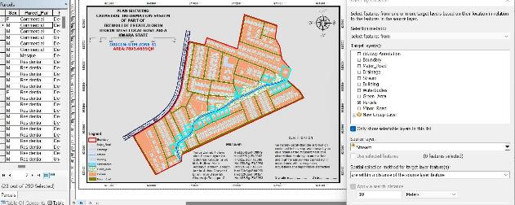

Fig 4.8.3.1: Screen print showing parcel parcel within 10m proximity to the stream
4.8.3.2 Discussion Of Result
Figure 4.8.3.1 shows the result of syntax modeled, attribute table. The table shows that only two out of all the parcels, only 25 parcel are within 10m proximity to the stream.

Fig4.8.5.4 Screen-shot showing the database created for the study area
Screen-shot showing the database created for the study area
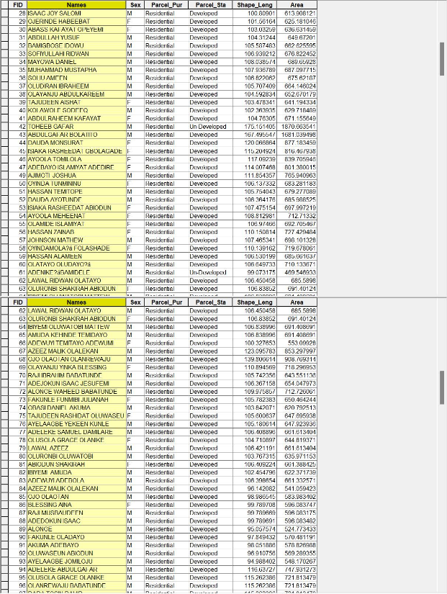

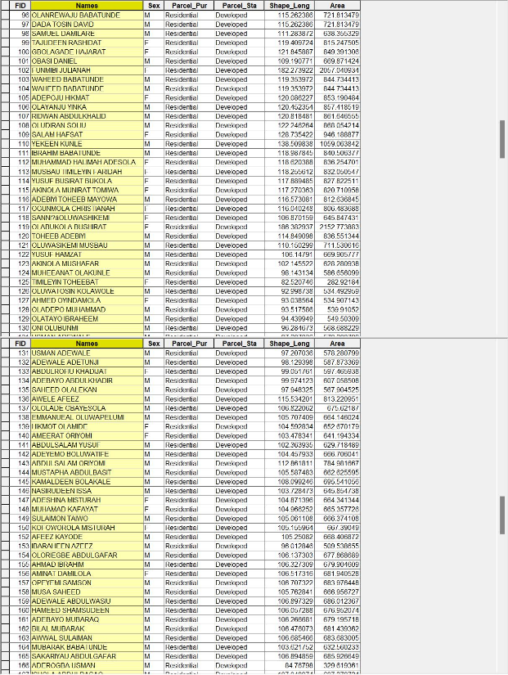

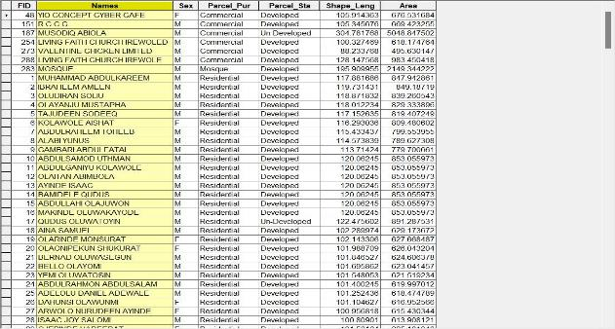

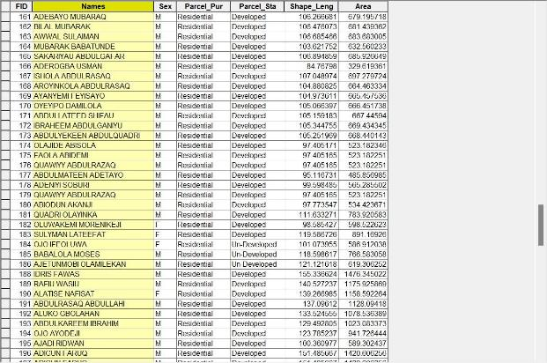

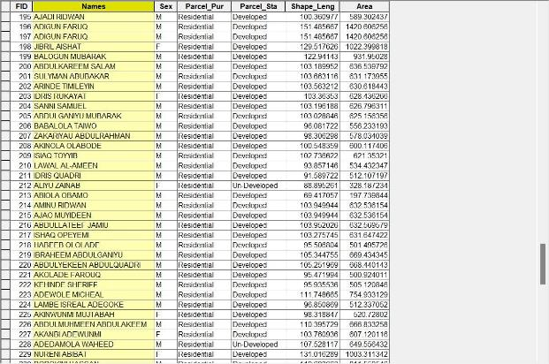

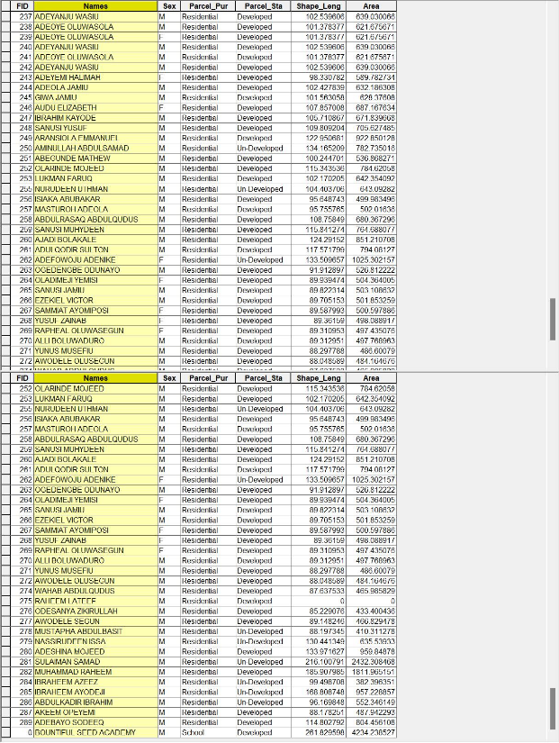

CHAPTER FIVE

  - COSTING, SUMMARY, PROBLEMS ENCOUNTERED, CONCLUSION AND RECOMMENDATION
  - COSTING

The project's cost was estimated using the Nigeria Institution of Surveyors' (NIS) professional scale of fees for construction industry consultants. This breakdown highlights the total expenditure incurred throughout the project's duration, from inception to completion.

RECONNAISSANCE

PERSONAL/QUALITY | DAY(S) | UNITRATE(N) | TOTAL AMOUNT(N)
1 Senior Surveyor | 1 | 18,443.92 | 18,443.92

Assistant Surveyor | 1 | 10,849.37 | 10,849.37
Transportation | 1 | 19,800.35 | 19,800.35
Basic Equipment | 1 | 19,800.35 | 19,800.35
Logistics | 1 | 8,000.00 | 8,000.00
TOTAL |  |  | #76,893.99k
TABLE: 5.1.1 shows the total amount spent for reconnaissance BEACON= 2,100 × 8
= #16,800

BEACONING

PERSONAL/QUALITY | DAY(S) | UNITRATE(N) | TOTALAMOUNT(N)
1Assistant Surveyor | 1 | 10,849.37 | 10,849.37
1Assistant Surveyor | 1 | 9,500.22 | 9,500.22
2Labour Crew | 1 | 6,468.61 | 6,468.61
Transportation | 1 | 19,800.35 | 19,800.35
Basic Equipment (6) | 1 | 19,800.35 | 19,800.35
Logistics | 1 | 8,000.00 | 8,000.00
TOTAL |  |  | #74,418.9k
TABLE: 5.1.2 shows the total amount spent for beaconing

TRAVERSING

PERSONAL/QUALITY | DAY(S) | UNITRATE(N) | TOTALAMOUNT(N)
1 Senior Surveyor | 2 | 18,443.92 | 36,887.84
1 Assistant Surveyor | 2 | 10,849.39 | 21,698.74
1 Chain Man | 2 | 9,500.22 | 19,000.44
2 Labor Crew | 2 | 6,468.61 | 25,874.44
Transportation | 2 | 19,800.35 | 39,600.7
Basic Equipment | 2 | 19,800.35 | 39,600.7
Logistics |  | 8,000.00 | 16,000.00
TOTAL |  |  | #198,662.86
TABLE: 5.1.3 shows the total amount spent for traversing DOWNLOADING DATA AND EDITING
PERSONAL/QUALITY | DAY(S) | UNITRATE(N) | TOTALAMOUNT(N)
1Principal Surveyor | 1 | 30,378.22 | 30,378.22
1SeniorSurveyor | 1 | 18,443.92 | 18,443.92
1AssistantSurveyor | 1 | 10,849.92 | 10,849.92
Basic Equipment | 1 | 19,800.35 | 19,800.35
Consumables | 1 | 13,927.00 | 13,927.00
Logistics | 1 | 8,000.00 | 8,000.00
TOTAL |  |  | #101,400.86

TABLE: 5.1.4 shows the total amount spent for downloading data and editing

PLOTTING

PERSONAL/QUALITY | DAY(S) | UNITRATE(N) | TOTALAMOUNT(N)
1Principal Surveyor | 1 | 30,378.22 | 30,378.22
1Senior Surveyor | 1 | 18,443.92 | 18,443.92
1Assistant Surveyor | 1 | 10,849.92 | 10,849.92
Basic Equipment | 1 | 19,800.35 | 19,800.35
Consumables | 1 | 13,927.00 | 13,927.00
Logistics | 1 | 8,000.00 | 8,000.00
TOTAL |  |  | #101,400.86

TABLE: 5.1.5 shows the total amount spent for plotting INFORMATION PRESENTATION
PERSONAL/QUALITY | DAY(S) | UNITRATE(N) | TOTALAMOUNT(N)
1PrincipalSurveyor | 1 | 30,378.22 | 30,378.22
1SeniorSurveyor | 1 | 18,443.92 | 18,443.92
Transportation | 1 | 19,800.35 | 19,800.35
Basic Equipment | 1 | 19,800.35 | 19,800.35
Consumables | 1 | 13,927.00 | 13,927.00
Logistics | 1 | 8,000.00 | 8,000.00
TOTAL |  |  | #110,351.84
TABLE: 5.1.6 shows the total amount spent for information presentation
- # 76,893.99k
- # 74,418.99k
- # 198,602.86k
- # 101,400.86k (5)#101,400.86k
(6) # 110,351.84k TOTAL # 663,069.4K

MOBILIZATION AND DEMOBILIZATION =1.5%
: 1.5%. ÷ 100 × 663,069.4
= 0.015 × 663,069.4
= 9,946.041

A. T = 1.75%
: 1.75% ÷ 100 × 663,069.4
= 0.0175 × 663,069.4
= 11,603.7145

ACCOMODATION = 2%
: 2 ÷ 100 × 663,069,4
= 0.02 × 663,069.4
= 13,261.388
TOTAL = 663,069.4
9,946.041
11,603.7145
13,261.388
= 691,880.5435

#105,984.47
Reconnaissance
Cutting of line & Tracing of layout | #565,858.96
Ground Control Establishment | #216,649.21
Traversing | #216,649.21
Data Capture | #216,649.21
Data Processing | #270,195.88
Plotting using ARCGIS | #179,826.00
Technical Report | #210,195.88
Total | #1,982,008.82
TABLE: 5.1.4 shows the total amount spent for all tables

SUMMARY

This project implemented a Cadastral Information System (CIS) for Kwara State Polytechnic, Ilorin, leveraging Geographic Information System (GIS) tools. The system aimed to create a comprehensive database of land parcels, property ownership, and usage.
Key Components

- Data Capture: Collected and integrated cadastral data, including property boundaries, ownership details, and land use information.
- GIS Mapping: Utilized GIS tools to create detailed maps of land parcels, visualizing property boundaries and relationships.
- Database Development: Designed and implemented a database to store and manage cadastral information.
- Data Analysis: Performed spatial analysis and queries to extract valuable insights from the cadastral data.
- Information Dissemination: Provided stakeholders with access to accurate and up-to-date cadastral information.
Benefits

- Improved Land Management: Enhanced land administration and management capabilities for the polytechnic.
- Accurate Property Records: Maintained accurate and reliable records of property ownership and boundaries.
- Informed Decision-Making: Supported informed decision-making through spatial analysis and data-driven insights.
Implementation Outcomes

- Cadastral Database: Developed a comprehensive database of land parcels and property information.

- GIS Maps: Created detailed maps of land parcels, facilitating visualization and analysis.
- Improved Efficiency: Streamlined land administration processes, reducing errors and increasing efficiency.

PROBLEMS ENCOUNTERED

Challenges Encountered During Project Execution

- Technical Issues

- Time-consuming measurements: Using a total station resulted in longer measurement and observation times, causing project delays.
- Human Factors

1. Public interference: Taking coordinates of each building led to harassment and questioning from some individuals, hindering work progress.
- Logistical Challenges

- Transportation costs: Changes in location led to transportation expenses exceeding the budget.

Lessons Learned

- Plan for contingencies: Anticipate potential delays and develop mitigation strategies.
- Community engagement: Educate stakeholders about project objectives and benefits to minimize interference.
- Budget flexibility: Build flexibility into the budget to accommodate unexpected expenses.
These challenges highlight the importance of careful planning, stakeholder engagement, and adaptability in project execution.

CONCLUSION.

Conclusion for Implementation of Relational Database System for Cadastral Information System
Key Outcomes

The implementation of a relational database system for the Cadastral Information System (CIS) was successfully completed, achieving the following outcomes:

- Comprehensive Database: A detailed database was developed, storing and managing cadastral information.
- Improved Data Management: The relational database system ensured data consistency, integrity, and accuracy.
- Practical Applications: The CIS can support land administration, urban planning, and resource allocation.
Benefits

- Enhanced Decision-Making: The CIS provides valuable insights for informed decision-making.
- Efficient Data Retrieval: The relational database system enables fast and accurate data retrieval.
- Scalability and Flexibility: The system can be expanded and modified to accommodate future needs.
Future Directions

The CIS has potential for future development, research, and expansion, contributing to improved land management and administration.

5.5.1 RECOMMENDATION
Recommendations for Cadastral Information System

- Regular Land Information Updates

  - Conduct frequent land surveys: Update land information regularly.

  - Benefits: Reduce corruption, improve property taxation, and enhance credit security.
- Departmental Resource Allocation
  - Provide surveying instruments: Equip the department with necessary surveying instruments.
  - Establish laboratory facilities: Set up laboratory facilities for efficient data processing and analysis.
Expected Outcomes

- Improved Efficiency: Faster project execution and data processing.

- Enhanced Accuracy: More accurate data and reduced errors.

- Better Decision-Making: Reliable data for informed decision-making.
These recommendations can enhance the effectiveness of the Cadastral Information System.

5.6 REFERENCES

- Adams, K., Broad, D., & Davis, A. R. (2020); Haarbrink & Koers (2016); Redmond, J., & Farhadi, M. (2017); Przybilla, et al. (1979). Classification of drones and geomatics application.

  - Amanah, D., & Harahap, D. A. (2020). [Title not specified]. Journal of Scientific & Technology Research.

  - Chintagunta, P. K., Gopinath, S., & [Co-author not listed]. (2010). [Title not specified]. Marketing Science. Retrieved from pubsonline.informs.org

  - Dale, P. F., & McLaughlin, J. D. (1976). Land Information Management. Oxford University Press, New York, p. 21.

  - Dhar, S. K., & Hoch, S. J. (1997). [Title not specified]. Marketing Science. Retrieved from pubsonline.informs.org

  - Dutta, S., Narasimhan, O., & Rajiv, S. (1999). [Title not specified]. Marketing Science. Retrieved from pubsonline.informs.org

  - Kaur, G. (2017). [Title not specified]. International Journal of Research – Granthaalayah. Retrieved from academia.edu

  - Mintzberg, H. (1980). [Title not specified]. Management Science. Retrieved from pubsonline.informs.org

  - Trott, P., & Hartmann, D. A. P. (2009). [Title not specified].

Journal of Innovation Management. World Scientific.

APPENDIX

NORTHING EASTING
NORTHING | EASTING
935610.110 | 671030.195
935588.956 | 671026.735
935546.647 | 671019.817
935567.802 | 671023.276
935664.242 | 671076.822
935645.404 | 671074.784
935624.237 | 671071.395
935603.069 | 671068.005
935581.902 | 671064.616
935539.915 | 671057.753
935560.735 | 671061.227
935639.619 | 671105.861
935618.433 | 671102.569
935597.248 | 671099.278
935576.062 | 671095.987
935534.572 | 671089.394

935609.976 | 671158.208
935685.660 | 671212.601
935622.014 | 671387.359
935629.861 | 671365.636
935637.708 | 671343.913
935645.555 | 671322.190
935653.402 | 671300.467
935661.249 | 671278.745
935669.097 | 671257.022
935676.944 | 671235.299
935716.912 | 671249.292
935709.268 | 671271.086
935701.623 | 671292.881
935693.979 | 671314.675
935686.334 | 671336.469
935678.690 | 671358.263

935671.046 | 671380.057
935725.350 | 671227.181
935240.915 | 671022.720
935249.541 | 671041.425
935258.168 | 671060.131
935266.794 | 671078.837
935275.421 | 671097.543
935284.048 | 671116.249
935292.674 | 671134.955
935301.301 | 671153.660
935309.927 | 671172.366
935318.554 | 671191.072
935327.180 | 671209.777
935336.027 | 671228.624
935269.006 | 671010.266
935277.890 | 671028.849
935286.775 | 671047.415
935295.653 | 671065.988
935304.533 | 671084.563
935313.039 | 671103.241
935321.370 | 671122.060
935329.702 | 671140.880
935338.033 | 671159.699
935346.365 | 671178.518
935354.696 | 671197.337
935363.530 | 671216.911

935554.877 | 671092.696
935655.785 | 671106.863
935679.816 | 671010.043
935658.092 | 671006.633
935636.946 | 671003.128
935615.800 | 670999.623
935594.655 | 670996.117
935552.364 | 670989.106
935573.509 | 670992.612
935524.068 | 671205.203
935515.221 | 671235.964
935519.645 | 671220.583
935510.884 | 671250.773
935504.090 | 671283.194
935506.546 | 671265.582
935529.850 | 671189.894
935557.110 | 671337.973
935547.745 | 671361.057
935528.420 | 671327.953
935522.537 | 671351.230
935498.124 | 671202.080
935472.693 | 671203.593
935231.108 | 670754.994
935285.608 | 670781.967
935257.017 | 670793.476
935231.699 | 670804.245

935596.725 | 671224.596
935563.069 | 671214.309
935584.247 | 671260.588
935552.140 | 671250.658
935575.974 | 671284.398
935544.888 | 671274.792
935538.411 | 671297.333
935568.137 | 671307.769
935433.953 | 671370.158
935405.605 | 671382.624
935414.568 | 671402.715
935443.362 | 671390.053
935452.770 | 671409.947
935423.531 | 671422.806
935462.179 | 671429.842
935432.518 | 671442.880
935471.388 | 671449.462
935441.629 | 671462.734
935451.108 | 671483.132
935476.286 | 671467.271
935468.597 | 671353.972
935478.261 | 671373.662
935487.975 | 671393.422
935497.690 | 671413.182
935504.834 | 671432.220
935719.739 | 671329.150

935206.333 | 670814.776
935180.802 | 670825.001
935155.206 | 670835.135
935129.538 | 670844.802
935107.378 | 670852.546
935167.868 | 670786.896
935167.868 | 670786.896
935140.042 | 670801.171
935115.530 | 670813.691
935093.982 | 670824.527
935502.026 | 671084.189
935499.132 | 671103.593
935496.224 | 671123.004
935493.321 | 671142.406
935490.418 | 671161.809
935463.704 | 671136.585
935466.019 | 671117.070
935468.337 | 671097.552
935470.649 | 671078.036
935461.388 | 671156.099
935459.070 | 671175.602
935483.156 | 671177.142
935453.430 | 671189.700
935427.021 | 671129.515
935428.791 | 671109.892
935430.561 | 671090.268

935704.331 | 671369.279
935762.962 | 671371.238
935770.229 | 671352.385
935776.532 | 671334.275
935747.563 | 671333.903
935736.698 | 671363.979
935358.509 | 671292.218
935345.200 | 671261.646
935376.305 | 671285.023
935363.475 | 671254.509
935394.616 | 671277.589
935381.896 | 671247.186
935412.976 | 671270.160
935400.358 | 671239.962
935431.389 | 671262.824
935418.907 | 671232.943
935374.037 | 671327.634
935391.311 | 671320.459
935409.422 | 671312.917
935427.707 | 671305.270
935445.993 | 671297.622
935386.102 | 671355.184
935402.922 | 671348.018
935420.838 | 671340.270
935439.009 | 671332.411
935457.067 | 671324.282

935432.350 | 671070.662
935514.752 | 671006.514
935503.179 | 670980.879
935524.324 | 670984.384
935511.905 | 671021.844
935509.146 | 671037.212
935506.012 | 671056.247
935482.715 | 671001.291
935479.456 | 671016.515
935406.672 | 671077.743
935388.609 | 671077.778
935304.276 | 671001.256
935132.843 | 670881.560
935143.924 | 670901.723
935199.080 | 670944.115
935217.901 | 670935.258
935325.946 | 670882.117
935287.781 | 670900.075
935306.864 | 670891.097
935249.617 | 670918.034
935268.699 | 670909.055
935305.492 | 670850.972
935267.327 | 670868.931
935286.409 | 670859.952
935229.162 | 670886.889
935248.245 | 670877.910

935781.749 | 671308.542
935787.881 | 671290.829
935793.688 | 671273.367
935799.496 | 671255.905
935805.767 | 671239.660
935755.833 | 671291.382
935735.338 | 671285.147
935705.906 | 671056.621
935759.977 | 671246.836
935635.714 | 671245.297
935627.491 | 671266.888
935619.441 | 671288.540
935611.305 | 671310.162
935603.168 | 671331.783
935594.978 | 671353.413
935585.241 | 671374.680
935574.896 | 671395.501
935643.850 | 671223.675
935651.986 | 671202.055
935660.122 | 671180.433
935668.259 | 671158.812
935676.332 | 671137.182
935684.392 | 671115.525
935692.489 | 671093.889
935699.732 | 671074.318
935560.442 | 671424.725

935293.188 | 670824.574
935254.605 | 670841.591
935273.888 | 670833.084
935215.952 | 670858.275
935235.332 | 670850.059
935196.705 | 670865.611
935174.652 | 670873.956
935203.130 | 670893.197
935476.149 | 671031.692
935472.246 | 671050.137
935482.431 | 670977.757
935313.233 | 670816.342
935443.675 | 670992.243
935439.993 | 671009.974
935436.238 | 671025.075
935431.771 | 671042.892
935376.631 | 670980.972
935357.973 | 670989.395
935397.772 | 670970.938
935394.162 | 671041.033
935687.989 | 670976.739
935666.376 | 670973.276
935645.229 | 670969.777
935624.082 | 670966.277
935602.936 | 670962.778
935560.723 | 670955.792

935581.827 670959.299
935539.550 | 670952.250
935518.387 | 670948.846
935497.160 | 670945.233
935476.333 | 670940.522
935435.900 | 670925.461
935417.749 | 670916.522
935400.550 | 670906.629
935384.335 | 670893.462
935409.826 | 670937.803
935454.280 | 670960.722
935401.806 | 671004.824
935544.173 | 671162.659
935551.179 | 671132.073
935659.225 | 671395.568
935604.088 | 671414.051
935430.315 | 670949.641
935455.752 | 670933.596
935350.755 | 670871.399
935327.572 | 670841.425

935379.334 | 670934.082
935358.770 | 670942.090
935339.340 | 670949.618
935319.912 | 670957.145
935300.484 | 670964.672
935282.407 | 670967.180
935242.796 | 670988.892
935223.786 | 670997.339
935212.953 | 670973.883
935231.870 | 670965.236
935269.705 | 670947.943
935288.622 | 670939.296
935307.540 | 670930.650
935326.457 | 670922.003
935345.374 | 670913.356
935363.828 | 670905.558
935350.086 | 671086.877
935358.537 | 671107.690
935366.356 | 671126.728

935374.174 671145.766

