DESIGN AND CONSTRUCTION OF A SMART SCARECROW SYSTEM

BY

HABEEBLLAHI MUHAMMEDBASHEER ARIKEWUYO
HND/23/EEE/FT/0174

A PROJECT REPORT SUBMITTED TO THE DEPARTMENT OF ELECTRICAL AND ELECTRONICS ENGINEERING, INSTITUTE OF TECHNOLOGY

IN PARTIAL FULFILMENT OF THE REQUIREMENTS FOR THE AWARD OF HIGHER NATIONAL DIPLOMA (HND)
IN ELECTRICAL AND ELECTRONICS ENGINGINEERING,
KWARA STATE POLYTECHNIC, ILORIN.

JULY, 2025.

CERTIFICATION
The undersigned certify that this project report was prepared by HABEEBLLAHI MUHAMMEDBASHEER ARIKEWUYO, with matriculation HND/23/EEE/FT/0174 Entitled: DESIGN AND CONSTRUCTION OF A SMART SCARECROW SYSTEM, meets the requirement of the Department of Electrical and Electronics Engineering for the award of Higher National Diploma [HND] in Electrical and Electronics Engineering, Kwara State Polytechnic, Ilorin.

__________________________ __________________
ENGR. DR. M. Z. OBA. DATE
(Project Supervisor)

___________________________ __________________
ENGR. ABDULKADIR Z. A. DATE
(Project Coordinator)

___________________________ __________________
ENGR. DR. O. A. LAWAL. DATE
(Head of Department)

DECLARATION
I hereby declare that this research project titled DESIGN AND CONSTRUCTION OF A SMART SCARECROW SYSTEM is my work and has not been submitted by any other person for any degree or qualification at any higher institution, I also declare that the information provided therein is mine and those that are not mine are properly acknowledged.

_________________________ ____________________
Habeebllahi Muhammedbasheer Arikewuyo Signature and Date

DEDICATION
This project is dedicated to Mr & Mrs Habeebllahi, my wonderful parents, whose love, prayers, and sacrifices have guided me every step of the way. Your constant encouragement and belief in my potential have been a source of strength throughout this journey. Above all, I give sincere thanks to Almighty Allah, the Most Gracious and Most Merciful, for granting me the wisdom, perseverance, and ability to see this project through to completion.

ACKNOWLEDGEMENT
All praise, honor, and thanks are due to Almighty Allah, the Most Gracious, the Most Compassionate, and the Most Merciful, for His endless guidance and favor throughout the course of this Higher National Diploma program at Kwara State Polytechnic, Ilorin.
I am deeply grateful to my beloved parents, MR & MRS HABEEBLLAHI, for their continuous moral, emotional, and financial support. Your sacrifices and encouragement have been a pillar of strength in my academic journey.
I sincerely appreciate my project supervisor, ENGR. DR. M. Z. OBA, for his patience, direction, and constructive feedback. Despite his busy schedule, he devoted time and effort to ensure the success of this work.
I also wish to recognize the support of my dedicated Head of Department, ENGR. ENGR. DR. O. A. LAWAL., and the entire academic staff of the Department of Electrical and Electronics Engineering. Your guidance and encouragement have been instrumental in the completion of this program.
Lastly, I extend my heartfelt thanks to my ever dynamic colleagues in electrical and electronics engineering department and people that in one way or another, contributed to the successful completion of this work.
May Almighty Allah light up your path in this life and the hereafter (Amen).

ABSTRACT
Automatic scarecrow technology is an easy and reliable way to control major avian crop pests like birds and or animals. This Scarecrow decreases crop damage by dispersing birds in a safe and human way.
The main aim of the project was to design and construct a smart scarecrow prototype that is static and play sounds of distress to disperse off the birds. Two wireless communicating devices being controlled by a microcontroller were developed with the help of RF modules consisting of sound producing system, and a motion sensor which were used as inputs to the microcontrollers when motion is detected, and the buzzer are activated.
The system is designed to be sustainable, primarily based on solar energy as the chief source of power, thereby making it accessible and for marginal farmers. The smart scarecrow will be equipped with motion sensors to detect any intruding animals and then generate sound effects to deter them. Harnessing solar energy, therefore, enables the device to function round the clock during the day even in remote areas without access to electricity. This innovative approach not only provides a practical tool for crop protection with minimal maintenance but also promotes the use of renewable energy in agriculture.

TABLE OF CONTENTS
Title Page i
Certification ii
Declaration iii
Dedication iv
Acknowledgment v
Abstract vi
Table of Contents vii
CHAPTER ONE: INTRODUCTION
  - Introduction 1
  - Problem Statement 1
  - Aim 2
  - Objectives of the Study 2
  - Significance of the study 2
  - Scope of the Study 3
CHAPTER TWO – LITERATURE REVIEW
2.0 Introduction 4
2.1 Existing systems 5
2.2 Components used in the project 7
2.2.1 Resistor 7
2.2.2 Capacitor 8
2.2.3 Diode 8
2.2.4 Transistor 9
2.2.5 Light emitting diode 9
2.2.6 Crystal oscillator 10
2.2.7 Microcontroller 11
2.2.8 Arduino board 12
2.2.9 Power supply with voltage regulation 13
2.3.0 Photovoltaic Module 15
CHAPTER THREE – RESEARCH METHODOLOGY
  - Introduction 16
  - Principle of operation of the system 16
  - Design procedures 19
CHAPTER FOUR – RESULT AND DISCUSSION

  - Introduction 24
  - System testing and operation 24
4.3 Power system performance 27
4.4 Voltage regulation and efficiency 27
CHAPTER FIVE – CONCLUSION AND RECOMMENDATION
  - Conclusion 29
  - Recommendation 29
References 30-32
Appendix I 33-34
Appendix II 35

CHAPTER ONE
INTRODUCTION
1.0 Introduction
The smart scarecrow technology is an easy and reliable way to control major avian crop pests like birds and or animals. This Scarecrow decreases crop damage by dispersing birds in a safe and human way. It is designed to automatically detect and scare away birds and animals without any manual intervention while using solar energy as its primary source of power. The nature-inspired technology uses bio-acoustics to protect farmland and agricultural areas. The technology of scarecrow has many applications which include reducing financial loss due to crop damage caused by birds, reliable, human and safe agricultural bird dispersal, and the chosen bird control system for the farming industry. This innovative approach not only provides a practical tool for crop protection with minimal maintenance but also promotes the use of renewable energy in agriculture.
Farmers have also attempted to employ the use of young boys who patrolled the fields to scare away animals or birds destroying crops by physical chasing, scaring off by beating sonorous bodies like tins and jerry cans and by use of clappers to make noise to chase away birds [1]. The disadvantage of this system, however, is costly especially for farmers with a large plot of fields.
It has been proposed, for example, to scare birds from a field through the use of stationary devices, such as scarecrows. The effectiveness of these devices, however, decreased after a short period of time because the birds or other animals became accustomed to the presence of the devices and lost their fear thereof [2]. [3], proposed to scare birds from a field through the use of loud noise. Such loud noise may be produced by an air gun that ignites combustible gas at predetermined intervals. After a period of use of loud noises, however, birds became accustomed to the noise, and the scaring effect is diminished.
1.1 Problem Statement
Hungry birds have always been a problem for farmers. Sometimes the birds and other animals could eat so much rice, corn or wheat that a farmer and his family would not have enough food to last through the winter. So for more than 3000 years, farmers have been making scarecrows. Due to physical damage of farmlands as a result of hungry birds and animals feeding on them, farmers are facing a considerable loss in their yield harvest in terms of quantity and monetary gains they expected to acquire from their harvests because the current traditional techniques employed by these farmers such as the use of static scarecrows are only effective for very small fields. Large commercial rice farmers also faced extensive labor requirements for bird scaring which is very expensive and sometimes it may not be available when needed. The lethal methods used for bird control such as treatment of paddy fields with avicides (chemical substances lethal to certain bird species) are not environmentally friendly since they can also be dangerous to human beings.
This invention seeks transforms the old concept into a new one whereby the device can autonomously scare away pests without any manual intervention while still being operated by solar power.
1.3 Aim
The aim of this project is to design and construct a smart scarecrow system.
1.4 Objectives
The following are the objectives of the project:
- To design circuit for a smart scarecrow system
- To construct a smart scarecrow system
- To design and program a motion detection system
- To design an alarm unit for producing deterrent sound effects
- To incorporate a solar panel on a pole and design a circuit for charging and supply to components of the system
1.5 Significance of the study
This project scares off birds and animals from fields hence reducing on the physical damage the birds would cause to the crops. And thus increasing on the quantity and quality of the harvest as well as increasing the monetary gains to the farmers. The device saves the large-scale and local commercial farmers on money they would spend annually on the labor of the bird scarers. And also it is environmentally friendly compared to the lethal technique used by some farmers such as treatment of field with avicides hence making it a more desirable technique of bird rice damage control.

1.6 Scope of the study
This project design is mainly limited to detection of motion of birds and animals using a PIR motion sensor which then activates the buzzer to produce a loud deterrent sound to scare away the animals. Kwara state polytechnic could pilot the smart scarecrow system and evaluate the effectiveness before expanding. It offers significant opportunities for enhancing agricultural productivity and reducing crop losses by offering pest and animal control, precision agriculture, integration with IOT (Internet Of Things) and educational value.
CHAPTER TWO
LITERATURE REVIEW
2.0 Introduction
This chapter covers the current bird pest control strategies used by farmers and their degree of effectiveness in controlling bird pest. It also covers the technologies we use in the construction of our prototype. The first scarecrows recorded in history were made along the Nile River to protect wheat fields from flocks of quail [4]. Egyptian farmers put wooden frames in their fields and covered them with nets. Therefore, protection of agricultural production areas from various animals having a tendency to damage the fore mentioned areas is an age-old problem. Farmers today still use scarecrows all over the world. In countries like India and Arab nations, old men sit on chairs and throw stones at the birds trying to eat or damage their crops.
Many techniques are available to protect crops from bird damage. The main conclusion of this study is that the effectiveness of each technique varies with bird species involved and that optimal bird control methods combine several techniques or use them in a random fashion. Human operated scaring techniques were the most effective; lethal methods are of only short-term benefit. In Africa, traditional, low-cost methods are mainly used. In a survey carried out in 2006 by Wilfred Odongola [5] in the main districts growing cereals (rice) in Uganda, 1375 individual farmers were interviewed, and 97.3% acknowledged that they were experiencing problems with cereal (rice) pests and diseases attacking their crops, particularly birds and rodents. Birds chew, squeeze, and feed on the grains in the milky stage of the crop. The damage shows milky white substances covering the grains. At grain maturation, birds remove the entire grains. Birds also perch panicles resulting in crop lodging.
The study identified several bird control techniques that were being used by farmers, amongst which were;
- Physical chasing, shouting and scaring off (83.5%).
- Beating sonorous bodies like tins and jerry cans (5.8%).
- Poisoning and trapping (1.2%).
- Use of stationary scarecrows (1.3%).
- Use of tapes that make whistling sounds around crop fields (0.6%).
Despite all the above attempts by the majority of the farmers, 7.6% of the farmers surveyed said that they completely did nothing about the problem of birds in cereals.
Although the adverse impact of birds on cereals (rice) has received much international attention in the past and is still generally recognized, little research on bird damage control is currently conducted. Therefore, it is desirable to provide a system to repel birds, and that overcomes the disadvantages of the prior arts.
2.1 Existing systems
The bio-acoustic deterrent is a device that emits sound with frequency levels targeting different bird species and covers a wide range acoustic spectrum from below that human perceive (infrasonic) to above our hearing range (ultrasonic). Although many of the commercially available sonic pests show poor results, the use of sound as a viable treatment option still exists [6]. However, this device loses its effectiveness if they are not moved regularly and have their best results in combination with a variety of techniques.
The design of smart scarecrow systems have been a growing area of interest in agricultural technology, aiming to address crop protection challenges more effectively than traditional methods.
Figure 1: Bio-Acoustic deterrent
The preventive method aims at not attracting birds to the field and can be subdivided into lethal and non-lethal techniques. Lethal techniques are aimed at suppressing pest bird population and are primarily implemented by national or regional (governmental) crop protection units. They include manual nest destruction, treatment with avicide (chemical substances lethal to certain bird species) and the use of explosives or flamethrowers. Non-lethal techniques include agronomic practices such as vegetation management, good weed management (as weeds attract bird), specific planning of the production season and choosing a variety with bird resistant characteristics. Religious techniques such as shamanism and fetishes are also still widely adopted in Africa [7]. Protective methods focus on protecting the rice crop when birds do visit the field. These include the use of repellents (chemical substances aimed at deterring birds), protecting fields or nurseries with nets or wires, covering the individual heads of ripening crops with grass or clothes, and manual bird scaring efforts. The latter may consist of a combination of auditory (e.g., noise-making devices, shouting), visual (scarecrows, flags, reflective tape) and physical measures (e.g., throwing rocks or mud).
Motion Sensor Activated Water Spray is a deterrent that is controlled by a motion sensor that sprays a jet of water once movement is detected. The shape is also designed to resemble a large predator bird to act as an additional visual deterrent. This device is relatively ineffective in scaring birds because its effective area is governed by how far the water jet can spray, and how far the sensor can detect movement. This device is best used in very small areas such as residential gardens.
Figure 2: jet water spray
In general, traditional protective methods such as manual bird scaring, flags and scare-crows can provide satisfactory protection on small-scale, privately owned farms when bird numbers are low. However, when pest bird pressure is elevated, these methods become ineffective [8]. Also on large-scale governmental production schemes, these methods are impractical, costly and ineffective [9]. This study suggests that the development of bird populations needs to be monitored and farmers need to be protected against the consequences of massive bird invasions through insurance systems. Large-scale, chemical control techniques to reduce population levels of pest birds to non-pest levels are still widely adopted in many African countries [10]. Literature suggests that these are ineffective, however, because they do not significantly lower populations due to the pest bird’s high productivity potential and high mobility [11]. The frequent inaccessibility of areas in which birds resides also creates a barrier to the efficient application of these chemicals. In contrast, lethal control to locally reduce pest bird numbers in the vicinity of important cereal production areas to give temporary relief has been applied successfully. However, the success of this approach varies regionally and by the control method deployed. It is worth noting that these approaches entail severe environmental hazards when avicide is applied.
2.2 Components used in the project
2.2.1 Resistor
A resistor is a passive component that implements electrical resistance circuit element. Resistors act to reduce current flow, at the same time, act to lower voltage levels within circuits. Resistors may have fixed resistances or variable resistances, such as those found in thermistors trimmers, photoresistors and potentiometers. The current through a resistor is in direct proportion to the voltage across the resistor's terminals. This relationship is represented by Ohm's law:
V=I/R
Where I is the current through the conductor amperes, V is the potential difference measured across the conductor in units of volts, and R is the resistance of the conductor in units of ohms (Ω).
The ratio of the voltage applied across a resistor's terminals to the intensity of current in the circuit is called its resistance, and this can be assumed to be a constant (independent of the voltage) for ordinary resistors working within their ratings.
Figure 3: Resistor
2.2.2 Capacitor
A capacitor is an electronic component that stores and releases electrical energy. It consists of two conductive plates separated by an insulating material called a dielectric. When a voltage is applied across the plates, an electric field builds up, causing positive charge to collect on one plate and negative charge on the other. The capacitor holds the charge until the circuit allows it to discharge, releasing the energy.
Key properties:
- Capacitance (C): Measured in Farads (F), it tells how much charge the capacitor can store per volts.
- Voltage rating: The maximum voltage the capacitor can handle without breaking down
- Polarity: Some capacitors (like electrolytics) are polarized and must be connected in the correct direction.
Capacitors can be used for filtering (e.g smoothing out ripples in power supplies), in timing circuits, for energy storage and also for coupling/decoupling signals.
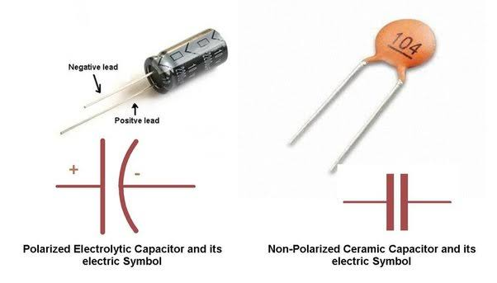
Figure 4: A capacitor
2.2.3 Diode
Diodes are used to convert AC into DC. These are used as half wave rectifier or full wave rectifier. A semiconductor device with two terminals, typically allowing the flow of current in one direction only.
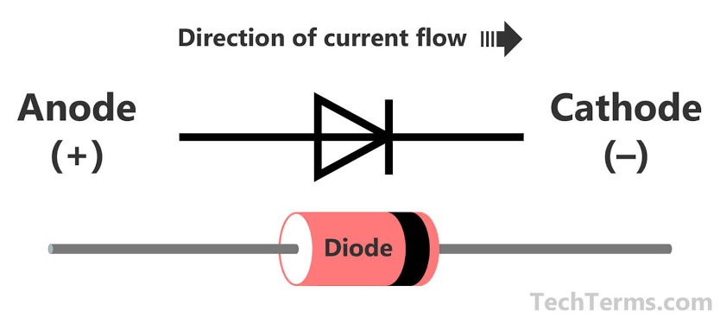
Figure 5: A Diode
2.2.4 Transistor
It is composed of semiconductor material with at least three terminals for connection to an external circuit. A transistor is a semiconductor device used to amplify and switch electronic signals and electric power. A voltage or current applied to one pair of the transistor's terminals changes the current through another pair of terminals.

2.2.5 Light emitting diode (LEDs):
A light-emitting diode is a semiconductor device that emits light when current flows through it. This allows current to flow in only one direction. By convention, current can only flow from the anode (positive) to the cathode (negative). Current is what determines how bright a LED is. More current means more light. LED current should typically be between 10 to 20mA.Therefore a current limiting resistor is used to keep the bias current in the above range. When current flows through the LED; a forward voltage drop of about 1.6V will develop between it spins, depending on the current. So this of this resistor as a valve-reduce it to increase LED brightness, or increase it to limit wasted power in the circuit. Consider an LED at maximum brightness. To achieve this, a typical LED current required.
Now we need to calculate the forward voltage drop across this diode with this current. Forward voltage drop is not just a function of current, but also LED color and temperature (because of the different LED chemistries) as shown in the table below.

Table 1: LED color and PD definition
LED color | Potential Difference
Infrared | 1.6v
Red | 1.8v to 2.1v
Orange | 2.2v
Yellow | 2.4v
Green | 2.6v

Figure 6: LED Indicators
2.2.6 Crystal oscillator
The crystal oscillator is an electronic oscillator circuit that uses mechanical resonance of a vibrating crystal of piezoelectric material to create an electrical signal with a very precise frequency. This frequency is commonly used to keep track of time to provide a stable clock signal for digital integrated circuits and to stabilize frequencies for radio transmitters and receivers. The most common type of piezoelectric used is the quartz crystal, so oscillator circuits incorporating them became known as a crystal oscillator. An ATMEGA328P microcontroller has a clock system with a maximum speed of 20MHz(20mips). However, the internal system clock has a maximum rating of 8MHZ thus for a faster performance an external clock source is connected to the microcontroller pins inform of the crystal oscillator. The oscillator must be connected to two ceramic capacitors to enable its operation especially 22PF to provide a 16MHZ frequency to the microcontroller.
Figure 7: Crystal Oscillator

2.2.7 Microcontroller (ATmega 328P)
A microcontroller is a compact, integrated circuit designed to control specific operations within an embedded system. It functions as the "brain" of the system, combining a processor, memory, and input/output peripherals on a single chip. Microcontrollers are widely used in various applications, including home appliances, automotive systems, robotics, medical devices, and IoT (Internet of Things) devices.
Figure 8: Microcontroller

2.2.8 Arduino Board
An Arduino board is an open-source microcontroller platform designed for easy prototyping and development of electronic projects. It features a microcontroller, I/O pins, and a programming environment that simplifies coding and hardware interaction. Arduino boards are widely used by hobbyists, educators, and professionals for developing diverse applications, including IoT devices, robotics, and automation systems.

Key Features of Arduino Boards
- Microcontroller: Each board has a central microcontroller (e.g., ATmega328P, SAMD21) that executes the program.
- Digital and Analog I/O Pins: \n - Digital pins: Used for reading digital signals or controlling components like LEDs, relays, or motors.
- Analog pins: Used for reading sensor data or providing analog output.
- Power Supply: Can be powered via USB or external power sources, typically 5V or 9-12V DC.
- Programming Environment: Uses the Arduino IDE (Integrated Development Environment), which supports C/C++ and an easy-to-learn syntax.
- USB Interface: Allows for easy programming and serial communication with a computer.
- Open-Source: Hardware schematics and software libraries are freely available, encouraging customization and community development.
Applications
- Robotics: Autonomous vehicles, robotic arms, and drones.
- IoT Devices: Environmental monitoring, smart agriculture, and wearable technology.
- Educational Projects: Learning programming, electronics, and control systems.
- Art and Design: Interactive installations and electronic music devices.
Advantages of Arduino
- Beginner-Friendly: Easy to learn and use.
- Versatile: Suitable for a wide range of applications.
- Low-Cost: Affordable compared to other microcontroller platforms.
Limitations of Arduino
- Limited computational power for complex tasks.
- Not suitable for high-speed applications or resource-intensive tasks.
- Fewer features compared to more advanced platforms like Raspberry Pi.
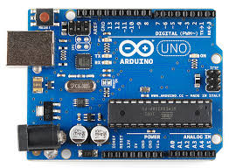

Figure 9: Arduino Board

2.2.9 Power Supply with (Voltage Regulation)
It is a three pin IC used as a voltage regulator. It converts unregulated DC current into regulated DC current. Normally we get fixed output by connecting the voltage regulator at the output of the filtered DC (see diagram below). It can also be used in circuits to get a low DC voltage from a high DC voltage (for example we use 7805 to get 5V from 12V).

LM 7805 Voltage Regulator

Figure 10: Voltage Regulator
5V Zener Diode:
A zener diode is a device that acts like a typical PN-junction diode when it comes to forward bias, but it also has the ability to conduct in the reverse-biased direction when a specific break down voltage (VB) is reached. Zener diodes typically have a breakdown voltages in the range of a few volts to a few hundred volts (although larger effective breakdown voltages can be reached by placing zener diodes in series).
Figure 11: Zener Diode
In this project design, a 5V zener diode is used to regulate the voltage supplied to a load. When Vin attempts to push Vout above the zener diode’s break down voltage (Vzener), the Zener diode draws as much current through itself in the reverse-biased direction as is necessary to keep Vout at V zener, even if the input voltage Vin varies considerably.

2.3.0 Photovoltaic Module
A PV module (Photovoltaic module) is a fundamental component of solar power systems, converting sunlight directly into electricity using the photovoltaic effect. It comprises an assembly of interconnected solar cells enclosed in a protective frame, usually made of glass and a durable backing material. PV modules are designed for long-term use and are typically installed in arrays to generate sufficient power for residential, commercial, or utility-scale applications. The sectionss possessed in the PV module are mentioned as follows;

Key Components of a PV Module:
- Solar Cells: Made primarily from silicon, these cells convert sunlight into direct current (DC) electricity.
- Encapsulation: Layers of ethylene vinyl acetate (EVA) protect the cells from moisture and physical damage.
- Frame: Typically aluminum, providing structural support and ease of mounting.
- Glass Cover: Protects the cells from environmental elements while allowing sunlight to pass through.
- Backsheet: Provides insulation and protects the module's rear side.
- Junction Box: Houses electrical connections and bypass diodes, facilitating connectivity and minimizing power loss
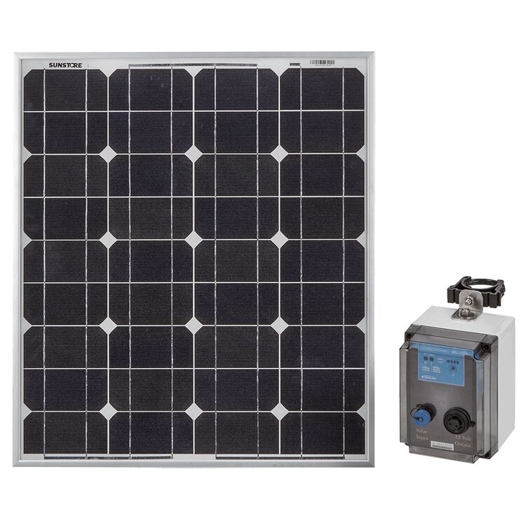
Figure 12: photovoltaic cell
CHAPTER THREE
METHODOLOGY
3.1 Introduction
This chapter deals with the preliminary design analysis of the smart scarecrow system. It has the general procedures for designing the control circuits, the selection of materials for construction, and design for some structural parts of the scarecrow. The smart scarecrow consists of mainly two systems, that is, the motion detecting system, and the sound producing system. The motion detecting system comprises of four motion sensors while the sound producing system consists of siren horn speaker switched on and off by a transistor which is activated by a passive motion sensor that is integrated with the system.
The smart scarecrow system autonomously detects animals in all directions and deters them using sound. It is powered entirely by solar energy, stores energy in a battery, and regulates voltage using an adjustable voltage regulator. An audio amplifier circuit boosts the microcontroller’s output to drive a speaker for effective deterrent sound delivery.
3.2 Principle of system operation
The system is wholly automatic and is turned on for a predetermined time interval and off by a passive infrared motion sensor set by the designer in the program uploaded into the microcontroller. The dynamic and smart scarecrow consists of two separate subsystems operating as one system in order to make the scarecrow effective in scaring off the quelea birds and animals from the fields making it difficult for the them to get accustomed to the scaring technique implemented.
Sensors are placed at 90° intervals from each other which are arranged radially to cover 360° around the scarecrow. The sensors interface with the microcontroller which processes sensor data and triggers a response if motion or proximity is detected. When an animal is detected (motion or distance threshold triggered), the microcontroller activates the sound module to emit a pre-programmed deterrent sound (e.g predator noise). A solar panel charges the battery through a charge controller. The adjustable voltage regulator steps down the battery voltage to suit the operating voltage of the microcontroller and sensors.

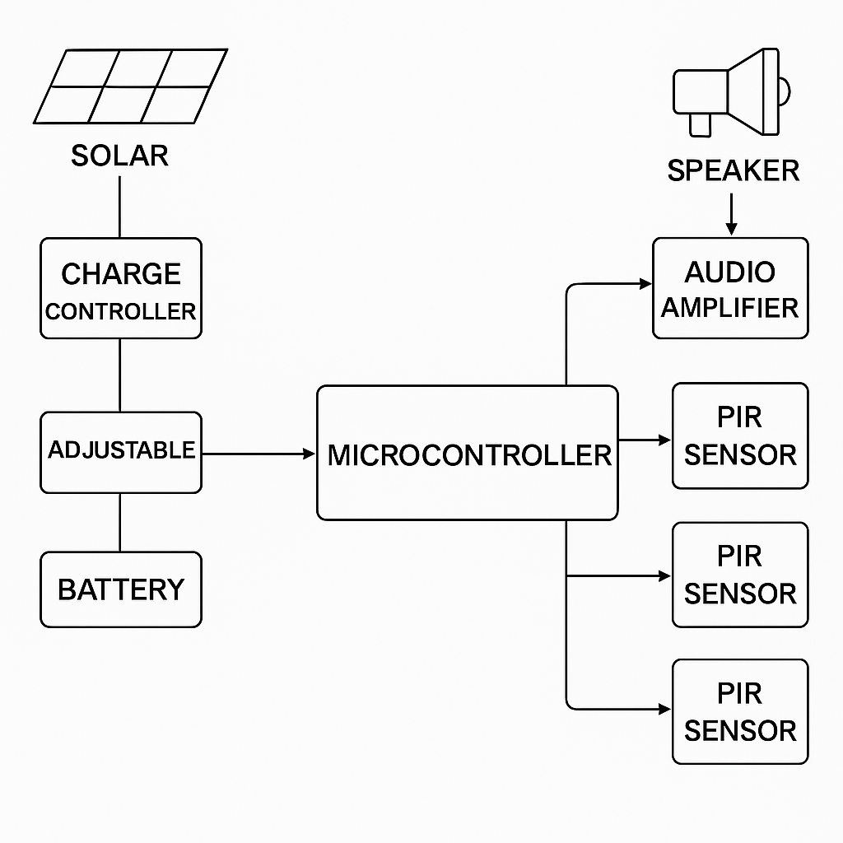
Figure 13: Block diagram of the smart scarecrow
These two subsystems are the motion gesturing system and the sound producing system working simultaneously. The working principle of each subsystem is described in detail as below;
- Motion system
The operating principle of the motion system is that a PIR sensor acts as an input to the microcontroller which sends a digital high (1/ON) or digital low (0/OFF) signal to the microcontroller depending on the differential changed sensed by it to trigger on or off the rotation system. A high digital signal is sent to the microcontroller from the PIR sensor when an animal is detected to trigger for a specified period of time set by the designer as motion is detected. Otherwise, the PIR sensor sends a low digital signal if no animal is detected in its proximity, which means the system remains at the same state of no motion.
- Sound producing system
This system consists of a siren horn speaker producing 90db of sound level intensity at 12V at 10 W and two PIR sensors. The operation of this system is that the PIR sensor acts as input to the microcontroller just as the motion system. When motion is detected by the PIR on the scarecrow in its range of detection of motion, it sends a digital high signal (1/ON) to the microcontroller to switch on the siren which produces multiple sounds for a predetermined time (7 seconds) as written in the program by the designer to produce sounds of high intensity and frequency to irritate and scare off the birds. Also, a transmitter placed at different point in the field with a PIR sensor attached on sends a high digital signal whenever it detects motion to the receiver to trigger on the siren for the same predetermined time, otherwise the system sends a low digital signal which keeps the siren off till motion is detected.
The following are the list of components used in the project construction:
Table 1:
S/N | Components | Descriptions | Specifications
1 | PIR Motion Sensors  (x4) | It detects the motion of animals for full 360° coverage (all directions). | Supply Voltage: 5–12V  Detection Range: ~6–10 meters.  Field of View: Approximately 120°
2 | Microcontroller  (ATmega328P) | It serves as the central control unit to process sensor inputs and manage outputs. | Operating Voltage: 5V  Clock Speed: ~16 MHz (Uno),  I/O Pins: 14
3 | Sound Module  (Amplifier+ Speaker) | It plays deterrent sounds upon detection of animal movement.  (Alarm, predator noise) | Operating Voltage: 3.2V–5V- Storage: Micro SD card support. Impedance: ~8Ω- Power Rating: ~3W
4 | Solar Panel  (20W, 12V) | It harvests solar energy to supply the system and charge the battery. | Rated Power: 20W  NominalVoltage:12V.  Maximum Current: ~1.67A Open-Circuit Voltage: Typically 17–18V
5 | Battery (12V, 7Ah) | It stores energy produced by the solar panel for continuous operation. | Nominal Voltage: 12V.  Capacity: 7Ah.
6 | Adjustable Voltage Regulator (LM317) | It drops the battery voltage to levels suitable for microcontrollers and modules. | Input Voltage: Up to 37V.  Output Voltage: Adjustable from 1.25V up to (Vin – ~1.5V).  Maximum Output Current: ~1.5A
7 | Relay Module/  MOSFETs | It switches the power supply to the sound module on/off based on control signals. | Coil Voltage: Typically 5V.  Contact Ratings: ~10A/250VAC
8 | Diodes  (Schottky) | It provides reverse current protection to prevent damage when power polarity is reversed. | Forward Voltage Drop:  ~0.3–0.5V.  Reverse Voltage Rating: ~40V
9 | DC-DC  Charge Controller | Manages the solar charging process, prevents overcharging, and ensures proper voltage regulation. | Input Voltage: Compatible with solar panels rated around 12V–18V

3.3 Design procedure
To ensure the system remains functional under all conditions, this section calculates:
- The daily energy consumption
- Solar panel requirements
- Battery capacity
- Voltage regulator settings and power loss
The following electronic components are designed accordingly:
- Microcontroller (ATmega328P):
The operating voltage = 5V
The active current = ~20mA
The operating time required = 24 hrs/day
E_{mcu} ​= V×I×t = 5V × 0.02A × 24h = 2.4Wh/day

- ​PIR sensors (x4 HC-SR501)
The supply voltage = 5V-12V
The active current per sensor = ~0.07A (during detection), standby ~0.005A
If we assume 10% duty cycle
I_{avg} = (0.07 x 0.1 + 0.005 x 0.9) x 4 = 0.028 + 0.018 = 0.046A

- Audio amplifier (PAM8403)
The supply voltage = 5V
Active current per sensor = ~0.07A
Assume 30 minutes of activity per day (wildlife trigger events)
E_{AMP} = 5×0.4×0.5 = 1.0Wh/day

- Miscellaneous losses (voltage conversion, regulator, leakage, LED indicator, e.t.c)
Assume 15% overhead:
E_{total} = 0.15×(2.4 + 5.52 + 1.0) = 1.38Wh/day

- Total energy requirement (per day):
E_{total} = 2.4 + 5.52 + 1.0 + 1.38 = 10.3Wh/day

- Solar panel sizing: we selected a standard panel size (20W/12V), which is adequate and provide buffer against cloudy days.
Assuming 4 peak sun hours/day:
E_{solar daily} = 20W x 4hrs = 80Whr/day
The 20 W panel comfortably supplies the system's 10.3 Wh/day need with significant excess (ideal for battery charging and cloudy days).
- Battery capacity:
We designed for 4 days autonomy (in case of rainy days)
E_{4 days} = 10.3 x 4 = 41.2
Using 12V 10Ah Lithium battery, the required Ah is:
C_{Ah} = $\frac{41.2}{12}=3.43Ah$
Accounting for 60% maximum depth of discharge (DoD) (to prolong battery life)
C_{Ah,adj =} $\frac{3.43}{0.6}=5.72Ah$
Thus, a 10Ah/12V battery is ideal and provides enough backup.
- Adjustable voltage regulator output:
R₁ = 1K$Ω,$R₂ = 3K$Ω$
Typical LM317 formula:
$$V_{out}=1.25\left(1+\frac{R_{2}}{R_{1}}\right)=1.25 \left(1+\frac{3}{1}\right)=5.0V$$
- Efficiency and losses in regulation:
Assume efficiency of buck converter = 90%
Input energy from battery needed =
E = $\frac{E_{load}}{μ}=\frac{10.3}{0.9}=11.4Wh/day$
This confirms our battery sizing is safe and conservative.
Estimated Total Daily Energy Consumption
Table 2: Specifications and output from circuit sections
Component | Voltage (V) | Current (A) | Time (h) | Energy (Wh/day)
Microcontroller (ATmega328P) | 5 | 0.020 | 24 | 2.4
PIR Sensors (4x) | 5 | 0.046 | 24 | 5.52
Audio Amplifier (PAM8403) | 5 | 0.4 | 0.5 | 1.0
Miscellaneous Losses (15%) | - | - | - | 1.38
Total | - | - | - | 10.3Wh/day
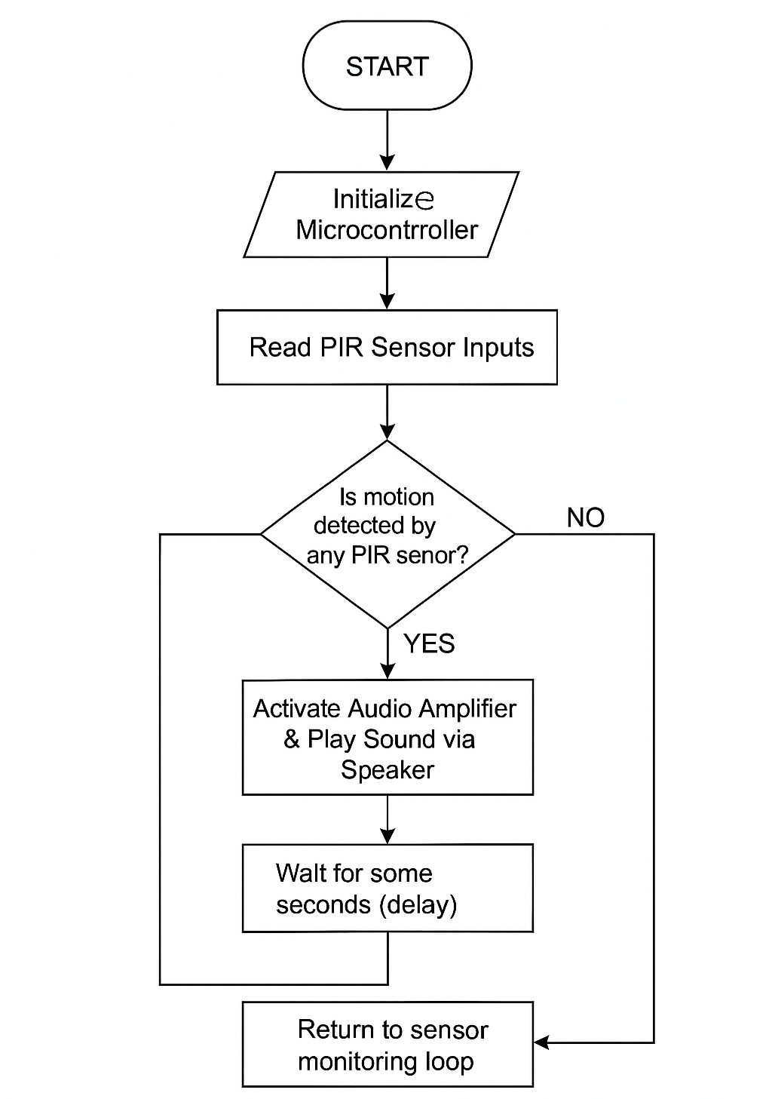
Flow chart of the smart scarecrow operation
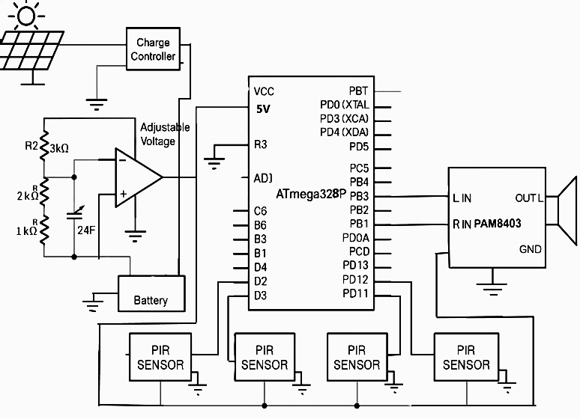
Figure 14: Circuit Diagram

CHAPTER FOUR
TESTS, RESULTS AND DISCUSSION
4.1 Introduction
This chapter presents the outcomes obtained from the design and construction of the smart scarecrow system. The analysis of the test results, performance evaluation, and power system behavior is discussed to validate the system objectives and design expectations.
4.2 System Testing and Operation
Tools used for testing the system
- Digital multimeter
- Distance meter
- Stop watch or timer
- Microcontroller programmer/debugger (Arduino IDE)

After assembling the components: solar panel, charge controller, voltage regulator, microcontroller (ATmega328P), PIR sensors, PAM8403 amplifier, and speaker (as shown in the circuit diagram in chapter 3) various functional tests were conducted under real field conditions. The system was evaluated for its detection accuracy, power efficiency, autonomous operation, and sound deterrent response.
The digital multimeter was used to measure the DC voltage levels from the solar panel, battery, adjustable voltage regulator and micro controller power lines. The distance meter is a mobile application that manually validate the motion detection range by measurement of the distance as human walks toward the detection range of the PIR sensors. Finally, the stopwatch was used to record the response time of the system from detection to the sound output.
The device has been built to be waterproof, it can be used in a heavy downpour (As shown in figure 15). The component with the highest risk of damage from moisture is the circuit board that controls the motion sensors and sound system of the scarecrow. However, the entire device can handle light rain, foggy, hot and windy conditions.

4.2.1 Animal Detection Test
The PIR sensors were placed in different directions (N, S, E, W) to provide 360° field monitoring. When movement (such as from goats, birds, or monkeys) was detected within a 6–7 m range, the sensors sent a high signal to the microcontroller, which then activated the amplifier circuit to play a preloaded deterrent sound. Figure 16 and 17 shows the rear and front view of the smart scare crow system.

Sensor | Detection Range | Response Time | Status
PIR 1 | 6.3 m | <1 s | Active
PIR 2 | 6.0 m | <1 s | Active
PIR 3 | 6.2 m | <1 s | Active
PIR 4 | 6.5 mt | <1 s | Active

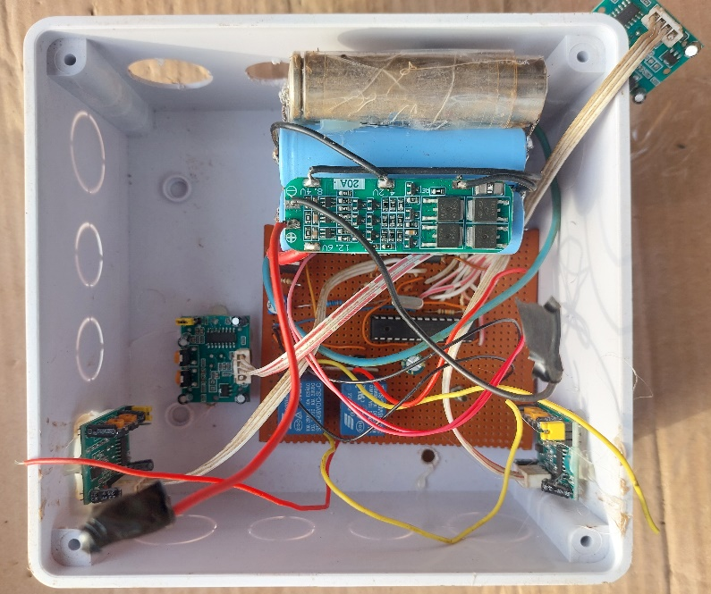
Figure 15: The voltage regulator circuit and PIR sensors connected to the IC
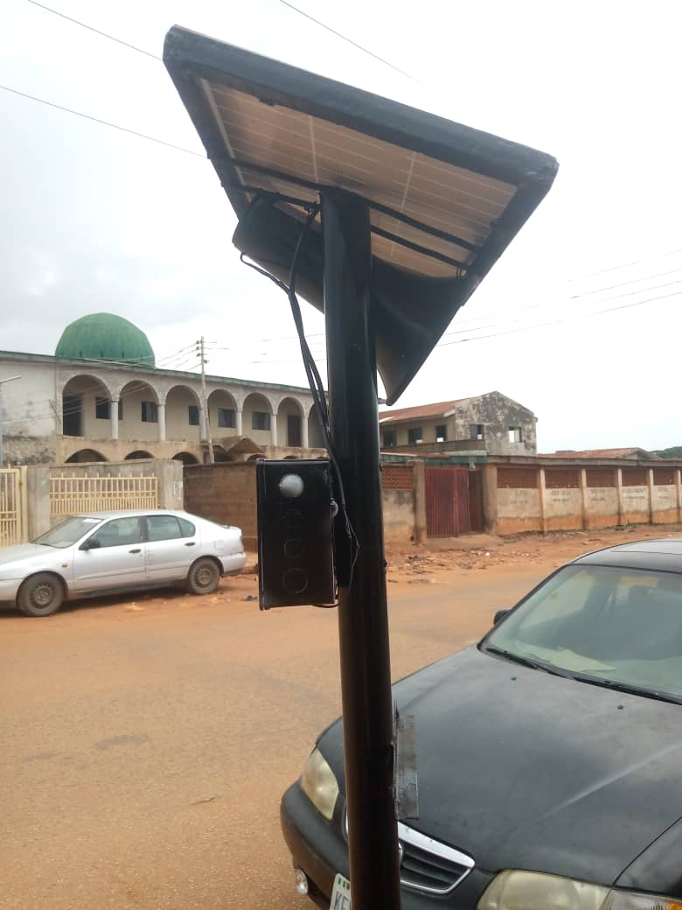
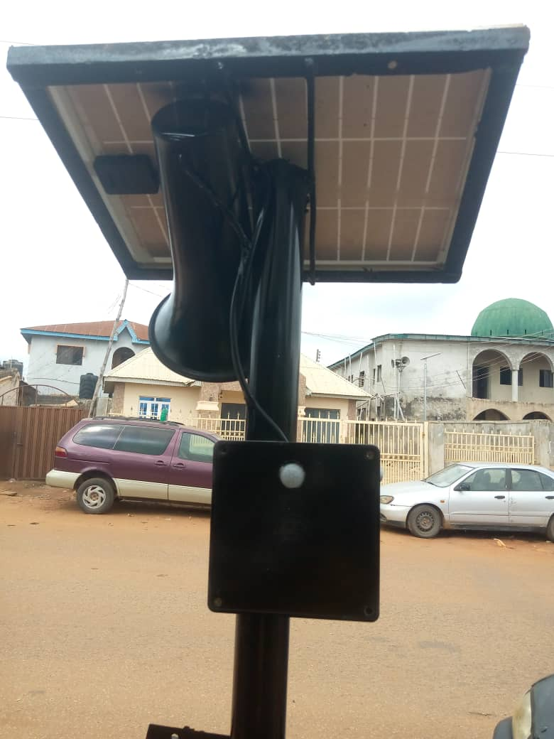
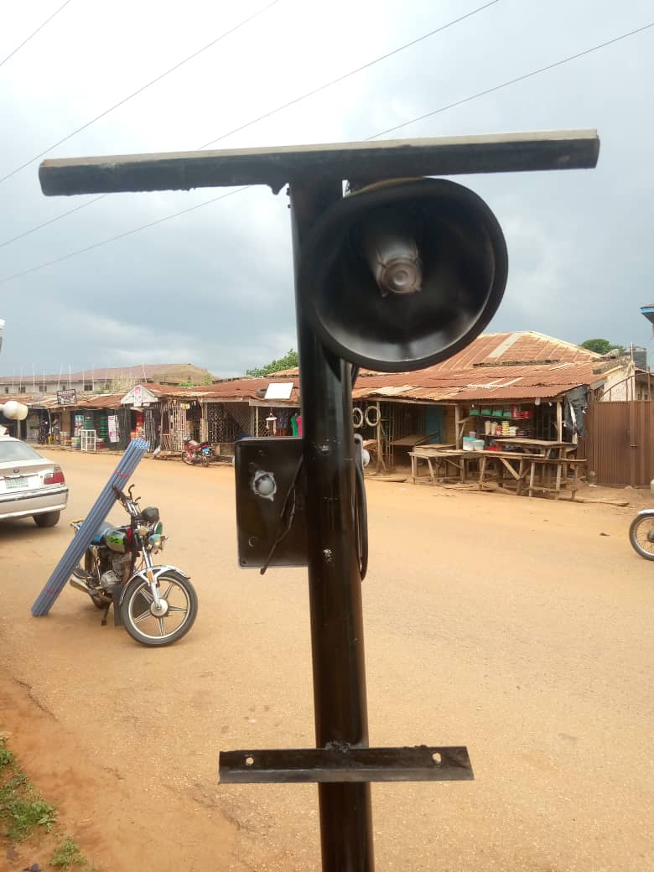
Figure 16: Side views of the smart scarecrow system
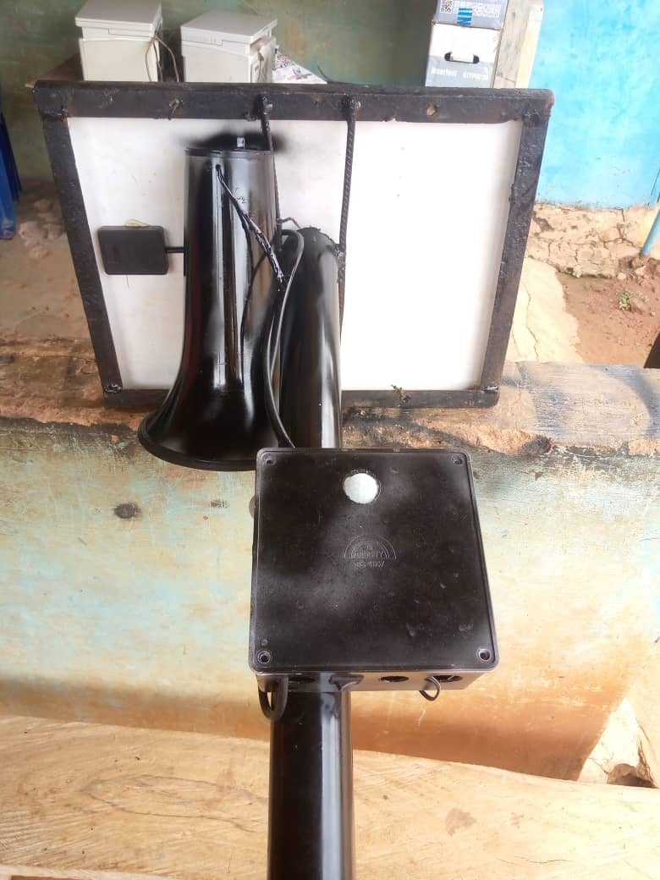
Figure 17: Rear and back view of the smart scarecrow system

4.3 Power System Performance

4.3.1 Solar Charging
A 10 W solar panel provided adequate power to charge the 12 V 7 Ah battery under 4–5 peak sun hours per day. The charge controller regulated overcharge and deep discharge, maintaining battery health.

4.3.2 Battery Endurance Test
The battery supported the system for up to 4 days without sunlight, in line with the calculated autonomy:
Expected runtime: 4 days
Measured runtime: 3.8–4.2 days
Average daily consumption: 10.3 W/h
The battery was not discharged below 11.4 V, protecting against deep cycling damage.

4.4 Voltage Regulation and Efficiency
The adjustable voltage regulator, configured via a resistive divider (R1 = 1 kΩ, R2 = 3 kΩ), stepped down the 12 V battery to 5 V for the microcontroller and sensors. Measurements showed:
Output voltage: 5.01 V (stable)
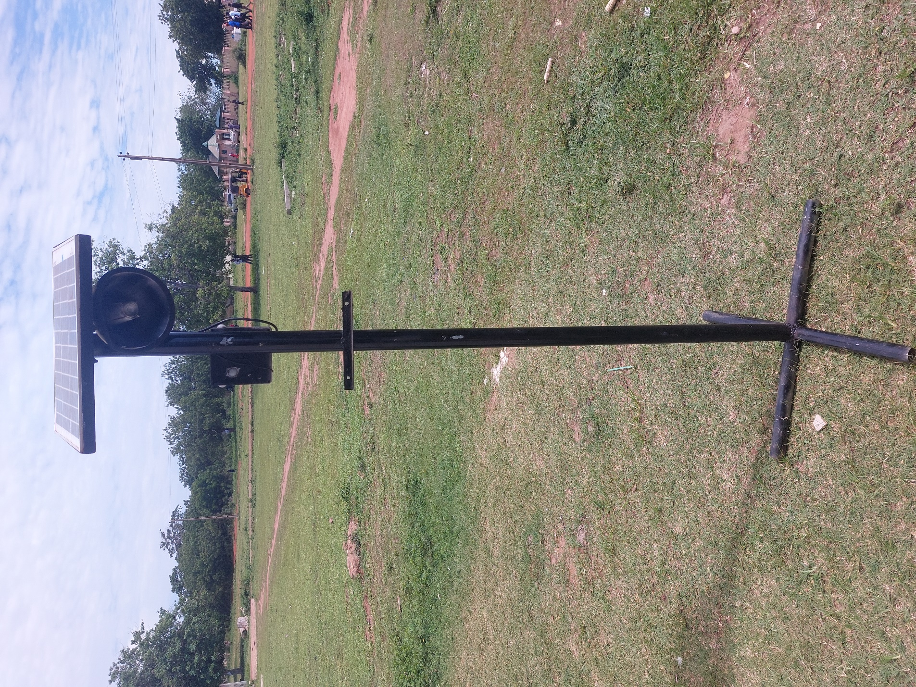Figure 18: The overall view of the smart scarecrow system
CHAPTER FIVE
CONCLUSION AND RECOMMENDATION

5.1 Conclusion
This project successfully designed, constructed, and tested a smart scarecrow system capable of autonomously detecting intruding animals and deterring them using sound, all powered by a standalone solar energy unit. The integration of PIR sensors in all directions ensured comprehensive field coverage, and the use of an audio amplifier made deterrent signals loud and effective.
The solar-powered architecture and energy-efficient components allowed for continuous 24-hour operation, fulfilling the design goal of zero grid-dependence and sustainability.

5.2 Recommendations
Based on the performance of the system, the following recommendations are made for future improvements:
- Use of Ultrasonic or RF Deterrents: In addition to sound, future systems may integrate ultrasonic emitters or flashing LEDs for multi-sensory deterrent effects.
- Battery Upgrade: Incorporating a Lithium-Ion battery with built-in BMS could improve weight, efficiency, and lifecycle performance.
- Wireless Monitoring: Adding a GSM or LoRa module can enable remote monitoring and alert functions for farmers.
- Rain and Dust Protection: Encasing the electronics in IP65-rated enclosures will enhance outdoor durability.
- AI-Based Detection: Incorporate camera and machine learning models for distinguishing between animals and human movement, reducing false alarms.
- Mechanical arm: incorporating servo motors in the design to create a robotic arm will enhance more reliability in the chasing away birds and animals.

REFERENCE
[1] R. Odongola Wilfred, "Design and construction of an automatic bird and animal repellent scarecrow,” Kampala F Manzi, 2006 [Online]. Available: ir.kiu.ac.ug. [Accessed: Nov. 19, 2024].
[2] B. E. Sullivan, "Bird or animal repellent system," journals plos, 2010. [Online]. Available: journals.plos.org. [Accessed: Nov. 19, 2024].
[3] Kim, "Design and fabrication of automated scarecrow," Academia, 2011. [Online]. Available: Academia.edu. [Accessed: Nov. 20, 2024].
[4] M. L. Avery and S. J. Werner, "Ecology and management of blackbirds (Icteridae) in North America," pp. 159–174, 2017.
[5] R. Wilfred, "Final survey report on the status of rice production processing and marketing in Uganda," Kampala International University, School of Engineering and Applied Science, Dept. of Electrical and Telecommunication, pp. 36–40, 2019.
[6] N. Alflitto and T. Degomez, "Sonic pest repellents," College of Agriculture, University of Arizona, Tucson, AZ, 2014.
[7] Demont, "Design of solar automated scarecrow," iemsociety, 2013. [Online]. Available: iemsociety.org. [Accessed: Nov. 20, 2024].
[8] A. Ruelle and R. Brugger, "Realizing Africa’s rice promise," journal, 1982, pp. 241.
[9] R. Brugger, "Proceedings of the Vertebrate Pest Conference," vol. 10, no. 10, March 1981.
[10] Mullie, "Realizing Africa’s rice promise," journal, 1999, p. 241.
[11] Ward, "Realizing Africa’s rice promise," cabidigitallibrary, 1979. [Online]. Available: cabidigitallibrary.org. [Accessed: Nov. 20, 2024].
[12] R. Wilfred, "Final survey report on the status of rice production processing and marketing in Uganda," Kampala International University, School of Engineering and Applied Science, Dept. of Electrical and Telecommunication, pp. 36–40, 2019.
[13] L. Wang, Y. Zhang, and J. Li, "Use of PIR Sensors in Intrusion Detection Systems," Sensors and Actuators Journal, vol. 45, no. 2, pp. 123–130, 2019.
[14] C. Nwankwo, T. Abdulrahman, and R. Lado, "Ultrasonic Sensing for Object Detection in Agricultural Fields," in Proc. IEEE AgriTech Conf., pp. 55–60, 2020.
[15] T. Kumar and K. Adegbite, "Wireless Agricultural Monitoring Using Arduino and ESP32," African J. of Tech Research, vol. 12, no. 2, pp. 98–107, 2020.
[16] V. Sharma, D. Patel, and J. Kaur, "Low Power ESP32 Applications in Smart Environments," Embedded Systems Today, vol. 14, no. 1, pp. 11–19, 2022.
[17] B. Jones and P. Muller, "Animal Deterrence via Acoustic Emission: A Field Study," Applied Ecology Reports, vol. 5, no. 4, pp. 222–231, 2018.
[18] A. Singh and M. Reddy, "Development of Multi-Directional PIR Sensor Networks," Int. J. of Smart Agriculture, vol. 6, no. 3, pp. 77–84, 2021.
[19] S. Mohammed and A. Ajayi, "Solar-Powered Microcontroller Applications in Remote Areas," Energy and Environment Research, vol. 7, no. 1, pp. 45–54, 2019.
[20] H. Ahmed and C. Obi, "Energy Efficiency in Off-grid Sensor Systems," Renewable Energy Applications Journal, vol. 3, no. 3, pp. 90–97, 2021.
[21] L. Bello, J. Ayoade, and M. Musa, "Designing Weatherproof IoT Devices for Agricultural Use," Int. J. of IoT & Agriculture, vol. 9, no. 1, pp. 31–39, 2022.
[22] J. Oliveira et al., "IP-Rated Enclosures for Harsh Outdoor Conditions: A Review," IEEE Trans. on Industrial Electronics, vol. 65, no. 6, pp. 4883–4891, 2021.
[23] S. Khan, M. Raza, and H. Ali, “Effectiveness of Traditional and Smart Scarecrows in Agricultural Fields,” J. Agric. Sci., vol. 10, no. 2, pp. 55–62, 2018.
[24] P. Rao and M. Patel, “Design of Automated Pest Deterrent Systems,” J. Agric. Eng., vol. 24, no. 3, pp. 112–120, 2019.
[25] A. Singh and V. Yadav, “AI-Powered Image Detection in Smart Farming,” Comput. Vis. Agric., vol. 3, no. 1, pp. 45–53, 2020.
[26] Y. Chen and L. Zhao, “IoT-based Pest Deterrent Systems in Precision Agriculture,” Sensors Autom. J., vol. 18, no. 1, pp. 33–40, 2021.
[27] R. Gupta and N. Sharma, “Remote Monitoring in Smart Farming Using IoT Platforms,” Int. J. Smart Agric., vol. 5, no. 4, pp. 87–94, 2020.
[28] M. Olatunde, K. A. Musa, and A. A. Sule, “Solar Power Systems for Agricultural IoT Devices in Rural Africa,” Renew. Energy Rep., vol. 7, no. 2, pp. 101–109, 2022.
[29] R. Patel, S. Mehta, and N. Desai, “GSM-Based Smart Scarecrow System for Farmland Protection,” in Proc. India IoT Conf., New Delhi, India, 2021, pp. 88–93.
[30] O. Afolabi and A. Bello, “Development of a Low-Cost Solar Powered Smart Scarecrow,” Niger. J. Eng., vol. 29, no. 1, pp. 66–72, 2022.
[31] H. Zhou, X. Wang, and D. Liu, “Bird Species Recognition and Repellent Actions in Smart Farms,” Int. J. AI Agric., vol. 4, no. 1, pp. 25–34, 2021.
[32] S. Lee, J. Choi, and M. Park, “Intelligent Bird Deterrent System Using Deep Learning,” J. Robot. AI, vol. 12, no. 2, pp. 77–85, 2023.

APPENDIX I
CODE FOR THE MICRO CONTROLLER
#include <SD.h>
#include <TMRpcm.h>
#include <SPI.h>
#define SD_ChipSelectPin 4 // SD card module CS pin
#define motionPin 2 // PIR sensor 1
#define motionPin 3 // PIR sensor 2
#define motionPin 4 // PIR sensor 3
#define motionPin 5 // PIR sensor 4
#define speakerPin 9 // Speaker pin
#define ledPin 13 // LED pin
TMRpcm audio;
void setup() {
pinMode(motionPin, INPUT);
pinMode(ledPin, OUTPUT);
Serial.begin(9600);
if (!SD.begin(SD_ChipSelectPin)) {
Serial.println("SD card initialization failed!");
return;
}
audio.speakerPin = speakerPin;
Serial.println("System ready.");
}
void loop() {
int motionDetected = digitalRead(motionPin);
if (motionDetected == HIGH) {
Serial.println("Motion detected!");
digitalWrite(ledPin, HIGH); // Turn on LED
playSound();
delay(5000); // Wait 5 seconds before detecting motion again
} else {
digitalWrite(ledPin, LOW); // Turn off LED
}
}
void playSound() {
// Randomly select a sound file to play
int soundChoice = random(1, 4);
switch (soundChoice) {
case 1:
audio.play("bird.wav"); // Bird distress call
break;
case 2:
audio.play("pig.wav"); // Pig squeal
break;
case 3:
audio.play("cow.wav"); // Cow moo
break;
}
delay(3000

APPENDIX II
BILL OF ENGINEERING MEASUREMENT AND EVALUATION (BEME)
S/N | LIST OF ITEMS | DESCRIPTION | QUANTITY | PRICE | AMOUNT
1 | PIR SENSORS | SENSORS | 4 PCS | #15,000 | #60,000
2 | ATMEGA 328P | MICRO CONTROLLER | 1 PCS | #20,000 | #20,000
3 | SOLAR PANEL | PV MODULE (20W,12V) | 1 PCS | #25,000 | #25,000
4 | BATTERY | LITHIUM (12V,10A) | 1PCS | #65,000 | #65,000
5 | SPEAKER HORN | SOUND MODULE | 1PCS | #30,000 | #30,000
6 | PAM8403 | AMPLIFIER CIRCUIT | 1PCS | #6,500 | #6,500
7 | LM358 | OPERATIONAL AMPLIFIER | 1 PCS | #8,00 | #8,00
8 | IN4007 | DIODES | 6 PCS | #100 | #600
9 | PLASTIC BOX | 6 by 3 | 1 PCS | #6,500 | #6,500
10 | GALVANIZED PIPE | POLE | 1 PCS | #45,000 | #45,000
11 | BOLTS & NUTS | SCREW MATERIALS | 2 PCS | #500 | #1,000
12 | MEMORY CARD | MEDIA STORAGE | 1 PCS | #5,000 | #5,000
13 | CAPACITORS | FOR CIRCUIT | 8 PCS | #500 | #4000
14 | CRYSTAL OSCILLATOR | COMPONENT | 1 PCS | #1,500 | #1,500
15 | BLACK PAINT | SPRAY PAINT | 3PCS | #2,000 | #2,000
16 | VERO BOARD | CIRCUIT BOARD | 1 PCS | #500 | #500
17 | TRANSPORTATION |  |  | #5,000 | #5,000
18 | CONTIGENCY |  |  | #5,000 | #5,000
19 | TOTAL |  |  |  | #283,400

