DESIGN AND IMPLEMENTATION OF DOUBLE LIER SECURITY MODEL FOR SECURING MEDICAL RECORDS
(USING TEXT CRYPTOGRAPHY AND IMAGE STEGANOGRAPHY)
(A Case Study of Medical Center Kwara State Polytechnic, Ilorin)

BY
FASHANU LEKAN PETER
HND/23/COM/FT/0496

A Project Submitted to the
Department of Computer Science,
Institute of Information and Communication Technology
Kwara State Polytechnic, Ilorin

In Partial Fulfillment of the Requirements for the award of Higher National Diploma (HND) in Computer Science

May, 2025
CERTIFICATION
This is to certify that this project was carried out by FASHANU LEKAN PETER with matriculation number HND/23/COM/FT/0496 and it has been read and approved as meeting the requirements for the award of Higher National Diploma (HND) in Department of Computer Science, Institute of Information and Communication Technology (IICT), Kwara State Polytechnic.

------------------------------------- ----------------------
MR ABIODUN E. T. Date
(Project Supervisor)

--------------------------------- ----------------------
MR OYEDEPO F.S. Date
(Head of Department)

----------------------------------- ---------------------
External Supervisor Date

DEDICATION
I dedicate this project to Almighty God who's protect me, guide me through this work a big thanks to Almighty God.

ACKNOWLEDGMENT
All praise is due to Almighty God for His grace, guidance, and strength throughout the course of this project. I am profoundly grateful to numerous individuals and institutions whose support and contributions were vital to the successful completion of this work.

Foremost, I extend my sincere appreciation to Mr Abiodun E. T. whose exceptional guidance, expertise, and unwavering support were instrumental in navigating the complexities of this research. His valuable insights and constructive feedback greatly shaped the direction and quality of this project. I am deeply thankful to my parents, Mr. and Mrs. DAVID FOLORUNSHO FABIYI, for their constant encouragement, prayers, and moral support throughout this journey. Their words of wisdom and emotional backing kept me focused and motivated during challenging periods. My heartfelt appreciation also goes to my entire family and friends, whose patience and uplifting presence provided strength and inspiration at every stage of this endeavor.
I would also like to acknowledge the Head of the Department of Computer Science, Mr. Oyedepo F. S., along with other dedicated staff members of the department. Their insightful critiques and academic support were invaluable in refining the scope and content of this work.
I extend my heartfelt gratitude and love to my father, DAVID FOLORUNSHO FABIYI, for his unwavering support and guidance. In loving memory of my mother, JULIANA ODUNOLA FABIYI, may her soul rest in peace. I'm also grateful to the entire FABIYI family for their love, care, and unity.
Lastly, I am sincerely grateful to all the participants and respondents who willingly provided their time, data, and perspectives for this research. Their contributions played a crucial role in the empirical validation and practical relevance of this study.
LIST OF FIGURES
Figure:2.1 Steganography Techniques 16
Figure 3.1: Algorithm for E-health Record Encryption and Decryption 20
Figure 3.2: System architecture 23
Figure 4.1: Assign Patient – 0003 25
Figure 4.2: Patient Record 25
Figure 4.3: Form to Enroll Record 26
Figure 4.4: The registered patient form 27

LIST OF TABLES
Table 2.1: Cryptography vs. Steganography 13
Table 4.1: Database 27

ABSTRACT
The successful storage, manipulation and retrieval of electronic medical records are some of the important functions of Electronic-Health Record (EHR) Systems. More so, the confidentiality and integrity of health information is of paramount importance to healthcare management organizations. Unfortunately, the occurrence of information security breaches with regards to EHR, which include loss of valuable data as a result of theft by unauthorized users, is increasingly becoming worrisome situations. Furthermore, these security challenges have led to cases of intentional or unintentional disclosure of vital patients’ information among others. Interestingly, previous studies attempted to implement secure systems in domains like finance, communication and commerce using asymmetric or visual cryptography. However, based on reviewed literatures, this security techniques are yet to be combined and applied as worthwhile approach to address authorization challenges in the EHR domain. Thus, a prototype web-based e-health record system was developed and combination of asymmetric and visual cryptographies were incorporated into the system as authorization mechanism to ensure confidentiality and integrity of pertinent health information. Subsequently, the fortified E-health record system provided important functionalities of a typical EHR record system, as well as prevent unauthorized users from accessing vital information.
TABLE OF CONTENTS
TITLE PAGE PAGE
CERTIFICATION ii
DEDICATION iii
ACKNOWLEDGEMENT iv
LIST OF FIGURES v
LIST OF TABLES vi
ABSTRACT vii
TABLE OF CONTENTS viii
CHAPTER ONE: GENERAL INTRODUCTION
1.1. BACKGROUND TO THE STUDY 1
1.2 STATEMENT OF THE PROBLEM 2
1.3 AIM AND OBJECTIVES 3
1.4 SIGNIFICANCE OF THE STUDY 3
1.5 SCOPE OF THE STUDY 4
1.6 ORGANIZATION OF THE PROJECT 4
CHAPTER TWO: LITERATURE REVIEW
2.1 REVIEW OF RELATED WORK 5
2.2 ELECTRONICS HEALTH INFORMATION PRIVACY AND SECURITY 6
2.2.1 THREATS TO HEALTH INFORMATION PRIVACY 7
2.2.2 MODERN HEALTH INFORMATION SECURITY 9
2.3 APPROACHES COMBINING CRYPTOGRAPHY AND STEGANOGRAPHY 10
2.3.1 CRYPTOGRAPHY GOALS 11
2.4 STEGANOGRAPHY APPROACH 12
2.4.1 STEGANOGRAPHY TECHNIQUE 13
CHAPTER THREE: RESEARCH METHODOLOGY AND ANALYSIS OF THE EXISTING SYSTEM
3.1 RESEARCH METHODOLOGY 15
3.3 ANALYSIS OF THE EXISTING SYSTEM 16
3.3 PROBLEMS OF THE EXISTING SYSTEM 17
3.4 DESCRIPTION OF THE PROPOSED SYSTEM 18
3.5 ADVANTAGES OF THE PROPOSED SYSTEM 19
CHAPTER FOUR: DESIGN, IMPLEMENTATION AND DOCUMENTATION OF THE SYSTEM
  - DESIGN OF THE SYSTEM 20
4.1.1. OUTPUT DESIGN 20
    - INPUT DESIGN 21
4.1.3. DATABASE DESIGN 24
4.1.4. PROCEDURE DESIGN 24
4.2. IMPLEMENTATION OF THE SYSTEM 24
4.2.1. CHOICE OF PROGRAMMING LANGUAGE 24
4.2.2 HARDWARE SUPPORT 25
4.2.3 SOFTWARE REQUIREMENTS 25
4.2.4 CHANGE OVER TECHNIQUE 25
4.3 DOCUMENTATION OF THE SYSTEM 25
4.3.1 PROGRAM DOCUMENTATION 26
4.3.2 OPERATING THE SYSTEM 26
4.3.3 MAINTAINING THE SYSTEM 27
CHAPTER FIVE: SUMMARY, CONCLUSION AND RECOMMENDATIONS
5.1 SUMMARY 28
5.2 CONCLUSION 27
5.3 RECOMMENDATIONS 28

REFERENCES
APPENDICES
APPENDIX 1: SIGN UP 39
APPENDIX 2: FORM TO ENROLL RECORD 40
APPENDIX 3: REGISTERED PATIENTS FORM 41
APPENDIX 4: SOURCE CODE 42

CHAPTER ONE
GENERAL INTRODUCTION

1.1. BACKGROUND TO THE STUDY
Medical Record and Management Systems Society defines electronic health record (EHR) as “a secure, real-time, point-of-care, patient centric information resource for clinicians” (HIMSS, 2023). EHR is on the verge of receiving widespread adoption as an instrument for improving the understanding of the state of health of individuals as it contains useful, legal and computerised historical health data from a variety of sources. Over time, a patient’s EHR accumulates significant information, such as identifying information, hospital visitations, laboratory data, surgery, radiology reports, allergies, vital signs, immunisations, prescriptions, sexual preference, psychological profiles, physician progress notes and among other relevant data that defines a medical record (Mercuri, 2022; Tiwari and Kumar, 2022). The importance of these data to healthcare providers, patients and cybercriminals made it necessary that the EHR designs be responsible for securing patients’ personal data, health records and managing the access rights to them (IMIA, 2020; Brumen et al., 2022; CTI, 2021).
Recently, technology faces various modes of intrusion which include; the integration of incorrect data or destructive programs into information systems, theft resulting to loss of important data or programs from a system and overall takeover and manipulation of a system's set-up and performance. Usually, hackers carryout these security breaches as a means of satisfying their own agenda. More so, criminals use it to improve their own interests, as well as commercial organizations that utilize it as mechanisms for neutralizing rivals or terrorists whose attacks can spread over a wide geographical range, eventually producing related effects irrespective of the criminal (Onuiri, Idowu, &Komolafe, 2022). In several studies, patients’ participation has been identified as crucial to manage records, because patients’ growing concern over the privacy and security of their personal and sensitive data stored in EHR has been a contributing factor to the slow adoption of this technology (Escarfullet et al., 2019; Dinev et al., 2020). Based on a survey report, 73% of information privacy and security issues reported by health organisation over the years involved electronic data (Hewapathiranae, 2019). Studies have shown that millions of patient records have been breached and are at the risk in the hands of malicious users (Robertson, 2018; Harris, 2016). In the USA alone, since 2005, more than 300 data breaches in which 100,000 or more records were compromised have been publicly disclosed in the health industry (Collins and Robertson, 2022). Also, since 2009, the annual number of cyber-attacks against the healthcare sector has drastically increased; often the number of attacks exceeds the previous year’s count by at least 40% (ICIT, 2021). Similarly, more often than expected, the majority of threats that healthcare organisations face are internal among other sources of threats (Gordon et al., 2021;). With inside attacks either continuously outnumbering or being the leading cause of external threats, most research still paid more attention to outsiders. The cost of privacy and confidentiality breaches is very difficult to recover for both the healthcare provider and patient (Appari and Johnson, 2019).
Asymmetric cryptography otherwise known as public key cryptography is a data security technique, which uses two distinct keys in cryptographic process. Unlike symmetric cryptography that uses same key for encryption and decryption, asymmetric process includes generations of the two distinct keys (private and public) from complex mathematical algorithm. The public key is made available to all message senders for encryption purpose, whereas, the private key is reserved as secret and only known to the receiver (owner of the public key) for message decryption. While key generation is faster with symmetric cryptography, the reverse is the case with asymmetric cryptography. Nevertheless, safeguarding a key from unauthorised user during transfer among legitimate users is the main setback for symmetric cryptography, while such challenge does not arise in asymmetric cryptography.

1. 2 STATEMENT OF THE PROBLEM
Information security issues with regards to Electronic-Health Records (EHR’s) is increasingly becoming worrisome, this brings about the urgent need to mitigate these challenges so as to curb unauthorized manipulation, storage and retrieval of information, thereby, retaining required confidentiality, availability and integrity of the EHR’s. Otherwise, any interception or interruption, may result to issues such as inaccurate diagnosis and medication, and in the worst case, death.
For privacy reasons, patients at some point may be unwilling to disclose important information about some health problems such as psychiatric behaviour and HIV as their violation or disclosure may lead to social stigma, unfair treatment by employers and possibly irreversible damage to their professional reputation (Carroll, 2021). Privacy and security are crucial factors in electronic healthcare; cryptography is the science of information scrambling and it has been recommended to be used everywhere for ensuring privacy and security (Grunwel and Sahama, 2021). Modern encryption offers a powerful set of methods to guarantee information access for authorized users while thwarting the adversary's malicious objectives. There is a need data privacy in health record on unsecured channel. To solve the issue of information threats, several methods have been proposed in the area of systems security under information hiding and encryption (Cheddad, Condell, Curran, McKevitt, 2022).
Through cryptography, a number of autonomous patients controlled medical record systems have been proposed and were discussed in Omotosho and Emuoyibofarhe (2019). Cryptographic-based-EHR has become very popular but patients’ privacy could still be violated, if in a patient controlled system, encryption keys are not efficiently managed. Likewise, clinician work flow would be hampered, if in the course of ensuring privacy, health data are not available in decrypted form for authorized access. Therefore, this project develops a double lier security model for securing medical records text cryptography and image steganography.

1. 3 AIM AND OBJECTIVES
The aim of this research work is to develop a double lier security model for securing medical records using text cryptography and image steganography. In other to achieve this aim, the following specific objectives were formulated to:
- Design a double lier security model for securing Medical Records System (MRS).
- Implement system developed in (i) using text cryptography and image steganography.
- Evaluate the performance of text cryptography and image steganography for securing medical record.
1.4 SIGNIFICANCE OF THE STUDY
This system significantly provides a medium through which the privacy of a patient’s electronic healthcare record could be preserved by enhancing the security measures using text cryptography and image steganography on the Medical Records System (MRS). since they are sensitive to patients and their caregivers.
The need for modern cryptography to provide techniques and keys to protect
record is vital (Muharrem, 2019). The process of encryption and decryption is essential for the health record is highly sensitive for information privacy. Due to the significant function that information plays, attackers are focusing on computer systems and open channels of communication in an effort to either acquire sensitive data or take down the essential information system. While the need for steganography is for robust privacy using image steganography techniques.
1.5 SCOPE OF THE STUDY
This system proposes a double lier model cryptography techniques with steganography techniques for secure securing medical records. The two system, image steganography and text cryptography are different techniques to maintain data confidentiality and integrity.
1.6 ORGANIZATION OF THE PROJECT
The project is organized into five chapters. Chapter one gives the background to the study, statement of the problem to be addressed, the aim and the formulated objectives. It also discuss the scope of the study, the significance of the study, definitions of some necessary terms and organization of the report. Chapter two presents the review of related literature. A review security system in health record, and cryptography, the area of their applications, benefits, and the algorithms.
More so, chapter three focused on the methodology of the research, the proposed system,. The algorithm of cryptography with the advantages. Chapter Four presents the discussion of the results and evaluation of the system. Lastly, chapter five discussed the summary of findings, conclusions and some recommendations to improve the study.

CHAPTER TWO
LITERATURE REVIEW

2.1 REVIEW OF RELATED WORK
Harman et al., (2022) conducted systematic analysis of health management system. The authors highlighted numerous advantages of electronic system over manual approach to health management. Amongst others, the authors identified reduced storage space, physical security of records and delay in processing health information as major drawbacks of manual approach. However, the authors emphatically raised concern over security of patient information by healthcare handlers. Thus, Harman et al. (2021) suggested the use of encryption as a proactive countermeasure to ameliorate security of health information in terms of confidentiality for devices employed in processing and disseminating such crucial information. In a similar systematic review, Fernández et al., (2021) agreed with Harman et al. (2020) on the major benefits of E-Health management systems and the importance of encryption scheme, but emphasised the need for more concerted efforts to address emerging security and privacy threats, because access to E-health systems becomes ubiquitous among stakeholders.
Likewise, Onuiri et al. (2023), explored various cyberspace challenges with respect to safeguarding information, investigating cyberspace threats, identifying stakeholders and transmitting information in E-health record system. The authors opined the combination of cryptography and biometric authentication as mitigating strategy for threats associated with e-health systems. Empirically, Qureshi et al. (2022) studied the effect of E-health which comprised of Telemedicine and mobile health on distant or remote locations. Interestingly, the authors stated the important characteristics of a successful and useful e-health system to include user-friendliness, easy-to-use and well integrated functionalities, as well as a backup, tracking and alert facilities. The authors observed a tremendous shift in e-health adoption, but reported low adoption in developing countries due to inadequate information on e-health websites. Thus, Qureshi et al. (2021) proposed that a qualitative, secured and well-structured e-health system will enhance the operational efficiency and sustainability of the healthcare institutions.
Also, Hawkes, Yasinsac and Cline (2022) analysed the possibility of securing financial documents with visual cryptography. The authors developed an application named VCRYPT which was described as a quick and uncomplicated visual cryptography technique. The VCRYPT is meant for privacy protection when data transits between offices, thereby preserving the integrity of document.
According to Hawkes et al. (2020), previous visual cryptography systems suffered from the decoded images having a greying-effect or the deciphered image being blurry and much obscurer than the original image. Consequently, the VCRYPT application addressed this problem and also reduced the computational impact. Furthermore, in order to enhance the performance of visual cryptography irrespective of domain of application, D’Arco and De Prisco (2022) proposed the deterministic and random grid models. However, the authors reported issues relating to contrast, pixel expansion and randomness reduction in both models.

Recently, Okkali and Sandikkaya (2024) applied visual cryptography to facial recognition in surveillance system for privacy preservation. The system employed facial characteristics of targeted person is concealed and split into n shares which are put into distinct storage areas and under the control of distinct entities. More so, Kester (2022) developed a visual cryptographic encrytption system for medical image using pixel shuffling procedure. The system used algorithm that shuffled the red, blue and green (RGB) values of a pixel using an encryption key generted from the image. However, the system is limited to medical image which is only one of the the file formats involved in a comprehensive e-health record system.
2.2 ELECTRONICS HEALTH INFORMATION PRIVACY AND SECURITY
Privacy is an underlying governing principle of the patient – physician relationship for effective delivery of healthcare. Patients are required to share information with their physicians to facilitate correct diagnosis and determination of treatment, especially to avoid adverse drug interactions. However patients may refuse to divulge important information in cases of health problems such as psychiatric behavior and HIV as their disclosure may lead to social stigma and discrimination (Applebaum 2022). Over time, a patient‘s medical record accumulates significant personal information including identification, history of medical diagnosis, digital renderings of medical images, treatment received, medication history, dietary habits, sexual preference, genetic information, psychological profiles, employment history, income, and physicians‘ subjective assessments of personality and mental state among others (Mercuri 2024).
Patient health records could serve a range of purposes apart from diagnosis and treatment provision. For example, information could be used to improve efficiency within healthcare system, drive public policy development and administration at state and federal level, and in the conduct of research to advance medical science (Hodge 2023). A patient‘s medical records are also shared with payer organizations such as insurance, Medicare or Medicaid to justify payment of services rendered by physicians. Healthcare providers may use records to manage their operations, to assess service quality, and to identify quality improvement opportunities. Furthermore, providers may share health information through a regional 4 health information organization to facilitate care services. Medical information of patients is also used for common good through federal and state government interventions regarding public health management, hospital accreditation, medical research, and for managing social and welfare systems.

2.2.1 THREATS TO MEDICAL RECORDS PRIVACY
Threats to patient privacy and information security could be categorized into two broad areas: (i) Organizational threats that arise from inappropriate access of patient data by either internal agents abusing their privileges or external agents exploiting vulnerability of information systems, and (ii) Systemic threats that arise from an agent in the information flow chain exploiting the disclosed data beyond its intended use (NRC 2020).
- Organizational Threats: may assume different forms, such as an employee who accesses data without any legitimate need or an outside attacker (hacker) that infiltrates organization‘s information infrastructure to steal data or render it inoperable. At the outset, these organizational threats could be characterized by four components – motives, resources, accessibility, and technical capability (NRC 2020). Depending on these components, different threats may pose different level of risk to organization requiring different mitigation and prevention strategies. Motives could be both of economic or noneconomic nature. For some, such as insurers, employers, and journalists, patient records may have economic value, while others may have noneconomic motives such as a person involved in romantic relationship. These attackers may have resources ranging from modest financial backing and computing skills to a well-funded infrastructure to threaten a patient as well as the operations of a healthcare organization. The attackers may require different types of access to carry out their exploits, such as access to the site, system authorization, and data authorization. In addition, threats could depend on technical capability of attackers who may be novice or sophisticated programmers. Moreover, with the growing underground cyber economy (Knapp and Boulton 2022), an individual with the intent to acquire data and possessing adequate financial resources may be able to buy services of sophisticated hackers to breach healthcare data. Recent studies suggest that the broad spectrum of organizational threats could be categorized into five levels, in the increasing order of sophistication (NRC 2021; Rindfleisch 2021):
a. Accidental disclosure: healthcare personnel unintentionally disclose patient information to others, e.g. email message sent to wrong address or an information leak through peer-to-peer file sharing.
b. Insider curiosity: an insider with data access privilege pries upon a patient‘s records out of curiosity or for their own purpose, e.g. a nurse accessing information about a fellow employee to determine possibility of sexually transmitted disease in colleague; or medical personnel accessing potentially embarrassing health information about a celebrity and transmitting to media.
c. Data breach by insider: insiders who access patient information and transmit to outsiders for profit or taking revenge on patient.
d. Data breach by outsider with physical intrusion: an outsider who enters the physical facility either by coercion or forced entry and gains access to system.
e. Unauthorized intrusion of network system: an outsider, including former vengeful employees, patients, or hackers who intrude into organization‘s network system from outside and gain access to patient information or render the system inoperable.

- Systemic Threats: Etzioni (2019), in discussing the Limits to Privacy‘, makes a strong case that a major threat to patient privacy occurs not from outside of the information flow chain in healthcare industry but from insiders who are legally privileged to access patient information. For example, insurance firms may deny life insurance to patients based on their medical conditions, or an employer having access to employees‘ medical records may deny promotion, or worse, terminate employment. Patients and /or payer organizations may incur financial losses as a result of malpractices including upcoding of diagnoses, and rendering of medically unnecessary services. In summary, healthcare information systems could be subjected to security threats from one or more sources including imposter agents, unauthorized use of resources, unauthorized disclosure of information, unauthorized alteration of resources, and unauthorized denial of service (Win et al. 2021). Denial-of-service attacks via Internet worms or viruses, equipment malfunctions arising from file deletion or corrupted data, and the lack of contingency plans pertaining to offsite backup, data restoration procedures, and similar activities may also trigger HIPAA violations (Mercuri 2021).

2.2.2 MODERN MEDICAL RECORDS INFORMATION SECURITY
Modern Medical Records System (MRS) are large networked systems managing patient data with a multitude of users accessing health data for diverse contextual purposes within and across organizational boundaries. Role Based Access Control (RBAC), originally developed to manage access to resources in a large computer network (Sandhu et al. 2022), is generally presented as an effective tool to manage data access in healthcare industry because of its ability to implement and manage a wide range of access control policies based on complex role hierarchies commonly found in healthcare organizations (Gallaher et al. 2021). This stream of research primarily focuses on developing algorithms and frameworks to facilitate role based information access, and contextual access control (Covington et al. 2020; Motta and Furuie 2021).
Schwartmann (2022) extends this stream of research by proposing an enhanced RBAC system that incorporates attributable roles and permissions. This enhanced system implementation is theorized to reduce the burden of managing access privileges by lowering extremely high number of permissions and roles to a manageable size and hence reducing administrative cost. In addition progress is being made in several fronts, including use of autonomous agents to create privacy-aware healthcare applications (Tentori et al. 2021), authorization policy framework for peer-to-peer technology based distributed healthcare system (Al-nayadi and Abawajy 2021), encrypted bar code technology framework for electronic transfer of prescription (Ball et al. 2022), pseudonymous linkage (Reidl et al. 2021), and electronic consent models that allows patients to define which component of a medical record could be shared to whom (Nepal et al. 2021).
Despite significant progress in technological solutions to information access control, operationalization remains a major challenge (Lovis, et al. 2022). Healthcare organizations, because of the complex nature of data access for diverse purposes, often give broader access privileges and adopt ‗Break the Glass‘ (BTG) policy to facilitate timely and effective care. Røstad and Edsburg (2022), for example, report that 99% of doctors were given overriding privileges while only 52% required overriding rights on regular basis, the security mechanisms of health information systems were overridden to access 54% of patients‘ records. Another common pitfall of BTG policy is that such broad-based privileges could be misused by employees. To address these issues Bhatti and Grandison (2022), proposed a privacy management architecture (PRIMA) model that leverages artifacts such as audit logs arising from the actual clinical workflow to infer and construct new privacy protection rules. In particular, PRIMA implements a policy refinement module that periodically examines the access logs and identifies new policy rules using sophisticated data-mining techniques. These audit logs could, as well, be used by privacy officials to determine privacy violations, which in itself is a complex process and often requires merging data from disparate sources (Ferreira, et al. 2021). Unfortunately such data merging may cause potential disclosure of patients‘ sensitive information to the investigators against the patients‘ consent. In a related study, Malin and Arioldi (2022) developed a Confidential Audits of Medical Record Access (CAMRA) protocol to ensure privacy of patient‘s identity during such linking of disparate databases for comprehensive audit purpose without disclosing sensitive information.
2.3 APPROACHES COMBINING CRYPTOGRAPHY AND STEGANOGRAPHY
Comparative study of steganography and cryptography and surveyed a number of methods combining cryptography and steganography in one system.
In the following the basic differences between the cryptography and steganography tabulated.

TABLE 2.1: Cryptography vs. Steganography
SL.  No | Criteria/Method | Steganography | Cryptography
1. | Definition | Cover writing | Secret writing
2. | Input file | At least two | One
3. | Carrier | Any digital media | Usually text based
4. | Resultant Output | Stego file | Ciphertext
5. | Key | Optional | Necessary
6. | Security services offered | Authentication,  Confidentiality, Identification | Confidentiality, Identification, Data Integrity and Authentication Nonrepudiation
7. | Type of Attack | Steganalysis | Cryptanalysis

2.3.1 CRYPTOGRAPHY GOALS
By the use of cryptography many goals may be performed, these dreams may be both all finished at the same time in one software, or only considered one of them. These goals are:

- Confidentiality: it is the most essential intention, that guarantees that no person can recognize the acquired message besides the only who has the decipher key.
- Authentication: it's far the manner of proving the identification that assures the communicating entity is the one that it claimed to be. This means that the person or the system can prove their very own identities to other events who don’t have private expertise in their identities.
- Data Integrity: its guarantees that the acquired message has no longer been changed in any way from its unique shape. The data may additionally get modified by using an unauthorized entity deliberately or accidently. Integrity provider confirms that whether records is unbroken or now not because it became closing created, transmitted, or stored with the aid of a licensed user. This can be completed by using the usage of hashing at both facets the sender and the recipient for you to create a unique message digest and compare it with the only that acquired.
- Non-Repudiation:it's miles mechanism used to prove that the sender honestly sent this message, and the message became received by using the desired birthday celebration, so the recipient can't claim that the message turned into now not despatched. For instance, as soon as an order is placed electronically, a client cannot deny the acquisition order, if non-repudiation carrier was enabled on this transaction.
- Access Control: it's far the method of stopping an unauthorized use of resources. This aim controls who may have access to the resources, If you may get right of entry to, beneath which regulations and situations the get entry to may be happened, and what is the permission stage of a given access.

2.4 STEGANOGRAPHY APPROACH
Steganography is the art and technology of writing hidden message in information besides the sender and intended recipient. Security plays a vital function in steganography. Steganography is an encryption method that may be used along with cryptography as an extra steady technique wherein to protect statistics. Steganography techniques may be carried out to snap shots, a video file or an audio document. Typically, steganography is written in individual together with hash marking, but its usage interior photography is moreover commonplace (Abdalzaher et al. 2022).
Cryptography is approach of securing facts and conversation via use of codes so that simplest those humans for whom the records is supposed can recognize it and procedure it. Thus, preventing unauthorized get right of entry to data. In cryptography the strategies which can be use to shield statistics are acquired from mathematical idea and a hard and fast of guidelines-primarily based calculations called algorithms to convert messages in techniques that make it difficult to decode it. These algorithms are used for cryptographic key generation, virtual signing, verification to shield facts privateness, internet purchasing on net and to defend personal transaction including deposit card and debit card transactions (Hossain et al. 2021).
- Key primarily based assault: In this grid a mystery key has been used for registration and authentication. The attacker has implemented identified and unknown key assault on the clever grid to take keep of the name of the game key.
- Impersonation primarily based attack: In this grid the detrimental can look at clever meter statistics which coming from smart houses to read how a bargain electric electricity intake is accomplished. The attackers are tries to display and modify these facts.
- Data based assault: In this attack, the weight balancing among demand and era is required. The attackers are trying to regulate these facts. Further, the records-based totally assault is categorized into a number of assault, which consists of modification assault, data integrity assault, selected plaintext cipher text assault and repudiation assault.
- Physical based totally assault: In this assault, the attacker’s intention the hardware used in smart grid which encompass battery motors, a neighborhood aggregator and a proxy server. This assault is labeled into 4 sorts such as a differential attack, malware attack, and collusion attack and so on.

2.4.1 STEGANOGRAPHY TECHNIQUE
On the basis of different types of cover files Steganographic techniques can be classified as shown in the figure below
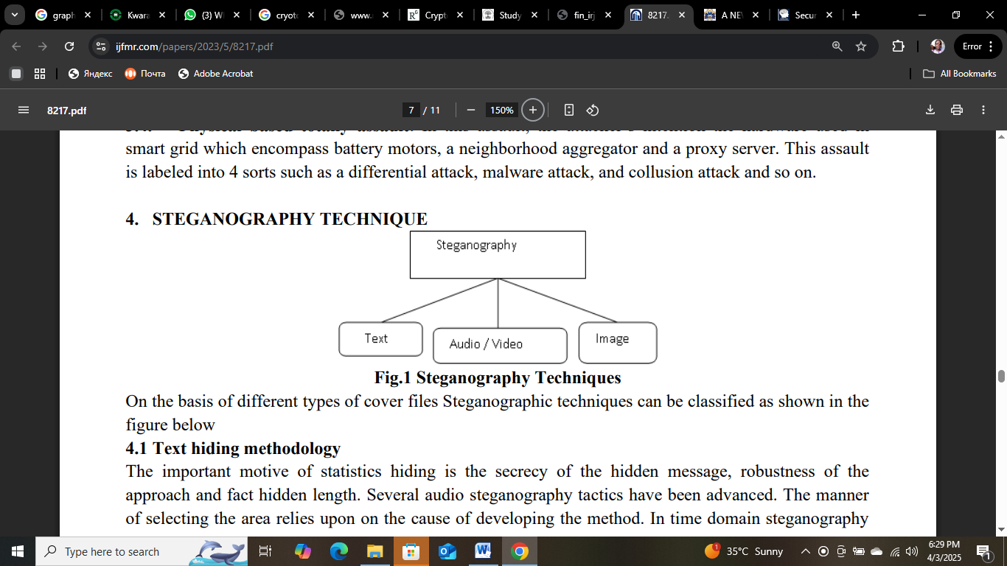
Figure:2.1 Steganography Techniques (Dong et al., 2021)

- Text hiding methodology: The important motive of statistics hiding is the secrecy of the hidden message, robustness of the approach and fact hidden length. Several audio steganography tactics have been advanced. The manner of selecting the area relies upon on the cause of developing the method. In time domain steganography technique watermark is straight away embedded into audio signal in which no domain remodel is required. The information and textual content that's to be hidden inside the cowl frame. The text has been converted into binary shape and every pixels of the frame had been calculated. Each little bit of the text message is to be changed with the two frames of LSB. Their goal was established an impervious way of retrieve the message. The frame has been examined and each pixels of frame is calculated. The approach is amazing transportable.
- Video Hiding methodology: The primary paintings of video steganography is cover secret message without affecting the great of the video file.In embedding algorithm, they first study the cover video. Now the video has been segments into frames and to compute the histogram of each body. If the 2-histogram fee of body is more or identical to histogram steady cost then determined the parameter used in recovery stage. Now embedded the hidden information into frame and get the stego image.
- Audio Hiding methodology: Audio steganography is one of the well-known records hiding techniques that embedded mystery facts into audio signs. On the opposite hand, the name of the game reality is hidden in a manner that unauthorized character isn't aware in the existence of the embedded statistics and except altering the first-rate of the quilt audio. Data hiding in audio regulate has numerous application consisting of safety of copyright audio sign ,covert communication ,hiding data that also can have an effect on the protection of governments and private .An excessive first-class audio steganography need to have the traits for profitable embedding and extracting records, high records charge and robustness of the embedded facts.

CHAPTER THREE
RESEARCH METHODOLOGY AND ANALYSIS OF THE EXISTING SYSTEM

3.1 RESEARCH METHODOLOGY
Visual cryptography is among the underlying techniques for guaranteeing security of images that concerns human visual system in digital space. Thus, this study utilised the algorithm medical image encryption. However, since typical E-health record comprises of both image and textual contents, then using asymmetric key for both contents will eliminate the need to have disparate encryption keys for a single cryptosystem. In addition, this approach promotes seamless integration and ciphering of text and image from system implementation point of view. Figure 3.1 shows the algorithm for the encryption and decryption processes, while Figure 3.2 presents the high-level diagram for same processes.
Text cryptography and image cryptography are among the underlying techniques for guaranteeing security of text/images that concerns human visual system in digital space.
Thus, this study utilized the text cryptography and image cryptography algorithm medical record system.
- Begin
- // encryption steps
- Import M-Record (Pr) = {plain text (Pt), plain image (Pi)}
- Convert {Pt, Pi} to Advance Encryption Standard (AES) equivalent {P’t, P’i}
- Generate encryption key (Ek) and decryption key (Dk) and with AES
- Encrypt P’t with AES as a:= (P’t, Ek)
- Encrypt P’i with visual steganography as v:= (P’i, Ek)
- Generate ciphered record (Cr) with Ea = g(v,a)
- Store Cr in M-Record database
- // decryption steps
- Retrieve Cr
- Decompose Cr to {P’t, P’t} with Da=g⁻¹ (Cr)
- Decrypt P’t with a⁻¹ := (P’I, Dk)
- Decrypt P’t with v⁻¹ := (P’I, Dk)
- Revert (P’t, P’i) to (Pt, Pi)
- Export (Pt, Pi) as plan E- Record record
- End

Figure 3.1: Algorithm for E-health Record Encryption and Decryption

3.2 ANALYSIS OF THE EXISTING SYSTEM
Kwarapoly Medical Center uses a single layer security model for Electronic Health Records (EHRs), relying on Role-Based Access Control (RBAC). Only authorized personnel with specific roles (e.g., doctors, nurses) can access patient records using unique login credentials.
One Layer Security Model:
- RBAC: Access restricted to authorized personnel based on roles
- Unique Login Credentials: Users authenticate with username and password
Potential Risks:
- Unauthorized Access: Insufficient access controls
- Data Breaches: Password vulnerabilities

3.3 PROBLEMS OF THE EXISTING SYSTEM
The problem that affect the efficient use of information exist in addition to the four basic components of information security are as follows:
- Even an authorized user may find it challenging to access strongly encrypted, authenticated, and password-protected information at a time when access is vital for decision-making. An intrusive party may attempt to assault the network or computer system and disable it.
- Cryptography cannot guarantee high availability, one of the core components of information security. Other defense strategies are required to counter dangers like denial of service (DoS) attacks and total information system failure.
- Selective access control, another essential requirement of information security, also cannot be met by using cryptography. For the same, administrative controls and processes must be used.
- The dangers and weaknesses that result from the shoddy systems, methods, and procedures are not protected by cryptography. These require the correct design and construction of a defensive infrastructure to be installed.

3.4 DESCRIPTION OF THE PROPOSED SYSTEM
The system architecture for the proposed E-health record system is presented in Figure 3.3. The architecture shows the stakeholders, information flow and data storage, as well as the positions of security mechanism to ensure confidentiality and integrity of medical records. Most of all, the stakeholders are patients whose health information needs to be secured and medical team who is the custodian of the records. As indicated in the diagram, all stakeholders require appropriate asymmetric key to encrypt or decrypt desired information. Equally important, all stakeholders must pass authentication challenge by supplying valid username and password before accessing the system.
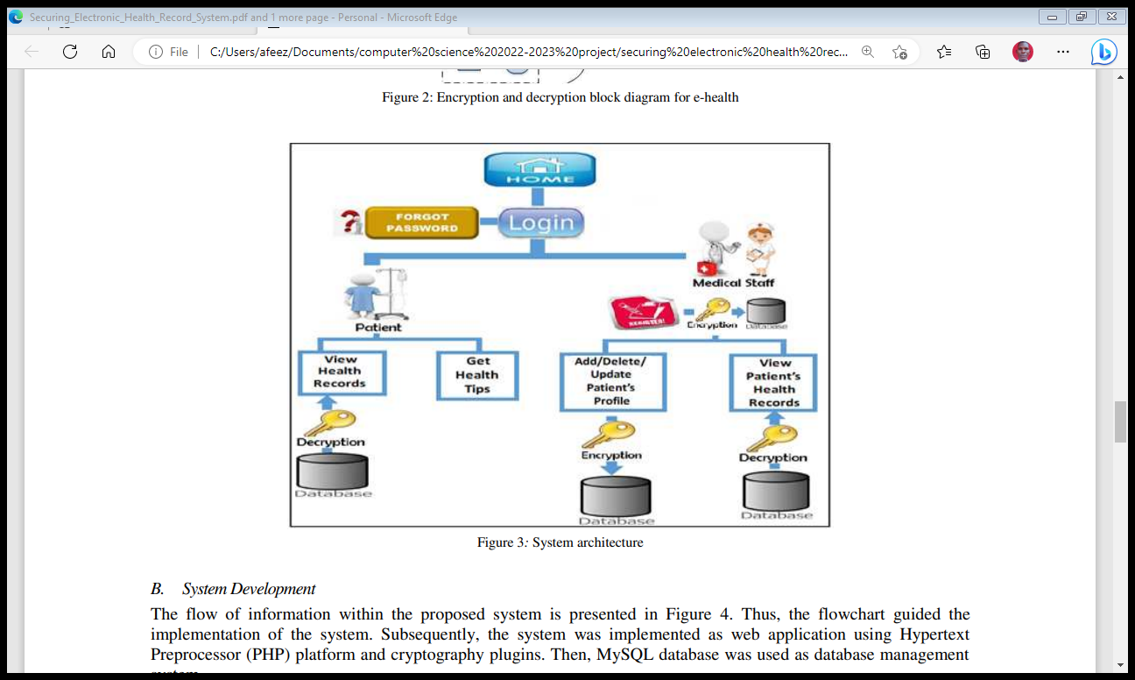
Figure 3.2: System architecture

3.5 ADVANTAGES OF THE PROPOSED SYSTEM
- A reliable method of identification that cannot be stolen or forgotten
- Easy and convenient to use, as there is no need to carry a physical object
- Suitable for people with special needs. One study has shown that illiterate people are content to use biometric identification as they don’t have to reveal the fact that they can’t write
- Confidentiality - An encryption method can protect data and communications against unauthorized access and disclosure.
- Authentication - Information can be safeguarded against spoofing and forgeries using cryptographic techniques like MAC and digital signatures, which are used for authentication.
- Data Integrity - Cryptographic hash functions are essential in giving users confidence in the accuracy of their data.

CHAPTER FOUR
DESIGN, IMPLEMENTATION AND DOCUMENTATION OF THE SYSTEM
  - DESIGN OF THE SYSTEM
The proposed system is designed in modules with each modules working together to perform the electronic allocation system in order to enhance the performance of the existing system as earlier discussed in chapter three.
The ability to analyze and give focus to the system is explained in the following formats which are output design, input design, database design and procedure design.
    - OUTPUT DESIGN
Output design for the computerized system to go to the screen and the outputs are designed to present report in a meaningful way. The outputs of the system include import report and lying report.

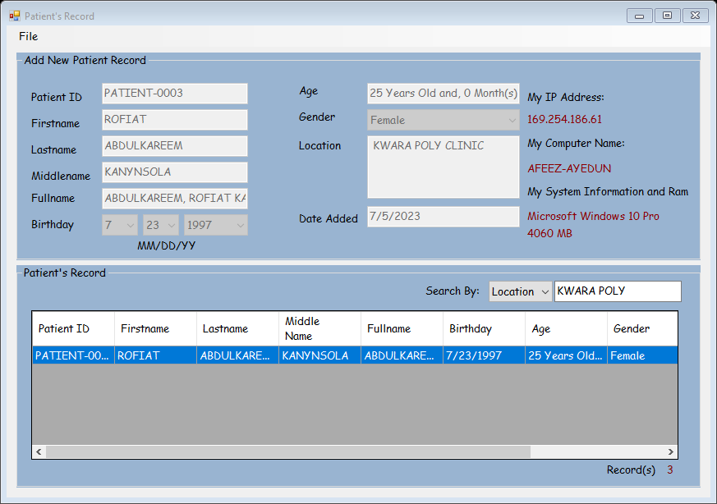
Figure 4.1: Assign Patient – 0003

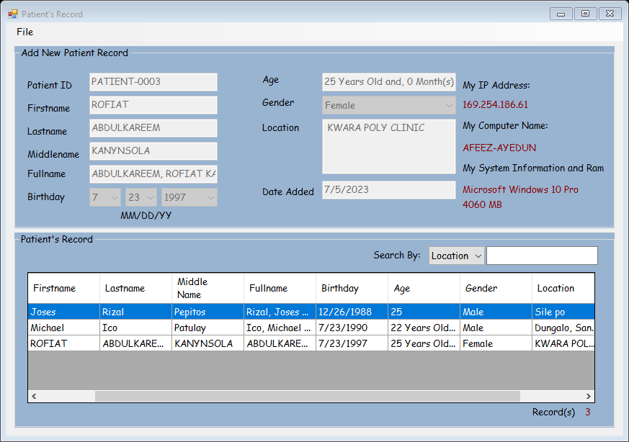
Figure 4.2: Patient Record

4.1.2 INPUT DESIGN
This aspect entails the description of the expected data input that will provide our output as described above. This section list out all the input required for the implementation of Career Guidance System. Data entry is done through the keyboard and mouse selection where required. The sample input interfaces are as shown below:
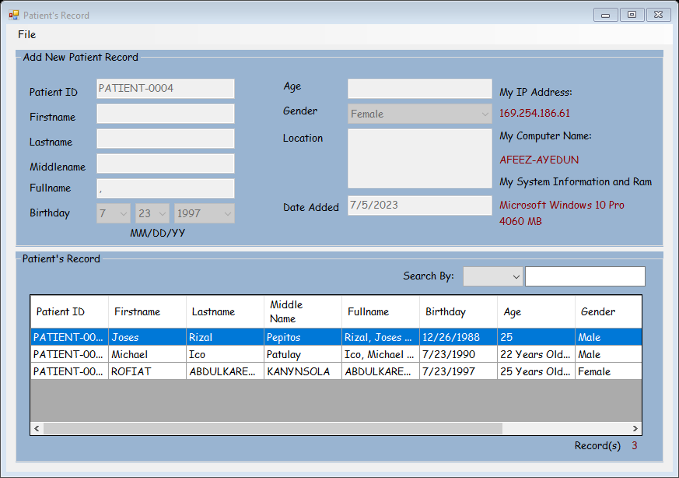
Figure 4.3: Form to Enroll Record
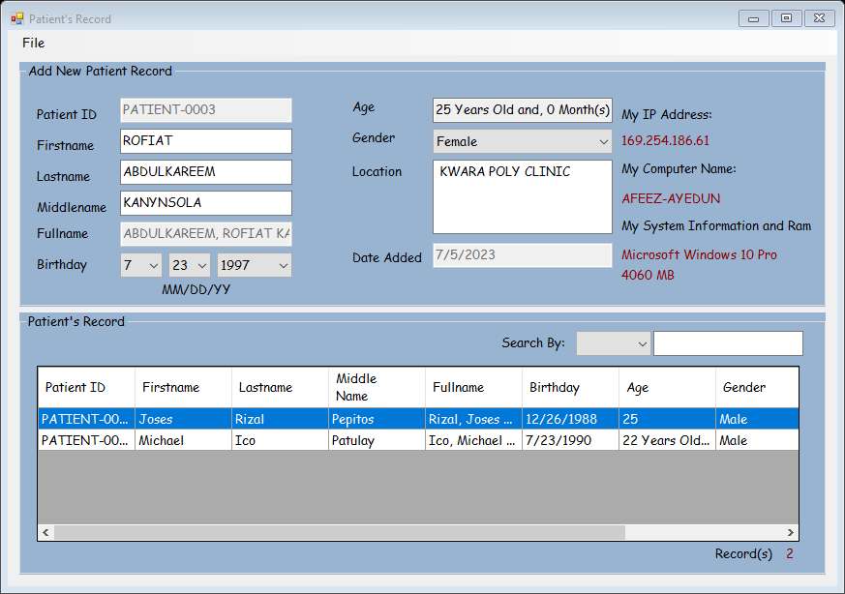
Figure 4.4: The registered patient form

    - DATABASE DESIGN
Table 4.1: Database
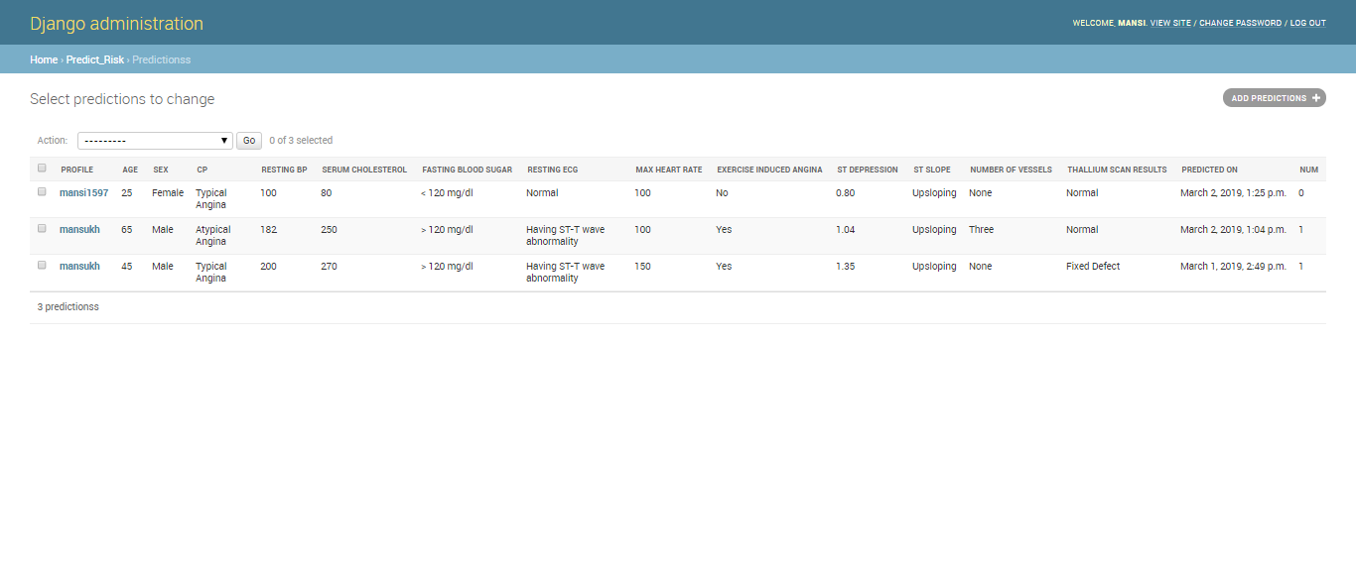

4.1.4 PROCEDURE DESIGN
The administrator can perform the following
- Add new medical record
- Generate security medical record
4.2 IMPLEMENTATION OF THE SYSTEM
4.2.1 CHOICE OF PROGRAMMING LANGUAGE
In determining a suitable programming language for the design of the online patient management system, the factors to be considered are:-
- The difficulty of the problem
- The technical skills required of the computer program
- The type of processing required
- The availability of sub-programming facilities
- The efficiency of the language translator
- Ease of maintaining and updating the program
- Hardware and software requirement
For the project work, the programming language to be used for the design of the system is PHP and MYSQL for database management system with embedded Structured Query Language (SQL) for database manipulation

4.2.2 HARDWARE SUPPORT
The hardware requirements for this program are:
- PC: The computer should be minimum of Pentium IV with 1000GHs processor speed but preferably Dual Core Processor for greater efficiency
- Memory: This system requires a Higher RAM not less than 512MG, 1GB RAM is recommended.
- Storage: the storage capacity must be 80GB and above.
- VDU: Visual Display Unit required should be a very high resolution not less than 1024 x 768 with 256 colour capability.
- Printer: This system also requires a printer
- Input: The input device required is a mouse, Optical Mouse should be provides for easy use.
4.2.3 SOFTWARE REQUIREMENTS
The software requirements for the operation of this program are as follows:
- Window Operating System
- XAMPP or Wamp Server (for Apache server on localhost)
- Web Browser e.g Mozilla Firefox
- Macromedia Dreamweaver
4.2.4 CHANGE OVER TECHNIQUE
The method used in the implementation of the proposed system is parallel, simply because parallel system supports the use of the existing system together with the proposed system and when there system failure information will not be totally lost and will not be back to square one for the users.
4.3 DOCUMENTATION OF THE SYSTEM
4.3.1 PROGRAM DOCUMENTATION
In order for the proposed system to be used on any computer system it takes the following ways
- Boot the system
- Copy the folder to www inside wamp folder of the drive C: after WAMP server is installed onto the system.
- Open any browser on the system (Microsoft internet Explorer, Mozilla Firefox, Netscape Navigator, Opera, Flock, Safari e.t.c)
- Type http://localhost/medicalrecord/index.php on the address bar and press the return key or enter key.
4.3.2 OPERATING THE SYSTEM
This refers to the step by step method of using the proposed system. The proposed system comprises of. The steps to use the proposed system are as follows
- On the address bar of any browser type
http://localhost/www.patienthealthrecord/index.php
- You are prompted to supply the username and password this verifies that you are a registered voter and has the privileged to vote.

4.3.3 MAINTAINING THE SYSTEM
- Data cable should be plugged properly
- Repair or replacement of all damaged accessories, system cards, peripheral e.t.c.
- prevention from dust
- Prevention of system from heat and moisture
- Prevention from static charges
- Examination of the new system from time to time to ensure it is performing as specified.
- Operators and users to the system must constantly check the output of the system to make sure that it is working accordingly.

CHAPTER FIVE
SUMMARY, CONCLUSION AND RECOMMENDATIONS
5.1 SUMMARY
Information security for authorized data disclosure, advocates of public health argue that privacy interests should be strongest where they matter most to the individual and communal interests should be maximized where they are likely to achieve the greatest public good. However, every healthcare provider may not deploy state-of-the-art technology, incorporated with most recent algorithms, to disclose data for secondary purposes. Understanding the operational effectiveness of data disclosure technology from the field may help hospital administration in refining disclosure policies, as well choosing appropriate data disclosure technology solutions.

5.2 CONCLUSION
Privacy and security are two important factors that must be considered when developing a patient centric EHR. Existing works have focused largely on security and less on how patient mastermind privacy control with the help of the healthcare providers. Also, outside threats were of more concern, but more often than expected insiders who have legitimate access to EHR are often overlooked. This research implements cryptographic techniques with biometrics despite its key security challenges. This research contributed to the body of knowledge in healthcare and self-care through the development of a cryptography key management scheme for ensuring the privacy of patients attributes in a cryptographic oriented EHR.
The synergistic combination of asymmetric visual cryptography system in the proposed Patient’s Health Record (PER) system has successfully provided a medium through which the privacy of a patient’s electronic health record is maintained. This will no doubt ensure that patient’s Electronic Health Records (PHR’s) are securely stored and that only authorized persons are allowed to view them. It is still important that further studies be carried out to improve on the security of EHR’s possibly by incorporating another security technique in addition to the Visual Cryptography technique. The result of the system evaluation shows significant improvements as the biometrics FAR were greatly reduced which lessens the likelihood of imposters gaining successful access to patients protected health information
5.3 RECOMMENDATIONS
The use of technology in health applications has great benefits over other means of authentication methods. Password and pin can easily be forgotten and is subject to theft. In developing countries including Nigeria, the use of security as a means of authentication in e-Health sector is still at its low ebb. This article is intended to serve as a security model for protecting the integrity of users of e-Health data.
This study developed the implementation for Patients Health Record (PHR). The system can be used by healthcare providers to keep records and secure patient health record. The system is expected to enhance the effectiveness and the overall efficiency of hospital management. The integration of security is to increase the users’ confidence in the system. The future directions on security in e-Health system comprises of DNA analysis, neural wave analysis, and skin luminescence. More so, the researchers intend to implement a secure mobile biometric system in the future
REFERENCES
Abass N., Thaear S., Khalaf Y., &Putrus S., (2020) NATIONAL IMMUNIZATION PLAN OF IRAQ” University Research Co., LLC.
Abdulazeez A. M., Zeebaree S. R., &Sadeeq M. A., (2018) Design and Implementation of Electronic Student Affairs System,” Acad. J. Nawroz Univ., vol. 7, no. 3, pp. 66–73. doi: 10.25007/ajnu.v7n3a201
Abdulla, A. I., Abdulraheem, A. S., Salih A. A., Sadeeq M. AM, Ahmed A. J., Ferzor B. M., Sardar O. S., & Mohammed S. I.,(2020) “Internet of Things and Smart Home Security,” Technol. Rep. Kansai Univ.,vol. 62, no. 5, pp. 2465–2476.
Abdullah D. & Sallow, A. (2018) “Developing Fault Tolerance Integrity Protocol for Distributed Real Time Systems,” AL-Rafidain J. Comput. Sci. Math.,vol. 10, no. 1, pp. 187–193, 2013,doi: 10.33899/csmj.2013.163435.
Abdullah, D. & Sallow, A., (2018) EOE-DRTSA: End-to-End Distributed Real-time System Scheduling Algorithm,” Int. J. Comput. Sci. Issues, vol. 10, no. 2, p. 8, 2013
AbdulRahman M., Al Dabbagh S., & Al Habeeb Q., (2018) Health education and peer leaders’role in improving low vaccination coverage in Akre district, Kurdistan region, Iraq,” East. Mediterr. Health J., vol. 19, no. 02, pp. 125–129, Feb. 2013,doi: 10.26719/2013.19.2.125.
Abdulrazaq M. &Salih A., (2018) Combination of multi classification algorithms for intrusion detection system,” Int J SciEng Res, vol. 6, no. 1, pp. 1364–1371, 2015.
Abdulrazzaq M. & Saeed J., (2019) A Comparison of Three Classification Algorithms for Handwritten Digit Recognition,” in 2019 International Conference on Advanced Science and Engineering (ICOASE), 2019, pp. 58–63.
Ahmed O. & Sallow, A. (2017) Android Security: A Review,” Acad. J. Nawroz Univ., vol. 6, no. 3, pp. 135–140,doi: 10.25007/ajnu.v6n3a97.
Anderson RM & May RM. (2018) Vaccination and herd immunity to infectious diseases. Nature. 2015;318(6044):323-9.
Bangure D, Chirundu D, Gombe N, Marufu T,Mandozana G,&Tshimanga M. (2018) Effectiveness of short message services reminder on childhood immunization programme in Kadoma, Zimbabwe - a randomized controlled trial, 2013. BMC Public Health. 2015;15:137
Bar-Shalom, Y. & Li, X. R. (2018) Multitarget-Multisensor Tracking: Principles and Techniques. Storrs, CT: YBS, 2015.
Blackman S. S. & R. Popoli,(2019) Design and Analysis of Modern Tracking Systems. Norwood, MA: Artech House, 2019.
Blackman, S. S., Dempster, R. J., Busch, M. T., & R. F. Popoli,(2019) “IMM/MHT solution to radar benchmark tracking problem,” IEEE Trans. Aerosp. Electron. Syst., vol. 35, pp. 730–738, Apr. 2019.
Blair, W. D., Watson, G. A., Kirubarajan, T. & Bar-Shalom, Y. (2018) “Benchmark for radar resource allocation and tracking in the presence of ECM,” IEEE Trans. Aerosp. Electron. Syst., vol. 34, pp. 1015–1022, Oct. 2018.
Brumen, B., Heričko, M., Sevčnikar, A., Završnik, J. and Hölbl, M. (2018) ‘Outsourcing medical data analyses: can technology overcome legal, privacy and confidentiality issues?’, J. Med. Internet Res. Journal of Medical Internet Research, Vol. 15, No. 12, pp.283.
CTI (Center for Technology Innovation at Brookings) (2016) Hackers, Phishers, and Disappearing Thumb Drives: Lessons Learned From Major Health Care Data Breaches.
Das, R. (2012) Bio-Cryptography: Increasing the Protection of Biometric Templates, http://www. biometricnews.net/article3.pdf
Dino H. &Abdulrazzaq M., (2019) “Facial Expression Classification Based on SVM, KNN and MLP Classifiers,” in 2019 International Conference on Advanced Science and Engineering (ICOASE), 2019, pp. 70–75.
Expanded Programme on Immunization (EPI) in the African Region. strategic plan of action 2001-2005. Harare: WHO; 2001. Accessed 28 February 2017
Eze G, &Adeleye O. (2018) Enhancing Routine Immunization Performance using Innovative Technology in an Urban Area of Nigeria. West Afr J Med. 2015;34(1):3-10.
Gatuha G. & Jiang T., (2018) “KenVACS: Improving Vaccination of Children through Cellular Network Technology in Developing Countries,” Interdiscip. J. Inf. Knowl. Manag., vol. 10, pp. 037–046, doi: 10.28945/2208.
Grunwel, D. and Sahama, T. (2016) ‘Delegation of access in an information accountability framework for eHealth’, Proceedings of the Australasian Computer Science Week Multiconference, Canberra, Australia
Haji A, Lowther S, &Ngan’ga Z. (2016) Reducing routine vaccination dropout rates: evaluating two interventions in three Kenyan districts. BMC Public Health. 2016;16(1):152.
HIMSS (Healthcare Information and Management Systems Society) (2018) EHR Definition, Attributes and Essential Requirements, http://www.himss.org/content/files/ EHRAttributes.pdf
ICIT (Institute for Critical Infrastructure Technology) (2016) Hacking Healthcare IT in 2016: Lessons the Healthcare Industry Can Learn
IMIA (International Medical Informatics Association) (2020) ‘Recommendations of the international medical informatics association (IMIA) ‘on education in health and medical informatics’, Methods Archive, Vol. 39, No. 3, pp.267–277.
Jain AK, Nandakumar K, Nagar A: (2018)Biometric template security. EURASIP J Adv Signal Process 2018, 1-17.
Jain AK, Ross A: U Uludag, (2018) Biometric template security: Challenges and solutions. Proc of European Signal Processing Conf (EUSIPCO) 2015.
Kashmola M., & Sallow A, (2019) “Information Hiding Techniques Using Network Protocols,” AL-Rafidain J. Comput. Sci. Math.,vol. 8, no. 2, pp. 35–50, 2011, doi: 10.33899/csmj.2011.163650.
Kasidet M., (2017) “SMS-reminder for vaccination in Africa: research from published, unpublished and grey literature” Yale University, New Haven, USA
Katankar V. &Thakare D., (2020) “Short Message Service using SMS Gateway,” vol. 02, no. 04, p. 5, 2020.
Kirubarajan, Y., Bar-Shalom, Blair W. D., & Watson, G. A. (2018) “IMMPDA solution to benchmark for radar resource allocation and tracking in the presence of ECM,” IEEE Trans. Aerosp. Electron. Syst., vol. 34, pp. 1023–1036, Oct. 2018.
Lerro, D. & Bar-Shalom, Y. (2018) “Interacting multiple model tracking with target amplitude feature,” IEEE Trans. Aerosp. Electron. Syst., vol. 29, pp. 494–509, Apr. 2013.
Mahmood M. &Abdulazeez A., (2019)“Different Model for Hand Gesture Recognition with a Novel Line Feature Extraction,” in 2019 International Conference on Advanced Science and Engineering (ICOASE), pp. 52–57.
Mahmood M. R., Abdulazeez A. M., &Orman A. M., (2020)“ A New Hand Gesture Recognition System Using Artificial Neural Network.”
Mercuri, R.T. (2014) ‘The HIPAA-potamus in health care data security’, Communications of the ACM, Vol. 47, No. 7, p.25.
Omotosho, A. and Emuoyibofarhe, J. (2018) ‘A criticism of the current security, privacy and accountability issues in electronic health records’, International Journal of Applied Information Systems, Vol. 7, No. 8, pp.11–18.
Scheirer, W., Bishop, B. and Boult, T. (2020) ‘Beyond PKI: the biocryptographic key infrastructure’, IEEE International Workshop on Information Forensics and Security (WIFS), Seattle, Washington, pp.1–6.
Stavroulakis, P. and Stamp, M. (2020) Handbook of Information and Communication Security, Springer, Heidelberg.
Tiwari, B. and Kumar, A. (2019) ‘Role-based access control through on-demand classification of electronic health record’, Int. J. Electronic Healthcare, Vol. 8, No. 1. pp.9–24.
Uludag U, Pankanti S, Prabhakar S, Jain AK: (2018)Biometric cryptosystems: issues and challenges. Proc IEEE 2014, 92(6):948-960

APPENDIX 1: SIGN UP

STOP
USER NAME
PASSWORD
IS
VALID
?
Main Menu
RETURN
NO

YES

APPENDIX 2: FORM TO ENROLL RECORD
START
Open DB

Accept Field
Is
Field
ok
Write DB
More
Close DB
RETURN
Close DB
Open DB
YES
YES

Display option

NO

Yes

NO

APPENDIX 3: PERSONAL DETAILS PAGE
START
Open DB

Accept Field
Is
Field
ok
Write DB
More
Close DB
RETURN
Close DB
Open DB
YES
YES

Display option

NO

Yes

NO

APPENDIX 3: REGISTERED PATIENTS FORM
NO
Start
Accept option
Accept option
Accept option
Accept option
Are options ok
Return
Close DB
Open DB
YES
LOGOUT
PROFILE
ADMIN

PPENDIX 4: SOURCE CODE
import numpy as np
import pandas as pd
import matplotlib.pyplot as plt
import seaborn as sns
from mlxtend.frequent_patterns import apriori
from mlxtend.frequent_patterns import association_rules

sns.set(style="darkgrid", color_codes=True)
pd.set_option('display.max_columns', 75)

data = pd.read_csv('Market_Basket.csv', header = None)
data.info()

color = plt.cm.rainbow(np.linspace(0, 1, 40))
data[0].value_counts().head(40).plot.bar(color = color, figsize=(13,5))
plt.title('frequency of most popular items', fontsize = 20)
plt.xticks(rotation = 90 )
plt.grid()
plt.show()

import networkx as nx
data['food'] = 'Food'
food = data.truncate(before = -1, after = 15)
food = nx.from_pandas_edgelist(food, source = 'food', target = 0, edge_attr = True)
In [8]:
import warnings
warnings.filterwarnings('ignore')

plt.rcParams['figure.figsize'] = (13, 13)
pos = nx.spring_layout(food)
color = plt.cm.Set1(np.linspace(0, 15, 1))
nx.draw_networkx_nodes(food, pos, node_size = 15000, node_color = color)
nx.draw_networkx_edges(food, pos, width = 3, alpha = 0.6, edge_color = 'black')
nx.draw_networkx_labels(food, pos, font_size = 20, font_family = 'sans-serif')
plt.axis('off')
plt.grid()
plt.title('Top 15 First Choices', fontsize = 20)
plt.show()

# Getting the list of transactions from the dataset
transactions = []
for i in range(0, len(data)):
transactions.append([str(data.values[i,j]) for j in range(0, len(data.columns))])
In [10]:
transactions[:1]
from itertools import permutations

# Extract unique items.
flattened = [item for transaction in transactions for item in transaction]
items = list(set(flattened))
In [12]:
print('# of items:',len(items))
print(list(items))
if 'nan' in items: items.remove('nan')
print(list(items))

# Compute and print rules.
rules = list(permutations(items, 2))
print('# of rules:',len(rules))
print(rules[:5])

# Import the transaction encoder function from mlxtend
from mlxtend.preprocessing import TransactionEncoder

# Instantiate transaction encoder and identify unique items
encoder = TransactionEncoder().fit(transactions)

# One-hot encode transactions
onehot = encoder.transform(transactions)

# Convert one-hot encoded data to DataFrame
onehot = pd.DataFrame(onehot, columns = encoder.columns_).drop('nan', axis=1)

# Print the one-hot encoded transaction dataset
onehot.head()

rules_ = pd.DataFrame(rules, columns=['antecedents','consequents'])

# Define an empty list for metrics
zhangs, conv, lev, antec_supp, cons_supp, suppt, conf, lft = [], [], [], [], [], [], [], []

# Loop over lists in itemsets
for itemset in rules:
# Extract the antecedent and consequent columns
antecedent = onehot[itemset[0]]
consequent = onehot[itemset[1]]

antecedent_support = onehot[itemset[0]].mean()
consequent_support = onehot[itemset[1]].mean()
support = np.logical_and(onehot[itemset[0]], onehot[itemset[1]]).mean()
confidence = support / antecedent_support
lift = support / (antecedent_support * consequent_support)

# Complete metrics and append it to the list
antec_supp.append(antecedent_support)
cons_supp.append(consequent_support)
suppt.append(support)
conf.append(confidence)
lft.append(lift)
lev.append(leverage(antecedent, consequent))
conv.append(conviction(antecedent, consequent))
zhangs.append(zhang(antecedent, consequent))

# Store results
rules_['antecedent support'] = antec_supp
rules_['consequent support'] = cons_supp
rules_['support'] = suppt
rules_['confidence'] = conf
rules_['lift'] = lft
rules_['leverage'] = lev
rules_['conviction'] = conv
rules_['zhang'] = zhangs

# Print results
rules_.sort_values('zhang',ascending=False).head()

