
A PROJECT
ON
LAND INFORMATION SYSTEM OF GOVERNMENT SECONDARY SCHOOL, MARABA, ILORIN, KWARA STATE

BY
HND/23/SGI/FT/0113
AJIDE ALICE OLUWATOYIN

SUBMMITTED IN PARTIAL FUFILMENT OF THE REQUIREMENTS OF THE AWARD OF HIGHER NATIONAL DIPLOMAL (HND) IN SURVEYING AND GEO-INFORMATICS TO THE DEPARTMENT OF SURVEYING AND GEO-INFOMATICS,
KWARA STATE POLYTECHNIC, ILORIN KWARA STATE.

JUNE, 2025.

CERTIFICATE
I hereby certified that all the information given in this project were obtained as a result of observations and measurements made by me and that the survey was carried out in accordance with Survey Rules, Regulations and Departmental instructions.

NAME: AJIDE ALICE OLUWATOYIN
MATRICNO.: HND/23/SGI/FT/0113

SIGNATURE: ………………………………….

DATE OF COMPLETION: ……………………………………………….

CERTIFICATION
This is to certify that AJIDE ALICE OLUWATOYIN with matriculation number HND/23/SGI/FT/0113 has satisfactorily carried out this project under our instructions and direct supervision.
_______________________ _______________________
MR. ABIMBOLA I. ISAU SIGNATURE AND DATE
(PROJECT SUPERVISOR)
_______________________ _______________________
SURV. AWOLEYE R. S SIGNATURE AND DATE
(PROJECT COODINATOR)
_______________________ ________________________
MR. ABIMBOLA I. ISAU SIGNATURE AND DATE
(HEAD OF DEPARTMENT)
_______________________ _______________________
EXTERNAL MODERATOR SIGNATURE AND DATE

DEDICATION
I dedicate this project to Almighty God, whose guidance, strength, and blessings have been my constant source of inspiration and perseverance.
ACKNOWLEDGEMENTS
All adoration be to God Almighty, the gracious one who has given me the opportunity to complete my HND program in Surveying and Geo Informatics.
My appreciation goes to my supervisor MR.ABIMBOLA.I.ISAU for his encouragement and motivation as regards the project thank you and God bless you sir.
To all my lecturers in the department of Surveying and Geo Informatics,
Surv. R.O ASONIBARE, SURV. A.G AREMU, SURV. R.S AWOLEYE, SURV. A.O AKINYEDE, SURV. AYUBA ABDULSALAM, SURV. F.D DIRAN AND SURV.BABATUNDE KABIR, may God bless you all (Amen).
I also express my sincere gratitude to my wonderful parents MR. & MRS. AJIDE their parental care and support since the inception of my educational career, they stood by me when things were tough and rough for me, they gave me hope, I will forever be grateful for the motivation you always gave to me at all time, if I would have to have parents in my life again, I will pray to have people like you around me again
To all my understanding friends and lovers, I so much appreciate your support and advice thanks so much, May almighty God bless you all (Amen).

TABLE OF CONTENTS
Cover page……………………………………………………………………….i
Certificate………………………………………………………………………..ii
Certification……………………………………………………………………..iii
Dedication……………………………………………………………………….iv
Acknowledgement…………………………………………………………….....v
Abstract………………………………………………………………………….vi
Table of contents ….…………………………………………………………..vii-ix

CHAPTER ONE: INTRODUCTION
1.0 Introduction…………………………………………………………………………. ..1
1.1 Background and Justification of the Project……………………………………………..2
1.2 Statement of the Problem ………………………………………………………………3
1.3 Aim of the Project ……………………………………………………………………..3
1.4 Objectives of the Project ………………………………………………………………4
1.5 Scope of the Project …………………………………………………………………..6
1.6 Project Specification ………………………………………………………………….6
1.7 Significance of the Study …………………………………………………………….7
1.8 List of Personnel …………………………………………………………………….9
1.9 Project Location…………………………………………………………………….12

CHAPTER TWO: LITERATURE REVIEW
2.0 Literature Review ………………………………………………………………14
2.1 Evolution of Land Information Systems …………………………………………15
2.2 Components of a Land Information System …………………………………………17
2.3 Importance of Land Information Systems …………………………………………18
2.4 Challenges in Implementing Land Information Systems ……………………19
2.5 Applications of Land Information Systems…………………………………………21

CHAPTER THREE: METHODOLOGY
3.0 Methodology………………………………………………………………23
3.1 Project planning………………………………………………………………25
3.2 Data Base Design………………………………………………………………28
3.3 Equipment Used………………………………………………………………30
3.4 Instrument Test………………………………………………………………33
3.5 Control Check………………………………………………………………35
3.6 Geometric Data Acquisition……………………………………………………39
3.7 Detailed Survey………………………………………………………………41
3.8 Database Creation/Implementation…………………………………………43

CHAPTER FOUR: ANALYSIS AND RESULTS
4.1 Introduction………………………………………………………………48
4.2 Spatial Data Results………………………………………………………………49
4.3 Topographical Analysis Results………………………………………………………53
4.4 Non-Spatial Data Results………………………………………………………………56
4.5 Query Execution and Results…………………………………………………………57

CHAPTER FIVE: COSTING, SUMMARY, PROBLEMS ENCOUNTERED, CONCLUSION AND RECOMMENDATION
5.1 Costing………………………………………………………………………………59
5.2 Summary…………………………………………………………………………….62
5.3 Recommendations…………………………………………………………………….65
5.4 Conclusion……………………………………………………………………………67

REFERENCES…………………………………………………………………………71
APPENDIXS……………………………………………………………………………

ABSTRACT
This project focuses on designing and developing a Land Information System (LIS) for Maraba Government School Ilorin, Kwara state, a comprehensive database that integrates spatial and non-spatial data to provide accurate and up-to-date information on land ownership, land use, and other relevant land-related data. The LIS aims to improve land management, enhance decision-making, and promote transparency and accountability in land administration. By leveraging Geographic Information System (GIS) technology and database management systems, the LIS provides a robust and scalable solution for managing land-related information, supporting sustainable development and economic growth.

CHAPTER ONE
1.0 INTRODUCTION
This chapter consists of eight (8) sections; an overview of the study background and justification, statement of the problem, aim of the project, objectives, significance of the project, scope of the project, personnel involved and project location.
1.1 Background and Justification of the Project
Global concerns such as urbanization, tenure insecurity, land conflict and unequal land access have put a high demand on reliable and up-to-date land information. To meet such requests and guarantee ownership rights, scholars have advocated for the development of an information system that can provide records on “who owns what piece of land”, what type of right and value exists”, and “what use is permissible” on time. The performance of these functions lies within the domain of land administration. “Land administration (LA) is a process of determining, recording, and disseminating information about land ownership, value, use, and associated resources (UNECE 2005). According to Enemark (2005), the success of land administration depends on an efficient land information infrastructure; this implies the management of rights, restrictions, responsibilities and natural resources must be facilitated by cadastral and topographic datasets, which allow easy access to land records. Agreeably, Alemie et al. (2015), Biraro et al. (2021a), Krigsholm et al. (2018), and Sattler & Nagel (2010)have asserted that access to adequate and reliable land information is essential for a well-functioning land administration. Such information is very relevant for stakeholders in making land-related decisions (Aydinoglu&Bovkir, 2017; Indrajit et al., 2021; Todorovski et al., 2018).
In recent times, the traditional land administration services have extended from cadastral activities in land tenure and land information management to sharing information among other land-related agencies (Agunbiade & Kolawole, 2016; Enemark, 2009; I. B. Karikari, 2006). This has made land information systems (LIS) imperative for efficient and effective land administration. A land information system (LIS) is a set of software and hardware-based databases that enable the entry, processing, storage, and retrieval of land records (Rakhmonov&Abdurakhimova, 2021). LIS enhances land record management and efficient access to information and reduces the bureaucracies in land administration processes (Meijer, 2009). Countries that have successfully implemented LIS for land administration continue to realise the benefits. For instance, experience from developed countries like the Netherlands has demonstrated the usefulness of LIS in making geographic data accessible to all, promoting transparency, and facilitating individual choices about real estate (Kadaster International, n.d.).
Unlike in developed countries, implementing LIS in developing countries is challenging (Berisso& de Vries, 2010; Correia et al., 2021). In countries where such information systems are in place, they remain latent; hence, essential decisions are made based on limited information (Karikari et al., 2003). Other challenges may result from inadequate land data, poor data quality, and the government’s unwillingness to invest in LIS (Yaw Adiaba, 2014). In the scope of innovation in information technology such as LIS, Davis (1989) argued that the system’s adoption and usage are crucial factors in achieving the overall success of implementation. One must utilize LIS to achieve the expected outcome; however, this is often not the case in many developing countries.
Similarly, most land administration institutions in Nigeria operate in the analogue land administration system despite the implementation and benefits of LIS. There is a need to understand why the adoption and usage of LIS remains a challenge in the land administration sector. Such understanding is crucial for determining solutions for enhancing LIS adoption and use.

1.2 Statement of the Problem
Land administration and management in Government Secondary School Maraba continues to form critical inefficiencies, lack of coordination, and outdated systems in the study area. These problems underscore a deeper need, the urgent implementation of a digital solution that can integrate spatial data, and land use details into a unified platform.
Therefore, this project seeks to address these challenges by designing and implementing a Land Information System that is intelligent, accessible, and tailored to support effective land administration and sustainable development in Government Secondary School Maraba.

1.3 Aim of the Project
The primary aim of this project is to design, develop, and implement a comprehensive and integrated Land Information System (LIS) of Maraba Government School Ilorin, Kwara state.

1.4 Objective of the Project
The specific objectives of this project are
- Design a user-friendly Land Information System capable of managing land and usage data in a centralized digital format.
- Geometric and attribute data acquisition
- Implement core features of the system including data entry, spatial mapping, search and retrieval functions, and secure access control.
- Integrate Geographic Information System (GIS) tools to visualize and enable location-based analysis and decision-making.
- Evaluate the performance of the developed system in terms of accuracy, usability, responsiveness, and reliability.
- To produce plans as graphical representation

1.5 Scope of the Project
The scope of this project covers the following major phases and activities:
- Reconnaissance Survey: Preliminary field inspection to understand the area of study, identify existing features and determine control points needed for mapping.
- Office Planning: Preparation of necessary materials, equipment checks, defining the workflow, and gathering existing maps or records for the project area.
- Data Acquisition: Collection of spatial and non-spatial data through total station.
- System Design and Implementation: Development of a functional Land Information System to address land management and decision making.
- Documentation and Reporting: Compilation of project activities, methodologies, system features, and outcomes into a final technical report.

1.6 Project Specification
This project is aimed at building a Land Information System (LIS) to support effective land management. The system will combine both spatial (map-related) and non-spatial (text-based) information to help users register, retrieve, and visualize land records

1.7 Significance of the Study
- Improve land record accuracy and completeness.
- Enhance land use planning and management.
- Increase access to land information and services.
- Support decision-making and policy development.
- Promote transparency and accountability in land administration.

1.8 List of the Personnel
The following are the personnel involved in executing the project:
S/N | NAMES | MATRIC/NO | POSITION
1 | Ajide Alice Oluwatoyin | HND/23/SGI/FT/113 | Writer
2 | Yunusa Rukayat | HND/23/SGI/FT/090 | Member
3 | Fatoyinbo Theresa | HND/23/SGI/FT/091 | Member
4 | OladitiAbdulmuheez O | HND/23/SGI/FT/092 | Member
5 | Aremu Oluwafemi V | HND/23/SGI/FT/093 | Member
6 | Agbalaya Olaide M | HND/23/SGI/FT/097 | Member
7 | Ajeorun Jamiu O. | HND/23/SGI/FT/99 | Member
8 | Samson Daniel | HND/22/SGI/FT/121 | Member

1.8 LOCATION
The project site is located inside at Maraba Government School Ilorin, Kwara state.Fall on geographic coordinate of Latitude: 008 33 25.96; Longitude: 004 37 54.39 to Latitude: 008 33 24.78 ; Longitude: 004 38 05.73. covered total area of 9hectares.

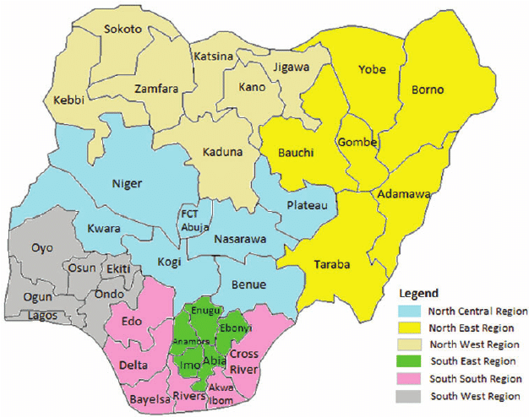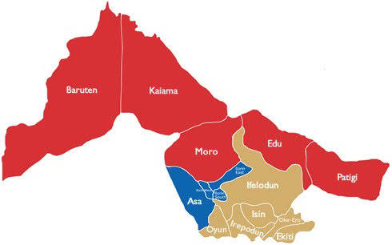
Map of Kwara State
Map of Nigeria

``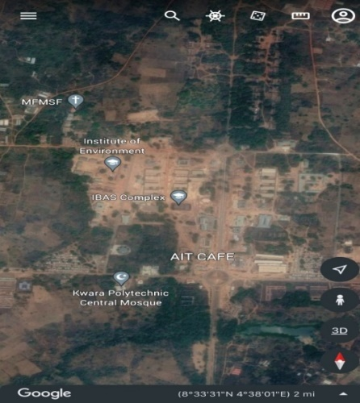
Google Imagery of the Study Area

Figure 1.10: Study Area Map

CHAPTER TWO

2.0 LITERATURE REVIEW

Land Information Systems (LIS) have become increasingly important in modern land administration, as they provide a framework for capturing, storing, analyzing, and displaying geographically referenced land-related data (Dale, 1991). This literature review aims to provide an overview of the concept, components, and applications of LIS, as well as its challenges and limitations.
The concept of LIS has evolved significantly over the past few decades. According to Dale (1991), LIS is a computer-based system that integrates spatial and non-spatial data to provide a comprehensive view of land information. The evolution of LIS has been influenced by advances in technology, changes in land administration policies, and increasing demand for efficient land management (Williamson, 2001).
Many scholars have defined the term LIS differently across various academic disciplines. Following Dale & McLaughlin (1999) and Larsson (1991), a land information system consists of land data, human and technical capital, and processes and techniques for data collection, updating, processing and dissemination.
Agreeably, The United Nations Economic Commission for Europe (UNECE) Report in 1996 states that LIS comprises the land information database and the procedures to collect, update, and distribute land records.
There are cases where such an information system was referred to as the general land administration system; thus, if the information system could facilitate the implementation of land policies and promote effective land administration. In their paper, Bishop et al. (2000) defined LIS as “a GIS that utilizes land parcels as the link to the non-graphic database attributes.” Hull &Whittal(2013) described the system as an established information system for land management purposes.
The typical lesson derived from these definitions is that LIS involves data to produce information, technology to ensure efficient operation, people to carry out its functions, and procedures to ensure adequate land administration.
Land is the ultimate resource of the biosphere whichrefers to a specific area of the earth surface withphysical entity in terms of its topography andspatial nature, and one of the characteristics of spacethat is widely recognized as a significant for planningand management purposes (Abbas et al., 2010).
Land information is an integral part ofgovernment, non-profit, and private sector activities.Adopting LIS technique can advance broader socialpurposes by making more effective public decisionsand by using natural resources in a more optimal way.LISsupports spatial analysis and modelling procedurefor solving complex planning andmanagementproblem. Information management system is anintegrating technologywhere resources and activitiesare brought together to support the decision makingprocess of an organization. By taking the advantage ofRemote Sensing (RS) andGeographic InformationSystem (GIS) technology, Land Record InformationManagement System for cadastral mapping wasdeveloped by integrating digital cadastralmap and landrecord database. The fast development of society hasbeen hastening theapplication of technologiesespecially LIS and technology in land administration. Asan important facet of nature and society, land isattracting people’s attention. The mostattractive pointwhich captures the interest of professionals andadministrators is thechanging policy of governmentabout naturalresources management and theapplicationof technologies especially GIS in resourcesadministration. The last decade has seen movestowards establishment of fully digitized land informationsystems throughout theworld. It is recognized thatcadastral systems are not ends in themselves. It is alsorecognized that digital cadastral systems must betailored to facilitate an efficient landmarket as well aseffective land-use administration and thereby, moregenerally, promote economic development, socialcohesion and sustainable development. (Enemark,
2007).
According to Dele and Mclaughlin (1998), landforms the basis for all forms of human activity, “from itwe obtain the food we eat, the shelter we need, thespace to work and the room we relax”. The usefulnessof land is enormous; therefore man has to guard itjealously considering its scarce nature. For this reason,conflicts most often arise in the sharing of resources orright of ownership of the land. This of course, is due tothe rapidpopulation growth of man on earth and hisdesires to explore land in myriad of ways.Partitioning ofland therefore often generates anxiety among thebeneficiaries; be it foradministrative, economic hazards,environmental degradation and population growth forpolicy making in sharing of land parcel or resourcesthereon.The resources of land areneither inexhaustiblenor indestructible. The importance of land to humanexistence and the need to survey and manageeffectively and efficiently for the use and good ofmankind is very crucial. Therefore, for Nigeria’ssustainable development, information relating to thelocation, size, use (residential, commercial, agricultural,industrial,educational, recreational, and cultural etc),contents/value, ownership and state of land must beaggregated as a system so that its administration wouldbe less cumbersome andpeople driven. This means,land information is a pre-requisite for land administration
(Molen, 2001).
Computerization has been a significant driver of change in the land administration domain. According to (Dhakal, 2016; Hale, 2011; Hull and Whittal, 2013; Kaufmann and Steudler, 1998; Romano et al., 2015; UNECE, 1996), applying modern technologies in land information management is optimal for ensuring good land service delivery and cost-effective land administration systems. Agreeably, a study by Ahuja & Singh (2006) indicated that introducing a computerized system with internal checks and controls over the deeds registration in helping tominimize the potential for error and drastically reduced land conflicts to the barest minimum.
According to UN-ECE (2005) “Land informationSystem (LIS) is defined as a tool for legal, administrationand economic decision making and an aid for planninganddevelopment which consist on one hand adatabase containing spatially reference landrelateddata for a defined area, and on the other handprocedures and techniques for the systematiccollection, updating, processing and distribution of data.The base of a landinformation system is a uniformspatial referencing system for the data in the systemwhichalso facilitates the linking of data and within thesystem with other land related data”.A land information system for stateadministration on land is expected to consist of thefollowing components.
• Geospatial data
• Software and programs
• Hardware system (data server, workstation,computers, scanners, printers,plotters, computer network: LAN, WAN, UPS etc)
• The operators (surveyors, land officers etc)
• The integrated approaches and methods
Several advanced countries have pioneeredsystem for using new technology in land information,which is receiving a wide acceptability in mostdeveloping countries like Nigeria. This acceptability ininformation technology on land is due to the fact that theusesof new information technology on land arereceiving a wider awareness which the analogue systemof land management are gradually been phased out. Itis due to the fact that the new information technologyhas a variety of manipulation capacities, high accuracy,time saving and aids decision making.

2.1 Evolution of Land Information Systems
The concept of LIS has evolved significantly over the past few decades. Here are some key milestones in the evolution of LIS:

1. Manual Systems (Pre-1960s)
Before the advent of computers, land information systems were manual, relying on paper-based records and maps (Larsson, 1991).

2. Computerized Systems (1960s-1980s)
The introduction of computers in the 1960s and 1970s enabled the development of computerized land information systems (Dale, 1991). These systems were mainly used for land registration and cadastral mapping.

3. Geographic Information Systems (GIS) (1980s-1990s)
The development of Geographic Information Systems (GIS) in the 1980s and 1990s revolutionized the field of land information systems (Rajabifard et al., 2003). GIS enabled the integration of spatial and non-spatial data, providing a more comprehensive view of land information.

4. Web-Based Systems (1990s-Present)
The widespread adoption of the internet in the 1990s enabled the development of web-based land information systems (Cagdas, 2006). Web-based systems provide easy access to land information, enabling stakeholders to query, analyze, and visualize data online.

5. Modern Trends (Present)
Modern land information systems are characterized by the use of advanced technologies, such as:
- Cloud computing: Enables scalable and on-demand access to land information.
- Mobile devices: Enables field-based data collection and access to land information.
- Big data analytics: Enables the analysis of large datasets to gain insights intoland use patterns and trends.

In conclusion, evolution of Land Information Systems have undergone significant changes over the past few decades. From manual systems to modern web-based systems, LIS has evolved to provide accurate and reliable information about land ownership, tenure, use, and value. The future of LIS will be shaped by emerging technologies, such as cloud computing, mobile devices, and big data analytics.
2.2 Components of a Land Information System
The system consists of three main components:

1. Land Records
Land records are the core component of LIS, containing information on land ownership, tenure, and use. These records include:

- Parcel boundaries: Geographic information describing the spatial extent of each land parcel.
- Land ownership: Information on the owners of each land parcel, including names, addresses, and contact details.
- Land use: Information on the current use of each land parcel, such as residential, commercial, agricultural, or conservation.
- Tenure: Information on the type of land tenure, such as freehold, leasehold, or customary tenure.

2. Human and Technical Resources
Human and technical resources are essential for the effective operation and maintenance of LIS. These resources include:

- Personnel: Trained staff with expertise in land administration, surveying, mapping, and information technology.
- Hardware: Computer servers, storage devices, and networking equipment to support the LIS.
- Software: Specialized software applications for data capture, storage, analysis, and display, such as geographic information systems (GIS) and computer-aided design (CAD) systems.
- Infrastructure: Telecommunications infrastructure, such as internet connectivity and data transmission networks.
3. Procedures and Techniques
Procedures and techniques ensure the accuracy and reliability of land information in LIS. These include:

- Data capture: Methods for collecting and capturing land-related data, such as surveying, mapping, and remote sensing.
- Data validation: Procedures for checking the accuracy and consistency of land-related data.
- Data analysis: Techniques for analyzing and interpreting land-related data, such as spatial analysis and statistical modeling.
- Data dissemination: Methods for sharing and disseminating land-related data to stakeholders, such as online mapping portals and data downloads.
These components work together to capture, store, analyze, and display geographically referenced land-related data.

2.3 Importance of Land Information Systems
Land Information Systems (LIS) play a crucial role in modern land administration, and their importance cannot be overstated. Here are some of the key reasons why LIS is important:

1. Securing Land Rights
LIS helps to secure land rights by providing a formal record of land ownership and tenure. This reduces the risk of land disputes and promotes social stability.
2. Promoting Efficient Land Use
LIS enables policymakers to make informed decisions about land use, leading to more efficient and sustainable use of land resources. This helps to prevent land degradation, promote conservation, and support economic development.
3. Supporting Economic Development
LIS provides a platform for supporting economic development by:
- Facilitating land transactions
- Promoting investment
- Supporting infrastructure development

4. Enhancing Transparency and Accountability
LIS promotes transparency and accountability in land administration by:
- Providing public access to land information
- Reducing corruption

5. Supporting Urban Planning
LIS helps to support urban planning by:
- Providing accurate and reliable information about land use and ownership
- Promoting efficient land use

The importance of LIS cannot be overstated, and its implementation is essential for promoting sustainable development and reducing poverty.

2.4 Challenges in Implementing Land Information Systems
Implementing a Land Information System (LIS) can be a complex and challenging task. Here are some of the key challenges that may be encountered:
1. Limited Financial Resources
Implementing an LIS requires significant financial investment in hardware, software, and personnel.

2. Inadequate Institutional Framework
An LIS requires a strong institutional framework to support its implementation and maintenance.

3. Technical Complexity
An LIS is a complex system that requires specialized technical expertise to implement and maintain.

4. Limited Capacity and Training
An LIS requires trained personnel to implement and maintain the system.

5. Resistance to Change
An LIS requires changes to existing business processes and workflows.

6. Sustainability and Maintenance
An LIS requires ongoing sustainability and maintenance to ensure its continued effectiveness
Implementing a Land Information System can be a complex and challenging task. The challenges outlined above highlight the need for careful planning, coordination, and execution to ensure the successful implementation of an LIS. Addressing these challenges requires a comprehensive approach that takes into account the technical, institutional, and social aspects of implementing an LIS.

2.5 Applications of Land Information Systems
Land Information Systems (LIS) have a wide range of applications in various fields, including:

1. Land Administration
- Land registration: LIS provides a platform for registering land ownership and tenure.
- Land titling: LIS enables the creation and management of land titles.
- Land valuation: LIS provides data for land valuation and taxation.
2. Urban Planning
- Urban planning: LIS provides data for urban planning, including land use, zoning, and infrastructure planning.
- Transportation planning: LIS provides data for transportation planning, including road network planning and traffic management.
- Utility planning: LIS provides data for utility planning, including water, sewage, and electricity planning.

3. Environmental Management
- Conservation planning: LIS provides data for conservation planning, including habitat protection and biodiversity conservation.
- Natural resource management: LIS provides data for natural resource management, including forestry, fisheries, and wildlife management.
- Disaster risk management: LIS provides data for disaster risk management, including flood, landslide, and earthquake risk assessment.

4. Agriculture and Rural Development
- Agricultural planning: LIS provides data for agricultural planning, including crop selection, soil management, and irrigation planning.
- Rural development planning: LIS provides data for rural development planning, including infrastructure development and social service planning.
- Land reform: LIS provides data for land reform, including land redistribution and land tenure reform.

5. Emergency Response and Recovery
- Emergency response planning: LIS provides data for emergency response planning, including evacuation planning and emergency shelter planning.
- Damage assessment: LIS provides data for damage assessment, including damage to infrastructure, housing, and agriculture.
- Recovery planning: LIS provides data for recovery planning, including reconstruction planning and economic recovery planning.

6. Research and Development
- Research: LIS provides data for research, including research on land use, land cover, and land tenure.
- Development: LIS provides data for development, including development of new technologies and new applications.

The benefits of LIS highlight the importance of implementing such a system to improve land administration, decision-making, transparency, land use planning, and disaster risk management.

CHAPTER THREE

3.0 METHODOLOGY
This explained the method and techniques used to pursue the objectives and to realize the aims of this project work, the execution of this project was based on the following basic principle of surveying
- Working from whole to the part.
- The principle of choosing the method of survey most appropriate to meet the desired result.
- The principle of provision for adequate checks to meet the required accuracy
3.1 PROJECT PLANNING
Effective planning is essential before initiating any survey project. This process begins with a thorough inspection of the project area, allowing the researchers to gain a clear understanding of the site prior to commencing fieldwork, known as “RECONNAISSANCE”. Reconnaissance typically consists of two main components: (i) Office Planning (ii) Field Reconnaissance
Effective surveying begins with comprehensive project planning, a systematic process that establishes the foundation for accurate data collection. This preparatory stage involves:
- Thorough research on the targeted land parcel
- Clear definition of survey objectives and deliverables
- Precision assessment to determine methodology and equipment.
3.1.1 OFFICE PLANNING
Office planning which could be termed as office reconnaissance involved knowing the type of instruments, purpose, specification and accuracy require of the survey to be carried out. These led to the choosing of appropriate equipment and method to be employed, also costing of the survey operation was done in the office. Information related to the project was collected from various sources, the coordinate (x, y, and z) of the initial and that of the three choosing controls used for orientation were all obtained from survey department office (KWGIS).
3.1.2 FIELD RECONNAISSANCE
The project site was visited by all the group members to have the true picture of the site for the better planning. The recce diagram was drawn alongside the carrying out and the reasonable artificial features were fixed along and within the traverse lines, the traverse was fixed to maintain perfect indivisibility.
3.2 DATA BASE DESIGN
The design of any database involves three stages namely;
- Conceptual design
- Logical design
- Physical design
VIEWOF REALITY
In database design, there is need for reality which is referred to as the phenomenon that actually exists, including all aspects which may or may not be perceived by individuals. The view of reality however, is the mental abstraction of the reality for a particular application or group of applications.
For this application, the view of reality is made of the topography of the project. Since it is not possible to represent the real world, the only option is to conceptualize and model it in a specified manner to represent the real world. The area of interest to use in this project includes; Green Reserve, Roads, Electric poles, Trees, Water Facilities, Buildings, Football pitch, Streams.

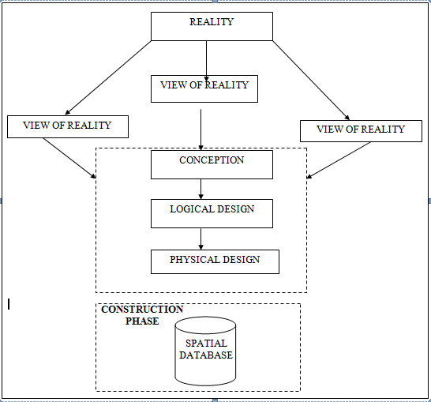

Fig.3.1Design and Construction Phases in Spatial Database (R Sobh, C Perry,. 2006)
    - LOGICALDESIGN

This is the design aspect of the database refers to the process of creating a conceptual framework or model that represents the structure and organization of spatial data within the system. It involves defining the data element, their relationship, and the rules for data manipulation and analysis. In this phase, the entities, their attributes and their relationships are represented in a single uniform manner in form of relation in such a way that would be no information loss and at the same time no unnecessary duplication of data. In this study, the logical database design is employed to generate a geo-relation database structure. Each entity has unique identifier in bold type. An attribute type or combination of attribute types that serves to identify an entity type is termed an identifier.
- Building (B_ID,B_Area, B_Name, B_Easting, B_Northing)

- Roads (R_ID,R_Width, R_Type, R-Condition, R_Easting, R_Northing)

- Vegetation (V_ID,GR_Area,)

- Tree (TR_ID,TR_spp,TR_Importance,TR_Easting,TR_Northing)

- Electric Pole (EP_No,EP_Type,EP_Height,EP_Easting,EP_Northing)

- Football Pitch FP_ID, FP_Area,FP_Status)

3.3 EQUIPMENT USED
3.3.1 HARD WARE
- Total Station (South
- Reflector Pole
- Hand-held GPS
- Steel tape
- Nails and bottle cover
- Field book
- 1 cutlass

3.3.2 SOFTWARE
- AutoCAD 2007
- Arc-GIS 10.2
- Google Earth
- Note pad
- Excel

3.4 INSTRUMENTTEST
To ensure data quality, the Total Station used for this project was tested for both vertical index and horizontal collimation errors. It was also to ascertain the efficiency and reliability of the instrument. The procedure used is described below.

3.4.1 HORIZONTALCOLLIMATIONTEST

This test was conducted to ensure that the line of sight was perpendicular to the trunnion axis. The Total Station was positioned over a specific point, and initial adjustments were made to ensure proper alignment, leveling, and focus (to eliminate parallax in the telescope). A vertical target was placed at a distance of 100 meters from the Total Station. To access the configuration menu of the Total Station, the menu key was pressed and held for approximately 2 seconds. From the

main menu, the calibration sub-menu was selected, and within that, the horizontal collimation test option was chosen. The target was then observed and divided into two halves, with horizontal readings recorded for Face left and Face right. The readings are shown in Table 3.4.1 below.

Total Station Reflector (Target)
100m

Station A Fairly Level Ground Station B

Fig3.4.1.1; Horizontal Collimation and Vertical Index error test

Table3.4.1.1: Horizontal Collimation Data

Station | Target | Face | Horz. Reading | Difference | Error
A | B | L | 025˚ 32‟ 32”
 |  | R | 205˚ 32‟ 35” | 180˚ 00’ 03” | 00˚ 00’ 03”

3.4.2 VERTICAL INDEX ERROR TEST

This test was conducted to verify the accuracy of the vertical reading when the line of sight is horizontal. The desired measurement for this test is exactly ninety degrees (90˚), any deviation from this value is referred to as the vertical index error.
The Total Station was positioned over a specific point, and necessary temporary adjustments were made to ensure proper alignment and functionality. A target was placed approximately100 meters away from the Total Station, and the instrument
was aimed at the target. The target was bisected by aligning the instrument on the face left, and the corresponding reading was recorded. Similarly, the target was then bisected on the face right and the respective reading were also recorded. The recorded readings are provided below:

Table3.4.2.1: Vertical Index Data

Instrument Station | Target Station | Face | Vertical | Sum | Error
A | B | L | 95˚ 00‟ 00”
 |  | R | 275˚ 00‟ 02” | 360˚ 00‟ 02” | 02”

3.4.3 ANALYSIS OF COLLIMATION AND VERTICAL INDEX DATA

The readings obtained during calibration were reduced to obtain new collimation and vertical errors.
Horizontal collimation = {(FR–FL) –180} /2 ={(00˚00‟03”} /2 =1.5”

Vertical collimation = {(FL+FR) –360} = (95˚00‟00” + 275˚00‟02” ) -360} = 02” The result shows that the instrument is still in good working condition.

3.5 CONTROL CHECK
3.5.1 Control Check Procedure Using Total Station
To ensure the accuracy and reliability of the Total Station observations used for spatial data acquisition, control checks were carried out before and during the main survey. The procedure involved setting up the instrument over a known control point, performing temporary adjustments, executing angular and distance observations (back sight and foresight), and validating the computed coordinates against known values.
Step 1: Instrument Setup and Centering.
The Total Station was mounted securely on a tripod placed directly over the first known control point.
Centering was done using the built-in optical plummet to align the vertical axis of the instrument precisely over the ground mark.
Fine adjustments were made by shifting the tripod legs or using the sliding base plate to achieve perfect alignment.
Step 2: Temporary Adjustments (Leveling and Elimination of Instrumental Error)
Leveling: The circular bubble was first centered using the tripod legs. Then, the tubular (or electronic) level was used with the foot screws to achieve fine leveling in two perpendicular directions.
Collimation Check: An internal calibration (collimation) check was performed using the instrument’s self-diagnosis function to ensure the vertical and horizontal axes were perpendicular.
The horizontal circle was then set to zero after selecting the backsight direction.

Step 3: Back sight Observation
The telescope was rotated to face a second known control point (backsight).
The instrument was focused accurately on the backsight prism, and both horizontal and vertical coordinates (XYZ) were measured.
Step 4: Foresight Observation and Coordinate Validation
The telescope was then turned to observe a third point (foresight). The horizontal and vertical coordinates (XYZ) were measured. The observed coordinates were then compared to the known coordinates of the foresight control point already established.
Coordinate difference (ΔX, ΔY, ΔZ) was calculated to assess positional accuracy. The difference was within the allowable tolerance (typically ±2cm for X/Y and ±3cm for Z), the instrument was considered properly calibrated.
Step 5: Repeat Check at another Station
The same procedure was repeated for every station setup across the site to ensure uniform accuracy across the network.
All three control stations showed closure errors and coordinate differences well within the accepted tolerance for third-order survey work. This control check procedure ensured that the Total Station data used for plotting school boundaries, buildings, and topography in the Land Information System were precise and trustworthy.
Once the control points were verified and validated, they were used as reference locations for the detailed survey of the school facilities.
Table 3.4.1: Coordinate of the observed and the original values of K654AD
PILLAR | NORTHING | EASTING | STATUS | REMARKS
SC/KW K654AD | 939792.896 | 673354.040 |  | ORIGINAL
SC/KW K654AD | 939792.886 | 673354.020 | FIXED | OBSERVED
DISCREPANCY | 0.010 | 0.020

Table 3.4.2: Coordinate of the observed and the original values of K656AD
PILLAR | NORTHING(m) | EASTING(m) | STATUS | REMARKS
SC/KW K656AD | 939837.818 | 673334.688 |  | ORIGINAL
SC/KW K656AD | 939837.797 | 673334.666 | FIXED | OBSERVED
DISCREPANCY | 0.021 | 0.022

Table 3.4.3: Coordinate of the observed and the original values of K657AD
PILLAR | NORTHING(m) | EASTING(m) | STATUS | REMARKS
SC/KW K657AD | 939803.143 | 673366.311 |  | ORIGINAL
SC/KW K657AD | 939803.132 | 673366.291 | FIXED | OBSERVED
DISCREPANCY | 0.011 | 0.020

3.7 GEOMETRIC DATA ACQUISITION

The total station instrument was set carefully on control point SC/KW K6546AD back sight taken to K SC/KW K654AD after necessary station adjustments has been carried out on it. The adjustments include; centering, leveling and focusing. The following procedures were then followed to determine the position of the next point (NL1) and the same procedure were repeated until all we come close to the site. The method used in acquiring data on site was radiation method where two or more points are coordinated from one instrument station.

- Having setup the instrument and temporary adjustment carried out, the instrument was powered „on‟ and a job file was created under job menu in the internal memory of the instrument. The job file created was named GSSGR4C.
- On the job, the coordinates of the three (3) control points were keyed in to the memory of the instrument and some codes were also saved. The codes include
„RD‟ for road, SP‟ for spot height, BD for buildings, etc.

- The height of the instrument was measured and saved on the memory of the instrument as well as their reflector height.
- On coordinate menu, orientation was set by inputting the coordinates of the instrument station and back sight. The reflector at the back station was perfectly bisected before the orientation was confirmed by clicking yes.
Having done the orientation, the reflector at the next station was bisected and observe option was clicked. The three-dimensional coordinate of the point (E N, H) were displayed on the display unit of the instrument and record button was clicked to save the data into the memory of the instrument. For subsequent observation after this, all options were used instead of pressing observation (“obs”) and pressing record later.

- It was ensured that the center of the prism of the reflector was bisected and that it was set perfectly on the tripod in order to minimize the error on height determination.
- The instrument is been shifted to another station after all details, spot height and boundary point visible from the instrument station have been picked, The instrument was set over new station and temporary adjustments carried out.

However, the above operations were repeated until all the boundary points with heights were coordinated.

In this project all spot height were not in grid intervals but randomly acquired. At the end of data acquisition process all details were observed and properly recorded to be shown in their respective positions on the plan.

Detailed Survey:
The detailed survey focused on mapping the internal structures and facilities within the school, including:
- Classrooms
- Staff rooms and administrative offices
- Laboratories and libraries
- Playgrounds and sports fields
- Roads, parking lots, and walkways
Geometric data for every feature were acquired using Total Station, and the collected spatial data were stored in a structured format. Screenshots of the Total Station data interface were captured to illustrate the data collection process. The observations were carried out systematically to ensure complete coverage of all features within the project area.

Non-Spatial Data Collection
In addition to spatial data, non-spatial data (attribute data) were collected to provide descriptive information about each observed feature. These data were gathered through field observations, school administrative records, and structured interviews with key personnel.

Types of Non-Spatial Data Collected
- Building Information: Name, number of floors, year of construction, type of usage (classroom, staff office, laboratory, etc.).
- Staff Room and Office Details: Departmental functions, number of staff, office occupants.
- Infrastructure Information: Type of roads (paved or unpaved), water supply, power supply.
A field book was used to record the collected data, ensuring uniformity and easy integration into the LIS database. The completed forms were reviewed for accuracy before entering the data into a spreadsheet for GIS processing. Screenshots of the attribute data collection forms were taken and included in the documentation.

3.3.4 Data Download and Storage
Once the field surveyed was completed, all collected data were transferred to a computer system for further processing and storage. The following steps were taken to ensure proper data management:
- Downloading Total Station Data: The surveyed X, Y, Z coordinates were extracted from the Total Station’s internal memory using instrument software. The data were saved in a CSV (comma-separated values) file format for compatibility with GIS and AutoCAD software.
- Organizing Non-Spatial Data: The collected attribute data were entered into an Excel spreadsheet, ensuring proper formatting for easy integration with spatial data. The file structure was reviewed to ensure consistency and completeness.
- Data Backup: Copies of all data files were stored in an external flash drive to prevent data loss. File versions were properly labelled to maintain organization.
The downloaded spatial and non-spatial datasets were prepared for further processing and integration into the LIS.
3.3.5 Data Validation and Accuracy Assessment
To ensure the accuracy and reliability of the collected data, a rigorous validation process was conducted. This involved cross-checking the surveyed coordinates, attribute data, and instrument readings to identify and correct any errors.
Validation of Spatial Data
- Coordinate Cross-Check: The surveyed points were compared with known control points to verify accuracy.
- Boundary Accuracy Check: The surveyed boundary was overlaid on an existing satellite image in Arc=GIS to detect any misalignment.
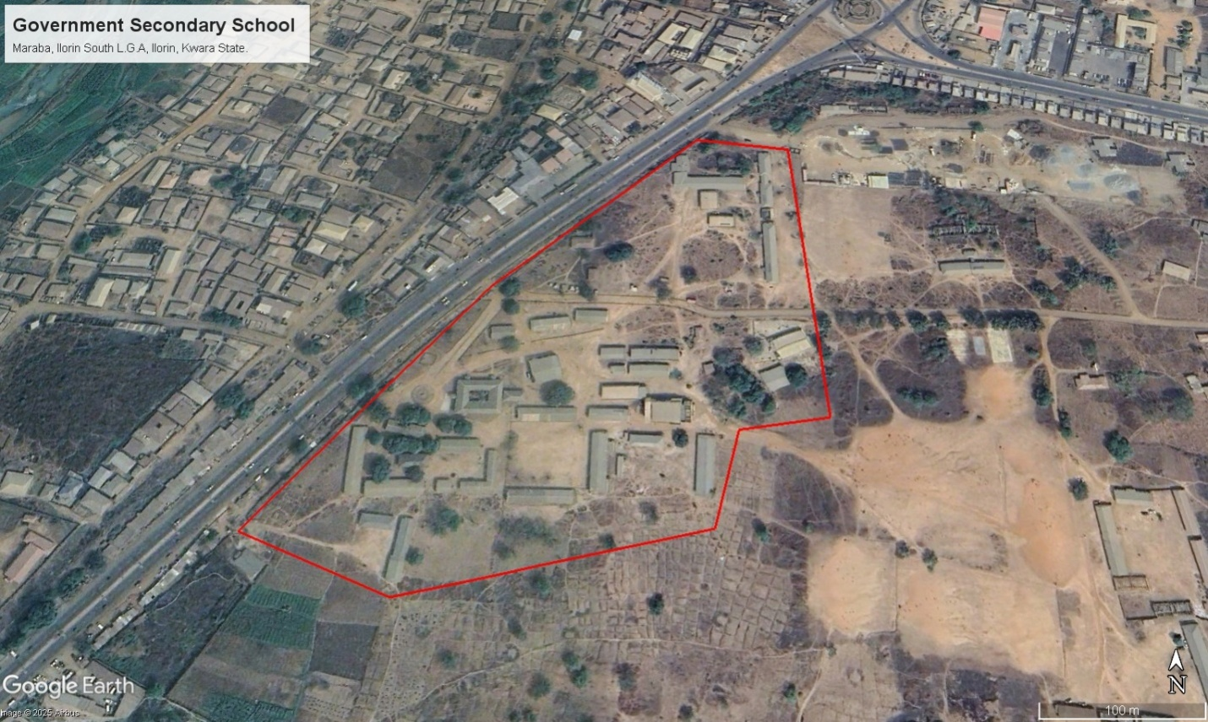
Figure 3.3: Satellite Imagery of the study area
Validation of Non-Spatial Data
- Attribute Consistency Check: The recorded building and facility details were compared with official school records.
- Correction of Data Entry Errors: Any discrepancies or incorrect attribute entries were identified and corrected before finalizing the dataset.

3.4 Data Processing and Integration
The data processing and integration phase is a critical step in transforming the raw data collected from the field survey into a structured Land Information System (LIS). This stage involves cleaning, organizing, and integrating both spatial and non-spatial data into a geodatabase, ensuring seamless access, analysis, and visualization.
The processing workflow consists of multiple steps, including spatial data processing in AutoCAD and Surfer, non-spatial data structuring in Excel, geodatabase creation in ArcGIS, and data integration for LIS development. The structured integration of these datasets enables effective querying, mapping, and decision-making for the secondary school management system.
3.4.1 Spatial Data Processing in AutoCAD
AutoCAD was used to plot the observed coordinates, (Geometric data) ensuring accurate representation of school facilities such as classrooms, staff rooms, administrative offices, roads, and playgrounds. The following steps were carried out:
- Importing Surveyed Points:
  - The CSV file containing surveyed coordinates was imported into AutoCAD.
  - The points were plotted based on their real-world X and Y coordinates, while the Z values were retained for elevation analysis.
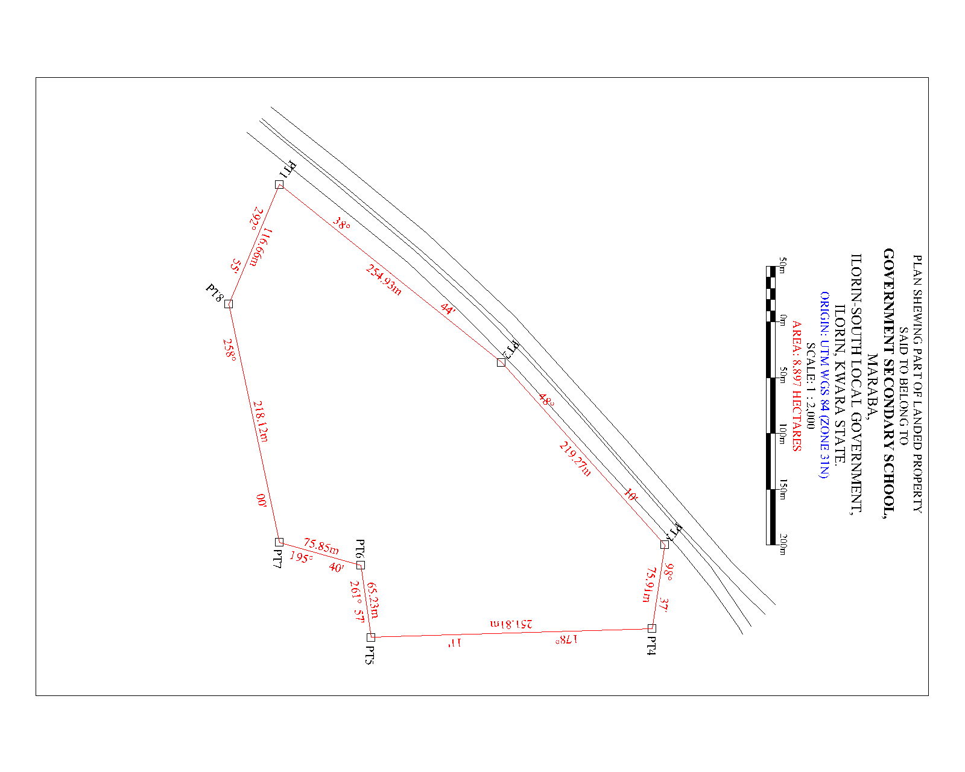
Figure 3.4: A screenshot of the boundary in AutoCAD. This is not a screenshot, use appropriate screenshot
- Plotting of Boundaries and Features:
  - The boundary points were connected using polyline tools, forming a closed polygon to define the extent of the school premises.
  - Each school building was mapped as a separate layer, and unique identifiers were assigned to distinguish classrooms, staff rooms, laboratories, and other structures.
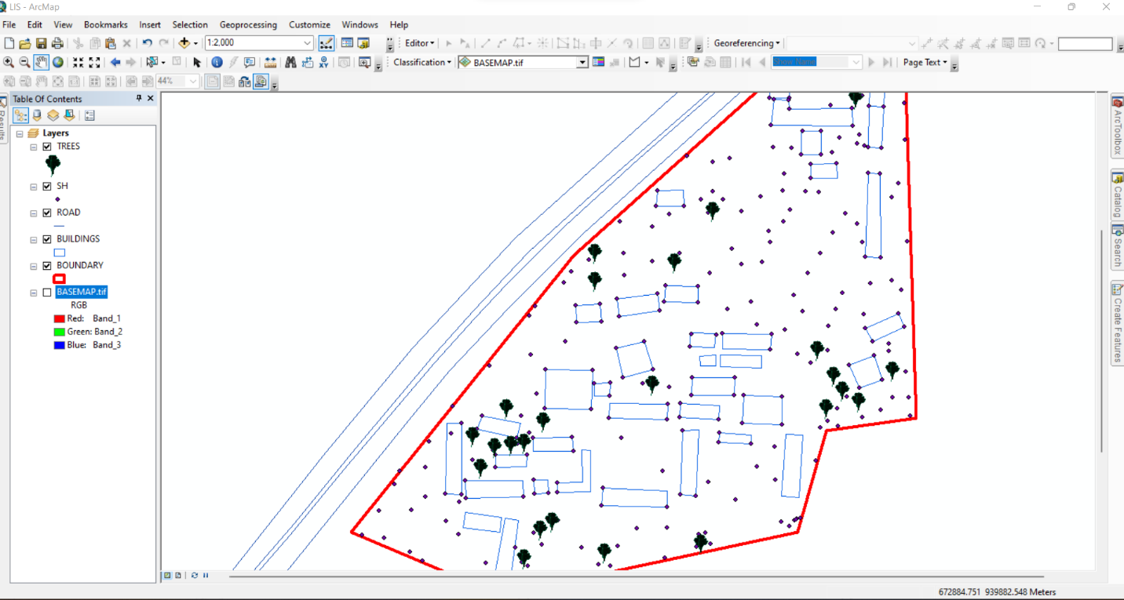
Figure 3.5 Screenshot of boundary digitization and features
3.4.2 Topographic Data Processing in Surfer
Surfer software was used for topographic analysis and terrain modelling based on the surveyed elevation data (Z values). The following procedures were followed:
- Importing Surveyed Data:
  - The X, Y, and Z coordinates were loaded into Surfer as a point dataset.
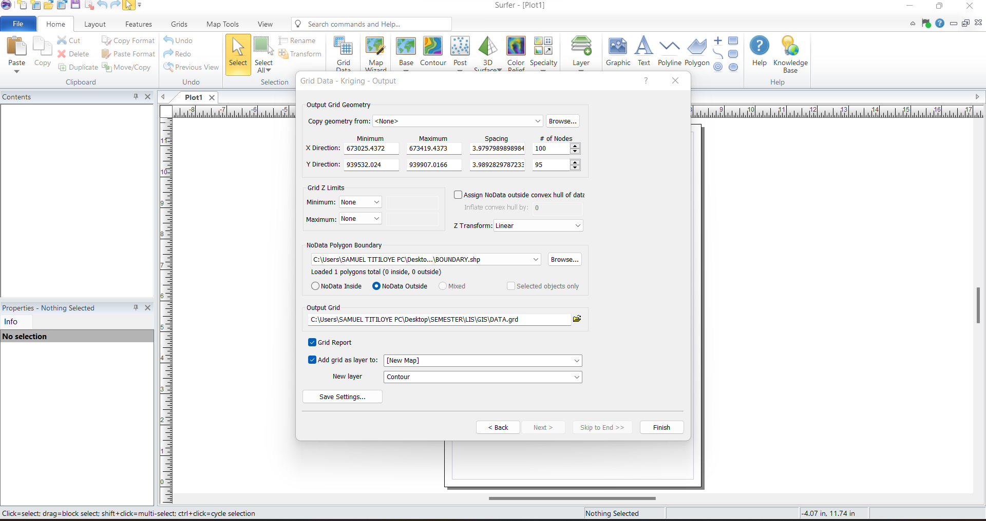
Figure 3.6: Screenshot of the imported dataset.
- Generation of Digital Elevation Model (DEM):
  - A grid-based interpolation technique was applied to generate a Digital Elevation Model (DEM) of the school area.
  - The DEM provided insight into the elevation variations across the school premises, assisting in drainage and flood risk assessment.
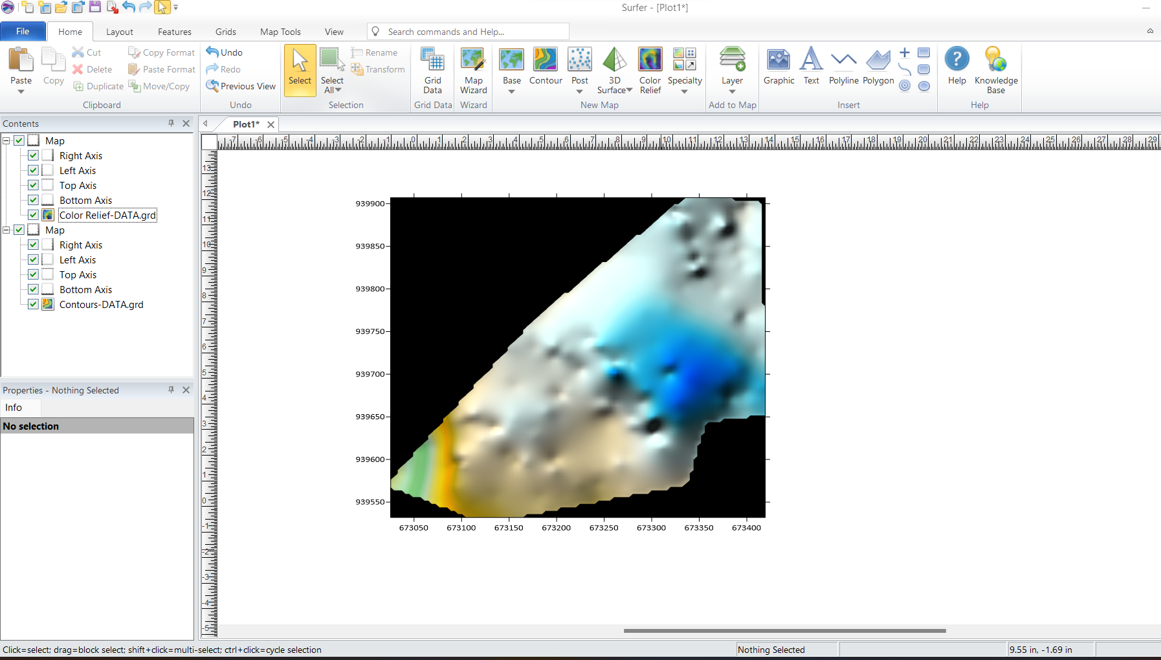Figure 3.7: Screenshot of the generated DEM.
- Creation of Contour Maps:
  - Contour lines were generated at specific intervals to visualize terrain variations.
  - The contour map was exported in Geo-TIFF format for integration into Arc-GIS.
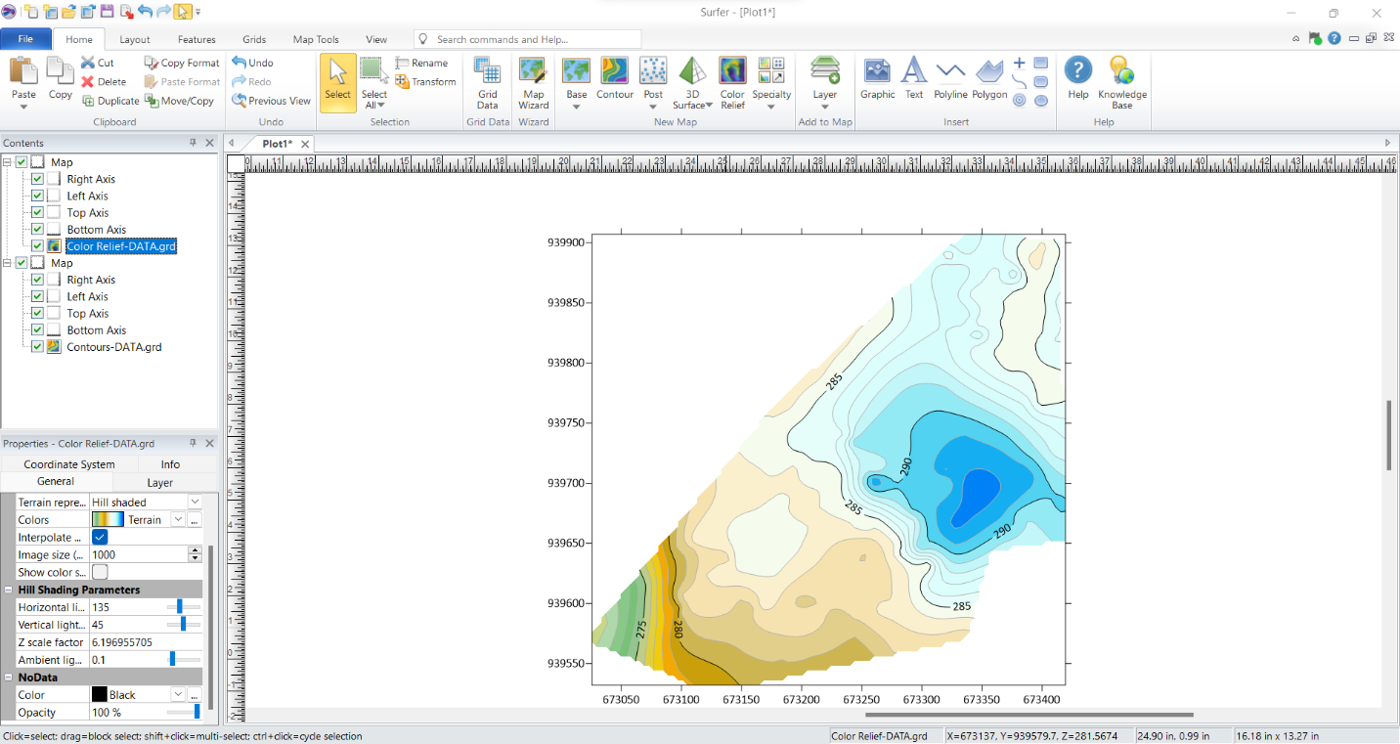Figure 3.8: Screenshots of the contour generation process.
3.4.3 Non-Spatial Data Processing in Excel
Non-spatial data collected through field observations and school administrative records were structured and formatted in Excel to ensure consistency and ease of integration into Arc-GIS.
- Data Entry and Formatting:
  - Each facility was assigned a unique ID corresponding to its spatial location.
  - Attributes such as building type, year of construction, and available amenities were recorded.
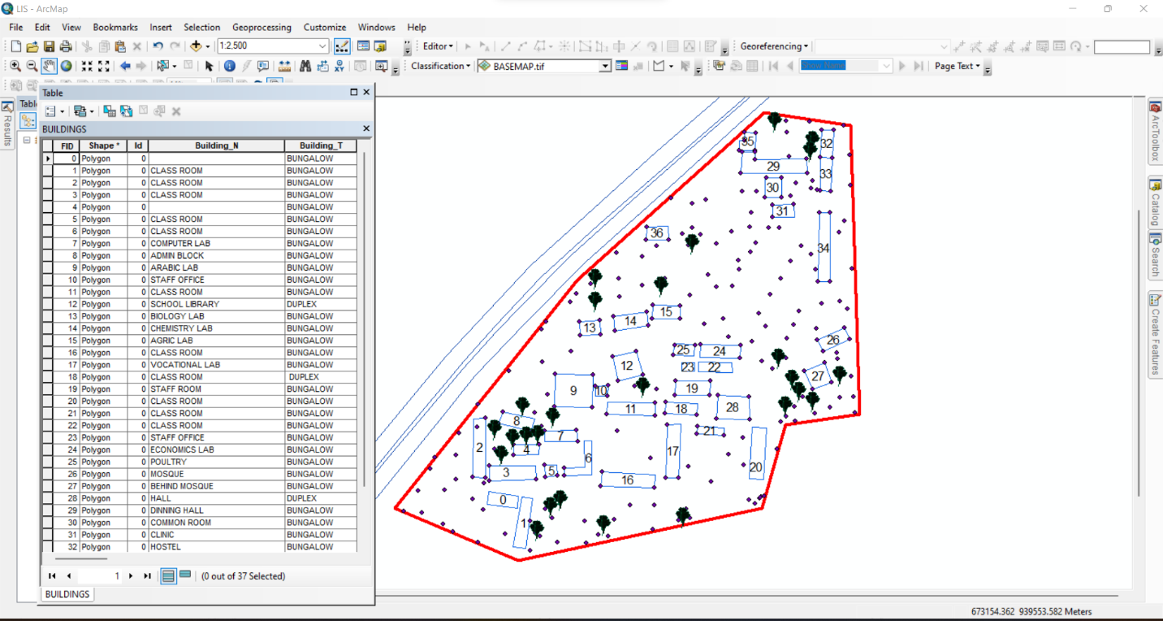Figure 3.9: Screenshot of the structured attribute table.
3.4.4 Geo-database Creation in Arc-GIS
A geo-database was created in Arc-GIS to integrate both spatial and non-spatial data, allowing efficient storage, retrieval, and analysis of school infrastructure data. The following steps were taken:
- Creating a New Geo-database:
  - A file geo-database was created in Arc-GIS to store all spatial data layers and attribute tables.
- Importing Spatial Data:
  - The DXF file from Auto-CAD (containing school boundaries and building layouts) was imported into Arc-GIS.
  - The GeoTIFF file from Surfer (containing the DEM and contour data) was also loaded.
- Defining Feature Classes:
  - Separate feature classes were created for classrooms, staff rooms, offices, laboratories, roads, and other infrastructure.
  - Each feature class was assigned relevant spatial properties (e.g., polygon for buildings, polyline for roads).
- Importing Non-Spatial Data and Linking to Spatial Features:
  - The CSV file containing attribute data was imported into ArcGIS.
  - A one-to-one relationship was established between the spatial features and their corresponding attribute records using the unique ID field.
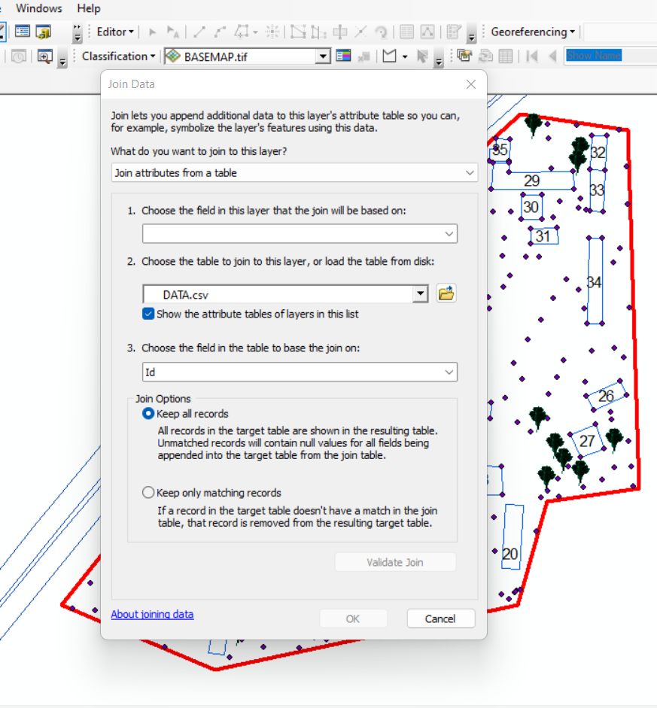
Figure 3.11: Screenshot of the data join process.
3.4.5 Data Integration and Finalization for LIS
The final stage involved ensuring seamless integration between spatial and non-spatial data within the LIS environment.
- Verification of Data Integrity
  - The attribute data were cross-checked to ensure they matched their respective spatial locations.
  - Any mis-linked records were corrected, and missing attributes were updated.
- Symbolization and Visualization:
  - Each feature class was assigned unique symbols and colors for better visualization in Arc-GIS.
  - Thematic maps were created to represent building categories, classroom capacities, and road networks.

3.7.1 Perimeter Plan of the Project Area
Figure 3.7.1: A screenshot of the boundary in AutoCAD.
- Boundary Digitization and Feature Mapping:
  - The boundary points were connected using polyline tools, forming a closed polygon to define the extent of the school premises.
  - Each school building was mapped as a separate layer, and unique identifiers were assigned to distinguish classrooms, staff rooms, laboratories, and other structures

3.7.2 Detailing
Figure 3.7.2 Screenshot showing the digitization process and layer management.
3.7.2 Topographic Data Processing in Surfer
Surfer software was used for topographic analysis and terrain modelling based on the surveyed elevation data (Z values). The following procedures were followed:
- Importing Surveyed Data:
  - The X, Y, and Z coordinates were loaded into Surfer as a point dataset.

3.7.3 Attribute data acquisition
Attribute data is information about spatial features. They provide the characteristics, description and nomenclature about spatial objects. Thus, the attributes data acquired includes names of buildings and their uses such as classrooms, roads, water facilities and prominent natural features Likes River and trees found and vegetation were properly identified within and around the study area.

3.8 Database Creation / Implementation
This is the database creation phase. Having completed the three stages of design phase (i.e Reality, Conceptual and Logical design), the data base was created using ArcGIS10.2 software. It involves the combination and storage of acquired graphic data and attributes data in creating the database for the purpose of spatial analysis and query.
Database is an organized integrated collection of data stored so as to be capable of use by revenant application with data being accessed by different logical part. After the Attribute table was populated via the keyboard, some attributes such as areas of settlements were automatically displayed by special command in the ArcGIS 10.2 version. The ArcGIS software was used to link the graphic data and table for query generation.

3.8.1 Database Management System (DBMS)
Data base management is a collection of software for creating, storing, manipulating, updating, organizing and querying of information in a database (Kufoniyi, 1998). It is a software package whose function is to manipulate a data base on behalf of the user.
A good DBMS must provide the following functions:

      - Storage and retrieval of data.

      - Access to by several users at a time.

      - A standardized interface between data base and application programmed.

      - Standardized access to data and separation of data storage and retrieval functions from the program using the data.

      - Maintenance of data security and integrity.

3.8.2 Data Quality
Having created the database, proper maintenance practice was made to meet its stated objectives. The ability to include more data and remove irrelevant data was possible by way of maintenance. There is every need for the data to be updated regularly because of the physical changes that may occur on the landscape with time. Both security and integrity were also exercised to ensure maintenance and to meet its stated objectives.
Proper observance, updating and management of database ensure its currency and quality to stand a profound chance in Spatial Decision Support System (SDSS). The quality of any database depends on the currency and fitness for use as a decision support system (SDSS). The quality of database depends on its ability to generally fit and use as a decision system(DSS). The storage media should be from time to time justified if otherwise could necessitate data inaccessibility or physical deterioration of the storage media. Also, care must be taken during populating any database system, as a database is only good as the data supplied. In archiving stable media should be used. Examples of these are
- Computer compatible tape reader

- Magnetic tape

- Optical disc and compact disc.

CHAPTER FOUR

ANALYSIS AND RESULTS

4.1 Introduction
This chapter presents the results obtained from the data acquisition, processing, and integration procedures described in the previous chapter. The findings provide a comprehensive spatial and non-spatial representation of the school environment, including the layout of buildings, topographical features, and attribute information related to school facilities. The results are structured to demonstrate how the Land Information System (LIS) can enhance school management by providing accurate, well-organized, and easily accessible data.
The results are categorized into different sections for clarity. The spatial data results include mapped school boundaries, building footprints, and access networks, all of which were digitized using GIS tools. The topographical results analyze elevation variations using Digital Elevation Models (DEM) and contour maps, which are crucial for site planning and infrastructure development. The non-spatial data results contain attribute information such as classroom capacity, staff room assignments, and building conditions, all integrated into the LIS database. The data integration and query results demonstrate how the LIS functions as an interactive tool for retrieving, analyzing, and visualizing school-related data.
This chapter also includes analyses that reveal important insights into building distribution, infrastructure conditions, environmental constraints, and potential areas for school expansion. The results are presented using maps, tables, and screenshots from GIS and related software to illustrate how data were processed and visualized. The goal of this chapter is to demonstrate the practical application of an LIS in school facility management and to highlight the benefits of integrating spatial and non-spatial data for decision-making.

4.2 Spatial Data Results
The spatial data results provide a detailed representation of the school’s geographical layout, including its boundaries, buildings, access roads, and pathways. These results were derived from Total Station survey data, processed in AutoCAD and ArcGIS to create an accurate Land Information System (LIS) for the school. This section highlights the steps taken to map the school boundary, digitize building footprints, and visualize access routes.
The spatial data results are essential for effective school management, as they provide a georeferenced framework that helps in planning expansions, monitoring infrastructure, and optimizing resource allocation. The outputs presented in this section form the foundation for further topographical, non-spatial, and LIS-based analysis discussed in subsequent sections.
4.2.1 School Boundary and Building Layout
The school boundary and building layout were mapped using surveyed coordinates (X, Y, Z) collected with the Total Station. The acquired data were processed in AutoCAD to generate a structured boundary map and building footprints, which were then imported into ArcGIS for further spatial analysis and integration into the LIS database.
Figure 4.2.1: As built Plan of Government Secondary School Maraba, Ilorin South East Local Government. using GIS software
Visualization of Spatial Data Results
The final processed spatial data were visualized in ArcGIS, where the school boundary, building footprints, and access roads were symbolized appropriately to enhance readability.
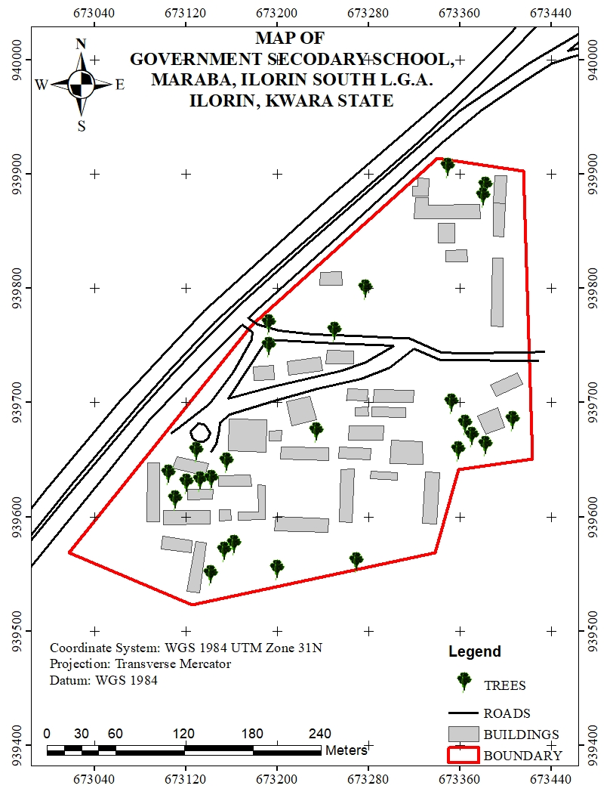
Figure 4.2.1: Mapped School Boundary and Buildings in ArcGIS
- The school boundary is represented as a bold polygon to define the outer limits of the school.
- Buildings are shown in different colors based on their usage (e.g., classrooms in blue, administrative offices in green, laboratories in red).
- Roads are displayed as lines, with roads marked in black.
This spatial data representation serves as the primary framework for the LIS database, allowing users to visualize, analyze, and manage school infrastructure efficiently.
Significance of the Spatial Data Results
The school boundary and building layout play a crucial role in:
- Infrastructure Planning: Ensuring optimal land use by identifying available spaces for future construction and expansion.
- Facility Management: Helping administrators monitor the condition, usage, and location of various school buildings.
- Navigation and Accessibility: Enhancing movement planning for students, staff, and visitors by identifying clear pathways and access points.
- Disaster Management: Providing accurate spatial information to plan for emergency exits, assembly points, and safety zones.
The spatial data results form the foundation for further analysis, including topographical evaluation, attribute data integration, and advanced GIS-based queries, which will be presented in the subsequent sections of this chapter.

4.3 Topographical Analysis Results
Topographical analysis provides crucial information about the elevation, slope, and terrain variations within the school environment. Understanding these features is essential for site planning, infrastructure development, drainage design, and environmental management. This section presents the results of topographical data processing and analysis, including the creation of Digital Elevation Models (DEM), contour maps, and slope analysis.
The topographical data were obtained using Total Station measurements, which captured X, Y, and Z coordinates of various points within the school premises. These data were processed in Surfer to generate elevation models and later integrated into ArcGIS for spatial analysis.
4.3.1 Digital Elevation Model (DEM)
The Digital Elevation Model (DEM) was created to provide a 3D representation of the school’s terrain. Using Z-coordinates from the Total Station survey, a gridded elevation surface was generated in Surfer and later exported to ArcGIS for further analysis.
Key Features of the DEM:
- The DEM visually represents variations in land elevation within the school compound.
- Areas of higher elevation are highlighted, aiding in infrastructure planning and water drainage management.
- The DEM serves as the base for further slope, aspect, and contour analysis.
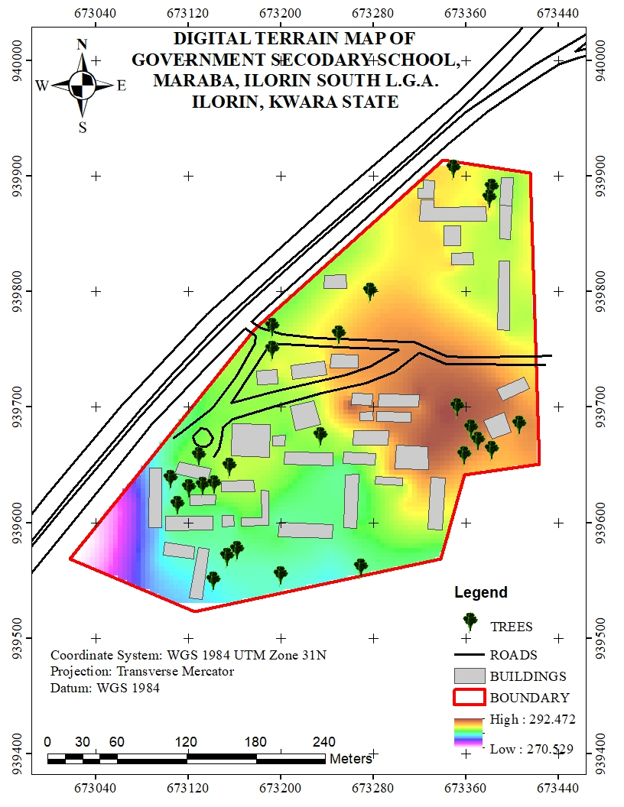
Figure 4.3.1: Digital Elevation Model (DEM) of the School Premises
4.3.2 Contour Mapping
Contour mapping was conducted to visualize elevation changes and terrain gradients within the school environment. The surveyed elevation data were processed in Surfer to generate contour lines, which were later imported into Arc-GIS for spatial overlay and analysis.
Key Results from Contour Analysis:
- The contour interval was set based on the range of elevation variations in the study area.
- Closely spaced contour lines indicate steep slopes, while widely spaced lines represent gentler slopes.
- The contour map helps in identifying low-lying areas that may be prone to water logging or flooding.
- The results assist in drainage planning by identifying natural water flow paths.
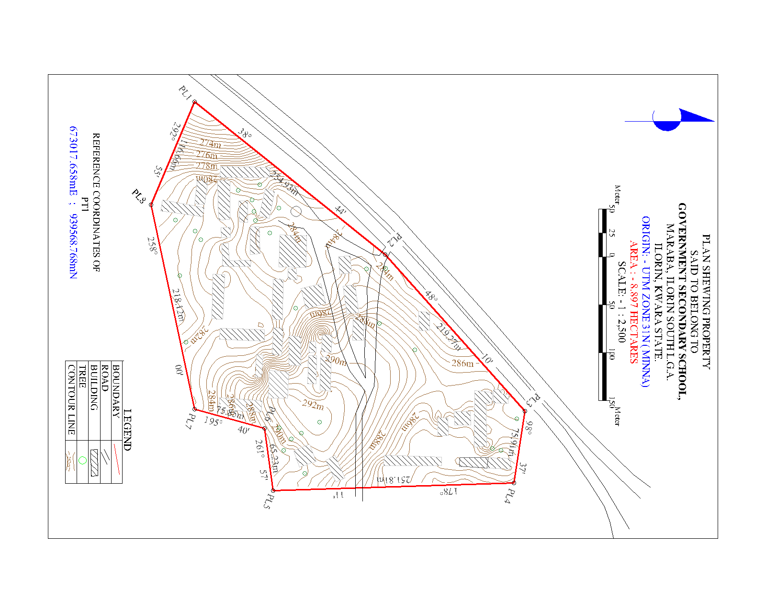
Figure 4.3.2: Contour Map of the School Premises
4.3.3 Slope and Terrain Analysis
A slope analysis was conducted to determine variations in land steepness across the school environment. The slope was computed using the DEM in ArcGIS, with results classified into different slope categories to assess terrain usability.
Key Findings from Slope Analysis:
- Flat areas (0-5 degrees) are suitable for classroom blocks, play areas, and other infrastructure.
- Moderate slopes (5-15 degrees) are manageable for footpaths and minor construction projects.
- Steeper slopes (above 15 degrees) may require erosion control measures or retaining walls to prevent land degradation.
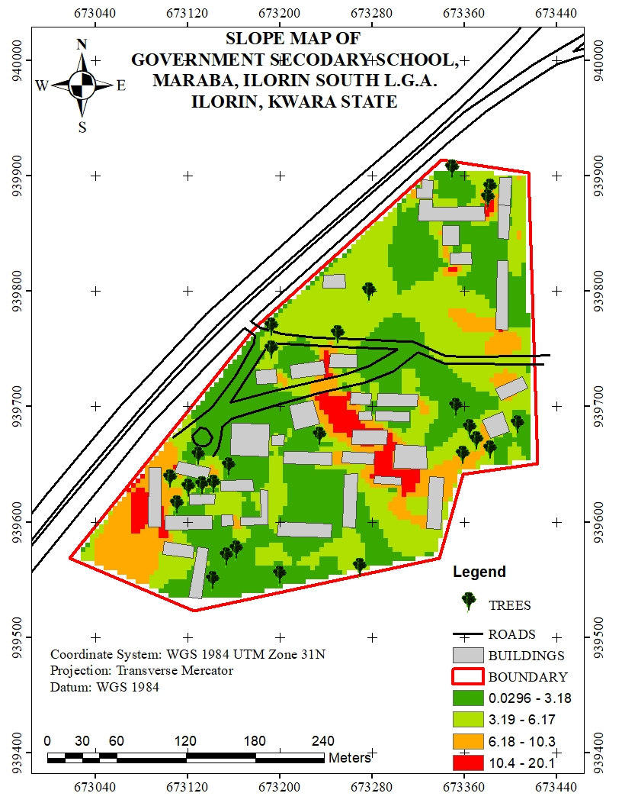
Figure 4.3.3: Slope Analysis Map of the School Premises
4.3.4 Significance of Topographical Analysis Results
The results of the topographical analysis provide essential insights for school management, infrastructure development, and environmental sustainability. These findings contribute to:
- Better infrastructure planning: Ensuring that new buildings and roads are constructed on stable ground.
- Improved drainage management: Reducing the risk of flooding and water stagnation within the school premises.
- Enhanced safety measures: Identifying steep areas that may require protective barriers or adjustments in land use planning.
- Sustainable land use: Helping decision-makers optimize space utilization while considering terrain constraints.
The topographical analysis results form an integral part of the Land Information System (LIS), ensuring that spatial data is not only stored but also analyzed for informed decision-making in school infrastructure management.
4.4 Non-Spatial Data Results
Non-spatial data results refer to the descriptive information associated with various school facilities, buildings, and infrastructure. Unlike spatial data, which provides geometric representations of features (such as school boundaries, buildings, and roads), non-spatial data includes textual and numerical attributes that help in facility management and decision-making.
The non-spatial data collected in this study were integrated into the Land Information System (LIS) to enhance school administration, infrastructure monitoring, and resource planning. The data were structured in tabular format and linked to corresponding spatial features in ArcGIS using unique identifiers.
4.4.1 Attribute Data for School Buildings
The non-spatial attributes for classrooms, staff rooms, laboratories, and administrative offices were recorded and organized in a database. Each building was assigned a unique identifier (Building ID), allowing for easy retrieval of information in GIS.
Key Attributes for Buildings:
- Building Name/ID (e.g., Classroom Block A, Staff Room 1)
- Building Type (Classroom, Laboratory, Office, Library, Hall)
- Primary Use (Teaching, Administration, Storage, Utility)
This information was stored in ArcGIS attribute tables and linked to the digitized building footprints, allowing users to perform queries such as identifying underutilized classrooms or buildings in need of maintenance.
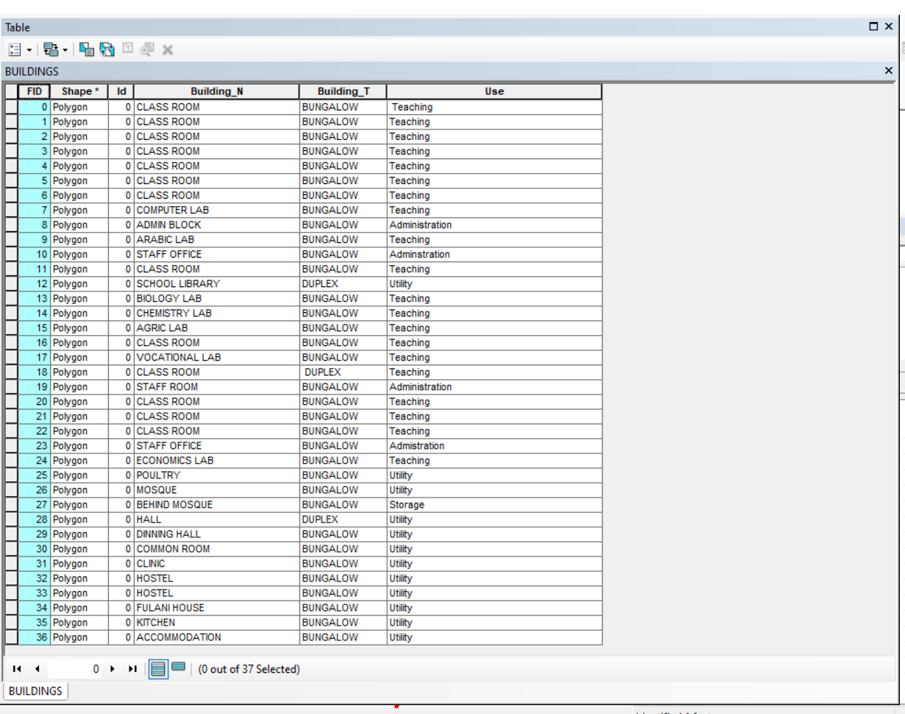
Figure 4.4.2: Sample Attribute Table for School Buildings

4.4.3 Linking Non-Spatial Data with GIS
All non-spatial datasets were linked to their corresponding spatial features in ArcGIS. This integration allows for interactive queries and visual analysis of school facilities. Some of the key functionalities include:
- Clicking on a building footprint to view its attributes (e.g., building name, building type, & use).
- Running queries to find classrooms that exceed their maximum student capacity.
- Generating reports on the maintenance history of infrastructure.
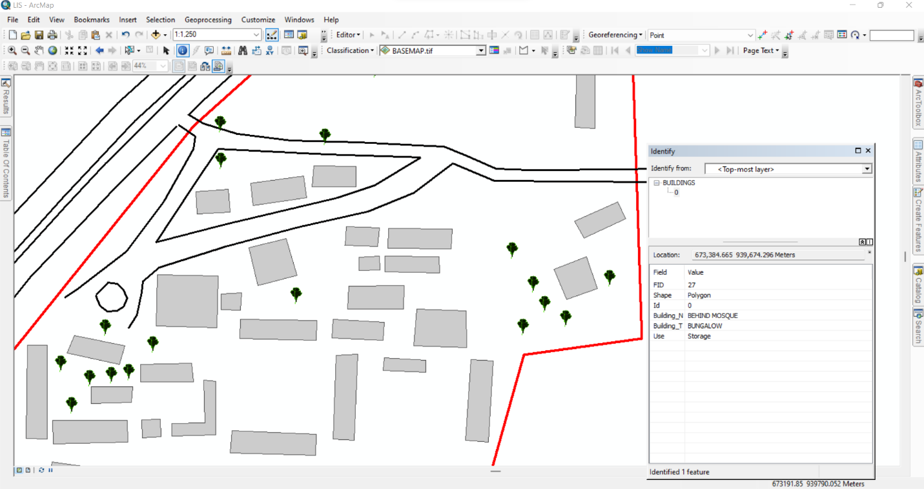Figure 4.4.3: Linking Non-Spatial Data to Spatial Features in ArcGIS
4.4.4: Significance of Non-Spatial Data in LIS
The integration of non-spatial data into the LIS enhances decision-making by providing comprehensive attribute information for school management. These results contribute to:
- Effective Resource Allocation: Ensuring that classrooms, offices, and other facilities are optimally utilized.
- Infrastructure Maintenance Planning: Monitoring facility conditions and scheduling necessary repairs.
- Improved School Administration: Tracking staff distribution, student population trends, and room assignments.
- Emergency Preparedness: Identifying critical infrastructure that requires regular inspections and safety measures.
The non-spatial data results demonstrate how a Land Information System (LIS) can support school facility management by combining spatial visualization with detailed attribute data. This information is essential for long-term planning, policy-making, and efficient school operations.

4.5 Query Execution and Results
With the integrated database, queries were performed in ArcGIS to extract specific information about the school environment. These queries help in analyzing building usage, staff distribution, facility conditions, and space utilization.
Example Query Results:
- Mapping Distribution of Staff Offices:
Query: "Show all staff offices"
Result: A spatial representation of staff office locations was displayed, ensuring adequate office space allocation.
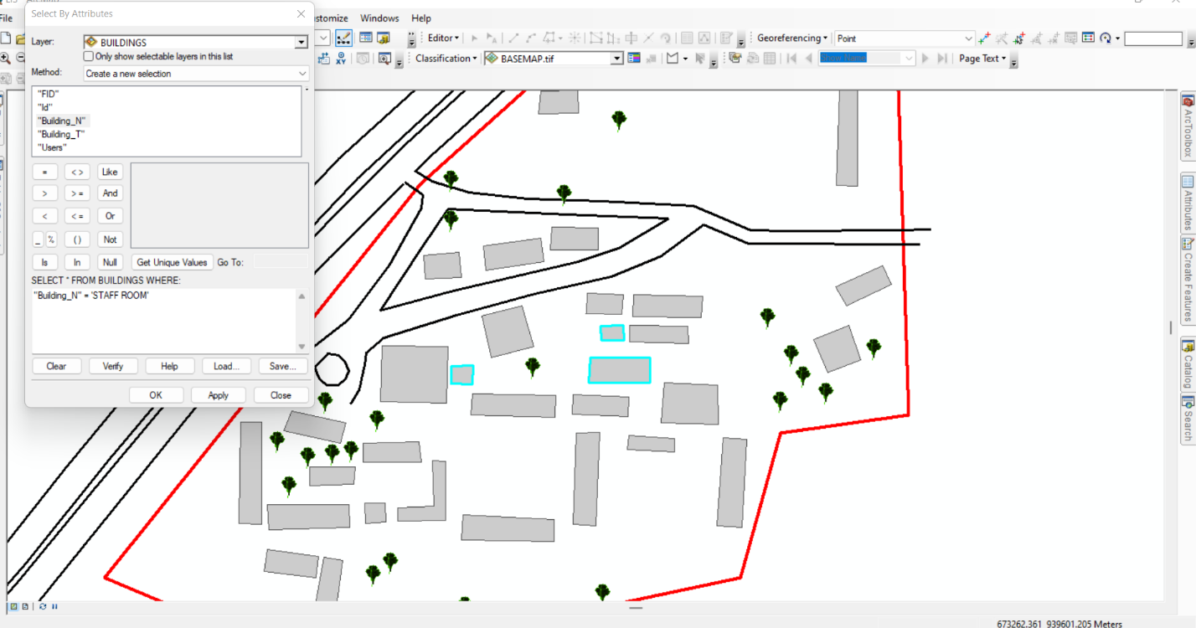
Figure 4.5.1: Sample Staff room Query Results in Arc-GIS
- Mapping Distribution of Class rooms:
Query: "Show all Class rooms"
Result: A spatial representation of class room locations was displayed, ensuring adequate office space allocation.
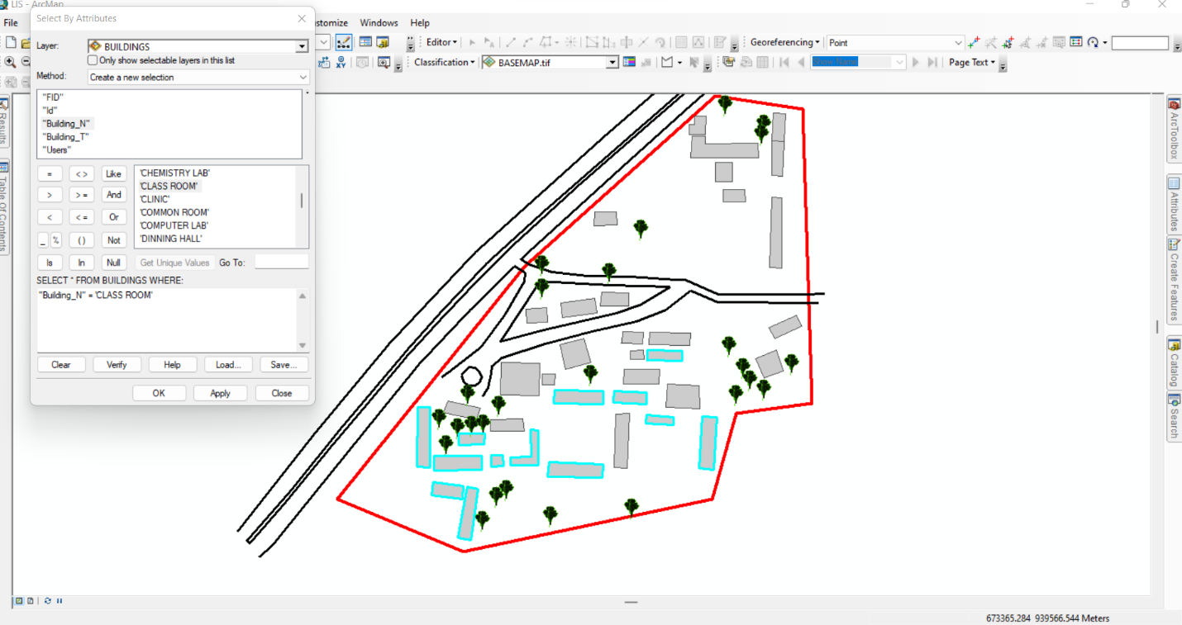
Figure 4.5.2: Sample Class room Query Results in ArcGIS

CHAPTER FIVE

5.0 COSTING, SUMMARY, PROBLEMS ENCOUNTERED, CONCLUSION AND RECOMMENDATION
5.1 COSTING
The costing of this project was done using the Nigeria Institution of Surveyor's (NIS) professional scale of fees for consultant in the construction industry. This stage shows the total cost that was spent on the project from day one to the final stage.
RECCI
PERSONAL/QUALITY | DAY(S) | UNITRATE(N) | TOTAL AMOUNT(N)
1 Senior Surveyor | 1 | 20,000.00 | 20,000.000
Assistant Surveyor | 1 | 8,000.00 | 8,000.00
Transportation | 1 | 7,000.00 | 7,000.00
Basic Equipment | 1 | 8,000.00 | 7,000.00
TOTAL |  |  | #42,000.00

BEACON= 2,100 × 5
= #10,500

BEACONING
PERSONAL/QUALITY | DAY(S) | UNITRATE(N) | TOTALAMOUNT(N)
1Assistant Surveyor | 1 | 8,000.00 | 8,000.00
Basic Equipment(6) | 1 | 8,000.00 | 8,000.00
Transportation | 1 | 7,000.00 | 7,000.00
TOTAL |  |  | #23,000.00

TRAVERSING
PERSONAL/QUALITY | DAY(S) | UNITRATE(N) | TOTALAMOUNT(N)
1 Assistant Surveyor | 2 | 8,000.00 | 16,000.00
Basic Equipment | 2 | 8,000.00 | 16,000.00
Transportation | 2 | 7,000.00 | 14,000.00
TOTAL |  |  | #46,000.00

DOWNLOADING DATA AND PLOTTING
PERSONAL/QUALITY | DAY(S) | UNITRATE(N) | TOTALAMOUNT(N)
1Senior Surveyor | 2 | 15,000.00 | 30,000.00
1AssistantSurveyor | 2 | 8,000.00 | 16,000.00
Transportation | 2 | 7,000.00 | 14,000.00
Consumables | 2 | 7,000.00 | 14,000.00
TOTAL |  |  | #74,000.00

INFORMATION PRESENTATION
PERSONAL/QUALITY | DAY(S) | UNITRATE(N) | TOTALAMOUNT(N)
1Assistant Surveyor | 1 | 8,000.00 | 8,000.00
Transportation | 1 | 7,000.00 | 7,000.00
TOTAL |  |  | #15,000.00

(1) # 42,000.00
(2) # 10,500.00
(3) # 23,000.00
(4) # 46,000.00
5) #74,000.00
(6) # 15,000.00
TOTAL # 210,500.00
CONSTIGENCIES=5%
210,500.00×5%÷ 100
= #10,525.00

V. A. T = 7.5%
210,500.00×7.5%÷100
= #15,787.50

MOBILIZATION AND DEMOBILIZATION =10%
2o10, 500.00 × 10%. ÷ 100
= #21,050.00
ACCOMODATION = 1.5%
210,500.00 ×1.5%÷100
= 3,157.50
TOTAL = 210,500.00
10,525.00
15,787.50
21,050.00
3,157.50
GRAND TOTAL = 261,020.00

5.2 Summary
The basic aim of the project is to design and develop a comprehensive system for managing land-related data and information, integrating spatial and non-spatial data to provide a platform for capturing, storing, analysing, and disseminating land-related information, enabling efficient decision-making, improved land management, increased transparency, ultimately contributing to better land management, sustainable development, and economic growth.Relevant literatures were reviewed and past researches highlighted. Data was acquired using digital methods of land survey and processing of the data was carried out with the use of relevant software.The data was processed and used to design, create and implement the database used for the analyses in this project, observing all the rules and conventions governing database creation and management. This was successful with the use of software suitable for the applications involved in the processing, analysis and presentation of information (Arc GIS).Presentation of information was done in digital format, in form of maps (hard and soft copies). A report on all the procedures carried out in the course of the project was presented containing all details about the project.

5.3 RECOMMENDATIONS
Recommendations for Land Information System based on the findings and outcomes of this project, the following recommendations are made:
- Regular Updates and Maintenance: The LIS should be regularly updated and maintained to ensure that the data remains accurate and relevant.
- Data Sharing and Integration: The LIS should be integrated with other relevant systems and databases to facilitate data sharing and improve decision-making.
- Training and Capacity Building: Stakeholders, including government officials, private developers, and the public, should be provided with training and capacity-building programs to effectively utilize the LIS.
- Security and Access Control: The LIS should have robust security measures and access controls to protect sensitive data and prevent unauthorized access.
- Expansion and Scalability: The LIS should be designed to be scalable and expandable to accommodate future needs and requirements.
- User-Friendly Interface: The LIS should have a user-friendly interface to facilitate easy access and utilization by stakeholders.
- Continuous Monitoring and Evaluation: The LIS should be continuously monitored and evaluated to identify areas for improvement and ensure that it meets its intended objectives.

By implementing these recommendations, the LIS can be optimized to provide maximum benefits and support effective land management and decision-making.

5.4 CONCLUSION
Land Information System (LIS) can provide us a better and more efficient system for land management. A LIS is a digital system having spatial (graphical) and attribute data for each land holding since the two are maintained in a digital form, it is possible to edit, maintain, rectify and keep the record up to data with least efforts. It can give reprieve to both land owners as well as the Government, which requires information for planning and implementation whereas people have access to information regarding their own holdings; the government will be able to extract information for the entire area of interest. It will also be able to maintain and track changes, detect errors, make online correction, and make land management a process dependent activity rather than people dependent.

REFERENCES
Abbas, I. I., Muazu, K. M., & Ukoje, J. A. (2010). Mapping land use-land cover and change detection in Kafur Local Government, Katsina, Nigeria (1995-2008) using remote sensing and GIS. Research Journal of Environmental and Earth Sciences, 2(1), 6-12.
Agunbiade, M. E., & Kolawole, J. T. (2016). Land information system and sustainable development in Nigeria: A review. Journal of Geography and Regional Planning, 9(1), 1-10.
Ahuja, R., & Singh, S. K. (2006). Computerization of land records in developing countries: A case study of India. Survey Review, 38(300), 638-654.
Alemie, B. K., Bennett, R. M., & Zevenbergen, J. (2015). Evolving urban cadastres in Ethiopia: The impacts on urban land governance. Land Use Policy, 42, 695-705.
Aydinoglu, A. C., & Bovkir, R. (2017). Generic land registry and cadastre data model supporting interoperability based on international standards for Turkey. Land Use Policy, 68, 59-71.
Berisso, K., & de Vries, W. T. (2010). Land information systems for emerging economies: A review of existing systems and challenges. Survey Review, 42(318), 291-306.
Biraro, M., Bennett, R., & Lemmen, C. (2021a). Towards responsible and inclusive land administration systems: A framework for implementation. Land Use Policy, 101, 105142.
Bishop, I. D., Escobar, F. J., Karuppannan, S., Suwarnarat, K., Williamson, I. P., Yates, P. M., & Yaqub, H. W. (2000). Spatial data infrastructures for cities in developing countries: Lessons from the Bangkok experience. Cities, 17(2), 85-96.
Cagdas, V. (2006). Web-based land information systems: A review. Survey Review, 38(300), 655-664.
Correia, J. A., Oliveira, S., & Silva, L. (2021). Challenges in implementing land information systems in developing countries: A systematic review. Land Use Policy, 108, 105532.
Dale, P. F. (1991). Land information systems: Development and application. Cambridge University Press.
Dale, P. F., & McLaughlin, J. D. (1999). Land information management: An introduction with special reference to cadastral problems in third world countries. Oxford University Press.
Davis, F. D. (1989). Perceived usefulness, perceived ease of use, and user acceptance of information technology. MIS Quarterly, 13(3), 319-340.
Dele, P. F., & Mclaughlin, J. D. (1998). Land information management: An introduction with special reference to cadastral problems in third world countries. Oxford University Press.
LIST OF COORDINANTES  S/N | EASTINGS | NORTHINGS | Elevation
1 | 673384.7 | 939882.4 | 284.324
2 | 673368.3 | 939852.6 | 284.974
3 | 673406 | 939809.5 | 285.418
4 | 673328.8 | 939826.6 | 286.878
5 | 673277.2 | 939835 | 285.121
6 | 673258.7 | 939839.1 | 283.911
7 | 673298.3 | 939799.4 | 288.005
8 | 673328.2 | 939792.3 | 287.552
9 | 673312.6 | 939762.8 | 289.926
10 | 673211 | 939791.9 | 283.435
11 | 673176 | 939756.2 | 283.922
12 | 673192.6 | 939752.9 | 284.652
13 | 673304.7 | 939734.3 | 290.222
14 | 673416.3 | 939684.2 | 290.247
15 | 673262 | 939711.3 | 288.105
16 | 673150 | 939731.4 | 284.378
17 | 673146.7 | 939696.4 | 283.653
18 | 673227.3 | 939675.6 | 284.134
19 | 673246.1 | 939672.8 | 284.316
20 | 673321.7 | 939630.2 | 288.378
21 | 673117.2 | 939688.4 | 282.391
22 | 673294 | 939592 | 283.783
23 | 673337.8 | 939578.5 | 283.019
24 | 673272 | 939568.4 | 282.117
25 | 673104.7 | 939620.4 | 281.182
26 | 673073.4 | 939634.1 | 276.58
27 | 673071.2 | 939615.2 | 275.123
28 | 673242.9 | 939550.3 | 280.075
29 | 673203.9 | 939544.3 | 280.735
30 | 673148.8 | 939568.4 | 281.263
31 | 673052.7 | 939612.9 | 272.448
32 | 673140.3 | 939546.8 | 280.215
33 | 673159.3 | 939539.3 | 280.517
34 | 673136 | 939532 | 279.591
35 | 673114.2 | 939546.4 | 279.556
36 | 673037.9 | 939584.1 | 270.915
37 | 673025.4 | 939566.5 | 270.677
38 | 673037.9 | 939584.1 | 270.915
39 | 673048.7 | 939603.2 | 272.177
40 | 673145.4 | 939724.6 | 283.813
41 | 673170.7 | 939748.4 | 284.45
42 | 673188.6 | 939764.6 | 283.773
43 | 673320.9 | 939845.5 | 287.18
44 | 673362.2 | 939875.4 | 285.746
45 | 673385.9 | 939892.8 | 284.152
46 | 673372.8 | 939797.9 | 284.644
47 | 673363.7 | 939784.4 | 286.123
48 | 673354.6 | 939769.4 | 288.129
49 | 673345.7 | 939755.1 | 289.742
50 | 673090.2 | 939538.8 | 278.481
51 | 673341.7 | 939727.3 | 291.403
52 | 673417.2 | 939777.8 | 284.558
53 | 673403.7 | 939704.2 | 289.927
54 | 673373.8 | 939666.3 | 290.383
55 | 673366.7 | 939657.7 | 289.8
56 | 673359.7 | 939648.9 | 289.387
57 | 673354.7 | 939644.1 | 289.178
58 | 673322.5 | 939606.4 | 286.048
59 | 673144.6 | 939544.4 | 280.276
60 | 673154.8 | 939560 | 281.098
61 | 673166.3 | 939577 | 281.907
62 | 673335.6 | 939739 | 291.06
63 | 673409.7 | 939902.9 | 285.097
64 | 673344 | 939813.6 | 285.841
65 | 673333 | 939800.4 | 286.532
66 | 673317.5 | 939785.4 | 288.656
67 | 673275.5 | 939754.9 | 289.562
68 | 673155.4 | 939649.3 | 284.999
69 | 673153.1 | 939647.9 | 284.914
70 | 673145.9 | 939640.2 | 284.266
71 | 673136.9 | 939632 | 283.646
72 | 673095.5 | 939590.5 | 279.358
73 | 673085.9 | 939576.8 | 278.209
74 | 673068.7 | 939548 | 275.907
75 | 673041.6 | 939564.6 | 272.021
76 | 673061 | 939584.5 | 273.936
77 | 673071.1 | 939593.9 | 275.368
78 | 673171.3 | 939705.6 | 284
79 | 673234 | 939763.5 | 286.572
80 | 673274.2 | 939798.6 | 287.23
81 | 673284.9 | 939807.8 | 287.065
82 | 673360.2 | 939896.9 | 286.454
83 | 673379.6 | 939906.3 | 285.363
84 | 673415.1 | 939877.3 | 285.558
85 | 673385 | 939777 | 285.683
86 | 673370.4 | 939740.7 | 289.914
87 | 673366 | 939728.9 | 290.9
88 | 673360.4 | 939716.8 | 291.697
89 | 673347.6 | 939690.5 | 292.448
90 | 673267.4 | 939567.2 | 281.818
91 | 673249.8 | 939761.5 | 287.673
92 | 673253.6 | 939769.1 | 287.673
93 | 673289.4 | 939837.7 | 285.923
94 | 673359.1 | 939907 | 286.683
95 | 673309.1 | 939718.2 | 290.864
96 | 673386.5 | 939846.5 | 284.751
97 | 673381.1 | 939847.9 | 284.798
98 | 673311.7 | 939810.2 | 287.49
99 | 673214.1 | 939753.6 | 285.594
100 | 673151.2 | 939668 | 284.273
101 | 673298.3 | 939761.6 | 289.834
102 | 673410.6 | 939819.5 | 286.064
103 | 673412.8 | 939743.1 | 286.98
104 | 673386 | 939725.4 | 289.89
105 | 673338.4 | 939696.8 | 292.455
106 | 673094.8 | 939567.3 | 279.722
107 | 673060.1 | 939554.7 | 274.721
108 | 673308.9 | 939615.9 | 286.747
109 | 673367.4 | 939644.7 | 288.332
110 | 673384.7 | 939651.2 | 288.549
111 | 673397.8 | 939656.6 | 288.644
112 | 673418 | 939665.7 | 289.824
113 | 673222.9 | 939571.6 | 281.678
114 | 673209 | 939559 | 281.109
115 | 673195.2 | 939545.6 | 280.87
116 | 673184.7 | 939538.6 | 280.999
117 | 673419.4 | 939652.4 | 289.44
118 | 673406.3 | 939665.7 | 289.634
119 | 673135.8 | 939557.7 | 280.436
120 | 673183.4 | 939557.6 | 281.026
121 | 673265.8 | 939558.1 | 281.327
122 | 673275.6 | 939560.4 | 282.041
123 | 673326.7 | 939576.1 | 282.93
124 | 673336.1 | 939577.2 | 282.915
125 | 673337.2 | 939577.8 | 282.96
126 | 673340.2 | 939579.1 | 283.101
127 | 673332.5 | 939572.9 | 282.561
128 | 673244.5 | 939571.8 | 280.976
129 | 673279.8 | 939710.7 | 289.235
130 | 673329.3 | 939714.1 | 291.661
131 | 673291 | 939772.5 | 289.507
132 | 673213.4 | 939769.2 | 285.037
133 | 673363.1 | 939841.6 | 285.29
134 | 673415.4 | 939850.6 | 286.503
135 | 673382.8 | 939854.7 | 284.659
136 | 673268.8 | 939807.9 | 286.262
137 | 673381.1 | 939790.3 | 285.169
138 | 673404.1 | 939698.9 | 290.112
139 | 673359.7 | 939699.5 | 292.101
140 | 673211.9 | 939636.4 | 283.159
141 | 673241.3 | 939612.7 | 282.141
142 | 673274.4 | 939604.9 | 282.939
143 | 673119.8 | 939627.5 | 282.657
144 | 673089.5 | 939639.6 | 279.492
145 | 673351.4 | 939620.1 | 286.705
146 | 673139.7 | 939652.3 | 284.027
147 | 673090.5 | 939659.4 | 280.094
148 | 673288 | 939729.3 | 289.918
149 | 673390.6 | 939747.4 | 287.987
150 | 673406.2 | 939749.5 | 286.834
151 | 673318.7 | 939777.2 | 289.241
152 | 673353.4 | 939813.4 | 285.219
153 | 673327.9 | 939814.1 | 286.716
154 | 673276.9 | 939802.7 | 287.085
155 | 673233.8 | 939788.3 | 285.237
156 | 673246.2 | 939797.5 | 285.454
157 | 673277.4 | 939813.8 | 286.407
158 | 673333.9 | 939845 | 287.321
159 | 673121.2 | 939624.5 | 283.071
160 | 673121.1 | 939615.1 | 282.792
161 | 673143.9 | 939624.5 | 283.815
162 | 673100.3 | 939592.9 | 281.442
163 | 673085.4 | 939596 | 278.194
164 | 673096.8 | 939595.6 | 279.372
165 | 673149.2 | 939596.2 | 281.843
166 | 673159.5 | 939597 | 281.78
167 | 673141.2 | 939594 | 282.01
168 | 673099.8 | 939605.7 | 282.096
169 | 673148.7 | 939606.2 | 282.084
170 | 673165.5 | 939604.1 | 283.126
171 | 673096.8 | 939647.3 | 281.218
172 | 673108 | 939642.9 | 281.375
173 | 673136.6 | 939636.5 | 282.179
174 | 673111.8 | 939652.6 | 283.596
175 | 673148.2 | 939636.5 | 284.471
176 | 673176.3 | 939637.2 | 284.381
177 | 673177.4 | 939627 | 284.25
178 | 673165.5 | 939597.3 | 283.212
179 | 673197.6 | 939587.9 | 282.967
180 | 673244.4 | 939586.8 | 282.022
181 | 673198.4 | 939600.3 | 281.592
182 | 673254.1 | 939595.6 | 282.376
183 | 673265.5 | 939594.9 | 283.309
184 | 673255.8 | 939641.6 | 282.017
185 | 673281.4 | 939633.4 | 283.739
186 | 673305.1 | 939632.2 | 284.123
187 | 673282.1 | 939640.3 | 285.194
188 | 673327.4 | 939646 | 290.763
189 | 673298.4 | 939647 | 289.971
190 | 673327.1 | 939666.1 | 292.244
191 | 673254 | 939661.3 | 284.252
192 | 673281.6 | 939649.9 | 284.438
193 | 673244.8 | 939649.7 | 282.435
194 | 673253.5 | 939651.3 | 282.443
195 | 673245.2 | 939660.8 | 283.997
196 | 673262.1 | 939667.2 | 284.253
197 | 673262.6 | 939679.7 | 286.756
198 | 673292.7 | 939667.2 | 287.534
199 | 673156.8 | 939657.7 | 284.797
200 | 673190.1 | 939656.9 | 284.931
201 | 673190.9 | 939685.2 | 284.021
202 | 673207.8 | 939700.8 | 284.134
203 | 673212.7 | 939679.8 | 283.992
204 | 673234.3 | 939685.5 | 284.829
205 | 673157.5 | 939685.9 | 283.582
206 | 673203.3 | 939666.4 | 284.044
207 | 673192.5 | 939675.4 | 283.893
208 | 673203.7 | 939675.9 | 283.133
209 | 673202.6 | 939650.8 | 283.871
210 | 673228.2 | 939705.8 | 284
211 | 673178.7 | 939731.5 | 284.127
212 | 673197.5 | 939720.1 | 284
213 | 673179.3 | 939719.3 | 284.169
214 | 673208.6 | 939736.3 | 285.441
215 | 673210 | 939723.9 | 285.565
216 | 673239.3 | 939728.1 | 287.38
217 | 673196.5 | 939732.8 | 285.965
218 | 673237.7 | 939740.2 | 285.981
219 | 673243.3 | 939745.8 | 287.908
220 | 673266.6 | 939745.3 | 289.626
221 | 673260.8 | 939702.2 | 292.324
222 | 673293.1 | 939679.9 | 290.403
223 | 673299.9 | 939667.1 | 289.403
224 | 673399.1 | 939678.4 | 289.269
225 | 673382.5 | 939672.3 | 289.093
226 | 673392 | 939705.9 | 291.205
227 | 673375.3 | 939688.7 | 291.609
228 | 673393.3 | 939695.9 | 290.854
229 | 673414.7 | 939716.5 | 288.314
230 | 673386.7 | 939715.5 | 290.931
231 | 673410.5 | 939726 | 287.665
232 | 673319.6 | 939710.9 | 292.093
233 | 673318.9 | 939700.1 | 289.855
234 | 673284.5 | 939711.5 | 289.939
235 | 673266.6 | 939734.1 | 289.765
236 | 673236.8 | 939802.9 | 284.509
237 | 673237.8 | 939814.4 | 283.996
238 | 673256.7 | 939803.2 | 285.935
239 | 673347.6 | 939823.1 | 287.83
240 | 673242.5 | 939734.1 | 289.519
241 | 673386.9 | 939766.8 | 286.751
242 | 673397.8 | 939766.3 | 284.723
243 | 673388.8 | 939826.9 | 284.968
244 | 673397.5 | 939826.6 | 284.746
245 | 673347.6 | 939833.6 | 285.377
246 | 673366.2 | 939833.9 | 284.881
247 | 673341.1 | 939840.1 | 286.99
248 | 673355.4 | 939840.2 | 285.718
249 | 673355.4 | 939857.2 | 285.598
250 | 673342 | 939857 | 285.635
251 | 673319.4 | 939861.2 | 287.356
252 | 673321.1 | 939879.7 | 287.56
253 | 673332 | 939879.4 | 287.867
254 | 673332.3 | 939873.1 | 287.697
255 | 673377.3 | 939873.8 | 287.932
256 | 673378.1 | 939860.8 | 284.921
257 | 673332.4 | 939880.9 | 286.766
258 | 673332.7 | 939896.3 | 287.526
259 | 673389.4 | 939875.3 | 284.306
260 | 673400 | 939874.5 | 284.067
261 | 673389.1 | 939845.7 | 284.362
262 | 673398.5 | 939845.2 | 284.514
263 | 673390.4 | 939899.1 | 284.735
264 | 673401 | 939898.6 | 283.725
265 | 673318.2 | 939880.8 | 287.29
266 | 673323 | 939896.6 | 286.94
267 | 673322.9 | 939889.5 | 285.163

