

A PROJECT REPORT
ON
AS-BUILT SURVEY OF PART OF HONEYWELL ESTATE, ALONG OKE OSE/OKE OYI

PRESENT BY:
DADA OLUWAFERANMI NATHANIEL
HND/23/SGI/FT/0122

SUBMITTED TO:
THE DEPARTMENT OF SURVEYING AND GEOINFORMATICS
INSTITUTE OF ENVIRONME NTAL STUDIES
KWARA STATE POLYTECHNIC P.M.B 1340
ILORIN,KWARA STATE.
IN PARTIAL FULFILLMENT OF THE REQUIREMENT FOR
THE AWARD OF HIGHER NATIONAL DIPLOMA IN SURVEYING
AND GEO-INFORMATICS

SUPERVISOR:
SURV. AYUBA. A

JULY,2025

TABLE OF CONTENTS
CHAPTER ONE
Introduction
1.1 Background to the Study ___________________________________________________7
1.2 Statement of the Study_____________________________________________________7
1.3 Aim and Objectives of the project____________________________________________7
1.4 Aim ___________________________________________________________________7
1.5 Scope of the project ______________________________________________________8
1.6 Significant of the project ___________________________________________________8
1.7 Study Area Description ____________________________________________________8
1.8 Limitations of the project __________________________________________________8

CHAPTER TWO
2.1 Literature review _________________________________________________________9
2.2 concept and definition of the As built Survey ___________________________________9
2.3 Evolution of As built Survey_________________________________________________9
2.4 Objectives and Applications of As built Survey __________________________________9
2.5 Surveying techniques for As built Survey ______________________________________10
2.6 Instruments and software used ______________________________________________10
2.7 importance of As-built survey in estate and Urban development ____________________10
2.9 Legal and regulatory framework for As-built survey in Nigeria _______________________11
2.10 Land information system (LIS) and As-built data _________________________________11
2.11 Problems Associated with As-built survey _______________________________________11
2.12 Related Studies and case Examples ____________________________________________12

CHAPTER THREE
3.0 Methodology______________________________________________________________14
3.1 Project Planning____________________________________________________________14
3.1.1 Office Reconnaissance______________________________________________________14
3.1.2 Field Reconnaissance_______________________________________________________14
3.2 Deliverables from Reconnaissance______________________________________________15
3.3 Instrumentation ____________________________________________________________16
3.3.1 Hardware Used___________________________________________________________17
3.4 Equipment Preparation and Instruments Testing__________________________________18
3.4.1 Test of DGPS_____________________________________________________________19
3.4.2 Test of Total Station_______________________________________________________19
3.4.2.1 Permanent Adjustments__________________________________________________19
3.4.2.2 Temporary Adjustments__________________________________________________20
3.4.3 Setting up Procedures_____________________________________________________20
3.5 Monumentation___________________________________________________________22
3.6 Centering and Leveling______________________________________________________22

3.7 Data Acquisition__________________________________________________________22
3.7.1 Traversing______________________________________________________________23
3.7.2 Detailing________________________________________________________________23
3.8 Data Processing, Mapping, and Cartography_____________________________________23
3.8.1 Data Drafting and Plan Production using AutoCAD_______________________________24
3.8.2 Data Visualization on ArcMap________________________________________________24
3.8.3 Database Creation_________________________________________________________25
3.8.3.1 Logical Design___________________________________________________________26

CHAPTER FOUR
4.1 Testing of Database__________________________________________________________28
4.2.1 Single Criteria Query_______________________________________________________28
4.3 Back Computation__________________________________________________________29
4.4 Area Computation__________________________________________________________29
4.5 Linear Accuracy Computation__________________________________________________30

CHAPTER FIVE
5.0 Summary of findings_________________________________________________________32
5.1 Conclusion ________________________________________________________________32
5.3 Recommendations __________________________________________________________32
5.4 Suggestions for Further studies ________________________________________________33
References _______________________________________________________________34

CERTIFICATION
This is to certify that this project titled:
“As-Built Survey of Part of Honeywell Estate, Along Oke Ose/Oke Oyi”
Was carried out by Dada Oluwaferanmi Nathaniel, with Matriculation Number HND/23/SGI/FT/0122, in partial fulfillment of the requirements for the award of the Higher National Diploma (HND) in Surveying and Geoinformatics, School of Environmental Studies, Kwara State Polytechnic, Ilorin.
This work is a product of his effort under my supervision and has been approved for submission.

_________________________ _____________________
Project Supervisor. Date
SURV. AYUBA.A

___________________________. ______________________
Head of Department. Date
SURV. ABIMBOLA. A

DEDICATION
This project is dedicated to the Almighty God, the giver of wisdom, strength, and grace, for seeing me through the course of this program.
I also dedicate this work to my loving parents and family members for their unwavering support, encouragement, and prayers throughout my academic journey.

ACKNOWLEDGEMENT
First and foremost, I give all glory and thanks to Almighty God for the wisdom, strength, and perseverance granted to me throughout the course of my Higher National Diploma program and the successful completion of this project.
My sincere gratitude goes to my supervisor, whose guidance, support, and constructive criticism helped shape this work into what it has become.
I would like to acknowledge all my lecturers in the Department of Surveying and Geoinformatics, Kwara State Polytechnic, for their tireless efforts and invaluable knowledge imparted during my academic program.
Special thanks to my parents and siblings for their moral, financial, and emotional support throughout my studies.
I am also grateful to my colleagues and friends for their support, encouragement, and cooperation during fieldwork and throughout the entire duration of this project.
To everyone who contributed in one way or the other to the success of this research, I say thank you and God bless you.

CHAPTER ONE:
1.1 INTRODUCTION
1.2 BACKGROUND TO THE STUDY
An as-built survey is a comprehensive representation of a constructed site as it exists at a particular time, reflecting any modifications or deviations from original construction plans. It is critical in surveying practice, especially in urban planning, estate management, infrastructure development, and cadastral documentation. This type of survey plays a vital role in updating existing maps, planning future expansions, and verifying design conformity.
Honeywell Estate, located along the Oke Ose/Oke Oyi corridor in Ilorin East Local Government Area of Kwara State, is a rapidly developing residential area characterized by a mix of planned and informal structures. Due to ongoing developmental changes and construction activities in the estate, there is a need to conduct an as-built survey to accurately map and document the current state of the area.
This project seeks to carry out an as-built survey of a portion of Honeywell Estate to serve as a planning tool for stakeholders including landowners, government agencies, estate developers, and utility companies.
1.3 STATEMENT OF THE PROBLEM
In many growing estates, including Honeywell Estate, there is often a mismatch between design layouts and the actual built environment due to unauthorized modifications, encroachments, or lack of enforcement of planning regulations. The absence of up-to-date records of built structures makes it difficult for effective monitoring, infrastructure planning, and property valuation. Hence, there is an urgent need for an as-built survey to provide accurate and reliable data on the current layout and structures in the estate.
1.4 AIM AND OBJECTIVES OF THE STUDY
1.5 AIM:
To carry out an as-built survey of part of Honeywell Estate along Oke Ose/Oke Oyi Road in Ilorin East L.G.A., Kwara State.
Objectives:
  - To identify and map the existing buildings and infrastructural elements in the study area.
  - To compare the actual layout with the original estate design or planning approval (if available).
  - To produce a detailed as-built plan of the surveyed area.
  - To make recommendations for proper planning, regulation, and future development.

1.6 SCOPE OF THE STUDY
The study is limited to a portion of Honeywell Estate along Oke Ose/Oke Oyi road. It focuses on capturing existing structures including residential buildings, access roads, drainage systems, and visible utility lines. Underground utilities and interior measurements of buildings are beyond the scope of this study.
1.7 SIGNIFICANCE OF THE STUDY
This study is significant for multiple reasons:
  - It provides accurate spatial data for planning and regulation.
  - It assists in updating estate layouts and land information systems.
  - It serves as a reference for legal documentation and property ownership verification.
  - It can guide future developments and prevent planning violations.

1.8 STUDY AREA DESCRIPTION
Honeywell Estate is situated in Ilorin East Local Government Area, Kwara State. The estate is accessible via the Oke Ose/Oke Oyi road and features a mix of residential and undeveloped plots. The area has witnessed increased construction activities in recent years, prompting the need for current data through as-built surveys.

1.9 LIMITATIONS OF THE STUDY
  - Challenges encountered during the study include:
  - Limited access to some private properties.
  - Weather conditions affecting fieldwork schedules.
  - Possible lack of original layout designs for comparison.

CHAPTER TWO:
LITERATURE REVIEW
2.1 INTRODUCTION
This chapter explores scholarly and professional literature related to as-built surveys, surveying techniques, land administration, and the relevance of as-built data in urban development. The review provides insight into tools, methods, applications, and challenges of as-built surveys while establishing a strong foundation for this study.

2.2 CONCEPT AND DEFINITION OF AS-BUILT SURVEY
An as-built survey refers to a detailed measurement and mapping of a site after construction is completed. It serves as a comparison between what was planned or designed and what was actually constructed. The goal is to produce updated records that reflect the true position and characteristics of physical features.
According to the American Congress on Surveying and Mapping (ACSM), an as-built survey is a survey conducted to obtain measurements for record, completion, and verification purposes. This survey ensures that all components of a built environment—such as buildings, drainage, roads, and utility lines—are documented as they exist on the ground.

2.3 EVOLUTION OF AS-BUILT SURVEYS
Historically, the need for as-built records emerged from discrepancies between engineering designs and actual construction. In the past, records were kept manually with limited spatial accuracy. The introduction of total stations, electronic distance measurement (EDM), and GPS revolutionized the process, offering higher precision and real-time updates.
Today, modern as-built surveys incorporate GIS, remote sensing, and digital mapping technologies. UAVs (drones) and laser scanning are now also employed in advanced as-built documentation, especially in large-scale infrastructure or urban renewal projects.

2.4 OBJECTIVES AND APPLICATIONS OF AS-BUILT SURVEYS
Key objectives include:
  - Verification of construction against original designs.
  - Creation of final documentation for maintenance and legal compliance.
  - Updating cadastral and planning databases.
  - Detecting construction errors or unauthorized modifications.

Applications:
Land registration and property documentation. Utility management (electricity, water, telecom)
Real estate valuation.
Urban redevelopment and slum upgrading programs.
Disaster management and post-construction audits.

2.5 SURVEYING TECHNIQUES FOR AS-BUILT SURVEYS
Several methods are employed depending on site characteristics and project objectives:
  - Ground-Based Surveying
Using total stations, theodolites, and leveling instruments, surveyors collect detailed data points and coordinate values of physical features.
  - GNSS/GPS Surveying
This method is ideal for rapid data collection over large areas. It provides georeferenced coordinates that can be integrated into national geospatial databases.
  - Drone Surveying and Photogrammetry
Drones equipped with high-resolution cameras capture aerial imagery which is processed into orthomosaics and digital surface models.
  - 3D Laser Scanning (LiDAR)
Highly accurate and suitable for complex structures, LiDAR creates 3D point clouds of features and is ideal for BIM (Building Information Modeling).

2.6 INSTRUMENTS AND SOFTWARE USED
  - Total Station: Measures distance, angles, and coordinates simultaneously.
  - Differential GPS (DGPS): For sub-meter to centimeter-level accuracy.
  - Dumpy Level/Automatic Level: For determining elevations.
  - AutoCAD Civil 3D: Used for plan production and profile creation.
  - ArcGIS/QGIS: Used for spatial analysis and integration into land databases.
  - Revit/SketchUp (for BIM integration): Used in high-end as-built modeling projects.

2.7 PROCESSING AND OUTPUT OF AS-BUILT SURVEYS
After field data collection, processing involves:
Data Cleaning: Removing outliers and errors.
Coordinate Computation: Adjusting for control stations.
Plotting: Producing layout plans, sectional drawings, and site maps.
Labeling and Annotation: Adding plot numbers, road names, and structure types.
Georeferencing: Aligning outputs to real-world coordinates.

The final deliverable may include:
Digital maps (PDF, CAD, or GIS format)
Layout plans
Cross-sectional and longitudinal profiles
Elevation models (if applicable)

2.8 IMPORTANCE OF AS-BUILT SURVEYS IN ESTATE AND URBAN DEVELOPMENt
In real estate and estate management, as-built surveys:
Enable proper estate planning and redevelopment.
Facilitate legal documentation and certificate of occupancy (C of O) issuance.
Improve valuation accuracy and property taxation.
Aid in infrastructure layout for roads, water, drainage, and electricity.
Support the prevention of encroachments and disputes.
Urban planners depend on such surveys to assess density, enforce zoning laws, and plan for public services. In emergency management, as-built records help first responders and utility companies operate more effectively.

2.9 LEGAL AND REGULATORY FRAMEWORK FOR AS-BUILT SURVEYS IN NIGERIA
The Surveyors Council of Nigeria (SURCON) regulates professional surveying practice. As-built surveys must conform to national geodetic controls and cadastral laws.
Key regulations include:
Land Use Act of 1978: Governs land ownership and documentation.
Urban and Regional Planning Law (URP): Mandates spatial documentation.
SURCON Professional Practice Guidelines: Defines standards for data collection, accuracy, and deliverables.
Local authorities such as Town Planning Departments also use as-built surveys in development control and enforcement.

2.10 LAND INFORMATION SYSTEM (LIS) AND AS-BUILT DATA
An LIS integrates spatial data (from surveys) with alphanumeric property records. As-built surveys contribute accurate base maps for:
- Title registration.
- Plot allocation.
- Land dispute resolution.
- Monitoring illegal developments.
States like Lagos, Kaduna, and FCT Abuja have advanced LIS systems that depend heavily on continuous updates via as-built surveys. Integration of these systems helps reduce fraud and promote transparency in land administration.

2.11 PROBLEMS ASSOCIATED WITH AS-BUILT SURVEYS
Challenges in executing successful as-built surveys include:
- Limited access to private properties.
- Lack of original layout or planning data for comparison.
- Poor coordination between surveyors and estate developers.
- Technological gaps (e.g., outdated instruments or software).
- Environmental conditions like heavy rain, terrain, or vegetation.
- Addressing these issues requires better collaboration between stakeholders, investments in modern equipment, and training of personnel.

2.12 RELATED STUDIES AND CASE EXAMPLES
Ilorin: As-built surveys have been used in the GRA and Tanke areas for infrastructure planning and land documentation by the Kwara Geographic Information Service (KWAGIS).
Lagos: Regular updates through as-built surveys have helped in flood management and slum upgrading.

Abuja: The FCDA requires as-built submissions before occupancy approval for major constructions.
These examples confirm the growing importance of as-built surveys in supporting sustainable urban growth.

CHAPTER THREE

3.0 METHODOLOGY
The process followed to achieve the expected result is grouped into the following three stages;
- Planning
- Data acquisition
- Data processing

3.1 PLANNING
The following are the methods adopted in carrying out as-built survey of Honeywell estate off oke ose/oke oyi road Ilorin, olrin south local government area

3.1.1 OFFICE PLANNING (RECONNAISSANCE)
This includes the purpose, precision, and accuracy of the survey, the type of equipment used, and the best method engage for the survey carried out. It also involves the decision and collection of instruments needed for the work, acquisition of existing building plans for buildings studied, instrument test, work plan, and acquiring and evaluating of all relevant data used for the project. Other secondary data needed for the study, such as the available coordinates of the control network used, was gotten from the department of surveying and geo-informatics.

Table.3.1 Coordinates of Controls
Station | Northing(m) | Easting(m) | Height(m)
KPT 120X | 945235.040 | 682280.278 | 211.976
KWCS102 | 945738.095 | 683583.702 | 201.532
SC/KWEAS5072 | 945974.041 | 684070.314 | 200.087
Source: office of surveyor general kwara state

3.1.2 FIELD PLANNING (RECONNAISSANCE)
This starts by visiting the study area to be pre-informed about the state of the site, and to determine the work path, then to ground truth the information obtained during the office recce.

Fig.3.1: Reece diagram of the study area (not drawn to scale)

3.2 DATABASEDESIGN
The design of any database involves three stages namely;
i Conceptual design
ii Logical design
iii Physical design

3.2.1 VIEW OF REALITY
In database design, there is need for reality which is referred to as the phenomenon that actually exists, including all aspects which may or may not be perceived by individuals. The view of reality however, is the mental abstraction of the reality for a particular application or group of applications.
For this application, the view of reality is made of the as-built of the project. Since it is not possible to represent the real world, the only option is to conceptualize and model it in a specified manner to represent the real world. The area of interest to using this project Includes; Green serve, Roads, Electric poles, Trees, Water Facilities, Buildings, Football pitch, Streams.

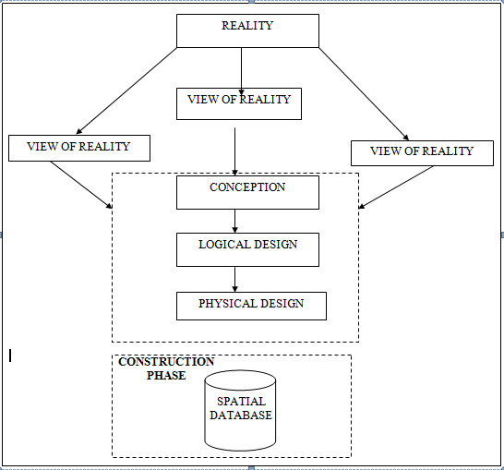
Fig.3.2 Design and Construction Phases in Spatial Database

3.2.2 CONCEPTUALDESIGN
Vector data model is the data type adopted for this project, which is represented, by points, lines and polygon. The identified entities are:-
      - Vegetation area (polygon)
      - Roads(line)
      - Trees(point)
      - Boundary line (polygon)
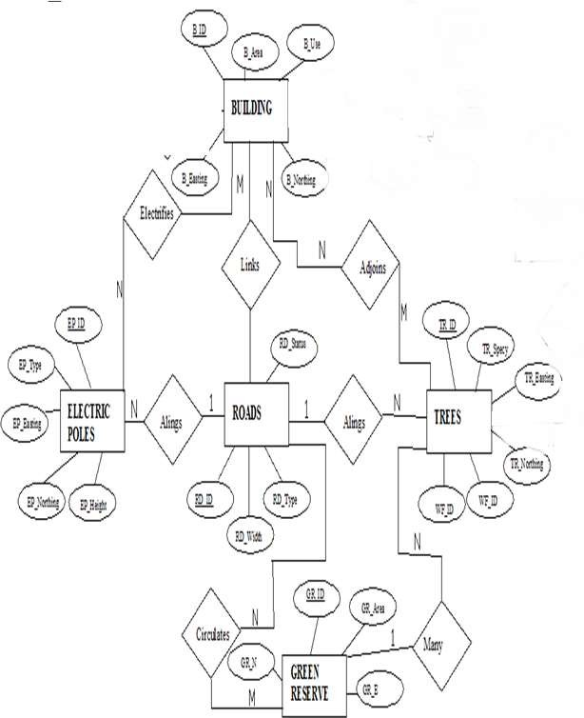
      - Buildings(polygon)

Fig.3.3. E-R Diagram (Entity relationship diagram)

3.2.3 LOGICALDESIGN
This is the design aspect of the database refers to the process of creating a conceptual framework or model that represents the structure and organization of spatial data within the system. It involves defining the data element, their relationship, and the rules for data manipulation and analysis. In this phase, the entities, their attributes and their relationships are represented in a single uniform manner in form of relation in such a way that would be no information loss and at the same time no unnecessary duplication of data. In this study, the logical database design is employed to generate a geo-relation database structure. Each entity has unique identifier in bold type. An attribute type or combination of attribute types that serves to identify an entity type is termed an identifier.
- Building(B_ ID, B_ Area, B_ Name, B_ Easting, B_ Northing)
- Roads(R _ ID, R _ Width , R _ Type, R- Condition, R_ Easting, R_ Northing)
- Tree(TR _ ID, TR_ spp, TR_ Importance, TR_ Easting, TR_ Northing)

3.2.4 PHYSICALDESIGN

Table3.2: Building and its attribute
ENTITY | DESCRIPTION
B_ID | Building Identification
B_name | Building Name
B_Area | Building Area
B_Easting | Building Easting
B_Northing | Building Northings

Table3.3: Road and its attributes
ENTITY | DESCRIPTION
R_ID | Road Identifier
R_ Length | Road Length
R_ Width | Road Width
R_ Type | Road Type
R_ Condition | Road Condition

Table3.4: Trees and its attributes
ENTITY | DESCRIPTION
TR_ID | Tree Identifier
TR_ Spp | Tree specy
TR_E | Tree_ Easting
TR_N | Tree Northing

3.3 EQUIPMENTUSED/SYSTEMSELECTIONANDSOFTWARE

3.3.1 HARDWAREUSED
- Total station
- 1reflector with a tracking rod.
- 1Tripod
- One(1)50m tape
- One(1)umbrella
- 1cutlass
- Hand held GPS
- Hammer
- Nails and bottle cover
- Field book and writing materials
- 1-NoofPersonalComputerHP655 and its accessories
- 1-NoofHP DeskJetK7100 A3 printer
- 1-NoofHPDeskJet 1110 A4printer

3.3.2 SOFTWARECOMPONENT
- Notepad.
- Microsoft Excel.
- AutoCAD2007
- Arc GIS10.2
- Microsoft Word.

3.4 INSTRUMENTTEST
To ensure the quality of the data, the Total Station employed for this project was tested for vertical index and horizontal collimation errors. These tests also aimed to verify the instrument’s efficiency and reliability. The procedure followed is outlined below.

3.4.1 HORIZONTALCOLLIMATIONTEST
This test was conducted to ensure that the line of sight was perpendicular to the trunnion axis. The Total Station was positioned over a specific point, and initial adjustments were made to ensure proper alignment, leveling, and focus (to eliminate parallax in the telescope). A vertical target was placed at a distance of 100 meters from the Total Station. To access the configuration menu of the Total Station, the menu key was pressed and held for approximately 2 seconds. From the main menu, the calibration sub-menu was selected, and within that, the horizontal collimation test option was chosen. The target was then observed and divided into two halves, with horizontal readings recorded for Face left and Face right. The readings are shown in Table 3.4.1 below.
Total Station
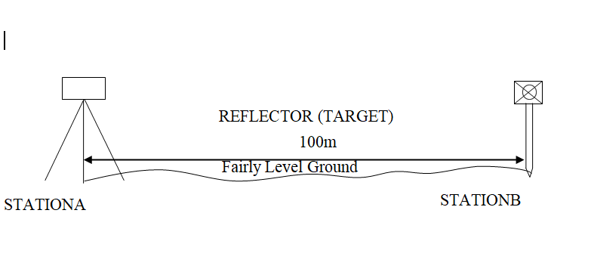

Fig3.4; Horizontal Collimation and Vertical Index error test.

Table3.5: Horizontal Collimation Data
Station | Target | Face | Hz Reading | Difference | Error
A | B | L | 38˚42‟32”
 |  | R | 218˚42‟35” | 180˚00‟03” | 03”
Source field work

3.4.2 VERTICAL IX ERNDEROR TEST
To perform the test, the Total Station was set up over a known point, and all necessary temporary adjustments were made to ensure proper alignment and functionality. A target was placed approximately 100 meters away, and the instrument was aimed at it. The target was first bisected using the face left position, and the corresponding vertical angle was recorded. The same process was then repeated using the face right position, and the resulting reading was also documented. The recorded values are presented below:

Table3.6: Vertical Index Data
Instrument Station | Target Station | Face | Vertical | Sum | Error
A | B | L | 90˚00‟00”
 |  | R | 270˚00‟02” | 360˚00‟02” | 02”
Source field work
3.4.3 ANALYSISOFCOLLIMATIONANDVERTICALINDEXDATA
The reading obtain during calibration were reduced to obtain new collimation and vertical errors.
Horizontal collimation={(FR–FL)–180}/2={(00˚00‟03”}/2=1.5”
Verticalcollimation={(FL+FR)–360}=(90˚00‟00”+270˚00‟02”)-360}=02”Theresult shows that the instrument is still in good working condition.

3.5 CONTROL CHECK
Three control beacons (KPT 120X, KWCS102 and SC/KWEAS5072) were used. In order to ascertain the in-situ of the control beacons, a check was carried out on them by observing the angle between them and comparing the result obtained with the computed angles from the giving coordinates.
The total station instrument was set on the control beacon KWCS102. After performing all the necessary temporary adjustment, the reflector was placed on the control beacon KPT 120X which served as the back station. The horizontal angular reading was taken and recorded while the instrument was on face left. The reflector was then taken to the control beacon SC/KWEAS5072 which serves as the forward station, the horizontal angle reading was then taken and recorded on both face left and face right. The reflector was taken back to the back station, the horizontal angle was then recorded on face right.

Table3.7: Table showing the back computation of the control coordinates
From STN | Bearing | Dist(m) | ∆N | ∆E | Northing(m) | Easting(m) | ToSTN
 |  |  |  |  | 945235.040 | 682280.278 | KPT 120X
KPT 120X | 68°53'46'' | 1397.130 | 503.050 | 1303.424 | 945738.095 | 683583.702 | KWCS102
KWCS102 | 64°07'57'' | 540.797 | 235.946 | 486.612 | 945974.041 | 684070.314 | SC/KWEAS5072
Source: office of surveyor general kwara state

Table3.8: Table showing the distance observation result of the control check
FROM | OBSERVED  DISTANCE  (m) | COMPUTED  DISTANCE  (m) | TO
KPT 120X | 1397.029 | 1397.130 | KWCS102
KWCS102 | 540.694 | 540.797 | SC/KWEAS5072

Table3.9: TABLE showing the observation result of the control check
STN | SIGHT | FACE | OBSERVEDHZANGLE | REDUCED HZANGLE | MEAN
 | KPT 120X | L1 | 357° 08'47''
KWCS102 | KPT 120X | L2 | 288° 14'07'' | 68° 54'40''
 | SC/KWEAS5072 | R2 | 108° 52'13'' | 68° 54'46''
 | SC/KWEAS5072 | R1 | 177° 46'59'' |  | 68° 54' 43''

Difference in angle (observed -computed)=68°54'43''-68°54'40''
=00° 00'03''
Since the allowable accuracy (angular) of third order traverse of one station is 00° 00' 30'' and the result obtained from the control check (00°00'03'') is less than allow able error. Therefore, the controls were angularly intact.

3.6 MONUMENTATION
The boundary of the area carved out was demarcated with the precast concrete beacons, after clearing the required line of sights. The identified points of changes in directions were dug and beacons were buried on it, leaving about 15cm part of the beacon above the ground Level. The beacons were buried at convenient distances as dictated by the nature of the boundary.

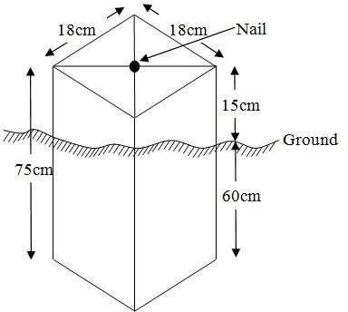

Fig.3.4: Pillar Description

3.7 DATA ACQUISITION

Data acquisition is a fundamental aspect of digital mapping. It involves collecting coordinate data of map features in a format compatible with computers. Various techniques exist for gathering topographical data, and the choice of method depends on several factors, including the data source, available hardware and software, desired level of accuracy, and the manpower involved. In addition to field and laboratory methods, data can also be obtained through social surveys.

In the context of this project, data acquisition refers to the methods and processes used to obtain the necessary data. The acquired data is categorized into two main types: geometric data and attribute data.

PRIMARYDATASOURCE
Field observation was the primary source of data for this project. Ground based method was used in acquiring data with the use of Total Station Instrument, which involved the collection of X, Y, Z data through coordinated Ground control Points (GCP) established at conspicuous points within the study area

SECONDARYDATASOURCE
An imagery of the area was acquired through Updated Google earth; this was used to ascertain the extent of coverage of the project area.

3.7.1 GEOMETRIC DATA ACQUISITION
This involves the acquisition of Nothings, Easting and Height value of features that are present on the project site. In the aspect of this project digital land survey method was adopted.

3.7.2 TRAVERSING
This is a series of connected straight lines, the length and direction of which are determined from measurements. This includes the distance measurement and angular measurements which include horizontal angle and vertical angle between points, whose direction between selected points is determined after some calculations. The total station computed directly the angle and distance measured on the site to determine the coordinates of the point with the aid of the processor. The total station was used to determine the coordinates of the boundary of the project site. The instrument was set on control ‘Y’ and adjustment (temporary) was done, the instrument was focused at the reflector on point ‘X’ to set orientation and point ‘Z’ was observed as the forward station. All other boundary point was observed as the reflector was placed on them.

3.7.3 DETAILING
Detailing entails fixing both natural and artificial feature that exists in the boundary. These include buildings, electric poles, footpaths, culverts, etc. In this project, details were fixed using the total station and its accessories using the ray shooting method.
Here, the ray shooting method was employed to effectively fix the details along the project area. Features such as roads, buildings, storex, etc. were fixed. To achieve this, the total station is set on the transferred point in the project boundary to bisect many edges of details and the reflector was placed at a known station for orientation before positioning it at each corner of the details. The coordinate of each corner is observed and recorded. The details taken include Road, Building, Storex, and Electric poles.

Orientation station
Building

Instrumentation

FIGURE 3.5 SHOW THE DETAILING OBSEVATION

3.7.4 ATRIBUTES DATA ACQUISITION
Attribute data is information about spatial features. They provide the characteristics, description and nomenclature about spatial objects. Thus the attributes data acquired includes names of buildings and their uses such as classrooms, roads, water facilities and prominent natural features likes river and trees found and vegetation were properly identified within and around the study area.

3.8 DATA DOWNLOADING AND PROCESSING

3.8.1 DATADOWNLOADINGANDEDITING
This is stage whereby all data acquired which were automatically stored in the Total Station were downloaded into personal computer. This was done with the aid of downloading cable connected to the computer and some associated complementing software installed on the System.

3.8.2 DATA PROCESSING AND DATA EDITING
These data were processed using AutoCAD 2007 where the acquired coordinate was plotted, and details fixed to depict the study area, after which were exported to Arc GIS 10.2 where digitizing was done, and the attribute data was used to create a database table in relationship to the details. This data table was queried to provide useful cadastral information.

3.8.3 Spatial Relationships
Spatial relationships are the relationship determined by the location, size, shape, and other features of spatial objects. The most common spatial relationships are distance relationships, direction relationship, and topological relationships.

3.8.4 Overlay of plan
The 2D plan of the building in the study was gotten from the ministry and was captured with a digital camera. After which, the captured image was added into the Arc GIS 10.2 environment as a geo-referenced raster image and the conversion to digital form was done by digitizing, then the overlay was done by putting on the two layers containing both files.

3.9 DATABASE IMPLEMENTATION
This phase involves the creation of the spatial database. Following the completion of the three design stages Reality, Conceptual, and Logical design the database was developed using ArcGIS10.2 software. This process entails integrating and storing both the acquired geometric (graphic) data and attribute data to enable spatial analysis and queries.
A database is an organized and integrated collection of data that is structured for efficient access and use by relevant applications, with data retrievable through various logical operations. Once the attribute table was populated manually via the keyboard, certain attributes such as the areas of settlements were automatically calculated and displayed using specific commands available in ArcGIS10.2.
Arc GIS was also used to link the graphic data with the attribute table, allowing for the execution of spatial queries and further analysis.

3.9.1 DATABASE MANAGEMENT SYSTEMS
Database management is a collection of software for creating, storing, manipulating, updating, organizing and querying of information in a database (Kufoniyi, 1998). It is a software package whose function is to manipulate a database on behalf of the user.
A good DBMS must provide the following functions:
- Storage and retrieval of data.
- Access to by several users at a time.
- A standardized interface between database and application programmed.
- Standardized access to data and separation of data storage and retrieval functions from the program using the data.
- Maintenance of data security and integrity.

3.9.2 DATABASE MAINTENANCE
Having created the database, proper maintenance practice was made to meet its stated objectives. The ability to include more data and remove irrelevant data was possible by way of maintenance. There is every need for the data to be updated regularly because of the physical changes that may occur on the landscape with time. Both security and integrity were also exercised to ensure maintenance and to meet its stated objectives.
Proper observance, updating and management of database ensure its currency and quality to stand a profound chance in Spatial Decision Support System (SDSS). The quality of any database depends on the currency and fitness for use as a decision support system (SDSS).The quality of database depends on its ability to generally fit and use as a decision system (DSS). The storage media should be from time to time justified if otherwise could necessitate data inaccessibility or physical deterioration of the storage media. Also care must be taken during populating any database system, as a database is only good as the data supplied. In archiving stable media should be used. Examples of these are
- Computer compatible tape reader
- Magnetic tape
- Optical disc and compact disc

3.9.3 BACK COMPUTATION Table

TABLE 3.10 SHOWS THE BACKWARD COMPUTATION
STN FROM | BEARING  ‘ ” | DIST  (m) | N | E | X | Y | STN  TO
 |  |  |  |  | 683827.457 | 946283.854 | PL1
PL1 | 66 1 55 | 303.145 | 123.146 | 277.005 | 684104.462 | 946407.843 | PL2
PL2 | 149 46 46 | 192.751 | -166.555 | 97.017 | 684201.479 | 946241.288 | PL3
PL3 | 155 17 55 | 50.039 | -45.426 | 20.985 | 684222.464 | 946195.862 | PL4
PL4 | 249 25 28 | 312.969 | -109.990 | -293.005 | 683929.459 | 946085.872 | PL5
PL5 | 332 44 31 | 222.713 | 197.982 | -102.002 | 683827.457 | 946283.854 | PL1

3.9.4 AREA COMPUTATION

TABLE 3.11 SHOWS Area Computation
Double Latitude | Departure | Multiplier
123.99 | -277.00 | -34,345.23
123.99
247.98
-166.55
81.43 | 97.02 | 7900.34
-166.55
-85.12
-45.43
-130.55 | 20.98 | -2738.94
-45.43
-175.98
-109.99
-285.97 | -293.00 | 83,789.21
-109.99
-395.96
+197.98
-197.98 | -102.00 | 20,193.96
+197.98
0.00

Total Area = {(-34,345.23--2738.94) + (7,900.34+83,789.21+20,193.96)}/2
Total Area = {(-37,084.174) + (111,883.51)}
Total Area = 74,799.336/2
Total Area = 37,399.668 SQ MTS

4.5 LINEAR ACCURACY COMPUTATION
Linear Accuracy = 1
{[SQRT (change in Northing) ² _{+ (change in Easting)} ²
_{Total Distance}
Linear Accuracy = 1
{SQRT [(0) ² ₊ ₍₋₅₅₄₎ ²]
_{1081.954}
Linear Accuracy = 1
{SQRT [306916]}
_{1081.954}
Linear Accuracy = 1
554
_{1081.954}
Linear Accuracy = 1
0.512036
Linear Accuracy = 1: 0.5

CHAPTER FOUR

4.0 RESULTS, ANALYSIS, AND DISCUSSION
GIS stands out from other information systems due to its powerful spatial analytical capabilities particularly overlay operations, buffering, spatial search, topographic analysis, and neighborhood and connectivity functions. These capabilities enable GIS to answer fundamental questions related to location, conditions, trends, routing, patterns, and modeling by manipulating and analyzing spatial data. In this project, the primary analyses conducted included overlay operations, topographic analysis, and spatial searches.

4.1 TESTING OF DATABASE
This is the test carried out to determine whether there exists a relationship between data modeled about entities in a spatial database as well as putting in to test its retrieval capabilities. This was done by designing a sample query with certain conditions attached and the query will began to see if desired result is achieved.
Analysis of Result
Data captured were full to ensure standardization of task. Coordinated point was used in order to produce information required and lastly to decision making and produce the output in digital form, while the attribute presented in tabular form. In most GIS operation package including arc view these include measurement techniques, query analysis and geometric operation in this project include questions such as:-
- Architectural planning
- Building overlay
The above listed queries are shown

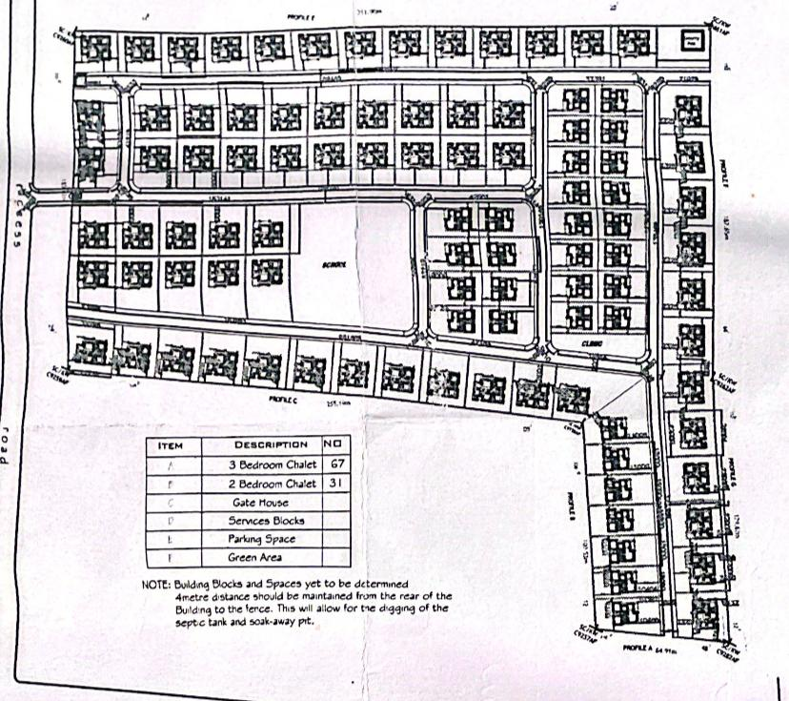

Fig4.1. showing the 2d plan architecture structure of the building
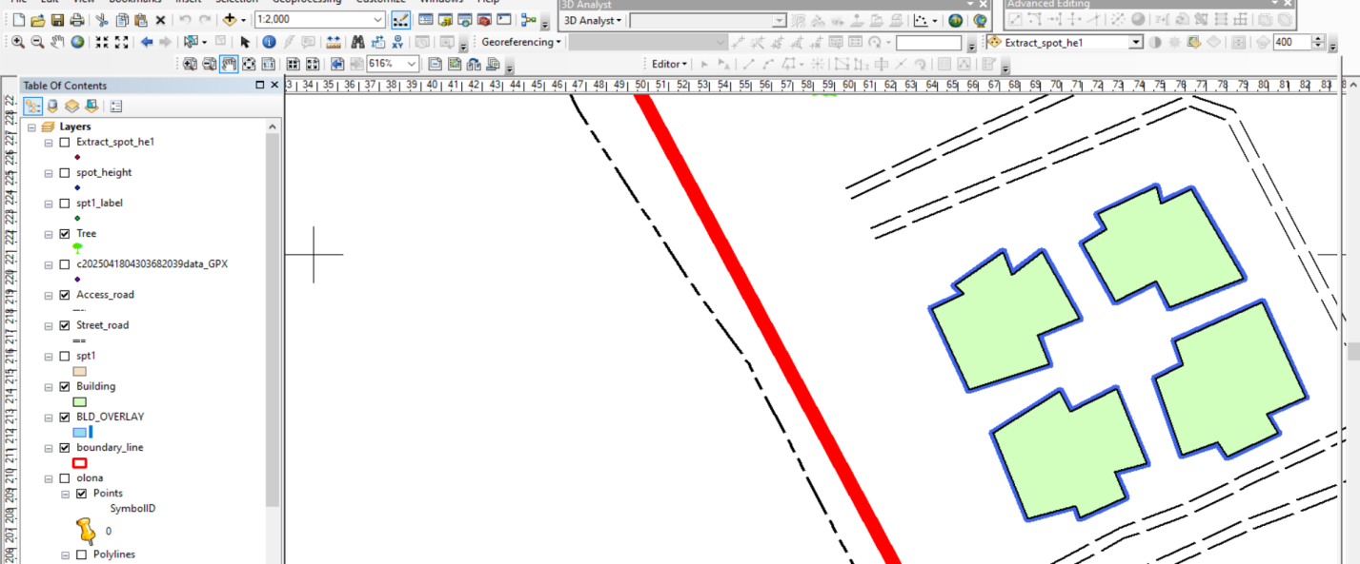
Note: - the 2d plan of the building in the study was gotten from the owner of the Honeywell estate and was captured with a digital camera. after which, the captured image was added into the Arc Gis10.2 environmental as a geo-referenced raster image and the conversion to digital form was done by digitizing then the overlay was done by putting on the two layers containing both files

Fig4.2: showing overlaid of all building in block A

Discussion of result (building overlay block A)
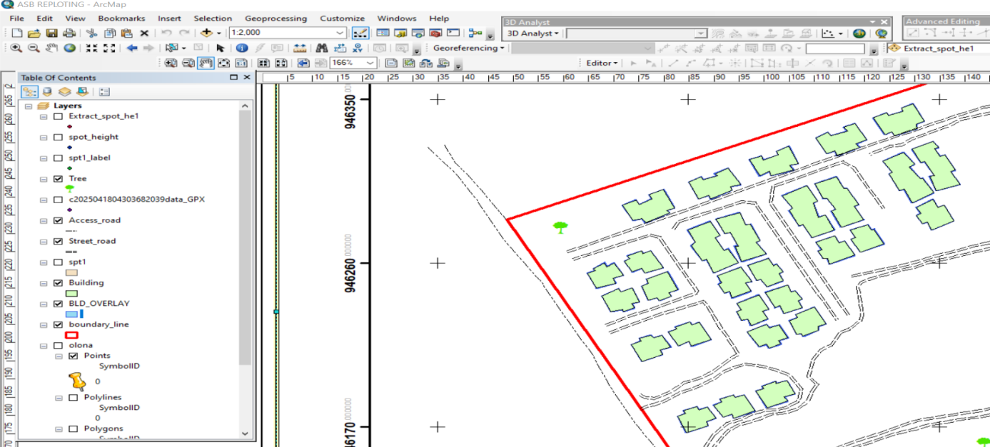
The blue line represents observed edges of the building while the black line represents the digitized edges of the building. It was noticed that the existing building archive design is the same with what we observed in field.

Fig 4.3: showing overlaid of all building of all block
Discussion of result (building overlay of building in all block)
The blue line represents observed edges of the building while the black line represents the digitized edges of the building. It was noticed that the existing building archive design is the same with what we observed in field. But some road paramount with existing architecture lay out while some not paramount, and all of the building shows in architecture plan are not built in land.

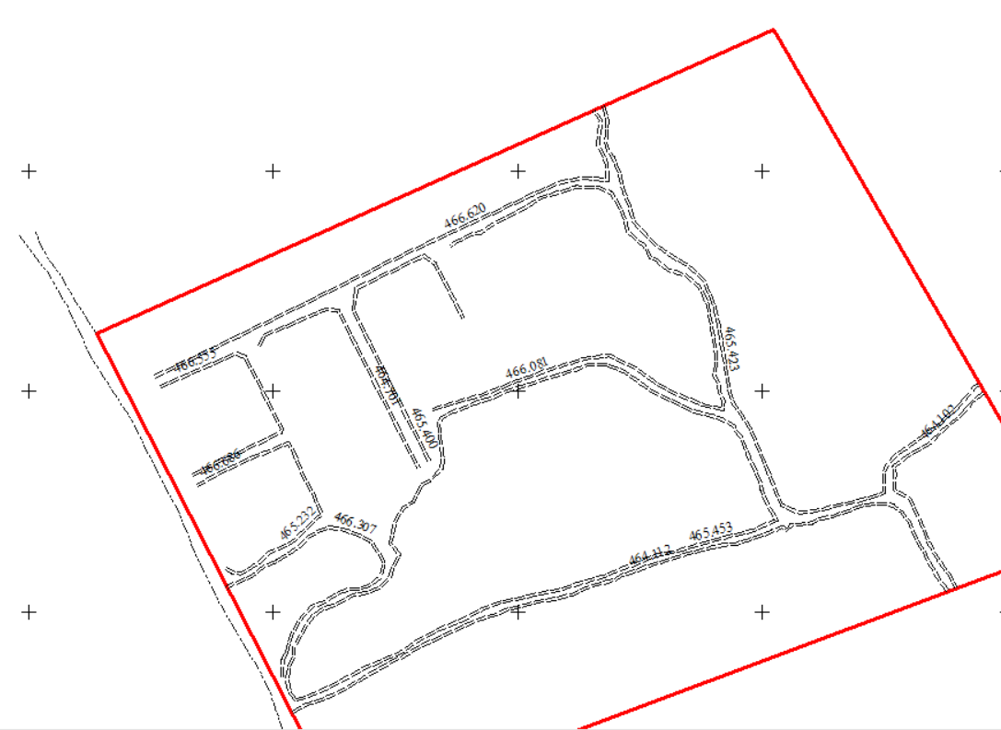

Figure 4.4 Shows the Height of Drainages
This height shows in the figure 4.4 above is the height of drainage were measured in sight with total stations

CHAPTER FIVE:
SUMMARY, CONCLUSION AND RECOMMENDATIONS
5.1 Summary of Findings
This project focused on the as-built survey of part of Honeywell Estate located along Oke Ose/Oke Oyi Road in Ilorin East Local Government Area of Kwara State. The purpose was to produce an accurate representation of existing structures and physical features in the area. Key findings and accomplishments include:
The survey successfully identified and mapped residential buildings, roads, drainage lines, and utility features within the study area.
Data collection was carried out using a total station and GPS equipment, followed by detailed processing using AutoCAD and GIS software.
Discrepancies were observed between existing development and the original (or expected) layout pattern, indicating informal modifications and possible violations of planning regulations.
The as-built plan produced can be used by relevant stakeholders for estate management, infrastructure planning, and regulatory compliance.

5.2 Conclusion
The as-built survey conducted in part of Honeywell Estate provides a clear and accurate picture of current developments in the area. This study reinforces the importance of up-to-date spatial data in managing urban estates and supporting sustainable development. The integration of modern surveying tools and geospatial software allowed for precise mapping, while the findings highlighted the need for improved development control in growing estates like Honeywell.
Accurate as-built data is essential for proper planning, utility management, land titling, and property evaluation. It ensures that government agencies and private developers can make informed decisions that align with planning standards and land use regulations.

5.3 Recommendations
Based on the findings of this study, the following recommendations are made:
- Regular As-Built Updates: Estate developers and local planning authorities should conduct periodic as-built surveys to monitor development and prevent illegal construction.

- Integration into Land Information Systems (LIS): The data generated from the as-built survey should be incorporated into the Kwara State Land Information System for effective land administration.
- Public Awareness: Property owners and developers should be educated on the importance of building in accordance with approved layouts and obtaining proper permits.
- Enforcement of Planning Laws: The local town planning authority should intensify efforts to enforce development control laws and penalize violations to ensure orderly estate growth.
- Capacity Building: Surveying professionals should be trained on the latest technologies including
GIS, LiDAR, and drone mapping for more efficient as-built surveEstates

5.4 Suggestions for Further Studies
Future research can expand on this project by:
Surveying the entire Honeywell Estate for a comprehensive spatial database.
Incorporating topographic and hydrological data to support infrastructure planning.
Assessing land use change over time using remote sensing and time-series GIS data.
Integrating the as-built survey with property valuation and taxation systems.

REFERENCES
Adebayo, R. O. (2019). Principles and Applications of Engineering Surveying. Ibadan: Folad Prints.
American Congress on Surveying and Mapping (ACSM). (2005). Surveying and Mapping Standards Manual. Washington D.C.: ACSM Press.
Lawal, M. A., & Ibrahim, T. K. (2021). “Challenges and Innovations in As-Built Surveying in Nigeria.” Nigerian Journal of Geomatics, 5(2), 45–53.
Olorunfemi, A. O. (2017). “Spatial Analysis for Urban Management: The Role of As-Built Surveys.” Journal of Urban and Regional Planning, 3(1), 23–34.
Onifade, S. B. (2020). Land Information Systems and Land Governance in Nigeria. Lagos: Archidata Press.
SURCON (2022). Professional Practice Guidelines for Nigerian Surveyors. Abuja: Surveyors Council of Nigeria.

