ROUTE SURVEY

OF

MICHEAL IMODU WAY TO KANGU OSHIN OLATUNJI ROAD
IFELODUN TO ILORIN WEST LOCAL GOVERNMENT AREA,
ILORIN KWARA STATE.

BY
OJO SIMON ABAYOMI
HND/23/SGI/FT/0114

SUBMITTED TO:
THE DEPARTMENT OF SURVEYING AND GEOINFORMATICS,
STATE POLYTECHNIC ILORIN, KWARA STATE.

IN PARTIAL FULFILMENT OF THE REQUIREMENTS FOR THE
AWARD OF HIGHER NATIONAL DIPLOMA IN
SURVEYING AND GEOINFORMATICS.

MAY, 2025

CERTIFICATE
I hereby certify that all the information given in this project was obtain as a result of my observation and measurements and was carried out by me in accordance with the survey rules, regulation and departmental instructions.

____________________ ---------------------------
OJO SIMON ABAYOMI Date and Signature
HND/23/SGI/FT/0114

CERTIFICATION
This is to certify that OJO SIMON ABAYOMI with matriculation number HND/23/SGI/FT/0114 has satisfactorily carried out the survey duties contained in his project under my instruction and direct supervision.
I hereby declare, that he has conducted himself with due diligence, honesty and sobriety on the project.

____________________ ____________________
Surv. A.O. Akinyede Sign and Date
Project supervisor

____________________ ___________________
Surv. S. A. Awoleye Sign and Date
Project Coordinator

____________________ __________________
Surv. I. I. Abimbola Sign and Date
Head of Department

____________________ __________________
External Examiner Sign and Date

DEDICATION
This project is dedicated to Almighty GOD

ACKNOWLEDGEMENT
All glory, Honor and Adoration to God Almighty, the gracious one who has given me the opportunity to complete my HND programme.
My appreciation goes to my supervisor Surv. A. O. Akinyede, for his encouragement and motivation as regard the writing of this project thank you and God bless you. And to all lecturers in the Department of Surveying and Geoinformatics, Surv. I .I.Abimbola (HOD). Surv. A. G. Aremu, Surv. R. S. Awoleye, Surv. R. O. Asonibare, Surv. Ayuba Abdulsalam, Surv. Babatunde Kabir, Surv. Bello F.D and others. May God bless you all (Amen).
I also express my sincere gratitude to my wonderful parent Mr. and Mrs. Ojo for their financial moral support toward the completion of this program. You will reap the fruit of your labor. (Amen).

ABSTRACT
This project was centered on route survey and engineering design from Micheal Imodu area to Kongu Oshin Olatunji area, Kwara State. The project aimed to provide baseline data along the route for construction purposes. The survey operations commenced with reconnaissance, marking of chainage at every 25m intervals, capturing geometric data along the route using Total Station order controls. The acquired data was downloaded with Leica Geo office, edited with Notepad and Microsoft Excel, and then imported into AutoCAD Civil CAD 2014. These refined coordinates were utilized to generate Cross sectional, Longitudinal, horizontal alignment plan showing affected structures along the route and calculating earthwork volumes for cut and fill. It was concluded that the result meets the required specification. Hence, the plans were produced in electronic and hard copy formats with horizontal scale 1:5000 and vertical scale 1:500 after which a comprehensive project report was written on the executed project. It is recommended that the refined information and plan obtained from this project should be used for the rehabilitation of the route from Micheal Imodu area to Kongu toward Oshin Olatunji area, Ifelodun to Ilorin West Local Government area Kwara State.

TABLE OF CONTENTS
TITLE PAGE……………………………………………………………………………..i
CERTIFICATE…………………………………………………………………………...ii
CERTIFICATION………………………………………………………………………..iii
DEDICATION…………………………………………………………………………....iv
ACKNOWLEDGEMENT………………………………………………………………...v
ABSRACT………………………………………………………………………………...vi
TABLE OF CONTENT…………………………………………………………………...vii
LIST OF TABLES………………………………………………………………………...viii
LIST OF FIGURES……………………………………………………………………….ix
CHAPTER ONE:
1.0 INTRODUCTION 1
1.1 STATEMENT OF THE PROBLEM 5
1.2 AIM OF THE PROJECT 6
1.3 OBJECTIVES OF THE PROJECT 6
1.4 SCOPE OF THE PROJECT 6
1.5 PROJECT LOCATION 8
1.6 SPECIFICATION OF THE PROJECT 9
1.7 PERSONNEL INVOLVES 9
CHAPTER TWO:
2.0 LITERATURE REVIEW 10-15
CHAPTER THREE:
3.0 METHODOLOGY 16
3.1 PRELIMINARY PLANNING AND PREPARATION 16
3.2 RECCONAISANCE PLANNING 17
3.3 OFFICE PLANNING 18
3.4 SELECTION OF THE EQUIPMENT AND SOFTWARE 18-19
3.5 BENCH MARKS ESTABLISHMENT, CAPPING AND LABEL 19-20
3.6 INSTRUMENT TEST 20-21
3.7 DATA ACQUISITION 21-26
CHAPTER FOUR:
4.0 DATA PROCESSING 27
4.1 DATA DOWNLOADING AND EDITING 27-28
4.2 DATA PROCESSING PROCEDURE 29-32
4.3 RESULT AND ANALYSIS 32-33
4.4 LINEAR ACCURACY 33-34
4.5 HEIGHT ACCURACY 35
4.6 PLAN PRODUCTION 35-39
4.7 PROJECT COSTING 40-42
FIG 4.1 SHOWING HORIZONTAL ALIGNMENT 36
FIG 4.2 SHOWING VERTICAL ALIGNMENT 37
FIG 4.3 SHOWING CROSS SECTION 38
FIG 4.4 DIAGRAM SHOWING GENERATED VOLUME COMPUTATION 39
CHAPTER FIVE:
5.0 SUMMARY, PROBLEM ENCOUNTERED, RECOMMENDATION AND COCLUSION
5.1 SUMMARY 43
5.2 PROBLEM ENCOUNTERED 44
5.3 RECOMMENDATION 45
5.4 CONCLUSION 45
5.5 REFRENCES 46
5.6 APPENDICES 47

CHAPTER ONE
1.0 INTRODUCTION
A road was defined as a constructed pathway that facilitates the movement of vehicles, pedestrians, and goods from one location to another. Roads can vary in type, including highways, local streets, and rural paths, and are integral to transportation networks, connecting communities and supporting economic activities (Anderson & Patel, 2024). It played a crucial role in modern infrastructure, serving as the backbone of transportation systems across the globe. They enable the efficient movement of people and goods, significantly impacting economic development and social connectivity. The design, construction, and maintenance of roads involve careful planning and engineering to ensure safety, durability, and accessibility.
Recent advancements in road engineering have focused on sustainability and smart infrastructure. Innovations such as smart traffic management systems and eco-friendly materials are increasingly being integrated into road design to enhance functionality while minimizing environmental impact (Hernandez & Lee, 2024). As urbanization continues to rise, the need for effective road networks that accommodate growing populations and vehicle traffic has never been more critical. Roads have been a fundamental part of human civilization for thousands of years, playing a crucial role in transportation, commerce, and social interaction. The evolution of roads can be traced back to ancient times, with various civilizations making significant contributions. The earliest known roads were built by the ancient Mesopotamians around 4000 BCE. These primitive roads, made of packed earth and stones, connected different cities and helped facilitate trade (Smith, 2020). The 20th century marked a period of rapid road development due to the proliferation of automobiles and the need for extensive transportation networks. The creation of the Federal Highway Administration (FHWA) in the United States in 1921 paved the way for the construction of the interstate highway system, which greatly expanded the road infrastructure across the country (Federal Highway Administration, 2020). It continued to evolve with the advancements in engineering, materials, and technology. Modern roads incorporate features such as multiple lanes, traffic signs, lighting, and advanced pavement
Materials to ensure safety and efficiency in transportation. Additionally, the development of smart roads and intelligent transportation systems holds the potential to revolutionize road networks, enhancing traffic management and reducing congestion (Chen et al., 2022). Route surveying was a critical component in the planning and execution of engineering projects, especially in transportation and infrastructure development. It involves the collection of data necessary to design roadways, railways, and other linear infrastructure. Recent advancements in technology, particularly in GIS and remote sensing, have transformed traditional methods of route surveying. Recent studies highlight the integration of drones and LiDAR technology in route surveying. For instance, Smith et al. (2023) demonstrated that drone-assisted surveys can significantly reduce fieldwork time and increase data accuracy, particularly in complex terrains (Smith & Lee, 2023).
Route surveying was a specialized branch of surveying focused on the assessment and analysis of land for the development of linear infrastructure, such as roads, railways, and pipelines. It encompasses the collection of topographical data, evaluation of geological conditions, and alignment design to ensure safe and efficient transportation systems. It is also defined as the process of measuring and mapping the land along a proposed route to provide essential data for design, construction, and maintenance of transportation facilities (Johnson & Lee, 2023). This process involves the use of advanced technologies such as GPS, GIS, and drone surveying to enhance precision and reduce project timelines.
There are different types of roads which range from earth road, surface dressed road, concrete paved way, single lane carriageway, dual lane carriageway and multi-lane freeway which depends mostly on the purpose of the road or the traffic congestion on any particular road.
Road in Nigeria can be classified into three major groups namely:
- Federal Roads (Trunk A): These were roads under the jurisdiction of the Federal Government of Nigeria. They were major transportation routes that span across states and regions of the country. The Federal Ministry of Works and Housing is responsible for the construction and maintenance of federal roads (Federal Ministry of Works and Housing, 2021).
- State Roads (Trunk B): State roads were managed and maintained by the respective state governments in Nigeria. They connect cities, towns, and regions within the same state,

Serving as important transportation links. The construction and maintenance of state roads are carried out by the state Ministry of Works or relevant agencies.
iii. Local Government Roads (Trunk C): Local government roads lies under the jurisdiction of local government authorities in Nigeria. These roads provide access to rural areas, connecting villages and communities. The responsibility for the maintenance and improvement of local government roads lies with the local government councils.
1.1 STATEMENT OF PROBLEM
It has been noted that roads were consistently eroded and washed away, primarily because of structural design deficiencies. It was discovered that part of the route from Micheal imodu area to oshin olatunji area, Moro Local Government area Kwara State lacks the basic road profile information which could serve as baseline information for physical development along the route. Therefore, these challenges necessitates the need to carry out this particular oect in order to provide such.

1.2 AIM OF THE PROJECT
The aim of this project is to carry out the engineering route design from Micheal Imodu to Kongu toward Oshin Olatunji. In other to produce horizontal alignment design, vertical alignment and the cross section design plans which will be used for the construction of the road. And it can also be used for estimate of BEME by the civil Engineering company.

1.3 OBJECTIVES OF THE PROJECT

In order to achieve the aforementioned aim, the objectives listed below were pursued:
- Design of the Horizontal alignment plan which show the horizontal section of the route.
- Design of the vertical alignment plan which show the vertical sections of the route.
- Design of the cross sectional area of the route at interval of 25m.
- Production of detail plan showing the horizontal and all the existing features closed to the route.
- Computing of the volume of earthwork of the route from the section include the ditches.
- Report writing.
- Project costing for the Engineering route.
1.4 SCOPE OF THE PROJECT
These were set of activities that was involved in the execution of the project:
i. Planning: This involved deciding the choice of instrument, purpose of survey, choice of control order which will determine the accuracy to which measurement are required and also, the Differential Global positioning System was tested to verify it working condition.
ii. Geometric data acquisition along the route using DGPS, cross sectional points and detailing of natural and manmade features
iii. Downloading and processing of acquired geometric data using software
iv. Volume computation of cuts and fills for each section along the route using Civil CAD 2022
v. Production of designed plans for horizontal and vertical alignments using Civil CAD with appropriate scales
vi. Presentation of visual report such as plan
1.5. PROJECT LOCATION
The location of the project site is the route from Micheal Imodu area to Kangu toward Oshin Olatunji axis. The distance covered along the route is 4.5km. The project site was lying along Ifelodun to Ilorin West Local Government area Kwara State, Nigeria. The site lies between geographical coordinates of Long. 004° 35’ 28.089’’; Lat. 008° 25’ 52.667’’ to Long. 004° 34’ 19.879’’; Lat. 008° 26’ 22.548’’. The community is developed area and the population is well spread. The figure below show the description of the project site for Micheal Imodu to Oshin Olatunji.

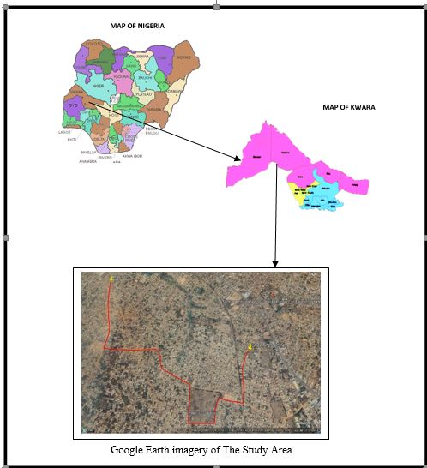
1.5 | PROJECT SPECIFICATION  This survey exercise was third order category. The required specification for this project
Was for large scale cadastral and engineering surveys as specified by the Surveyor's Council of
Nigeria (SURCON). Such specifications are stated below;
i. Traverse must commence on known controls and closed on the same or another set of second coordinated controls which must be confirmed undisturbed by necessary measurement (control checks)
ii. Allowable linear accuracy of third order traverse should not be less than 1:5000
iii. Allowable angular accuracy of third order traverse should not exceed 30″√n
iv. The traverse must be in loop and carefully closed at every 1km
v. Chainages should be marked at every 25m interval starting from 0.0m chainage to the end.
vi. Marking of cross-section at every 5m and 10m on both side of road from the Centre line
vii. Longitudinal and cross-section heightens, traversing and detailing should be done using Total Station
viii. Alignments design of the route should be carefully done with estimation of amount of cut and fill through volume computation.
1.8. PERSONNEL INVOLVED
Name Matric Number Role
- Ojo Simon Abayomi HND/23/SGI/FT/0114 Author
- Aina Joseph Olasunkanmi HND/23/SGI/FT/0116 Member
- Soladoye Amidat Olabisi HND/23/SGI/FT/0109 Member
- Sodiq Ayuba Adebayo HND/23/SGI/FT/0110 Member
- Okunoye Nafisat Adeyemi HND/23/SGI/FT/0111 Member
- Rotimi Iyanuoluwa Anu HND/23/SGI/FT/0104 Member
- Babatunde S. Jokotola HND/22/SGI/FT/0113 Member

CHAPTER TWO
2.0 LITERATURE REVIEW
Route surveying was the systematic process of collecting, analyzing, and interpreting data along a proposed transportation corridor to inform the design and construction of infrastructure such as roads, railways, and pipelines. This process involves evaluating topography, alignment, environmental conditions, and existing structures to ensure that the route is safe, efficient, and feasible. Route surveying encompasses a variety of techniques, including topographical surveys, horizontal and vertical alignment studies, and environmental assessments (Kadir, & Usman, 2022). Johnson and Smith (2020), examined the implications of route selection on environmental sustainability. They emphasized the importance of minimizing ecological disturbance and preserving natural habitats when planning transportation routes. The authors highlighted the need for comprehensive environmental assessments and mitigation measures to minimize the adverse effects of infrastructure development. Implications of route selection on environmental sustainability in transportation projects (Johnson & Smith, 2020).
Route survey operations involved the collection and analysis of various types of spatial data to determine the most suitable routes for infrastructure projects. The data required for route surveying includes cross-sectional data, longitudinal sectional data and horizontal alignment data. Cross-sectional data in the context of route surveying entailed the detailed information collected at specific intervals along a proposed route, providing a "snapshot" of the terrain's characteristics at those points. The data was crucial for understanding the physical features of the land and plays a vital role in the design and planning of transportation infrastructure, such as roads and railways. Cross-sectional data in route surveying helped engineers and planners create effective, safe, and sustainable transportation infrastructure. The role of cross-sectional data in route surveying for transportation infrastructure. Journal of Civil Engineering and Geospatial Analysis (Kadir & Usman, 2022).
Longitudinal sectional data were information collected along the length of a proposed route, providing insights into how the elevation and other characteristics change as you move from one end of the route to the other. This type of data was essential in the planning and design of transportation infrastructure, such as roads and railways. Also, information about the horizontal alignment (curves and straight sections) in conjunction with vertical changes, providing a complete view of the route's path. Longitudinal sectional data were crucial for understanding the vertical characteristics of a route, informing design decisions that enhance safety, efficiency, and sustainability in transportation projects. Longitudinal sectional data and its significance in route surveying for transportation infrastructure design (Kadir & Usman, 2022)
Horizontal alignment data was a fundamental aspect of route design that directly influences safety, efficiency, and environmental sustainability in transportation infrastructure projects. The information were related to the geometric configuration of a route as it curves or turns horizontally. The data was essential in the design and planning of transportation infrastructure, such as roads, highways, and railways, as it affects vehicle handling, safety, and overall efficiency.in conclusion, analyzing horizontal alignment helped in evaluating the route’s impact on surrounding environments, including minimizing disruption to ecosystems and communities. The importance of horizontal alignment in route surveying for transportation infrastructure (Smith & Johnson, 2021).
In Nigeria, several route surveying projects have been undertaken to support the development of transportation infrastructure. Some of this notable projects were highlighted below:
I Lagos-Ibadan Expressway expansion: The project aimed to improve the capacity and safety of one of the busiest highways in the country which covers approximately 127 kilometers. The route surveying efforts for this project involved extensive topographic mapping, environmental impact assessments, and traffic flow analysis to optimize the alignment and design of the expanded roadway. The alignment and construction accuracy achieved high standards, ensuring the safety and efficiency of one of Nigeria's most crucial road networks which was executed by Julius Berger Nigeria Plc (Ayegun & Ogunbayo, 2018).
ii. Second Niger Bridge project: The project aimed to alleviate traffic congestion and improve connectivity between the eastern and western regions of Nigeria with a significant distance across the Niger River. The project was executed by Julius Berger Nigeria Plc in collaboration with Julius Berger International GmbH and others which met the required precision and engineering standards, ensuring the creation of a vital infrastructure link (Obiajulu & Okolie, 2021).
iii. East-West Road project: The project involved the construction and rehabilitation of a key highway that links the Niger Delta region to other parts of the country. It was executed by Setraco Nigeria Limited which covers a vast stretch of approximately 338 kilometers.
The project met precision standards, contributing to improved transport infrastructure along the East-West corridor (Jaja & Oluoch, 2017).
iv. Abuja-Kaduna-Zaria-Kano Road Rehabilitation: The project involved the extensive rehabilitation work covering over 375 kilometers which was executed by Dangote Group in collaboration with other construction firms. The project achieved commendable precision in roadworks, contributing to enhanced road safety and longevity (Bashir & Ahmed, 2019).
Outside Nigeria, various route surveying projects have been conducted to support transportation infrastructure development.In London, the Crossrail project involved detailed route surveying to integrate new rail lines with existing infrastructure. Advanced surveying techniques were used to map underground conditions and optimize station placements, significantly impacting urban mobility (Smith, & Jones, 2023). Moreover, the development of the Madrid-Barcelona high-speed rail line employed extensive route surveying for precise alignment and infrastructure planning. The surveying included assessments of environmental and socio-economic factors, ensuring compliance with regulations and enhancing community support. (García, & López, 2023). Additionally, Singapore's Land Transport Authority implemented route surveying for the development of autonomous vehicle corridors, the surveys focused on mapping current road networks and predicting traffic patterns, which are critical for integrating autonomous systems (Tan, & Lim, 2023)
These examples highlighted the critical role of route surveying in diverse transportation infrastructure projects, demonstrating its applications in optimizing design, enhancing safety, and ensuring sustainability both in Nigeria and internationally. The recent studies cited provided valuable insights into the methodologies and outcomes of effective route surveying practices
Finally, route surveying played crucial role in the planning and execution of transportation infrastructure projects.

CHAPTER THREE

3.0. METHODOLOGY

Methodology is the set of methods and principles and instructions used to perform a particular activities or task. Its show the stages involved during the execution phase of the project research work. The methods involved in the execution of this project are includes traversing, detailing and contouring, processing and presentation. According to Oloyede et al. (2017), Total stations and GPS equipment are commonly used in Nigerian route surveys, providing precise measurements of distance, angles, and elevations. These tools allow surveyors to collect data on the terrain, which is essential for designing roads and other infrastructure projects
3.1 Preliminary Planning and Preparation:
- Route Selection: Based on preliminary maps and project requirements, a set of possible routes was identified and later the route from Michael Imodu to Oshin Olatunji was chosen.
- Site Visit: All the team member of Surveyors crew and Engineers visited the potential sites to familiarize themselves with the terrain and environment.
- Other: other preliminary activities was done in the office by the surveyor team. These activities are check the condition of the surveying equipment for the project execution and son costing activities.

3.2. RECONNAISSAINCE SURVEY

Reconnaissance Survey was carried out by the members of Group 5C, were the necessary information about the project area were gathered which are paramount to the successful execution of this project work. It is pre-requisite for any survey project to be carried out. During the Recce. Survey the group member visited the site in order to have a good view of the site location with other relevant information, the selection of the bench marks point, the tracking of the existing route using handheld GPS (Garmin 72) to know the length of the road, and checking of the available with. This was continue from the starting chainage to the end and at the end of the Recce. Survey activities the reconnaissance diagram was drawn as show on the figure below.

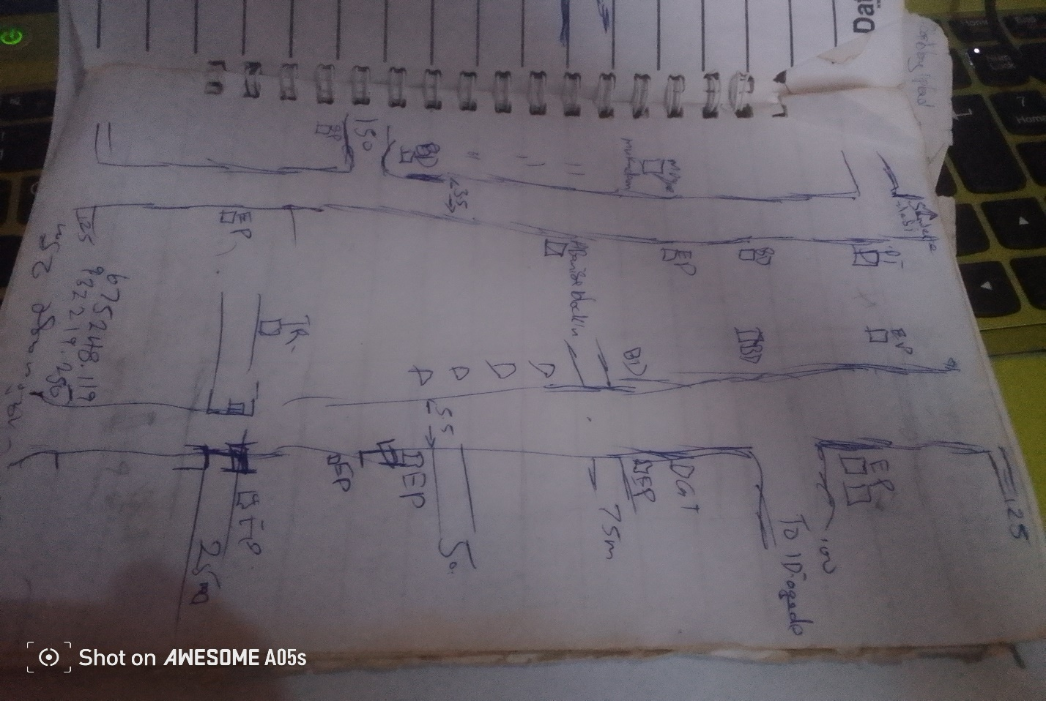Fig.3.1: Recce Diagram of the project location (Not drawn to scale)

3.3 OFFICE PLANNING

Having completed the field recce survey, then office planning was followed on the next day. It involves chosen the type of instruments, purpose and accuracy required of the survey be carried out. The collection of equipment needed for the project and also test of the instrument, mission planning, assembling and studying of all available data project of the relevant to the project, the costing of the operation was also done in the office. In executing the project, necessary information related to the project given such as the coordinates of the control. The prefix number of the controls used and the bench marks.
Table 3.1 shows the list of coordinates of existing control points
BEACON NO. | NORTHING(m) | EASTING(m) | HEIGHT(m) | LOCATION
BM.01 | 932229.902 | 675261.302 | 312.39 | Ilorin
BM.02 | 932225.637 | 675284.873 | 313.04 | Ilorin
BM.03 | 932207.160 | 675272.022 | 312.97 | Ilorin
Source: Author, 2025.
3.4. SELECTION OF THE EQUIPMENT AND SOFTWARE
The equipment, tools and software used for this project were grouped into two categories and they are:
- Hardware
- Software
3.4.1 Hardware Used
- Sokkia (CX105) Total Station 1 No.
- Hand held GPS receiver 1 No.
- HP Design jet 7100 series 1 No.
- HP Gateway laptop 1 No.
- Tracking rod 1No.
- Tripod 1 No.
- Linear tape (50m) 1 No.
3.4.2 Software Used
- Ts-link for (CX105) Total Station downloading software
- AutoCAD 2007
- CivilCAD 2014
- Note pad
- Microsoft Office package (Word and Excel).

3.5. BENCH MARKS ESTABLISHMENT, CAPPING AND LABEL
- Temporary bench marks (TBM) were established and coordinated along the entire route of the project, which were meant to serve as a check for data acquisition and controls for establishing centerlines chainages, setting out of curves and other road features during the actual construction.
- The positions of these beacons (TBMs) were selected and established at certain distances part not above 500m interval in such a way that they are inter-visible to each other, not too far from the proposed road and considerable number of centerline chainages can be set out from them.
- The property beacons used were precast with dimensions 18cm x 18cm x 75cm in length. Sixty five centimeters (65cm) of the precast beacon was buried beneath the surface and ten centimeters (10cm) above as shown in fig. 2.3.
- The numbering was done serially from the beginning to the end of the proposed road and was prefixed with identification number BM01, BM02, BM03 and so on. The values of those TBMs were shown on appendix
10cm
65cm
Ground level
18cm
BM
01
18cm
18cm
B
M

01

Figure 3.2: Show the Description Typical Bench Mark.

3.6. INSTRUMENT TEST
3.6.1. COLLIMATION TEST
The procedure undergone to perform instrument test is as explained thus:
The instrument (CX105 Total Station) was set up on TBM.01 and all temporary adjustments (centering, leveling and parallax elimination) were performed. A reflector prism was set-up at a distance of about 100m to the line of sight and bisected on both face left and face right. The instrument was switched on and program which is on-board of the micro-computer of the instrument was switched to the columniation program. Then horizontal columniation and vertical index were in sequence recorded and stored in the memory of the instrument. The telescope was transited and the same target was bisected. Both the new vertical index and columniation error were recorded and stored accordingly. It was transited to the same target with both horizontal and vertical readings recorded to check the instruments accuracy. The readings obtained were shown in the table below.
Table 3.2 Show the Horizontal Circle Readings
Station | Sights | Face | Horizontal Circle Readings | Diff. Between (FL & FR)
A | C  C | L  R | 204⁰ 36’ 42’’  024⁰ 36’ 36’’ | 180⁰00’ 06’’

Table 3.3 Show the result of the adjustment made.
 | OLD READING | NEW READING
Horizontal Columniation | 00° 00’ 18’’ | 00° 00’ 06’’
Vertical Index | 00° 00’ 11’’ | 00° 00’ 04’’

3.7 DATA ACQUISITION
3.7.1 IN-SITU CHECK
The in-situ check was carried out on the control TBM.01, TBM.02, and TBM.03, the result showed that the pillars were reliable enough to be used for the project. An analytical comparison of the measured data obtained from the check and the calculated values is as shown below.
Table 2.3 Show the observed coordinates of TBM.01 from TBM.02
STATION | NORTHING(m) | EASTING (m) | HEIGHT(m) | REMARK
TBM.01 | 932229.902 | 675261.302 | 312.39 | Observed
TBM.01 | 932229.896 | 675261.311 | 312.37 | GPS Given
Discrepancy | -0.006 | 0.009 | -0.017

Table 2.4: Show the observed coordinates of TBM.03 from TBM.02
STATION | NORTHING(m) | EASTING (m) | HEIGHT(m) | REMARK
TBM.03 | 932207.160 | 675272.022 | 312.97 | Observed
TBM.03 | 932207.164 | 675271.996 | 312.98 | GPS Given
Discrepancy | 0.004 | -0.006 | 0.006
Table 2.5: Result of the computed control check (from given GPS coordinates).
STATION FROM | BEARING | DISTANCE | DN | DE | NORTHING | EASTING | STATION  TO
 |  |  |  |  | 932229.896 | 675261.311 | TBM.01
TBM.01 | 349ᴼ59’59” | 23.953 | -4.255 | 23.478 | 932225.637 | 675284.873 | TBM.02
TBM.02 | 234ᴼ59’56” | 22.507 | -18.482 | -12.858 | 932207.164 | 675271.996 | TBM.03

The result was used to obtain the inclusive angle between TBM.01, TBM.02, and TBM.03 by finding the difference between the bearings of two lines.
TBM.02 TBM.01 => 169ᴼ59’59”
TBM.02 TBM.03 => 234ᴼ59’56”
Therefore (234ᴼ59’56”-169ᴼ59’59”)
Check angle 64⁰ 59’ 57’’

64⁰ 59’ 57’’

Fig.2.5 Show sketch of the check angle from three Given data
Table 2.6: Show result of the computed control check angle (from observed coordinate).
STATION FROM | BEARING | DISTANCE | DN | DE | NORTHING | EASTING | STATION  TO
 |  |  |  |  | 932229.902 | 675261.302 | TBM.01
TBM.01 | 350ᴼ01’01” | 23.954 | -4.264 | 23.570 | 932225.637 | 675284.873 | TBM.02
TBM.02 | 234ᴼ59’59” | 22.508 | -18.477 | -12.851 | 932207.160 | 675272.022 | TBM.03

The result was used to obtain the included angle between TBM.01, TBM.02 and TBM.03 by finding the difference between the bearings of two lines.
TBM.02 TBM.01 => 170ᴼ01’01”
TBM.02 TBM.03 => 234ᴼ59’59”
Therefore (234ᴼ59’58”-170ᴼ01’01”)
Check angle 64⁰ 59’ 58’’
TBM.02TBM.02
TBM.01TBM.01
TBM.03TBM.03
64⁰ 59’ 58’’

Fig.2.6 show the sketch of check angle from the observed data
The difference between the Observed check angle and the computed from given check angle was 00⁰ 00’ 01’’
- Computed distance from the given data (TBM.02 TBM.01) = 23.953m
- Computed distance from the observed data (TBM.02 TBM.01) = 23.954m
Difference obtained with the two result was compared as = 0.001m
- Computed distance from the given data (TBM.02 TBM.03) = 22.507m
- Computed distance from the observed data (TBM.02 TBM.03) = 22.508m
Difference of the two results = 0.001m
3.7.2 GEOMETRIC DATA ACQUISITION
3.7.3 TRAVERSE OF BM POINTS
Traverse was run round the established eleven (11) BM points. The CX105Total Station was set up on BM.02, a back sight was taken to BM.01 after the instrument is switched on and all temporary adjustments were carried out. The stations parameters (N, E and H) were enter into the memory of instrument for both occupied and reflector target station at back sight station (BM.02 and BM.01) respectively. Fore sight was taken to the first BM.03 and measurement stored, the instrument was then moved to the BM.01 as instrument station and reflectors were positioned at BM.02 and BM.03 as back sight and fore sight respectively. The occupied station (BM.01) parameter was entered into the Total Station and measurement was taken to CL-Road Centerline. This whole process continues and the traverse was closed back at BM.02. The numbers of BM are eleven (11) in total. The table below show the list of the benchmarks observed.
3.7.4 DATA ACQUISITION
The CX Total Station was set-up on BM.02, switched on and all temporary adjustments were carried out. The instrument was set on coordinates mode and the instrument parameters (Station name, Height of instrument, and N, E, H) as well as the target station parameters (Back sight station name, Height of reflector, and N, E H) were keyed into the Total Station. Then orientation was made to the reflector at station BM.01, and the measurement between the two stations was stored in the memory of the instrument. Foresight was made to 0+000m chainage centerline and then to the cross-sections at 20m away from the center line on both side and stored on the Total Station. Then the reflectors were now moved to the next chainage 0+025 and the same measurement performed for the first chainage is repeated here i.e. the centerline and the cross-section. Also details were fixed alongside traversing; IP points was also coordinated by moving the reflectors to the desired point of interest and denoted using a different code (CL, BLD, E.P, RT, LT, W.F, and DR. CV. Where CL means Centerline, BLD means Buildings, E.P. means Electric Poles, RT means Road Right Side, LT means Road Left Side, W.F. means Wall Fenced, DR mean Drainage line, CV mean Culvert ). This whole process continues until the reflector is no longer visible from the instrument. Then the instrument station was changed and the above process of data acquisition was repeated for the marked chainages and BM points till the end of the route was reached. The traverse was closed on BM11. The discrepancy between the observed and the given coordinates for the easting and northing is -0.099m and +0.102 respectively was used to compute for linear accuracy and found to be 1: 63,000, compare with the permissible accuracy of 1:5000.

TP2
TP1
CL
TP3

CH 0+000 CH 0+100 CH 0+200 CH 0+300

CHAPTER FOUR
4.0 DATA PROCESSING
The data processing follows immediately after the completion of the data acquisition and the selected software from the chapter three. This involved the methods used in downloading / retrieving, sorting and analyzing of acquired data (field data). Here the data downloaded was processed into information using appropriate methods and software. The steps involved are as follows;
4.1 DATA DOWNLOADING (CX- TOTAL STATION)
4.1.1 DOWNLOADING PROCEDURE
The data were transferred from the Total station to the SD Card via the SD card Slotted in into Total Station and later downloaded into the computer using Ts-Link Sokkia (CX105) Total Station software.
The following procedure was followed during the downloading from the Total Station to the computer;
The SD card was Slot in into the Total Station and the instrument was powered on. The job “Route” was selected from the list of JOBS to be downloaded then transfer to the SD Card following the steps below
- click on F4 which means transfer
- The following option displayed on the total station screen
- Comm. sends data
- Comm. receive data
- Comm. setting
- Memory to S.D card
- S.D card to memory
- S.D card to file manager
- Then the fourth (4th) option is selected since we are moving the job “Route” from Instrument memory to SD card
- Then press ok
- Click on F1 to create a new file
- Input the file name and press F5 (ok)
- Search for the file name then press enter and the data was successfully moved from instrument memory to SD card
4.1.2 DOWNLOAD FROM SD CARD TO COMPUTER SYSTEM
The Sokkia-link software was installed on the computer system and was used to download from the SD card to system.
The following procedures were followed
- Insert the memory card at the appropriate slot on the Computer system.
- Sokkia-link software was launched from the desktop screen.
- Click on the SD card on the software
- Scroll on import data
- Click on the file name
- Click on yes
The coordinates will display in the format
PT | N/X | E/Y | Z | CODE
- Then save the file as text file.
4.2 DATA PROCESSING PROCEDURE
The file was opened and point data were displayed. This was then copied to a notepad and Microsoft excel environment for further processing.
On notepad, data were well spaced to differentiate one column from the other and unwanted information deleted.
On Microsoft excel, data were prepared for scripting purpose in AutoCAD. A small programme was written to prepare point and text scripts files.
4.2.1 PLOTTING PROCEDURE IN CIVILCAD 2014
    - CIVILCAD 2014 was lunched and NEW PROJECT was clicked index FILE MENU and named e.g. Route Survey, the OPEN button was clicked.
    - CONFIGURATION was then clicked under file menu to carry out General settings (Language, System units, Angles units, and Printout font size etc.), drawing environment settings, and Coordinate format settings and File settings.
    - Having completed the configuration, TOPOGRAPHY MENU was clicked and COORDINATES was chosen in the pull down menu.
    - In the dialogue box, ‘Load menu from text file’ button was clicked to load raw data coordinates that was arranged in the format; Point ID, Easting, Northing, and Height.
    - After selecting the raw data file and clicked Open, REFRESH ALL button was clicked and the software automatically run the script and plot the whole data just exactly the way it was surveyed. Also layers were automatically created for all the point Ids, Heights and Symbols used. But layers for each feature that was fixed along the route were manually created, e.g. buildings, Electric poles, Drainages, Culverts etc.
    - Line, Polyline, points and Splines tools were used to join all the features that were fixed along the route path into its appropriate layers.
4.2.2 PROFILE / VERTICAL ALIGNMENT PLOTTING USING CIVILCAD
- In CivilCAD2014 environment, ROAD MENU was clicked and VERTICAL ALIGNMENT submenu under Road selected.
- The Options Button was clicked in the dialogue box to set the Slope format, Vertical curves’ factor, Data precision and super elevation maximum slope. After the settings of these parameters, OK button was clicked.
- Having done this, ‘Load sections from a text file’ button was clicked to load sections of the centerline data, which was prepared in notepad in this format;
Station Chainage leveling height
  - 0 312.870
  - 25 312.710
  - 50 312.540
  - 75 312.390......
- Zoom Extent was opted for under view menu to view the whole profile drawing.
- A design was carried out on the profile by selecting a polyline tool to pick points along the profile, and when this was completed, APPLY button was clicked and the software automatically generates design levels for the whole profile.
- The design level was then used to calculate the volume of CUT and FILL on each section of the centerline.
4.2.3 LOGITUDINAL / HORIZONTAL ALIGNMENT PLOTTING USING CIVILCAD
- In CivilCAD2014 environment, Road Menu was clicked and HORIZONTAL ALIGNMENT chosen.
- Options button was clicked in the appeared dialogue box and Define Section was then clicked to choose the section format and the distance between the sections. Format 2 was chosen and the distance between sections was taken to be 25m
- Having chosen these options, OK was clicked twice.
- Pick tool was selected from the right pane dialogue box to pick all the intersection points (IPs), and appropriate radius values of curve was given to each IP as specified by the client.
- Apply button was then clicked to effect all the given parameters on the drawing. On each IP position, information about the IP is been displayed. Such information are; IP number, X coordinate, Y coordinate, Radius of curve, Length of curve, Deflection angle and so on.

4.2.4 PLOTTING OF CROSS-SECTIONS USING CIVILCAD
- In CivilCAD2014 environment, Road menu was clicked and CROSS SECTION selected. Then ‘Load sections from text file’ button was clicked to load the existing ground level data.
- Having uploaded the data file, Existing Ground Level was chosen to specify that the data coming in is for existing ground level.
- The same format of data was uploaded next but for Designed Level by choosing Designed Ground Level button. The design level data was calculated using 2.5% slope for cambering and 3% slope for the shoulder.
- The software then superimposed the two drawing together to calculate the volume of CUT and FILL at each cross sections.
- Then frame division was clicked and the Output scale, Paper size and range was chosen for the final output of the cross sections.
4.2.5 GENERATING EARTHWORK TABLE USING CIVILCAD 2014
- Under Road menu, EARTHWORK button was clicked and the Apply button to generate the volume of earthwork table.
- Having done this, a geometry report dialogue box appears on the screen showing the accumulated volume of Cut and Fill, which can be directly printed or exported to Microsoft Excel for further editing.
  - RESULT AND ANALYSIS
This is a systematic examination and evaluation of data obtained and processed as a result of my field observation. This was achieved by taking into consideration all the necessary survey procedures and adhering to survey rules and regulations while on field and during processing.
The final results were tabulated in appendix
The route survey traverse started from TBM.01, TBM.02 andTBM.03 but closed back on TBM.02.
Table 4.7: Abstract of BM coordinates
TBM.01 | 932229.902 | 675261.302 | 312.39
TBM.02 | 932225.637 | 675284.873 | 313.04
TBM.03 | 932207.160 | 675272.022 | 312.97
TBM.04 | 931583.654 | 674839.222 | 310.21
TBM.05 | 931589.824 | 674818.166 | 309.58
TBM.06 | 674441.073 | 931811.975 | 310.13
TBM.07 | 931823.719 | 674448.987 | 309.46
TBM.08 | 932238.880 | 673657.641 | 322.56
TBM.09 | 932216.454 | 673658.547 | 323.87
TBM.10 | 933121.878 | 673159.463 | 303.71
TBM.11 | 933124.483 | 673178.850 | 303.56

Finally the observed coordinates and the given coordinates were compared and the computation shows that the traverse closed.
4.4 LINEAR ACCURACY
The accuracy was computed with the formula below:
For the boundary traverse;
_____1_____
√(ΔE)² + (ΔN)²
Total Length

Starting Coordinate (TBM.02) 932225.637mN; 675284.873mE, Ht = 313.040m
Closed Coordinate (TBM.02) 932225.739mN; 675284.774mE, Ht = 312.068.m
Misclosure in Easting (E) = -0.099m
Misclosure in Northing (N) = + 0.102m
Total Length = 9000m

_____1_ _____
√ (0.099)² + (0.102)²
= 9000m
_1_ __
√ 0.020205
= 9000m
_____1_ _ _
0.1421443
= 9000m
____1_ _
= 0.00001579381
= 63,315

The computed accuracy is 1/63,000
The permissible accuracy is 1/5,000
4.5 HEIGHT ACCURACY
Obtained error in leveling traverse (Misclosure) = -0.028m
Minimum allowable error in leveling (Permissible) = 24mm√k
Where k = distance covered in kilometers is 9.0km
Allowable error over in height over km =
24mm√k = 24mm√9.0km = - 0.0026m
Therefore, it means that the job met the required specification.
From the above computations, the linear accuracy obtained was better than the allowable limits of 1:5000 according to SURCON specifications for third order engineering job.
4.6 PLAN PRODUCTION
The adjusted coordinates were plotted in AutoCAD 2007 and Civil CAD 2013 Environment to generate the centerline of the road, longitudinal profile and cross section. The details were also plotted. The essence of obtaining a detail plan is to provide a platform for horizontal curve and alignment design for the road expansion /rehabilitation. Information shown on the detail plan provides a vivid representation of the land mass for easy understanding of the route.
    - HORIZONTAL ALIGNMENT PLAN
AutoCAD Land Development software 2009 was used to transform the collected and already processed data into a plan for visual presentation. A hard copy of the plan was printed using the AutoCAD visual display graphical information. Plots of the cross-section, profile, and longitudinal section were made which was attached to this project.
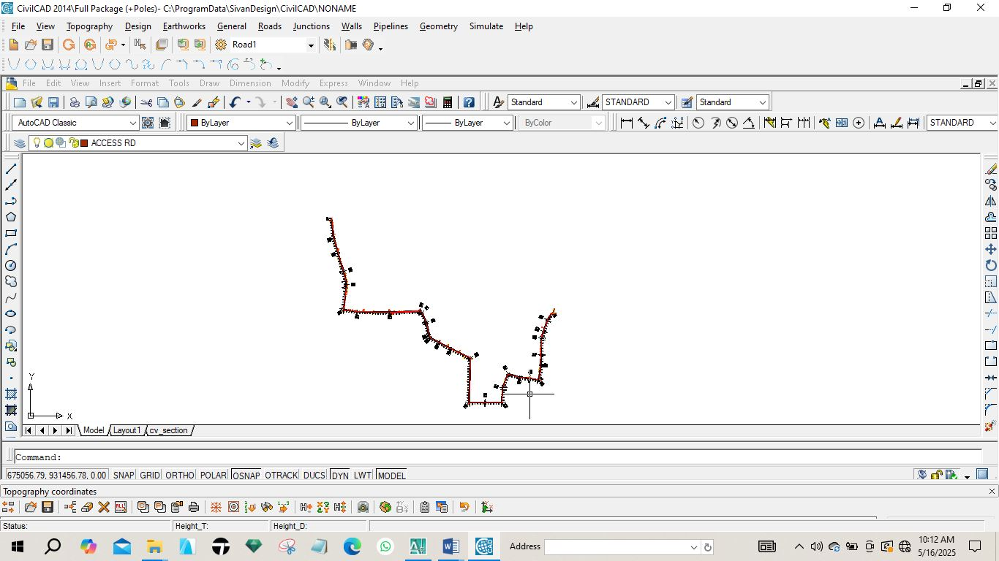
Fig 4.1: Horizontal plan of the route

4.6.2 VERTICAL ALIGNMENT PLAN
In order to give vertical height and terrain information along a route for vertical alignment and curve design, a profile was created. It gives a clear view of the terrain and helps decide where to fill or cut. It offers details like the existing level, formation level, tangent points, and slope.
The design of the route was done after the creation of the longitudinal profile. The longitudinal profile was created using AutoCAD Civil 3D 2022. The steps in the creation of the longitudinal profile shown in fig 4.2 are as follows:
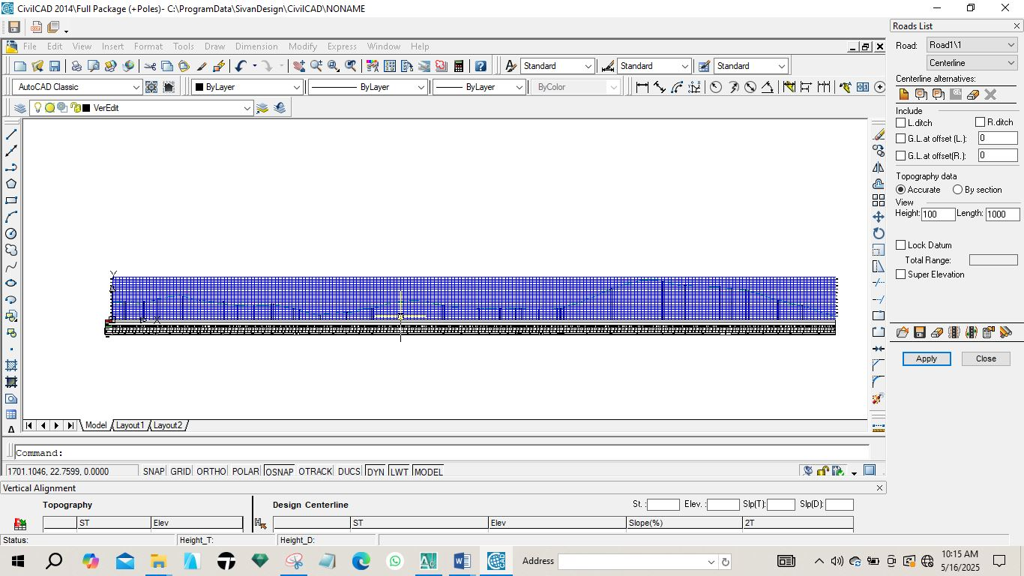
Fig 4.2: Vertical Profile of the route.
    - CROSS SECTION PLAN
The terrain information across the road chainage is shown in the cross-section. Details were displayed, including the height of the proposed and current center line and embankments. In cut and fill analysis, the area and, consequently, the volumes of earthwork were generated using the cross-section parameters.
The following process was carried out on the currently plotting on Auto CAD Civil CAD for generating cross section. The Cross Section icon was used to sample the sections from the existing ground, edit the values of the tangents, curves, and spirals, and create a current surface by clicking on surfaces and setting current surface. A template was created for the section and it was also edited under design control. Then, by clicking on section plot, all was selected, and all sections were created.
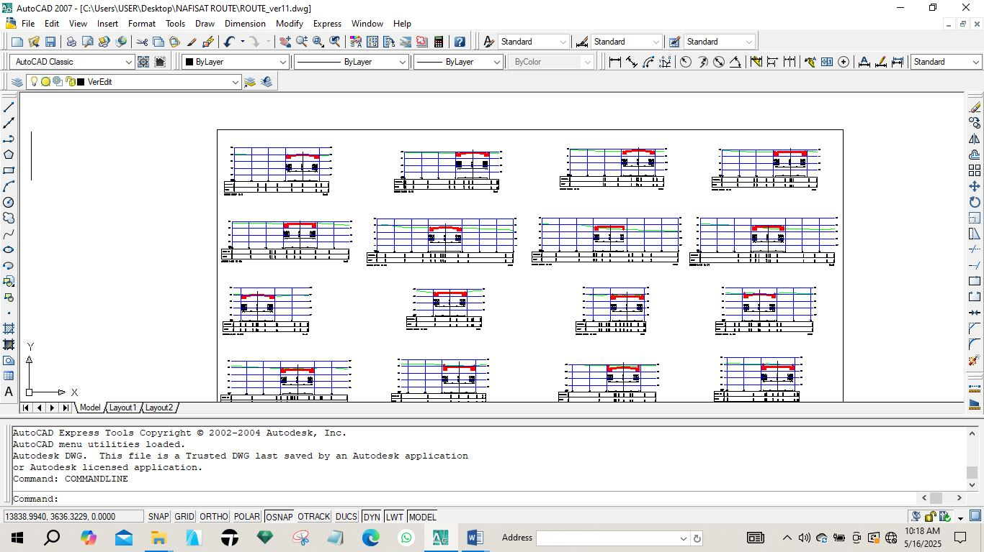
Fig. 4.3: Diagram showing generated cross section
4.6.4 VOLUME OF EARTWORKS
Volume computation in route surveying is a fundamental process used to estimate the quantity of earthwork required for road construction projects. Accurate volume calculations help engineers plan excavation and embankment activities efficiently, ensuring cost-effective and sustainable infrastructure development.
The software used for volume of earth work calculation is AutoCAD 2007and Civil CAD 2014, the process involves selecting specific areas for calculation and defining initial and final surfaces, which can be particularly useful in monitoring changes over time, such as material removal or deposition.
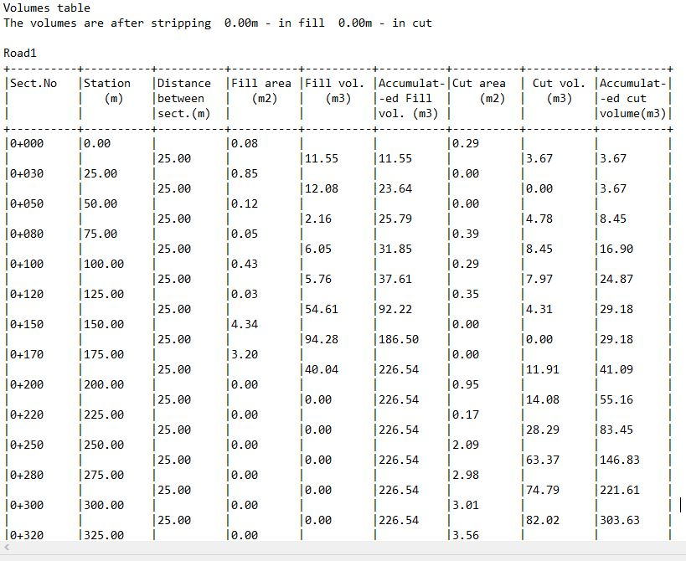
Fig. 4.4: Diagram showing generated volume computation

  - PROJECT COSTING
Table 4.4.1: shows the worked out cost of the project
OPERATION | RATE / DAY | NO OF DAYS | UNIT COST (#) | AMOUNT (#)
RECCONNAISSANCE (DAY)
1 Senior Surveyor | 10,000 | 1 | 10,000 | 10,000
8 Technical officer | 5,000 | 1 | 40,000 | 40,000
1 skilled labour | 5,000 | 1 | 5,000 | 5,000
Transportation (Field vehicle + Driver/ Mechanic + fuel) | 20,000 | 1 | 20,000 | 20,000
Basic Equipment (Hand held GPS, Field Book etc.) | 5,000 | 1 | 5,000 | 5,000
SUB TOTAL |  |  |  | #83,000
DETAILING AND SPOT HEIGHTING 4DAYS
1 Senior Surveyor | 10,000 | 4 | 40,000 | 40,000
8 Technical officer | 5,000 | 4 | 20,000 x 8 | 160,000
Basic Equipment (Total Station, Reflector) | 20,000 | 4 | 80,000 | 80,000
Transportation (Field vehicle + Driver/ Mechanic + fuel) | 20,000 | 4 | 80,000 | 80,000
SUB TOTAL |  |  |  | #360,000
DATA PROCESSING 1WKS
1 Principal surveyor | 10,000 | 5 | 50,000 | 50,000
1 surveyor | 8,000 | 5 | 40,000 | 40,000
1 assistant technical officer | 5,000 | 5 | 25,000 | 25,000
Computer accessories (printer, internet, generator, fuelling etc.) | 15,000 | 5 | 75,000 | 75,000
SUB TOTAL |  |  |  | #190,000
INFORMATION PRESENTATION
1 Senior surveyor | 10,000 | 1 | 10,000 | 10,000
1 technical officer (CAD) | 8,000 | 1 | 8,000 | 8,000
Standard set (computer, plotter, Generator etc.) | 15,000 | 1 | 15,000 | 15,000
SUB TOTAL |  |  |  | #33,000
TECHNICAL REPORT
1 Chief surveyor | 30,000 | 1 | 30,000 | 30,000
2 Surveyors | 20,000 | 1 | 20,000 x 2 | 40,000
SUB TOTAL |  |  |  | 70,000

COST OF THE PROJECT | #736,000
MOBILIZATION / DEMOBILIZATION (10% of the project) | #73,600
CONTIGENCY (5% of the project) | #36,800
TOTAL COST OF THE PROJECT | #846,400
VAT) (5% of the project) | #42,320
GRAND TOTAL | #888,720

CHAPTER FIVE
5.0 SUMMARY, PROBLEMS ENCOUNTERED, CONCLUSION AND RECOMMENDATION
5.1 SUMMARY
The project focused on route surveying, a specific type of survey falling within the broader domain of engineering surveys. It delineated the methods, equipment, and personnel involved in the project execution, ultimately assisting in determining the appropriate instruments type and accuracy, creating a reconnaissance diagram, and identifying suitable methods for data acquisition to design the road. For conformity, 11 Control stations were established and Markers were placed at 25m intervals to establish chainages from 0m to a total length of 4.5km including 5m cross sections at the left and right of each center line for every chainage. Total station was utilized to capture the horizontal and vertical coordinates for profile and cross-sectional points and to detail the route. The accumulated data was transferred using Leica Geo-office software via a download cable. This processed data was plotted using AutoCAD Civil CAD 2014 to generate cross-sections, profiles and Horizontal alignment. The survey information was visually represented in hardcopy format, and a comprehensive report detailing the project's activities was subsequently produced.
  - PROBLEMS ENCOUNTERED
The foremost challenge encountered during field observation involved hindrances due to vehicle obstructions and temporary structures, disrupting our ability to accurately measure and record data.
  - CONCLUSION
Upon analyzing the results computed in chapter four of the project report, it is clear that the project adhered to the specifications of engineering survey, constituting a third order survey project. Both the field and office work were meticulously executed in line with the regulations and specifications of this project. This experience has contributed significantly to my knowledge and expertise, positioning me favorably as a technologist in the Survey profession. Despite the 39 challenges encountered on-site and throughout the project, the project's objective was successfully accomplished.
  - RECOMMENDATIONS
As a result of the experience and knowledge acquired from this project, I hereby recommend that: i. ii. iii. iv. The methodology employed in this project enhances its accuracy, adopting such an approach globally is recommended to improve the precision of survey work. Considering the project's nature, telecommunication devices should be employed due to communication barriers to facilitate effective communication at project sites. The acquired data should be preserved for future use to minimize construction expenses for any future road development. Given the thorough execution of the project's field work, the attained precision, and the sufficiency of the acquired data, it can effectively support any construction undertaking within the route. With the advancement of technology there should be comparison between GNSS and Total station to be employed in this project.

5.4 REFERENCE
Anderson, L., & Patel, R. (2024). The role of roads in modern transportation networks. Transportation Studies, 28(3), 201-215. Chen, Y., Liu, S., & Zhang, T. (2022). Smart roads and intelligent transportation systems: Revolutionizing road networks. Journal of Transport Engineering, 47(4), 305-320. Davis, T., & Chen, L. (2021). GIS applications in earthwork volume calculation: A case study. Journal of Geographic Information Science, 29(4), 411-423. Federal Highway Administration. (2020). History of the Federal Highway Administration. Retrieved from https://www.fhwa.dot.gov/infrastructure/history.cfm Federal Ministry of Works and Housing. (2021). Overview of federal roads in Nigeria. Retrieved from [insert URL here] Green, E., & Rivera, M. (2023). Integrating environmental impact assessments in route surveying. Environmental Engineering Journal, 40(1), 45-57. Hernandez, J., & Lee, A. (2024). Advancements in sustainable road engineering. Journal of Civil Infrastructure, 39(2), 150-165. Johnson, M., & Patel, R. (2024). Machine learning in volume computation: A review. Construction and Building Materials, 232, 125-134. Johnson, M., & Lee, K. (2023). Route surveying for linear infrastructure development. Journal of Surveying Engineering, 149(3), 123-138. Martin, A., & Taylor, B. (2024). Fundamentals of surveying techniques and practices. Surveying Science, 12(1), 15-29. Roberts, T., & Wang, H. (2024). The impact of drone technology on topographic surveys. Journal of Surveying and Geomatics, 55(2), 89-104. Smith, J., & Lee, K. (2023). Drone technology in route surveying: Enhancing efficiency and accuracy. Journal of Civil Engineering, 45(2), 123-135. Smith, A. (2020). The evolution of roads from ancient to modern times. Historical Transport Review, 15(1), 5-20. Wang, H., & Zhao, Y. (2022). 3D modeling in route engineering: Applications and challenges. International Journal of Engineering Research, 36(1), 78-89.

5.5 APPENDIX
i. Recci diagram
ii. Field book
- Computation sheet
- Plotting: Analogue and Digital plans

