ASSESSMENT OF VALUATION ON COMPULSORY LAND ACQUISITION AND COMPENSATION
(A CASE STUDY OF KWARA GEOGRAPHIC INFORMATION SERVICE, ILORIN)

PRESENTED BY

MEMUDU QUADRI OPEYEMI
HND/23/ETM/FT/0102

BEING A RESEARCH PROJECT SUBMITTED TO DEPARTMENT OF ESTATE MANAGEMENT AN D VALUATION, INSTITUTE OF ENVIRONMENTAL STUDIES, KWARA STATE POLYTECHNIC, ILORIN.

IN PARTIAL FULFILMENT OF THE REQUIREMENTS FOR THE AWARD OF HIGHER NATIONAL DIPLOMA IN ESTATE MANAGEMENT AND VALUATION.

JULY, 2025



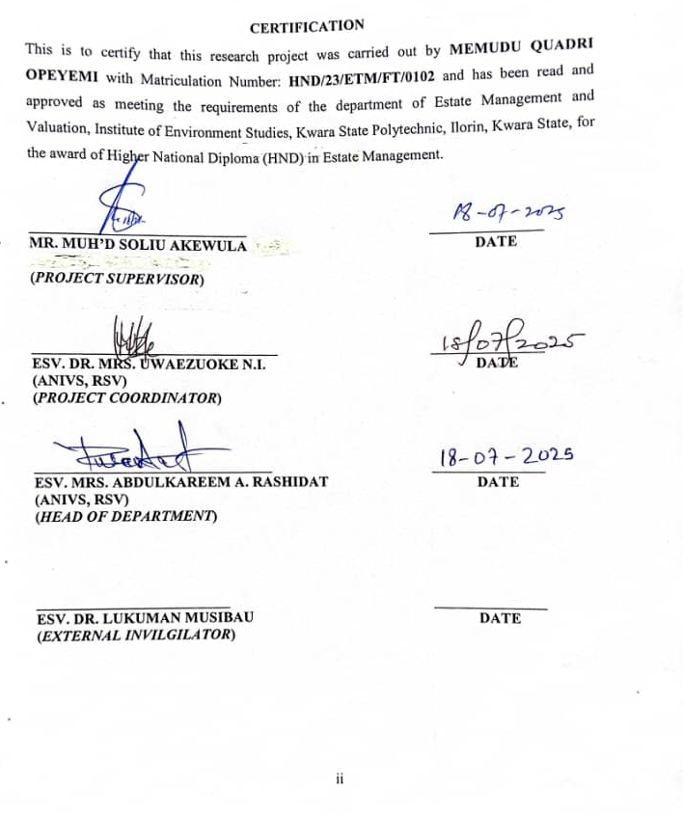

DEDICATION
This project work is dedicated to Almighty God, the sustainer of heaven and earth who by his glorious power gave me the ability, wisdom and effort to write this project and also to my parent who have given me both moral and financial support.

ACKNOWLEDGEMENT
I give glory to Almighty Allah for his protection, guidance and for his love over us because He is the only that can never fail.
It is expedient on my part to give glory to Almighty Allah, the Omnipotent, Omniscience and ever living God for his love over me throughout the course of my study in this citadel of learning, may his name be praised forever.
My gratitude goes to my project supervisor, MR. MUH’D SOLIU AKEWULA for taking time out of his busy schedule for the supervision of this project and for his advice during the course of this write-up, sir, I say a big thanks, may Almighty Allah reward you abundantly.
My immense gratitude goes to my HOD ESV. ABDULKAREEM R.A, also to my project coordinator ESV. DR. MRS. UWAEZUOKE N.I., I also appreciate my lecturers; ESV LANRE HASSAN, ESV YAKUB BOLAJI, ESV AFOLAYAN, MR ABDULMUMEENI, MR. IMAM, and other lecturers, I say a very big thank you for the knowledge you pass to me.
My sincere gratitude goes to my parent for their support both financially, morally, spiritually and for their undying love for me, my prayer is that you shall live long to reap the fruit of your labour (amen)
Lastly, to my brother, who contributed, helped and support me with every means possible just to be able to finish this journey, may the blessings of Almighty Allah never cease from your homes and family.
Thank you.
ABSTRACT
The administration of land, particularly with regards to acquisition and compensation has been redefined by the Land Use Act, which by its establishment in 1978 created a dialectical relationship between the state and communities. The relationship empowered the state to own and control land within its territory for public interest. The main thrust of this paper is to examine the policies that underpin land administration particularly as regards acquisition and compensation in Nigeria and, to know whether it has been able to bring about the achievement of its noble objective. Land use and management has proved to be a source of worry and conflict in the world especially the developing world. In contemporary Nigeria, most people no longer view land as a place where people live, but a new way for business deals and new profit opportunities. This paper found out that, there are gaps in policies guiding the process of land acquisition and payment of compensation in Nigeria, and there is a possibility of abuse by those who control the affairs of the state to their advantage. This paper also found out that, section 47(2) of the Act seems dictatorial; for compensation litigation, the court is not to determine the value of properties of a beneficiary or would be beneficiary. This paper concludes that, the increasing vulnerability of customary land rights due to weak governance structures and shortcomings in the implementation of land policies has a direct consequence. Therefore, the practice in Nigeria is not equitable and as such not in tune with global best and standard practices. The paper recommended that, provisions of the Land Use Act that are obnoxious and undemocratic be reviewed to allow for better practices as it is done in other countries.
Keywords: Land Policies, Land Acquisition, Compensation, Development, Public Interest
TABLE OF CONTENTS
Title Page………………………………………………..……………………… i
Certification……………………………………………….………………… ii
Dedication………………………………….……………………………….. iii
Acknowledgement……………………….…………………………………. iv
Abstract………………………………….………………………………….. v
Table of contents…………………………….…………………………….... vi

CHAPTER ONE
1.0 Introduction…………………..…………………………………………. 1
1.1 Background of the study…….……………………………………………. 1-2
1.2 Statement of the problem………………….……………………………. 2-3
1.3 Research Questions……………………..………………………………. 3
1.4 Aims and Objectives of the study…..…………………………………… 3
1.5 Significance of the study………..……………………………………….. 3-4
1.6 Scope of the study…………………………….………………………… 4
1.7 Study Area……………………………………………………………… 4
1.7.1 Climate……………………………………………..…………………. 5
1.7.2 Relief and Drainage…………………………………….…………….. 5
1.7.3 Soil and Vegetation………………………………………..………….. 5
1.7.4 Geology and Geomorphology………………………………..……….. 5
1.7.5 Commerce and Socio-Economic Activities…………………………… 6-9
1.8 Definition of terms……………………………………………………… 9

CHAPTER TWO
2.0 Introduction……………………………………………………………... 10
2.1 Literature Review………………………………………………………... 10
2.2 Conceptual framework: assessment of valuation on compulsory land acquisition and compensation……………….………………….………………………….... 10
2.2.1 Compulsory Land Acquisition…………………………………………..… 10-11
2.2.2 Compensation………………………………………………..…………... 11-12
2.2.3 Legal Basis of land Acquisition………………………………………..…. 12-14
2.2.4 Concepts in Valuation for Compensation……………………………….. 14-15
2.2.5 Compensation Method………………………………………………….... 15-16
2.2.6 Valuation Principles for compulsory land Acquisition…………………. 16-18
2.2.7 Factor influencing valuation and compensation……………….……… 18
2.3 Theoretical Review……………..…………………………………….…. 18
2.3.1 Economic theory of property right…………………………………...…. 18-19
2.3.2 Compensation theory and compensation scope…………………............ 19-21
2.3.3 Theoretical underpinning……..……………………………………….…. 21-23
2.4 Empirical Studies………….……………………………………….……… 23-24
2.5 Research Gap……………………………………………………………..… 24

CHAPTER THREE
3.0 Research methodology……………………………………………….…. 25
3.1 Introduction……………………………………………………………... 25
3.2 Research Design……………………………………………………….... 25
3.3 Data types and Source….……………………………………………….. 25
3.4 Instrumentation for data collection…………………………………....... 26
3.5 Target population………………………………………………………… 26
3.6 Sample Frame…………………………………………………………... 26
3.7 Sample Size……………………………………………………………….… 26-27
3.8 Sampling Procedure……………………………………………………… 27
3.9 Method of data Analysis………………………………………….…….. 27

CHAPTER FOUR
4.0 Data presentation and data analysis…………..…………………..…….. 28
4.1 Introduction……………………………………………………………... 28
4.2 Data presentation and analysis……………………………………………… 28-33

CHAPTER FIVE
5.0 Summary, Conclusion and Recommendation……………………………. 34
5.1 Summary of findings……………………………………………………… 34
5.2 Conclusion…………………………………………………………………. 34-35
5.3 Recommendations………………………………………………................. 35-36
References………………………………………………………...……... 37-38

CHAPTER ONE
1.0 Introduction
1.1 Background to the Study
Land has always played a crucial role in life of human community and is basics to human existence and also a limited resource. It plays an important role as a financial asset. Investment in infrastructure development such as airport, road, railways, hydropower, irrigation and town development for public purpose is very important for the development of any country and any infrastructure development needs a huge quantity of land. The first step towards the public infrastructure development is the acquisition of land. Land acquisition is a process of acquiring private or public land and providing for the public benefits. The compulsory acquisition or expropriation is the method for acquiring the land. Acquisition of land with low market value is common for the land acquisition in developing countries. The issues such as land valuation, compensation, and violation of rights, loss of ownership and livelihood of affected people come together during land acquisition. The world over, laws exist that govern land and its resources and Nigeria is not an exception. In 1978, the Land Use Act was established which created a dialectical relationship between the State and communities. The relationship empowered the State to hold land in trust for public interest. However, the exercise of this power by the State is not without controversy which seems to border on valuation methods which results into insufficient compensation. These laws that specify how land is to be acquired and used are determined by the state’s system of land administration. It is the administrative system that determines the portion of land, condition and time limits to the use of land resources. In contemporary Nigeria, the demands for land and its usage keep increasing everyday; the space to build and live, the space to construct and the space to farm is becoming unavailable in most places. The government of the day wants to acquire the land for development purposes; the community’s quest to keep its land is connected to construction of houses, farming, and burial of deceased members, establishment of market squares and other communal uses. Land use and the interest in land is becoming complex. In all these, the concern remains an effective land administration system.
Compulsory land acquisition is the most challenging aspect in land management as it affects both the government and the governed, and this rooted to the fact that land often means different things to different people and as such is not easy to let go. Few people look at it as an area of ground or a structure that is not covered by water while other people look at it as the area for producing grains to feed themselves, their family and their livestock. Some people however derive their dignity from land, which is why people respect land more. The importance of land in realising the basic necessity of life is unquantifiable. It is therefore not difficult to understand, why there is very high demand for land; Owners having different attitudes to land and this routes from their perspective or views about land. This is what brings about different reactions to in compulsory land acquisition and compensation made by government, Silvery and Larbi (as cited in Oladapo and Ige, 2024).
1.2 Statements of the problems
Because of growing population and increasing needs of the human being who are looking for more areas to use for infrastructural development and as such, taking people’s properties, cutting trees and causing harm to ecosystem. Compulsory acquisition is a statutory practice in Nigeria under the Land Use Act Cap L5 LFN 2004 available to the government to acquire land (Sections 28 (1); 2 (a), (b), (c); 3(a), (b), (c), (d) and (4)) as government cannot rely on land markets alone when and where land is needed to provide major infrastructure facilities for the general public. Owners of property have their rights on the properties revoked for overriding public interest with promises to pay compensation but are usually compensated. However, when it took long for the compensation to be paid, the claimants keep improving their properties with the belief that government is no longer interested since compensation is not yet paid to them but if in the long-run, the government pays, it does not capture the additional improvement on land or value update as at the time of payment neither is interest added to the earlier value for delayed payment. Coupled with the above a lot of items are not taken into account, during the survey on the assumption that they have no economic value since the government has no rates for purposes of compensation calculation.
1.3 Research Questions
The following research questions will guide the study:
- What is the compulsory land acquisition practice in Nigeria?
- What is the compensation practice for land compulsorily acquired in Nigeria?
- What is the extent of compliance of the compulsory land acquisition practice in Nigeria by Kwara State?
1.4 Aim and Objectives of the Study
The aim of the study is to appraise the compulsory land acquisition and compensation practice in Nigeria with Kwara State as a case study. Specifically, the study will be premised on the following objectives are to:
- Examine the effectiveness of compulsory land acquisition practice in Nigeria
- Assess the compensation practice for land compulsorily acquired in Nigeria
- Appraise the extent of compliance of the compulsory land acquisition practice in Nigeria by Kwara State
  - Significance of the Study
Real estate investors are becoming more unlimited and the land use changes are also expanding more due to its lucrative returns. A means to reduce the actual and potential infrastructure damage caused by urbanization is to plan urban centers and to assure strict adherence to its provisions in the cause of its implementation.
Hence, the dynamics of urban growth in Ilorin East Local Government Area, requires a more powerful and sophisticated system such as Remote Sensing data which provides a general extensive synoptic coverage of large areas with details than area photography and Geographical Information Systems which offer interpretation of physical (spatial) data on land use and thereby provide an important means to proffer possible solution on proper land use management with the use of questionnaire to reduce the consequences of urban growth on infrastructure and services.
  - Scope of the Study
This project work was limited to Ilorin East Local Government Area to lack of real estate market research and its consequences on infrastructure and services. The information used for this study was gotten from related textbooks, articles, journals and satellite imageries. This growth has being a great concern over period of time with the increase in population in the study area that as also leads to the disintegration of infrastructure. The use of GIS will be adopted to access the growth by classifying Ilorin east local government area satellite image and the use of questionnaire for the urban growth consequence on infrastructure and services.
This study has some limitations most especially obtaining the satellite imageries, area of data collection and financial constraints, however in respect to all the limitation faced, the aims and objectives of the research work will be accomplished.
1.7 Study Area
Ilorin East Local Government Area of Kwara State is located between latitude 8º50'N and longitude 4º33'E, it is situated in the transitional zone between the Northern and Southern parts of Nigeria. It has an area of 486km² and a population of 204,310 at the 2006 census. Ilorin Local Government Area was created in October 1991. The headquarters located at Oke-Oyi which is about 16 kilometers from Ilorin Township.

1.7.1 Climate
The climate is humid tropical type and is characterized by wet and dry seasons (Ilorin Atlas 1981). The tropical humid climate having a mean annual temperature of 30^{o -}32ºC and a mean daily temperature which is less than 40ºC . The lowest temperature is always around January and December. The type of rainfall is conventional, characterized by storms and sometimes very windy. The mean annual rainfall is 1,250mm and the wet season begins towards the end of March and ends in October. The dry season is from October to March.
1.7.2 Relief and drainage
The landscape of the region is relatively flat. The height of land in Ilorin east local government area ranges from 250m-400m above sea level. Ilorin East is well drained i.e. the major rivers in Ilorin are river Asa (most popular), and river Oyun (the longest).
1.7.3 Soil and vegetation
The soil of Ilorin east is fertile and supports various plants species. The vegetation existing is classified as the tropical deciduous. Presently, the vegetation is under the guinea savanna type which is the reason why crops like shea butter, locust beans, palm trees are still found. Her vegetation is characterized by scattered tall tree shrubs of between the height of ten and twelve feet.
1.7.4 Geology and geomorphology
The foundation of rock in Ilorin is crystalline rock of the pre-Cambrian age, with an elevation which ranges between 273m to 333m in the West and 200m to 364m in the East. The rock type includes granite, biotile, gneiss, schist and quartzite. The nature of the rocks is heavily faulted and weakened which form low inserlbergs. The geomorphology is a general undulating landscape.

1.7.5 Commerce and Socio-Economic Activities
(a) Commercial Activity
The inhabitants of the Local Government Area are very industrious and enterprising. Current commercial activities could be classified as large-scale and small-scale types. The large scale operations take place mainly in big shops and markets while the small scale activities such as retailing in big shops and markets, small kiosk, hawking, and other forms of petty trading are common among the inhabitants. The Local Government is desirous to develop modern markets in Ilorin metropolis by expanding and improving the modern markets in different locations and building shops in strategic locations provided with facilities such as electricity, portable water and toilets.
(b) Industrial Development
There are more than 600 small scale industrial establishments in the study area. Such small scale industries identified are local cloth (Aso-Oke) weaving industry, shoe making, bakery, block making, blacksmith and furniture making. Others are grain milling, knitting, auto-mobile mechanic, local pottery, printing, saw milling, watch repairing, welding and panel beating e.t.c. There are some small scale industries that processes farm produces e.g. sheanut processing industry at JajiFamole.
(c) Transportation
Road and Railway Road is one of the major means of transportation in and around Ilorin East Local Government Area. It is being used for the transportation of the inhabitants, visitors as well as goods and services. The rail lines that link the Southern to the Northern part of the country passes through the Local Government Area. The local government area is linked up with the railway system through some major roads.

(d) Electricity
The State has access to the National Grid through the Kainji Hydro-Electricity Dam, the local government headquarters and majority of the towns and villages in Ilorin East Local Government Area.
(e) Housing & Environmental Conditions
Due to the high demand for residential accommodation ownership of houses by private individuals increases tremendously in Ilorin and Oke-Oyi. The Local Government Headquarters has becomes a lucrative business community, by this many investors took this advantage to establish business ventures which has positively affected the quality and quantity of houses built in recent years
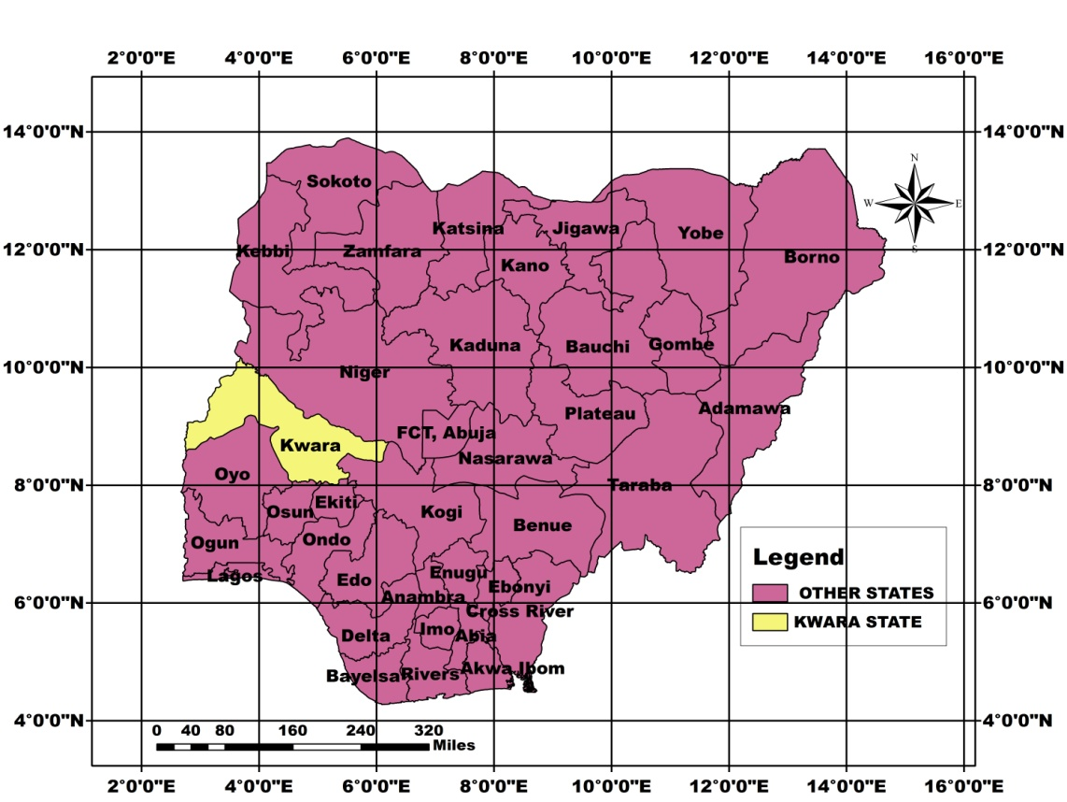
Fig 1.1: Location of Kwara State.
Source: Department of Geography, Federal University of Technology Minna, Niger State
(April 2024).
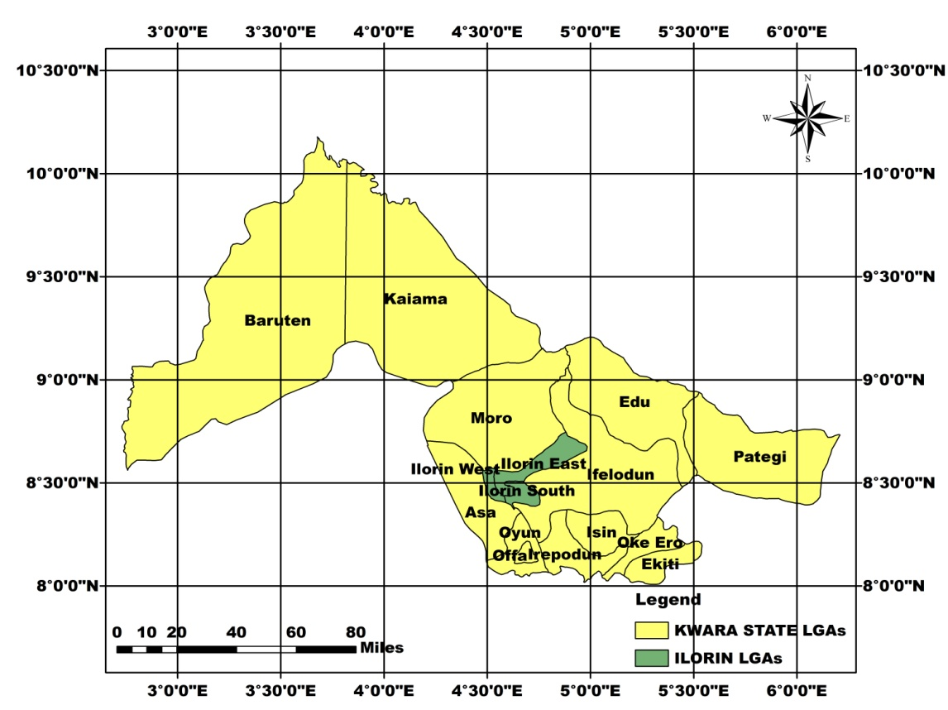
Fig 1.2: Location of Ilorin Local Government Area
Source: Department of Geography, Federal University of Technology Minna, Niger State
(April 2024).
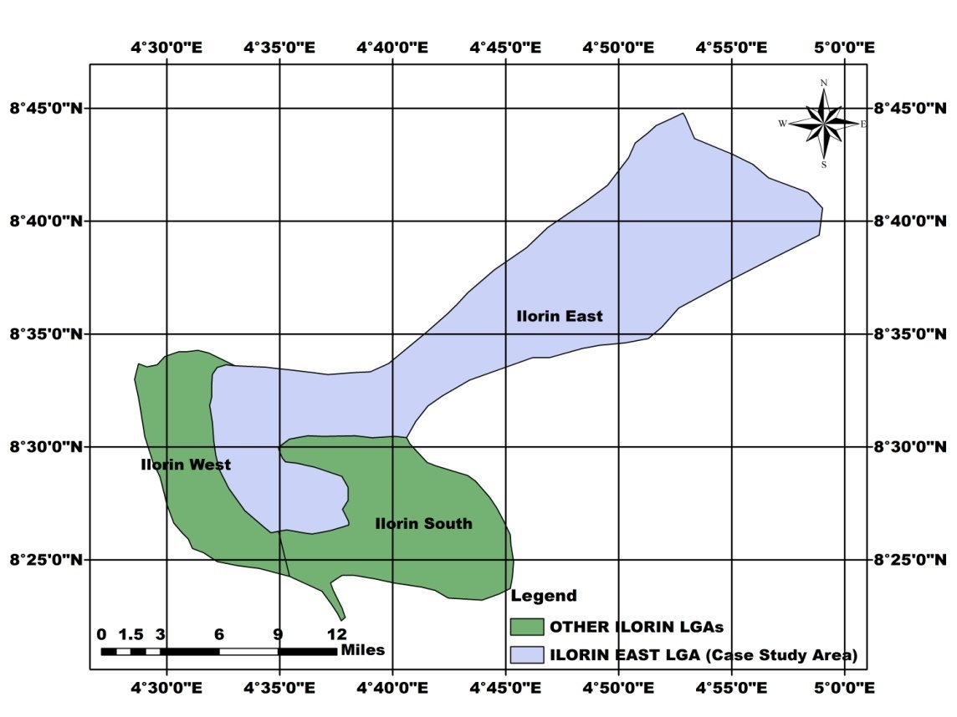
Fig 1.3: Location of the Study Area
Source: Department of Geography, Federal University of Technology Minna, Niger State
(April 2024).
  - Definition of the Terms
Land policy: is a set of rules and regulations that govern the use, ownership, and distribution of land in a specific region or country.
Land acquisition: means the compulsory taking of a alienation of land building or other assets thereon for purposes of the project.
Land compensation: is the payment of money to third parties for the value of land or an interest in land that has been taken.
Public interest: is the welfare of society as a whole, and can be universal or particular.
Valuation: An estimation of the worth of something, especially one carried out by a professional valuer.
Assessment: an assessment is an evaluation, and one type of assessment is used to measure what someone knows or has learned.

CHAPTER TWO
2.0 INTRODUCTION
2.1 LITERATURE REVIEW
This chapter reviews some literatures relevant and related to the problem under study. It is divided into four sections including this preamble. Section two focuses on conceptual clarification of terms, section three-review related theories on compulsory land acquisition and compensation, section four basis empirical review while section five discuss on the research gap.
2.2 CONCEPTUAL FRAMEWORK
2.2.1 Compulsory land acquisition
The compulsory acquisition of land has always been a delicate issue and is increasingly so nowadays in the context of rapid growth and changes in land use. Governments are under increasing pressure to deliver public services in the face of an already high and growing demand for land. Many recent policy dialogues on land have highlighted compulsory acquisition as an area filled with tension. From the perspective of government and other economic actors, the often conflictual and inefficient aspects of the process are seen as a constraint to economic growth and rational development. (FAO, 2008).
Compulsory acquisition is the power of government to acquire private rights in land without the willing consent of its owner or occupant in order to benefit society. It is a power possessed in one form or another by governments of all modern nations. This power is often necessary for social and economic development and the protection of the natural environment. Land must be provided for investments such as roads, railways, harbours and airports; for hospitals and schools; for electricity, water and sewage facilities; and for the protection against flooding and the protection of water courses and environmentally fragile areas. A government cannot rely on land markets alone to ensure that land is acquired when and where it is needed. However, a number of countries require that the government should attempt to buy the required land in good faith before it uses its power of compulsory acquisition. Compulsory acquisition requires finding the balance between the public need for land on the one hand, and the provision of land tenure security and the protection of private property rights on the other hand. In seeking this balance, countries should apply principles that ensure that the use of this power is limited, i.e. it is used for the benefit of society for public use, public purpose, or in the public interest. Legislation should define the basis of compensation for the land, and guarantee the procedural rights of people who are affected, including the right of notice, the right to be heard, and the right to appeal. It should provide for fair and transparent procedures and equivalent compensation.. Compulsory acquisition is inherently disruptive. Even when compensation is generous and procedures are generally fair and efficient, the displacement of people from established homes, businesses and communities will still entail significant human costs. Where the process is designed or implemented poorly, the economic, social and political costs may be enormous. (FAO 2008).
2.2.3 Compensation
Compensation can be seen as the means to put the expropriated or the dispossessed back to the position he was prior to the revocation of his right and interest in the demised property or possibly, or to the position better than where he was prior to the compulsory acquisition. The basis and techniques for compensation valuation are stipulated by regulatory laws and vary from one country to another. In Nigeria, only the holder of Right of Occupancy whose interest in land has been revoked by the Governors for public purpose and no other person is entitled to compensation for the value of the Right of Occupancy in the land at the date of revocation, for the unexhausted improvements. As observed by Jack-Osimiri, under Section 29, the Act states that the holder of an empty, vacant, or bare holding, without improvements or development in the form of buildings, walls, or structures etc, of any sort, has no right to receive compensation on revocation of their Right of Occupancy as such land has no commercial value. The rationale is that compensation is not payable unless there are improvements which have not been totally exhausted by the holder at the date of revocation of the Right of Occupancy. Consequently, it follows from this argument that the Governors is not obliged to pay compensation or provide resettlement/alternative accommodation in lieu of the compulsorily acquired land. It has been emphasized that the Land Use Act of 1978 neither disposes anybody of his land nor has it ever deprive owners of their (use) interests in land. In fact, it is only the radical title in respect of all the land in the State that has been transferred to and vested in the State Governor in trust for all Nigerians. By virtue of sections1 and 2 of the Land Use Act, 1978, the Governor is a mere Trustee or Administrator of all the Land within that State, never a beneficial owner. Similar situation is found in Tanzania, where all land is vested in the president for the use and benefit of Tanzanian people according to the stipulation in the Tanzanian Land Act. Therefore, the governor or president is not the beneficial owner but holds the land in trust and administers the same for the benefit of all citizens. In spite of the vesting of the absolute ownership of the land on the governor or president, the land owners still retain possessory titles as occupiers vested with usufructuary rights.
2.2.4 Legal basis of land acquisition
Nigerian Laws that Regulate Compulsory Acquisition of Land and Compensation
Several laws had been promulgated to reduce injurious affections suffered by persons who have been dispossessed of their right to landed properties. These laws which impose the power to revoke also oblige the agency to duly compensate the dispossessed. They include: the land
(i) The Constitution of the Federal Republic of Nigeria, 1999: This is the supreme law of the land which provides for the right of a landowner or community to compensation in Nigeria. According to the Constitution, compensation should be paid on damage to buildings, economic trees or crops, or where any authority or person enters any land to survey or dig, install or erect poles, cables, wires, pipes or other conductors or structures, in order to provide or maintain the supply or distribution of energy, fuel, water, sewage, telecommunication services or other public facilities or public utilities. Section 44(1) states that no moveable property or any interest in an immovable property shall be taken possession of compulsorily in any part of Nigeria except prompt payment of compensation be made. The affected property owner has a right to determine his interest in the property and the amount of compensation in the court of law or body having jurisdiction in Nigeria. Going by this proviso, the appropriate officer who is the most senior Lands Officer in the Federal or State Ministry, or from the acquiring agency responsible for lands acquisition and compensation matters should ensure the computation of adequate compensation to be paid to victims of lands for justice to prevail.
(ii) Public Lands Acquisition Act (Cap 167) of 1917. The Act formally called „The Public Land Ordinance‟ was promulgated in 1876 by the colonial government to ensure total control of all lands in Lagos and its environs. This legislation was for the then government to compulsorily acquire land for public purposes such as construction of roads, and other public utilities, with payment of compensation to the land owners and named them Crown lands (now State lands). The Act was modified as the Public Lands Acquisition Act, 1917 to provide for compulsory acquisition of land for public interest and compensation was for only occupied land. This was the beginning of the problem regarding compensation for acquisition of empty land in Nigeria before the introduction of the Land Use Act.
(iii) The Land Use Act of 1978; The LUA was introduced to ensure that all Nigerians have easy access to land and to ensure that the rights of all Nigerians to land in Nigeria be asserted and preserved by law. The Act, as earlier discussed, provides that the holder/occupier of the right of occupancy which is revoked for overriding public interest shall be entitled to compensation under the following heads of claims;
(a) Land: For an amount equal to the rent, if any, paid by the occupier during the year in which the right of occupancy was revoked;
(b) Buildings, Installations, and Improvements thereon: The amount of the replacement cost of the building, installation or improvement, that is to say, such cost as may be assessed on the basis of the prescribed method of assessment as determined by the appropriate officer less any depreciation, together with interest at the bank rate for delayed payment of compensation and in respect of any improvement in the nature of reclamation works, being such cost thereof as may be substantiated by documentary evidence and proof to the satisfaction of the appropriate officer as contemplated in Sec 29 (4b);
(c) Crop: crops on land, apart from any building, installation or improvement thereon, for an amount equal to the value as prescribed and determined by the appropriate officer.
2.2.5 Concepts in valuation for compensation
Valuation primarily involves the estimation and determination of the worth orvalue of an interest in real properties. This requires a high level of technical and professional expertise and skills especially when it involves valuing an interest in real property where the physical object to be valued (economic crops, trees, plant and other farm structures etc.), are no longer in existence having been damaged or destroyed. Determining or valuing a stream of income of an asset or real properties at a future date can be challenging. Valuation is a process of establishing an opinion of value for an interest in landed property/real estate. (Ogunba, 2004). Valuation is defined as the process of estimating the value of an identified interest or interests in a specific parcel of real estate as of a given date, (Appraisal Institute,2000), This implies that valuation is time bound in nature. Real Estate includes land and all things that are a natural part of the land (e.g. trees, minerals) and things that have been attached to the land (e.g. buildings and site improvements) and all permanent building attachments (e.g. mechanical and electrical plant providing services to a building), that are both below and above the ground. Valuation is an opinion of the value of an asset or liability on a stated basis, at a specified date. Unless limitations are agreed in the terms of engagement this will be provided after an inspection, and any further investigations and enquiries that are appropriate, having regard to the nature of the asset and the purpose of the valuation, (RICS, 2017). It is a professional individual‟s opinion of the capital or rental price or value of a property on a defined basis, (RICS, 2006).
2.2.6 Compensation Method
The calculation of compensation is based on the value of the land rights and improvements to the land, and on any related costs. The determination of equivalent compensation can be difficult, particularly when land markets are weak or do not exist, when land is held communally, or when people have only rights to use the land. Many factors can lead to inadequate compensation. Legislation should ensure fair processes for determining valuation and compensation. While the public interest in keeping costs as low as possible is important, this concern should not deprive people of the equivalent compensation they need in order re-establish their lives after the loss of their land.
Factors that lead to unjust compensation
- Poorly drafted laws and regulations create confusion, error, conflicting outcomes, and opportunities for abuse of power.
- Determination of equivalent compensation is difficult when people do not have clear legal rights to the land.
- Affected owners and occupants often have less negotiating power, experience and skills than the acquiring agency. They may be unaware of their rights, and under pressure to accept a low offer in order to be able to resettle elsewhere quickly. The rich may be able to afford professional advice on the value of compensation but the poor are likely to be at a disadvantage.
- A lack of standards and good governance practices allows corrupt officials to provide favourable compensation to those who offer bribes.
- Accurate valuation is difficult because it is time-consuming and expensive: each land parcel must be inspected to determine the value of the land and improvements. A shortage of skilled valuers will increase the time required to complete the work. It may be difficult to prepare reliable indicators for valuation when land sales are informal, or where markets do not exist or are just developing. It may be also difficult to financially quantify non-economic losses, e.g. religious, historical or cultural claims to the land.
- News of the project may affect the market value of the land. Legislation that does not clearly state the basis for compensation may result in inequitably low compensation if values fall, and inequitably high compensation and greater costs to the government if values rise.
- Appeals processes that are expensive and difficult to use are accessible only to the rich. The poor may have little option but to accept the offer of compensation even if they believe it is inadequate.
2.2.7 Valuation principles for compulsory land acquisition
Compensation, whether in financial form or as replacement land or structures, is at the heart of compulsory acquisition. As a direct result of government action, people lose their homes, their land, and at times their means of livelihood. Compensation is to repay them for these losses, and should be based on principles of equity and equivalence. The principle of equivalence is crucial to determining compensation: affected owners and occupants should be neither enriched nor impoverished as a result of the compulsory acquisition. Financial compensation on the basis of equivalence of only the loss of land rarely achieves the aim of putting those affected in the same position as they were before the acquisition; the money paid cannot fully replace what is lost. In some countries, there is legal provision recognising this in the form of additional compensation to reflect the compulsory nature of the acquisition. In practice, given that the aim of the acquisition is to support development, there are strong arguments for compensation to improve the position of those affected wherever possible. 4.1 BOX 6
PRINCIPLES OF EQUITY AND EQUIVALENCE
Guiding principles for ensuring equity and equivalence include:
- Equivalence: people should receive compensation that is no more or no less than the loss resulting from the compulsory acquisition of their land.Appropriate measures should ensure that those affected, and particularly the vulnerable, are not disadvantaged.
- Balance of interests: the process should safeguard the rights of people who lose ownership or use rights of their land while ensuring that the public interest is not jeopardized.
- Flexibility: the law should be specific enough to provide clear guidelines, but flexible enough to allow for the determination of appropriate equivalent compensation in special cases. Legislators cannot foresee all possible scenarios, and a rigid application of detailed provisions may result in people not being compensated for losses that are not identified in the legislation.
- Compensation: should address both de facto and de jure rights in an equitable manner following the principle of equivalence.Where occupants have no recognizable legal right or claim to the land occupied, they may be entitled to resettlement assistance and to compensation for assets other than land. Some form of fair payment for squatters is important, particularly where they are poor, are driven to informality out of necessity, and especially where government has condoned or encouraged the settlement in the first place.
- Fairness and transparency: the negotiating powers of the acquiring agency and affected people should be as equal as possible. Reasonable costs of affected people, including support to the poor and illiterate in negotiations, should be paid as part of the compensation. Negotiations should be based on an open exchange of information.
2.2.8 Factor influencing valuation and compensation
During the valuation phase, the acquiring agency and the people whose land is being acquired gather information and evidence to support their arguments for the compensation values they believe to be equitable. This work is triggered by the notice of intention to compulsorily acquire land. The notice of intention should set a deadline by which each affected owner or occupant submits a claim for compensation. Responsibility for the valuation of land varies from one country to another. In some countries the work is done by or for the acquiring agency while in other countries the valuations are the responsibility of independent commissions. The notice of intention should set a deadline by which each affected owner or occupant submits a claim for compensation. At some point after notice has been given, the project’s valuers must enter the land to inspect it and all improvements in order to determine their value. Owners and occupants should hire their own valuers, or find other ways to determine the value of their land. (FAO 2008)
2.3 THEORETICAL REVIEW
The reviews have delved into various theories that will act as foundation for this research study. The theories and findings from the past studies were to act as the core variables of this study.
2.3.1 Economic theory of property right
According to economic theory, the clear definition of property rights is essential for well-functioning markets. Comparatively little attention, however, is given to explaining the development of these rights. Economic reasoning suggests that markets themselves call property rights into existence: persons contract to set up institutions enforcing stable, definite entitlements to scarce resources in order to facilitate investment, production, and exchange. Thus, contracts constituting property rights and institutions precede those contracts dealing with existing property rights; both can be conceived as market transactions made in pursuit of gains.
An historical approach to the development of property rights may suggest further explanation adding to the economist's parsimonious theory. Economic institutions and activities need not be subsumed within purely economistic interpretations; they are also susceptible to legal and historical analysis. Much can be learned from studying the ideas, institutions, and laws of property during England's pioneering industrialization in the eighteenth and nineteenth centuries - the period known as the Industrial Revolution. This essay in the history of ideas describes the origins of the modern economic theory of property. The theory traces back to nineteenth- and twentieth-century historical and social-scientific models of the Industrial Revolution. The sources of property theory in the world of the classical economists are now forgotten, and this lapse of memory has blunted the critical self-consciousness necessary for the theory to be effective and fruitful. The solution lies in a restoration of historical self-consciousness and an openness to alternative disciplinary approaches.
Compensation Theories
This section discusses the main classes of compensation theories, compensation aims, basis and methods for assessing compensation for loss of property during expropriation, with a focus on customary property rights.
2.3.2 Compensation Theories and Compensation Scope
Indemnity and taker’s gain are the two main groups of compensation theories, founded on compensation scopes covered to meet different compensation goals. The indemnity theory desires compensation that considers the whole range of losses to put expropriatees on a similar status as before the expropriation, but not worse-off (Denyer-Green, 2014). Characteristically, this requires compensation covering market value of property taken, plus additional compensation for severance and injurious affection, expropriatory disturbances, consolatory payments (solatium) and/or special values. Under this principle, compensation is measured by considering an expropriatee’s losses, and not purchaser’s benefits (Barnes, 2014). Various compensation concepts including adequate compensation, appropriate compensation, commensurate compensation, fair compensation, full compensation, equivalent compensation, and full indemnification, among others, subscribe to the indemnity philosophy. Market value of acquired property is generally the principal item for compensation. Likewise, severance and injurious affection are based on market or rental values (Baum et al., 2008). Severance is loss in value of any remaining property where only a fraction of the property is expropriated, while injurious affection is depreciation in value of any remaining property caused by proposed uses on acquired land or the actual works (Barnes, 2014). Generally, depreciation in market value of remaining land is the compensation amount for severance and injurious affection. Disturbance compensation is based on financial calculations and includes profit/income and business losses; costs for relocation and transport, legal and valuation services, among many others (Baum et al., 2008). Solatium, as a consolation payment for expropriation, is given as a lump sum or as a proportion of the agreed compensation sum (Baum et al., 2008) and varies in different jurisdictions. Special value depends on sentimental attachments between owners and the expropriated properties and benefits emanating from the property to owners besides market value (Keon-Cohen, 2002). Special value is based on a percentage of the compensation sum, or it is agreed upon by the parties (Fortes, 2005). Thus, the indemnity theory desires compensation that consists of market value of property taken, severance and injurious affection, disturbance, solatium and/or special value to restore expropriatees. Alternatively, taker’s gain theory focuses on the expropriated property. It argues that compensating the other additional items covered under the indemnity theory like disturbance, drains public resources (Kratovil & Harrison, 1954), while enriching affected people. Since it is property that is taken, then government should compensate for that at its market value and nothing more or less. Taker’s gain compensation is measured by the gains of the acquisition to the taker, and not expropriatee’s losses (Kratovil & Harrison, 1954). As such, compensation under taker’s gain usually consists of market value of acquired property, which also measures adequacy of compensation required to restore affected people. Thus, all compensation principles focusing only on expropriated property belong to takers’ gain theory.
2.2.3 Theoretical Underpinning
The Lockean Property Theory and Neoclassical Economic Theory offer valuable frameworks for examining the complexities of land acquisition for infrastructure projects in Ilorin kwara state Nigeria, particularly in the context of the New Ilorin SmartCity Estate. These theoretical perspectives can provide a comprehensive analysis of both the ethical and economic dimensions of this issue, offering a robust understanding of the challenges involved in the specific case.
Neo-classical Economic
Theory Neo-classical Economic Theory is relevant to the research on land acquisition for infrastructure in Nigeria, specifically the New Ilorin SmartCity Estate, as it offers a framework for analyzing the allocation of resources to maximize utility and efficiency. This theory helps assess the economic implications of land acquisition, including determining fair compensation rates, understanding the impact on land values, and evaluating the cost-benefit analysis of the infrastructure project (Agboola, 2015). By applying this theory, the research can propose improvements to current land acquisition processes to ensure that land is acquired efficiently, with minimal negative impact on landowners and optimal benefits for the broader society. Neoclassical economic theory views land ownership through an individualistic lens. Johnson (1972) explored how different land tenure systems impact wealth creation. The theory posits that optimal land tenure systems clearly define and allocate property rights, incentivize efficient land use, and minimize restrictions on land sales to stimulate investment. According to Johnson, unclear land rights increase transaction costs, hindering land productivity. Neoclassical economists advocate for well-defined property rights to reduce transaction costs and maximize land returns. They emphasize the importance of individual incentives, arguing that people will use land efficiently when they directly benefit or suffer from the consequences of their decisions (Agboola, 2015).
Neoclassical economists argue that converting land ownership to freehold titles decreases the costs associated with transferring land ownership. By eliminating restrictions on land sales, this system encourages transactions where the benefits outweigh the costs. This market-driven approach leads to land being allocated to its most productive use, as those who can generate the highest returns compete for ownership (Colander, 2000). Individualized land tenure is considered more efficient due to increased security, reduced legal disputes, and optimized land utilization. This economic perspective explains patterns of land fragmentation and use changes, often driven by the pursuit of financial gain and perceived efficiency, rather than solely inheritance factors.
The Lockean Property Theory
This theory is relevant to the research on land acquisition for infrastructure in nigeria, particularly the Kisii-Awendo power wayleave, as it emphasizes the sanctity of private property rights derived from one's labour. This theory supports the need for fair compensation and procedural fairness in compulsory land acquisition, ensuring that landowners' rights are respected. It highlights the moral and ethical considerations of displacing individuals for public projects and advocating for just and equitable treatment to mitigate the human and social costs involved (Ashcraft, 1987; Locke, 1980). John Locke's theory of property rights posits that individuals possess inherent authority to establish property ownership without relying on societal agreements (Locke, 1960). In a hypothetical state of nature devoid of government, money, or trade, individuals could freely acquire both moveable and immovable property (Locke, 1980). Locke argued that these natural rights, including property rights, must be upheld by any subsequent government (Locke, 1980). Locke envisioned a primitive society with abundant but unclaimed resources. In this context, individuals had an equal right to utilize these resources. The foundation of property ownership, according to Locke, lies in the application of individual labour to unclaimed resources. For instance, cultivating land through labour establishes ownership, while mere hunting and gathering do not (Ashcraft, 1987; Locke, 1980).
2.4 Empirical Studies
Deeyah and Akujuru (2016) in the research; assessing the effectiveness of the Nigerian compulsory acquisition practice in road infrastructural provision in rivers state opined that lack of transparency, unfairness, inconsistencies in the assessment of property values for compensation was one of the common problems revealed by the study, where majority (73.3%) 22 of the affected landowners were not aware of the items to be compensated. The confidentiality of the compensation assessment process led to suspicion of claimants about the compensation awarded. The researchers recommended that, to avoid people been impoverished and their right to land adequately protected when government compulsorily acquire urban land for road infrastructural development, it is necessary that best practices are adapted and effectively implemented to ensure that affected persons are placed in the position they were before the acquisitions. And more so, there should be appropriate legislation with clear and transparent acquisition procedure to ensure people know their rights. Kakulu (2007) provided that inconsistency, lack of clarity, ambiguity in content and interpretation of enabling statutes (Land Use Act Cap L5 LFN, 2004) are partly responsible for inadequate compensation.
The study further stated that the application of multiple standards, procedures and methods of valuation results in alarmingly wide discrepancies in compensation values over the same interest in land. The study concludes that the assessment process could be improved considerably by the introduction of a compensation valuation code in Nigeria and also suggested that such a code should be guided by international standards of valuation for compensation. Perhaps, these studies fail to study and list the claimants’ views on variables encountered during and after the compensation have been paid.
2.5 Research Gap
The researchers has carried out a great work on the assessment of valuation of compulsory land acquisition and compensation and the impact to the environment in many areas of the world, including Nigeria but none has carried out consequences of urban growth on infrastructure facilities in the particular location of this study area. Their work has been an insight to see various Remote Sensing, GIS techniques and Statistical method which can be use to assess urban growth in order for a better sustainability to infrastructure facilities. Now decided to carry out my research work by adopting some of the method they use to assess urban growth (land use) and its consequences on infrastructure facilities.

CHAPTER THREE
3.0 Research Methodology
3.1 Introduction
This chapter involves the presentation of the various methodological approaches that will be utilized in the course of this study. It includes the study of population and its characteristics, the techniques to be adopted in getting the data needed, as well as the method to be adopted in the analysis of the collected data. Two things are usually faced under the term “methodology” the methodology itself and the method.
According to Barley (2000), methodology means the philosophy of the research process and this includes assumption and value that served rational for the research, while the method simply means the research techniques used for gathering data.
3.2 Research Design
Research design is perceived to be an overall strategy adopted by the researcher whereby different components of the study are integrated in a logical manner to effectively address a research problem. In this study, the researcher employed the survey research design, this is due to the nature of the study whereby the opinion and views of people are stamped.
3.3 Data Types and Sources
There are two types of data and they are; primary data and secondary data.
Primary Data:
These are data collected by the researcher himself or herself. Primary data can be collected through various means like direct personal observation, oral interview, telephone conversation as well as questionnaire administration.
Secondary Data:
These involve the extraction of relevant information from documented publication, textbooks, journals as well as internet expiration that are relevant to the subject of the study. In other words, they are collected from both published and unpublished works.
3.4 Instrumentation for Data Collection
The research instrument used in this research work is the questionnaire which is in line with the study objectives aimed at providing answers to the research questions.
  - Target Population
According to Gilbert (2002), since it is not possible to deal with the whole target population, one must identify the portion of population in which one can access. For the purpose of this research work, the target population includes the stakeholders involved in the leasing and management of commercial properties in Kamaboye Estate. These comprise 30 Commercial property owners/landlords, 43 Tenants and business occupants, 5 Property managers/agents and 2 Legal practitioners involved in property agreements
3.6 Sample Frame
This is otherwise known as population of the study and it can be define as including all the people or items with the characteristic, one wish to understand. Because there is rarely enough time or gather information from everyone or gathering in a population, the goals become finding a representative sample of that population.
The sample frame for this research work is based on Commercial property owners/landlords, Tenants and business occupants, Property managers/agents and Legal practitioners involved in property agreements
3.7 Sample Size
The sample size is a percentage representation of all elements in a sample frame. In other words, it is the representation of the sample frame which the researcher intends to carefully understudy while carrying out the research.
To determine a sample the formula below was used. The rationale for using this formula was because the sample frame is 100
S = N/[1+N(e)²]
Where N = target population of 100;
S = Sample size; e = level of significance of 5%
S =100/[1+200(0.1)²] = 80
The sample size is 80.
3.8 Sampling Procedure
The sampling procedure used in sampling the respondents in this research work is systematic random sampling. Systematic sampling is a probability sampling method in which a random sample, with a fixed periodic interval, is selected from a larger population. The fixed periodic interval, called the sampling interval, is calculated by dividing the population size by the desired sample size.
3.9 Method of Data Analysis
Data realized from administration of the research instruments was analyzed and processed with the aid of Statistical Packages for Social Sciences (SPSS 2016). Data measured on nominal scale was analyzed using descriptive statistics such as frequency distribution tables and percentages. In the analysis, the “Mean Score” method was adopted to establish the impact of town planning law on commercial property development in Nigeria. This will enable the researcher assign positions (rank) these effects, with the most sensitive effect ranked first, while the least sensitive effect is ranked at the bottom of the table.
3.10. Summary of Data Analysis
S/N | RESEARCH  DISIGN | SOURCE OF DATA | TARGEST  POPULATION | SAMPLE FRAME | SAMPLE  SIZE | SAMPLE  TECH. | ISTRUMENT  OF DATA  COLLECTION | METHOD  OF DATA  ANALYSIS
1 | Descriptive | Primary and  Secondary | Commercial property owners/ landlords, Tenants and business occupants, Property managers /agents and Legal practitioners involved in property agreements | 80 | 80 | Systematic | Questionnaire | Frequency  table
CHAPTER FOUR
4.0 Data Presentation and Data Analysis
4.1 Introduction
This chapter is based on the process of arriving at a dependable solution to the problem intended to be solve by this project. It is described with special focus on the study population, data collection and response as well as the process of data collection.
4.2 Data Presentation and Analysis
Table show, number of questionnaire
Eighty (80) questionnaires are thus analyzed as shown below:
Table 4.2.1: Sex of the Respondence
Despondency | Frequency | Percentage
MALE | 45 | 56.25%
FEMALE | 35 | 43.75%
TOTAL | 80 | 100%
Source: field survey 2025
From the table above, it is indicated that male has the highest number of respondents and compared to resident.
TABLE 4.2:2 Age Distribution of Respondents
Despondency | Frequency | Percentage
20-30years | 20 | 25%
31-40years | 25 | 31.25%
41-50years | 20 | 25%
51-60years | 10 | 12.5%
61years and above | 5 | 6.25
TOTAL | 80 | 100%
Source: Researcher’s Survey, 2025.
From the table above, 20 respondents representing 25% of the total respondents are between the age of 20-30years, 25 respondents representing 31.25% are between the age of 31-40years, 20 respondents representing 25% of the total respondents are between the age of 41-50years, 10 respondents representing 12.5% also are between the age of 51-60years. While 61years and above age of respondents is 10 representing 6.25%.
TABLE 4.2:3 Respondents’ Marital Status?
Despondency | Frequency | Percentage
Single | 35 | 43.75%
Married | 30 | 37.5%
Divorced | 5 | 6.25%
Widowed | 10 | 12.5%
TOTAL | 80 | 100%
Source: Researcher’s Survey, 2025.
From the table above, 35 respondents representing 43.75% of the total respondents are still single, 30 respondents representing 37.5% are Married. 5 respondents representing 6.25% of the total respondents are Divorced while 10 respondents representing 12.5% are Widowed.
TABLE 4.2.4: Questionnaires Administered
Despondency | Frequency | Percentage
Students | 10 | 12.5%
Trader | 40 | 50%
Civil servant | 20 | 25%
Self employ | 10 | 12.5%
Total | 80 | 100%
Source-field survey, 2025
From the analysis above, the focus on the questionnaires distributed 80 questionnaires were distributed to trader, civil servant and self employ.
TABLE 4.2.5: Duration of the staying in the area
Despondency | Frequency | Percentage
1-3years | 30 | 37.5%
4-6 years | 30 | 37.5%
6-9years | 10 | 12.5%
10 and above | 10 | 12.5%
Total | 80 | 100%
Source: field survey, 2025
From the table above, 30 respondents representing 37.5% of the total respondents were staying for the past 1 to 3 year, 30 respondents representing 37.5% stay for 4-6years, 10 respondents representing 12.5% stay for 6-9years while 10 respondents representing 12.5% stay for 10 and above years.
TABLE: 4.2.6: Enacted Laws Influencing Land Use Decision in Ilorin Metropolitan?
Despondency | Frequency | Percentage
Town planning and Land Use Regulations | 15 | 18.75%
Housing and Property Development Regulations | 15 | 18.75%
Traffic and Transportation Regulations | 20 | 25%
Urban Renewal Regulations | 10 | 12.5%
Rent and Land Use Charge Legislations | 20 | 25%
Total | 80 | 100%
Source: Field survey, 2025
From the table above, it shows that 15 respondents representing 18.75% were town planning and land use regulations, 15 respondents representing 18.75% were Housing and Property Development Regulations 20 respondents representing 25% were Traffic and Transportation Regulations, 10 respondents representing 12.5% were Urban Renewal Regulations while 20 respondents representing 25% were Rent and Land Use Charge Legislations. This shows that all the listed laws in table were enacted the land use laws in Ilorin metropolis.

TABLE 4.2.7: The enacted enforced land use laws for property development in Ilorin Metropolis.
Despondency | Frequency | Percentage
The Master Plan and Zoning | 30 | 37.5%
Laws and Regulations | 20 | 25%%
Sources of Property Ownership | 20 | 25%
Property and rent charges law | 10 | 12.5%
Total | 80 | 100%
Source: field survey2025
From the table above, it shows that 30 respondents representing 37.5% were The Master Plan and Zoning, 20 respondents representing 25% were Laws and Regulations, 20 respondents representing 25% were Sources of Property Ownership while 10 respondents representing 12% Property and rent charges law floor. This shows that the enacted lend use laws mostly in practice and enforced are (i) the master plan and zoning (ii) laws and regulations (iii) sources of property ownership and (iv) property and rent charges law.
TABLE 4.2.8: To assess the procedure of land acquisition.
Despondency | Frequency | Percentage
Satisfied | 10 | 12.50%
Fair | 25 | 25%
Unsatisfied | 50 | 62.50%
Total | 80 | 100%
Source: Field survey 2025
Table 4.9 shows that 10 (12.50%) of the respondents listed that the land acquisition procedure is satisfied, while as high as 50 (62.50%) significance unsatisfied of the government procedure. 20 (25%) commented fair with the procedure. This shows that the procedure for land allocation for development in Kwara state is not satisfactory. This could be as a result of the discovered factors militating against allocation procedures in table 4.10
TABLE 4.2.9: Factors militating against the land acquisition and compensation in Ilorin metropolis?
Despondency | Frequency | Percentage
- The slowness of state authorities in laying out both industrial and residential plots and providing infrastructure. | 15 | 18.75%
The delay in issuing certificates of occupancy to allottees, making it difficult or impossible for developers to obtain loan from financial houses and thus holding up development. | 15 | 18.75%
- Multiplicity of state agencies dealing with land allocation, approval of layouts and building plans leading to confusion and delay in project development. | 10 | 12.5%
Lack of awareness of applicants on the need for planning approval in many cases leading to misunderstanding of the requirements of current regulations. | 10 | 12.5%
The collusion of some Land Use and Allocation Committee staff that enables some landowning families to continue to sell land illegally and at exorbitant prices. | 20 | 25%
Lack of procedural uniformity from one State to another and from one Local Government Authority to another. | 10 | 12.5%
TOTAL | 80 | 100%
Source: field survey 2025
From the table above, it shows that 15 respondents representing 18.75%, 15, 25 respondents representing 31.25 % while 25 respondents representing 31.25%. stated their different factors militating against the land acquisition and compensation in Ilorin.
Table 4.2.10: Factors Militating against land use allocation procedure?
Despondency | Frequency | Percentage
Inadequate information/data | 20 | 25%
Housing development policies, | 30 | 37.5%
Transportation routes | 10 | 12.5%
Industrialization | 10 | 12.5%
Government policies | 10 | 12.5%
Total | 80 | 100%
Source: field survey, 2025.
From the table above, it shows that 20 respondents representing 25% were Inadequate information/data, 30 respondents representing 37.5% were Housing development policies 10 respondents representing 12.5% were Industrialization while 10 respondents representing 12.5% were Government policies. The above in table 4.11 are still part of the factors that militate against the land use allocation procedure in it study area.

CHAPTER FIVE

Summary, Conclusion and Recommendation

5.1 Summary of Findings
This work is aimed to study the assessment of valuation on compulsory land acquisition and compensation using Ilorin east as a case study. Findings shows that the level of compliance of buildings to land use allocation procedure is not significant which recorded very low compliance are: set –back from property boundaries; road/ street right-of-way; plot coverage; plot size; certificate of fitness for habitation/ as built drawings; and change of use standards. Findings also show that there is significant difference in the rate of compliance to planning regulations between buildings constructed in the urban areas, and those constructed in suburban/ rural areas and those constructed in suburban/ rural areas This findings implies that development control activities of the planning authorities have failed to deliver a sustainable and functional built environment, and therefore needs to be re-examined. It also means that timely intervention in the suburban/rural areas to correct these planning aberrations through preparation and implementation of planning schemes would be of great benefit.
Considering the need and importance to achieve organized environment devoid of illegal development, it is imperative that effort should be made to ensure that a healthy environment is realized in line with the following recommendations.

5.2 Conclusion
This research sufficiently indicates that town planner in the authority areas under study were amenable to the demands of Town planning services should town planning work be done properly in the authority area. Again, it was observed from all the planning authorities that the rate of non-compliance to planning standards in their planning authority which was attributed to the nature of the planning administrative structure of the planning authority was high. Similarly, the headship of the town planning authorities by political chief executives such as the commissioner in charge or the local government chairman which was expected to bestow political power on the strength of town planning authorities now seems, from this research, to sometimes be working on the opposite direction. Thus, it was recommended that the Authority board be the Apex of the Administrative structure in which case the director of Town Planning who is a member does the liaison with and represents the Commissioner in-charge. The chairman should be appointed on part-time and should be a retired Town Planner, or an employee Town Planner not working within the Authority Area.
  - Recommendations
From the research carried out, there is serious indication of inadequate manpower in the respective town planning authorities for effective development control. In view of the identified problem, there is need to employ more qualified manpower to reinforce the existing staff of the authorities. There should be a frantic effort made towards proper reconstituting of the various administrative planning law since this study has proven that its present form has direct link with the increased non-compliance to planning standards in their planning authority areas by the town planning authority.
- The law should be such that will not allow the political class to make decisions in issues that involves development control.
- The planning authority should be only accountable to the director of Town Planning with minimal interference from the local government chairmen.
- It is also recommended that the Authority board be the Apex of the Administrative structure in which case the director of Town Planning who is a member does the liaison with and represents the Commissioner in-charge.
- The chairman should be appointed on the implementation of the Nigerian Urban and Regional Planning Law will enhance reorganization of town planning administration in the study area. When this is done, more articulate and effective development control will be enhanced.
- In the same vein, some other government departments, professional bodies and professions which are supposed to be fully involved in development control will be fully integrated and incorporated into the system.
- It is recommended that the various Town Planning Authorities with possible assistance of government should urgently embark on vigorous public enlightenment programmes.
- This is to educate the public (developers) on the functions and responsibilities of the Town Planning Authority, the benefits derivable from good planning with respect to clean and healthy environment and the need to neglect the harassment of touts in the development sites.
- Developers should always insist to come to town planning office for clarification when in doubt of anything. Such enlightenment programmes may be in the form of radio and television discussions, newspaper publication, organized seminars, symposia, jingles etc, while the medium of communication should be simplified for the sake of easy comprehension by members of the public.
- This will make the operations of the planning authorities more effective. Again, those to be employed should be honest and dedicated since effective monitoring and control depend on the caliber of staff of the authorities. Furthermore, corrupt practices among officials are likely to be minimized if the right calibre of qualified personnel could be employed.
- There is also need to make provision for training and retraining of staff of the authorities in development control matters for purposes of efficiency.

REFERENCES
Ige, V.O., Akintomide, A.J., & Adeola, T. O. (2016). Compulsory land acquisition and compensation in Nigeria: coastal communal perception Retrieved from https://www.ajol.info/index.php/ejesm/article/vi ew/145401

Oladapo, R. A. & Ige V. (2014). Assessment of Claimants’ Satisfaction to Variation in Compensation Paid for Compulsory land Acquisition in Ondo State, Nigeria Retrieved from http://www.fig.net/pub/fig2014/papers/ts04f/TS 04F_oladapo_6820.

Obineme, C. H., Emoh, F. I., & Igwenagu, C. L. (2019). An evaluation of quality of mortgage valuation reports in Nigeria Retrieved from https://www.semanticscholar.org/paper/.
Adekunle, M.U., Muhammad, M. S., Oluwole, M. O., Bello, H. T., &Idris, I. (2019). Landholders’ involvement in the compulsory acquisition of land and compensation process in Bauchi, Nigeria Retrieved from http://cyberleninka.ru/article/n/landholdersinvolvement-in-the-compulsory-acquisition-ofland-and-compensation-process-in-bauchinigeria.
Alias, A. & Daud, M. N. (2006). Payment of adequate compensation for land acquisition in Malaysia Retrieved from https://www.researchgate.net/publication/23712 5458_Payment_of_Adequate_Compensation_fo r_Land_Acquisition_in_Malaysia
Deeyah, C. L. & Akujuru, V. A. (2016). Assessing the effectiveness of the Nigerian compulsory acquisition practice in road infrastructural provision in rivers state Retrieved from 311233387_ASSESSING_THE_EFFECTIVEN ESS_OF_THE_NIGERIAN_COMPULSORY_ACQUISITION_PRACTICE_IN_ROAD_INFR ASTRUCTURAL_PROVISION_IN_RIVERS
Ige, V.O., Akintomide, A.J., & Adeola, T. O. (2016). Compulsory land acquisition and compensation in Nigeria: coastal communal perception Retrieved from https://www.ajol.info/index.php/ejesm/article/vi ew/145401
Kakulu, I. I. (2007). The Assessment of Compensation in Compulsory Acquisition of Oil and Gas Bearing Lands: The Niger Delta experience. Being paper presented at the Joint Seminar on Compulsory Purchase and Compensation in Land Acquisition and Takings. 2456-8880 IRE 1702597 ICONIC RESEARCH AND ENGINEERING JOURNALS 32 Organized by FIG Commission, Helsinki, Finland, September 6th to 8th
Obineme, C. H., Emoh, F. I., & Igwenagu, C. L. (2019). An evaluation of quality of mortgage valuation reports in Nigeria Retrieved from https://www.semanticscholar.org/paper/ ANEVALUATION-OF-QUALITY-OFMORTGAGE-VALUATION-REPORTS-INObinemeEmoh/e2838deaa0e2b8bf45024f6541c6233f848 4c9d
Odudu, C.O. (2017). Compensation issues in the Niger-Delta –A case study of Boboroku, Jesse, Delta state, Nigeria Retrieved fromhttp://www.eajournals.org/journals/internat ional-civil-engineering-construction-estatemanagement-ijcecem/vol-5-issue-4-december2017/compensation-issues-niger-delta-casestudy-boboroku-jesse-delta-statenigeria/&sa=U&ved=2ahUKEwiFo_LI8pnrAh VEUxoKHRpKDUIQFjAAegQIABAB&usg=A OvVaw0vIGiHpA_9icDaZ4hkBQST
Oladapo, R. A. & Ige V. (2014). Assessment of Claimants’ Satisfaction to Variation in Compensation Paid for Compulsory land Acquisition in Ondo State, Nigeria Retrieved from http://www.fig.net/pub/fig2014/papers/ts04f/TS 04F_oladapo_6820.pdf&sa=U&ved=2ahUKEw jegbDc6o3rAhXaMMAKHUAaAkUQFjABeg QIBhAb&usg=AOvVaw0IhnR2y6Lg1- _dX8LMDnpE

APPENDIX
Department of Estate Management and Valuation
Kwara State Polytechnic,
Ilorin
Kwara State
Dear respondent,
This project is written in partial fulfillment of the requirement of the award of Higher National Diploma in Estate Management and Valuation.
The topic of the project is the “Assessment of valuation on compulsory land acquisition and compensation in Ilorin” a case study of kwara Geographical Information Service.
The respondents are hereby requested to supply required information needed for the following questions appropriately. The given response shall be handled as confidential information as data required will be used for this project only.

________________________________
MEMUDU QUADRI OPEYEMI
HND/23/ETM/FT/0102

DEPARTMENT OF ESTATE MANAGEMENT AND VALUATION
INSTITUTE OF ENVIRONMENTAL STUDIES,
KWARA STATE POLYTECHNIC, ILORIN

QUESTIONNAIRE
- SECTION A
1. Sex: Male ( ) Female ( )
2. Age: 20- 30 ( ) 31- 40 ( ) 41 -50 ( ) 51- 60 ( ) 61 and above ( )
3. Marital status: Single ( ) Married ( ) Widow(er) ( ) Divorced ( )
4. Occupation: Student ( ) Trader ( ) Civil Servant ( ) Self Employ ( )
5. Duration of the staying in the area: 1-3years ( ) 4-6 years ( ) 6-9years ( ) 10 and above
6. Questionnaire Administered: Property owners ( ) Town planning authority ( )
7. Enacted Laws Influencing Land Use Decision in Ilorin Metropolitan: Town planning and Land Use Regulations ( ) Housing and Property Development Regulations ( ) Traffic and Transportation Regulations ( ) Urban Renewal Regulations ( ) Pollution and Environmental Regulations ( ) Rent and Land Use Charge Legislations ( )
2.0 SECTION B: - OBJECTIVES
1. To assess the compulsory land acquisition and compensation in Ilorin metropolis.
Please click (√) what is the procedure involved in land use allocation for property development in Ilorin metropolis
 | Procedure involved in valuation of compulsory land acquisition and compensation | Not Agree | Fairly Agree | Agree | High Agree | Very High Agree
2.1.1 | The Master Plan and Zoning
2..1.2 | Laws and Regulations
2.1.3 | Sources of Property Ownership
2.1.4 | property and rent charges law

2.2 To determine the effectiveness of the valuation compulsory land acquisition and compensation
Please (√) what are the effect of the procedure of land use allocation procedure in Ilorin metropolis?
 | Effect of the compulsory land acquisition and compensation in Ilorin metropolis. | Not Agree | Fairly Agree | Agree | High Agree | Very High Agree
2.2.1 | - The slowness of state authorities in laying out both industrial and residential plots and providing infrastructure.
2.2.2 | The delay in issuing certificates of occupancy to allottees, making it difficult or impossible for developers to obtain loan from financial houses and thus holding up development.
2.2.3 | - Multiplicity of state agencies dealing with land allocation, approval of layouts and building plans leading to confusion and delay in project development.
2.2.4 | - Lack of awareness of applicants on the need for planning approval in many cases leading to misunderstanding of the requirements of current regulations.
2.2.5 | The collusion of some Land Use and Allocation Committee staff that enables some landowning families to continue to sell land illegally and at exorbitant prices.
2.2.6 | Lack of procedural uniformity from one State to another and from one Local Government Authority to another

2.3 To identify the factors militating against valuation of compulsory land acquisition and compensation in Ilorin
Please (√) what are the factors militating against land use allocation procedure in Ilorin metropolis?
 | Factors militating valuation of compulsory land acquisition and compensation procedure | Not Agree | Fairly Agree | Agree | High Agree | Very High Agree
2.3.1 | Inadequate information/data
2.3.2 | Housing development policies,
2.3.3 | Transportation routes
2.3.4 | Industrialization
2.3.4 | Government policies

2.4 Any further comments:
………………………………………………………………………………………………………………………………………………………………………………………………………………………………………………………………………………………………
Many thanks for your immerse attention and contribution to this study

