DESIGN AND IMPLEMENTATION OF SALES FORECASTING SYSTEM

BY

ABDULAZEEZ IDRIS OLAYINKA
ND/23/COM/PT/0008

SUBMITTED TO THE DEPARTMENT OF COMPUTER SCIENCE,
INSTITUTE OF INFORMATION AND COMMUNICATION TECHNOLOGY
KWARA STATE POLYTECHNIC, ILORIN.

IN PARTIAL FULFILLMENT OF THE REQUIREMENTS FOR THE AWARD OF NATIONAL DIPLOMA (ND) IN
COMPUTER SCIENCE

JULY, 2025.

CERTIFICATION
This is to certify that this project research was carried out by ABDULAZEZ IDRIS OLAYINKA with Matriculation Number: ND/23/COM/PT/0008, has been read and approved as meeting part of the requirement for the award of National Diploma (ND) in computer science

…………………………………. ….………………………
MR. ABIODUN E.T. Date
Project Supervisor

…………………………………. ….………………………
MR OYEDEPO F.S Date
Head of Department

…………………………………. ….………………………
External Examiner Date

DEDICATION
I dedicate this project work to Almighty God who inspired me and directed my ways during my academic stay in the polytechnic.

ACKNOWLEDGEMENT
All praise is due to Almighty God the Lord of universe. I praise him and thank him for giving me the strength and knowledge to complete my ND programand also for our continued existence on the earth.
I appreciate the utmost effort of our supervisor, MR ABIODUN E.T whose patience, support and encouragement have been the driving force behind the success of this research work. He gave useful corrections, constructive criticisms, comments, recommendations, advice and always ensures that an excellent research is done. My sincere gratitude goes to Head of Department and other members of staff of the Department of Computer Science, Kwara State Polytechnic, Ilorin, for their constant cooperation, constructive criticisms and encouragements throughout the programme.
Special gratitude to my parents, who exhibited immeasurable financial, patience, support, prayers and understanding during the period in which I was busy tirelessly on mystudies, special thanks go to my lovely siblings
My sincere appreciation goes to my friends and classmates.

LIST OF FIGURES
Figure 4.1: Dashboard page 23
Figure 4.2: Login page 24
Figure 4.3: Add customer page 24
Figure 4.4: Add product page 25
Figure 4.5: Make sales page 25
Figure 4.6: Edit product page 26
Figure 4.7: Delete product page 26

LIST OF TABLES
Table 4.1: Product details table 27
Table 4.2: users database table 28
Table 4.3: purchase details database 28

TABLE OF CONTENTS
Title page i
Certification ii
Dedication iii
Acknowledgements iv
List of figures v
List of tables vi
Table of contents vii
Abstract viii
CHAPTER ONE: GENERAL INTRODUCTION
1.1 Background to the Study 1
1.2 Statement of the Problem 2
1.3 Aim and Objectives 2
1.4 Significance of the Study 3
1.5 Scope of the Study 3
1.6 Organization of the Report 3
CHAPTER TWO: LITERATURE REVIEW
2.1 Review of Related Works 5
2.2 Overview of sales and inventory 7
2.3 Direct Extrapolation of Sales 10
2.4 Casual Approaches to Sales Monitoring 11
2.5 Choosing the Right Monitoring Methodology 11
2.6 Overview of K-Means Clustering Algorithm 12
CHAPTER THREE: RESEARCH METHODOLOGY AND ANALYSIS OF THE SYSTEM
  - Research Methodology 14
  - Analysis of the Existing System 16
  - Problem of the Existing System 17
  - Analysis of the Proposed System 17
  - Advantage of the Propose System 19

CHAPTER FOUR: DESIGN, IMPLEMENTATION AND DOCUMENTATION OF THE SYSTEM
  - Design of the System 21
    - Output Design 21
    - Input Design 22
    - Database Design 26
    - Procedure Design 28
  - Implementation of the System 29
    - Choice of programming language 29
    - Hardware support 29
    - Software Support 29
  - System Documentation 30
    - Operating the System 30
    - Maintaining of the System 30
CHAPTER FIVE: SUMMARY CONCLUSION ANDRECOMMENDATION
5.1 Summary 31
5.2 Conclusion 31
5.4 Recommendations 32
References 33
APPENDICES
APPENDIX 1: SYSTEM FLOWCHART 34
APPENDIX 2: LOGIN 35
APPENDIX 3: ADD PRODUCT 36
APPENDIX 4: MODIFY PRODUCT 37
APPENDIX 5: DELETE PRODUCT 38
APPENDIX 6: MAKE SALES 39
APPENDIX 7: SALES REPORT 40
APPENDIX 8: SOURCE CODE 41

ABSTRACT
Sales Forecasting is the process of estimating what your business’s sales are going to be in the future. It is an integral part of business management to have a solid idea of what your future sales are going to be. Forecasting is the process of making statements about events whose actual outcomes (typically) have not yet been observed. A commonplace example might be estimation for some variable of interest at some specified future date. Prediction is a similar, but more general term. This system will be develop for SEVENUP bottling company which compresses of Pepsi, Sevenup, Merinda, Mountain Dew, ETC Asadam Ilorin, Kwara State to forecasting the sales of the organization and tell the product that sell most per week, month and yearly shown on a graph for better explanation. Forecasting is the process of making statements about events whose actual outcomes (typically) have not yet been observed. (Dalrymple, 2016) A commonplace example might be estimation for some variable of interest at some specified future date. Prediction is a similar, but more general term. Both might refer to formal statistical methods employing time series, cross-sectional or longitudinal data, or alternatively to less formal judgmental methods. In any case, the data must be up to date in order for the forecast to be as accurate as possible. Usage of forecasting can differ between areas of application. The project focused specifically on the efficient and effective application design and use of qualitative (also called subjective or judgmental) forecasting techniques to predict and analyses the future sales of a company over a reasonable period of time. Implementing qualitative forecasting techniques, the application is used for either supplementing or replacing mathematical models that processes the sales data and information for the company. They include feature normalization alongside centroids initialization step, assignment step and updating step, which are the three major generic steps in the k-Means algorithms.

CHAPTER ONE
GENERAL INTRODUCTION
  - BACKGROUND TO THE STUDY
The process of using companies sales record over the past years to predict the sale performance for companies’ future. This process is known as sale forecasting. Day by day competition among different shopping malls as well as big marts is getting more serious and aggressive only due to the rapid growth of the global malls and on-line shopping. Every mall or mart is trying to provide personalized and short-time offers for attracting more customers depending upon the day, such that the volume of sales for each item can be predicted for inventory management of the organization, logistics and transport service, etc. The present machine learning algorithm is very complex and it also provides some techniques to predict or forecast the future demand of sales for an organization, which also helps in overcoming the cheap availability of computing and storage systems. In this project work are addressing the problem of alike a shopping malls sales prediction or forecasting of an item on customer’s future demand in different stores across various locations. Machine learning algorithms like linear regression analysis are used for the sale prediction or to forecasting the sales volume. As good sales are the life of every organization so the forecasting of sales plays an important role in any shopping complex. Always a better prediction is helpful. This project use multi-variable linear regression model with a straight-lined equation MX+C. The multiple parameters used are the quantity and price (Niya &Jasmine, 2021).
Sales monitoring is the process of estimating what your business’s sales are going to be in the future. It is an integral part of business management to have a solid idea of what your future sales are going to be. Forecasting is the process of making statements about events whose actual outcomes (typically) have not yet been observed. A commonplace example might be estimation for some variables of interest at some specified future date. Prediction is a similar, but more general term. Kwara State to forecasting the sales of the organization and tell the product that sell most per week, month and yearly shown on a graph for better explanation (Gokilavan, et al.2020).
Monitoring is the process of making statements about events whose actual outcomes (typically) have not yet been observed. A commonplace example might be estimation for some variable of interest at some specified future date. Prediction is a similar, but more general term. Both might refer to formal statistical methods employing time series, cross-sectional or longitudinal data, or alternatively to less formal judgmental methods. In any case, the data must be up to date in order for the forecast to be as accurate as possible. Usage of forecasting can differ between areas of application (Dalrymple, 2016).
Regression analysis is a set of statistical methods used for the estimation of relationships between a dependent variable and one or more independent variables. It can be utilized to assess the strength of the relationship between variables and for modeling the future relationship between them. Simple linear regression is a model that assesses the relationship between a dependent variable and an independent variable.
  - STATEMENT OF THE PROBLEM
Inventory changes constantly. Throughout each day, sales, returns, new receipts even damage and theft affect your inventory levels. While daunting, effective inventory management and inventory control are the most important jobs in a successful supermarkets. Effectively managing inventory gets harder as your business scales and the amount of inventory you’re handling increases. The supermarket offers wholesale, retail and distribution services of their products to its customers. The current system for the medium scaled business was described by manual field enrollment and record based system which was vulnerable to an inordinate couple of mistakes, information repetition and the trouble of data about the items in stock are nevertheless only a couple of the difficulties the organization faces.A manual ledger system which brings about a lot of inconveniences and undesired drawbacks. Since the manual ledger system can easily be manipulated, ledger books can get lost and it also undergoes wear and tear thus leading to loss of data which is vital to the company ergo making the system insecure.This therefore brought about a need for an Automated Inventory Management System for supermarkets to be put in place which would help in improving the system. The advent of an Automated Inventory Management System would thus rid of the problems nurtured by the manual ledger system used by the supermarkets.
  - AIM AND OBJECTIVES
The project is aimed at developing a computer based application which isto plan purchasing and inventory system of a company. Sales forecasting is an important tool used by many businesses to fulfill several objectives such as:
- To design a system that can be used for marketing or sales planning
- To develop a software that shall be used for financial planning, reporting and budgeting
- Implement the above in C# Programming Language
1.4 SIGNIFICANCE OF THE STUDY
The execution of this has a great advantage to the business people dealing with goods in a way that due to the problems the companies are facing, the designed system can be more important to the company in the following ways. The company is able to save a bit more money on expenses as it wouldn’t need to buy much paper and ink.

1.5 SCOPE OF THE STUDY
The study is primarily aimed at increasing efficiency in operation, reducing maintenance and running cost, monitoring the supply of goods and its distribution and increase profit in the supermarkets by introducing an automated inventory control system.The scope of this study covers the supermarket as whole, and its customers which include retailers, distributors and the general public.
1.6 ORGANISATION OF THE REPORT
For easy study and proper understanding of this project write-up, it is planned and organized into five chapters. The description of what each chapter contains is explained below:
Chapter one contains an introduction to the whole write-up, the problem of the study, aim and objectives of the study, the significant of the study, the scope and limitation of the study, and organization of the report. Chapter two focuses on the literature review of the study, review of general text and overview of the system.
Chapter three presents the Methodology, analysis of the existing system, problem of the existing system, description of the proposed system and advantages of the new system over the existing system. Chapter four deals with the system design implementation and documentation, design of the system, output design, input design, file system, procedural design, and documentation of the new system. Chapter five centers on the summary, experienced gained, recommendation and conclusion.

CHAPTER TWO
LITERATURE REVIEW
2.1 REVIEW OF RELATED WORKS
Gokilavani,et al (2020) opined sales forecasting using prediction analytics algorithm and planned for providing a complete analysis of sales forecasting. Sales forecasting is an important aspect of different companies engaged in retailing, logistics, manufacturing, marketing and wholesaling. It allows companies to efficiently allocate resources, to estimate achievable sales revenue and to plan a better strategy for future growth of the company. In this project, prediction of sales of a product from an outlet is performed via a two-level approach that produces better predictive performance compared to any of the popular single model predictive learning algorithms. The approach is performed on Departmental store. The proposed approach was organized into six stages, first is data collection, which includes collecting data and dataset, second is hypothesis definition, which is used to analyse the problems, third is data exploration which used to explore the uniqueness of the data, fourth is data cleaning, which is used to detect and correct the inaccurate dataset, fifth is data ptimize, which is used to predict the data using machine learning techniques, sixth is feature engineering, which is used to import the data from machine learning algorithm.

Scott (2019) reviewed Sales Forecasting Sales forecasting involves predicting the amount people will purchase, given the product features and the conditions of the sale. Sales forecasts help investors make decision about investments in new ventures. They are vital to be efficient operation of the firm and can aid managers on such decisions as the size of a plant to build, the amount of amount of inventory to carry, the number of worker, to hire the amount of advertising to place, the proper price to charge, and the salaries to pay sale people.

Bohdan (2018) writes on Machine-Learning Models for Sales Time Series Forecasting using machine-learning models for sales predictive analytics. The main goal of this paper is to consider main approaches and case studies of using machine learning for sales forecasting. The effect of machine-learning generalization has been considered. This effect can be used to make sales predictions when there is a small amount of historical data for specific sales time series in the case when a new product or store is launched. A stacking approach for building regression ensemble of single models has been studied. The results show that using stacking techniques, we can improve the performance of predictive models for sales time series forecasting.

Trapero, Kourentzes & Fildes (2023) writes on the identification of sales forecasting models in the presence of promotions shorter product life cycles and aggressive marketing, among other factors, have increased the complexity of sales forecasting. Forecasts are often produced using a Forecasting Support System that integrates univariate statistical forecasting with managerial judgment. Forecasting sales under promotional activity is one of the main reasons to use expert judgment. Alternatively, one can replace expert adjustments by regression models whose exogenous inputs are promotion features (price, display, etc.). However, these regression models may have large dimensionality as well as multicollinearity issues. We propose a novel promotional model that overcomes these limitations. It combines Principal Component Analysis to reduce the dimensionality of the problem and automatically identifies the demand dynamics. For items with limited history, the proposed model is capable of providing promotional forecasts by selectively pooling information across established products. The performance of the model is compared against forecasts provided by experts and statistical benchmarks, on weekly data; outperforming both substantially.

Niya &Jasmine, (2021) presented sale prediction using linear regression model Regression analysis is an machine learning model for sale prediction. For this kind of prediction a company needs time series of data based on that it also predict the future sales. In this project we will analyze the sale data of the company based on that we predict the sales for a specific product. For this project we apply multi-variable linear regression using a straight-lined equation.

Giang,et al (2023) presented sales forecasting using regression and artificial neural networks the goal of this paper is to incorporate regression techniques and artificial neural network (ANN) models to predict industry sales, which exhibit a seasonal pattern, by using both historical sales and non-seasonal economic indicators. Both short-term and long-term predictive models were constructed, ranging from one-quarter predictions to twenty-quarter predictions. The step-by-step process was as follows: deseasonalize the data set, choose the relevant economic indicators using various statistical techniques, make predictions with ANNs, reseasonalize the predictions, and compute the errors of the predictions.

Marketing practitioners believe that sales forecasting is important. In Darymple, (2010) survey of marketing executives in US companies, 93 percent said that sales forecasting was “one of the most critical” or “a very important aspect of their company’s success”. Furthermore, formal marketing plans are often supported by forecasts Darymple (2010). Given its important to the profitability of the firm, it is surprising that basic marketing texts devote so little space to the Armstrong, (2001), in a content analysis of 53 marketing textbooks, found that forecasting was mentioned on less than 1 percent of the pages.

2.2 REVIEW OF RELATED CONCEPTS
2.2.1 OVERVIEW OF SALES AND INVENTORY
Forecasting involves methods that device primarily from judgmental sources versus those from statistical source, judgment and statistical procedure are often used together, and since 1985 much research has examined the integration of statistical and Judgmental Armstrong, (2001). Going down the figure, there is an increasing amount of integrated between judgment and statistical procedures. A brief description of the methods is provided here. Makreidakis and Wheelwright (2013) provide details on how to apply many of these methods.
A person’s role may be a dominant factor in some situations, such as predicting how someone would behave in a job related situation. Role-playing is useful for making forecasts of the behavior of individuals who are interacting with others, and especially in situations involving conflict.
Another way to make forecasts is to ask experts to predict how others will believe in given situations. The accuracy of expert forecasts can be improved through the use of structured methods, such as the Delphi procedure. Delphi is an iterate survey procedure in which experts provide forecast for a problem, receive anonymous feedback on the forecast made by other experts, and then make another forecast, for a survey of the evidence on the accuracy of Delphi versus unstructured judgment, Rowe and Wright (2010). One principle is that experts” forecasts should generally be independent of one another. Focus groups always this principle. As a result, they should not be used forecasting.
Intentions can be explained by relating the “predictions” to various factors that describe the situation. By asking consumers to state their intentions to purchase for a variety of different situation, it is possible to infer how the factors relate to intended sales. This is often done by regressing their intentions against the factors, a procedure known as “conjoint analysis”. As with conjoint analysis, one can develop a model of the expert. This approach, judgmental bootstrapping, converts subjective judgments into objective procedures. Experts are asked to make a series of predictions. For example, they could make forecasts for the next year’s sales in geographical regions. This process is then converted to a set of rules regressing the forecasts against the information used by the forecaster. Once developed, judgmental models offer a low-cast procedure for making forecasts. They almost always provide an improvement in accuracy in comparison to judgmental forecasts, although these improvements are typically modest Armstrong, (2010).
Extrapolation methods use only historical data on the series of interest. The most popular and cost effective of these methods are based on exponential smoothing, which implements the use of principle that the more recent data are weighted more heavily. Another principle for extrapolation is to use long time series when developing a forecasting model. Yet, focus forecasting, one of the most widely-used time-series methods in business firms, does not do this. As a result, it forecasts are inaccurate Gardner and Andersen (2015).
Still another principle for extrapolation is to reliable data. The existence of retail scanner data means that reliable data can be obtained for existing products. Scanner data are detailed, accurate timely and inexpensive. As a result the accuracy of the forecasts should improve, especially because of the reduction in the error of assessing the current status. Not knowing where you are starting form has often been a major source of error in predicting where you will wind up. Scanner data are also expected to provide early identification of trends.
Empirical studies have led to the conclusion that relatively simple extrapolation methods perform as well as more method. For example, the boc-jerkins procedure, one of the more complex approaches, has produced no measurable gains in forecast accuracy relation to simpler procedures Makridakis et al. (2015); Armstrong (2010). Although distressing to statisticians this finding should be welcome to managers.
Quantitative extrapolation methods make no use of management knowledge of the series. They assume that the causal forces that have affected a historical series will continue over the forecast horizon. The later assumption is sometimes false. When the casual forces are contrary to the trend in the historical series, forecast errors tend to be large Armstrong, (2001). While such problems may occur only in a small minority of cases in sales forecasting, their effect can be disastrous. One useful guideline is that trends should be extrapolating only when coincide with managements” prior expectations.
Judgmental extrapolations are preferable to quantitative extrapolations when there have been large recent changes in the sale level and where there is relevant knowledge about the item to be forecast. Quantitative extrapolations have an advantages over judgment method when the large Armstrong (2010). More important than these small gains in accuracy, however, is that the quantitative methods are often less expensive. When one has thousands of forecasts to make every month, the use of judgment is seldom cost effective.
Experts can identify analogous situations. Extrapolation of results from this situation can be used to predict for the situation that is interest. For example, to assess the loss in sales when the patent protection for a drug is removed, one might examine the results for previous drugs, indecently the first year loss is substantial.
Rule-based forecasting integrates judgmental knowledge about the domain. Rule-based forecasting is a type of expert system that is limited to statistical time series. Its primary advantages are that it incorporates the manger’s knowledge in an inexpensive way. Expert opinion, conjoin analysis, bootstrapping and econometric models can aid in the development of expert systems.
Despite an immense amount of research effort, there is little evidence that multivariate time-series provide any benefits to forecasting. As a result, these methods are not discussed here.
Econometric models, the use of data to estimate the parameters of a given various constraints. Which is nearly always in management problem, one can draw upon prior research to determine the direction, functional form, and magnitude or relationship, and in addition, they can integrate expert opinion, such as the forma judgmental bootstrapping model. Estimated of relationships can then updated by suing time-series or cross-sectional data. Here again, reliable data are needed. Scanner data can provide data from low cost field experiments where key features such as advertising or price are varied to assess how they affect sale. The outcomes of such experiments can contribute to the estimation of relationship. Econometric models can also use inputs form conjoint models, Econometric models allow for extensive integration of judgmental planning and decision making. They can incorporate the effects of marketing mix variables as well as variables representing key aspects market and the environment. Econometric methods are appropriate when one need to forecast what will happen using different assumption about the environment or different strategies. Econometric methods arc most useful when;
- Strong causal relationships with sales are expected;
- These casual relationship can be estimated;
- Large changes are expected to occur in the casual variables over the forecast horizon; and
- These changes in the casual variables can be forecast or controlled, especially with respect to their direction.
If any of these conditions does not hold (which is typical for short-range sales forecasts) then econometric methods should not be expected to improve accuracy.
2.2.2 DIRECT EXTRAPOLATION OF SALES
If one does not have substantial amount of individual person has good knowledge about the product. For example, the characteristics of the product market and future plans are well-known.When one has sample sales data, it is often sufficient merely to extrapolate the trend. Extrapolation of the historical sales trend is common in Firms Mentor and Kahn (2014). Extrapolation methods are used for short-term forecasts of demand for inventory and production decisions.When the data are for time intervals shorter than a year, it is generally advisable to use seasonal. If the historical series involve much uncertainty, the forecaster should use relatively simple models. Uncertainty in this case can be assessed by examining the variability about the long-wend line.
Schnaars (2015) presented evidence that the I forecastwas or me most accurateprocedures for industry sales forecast. Uncertainty also calls for conservative forecasts. Being conservative mean to stay near the historical average. Thus, ft often help to dampen the trend horizon increases Gardner and MeKenzie, (2010). One of the key issues in the extrapolation of sales is whether to use top-down or bottom-up approaches. By starting at the top (say the market for automobiles), and then allocating the forecast among the elements (e.g. sales of luxury cars or sales of the BMW 3-scries) one typically benefits from having more.But the data are less relevant. In contrast, the bottom-up approach is more relevant and less reliable. Armstrong (2010).
2.2.3 CASUAL APPROACHES TO SALES MONITORING
Instead of extrapolating sales directly, one can monitor the factors that cause sales to vary. This begins with environmental factors such as population, gross national product (GIMP) and the legal system.
These affect the behavior of customers, competitors, suppliers, distributors and complementary (those organizations with whom you cooperate). Their actions lead to a market monitoring.
Their actions also provide inputs for the market share forecast. The product of the market forecast and the market share forecast yields the sales monitoring.
The breakdown of the problems into the elements, may aid one’s thinking about the sales forecasts. It is expected to improve accuracy (versus the extrapolation of sales) only if one has good information about each of the components and if there is a understanding about how each relates to sales, (f there is high uncertainty about any of the elements, it might be more accurate to extrapolate sales direct.

2.2.4 CHOOSING THE RIGHT MONITORING METHODOLOGY
All statistical methods either even out thepeaks and troughs in sales history to produce trend-based forecasts, or else they look for repeated patterns in the historical peaks and troughs to make future monitoring.
But, if the peaks and troughs in sales are often caused by factors that are genuinely ‘random’ events, such as promotions or competitor activity, how can statistical methods help you forecast? On the one hand, a smoothed forecast has little value if the primary purpose for forecasting is to predict the short term sales peaks and troughs. On the other hand, how valid is the second approach looking for repealed patterns) given the random nature of historical peaks and troughs? Even seasonality’ can vary with the weather, public holidays, world events etc.
If you cannot use statistics, what can you use? (n the majority of situations, informed management judgment (or finger to the wind’ as cynics might describe it) is actually more likely to product better results within real-world markets.

CHAPTER THREE
RESEARCH METHODOLOGY AND ANALYSIS OF THE SYSTEM
3.1 RESEARCH METHODOLOGY
In this research, linear regression and logistic regression model will be trained and tested for the dataset. This download the sample dataset from online survey. Those data is then undergoes for the feature selection and for the feature extraction. After that apply machine learning regression models for the training dataset to train the model. This train model will then be tested based on test dataset and validation dataset for checking the accuracy of the model.
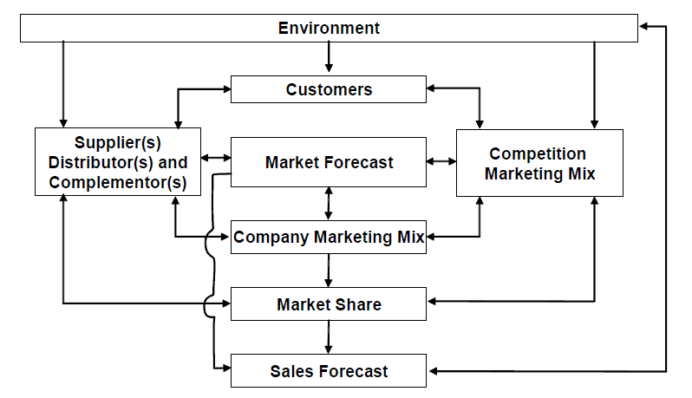
Figure 3.1: Causal approach to sales forecasting
They include feature normalization alongside centroids initialization step, assignment step and updating step, which are the three major generic steps in the k-Means algorithms.
3.2 ANALYSIS OF THE EXISTING SYSTEM
When trying to deal with sales monitoring management it is important that the fundamentals of sales forecasting is fully understood. A separation of several aspects to sales forecasting can be made and by that, get a clear picture of what sales forecasting purposes and uses, methods for how a monitoring can be produced, what indicators affects the forecast and, perhaps most importantly, what impacts errors in forecasts have. With this separation, several aspects between the user and the producer perspective are highlighted and easier to deal with.
Sales monitoring is a best guess about customer demand for goods in a particular time period. How this is made on depends on whether one using a qualitative or a Quantitative method. Its’ purpose is to, as accurately as possible, try to predict what quantity of goods or services will be sold, and by doing that, try to decrease the costs for inventory and transportation.
Volumes of sales can be measured in either physical or financial units Ok measured in both. One of the reasons for measuring in physical units is to neglect the impact of monetary values when buying and selling in different currencies. A reason for measuring in financial units is to attain a more understandable measure on how the sales affect the whole organization. One of the reasons measuring units in both physical and financial units is that the users of the forecasts are in need of different information. Mentzer (2005) where the sales department might choose to measure in financial units by product line, the logistical functions choose measure in physical units due to cargo and stock-keeping space. To classify the products, several different methods are used in practice. A common practice is to forecast by product family in contrast to forecasting by individual product
(Flores, 2017).

3.3 PROBLEMS OF THE EXISTING SYSTEM
Excel spreadsheet based systems. Some use an option from their ERP (Enterprise Resource Planning) system. None of these approaches are ideal. The problems associated with existing system of sales forecast are as follows:
- Spreadsheet based systems are generally difficult to maintain, in terms of adding new products or customers, updating actual or rolling forward years.
- They also tend to show the data in fixed views due to the fixed rows and columns structure of spreadsheet programs.
- The manual approach tends to be clumsy and labor intensive. Aggregation/consolidation of data across products and customers tend to require considerable manual processing.
- Brower based forecasting systems overcome the maintenance problems but tend to be inflexible, lacking functionality, and do not provide the variety of instant graphical views that a specialized PC based system makes possible. In addition, it is hard to give these systems the degree of user-friendliness which sales and marketing users generally prefer.

3.4 DESCRIPTION OF THE PROPOSED SYSTEM
In its beginning stages, forecasting involves gauging customer interest in light of trends in marketing and consumer spending. Once a market has been established, forecasting can be used to develop a realistic marketing budget and appropriately allocate resources. It may determine decisions such as how many sales department personnel a business hires. Gathering data about the performance of a service or product over the course of several years can help businesses improve the accuracy of future forecasts.
Before making a sales monitoring, it is useful to have statistics on competition, economic trends, and past sales data. If you are forecasting a new product or service, you may have to utilize market, data for similar enterprises. Many sales and marketing organizations publish useful information such as buying power indexes. Experienced sales managers may be skilled at developing forecasts. However, many businesses are turning to computer assisted forecasting for curate results. If your company is interested in sales forecasting assistance, consider exploring the list of reputable Business.com providers located to the left.
Sales monitoring provides a statistical method for you to determine the probability of your sales. Whether you want to establish your bottom line, or you want to determine your average monthly sales, you can use sales forecasting. Key’ terms in this industry can help you determine which forecasting techniques to use some key terms to know include predictive modeling, consensus, collaboration, and modeling algorithms.
Motoringhelps to provide speed, accuracy and offers data needed to make necessary adjustments that will benefit the business. Many large corporations maintain forecasts updated on a quarterly or even monthly basis that have been revised to account for environmental factors as well as the changing business climate.
Depending on the needs of your business and the application of the forecasts, you can choose to update the forecasted numbers as you sec fit.
Developing an accurate forecast is done by performing an analysis of past performance and gauging future obligations and anticipated future contacts of the business. Past performance indicators as well as sales trends are most likely to indicate future performance. If your business is experiencing a boom, naturally recasts would reflect current sales combined with anticipated rate of growth, holding all other factors constant. Many businesses which fluctuate seasonally, such as farming, must more heavily on past performance numbers from previous years in order to gauge seasonal sales impact. Judging winter sales of tomatoes based on summer sales figures seems somewhat illogical, and it makes more sense to base projections on the previous winter’s sales.
Enterprise resource planning software systems can be a valuable aid in determining forecasting parameters as well as to manage volume and inventory numbers. Software developers such as Oracle have developed comprehensive systems aimed at the analysis and projection of business financial figures. With a business of a smaller scale, you might find that you have a more in-depth knowledge of your business practices and will most likely be able to draw up more accurate forecasting numbers manually than with computer assistance.
Monitoring does have its limits, however. Small business is volatile and in large part depends on human action. Other outside factors can affect actual sales and production numbers as well while your forecasting models may be theoretically flawless, events such as natural disasters or economic downturn can significantly affect your financial figures.
By developing a reliable and consistent forecasting methodology, you can enhance the prowess of your company by being able to predict future sales and anticipated costs with an acceptable degree of accuracy. By having reliable future data to base decision off of, you can be sure that you will be able to make the most of corporate strategy adjustments.

  - ADVANTAGES OF THE PROPOSED SYSTEM
Monitoring software can help here, by providing the forecasters with a productive and flexible environment in which to analyze and manipulate their forecasts. The advantages of the computer based sales forecasting system are:
1.Create precise, forward-looking projections: Take demand Planning to the next level-integration with the new Demand Planner module provides access to
powerful tools to complete statistical forecasting and interactive simulation scenarios.
2.Leverage historical information for more accurate forecasts: Empower sales managers to review prior years’ sales and quickly revise projections based on their knowledge of the customer and the market, and to create new stiles forecasts from the old as new events arise that affect the demand for production resources.
3. Diminish the impact of unforeseen events: Maintain an unlimited number of forecasts, making it easy for both sales and manufacturing managers to gauge the impact of a variety economic or environmental force on production, and anticipate and prepare for possible scenarios ahead of time.
4. Aggregate demand from multiple sources.
5. Effectively collaborate between operations and sales.

CHAPTER FOUR
DESIGN, IMPLEMENTATION AND DOCUMENTATION OF THE SYSTEM
4.1 DESIGN OF THE SYSTEM
The proposed system is designed in modules with each modules working together to perform the Design and Implementation of an Academic Information System in order to enhance the performance of the existing system as earlier discussed in chapter three.
The ability to analyze and give focus to the system is explained in the following formats which are output design, input design, database design and procedure design.
    - OUTPUT DESIGN
The outputs to be extracted from the proposed system are as shown below
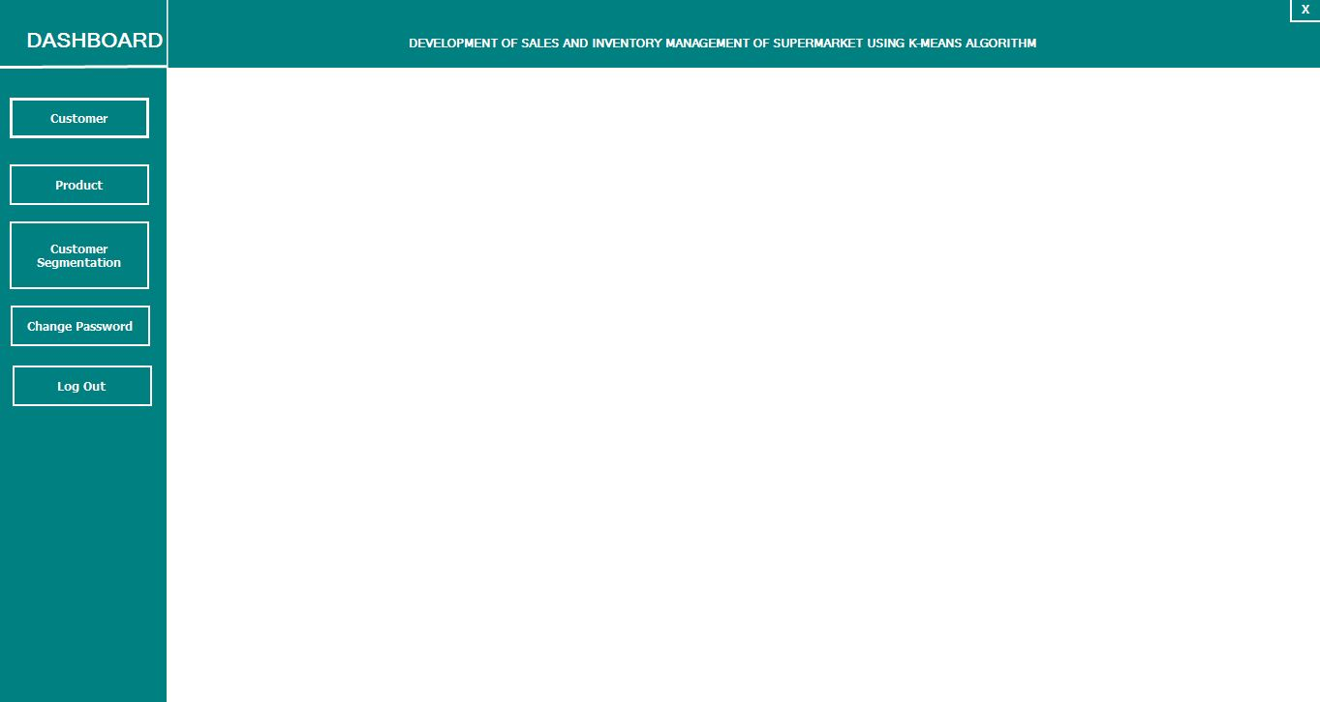
Figure 4.1: Dashboard

    - INPUT DESIGN
The input to be extracted from the proposed system areas are shown below
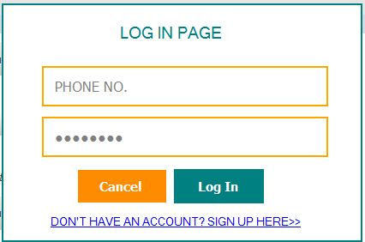
Figure 4.2: Login Page

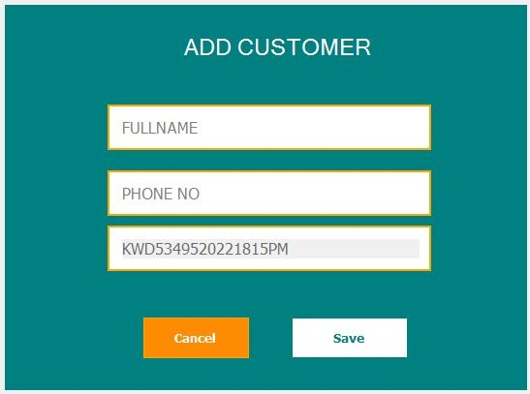
Figure 4.3: Add Customer Page
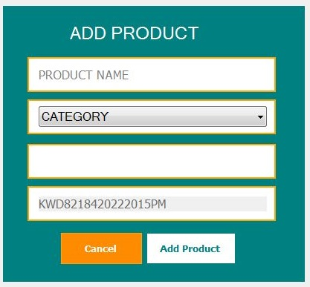
Figure 4.4 Add Product Page

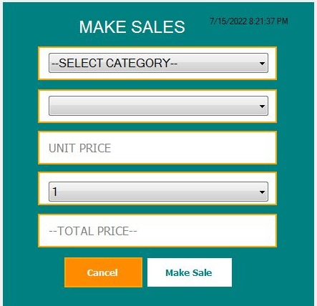
Figure 4.5 Make Sales Page

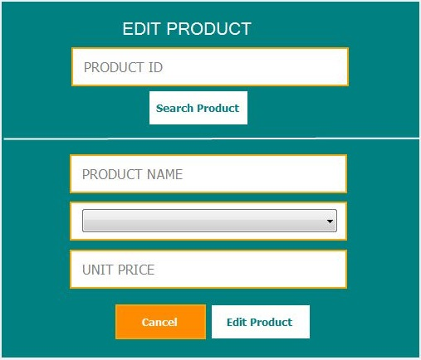
Figure 4.6 Edit Product Page
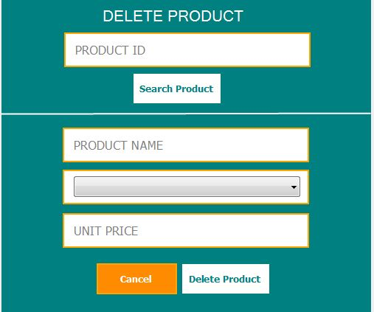
Figure 4.7: Delete Product Page
    - DATABASE DESIGN
This refers to the back end of the proposed system. The following steps are employed in the development of the database.
- Click on start button and locate Ampp.
- Open any browser and type http://localhost/phpmyadmin
- Type the name of the database i.e Pharmacy and click on create new
- In few seconds the database is created.
- To create table is the next action.
- On a create table menu type the name of the table and click on ok.

Table 4.1: Product Details Table
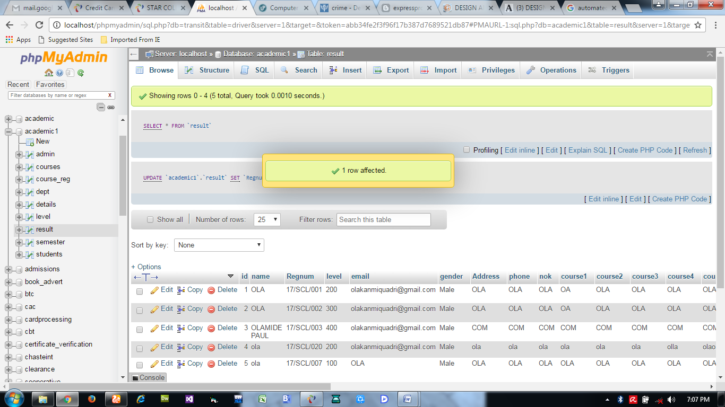

Table 4.2: Users database table
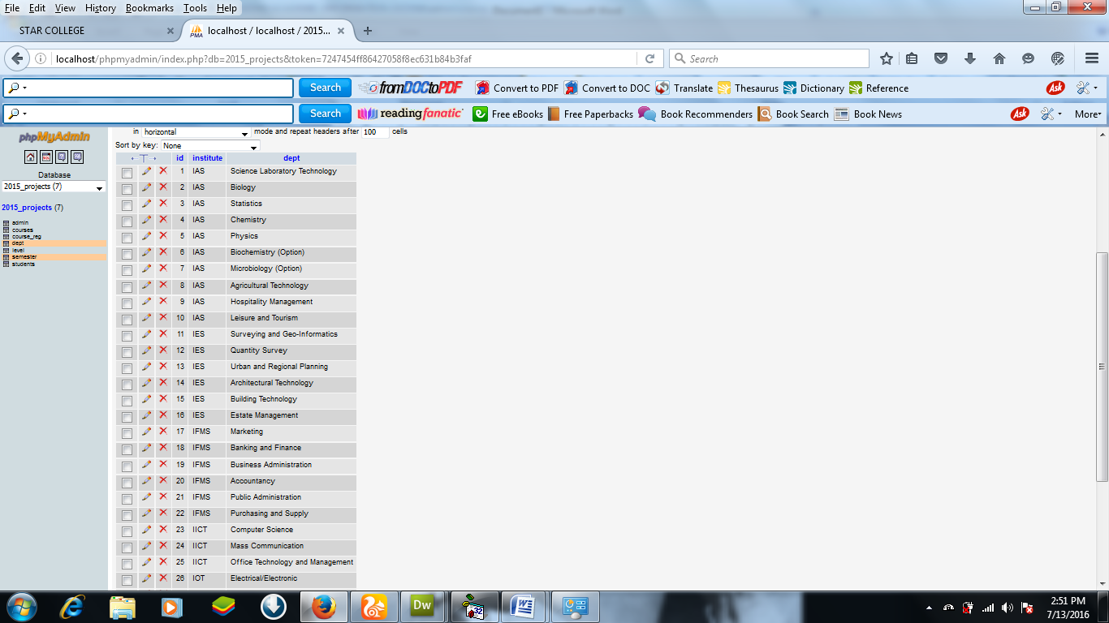

Table 4.3: Purchase Details Database
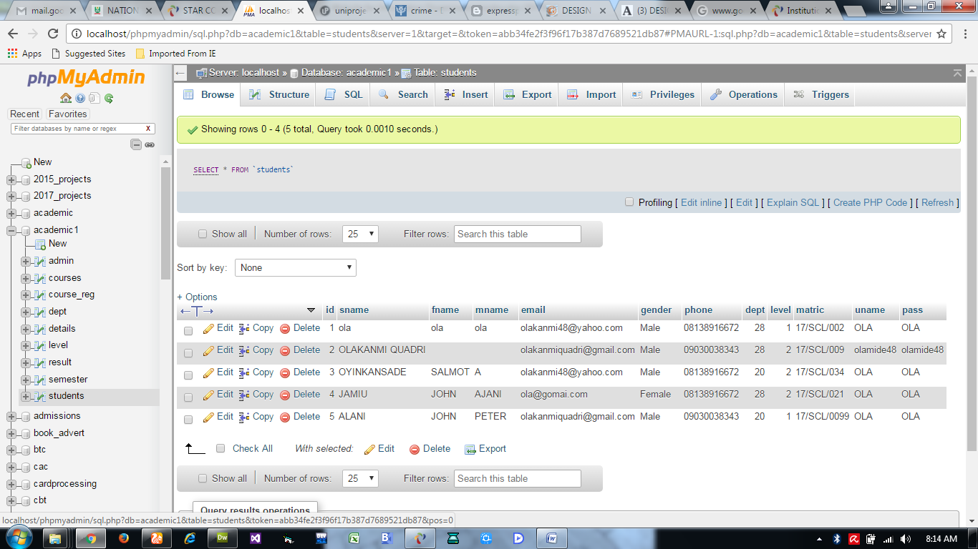

    - PROCEDURE DESIGN
This refers to the step by step method of using the proposed system. The proposed system comprises of Home, Login, Add Record, View Cart, View Mode, Reports, Log out while the administrator is able to add available position as well as its modification.
- On the address bar of any browser type http://localhost/Pharmacy/admin/
- You are prompted to supply the username and password this verifies that you are authorized user and has the privilege to add Product.
- If the username and password supplied are correct as that of the voter you are prompted with the home page with the list of add available position.
- The website has two environments the general user and the administrator environment.
- User you are to type http://localhost/Pharmacy/login.php on the address bar.

  - IMPLEMENTATION OF THE SYSTEM
    - CHOICE OF PROGRAMMING LANGUAGE
The reason for choosing PHP is that it is among the language of the web and as well it is an open source language in which help is readily available when needed and its level of pedagogy. And also the mysql data base was chosen because of its data integrity and high secured back end. Cascading Style Sheet was used to style the layout of the website while the javascript was used as the server side script in the development of the system

    - HARDWARE SUPPORT
CPU : PENTIUM IV
PROCESSOR SPEED : 2 GHz
COPROCESSOR : BUILT IN
TOTAL RAM : 1GB or Higher
HARD DISK : 80 GB
KEYBOARD : 105 KEYS
MOUSE : LOGITECH MOUSE
DISPLAY : SGVA COLOR
    - SOFTWARE SUPPORT
The proposed system makes use of macromedia fireworks for graphics work on the images and background used in the system, macromedia Dream weaver (a text editor) while MY SQL is used as the database.
    - CHANGEOVER TECHNIQUES
The implementation technique to be used in the system is parallels, a system that support the current system along-side with the proposed system. This means that for 7 UP bottling Company Limited Ilorin to adopt the proposed system a paper and pen method that is currently in use will still be in existence so that a failure in the proposed system will not lead to total loss of vital information.
  - DOCUMENTATION OF THE SYSTEM
    - PROGRAM DOCUMENTATION
In order for the proposed system to be used on any computer system it takes the following ways
- Boot the system
- Copy the folder to www inside Wamp folder of the drive C: after Wamp server is installed onto the system.
- Open any browser on the system (Microsoft internet Explorer, Mozilla Fire fox, Netscape Navigator, Opera, Flock, Safari e.t.c)
- Type http://localhost/Pharmacy/admin/on the address bar and press the return key/ enter key.
    - SYSTEM MAINTAINANCE
The system is flexible enough to entertain any future amendment which might be required when the need arise. The system requires regular update which necessitates the function of an administrator for regular information that is needed in the system. The system is also design in such a way that it will be convenient for any other programmers or system analyst that might want to work on the maintenance of the system if the need arises by documenting each and every part of the modules that made of the system.
CHAPTER FIVE
SUMMARY, CONCLUSION AND RECOMMENDATION
5.1 SUMMARY
In the first place, sales forecasts are frequently used for all the purposes suggested above. This leads to conflicts between optimism and pessimism and potentially introduces ‘political’ influences into the process. Examples are the different role of the profit forecast (probably conservative) and the sales plan (probably optimistic), or where marketing expenditure is loosely linked to the sales revenue of products (and therefore leads to defensive forecasting to protect planned marketing spends).
There are also conflicts in terms of which units should be forecasted – orders-based for production forecasting or invoice-based for financial forecasting.The important point is to have a clear vision of who the primary customer or customers of the forecasts are. Select the appropriate level of detail and time horizon accordingly and accept that secondary customers of the forecast will probably have to accept sub-optimal forecasts. In many situations, it is helpful for both Marketing and Sales to generate sales forecasts. Sales are often more likely to possess the detailed short term knowledge whilst Marketing need to ‘own’ the forecasts as a result of their role as brand profit ‘custodians’, and possibly have a clearer knowledge of longer term influences. It is vital here that each area is clear about the role and purpose of the forecasts they produce, and that forecast publication schedules ptimize the currency of the data used as inputs, and given as outputs, by each forecaster.
5.2 CONCLUSION
Sales forecasting is a large and important field because it allows businesses to more accurately manage their inventory levels. The goal of our project was to apply the techniques of regression and ANN to predict future sales without using historical sales as the primary predictors. Instead of historical sales alone, we also used various economic indicators as the input variables of the artificial neural networks.
5.3 RECOMMENDATION
Future research in this topic can aim to automate the process of choosing relevant economic indicators used as inputs into the neural network. Since economic indicators are determined by comparing information about the level of fit of different models until a satisfactory level of fit is achieved, it might be worthwhile to create a computer program that executes all of the comparisons until the statistical measures reach a pre-established threshold. Such a technique would enable us to accomplish the determination of economic indicators in a more efficient manner.

REFERENCES
Gokilavani et al., (2020) Sales Forecasting Using Prediction Analytics Algorithm. International Journal of Research and Innovation in Applied Science (IJRIAS) | Volume V, Issue VII, July 2020|ISSN 2454-6194 www.rsisinternational.

Bohdan M. (2019) Machine-Learning Models for Sales Time Series Forecasting. Received: 3 November 2018; Accepted: 14 January 2019; Published: 18 January 2019

Niya, N. J., (2021) Sale prediction using linear regression model.IJCRT Volume 9, Issue 3 March 2021 | ISSN: 2320-2882

Juan R. et al., (2014) On the identification of sales forecasting models in the presence of Promotions. Article in Journal of the Operational Research Society· January 2014 DOI: 10.1057/jors.2013.1

Armstrong, J. S. (2016). Sales Forecasting.The IEBM Encyclopedia of Marketing, 278 290. Retrieved fromhttps://repository.upenn.edu/marketing_papers/237

Efendigil T, Önüt S, Kahraman C, A decision support system for demand forecasting with artificial neural networks and neurofuzzy models:A comparative analysis. Expert Syst. Appl,2017.

Mentzer, J.T.; Moon, M.A. Sales Forecasting Management: A Demand Management Approach; Sage: Thousand Oaks, CA, USA, 2004.

Efendigil, T.; Önüt, S.; Kahraman, C. A decision support system for demand forecasting with artificial neural networks and neuro-fuzzy models: A comparative analysis. Expert Syst. Appl. 2009, 36, 6697–6707. https://community.tableau.com/docs/DOC-1236

IntelligentSalesPredictionUsingMachineLearningTechniques. https://ieeexplore.ieee.org/document/8659115/authors

Sales-forecastingofRetail Stores using Machine Learning Techniques.https://ieeexplore.ieee.org/document/8768765.

Predicting and Defining B2B Sales Success with Machine Learning.https://ieeexplore.ieee.org/document/8735638.

A Comparative Study of Big Mart Sales Prediction Gopal Behera1 and Neeta Nain Malaviya National Institute of Technology Jaipur, India1,2

APPENDIX 1:
SYSTEM FLOWCHART/MAINMENU

START
STOP
MAKE SALES
MODIFY PRODUCT
DELETE PRODUCT
SALES REPORT
ADD PRODUCT
MAIN MENU
LOG IN

APPENDIX 2: LOG IN
Start

Open Database

Return
Main Menu
Invalid Username or Password
Is Username and Password correct?
Supply Username and Password

N

Y
Close Database

APPENDIX 3: ADD PRODUCT
Start
Enter Product Details
Is Any Field Empty?
All Fields Are Required
Return
Open Database

Y

N
Save to Database

Close Database

APPENDIX 4: MODIFY PRODUCT
Start
Enter Product ID to Search
Open Database
Return

Does Product ID Match?
Record Not Found
N

Y
Enter New Product Details
All Fields Are Required
Is Any Field Empty?

Y

Update Database
N
Close Database

Return
APPENDIX 4: DELETE PRODUCT
Start
N
Record Not Found
Does Product ID Match?
Enter Product ID to Search
Open Database

Return
Close Database
Y
Delete Record

APPENDIX 5: MAKE SALES
All Fields Are Required
Close Database
Open Database
Return
Save Sales to Database
Is Any Field Empty?
Enter Product Details
Start

Y

N

APPENDIX 6: SALES REPORT
Start
Return
Close Database
Open Database

Display All Sales Report

APPENDIX 7: SOURCE CODE
Public A, Where As String,
k As IntegerPublic Q As Integer
Private Sub Form_KeyPress(KeyAscii As Integer)
Unload Me
Load frmLogInfrmLogIn.Show vbModal
End SubPrivate Sub Form_Load()
A = Label1.Caption
Q = 1Label1.Caption = Empty
Label3.Width = 0
Label4.Width = 0
Label2.Height = 0
Label5.Height = 0
Label6.Height = 0
Label7.Height = 0
Label8.Height = 0
Label9.Height = 0
Label15.Width = 0
Label16.Height = 0
End Sub
Private Sub Timer1_Timer()
Label1.Caption = Left(A, Q)
Q = Q + 1
If Label1.Caption = A Then
Timer1.Enabled = False
TimerDelay.Enabled = True
Where = "1"
End If
End Sub
Private Sub Timer2_Timer()
Label2.Height = Label2.Height + 50
If Label2.Height >= 1215 Then
Timer2.Enabled = False
TimerDelay.Enabled = True Where = "2"End IfEnd SubPrivate Sub Timer3_Timer()
If Where = "2" Then
Label3.Width = Label3.Width + 20
If Label3.Width >= 600 Then
Timer3.Interval = 50
End If If Label3.Width >= 900 Then Timer3.Interval = 5
End If If Label3.Width >= 1635 Then Timer3.Enabled = False TimerDelay.Enabled = True
Where = "2.5" End IfElseIf Where = "2.5" Then Label4.Width = Label4.Width + 20
If Label4.Width >= 300 Then Timer3.Interval = 50 End If If Label4.Width >= 600 Then
Timer3.Interval = 5 End If If Label4.Width >= 1455 Then Timer3.Enabled = False
TimerDelay.Enabled = True
Where = "3" End If
End If
End Sub
Private Sub Timer4_Timer()
If Where = "3" Then
Label5.Height = Label5.Height + 20 If Label5.Height >= 270 Then Timer4.Enabled = False
TimerDelay.Enabled = True Label5.ForeColor = RGB(Rnd * 255, Rnd * 255, Rnd * 255)
Label5.ForeColor = RGB(Rnd * 255, Rnd * 255, Rnd * 255)
'Label5.ForeColor = RGB(Rnd * 255, Rnd * 255, Rnd * 255)
'Label5.ForeColor = RGB(Rnd * 255, Rnd * 255, Rnd * 255)
'Label5.ForeColor = RGB(Rnd * 255, Rnd * 255, Rnd * 255) Where = "3.1" End If
ElseIf Where = "3.1" Then
Label6.Height = Label6.Height + 20
If Label6.Height >= 270 Then
Timer4.Enabled = False
TimerDelay.Enabled = True
Label6.ForeColor = RGB(Rnd * 255, Rnd * 255, Rnd * 255)
Label6.ForeColor = RGB(Rnd * 255, Rnd * 255, Rnd * 255)
Where = "3.2"
End If
ElseIf Where = "3.2" Then
Label7.Height = Label7.Height + 20
If Label7.Height >= 270 Then
Timer4.Enabled = False
TimerDelay.Enabled = True
Label7.ForeColor = RGB(Rnd * 255, Rnd * 255, Rnd * 255)
Label7.ForeColor = RGB(Rnd * 255, Rnd * 255, Rnd * 255)
Where = "3.3" End IfElseIf Where = "3.3" Then
Label8.Height = Label8.Height + 20
If Label8.Height >= 270 Then Timer4.Enabled = False
TimerDelay.Enabled = True
Label8.ForeColor = RGB(Rnd * 255, Rnd * 255, Rnd * 255)
Label8.ForeColor = RGB(Rnd * 255, Rnd * 255, Rnd * 255)
Label8.ForeColor = RGB(Rnd * 255, Rnd * 255, Rnd * 255)
Label8.ForeColor = RGB(Rnd * 255, Rnd * 255, Rnd * 255)
Label8.ForeColor = RGB(Rnd * 255, Rnd * 255, Rnd * 255)
Label8.ForeColor = RGB(Rnd * 255, Rnd * 255, Rnd * 255)
Label8.ForeColor = RGB(Rnd * 255, Rnd * 255, Rnd * 255)
Label8.ForeColor = RGB(Rnd * 255, Rnd * 255, Rnd * 255)
Where = "3.4"
End If
ElseIf Where = "3.4" Then
Label9.Height = Label9.Height + 20
If Label9.Height >= 270 Then Timer4.Enabled = False
TimerDelay.Enabled = True
Label9.ForeColor = RGB(Rnd * 255, Rnd * 255, Rnd * 255)
Label9.ForeColor = RGB(Rnd * 255, Rnd * 255, Rnd * 255)
Label9.ForeColor = RGB(Rnd * 255, Rnd * 255, Rnd * 255)
Where = "4"
End IfEnd IfEnd SubPrivate Sub Timer5_Timer()
If Where = "4" Then
Label15.Width = Label15.Width + 20
If Label15.Width >= 600 Then
Timer5.Interval = 50
End If
If Label15.Width >= 900 Then
Timer5.Interval = 5
End If
If Label15.Width >= 1860 Then

Timer5.Enabled = False
TimerDelay.Enabled = True

Where = "4.1"
End If

ElseIf Where = "4.1" Then

Label16.Height = Label16.Height + 20
If Label16.Height >= 495 Then
Timer5.Enabled = False
TimerDelay.Enabled = True
Where = "5"
End If

End If
End Sub

Private Sub Timer6_Timer()
Label2.ForeColor = RGB(Rnd * 255, Rnd * 255, Rnd * 255)
End Sub

Private Sub Timer7_Timer()
lblPress.Visible = Not lblPress.Visible
End Sub

Private Sub TimerDelay_Timer()
TimerDelay.Enabled = False
If Where = "1" Then
Timer2.Enabled = True
ElseIf Where = "2" Then
Timer3.Enabled = True
ElseIf Where = "2.5" Then
Timer3.Enabled = True
ElseIf Where = "3" Then
Timer4.Enabled = True
ElseIf Where = "3.1" Then
Timer4.Enabled = True
ElseIf Where = "3.2" Then
Timer4.Enabled = True
ElseIf Where = "3.3" Then
Timer4.Enabled = True
ElseIf Where = "3.4" Then
Timer4.Enabled = True
ElseIf Where = "4" Then
Timer5.Interval = 5
Timer5.Enabled = True
ElseIf Where = "4.1" Then
Timer5.Enabled = True
Timer5.Interval = 50
ElseIf Where = "5" Then
TimerDelay.Interval = 500
Where = "6"
TimerDelay.Enabled = True
ElseIf Where = "6" Then
Unload Me

